
Fashion Design
Level III
Based on March, 2023, Curriculum Version 1
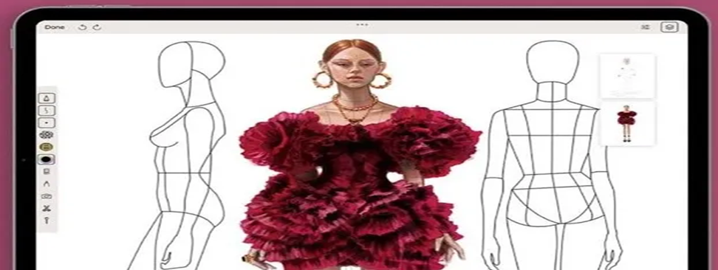
Module Title: - Using software for fashion Design
Module code: IND FAD4 M04 0322
Nominal duration: 100 Hours October, 2023
Preperd By BEREKET YOHANNES BUNE Addis Ababa, Ethiopia

Table of Contents
Figure of Contents ii
Acknowledgment 1
Introduction 2
Unit one: Prepare work area 4
1.1. Identifying and interpreting design specifications. 5
1.2. Identifying and using suitable programs and equipment for fashion design 8
1.2.1. The Essential Fashion Designer Tools 9
1.3. Identifying garment software considerations. 16
1.3.1. Type of fabric for fashion design 17
1.3.2. Color of fabric 18
1.3.3. Purpose of garment fashion design 19
1.3.4. Quality standards of fashion design 21
Self-check-1 23
Unit Two: Using design tools 26
2.1. Using design programs and equipment according to OHS practices 27
2.2. Using design programs and equipment to create design. 31
2.3. Using Design programs and equipment to test design. 32
Part III -Lap Test-1 39
Unit Three: Assessing electronic outputs 41
3.1. Assessing outputs generated using electronic design programs 42
3.2. Presenting outputs to assess appropriate personnel accuracy and completeness 43
3.3. Making improvements as required by appropriate personnel 44
Self-check .3 46
Unit Four: Maintaining electronic design system 50
4.1. Creating, storing, organizing and protecting designs, patterns or production specifications. 51
4.2. Maintaining and storing design programs. 54
Self-check .4 58
Operation sheet 2 60
References: 61

Figure of Contents

Figure 1: Digital Pro design 6
Figure 2: specification design 8
Figure 3: suitable programs 9
Figure 4: widow CLO 10
Figure 5: tools Bar 12
Figure 6: tool and feature 12
Figure 7 : 2D and 3D window 13
Figure 8: Sketch Software 14
Figure 9: CorelDraw Software 14
Figure 10: Adobe Illustrator 15
Figure 11: TUKA 16
Figure 12: fabric for design 18
Figure 13 : Color 19
Figure 14: garments 21
Figure 15: tools 28

.

Acknowledgment

Ministry of Labor and Skills wish to extend thanks and appreciation to the many Representatives of TVET instructors and respective industry experts who donated their time and expertise to the development of this Teaching, Training and Learning Materials (TTLM).

Introduction
In today’s Using software for fashion Design era if you want to become a fashion entrepreneur or successful fashion designer, you will need specific tools in your arms which are capable of taking your creative renderings from paper to product. You must have access to different fashion design software which are developed to make your ideas and sketches an appreciable reality. Nowadays, almost all the fashion designers, clothing line start-ups, textile designers, apparel manufacturers, and even fashion students utilize CAD software to enhance their skills and creativity. At the moment, many fashion entrepreneurs and illustrators are most likely using Adobe Illustrator or Corel Draw to take their designs into the digital world and make it more live. Today commercially many software’s are available which can help us to start our clothing line. This software’s gives a full range of options like digital fashion sketches, digital samples, and develop prototypes, computerized marker making, etc.

Software in fashion design; in this module assists to attain the learning objectives stated in the cover page. Specifically, upon completion of this Learning Guide,
This module covers the units:
- Prepare work area
- Using design tools
- Electronic outputs
- Electronic design system
Learning Objective of the Module
- Identify prepare work area
- Modify using design tools
- Assessing electronic outputs
- Maintaining electronic design system
Module Instruction
For effective use this modules trainees are expected to follow the following module instruction:
1. Read the information written in each unit
2. Accomplish the Self-checks at the end of each unit
3. Perform Operation Sheets which were provided at the end of units\
4. Do the ―LAP test‖ giver at the end of each unit and
5. Read the identified reference book for examples and exercise

Unit one: Prepare work area
This unit is developed to provide you the necessary information regarding the following content coverage and topics:
- Interpreting design specifications.
- using suitable programs and equipment for fashion design
- Garment software considerations.
- fashion design Production requirements
This unit will also assist you to attain the learning outcomes stated in the cover page. Specifically, upon completion of this learning guide, you will be able to:
- Identifying and interpreting design specifications.
- Identifying and using suitable programs and equipment for fashion design
- Identifying garment software considerations.
- Identifying fashion design Production requirements

Identifying and interpreting design specifications.
Benefits and Importance of Computer Aided Design in Fashion Industry Using CAD software, a fashion designer can develop new sketches, patterns, varieties of prints more quickly and accurately. With the evolutionary use of CAD, fashion designers can create multiple modifications of a single design or style and adapt it as per the requirement. It is known that not all colors work for all kinds of designs. A certain color might work for a particular design pattern but might not work for other patterns. This is where CAD comes for the designer’s relief. CAD helps in exploring more colors among the designs to help you get the perfect color that brings out the pattern individually. In fabric designing process, it allows the designers to work with different fabric patterns and textures. This will ultimately reduce the cost and will save the time taken to deal the patterns manually. As the whole process can be done on virtual version and very less part of the whole process is an actual physical, so the raw material cost of collection development in fashion designing can be reduced to a minimum.
CAD also allows the fashion designer to explore various color ways of a print developed as compared to the traditional design methods, where the modifications and rectifications are more fast as well as more accurate, as it reduces rooms for errors. CAD helps designers in lot of aspects. Previously, it was very hard to give life to a design by solving sewing errors. CAD helps in rendering a similar model design with exact specifications which gives idea to the designers for rectifying the errors and modify the design. Instead of saving your work on paper, clipboards and albums or in hard copy, if you have soft copies of your work, chances of losing your work will be very less as well as it can be retrieved very easily at any place and any time.
Design Specifications describe how a system performs the requirements outlined in the Functional Requirements. Depending on the system, this can include instructions on testing specific requirements, configuration settings, or review of functions or code. Fashion design software is basically a computer-aided design (CAD) tool that allows users to make 2D and 3D sketches, illustrations, and tech packs with callouts to specific design and functions. The goal of using fashion design software is to simplify communicating design ideas for accurate samples, illustrations and production which run later in the supply chain. Once the designs produced using these software’s are approved, they become the only source of truth for those constructing the garment.
You may also like: Marker Making, Planning, Efficiency and Use of CAD
Various logistics software for fashion and textile solutions is available to you when you start your clothing line or fashion designing. Here are five fashion design software programs with multiple functionalities that could be advantageous to your fashion design process by eliminating particular aspects of your work while giving you a competitive spirit.
Digital Fashion Pro: Professional Digital Fashion Sketching & Illustration
Digital Pro is a good solution which is developed to start the fashion brand. The package includes professional design software and different fashion design templates, samples everything which is needed to make a business in fashion digitally. It includes video and E-training guide that explains the core functions of designing in a clothing line. This software is specifically helpful to create technical sketches and design menswear, women’s wear, kid’s wear, baby clothing, handbags, shoes, and accessories.
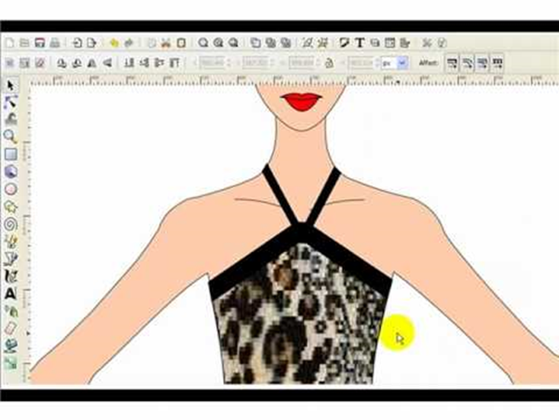
Figure 1: Digital Pro design
A design specification is a detailed document that sets out exactly what a product or a process should present. For example, the design specification could include required dimensions, environmental factors, ergonomic factors, aesthetic factors, maintenance that will be needed, etc. Design Specifications may include:
- Specific inputs, including data types, to be entered into the system.
- Calculations/code used to accomplish defined requirements.
- Outputs generated from the system.
- Explaining technical measures to ensure system security.
Basics to create a good design brief
- Objectives and goals of the new design.
- Budget and schedule.
- Target audience.
- Scope of the project.
- Available materials/required materials.
- Overall style/look.
- Any definite "Do notes"
What is specification in fashion design?
A garment specification (spec) sheet, or measurement table, is a technical document that contains all construction details of the garment. It looks like a technical diagram or a sketch of a garment, including all of its measurements. Spec sheets are used by designers to communicate design concepts to manufacturers.
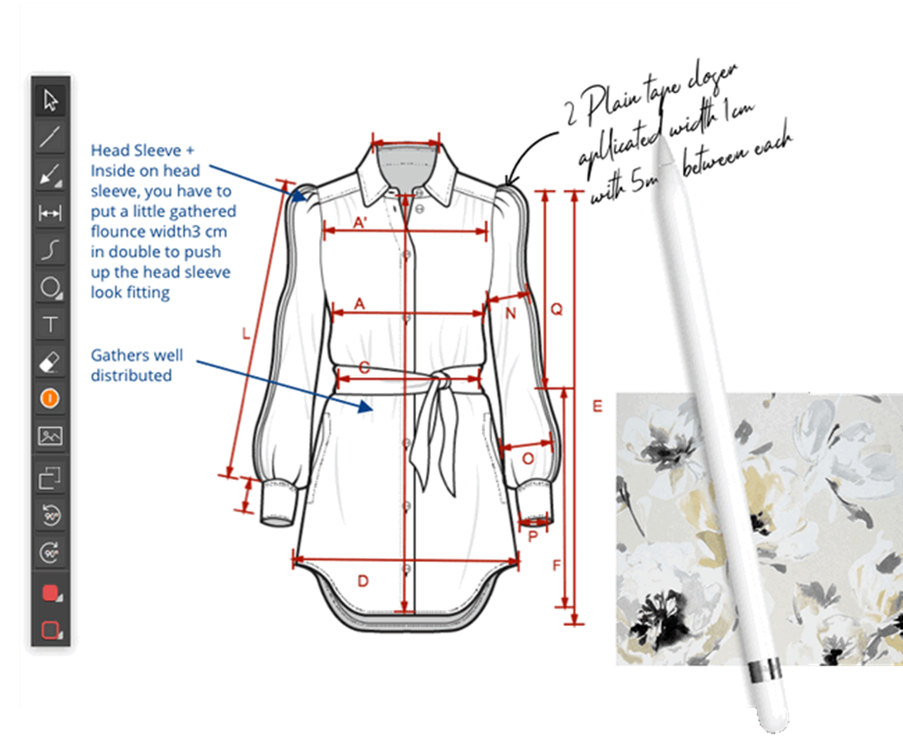
Figure 2: specification design

Identifying and using suitable programs and equipment for fashion design
The basic software’s used by a fashion designer to create beautiful designing patterns, prints, motifs, different elements of designs and many others. Nowadays software and updating technology place and very vital role in day to day life of humans. So, the use of software’s and various technology’s in different sectors like textiles, clothing, manufacturing, and other are sectors is increasing day by day. In today’s digital age, fashion design software has become an indispensable tool for designers, which provide them different tools and techniques to bring their ideas to life on a screen of computer. Use of Technology enhance the human work and add particular value into that design. It’s have lot of benefits which includes less human efforts, utilization of time, create beautiful designs at lesser time, add value into design, increase price of pattern. And provide many other benefits to the fashion designer.
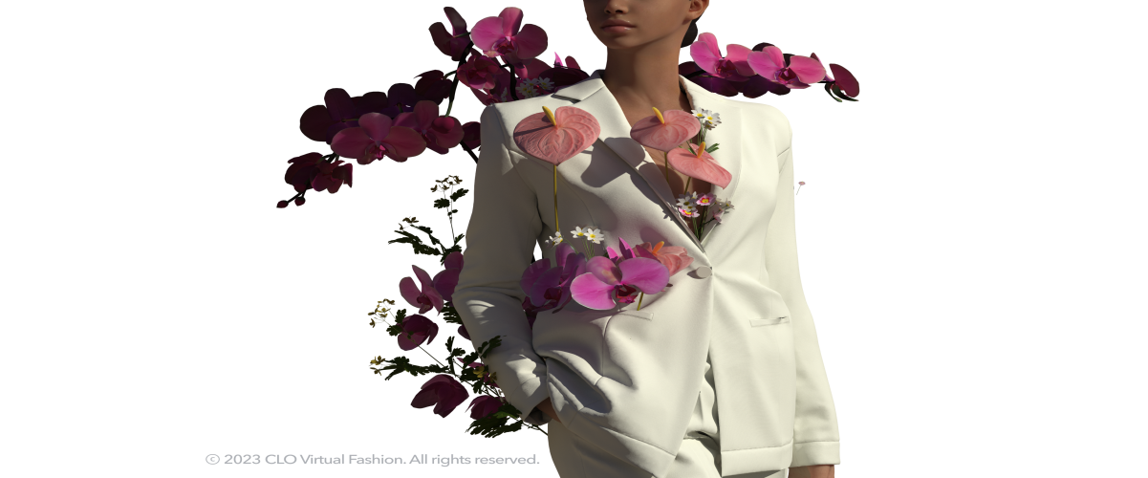
Figure 3: suitable programs

The Essential Fashion Designer Tools

Use 2D patterns
One of the main advantages of CLO 3D is that it allows you to create 3D garments from 2D patterns. This means that you can use your existing patterns or create new ones in CLO 3D or in another software and import them into CLO 3D. Using 2D patterns will help you create accurate and realistic 3D garments that match your design intentions and specifications. You can also edit and adjust your 2D patterns in CLO 3D to see how they affect the 3D garment in real time.
CLO 3D is a powerful software that allows fashion designers to create realistic 3D garments and simulate how they fit and move on different body shapes and poses. It can help you save time and resources, improve your design quality and accuracy, and showcase your creativity and style. However, to get the most out of CLO 3D, you need to follow some best practices that will enhance your workflow and results. In this article, we will share with you some tips and tricks that will help you use CLO 3D effectively and efficiently in your fashion design projects.
Complete Guide to ALL CLO 3D Tools! Whether you're a budding fashion designer, an aspiring entrepreneur in the clothing industry, or a seasoned professional, this comprehensive course is your ultimate gateway to mastering the vast array of tools and features offered by CLO 3D.
CLO 3D is a cutting-edge software renowned for its virtual garment simulation capabilities, enabling designers to bring their creative visions to life with unparalleled precision and efficiency. This course is thoughtfully crafted to take you on a transformative journey, unlocking the full potential of this remarkable 3D apparel design software.
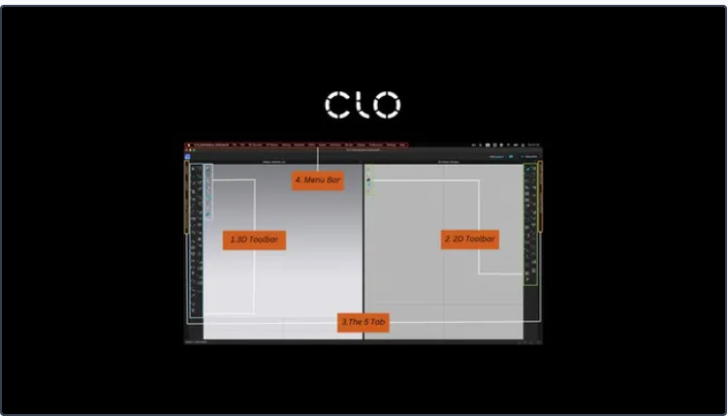
Figure 4: widow CLO
Throughout this course, you'll embark on an immersive learning experience, diving into each tool and feature of CLO 3D step by step.
Starting with the 3D toolbar.
Key Course Highlights:
Familiarizing with CLO 3D Interface and Basic Tools
Mastering all the tools in 3D toolbar
Mastering all the tools in 2D toolbar
How to use Library, Modular configurator, Object browser, and property editor
All tools are in the menu bar.
By the end of this course, you'll be well-versed in every tool and feature that CLO 3D has to offer, enabling you to transform your creative concepts into photorealistic virtual garments. Whether you're an industry professional seeking to elevate your skills or an aspiring designer eager to stand out, this course will equip you with the expertise and confidence to conquer the world of 3D apparel design.
Join us on this incredible journey of creativity and innovation in the realm of fashion with the Complete Guide to ALL CLO 3D Tools! Enroll now and unlock the door to boundless possibilities in the realm of virtual garment design.
CONTENT
Introduction
Complete 3D Tool Bar
Complete 2D Tool Bar
Library, Modular Configurator, Object browser and Property Editor
Menu Bar
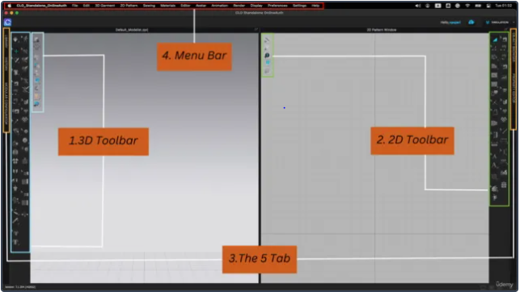
Figure 5: tools Bar
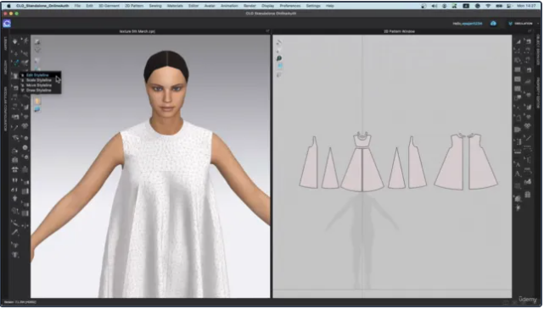

Figure 6: tool and feature
The some best Fashion Design Software:
CLO:
It is the best and basic software used by and fashion designer. CLO is popularly used software which is used as a 3D fashion designing tool. It is mostly used for create beautiful garment designs and enable user to create different enthusiastic visual garments. That means it provides and realistic appearance of the fabric on the visual body so that it looks like a real garment. CLO software provide you an extensive library of garment templates, so that you can visualize drape of the fabric, flow of the fabric, various moments of the fabric and designs with respect to the moment of body. So it is mostly used by a designer as a basic and beginner tool to create and experiment variety of garments with different fabrics styles, color, shades, and may more.
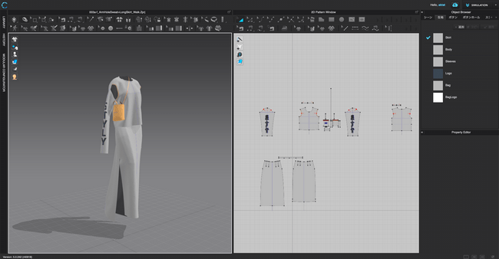
Figure 7 : 2D and 3D window

Sketch:
Another type of software which you can use as a beginner is sketch software. Sketch is a digital type of designing tool which is most widely used by and designing professionals and fashion designers to create their beautiful garments and too add realistic looks into it. It is mostly user friendly with you and provides powerful tools and techniques so that you can create variety of garments by using sketch. It includes and basic and most powerful feature which is illustrations. Sketch is mostly used to create various types of fashion illustrations, to create models and dummies. It enables you to create render garments on those illustrations. So as a beginner you can use this Sketch software to build up your skills and knowledge of fashion designing.
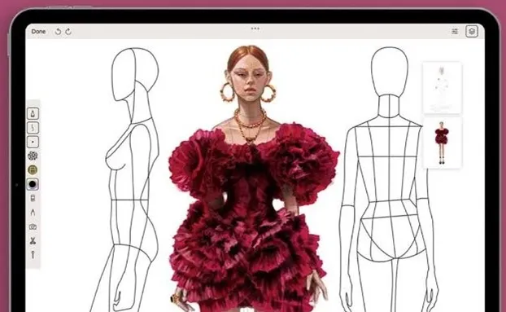

Figure 8: Sketch Software
CorelDraw:
As we all aware about CorelDraw it is most widely used and a graphic designing tool which provides lot of applications of designing, sketching, drawing, vector designing, and many other things. After you know the basic tools and functions of some basic designing software’s you must go for interference of CorelDraw with you. Because it provide slot of different and advanced features so that you can learn variety of designing things through it. It also has a vast library of templates of designing so that you can boost your creativity levels and enhance your creation though it.
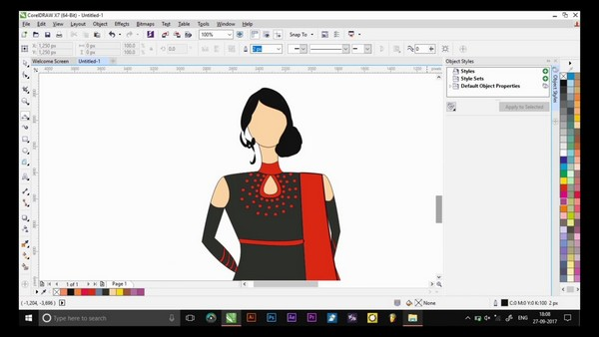

Figure 9: CorelDraw Software

Adobe Illustrator:
After Corel draw software, Adobe illustrator is pop-up on your designing mind. It is a most widely used industrial standard software by a fashion designer. It has some advance tools and features so you should have a great knowledge of basic tools and techniques before using Adobe illustrator.
Adobe illustrator provides you a wide variety of interference and wide range of different tools and techniques to create, to design, to sketch, to illustrate, different fashion elements. It is used to create different designs of textiles and patterns. It is a totally vector based the software. Here vector this software enables you to maintain your quality of design or pattern. After designing your pattern you can resize your pattern shape, size, and color without losing the original quality of that design.
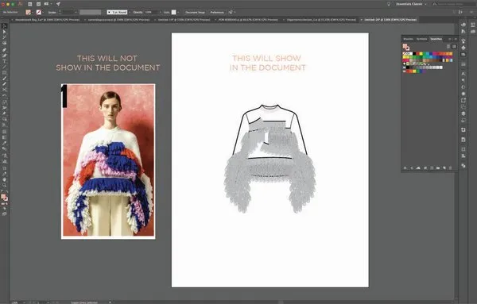
Figure 10: Adobe Illustrator

TUKA cad:
TUKA cad is one of my favorite designing software. It is not only used by an fashion designer, but it is now a standard and most widely used and industrial tools for creation of illustrations, designs, pattern, sketching and various this up to production. Which includes pattern making, drafting that pattern, re-designing, grading, and then creating a marker that means marker making? So that’s why it mostly widely used software as a industrial designing tool. Then TUKA 3D is and one the part of TUKA cad software which enables you to create 3D avatar means 3D dummy on your computer screen.
It enables you render fabric on that visual body so that you get to know about the drape of fabric, flow of that fabric, effect of stitch and its tension at various body parts, and other side range of applications. So TUKA cad is widely used in the garment and fashion industries and is known for its higher accuracy and efficiency.
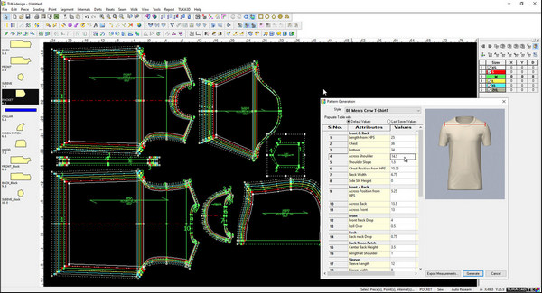
Figure 11: TUKA

Identifying garment software considerations.
Garment manufacturing software also helps companies improve employee satisfaction and customer relationships by automating repetitive tasks such as sales order tracking and fulfillment, and manage quality control across various garment production lines. However, choosing the right Garment ERP Software for your business can be an overwhelming process especially if you’re new to this business or the fashion industry.
Selecting the right Garment ERP Software for managing your fashion supply chain is a vital decision. You don’t want to choose a system that will hinder your workflows and make it harder to run day-to-day operations.

Best Clothing Design Software for 3D Rendering & Modeling.
Adobe Illustrator.
Blue Cherry.
Brow wear.
C-Design Fashion. ...
CLO 3D. ...
Corel Draw. ...
Digital Fashion Pro. ...
EFI OPTITEX.

Type of fabric for fashion design

Cotton, silk, wool, and synthetic fibers are commonly used, making it a versatile fabric. Crepe is usually named after the fiber it is made of, such as crepe silk or crepe chiffon. Crepe is a soft, pleasant, and easy-to-work-with fabric that is commonly used in suit and dressmaking.
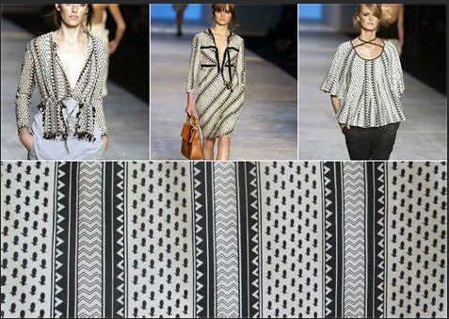
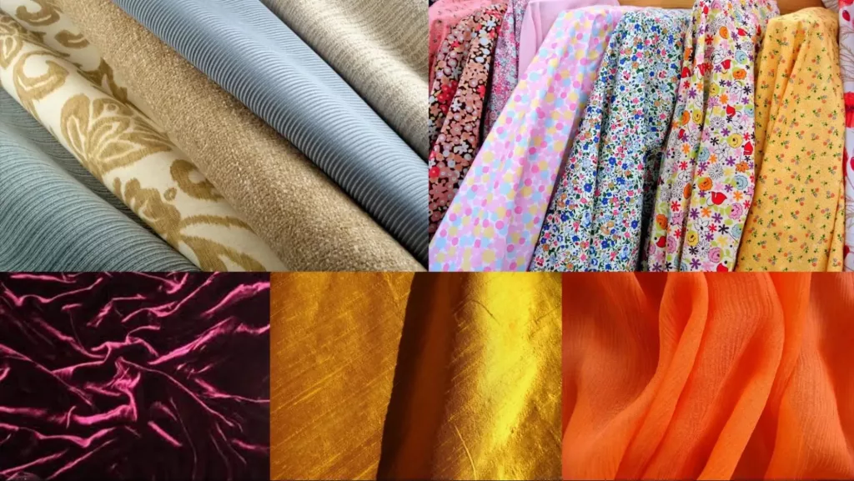
Figure 12: fabric for design

Color of fabric
Color theory is very important to any type of clothing, footwear, or accessory design you do. Color can bring your designs to life or bring them down and leave you with unsold products. When designing apparel, it’s important to know which colors go well together, how to create those colors, and what color terminology the fashion industry uses.
Primary colors are something that you may or may not be familiar with. The traditional primary colors are Red, Yellow, and Blue. There is some disagreement and argument as to why red, blue, and yellow are actually not the primary colors. Some people favor CMYK (Cyan, Magenta, Yellow, and Black, also known as Key), or CMY, as the primary colors. You might have noticed that your printer test prints and uses CMYK ink cartridges. Others still argue for RGB – Red, Green, and Blue.
Designers can desaturation and make new colors using tints, shades, tones, and mutes. These can make a color softer, lighter, darker, duller, or muted.
Tints = color + white Shades = color + black
Tones = color + gray Mutes = color + its complement color
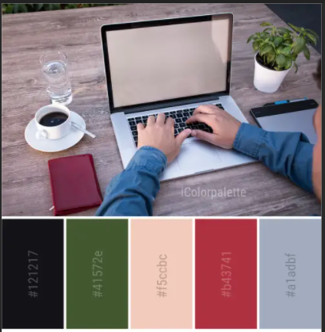
Figure 13 : Color

Purpose of garment fashion design
Fashion designers attempt to design clothes that are functional as well as aesthetically pleasing. They consider who is likely to wear a garment and the situations in which it will be worn, and they work within a wide range of materials, colors, patterns, and styles.
Fashion design serves several important purposes, and its significance extends beyond the creation of clothing and accessories. Here are some of the primary purposes of fashion design:
- Self-Expression: Fashion design allows individuals to express their personal style, creativity, and individuality. It provides a means for people to communicate their identity, values, and personality through the clothing and accessories they choose to wear.
- Aesthetic Appeal: Fashion design is inherently linked to aesthetics. Designers create visually appealing garments and accessories that can be appreciated as works of art. Fashion adds beauty and variety to our lives and can evoke emotions and feelings through color, texture, and form.
- Functionality: While fashion is about style and aesthetics, it is also about practicality. Fashion designers consider the functionality and comfort of their creations, ensuring that clothing and accessories are suitable for different occasions, activities, and climates.
- Cultural Expression: Fashion design reflects the culture and heritage of a society. It can incorporate traditional elements, symbols, and motifs that represent a particular culture or community. It also plays a role in cultural exchange and can help bridge gaps between different cultures.
- Economic Impact: The fashion industry is a significant contributor to the global economy. Fashion design creates jobs in areas such as design, manufacturing, retail, marketing, and more. It stimulates consumer spending and drives economic growth.
- Innovation and Creativity: Fashion design fosters innovation and encourages designers to push the boundaries of creativity. Designers experiment with new materials, technologies, and techniques, contributing to advancements in various industries, including textiles and manufacturing.
- Social and Political Commentary: Fashion can be a powerful medium for social and political commentary. Designers often use their collections to address important issues, challenge norms, and provoke thought and conversation on topics like gender, identity, sustainability, and social justice.
- Environmental and Ethical Considerations: In recent years, fashion design has increasingly focused on sustainability and ethical practices. Designers are working to create eco-friendly and socially responsible fashion that minimizes harm to the environment and respects workers' rights.
- Cultural Trends and Influences: Fashion design responds to cultural, societal, and historical trends and influences. It reflects the spirit of the times and can capture the mood and values of a particular era or generation.
- Individual and Collective Identity: Fashion design plays a role in shaping both individual and collective identity. It can empower individuals by helping them feel confident and authentic in their clothing choices. At the same time, it can be a unifying force, connecting people with similar tastes and interests.
This lesson is an introduction to arranging pattern pieces to correct positions around our avatar and then sewing them together. We will go over various tools for utilizing pre-existing patterns, allowing us to create style visualization and fit check of our virtual garment. You will also learn a troubleshooting technique for a common but easily remedied issue when constructing garments in the 3D space.
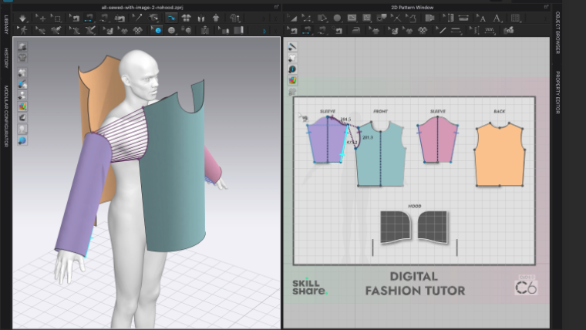
Figure 14: garments

Quality standards of fashion design
Implementing and documenting a quality management system, or a QMS for short, is an important part of boosting quality control in fashion product sampling and production. A QMS takes a look at all the policies, procedures, and processes for your company that help improve overall efficiency and organization.
Customers are drawn towards businesses that put quality at the forefront. This trend and the added process improvements that a QMS brings to a company are the primary reasons to implement one. Some other advantages include:
  - Improved product quality - Since you will be able to manage the quality of your products with clear definitions of what you are striving for, the product quality will inherently improve, whether you design and sell clothing, accessories, or any other fashion apparel.
  - Increased productivity and reduced costs - Set standards and protocols bring about more organization and efficiency. Having various steps and requirements set out for everyone can help increase productivity and reduce costs.
  - Increased customer satisfaction - As mentioned earlier, consumers are drawn to businesses that prioritise quality products. As a result, having a detailed process in place will help assure that you delight your customers with high-quality products in-hand
  - Simplified training for new employees - Any new employees will be easier to train if the definition of what quality means to your company is conveyed early on.
  - Increased competitiveness - The fashion world is full of competitors that strive to deliver high-quality products. A QMS will allow you to also remain competitive against them.
  - Identifying fashion design Production requirements.
These requirements may include raw materials, labor, finances, equipment and machines. Identifying the prerequisites for production helps the company prepare adequately or make relevant adjustments to suit its requirements.
Top Features
Vector-based graphics. Scale your designs up or down without losing quality to create infinitely scalable illustrations for any garment size.
The Pen tool. Sketch garments and create detailed fashion illustrations with precision by using Illustrator’s Pen tool.
Custom brushes. Craft unique textures and patterns for fabrics, accessories, and garment details with Illustrator’s custom brushes.
Saved design elements. Save reusable design elements like buttons, zippers, or patterns as symbols to incorporate into future designs.
Automated gradients. Use gradients to create depth and dimension in your fashion illustrations and pattern designs.

Self-check-1

Test-I choose the best answers for the following questions
Instruction: Select the best answer for each question. Do this by circling the identifying letter next to your answer. You have given 1 Minute for each question. Each carries 3 Points.
1. What is the main benefit of using CAD in the fashion world?
a) It allows designers to work with different fabric patterns and textures
b) It reduces the cost and time taken to deal with patterns manually
c) It helps designers explore various color ways of a print
d) It helps in rendering a similar model design with exact specifications

2. How does CAD help in reducing errors in fashion design?
a) It allows for modifications and rectifications to be made more quickly and accurately
b) It helps in exploring more colors among the designs
c) It reduces the cost of collection development
d) It allows for easy retrieval of work at any time and place

3. What are design specifications in the fashion industry?
a) Instructions on testing specific requirements
b) Configuration settings for fashion design software
c) Review of functions or code in fashion design software
d) Instructions on how a system performs the functional requirements

4. What is the goal of using fashion design software?
a) To simplify communication of design ideas for accurate samples and illustrations
b) To reduce the cost and time taken to deal with patterns manually
c) To explore various color ways of a print
d) To render a similar model design with exact specifications

5. What becomes the only source of truth for those constructing the garment once designs are approved using fashion design software?
a) The raw material cost
b) The physical patterns
c) The soft copies of the designs
d) The tech packs with callouts to specific design and functions

6. Which of the following is NOT a traditional primary color in the fashion industry?
a) Cyan
b) Red
c) Yellow
d) Blue

7. Which color model is commonly used in printers?
a) RGB
b) CMYK
c) CMY
d) Key

8. What is the purpose of understanding color theory in fashion design?
a) To create visually appealing designs
b) To save money on ink cartridges
c) To simplify communication with manufacturers
d) To increase sales of products

9. Which color model is commonly used in digital displays?
a) RGB
b) CMYK
c) CMY
d) Key

10. Why is it important to know which colors go well together in fashion design?
a) To create unique and innovative designs
b) To accurately represent fabric patterns and textures
c) To simplify communication with suppliers
d) To avoid creating unsold products

Test II: short Answer writing
Instruction: write short answer for the given question. You are provided 3 minute for each question and each point has 5 points.
1. What is specification in fashion design?
2. Which the Essential Fashion Designer Tools Measuring tapes?
3. Which of the following is best Fashion Design Software?
4. What Adobe illustrator is pop-up on your designing mind?

Unit Two: Using design tools
This unit is developed to provide you the necessary information regarding the following content coverage and topics:
- Design programs and equipment according to OHS practices
- Design programs and equipment.
- Design programs and equipment
This unit will also assist you to attain the learning outcomes stated in the cover page. Specifically, upon completion of this learning guide, you will be able to:
- Using design programs and equipment according to OHS practices
- Using design programs and equipment to create design.
- Using Design programs and equipment to test design test.

Using design programs and equipment according to OHS practices

An Image/Link below is provided (as is) to : Content on the Website is provided to you as is for your information and personal use and may not be sold / licensed / shared on other websites without getting consent from its author. Download presentation by click this link. While downloading, if for some reason you are not able to download a presentation, the publisher may have deleted the file from their server.
Fashion design is the art of making clothing designs. It involves cutting patterns on fabrics, sewing, manufacturing garments, and processes of crafting. You need the right fashion design tools to impressively make clothes fast. An experienced fashion designer has all the tools needed to make beautiful clothing items. With the right tools and equipment, you reduce the time it takes to create new cloth designs.
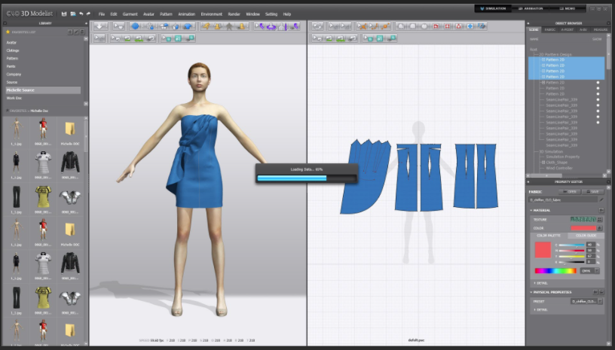

Figure 15: tools
The tools also minimize mistakes and help make perfect clothes designs.
Whether you have great artistic and design skills or drape your clothes on dummies to make perfect cuts, you’re in the right place.
Here’re a few fashion design tools you need to get started with your hobby or career:
- A tape measure
You need a tape measure around your fashion desk at all times. When working, it’s easy to lose track of time and get your space a bit messy.
Therefore, it’s important to have at least three tape measures. Keep one tape measure in the toolbox, another around your neck, and the third in the fabric you intend to sew.
With a tape measure, you create picture-perfect clothes that fit your clients. Instead of this tool, some designers use a grading ruler and a set square to achieve the same outcomes. You’ll find the two handy if you aren’t good at using a tape measure.
- Scissors
Fashion designers use different kinds of scissors for varied jobs. The three major scissors you need to create perfect fabric designs include:
Shear scissors – heavier than card scissors, shear scissors are used to cut all kinds of fabrics.
Card scissors – help fashion designers cut cardboard designs or patterns to ease the sewing phase.
Lightweight scissors – the scissors support cutting of light cloth materials such as lining, silk, etc.
- A tailor’s chalk
You can’t work on your fashion designs without a tailor’s chalk. You may easily misplace them and get frustrated, hence the need to have a number of them within reach. So…
When you begin working, spread out at least five tailor’s chalks around your work area. Make sure they’re in different bold colors for easy identification.
Your tape measure and tailor’s chalk go hand in hand; you can’t use one without the other. After taking measurements, use the chalk to mark lines on the fabric to begin snipping right away.
Make sure you’ve got enough supply of a tailor’s chalk in your fashion house.
- Pearl headpins
Pre-sewing before the actual sewing gives you an idea of how the dress will look when done. It’s important to ensure that your seams will look perfect on the final dress. This is where the pearl head pins come in.
The pins allow you to sink them into the dummy when trying to fit the cloth into a perfect size. What’s more, the pins are easy to grab and use.
- 5. A dressmaker dummy
When looking for dressmaker dummies for your fashion business, opt for adjustable ones to enable you to work on different dress sizes. This will also help reduce the number of dummies taking up space in your shop.
The dummies give you an idea of how the dress you’re making will look at the real person upon wearing it. With the dressmaker dummy, you take less time working on body parts that don’t fit, thereby saving you time.
- A sewing machine
The sewing machine is the most important equipment in your fashion business. Without it, no sewing can take place. It completes your list of fashion design tools.
The machines vary to meet unique design needs out there.
A zigzag machine is designed to create beautiful patterns on your fabric instead of over-lock sewing machines. Opt for one with a metal base for sturdiness and durable use.
It’s important to invest in some handy power tools to repair or fix your sewing machine and other equipment that may fail or stop running for unknown reasons.
A router table will help you mount your router atop providing the extra working surface you may need. The table also determines the length and width of your fabrics.
- Hand and machine sewing needles
Whereas some people sew entirely by hand, others use sewing machines. However, if you run a busy fashion house or business, you may not meet client needs and demands if you sew entirely with your hands.
Designers who’re patient enough to sew by hand don’t just have all the time but also use easy hand stitches to create perfect clothes. Even so, sewing machine projects also involve hand sewing at one point or another.
Therefore, you need hand sewing needles.
When working on intricate beading work, you’ll need short beading needles and pins to get the job done. You may also use hand sewing needles. Use the beading pins to hold the beads you’re fixing in place.
However, you’ll need milliner needles to sew tacking stitches.
If working from your new sewing machine, you’ll need sewing needles. Use a sharp needle to sew or stitch to prevent your fabric from getting frayed.
Depending on the fabric you’re working on, you’ll need different types of needles. This means you need to know how to choose the best sewing needle for your fashion design project at hand.
When storing your needles, separate the hand and machine sewing needles from each other. Keep them in separate boxes wrapped in paper and labeled for protection from corrosion and bluntness.

Using design programs and equipment to create design.

Fashion design software has revolutionized the clothing design industry, providing designers with powerful tools to unleash their creativity and bring their fashion ideas to life. From sketching and illustrating designs to creating 3D garments and simulating motion, these software programs have become essential in the fashion design process.
In this article, we will explore the best 6 free fashion design software available in the market, allowing aspiring designers and enthusiasts to get creative and explore the world of fashion design. Whether you are an experienced or amateur clothing designer, try using the best free fashion design software to create models of clothes and original accessories for further production.
How Fashion Design Software Changed Clothing Design
Fashion Design Software is a computer-aided graphic design tool for creating digital fashion sketches, designing clothing, textiles, fashion illustration, artwork and other elements related to the design of apparel, footwear and accessories. Fashion design software has significantly impacted the clothing design industry, streamlining and enhancing the creative process. These software programs have brought about several key changes in clothing design.
Visualization: Fashion design software allows designers to visualize their ideas before bringing them to life. With the help of digital tools, designers can create detailed sketches and illustrations, enabling them to experiment with different styles, fabrics, and colors effortlessly.

Efficiency: Fashion design software streamlines the design process, reducing the time and effort required to create clothing prototypes. Designers can make quick edits, modify patterns, and experiment with different designs without the need for physical samples.
3D Modeling: Fashion design software offers 3D modeling capabilities, allowing designers to create virtual garments and see how they fit and move on virtual models. This eliminates the need for physical prototypes and enables designers to iterate and refine their designs more efficiently.
There is various fashion design software on the market. The majority of such programs have good rendering capabilities, meaning that you can successfully present your models. If you don’t have any experience with CAD fashion design software, keep reading this article to find the best clothing design software for your modeling needs.
In addition to finish dress drawing with our AI image generator, you are also
Allowed to edit your clothing design with the powerful photo editing tools. For
Example, you can remove the background of your design and change the
Background to take a look at what it is suitable for.
Key Features:
• A familiar, easy-to-use interface.
• Easy pattern creation
• Various built-in photo editing tools
• Create real garments in real-time.
• Graphic design elements to customize your clothing design

Using Design programs and equipment to test design.

Clo 3D enables users to design true to life images for clothing. This virtual garment visualiser simulates fashion and apparel on software wherein you can design, optimise and perform real-time interactivity on the interface. Clo 3D has revolutionised the fashion industry by offering unlimited designs and options to make the perfect outfit.
The whole idea behind the clo 3D process is making the actual costume. Clo 3D utilises multiple 2D patterns and images to sew patterns together. The framework provided by clo 3D to design clothes consists of an unlimited variety of fabrics, accessories, sewing patterns and designs that can be put on and off to achieve the perfect design.
Clo 3D is an intuitive designing process with efficient modelling designs available on the interface. These designs can be simulated on real-time models of different sizes and shapes. You can opt for a variety of weaves knitted fabric options such as denim or leather. The traditional methods of costume designing and fittings demanded tedious efforts and wastage of fabric, but with the clo 3D you can pre-fit the design and estimate the fabric requirement, mix and match your colour combinations for best suitability.
You can create multiple colour detailings, modify designs, and change the fit only at the expense of a click. This allows fashion designers to make more drafts, experiment more and exchange design proposals more easily.

Uses of Clo 3 D:
Limitless designs: Clo offers unlimited designs to create styles and looks. Design a simple skirt pattern or an intricate pattern made of multiple complicated pieces. Also, the interface is not limited to garment designing; you can create designs of hats, bags, pants and wallets. Play with colours, sizes, shapes and weaves; there is no limit when it comes to designing.
Real-time activity: Clo 3D works with real-time interactivity. Whatever designs and colours you select are stimulated immediately. Designing can be improved instantly by selecting the right colour and silhouette for your design. Change textures finishing details till you finalise the desired design.
Usability: Visualising your designs was never easy, but with clo 3D, you can amend designs in just a few clicks. Users do not require any special set of skills to operate; the interface is simple and repeated practice can help master.

Improve as you work:
Clo 3D reduces the preparation per design and quickly adds new sketches. Your designs evolve to generate new avatars as you keep working on clo 3D. This interface is fun to operate and brings a creative pool in your head.
Material choice: Clo 3D automatically chooses drape fabrics for the perfect design. For example, choosing flowy, lightweight fabrics for skirts or sarees, using linen for trousers and so on. Finishing techniques are also chosen intuitively for seams and thread colours.
Efficient process: With endless possibilities for designing and creating virtual images of the designs before launching cuts off so many physical processes such as sampling of fabric, colour matching, thread work, embroideries, etc. Fashion designers can eliminate all the extra work before letting the design go for regular production.
All Fashion Illustration
What are the best practices for using CLO 3D in fashion design?
CLO 3D is a powerful software that allows fashion designers to create realistic 3D garments and simulate how they fit and move on different body shapes and poses. It can help you save time and resources, improve your design quality and accuracy, and showcase your creativity and style. However, to get the most out of CLO 3D, you need to follow some best practices that will enhance your workflow and results. In this article, we will share with you some tips and tricks that will help you use CLO 3D effectively and efficiently in your fashion design projects.
Know your basics
Before you dive into CLO 3D, you need to have a solid understanding of the basic concepts and tools that the software offers. You should be familiar with the interface, the menus, the panels, the tools, and the shortcuts that will make your life easier. You should also know how to import and export files, how to use the library, how to set up your preferences and units, and how to customize your workspace. You can find tutorials and guides on the official website of CLO 3D or on YouTube that will help you learn the basics and get started.

Plan your design
Before you start creating your 3D garment, you need to have a clear idea of what you want to achieve and how you want to achieve it. You should have a sketch, a mood board, a reference image, or a pattern ready to guide you through the process. You should also decide on the fabric, the color, the texture, the details, and the style of your garment. Having a plan will help you avoid confusion and frustration, and will help you achieve your design goals faster and easier.
Use 2D patterns
One of the main advantages of CLO 3D is that it allows you to create 3D garments from 2D patterns. This means that you can use your existing patterns or create new ones in CLO 3D or in another software and import them into CLO 3D. Using 2D patterns will help you create accurate and realistic 3D garments that match your design intentions and specifications. You can also edit and adjust your 2D patterns in CLO 3D to see how they affect the 3D garment in real time.
Simulate and fit
Another key feature of CLO 3D is that it allows you to simulate how your 3D garment fits and moves on different body shapes and poses. You can use the default avatars or import your own models or measurements into CLO 3D. You can also change the pose, the animation, the gravity, the wind, and the collision settings to see how your garment behaves in different scenarios. Simulating and fitting your garment will help you check for any errors, issues, or improvements that you need to make on your design.

Add details and effects
While attention to detail is paramount, the power of storytelling through 3D garments shouldn't be overlooked. Leverage the capabilities of CLO 3D to not just add embellishments but to convey a narrative or theme. For instance, create a series of garments that explore the sustainability angle, utilizing texture and color to represent various ecological elements. Or, employ smart tagging to provide AR-enabled information on the craftsmanship or origin of fabrics when viewed through a mobile app. infusing your creations with a deeper layer of meaning can elevate your work from merely eye-catching to profoundly impactful.
Render and export
The final step in using CLO 3D is to render and export your 3D garment. You can use the render settings and options in CLO 3D to adjust the lighting, the shadows, the background, the resolution, and the quality of your image or video. You can also use the camera and the turntable tools to create different angles and views of your garment. Rendering and exporting your garment will help you present your design in a professional and attractive way.

Self-check .2
PART I Say true If the statement is correct and false if the statement is not correct
1. Fashion design software has revolutionized the clothing design industry?
2. Fashion design software allows designers to visualize their ideas before bringing them to life?
3. Fashion design software reduces the time and effort required to create clothing prototypes?
4. Fashion design software does not offer 3D modeling capabilities?
5. Fashion design software does not allow for editing clothing designs with photo editing tools?

PART -I I choose the best answers for the following questions
Instruction: Select the best answer for each question. Do this by circling the identifying letter next to your answer. You have given 1 Minute for each question. Each carries 3 Points.
1. What is the purpose of fashion design software?
a) To create digital fashion sketches and illustrations
b) To design clothing, textiles, and accessories
c) To streamline and enhance the creative process in clothing design
d) All of the above
2. How has fashion design software changed the clothing design industry?
a) It allows designers to visualize their ideas before bringing them to life
b) It streamlines the design process, reducing time and effort
c) It offers 3D modeling capabilities for virtual garment creation and testing
d) All of the above
3. What is one advantage of using fashion design software?
a) It allows for quick edits and modifications without physical samples
b) It enables designers to experiment with different styles, fabrics, and colors effortlessly
c) It eliminates the need for physical prototypes
d) All of the above
4. What is the main purpose of rendering capabilities in fashion design software?
a) To create detailed sketches and illustrations
b) To present models effectively
c) To edit clothing designs with photo editing tools
d) None of the above
5. What can you do with AI image generator in fashion design software?
a) Create digital fashion sketches and illustrations
b) Design clothing, textiles, and accessories
c) Edit clothing designs with photo editing tools
d) Finish dress

Part III -Lap Test-1
    - Task-1. Start by opening the fashion design software on your computer and create a new project.

    - Task-2. Select the option to design a basic T-shirt from the available clothing design industry templates.

    - Task-3. Choose the desired fabric type, color, and texture for the T-shirt. Adjust the software settings to accurately represent the chosen fabric.

    - Task-4. Begin designing the T-shirt by selecting the appropriate neckline style, such as crew neck, V-neck, or scoop neck. Use the software's tools to modify the neckline's shape and size according to your vision.

    - Task-5. Proceed to design the sleeves of the T-shirt. Decide whether you want short sleeves, long sleeves, or no sleeves at all. Utilize the software's tools to adjust the sleeve length, width, and any additional details like cuffs or ruffles.

    - Task-6. Move on to designing the body of the T-shirt. Determine if you want a loose fit, slim fit, or any other specific silhouette. Use the software's features to adjust the width, length, and overall shape of the T-shirt's body.

    - Task-7. Add any desired details to enhance the design, such as pockets, embellishments, or contrasting panels. Utilize the software's tools to accurately represent these elements on the virtual T-shirt.

    - Task-8. Once you are satisfied with the overall design, proceed to create a 1 Lap Test for the T-shirt. This test involves visualizing how the garment would appear when worn by a model walking one lap on a runway.

    - 9. Use the software's animation or simulation features to create a virtual model wearing the designed T-shirt. Set up a virtual runway and adjust the model's movements to simulate walking one lap.

    - 10. Observe the T-shirt's design during the virtual 1 Lap Test. Pay attention to how the fabric drapes, how the neckline and sleeves move, and if any design elements disrupt the overall aesthetic or functionality.

    - 11. Make any necessary adjustments to the T-shirt's design based on the observations made during the 1 Lap Test. Modify elements such as fit, length, or details to optimize the garment's appearance and functionality.

    - 12. Save the final design and export it in a suitable format for further use, such as sharing with colleagues, clients, or manufacturers.

Unit Three: Assessing electronic outputs
This unit is developed to provide you the necessary information regarding the following content coverage and topics:
- Interpreting design specifications.
- using suitable programs and equipment for fashion design
- Garment software considerations.
- fashion design Production requirements
This unit will also assist you to attain the learning outcomes stated in the cover page. Specifically, upon completion of this learning guide, you will be able to:
- Identifying and interpreting design specifications.
- Identifying and using suitable programs and equipment for fashion design
- Identifying garment software considerations.
- Identifying fashion design Production requirements

Assessing outputs generated using electronic design programs
When assessing outputs generated using electronic design programs in fashion design software, there are several factors to consider. These factors include:
Accuracy: Evaluate how accurately the software can recreate the designer's vision in terms of colors, patterns, textures, and shapes. The output should match the original design concept as closely as possible.
Detail and Clarity: Assess the level of detail and clarity in the output. It should be able to clearly represent the different elements of the design, such as stitching, fabric textures, buttons, and other trimmings.
Realism: Determine whether the software can produce realistic representations of different garment types and styles. The output should resemble the actual physical garment, including how it drapes, fits, and looks on a human body.
Customization: Check if the software allows for customization options, such as adjusting measurements, fabric choices, and styling details. The output should accurately reflect these customizations.
Rendering Speed: Evaluate the speed at which the software generates outputs. Faster rendering speeds allow designers to quickly visualize and iterate their designs, saving time and improving efficiency.
User Interface: Consider the software's user interface and workflow. The output generation process should be intuitive and easy to navigate, allowing designers to focus on their creativity rather than struggling with technicalities.
Compatibility: Check if the software's output files are compatible with other design applications, such as CAD software or pattern-making programs. This ensures seamless integration into the broader design and production process.
Collaboration and Sharing: Assess the software's ability to facilitate collaboration and sharing. It should allow designers to easily share their designs with colleagues, clients, manufacturers, or suppliers, ensuring effective communication throughout the design process.
File Formats: Evaluate the variety of file formats supported by the software. A wide range of file formats enables designers to use the outputs across different platforms and software applications.
Overall Usability and Reliability: Consider the overall usability and reliability of the software. It should be stable, responsive, and user-friendly, providing a positive experience for the designer.
By carefully assessing these factors, fashion designers can choose the right electronic design program that best suits their needs and enhances their creative process.

Presenting outputs to assess appropriate personnel accuracy and completeness
Used to present outputs and assess the accuracy and completeness of design work done by personnel. The software allows designers to create digital sketches, patterns, and prototypes of their designs. These outputs can then be reviewed and evaluated by the appropriate personnel, such as creative directors, product managers, and buyers.
The software enables designers to showcase their designs in a realistic and detailed manner. They can create 3D renderings of garments, simulate fabric textures and patterns, and even apply colors and prints to visualize the final product. This helps personnel to better understand the designer's vision and make informed decisions about the design.

By using fashion design software, personnel can assess the accuracy of the designs in terms of proportions, measurements, and fit. They can zoom in and examine the details of the design to ensure that all components are correctly placed and aligned. This reduces the need for physical prototypes and allows for quicker and more efficient design iterations.

Furthermore, the software allows for the assessment of completeness in terms of design elements and details. Designers can present outputs that include all necessary components, such as buttons, zippers, and embellishments, and ensure that they are accurately represented. Personnel can also evaluate the design in terms of functionality and practicality, ensuring that it meets the intended purpose and is suitable for production.

Overall, fashion design software plays a crucial role in presenting outputs and assessing the accuracy and completeness of designs. It allows personnel to review designs in a detailed and realistic manner, reducing the need for physical prototypes and enabling quicker design iterations. By utilizing this software, fashion companies can ensure that their designs are accurate, complete, and ready for production.

Making improvements as required by appropriate personnel
There are several ways to make improvements to fashion design software as required by appropriate personnel. Here are some suggestions:
Gather feedback: Talk to the appropriate personnel, such as fashion designers, pattern makers, and garment technicians, to understand their specific needs and pain points with the current software. Conduct surveys or interviews to gather feedback on what features or functionalities they would like to see improved or added.
Conduct user testing: Invite the appropriate personnel to test the software and observe how they interact with it. This will provide valuable insights into any usability issues or areas for improvement. Encourage them to provide feedback on their experience and take note of their suggestions.
Prioritize feature requests: Based on the feedback collected, prioritize the most requested features or changes. Focus on the improvements that will have the biggest impact on the workflow and efficiency of the fashion designers and other personnel using the software.
Collaborate with in-house experts: If you have in-house fashion design experts or consultants, collaborate with them to ensure that the improvements align with industry standards and best practices. Their expertise can help guide the development process and ensure that the software meets the needs of the fashion industry.
Continuous updates: Implement agile development practices to release regular updates and improvements to the software. This allows for quick iterations and the ability to address any issues or requests in a timely manner. Regular software updates also demonstrate a commitment to improvement and responsiveness to user feedback.
Provide training and support: Offer training sessions or workshops to educate the appropriate personnel on any new features or improvements. This will help them make the most of the updated software and ensure a smooth transition. Additionally, provide ongoing technical support to address any questions or issues that may arise.
Encourage ongoing feedback: Maintain an open line of communication with the appropriate personnel and encourage them to provide feedback on the implemented improvements. This will help uncover any additional areas for enhancement and ensure that the software continues to meet their evolving needs.
By following these steps, fashion design software can be continuously improved to better support the creativity, efficiency, and productivity of fashion designers and other personnel in the industry.

Self-check .3
PART I : Choose the best answers for the following questions
1. When assessing outputs generated using electronic design programs in fashion design software, what is one factor to consider?
a) Accuracy
b) Comfort
c) Durability
d) Price
2. What should the output of the software be able to clearly represent?
a) Different elements of the design
b) The designer's personal style
c) The latest fashion trends
d) The software's capabilities
3. What should the output of the software resemble?
a) The actual physical garment
b) A digital representation of the garment
c) A fashion illustration
d) The designer's vision
4. What customization options should the software allow for?
a) Adjusting measurements, fabric choices, and styling details
b) Changing the entire design concept
c) Adding new features to the software
d) None of the above
5. Why is rendering speed important in fashion design software?
a) It allows designers to quickly visualize and iterate their designs
b) It ensures accurate color representation
c) It improves collaboration and sharing capabilities
d) It enhances the user interface
6. What should the software's user interface and workflow be?
a) Intuitive and easy to navigate
b) Complex and technical
c) Limited in customization options
d) None of the above
7. Why is compatibility with other design applications important?
a) It ensures seamless integration into the broader design and production process
b) It allows for easy collaboration and sharing
c) It improves rendering speed
d) It enhances the overall usability and reliability
8. How does fashion design software facilitate collaboration and sharing?
a) By allowing designers to easily share their designs with others
b) By automatically generating reports for personnel assessment
c) By providing a platform for online fashion communities
d) None of the above
9. Why is the variety of file formats supported by the software important?
a) It allows designers to use the outputs across different platforms and software applications
b) It improves the accuracy of the designs
c) It enhances the overall usability and reliability
d) It ensures compatibility with other design applications
10. What does assessing the overall usability and reliability of the software involve?
a) Evaluating stability, responsiveness, and user-friendliness
b) Assessing the accuracy of the designs
c) Checking the software's customization options
d) None of the above
PART I Say true If the statement is correct and false if the statement is not correct
1. The price of a garment product depends on the all cost incurred to make it available for selling.
2. Worker protection is not the costs associated with providing a safe and healthy working environment for employees.
3. Actual costs are estimated by the collection of information from the production department.
4. Pricing of the garment can be done by manufacturing cost (CM) added with estimated mark-up or profit % to it.
5. Preliminary or pre costing in fashion industry which is carried out during product development after samples are made.

PART II : Match from columns:-

A B
1. Accuracy | Evaluate how accurately the software.
2. Detail and Clarity | Assess the level of detail and clarity in the output.
3. Customization | Determine whether the software can produce.
4. Rendering Speed | Check if the software allows for customization options,
5. User Interface | Evaluate the speed at which the software generates outputs.
6. Compatibility | Consider the software's user interface and workflow

PART III : short Answer writing
1. What is specification in fashion design?
2. Which the Essential Fashion Designer Tools Measuring tapes?
3. Which of the following is best Fashion Design Software?
4. What Adobe illustrator is pop-up on your designing mind?

Unit Four: Maintaining electronic design system
This unit is developed to provide you the necessary information regarding the following content coverage and topics:
- Interpreting design specifications.
- using suitable programs and equipment for fashion design
- Garment software considerations.
- Fashion design Production requirements.
This unit will also assist you to attain the learning outcomes stated in the cover page. Specifically, upon completion of this learning guide, you will be able to:
- Identifying and interpreting design specifications.
- Identifying and using suitable programs and equipment for fashion design
- Identifying garment software considerations.
- Identifying fashion design Production requirements

Creating, storing, organizing and protecting designs, patterns or production specifications.
Creating, storing, organizing, and protecting designs, patterns, or production specifications can be done through the following steps:
Creation: Designs, patterns, or production specifications can be created using various software tools like computer-aided design (CAD) software, graphic design software, or pattern-making software. These tools allow designers to create digital representations of their ideas, patterns, or technical specifications.
Storage: Once created, these digital files need to be stored in a secure and accessible location. This can be achieved by using cloud-based storage solutions, external hard drives, or dedicated servers. It is important to regularly backup the files to prevent any loss or damage.
Organization: Proper organization is essential to easily locate and retrieve the required designs, patterns, or production specifications. Creating a logical folder structure, using descriptive file names, and tagging or categorizing files can help in efficient organization. Document management software can also be useful in organizing and indexing files.
Protection: Intellectual property protection is crucial to safeguard designs, patterns, or production specifications from unauthorized use or infringement. This can be achieved by obtaining patents, copyrights, or trademarks, depending on the nature of the intellectual property. Additionally, strict access controls and user permissions should be implemented to prevent unauthorized access or distribution of these files.
Implementing secure data storage practices like encryption, firewalls, and regular security updates can further enhance protection.
Version control: To track changes and revisions, using version control systems or software can be helpful. This ensures that the most recent and accurate versions of designs, patterns, or production specifications are accessible and any modifications are properly documented.
Collaboration: Collaboration tools or project management software can facilitate teamwork and collaboration among designers, pattern makers, and production teams. This allows for seamless communication, feedback exchange, and real-time updates, ensuring that everyone is working on the latest version of the designs or specifications.
Documentation: Proper documentation of designs, patterns, or production specifications is important for future reference, quality control, and compliance purposes. This includes maintaining detailed records of design iterations, pattern modifications, and specification updates.
By following these steps, designers, manufacturers, and organizations can effectively create, store, organize, and protect their designs, patterns, or production specifications, ensuring the integrity and confidentiality of their intellectual property.
Creating, storing, organizing and protecting designs, patterns or production specifications using CLO software
1. Objective: The objective of using CLO software for fashion design is to create, store, organize, and protect designs, patterns, or production specifications efficiently and effectively.
2. Equipment and Tools Required:
- Computer with CLO software installed
- Digital design files
- Internet connection (for cloud storage and backup)
- External hard drive or storage device (optional)
3. Procedure:
Step 1: Creating Designs
a. Launch the CLO software on your computer.
b. Create a new project or open an existing project.
c. Utilize the various tools and features of CLO to create designs, patterns, or production specifications according to the requirements.
d. Save the designs regularly during the creation process to prevent data loss.
Step 2: Storing Designs
a. After creating a design, save it in the appropriate format supported by CLO software (e.g., .cld, .obj, .fbx).
b. Create a folder structure on your computer or network drive to organize the saved designs.
c. Assign unique and descriptive file names to easily identify and locate the designs later.
Step 3: Organizing Designs
a. Use CLO's built-in organization features such as folders, categories, or tags to group similar designs together within the software.
b. Utilize metadata or annotations within CLO to add additional information about each design, such as fabric type, color variations, or style details.
c. Maintain a consistent naming convention for files and folders to ensure easy navigation and retrieval of designs.
Step 4: Protecting Designs
a. Implement data backup strategies to protect against accidental loss or system failures. This can include:
- Regularly backing up design files to an external hard drive or cloud storage service.
- Enabling auto-save features within CLO software to minimize data loss during unexpected events.
b. Consider implementing security measures to protect designs from unauthorized access or theft, such as:
- Using strong passwords and encryption for CLO software and design files.
- Limiting access to design files to authorized personnel only.
- Utilizing digital rights management (DRM) solutions if necessary.
4. Safety Precautions:
- Ensure that your computer and CLO software are protected with up-to-date antivirus software to prevent potential malware threats.
- Regularly update your CLO software to benefit from the latest security patches and improvements.
Note: This operation sheet provides a general guideline for using CLO software for fashion design. It is recommended to refer to the specific software documentation and consult with professionals for industry-specific best practices.

Maintaining and storing design programs.
Maintaining and evolving a design system is a significant undertaking. Fundamentally, design systems are meaningless if they don’t get adopted and used by people. As Brad Frost called out in a recent talk, “A design system needs to help build real software products.” It’s crucial that the design system is actually linked to product design, to the websites and applications that are shipped and live for customers to use.

Stephanie Poce, a UX manager on the Shopify Polaris design systems team, agrees. “A lot of the time it seems design systems start with a very component focused view, and I think we should really be starting with people. Who is this for and how are they going to use it? How are they going to understand it as their own? And most importantly, how are they going to contribute back to the system?”

These are all questions that come into play as a design system matures, and as an organization tries to scale and steward the design system to being a successful service. We asked designers at Shopify, TELUS, AirBnB, and Google about their experiences. Here are their top tactics for tackling this challenge.
Building versus stewarding
Building a design system is a different mindset to stewarding it. Building mode is craft focused, whereas stewarding mode requires people who can evangelize, promote, and support the design system in use. “Now that Polaris is two years old, system health is one of our major initiatives. When you’re building a design system you want deeply knowledgeable designers, developers, and content strategists who can think from a systems perspective. Maintaining it requires a different set of skills, like education, promotion, and marketing skills sets,” says Poce.
At Shopify there’s currently a 60:40 split in the work that takes place on Polaris. “Sixty percent of the work is helping the community to use Polaris, for example monitoring the Slack channel, holding office hours, and managing Github issues. There’s a service focus to the work. The other forty percent is evolving the system itself, for example updating components,” shares Yesenia Perez Cruz, a senior UX manager on the Polaris team.
Part of this service focus is making sure that the design system lives as a central part of a company culture. When Gavin Harvey (now at Google) was working at Adobe on the Spectrum design system, he tackled this challenge by hiring someone to focus on it. “Design systems teams have to absorb all of the marketing, support, product strategy, and product management efforts. One of the best things we did with Spectrum was hire a product manager, Veda Rosier. Veda really helped us to know who our customer is, and she helped us to develop onboarding, and marketing materials for the design system.”

Adobe Spectrum serves the many design and product teams at Adobe. Hiring a product manager helped the team to understand their user, and create onboarding and marketing materials that drive adoption of the system. Image by Spectrum.
In terms of tactics, Harvey recommends looking at the communication channels you have available within the organization. “At Google we ensure that design system knowledge is a part of every new employee’s onboarding experience. We also rely on internal marketing tactics such as posters, email newsletters and talks to raise awareness about our design system. You can also create videos and posters to put on the wall to spread the word and internally ‘market’ the system.” Similarly, onboarding employees to their design system is also part of the process for new Airbnb team members when they join the company.
In essence, all of these tactics are about embedding the design system into the company’s way of working, and providing support for people to use it effectively.
Contribution models and incentives
Once a design system has a baseline set of components, you need to figure out how to support its evolution. Ideally, people across the organization are able to contribute back so that the design system stays relevant for a range of use cases. However, product teams are busy with their own day-to-day work of building and shipping products. Encouraging an active contribution model that draws on the insights of many designers and developers across the organization is a challenge.

At TELUS (one of Canada’s largest telecom companies) the design system team has gamified the contribution model. Varun Jain is the senior technical product owner for the TELUS design system (TDS). “A lot of design systems like Shopify and Atlassian support third-party application builders. TDS is focused on the 400 plus digital designers, developers and content practitioners who are building TELUS customer experiences. We need people from across the outcome focused teams to be contributing to the system. We’re constantly looking at ways to scale the design system, and TDS community was our solution to that.”

A really important part of encouraging the TDS community to contribute to the system has been gamifying the contribution process. “We’ve created something called TDS Community Heroes, where we’ve added gamification to the design system contribution model. When you contribute to the design system you get power levels, and once you have enough power levels these can be translated into tangible swag items like socks, mugs, and lanyards.”
For Jain, the success of the TDS Community Heroes model is a highlight. It’s a testament to how the TDS team has been shifting their focus to enabling users of the design system. “It’s really cool to see the team evolving our contribution model. TDS heroes also means that, in addition to our original core components, we have community contributed components. This is making it an inclusive design system, for everyone.

Self-check .4
PART I: Say true If the statement is correct and false if the statement is not correct
1. Design systems are meaningless if they are not adopted and used by people.
2. A design system needs to help build real software products.
3. The design system should be linked to product design and the websites and applications that are shipped and live for customers to use.
4. Design systems should be created with consideration for the people who will be using it, understanding how they will use it, understand it as their own, and contribute back to the system.
PART I I: choose the best answers for the following questions
Instruction: Select the best answer for each question. Do this by circling the identifying letter next to your answer. You have given 1 Minute for each question. Each carries 3 Points.
1. What is the main goal of a design system?
a) To build real software products
b) To evolve and maintain a system
c) To promote and support the design system
d) To embed the design system into the company's way of working
2. What is the difference between building and stewarding a design system?
a) Building mode is craft focused, while stewarding mode requires promotion and support
b) Building mode requires promotion and support, while stewarding mode is craft focused
c) Building mode focuses on system health, while stewarding mode focuses on evolving the system
d) Building mode focuses on evolving the system, while stewarding mode focuses on system health
3. What skills are required to maintain a design system?
a) Craft skills, like design and development
b) Education, promotion, and marketing skills
c) System perspective and content strategy skills
d) Support, product strategy, and product management skills
4. How can a design system be embedded into a company culture?
a) By hiring a product manager to focus on the design system
b) By creating onboarding and marketing materials for the design system
c) By ensuring design system knowledge is part of every new employee's onboarding experience
d) All of the above
5. How can awareness about a design system be raised within an organization?
a) Through communication channels like posters, email newsletters, and talks
b) By creating videos and posters to internally market the system
c) By onboarding employees to the design system when they join the company
d) All of the above
PART III: Match from columns
A | B
- Creation | - Designs, patterns, or production specifications.
- Storage | - Once created, these digital files.
- Organization | C. Proper organization is essential to easily locate.
- Protection | D. Intellectual property protection is crucial to safeguard designs, patterns

PART II: short Answer writing
1. What is Hiring software product manager helped the team to understand their user?
2. list software tools creation designs, patterns, or production specifications can be created using?

Operation sheet 2
Product specifications
Operation title: womens waist dart shirt
• Purpose: To practice To practice and demonstrate the knowledge and skill required in specifications design to make
• Instruction: Use the instruction form the given computer software the required materials for standard spec sheet. for this operation you have given 4Hour
• Tools and requirement
-Equipment and Tools Required:
- Computer with CLO software installed
- Digital design files
- Internet connection (for cloud storage and backup)
- External hard drive or storage device (optional)
• Precautions: Remember points while cleaning and oiling the sewing machine
Step 1: Creating Designs
Step 2: Storing Designs
Step 3: Organizing Designs
Step 4: Protecting Designs
Step 5: design files safety Precautions:

References:
1. CAD and Rapid Prototyping for Product Design by, Douglas Bryden.
2. Pattern cutting for clothing using CAD by, The Textile Institute and Woodhead Publishing
3. Importance of Computer Aided Design in Fashion Industry by, Prachi Shah
4. Fashion CAD Solutions That Could Make Your Fashion Design Process Easier
5. https://www.suuchi.com/5-fashion-cad-solutions-that-could-make-your-fashion-design-
6. Evaluating the Benefits of Computer Aided-Design (CAD) in Fashion Education, the Case of Accra Polytechnic Joyce Adwoa Oppong, Vivian Biney-Aidoo & Eunice Antiaye Department of Fashion Design & Textiles.
7. CAD System and Its Application in Garment & Fashion Industry
8. https://www.onlineclothingstudy.com/2018/10/cad-system-and-its-application-in.html
9. https://www.brainkart.com/article/Application-of-CAD-Textile-softwares-in-garment-designing_1912/

.

No_ | Name | Qualification (Level) | Field of Study | Organization/ Institution | Mobile number | E-mail
1 | Bereket Yohannes | B-Level | Garment Technology | Misrak Polytechnic College | +251923327388 | berekety26@gmail.com

