

FASHION DESIGN

Level IV

Based on March 2022, Curriculum Version 1
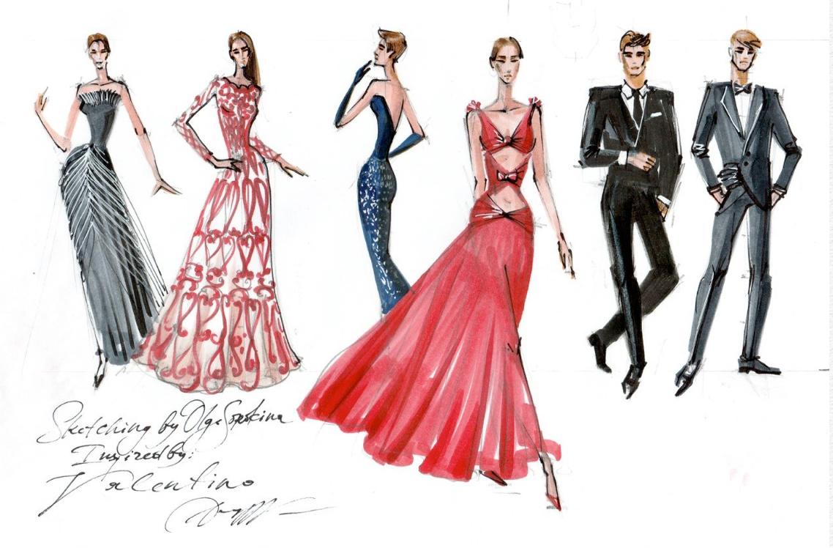

MODULE TITLE: Developing patterns for complex fashion garments

MODULE CODE: IND FAD4 M06 0322

NOMINAL DURATION: 120 Hours

Table of Contents
Level IV 0
Based on March 2022, Curriculum Version 1 0
MODULE TITLE: Developing patterns for complex fashion garments 0
MODULE CODE: IND FAD4 M06 0322 0
NOMINAL DURATION: 120 Hours 0
Unit 1. Preparing Pattern Workstation. 8
1.1. Applying OHS practices. 8
1.1.1. Introduction 8
1.1.2. What is Occupational Health and Safety (OHS)? 9
1.1.3. The Value of Occupational Health and Safety (OHS) 10
1.2.1 List of Pattern Making Tools and Their Uses 10
Self-check 1 14
Unit 2 Analyzing garment range 16
2.1 Analyzing and confirming garment range. 16
2.1.1. Introduction: 16
2.1.2. Garment Analysis Method Followed in Apparel Industry: 16
2.2. Interpreting and classifying design sketches or drawings 18
2.2.1. Introduction 18
2.2.2. TYPES OF SKETCHING 19
2.2.3. Sketching Exercises to Transform Your Drawing 23
2.3. Establishing intended purpose of design. 24
2.4. Obtaining profile of target market 26
2.4.1. What Is A Target Market Profile? 26
2.4.2. How to Find Your Target Market Customer Profile 26
2.4.3. Why you need a target market profile? 27
2.4.4. How to use your target market profile? 28
2.5. Evaluating and recording designs in relation to specification. 28
2.5.1. Introduction 29
2.5.2. Technical Specification in Fashion Design Process 29
2.5.3. Anatomy of Garment Specifications 30
Self-check 2 31
Unit 3.Analyzing fabrics for garment range 32
3.1. Fabric characteristics and performance, trims and finishing are considered in relation to the design. 33
3.1.1 Fabric characteristics 33
3.1.2. FACTORS THAT INFLUENCE FABRIC BEHAVIOUR 35
3.2. Considering trims and finishing relation to the design. 36
3.2.1. Introduction 36
3.2.2. Garment trims 36
3.2.3. Accessories 37
3.3. Budget constraints for fashion garment range 37
3.3.1. What is a budget constraint? 37
3.3.2. How do budget constraints work? 38
Self-check 3 41
Unit 4. Selecting and assessing block portfolio 41
4.1. Check blocks for accuracy and appropriateness. 42
4.1. 1.Introduction block pattern 42
4.1. 2. Planning pattern production for the design from the selected block. 43
4.2. Determining appropriate block portfolio. 45
4.3. Checking blocks for accuracy and appropriateness. 46
Self-check 5 47
Unit 5. Creating pattern 48
5.1. Calculating ease for wear-ability. 49
5. 1.1.Introduction 49
5.1.2. Calculating ease for wear-ability. 49
5.2. Performing Advanced dart manipulation 56
5.2.1. Introduction of Dart manipulation 56
5.2.2. Types of Dart Manipulation 56
5.4. Producing pattern using advanced pattern-making manipulations. 58
5.4.1. Pivoting 58
5.4.2. Square blocking 63
5.4.3. Contouring 74
5.4.4. Add fullness 96
5.5. Documenting used methods and formulas. 102
5.6. Checking Pattern pieces for accuracy 102
5.7. Completing pattern pieces labeling and markings. 103
Self-check 5 104
Operation sheet 1 105
Lap test 1 107
Operation sheet 2 107
4. Press the seams flat, toward the colored fabric. 109
Lap test 2 109
LABORATORY WORK: Materials Required: 110
Unit 6. Preparing sample pattern 110
6.1. Constructing toile or prototype. 111
6.1.1. WHAT IS A TOILE? 111
6.1.2. WHY SHOULD I TOILE? 112
6.2. Examining and assessing toile in consultation with designer. 119
6.3. Identifying pattern problems or faults. 120
6.4. Altering pattern. 121
6.4.1. Introduction Pattern alteration 121
6.4.2. Principles of Pattern Alteration: 123
6.4.3. Pattern Alterations for Basic Fit Problems: 124
Self-check 6 Part I Matching 126
UNIT 7 Developing Pattern Portfolio 127
7.1. Preparing patterns for product development and sampling. 128
7.1.1. Introduction 128
7.1.2. Garment Sampling: A Complete Guide 129
7.1.3. Types of Samples 130
7.2. Preparing required specification documents. 132
7.3. Storing and filing patterns. 133
Unit 8 .marinating records 134
8.1. Recording and maintaining prepared report. 134
Self chek 7 135

List of figure
Figure 1 Pattern making tools 11
Figure 2 Interior drawing. 20
Figure 3 Fashion sketching 21
Figure 4 Industrial sketching 22
Figure 5 Travel sketching 23
Figure 6 fabric characterstic 33
Figure 7 budget constrait line 40
Figure 8 pattern production process 45
Figure 9.Positive Ease 51
Figure 10. Zero Ease 52
Figure 11 Negative Ease 53
Figure 12. Combinations of negative, zero, and positive ease 54
Figure 13 slash and spread method 57
Figure 14 both dart legs are equal in length 60
Figure 15 Pin the dart to hold it in place 61
Figure 16 Remove the pin and open up the dart 62
Figure 17. Transferring a dart using the pivoting method 62
Figure 18 Two pieces look placed on top of each other 63
Figure 19 Fabric Used In The Simple Square Blocks Quilt 65
Figure 20 Cut Fabrics. 68
Figure 21. Cut the white square 68
Figure 22Sew two random patterned rectangles together 69
Figure 23 sort rectangle colors and sew by chain everything together 69
Figure 24. press the block and trim 70
Figure 25 Assemble the blocks within color distribution 70
Figure 26 sashing strips for the throw-size quilt. 72
Figure 27 Sew a sashing strip in between each row, plus on the top and bottom of the quilt top. 73
Figure 28. Sandwich and quilt the simple square blocks quilt top as desired 73
Figure 29contours making bodies front 75
Figure 30: Cutaway armhole 77
Figure 31: Shoulder line shaping 78
Figure 32: Low neckline 80
Figure 33Empire Line Guides 81
Figure 34The Empire Line return 82
Figure 35 Shoulder line shaping 83
Figure 36: Increase height of waist dart 84
Figure 37: Increase of dart 85
Figure 38Individual Contouring Amounts 86
Figure 39sleeveless bodies front and back 88
Figure 40sleeveless body shoulder line 89
Figure 41. Sleeveless bodies within low neckline 90
Figure 42toile making 92
Figure 43Sleeveless bodies within neck dart 92
Figure 44sleeveless bodies with cutaway armhole line 93
Figure 45strapless 94
Figure 46law neckline design line with gap dart 95
Figure 47neck cape darts moved in to side seam dart 96
Figure 48 Adding fullness Equally 99
Figure 49 Adding Fullness one side 100
Figure 50 adding fullness unequal 102
Figure 51 check the neck line 113
Figure 52 check length 116
Figure 53 focus on design detail 117

Acknowledgment
I wish to extend my thanks and appreciation to many of my staff members, the department head, and our college’s dean for facilitating the development of these teaching, training, and learning materials. (TTLM).

MODULE DESCRIPTION:
Introduction to the Module
MODULE DESCRIPTION: This module covers the skills, attitudes and knowledge to develop patterns for use in the production of complex fashion garments with advanced styling requirements.
This module covers the units
- Prepare pattern workstation
- Analyst garment range
- Analyst fabrics for garment range
- Select and assess block portfolio
- Create pattern
- . Prepare sample pattern
- Develop pattern portfolio
- Maintain records
Learning Objective of the Module
- Prepare pattern workstation
- Analyze garment range
- Analyze fabrics for garment range
- Select and assess block portfolio
- Create pattern
- Prepare sample pattern
- Develop pattern portfolio
- Maintain records
Module Instruction
For effective use this modules trainees are expected to follow the following module instruction:
1. Read the information written in each unit
2. Accomplish the Self-checks at the end of each unit
3. Perform Operation Sheets which were provided at the end of units
4. Do the “LAP test” giver at the end of each unit and
5. Read the identified reference book for Examples and exercise

Unit 1. Preparing Pattern Workstation.
This unit is developed to provide you the necessary information regarding the following content coverage and topics:
- Apply OHS practices.
- Select and preparing pattern-making tools and equipment.
- Collect additional materials.
This unit will also assist you to attain the learning outcomes stated in the cover page. Specifically, upon completion of this learning guide, you will be able to
- Understand OHS practices.
- Use pattern-making tools and equipment.
- Collect additional materials.

1.1. Applying OHS practices.

1.1.1. Introduction
Good workstation design is essential in creating a healthy, comfortable, and task-efficient laboratory. Workstations should follow the workflow and be planned to accommodate equipment, ancillary equipment, tools, and supplies. Consideration must also be given to the number of people who will use the space, their physical characteristics, whether they will sit, stand, or use a combination of positions, and if they need some type of aid to be able to see and reach all of the necessary components. Air quality, temperature, and humidity must be regulated and drafts must be avoided. Lighting must be task appropriate, not necessarily standard overhead lighting, and noise must be minimal.
Ideally, laboratory workstations are versatile, modular, and flexible so that they can be altered to accommodate new tasks, equipment or people. The work surface should be height adjustable, and seating should be individualized and task appropriate. Unfortunately, good workstation design is rare in histology laboratories apply ohs practice

1.1.2. What is Occupational Health and Safety (OHS)?
Occupational Health and Safety (OHS), also known as Occupational Safety and Health (OSH), refers to the generic practice of addressing and reducing potential safety and health risks to employees. This can cover anything from risk assessment, injury prevention, work-life balance, safety protocols, and workplace hazards, to compensation and benefits, and employee management.
When it comes to applying occupational health and safety (OHS) practices in the fashion industry, there are several areas where these practices can be implemented. Some of these areas include:
1. Safe working conditions: Ensuring that the workplace is safe and free from hazards is crucial in the fashion industry. This includes providing adequate lighting, ventilation, and ergonomic workstations to prevent injuries and promote overall well-being.
2. Proper handling and storage of materials: In the fashion industry, there are various materials and chemicals used in the production process. It is important to handle and store these materials safely to prevent accidents or exposure to harmful substances. This can involve proper labeling, storage protocols, and training for employees on handling hazardous materials.
3. Machinery and equipment safety: Fashion production often involves the use of machinery and equipment such as sewing machines, cutting tables, and steamers. Regular maintenance, inspection, and training on the safe operation of these machines are essential to prevent accidents and injuries.
4. Personal protective equipment (PPE): Depending on the tasks performed in the fashion industry, employees may need to wear PPE such as gloves, safety glasses, or protective clothing. Providing and enforcing the use of appropriate PPE can help minimize the risk of injuries or exposure to harmful substances.
5. Training and education: Proper training and education on OHS practices should be provided to all employees in the fashion industry. This can include training on safe work practices, emergency procedures, and awareness of potential hazards specific to the industry.
By implementing these OHS practices, fashion industry employers can create a safe and healthy work environment for their employees, reducing the risk of accidents, injuries, and long-term health issues.

1.1.3. The Value of Occupational Health and Safety (OHS)
Occupational safety is an important part of any business, as staff safety should always be prioritized before anything else. It’s the responsibility of employers to ensure that their staff are well-taken care of and are surrounded by as few risks as possible, so having guidelines in place for OHS can help them greatly.
A guide on OHS and having OHS standards in place will not only ensure a safe workplace and safe and healthy employees, but they could also lead to improvements in business as well. Studies in Europe show that workplace hazards and injuries not only have a physical cost on employees, but they have additional costs to companies as well . Employees getting sick and injured are costly to deal with for both the employees and their leaders, so preventing and mitigating them early on will save them both a lot of time and money. Good workplace conditions are also linked to more employee productivity, as employees are more likely to be motivated when they know they are cared for and are in a safe environment where they can work their best.
How seat Workstation set up according to OHS practices and specifications for work.
• Pattern-making tools and equipment are selected and prepared.
• Any additional materials and equipment required to perform task are collected.
• Patternmaking tools, equipment and supplies are laid out.

Selecting and preparing pattern-making tools and equipment.

1.2.1 List of Pattern Making Tools and Their Uses
Pattern Making Tools:
To work efficiently, the pattern maker must have the proper pattern making tools and supplies. For making better communication with the workroom and to minimize errors due to misunderstanding, the pattern maker should know and understand some terminology related to pattern-making tools.
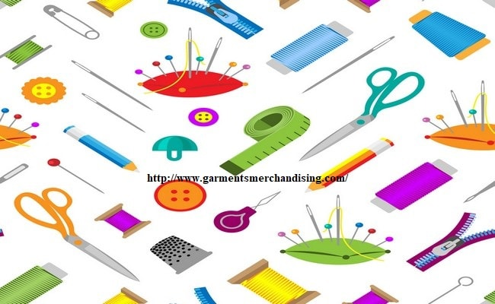
Figure 1 Pattern making tools
List of Pattern Making Tools and Their Function:
There are various pattern making tools which are vastly used in the apparel industry have pointed out in the below with their function:
All the above pattern making tools have explained the below with their function:
1. Straight pins:
The dressmaker used it for draping and fitting.
2. Straight pin holder:
Pincushion or magnetic holder which is used for wrist and table.
3. Scissors:
There are different types of scissors such as paper scissors, fabric scissors, etc.
4. Pencils and pens:
Mechanical pencil and sharpener which is used for pattern work.
Red and blue colored pencils are used to identify pattern changes. Black, green, red and blue felt tip pens for pattern information.
5. Rulers:
Tailors square (24 × 14) inch metal ruler with two arms forming a 90® angle that measures, rules and squares simultaneously.
Also used to a triangle with the measurements to straight lines.
6. Curve rules:
A French curve is one of the several curves used for shaping the armhole and neckline.
7. Hanger hooks or ringers:
It is used to hold the patterns together for hanging on rods.
8. Pushpins:
Pushpins are used for pattern manipulation. It also prevents pattern slippage when cutting several plies of paper together.
9. Magic mend scotch tape:
It is used to mend pattern work.
10. Black twill tape:
Black twill tape is used for the placement of style lines on garments.
11. Notcher:
It is used to indicate seam allowance, centerline, and also to identify the front and back of patterns.
12. Tracing wheels:
It is used to transfer pattern shapes into the paper.
13. Awl:
It is used to indicate the ending of darts, pocket, trim, and buttonhole placements.
14. Metal weight:
Metal weight is used to hold the patterns in place for tracing and marking.
15. Measuring tape:
It is used to measure the size of the pattern.
16. Tailor’s chalk.
Tailor’s chalk is used for making adjusted seams and style lines.
Pattern making
Collecting additional materials.
Pattern: A Pattern is a model or the replica of the object to be cast.Except for the various allowances a pattern exactly resembles the casting to be made. Patterns may be in two or three pieces, where as casting are in a single piece.
A pattern is required even if one object has to be cast.
The quality of casting and the final product will be effected to a great extent by the planning of pattern. A Pattern prepares a would cavity for the purpose of making a casting. A Pattern may contain projections known as core prints if the casting requires a core and need to be made hollow. Risers, runners and gates may form a part of the pattern. Patterns properly made and having finished and smooth surfaces reduce casting defects. Properly constructed patterns minimize overall cost of the casting. Functions of Patterns:
Selection of Pattern Materials: The following factors assist in selecting proper pattern material: ¬No. of castings to be produced. ¬Metal to be cast. ¬Dimensional accuracy & surface finish. ¬Shape, complexity and size of casting. ¬Casting design parameters. ¬Type of molding materials. ¬The chance of repeat orders. ¬Nature of molding process. ¬Position of core print.
Materials for making patterns: 1. Wood 2. Metal 3. Plastic 4. Plaster 5. Wax.
Wood Patterns: These are used where the no. of castings to be produced is small and pattern size is large. Advantages: ⎫Inexpensive ⎫Easily available in large quantities ⎫Easy to fabricate ⎫Light in weight ⎫They can be repaired easily ⎫Easy to obtain good surface finish
Limitations: Susceptible to shrinkage and swelling Possess poor wear resistance Abraded easily by sand action Absorb moisture, consequently get wrapped Cannot withstand rough handling Life is very short Commonly used woods for making patterns: a. Teak b. Pine c. Mahogany d. Deodar etc..
Are employed where large no. of castings have to be produced from same patterns. Advantages: ⎫ Do not absorb moisture ⎫ More stronger ⎫ Possess much longer life ⎫ Do not wrap, retain their shape ⎫ Greater resistance to abrasion ⎫ Accurate and smooth surface finish ⎫ Good machinability
Limitations: Expensive Require a lot of machining for accuracy Not easily repaired Ferrous patterns get rusted Heavy weight , thus difficult to handle Commonly used metals for making patterns: i. Cast iron ii. Aluminium and its alloys iii. Steel iv. White metal v. Brass etc..
Durable ⎫ Provides a smooth surface ⎫ Moisture resistant ⎫ Does not involve any appreciable change in size or shape ⎫ Light weight ⎫ Good strength ⎫ Wear and corrosion resistance ⎫ Easy to make ⎫ Abrasion resistance ⎫ Good resistance to chemical attack Limitations: Plastic patterns are Fragile These are may not work well when subject to conditions of severe shock as in machine molding (jolting).
It can be easily worked by using wood working tools. ⎫ Intricate shapes can be cast without any difficulty. ⎫ It has high compressive strength. ¬ Plaster may be made out of Plaster of paris or Gypsum cement. ¬ Plastermixtureis pouredintoa mouldmadeby a sweeppatternor a woodenmasterpattern,in ordertoobtaina Plasterpattern.
Provide very good surface finish. ⎫ Impart high accuracy to castings. ⎫ After being molded, the wax pattern is not taken out of the mould like other patterns; ⎫ rather the mould is inverted and heated; the molten wax comes out and/or is evaporated. ⎫ Thus there is no chance of the mould cavity getting damaged while removing the pattern. ¬ Wax patterns find applications in Investment casting process.

Self-check 1
Part I matching
A |  | B
1 | Black twill tape: | A | used for pattern manipulation
2 | Magic mend scotch tape: | B | used to hold the patterns together for hanging on rods
3 | Pushpins: | C | used to mend pattern work
4 | Hanger hooks or ringers: | D | used for shaping the armhole and neckline.
5 | Curve rules | E | used for the placement of style lines on garments.

Part II Multiple choices
1. Factors of patterns making
A. The shape and size of casting
B. No. of castings required
C. Method of molding employed
D. Anticipated difficulty of molding operation
E. all
2. Which is false Workstation set up according to OHS practices
- Pattern-making tools and equipment are selected and prepared.
- Any additional materials and equipment required to perform task are collected.
- Patternmaking tools, equipment and supplies are not laid out.
Part III short answer
1. What is Value of Occupational Health and Safety

Unit 2 Analyzing garment range
This unit is developed to provide you the necessary information regarding the following content coverage and topics
- Analyzing and confirming garment range.
- Interpreting and classifying design sketches or drawings.
- Establishing intended purpose of design.
- Obtaining profile of target market.
- Evaluating and recording designs in relation to specification.
This unit will also assist you to attain the learning outcomes stated in the cover page. Specifically, upon completion of this learning guide, you will be able to
- Understand garment range.
- Interpret and classify design sketches or drawings.
- Describe purpose of design.
- Identify profile of target market.
- Evaluate and record designs in relation to specification

2.1 Analyzing and confirming garment range.

2.1.1. Introduction:
A garment merchandiser faces too much pressure before confirmation of a garment export order. During this time he has to analysis different matters related with the garments costing. This topic has shown a garment analysis method which are strongly followed in ready-made garment industry.

2.1.2. Garment Analysis Method Followed in Apparel Industry:
There are various key points of garment analysis especially in the apparel business. Those points have mentioned in the below:
1. Measurement chart,
2. Size ratio,
3. Color,
4. Quality of garments,
5. List of trimmings and accessories required,
6. Fabric consumption per dozen,
7. Cost of garments per dozen,
8. Determination of production time and delivery date.
All the above key points have explained in the following:
1. Measurement chart:
It is the first step of garment analysis for the apparel export order. Here, garment buyer passes the measurement chart to the apparel merchandiser. By following this measurement chart, manufacturers have to make the garments.
2. Size ratio:
Size ratio is another important point of garment analysis in garments export business. Size ratio consists of XS, S, M, L, XL, and XXL etc. It is normally confirmed by the buyers. It can be S: M: L:: 1:2:1. It’s just an example.
3. Color:
Color of garment is confirmed by the buyers. After receiving the color code or pantone number, garment merchandiser has to do lab dip for the definite color and approve from the buyer. It’s too much needy for the colored garments. It should be done by maintaining various precautions.
4. Quality of garments:
In this modern garment export business, quality plays an important role. Buyers are invested a lot of dollar to sustain their brand’s quality. As a result, garment merchandiser should confirm about different types of key matters which directly affected on garments quality such as measurement tolerance, fabric strength, seam strength, fabric defects, garment defects etc. Quality has too much impact on garment analysis.
5. List of trimmings and accessories required:
Before garments order confirmation, apparel merchandiser should have excellent idea about the trimmings and accessories required for manufacturing the garments. Otherwise order profit will be decreased. it is one of the important point of garment analysis.
6. Fabric consumption per dozen:
Garments profit totally depends on fabric consumption. As a result it is too much important for a garment merchandiser to calculate accurate fabric consumption for the garments by following measurement chart. Normally it’s calculated in dozen.
7. Cost of garments per dozen:
After calculating fabric consumption, garments costing should be done by the apparel merchandiser. Cost of garments includes fabric cost, trimmings and accessories cost, washing cost, printing cost, dyeing cost, embroidery cost and others. It is also very important point of garment analysis. 8. Determination of production time and delivery date:
It is the last key point of garment analysis for a garment export order. Garment merchandiser should confirm the production time and delivery date for the order by discussing with the garments production personnel.

Bottom of Form
2.2. Interpreting and classifying design sketches or drawings.

2.2.1. Introduction
Sketch is typically use quick marks and simple lines to capture only the essential elements of the subject matter. A sketch will usually lack many of the details that a finished drawing would have.
The fundamental elements will get worked out in a sketch, such as the composition, proportion, scale, and the balance between values. If an artist works these out in their draft sketch, they can avoid mistakes in their finished drawing, painting, or other artwork.
A drawing is a fully conceptualized and completed artwork. Finished drawings include more detail and techniques such as watching, shading, or even color.
A successful sketch must master all the elements or basics of three-dimensional artwork, such as line, proportion, scale, balance, positive and negative space, etc.
An artist must master these complex essential elements before moving on to detailed drawings or paintings. For this reason, sketching is often one of the first things art students learn as an artistic fundamental.
Basically, it is about making a quick drawing, a study, which helps you to represent a design idea. And it has a plethora of applications:
Travel sketching (or sometimes city or urban sketching): expressive, energetic, and usually speedy drawings of architectural details, city views, restaurants, etc.
It can be made both in the open air (“pleinair” in French) and working from your memory – recollections of your trip when you are back at home, or using photos and creating compositions out of them. It includes “cafe sketching” as well.
Fashion sketching: people, fashion-looks, and accessories. It is used mainly for illustrations or magazines, e.g., for brand promotion. It helps designers during the first stages of the creation of their collections and helps to introduce changes.
Industrial Design sketching: probably the most known and popular branch of sketching. Obviously, it was created by industrial designers; a good example is car sketching. In this case, all sketches are made with great speed and confidence.
Sketching is a fantastic skill that lets you transfer your design idea onto paper in the most fun, fast and effective way. In other words, sketching is a unique instrument for visualizing your concepts. Nowadays, it is associated mostly with such media as specialized professional markers, for example, Copic, Stylefile, Chartpak, Promarkers, ZIG, etc. Sketching “palette” is vast and versatile: you can start from scratch by using a pencil, charcoal, or black liner and end up by using different types of colouring techniques, for instance, water colour, coloured ink and pastel or watercolour pencils. It is possible to mix various media, for example, markers + pastel or watercolour + coloured pencils.

2.2.2. TYPES OF SKETCHING
There are different types of sketching, and here I would like to talk about each one in a little bit more depths. Let’s take a quick look at the main features of the most popular of them by splitting them into key concepts and keywords.
1. Interior sketching
For this kind of sketching, it is highly important to understand the laws of perspective and train your eye to judge scale and proportion. It is always good to be able to execute your drawings within different time frames because sometimes you will need to draw your idea quickly in front of your customer. As an interior designer, you should have an eye for beauty, a feeling for harmonious colours, and a perfect palette. And, as in other types of sketching, you should be able to render a variety of materials such as fabric, wood, stone, and glass.

Figure 2 Interior drawing.
2. Fashion sketching
For this type of sketching, it is crucial to have a good understanding of human proportions (face and body). You should know how to stylize figures in your drawings. More often than not, body proportions are elongated in fashion sketching. For example, the total height of the human body in fashion sketching is 10, 11, or even 12 times the height of a human head as opposed to real-life proportions of only 7.5 to 8 heights of a human head. The most important aspect of fashion sketching is to be able to capture a design idea in the best possible\light. Hence a facial-portrayal of a human figure is usually not significant. In this case, it is critical to be able to deliver the idea of the designed collection to the best advantage. In fashion sketching, it is essential to bring the clothing design into focus, and a life-like portrayal of the figure is usually unimportant. You will also need to know how to convey through hand-render the look and feel of such materials and textures as skin, hair, different types of fabric, metal, etc
.
Figure 3 Fashion sketching

3. Industrial sketching
You will need the ability to draw objects in 3D, clearly showing their structural design and volume. To be able to render a professionally looking arrangement of component part on a piece of paper, you will need a firm grasp of the principles of composition. You will also need to perfect your technique and speed in order to develop an assured line and confident hand. The most common materials that need rendering in industrial sketching are metal, plastic, and glass.

.
Figure 4 Industrial sketching
4. Travel sketching
In this type of sketching, the most crucial skill is to manage to convey the feel, the ambience of a place, to capture the flitting moment and, at the same time, to deliver the correct scale and proportions of the object. More often than not, you will also need to be able to perform at high speed, as you will be sketching while travelling, while on the road, when you do not have several hours at your disposal the way it would have been the case with "plein air" sketching. In this type of sketching, it is important to grasp the intrinsic traits of the place you are observing and afterwards graphically stylize it in your drawing.
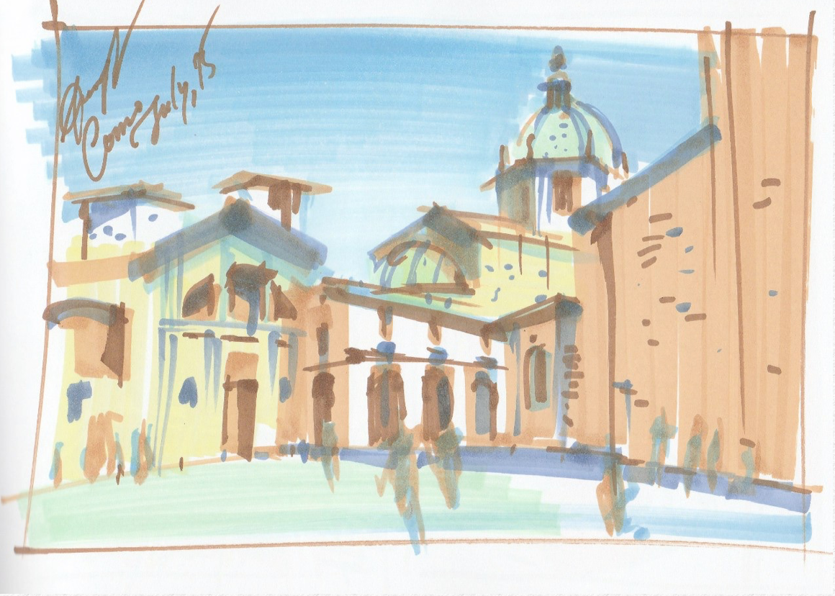
Figure 5 Travel sketching

2.2.3. Sketching Exercises to Transform Your Drawing
It’s no secret that if you want to improve your art, you’ve gotta practice. But that doesn’t have to mean repeating the same thing over and over again. In fact, the more you mix it up, the more you’ll grow — we promise!
Drawing Exercises
These six exercises are hand-picked to stretch your skills and open up some new artistic doors. Let’s go!
1. Begin With Breakfast
Start a sketching practice is by drawing what’s in front of you every morning … your breakfast! Start honing your observational skills while practicing value and perspective — you’ll continue to build on these techniques in every drawing you do.
2. Sketch an Urban Scene
Creating quick, loose vignettes is a great practice for learning how to capture the world in pen and ink. It all starts with “reading” the scene around you to select and frame the most interesting angle on your surroundings.
3. Practice Your Hatching
Cross-hatching is a technique you’ll turn to again and again in your pen and ink drawing. Get the method down by sketching everyday objects in your home.
4. A New Perspective on Plants
How much detail and nuance lies in a simple leaf? Learn how a pro scientific illustrator approaches botanical drawing, then apply those techniques to your own work. You’ll never look at a garden the same way again!
5. Your Neighborhood, in Miniature
Try recreating your fave neighborhood building in a thumbnail sketch! It’s a great way to practice framing and blocking in basic shapes. And if you’re loving what you see, use that foundation to create a fully realized drawing!
6. Put People in Motion\
Capturing a subject on the go is a whole different type of challenge — but a few clever tricks go a long way in improving your sketches. This tutorial breaks it all down into surprisingly simple lines and shape

2.3. Establishing intended purpose of design.
Good design isn’t just about visual appeal. A truly effective design not only captures our attention, but also has purpose and meaning. Purpose-driven design achieves the optimal balance between function and aesthetics. It not only looks good, but delivers the intended message effectively and clearly.
Let’s get started …
So, how does one design with a purpose? Well, to start off with, it’s not a rushed affair. It means taking the time to evaluate the story that must be told about a business, what it represents, the brand message, the clients the business has at present, and those it would like to attract.
Only once these factors have been determined, will a designer be able to make decisions relating to colors, fonts and general look and feel. “Before I start a design, I thoroughly research the industry in which the client operates, their target market and the general culture of the company – is it an elite, sophisticated business or a more relaxed, fun type of company? This informs my decisions on what colours and fonts to use and also the general structure of the designs,” says ICSC designer Cara Mego.
Colors are key
“Colors are very important in design as they create a lasting first impression. People respond to colors subconsciously and they can spark immediate emotions. So, when choosing a color, it needs to be visually appealing, relate well to the type of company, and portray the underlying feeling you want a business or product to evoke in the client or consumer,” she adds.
The feeling that a design evokes in potential clients is far more important than we may realize. As author Simon Sinek says, “People don’t buy what you do, they buy why you do it.” A design which creates a feeling of purpose and meaning in its target audience will linger in their minds long after they have seen it.
Find the right font
Fonts are another often-overlooked element of design. Popular or decorative fonts may not always be the best match for your designs. “Fonts must be legible – this is crucial. Also, the wrong choice of font can throw off the balance of a design very easily. It has to relate to the style of the company. With a sophisticated company, an elegant and simple f-ont is the best choice, whereas a trendy company can get away with a more abstract, styled font, which should still always be legible,” says Cara.
Logos should last
Another crucial element of design is your logo. A logo should never just fill a vacant space in your letterhead or a prominent corner of your website. Your logo must speak to the values, ideals and vision of your organization. Once these have been identified, it makes it so much easier for a designer to create a logo design that will encapsulate your company.
Three steps to design success
As a rule of thumb, purpose-driven design generally comprises at least three steps:
• Research and analysis – what are your vision, goals and values? What sets you apart from your competitors?
• Create a design strategy – in this step all leanings and insights are combined to create a design brief and strategy.
• Design with purpose – this entails creating designs based on the creative brief, while remaining true to the essence of the company concerned.
When these steps are followed, the end result inevitably stands out from the rest. “In a good design, all elements come together in a balanced, attractive manner to portray the product or company. Good design flows well on different mediums; it has a uniform appearance and is never disjointed,” adds Cara.
It’s evident that purposeful design allows organizations to tell a powerful story about their businesses. Contact ICSC today to find out more about our design offering and how we can create memorable visual messages for you
2.4. Obtaining profile of target market.

2.4.1. What Is A Target Market Profile?
A target market profile is basically a detailed description of your ideal customer. It includes information like:
Demographics: age, gender, location, income, education, etc.
Psychographics: lifestyle, personality, interests, values, etc.
Buying habits: how often they purchase, what they purchase, where they purchase, etc

2.4.2. How to Find Your Target Market Customer Profile
A target market customer profile identifies the customer most likely to buy your product or service. While some companies create products around a customer profile, others identify the customer profile once marketing strategies are developed. The target customer profile identifies shared characteristics, behaviors and attitudes the target customers have, and this knowledge is used when creating captivating marketing materials and promotions. Having a solid and suitable target customer profile may increase your company’s profits because people in need are buying the products or services.
Define who your target customer is based on who would purchase the company’s products or services. Identify the common age group, gender and occupation to get a generic persona. Narrow the generic persona by adding a general location, marital status, income level, common education level and nationality.
Identify why these target customers act as they do based on the persona profile created in the previous step. For example, identify why this target customer always buys the cheapest product or why he invests in the newest products on the market. This step allows you to identify customer buying habits.
Analyze how often the target customer uses social media to find products and communicate with people, such as Facebook, Twitter, StumbleUpon and MySpace. People often use social media to find new products and articles, so you can learn about their browsing habits and online behavior. This is useful, as marketing and advertising often happens on social media sites.
Create your marketing campaigns based on your target persona. For example, a high-priced and modern business suitcase designed for lawyers, business owners and executives requires a specific target buyer. In this case, your target customer profile may be single or married, live in a downtown area, be between 25 and 40 years of age, be well-educated and have a high-paying job. The product may appeal to any nationality, despite being created with a western persona in mind. This customer may be willing to pay the higher price for a high-quality product and is willing to invest in modern and trending suitcases.

2.4.3. Why you need a target market profile?
There are several reasons why it's important to have a target market profile.
1. It Helps You Focus Your Marketing Efforts.
When you know who your target market is, you can focus your marketing efforts on reaching them. You can create targeted campaigns and messages that speak directly to their needs and wants.
2. It Saves You Time And Money.
Marketing to everyone is a waste of time and money. By targeting your marketing to a specific group of people, you'll be more efficient and effective with your resources.
3. It Makes Your Marketing More Effective.
When your marketing is targeted to a specific group of people, it will be more effective. Your message will be more relevant and your offer will be more appealing. As a result, you'll see better results from your marketing efforts.
4. It Helps You Create Better Products And Services.
When you know who your target market is, you can design products and services that meet their specific needs and wants. This can help you create a loyal customer base and boost your sales.
5. It Allows You To Build Better Relationships With Your Customers.
When you know who your target market is, you can build better relationships with them. You can connect with them on a deeper level and create loyalty and goodwill.

2.4.4. How to use your target market profile?
Your target market profile is the key to understanding who your target market is, what they want, and how to reach them. It's essential to your business success.
Creating a target market profile can be done in several ways. The most common way is to use market research. This can be primary research, which is research you conduct yourself, or secondary research, which is research that's already been conducted by someone else.
Once you have your market research, you can start to create your target market profile. Begin by segmenting your market into different groups. For example, you might segment by age, gender, income, location, or interests.
Then, choose one or two segments that you want to focus on. These are your target markets.
Finally, start to create profiles for each of your target markets. Include information like demographics, psychographics, and behaviors.
Once you have your target market profile, you can start to create marketing campaigns that are tailored to them. This will help you reach your target market more effectively and achieve better results.

2.5. Evaluating and recording designs in relation to specification.

2.5.1. Introduction
A design specification is a detailed document that sets out exactly what a product or a process should present.[1] For example, the design specification could include required dimensions, environmental factors, ergonomic factors, aesthetic factors, maintenance that will be needed, etc. It may also give specific examples of how the design should be executed, helping others work properly (a guideline for what the person should do)
Technical specifications of the fashion designs should be made into written form to produce a clothing collection. Thus, the designer visualizes his/her idea using technical drawings.
To fully realize his/her idea, it is important that the designer should provide the details regarding the technical specifications correctly. Because while a clothing collection is produced, it goes through many processes by different people. That the designer introduces technical specifications in detail provides accurate production of the collection.

2.5.2. Technical Specification in Fashion Design Process
The designers must consider the elements of good design. The direction of visual interest in a collection of garments created by construction details such as seams, openings, pleats, gathers, tucks, topstitching, and trims (Frings, 2014). Accurate adaptation from specification drawings can be made of the type of design illustrated. Basic seam and pocket positions can be marked, pattern pieces can be traced off and modified (Aldrich, 2004).Couture and top ready-to-wear designers are able to enhance their creativity with expensive fabrications and beautiful workmanship because they are able to sell at higher prices. This freedomenables them to create trends. Mainstream designers must know how to interpret these trends to suit their own customers and select fabrics that fit into their company’s price range. They are responsible for concepts, styling, and color selection. Designer must also supervise patternmaking, fit, andsamplemaking, as well as see their lines through to a successful completion (Frings, 2014). It iseventually very important that the designers are able to manage this whole process.It is necessary to give information about teaching the technical specifications for managing designprocess. The content of the technical document to be prepared by the designers in the fashion designprocess is given below.
The evaluation of designs in relation to fit model, body movement, and comfort is a crucial aspect of the fashion industry. The fit model is a person whose body measurements are used as a reference for the creation of clothing patterns. The fit model’s body measurements are used to create a sample garment that is then evaluated for fit, comfort, and movement. The evaluation process involves recording the measurements of the sample garment and comparing them to the fit model’s measurements. If the sample garment does not meet the required specifications, adjustments are made to the pattern until the desired fit is achieved1.
Body movement is another important factor that is considered during the evaluation process. The garment must be designed to allow for ease of movement and flexibility. This is especially important for sportswear and active wear, where freedom of movement is essential.
Comfort is also an essential aspect of garment design. The garment must be comfortable to wear and not cause any discomfort or irritation to the wearer. Comfort can be achieved through the use of appropriate fabrics, construction techniques, and design features.
Overall, the evaluation of designs in relation to fit model, body movement, and comfort is a complex process that requires careful consideration of various factors. By ensuring that these factors are taken into account during the design process, designers can create garments that are both functional and aesthetically pleasing.
Every garment tells a unique story. From the choice of fabric to the placement of a button, every detail contributes to the narrative that a designer weaves. The invisible choreographer orchestrating this symphony of style is none other than garment specifications. These intricate details outline the blueprint of a design, ensuring that every stitch, seam, and element aligns harmoniously to bring a vision to life.

2.5.3. Anatomy of Garment Specifications
The beauty of garment specifications lies in their comprehensive nature. These intricate documents encapsulate a multitude of design elements that together form the DNA of a garment. Let's dive into the key components that make up this intricate anatomy:
1. Measurements: Every garment is designed to flatter the body it adorns. Measurements play a pivotal role in achieving this goal. From bust and waist to hips and inseam, these numeric values ensure that the garment hugs the body in all the right places. Garment specifications meticulously outline these measurements, ensuring that the final creation is tailor-made for its wearer.
2. Stitching Details: The artistry of stitching goes beyond mere functionality; it defines the garment's structure and aesthetics. Garment specifications provide a roadmap for stitching details, from the type of stitch to the thread color. These details shape the way the fabric drapes, the seams align, and the overall visual appeal of the garment.
3. Fabric and Material: The choice of fabric is the canvas upon which a design comes to life. Garment specifications delve into fabric types, textures, and weights, ensuring that the chosen material complements the design's vision. Whether it's silk for a luxurious evening gown or denim for a rugged pair of jeans, the fabric is an integral part of the story.
4. Trims and Embellishments: From delicate lace to bold sequins, trims and embellishments add character and charm to a design. Garment specifications provide explicit details about the placement, type, and quantity of trims used. This ensures that every embellishment contributes to the overall aesthetic without overwhelming the design.
5. Closures and Fastenings: Buttons, zippers, hooks, and snaps – closures play a functional role while also serving as design accents. Garment specifications guide the placement and type of closures, ensuring that they align with the garment's design and purpose. Whether it's a hidden zipper on a sleek dress or ornate buttons on a jacket, closures are seamlessly integrated into the design narrative.

Self-check 2
Part I matching
A |  | B
1 | crucial to have a good understanding of human proportions (face and body |  | Travel sketching
2 | highly important to understand the laws of perspective and train your eye to judge scale and proportion |  | Industrial sketching
3 | draw objects in 3D, clearly showing their structural design and volume |  | Fashion sketching
4 | capture the flitting moment and, at the same time, to deliver the correct scale and proportions of the object |  | Interior sketching

Part II multiple choice
- A target market profile include
- age, gender, location, income, education,
- lifestyle, personality, interests, values,
- how often they purchase, what they purchase, where they purchase,
- all
- Which is false the purpose of target market profile?
- It Helps You Focus Your Marketing Efforts.
- It Saves You Time And Money..
- It Makes Your Marketing less Effective..
- It Helps You Create Better Products And Services.
- It Allows You To Build Better Relationships With Your Customers.
- Design specification include required dimensions,
- Environmental factors,
- Ergonomic factors,
- Aesthetic factors,
- All answer
Part III Long answer
- Discus key points of garment analysis especially in the apparel business

Unit 3.Analyzing fabrics for garment range
This unit is developed to provide you the necessary information regarding the following content coverage and topics:
- Fabric characteristics and performance in relation to the design.
- Trims and finishing relation to the design.
- Budget constraints for fashion garment range.
This unit will also assist you to attain the learning outcomes stated in the cover page. Specifically, upon completion of this learning guide, you will be able to
- Understand Fabric characteristics and performance in relation to the design.
- Identify Trims and finishing relation to the design.
Determine Budget constraints for fashion garment range

3.1. Fabric characteristics and performance, trims and finishing are considered in relation to the design.

3.1.1 Fabric characteristics
The type of fabrics used for fashion apparel which include woven, knitted fabrics, braids, interlining, bonded fabrics and felt. It should be noted that fabrics – woven and knitted will perform differently due to their structural variation which is summarized in Functional
Apparel has a combination of fabrics made of woven and knitted to suit various Applications.
A confident understanding of fabric behavior and characteristics are vital in the design and development of a functional garment.
Garments intended for fashion apparel will have to fulfill the following characteristics: durability, strength, colorfastness, aesthetics and so forth. These properties are mandatory for everyday use and maintenance for fashion apparel. However, in the case of performance apparel the requirements are functional and application-specific properties, such as moisture transmission, thermal resistance, wicking, water proof, and flame resistant. The reason for requirements of such properties is because functional apparel are subjected to a wide range of end uses such that a garment will be affected by internal (fibres, yarn fineness, warp/weft movement, fabric density, thickness, fabric count) and external factors (external environment – exposure to sunlight, wind, rain, cold weather conditions and during use) 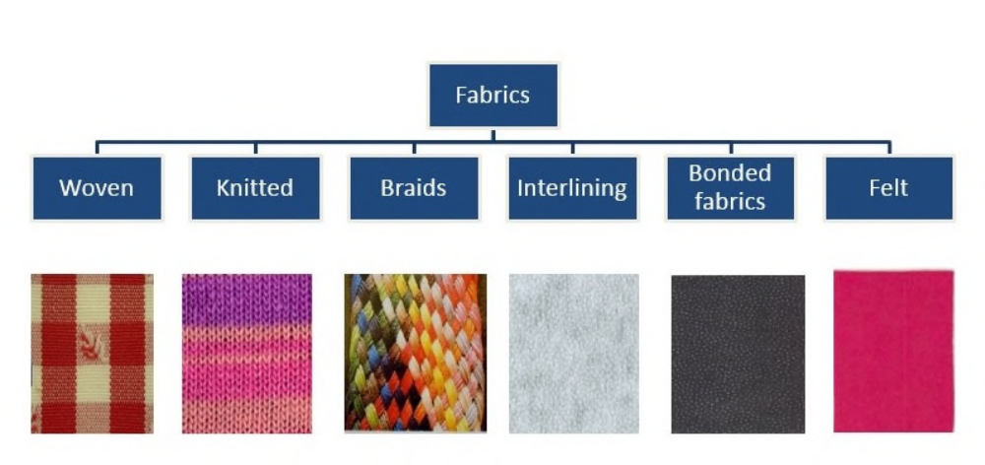
Figure 6 fabric characterstic
A number of fabrics are used in performance and sportswear apparel include – smart fabrics which has intelligent approach to high body or ambient temperature – the warmer the material gets the faster the moisture management system functions Burlington’s smart fabric temperature management. The technology uses micro-encapsulated phase change materials called Thermocule to absorb and release heat to enhance comfort. Light weight, stretchable and soft waterproof or breathable fabrics; fabrics made of fine micro-fibers with breathability; soft shell or three layer fabrics which are bonded as well as laminated made of tricot warp knits or woven fabric for wind insulation or water proof; knits – with synthetic or natural fiber blends and up to 30% elastin fibers for stretch and recovery, fleece and brushed knit made of synthetic fibres that has a natural feel, stretchy and smooth surface; woven shirts with varying fabric weight (160 to 400 g/m2 ); ecofriendly fabrics include recycled polyester; fancy fabrics with patterns, designs and finishes, laser or etched burnt out, 3D knits, honey comb patterns and work wear and protective wear fabrics include durable rugged finish, cut resistant, flame retardant, resistance to abrasion, reflective facings, etc.
Table Fabric characteristics
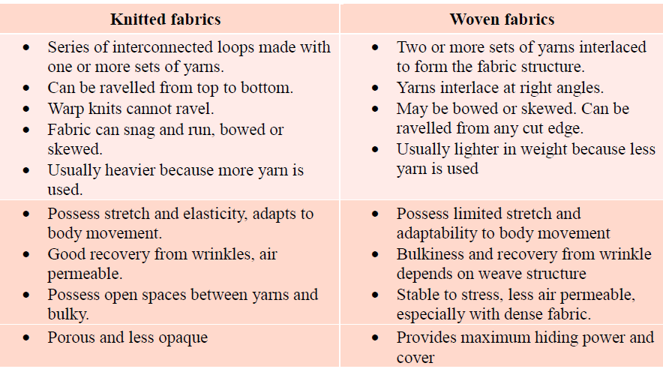
Figure 1: Common fabric types for apparel end use

3.1.2. FACTORS THAT INFLUENCE FABRIC BEHAVIOUR
Functional apparel will be subjected to a wide range of end uses such that a garment will be affected by internal (fibres, yarn fineness, warp/weft or course/;wale movement, fabric density, thickness, fabric count) and external factors (external environment – exposure to sunlight, wind, rain, cold weather conditions, fabric/human body interaction). These factors affect the performance and behaviour of functional apparel which are discussed in the sections with examples.
.1 Internal factors influencing fabric performance
Fabric is either interlaced with one or more set of yarns or interconnected with loop of yarns, which are composed of fibres and filaments, and it is the fundamental element. In performance apparel a wide range of synthetic filaments such as nylon, polyester, elastane, acrylic and so forth are widely used. Fabric behaviour is affected by fibre blends and their fineness (McGregor and Naebe, 2013). Similarly, yarn quality (count) is pivotal in producing a uniform fabric texture. Some of the yarn quality parameters such as yarn twist, number of folds, and yarn count affect fabric characteristics. For instance, a fine quality yarn made of fine denier filament will possess a supple and pliable fabric that has low drape coefficient. On the other hand, a coarse yarn will produce a stiff fabric that has high drape. There is effect of fiber type, yarn quality and fabric attributes on fabric performance. McGregor and Naebe (2013) reported the comfort properties of single jersey knitted fabrics with varying fibre, yarn and fabric attributes. The research studied the comfort properties of wool knitted fabrics with types of fibre blends, types of yarn and different fabrics. Authors reported that tighter fabrics were less comfortable and progressive blending of cashmere with wool progressively increased comfort assessment. The tactile comfort properties were assessed using WCM – wool comfort metre. They further added that fabric thickness, yarn elongation and yarn quality (thick and thin places) affected fabric comfort properties Internal factors affecting fabric performance It should also be noted that finer fibres (linear density) influence the behaviour of fabric and its performance especially in sportswear.
The water vapour and air permeability improved with the increase in the composition of bamboo fibre content. Water vapour permeability determines breathability of the clothing material. It is the transmission of water vapour through fabric from the skin to the outer surface by diffusion and absorption-desorption process (Das et al, 2009). As the yarn linear density increased, thermal conductivity decreased because fibres trapped more air.
The yarn linear density increased, relative water vapour permeability increased particularly for bamboo blended fabrics. Researchers noted that increase in water vapor permeability can be attributed to lower fabric density and thickness. When the yarn count is coarser, the fabric density and thickness increased resulting lower water vapour permeability. Karhan et al. (2006) stated that natural bamboo fibre provided functional properties due to its excellent moisture absorption, quick evaporation and anti-bacterial properties. This shows that a number of internal factors including fibres, yarn and fabric structure affect the fabric characteristics and designers/garment developers should pay particular attention in the Jai Shri Ram 19 selection of appropriate fabric.
2 External factors influencing fabric behavior Performance apparel is exposed to a wide range of external conditions including sunlight, rain, wind, cold/warm weather conditions or during intense physical activity interaction with the human body. Generally, fabrics meet common requirements such as strength and durability; however fabrics with special properties make them to be used in special applications intended for high performance apparel. Typical performance apparel for active wear involves wearing clothing layers and various requirements of fabrics is outlined below (.

3.2. Considering trims and finishing relation to the design.

3.2.1. Introduction
To fulfill the design objectives we need a different kind of materials. Fabrics are the main material, which used for garment manufacturing. We need other materials also, which make the garments aesthetic, functional and commercially required. Usually other than fabrics this material used for making garments are called trims and accessories.

3.2.2. Garment trims
Trims are often applied to garment components prior to assembly to facilitate handling and application. They become more integral part of a garment if applied early in the production process. A wide variety of materials may be used as garment trims, including piece goods, support materials, closures, sewing thread and special purposes fabrications. These materials are applied to garments as Bindings, Edgings, Flat Applications & other Trims. Bindings are primarily functional trims that finish outer edges of garments or garment components by encompassing them. They are used to finish necklines, armholes, hems, front openings etc. Edgings are used to accentuate style lines, outline shapes, or to compartmentalize blocks of Color. They may be applied to edges or included in-seams of garment components. Common types of edgings are Piping, Lace, Ribbon, Fringe, Tapes, and Picot Trim etc.
Flat trims are applied to the surface of garment components to ornament a style. Flat trims include Braids of all types & designs, twill tapes, ribbons, knit tubing, narrow weaves, Embroidery, appliques and screen printed trims. Other trims including nail heads reverts, grommets and buckles are sewn or clinched into garments with special equipment.
Appropriate Trim selections can make an ordinary garment Special. The garments with wrong trims cannot be marketable. High quality trims can make otherwise inexpensive garments look outstanding while cheap buttons or laces can ruin the appeal of well-made garment. Some trims have specific appeal to certain market segments. For an example, Lace trims and ruffles on little girls’ dresses are more important to the gift market and fashion scene.
Example of Trims
Labels Buttons Zippers Padding Interlining Down Elastic Thread Twill Tape Stopper String/Draw Cord Piping Cord Emblem Logo Print Swivel Hook Eyelet/ Grommet Collar Stay Cord Bell Buckle Rivet Weaving Belt Hook and Eye Velcro Tape Seam Sealing tape Shoulder pad Cable (steel ware) Adjuster Recco Elastic Threads Shoulder Tape

3.2.3. Accessories
The materials, which are used to make a garment attractive for sale and packing, other than fabrics and trims, are called Accessories.
Example of accessories
Polybag
Elastic bag
Mini Polybag
Pin Collar Stand…..

3.3. Budget constraints for fashion garment range

3.3.1. What is a budget constraint?
A budget constraint is an economic term referring to the combined amount of items you can afford within the amount of income available to you. For example, if you are a sales professional with a $1,000 budget for promotional items, this sets the upper limit on items you can purchase. The cost of each item and the minimum quantity you need would -determine how many you can buy within your budget.
The same principle of budget constraint can also be applied to time. If you are a manager, your employees only have a certain number of hours in a workday, which means you need to determine how much of their time they should spend on the various things they need to accomplish. The calculation may vary from week to week as your business priorities change and your employees' available time adjusts since some weeks include holidays or employees might take time off.

3.3.2. How do budget constraints work?
When calculating budget constraints, you normally have a number of things under consideration for which you are trying to budget. However, it's easier to understand how budget constraints work if you just consider two sets of items. You could spend your entire budget on item one, or you could spend it all on item two. Alternatively, you could buy a combination of some of item one and some of item two. The proportions of each item you purchase would be constrained by your budget.
If you are managing a department, calculating your budget constraint can help you determine whether the amount budgeted to you is adequate for your needs. Knowing how many things such as salaries, supplies and training materials you can afford within your budget constraint can help you determine if you need to request additional funding from your senior management.
Budget constraint equation
You can use the following equation to help calculate budget constraint:
(P1 x Q1) + (P2 x Q2) = m
In this equation, P1 is the cost of the first item, P2 is the cost of the second item and m is the amount of money available. Q1 and Q2 represent the quantity of each item you are purchasing. You could express this equation verbally by saying that the cost of the total number of X items added to the cost of the total number of Y items must equal the amount of money or income you have available.
If you draw this equation on a graph where the x-axis represents quantities of one item and the y-axis represents quantities of the other, it should plot a straight diagonal line sloping down from the left side to the right side. This line is called the budget line. Any point along the budget line indicates the quantities of each item you could purchase within your budget. If the price of one or both items changes, you would need to adjust this line accordingly. What is opportunity cost?
Opportunity cost is the term economists give to the amount of money you've allocated to one item in preference to other items. For example, if you spend $50 on a gift for a friend, that $50 represents the opportunity cost. In other words, it's the money you didn't spend on eating at an expensive restaurant, concert tickets or for some other purpose.
Difference between Budget Set and Budget Constraint
There is a difference between budget set and budget constraint.
Let's contrast the two terms below so that it becomes clearer! The budget constraint represents all the possible combinations of two or more goods that a consumer can purchase, given current prices and their budget. Note that the budget constraint line will show all the combinations of goods you can buy given that you spend all the budget you allocate for these particular goods.It is easier to think about it in two goods scenario. Imagine you can buy only apples or bananas and have only $2. The price of an apple is 1$, and the cost of a banana is $2. If you only have $2, then all the possible combinations of goods that represent your budget constraint are as follows:
Be A budget constraint line shows all the combinations of goods a consumer can purchase given that they spend all their budget that was allocated for these particular goods.
In theory, all the points along the budget constraint represent the possible combinations of apples and bananas you could buy. One such point - point C, where you buy 1 apple and half a banana to spend your $2 is shown in Figure 1 above. However, this consumption combination is unlikely to be achieved in practice. Cause of the ratio of the two prices and the limited income, you are induced into choosing to trade off 2 apples for 1 banana. This trade-off is constant and results in a linear budget constraint with a constant slope.
• Properties of the budget constraint line:
The slope of the budget line reflects the trade-off between the two goods represented by the ratio of the prices of these two goods.
A budget constraint is linear with a slope equal to the negative ratio of the prices of the two goods. Let’s now look at how a budget set differs from the budget constraint. A budget set is more like a consumption opportunity set that a consumer faces, given their limited budget. Let's clarify by looking at Figure below.
Budget Constraint Line
What is the budget constraint line? The budget constraint line is a graphical representation of the budget constraint. Consumers who choose a consumption bundle that lies on their budget constraints utilize all of their income. Let’s consider a hypothetical scenario in which a consumer must allocate all their income between the necessities of food and clothing. Let's denote the food price as 1 and the quantity chosen as 1. Let the clothing price be 2, and the quantity of clothing be 2. Consumer income is fixed and denoted by What would the budget constraint line formula be? 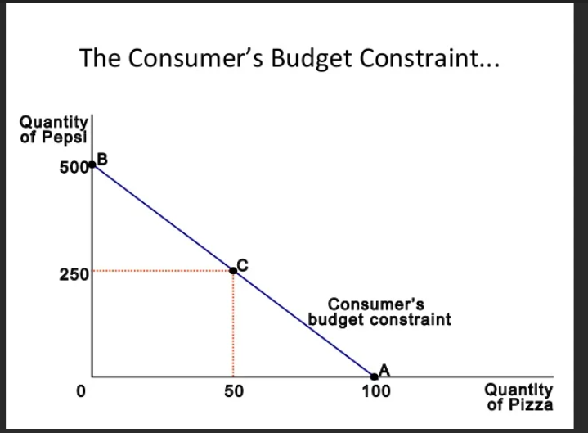
Figure 7 budget constrait line
a general budget constraint line graph that works for any two goods with any prices and any given income. The general slope of the budget constraint is equal to the ratio of the two product prices The budget constraint line intersects the vertical axis at point the horizontal axis intersection point is Think about it: when the budget constraint intersects the vertical axis, you are spending all your income on good 2, and that is exactly the coordinate of that point! Conversely, when the budget constraint intersects the horizontal axis, you are spending all your income on good 1, and so the intersection point in units of that good is your income divided by the price of

Self-check 3
Part I MATCHING
A |  | B
1 | Possess stretch and elasticity adapt body movement | A | yarn twist, number of folds,
2 | Possess limited stretch adaptability body movement | B | woven fabric
3 | yarn quality parameters | C | thermal conductivity decreased
4 | synthetic filaments such as | D | kitted fabric
5 | When yarn linear density increased, | E | nylon, polyester , acrylic

Part 2 short answer
- Discus the effect of trim and accessory in fashion design
- What is Budget Constraint; its formula; properties and effects of budget constraints
- What does the slope of a budget line reflect

Unit 4. Selecting and assessing block portfolio
This unit is developed to provide you the necessary information regarding the following content coverage and topics:
- Planning pattern production for the design from the selected block.
- Determining appropriate block portfolio.
- Checking blocks for accuracy and appropriateness.
This unit will also assist you to attain the learning outcomes stated in the cover page. Specifically, upon completion of this learning guide, you will be able to
- Plan pattern production for the design from the selected block.
- Determine appropriate block portfolio.
- Check blocks for accuracy and appropriateness.

4.1. Check blocks for accuracy and appropriateness.

4.1. 1.Introduction block pattern
. A block or sloper is a master or foundation pattern that is used to make other patterns and other blocks 1 A full set of basic blocks usually consists of: bodice front and back, sleeve, and skirt front and back . Using these blocks while applying the principles of patternmaking allows you to make sewing patterns . From these basic blocks, you can also make derivative blocks, such as sleeveless, torso, extended line dress, and others
1. Patternmakers in the fashion industry use these blocks to make patterns for their clothing line; their particular blocks will be made for their target audience; e.g. if that fashion line makes clothing for curvier figures, their blocks will be different from another fashion house that makes clothing for a less curvy shape. The measurements used to make blocks will therefore vary from fashion line to fashion line, but they get their measurements in some way or other from anthropometric data
When selecting and assessing a block portfolio, consider the following:
1. Variety of silhouettes: Ensure that your block portfolio includes a range of silhouettes that align with your brand's aesthetic. This will allow for versatility in design options.
2. Fit and proportion: Evaluate the fit and proportion of the blocks in your portfolio. Look for blocks that have been tested and adjusted to ensure accurate sizing and proper fit.

3. Adaptability: Consider how easily the blocks can be modified and adapted to create different designs. Look for blocks that have clear lines and simple construction, as they will be easier to work with.
4. Size range: Check if the blocks in your portfolio cover a wide size range. It is important to cater to different body types and ensure inclusivity in your designs.
5. Construction details: Assess the level of construction details included in the blocks. Look for blocks that have basic construction elements such as darts, seams, and closures, as these can be easily customized to create different styles.
6. Cost and availability: Consider the cost and availability of the blocks in your portfolio. Look for options that are affordable and easily accessible, either through patternmaking software or physical templates.
7. Feedback and reviews: Seek feedback from other designers or patternmakers who have used the blocks in your portfolio. Their insights can help you assess the quality and usability of the blocks.
By carefully selecting and assessing your block portfolio, you can ensure that you have a range of options that meet your design requirements while staying within budget constraints.

4.1. 2. Planning pattern production for the design from the selected block.
Once you have selected and assessed your block portfolio, you can start planning the pattern production for your designs. Here are some steps to consider:
1. Identify design requirements: Determine the specific design elements and features you want to incorporate into your patterns. Consider factors such as style lines, seam placements, and design details.
2. Create a production plan: Outline the steps and timeline for pattern production. This includes tasks such as drafting, grading, and creating markers for cutting. Break down the process into manageable stages to ensure efficient production.
3. Draft the patterns: Use the selected blocks as a starting point and modify them according to your design requirements. Make necessary adjustments to achieve the desired fit, style, and proportions.

4. Grade the patterns: Scale the patterns up or down to create different sizes. Ensure that the grading is accurate and maintains the integrity of the design.

5. Create markers: Lay out the pattern pieces on a marker to optimize fabric usage. Consider fabric width, pattern placement, and any directional prints or motifs.

6. Test and adjust: Make a sample garment using the patterns to check for fit and construction issues. Make any necessary adjustments to improve the final product.

7. Finalize patterns: Once the patterns have been tested and adjusted, finalize them by adding seam allowances, notches, and other necessary markings.

8. Document and organize: Keep detailed records of your patterns, including all modifications and adjustments made during the production process. Organize your patterns in a systematic manner for easy reference in future projects.

9. Maintain quality control: Regularly review and update your patterns to ensure they remain accurate and up to date. Consider seeking feedback from wear testers or conducting fit sessions to identify any areas for improvement.

By following these steps, you can effectively plan and execute the pattern production process for your designs, resulting in high-quality garments that meet your design vision and customer needs.

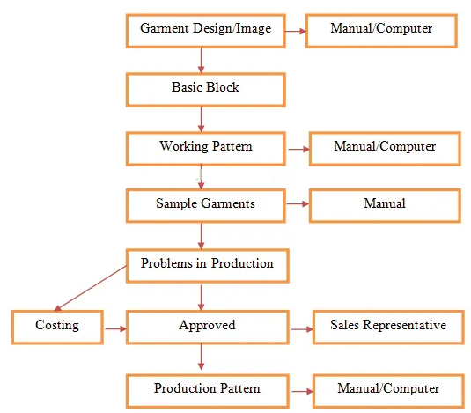
Figure 8 pattern production process

4.2. Determining appropriate block portfolio.
Determining an appropriate block portfolio for shirt design is a crucial step in the design process. A block portfolio is a collection of basic patterns that can be used to create different styles of shirts. It is important to have a variety of blocks in your portfolio to ensure that you can create a wide range of designs.
To determine the appropriate blocks for your portfolio, you should consider the following factors:
Design aesthetic: Consider the style of shirts you want to create. Do you want to create classic, tailored shirts or more relaxed, casual styles? This will help you determine which blocks to include in your portfolio.
Target audience: Think about who your target audience is and what they are looking for in a shirt. Are they looking for something trendy and fashionable or something more classic and timeless? This will help you determine which blocks to include in your portfolio.
Fabric selection: The type of fabric you plan to use will also impact the blocks you choose for your portfolio. Different fabrics drape differently and require different types of patterns.
Skill level: Consider your skill level when selecting blocks for your portfolio. If you are new to shirt design, it may be best to start with simpler blocks and work your way up to more complex designs.
Industry standards: Finally, it is important to consider industry standards when selecting blocks for your portfolio.
To determine the appropriate block portfolio, consider the specific design requirements and target market for your pattern. Research and gather a variety of block options that align with the desired silhouette and style. This may involve creating or sourcing different block templates or base patterns that can be customized to suit your design. Consider factors such as body shape, size range, and design elements when selecting the blocks for your portfolio. It may also be helpful to consult with industry professionals or experienced patternmakers for guidance and advice on selecting the most suitable blocks for your design.

4.3. Checking blocks for accuracy and appropriateness.
Before starting the pattern production process, it is important to check the accuracy and appropriateness of the selected blocks. Here are some steps to consider:
1. Verify measurements: Double-check the measurements of the blocks to ensure they are accurate and align with your design requirements. Compare them to industry standard measurements or any specific size charts you are using.
2. Check proportions: Assess the proportions of the blocks to determine if they match the desired style and fit of your designs. Make any necessary adjustments to achieve the desired silhouette.
3. Evaluate seam placements: Examine the seam placements on the blocks to ensure they align with your design vision. Consider how the seams will affect the overall look and fit of the garment.
4. Assess style lines: Review the style lines on the blocks to ensure they match your design aesthetic. Determine if any additional style lines need to be added or if existing ones need to be modified.
5. Consider design details: Evaluate the design details on the blocks, such as pockets, pleats, or decorative elements. Determine if they are appropriate for your designs or if any changes need to be made.
6. Test fit: Make a toile or muslin sample using the blocks to check the fit on a real body. Assess how the garment drapes and moves, and make any necessary adjustments to improve the fit and comfort.
By thoroughly assessing and checking the blocks for accuracy and appropriateness, you can ensure that they serve as a solid foundation for your pattern production process. This will help you create high-quality patterns that result in well-fitting and visually appealing garments.

Self-check 5
Part I Multiple choice
- factors that consider to determine the appropriate blocks for your portfolio
- Design aesthetic:
- Target audience:.
- Fabric selection
- Skill level
- all answer
- Which is false when selecting the blocks for your portfolio
- Body shape,
- size range,
- design elements
- language
- which not consists A full set of basic blocks:
- bodice front and back
- sleeve
- collar
- skirt front and back
- what consider When selecting and assessing a block portfolio,
- Unity of silhouettes
- Fit and proportion:
- Adaptability:.
- Size range:
- All answer

Part II short answer
Write steps to planning the pattern production for your designs
How Check blocks for accuracy and appropriateness.

Unit 5. Creating pattern
This unit is developed to provide you the necessary information regarding the following content coverage and topics:
- Ease for comfort and appropriateness is calculated in achieving design outcomes.
- Advanced dart manipulation is performed as required.
- Necessary adjustments are made to seams to create silhouette to match design brief.
- Pattern is produced using advanced pattern-making principles.
- Methods and formulas used are documented.
- Pattern pieces are checked for accuracy of seam allowances, seam match, hems and functional openings.
- Pattern pieces are labeled and markings completed.
This unit will also assist you to attain the learning outcomes stated in the cover page. Specifically, upon completion of this learning guide, you will be able to
- Determine Ease for comfort and appropriateness is calculated in achieving design outcomes.
- Produce Advanced dart manipulation is performed as required.
- Identify Necessary adjustments are made to seams to create silhouette to match design brief.
- Produce Pattern using advanced pattern-making principles.
- Understand Methods and formulas used are documented.
- Check Pattern pieces for accuracy of seam allowances, seam match, hems and functional openings.
- label Pattern pieces and marking

5.1. Calculating ease for wear-ability.

5. 1.1.Introduction
Pattern making is the art of designing patterns by making templates from which clothing and craft items can be sewn. A pattern making process actually help to come out with the imagination of designer from the sketching till real product. Pattern makers are also called 'Technical Designers'. When Fashion Designers complete their garment designing, Technical Designers starts their work to prepare the pattern of the garment. The garment making process consists of disparate yet interdependent stages. The aesthetic appearance, correct fit and the drape attributes of a garment depends significantly on every garment making process. Pattern making is considered as the first step in garment production. While making a garment as per design, templates are used to trace the various garment parts of similar style onto fabric prior to cutting and assembling. Generally, patterns are made of paper or cardboard templates that have become a skilled technical process over the centuries.

5.1.2. Calculating ease for wear-ability.
There are two main types of ease in all garments. I’m going to be mainly focusing on style ease in this post, but let’s do a quick rundown on wearing ease just to distinguish the two.
(Remember, ease in a garment can be calculated by subtracting the body measurements for each size from the corresponding finished garment measurements.)
Wearing Ease
Wearing ease in a garment is the difference between your body measurements and the garment’s measurements that allow you to move – raise your arms, sit down, flex your biceps, breathe, etc.
In garments made with woven non-stretch fabrics, wearing ease is almost always a positive number and it varies based on the type of garment and the part of the body it covers. For example, you need very little wearing ease at your waist to accommodate motion. However, hips need relatively more ease to accommodate actions like sitting down or crouching. Measure the fullest part of your hips/butt when you’re standing vs. sitting down and you’ll immediately see why that area requires some room to move.
Close fitting garments don’t have very much wearing ease (think of a sheath dress with a pencil shape in the skirt), and thus need shaping mechanisms like darts and pleats to fit around your body’s curves and closures like buttons and zippers to get on and off your body.
In garments made with stretch knit fabrics, the line between wearing and style ease is a little more blurred and can be a negative number, zero, or a positive number. For this reason, the argument could be made that all ease on stretch knit garments is style ease. This depends on the type of garment, where it is worn on the body, and the type of knit used. A knit camisole or leggings will have negative ease because they are meant to stretch to fit tightly against your body. Closer fitting garments like fitted tees or pj pants may have zero ease. They don’t stretch to fit around the body, but they fit your curves closely. And some knits have positive ease, such as hoodies and joggers, because they are meant to be worn as layers or be looser on the body.
Style Ease
Style ease is not the same as wearing ease. When drafting a pattern, the pattern maker will first use a block that contains wearing ease. From there they will make decisions about style ease based on the intended fit of the garment. That can involve removing ease (for tight knits) or adding ease. The important thing to remember is that this ease is not adjusted to make it possible to move in the garment, that has already been done. It is adjusted to create the intended style.
There is really no limit to style ease depending on the garment type and current fashions. A large caftan style dress will have enormous amounts of style ease. A pencil skirt will have reduced style ease (usually reduced to the minimum amount of wearing ease). Here are a couple examples using Hey June Patterns:
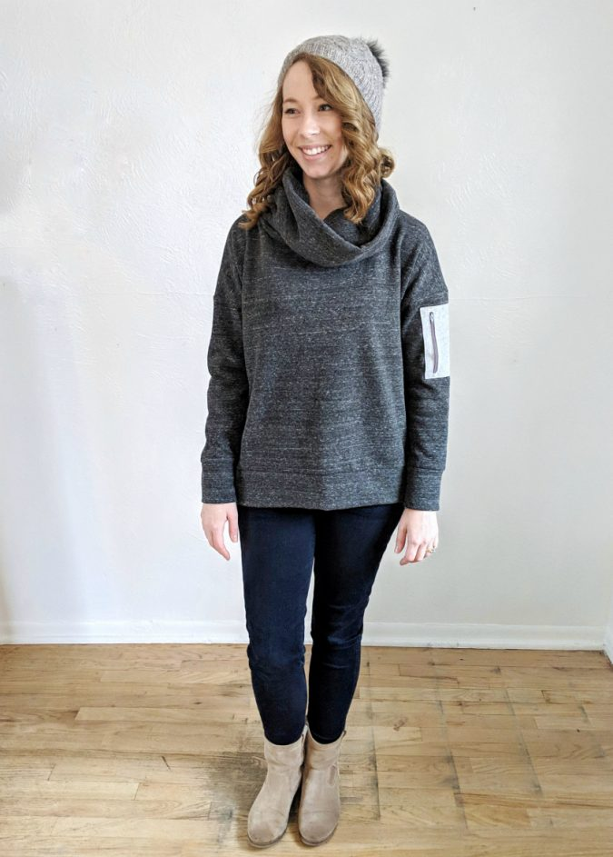
Figure 9.Positive Ease
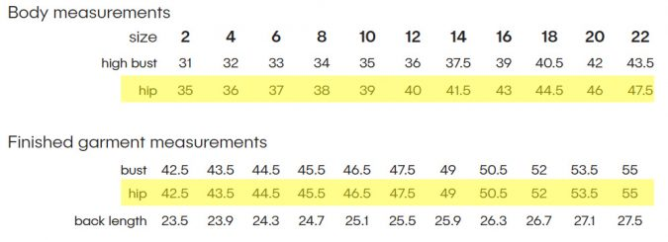
The Brunswick Pullover is on trend with today’s styles of cropped, boxy tops. Thus, it has generous positive style ease. It is meant to truly look like a rectangle when the arms are held out at the sides. Looking at the difference between the body and garment measurements on the pattern, you can see that the intended ease at the hip is 7.5″. That is the total amount of ease so you can assume that some is wearing ease and the rest is style ease. Knowing how that much ease will fit and look on your body is a combination of measuring, math, experience, and looking at the garment on other bodies on social media and the blog. It can be helpful to measure yourself against some of your ready to wear garments to figure out how different amounts of ease will look on your body (but be very careful to pay attention to the fabric type and stretch too, as that has a huge impact!)
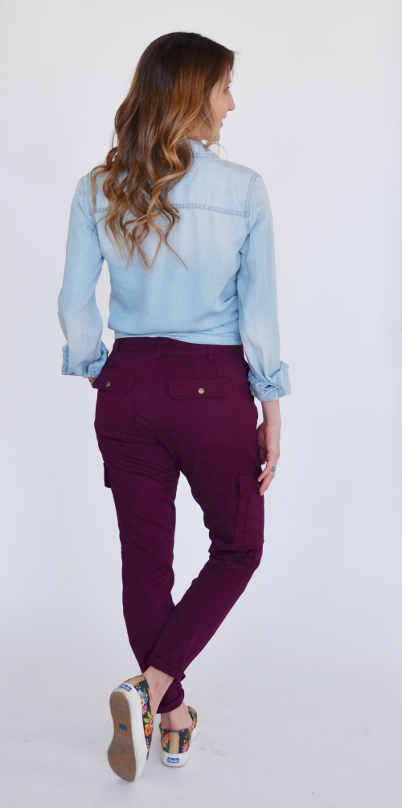
Figure 10. Zero Ease

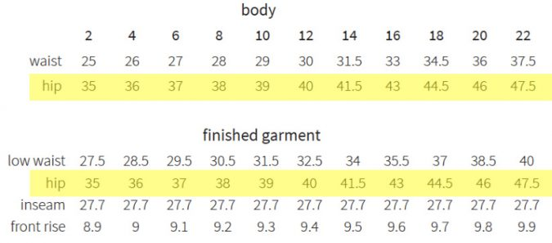
The Bryce Cargo Pants have zero ease at the hip. They can get away with this in a woven because the fabric requirements are for a stretch woven with at least 10% stretch, which accounts for the wearing ease that was eliminated when the pattern was reduced to zero ease at the hip. As you can see, this creates a fitted but not tight garment. The fabric stretch also means that the garment will loosen with wear and movement to some degree until it is washed again.
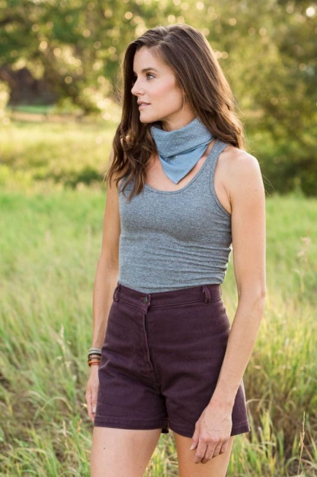
Figure 11 Negative Ease

I don’t generally make super fitted garments, so I don’t have very many examples for negative ease. The Kila Tank from Allie Olson Patterns (pictured above) is a great example though. This is meant to be a very close fitting garment for warm weather or layering. It has 2.5″ of negative ease at the waist and 6.5″ of negative ease at the hip for the smallest size. Patterns like the Kila with such important negative ease will also give very specific fabric requirements based on fiber/substrate/stretch percentage and disregarding those requirements can also greatly impact the wearability of the finished garment.

Combinations of negative, zero, and positive ease
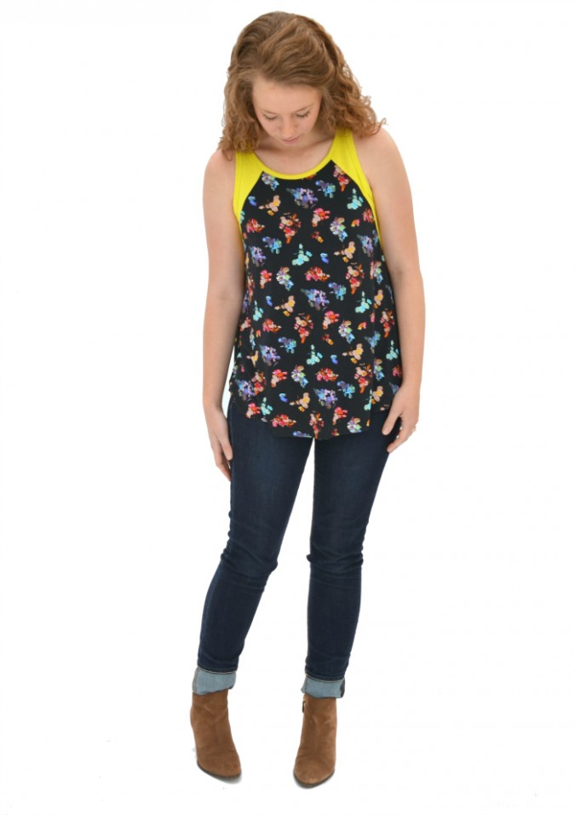
Figure 12. Combinations of negative, zero, and positive ease

A lot of garment styles will have different percentages of ease on different parts of the body. For example, a fit and flare knit dress could have negative ease at the bust and waist but it will have large amounts of style ease at the hip. The Santa Fe Top is a good example of this. The tank top versions have negative to zero ease at the upper chest but the trapeze style means the hip has a large positive style ease. This is the intended fit of the garment. I see a lot of comments regarding the Santa Fe where people say it is “way too big” at the hip. This subjective statement is really just a description of ease, which is information that could’ve been discovered by reading the pattern information.
Ease is important for both the garment's fit and its design. "Wearing ease" is what allows us to have movement in our garments. If we sewed a pattern in a woven fabric that matched our exact measurements, it would fit like a second skin, and we would have no range of movement! So, we add ease. "Design ease" is added to a garment to influence the overall shape and silhouette of the style. A close-fitting garment—like the Christina pencil skirt—has less ease. A loose-fitting garment—like the Tacara knit dress—has more ease.
Before you pick a size to cut, it's important to check two measurement charts—body measurements and finish garment measurements. They may or may not be on separate charts. Seamwork has both included on the same size chart. Here I have the size chart for the York. The bust measurement on a size 8 is 37 inches. The finished garment measurement is 40 inches. To calculate the amount of ease, you subtract the body measurements from the finished garment measurements. So, 40 minus 37 equals 3 inches of ease in the bust on a size 8. Now let's talk about negative ease. While woven garments add ease, many knit garments subtract ease to get negative ease. "Negative ease" is when the finished garment measurements are smaller than the body measurements. A close-fitting tank top or T-shirt will likely have negative ease. I'm wearing the Seamwork Margo. Margo has negative two inches of ease in the hips so what that means is that the finished garment measurement of the Margo is 2 inches smaller than my body measurement.
You might be wondering how patternmakers draft to include ease. Each company has their own standards for the main measurement points on the body— bust, waist, hip, etc. The patternmaker will start with these standards and then we'll add or subtract ease to achieve the silhouette that the pattern designer has sketched out.
Here are 3 tips for using ease while sewing. Tip #1: keep ease in mind when deciding which size to cut. Do you want your garment to fit more closely or do you want it to be a little roomier? Calculate the amount of ease for the main measurement points, and keep that in mind when choosing which size. This is especially helpful for when your measurements fall between sizes.
Tip #2: you can often size up or down if you prefer more or less ease. Keep in mind that when you size up or down, it will affect all of the pattern measurements, including measurements like the shoulder width, the bicep, and the sleeve length. You may need to measure portions of the pattern and compare them to your own measurements and then adjust as necessary.

5.2. Performing Advanced dart manipulation

5.2.1. Introduction of Dart manipulation
Dart manipulation is the art of taking the existing darts in a sewing pattern, and manipulating them around the pattern to achieve something else. It’s a common technique used in pattern making.
Manipulating darts is one of the most creative ways to develop sewing patterns, or even get creative with patterns that you know and love.
The female body is made up of nooks and crannies, and to create clothes that fit those nooks and crannies, we need to manipulate the fabric to be more form fitting.

5.2.2. Types of Dart Manipulation
Yes! When it comes to manipulating darts there are two methods that are used:
Slash and spread method
Pivotal method
What Is The Slash and Spread Method In Pattern Making?
The slash and spread method in pattern making is exactly as it sounds.
Your pattern is cut (slashed) to the dart point, and then spread open the required amount to add fullness, or moved closer together to remove the fullness.
The slash and spread method is a pattern-making technique used to add volume to a garment. . It is used to add pleats, gathers, or even sweep to a garment
Here are the steps to follow:
Take the pattern you want to modify and trace it onto a new piece of paper.
Draw lines from the edge of the pattern piece to the point where you want to add volume.
Cut along these lines, but do not cut all the way through the paper.
Spread the cut edges apart by the desired amount and tape them down onto a new piece of paper.
Redraw the pattern lines around the new shape, and cut out your new pattern piece.
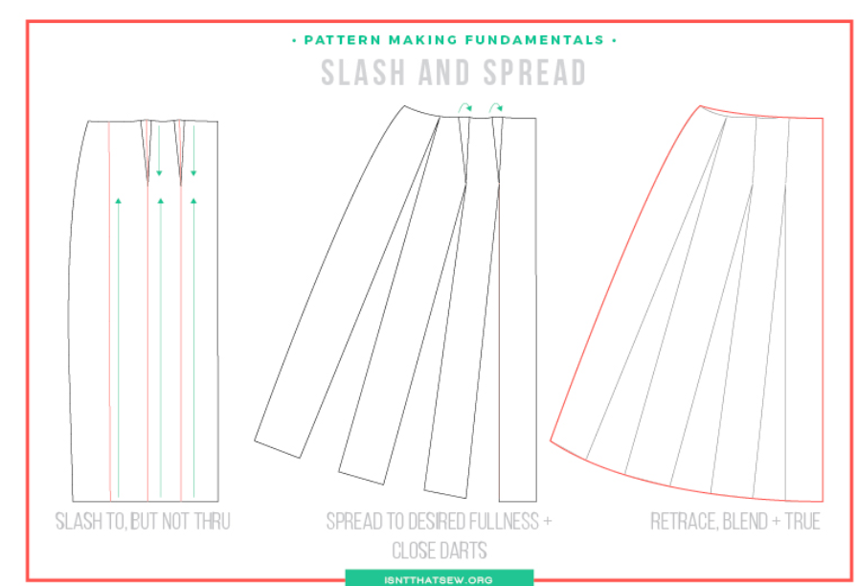
Figure 13 slash and spread method
5.3. Creating necessary adjustments to seams to create silhouette to match design brief.
To create necessary adjustments to seams and achieve the desired silhouette as per the design brief, follow these steps:
1. Analyze the design brief: Understand the specific silhouette required for the garment. Consider factors such as the shape, fit, and overall aesthetic mentioned in the brief.
2. Study the pattern: Examine the garment pattern and identify the seams that need adjustment. Look for areas where the current seam lines may not align with the desired silhouette.
3. Make a muslin toile: Create a muslin toile (a mock-up of the garment) using the existing pattern. This will allow you to visualize how the garment fits on a body and identify any necessary alterations.
4. Pin and mark adjustments: While wearing the muslin toile or using a dress form, pin and mark areas where the seams need adjustment. For example, if a more fitted waist is desired, pin in excess fabric along the side seams to achieve a tapered waistline.
5. Transfer adjustments to the pattern: Remove the muslin toile and carefully transfer the pinned adjustments onto the pattern. Use tracing paper or a pattern drafting tool to redraw the seam lines to match the desired silhouette.
6. Cut and sew the adjusted pattern: Cut out the fabric using the adjusted pattern and sew the garment together following the new seam lines. Be sure to make any additional adjustments during the sewing process if needed.
7. Fit and refine: Try on the garment or use a fitting model to assess how well it matches the desired silhouette. Make any final tweaks or modifications to ensure a perfect fit and silhouette.
8. Finish the garment: Once satisfied with the adjustments and fit, complete the garment by finishing hems, adding closures, and any other necessary details.
By following these steps, you can successfully make necessary adjustments to seams and create a silhouette that aligns with the design brief.

5.4. Producing pattern using advanced pattern-making manipulations.

5.4.1. Pivoting
The pivot method of dart manipulation is when we move the pattern at the dart point, and trace around the pattern to remove or add fullness, instead of cutting into the pattern itself.
Reasons to Pivot Darts
You may be wondering why you would even want to pivot darts – and the reasons are fourfold!
To move one dart to a new place on a sewing pattern
To separate one large dart into several smaller darts
To distribute the fabric suppression in a dart into tucks, pleats or gathers
To add style lines to pattern and eliminate darts either partially or fully
Tools For Pivoting Darts
The tools needed for pivoting darts on sewing patterns are:
Pattern making paper
Hard pencil
Coloured pencils
Pattern master or fashion ruler
Paper scissors
Tape measure
Masking tape (the non-tacky option)
Glue stick
Pins
Tracing wheel
Awl
Cutting mat
Pivoting Darts – The Process!
Start by tracing off the one section of the bodice. Starting at the bust point, I traced clockwise along:
The bottom dart leg
Around the armhole
Down the side seam
Across to center front
Up center front
Around the neckline
Down to the bust point to connect the section
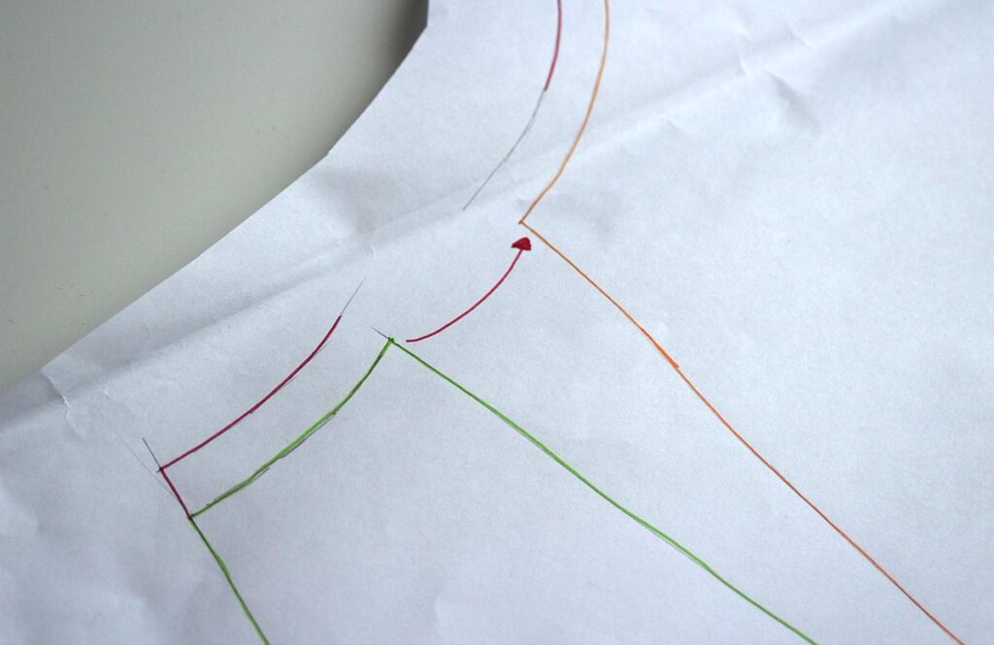
Figure 14 both dart legs are equal in length
We need to make sure that when the new dart is closed, both dart legs are equal in length and that the seam allowance is correct when the dart is pressed towards the center.
Start by creating a fold on the dart leg nearest centre front, then bring it over to meet the second dart leg – move in the direction of the arrow as this will create the dart in a way that the fold is towards the center front!
Pin the dart to hold it in place. Notice how the paper no longer lies flat, but has shape to it now the dart is secured in place! You should find that both darts meet at the neckline in the same place! Now, grab your tracing wheel!
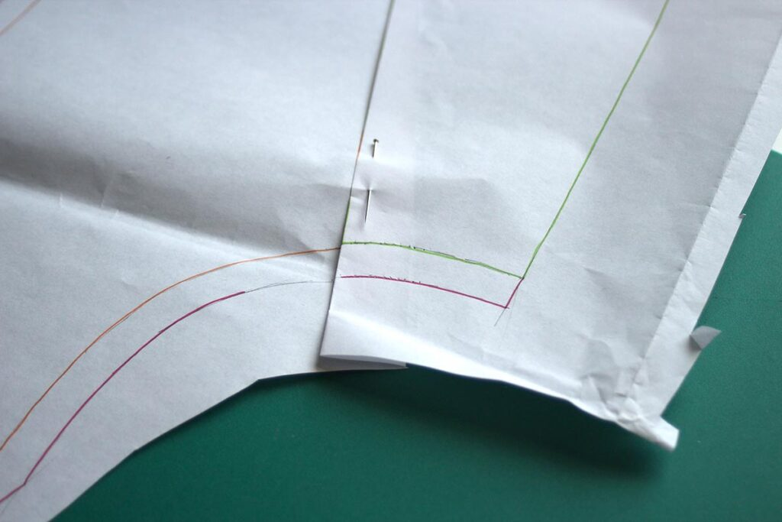

Figure 15 Pin the dart to hold it in place
Remove the pin and open up the dart. Notice how the seam allowance for the dart is curved and not straight? This is good!
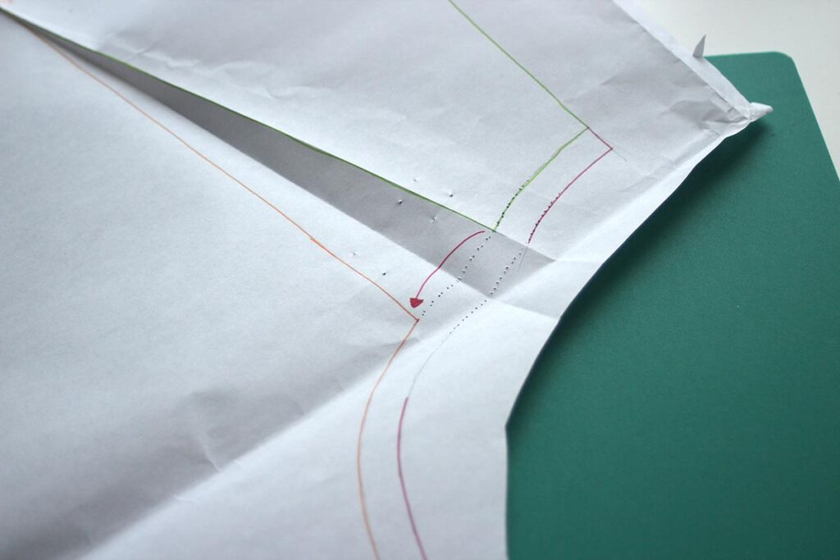
Figure 16 Remove the pin and open up the dart
Now, grab your pencil (in my case pen) and mark in both the stitch line and the seam allowance line, following the pin-prick traced line!
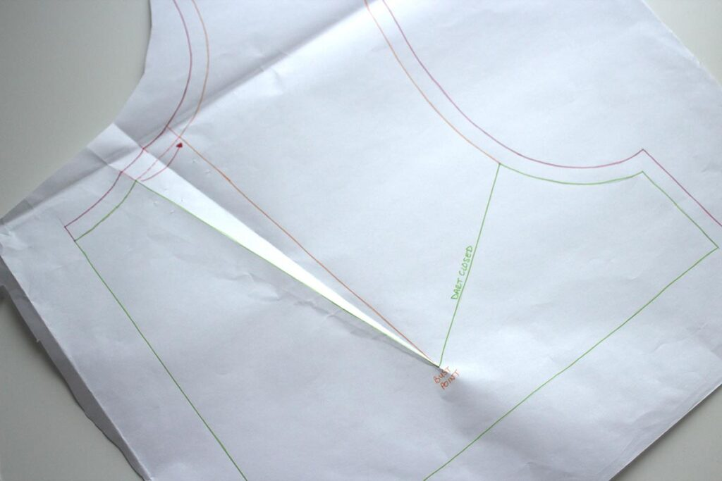
Figure 17. Transferring a dart using the pivoting method
That’s it! Your first attempt at transferring a dart using the pivoting method of dart manipulation is complete!
Below is how the two pieces look placed on top of each other. If these were both sewn up in calico, they would fit exactly the same – the fabric suppression is exactly the same, we simple transferred it around the bodice by transferring the dart.
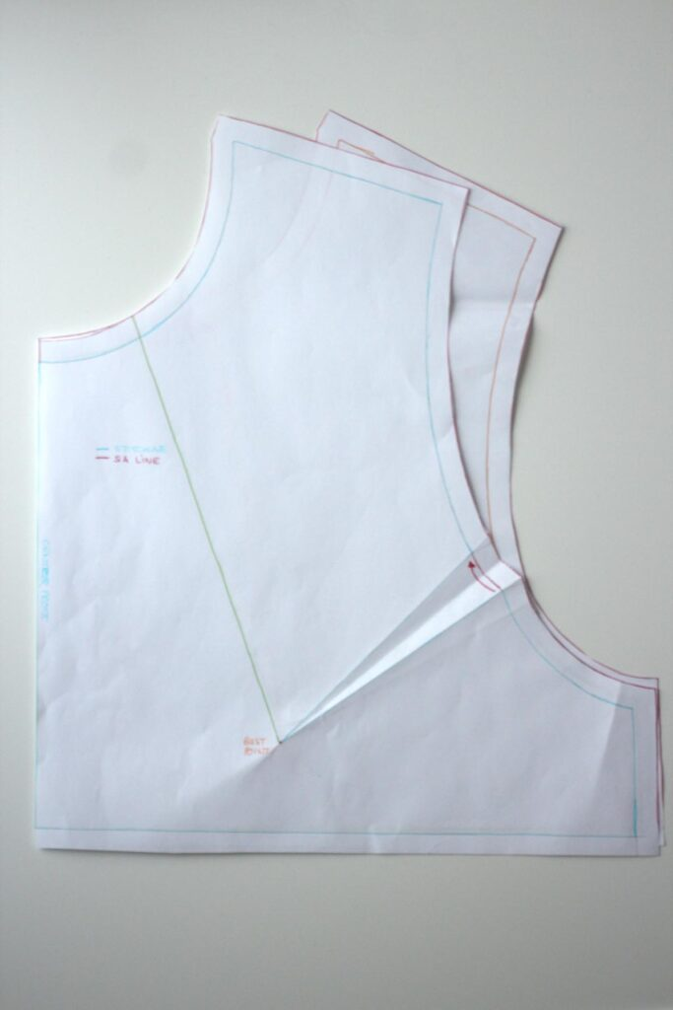
Figure 18 Two pieces look placed on top of each other

5.4.2. Square blocking
A square block pattern is a type of quilt pattern that consists of square-shaped blocks arranged in a grid. The blocks can be made up of a single fabric or multiple fabrics, and they can be arranged in a variety of ways to create different designs. One example of a square block pattern is the Simple Square Blocks Quilt Pattern. This beginner-friendly pattern is designed for layer cake precuts and can be finished in a short amount of time
Simple Square Blocks Quilt Pattern
The Simple Square Blocks Quilt is a fast and free quilt pattern. The pattern is beginner-friendly and a perfect project for those new to quilting or just looking for a project that can be finished in a short amount of time. Perfect for precuts, you’ll love the simplicity of this easy pattern.
Simple Square Blocks Quilt Pattern
The Simple Square Blocks Quilt pattern is a fun way to showcase your favorite set of holiday fabrics. Designed for layer cake precuts, you will have so much fun piecing the quilt together.

Why Make This Quilt
It’s a perfect quilt to make if you are a beginner quilter or just looking for a quick quilt you can finish in a day.
You can make the quilt using a layer cake, so your cutting time and fabric selection time is greatly reduced.
Cutting is simple, with only a few straight cuts per block.
Since the quilt is made with larger squares and rectangles, the piecing comes together very fast, especially since there are no seams or points to line up.
The pattern includes a printable template for you to save and use.
Quilt Details
The Simple Square Blocks Quilt is made up of patterned “square blocks” surrounded by solid sashing and borders.
The quilt pattern comes in 3 sizes, throw (60 by 69 inches), twin (72 by 91 inches), and full (83.5 by 91 inches).
Square Blocks Quilt Color Variations
I made today’s version with holiday fabrics, but you can use any layer cake or color variation you like! Valentine’s, rainbow, fall colors, you can even remove the sashing for an entirely different look!
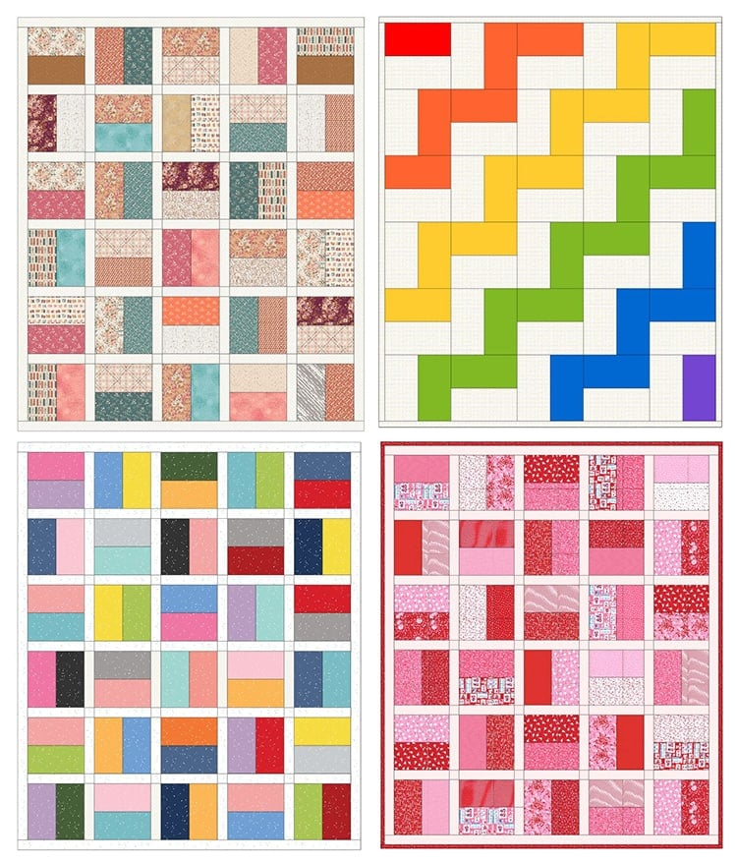
Figure 19 Fabric Used In The Simple Square Blocks Quilt
What drew me to this particular fabric set was the greens, reds, black, and of course pink fabric prints, and also that there were plenty of low volume (white background) prints to set off the bright holiday colors.
Quilting Options
There are so many ways this square blocks quilt can be quilted. I am in a hurry to get mine done, (I want it finished before December starts) so I plan to do a very simple free-motion design, similar to the quilting design in the left image below. I do not plan to use a ruler to keep the lines straight.
If you are quilting on a home sewing machine a great option would be to stitch in the ditch or a simple cross-hatch pattern similar to the image on the right.
The link for the free Square Blocks Quilt pattern / template is under the materials needed section. Click the link, add the pattern to your cart and check out. (takes about 15 seconds for the process.) A copy of the pattern will be emailed to you.
Square Blocks Quilt Pattern
Pattern Notes:
wof = width of fabric.
Scant 1/4 inch seam allowances used.
RST = Right sides together.
Chain piecing = The process of sewing blocks of fabric together without stopping between each one. The threads are clipped after all pieces are sewn. This saves time and thread.
Press the seams to the colored fabric side.
Fabric Requirements:
If you want lots of various prints for your quilt I recommend using a layer cake as you will have 20 to 24 different prints to work with.
Throw:
Patterned fabric: 30 – ten-inch squares
Background fabric: 12 – ten-inch squares and 3/4 yard cut into ten 2.5 inches by WOF (or ten jelly roll strips)
Backing: 4 1/4 yard (assuming 42-inch wide directional fabric)
Binding: 5/8 yard (assuming 42-inch wide fabric and 2.75-inch wide binding)
Twin:
Patterned fabric: 48 – ten-inch squares
Background fabric: 17 – ten-inch squares and 1-1/3 yard cut into eighteen 2.5 inches by WOF (or 18 jelly roll strips)
Backing: 5.5 yard
Binding: 3/4 yard
Full:
Patterned fabric: 56 – ten-inch squares
Background fabric: 10 – ten-inch squares and 1-1/2 yard cut into twenty-one 2.5 inches by WOF (or 21 jelly roll strips)
Backing: 8 yards
Binding: 7/8 yard
Materials Needed For Throw Size Quilt
Pattern
Fabric
30 -10 inch squares (or yardage cut in squares- see fabric requirements above)
12 – solid 10 inch squares (or yardage cut in squares- see fabric requirements above)
10 – 3/4 yard solid fabric cut into ten 2.5 inches by WOF (or ten jelly roll strips)
Rotary Cutter and mat
Ruler (If you want the use yardage for your quilt, this slotted ruler makes quick and easy work of cutting fabric into 2.5-inch strips.)
Iron
Basic quilting supplies
Sewing Instructions
Step 1: Cut Fabrics.
Cut all the patterned 10-inch squares/ layer cake squares in half.
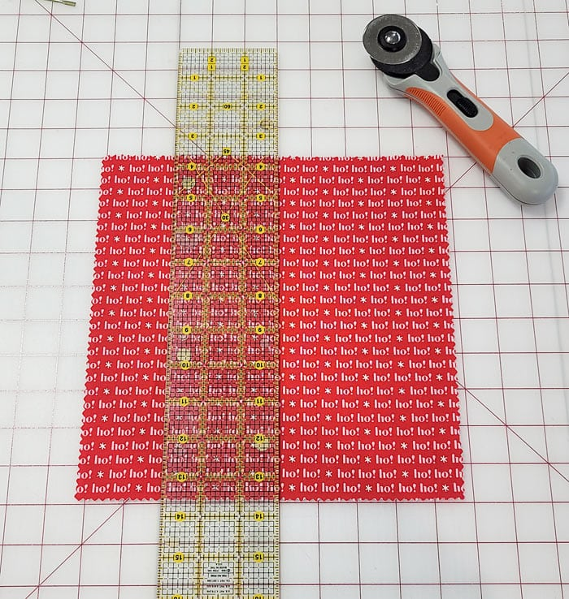
Figure 20 Cut Fabrics.

Trim all the white 10-inch squares to 10 by 9.5 inches. (half an inch off one side.)
Then cut all the white squares into four 9.5 by 2.5-inch strips.
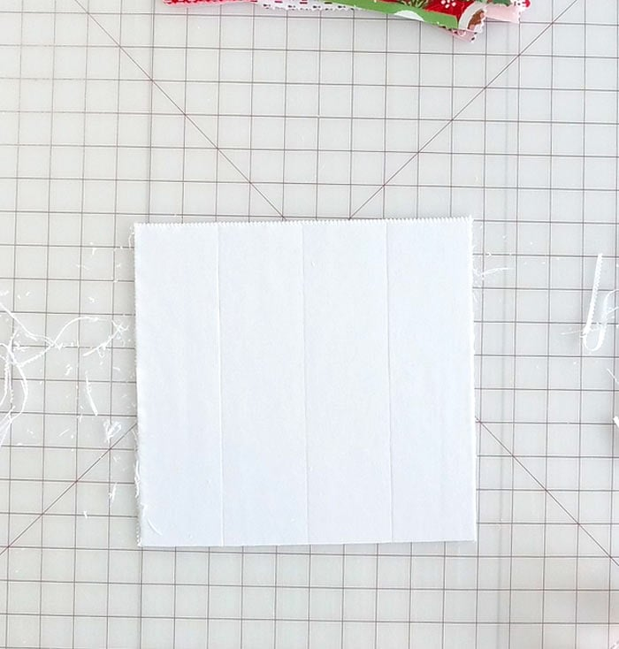
Figure 21. Cut the white square
Step 2: Sew Blocks.
Sew two random patterned rectangles together, using a scant quarter-inch seam allowance.
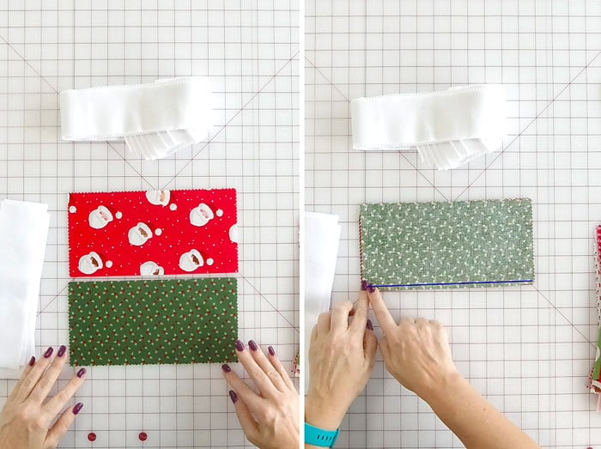
Figure 22Sew two random patterned rectangles together
To speed up the sewing, I sorted my rectangles into colors, took the stacks to my sewing machine and chain pieced everything together.
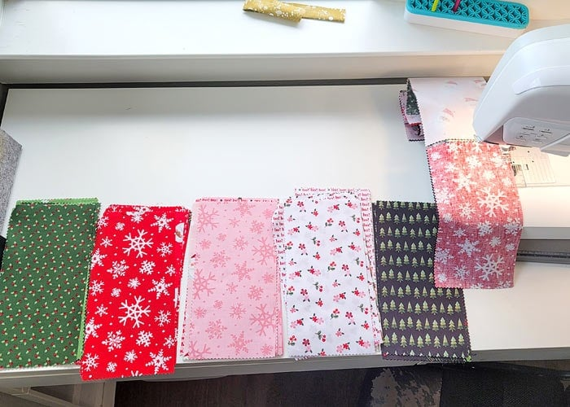
Figure 23 sort rectangle colors and sew by chain everything together
Press the blocks and trim to 9.5 inches square.
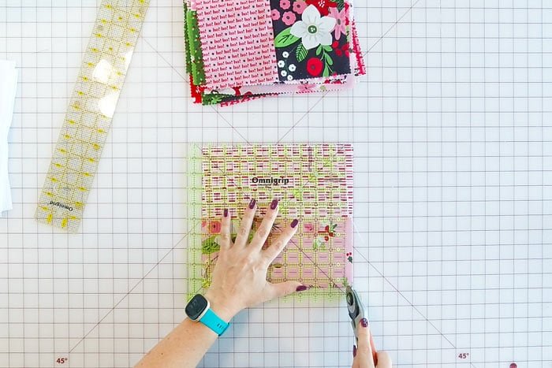
Figure 24. press the block and trim
Step 3: Sew Rows.
Once all your blocks are sewn together, pressed, and trimmed, you’ll want to lay them out on the floor or a design wall to determine the best way to assemble the blocks for color distribution. (I love my portable design wall for this.)
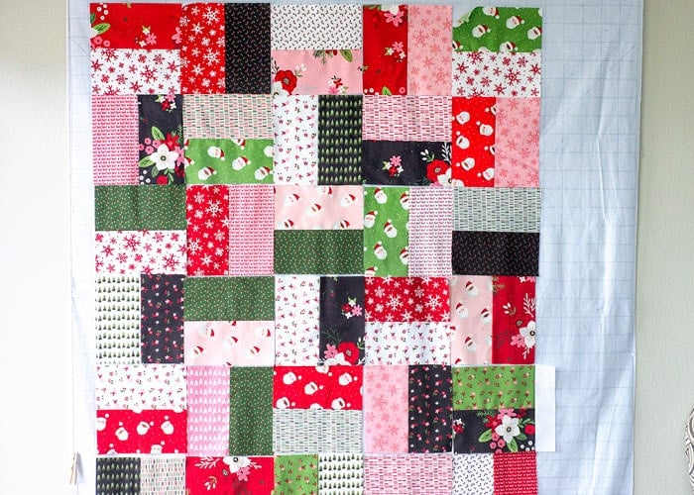
Figure 25 Assemble the blocks within color distribution
Working one row at a time, sew the 2.5 inch strips in between each block. I found it best to line up the blocks in a row, sack the strips on top, then stack the squares up in order of how they will be sewn.
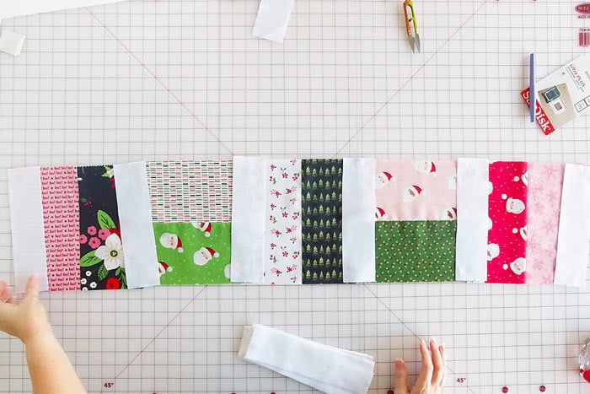
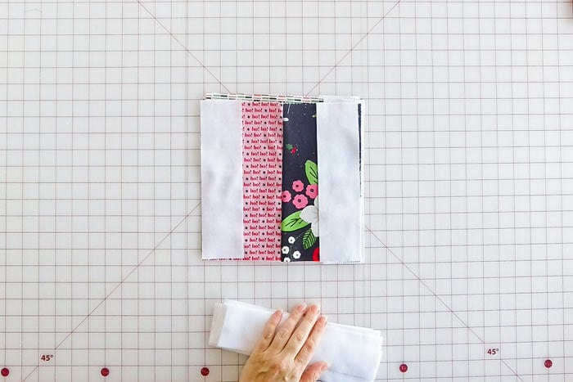
Once sewn, press with the iron and repeat this process for the rest of the rows.
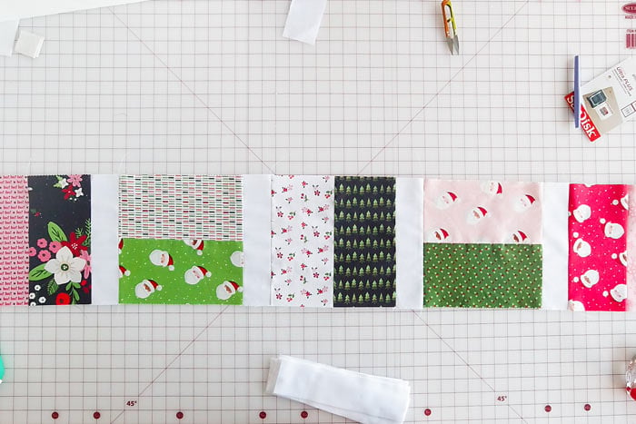
Step 4: Add Sashing Between Rows
Grab the jelly roll strips (or yardage cut into strips) and sew together end to end. Trim the sewn strip so they are the same width as your rows. (You’ll find it takes about 1 and 1/3 of a jelly roll strip.)
You need 7 sashing strips for the throw-size quilt.
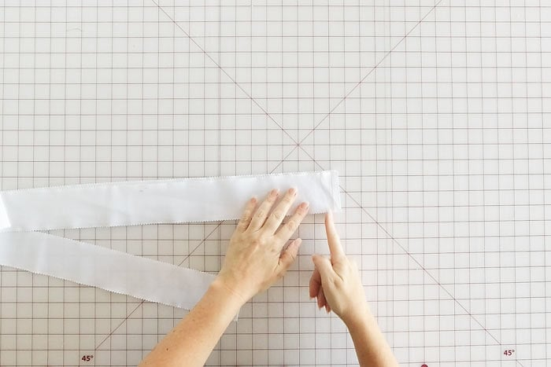
Figure 26 sashing strips for the throw-size quilt.
Sew a sashing strip in between each row, plus on the top and bottom of the quilt top.
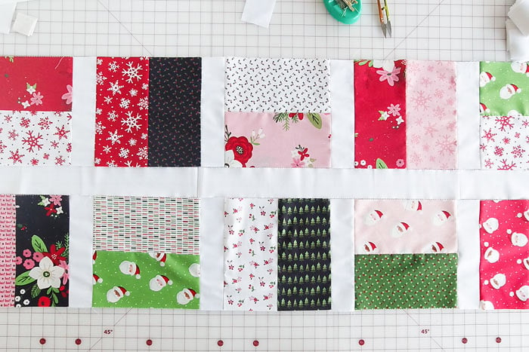
Figure 27 Sew a sashing strip in between each row, plus on the top and bottom of the quilt top.
Press the seams flat, toward the colored fabric.
Step 5: Baste And Quilt.
Make your quilt sandwich and quilt the simple square blocks quilt top as desired!
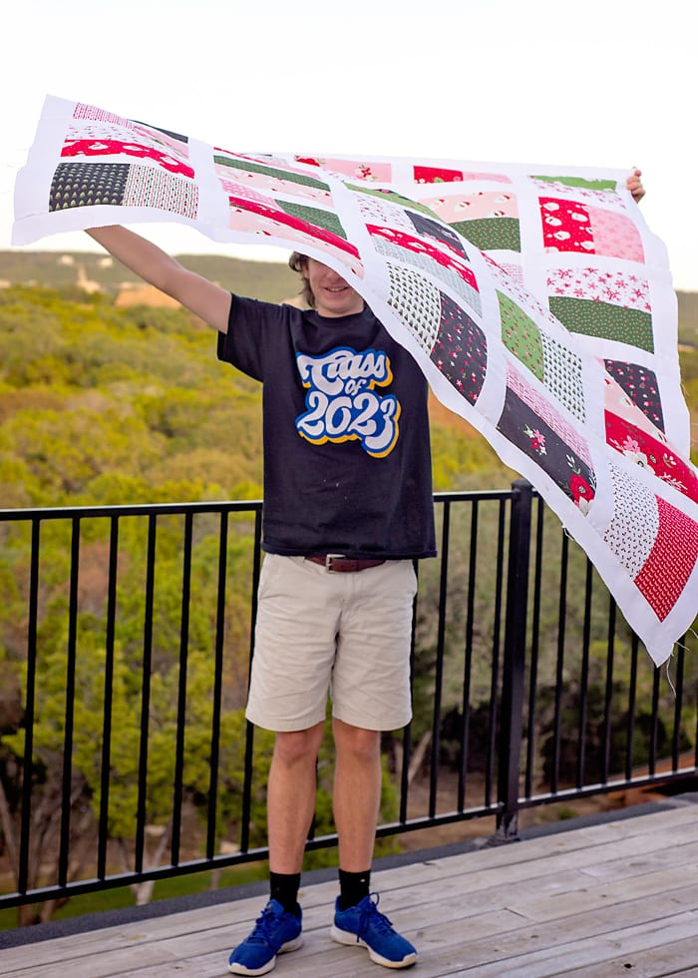
Figure 28. Sandwich and quilt the simple square blocks quilt top as desired

Well looky there, it’s someone who has not made an appearance on the blog in 5 or 6 years!

5.4.3. Contouring

Contouring
Part 1: The Need For Contouring
• Part 2: Contour Markings
• Part 3: Sleeveless Block
• Part 4: Standard Contouring Amounts
• Part 5: Individual Contouring Amounts
• Part 6: Strapless
• Part 7: In Action Example
Part 1: The Need For Contouring
The basic Bodice Block Set is for creating garments with sleeves and a fairly high neckline. If you use this block and try to create a garment with a low neckline, and/or a garment with cutaway arms, it will not work so well. Depending on your body (bust-cup size and other considerations), the resulting garment may be un wearable. For those with a standard figure and a small bust-cup, it may not be too bad, but chances are it will not be ideal.
The reason that the basic Bodice Block does not work well for garments with low necklines and cutaway arms, is that it does not follow the contours of the body; it falls in a straight line from the neck, over the bust and down to the waist. There is usually some space between the garment and the chest underneath, and often underneath the bust.
The basic Bodice Block is also created to be used with Sleeves; therefore it has more ease at the underarm level than is needed for a sleeveless garment. This results in gaping in the armhole.
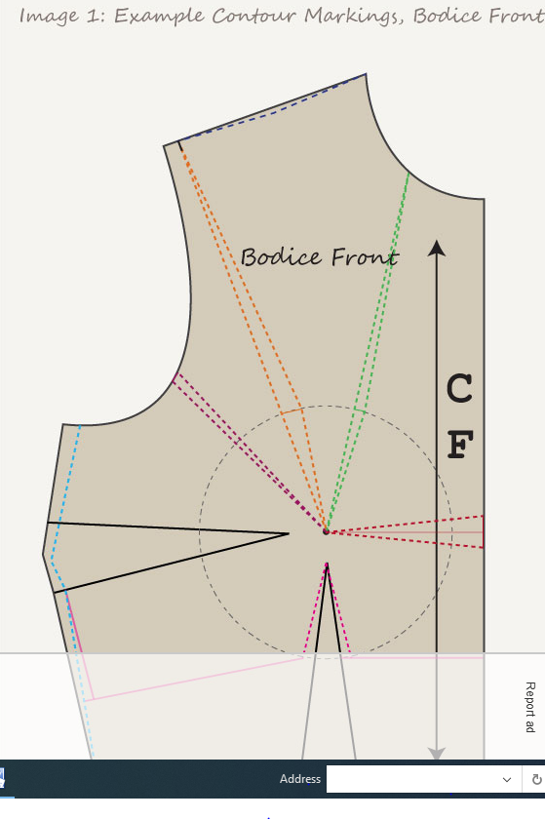
Figure 29contours making bodies front

The result of using the basic Bodice Block to create garments with low necklines or cutaway armholes, will be gaping in those areas.
There are four parts to this issue:
Understanding the need for Contouring (that gaping will occur).
Knowing (determining) where the gaping will occur so that the problem can be fixed during the patternmaking process.
Placing this information on the block (in the form of gape darts).
Solving the problem (fix the gaping, or closing the gape darts).
This is not just limited to necklines and armholes; if you want to create an Empire Line dress, you usually need to reduce the amount of fabric at the under-bust level. This Empire Line contouring is also marked on the block with other contouring information.
You can put all this information onto the Bodice Block, or you may also want to create a Sleeveless Block. In a Sleeveless Block, two of the contouring items – the block ease and the armhole ease are incorporated into the block and therefore do not have to be redone with each pattern.
Bust Mound Radius
In order to place contouring marks on your Bodice Front, you need to draw the Bust Circle . You will need a compass to draw a perfect circle.
The radius of the circle is the Bust Mound; from the Bust Apex (the nipple), down under the bust where it ends at the ribs. See Figure 2, which shows the Bust Mound Radius on the body and on the block. The circle is drawn on the Bodice Front; the center point is the Bust Point.
For Standard Blocks (used to make garments for the fashion industry), this Bust Mound and the Contour Markings are set amounts. The Bust Mound Radius increases with size, but the other markings are set amounts that are the same for all sizes. The specifics are covered in detail in later pages on Contouring.
Note for Figure 2: The block shown is the standard block with standard markings, not my block with my contour markings.
Part 2: Contour Markings (Gape Darts)
Contour markings are necessary for both the Bodice Front and the Bodice Back. The purpose of these lines is to show if and/or where gape darts are required, and the size of the gape darts. In the images below, these contour markings are shown on the standard Bodice (Sleeves) Block.
The circle shown on the block indicates the Bust Mound; the circle is drawn with the Bust Radius measurement.
This page just shows the contour markings on the Bodice Front and the Bodice Back. Details such as the amount of contouring will be found on one of the following pages.
The curve of the armhole is closer to the body without a sleeve. When this excess amount is removed it reduces the armhole measurement and also raises the armhole.
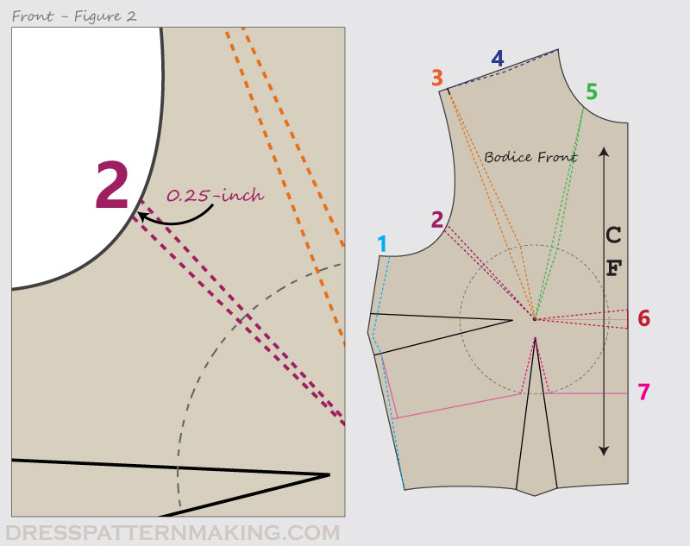

Figure 30: Cutaway armhole
Reduction of 0.5-inch at bust circle, tapering to zero at both the shoulder and the Bust Point.
A cutaway arm will cause gaping between the shoulder and the bust mound. As this line will be on the bias stretch, the gape dart amount is more than the actual gape.
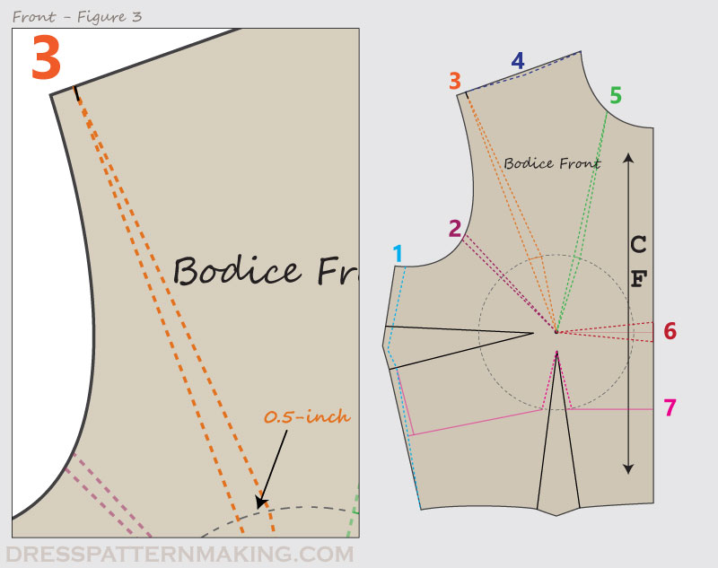
Figure 31: Shoulder line shaping
Reduction of 0.13-inch at mid-shoulder.
The shoulder usually dips a little in the middle. (See the Examples for an application of using this guideline).
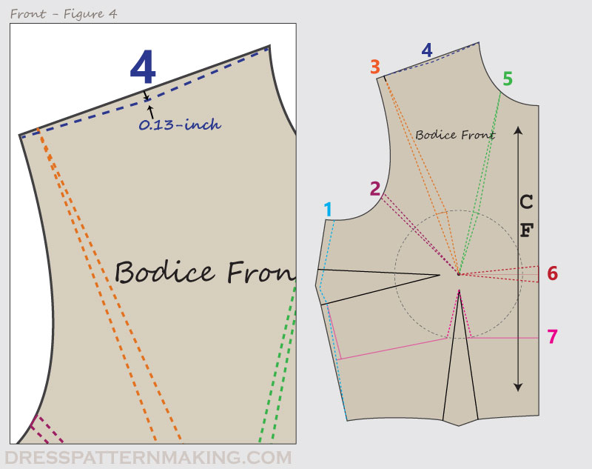
Front Figure 30: Low neckline guide
Reduction of 0.25-inch at the bust circle, tapering to zero at both the neckline and the Bust Point.
The lower the neckline, the more the gape. Note that when the neckline dips to near or below the Bust Point, contouring line No.6. applies in addition to this one.
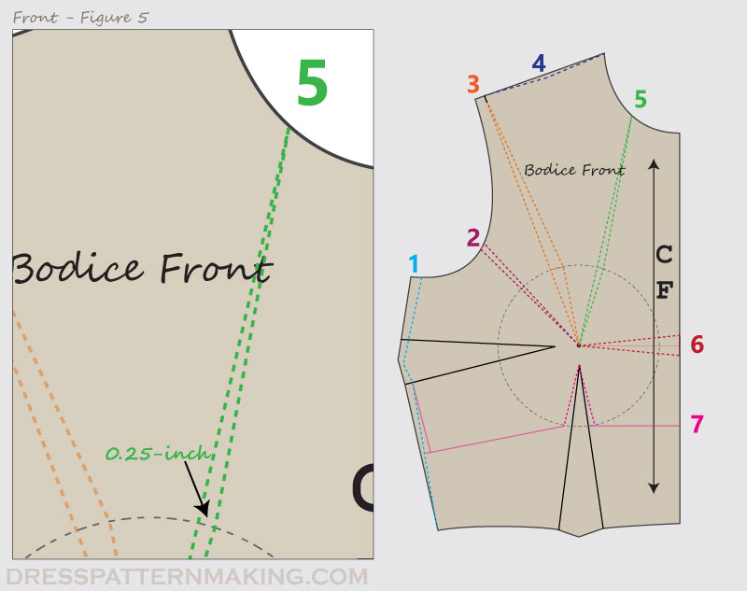
Figure 32: Low neckline
Very near and below the Bust Point; 0.75 inch total at Centre Front.
Necklines that dip to the Bust Poin and below need even more contouring.
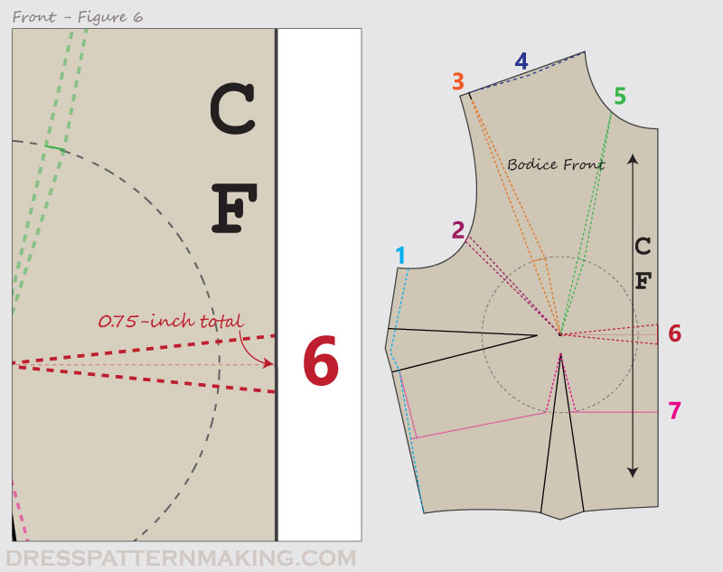
Figure 33Empire Line Guides
The dart width increases 0.75-inch at the bust circle.
The Empire Line style ends beneath the bust, therefore the dart ends at the bust circle rather than extending to the waist. The dart needs to be wider for the garment to return to the body under the bust.
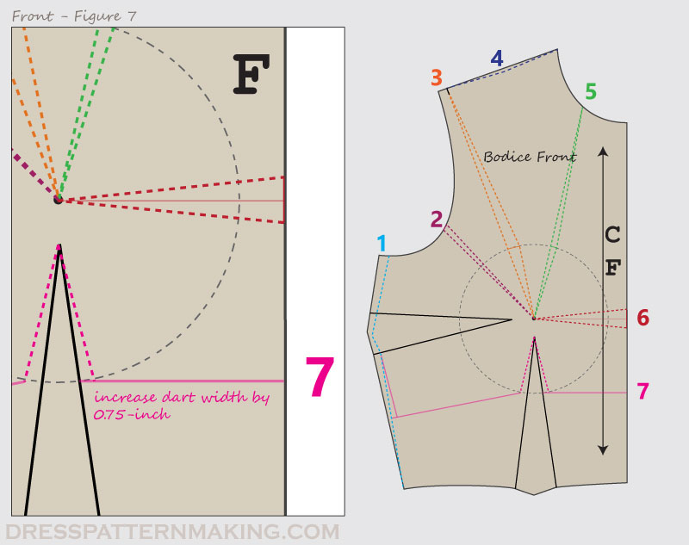
Front Figure 33: The Empire Line return
The Empire Line returns to the body under the bust, rather than falling from the bust to the waist.
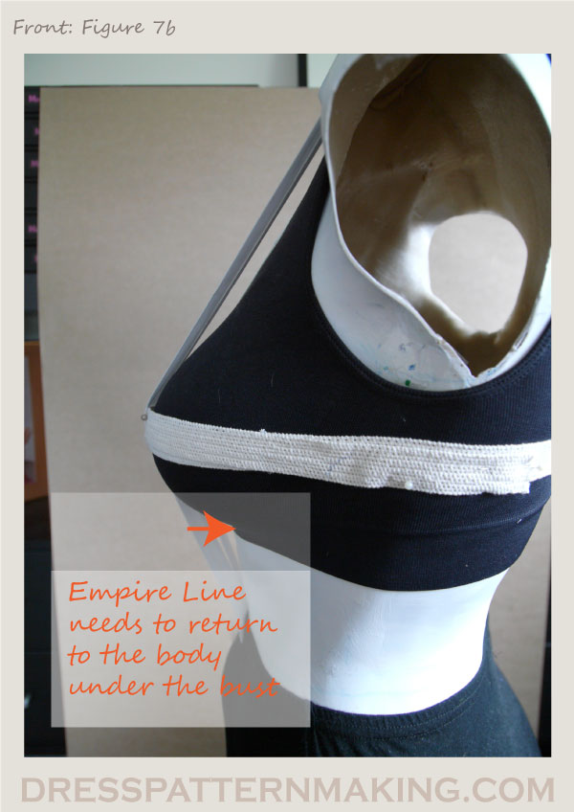
Figure 34The Empire Line return
Bodice Back
Back Figure 1: Reduction in block width
The reduction is 0.5-inch.
When creating the Bodice Block, the amount of ease added to the body measurement, at the underarm level, was 6 inches. This is ideal for garments with sleeves. This reduction of 0.5-inch on the half-blocks front and back will the total amount of ease to 4 inches for the fitted sleeveless garment.

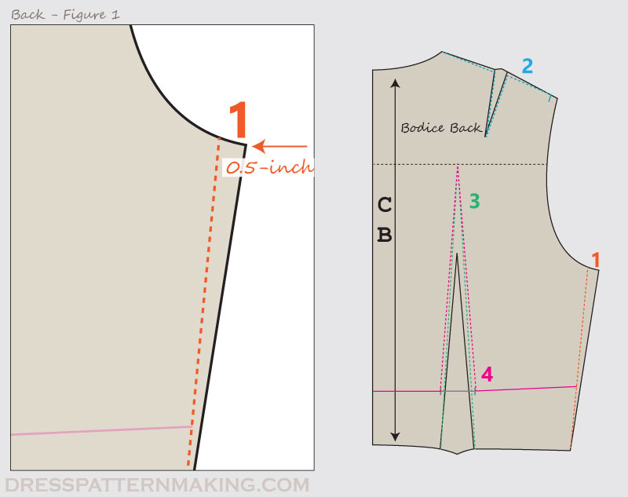

Figure 35 Shoulder line shaping
Reduction of 0.13-inch at mid-shoulder.
The shoulder usually dips a little in the middle. (See the Examples for an application of using this guideline).
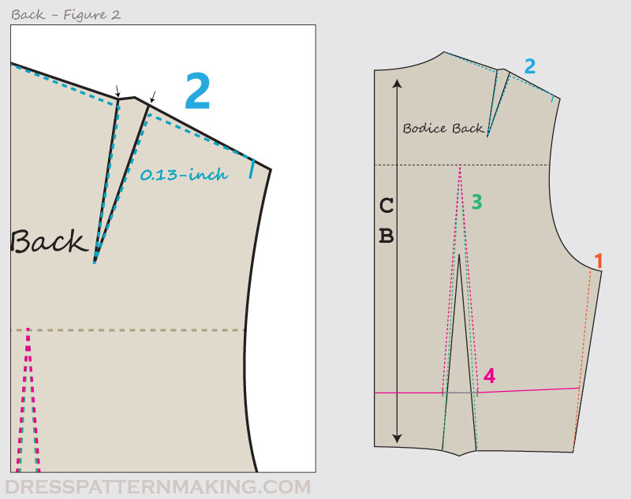
Figure 36: Increase height of waist dart
Increase the height of the waist dart by extending the dart point up to the Across Back line.
The placement of the Across-Back line is 1/4 of the CB measurement – down from the CB neck point. This line is drawn at right angles to the CB line.
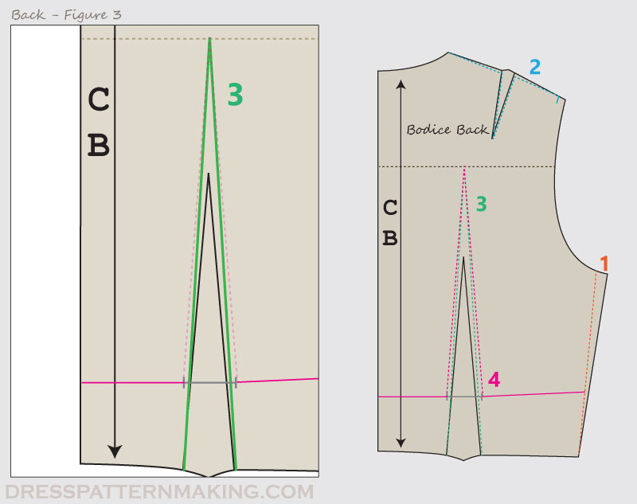
Figure 37: Increase of dart
The dart, which was previously at the waist level, is now under the bust. The width increases 0.75-inch at Empire Line level.
The placement of the Empire Line is another matter – it is based on the Bodice Front Empire Line. See the page Empire Line Styling in the Elements Menu.
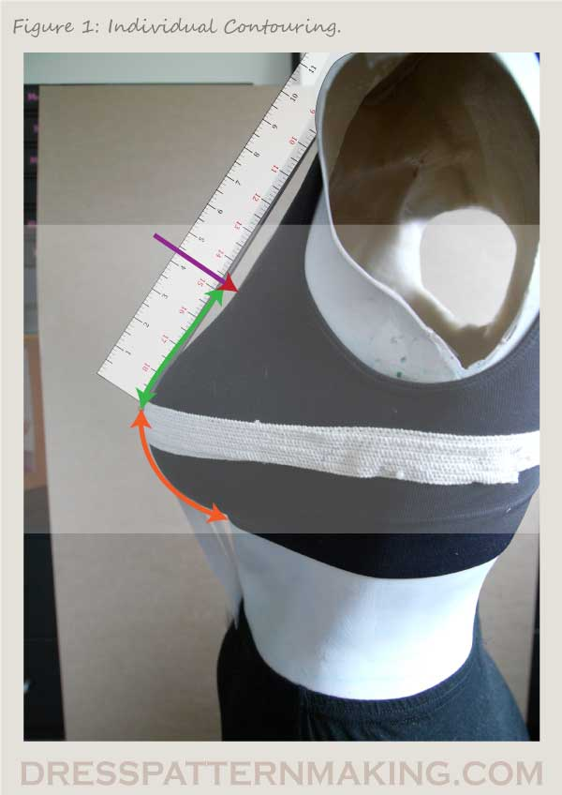
Figure 38Individual Contouring Amounts
Working out your individual contouring amounts does take some time and effort, but it is worth spending the time up front to get it right.
Some instructions suggest using a ruler against the body at the relevant points, as the example shown in Figure 1, and measuring the depth of the gaps, but I could not get accurate contouring with this method. As I had to make a toile to test and cut down the neckline and cut away the armholes, I think that one may as well go directly to the toile to work out the contouring.
In order to be accurate, I think it’s necessary to make at least two toiles; one for the neckline and one for the armhole. Once you have determined those amounts, you can then use those same two toiles again to cut out the other (e.g. with the one you used for the neckline, you then also cut away the armholes and visa versa). If you want to make extremely low necklines or strapless garments, you will probably need to make further toiles.
I use the Sleeveless Block to make the toile to work out the contouring. The sleeveless block has some of the block ease removed, and the armhole it raised up. In the following example, a Sleeveless Block is used.
These examples give you an idea of what you need to do, you will need to apply these ideas to contouring for which I have not supplied examples. The information I am giving is a general guide, in some cases you will need to apply some logical thinking to solve some issues.
Note that the Empire Line contouring is not covered here; see the Empire Line page under the Elements Menu.
Preparation
On your Sleeveless blocks, draw the following guides:
Bodice Front:
Your Bust Circle, shown by the purple dashed line. See the contouring page Contouring Overview if you are unsure of this measurement.
A straight line from the Bust Point to the shoulder tip. This is the cutaway arm line, and is shown in orange.
A straight line from the Bust Point to the mid-neck. This is the low neckline line, and is shown in green.
A straight line from the Bust Point to the Center Front. This is for very low necklines that go below the Bust Point, and is shown in red.
The contouring line for the shoulder. This is for the dip that is usual for the shoulder, and is shown in blue. Use the standard measurement to begin with – see the Standard Contouring page for details.
Bodice Back:
Extend the height of the waist dart up to the Across Back line. This placement of this line is 1/4 of the CB measurement, measuring down from the CB neck point. The line is drawn at right angles to the CB line.
The contouring line for the shoulder. This is the same measurement you used for the Bodice Front shoulder line.

f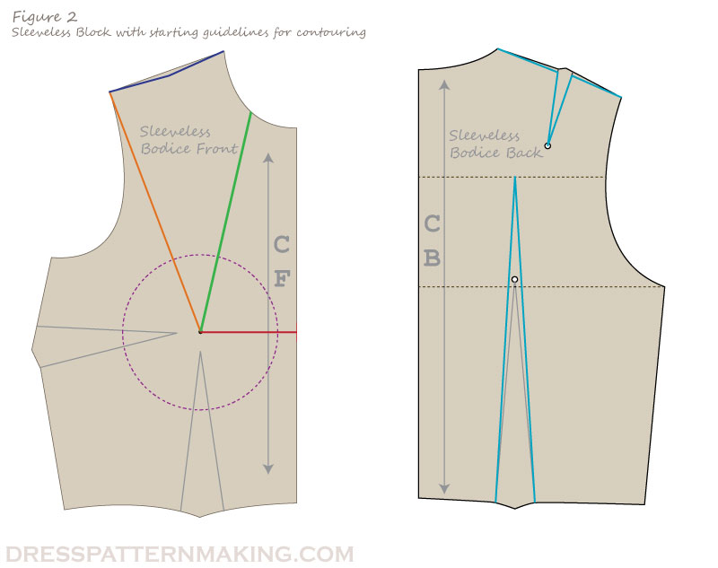
Figure 39sleeveless bodies front and back
Important Note: Shoulder line
The shoulder line may confuse some people, and suggest that a curve line is required. That is not the case. (Note that there is nothing wrong with a curve, but this is not what the guideline is about).
See below find four examples of how the shoulder line is used. Examples given are the Bodice Front, but they apply in the same manner to the Bodice Back. The colored shapes are the garment; look closely at the shoulder lines – in all these cases the shoulder line is straight.
In these cases, the shapes that are shown have not had the contouring done for the cutaway arm or necklines; these shapes are just to clarify how the shoulder line guide is used.

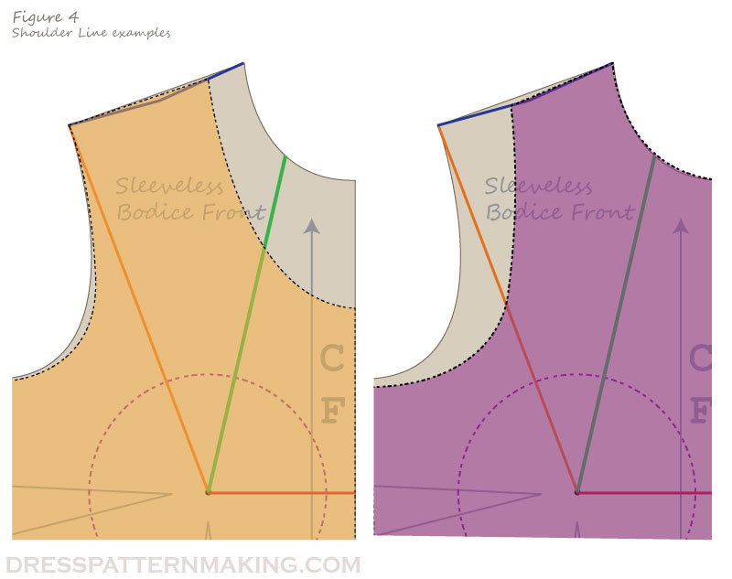
Figure 40sleeveless body shoulder line
Toile 1: Low Necklines
Mark the neckline design lines
On your Bodice Front block, draw four necklines, going progressively lower. Line up your Bodice Back at the shoulder line and continue the curve to draw the Bodice Back neckline. Don’t cut dow the back neckline very far.
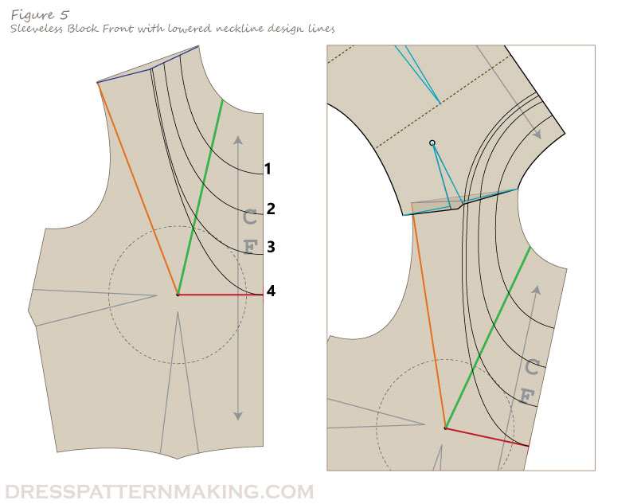
Figure 41. Sleeveless bodies within low neckline
Note: Having a very low cut back as well as a low cut front will create further problems (e.g. the garment falling off the shoulder), so to begin with it’s better to cut the back down just a small amount (as per the image above) to concentrate on the front. Once you determined the contouring for the front, you can then take on the task of working out how far you can cut the back down before the garment starts falling off the shoulder. Low back necklines will not be covered here, you can apply the steps below to a low cut Bodice Back at a later stage if making garments with a low cut back is something you want.
Transfer markings to your toile, make and fit
draw the bust mound, the three gape dart guides and the necklines onto your toile.
create the toile at the first neckline (the Bodice Back is made with the contouring adjustments)
try the toile on on and use pins to fit the garment: creating a dart at the green line (with the green line at the center), on both sides of the boy
remove the toile and transfer the information, the pinned amount, to the Block
remove pins
cut at the second line
pin, measure, transfer information to block
One you have pinned No.3, leave that dart pinned in place when fitting dart No.4. (You may have to sew it in place to get an accurate fit).
Note that this is a good time to mark the block with your preferred neckline depths.
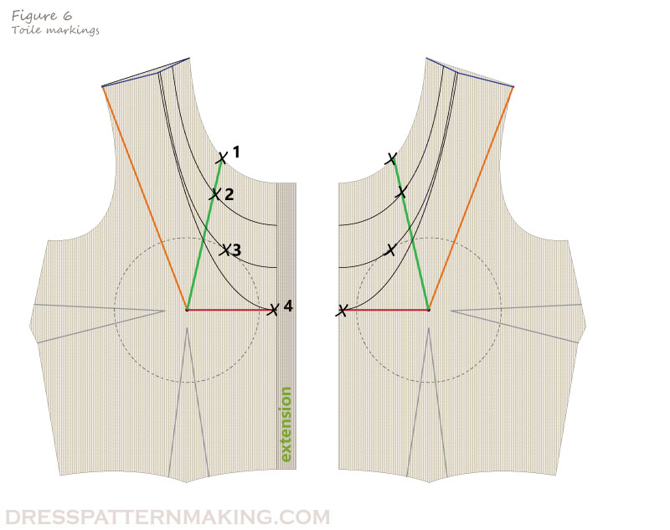
Figure 42toile making
Markings on Bodice Block
Of the first three necklines, No.3. should have the largest dart. You should be able to draw the dart information like this:
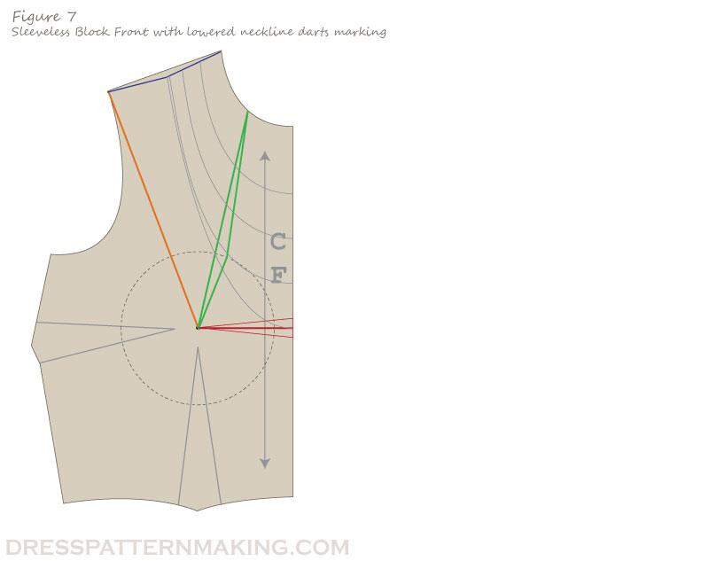
Figure 43Sleeveless bodies within neck dart
Toile 1: Cutaway Armholes
Repeat the process with a toile for determining the cutaway arm gape darts.
Note that you will need to remove the shoulder dart in the Bodice Back. However the shoulder line should still dip in the middle.
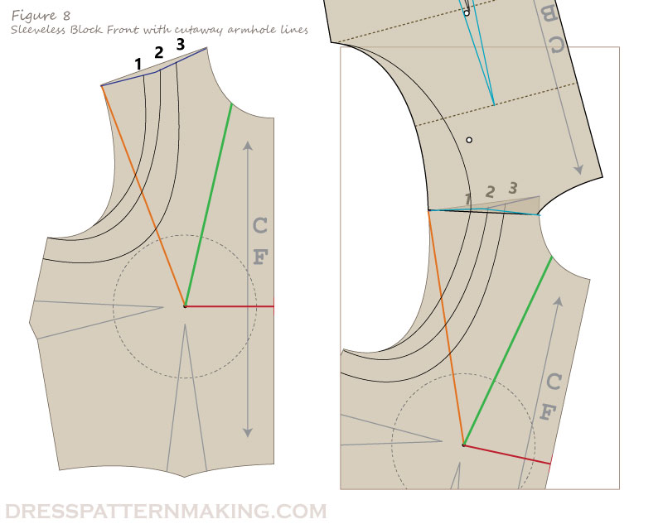
Figure 44sleeveless bodies with cutaway armhole line
Part 6: Strapless
For strapless garments, the armhole gape dart, the neckline gape dart and the Center Front gape dart are all rolled into one big gape dart. Note that this is using the Sleeveless Block. If you are using the Sleeve Block, you will also have to include the armhole gape dart.
If you are unsure how to merge these three darts (or any number of darts) into one, see the Manipulating Darts section of the Principals Menu.
See the image below for an example of the three gape darts merged into one.
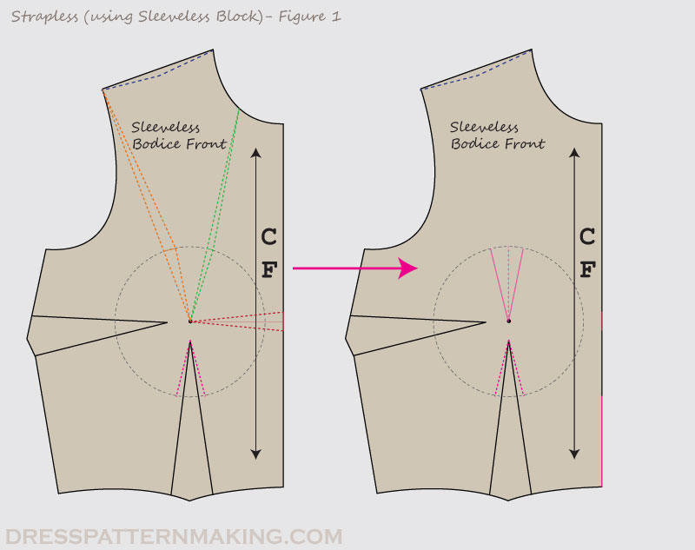
Figure 45strapless
Part 7: In Action: Example
This follows on from Strapless.
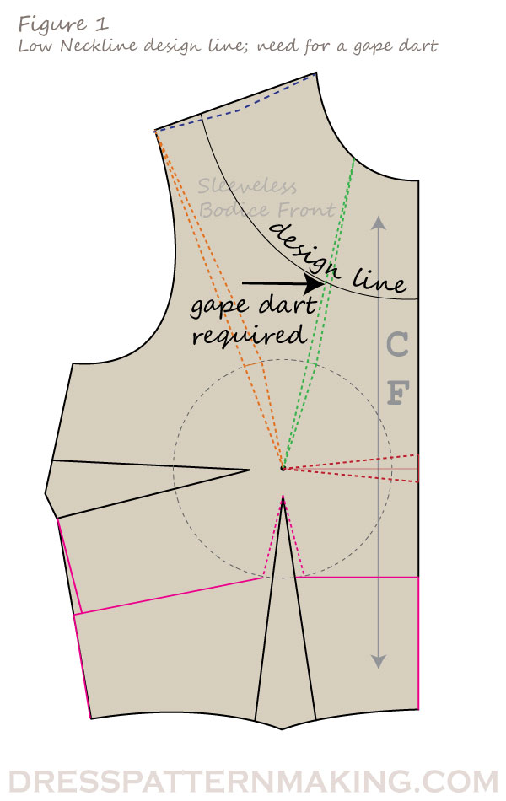
Figure 46law neckline design line with gap dart
In the previous pages we marked contouring information on the Bodice block, but what do we do with this information, how do we use it?
Contouring marks indicate where gaping will occur. Gaping means that a dart is required, so the solution is to put in a dart.
In the example in Figure 1, the design line crosses one of the gape dart lines, so a dart is required. This does not mean putting a dart in the neckline** – the gape dart needs to be incorporated into the design. In this case, it will be moved into the side seam dart.
Moving darts to difference places in the Bodice Block is covered in detail in the Manipulating Darts section of the Principles pages, and is a skill you need to learn before attempting to make your own patterns. Below in an example of how this gape dart information is applied; in this example you can see the difference in the shape of the pattern piece when the gape dart is moved to the side seam dart.
** Note: You can put a dart in the neckline if the design calls for it, but in this case it doesn’t.
The Gape Dart Moved
In Figures 2 & 3 below, the gape dart has been moved into the side seam dart.
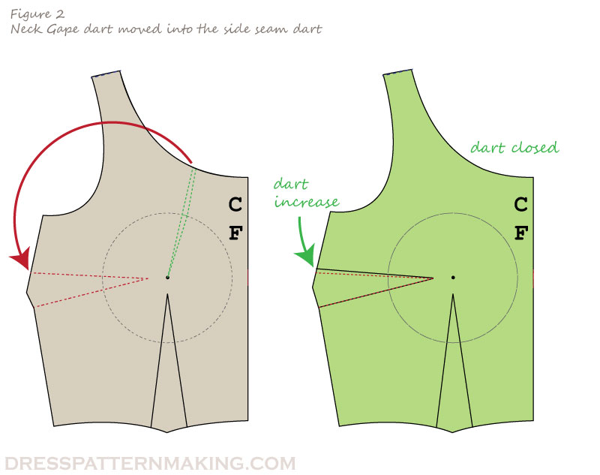
Figure 47neck cape darts moved in to side seam dart

5.4.4. Add fullness
Fullness can be added to any pattern piece for one of two reasons:
Add extra ease (e.g. An A-line skirt; fullness is added in the hem).
For design/stylistic purposes (e.g. fullness added to the sleeve cap to produce a puff sleeve that doesn’t add any wearing ease to the sleeve, it just creates a look)
Types of fullness

Tucks.
Pleats.
Gathers.
Shirring.
Ruffles and frills.
Gores.
Godets.

Principle of added Fullness

Fullness can be provided in a garment with the help of gathers, pleats, flare and tucks etc. to increase the fullness in a garment to the amount greater than provided by dart excess, the length and/or width in a pattern frame is increased.
To add fullness working pattern is increased in three ways:
1. Equal fullness: pattern is spread equally to both opposite sides to increase amount equally on top and bottom. (Figure 11 a)
2. One-sided fullness: pattern is spread to the desired amount at one side only. One side remained unspread. This creates an arc shape at top and bottom. (Figure 11 b)
3. Unequal fullness: one side pattern is spread more than other side. This also creates an arc shape on both the sides. (Figure 11 c)
Method of adding fullness to the garment
1. Pattern is traced on a paper large enough to spread slash lines. Mark grain line as in original pattern.
2. Mark the pattern with series of slash lines in the direction of fullness as appear in the design.
3. Slash line can be drawn horizontally, vertically or at angle as appear in the design. Beginning and end of the slash line depend upon the fullness position in the design.
4.Dart excess is absorbed in added fullness.
5.Cut through slash lines and spread pattern in direction of fullness.
6.Trace the outer shape of the new pattern and mark grain line.
7.Cut on muslin and test for fit.
Adding Fullness: Equally, One-Sided and Unequal
Fullness can be added three ways. The examples below use the sleeve, but fullness can be added to any garment part.
Adding Fullness Equally throughout the pattern piece
In this image, the sleeve is cut and spread so that the fullness is added throughout the sleeve equally, from to bottom. The top resulting sleeve would have added fullness in both the sleeve cap and the bicep.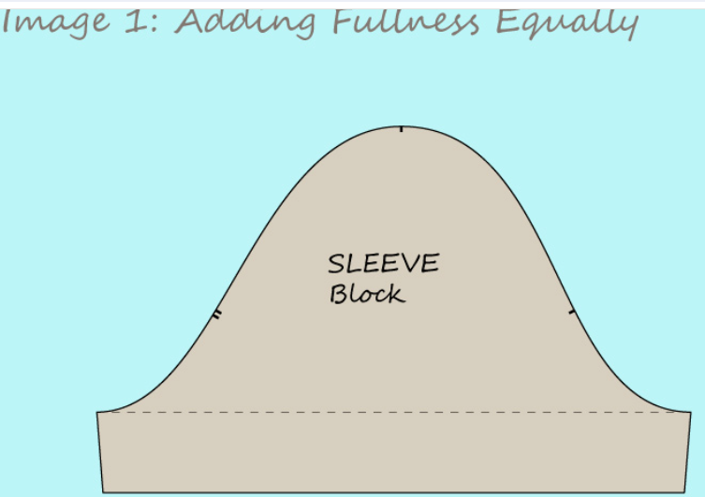
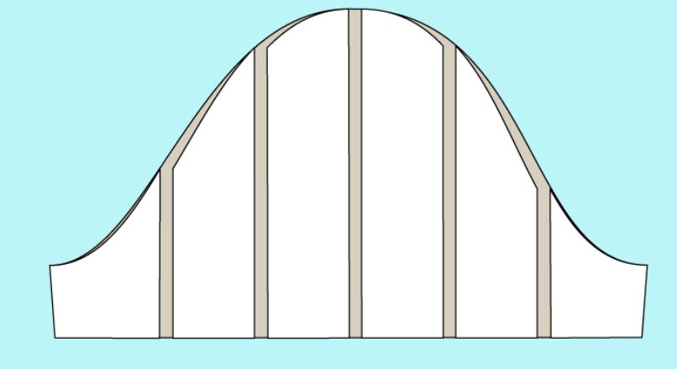
Figure 48 Adding fullness Equally
Adding Fullness along one side
In this image, the sleeve is spread at the bottom only, adding fullness to the bicep, but not to the sleeve cap. 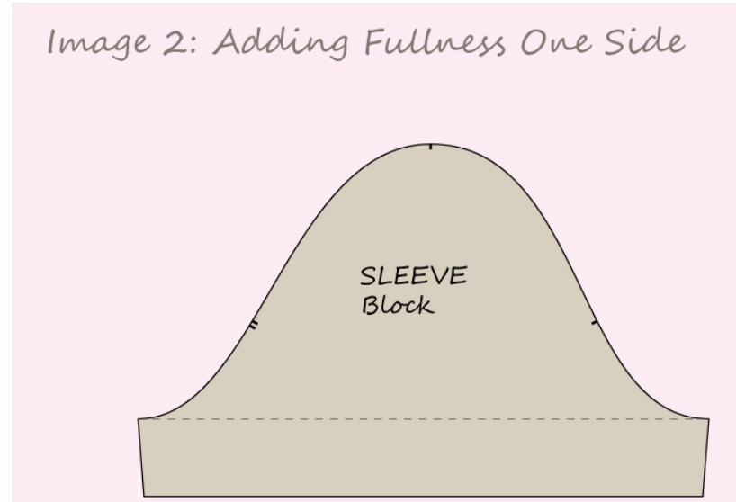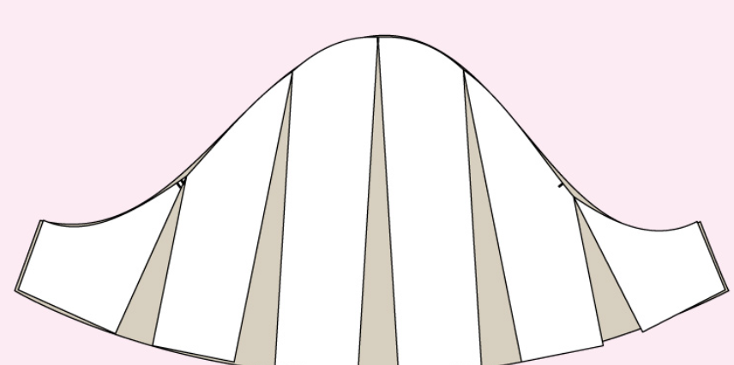
Figure 49 Adding Fullness one side
In this image, fullness has been added to both sides; the sleeve cap and the bicep, but not equally to both sides. More ease is added to the sleeve cap than to the bicep. 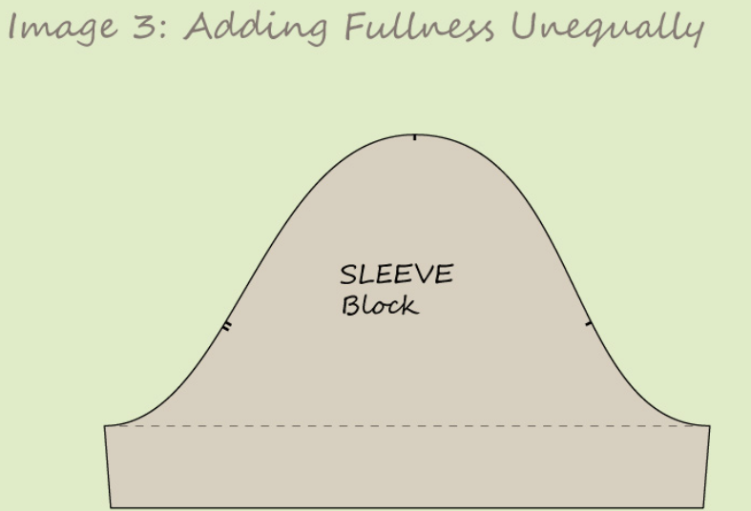
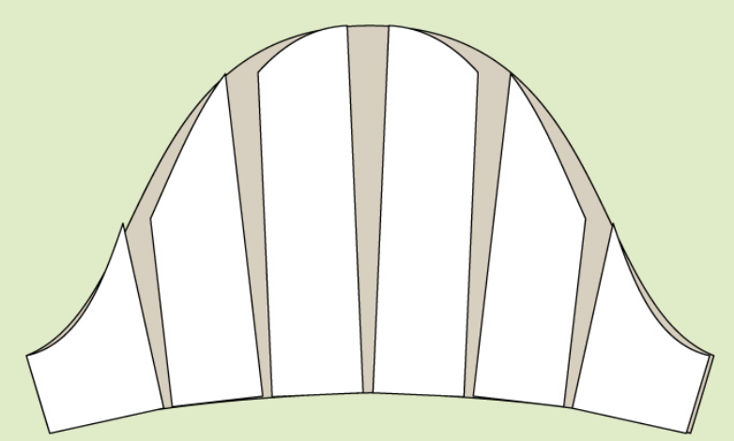
Figure 50 adding fullness unequal

5.5. Documenting used methods and formulas.
Pattern making is a process of creating a blueprint for a garment. There are different methods for pattern making, including pattern drafting with measurements, cloning existing clothes from your closet by tracing them, deconstructing ready-made clothes, developing a block from a commercial sewing pattern, and draping on the stand ¹. The most common 2D patternmaking methods are flat, drafting, and reverse engineering ² Pattern making involves three methods: drafting, draping, and flat pattern making ³.
In the field of fashion design, pattern making is an essential skill that involves creating templates or patterns for garments. These patterns serve as a blueprint for cutting and sewing fabric pieces together to create a finished garment.
There are various formulas and methods used in pattern making, depending on the specific garment being created. One commonly used formula is the flat pattern method, which involves taking measurements of the body and using mathematical calculations to create a pattern that will fit the individual.
The basic steps in the flat pattern method include:
1. Taking accurate body measurements: This involves measuring various parts of the body, such as the bust, waist, hips, and length from shoulder to waist.
2. Drafting the basic pattern: Using the measurements as a guide, the pattern maker creates a basic pattern on paper or cardboard. This pattern includes lines and curves that represent the shape and size of different garment pieces.
3. Adding seam allowances: Seam allowances are added to the basic pattern to allow for sewing and fitting adjustments. The amount of seam allowance added depends on the specific garment and fabric being used.
4. Making adjustments: The pattern is then tested by creating a prototype or muslin sample. Any necessary adjustments, such as increasing or decreasing the size of certain areas, are made to ensure a proper fit.

5.6. Checking Pattern pieces for accuracy
Checking pattern pieces for accuracy is an important step in the pattern making process to ensure that the final garment will fit properly. Here are some steps to check pattern pieces for accuracy:
1. Lay out the pattern pieces: Lay out all the pattern pieces on a flat surface, such as a cutting table or the floor. Make sure they are arranged according to the cutting layout indicated on the pattern instructions.
2. Check measurements: Use a ruler or measuring tape to measure key points on the pattern pieces, such as the bust, waist, and hip measurements. Compare these measurements to the corresponding measurements on the body measurement chart or size chart provided with the pattern. Ensure that the pattern measurements match the desired size.
3. Check seam allowances: Measure the seam allowances on the pattern pieces to ensure they are consistent and accurate. Seam allowances are typically marked on the pattern, but it's always good to double-check.
4. Check notches and markings: Look for notches, dots, or other markings on the pattern pieces that indicate where pieces should be aligned or matched during construction. Ensure that these markings are present and accurate.
5. Check grain lines: Grain lines indicate the direction in which the pattern piece should be placed on the fabric. Check that the grainlines are straight and aligned correctly with the fabric's grain.
6. Check ease and darts: If the pattern includes ease or darts, make sure they are marked correctly and positioned accurately on the pattern pieces. Ease refers to additional room added to a garment for movement, while darts are folded and stitched areas that shape the fabric to fit the body.
7. Test-fit the pattern: If possible, create a muslin or prototype of the garment using inexpensive fabric before cutting into your final fabric. This will allow you to test the fit of the pattern and make any necessary adjustments before sewing the final garment.
By carefully checking pattern pieces for accuracy, you can ensure that your finished garment will fit well and look as intended.

5.7. Completing pattern pieces labeling and markings.
Pattern pieces should be labeled and marked with important information to make the sewing process easier. Here are some common labeling and marking practices:
1. Pattern name or number: Each pattern should have a unique name or number to identify it. This can be written on each pattern piece or on a separate label attached to the piece.
2. Pattern piece name: Each pattern piece should be labeled with its specific name, such as "front bodice" or "sleeve." This helps to identify and organize the pieces during construction.
3. Grainline arrow: The grainline arrow indicates the direction in which the pattern piece should be placed on the fabric. It should be clearly marked with an arrow pointing in the correct direction.
4. Cutting line: The cutting line is the outermost line on the pattern piece and indicates where the fabric should be cut. It should be a solid line and should not be confused with other lines, such as stitching lines or fold lines.
5. Stitching lines: Stitching lines indicate where the seams should be sewn. They are usually marked with dashed or dotted lines and are located inside the cutting line.
6. Notches: Notches are small markings along the edges of pattern pieces that help align and match pieces during construction. They can be marked with small triangles, squares, or other shapes.
7. Darts: If the pattern includes darts, they should be marked with lines and dots indicating where the fabric should be folded and stitched. The dart legs should be labeled with arrows pointing towards the dart point.
8. Fold lines: Fold lines indicate where the fabric should be folded during construction. They are usually marked with a dashed or dotted line and an arrow indicating the direction of the fold.
9. Size markings: If the pattern includes multiple sizes, each pattern piece should be labeled with the corresponding size. This helps to easily identify which pieces to use for each size.
10. Additional markings: Depending on the pattern, there may be additional markings such as pleat markings, pocket placement markings, or buttonhole markings. These should be clearly labeled and marked on the pattern pieces.
By properly labeling and marking pattern pieces, you can easily identify and understand how to assemble the garment correctly.

Self-check 5
Part 1 multiple choice .
- Which is not Reason to Pivot Darts
- To move one dart to a new place on a sewing pattern
- To separate one large dart into several smaller darts
- To merge the fabric suppression in a dart into tucks, pleats or gathers
- To add style lines to pattern and eliminate darts either partially or fully

- Why Make Quilt
- cutting time and fabric selection time is greatly reduced.
- cutting is simple, with only a few straight cuts per block.
- made with larger squares and rectangles, the piecing comes together very fast, especially since there are no seams or points to line up.
- The pattern includes a printable template for you to save and use.
- All answer

Operation sheet 1
Operation sheet title Producing pattern using advanced pattern-making manipulations.( Pivoting)
PURPOSE: to understand the dart manipulation pivotal method
Condition Trainees should know how made up different body shape by youth dart manipulation within pivot method
The tools needed for pivoting darts on sewing patterns are:
Pattern making paper
Hard pencil
Colored pencils
Pattern master or fashion ruler
Paper scissors
Tape measure
Masking tape (the non-tacky option)
Glue stick
Pins
Tracing wheel
Awl
Cutting mat
The pivot method of dart manipulation is when we move the pattern at the dart point, and trace around the pattern to remove or add fullness, instead of cutting into the pattern itself
Pivoting Darts – The Process!
Start by tracing off the one section of the bodice. Starting at the bust point, I traced clockwise along:
The bottom dart leg
Around the armhole
Down the side seam
Across to center front
Up center front
Around the neckline
Down to the bust point to connect the section
Instruction 1
Steps
Create block pattern need to make sure both dart legs are equal in length and that the seam allowance is correct when the dart is pressed towards the center.
Start by creating a fold on the dart leg nearest center front, then bring it over to meet the second dart leg – move in the direction of the arrow as this will create the dart in a way that the fold is towards the center front!
Pin the dart to hold it in place. Notice how the paper no longer lies flat, but has shape to it now the dart is secured in place! You should find that both darts meet at the neckline in the same place! Now, grab your tracing wheel!
Remove the pin and open up the dart. Notice how the seam allowance for the dart is curved and not straight? This is good! Now, grab your pencil (in my case pen) and mark in both the stitch line and the seam allowance line, following the pin-prick traced line!
Transferring a dart using the pivoting method of dart manipulation is complete! Below is how the two pieces look placed on top of each other. If these were both sewn up in calico, they would fit exactly the same – the fabric suppression is exactly the same, we simple transferred it around the bodice by transferring the dart.
Two pieces look placed on top of each other

Lap test 1
JOB TITLE– dart manipulation pivot method
OBJECTIVES: At the end of this session trainees will be able to know how to made up different patterns by use dart manipulation within pivot method
LABORATORY WORK: Materials Required:
Task1. Identify material needs pivot
Task. 2 Identifying the procedure
Task 3 made up of different designs by pivot

Operation sheet 2
OPERATION TITLE Producing pattern using advanced pattern-making manipulations( Square blocking)
PURPOSE: to understand the blocks can be made up of a single fabric or multiple fabrics, and they can be arranged in a variety of ways to create different designs
CONDITIONS: Trainees should know how made up of a single fabric or multiple fabrics, and they can be arranged in a variety of ways to create different designs
Materials
• Pattern
• Fabric
• 30 -10 inch squares (or yardage cu t in squares- see fabric requirements above)
• 12 – solid 10 inch squares (or yardage cut in squares- see fabric requirements above)
• 10 – 3/4 yard solid fabric cut into ten 2.5 inches by WOF (or ten jelly roll strips)
• Rotary Cutter and mat
• Ruler (If you want the use yardage for your quilt, this slotted ruler makes quick and easy work of cutting fabric into 2.5-inch strips.)
• Iron
• Basic quilting supplies
PRINT
The Simple Square Blocks Quilt is a fast and free quilt pattern. The pattern is beginner-friendly and a perfect project for those new to quilting or just looking for a project that can be finished in a short amount of time. Perfect for precuts, you’ll love the simplicity of this easy pattern.
Instructions
Step 1: Cut Fabrics.
1. Cut all the patterned 10-inch squares/ layer cake squares in half.
2. Trim all the white 10-inch squares to 10 by 9.5 inches. (half an inch off one side.)
3. Then cut all the white squares into four 9.5 by 2.5-inch strips.
Step 2: Sew Blocks.
1. Sew two random patterned rectangles together, using a scant quarter-inch seam allowance.
2. To speed up the sewing, I sorted my rectangles into colors, took the stacks to my sewing machine and chain pieced everything together.
3. Press the blocks and trim to 9.5 inches square.
Step 3: Sew Rows.
1. Once all your blocks are sewn together, pressed, and trimmed, you'll want to lay them out on the floor or a design wall to determine the best way to assemble the blocks for color distribution. (I love my portable design wall for this.)
2. working one row at a time, sew the 2.5 inch strips in between each block. I found it best to line up the blocks in a row, sack the stips on top, then stack the squares up in order of how they will be sewn. (You can see this in action in the video I made for this pattern.)
3. Once sewn, press the with the iron and repeat this process for the rest of the rows.
Step 4: Add Sashing between Rows
1. Grab the jelly roll strips (or yardage cut into strips) and sew together end to end. Trim the sewn strip so they are the same width as your rows. (You'll find it takes about 1 and 1/3 of a jelly roll strip.)
2. You need 7 sashing strips for the throw-size quilt.
3. Sew a sashing strip in between each row, plus on the top and bottom of the quilt top.

4. Press the seams flat, toward the colored fabric.
Step 5: Baste and quilt.
Make your quilt sandwich and quilt the simple square blocks quilt top as desired!

Lap test 2
JOB TITLE– Square blocking
OBJECTIVES: At the end of this session trainees will be able to know how to made up of a single fabric or multiple fabrics, and they can be arranged in a variety of ways to create different designs

LABORATORY WORK: Materials Required:
Task1. Identify material needs Square blocking
Task. 2 Identifying the procedure
Task 3 made up of a single fabric or multiple fabrics, and arrange in a variety of ways create different designs

Unit 6. Preparing sample pattern
This unit is developed to provide you the necessary information regarding the following content coverage and topics:
- Toile or prototype is constructed as appropriate in stages or as a complete garment.
- Toile or prototype is examined and assessed in consultation with designer.
- Pattern problems or faults are identified.
- Pattern is altered or adjusted as required to meet design requirements.
- Pattern is finalized and checked to ensure accuracy, completeness and compliance to design requirements.
This unit will also assist you to attain the learning outcomes stated in the cover page. Specifically, upon completion of this learning guide, you will be able to

- Construct Toile or prototype as appropriate in stages or as a complete garment.
- Examine Toile or prototype and assessed in consultation with designer.
- Identify Pattern problems or faults are identified.
- Alter or adjusted Pattern as required to meet design requirements.
- Finalized and checked Pattern to ensure accuracy, completeness and compliance to design requirements.

6.1. Constructing toile or prototype.

6.1.1. WHAT IS A TOILE?
A toile (also known as muslin’) is basically a draft version of a garment. A toile is normally made from a cheaper fabric, so that you can test the fit of a particular garment before cutting into your real (and normally more expensive) fabric.
It is best to choose a fabric to toile in, that is similar to what you plan to make the actual garment in. If you are using a lovely sandwashed silk, then you will need something with a similar handle and drape as the silk, so you can get a good idea of what the final garment will look like. Making a winter coat? Choose something with a similar thickness and drape.
To construct a toile or prototype in fashion design, you can follow these steps:
1. Choose the pattern you want to use.
2. Select the fabric you want to use for your final garment.
3. Choose a cheaper fabric that has similar properties to your final fabric.
4. Cut out your pattern pieces from the cheaper fabric.
5. Sew together your toile using the same techniques you would use for your final garment.
6. Try on your toile and make any necessary adjustments.
7. Make changes to your pattern based on the adjustments you made to your toile.
8. Cut out your pattern pieces from your final fabric and sew together your final garment. How to (and why) make a toile
6.1.2. WHY SHOULD I TOILE?
We all come in different shapes and sizes, and although I may have the same measurements as the girl next to me, this does not at all mean we have the same body shape. Some of us may have a sway back, forward sitting shoulders (that’s me!), narrow shoulders, longer legs etc. By doing a toile, you can quickly see if any adjustment needs to be made. As you sew more garments for yourself, you will get better at knowing what to look for, as you will often notice the same fitting problem across the board.
To make up the dress in your chosen toiling fabric. You don’t have to add facings, collars or pockets etc. I never bother with buttonholes or zips when I toile, I just pin the opening closed when it’s on.
You just want to check the overall fit of the garment, so you will only need the main pattern pieces. There is no need to even finish the seams! Mark the position of pockets so you can check pocket placement, without actually having to sew them.
When sewing, consider using a long stitch length, so that you can quickly and easily unpick any seams that need to be altered. You can also use a contrasting thread to make it even easier to see your stitches. As you will not be adding binding around the neckline and armhole of The Rushcutters, make sure you trim back the seam allowance (1cm) so you can get an accurate idea of how it will look when it’s finished.
NEXT Try it on, get in front of the mirror and take a look! Is it sitting like it should? How does it feel? Can you sit down comfortably? Can you raise your hands in the air without showing off too much booty? Is it hanging properly? Does it feel too tight in any areas?
If you do need to make some changes, then take a pen (or fabric marker / chalk) and draw the changes directly onto the toile.
CHECK THE NECKLINE
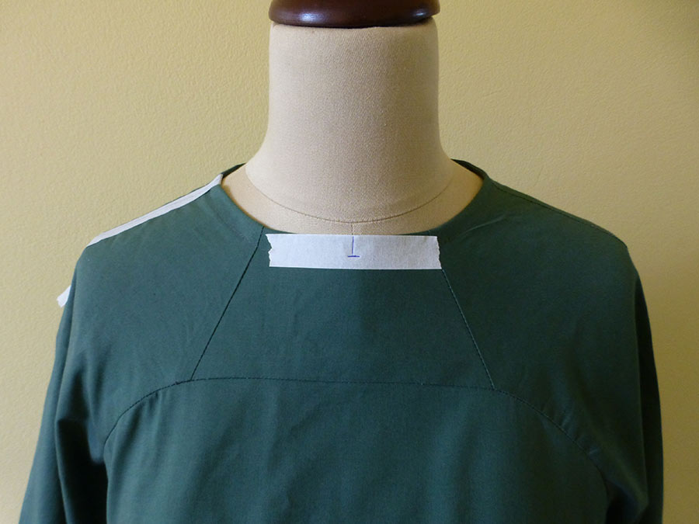

Figure 51 check the neck line
For example, if the neckline is too high, then draw where you would like the neckline to be. If you are toiling in a darker fabric, or making a wearable toile (like I was), then use masking tape to indicate problem areas and mark the changes on that. I also like to use tape to write notes on the toile, if needed.
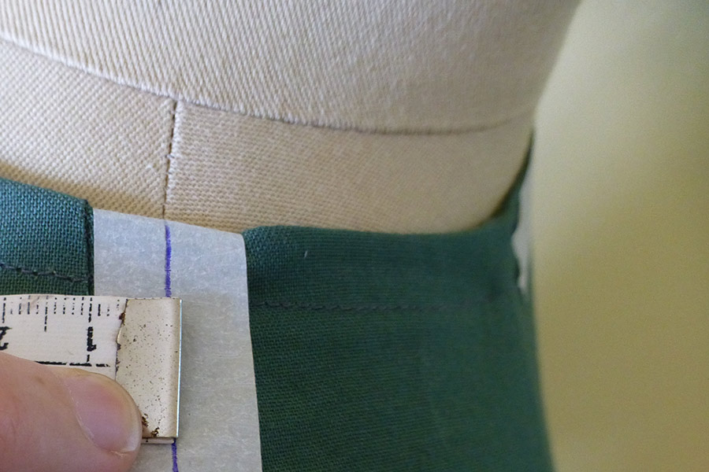
Use a tape measure, or ruler, to make note of any distances / measurements. You can write them directly on the toile (like I do) or write them on a piece of paper.
FOCUS ON THE OVERALL FIT
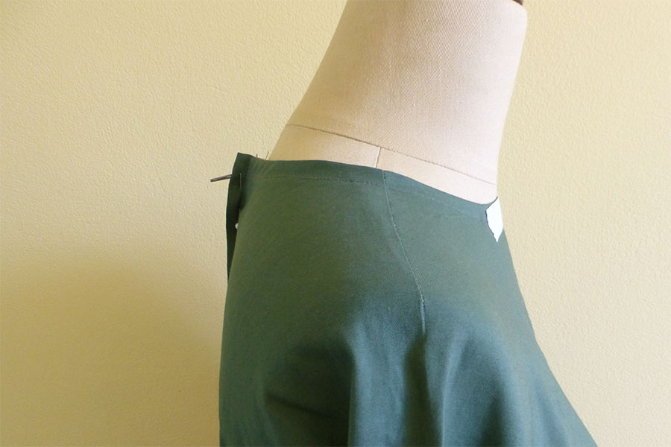
If it feels too big, pin out some of the excess fabric in the side seams and / or centre back.
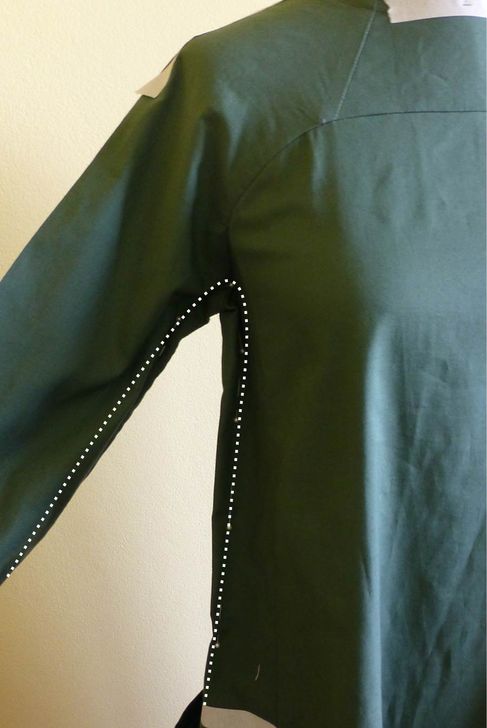
If the dress feels too wide in the body of the dress, pin out the excess in the centre of the SIDE PANEL. Remember, if you bring the dress in at the side, you will also need to reduce the width of the sleeve, as these two pieces join together.
On the contrary, if an area is too tight, cut into the fabric and use pins to fill the gap with a separate piece of fabric.
CHECK THE LENGTH
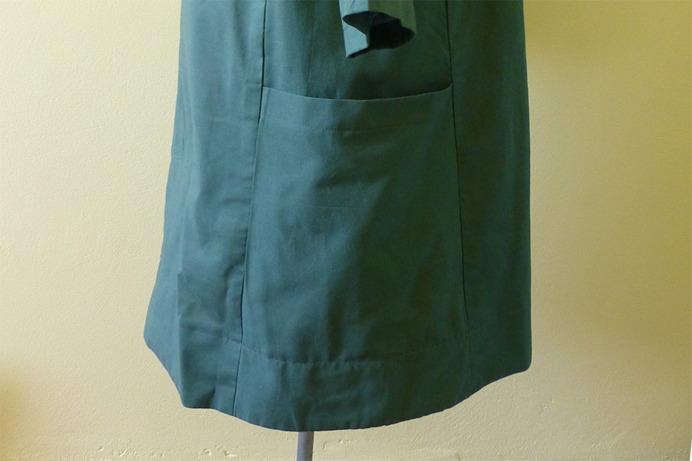
Figure 52 check length
Check the length – does it need to be lengthened or shortened? Place a pin horizontally at your ideal length (or take note of how much longer you would like to make it).
Is the hem sitting straight
You will see in the image above that the hem lifts slightly at the front - this could be a sign of needing to do a full bust adjustment (my dummy has quite large breasts for her size!) The same goes for the back. If the hem is lifting at the back, you may need to add some length to the pattern.
FOCUS ON THE PLACEMENT / POSITION OF DESIGN DETAILS
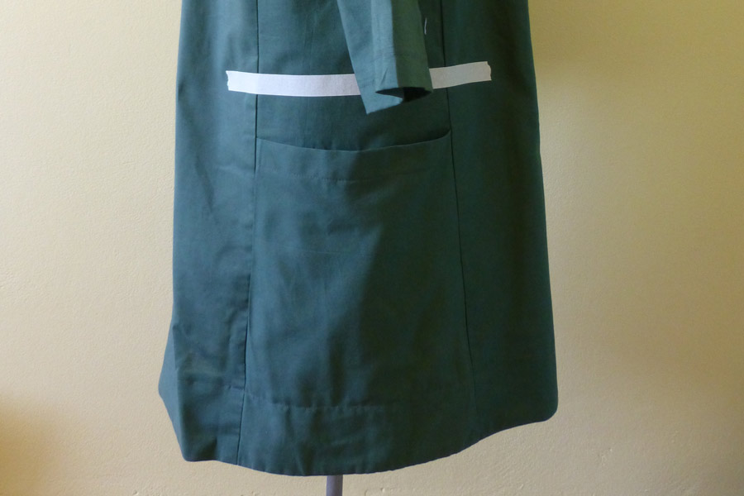
Figure 53 focus on design detail
Check the pocket placement (whether it is with actual pockets or just markings of where they are) and make note of any changes required.
Check dart placement / shoulder seams
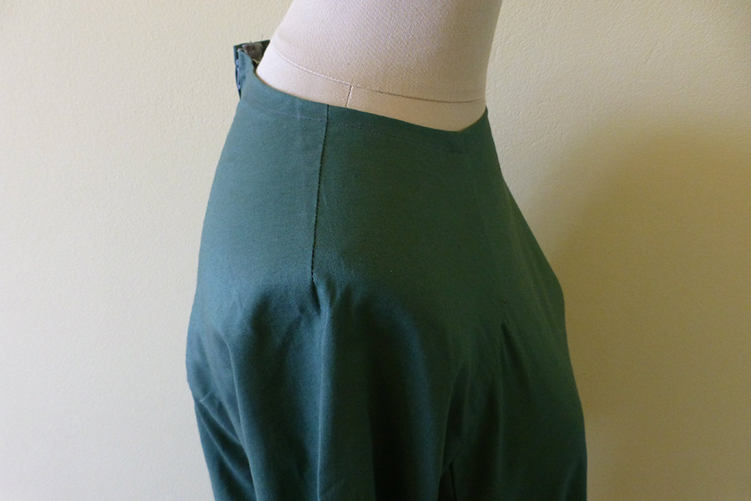
For View A, check the placement of the shoulder dart. Does it sit on your shoulder and finish at the peak of your shoulder? You will see in the image above, that the dart sits slightly back from the shoulder line.
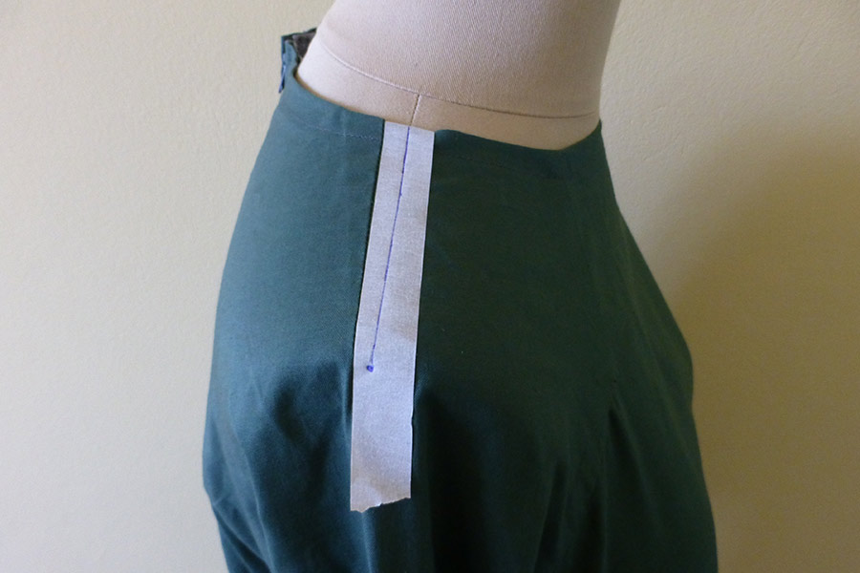
To mark the change I required, I used masking tape to draw in the new dart position (being sure to also mark the dart point).
For View B, check that the shoulder seam lies on your shoulder. Re-draw the shoulder seam if you feel it needs to be further forward or back.

6.2. Examining and assessing toile in consultation with designer.
To examine and assess toile in consultation with a designer, you can follow these steps:
1. Understand the purpose of the toile: Toiles are mock-ups or prototypes of a garment or design. They are typically made from inexpensive fabric to test the fit, construction, and overall design before creating the final piece. Before examining the toile, make sure you understand the designer's intentions and what they are looking to achieve.
2. Review the design specifications: Familiarize yourself with the designer's specifications for the garment or design. This may include details such as the desired silhouette, construction techniques, fabric choices, and any specific design elements they want to incorporate.
3. Assess the fit: The fit of the toile is crucial in determining how well the final garment will suit the wearer. Check the fit of the toile on a dress form or a live model, if available. Pay attention to areas such as shoulder seams, armholes, waistline, and hemline. Look for any areas that may need adjustment or alteration.
4. Evaluate the construction: Examine the construction of the toile to ensure it aligns with the designer's vision. Look for clean and precise stitching, properly finished seams, and accurate placement of any design details such as darts, pleats, or gathers. Identify any areas that may require improvement or refinement.
5. Consider the fabric choice: Assess the fabric used for the toile and evaluate its suitability for the design. Consider factors such as drape, weight, texture, and color. Discuss with the designer if any changes in fabric choice are necessary to achieve their desired aesthetic or functionality.

6.3. Identifying pattern problems or faults.
In addition to labeling and marking pattern pieces, it is also important to identify any problems or faults in the pattern before beginning the sewing process. Here are some tips for identifying pattern problems:
1. Check the measurements: Compare the measurements provided on the pattern to your own body measurements. If there are significant discrepancies, it may indicate an issue with the pattern's sizing.
2. Test the fit: Before cutting out your fabric, it can be helpful to make a muslin or test garment using inexpensive fabric. This allows you to check the fit and make any necessary adjustments before cutting into your final fabric.
3. Look for inconsistencies: Examine the pattern pieces for any inconsistencies or errors in the markings, notches, or lines. If something doesn't look right or doesn't match up, it may be a sign of a problem with the pattern.
4. Read reviews or seek advice: If you are using a commercial pattern, check online reviews or sewing forums to see if others have encountered any issues with the pattern. You can also seek advice from more experienced sewers who may be able to help identify any potential problems.
5. Make a mock-up: If you are unsure about the fit or construction of a pattern, consider making a mock-up using scrap fabric or an old bedsheet. This allows you to test the pattern without wasting your good fabric.
By carefully examining the pattern and addressing any problems or faults before starting the sewing process, you can ensure that your finished garment will turn out as desired.

6.4. Altering pattern.

6.4.1. Introduction Pattern alteration
Pattern alteration is the process of customizing patterns to fit according to body shape. For example, shortening arms or lengthening a top. Patterns are prepared according to standard measurement charts which are based on average sizes 1. After measuring the human body and adding needed ease, compare this measurement to the pattern’s measurement. All commercial patterns are made to standard average body measurements for each figure type or size. Companies spend a lot of time and money inviting the public to take part in measurement surveys, eager for their patterns to fit as many people as possible 1. In reality, of course, we are all different – but standardizing measurements is a necessary process for the industry.
Once the fabric is cut, however, fitting adjustments are limited to existing darts and seam allowances. Before cutting the garment, check the pattern fit and alterations according to the correct body measurement that will eliminate many problems from fabric. Therefore, fitting problems should be solved before the garment is cut by making needed changes in the pattern
A Basic Guide on Pattern Alterations for Beginners Introduction:
Fitting is an important part that makes a garment perfect. The art of garment fitting requires skill and patience. When standard fit is done, garments will look better and feel more comfortable. Making apparel which really fits is one of garment making’s greatest challenges and crucial successes. No matter how lovely the fabric, how fine the garment design, or how expert the sewing, the results are disappointing if the garment fits poorly. Perfect measurements are the key of good fit.
Good fit are influenced by many things such as:
The current fashion look,
The hang and stretch of the fabric,
The amount of ease preferred and
Figure size and type.
A pattern can be altered and adjusted three ways:
By folding out excess fullness to make an area smaller.
By slashing and spreading to increase dimensions, or slashing and overlapping to decrease dimensions.
By redrawing darts or seemliness.
Importance of Pattern Alterations:
To get a perfect fit on your figure, garment is cut after the pattern is altered.
If the pattern is altered before the fabric is cut, there will be no adjusting in the final fitting.
There is no danger of wasting expensive fabric and spoiling the garment.
Each adjustment necessary in the flat pattern for saving time and avoid ripping later.
Sometimes alterations are essential to get perfect pattern.
Keep the records of pattern alterations and their effectiveness; it is the way to perfect individual requirements.
Patterns Alteration Standards:
Original grain-lines are saved.
Patterns are kept in balance and proportion.
Change is created only where needed and is not obvious.
Designer’s lines are protected.
Basic Rules or Techniques of Pattern Alteration:
Traditionally, alteration of garment patterns is an essential step in producing attractive and accurately fitting clothing from patterns which already exist. There have been numerous publications by tailoring experts on how to alter garment patterns for different figure forms. Alterations can be done by using measurements, taken by a tape measure and incorporating them onto a paper pattern using the slash, seam or pivot methods.
Basic pattern alteration techniques are given below:
All similar pieces must be altered to correspond with the alterations on the major piece.
Additions or extensions must be made by taping an extension strip to the edge involved.
Altered patterns must have the same character as the original pattern piece.
Correct movement on altered pattern to give the altered line the same character as the original line.
The altered pattern must be properly flat, as like the original pattern piece.
There are also some methods for pattern alteration:
Pattern alteration for flattering the figure
Pattern alteration for non-standard figures
Pattern alteration with experimental methods
Pattern alteration using computer-aided design (CAD) programs

6.4.2. Principles of Pattern Alteration:
1. A far as possible make changes within the pattern by slashing and spreading or slashing and lapping. Patterns can also be altered by redrawing the edges of the pattern. (This is the method adopted for altering garments at the time of fitting.) But the first method is by far the best in altering paper patterns.
2. To preserve the original grain line, make all slashes and folds parallel or perpendicular to the grain line (to center front line, center back line etc.).
3. Where there are darts, make changes between the tip of the dart and the outside edge.
4. If an alteration in length is made along one edge of the pattern, take care to make an identical alteration in the adjoining edge. For example, if back shoulder seam is shortened the front shoulder seam should also be shortened.
5. When tucks or darts are used for making a pattern smaller, remember that the width of these should be just half the amount to be removed.
6. When decreasing or increasing the width of pattern pieces, if only half the pattern (half back or half front) is used, subtract or add only one fourth of the total adjustment to be made. For example, if waist measurement has to be increased by one inch, add ¼” to the half back pattern and the same amount to the front pattern. If only a front or back section needs adjustment, add or minus half the amount of the adjustment to the respective section.
7. When the pattern alteration involves slashing and spreading, it is necessary to keep a sheet of paper beneath and to pin or stick to it the spread-out parts so that they will thereafter remain in position. On spreading or lapping after slashing, some edges of the pattern become jagged. These must be trimmed after drawing the new seam lines.
6.4.3. Pattern Alterations for Basic Fit Problems:
Most of common fitting problems are increase or decrease in height and width. Alterations help to increase the life of the garment.
Before cut the fashion fabric check the pattern fit, only the basic parts of the garment together. Take a helping person who helps you to check the fit of the garment. Otherwise you stand in front of a full-length mirror. Use the following checklist that helps you, if further alterations or minor fitting is needed for a good fit.
Adequate wearing ease is available for sitting, moving and bending.
Armhole seams curve smoothly over the end of shoulder.
Crosswise grain lines are parallel to floor.
Crotch depth is right, neither too low and baggy nor too tight and binding.
Darts point to the fullest part of the curve.
Hemline is even.
Hipline fits smoothly.
Lengthwise grain lines, side seams, center front and center back seams hang straight or at right angles to the floor.
Pant legs hang smoothly and do not restrict any part of the legs.
Pants hang smoothly from the waist. The waistband fits the body comfortably and stays in place when bending and sitting.
Pants have no pulls or excess fabric across the front or back crotch level.
Shoulder seam length comes to end of shoulders.
Sleeves are comfortable with no wrinkles.
The length of the garment is becoming.
Conclusion:
Body contour, posture, body proportion and symmetry affect the fit of clothing. Patterns are designed for an average symmetrical body shape, with standard posture and body proportions. Very few individuals are the same size and shape as this standard model; therefore, pattern alterations need to be made before garment pieces are cut and fitting adjustments are also made during the assembly process.
Finalizing and checking pattern
Once you have identified any problems or faults in the pattern, it is important to finalize and check the pattern before proceeding with sewing. Here are some steps to follow:

1. Make any necessary adjustments: If you have identified fit issues or inconsistencies in the pattern, make the necessary adjustments to ensure a proper fit. This may involve grading between sizes, adding or removing length, or making other alterations.
2. Double-check markings and notches: Go over the pattern pieces again to ensure that all markings and notches are clear and accurate. If any are missing or unclear, make the necessary adjustments or add your own markings.
3. Check seam allowances: Verify that the pattern includes seam allowances and that they are consistent throughout. If the pattern does not include seam allowances, add them as needed.
4. Test the construction: Before cutting into your final fabric, consider doing a trial run of the construction process using scrap fabric or an old bedsheet. This will allow you to practice the techniques involved and make sure everything comes together correctly.
5. Review instructions: Read through the pattern instructions thoroughly to make sure you understand all the steps involved. If anything is unclear or confusing, seek clarification from the pattern designer or consult sewing resources for guidance.
6. Consider making a second mock-up: If you made a mock-up earlier to test the fit, it can be helpful to make a second mock-up using your finalized pattern. This will give you a chance to double-check that all adjustments have been made correctly and ensure that the final garment will fit properly.
By taking the time to finalize and check the pattern before beginning the sewing process, you can save yourself potential headaches and ensure a successful outcome for your project.

Self-check 6 Part I Matching
A |  | B
1 | Negative Ease | A | make super fitted garments, very close fitting garment for warm weather or layering.
2 | Zero Ease | B | difference between your body measurements and the garment’s measurements that allow you to move
3 | Positive Ease | C | Ease based on the intended fit of the garment
4 | Wearing Ease | D | Truly look like a rectangle when the arms are held out at the sides.
5 | Style Ease | E | Garment will loosen with wear and movement to some degree until it is washed again.
Part 2 multiple choice
- Good fit are influenced by:
- The current fashion look,
- The hang and stretch of the fabric,
- The amount of ease preferred and
- Figure size and type.
- All answer
- Importance of Pattern Alterations’ except
- To get a perfect fit on your figure,
- There is danger of wasting expensive fabric and spoiling the garment.
- For saving time and avoid ripping later.
- To get perfect pattern.
- Which is false methods for pattern alteration:
- Pattern alteration for flattering the figure
- Pattern alteration for-standard figures
- Pattern alteration with experimental methods
- Pattern alteration using computer-aided design (CAD) programs
- How to Check the Altered Fit?
- Adequate wearing ease is available for sitting, moving and bending.
- Armhole seams curve smoothly over the end of shoulder.
- Crosswise grain lines are parallel to floor.
- Crotch depth is right, neither too low and baggy nor too tight and binding.
- All answer

UNIT 7 Developing Pattern Portfolio
This unit is developed to provide you the necessary information regarding the following content coverage and topics:
- Prepare Patterns for product development and sampling.
- Prepare Specification documents as required.
- File Patterns and store.
This unit will also assist you to attain the learning outcomes stated in the cover page. Specifically, upon completion of this learning guide, you will be able to
- Prepare Patterns for product development and sampling.
- Prepare Specification documents as required.
Prepare File Patterns and store

.

7.1. Preparing patterns for product development and sampling.

7.1.1. Introduction
To prepare patterns for product development and sampling, follow these steps:
1. Finalize the design: Ensure that the design is complete and approved before moving forward with pattern preparation. Make any necessary adjustments or modifications to the design.
2. Determine the size range: Decide on the size range for your garments. Consider factors such as target market, customer demographics, and industry standards. Create a size chart that includes measurements for each size in the range.
3. Draft the base pattern: Start by creating a base pattern for the garment. This is a basic template that will be used as a starting point for all sizes in the range. Use a pattern drafting tool or software to accurately measure and draw the base pattern.
4. Grade the pattern: Grading is the process of scaling the base pattern up or down to create patterns for each size in the range. Use grading rules and techniques to ensure that the proportions and fit of the garment are maintained across all sizes.
5. Test the patterns: Cut out and sew test garments using the graded patterns. These test garments, also known as samples or prototypes, will help you assess the fit, proportions, and overall construction of the garment. Make any necessary adjustments to the patterns based on the feedback from the test garments.
6. Create production patterns: Once the patterns have been tested and finalized, create production patterns. These are the patterns that will be used to cut out fabric and produce the final garments. Transfer all necessary markings, notches, and seam allowances onto the production patterns.
7. Create marker layouts: A marker layout is a plan that shows how pattern pieces should be arranged on fabric to minimize waste during cutting. Use marker making software or manually create marker layouts to optimize fabric usage and maximize efficiency during production.
8. Prepare pattern files: Organize and save your pattern files in a format that is compatible with your production process. This could be digital files in formats such as PDF or DXF, or physical pattern pieces that are neatly labeled and stored.
By following these steps, you can effectively prepare patterns for product development and sampling, ensuring that your garments are accurately sized and ready for production

7.1.2. Garment Sampling: A Complete Guide
Garment sampling in simplified terms is the process in which a physical prototype is created from a clothing design concept. Garment sampling is one of the first and most crucial steps in the production of clothing. In this guide we are going to explore garment sampling in depth to give you everything you need to know.
The garment sampling process varies significantly for each brand. This all depends on the size and budget of your brand. As well as the complexity of the garment. Its not uncommon for big brand names to order 10,000 pieces of clothing in one style. This is a large investment so it’s crucial that they get there designs exactly spot on before bulk production.
In contrast smaller brands tend to have smaller budgets, less time and simpler designs. In most cases, smaller brands utilize a more simplified and cost effect sampling process.
3 Phases of Garment Sampling
The design phase of garment sampling is where technical designers will create digital patterns from the information provided on the tech pack. Depending on how good the initial design information is, technical designers may have to communicate back and forth with the customer to seek approval on making changes to make the garment ergonomically work.
In the evaluation phase, sample makers will then create a physical sample of the design. They use dummies or mannequins with highly accurate body dimensions to fit the sample on. They do this to ensure the garment fits perfectly before sending it to the customer for evaluation and approval.
In many cases the customer may seek to make some minor adjustments. The customer can create a new sample. Or in the production phase adjustments can be made.
Finally, once approved production phase samples are created for the garment manufacturer. They use these final samples to communicate and use as an example for the production team to ensure quality control.

7.1.3. Types of Samples
1. Mockup
A mockup or muslin is the very first sample. It’s basically a loose take of a design concept to help visualize what the garment would look like three dimensional. It is usually made from inexpensive fabric and generally doesn’t include any trims or extras. This style of sample is generally used by creative in-house designers working on their own range. Its generally a very hands-on approach which may take many revisions to perfect. Garment manufacturers generally do not provide this service.
Development Sample
The development or proto sample is what initiates the entire production cycle. Most reputable clothing manufacturers will require complete tech packs to ensure there is little time wasted in communication and revisions. Development samples are generally constructed out of the correct fabrics and trims. In some cases, customers with an existing relationship with a reputable garment manufacturer may opt to speed up the process by only using similar fabrics.
Smaller brands often only use development samples for a simplistic, affordable and time efficient solution to sampling. When done correctly and with the right manufacturer, it can be a fantastic option.
Digital Garment Sample
In the past, digital garment samples had never really been adopted as a suitable option to sampling. The technology wasn’t advanced enough. However the evolution of technology in the textile and design industry has since skyrocketed.
Digital sampling technology is now a serious contender to reshape the entire industry. Digital samples are three dimensional digital renderings of design concepts. They now have the ability to visualize the fit and fall of a garment in motion or resting still.
This is still out of reach for most manufacturers and designers as the cost of this early technology is very expensive.
Fit Sample
Fit samples are as the name would suggest. The customer uses this to perfect the fit and drape of the garment. They are created using digital patterns and are fitted to custom built mannequins with accurate life-like dimensions. Small adjustments may need to be made to perfect the fit. The digital patterns will then be updated to reflect the changes.
Size Set Sample
The tailor grades the pattern across all sizes. Afterward, the technical designer will digitally grade or scale the sizes according to grading rules to fit all sizes. The customer approves the size set sample before full production begins.
Sales Sample
Sales samples are the final complete garment with the correct fabric and trims. Big brands who wholesale their garments to retail stores use these. Sales teams from the brand will use them to sell new ranges.
GPT Sample
Some big brands may require Garment Package Test or Garment Performance samples. The manufacturer uses GPT samples to test seam strength, color fastness amongst a plethora of other testing options.
Pre-production sample
The very first garments made in full production are pre-production samples. The manufacturer uses these samples as a final approval mechanism.
Development samples and pre-production samples can be interchangeable for smaller brands.
Top of Production
Large to medium size brands often hire third party quality control inspection officers to inspect garments during and after production. They do this to ensure consistency and quality throughout and after production. TOP samples refer to garments that an inspection officer might choose randomly from the production floor.
Shipment Sample
The manufacturer completes bulk production and keeps a shipment sample. The Manufacturer keeps this garment as a reference to address queries.
Conclusion
As you can see, the sampling process can be a very costly and time intensive exercise. Subsequently, large brands use most of the sample types explained in this article. Creating samples up to 1 year before bulk production begins. Lastly, big brands have large product development budgets and many of their samples never make it to final production.
In contrast, many smaller brands will generally take all of their samples to full production and follow a simple 3 step process:
1. Create tech pack with designer
2. Order 1 development sample
3. Make minor adjustments on pre-production sample
4. Proceed with bulk production
It goes without saying; you will need a capable manufacturer to pull this off. Yoke Apparel Manufacturing based in Vietnam not only has the capability and know how to work with big brands but also offers many easy tailor made solutions for smaller brands.

7.2. Preparing required specification documents.
In addition to preparing patterns, it is important to also prepare the necessary specification documents for product development and sampling. These documents provide detailed instructions and information about the desired characteristics and requirements of the garment. Here are some steps to prepare these specification documents:
1. Style sheet: Create a style sheet that includes all the essential details about the garment, such as style name, description, reference images or sketches, fabric and color requirements, and any specific design features or details.
2. Measurement chart: Develop a measurement chart that outlines the required body measurements for each size in the size range. Include instructions on how to take these measurements accurately.
3. Construction details: Specify the construction details of the garment, such as the type of stitches, seam finishes, closures (zippers, buttons, etc.), and any additional embellishments or trims.
4. Fabric and material specifications: Provide detailed information about the recommended or required fabrics and materials for the garment. Include specifics such as fabric composition, weight, color, and any special treatments or finishes.
5. Quality standards: Define the quality standards and requirements for the garment. This can include criteria for fabric quality, stitching quality, durability, and overall appearance.
6. Packaging and labeling instructions: If applicable, provide instructions for packaging and labeling the finished garments. This can include details on how the garments should be folded, packed, and labeled with necessary information such as size, care instructions, and branding.
7. Timeline and deadlines: Clearly communicate any deadlines or timeline expectations for the development and sampling process. This helps ensure that everyone involved understands the project timeline and can plan accordingly.
By preparing these specification documents, you provide clear guidelines and instructions to your team or manufacturer, ensuring that the final product meets your desired standards and requirements.

7.3. Storing and filing patterns.
Storing and filing patterns is crucial for easy access and organization. Here are some steps to effectively store and file patterns:
1. Choose a storage system: Decide on a storage system that works best for you. This can include physical storage options like folders, binders, or filing cabinets, or digital storage options like cloud-based platforms or computer folders.
2. Label and categorize patterns: Assign labels or categories to each pattern to make it easier to locate and retrieve later. This can be based on garment type, season, or any other relevant criteria.
3. Use clear and consistent naming conventions: Develop a naming convention for your patterns that is clear and consistent. This can include including the style name, size range, and any other relevant details in the pattern name.
4. Store patterns in protective covers: If using physical storage options, consider storing patterns in protective covers or sleeves to prevent damage from dust, moisture, or handling.
5. Create an inventory system: Keep track of your pattern inventory by creating an inventory system. This can be a simple spreadsheet or database that lists all the patterns you have, along with their location or file path.
6. Regularly update and review: Regularly update your pattern storage system by adding new patterns and removing outdated or unused ones. Also, periodically review your inventory to ensure accuracy and make any necessary adjustments.
7. Back up digital files: If storing patterns digitally, regularly back up your files to prevent loss in case of technical issues or data loss.
By implementing an organized system for storing and filing patterns, you can save time and effort when searching for specific patterns, ensuring efficient workflow and production processes

Unit 8 .marinating records
This unit is developed to provide you the necessary information regarding the following content coverage and topics:
- Recording and maintaining prepared report.
This unit will also assist you to attain the learning outcomes stated in the cover page. Specifically, upon completion of this learning guide, you will be able to
- Record and maintain prepared report.

8.1. Recording and maintaining prepared report.
To effectively store and file patterns, it is important to keep a record of your inventory and maintain a prepared report. Here are some steps to do so:
1. Create a pattern record template: Develop a template that includes fields for pattern details such as pattern name, category, size range, location (physical or digital), and any other relevant information.
2. Fill in the pattern record: Whenever you add a new pattern to your collection, fill in the pattern record with all the necessary details. This will help you keep track of your inventory and easily locate patterns when needed.
3. Update the pattern record regularly: As you add or remove patterns from your collection, make sure to update the pattern record accordingly. This will ensure that your inventory remains accurate and up-to-date.
4. Review and audit the pattern record: Periodically review your pattern record to check for any discrepancies or errors. Conduct an audit to ensure that all patterns are accounted for and that there are no missing or duplicate entries.
5. Maintain a backup of the pattern record: Just like with digital files, it is important to have a backup of your pattern record. Keep a physical copy or store it on a separate device or cloud-based platform to prevent loss in case of damage or technical issues.
6. Keep the pattern record accessible: Store the pattern record in a place where it is easily accessible to you and any other team members who may need to reference it. This could be a physical binder or folder, or a shared digital document.
By maintaining a prepared report of your pattern inventory, you can easily track and manage your patterns, ensuring efficient organization and retrieval when needed.

Self chek 7
Part I Matching
A |  | B
1 | The tailor grades the pattern across all sizes. | A | Development Sample
2 | Three dimensional digital renderings of design concepts. | B | A mockup
3 | fitted to custom built mannequins with accurate life-like dimensions. | C | Size Set Sample
4 | first sample. | D | 1Digital Garment Sample
5 | Constructed out of the correct fabrics and trims. | F | Fit Sample
6 | to test seam strength, color fastness amongst a plethora of other testing options. | G | Sales Sample
7 | the final complete garment with the correct fabric and trims | h | Pre-production sample
8 | The Manufacturer keeps this garment as a reference to address queries. | I | Top of Production sample
9 | . The manufacturer uses these samples as a final approval mechanism. | J | GPT Sample
10 | garments that an inspection officer might choose randomly from the production floor | K | Shipment Sample
.

