FASHION DESIGN
Level-VI
Based on March, 2022 Curriculum Version-1

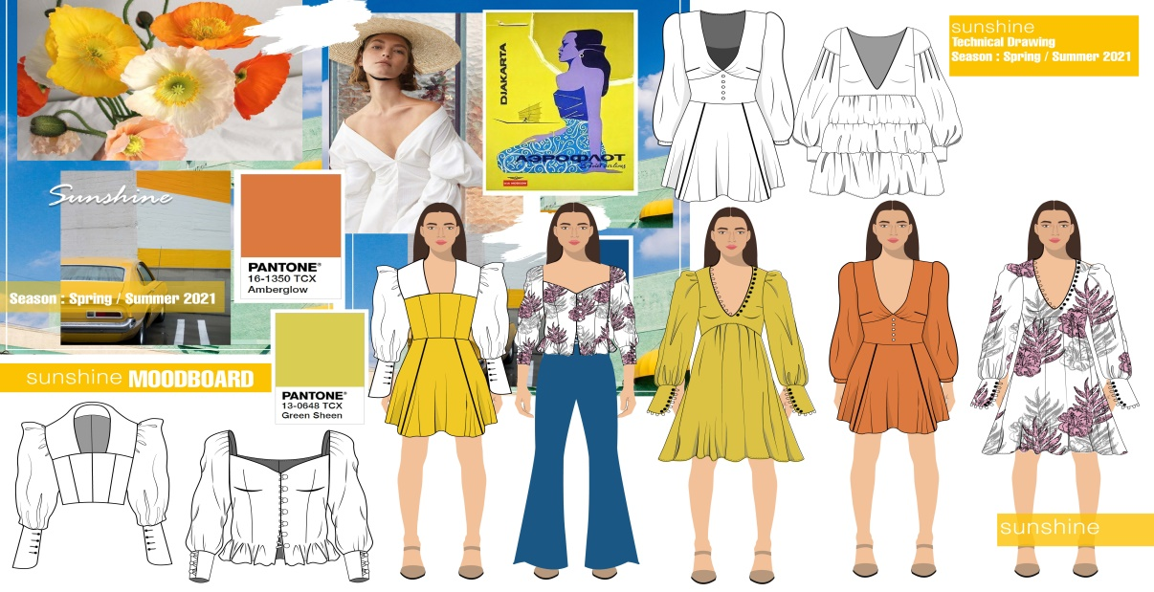
Module Title: Produce Fashion Collection

Module code: IND FAD4 12 1221

Nominal duration: 120 Hour

Prepared by: MPTC

Based on Semte, 2023
Addis Ababa, Ethiopia

Table of content
Table of content 1
Acknowledgment 4
Module Introduction 6
This module covers the units 6
Learning Objective of the Module 6
Module Instruction 6
Unit one: Determine job requirements 7
1.1 Analyses market trend Standard operating procedures are followed 8
1.2 Work health and safety requirements are compiled at all times 8
1.3 Appropriate personal protective equipment is used 9
1.4. OHS practices and workplace practices for dealing with hazards are identified and followed 9
Self-Check 1 Written Test 11
1.Workplace related injuries, illnesses and deaths impose costs upon? 11
Unit Two: Plan workflow 12
2.1 Prepare Workstation, tools and equipment 13
2.2 planned production efficiency efficient workflow considering quality standards 13
Self-check 2 15
Unit Three: Prepare component 16
3.1 Pattern and interfacing Selected according to size require 17
3.1.1.Selecting Interfacings, Underlining, and Linings 18
3.1.2.Uses for Interfacing Fabric 21
3,1.3.Tips for Using Interfacing Fabric 22
3.1.4 How to Read a Sewing Pattern? 23
3.1,5. Tips for Using a Sewing Pattern 25
3.2. Selected and arranged following tech pack Required fabric, interfacing, trims, yarn and accessories. 25
3.2.1 What is a Tech Pack? 26
3.2.2 What Is Interfacing? The Different Types & Its Uses 32
3.2.3.Different types of trims used in garment making 37
3.2.4 ,Types of yarn 41
3.3.1.Garments Manufacturing Process: 67
3.3.2. Sequence of Garment Manufacturing are given below in details: 69
3.3.3. Sequence of Garment Sample Development 69
3.3.4. Flow Chart of Proto Sample Development in Apparel Industry 71
3.3.5. Production Pattern: 73
3.3.6. Difference between manual and computerized method of marker making: 76
3.3.7. Factors on which marker efficiency depends on: 77
3.4.1.What is a marker in apparel Industry? 98
3.4.2.Why a marker is needed for cutting in apparel manufacturing ? 98
3.4.3.How a marker is made ? 98
3.4.4. Pattern Markings and Symbols 99
3.4.5.What are pattern symbols and markings and what are they used for? 99
3.4.6. Why are pattern symbols important? 99
3.4.7.Why are pattern symbols and markings different on some patterns? 99
3.4.8.What are the types of pattern markings and symbols? 100
3,5 Layout according to sequence of assembly operations Garment component 107
3.5.1.Basics of Apparel Plant and Sewing Machines Layout 109
Self-check 3 112
Unit one: 4 Assemble garment components and finish complex garments 114
4 .Assemble garment components and finish complex garments 115
4.1. Integrating division of labor 115
4.2 . Assemble garment components 116
4.2.1Assembly of the Garment 116
4.2.2.Garment Assembly System 116
4.2.3.Automated Garment Assembly 117
4.2.4.Process Of Garment Assembly 117
4.2.5.Why and How to Specify the Assembly of a Garment 118
4.3. Controlling machine speed and work handling for type of sewing operations 120
4.3.1.How to Set Sewing Machine Speed 121
4.3.1 Sewing Machine Speed 121
4.4. Sewing components 127
4.5. Checking assembly garment quality 128
4.6.Pressing components according to workplace procedures 132
4.6.1 Pressing: Important Finishing Process in Garment Industry 132
4.6.2. Objectives of Pressing Process in Garment Industry 134
SELF CHECK 4 135
Unit one: 5 Completing work 136
5.1. Completing all garments and finalize finishing 137
5.2. Inspecting and identifying faults 142
5.3. Recording outcome including time frame 145
5.4.Identifying options for improvement of manufacturing process of a collection 146
Self-check 5 151
Unit one: 6 Arranging collection for presentation 152
6.1 .Arranging every outfit by presenting the entire piece 153
6.2. Comparing and concluding collection in comparison with design 153
Self-check 6 156
References 157

Figure content table
Figure 1: first aid symbols 10
Figure 2 personal protective equipment. 10
Figure 3 ;multiple views of a handbag 28
Figure 4. Detailed pocket sketches 28
Figure 5 .Difference between illustration and a fashion flat sketch 29
Figure 6w nowMenswear Jacket 31
Figure 7 Women's shoulder bag 32
Figure 8 Bed linens 32
Figure 9 woven interfacing 33
Figure 10 knit interfacing 34
Figure 11 stretch fabric. 34
Figure 12. fusible (iron on) interfacing 36
Figure 13. B, S- and Z-twist yarns 42
Figure 14 diagram of single, ply, and cord yarns 42
Figure 15 examples of textured yarns 43
Figure 16 three basic motions of weaving 47
Figure 17.Jacquard loom 51
Figure 18.diagram of a modern handloom 53
Figure 19.Basic weaves 55
Figure 20.Types of garment accessories 62
Figure 21.Hangtags 63
Figure 22.Price tag 63
Figure 23.Polybag 64
Figure 24.Carton 64
Figure 25;Scotch Tape 65
Figure 26;Clips 65
Figure 27;Clothes Hanger 66
Figure 28 ; Garments Manufacturing Process 67
Figure 29;Garment Proto Sample Development 71
Figure 30;Marker making 74
Figure 31;Garment marker plan 77
Figure 32Constraints of marker making 78
Figure 33; Automated method of fabric spreading 82
Figure 34; Sewing section 84
Figure 35; Inspection in Garment Industry 91
Figure 36; Pressing Process in Garment Industry 92
Figure 37.Steam Iron 95
Figure 38;Steam pressing machine 95
Figure 39;These two lines can be extended from the middle point of the neck width measurement down the bottom of the garment. 100
Figure 40;Grain line 100
Figure 41; Grain line symbol 101
Figure 42Fold line / Cut on fold 101
Figure 43;Notch / Double Notch 102
Figure 44Seam line / Stitching line 102
Figure 45;Cut line / Cutting line 103
Figure 46;Alteration / Adjustment line 103
Figure 47;Button / Buttonhole 104
Figure 48;Zipper 104
Figure 49;Dart 105
Figure 50;Bust Point 105
Figure 51;Pleats / Tucks / Gathers 106
Figure 52;Other element position 106
Figure 53;Basics of Apparel Plant and Sewing Machines Layout 109
Figure 54;The manufacturing system PBU assembly line, sectional assembly line, etc. 111
Figure 55;What is the Garment's Assembly? 116
Figure 56;The steps involved in the assembly of a garment are 117
Figure 57;Sewing 119
Figure 58;Sewing Machine Speed 121
Figure 59;How to adjust the speed on a singer sewing machine? 124
Figure 60;Pressing Process in Garment Industry 133
Figure 61;Ironing process in Garments 139
Figure 62;Garments Packing Process 140
Figure 63;AQL Process 141
Figure 64;Fabric Inspection 143
Figure 65;Four Point System for Fabric Inspection 143
Figure 66;Recording (plans / case notes) 146
Figure 67 ;Strategies for optimizing your production processes 149
Table of content
Table 1: Button Size Chart 38
Table 2: Difference between manual and computerized method of marker making 76
Table 3: Difference between automatic and interactive marker making 76
Table 4: Marker inspection 81
Table 5:Diagram in how sewing section perform 85
Table 6: Basic Shirt Manufacturing Process 88
Table 7:On the basic of cut mark 145

Acknowledgment

Garment section wish to extend thanks and appreciation to the many Representatives of TVET instructors and respective industry experts who donated their time and expertise to the development of this Teaching, Training and Learning Materials (TTLM).

Module Introduction
This module covers the knowledge, skills and attitude to manufacture a range of garments as a fashion collection. It involves all operations in fashion collection from written specification and delivered pattern

This module covers the units
Determine job requirements

Plan workflow

Prepare component

Assemble garment components and finish complex garments

Complete work

Arrange collection for presentation

Learning Objective of the Module

job requirements

Plan workflow

Prepare component

Assemble garment components and finish complex garments

Complete work

Arrange collection for presentation

Module Instruction
For effective use this modules trainees are expected to follow the following module instruction:

1. Read the information written in each unit

2. Accomplish the Self-checks at the end of each unit

Unit one: Determine job requirements

This unit is developed to provide you the necessary information regarding the following content coverage and topics:
1, Applying OHS practices

This unit will also assist you to attain the learning objectives stated in the cover page. Specifically, upon completion of this learning guide, you will be able to:
1, apply work instructions
2, Observe OHS
3, Select appropriate material
4, Check safety equipment and tools.

1.1 Analyses market trend Standard operating procedures are followed
While implementing a sorting activity in the workplace, it is also important to analyze market trends and ensure that standard operating procedures (SOPs) are followed. Here's how these factors can be incorporated:

1. Market trend analysis: Before implementing a sorting activity, it is crucial to analyze market trends to determine the demand and requirements for the sorted items. This analysis helps in planning the sorting process efficiently and ensures that the right items are sorted in the right quantities.

2. SOP adherence: Establishing clear and detailed SOPs for the sorting activity is essential. These SOPs should outline the step-by-step process, quality standards, and any specific requirements for sorting. Employees should be trained on these SOPs and regularly monitored to ensure compliance. Adhering to SOPs helps maintain consistency, quality, and efficiency in the sorting process.

By incorporating market trend analysis and adhering to SOPs, organizations can optimize the sorting activity to meet customer demands and ensure smooth operations.

1.2 Work health and safety requirements are compiled at all times
. Market trend analysis: Before implementing a sorting activity, it is crucial to analyze market trends to determine the demand and requirements for the sorted items. This analysis helps in planning the sorting process efficiently and ensures that the right items are sorted in the right quantities.

2. SOP Establishing clear and detailed SOPs for the sorting activity is essential. These SOPs should outline the step-by-step process, quality standards, and any specific requirements for sorting. Employees should be trained on these SOPs and regularly monitored to ensure compliance. Adhering to SOPs helps maintain consistency, quality, and efficiency in the sorting process.

By incorporating market trend analysis and adhering to SOPs, organizations can optimize the sorting act Work health and safety requirements: It is important to ensure that work health and safety requirements are complied with during the sorting activity. This includes providing a safe and ergonomic work environment, training employees on proper lifting techniques and safety procedures, and providing necessary personal protective equipment. Regular safety inspections should be conducted to identify and address any hazards or risks associated with the sorting process.

4. Continuous improvement: Implementing a sorting activity should not be a one-time effort. It is important to continuously monitor and evaluate the effectiveness of the sorting process and make improvements as needed. This can involve collecting feedback from employees and customers, analyzing data on sorting efficiency and accuracy, and implementing changes to optimize the process.

5. Communication and collaboration: Effective communication and collaboration among team members are essential for successful implementation of a sorting activity. Regular team meetings should be held to discuss progress, address any challenges, and brainstorm ideas for improvement. Open communication channels should be established to ensure that all employees are aware of their roles and responsibilities in the sorting process.

Incorporating these factors into the implementation of a sorting activity in the workplace helps ensure that the sorting process is efficient, meets market demands, adheres to SOPs, complies with work health and safety requirements, and allows for continuous improvement. This ultimately leads to improved customer satisfaction, productivity, and overall success of the organization.

1.3 Appropriate personal protective equipment is used
This may include items such as gloves, safety glasses, hard hats, and steel-toed boots, depending on the specific hazards present in the sorting activity. The type of personal protective equipment required should be determined through a thorough risk assessment of the sorting process. It is important to provide employees with the necessary training on how to properly use and maintain their personal protective equipment to ensure its effectiveness in protecting against workplace hazards.

1.4. OHS practices and workplace practices for dealing with hazards are identified and followed
Some common OHS practices and workplace practices for dealing with hazards include:
1. Hazard identification and assessment: Regularly inspecting the workplace to identify potential hazards and assessing the level of risk associated with each hazard.
2. Risk control measures: Implementing appropriate control measures to eliminate or minimize the identified hazards. This may include engineering controls (e.g., installing machine guards),administrative controls (e.g., implementing safe work procedures), and
personal protective equipment.


Figure 1: first aid symbols

Figure 2 personal protective equipment.

3. Training and education: Providing employees with training and education on hazard recognition, safe work practices, and the proper use of personal protective equipment.
4. Communication: Establishing effective communication channels to ensure that employees are aware of potential hazards, control measures, and any changes in procedures or equipment.
5. Emergency preparedness: Developing and implementing emergency response plans and procedures to address potential workplace emergencies, such as fires or chemical spills.
6. Incident reporting and investigation: Establishing a system for reporting and investigating incidents, near misses, and hazards to identify the root causes and implement corrective actions.
7. Regular review and improvement: Periodically reviewing the effectiveness of OHS practices and workplace practices, updating them as necessary, and continuously improving the safety culture within the organization.
By following these practices, employers can create a safe and healthy work environment, reduce the risk of accidents and injuries, and comply with relevant OHS regulations and standard

Self-Check 1 Written Test
Name of trainees ------------------------------- ----------------- sections---------------sign ---------
Cookery for the Hospitality Industry 6th Edition
True or false questions
Highlight or circle the correct answer, or enter your answer in the space provided.
Answer true or false about occupational health and safety
1. Emergency procedures have been devised to
keep everyone safe.
True False
2. A hazard is any situation that has the
potential to cause injury, illness, or death.
True False
3. If no notification is made of an injury
sustained compensation can be obtained for
that injury.
True False
4. To reduce injury, a risk control process
accompanied by hazard-management
procedures needs to be established.
True False
5. Safety signs can prevent accidents. True False
6. A duty of care in the workplace is the
responsibility of the employer only.
True False
7. The direct costs of workplace-related
injuries are workers’ compensation premiums
paid and workers’ compensation payments.
True False
8. When providing a safe working environment
for staff, employers must eliminate all risks to
health and safety.
True False
9. The safety and wellbeing of people in the
workplace also includes guests and customers
of the workplace.
True False
10. If you have to evacuate the workplace
during an emergency, ensure that you take all
of your personal belongings before evacuating
the building.
True False
Answers: True, True, False, True, True, False, True, False, True, Fals
I. Answer true or false about occupational health and safety
1. Emergency procedures have been devised to keep everyone safe.
2. A hazard is any situation that has the potential to cause injury, illness, or death.
3. If no notification is made of an injury sustained compensation can be obtained for that injury.
4. To reduce injury, a risk control process accompanied by hazard-management procedures needs to be established.
5. Safety signs can prevent accidents.
6. A duty of care in the workplace is the responsibility of the employer only.
7. The direct costs of workplace-related injuries are workers’ compensation premiums paid and workers’ compensation payments.
8. When providing a safe working environment for staff, employers must eliminate all risks to health and safety.
9. The safety and wellbeing of people in the workplace also includes guests and customers of the workplace.
10. If you have to evacuate the workplace during an emergency, ensure that you take all of your
personal belongings before evacuating the building.

II. Choose the following question.

1.Workplace related injuries, illnesses and deaths impose costs upon?
a Employers b Employees c The community d All of the above
2.What are the most common injuries in the hospitality industry?
A Sprains and strains B Being hit by falling objects C Falls D Sun-related injuries
3.What does the provision of security of people’s assets while at the workplace entail?
A Having all assets under lock and key B Preventing theft, pilferage and damage of assets
C Being vigilant with the security of the assets D Issuing security badges and identity cards to all people at the workplace
4.What is the primary emergency telephone number in Australia?
a 011 b 101 c 000 d 111
5.What is the role of the workplace’s health and safety representative?

Unit Two: Plan workflow

This unit to provide you the necessary information regarding the following content coverage and topics:
- Prepare Workstation, tools and equipment
- Efficient workflow considering quality standards and production efficiency are planned

This guide will also assist you to attain the learning objective stated in the cover page. Specifically, upon completion of this learning guide, you will be able to:
- Identify Workstation, tools and equipment
- Preparing Workstation, tools and equipment

2.1 Prepare Workstation, tools and equipment
To prepare a workstation, tools, and equipment for occupational health and safety purposes, you should follow these steps:

1. Clean and organize the workstation: Remove any unnecessary items and ensure that the area is free from clutter. This will help prevent accidents and make it easier to locate tools and equipment.

2. Check for hazards: Inspect the workstation for any potential hazards such as loose wires, slippery surfaces, or sharp edges. Address these issues immediately to create a safe working environment.

3. Ensure proper lighting: Adequate lighting is essential for a safe and productive workspace. Make sure that the area is well-lit to prevent eye strain and accidents caused by poor visibility.

4. Arrange tools and equipment ergonomically: Position tools and equipment in a way that promotes good posture and reduces the risk of repetitive strain injuries. Keep frequently used items within easy reach to minimize unnecessary movements.

5. Provide personal protective equipment (PPE): Depending on the nature of the work, employees may need to wear PPE such as gloves, safety goggles, or ear protection. Ensure that these items are readily available and in good condition.

6. Regularly maintain tools and equipment: Inspect and maintain tools and equipment regularly to ensure they are in proper working order. Broken or faulty equipment should be repaired or replaced promptly to prevent accidents.

7. Train employees on safe use: Provide comprehensive training on how to safely operate tools and equipment, as well as any specific safety procedures relevant to the workstation. This will help minimize the risk of accidents and injuries.

By following these steps, you can create a safe and efficient workstation that promotes occupational health and safety.

2.2 planned production efficiency efficient workflow considering quality standards
Developing standard operating procedures: Establishing clear and detailed procedures for each task or process to ensure consistency, efficiency, and quality in work performance.
Providing adequate training and education: Ensuring that employees receive proper training on job-specific tasks, equipment operation, and safety protocols to enhance their skills and knowledge.
Implementing quality control measures: Establishing processes to monitor and evaluate the quality of work output, identify any deviations or defects, and implement corrective actions to maintain high-quality standards.
Streamlining processes and eliminating waste: Continuously reviewing workflows and identifying areas for improvement to eliminate unnecessary steps, reduce waste, and optimize production efficiency.

Utilizing technology and automation: Investing in technology and automation systems that can streamline processes, improve accuracy, and increase productivity while maintaining quality standards.
Implementing a feedback system : Establishing a mechanism for employees to provide feedback on workflow efficiency, identify bottlenecks or challenges, and propose solutions for improvement.
Conducting regular performance evaluations: Evaluating employee performance regularly to identify strengths and areas for improvement, provide feedback, and offer opportunities for growth and development.
Encouraging teamwork and collaboration: Promoting a collaborative work environment where employees can communicate effectively, share ideas, and work together to achieve common goals.
Continuously monitoring and adjusting workflows: Regularly reviewing workflow processes, analyzing data, and making necessary adjustments to ensure ongoing efficiency and quality improvement.by incorporating these practices into their workflow planning, employers can achieve a balance between quality standards and production efficiency, resulting in a more efficient and effective work environment.

Self-check 2
I. TRUE or FALSE.
1. Sewing equipment are different tools used in garment construction.
2. Success in sewing calls for the right tools at the right time.
3. Cutting tools are instruments that serve well if properly maintained in
4. Cutting tools must be sharpened regularly and the joints are oiled occasionally for
5. The fabric is the cloth used in making garments.
6. Neck measurement is taken around the neckline.
7. Upper arm is measuring from the under armpit to natural waistline down.
8. Horizontal measurement is taken from the top of the body figure to the
9. The purpose of an SOP is to ensure adherence to best practices and provide detailed instructions for tasks and processes.
Answer: True
10. An SOP does not contribute to consistency and efficiency in operations.
11. An SOP does not enhance the overall quality of work.
12. An SOP cannot facilitate employee onboarding and training.
13. It is not important to document SOPs within an organization.
14. An SOP does not reduce misunderstandings and foster effective communication.
15. SOP documentation cannot demonstrate regulatory compliance.
16. An SOP does not contribute to improved safety in an organization.
16. SOPs do not provide any benefits to healthcare organizations.
17. SOPs cannot help organizations fulfill general legal obligations.

II. Write the following question
- What is Provide personal protective equipment (PPE)

Unit Three: Prepare component

This unit to provide you the necessary information regarding the following content coverage and topics:
- Selected Pattern and interfacing are
- selected fabric, interfacing, trims, yarn and accessories
- according to pattern garment assembly operations are determined requirements
Pattern pieces are marked and labeled
- Layout Garment component t according to sequence of assembly operations

This unit will also assist you to attain the learning objectives stated in the cover page. Specifically, upon completion of this learning guide, you will be able to:

- Identify interfacing, trims, yarn and accessories
- Improve sequence of assembly operations

3.1 Pattern and interfacing Selected according to size require
Selecting appropriate patterns and interfacing: Choosing patterns and interfacing materials that are suitable for the size and requirements of the project to ensure proper fit and structural integrity.

Ensuring accurate measurements: Taking precise measurements of the individual or object to be worked on to ensure the correct size and fit of the final product.

Proper cutting and marking techniques: Using accurate cutting and marking techniques to ensure clean edges, precise lines, and proper alignment of pattern pieces.

Skillful sewing and construction methods: Employing skilled sewing techniques and construction methods to ensure strong seams, proper shaping, and overall durability of the finished product.

Attention to detail and finishing touches: Paying close attention to details such as topstitching, pressing, and finishing touches to ensure a professional and polished appearance.

Quality control checks throughout the process: Conducting regular quality control checks at various stages of the sewing process to identify any errors or defects and make necessary corrections.

Proper storage and organization of materials: Implementing a system for storing and organizing sewing materials to ensure easy access, prevent damage, and maintain a clean and efficient work area.

Continuous learning and skill development: Encouraging employees to participate in ongoing training and skill development programs to stay updated with the latest sewing techniques and industry trends.

Collaboration with other departments or teams: Collaborating with other departments or teams involved in the production process, such as design or product development, to ensure seamless integration and alignment of goals.
Regular communication with clients or customers: Maintaining open lines of communication with clients or customers to understand their specific needs and expectations, address any concerns or issues, and provide updates on progress.
Implementing sustainable practices: Incorporating sustainable practices into the sewing process, such as using eco-friendly materials or reducing waste, to minimize environmental impact.

Adapting to changing market demands: Staying informed about market trends and consumer preferences to adapt sewing processes and product offerings accordingly.

By following these practices, employers can ensure that their sewing operations are efficient, produce high-quality products, and meet customer expectations.

3.1.1.Selecting Interfacings, Underlining, and Linings
Fashion sets the silhouette or shape of a garment. A garment’s silhouette can take many forms, from soft and draped to crisp and firm, and the construction techniques used for shaping and reinforcing certain areas of the garment are selected to create that silhouette.
Methods for creating a garment silhouette vary according to the fashion fabric, the type of garment, and the care procedures for the finished garment.
Shaping Garments
The silhouette of a garment can be shaped and reinforced with interfacing and/or underlining.
Interfacing
Interfacing is a layer of knitted, woven, or nonwoven fabric placed between the garment fabric and facing to reinforce, add body, and guarantee crispness. Interfacing improves a garment’s appearance and preserves its shape. Interfacing is usually cut by a special pattern or by the facing pattern pieces.
Interfacing usually is used for the front opening edges, especially where there are buttons and buttonholes, collars, cuffs, waistbands, and pocket flaps. Any area where stretching or loss of crispness from wear will occur should be interfaced.
Different areas of a garment may require different kinds of interfacing fabric. Select interfacing from knitted, woven, and nonwoven fabrics that can be sewn in or fused to the garment. Consider the weight of the garment fabric and select an interfacing that is the same weight or lighter. When selecting a fusible interfacing, use a lighter weight than the fabric needs because fusing often stiffens the fabric. You may want to use an interfacing fabric that is heavier than the garment fabric for special effects.
Consider the care procedures for the garment fabric when you select interfacing. An interfacing should have the same or similar care procedures. For example, if the garment fabrics are permanent press, use permanent press interfacing.

Underlining
Underlining is a backing for the garment fabric. Cut underlining from the same pattern pieces as the garment. Stitch the pieces to the garment fabric, then treat the two as one during garment construction.
Underlining is used to add body to garment fabric and to support major design lines. It adds strength and durability to the garment. Underlining can be used to add opaqueness to fabric or to create a special color effect for sheer fabrics. Garments that are underlined are less likely to become baggy in stress areas or to have pulling along seam lines.
Underlining does not add crispness or stiffness to a garment. It does not finish the inside of the garment. Knits usually are underlined with only knit underlining; a woven fabric underlining would limit the stretch ability of the knit.
Underlining fabric should be similar to the fashion fabric in terms of wear ability, drapability, weight, and care required. Its weight should be the same or lighter; the underlining should not overpower the characteristics of the garment fabric.
Patterns seldom specify the use of underlining, but it should be used with garment fabric that appears likely to lose its shape with regular wear. In some instances, only special parts of a garment are underlined—the skirt back or the knee area of pants. Garments may require both interfacing and underlining to create the desired silhouette. When selecting fabrics to be used together, be careful to select those with similar durability and care procedures.
Line to Preserve Garment Shape
After the garment’s silhouette has been established with interfacing or underlining or both, preserve it.
A lining will help preserve garment shape, especially if it is made slightly smaller than the garment. Use a lining to add a feeling of luxury to the garment, protect the garment fabric from body oils, and make wearing a slip unnecessary. Lining gives a finished appearance to the inside of a garment. Wrinkle resistance often is increased when a garment is lined. If the lining fabric is “antistatic,” the lining can help eliminate garment cling.
A lining should not add shape to the garment. It is made as a separate unit, then placed inside the garment wrong side to wrong side and attached along the garment edges. Because the lining covers the garment seam allowances, a seam finish is seldom required unless the fabric ravels badly.
Select firmly woven or knitted lining fabric that is lighter weight than the garment fabric. It should also be soft, pliable, and smooth, so the finished garment can slip over the body easily.
For a knit garment, the lining fabric may be woven or knit. A woven lining will limit the garment’s stretchiness. A knit lining will finish the inside of the garment, but will not affect the fabric’s stretchiness.
Select lining fabrics in a color to harmonize or contrast with the garment fabric. However, the lining color should not affect the outside appearance of the finished garment. A printed lining fabric adds a very special fashion touch to any garment.
Be sure the lining fabric has care requirements similar to the garment fabric. Use a fabric protector like Scotchgard on lining fabrics to reduce dry cleaning bills. Durability is also important; the lining fabric should have a wear life as long as that of the garment fabric.

Yardage Required
The pattern envelope usually indicates the amount of interfacing required. Instead of purchasing small amounts of interfacing for individual projects, it may be more economical to purchase at least a yard or more to keep on hand. Less fabric is wasted when pattern pieces are cut from longer lengths of interfacing.
Lining requirements for jackets and coats can also be found on the pattern envelope. Yardage for underlining and linings for dresses may not be given. In such cases, purchase the same amount required for the garment
Garment Fabric
Very light to lightweight cottons, silks, blends, synthetics, voile, lawn, pure silk, lace, sheer, crepe, challis
Medium-weight cottons, synthetics, blends, silks, wools, linens, denim, homespun, poplin, silk linen, flannel
Heavyweight cottons, linens, wools, blends, corduroy, brocade, tweed
Knits, jerseys
Leather, suede, synthetic leather.
Interfacing
Lightweight interfacing with soft or crisp finish, permanent press; soft: batiste-type woven or regular, all-bias or one-way, stretch, nonwoven; crisp: organdy, organza (for silk), lightweight nonwoven
Medium-weight interfacing with soft or crisp finish, permanent press; soft: regular, all-bias or one-way stretch. Nonwoven, medium-weight woven; crisp: medium-weight nonwoven, lightweight hair canvas, canvas interfacing, iron-on woven or nonwoven
Medium- or heavyweight interfacing with soft or crisp finish, permanent press; soft: soft hair canvas; crisp: heavyweight nonwoven, medium- or heavyweight crisp hair canvas or canvas interfacing, wool/synthetic blends, iron-on woven or nonwoven
Used where stretch is not desired or where support is needed to maintain the shape. Use light or medium fusible knitted, woven, or nonwoven interfacing, permanent press, iron-on nonwoven in regular or stretch types
Woven or nonwoven interfacing, muslin, hair canvas, permanent press
Underlining
Lightweight synthetic underlining with soft or crisp finish, permanent press; soft: cotton or synthetic sheath lining; crisp: organdy, organza (for silk), lightweight nonwoven
Medium-weight synthetic underlining with soft or crisp finish, permanent press; soft: lightweight nonwoven; crisp: medium-weight taffeta or nonwoven
Medium- or heavyweight synthetic underlining with soft or crisp finish, permanent press; crisp: medium- or heavyweight nonwoven
Knits are very seldom underlined because it limits their natural stretch
Usually not needed
Lining
Silk-like rayon or polyester lining, china silk, acetate, sheath lining, lightweight crepe (antistatic)
Acetate sheath lining, polyster lining, medium crepe, silk surah, polished cotton (for cottons and linens), taffeta (antistatic)
Heavyweight taffeta, satin, crepe-back satin, medium crepe, silk shantung, rayon twill (antistatic)
Linings listed above of the appropriate weight. Swimwear linings should have two-way stretch. The lighter weights have more stretch.
Satin, taffeta, vinyl, rayon twill. May place lining on wrong side of pants front in knee area to prevent stretching. Stitch in leg seams, but leave free at top and bottom.
Table 1 lists the types of interfacing, underlining, and lining fabrics suitable for popular garment fabrics.
Purchasing Tips
Pay very close attention to fiber content and fabric weave since they provide some very important clues about a lining’s durability. If a garment will be worn close to the body—like a dress—be sure the lining is absorbent or “breathable.” This often eliminates some synthetic linings made of polyester, nylon, etc. Rayons, rayon/acetate blends, or cotton may be more comfortable. Purchase or invest in the highest quality lining available.
Sew-In Interfacing vs. Fusible Interfacing
Fusible interfacing features an adhesive layer on one side and bonds to a garment through heat and steam, whereas you apply sew-in interfacing (or non-fusible interfacing) to the edge of the fabric by stitching it into the garment’s border.
Since you apply fusible interfacing with an iron, avoid using this interfacing on thin garments and heat-sensitive fabrics, such as vinyl, velvet, fur, lace, or mesh. Sew-in interfacing works well with these heat-sensitive, delicate, and textured fabrics. You can use a sewing machine to apply non-fusible interfacing or hand sew it into the main fabric.

3.1.2.Uses for Interfacing Fabric
When your sewing project requires body or support, you’ll need to add a layer of interfacing. Some commons pattern pieces that require interfacing include:

1. Bag linings: Some bags, such as totes, backpacks, and purses, use interfacing to create a distinct shape and provide extra support. Adding a layer of interfacing to your bag ensures the sides of the bag stand upright, maintaining the shape of your design.
2. Buttonholes: Interfacing also helps stabilize buttons and keep them in place. Lining your buttonhole with interfacing secures the button and prevents the hole from expanding over time.
3. Pockets: Interfacing also helps preserve the shape of pockets. Pants, jackets, skirts, and dresses often use interfacing to increase the durability of pockets.
4. Quilting: When you sew an appliqué onto a quilt, adding a layer of interfacing acts as a stabilizer, holding the fabric in place. Interfacing also prevents the quilt from fraying at the ends.
5. Shirt collars: Lining a shirt collar with interfacing keeps the collar away from the neck and prevents it from hanging loose. This gives the shirt a sturdy neckline and a professional finish.
6. Waistbands: Waistbands need interfacing for reinforcement to help maintain their shape. The interfacing stiffens the layers of fabric and supports the weight of the lower half of the garment.
3 Types of Interfacing Weights
Both fusible and sew-in interfacings come in different weights. Your sewing pattern or tutorial should indicate which weight the project requires.
1. Light: As the name implies, this type of interfacing is best for lightweight fabrics, such as lace, voile cotton, organza, muslin, and chiffon. It’s essential to use lightweight interfacing with delicate fabrics, as heavy materials can weigh the garment down and change the drape or structure.
2. Heavy: Thick fabrics used for projects like hats or purses require heavy interfacing to support and maintain their shape. When selecting interfacing for these types of projects, be sure the weight of the interfacing is strong enough for the fabric.
3. Medium: For mid-weight fabrics like poplin cotton, velvet, denim, jersey knit, and polyester, use medium interfacing.
3 Types of Interfacing Weaves
For the best results, match the weave of your fabric to the weave of your interfacing. The three main types of interfacing weaves are:
1. Knit: This type of interfacing consists of knitted fibers, making it more flexible and stretchy than non-woven and woven interfacing. Use knit interfacing when working with stretchy fabrics, such as knits and jersey fabric.
2. Non-woven: This thin type of interfacing consists of bonded fibers; therefore, it is free of a grain line, so you can cut non-woven interfacing in any direction, and the edges will not fray. Non-women fusible and sew-in fabrics are easy to work with and suitable for all garments except stretch or knit fabrics.
3. Woven: Similar to regular fabric, woven interfacing has a grain line. When working with woven fabric, cut along the grainline, matching the piece of fabric’s grain line with that of the woven interfacing.

3,1.3.Tips for Using Interfacing Fabric
Try these sewing tips as you add interfacing to your sewing project.
Choose the right color. Matching the color of your interfacing with your garment prevents the interfacing from showing through the fabric. For lightweight or loosely woven fabrics, use light-colored interfacing.
Test your interfacing. Before attaching your interfacing onto your main garment, test it on a scrap piece of fabric. Whether you’re using fusible or non-fusible interfacing, testing it can help you determine if the weight of the interfacing fabric matches your garment. If the piece of scrap fabric comes out too stiff, then the interfacing is too heavy for your garment. Conversely, if the garment is too flimsy, you need heavier interfacing.
Use a press cloth for fusible interfacing. When using fusible interfacing, use a pressing cloth to protect your fabric from the heat. Lay your garment on a flat surface, such as a table or ironing board, and place a press cloth on top. This prevents any glue in the adhesive from seeping through and staining the front or “right side” of the fabric.
How to Read a Sewing Pattern | Tips for Using a Sewing Pattern
If you’re someone who often sews clothes, then knowing how to read a sewing pattern is a must. Despite the fact that most of the sewing patterns are labeled as ‘easy’ or ‘quick’, it is not often that easy to read it. The writers who develop these reading patterns easily assume that you have a lot of knowledge when it comes to sewing. However, there is nothing more frightening than trying to make sense of all the hieroglyphics on the different parts of a pattern. If such is the case with you also, then you have come to the right place. Do not worry! We are here to help you with the traditional printed pattern as well as the digital pattern. Thus, if you’re uncertain about a few things, all that confusion will be cleared now. In order to get a hang of the sewing pattern, you must begin by going through the instruction section of the booklet or file attached. It is essential for you to read this since this the place from where you will receive most of the data, materials, and useful tips. Thus, it is quite important as it is beneficial even before you start cutting the fabric and then piece it together to get the final product.

3.1.4 How to Read a Sewing Pattern?
1. Line drawings
Often at times, the diagrams that you see with a pattern may be misleading. It gets very confusing to understand the pictures which results in a messed up sewing project. We don’t want that now do we? Thus, in order to avoid this, looking at the flat, drawn designs assists you in better understanding and judging whether you like the style or not. The flat, 2D pattern results in the accurate depiction of the lines. It also helps you better understand the pattern because there are no fancy prints or fabric to cause any distraction. It is only the raw essence of the pattern. Moreover, if your pattern has multiple designs, the differences can be clearly seen in the line drawings.
2. Sewing level
The patterns that are considered to be easy usually have more detailed instructions present on them. These instructions can be quite overwhelming especially if you’re a beginner. However, it is essential to read the instructions as it gives you a lot of minute details as to how you must go about your work. Little, yet important details like how to correctly press seams while you sew are given in the instructions. Moreover, you also get to know what tools to use for each task. Hence, it becomes quite useful for those who have just started to sew.
More tips on choosing the right sewing level:
Reading the sewing patterns can be quite the task if you are a beginner. Hence, try to choose something that has fewer pattern pieces for your first sewing project. This means that you should try to avoid facings, collars, cuffs etc. The fewer the pieces you have to work with, the easier and faster will it be for the finished product to come together. Thus, you will get instant gratification.
Furthermore, if you are stuck on a pattern you found online, you can ask a designer for help and suggestions. Many indie designers are quite friendly and always ready to help online along the way.
3. Fabric suggestions
When you read sewing patterns, you will find out that it gives you suggestions as to what fabric would be great for your project. If you use of these suggested options, we guarantee you that your finished work would be one to behold. The final project will look exactly like the picture that you first saw, thus you do not need to snub their tips.

Moreover, as you continue to sew and get a grasp on things, you’ll definitely want to experiment with different types of fabrics, even those which are not given on the list. We can guarantee that you’ll receive a pleasant surprise if you something out of the box. However, even if you are experimenting, you still need to follow certain rules and limits. An example of this is that fitted patterns calling for knit fabric will not work out in a woven, stable fabric. The more you get to know about different fabrics, the more easily you can make this decision.
Fabric yardages:
Fabric yardages are provided by designers to give you an estimated idea as to how much fabric you will need according to the size you are making. In most cases, a chart is provided for you to find the view and the size that you plan to sew. This is where you’ll find out the amount of yardage that is required. Moreover, there are also some patterns that include the yardage amount for almost about 45” or 60” fabric widths.
When you look at yardages, you need to know that they must account for pre-wash shrinkages. However, you still need to stay on the safe side. You can achieve this by buying at least 10 percent extra fabric as a self insurance for shrinking fabrics. Moreover, it is also considered to be a better idea if you purchase extra fabric for patterns that have a nap or those which have either a print or pattern. In this way you are able to maintain the directionality that some patterns account for.
4. Thread and notions
After the yardages you’ll mostly find a list of notions that you need for a specific pattern. Together with this, you’ll also find what types of threads to use. This is a great help for all the beginners who are still learning their way around sewing. An example of a list of notions for a specific pattern is that it will guide you as to if you need interfacing, zippers, bias tape, elastic, etc. You need to make sure to take a look at this. Do not forget to go through this part before you go into the store.
Inside the pattern envelope
5. Size chart
A size chart is also one of the most important things when it comes to reading a sewing pattern. It is essential for you to know the size chart so that you can get all the fittings and measurements done right. In a size chart, the pattern pieces are outlined multiple times. Each line accounts for a different size. In this way, you have a number of different sizes that you can work with and find out which one is the perfect fit. Moreover, somewhere on the pattern sheet, you will find a size key or chart. This size key is provided to help you choose the right line for your size. This step is very critical because if you do not figure out the right lines, then you will mess up the size. Nobody wants that now, do they? If this does happen, then you will have to start sewing all over again to get things right. This not only takes up your time and effort but also the resources you are working with. Therefore, it is important to choose the right lines initially to get the perfect size and avoid all the hassle.
6. Pattern layouts or measurements chart
Prior to cutting the fabric, you need to figure out what pieces are really required. This can be done by looking at a pattern piece chart or a layout diagram. If your pattern is made out in simple geometric shapes, then the designer is likely to just provide you with the measurements. However, that is not a sensible option if the patterns are more intricate. Thus, in most cases, your pattern comes together with templates to cut out and trace onto the fabric. Tracing the pattern onto the fabric is also quite easy and requires less of an effort.
The pattern layouts provide you with all kinds of information that you may need. This includes:
How to lay out your fabric. For example, which way should the right side of the fold face?
How to arrange pattern pieces on fabric including grain line. This is especially important if you have to work with multiple pattern pieces.
A key explaining what the lines denote together with the right and wrong side of the fabric. This is important to get the perfect final product.
7. Symbols
Symbols are a part of the language of sewing. They help you better understand how to sew so that your sewing experience is one of the best. Symbols are there to guide you through every step of your sewing experience. These symbols tell you how to place the pattern on top of the fabric, where the grain line is, and whether the pieces should be aligned with the fabric fold or not. Moreover, they also tell you where to gather the fabric, where to place a button and so much more. This is extremely essential as it helps you achieve the best final product.
When it comes to symbols, you will usually see a variety of dashed, dotted and solid lines that denote stitch lines, and fold line etc. It is important to know what these lines stand for so that when you begin sewing, you know what everything means so that you do not mess up. There are symbols for most of the designs and technicalities. You will find symbols for a notch, button placement, buttonhole, test square, place on fold, grain line, and gather between dots. There can be different symbols for each pattern so you need to make sure that you understand what that means. Be sure to look at your pattern legend to attain the best sewing experience.

3.1,5. Tips for Using a Sewing Pattern
1. Read through it
We can understand that reading can be a tedious task for most people. However, this is one of the most important steps when it comes to understanding the sewing patterns. Make sure that you do not skip this step at any cost. Even you are more experienced when it comes to sewing; you still must read all the instructions from beginning to end to help you better understand the entire workflow. This will also help you work in a more organized manner and finish your project on time.
2. Print the pattern
If you are someone who uses the PDF sewing pattern, then you need to print, trim and tape the sheets together. To make this step more fun, you must follow the instructions properly and use the correct tools. People can find this step tiring due to the amount of work that needs to be done. However, if done in the correct way, we assure you that you will definitely have a lot of fun.
3. Trace the pattern (if desired)
If you are someone who uses a traditional paper pattern, then tracing is a must for you. On the other hand, it is not always necessary for those using a PDF pattern. Tracing does have a few short comings. The major drawback being that it requires a lot of time. Those who do not trace, take up less time to re-print, re-trim and re-tape. This is because tracing the pattern is more time consuming.
4. Follow the right lines
It is very important to follow the correct lines to get the perfect shape and size for your project. Highlighting the lines for your size makes everything more easy for you. Thus, you can outline the lines of the required size with a bright pen to make it more prominent; otherwise it is possible for you to trace the wrong size.

3.2. Selected and arranged following tech pack Required fabric, interfacing, trims, yarn and accessories.
Reviewing the tech pack: Carefully reviewing the tech pack provided by the client or design team to understand the required fabric, interfacing, trims, yarn, and accessories for the project.
Conducting fabric and material sourcing: Researching and sourcing appropriate fabrics, interfacing, trims, yarn, and accessories that meet the specifications outlined in the tech pack.
Evaluating fabric quality and properties: Assessing the quality, durability, stretch, weight, colorfastness, and other properties of the selected fabric to ensure it is suitable for the intended use and meets the client's requirements.
Testing interfacing compatibility: Conducting tests to ensure that the selected interfacing material is compatible with the chosen fabric and provides the desired level of structure and support.
Sourcing trims, yarn, and accessories: Identifying and procuring trims, yarn, and accessories that match the desired aesthetic and functional requirements of the project.
Ensuring availability and lead times: Verifying the availability of required fabrics, interfacing, trims, yarn, and accessories and considering lead times to ensure timely production. Communicating with suppliers: Maintaining regular communication with fabric suppliers, trim manufacturers, yarn producers, and accessory vendors to address any issues or concerns and ensure smooth procurement.
Proper storage and handling of materials: Implementing proper storage and handling practices to prevent damage or deterioration of fabrics, interfacing, trims, yarn, and accessories.
Tracking inventory: Keeping track of inventory levels to ensure an adequate supply of materials and avoid delays or shortages during production.
Monitoring material costs: Monitoring material costs and exploring cost-saving options without compromising quality to optimize production budgets.
Documenting material usage: Keeping accurate records of fabric, interfacing, trims, yarn, and accessory usage to track expenses and facilitate reordering when necessary.
Conducting regular material audits: Performing regular audits to ensure that the correct fabrics, interfacing, trims, yarn, and accessories are being used and that any discrepancies are promptly addressed.
Staying updated on material trends: Keeping abreast of current fabric, trim, yarn, and accessory trends to offer clients the latest options and stay competitive in the market

3.2.1 What is a Tech Pack?
A Tech Pack, also known as specification sheets, is a set of documents created by designers to explain their design to a manufacturer so that they can turn this information into a finished garment. It serves as a blueprint of a final garment that includes information like detailed flat sketches of the design, materials to be used like trims and labels, measurement specs, size grading, color ways, etc.
A,Tech Pack sheet with stitch details
When it comes to outsourcing garment production, most contractors and factories will not take your orders unless you provide a clear and detailed Tech Pack. A Tech Pack minimizes risk for both the manufacturer and the designer, by clearly setting out what the desired specifications are for the future product. The ultimate goal of a Tech Pack is to minimize the number of samples made and bring a product to market faster. The Tech Pack also serves as a master document to track product development including comments, revisions, and any last-minute changes.
B, Why is a Tech Pack important?
Here are some of the reasons why Tech Packs are a must-have when creating any fashion product:
It saves you time and money
A comprehensive and easy-to-read Tech Pack helps you get error-free samples that match your original vision.
It helps with an accurate price quotation
The more detailed your Tech Pack is, the easier it will be for your factory to gauge how much time it will take to make your product and, thus, how much it will cost.
Tech Packs help improve fit quality
When a fit sample is received from the manufacturer you can add a custom column, called Fit Sheet, and register the actual measurements. You can compare these actual measurements to the initial measurements in the table and check whether the particular dimensions are within tolerance. This gives you room to adjust accordingly and significantly improves fit quality.
It's a reference point for quality control
For every round of samples, you’ll have to check its points of measurements, materials, and construction details. If any of those deviate away from your specifications you can tell your manufacturer and they can make the necessary changes.
It helps you collaborate in teams
A Tech Pack can be transformed from a mere document to a collaborative environment where designers, product developers, buyers, and quality control planners work together to create better products faster.
C, What does a Tech Pack include?
The information included in a Tech Pack is subjective to the type of product and its design. But here's a list of the most common information included in a typical garment Tech Pack.
Fashion flat sketches
Technical sketches (also called fashion flats) illustrate every design detail from different angles (front, back, side, and yes, even inside). They help your factory and pattern maker visualize how to make the first sample look as close as possible to your desired look. That’s why they are done in black and white and are typically created on Adobe Illustrator.
Making sure you have a complete garment or accessory sketch before starting your Tech Pack is essential. Here are some tips to create professional flat sketches for your Tech Pack:
Multiple views of a handbag
Including many vantage points such as side views, inside labels and other details makes it easier for your manufacturer to see how the garment should be constructed. It’s important to write down any details about the garments which are not obvious in these sketches. These usually include diagrams with labeled arrows pointing out collars, plackets, cuffs, fastenings, bar tacks, and artwork placement. 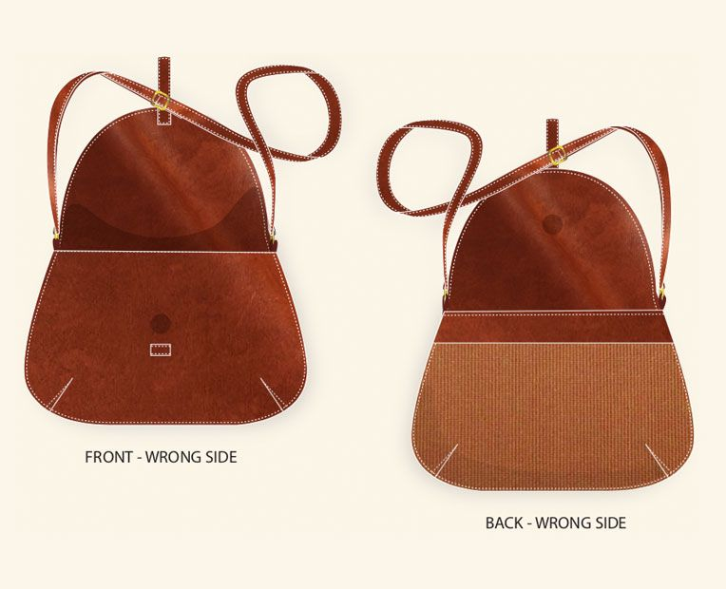
Figure 3 ;multiple views of a handbag

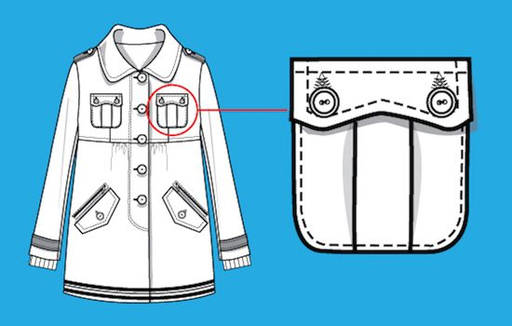
Figure 4. Detailed pocket sketches

Be thorough and pay close attention to detail. Omitting parts of your sketch will only make it more difficult to explain your design to the factory. This requires that every seam, dart, stitch, and button be in place. A solid line on a garment typically represents a seam line, while a dashed line represents stitching. Don't point out a detail in your Tech Pack that isn't visible on your sketch!
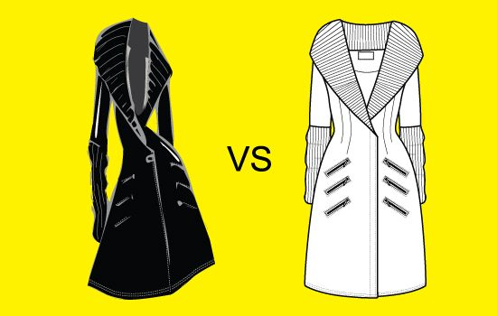
Figure 5 .Difference between illustration and a fashion flat sketch
Add details to your sketches but don't overcomplicate things. Avoid shading and use plain black and white sketches to clearly represent your design.
Bill of materials
The Bill of Materials (BOM) is a list of raw materials to produce a garment and prepare it for shipment. When your business makes a physical product, you need to source the materials to make it. Sourcing materials is an essential part of the production process. The materials you choose make a huge difference to the quality of your product.
A typical BOM table includes main fabric, secondary fabric (lining), thread, trims, closures, labels, and packaging.
In the apparel industry, a Bill of Materials is often created by a technical designer and product developers. These designers work closely together, sending comments to factories who can then adjust the Tech Pack accordingly. A technical designer usually creates a Bill of Materials based on a CAD (Computer-Aided Design) drawing
Here are three main reasons why a well-defined BOM table is important:
To determine costing and pricing of the garment.
To ensure your factory doesn’t miss any components.
To standardize manufacturing and ensure quality and consistency in every batch.
Assuming you have defined the style, set up the sketches and materials page, the next step to creating your Tech Pack is to include measurements. The Measurements specification sheet (or measurement specs) is an elaborate detailing of the measurements of different components in a particular garment.
There are general measurement terms that are typically used in every Measurement Sheet, such as body length, chest, waist, hips, armhole, shoulder drop, and neck opening. However, depending on how complex the garment is, more points of measurement will need to be included. For example: collar length/width, cuff length/width, pockets measurements, etc.
The garment measurement sheet is one of the most important documents used to produce a piece of clothing. Any mistakes in the spec sheet may result in a loss of time and money for designers, as well as clothes that don’t fit the way they were intended to.
Measurement spec sheets can be created based on standard sizing charts or according to custom body measurements.
A garment cost sheet is made to calculate the cost of a piece of garment. The typical garment cost sheet includes the material cost, labor, and cost of processing.
Each type of product has different specifications and therefore a different costing table. Each one has essential elements that you don’t want to miss. The number of details in the garment cost sheet always depends on the complexity of the garments.
To calculate the final cost of the garment, you must clearly specify each component that goes into its manufacture. Main fabric, lining, interfacing, trims, buttons, zippers, embellishments, appliques, and so on. The costing table must include all of these details. Quantities of each item must be listed, preferably in a separate column to facilitate visualization and calculation.
There are parts that are commonly used for all products. Things like tags, labels, sewing thread, packaging materials will be a part of any costing table no matter what type of product you are creating. So be sure to add those too
D, How to create a Tech Pack
Microsoft Excel has been the de facto tool to create tech packs for the fashion industry. It’s versatile, jam-packed with features, and based on something very familiar: spreadsheets. But this is the crux of the problem.
Lack of communication between team members. Tech Packs are usually created by the design teams. Using spreadsheets team members cannot collaborate in real-time. Tech Pack versions are shared back and forth via emails, which causes delays in product development.
Spreadsheets are static. Product info is divided into tabs. And Tech Packs are spread out inside different files and folders. Which makes product development not visual and prone to mistakes.
Creating seasonal tech packs is slow and inefficient. Product information on Excel is not only static - but also disconnected. Tech Packs are fragmented, making design details hard to reuse. The result is a lot of data entry. To repurpose your design info using Excel spreadsheets you would copy the entire Tech Pack, make sure all your measurements are consistent and the formulas are working properly.
Luckily, using up-to-date technologies you can streamline your product development and avoid production delays. This is where cloud-based software like Techpacker steps in.
Unlike Excel, this visual approach of Techpacker gives you a big-picture snapshot of your entire product development process in one glance. You don’t have to switch between tabs when double-checking or editing different sections in your Tech Pack.
Sketches, Bill of Materials, Point of measurements, Costing Tables, etc. - everything is visible on a single page. And at any time in just one click, you can turn this visual board into a PDF-ready Tech Pack and share it directly with your manufacturer.
Factory-ready Tech Pack created on Techpacker
And the best thing is that you can simply re-use your design specs for future collections by utilizing Techpacker card libraries. Where each card securely stores design info like sketches, measurements, or materials.
E, Using card libraries to create a new tech pack
You can collaborate with your team directly on these Cards by adding comments and tagging each other. Communicating in real-time speeds up the product development process significantly.
Leaving comments on cards for other team members
Tech Pack examples
Now that you’ve learned all about how to make a tech Pack, here are some examples of detailed Tech Packs made with Tech packer.
Wrap dress
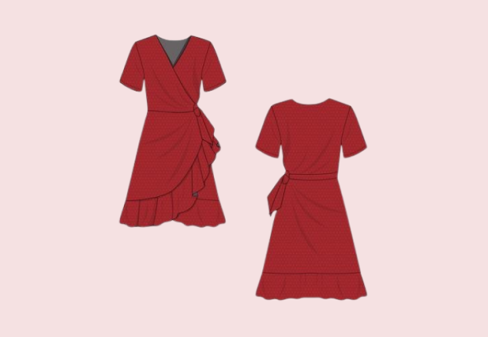

Figure 6w nowMenswear Jacket
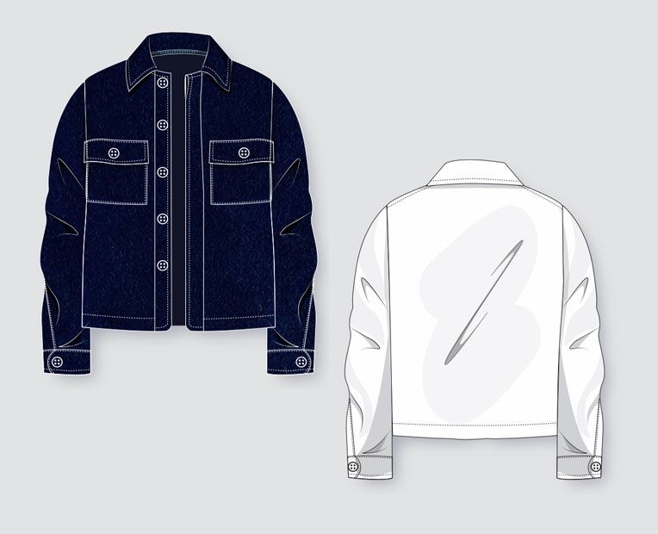V

Figure 7 Women's shoulder bag
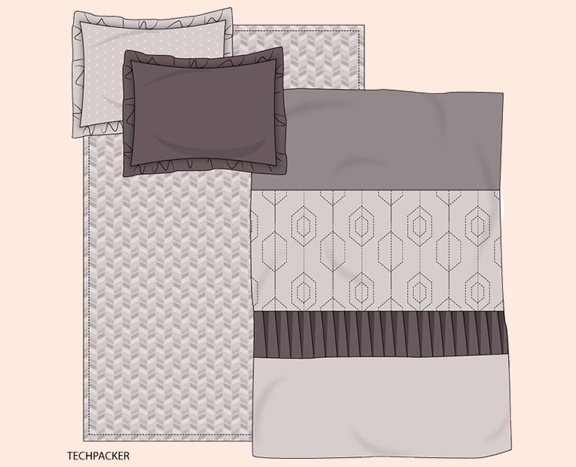
View now
Figure 8 Bed linens

3.2.2 What Is Interfacing? The Different Types & Its Uses
Interfacing is a fabric which is used to give support and structure to the material it is adhered to.
A,What type of interfacing is best?
Interfacings come in 2 main types:
fusible (iron on) and
sew in.
3 Different weaves:
non-woven,
woven and
knit.
3 different weights:
light,
medium and
heavyweight.
Fusible interfacing is the easiest to use because it has an adhesive on one side which bonds permanently with the fabric when pressed with an iron. Most sewing patterns will have instructions as to which pieces need interfacing.
B,What is sew in interfacing?
Sew-in interfacing is another layer of fabric which is hand sewn on to the main fabric to give it rigidity.
Add another layer of fabric to the main fabric to achieve a more structured end result.
Held in place by hand stitches it gives a natural shaping and drape as there is less “stiffness” to it.
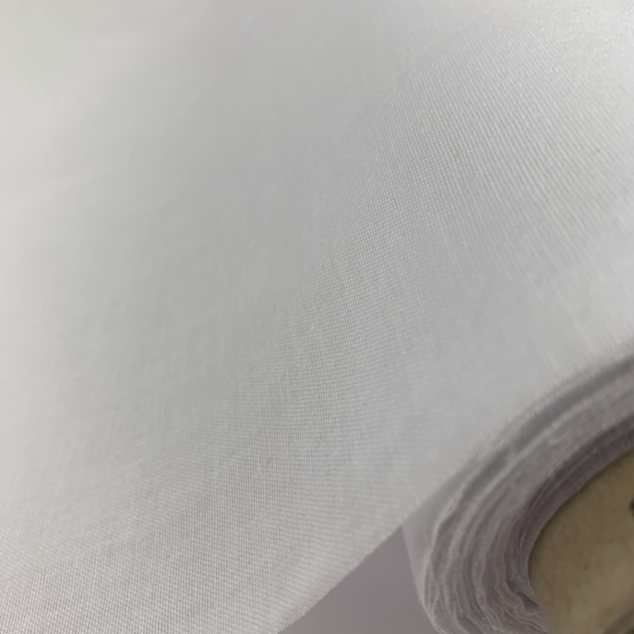

Figure 9 woven interfacing

C,What is non-woven interfacing?

Non-woven interfacing is made by bonding fibres together. It has no grain, can be cut any direction and won’t fray.
D,What is woven interfacing?
Woven interfacing has a lengthwise and crosswise grain. In other words match the grain of the interfacing, with the grain of the piece of the garment to be interfaced. This will enable the two layers of fabric work together with no distortion.
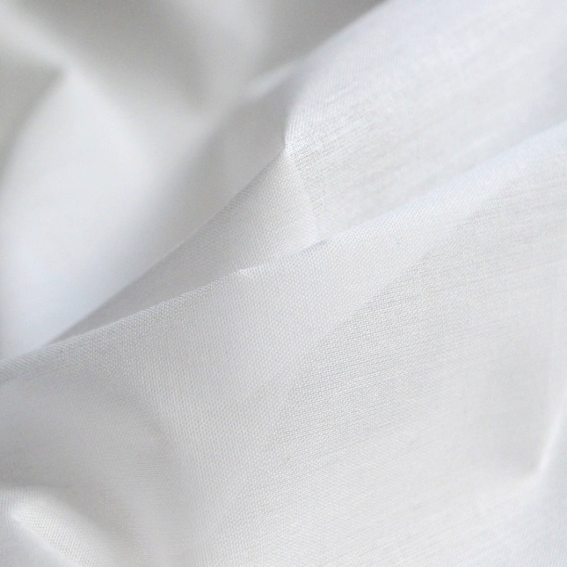

Figure 10 knit interfacing
E, What is knit interfacing?

Made by knitting the fibres together, it has an amount of stretch in it. Use with jerseys and other stretch fabrics as it will stretch with the garment. However, add a woven interfacing to a knit fabric, and the fabric’s stretch properties are reduced. In conclusion, only use a stretch interfacing on stretch fabric.
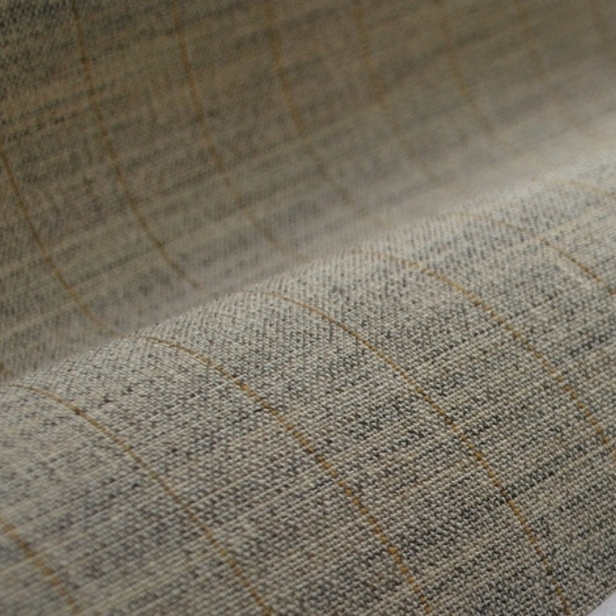
Figure 11 stretch fabric.
F, When should interfacing be used?
It reinforces fabrics – button strips on a button up shirt, makes it easier to sew good buttonholes.
Stabilizes flimsy fabrics to allow you to make a shaped collar or cuff.
Used in applique projects, interfacing allows you to draw and cut your design out easily and gives the design a rigidity which works perfectly with satin stitching.
Interfacing is used to stabilize the edges, when repairing a hole or tear in the fabric.
G,What weight interfacing should be used?
Interfacing should be the same weight as the fabric, or a bit lighter.
Do NOT use a heavier weight interfacing than the fabric, because the garment won’t drape well.
For medium weight fabrics, use medium weight interfacing.
Knit fabrics, use medium weight knit interfacing.
With very sheer or lightweight fabrics, use a second layer of the main fabric as a form of sew-in interfacing!
TOP TIPS
Use a knit interfacing with jersey or stretch fabrics.
Use non-woven interfacing for most tasks (other than when using jersey or stretch fabric) however, only consider woven interfacing for particularly fine materials such as sheers and silks.
Match the interfacing colour with the fabric. Black interfacing for dark colours and white for light colours.
A medium weight is generally good for most things. The pattern will recommend the best interfacing.
DO NOT use fusible (iron on) interfacing with...
Pile fabric like velvet or fur as it flattens the pile.
Fabric that will melt or distort with heat – sequins, plastic, vinyl.
Very textured fabrics with uneven surface – glue will not stick.
Because fabrics like lace, tulle and other mesh-based material have little or no “substance” for the glue to adhere to, fusible interfacing can be difficult to use.

H, How to apply a fusible (iron on) interfacing
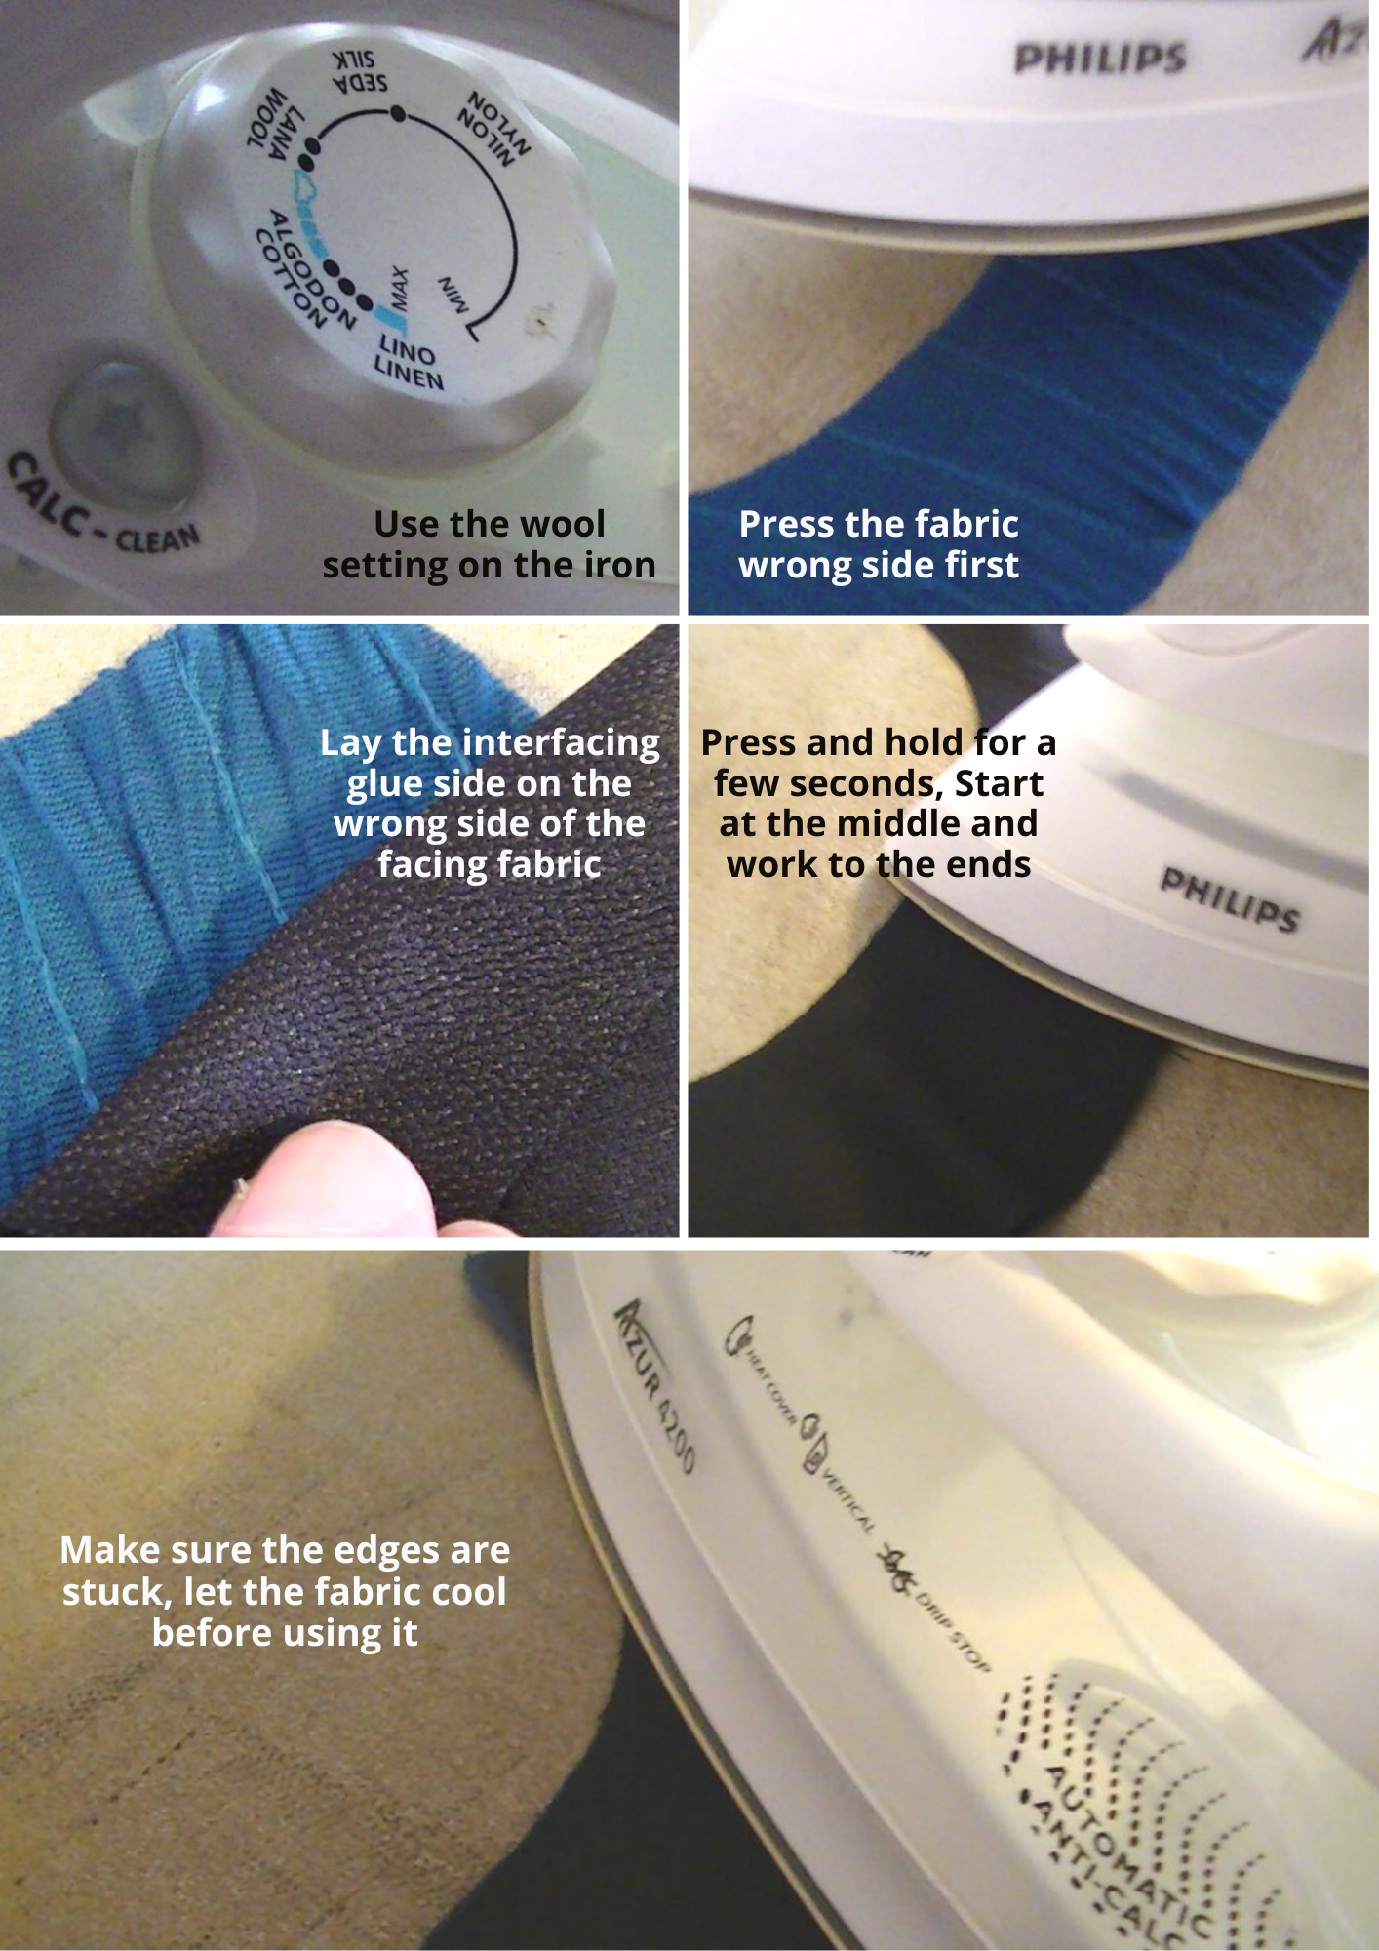
Figure 12. fusible (iron on) interfacing

Apply fusible interfacing to facings rather than to the fabric of the garment.
Fusible interfacing can cause the fabric to have a wrinkled look as a result of being washed.
With the fabric wrong side up use a hot iron to pre-heat the fabric.
Place the glue side (it is shiny) of the interfacing on the wrong side of the fabric. Press with a hot iron and pressing cloth.
Make sure the heat setting is suitable for the fabric.
Use steam for better adherence. A pressing cloth should be used to prevent water marks.
Above all press firmly down on the fabric to secure, let the fabric pieces cool down before using.
I, How to use sew-in interfacing
The interfacing should be cut to the same pattern as the piece it is going to back.
As the garment is being constructed, hand sew or baste the interfacing into it attaching it carefully.
Pin the sew-in interfacing to the wrong side of the material and stitch with a 1/2 inch seam allowance.
Trim at the corners to lessen the bulkiness at the seams.
Give the interfacing as much support as possible to prevent it from just hanging.

3.2.3.Different types of trims used in garment making
In a short period of time, fashion went from being a street style to a life style. Fashion is a vibrant industry. Fashion involves choosing daily outfits that follow current trends.
Fashion includes all of the little details in addition to the clothes you wear. When discussing specifics, the buttons on the pants, the zipper on the sides, the ripped jeans, the sheen of the dress, and so on jump out at us. These are simply trims.
Any materials or components used in clothing that are not the main fabric are referred to as trims. In addition to the primary fabric, the garments are made from a variety of other materials. Examples of trims include sewing thread, buttons, zippers, Velcro, labels, shoulder pads, linings, and interlinings.
Trimmings or trims come in two varieties: visible trimmings and invisible trimmings. Some trims are used on clothing for functional purposes, while others are used for aesthetic ones. Additionally, we can call the things used in sewing rooms besides textile fabrics are trims.

List of different types of trims
Here I have shared common trims used in apparels and clothing items. An image is added for representing the trims.
1. Sewing Thread
It is invariably the most important part of any garment industry. Garments cannot be stitched without a sewing thread. Even though sewing thread typically makes up a small portion of the cost of clothing, it has a huge impact on the final item's appearance and durability. Natural and synthetic fibres can both be used to make sewing thread. There are various types of threads available such as synthetic threads, threads made from natural fibres, filaments, spun and core-spun.
2. Buttons
Buttons are the one item that can be used with any outfit and serve as both a functional and decorative element. It is a tiny, generally round, plastic or metal object with a disc- or knob-like shape that is used to close openings or decorate clothing. It is typically made of plastic, but it can also be made of metal, horn, ivory, shell, celluloid, glass, wood, etc. A button is typically a fastener that is inserted into a loop of thread or a buttonhole.
Learn about button sizing.
Button Size Chart
Ligne Code | Button  Dia in Inch | Button  Dia in mm
10 L | 0.25 | 6.4
14 L | 0.35 | 8.9
16 L | 0.4 | 10.2
18 L | 0.45 | 11.4
22 L | 0.55 | 14.0
24 L | 0.6 | 15.2
26 L | 0.65 | 16.5
28 L | 0.7 | 17.8
30 L | 0.75 | 19.1

Table 1: Button Size Chart
3. Rivets
Rivets takes us back to the time when denim or jeans were invented. They are positioned on the parts of the jeans that are most likely to be torn apart by pressure or movement and work to keep the fabric together, extending the life of the garment. A "washer" or "disc" is pressed or hammered onto a metal stud that protrudes through the fabric to create a rivet. Invented by Jacob Davis and patented by Levi Strauss & Co. in 1873, the riveting of work wear trousers was what started the legend that made blue jeans famous and long-lasting.
4. Zipper
A zipper is a slide fastener made of interlocking elements that are each attached to one of the opposing edges of two tapes, as well as a movable component known as a "slider" that spans the interlocking elements. When the slider is moved in one direction, the elements on one tape engage with those on the other tape, while when it is moved in the opposite direction, the elements disengage. It is utilised in clothing (such as jackets and jeans), bags, sporting goods, camping equipment (such as tents and sleeping bags), and other items used on a daily basis.
5. Lining
Linings are typically useful components of a garment. The inner side of the garment has linings to offer comfort and protection. For use where decoration and a warm handle are required, linings are available as knitted and woven fabric made from polyester, poly-amide, acetate, or viscose. Linings are attached to the main garment by sewing, and a standard, plain sewing machine is used for this.
6. Interlining
The terms lining and interlining are distinct. A textile called interlining is inserted between two layers of fabric in clothing. Essentially, it is placed between the lining and the shell fabric. They are utilised to support, strengthen, and regulate the shape of some parts of clothing, such as the collar, cuffs, waistbands, facings, and coat lappets. They could be fused to the garment or they could be sewn into it. Compared to sewn interlinings, fusible interlinings produce better results. Both woven and non-woven products are acceptable.
7. Hook and loop fastener
This item was created by a Swiss inventor, who proposed the brand name "Velcro" for it. This product is made of two woven poly-amide tapes that can be pulled apart and cling together when pressed around each other. One of the tapes is covered in extremely tiny hooks, and the other in extremely tiny loops. Only a small number of clothing items, such as shoes, belts, sportswear, children's clothing, medical textiles, etc., use it.
8. Hook and eye closure
A hook-and-eye closure is a type of clothing fastener that consists of two parts: one has a small, protruding blunt hook, and the other has a protruding eye. Both parts are sewn to the appropriate pieces of fabric. The hook is inserted into the loop to secure the garment. Usually used in groups, hook-and-eye closures are strong enough to withstand the forces involved in everyday wear. In corsets, hook-and-eye closures are frequently employed.
9. Eyelet or Grommet
Grommets are typically larger in size and used for heavier-duty materials. To close off the opening for a drawstring casing, eyelets are frequently used. A buttonhole will accomplish the same thing, but an eyelet can add a polished appearance. It is a required trim for hoodie.
10. Label
Labels are an integral part of clothing that are sewn or printed with significant information about the item. It enables customers to be conscious of what they are wearing. The buyer's name, the country of origin, the fabric and yarn types, the fabric composition, the size of the garment, any special care instructions, and other information are all included on a garment's label.
11. Patch
A patch is a type of trim made from fabric, leather, or other materials that is sewn or heated to the garment. It was a very original, well-known, and alluring idea to sew patches onto
clothing. Patches still have some special meaning associated with various brands today. Some incredibly well-known brands, including Levis, still use it.
12. Motif
A motif is a recurring concept, design, pattern, or idea. A motif is a smaller component of a much larger work in textile arts. Motifs can be of any size, but they are typically all the same size in a single work. On the motif, you can write the company name, a trademark, or other symbols.
13. Shoulder pad
For both men's and women's tailored clothing, shoulder pads are a standard component. Both the top and bottom of the shoulder pad are lined. The appearance consequently improves in attractiveness, comfort, and longevity.
14. Snap fastener
A pair of interlocking discs known as a snap fastener, also known as a snap, popper, or press stud, is frequently used to secure clothing instead of buttons. Up until a certain amount of force is applied, a circular lip under one disc fits into a groove on top of the other, holding them fast. By using a particular punch and die set, hammering, plying, or sewing, snaps can be attached to fabric.
15. Hasps and Slider
A metal fastening system known as a "Hasp and Slider" is used on the shoulder strap to adjust the length of the strap by sliding it, and the hasp is connected by the slider to a button fastened to the bib of the overalls. The Hasp and Slider pattern is most frequently seen on infant clothing. The baby clothing products have a stylish appearance thanks to Hasp and Slider.
16. Beads
A tiny piece of plastic or another similar material that is usually rounded and perforated so that it can be woven into a necklace or sewn to fabric.

The following names are also used to refer to seed beads: Czech glass beads, Miyuki seed beads, Glass beads, Miyuki Delica beads, Toho seed beads, Swarovski crystal beads, Art beads, Fusion Beads, Nalki beads, Miyuki beads, Cut Dana beads, Celica Beads, Preciosa beads, Embroidery beads, or Bugle Beads are some of the bead types available. Czech machine-cut glass is highly polished and used to make crystal beads. They come in a variety of shapes, including drum, round, bacons, drop, rondelle, briolette, and cubic. Machine embroidery employs plastic beads with holes for sewing.
17. Sequins
A sequin is a tiny, shiny plate that is used as an ornament, especially on clothing. Sequins can be found in a variety of hues. Additionally, they are divided into four main categories: coated, coated with pearl, coated with holograms, and metal. The sequin trim is the most striking of all the trims.
18. Rhinestones
Rhinestones were originally rock crystals collected from the Rhine, hence the name, but today the term "rhinestone" only refers to lead glass varieties referred to as crystal glass. Rhinestones come in a variety of styles, including glue-on flat back rhinestones, sew-on rhinestones, and flat back hot-fix rhinestones. Rhinestones are widely used as a trim to decorate or create stylish products for infants or women.
19. Ribbon
A ribbon, also known as a riband, is a short, flexible band of material, usually made of cloth but occasionally of plastic or metal, that is primarily used for tying and binding. Cloth ribbons, of which silk is the most common type, are used for a variety of practical, decorative, and symbolic purposes by cultures all over the world. They are also frequently used in connection with clothing.
20. Drawstring
Any retractable cord, ribbon, or tape made of a textile or non-textile material with two loose ends that fits snugly around something or doesn't. To change the size of the garment opening, drawstrings are pulled together.
Related post: Raw material used in making coats and jackets
23. Lace
Lace is a sensual fabric that can be created manually or artificially using yarn or thread arranged in an arbitrary web-like pattern. It is sewn into bralettes, dresses, skirts, and other clothing. Cotton thread is now used more frequently than silver, gold, silk, or linen threads, which were used previously.
24. Fringe
Fringe is a straightforward trim that can be added to any garment to give it an elegant appearance. It is a decorative textile border that is sewn onto the edge of a textile product, like drapery, a flag, or epaulettes.
25. Fur
Fur trim is warm, stylish, and absolutely gorgeous. Many costume designers, including Duru Olowu, Proenza Schouler, and Alberta Ferretti use fur to give their creations an edge over the competition.
26. Feathers
Feathers were very popular in the late 19th and early 20th centuries. Anyone who was anyone wore feathers, which were taken from various birds and sewn onto their clothing and hats. The economy benefited greatly from this trend, but the bird community suffered greatly; several species came dangerously close to extinction. Nowadays, feathers made of synthetic fibres are more commonly used as a dress trim rather than on hats.
27. Tassel
A tassel is an ornament made of gathered yarn or thread and a solid, big assembly point that connects to a cord. It is primarily used in sarees and dupattas to give them that extra oomph.

3.2.4 ,Types of yarn
Classification based on number of strands
Yarns can be described as single, or one-ply; ply, plied, or folded; or as cord, including cable and hawser types.
A, Single yarns
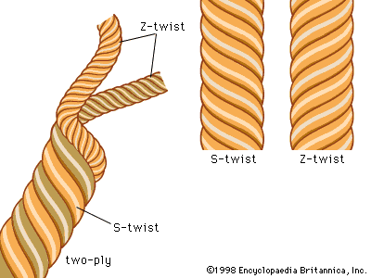
Figure 13. B, S- and Z-twist yarns
Single, or one-ply, yarns are single strands composed of fibers held together by at least a small amount of twist; or of filaments grouped together either with or without twist; or of narrow strips of material; or of single synthetic filaments extruded in sufficient thickness for use alone as yarn (monofilaments). Single yarns of the spun type, composed of many short fibres, require twist to hold them together and may be made with either S-twist or Z-twist. Single yarns are used to make the greatest variety of fabrics.
C, Ply yarns
Ply, plied, or folded, yarns are composed of two or more single yarns twisted together. Two-ply yarn, for example, is composed of two single strands; three-ply yarn is composed of three single strands. In making ply yarns from spun strands, the individual strands are usually each twisted in one direction and are then combined and twisted in the opposite direction. When both the single strands and the final ply yarns are twisted in the same direction, the fibre is firmer, producing harder texture and reducing flexibility. Ply yarns provide strength for heavy industrial fabrics and are also used for delicate-looking sheer fabrics.
D, Cord yarns
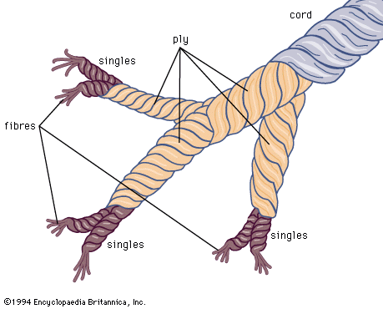

Figure 14 diagram of single, ply, and cord yarns
Cord yarns are produced by twisting ply yarns together, with the final twist usually applied in the opposite direction of the ply twist. Cable cords may follow an SZS form, with S-twisted singles made into Z-twisted plies that are then combined with an S-twist, or may follow a ZSZ form. Hawser cord may follow an SSZ or a ZZS pattern. Cord yarns may be used as rope or twine, may be made into very heavy industrial fabrics, or may be composed of extremely fine fibres that are made up into sheer dress fabrics.
E, Novelty yarns
Novelty yarns include a wide variety of yarns made with such special effects as slubs, produced by intentionally including small lumps in the yarn structure, and synthetic yarns with varying thickness introduced during production. Natural fibres, including some linens, wools to be woven into tweed, and the uneven filaments of some types of silk cloth are allowed to retain their normal irregularities, producing the characteristic uneven surface of the finished fabric. Synthetic fibres, which can be modified during production, are especially adaptable for special effects such as crimping and texturizing.
F, Textured yarns
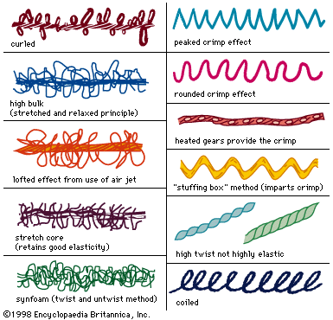
Figure 15 examples of textured yarns
Texturizing processes were originally applied to synthetic fibres to reduce such characteristics as transparency, slipperiness, and the possibility of pilling (formation of small fibre tangles on a fabric surface). Texturizing processes make yarns more opaque, improve appearance and texture, and increase warmth and absorbency. Textured yarns are synthetic continuous filaments, modified to impart special texture and appearance. In the production of abraded yarns, the surfaces are roughened or cut at various intervals and given added twist, producing a hairy effect.
Bulking creates air spaces in the yarns, imparting absorbency and improving ventilation. Bulk is frequently introduced by crimping, imparting waviness similar to the natural crimp of wool fibre; by curling, producing curls or loops at various intervals; or by coiling, imparting stretch. Such changes are usually set by heat application, although chemical treatments are sometimes employed. In the early 1970s bulky yarns were most frequently produced by the “false twist” method, a continuous process in which the filament yarn is twisted and set and then untwisted and heated again to either stabilize or destroy the twist. The “stuffing box” method is often applied to nylon, a process in which the filament yarn is compressed in a heated tube, imparting a zigzag crimp, then slowly withdrawn. In the knit-de-knit process, a synthetic yarn is knitted, heat is applied to set the loops formed by knitting, and the yarn is then unraveled and lightly twisted, thus producing the desired texture in the completed fabric.
Bulk may be introduced chemically by combining filaments of both high and low shrinkage potential in the same yarn, then subjecting the yarn to washing or steaming, causing the high shrinkage filaments to react, producing a bulked yarn without stretch. A yarn may be air bulked by enclosing it in a chamber where it is subjected to a high-pressure jet of air, blowing the individual filaments into random loops that separate, increasing the bulk of the material.
G, Stretch yarns
Stretch yarns are frequently continuous-filament synthetic yarns that are very tightly twisted, heat-set, and then untwisted, producing a spiral crimp giving a springy character. Although bulk is imparted in the process, a very high amount of twist is required to produce yarn that has not only bulk, but also stretch.
Spandex is the generic term for a highly elastic synthetic fibre composed mainly of segmented polyurethane. Uncovered fibers may be used alone to produce fabrics, but they impart a rubbery feel. For this reason, elastomeric fibre is frequently used as the core of a yarn and is covered with a nonstretch fibre of either natural or synthetic origin. Although stretch may be imparted to natural fibres, other properties may be impaired by the process, and the use of an elastic yarn for the core eliminates the need to process the covering fibre.
H, Metallic yarns
Metallic yarns are usually made from strips of a synthetic film, such as polyester, coated with metallic particles. In another method, aluminum foil strips are sandwiched between layers of film. Metallic yarns may also be made by twisting a strip of metal around a natural or synthetic core yarn, producing a metal surface.
For additional information about the production, characteristics, and uses of modern synthetic novelty yarns, see man-made fibre.

3.2.4.1Classification based on use
1,Fabric construction yarns
Almost any textile yarn can be used to produce such interlaced fabrics as woven and knitted types. In weaving, the warp, or lengthwise, yarns are subjected to greater stress and are usually stronger, smoother, and more even and have tighter twist than the weft, or crosswise, yarns. A sizing (stiffening) material such as starch may be applied to warp yarns, increasing their strength to withstand the stresses of fabric construction operations. Weft yarns, subjected to little stress during weaving, may be quite fragile.
Warp and weft threads used in the same fabric may be of differing diameter, producing such special effects as ribbing or cording in the fabric. Special effects may also be obtained by combining warp and weft yarns of fibre from differing origin, or with different degrees of twist, or by introducing metallic threads into weaves composed of other fibres.
Yarns for machine knitting are usually loosely twisted because softness is desired in knit fabrics.
2,Yarns used in handwork
Yarns used in hand knitting are generally of two or more ply. They include such types as fingering yarns, usually of two or three plys, light to medium in weight and with even diameter, used for various types of apparel; Germantown yarns, soft and thick, usually four-ply and of medium weight, frequently used for sweaters and blankets; Shetland yarns, fine, soft, fluffy, and lightweight, frequently two-ply, used for infants’ and children’s sweaters and for shawls; worsted knitting yarn, highly twisted and heavy, differing from worsted fabric by being soft instead of crisp, and suitable for sweaters; and zephyr yarns, either all wool, or wool blended with other fibres, very fine and soft, with low twist, and used for lightweight garments.
Embroidery floss, used in hand embroidery, generally has low twist, is of the ply or cord type, and is made of such smooth filaments as silk and rayon. Yarn used for crocheting is frequently a loose cotton cord type; and darning yarns are usually loosely spun.
3,Sewing thread
Sewing threads are tightly twisted ply yarns made with strands having equally balanced twist, producing a circular cross section. Thread for use in commercial or home sewing machines and for hand sewing should allow easy movement when tension is applied and ease in needle threading; should be smooth, to resist friction during sewing; should have sufficient elasticity to avoid the breaking of stitches or puckering of seams; and should have sufficient strength to hold seams during laundering or dry cleaning and in use.
Threads for special uses may require appropriate treatment. Garments made of water-repellent fabrics, for example, may be sewn with thread that has also been made water-repellent. Thread is usually subjected to special treatment after spinning and is then wound on spools. Thread size is frequently indicated on the spool end, and systems for indicating degree of fineness vary according to the textile measurement system used locally.
Silk thread has great elasticity and strength combined with fine diameter. It can be permanently stretched in sewing, and is suitable for silks and wools. Buttonhole twist is a strong, lustrous silk about three times the diameter of normal sewing silk, and is used for hand-worked buttonholes, for sewing on buttons, and for various decorative effects.
Cotton thread is compatible with fabric made from yarn of plant origin, such as cotton and linen, and for rayon (made from a plant substance), because it has similar shrinkage characteristics. It is not suitable for most synthetics, which do not shrink, or for fabrics treated to reduce shrinkage. Its low stretch is useful for woven fabrics, but not for knits, which require more stretch.
Nylon thread is strong, with great stretch and recovery, does not shrink, and is suitable for sheers and for very stretchy knits. Polyester thread has similar characteristics, and is appropriate for various synthetic and preshrunk fabrics, and for knits made of synthetic yarns.

4,Measurement systems
Yarn measurements are expressed as yarn number, count, or size, and describe the relationship of length and weight (or approximate diameter). Because methods of measurement were developed in various areas of the world, there has been a lack of uniformity in such systems.
5,Indirect systems
Indirect measuring systems are those employing higher number to describe finer yarns and are based on length per unit weight. Most countries measure yarns made from staple fibres according to the weight of a length of yarn. If one pound is used as a standard unit, for example, a very fine yarn will have to be much longer than a coarser yarn to weigh a pound, so higher counts indicate finer yarns. The size number is an indication of the length of yarn needed to reach a weight of one pound.
In the United States, the system is based on the number of hanks per pound, with a hank of 840 yards for cotton and spun silk, 300 yards (a lea) for linen, 256 yards for woollen yarns, and 560 yards for worsted yarns. A widely used Continental system is based on the number of hanks of 1,000 metres (one kilometre) required to reach a weight of one kilogram.
6,Denier system
The denier system is a direct-management type, employed internationally to measure the size of silk and synthetic filaments and yarns, and derived from an earlier system for measuring silk filaments (based on the weight in drams of 1,000 yards). Denier number indicates the weight in grams of 9,000 metres of filament or filament yarn. For example, if 9,000 metres of a yarn weigh 15 grams, it is a 15-denier yarn; if 9,000 metres of a yarn weigh 100 grams, it is a 100-denier yarn and much coarser than the 15-denier yarn. Thus, a smaller number indicates a finer yarn. This system is not convenient for measurement of staple yarns because their greater weight would require the use of very large numbers.
7,Tex system
The tex system, originally devised in 1873, is a universal method developed for the measurement of staple fibre yarns and is also applicable to the measurement of filament yarns. It is based on the weight in grams of one kilometre (3,300 feet) of yarn.
3.2.4.2 Production of fabric
Fabric construction involves the conversion of yarns, and sometimes fibres, into a fabric having characteristics determined by the materials and methods employed. Most fabrics are presently produced by some method of interlacing, such as weaving or knitting. Weaving, currently the major method of fabric production, includes the basic weaves, plain or tabby, twill, and satin, and the fancy weaves, including pile, Jacquard, dobby, and gauze. Knitted fabrics are rapidly increasing in importance and include weft types and the warp types, raschel and tricot. Other interlaced fabrics include net, lace, and braid. Nonwoven fabrics are gaining importance and include materials produced by felting and bonding. Laminating processes are also increasing in importance, and fairly recent developments include needle weaving and the sewing-knitting process.
A, Woven fabrics
Woven fabrics are made of yarns interlaced in a regular order called a binding system, or weave. Weaving is the process of combining warp and weft components to make a woven structure. The components need neither be parallel to each other nor cross each other at right angles, but most woven structures are composed of two sets of components, both flexible and crossing at right angles. Weaving is differentiated from warp and weft knitting, braiding, and net making in that these latter processes make use of only one set of elements. In addition, there are geometrical differences, one of the most significant being the small angles through which the components of a woven structure are, in general, bent, in contrast with the components of other structures.
Weaving is a widely used constructional method because it is cheap, basically simple, and adaptable. Woven fabrics have valuable characteristics resulting partly from the geometrical conformation of their components and partly from the fact that the components are held in position not by rigid bonding but by friction set up at the areas where they make contact. Woven fabrics are used in household, apparel, and industrial textiles.
Textile designers can produce a very large variety of cloths by their selection of yarns, finishing processes, and binding systems. Yarns vary in thickness, smoothness, fibre content, twist, and colour, all of which have a profound influence on the finished cloth. Finishing processes range from such simple treatment as brushing up the nap on a woven fabric to such a complicated chemical process as that employed to change opaque cotton fabric to transparent, permanently stiffened organdy.
The binding system, or weave, however, is the basic factor in determining the character of a woven fabric. The three basic systems are plain or tabby, twill, and satin. In complex binding systems, the basic weaves are combined or enriched by hand manipulation or mechanical loom attachments; these include multiple-plane, pile, inlaid, and gauze weaves. Regardless of the binding system, other devices—manipulation of warp spacing, beating in, or tension—can be used to alter the appearance of any weave, to make it looser or more compact, to make it more or less regular.
As musical notation conveys a composer’s ideas, so weave drafts or point paper plans communicate a textile designer’s directions for constructing woven fabrics. The draft is a plan on graph paper showing at least one repeat or weave unit of the fabric to be woven. This information enables the weaver or mill specialist to plot the drawing in of the warp, the tie up of harnesses to the shedding mechanism, and the shedding order.
The weaving process
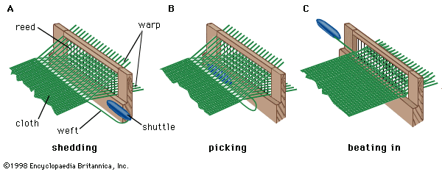
Figure 16 three basic motions of weaving
Woven cloth is normally much longer in one direction than the other. The lengthwise threads are called the warp, and the other threads, which are combined with the warp and lie widthwise, are called the weft (synonyms are “filling,” “woof,” and “shoot,” or “shute”). An individual thread from the warp, of indefinite length, is called an end; each individual length of weft, extending from one edge of the cloth to the other, is called a pick, or shot. Consecutive picks are usually consecutive lengths of one piece of weft yarn that is repeatedly folded back on itself.
In all methods of weaving cloth (except the rudimentary form of darning), before a length of weft is inserted in the warp, the warp is separated, over a short length extending from the cloth already formed, into two sheets. The process is called shedding and the space between the sheets the shed. A pick of weft is then laid between the two sheets of warp, in the operation known as picking. A new shed is then formed in accordance with the desired weave structure, with some or all of the ends in each sheet moving over to the position previously occupied by the other sheet. In this way the weft is clasped between two layers of warp.
Since it is not possible to lay the weft close to the junction of the warp and the cloth already woven, a further operation called beating in, or beating up, is necessary to push the pick to the desired distance away from the last one inserted previously. Although beating in usually takes place while the shed is changing, it is normally completed before the new shed is fully formed.
The sequence of primary operations in one weaving cycle is thus shedding, picking, and beating in. At the end of the cycle the geometrical relation of the pick to the warp is the same as it would have been if the pick had been threaded through the spaces between alternate ends, first from one side of the cloth and then from the other, as in darning. This is the reason the weaving process is considered an interlacing method.
Early development of the loom
The word loom (from Middle English lome, “tool”) is applied to any set of devices permitting a warp to be tensioned and a shed to be formed. Looms exist in great variety, from the bundles of cords and rods of primitive peoples to enormous machines of steel and cast iron.
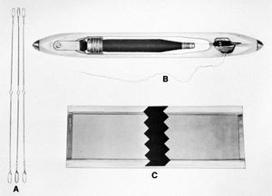
Fig: loom devices and their functions
loom devices and their functions
Except on certain experimental looms, the warp shed is formed with the aid of heddles (or healds). Usually one heddle is provided for each end, or multiple end, of warp thread, but on some primitive looms simple cloths are produced with heddles provided only for each alternate end. A heddle consists of a short length of cord, wire, or flat steel strip, supported (in its operative position) roughly perpendicular to the unseparated sheet of warp threads and provided, in modern looms, with an eyelet at its midpoint, through which the warp end is threaded. By pulling one end of the heddle or the other, the warp end can be deflected to one side or the other of the main sheet of ends. The frame holding the heddles is called a harness.
In most looms, the weft is supplied from a shuttle, a hollow projectile inside which a weft package is mounted in such a way that the weft can be freely unwound through an eyelet leading from the inside to the outside. The shuttle enters the shed and traverses the warp, leaving a trail of weft behind.
Beating in is generally effected by means of a grating of uniformly spaced fine parallel wires, originally made of natural reeds and thus called a reed, which, mounted at right angles to the warp, oscillates between the heddles and the junction of the warp and the cloth. The ends pass, one or more at a time, through the spaces between consecutive reed wires, so that the reed, in addition to beating in, controls the spacing of the ends in the cloth.
Two-bar
The earliest evidence of the use of the loom (4400 BCE) is a representation of a horizontal two-bar (or two-beamed—i.e., warp beam and cloth beam) loom pictured on a pottery dish found at Al-Badārī, Egypt. The warp is stretched between two bars or beams, pegged to the ground at each of the four corners. Lease (or laze) rods are used to separate the warp yarns, forming a shed and aiding the hands in keeping the yarns separated and in order. Lease rods were found in some form on every later type of improved loom, and their use at this very early date indicates that the loom already had been in use long enough to have reached a stage of improvement by addition of devices to aid the hands.
Before lease rods were added, it would have been necessary for the fingers to separate each odd from each even warp thread to create the shed through which the weft yarn was passed. A third rod also seen in this early drawing may be a heddle rod. If so, this loom represents a still more advanced stage of development.
The heddle rod rests on top of the warps. To produce a plain weave, alternate warp yarns are tied to the rod, and, when it is raised, the shed is formed quickly and accurately. Some authorities consider the heddle to be the most important step in the evolution of the loom. A shed stick is ordinarily used with the heddle, forming the second, or countershed, opening for the return of the weft.
In addition to the horizontal two-bar loom, there are two other primitive varieties: the warp-weighted and the vertical two-bar loom. The warp-weighted loom consists of a crossbar supported by two vertical posts. The warp threads hang from the crossbar and are held taut by weights of clay, ceramic, or chalk tied to their free ends. Loom weights have been found at archaeological sites dating from 3000 BCE, but this type of loom may have originated even earlier. The earliest picture of a vertical two-bar loom is from the Egyptian 18th dynasty (1567–1320 BCE). It coincides with the appearance of more intricate textile patterns, the earliest known tapestries (datable between 1483 and 1411 BCE) having been found in the tomb of Thutmose IV at Thebes. (Even today the vertical loom is preferred for tapestry weaving.) In the vertical two-bar loom the ends of the warp yarns are attached to a second crossbar, thus combining features of both the horizontal two-bar and the warp-weighted looms.
The heddle rods and shed sticks are used in a similar way on all three types.
Counterparts of these very early looms have been used through the ages in many cultures. The Navajo Indians, probably the best known of the American Indian weavers, have used the simple two-bar vertical loom for several centuries to produce their beautiful rugs and blankets. A form of the horizontal two-bar loom was the back-strap loom, in which one bar was tied to a tree or other stationary device, the second being attached to the weaver’s waist by a strap. The weaver could control the tension of the warp yarns by applying pressure as necessary. The back-strap loom was used in pre-Columbian Peru, in other cultures of Central and South America, in Asia, and elsewhere.
Horizontal frame looms
By about 2500 BCE a more advanced loom was apparently evolving in East Asia. Fragments of silk fabrics found adhering to bronzes of the Shang (or Yin) period (18th–12th centuries) in China show traces of a twill damask pattern, suggesting an advanced weaving knowledge, since such fabrics could not practicably be woven on the looms described above. These fabrics were probably produced on a horizontal frame loom with treadles. The logical connecting link between the horizontal two-bar and the horizontal frame loom with treadles would have been a loom with a heddle rod that was controlled by one foot, for which no early illustrations have been found.
The earliest European pictorial record of the horizontal frame loom with a treadle dates from the 13th century, when it appears in a highly developed form, almost certainly introduced from the East. This two-bar loom was mounted in a frame; to this was connected a treadle operated by the feet, moving the heddles, an improvement of the heddle rod or cord controls now mounted between bars and called a shaft. The advantages of this type of loom were many. First, in the two-bar loom, though more than two heddle rods could be used, the number of groupings of warp threads was limited. Although highly complex patterns could be woven, it was not practical to do so in producing any but very small quantities of cloth. The shaft loom allowed as many as 24 shafts to be set up easily, enabling the weaver to produce comparatively intricate patterns. Second, the weaver’s sword or comb formerly used to beat the weft into place was replaced by the batten, supported in a heavy wooden frame from the main frame of the loom; its weight and free-swinging motion improved the beating-in action and made it easier. Third, use of the foot treadle freed both hands to throw the shuttle and swing the batten. The loom remained virtually unchanged for many centuries thereafter.
Draw looms
The shaft loom was adequate for plain and for simply patterned fabrics, but a more complex loom was needed for the weaving of intricately figured fabrics, which might require 100 or more shafts. This kind of weaving was accomplished on the drawloom. Its origin is unknown, but it probably was first used in East Asia for silk weaving and was introduced into the silk-working centres of Italy during the Middle Ages. The drawloom had two devices for shedding: in addition to the shafts, which the weaver operated by treadles, cords were also used to raise the warp threads, gathered into groups as required by the pattern. The cords were worked by an operator (called a drawboy) seated on top of the loom.
The drawloom was improved in Italy and France in the early 17th century by the addition of a type of mechanical drawboy, allowing the assistant to stand on the floor at the side of the loom and increasing the control of the cords. The continued inconvenience of employing an assistant, however, who might also make errors, led to a search for an automatic mechanism that would perform all the work of the drawboy. Most of the later developments in automatic mechanisms to control the shedding operation originated in France, which had become one of the leading countries in the weaving of figured silks.
In 1725 Basile Bouchon added to the mechanical drawboy a mechanism that selected the cords to be drawn to form the pattern. Selection was controlled by a roll of paper, perforated according to the pattern, which passed around a cylinder. The cylinder was pushed toward the selecting box and met with needles carrying the warp-controlling cords; the needles that met unperforated paper slid along, and the others passed through the holes and remained stationary. The selected cords were drawn down by a foot-operated treadle.
The mechanical drawboy made the proper selection of warp threads, eliminating errors, but still required an operator. The mechanism was improved in 1728 by increasing the number of needles and using a rectangular perforated card for each individual shedding motion, the cards being strung together in an endless chain. In 1745 Jacques de Vaucanson constructed a loom incorporating a number of improvements. He mounted the selecting box above the loom, where it acted directly on hooks fastened to the cords that controlled the warp yarns. The hooks passed through needles and were raised by a strong metal bar. The needles were selected by perforated cards passing around a sliding cylinder, without the aid of a second operator or assistant. The cylinder was very complex, and the mechanism is not known to have been adopted, but it served as the foundation for the successful Jacquard attachment.
The Jacquard attachment
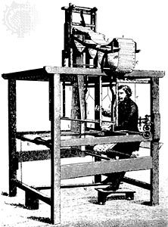
Figure 17.Jacquard loom
The French inventor Joseph-Marie Jacquard, commissioned to overhaul Vaucanson’s loom, did so without the directions, which were missing. In 1801, at the Paris Industrial Exhibition, he demonstrated an improved drawloom. In 1804–05 he introduced the invention that ever since has caused the loom to which it is attached to be called the Jacquard loom.
The Jacquard attachment is an automatic selective shedding device, that is mounted on top of the loom and operated by a treadle controlled by the weaver. As in the drawloom, every warp yarn runs through a loop in a controlling cord, held taut by a weight. Each cord is suspended from a wire (“hook”) that is bent at the bottom to hold the cord and bent at the top in order to hook around the blades or bars of the griff, the lifting mechanism. To allow only those warp threads that are needed to form the pattern to be raised, some hooks must be dislodged from the rising griff. This is accomplished by horizontally placed needles connected to the hooks. As the perforated pattern card moves into place on the cylinder (which is, in fact, a quadrangular block), the needles pass through the holes in the card, and the warps are raised; where there are no holes, the needles are pushed back (by a spring action on the opposite end of each), pulling the hooks away from the rising griff bar, and the warps are not raised.
Each card represents one throw of the shuttle, and the pattern is transferred to the cards from the designer’s weave draft. Although each Jacquard attachment is limited in the number of hooks it can control and, therefore, in the size of the repeat pattern, several Jacquard attachments can be added to one loom so that the weaver not only can produce intricately figured fabrics but also can weave pictures of considerable size.
The flying shuttle
The first decisive step toward automation of the loom was the invention of the flying shuttle, patented in 1733 by the Englishman John Kay. Kay was a weaver of broadloom fabrics, which, because of their width, required two weavers to sit side by side, one throwing the shuttle from the right to the centre and the other reaching between the warps and sending it on its way to the left and then returning it to the centre. The stopping of the shuttle and the reaching between the warps caused imperfections in the cloth. Kay devised a mechanical attachment controlled by a cord jerked by the weaver that sent the shuttle flying through the shed. Jerking the cord in the opposite direction sent the shuttle on its return trip. Using the flying shuttle, one weaver could weave fabrics of any width more quickly than two could before. A more important virtue of Kay’s invention, however, lay in its adaptability to automatic weaving.
Power-driven looms
The first power-driven machine for weaving fabric-width goods, patented in 1785 by Edmund Cartwright, an English clergyman, was inadequate because it considered only three motions: shedding, picking, and winding the woven cloth onto the cloth beam. Cartwright’s second patent (1786) proved too ambitious, but his concept of a weaving machine became the basis for the successful power loom.
One of the great obstacles to the success of the power loom was the necessity to stop the loom frequently in order to dress (i.e., apply sizing to) the warp, an operation that, like many others, had been done in proportionately reasonable time when the weaving was done by hand. With the power loom a second man had to be employed continuously to do this work, so there was no saving of expense or time. In the early 19th century a dressing machine was developed that prepared the warp after it had been wound onto the warp beam and as it was passed to the cloth beam. Although later superseded by an improved sizing apparatus, this device made the power loom a practical tool.
Advances made by William Horrocks of Scotland between 1803 and 1813 included an improvement in the method of taking up the cloth (i.e., winding the woven fabric onto the cloth beam) and making a more compact machine of iron, requiring little space as compared with wooden handlooms.
Francis Cabot Lowell, of Boston, experimented with the power loom, adding improvements to increase the weaving speed, and also improved the dressing machine.
A valuable improvement was that of the let-off and take-up motions, to maintain uniform warp tension automatically. The principle of holding at the beat (i.e., not permitting the warp to be let off until the pick was beaten into place), first applied by Erastus Brigham Bigelow in the carpet loom, was successfully applied to all kinds of weaving. Another Bigelow invention, applicable to power looms in general although first used on a carpet loom, was the friction-brake stop mechanism, allowing the loom to be stopped without a shock.
These developments were primarily concerned with the power loom used for weaving plain goods. William Crompton, an English machinist working in the machine shop attached to a cotton factory in Massachusetts, undertook the development of a loom that could weave fancy goods, patented in both the United States and England in 1837. The loom was later much improved by his son George Crompton. Such 19th-century inventions made possible the production of textile goods for every use in great volume and variety and at low cost.
Modern looms
Modern looms still weave by repeating in sequence the operations of shedding, picking, and beating in, but within that framework there has been considerable development during the 20th century. Several new types of loom have come into industrial use, whereas older types have been refined and their scope extended. Two main influences have been the rising cost of labour and the increasing use of synthetic continuous-filament yarns. The first has led to an increase in automatic control, in automatic handling of yarn packages, and in the use of larger packages; the second, to greater precision and finish in loom construction, because deficiency in these qualities is readily reflected in the quality of the cloth made from these yarns.
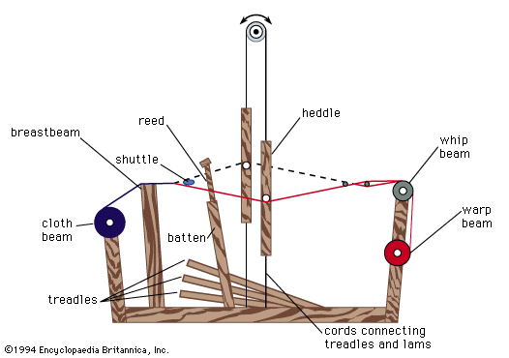
Figure 18.diagram of a modern handloom
Modern looms can be grouped into two classes according to whether they produce cloth in plane or tubular form. Looms of the first kind, comprising all but a few, are called flat looms; the others are described as circular. Since the majority are flat looms, the adjective is used only when a distinction has to be drawn. Flat looms fall into two categories: those that employ a shuttle and those that draw the weft from a stationary supply, usually called shuttleless looms. (This term is not entirely satisfactory, as some primitive looms make no use of a shuttle, merely passing through the shed a stick with weft wound on it.) Shuttle looms fall into two groups according to whether the shuttle is replenished by hand or automatically. The second kind is often described as an automatic loom, but, except for shuttle replenishment, it is no more automatic in its operation than the hand-replenished or so-called nonautomatic loom, which, like all modern looms, is power-operated by electric motor. With both types of loom the actual weaving operation is entirely automatic and is performed in exactly the same manner.
Hand-replenished, or no automatic, looms are used only where particular circumstances—of yarns, fabrics, or use—make automatically replenished looms either technically unsuitable or uneconomic. Basically, they differ little from the power looms of the latter half of the 19th century. They do not run appreciably faster but are better engineered, making use, for example, of machine-cut instead of cast gear wheels. Often there is no superstructure, which makes for cleanliness and improved illumination; frequently rigid heddle connectors are employed, leading to precise and stable setting of the shed; and usually the over pick mechanism has been replaced by the cleaner and safer under pick.
Automatically replenished flat, or automatic, looms are the most important class of modern loom, available for a very wide range of fabrics. In virtually all such looms, the shuttle is replenished by automatically replacing the exhausted bobbin with a full one. In principle they are thus the same as the automatic looms introduced at the end of the 19th century. Since that time, automatic shuttle-changing looms have also been introduced but have largely become obsolete, because bobbin-changing looms have been developed to a point where they can deal with most of the yarns for which it was once thought necessary to use shuttle-changing looms.
Apart from the general engineering refinements, automatic looms have advanced mainly in respect of the weft supply. Alternatives to the hand-replenished bobbin now exist in the form of the automatic bobbin loader, the loom being supplied with boxes of pined (reeled) weft; and the automatic loom winder, the loom being fed with large cones of yarn, which is wound onto pins at the loom. These alternatives are technically feasible and economic only with certain yarns. Therefore, all three types of weft supply continue to be used. An alternative to the rotary battery, when weft of more than one color is used, is a series of vertical stacks.
The principle of shuttle replenishment is the same for all three systems. When the shuttle is stationary in the shuttle box, and the bar carrying the reed is farthest forward, a feeler enters the shuttle and senses whether the weft is on the point of exhaustion. Feelers may be mechanical or electrical, relying respectively on the change in friction or the change in electrical resistance brought about by the absence of weft. Alternatively, with delicate wefts, an optical feeler may be used that depends for its action on the change in the amount of light reflected when the bare pirn is revealed.
When the feeler has sensed that the bobbin is nearly empty, mechanical or electrical signals are transmitted to the transfer mechanism that, when the shuttle is appropriately positioned and momentarily at rest, both as regards warp-way and weft-way motion, hammers a new bobbin into position, simultaneously ejecting the empty one through the open base of the shuttle. The loom continues to run at its normal speed throughout.
In the course of this operation, there are created unwanted lengths of weft extending from the nearer selvage. These, if not controlled and disposed of, may find their way into the cloth and appear as defects. Modern looms supplement the earlier mechanical methods by pneumatic suction, with the result that the most delicate fabrics can be woven on automatic bobbin-changing looms without any loss of quality. To make certain of removal of the remnant of weft on the old bobbin, extending to the eye of the shuttle, a cutter moves forward into the shuttle box and cuts the weft close to the eye just before the bobbin is ejected.
High speed, often combined with the use of large and heavy shuttles, means that these modern looms are noisier than ever. The noise level in a typical textile mill is above the level at which deafness occurs following prolonged exposure.
Shuttle less looms are of three kinds, of which the first predominates: dummy shuttle, rapier, and fluid jet. The dummy-shuttle type, the most successful of the shuttleless looms, makes use of a dummy shuttle, a projectile that contains no weft but that passes through the shed in the manner of a shuttle and leaves a trail of yarn behind it.
The rapier type conveys a pick of weft from a stationary package through the shed by means of either a single rapier or a pair of rapiers. Rapiers are either rigid rods or flexible steel tapes, which are straight when in the shed but on withdrawal are wound onto a wheel, in order to save floor space. Rapier looms are, on the whole, simpler and more versatile than dummy-shuttle looms, but they have failed to achieve such high rates of weft insertion, the maximum being not more than 400 yards (365 meters) per minute. They differ in respect of the number of rapiers employed and the type of selvage provided; some of them operate by gripping the free end of the weft and conveying that through the shed rather than by starting with a loop. Fluid-jet looms, most recently developed of the shuttleless types, are produced and used on a much smaller scale than the two other types described above. They are of two kinds, one employing a jet of air, the other a water jet, to propel a measured length of weft through the shed. The significance of this development is that for the first time nothing solid is passed into the shed other than the weft, which eliminates the difficulties normally associated with checking and warp protection and reduces the noise to an acceptable level.
In addition to those looms that have established themselves industrially, there are looms still in the experimental stage. Loom development is always slow: some of the looms just gaining favour had their origins in inventions made 50 or even 100 years earlier. The most intense activity is in the field of shuttleless looms, because these offer the greatest prospect of achieving increased rates of weft insertion and of avoiding the drawbacks of noise, danger, vibration, high power consumption, and wear attendant on the use of a shuttle. The ultimate in direct projection is a method, still experimental, in which the weft is projected longitudinally at high speed and traverses the warp under its own momentum, nothing entering the shed but the pick of weft. The name inertial has been given to this method. Another experimental loom employs multiple rapiers for weft insertion and, in addition, eliminates the heddles and the reed.
Figure 19.Basic weaves
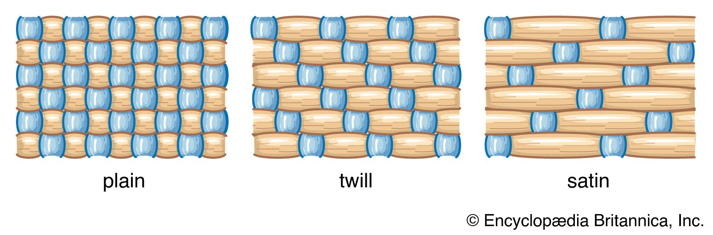
Types of weaves
The basic weaves include
plain (or tabby),
twills, and
satins.
Plain weave
Plain, or tabby, weave, the simplest and most common of all weaves, requires only two harnessses and has two warp and weft yarns in each weave unit. To produce it, the warp yarns are held parallel under tension while a crosswise weft yarn is shot over and under alternate warps across the width of the web. The weave unit is completed at the end of the second row, when the weft has been inserted over and under the opposite set of warps, thus locking the previous weft in place. Fabric length is increased with the insertion of each succeeding weft yarn. When warp and weft yarns are approximately equal in size and quantity, the finished fabric is balanced and potentially stronger than cloth made of the same kind and number of warp and weft yarns in any other basic weave. Tabby woven with different-sized warp and weft yarns results in such fabrics as taffeta and poplin, in which many fine warps are interlaced with proportionately fewer thick weft yarns to form cloths with crosswise ridges or ribs.
The term extended tabby describes any weave in which two or more warps or wefts, or both, are interlaced as a unit. The group includes fabrics with basketry effects and fabrics with ribs formed by groups of warps or wefts in each shed.
Tapestry weave is a tabby in which a variety of coloured weft yarns is interlaced with the warp to form patterns. It is usually an unbalanced weave, with wefts completely covering a proportionately low number of warps. These cloths are sturdy and compact. Although they are flat and generally do not drape well, they have been used for centuries to make ceremonial and decorative dress and costumes.
Twill weave
Twill weave is distinguished by diagonal lines. The simplest twill is that created by the weft crossing over two warp yarns, then under one, the sequence being repeated in each succeeding shot (pick), but stepped over, one warp either to the left or right. Twills with more warps than wefts floating on the fabric’s face are called warp faced; those with wefts predominating, weft faced. The angle of the twill can also vary.
Twills can be varied by changing the relative number of warps and wefts in each repeat (2:1, 2:3, 3:1, 6:2, etc.); by stepping the repeat in one direction; by breaking the direction of the diagonals formed by the twill at regular intervals; by reversing the direction of the diagonal at regular intervals to form chevrons or lozenges; or by combining several twills or modifying them to create a pattern.
Twills drape better than plain weaves with the same yarn count because twills have fewer interlacings. Twill weaves have been used throughout history in many weights and textures, from wool serges mentioned in medieval French manuscripts to English diapered (diamond patterned) table linens, patterned bed coverlets, and Indian shawls.
Satin weave
Although satin-weave drafts superficially resemble those of twills, satin weave does not have the regular step in each successive weft that is characteristic of twills. Thus, there is no strong diagonal line, and the fabric is smooth faced, with an unbroken surface made up of long floating warp yarns. A true satin must have at least five warp and weft yarns in each complete weave repeat and thus requires at least five harnesses. Most satin fabrics are made of smooth, lightly twisted yarns that heighten the effect of light unbroken by visible crosswise bindings. The limited number of interlacings allows the weaver to use a proportionately large number of warp yarns and thus produce a heavy textured cloth that can be arranged in smooth, shadowed folds. Satins, having long floats, are susceptible to the wear caused by rubbing and snagging and are, therefore, generally regarded as luxury fabrics.
Among the variations of satin weave are damask and sateen, a weft-faced satin. Damask is the most important variation of basic satin weave. Classic damask is a patterned solid-coloured fabric with figures in warp-faced satin and background in weft-faced satin weave. The pattern is created by the difference in light reflection between the warp-faced and weft-faced areas. Silk damasks probably originated in China and came to Europe through Italy, the centre of European silk manufacture between the 13th and 17th centuries. During this period drawloom weavers from the Netherlands and Belgium also developed the art of linen damask weaving. Pictorial linen damasks, unlike most silk damasks of the time, often consisted of a single large repeat, picturing biblical scenes, contemporary events, or the arms of nobles and kings.
Complex weaves
Complex weaves include multiple plane, pile, inlaid, Jacquard, dobby, and gauze (or leno) weaves.
Multiple plain weave
Reversible double-woven cloth is produced by multiple plain weaving. It is woven in two layers, which may be completely independent, may be joined at one or both selvages, may be held together along the edges of a pattern, or may be united by a separate binding weft. Though often tabby weave is employed on both surfaces, any of the basic weaves may be used, depending on the intended use of the fabric.
Double-woven cloths have been used for clothing, but, though warm, they tend to be heavy and to drape poorly. They are most often used as bedcovers or wall hangings. German 18th-century Beiderwand is an example of antique double-woven cloth consisting of two layers of tabby weave joined only along the edges of the pattern. A dark-coloured pattern in one layer is set against the light-coloured ground of the other layer; the pattern is seen in negative or the reverse side of the cloth.
Nonreversible cloth with two or more sets of warp and sometimes of weft can also be produced. These cloths have an intricately patterned face, and all warps and wefts that do not appear on the face are carried along and bound into the web on the reverse side. This class includes important historic textiles, such as early Persian and Byzantine figured fabrics, as well as more recent Jacquard-woven imitation tapestries and a wide range of imitation brocaded fabrics.
Pile weave
Pile weaves have a ground fabric plus an extra set of yarns woven or tied into the ground and projecting from it as cut ends or loops. A great range of textures is included in this binding system, from terry pile toweling and corduroy to silk velvets and Oriental rugs.
In warp-pile fabrics the pile is formed by an extra set of warp yarns. To create such a fabric, first one set (sheet) of ground warps is raised, and the weft makes its first interlacing with the ground warp. Next, pile warps are raised, and a rod is inserted through the entire width of the web. The remaining ground warps are raised to form the third shed; then the ground weft is shot across again. This sequence is repeated several times; then the rods are slipped out, leaving a warp pile. To form cut-pile velvet, a knife on the end of the rod cuts the pile warps it passes, creating two fine rows of cut pile. Although the system has many technical variations, the same basic process can be applied to most warp-pile weaving.
If the pile is not cut when the rod is removed, a loop pile fabric results. In weaving terry pile fabrics, the ground warp is under tension, and the pile warp stays slack. When wefts are beaten in, the slack yarns are pushed into loops on both sides of the cloth.
To make velvets by double-cloth construction, two layers of cloth are woven simultaneously face-to-face, with long pile warp yarns connecting the two layers. After the cloth is woven, a knife slices the two layers apart.
Corduroy and velveteen are weft-pile constructions. Weft yarns having long floats are inserted between ground-weave picks. The floats are slit longitudinally after the fabric is completed, thus forming a ribbed surface of cut pile. In manufacture of velveteen the floats are formed over the whole surface of the fabric and cut evenly to imitate velvet.
Hand-knotted Oriental and Scandinavian rugs are constructed on a tabby-weave ground, with each row of knots followed by tightly beaten-in wefts. The pile of fine Oriental rugs may contain 160 knots per inch, thus completely obscuring the knots in the rug’s foundation.
Inlaid weave
In all of the fabrics of this class, designs are created by inserting pattern warp or weft yarns between ground warps or wefts.
Brocaded fabric has a pattern of coloured or metallic threads, or both, set in low relief against the ground weave. The ground weave can be any basic weave, since the brocaded pattern is merely inserted between ground wefts and is bound by ground warps. Until the advent of the Jacquard mechanism in the early 19th century, brocaded fabrics were woven by drawloom weavers who inserted the pattern wefts by hand. These weft yarns were wound on small brocading shuttles that travelled across the width of each pattern repeat, a separate shuttle being used for each colour in the repeat. Generally, these extra wefts were found only in the area in which the pattern was located and usually formed long floats on the reverse side of the fabric.
A mechanical process closely corresponding to hand brocading is called swivel, a system of figuring fabrics by using mechanically controlled pattern shuttles. The figures, inserted between ground-weft picks, interlace with the warp. The lappet system produces figured fabrics resembling those made by swivel figuring, but the pattern yarns are extra warps (rather than wefts) brought into play from separate warp beams. Lappet weaving is generally confined to coarse pattern yarns and can be distinguished from swivel by its interlacing with weft rather than with warp yarns.
Jacquard weave
The Jacquard weave, used to make allover figured fabrics such as brocades, tapestries, and damasks, is woven on a loom having a Jacquard attachment to control individual warps. Fabrics of this type are costly because of the time and skill involved in making the Jacquard cards, preparing the loom to produce a new pattern, and the slowness of the weaving operation. The Jacquard weave usually combines two or more basic weaves, with different weaves used for the design and the background.
Dobby weaves
Dobby weaves also produce allover figured fabrics. They are made on looms having a dobby attachment, with narrow strips of wood instead of Jacquard cards. Dobby weaves are limited to simple, small geometric figures, with the design repeated frequently, and are fairly inexpensive to produce.
Gauze or leno weave
Gauze weaving is an open weave made by twisting adjacent warps together. It is usually made by the leno, or doup, weaving process, in which a doup attachment, a thin hairpin-like needle attached to two healds, is used, and the adjacent warp yarns cross each other between picks. Since the crossed warps firmly lock each weft in place, gauze weaves are often used for sheer fabrics made of smooth fine yarns. Although gauze weaving, with its multitude of variations, has been adapted to modern production, it is an ancient technique.
Knitted fabrics
Knitted fabrics are constructed by interlocking a series of loops made from one or more yarns, with each row of loops caught into the preceding row. Loops running lengthwise are called wales, and those running crosswise are courses. Hand knitting probably originated among the nomads of the Arabian Desert about 1000 BCE and spread from Egypt to Spain, France, and Italy. Knitting guilds were established in Paris and Florence by the later Middle Ages. Austria and Germany produced heavily cabled and knotted fabrics, embroidered with brightly coloured patterns. In the Netherlands, naturalistic patterns were worked on fabric in reverse stocking stitch, and several Dutch knitters went to Denmark to teach Danish women the Dutch skills. The craft of hand knitting became less important with the invention of a frame knitting machine in 1589, although the production of yarns for hand knitting has remained an important branch of the textile industry to the present day.
The frame knitting machine allowed production of a complete row of loops at one time. The modern knitting industry, with its highly sophisticated machinery, has grown from this simple device.
Knitted fabrics were formerly described in terms of the number of courses and wales per unit length and the weight of the fabric per unit area. This system is limited, however, and there is a shift to use of the dimensions and configuration of the single loop, the repeating unit determining such fabric characteristics as area, knitting quality, and weight. The length of yarn knitted into a loop or stitch is termed the stitch length, and in a plain knitted structure this is related to the courses per inch, wales per inch, and stitch density. The two basic equilibrium states for knitted fabrics are the dry-relaxed state, attained by allowing the fabric to relax freely in the air, and the wet-relaxed state, reached after static relaxation of the fabric in water followed by drying.
Weft knitting
The type of stitch used in weft knitting affects both the appearance and properties of the knitted fabric. The basic stitches are plain, or jersey; rib; and purl. In the plain stitch, each loop is drawn through others to the same side of the fabric. In the rib stitch, loops of the same course are drawn to both sides of the fabric. The web is formed by two sets of needles, arranged opposite to each other and fed by the same thread, with each needle in one circle taking up a position between its counterparts in the other. In a 2:2 rib, two needles on one set alternate with two of the other. The interlock structure is a variant of the rib form in which two threads are alternately knitted by the opposite needles so that interlocking occurs. In the purl stitch, loops are drawn to opposite sides of the fabric, which, on both sides, has the appearance of the back of a plain stitch fabric. Jacquard mechanisms can be attached to knitting machines, so that individual needles can be controlled for each course or for every two, and complicated patterns can be knitted. To form a tuck stitch, a completed loop is not discharged from some of the needles in each course, and loops accumulating on these needles are later discharged together. The plaited stitch is made by feeding two threads into the same hook, so that one thread shows on the one side of the fabric and the other on the opposite side. A float stitch is produced by missing interlooping over a series of needles so that the thread floats over a few loops in each course.
Knitting machines can be flat or circular. Flat machines have their needles mounted in a flat plate or needle bed or in two beds at right angles to each other and each at a 45° angle to the horizontal. The knitted fabric passes downward through the space between the upper edges of the plates, called the throat. In the knitting process, the needles are pushed up and down by cams attached to a carriage with a yarn guide, which moves over the length of the machine. The width of the fabric can be altered by increasing or decreasing the number of active needles, allowing production of shaped fabrics, which when sewn together make fully fashioned garments. Although flatbed machines are suited for hand operation, they are power driven in commercial use, and, by selection of colour, type of stitch, cam design, and Jacquard device, almost unlimited variety is possible. The cotton frame, designed to knit fine, fully fashioned goods, shaped for improved fit of such items as hosiery and sweaters, is fitted with automatic narrowing and widening devices.
Circular machine needles are carried in grooves cut in the wall of a cylinder, which may be as small as 1 cm (0.4 inch) in diameter and as large as 1.5 metres (5 feet). Some circular machines have two sets of needles, carried in concentric cylinders, so that the needles interlock. During the knitting operation the butts of the needles move through cam tracks, the needles sliding up and down to pick up yarn, form a new loop, and cast off the previously formed loop. In the least complicated of these machines, yarn is supplied from one package, each needle picking up the yarn once per revolution of the cylinder. Modern machines may have as many as 100 feeders, allowing each needle to pick up 100 threads per revolution. Both latch and spring needles are used, with the former more common. Modern, large, circular, plain or jersey machines having 90–100 feeders are frequently used to produce medium-weight fabric. Small bladelike units, or sinkers, are inserted between every two needles to engage and hold the completed fabric, preventing it from riding up with the needles as they are lifted to form new stitches. Machines may be fitted with pattern wheels controlling needle action to produce tuck and float stitches, and a Jacquard mechanism may also be attached. Stop motions are essential to stop the machine when a thread breaks. Because yarn tension affects fabric uniformity, various tension controllers have been devised. An alternative method, positive feed, which feeds precisely measured amounts of yarn into the machine, is now considered more satisfactory.
Circular rib machines consist of a vertical cylinder, with needle slots on the outside, and a horizontal bed in the form of a circular plate or dial with needle slots cut radially, so that the two sets of needles are arranged at right angles to each other.
Seamless hosiery, knitted in tubular form, is produced by circular knitting machines. Modern hosiery machines, such as the Komet machine, employ double-hooked needles directly opposite each other in the same plane to knit the leg and foot portions, the heel and the toe. The toe is later closed in a separate operation. In the Getaz toe, the seam is placed under the toes instead of on top of them.
Underwear fabrics are usually knitted on circular machines, and—except for fully fashioned underwear, tights, and leotards, which are knitted to pattern and sewn together—underwear making is a cut, make, and trim operation. Tights or panty hose are a combination of hosiery and underwear and can be fully fashioned. Seamless panty hose are made on circular hose machines modified to make very long stockings with open tops, two of which are cut open at opposite sides and seamed together front and back. The wearing quality and fit of modern panty hose have been greatly improved with the development of stretch nylon and spandex, and greater variety has been introduced with the development of texturized yarn.
Much hosiery is finished by washing, drying, and a boarding process in which the hosiery is drawn over a thin metal or wooden form of appropriate shape and pressed between two heated surfaces. The introduction of nylon fibre led to the development of a preboarding process, setting the loops and the fabric in the required shape before dyeing and finishing. The article, fitted on a form of appropriate shape, is placed in an autoclave or passed through a high-temperature setting unit. Fabric treated in this way does not distort during dyeing.
Circular knitting machines can be adapted to make simulated furs. One type intermeshes plush loops with the plain-stitch base fabric then cuts the loops, producing a pile. A more common method forms the pile with a carded sliver. A plain-stitch fabric is used as the base and loose fibres from a sliver, fed from a brushing or carding device, are inserted by a V-shaped claw, forming the pile. Pile depth is determined by the length of the fibres in the sliver.
One of the most sophisticated knitting machines incorporates electronic selection of sinkers in a Jacquard circular knitting machine.
Warp knitting
The two types of warp knitting are raschel, made with latch needles, and tricot, using bearded needles.
Raschel
Coarser yarns are generally used for raschel knitting, and there has recently been interest in knitting staple yarns on these machines. In the Raschel machine, the needles move in a ground steel plate, called the trick plate. The top of this plate, the verge, defines the level of the completed loops on the needle shank. The loops are prevented from moving upward when the needle rises by the downward pull of the fabric and the sinkers between the needles. Guide bars feed the yarn to the needles. In a knitting cycle, the needles start at the lowest point, when the preceding loop has just been cast off, and the new loop joins the needle hook to the fabric. The needles rise, while the new loop opens the latches and ends up on the shank below the latch. The guide bars then swing through the needles, and the front bar moves one needle space sideways. When the guide bar swings back to the front of the machine, the front bar has laid the thread on the hooks. The needles fall, the earlier loops close the latch to trap the new loops, and the old loops are cast off. Raschels, made in a variety of forms, are usually more open in construction and coarser in texture than are other warp knits.
Tricot
Tricot, a warp knit made with two sets of threads, is characterized by fine ribs running vertically on the fabric face and horizontally on its back. The tricot knitting machine makes light fabrics, weighing less than four ounces per square yard. Its development was stimulated by the invention of the so-called FNF compound needle, a sturdy device that later fell into disuse but that made possible improved production speeds. Although approximately half of the tricot machines in current use make plain fabrics on two guide bars, there is increasing interest in pattern knitting. In this type of knitting, the warp-knitting cycle requires close control on the lateral bar motion, achieved by control chains made of chunky metal links.
Special effects in warp knits
The scope of warp knitting has been extended by the development of procedures for laying in nonknitted threads for colour, density, and texture effects (or inlaying), although such threads may also be an essential part of the structure. For example, in the form called “zigzagging across several pillars,” the ground of most raschel fabrics, the front bar makes crochet chains, or “pillars,” which are connected by zigzag inlays.
An extension of conventional warp knitting is the Co-We-Nit warp-knitting machine, producing fabrics with the properties of both woven and knitted fabrics. The machines need have only two warp-forming warps and provision for up to eight interlooped warp threads between each chain of loops. These warp threads are interlaced with a quasiweft, forming a fabric resembling woven cloth on one side.

3.2.4.3.Different Types of Garments Accessories with Pictures
Garment Accessories:
Accessories cover all of the things except the main or base fabric and other trimmings required to dispatch (send out) the garments to the final destiny or to the buyer or customer. Or, The materials which are used to make a garment attractive for selling and packing other than fabric and trims is called accessories. The things those are attached to the garments after finishing are termed as accessories in garments manufacturing technology. Some individuals mistakenly consider accessories and trimmings to be the same but the difference between them is that the trimmings are attached to the garments during making or manufacturing, whereas accessories are attached to the garments after finishing. Types of garments accessories cover the following things: Collar insert or neck board or collar stand, Back board, Butterfly, Hangtags (Price tag, size tag, etc), Tag pins, Tissue paper, Hangers, Single and blister poly bag, Metal clip or plastic clip, Alpin, Bar code sticker, Scotch tape, Gum tape, Cellophane tape, Export carton, etc.
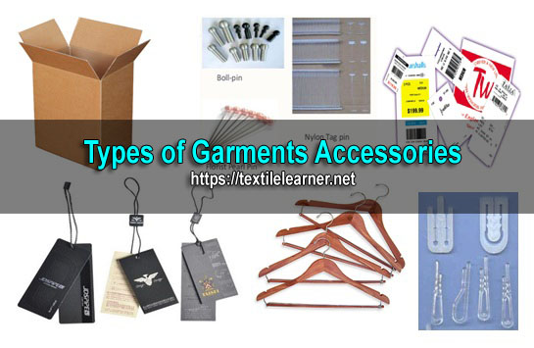
Figure 20.Types of garment accessories
According to book “Apparel Manufacturing” by Glock and Kunz, definition of accessories are:
Accessories: Item that enhances the aesthetic appeal or function of a garment including belt, scarves or other objects. In generally these components are sewing less.

Types of Garments Accessories:
Accessories that are carried (Small pets, toy dog, cats, birds, snakes, taking parrots)
Accessories that are worn, (Necklace, Umbrella, Bag, Parts etc.)
Hangtags:
Hangtags are designed to draw attention to the garments and are hung on the side of the garment and sometimes in front of button line so that the customers can see them easily. Hangtags are printed paper tags hung from the garments by plastic staple or string. They usually show the brand name, style number, etc. It is regarded as one of the finishing accessories.
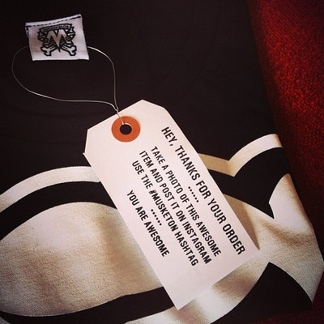
Figure 21.Hangtags
Price tag:
It is a type of tag printed with the sales price of the garment. It is usually supplied from the buyer’s side. The merchandiser usually takes it from the buyer and supplies to the folding section.
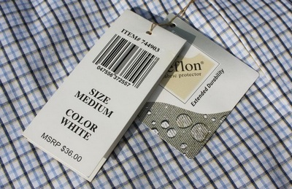
Figure 22.Price tag
Polybag:
A polybag is a plastic bag used for packing garments. The garment is first folded as per direction of the order sheet then is packed. There are two types of polybag used in garments packing; one is single polybag in that a single garment is packed and the other is blister polybag in that more than one garment are packed. For packing the garments into blister polybag, packing instructions must be followed.
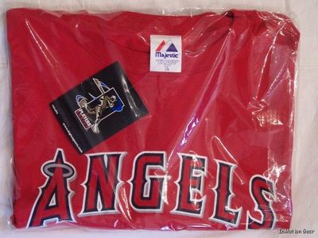
Figure 23.Polybag
Carton:
Carton is the name of certain types of containers typically made from paperboard which is also sometimes known as “cardboard”. Many types of cartons are used in packaging garments ready for shipment. The dimensions of the cartons depend on buyer instructions and the number of pieces of garments in each carton is given in the order sheet. Sometimes a carton is also called a box.
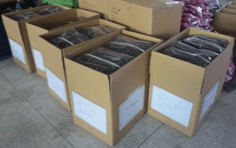
Figure 24.Carton
Scotch Tape:
Scotch Tape is used to describe certain pressure sensitive tapes used for wrapping the cartons. Scotch tape is available in roll form and contains 25 yards in each roll. The approximate price of the scotch tape is USD 0.45 per roll.
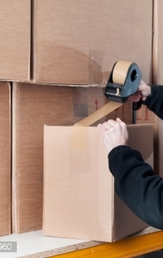
Figure 25;Scotch Tape
Clips:
A clip is a device which holds the fold portion of the garment together by means of pressure: it leaves the fold portion intact and can be quickly and easily removed, unlike the staple, which will damage the paper unless removed carefully, and will always leave two holes in the paper.
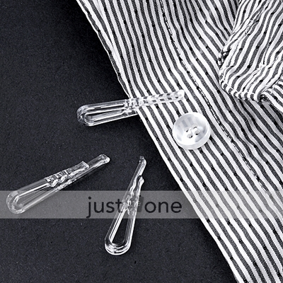
Figure 26;Clips
Clothes.Hanger:
A cloth’s hanger, or coat’s hanger, is a device in the shape of:
Human shoulders designed to facilitate the hanging of a coat, jacket, sweater, shirt, blouse or dress in a manner that prevents wrinkles, with a lower bar for the hanging of trousers or skirts.
Clamp for the hanging of trousers, skirts, or kilts. Both types can be combined in a single hanger.
There are two basic types of clothes hangers. The first is the wire hanger and the second is the wooden hanger. There are also plastic coat hangers, which mostly mimic the shape of either a wire or wooden hanger. Plastic coat hangers are also produced in smaller sizes to accommodate the shapes of children’s clothes.
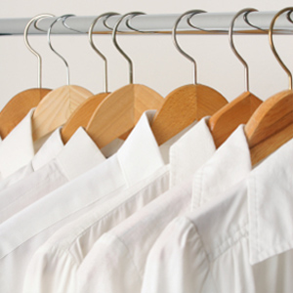
Figure 27;Clothes Hanger
3.3.Determined According To Pattern Requirements Sequencing Of Garment Assembly Operations
Sequencing of garment assembly operations refers to the order in which different tasks and processes are performed during the manufacturing of a garment. This sequencing is determined based on several factors such as the design of the garment, the type of fabric used, the complexity of the construction, and the efficiency of the production process.
The following are some common steps involved in the sequencing of garment assembly operations:
1. Cutting: The first step is to cut the fabric according to the pattern pieces. This can be done manually or using automated cutting machines.

2. Marking: After cutting, the fabric pieces are marked with important information such as notches, grain lines, and reference points. This helps in aligning and joining the pieces accurately during assembly.
3. Sewing: The sewing process involves joining the fabric pieces together using various stitching techniques. The order of sewing operations is determined based on the construction requirements of the garment. For example, seams that require topstitching or special finishes may be sewn before other seams.
4. Pressing: Pressing is an important step in garment assembly as it helps in shaping and setting the seams. It involves using heat and steam to flatten and smooth out the fabric.
5. Finishing: After sewing and pressing, the garment goes through various finishing operations such as attaching buttons, zippers, or other closures, hemming, adding trims or embellishments, and attaching labels or tags.
6. Quality Control: Throughout the assembly process, quality control checks are performed to ensure that the garment meets the required standards. This includes checking for any sewing defects, proper alignment of pattern pieces, and overall appearance.
7. Packaging: Once the garment has passed all quality control checks, it is folded, packed, and prepared for shipping or distribution.
The sequencing of these operations may vary depending on the specific requirements of each garment and the production facility. Efficient sequencing is essential to optimize production time, minimize errors, and ensure consistent quality in garment manufacturing.

3.3.1.Garments Manufacturing Process:
The clothing creation running actions and methods included in the developing outfits for the huge of creation in company time frame for company reasons is known as outfits developing technologies. On industrial basis there are certain areas or sequence through which garments are manufactured. In this article I will discuss every process sequence of garment manufacturing.
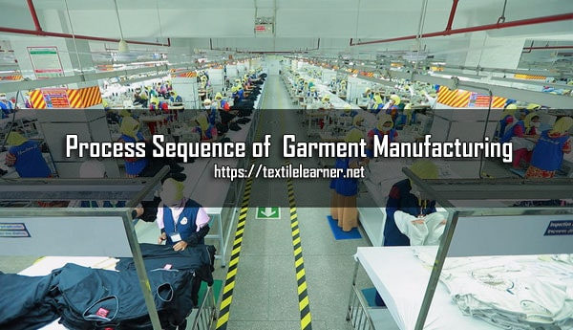
Figure 28 ; Garments ManufacturingProcess

Sequence of Garment Manufacturing
Step wise garment manufacturing process sequence on industrial basis is given below:
Design / Sketch
↓
Pattern Design
↓
Sample Making
↓
Production Pattern
↓
Grading
↓
Marker Making
↓
Spreading
↓
Cutting
↓
Sorting/Bundling
↓
Sewing/Assembling
↓
Inspection
↓
Pressing/ Finishing
↓
Final Inspection
↓
Packing
↓
Dispatch

3.3.2. Sequence of Garment Manufacturing are given below in details:
Design/Sketch:
In the garment manufacturing the first step is designing the sketch for the dresses that have to be prepared. For this purpose, the designer first draws several rough sketches in the sketch book. The designer does not go for details at this moment but he rather let his creativity flow on the paper and he draws many sketches. Later these sketches are analyzed by a panel of designers. They finally select few out of them. These few sketches are rendered in detail separately or in the form of a single collection. The designer also draws working drawings along with the sketch. Working drawings are flat drawing of the sketch and it help pattern maker in understanding the patterns involved in the construction.
Pattern Design:
Hard paper copy of each component of the garment of exact dimension of each component is called pattern. The patterns also include seam allowance, trimming allowance, dirt’s, and pleats, ease allowance, any special design etc. affairs. Pattern design could also be done manually or with the help of computer.
Sample Making:
The first patterns are sent to the sewing unit for assembling them into garment. This is usually stitched on calico or muslin which is an inferior quality of fabric and it reduces cost. This sample is constructed to analyze the pattern fit and design too. After the sample garment is stitched it is reviewed by a panel of designers, pattern makers and sewing specialists. If any changes have to be made, they are made at this time.

3.3.3. Sequence of Garment Sample Development
1st Pattern
↓
2nd Pattern
↓
Counter Sample
↓
Salesman Sample
↓
Photo Sample
↓
Approved Sample
↓
Pre-production Sample
↓
Production Sample
↓
Shipping Sample

3.3.4. Flow Chart of Proto Sample Development in Apparel Industry
Protosample:
Proto sample is the first sample in production development stage in apparel industry. It is prepared according to the buyer’s specification. This type of sample is designed by the designers. Fit and fabric detailing is not considered in this sample.
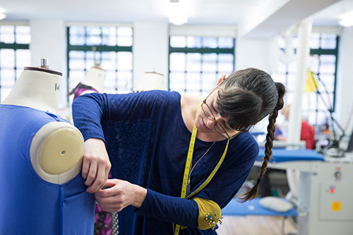

Figure 29;Garment Proto Sample Development
Process Flow Chart of Proto Sample Development in Garment Industry
Program Received from Buyer
↓
Personal Study on Tech pack
↓
Meeting with Internal Team
↓
Advice for pattern making
↓
Sourcing Raw materials
↓
After Receiving Raw Materials Send to Sample Section
↓
Cutting
↓
Printing/Artwork
↓
Sewing
↓
Washing (If Needed)
↓
Finishing and QC
↓
Final Review
↓
Tagging
↓
Packing/Invoice
↓
Send to Buyer

All of the above parameters are discussed shortly:
Program Received from Buyer
First step of proto sample development is program receive from buyer. Buyer gives us a tech pack to develop a proto sample. We collect all the details from buyer regarding development program.
Personal Study on Tech Pack
After receiving program we have to study on it. Because of to check whether we are capable to develop a proto sample, to check how much requirement of buyer and how much we have.
Meeting with Internal Team
After case study on tech pack then arrange a meeting with internal team who involved in this development program. In this meeting to discussed how much important this program and what is the dead line also discussed we are capable or not for this program.
Advice for Pattern Making
After complete a meeting now advice a team to make a pattern for program.
Sourcing Raw materials
According to buyer requirement source raw materials from the supplier. For sourcing we have to send mail to supplier with attaching all the details. Such as brand name, style no, color, fabrication details, fabric description etc.
After Receiving Raw Materials Send to Sample Section
After receiving raw materials send to sample section for make a proto sample. It is responsibility of merchandiser to keep communication with sample section. So that, the sample make in time and better quality.
Cutting
Now fabric send to cutting section for cut the fabric according to pattern. Cutting is one of the major process in proto sample development program.
Printing/Artwork
If buyer has any requirement of printing or artwork then its place on right place. This process is called artwork placement.
Sewing
All the parts of a garment are joined here to make a complete garment. Sewing process is done by manually.
Washing (If Needed)
If buyer wants any washing in sample we have to apply it.
Finishing and QC
After washing we will get a complete garment which is treated with steam ironing & also several finishing processes are done for example extra loose thread cutting etc.
Tagging
Tagging is very important in proto sample development program because if we do not keep tagging against each style it is possible to mix with other style.
Packing/Invoice
According to buyer requirement packing all the garments.
Send to Buyer
After complete all the process now send the sample to buyer and waiting for approval

3.3.5. Production Pattern:
The pattern design is now taken for creating the production patterns. The production pattern is one which will be used for huge production of garments. The pattern maker makes the patterns on standard pattern making paper. These papers are made-up of various grades. The most important component, the tissue paper pattern, is made from the lightest and thinnest paper commercially available (it is not made at the pattern companies). It is called 7.5 lb (3.4 kg) basis paper, meaning that a ream of it (500 sheets) only weighs 7.5 lb (3.4 kg).
Garment patterns can be constructed by two means: manual method, CAD/CAM method. Today many companies have developed CAD/CAM because of the ease of designing patterns, fluency and precision involved which cannot be guaranteed with the manual method. Investing once into the CAD/CAM unit is worth in itself. Many buyers around the world prefer manufacturers who are using CAD/CAM methods. The production patterns created in CAD/CAM can be stored easily and they can be modified at any point of time.
A garment sewing pattern or garment fabric & patterns draft is developed by calculating, taking account of the following measurements:
Direct Sample.
Specification Sheet/ Measurement Chart.
Actual body size measurements.
Ease Allowances.
Sewing Allowance.
These allowances are different for different type of fabrics and patterns.
Grading:
The purpose of grading is to create patterns in different standard sizes. Grading a pattern is really scaling a pattern up or down in order to adjust it for multiple sizes. Pattern sizes can be large, medium and small or else there are standard patterns of size 10, 12, 14, 16 and so on for different figure and statures sizes. This is generally how we get S M L XL XXL sizing. Pattern grading by manual method is a cumbersome task because the grader has to alter the pattern on each and every point from armhole, to neckline, sleeve cap and wrist etc. by using CAD it is much easier and faster.
Marker.Making:
All the pattern pieces for all the required sizes are arranged and the paper in such a way so that maximum number of garments could be produced with minimum fabric wastage. Markers are made for 6, 12, 18, 24 etc. pieces. Marker is also useful to estimate fabric consumption calculations.
What,Marker:
Marker is a thin paper which contains all the necessary pattern pieces for all sizes for a particular style of garments. It is made just before cutting and its purpose is to minimize the wastages. The width of the marker is equal to the width of the fabric and it should not be greater than the width of the fabric, i.e. fabric width is greater than or equal to marker width. The pattern pieces should be placed very carefully in such a way that it would minimize wastages. Different techniques are used in marker making to minimize the wastages.
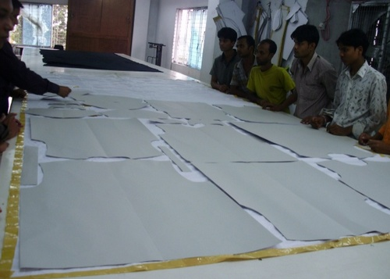

Figure 30;Marker making
Possibilities / Methods / Techniques of Marker Making:
Generally there are two methods by which a marker can be made.
A. Manual Method
The man performs it by himself using hands. If is a conventional system that requires more time.
1. Full size marker: Full size marker is made for production purpose.
2. Miniature type marker: Miniature type marker is sometime made and its purposes are to plan or schedule and learn or study i.e. for planning and learning purposes.
B. Computerized Method
This is the best method as it gives higher marker efficiency. In this method, the pattern size, pattern pieces, grade rule, screening are fed to the computer and set in the memory which produces maker automatically. This method normally is a part of an integrated system which includes:
1. Digitizing system: In this system, the working patterns are placed on to the digitizing board/table, then clicking according to the pattern dimensions.
2. Scanning system: Scanner is one kind of machine like photo copier. The working patterns are placed on to the glass of the scanner and then marker is made for a selected size.
Types of computerized method
There are two types of computerized technique:
1. Automatic marker making: It involves calling up data defining the placement of pieces in marker previously planned and selecting from a series.
2. Interactive marker making: It is a common process in that the operator plans marker by interacting directly with the system through a computer screen. All the pattern pieces are displayed in miniature at the top of the screen.
Advantages of computerized method over manual method
Suitable for large scale of production.
Marker efficiency is higher than that obtained in manual method.
Least fabric wastage.
Low production cost.
Marker can be printed out if necessary.
Grading of the pattern could be done automatically.
Few time assumption.
Disadvantages compared to manual method
Initial investment is high.
Skilled operator is greatly necessary.

3.3.6. Difference between manual and computerized method of marker making:
Manual method | Computerized method
Suitable for small amount of production. | Used for large scale of production.
Marker efficiency is lower. | Higher
Initial investment is not high. | Higher
It is usually a slower method. | Quicker method
Production cost is high. | Low
Fabric wastage is high. | Low
Can not be copied as and when wish. | Can be copied as and when desired.
Table 2: Difference between manual and computerized method of marker making
Difference between automatic and interactive marker making:
Automatic | Interactive
Most efficient marker is obtained. | Comparatively less efficient.
More time is required. | Comparatively less time is required.
Computer makes marker by previously planned data. | Operator makes marker with the help of computer.
Smaller sized patterns are displayed on the computer screen and full size patterns are stored in the computer memory. | All the pattern pieces are displayed in miniature at the top of the screen.
Grading rule is applied. | Not applicable.

Table 3: Difference between automatic and interactive marker making

Markers may be of different types which are as follows:
- Half garment marker
- Whole garment marker
- Single size marker
- Multi size marker
- Sectional marker
- Interlocking marker
- Mixed multi-size lay
- Marker efficiency:It may be defined as the ratio of the total area of all the pattern pieces in the marker to the total area of the marker plan. It is expressed in percentage (%).
………………………………….Total area of all the pattern pieces in the marker
Marker efficiency (η) = ……………………………………………………………………………x 100
……………………………………………..Total area of the marker plan
The higher the marker efficiency, the lower will be the fabric wastage i.e. least fabric will be required to make a definite number of garments. So increase in marker efficiency is very important.
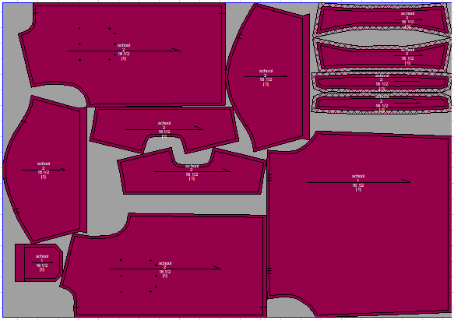
Figure 31;Garment marker plan

3.3.7. Factors on which marker efficiency depends on:
1. Marker planner: Marker efficiency is largely governed by the experience, honesty, sincerity and technological knowledge of the marker planner. It also depends on the number of trials given for marker making.
2. Size of garments: If more sizes of garments can be included e.g. S, M, L, XL, XXL for a particular style in the marker, then more will be the efficiency.
3. Marker length: If the marker length is higher, then efficiency will be higher. The length of the marker is related with many factors but bigger marker length enhances more production in the cutting room.
4. Pattern engineering: Marker efficiency can also be increased by changing or alternating the patterns’ position in the marker.
5. Fabric characteristics: Efficiency will be higher for symmetrical fabric. But if the fabric is asymmetric then the marker efficiency will be less. If the fabric is cheeked or stripped then marker efficiency will be obtained less.
6. Marker making method: Efficiency will be higher for computerized method that obtained in manual method. But if the marker maker is highly experienced, then manual method may enhance more efficiency.
7. Marker width: It has been found from experiment that if the marker width is more, then efficiency will be more because patterns can be placed in the marker easily. But for tubular fabric, the above statement may not be correct.
8. Style of garments: The more large patterns and less small patterns for a particular style of garments reduce efficiency and vice versa.
y marker maker wants to plan marker with highest efficiency to confirm the highest use of fabrics during apparel production but it is always not possible to place the pattern pieces as desired place. This occurs because during marker planning, marker maker have to maintain some requirements.
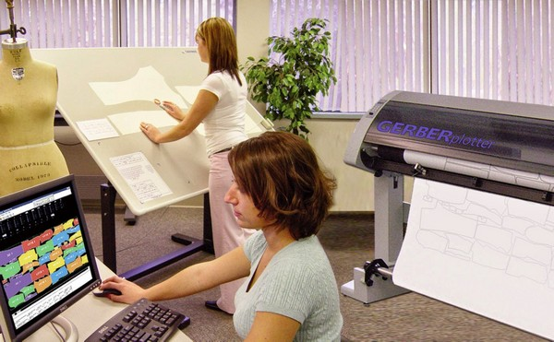
Figure 32Constraints of marker making
Constraints of Marker Making:
The limitations for which marker maker cannot plan marker as desired are as-
Grain Line
Design of Garments
Nature of the Fabric
Cutting Accuracy
Production Planning
The hinders or constraints of marker making are described here:
1. Grain Line: Grain line is a more effective constraint of marker making because of grain line sometimes it is tough to place the pattern pieces onto the marker, even though it is possible the wastage becomes higher.
2. Design of Garments: Sometimes the designs and repeats of the fabric are regarded as constraints of marker making. The patterns may miss the designs or may overlap the designs.
3. Nature of the Fabric: Nature of the fabric may sometimes be regarded as a constraint of marker making. Nature of the fabric includes symmetric and asymmetric.
4. Cutting Accuracy: Accurate cutting may be one of the constraints of marker making.
During cutting the edge of cutting knife blade requires sufficient space so that it can be moved in desired direction. So that the pattern pieces should be arranged with a little space among themselves. Otherwise, it may reduce marker efficiency.
Pattern pieces for a particular order should be counted carefully to ensure that no parts have been missed to be included as well as to ensure that no parts have been included twice unnecessarily.
Production Planning: Production planning includes rate of production, types of garments, sizes of garments, etc.
Suppose we have order of 3000 pieces for the four sizes like S, M, L, and XL.
Where, S = 600 pieces, M = 1200 pieces, L = 600 pieces, and L = 600 pieces. Fabric thickness constraints the number of plies in the lay to 150 only. Then size ratio will be:
600 : 1200 : 600 : 600
= 4 : 8 : 4 : 4
Total 20 sets of patterns will be included in the marker. It would be a long marker obviously so in that case marker efficiency will be higher; but it will require more time, bigger sized table, more lays of fabric from different rolls which can increase the possibility of shade variation.
Therefore, we can produce two markers without altering the size ratio and two relatively short markers would be produced.
First marker = 2 : 4 : 2 : 2 (10 sets of patterns in the marker)
Second marker = 2 : 4 : 2 : 2 (10 sets of patterns in the marker)
Quality control in marker making:
Marker is a thin paper which contains all the necessary pattern pieces for all sizes for a particular style of garments. It is made just before cutting and its purpose is to minimize the wastages of fabric. In case of marker making quality is very important factor. Though quality is a relative term.
Purposes of quality control in marker making:
The objectives of quality control in marker making can be summarized as:
To ensure the markers are made to a size ratio that gives the required quality and quantity per order by reducing the wastage of fabrics.
To ensure no garment part is missed in the marker and the marker is of comparable length and width of the fabric being laid.
To check notch or drill mark
Fabric width must be higher than marker width
Fabric length must be higher than marker length
Matching of green line
Check pattern size and dimension
Matching of check and stripe taking into consideration
Considering garments production plan
Cutting table length consideration
Pattern direction consideration
Cutting section starts with the receipt of piece goods and ends with the completion of the bundles of cut parts ready for sewing. The preparation for cutting is very important prior to the cutting operation. Accurate cutting simplifies the sewing and pressing operation. Cutting of fabrics or trims to size, where possible, eliminates considerable measuring, matching, shaping and trimming in the sewing room. Proper punching of holes and notching is important for accurately locating parts.
Quality inspection process in marker making:
Locations with manual marker making system: In these locations, the markers should be inspected by the Quality Control Department before the fabric is laid. This will leave sufficient time to make any correction to the marker that is necessary.
Locations with computer marker making (CAD) system: In location that uses the CAD system, the marker information needs to be cross-checked by an operator other than one who complied the marker, before the marker is printed. This is to ensure that no operator error has occurred. The marker can then be re-inspected by the Quality Control Department
after it has been placed on the lay of fabric prior to cutting.

Marker inspection:
SL | Check points | Allowance
1 | Ensure the correct patterns have been used. | No allowance
2 | Ensure the size ratio is correct | No allowance
3 | Ensure the correct sizes have been drawn onto the marker as per the size ratio | No allowance
4 | Ensure all the garment parts have been drawn onto the marker | No allowance
5 | Ensure the patterns are facing the correct direction in case of marker making modes. | No allowance
6 | Ensure the patterns have been placed onto the marker in such a manner as to achieve the highest fabric utilization. | Stripes and Checks 80% & Solid color 95%
7 | Ensure the marker is of the correct widths, comparable to the fabric so that the fabric is not wasted. If the marker is too small or too wide then incomplete garment parts are cut. | Zero to half inch
8 | Ensure the marker is of correct length | Zero to one inch
9 | Ensure splicing marks are correctly drawn on the marker. | No allowance
10 | Ensure all notches and drill holes have been drawn on the marker. | No allowance
11 | Ensure no unauthorized alterations have been made to the marker. | No allowance

Table 4: Marker inspection

Spreading:
It is the process of arranging fabrics on the spreading table as per length and width of the marker in stack form. Normally height of the lay/fabric is limited up-to maximum six inches high. But 4 inches to 5-inch height of the lay is safe.
Fabric spreading:
Fabric spreading means the smooth laying out of the fabric in superimposed layers (plies) of specified length. Knitted or woven fabrics are laid in one ply (single ply) or in several plies (multi lays) for simultaneous cutting in one operation. Fabrics are usually laid up manually.
The manual spreading process is suitable for small-scale production. Manual spreading may be used for all kind of fabrics, including those with complex structures and intricate patterns. In large-scale production, manual cutting is often used for working with intricately patterned and high-cut pile fabrics. When compared to automated spreading, the cost of technical equipment in manual spreading is low, but the productivity is poor. The fabric spreading process is carried out by one/two workers at each side of the spreading table who move the fabric ply to the beginning of a spread. The spreading process is repeated until the desired number of fabric plies are laid down.
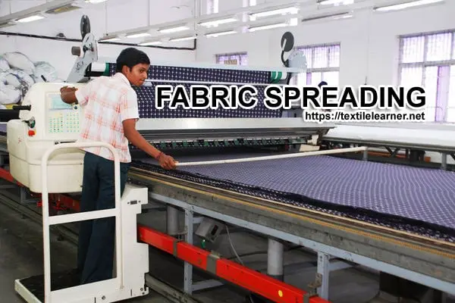

Figure 33; Automated method of fabric spreading
Automated methods of fabric spreading have significantly increased the productivity of the spreading process, but have not altered its main work principles. Similar operations are performed in both the manual and the automated spreading processes.
Methods of Fabric Spreading:
Four methods of fabric spreading are available in garment industry:
Completely manual laying-up;
Electrically driven laying-up by spreading machines (Semi-automatic or fully automatic)
Manual laying-up aided by spreading and cutting off devices;
Manually driven, mechanized laying-up using carriages;
The piece goods are provided in rolled or lapped form and are spread open or folded. On the fold, markers are used for doubled lays while full markers serve for open lays. Piece good lays are either single lays (consisting of one fabric ply) or multi lays (formed by several plies).
1. Completely manual laying-up:
This is the most extensively used method in our country because of cheap labor cost, availability of workers and comparatively less time consumed. In this method, a roll of fabric is taken and its one end is fixed at one side of the table and spreading continued without using any mechanical assistance. A large number of workers is required to carry out this process to fulfill the requirements of fabric spreading.
2. Electrically driven laying-up by spreading machines:
An electrically driven and controlled cloth spreading machine including means for reversing the travel of the machine, means for controlling the high and low speeds of the machine, means for causing the machine to fail safe at low speed upon power failure and open circuit conditions caused by different changes in function of the machine.
3. Manual laying-up aided by spreading and cutting off devices:
The fabric in roll form may be supported to a frame and carried along the table where the end is secured by weight or by a clamp. The operators work back from the end aligning the edges and ensuring that there are no wrinkles or any extra tension. The ply is normally cut with hand shears or with a powered circular knife mounted on the frame. This system of spreading is suitable for checks or striped or other regular repeating patterns.
4. Manually driven, mechanized laying-up using carriages:
Spreading machine carries the piece of fabric from end to end of the spread dispensing one ply at a time onto the spread. Their is a frame or carrier wheels traveling on guide rails at the edges of the table, a fabric support and guide collars to aid the correct unrolling of the fabric. In the sampler versions, the operators clamp the free end of the fabric in line with the end of the spread, push the spreader to the other end, cut off the ply in line with that end, clamp the beginning of the next ply, push the spreader to the other end and so on.
Fabric Cutting:
On the fabric lay/spread the marker paper is placed carefully and accurately, and pinned with the fabric to avoid unwanted movement or displacement of the marker paper. Normally straight knife cutting machine is used to cut out the garment component as per exact dimension of each patterns in stack form, care must be taken to avoid cutting defects.
Sorting/ Bundling:
After cutting the entire fabric lay, all the garments components in stack form is shorted out as per size and color. To avoid mistake in sorting, it is better to use code number on each pattern.
Sewing or Assembling:
It is the most important department/section of a garment manufacturing industry. Sewing machines of different types are arranged as a vertical line to assemble the garments. Sequence of types of sewing machine arrangement depends on sequence of assembling operations. Number of sewing machines per line varies from 20 nos to 60 nos depending on the style of the garmnet to be produce. Production per line per hour also varies from 100 to 150 pieces depending on specific circumstances. Number of sewing machine arrangement per line may be up-to 60 depending on design and output quantity of garment.
Sewing section:
The sewing process is the attachment of different parts of the cut pieces. In this work place there are many operators who perform single operation. All this factor decides what parts of garment can be sewn at that station. Sewing section is the most importat department in apparel industry.
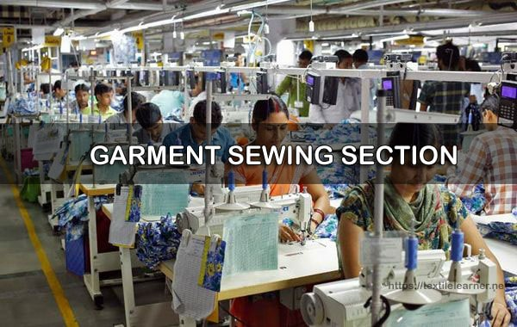

Figure 34; Sewing section
Machine used in the sewing section:
Single Needle Lock Stitch machine
Double needle Lock stitch machine
Vertical Lock stitch machine
Single needle Chain Stitch machine
Pointer (collar, cuff)
Halamark m/c
Overclock Machine (5Thread)
Feed off the Arm machine
Flat bet fusing machine
Continuous fusing Machine
Kansai machine etc.

Process flow of sewing section:
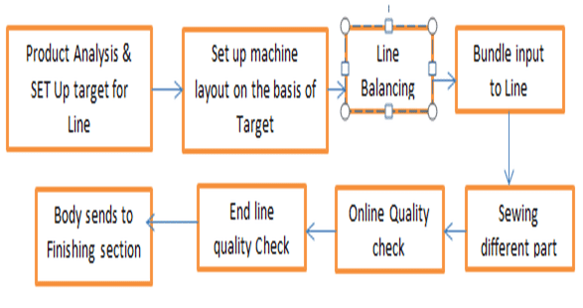
Table 5:Diagram in how sewing section perform

Working way of sewing floor:
Product Analysis and set up target for Line: Here usually find the critical operation of the product by analyzing the product and decide where need help, which operator works on which operation. After analyzing the product line target is set for per hour production. Line supervisor monitoring target production achieving or not.
Set up machine layout on the basis of Target: On the basis of operation layout and target of per line, machine layout is setup to ensuring target per hour production.
Line balancing: Line balancing is a tool used for production line to capacitate the flow line of production. If line is not balanced properly, required target result will not be achieved properly. Some work have higher work load, some have lower load which caused bottleneck in the line.
Bundle Input to Line: After ensuring line balancing, bundle wise cut panel input to line as per pre-determined manner to workers.
Sewing: Workers sew different parts as per pre-determined manner according to machine layout for ensuring right operation is made by right machine and right operator.
Online Quality check: In this stage, front and back part sewing quality checked by on-line quality inspector. If found any defect, send the garment to that operator who sew the defective for repair the sewing faults.
End line Quality check: Here Full garments of both inside and outside checked properly to ensure the garments is defect free. If found any defect, repair that defect by who are responsible for that defect. Here also count the body to comparing if target is achieved or not.
Body sends to finishing section: After end line quality inspector, garments are sending to finishing section for finished the body for shipment as per buyer’s requirements.

Process Breakdown of Basic Shirt (Full Sleeve):
Basic Shirt Manufacturing Process:
SL No.# | Process name | Machine & Attachment
Collar
1 | Collar top part Fusing | Continues Fusing m/c
2 | Collar finish pattern mark on Collar | Pencil and pattern
3 | Collar trim | Overclock m/c (without thread and needle )
4 | Collar run stitch (top and in part) | SNLS
5 | Collar Turn | Hand work
6 | Collar point | Pointer + Collar stay
7 | Collar outline (1/4 top stitch) | SNLS
8 | Collar band fusing | Continuous fusing m/c
9 | Collar band hem | SNLS
10 | Finish pattern mark on collar pattern | Pattern .pencil
11 | Collar and collar band attach | SNLS
12 | Collar band turn | Hand work
13 | Collar band (1/4 top stitch) | SNLS
14 | Collar Band point | Pointer
Cuff
15 | Cuff fusing | Continuous Fusing machine
16 | Cuff hem | SNLS
17 | Cuff Run stitch | Vertical Lock stitch machine
18 | Cuff turn in pair | Hand word
19 | Cuff outline (1/4 top stitch) | SNLS
Front part
20 | Front Pair tuck + care label joint | SNLS
21 | Front BTN placket make | Kansai machine + folder
22 | Front Placket Fusing | Flatbed fusing machine
23 | Box placket make | SNLS + Folder
24 | Pocket positioning | Pattern
25 | PKT Rolling | SNLS
26 | PKT iron + scissoring | Iron + scissor
27 | PKT Attach to front + placket close | SNLS
Back part
28 | Main and size label joint | SNLS
29 | Label attach to Bk part | SNLS
30 | Yoke attach to BK part | SNLS
31 | Yoke top stitch | SNLS
Sleeve part
32 | Gamble attach to body | SNLS
33 | SLV placket fold and iron | Iron + folder
34 | SLV Placket attach | SNLS
Assembly
35 | Shoulder Joint | SNLS
36 | Shoulder top stitch | SNLS
37 | SLV Joint to body | Overlock m/c
38 | Armhole Top stitch | SNLS + Folder
39 | Collar joint to body | SNLS
40 | Collar Closed | SNLS
41 | Collar to Stitch | SNLS
42 | Side seam | Feed off the arm machine
43 | Cuff attach to SLV | SNLS
44 | Bottom hem | SNLS + Folder
44 | BTN Hole | BTN Holing Machine
45 | BTN Attach | BTN Attaching machine

Table 6: Basic Shirt Manufacturing Process
Elements of sewing section:
- Sewing thread
- Needle
- Sewing Machine
Sewing defects:
- Needle damage
- Skip stitches
- Thread breakages
- Broken stitches
- Seam puckering
- Pleated seam
- Wrong stitch density
- Uneven stitch density
- Staggered stitch
- Improperly formed stitches.
For making a basic shirt, we need 7 types of sewing machines. They are given below:
- Plain Machine or Lock Stitch Machine
- Over lock or over edge Stitch Machine
- Button Holing Machine
- Button Attaching Machine
- Feed of the Arm
- Kansai or Multi needle chain stitch machine
- Single Needle & Double Needle Chain Stitch Machine (with or without edge cutter & thread cutting mechanism)
Important sewing machine descriptions are given below:
Plain Machine or Lock Stitch Machine:
- No. of needle: Generally 1 needle or 2 needles
- SPM (Stitches per Minute): 1500-5500
- Stitch Length: 5mm in Juki
- Automatic Thread Cutting
- Automatic Bobbin Winging
- Edge Cutting System
- Most commonly used for sewing of woven garments.
Over lock or Over edge Stitch machine:
- No. of needle: one or 2 needle
- No. of thread: 2-5 threads
- SPM: 6500-8000
- Stitch length: maximum 4mm and stitch length can be changed by push button.
Button Holing Machine:
- Stitch group: lock or chain stitch
- Arrangement of button hole size being small or larger
- Arrangement of stitch density being increased or reduced.
- Button hole can be made to cut the hole before or after sewing a button hole.
Button Attaching Machine:
Productions lock stitch, chain stitch or hand stitch.
Various types button clamps needs for attaching various sizes and types of button.
The bottom may be 2 or 4 holes. 4 whole button may be sewed by cross or parallel.
If chain stitch is used, the sewing looks nice, but the security of stitch is comparatively less.
In case of lock stitch used no possibility of sewing opening. But not looks nice. In fully automatic machines, button feeding and positioning inside the button clamp is performed by a hopper and pipe.
It can attach predetermined number of buttons at a predetermined distance in acyclic order.
Feed of the Arm:
- Number of needle: 2
- SPM: 3000 -3200
- Number of thread: 4 threads
- Twist per inch: 15 – 20
- Stitch group: chain stitch
- Mainly sewing shirts, Jeans, Gridding goods & double stitching pants
Kansai or Multi needle chain stitch machine:
- Number of needle: 6-17
- Number of thread: 12 – 34
- SPM: 4000 – 4500
- Stitch group: Chain Stitch
Chain Stitch Machine:
- No. of needle: one or more needle
- No. of thread: one or more thread (Single thread or multi thread)
- SPM: 1800-6000
- Stitch length : 1.4 to 4.5 mm
- Automatic thread trimmer
- Various types of feed mechanism is adjusted to the machine.
- Used in knitted wear and jeans.
Inspection:
Each and every garment after sewing passes through the inspection table/ point, where the garments are thoroughly and carefully checked to detect/find any defect if present in the garment. The defects may be for example variation of measurement, sewing defect, fabric defects, spots etc. if the defect is possible to overcome, then the garment is sent to the respective person for correction. If the defect is not correction-able, then the garment is separated as wastage.
Garment Inspection:
Inspection is the act of looking at something closely in order to learn more about it, to find problems, to see if rules are being followed and things are in their proper condition. Quality assurance process the bulk pollution is examined before delivery to the customer to see if it meets the specifications. The consumers want to get high quality products in low price. The products should reach the consumers with right quality depends on the cost. Quality assurance covers all the process within a company that contributes to the production of quality products. Which is conduct form beginning to end of the process (or) shipment? The inspection is carried out by representatives of the current production and the result record on control chart. Which is a process to Assure the product quality acceptable or not.
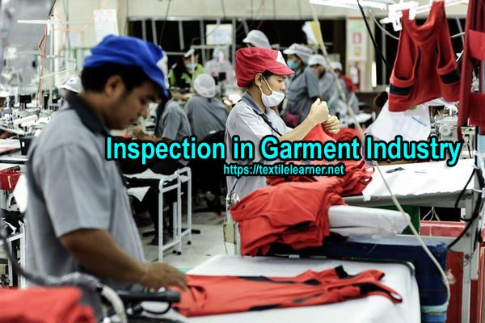

Figure 35; Inspection in Garment Industry
Stages of Inspection in Garment Industry
The aim of garment inspection is to visually inspect articles at random from a delivery in order to verify their general conformity and appearance with instruction/description and/or sample received.
There are different stages of inspection are done in garments industry following by inspectors as requirement of consumers:
- Pre-Production Check (PPC)
- Initial Production Check (IPC)
- During Production Check (DuPRO)
- Final Random Inspection (FRI)
A. Pre-Production Check (PPC):
This is done before production starts. Where then is a final verification of the material used; style, cut and workmanship of the garment or pre-production sample as per the customer requirements.
B. Initial Production Check (IPC):
This is done at the start of production where a first batch of garments is inspected; to distinguish possible discrepancies/variation and to allow for the necessary corrections to be made bulk production. The inspection is a preliminary stage covering mainly style and general appearance, workmanship, measurements, quality of fabrics, components, weight, color and/or printing.
C. During Production Check (DuPro):
This is done during production to ensure initial discrepancies/variations have been rectified. This inspection is in fact the follow -up of the initial production check and is generally carried out a few days after the initial inspection, especially if discrepancies have been detected at that time.
D. Final Random Inspection (FRI):
This is carried out when the production of the total quantity of an order or partial delivery is completed. A sample lot will be selected from the order and a percentage of the garments will be inspected, this percentage usually being stipulated by the buyer. The AQL sampling inspection may be applied or another inspection system designed by the buyer.
Pressing/ Finishing:
After passing through the inspection table, each garment is normally ironed/ pressed to remove unwanted crease and to improve the smoothness, so that the garments looks nice to the customer. Folding of the garment is also done here for poly packing of the garments as per required dimension.
Pressing Process:
The process by which the unwanted creases and wrinkles are removed from the garments and the outlook of the garments is improved as well is termed as pressing. The pressing process influences the final garment appearance and hence the garment appeal. Finishing and pressing machines contour the semifinished garment panels as well as finished garments by bringing down the fibres in the fabric to an elastic state and then deforming and setting them. It is also known as ironing. Pressing is an important finishing process of in garment industry. In garments industries there is a separate section for ironing the products. It is generally done by heated plates and electric irons in moist condition of garments.
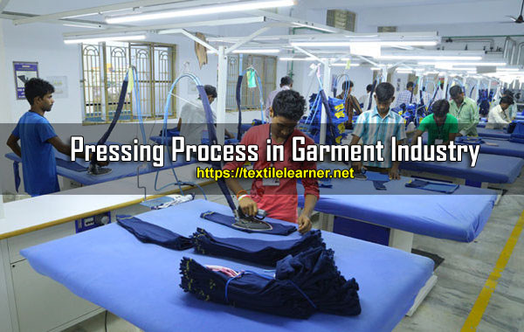

Figure 36; Pressing Process in Garment Industry
Basic Components / Parameters of Pressing:
In order to achieve good pressing quality, there are four basic parameters that need to be controlled to meet optimum performance: heat, moisture, pressure and cooling with vacuum.
The importance of each parameter is discussed below:
1. Heat: Heat is required in most pressing operations to enable the fibres to soften and thus stabilise the garment shape. Temperature selection is of utmost importance, as an incorrect temperature setting can cause damage to fibres and yarns.
2. Moisture: Moisture is introduced by the use of steam. Steam at different pressures has different moisture contents; the higher the steam pressure, the lower the moisture in the steam. The presence of moisture is required to aid in fiber swelling and thus shape stabilisation. Different fibers require different amounts of moisture. For example, natural fibres such as cotton and wool and regenerated cellulose fibres such as bamboo viscose and viscose rayon require the presence of moisture in the steam, and therefore steaming tables are usually preferred. On the other hand, synthetic fibres require heat to promote swelling and therefore relaxation of the structure. Excessive moisture may cause fabric shrinkage and colour bleeding.
fiber swelling
What is Swelling?
When the fibers absorb water, they change dimensionally (length, diameter, area). Swelling occurs in transverse direction (width wise) and axial direction (length wise). It can be expressed in terms of increase in diameter, length, area and volumes. That means the dimensionally changes due to absorbing water or moisture by any fiber is termed as swelling property.
3. Pressure: Pressure is applied to the garment during pressing to give good crease retention and permanency. Excessive pressure may result in garment or crease distortion.
4. Vacuum: Vacuum is applied at the completion of the pressing operation. This draws cool air through the garment, reducing the garment temperature, lowering the moisture content and increasing shape retention. Particularly important for garments made from wool and wool blends, this also applies to cotton and viscose blends with synthetic fibres such as polyester and nylon.
Classification of Pressing:
The basic processes that are involved in pressing can be divided into two groups:
1. Under pressing: It is the pressing operation performed on garment components as they are made up.
2. Top pressing/Final pressing: This refers to the finishing operation, which a garment undergoes after being completely assembled.
Both groups involve a huge number of individual processes, their extent determined by the cloth, quality and design of the garment.
Objectives of Pressing Process in Garment Industry:
The main object of pressing is to improve the outer appearance of the garments. However, the objects of pressing include much more:
1. Removal of unwanted creases and wrinkles: During garments manufacturing, creasing occurs in garments due to operator’s handling and for tying up garments tightly in boxes. To remove these creases and unwanted wrinkles pressing is to be done.
2. Hiding imperfections: Pressing can hide a multitude (huge number) of garment’s imperfections and faults such as puckered seam and neps.
3. To apply creases where necessary: Sometimes in garment we may need to apply some permanent creases such as pleats in shirts and for that purpose we have to apply creases or folds by pressing. Sometimes the pressing is done before sewing though after sewing it is also common.
4. Shaping: Dart and seam are used to make garments properly fit with the shape of human body. To make these darts more attractive, pressing is applied which is known as shaping. The part of garment may have to be shrunk or stretched for shaping.
5. Under pressing: For sewing easily and properly pressing is done on some parts of garments before sewing, which is called under pressing. Under pressing is done in manufacturing jackets, trousers, coats, etc. They also require final pressing.
6. Final pressing: The pressing which is done before packing the garments is known as final pressing. By final pressing the garments become glossy (silky).
Types of Pressing Equipments:
There are various types of pressing machine used in apparel industry. I have already published an article on garment pressing equipments.
Necessary Equipment’s for Garment Pressing:
Steam Iron
In house hold operations, normal electric irons are extensively used. But today steam irons are used for industrial purposes. In stem irons, the iron is heated up by steam which is supplied from a central boiler or a mini boiler. The supply of steam is regulated by a hand regulated button. This steam is supplied to iron from the boiler through a pipe and is let to come out through perforations under the iron. These irons are triangular in shape and their weight varies from 1 to 15 kg. For pressing this iron, ironing bed or table is required. With the bed there should be a provision of air suction system. After ironing, a foot regulated switch is pressed for air suctioning which removes the moisture and heat as well from the pressed garment quickly. To operate steam iron, skilled and experienced operator is required because the proper regulation of air and steam supply depends on operator’s stillness.
Steam Pressing Machine
A steam pressing machine consists of a static BUCK and HEAD of 
Figure 37.Steam Iron
complementary shape, which closes onto it. Thus sandwiching the garment to be pressed. It has a frame carrying the BUCK which is generally round in shape. Besides this, it has linkages to close the HEAD, pipe system to supply steam to HEAD and BUCK, a vacuum system to provide suction through the BUCK, a table around the BUCK to aid the handling of the garments and foot control for HEAD closure and vacuum. The cycle of operation of this pressing machine for pressing a garment (like skirt, shirt, trouser, etc) is as follows:
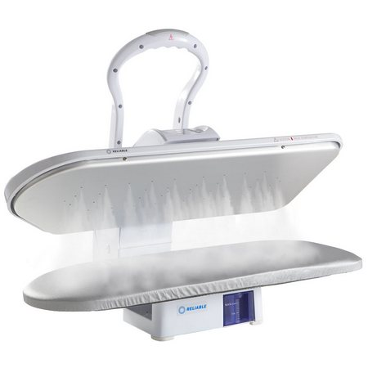
Figure 38;Steam pressing machine
In the case of manually operated press, the duration of steam supply, pressure and vacuum are left to the skill and judgment of the operator.
Working process of steam pressing machine
Steam from the BUCK is applied
↓
The HEAD is locked to press the garment
↓
Further steam may be applied from HEAD or BUCK
↓
Heat is released
↓
Vacuum is applied to cool and dry the garment
Final Inspection:
It is the last stage of inspection f the manufactured garments on behalf of the garment manufacturing organization, to detect any defective garments before packing.
Packing:
After final inspection, the garments are poly-packed, dozen-wise, color wise, size ratio wise, bundled and packed in the cartoon. The cartoon is marked with important information in printed form which is seen from outside the cartoon easily. Final Inspection:
Final inspection consists of inspecting finished garments from the buyer’s point of view; size measurements, form fitting (putting garments on the proper size manikins to see if they properly fit labeled sizes); and live modeling if necessary (again to see if the garments properly fit the labeled sizes). Final inspection in garment industry may occur before or after garments are packed in poly bags and cartons. If it is done after garments packed, then proper size and style markings on the package can also be checked.
Total Acceptable Product (TAP) & Acceptable Quality Limit (AQL)
TAP means the number of acceptable products in a lot. On the other hand, AQL means maximum acceptable capability or rejected % of products in a lot.
Example
10,000 dozen T-Shirts have AQL of 4%. Then find out TAP of that lot.
Here,
100 dozens T-Shirts have acceptable limit = 4 dozens
1 dozen T-Shirts has acceptable limit = 4/100 dozen
10,000 dozens T-Shirts have acceptable limit = (4/100) X 10,000 dozens
= 400 dozens
Therefore,
TAP = (10,000 – 400) dozens
= 9600 dozens
Generally in garment industries, inspections are made 1%, 1.5%, 2.5%, 4%, 6.5%, 10%, etc. This depends on the buyer’s requirements.
Uses of AQL
In this system, sample is selected by random sampling technique from a lot. After proper inspection, the decision is taken whether the lot will be accepted or rejected. This is applicable for raw materials to finished products inspection as well as garments. This system is popular and used widely in the world trade.
Acceptable sampling system consists of 5 parts:
Lot size
Sample size
AQL
Accept number
Reject number
Customer’s choice is given priority in this system. It is the customer who decides whether the goods will be inspected at AQL of 1.5%, 2.5% or so on. They generally give preference to the major defects (such as oil mark, holes, torn, etc) i.e. which at a glance seems to be odd for use. They also give the direction on sampling technique.
Finishing
In garments industry finishing is a process which consists of pressing or ironing, folding and packing of garments. Among them, by pressing we remove unwanted crease or wrinkles from garments. Again folding is done by ironing. After pressing, the process used to fold the garment in a required size and shape is called folding.
Types of Packing and Folding
There are four types of packing and folding for shirts, they are mentioned below:
1. Stand up pack
In which collar is folded and kept at 900 angles with the body.
2. Semi-stand up pack
In which collar is folded and kept at 450 angles with the body.
3. Flat pack
In which collar is folded and completely laid flattened on the body.
4. Hanger pack
In which shirt is supplied in box by hanging on a hanger.
15. Dispatch:
The cartoons of the manufactured garments are delivered or placed in the dispatch department or finished product godown, from where the garments lot is delivered for shipment.
3.4 marked and labeled Pattern pieces
After cutting the fabric pieces, they are marked and labeled with important information such as notches, grain lines, and reference points. This helps in aligning and joining the pieces accurately during assembly.
3.4.1.What is a marker in apparel Industry?
A marker in apparel industry is an efficient arrangement of 2d pattern pieces for one or more garments in a rectangular way which is printed on paper to help in cutting of fabric by acting as a reference. The width of the marker is decided by the available fabric width.
There can be hundreds of combinations of pattern placements to form a marker therefore making and efficient marker which occupies less space is not an easy task.
3.4.2.Why a marker is needed for cutting in apparel manufacturing ?
A marker in apparel manufacturing is needed because hundreds of garments are cut at once by spreading layers of fabric (plies) one over the other and then a marker is placed on top of the lay which acts as a guide mark for cutter to cut the fabric. To know more about the industrial cutting of apparels you can read this post.
3.4.3.How a marker is made ?
There are three ways to make a marker:
1. Manual marker
Individual ready cut patterns are arranged on laid fabric by hand either over a paper or directly on the fabric. Different combinations are tried to get an efficient arrangement.
This process is time consuming and requires skills and excellent puzzle solving skills, but this might result in fabric saving as cutting operators can utilize the full width of fabric for each lay which can be a difficult in automated markers as width has to be entered in the software before the fabric is spread.
2. Semi-Automated markers
Most factories use Computer aided design (CAD) software for making patterns and markers. In semi-automated system, marker maker can visualize a marker with all pattern pieces on a computer screen and drag and drop to arrive at an efficient marker. An efficient marker maker can make better markers than a fully automated marker if automated system is not the latest. You will have to run few tests to find that out and I believe very factory must check this occasionally to know if their CAD system is giving the right result.
3. Auto nested (automatic) markers
CAD systems are capable of automatically arranging patterns and arriving at an efficient marker. The efficiency of marker can be increased if more time is allocated for auto nesting as that means that more combinations are tried by the system.
As a practice marker maker often make minor adjustments in the generated auto marker to check the possibility of saving some extra fabric.
Auto nesting also has a newer version which can arrive at the efficient marker in lesser time and can analyze more combinations. These systems require powerful computers.
3.4.4. Pattern Markings and Symbols
So you bought a pattern for your new sewing project, and you found multiple strange symbols and markings on the pattern pieces? What are those symbols? Why pattern markings and symbols can be found on all patterns? Why are they important? And why do they vary from designer to designer?
I know at the beginning it can all seem overwhelming - we all have been there. It is quite a lot to take in at first, but don't you worry, because here are the pattern symbols and markings explained.
3.4.5.What are pattern symbols and markings and what are they used for?
Essentially pattern markings are signs that help you understand, assemble and align the garment pieces when sewing. In some cases they also help you to alter the pattern piece (like lengthening or shortening). In other words pattern markings is a sign language that helps you navigate through the assembly of the garment. A sewing pattern without pattern markings almost doesn’t exist.
3.4.6. Why are pattern symbols important?
Sewing pattern symbols are like traffic signs - you can drive without them if you know how to drive, but it is way much easier to navigate when sewing if you have them indicated and also some of them transferred to your fabric. They help you with multiple steps when assembling the garment. For example, having a grainline indicated helps you cut the fabric in the right direction. Also they can help you with precision, like marking the notches that help you to match the fabric pieces. And lastly they can't be avoided on some garments, because the construction elements like darts, pleats, tucks or pockets have to be marked.
3.4.7.Why are pattern symbols and markings different on some patterns?
Pattern symbols do vary slightly from one pattern designer to another. Commercial patterns will always have more or less the same pattern symbols. Even when buying vintage patterns you probably still find the same markings as on the new ones. On the other hand some indie pattern designers might add different looking signs to their patterns. However, in most cases they vary only visually. For example, a notch can be indicated either as a tiny stripe or a triangle. That means - you should be able to identify what is what if you know how the symbols are called and what they are supposed to mean. From time to time you might find a symbol that is completely new, or is only used by a certain pattern designer, but in that case the symbol will be explained on the pattern instruction.

3.4.8.What are the types of pattern markings and symbols?
These are the main types of sewing pattern symbols.
Center front / Center Back
Center front is a vertical line running through the center of the pattern front piece. It is marked with two capital letters - CF.
Center back is a vertical line running through the center of the pattern back piece. It is marked with two capital letters - CB.
In some cases these lines can be indicated in words ,,Center Front’’ and ,,Center Back’’ next to the line.
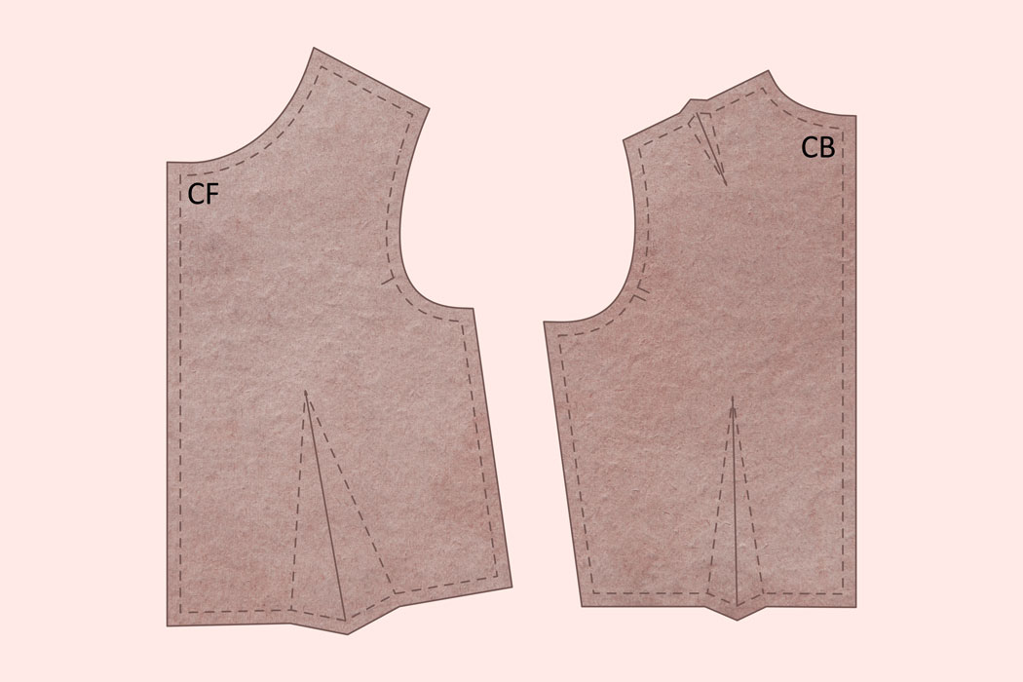
Figure 39;These two lines can be extended from the middle point of the neck width measurement down the bottom of the garment.
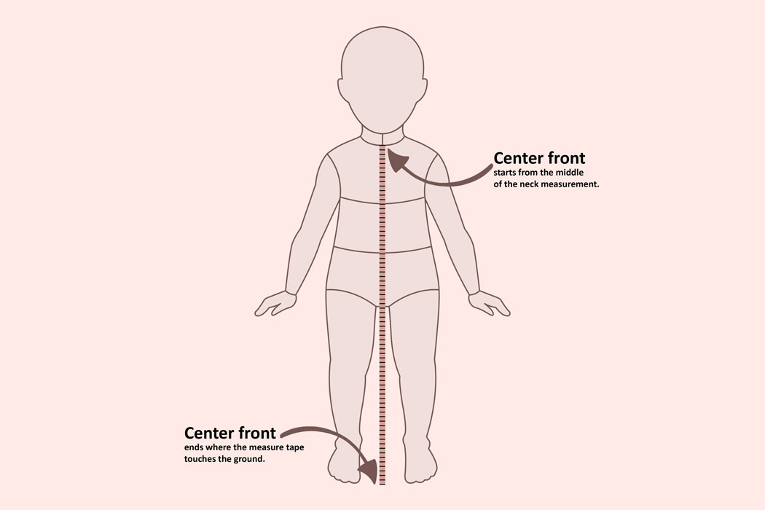
Figure 40;Grain line
Grain line is the weave of the fabric or in other words the direction in which the threads are running. Straight grain, lengthwise grain, or the Warp are the treads that are running parallel to the selvage.
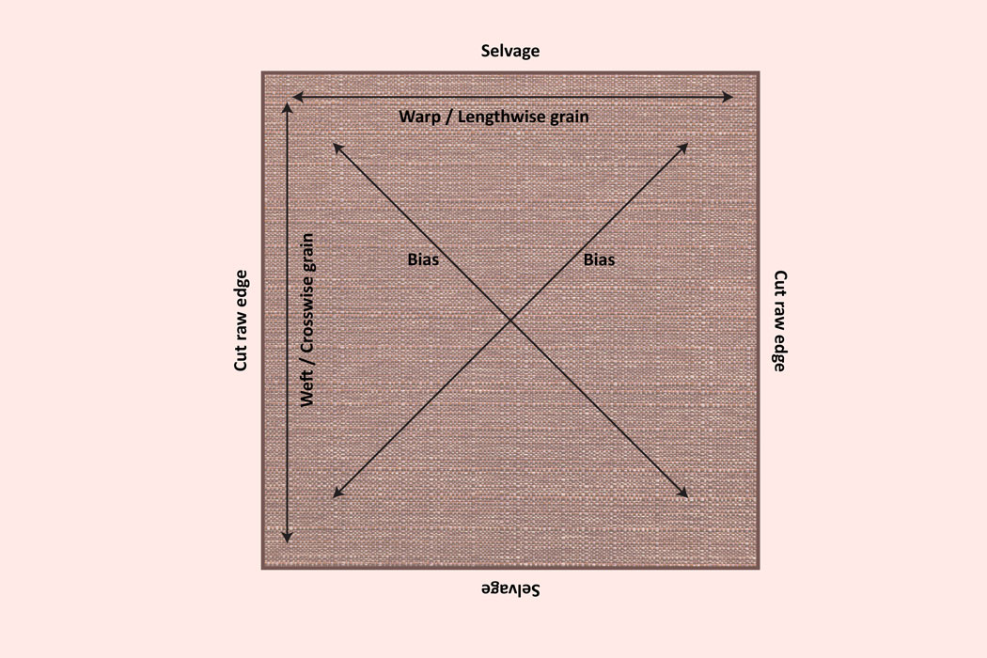
Figure 41; Grain line symbol
Grainline symbol in pattern marking is always an indication of Straight grain, or lengthwise grain. You must place your patter piece on the fabric in the way that the grainline symbol would match the straight grain or the selvedge.
Why is the grainline symbol useful?
First of all, the direction you cut your panels out of the fabric has a big impact on how the fabric will look once the garment is finished. If placed incorrectly it can impact the shape, drape, stretch and overall visual outcome of the garment piece.
You will notice that sometimes this symbol matches the center front or center back and sometimes intentionally placed diagonally to give the garment a certain shape or look.
Another type of symbol used for grainline is fold line/or cut on fold. Yes, it is a bit confusing because the cut on fold sign is a bit different. But just use this rule - If there is no grainline indicated but you have cut on the fold sign - straight grain line is parallel to the fold of the fabric.
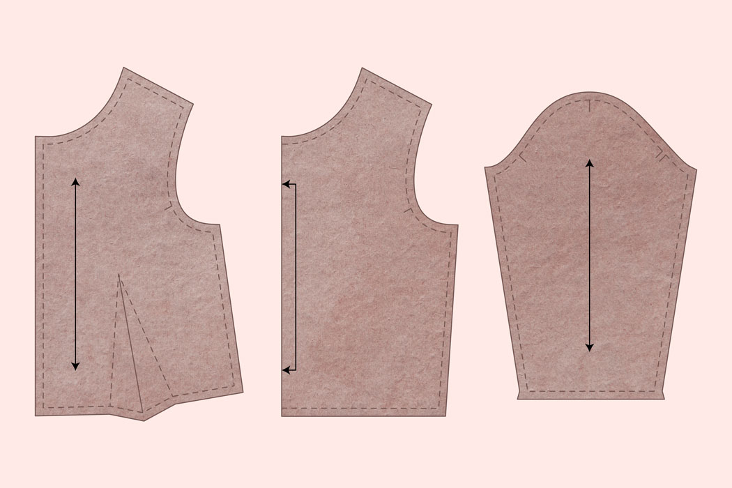
Figure 42Fold line / Cut on fold
What does cut on fold mean? The pattern piece will have this symbol when you need a symmetrical garment panel to be cut. The fabric needs to be folded and the cut on fold line aligned with the folded edge. The sign serves two purposes. First one being, you always get a symmetrical garment panel. Second one being, you save more paper when printing out or drafting the pattern piece. Important thing to know is that the grainline always matches with the fold line.
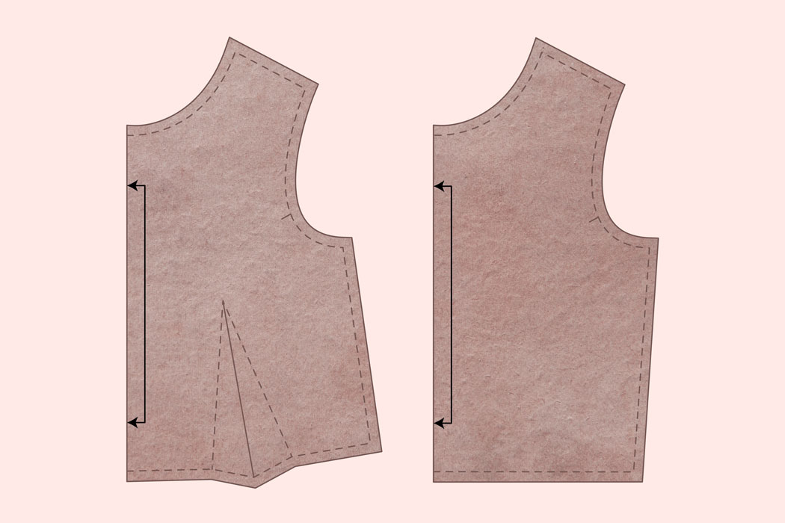
Figure 43;Notch / Double Notch
Essentially notches are tiny cuts on the edges of your garment panels. They help you to align two garment panels together. For example, you can have notches that you need to match up on the side of your bodice panel indicating the waistline. Another example is notches on the sleeve armscye. In some cases sleeves have two sets of notches, single notch and double notch that you need to match with the armhole notch on the bodice front or back. Sleeves can also have a shoulder point notch that needs to be matched with the shoulder seam.
Notches are very useful when sewing needy fabrics or large panels.
Notches can be indicated by tiny stripes meeting the pattern edge or tiny triangles.
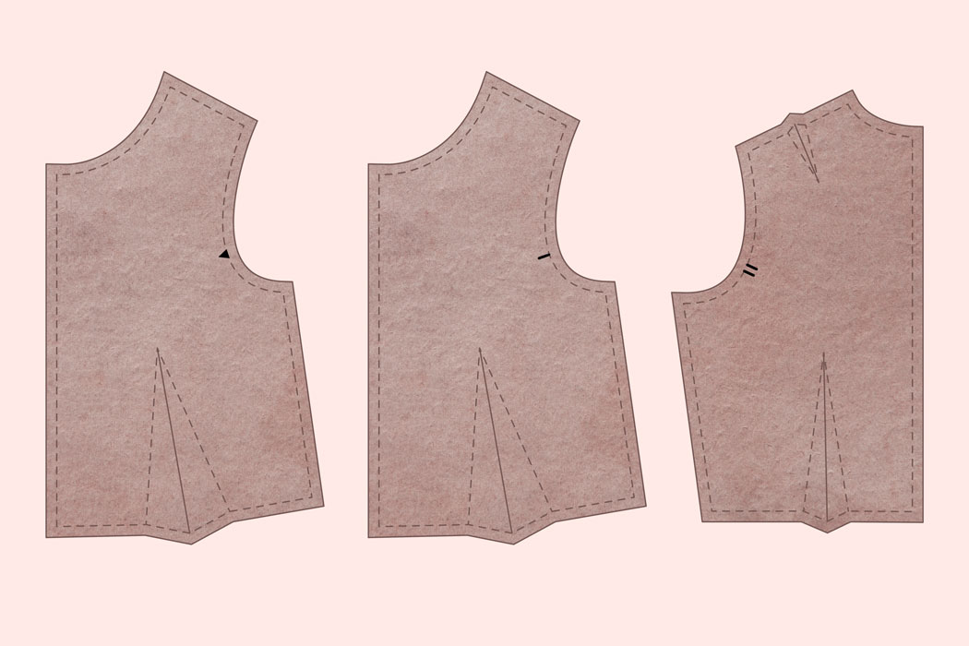
Figure 44Seam line / Stitching line
Stitching line is the line where the fabric pieces will be stitched together. In patterns without seam allowance added stitching line is usually the edge of the pattern. Or, in some cases it can also indicate pocket placement where the pocket needs to be stitched to the garment. In patterns with seam allowance added this is either indicated with the dashed line that runs parallel to the edge of the pattern or isn’t indicated at all.
Multi sized patterns have as many different stitching lines as they have sizes. In other words each size is marked with a different type of stitching line. For example, some designers use slightly different dashed lines for patterns that have multiple sizes. Some designers draw different color lines, some even draw the line from random symbols (like hearts, stars or squares) for each size. Others draw the regular line and write the size next to it. Usually you will have a chart that explains which stitching line represents which size.
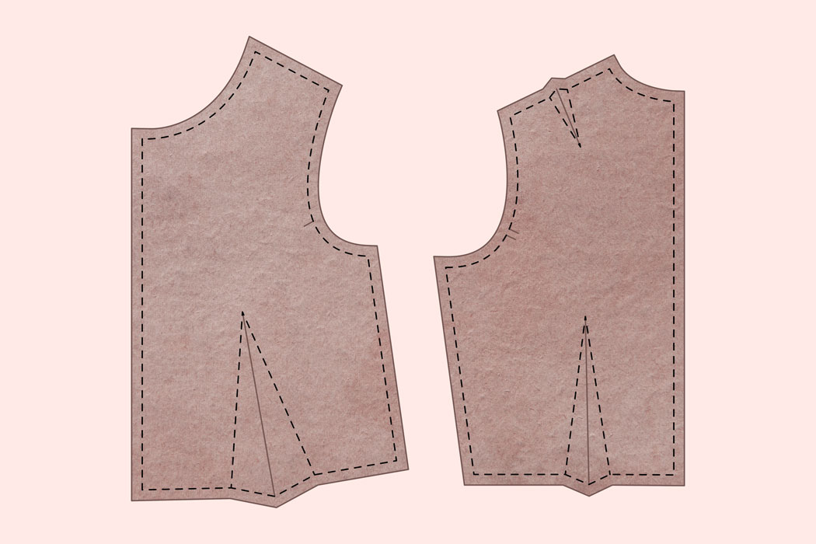
Figure 45;Cut line / Cutting line
It is a line where the pattern needs to be cut. In some cases it is the same as seam line or stitching line, in other cases it is an additional cut on the garment panel. Symbol usually is a line with a scissor icon. Cutting line can be found where the cuts for welt pockets are indicated. Sometimes it can also be found where one panel of the garment has to be sewed into another therefore it needs a cut. For example, you can find cut lines on hood panels for animal ears to be sewed in.
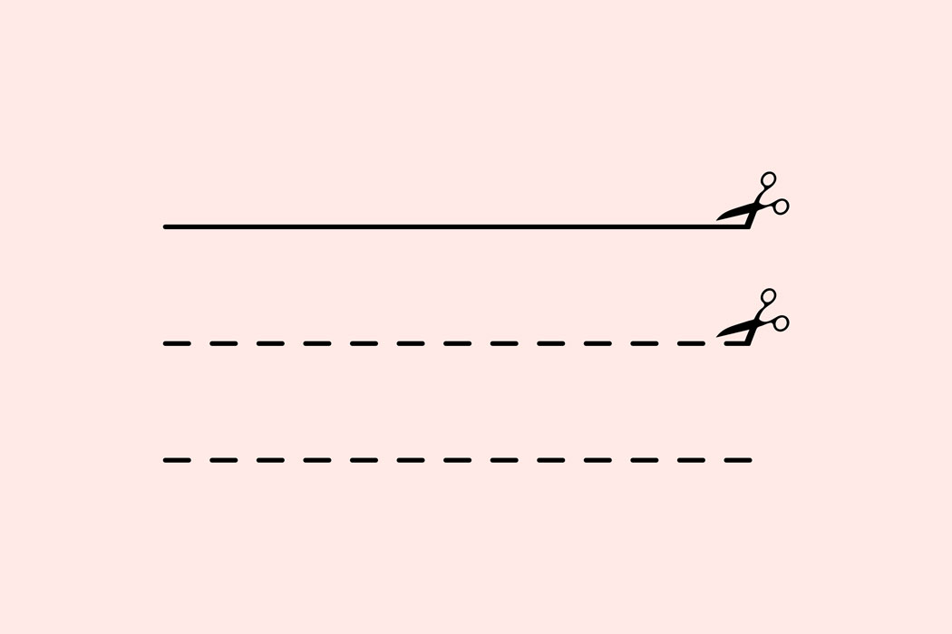
Figure 46;Alteration / Adjustment line
Alteration lines are usually indicated by two parallel lines that run horizontally through your pattern. These are used for the pattern to be altered easily. In most cases if you follow these lines, you will be able to know where to make the panel shorter or longer.
To alter the length of a paper pattern piece follow and cut it on the alteration line. Place the pieces of the pattern apart at your preferred distance. For example, if you have a sleeve pattern piece and want it to be 2 cm longer - place the pattern piece 2 cm apart. Align the pieces, add extra paper, tape everything together, draw a new line for the inseam, and cut out the new longer piece.
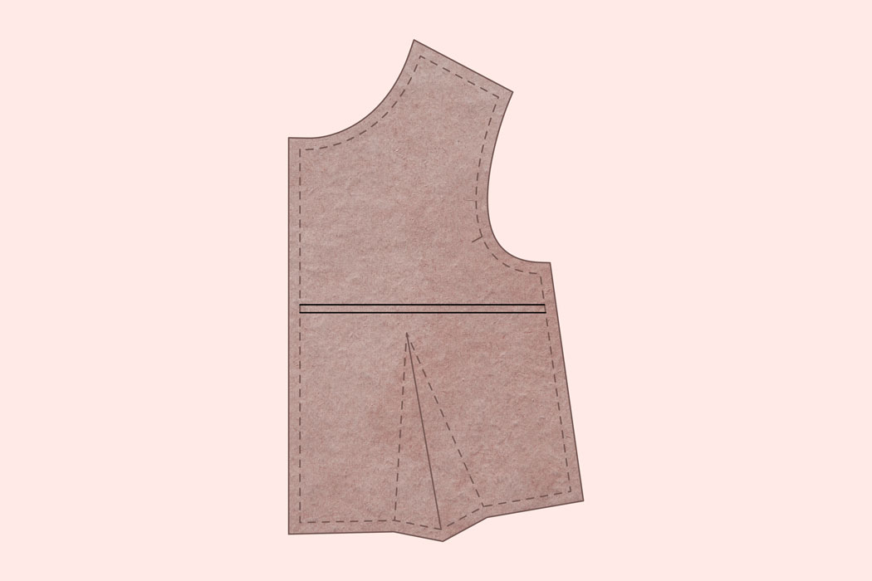

Figure 47;Button / Buttonhole
In most cases the position of the button on the pattern looks like capital ,,X’’ letter and the buttonhole is indicated by a sign that looks like capital, ,,I’’. In some cases these symbols are merged together. Other times these symbols are marked by a circle or an icon of a button or buttonhole.
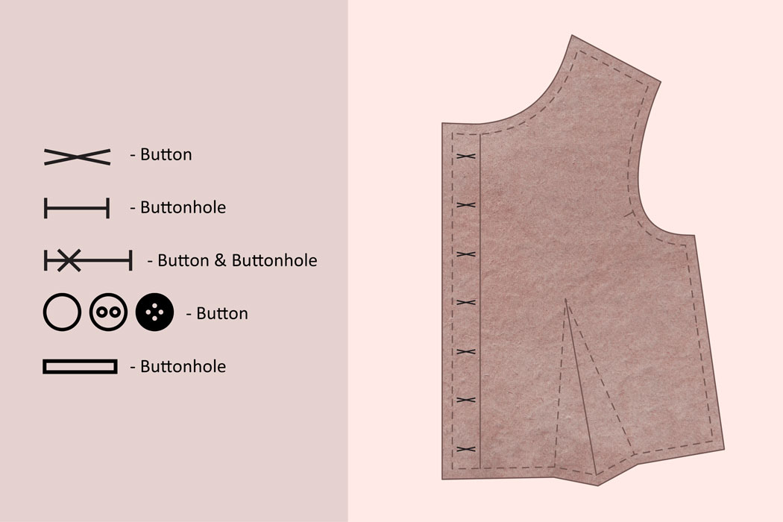
Figure 48;Zipper
This symbol indicates the zipper placement. Usually it is indicated by tiny black triangles indicating the end, a line out of triangles resembling the zipper itself or just a line with words ,,Zipper placement’’ next to it.
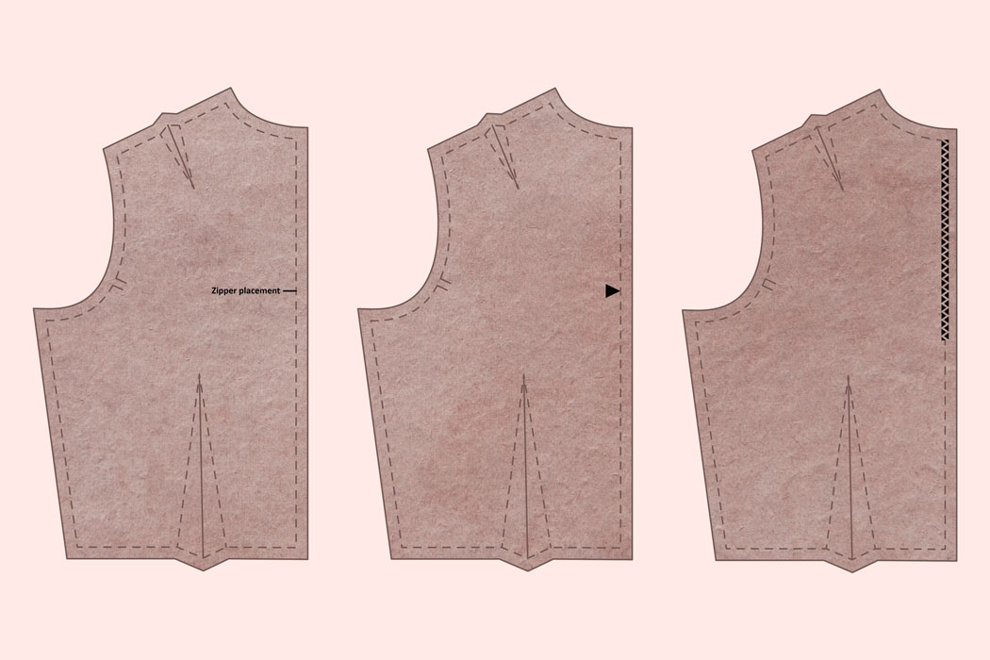
Figure 49;Dart
Darts are tucks that come together at one point and are used to give a garment a shape. Usually you can find them around the chest or waist area. Dart lines are indicated by diamond shape or two lines spreading out from one point.
Darts are essential construction elements when shaping a garment piece, therefore they must be transferred. You can transfer dart symbols to a fabric piece by using tailor’s tacks, tailor’s chalk or tracing wheel with tracing paper. Another way to transfer them is to use a single stitch to mark a dart point, and scissors to make tiny cuts on the seam allowance for the dart lines.
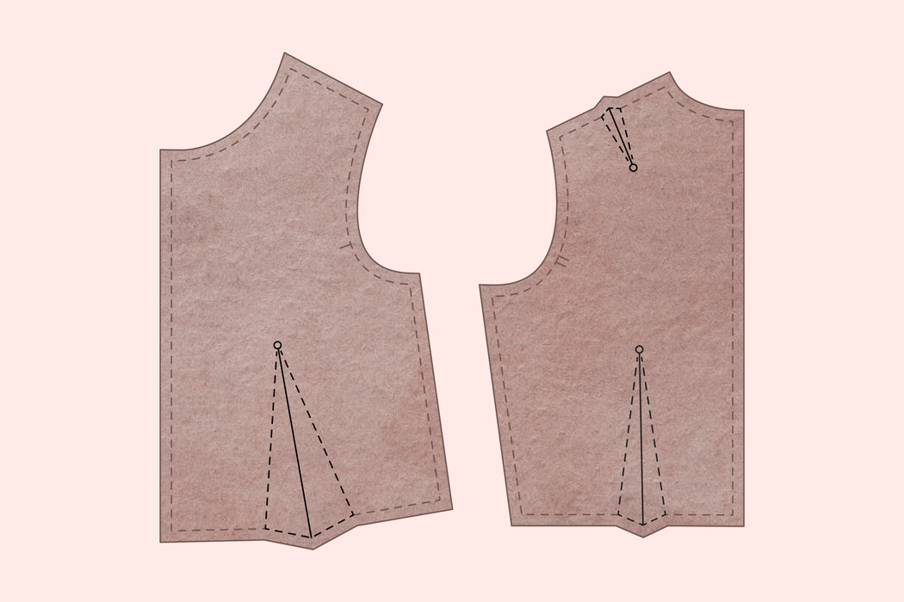
Figure 50;Bust Point
Bust point indicates the highest point of the bust, also sometimes called ,,apex’’. The bust point is a pivot point for moving the dart. However, the bust point is not the same as the dart point.
Bust pint is mostly indicated by a small circle or a circle with crossed lines in the center.
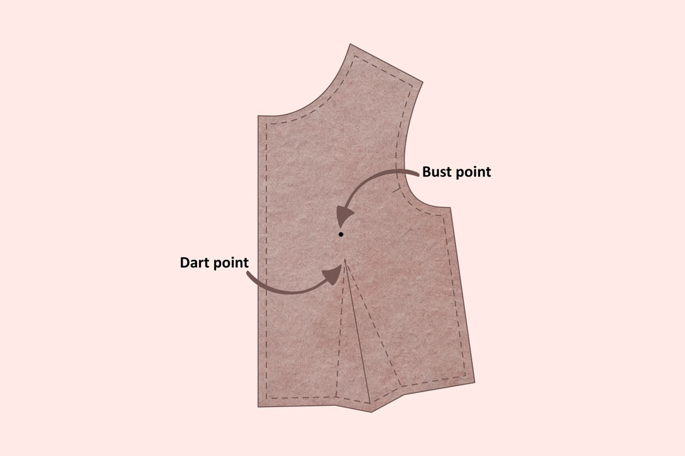

Figure 51;Pleats / Tucks / Gathers
All of these elements are usually indicated by two lines that need to be matched together.
Between those lines you will find an arrow. The arrow in between the two lines represents the motion of the fabric:
If the line has one arrow head then in most cases it's a pleat. Then the fabric from one line to another needs to move and come together in that direction.
If it is a tuck or a gather - the line in between has two arrowheads representing that the lines either have to come together, or the fabric in between the lines needs to be gathered.
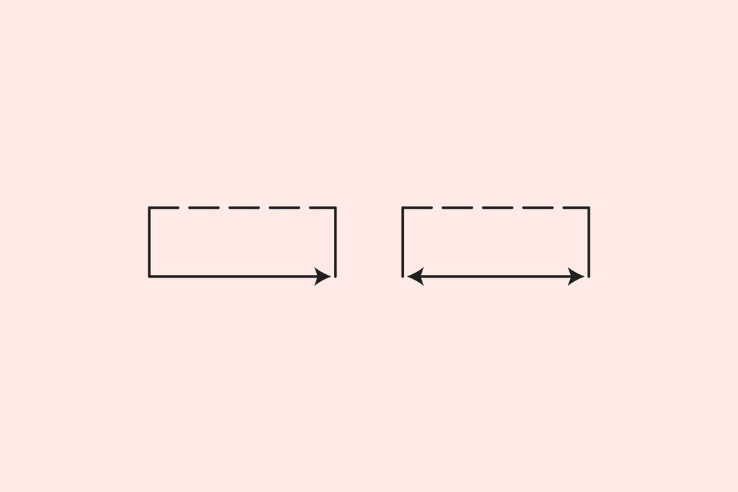
Figure 52;Other element position
Other garment element positions can be represented by any kind of line indicated where additional parts of garment (pockets, apliques, etc.) need to be placed. If you have a strange shape on a pattern piece that resembles another pattern piece, most likely this is an indication of a location where to put it and stitch it on.
Miscellaneous Signs
Depending on the pattern designer the pattern can have any kind of signs represented by various shapes for special cases, like where to place rivets, or apliques, or embellishments. Usually pattern designers include explanations for their pattern markings. Make sure to go through the pattern sewing instructions and figure them out before starting your sewing project.
Now you know how to read sewing pattern symbols. Do you want to know how to transfer pattern symbols and markings of fabric? Or maybe you want to learn about the tools used to transfer pattern markings on the fabric? Which tool works best for delicate fabrics or what are the tailor's tacks?
Read our blog post about the ways to transfer pattern markings on the fabric or the tools you can choose from to do that.

3,5 Layout according to sequence of assembly operations Garment component
The layout of a garment component assembly line would typically be organized in a sequential manner to ensure smooth and efficient production. Here is a suggested layout according to the sequence of assembly operations:

1. Cutting Area: This is where the fabric is cut into individual pieces according to the pattern. It should be equipped with cutting tables, fabric rolls, and cutting tools.

2. Sewing Stations: These stations are where the individual fabric pieces are sewn together to create the garment. Each station should have sewing machines, worktables, and necessary tools.

3. Pressing Area: After sewing, the garment needs to be pressed to remove wrinkles and give it a finished look. This area should have pressing machines and ironing boards.

4. Quality Control Station: This station is responsible for inspecting the completed garments to ensure they meet the desired quality standards. It should have proper lighting, mirrors, and quality control tools.

5. Finishing Area: In this area, the final touches are added to the garments, such as attaching buttons, zippers, or other accessories. It should be equipped with worktables, sewing machines, and necessary finishing tools.

6. Packaging Area: Once the garments have passed quality control and finishing, they need to be properly packaged for shipment or retail display. This area should have packaging materials, labeling machines, and storage shelves.

7. Storage Area: This is where the finished garments are temporarily stored before being shipped or sent for further processing. It should have organized racks or shelves to prevent damage or misplacement.
It's important to note that the layout may vary depending on the specific assembly process and the size of the operation. Additionally, ergonomic considerations and safety measures should be incorporated into the design to ensure a comfortable and safe working environment for the assembly line workers.

What is Line Layout in Garment Industry?
You know, the garment stitching is the core process in the apparel and fashion industry supply chain.
In apparel manufacturing industry, most garment manufacturers use the assembly line for making clothes and garments. In the assembly line, a number of sewing machines (including different types of sewing machines and non-sewing equipment) are placed in a line according to the process sequence requirement. Garment bundles are loaded at one end of the line and moved from one workstation to another, and finally stitched garments come out from the line.
Define Line Layout
When we talk about preparing a line layout, it means designing the presentation of workstations in an assembly and showing the flow of work from start to end. It can be a simple line diagram. See the following image. The rectangle boxes are indicating sewing workstation. The number marked inside the boxes are indicating operations sequence in the Operation Bulletin (OB) and arrows are showing the flow of work. The line layout is prepared after the operation bulletin is made.

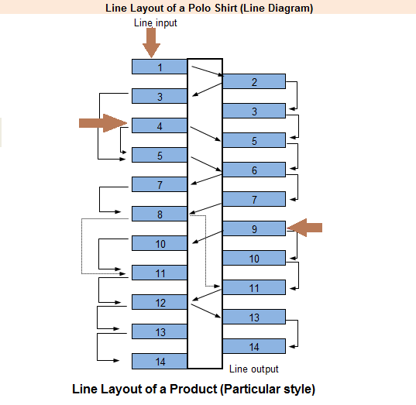

A sample line layout line diagram
There are different types of sewing line layouts. Whatever the line layout one factory uses industrial engineers need to prepare line layout for the upcoming orders.
For an example, a production line involved different types of sewing machines, non-sewing equipment, and workstations for manual processes. Each workstation is designed for an operation.
When you prepare the line layout, you will see following cases and you will define a workflow on the line layout.
You may need to assign more than one workstation for the same operation,
You may need to use same machine (workstation) for more than one operations
You may need to load bundles or garment component in multiple workstations
Why you prepare a line layout?
Followings are some of the primary benefit and application of line layout
The line layout helps line supervisors to set the line for a new order in the least time.
From the layout, you will get the exact requirement of machines and equipment. Production team can be better prepared
Style changeover time can be reduced by preparing a detailed line layout and doing line set-up based on the line layout
For new plant set-up, designing the line layout is an essential part. Looking at line layout, overhead wiring, air connection, installation of ironing tables, QC tables and fixture installed.
In case a factory produces same product for all the time, still they need to change the line layout depending on the product design. In such cases factory may need minimum change of sewing machines and workstation

3.5.1.Basics of Apparel Plant and Sewing Machines Layout

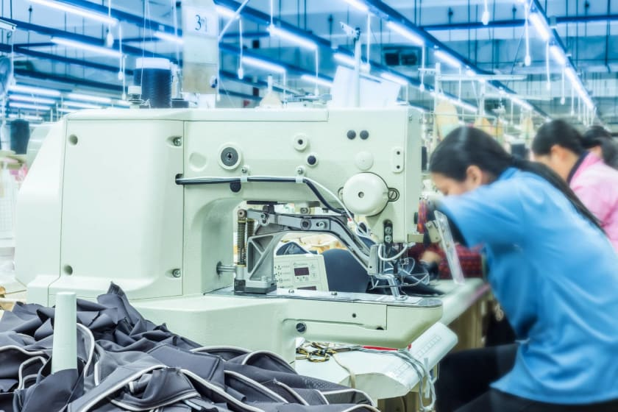

Figure 53;Basics of Apparel Plant and Sewing Machines Layout

The layout of a garment factory is associated with a good workflow which includes things such as receiving materials and sending the finished goods out of the garment factories. Therefore the type of apparel plant you develop directly must be optimized according to time and flexibility. There may be slight changes according to the owner of a garment factory. However, there are some common things that you must keep in mind before making a blueprint and proceeding forward.
Now let's talk about a plant layout. An apparel plant layout is the management of space and position of various departments, machinery, and working areas necessary for the functioning of a plant. The layout must be such that the plant will have a good workflow, and there must be integration starting from receiving materials to producing finished goods and sending them to the market. Apart from all these, you must make the layout of the garment factory in a way that it will be flexible enough to change depending on the requirements or the demand of the product, delivery schedule, etc. You must also involve things in the layout such as emergency exits, fire, and safety areas, etc.
Here are some factors which you must keep in mind before planning a layout:
- Keep the cost of manufacturing low.
- Plan the layout in such a way that the feeding of materials to the machinery must be speedy. It must also be ensured that none of the parts must come back.
- There must be room for the plan, including revamping the factory.
- Keep fixed and properly allocated places for all the pieces of machinery and work processes.
Garment factory's layout
Make the layout of the garment factory in such a way that the steps involved in the production of an item, building structure, and the configuration of machinery are followed properly. Some factors which have an impact on the layout of a factory or plant are:
The number of workers, both male and female
The number of machines
The placement of entrances and exits
The location of the administrative office, changing room, washroom for both men and women, medical emergency rooms, etc.
Steps to Make an Apparel Plant Layout
The first step to making a good layout is that the layout must be properly scaled without any rough estimates.
Make models of the machinery.
Draw the immovable equipment which will be permanently fixed in a particular location.
Mark things such as entry points, exit points, washrooms, corridors, vacuum lines, air conditioning ducts, etc in the layout.
Other crucial things that must be included are power sources, electric lines and water sources.
Try to incorporate everything related to the process according to the production flow in a straight line.
Factors That Impact the Layout of Machines
Let's know what the machine layout is. Machine Layout is an arrangement based on the sequence of the operations. Here are some factors that you must keep in mind before setting up the machinery layout -
1. Products to be manufactured
Before making the layout of machinery, the types of products to be manufactured must be kept in mind. Along with the type of products, man-hours, the different types of apparel, designs, and changes in fashion trends every year are things that you must also consider before setting up the layout.
2. Manufacturing system
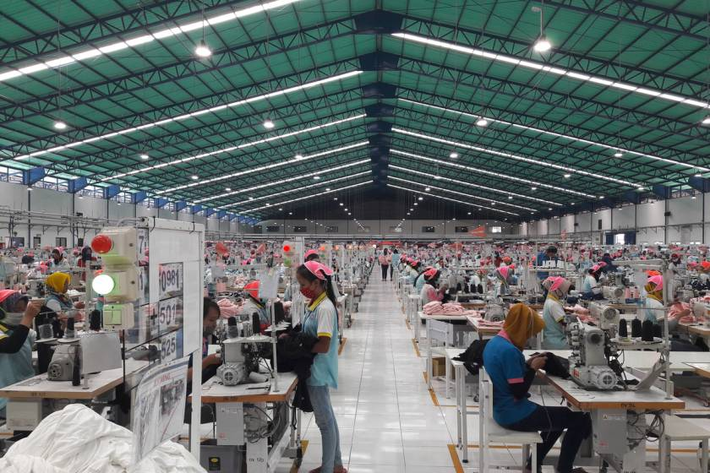
Figure 54;The manufacturing system PBU assembly line, sectional assembly line, etc.
3. Method for alterations in style
There are two types of changes: overall change and consecutive change. Overall changes occur when the products being manufactured are not associated with each other. Therefore if some changes have to occur, there will be an overall change. In consecutive changes, manufactured products have much more similarities and have negligible variations. Most of the operations required to produce these products are similar. Hence, major changes are not necessary.
4. Material transfer system
a. Bundle system
In this type of system, the products are packed in bundles which can be in a bundle of 5, 10, or 15. The size of the bundle is also important as it will impact the way it will be handled. Usually, these bundles are packed in boxes.
d. Per piece
Per piece, transfer means that the parts of a garment are moved from one operation area to another one by one.
c. Overhead hanger
The parts of the garment are clipped in hangers which present overhead and can be moved by rails manually.
5. Storage method of semi-finished goods
The layout should also be made keeping in mind the places that can be used to store semi-finished products.
6. Equipment
The equipment includes types such as machines that are used for special purposes, general-purpose, semi-automatic, and automatic work areas.
7. Transportation equipment
The equipment for transportation includes
Manual transportation
Racks
Trucks
Conveyors (powered and unpowered

Self-check 3
  - Choose the best answer for the following question
Name of trainees ------------------------------- ----------------- sections---------------sign ---------
1 The short length man-made yarns are called ___________ yarns.
A. Complex B. Filament C. Spun D. None of these
2) Which is an elastomeric fiber?
A. Acrylic B. Mod Acrylic C. Nylon D. Spandex
3) Spinning of yarn means_________ .
A. Denier B. Twisting C. Tex D. Pulling
4) Symmetrical balance occurs when the space within a garment is divided into _________ parts.
A. Equal B. Un equal C. Three D. Four
5) When the design elements work well together _______ is achieved.
A. Rhythm B. Balance C. Proportion D. Harmony
6) Triangular-shaped folds of fabric stitched to control fullness are called __________.
A. Gathers B. Pleats C. Darts D. Hem
7) The process of converting waste material into new product and objects is called __________.
A. Recreation B. Redesigning C. Reformation D. Recycling
8) The process of converting fibers directly into fabric is __________.
A. Weaving B. Spinning C. Knitting D. Felting
9) Colors which are exact opposite to each other on color wheel are _________.
A. Analogous B. Monochromatic C. Complimentary D. Tetrads
10) Lightness or darkness of a color is known as ____________.
A. Value B. Intensity C. Brightness D. Dullness
11) There are ___________ neutral colors.
A. 1 B. 4 C. 3 D. 5
12) Flax is a __________ fiber.
A. Cellulosic B. Proteomic C. Synthetic D. Man Made
13) __________ is the art of creating designs for knitted, woven and non-woven fabrics.
A. Illustrations B. Textile Designs C. Paintings D. Sketches
14) _________French term for exclusive one-of-kind” high fashion”.
A. Boutique B. Show room C. Out let D. Haute couture’s
15) _______________ is the basic unit of textile.
A. Fabric B. Yarn C. Fiber D. Cloth
16) Solution dyeing is mostly used for ________ fibers.
A. Wool B. Natural C. Synthetic D. Cellulosic
17) Creativity in textile is also known as ___________.
A. Fabric B. Clothing C. Textiles D. Designing
18) ___________ designing shows awkward look in clothing.
A. Good B. Incomplete C. Unstitched D. Raw
19) ______________ designers sell their designs to fashion houses
A. Full-time B. Freelance C. Self-employed D. In-house
20) Grey cloth is also known as _________.
A. Toile B. Kutch C. Malison D. Unfinished fabric
21) First synthetic dye was developed in ________.
A. 1856 B. 1857 C. 1858 D. 1859
22) _________ are made specifically for an individual.
A. Haute-Couture B. Pret wear C. Special cloths D. Costumes
23) Feel or hand of the fabric is its __________.
A. Texture B. Strength C. Fall D. Drape
24) Compounds that color textile is known as __________.
A. Finished B. Dyes C. Bleaching D. None of these
25) Which fiber is popularly called ‘Golden fiber’.
A. Cotton B. Silk C. Jute D. Flax
26) _________ are forms of art that are created by using your hands.
A. Hand works B. Designs C. Handicrafts D. Drawings
27) _________ is an ironing process that adds sheen to the fabric.
A. Shearing B. Weighting C. Calendaring D. Embossing
28) The companies that apply only finishes on textiles are….
A. Finish Product Supplier B. Converters and jobbers C. Retail Distributor D. None of These
29) Blends are combination of ……………….. fibers.
A. Same B. BondedC. Different D. None of these
30) The lengthwise yarn in a woven fabric is known as __________.
A. Selvedge B. Grain C. Warp D. Weft

Unit one: 4 Assemble garment components and finish complex garments
This unit is developed to provide you the necessary information regarding the following content coverage and topics:
- Integrating division of labor
- .Planning and work bulk processes
- .Controlling machine speed and work handling for type of sewing operations 4.4.Sewing component
- .Checking garment for correct fit and assembly quality
- .Pressing components according to workplace procedures

This unit will also assist you to attain the learning objectives stated in the cover page. Specifically, upon completion of this learning guide, you will be able to:
- select garment components.
- Assemble garment componenty
.

4 .Assemble garment components and finish complex garments

4.1. Integrating division of labor
Integrating division of labor refers to the process of effectively organizing and coordinating different tasks or roles within a larger system or organization. Division of labor is the specialization of tasks where individuals or groups focus on specific aspects of a larger process, leading to increased efficiency and productivity.

To integrate division of labor, several steps can be followed:

1. Identify tasks: Break down the overall process or project into smaller tasks or subtasks. This helps in understanding the specific roles and responsibilities required for each task.

2. Define roles and responsibilities: Clearly define the roles and responsibilities for each task or subtask. This ensures that everyone involved understands their specific contribution and avoids duplication or confusion.

3. Assign tasks to individuals or teams: Allocate the identified tasks to individuals or teams based on their skills, expertise, and availability. Consider their strengths and weaknesses to ensure the right person is assigned to each task.

4. Establish communication channels: Set up effective communication channels to ensure smooth coordination among individuals or teams. This can include regular meetings, project management tools, or digital collaboration platforms.

5. Provide training and support: Ensure that individuals or teams have the necessary training and support to perform their assigned tasks effectively. This may involve providing resources, guidance, or mentoring.

6. Monitor progress: Regularly monitor the progress of each task to ensure that the division of labor is being integrated effectively. This allows for early identification of any issues or bottlenecks that may arise.

7. Foster collaboration: Encourage collaboration and knowledge sharing among individuals or teams involved in different tasks. This helps in maintaining a cohesive approach and allows for cross-pollination of ideas and best practices.

8. Evaluate and refine: Continuously evaluate the effectiveness of the integrated division of labor and make necessary adjustments or refinements. This ensures that the division of labor remains aligned with the overall goals and objectives.

By following these steps, organizations can successfully integrate division of labor, leading to improved efficiency, productivity, and overall performance

4.2 . Assemble garment components

4.2.1Assembly of the Garment
Garment assembly refers to the process of putting together all the individual parts of a garment to create a finished product. This involves a series of steps such as cutting, sewing, pressing, and finishing and is performed by skilled workers in a factory setting. The goal is to produce a high-quality garment that meets the specifications set by the designer and manufacturer.
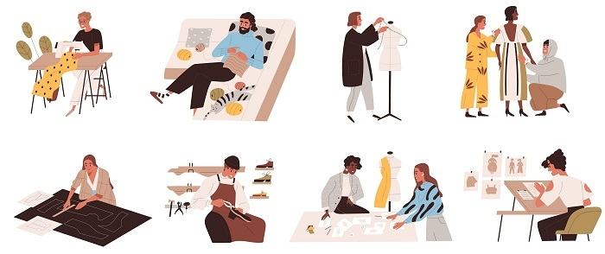
Figure 55;What is the Garment's Assembly?
Assembly of the garment is the process of constructing a finished clothing item from individual fabric pieces and other components. This process typically involves several stages, such as cutting the fabric, sewing the pieces together, pressing the seams, and adding any finishing touches like buttons or zippers. The goal is to create a high-quality, finished garment that meets the specifications set by the designer and manufacturer. The assembly process is typically performed by skilled workers in a factory setting.

4.2.2.Garment Assembly System
The garment assembly system refers to the complete process of constructing a garment, from the creation of the pattern to the production of the finished item. It encompasses all the steps involved in the assembly of a garment, including pattern making, cutting, sewing, pressing, finishing, quality control, and packaging.
A well-designed garment assembly system should be efficient, cost-effective, and capable of producing high-quality garments that meet the specifications set by the designer and manufacturer. The system should also be flexible enough to accommodate changes in the design, materials, or production volume and should be able to respond quickly to any issues that arise during the production process. In modern garment production, the garment assembly system is often automated and uses computer-controlled equipment and processes to increase efficiency and reduce costs.
However, it is still important to have skilled workers involved in the assembly process, particularly for tasks that require manual dexterity and attention to detail, such as sewing and finishing. Overall, the garment assembly system is a critical component of the garment production process and plays a key role in determining the quality, efficiency, and profitability of the finished product.

4.2.3.Automated Garment Assembly
Automated garment assembly refers to the use of automated machinery and equipment to construct garments in a fast, efficient, and cost-effective manner. The goal of automated garment assembly is to increase productivity, reduce production costs, and improve the quality and consistency of the finished product. Examples of automated garment assembly equipment include computer-controlled cutting machines, sewing robots, and pressing machines. These machines are programmed to perform specific tasks, such as cutting fabric pieces to precise measurements, sewing seams with consistent stitch lengths, and pressing seams to a uniform finish.
In an automated garment assembly system, the machines are linked together in a sequence, with each machine completing its task before passing the workpiece on to the next machine. This allows for a highly efficient and consistent production process, with minimal human intervention required. While automated garment assembly can provide many benefits, it also presents some challenges, such as the need for specialized knowledge and training to operate and maintain the equipment and the potential for disruptions if the machinery fails or malfunctions. Overall, automated garment assembly is an important development in the garment production process, offering the potential for increased efficiency, reduced costs, and improved product quality.

4.2.4.Process Of Garment Assembly
Figure 56;The steps involved in the assembly of a garment are
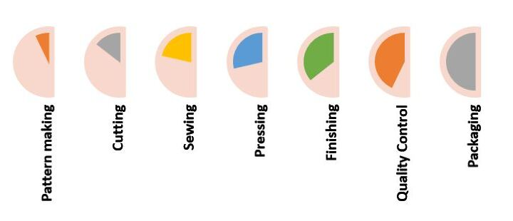
- Pattern making − Creating a blueprint or template for the garment based on the design specifications
- Cutting − Cutting the fabric pieces according to the patterns and laying out the pieces in the proper order.
- Sewing − Using a sewing machine or by hand, join the fabric pieces together.
- Pressing − Using an iron to press and shape the seams to ensure a neat and professional finish
- Finishing − Adding any final touches such as buttons, zippers, hems, and labels
- Quality control − Checking the finished garment for any defects or issues and making any necessary repairs or adjustments.
- Packaging − Packing the finished garment for shipping or storage
The number and complexity of steps involved in the assembly process can vary depending on the type of garment and the level of customization required. However, the goal of each step is to create a high-quality, well-constructed garment that meets the requirements of the designer and manufacturer.

4.2.5.Why and How to Specify the Assembly of a Garment
Specifying the assembly method for a garment is important because it can impact the quality, cost, and efficiency of the production process. The correct specification of the assembly method will help ensure that the garment is produced in the most efficient and effective way possible, while also meeting the design specifications and standards.
To specify the assembly method, the following steps can be taken
Determine the design specifications − Review the design requirements, such as the type of garment, the fit, the style, and the materials to be used.
Assess the production process − Consider factors such as the production volume, the available resources, and the skill level of the workers.
Choose the most appropriate assembly method − Based on the design specifications and the production process, choose the most appropriate assembly method, such as flat pattern making, draping, cut and sew, block pattern making, or CAD.
Document the specification − Record the chosen assembly method in the production specification document, along with any additional details or requirements, such as materials, equipment, and processes to be used.
Communicate the specification − Share the production specification document with all relevant stakeholders, including designers, manufacturers, and workers, to ensure that everyone is aware of the assembly method that has been specified.
By specifying the assembly method in a clear and concise manner, it is possible to streamline the production process, reduce the risk of mistakes, and achieve the desired results in a cost-effective and efficient way.
Assembling Technologies
Assembling technology refers to the methods and techniques used to construct a garment from separate pieces of fabric or materials. There are several different assembling technologies used in garment production, including
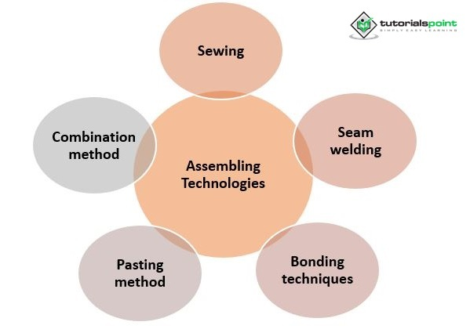
Figure 57;Sewing
Sewing is a traditional method of garment assembly that involves using a needle and thread to join two or more pieces of fabric together. It is the most widely used method for garment assembly as it provides a flexible and versatile method of joining different types of fabrics.
Seam Welding
Seam welding is a process that uses heat and pressure to join two pieces of fabric together. It is typically used for lightweight or synthetic fabrics, as it provides a strong and permanent bond without the need for stitching.
Bonding Techniques
Bonding techniques are methods that use adhesives, such as glue or resin, to join two pieces of fabric together. This method is often used for sportswear and outdoor clothing, as it provides a lightweight and durable bond that can withstand exposure to the elements.
Pasting Method
Pasting is a method of garment assembly that uses a heat-activated adhesive to join two pieces of fabric together. It is often used for attaching linings or interlinings to the main fabric, as it provides a strong and flexible bond that is easy to work with.
Combination Method
The combination method of garment assembly involves using a combination of two or more of the above methods on a single garment. For example, a garment may be assembled using a combination of sewing and seam welding, or bonding and pasting, to achieve the desired level of strength, durability, and flexibility.
Each of these assembly technologies has its own strengths and limitations, and the choice of method will depend on the design specifications, the materials being used, and the production volume. By carefully considering these factors and selecting the most appropriate assembly method, it is possible to produce high-quality garments that meet the needs of the designer, manufacturer, and customer.

4.3. Controlling machine speed and work handling for type of sewing operations
Controlling machine speed and work handling is an important aspect of ensuring efficient sewing operations. Here are some steps to consider:

1. Understand the sewing operation requirements: Different sewing operations may require different machine speeds and work handling techniques. It is important to have a clear understanding of the specific requirements for each operation.

2. Set appropriate machine speed: Adjust the machine speed according to the type of sewing operation being performed. Some operations may require a slower speed for precision and accuracy, while others may benefit from a faster speed to increase productivity.

3. Train operators on machine control: Provide training to operators on how to control the machine speed effectively. This includes understanding the machine controls, practicing proper foot pedal control, and maintaining a consistent speed throughout the sewing process.

4. Monitor machine speed: Regularly monitor the machine speed during sewing operations to ensure it is consistent with the requirements. This can be done through visual observation or by using speed monitoring tools or software.

5. Adjust work handling techniques: Depending on the sewing operation, it may be necessary to adjust the way the work is handled to optimize efficiency. This could involve using different attachments or accessories, adjusting fabric tension, or implementing specific handling techniques.

6. Address any issues promptly: If any issues arise with machine speed or work handling, address them promptly. This could involve troubleshooting machine malfunctions, providing additional training or guidance to operators, or making adjustments to the workflow or equipment.

7. Continuously evaluate and improve: Regularly evaluate the effectiveness of machine speed and work handling techniques and make necessary improvements. This could involve analyzing productivity data, seeking feedback from operators, or implementing changes to optimize efficiency and quality.

By controlling machine speed and work handling for different sewing operations, organizations can ensure that the sewing process is carried out effectively and efficiently, resulting in high-quality sewn components.

4.3.1.How to Set Sewing Machine Speed
One of the most common questions we get asked at The Sewing Machine Shop is "What sewing machine speed should I use?" Even experienced sewers can be confused about which speed to use for specific types of fabrics and fabrics-to-cloth ratios. In this article, we'll provide you with an overview of the different types of fabrics and help you choose the right sewing machine speed for your project. 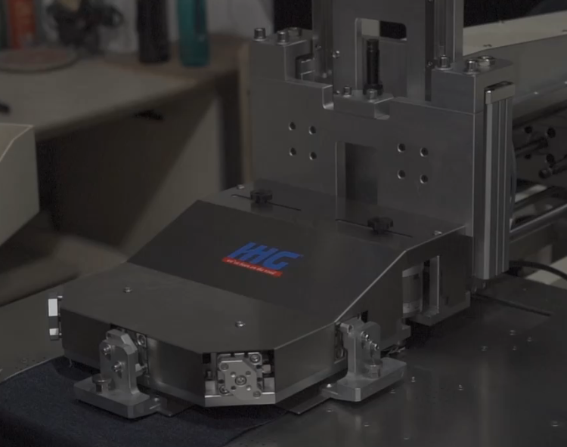
Figure 58;Sewing Machine Speed

4.3.1 Sewing Machine Speed

In the early days of sewing machines, they were all hand-crank operated. This meant that the operator had to turn the crank at a consistent speed in order to keep the stitches even. As technology has progressed, so too have sewing machines. Sewing machine speed is now controlled by a foot pedal, which allows the operator to maintain a consistent speed without having to turn a crank.

The speed of a sewing machine can be adjusted by turning the speed control knob. On some machines, the speed can also be controlled by using the foot pedal. The faster the speed, the more stitches per minute the machine will sew. The slower the speed, the fewer stitches per minute the machine will sew. It is important to adjust the speed to match the thickness and type of fabric being sewn. For instance, a heavy fabric should be sewn at a slower speed than a thin fabric.

sewing machine with speed control

Anyone who has ever tried to sew knows that it can be a slow process. You have to adjust the speed of the machine to match the fabric, and if you're working on something delicate, you have to go even slower. But what if you could control the speed of your machine? That's where a sewing machine with speed control comes in handy. With this feature, you can set the machine to sew as fast or as slowly as you need it to. This can be a great asset when working with delicate fabrics or when you need to make a quick repair.

When do we need to control the speed of a sewing machine?

There is no single answer to this question as the optimum sewing machine speed setting depends on the project you are working on, the type of fabric you are using, and your own personal preferences. However, as a general rule, you will need to control the speed of your sewing machine when working with delicate fabrics or when making intricate stitches. It is also important to adjust the speed when using a new or unfamiliar fabric to avoid damaging it. Conversely, if you are looking to quickly sew through multiple layers of fabric, you will need to increase the sewing machine's speed setting. Experiment with different speeds to see what works best for each individual project.

The average person sewing a quilt or other fabric project on a home machine probably has no idea what "speed" means. It's not until you try to sew something really fast, like a four-inch seam, that you realize just how much power your machine needs to move the needle at that speed. If you're in the market for a new sewing machine, be sure to take into account what speed range your project will require so you can get the best possible result.

What factors influence the speed of a sewing machine?

Sewing machines come in a variety of speeds that can be adjusted to best suit your needs. Different fabrics and types of seams require different speeds, so it's important to find the speed that works best for you. There are also special sewing techniques that are easier or more difficult at different speeds. Experiment to see what speed is best for you and your project!

How do I adjust the speed of my sewing machine?

There are a few ways that you can control the speed of your sewing machine. The most common way is by using the foot pedal. This pedal controls the speed at which the needle moves up and down.

There are a few ways that you can control the speed of your sewing machine. The most common way is by using the foot pedal. This allows you to control the speed of the machine by how hard you press on the pedal.
You can also adjust the speed of your machine through the screen touch panel. This panel is located on the front of your sewing machine.
The last way to control the speed is by using a dial. You can also use the digital control panel to adjust the speed of your machine. This panel is located on the side of your machine. Some machines have buttons that allow you to choose between fast and slow speeds. This will let you choose different speeds for different fabrics. Whichever way you choose, be sure to practice on some scrap fabric before starting on your project.
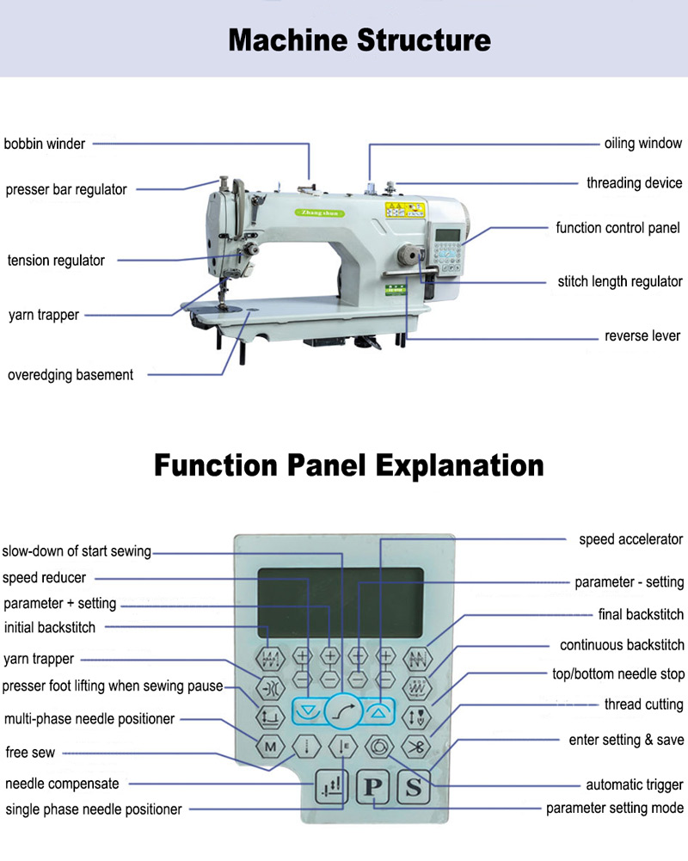

Figure 59;How to adjust the speed on a singer sewing machine?
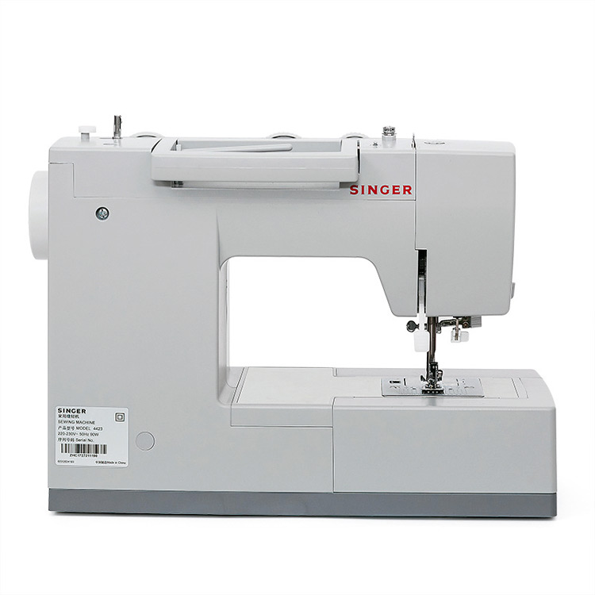
If you're new to using a singer sewing machine, you may not know how to adjust the speed. This article will show you how to do that, as well as how to make other adjustments like thread tension and stitch length.

When you are sewing, the speed of your sewing machine is important. You want to make sure that the stitches are consistent and even. If the machine is going too fast or too slow, it can cause problems with the quality of your stitches. In this article, we will show you how to adjust the speed of a singer sewing machine step by step.

First, make sure that the machine is not sewing.

Next, locate the speed control on the front of the machine. There are usually two different options: high and low. Choose the speed that is best for your project.

Finally, confirm the sewing machine speed setting and test it out. Hold down the pedal and test out both speeds to see which one works best for you. If you need to make further adjustments, you can do so using the knob on top of the machine. This will allow you to make finer adjustments. You can also try turning your machine upside down and straddling it. This will loosen up any tension from the bobbin case. When you are done, unplug the machine and turn it off.

How to do brother sewing machine speed control?
Brother sewing machines are some of the most popular on the market. They come with a variety of features, including speed control. This allows you to adjust the speed at which the machine stitches. This is a great feature for those who are new to sewing or for those who want to take their time when stitching a project. Here is how to do brother sewing machine speed control:

1) Locate the speed control dial on your Brother sewing machine. This is typically found on the front or top of the machine.
2) Turn the dial to the desired speed. The numbers on the dial represent different speeds, so choose the one that best suits your needs.
3) Sew away! Now that you have set the speed, let your machine do all of the hard work while you sit back and relax.

There are different types of Brother Sewing Machine, with different features. One popular model is the Brother XR9500PRW sewing machine which has a speed control slider. This feature allows you to choose the optimal speed for your project, whether you are piecing quilts or monogramming fabric. The machine also has an automatic needle threader and tension adjuster, making it easy to use.

What is a sewing machine speed reducer?
A sewing machine speed reducer is a device that attaches to the motor of a sewing machine and allows the user to control the speed of the machine. This is especially useful for projects that require precision and accuracy, such as quilting. A speed reducer can also help extend the life of your motor by running it at a lower speed.

Example: Industrial Sewing Machine speed reducer

If you are looking to reduce the speed of your industrial sewing machine, there are a few things you can do. The most common way to do this is by using a speed reducer. This is a small device that attaches to your machine and reduces the speed of the needle. It can be adjusted to fit your needs, so you can sew at a slower pace.
To install a speed reducer, first, remove the screws on the back of your machine. Next, locate the belt and remove it from the pulleys. Install the speed reducer on the machine and replace the belt. Make sure it is tight against the pulleys. Replace the screws on the back of the machine and you are good to go!

4.4. Sewing components
Sewing components are the various parts and materials that are used in the process of sewing. These components can include:

1. Fabric: The main material used in sewing, which can be made from various fibers such as cotton, silk, polyester, or linen.

2. Thread: A thin strand of yarn or fiber used to stitch fabric together. It comes in different colors and types, such as polyester, cotton, or nylon.

3. Needles: Sharp, pointed instruments used to push thread through fabric. There are different types and sizes of needles for different sewing projects.

4. Pins: Thin, sharp metal or plastic objects used to hold fabric pieces together before sewing. They can be straight pins or safety pins.

5. Buttons: Small, round fasteners used to secure openings on garments. They come in various sizes, shapes, and materials like plastic, metal, or fabric-covered.

6. Zippers: Fasteners that consist of two strips of fabric with interlocking metal or plastic teeth. They are used to open and close openings in garments.

7. Elastic: Stretchable material used to create a snug fit in garments or to provide flexibility in waistbands, cuffs, or sleeves.

8. Bias tape: Strips of fabric cut on the bias (a 45-degree angle to the grain) and used to finish raw edges or add decorative trims.

9. Interfacing: A stiff fabric used to reinforce areas of a garment, such as collars, cuffs, or buttonholes.

10. Velcro: A fastening system consisting of two strips, one with tiny hooks and the other with small loops. It provides a secure closure and is commonly used in clothing, bags, and accessories.

These are just a few examples of sewing components, and there are many more depending on the specific project or technique being used.

4.5. Checking assembly garment quality
To check assembly garment quality, you can follow these steps:

1. Visual Inspection: Examine the garment thoroughly for any visible defects such as loose threads, uneven stitching, fabric pulls, or irregularities in the seams, hems, and trims.

2. Measurement Check: Verify if the garment's dimensions match the required specifications. Measure key areas like length, width, and sleeve length to ensure accuracy.

3. Fit Assessment: Evaluate how the garment fits on a mannequin or a person, paying attention to the overall silhouette, ease of movement, and comfort. Check if the sizing is consistent with industry standards.

4. Fabric Inspection: Inspect the fabric for flaws like stains, discoloration, pilling, or fading. Ensure that the fabric is of the desired quality, weight, and texture as specified.

5. Seam Strength Test: Apply gentle pressure to the seams to check their durability and strength. Look for any signs of fraying or weakness that could lead to seam failure.

6. Button and Zipper Functionality: Test all buttons, snaps, hooks, and zippers to ensure they function properly. Check if they are securely attached and do not easily come undone.

7. Colorfastness Test: Rub a damp cloth against different areas of the garment to see if any color transfers onto the cloth. This will help determine if the dye is properly set and won't bleed during washing.

8. Label and Tag Accuracy: Verify that all labels and tags are correctly attached and provide accurate information about the garment's composition, care instructions, and country of origin.

9. Quality Control Checklist: Use a checklist to ensure all required quality standards are met. This can include specific criteria for stitching, finishing, packaging, and any other relevant factors.

10. Random Sampling: Conduct random sampling by inspecting a statistically significant number of garments from each production batch to ensure consistency in quality across the entire assembly.

It is also advisable to involve trained quality control personnel or third-party inspection agencies to conduct comprehensive inspections and provide objective assessments of the garment's overall quality.
Garments Quality Checking in Production | Check list of Garments Quality
Quality means customer demands to be met. Any failure to maintain an adequate quality standard can be therefore be unsuccessful. Cost is involved to maintain an required standard of quality. In the garment industry quality control is practiced just right after in house fabric and all other materials in a production facility. It also can define as quality control that starts from the initial stage of sourcing raw materials to the stage of final finished goods. For whole textile industry quality of the product is calculated in terms of quality and standard of fiber, yarns, fabric construction, color or shade matching, color fastness, design and the appearance or look of final finished garments. Also the quality standards depend on the type of the customer segments and the retail outlets.
The ultimate customer of a garment look at the quality and appearance of the product at first place. Thus, to satisfy customer needs quality standard must be followed. Supplier can't produce and ship out garments according to their own wish as according to the purchase agreement, buyer can penalize supplier for delivering any defective garments. Buyer lost their faith on supplier if they do the things. Therefore it's supplier’s responsibility to take care of whole production and ensure quality goods. Most of the cases, respective buying QC conducts the final inspection before delivering the goods. Whatever defects found in the final inspection, it is the result and cumulative figure of previous processes. Thus, it is very important to rectify defective garments before offering any final inspection.
Reason of producing defective garments:
There are lot of people and machines are involved in producing any garment. So there is an absolute scope of producing defective garments because of incorrect machine operation or handling of human. But, still the manufacturers have opportunity to rectify the faulty pieces though it is costly and time consuming. To make the garment production efficient maintaining good quality the checking points and methods must be followed.
The Major quality measuring points:
Fabric,Store:
Fabrics are inspected fully or partially according to the international fabric inspection methods. Before issuing fabric to the cutting unit inspection is completed. Since it is the main raw material of a garment, no manufacturer compromise to check and ensure the quality.In most of the cases 10% fabrics are checked whereas for power loom and printed fabric almost 100% fabrics are checked.Among all the methods 4 point system is popular and mostly used.
Common check list of this section-
Fabric roll to roll shade check.
Fabrics GSM check.
Fabric color mistake check.
Yarn contamination or foreign yarn Check.
Selvedge or running shade check for solid dyed fabric
Fabric blanket check after washing in case of woven and denim garments.
Fabric width check with the PI
Make shade range and get confirmation from buyer agents
Cutting Section:
Commonly cutting is the heart of bulk production. To avoid defects fabric needs to be cut precisely.
Quality check list of this section-
Double check the pattern and the marker
Check the knife of the cutter before starting cutting
Fabric lay check
Cut panel check
Size mistake check
Mixed shade check at cut panel and replace it
Trims and Accessories check:
It is very important to check the quality of trims as well because for a small item whole garment might be rejected. If there is any incorrect items and missing items found in checking then corrective steps can be taken immediately.
The check list for this section -
Approved trims card check and confirm.
Main, Size & Care Label Check.
Care symbol check based on tech pack
Thread color, count and quality check.
All kinds of hang tag & price ticket heck.
Sewing Section:
Quality checking in sewing section starts through size set sample making. With correct size set manufacturers and buying QC together conduct the PP meeting before starting bulk production. During PPM, samples are checked with buyer approved PP sample or counter sample. Major mistakes and quality concern are highlighted in the meeting so that bulk goods satisfy the buyer standard. PP meeting is so important as before sewing whatever corrective action plan can be taken otherwise whole production will be rejected or subjected to have rectification.
Then quality is checked in pilot run garments or trial cut garments to ensure whatever findings were in size set that are corrected now. Then inline inspection is done based on buyers AQL (Acceptable Quality Limit). Each sewing line one quality check point is present where assembled garments are taken for checking by factory quality checker or GPQ (Guideline for Production and Quality). Also in assembly line check points are kept for the critical operations. In these checkpoints, 100% checking is done for partially or fully stitched garments and defect free pieces are forwarded to the subsequent process.
The major check points of this section are:
Approved PP/counter sample & measurement sheet check, also check the final comments from buyer.
Sample wise input check.
Approved trims card check.
Styling check based on approved sample
All machine thread tension check.
Print & Embroidery placement check.
All process measurement check.
All machine oil spot check.
All process SPI (Stitch Per Inch) check as per customer demand
Part shading, bundle mistake & size mistake check.
Need to balance the sewing tension precisely
Front part, back part, sleeve & thread shading check.
SPI check for all process.
Main, size and care label check.
All process alter check.
Print/Embroidery Check:
These are not compulsory process for all styles but where it is required must be checked before forwarding them to next process. If printing is done in fabric mill then it is checked by store and if printing is done on cut panel then it is checked before sewing. For knit garments, mostly printing is done on cut panels. So before issuing cutting to sewing department each panel should be checked properly. If any defect is found on cut panel then it must be replaced by new one but it must be kept in mind that replaced cut panels shade should be identical to the other portion of that garment.
Like printing, embroidery is also checked and ensure 100% correct panels are being forwarded to next process.
The Check lists are-
Approved sample or artwork wise bulk garment print & embroidery design check.
Size wise approved pattern and placement check.
Print design, color & quality check.
Bundle & size wise print/embroidery check.
Finishing.Section:
At finished garments quality is checked before packing. If all the previous check point works properly then quality goods will come in finishing section. Some processes are involed in finishing like button attachment, Hang Tag, Waist Card or other accessories attachemnt so the quality check point in this section should be strong. Here, initial finishing inspection, pre-final inspection and final inspection are conducted after finishing and packing the goods. All inspections are conducted by buying QC or assigned designated person of respective factory.
Below are the check lists of this section-
Full styling check once again based on approved sample
All garments shade check before starting finishing
Print/Embroider and other sewing trims check
All process stitching quality check
Keep separately if there is any dirty or oil spotted garment
All label and finishing accessories attachment and quality check
Reject the pieces containing too much frying at inside of garments because of faulty over lock machine operation
Remove flying dust, hairiness and uncut threads from the surface of the garment
All points measurement check properly
Check the manual before attaching hang tags and fold the garments
Pack the garments based on customer demand as it may be single or blister pack
Do cartooning carefully and keep them for final inspection

4.6.Pressing components according to workplace procedures
To ensure the quality of pressed components, follow these steps:

1. Set up the pressing equipment: Make sure the pressing machine is properly set up and calibrated according to workplace procedures. This includes adjusting the temperature, pressure, and steam settings as required for the specific fabric and garment type.

2. Pre-press preparation: Prepare the components by ensuring they are clean, free from wrinkles, and properly aligned. This may involve ironing or steaming the components before pressing.

3. Positioning: Place the component on the pressing surface, ensuring it is centered and aligned correctly. Use pins or clips if necessary to hold the component in place.

4. Pressing technique: Apply the pressing equipment to the component using the appropriate technique. This may involve using a steam iron, a heat press, or a specialized pressing machine depending on the fabric and component type.

5. Pressing duration: Follow the recommended pressing time for each component. Avoid excessive pressing as it can damage the fabric or distort the shape of the component.

6. Pressure application: Apply consistent pressure to the component during pressing. This helps to ensure even heat distribution and proper shaping of the component.

7. Cooling and inspection: Allow the pressed component to cool down before handling or inspecting. Once cooled, visually inspect the component for any defects such as wrinkles, creases, or uneven pressing.
8. Quality control check: Use a checklist or quality control guidelines to verify that the pressed components meet the required standards. This may include checking for proper shaping, smoothness, and adherence to any specific pressing requirements.
9. Documentation: Record any defects or issues identified during the inspection process. This documentation helps track and address any recurring quality issues.

10. Continuous improvement: Regularly review and analyze the pressing process to identify areas for improvement. This may involve adjusting equipment settings, training operators on proper pressing techniques, or implementing new quality control measures.
By following these steps, you can ensure that pressed components meet the desired quality standards and contribute to the overall quality of the assembly garment.

4.6.1 Pressing: Important Finishing Process in Garment Industry
Pressing,Process:
The process by which the unwanted creases and wrinkles are removed from the garments and the outlook of the garments is improved as well is termed as pressing. The pressing process influences the final garment appearance and hence the garment appeal. Finishing and pressing machines contour the semifinished garment panels as well as finished garments by bringing down the fibres in the fabric to an elastic state and then deforming and setting them. It is also known as ironing. Pressing is an important finishing process of in garment industry. In garments industries there is a separate section for ironing the products. It is generally done by heated plates and electric irons in moist condition of garments.

Figure 60;Pressing Process in Garment Industry
Basic Components / Parameters of Pressing:
In order to achieve good pressing quality, there are four basic parameters that need to be controlled to meet optimum performance: heat, moisture, pressure and cooling with vacuum.
The importance of each parameter is discussed below:
1. Heat: Heat is required in most pressing operations to enable the fibres to soften and thus stabilise the garment shape. Temperature selection is of utmost importance, as an incorrect temperature setting can cause damage to fibres and yarns.
2. Moisture: Moisture is introduced by the use of steam. Steam at different pressures has different moisture contents; the higher the steam pressure, the lower the moisture in the steam. The presence of moisture is required to aid in fiber swelling and thus shape stabilisation. Different fibers require different amounts of moisture. For example, natural fibres such as cotton and wool and regenerated cellulose fibres such as bamboo viscose and viscose rayon require the presence of moisture in the steam, and therefore steaming tables are usually preferred. On the other hand, synthetic fibres require heat to promote swelling and therefore relaxation of the structure. Excessive moisture may cause fabric shrinkage and colour bleeding.
3. Pressure: Pressure is applied to the garment during pressing to give good crease retention and permanency. Excessive pressure may result in garment or crease distortion.
4. Vacuum: Vacuum is applied at the completion of the pressing operation. This draws cool air through the garment, reducing the garment temperature, lowering the moisture content and increasing shape retention. Particularly important for garments made from wool and wool blends, this also applies to cotton and viscose blends with synthetic fibers such as polyester and nylon.
Classification of Pressing:
The basic processes that are involved in pressing can be divided into two groups:
1. Under pressing: It is the pressing operation performed on garment components as they are made up.
2. Top pressing/Final pressing: This refers to the finishing operation, which a garment undergoes after being completely assembled.
Both groups involve a huge number of individual processes, their extent determined by the cloth, quality and design of the garment.
4.6.2. Objectives of Pressing Process in Garment Industry
The main object of pressing is to improve the outer appearance of the garments. However, the objects of pressing include much more:
1. Removal of unwanted creases and wrinkles: During garments manufacturing, creasing occurs in garments due to operator’s handling and for tying up garments tightly in boxes. To remove these creases and unwanted wrinkles pressing is to be done.
2. Hiding imperfections: Pressing can hide a multitude (huge number) of garment’s imperfections and faults such as puckered seam and naps.
3. To apply creases where necessary: Sometimes in garment we may need to apply some permanent creases such as pleats in shirts and for that purpose we have to apply creases or folds by pressing. Sometimes the pressing is done before sewing though after sewing it is also common.
4. Shaping: Dart and seam are used to make garments properly fit with the shape of human body. To make these darts more attractive, pressing is applied which is known as shaping. The part of garment may have to be shrunk or stretched for shaping.
5. Under pressing: For sewing easily and properly pressing is done on some parts of garments before sewing, which is called under pressing. Under pressing is done in manufacturing jackets, trousers, coats, etc. They also require final pressing.
6. Final pressing: The pressing which is done before packing the garments is known as final pressing. By final pressing the garments become glossy (silky).
Types of Pressing Equipments:
There are various types of pressing machine used in apparel industry. I have already published an article on garment pressing equipments. You can read here, Essential Equipment’s for Garment Pressing

SELF CHECK 4
Name of trainees ------------------------------- ----------------- sections---------------sign ---------
  - True /false the following question
    - Garment assembly refers to the process of putting together all the individual parts of a garment to create a finished product
    - Sewing is a traditional method of garment assembly that involves using a needle
    - Sewing machines come in a variety of speeds that can be adjusted to best suit your needs.
    - There are a few ways that you can control the speed of your sewing machine
    - The main material used in sewing, which can be made from various fibers such as cotton, silk, polyester, or linen
    - Heat is required in most pressing operations to enable the fibres to soften and thus stabilise the garment shape.
    - Vacuum is applied at the completion of the pressing operation.
    - The last way to control the speed is by using a dial.
    - Fabrics are inspected fully or partially according to the international fabric inspection methods.
    - ;Quality checking in sewing section starts through size set sample making
  - Match the following question
A B
    - Seam Strength Test A. to ensure all required quality standards are met
    - Quality Control Checklist B. durability and strength.
    - Colorfastness Test C. function properly
    - Label and Tag Accuracy D. won't bleed during washing.
    - Button and Zipper Functionality E. Verify that all labels

Unit one: 5 Completing work

This unit is developed to provide you the necessary information regarding the following content coverage and topics:
- Completing all garments and finalize finishing
- Inspecting and identifying faults
- Recording outcome including time frame
- Identifying options for improvement of manufacturing process of a collection

This unit will also assist you to attain the learning objectives stated in the cover page. Specifically, upon completion of this learning guide, you will be able to:
- Select finished components.
- Assemble garment component
- identifying faults
.

5.1. Completing all garments and finalize finishing
Final finishing: Once all the pressed components are completed, finalize the finishing of the garment. This may involve adding buttons, zippers, or any other necessary finishing touches.

1. Inspection: Conduct a final inspection of the finished garment to ensure that all components are properly attached and aligned, and that there are no visible defects or inconsistencies.

2. Quality assurance: Use quality control measures such as random sampling or thorough inspections to ensure that the finished garment meets the required quality standards.

3. Packaging and labeling: Properly package and label the finished garments according to workplace procedures. This includes ensuring that each garment is protected from damage during transportation and clearly labeled with necessary information such as size, style, and care instructions.

4 Record keeping: M.aintain detailed records of the pressing and finishing processes for each garment, including any issues or defects encountered and how they were resolved. This documentation helps track and address any recurring quality issues and can be used for future reference.

By completing all garments and finalizing the finishing process, you can ensure that the pressed components are integrated into a high-quality finished garment that meets customer expectations

Garments Finishing:
Finishing is very important section in the garment industry. In this sector we take the finished goods from sewing section and keep records, then after suckering it we send to iron section. Then the ironman irons these as per buyer instructions. The thread is sucking, fusing machine, metal Detector, vacuum table, Steam Iron, Table granding machine, Stan drill machine etc. are used in the finishing process. Let’s see the steps of garments finishing with brief descriptions
Flow Chart of Garments Finishing:
Flow chart of garments finishing are as follows-
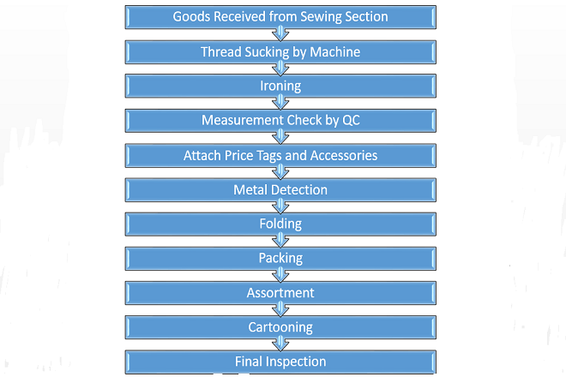
Flow chart of garments finishing
Steps of Garments Finishing:
The steps of garments finishing are as follows-
1. Goods Received from Sewing Section:
At first, finished garments are received from sewing section as per order quantity. Good received from sewing section is the first step to finishing section.
2. Thread Sucking by Machine:
In this step extra lose sewing thread are sucking by sucking machine in garments. Threads are suckered by two systems. One by done by hand which is manual system and the other is done by sucking machine.
3. Ironing:
Ironing is a finishing process done by a cloth to heat and pressure with or without steam to remove creases and to impart a flat appearance to garments. Ironing process is also called as pressing process. After completing ironing, garments have to be folded.
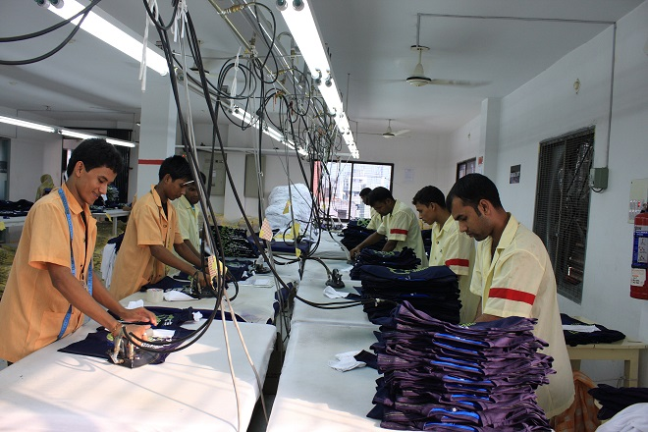
Figure 61;Ironing process in Garments
5. Measurement Check by QC:
When ironing process running that time also check measurement of garments. During the ironing process measurement is also check out by the QC.
6. Attach Price Tags and Accessories:
After above process, different types of tags and accessories are attached with the garments as per buyer comment. For an export order, must attach price tags with the garments.
7. Metal Detection:
Garments are passed through into the metal detection m/c for metal check. Now most of the buyer recommended to use metal detector for garments more safety. To use metal detector for kid’s item is must.
8. Folding:
Garments are folded according to buyer directions in a standard area. There are fore types of folding in garments. They are as follows-
Stand up
Semi stand up
Flat back
Hanger pack.
9. Packing:
After folding garments are ready for packing. The size of polythene is vary according to the size, garments ratio. Before packing it is needed to ensure the placement of sticker in proper place.
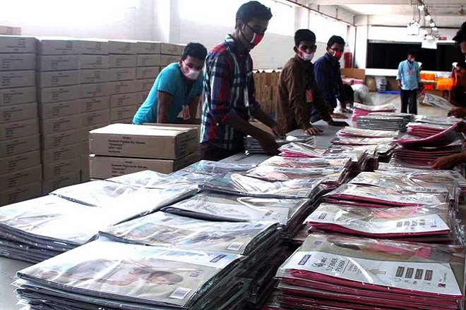
Figure 62;Garments Packing Process
9. Assortment:
After completing the packing, it must be placed the garments in a predetermined packed by sorting according to the size and color is called assortment.
10. Cartooning:
At last cartooning is done according to buyer comment into the inner boxes and is properly warped by the scotch tape. Some information like carton box no, size, shipping mark, destination are printed on the cartoon.
11. Final Inspection:
Final inspection is an important part and last step of garments finishing. Normally final inspection is made by buyer. Buyer checks the garments according some rules like Accepted Quality Level (AQL)
AQL:
AQL means Accepted Quality Level. AQL is designed as the maximum average defective items in a lot. It is expressed in a percentage number of average defective items can simply be identified by following a formula,
Average defective item = No. of defective item found during inspection / Total no. of item inspection X 100.
Following AQL system can be used in garments industry for final inspection.
AOL 1%
AOL 1.5%
AOL 2.5%
AOL 4%
AOL 6.5%
AOL 10%
AQL Process:
This AQL standard will be used for inspection is dependent on the price and the quality of the product. Normally lower figure AQL standard such as AQL 1% is used for higher price garments and lower figure AQL standard such as 10% is used for lower quality and lower price garments. As, for example, AQL 2.5% means, maximum average defective item is 2.5%, which is acceptable in the inspection system.
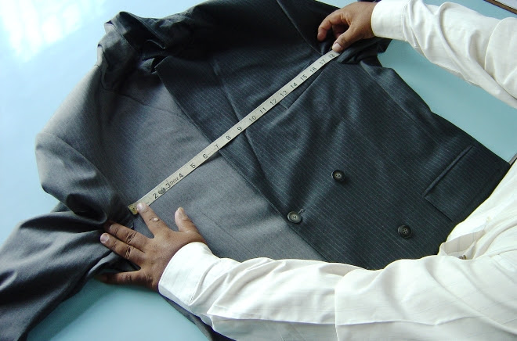
Figure 63;AQL Process
It is the supplier’s responsibility to ensure that the product is manufactured based on the AQL standard. The supplier must have an internal audit system in place on all stages of production. Normally standard garments factory work to an AQL 2.5 for major defects and AQL 4.0 for minor. For critical defects, they adopt a Zero Acceptance Level. For deliveries that fail the AQL, a 100% inspection must be completed.
AQL Chart for Apparel Industry:
Almost every factory recommends Suppliers use a tighter AQL in executing their internal audit. Please see the AQL chart below-
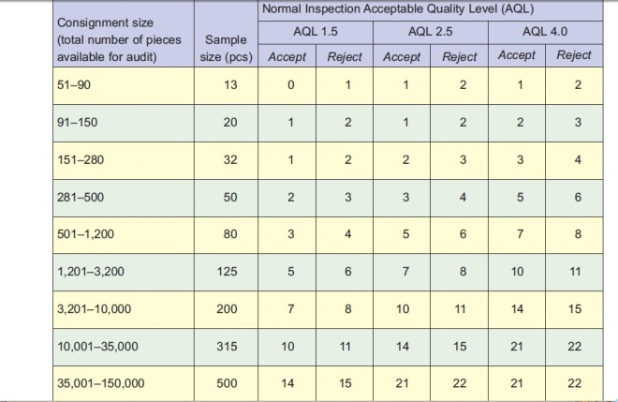
AQL Chart for Apparel Industry
This chart is a tool provided to help determine the sample lot. The effectiveness and efficiency of a quality audit largely depend upon proper audit execution.
This means:
1. Correct selection of sampling lot.
2. Good random sample pick-up.
3. Accurate classification of defects.

5.2. Inspecting and identifying faults
If any faults are identified, they should be documented and addressed accordingly. This may involve repairing or replacing components, repressing certain areas, or taking any other necessary steps to ensure that the garment meets the required standards.

It is also important to identify any patterns or trends in the faults that are found. This can help identify potential issues in the production process that may need to be addressed to prevent future defects.

Overall, the inspection process plays a crucial role in ensuring that the finished garments are of high quality and meet customer expectations. By carefully examining each garment and addressing any faults or defects, you can ensure that the final product is ready for packaging and delivery to the customer.

Method of Fabric Inspection:
- Select the rolls to inspect
- Both fabric manufacturer and garment manufacturers’ inspector to have an approved fabric submission form to compare bulk to bulk.
- Put the rolls on the inspection machine or viewing device.
- In order to assess shade continuity please refer to Best Practice for Shade Continuities
- Inspect for visual defects with the light on at a speed slow enough to find the defects. (The fabric must be checked at a slow rate in order to effectively find flaws). Sometimes inspector may have to turn the light off to see how a flaw will affect the appearance of a garment.
- Check for skewed, biased, and bowed fabric.
- Woven Fabrics: maximum 3%
- Knitted Fabrics: maximum 5%
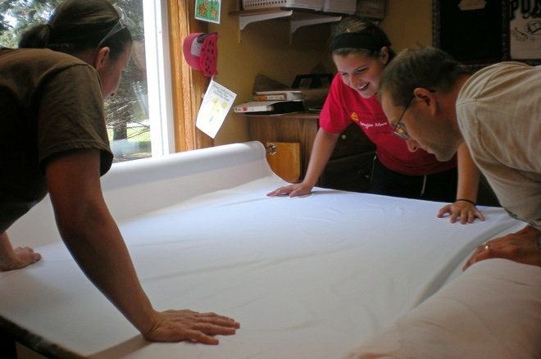
Figure 64;Fabric Inspection
- Mark any defects to the side with colored tape or thread so that they can be easily found and noted
- Some garment makers will require faults to be marked with a sticker on the fault. This should be communicated in pre-production meetings
- Check that the roll contains the correct yardage as stated by the piece goods source
- Record any defects. Defects must be recorded for every roll and clearly identified on the roll ticket. Records must be kept.

Four Point System:
There are two methods is available in the garments industry. They are 4 point system and 10 point system. But 4 point system is vastly used in the garment industry for fabric inspection. Normally 4 point system is used for better quality of fabric inspection. In the apparel industry, 4 point system is calculated on the basis of fabric cut mark and hole or opening. They are as follows-
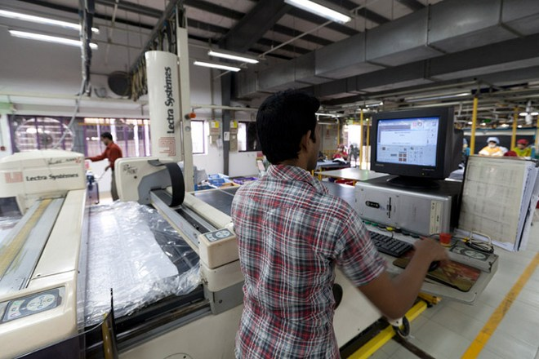
Figure 65;Four Point System for Fabric Inspection
On the basic of cut mark
Size of fault | Defect point / Penalty point
Up to 3” | 1
3-6” | 2
6-9” | 3
Above 9 | 4
On the basic of hole and opening
Size of fault | Defect point / Penalty point
Up to 1” | 2
Above 1” | 4
Example:
Suppose,
about an intact fabric roll
Fabric length = 110 inch,
Fabric width = 54 inch,
and fabric contains the following defects:-
Size of Defect | Multiple | Point
5 defects up to 3 inch | 5 X 1 | 5
4 defects over 3 inch but less 6 inch | 4 X 2 | 8
2 defects over 6 inch but less 9 inch | 2 X 3 | 6
1 defects over 9 inch | 1 X 4 | 4
1 hole up to 1 inch dimensions | 1 X 2 | 2
1 hole over 1 inch dimensions | 1 X 4 | 4
Total defect point | = | 29
Table 7:On the basic of cut mark
Therefore,
Points per 100 yard square
Total points X 36 inch
=……………………………………………………… X 100
Fabric width in inches X Fabric length in inches
29 X 36
………… X 100
110 X 54
= 17.58
so, the defect points per 100 yard square is 17.58
We know that, 40 points per 100 yards is the acceptable that means the roll of fabric is accepted.

5.3. Recording outcome including time frame
Recording the outcome of the inspection process is an essential step in maintaining quality control and ensuring that any faults or defects are properly addressed. This includes documenting the specific issues found in each garment, as well as the actions taken to rectify them.

The outcome should be recorded in a clear and organized manner, including details such as the date and time of the inspection, the specific garment or batch number, and a description of the faults or defects found. It is also important to note the actions taken to address these issues, such as repairs made or components replaced.

Additionally, it is beneficial to record any patterns or trends identified during the inspection process. This can help identify potential issues in the production process that may need to be addressed to prevent future defects. For example, if multiple garments from the same batch consistently have loose threads, this may indicate a problem with the stitching process that needs to be addressed.

The time frame for recording the outcome of the inspection process should be prompt and efficient. Ideally, it should be completed immediately after each inspection is conducted to ensure accuracy and prevent any delays in addressing the identified faults or defects. This allows for timely action to be taken to rectify any issues and ensures that the final product meets the required standards before packaging and delivery to the customer.
Key point
Recording (plans / case notes) takes time and often responds to different demands
Including what matters to people does not require extra time and there are resources to support this
Recording outcomes with people can help to build trust and relationships
‘Measuring’ outcomes can be required for planning, reporting and commissioning purposes and should flow from recording rather than driving decisions
There is useful learning about possibilities and limits of measurement and outcomes


Figure 66;Recording (plans / case notes)

5.4.Identifying options for improvement of manufacturing process of a collection
1. Conducting regular and thorough inspections throughout the manufacturing process to identify any potential issues or defects early on.

2. Implementing quality control measures at each stage of production, such as checking for proper stitching, accurate measurements, and overall product appearance.

3. Providing training and education to manufacturing staff to ensure they are aware of and adhere to quality standards and processes.

4. Utilizing advanced technology and automation to streamline and improve production processes, reducing the chances of errors or defects.

5. Collaborating closely with suppliers and manufacturers to establish clear communication channels and expectations regarding quality control.

6. Implementing a system for tracking and documenting any defects or issues that arise during production, allowing for analysis and identification of patterns or trends.

7. Regularly reviewing and evaluating the manufacturing process to identify areas for improvement and implement necessary changes.

8. Conducting customer feedback surveys or focus groups to gather insights on product quality and identify any areas for improvement.

9. Investing in research and development to stay updated on the latest manufacturing techniques and technologies that can enhance product quality.

10. Establishing a culture of continuous improvement within the manufacturing team, encouraging employees to actively seek out ways to enhance the manufacturing process and product quality.
tips for improving your production processes
You can optimize your production processes in any one of several ways. Take advantage of the following tips and tricks!

1. Analyze your current workflows
You can only go from A to B if you know where A is to begin with. Take a close look at your workflows from three perspectives.
Personnel – Are the right people with the right skills in the right place at the right time? Have you clearly defined SMART objectives for your production processes – are they specific, measurable, assignable, realistic, time-related?
Processes – When did you last map out and evaluate your processes? Where are the bottlenecks and obstacles?
Tools & technology – Is all your machinery and equipment in good condition? Are you using the most relevant technology to meet your business-critical requirements? And how easily can you alter your production processes?
2. Modernize your processes and technologies
Once you’ve mapped your current workflows, it’s time to determine whether you should modernize or improve your processes and technologies. Could you automate certain processes? Could you use new software to improve planning, inventory control, or monitoring? Could you replace or upgrade your equipment and machinery?
If you’re considering adopting new technologies or equipment, don’t forget to look long and hard at ‘total cost of ownership’ (TCO) – would a change actually reduce your TCO?
3. Pay particular attention to planned maintenance
One of the main causes of poorly performing production processes is a lack of planned maintenance. Neglecting maintenance is dire for your business because broken or worn-out machinery costs far more to put right than a brief production shutdown to perform maintenance.
You can beef up your planned maintenance program by taking the measures we’ve listed below:
Train all your operators and maintenance technicians well so that they can respond quickly and effectively when a problem arises.
Set fixed dates and times at regular intervals for your planned maintenance.
Observe and listen closely to shop-floor personnel to determine the best times to schedule your planned maintenance – their hands-on, day-to-day experience is invaluable in this respect.
Don’t postpone maintenance for too long – the longer you wait, the worse any hidden problems become.
Tip: Read our article, ‘So, what is TPM?’ – about Total Productive Maintenance and how it could help your organization.
4. Train your staff
When you optimize your production processes, don’t forget to bring your staff up to speed. The better they can operate and maintain your machinery and equipment, the less likely it is that production will come to a sudden standstill.
Offer your personnel the opportunity to learn new skills and schedule training sessions any time you install a new piece of equipment. Keep close track of a need for refresher or retraining courses.
5. Keep your workplace neat and tidy
A neat and tidy workplace is an important precondition for optimal production processes. Tidy up any mess, as well as any spare parts and unused tools that you’ve left lying around. Lay out workstations as efficiently as possible so that tools are easy to find and close at hand. Try to minimize the distance between machinery and essential tooling as much as possible.
6. Keep well stocked
It’s about finding a balance between too little and too much inventory! Make sure you know exactly what you have in stock and where it is. But what’s the solution? Use modern software that tracks inventory levels, predicts material requirements, and automatically notifies you when you have too much or too little.

Figure 67 ;Strategies for optimizing your production processes
You can adopt any one of several strategies to help improve your production processes. We’ll be discussing four such strategies: Continuous Improvement, Performance Support, Workforce Planning, and Training Within Industry.
7. Continuous improvement
Continuous improvement, a.k.a. Kaizen, is one of the pillars of the Lean method. It aims to improve productivity, quality, costs, and turnaround times gradually and iteratively, rather than as a one-time, large-scale transformation.
What’s more, continuous improvement implies that optimizing processes is never-ending and relies on employees themselves to make these iterative changes and improvements.
This is why it’s important to provide training and coaching, for example in the form of on-the-job training.
Continuous improvement comprises three main phases:
Gather suggestions – identify and summarize the problems
Implement suggestions – resolve the problems identified above using the suggestions gathered
Monitor and learn – evaluate how effective the improvements have been
(This also allows you to determine which suggestions for improvement work and whether teams are progressing at different rates or to varying degrees.)
8. Performance support
Performance support is a method for improving production processes based on practical learning. It involves creating ‘learning moments’ tailored to the practical requirements of staff on the shop floor.
Performance support comprises five moments of need:
New – a need to learn something new or acquire new skills
More – a need to learn more about a specific topic or way of working
Practice – a need to put certain information, skills, or procedures into practice
Change – a need to keep abreast of change(s)
Solve – a need to overcome and solve problems
9. Workforce planning
Workforce planning aligns an organization’s priorities and requirements to those of its available personnel. It primarily addresses factors such as:
scope – do you currently have a lot of job openings?
mix – do you have the mix of skills in-house you’ll need today and tomorrow?
costs – do you have a healthy balance between your labor costs and your organization’s requirements?
flexibility – is your workforce agile and flexible enough to respond to changing market conditions?
Workforce planning makes it easier to optimize your operating costs, gives you greater control over staff turnover, pinpoints potential skills gaps, and helps you establish the right training and education programs
10. Training Within Industry
Training Within Industry (TWI) originated in the USA at the United States Department of War as part of the war effort (1940-45). Its aim was to safeguard the provision of services to sectors of industry vital to the war effort, which had lost personnel to the armed forces. There was a severe shortage of skilled personnel because of the war and there was an acute need to train new staff quickly and affordably.
TWI proved a huge success and, after the war, spread around the world to help many organizations looking to optimize their production processes.
The TWI method standardizes work processes within a framework comprising four modules: job instruction, job methods, job relations and program development. This enables new staff to become productive sooner. What’s more, TWI also provides you a greater insight into operational and process-related improvements.

Self-check 5
Name of trainees ------------------------------- ----------------- sections---------------sign ---------
  - True /false the following question
- Garments are passed through into the metal detection m/c for metal check.
- When ironing process running that time also check measurement of garments.
- After folding garments are ready for packing.
- There are two methods is available in the garments industry.
- Kaizen is one of the pillars of the Lean method.
- Continuous improvement comprises three main phases:

II. Match the following question
A B
- Accepted Quality Level A. AQL
- AQL 1% B. used for higher price garments
- AQL 10% C. used for lower quality
- AQL 2.5 % D. for major defects
- AQL 4.0 % E. for minor
- AQL 100% F. inspection must be completed
- Continuous improvement comprises three main phases: G. Gather suggestions
- Kaizen, H. pillars of the Lean method
- Woven Fabrics I. maximum 3%
- Knitted Fabrics: J. maximum 5%

Unit one: 6 Arranging collection for presentation

This unit is developed to provide you the necessary information regarding the following content coverage and topics:
- Arranging every outfit by presenting the entire pieces together attractively.
- Comparing and concluding collection in comparison with design.
This unit will also assist you to attain the learning objectives stated in the cover page. Specifically, upon completion of this learning guide, you will be able to:
- Present the pieces
- Collection the design
.

6.1 .Arranging every outfit by presenting the entire piece
Presentations are the most important aspect of obtaining funding, marketing or selling clothing designs to major clothing companies. Whether the designs are meant for high fashion or consumer purchases, presenting the ideas to the company or manufacturer is the most important part of getting the clothing design made and sold. Presentations are challenging, especially for those with stage fright or fear of public speaking, but anyone can present ideas well
Attending a conference can be an exciting experience, but deciding what to wear can be a daunting task. No doubt, times have changed regarding the rules for dressing professionally. As we continue to gather in person more often, the Zoom dress code (think button-up top with lounge pants) doesn’t quite translate the same way in person as it does on screen. First impressions are important, and we’re here to help you dress your best for any professional (in-person) occasion. In this article, you’ll gain tips for determining appropriate conference attire, learn conference outfit ideas, and be able to attend your next conference feeling confident in your wardrobe!

6.2. Comparing and concluding collection in comparison with design
Types of fashion collections
From a sales perspective, fashion collections can be categorized into two main types: conceptual and commercial.
Conceptual collections
Conceptual collections are designed to emphasize the theme that the designer has worked on.
They are based on concepts, ideas, and other sources of inspiration that guided the creation of the collection.
Because of their nature, the clothes showcased on the runway may not necessarily be practical for everyday wear.
These collections prioritize creativity and exploration rather than conforming to market wear ability requirements or catering to current trends and the preferences of the target audience.
Commercial collections
Commercial collections are created with the primary objective of being sold.
They typically don’t emphasize the deep conceptual stage that conceptual collections do.
Instead, commercial collections rely on studies of fashion trends to develop sets of clothing and accessories that align with a specific theme and can be quickly delivered to consumers.
These collections are geared toward meeting consumer demand and market trends.
The power of storytelling in fashion collections
One of the key techniques used in crafting fashion collections is storytelling – the art of telling stories.
While the idea itself isn’t new, storytelling has been a part of human communication since ancient times.
However, recent studies have highlighted the significance of brands, including fashion collections, in storytelling.
The goal is to make the connection between the consumer and the product feel more human by creating emotional bonds and a sense of affection.
How to create a fashion collection?
Creating a fashion collection involves several stages, from the initial idea to the final fashion show. These stages help streamline processes, reduce errors, avoid rework, and prevent delays.
There are two main types of collections: conceptual and commercial. Begin by deciding which one suits your goals and the market. This choice depends on various factors, including your brand’s objectives and the current fashion landscape.
Conduct market analysis
Fashion products are consumer goods, catering to an ever-changing audience with shifting trends.
Therefore, a thorough market analysis is essential for the success of your collection.
Study the market and trends, with a focus on influential European fashion trends, which often set the tone.
This analysis will help you determine the most suitable collection type, the number of pieces needed, and other crucial details.
Learn more: Uncover the benefits of fashion trend forecasting for your clothing business
Identify your target audience
Every fashion collection should have a specific target audience in mind.
While market research helps you understand emerging trends and consumer behaviors, defining a target audience helps narrow down the designer’s ideas.
It allows you to fine-tune the final pieces to cater to the chosen audience segment.
Collect as much information as possible about your target audience, including their socioeconomic background, consumer profile, age group, aesthetic preferences, and interests.
Create a collection timeline
Developing a collection timeline is a crucial step in ensuring a successful outcome.
This schedule manages the entire process, from sourcing materials and the creative design phase to production, packaging, and distribution.
Proper planning and strict adherence to the timeline are vital to avoid delays and unexpected setbacks that could cost you both time and money.
Define the collection theme
Determining the theme of your collection marks the beginning of the creative process. It starts with an analysis of trends, the preferences of your target audience, and the ideas of the fashion designer and stylist.
The theme should encompass various visual elements such as designs, cuts, fits, types of garments, color schemes, textures, fabrics, and all the aesthetic, ergonomic, and usability components that will be incorporated into the collection’s items.
Create sketches
The next step is to turn your ideas and theme into real designs through sketches. These sketches serve as a visual guide for the technical aspects of styling and pattern-making. They also provide an aesthetic foundation for the designer and the team to approve the models that will be part of the collection.
Produce sample garments
Following the styling stage, the collection’s pieces move on to the modeling phase. Initially, detailed samples are created.
These prototypes help patternmakers create the necessary block patterns, and they serve as the foundation for producing sample garments.
During this phase, details such as fit, cut, and other characteristics are analyzed and approved by the team.
In modern fashion, the technical pattern-making process is often entirely digital, which streamlines the collection timeline.
Commence production
With the samples approved, it’s time to proceed with cutting the fabric patterns and start the actual production of the garments.
After production, the pieces undergo a final quality check to ensure they meet the desired standards.
Only then are they ready for the collection’s debut during the fashion show.
Where to find inspiration for your collection?

You can discover inspiration for your fashion collection from various sources, ranging from technical to creative fonts. Here are some places to explore ideas for your collections:
Trend research during the collection design phase
Major fashion events of the season
Natural, ethnic, or historical elements
Look to respected fashion magazines for insights and ideas
Designer’s experiences and knowledge
Typically, the chosen theme for a collection combines elements from these various sources. The key is to incorporate references that not only look appealing but also align with the needs and expectations of your target audience.
How to name your fashion collection?
Naming your fashion collection may seem like a small detail, but it’s actually one of the most important elements.
The collection’s name is the first thing consumers see, and it plays a vital role in conveying the storytelling and concept behind your collection.
However, choosing the right name isn’t always an easy task. To help you decide, consider the following factors:
References from your collection items
The theme of your pieces
The story your collection wants to tell
Creative techniques to capture attention.
There are no strict rules for naming a collection, but ideally, the name should somehow represent the concept and the history behind the collection’s pieces that you’re presenting to the public.

Self-check 6
Name of trainees ------------------------------- ----------------- sections---------------sign ---------

  - True /false the following question
- From a sales perspective, fashion collections can be categorized into two main types
- Creating a fashion collection involves several stages, from the initial idea to the final fashion show
- There are two main types of collections: conceptual and commercial
- Typically, the chosen theme for a collection combines elements from these various sources.
- Commercial collections are created with the primary objective of being sold.

II. Explain the following question

- Write two main types of fashion collections?
- How to create a fashion collection?

References
https://textilelearner.net/different-types-of-trims-used-in-garments/
https://thedesigncart.com/blogs/news/garment-trims
https://textileapex.blogspot.com/2019/10/trims-accessories-for-clothing.html
https://en.wikipedia.org/wiki/Trim_(sewing)
https://www.moodfabrics.com/blog/trend-report-trims
https://textilelearner.net/pressing-important-finishing-process-in-garment-industry/
http://textilemerchandising.com/aql-chart-apparel-industry/
https://www.ag5.com/10-ways-to-improve-your-production-processes/

Participants of this Module (training material) preparation
No | Name | Qualification (Level) | Field of Study | Institution |  | Mobile number | E-mail
1 | Boja mokonen | B | Fashion design | MPTC | 920623548 |  | bojagarment@gmail.com

