GARMENT PRODUCTION
LEVEL – III
Based on March, 2022 Curriculum Version I,
Module Title: Maintain and Repairing Apparel Machineries
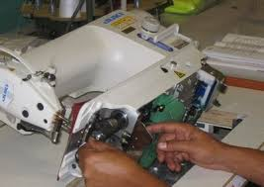

Module Code: IND GAP3 M08 0322
Nominal duration: 40 Hours

Prepared By: Addis Ababa TVET Bureau
Sept /2023
Addis Ababa, Ethiopia

Acknowledgement

Addis Ababa city administration Technical vocational Training & Technology Development Bureau wish to extend thanks and appreciation to the many representatives of TVET instructors and respective industry experts who donated their time and expertise to the development of this Teaching, Training and Learning Materials (TTLM).

Table of Contents
Acknowledgement 1
Acronyms 4
INTRODUCTION OF THE MODULE 5
Module units 6
Module Learning Instructions: 6
Unit one: safety and maintenance 7
1. Safety and maintenance 8
1.2 Inspecting (checking) machine and equipment’s 8
1.2.1 Breakdown and Preventive maintenance Policy of Sewing machine in Garments
1.2 Follow up operational procedures to check the machine 2
1.3 Calibrating apparel machinery 3
1.3.1 Sorting tools, instruments and equipment 5
1.4 Spreading and cutting machines 6
1.4.1 Sewing machines (single, over lock, chain stitch, buttonhole) 7
1.4.2 Finishing machines (ironing, pressing, washing machines) 9
SELFE CHECK 11
UNIT – TWO: Basic Maintenance Program 13
2. Basic Maintenance Program 11
Basic Maintenance Program 13
2.1 Cleaning and lubricating Machinery / equipment’s 14
2.2 Remove/ replacing of consumable component 15
2.2.1 Sewing machine parts 17
2.2.2 Cutting machine blades 23
2.3 Replace and / or topping up Fluids and lubricants 28
2.4 Performing minor repairing 29
2.5 Adjusting machine moving part 30
2.5.1 Programmed safety and maintenance checks 31
2.5.2 Adjustments of a limited nature including safety guards, stops, wear pads 32
SELFE CHECK 34
Unit Three: Basic Preventive Maintenance and Tools 35
3. Basic Preventive Maintenance and Tools 35
3.1 Identifying a machine failure 36
3.2 Report machine/equipment failure 38
3.3 Performing cleaning operations 39
3.4 Accomplishing necessary report 40
SELFE CHECK 46
Unit four : Inventory Of Machineries And Complete Work Activities 47
4. Inventory of Machineries and Complete Work Activities 47
4.1. Performing inventory control 49
4.1.1 Benefits of Effective Inventory Control in Garment: 49
4.2 Documenting inventory result 50
4.3 Store machineries, tools and equipment safely 51
4.3.1 Different Types of Machineries, Tools, and Equipment: 51
4.3.2 Cleaning materials: 53
SELFE CHECK 55
Reference 56

Acronyms
SOP Standard Operating Procedure
PPE Personal protective equipment
MSDS Material safety data sheet
OSHA Occupational Safety and Health Administration
JHA Job hazard analysis
LOTO Lockout/ tag out
TTLM Teaching, Training and Learning Materials

INTRODUCTION OF THE MODULE
Maintaining apparel machineries: - Maintaining and repairing apparel machineries is essential for ensuring the smooth operation of the garment production process. By following the tips above, apparel manufacturers can extend the lifespan of their machines, reduce downtime, and improve productivity.
Regular cleaning and lubrication: Machines should be cleaned and lubricated regularly to remove dirt and debris, and to reduce friction and wear and tear. Inspections: Machines should be inspected regularly for any signs of damage or wear. Any damaged parts should be repaired or replaced immediately. Adjustments: Machines should be adjusted regularly to ensure that they are operating at optimal performance. Following the manufacturer's instructions: It is important to follow the manufacturer's instructions for maintaining and operating apparel machineries. This will help to ensure that the machines are used properly and that they last longer.
Repairing apparel machineries: - If an apparel machine breaks down, it is important to have it repaired by a qualified technician. There are a number of common problems that can occur with apparel machineries, including: Threading problems: Threading problems are one of the most common problems with apparel machineries. This can be caused by a number of factors, such as using the wrong type of thread, or threading the machine incorrectly.

Module units
Unit 1. Identify safety and maintenance checks
Unit 2. Identify basic programmed maintenance
Unit 3. Perform basic preventive maintenance of tools
Unit 4. Perform inventory of machineries and complete work activities
Learning objectives of the Module At the end of this session, the students will able to:
- Identifying safety and maintenance checks
- Identifying basic programmed maintenance
- Performing basic preventive maintenance of tools
- Performing inventory of machineries and complete work activities

Module Learning Instructions:
- Read the specific objectives of this Learning Guide.
- Follow the instructions described below.
- Read the information written in each unit
- Read the identified reference book for Examples and exercise.
- Accomplish the Self-checks at the end of each unit

Unit one: safety and maintenance
This learning unit is developed to provide the trainees the necessary information regarding the following content coverage and topics:
- Inspection/check machine and equipment’s
- Follow up operational procedures to check the machine
- Calibrating apparel machinery
- Sorting tools, instruments and equipment

This unit covers the knowledge, skills and attitude required to finish completed work in the production of garments or other associated articles
- Inspecting of machine and equipment’s
- Identifying operational procedures and to check the machine
- Calibrating apparel machinery
- Sorting tools, instruments and equipment

Safety and maintenance
Safety is the condition of being protected from or not exposed to danger, risk, or injury. It is an important consideration in all aspects of life, including the workplace, the home, and the environment. Maintenance is the upkeep and preservation of something, typically property or equipment. It is important to perform maintenance on a regular basis to keep things in good condition and prevent problems from developing.
Safety and maintenance are closely related. By performing regular maintenance on equipment and facilities, you can help to prevent accidents and injuries. For example, by regularly inspecting and lubricating machinery, you can reduce the risk of breakdowns and failures.
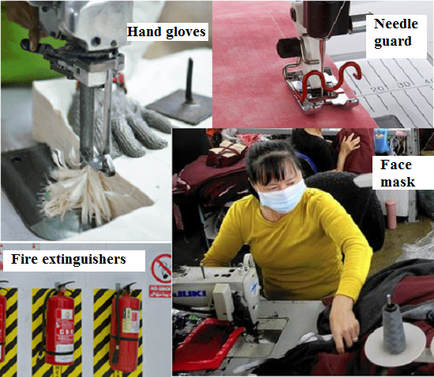

1.2 Inspecting (checking) machine and equipment’s
Inspecting and checking machines and equipment in garment is important to ensure that they are in good working order and that they are not a safety hazard. It is also important to inspect and check machines and equipment to identify any potential problems early on, so that they can be repaired or replaced before they cause a breakdown.
There are a number of different ways to inspect and check machines and equipment in garment. Some common methods are:-
- Visual inspection: This involves looking at the machine or equipment for any signs of damage or wear and tear.
- Functional inspection: This involves testing the machine or equipment to make sure that it is working properly.
- Safety inspection: This involves checking the machine or equipment for any potential safety hazards.
The specific inspection and checking procedures that are used will vary depending on the type of machine or equipment being inspected. However, there are some general tips that can be followed:
- Inspect machines and equipment on a regular basis. This will help to identify any potential problems early on.
- Use a checklist to ensure that all aspects of the machine or equipment are inspected.
- Keep records of all inspections and checks. This will help you to track any changes over time and to identify any trends.
By following these tips, you can help to ensure that your machines and equipment are in good working order and that they are not a safety hazard.
If you find any problems with a machine or piece of equipment, it is important to take corrective action immediately. This may involve repairing or replacing the machine or equipment, or making adjustments to the operating procedures.
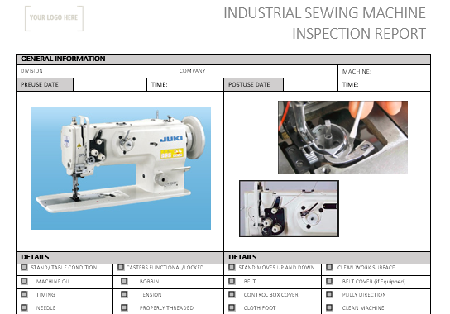

1.1.1 Breakdown and Preventive maintenance Policy of Sewing machine in Garments Manufacturing

Machine Maintenance
The machine is an important resource that is constantly used for adding value to a product. So it is necessary to keep in the best operating condition. Otherwise, there will be excessive downtime and also interruption of production if is used in the mass production line. Poor working of machinery and equipment will lead to quality-related problems, it's necessary to maintain the machine in good operating conditions with economical cost. The machine maintenance system is the key factor for Garments Manufacturing. The factory’s work efficiency depends on machine fitness too.
Maintenance is the action to retain or to fix or to restore an item in a state in which it can perform its required function by the combination of all technical administrative, managerial, and supervision actions. In general words, maintenance is the process by which equipment is looked after in such a way so that it runs trouble-free. Service and increased machine life can be ensured and specific product quality required by the customer is sustained.
Preventive maintenance is to retain the healthy condition of equipment and prevent major breakdowns of failure by a deterioration of facilities. It ranges from such simple tasks as cleaning, inspection, equipment condition diagnosis checking, changing oil, water, air, alignment, re-tightening,
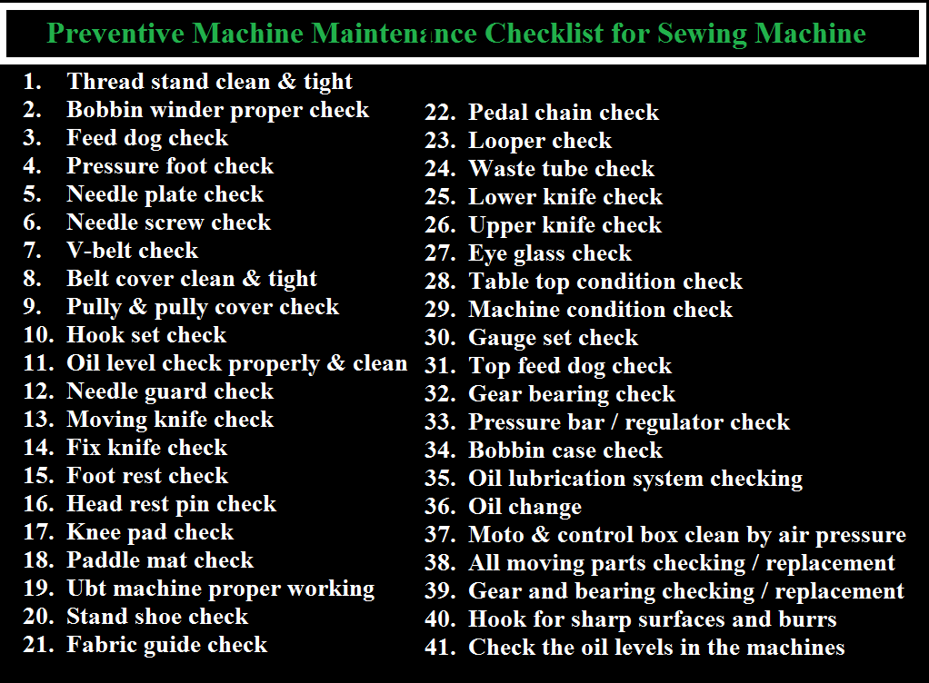

Types of Maintenance
Generally, there are two types of maintenance systems found in the apparel industry:

1. Breakdown Maintenance
2. Preventive Maintenance/Routine maintenance

1. Breakdown Maintenance: is the repair generally done after equipment has attained downstate. Online mechanics set for breakdown maintenance sewing line for immediate support or quick information system can be set to call mechanic, can set traffic lighting system in every sewing line. Breakdown time should be recorded and tracked to see a mechanic's performance. Machine breakdown time considers a loss of time in garments manufacturing. These are unpredictable or reactive types of maintenance and are more difficult to schedule than the above categories. There are no routine maintenance tasks to perform and equipment is repaired or replaced only when obvious problems occur. Breakdown maintenance works well if equipment shutdowns don’t affect product quality or revenue generation.
2. Preventive maintenance/Routine maintenance:- is periodical inspection (daily, weekly, monthly basis cleaning, inspection, oiling, and re-tightening) and service activities that are aimed to detect potential failures and perform minor adjustments and repairs which will present major operating problems in the future. The sewing maintenance team does preventive maintenance asper their maintenance schedule or calendar. It’s the preventive maintenance to retain the healthy condition of equipment and prevent major breakdowns of failure by a deterioration of facilities. It ranges from such simple tasks as cleaning, inspection, equipment condition diagnosis checking, changing oil, water, air, alignment, re-tightening, etc. Routine maintenance consists of periodically inspecting, servicing, lubricating, and cleaning equipment and replacing parts to prevent sudden failure and process problems to ensure continuous working conditions.

Sewing Machine Maintenance equipment:

  - Flat screwdriver (Small/ Medium/ Large)
  - Star screwdriver (Small/ Large)
  - Nose pliers (Large/ Small)
  - Sly- Wrench
  - Forceps (chimta)
  - L- Key Needle
  - Needle driver
  - L- Keyset
  - Daly set
  - Lock Pliers
  - Hammer (Small/ Large)
  - File set
  - Tester
  - Welding machine
  - Air gun
  - Vacuum cleaner

Preventive Maintenance Checklist for Single Needle Lockstitch machine

- Clean Oil Filter
- Needle Condition/ Position
- Thread Sequence
- Oil Level
- Check Spring Operation
- Treadle Looseness/ Operation
- Brake Position
- Belt Tension + Condition.
- Oil Flow to Rotary Hook.
- Thread Stand Tight + Straight.
- Oil Condition.
- Rotary Hook Condition.
- Hook Timing.
- Bobbin Case Thread Tension.
- Feed Dog Height/Condition
- Presser Foot Sole Condition.
- Position Finger Condition

Preventive Maintenance Checklist for Over Lock Machine:

- Needle
- Thread Sequence
- Machine Clean
- Oil Level
- Knife Sharpness
- Treadle Looseness/ operation
- Brake Position
- Stitching part check
- Feed dog height
- Oil Condition
- Oil Filter clean
- Check all screws complete clean and test
- Thread stands Straight + Tight

Preventive Maintenance Checklist for Button Attach Machines:

- Needle Position/Condition
- Thread Sequence
- Oil all parts indicated in manual
- Drive belt tension
- Grease gears + clutch
- Clean Machine thoroughly Needle to buttonhole position
- Treadle operation smooth
- Stitching parts timing

Preventive Maintenance Checklist for Bar tacking Machine:

- Needle Condition/Position
- Thread Sequence
- Check spring Operation
- Bobbin case threads tension
- Bobbin winder operation
- Throat plate Condition (hole)
- Drive belt Condition/tension
- Oil Machine (as per manual)
- Clean Machine thoroughly

Preventive Maintenance Checklist for Lockstitch Button Hole Machine:

- Thread Stand Straight – Tight
- Needle Condition / Position
- Thread Sequence
- Cutting knife Condition
- Oil Level
- Clean Machine Thoroughly
- Check Oil flow to Rotary Hook
- Check Half-Speed Operation
- Check Upper Trimmer operation
- Bobbin Winder Operation
- Oil Condition
- Drive Belts (3) Condition + Tensional
- Treadle Operations (2)
- 14. Presser Foot Rubber Condition

Follow up operational procedures to check the machine
Operational procedures are the step-by-step instructions on how to perform a particular task or job in the garment manufacturing process. They are important for ensuring that all tasks are completed to a consistent standard and that the garment manufacturing process is efficient and productive., Operational procedures can be developed for a wide range of tasks in garment manufacturing, such as:

- Receiving and inspecting raw materials
- Cutting fabric
- Sewing garments
- Inspecting finished garments
- Packing and shipping garments

To ensure the smooth operation of the garment production process, it is important to follow up on operational procedures to check the machine in garment. This includes:
- Checking the machine for any signs of damage or wear and tear. Any damaged parts should be repaired or replaced immediately.
- Checking the machine's settings to ensure that they are correct. This includes checking the needle size, thread tension, and stitch length.
- Testing the machine to make sure that it is operating properly. This can be done by sewing a sample piece of fabric.
Here are some specific steps that can be followed:
- Check the machine's power cord and plug to make sure they are properly connected.
- Turn on the machine and check the lights and displays to make sure they are working properly.
- Thread the machine with the correct type and color of thread.
- Select the correct needle size and stitch length for the fabric you are sewing.
- Sew a sample piece of fabric to test the machine.
- If the machine is operating properly, you can begin sewing your garment.
It is also important to follow the manufacturer's instructions for maintaining and operating your garment machine. This will help to ensure that the machine lasts longer and operates safely.

Calibrating apparel machinery
Apparel machinery is the equipment used to manufacture garments. It includes a wide range of machines, from simple tools like needles and scissors to complex machines like sewing machines and cutting machines. Apparel machinery is used to perform all of the tasks involved in garment manufacturing, from cutting fabric to sewing garments to finishing garments.
Common types of apparel machinery
- Sewing machines: Sewing machines are used to sew together pieces of fabric to create garments. There are many different types of sewing machines available, each designed for a specific task. For example, there are sewing machines for sewing straight seams, zigzag seams, and overlock seams.
- Cutting machines: Cutting machines are used to cut fabric into the shapes needed for garments. There are many different types of cutting machines available, including manual cutting machines, electric cutting machines, and laser cutting machines.
- Pressing machines: Pressing machines are used to iron garments and to set seams. There are many different types of pressing machines available, including steam irons, dry irons, and hydraulic presses.
- Finishing machines: Finishing machines are used to add finishing touches to garments, such as buttons, zippers, and labels. There are many different types of finishing machines available, including button attaches, zipper attaches, and label attaches.
Calibrating apparel machinery is the process of adjusting the machine to ensure that it is producing accurate results. This is important for ensuring the quality of finished garments and for avoiding costly mistakes. The specific steps involved in calibrating apparel machinery will vary depending on the type of machine. However, there are some general principles that apply to all machines.
General steps for calibrating apparel machinery:
- Clean and inspect the machine. This includes removing any dirt or debris and checking for any signs of damage or wear and tear.
- Follow the manufacturer's instructions for calibration. This will typically involve adjusting specific settings on the machine.
- Test the machine to make sure that it is calibrated correctly. This can be done by sewing a sample piece of fabric and measuring the results.
Examples of how to calibrate different types of apparel machinery:
- Sewing machines: Sewing machines need to be calibrated to ensure that they are sewing the correct stitch length and tension. To calibrate a sewing machine, you will need to adjust the needle size, thread tension, and stitch length. You can test the machine to make sure that it is calibrated correctly by sewing a sample piece of fabric and measuring the results.
- Cutting machines: Cutting machines need to be calibrated to ensure that they are cutting the fabric accurately. To calibrate a cutting machine, you will need to adjust the blade height and the cutting speed. You can test the machine to make sure that it is calibrated correctly by cutting a sample piece of fabric and measuring the results.
- Pressing machines: Pressing machines need to be calibrated to ensure that they are pressing the fabric at the correct temperature and pressure. To calibrate a pressing machine, you will need to adjust the temperature and pressure settings. You can test the machine to make sure that it is calibrated correctly by pressing a sample piece of fabric and checking the results.

1.3.1 Sorting tools, instruments and equipment
To sort tools, instruments and equipment in garment, we can group them into different categories based on their function or purpose. Here are some examples:, Cutting tools: scissors, shears, rotary cutters, cutting machines
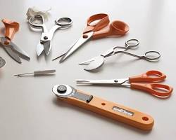 Garment cutting tools
Sewing tools: needles, thread, sewing machines, serge’s, over lockers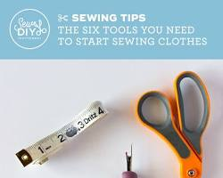 Garment sewing tools
- Pressing tools: irons, pressing machines, steam irons, steamers
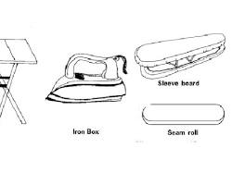 Garment pressing tools
- Measuring and marking tools: rulers, measuring tapes, tailor's chalk, pins
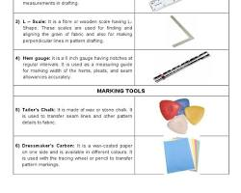 Garment measuring and marking tools
- Other tools and equipment: sewing notions, such as buttons, zippers, hooks and eyes, and trims; pressing tables, dress forms, and cutting tables
We can also sort garment tools, instruments and equipment by their location in the garment factory. For example, we can have a category for tools and equipment that are used in the cutting room, a category for tools and equipment that are used in the sewing room, and a category for tools and equipment that are used in the finishing room.
Finally, we can also sort garment tools, instruments and equipment by their manufacturer or brand. This can be helpful if we need to order replacement parts or accessories., No matter how we choose to sort them, it is important to have a system in place for organizing and storing garment tools, instruments and equipment. This will help us to keep our workspace tidy and efficient, and it will make it easier to find the tools and equipment we need when we need them.

1.4 Spreading and cutting machines
Spreading machines in garment are used to spread layers of fabric evenly on a cutting table. This is an important step in the garment production process, as it ensures that the fabric is cut.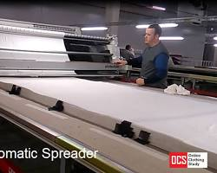 Spreading machine in garment
Cutting machines in garment are used to cut fabric into the shapes needed for different garment parts. There are a variety of different cutting machines available, depending on the type of fabric being cut and the desired results
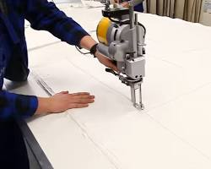 Cutting machine in garment
Here are some of the most common types of spreading and cutting machines used in the garment industry:
- Spreaders: Spreaders can be manual or automatic. Manual spreaders are less expensive, but they are also more time-consuming to use. Automatic spreaders are more efficient, but they are also more expensive.
- Cutting machines: Cutting machines can be mechanical or laser-cut. Mechanical cutting machines use blades to cut the fabric. Laser cutting machines use lasers to cut the fabric.
The type of spreading and cutting machines used in a garment factory will depend on the size of the factory, the type of garments being produced, and the budget of the factory.

1.4.1 Sewing machines (single, over lock, chain stitch, buttonhole)
Sewing machines are used to sew together pieces of fabric to create garments. There are many different types of sewing machines available, each designed for a specific task. For example, there are sewing machines for sewing straight seams, zigzag seams, and overlock seams.
There are many different types of sewing machines available, each with its own unique features and capabilities. Here is a brief overview of some of the most common types of sewing machines:
- Single lock stitch machines: These are the most basic type of sewing machine and are used for general sewing tasks. They create a single stitch that is strong and durable.

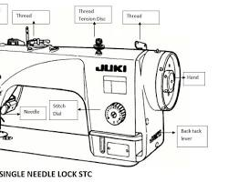
Single lock stitch machine

- Overlock machines: These machines are used to finish the edges of fabric to prevent fraying. They create a zigzag stitch that is both decorative and functional.
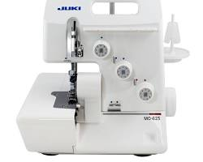 Overlock machine
- Chain stitch machines: These machines are used to sew stretchy fabrics, such as knit and jersey. They create a chain stitch that is stretchy and durable.
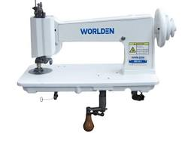 Chain stitch machine
- Buttonhole machines: These machines are used to create buttonholes in fabric. They can create a variety of different buttonhole styles, including standard buttonholes, bound buttonholes, and keyhole buttonholes.
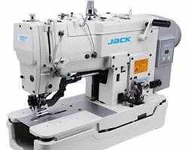 Buttonhole machine
- Button stitch machines: These machines are used to sew buttons onto fabric. They can sew a variety of different button types, including shank buttons, flat buttons, and snap buttons.
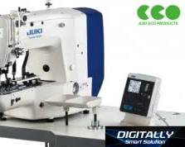 Button stitch machine
In addition to these basic types of sewing machines, there are also a variety of specialized sewing machines available. For example, there are machines for sewing leather, quilting, embroidery, and even for making shoes.
The type of sewing machine that is best for you will depend on your individual needs and sewing projects. If you are a beginner, it is a good idea to start with a basic single lock stitch machine. As you become more experienced, you can add other types of sewing machines to your collection to expand your capabilities.

1.4.2 Finishing machines (ironing, pressing, washing and drying, Embroidery machines)
Finishing machines are used to give garments the final touches that make them ready for sale. These machines can be used to iron, press, wash, dry, and embroider garments.
- Ironing machines: Ironing machines are used to remove wrinkles and creases from garments. They can be manual or automatic. Manual ironing machines require the operator to move the garment over the heated surface of the iron. Automatic ironing
Machines use a conveyor belt to.
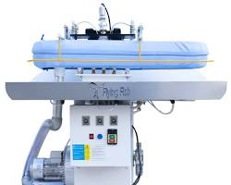
- Pressing machines: Pressing machines are used to apply heat and pressure to garments to give them a sharp, polished look. They can be used to press seams, collars, and cuffs.
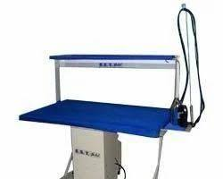
- Washing machines: Washing machines are used to wash garments to remove dirt and stains. They can be industrial-sized or home-sized.
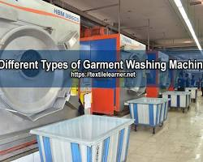
- Drying machines: Drying machines are used to dry garments after they have been washed. They can be industrial-sized or home-sized.
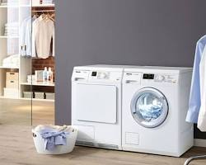
- Embroidery machines are used to add decorative stitching to garments. They can be used to embroider logos, designs, and names on garments.
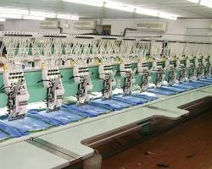 Embroidery machine in garment
- Embroidery machines are available in a variety of sizes and types. Some embroidery machines are designed for home use, while others are designed for industrial use.

SELFE CHECK – ONE
Instruction: write True/False for the given question. You are provided 5 minute for each question and each point has 1Points
- All garment workers should receive safety training.
- It is safe to operate machinery without proper guarding.
- Good lighting and ventilation are important for safety in garment factories.
- Emergency exits should be blocked for security purposes.
- Fire extinguishers should be checked and serviced regularly.
Instruction: write Matching for the given question. You are provided 5 minute for each question and each point has 1Points
- OSHA ------ (a) Personal protective equipment
- LOTO ----- (b) Material safety data sheet
- PPE ----- (c) Occupational Safety and Health Administration
- JHA ----- (d) Job hazard analysis
- MSDS ------ (e) Lockout/ tag out
Instruction: write short answer for the given question. You are provided 3 minute for each question and each point has 5Points
- What are some of the most common hazards in garment factories?
- What are some ways to prevent accidents and injuries in garment factories?
- What should you do in the event of an emergency in a garment factory?

Unit Two: Basic Maintenance Program
This learning unit is developed to provide the trainees the necessary information regarding the following content coverage and topics:
- Cleaning and lubricating Machinery / equipment’s
- Removing/ replacing of consumable component
- Replacing and / or topping up Fluids and lubricants
- Performing minor repairing
- Adjusting machine moving part

This unit covers the knowledge, skills and attitude required to finish completed work in the production of garments or other associated articles
- Cleaning and lubricating Machinery / equipment’s
- Removing/ replacing of consumable component
- Replacing and / or topping up Fluids and lubricants
- Performing minor repairing
- Adjusting machine moving part

UNIT – TWO

Basic Maintenance Program
A basic maintenance program in garment is a set of procedures and tasks that are performed to keep machinery and equipment in good working order. This helps to prevent breakdowns, improve the quality of products, and extend the lifespan of assets.
A basic maintenance program is listed bellow
- Daily maintenance:
- Clean and lubricate all machinery according to the manufacturer's instructions.
- Check for any signs of wear or damage to machinery and repair or replace as needed.
- Keep the factory floor clean and free of obstructions.
- Weekly maintenance:
- Conduct a more thorough inspection of all machinery and make any necessary repairs.
- Check the fire extinguishers and ensure that they are properly charged.
- Clean the factory lighting fixtures and ensure that all bulbs are working.
- Monthly maintenance:
- Conduct a comprehensive inspection of all machinery and make any necessary repairs.
- Check the electrical system and ensure that all wiring is in good condition.
- Test the emergency alarms and ensure that they are working properly.
In addition to these routine maintenance tasks, garment factories should also have a plan for responding to emergencies, such as fires and earthquakes. The plan should include procedures for evacuating the factory and providing first aid to injured workers.
Garment factories should also keep a record of all maintenance activities. This record can be used to track trends and identify any areas where maintenance may be needed more frequently.
Here are some additional information for developing and implementing a basic maintenance program in garment:
- Involve workers in the development and implementation of the program. Workers are often the first to identify problems with machinery and equipment, and their input can be valuable in preventing accidents and injuries.
- Create a maintenance schedule and post it in a visible location. This will help to ensure that all maintenance tasks are completed on time.
- Provide workers with the training and resources they need to carry out maintenance tasks safely and effectively.
- Conduct regular audits to ensure that the maintenance program is being followed and that all machinery and equipment is in good working order.

2.1 Cleaning and lubricating Machinery / equipment’s
Cleaning sewing machines is important to keep them in good working order and to prevent problems from developing. Sewing machines can become dirty from dust, lint, and thread residue. This can cause the machine to run slow, produce uneven stitches, or even jam.
Cleaning and lubricating machinery and equipment in garment factories is essential for ensuring their safety and efficiency. By following a regular cleaning and lubrication schedule, garment factories can help to prevent accidents and injuries, extend the lifespan of their machinery and equipment, and improve their bottom line.
Cleaning and lubricating machinery and equipment in garment factories:
- Cleaning: - Use a soft brush or cloth to remove dust and debris from all surfaces of the machinery and equipment.
- Use a mild soap and water solution to clean any dirt or grime.
- Avoid using harsh chemicals or abrasive cleaners, as these can damage the machinery and equipment.
- Pay special attention to areas where dust and debris can accumulate, such as vents and fans.
- Lubrication: - Use the lubricant recommended by the manufacturer of the machinery and equipment.
- Apply the lubricant to all moving parts according to the manufacturer's instructions.
- Be careful not to over-lubricate, as this can attract dirt and debris and lead to premature wear and tear.
How often to clean and lubricate machinery and equipment:
The frequency of cleaning and lubricating machinery and equipment will vary depending on the type of machinery and equipment, the environment in which it is operated, and the frequency with which it is used. However, it is generally recommended to clean and lubricate machinery and equipment on a daily or weekly basis.
Additional: - Keep a record of all cleaning and lubrication activities. This record can be used to track trends and identify any areas where maintenance may be needed more frequently. Train workers on how to clean and lubricate machinery and equipment safely and effectively. Develop and implement a procedure for responding to spills and leaks.
By following these tips, garment factories can ensure that their machinery and equipment is properly cleaned and lubricated, which will help to prevent accidents and injuries, extend the lifespan of their machinery and equipment, and improve their bottom line.

2.2 Remove/ replacing of consumable component
Removing garment components is the process of taking a piece of clothing apart in order to replace or remove a component. This can be done for a variety of reasons, such as to fix a broken zipper, replace a missing button, or remove a label.
To remove a garment component:
- Identify the component that needs to be replaced. This may be obvious, but it is important to make sure that you are removing the correct component.
- Use the appropriate tools to remove the component. The specific tools you need will depend on the type of component you are removing. For example, a screwdriver may be needed to remove a screw, or a pair of pliers may be needed to remove a snap.
- Be careful not to damage the garment while removing the component. It is important to be gentle when removing garment components, as you can easily damage the fabric if you are not careful.
Once you have removed the garment component, you can replace it with a new component. Be sure to follow the manufacturer's instructions when attaching the new component.
Replacing a garment component is the process of attaching a new component to a garment in place of an old or damaged one. This can be done for a variety of reasons, such as to fix a broken zipper, replace a missing button, or add a new embellishment.
There are a few different ways to replace garment components, depending on the type of component and how it is attached. Here are some general tips:
- Identify the component that needs to be replaced. This may be obvious, but it is important to make sure that you are replacing the correct component.
- Choose the right replacement component. The replacement component should be the same size and type as the original component. It is also important to choose a component that is made of a compatible material.
- Use the appropriate tools to attach the new component. The specific tools you need will depend on the type of component you are attaching. For example, a needle and thread may be needed to sew on a button, or a rivet gun may be needed to attach a rivet.
- Be careful not to damage the garment while attaching the new component. It is important to be gentle when attaching garment components, as you can easily damage the fabric if you are not careful.
Here are some additional tips for removing and replacing consumable components safely and efficiently:
- Work in a well-lit area so that you can see clearly what you are doing.
- Use sharp tools to avoid damaging the fabric.
- Be careful not to pull too hard on the garment, as this can damage the fabric.
- If you are unsure how to remove or replace a particular component, consult the garment's care label or the manufacturer's website.
- Needles: - Sewing machine needles are thin, metal rods with a point at one end and a hole at the other end. The point is used to pierce the fabric, and the hole is used to thread the needle. Sewing machine needles are available in a variety of sizes and types, each designed for a specific task.
The main parts of a sewing machine needle are:
- Butt: The butt is the flat end of the needle that fits into the needle bar of the sewing machine.
- Shank: The shank is the long, straight part of the needle that extends from the butt to the shoulder.
- Shoulder: The shoulder is the curved part of the needle that connects the shank to the blade.
- Blade: The blade is the long, thin part of the needle that has the point and the eye.
- Point: The point is the sharp tip of the needle that pierces the fabric.
- Eye: The eye is the hole in the needle that is used to thread the needle.
Needle types: - There are many different types of sewing machine needles available, each designed for a specific task. Some of the most common types of needles include:
- Universal needles: Universal needles are the most common type of sewing needle. They can be used to sew a variety of fabrics, including cotton, wool, and synthetic fabrics.
- Sharp needles: Sharp needles are used to sew delicate fabrics, such as silk and chiffon.
- Ballpoint needles: Ballpoint needles are used to sew knit fabrics, such as jersey and t-shirt fabric.
- Leather needles: Leather needles are used to sew leather and other heavy-duty fabrics.

2.2.1 Sewing machine parts
Are the different components that make up a sewing machine and allow it to function? There are many different parts in a sewing machine, each with its own specific purpose.
- Some of the most common sewing machine parts include:
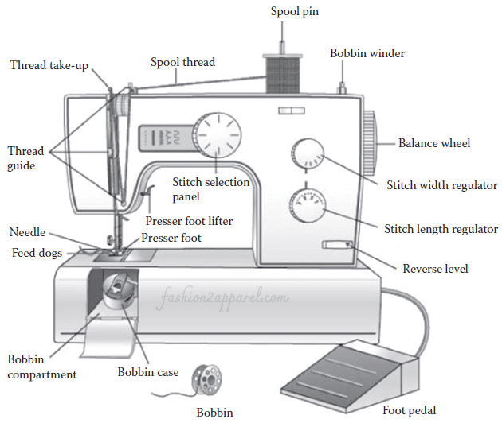
1. Foot pedal: - It controls the speed of the machine which depends on the force exerted on it. But it is not an essential part of high-speed sewing machines as the machine speed can be set by one single adjustment and start and stop of the sewing machine is then controlled with the push of a button.
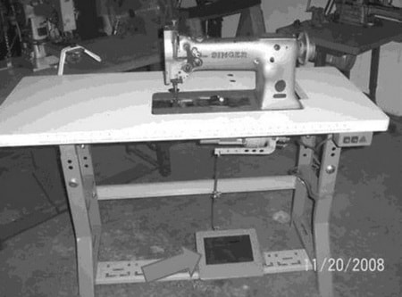
Figure-2: Foot pedal
2. Power cord and switch: - The electricity for the machine is supplied by the power cord which has to be connected tightly to the machine for constant supply of power. The power switch is used for switching ON and OFF of the sewing machines electrically.
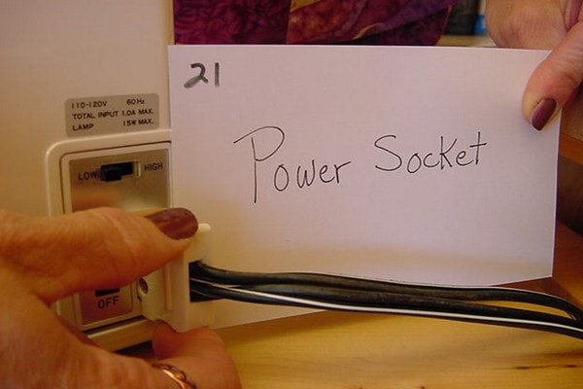Figure-3: Power socket
3. Hand wheel: - It is used for slowly raising and lowering the sewing needle manually to provide better control to position fabric under the needle. The clutch knob positioned inside the wheel acts as a safety feature, that is, when the knob is pulled out, it avoids the needle from jabbing up and down while winding a bobbin.
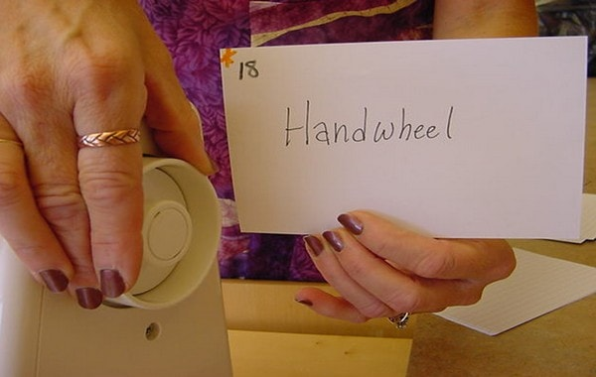Figure-4: Hand wheel
- Reverse lever: - It is situated on the front side of the machine. This is used for making reverse stitching while sewing at the end of every seam to secure it.
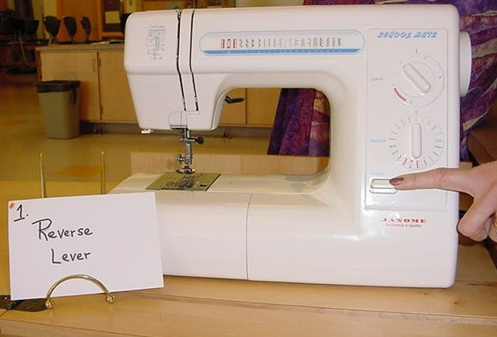Figure-5: Reverse lever
- Spool pin and holder: - It holds the sewing thread besides controls the sewing thread direction as it goes through the machine.
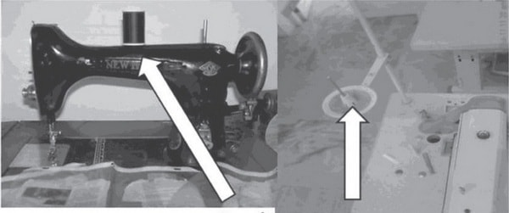
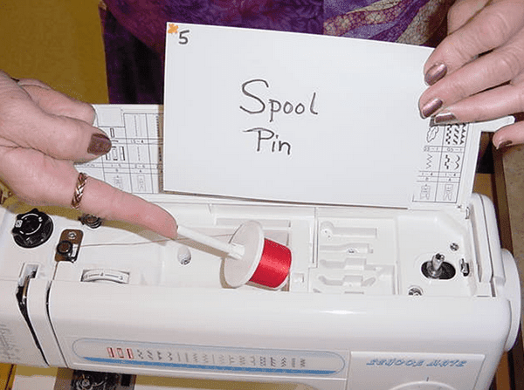 Figure-6: Spool pin
6. Bobbin winder:- It is used to wind the bobbin thread on the empty bobbin. Bobbin winders can be located at the top or right side of the machine.
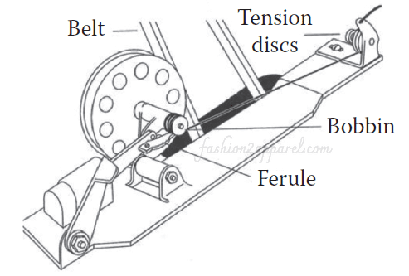
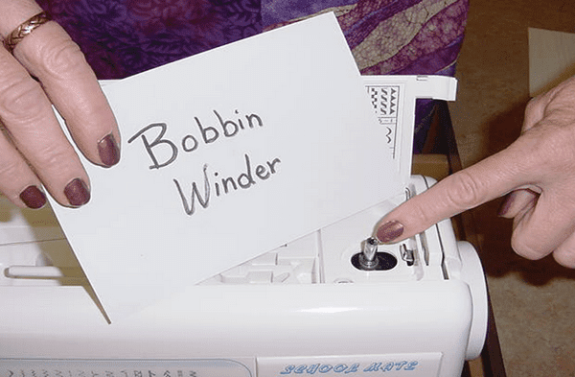Figure-7: Bobbin winder
7. Pattern selector:- It is used to decide the kind of stitch to be sewn on the fabric, such as straight stitches or zigzag or an embroidery stitch. Based on the machine type, a variety of stitches can be selected beside straight stitches.
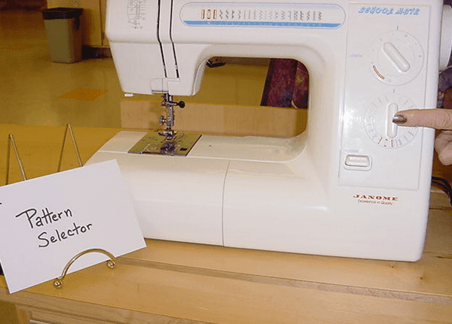

Figure-8: Pattern selector
8. Stitch length adjustment:
- Stitch length determines the length of the stitch
- The range on the machine is from 0 to 4. 0 is the shortest stitch, 4 is the longest.
- The stitch length adjustment adjusts the length of stitches the sewing machine makes. The adjustment takes place at the feed dog not the machine needle.
- Shortening the stitch length shortens the amount of fabric that is fed under the presser foot before the needle comes down and vice versa.
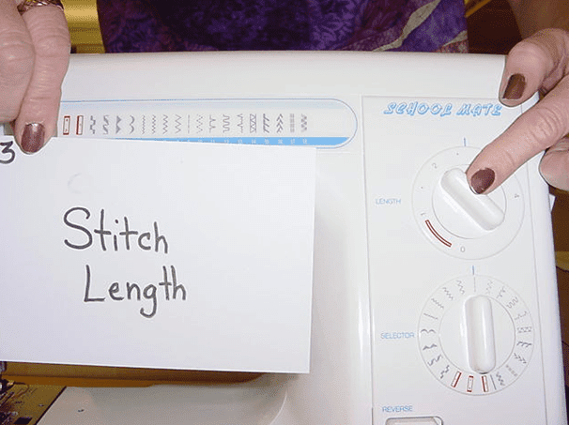Figure-9: Stitch length adjuster
9. Tension disks: - Thread tension determines the looseness or firmness of the stitch. Tensions disks control the pressure applied to the thread for uniform feed to the machine needle. The main functions of tension device is to

- Position the thread to needle
- Regulate the flow of the thread
- Maintain the smoothness in stitching
- Control the thread passage precisely

There are two kinds of tension device, such as direct tension device and indirect tension device. Both types have parts like (a) pressure disk, (b) tension spring, (c) thumb nut, (d) tension mounting bar and (e) pressure releasing unit.
On high speed and modern machines, the tension dial with numbers graduated on it is used for varying the tension. The higher the number, the greater the tension and vice versa. When the tension is adjusted correctly, the stitch line will be straight and even on either side of the fabric.
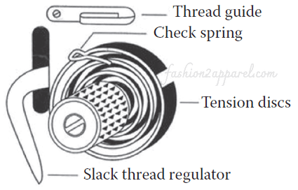
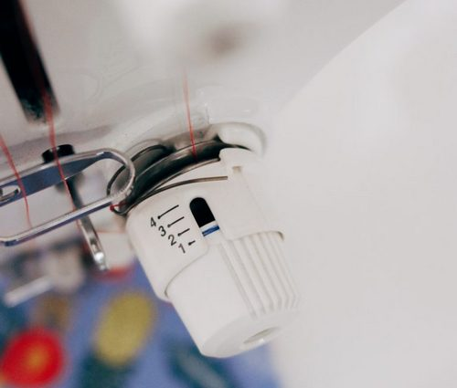
Figure-10: Tension
10. Needle and needle clamp:- The needle fits into the needle bar, which holds it in place with a small screw. The needle clamp is used to fix the needle in place.

2.2.2 Cutting machine blades
Cutting machine blades are an essential part of the garment manufacturing process. They are used to cut fabric into the shapes needed for garments. There are many different types of cutting machine blades available, each designed for a specific purpose. Some of the most common types of cutting machine blades used in garment manufacturing include:
- Rotary cutting blades: Rotary cutting blades are used in rotary cutters, which are handheld tools used to cut fabric and other materials. Rotary cutting blades are typically made of circular high-carbon steel blades and are available in a variety of sizes. Rotary cutting blades are commonly used to cut fabric for small and medium-sized production runs.
- Laser cutting blades: Laser cutting blades are used in laser cutting machines, which are computer-controlled machines that use lasers to cut materials. Laser cutting blades are typically made of tungsten carbide and are extremely sharp and durable. Laser cutting machines are commonly used to cut fabric for mass production runs.
- Water jet cutting blades: Water jet cutting blades are used in water jet cutting machines, which are computer-controlled machines that use high-pressure water jets to cut materials. Water jet cutting blades are typically made of stainless steel and can be used to cut a wide variety of materials, including fabric, metal, and glass. Water jet cutting machines are commonly used to cut fabric for complex designs and patterns.

- Presser feet
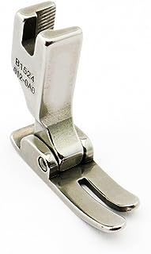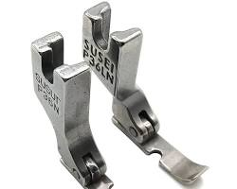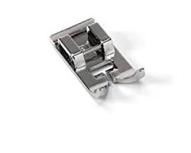
- Universal presser foot: The universal presser foot is the most common type of presser foot and can be used for a variety of sewing tasks, such as sewing straight seams, zigzag seams, and buttonholes.
- Zipper presser foot: The zipper presser foot is designed for sewing zippers into garments.
- Buttonhole presser foot: The buttonhole presser foot is designed for sewing buttonholes into garments.
- Overlock presser foot: The overlock presser foot is designed for finishing raw edges of fabric to prevent fraying.
- Walking foot: The walking foot is designed for sewing fabrics that tend to slip or shift, such as leather and vinyl.
- Quilting foot: The quilting foot is designed for quilting and other sewing tasks that require precise stitching.

- Zippers: - is a device that fastens two edges of fabric together. It consists of two rows of interlocking teeth, a slider, and two pull tabs. The slider is pulled up to close the zipper, and down to open it., Zippers are used in a wide variety of garments and accessories, including jackets, coats, pants, dresses, bags, and shoes. They are also used in many industrial and commercial applications, such as tents, sleeping bags, and luggage.
Zippers are made from a variety of materials, including metal, plastic, and nylon. The most common type of zipper is the metal zipper, which is durable and long-lasting. Plastic zippers are less durable than metal zippers, but they are also lighter and less expensive. Nylon zippers are a good all-around zipper that is both durable and lightweight.
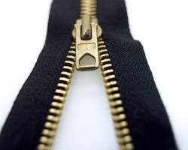
Here are some of the different types of zippers:
- Open-ended zippers: Open-ended zippers can be separated at the bottom, making them ideal for use in jackets and coats.
- Closed-ended zippers: Closed-ended zippers cannot be separated at the bottom, making them ideal for use in pants and skirts.
- Invisible zippers: Invisible zippers are hidden from view when closed, making them ideal for use in delicate garments and accessories.
- Water-resistant zippers: Water-resistant zippers are designed to keep water out, making them ideal for use in outerwear and rain gear.
Zippers are a versatile and essential fastener that is used in a wide variety of applications. By choosing the right zipper for the job, you can ensure that your garments and accessories are both functional and stylish.
Zippers is a small fastener that is used to attach two pieces of fabric together. It consists of a disk with a shank on the back. The shank is inserted through a hole in the fabric, and the button is secured on the other side of the fabric with a thread loop.
- Buttons are used in a wide variety of garments and accessories, including shirts, blouses, pants, skirts, dresses, coats, and bags. They are also used in many industrial and commercial applications, such as tents, sleeping bags, and luggage.
Buttons are made from a variety of materials, including plastic, metal, wood, and shell. The most common type of button is the plastic button, which is durable and inexpensive. Metal buttons are also popular, and they are often used on high-quality garments and accessories. Wood and shell buttons are less common, but they can add a touch of luxury to a garment.

Here are some of the different types of buttons:
- Flat buttons: Flat buttons are the most common type of button. They are typically round or square, and they have a flat surface.
- Shank buttons: Shank buttons have a shank on the back that is inserted through a hole in the fabric. This type of button is more secure than a flat button, but it can be more difficult to sew on.
- Toggle buttons: Toggle buttons have a loop on one side and a bar on the other side. The bar is inserted through the loop to fasten the button.
- Snap buttons: Snap buttons have two parts that snap together. They are easy to use and are often used on children's clothing.

- Snaps: - are a type of fastener that is used to attach two pieces of fabric together. They consist of two parts: a cap and a socket. The cap has a spring-loaded post, and the socket has a hole. The cap is inserted into the hole in the socket, and the spring-loaded post snaps into place to secure the two pieces of fabric together.
Snaps are easy to use and are often used on children's clothing, outerwear, and accessories. They are also used in many industrial and commercial applications, such as tents, sleeping bags, and luggage.
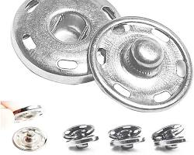
Here are some of the different types of snaps:
- Sew-on snaps: Sew-on snaps are sewn onto the fabric. They are the most common type of snap and are available in a variety of colors and sizes.
- Prong snaps: Prong snaps have prongs on the back that are inserted through the fabric and clinched on the other side. Prong snaps are more secure than sew-on snaps, but they are also more difficult to install.
- No-sew snaps: No-sew snaps do not require sewing to install. They have a sticky backing that adheres to the fabric. No-sew snaps are the least secure type of snap, but they are also the easiest to install.
Snaps are a versatile and convenient fastener that is used in a wide variety of applications. By choosing the right snap for the job, you can ensure that your garments and accessories are both functional and stylish.
- Hooks and eyes
Hooks and eyes are a type of fastener that consists of two parts: a hook and an eye. The hook is a small metal or plastic piece with a curved end. The eye is a small metal or plastic piece with a small hole in it. The hook is inserted into the eye to fasten the two pieces of fabric together.
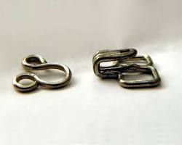
Hooks and eyes are often used on garments and accessories that need to be closed securely, such as corsets, bras, and dresses. They are also used in many industrial and commercial applications, such as tents, sleeping bags, and luggage.
Here are some of the different types of hooks and eyes:
- Sew-on hooks and eyes: Sew-on hooks and eyes are sewn onto the fabric. They are the most common type of hook and eye and are available in a variety of sizes and colors.
- No-sew hooks and eyes: No-sew hooks and eyes do not require sewing to install. They have a sticky backing that adheres to the fabric. No-sew hooks and eyes are the easiest to install, but they are also the least secure.
Removing and replacing consumable components in garments is a relatively simple process, but it is important to follow the manufacturer's instructions carefully to avoid damaging the garment or the component.

2.3 Replace and / or topping up Fluids and lubricants
Fluids and lubricants play an important role in the operation and maintenance of garment machinery and equipment. They help to reduce friction, wear and tear, and heat generation. It is important to replace and/or top up fluids and lubricants on a regular basis to ensure that machinery and equipment is operating efficiently and safely.
Replacing and/or topping up fluids and lubricants in garment:
- Identify the fluids and lubricants that need to be replaced or topped up. This information can be found in the manufacturer's instructions for the machinery and equipment.
- Use the fluids and lubricants recommended by the manufacturer. Using the wrong fluids and lubricants can damage the machinery and equipment.
- Follow the manufacturer's instructions for replacing and/or topping up fluids and lubricants. This will help to ensure that the fluids and lubricants are applied correctly and that the machinery and equipment is not overfilled.
In addition to replacing and/or topping up fluids and lubricants, it is also important to clean and inspect the machinery and equipment on a regular basis. This will help to identify any potential problems early on and prevent them from causing damage to the machinery and equipment or leading to accidents and injuries.

2.4 Performing minor repairing
Performing minor repairs in garment is an essential skill for anyone who wants to keep their clothes looking and feeling their best. It can also be a fun and rewarding way to extend the lifespan of your favorite items.
- Identify the repair that needs to be made. This may involve sewing a seam, replacing a button, or repairing a tear.
- Gather the necessary tools and supplies. This may include a sewing needle and thread, a seam ripper, buttons, and scissors.
- Follow the appropriate steps for the repair. There are many resources available online and in libraries that can provide detailed instructions for common garment repairs.
- Take your time and be careful. It is better to take your time and do the repair correctly than to rush and make a mistake.
Common minor garment repairs:
- Sewing a seam:
- Use a needle and thread that match the color and weight of the fabric.
- Backstitch the seam to make it strong.
- Tie off the thread securely.
- Replacing a button:
- Use a button that is the same size and type as the original button.
- Sew the button on securely, using a backstitch or other strong stitch.
- Repairing a tear:
- Trim the edges of the tear with scissors.
- Sew the tear together, using a backstitch or other strong stitch.
- If the tear is large, you may need to use a patch to reinforce the repair.
If you are unsure about how to perform a minor garment repair, it is always best to consult a professional seamstress or tailor. They will be able to assess the damage and recommend the best course of action.
By following these tips, you can easily perform minor repairs in garment, which will help to keep your clothes looking and feeling their best.

2.5 Adjusting machine moving part
Adjusting machine moving parts in garment is an important part of regular maintenance. By properly adjusting moving parts, garment factories can help to prevent accidents and injuries, improve the efficiency of operations, and extend the lifespan of their machinery and equipment.
Here are some general tips for adjusting machine moving parts in garment:
- Identify the machine moving parts that need to be adjusted. This information can be found in the manufacturer's instructions for the machinery and equipment.
- Use the tools recommended by the manufacturer. Using the wrong tools can damage the machinery and equipment.
- Follow the manufacturer's instructions for adjusting the machine moving parts. This will help to ensure that the parts are adjusted correctly and that the machinery and equipment is safe to operate.
- Test the machinery and equipment after adjusting the moving parts. This will help to ensure that the parts have been adjusted correctly and that the machinery and equipment is operating properly.
- Adjusting common machine moving parts in garment:
- Sewing machine needle: example
- Adjust the needle position so that it is centered in the needle hole.
- Adjust the needle thread tension so that the stitches are balanced and not too tight or too loose.
- Sewing machine presser foot:
- Adjust the presser foot pressure so that it provides enough pressure to feed the fabric through the machine without damaging it.
- Cutting machine blade:
- Adjust the cutting machine blade so that it is sharp and aligned correctly.
- Pressing machine:
- Adjust the pressing machine temperature and pressure so that it is appropriate for the type of fabric being pressed.
By following these tips, garment factories can help to ensure that their machine moving parts are properly adjusted, which will help to prevent accidents and injuries, improve the efficiency of operations, and extend the lifespan of their machinery and equipment. It is important to note that adjusting machine moving parts can be dangerous if not done correctly. If you are unsure about how to adjust a machine moving part, it is always best to consult a qualified technician.

2.5.1 Programmed safety and maintenance checks
Programmed safety and maintenance checks in garment are a set of procedures that are performed on a regular basis to ensure the safety and efficiency of garment machinery and equipment. These checks can be performed manually or automated, depending on the size and complexity of the garment factory. Here are some of the most common programmed safety and maintenance checks in garment:
- Safety checks:
- Check for any signs of wear or damage to machinery and equipment.
- Make sure that all guards and safety devices are in place and working properly.
- Test all emergency alarms and shut-off switches.
- Check for any electrical hazards, such as exposed wires or frayed cords.
- Maintenance checks:
- Lubricate all moving parts according to the manufacturer's instructions.
- Clean and inspect all machinery and equipment for any signs of wear or damage.
- Replace any worn or damaged parts as needed.
- Test all machinery and equipment to make sure that they are operating properly.
Programmed safety and maintenance checks can be scheduled to occur on a daily, weekly, monthly, or quarterly basis, depending on the needs of the garment factory. It is important to keep a record of all programmed safety and maintenance checks so that trends can be identified and problems can be addressed early on. This is implementing programmed safety and maintenance checks in garment:
- Identify the specific checks that need to be performed and the frequency of the checks. This information can be found in the manufacturer's instructions for the machinery and equipment.
- Develop a checklist for each check. This will help to ensure that all of the necessary steps are performed correctly.
- Assign specific personnel to perform the checks. This will help to ensure that the checks are performed on a regular basis and that any problems are identified and addressed promptly.
- Keep a record of all checks. This will help to track trends and identify any areas where maintenance may be needed more frequently.
By implementing programmed safety and maintenance checks, garment factories can help to prevent accidents and injuries, improve the efficiency of operations, and extend the lifespan of their machinery and equipment.
In addition to programmed safety and maintenance checks, garment factories should also have a plan for responding to emergencies, such as fires and earthquakes. The plan should include procedures for evacuating the factory and providing first aid to injured workers.
    - Adjustments of a limited nature including safety guards, stops, wear pads & tool holders, nipping up glands, adjustment of scrapers ,aprons.
Adjustments of a limited nature including safety guards, stops, wear pads and tool holders, nipping up glands and adjustment of scrapers and aprons in garment are all important tasks that can help to ensure the safety and efficiency of garment machinery and equipment.
- Safety guards: - are essential for preventing accidents and injuries. It is important to make sure that all safety guards are in place and working properly. This may involve adjusting the guards to ensure that they are properly aligned and that they do not interfere with the operation of the machinery and equipment.
- Stops: - used to prevent machinery and equipment from moving too far. It is important to make sure that all stops are properly adjusted. This may involve adjusting the stops to ensure that they are in the correct position and that they are strong enough to stop the machinery and equipment from moving too far.
- Wear pads: - is are used to protect machinery and equipment from wear and tear. It is important to make sure that all wear pads are in place and in good condition. This may involve adjusting the wear pads to ensure that they are properly aligned and that they are not too worn.
- Tool holders:- is are used to hold tools in place while they are being used. It is important to make sure that all tool holders are properly adjusted. This may involve adjusting the tool holders to ensure that they are in the correct position and that they hold the tools securely.
- Nipping up glands: - used to seal openings in machinery and equipment. It is important to make sure that all glands are properly nipped up. This may involve adjusting the glands to ensure that they are tight enough to prevent leaks, but not so tight that they damage the machinery and equipment.
- Adjustment of scrapers and aprons:- Scrapers and aprons are used to remove dirt and debris from machinery and equipment. It is important to make sure that all scrapers and aprons are properly adjusted. This may involve adjusting the scrapers and aprons to ensure that they are in the correct position and that they are making contact with the machinery and equipment.
- Use the correct tools and equipment.
- Make sure that the machinery and equipment is properly turned off and disconnected from the power supply before making any adjustments.
- Be careful not to overtighten any nuts or bolts.
- Test the machinery and equipment after making any adjustments to ensure that it is operating properly.

SELFE CHECK - TWO
- PART: I Say true or false the following question
    - All garment factories should have a basic maintenance program in place.
- Choose the following question

- Which of the following is NOT a common part of a basic maintenance program in garment?

(a) Cleaning and lubricating machinery and equipment
(b) Replacing worn or damaged parts
(c) Adjusting machine moving parts
(d) Operating machinery without proper guarding

Operating machinery without proper guarding is a safety hazard and should not be part of a basic maintenance program.
- Short Answer
- What are some of the benefits of having a basic maintenance program in place in a garment factory?

Unit Three: Basic Preventive Maintenance and Tools
This learning unit is developed to provide the trainees the necessary information regarding the following content coverage and topics:
- Identifying a machine failure
- Reporting machine/equipment failure
- Performing cleaning operations
- Accomplishing necessary report

This unit covers the knowledge, skills and attitude required to finish completed work in the production of garments or other associated articles
- Identifying a machine failure
- Reporting machine/equipment failure
- Performing cleaning operations
- Accomplishing necessary report

Basic Preventive Maintenance and Tools
Basic preventive maintenance in garment is the practice of regularly inspecting and servicing machinery and equipment to prevent problems from occurring. This can help to reduce downtime, improve efficiency, and extend the lifespan of assets., Some common basic preventive maintenance tasks in garment include:

- Cleaning and lubricating machinery and equipment
- Inspecting for wear and tear
- Replacing worn or damaged parts
- Adjusting machine settings
- Testing safety devices

Basic tools for preventive maintenance

- Screwdrivers
- Wrenches
- Pliers
- Allen wrenches
- Oil cans
- Grease guns
- Rags
- Flashlight
- Safety glasses

There are many benefits to implementing a basic preventive maintenance program, including:

- Reduced downtime
- Improved efficiency
- Extended lifespan of assets
- Reduced maintenance costs
- Improved product quality
- Reduced risk of accidents and injuries

To implement a basic preventive maintenance program
- Identify the machinery and equipment that needs to be maintained.
- Determine the frequency of maintenance for each piece of machinery and equipment.
- Develop a checklist of maintenance tasks for each piece of machinery and equipment.
- Assign maintenance tasks to qualified personnel.
- Schedule maintenance tasks and track progress.
- Review the maintenance program regularly and make adjustments as needed.

Identifying a machine failure
Here are a number of ways to identify machine failure in garment. Some of the most common signs include:
- Unusual noises: If a machine is making unusual noises, it may be a sign that there is a problem. For example, a grinding noise may indicate that there is a problem with the bearings, while a squealing noise may indicate that there is a problem with the belts.
- Vibration: Excessive vibration can also be a sign of machine failure. For example, if a sewing machine is vibrating more than usual, it may be a sign that the needle is bent or that the machine is not properly balanced.
- Smoke or sparks: Smoke or sparks coming from a machine are a clear sign that there is a problem. This could be due to an electrical short circuit, a problem with the bearings, or a fire.
- Leaks: Leaks of oil, hydraulic fluid, or other fluids can also be a sign of machine failure. These leaks can damage the machine and create a safety hazard.
- Reduced performance: If a machine is not performing as well as it used to, it may be a sign that there is a problem. For example, if a sewing machine is skipping stitches or if a cutting machine is not cutting through the fabric properly, it may be a sign that the machine needs to be serviced.
In addition to these general signs, there may be specific signs of machine failure that are unique to certain types of machinery. For example, if a sewing machine is not feeding the fabric properly, it may be a sign that there is a problem with the presser foot or the feed dogs.
If you notice any of these signs of machine failure, it is important to stop the machine immediately and have it inspected by a qualified technician. Ignoring the signs of machine failure can lead to further damage to the machine and create a safety hazard.
Identifying machine failure in garment:
- Inspect machinery and equipment regularly. Look for any signs of wear or tear, such as cracks, chips, or loose parts.
- Listen for unusual noises or vibrations. If you hear or feel anything out of the ordinary, stop the machine and have it inspected.
- Be aware of the signs of fluid leaks. If you see any leaks of oil, hydraulic fluid, or other fluids, stop the machine and have it inspected.
- Monitor machine performance. If a machine is not performing as well as it used to, it may be a sign that there is a problem.
- Report any concerns to your supervisor immediately.

3.2 Report machine/equipment failure

There are a number of ways to identify machine failure in garment. Some of the most common signs include:
- Unusual noises: If a machine is making unusual noises, it may be a sign that there is a problem. For example, a grinding noise may indicate that there is a problem with the bearings, while a squealing noise may indicate that there is a problem with the belts.
- Vibration: Excessive vibration can also be a sign of machine failure. For example, if a sewing machine is vibrating more than usual, it may be a sign that the needle is bent or that the machine is not properly balanced.
- Smoke or sparks: Smoke or sparks coming from a machine are a clear sign that there is a problem. This could be due to an electrical short circuit, a problem with the bearings, or a fire.
- Leaks: Leaks of oil, hydraulic fluid, or other fluids can also be a sign of machine failure. These leaks can damage the machine and create a safety hazard.
- Reduced performance: If a machine is not performing as well as it used to, it may be a sign that there is a problem. For example, if a sewing machine is skipping stitches or if a cutting machine is not cutting through the fabric properly, it may be a sign that the machine needs to be serviced.
In addition to these general signs, there may be specific signs of machine failure that are unique to certain types of machinery. For example, if a sewing machine is not feeding the fabric properly, it may be a sign that there is a problem with the presser foot or the feed dogs.
If you notice any of these signs of machine failure, it is important to stop the machine immediately and have it inspected by a qualified technician. Ignoring the signs of machine failure can lead to further damage to the machine and create a safety hazard.
- Inspect machinery and equipment regularly. Look for any signs of wear or tear, such as cracks, chips, or loose parts.
- Listen for unusual noises or vibrations. If you hear or feel anything out of the ordinary, stop the machine and have it inspected.
- Be aware of the signs of fluid leaks. If you see any leaks of oil, hydraulic fluid, or other fluids, stop the machine and have it inspected.
- Monitor machine performance. If a machine is not performing as well as it used to, it may be a sign that there is a problem.
- Report any concerns to your supervisor immediately.

3.3 Performing cleaning operations
Performing cleaning operations in garment is essential for maintaining a clean and safe work environment. It also helps to extend the lifespan of machinery and equipment and improve the quality of finished products.
- Identify the areas and equipment that need to be cleaned. This will vary depending on the specific garment factory and the types of machinery and equipment that are used.
- Choose the appropriate cleaning methods and materials. This will depend on the type of dirt and debris that needs to be removed, as well as the materials that are being cleaned.
- Follow the manufacturer's instructions for cleaning machinery and equipment. This will help to prevent damage and ensure that the equipment is cleaned properly.
- Wear appropriate personal protective equipment (PPE) when cleaning. This may include gloves, safety glasses, and a respirator.
- Floors: Sweep and mop floors regularly to remove dirt, dust, and debris. Be sure to clean under machinery and equipment.
- Machinery and equipment: Clean machinery and equipment regularly according to the manufacturer's instructions. This may involve using a vacuum cleaner, a brush, or a cloth to remove dirt, dust, and debris. You may also need to use a cleaning solution to remove grease and grime.
- Sewing machines: Pay special attention to the needle, bobbin case, and feed dogs when cleaning sewing machines. These areas can easily become clogged with lint and thread, which can cause problems with the machine.
- Cutting machines: Clean cutting machines regularly to remove fabric dust and lint. Be sure to clean the blades and other moving parts.
- Pressing machines: Clean pressing machines regularly to remove fabric dust and lint. Be sure to clean the heating element and the pressing plate.
In addition to cleaning areas and equipment, it is also important to clean and organize workspaces. This will help to create a safe and efficient work environment.
- Keep workspaces free of clutter. This includes removing any unnecessary materials and tools.
- Organize materials and tools so that they are easy to find and use.
- Clean and disinfect work surfaces regularly.
- Dispose of waste properly.

3.4 Accomplishing necessary report
Accomplishing necessary reports in garment is essential for tracking progress, identifying areas for improvement, and making informed decisions. There are a variety of different reports that may be needed in a garment factory, such as:
- Production reports: These reports track the quantity and quality of garments produced.
- Inventory reports: These reports track the quantity and value of raw materials, work-in-progress, and finished goods.
- Financial reports: These reports track the financial performance of the garment factory.
- Quality control reports: These reports track the quality of garments produced and identify any areas for improvement.
- Maintenance reports: These reports track the maintenance of machinery and equipment.
The specific reports that are needed will vary depending on the size and complexity of the garment factory. However, there are some general tips for accomplishing necessary reports in garment:
- Identify the reports that are needed. This can be done by consulting with management and other employees to determine what information is needed to make informed decisions.
- Gather the necessary data. This data can be collected from a variety of sources, such as production records, inventory records, financial records, and quality control records.
- Analyze the data. Once the data has been gathered, it needs to be analyzed to identify trends and patterns. This can be done using a variety of methods, such as statistical analysis and charting.
- Write the report. The report should be clear, concise, and easy to understand. It should include the following information:

- The purpose of the report
- The data that was analyzed
- The findings of the analysis
- Any recommendation
It is important to review reports regularly to ensure that they are accurate and up-to-date. Reports can also be used to identify areas for improvement and make informed decisions.
- Use a report template. A report template can help you to save time and ensure that your reports are complete and consistent.
- Automate the report generation process. If possible, automate the report generation process to save time and reduce errors.
- Share reports with relevant stakeholders. Be sure to share reports with the relevant stakeholders, such as management, supervisors, and other employees.
- Use reports to improve performance. Use reports to identify areas for improvement and make informed decisions.
- Needles: - are thin, pointed objects that are used to sew fabric together. They are made of a variety of materials, including steel, plastic, and bone. Needles come in a variety of sizes and shapes, depending on the type of fabric being sewn and the desired stitch.

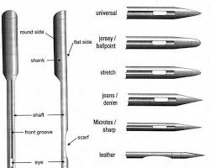
- Garment needles:- There are a variety of different types of garment needles available, each designed for a specific purpose. The type of needle used will depend on the type of fabric being sewn, the stitch type being used, and the desired results.
Here are some of the most common types of garment needles:
- Universal needles: Universal needles are the most versatile type of garment needle. They can be used to sew a variety of different fabrics, including cotton, wool, and synthetic fabrics.
- Sharp needles: Sharp needles are used to sew delicate fabrics, such as silk and chiffon. They are also used to sew fabrics with a tight weave, such as denim and canvas.
- Ballpoint needles: Ballpoint needles are used to sew knits and other fabrics with a loose weave. They prevent the fabric from puckering and stretching.
- Twin needles: Twin needles are used to sew two parallel rows of stitching at the same time. They are often used to sew decorative topstitching and hems.
When choosing a garment needle, it is important to consider the following factors:
- The type of fabric being sewn: Choose a needle that is designed for the type of fabric you are sewing. For example, use a sharp needle to sew delicate fabrics and a ballpoint needle to sew knits.
- The stitch type being used: Some stitch types, such as the zigzag stitch, require a specific type of needle. For example, a zigzag needle is used to sew the zigzag stitch.
- The desired results: If you want a specific look, such as a decorative topstitch, you may need to use a specific type of needle. For example, a twin needle is used to sew decorative topstitching.
Garment needles can help you to achieve the desired results when sewing garments. By choosing the right needle for the job, you can ensure that your seams are strong, even, and durable.
- Bled: - Bleed is the area of a printed work that is outside of the trim line, but still within the printing area. This area is trimmed off after the printing process is complete. Bleed is used to ensure that there are no white borders around the printed work when it is trimmed.
- Color bleed: This occurs when the dye from one garment bleeds onto another garment when they are washed together. Color bleed is more likely to happen with dark-colored garments.
- Ink bleed: This occurs when the ink from a print or design on a garment bleeds onto another part of the garment. Ink bleed is more likely to happen with screen-printed garments.
- Fabric bleed: This occurs when the fibers from one garment shed and become attached to another garment when they are washed together. Fabric bleed is more likely to happen with garments made from synthetic fabrics.

- Fabric bleed: Fabric bleed is a type of dye transfer that occurs when the dye from one fabric transfers to another fabric. This can happen during washing, drying, or even just when the two fabrics are in contact with each other. Fabric bleed can be a major problem for garment manufacturers, as it can ruin the appearance of garments. There are a number of ways to prevent fabric bleed, such as using pre-washed fabrics, separating fabrics by color, and using a color catcher in the washing machine.
- Bleed out: - is a type of sewing mistake that occurs when the seam allowance is too small and the fabric pulls away from the seam. This can happen for a number of reasons, such as using the wrong needle or thread, sewing too quickly, or not using enough seam allowance. Bleed out can weaken the garment and make it more likely to tear. There are a number of ways to prevent bleed out, such as using the correct needle and thread, sewing slowly and carefully, and using enough seam allowance.
Bleed out in garment
- Bleed-through: Bleed-through is a type of printing mistake that occurs when the ink from one side of the fabric bleeds through to the other side. This can happen for a number of reasons, such as using too much ink, using the wrong type of ink, or not using a heat press. Bleed-through can ruin the appearance of the garment and make it unwearable. There are a number of ways to prevent bleed-through, such as using the correct amount of ink, using the correct type of ink, and using a heat press.
These are just a few of the most common definitions of the word “bled” in garment. If you are unsure of what the word means in a particular context, it is always best to ask a more experienced person for clarification.
- Grinding stone:- grinding stone in garment is a tool that is used to create a distressed look on fabric. It is typically made of a rough material, such as pumice or sandstone, and it is used to abrade the fabric, creating a worn-in effect.
Grinding stones are often used on denim garments, such as jeans and jackets, to create a vintage look. They can also be used on other types of garments, such as chinos and t-shirts, to create a more edgy or distressed look.
To use a grinding stone on a garment, simply rub it over the fabric in the areas where you want to create a distressed look. Be careful not to overdo it, as you can easily damage the fabric. Once you are satisfied with the results, wash the garment to remove any dust or debris.
Here are some tips for using a grinding stone
- Use a light touch. It is better to start with a light touch and add more pressure as needed. You can always go back and grind the fabric more if needed, but it is difficult to undo the damage if you grind the fabric too much.
- Be careful around seams and delicate areas. Avoid grinding over seams or delicate areas of the fabric, such as the crotch or the underarms, as this could damage the fabric.
- Test the grinding stone in an inconspicuous area before using it on the entire garment. This will help you to determine how much pressure to apply and what kind of results you can expect.
- Wash the garment after grinding. This will remove any dust or debris from the grinding process.

SELFE CHECK –THREE
  - PART: I Say true or false
  - A basic preventive maintenance program in apparel can help to reduce downtime and improve efficiency.
  - Choose the correct answer
1. Which of the following is NOT a common basic preventive maintenance task in apparel?
(a) Cleaning and lubricating machinery and equipment
(b) Replacing worn or damaged parts
(c) Adjusting machine settings
(d) Operating machinery without proper guarding
- Short Answer: question and answer
- What are some of the basic tools that are commonly used for preventive maintenance in apparel?
- What is the importance of following the manufacturer's instructions when performing preventive maintenance on apparel machinery and equipment?

Unit four : Inventory Of Machineries And Complete Work Activities
This learning unit is developed to provide the trainees the necessary information regarding the following content coverage and topics:
- Performing inventory control
- Documenting inventory result
- Store machineries, tools and equipment safely

This unit covers the knowledge, skills and attitude required to finish completed work in the production of garments or other associated articles

- Performing inventory control
- Documenting inventory result
- Store machineries, tools and equipment safely

Inventory of Machineries and Complete Work Activities
Inventory is the term used to describe the goods and materials that a business holds for the ultimate goal of resale, production or utilization. Inventory management is a discipline primarily about specifying the shape and placement of stocked goods.
An inventory of machineries in garment is a list of all of the machinery and equipment that is used in a garment factory. This includes sewing machines, pressing machines, cutting machines, and other specialized equipment. An inventory of machineries can be used for a variety of purposes, such as:
- Tracking the location and condition of machinery and equipment
- Scheduling maintenance and repairs
- Identifying and replacing outdated or damaged machinery and equipment
- Making budgeting decisions

Steps of performing an inventory of machineries
- Identify all of the machinery and equipment that is used in the garment factory.
- Gather information about each machine and equipment, such as its make, model, serial number, condition, and location.
- Record the information in a spreadsheet or database.
- Analyze the inventory data to identify any trends or patterns. For example, are there any machines that are frequently out of service? Are there any machines that are nearing the end of their lifespan?
- Develop a plan to address any issues. This may involve repairing or replacing machines, or developing a preventive maintenance program.
By regularly performing an inventory of machineries, garment factories can ensure that they have the equipment they need to operate efficiently and produce high-quality garments.
Here are some of the benefits of having an accurate and up-to-date inventory of machineries in garment:
- Improved efficiency: By tracking the location and condition of machinery and equipment, garment factories can avoid downtime and delays. This can lead to improved efficiency and increased productivity.
- Reduced costs: By identifying and replacing outdated or damaged machinery and equipment, garment factories can reduce maintenance and repair costs.
- Improved quality: By having properly maintained and calibrated machinery and equipment, garment factories can produce high-quality garments that meet customer expectations.
- Enhanced safety: By following safety procedures and using properly maintained machinery and equipment, garment factories can reduce the risk of accidents and injuries.

4.1. Performing inventory control
Performing inventory in the apparel industry is the process of tracking and managing the flow of raw materials, work-in-progress, and finished goods throughout the apparel manufacturing process. Performing inventory control in garment involves tracking and managing the flow of raw materials, work in progress, and finished goods throughout the garment manufacturing process. This includes tasks such as:
- Identifying and tracking the location of all inventory items. This can be done using a variety of methods, such as barcodes, RFID tags, or manual inventory tracking systems.
- Managing inventory levels to ensure that there is enough stock to meet demand, but not so much that inventory costs are excessive. This involves forecasting demand, setting inventory levels, and placing orders.
- Tracking inventory movements to identify any discrepancies or losses. This includes tracking the receipt and shipment of inventory, as well as the movement of inventory within the garment factory.
- Performing regular inventory audits to ensure that inventory records are accurate. This can be done by manually counting inventory or by using automated inventory counting systems.
Inventory control is important in the garment industry to ensure that garment manufacturers have the materials and products they need to meet demand, while also minimizing inventory costs.

4.1.1 Benefits of Effective Inventory Control in Garment:
- Reduced inventory costs: Effective inventory control can help garment manufacturers to reduce their inventory costs by reducing the amount of inventory they hold and by optimizing their inventory turnover.
- Improved production efficiency: Effective inventory control can help garment manufacturers to improve their production efficiency by ensuring that they have the materials they need when they need them.
- Reduced stock outs: Effective inventory control can help garment manufacturers to reduce stock outs by ensuring that they have enough stock to meet demand.
- Improved customer service: Effective inventory control can help garment manufacturers to improve their customer service by ensuring that they have the products that their customers want in stock when they want them.
- Increased profitability: Effective inventory control can help garment manufacturers to increase their profitability by reducing costs, improving production efficiency, and reducing stock outs.
Performing effective inventory control in garment:
- Use a variety of inventory tracking methods. This will help to ensure that inventory is accurately tracked and accounted for.
- Implement a just-in-time inventory system. This will help to reduce inventory costs by minimizing the amount of inventory that is held.
- Use an automated inventory control system. This will help to streamline the inventory control process and improve accuracy.
- Conduct regular inventory audits. This will help to ensure that inventory records are accurate and up-to-date.
- Train employees on inventory control procedures. This will help to ensure that all employees understand the importance of inventory control and how to follow proper procedures.

4.2 Documenting inventory result

Documenting inventory results in the apparel industry is an important part of inventory control. It helps to ensure that inventory records are accurate and up-to-date, and it can also be used to identify trends and patterns in inventory usage.
There are a variety of ways to document inventory results. Some common methods include:
- Inventory reports: Inventory reports are typically generated using an inventory control system. They provide detailed information about inventory levels, such as the quantity of each item in stock, the location of each item, and the value of each item.
- Inventory spreadsheets: Inventory spreadsheets can be used to manually track inventory levels. They are typically less detailed than inventory reports, but they can be a good option for small businesses or businesses that have a limited budget.
- Inventory inventory tags: Inventory inventory tags are physical tags that are attached to each inventory item. They typically include information such as the item number, the quantity, and the location.
The best way to document inventory results will vary depending on the size and complexity of the apparel business. However, it is important to choose a method that is accurate and easy to use
Here are some tips for documenting inventory results in the apparel industry:
- Use a consistent format. This will make it easier to track inventory results over time and to identify trends and patterns.
- Include all relevant information. This may include the item number, the description, the quantity, the location, the value, and the condition.
- Update inventory records regularly. This will ensure that the records are accurate and up-to-date.
- Secure inventory records. Inventory records should be stored in a safe place to prevent unauthorized access.

4.3 Store machineries, tools and equipment safely
- Store machineries, tools, and equipment in a clean, dry, and well-ventilated area. This will help to prevent rust, corrosion, and other damage.
- Store machineries, tools, and equipment on level surfaces. This will help to prevent them from tipping over or falling.
- Store machineries, tools, and equipment in a way that is organized and accessible. This will help to prevent accidents and injuries.

4.3.1 Different Types of Machineries, Tools, and Equipment:
- Sewing machines: Sewing machines should be stored in a clean, dry, and well-ventilated area. They should be covered with a dust cover to protect them from dust and dirt. Sewing needles should be stored in a needle case to prevent them from becoming lost or damaged.
- Cutting machines: Cutting machines should be stored in a clean, dry, and well-ventilated area. They should be turned off and unplugged when they are not in use. Cutting blades should be stored in a safe place to prevent accidents and injuries.
- Pressing machines: Pressing machines should be stored in a clean, dry, and well-ventilated area. They should be turned off and unplugged when they are not in use. Pressing plates should be cleaned after each use to prevent the build-up of dirt and adhesive.
- Tools: Tools should be stored in a clean, dry, and well-ventilated area. They should be organized and accessible. Sharp tools should be stored in a safe place to prevent accidents and injuries.
- Equipment: Equipment should be stored in a clean, dry, and well-ventilated area. It should be organized and accessible. Heavy equipment should be stored on level surfaces.

- Scissors
- Tape
- winch
- French curve
- Measuring instruments
- Calibers
- Screw driver

- Scissors are a pair of two metal blades pivoted together at one end, used for cutting various materials. They are one of the most common tools in the world, and are used in a wide variety of industries, including garment, arts and crafts, and home improvement. Scissors are available in a variety of sizes and shapes, depending on the intended use. For example, dressmaker's shears are designed for cutting fabric, while kitchen shears are designed for cutting food.
- Tape is a thin strip of material with an adhesive backing that is used to fasten objects together. There are many different types of tape available, each with its own specific use. For example, masking tape is used to protect surfaces during painting, while duct tape is used for general repairs.
- A winch is a mechanical device that is used to pull or wind a cable or rope. Winches are used in a variety of industries, including garment, construction, and forestry. A French curve is a drafting tool that is used to draw smooth curves. It is also used in garment to draw the outlines of patterns.
Measuring instruments
There are a variety of measuring instruments used in garment, including:
- Rulers: Rulers are used to measure length.
- Tape measures: Tape measures are used to measure length and circumference.
- Hem gauges: Hem gauges are used to measure the width of hems.
- Sewing gauges: Sewing gauges are used to measure the distance between seams.
- Screw drivers are used to turn screws. There are two main types of screw drivers: flathead screw drivers and Phillips screw drivers. Flathead screw drivers are used to turn screws with a flat head, while Phillips screw drivers are used to turn screws with a Phillips head. These are just a few of the most common tools used in garment. There are many other tools that are used, depending on the specific task being performed

4.3.2 Cleaning materials:
Cleaning materials in garment are the substances or tools used to remove dirt, stains, and other unwanted materials from fabrics. They can be used to clean garments before, during, or after the manufacturing process, as well as to clean garments that have been worn and need to be refreshed.
Common examples of cleaning materials used in garment:
- Detergents: Detergents are used to remove dirt and stains from fabrics. They are typically added to the water used to wash garments, and they work by loosening and suspending dirt and stains so that they can be washed away.
- Fabric softeners: Fabric softeners are used to make fabrics softer and reduce static cling. They are typically added to the final rinse cycle of the washing machine or applied to garments after they have been washed.
- Spot removers: Spot removers are used to remove specific types of stains, such as grease, oil, and ink. They are typically applied directly to the stain and then blotted away.
- Bleaches: Bleaches are used to whiten fabrics and remove stains. They are typically added to the water used to wash garments, but they can also be applied directly to fabrics. It is important to use bleach carefully, as it can damage fabrics if it is not used properly.
- Ironing boards: Ironing boards are flat surfaces that are used to iron garments. They are typically covered with a heat-resistant fabric.
- Irons: Irons are heated appliances that are used to remove wrinkles from garments and to set seams. They are available in a variety of styles, each with its own features.
Dust removers are used to remove dust and other debris from fabrics. This is important because dust can attract dirt and stains, and it can also make fabrics look dull and dingy. There are a variety of dust removers available, including lint rollers, dust brushes, and vacuum cleaners.
Lubricants are used to reduce friction and wear on sewing machines and other equipment. This can help to extend the life of the equipment and improve its performance. There are a variety of lubricants available, including sewing machine oil, grease, and wax.
Brushes are used for a variety of purposes in garment, including cleaning fabrics, brushing away lint, and pressing seams. There are a variety of brushes available, each with its own specific use. For example, garment brushes are designed to be used on delicate fabrics, while upholstery brushes are designed to be used on more durable fabrics. Some specific examples of how dust removers, lubricants, rugs, and brushes are used in garment:
- Dust removers: Dust removers are used to remove dust and other debris from fabrics before sewing, as well as from finished garments. This can help to prevent dirt and stains from setting in, and it can also make garments look their best.
- Lubricants: Lubricants are used to reduce friction and wear on sewing machines and other equipment. This can help to extend the life of the equipment and improve its performance. For example, sewing machine oil is used to lubricate the moving parts of a sewing machine, while grease is used to lubricate the gears of a cutting machine.
- Rugs: Rugs are used to protect floors from dirt and debris in garment factories and retail stores. They can also be used to add a touch of style to a room. For example, a rug can be placed in front of a sewing machine to protect the floor from oil and fabric scraps.
- Brushes: Brushes are used for a variety of purposes in garment, including cleaning fabrics, brushing away lint, and pressing seams.

SELFE CHECK - FOUR
  - Instruction: write True/False for the given question.
- Having a well-maintained inventory of garment machinery is important for producing high-quality garments.
- Garment machinery should be inspected regularly to ensure that it is in good working condition.
- Garment work activities should be planned in advance to avoid delays and disruptions.
- It is important to track all garment machinery and work activities to ensure that they are accounted for.
  - Instruction: Choose the best answer for the given question.
- Which of the following is NOT a benefit of having a well-maintained inventory of garment machinery?

- Increased efficiency
- Reduced downtime
- Improved safety
- Increased costs

- Which of the following is the MOST important factor to consider when planning garment work activities?

- The availability of machinery
- The skills of the workers
- The deadline for the project
- The budget for the project

  - Instruction: write Short Answer for the given question.
- What are some of the challenges of managing an inventory of garment machinery?
- How can you ensure that garment work activities are completed efficiently and effectively?
- What are some of the benefits of using technology to manage inventory and work activities in garment?

Reference
- Bentley, M., Peerenboom, C. A., Hodge, F. W., Passano, E. B., Warren, H. C., & Washburn, M. F. (1929). Instructions in regard to preparation of manuscript. Psychological Bulletin, 26(2), 57–63. https://doi.org/10.1037
- WEB Address , http://www.qualitygurus.com/courses/mod/forum/discuss.php?d=1557
- A Complete Guide by Rajkishore Nayak
- Apparel Manufacturing Technology by T. P. Singh
- A Practical Guide by Harold Carr and Stephen Glasby
- Safety and Health in the Garment Industry by International Labour Organization (ILO)
- Garment Industry Safety and Health Manual by Bangladesh Accord on Fire and Building Safety
- Technology of Clothing Manufacture-Carr.
- An Introduction to Garment Manufacture- Gerry Cooklin.
- The Sewing Machine Master Guide: From Basic to Expert by Clifford L. Blodget

Developers Profile
No | Name | Qualification (Level) | Field of Study | Organization/  Institution | Mobile number | E-mail
1 | YALEMZEWD GELETAW | A | GAMENT ENGINERING | BOLE MANUFACTURING COLLEGE | 0910873921 | yalemzwdg@gmail.com
2 | melke erkihun | A | GAMENT ENGINERING | BOLE MANUFACTURING COLLEGE | 0921417903
3 | ESHETU WERKU | A | GAMENT ENGINERING | BOLE MANUFACTURING COLLEGE | 0993945146
4 | ANDEBET ZEWDU | A | GAMENT ENGINERING | BOLE MANUFACTURING COLLEGE | 0931494269
5 | KUSA SEBOKA | B | GARMENT TECHNOLOGY | BOLE MANUFACTURING COLLEGE | 0917714156
6 | HAYMANOT LEGESE | B | GARMENT TECHNOLOGY | BOLE MANUFACTURING COLLEGE | 0912078946
7 | TAMRU GEMECHU | B | GARMENT TECHNOLOGY | BOLE MANUFACTURING COLLEGE | 0900649864
8 | AZIZA ABDUSEMED | B | GARMENT TECHNOLOGY | BOLE MANUFACTURING COLLEGE | 0913663240

