Garment Production
Level – IV
Based on March 2022, Curriculum Version 1
Module Title: Produce Advanced Garment products
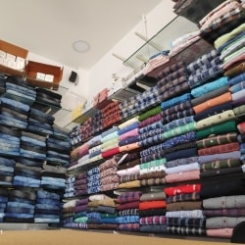
Module code: IND GAP4 04 1221
Nominal duration: 150 Hour
Prepared by: - Addis Ababa TVET Bureau

September, 2023
Addis Ababa, Ethiopia

ACRONYM
OHS: - Occupational Health and Safety
CAD: computerize aided designee
TVET: Technical Vocational and Educational Training
TTLM: -Teaching, Training and Learning Materials
PPE: Personal Protective Equipment
UPS: - Unit Production System

ACKNOWLEDGMENT
Addis Ababa TVET Bureau wishes to extend thanks and appreciation to the many representatives of TVET instructors and respective industry experts who donated their time and expertise to the development of this Teaching, Training and Learning Materials (TTLM).

Table of contents
ACRONYM 2
ACKNOWLEDGMENT 3
INTRODUCTION OF THE MODULE 5
UNIT ONE: Prepare for garment production 7
1. Garment production 8
1.1. Develop Pattern for garment production 9
1.1.1. Types of Patterns for new design 10
1.2. Select and preparing needed Fabric, materials, tools and equipment 13
1.3. Check and assessing tools and equipment 14
1.4. Additional required resources 16
SELF CHECK 1 19
UNIT TWO: Produce garment 20
1. Produce garment 21
2.1. Apply OHS practices sew garment 22
2.2. How to Sew garment 23
2.2.1. Understand about Jacket with lining 24
2.2.2. Understand about Denim jacket 25
2.2.3. Understand about Suit 26
2.3. Check garment against pattern and design 43
2.3.1. Identify and correcting faults 45
2.3.2. Review production techniques and design 47
SELF CHECK 2 52
UNIT THREE: Complete production process 56
3.1. Finish garment according to design requirements 59
3.2. Assess garment against design and pattern 64
3.3. Rectify garment faults 67
3.4. Clean area and equipment 70
SELF CHECK 3 73
REFERENCE 74

INTRODUCTION OF THE MODULE
The garment industry is constantly evolving, and new technologies are constantly being developed to improve the production of garments. Advanced garment products are garments that are made using innovative technologies and materials to improve their performance, functionality, and sustainability.
There are a number of different ways to produce advanced garment products. One common approach is to use new materials with improved properties. For example, some advanced garment products are made using fabrics that are water-resistant, breathable, or flame-retardant. Other advanced garment products are made using fabrics that are made from recycled materials or produced using environmentally friendly processes.
Another way to produce advanced garment products is to use new technologies to improve the manufacturing process. For example, some advanced garment products are made using laser cutting or 3D printing to create precise and intricate designs. Other advanced garment products are made using automated sewing machines or other specialized equipment to improve efficiency and accuracy.
The production of advanced garment products is a complex and challenging process, but it is also a rewarding one. By developing and producing innovative garments that meet the needs of consumers and businesses, advanced garment manufacturers can make a significant impact on the world.
Here are some examples of advanced garment products that are currently being produced:
- Smart clothing: Clothing that incorporates sensors and other electronic components to track the wearer's vital signs, activity levels, and other metrics. Smart clothing can be used for a variety of purposes, such as monitoring athletes' performance, tracking patients' health conditions, and helping people stay safe in dangerous environments.
- Performance clothing: Clothing that is designed to improve athletic performance or protect the wearer from extreme environments. Performance clothing can be made from a variety of materials, including high-tech fabrics that wick away moisture, regulate body temperature, and provide support and stability.
- Sustainable clothing: Clothing that is made from recycled materials or produced using environmentally friendly processes. Sustainable clothing is becoming increasingly popular as consumers become more aware of the environmental impact of the fashion industry.
The demand for advanced garment products is growing rapidly, as consumers and businesses become more aware of the benefits they offer. As a result, many garment manufacturers are investing in research and development to develop new and innovative advanced garment products.
This module covers the units:
Unit 1: Prepare for garment production
Unit 2: Produce garment
Unit 3: Complete production process
Learning Objective of the Module
- Prepare for garment production
- Produce garment
- Complete production process
Module Instruction
For effective use this modules trainees are expected to follow the following module instruction:
- Read the specific objective of this learning guide.
- Follow the instruction describes.
- Read the information, and try to understand what are being discussed. Ask your teachers for assistance if the content is hard.
- Accomplish the self-check.
- Ask Key answers from your teachers or you can request your teacher to correct. Answer. You are to get the key answer only after you finished answering the self-check.
- Submit your accomplished self-check. This will from part of your training portfolio.

UNIT ONE: Prepare for garment production
This unit is developed to provide you the necessary information regarding the following content coverage and topics:
  - Develop Pattern for garment production
  - Modify Patterns for new design
  - Select appropriate Fabric and materials,
  - Select sewing tools and equipment
  - Check Equipment ensure correct operation
  - Assess Ability of sewing tools and equipment
  - Identify Additional sewing resources
This unit will also assist you to attain the learning outcomes stated in the cover page. Specifically, upon completion of this learning guide, you will be able to:
  - Developing Pattern for garment production
  - Modifying Patterns for new design
  - Selecting appropriate Fabric and materials,
  - Selecting sewing tools and equipment
  - Checking Equipment ensure correct operation
  - Assessing Ability of sewing tools and equipment
  - Identifying Additional sewing resources

- Garment production
To prepare for garment production for advanced garment production, you need to:
- Develop a technical pack. This is a document that provides all the necessary information to produce a garment, including the design specifications, materials, and construction details.
- Source the materials. This includes the fabric, trims, and other supplies needed to produce the garment.
- Create and grade the patterns. This involves creating a precise template for each piece of the garment, taking into account the different sizes that will be produced.
- Make samples. This is an important step to ensure that the garment is produced to the correct specifications and that the fit is accurate.
- Finalize the production plan. This includes determining the production schedule, allocating resources, and setting quality control standards.
In addition to the above steps, there are a number of other things you can do to prepare for advanced garment production, such as:
- Invest in automated equipment. This can help to improve efficiency and reduce costs.
- Implement quality control measures at every stage of the production process. This will help to ensure that the garments meet your high standards.
- Train your workers on the latest garment production techniques. This will help them to produce garments of the highest quality.
Here are some specific tips for advanced garment production:
- Use computer-aided design (CAD) software to create and grade your patterns. This will help to ensure that your patterns are accurate and consistent.
- Use laser cutting to cut your fabric. This is a precise and efficient way to cut fabric, and it can help to reduce waste.
- Use automated sewing machines to sew your garments. This can help to improve efficiency and reduce costs.
- Implement a quality control system at every stage of the production process. This should include inspecting the fabric, trims, and other supplies before they are used, as well as inspecting the garments at various stages of production.
By following these tips, you can prepare for advanced garment production and ensure that you are able to produce high-quality garments efficiently and cost-effectively.

Develop Pattern for garment production
Develop a pattern for garment production is a critical step in the manufacturing process. A well-designed pattern will ensure that the garment fits well and is comfortable to wear. It will also make it easier for workers to assemble the garment efficiently.
There are two main types of garment patterns: flat patterns and draped patterns.
- Flat patterns are created by drawing a two-dimensional representation of the garment on paper or fabric. They are then used to cut out the pieces of fabric that will be used to make the garment.
- Draping patterns are created by draping fabric on a dress form or model. The fabric is manipulated and pinned until the desired shape is achieved. The draped pattern is then used to create a flat pattern.
The type of pattern that is used to produce a garment will depend on the design of the garment and the type of fabric being used. Flat patterns are typically used for garments with simple designs and made from woven fabrics. Draping patterns are typically used for garments with more complex designs and made from knit fabrics.
Here are the steps involved in developing a pattern for garment production:
- Identify the design of the garment. The design of the garment will determine the shape of the pattern pieces.
- Choose the type of fabric. The type of fabric will determine the type of pattern that is used and the construction techniques that are used.
- Take measurements. The measurements of the garment will be used to create a pattern that fits well.
- Create the pattern. The pattern can be created using a variety of methods, including flat pattern drafting, draping, or using a computer-aided design (CAD) program.
- Grade the pattern. If the garment is being produced in multiple sizes, the pattern will need to be graded to create patterns for each size.
- Test the pattern. The pattern should be tested on a sample garment to ensure that it fits well and is easy to assemble.
- Finalize the pattern. Once the pattern has been tested and any necessary adjustments have been made, it can be finalized. Once the pattern has been finalized, it can be used to produce the garment. The pattern pieces will be cut out from the fabric and then sewn together to create the garment. CAD program for pattern making
Here are some additional tips for developing a pattern for garment production:
- Use a variety of resources. There are many resources available to help you develop patterns for garment production. These resources include books, websites, and online courses.
- Experiment with different techniques. There is no one right way to develop a pattern for garment production. Experiment with different techniques to find the one that works best for you.
- Get feedback from others. Once you have created a pattern, get feedback from other people, such as experienced sew or garment designers. This feedback can help you to identify any areas where the pattern can be improved.

Types of Patterns for new design
There are many different types of patterns that can be used for new designs in garment production. Some of the most common types of patterns include:
- Flat patterns: Flat patterns are two-dimensional representations of the garment that are used to cut out the pieces of fabric that will be sewn together to create the garment. Flat patterns are typically used for garments with simple designs and made from woven fabrics.
- Draping patterns: Draping patterns are created by draping fabric on a dress form or model. The fabric is manipulated and pinned until the desired shape is achieved. The draped pattern is then used to create a flat pattern. Draping patterns are typically used for garments with more complex designs and made from knit fabrics.
- Digital patterns: Digital patterns are created using computer-aided design (CAD) software. Digital patterns can be used to create a wide range of designs, from simple to complex. Digital patterns are often used for mass production of garments, as they can be easily graded and used to create cutting markers.
In addition to these general types of patterns, there are also many specific types of patterns that can be used for new designs in garment production. Some examples include:
- Dart patterns: Darts are used to create shape and fit in garments. Dart patterns are typically used in the bodice and hips of garments.
- Seam patterns: Seam patterns show the location and type of seams that will be used to sew the garment together.
- Hem patterns: Hem patterns show the location and width of the hem of the garment.
- Facing patterns: Facing patterns are used to finish the edges of garments, such as the neckline and armholes.
- Pocketing patterns: Pocketing patterns are used to create pockets for garments.
The type of pattern that is used for a new design will depend on the design of the garment, the type of fabric being used, and the desired production method. For example, a simple T-shirt with a flat front and back might be made using a flat pattern. A more complex dress with a draped bodice and a full skirt might be made using a draping pattern. A mass-produced garment, such as a pair of jeans, might be made using a digital pattern.
No matter what type of pattern is used, it is important to have a well-drafted pattern in order to create a garment that fits well and is comfortable to wear. A well-drafted pattern will also make it easier to produce the garment efficiently.
Here are some tips for creating new patterns for garment production:
- Start with a basic pattern. A basic pattern is a simple pattern that can be used as a starting point for creating a variety of designs. Basic patterns are typically available for purchase or can be created using CAD software.
- Experiment with different techniques. There are many different ways to create patterns, so it is important to experiment with different techniques to find what works best for you. You can try using flat pattern drafting, draping, or CAD software.
- Test your patterns. Once you have created a pattern, it is important to test it to make sure that it fits well and is easy to assemble. You can test your pattern by sewing a sample garment or by using a dress form or model.
- Get feedback from others. Once you have tested your pattern, it is helpful to get feedback from other people, such as experienced sew or garment designers. This feedback can help you to identify any areas where the pattern can be improved.
There are many different types of patterns that can be used for new design for garment production. Some of the most common types of patterns include:
- Basic patterns: Basic patterns are the foundation of all garment patterns. They are simple, fitted patterns that can be used to create a variety of different garment styles. Examples of basic patterns include the bodice block, sleeve block, and skirt block.
- Draping patterns: Draping patterns are created by draping fabric on a dress form or model. This is a more creative approach to pattern making, and it can be used to create unique and complex designs.
- CAD patterns: CAD patterns are created using computer-aided design (CAD) software. CAD patterns are precise and accurate, and they can be used to create a wide range of different garment styles.
In addition to these basic types of patterns, there are many other types of patterns that can be used for new design for garment production. Some examples include:
- Grading patterns: Grading patterns are used to create different sizes of a garment pattern. Grading is typically done using CAD software, but it can also be done manually.
- Marker patterns: Marker patterns are used to layout garment patterns on fabric in a way that minimizes waste. Marker patterns are typically created using CAD software, but they can also be created manually.
- Fit patterns: Fit patterns are used to check the fit of a garment pattern before it is sewn. Fit patterns are typically made from muslin or another inexpensive fabric.
The type of pattern that is used for a new garment design will depend on the desired outcome. For example, if the designer wants to create a simple and classic garment, they might use a basic pattern. If the designer wants to create a more unique and complex garment, they might use a draping pattern or a CAD pattern.
Here are some specific examples of how different types of patterns can be used for new design for garment production:
- A designer might use a basic bodice block pattern to create a new style of blouse.
- A designer might use a draping pattern to create a new style of dress with a unique neckline.
- A designer might use a CAD pattern to create a new style of swimsuit with a complex geometric print.
- A designer might use a grading pattern to create different sizes of a new style of jacket.
- A designer might use a marker pattern to layout the pattern pieces for a new style of skirt on fabric in a way that minimizes waste.
- A designer might use a fit pattern to check the fit of a new style of pants before they are sewn.

Select and preparing needed Fabric, materials, tools and equipment
To select and prepare the needed fabric, materials, tools, and equipment for advanced garment production, you need to consider the following factors:
- The type of garment you are producing: The type of garment will determine the type of fabric, materials, tools, and equipment you need. For example, if you are producing a formal dress, you will need different fabrics and tools than if you are producing a casual t-shirt.
- The quantity of garments you are producing: If you are producing a large quantity of garments, you will need to purchase more fabric and materials. You may also need to invest in industrial-grade tools and equipment.
- Your budget: The cost of fabric, materials, tools, and equipment can vary widely. It is important to set a budget before you start shopping so that you don't overspend. Once you have considered these factors, you can start selecting and preparing the needed fabric, materials, tools, and equipment. Fabric The type of fabric you choose will depend on the type of garment you are producing. For example, if you are producing a dress, you might choose a fabric such as cotton, silk, or polyester. If you are producing a t-shirt, you might choose a fabric such as cotton or jersey.
When choosing fabric, it is important to consider the following factors:
- Weight: The weight of the fabric will affect the drape and fit of the garment. For example, a heavier fabric will drape more than a lighter fabric.
- Opacity: The opacity of the fabric will determine how sheer or opaque the garment is. For example, a sheer fabric will be more transparent than an opaque fabric.
- Texture: The texture of the fabric will affect the overall look and feel of the garment. For example, a smooth fabric will have a different look and feel than a textured fabric.
Materials
In addition to fabric, you will also need a variety of other materials for advanced garment production. These materials may include:
- Thread: Thread is used to sew the pieces of fabric together. The type of thread you choose will depend on the type of fabric you are using.
- Zippers: Zippers are used to open and close garments. The type of zipper you choose will depend on the type of garment you are producing.
- Buttons: Buttons are used to fasten garments. The type of button you choose will depend on the type of garment you are producing.
- Trims: Trims are used to decorate garments. Trims may include lace, ribbon, or appliqués.
Tools and equipment
The tools and equipment you need for advanced garment production will depend on the type of garment you are producing and the techniques you are using. Some common tools and equipment include:
- Sewing machine: A sewing machine is used to sew the pieces of fabric together.
- Used to finish the edges of fabric to prevent fraying.
- Iron: An iron is used to press the fabric and to create folds and pleats.
- Cutting shears: Cutting shears are used to cut fabric.
- Measuring tape: A measuring tape is used to measure fabric and to ensure that the garment fits properly.
Preparing the fabric
Once you have selected the fabric, materials, tools, and equipment you need, you can start preparing the fabric. This may involve washing and ironing the fabric to remove any wrinkles or shrinkage. You may also need to pre-cut the fabric into the desired pattern pieces.

Check and assessing tools and equipment
Checking and assessing tools and equipment for advanced garment production is essential to ensuring that they are in good working order and that they will produce high-quality garments. Here are some tips:
- Visually inspect the tools and equipment for any signs of damage or wear and tear. This includes checking for cracks, rust, and loose parts.
- Test the tools and equipment to make sure that they are working properly. For example, test the sewing machine to make sure that it sews a straight stitch and that the tension is correct.
- Calibrate the tools and equipment regularly. This is especially important for tools and equipment that are used to measure fabric or to apply heat and pressure.
- Keep the tools and equipment clean and well-maintained. This will help to extend their lifespan and prevent problems.
Here are some specific examples of how to check and assess tools and equipment for advanced garment production:
- Sewing machine: Check the needle to make sure that it is sharp and not bent. Check the bobbin to make sure that it is properly wound. Test the sewing machine to make sure that it sews a straight stitch and that the tension is correct.
- Serge: Check the blades to make sure that they are sharp. Check the tension to make sure that it is correct. Test the serge to make sure that it finishes the edges of fabric cleanly.
- Iron: Check the soleplate to make sure that it is clean and free of any debris. Check the temperature setting to make sure that it is appropriate for the type of fabric you are ironing. Test the iron on a scrap piece of fabric to make sure that it is not too hot or too cold.
- Cutting shears: Check the blades to make sure that they are sharp and aligned properly. Test the cutting shears to make sure that they cut fabric cleanly.
- Measuring tape: Check the measuring tape to make sure that it is accurate. Test the measuring tape by measuring a known distance, such as a ruler or a yardstick.
By following these tips, you can ensure that your tools and equipment are in good working order and that they will produce high-quality garments.
Here are some additional tips for checking and assessing tools and equipment for advanced garment production:
- Read the manufacturer's instructions. The manufacturer's instructions will provide specific information on how to check and maintain your tools and equipment.
- Keep a maintenance log. A maintenance log can help you to track when you last checked and maintained your tools and equipment. This can help you to identify any potential problems early on.
- Have your tools and equipment serviced by a professional. It is important to have your tools and equipment serviced by a professional on a regular basis. This will help to ensure that they are in good working order and that they will last for many years.

Additional required resources
In addition to the basic resources listed in my previous responses, there are a number of additional resources that may be required for advanced garment production. These resources may include:
- CAD/CAM software: CAD/CAM software can be used to design and create garment patterns, as well as to program industrial sewing machines and other equipment.
- Automated cutting machines: Automated cutting machines can be used to cut fabric quickly and accurately.
- Industrial sewing machines: Industrial sewing machines are designed for heavy-duty use and can sew a variety of different fabrics, including thick and heavy fabrics.
- Finishing equipment: Finishing equipment can be used to give garments a polished and professional look. Examples of finishing equipment include pressing machines, steamers, and buttonhole machines.
- Quality control equipment: Quality control equipment can be used to inspect garments for defects. Examples of quality control equipment include shade detectors and seam strength testers.
The specific resources that are required will depend on the type of advanced garment production being undertaken. For example, a manufacturer that is producing high-end garments may need to invest in more sophisticated CAD/CAM software and finishing equipment than a manufacturer that is producing basic garments.
In addition to the physical resources listed above, advanced garment production may also require additional resources such as:
- Skilled workers: Advanced garment production requires skilled workers who are trained to use specialized equipment and techniques.
- Training programs: Training programs can be used to train workers on the latest equipment and techniques.
- Quality control procedures: Quality control procedures can be used to ensure that garments meet high standards of quality.
- Certifications: Some manufacturers may need to obtain certifications in order to produce certain types of garments. For example, a manufacturer that is producing garments for children may need to obtain a certification from the Consumer Product Safety Commission (CPSC).
In addition to the basic resources needed for garment production, such as fabric, sewing machines, and other tools, advanced garment production may require additional resources, such as:
- Computer-aided design (CAD) software: CAD software is used to create and edit garment patterns. It can also be used to generate cutting layouts and to simulate the sewing process.
- Computer-aided manufacturing (CAM) software: CAM software is used to control CNC cutting machines and other automated equipment.
- Automated sewing machines and other equipment: Automated sewing machines and other equipment can be used to increase production speed and efficiency.
- Quality control equipment: Quality control equipment is used to inspect garments for defects.
- Testing equipment: Testing equipment is used to test the performance of garments, such as their colorfastness and durability.
- Skilled labor: Advanced garment production requires skilled labor with experience in using CAD/CAM software, automated equipment, and quality control procedures.
The specific resources that are needed will depend on the type of advanced garment production being undertaken. For example, a manufacturer of high-fashion garments may need different resources than a manufacturer of mass-produced garments.
Here are some examples of how these additional resources can be used in advanced garment production:
- CAD software can be used to create complex garment patterns that would be difficult or impossible to create manually.
- CAM software can be used to generate cutting layouts that minimize waste and to control CNC cutting machines.
- Automated sewing machines can be used to sew garments quickly and efficiently.
- Quality control equipment can be used to inspect garments for defects, such as uneven stitching and incorrect sizing.
- Testing equipment can be used to test the performance of garments, such as their colorfastness and durability.
- Skilled labor can be used to operate CAD/CAM software, automated equipment, and quality control procedures.

SELF CHECK 1

PART I: TRUE/FALSE QUESTIONS
- It is important to create a production plan before starting garment production.
- The quality of the raw materials used in garment production has a significant impact on the quality of the finished product.
- It is important to have a good understanding of the target market before starting garment production.
- Any garment manufacturer can produce any type of garment.
- Garment production is a simple process that can be done by anyone.
PART II: MULTIPLE CHOICE QUESTIONS
- What are the most important factors to consider when preparing for garment production?
a) The target market c) The production plan
b) The raw materials d) All of the above
- Which of the following is NOT a type of advanced garment product?
a) Smart clothing c) Sustainable clothing
b) Performance clothing d) Regular clothing
PART III: SHORT ANSWER
- What are some of the challenges that garment manufacturers face today?
- What are some tips for success in garment production?

UNIT TWO: Produce garment
This unit is developed to provide you the necessary information regarding the following content coverage and topics:
  - Apply OHS practices sew garment
  - Sew garment
  - Checking Garment against pattern and design
  - Correcting minor process faults or defect
  - Reviewing Production techniques
This unit will also assist you to attain the learning outcomes stated in the cover page. Specifically, upon completion of this learning guide, you will be able to:
  - Applying OHS practices sew garment
  - How to Sew garment product
  - Understanding about Jacket with lining
  - Understanding about Denim jacket
  - Understanding about Suit
  - Understanding about Coat
  - Checking Garment against pattern and design
  - Correcting minor process faults or defect
  - Reviewing Production techniques

- Produce garment
To produce a garment for advanced garment production, the following steps are typically involved:
- Design: The garment is designed using computer-aided design (CAD) software. This software allows designers to create and edit garment patterns, generate cutting layouts, and simulate the sewing process.
- Pattern making: Once the design is finalized, a pattern is created. The pattern is a template that is used to cut out the pieces of fabric that will make up the garment.
- Grading: If the garment is being produced in multiple sizes, the pattern will need to be graded. Grading involves adjusting the pattern to create patterns for each size.
- Marker making: Once the pattern is graded, a marker is created. The marker is a layout that shows how the pattern pieces should be arranged on the fabric to minimize waste.
- Cutting: The fabric is then cut out according to the marker. This can be done manually or using a computer-controlled cutting machine.
- Sewing: The pieces of fabric are then sewn together to create the garment. This can be done manually or using a sewing machine.
- Finishing: Once the garment is sewn together, it is finished. This may involve pressing the garment, trimming the threads, and adding any finishing touches, such as buttons or zippers.
- Quality control: The garment is then inspected to ensure that it meets quality standards.
Advanced garment production often incorporates additional technologies and processes to improve efficiency, quality, and sustainability. For example, some manufacturers use automated sewing machines and other equipment to increase production speed and reduce waste. Others use 3D printing to create custom garments and prototypes. And still others use artificial intelligence (AI) to automate tasks such as pattern making and quality control.
Here are some specific examples of how advanced technologies and processes can be used to produce garments:
- CAD software can be used to create complex garment patterns that would be difficult or impossible to create manually.
- CAM software can be used to generate cutting layouts that minimize waste and to control CNC cutting machines.
- Automated sewing machines can be used to sew garments quickly and efficiently.
- 3D printing can be used to create custom garments and prototypes.
- AI can be used to automate tasks such as pattern making and quality control.

Apply OHS practices sew garment
There are a number of ways to apply OHS practices in garment sewing. Here are a few examples:
- Machine safety: Ensure that all sewing machines are properly guarded and maintained. Provide training to operators on how to use the machines safely.
- Ergonomics: Design workstations and tasks to minimize the risk of repetitive strain injuries (RSIs). This may involve providing adjustable chairs and tables, as well as tools and equipment that are designed to reduce the amount of force required to perform tasks.
- Fire safety: Install and maintain fire extinguishers and smoke alarms throughout the facility. Develop and implement a fire evacuation plan.
- Electrical safety: Ensure that all electrical wiring and equipment is properly grounded and maintained. Inspect electrical cords and outlets regularly for signs of damage.
- Chemical safety: Provide training to employees on the safe handling and storage of chemicals. Ensure that adequate ventilation is provided in areas where chemicals are used.
- Personal protective equipment (PPE): Provide employees with the appropriate PPE for their job duties. This may include gloves, safety glasses, and earplugs.
- Training: Provide employees with training on OHS practices. This training should cover topics such as machine safety, ergonomics, fire safety, electrical safety, chemical safety, and PPE.
In addition to these general OHS practices, there are a number of specific hazards that garment sewing workers may face. For example, workers may be exposed to dust and fumes from fabric cutting and sewing, or to repetitive motions that can lead to RSIs. It is important to identify and assess these hazards and to implement appropriate controls to mitigate them.
Here are some specific examples of OHS practices that can be applied to address common hazards in garment sewing:
- Dust and fumes: Install ventilation systems to remove dust and fumes from the air. Provide workers with respirators to protect them from exposure to dust and fumes.
- Repetitive motions: Design workstations and tasks to minimize the risk of RSIs. This may involve providing adjustable chairs and tables, as well as tools and equipment that are designed to reduce the amount of force required to perform tasks. Provide workers with breaks throughout the day to rest and stretch their muscles.
By applying OHS practices, garment sewing factories can create a safer and healthier work environment for their employees.

How to sew garment
To sew a garment product, you will need the following materials:
- Fabric
- Sewing machine
- Thread
- Scissors
- Pins
- Measuring tape
- Seam ripper
- Ironing board and iron
Instructions:
- Wash and iron your fabric before you start sewing. This will help to prevent shrinkage and wrinkles.
- Cut out your pattern pieces according to the instructions on the pattern envelope.
- Pin the fabric pieces together, right sides facing.
- Sew the fabric pieces together using a seam allowance of 1/4 inch.
- Finish the seams by trimming them, zigzag stitching them, or serging them.
- Press the seams open.
- Sew on any additional embellishments, such as buttons, zippers, or pockets.
- Hem the garment.
- Press the finished garment.
Here are some additional tips for sewing a garment product:
- Use a sharp needle and the correct thread for your fabric.
- Sew slowly and carefully to avoid mistakes.
- Backstitch at the beginning and end of each seam to reinforce it.
- Press the seams as you go to make it easier to sew the next seam.
- If you make a mistake, don't panic! Just rip out the stitches and try again.
With a little practice, you will be sewing garment products like a pro in no time!
Here are some additional tips for sewing specific types of garment products:
- Tops: When sewing tops, be sure to choose a fabric that is comfortable and breathable. You may also want to consider using a lining fabric for the bodice.
- Bottoms: When sewing bottoms, be sure to choose a fabric that is durable and easy to care for. You may also want to consider using a facing fabric for the waistband and hem.
- Dresses: When sewing dresses, be sure to choose a fabric that is appropriate for the occasion. You may also want to consider using a lining fabric for the skirt.
- Outerwear: When sewing outerwear, be sure to choose a fabric that is warm and water-resistant. You may also want to consider using a lining fabric for the inside of the garment.

2.2.1. Understand about Jacket with lining
A jacket with lining is a jacket that has an inner layer of fabric, called a lining. The lining is typically made of a lightweight fabric, such as silk, rayon, or polyester. It is sewn to the inside of the jacket and serves a number of purposes, including:
- Adding comfort and insulation: The lining can help to keep the wearer warm in cold weather and cool in hot weather. It can also help to prevent the jacket fabric from chafing the wearer's skin.
- Protecting the jacket fabric: The lining can help to protect the jacket fabric from wear and tear. It can also help to prevent the jacket fabric from fading or shrinking.
- Giving the jacket a finished look: The lining can help to give the jacket a clean and polished look. It can also help to conceal the seams and construction of the jacket.
There are two main types of jacket linings: full linings and half linings. A full lining covers the entire inside of the jacket, including the sleeves. A half lining only covers the body of the jacket, not the sleeves.
Jackets with linings are typically more expensive than jackets without linings. However, they are also more durable and comfortable to wear. Jackets with linings are a good choice for people who live in cold climates or who spend a lot of time outdoors. They are also a good choice for people who want a jacket that looks polished and professional.
Here are some of the benefits of wearing a jacket with lining:
- Comfort: The lining can help to make the jacket more comfortable to wear, especially in cold weather.
- Warmth: The lining can help to keep the wearer warm by trapping heat.
- Durability: The lining can help to protect the jacket fabric from wear and tear.
- Style: The lining can give the jacket a more finished and polished look.

2.2.2. Understand about Denim jacket
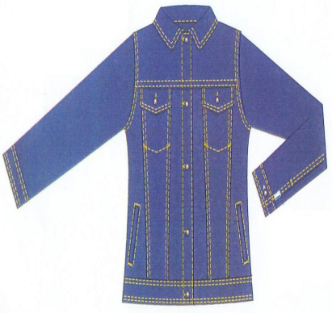
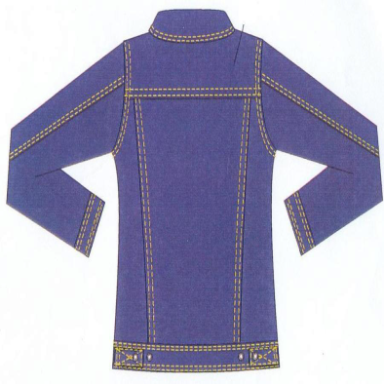

A denim jacket is a type of jacket that is made from denim fabric. Denim is a sturdy twill fabric that is made from cotton.
Denim jackets are typically blue in color, but they can also be found in other colors, such as black, white, and gray.
Denim jackets are a popular garment for people of all ages and genders.
They are versatile and can be worn for a variety of occasions, from casual to formal. Denim jackets are also relatively durable and easy to care for.
Denim jackets are typically produced in garment factories.
The production process begins with the cutting of the denim fabric into the desired pattern pieces.
The pattern pieces are then sewn together to create the jacket.
Once the jacket is sewn together, it is finished by washing, drying, and ironing it.
Here is a more detailed overview of the denim jacket garment production process.
- Cutting: The denim fabric is cut into the desired pattern pieces using a laser cutter or a manual cutting machine.
- Sewing: The pattern pieces are sewn together to create the jacket using a sewing machine.
- Finishing: The jacket is washed, dried, and ironed to give it a finished look.
- Inspection: The jacket is inspected for any defects before it is packaged and shipped.
Denim jackets are a popular garment because they are durable, versatile, and stylish. They are also relatively easy to produce, which makes them affordable for consumers.
Here are some of the benefits of wearing a denim jacket:
- Durability: Denim is a sturdy fabric that can withstand a lot of wear and tear. This makes denim jackets a good choice for people who need a jacket that can last for a long time.
- Versatility: Denim jackets can be dressed up or down, making them appropriate for a variety of occasions. They can be worn with jeans and a t-shirt for a casual look, or with a dress or skirt for a more formal look.
- Style: Denim jackets are a classic and stylish garment that can be worn by people of all ages and genders.

2.2.3. Understand about Suit
A suit is a set of garments that includes a jacket and trousers, and sometimes a vest. Suits are typically worn by men, but there are also women's suits. Suits can be made from a variety of materials, including wool, cotton, linen, and synthetic fabrics.
Suit garment production is a complex process that involves many different steps. The following is a brief overview of the main steps involved:
- Design: The first step is to design the suit. This involves creating sketches and technical drawings of the suit. The designer will also need to choose the fabrics and trims that will be used to make the suit.
- Pattern making: Once the design has been finalized, the next step is to create patterns for the different parts of the suit. The patterns are typically made out of paper or cardboard.
- Grading: Once the patterns have been made, they need to be graded to different sizes. This is done by adjusting the dimensions of the patterns.
- Cutting: The next step is to cut the fabric into the different pieces of the suit. This is done using a variety of cutting machines, including laser cutters and waterjet cutters.
- Sewing: Once the fabric has been cut, the different pieces of the suit are sewn together. This is done using a variety of sewing machines.
- Finishing: Once the suit has been sewn together, it is finished off with a variety of processes, such as pressing and ironing.
Suit garment production can be done on a small scale or on a large scale. Small-scale suit production is often done by bespoke tailors, who create custom-made suits for individual customers. Large-scale suit production is typically done by garment factories, which produce suits in bulk for retail sale.
Suit garment production is a global industry. Some of the largest suit garment producers in the world include China, Vietnam, and India. However, there are also many suit garment producers in Europe and North America.
Understanding the suit in garment production is important for a number of reasons. First, it can help you to appreciate the craftsmanship and skill that goes into making a well-made suit. Second, it can help you to make informed choices about the suits that you buy. Finally, it can help you to understand the global supply chain for suits and the impact that it has on workers and the environment.
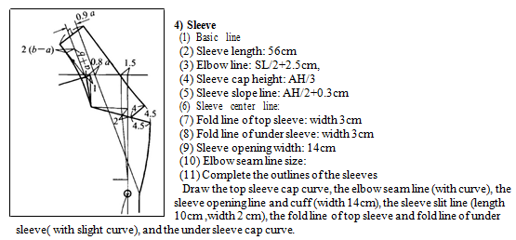
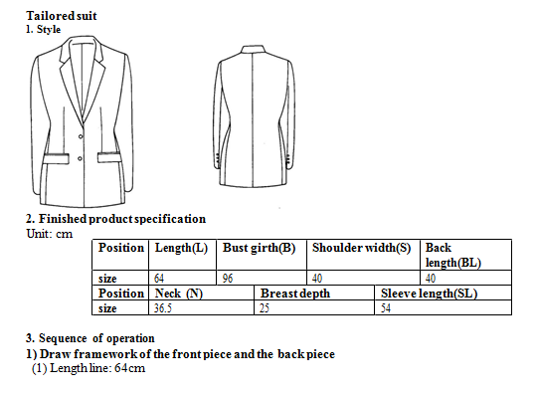
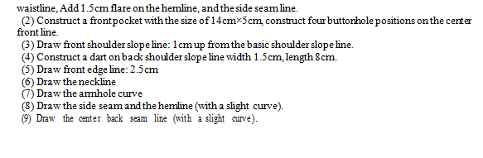

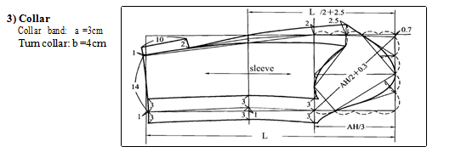
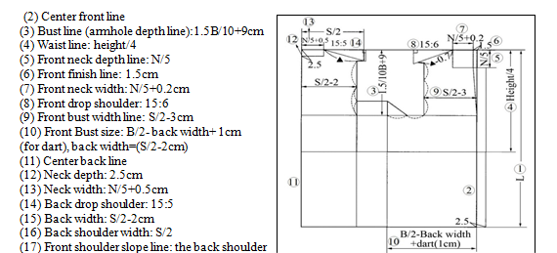
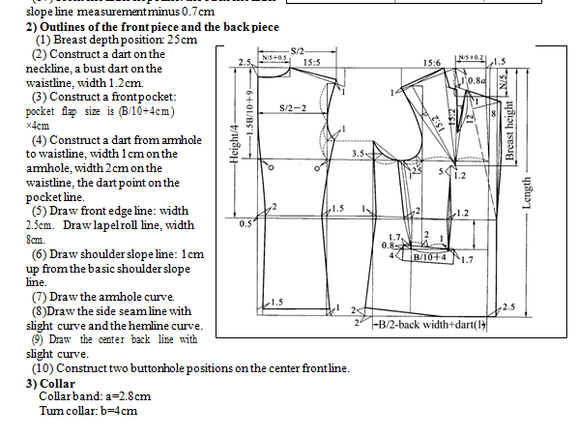
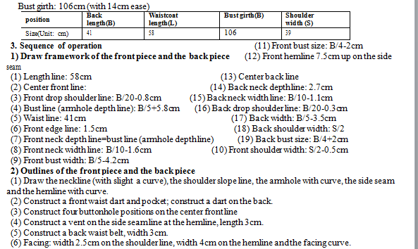
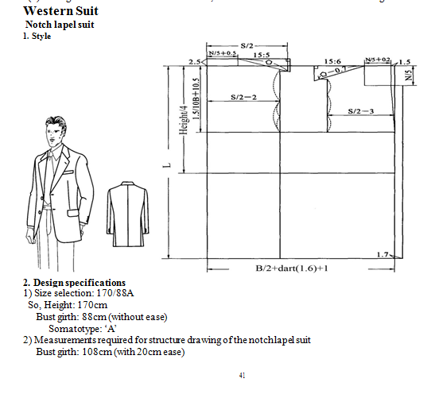
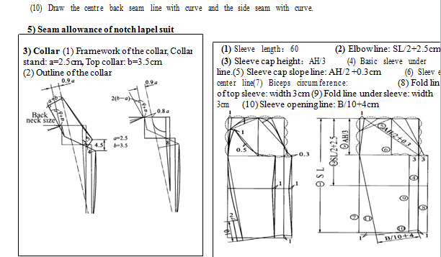
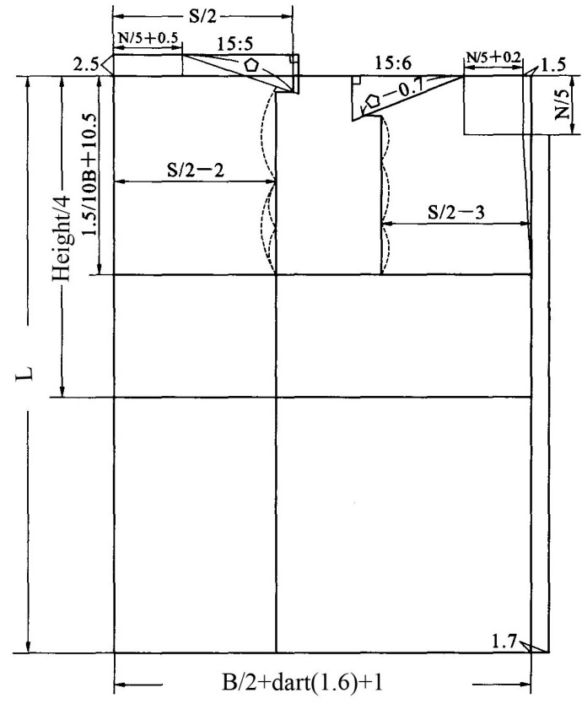
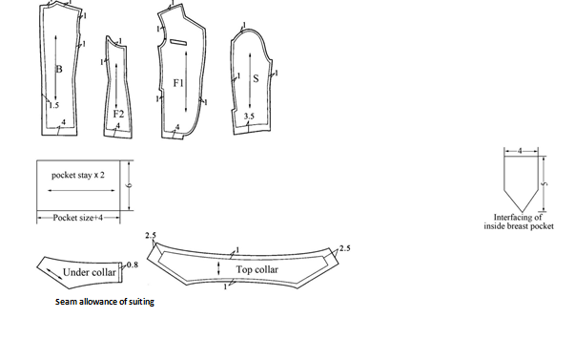
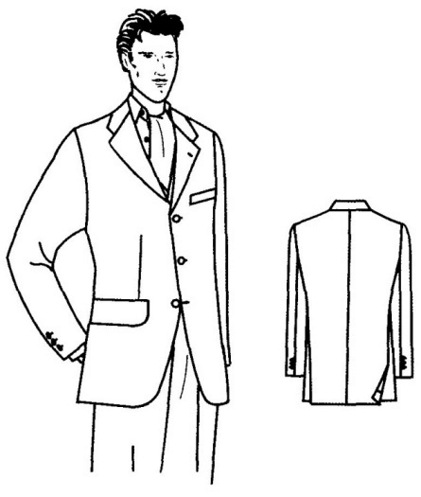
1. Style

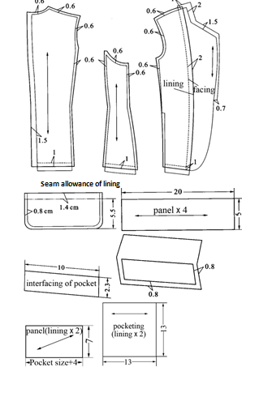

2. Design specification
1) Size selection: 170/88A, So, Height: 170cm Bust girth: 88cm (without ease) Some to type: ‘A’
2) Measurements required for structure drawing of the single-breasted suit Bust girth: 108cm (with 20cm
ease)
3. Sequence of operation
1) Draw framework of the front piece and the back piece
(1) Length line: 76cm
(2) Center front line:
(3) Front edge line: width1.7cm
(4) Front finish line: width1.5cm
(5) Bust line (Armhole depth line): 1.5B/10+10.5cm
(6) Waist line: 42.5cm
(7) Front neck depth line: N/5
(8) Front neck width line: N/5+0.2cm
(9) Front drop shoulder line: 15: 6
(10) Front bust width: S/2-3cm
(11) Front bust size: [B/2+1.6cm (dart) +1cm -(S/2-2)]
(12) Center back line: measure (B/2 +1.6cm+ 1cm) from centre front line
(13) Back neck depth line: 2.5cm up from the front length line.
(14) Back neck width line: N/5+0.5cm
(15) Back drop shoulder line: 15:5
(16) Back width: S/2-2cm
(17) Back shoulder width: S/2
(18) Front shoulder slope measurement: the back shoulder slope measurement minus 0.7cm
(19) The shoulder point: 1cm up.
2) Outlines of the front piece and the back piece.
(1) Lapel width: 8cm
(2) Draw the front edge line, the neckline, the shoulder slope line (with slight curve), the armhole curve,
the side seam, the front round bottom, the center back seam line and the hemline. 45 (3) Construct a front breast pocket.
(4) Construct a front double welt pocket: width B/10+5cm, the flap 5.5cm
(5) Construct a front dart, the dart width 1cm on the armhole line, width 1.5cm on the waistline, the dart
point on the pocket line, and then curve the dart line from the armhole dart to the hemline.
(6) Construct front bust dart on the waistline, the dart width 1cm on the waistline, width 0.8cm on the
double welt pocket line.
(7) Construct two buttonhole positions on the center front line, width 10cm between the two buttonholes.
(8) Construct side slit on the side seam, width 4cm on the side seam.
Double-breasted with peak lapel suit
1. Style

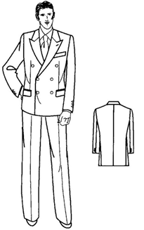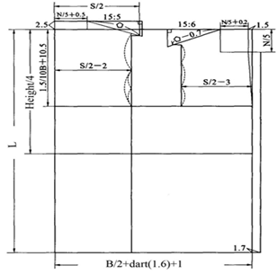

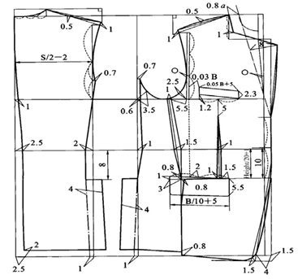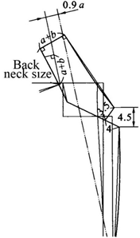

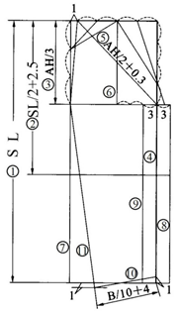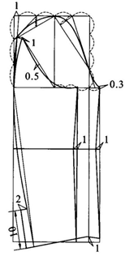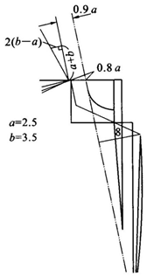
3) Collar (1) Drawing framework of the collar
Collar stand: a=2.5cmTop collar: b=3.5cm (2) Outline of the collar

. Design specifications
1) Size selection: 170/88A, So, Height: 170cm, Bust girth: 88cm (without ease) Some to type: ‘A’
2) Measurements required for structure drawing of double-breasted with peak lapel suit
Bust girth: 108cm (with 20 cm ease)
3. Sequence of operation
1) Draw framework of the front piece and the back piece
(1) Length line: 76cm
(2) Center front line:
(3) Overlap width：6cm
(4) Front finish line: 1.5cm
(5) Bust line (Armhole depth line): 1.5B/10+10.5cm
(6) Waist line: 42.5cm
(7) Front neck depth line: N/5
(8) Front neck width line: N/5+0.2cm
(9) Front drop shoulder: 15: 6
(10) Front bust width: S/2-3cm
(11)Center back line: [B/2+ 1.6cm (for dart) +1], the measurement from center front line to center back
line.
(12) Back neck depth line: 2.5cm up from the front length line.
(13) Back neck width line: N/5+0.5cm
(14) Back drop shoulder: 15:5 (16) Back shoulder width: S/2
(15) Back width: S/2-2cm (17) 1cm up for the shoulder point
(18) Front shoulder slope measurement: the back shoulder slope measurement minus 0.7cm
2) Outlines of the front piece and the back piece.
(1) Lapel width: 8cm
(2) Draw the front edge line, the neckline, the shoulder slope line (with slight curve), the armhole curve, the front and back seam line with curve, the centre back seam line (with curve), the front round cut and the hemline.
(3) Construct a front breast pocket.
(4) Construct a front waist dart, width 1cm on the waistline, width 1cm on the pocket line
(5) Construct a front double welt pocket.
(6) Construct a front side dart, with 1cm on the armhole line, width 1.5cm on the waistline. Draw the dart line with curve.
(7) Decide three buttonhole positions on the center front line.

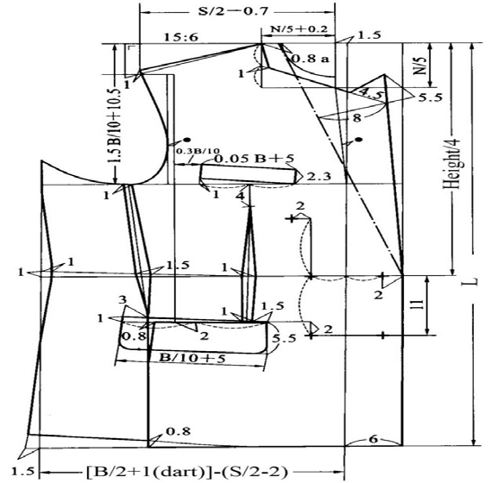
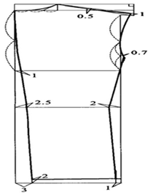
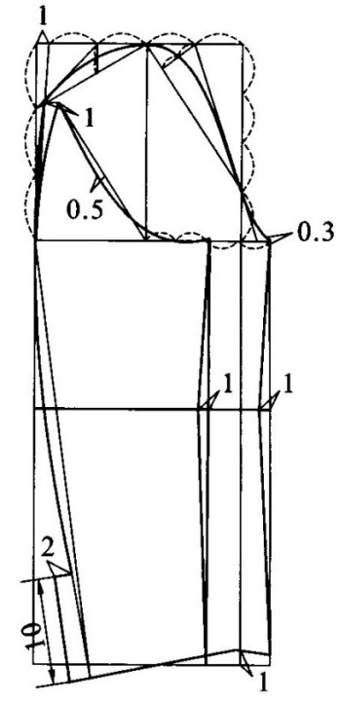
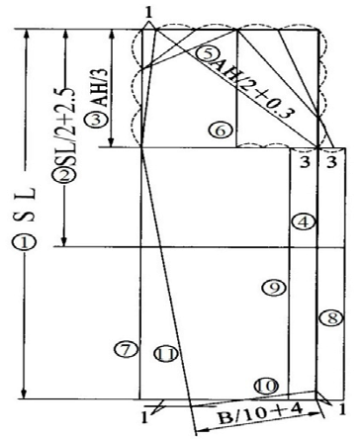
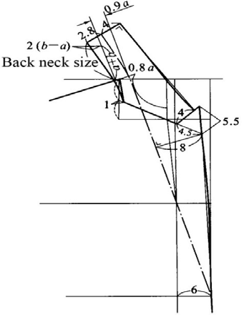

3) Collar &
4) Sleeve (1&2)
1) Draw framework of the collar Collar stand: a=2.5cmTop collar: b=3.5cm2) Outline of the collar
2.2.4. Understand about Coat
To produce a coat in garment production, the following steps are typically involved:
Pre-production
- Design: The coat is designed using computer-aided design (CAD) software. This software allows designers to create and edit garment patterns, generate cutting layouts, and simulate the sewing process.
- Pattern making: Once the design is finalized, a pattern is created. The pattern is a template that is used to cut out the pieces of fabric that will make up the coat.
- Grading: If the coat is being produced in multiple sizes, the pattern will need to be graded. Grading involves adjusting the pattern to create patterns for each size.
- Marker making: Once the pattern is graded, a marker is created. The marker is a layout that shows how the pattern pieces should be arranged on the fabric to minimize waste.
- Cutting: The fabric is then cut out according to the marker. This can be done manually or using a computer-controlled cutting machine.
Production
- Fusing: The fabric pieces are fused together to give the coat structure and body. This is done using a heat press.
- Sewing: The coat pieces are then sewn together, starting with the lining and then the outer fabric. The following operations are typically involved:
  - Attaching the lining to the front and back pieces
  - Sewing the side seams
  - Sewing the shoulder seams
  - Sewing the sleeves in
  - Attaching the collar
  - Attaching the cuffs and waistband
- Finishing: Once the coat is sewn together, it is finished. This may involve pressing the coat, trimming the threads, and adding any finishing touches, such as buttons, zippers, and pockets.
Quality control
The coat is then inspected to ensure that it meets quality standards. This may involve checking the stitching, the fit, and the overall appearance of the coat.
Here are some additional tips for producing coats:
- Use high-quality fabric. The fabric should be durable and warm, and it should hold its shape well.
- Make sure that the coat fits the body well. The coat should not be too tight or too loose, and it should have a flattering silhouette.
- Use a good quality sewing machine and thread. The sewing machine should be able to sew through the fabric without difficulty.
- Finish the coat carefully. Take the time to press the seams and trim the threads neatly.
By following these tips, you can produce coats that are high-quality and stylish.
Here are some specific examples of how advanced technologies and processes can be used to produce coats:
- CAD software can be used to create complex garment patterns that would be difficult or impossible to create manually.
- CAM software can be used to generate cutting layouts that minimize waste and to control CNC cutting machines.
- Automated sewing machines can be used to sew coats quickly and efficiently.
- 3D printing can be used to create custom coats and prototypes.
- AI can be used to automate tasks such as pattern making and quality control.

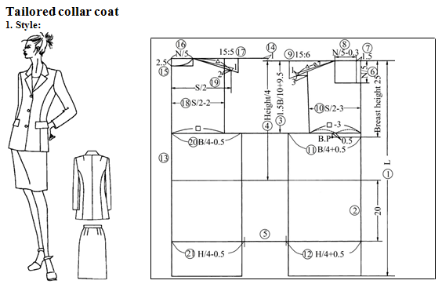

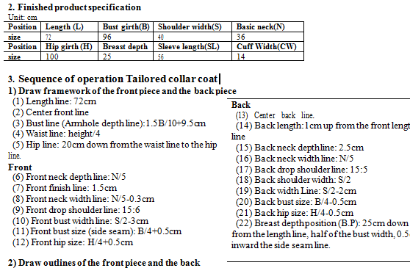
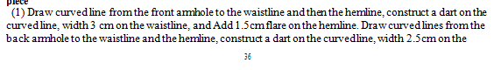

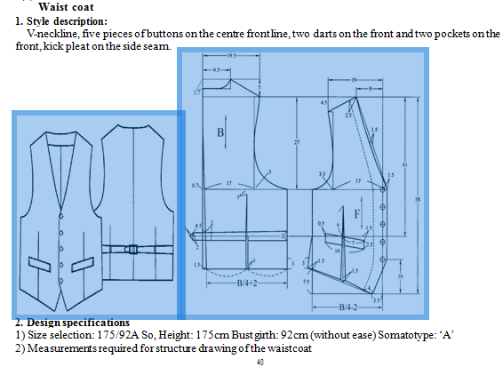
Here is an example of a garment Operations for a Coat:

Operation | Description | Machine/Tool
Cutting | Cut the fabric pieces according to the pattern. | Electric cutting machine
Sewing | Sew the fabric pieces together to create the coat. | Sewing machine
Pressing | Press the seams flat and give the coat a finished look. | Iron and ironing board
Finishing | Add any finishing touches to the coat, such as buttons, zippers, or a lining. | Sewing machine and other finishing tools

Check garment against pattern and design
Checking a garment against a pattern and design for advanced garment production is an important step in ensuring that the garment meets quality standards. This process can be done manually or using computer-aided design (CAD) software.
To check a garment against a pattern and design manually, the following steps can be taken:
- Place the garment on a flat surface.
- Lay the pattern pieces over the garment.
- Pin the pattern pieces to the garment.
- Check to make sure that the pattern pieces fit snugly against the garment.
- Make any necessary adjustments to the garment.
To check a garment against a pattern and design using CAD software, the following steps can be taken:
- Import the garment and pattern files into the CAD software.
- Overlay the pattern pieces over the garment.
- Check to make sure that the pattern pieces fit snugly against the garment.
- Make any necessary adjustments to the garment.
Once the garment has been checked against the pattern and design, it is important to make any necessary adjustments. This may involve altering the size of the garment, adjusting the placement of the pattern pieces, or making other changes to the design.
Here are some specific tips for checking a garment against a pattern and design for advanced garment production:
- Pay attention to the grain of the fabric. The grain of the fabric should run parallel to the edges of the pattern pieces.
- Check to make sure that the pattern pieces are aligned correctly. This is especially important for garments with symmetry, such as dresses and skirts.
- Be careful not to stretch the fabric when pinning the pattern pieces to the garment.
- Make sure that the garment is pressed before checking it against the pattern and design. This will help to ensure that the garment is the correct size and shape.
- If you are using CAD software, be sure to use the correct settings. For example, make sure that the scale is set correctly and that the pattern pieces are oriented correctly.
To check a garment against a pattern and design for advanced garment production, the following steps can be taken:
- Lay the garment out flat on a table.
- Place the pattern pieces over the garment, aligning the notches and seam allowances.
- Pin the pattern pieces to the garment.
- Check to make sure that the pattern pieces fit snugly on the garment, with no gaps or excess fabric.
- If any adjustments are needed, make them now.
- Once the pattern pieces fit snugly on the garment remove them and check the garment against the design.
- Make sure that the garment matches the design in terms of style, fit, and finish.
- If any adjustments are needed, make them now.
Here are some specific things to check when comparing the garment to the pattern and design:
- Grainline: Make sure that the grainline of the fabric is aligned with the grainline of the pattern pieces.
- Notches: Make sure that the notches on the pattern pieces match the notches on the garment.
- Seam allowances: Make sure that the seam allowances on the pattern pieces match the seam allowances on the garment.
- Overall fit: Make sure that the garment fits the body as intended.
- Style details: Make sure that the garment matches the design in terms of style details, such as pleats, gathers, and embellishments.
It is important to check the garment against the pattern and design at multiple stages of the production process. This will help to ensure that any errors are caught and corrected early on.
Here are some additional tips for checking a garment against a pattern and design for advanced garment production:
- Use a good quality light source to inspect the garment. This will help to identify any defects or inconsistencies.
- Use a magnifying glass to inspect the garment up close. This will help to identify any small defects.
- Have a second person inspect the garment after you have finished checking it. This will help to catch any errors that you may have missed.

Identify and correcting faults
To identify and correct faults in garment production, you can follow these steps:
- Inspect the garment carefully. Look for any defects, such as uneven seams, puckering, or missing stitches.
- Identify the cause of the fault. Once you have identified the fault, you need to determine the cause. This will help you to correct the fault and prevent it from happening again.
- Correct the fault. There are a variety of ways to correct faults in garment production. The specific method that you use will depend on the type of fault.
Here are some specific examples of how to identify and correct common faults in garment production:
- Uneven seams: Uneven seams can be caused by a number of factors, such as using the wrong needle size, sewing too quickly, or not pulling the fabric taut enough. To correct uneven seams, you can use a seam ripper to undo the seam and then sew it again more carefully.
- Puckering: Puckering can be caused by sewing too tightly or using the wrong presser foot. To correct puckering, you can use a steam iron to press the fabric flat. You may also need to adjust the tension on your sewing machine.
- Missing stitches: Missing stitches can be caused by a number of factors, such as a dull needle, a dirty bobbin, or the wrong thread tension. To correct missing stitches, you can use a seam ripper to undo the stitching and then sew it again more carefully.
If you are new to garment production, it is good ideas to have someone else inspect your garments for faults. This can help you to identify and correct any problems before they become major.
Here are some additional tips for identifying and correcting faults in garment production:
- Use a magnifying glass to inspect the garment for small defects.
- Test the garment on a model to check the fit and to identify any areas of the garment that need to be adjusted.
- Keep a record of the faults that you find and the steps that you take to correct them. This will help you to avoid making the same mistakes in the future.
By following these tips, you can help to ensure that your garments are free of faults and that they meet the highest quality standards.
There are many different types of garment faults, but some of the most common include:
- Incorrect size: The garment may be too big or too small.
- Uneven seams: The seams may be crooked or uneven.
- Puckering: The fabric may be puckered or gathered.
- Skipping stitches: The sewing machine may have skipped stitches, leaving holes in the seam.
- Missing hardware: Buttons, zippers, or other hardware may be missing.
To identify garment faults, you can inspect the garment carefully before you finish sewing it. You can also try on the garment to check the fit and to identify any areas that need to be corrected.
Once you have identified any garment faults, you can take steps to correct them. Here are some tips:
- Incorrect size: If the garment is too big or too small, you can adjust the pattern or take in or let out the garment.
- Uneven seams: If the seams are uneven, you can unpick them and sew them again.
- Puckering: If the fabric is puckered or gathered, you can press the seams or use a seam ripper to let out the fabric.
- Skipping stitches: If the sewing machine has skipped stitches, you can unpick the seam and sew it again.
- Missing hardware: If any buttons, zippers, or other hardware are missing, you can sew them on.
If you are new to garment construction, it is a good idea to have someone else helps you identify and correct garment faults. This can help to ensure that you are making the correct adjustments and that the garment will look its best.
Here are some additional tips for identifying and correcting garment faults:
- Use a magnifying glass to inspect the garment for small faults.
- Try on the garment to check the fit and to identify any areas that need to be corrected.
- Take your time and be patient. It is better to correct a garment fault before you finish sewing it than to have to start over.
By following these tips, you can ensure that your garments are well-made and free of faults.

Review production techniques and design
To review production techniques and design, you can follow these steps:
- Analyze the production techniques that were used. This includes identifying the types of stitches that were used, the order in which the stitches were sewn, and the types of tools and equipment that were used.
- Evaluate the design of the garment. This includes assessing the fit, the style, and the overall aesthetic of the garment.
- Identify any areas where the production techniques or design could be improved. This could include things like making the garment more durable, improving the fit, or making the garment more stylish.
- Make a plan for how to improve the production techniques or design. This could include using different stitches, sewing the stitches in a different order, or using different tools and equipment. You could also make changes to the design, such as adjusting the fit or changing the style.
Here are some specific things to look for when reviewing production techniques and design:
- Stitches: Are the stitches even and consistent? Are the stitches the correct type for the fabric and for the garment?
- Seams: Are the seams aligned properly? Are the seams finished neatly?
- Fit: Does the garment fit properly? Is the garment comfortable to wear?
- Style: Is the garment stylish? Is the garment appropriate for the intended use?
- Overall aesthetic: Is the garment well-made and attractive?
Here are some additional tips for reviewing production techniques and design:
- Look at other garments for inspiration. Pay attention to the types of stitches that are used, the construction of the seams, and the overall design of the garments.
- Experiment with different production techniques and designs. This is the best way to learn what works best for you and for the type of garments that you are sewing.
- Don't be afraid to make mistakes. Everyone makes mistakes when they are first learning to sew. The important thing is to learn from your mistakes and to keep practicing.
By following these tips, you can improve your production techniques and design skills, and you can create garments that are both well-made and stylish.
To review production techniques and design, you can follow these steps:
- Gather all of the relevant information. This includes the design sketches, the pattern, the tech pack, and any other relevant documentation.
- Identify the key production techniques that will be used to produce the garment. This may include things like cutting, sewing, pressing, and finishing.
- Evaluate the design to ensure that it is feasible to produce. This includes things like considering the fabric, the construction techniques, and the target price point.
- Make any necessary adjustments to the production techniques or design.
- Review the production techniques and design with the production team to ensure that everyone is on the same page.
Here are some specific things to look for when reviewing production techniques and design:
- Fabric: Is the fabric suitable for the production techniques that will be used?
- Is the fabric available in the necessary quantity and quality?
- Construction techniques: Are the construction techniques that will be used feasible and cost-effective?
- Target price point: Are the production techniques and design consistent with the target price point?
- Fit: Does the garment fit properly?
- Style: Does the garment match the desired style?
If you are new to garment production, it is a good idea to have someone else reviews the production techniques and design with you. This can help to ensure that you are making the correct decisions and that the garment will be produced to the highest quality standards.
Here are some additional tips for reviewing production techniques and design:
- Be realistic about your budget and timeline. It is important to be realistic about the cost and time it will take to produce the garment.
- Don't be afraid to make changes. If you are not happy with the production techniques or design, don't be afraid to make changes. It is better to make changes early on in the production process than to be disappointed with the finished product.
- Communicate with the production team. It is important to communicate with the production team throughout the design and production process. This will help to ensure that everyone is on the same page and that the garment is produced to your specifications.
By following these tips, you can ensure that your garments are well-made and stylish.
To review production techniques and design, you can follow these steps:
- Identify the goals of the review. What do you hope to achieve by reviewing the production techniques and design?
- Are you looking to improve quality, reduce costs, or increase efficiency?
- Gather information. This may include reviewing the pattern, the production process, and the materials used. You may also want to talk to the people who are involved in the production process.
- Analyze the information. Once you have gathered all of the information, you can start to analyze it. Look for areas where the production techniques or design can be improved.
- Make recommendations. Based on your analysis, make recommendations for how the production techniques and design can be improved.
- Implement the recommendations. Once you have made your recommendations, work with the people who are involved in the production process to implement them.
Here are some specific things to look for when reviewing production techniques and design:
- Efficiency: Are the production techniques as efficient as possible? Are there any ways to reduce the amount of time or effort required to produce the garment?
- Quality: Are the production techniques producing high-quality garments? Are there any ways to improve the quality of the garments?
- Cost: Are the production techniques cost-effective? Are there any ways to reduce the cost of producing the garments?
- Design: Is the design of the garment feasible to produce? Are there any design changes that need to be made?
It is important to note that reviewing production techniques and design is an ongoing process. As you learn more about the production process and the materials used, you may identify new ways to improve the production techniques and design.
Here are some additional tips for reviewing production techniques and design:
- Be objective. Try to avoid making assumptions about the production process or the design.
- Be open to new ideas. Don't be afraid to try new things and to experiment.
- Be patient. It may take time to identify and implement improvements to the production techniques and design.
By following these tips, you can ensure that your production techniques and design are efficient, high-quality, and cost-effective.
Drive spread sheet Export to Sheets
This is just a basic overview of the operations breakdown for a coat. The specific operations and machines/tools used will vary depending on the style of the coat and the manufacturer's production process.
For example, a more complex coat may require additional operations, such as:
- Fusing: Applying a layer of adhesive to the fabric to help it hold its shape.
- Welt pockets: Sewing pockets into the coat those are finished with a welt, or facing.
- Buttonholes: Sewing buttonholes into the coat.
- Lining: Sewing a lining into the coat.
The manufacturer's production process will also affect the operations breakdown. For example, a manufacturer that produces coats in bulk may use different machines and tools than a manufacturer that produces coats in small batches.
I hope this information is helpful. Please let me know if you have any other questions.
Cutting:
- Spread the fabric on the cutting table.
- Lay the pattern pieces on the fabric and pin them in place.
- Cut out the pattern pieces using a rotary cutter or scissors.
- Number the pattern pieces so that they can be sewn together correctly.
Sewing:
- Sew the front and back pieces of the coat together at the shoulder seams.
- Sew the sleeve pieces to the front and back pieces of the coat.
- Sew the side seams of the coat.
- Hem the sleeves and the bottom of the coat.
- Attach any closures, such as buttons or zippers.
Quality control:
- Inspect the coat for any defects, such as uneven seams or loose threads.
- Repair any defects that are found.
- Press the coat to give it a neat and finished appearance.
Packing:
- Fold the coat neatly.
- Place the coat in a plastic bag or box.
- Seal the bag or box.
- Attach a shipping label to the bag or box.
This is just a basic operations breakdown for a coat. The specific operations involved in manufacturing a coat may vary depending on the style of the coat, the materials used, and the manufacturing process.
Here are some additional tips for developing an operations breakdown:
- Identify all of the steps involved in manufacturing the product.
- Break down each step into smaller, more manageable tasks.
- Sequence the tasks in a logical order.
- Estimate the time required for each task.
- Identify any resources that are needed for each task.
- Document the operations breakdown in a clear and concise format.
By following these tips, you can develop an operations breakdown that will help you to manufacture your products efficiently and effectively.

SELF CHECK 2
PART I TRUE/FALSE QUESTIONS
- It is important to follow the technical pack when producing garments.
- Garments can be produced using a variety of different sewing techniques.
- Quality control is essential in garment production.
- Garments can be produced using a variety of different materials.
- Garment production is a complex process that requires a high level of skill and expertise.
PART II: MULTIPLE CHOICE QUESTIONS
- Which of the following is NOT a part of the garment production process?
a) Cutting c) Finishing
b) Sewing d) Design
2. Which of the following is the most important factor to consider when choosing the right sewing needle for a particular garment?
a) The type of fabric c) The color of the needle
b) The size of the needle d) the brand of the needle
PART III SHORT ANSWER
- What are some of the most common defects that can occur in garment production?
- What are some tips for preventing defects in garment production?

Operation Sheet | Producing advanced garment products
The operation breakdown of producing advanced garment products varies depending on the specific product and the manufacturing process used. However, there are some general steps that are common to most advanced garment manufacturing processes:
- Design: The garment is designed by a designer, who takes into account the target market, the latest trends, and the desired functionality of the garment. The design is then translated into a technical drawing, which includes all of the necessary specifications for the garment, such as the dimensions, materials, and construction details.
- Pattern making: A pattern maker creates a pattern for the garment, based on the technical drawing. The pattern is a set of templates that are used to cut the fabric to the desired shape and size.
- Grading: The pattern is graded to create different sizes of the garment. Grading involves adjusting the dimensions of the pattern to ensure that the garment will fit a variety of body types.
- Marker making: A marker maker creates a marker layout, which is a plan for how to cut the fabric in the most efficient way possible. The marker layout takes into account the width of the fabric, the pattern pieces, and the desired number of garments to be cut.
- Cutting: The fabric is cut to size using the marker layout. This can be done manually or using a computerized cutting machine.
- Sewing: The garment is sewn together using a variety of sewing machines and techniques. The specific sewing operations that are required will vary depending on the design of the garment.
- Finishing: The garment is finished by adding labels, trims, and other embellishments. It may also be washed, pressed, and inspected to ensure quality.
In addition to the above steps, advanced garment manufacturing may also involve other processes, such as:
- Computer-aided design (CAD): CAD is used to create and modify garment designs, patterns, and marker layouts.
- Computer-aided manufacturing (CAM): CAM is used to control automated cutting and sewing machines.
- Laser cutting: Laser cutting can be used to cut fabric with high precision and accuracy.
- Embroidery: Embroidery can be used to add decorative designs to garments.
- Printing: Printing can be used to add designs, logos, and other information to garments.
Lab test | Producing advanced garment products
Lab tests are an important part of producing advanced garment products. They can be used to:
- Ensure the quality of the materials used in the garment
- Test the performance of the garment, such as its durability, breathability, and water resistance
- Identify and correct any potential problems with the garment before it is mass-produced
Some common lab tests for advanced garment products include:
- Fabric testing: Fabric testing can be used to measure the strength, durability, and other properties of the fabric used in the garment.
- Seam testing: Seam testing is used to assess the quality and strength of the seams in the garment.
- Colorfastness testing: Colorfastness testing is used to determine how well the colors in the garment will resist fading when washed, exposed to sunlight, or other environmental factors.
- Wash and wear testing: Wash and wear testing is used to simulate the wear and tear that the garment will be subjected to in real-world use. This can help to identify any potential problems with the garment, such as shrinkage, pilling, or fading.
- Performance testing: Performance testing can be used to measure the garment's performance in specific conditions, such as its breathability, water resistance, or flammability.
In addition to these general tests, there may also be specific lab tests that are required for certain types of advanced garment products. For example, garments that are designed for extreme sports or outdoor use may need to be tested for their durability and performance in harsh conditions.
Lab tests play an important role in ensuring the quality and safety of advanced garment products. By testing the materials and performance of garments at an early stage, manufacturers can identify and correct any potential problems before the garments are mass-produced. This can help to ensure that consumers have access to high-quality, durable, and safe garments.
Here are some specific examples of lab tests that may be conducted for advanced garment products:
- Abrasion resistance testing: This test is used to measure how well the fabric in the garment will resist wear and tear.
- Tear strength testing: This test is used to measure how much force is required to tear the fabric in the garment.
- Bursting strength testing: This test is used to measure how much pressure is required to burst the fabric in the garment.
- Pilling resistance testing: This test is used to measure how well the fabric in the garment will resist pilling, which is the formation of small balls of fabric on the surface of the garment.
- Breathability testing: This test is used to measure how well the fabric in the garment allows air to pass through it.
- Water resistance testing: This test is used to measure how well the fabric in the garment repels water.
- Flammability testing: This test is used to measure how well the fabric in the garment resists fire.

UNIT THREE: Complete production process
This unit is developed to provide you the necessary information regarding the following content coverage and topics:
- Finish garment according to design requirements
- Assess garment against design and pattern
- Rectify garment faults
- Clean area and equipment
Stored tools and equipment This unit will also assist you to attain the learning outcomes stated in the cover page. Specifically, upon completion of this learning guide, you will be able to:
- Finishing garment according to design requirements
- Assessing garment against design and pattern
- Rectifying garment faults
- Cleaning area and equipment

3. Complete production process
Sure. Here is a more detailed breakdown of the complete production process of a coat:
1. Design: The first step is to design the coat. This involves creating sketches and technical drawings of the coat, as well as choosing the materials and colors. The designer will consider the target market, the latest trends, and the brand's aesthetic when creating the design.
2. Pattern making: Once the design is finalized, the next step is to create a pattern for the coat. This involves drafting the pattern pieces on paper and then grading them to create a range of sizes. The pattern maker will need to consider the fit and drape of the garment when creating the pattern.
3. Sourcing materials: Once the pattern is created, the next step is to source the materials for the coat. This includes the fabric, lining, hardware, and any other materials that are needed. The manufacturer will need to consider the quality and cost of the materials when making their selection.
4. Cutting: Once the materials have been sourced, the next step is to cut the fabric into the pattern pieces. This can be done manually or using a computer-controlled cutting machine. The cutter will need to be careful to ensure that the fabric is cut accurately and that there is minimal waste.
5. Sewing: Once the fabric has been cut, the next step is to sew the pattern pieces together to create the coat. This can be done manually or using a sewing machine. The sewer will need to follow the pattern instructions carefully and ensure that the seams are sewn evenly and securely.
6. Finishing: Once the coat is sewn together, it is finished by pressing the seams, attaching any hardware, and inspecting it for any defects. The finisher will also need to make any necessary adjustments to the garment to ensure that it fits properly.
7. Packing: Once the coat is finished, it is packed and shipped to the retailer or customer. The coat is typically packaged in a polybag or box to protect it from damage during shipping.
Here are some additional tips for ensuring a smooth and efficient production process:
- Quality control: It is important to have a quality control process in place at every stage of the production process. This will help to identify and correct any problems early on and ensure that the final product meets quality standards.
- Communication: It is important to have good communication between all of the different departments involved in the production process. This will help to ensure that everyone is on the same page and that the process is running smoothly.
- Efficiency: There are a number of ways to improve the efficiency of the production process. For example, using computer-controlled machines can help to reduce the time and labor required to complete certain tasks.
- Finishing garment according to design requirements volume up
To finish a garment according to design requirements, you will need to:
- Inspect the garment. Inspect the garment carefully for any defects, such as uneven seams, loose threads, or puckering.
- Press the seams. Press the seams to give the garment a neat and finished appearance.
- Attach any hardware. Attach any hardware, such as buttons, zippers, or hooks and eyes.
- Make any necessary adjustments. If necessary, make any adjustments to the garment to ensure that it fits properly.
- Package the garment. Package the garment in a way that protects it from damage during shipping or storage.
Here are some additional tips for finishing a garment according to design requirements:
- Follow the pattern instructions carefully. The pattern instructions will provide information on how to finish the garment according to the design.
- Use the correct tools and materials. Make sure that you are using the correct tools and materials for the job. For example, use a pressing cloth to protect delicate fabrics when pressing the seams.
- Be patient and take your time. It is important to take your time and finish the garment to the best of your ability. A well-finished garment will look more professional and will last longer.
Here are some specific examples of how to finish a garment according to design requirements:
- Hem the sleeves and bottom of the garment. To hem the sleeves and bottom of the garment, use a sewing machine or a needle and thread to sew a straight seam along the edge of the fabric. You can also use a blind stitch to hem the garment, which will create a more invisible seam.
- Attach a button. To attach a button, sew a shank on the back of the button and then sew the shank to the garment. You can also use a sewing machine to attach a button.
- Attach a zipper. To attach a zipper, sew one side of the zipper to the garment and then sew the other side of the zipper to the garment. You can also use a sewing machine to attach a zipper.

Finish garment according to design requirements
- Finishing a garment according to design requirements is an important step in the production process.
- It ensures that the garment meets the designer's vision and that it is of the highest quality.
There are a number of different finishing techniques that can be used, depending on the style of the garment and the desired effect.
Some common finishing techniques include:
- Pressing: Pressing the seams of the garment will give it a neat and finished appearance. It is important to use the correct heat setting for the fabric type to avoid damaging it.
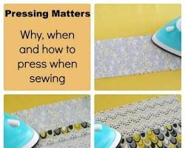
Pressing garment seams
- Hemming: Hemming the sleeves and bottom of the garment will prevent the fabric from fraying. There are a variety of different hemming techniques that can be used, depending on the desired effect.
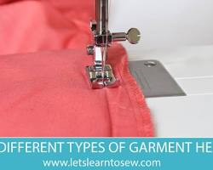
Hemming a garment
- Attaching hardware: Buttons, zippers, and other hardware should be attached securely to the garment. It is important to use the correct type of hardware for the fabric type and garment style.
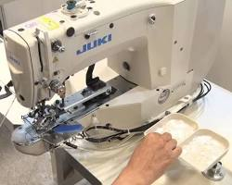 .

Attaching a button to a garment
- Inspect the garment. Inspect the garment carefully for any defects, such as uneven seams, loose threads, or puckering.
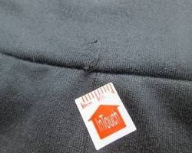
Inspecting garment for defects
- Attach any hardware. Attach any hardware, such as buttons, zippers, hooks and eyes, or embellishments.
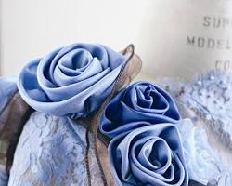
Attaching embellishments to garment
- Make any necessary adjustments. If necessary, make any adjustments to the garment to ensure that it fits properly.
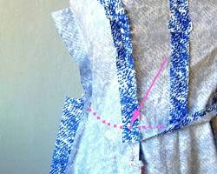
Adjusting garment fit
- Package the garment. Package the garment in a way that protects it from damage during shipping or storage.
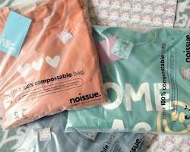
Packaging garment for shipping
Here are some additional tips for finishing a garment according to design requirements:
- Follow the pattern instructions carefully. The pattern instructions will provide information on how to finish the garment according to the design.
- Use the correct tools and materials. Make sure that you are using the correct tools and materials for the job. For example, use a pressing cloth to protect delicate fabrics when pressing the seams.
- Be patient and take your time. It is important to take your time and finish the garment to the best of your ability. A well-finished garment will look more professional and will last longer.
Here are some specific examples of how to finish a garment according to design requirements:
- Hem the sleeves and bottom of the garment. To hem the sleeves and bottom of the garment, use a sewing machine or a needle and thread to sew a straight seam along the edge of the fabric. You can also use a blind stitch to hem the garment, which will create a more invisible seam.
Hemming garment sleeves
- Attach a button. To attach a button, sew a shank on the back of the button and then sew the shank to the garment. You can also use a sewing machine to attach a button.
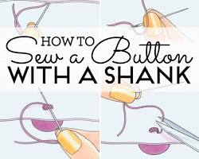
Attaching shank to button
- Attach a zipper. To attach a zipper, sew one side of the zipper to the garment and then sew the other side of the zipper to the garment. You can also use a sewing machine to attach a zipper.
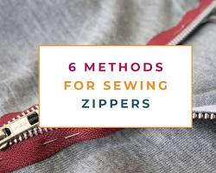
Sewing zipper to garment
- Attach embellishments. To attach embellishments, such as beads, sequins, or appliqués, use a sewing machine or a needle and thread to sew them to the garment. You can also use glue to attach embellishments, but be sure to use glue that is specifically designed for fabric.
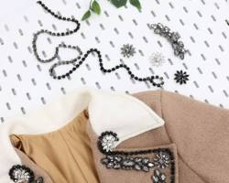
Sewing embellishments to garment
By following these tips, you can finish your garments according to design requirements and create high-quality garments that will look and feel great.

Assess garment against design and pattern
To assess a garment against the design and pattern, you can follow these steps:
- Compare the garment to the design sketches and technical drawings. Make sure that the garment matches the design in terms of style, silhouette, and details.
- Measure the garment against the pattern pieces. Make sure that the garment is the correct size and that the pattern pieces have been sewn together accurately.
- Inspect the garment for any defects. Look for uneven seams, loose threads, puckering, or any other problems.
- Try on the garment to make sure that it fits properly. The garment should be comfortable and flattering, and it should allow for full range of motion.
Here are some specific things to look for when assessing a garment against the design and pattern:
- Style and silhouette: Is the overall style and silhouette of the garment the same as the design?
- Details: Are all of the details of the garment included, such as pockets, closures, and embellishments?
- Size and fit: Is the garment the correct size? Does it fit properly and allow for full range of motion?
- Construction: Is the garment well-constructed? Are the seams even and secure? Are there any defects?
If you are not satisfied with any aspect of the garment, you can make adjustments to the garment or have it altered by a professional.
Here are some additional tips for assessing a garment against the design and pattern:
- Use a good quality light source. This will help you to see any defects in the fabric or construction.
- Have someone else help you. It can be helpful to have someone else help you to inspect the garment and to make sure that it fits properly.
- Be critical. Don't be afraid to point out any problems with the garment. The goal is to create a garment that meets your expectations and that you will love to wear.
By following these tips, you can ensure that your garments are well-made and that they meet your design requirements.
To assess a garment against design and pattern, you can follow these steps:
- Inspect the garment carefully. Look for any defects, such as uneven seams, loose threads, puckering, or skipped stitches.
- Compare the garment to the pattern. Make sure that all of the pattern pieces have been used and that the garment is the correct size.
- Check the fit of the garment. Try on the garment to make sure that it fits properly. Pay attention to the fit in the shoulders, chest, waist, and hips.
- Evaluate the overall look and feel of the garment. Does the garment look like the design intended?
Here are some specific things to look for when assessing a garment against design and pattern:
- Seams: The seams should be even and secure. There should be no puckering or skipped stitches.
- Hem: The hem should be even and straight.
- Fit: The garment should fit snugly but comfortably. It should not be too tight or too loose.
- Finish: The garment should be well-finished. All of the loose threads should be trimmed and all of the hardware should be securely attached.
If you find any defects in the garment, you can try to fix them yourself or take the garment to a tailor to be repaired.
It is also important to assess the garment against the design to make sure that it meets your expectations. Does the garment look and feel the way you wanted it to? Are you happy with the overall quality of the garment?
If you are not happy with the garment, you can try to make adjustments yourself or take the garment to a tailor to be altered. You may also want to consider returning the garment to the store where you purchased it.
By following these tips, you can assess a garment against design and pattern and ensure that you are getting a high-quality garment that meets your expectations.
To assess a garment against the design and pattern, you can follow these steps:
- Inspect the garment carefully. Look at the overall silhouette, drape, and fit of the garment. Make sure that the garment matches the design and pattern in terms of style, shape, and size.
- Measure the garment. Compare the garment measurements to the pattern measurements. Make sure that the garment is the correct size and that the proportions are accurate.
- Check the seams. Inspect the seams carefully to make sure that they are even, straight, and secure.
- Check the hardware. Make sure that any hardware, such as buttons, zippers, or hooks and eyes, is attached securely and is of good quality.
- Try on the garment. Try on the garment to make sure that it fits well and is comfortable to wear.
Here are some specific things to look for when assessing a garment against the design and pattern:
- Overall silhouette and drape: Does the garment match the design and pattern in terms of style and shape? Does the garment drape well and create the desired silhouette?
- Fit: Does the garment fit well and is it comfortable to wear? Are the proportions of the garment accurate?
- Seam work: Are the seams even, straight, and secure? Are there any puckers or gaps in the seams?
- Hardware: Is any hardware, such as buttons, zippers, or hooks and eyes, attached securely and is of good quality?
- Finishing: Is the garment well-finished? Are there any loose threads, frayed edges, or unfinished seams?
By following these steps, you can thoroughly assess a garment against the design and pattern and identify any areas that need improvement.
Here are some additional tips for assessing a garment against the design and pattern:
- Use a good quality mirror. A good quality mirror will help you to see the garment accurately and to identify any fit problems.
- Have someone else assess the garment. It can be helpful to have someone else assess the garment for you, as they may be able to see things that you miss.
- Take your time. Don't rush the assessment process. Take your time to inspect the garment carefully and to make sure that it meets your standards.
By following these tips, you can ensure that your garments are well-made and meet your design requirements.

3.3. Rectify garment faults
There are a variety of ways to rectify garment faults, depending on the type of fault and the fabric of the garment. Here are some general tips:
- Identify the fault. The first step is to identify the type of fault and the location of the fault on the garment. This will help you to determine the best course of action.
- Assess the damage. Once you have identified the fault, assess the damage. Is the fault minor or major? Is the fabric damaged?
- Choose the right method. There are a variety of different methods that can be used to rectify garment faults. The best method will depend on the type of fault, the fabric of the garment, and your skill level.
Here are some specific examples of how to rectify common garment faults:
- Uneven seams: To rectify uneven seams, you can use a seam ripper to remove the stitches and then sew the seam again. Be sure to use a sharp needle and thread that matches the weight of the fabric.
- Puckering: To rectify puckering, you can use a steam iron to press the seam. You can also use a seam ripper to remove the stitches and then sew the seam again, taking care to avoid stretching the fabric.
- Loose threads: To rectify loose threads, you can use a pair of scissors to trim them close to the fabric. If the loose threads are long, you can use a needle and thread to secure them.
- Holes: To rectify small holes, you can use a sewing machine to patch the hole. For larger holes, you may need to use a fusible web or iron-on patch.
- Tears: To rectify tears, you can use a sewing machine to sew the tear together. If the tear is large, you may need to use a fusible web or iron-on patch.
If you are unsure how to rectify a particular garment fault, it is best to consult a professional seamstress or tailor.
Here are some additional tips for rectifying garment faults:
- Use the correct tools and materials. Make sure that you are using the correct tools and materials for the job. For example, use a sharp needle and thread that matches the weight of the fabric.
- Be patient and take your time. It is important to take your time and to rectify the fault carefully. Rushing the process may make the fault worse.
- Test the repair. Once you have rectified the fault, test the repair to make sure that it is secure.
By following these tips, you can rectify garment faults and keep your clothes looking their best.
To rectify garment faults, you can follow these steps:
- Identify the fault. The first step is to identify the fault in the garment. This may be a seam that has come undone, a hole in the fabric, or a stain.
- Assess the fault. Once you have identified the fault, you need to assess it to determine the best way to rectify it. For example, if the seam has come undone, you may be able to simply resew it. If there is a hole in the fabric, you may need to patch it or replace the piece of fabric. If there is a stain, you may need to treat it with a stain remover.
- Gather the necessary materials. Once you have assessed the fault, you need to gather the necessary materials to rectify it. This may include thread, needles, a sewing machine, a patch, or stain remover.
- Rectify the fault. Once you have gathered the necessary materials, you can rectify the fault. Be sure to follow the instructions on any products that you use.
- Inspect the garment. Once you have rectified the fault, inspect the garment carefully to make sure that the fault has been fixed and that the garment is in good condition.
Here are some specific tips for rectifying common garment faults:
- Seam that has come undone: To rectify a seam that has come undone, simply resew it using a needle and thread or a sewing machine. Be sure to sew the seam in the same direction as the original seam.
- Hole in the fabric: To rectify a hole in the fabric, you can patch it or replace the piece of fabric. To patch the hole, cut a piece of fabric that is slightly larger than the hole. Place the patch over the hole and sew it in place. To replace the piece of fabric, cut out the piece of fabric with the hole in it. Cut a new piece of fabric that is the same size as the hole. Pin the new piece of fabric in place and sew it in place.
- Stain: To rectify a stain, treat it with a stain remover. Be sure to follow the instructions on the stain remover product.
If you are unsure about how to rectify a garment fault, you can take the garment to a tailor or seamstress. They will be able to assess the fault and rectify it professionally.
Here are some additional tips for rectifying garment faults:
- Use high-quality materials. When rectifying a garment fault, it is important to use high-quality materials. This will ensure that the repair is durable and that the garment looks its best.
- Be careful not to over-sew. When sewing a seam or patch, be careful not to over-sew. Over-sewing can make the seam or patch look bulky and unprofessional.
- Press the seams. Once you have rectified a garment fault, be sure to press the seams. This will give the garment a neat and finished appearance.
By following these tips, you can rectify garment faults effectively and efficiently.

3.4. Clean area and equipment
To clean an area and equipment for garment production, you can follow these steps:
- Remove all garments and materials from the area. This will give you clear access to the area and equipment that you need to clean.
- Sweep and mop the floor. Use a broom or vacuum cleaner to sweep up any loose dirt or debris. Then, mop the floor with a disinfectant cleaner.
- Wipe down all surfaces. Use a damp cloth to wipe down all surfaces in the area, including tables, chairs, shelves, and equipment. Pay particular attention to areas that are frequently touched, such as door handles and light switches.
- Clean and disinfect equipment. Use a disinfectant cleaner to clean and disinfect all equipment, such as sewing machines, cutting machines, and pressing machines. Be sure to follow the instructions on the cleaner product.
- Clean and sanitize tools. Use a disinfectant cleaner to clean and sanitize all tools, such as scissors, needles, and pins. Be sure to follow the instructions on the cleaner product.
- Once everything is clean and dry, you can put the garments and materials back in the area.
Here are some additional tips for cleaning an area and equipment for garment production:
- Use a mild soap or detergent. Avoid using harsh chemicals, as these can damage the equipment and materials.
- Wear gloves and other protective gear. When cleaning, be sure to wear gloves and other protective gear, such as safety glasses and a mask. This will help to protect you from harmful chemicals and dust.
- Clean the area and equipment regularly. It is important to clean the area and equipment regularly to prevent the buildup of dirt, dust, and bacteria.
By following these tips, you can keep your garment production area and equipment clean and sanitary. This will help to prevent the spread of germs and ensure that your garments are to clean the area and equipment used in garment production, you can follow these steps:
- Remove all garments and materials from the area. This will give you clear access to clean the area and equipment.
- Sweep and mop the floor. Use a broom or vacuum cleaner to sweep up any dirt or debris. Then, mop the floor with a disinfectant solution.
- Clean the tables and work surfaces. Use a damp cloth to wipe down the tables and work surfaces. If necessary, you can use a disinfectant solution to clean the surfaces.
- Clean the sewing machines and other equipment. Use a dry cloth to wipe down the sewing machines and other equipment. If necessary, you can use a damp cloth to clean the equipment.
- Put away all garments and materials. Once the area and equipment are clean, you can put away all garments and materials.
Here are some additional tips for cleaning the area and equipment used in garment production:
- Clean the area and equipment at the end of each day. This will help to prevent dirt and debris from building up.
- Use the appropriate cleaning products. Be sure to use the appropriate cleaning products for the surfaces and equipment that you are cleaning.
- Be careful not to damage the equipment. When cleaning the equipment, be careful not to damage it. Avoid using harsh chemicals or abrasive materials.
- Inspect the area and equipment regularly. Inspect the area and equipment regularly for any signs of damage or wear and tear. Address any problems as soon as possible.
By following these tips, you can keep the area and equipment used in garment production clean and in good condition. This will help to ensure a safe and productive work environment.
Produce in a safe and hygienic environment.
To clean the area and equipment used for garment production, you will need:
- Cleaning supplies (e.g., broom, mop, bucket, soap, disinfectant)
- Safety gear (e.g., gloves, mask, goggles)
Steps:
- Prepare the area. Remove any garments or other materials from the area to be cleaned.
- Sweep and mop the floor. Sweep the floor to remove any loose dirt and debris. Then, mop the floor with a solution of soap and water. Be sure to disinfect the floor to kill any bacteria or viruses.
- Clean the equipment. Wipe down all equipment with a damp cloth. Be sure to pay special attention to any areas that are frequently touched, such as doorknobs, light switches, and machine controls. You may also need to clean the inside of machines and equipment.
- Inspect the area and equipment. Once you have finished cleaning, inspect the area and equipment to make sure that everything is clean and in good condition.
Additional tips:
- Clean the area and equipment regularly. The frequency of cleaning will depend on how often the area and equipment are used.
- Use the appropriate cleaning supplies for the job. Be sure to read the instructions on the cleaning products before using them.
- Take safety precautions when cleaning. Wear gloves, a mask, and goggles to protect you from exposure to chemicals and other hazards.
- Train employees on how to clean the area and equipment. This will help to ensure that the area and equipment are cleaned properly and that safety precautions are followed.

SELF CHECK 3
PART I: TRUE/FALSE QUESTIONS
- The production process begins with the design of the garment.
- The production process ends with the packaging and shipping of the finished garment.
- It is important to have a good understanding of the production process before starting production.
- All production processes are the same.
- The production process can be complex and challenging.
PART II: MULTIPLE CHOICE QUESTIONS
- Which of the following is NOT a part of the garment production process?

a) Design
b) Prototyping
c) Manufacturing
d) Quality control
e) Sales

- Which of the following is the most important factor to consider when choosing a production process?

a) The type of garment being produced
b) The quantity of garments being produced
c) The budget
d) All of the above

PART III: SHORT ANSWER
- What are some of the challenges that garment manufacturers face in the production process? What are some tips for success in the garment production process?

REFERENCE
Garment Production: A Practical Guide by A.K. Saxena, 2022
Sustainable Garment Production: A Practical Guide by Subramanian Senthilkannan Muthu, 2021
Advanced Garment Production: A Practical Guide by A.K. Saxena, 2023
Saxena, A. K. (2022). Garment production: A practical guide. Woodhead Publishing.
Jain, S. K. (2021). Garment manufacturing: A complete guide. CRC Press.
Dave, R. B. (2020). Garment production technology. Laxmi Publications.
Singh, P. N. (2019). Garment production management. Tata McGraw-Hill Education.
Singh, A. K. (2018). Garment production engineering. CRC Press.
Muthu, S. S. (2021). Sustainable garment production: A practical guide. Woodhead Publishing.
Saxena, A. K. (2023). Advanced garment production: A practical guide. Woodhead Publishing.
Muthu, S. S. (2023). Garment production for smart clothing. Woodhead Publishing.
Saxena, A. K. (2023). Garment production for performance clothing. Woodhead Publishin
Production and Operations Management by Jay Heizer and Barry Render, 2023
Operations Management: Processes and Value Chains by Nigel Slack, Stuart Chambers, and Robert Johnston, 2023
Production and Operations Management: Strategy, Innovation, and Performance by Steven Nahmias and Philip McGraw, 2023
Operations Management for Manufacturing and Services by William Stevenson, 2023
Fundamentals of Production Planning and Control by Stephen Chapman, 2023

No | Name | Qualification (Level) | Field of Study | Organization/ Institution | Mobile number | E-mail
1 | Andebte Zewedu | A | Garment technology | Bole manufacturing college | 0931494269 | andebetezewdu10@gmail.com
2 | Eshetu Werku | A | Garment technology | Bole manufacturing college | 0993945146 | eshetworku16@gmail.com
3 | Haymanot Legesse | B | Garment technology | Bole manufacturing college | 0912078946 | haimanotma@gmail.com
4 | Tamiru Gemechu | B | Garment technology | Bole manufacturing college | 0900649864
Participants of this Module (Participants of this Module (training material) preparation

