
Bakery and Pastry Production Level I
Based on November 2022 Curriculum Version-2
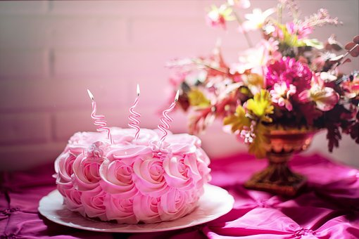
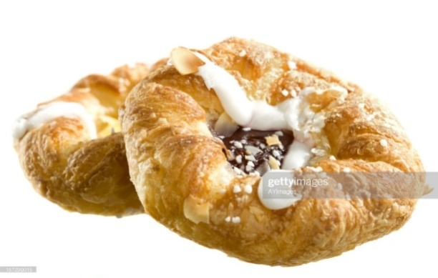
Module Title: Prepare and Produce Cakes
Module code: CSTBPP1 M10 1122
Nominal duration: 86 Hours

Prepared by: Ministry of Labor and Skill

November, 2022
Addis Ababa, Ethiopia

Contents
Acknowledgment 2
Introduction to the Module 3
Unit One: Prepare& produce cakes 4
1.1 Selecting suitable ingredients 5
1.2.Techniques of Cakes Making 16
1.3. Selecting required oven temperature 19
1.4. Preparing a variety of basic cake 22
Unit Two: Decorate and present cake 41
2.1. Decorate cakes 42
2.2. Presenting cakes 47
Unit Three: Store cakes 51
3.1. Store cakes products 52
REFERENCE 64

Acknowledgment
Ministry of Labor and Skills wish to extend thanks and appreciation to the many representatives of TVT instructors and respective industry experts who donated their time and expertise to the development of this Teaching, Training and Learning Materials (TTLM).

Introduction to the Module
Cake is a form of sweet dessert that is typically baked. In its oldest forms, cakes were modifications of breads, but cakes now cover a wide range of preparations that can be simple or elaborate, and that share features with other desserts such as pastries, meringues, custards, and pies. Typical cake ingredients are flour, sugar, eggs, butter or oil, a liquid, and leavening agents, such as baking soda and/or baking powder. Common additional ingredients and flavour include dried, candied, or fresh fruit, nuts, cocoa, and extracts such as vanilla, with numerous substitutions for the primary ingredients. Cakes can also be filled with fruit preserves or dessert sauces (like pastry cream), iced with butter cream or other icing, and decorated with marzipan, piped borders, or candied fruit. Cake is often served as a celebratory dish on ceremonial occasions, such as weddings, anniversaries, and birthdays. There are countless cake recipes; some are bread-like, some are rich and elaborate, and many are centuries old. Cake making is no longer a complicated procedure; while at one time considerable labor went into cake making (particularly the whisking of egg foams), baking equipment and directions have been simplified so that even the most amateur cook may bake a cake.

This module covers the units:
- Prepare& produce cakes
- Decorate and present cakes
- Store cakes
Training Objective of the Module
- Prepare and produce various cake products
- Present and display cake products
- Store cakeproducts
Module Instruction
For effective use this modules trainees are expected to follow the following module instruction:
- Read the information written in each unit
- Accomplish the Self-checks at the end of each unit
- Perform Operation Sheets which were provided at the end of units
- Do the “LAP test” given at the end of the unit and
- Read the identified reference book for Examples and exercise

Unit One: Prepare& produce cakes
This unit is developed to provide you the necessary information regarding the following content coverage and topics:
- Selecting suitable ingredients
- Techniques of Cakes Making
- Selecting required oven temperature
- Preparing a variety of basic cake
This unit will also assist you to attain the learning outcomes stated in the cover page.
Specifically, upon completion of this learning guide, you will be able to:
- Select suitable ingredients &equipment
- Apply Techniques of Cakes Making
- Select required oven temperature
- Prepare a variety of basic cakes

Introduction: - By definition, a cake is a ‘sweet baked ’product usually containing flour, sugar, eggs and fat. Other typical ingredients are flavouring agents, liquids and leavening or raising agents, such as baking powder or baking soda. Cake is a form of sweet dessert that is typically baked. In its oldest forms, cakes were modifications of breads, but cakes now cover a wide range of preparations that can be simple or elaborate, and that share features with other desserts such as pastries, meringues, custards, and pies.
This module is designed to meet the industry requirement under the bakery and pastry production occupational standard.

1.1 Selecting suitable ingredients
1.1.1 Selecting suitable ingredients
The following is a list of baking ingredients and a description of the function each performs in baked goods. While substitutions can be made, varying the proportions of ingredients in a recipe alters the texture and flavour of the finished product.
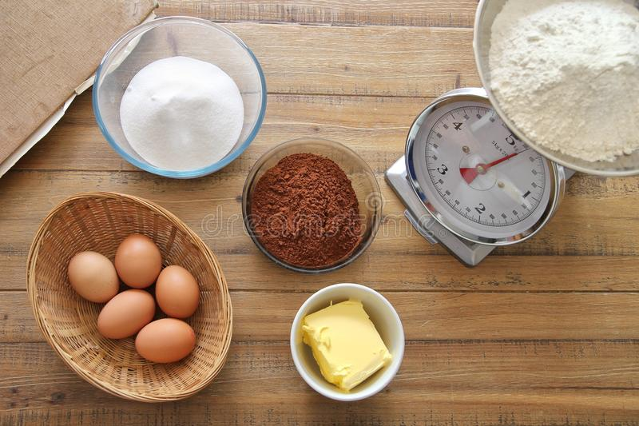

Fig1.1. Cake ingredient
- Flours. Flour provides the structure in baked goods. Wheat flour contains proteins that interact with each other when mixed with water, forming gluten. It is this elastic gluten framework which stretches to contain the expanding leavening gases during rising. The protein content of a flour affects the strength of a dough. The different wheat flour types contain varying amounts of the gluten forming proteins. Hard wheat, mainly grown in Midwestern U.S. has a high protein content. Soft wheat, grown in southern U.S. has less protein. In yeast breads, a strong gluten framework is desirable, but in cakes, quick breads and pastries, a high protein flour makes a tough product.

Bread flour.is a hard wheat flour with about 12 percent protein. Bread flour is used for yeast raised bread because the dough it produces has more gluten than dough made with other flours. Sufficient gluten produces a light loaf with good volume. Slices hold together, rather than crumble.
Cake flour.The lower gluten content causes products to have a tender, more crumbly texture that is desirable in cake.
All-purpose flour.is blended during milling to achieve a protein content of 10.5 percent. This medium protein flour can be used for all baking purposes. If using all-purpose flour in place of cake flour in a recipe, substitute 1 cup minus 2 tablespoons all-purpose flour for 1 cup cake flour.
Whole wheat flour. May be substituted for part of the white flour in yeast and quick bread recipes, but the volume of the finished product will be reduced. Whole wheat flour contains the nutritious germ and bran as well as the endosperm of the wheat kernel. Bran particles cut through the gluten during mixing and kneading of bread dough, resulting in a smaller, heavier loaf. If substituting a very coarsely ground whole wheat flour for all-purpose flour, use 1 cup plus 2 tablespoons whole wheat flour for every cup of all-purpose flour. To substitute whole wheat flour in a white bread recipe, use half whole wheat and half bread flour for the best results. Wheat germ, though not a flour, is often used in place of part of the flour in recipes for flavor and fiber. Protein, vitamins, minerals, and polyunsaturated fats are concentrated in the germ of grain kernels. Wheat germ, preferably toasted, can be used in place of up to 1/3 of the flour in a recipe. The following non-wheat grain products are often used in baked goods. They are rich in protein but most do not have the potential for developing gluten. For this reason, at least 1 cup of wheat flour should be used for every 1 cup of non-wheat flour so the product will not become too heavy.
Rye flour. Is often used in combination with wheat flour for bread. Light rye flour can be successfully substituted for 40 percent of wheat flour in a recipe without loss of volume.

Medium and dark rye flours should be limited to 30 percent and 20 percent, respectively, of the total flour amount.
Triticale flour.is a hybrid of wheat and rye. It has an average protein content higher than that of wheat flour. In yeast bread dough, triticale flour has better handling properties than rye flour because it will form gluten, but does not handle as well as wheat dough. For a good quality dough, ferment yeast dough made with triticale flour for a shorter period than wheat flour dough. Oat flour has a relatively high protein content, 17 percent, but does not form gluten.
Oat flour. Can be substituted for as much as 1/3 of wheat flour in bread.
Corn meal.is coarsely ground dried corn. Corn flour is more finely ground corn. Both corn flour and corn meal contain 7-8 percent protein on a dry basis. Neither corn meal nor corn flour will form gluten. A grainy texture in cornbread can be avoided by mixing the cornmeal with the liquid from the recipe, bringing to a boil, and cooling before mixing with the other ingredients.
Rice flour has about 6.5-7 protein and does not form gluten. For people who do not tolerate gluten, rice flour is an acceptable substitute for wheat, barley, rye or oat flours. In baked products, 7/8 cup of non-waxy rice flour can be used in place of 1 cup all-purpose wheat flour.
Potato starch flour, another non-gluten forming flour is usually used in combination with other flours. It has a mild potato taste. For substitutions, 5/8 cup of potato flour can be used for 1 cup of all-purpose flour. Soy flour contains 50 percent protein and is used primarily to boost the protein content of baked goods.
Soy flour cannot form gluten and does not contain starch. Its use in large amounts affects the taste of baked goods and causes them to brown quickly. An acceptable substitution is to take 2 tablespoons flour out of each cup of flour in a recipe and add 2 tablespoons soy flour.

B .SWEETENERS
- Sucrose, (table sugar) has many functions in food other than providing sweetness. In small amounts, added sugar helps yeast begin producing gas for raising yeast dough. Sugar in large amounts slows yeast fermentation; in a very sweet dough the rising time is longer. Sugar tenderizes dough and batter products and may help the baked product to brown. Moisture is retained better in sweetened breads than in unsweetened breads. It is the sugar in cookie dough that causes spreading to occur during baking. Reducing the amount of sugar by more than 1/3 can cause loss of tenderness, moisture, browning, and sweetness. The volume may increase in a bread recipe when sugar is reduced.
- Fructose in crystal form is nearly twice as sweet as sucrose and is more expensive. Fructose attracts more water than sugar, therefore, fructose sweetened

products tend to be moist. Baked products made with fructose will be darker than if they were made with sucrose. Honey is sweeter than sugar because it contains fructose.
- Honey has a distinctive flavour. When using honey in place of sugar, use 3/4 cup plus 1 tablespoon honey in place of 1 cup sugar and reduce the other liquid ingredients by 2 tablespoons. Even when liquid is reduced, a product that contains honey will be moist because the fructose absorbs moisture from the atmosphere. Too much honey may cause the product to become too brown.
- Molasses imparts a dark colour and strong flavour to baked foods. It is not as sweet as sugar. When using molasses in place of sugar, use 1-1/3 cups molasses for 1 cup sugar and reduce the amount of liquid in the recipe by 5 tablespoons. Because molasses is more acidic than sugar, it may be necessary to add 1/2 teaspoon baking soda for each cup of molasses used in substitution for sugar. Replace no more than 1/2 the sugar called for in the recipe with molasses. The following artificial sweeteners are available for home use. They provide sweetness to homemade foods but lack the browning, tenderizing, and moisture retaining properties provided by table sugar. Specially formulated recipes are often needed to make a product with acceptable texture and appearance when using artificial sweeteners. Because the different low-calorie sweeteners vary in sweetness and bulk, package directions must be followed for the amount to use in place of sugar.
- Saccharin is a heat stable non caloric sweetener that, in its pure form is 200-300 times as sweet as sucrose. Bulking agents are added to saccharin products to aid in measuring. Saccharin has a bitter aftertaste.
- Acesulfame K (Sweet OneSM) is a very low calorie sweetener that is 200 times as sweet as sucrose. It is heat stable so it can be used in baked goods. For improved texture in baked products, use acesulfame K in combination with granulated sugar. Acesulfame K reportedly has no unpleasant aftertaste.
C.SALT
Salt is used to enhance the flavours and sweetness of other ingredients in food. If salt is omitted or reduced, other spices or flavourings in the recipe should be increased slightly. In yeast dough, salt slows yeast fermentation. Omitting or reducing the amount of salt in yeast dough can cause the dough to rise too quickly, adversely affecting the shape and flavour of bread.
D.LEAVENING AGENTS
Baking Soda produces gas for leavening when combined with an acidic ingredient such as vinegar, lemon juice, or molasses. The volume of quick breads, cookies, cakes, and some candies depends largely on the amount of baking soda added to the batter or dough. Reducing the amount of baking soda without replacing it with another leavening agent will reduce the volume and lightness of the finished product.
Baking powder contains baking soda and the right amount of acid to react with it. Batters made with double acting baking powder rise twice; once when dry and moist ingredients are mixed together, and again when the product is baked.
Yeast is a living microorganism until it is destroyed by heat. As yeast grows and multiplies it gives off carbon dioxide which causes the dough to rise. Its action is affected by the addition or deletion of other ingredients such as salt and sugar. Using less yeast than specified in a recipe causes the dough to take longer to reach the desired volume in the rising stages.
Fat, in the form of solid shortening, margarine, or butter; or in the liquid form of oil contributes tenderness, moistness, and a smooth mouth feel to baked goods. Fats enhance the flavours of other ingredients as well as contributing its own flavor, as in the case of butter. In baked goods such as muffins, reducing the amount of fat in a recipe results in a tougher product because gluten develops more freely. Another tenderizing agent such as sugar can be added or increased to tenderize in place of the fat. A small amount of fat in a yeast dough helps the gluten to stretch, yielding a loaf with greater volume.
Shortening: Shortening is 100 percent fat and is solid at room temperature. It is often made of hydrogenated (solidified by adding hydrogen) vegetable oils, but sometimes contains animal fats. The flakiness of pastry comes from solid fat such as shortening or lard rolled in layers with flour. In some recipes for cookies or cake, shortening is creamed with sugar to trap air. A lighter product will result. There are emulsifiers in shortening to help emulsify shortening and liquid. This means that oil and water stay mixed together, creating an even distribution of flavors and a consistent texture in batters and dough. Butter is made from cream and has a fat content of at least 80 percent. The remaining 20 percent is water with some milk solids.
Butter imparts a good flavor without a greasy mouth feel to baked goods because it melts at body temperature.
Margarine is made from fat or oil that is partially hydrogenated, water, milk solids, and salt. Vitamins and coloring are usually added also. The fat or oil can be of animal or vegetable origin. Margarine has the same ratio of fat to non-fat ingredients as butter (80:20), and can be used interchangeably with butter.
Reduced fat substitutes have less than 80 percent fat. These do not work the same as butter or margarine in baked goods, though some specially formulated recipes can be found on the packages of these products. Fat free margarines also are available and contain no fat. These margarines are best used as spreads.

Oil is used in some muffin, bread and cake recipes. Oil pastry is mealy rather than flaky. To substitute oil for butter or margarine, use 7/8 cup oil for 1 cup butter or margarine. If oil is used in place of a solid fat for some cake recipes, the texture will be heavier unless the sugar and egg are increased.
- EGGS
Eggs serve many functions in baked goods. They add flavour and colour, contribute to structure, incorporate air when beaten, provide liquid, fat, and protein, and emulsify fat with liquid ingredients. Reducing or omitting egg yolks can result in less tenderness. Reducing or omitting egg whites can result in less volume. Cakes made without the emulsifying action from the egg yolk may not have a uniform flavour and texture. If a low fat, low cholesterol baked product is desired, use 2 egg whites for 1 whole egg; the white has very little fat or cholesterol. When a recipe calls for an egg, the best size to use is a 2 oz. Grade A large egg.
- LIQUIDS
Liquids are necessary in baked goods for hydrating protein, starch and leavening agents. When hydration occurs, water is absorbed and the chemical changes necessary for structure and texture development can take place. Liquids contribute moistness to the texture and improve the mouth feel of baked products.
- Water vaporizes in a batter or dough, the steam expands the air cells, increasing the final volume of the product.
- Milk contributes water and valuable nutrients to baked goods. It helps browning to occur and adds flavor. When making yeast dough, milk should be scalded and cooled before adding to other ingredients. This is done to improve the quality of the dough and the volume of the bread.
- Juice may be used as the liquid in a recipe. Because fruit juices are acidic, they are probably best used in baked products that have baking soda as an ingredient.
    - Select equipment
- Select& use appropriate equipment safely
Equipment ---
- Bowl :
- Sieve
- Rolling pin
- Cooling rack
- pastry brush
- Whisker
- baking sheet
- Measuring scale & measuring jug,etc.
- piping bag
- spatula

Table 1.1 cake equipment
No. | Name of tools &equipment | Picture | Description
1. | Bowl | 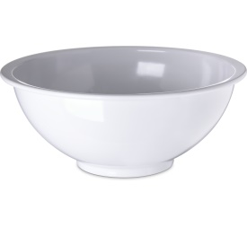 | A mixing bowl is a bowl used for mixing of ingredients.
2. | Sieve | 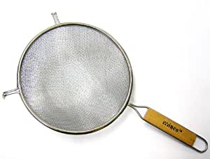 | A sifter is used for breaking up lumps of food/flour into smaller pieces.
3. | Rolling pin | 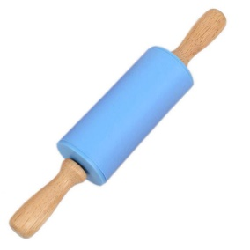 | A rolling pin is a cylindrical food preparation utensil used to shape and flatten dough.

4. | Cooling rack | 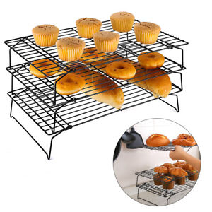 | A cooling rack (also known simply as a wire rack) is used to allow air to circulate freely to cool baked goods, and to prevent them getting soggy from condensation
5. | brush | 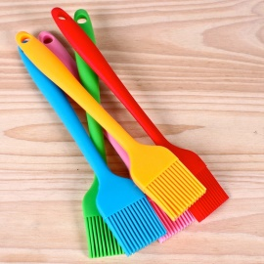 | A brush is a small brush that is used to greasebaking sheet before transfer the dough
6. | Whisker | 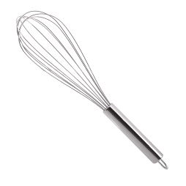 | Whisks are used to either add air into a mixture or thoroughly blend ingredients together.
7. | baking sheet | 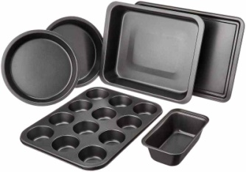 | A sheet pan, baking tray or baking sheet is a flat, rectangular metal pan used in an oven. It is often used for baking bread rolls, pastries and flat products such as cookies, sheet cakes, Swiss rolls and pizzas.
8. | Measuring scale | 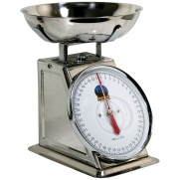  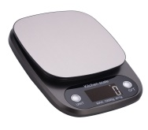 | A baking scale, also known as a catering scale, is a weighing machine used by bakers and caterers for measuring food ingredients. There are many types of baking scale on the market, from digital kitchen or cooking scales for personal use to commercial catering
9. | measuring jug | 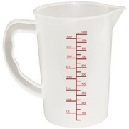 | it’s used to measure things  It is a jug with graduated measurements printed on the sides.
10. | Measuring cups | 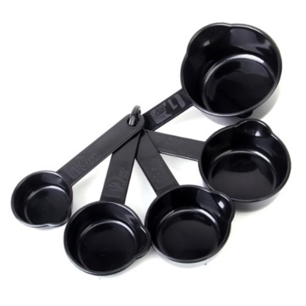 | Measuring cups are a cup like tool to measure ingredients. Generally consists of scale markings at varying heights.
11. | Measuring spoon | 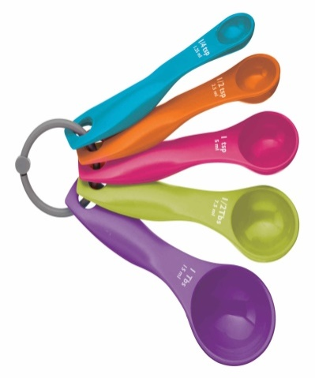 | Measuring spoons are spoons that measure small amounts of wet and dry ingredients. Most measuring spoons come in sets of four or six. A set of four measuring spoons includes ¼ teaspoon, ½ teaspoon, 1 teaspoon, and 1 tablespoon sizes. A set of six measuring spoons usually includes ⅛ teaspoon, ¼ teaspoon, ½ teaspoon, 1 teaspoon, ½ tablespoon, and 1 tablespoon sizes.
12 | spatula | 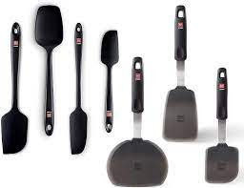 | a kitchen utensil you can use to mix, scrape, flip, or spread ingredients
13 | Piping bag | 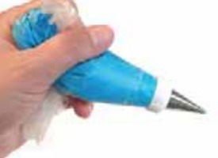 | Used to push out soft mixtures such as cream, icing or mashed potato into attractive shapes.

- Cake Baking Equipment
Apart from the basic tools, you must acquire the following cake baking equipment.
- Ovens
The tool which is the heart of cake baking. However, you can choose one of the following kind.
- Convection Oven
It is one of the run-of-the-mill types of commercial bakery equipment. That is, convection ovens do a great job as they can quickly and evenly bake a range of products, from bread to cookies to cakes, pies, and brownies. Also, they are less expensive.
- Deck Oven
On the other hand, if you are thinking of artisan or specific style baking business, you can prefer a deck oven. It has stone cooking decks that heat up and give the crust a distinctive, crispy character. Also, they’ll aid you to maintain a soft and moist inside. But it takes up a comparatively large space.
- Roll-in Rack Oven
In it, you can rotate a pan rack full of goods right into the oven for baking. Moreover, some models will grab the pan rack and wheel them during the baking process for consistent results. The benefit of this style is time and labor savings, as there is less product handling.
It has large revolving trays with which you can load the products. Additionally, the revolving oven has a very high capacity and output capability but also quite expensive.
- Commercial Mixer
Commercial planetary mixers have a dizzying variety of sizes, from small 5 qt countertop models to 100+ qt floor units. Most medium to large size bakeries will have several large floor units. However, you also might get benefit from the portable nature of a countertop unit, with which it can mix up small batches of icing or fillings quickly and easily.
- Cake Dividers and Cutters
To get the perfect slice every time, you need a specialty cake dividers or markers for your commercial kitchen. These bakery utensils are made from durable stainless steel and great for evenly cutting pies, cheesecakes, cakes, and more. Whether you’re cutting directly for the plate or stocking your bakery’s display case, these are a must-have for even slices. Also, you can reserve levelers for making layered cakes or filled cakes, cutters with varying portions for slim to generous slices.
- Holding/Proofing
For assuring consistent results and maintaining baking schedules, proofing equipment is used. It handles the speed and qualities of fermentation. In short, dough proofer is a warming chamber used in baking that encourages fermentation of dough by yeast through warm temperatures and controlled humidity. As a result, the high temperatures increase the activity of the yeast, resulting in increased carbon dioxide production and a higher, faster rise.
- Infrared Temperature Gun
You know what? Measuring the perfect temperature is the most crucial task for making the best cake. Any ups and downs in temperature, your cake can be ruined completely!
For this, the infrared temperature gun is a great tool to measure the temperature of baked food, boiling sugar melted chocolate, etc. without having to penetrate them or even making any contact at all. With the help of it, you can be more precise in measuring temperature.

Techniques of Cakes Making

Preparation techniques
Cake making methods
There are five main methods of cake making:
• Rubbing–in
• Melting
• Creaming
• Whisking
• ‘All in one’ - same proportions as the creaming method
Each method produces products that have a different texture. The different proportion of ingredients used will determine the texture and taste of the cake product. The amount of fat in the cake product will determine how long the cake will stay fresh – without drying out. Cakes cannot be made successfully with low fat spreads; this is because they contain a higher proportion of water.

Table 1.2. Preparation techniques
Method of making | Example | Ratio of fat to flour | Raising agent Basic Recipe | Raising agent Basic Recipe
Creaming | Victoria Sandwich Fairy Cakes | 1:1 | Self – raising flour | 100g SR Flour 100g fat 100g sugar 2eggs
All in one | Victoria Sandwich Fairy Cakes | 1:1 | Self-raising flour Baking powder | 100g SR Flour 100g fat 100g sugar 2eggs 2tsps baking powder
Whisking | Swiss roll Fruit flan Gateaux | No added fat | Air Steam | 50g Plain flour 50g sugar 2 eggs
Rubbing in | Fruit cake Scones Welsh cakes | 1:2 in cakes 1:4 in scones | Self-raising flour | Cakes 200g SR Flour 100g fat 100g sugar 2eggs 50ml milk Scones 200g SR Flour 50g fat (margarine or butter) 125ml milk
Melting | Gingerbread Parkin Chocolate Brownie | Depends on individual recipe | Bicarbonate of soda (in gingerbread) | Varies depending on the product

- Rubbing in Method
  - Air is trapped in sieving the flour and by lightly (with finger tips) rubbing the fat in to the flour.
  - arising agents in the flour help the cake to rise

- Melting
- Fat and sugar ingredients are melted in a saucepan
- Texture tends to be much heavier than other cakes and won’t rise much
Bicarbonate of soda can be used to create a lighter texture Fruit Cake Scones Welsh Cakes Examples of cakes made using the rubbing in method
Examples of cakes made with the melting method Chocolate Brownies Gingerbread/ Parkin
- Creaming
- Air is trapped by creaming the sugar and fat together
- This give a lighter texture
Examples of cakes made using the Creaming method of cake making Victoria sponge Chocolate Victoria Sponge Fairy Cakes
- Whisking Method
- Eggs and sugar whisked together to trap air (aerate)
Examples of cakes made using the Whisking method of cake making Chocolate / Vanilla Swiss Roll and Sponge Flan
- All in one method
Example:Fairy Cakes Victoria Sandwich

youcan add value to cakes to change:-
• The flavour
• The texture
• The colour
Techniques of cake making
General rules in baking
1. Always sieve flour & icing sugar before use
2. Wash your hand before any mixture.
3. Always work on clean & dry surface
4. Always keep clean napkins close while you are working
5. Wash all instruments used and dry them
Techniques and conditions for producing cakes may include:
- weighing or measuring and sifting dry ingredients
- adding fats and liquids to dry ingredients
- stirring and aerating to achieve required consistency and texture
- selecting and preparing appropriate cake tins and moulds
- using required amount of batter according to desired characteristics of finished products
- preparing and using appropriate pre-bake finishes and decorations
- selecting baking conditions and temperatures

1.3.Selecting required oven temperature
The recommended temperature& time for cakes& other dishes are given in table below
Baking Temperatures and Times

Table 1.3.

 | Temp (F/C) | Minutes
Breads
Biscuits | 425 - 450 F  218 - 232 C | 10 - 15
Cream Puffs | 375 F  190 C | 60
Popovers | 375 F  190 C | 60
Quick Loaf Breads | 350 - 375 F  177 - 190 C | 60 - 75
Yeast Bread | 400 F  205 C | 30 - 40
Yeast Rolls
Plain | 400 - 425 F  205 - 218 C | 15 - 25
Sweet | 375 F  190 C | 20 - 30
Cakes With Fat
Cupcake | 350 - 375 F  177 - 190 C | 15 - 25
Layer Cake | 350 - 375 F  177 - 190 C | 20 - 35
Loaf Cake | 350 F  177 C | 45 - 60
Cakes Without Fat
Angel Food & Sponge | 350 F  177 C | 50 - 60
Cookies
Drop | 350 - 400 F  177 - 205 C | 8 - 15
Rolled | 375 F  190 C | 8 - 10

Egg, Meat, Milk & Cheese
Souffle (in a hote water pan) | 350 F  177 C | 30 - 60
Custard (in a hot water pan) | 350 F  177 C | 30 - 60
Macaroni & Cheese | 350 F  177 C | 20 - 30
Meat Loaf | 350 F  177 C | 60 - 90
Meat Pie | 400 F  205 C | 25 - 30
Rice Pudding (raw rice) | 300 F  149 C | 120 - 180
Scalloped Potatoes | 350 F  177 C | 60
Pastry
1 Crust Pie (Custard Type) | 400 - 425 F  205 - 218 C | 30 - 40
Shell Only | 450 F  232 C | 10 - 12
2 Crust Pies with Uncooked Filling | 400 - 425 F  205 - 218 C | 45 - 55
2 Crust Pies with Cooked Filling | 425 - 450 F  218 - 232 C | 30 - 45

1.4. Preparing a variety of basic cake
Cakes
Definition:a cake is a ‘sweet baked’ product usually containing flour, sugar, eggs and fat. Other typical ingredients are flavouring agents, liquids and leavening or raising agents, such as baking powder or baking soda.
A Cake is a sweet baked food made from flour, oil, eggs, and sugar and flavoring agents. A batter made with these ingredients is put in the oven to turn into a fluffy, baked bread-like food. The surface is either plain or decorated with frostings, icings, fruits, fondant and other elements. The inside of the cake comes with fillings like a fruit compote, caramel, ganache, whipped cream etc., for a rich taste.
History of Cakes:
The history of cakes is beyond fascinating! The word “Cake” comes from the Old Norse word “Kaka”, which means a small cake or a cookie. The Greeks and Romans had their own version of cakes made with eggs, milk, honey and nuts. In mid-17th century Europe, the cake got a real ‘facelift’ that closely resembles the cakes we eat now.
What are the Classification of Cakes with Examples?
Cakes are classified into three main categories –
A. Shortened,
B. Un-shortened and
C. Chiffon.
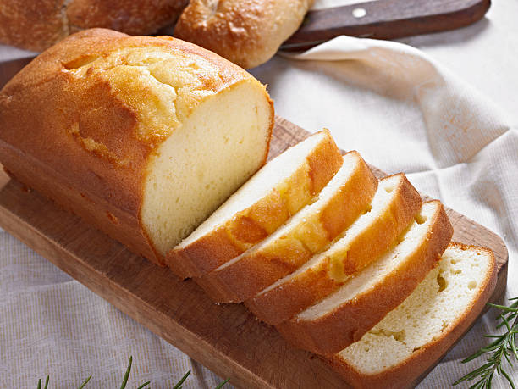
Let us now understand the differences between each:
- Shortened Cakes: These are conventional or standard birthday or wedding cakes that are quite moist and fluffy due to the addition of fats like butter or oil. Almost all shortened cakes go through the creaming method, which involves blending fats with sugar for a better rise.
Examples: Buttercream Cakes, Instant Cake Mixes, Pound Cakes
Fig.1.2. pound cake

- Unshortened Cakes:
These types of cakes contain higher amounts of foamed eggs or egg whites than fats like butter or oil. They are also called Foam cakes or Sponges. The egg is a key ingredient in these cakes whose proteins create the structure. The textures can range from spongy, dense to dry and crisp, depending on the variant.
Examples: Sponge Cake, Angel Food cake

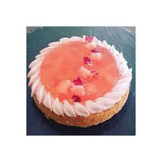

- Chiffon Cakes:

Chiffon cakes fall in between shortened and unshortened cakes. They contain both oils and eggs to create a moist and fluffy cake. The crucial part of a chiffon cake lies in beating the whites to stiff peaks and folding them into the cake batter instead of adding them whole. Butter is not an element in chiffon cakes, and hence the rich, buttery flavor goes missing in them!
Examples: Chocolate Chiffon Cake, Orange Chiffon Cake etc.

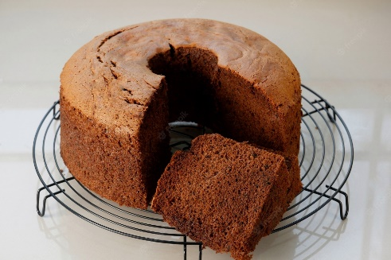

Fig.1.4 chocolate chiffon cake

Characteristics of cakes:
A good cake has the following characteristics;
- Appearance Thin, golden-brown crust. Uniform crumb color.
- Texture. Light in weight in proportion to.
- Tenderness Moist. Soft crust and crumb.

- Flavor. Pleasant, well blended

difference between cupcakes and muffins
Texture:
1. Cupcakes have a lighter and fluffier texture than muffins. While cupcake batters are soft and smooth, muffin batters are thicker, resulting in a denser texture, similar to bread.
2. The only two differences between cake and cupcakes: the type of pan you use to bake and the amount of time they spend in the oven. We're giving you all the details so that the next time you only have a box of cake mix, you'll know how to convert the recipe into cupcakes that are just as tasty.

Four Tips for Making a Swiss Roll;
It takes a bit of technique to achieve the signature swirl of a Swiss roll.
I. Prep the pan to keep the cake from sticking. Since a jelly roll pan has a large surface area, one danger is that the cake might stick to the center of the pan. To prevent this, line the pan with parchment paper and grease it with butter or cooking spray before pouring in the batter.
II. Cool the cake carefully. There are two methods for cooling a Swiss roll, and neither involves a wire rack. For the kitchen towel method, invert the pan to release the freshly baked cake, and roll it up in a clean tea towel while it's still warm. Once it cools, carefully unroll the cake and spread filling across it evenly before rolling it back up. The other method involves gently steaming the cake to soften it. As soon as the cake comes out of the oven, cover it with aluminium foil. This will trap moisture inside the pan, gently steaming the cake to make it more pliable. You can then assemble the cake directly in the pan.
III. Use all-purpose flour. A crack-free cake starts with a great cake batter. While some recipes recommend using cake flour (a low-gluten flour) for the tenderest sponge, all-purpose flour will yield a sturdier cake that's less likely to break when rolling.
Iv. Choose a filling with the right consistency. Jam is a classic filling, but it needs to be the right kind of jam. If it’s too runny, the jam will soak into the cake. If it’s too thick or chunky, the jam won't spread evenly. Buttercream and whipped cream fillings are a little easier to work with, but you'll have to be extra gentle when assembling the cake.

Basic cakes may include:
- English cake
- muffin
- Marble cake
- Banana cake
- Orange cake
- Fruit cake
- cup cake
- Madeira cake
- Genoese sponge
- basic aerated sponge
- Swiss roll
- Chiffon cake

COMMON TERMINOLOGIES IN BAKIN
- Pastry: is a mixture of fat, flour, sugar and liquid
- Knead: means softening of pastry by gently pressing with rolling pin.
- Creaming: is mixing fat and sugar together as in cakes.
- Flaking: is pressing together the edge of a pastry as in meat pie/sausage roll
- Glazing: is brushing the top of a pastry with egg before baking as in meat pie/sausage
- Batter: mixture of flour & liquid e.g. water, milk and egg.
- Raising agent: baking powder, yeast.
- Dough: is the pastry after mixture.
- Rolling: spreading the dough on a floured table using rolling pin
- Piping: putting finishing touch to iced cakes

SELF-CHECK 1 | WRITTEN EXAM

Answer the following questions:
PART I Say true or false
1. The recommended baking temperature of loaf cake is 210c.
2. A Cake is a sweet baked food made from flour, oil, eggs and sugar and flavoring agents.
PART II Multiple choice
3. ----are used to either add air into a mixture or thoroughly blend ingredients together.
A. Whisker C. Tong
B. Bowl D. Oven
4. Which one is the preparation techniques of cake?
A. Creaming C. Whisking
B. Melting D. All
5. Which is not the characteristics of a good cake?
A. Appearance C. Texture
B. Flavor D. Sunk
PART III Write a short answer
- Compare& contrast the three main categories of cake
- List at least 5 kinds of cake available in local market.
- Brief at least 3 tools& equipment’s used in cake baking& its function.

Operation sheet 1. Prepare and produce variety cakes
Operation Title:Producing a
Purpose: to perform cake production
Conditions or situations for the operations:
- Safe working area
- Properly operated tools and equipment
- Appropriate working uniforms fit for the practical performance
Equipment Tools and Materials:
-Mixer - scale - 100g flour
- Oven - bowl - 100g sugar
- Scraper - 50g butter, etc.
-baking pan -4 egg
-Whisker
Cooling rack
Quality Criteria: Assured performing of all the activities according to the procedures
Steps in doing the task
Preparation
1. Whisk the eggs and sugar with a balloon whisk in a bowl over a pan of hot water
2. Continue until the mixture is light, creamy, and double in bulk
3. Remove from the heat whisk until cold and thick (ribbon stage)
4. Fold in the flour very gently
5. Fold in the melted butter very gently
6. Place in a greased, floured Genoese mould
7. Bake in a moderately hot oven 200-degree c for 25min. Fig.1.5.Genoese sponge

Operation sheet 2. Prepare and produce variety cakes
Operation Title:Producing Orange cake
Purpose: to perform cake production
Conditions or situations for the operations:
- Safe working area
- Properly operated tools and equipment
- Appropriate working uniforms fit for the practical performance
Equipment Tools and
- Oven - scale - Whisker
- Bowl --Cooling rack
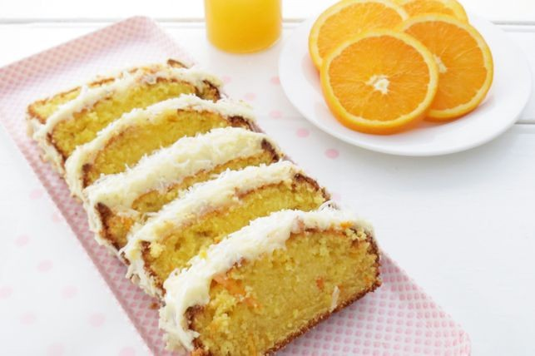
- Scraper
-baking pan

Material
125g butter, softened
1/4 cup milk
1/4 cup orange juice
2 eggs
3/4 cup caster sugar
1 1/2 cups self-raising flour sifted
1 tbs orange zest, finely grated

Orange icing Fig.1.6. Orange cake
1/3 cup butter softened
1 1/2 cups icing sugar sifted
2 tbs orange juice *to taste
1/2 tsp orange zest, finely grated

Quality Criteria: Assured performing of all the activities according to the procedures
Steps in doing the task
Method

1. Combine all cake ingredients and beat thoroughly for 3 minutes.
2. Pour mixture into a greased 20cm x 10cm loaf or 20cm ring tin.
3. Bake in the center of a 180C oven for 30-40 minutes.
4. Turn onto a wire rack and allow to cool.
5. Mix orange icing ingredients together in a bowl, then ice cake.

Operation sheet 3. Prepare and produce variety cakes
Operation Title:Producing banana cake
Purpose: to perform cake production
Conditions or situations for the operations:
- Safe working area
- Properly operated tools and equipment
- Appropriate working uniforms fit for the practical performance
Equipment Tools and
- Oven - bowl - scale
-Mixer - Scraper-Whisker
-Cooling rack -baking pan
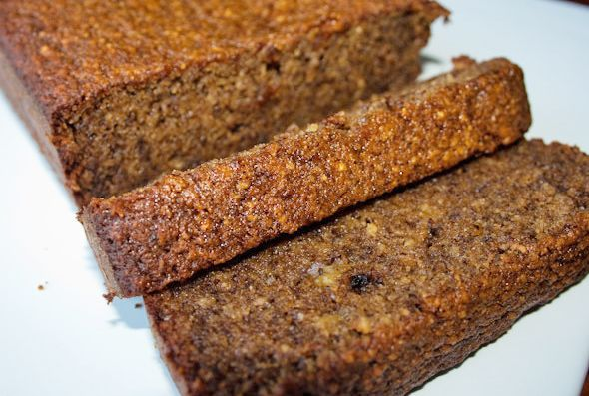
Materials:
3/4 cup caster sugar
1 tsp vanilla essence
1 egg
2 bananas mashed ripe
1 1/2 cups self-raising flour
1/4 cup milk

Fig.1.7. banana cake

Quality Criteria: Assured performing of all the activities according to the procedures
Steps in doing the task
1. Melt the butter, sugar and vanilla in a medium-sized saucepan.
2. Remove from the heat.
3. Add mashed bananas and stir through until just combined.
4. Add egg and mix well. Stir in the flour, then pour in the milk and fold in lightly.
5. Bake at 170C for approximately 40 minutes.

Operation sheet 4. Prepare and produce variety cakes

Operation Title:Producing muffin cake

Purpose: to perform cake production
Conditions or situations for the operations:
- Safe working area
- Properly operated tools and equipment
- Appropriate working uniforms fit for the practical performance
Equipment Tools and
-Mixer - scale
- Oven - bowl
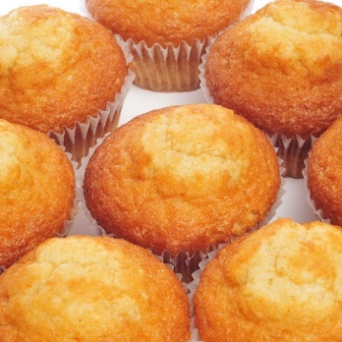
- Scraper
-baking pan
-Whisker
Cooling rack
Materials: making 12 muffin
2 cups white flour
1 tablespoon baking powder
½ teaspoon saltFig. 1.8.muffin cake
2 tablespoons sugar
1 egg, slightly beaten
1 cup milk
¼ cup melted butter
Quality Criteria: Assured performing of all the activities according to the procedures
Steps in doing the task
Step 1
Preheat the oven to 375°F. Butter muffin pans. Mix the flour, baking powder, salt, and sugar in a large bowl. Add the egg, milk, and butter, stirring only enough to dampen the flour; the

batter should not be smooth. Spoon into the muffin pans, filling each cup about two-thirds full. Bake for about 20 to 25 minutes each.
Step 2------ Blueberry Muffins
Use ½ cup sugar. Reserve ¼ cup of the flour, sprinkle it over 1 cup blueberries, and stir them into the batter last.
Step 3--- Pecan Muffins
Use ¼ cup sugar. Add ½ cup chopped pecans to the batter. After filling the cups, sprinkle with sugar, cinnamon, and more chopped nuts.
Whole-Wheat Muffins
Step 4
Use ¾ cup whole-wheat flour and 1 cup white flour.
Date or Raisin Muffins
Step 5
Add ½ cup chopped pitted dates or ⅓ cup raisins to the batter.
Bacon Muffins
Step 6
Add 3 strips bacon, fried crisp and crumbled, to the batter.

Operation sheet 5. Prepare and produce variety cakes
Operation Title:Producing Madeira cake
Purpose: to perform cake production
Conditions or situations for the operations:
- Safe working area
- Properly operated tools and equipment
- Appropriate working uniforms fit for the practical performance
Equipment Tools and
- scale
- Oven - bowl
- Scraper
-baking pan
-Whisker
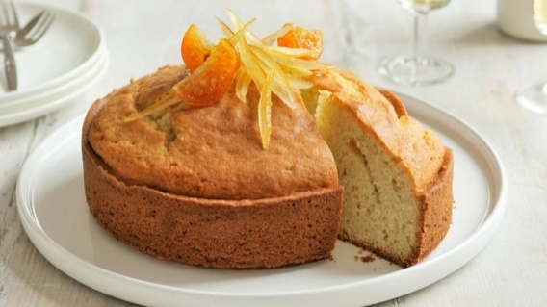
-Cooling rack
Materials:
Ingredients
175g/6oz butter, at room temperature
175g/6oz caster sugar
3 free-range eggs
250g/9oz self-raising flour
2-3 tbsp milk Fig.1.9. Madeira cake
1 lemon, zest only
1-2 thin pieces of candied citron or lemon peel, to decorate

Quality Criteria: Assured performing of all the activities according to the procedures
Steps in doing the task
- Pre-heat the oven to 180C/350F/Gas 4. Grease an 18cm/7in round cake tin, line the base with greaseproof paper and grease the paper.

- Cream the butter and sugar together in a bowl until pale and fluffy. Beat in the eggs, one at a time, beating the mixture well between each one and adding a tablespoon of the flour with the last egg to prevent the mixture curdling.
- Sift the flour and gently fold in, with enough milk to give a mixture that falls slowly from the spoon. Fold in the lemon zest.
- Spoon the mixture into the prepared tin and lightly level the top. Bake on the middle shelf of the oven for 30-40 minutes, or until golden-brown on top and a skewer inserted into the centre comes out clean.
- Remove from the oven and set aside to cool in the tin for 10 minutes, then turn it out on to a wire rack and leave to cool completely.
- To serve, decorate the cake with the candied peel.

Operation sheet 6. Prepare and produce variety cakes
Operation Title:Producing chiffon cake
Purpose: to perform cake production
Conditions or situations for the operations:
- Safe working area
- Properly operated tools and equipment
- Appropriate working uniforms fit for the practical performance
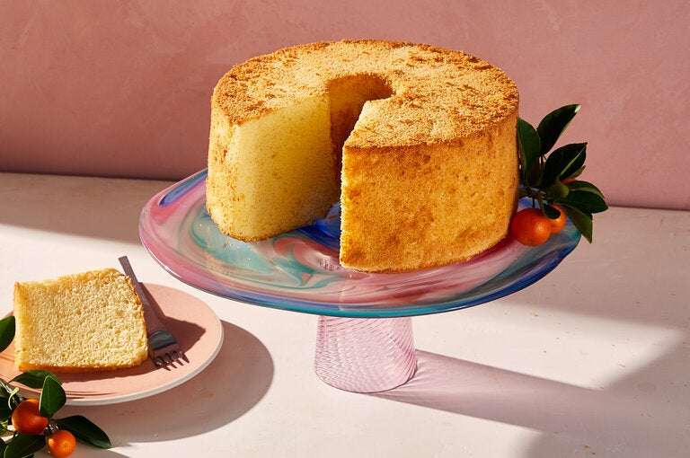
Equipment Tools and
- Oven - scale -baking pan
- Bowl -Whisker
- Scraper - Cooling rack
- Baking sheet - measuring cups& spoons
Materials:
Ingredients Fig.1.10. Chiffon cake
2 cups sifted cake flour
1 ½ cups white sugar
1 tablespoon baking powder
1 teaspoon salt
7 large eggs, separated, divided
¾ cup cold water
½ cup vegetable oil
2 teaspoons vanilla extract
1 teaspoon lemon extract
½ teaspoon cream of tartar
- Meringue. (An item of sweet food made by baking a mixture of stiffly beaten egg whites and sugar until crisp.)

Quality Criteria: Assured performing of all the activities according to the procedures
Steps in doing the task
Directions
1. Preheat the oven to 325 degrees F (165 degrees C). Wash a 10-inch angel food tube pan in hot soapy water to ensure it is grease-free; dry well.
2. Measure flour, sugar, baking powder, and salt into a sifter; sift into a bowl. Make a well; add egg yolks, water, oil, vanilla extract, and lemon extract to the well in the order listed. Do not beat.
3. Beat egg whites and cream of tartar in a large bowl until very stiff.
4. Using the same beaters, beat egg yolk batter until smooth and light; pour slowly over egg whites. Gently fold mixtures together with a rubber spatula; do not stir. Pour batter into the angel food tube pan.
5. Bake cake in the preheated oven for 55 minutes. Increase heat to 350 degrees F (175 degrees C) and continue baking until a toothpick inserted into the center comes out clean, 10 to 15 more minutes.
6. Invert the pan onto a wire rack. Let cool completely before unmolding and frosting as desired.

Operation sheet 7. Prepare and produce variety cakes
Operation Title:Producing black forest cake
Purpose: to perform cake Materials: production
Conditions or situations for the operations:
- Safe working area
- Properly operated tools and equipment
- Appropriate working uniforms fit for the practical performance
Equipment Tools and
- Oven - scale -Whisker -Baking pan
- Bowl -Cooling rack
- Scraper - piping bag
Materials:
Ingredients
Cake:
2 ⅛ cups all-purpose flour
2 cups white sugar
¾ cup unsweetened cocoa powder
1 ½ teaspoons baking powder
¾ teaspoon baking soda
¾ teaspoon salt
3 eggs
1 cup milk
½ cup vegetable oil
1 tablespoon vanilla extract
Topping:
2 (20 ounce) cans pitted sour cherries
1 cup white sugar
¼ cup cornstarch
1 teaspoon vanilla extract
Frosting:

3 cups heavy whipping cream
⅓ Cup confectioners' sugar
Quality Criteria: Assured performing of all the activities according to the procedures
Steps in doing the task
Directions
1. Preheat the oven to 350 degrees F (175 degrees C). Grease and flour two 9-inch round cake pans; line bottoms with parchment paper. Place a medium bowl in the refrigerator to chill.
2. Whisk flour, sugar, cocoa, baking powder, baking soda, and salt together in a large bowl. Add eggs, milk, oil, and vanilla; beat until combined. Pour cake batter into the prepared pans.
3. Bake in the preheated oven until a toothpick inserted in the centers comes out clean, about 35 minutes. Cool layers in pans on wire racks for 10 minutes. Run a paring knife around edges to loosen and invert carefully onto racks to cool completely, 1 to 2 hours.
4. While cake layers bake, drain cherries for topping, reserving 1/2 cup juice. Combine reserved juice, cherries, sugar, and cornstarch in a 2-quart saucepan. Cook, stirring constantly, over low heat until thickened. Stir in vanilla. Let cool at room temperature for 30 minutes. Transfer to the refrigerator to cool completely before assembling cake.
5. Combine whipping cream and confectioners' sugar for frosting in the chilled medium bowl. Beat with an electric mixer at high speed until stiff peaks form.
6. Split each cake layer in half horizontally using a long serrated knife. Tear one layer into crumbs; set aside. Gently brush loose crumbs off top and sides of remaining layers using a pastry brush or your hands. Reserve 1 1/2 cups frosting for piping decorations on cake; set aside.
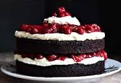
7. To assemble, place one cake layer on a cake plate. Spread with 1 cup frosting; top with 3/4 cup cherry topping. Top with second cake layer; repeat layers of frosting and cherry topping. Top with third cake layer and frost sides of cake.
8. Pat reserved cake crumbs onto sides of cake. Spoon reserved 1 1/2 cups frosting into a pastry bag fitted with a star decorator tip. Pipe around top and bottom edges of cake. Spoon remaining cherry
9. Topping on top of cake.
Store covered in the refrigerator until ready to serve.

Fig.1.11. black forest
Operation sheet 8. Prepare and produce variety cakes

Operation Title:Producing carrot cake
Purpose: to perform cake production
Conditions or situations for the operations:
- Safe working area
- Properly operated tools and equipment
- Appropriate working uniforms fit for the practical performance
Equipment Tools and
- Scale-Cooling rack
- Oven - bowl - Whisker
- Scraper -Baking pan
Materials:
Ingredient
230ml vegetable oil, plus extra for the tin
100g natural yogurt
4 large eggs
1½ tsp vanilla extract
½ orange, zested
265g self-raising flour
335g sugar
2½ tsp ground cinnamon
¼ fresh nutmeg, finely grated
265g carrots (about 3), grated
100g sultanas or raisins
100g walnuts or pecans, roughly chopped (optional)
For the icing
100g slightly salted butter, softened

300g icing sugar
100g soft cheese
Quality Criteria: Assured performing of all the activities according to the procedures
Steps in doing the task
Method
STEP 1. Heat the oven to 180C/160C fan/gas 4. Oil and line the base and sides of two 20cm cake tins with baking parchment. Whisk the oil, yogurt, eggs, vanilla and zest in a jug. Mix the flour, sugar, cinnamon and nutmeg with a good pinch of salt in a bowl. Squeeze any lumps of sugar through your fingers, shaking the bowl a few times to bring the lumps to the surface.
STEP 2Add the wet ingredients to the dry, along with the carrots, raisins and half the nuts, if using. Mix well to combine, then divide between the tins.
STEP 3Bake for 25-30 min or until a skewer inserted into the centre of the cake comes out clean. If any wet mixture clings to the skewer, return to the oven for 5 min, then check again. Leave to cool in the tins.
STEP 4. To make the icing, beat the butter and sugar together until smooth. Add half the soft cheese and beat again, then add the rest (adding it bit by bit prevents the icing from splitting). Remove the cakes from the tins and sandwich together with half the icing. Top with the remaining icing and scatter with the remaining walnuts. Will keep in the fridge for up to five days. Best eaten at room temperature.

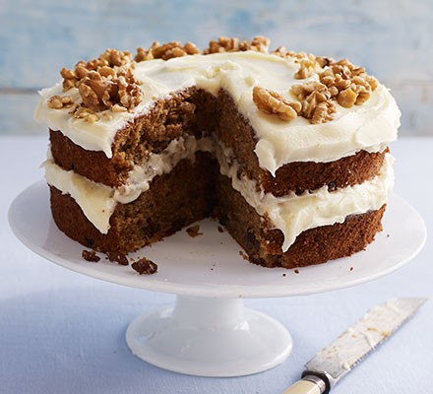

Fig.1.11. carrot cake

Lap test 1:
Instructions: Given necessary templates, tools and materials you are required to perform the following tasks accordingly.
Task 1: pre heat the oven
Task 2: prepare the necessary equipment&ingredients
Task 3:beat the sugar& egg
Task 4:combine dry ingredients
Task 5: combine liquid ingredient
Task 6: combine the egg& liquid mixture.
Task 7: fold with dry ingredients
Task 8:pour cake dough to grease cake pan
Task 9: bake & cool

Unit Two: Decorate and present cake
This unit is developed to provide you the necessary information regarding the following content coverage and topics:
- Decorating cakes
- Presenting cakes
This guide will also assist you to attain the learning outcomes stated in the cover page. Specifically, upon completion of this learning guide, you will be able to:
  - Decorate cakes
  - Present cakes

2.1. Decorate cakes
2.1.1. Using suitable fillings, icings and decorations
Prepare a variety of fillings and coating/icing, glazes and decorations for cakes
The important of prepare fillings in a cake
- Filling a Cake: Adding filling between layers holds the layers together, giving your cake flavor as well as height.
Frosting and Icing
- Frosting or icing, fillings and glazes are typically a sweet, sugar-based soft mixture used to fill, coat, add flavor, and improve the appearance and texture. They are used on baked recipes such as cakes, cupcakes, cookies and pastries, or formed and used when decorating as a Crafty Baker, ranging from simple to elaborate. The filling is applied before the frosting or glaze is applied.In addition to sugar, frosting can contain a combination of other ingredients including butter, milk, water, eggs and various flavorings. It can be cooked (as with boiled icing) or uncooked (as with buttercream), and can range from thick to thin. There are so many choices. The flavors, colors and consistencies should complement what's inside; one should not overpower the other. Some are cooked, while others can be uncooked, and many can be purchased ready-made from a baking supply store online. Make sure you understand the storage requirements of each.
The goal in frosting or glazing a cake is to put it on smoothly, while keeping the cake crumbs out. It also adds a protective shield that preserves freshness in a baked dessert. Usually two layers of frosting are put on: a crumb coat or a thin layer and a final coat. Sometimes a third icing coat can be applied, if necessary.
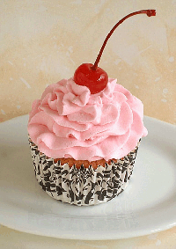
After finishing the cake, it will stay fresh at least a couple of days, depending on the type of icing and filling used. Once cut, keep the cut edges of the main cake covered with plastic wrap or waxed or parchment paper. If it contains any perishable items, the cake MUST BE refrigerated, and can only stay out of refrigeration for no more than two hours for food safety reasons.
Fig.2.1. Frosting

Icing cake has three main functions:
- Frosting contributes flavor and richness to the cake
- Frosting improves the cake's appearance.
- Frosting improves the keeping the qualities of the cake by forming a protective coating around it, sealing in moisture and flavor and allowing it to be eaten over a couple of days.
Decorating cakes:Cake decorating tools can help you with piping flowers, borders, words, and other designs. It is much easier to decorate a cake with the proper tools rather than just using a butter knife or spatula. Decorating your cakes will no longer be a scary task when you have all the right piece.

Butter creams
The most used butter creams are the following:
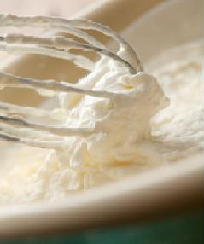
- Italian Butter cream, which is based on a boiled meringue and butter. This method is very stable, has an excellent shelf-life and is easy to produce. Fondant and butter mixture is not classified as an Italian meringue; it has poor eating qualities and is lacking flavor.
- German Butter cream is based on a Crème patisserie. This method is particular good as Crème patisserie is standard for most producers of cakes and desserts, therefore it is excellent to use in emergencies. Shelf-life is limited due to the egg content. Fig.2.2. Butter cream
French Butter creamis based on a sabayon. It is difficult to make, due to the warming of the egg-mixture, this when overheated coagulates and small egg lumps are visible in the cream. The butter cream is very light and has particular good eating qualities it is very suitable to use for petit fours.
With all of these recipes it is important to cool the initial mix, before the butter is added. It should be of the same temperature and consistency as the butter.
If the mixture is too warm, the butter melts and it loses volume and lightness.
If the mixture is too cold, the butter is hard and it does not combine with the base, it results in lumps of fat in the mixture - it slits.
Butter cream can be flavoured in many ways, either with alcohol, essences, fruit, nuts, nougat, chocolate etc.
- It is used to decorate or fill cakes, desserts, roulades and petit fours
- Butter cream products need to be stored in the refrigerator, but should be eaten at a temperature of 12ºC – 15ºC as its best
- To lighten butter cream and increase the “melt in the mouth”, some butter may be replaced with copha, which has a lower melting point
Split butter cream can be tempered again, by warming over a water-bath
Fondant
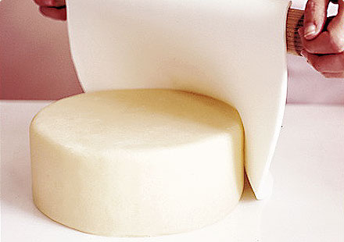
The value of fondant as a decorative medium lies in the attractive smooth glossy surface, which can be retained on the cake surface when correctly applied. Fondant may be coloured and flavoured.
There are several types of fondant and these are:
- Extra soft
- Soft
- Standard
- Hard.

Fig.2.3. Fondant
Fondant must be handled with care if the loss of gloss is to be prevented when it used in cake decoration. Having the correct temperature is a key factor in handling fondant.
Fondant consists of minute sucrose crystals suspended in saturated sugar syrup with sufficient invert sugar or glucose to prevent the growth of crystals.
In preparing fondant for use it should be heated in water-jacket pans with the appropriate amount of stock syrup to produce the desired consistency, because in this way there is less danger of overheating. Thermostatically controlled pans are desirable.

The temperature should not greatly exceed 38°C if a good gloss is to be retained.
If overheated, the crystals redissolve and, on cooling, recrystallise into larger crystals, which do not reflect as much light, and the result is that the gloss will be spoiled.
If it is under-heated the fondant will not set firm, but will be sticky and runny.
The bulk fondant should therefore be heated carefully to no more than 39°C, stirred continuously, then thinned down to the required consistency and used immediately.
At 37°-39°C, approximately 115% of the sucrose crystals dissolve, and a recrystallization cement the remaining crystals together and thus produce a firm dry surface.
Fondant can be thinned down by the addition of any of the following:
- Sugar syrup
- Alcohol or liquid flavouring or colouring
- Egg white.
The best thinning agent to use is sugar syrup as it is the most cost effective and easier to regulate in amounts to be used.
1 part sugar with 1 part water
Aromatics may be added but then all those flavours go into everything
Five Types of cake decorating:
- Fondant icing.
- Royal icing.
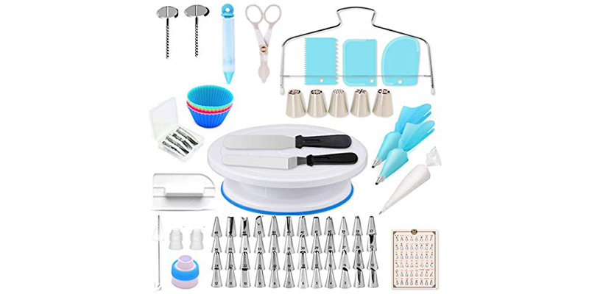
- Marzipan.
- Gum paste.
- Modeling chocolate.

Fig 2.4.decorating tools

Ten Best Cake Decorating Tools:
- Cake leveler. One of the very basic relevant cake decorating tools is the cake leveler. It not only makes the layers perfect, you can easy trim and cut the best part out of your cake.
- Cake turntable. Cake turntable is the best tool when it comes to icing and serving your cake.it helps to keep the cake in the perfect position when piping borders or decorating bases.
- Cake airbrush.It helps to create the most astonishing details when the airbrushed colour is used on the icing.
- Cake spatula.icing, frosting or separating layers, the spatula always helps.
- Cake scraper. For scraping the sides of your cake and enhance the ends of your icing tip, scraper is a mandatory tool.
- Piping nozzles. They are used for designing and decoration on the ice caked, for making flowers as well as necessary designs on the cake.
- Cake comb.one of the important cake making tools used for designing the frosting of a cake. Usually it is used to make parallel lines around the frosts, so that the decorations are easy.
- Piping bags. They are used to swirl buttercream on your cake and make it more appealing. However, you need to learn how to use them appropriately.
- Cake smoother.The cake smoother holds a comfort grip at the corner ends that makes them easy to hold. To get your cake a polished finish, you can use a cake smoother enhancing the look and presentation.
- A serrated knife. A serrated knife is used to torte the cakes and bring the best frost served while cake cutting.
Ten Step of decoratingcake:
Step 1. Prep the Turntable.
Step 2. Apply The First Cake Layer.
Step 3. Apply The Filling.
Step 4. Apply The Second Cake Layer.
Step 5. Apply The Crumb Coating.
Step 6. Apply The Top Layer of Icing.
Step 7. Fix the Edges and Smooth the Sides.
Step 8. Pipe the Borders.
Step 9. Add garnishes
Step 10. Serve and store

Filling for different cake may include:
- fresh and crystallised fruit
- fruit purées
- jams
- nuts
- creams
- mousse
- custard
- syrup
Decoration may include:
- glazes and jellies
- icings
- chocolate
- sprinkled icing sugar
- fresh, preserved or crystallised fruits
- fruit purées
- whole or crushed nuts
- colour and flavoured sugar

2.2. Presenting cakes

Here are some tips for plating desserts effectively and beautifully.
- Be creative with color.
- Combine textures.

- Compose your plate as you would a painting.
- Consider the vessel.
- Contrast temperatures.
- Have a focal point.
- Let it be dramatic.
- Don't make it too tall or wobbly.
- Garnish with care.
- Be consistent
Four Main Features of a Plated Dessert.
1. Main Item: This of course is the star of the show: a cake, a custard, a tart...
2. Sauce: This is usually a flavor that complements or contrasts with the star: raspberry sauce, chocolate, cremeanglaise...
3. Crunch: An essential component if the main item has no crunch itself: nuts, cookie, caramel decoration, piece of chocolate...
4. Garnish: A fancy dessert garnish can add color or decorate...sugared petals, a frosted basil leaf, chocolate shavings, berry, candied orange peel, mint leaves...
Here are some ways to help you prepare for a presentation:
- Rehearse in front of a crowd.
- Take notes.
- Experiment.
- Time yourself.
- Record yourself.

Things to Look Out For in Cake Presentation
- Icing. The first thing you will probably notice about the cake you are about to eat is the icing.

- Look for Crumbs. Depending on the type of cake you are about to eat, it should be moist but still be able to hold its shape. ...
- Decorations.
SELF-CHECK 2 | WRITTEN EXAM
Answer the following questions:
Part I. Say True or False
- Adding filling between layers of cakes holds the layers together, giving your cake flavor as well as height.
- Frosting or icing, fillings and glazes are typically a sweet, sugar-based soft mixture used to fill, coat, add flavor, and improve the appearance and texture.
- Creams, mousse& custard are filling item which is used for filling of cakes.
- Glazes and jellies, icings& chocolate are used to decorate various cakes.
- Things that affect the freshness of the cake are heat, humidity, and intense artificial light
Part II. Short answer
- Mention the steps of cake decoration.
- List at least 5 cake decorating equipment.

Operation sheet 2:decorate&present cake
Operation Title:prepare butter cream for decor.
Purpose: to décor& present variety of cake
Conditions or situations for the operations:
- Safe working area
- Properly operated tools and equipment
- Appropriate working cloths fit for the practical performance
Equipment Tools and Materials:
Materials
Bowl
Whisker

Ingredients
½ cup unsalted butter, at room temperature
2 cups confectioners' sugar, sifted
1 ½ teaspoons pure vanilla extract
2 tablespoons milk
3 drops food coloring, or as needed (Optional)
Directions
Cream butter in the bowl of a stand mixer fitted with the paddle attachment until smooth and fluffy. Gradually beat in confectioners' sugar until fully incorporated. Beat in vanilla extract.
Add milk and beat for an additional 3 to 4 minutes. Add food coloring and beat for thirty seconds until smooth or until desired color is reached.

Operation sheet 2: decorate&present cake
Operation Title: select display equipment for bread.
Purpose: to décor and present variety of cake
Conditions or situations for the operations:
- Safe working area
- Properly operated tools and equipment
- Appropriate working cloths fit for the practical performance

Equipment Tools and Materials:
- Cake leveler. Piping nozzles.
- Cake comb. Piping bags.
- Cake smoother. Cake scraper.
- A serrate Cake turntable.
- Cake airbrush. Cake spatula.

Steps in doing the task
Step 1. Prep the Turntable.
Step 2. Apply The First Cake Layer.
Step 3. Apply The Filling.
Step 4. Apply The Second Cake Layer.
Step 5. Apply The Crumb Coating.
Step 6. Apply The Top Layer of Icing.
Step 7. Fix the Edges and Smooth the Sides.
Step 8. Pipe the Borders.
Step 9.add garnishes
Step 10.serve and store

Unit Three: Store cakes
This unit to provide you the necessary information regarding the following content coverage and topics:
- Storing cakes and ingredients
- storage conditions for cake products
This guide will also assist you to attain the learning outcomes stated in the cover page. Specifically, upon completion of this learning guide, you will be able to:
- Store cakes and ingredients
- Applystorage conditions for cake products

3.1. Store cakes products
3.1.1. Usecorrect temperature and conditions of storage
Some cake storage materials
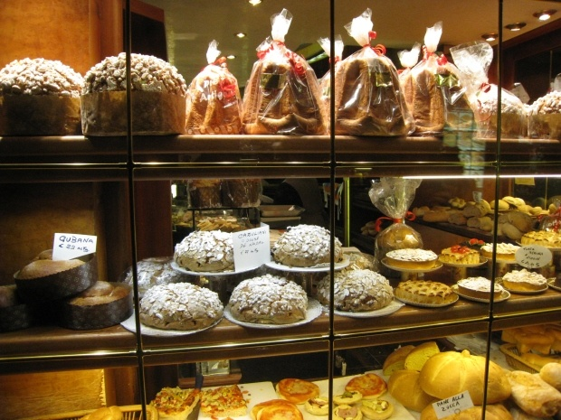
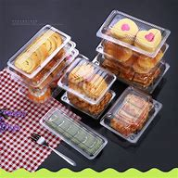

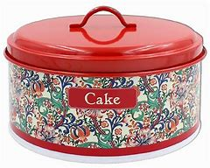
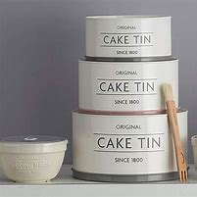

Fig.3.1. Storage equipment

    - Store cakes

Learn how to store cake, whether that's on the counter, in the refrigerator, or the freezer so that your leftover cake never goes to waste!
The following points should be consider during storing:
- What happens when you store baked goods?
- General guidelines for storing cake
- Short-term versus long-term storage
- What you need to store cakes?
- Steps to store simple cakes, like unfrosted cake layers
- Steps to store a frosted layer cake
- Storing other types of cakes
- Longer storage
- Defrosting layer cakes
- How to use up leftover cake
- Key takeaways

There are two important things that can happen when we store baked goods, and specifically cake:
- The cake dries out from air exposure. Moisture evaporates and the crumb becomes dry and brittle, prone to crumbling and generally not as pleasant to eat.
- The cake absorbs moisture and becomes gummy. Moisture on the surface of cake makes it sticky and can lead to the growth of microorganisms, which can be bad for your health or potentially dangerous.
Types of cakes more prone to drying out:
You'll notice after a few years of baking and storing baked goods that some will dry out and others will go bad. Cakes that dry out are often lower in fat, and cakes that are lower in sugar are especially prone to drying out.
Remember that sugar is hygroscopic, meaning that it absorbs moisture from its surroundings. Sugar actually acts like a preservative for this reason.
Types of cake prone to spoiling:

The opposite of drying out can happen when you store cake: it can become so moist and gummy that microorganisms thrive and take over. This is especially true for cakes that have a high moisture content, made with fruit purées. These can spoil if incorrectly stored and go mouldy even, if you aren't careful.
General guidelines for storing cake:
Regardless of the type of cake or baked good, it's very important to cool the freshly-baked cake to room temperature before storing. This allows the cake to firm up, making it easier to handle and less delicate. More importantly, cooling down a cake before storing it allows for evaporation of steam.
Never cover or wrap a cake that is warm because you will trap steam and moisture. The surface of the cake will absorb that water, creating a humid layer that is the perfect environment for the growth of microorganisms that cause spoiling and could be harmful.
Always store cakes wrapped or covered, whether that's in an airtight container, in a cake dome, or wrapped in aluminium foil or plastic wrap (depending on the item).
Short-term versus long-term storage
Choosing where to store a cake, whether on the counter, the fridge or the freezer, is entirely dependent on a few things:
Are there ingredients in the cake that need to be stored in the fridge?
Example cream cheese isn't designed to be left on the counter for a week, so you need to store anything with cream cheese frosting in the fridge or freezer, otherwise it will spoil. Fruit fillings can spoil very quickly at room temperature, as well.
Are you storing the cake to enjoy over the course of a week or are you storing the cake to serve it in a month? Longer storage will require cooler storage temperatures, if not freezing.
- For short-term storage of baked goods that won't spoil quickly or go bad:

- For everyday baked goods, for up to a week, store items covered on the counter at room temperature without a worry. Baked goods like quick breads, muffins, and pound cakes store well on the counter, wrapped.
- For frosted cakes, for up to a week, store them in the refrigerator
- For long-term storage of any these items, store these items in the freezer
If it's a heatwave and your room temperature is creeping up above 23 ºC, you are safer storing baked goods in the refrigerator or the freezer.
- To store a cake, you may need a few of the following items, depending on what type of cake you are storing and for how long:
- Parchment paper
- Aluminum foil
- Plastic wrap
- Cake dome
- Cake box
Short -term storage—counter or fridge
For most quick breads and loaf cakes, I like to store them on a plate or a cutting board, and then wrap them in aluminium foil to store them at room temperature. I prefer foil, which is recyclable, though you may prefer plastic wrap. You could also consider large sheets of reusable and washable bees wrap, like Abe ego wrap, which functions just like foil, but is even more environmentally friendly. Just make sure the cake is completely covered.
- Long term storage—freezer:
To store simple unfrosted cakes in the freezer, freeze them on a parchment-lined sheet pan, then wrap tightly in plastic wrap, and then aluminium foil. You could also store the frozen cake in a freezer bag.

There are two important things that can happen when we store baked goods, and specifically cake:
- The cake dries out from air exposure. Moisture evaporates and the crumb becomes dry and brittle, prone to crumbling and generally not as pleasant to eat.
- The cake absorbs moisture and becomes gummy. Moisture on the surface of cake makes it sticky and can lead to the growth of microorganisms, which can be bad for your health or potentially dangerous.
Types of cakes more prone to drying out:
You'll notice after a few years of baking and storing baked goods that some will dry out and others will go bad. Cakes that dry out are often lower in fat, and cakes that are lower in sugar are especially prone to drying out.
Remember that sugar is hygroscopic, meaning that it absorbs moisture from its surroundings. Sugar actually acts like a preservative for this reason.
TYPES OF CAKE PRONE TO SPOILING
The opposite of drying out can happen when you store cake: it can become so moist and gummy that microorganisms thrive and take over. This is especially true for cakes that have a high moisture content, made with fruit purées. These can spoil if incorrectly stored and go mouldy even, if you aren't careful.
GENERAL GUIDELINES FOR STORING CAKE
Regardless of the type of cake or baked good, it's very important to cool the freshly-baked cake to room temperature before storing. This allows the cake to firm up, making it easier to handle and less delicate. More importantly, cooling down a cake before storing it allows for evaporation of steam.
Never cover or wrap a cake that is warm because you will trap steam and moisture. The surface of the cake will absorb that water, creating a humid layer that is the perfect environment for the growth of microorganisms that cause spoiling and could be harmful.
Always store cakes wrapped or covered, whether that's in an airtight container, in a cake dome, or wrapped in aluminium foil or plastic wrap (depending on the item).

Seven steps of storing cake;
Preserving cake properly can help you enjoy this treat for days past its initial serving.
- Analyze the cake recipe. Before you decide how to store your cake, you need to know what’s in it to settle on the best method. A ganache-covered chocolate cake with buttercream frosting can remain at room temperature, but a cream cake with a fresh fruit filling should stay in the refrigerator. The main thing you’re looking for is whether any ingredients are perishable. Cheesecakes should also remain in the refrigerator since they include different ingredients than regular cake.
- Fortify or strength with frosting. Frosting serves as a natural preservative so long as it does not include perishable dairy or fruit materials. Once you cut cake open, simply cover the sliced edges with more frosting to help it last longer. This retains the moisture without you having to resort to plastic or aluminum wrapping. Don’t rely on the bits of frosting inside a layer cake to do the job, though—you must lather the entire exposed area with new frosting.
- Freeze for longer periods. You can always freeze cake if you don’t plan to eat it for a long period of time. If you place an uncut whole cake in the freezer, you can easily get this dessert to last up to three months. Make sure to wrap the cake before putting it in the freezer.
- Improvise if necessary. You don’t need a specifically manufactured cake stand to store your dessert well. Place the cake on a plate or baking sheet, wrap it with aluminum foil, and place an overturned bowl on top of it for a makeshift storage container. This will keep your cake fresh for three to seven days.
- Protect the frosting. Place your cake in the refrigerator for twenty minutes or so to harden the frosting before you wrap it for storage. Insert toothpicks on the top and sides of the cake so that the wrapping doesn’t touch the frosting itself.
- Rely on room temperature. You can leave out your covered cake overnight without even wrapping it, and it should be fine in the morning. For any amount of time longer than that, make sure to wrap it in something. Rely on room temperature to maximize its shelf life—up to about three to seven days—unless specific ingredients require that it remains refrigerated.
- Wrap the cake. Use aluminum foil or plastic wrap to protect your cake if you’re planning to eat it over several days. If you choose to place the wrapped cake in an airtight container for added security, make sure to leave a tiny portion open. Protect sheet cakes from dust and other dirty elements fluttering around your kitchen, but they still need air to retain their texture.
- To keep cakes fresh, it's best to <store them in airtight containers in a cool, dry place.>If you don't have an airtight container or cake tin, use can also use an overturned bowl (although it won't keep the cake as fresh). To keep cakes fresh for more than 1 week, try freezing them.
- The 4 steps to store your sponge cake:
- Store your cake at room temperature and
- Keep it out of the direct sun and
- Away from any major heat sources that might melt the icing.
- Keep your cake boxed on the counter for up to three days. A sponge cake can be stored in a sealed, airtight container at room temperature for about three days.
It is important to know how to store a cake properly whether it is decorated or not. A decorated cake will require care in how it is stored so that the frosting design is not disturbed; whereas, an undecorated cake must be stored properly to maintain freshness.
Bread and baked products such as muffins, bagels, quick breads, waffles, pastries, cakes and cookies are safely stored on the counter or in the pantry. Storing in the refrigerator can increase shelf-life by 2-3 weeks by reducing spoilage issues such as mold growth.
- Thefactors to consider in storing cakes:
Things that affect the freshness of the cake are heat, humidity, and intense artificial light. The intense light can change the color of the cake. Cake can be kept in the best condition if it is stored away from all of these elements.

Common Methods of Food Preservation
- Chilling.
- Freezing.
- Sugaring.

- Salting.
- Canning.
- Vacuum Packing.

Store a cake in the fridge
If you do refrigerate, wrap unfrosted cakes in plastic to protect them from absorbing any weird fridge smells and to protect them from drying out, and then unwrap it to warm up on

the counter before serving. For frosted cakes, chill the cake uncovered for 15 minutes to harden the icing, then wrap it in plastic wrap
To preserve a cake without refrigeration
Place the wrapped layers in a zip-top plastic bag, and store them on the kitchen counter for up to five days, but make certain to store the cake in a cool, dry place away from any direct sunlight.
Typically, a cake will only stay fresh for up to three or four days before the moisture is drawn out and the texture becomes drier. A cake can last in a fridge for a little bit longer if it has been frosted as the frosting keeps the moisture in the sponge

SELF-CHECK 3 | WRITTEN EXAM

Answer the following questions:
Part I. Say True or False
- The proper way of storing cake is important to maintain its freshness.
- Storing cake in the refrigerator can increase shelf-life by 2-3 weeks by reducing spoilage issues such as mold growth.
- Sugaring is the common method of preservative of cakes.
Part II. Write a short answer
- How do you store cake products to maintain its freshness?
- List some storage materials that is appropriate to store cake.
- What will happen if you wrap or cover warm cake?

Operation sheet 3:Storing cakes
Operation Title:Store cakesproducts
Purpose: to store and display variety of cakes products.
Conditions or situations for the operations:
Safe working area
Properly operated tools and equipment
Appropriate working clothes fit for the practical performance
Equipment& tools
- Parchment paper
- Aluminium foil
- Plastic wrap
- Cake dome
- Cake box

Steps in doing the task
- Analyze the cake recipe.
- Fortify or strength with frosting
- Freeze for longer periods
- Improvise if necessary
- Protect the frosting
- Rely on room temperature
- Wrap the cake

Quality Criteria: Assured performing of all the activities according to the procedures

Measurement unit relationship
Measuring cups in grams for most common recipe
Cup | Gram
1 cup | 250gm
¾ cup | 190gm
2/3 cup | 170gm
1/2 cup | 125gm

For Suger
Cup |  | Gram
Sugar,raw | 1 cup | 205gm
Sugar,caster | 1 cup | 215 gm
Suger,brown | 1 cup | 200 gm
Sultans | 1 cup | 170 gm
For Butter
Cup | Gram
1 cup | 227 gm
1/2 cup | 113 gm
1/3 cup | 76 gm
1/4 cup | 57 gm
Measuring cups in mili litter(ml)

Cup | Ml(mili littre)
1 cup | 250ml
3/4 cup | 175ml
2/3 cup | 150ml
1/2 cup | 125ml
1/3 cup | 70ml
¼ cup | 60ml

Measuring spoon in mili littre
Spoon | Ml(mili littre)
1Table spoon(Tbsp) =3Tea spoon(Tsp) | 15 ml
1Tea spoon(1Tsp) | 5 ml
1/2Tea spoon(1/2Tsp) | 2.5 ml
¼ Tea spoon(1/4Tsp) | 1.75 ml
Measuring cup in measuring spoon
cup | spoon
1 cup | 16 Tbsp
¾ cup | 12
2/3 cup | 10Tbsp+2Tsp
½ cup | 8 Tbsp
¼ cup | 4 Tbsp
1/8 cup | 2 Tbsp

Conversion unit
1lb (Pound) = 16 oz(ounce)
1lb (Pound) = 453.6 gram
1oz(ounce) = 28 gram
oz(ounce) = 56gram

REFERENCE

- A TEXTBOOK OF BAKING AND PASTRY FUNDAMENTALS
- BAKERY & CONFECTIONARY COURSE ,FOOD PRODUCTION DEPARTMENT
KENYA UTALII COLLEGE, NIROBI
- READING MATERIALS ON PASTRY AND BAKERY PRODUCTION
- PREPARE & PRODUCE BAKERY, PASTRY & CAKES PRODUCTS

Participants of this Module (training material) preparation

No | Name | Qualification (Level) | Field of Study | Organization/ Institution | Region | Mobile  number | E-mail
1 | Zuriyash-work Belay | B | Hotel Management | TTI Addis Abeba |  | 0911643817 | zuriyashwb@gmail.com
2 | ZelalemAlmaw | B | Food Science& post-Harvest Technology | Bahir Dar PTC |  | 0918012521 | Parazolla25@gmail.com
3 | HiwotTedla Belay | B | BA degree in Accounting and finance and diploma in Hotel Management | Harer Polytechnic College | Hareri | 0913789086 | hiwietaba@gmail.com
4 | AbrehamMayzaMengesha | A | BA degree in Hotel and Tourism | Arbaminch Polytechnic college | SNNP | 0913711922 | Abrehammayza9@gmail.com
5 | Mohammed Liben Mohammed | B | BA degree in Hotel and Tourism management  MA degree in Disaster Risk Management | Jigjiga Polytechnic college | Somalia | 0992326557 | cherechaw@gmail.com

