Bakery and Pastry Production
Level I
Based on November 2022 Curriculum Version-2

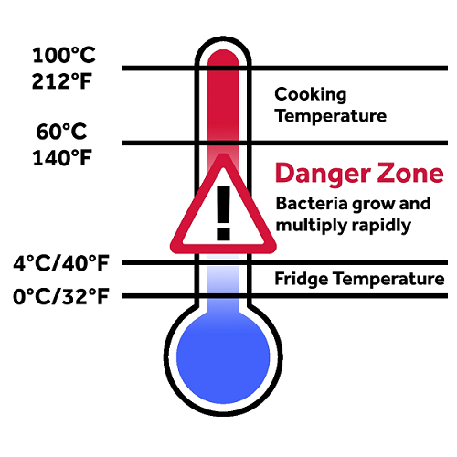

MODULE TITLE: Food Safety and Sanitation
MODULE CODE: CST BPP1 M02 1122
NOMINAL DURATION: 60 Hours

Prepared By: Ministry of Labor and Skill

November, 2022

Addis Ababa, Ethiopia

Contents
Acknowledgment 3
Module Learning Instructions 5
UNIT ONE :Health, safety and security 6
1.1 health, safety and security procedures 7
1.2. Safe work practices 9
1.3 Safety hazards 13
Self-Check -1 19
UNIT TWO: Emergency Situations 21
2.1 Action to potential emergencies 22
2.2 Requesting Assistance 28
1.3Reporting emergency situations 28
Self-Check -2 31
Unit Three: Follow hygiene procedures and identify hygiene hazards------------------------ 32
3.1 Hygiene procedures and policies 33
3.2. Hygiene hazards 52
3.3. Minimizing hazards 54
3.4. Reporting hygiene hazards 55
Self-Check -3 58
UNIT FOUR: Cross-contamination 60
4.1 Food borne illness 60
4.2 Danger zone and potentially hazardous foods. 67
4.3 Personal hygiene 69
4.4 Preventing unnecessary direct contact with ready to eat food. 71
Self-Check -4 73
UNIT FIVE: Clean and sanitize premise and equipment 74
5.2. Cleaning agents 76
5.3. Cleaning and sanitizing walls, floors, shelves and other surfaces 77
5.4. Cleaning and sanitizing Equipment and utensils 79
5.5. Storing Cleaned equipment and utensils 83
Self-Check -5 85
Unit Six: Reduce negative environmental impacts----------------------------------------------86
6.1 Conserving resources 88
6.1.1. Restaurants and Hotel Kitchens 88
6.1.2 Water consumption 89
6.1.3 Energy consumption 89
6.2 Segregating wastes using color coded bins 89
6.2.1 Achieved Environmental Benefit 92
Self-Check -6 93
UNIT SEVEN: Reporting any personal health issues 94
7.1 Personal Health Issues. 95
7.1.1 Health and safety concerns at work 95
7.2. Incidents of Food Contamination 97
Self-Check -7 100
Reference 101
DevelopersProfile 102

Acknowledgment

Ministry of Labour and Skills wish to extend thanks and appreciation to the many representatives of TVET instructors and respective industry experts who donated their time and expertise to the development of this Teaching, Training and Learning Materials (TTLM).

Introduction to the Module

This module describes the knowledge, skills and attitude required to clean and maintain kitchens, and food preparation and storage areas in commercial cookery or catering operations. It requires the ability to set up cleaning equipment and to safely clean premises and equipment using resources efficiently to reduce negative environmental impacts.
This module is designed to meet the industry requirement under the Bakery and Pastry Production occupational standard.
This module covers the units: -
- Health, safety and security
- Emergency situations
- Follow hygiene procedures and identify hygiene hazards
- cross-contamination
- Clean and sanitize premise and equipment
- Reduce negative environmental impacts
- Report any personal health issues
Training Objective of the Module:-
- Explain workplace procedures for health, safety and security
- Explain procedures for emergency situations
- Explain hygiene procedures and identify hygiene hazards
- Preventing food and other items from any cross-contamination
- Cleaning and sanitizing premise and equipment
- Reducing negative environmental impacts
- Use any personal health issues

Module Learning Instructions
- Read the specific objectives of this Learning Guide.
- Follow the instructions.
- Read the information written in the information Sheets
- Accomplish the Self-checks

UNIT ONE | Health, safety and security
This learning guide is describes knowledge, skills and attitude required for food sanitation and safety in a commercial kitchen or catering operation.

- health, safety and security procedures
- Safe work practices
- Safety hazards
This guide will also assist you to attain the learning outcomes stated in the cover page. Specifically, upon completion of this learning guide, you will be able to:
- Follow health, safety and security procedures
- Apply Safe work practices
- Identify Safety hazards

1.1 health, safety and security procedures
Safety and security is the major concern among all the living creature of this universe. It is also described by Maslow through his Need and Hierarchy Theory. The safety and security does not confined to life only but it also emphasizes on job, health and environment. When we think for safety and security especially in hotels, automatically it comes on the part of tourists. As we know tourism is a recreational activity in which a tourist leaves his/her home to a distant place and safety and security is a major challenge for him/her. At this (new and unfamiliar) place he/she has to stay somewhere so that he/she can feel safe. Thus, some short of means of shelter is required to keep himself/herself safe from unforeseen circumstances. The moto of hospitality industry emphasizes that Guest is God and the God should be provided safety and security. The guests coming to the hotel must be given safe and secure environment so that their stay must be comfortable and enjoyable and over all the hotels are gaining monetary benefit from those guests. It is the moral and ethical responsibility of the hotels to protect guests from any mishap leading to their death and loss of baggage. The hotels are also aware that if they fail in providing safety and security to guests, the bad reputation tag will be tagged and it will affect their business in many folds. It has also been seen that hotel keeps on hiding the information of some eminent person/ VVIP/ celebrities movement in their premises because it will create chaos and hamper the smooth functioning of the hotel. It is a good practice to not disclose the identity of such persons and hotels are doing just to provide such guests an environment where such persons can feel safe and secure.
All food handling premises are entitled to implement policies and procedures which exceed minimum legal requirements.
This means, for example, a food handling premises may require food handlers to wash their hands every 30 minutes (or every hour) regardless of what activities they are engaged in.
A business may also require staff to wash their hands in the wash hand basin in the toilet after using the toilet, and then wash their hands again when they re-enter the kitchen area.
Where the workplace has hand washing requirements exceeding the mandatory minimum requirements, always adhere to these workplace practices.
The organizational programs that promote and protect the health conditions and initiate measures that would render a significant contribution in the prevention of diseases, and accidents have the potential to reach all the members of the organization. The programs make provision of adequate information to the individuals. It is essential on the part of the individuals to acquire an appropriate understanding of it and put it into practice in an effectual manner. In India, individuals, who are engaged in full time jobs, normally spend six days a week and ten to twelve hours per day towards their job duties. In some cases, as their job duties permit, they are required to go to the field as well. Hence, job duties are challenging. The employers are vested with the responsibility of creating a safe and an amiable working environment. They also are required to look after the health and well-being of the employees and promoting a healthy environment (Workplace Health Promotion, 2015).
Efficient organizational programs and policies are the ones that can promote policies and cause reduction in risks and hazards. The more the workforce is healthier; it can mean lower direct costs, such as insurance premiums and the compensation claims of the workers.
It can also transform to lower indirect costs, if the workers miss less work, due to illnesses and health problems and are more productive. As more employers recognize these benefits, the more they are providing wellness programs to the employees. One wellness program is considered as the part of the health benefits (Workplace Health Promotion, 2015). In India, there are number of individuals, who are engaged in hazardous jobs, hence, health benefits are important for the individuals. These individuals get exposed to even chemicals and harmful substances, which affects their health conditions
The word safety and security are used together but it has literary differences too. Safety has been defined as a condition in which a person is being protected from harm caused by unintentional failure while security is defined as a condition in which a person is being protected from harms caused due to intentional human behaviour or actions. So, in the present unit we will be discussing about the relevance of safety and security in the hotel industry along with the case studies of various hotel chains.

1.2. Safe work practices
1.2.1 Safe work practices Safe job procedures
Definition
Safe work practices are generally written methods outlining how to perform a task with minimum risk to people, equipment, materials, environment, and processes.
Safe job procedures are a series of specific steps that guide a worker through a task from start to finish in a chronological order.
- Safe job procedures are designed to reduce the risk by minimizing potential exposure.
Safe work practices should be developed as a result of completing a job safety analysis (JSA) or a hazard risk assessment (HRA) and should closely reflect the activities most common in the company's type or sector of construction.
Safe job procedures are usually developed by management and workers as a result of a JSA/HRA, accident or incident investigation, and/or as a supplement to a safe work practice.
All safe work practices should be kept in a location central to the work being performed and readily available to the workforce. Some safe work practices will require specific job procedures, which clearly set out in a chronological order each step in a process.
Safe work procedures should be included in the company's "Worker Orientation" program. All workers should be aware of the fact that safe job procedures have been established, are in effect, are written down, and must be followed.
IHSA suggests that you build your collection of safe practices/procedures incrementally—start with a few major items and add to them as needed. Avoid simply repeating clear regulatory requirements. Rather, if needed, provide direction on how your company will implement/apply those requirements
To ensure a healthy working environment there must be monitoring at the workplace. This involves systematic surveillance of the factors in the working environment and working practices which may affect workers’ health, including sanitary installations, canteens and housing, where these facilities are provided by the employer, as well as ensuring the working environment complies with safety and health standards.
Everyone associated with the workplace – from the most junior worker right through to the employer – should be actively involved in the surveillance of the working environment. Basic surveillance is carried out by simple observation, and every worker, from shop floor to senior administration, should be trained to identify those factors (potential or actual) which may affect workers’ health. Such training is necessary to enable the worker to report immediately to his or her direct supervisor any situation which can reasonably be thought to present an imminent and serious danger to life or health. In such a situation, the employer cannot require the worker to return to work until any necessary remedial action is taken
Simple observation (a walk-through survey) of work processes and the working environment is the first step in any surveillance. Such observation may be sufficient in some cases to detect a lack of adequate control measures and exposure of workers to risk. An evaluation based on this type of observation may justify the recommendation of control measures without the need for any more sophisticated determination of the level of exposure.
Repeat visits to the workplace and walk-through observation are also necessary to provide an assurance that no deterioration has occurred at workplaces initially evaluated as satisfactory.

1.2.2 Kitchen personal protective Equipment
Kitchens are hot, busy and dangerous places to work. Hot ovens, open fires, and sharp knives all add to the risk of injury, which makes PPE for chefs invaluable. Even for the most experienced of chefs, wearing PPE when working in a kitchen helps to prevent injury by protecting you from burns, cuts and more.
The food service industry is responsible for making, transporting, or selling meals, drinks, and other food products for restaurants, school cafeterias, work canteens, hotels, bars, and many other institutions around the country.
As an industry that generates around $50 billion per month and employs over 11 million people nationwide, strict regulations are in place to ensure the safety of all involved.
The Role of PPE in Food Safety
The Occupational Safety and Health Administration (OSHA) recommend using personal protective equipment (PPE) to enhance the safety of the food, workers, and customers.

- Protecting the Food
Using appropriate PPE during food preparation and handling helps minimize the risk of cross contamination and unnecessary food spoilage. By providing their employees with high-quality PPE, food companies are less likely to experience contamination in their products through parasites, bacteria, dust, mould, and other human-related debris.
Contaminated food is a common source of severe illness, such as salmonella, E. coli, and Hepatitis A, making it a serious public health concern.
Common PPE worn to protect food includes gloves, safety glasses, masks, face shields, and hairnets.
- Protecting the Workers
Employees in the food service industry are at risk of exposure to harmful chemicals and toxic materials. Ammonia from cooling systems, disinfectants and other chemicals found throughout food manufacturing plants pose health risks to anyone who comes in contact with them. Workers at risk of contamination should wear protective clothing, such as gloves, safety glasses, face shields, masks, or overalls.
Restaurants and kitchens also contain potential hazards for workers. Employees can easily sustain an injury from sharp knives or hot dishes if they don’t have the right PPE. Gloves, oven mitts, aprons, anti-slip footwear, slip-resistant floor mats, and wet floor signs are all examples of PPE found in restaurants, cafes, and bars.
- Protecting the Customers
If a restaurant or food service provider is found to be negligent regarding the safe preparation and provision of food to their customers, they can face penalties that may ultimately result in the closure of the premises.
Business owners or managers must provide staff with adequate PPE to prevent contamination and the spread of foodborne illnesses.

1.2.3 Types of PPE Used in the Food Service Industry

The type of PPE recommended for use in the food service industry depends on the nature of the business, the work environment, and the employees.
To determine what PPE is necessary, an employer must survey the workplace and conduct a safety audit. The surveyors should look for potential hazards like obstructions, exposed wiring, or emergency exit access during the audit.
Employees must be trained to use their assigned personal protective equipment correctly to ensure safety. PPE must be fitted to the wearer, or it could become a safety hazard. For example, a protective apron that’s too large may tear or snag on equipment, compromising the safety of the food and workers.

It’s beneficial to carry out periodic audits to guarantee safety standards are maintained and that PPE is adequately stocked onsite.
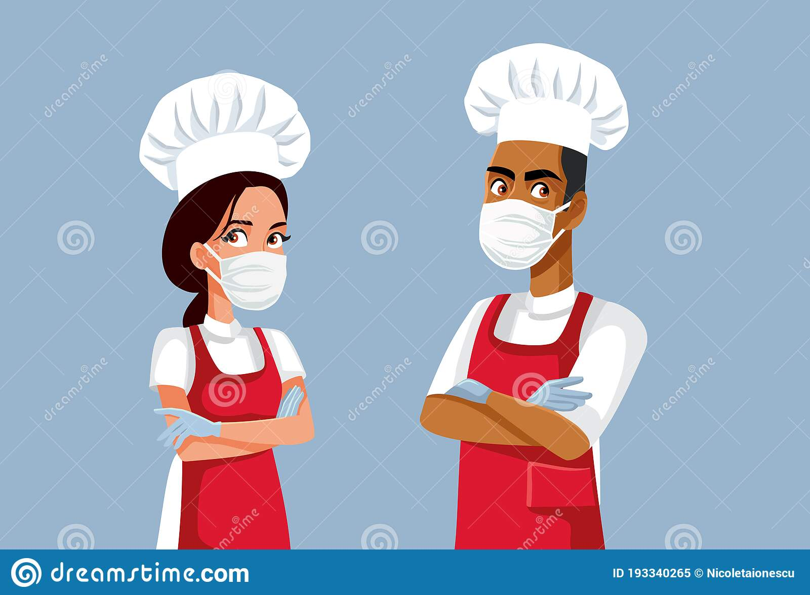

Fig.1.1 PPE
- Some of the most critical pieces of PPE for the food service industry are:

- Gloves

Handling food with bare skin is a significant contributor to transmitting harmful pathogens. Food industry employees should wear food-grade gloves to enhance safety.
Two of the most effective glove materials for handling food are nitrile and vinyl. Both materials offer adequate protection for food handling. While nitrile gloves are more durable and touch-sensitive, they tend to be more expensive than vinyl.
- Face Shields

Face shields protect against the spread of pathogens via large respiratory droplets in restaurants, kitchens, and food processing plants. Chefs, servers, and other employees who frequently handle the food may wear face shields to reduce how far their respiratory droplets travel. This prevents contamination of food being prepared, packaged, or served.
- Respirators
Respirators, such as N95 masks, protect the wearer from inhaling contaminated air. They are used to protect workers in food manufacturing facilities where there is a risk of ingesting harmful airborne pollutants.
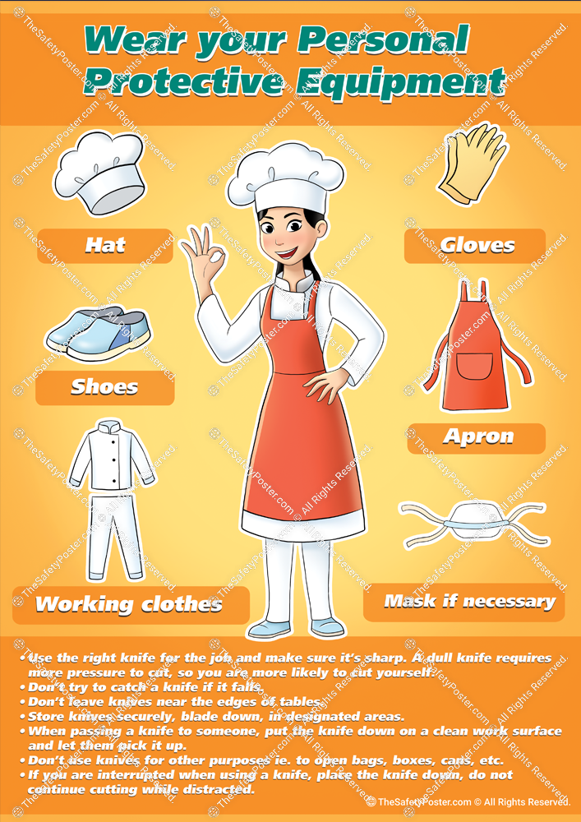

Fig.2PPE

- Disposable Face Masks
Since the beginning of the COVID-19 pandemic, disposable face masks have been widely used, especially in the foodservice industry. They do not offer protection from inhaling particles and pathogens, but they act as a protective barrier to stop large droplets from entering or exiting through the nose and mouth.
- Hand Sanitizer
The pandemic has also increased the attention to hand sanitization in the food service industry. The CDC actively encourages food services to provide staff training on proper hand sanitization habits and offer more access to hand sanitizing equipment, including sanitizer. The CDC also recommends using alcohol-based sanitizer with a minimum of 60% alcohol content.
Adequate PPE for the food industry should be cut or puncture-resistant, thermal resistant, and offer liquid protection.

1.3 Safety hazards
1.3.1 Hazard
A hazard is anything that has the potential to harm or injure people, property, or equipment; a hazard report is an account of any potential risk to the health or safety of any person, property or equipment in the workplace.
The consequences of the Coronavirus on the hospitality industry have been particularly hard-hitting. Now lockdown restrictions are easing, many food businesses and hotels have reopened in line with the government roadmap and are beginning to serve customers so they can be up and running for the summer months ahead. Having no doubt spent a long time meticulously planning a reopening (again!), including Covid-19 risk assessments and creating new Covid-secure policies, it is important not to overlook the other common safety hazards that must be taken into account, alongside the management of Covid-19 risks.
Even before the pandemic hotels, pubs and restaurants were familiar with managing the common everyday health and safety risks to their employees and customers. Controlling these risks is part of working within this industry. We take a brief look at some of the most common safety hazards for those that work in the hospitality industry.
1.3.2 Types of Hazards in the Workplace
Hazards are dangers to not only the people in the company but also to the company’s reputation in the industry and its relationship with clients. Aside from negatively impacting the lives of workers and their families, injuries caused by unreported hazards also cost the company time and money through a reduced workforce and long-term medical expenses.
Hazards can come in many forms, but they generally fall under the following categories:
- Safety Hazards
Safety hazards are mostly general hazards that can be found in any workplace, even in plush corporate offices. These can be something as simple as wet floors or something deadly like malfunctioning equipment
While the kind of safety hazard to look out for will depend on the nature of the work and the specific location of the workplace, safety hazards in specific industries such as construction should never be overlooked.
- Chemical Hazards
Unlike safety hazards, chemical hazards are usually only found in chemical manufacturing and import facilities. For workplaces involved in the handling of hazardous substances, employers are required to label the chemicals, use Safety Data Sheets (SDS), and properly train their employees.
Common chemical hazards include corrosive substances such as strong acids and oxidizers as well as flammable and/or toxic gases, liquids, and solids. Safety measures regarding these chemical hazards must be effectively communicated in the workplace, as part of an employer’s hazard communication (HazCom) program.
Other places which may require the implementation of a HazCom program are science laboratories in academic institutions. Elementary and secondary schools are especially prone to situations in which an untrained student mishandles a chemical and inadvertently causes a fire.
- Physical Hazards
While a safety hazard can also be classified as a physical hazard, the main difference between them is that physical hazards are always present and are not necessarily caused by an incident or a mistake on the part of the employee.
One profession that is exposed to many physical hazards is a flight attendant. Flight attendants constantly experience poor cabin air quality, lowered barometric pressure, hypoxia (reduced oxygen levels), low humidity, and cosmic ionizing radiation.
- Psychosocial Hazards
Aside from physical hazards, flight attendants are also vulnerable to sexual harassment and verbal abuse, which are psychosocial hazards. Surveys show that as many as 65% of flight attendants experience sexual harassment, with 1 in 3 having experienced physical sexual harassment from passengers.
Other psychosocial hazards include bullying and unfair treatment or discrimination.
- Biological Hazards
These hazards adversely affect one’s health and can cause serious, long-term health conditions. Biological hazards include mold, dust, insects, bacteria, and viruses.
While biological hazards can be found in any workplace, the management of these hazards in the food industry is critical. One way to do so is to follow HACCP, a food monitoring system endorsed by the FDA and recognized internationally.
1.3.3 Write a Hazard Report
To write a hazard report, it is ideal that you use a hazard report form so you are guided in doing the following steps:
Describe the hazard identified using text, images, and annotations, and provide brief but detailed information
Determine the (possible) seriousness of the injury and the medical attention required
Indicate the corrective action needed to control the hazard
- Submit the hazard report and record the control measures done for accident prevention.
- Report Example Questions
- Describe the hazard:
- Why or how is it a hazard
- How serious could the injury be
- How likely is it to be that serious
- Unlikely Corrective action:
(a) Remove the cables from the floor.
(b) Organize the cables so that people don’t accidentally trip or fall.
1.3.4 How to Encourage Workers to Report
Safety managers have to actively promote hazard reporting among employees if they want to reduce their TRIR, a metric used by OSHA (Occupational Safety and Health Administration) to evaluate working conditions. Though this can be challenging, here are three tips on how to encourage people to report hazards:
- Build Trust
Employees won’t report hazards if they don’t believe in the organization’s commitment to safety. While building trust will look differently for each organization, one way to do it is to foster engagement between field workers and safety managers.
Safety managers have to show field workers that their feedback is crucial for the organization to improve its safety and overall processes.
- Keep Promises
Aside from creating a culture of open communication between employees and leaders, one of the most effective ways to encourage people to report hazards is to take action, fix what needs fixing, and do what’s needed to eliminate hazards.
Listen to field workers when they flag an issue or raise a concern. If necessary, visit the site to inspect the hazard or seek assistance from an executive to solve the problem.
- Don’t Use Paper Hazard Report Forms
Filling out a paper hazard report form can make hazard reporting a hassle for employees and takes up too much of their valuable working time. Even if the employee succeeds in accomplishing the hazard report form, getting that piece of paper to the safety manager is a struggle in itself.
Once that paper form finally reaches the safety manager’s desk, days might have passed since the incident took place and the investigation is prolonged.
- Advantages of Digitalizing Hazard Report Forms
Unlike paper, digital hazard report forms make hazard reporting easy for field workers and safety managers. With a digital hazard report form, a field worker can take photos and make annotations to provide a detailed explanation of what happened.
A digital hazard report form also allows the safety manager to get information instantly, despite being miles away from the site. This can lead to the investigation being completed within hours of the incident, instead of days or even weeks.

Hazard Report Form

DATE___________ LOCATION_________________REPORTED BY______________

NATURE OF HAZARD AND POTENTIAL RISKS IF LEFT UNTREATED

RECOMMENDATIONS / CONTROLS

Hazard Report Form

MANAGERS COMMENTS ON CORRECTIVE ACTION

SIGNED BY: __________________POSITION:________________DATE:_________
Person reporting the hazard

SIGNED BY: __________________POSITION:________________DATE:_________
Management

Additional sign offs as required to show consultation with all parties affected by the hazard and recommended controls

Self-Check -1 | WRITTEN TEST

- Choose The best Answers
- What are the Unlikely Corrective action:
- Remove the cables from the floor.
- Organize the cables so that people don’t accidentally trip or fall.
- A&B
- All
- What are The Types of Hazards in the Workplace:
- Safety Hazards
- Chemical Hazards
- Physical Hazards
- All
- What are the types of PPE Used in the Food Service Industry?
- Gloves
- Face Shields
- Respirators
- All

- True OR false
1. The hazard adversely affects one’s health and can cause serious, long-term health conditions.
2. Common chemical hazards include corrosive substances such as strong acids and oxidizers as well as flammable and/or toxic gases, liquids, and solids.
3. Handling food with bare skin is a significant contributor to transmitting harmful pathogens.
4. Employees must be trained to use their assigned personal protective equipment correctly to ensure safety.

- Directions: Answer all the questions listed below
- How do you write a hazard report?
- What is the importance of using PPE in the kitchen?
- What are the 5 safety measures in the use of kitchen tools and equipment?

UNIT TWO | Emergency Situations
This learning guide is describes knowledge, skills and attitude required for food sanitation and safety in a commercial kitchen or catering operation.
- Action to potential emergencies
- Requesting Assistance
- reporting emergency situations
This guide will also assist you to attain the learning outcomes stated in the cover page. Specifically, upon completion of this learning guide, you will be able to:

- Take Action to potential emergencies
- Request Assistance
- Report emergency situations

2.1 Action to potential emergencies
2.1.1 Introduction
Nobody expects an emergency or disaster -- especially one that affects them, their employees, and their business personally. Yet the simple truth is that emergencies and disasters can strike anyone, anytime, and anywhere. You and your employees could be forced to evacuate your company when you least expect it.
- workplace emergency
A workplace emergency is an unforeseen situation that threatens your employees, customers, or the public; disrupts or shuts down your operations; or causes physical or environmental damage. Emergencies may be natural or manmade and include the following:
- Floods,
- Fires,
- Toxic gas releases,
- Chemical spills,
- Radiological accidents,
- Explosions,
- Civil disturbances, and
- Workplace violence resulting in bodily harm and trauma.
- Protect of yourself, your employees, and your business
The best way is to prepare to respond to an emergency before it happens. Few people can think clearly and logically in a crisis, so it is important to do so in advance, when you have time to be thorough.
Brainstorm the worst-case scenarios. Ask yourself what you would do if the worst happened. What if a fire broke out in your boiler room? Or a hurricane hit your building head-on? Or a train carrying hazardous waste derailed while passing your loading dock? Once you have identified potential emergencies, consider how they would affect you and your workers and how you would respond.
- emergency action plan
An emergency action plan covers designated actions employers and employees must take to ensure employee safety from fire and other emergencies. Not all employers are required to establish an emergency action plan. See the flowchart on page 17 to determine if you are.

Even if you are not specifically required to do so, compiling an emergency action plan is a good way to protect yourself, your employees, and your business during an emergency.
Putting together a comprehensive emergency action plan that deals with all types of issues specific to your worksite is not difficult.
You may find it beneficial to include your management team and employees in the process. Explain your goal of protecting lives and property in the event of an emergency, and ask for their help in establishing and implementing your emergency action plan. Their commitment and support are critical to the plan’s success.
- Emergency action plan include
When developing your emergency action plan, it’s a good idea to look at a wide variety of potential emergencies that could occur in your workplace. It should be tailored to your worksite and include information about all potential sources of emergencies. Developing an emergency action plan means you should do a hazard assessment to determine what, if any, physical or chemical hazards in your workplaces could cause an emergency. If you have more than one worksite, each site should have an emergency action plan.
- At a minimum, your emergency action plan must include the following:
- A preferred method for reporting fires and other emergencies
- An evacuation policy and procedure;
- Emergency escape procedures and route assignments, such as floor plans, workplace maps, and safe or refuge areas;
- Names, titles, departments, and telephone numbers of individuals both within and outside your company to contact for additional information or explanation of duties and responsibilities under the emergency plan;
- Procedures for employees who remain to perform or shut down critical plant operations, operate fire extinguishers, or perform other essential services that cannot be shut down for every emergency alarm before evacuating; and
- Rescue and medical duties for any workers designated to perform them.
You also may want to consider designating an assembly location and procedures to account for all employees after an evacuation.

- Alert employees to an emergency
Your plan must include a way to alert employees, including disabled workers, to evacuate or take other action, and how to report emergencies, as required. Among the steps you must take are the following:
- Make sure alarms are distinctive and recognized by all employees as a signal to evacuate the work area or perform actions identified in your plan;
- Make available an emergency communications system such as a public address system, portable radio unit, or other means to notify employees of the emergency and to contact local law enforcement, the fire department, and others; and
- Stipulate that alarms must be able to be heard, seen, or otherwise perceived by everyone in the workplace. You might want to consider providing an auxiliary power supply in the event that electricity is shut off.
- Using tactile devices to alert employees who would not otherwise be able to recognize an audible or visual alarm
- Providing an updated list of key personnel such as the plant manager or physician, in order of priority, to notify in the event of an emergency during off-duty hours.
- Develop an evacuation policy and procedures
A disorganized evacuation can result in confusion, injury, and property damage. That is why when developing your emergency action plan it is important to determine the following:
- Conditions under which an evacuation would be necessary;
- A clear chain of command and designation of the person in your business authorized to order an evacuation or shutdown. You may want to designate an “evacuation warden” to assist others in an evacuation and to account for personnel;
- Specific evacuation procedures, including routes and exits. Post these procedures where they are easily accessible to all employees;
- Procedures for assisting people with disabilities or who do not speak English;
- Designation of what, if any, employees will continue or shut down critical operations during an evacuation. These people must be capable of recognizing when to abandon the operation and evacuate themselves; and

- A system for accounting for personnel following an evacuation. Consider employees’ transportation needs for community-wide evacuations.
- Medical assistance should you provide during an emergency
Company does not have a formal medical program, you may want to investigate ways to provide medical and first-aid services. If medical facilities are available near your worksite, you can make arrangements for them to handle emergency cases. Provide your employees with a written emergency medical procedure to minimize confusion during an emergency.
Infirmary, clinic, or hospital is not close to your workplace; ensure that onsite person(s) have adequate training in first aid. The American Red Cross, some insurance providers, local safety councils, fire departments, or other resources may be able to provide this training. Treatment of a serious injury should begin within 3 to 4 minutes of the accident.
Consult with a physician to order appropriate first-aid supplies for emergencies. Medical personnel must be accessible to provide advice and consultation in resolving health problems that occur in the workplace. Establish a relationship with a local ambulance service so transportation is readily available for emergencies.
- Employees play in your emergency action plan
The best emergency action plans include employees in the planning process, specify what employees should do during an emergency, and ensure that employees receive proper training for emergencies. When you include your employees in your planning, encourage them to offer suggestions about potential hazards, worst-case scenarios, and proper emergency responses. After you develop the plan, review it with your employees to make sure everyone knows what to do before, during and after an emergency.
Keep a copy of your emergency action plan in a convenient location where employees can get to it, or provide all employees a copy. If you have 10 or fewer employees, you may communicate your plan orally.
- Information should your plan include
In the event of an emergency, it could be important to have ready access to important personal information about your employees. This includes their home telephone numbers, the names and telephone numbers of their next of kin, and medical information.
- Training to your employees

Educate your employees about the types of emergencies that may occur and train them in the proper course of action. The size of your workplace and workforce, processes used, materials handled, and the availability of onsite or outside resources will determine your training requirements. Be sure all your employees understand the function and elements of your emergency action plan, including types of potential emergencies, reporting procedures, alarm systems, evacuation plans, and shutdown procedures. Discuss any special hazards you may have onsite such as flammable materials, toxic chemicals, radioactive sources, or water-reactive substances. Clearly communicate to your employees who will be in charge during an emergency to minimize confusion.
General training for your employees should address the following:
- Individual roles and responsibilities;
- Threats, hazards, and protective actions;
- Notification, warning, and communications procedures;
- Means for locating family members in an emergency;
- Emergency response procedures;
- Evacuation, shelter, and accountability procedures;
- Location and use of common emergency equipment; and
- Emergency shutdown procedures.
You also may wish to train your employees in first-aid procedures, including protection against blood borne pathogens; respiratory protection, including use of an escape-only respirator; and methods for preventing unauthorized access to the site.
Once you have reviewed your emergency action plan with your employees and everyone has had the proper training, it is a good idea to hold practice drills as often as necessary to keep employees prepared. Include outside resources such as fire and police departments when possible. After each drill, gather management and employees to evaluate the effectiveness of the drill. Identify the strengths and weaknesses of your plan and work to improve it.
Review your plan with all your employees and consider requiring annual training in the plan. Also offer training when you do the following:
- Develop your initial plan;
- Hire new employees;
- Introduce new equipment, materials, or processes into the workplace that affect evacuation routes;
- Change the layout or design of the facility; and
- Revise or update your emergency procedures.

- Plan need to include about hazardous substances
No matter what kind of business you run, you could potentially face emergency involving hazardous materials such as flammable, explosive, toxic, noxious, corrosive, biological, oxidizable, or radioactive substances.
The source of the hazardous substances could be external, such as a local chemical plant that catches on fire or an oil truck that overturns on a nearby freeway. The source may be within your physical plant. Regardless of the source, these events could have a direct impact on your employees and your business and should be addressed by your emergency action plan.
If you use or store hazardous substances at your worksite, you face an increased risk of an emergency involving hazardous materials and should address this possibility in your emergency action plan. OSHA’s Hazard Communication Standard requires employers who use hazardous chemicals to inventory them, keep the manufacturer-supplied Material Safety Data Sheets (MSDSs) for them in a place accessible to workers, label containers of these chemicals with their hazards, and train employees in ways to protect themselves against those hazards. A good way to start is to determine from your hazardous chemical inventory what hazardous chemicals you use and to gather the MSDSs for the chemicals. MSDSs describe the hazards that a chemical may present, list the precautions to take when handling, storing, or using the substance, and outline emergency and first-aid procedures.
- Provide special equipment for emergencies
Your employees may need personal protective equipment to evacuate during an emergency. Personal protective equipment must be based on the potential hazards in the workplace. Assess your workplace to determine potential hazards and the appropriate controls and protective equipment for those hazards. Personal protective equipment may include items such as the following:
- Safety glasses, goggles, or face shields for eye protection;
- Hard hats and safety shoes for head and foot protection;
- Proper respirators;
- Chemical suits, gloves, hoods, and boots for body protection from chemicals;
- Special body protection for abnormal environmental conditions such as extreme temperatures; and
- Any other special equipment or warning devices necessary for hazards unique to your worksite.

2.2 Requesting Assistance
Emergencies, fires, accidents and injuries can occur at any time and without warning. Being prepared and knowledgeable about York University’s emergency procedures is critical before, during and after an emergency situation.
The purpose of this guide is to assist persons with disabilities and community members in becoming familiar with this information. Please read this guide thoroughly before an emergency. It could perhaps save your life or the lives of others.
Persons who may require assistance are all those who are limited by mobility, hearing, visual, and other cognitive/mental demands. Assistance may be temporary or permanent.
Persons Requiring Assistance will only be evacuated if they are in physical danger, as it can expose them to unnecessary risk otherwise. They should follow these three procedures:
When large-scale disasters occur, it is sometimes difficult for damaged countries to assist the victims and protect the environment and material values because of personnel and resource limitations. To prevent the disaster from becoming multiple and complex through the occurrence of secondary and subsequent disasters, it is necessary to provide swift international assistance. In order to respond to requests from the governments of disaster-stricken countries or international organizations, Japan has established a system of international emergency assistance to provide financial, personnel, and material assistance.
Emergency grant assistance, which is provided either directly to the government of a damaged country or through an international assistance organization, is a form of humanitarian assistance to help disaster victims, refugees, or displaced persons. In view of the emergency and humanitarian nature of this assistance, it is implemented swiftly with flexible and extremely simplified procedures.

Reporting emergency situations
Emergency: Any threat to life and/or property that requires immediate response from police, fire or medical services.

Examples:
- Serious injury or illness
- Crime in progress
- Fire or explosion

1.3.1. ACTION GUIDELINES
To report an emergency on campus:
- Make sure you are in a safe location, otherwise find one
- Do not attempt to interfere with the situation, except for self-protection
- Observe the activity from a safe distance
- Call 911
- Tell the dispatcher:
- Your location
- Phone number from which you are calling
- Nature of the emergency
- Do not hang up unless your safety is threatened or you are told to do so
- Watch for arrival of emergency personnel and direct them
- After emergency personnel arrive,
- stay out of the way but do not leave
A. Clery Act Crimes:
Murder and Non-Negligent Manslaughter, Negligent Manslaughter, Sex Offenses (Forcible and Non-forcible), Robbery, Aggravated Assault, Burglary, Motor Vehicle Theft, Arson and Hate Crimes as defined by the Federal Bureau of Investigation’s Uniform Crime Reporting Handbook.

B. To report a Clery Act crime:
Any Clery Act crime committed on or near University of Miami campuses should be reported to the following:
Coral Gables Campus: University of Miami Police Department.
Medical Campus (Miller School of Medicine &UHealth): Medical Security Department
Marine Campus (Rosenstiel School of Marine and Atmospheric Science): Emergency Preparedness and Campus Safety Manager and local police

Self-Check -2 | WRITTEN TEST
- Coos The best Answers
- ----------- is an unforeseen situation that threatens your employees, customers, or the public; disrupts or shuts down your operations; or causes physical or environmental damage.
- A workplace emergency
- PPE
- A&B
- All
- Emergency action plan must include:
- preferred method for reporting fires and other emergencies
- An evacuation policy and procedure
- Rescue and medical duties for any workers designated to perform them.
- All
- The best emergency action plans include:
- Employees in the planning process
- Specify what employees should do during an emergency
- Ensure that employees receive proper training for emergencies.
- All
II. True or false
- A good way to start is to determine from your hazardous chemical inventory what hazardous chemicals you use and to gather the MSDSs for the chemicals.
- Emergencies, fires, accidents and injuries can occur at any time and without warning.
- Persons who may require assistance are all those who are limited by mobility, hearing, visual, and other cognitive/mental demands.
- Directions: Answer all the questions listed below
- What are the procedures for dealing with an emergency?
- What is means by emergency procedure?
- What are the 4 main steps of an emergency action plan?

Unit Three | Follow hygiene procedures and identify hygiene hazards
This learning guide is describes knowledge, skills and attitude required for food sanitation and safety in a commercial kitchen or catering operation.

  - Hygiene procedures and policies
  - Types of Hygiene hazards
  - Minimizing hazards
  - Reporting hygiene hazards

This guide will also assist you to attain the learning outcomes stated in the cover page. Specifically, upon completion of this learning guide, you will be able to:

  - Follow Hygiene procedures and policies
  - Identify Types of Hygiene hazards
  - Minimize hazards
  - Report hygiene hazards

3.1 Hygiene procedures and policies
3.1.1 Kitchen Hygiene This learning guide is describes knowledge, skills and attitude required for food sanitation and safety in a commercial kitchen or catering operation.
It goes without saying that cleaning in kitchens needs to be approached in a way that not only ensures the highest standards of cleanliness but also minimises the risk of spreading harmful bacteria. To do this you will need to thoroughly examine all of the processes undertaken within the kitchen environment and carefully consider how they could contribute to their handling of foods from harvest to slaughter through to human consumption provides many opportunities for the food to become contaminated with micro-organisms. It is often either poor hygiene practices by food handlers or unhygienic working conditions that can sometimes lead to the contamination of foods with pathogens. Any lapse in hygiene standards in the food chain, or indeed improper food storage and preparation procedures, can have serious consequences for both the customers and the future success of a business.
As you are responsible for hygiene standards in kitchens, this guide aims to build your understanding of the importance of hygiene and provide you with the knowledge required to develop the high standards of hygiene inherent in a successful catering business.
The importance of hygiene to both humans and the business cannot be over emphasised. The effective cleaning of commercial kitchens is not only important from the aspect of safety. The hygiene standards required are set down in a number of Acts of Parliament, the most notable of which is the Food Hygiene (General) Regulations 1970 the latest amendment of which was in 2006.
This amendment places greater emphasis on Hazard Analysis and Critical Control Points (HACCP) as a method for ensuring hygiene standards. This will be covered in more detail later in the Guide.
In broad terms, the regulations impose a duty on the owner or occupier to keep the premises, equipment, containers and all utensils used in the preparation of food, clean. Individual food handlers have duties in respect of personal hygiene standards and managers have a legal duty to ensure that all staff complies with the regulations at all times. Your Local Authority is responsible for monitoring compliance and enforcing the regulations usually via Environmental Health Officers.

- Aspects of Kitchen Safety
Before carrying out your cleaning duties within the kitchen environment, operatives and managers must consider the aspects of the job that present risks to the person carrying out the individual task. These are matters not dealt with specifically under any set of regulations but which must be considered when various cleaning operations are undertaken.
- Handling Knives and Other Sharp Implements

- When handling single knives, hold them by the handle with the blade pointing downwards.
- Hold the knife with your arm straight and close to the body.
- When moving multiple knives, they should be placed in a deep tray or basket and transported in a trolley if there is significant weight.
- All sharp items should be separated away from other utensils and cleaned separately, one at a time.
- Wherever soaking is required, all sharp items should be placed in clearly identifiable containers and not left in dishwashing water with other utensils.
- If facilities are available, all sharp items should be cleaned in isolation from other utensils in a designated, clearly marked area of the kitchen.
- All staff should be trained in the safe processes for cleaning sharp items that reduces the risk of injuries to the hand being sustained.

- Handling, Storing and Disposing of Refuse
- Make sure that all refuse is removed from site as soon as possible.
- Do not place broken glass or other sharp items with normal refuse.They must be segregated and placed in rigid-walled containers i.e. cardboard boxes and clearly marked as to their content.
- Never attempt to burn refuse unless you have access to an incinerator specifically designed for the purpose.
- If an incinerator is used, make sure that the refuse does not contain any flammable chemicals, solvents or pressurised containers.
- Never dispose of any food materials that may be considered infected or unsafe. Refer these to the relevant local authority for advice on safe disposal.

- Cleaning Glassware
- The same procedures as outlined for cleaning knives and other sharp items apply.
- In addition, the following points would apply:
- Whenever a glass item breaks during manual washing, the container used must be drained of all liquid and the broken glass removed. The container must then be thoroughly cleaned.
- When handling broken glass, the use of a dust pan and brush is preferred. Where they are unavailable staff should be issued with heavy duty PVC or canvas gloves.
- Electrical Wiring and Safety
- All electrical fittings and associated wiring must only be repaired and maintained by qualified and competent electricians.
- Before commencing any cleaning task, all operatives should visually check that there is no obvious damage to the machine being used and that the electrical parts are in good condition.
- If any faults are detected by the operative, the machine should be marked as “Out of Order” and placed in a secure area whilst awaiting repair.
- All items that are not in use or left unattended for any period should be disconnected from the mains, removed from the work area and their cables mounted correctly.
- If the operative notices a significant change in the performance of any piece of electrical equipment, or notices a burning or “fishy” smell during use, they should treat it as a fault and decommission the machine immediately.
- Make sure that all machine wires are kept clear of the work area at all times and are not allowed to become taut and raised above floor level.
- Gas Supplies and Appliances
- Staff should always ensure that gas taps are switched off during cleaning.
- Care should be taken when cleaning around gas ovens that gas taps are not accidentally switched on.
- If a machine being cleaned has recently been disconnected from the gas main or had parts replaced, make sure that it is safe to use.
- If, when cleaning, operatives detect a smell of gas, where the source cannot be accounted for, raise the alarm immediately and leave the building.
- Cleaning of Stairs, Raised Platforms and Floor Openings
- Make sure that banisters and handrails near areas being cleaned are in good repair.
- Never attempt to climb on or stretch over banisters or handrails.
- Ensure that any equipment placed on stairs is kept to minimum and never left unattended.
- Always restrict access to areas being cleaned.
- If there is an unguarded opening to a floor, i.e. drainage cover, man-hole, take extra care when cleaning and close off using cleaning warning barriers for extra safety.
- Always work from the top to the bottom of stairs.
- Lifting, Carrying and Reaching
- All staff should be trained in the safe Manual Handling techniques specific to the tasks they are required to perform.
- Lifting and carrying should be avoided in preference to safer alternatives such as trolleys.
- Where a load is being moved in a fashion that it restricts the view of the carrier, another operative should guide him/her in safe passage.
- Operatives should never over-stretch, especially from ladders or over hot surfaces

- Cleaning within the Kitchen Environment
As food is handled and prepared in a kitchen, it is inevitable that surfaces and equipment will become soiled from a variety of sources. External soil can be carried in on staff shoes or clothing, food residues can be left on chopping boards and equipment, grease can accumulate on walls and ceilings. If left to accumulate, these soils would prove a serious risk not just to food contamination but to the health and safety of the staff and customers. Although a legal requirement, an effective cleaning regime should be seen in terms of the genuine benefits it will bring to the business:
- Reduce risk of food spoilage or food poisoning – less waste and more satisfied customers, less risk of business closure or failure
- Promote effective working practices – faster delivery of food to customer.
- Reduce favourable environment for pests – less risk of food contamination
- Help prompt discovery of pest infestation – can eradicate quickly
- Provide safe and pleasant working environment for staff and encourage morale – less injuries and absenteeism. Slips and trips are the biggest cause of accidents in kitchens.
- Promote positive customer perception – leads to more return business and word of mouth recommendation.
- Prolong life of equipment and premises – higher return on investment.
- Less risk of fire from grease build up in ventilation unit.
3.1.2 Maintaining Hygiene Standards
- Food Contact Surfaces
These are areas where cross contamination can easily occur if hygiene standards are not maintained.
An important differentiation to make at this stage is between disinfectants and sanitisers, which are often mistakenly interchanged terms.


Following the key principles of manual washing up will ensure a high level of hygiene within your unit:
- Using water of 50ºC, make up a solution of diluted washing up liquid in the washing up sink following the manufacturer’s instructions.
- Scrape off any loose debris into the bin.
- Place articles to be cleaned in the sink and scrub with a clean brush, cloth or scouring pad depending on the item. Change water regularly.
- Using a second sink (where available), rinse clean articles with hand hot water.
- Allow to air dry on a clean sanitised surface, or dry with disposable paper towels.

B .Floors and walls
Regular cleaning is needed to prevent the build-up of grease, dirt and food residues, which would otherwise provide the bacteria with an environment in which to thrive and multiply.
When cleaning walls you should always work from top down to avoid contamination of clean areas, and with floors, particular attention should be paid to corners and areas around the edges of equipment.
C. Manual Washing Up
Typically, manual washing up has been characterised by short contact times, high soil loads and low detergent levels and, although there are many manual washing up liquids containing bactericides, these should not be relied upon solely to provide the high bactericidal effect needed
D.Automatic Dishwashing
- Commercial dishwashers generally fall into one of three main categories depending on the volume of washing up required by the end user.
- Where the volume requirements are relatively low, such as in small cafes, bars and guest houses, a front loading machine with integral or manual dosing would be sufficient.
- Where the volume of dishwashing is higher, you will need to consider single tank pass through machines.
- For extremely large and busy catering operations such as large hotels and in-flight catering continuous conveyor or ‘flight’ machines are used. These are multi tank machines where the dishes travel continuously through the machine, emerging clean and dry on exit.
3.1.3. Importance of Personal Hygiene
One of the greatest potential sources of food contamination in a kitchen comes from the kitchen staff themselves, or indeed anyone who visits the kitchen environment, including managing staff, delivery staff and visitors.
Even as healthy humans we will often be carrying a number of pathogens e.g. Staphylococcus aurous, on our skin, in our nose, throat and mouth, and these pathogens can easily be transferred to food through lack of thought or understanding of good personal hygiene.
When we are ill or have cuts and wounds, we carry potentially millions of pathogens and in these circumstances are often required to temporarily cease working in an open food environment.

The contamination of food by the transfer of pathogens from humans is well understood, and in fact the procedures for minimising the risk are relatively simple in theory. In practice, however, it requires staff to be constantly aware of the threat they pose to contaminating the food and for them to potentially change their habits. What starts as a normal reaction, scratching an itchy nose for example, could end in a food poisoning outbreak affecting both customers and staff.

- Hand Washing
The regular washing of hands is probably the single most important aspect of personal hygiene as it is our hands that are in actual contact with the food, and therefore the most likely source of pathogens if they are not clean.
It is crucial that all staff get into the habit of washing their hands regularly and thoroughly, particularly at these critical risk points:
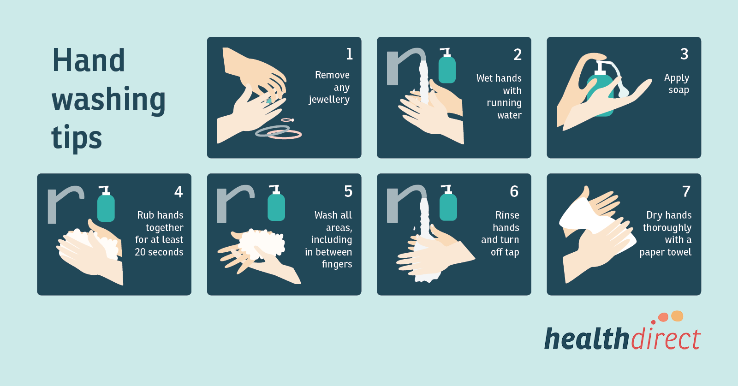
Figure 3.1hand washing tips

- Hair often carries pathogens that can be transferred to food in two ways. Firstly the handlers may touch their hair, often an unconscious reaction, transferring the

Pathogen to their hands. Secondly, and more importantly is loose strands of hair or dandruff can fall out on to food and contaminate it directly.
Regular hand washing will help minimise the risks from touching hair, and regular hair washing combined with the use of hairnets and hats will help prevent loose hair and dandruff from contaminating food.
Food handlers should only groom their hair in the cloakrooms and never in the kitchen.
- Jewellery worn by food handlers can pose a problem by either falling onto food and being partially or completely ingested, or by harbouring pathogens on the skin under the jewellery that can be transferred through hand contact.
Generally only plain wedding rings are permitted to be worn in the kitchen.
Food handlers should be encouraged to avoid using excessive make-up and strong smelling personal toiletries as these can taint or contaminate the food.
- Protective clothing is designed for either protecting the wearer from some type of personal injury such as a burn or knife cut, or more commonly to protect food from contamination from handlers’ general clothing, which will often be contaminated with staphylococci. Protective clothing is not, as many food handlers believe, to protect their own clothing.
Protective clothing should completely cover a handler’s personal clothing and should always be clean. The use of a light colour is advised as this shows up dirt and spoilage easily and encourages cleaning and replacement.
- Gloves should be worn for handling chemicals and washed regularly if used in food areas.
Eye or face protection is necessary for oven cleaning because of the caustic nature of the chemicals involved.

- Smoking is not allowed in the kitchen or food preparation areas, as there is a risk of physical contamination of ash and cigarette ends along with an increased risk of bacterial infection from saliva on cigarette ends and fingers.
Smoking can also encourage coughing which can release infected saliva and mucus onto hands, food surfaces and food itself.
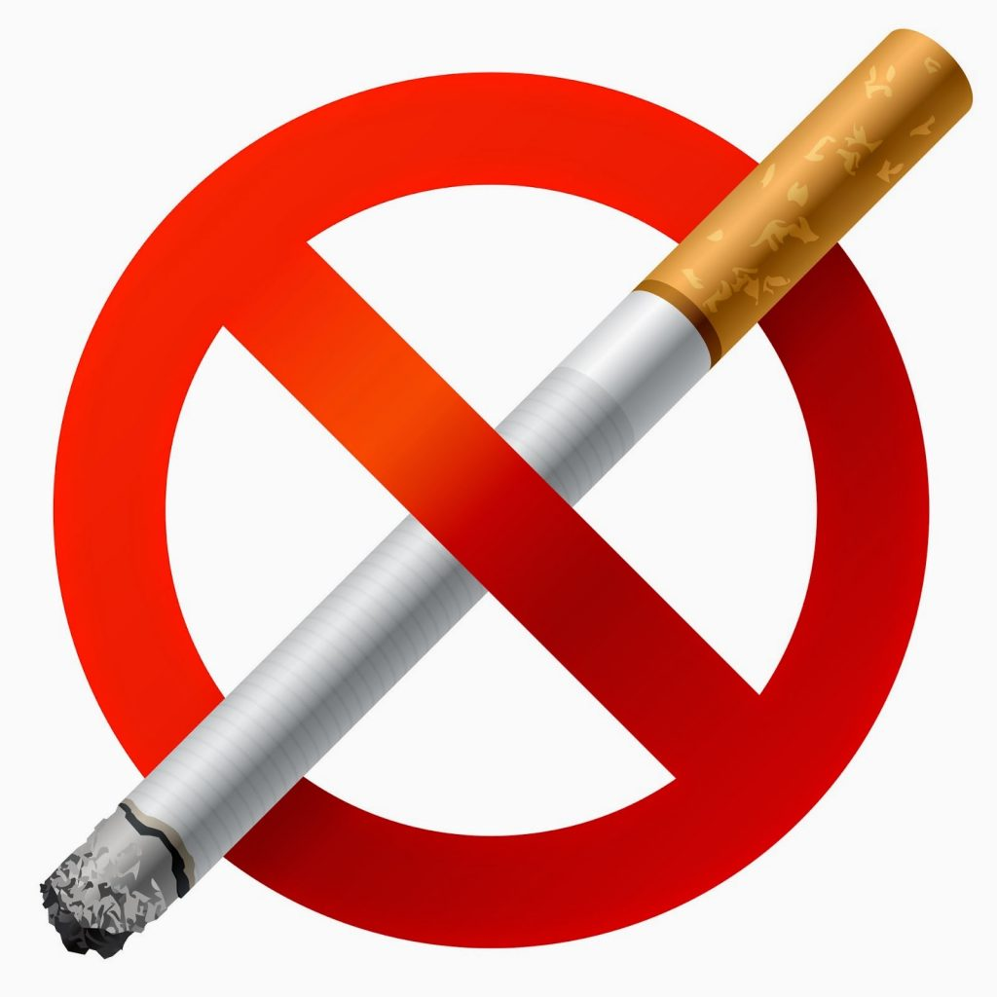
Figure 3.2 cigarette
- Food Handlers Health
It is an offence for people to be working in a kitchen or any other food handling area if they are suffering from, suspected to be suffering from, or carrying a disease that could be transmitted through food. This also applies to boils and septic cuts as they can contain Staphylococcus aurous.
The food handler has a legal as well as a moral obligation to inform the catering management of any symptoms of food poisoning eg diarrhoea or vomiting, or any suspicion they may have that they are carrying any food poisoning organisms.

Figure 3.3food poisoning

3.1.4 Cleaning Process
Cleaning requires two key elements, namely energy and time.Energy can be supplied in three different forms:
- Chemical – supplied by detergents
- Physical or Mechanical – supplied by scrubbing or sweeping, and by machines such as dishwashers and floor scrubbers.
- Heat – Supplied by hot water or steam.
3.1.5 Cleaning Products Used

- Detergents
Within the kitchen environment, degreasing agents and oven cleaning detergents are used extensively.
- Sanitizers
Sanitising solutions have been developed for use within the kitchen environment and are suitable for use on all surfaces. Sanitizers do not necessarily disinfect. They will kill virtually all of the harmful bacteria known to breed within kitchens and are critical in ensuring that exacting hygiene standards are achieved and maintained.
- Washing up Liquid
Washing up liquid is provided for hand dishwashing. It can be added to water manually by the operative or by means of a dosing system connected to a large container.
Washing up liquid can incorporate an anti-bacterial ingredient to provide germ-killing properties and all types are generally neutral.
- The Systematic Approach to Cleaning Kitchen Equipment
The type of task will determine the amounts of the various types of energy needed as well as the correct time, and total time required to complete the task.
We have seen when looking at the difference between manual washing up and machine dishwashing how the different elements change.

3.1.6. The Cleaning Programme
Having considered the cleaning requirements, we can now look at frequencies and methods to be adopted which will make up the overall cleaning programme.
Cleaning tasks will essentially fall into one of four categories in terms of the frequency they are carried out:
  - After each use
  - Daily
  - Weekly
  - Monthly
Table 3.1the cleaning requirements
Task | Frequency | Cleaning Method
Chopping boards and food  Preparation surfaces | After each use | • Make a solution of cleaner sanitizer  • Brush off and remove debris  • Load a clean cloth with clean, warm water and wipe  the surface  • Load a clean cloth with cleaning solution and liberally  wet the surface  • Allow time for the solution to act on the surface  • Wipe the surface clean, rinse well with clean water and allow to air dry.
Manual Dishwashing | After each use | • Prepare a solution of hot water and concentrated washing-up liquid  • Scrape off any waste foodstuffs into a waste food bin  • Place dishes in the solution and allow to soak  • Remove residual waste using a clean scrubbing brush or abrasive pad  • Rinse with clean hot water and allow to air dry
Food Processing Machinery - Slicers, mincers, mixers, peelers and can openers | After each use or maintenance procedure | • Switch off power and remove the plug from electrical supply  • Protect electrical parts using a waterproofing kit  • Prepare a solution of hot water and cleaner/sanitizer  • Place any removable parts in the solution or spray and allow to soak  • Clean all parts by brushing or wiping  • Rinse well with clean water and allow to air dry and reassemble
Fryers  (always refer to manufacturer’s cleaning  guidelines) | Weekly | • Switch off power and remove plug from the electrical supply  • Drain fat into a waste container and wipe away any  residual grease with disposable paper tissue  • Fill fryer with a solution of water and cleaner/degreaser  • Submerge all baskets and utensils in the solution  • Switch on and boil  • Check on progress of cleaning and switch off when satisfied  • Remove any film of deposits from the inside of the fryer with a brush or spatula and deposit in a waste food bin  • Empty the fryer and rinse thoroughly with clean hot water  • Allow to air dry
Dishwashers  (always refer to  manufacturer’s  cleaning  guidelines) | Daily  (if not self-cleaning) | • Switch off power and remove the plug from the electrical supply  • Drain machine of any residual waste water  • Remove spray arms and check holes are not blocked  • Remove filters and empty out any debris  into a waste bin  • Prepare solution of hot water and degreaser in a bucket or bowl  • Clean filters with solution and rinse well with clean hot water  • Clean interior then exterior with solution using a clean cloth  • Rinse all surfaces with clean, hot water  • Replace all removable parts and allow to air dry
Refrigerators,  freezers and cold  rooms | Weekly  (or more frequently  if required) | • Prepare a solution of hot water and cleaner/sanitizer in a bucket or bowl  • Switch of power and remove the plug from the electrical supply  • Transfer food to alternative cool storage  • Remove racks and soak in solution  • Clean all surfaces, handles and seals with the solution using a clean cloth  • Rinse well with clean, hot water and allow to air dry  • Reconnect appliance and allow it to reach correct temperature before replacing food
Shelves, drawers  and food storage  racks | Weekly | • Prepare a solution of hot water and cleaner/sanitizer in a bucket or bowl  • Remove contents of drawers or shelves  • Brush/wipe off all loose debris  • Clean all surfaces with solution using a clean cloth  • Rinse with clean, hot water and replace all contents
BainsMaries, hot  cupboards,  refrigerated display  cabinets and  hot/cold serveries | Daily | • Prepare solution of hot water and cleaner/sanitizer  in a bucket or bowl  • Brush up and remove all loose debris  • Clean all surfaces with solution using a clean cloth  • Rinse thoroughly and allow to air dry
Microwave/  Combi-ovens | After each use | • Switch off power and remove plug from electrical supply  • Prepare solution of hot water and cleaner/degreaser in a bucket or bowl  • Prepare a solution of hot water and washing-up liquid in a kitchen sink and rinse with clean, hot water  • Take all removable parts and place and clean in solution in sink  • Clean all interior then exterior surfaces with the cleaner/degreaser solution using a clean cloth  • Replace all removable parts  • Rinse all surfaces using clean, hot water and allow to air dry
Ovens/Grills | After each use | • Spray surfaces with Oven Cleaner or Liquid Griddle Cleaner (supplied ready-to-use)  • Allow adequate contact time  • For stubborn deposits use an abrasive cleaning pad  • Rinse thoroughly using clean, hot water and allow to air dry
Floors | Daily | • Place warning signs at the extremes of the work area  • Prepare a solution of hot water and cleaner/degreaser in a mop bucket  • Apply solution to the floor using a clean mop  • Rinse the floor using clean, hot water with a clean mop  • Allow to air dry before removing warning signs
Canopies,  ventilation  ducting and  pipe work | Spot clean as  required, full clean  monthly | • Assess work area for the use of appropriate access  equipment (ladders, extension poles)  • Place warning signs at the extremes of the work area  • Remove any build ups of dust from high levels using a cobweb duster and wash down using damp cloth soaked in warm water  • Prepare a solution of hot water and cleaner/degreaser in a bucket or bowl  • Clean all surfaces with solution using a clean cloth  • Allow all areas to air dry before removing warning signs
Walls and  paintwork | Spot clean as  required, full clean  monthly | • Assess work area for the use of appropriate access equipment (ladders, extension poles)  • Place warning signs at the extremes of the work area  • Remove all items from walls and protect all electrical sockets and other fittings  • Remove any build ups of dust from high levels using a cobweb duster and wash down using damp cloth soaked in warm water  • Prepare a solution of hot water and cleaner/degreaser in a bucket or bowl  • Clean all surfaces with solution using a clean cloth making sure you clean from bottom to top  • Rinse all surfaces with clean, hot water making sure you do so from top to bottom  • Allow all areas to air dry before removing warning Signs
Drains and gullies | Weekly | • Place warning signs at extremes of work area  • Remove all drain/gully covers from areas to be cleaned  • Remove all excess debris and place in waste bin  • Prepare a solution of hot water and cleaner/sanitizer in a bucket or bowl  • Clean all surfaces and covers with solution using a clean cloth  • Replace all covers and allow to air dry before removing warning signs.

3.1.7 Monitoring Standards

As we mentioned at the start of this section, hygiene standards throughout the kitchen should be maintained at all times. Commercial kitchens are subject to regular inspections by Environmental
Health Officers, who, in addition to checking that kitchen operators are meeting their legal obligations, will rigorously check the effectiveness of the cleaning regime.
Therefore, it is a good idea to adopt a monitoring programme that checks the levels of cleanliness within the kitchen against an agreed standard. We have already identified that certain items need to be cleaned periodically to prevent the build-up of dirt and grease and these should also be monitored separately upon completion as part of the overall planned monitoring programme.

- Cleaning Checklists
These can be produced to cover individual areas, items, tasks etc. and usually take the form of a table which allows the inspector to decide whether or not the item is satisfactory or not. It should also allow the inspector to make comments and set deadlines for improvement or compliance. Finally, it should also allow for the inspector to check progress at subsequent visits. For example, the form could look something like this:
Table 3.2Cleaning Checklists
Task/Item | Satisfactory | Details | Action Required
Floors | No | Build-up of dirt around edges of floor | Floor requires machine  Scrubbing
Walls | No | Finger marks on tiles  above worktops | Remove immediately
Appliance  (outside surface) | No | Grease marks on side of  main oven | Pull out oven and clean all exterior surfaces
Appliances  (inside) | No | Build-up of burnt deposits on oven walls and base | Thoroughly clean using oven cleaner as per agreed procedures.

Inspected by:
Date of Inspection:
Date of Re-Inspection:
All companies are different and, as such, there are no hard and fast rules governing the way in which work should be monitored. Suffice to say that as long as the monitoring checklist covers all of the activities undertaken and is considered against a set of agreed cleaning standards, this should do the trick… but only if action is taken on the findings, quickly and efficiently.

3.1.8. Cleaning – General Rules
Given the variety of equipment and surfaces within the kitchen, it is not feasible to discuss the detailed cleaning methods for each task. However, there are a number of general rules which can be applied to all items and surfaces.
The degree to which these rules are followed will depend on the frequency of the clean ie daily clean or a deep monthly clean.
Although the following list may seem lengthy; failure to follow these rules, at least at the monthly deep clean, could result in pest infestation and food poisoning.
You will find a ‘clean as you go’ policy will make best use of effort and yield the highest standard of hygiene.
- General Rules
- For deep clean, work in the direction from the ceiling to the floor.
- Clean from clean to dirty e.g. for preparation table, work from the top surface to the floor.
- Dismantle equipment as far as possible e.g. remove doors, trays/shelves, gas rings, cooker knobs, filters, mixing paddles, etc.
- Be aware of legislative requirements, such as age limits for handling meat slicers.
- Drain items such as deep fat fryers, ice-cream makers etc.
- If possible, pull out large items such as ovens and refrigerators and clean behind and under these items.
- Look for signs of infestation such as droppings and nests.
- Remove gross debris by hand, e.g. by brushing.
- Check that all electrical equipment functions prior to and after cleaning.
- Ensure that all electrical equipment is isolated during cleaning.
- Use products in accordance with manufacturers’ directions.
- Take care with blades and sharp edges.
- If necessary, wear appropriate personal protective equipment.
- Use the correct dilution of the product to aid cleaning/achieve required sanitation.
- Ensure that sanitizer is in contact with surface for the required period to ensure sanitation standards. Typically this is 5 minutes; from 30 seconds for cleaned surfaces up to 15 minutes for a soak.
- Soak heavily soiled items to loosen dirt and aid cleaning.
- Pay particular attention to corners, ledges, rims, wheels, runners etc.
- Ensure that hidden surfaces, such as under preparation tables, oven doors and the seals of refrigerators and freezers are not overlooked and are cleaned/ sanitised
- Ensure that pilot lights, refrigerators etc. are re-lit/switched on after cleaning.
- Report and repair/replace damaged items/ surfaces.
3.1.9 Hazard Analysis Critical Control Point /HACCP
No Guide to Kitchen Hygiene would be complete without mentioning HACCP.
HACCP stands for Hazard Analysis Critical
Control Points and is a Food Safety methodology that relies on the identification of Critical Control
Points (CCP's) in food production and preparation processes. The CCPs are the closely monitored in order to ensure that food is safe for consumption
Although it sounds complicated, it is not, and really just requires a large measure of common sense.
The key is firstly to identify any potential hazards in the kitchen, which is something that may do somebody harm; secondly you need to identify the risks i.e. where there is a possibility of the hazard actually harming someone.
Once the risk has been identified, measures need to be put in place that will control the risk so that it does not become harmful to human health. As an example, salmonella, which often occurs naturally on raw chicken would be a hazard and, if the chicken is undercooked or stored incorrectly, would allow the bacteria to multiply and increase the risk of somebody becoming ill. To control the risk you must therefore store at the right temperature and cook thoroughly.
- Hazards fall into three main categories:
- Chemical, such as cleaning materials can present a hazard and should be stored out of food preparation areas and away from food altogether. Surfaces should be rinsed off after chemicals have been used.
- Physical contamination can occur from items such as broken glass, hair and jewellery, and care should be taken to:
- Ensure pests are excluded (e.g. mice, rats, cockroaches, flies)
- Keep your food areas clean
- Keep food covered and ensure packaging is intact
- Keep rubbish in closed bins
- Ensure that food handlers do not wear jewellery (or watches)
- Bacteria/Biological are the third type of hazard and need to be either stopped from growing in numbers or killed, through cooking and storing at the right temperatures. Bacteria can double their numbers every 20 minutes and can grow from one to 16 million in eight hours overnight.

3.2. Hygiene hazards
Industrial Hygiene is the science of recognizing and evaluating environmental hazards that could cause illnesses or other injuries. An industrial hygienist must assess risk based on both observed outcomes as well as anticipated ones.
The study and practice of industrial hygiene plays a vital role in the health and safety of workers across the globe. Governments and industries have developed standards over time that are meant to contribute to the welfare of those doing the work as well as the health and well-being of surrounding communities. Within these standards are generally accepted categories of hazards. The types of hazards defined by industrial hygiene are: airborne hazards, chemical hazards, biological hazards, ergonomic hazards, and physical hazards.
We’ll break down each of these categories, and answer some common questions about industrial hygiene.

3.2.1. Types of Industrial Hygiene Hazards
A. Airborne hazards
Any task that produces particulates, gas, or vapour contaminants presents an airborne hazard. The most common air contaminants typically include:
- Dusts or solid particulates that result from the physical alteration (crushing, grinding, burning, etc.) of materials such as rock, wood, metal, and grain.
- Fumes, the result of material that has become a vapor then cooled in the air to become suspended particulates.
- Mists, a vaporized material that has condensed back to a liquid state, or a liquid that has been dispersed into the air and broken into fine liquid droplets that remain suspended in the air for a period of time.
- Aerosols, especially fine liquid particles that easily enter the lungs.
- Fibre’s, a solid particle whose length is several times its diameter.
B. Chemical hazards

Chemical hazards present a risk to humans when they are inhaled, come in contact with the skin (corrosive injury), are absorbed through the skin, or are ingested. These hazards are found in the form of solids, liquids, gasses, mists, dusts, fumes, and vapors. Industrial hygiene standards typically take into account the concentration of the chemical present when assessing worker risk.
C. Biological hazards
These hazards include bacteria, viruses, fungi, and other living organisms. The risk from biological hazards presents when they enter the human body through breaks in the skin or through inhalation, absorption, or ingestion. Once inside the body, these organisms can cause acute or chronic infections. Biological hazards are most commonly found in settings where workers come in contact with organic and/or living organisms, such as those found in healthcare or food processing.
D. Ergonomic hazards
Ergonomics is the study of how people work within their environment. Ergonomic hazards are present when tasks involve motion or movement that puts undue strain on the body or places the body at risk of physical harm due to the motions involved in specific tasks. Repetitive motion tasks also pose a high risk for becoming ergonomic hazards.
E. Physical hazards
Physical hazards include excessive exposure to physical stimulants, such as noise, illumination, temperature, vibration, and both ionizing and nonionizing electromagnetic radiation. While radiation risks are not common across all industries, most other physical hazards can be present in a variety of work environments.
3.2.1 Workplaces control hazards
Across the field of health safety, professionals usually use the same types of controls to manage hazards. This includes industrial hygiene-related concerns.
- Engineering controls manage risk by isolating workers from the hazard or reducing/removing the hazard at the source. A dust collection unit in a wood shop is a type of engineering control.
- Workplace controls adjust the manner and space in which the tasks are performed to manage risk. For instance, isolating break rooms and meal areas and encouraging proper hand washing reduces the risk of ingesting chemical or biological hazards.
- Administrative controls include high-level tasks such as process management and scheduling. Properly managing risk at an administrative level adds another layer of protection against occupational hazards.
- Biological. Biological hazards include viruses, bacteria, insects, animals, etc., that can cause adverse health impacts. For example, mould, blood and other bodily fluids, harmful plants, sewage, dust and vermin.
- Chemical. Chemical hazards are hazardous substances that can cause harm. These hazards can result in both health and physical impacts, such as skin irritation, respiratory system irritation, blindness, corrosion and explosions.
- Physical. Physical hazards are environmental factors that can harm an employee without necessarily touching them, including heights, noise, radiation and pressure.
- Safety. These are hazards that create unsafe working conditions. For example, exposed wires or a damaged carpet might result in a tripping hazard. These are sometimes included under the category of physical hazards.
- Psychosocial. Psychosocial hazards include those that can have an adverse effect on an employee’s mental health or wellbeing. For example, sexual harassment, victimisation, stress and workplace violence.

3.3. Minimizing hazards
In evaluating the risk and making recommendations to limit the risk, Sanford Health uses the following as a guide.
- Elimination: Physically remove the hazard.
- Substitution: Replace the hazard.
- Engineering controls: Isolate people from the hazard.
- Administrative controls: Change the way people work.
- Personal protective equipment: Protect the worker with equipment such as helmets, respirators, earplugs and more.
On occasion if these first three steps are not feasible, employers can limit the hours worked in dangerous areas by rotating staff to safer areas.
Lastly, if there is still a concern, personal protective equipment is recommended. Occupational medicine professionals can make sure that the PPE is fitting properly and providing the best protection for the worker.
Once workplaces have minimized worker exposure to these agents, Sanford Health can provide annual surveillance exams. The exams will monitor the workers to assure that protection is working properly and the workers are not developing any work-related adverse health effects.
Injuries and illnesses in the workplace are costing businesses billions of dollars and at the same time loss of productivity and profits. This program examines the most frequent causes of injuries and best practices to eliminate them.
Occupational hygienists work to recognize and mitigate workplace health hazards.
Employers use many different materials daily in carrying out their business operations. Many of these materials contain toxins which can have devastating effects on their workers’ health.

3.4. Reporting hygiene hazards
All faculty, staff and students have a role to play - ensuring people under their direction have all that they need to work and study safely, using good judgment and adhering to environmental health and safety precautions, and looking out for each other to avoid injuries, illnesses and environmental harm. When something goes wrong or even almost goes wrong and when something just doesn't seem safe, it is important to report concerns to supervisors and/or to EHS.
- Managing Safety Issues
Department Chairs, Heads of Offices, Directors of Programs, Laboratory Directors, Principal Investigators, managers, supervisors, foremen, etc. are responsible for the health and safety of students and employees engaged in activities under their direction or supervision. These supervisors must ensure that their employees or students:
- Perform work activities in a safe and considerate manner.
- Comply with all relevant regulations and accepted standards.
- Have the engineering controls or protective equipment needed to perform work safely.
- Complete applicable EHS-required training and have access to training records.
- Receive additional job or activity-specific training as needed.
- Ensure visitors are safe from and aware of hazards in the area or workplace.
- Faculty, staff and students are responsible for:
- Adhering to all University and departmental or office safety policies and procedures and comply with safety directives issued by their individual supervisors.
- Complying with the applicable provisions of health and safety standards and regulations promulgated by regulatory agencies.
- Attending required training.
- Raising safety concerns.
- Reporting Safety Issues
Individuals with specific safety questions or concerns are encouraged to raise them with their immediate supervisor. Dealing with safety issues through the supervisory chain of command is the preferred method; however, when this approach is unsuccessful in resolving a safety issue, you may contact a member of the EHS staff directly. EHS staff will, on request, keep the name of a complainant confidential; however, in some instances, this constraint may prevent thorough investigation and resolution of a complaint.
- Escalating Concerns
EHS makes every effort to work with individuals and supervisors to resolve safety issues. In the event that such issues cannot be resolved easily, EHS will follow an escalation process:

- Research Laboratories
When an instance of non-compliance is observed in the research laboratory EHS will always counsel the individual directly involved. Depending on severity, EHS will often follow up with the principal investigator (PI) to make them aware of the issue. EHS expects the PI to take action to ensure the lab staff understand the importance of compliance.
An escalation process is followed when repeated issues are observed and the PI does not take appropriate action to correct the behavior/issue. If the issue is connected to work with animals, biological or radioactive materials, EHS may work with the Institutional Animal Care and Use Committee (IACUC), Institutional Biosafety Committee (IBC), or the Radiation Safety Committee (RSC). Otherwise:
- Report to and work with the chair of the department or institute. If that is not successful...
- Report to and work with the dean of the school (if one exists). If that is not successful...
- Report to and work with the Dean for Research and/or the Dean of the Faculty
- Non-Laboratory Areas
The escalation process for non-laboratory areas includes:
- Report to and work with department or office head.
- Report to and work with vice president to which the department or office reports.
- Report to and work with the Executive Vice President.
- Faculty and Staff
Employees are responsible for complying with the applicable provisions of health and safety laws, standards and regulations, adherence to all University and departmental or office safety policies and procedures, and complying with safety directives issued by their individual supervisors. When employees do not meet these standards, it is the supervisor's responsibility to act in a timely manner and initiate a program of disciplinary steps to address the problem, as outlined in the University’s Disciplinary Procedure(link is external).
- Students
When students do not meet the above-mentioned standards and the supervisor or advisor is unable to resolve the issue, EHS will work with the Dean of Undergraduate Students or the Dean of the Graduate School.

Self-Check -3 | WRITTEN TEST

- Choose The best Answers
- What are the guides to Minimizing hazards:
- Elimination: Physically remove the hazard.
- Substitution: Replace the hazard.
- Engineering controls: Isolate people from the hazard.
- Administrative controls: Change the way people work.
- All
- The field of health safety, professionals usually use the same types of controls to manage hazards.
- Engineering controls
- Workplace controls
- Administrative controls
- All
- What are the Types of Industrial Hygiene Hazards:
- Airborne hazards
- Chemical hazards
- A&B
- All
- True or false
- The risk from biological hazards presents when they enter the human body through breaks in the skin or through inhalation, absorption, or ingestion.
- Physical hazards include excessive exposure to physical stimulants, such as noise, illumination, temperature, vibration, and both ionizing and nonionizing electromagnetic radiation.

III. Directions: Answer all the questions listed below
1. What are the hygiene procedures?
2. How do you identify and prevent hygiene risks?
3. Why is personal hygiene 10 important?

UNIT FOUR | Cross-contamination
This learning guide is describes knowledge, skills and attitude required for food sanitation and safety in a commercial kitchen or catering operation.
- Food borne illness
- danger zone and potentially hazardous foods (PHFs)
- Personal hygiene
- Preventing unnecessary direct contact with ready to eat food.

This guide will also assist you to attain the learning outcomes stated in the cover page. Specifically, upon completion of this learning guide, you will be able to:
- Avoid Food borne illness
- Identify Danger zone and potentially hazardous foods (PHFs)
- Practice Personal hygiene
- Prevent unnecessary direct contact with ready to eat food.

4.1 Food borne illness
Foodborne illness, also called food poisoning, is an illness acquired from eating or drinking contaminated food or water.
- When food is contaminated by bacteria, viruses, parasites, or chemicals it can make you sick
- For each reported case of foodborne illness, it’s estimated that hundreds of additional cases go unreported in the community each year
Most foodborne illnesses are acute, meaning they happen suddenly and last a short time, and most people recover on their own without treatment. Rarely, foodborne illnesses may lead to more serious complications.

A Causes of food borne illnesses
The majority of foodborne illnesses are caused by harmful bacteria and viruses.2 Some parasites and chemicals also cause foodborne illnesses.
- Bacteria
Bacteria are tiny organisms that can cause infections of the GI tract. Not all bacteria are harmful to humans.
Some harmful bacteria may already be present in foods when they are purchased. Raw foods including meat, poultry, fish and shellfish, eggs, unpasteurized milk and dairy products, and fresh produce often contain bacteria that cause foodborne illnesses. Bacteria can contaminate food—making it harmful to eat—at any time during growth, harvesting or slaughter, processing, storage, and shipping.
Foods may also be contaminated with bacteria during food preparation in a restaurant or home kitchen. If food preparers do not thoroughly wash their hands, kitchen utensils, cutting boards, and other kitchen surfaces that come into contact with raw foods, cross-contamination—the spread of bacteria from contaminated food to uncontaminated food—may occur.
If hot food is not kept hot enough or cold food is not kept cold enough, bacteria may multiply. Bacteria multiply quickly when the temperature of food is between 40 and 140 degrees. Cold food should be kept below 40 degrees and hot food should be kept above 140 degrees. Bacteria multiply more slowly when food is refrigerated, and freezing food can further slow or even stop. The spread of bacteria However, bacteria in refrigerated or frozen foods become active again when food is brought to room temperature. Thoroughly cooking food kills bacteria.
Many types of bacteria cause foodborne illnesses. Examples include
- Salmonella, a bacterium found in many foods, including raw and undercooked meat, poultry, dairy products, and seafood. Salmonella may also be present on egg shells and inside eggs.
- Campylobacter jejuni (C. jejuni), found in raw or undercooked chicken and unpasteurized milk.
- Shigella, a bacterium spread from person to person. These bacteria are present in the stools of people who are infected. If people who are infected do not wash their hands thoroughly after using the bathroom, they can contaminate food that they handle or prepare. Water contaminated with infected stools can also contaminate produce in the field.
- Escherichia coli (E. coli), which includes several different strains, only a few of which cause illness in humans. E. coli O157:H7 is the strain that causes the most severe illness. Common sources of E. coli include raw or undercooked hamburger, unpasteurized fruit juices and milk, and fresh produce.

Factors affecting bacteria growth
Bacteria need a combination of factors to grow:
- Food source high in protein
- Acidity (pH)
- Time
- Temperature
- Oxygen
- Moisture (available water)
- Food source high in protein
Pathogenic bacteria and spoilage bacteria grow best in high protein foods such as meat, seafood and dairy
- Acidity (pH)
- Acid and base concentrations are measured on a pH scale that ranges from 0 (most acidic) to 14 (most basic)
- Pathogenic bacteria survive best in a neutral environment.
- Tap water has a pH of 7 (neutral), bleach has a pH of 13 (alkaline) and lemon has a pH of 3 (acidic)
- Time
- Leaving food in the “danger zone” (4°C to 60°C) for more than two hours may be long enough for pathogenic bacteria to multiply and cause food poisoning
- By reducing the time food is kept in the danger zone, the amount of bacterial growth is limited
- Temperature
- Most bacteria grow best in the temperature danger zone
- Temperatures below 4°C will not kill pathogenic bacteria but will slow down their growth
- At temperatures above 60°C, pathogenic bacteria will not grow.
- Cooking food to appropriate final internal cooking temperatures is the only way to ensure pathogenic bacteria are destroyed (refer to page 46 for cooking temperatures)
Figure 4.1 thermostat
- Oxygen
- Most pathogenic bacteria can only grow where there is oxygen present while some can only grow where there is no oxygen
- For example, the pathogenic bacteria, Clostridium botulinum can grow in canned foods and in flavoured oils where there is no oxygen
- Moisture (available water)
- Pathogenic bacteria need a water supply to survive
- The amount of water in food can be reduced by processes such as smoking, drying or adding salt or sugar
These six factors influence the growth of pathogenic bacteria. By sufficiently changing or eliminating one of the factors, bacterial growth and the risk of foodborne illness can be prevented. Time and temperature are the easiest factors for food handlers to control.
- Viruses
Viruses are tiny capsules, much smaller than bacteria that contain genetic material.Viruses cause infections that can lead to sickness. People can pass viruses to each other. Viruses are present in the stool or vomit of people who are infected. People who are infected with a virus may contaminate food and drinks, especially if they do not wash their hands thoroughly after using the bathroom.
- Food prepared by a person infected with a virus
- Shellfish from contaminated water
- Produce irrigated with contaminated water
- Nor virus, which causes inflammation of the stomach and intestines
- Hepatitis A, which causes inflammation of the liver
- Parasites
Parasites are tiny organisms that live inside another organism. In developed countries such as the United States, parasitic infections are relatively rare.
Cryptosporidium parvum and Giardia intestinalis are parasites that are spread through water contaminated with the stools of people or animals that are infected. Foods that come into contact with contaminated water during growth or preparation can become contaminated with these parasites. Food preparers who are infected with these parasites can also contaminate foods if they do not thoroughly wash their hands after using the bathroom and before handling food.
- Chemicals
Harmful chemicals that cause illness may contaminate foods such as fish or shellfish, which may feed on algae that produce toxins, leading to high concentrations of toxins in their bodies. Some types of fish, including tuna and mahimahi, may be contaminated with bacteria that produce toxins if the fish are not properly refrigerated before they are cooked or served.

4.1.2 Symptoms of foodborne illnesses

Symptoms of foodborne illnesses depend on the cause. Common symptoms of many foodborne illnesses include.
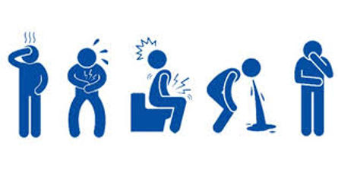Figure 4.2 symptoms of foodborne illnesses

- vomiting
- Diarrhoea or bloody diarrheal
- Abdominal pain
- Fever
- chills
Symptoms can range from mild to serious and can last from a few hours to several days.C. botulinum and some chemicals affect the nervous system, causing symptoms such as
- Headache
- Tingling or numbness of the skin
- blurred vision
- Weakness
- Dizziness
- Paralysis

4.1.3. Cross Contamination
Cross-contamination is one of the most common causes of food poisoning. It happens when harmful bacteria are spread on food from other food, surfaces, hands or equipment. Contamination of food can also be physical or chemical.

- Separation
- Identification of separate work areas, surfaces and equipment for raw and ready-to-eat food
- Use of separate complex equipment, such as vacuum-packing machines, slicers, and mincers for raw and ready-to-eat food at all times.
- If possible, use separate fridges for raw and ready-to-eat food. If not, always store raw food below ready-to-eat food.
- Defrosting raw meat should be kept covered at the bottom of the fridge below ready to eat foods.
- Cleaning Schedule
Your cleaning schedule should be sufficient to recognise what needs to be cleaned to prevent cross contamination from surfaces and equipment. It should address how to effectively clean and disinfect by stating the cleaning product, cloth to use, method and frequency of cleaning.
Cloths should either be disposable or reusable but washed on a hot cycle over 82°C and separate cloths used for separate areas i.e. raw and ready to eat preparation areas.
Refer to fact sheet ‘Cleaning and Disinfection’.
- Personal Hygiene
Hand washing should be carried out using a recognised technique. Anti-bacterial gels must not be used instead of thorough hand washing. Hot water, soap and disposable hand towels should be available at all hand wash sinks.
Wash your hands before preparing food and after touching raw food.
All staff should wear clean clothes when working with food which should be changed after handling raw food and before handling ready to eat food.
- Chemical Contamination
Clearly label cleaning chemicals and store them away from food.
All food should be protected during cleaning or put away, the task should not be undertaken when the kitchen is operational.
- Physical Contamination
A pest’s control policy should be in place, either with a pest control company or by introducing your own checks.
Food handlers should have hair tied back, and should not wear jewellery or clothing which could fall out and contaminate food.
Repair or replace equipment and utensils which are damaged and a no glass policy would be encouraged.
- Food Safety Management
- Make sure staff are aware they have a duty to inform you if they suffer from diarrhoea or vomiting, and implement a 48 hour symptom-free policy.
- Staff responsible for preparation of food should have adequate training i.e. a minimum of Level 2 in Food Safety in Catering. Staff should also be trained in your food safety management system e.g. Your SFBB pack on cross contamination (the red section.)

4.2 Danger zone and potentially hazardous foods.
Leaving food out too long at room temperature can cause bacteria (such as Staphylococcus aureus, Salmonella Enteritidis, Escherichia coli O157:H7, and Campylobacter) to grow to dangerous levels that can cause illness. Bacteria grow most rapidly in the range of temperatures between 40 °F and 140 °F, doubling in number in as little as 20 minutes. This range of temperatures is often called the "Danger Zone."
4.2.1 Keep Food Out of the "Danger Zone"
Never leave food out of refrigeration over 2 hours. If the temperature is above 90 °F, food should not be left out more than 1 hour.
- Keep hot food hot—at or above 140 °F. Place cooked food in chafing dishes, preheated steam tables, warming trays, and/or slow cookers.
- Keep cold food cold—at or below 40 °F. Place food in containers on ice.
- Cooking
raw meat and poultry should always be cooked to a safe minimum internal temperature (see graphic). When roasting meat and poultry, use an oven temperature no lower than 325 °F.If you aren't going to serve hot food right away, it's important to keep it at 140 °F or above.
- Storing Leftovers
One of the most common causes of foodborne illness is improper cooling of cooked foods. Bacteria can be reintroduced to food after it is safely cooked. For this reason leftovers must be put in shallow containers for quick cooling and refrigerated at 40 °F or below within two hours.
- Reheating
Foods should be reheated thoroughly to an internal temperature of 165 °F or until hot and steaming. In the microwave oven, cover food and rotate so it heats evenly.

The temperature danger zone for food is recognized to be within 40°F to 140°F (5°C to 60°C).
Within the temperature danger zone for food, pathogens can multiply at a fast rate and can spoil foods within the first 2 hours.
Foods are advised to be kept outside the temperature danger zone using operations such as hot holding and refrigeration.
At home, when you can't finish your food, you know to never leave it on the countertop of your kitchen if you intend to eat it at a later time. As part of your food safety precautions, you always repack it and put it inside the refrigerator. This is also the case when you do make-ahead recipes. You are well aware that food safety hazards can contaminate them anytime and cause your food to spoil. In a professional kitchen setup, these scenarios also happen.
To prepare for busy food service each day, food handlers partially prepare some of the ingredients to speed up the process during service. Food handlers do this to keep the food away from the temperature danger zone.
The temperature danger zone is the range at which most pathogenic microorganisms thrive and optimally multiply, thereby increasing the risk of foodborne illnesses. This temperature range is generally recognized within 40°F and 140°F (5°C and 60°C, respectively). At this temperature, pathogens such as bacteria, fungi, yeasts, viruses, and parasites thrive best. Temperatures within this range are often used as model temperatures and the perfect environment to determine the optimal doubling time of bacteria, or the time needed by bacteria to double in number. Around 40°F to 140°F (5°C to 60°C), it takes around 20 minutes for fast-growing bacteria such as E.coli to double in number.
Depending on the initial load of the pathogens on the food, spoilage can occur at a rapid rate within the first 2 hours of keeping food at room temperature. Of course, other factors such as acidity, moisture level, presence of preservatives, and nutrient content also affect the process.
The danger zone is the temperature range in which food-borne bacteria can grow. Food safety agencies, such as the United States' Food Safety and Inspection Service (FSIS), define the danger zone as roughly 40 to 140 °F (4 to 60 °C).The FSIS stipulates that potentially hazardous food should not be stored at temperatures in this range in order to prevent foodborne illness (for example, a refrigerator's temperature must be kept below 4 °C (40 °F)^{[4]}), and that food that remains in this zone for more than two hours should not be consumed.^{[5]} Foodborne microorganisms grow much faster in the middle of the zone, at temperatures between 21 and 47 °C (70 and 117 °F). In the UK and NI, the Danger Zone is defined as 8 °C - 63 °C
Food-borne bacteria, in large enough numbers, may cause food poisoning, symptoms similar to gastroenteritis or "stomach flu" (a misnomer, as true influenza primarily affects the respiratory system). Some of the symptoms include stomach cramps, nausea, vomiting, diarrhea, and fever. Food-borne illness becomes more dangerous in certain populations, such as people with weakened immune systems, young children, the elderly, and pregnant women. In Canada, there are approximately 4 million cases of food-borne disease per year. These symptoms can begin as early as shortly after and as late as weeks after consumption of the contaminated food.
Time and temperature control plays a critical role in food safety. To prevent time-temperature abuse, the amount of time food spends in the danger zone must be minimized. A logarithmic relationship exists between microbial cell death and temperature, that is, a small decrease of cooking temperature can result in considerable numbers of cells surviving the process. In addition to reducing the time spent in the danger zone, foods should be moved through the danger zone as few times as possible when reheating or cooling.
- Foods that are potentially hazardous inside the danger zone:
- Meat: beef, poultry, pork, seafood
- Eggs and other protein-rich foods
- Dairy products
- Cut or peeled fresh produce
- Cooked vegetables, beans, rice, pasta
- Sauces, such as gravy
- Sprouts
- Any foods containing the above, e.g. casseroles, salads, quiches

4.3 Personal hygiene
Personal hygiene is how you care for your body. This practice includes bathing, washing your hands, brushing your teeth, and more.
Every day, you come into contact with millions of outside germs and viruses. They can linger on your body, and in some cases, they may make you sick. Personal hygiene practices can help you and the people around you prevent illnesses. They can also help you feel good about your appearance.
Learn more about why hygiene is so important, the best ways to practice it, and how you can change your habits to make yourself feel and look better.
4.3.1. Types of personal hygiene
Each person’s idea of personal hygiene differs. These main categories are a useful place to start for building good hygiene habits:
- Toilet hygiene
Wash your hands after you use the restroom. Scrub with soap for 20 to 30 seconds, and be sure to clean between your fingers, on the back of your hands, and under your nails. Rinse with warm water, and dry with a clean towel.
If you don’t have running water or soap, an alcohol-based hand sanitizer will also work. Use one that’s at least 60 percent alcohol.
- Shower hygiene
Personal preference may dictate how often you wish to shower, but most people will benefit from a rinse at least every other day. Showering with soap helps rinse away dead skin cells, bacteria, and oils.
You should also wash your hair at least twice a week. Shampooing your hair and scalp helps remove skin buildup and protects against oily residues that can irritate your skin.
- Nail hygiene
Trim your nails regularly to keep them short and clean. Brush under them with a nail brush or washcloth to rinse away buildup, dirt, and germs.
Tidying your nails helps you prevent spreading germs into your mouth and other body openings. You should also avoid biting your nails.
- Teeth hygiene
Good dental hygiene is about more than just pearly white teeth. Caring for your teeth and gums is a smart way to prevent gum diseases and cavities.
Brush at least twice a day for 2 minutes. Aim to brush after you wake up and before bed. If you can, brush after every meal, too. Floss between your teeth daily, and ask your dentist about using an antibacterial mouthwash.
These two steps can help prevent tooth decay and eliminate pockets where bacteria and germs can build up.
- Sickness hygiene
If you’re not feeling well, you should take steps to keep from spreading germs to others. This includes covering your mouth and nose when sneezing, wiping down shared surfaces with an antibacterial wipe, and not sharing any utensils or electronics. Also, immediately throw away any soiled tissues.
- Hands hygiene
Germs on your hands can easily enter your body through your mouth, nose, eyes, or ears. Wash your hands:
- when you handle food
- before you eat
- if you handle garbage
- when you sneeze
- any time you touch an animal

4.4 Preventing unnecessary direct contact with ready to eat food.
The main reason for not touching ready-to-eat foods with bare hands is to prevent viruses and bacteria which are present in your body from contaminating the food. Viruses and bacteria are invisible to the naked eye, but may be present on your hands if you do not wash them thoroughly, particularly after using the bathroom. The law prohibits bare hand contact with ready-to-eat foods and requires good hand washing by food service workers.
4.4.1 Required to wash my hands
- before starting work;
- before putting on single service gloves;
- after touching raw, fresh or frozen beef, poultry, fish or meat;
- after mopping, sweeping, removing garbage or using the telephone;
- after using the bathroom;
- after smoking, eating, sneezing or drinking;
- after touching anything that might result in contamination of hands.
4.4.2 Good hand washing
All employees involved with food preparation must wash their hands and exposed portions of their arms with soap and water. Thorough hand washing is done by vigorously rubbing together the surfaces of lathered hands and arms for at least 20 seconds followed by a thorough rinse with clean water. Use a single-service towel or hot air dryer to dry hands. No special soaps are needed.
- Disposable sanitary gloves
State law does not require gloves to be worn, but does require that ready-to-eat food be prepared and served without bare hand contact. Wearing disposable sanitary gloves is one of several acceptable ways to comply with this law.
- tongs;
- forks & spoons;
- deli paper;
- disposable gloves;
- waxed paper;
- napkins;
- spatulas.
- Foods may not be touched with bare hands
- prepared fresh fruits and vegetables served raw;
- salads and salad ingredients;
- cold meats and sandwiches;
- bread, toast, rolls and baked goods;
- garnishes such as lettuce, parsley, lemon wedges, potato chips or pickles on plates;
- fruit or vegetables for mixed drinks;
- ice served to the customer;
- Any food that will not be thoroughly cooked or reheated after it is prepared.
- Cook required to wear gloves
No. Food outbreak investigations have not identified the handling of money as a cause of illness. But it is a good idea to change your gloves and wash your hands between touching money and preparing food. Many patrons complain to the local health department if they see food workers using the same gloves to prepare food and handle money.
The short order cook may not touch ready-to-eat foods with bare hands. Disposable gloves are one possible way to prevent bare hand contact with ready-to-eat foods. Another way is to use forks, tongs or spatulas.

Self-Check -4 | WRITTEN TEST

- Choose the best Answers

- -------are factors when affecting bacteria growth
- Food source high in protein
- Acidity (pH)
- Time
- Temperature & Oxygen
- All
- Which one true about Acidity (pH)
- Acid and base concentrations are measured on a pH scale that ranges from 0 (most acidic) to 14 (most basic)
- Pathogenic bacteria survive best in a neutral environment.
- Tap water has a pH of 7 (neutral), bleach has a pH of 13 (alkaline) and lemon has a pH of 3 (acidic)
- All
- ----------are factors influence the growth of pathogenic bacteria.
- Viruses
- Parasites
- Chemicals
- All

UNIT FIVE | Clean and sanitize premise and equipment
This learning guide is describes knowledge, skills and attitude required for food sanitation and safety in a commercial kitchen or catering operation.

  - Cleaning schedules.
  - Cleaning agents
  - Cleaning and sanitizing walls, floors, shelves and othersurfaces
  - Cleaning and sanitizing Equipment and utensils
  - Storing Cleaned equipment and utensils

This guide will also assist you to attain the learning outcomes stated in the cover page. Specifically, upon completion of this learning guide, you will be able to:

  - Follow Cleaning schedules.
  - Apply Cleaning agents
  - Clean and sanitize walls, floors, shelves and othersurfaces
  - Clean and sanitize Equipment and utensils
  - Store Cleaned equipment and utensils

5.1 Cleaning schedules
Dirt, food waste and other debris can be a potential source of microbiological and physical hazards and will also attract pests that can contaminate the production environment. Effective cleaning on a regular basis is essential to remove dirt and debris from the food premises. Effective disinfection of clean food contact surfaces is necessary to reduce bacteria to an acceptable level. Poorly executed cleaning programmes and careless storage and use of cleaning materials may give rise to chemical hazards. Procedures are needed to prevent or minimise the risk of such hazards causing illness or injury to consumers.

Table 5.1.Demonstrating the importance of cleaning

Problem | Effect | Possible outcome
Poor cleaning within the  working environment | Food is contaminated by dirt from the working environment such as dust, rust flakes, lubricating oil and food processing residues | Increases the chances of  cross contamination of food  products by food poisoning  micro-organisms
Food premises is not  cleaned properly | Organic material such as meat,  blood and other edible and  Inedible tissues can become contaminated. Moisture can  Accumulate | Encourages growth of microorganisms  such as  Salmonella
Poor cleaning | Pests are attracted to organic  Material | Pest species, for example,  flies, beetles, rodents, are  carriers of micro-organisms  that can cause food  poisoning
Careless use of cleaning  Agents | Chemicals spill on food | Lead to chemical  contamination of food
Ineffective and poor  cleaning | Cleaning implements are  themselves contaminated during  the cleaning process | Lead to cross contamination  when implements are next  used

5.2. Cleaning agents
‘Clean’ means free from dirt, marking, or soiling. Visibly clean surfaces look, smell and feel clean. Dirt and soil can be organic, for example, fat, blood; or inorganic, for example rust, and lime scale. Surfaces in contact with food should be:
- Physically clean – all visible dirt / soil / residues have been removed. Best assessed using white moist wipes.
- Chemically clean – all cleaning material residues have been removed.
Microbiologically clean – the number of micro-organisms has been reduced to a level acceptable for human health. This usually involves the use of disinfectants.

Figure 5.1Cleaning Agents

5.3. Cleaning and sanitizing walls, floors, shelves and other surfaces
Effective cleaning depends on the removal of gross physical contamination followed by the correct use of chemical agents. This means using the right chemicals, applying them at the right concentration and application rate using the right equipment, and allowing them time to work.
- Cleaning chemicals
- Detergents – chemicals used to dissolve grease and remove dirt and soil. Appropriate acidic or alkaline products can also be used.
- Disinfectants – chemicals that reduce bacteria to an acceptable level and may kill them.Products may be called germicides, bactericides or biocides. Surfaces need to be clean of grease, dirt and soil before a disinfectant is used - there is little point in disinfecting a dirty Surface. As well as the main biocide components, disinfectant formulations may include:
- surfactants to improve the wetting properties of the product and to control foamproduction
- sequester ants to improve suspension of any remaining inorganic soils from thesurfaces, to prevent scale forming on contact surfaces and to improve the biocidal activity of the disinfectant
- stabilisers to prevent disassociation of the disinfectant when used
- alcohols to decrease drying time by evaporating off the surface and leaving it dry
- Sanitizers – two-in-one products that act as both a detergent and a disinfectant. Do not attempt to mix cleaning chemicals yourself.
Provide instructions to make sure that disinfectant use is effective by avoiding common situations such as:
- lack of cleaning before disinfection
- use of incorrect disinfectants
- incorrect use of disinfectants
- biofilm build up, which prevents penetration by chemical disinfectants
- poor rinsing or non-rinsing of disinfectants
Ensure the following surfaces and equipment at least is disinfected:
- food contact surfaces and equipment
- hand contact surfaces
- cleaning equipment and materials

Table 5.1 Cleaning schedule example
CLEANING SCHEDULE |  |  | Issued by [Name]  [Date]
CLEANING OF: | Method, Chemical, Time | Equipment | PPE | Frequency | Notes
Kitchen / Area [A] | ------------- disinfection |  |  | Daily
Kitchen Machine [1] | ---------------- |  |  | D +breaks
Kitchen hood | ------------------ |  |  | D | + deep  Clean

Cleaning checklist example
CLEANING CHECKLIST |  |  |  |  |  |  |  | Checked by [Name]  [Date]
AREA / cleaned | Initialled by Cleaner Equipment |  |  |  |  |  |  |  |  | Frequency | Notes
AREA / cleaned | M | T | W | T | F | S | S |  | remark | Frequency | Notes
Kitchen / Area [A] |  |  |  |  |  |  |  |  |  | Daily
Kitchen Machine |  |  |  |  |  |  |  |  |  | D +breaks
Kitchen Hood |  |  |  |  |  |  |  |  |  | D | + deep  Clean

5.4. Cleaning and sanitizing Equipment and utensils
If you don’t clean your kitchen properly, germs and bacteria can start to grow – and quickly, too! This definitely isn’t ideal in a place where you prepare and cook food as it can lead to the people who visit your business getting ill. To avoid this, it’s important you’re cleaning and sanitizing kitchen utensils properly after you use them.
- Clean your kitchen utensils in hot water with an antibacterial detergent.
- When sanitizing kitchen tools and equipment, use either boiling water or a solution of bleach and water.
- Store your tools in a regularly cleaned plastic or metal box to keep the germs away.
When cleaning and sanitizing kitchen utensils, remember to dry them with dishcloths that have been cleaned using a quality detergent, such as Sunlight Liquid Detergent.
5.4.1 Cleaning after cooking
After you’ve finished cooking, it’s vital you’re cleaning and sanitizing kitchen tools and equipment to prevent the spread of bacteria. To start with, here’s how you can clean your tools:
- Scrape any food debris into a bin before cleaning and sanitizing tools and equipment.
- Fill your sink with warm to hot water and an antibacterial detergent.
- Use a clean sponge or brush to scrub each item thoroughly, making sure to remove all bits of food and getting into all the little, hard-to-reach areas.
- Either leave to air dry or use a dish cloth, which should be cleaned with a quality detergent, such as, to ensure you’re properly cleaning and sanitizing kitchen tools and equipment.
5.4.2. Cleaning vs. Sanitizing
If you run a restaurant, food factory, or an online food business from your kitchen, you must know the value of offering safe food. Cooking safe food means that you must sanitize your kitchen tools and equipment. We cannot stress enough how crucial it is to regularly sanitize your kitchen equipment.
However, many people often think that cleaning and sanitizing are the same. They’re not.
For one, cleaning removes contaminants (e.g. dust and dirt) from something (e.g kitchen tools). On the other hand, sanitizing means killing pathogens (e.g. germs) on a clean surface.
The Center for Disease Control and Prevention recommends doing both. In particular, you need to clean something first, then sanitize it. Depending on where you live, the local authorities usually set protocols about food preparation. As a responsible food business owner, you must follow these protocols. These guidelines usually include keeping your kitchen hygienic. To comply with these guidelines, you must regularly clean and sanitize kitchen premises.
- Important to Sanitize Kitchen Tools and Equipment
There are many reasons why you need to sanitize kitchen tools and equipment. Here are the top five reasons why is it important to sanitize kitchen tools and equipment:
II. Sanitizing prevents pathogens from spreading to your food.
One of the main reasons why you need to sanitize your tools is to prevent pathogens such as viruses, bacteria, and molds from spreading to your food.
When you use your tools to prepare raw food, pathogens from the raw food transfer to your tools. If you do not sanitize your tools, pathogens will spread to your finished product.
Similarly, dirty tools can transfer pathogens from one food to another. For instance, if you use baking tools and equipment to mix raw eggs and don’t sanitize them afterward, pathogens build up on your tools. As a result, the pathogens spread to the next baked treat you make.
III. Sanitizing lets you comply with health standards.
Local authorities set health standards to make sure that clean food products go to the market. Without these standards, restaurants and factories won’t be helped accountable in case their workers and customers get sick.To ensure everyone’s health, you must follow the health standards set by the authorities. These include sanitizing your tools and keeping your kitchen as clean as possible.In addition, local authorities conduct random inspections.
III. Sanitizing keeps your customers safe.
Food goes into people’s systems. Unlike clothing or skincare products, people ingest food. So, if you sell food, you must be extremely careful of your products. For one, you must prepare the food you sell in a clean and sanitized kitchen. Your tools must be clean and sanitized as well.
You should also make sure that your ingredients are safe. For instance, if you sell baked treats, your baking ingredients must be fresh and clean.

IV. Sanitizing keeps you and your workers safe.
When you sanitize your tools, you don’t just keep your customers safe. You keep yourself safe as well. If you have workers, you keep them safe, too.Viruses and bacteria easily spread among dirty tools and equipment. When this happens, you and your workers become exposed to the said pathogens. If you or your workers have weak immune systems, they can be sick.
Regularly cleaning and sanitizing your tools keeps you and your workers safe. After all, you might not want anyone in your team to get sick.
V. Sanitizing helps scale your business.
As we mentioned, cleaning and sanitizing your tools means producing safe food products.
When you do this, your customers will trust you more. If they know that you prepare your food properly, they tend to trust your brand. Over time, this trust turns into loyalty. As a result, you get loyal customers that keep on buying your products.Interestingly, you can also use your food preparation as a social media strategy for your business. For instance, you make ice cream cakes. You can shoot a video of how you safely prepare your products, post that video online, and let your prospects see it. Furthermore, sanitized tools let you maintain a great reputation. In particular, sanitized tools and equipment prevents your kitchen from reeking with unpleasant smells that may seep out from your restaurant or factory. As you may well know, no one wants to eat at smelly restaurants. If you sanitize your tools and equipment, you don’t have to deal with this problem.
- When to Sanitize Kitchen Tools and Equipment
However, tools that come into contact with the food you prepare should be cleaned and sanitized with a proven sanitizing method.
In particular, they must be cleaned and sanitized:
- Every time you use tools, equipment, and any surface.
- After using them to prepare raw meat, fruits, vegetables, and other ingredients.
- When you start preparing another type of food.
- At least every four hours if you constantly use the tools, equipment, and any surface.
- Steps in Cleaning and Sanitizing Utensils / How to Sanitize Kitchen Tools
- Remove loose particles from the tools.
- Rinse the tools with water.
- Wash the tools using detergent.
- Rinse the tools.

- Place the tools in a container.
- Pour hot water into the container.
- Let the tools sit in the water.
- Treat the tools with sanitizer as instructed on the label.
- Place your tools on the countertop.
- Let the tools air dry.
- How to Sanitize Kitchen Tools in 10 Easy Steps
Now that you know why is it important to sanitize kitchen tools and equipment and when to do so, it’s time to know how to do it.
- Here’s how to sanitize kitchen tools and equipment:
- Remove loose dirt and food debris from the tools.
- Rinse them with water.
- Wash the tools using a sponge and detergent. As an alternative, you can use a dishwasher.
- Rinse the tools.
- Place the tools in a container.
- Pour hot water (75 °C) into the container.
- Let the tools sit in the water for at least two minutes.
- Treat the tools with sanitizer as instructed on the label.
- Place your tools on the kitchen countertop. As an alternative, you can place them on a draining rack.
Let thetools air dry. As an alternative, you can wipe them dry using clean cloth.

5.5. Storing Cleaned equipment and utensils
- "Food establishment" means any place whether temporary or permanent, stationary or mobile, or whether it be considered public, semi-public or private, where food or drink is prepared, processed, manufactured, packaged, stored, served, sold or offered for sale. Provided that the following places are not included: homes containing what is commonly known as the family unit and their nonpaying guests; food service operations as defined in Ohio R.C. 3732.01; dairy plants, meat plants, slaughter houses, abattoirs and food-processing and food-manufacturing establishments which are under regulatory authority of the State and/or Federal Government.

- "Board of Health" means the Board of Health of the Springfield City Health District as created by the provisions of Ohio R.C. 3709.02 and 3709.05 and Chapter 159 of the Codified Ordinances of the City.
- "Health Commissioner" means the person occupying the office in the Springfield City Health District which is created by Ohio R.C. 3709.11 and 3709.14 and Chapter 137 of the Codified Ordinances of the City.
- "Mobile food establishment" means one which may be moved from one location to another without significant alteration of the structure or equipment.
- "Food product" means any raw, cooked or processed edible substance, ice, beverage or ingredient used or intended for use or for sale in whole or in part for human consumption.
- "Bulk food product" means processed or unprocessed food in aggregate containers from which individual quantities are withdrawn for the consumer.
- "Equipment" means items other than utensils used in the storage, preparation, display and transportation of food such as stoves, ovens, hoods, slicers, grinders, mixers, scales, meat blocks, tables, food shelving, reach-in refrigerators and freezers, sinks, ice makers and similar items used in the operation of food establishments.
- "Utensils" means and includes any food-contact implement used in the storage, preparation, transportation or dispensing of food and food products
- "Food-contact surfaces" means those surfaces of equipment and utensils with which food normally comes into contact, and those surfaces from which food may drain, drip or splash back onto surfaces normally in contact with food.
- "Unwholesomeness" means adulteration as defined in Ohio R.C. 3715.59.
- "Corrosion-resistant materials" means those materials that maintain acceptable sanitary surface characteristics under prolonged influence of the food to be contacted, the normal use of cleaning compounds and sanitizing solutions, and other conditions of the use environment.
- "Easily cleanable" means that surfaces are readily accessible and made of material and finish and are so fabricated that residue can effectively be removed by normal cleaning methods.
- "Hermetically sealed container" means that container which is designed and intended to be secure against the entry of microorganisms and will maintain the commercial sterility of its contents after processing.
- "Packaged" means bottled, canned, cartoned, bagged or securely wrapped.
- "Operator" means any person, partnership, corporation, association, or other legal entity operating a food establishment within the jurisdiction of the City Health District.
- "Potentially hazardous food" means any food that consists in whole or in part of milk or milk products, eggs, meat, poultry, fish, shellfish, edible crustacea or other ingredients, including synthetic ingredients, and which is in a form capable of supporting rapid and progressive growth of infectious or toxigenic microorganisms.
- "Permit" means that document issued by the Board of Health which authorizes the operation of a food establishment within the jurisdiction of the City Health District.
- Part of the conventional cooking process.
- FoodDisplay. Potentially hazardous foods shall be held at an internal temperature of 45º F (7º C) or below or at an internal temperature of 140º F (60º C) or higher during display, except that rare roast beef offered for sale hot shall be held at a temperature of at least 130º F (55º C).
- Frozen Foods. Food intended for sale in a frozen state shall be displayed at an air temperature of 0º F (-18º C) or below, except for defrost cycles and brief periods of loading or unloading. Frozen foods should be displayed below or behind product food lines according to cabinet manufacturer's specification.
- Food Products. Food on display, other than whole, unprocessed raw fruits and unprocessed raw vegetables, shall be protected from contamination by being packaged, by display cases, by covered containers for self-service, or by similar protective equipment. All food shall be displayed above the floor in a manner that protects the food from contamination. Hot and cold food units shall be provided to assure the maintenance of potentially hazardous food at the required temperature during display. Potentially hazardous food shall not be provided for consumer self-service.
- Food Dispensing Utensils. Unnecessary manual contact with food shall be avoided and suitable dispensing utensils and single-service articles shall be provided and used by the food establishment employees. Consumers who serve themselves bulk food shall be provided suitable dispensing utensils.

Self-Check -5 | WRITTEN TEST

- True or false
- Sanitizing prevents pathogens from spreading to your food.
- Effective cleaning depends on the removal of gross physical contamination followed by the correct use of chemical agents.
- One of the main reasons why you need to sanitize your tools is to prevent pathogens such as viruses, bacteria, and molds from spreading to your food.
- Directions: Answer all the questions listed below
- What are the principles of cleaning?
- What are the 3 types of cleaning?
- What are the 4 basic steps in cleaning?

Unit Six | Reduce negative environmental impacts
This learning guide is describes knowledge, skills and attitude required for food sanitation and safety in a commercial kitchen or catering operation.

- Conserving resources
- Segregating wastes using color coded bins

This guide will also assist you to attain the learning outcomes stated in the cover page. Specifically, upon completion of this learning guide, you will be able to:
- Conserve resources
- Segregate wastes using color coded bins

6.1 Conserving resources

6.1.1. Restaurants and Hotel Kitchens

The preparation of meals, snacks and drinks is a core tourism service undertaken in most types of accommodations, and in dedicated restaurants and bars. This chapter covers the main measures available to minimise environmental impacts attributable, directly and indirectly, to operations in restaurant and hotel kitchens. Many of these techniques are also applicable to smaller food and drink services such a bars or breakfast preparation in small bed and breakfast accommodations.
Water and energy efficiency measures have therefore traditionally been a low priority for kitchen managers. Operational optimization is usually focussed on delivering service quality (Carbon Trust, 2011). Consequently, as little as 40 % of the energy consumed in kitchens goes into useful processes such as cooking, food storage and washing: much of the remainder is lost as waste heat (Carbon Trust, 2007). Therefore, there is considerable scope for improvement in the energy efficiency of kitchens serving standalone restaurants or hotel guests. Figure 8.24 shows that, excluding processes attributable to the dining area, the main energy consuming processes in kitchensare:
- cooking
- waterheating
- cooling andventilation
- refrigeration
- Lighting.
Catering establishments prioritise food quality, and operatives often work under high pressure. Water and energy efficiency measures have therefore traditionally been a low priority for such establishments. Few catering supervisors have any input into equipment selection, especially in terms of energy and water efficiency, whilst the behaviour of catering staff is largely determined by a need to deliver quality and service using the equipment available
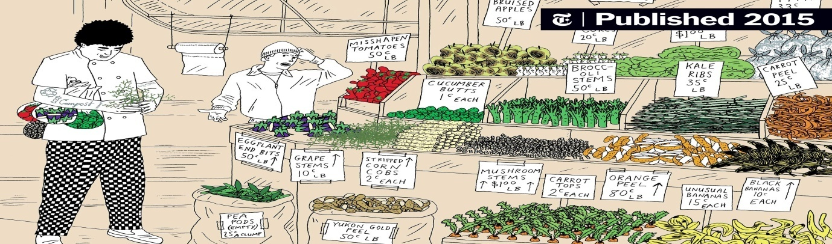
Figure 6.1 Catering establishment’s tips

6.1.2 Water consumption
For relatively water-efficient hotels with small restaurants that serve breakfast for all guests plus cover meals to conference and à-la-carte guests numbering no more than half the number of overnight guests, water consumption in bar and restaurant areas equates to approximately 15 % of total water consumption, or just over 20 L/gn (Scandic Hotels, 2012). This corresponds with modelled water consumption for hotels presented

6.1.3 Energy consumption
According to ÅF-Energikonsult AB (2001), kitchens represent 25% of total hotel energy consumption, through demand for cooking, appliances, refrigeration and ventilation. Bohdanowicz and Martinac (2007) refer to average energy consumption of between 4 and 6 kWh per cover meal served in hotels. However, this value varies considerably depending on the type of meal served. ÅF-Energikonsult AB (2001) estimate average energy consumption in hotel kitchens of between 1 and 2 kWh per meal. Best practice to minimise energy consumption in kitchens, with a focus on cooking, ventilation and refrigeration

6.2 Segregating wastes using color coded bins
A survey of organic waste generation, including information on sources (e.g. spoilage of stored food, preparation, and plate returns), should be used to inform appropriate avoidance actions. Portion sizing may be reduced without impacting on customer satisfaction. The quantity and type of food returning on customers' plates can be used as a guide for portion sizing and menu planning. Menu planning to avoid waste should be performed in combination with green procurement (section 8.1). One pub-restaurant in Tipperary, Ireland, reduced the amount of food waste generated by over one-third through reducing portion sizes

(Irish EPA, 2008). Boxes or bags can be offered to diners to take home food servings that they cannot eat.
Separation of non-organic waste fractions is also important in kitchens,
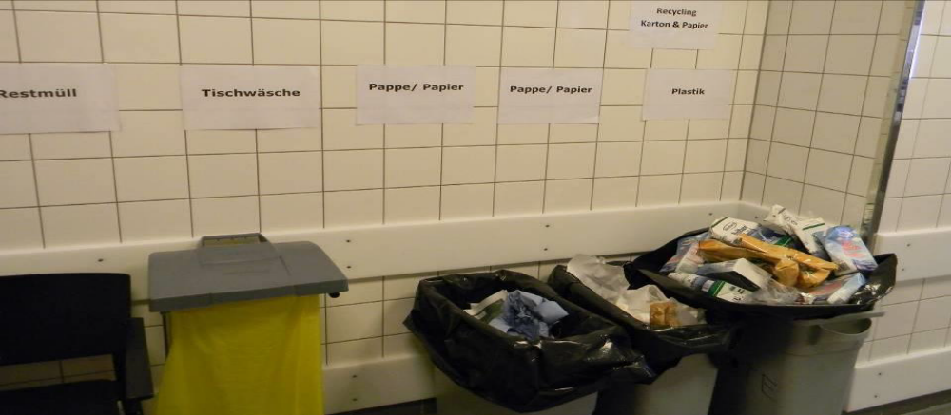
Figure 6.2 non-organic waste fractions
Food preparation accounts for the majority of food waste. Organic waste bins should be conveniently positioned for easy access at all stages of food preparation, plate return and washing. Biodegradable bags made from, e.g. corn starch can be used to collect food waste where necessary, as this breakdown during composting and anaerobic digestion. The sequence below presents an example of organic waste recovery throughout kitchen operations, from food preparation to plate washing.
- Food preparation
Bins are placed next to chefs during food preparation to separate offcuts and peelings, etc., at source.
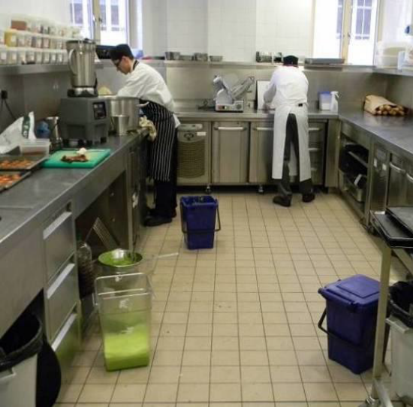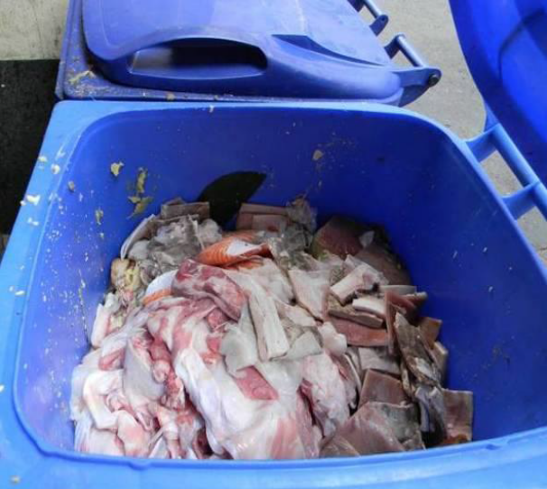
- Plate return
Food scrapings from returned plates separated from other waste (rather than placed in mixed bins, or the sewer via a macerator).
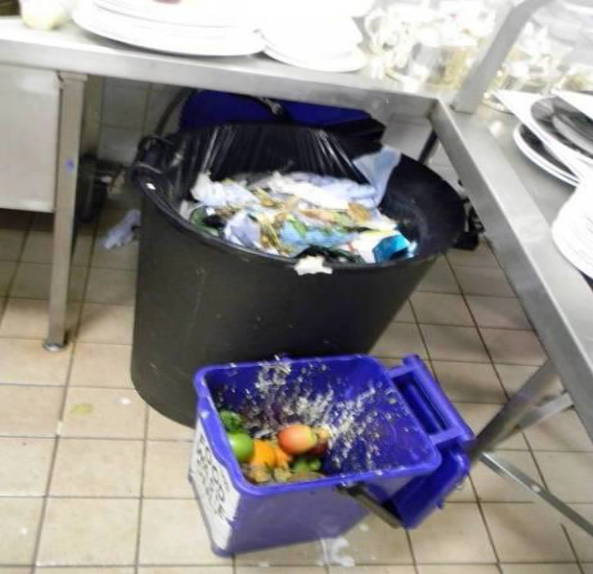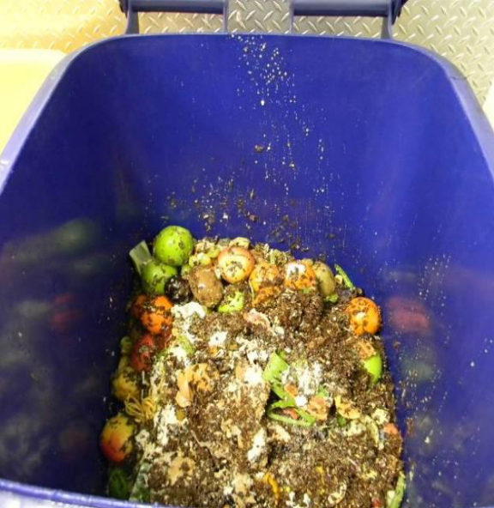
- Prewashing
Food residues are rinsed off crockery and utensils during prewashing and captured in a sieve (also reduces drain blockages).
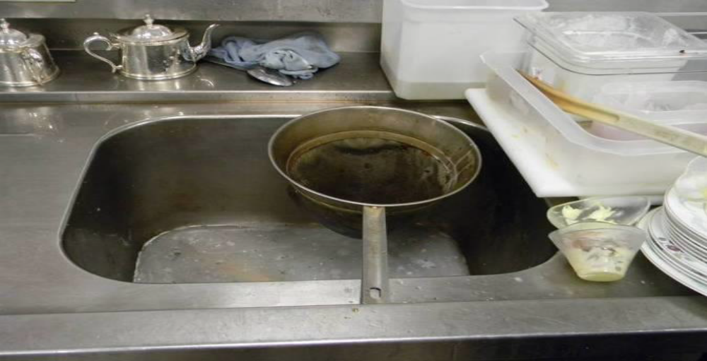
Separated organic waste can then be placed in large separate waste bins for collection to centralised or decentralised anaerobic digestion plants, or alternatively if other options are not available, for centralised or on-site composting (see below). Food close to its use-by date may be used for staff meals, given to staff to take home, or donated to charities. Food past its use-by date should be placed in organic waste recycling bins for separate collection. Waste bins containing organic waste may be chilled, especially in urban locations, to prevent odour and vermin problems (e.g. Scandic Berlin, 2011).

6.2.1 Achieved Environmental Benefit
Achievable water savings are referred to in Table 6.1. Installing efficient PRSVs and dishwashers can achieve the greatest annual water savings. Replacing boiler steamers with chemical dosing in dishwashers is based on water consumption, so that chemical consumption is proportionate to water consumption. Chemical-saving systems that use an extra prewash cycle and deionised water for rinsing can reduce chemical dosing by up to 80 %, equivalent to 400 litres per year for a water-efficient machine.

Self-Check -6 | WRITTEN TEST

True or false
- The preparation of meals, snacks and drinks is a core tourism service undertaken in most types of accommodations, and in dedicated restaurants and bars.
- Catering establishments prioritise food quality, and operatives often work under high pressure.
- Portion sizing may be reduced without impacting on customer satisfaction.

- Directions: Answer all the questions listed below
- What are the benefits of waste segregation at source?
- What is resource efficiency in waste management?
- Why is it important to segregate and dispose waste properly?

UNIT SEVEN | Reporting any personal health issues
This learning guide is describes knowledge, skills and attitude required for food sanitation and safety in a commercial kitchen or catering operation.
- Personalhealth issues.
- Incidents of food
This guide will also assist you to attain the learning outcomes stated in the cover page. Specifically, upon completion of this learning guide, you will be able to:
  - Report personal health issues.
  - Report Incidents of food

7.1 Personal Health Issues.

If you're worried about something, it helps to speak up. Reporting your concerns means they can be addressed. Problems can be fixed. Accidents can be avoided. But how should you report your concerns, and who should you report them to? Let's look at ways to report health and safety issues.
The best health and safety management is proactive. It controls hazards and minimises risks. It gives people a safe place to work. It prevents harm from occurring. But what if you find a hazard that hasn't been controlled, if you feel you, or others might be at risk?
If you are worried about something, it helps to speak up. Reporting your concerns means they can be addressed. Problems can be fixed. Accidents can be avoided.
It's not possible to remove all risks completely. Sometimes, we have to react to problems. Reactive health and safety management deals with problems before they get out of hand. By reporting a problem, you can help get it sorted. That protects you, and others too!

7.1.1 Health and safety concerns at work

If you have a health and safety concern at work, don't stay silent. Your boss isn't a mind reader, they need your help to notice when there is a problem. As an employee, you have health and safety responsibilities. One of those responsibilities is to report dangers to health and safety.
Every employee shall inform his employer or any other employee of that employer with specific responsibility for the health and safety of his fellow employees—of any work situation which a person with the first-mentioned employee’s training and instruction would reasonably consider represented a serious and immediate danger to health and safety; and of any matter which a person with the first-mentioned employee’s training and instruction would reasonably consider represented a shortcoming in the employer’s protection arrangements for health and safety
Report to your supervisor
The first step you can take is to report to your supervisor. Let them know what you are worried about, and why. They should be able to show you the risk assessment, perhaps even involve you in improving it. If they feel that the work is safe, they should be able to explain the controls in place, and how are adequate to control the risks.
If you are still worried or feel that your supervisor hasn't taken your concerns seriously, report to your health and safety manager, or directly to your employer.
Employers also have health and safety responsibilities. They must make sure that your work can be carried out safely.
It shall be the duty of every employer to ensure, as far as is reasonably practicable, the health, safety and welfare at work of all his employees.
Submit a written report
Many workplaces have a formal reporting system for health and safety concerns, near misses or dangerous situations. Even if yours doesn't, putting your concerns in writing can help make sure any issues get resolved.
If you spot a hazard or witness a near miss, you should submit a near miss report. Not every workplace has a formal system in place, but you can use this free near miss report template to get started. Near miss reporting has many benefits, the biggest being, it stops accidents before they happen!
Once you have submitted your report, you should expect to hear back on what action has been taken, and why. Not all risks need to be addressed right away, they are usually prioritised. Anything high risk should be dealt with as a matter of urgency.
Report to union or health and safety representative
Some workers are represented by unions. If your employer recognises a trade union, safety representatives are appointed. A safety representative will be able to give you confidential help and advice with health and safety concerns or complaints.
Not every workplace has this, but it may be available to you in larger organisations or particular industries.
Report to the local authority governmental office
If none of the above resolves the issue, you may want to report your concerns to an enforcing authority. If you think health and safety laws are being broken, putting you or others at risk of serious harm, you can report your concerns to the HSE (or the local authority).
Reporting concerns to the HSE can be done through an online form or via telephone. They will take your details but you can ask them not to disclose this to your employer if you don't want them to.
Health and safety concerns outside work
Employers don't just need to protect their employees, but anyone who may be affected by their work. If you are worried or concerned about health and safety, you should report your concerns. It may save a life, or stop someone getting hurt.

Report to the business
Your first step can be to report the health and safety issue or concern to the business involved. It might be obvious who this is, for example, if you are in their premises. It might also not be so obvious, for example, if some workers are working remotely and there are no signs or they don't wear a uniform.
The business should take any concerns seriously. They may advise you how and why the situation is safe, and the controls in place. Or they might need to take action to resolve any issues.

- Reporting health and safety concerns.
- Training
As an employer, you must consider the health and safety training needs of your employees, including new recruits, young workers, part-timers and temporary or agency staff. You must also consider how you will train employees who do not have English as their first language.
- The role of enforcement officers
In most catering situations, local authority enforcement officers are responsible for enforcing health and safety law. Inspectors from HSE look after health and safety in catering facilities in institutions such as hospitals, schools etc. The role of the enforcement officer is not just to enforce the law, but also to promote health and safety, give advice on the law and how to comply with it and advise on other sources of information

7.2. Incidents of Food Contamination
An incident is defined as:
‘Any event where, based on the information available, there are concerns about actual or suspected threats to the safety or quality of food and/or feed that could require intervention to protect consumers’ interests.’
Incidents involving contamination of food or animal feed in the processing, distribution retail and catering chains. These incidents may result in action to withdraw the food from sale and, in certain circumstances, to recall. Alerting the public not to consume potentially contaminated food

- Hygiene Incident Report Form
In order to maintain due diligence in accordance with the Food Safety Act and Good Manufacturing Practices all hygiene contamination incidents must be initially recorded via the Hygiene Incident Report Form, and should be completed by the affected person/team.
Upon completion of this form it must be signed and returned to the Operations Manager.
Hygiene Incident Report Form
Department Affected:-……………………………………….

Name of employ:-……………………………………………..

Area/Machine Affected…………………………………………

Shift:………………… | Day or Night |  |  |  |  |  |  | Time of Incident:………...
 |  |  |  |  |  |  |  | Date of Incident:………
Type of incident: (Please tick appropriate box/s)
Physical contamination: | Glass |  | Sharps |  | Insect/Pest |  | Other
Chemical contamination: | Oil |  | Solvent |  | Grease |  | Other
Biological contamination | Food |  | Body fluids |  | Jewellery |  | Other
Overview of the Incident:……………………………………………………………………………………………………………………………………………………………………………………………………………………………………………………………………………………………………………………………………………………………………………………………………………………………………………
Approved by ……………………………………………….Fig.7.1. Hygiene Incident Report Form

Sign ……………………………………

Self-Check -7 | WRITTEN TEST

Directions: Answer all the questions listed below
- What are some personal health issues likely to cause a hygiene risk?
- How do you report hygiene risks in the workplace?
- Who should you report health and safety issues to?

Reference
- ÅF-Energikonsult AB, Chose: Energy Savings by Combined Heat Cooling and Power Plants (CHCP) in the Hotel Sector (final report), ÅF-Energikonsult AB, 2001, Stockholm.
- Bohdanowicz, P., Martinac, I., Determinants and benchmarking of resource consumption in hotels – Case study of Hilton International and Scandic in Europe, Energy and Buildings, Vol. 39 (2007), pp. 82 – 95.
- Carbon Trust, Cost effective efficiency savings in commercial kitchens, publication CTG040, Carbon Trust, 2011a, London UK.
- Scandic Hotels, personal communication January 2012.
- SRA, Too good to waste: restaurant food waste survey report (2010), SRA, 2010, London UK.
- profestional cooking 6th and 7th edition

- Developers’ Profile
No | Name | Qualification | Educational background | Region | College | Mobile number | E-mail
1 | Mohammed Liben Mohammed | Hotel and Tourism Sector head | - BA degree in Hotel and Tourism management  - MA degree in Disaster Risk Management | Somali | Jigjiga Polytechnic college | 0992326557 | cherechaw@gmail.com
2 | AbrehamMayzamengesha | Instructor | Bed degree in Hotel and Tourism | SNNP | Arbaminch Polytechnic college | 0913711922 | Abrehammayza9@gmail.com
3 | ZelalemAlmawEndalew | Instructor | - BSC degree in Food science and post harvest technology | Amhara | Bahirdar Polytechnic College | 0918012521 | Parazolla25@gmail.com
4 | HiwotTedla Belay | Instructor | BA degree in Accounting and finance and diploma in Hotel Management | Hareri | Harer Polytechnic College | 0913789086 | hiwietaba@gmail.com
5 | ZuryashWork Belay Nigatu | Instructor | BA degree in Hotel Management | Addis Ababa | TTI | 0911643817 | zwb@gmail.com

