Bakery and Pastry Production Level I
Based on November 2022, CurriculumVersion -II
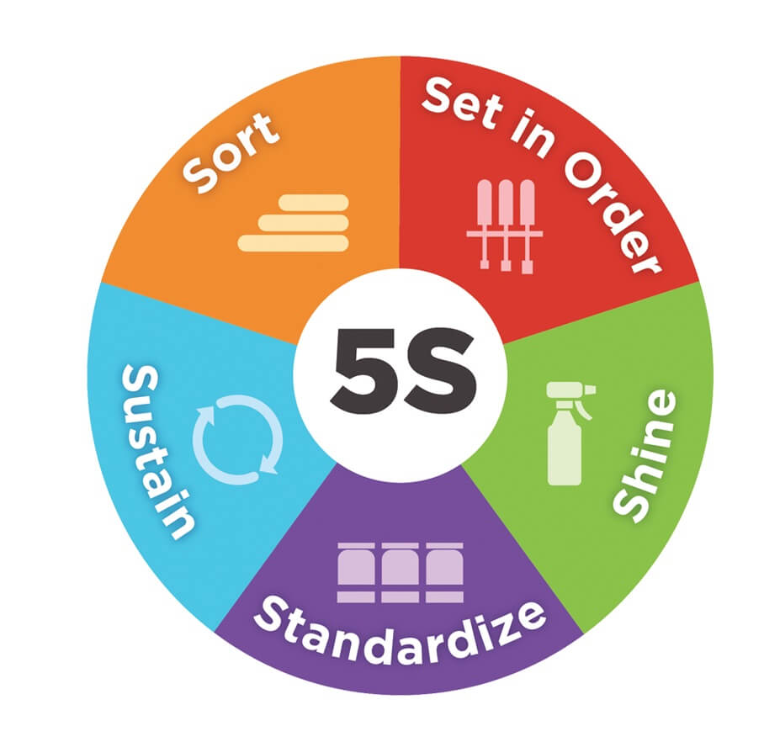
Module Title: Applying 5S Procedures
Module code: CST BPP1M03 1222
Nominal duration: 32 Hour

Prepared by: Ministry of Labor and Skill

December, 2022
Addis Ababa, Ethiopia

Acknowledgment
Ministry of Labour and skill wishes to extend thanks and appreciation to bakery and pastry production instructors who donated their time and expertise to the development of this Teaching, Training and Learning Materials (TTLM

Acronym
- PDCA Plan Do Check Act
- OHS Occupational health and safety
- PPE Personal protective Equipment
- PQCDSM Productivity Quality Cost Delivery Safety and Morale

Table of Contents
Acknowledgment 2
Acronym 3
Introduction to the Module 6
This module covers the units 7
Unit One: Prepare for work 8
Introduction 8
1.1 Work instructions 9
1.2 OHS requirements 10
1.3 Workplace hazards 10
1.4 Kaizen Board 11
Self-Check 1 13
Unit Two: Sort Items. 14
2.1 Preparing and implementing plan 15
2.2 Sorting plan preparation 16
2.3Benefits of sorting 17
2.4 Identifying all items 17
2.5 Listing Necessary and unnecessary items 18
2.6 Allocating unnecessary items 18
2.7 Red tag strategy 19
Self-Check-2 25
LAP Test 1 27
Unit Three: Set in order. 28
3.1 Preparing plan for Set in order activities 29
3.2 Benefits of set in order 30
3.3 planning and procedures for set in order 32
3.4 Layout arrangement 33
3.8 Visual control Strategy to return items after use 35
Self-Check 3 36
Operation sheet 2 37
LAP Test 2 38
Unit Four:Perform shine activities 39
4.1 Definition of Shine 40
4.2 Benefits of shine 41
4.3 Tools and materials used to implement shine 42
4.4 Shine activities planning and procedures 44
4.6 Shine activity procedures. 45
Self-Check 4 48
Operation sheet 3 49
LAP Test 3 50
Unit Five:Standardize 5S 51
5.1 Standardize plan preparation 52
5.2 Role of standardize in all 5s elements 52
Self-Check -5 54
Unit Six:Sustain 5S 55
6.1 Planning sustain 5S activities 56
6.2 Techniques of sustain 58
6.3 Cleaning up workplace 59
Self-check:6 62
Reference books 63
1. Developers’ Profile 64
1. 65

Introduction to the Module
This module is applying 5S Procedures to meet the industry requirement under the bakery production level I occupational standard. This module conversthe knowledge, skills and attitude required to apply 5S techniques to workplace. It covers responsibility for the day-to-day operations of the workplace and ensuring that Kaizen elements are initiated and institutionalized.
This module covers the units
      - Prepare for work.
      - Sort items
      - Set all items in order.
      - Perform shine activities.
      - Standardize 5S.
      - Sustain 5STraining Objective of the Module
At the end of this session, the students will able to:
- ImplementShine activity.
- Use Kaizen Board
  - Remove Unnecessary items
- Place items in their assigned locations.
- Plan to standardize 5S activities.
- Determine Tools and techniques
Module Instruction
For effective use this modules trainees are expected to follow the following module instruction:
- Read the information written in each unit
- Accomplish the Self-checks at the end of each unit
- Perform Operation Sheets which were provided at the end of units
- Do the “LAP test” giver at the end of each unit and
- Read the identified reference book for Examples and exercise

Unit One: Prepare for work
This unit is to provide you the necessary information regarding the following content coverage and topics:
  - Work instructions. .
  - OHS requirements.
  - Workplace hazards
  - Safety of Tools and equipment.
  - Implementing 5S.
  - kaizen board
This unit will also assist you to attain the learning outcomes stated in the cover page. Specifically, upon completion of this learning guide, you will be able to:
  - Determine work instructions.
  - Observe OHS requirements.
  - Implement 5S.
  - Check equipment safety.
  - Prepare kaizen board.

Introduction
Basically 5S is a philosophy and an approach of organizing and managing the workplace and course of work with the commitment of increasing efficiency by reducing waste, enhancing flow and decreasing process irrationality. It uses a list of five Japanese words: Seiri (Sort) Seiton (Set in Order), Seiso (Shine), Seiketsu (Standardize), and Shitsuke (Sustain).
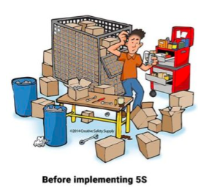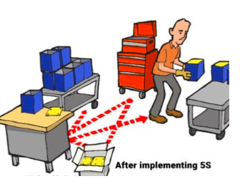

Work instructions
Work instruction is a description of the specific tasks and activities within an organization. A work instruction in a business will generally outline all of the different jobs needed for the operation of the firm in great detail and is a key element to running a business smoothly. In other words it is a document containing detailed instructions that specify exactly what steps to follow to carry out an activity. It contains much more detail than a Procedure and is only created if very detailed instructions are needed.

Procedures vs. Work Instructions
Many people confuse “procedures” with “work instructions”. In fact, most people write work instructions and call them procedures. Knowing the differences of procedures vs work instructions can help you understand the documentation process much better and, therefore, procedure documentation.
Procedures describe a process, while a work instruction describes how to perform the conversion itself. Process descriptions include details about the inputs, what conversion takes place (of inputs into outputs), the outputs, and the feedback necessary to ensure consistent results. The PDCA process approach (Plan, Do, Check, Act) is used to capture the relevant information.
Questions that need to be answered in a procedure
- Where do the inputs come from (suppliers)?
- Where do the outputs go (customers)?
- Who performs what action (responsibilities)?
- How do you know when you have done it right (effectiveness)?
- What feedback should be captured (metrics)?
- How do we communicate results (charts, graphs and reports)?

OHS requirements
OHS requirements are legislation/regulations/codes of practice and enterprise safety policies and procedures. This may include protective clothing and equipment, use of tooling and equipment, workplace environment and safety, handling of material, use of firefighting equipment, enterprise first aid, hazard control and hazardous materials and substances
Personal protective equipment includes those prescribed under legislation/ regulations/codes of practice and workplace policies and practices. Safe operating procedures include the conduct of operational risk assessment and treatments associated with workplace organization. Emergency procedures include emergency shutdown and stopping of equipment, extinguishing fires, enterprise first aid requirements and site evacuation.

Occupational safety and health (OSH) also commonly referred to as occupational health and safety (OHS) or workplace health and safety (WHS) is an area concerned with the safety, health and welfare of people engaged in work or employment. The goals of occupational safety and health programs include fostering a safe and healthy work environment. OSH may also protect co-workers, family members, employers, customers, and many others who might be affected by the workplace environment. In the United States the term occupational health and safety is referred to as occupational health and occupational and non-occupational safety and includes safety for activities outside work

Workplace hazards
Although work provides many economic and other benefits, a wide array of workplace hazards also present risks to the health and safety of people at work. These include "chemicals, biological agents, physical factors, adverse ergonomic conditions, safety risks and a broad range of psychosocial risk factors.

Physical and mechanical hazards
Physical hazards are a common source of injuries in many industries. They are perhaps unavoidable in certain industries, such as construction and mining, but over time people have developed safety methods and procedures to manage the risks of physical danger in the workplace. Employment of children may pose special problems. Falls are a common cause of occupational injuries and fatalities, especially in
- Construction,
- Extraction,
- Transportation,
- Healthcare,
- Building cleaning and
- Maintenance.

Kaizen Board
A Kaizen board is a visual tool that helps teams and organizations manage their continuous improvement efforts. A Kaizen board is a representation of this process of continuous improvement which begins with identifying problems within your production system. Using a Kaizen board as a visual tool to represent teamwork is an efficient way for teams and organizations to make continuous improvements.
Newly introduced Kaizen board might be exactly what you need. Inspired people want to make changes but can't seem to keep up the fast-pace. The more meetings are held, the more excited everyone feels - leading to no true change. The success of projects stagnates. Kaizen boards capture improvement suggestions into visuals that lead you through implementing them systematically making change simpler and less complicated.
Kaizen boards turn good ideas into actionable cards and can help you to turn your good ideas into a reality if the board is prioritized by the team collaboratively at the same time as any other work.
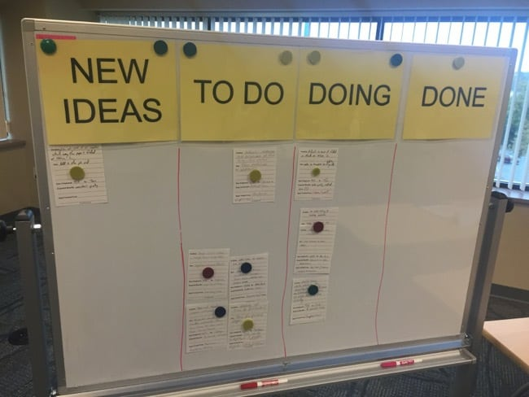
Fig 1: kaizen board

Self-Check 1
- Write true or false
- Kaizen board helps organizationsto manage their continuous improvement efforts.
- The goal of occupational health and safety programs include fostering a safe and healthy work environment.
- Work instruction is a description of the specific tasks and activities within an organization.
- Sorting the last s of 5s.

- Answer all the questions listed below
- What is the meaning of job?
- List the requirements of job.
- What is the meaning of work? (2 points)
- Describe work instruction in your own words. (5 points)
- Explain the difference between procedure and work instruction? (5 points)
- Define job specification? (3 points)
- Prepare specification samples. (10 points

Unit Two: Sort Items.
This unit is developed to provide you the necessary information regarding the following content coverage and topics:
- Preparing sorting plan.
- Benefits of sorting
- Performing cleaning
- Items Identification.
- Listing Necessary and unnecessary items.
- Red tag strategy.
- Placing unnecessary items.
- Reporting performance results.
- Checking regularly necessary items.
This unit will also assist you to attain the learning outcomes stated in the cover page. Specifically, upon completion of this learning guide, you will be able to:
- Prepare and implementing plan.
- Perform cleaning.
- Identify all items.
- List Necessary and unnecessary items.
- Use red tag strategy.
- . Evaluate and placing unnecessary items.
- Record and quantifying necessary items.
- Report performance results.
- Check regularly necessary items.

2.1 Preparing and implementing plan
Implementing sort activity is not always easy to identify unneeded items in a factory or workshop. Workers seldom know how to separate items needed for current production from unnecessary items. The following procedures will help in implementing sort activity based on the Plan Sort activity and plan sheet (sample

Table 2-1 Sort activity plan sheet (sample
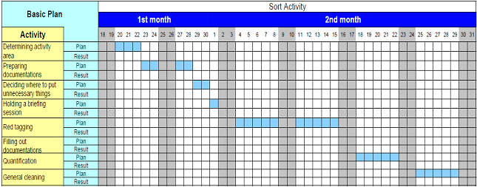

- Procedure for Sort activity
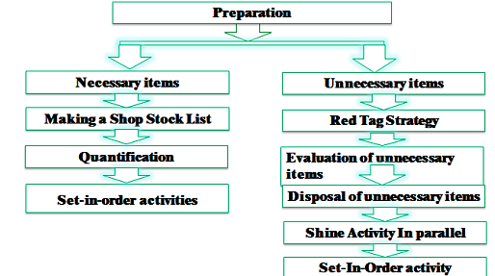
- Steps implementing sorties
- Evaluate and take pictures of the work area. It’s extremely important to take pictures during this evaluation step since referencing them after improvements have been made can be very enlightening. To help you get started use also a 5S evaluation form.
- Identify and red tag the items you no longer need.
- Decide what to do with the tagged items.

Sorting plan preparation
Sort, the first pillar of 5S, means classifying items in the workplace in to two categories – necessary and unnecessary - and removing all the unnecessary items that are not needed for current operations. It corresponds to the just in time (JIT) principle of “only what is needed, only in the amount needed, and only when it is needed.” Mostly, the workplace is full of unused machines, jigs, dies, rejects, work-in-process, raw materials, supplies, parts, shelves, containers, desks, workbenches, files, carts, racks, pallets and other items.

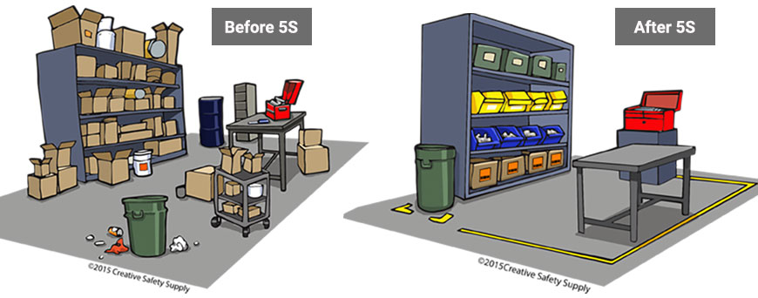
Fig 2.1 sorting items

2.3Benefits of sorting
Implementing this first pillar creates a work environment in which space, time, money, energy, and other resources can be managed and used most effectively. Sorting can lead to a much safer workplace. By clearing out the items you no longer need, people will have more room to work and things like trip hazards and items falling off shelves will be greatly reduced. Sorting also improves work flow since there is less clutter to deal with and will most definitely increase productivity in both production and office environments.
Problems and annoyances in the work flow are reduced, communication between workers is improved, and product quality is increased, and productivity is enhanced. If the first pillar is not well implemented, the following types of problems occur:
- The factory or a workshop becomes increasingly crowded and hard to work in.
- Unnecessary lockers, shelves, cabinets and items make communication between employees difficult.
- Time is wasted in searching for parts and tools.
- Increase unnecessary maintenance cost of unneeded inventory and machinery.
- Excess stock-on-hand hides other types of problems in production.
- Unneeded items and equipment make it harder to improve the process flow

Identifying all items
Depend up on theworkshop’smaterial; deviceand equipment, identify the all of the itemsdisposed. Follow the following checklist table.
Table 2-2 list of all the items at the work shop
No. | Name of items | Unit | QYT | Category
 |  |  |  | Equipment’s | Tools/device | materials
1
2
3
4
5
6

Listing Necessary and unnecessary items
Some types of unnecessary items are:
- Defective or excess quantities of small parts and inventory
- Outdated or broken jigs and dies
- Worn-out bits
- Outdated or broken tools and inspection gear
- Old rags and other cleaning supplies
- Electrical equipment with broken cords
- Outdated posters, signs, notices, and memos
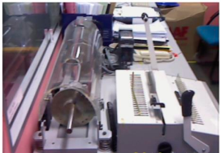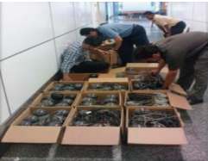
Figure 2.1Unused machinery or equipment Figure 2.2 Obsolete equipment

2.6 Allocating unnecessary items
Some locations where unneeded items tend to be accumulated in are:
- In rooms or areas not designated for any particular purpose
- In corners next to entrances or exists
- Along interior and exterior walls, next to partitions, and behind pillars.
- Under the roof space of warehouses.
- Under desks and shelves and in desk and cabinet drawers
- Near the bottom of tall stacks of items
- On unused management and production schedule boards
- In tools boxes that are not clearly sorted

Red tag strategy
The Red-Tag Strategy is a simple method for identifying potentially unneeded items in the factory or workshop, evaluating their usefulness and dealing with them appropriately. Red-tagging means putting red tags on items in the factory or workshop that need to be evaluated as being necessary or unnecessary. A Red tag is a red colored tag used to identify items no longer needed in a particular work area. The red tags catch people’s attention because red is a color that stands out. An item with a red tag is asking three questions:
- Is this item needed?
- If it is needed, is it needed in this quantity?
- If it is needed, does it need to be located here?
Once these items are identified, they can be held in a “Red Tag Holding Area” for a period of time to see whether they are needed, disposed of, relocated, or left exactly where they are.
2.7.1 Red-tag holding areas
In order to implement the red-tag strategy effectively, a red-tag holding area must be created. A red-tag holding area is an area set aside for use in storing red-tagged items that need further evaluation. Red-tagging is helpful when the need or frequency of need for that item is unknown. When an item is set aside in a red-tag holding area and watched for an agreed-upon period of time people tend to be more ready to let it go when that time is over.
There are two red-tag holding areas: local and central holding areas. Local red-tag holding area is used to manage the flow of red-tagged items with in a local department orproduction area.
Central red-tag holding area is used to manage the flow of items that cannot or should not be disposed of by individual departments or production area. Usually central red-tag holding area is used by an organization that is launching a companywide red-tagging effort
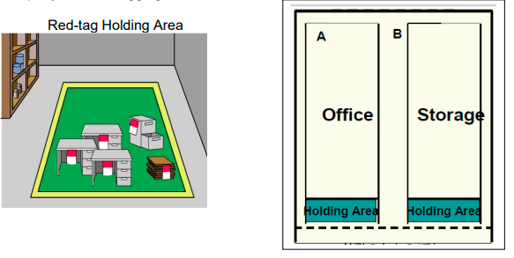
Figure 2.3 central red-tag holding area Figure 2.4local red-tag holding area

2.7.2 Steps in Red tagging
The red-tagging process in a department or work area can be broken down into seven steps
Step 1: Launch the red-tag project.
Step 2: Identify the red-tag targets.
Step 3: Set red-tag criteria.
Step 4: Make red tags.
Step 5: Attach red tags.
Step 6: Evaluate red-tagged items.
Step 7: Document the results of red-tagging
Step 1: Launch the red-tag project
Red-tag campaigns are started and coordinated by the upper-level management of a company. Even when a red-tag campaign is companywide, local campaigns need to be organized in each department or production area. This involves
- Organizing a team
- Organizing supplies
- Organizing a time or schedule to perform red-tagging
- Deciding a local-tag holding area
- Planning for disposal of red-tagged items
People from outside a department can be valuable members on a red-tagging team since they tend to see the area with a fresh eye. Hence, it is helpful to partner with other departments or production areas Items.
Step 2: Identify red-tag targets
There are two red-tag targets
- In the manufacturing area items like inventory (warehouse and inprocess inventory), equipment, and space are targets for red tags. Warehouse inventory include material, parts, products etc.
- Areas: It is better to define a smaller area and evaluate it well than to define a larger area and not be able to evaluate it fully in available time in creating red-tagging teams.
Step 3: Set red-tag criteria
As already mentioned, the most difficult thing about red-tagging is differentiating what is needed from what is not. This issue can be managed by establishing clear-cut criteria for what is needed in particular area and what is not. The most common criterion is the next Month’s production schedule
- Items needed for that schedule are kept in that location.
- Items not needed for the schedule can be disposed of or stored in a separate location.
Three main factors determine whether an item is necessary or not. These factors are:
- The usefulness of the item to perform the work at hand. If the item isn’t needed it
- Should be disposed of.
- The frequency with which the item is needed. If it is needed infrequently it can be
- Stored away from the work area.
- The quantity of the item needed to perform this work. If it is needed in limited
- Quantity the excess can be disposed or stored away from the work area.
Each company must establish its own red-tagging criteria and each department may customize this standard to meet its local needs.
Step 4: Make red-tags
Each company has specific needs for documenting and reporting the movement, use, and value of materials, equipment, tools, inventory and products. The company’s red Tags should be designed to support this documentation process.
Various types of information on a red tag may include:
- Category: provides a general idea of the type of item (e.g., a warehouse item or
- Machine). Categories include raw materials, in-process inventory, products,
- Equipment, jigs, tools and dies.
- Item name and manufacturing number.
- Quantity: indicates the number of items included under this red tag.
- Reason: describes why a red tag has been attached to this item.
- Division: includes the name of the division responsible for managing the red-tagged item.
- Value: includes the value of the red-tagged item.
- Date: includes the red-tagging date
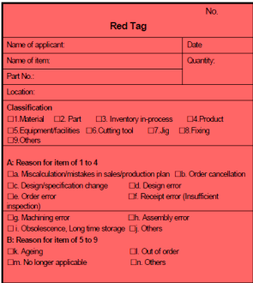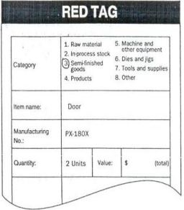
Figure 2.5 Make red-tags
The material used for red tags can be red paper, thick red tape, or others. Red tags can be laminated with plastic or another material to protect them during repeated use.
Step 5: Attach the red tags
The best way to carry out red-tagging is to do the whole target area quickly, if possible, in one or two days. In fact, many companies choose to red-tag their entire factory during a one or two day period. Red-tagging should be a short and powerful event. You should red-tag all items you question, without evaluating what to do with them
Step 6: Evaluate the red-tagged items
In this step, the red-tag criteria established in step 3 are used to evaluate what to do with red-tagged items. Options include:
- Keep the item where it is.
- Move the item to a new location in the work area.
- Store the item away from the work area.
- Hold the item in the local red-tag holding area for evaluation.
- Dispose of the item.
Step 7: Document the results of red-tagging
Each company or organization needs to create its own system for logging and tracking necessary information as red-tagging takes place. The documentation system may involve a written logbook in each department and in the central red tag holding area. Or it may involve entering data from the red-tags into a computer system. Whatever the system, documenting results is an important part of the red-tagging process. It allows the company to measure the improvement and savings produced as a result of the restaging effort. As it is indicated in step 4, the red-tags should be designed to support the documentation process.
Determine in advance approximately how many red-tags each workplace should use. An average of four red-tags per employee should be used. This means a workshop with 30 employees should need about 120 red tags. In addition when you find a shelf full of items which are difficult to decide, we don’t have to be tempted to attach one red-tag for the whole shelf. Because this can lead to confusion when we want to dispose of these items in the shelve. Therefore, avoid this temptation and attach individual tags to individual items.
When red-tagging is completed the factory or workshop is usually dotted with empty spaces – a sign of real progress. Then the layout of equipment’s and worktables can be changed to occupy the free space. Companies or organizations who think they need to build a new factory for a production of new products/ services should first apply the sort activity or the red-tag strategy so that they could get plenty of free space.

Self-Check-2
- Write true or false
- Unnecessary equipment should be removed from areas where daily production activities take place.
- Local red-tag holding area is used to manage the flow of red-tagged items with in a local department orproduction area.
- Central red-tag holding area is used by an organization that is launching a companywide red-tagging effort.
- Sorting can lead to a much safer workplace.
- Answer all the questions listed below.
- Define the first pillar of 5S – Sort. (2 points)
- write the benefits of implementing sort of activity (4 points)
- What problems occur in a workshop if sort activity is not implemented?(6 points)
- What are the reasons for the accumulation of unnecessary items in a workshop? (3 points)
- write the procedures of sort activity (5 points)
- define the red-tagging strategy(3 points)
- What are red-tag holding areas and explain the types? (4 points)
- List the steps of red-tagging strategy. (7 points)
- List at least seven items that are considered as unnecessary. (2 points
- Name places where unnecessary items are accumulated? (3 points)

Operation sheet 1
- Operation title: Sorting
- Purpose:To implement sort in the work place
- Instruction:By following steps in implementing sort, apply them at your work place.
- Tools and requirement:
- PPE
- Camera
Steps in doing the task
1. Use the straight edge of the line a
2. Record the result on the line a
3. Repeat the step for line b, c and d
4. Check for the second time for the second round
5. Complete your work by confirming the recorded measurement
Quality Criteria: Taking photos before and after to inspect thorough implementation of sort.
Precautions: Utilizing PPEs carefully..

LAP Test 1
Instructions: Given necessary templates, workshop, tools and materials you are required to perform the following tasks.
Task 1: Perform a sorting stage in 5S of materials, tools and equipment at your work place.

Unit Three: Set in order.
This unit is developed to provide you the necessary information regarding the following content coverage and topics:
- Preparing plan for Set in orderactivities
- Benefits of set in order
- Layout, storage and indication methods.
- Return items after use.
This unit will also assist you to attain the learning outcomes stated in the cover page. Specifically, upon completion of this learning guide, you will be able to:
- Prepare plan.
- Perform general cleaning activities.
- Decide location, storage and indication methods.
- Prepare and use tools or equipment.
- Placeand assign Items.
- Return and assign items.
- Report performance results.
- Check each item

Preparing plan for Set in order activities
In the Set in Order step, companies should match the place of an item with its amount of use. Items used more frequently should be designated first and should be placed near where they will be used. By moving items not frequently used out of the way, the workplace will become more efficient.

Set in Order activities include:
- Arrange items for convenience when using.
- Eliminate wasting time looking for certain tools and items.
- Simplify the work process by making it easier to find necessary tools.
- Create a plan to help the workplace stay in this new organization.
- Organize items based on their frequency of use and proximity to where they are used.
Set in Order planning is to
- Eliminate unnecessary items
- Take before and after photographs
- Label items and workplace with new Set in Order organization
- Find the true use for each item in order to choose its new placement
- Make a list of the items and their new locations until employees get used to the new set up
Labeling is also very important during the Set in Order stage so that even those who did not help make the plan can abide by the new designated places for workplace items. Companies have used shadow boards, creating a shadow the shape and size of an item, as a way to identify its proper place. Labels are extremely useful during this phase of Set in Order as well.
Things you can set in Order:
- Offices
- Books
- Papers
- Printed manuals
- Invoices
- Desk Drawers
- Tools
- Storage areas
In conclusion, it is important to remember that once everything has been assigned a proper place, also create a system that will help everything easily be returned to its proper place so as to maintain your Set in Order step.

Benefits of set in order
Setting in order is important because it eliminates many kinds of waste from operations in a workplace. These include searching time waste, waste due to difficulty in using items, and waste due to difficulty in returning items. In general, the following problems and wastes are avoided when set in order is well implemented.
- Motion wastes
- Searching time wastes
- The waste of human energy
- The waste of excess inventory
- The waste of defective products
The waste of unsafe conditions The set in order step is actually at the core of so many important business principles such as safety, ergonomics, quality, inventory control, productivity, standard work, the visual workplace and employee morale. Also it is the core of standardization. This is because the workplace must be organized before any type of standardization can be implemented effectively. Look the following figure how to set in order of materials and equipments.

For example, machinery standardization means anyone can operate the machinery. Also if we have operation standardization this means anyone can perform the operation. Even for people to get along together, they need to standardize their behaviors, at least to some extent

Figure 3.2Set in order is the core of standardization.

In implementing set in order pillar, we use visual controls so that communications became easy and smooth. For example, we can visually know where items are placed and where to return them and so on. A visual control is any communication device used in the workplace that tells us at a glance how work should be done. Through visual controls, information such as where items belong, how many items should be placed there, what the standard procedure is for doing something, the status of work in process etc. can be communicated.
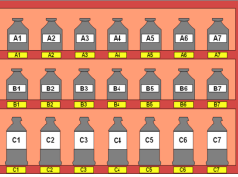
Figure 3.3 set in order keeps communication of standardization

3.3 planning and procedures for set in order
3.3.1 Set in order activity plan sheet
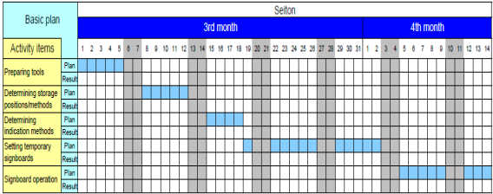

The Procedures for Set in orderis implements follow as
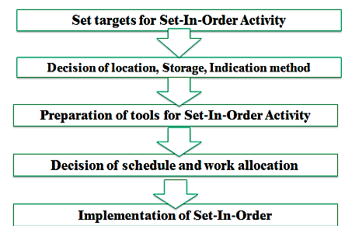

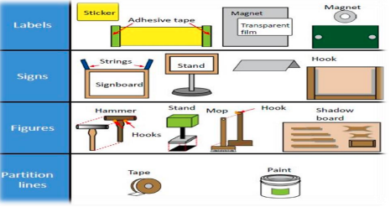

3.4 Layout arrangement
There are some principles for deciding best locations for tools and equipments, Jigs, tools and dies.Some of the principles are:
- Locate items in the workplace according to their frequency of use.
- Place frequently used items near the place of use.
- Store infrequently used items away from the place of use.
- Store items together if they are used together, and store them in sequence in which they are used.
- Device a just let go arrangement for tools. This approach involves suspending tools from a retractable cord just within reach so that they will automatically go back in to their correct storage position when released.
- Make storage places larger than the items stored there so that they are physically easy to remove and put back
- Eliminate the variety of jigs, tools and dies needed by creating a few jigs, tools and dies that serve multiple functions.
- Store tools according to function or product. Function-based storage means storing tools together when they have similar functions. This works best for job-shop production. Product-based storage means storing tools together when they are used on the same product. This means works best for repetitive production.
There are principles helpful in deciding the best locations for parts, equipment’s, and machinery, as well as tools by removing motion wastes. Motion wastes are unnecessary movements created when people move their trunks, feet, arms, and hands more than needed to perform a given operation. These wastes lead to waste of time, energy and effort. These motion wastes can be minimized by locating parts, equipment’s, and machinery in the best locations possible. More important than removing motion wastes is asking why it occurs. By asking ‘why’ we can find the methods of manufacturing that work and approach the zero-waste mark. Eliminating the unnecessary motions from existing operations is called Motion improvement. And finding ways to eliminate the whole operations to remove the wastes is called Radical improvement.
The principles that are helpful to eliminate or reduce motions that operators make are:
- Principle 1: Start and end each motion with both hands moving at once.
- Principle 2: Both arms should move symmetrically and in opposite directions.
- Principle 3: Keep trunk motions to a minimum.
- Principle 4: Use gravity instead of muscle.
- Principle 5: Avoid zigzagging motions and sudden changes in direction.
- Principle 6: Move with a steady rhythm.
- Principle 7: Maintain a comfortable posture with comfortable motions.
- Principle 8: Use the feet to operate on and off switches for machines where practical.
- Principle 9: Keep materials and tools close and in front
- Principle 10: Arrange materials and tools in the order of their use.
- Principle 11: Use inexpensive methods for feeding in and sending out materials.
- Principle 12: Stand at a proper height for the work to be done.
- Principle 13: Make materials and parts easy to pick up.
- Principle 14: Make handles and grips in efficient, easy-to-use shapes and positions.
3.4.1 Evaluating current locations and deciding best locations
The 5S Map is a tool that can be used to evaluate current locations of parts, jigs, tools, dies, equipment, and machinery, and to decide best locations. 5S Map involves creating two maps before map and after map. The before map shows the layout of the workplace before implementing set in order. The ‘after map’ shows the workplace after implementing set in order. The 5S Map can be used to evaluate the locations in small or large workplaces, like in single workstations, on a production line, or in a department.

3.8 Visual control Strategy to return items after use
A visual control is any communication device used in the work environment that tells us at a glance how work should be done. There are several strategies for setting in order items so that to easily identify what, where and how many (visual control). These visual control strategies are discussed in the next contents
Signboard strategy: uses signboards to identify what, where, and how many. The three main types of signboards are:
- Location indicators that show where items go.
- Item indicators that show what specific items go in those places.
- Amount indicators that show how many of these items belong there.

Self-Check 3
- Write true or false
- A visual control is any communication device used in the work environment that tells us at a glance how work should be done.
- 5S Map involves creating two maps before map and after map.
- The 5S Map uses to evaluate locations in small workplaces only.
- Zigzagging motions and sudden changes in direction are advised to avoid motion waste.

- Answer all the questions listed below.
- Write the three main types Signboard strategy?
- Defined the principles of helpful to eliminate or reduce motions?
- Write The Procedures of Set in order implements?
- Define the Implements of Set in order?

Operation sheet 2
• Operation title: Set-in order
• Purpose: To implement Set-in order in the work place
• Instruction: By following steps in implementing Set-in order, apply them at your work place.
• Tools and requirement:
1. PPE
2. Cart
3. Ladder
Steps in doing the task
- Locate items in the workplace according to their frequency of use.
- Place frequently used items near the place of use.
- Store infrequently used items away from the place of use.
- Store items together if they are used together, and store them in sequence in which they are used.
- Device a just let go arrangement for tools. This approach involves suspending tools from a retractable cord just within reach so that they will automatically go back in to their correct storage position when released.
- Make storage places larger than the items stored there so that they are physically easy to remove and put back
- Eliminate the variety of jigs, tools and dies needed by creating a few jigs, tools and dies that serve multiple functions.
- Store tools according to function or product. Function-based storage means storing tools together when they have similar functions. This works best for job-shop production. Product-based storage means storing tools together when they are used on the same product. This means works best for repetitive production.
• Quality Criteria: Taking photos before and after to inspect thorough implementation of se-in order.
• Precautions: Utilizing PPEs carefully and taking care for tools and equipments.

LAP Test 2
Instructions: Given necessary templates, workshop, tools and materials you are required to perform the following tasks.
Task 1: Perform Set in Order of materials, tools and equipment at your work place.

Unit Four:Perform shine activities
This unit is developed to provide you the necessary information regarding the following content coverage and topics:
- Benefits of shine
- Implement shine activities.
- Prepare tools and equipment.
- Shine activityprocedures.
This unit will also assist you to attain the learning outcomes stated in the cover page. Specifically, upon completion of this learning guide, you will be able to:
- Understand uses of shine
- Implement shine activities.
- Prepare necessary tools and equipment.
- Implement shine activityprocedures.
- Report performance results
- Conduct regular shining activities

Definition of Shine
The third pillar of 5S is shine. Shine means sweeping floors, wiping off machinery and generally making sure that everything in the factory stays clean. In a manufacturing company, shine is closely related to the ability to produce quality products. Shine also includes saving labor by finding ways to prevent dirt, dust, and debris from piling up in the workshop. Shine should be integrated in to daily maintenance tasks to combine cleaning checkpoints with maintenance checkpoints.
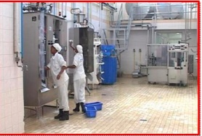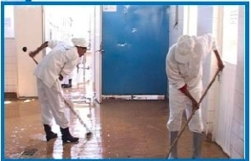
Figure 4.1 Workers shinning machinesFigure 4.2 Workers shinning the floor

Cleaning is so important because when we clean an area, we are also doing some inspection or checking of machinery, equipment and working conditions. An operator cleaning a machine can find many mal-functions. When a machine is covered with oil, soot and dust, it is difficult to identify any problems that may be developing. While cleaning the machine, however, one can easily spot oil leakage, a crack developing on the cover, or loose nuts and bolts. Once these problems are recognized, they are easily fixed.
It is said that most machine breakdowns begin with vibration (due to lose nuts and bolts), with introduction of foreign particles such as dust (due to the crack on the cover, for instance), or with inadequate oiling and greasing. For this reason shine is useful to make discoveries while cleaning machines. Hence, shine means cleaning the workplace’s floors, equipment and facilities, provide inspection at the same time, and ensure that they are in good operating condition.

Benefits of shine
One of the more obvious purposes of shine is to turn the workplace in to clean and bright place where everyone will enjoy working. Another key purpose is to keep everything in top condition so that when someone needs to use something, it is ready to be used. Companies or organizations should avoid the tradition of annual at the end of the year or on spring cleanings. Instead, cleaning should become a deeply ingrained part of daily work habits, so that tools, equipment, and work areas will be ready for use all the time.

Figure 4.3 Workers cleaning machines
Cleanliness for factories and offices is a lot like bathing for human beings. It relieves stress and strain, removes sweat and dirt, and prepares the body and mind for the next day. Cleanliness is important for physical and mental health. Just as you would not bath only once a year, performing shine procedures in a factory should not be an annual activity. Cleaning should be done on daily basis.
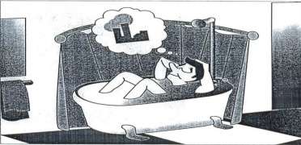
Figure 4.4Shine activities relieves stress and strain
Shine activities can play an important part in bringing work efficiency and safety. Cleanliness is also linked with the morale of employees and their awareness of improvements. Factories or workshops that do not implement the shine pillar suffer the following types of problems:
- Poor morale and inefficiency at work. This could be due to dirty windows that can pass only little light.
- Unable to see or find defects in dark and messy workplaces.
- Slipping and injuries can be created due to puddles of oil and water on the floor.
- Frequent breakdown of machines due to insufficient check-ups and maintenances which in turn leads to late deliveries.
- Low and unsafe operating machines due to insufficient checkups and maintenance which in turn leads to hazard and accidents.
- Defects will result due to shaving cuts getting mixed in to production or assembly processes.
- Shaving cuts can get in to people’s eyes and create injuries.
- Low morale due to filthy work environments.

Tools and materials used to implement shine
The following are some tools and materials used to implement the third pillar of 5S Shine.
- Sponge oil
- Broom detergent s
- Brush spade
- Vacuum cleaner bolts
- Garbage containers floor scrubber cleaning Pads
- Screws etc…

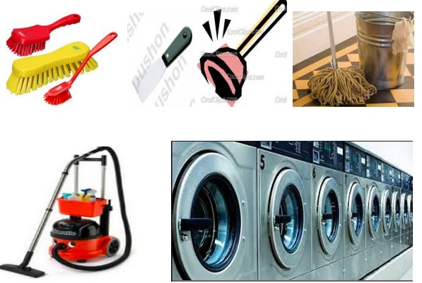
Figure 4.5 Tools and materials or shinning

Fig 4.6 cleaning equipments

4.4 Shine activities planning and procedures
Shine activities should be taught as a set of steps and rules that employees learn to maintain with discipline. The following sample format can be used to prepare a plan for implementing shine activities.
Shine activity plan sheet sample
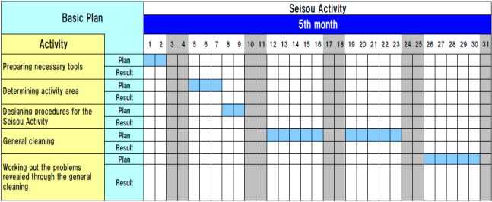
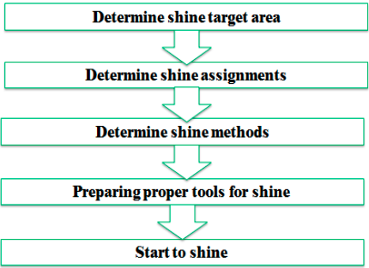

Shine activity procedures.
Step 1: Determine shine target areas Shine target areas are grouped in to three categories: warehouse item, equipment’s and space. Warehouse items include raw materials, procured subcontracted parts, parts made in-house, and assembly components, semi-finished and finished products. Equipment includes machines, welding tools, cutting tools, conveyance tools, and general tools, measuring instruments, dies, wheels and casters, worktables, cabinets, desks, chairs and spare equipment. Space refers to floors, work areas, walkways, walls, pillars, ceilings, windows, shelves, closets, rooms and lights.
Step 2: Determine Shine Assignments Workplace cleanliness is the responsibility of everyone who works there. Each employee should be assigned specific area to clean. To do these two methods can be used:
A 5S Assignment Map – shows all the target areas for shine activity and who is responsible for cleaning them. By marking on 5S Map, the shine assignments can be shown.
- A 5S schedule – shows in detail that is responsible for cleaning which areas on which days and times of the day. Then this schedule should be posted in the work area.
- A 5S schedule – shows in detail that is responsible for cleaning which areas on which days and times of the day. Then this schedule should be posted in the work area.
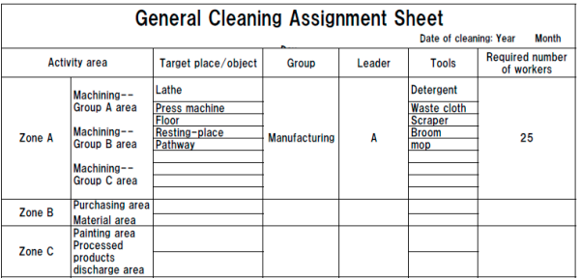
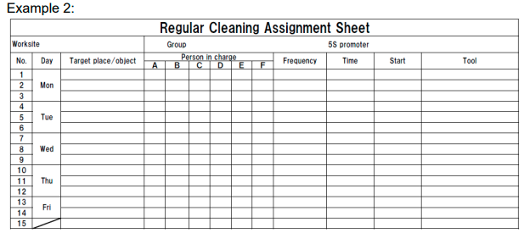
Step 3: Determine shine methods Shine activities should be a natural part of the daily work. Shine activities and inspection should be done before a shift starts, during work time and at the end of the shift.
Shine methods include
- Choosing targets and tools. Define what will be cleaned in each area and what supplies and equipment will be used.
- Performing the five-minute shine. Cleaning should be practiced daily and should not require a lot of time.
- Creating standards for shine procedures. People need to know what procedures to follow in order to use their time efficiently. Otherwise, they are likely to spend most of their time getting ready to clean.
Step 4: prepare tools the cleaning tools should be placed properly or set in order where they are easy to find, use and return.
Step 5: Start to shine
When implementing the shine procedures, consider the following suggestions:
- Be sure to sweep dirt from floor cracks, wall corners, and around pillars.
- Wipe off dust and dirt from walls, windows, and doors.
- Be thorough about cleaning dirt, scraps, oil, dust, rust, cutting shavings, sand,
- Paint and other foreign matter from all surfaces.
- Use cleaning detergents when sweeping is not enough to remove dirt.

Self-Check 4
  - Write true for correct statements and false otherwise.
- Shining is the second element of 5s.
- One the more obvious purposes of shine is to turn the workplace in to clean.
- Shine means cleaning the workplace’s floors, equipment and facilities.
- Shinning and sorting are the same and one in their implementation process.
- Factories that do not implement the shine pillar will Unable to find defects in dark and messy workplaces.
  - Answer all the questions listed below.
- Write the definition of the third pillar shine? (2 points)
- What problems occur in a workshop if shine is not implemented? (8 points)
- What are the steps/procedures for implementing shine? (5 points)
- Described the methods of used to assign shine activities to employees? (2 points)
- What are the most frequent problems of equipment’s/machines? (4 points)
- List the steps of inspection? (5 points)
- How do you detect abnormalities in a workplace or machine? (4 points)

Operation sheet 3
Operation title: Shine
Purpose: To implement shine in the work place
Instruction: By following steps in implementing shine, apply them at your work place.
Tools and requirement:
1. PPE
2. Cart
3. Ladder
4. Cleaning tools, equipment and agents
5. Paints and brush
Steps in doing the task
- Determine shine target areas; Shine target areas are grouped in to three categories: warehouse item, equipment’s and space.
- Determine Shine Assignments; Workplace cleanliness is the responsibility of everyone who works there. Each employee should be assigned specific area to clean.
- Determine shine methods; Shine activities should be a natural part of the daily work. Shine activities and inspection should be done before a shift starts, during work time and at the end of the shift.
- Prepare tools the cleaning; tools should be placed properly or set in order where they are easy to find, use and return.
- Start to shine
- Quality Criteria: Taking photos before and after to inspect thorough implementation of shine.
• Precautions: Utilizing PPEs carefully and taking care for tools and equipment.

LAP Test 3
Instructions: Given necessary templates, workshop, tools and materials you are required to perform the following tasks.
Task 1: Identify and prepare tools and materials for implementing shine activity.
Task 2: Prepare plan for shine and Sample plan
Task 3: Implement shines activity.

Unit Five:Standardize 5S
This unit is developed to provide you the necessary information regarding the following content coverage and topics:
- Standardize plan preparation.
- Role of standardize in all 5s elements
- Work place standard
This unit will also assist you to attain the learning outcomes stated in the cover page. Specifically, upon completion of this learning guide, you will be able to:
- Prepare Standardize plan
- Use techniques of Standardize
- Keep workplace.

Standardize plan preparation
Standardize is an essential bridge between Shine and the last step of 5S. By systematizing the method to 5S through standardization, it can be confirmed that organizational efforts are continued in due course through a sustainable approach. If an organization fails to standardize work processes then it can cause disordered and inefficient work over time. It is helpful to give employees opportunities to play a dynamic role in the standards development.
The first step in 5S workplace organization and standardization emphasizes on reducing unneeded items from the workplace. Here the equipment, furniture and tool in workplace are categorized into the 3 categories which are necessary, unnecessary and may not be necessary. Moreover, this step can also be beneficial with the “just in case” approach. Industrial bins are required for an exact class. On the basis of the standard method, three to four “bins” or organizing sorts are used when performing a 5S category that comprises of keep, remove, and probation and to move. It is a key point to audit the categorization process dynamically of any 5S’d space to make sure precision and focus. At times, a focus on organization can dominate further main areas so it must be ensured to register on tool standardization, expiration dates of supply, and possible safety risks while areas are going through audit organization.

5.2 Role of standardize in all 5s elements
- Standardization in Set in Order
The term “Set” is based on determining efficient and effective storage of essential articles. It uses the idea of “can see, can take out, and can return”. By following this philosophy time and energy can be saved when we want to find something. An effective approach to initiate this step is to plan the space where the tools and equipment will be going back to. It is very important to truly consider the jobs being done in or around every station during this stage. This approach must be used to design the most suitable and easy areas for employees to go. Furthermore, employees’ most commonly used tools must be located in convenient and easily accessible areas with the minimum possible limitations.

- Standardization in Shine
This step means cleaning up the workplace on every day basis with the intention of having no dust on floors, machines or tools. By following this approach ownership can be created and pride can be built among the workers. Approximately in any case, there is no doubt that an uncontaminated workplace is a safer place of work. For example, when the floors are maintained clear of dirt and residues it facilitates to lessen the hazard of tours, slips, and falls which are a very common source injuries in the workplace. It is useful to post images in the proximate areas displaying the entirely cleaned or “shined” workplace condition. It can be a useful approach to have this communication successful even when nobody is actually around to provide it. Likewise, an information board can also be used which illustrates step-by-step guidelines for cleaning specific areas or equipment’s.
- Standardization in sorting
An essential bridge between Shine and the last step of 5S is to standardize. By systematizing the method to 5S through standardization, it can be confirmed that organizational efforts are continued in due course through a sustainable approach. If an organization fails to standardize work processes then it can cause disordered and inefficient work over time. It is helpful to give employees opportunities to play a dynamic role in the standards development. An outstanding technique to accomplish this is to plan and print out 5S sheets of audit that can be used by anyone who is examining an area on a particular day.
- Standardization in Sustain
The last step of 5S workplace organization and standardization is called Sustain or Shitsuke which concentrates on covering every former step of 5S, with the standardized processes, and converting them into continuing practices to guarantee continuous improvement. It addresses describing a new outlook and a standard in place of work. It must be kept in mind that anything anticipated from workers must be shown properly by a qualified and experienced professional. Additionally, employees must be observed in their first efforts to check the 5S daily routines that are being made are the precise practices required and looked-for. More to the point, mistakes must be fixed. Occasionally continuous unwanted behavior or unwanted outcomes occur as a result of a defective system. In that case, the fault must be found in the actual system and it must be corrected as necessary.

Self-Check -5
  - Match the items under A to those under B.
- B.
- Set in order a. The first element of 5s
- Standardize b. The fifth element of 5s
- Sustain c. The secondelement of 5s
- Sort d. The third element of 5s
- Shinee.The third element of 5s

II. Give Short answer for the following questions
1. Define Sustain in 5s (2points)
2. List techniques to sustain 5S (5 points)

Unit Six:Sustain 5S
This module is developed to provide you the necessary information regarding the following content coverage and topics:
- Planning sustain 5S activities.
- Techniques and procedures of sustain.
- Cleaning up workplace.
This unit will also assist you to attain the learning outcomes stated in the cover page. Specifically, upon completion of this learning guide, you will be able to:
- Plan sustains 5S activities.
- Implement techniques and procedures.
- Clean up workplace.
- Identify unlikely Situations.
- ReportSustainactivities

6.1 Planning sustain 5S activities
Previously, we have discussed 5S in general, the phases Sort and Straightens, and the phases Sweep and Standardizing in previous units. This unit will discuss the final phase of 5S- the sustain phase. All these units are covered in the modules of Sustainable 5S.

The fifth and final S in the 5S model stands for SUSTAIN, and this is the most difficult of the stages to implement in practice. It is difficult because this stage circles back on all the prior stages to ensure that they are being appropriately maintained and updated as necessary. The sustain stage therefore has two main objectives:
- sustaining the current standard as they were agreed upon by the team and
- Identifying improvements when the standards are no longer relevant or complete.

An aid that can be used to check whether the standards are sustained is a mini-audit. By writing short questions on a T-card (a small card in the shape of a T so that it can easily fit a plan board) everyone can perform a mini audit in an area of their choosing. The cards can include questions such as; “Are all materials placed at their specified location?”, “is there something missing that you need to do your job properly or better?”, “are the tools on the shadow board cleaned according to standard?”
The easiest way to perform such an audit is by linking each T-card to the standards defined in the previous step, leading to one T-card per standard.

Figure 4 shows an example of a T-card system that is used in a Dutch factory. On the left, a board with different T-cards is shown on which the mini-audit cards are kept and can be accessed on the shop floor. The right picture shows an example of one T-card in the hand of an operator, on which the use of a team board is assessed.

Check | Checklist
Check | yes | no
- Devices and equipments arecleaned duringactivity continuously?
- All obsolete, broken or unnecessary equipment not required for current projects are removed from the area or red tagged for removal?
Equipment/machinery is clearly identified (numbered, named, color-coded, etc.) and placed in a properly identified location. Critical maintenance points are clearly marked.
All tripping hazards such as electrical wires and equipment cables are removed from all working, standing, and walking areas.

GenerallySustaining is the end result of how well we have performed the previous four S’s. In the sustainability stage, think of ways to eliminate effort in maintaining an area.Doing things spontaneously without being told and Educate people so that 5S expands beyond initial limits and turns into natural standard behavior.
PROCESS/PROCEDURE:
Step 1: - Create reasonable rules.
- Create reasonable rules of behavior in the workplace.
- Engage everyone concerned in the creation of rules not just the department heads or supervisors.
- Discuss the rules with everyone concerned. This will result to a feeling of involvement.
- Show rules and standards clearly and attractively using illustrations, photographs and color-coding.
Step 2: - Exhibit before and after 5S photos where everyone will see them.
Step 3: - Recognize good practices and good performance.
Train people to follow good housekeeping rules autonomously.
- Enhance autonomous management activities
- Maintain the discipline needed to do a good job
- Upgrade productivity and quality consciousness
- Wash hands after going to the toilet
- Wash hands before and after meals
- Eat and smoke at designated places
- Keep workplace always clean and tidy
- Wear clean uniform and shoes
- Follow safety rules
- Put things back in their proper places
- Work according to standards
- Observe proper office decorum

6.2 Techniques of sustain
There are three keys to successfully sustaining 5S: commitment, top management support, and performance measurement.
- Commitment.The first key is to commit to all five S’s. While this may appear to be obvious. If your entire organization is not committed to 5S, your organization’s 5S program will be short-lived
- Top management support.The first and second keys go hand-in-hand. Commitment is not possible without top management’s visible support for the program. All employees must believe that the organization has committed to the program. One way that we encourage top management to get involved on a continuing basis is for them to conduct quarterly 5S visits in which executives inspect each work area to 5S conditions and offer advice and support to the employees. Another effective method for demonstrating top management support is for executives to mandate and participate in visible promotion of 5S. Some ways to promote 5S include:
- Designated 5S days: Select a day per month or per quarter to emphasize 5S throughout the plant.
- Slogans: Select a 5S related slogan, post it in public areas throughout the plant, pass out shirts made up with the slogan to successful 5S teams, etc.
- Public Announcements: In monthly or quarterly announcements/all-employee meetings, take some time to emphasize the importance of 5S.
- Performance measurement and recognition.The third key is to measure 5S performance in each work area and set up a reward system to reward teams that achieve 5S success. Organizations that have successful 5S programs measure their performance through weekly audits using checklists and score sheets. Results of the audits are posted in public areas. This creates an atmosphere of friendly competition and will help to instill pride in the teams you’ve set up. This measurement and competition should be combined with a reward system; most successful organizations offer monthly or quarterly rewards for their teams in various 5S categories. The rewards can range from movie tickets to cash bonuses.

Cleaning up workplace
The importance of maintaining a clean workplace goes beyond aesthetics and first impressions: it can also have a direct impact on the health and safety of staff, visitors and the general public. Having clean workplace can be achieved by following steps to maintain a clean, safe workplace.

Clean, dry floors
Prevent falls by ensuring your floors are clean and dry at all times. Make sure your cleaner is using the correct floor cleaner chemical for your floor type – using the wrong product can create a slipping hazard and lead to workplace injuries. Clean up spills as soon as they happen.
  - Disinfect Surfaces
Shared surfaces and equipment should be cleaned regularly to ensure cold and flu viruses are removed. Hand washing and sanitizing is an effective way to prevent the spread of infectious diseases, including cold and flu viruses. Encourage your employees to regularly sanitise their hands by making hand sanitiser available at shared facilities such as kitchens and bathrooms, at the reception desk, next to the photocopier and other office equipment.

Clean your air conditioner filters to remove hazardous substances
Effective cleaning and maintenance of your AC system helps to reduce the circulation of germs and dirt throughout your office. Clean air conditioner filters make for healthier air and healthier employees.

Remove clutter from floors and walk ways
Reduce the potential for injury by keeping walk ways clean from clutter. An unexpected object in a walkway can create a tripping hazard for your staff and visitors.

Manage cables
Power, internet and phone cables can create obstacles for employees and customers. Try to run cables behind walls or under carpets to keep them hidden. Install power outlets, internet connections and phone jacks in easily accessible locations to avoid running cables across walkways.

Dispose of waste promptly
Don’t allow your waste baskets and bins to become overflowing with rubbish – prompt disposal of rubbish will keep the area clutter free and reduce the potential spread of infection.

6.3.1 Identifying Situations where fulfillment to standard is unlikely
Compliance isn’t easy: it’s expensive, time consuming, and regulations are constantly changing. It may be hard to get buy-in from employees or leadership who see compliance as a barrier to productivity and it may also be difficult to know when your organization falls out of compliance.For one thing, standards and regulations are in place for a reason — to protect your data and the data of your customers.
To avoid these costs, it’s imperative that your company is proactive about compliance. Here are some suggestions for doing so:
1. Keep on top of regulatory changes
It’s not enough to be compliant after the fact; make sure you’re proactive about checking for updated standards and regulations.
2. Make sure your employees understand the importance of compliance
It’s hard to get excited about compliance if you don’t understand what regulations you’re complying with and why you have to be in compliance.
Make the process less opaque for your employees by offering training, explaining the regulations you have to follow, why those standards and regulations are important, and how that affects your employees’ daily jobs.
- Constantly monitor for compliance with the right tools
It’s no longer enough to use static tools like checklists to monitor for compliance. Checklists are a snapshot. They only allow you to see if you’re in compliance when the checklist is being completed.

Self-check:6
- Write true or false
- Power, internet and phone cables may create obstacles for employees and customers.
- GenerallySustaining is the end result of how well we have performed the previous four S’s.
- As a Hospitality professional, you must always keep workplace clean and tidy.
- Sustaining is a one night activity.
- It is recommended to reduce the potential for injury by keeping walk ways clean from clutter

- Write the correct answer on the blank space.
- ____________ is a process-centered approach to ensuring that a company or organization is providing the best possible products or services.
- _____________typically require a strong knowledge of the business processes of an organization.
    - 5S is a systematized approach to:_____________________, _____________________ and _____________________
- Give short answer
- Write the 5S elements in Japanese and English terms?
- What can a company gain from 5S?
P. __________________
Q. __________________
C. ___________________
D. ___________________
S. ___________________
M. ___________________
3. What are the benefits of 5S?

Reference books
  - 5S for operators (1995)
  - Ethiopia Kaizen Manual (2011)
  - Journal5S for operators (1995)
  - Job specifications
  - Safety Manual and Guide

- Developers’ Profile

No | Name | Qualification | Educational background | Region | College | Mobile number | E-mail
1 | Mohammed Liben Mohammed | Hotel and Tourism Sector head | - BA degree in Hotel and Tourism management  - MA degree in Disaster Risk Management | Somali | Jigjiga Polytechnic college | 0992326557 | cherechaw@gmail.com
2 | AbrehamMayzamengesha | Instructor | Bed degree in Hotel and Tourism | SNNP | Arbaminch Polytechnic college | 0913711922 | Abrehammayza9@gmail.com
3 | ZelalemAlmawEndalew | Instructor | - BSC degree in Food science and post harvest technology | Amhara | Bahirdar Polytechnic College | 0918012521 | Parazolla25@gmail.com
4 | HiwotTedla Belay | Instructor | BA degree in Accounting and finance and diploma in Hotel Management | Hareri | Harer Polytechnic College | 0913789086 | hiwietaba@gmail.com
5 | ZuryashWork Belay Nigatu | Instructor | BA degree in Hotel Management | Addis Ababa | TTI | 0911643817 | zwb@gmail.com

