Bakery and Pastry Production
Level- I
Based on November 2022, Curriculum Version 2

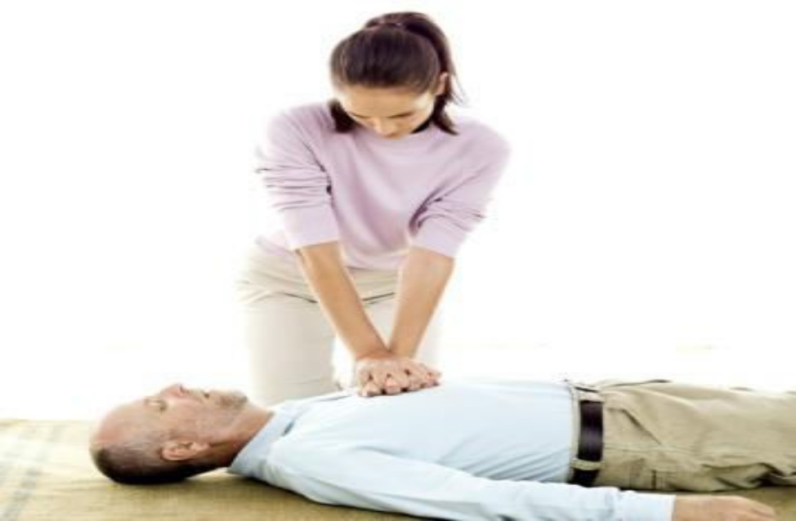

Module Title: Providing first aid
Module code: CST BPP1 M05 1122
Nominal duration: 40Hour

Prepared by: Ministry of Labor and Skill
December, 2022
Addis Ababa, Ethiopia

Acknowledgment
Ministry of Labor and skill wishes to extend thanks and appreciation to bakery and pastry production instructors who donated their time and expertise to the development of this Teaching, Training and Learning Materials (TTLM).

Table of Contents
Acknowledgment 1
Acronyms 3
Introduction to the Module 1
Module units 1
Learning Objectives of the Module 1
Module Learning Instructions 1
Unit one: Assessing the situation 2
1.1 Concept of first aid 3
1.2 Types of hazards 4
1.3 Ways of hazard identification 4
1.4 Minimize immediate risk to self and health and safety of the casualty 5
1.5 Protect the neck 5
1.5 use bystanders to help you 6
1.6 ‘Fire man’s Carry’ to move casualties 6
Casualty’s vital signs and physical condition 7
1.8 Pulse finding 11
1.9 pulse rate Vital signs 12
Self check 1 1
Unit Two: Apply basic first aid techniques 2
2.1 Applying mouth-to-mouth resuscitation 2
fig 2.1 mouth-to mouth 3
2.2 Recovery position 3
2.3 Applying cardio-pulmonary resuscitation 3
2.4 Managing bleeding 5
Fig 2.3 bandage 5
2.5 Treating burns 5
2.5.1 Clothes on fire 6
2.6 Treating electrical burns 6
2.7 Applying basic first aid to bites and stings 7
2.7.1 Treating snake bites 7
2.7.2 Treating insect bites 8
2.8 Rapid diagnosis and quick treatment 9
2.9 Responding to choking 9
2.10 fractures 10
2.11Treating Sprains 11
2.12 Head or spine injuries 11
2.13 Treating shock 12
Monitoring casualty’s condition 13
2.15 Seek first aid assistance 14
2.16 Sample Incident Report form 1
2.17 Injury Register 1
Self check 2 1
Unit Three: Communicate details of the incident 1
Request medical assistance 1
3.2 Communicating details of the incident 3
3.3 Preparing a report 3
Self check 3 1
Recommended reading 2
Developers’ Profile 1

Acronyms

- CPR Cardio-Pulmonary Resuscitation
- DRABC Danger Response Airway Breathing Circulation
- R ICE Raise Ice Compress Elevate

Introduction to the Module

This module covers the knowledge, skills and attitude required to provide an initial response where First Aid is required. In this unit it is assumed that the First Aider is working under the supervision according to the established workplace First Aid procedures and policies.

Module units
- Assess the situation
- Basic first aid techniques
- Communicate details of the incident

Learning Objectives of the Module

At the end of this session, the students will able to:
- Assess the situation
- Identify physical hazards
- provide First Aid management
- Apply basic first aid techniques
- Communicate details of the incident

Module Learning Instructions
- Read the specific objectives of this Learning Guide.
- Follow the instructions.
- Read the information written in the information Sheets
- Accomplish the Self-checks

Unit one: Assessing the situation
This learning unit is developed to provide the trainees the necessary information regarding the following content coverage and topics:

Concept of first aid

Physical hazards

Occupational health safety (OSH)

Casualty’s vital signs and physical condition

This unit will also assist you to attain the learning outcomes stated in the cover page. Specifically, upon completion of this learning guide, you will be able to:

Apply first aid

Determine Physical hazards

Understand Occupational health safety (OSH)

Assess Casualty’s vital signs and physical conditions

1.1 Concept of first aid

When administering first aid, your first concern must be to make sure you do not become a casualty of the situation. This means you must assess the situation you are facing and take time to identify the physical hazards that may be present to your own safety and that of others who may be present.

Fig 1: Assessing the situation

First aid: is any care given toan injured or ill person (called a casualty) before professional medical assistance (ambulance, paramedics, nurse or doctor) arrives on the scene to take control of the situation.
First aid can include the provision of:
- Mouth-to-mouth resuscitation– if the casualty is not breathing
- Cardio-Pulmonary Resuscitation (CPR)– where there is no
- Breathing and no pulse Control of bleeding–to limit blood loss
- Wound care–to limit blood loss and infection by covering wounds
- Treatment for burns and scalds– including treatment for electric Shock
- Bandaging and splinting– to fractures and sprains.

The following important points must always be taken into account when providing first aid:
Protect yourself and others at all times against injury. Persons delivering first aid should not become casualties
The casualty must be protected against further injury
When ever there is a need to administer first aid make sure you notify your supervisor immediately to arrange for professional help to be called
Wear protective gloves when administering first aid to protect against infection.

1.2 Types of hazards
To protect first aid providers, by standers and casualties against harm when providing first aid you must take care to identify physical and other hazards which may be present such as:

Work placeand incident- specific hazards- including stock, plant, equipment, machinery, utensils and vehicles. It also includes the general environment in the form of heat, cold, wind, sunshine, rain.
Hazards sometimes associated with casualty management –for example, first aid providers need to be aware there can be a risk of being bitten.
Always wear protective gloves when providing first aid.
- Risk of further injury to the casualty– which can be caused by arrange of issues, for example:
    - The casualty being burned by fire spreading toward them
    - Something falling on to the casualty and adding to their existing injury.

1.3 Ways of hazard identification
The accepted ways to identify hazards when providing first aid are:
- Use commonsense –this is the most important aspect
- Use your sense of sight– look for things that could present a problem. Look carefully in all directions. Be alert to smoke, fire and emerging issues
- Use your sense of hearing– listen for scalping gas, crackling of flames or creaking of wood and metal
- Use your sense of touch– vibrations or heat
- Use your sense of smell–gas or smoke.

1.4 Minimize immediate risk to self and health and safety of the casualty
The action you need to take to minimize risk will depend on the hazard you have identified.
Only act to address identified issues where they pose a risk. Generally speaking, casualties should not be moved until they have been assessed as being safe to move BUT if there is a serious and immediate risk of extra injury to a casualty from an identified hazard it is standard practice to move them away from the hazard.
If un injured by standers are near an identified hazard, they must be told to move away to a safe location. Whenever there is identified danger from fire, gas leaks or smoke the emergency fire authorities must be called. Where there is an identified hazard from electricity, the electricity supply company or someone from within the work place with knowledge of how to turn off the power must be contacted.
Other action may include:
If there is a fire near the casualty–call the fire brigade, move the casualty out of the danger zone or fight the fire with nearby hoses, fire blanket or extinguisher
If the casualty’s situation is being made worse by rain or sunshine
– provide cover to the person
If gas is leaking from a damaged appliance–turn off the gas at the stop valve and make sure no one is smoking
If unstable items are near-by and posing a risk of– either move the items or casualty
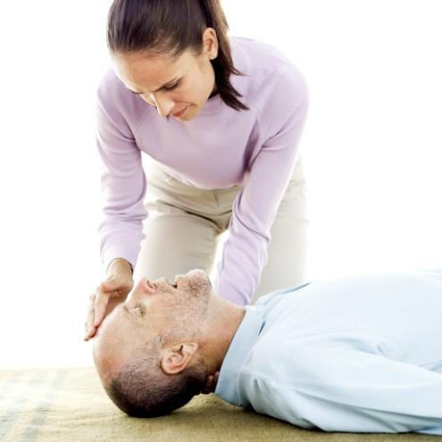
If the casualty is in a position where they are likely to be run over by vehicles –move them or take action to stop traffic.

1.5 Protect the neck
If you ever have to move a casualty because they or you may be in danger, do whatever you can to protect the neck against movement. This is vitally important where the casualty is unconscious and you are un sure what injuries they have.
To help protect the neck: fig 1.2
- Keep the casualty still– tell the casualty not to move
- Kneel behind the head and place your hands on
- Either side to support it–with the head, neck and spine in a straight line
- Put rolled up towels, blankets, or clothing on each Side of the casualty head to keep it from moving.

1.5 use bystanders to help you
Always be alert to the possibility of asking others to assist you by
calling emergency services
Moving items
- Helping to move the casualty
- Using fire-fighting equipment.
This could include other staff, bystanders, customers, management, friends or family of the casualty. Remember others are often prepared and willing to help if they are told what to do.

1.6 ‘Fire man’s Carry’ to move casualties
The„ Fire man’s Carry‟ is used to move unconscious people or casualties who are un able to walk. Do not use the Fire man’s Carry if the casualty has an injured arm, leg, ribs, neck, or back. The steps for the Fire mans Carry are:
- Place the casualty face down
- Grab the person around the waist help bring him or her to a standing position, facing you
- Keep one arm around his or her waist when you have him or her in the standing position
- Grasp the casualty’s right arm in your left hand and swing his or her arm around the Back of your neck
- Pull him or her across your shoulders by bringing his or her raised arm around your neck and over your shoulder. In this position, the injured person's legs will be over one shoulder, and his or her arm and head will be over the other shoulder
- Reposition your hand from the person's waist to the back of his or her knee
- Lift yourself with the injured person in to a standing position.

Casualty’s vital signs and physical condition

DRABC is an acronym used to describe the procedures which should be used by first aiders when providing first aid to victims. Following DRABC helps ensure further injury does not occur, and addresses the important casualty assessments that should be made before first aid is provided.
In brief, DRABC stands for
D for Danger
R for Response– Check consciousness, check on vital signs
A for Airway–Open air way
B for Breathing–Check respiration rates
C for Circulation–Give chest compressions.
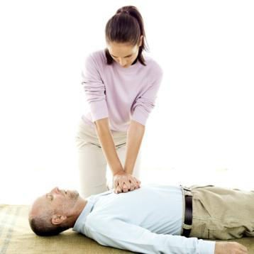

Fig 1.3 Casualty’s vital signs and physical conditio

Danger - Assess situation and check for danger
Before you give first aid, you must assess to the best of your ability the situation you are facing. To re-cap, the important aspects are:
Check for danger to you, the casualty and others. Look for obvious, immediate, life- threatening hazards such as fire, the possibility of a gas explosion, and electrical hazards
If there is danger around, you will need to move yourself and your casualty to prevent further injury to anyone
If you think the casualty has a spinal injury, take care to stop more damage to the spine by stopping movement of the casualty's neck and back.

Response– Check to see if the person is conscious or unconscious
Response is a step enabling you to determine if the casualty is conscious or
Unconscious.
- Try and get a response from the casualty by gently tapping his or her shoulder and calling his or her name
- Avoid shaking them as this may worsen an existing injury
- Get a history – ask the casualty or any witnesses who saw the incident: What happened? Does the casualty have a neck or back injury? Does the casualty have an allergic reaction?
- Identify how the casualty feels. Ask: How do you feel? ‟ Do you feel dizzy or weak?‟,
- „Do you have pain? Where? For how long?‟
- Check the physical condition of the casualty– take a look at them and around them. Is there evidence:
- Bones are broken?
- Of swelling, bites, burns, scald?
- Of possible neck or back injury?
- They are suffering allergic reactions–perhaps to food, sting or bite?
- The casualty is in shock– symptoms of shock include:
  - Sweaty but cool skin, pale color or bluish skin around the mouth
  - Shallow, fast breathing
  - Rapid pulse that becomes weaker
  - As shock progresses, you will see the casualty has:
  - Anxiety–they will appear restless, agitated, worried
  - Unusual thirst
  - Yawning and sighing
  - Nausea.

Airway–Check to make sure the air way is free of obstructions
If casualty is not breathing, open the air way by placing one hand on their fore head and gently tilt the head back by lifting the chin
Remove any visible obstructions (vomit, mucus, saliva, false teeth, loose or broken teeth, food and tongue) from the mouth and nose to unblock the airways
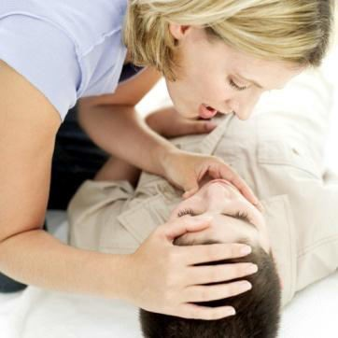
If obstructions are present the casualty will not be able to breathe and the obstruction will also impede the provision of rescue breathing /mouth-to-mouth resuscitation also known as EAR (Expired Air Resuscitation).

Fig 1.5 Airway Checking

Breathing–Check to determine if casualty if breathing
Check breathing by looking (to watch the rise and fall of chest), listening (to the sounds of in haling and exhaling) and feeling for breathing (by placing your cheek next to their mouth and feeling for exhaled breath on your check) for up to 10 seconds. Is the casualty breathing regular or irregular?
If casualty is not breathing, administer rescue breathing /mouth-to-mouth resuscitation /EAR
If casualty is breathing:
- Continue to monitor it to ensure they continue to breathe
- Apply rescue breathing if their breathing stops
- Note their respiration rate so it can be communicated to professionals when they arrive.
Vital signs–respiration rate
„Respiration rate‟ is the rate at which the casualty is breathing. To determine the respiration rate for a casualty, watch their chest or stomach rise and fall for 15 seconds counting how many times it rises. Multiply this figure by four to obtain respirations per minute. Write down your findings so they can be passed on to professional medical help when they arrive.
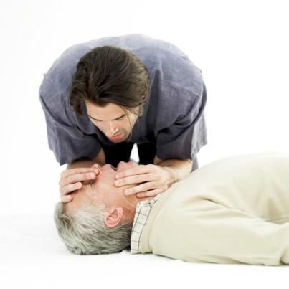

Fig 1.6 Breathing checking

Respiration rates
The normal range of respiration rates in an adult when resting is 12 to 20 respirations per minute
Respiration rate below 12 respirations per minute is called slow
Respiration rate above 20 respirations per minute is rapid
A breathing rate slower than 12 respirations per minute or faster than 20 respirations per minute may indicate a problem affecting the casualty's ability to get oxygen.

Circulation–Check to see if the person has a pulse
This will indicate whether or not their heart is beating
- Without a pulse, there is no heart beating and there is no circulation
- If you cannot detect a pulse, commence chest compressions
If casualty is not breathing and there is no pulse, administer CPR (Cardio-Pulmonary Resuscitation). This is a first aid technique combining rescue breathing and external chest compressions.
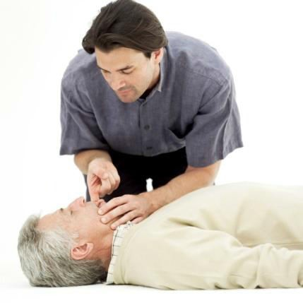

Fig 1.7 Circulation Checking

1.8 Pulse finding
- It is important to take the pulse of a casualty to determine if their heart is till beating or not. No pulse means their heart is not beating and chest compressions must commence.
- If there is no pulse and there is no sign of breathing, CPR (cardio-pulmonary resuscitation) must commence. A good point for taking the pulse is the neck (carotid arteries). Place the middle and index fingers on the casualty's larynx (voice box).
- Move the fingers to the side until you feel the groove (between the bone and the muscle) next to the trachea (wind pipe), then press on the groove until you feel the pulse.
- Place the tips of your index and middle fingers over the pulse site and press gently. Using a watch with a second hand.
- Count the pulse for 15 seconds and then multiply by four to obtain beats per minute.
- Write down your findings.

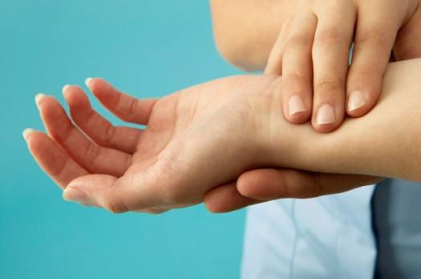

Fig 1.8 Pulse finding

1.9 pulse rate Vital signs
- A normal pulse rate for an adult when resting is 60 to 80 beats per minute. The average is72 beats per minute.
- A resting pulse rate of more than 80 beats per minute is a higher than normal pulse rate. This can be caused by shock, bleeding, heat, dehydration, fever, pain or exercise.

Using history signs and symptoms
If the casualty is conscious and able to talk, speak to them to obtain whatever history is available relating to their condition. By putting the history, signs and symptoms together, you will have a better assessment of the injury.
For example:
The casualty’s chest pain came on quickly
The casualty has had chest pain for more than 10 minutes and is short of breath and sweating
The casualty is experiencing pain in the chest that is spreading down the arms. They also feel weak and dizzy

Self check 1

I. Answer the following questions
1. You have been called to attend a casualty who has collapsed in a room where there is believed to be a gas leak

- Identify physical hazards you might encounter in this situation?
- Describe the action you would take to minimize immediate risk to self, others and the casualty?
- Develop and submit a pro forma document /form that:
  - Could be used by a first aid provider to record the vital signs and physical condition of a casualty when they arrive at the scene and while they are providing basic first aid
    - Gives direction on how to obtain heart rate and respirations per minute.

Unit Two: Apply basic first aid techniques
This learning unit is developed to provide the trainees the necessary information regarding the following content coverage and topics:

First aid Management

First aid assistance

Casualty’s condition

This unit will also assist you to attain the learning outcomes stated in the cover page. Specifically, upon completion of this learning guide, you will be able to:

Understand First aid Management

Give First aid assistance

Monitor Casualty’s condition

2.1 Applying mouth-to-mouth resuscitation
If the casualty is breathing, mouth-to-mouth resuscitation is no required and you must manage bleeding and other injuries. Mouth-to-mouth resuscitation should be given when diagnosis reveals the patient is not breathing.

Procedure for mouth-to-mouth resuscitation
Turn casualty onto their back and:
- Kneel beside the casualty
- Keep the casualty's head tilted back
- Pinch the casualty's nostrils with your fingers
- Lift the jaw forward with your other hand
- Take a deep breath and open your mouth wide resuscitation
- Place your mouth firmly over their mouth making an airtight seal
- Breathe into the casualty's mouth
- Remove your mouth and turn your head to observe the chest fall and listen or feel for exhaled air.

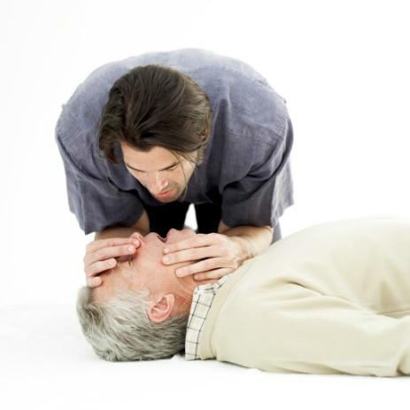

fig 2.1 mouth-to mouth

2.2 Recovery position
When it has been determined the casualty is breathing, they should be placed into the ‘Recovery Position‟.
The steps are:
Kneel beside him or her
Place the furthest arm at right angles to the body Place his or her nearest arm across the chest
Lift his or her nearest leg at the knee so it is fully bent upwards
Roll casualty away from you onto the side while supporting head and neck and keeping the leg at right angles with the knee touching the ground.

2.3 Applying cardio-pulmonary resuscitation
If the casualty is not breathing and has no pulse, administer cardio-pulmonary resuscitation (CPR).Where CPR is needed, it must take priority over treating other injuries.
To apply CPR to an adult:
Ask somebody to call an ambulance or summon assistance from on-site professionals
Start CPR:
  - Place one hand on the breast bone (centre of chest)
  - Place other hand on top of hand positioned on breast bone
  - Align your shoulders above your hands and straighten your elbows, using the weigh to your upper body, with the heel of your hand, press down (4–5cm)
  - Perform30compressions(presses) at a rate of100 per minute
  - Count aloud at a steady and fast pace to achieve this rate
  - After every 30 chest compressions give two breaths–with casualty’s head tilted back ,pinch their nose, place your mouth over the mouth, and give two breaths–blowing steadily.

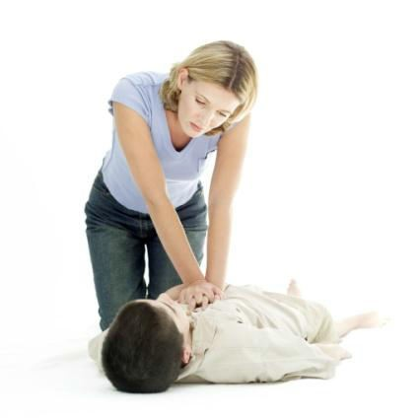

fig 2.2 Applying cardio-pulmonary resuscitation
Check again for signs of circulation and breathing.
If the casualty does not have sign so circulation and does not begin breathing, continue CPR until signs of circulation and breathing return or until emergency medical help arrives.
If two first aid providers are present:
- One should give chest compressions
- one should give breaths
- Count the compressions out loud.

2.4 Managing bleeding
Bleeding is loss of blood. Loss of blood can be external or internal. First aid treatment relates to managing external bleeding.
Guide lines
- Use disposable gloves to reduce the risk of cross-infection
- If the wound is a clean cut (free of dirt), apply addressing. Your main aim is to stop the flow of blood. If blood comes out of addressing applied to an arm or a leg, apply a pressure dressing (a wad of material on top of the dressing and directly over the wound) then raise the injured arm or leg above heart level
- If an object is stuck in the wound, stabilize the object with a bulky dressing made from the cleanest material available. Then apply a bandage over the dressing. Do not press on the object; do not try to remove object.


Fig 2.3 bandage

2.5 Treating burns

2.5.1 Clothes on fire
If the casualty's clothing is on fire, cover the casualty with a fire blanket and roll them on the ground until the fire is putout. If you cannot get to a fire blanket quickly, tell the casualty to drop to the ground and roll on the flame until it goes out.

Treatment of burns
- Place the burn under cold running water for at least 10 minutes
- Cut and gently lift away any clothing covering the burned area
- Leave any piece of clothing that sticks to the burned area in place
- Remove any jewelry from the burned limb so you do not have to cut off the jewelry later when the limb swells
- Apply a sterile dressing over the burn and raise the limb to reduce swelling
- If the burned area is large, use the cleanest material available to cover the burned area
- Do not try to clean the burned area before applying the dressing
- Do not apply ointments or medications to the burned area
- Do not break any blisters.
- Fluid lost through burns is a cause of shock.
- Respond appropriately to prevent shock or control shock. A casualty with serious burns should receive intravenous fluids and medical attention as soon as possible.
- If the casualty is not in shock or suffering nausea, you can give small amounts of cool water to drink.

2.6 Treating electrical burns
Electrocution occurs when electricity goes through the body. If the casualty is lying on an electrical wire, the electrical wire is probably carrying electrical current and can be a danger to you as well as to the casualty.
Below are the steps you should follow:
Do not touch the electrical wire with your handsDo not touch the casualty
Find the source of the electricity and turn it off. If you cannot turn off the electricity:
  - Protect yourself by standing on something dry and non-conductive like a wooden chair
  - Push the casualty away from the electricity, or push the source of the electricity away from the casualty with anon-conductive pole like a wooden broom handle
Check for breathing – use resuscitation techniques if he or she is not breathing
- Find and dress the entry burn wound and the exit burn wound – the sole of the foot is a common location for the exit burn.
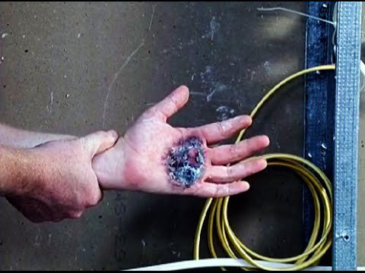
Fig 2.6 electrical shock

2.7 Applying basic first aid to bites and stings

2.7.1 Treating snake bites
To treat snake bites:
- Apply a firm crepe or elastic bandage over the bite site, then the rest of the limb
- Stop the arm or leg from moving
- Do not allow the casualty to move around more than is necessary
- Monitor the casualty’s breathing
- Watch the casualty for shock.
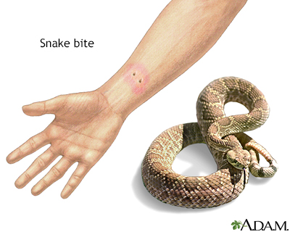
Fig 2.7 snake bite

Bites from other animals can cause severe bruises and infection, and break the skin. Here First aid should include: Cleaning the bite thoroughly with soap or antiseptic, washing the bite with water, covering the bite with a sterile dressing, Immobilizing an injured arm or leg and Taking the casualty immediately to a medical facility.

2.7.2 Treating insect bites
First aid should include:
- Removing any stingers by carefully scraping the skin with a clean finger nail or blunt knife
- Washing the bite/sting site
- Applying ice or cold compresses to the bite /sting site
- Treating more serious reactions, including severe and
- rapid swelling, allergic symptoms, the same as a snake bite
- Monitoring the casualty’s breathing.
Insect bites/stings may cause severe allergic reaction, such as difficulty breathing, if a person is sensitive. Symptoms include swelling of the mouth and throat, red face, hives, wheezing or difficulty breathing, coughing, nausea or vomiting, convulsions, drop in blood pressure and loss of consciousness.
Often allergic people carry identification, such as a MEDICALERT tag, or emergency insect bite treatment kits. If the casualty is having an allergic reaction and has such a kit, follow the instructions that accompany the kit.

2.8 Rapid diagnosis and quick treatment
Call professional medical assistance and identify anaphylactic shock is suspected
Search casualty for„ rescue medication'. This is medication carried by persons susceptible to anaphylaxis for use by first aid providers when treating them.
Administer rescue medication:
- Inject into the outer thigh
- Do not inject intravenously
- Do not inject into the buttock
Prepare yourself to administer CPR–as anaphylaxis can stop breathing and the heart.

2.9 Responding to choking
If a person has food stuck in their throat, they could be choking. To treat choking:
- Use the„ heel of your hand‟, and give up to five blows
- Between the shoulder blades
- Check the casualty’s mouth quickly after each blow and
- Remove any thing that is stuck in there
- Give up to five abdominal thrusts, if the casualty is still choking. Place a clenched fist between the navel and the bottom of the breast bone and pull inwards and up wards
- Check the casualty’s mouth quickly after each abdominal
- Thrust and remove any thing that is stuck in there.

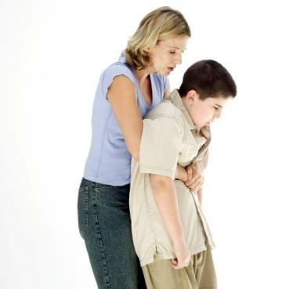

Fig 2.9 choking

2.10 fractures
A fracture is a broken bone. It is standard practice to splint or immobilize an arm or leg, even if they are not broken as this will reduce the pain. The technique is as follows:
- Remove any jewelry on the casualty's injured limb
- Dress any open wounds on the injured limb before applying the splint or sling
- Cover any exposed bone with a dressing
- Do not try to push the bone back under the skin
- Do not try to straighten or„ put together ‟the injured limb
- Place the fractured arm in a sling:
- Place the triangular sling under the injured arm so the arm is in the centre, the base of the sling is beyond the elbow and the top corner is over the shoulder of the injured side
- Position the fore arm with the hand slightly raised (about 10 degree angle)
- Bring the lower portion of the material over the injured arm and over the shoulder of the un injured side
- Tie the two corners in a knot on the side of the neck on the un injured side
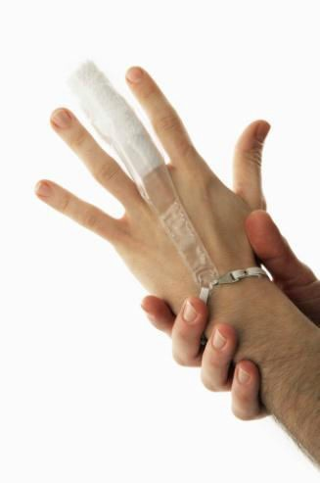
- Twist the pointed end of the sling and tuck it in at the elbow.

Fig 2.10 fractures

To splint a fractured leg or arm
Place one splint on each side of the arm or leg
The aim of splinting is to immobilize the joints above and below any fracture so ensure splints go above and below the fracture
Secure each splint in place above and below the fracture site with little movement to the injured areas
Use the chest wall to immobilize a fractured arm and use the good leg to immobilize the fractured leg if nothing is available.

2.11Treating Sprains
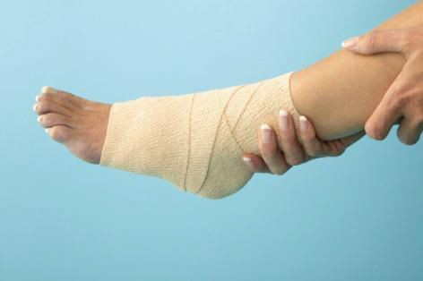
A sprain is injury to the soft part in the ankle, knee, or wrist. Use the RICE procedure to treat sprains:
- R aise the limb
- Ice –apply ice or a cold pad to the injured area
- Compress the injury using a bandage or soft padding
- Elevate the injured limb. Fig 2.11 sprain

2.12 Head or spine injuries
Do not move the casualty if you think they have a spinal injury, unless you believe there is immediate danger. If you must move the casualty to save his or her life, keep the movement of their back and neck to a minimum. The steps are:
- Send someone to get medical help immediately
- Keep the casualty still–tell the casualty not to move
- Kneel behind the head and place your hands on either side to support it, with the head, neck and spine in a straight line
- Put rolled up towels, blankets, or clothing on each side of the casualty’s head to keep
- It from moving
- Cover the casualty with a blanket.
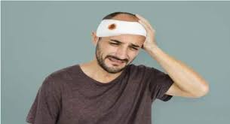

Fig 2.12 head injury

2.13 Treating shock
A casualty with burns or bleeding can have shock. Signs of shock include:
- Sweaty but cool skin, pale colour, or bluish skin around the mouth
- Shallow, fast breathing
- Rapid pulse that becomes weaker.
- As shock progresses, you will see the casualty has: Anxiety: they will appear restless, agitated, worried, unusual thirst, Yawning and sighing and Nausea.
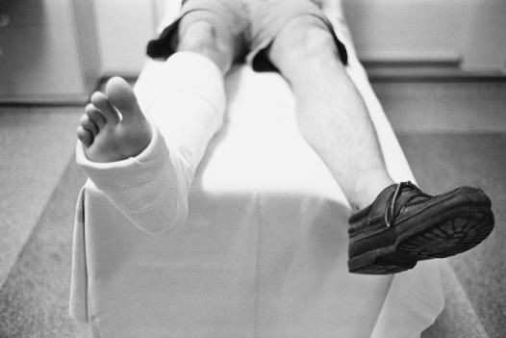

Treat shock by:
- Calling an ambulance or summoning professional medical attention
- Treating major wounds and stopping heavy bleeding
- Positioning the casualty on their back with a blanket to keep warm
- Keeping the casualty calm–confidently and calmly tell the casualty that you are helping and they are fine
- Making sure fractured legs are splinted before you elevate the legs
- Raising casualty's legs so feet are slightly higher than the level of the heart. Place a rolled up towel or other stable object under the casualty’s feet or ankles
- Not elevating the legs if you think that a casualty has a broken back
- Placing un conscious casualties in the Recovery Position
- Loosening any tight clothing, including boots
- Keeping the casualty from being too warm or too cold.

Monitoring casualty’s condition
When you have rendered all the first aid you can, you should monitor the condition of the casualty. Try to record the casualty’s condition and any changes that may occur. This information should be provided to professional medical help when it arrives.

- Monitoring the casualty
When you have rendered all the first aid you can, you should monitor the condition of the casualty. Take written notes of any observations rather than rely on memory. Make sure you record the time of the note being made.
Things to note at this stage may include:
Their pulse and respiration and any changes in them
Colour of and any changes in the colour of the
Casualty’s skin
- Mention made by the casualty of pain including location of the pain, type of pain and degree of pain
- Requests for anything–warmth, liquids, pain relief
- How long casualty was unconscious
- Comments made relating to cause of the injury.

Responding with first aid principles
When monitoring a casualty and waiting for professional help to arrive:
- Re assure the casualty they are doing fine
- Double-check someone has called for professional medical personnel to attend
- Do not allow them to smoke
- Do not give them alcohol
- Do not give them food
- Generally speaking, avoid giving liquids– with the exception of water to wet the lips
- Keep on-lookers away
- Keep them still
- Protect them from the natural elements including sun, rain and wind.

2.15 Seek first aid assistance
In all first aid situations there can be a need to call on others who are not professional medical people to help you provide the basic first aid necessary.
Factors to consider
In addition to volunteers, assistance at the scene may be sought from:
- Other staff and colleagues
- Members of the public
- Friends or family members of casualty.
When seeking first aid assistance from others, consider the following
- :Never be afraid to ask for help
- Most people are prepared to help even if they do not know what to do. They will do
- What you ask them to do.
- A vital thing they can do is to confirm professional medical help is on the way.
They can be asked to:
  - Give information about causes of the incident and injury
  - Provide directions to emergency services to help them get quickly to the scene
  - Contact friends or relatives of the casualty, so they can attend and perhaps provide history about the casualty
  - Help move the casualty
  - Help protect the casualty from further injury
  - Communicate with emergency services to provide them with updates
  - Communicate with emergency services to obtain advice
  - Record verbal information you give them–vital signs and condition of casualty
  - Obtain first aid requisites for you including fetching bandages or slings from the first aid room/ main office
If one person refuses to help, ask someone else. Never assume just because one person has refused, everyone will refuse.

Timing- Identify possible helpers immediately
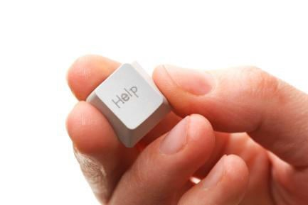
Always identify potential helpers as soon as possible when you arrive on scene.
Ask questions such as:
- “Does anyone have first aid experience or Qualifications?
- “Can anyone here help me if I need help?”
- “Does anyone have a cell phone?”
- It is best to have people ready to help and not need to use them than it is to not have identified possible helpers and then find you do need them.
- When you have identified helpers Thank them
- Ask them to stand where you can communicate readily with them
- Give them a job– get them to hold something, take notes, control the crowd or provide shade.

‘Timely manner’
Obtaining assistance for others must be done in a„ timely manner‟. This means you must do it as soon as you identify a need for help from others. For example, you may be dealing quite competently with a casualty but suddenly find changes in the environment or condition of the casualty. As soon as this is identified, action must be taken to obtain help from others immediately. Do whatever is needed – call out, ask by standers or use your cell phone to call for help.



Fig calling for assistance

Incident Report
After an incident you may be required to complete an Incident Report. The purpose of an incident report is to provide details about the event to enable action to be taken to prevent a recurrence. Information in the Incident Report may include:
- Date, time and location of the accident or injury
- Who was involved– names of casualties
- Numbers involved, identification of gender
- Names of staff involved– as first aid responders and care givers
- Action taken– describing the first aid delivered and contact of professional medical assistance
- Involvement of Emergency services–when they were called, when they arrived and the action they took
- Why you believe the injury or incident occurred– to prevent recurrence
- Names and contact details of witnesses.
- A sample Incident Report follows on the next pages.

2.16 Sample Incident Report form
Part A: To be completed by the injured worker

Details of injured /ill staff member Staff number:

Surname: Given names:

Home address:

Job title Phone number:

Staff member's normal working hours:
Am / pm to: am/pm

Has the injured /ill staff worker returned to work since the injury? (Please check one)

    - Yes (go to injury/ illness details)  No

Date and time work ceased: Date: / /
Time: am/pm

Has the injured /ill staff worker returned to work since the injury?  Yes  No
Illness details Type of injury (please check where applicable)

    - fracture/dislocation  skin disorder  damage to artificial aids

    - burn/ scald  contusion/crush  bite/sting

    - cut/ abrasion (first- aid only)  poison  strain/sprain

Open wound (medical treatment)
❑
    - amputation  other

Location of injury (e.g., left arm, right hand, leg, back, head & neck):

First aid /medical treatment
If any first aid or medical treatment was required, please state name and phone number of first aid /medical attendant:
Name: Phone number:
Please list all items used from first aid kit (including multiple use /non-disposable items)

Details of incident

Date of incident: / /
Time of incident: _am/pm

Date incident reported: / /

Location of incident:

Primary reason for injury (please check where applicable)
slip, trip or fall body stress (exertion to muscles, tendons, ligaments & bone)
❑ 

    - Noise or vibration  hitting objects with part of the body

struck by a moving object biological exposure (germs, viruses & bacteria)
❑ 

    - other:

Brief description of incident:
If any witnesses, please state name and phone number
1.Name: | Phone number:
2.Name: | Phone number:
3.Name: | Phone number:
Any further comments:
Part B:To be completed by the Supervisor
Action (if any) taken to prevent the incident from occurring in the future:

2.17 Injury Register
Employers should have an Injury Register where accidents and injuries involving staff must be recorded.
The injured staff member may be required to record the details of the incident or if the person is un able to do that, the First aid provider may be required to do so.
The following information needs to be recorded in the register:
- Worker’s name
- Worker’s occupation or job title
- Time and date of injury
- Worker’s exact location at the time of the injury
- Exact description of how injury was sustained
- Nature of injury and the body part(s) affected
- Witnesses to the injury ,if any
- Date of entry in register
- Name of person making the entry.

Self check 2

- Prepare a list of first aid resources and equipment available in your workplace and for each item:

  - Identify the potential use for each item
  - Explain how to use each item for every identified possible use.

  - Record yourself performing simulated CPR on an adult.

  - List the options available to you in your work place to obtain first aid assistance from others in the event of a medical emergency.

  - Provide a copy of a work place document used to record:

  - Injury or accident involving a staff member and the action taken (for example, Injury Register)
  - Injury or accident involving a customer and the action taken (for example, Incident Report).

Unit Three: Communicate details of the incident
This learning unit is developed to provide the trainees the necessary information regarding the following content coverage and topics:
- Requesting Medical Assistance
- Conveying Details of casualty’s condition
- Report to medical expert
This unit will also assist you to attain the learning outcomes stated in the cover page. Specifically, upon completion of this learning guide, you will be able to:
- Request Medical Assistance
- Convey Details of casualty’s condition
- Prepare Report to experts

3.1 Request medical assistance
Whenever there is a need for you to provide first aid, it should be standard practice to also involve professional medical authorities. Your role should only be as a„ first responder‟ to provide emergency help. Your job is not to deliver professional medical assistance. This should apply whether the casualty is a customer, member of staff or member of the public.

The importance of obtaining professional medical assistance
It is more important to get suitably -qualified professional assistance moving in your direction than it is to render first aid. This means professional medical Assistance must be summoned when you are advised there is a need to attend a casualty to provide first aid.
Never wait until you have started treating the casualty before contacting professional medical assistance. Contact the ambulance or other suitable people as soon as possible. You do not need to have attended the casualty before requesting help. Contact the ambulance and give them the information you have to begin with and get them moving towards you. You can always phone back later and give them an update. If you have to choose between providing first aid and summoning professional medical help always choose to contact the ambulance or professional assistance first.

Calling for help
Common sense must be used when contacting professional medical assistance.
Options include:
- Asking someone else to call for help whether it is a colleague, management, bystander or member of the public. This can be done while you go to the casualty or while you are rendering first aid
- Yelling out for help or for someone to ring an ambulance
- lagging down a passing vehicle and asking them for help or to ring an ambulance
- If you cannot make telephone contact–activating a Fire‟ alarm.
- Never waste time thinking about whether or not to summon medical assistance– always
- Summon medical assistance.
- If you have to choose, delay rendering first aid until you have called for assistance.

Facilitate arrival of authorities
You should take whatever action you can to facilitate the arrival of emergency services or professional medical help to the casualty’s location.
This may involve:
- Opening gates or arranging for them to be opened
- Moving vehicles which may impede access
- Asking others to position themselves in locations to sign post the location of the casualty as emergency service workers arrive on scene.

3.2 Communicating details of the incident

When professional medical assistance or a relieving first aid provider arrives you must communicate to them all knowledge you have about the casualty changes in their vital signs, action taken and, where appropriate, the incident giving rise to the injury.

Calling for assistance
When making initial contact with Emergency Services to obtain help they will require information about the incident before they send assistance:
Be guided by them–let them ask questions and answer them as required
Speak clearly and calmly
Never hang up the telephone until directed to do so.
Emergency service telephone operators will want information about:
- The exact location of the casualty
- The number of casualties
The age and gender of casualties
Descriptions of injury, illness and symptoms
Details of any first aid which may already been given
Whether or not the situation is life threatening and if you need over-the-telephone assistance in rendering more first aid.
While the authorities will prefer to have all of the above information, never delay calling them just because you are missing some of the information they will ask you about.Always contact them and get them moving towards you.

3.3 Preparing a report
When preparing a report:
- Observations taken at the time should be referred to. This may include vital signs or actions taken
- Any record prepared (see2.4) should be used
- Ensure„ facts‟ are distinguished from„ beliefs ‟–it is important for the report to be fact- based.
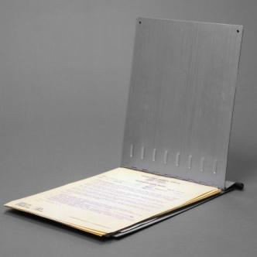

Fig 3.3 Report preparation
Facts may relate to:
- Time you were advised of the incident
- Time of your arrival at the scene
- Date
- Location of the incident
- Name of casualty or casualties
- Time professional medical help or emergency services we recalled- and name of person who called them
- Time professional assistance arrived on scene–and name of emergency services or professional help that responded
- Description of the casualty when you arrived– position, vital signs, original diagnosis and reasons for same
- First aid action taken – detailing what was done and the sequence in which it was done
- Details of any action taken as a result of the understanding the casualty was in danger and there was a need to move the person
- Details of any action taken to mitigate further injury, or injury to other persons
- Record what happened to the casualty–„Taken by ambulance to XYZ hospital‟

Assist the employer by:
    - Identifying what you believe may have been the cause of the–such as„ Casualty appears to have slipped on wet floor in toilet‟, or„ Casualty was burned as a result of touching top of bain Marie in dining room‟
    - Making suggestions as to what could be done to prevent a recurrence of the incident
Sign and date the report providing your contact details.

.

Self check 3

1. An elderly, male customer has been discovered lying on the foot path in front of your work place and it appears they may have suffered a heart attack.
Provide a written description or a recording, of how you would:call for professional medical assistance
Convey details of the casualty’s condition.

2. Submit a report presenting all relevant facts about a fictitious situation of your own choosing, where you were required to provide basic first aid treatment to a customer in your workplace. Ensure the report addresses:

  - Details of the customer
  - Details of the situation, context and location of the casualty
- Description of the injury
- Description of the action taken in response to the identified situation.

Recommended reading
- Australian RedCross,2005,Firstaid:respondingto emergencies, Revised edn., Australian Red Cross, Carlton, Victoria, Australia
- Fermie,P., Keech, P.& Shepherd, S., The illustrated practical book of first aid & family health : from treating cuts, sprains and bandaging in an emergency to making decisions on headaches, fevers and rashes...,Lorenz, London
- Haines,J.,2010,Emergencyfirstaid,Medic Media, Up wey, Victoria, Australia
- Keech,P., 2003, Practical guide to first aid: fast and effective emergency care, Lorenz Books, London
- St.JohnAmbulanceAustralia,2007,Australianfirstaid: an authorized manual of St John Ambulance Australia, St. John Ambulance Australia, Forrest, A.C.T
- Tyler, E., 2002,CPR:withstep-by-step instructions, Tyr rells Building Consultancy for the First Aid Trust, Rydalmere,N.S
- http://www.expertvillage.com/video/139808_carry-injured-person yourself-first.htm.
- http://www.redcross.org.uk/standard.asp?id=75052.

Developers’ Profile
No | Name | Qualification | Educational background | Region | College | Mobile number | E-mail
1 | Mohammed Liben Mohammed | Hotel and Tourism Sector head | - BA degree in Hotel and Tourism management  - MA degree in Disaster Risk Management | Somali | Jigjiga Polytechnic college | 0992326557 | cherechaw@gmail.com
2 | Abreham Mayza mengesha | Instructor | Bed degree in Hotel and Tourism | SNNP | Arba minch Polytechnic college | 0913711922 | Abrehammayza9@gmail.com
3 | Zelalem Almaw Endalew | Instructor | - BSC degree in Food science and post harvest technology | Amhara | Bahir dar Polytechnic College | 0918012521 | Parazolla25@gmail.com
4 | Hiwot Tedla Belay | Instructor | BA degree in Accounting and finance and diploma in Hotel Management | Hareri | Harer Polytechnic College | 0913789086 | hiwietaba@gmail.com
5 | ZuryashWork Belay Nigatu | Instructor | BA degree in Hotel Management | Addis Ababa | TTI | 0911643817 | zwb@gmail.com

