Bakery and Pastry Production Level-2
Based on November 2022 Curriculum Version -2


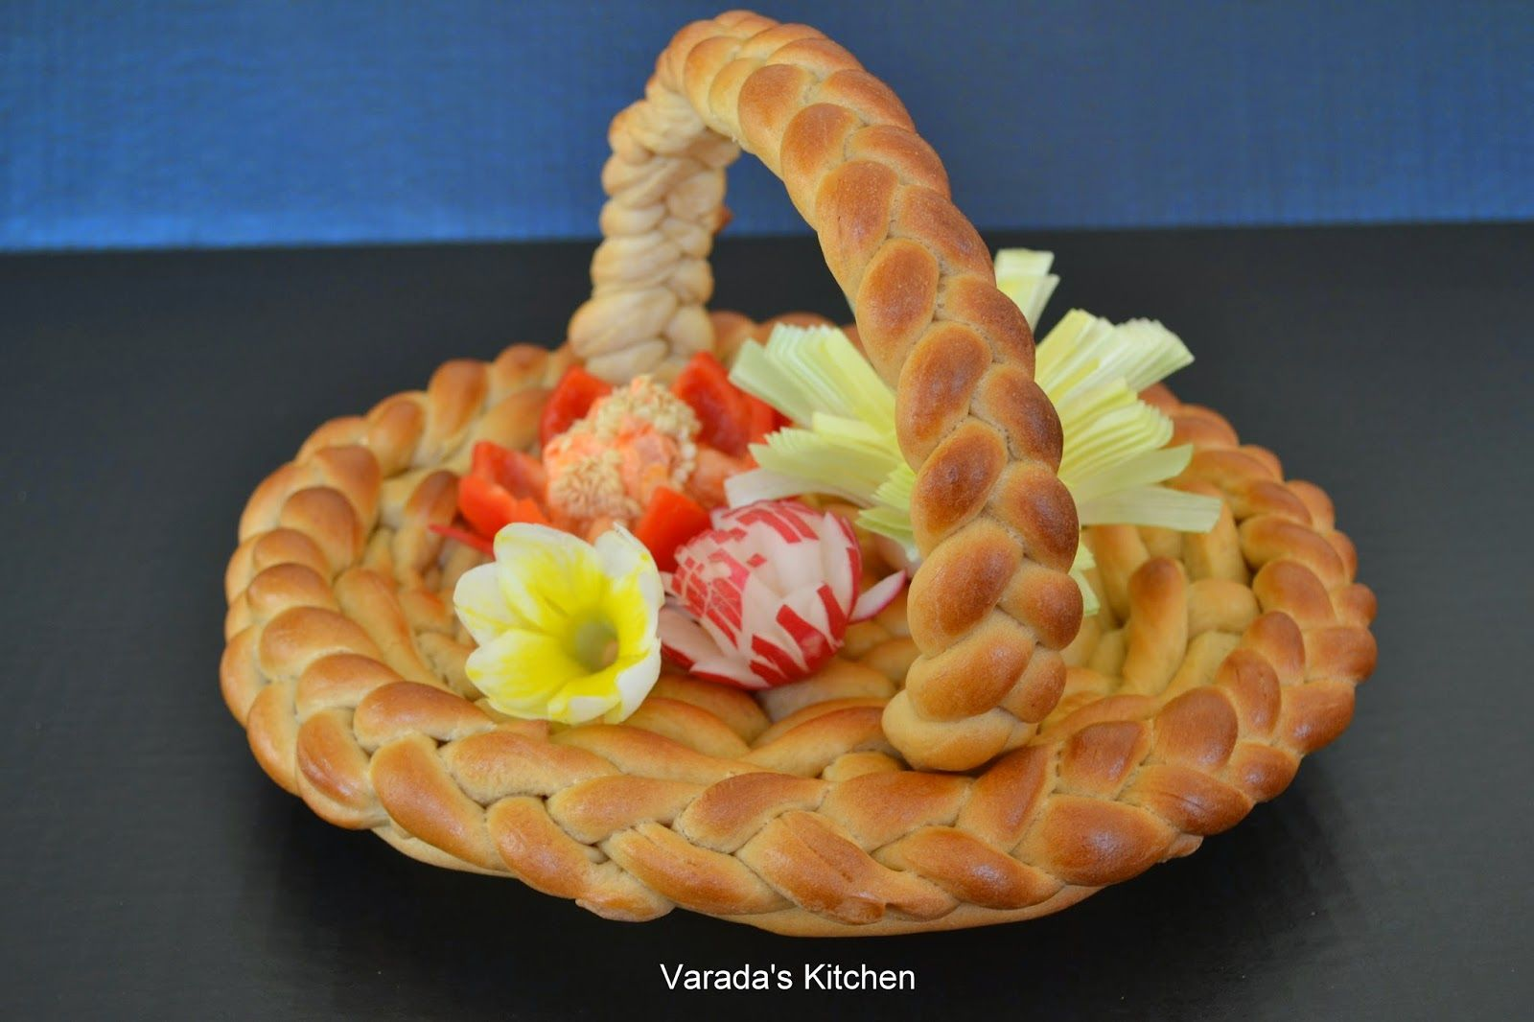
Module Title: Produce bread products
Module code: CST BPP1 M07 1122
Nominal duration: 54 Hours

Prepared by: Ministry of Labor and Skill

November, 2022
Addis Ababa, Ethiopia

Table Contents
Introduction to the module 2
This module covers the units: 3
Learning Objective of the Module 3
Unit One: variety of bread products 4
1.1 Choose ingredients 5
1.2. Selecting equipment 6
1.3. Preparation techniques of bread 10
1.4. Produce variety of bread 11
SELF-CHECK 1 14
Operation sheet1 15
Lap test 1 20
Unit Two: Present & display bread 22
2.1 Select equipment 22
2.2 Display bread 26
SELF-CHECK 2 28
Operation sheet 2 29
Unit Three: Store bread products 30
3.1. Store bread 30
3.2 .The Big No-No: Avoid Storing Your Bread 31
SELF-CHECK 3 33
Operation sheet 3 34
RECOMMENDED READINGS 35
Participants of this Module (training material) preparation 36

Acknowledgment
Ministry of Labor and Skills wish to extend thanks and appreciation to the many representatives of TVT instructors and respective industry experts who donated their time and expertise to the development of this Teaching, Training and Learning Materials (TTLM).

Introduction to the module

Producing variety of products in bakery and pastry production field will enhance the Hospitality industry service, serving the customer in full capacity and it is very important to keep the standards of bread and other sweet desserts service. On the other hand it is also a means to create a job for small scale industries and to street food service providers
This module is designed to meet the industry requirement under the bakery and pastry production occupational standard.

This module covers the units:
- Variety of bread products
- Display bread products
- Store bread products

Learning Objective of the Module
- Produce variety of bread products
- Present and display bread products
- Store bread products

Module Instruction
For effective use this modules trainees are expected to follow the following module instruction:
- Read the information written in each unit
- Accomplish the Self-checks at the end of each unit
- Perform Operation Sheets which were provided at the end of units
- Do the “LAP test” given at the end of the unit and
- Read the identified reference book for Examples and exercise

Unit One: variety of bread products
This unit is developed to provide you the necessary information regarding the following content coverage and topics:
- Choose ingredients
- Select equipment
- Preparation techniques of bread dough
- Produce variety of bread

This unit will also assist you to attain the learning outcomes stated in the cover page.
Specifically, upon completion of this learning guide, you will be able to:
- Identify, collect& measure ingredients
- Select& use appropriate equipment safely
- Apply Preparation techniques of bread dough
- Prepare& bake variety of breadat correct temperature& time

Introduction:
Bread: is a staple food prepared from dough of flour and water.
- Is a food made of flour, water and yeast or another leavening agent, mixed together and baked.

Choose ingredients
Definition:
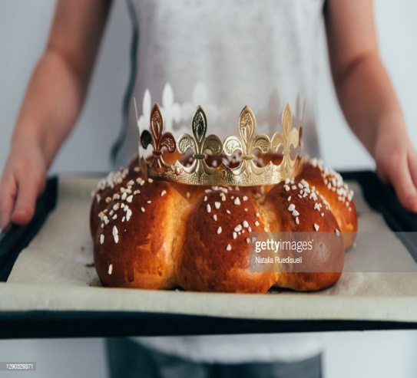
Ingredient: something that enters into a compound or is a component part of any combination or mixture

1.1.1 Identify, collect&measure ingredients
Ingredients
Flour-
- It is the back bone & structure of baked goods
- It acts as a binding and an absorbing agent
- It is important for the flavour of the product
- It adds nutritional value to the product
Fig1.1.guglhoph bread
Butter/ Margarine – Counter acts the toughening of ingredients in the baked goods
- Improves texture
- Prolong freshness & add flavour
- It also adds nutritional value
Leavenings agents / yeast
- Lightens dough & makes the finished product more digestive
Salt-
- It has a strengthening effect on the gluten
- It improves flavor
- It improves the texture of the dough

Sugar –
- Adds sweetness
- Aids in fermentation of yeasts
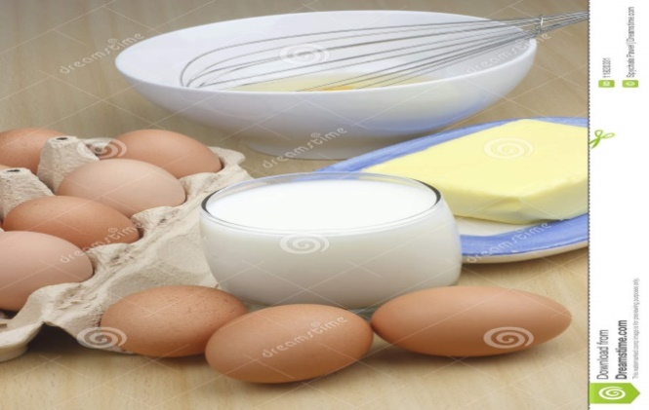
- Retains moisture

- Egg
- Milk
- Water
- Flavorings, etc.

Fig 1.2. Eggs, milk& butter

1.2. Selecting equipment

1.2.1Select& use appropriate equipment safely
Equipment ---
- Bowl :
- Flower sifter
- Rolling pin
- Cooling rack
- pastry brush
- Whisker
- baking sheet
- Measuring scale & measuring jug,etc.
Table 1.1. Tools &equipment
No. | Name of tools &equipment | Picture | Description
1. | Bowl | 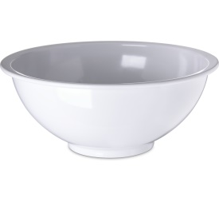 | A mixing bowl is a bowl used for mixing of ingredients.
2. | Flower sifter | 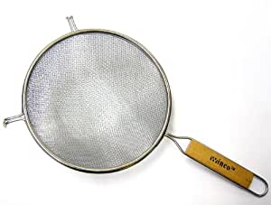 | A sifter is used for breaking up lumps of food/flour into smaller pieces.
3. | Rolling pin | 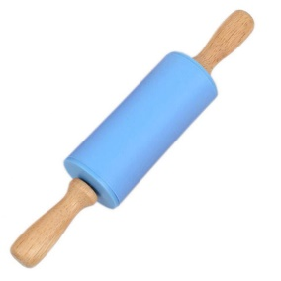 | A rolling pin is a cylindrical food preparation utensil used to shape and flatten dough.

4. | Cooling rack | 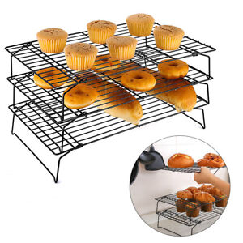 | A cooling rack (also known simply as a wire rack) is used to allow air to circulate freely to cool baked goods, and to prevent them getting soggy from condensation
5. | pastry brush |  | A pastry brush is a small brush that is used to paint an egg wash on top of dough before baking to give the top a nice brown color.
6. | Whisker | 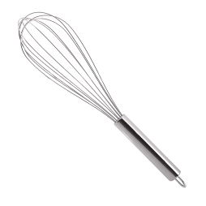 | Whisks are used to either add air into a mixture or thoroughly blend ingredients together.
7. | baking sheet | 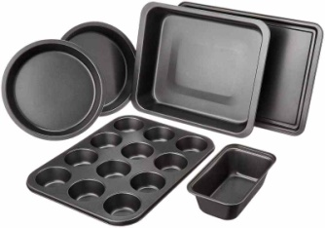 | A sheet pan, baking tray or baking sheet is a flat, rectangular metal pan used in an oven. It is often used for baking bread rolls, pastries and flat products such as cookies, sheet cakes, Swiss rolls and pizzas.
8. | Measuring scale | 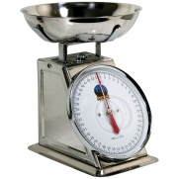  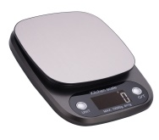 | A baking scale, also known as a catering scale, is a weighing machine used by bakers and caterers for measuring food ingredients. There are many types of baking scale on the market, from digital kitchen or cooking scales for personal use to commercial catering
9. | measuring jug | 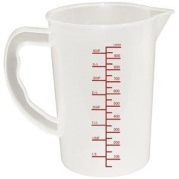 | It is used to measure things  it is a jug with graduated measurements printed on the sides.
10. | Measuring cups | 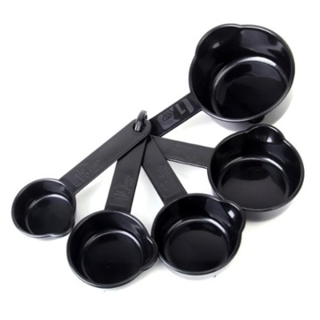 | Measuring cups are a cup like tool to measure ingredients. Generally consists of scale markings at varying hiegahts.
11. | Measuring spoon |  | Measuring spoons are spoons that measure small amounts of wet and dry ingredients. Most measuring spoons come in sets of four or six. A set of four measuring spoons includes ¼ teaspoon, ½ teaspoon, 1 teaspoon, and 1 tablespoon sizes. A set of six measuring spoons usually includes ⅛ teaspoon, ¼ teaspoon, ½ teaspoon, 1 teaspoon, ½ tablespoon, and 1 tablespoon sizes.

1.3. Preparation techniques of bread
    - Use Preparation techniques of bread dough
Definition: preparation technique is the action or process of making something ready for use or service or of getting ready for some occasion, test, or duty.Baking is a subset and specialized type of cooking that uses dry heat to make baked products.
Quick bread mixing method.
- The Creaming Method.
- Rub In The Flour Method.
- Hot Milk Method for Baking.
- Kneading the mixture
- Maintaining consistency of the mixture
- Portioning Proofing the dough and baking

Basic Rules of Baking
- Read your recipe. Before you even start adding things to your mixer, read your recipe all the way through.
- Do the research.
- Avoid distractions.
- Check your ingredients.
- Check your utensils.
- Follow the instructions. .
- Preheat the oven.
- Make accurate measurements

Dozen steps of baking Bread
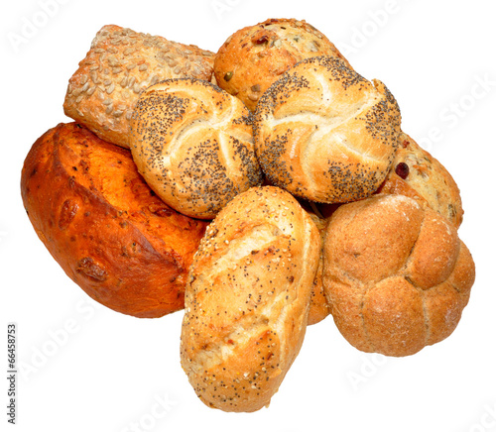
- Start with row materials
- Weigh ingredients
- Mix
- Fermentation period
- Sealing
- Rounding
- Bench proofing
- Molding
- Panning
- Pan proofing
- Baking
- Cooling
Fig1.3.Assorted bread

1.4. Produce variety of bread

1.4.1. Prepare& bake variety of bread at appropriate temperature& time

Basic baking procedure:
- Dissolve the yeast in lukewarm water& add the sugar and let it stand until it bubbles up
- Sieve the flour, mix the ingredients with the yeast mixture & knead it very well
- Keep cover until double in size
- Divide in to equals and give a desired shape, place it on greased baking sheet
- Leave it in a warm place until rise then bake it at 200-degree c.for 10-15 min.
Basic bread dough:
1. Soft dough is sticky and is used for breads that don’t require kneading, such as batter breads. — Moderately soft dough is slightly sticky and may be kneaded on a floured surface. It is used for most sweet breads. It kneads easily when on a floured surface, and is used for most unsweet breads.

Examples of soft dough
Types of dough
- Brioche – Flour, eggs and a large quantity of butter.
- Challah – egg dough.
- Crêpe.
- Focaccia – for Italian leavened flat bread.
- Pasta dough – for making noodles, ravioli, etc.
- Pizza Dough.
- Sourdough is a bread product made by a long fermentation of dough using naturally occurring lactobacilli and yeasts. In comparison with breads made quickly with cultivated yeast, it usually has a mildly sour taste because of the lactic acid produced by the lactobacilli.
- Stiff dough is firm to touch and kneads easily on a lightly floured surface. Check your bread for doneness by tapping the top of the loaf with your finger.
e.g. scones, pizza crusts & cookies.
4. Sweet dough – is an enriched dough which means it has things like eggs, butter & sugar added. These ingredients make the dough very soft and moist. It also means that it can take longer to rise
Producing variety of bread

Bread products:
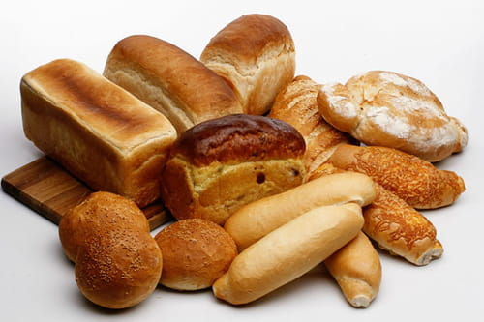
- Loaf bread
- mini loaf
- bun bread
- brioche bread
- sweet bread
- Baguette bread
- Focaccia
- Crisp bread
- Chapatti bread
- Nan bread Fig1.4.roll, and loaf types
- German bread
- Artisan bread
- Country loaf
- Sour bread
- breakfast and savoury items
- breakfast and speciality breads

.
SELF-CHECK 1 | WRITTEN EXAM

Answer the following questions:
- What is bread? Elaborate.
- List the main ingredients necessary for making bread.
- Mention some equipment needed for making bread.
- What is the use of flour as a bread raw material?

Operation sheet1. Produce variousbreads.

Operation Title:Producing different kinds ofbread.
Purpose: to perform different kinds ofbread.
Conditions or situations for the operations:
- Safe working area
- Properly operated tools and equipment
- Appropriate working uniforms fit for the practical performance

Equipment Tools and Materials:
-Mixer - scale - flour
- Oven - bowl - yeast
- Scraper - butter, etc.
Quality Criteria: Assured performing of all the activities according to the procedures
Recipe of different kinds of bread
  - Making loaf bread
Ingredients
- 500gm. flour
- 8gm. yeast
- 250-300ml. of lukewarm water
- 5gm, salt
- 1 tsp. sugar
Preparation
1. Dissolve the yeast in lukewarm water& add the sugar and let it stand until it bubbles up
2. Sieve the flour, mix the ingredients with the yeast mixture & knead it very well
3. Keep cover until double in size
4. Divide in to equals and give a desired shape, place it on greased baking sheet
5. Leave it in a warm place until rise then bake it at 200-degree c. for 10-15 min.

B. Making Sweet bread Loaf
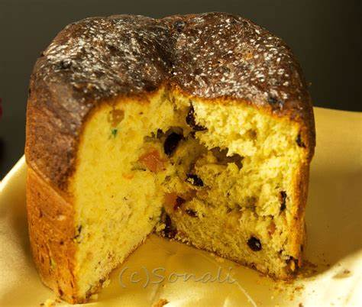
Yield: 2 Loaves
Ingredients:
- Sifted Flour - 1 1/2 lb
- Shortening - 1 oz
- Margarine - 3 oz
- Grated Coconut - 3 oz
- Brown Sugar - 4 oz
- Yeast - 1 1/2 tsp
- Baking Powder - 1 1/2 tsp
- Mixed Fruits - 1/4 cup
- Cinnamon Powder - 1 Pinch Fig1.5. Panatone bread
- Nutmeg Powder - 1 tsp
- Mixed Essence - 1/2 tsp
- Water - 1 cup , Raisin

Procedure:
    - Add flour, shortening and Margarine to bowl
    - Cut shortening and margarine into flour.
    - Add coconut, sugar, yeast, baking powder, mixed fruits, cinnamon and nutmeg.
    - Mix together until well incorporated.
    - Add essence and water.
    - Begin to knead.
    - Add risen hops dough as the sweet bread loaf dough begins to form.
    - Continue to knead until well incorporated (about 5 minutes).
    - Cover with cling wrap or a damp cloth and allow to rest for 10 minutes.
    - Divide dough into two and place into greased bread pans.
    - Cover with a damp cloth and allow to rise for 30 minutes.
    - Bake at 350°F for 35 to 40 minutes.
    - Allow to cool and enjoy!

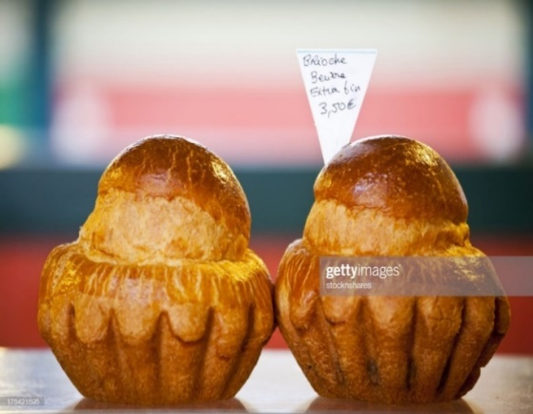
  - Making Brioche
Ingredients
- 125g.butter (melted or cold)
- 3 eggs
- 250g.flour
- 3g. salt
- 25g. sugar
- 10g. yeast
- 50 ml. water /milk
Fig6.Brioche
Preparation: proceed as yeast dough bread procedure.
Note:
If we use melted butter mix all, knead, keep it to rise and continue the procedure
If it is cold butter first make a dough without the butter, keep it to rise and add the butter combine it keep it to rise again use the muffin cup to bake.
* Shape varieties: chain wheel, brioche with head and with out
* Egg wash is necessary for any sweet goods

  - Making Bun bread
Ingredients
- 200 gr. Flour
- 5 gr. Yeast
- 125 ml. milk /water
- 1 egg
- 50 gr. Butter or margarine
- 25 gr. Castor sugar
Preparation
- sieve the flour, make a wale in the center of the flour
- Dissolve the yeast, add in to the flour
- Add
- The beaten egg, butter or margarine, sugar & the remainder of the liquid.
- Kneed well to form a soft dough until smooth
- Keep covered in a warm place until rise
- Use as required

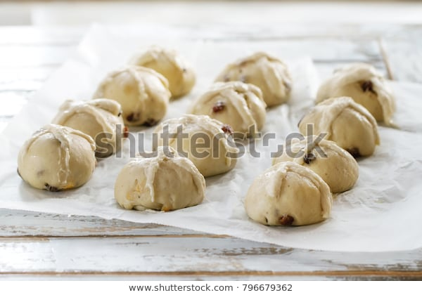

Fig.1.7. Bun bread

E.Making Focaccia Bread ECIPE
Ingredients
- 4 cupsBread Flour (or all-purpose flour, see notes above)
- 2 teaspoons Kosher Salt
- 2 teaspoons Instant Yeast (see notes above if using active dry)
- 2 cupsLukewarm Water (made by combining 1/2 cup boiling water with 1 1/2 cups cold water)
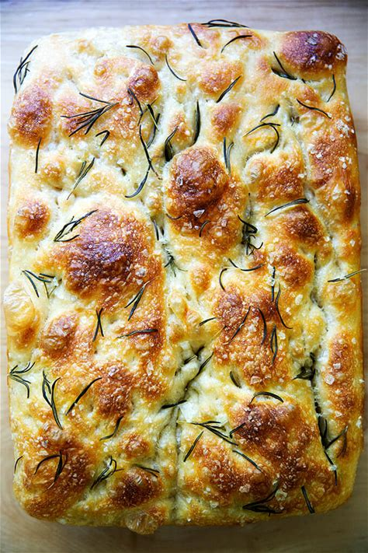
- a (for greasing)
- 4 tablespoons Olive Oil (divided)
- add Flaky Sea Salt
- 2 teaspoons Whole Rosemary Leaves (optional)

Fig1.8. Focaccia bread

  - Chapatti (Indian Flat Bread)
Ingredients
2 cups whole wheat flour or drum-wheat “Atta”
1 teaspoon salt
1 cup water
- tablespoons wheat flour, for rolling and dusting
Instructions / procedure
Sieve the flour, add salt to it and mix well. Place the flour in a large bowl and add 3/4 cup of the water. Stir gently with fingers in a circular motion until the flour starts to gather. Add 1-2 tablespoons more flour if the dough looks too sticky. Add more water if it looks too dry and firm.
Knead the flour until it becomes soft and pliable and doesn't stick to your fingers. You can put a little oil on your hand while kneading the dough to help with kneading. Cover the dough with plastic wrap and let the dough rest for at least 1 hour, at room temperature. You may store the dough in refrigerator. Just thaw to room temperature before using it.
Once ready to make chapatis, heat the griddle over medium-high heat. Divide the dough into 10-12 equal-sized dough balls. Working on one dough ball at a time. Roll a dough ball in the flour and flatten it a bit with your hands. Transfer the flatten ball to a clean flat surface, roll it with a rolling pin into a 6-7 inch disc. If the dough sticks to the surface, dust the surface with more flour.
4. Place the chapatti on the hot griddle and cook for 30 seconds or until tiny golden dots appear on the surface, flip over and cook the other side. Flip over again and soon the chapatti will start to puff up. Use a folded kitchen towel and press gently on the puffy chapatti to push the air to the flatten part of the chapatti. The whole bread should puff up into a round ball.
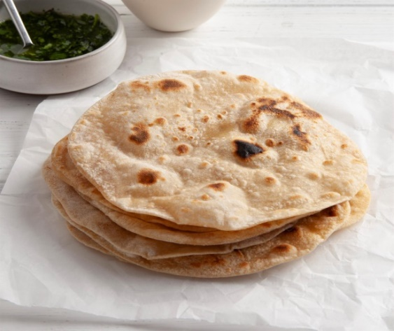
5. Transfer the cooked chapatti to a serving platter. You may baste it with a little butter or ghee. Serve immediately.

Fig1.9. Chapatti bread
Lap test 1:
Instructions: Given necessary templates, tools and materials you are required to perform the following tasks accordingly.
Task 1: pre-prepare the necessary equipment
Task 2: prepare the necessary ingredients
Task 3: measure the ingredients according to the recipe
Task 4: make a dough
Task 5: give rest, shape & pan proof
Task 6: bake & cool

Unit Two: Present & display bread
This unit to provide you the necessary information regarding the following content coverage and topics:
- Equipment for display
- Display bread
.This guide will also assist you to attain the learning outcomes stated in the cover page. Specifically, upon completion of this learning guide, you will be able to:
- Identify equipment for display
- Present different bread for display

2.1 Select equipment

2.1.1 Identify equipment for display
Serving platters
Tongs
Plate
Sauce jugs

- What is to identify: to recognize or establish as being a particular thing.
Table2.1. equipment
No. | Name equipment | Picture | Description
1. | Serving platters |  | Serving platters are essentially flat dishes or trays that are used to display and serve a variety of foodstuffs including bread.
2. | Sauce jugs | 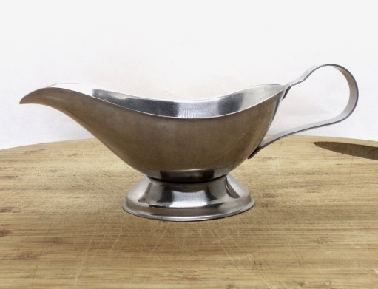 | Perfect for Sunday dinner or Christmas lunch these two silver metal jugs could be used for all kinds of pouring sauces and gravy for the main meal as well as to hold custard or cream for dessert.
3. | Plates | 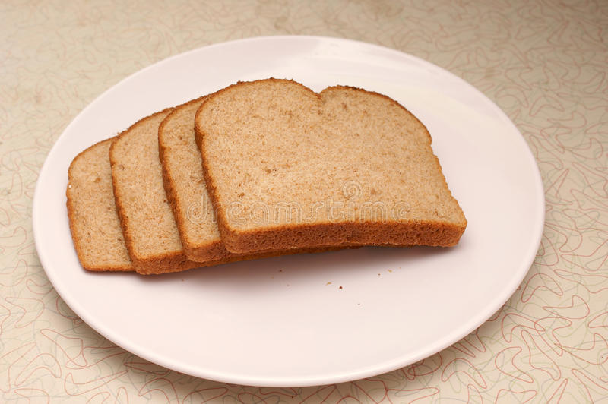 | the main purpose of these plates is to keep the bread out of other dishes on the plate where the bread may get soaked in sauce or gravy. The bread and butter plates are placed on the left-hand side of the place setting, right above the tips of the forks.
4. | Cutlery | 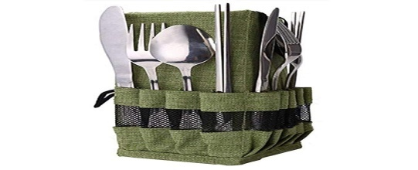 | Cutlery used to cut, slice bread,and coat jam,butter andothers
5. | Tongs | 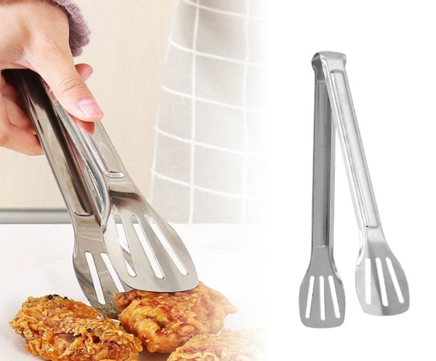 | Tongs are a type of tool used to grip and lift objects instead of holding them directly with hands.
6 | Refrigerated cooling | 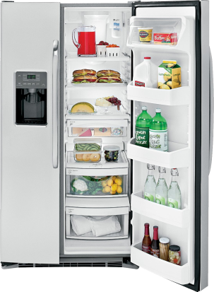 | The fundamental reason for having a refrigerator is to keep food cold. Cold temperatures help food stay fresh longer. The basic idea behind refrigeration is to slow down the activity of bacteria (which all food contains) so that it takes longer for the bacteria to spoil the food.
7. | Hot display bain-marie | 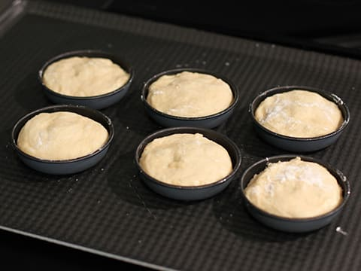 | Bain-marie (pronounced "bane mah-REE") is essentially a fancy way to describe a hot water bath in the culinary world. It is commonly used for cooking delicate foods such as custards. The purpose of a bain-marie is that it creates a gentle heat around the food and results in a uniform cooking process.

2.2Display bread
What is to display?
To display mean: put (something) in a prominent place in order that it may readily be seen
- To present to view
- To exhibit
- To spread out
Displays food, it’s important to protect it from contamination and keep it at the right temperature so it stays safe to eat. The purpose of a display is to highlight certain products by increasing their visibility.

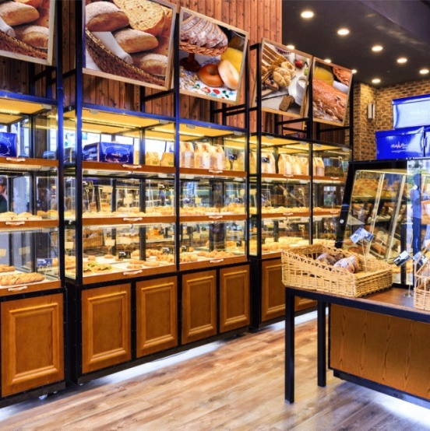
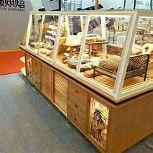
Fig.2.1.
Fig2.1.

Temperature
The temperatures at which bread served all affect the eating sensation and overall customer satisfaction. The bread box is slightly cooler since it blocks out the sun and electric lights. Furthermore, sitting in a plastic bag in a dark pantry is fine, too. You can store the bread at 20 to 22 degrees C or 68 to 72 degrees F that maximizing the time the loaf remains fresh and soft.

SELF-CHECK 2 | WRITTEN EXAM

Answer the following questions:
How would you decide the amount and variety of bread to be displayed for an event or service period?
Identify three items of bread display equipment and describe how each might be used to enhance the presentation of desserts at a display.
What is the required temperature at which bread should be served?
What impact should the presentation make?

Operation sheet 2:Present& display bread.
Operation Title: select display equipment for bread.
Purpose: to present and display variety of bread
Conditions or situations for the operations:
- Safe working area
- Properly operated tools and equipment
- Appropriate working cloths fit for the practical performance
Equipment Tools and Materials:
Serving platters
Bread box
Shelves
Sauce jugs
Plates
Cutlery
Napkins
Tongs and Lifters
Steps in doing the task
Comply with workplace hygiene procedures
Implement occupational health and safety procedures
Prepare and store food
Work effectively with colleagues and customers
Maintain strategies for safe food
Present and display the products

Unit Three: Store bread products

This unit to provide you the necessary information regarding the following content coverage and topics:
- Store bread products
This guide will also assist you to attain the learning outcomes stated in the cover page. Specifically, upon completion of this learning guide, you will be able to:
  - Select Suitable equipment
  - Apply appropriate storage procedure to Maintain maximum quality, appearance and freshness

3.1. Store bread
To store is: to place or leave in a safe place for preservation or later use.
- Let the bread rest uncovered on the day that you make it.
- Make sure it's kept at room temperature at around 68 °F (20 °C)
- Wrap store-bought bread in plastic or aluminum foil.
- Wrap your homemade bread in foil and store it in a breadbox overnight.
- Avoid putting bread in the refrigerator.
- Store slices in individual plastic bags
- Bread with oil or fat in it keeps longer, as these ingredients act as preservatives. This includes bread made from olive oil, eggs, and buttershort bread disc and shells:

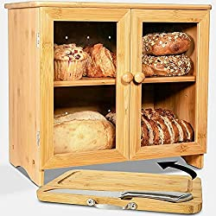

Fig 12. Storage shelf
These do not need to be chilled. They just need to be placed into food grade secure containers.
Bread should be stored in a dry, cool and dark place. The bread itself should never be storeddirectly in a plastic bag. If stored properly bread should stay fresh for about 3 days ( if it is a highly hydrated sourdough bread you could keep it fresh for about 4-5 days ).

3.2 .The Big No-No: Avoid Storing Your Bread

A Plastic bag
Storing your loaf in a plastic bag encourages mold growth. It traps the moisture inside the bag and (among others) softens up your crust. The end result being your bread goes bad much faster.
Tinfoil
Tinfoil act very similar to a plastic bag, meaning trapping the moisture inside it, making the bread develop mold faster than it normally would.

Storing bread in the fridge
Storing bread in a fridge is a bad choice as your refrigerator is a very dry (too dry) environment.
Once the bread has cooled to room temperature, the bread needs to be put in a sealed container. This could be a bread box or plastic bag, and the bread can be put in a plastic bag before being stored in the bread box. Keep the bread in a cool, dark place.
You can store the bread at 20°c to 22°c or 68°c to 72° f that maximizing the loaf remains fresh and soft
SELF-CHECK 3 | WRITTEN EXAM

Answer the following questions:
- How do you store bread products maintaining its quality & freshness?
- List some storage materials that is appropriate to store bread.
- What do you know about plastic materials as storage for bread and products? Give some explanation.

Operation sheet 3:Storing bread products
Operation Title:Store bread products
Purpose: to store and display variety of bread products.

Conditions or situations for the operations:
- Safe working area
- Properly operated tools and equipment
- Appropriate working clothes fit for the practical performance

Steps in doing the task
- Avoid refrigeration.
- Freeze bread
- Only slice the bread when necessary
- Push cut sides together
- Put stale bread to good use. Sometimes, you can’t avoid bread going stale—in such a time, you can make use of the leftovers. Breadcrumbs, croutons, and stuffing, in particular, stand out as popular options for you to put your stale bread to good use.
- Use a bread box.
- Wrap bread.

Quality Criteria: Assured performing of all the activities according to the procedures

RECOMMENDED READINGS

- FROM THE INTERNET
- BAKERY & CONFECTIONARY COURSE ,FOOD PRODUCTION DEPARTMENT
KENYA UTALII COLLEGE, NIROBI
- READING MATERIALS ON PASTRY AND BAKERY PRODUCTION

Participants of this Module (train ing material) preparation
No | Name | Qualification | Educational background | Region | College | Mobile number | E-mail
1 | Mohammed Liben Mohammed | Hotel and Tourism Sector head | - BA degree in Hotel and Tourism management  - MA degree in Disaster Risk Management | Somali | Jigjiga Polytechnic college | 0992326557 | cherechaw@gmail.com
2 | Abreham Mayza mengesha | Instructor | Bed degree in Hotel and Tourism | SNNP | Arba minch Polytechnic college | 0913711922 | Abrehammayza9@gmail.com
3 | Zelalem Almaw Endalew | Instructor | - BSC degree in Food science and post harvest technology | Amhara | Bahir dar Polytechnic College | 0918012521 | Parazolla25@gmail.com
4 | Hiwot Tedla Belay | Instructor | BA degree in Accounting and finance and diploma in Hotel Management | Hareri | Harer Polytechnic College | 0913789086 | hiwietaba@gmail.com
5 | Zuryash-Work Belay Nigatu | Instructor | BA degree in Hotel Management | Addis Ababa | TTI | 0911643817 | zuriyash@gmail.com

