BAKERY AND PASTRY PRODUCTION
Level 1
Based on November 2022 Curriculum Version II

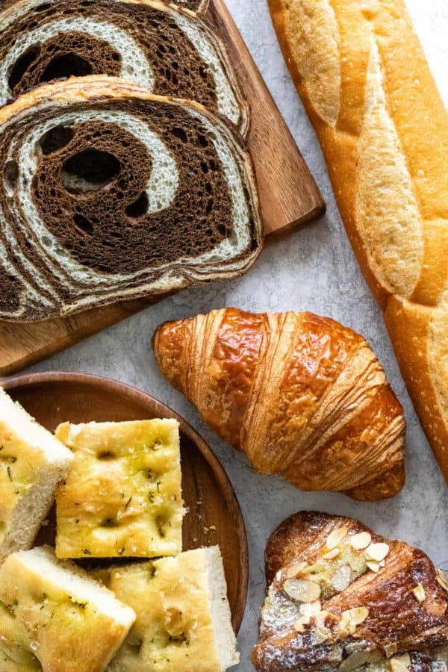
Module Title: Yeast products
Module code:CST BPP1 M08 1122
Nominal duration: 40 Hours

Prepared by Ministry of Labor and Skills December, 2022
Addis Ababa Ethiopia

Acknowledgment
Ministry of Labor and Skills wish to extend thanks and appreciation to the many representatives of TVT instructors and respective industry experts who donated their time and expertise to the development of this Teaching, Training and Learning Materials (TTLM).

Table of Contents
Acknowledgemnt ………………………………………………………………………………… 1
Unit One: Prepare and produce yeast goods 4
1.1 Selecting ingredients 5
1.2. Using appropriate equipment 7
1.3. Techniques for Preparing yeast goods 11
1.4. Oven temperature 13
1.5.Yeast goods 14
SELF-CHECK 1 17
WRITTEN EXAM 17
Unit Two: Decorate and present yeast goods 35
2.1. Decorating yeast goods 36
2.2. Present yeast goods. 42
Unit Three: Present and display yeast-based products 51
3.1. Using suitable equipment 52
3.2. Displaying yeast-based products 56
SELF-CHECK 3 57
WRITTEN EXAM 57
Unit Four: Store bread products 58
4.1. Store yeast goods and Products 59

Introduction to the Module
Producing variety of bread products in bakery and pastry production field will enhance the Hospitality industry service, serving the customer in full capacity and it is very important to keep the standards of bread and other sweet desserts service. On the other hand it is also a means to create a job for small scale industries and to street food service providers
This module is designed to meet the industry requirement under the bakery and pastry production occupational standard.

This module covers the units:
- Preparing and producing yeast goods
- Decorate and present yeast goods
- Present and display yeast-based products
- Store yeast goods

Training Objective of the Module
At the end of this season, the students will be able to:
- Prepare and produce yeast goods
- Decorate and present various of yeast goods
- Present and display yeast-based products
- Store yeast goods products

Module Instruction
For effective use this modules trainees are expected to follow the following module instruction:
- Read the information written in each unit
- Accomplish the Self-checks at the end of each unit
- Perform Operation Sheets which were provided at the end of units
- Do the “LAP test” given at the end of the unit and
- Read the identified reference book for Examples and exercise

Unit One: Prepare and produce yeast goods
This unit is developed to provide you the necessary information regarding the following content coverage and topics:
- Selecting ingredients
- Using appropriate equipment
- Techniques for Preparing yeast goods
- Oven temperature
- yeast goods

This unit will also assist you to attain the learning outcomes stated in the cover page.
Specifically, upon completion of this learning guide, you will be able to:
  - Identifyingredients
  - Useappropriate equipment
  - Apply Techniques for Preparing yeast goods
  - Use Oven temperature
  - prepare yeast goods

Selecting ingredients

1.1.1.Identify, collect& measure ingredients
Bread: - is a staple food prepared from dough of flour and water.
Yeast goods are defined as a sweet dough product Bread is produced with yeast and is the savoury version A sweet yeast product would be any dough with more than 5% sugar and increased levels of fat Trainer to discuss:
Ingredients: definition-A food ingredient is any substance that is added to a food to achieve a desired effect. The term “food ingredient” includes food additives, which are substances added to foods for specific technical and/or functional purposes during processing, storage or packaging.
- Flour -
- It is the back bone & structure of baked goods
- It acts as a binding and an absorbing agent
- It is important for the flavour of the product
- It adds nutritional value to the product
- Fat
Fat is a generic term it can mead:
- Oil
- Butter
- Margarine
- Shortening
- Effect of fat
- Improves texture
- Improves slicing
- Softer crumb
- Shorter eating crumb
- Softer crust
- Prolong freshness & add flavour
- It also adds nutritional value
- Emulsified fats retard crumb
- Enhances firmness
- Leavenings agents / yeast
Lightens dough & makes the finished product more digestive
Types of yeast
- Compressed
- Dried
- Creamed or liquid
- Salt-
- It has a strengthening effect on the gluten
- Increases volume
- Enhances flavors
- Increases shelf life
- Improves crust
- It improves flavor
- It improves the texture of the dough
- Sugar –
- Adds sweetness
- Aids in fermentation of yeasts
- Retains moisture
- Egg
- Milk
- Water
- Flavorings,etc.
- A food made of flour, water, and yeast or another leavening agent, mixed together and baked, deep-frying

Mise en Place
In the late 1800s, professional chefs adopted a now revered method of preparation known as mise en place, or ‘set in place’. Mise en place maximizes efficiency and reduces errors. This approach is taught in every culinary school, and the average cooking class, around the world.
There are 5 steps to mise en place:
- Know your recipe — necessary ingredients, cookware, and baking times
- Prepare your ingredients — clean, chop, mince… whatever is required
- Arrange your ingredients — appropriate size bowls, positioned logically
- Prepare your workstation — set the oven temperature, clean the utensils
- Arrange your tools — similar logic applied to cookware and necessary equipment
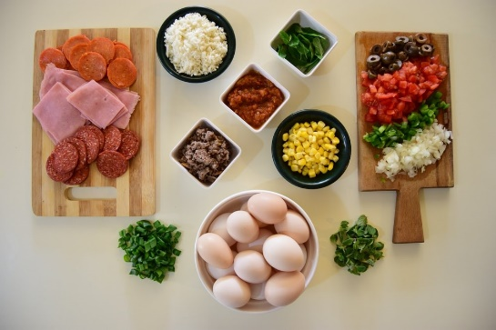

Fig 1.1.

1.2. Using appropriate equipment

    - Select& use appropriate equipment safely

Equipment
  - Ovens Deck ovens
  - Rack oven
  - Gas & electric ovens
  - Wood firs ovens
  - Brick bottom ovens

- Proofer and retarders
- Proofer:- warm environment with high humidity allows the yeast to reproduce and make the dough rise and increase in size
- This is a chilled environment with high humidity that will hold the dough and not allow the yeast to grow.
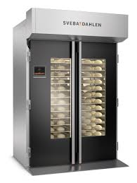
Fig. 1.2. Proofer
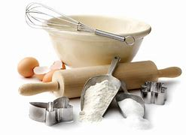
Mixers, dividers and rollers
- Spiral dough mixer
- Planetary mixer
- Bun dividers and roller
- commercial mixers and attachments
- cutting implements Fig. 1.3. Mixers, dividers and rollers
- scales
- measures
- bowl cutters
- piping bags and attachments
- moulds, shapes and cutters
- working marble table
- Bowl
- Flower sifter
- Rolling pin
- Cooling rack
- pastry brush
- baking sheet
- Measuring scale & measuring cup etc.

 Pastry brush: a brush with thickly packed bristles used for brushing pastry and applying glazes, marinades etc.


Tongs: made from stainless steel or plastic, they are used to lift and turn food

 Balloon whisk: used to beat air into and lumps out of a mixture by whisking the food through loops of wire.
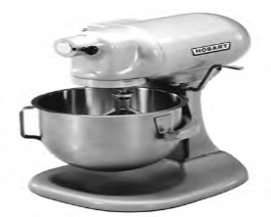

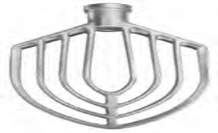


Mixerballoon arm balloon whiskpaddle

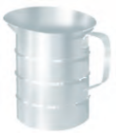
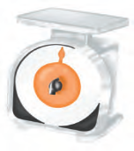

-scale measuring jug Pastry wheel


scraper / dough cutter

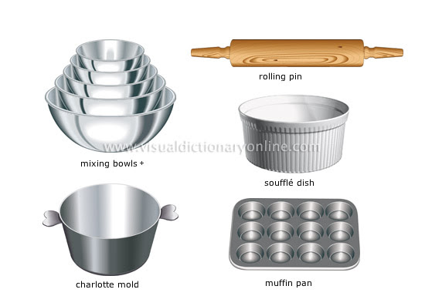

Fig. 1.4. Yeast goods production equipment
Table

Name of tools &equipment | Picture | Description | Name of tools &equipment
1. | Cooling rack | 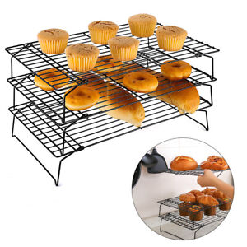 | A cooling rack (also known simply as a wire rack) is used to allow air to circulate freely to cool baked goods, and to prevent them getting soggy from condensation
2. | brush |  | A brush is a small brush that is used to grease baking sheet before transfer the dough
3 | Whisker |  | Whisks are used to either add air into a mixture or thoroughly blend ingredients together.
4 | baking sheet | 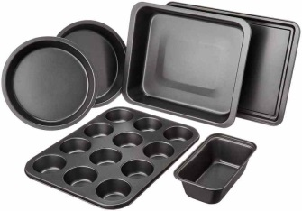 | A sheet pan, baking tray or baking sheet is a flat, rectangular metal pan used in an oven. It is often used for baking bread rolls, pastries and flat products such as cookies, sheet cakes, Swiss rolls and pizzas.
5 | Measuring scale | 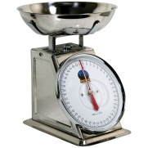   | A baking scale, also known as a catering scale, is a weighing machine used by bakers and caterers for measuring food ingredients. There are many types of baking scale on the market, from digital kitchen or cooking scales for personal use to commercial catering
6 | measuring jug | 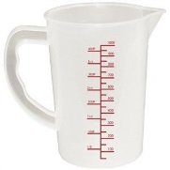 | it’s used to measure things  It is a jug with graduated measurements printed on the sides.
7 | Measuring cups | 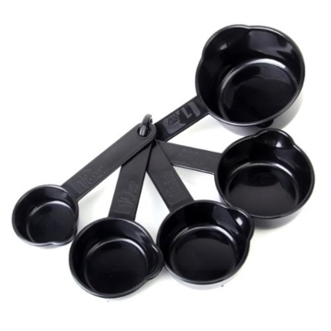 | Measuring cups are a cup like tool to measure ingredients. Generally consists of scale markings at varying heights.
8 | Measuring spoon |  | Measuring spoons are spoons that measure small amounts of wet and dry ingredients. Most measuring spoons come in sets of four or six. A set of four measuring spoons includes ¼ teaspoon, ½ teaspoon, 1 teaspoon, and 1 tablespoon sizes. A set of six measuring spoons usually includes ⅛ teaspoon, ¼ teaspoon, ½ teaspoon, 1 teaspoon, ½ tablespoon, and 1 tablespoon sizes.
9 | spatula | 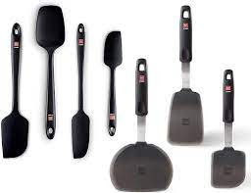 | a kitchen utensil you can use to mix, scrape, flip, or spread ingredients

1.3. Techniques for Preparing yeast goods

    - Use Preparation techniques yeast production
The production of quality yeast breads and rolls requires good technique, patience, and creativity. To produce a good yeast product, you will need to learn dough mixing methods.The steps involved in making yeast breads vary depending on the type of dough that is used and the item that is being produced. However, the same general stages apply to all yeast dough products:
Follow the following Techniquesto Preparing yeast goods
- Chilling ingredients and work surfaces
- Kneading and handling
- Incorporating fat
- Rolling
- Preparing and using types of yeast
- Cutting, shaping and moulding
- Preparing and using appropriate fillings and pre-bake finishes and decorations

Important rules in making Yeast goods

- Strict personal cleanliness
- Clean utensils, materials & machinery
- Use quality ingredients
- Read all formulas (the recipe) carefully & scale all ingredients properly
- Serve fresh products.

1.4. Oven temperature

1.4.1. Select correct oven conditions for baking yeast goods
- Yeast goods will be baked in an oven temperature ranging from 180ºC – 220⁰C
- Products baked with sugar will darken on the crust quicker than bread
- To control the browning of the crust the product is baked at a lower temperature
 | Temp (F/C) | Minutes
Breads
Biscuits | 425 - 450 F  218 - 232 C | 10 - 15
Cream Puffs | 375 F  190 C | 60
Popovers | 375 F  190 C | 60
Quick Loaf Breads | 350 - 375 F  177 - 190 C | 60 - 75
Yeast Bread | 400 F  205 C | 30 - 40
Yeast Rolls

Plain | 400 - 425 F  205 - 218 C | 15 - 25
Sweet | 375 F  190 C | 20 - 30

1.4.2. Desired dough temperature
Yeast in the dough ferments best in the temperature range of 70-77ºF (21-25ºC). To achieve this temperature, you need to consider a couple of different factors affecting the dough before it’s even made. The final temperature of the dough is a product of:
- Dry ingredient temperatures: Most of your dry ingredients are kept at room temperature
- Friction Factor from Mixing: Friction during mixing will increase the temperature of the dough. We can’t forget this component!
- Water Temperature: Water temperature is the most easily manipulated component, and it depends on the temperature of the dry ingredients, and how much the temperature will rise during mixing. With the recipe we used, the best water temp was 60-65ºF (16-18ºC). Don’t worry about your yeast dissolving. Instant yeast doesn’t need warm temperatures around 100-105ºF (38-41ºC) to dissolve like active dry yeast does. Instant yeast dissolves at cold temperatures very readily

1.5.Yeast goods
1.5.1.Dough making process
Modern production of dough varies from country to country. There are two dough making processes:
- Rapid or “no time” process (Add process)
- Ferment and dough process

1.5.2. Prepare and produce variety of bread and yeast product
Variety breads are yeast-leavened bakery products that are made from a cereal flour (e.g. wholegrain, clear or refined) or a combination of cereal flours. They are usually baked in a pan to obtain a loaf-type shape.
Yeast goods product may include:
- Coffee scrolls: Similar to a cinnamon roll or Chelsea bun, coffee scrolls are a traditional Australian bakery treat. They can be both savoury, like these pizza scrolls or sweet like this sweet scrolls recipe, with it's fluffy sultana dough, syrup glaze and coffee icing topping.
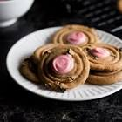
- The croissant was born! One hundred years later, Marie Antoinette (Austrian Princess who married Louis XVI), introduced the croissant to the French aristocrats. It was only at the start of this century that the butter-puff croissant was created, and became the French national product



- Brioche is different to most breads because it's made with an enriched dough and tastes a little sweeter. . Because it's an enriched dough, you get that famous brioche texture of soft bread, the classic golden colour and quintessentially rich taste

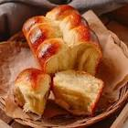

- Rum baba, baba au rhum or savarin is a French pastry originating in Lorraine. It consists of a biscuit made of leavened dough that is soaked in rum. Rum baba has the particularity of being baked in a ring-shaped savarin mold or in a bundt cake mold. It is eaten cold and is often filled with whipped cream.

- Typical Danish pastries include a snegl, a cinnamon roll-style pastry, a spandauer, a pastry with a dab of custard cream in the middle (you probably know this as a 'Danish pastry'), and a tebirkes, a pastry with remonce in the middle and poppy seeds all over the top.

- Cinnamon roll is a sweet rolled pastry made with a yeasted dough, gooey cinnamon-sugar filling, and topped with cream-cheese icing.


SELF-CHECK 1 | WRITTEN EXAM

Part I: choose the correct answer
- It is the back bone & structure of baked goods
- Yeast C. Fat
- Flour D. salt
- . is a sweet dough product
- Yeast goods C. Improves texture
- Bread D. All
- Which one of the following is Effect of fat
- Improves texture C. Improves slicing
- Softer crumb D. All
- . has a strengthening effect on the gluten
- Salt C. Fat
- Yeast D. sugar
- Which one of the following is production steps?
- Disperse yeast in water Rest period
- Prepare baking pans and trays D. All
Part II. Matching
“A” “B”
- Yeast goods baking temperature range A. 21 - 25ºC
- The best yeast dough ferments temperature range B. 180ºC – 220⁰C
- Sifter, cooling rack, whisker and baking sheet C. Set in place
- Mise en place D. Equipment

Part III. Answer the following questions:
- List the main ingredients necessary for making yeast goods .
- Mention some equipment needed for making yeast goods
- What is the Effect of fat?
- What is the use of flour as a yeast goods?

Operation sheet1. Yeast product

Operation Title:ProduceDanish pastry
Purpose: to produceyeast goods
Conditions or situations for the operations:
- Safe working area
- Properly operated tools and equipment
- Appropriate working uniforms fit for the practical performance

Equipment Tools and Materials:
-Mixer - scale - flour
- Oven - bowl - yeast
- Scraper - butter, etc.
Production steps
- Disperse yeast in water
- Whisk vigorously to break down lumps
- Add small sugar to stimulate the yeast
- Mix in flour
- Mix to produce a smooth batter
- Whisk to aerate to stimulate the action of the yeast
- Cover and allow to rest in warm environment 32ºc for approximately 25-35 minute
- Allow the ferment to stand until it begins to fall away
- Dough mixing
- Rest period
- Moulding
- Prepare baking pans and trays
- Final prove
- Baking
- Bun wash or glaze
- Decoration

- It is a favorite snack with coffee for Denmark people
- The Denmark people call it Viennese bread
- When imported to America they call it Danish pastry

      - Danish pastry
Ingredients
- Flour
- Butter
- Yeast
- Egg
- Milk
- Sugar Fig. 1.5. Danish pastry
- Cardamom powder
- Salt
Preparation method
- Make a dough by combining all except butter
- Keep a dough until rise & punch down
- Roll out a rectangle
- Add the butter & give turns
- 3 single turns are required by giving rest for every turn
It is used for making twists with filling & without filling

2. Coffee scrolls
Ingredients
- milk 200 ml
- butter 50 g
- plain flour 450 g
- ground cinnamon ½ teaspoon
- salt pinch
- dried yeast 7 g
- sugar granulated 35 g
- beaten egg 1
- sultanas 100g (⅔c)
Filling
- butter softened 25 g
- ground cinnamon 2 teaspoon
- soft brown sugar 30 g
Glaze – optional
- granulated sugar 25 g
- water 25 ml
Coffee Icing
- cream cheese room temperature 50 g
- butter softened 15 g
- icing sugar 60g (½c)
- vanilla essence ½ teaspoon
- teaspoon coffee granules ¼-⅓
- boiling water ¼ teaspoon
INSTRUCTIONS
- Place the milk and butter in a small saucepan and place over a low heat until the butter has just melted. (You don't want the milk to be too hot.) Place to one side.
- Sift the flour into a medium mixing bowl and add the yeast, granulated sugar, cinnamon and a pinch of salt. Stir in the just warm milk and add the beaten egg.
- Bring together to make a soft dough and then knead for 7 minutes by hand, until the dough is elastic and smooth. You can also knead in a stand mixer fitted with a dough hook for 7 minutes on medium speed. (For bread maker instructions see below).
- Cover with a clean tea towel and leave in a warm place for 1 – 1½ hours, until doubled in size.
- Sprinkled the sultanas on top of the dough and mix to combine, then turn the dough out on to a lightly floured board or surface and roll into a rectangle 20cm x 30cm (7.8" x 11.8").
- Spread the softened butter over the dough in an even layer.
- Mix the cinnamon with brown sugar, then sprinkle evenly over the butter.
- Gently press the longest edge closest to you down slightly onto the surface, then take the opposite long edge and roll tightly towards you.
- Cut into 9 even sized pieces around 4-5cm (1.5"-1.9") thick.
- Line the bottom of a 20cm x 20 cm (8" x 8") square tin with baking paper (no need to line the sides).
- Place the scrolls cut side up into the tin in 3 rows of 3, leaving a slight gap between them all.
- Cover with a clean tea towel and leave in a warm place for 30-40 minutes, until the scrolls have grown and are now touching.
- Preheat the oven to 180˚C fan/ 200˚C / 360˚F
- Bake the scrolls for 20-25 minutes, until golden brown.
- Leave to cool in the tin for 5 minutes and whilst they are cooling, make the glaze.
To make the glaze – optional step
- Heat the sugar and water in a small saucepan over a medium heat, stirring until the sugar dissolves.
- Brush the glaze over the warm scrolls.
- Leave for 5 minutes and then turn out onto a wire rack to cool completely.
- When the scrolls are completely cold, make the icing.
To make the coffee icing
- In a medium mixing bowl beat the butter and cream cheese together until smooth.
- Add the vanilla essence and stir before sifting in the icing sugar.
- In a small bowl or mug, mix the coffee granules with the boiling water, leave to cool slightly for a couple of minutes, then pour this into the icing and stir to combine.
- Spread the icing over the scrolls, and then enjoy!
Making scrolls in a bread maker:
- Melt the butter with milk until just melted and place to one side.
- Weigh out the flour, yeast, cinnamon and salt in the bread maker pan, then add the egg and mix slightly before adding the warm milk.
- Place into the bread maker and use the setting for kneading and rising.
- Once ready, mix in the sultanas, then roll out into a rectangle and continue as above from step 5.

Fig.1.6.Coffee scrolls
3. Cinnamon rolls

Ingredients
All-purpose flour (spoon &leveled) 2 and 3/4 cups (344g)
(50g granulated sugar) ¼ cup
salt 1/2 teaspoon
whole milk 3/4 cup (180ml)
unsalted butter Tablespoons (45g)
2 and 1/4 teaspoons Platinum Yeast from Red Star or any instant yeast (1 standard packet)
large egg 1, at room temperature
Procedures
- Whisk the flour, sugar, and salt together in a large bowl. Set aside.
- Combine the milk and butter together in a heatproof bowl. Microwave or use the stove and heat until the butter has melted and the mixture is warm to the touch (about 110°F/43°C, no higher). Whisk in the yeast until it has dissolved. Pour mixture into the dry ingredients, add the egg, and stir with a sturdy rubber spatula or wooden spoon OR use a stand mixer with a paddle attachment on medium speed. Mix until a soft dough forms.
- Transfer dough to a lightly floured surface. Using floured hands, knead the dough for 3 minutes. You should have a smooth ball of dough. If the dough is super soft or sticky, you can add a little more flour. Place in a lightly greased bowl (I use non-stick spray), cover loosely, and let the dough rest for about 10 minutes as you get the filling ingredients ready.
- Fill the rolls: After 10 minutes, roll the dough out in a 14×8-inch (36×20-cm) rectangle. Spread the softened butter on top. Mix together the cinnamon and brown sugar. Sprinkle it all over the dough. Roll up the dough to make a 14-inch log. Cut into 10–12 even rolls and arrange in a lightly greased 9- or 10-inch round cake pan, pie dish, or square baking pan.
- Rise: Cover the pan with aluminum foil, plastic wrap, or a clean kitchen towel. Allow the rolls to rise in a relatively warm environment for 60–90 minutes or until double in size. (For a tiny reduction in rise time, see my answer to Where Should Dough Rise? in my Baking with Yeast Guide.)
- Bake the rolls: After the rolls have doubled in size, preheat the oven to 375°F (190°C). Bake for 24–27 minutes, or until lightly browned. If you notice the tops are getting too brown too quickly, loosely tent the pan with aluminum foil and continue baking. If you want to be precise about their doneness, their internal temperature taken with an instant read thermometer should be around 195–200°F (91–93°C) when done. Remove pan from the oven and place pan on a wire rack as you make the icing. (You can also make the icing as the rolls bake.)
- Make the icing: In a medium bowl using a handheld or stand mixer fitted with a paddle or whisk attachment, beat the cream cheese on high speed until smooth and creamy. Add the butter and beat until smooth and combined, then beat in the confectioners’ sugar and vanilla until combined. Using a knife or icing spatula, spread the icing over the warm rolls and serve immediately.
- Cover leftover frosted or unfrosted rolls tightly and store at room temperature for up to 2 days or in the refrigerator for up to 5 days
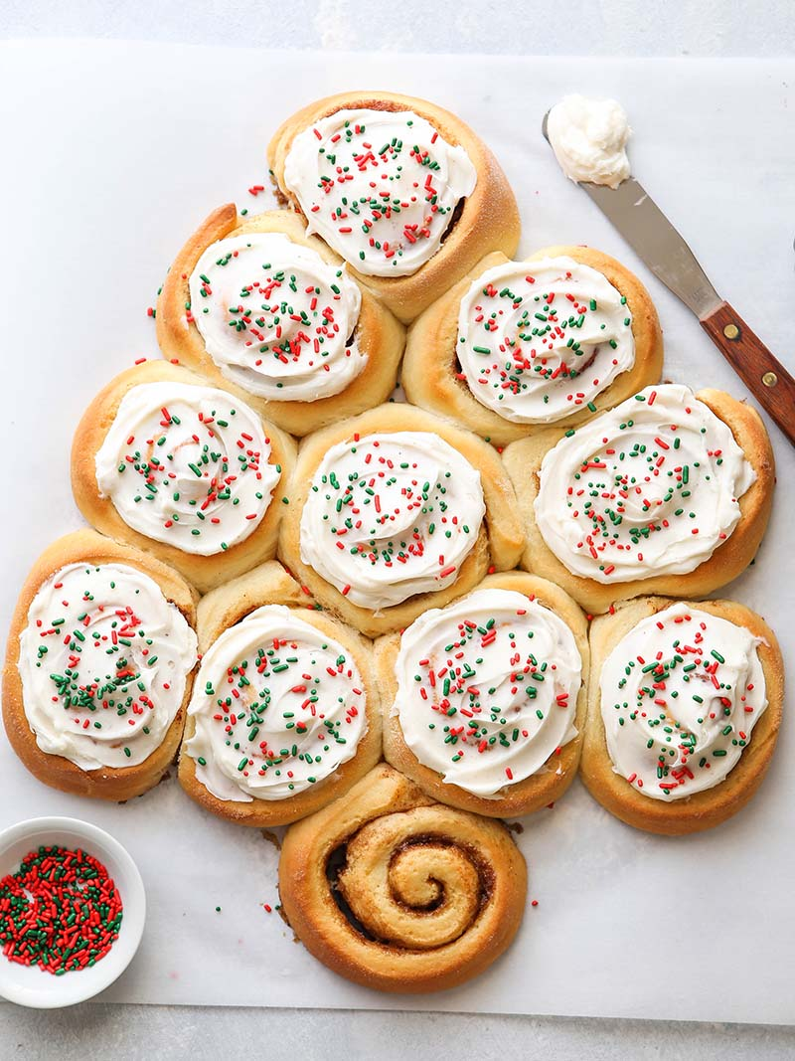
Fig.1.7. Cinnamon rolls

4. Loaf bread
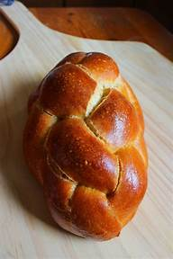
Ingredients
- 500gm. flour
- 8gm. yeast
- 250-300ml. of lukewarm water
- 5gm, salt
- 1 tsp sugar

Fig. 1.8. Loaf bread
Preparation
- Dissolve the yeast in lukewarm water& add the sugar and let it stand until it bubbles up
- Sieve the flour, mix the ingredients with the yeast mixture & knead it very well
- Keep cover until double in size
- Divide in to equals and give a desired shape, place it on greased baking sheet
- Leave it in a warm place until rise then bake it at 200-degree c.for 10-15 min.

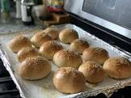
5. Bun dough (basic mixture)
Ingredients
- 200 gr. Flour
- 5 gr. Yeast
- 125 ml. milk /water
- 1 egg Fig. 1.9. Bun dough
- 50 gr. Butter or margarine
- 25 gr. Castor sugar
Preparation
- sieve the flour, make a wale in the center of the flour
- Dissolve the yeast, add in to the flour
- Add
- The beaten egg, butter or margarine, sugar & the remainder of the liquid.
- Kneed well to form a soft dough until smooth
- Keep covered in a warm place until rise
- Use as required
*Bun wash
-100 gr. Sugar
- 125 ml. water or milk, Boil together until the consistency of thick syrup


- Challah bread
Ingredients
- 550 g, flour
- 250 ml. water/milk
- 5 gr. Salt
- 8 gr. Yeast
- 100ml. olive oil
- 2pc,eggs Fig. 1.10.Challah bread
Preparation: proceed as yeast dough bread procedure
- white bread
Ingredients
- 1kg. flour
- 15gm.yeast
- 5oo- 600 ml. lukewarm water
- 10gm. salt
- 5gm. Sugar
Preparation
- Dissolve the yeast in lukewarm water& add the sugar and let it stand until it bubbles up
- Sieve the flour, mix the ingredients with the yeast mixture & knead it very well
- Keep cover until double in size
- Divide in to equals and give a desired shape, place it on greased baking sheet
- Leave it in a warm place until rise then bake it at 200-degree ° 10-15 min.
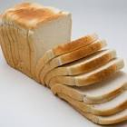

Fig. 1.11. White bread


- Italian bread
Ingredients
- 550 g, flour
- 250 ml. water
- 5 gr. Salt
- 8 gr. Yeast
- 100ml. oil Fig. 1.12. Italian bread
Preparation: proceed as yeast dough bread procedure
- Doughnut
Ingredients
-1kg. Flour
-30gm. Yeast
-5gm.bread improver
-15gm. Salt
-100gm.sugar
-2pcs of egg
-40gm milk powder/ 500ml.milk or water
-flavour

Preparation: Proceed as yeast dough.

Fig 1.13. Doughnut
- Brioche
Ingredients
- 125g.butter (melted or cold)
- 3 eggs
- 250g.flour
- 3g. salt
- 25g. sugar
- 10g. yeast
- 50 ml. water /milk
Preparation: proceed as yeast dough bread procedure.
- If we use melted butter mix all, knead, keep it to rise and continue the procedure
- If it is cold butter first make a dough without the butter, keep it to rise and add the butter combine it keep it to rise again use the muffin cup to bake.
* Shape varieties: chain wheel, brioche with head and with out
* Egg wash is necessary for any sweet goods
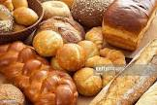

Fig. 1.14. Brioche

- Croissant
Ingredients:
-1kg.flour
-3pcs.egg
-5gm bread .improver
- 20 gm. Yeast
-15 gm. Salt
-60gm. Sugar
-60gm. Table butter
-20gm.milk powder
-500 ml. cold water
- For folding 500gm. Table butter
Preparation: proceed as yeast dough + continue applying 3 single turns.


Lap test 1:
Instructions: Given necessary templates, tools and materials you are required to perform the following tasks accordingly.
Task 1: pre-prepare the necessary equipment
Task 2: prepare the necessary ingredients
Task 3: measure the ingredients according to the recipe
Task 4: make a dough
Task 5: give rest, shape & pan proof
Task 6: bake & cool

Unit Two: Decorate and present yeast goods
This unit to provide you the necessary information regarding the following content coverage and topics:
- Decorating yeast goods
- Presenting yeast goods
.This guide will also assist you to attain the learning outcomes stated in the cover page. Specifically, upon completion of this learning guide, you will be able to:
- Decorate yeast goods
- Present yeast goods.

  - Decorating yeast goods
Decorate pastries, & pastry products, cakes &yeast goods to enhance appearance using suitable fillings, icings, sauces, & decorations to standard recipe.
    - The art of decorating foods
The term decorated food is generally used to describe a food that has been filled, iced, and has some type of finishing touch on the icing.
For example, if the cake is decorated attractively, can influence our sales to a great degree. The decoration should tempt the customer to use (try) the product and at the same time it should suggest flavor and texture of the cake and filling.
The decoration is the final wrapping or packaging, designed to our product. If we are displaying cakes in a pastry cakes, the servings will still look attractive even if only a few remain. Decorating food is to make the finished product look tasteful and elegant, rather than busy or cluttered.
The role of color and texture in food preparation
Color - it is the quality in objects which allows the eyes to see the difference between, for example a red flower and a blue flower. Behavior of a thing (a product) that interests the mind or eye and excites the imagination.
Texture – the degree of roughness or smoothness or fineness, of a surface, substance or materials as felt by touch.
Color, size (shape) texture and flavor of foods stimulates interest and appetite
When we speak of the “texture” of a food, we mean it is soft, hard, crisp or moist
Example:
- Bread soft and dry,
- Cream soft and moist,
- Cookies crisp and dry.

    - Glazing of yeast goods
Glazing
Most glazes are applied to the dough before baking, but some recipes call for the glaze to be applied after the bread is baked. Glazes add flavor, provide and attractive finish on the bread, and add moisture
    - Decoration is very basic with yeast goods.
- Sugar syrup glaze, normally 1 part sugar,1 part water boiled and let cool. This is referred to as a stock syrup. The formula may vary but they are all called the same.
- Boiled apricot jam: applied to product when it has just been removed from the oven and while the jam is boiling. This causes the jam to dry and impart a shine and flavor to the product.
- Icing sugar can be sifted over the final baked product with no glaze applied.
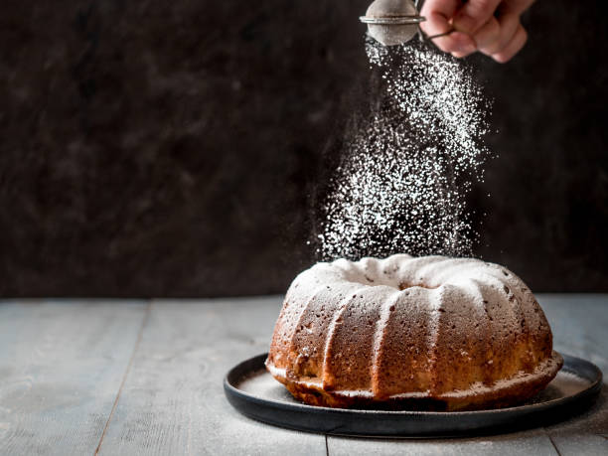
Fig. 2.1. Icing sugar
- Fondant: Fondant can be applie dafter removing from oven. Fondant needs to be tempered if a shine is required on the finished product. Fondant can be thinned to required consistency. Fondant should be touch dry when it has been applied and cooled. After glazing with fondant roasted, shaved or chopped nuts can be used to decorate the end product.
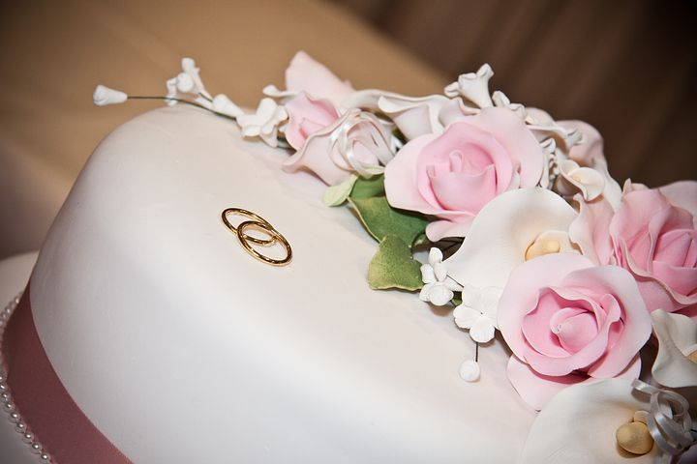
Fig 2.2.Fondant
- Frostings: Frosting is sugar and fat blended together with some water added to soften. It is composed of 80% icing Sugar with 20% fat ratio and 5% water. Special emulsified shortening works well here as they will hold more water.
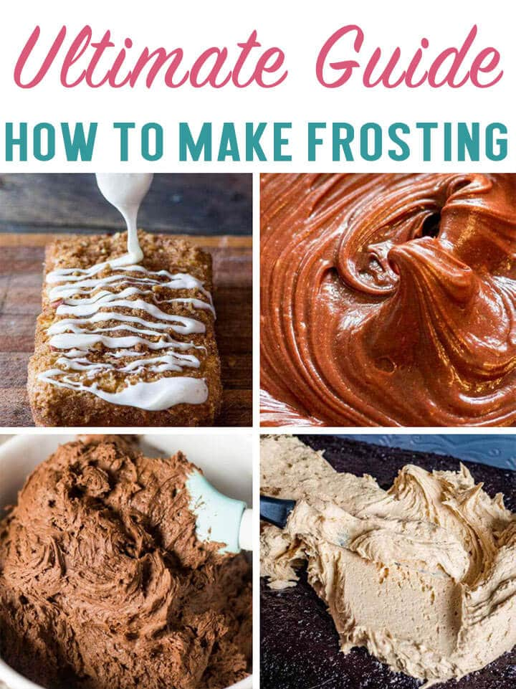
Fig 2.3. Frostings
- Bienenstich: This is a sweet dough of varying sizes that have been coated with a mixture of almonds, sugar, butter, honey and cream and which has been heated and cooled before being placed onto the unbaked dough. It is warmed to body temperature and spread thinly over unbaked product. When baked it should have a golden crust of nut topping. When cool the product can be sliced and filled with a crème pâtissière filling or served plain. It can be produced in large piecesor in thin sheets for slicing and cutting into individual pieces.

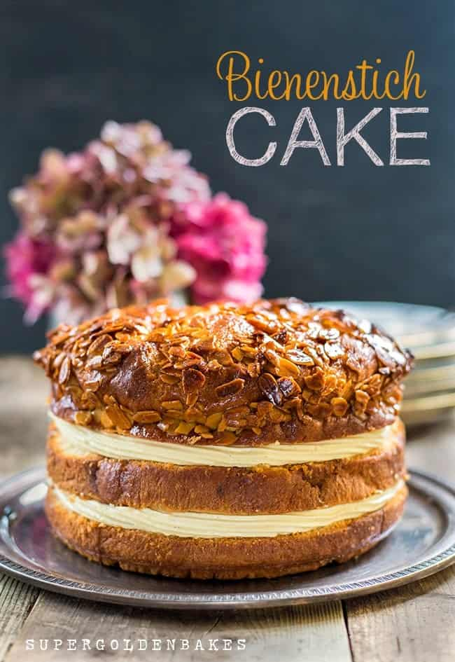
Fig. 2.4. Bienenstich
Fillings
- Crème pâtissière:Starch thickened milk that can be flavoured and coloured to enterprise requirements. It isstable at high temperaturesand will sit at room temperaturesfor extended periods.Many commercial mixes contain preservatives that extend shelf life at room temperatures.
- Fruit fillings:Most fruits used as filling need to be stabilised in a starch gel. This is because when sugaris added to fruit it will dissolve and the free liquid boils inside the dough and is detrimental to the finished product.Fruits will need to be cooked before being used in fillings. Some fruits may not cook inside the dough before the dough has baked.Canned fruits are economicalwhen used in fillings for danish and steusseldough. Solid pack ‘Pie’fillings can be purchased to fit this need. This is fruit in a can that has no added water or syrup.However, when sugar is added to this is does dissolve sothat liquid needs to be stabilised.There are proprietarypowders that can be added to fruit mixes. These are pre-gelatinised gels. They rehydrate when added to the pie mixes and hold the moisture in suspension.These powders have been cooked to a thick viscous state and then dried on steam heated rollers and ground to powder so they can be added to fruits or other liquids at a later stage.These pre-gelatinised powdersare best added to the sugar before mixing into the fruit.
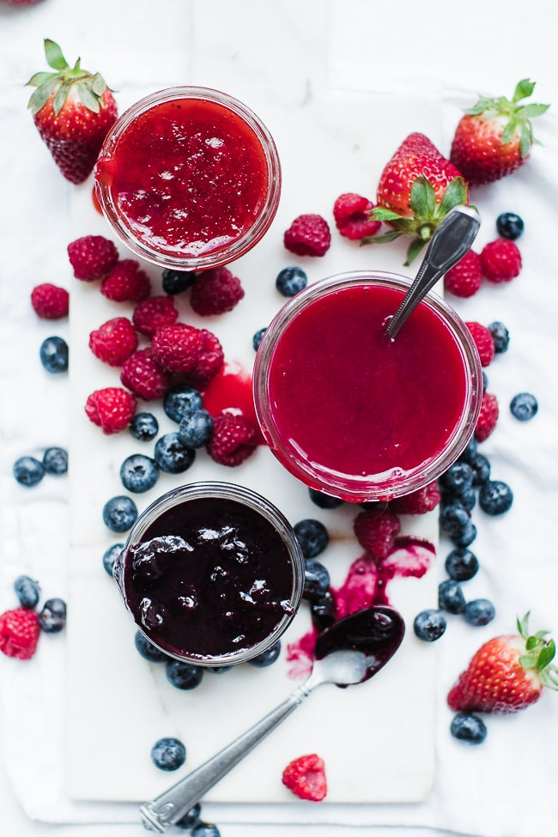
Fig. 2.5.Fruit fillings
- Cream: Whipped fresh cream flavoured with sugar and vanillahas always been popular as a filling but needs to be kept in a controlled environment. It is not suited to hot climates.
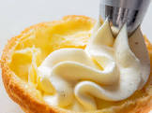

- Nut fillings: Nuts can be ground and mixed with sugar and liquids to form pastes.

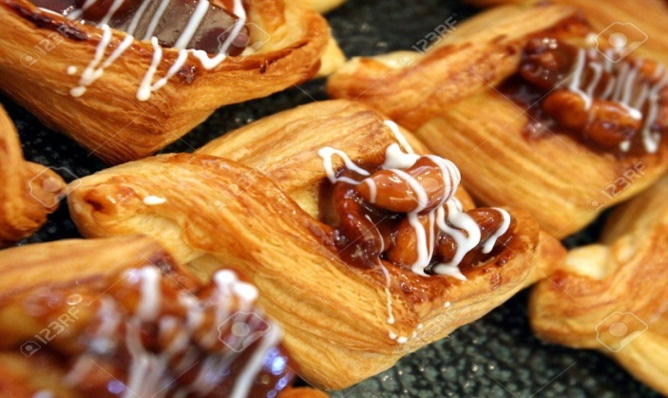
Fig. 2.6. Nut fillings

- Cheese fillings: Quark,cottage and cream cheeses can be sweetened and flavoured before being used as fillings. Some cheeses with high moisture contents can be stabilised with the addition of starch that will thicken during the baking process.
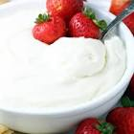
Fig. 2.7.Cream Cheese fillings
All fillings used in yeast goods:
- Add flavour
- Add interest
- Add food value.
Prepare a variety of fillings glazes decorations
- Fruit filling
- Gel stabilized
- Cream cheese filling
- Sweetened and flavoured
- Icing
- Fondant
- Water ices
- Dust – icing sugars
- Nut pastes
- Ground
- sweetened
- Savory filling
- Meats and spices
- Vegetables and spices

Basic decoration may include:
- glazes
- jellies
- fruit purées
- icings
- sprinkled icing sugar
- flavoured and colored sugars
- fresh, preserved or crystallised fruits
- nuts
- Fillings, including cream, mousse and fruit purées

The keys to success in decoration are:
- Having a creative mind
- Showing an ability to reflect the tastes of your clientele.
- Keeping in mind when the decorated cake is going to be served – whether it is for a special event or for ordinary daily consumption.
- Making use of different types of fruit as they offer a wide range of decorative possibilities depending on their shape and texture.

  - Present yeast goods.

- Display in bakery: Most are displayed on trays that contain up to 12portions. Service is taken from the back of the tray.Larger pieces might be presented individually on doyley and cardboardbases.Doyleys are used extensively in presentation as it is a barrier between the product and Serviceware.

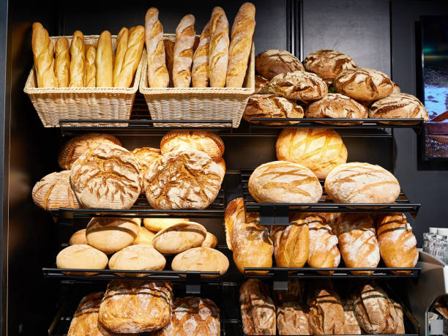

Fig. 2.8. Display in bakery

- From the restaurant show case or buffet trolley
When purchasing your morning coffee a selection of bakery goods will be displayed for customer selection.At the café they will be behinda safety barrier.In fine dining hotelsit can be displayed on a trolley that is wheeled up to the table for the customer to choose.This is an old practice and is not used in many places these days.

Serviceware: these are the plattertrays and plates that are used to display and serve product in cafes and dining rooms.They can also be used in conjunctionwith doyleys between product and serviceware.A good display should highlight the product at its best.
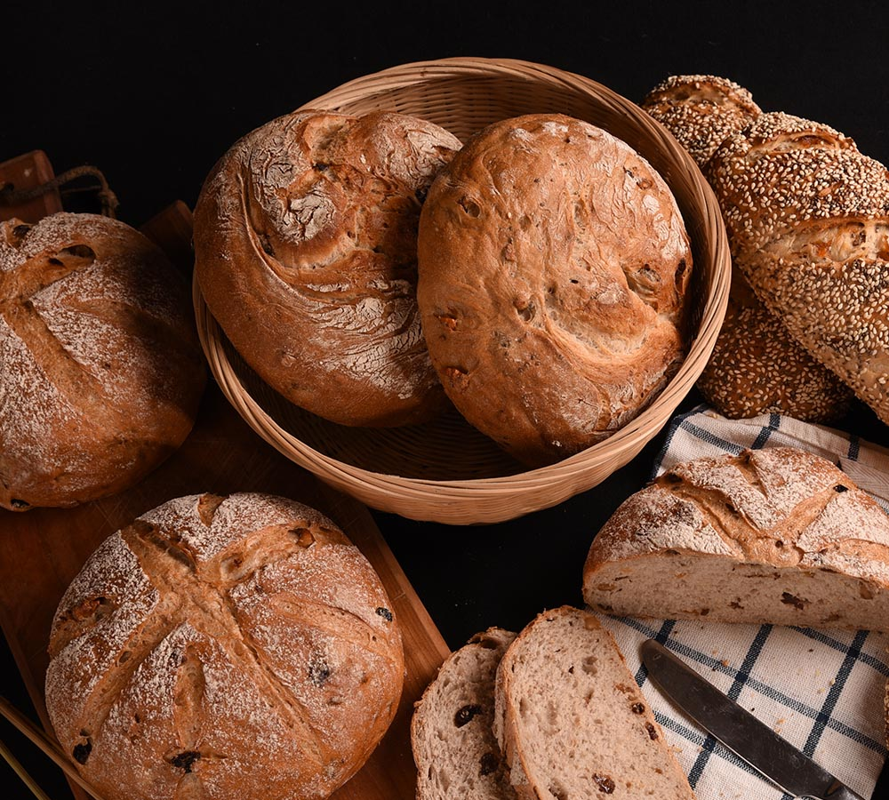
Fig. 2.9. Service ware

Fruit purees are made from uncooked fruit, which has had the skin and seeds removed. After that, the fruit is pulped and mashed into a creamy paste or liquid. Fruit puree is a semi-finished product, which can be obtained from a large variety of fruits by using the correct technological process.

SELF-CHECK 2 | WRITTEN EXAM

Answer the following questions:
Part I. Say True or False
- Adding filling between layers of cakes holds the layers together, giving your cake flavor as well as height.
- Frosting or icing, fillings and glazes are typically a sweet, sugar-based soft mixture used to fill, coat, add flavor, and improve the appearance and texture.
- Creams, mousse& custard are filling item which is used for filling of cakes.
- Glazes and jellies, icings& chocolate are used to decorate various cakes.
- Things that affect the freshness of the cake are heat, humidity, and intense artificial light
Part II. Short answer
- Mention the steps of yeast goods production .
.
- List at least 5 yeast goods production equipment.
.

Operation sheet 1:Yeast products
Operation Title:produce Bienenstich
Purpose: to Decorate and present yeast goods
Conditions or situations for the operations:
- Safe working area
- Properly operated tools and equipment
- Appropriate working cloths fit for the practical performance
Equipment Tools and Materials:
- Oven - scale - Whisker
- Bowl --Cooling rack
- Scraper
-baking pan
Ingredients
The Dough
▢ 2/3 cup milk, warm
▢ 3 cups all-purpose flour
▢ 2 1/2 teaspoons dry instant yeast
▢ 1/3 cup granulated sugar
▢ 1 teaspoon vanilla extract
▢a pinch of salt
▢ 1/3 cup butter, room temperature
▢ 1 medium-sized egg, room temperature
The Pudding-Cream Filling (see notes)
▢ 2 cups milk, estimate
▢ 1 package instant pudding, vanilla (approximately 1/2 cup pudding powder)
▢ 1/2 teaspoon vanilla extract
▢ 1/2 cup whipping cream or 1/2 cup butter, needed towards the end
The Almond Topping
▢ 1/2 cup granulated sugar
▢ 1/2 cup butter
▢ 2 tablespoons honey
▢ 1/4 cup whipping cream
▢ 2 cups sliced almonds
Instructions
Make The Dough
- Warm up the milk in the microwave or on the stove. It should be slightly warm, not hot or boiling!
- Put the flour into a large mixing bowl and add the dry yeast (check packaging instructions to make sure it doesn’t have to be dissolved in water or milk first). Sprinkle the sugar on top. Now add the lukewarm milk and the vanilla extract and knead everything using the spiral dough hooks of your electric mixer.
- Add the soft butter, and egg and keep kneading the dough for around 5 minutes until it forms a ball and no longer sticks to the sides of the bowl. If the dough is too sticky, add a little bit more flour. If it is too crumbly, add a little bit more milk and knead again.
- Place a towel or lid over the bowl and let the ball of dough rise for 1 hour in a warm place without a draft.
Make The Pudding
- Prepare the instant pudding according to package directions with the pudding powder and milk. Also, add more vanilla extract to give it a more intense flavor. The 2 cups of milk mentioned above should be accurate for most instant puddings but adjust it according to the pudding you are using.
- After you have prepared the pudding, pour it into a bowl, cover it with cling film, and set it aside. You do not need the whipping cream or butter yet!
Make The Almond Topping
- Add butter, sugar, honey, and whipping cream to a small pot. Heat everything on low heat until the butter has melted and sugar has dissolved.
- Remove the pot from heat and stir in the sliced almonds. Set the mixture aside to cool.
- Bake And Assemble
- Grease and flour a baking sheet/pan of approx. 13.5 x 9.5 inches in size.
- After the dough is done rising, sprinkle flour onto your countertop. Briefly knead the dough again, then roll it out so it fits the size of your baking sheet.
- Place the dough into the baking pan and let it rest for another 15 minutes.
- In the meantime, preheat your oven to 350 degrees Fahrenheit.
- After the 15 minutes are up, spread the almond topping onto the dough.
- Bake the cake in the middle rack of your oven for around 20-25 minutes until the top is nicely golden brown but not burned.
- Remove the cake from the oven and let it cool fully.
- In the meantime, whip the cream or the butter for the pudding filling. The choice is up to you. Using cream will make it slightly fluffier, using butter will make it richer but also firmer and slightly easier to assemble. When using cream, carefully fold the cream into the pudding with a spatula. When using butter, carefully mix the pudding little by little into the whipped butter. Set the pudding filling aside.
- Cut the cooled cake into quarters and remove them from the baking pan. Then cut the quartered slices horizontally separating the almond-covered top from the cake bottom.
- Spread the bottoms of the cake with the pudding-cream filling. Cut the tops into slices of desired size (it is easier to cut them into slices now than cutting the whole cake once it is assembled because of the crunchy almonds on top). Then place the almond tops back on top of the pudding-cream filling in their correct place.
- Let the cake cool for at least 1 hour before serving to allow the pudding cream to harden slightly. Cut the cake into slices before serving.
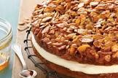

2. Nut fillings
Ingredients
/2 cup packed brown sugar
1/2 cup chopped walnuts or pecans
1 teaspoon ground cinnamon
2 tablespoons butter, softened
Procedure
In a bowl, combine the brown sugar, walnuts and cinnamon. Use for Braided Coffee Cake or Coffee Cake Ring. Spread butter over dough; sprinkle with sugar mixture 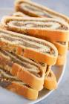
- Frangipane filling
Ingredients
1⁄4 cup plus 2 Tbsp. sugar
1⁄4 cup plus 1 Tbsp. (3.5 oz.) almond paste
2 large eggs
1 stick (4 oz.) unsalted butter, at room temperature
3⁄4 tsp. pure vanilla extract
1⁄8 tsp. finely grated orange zest
3 tbsp. unbleached all-purpose flour
1⁄4 tsp. baking powder
1⁄4 tsp. kosher salt
Frangipane can be made up to 2 days in advance and refrigerated in an airtight container; it's far easier to spread and smooth once chilled. During assembly, there's no need to push fruit into the filling: While baking, the frangipane will rise up and blanket it as it browns. Use as a filling for Almond Frangipane Tart with Cranberries and Honeyed Pistachios.
Instructions
STEP 1In the bowl of a stand mixer fitted with a paddle attachment, beat the sugar, almond paste, and 1 egg on medium speed until blended. Add the butter, vanilla, and zest and beat until smooth. Scrape down the bowl, then beat in the remaining egg.
STEP 2In a separate bowl, briefly whisk the flour, baking powder, and salt. Add to the butter mixture and beat at low speed until just absorbed. Transfer to a storage container, cover, and chill for at least 1 hour or up to 2 days.
Keep Reading
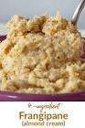
- Chocolate filling
Ingredients
List of ingredients that you can add to your cart by selecting and then choosing "Add Selected to Cart"
6 tablespoons granulated sugar
3 tablespoons all-purpose flour
1/2 teaspoon salt
1 cup half & half
5 egg yolks
2 teaspoons vanilla extract
1 square (2 ounces) semi-sweet chocolate,
Instructions
1 .In small saucepan, whisk together sugar, flour, salt, half & half and egg yolks until smooth.
2. Heat over medium heat until mixture is thickened, about 5 minutes, stirring constantly with a spoon or rubber spatula.
3. Remove from heat; stir in vanilla and chocolate. Continue stirring until chocolate is melted. Cool quickly. Fill cupcake.
Notes:
To prevent a skin from forming, brush surface with melted butter. Stir before using.

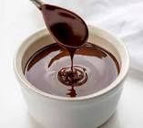

- Strawberries Jam
Ingredient
4 cups mashed fresh strawberries
2 ½ cups sugar
1 (3-oz.) package strawberry-flavoredgelatin
Procedure
      - Stir together strawberries and sugar in a large saucepan; let stand 30 minutes.
      - Bring strawberry mixture to a boil over medium heat; boil 5 minutes. Remove from heat, and stir in gelatin until dissolved; cool completely (about 1 hour). Cover and chill 8 hours.
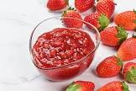

Unit Three: Present and display yeast-based products
This unit to provide you the necessary information regarding the following content coverage and topics:
- using suitable equipment
- Presenting yeast goods.
This guide will also assist you to attain the learning outcomes stated in the cover page. Specifically, upon completion of this learning guide, you will be able to:
- use suitable equipment
- display yeast-based products

3.1. Using suitable equipment
- Select and use suitable equipment safely and efficiently.
suitable equipment for yeast goods
Selecting necessary equipment for displaying bread and yeast goods products:

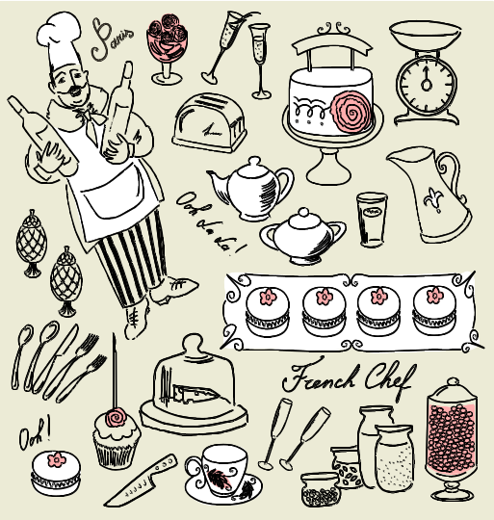
Equipment for display
- Serving platters
- Sauce jugs
- Plates
- Cutlery
- Napkins
- Tongs
- Lifters
- Refrigerated cooling

Hot display bain-marie
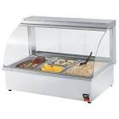

3.2. Displaying yeast-based products
- Display Cases
Display cases allow you to attract customers with mouthwatering displays of your food products while keeping the items at ideal holding temperatures. Bakery display cases can be refrigerated, non-refrigerated, or heated.
Refrigerated cases hold food at cool temperatures, making them perfect for displaying frosted items, such as cakes and cupcakes. These have low-velocity cooling systems to keep delicate cakes and baked goods from drying out. Breads and bagels, on the other hand, hold up just right in non-refrigerated cases. The transparent glass or acrylic covers provide protection against dust, debris, or excess moisture in the air that could affect the quality of your products. Heated displays hold food items at high temperatures to keep them warm right up to the moment of serving. They typically have glass defoggers so that customers can see inside.

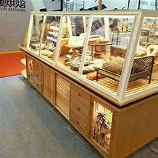
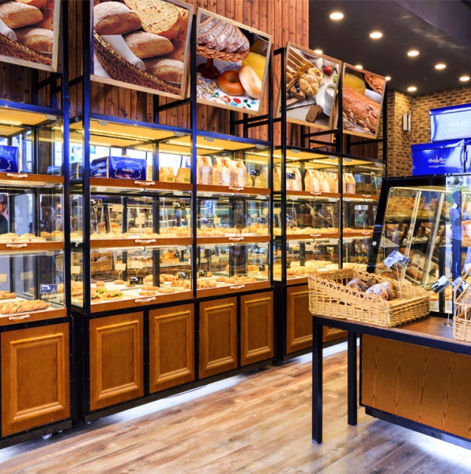
- Temperature
The temperatures at which bread served all affect the eating sensation and overall customer satisfaction. The bread box is slightly cooler since it blocks out the sun and electric lights. Furthermore, sitting in a plastic bag in a dark pantry is fine, too. You can store the bread at 20 to 22 degrees C or 68 to 72 degrees F that maximizing the time the loaf remains fresh and soft.The presentation and display are essential for increasing the sales and footfall for any bakery store. The display strategy also plays a role in keeping your baked items fresh and tasty for a long time. Putting efforts in decorating your finished baked products can help you attract many customers.

There are some ways to present and display pastry products:
- Make use of accessories. Don't limit yourselves to just display boxes and baked goods when presenting your delicious artistry
- avoid empty spaces
- don't forget name cards and toppers
- color coding works too
- Keep sweets and savories separate.
- the bottom line

SELF-CHECK 3 | WRITTEN EXAM

Part I say true or false
1. Theuse ofbowl is to mixingingredients.
2. Cooling rack is used to allow air to circulate freely to cool baked goods
3. Brushis used to either add air into a mixture or thoroughly blend ingredients together

Part II. Answer the following questions:
      - Write the use of spatula .
      - Write the use of measuring scale
      - write the use of whisker .

Unit Four: Store bread products
This unit to provide you the necessary information regarding the following content coverage and topics:
- Storing yeast goods and Products
- Identifyingstorage conditions
This guide will also assist you to attain the learning outcomes stated in the cover page. Specifically, upon completion of this learning guide, you will be able to:
- Store yeast goods and Products
- Identifyingstorage conditions

Store yeast goods and Products
- Store at correct temperature and maintain maximum quality, appearance and freshness.
All yeast goodproducts will stalequickly. Staling is the process where the optimum eating fades.Staling can be in several forms:
- Air passes through the product and dries the product out
- Moisture from the air enters the product so it loses some of the eating quality. Crisp product goes soft.To maintain the eating quality of bakery items:
- Use as soon as possible
- Cover to protect from environment
- Keep chilledif needed
- Keep dry
Danish pastry is best consumed on the day that it was produced.
It can be stored and reheated at a later time, but eating quality is reduced.
Any Yeast Goods product is best consumed on the day that it was produced.
Optimise freshness
- Bake daily
- Bake only what you can sell
- Bake in small batches
- Baked Pastry
Pastry that has been baked ready for filling can be stored at room temperature until required if protected from adverse conditions and outside contamination:
- Wrapped in food safe containers and labelled.
Sugar based garnishes need to be stored:
- In food safe container
- Well wrapped
- To stop moisture from the air causing product to soften.
Glacé fruits can be stored at room temperature if kept in syrup with which they were purchased. They will start to dehydrate and loss sheen.
Croissantswill be considered stale the next day when they lose crispness. After baking it is best to freeze them if you wish to store them for anyperiod of time:
- Thawing is quick as theproduct is light
- Thawing is best at room temperature
Danish pastry is best consumed on the day that it was produced.
It can be stored and reheated at a later time, but eating quality is reduced
Any Yeast Goods product is best consumed on the day that it was producedOptimise freshness
- Bake daily
- Bake only what you can sell
- Bake in small batches

Identifying storage conditions
- Yeast product can be stored in a cool location (pantry or cabinet), refrigerated, or frozen for up to two years. Once the yeast is opened, it's best kept in the refrigerator to use within four months, and six months – if kept in the freezer.
- There's one rule to keeping opened yeast as fresh as possible—always store it in an airtight container. Any exposure to air and moisture will shorten the lifespan of the yeast and cause it to spoil. If the yeast you purchase comes in a packet, fold over the top of the package and seal it with tape.
- Storage temperature is so important for healthy yeast and successful fermentations. Ideally, yeast is stored in a fridge around 33-38°F/1-3°C and used as fresh as possible.

May include but not limited to:
- consideration of temperature, light and air exposure
- use of airtight containers
- display cabinets, including temperature-controlled cabinets to cool or warm
- refrigeration, chilling and freezing

SELF-CHECK 4 | WRITTEN EXAM

Answer the following questions:
- How do you store bread and yeast products maintaining its quality & freshness?
- List some storage materials that is appropriate to store bread and yeast products.
- What do you know about plastic materials as an storage for bread and yeast products. Give some explanation.

Reference

- FROM THE INTERNET
- BAKERY & CONFECTIONARY COURSE ,FOOD PRODUCTION DEPARTMENT
KENYA UTALII COLLEGE, NIROBI
- READING MATERIALS ON PASTRY AND BAKERY PRODUCTION

Participants of this Module (training material) preparation
No | Name | Qualification | Educational background | Region | College | Mobile number | E-mail
1 | Mohammed Liben Mohammed | Hotel and Tourism Sector head | - BA degree in Hotel and Tourism management  - MA degree in Disaster Risk Management | Somali | Jigjiga Polytechnic college | 0992326557 | cherechaw@gmail.com
2 | Abreham Mayza mengesha | Instructor | Bed degree in Hotel and Tourism | SNNP | Arba minch Polytechnic college | 0913711922 | Abrehammayza9@gmail.com
3 | Zelalem Almaw Endalew | Instructor | - BSC degree in Food science and post harvest technology | Amhara | Bahir dar Polytechnic College | 0918012521 | Parazolla25@gmail.com
4 | Hiwot Tedla Belay | Instructor | BA degree in Accounting and finance and diploma in Hotel Management | Hareri | Harer Polytechnic College | 0913789086 | hiwietaba@gmail.com
5 | ZuryashWork Belay Nigatu | Instructor | BA degree in Hotel Management | Addis Ababa | TTI | 0911643817 | zwb@gmail.com

