Bakery and Pastry Production Level I
Based on December 2022 Curriculum Version-2
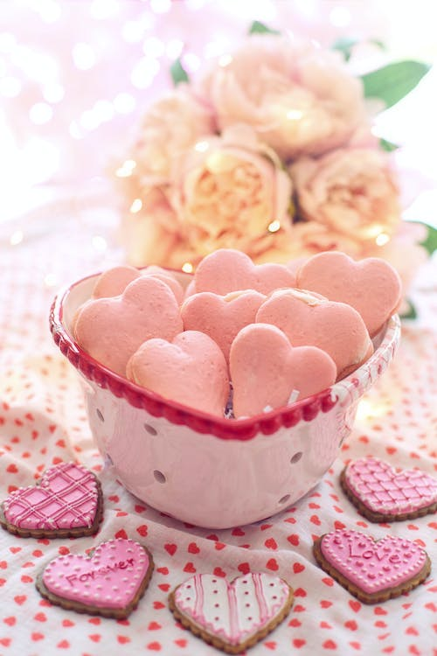

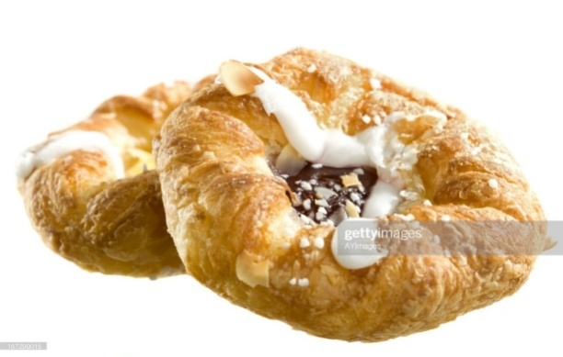
Module Title: Cookies Products
Module code:CST BPP1 M09 1122
Nominal duration:48 Hours

Prepared By: Ministry of Labor and Skill
December 2022
Addis Ababa, Ethiopia

Acknowledgment
Ministry of Labor and Skills wish to extend thanks and appreciation to the many representatives of TVT instructors and respective industry experts who donated their time and expertise to the development of this Teaching, Training and Learning Materials (TTLM).

Table Contents
Acknowledgment 2
Introduction to the module 4
This module covers the units: 5
Learning Objective of the Module 5
Module Instruction 5
Unit One: Cookies 6
1.1 Suitable Ingredients 7
1.2. Techniques & Product characteristics: 9
1.3. Oven temperature and baking time: 10
SELF-CHECK 1 11
WRITTEN TEST 11
Operation sheet1. 12
Lap test 1 15
Unit two: Decorate cookies 16
2.1. Fillings & Icings 16
2.2 Attractively presented cookies using suitable service ware 18
SELF-CHECK 2 19
WRITTEN TEST 19
Operation sheet 2. 20
Lap test 2. 25
Unit three: Store cookies 26
3.1. Materials for storage 27
3.2. Storage condition 28
SELF-CHECK 3 30
RECOMMENDED READINGS 30
Participants of this Module (training material) preparation 31

Introduction to the module

Producing variety of products in bakery and pastry production field will enhance the Hospitality industry service, serving the customer in full capacity and it is very important to keep the standards of cookies and other sweet desserts service. On the other hand it is also a means to create a job for small scale industries and to street food service providers
This module is designed to meet the industry requirement under the bakery and pastry production occupational standard.

This module covers the units:
- Cookies
- Decorate and present cookies
- Cookies storage

Learning Objective of the Module
- Prepare cookies
- Apply decoration
- Store cookies

Module Instruction
For effective use this modules trainees are expected to follow the following module instruction:
- Read the information written in each unit
- Accomplish the Self-checks at the end of each unit
- Perform Operation Sheets which were provided at the end of units
- Do the “LAP test” given at the end of the unit and
- Read the identified reference book for Examples and exercise

Unit One: Cookies
This unit is developed to provide you the necessary information regarding the following content coverage and topics:
- Suitable ingredients
- Techniques&Product characteristics
- Filling& decorations
- storage conditions
This unit will also assist you to attain the learning outcomes stated in the cover page.
Specifically, upon completion of this learning guide, you will be able to:
- Select suitable ingredients
- Apply the correct techniques to meet the required characteristics
- Prepare fillings & decorations
- Apply preservation

1.1 Suitable Ingredients

Introduction:
Cookies appear to have their origins in 7th century AD Persia, shortly after the use of sugar became relatively common in the region. They spread to Europe through the Muslim conquest of Spain. By the 14th century, they were common in all levels of society throughout Europe, from royal cuisine to street vendors.
A cookie is a baked or cooked snack or dessert that is typically small, flat and sweet. It usually contains flour, sugar, egg, and some type of oil, fat, or butter. It may include other ingredients such as raisins, oats, chocolate chips, nuts, etc.

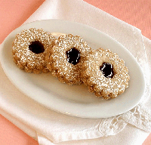
The three main INGREDIENTS present in nearly every type of cookie are wheat flour, sugar, and fat, but you'll see other ingredients such as leaveners, eggs, liquids, such as milk, perhaps some chocolate, coconut, spices or nuts. As in all other areas of baking, using fresh, high-quality ingredients is critical to success.

Fig.1.1.coconut cookies

Table 1.1 Suitable ingredients.

No. | Ingredients | Picture | Description
 | Flour | 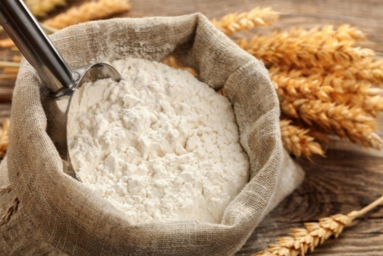 | Flour works as a stabilizer and thickener in cookies. In addition, flour also contributes to how much the cookie rises and holds it together. It also works to give the cookies a nice, delicious texture.
- 222222222 | Sugar | 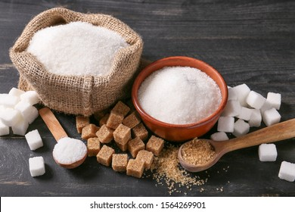 | -Sugar tenderizes : absorbs moisture  - Sugar caramelizes: When heated melting point sugar turns golden or amber.  - Sugar expands: helps the cookies to spread on the baking sheet.  - Sugar stabilizes: sugar adds bulk, helping to slow coagulation.
3. | Butter (fat) | 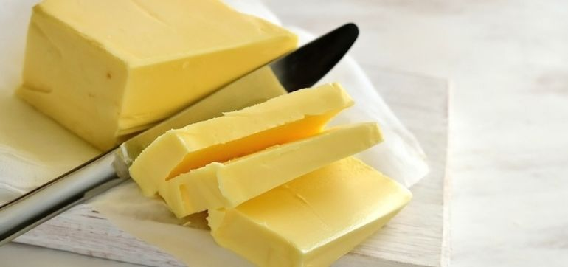 | Butter is primarily fat that gives flavour, tenderness, and flaky layers to baked goods, it also has a bit of liquid (some water, some milk bits) that also contribute to structure and rise.
4. | Eggs | 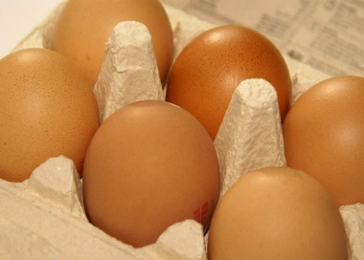 | -Eggs add structure to baked goods  -Add texture and fluffiness  -Keep baked goods more delicate  -Add a shiny finish  -Emulsifying(Help Ingredients Mix Better)  -Add Flavour
5. | Milk | 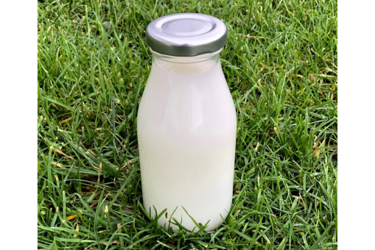 | In baking, it moistens batter or dough, and adds protein, color and flavour to baked goods.

1.2. Techniques & Product characteristics:
Cookies today are small, flat pastries. A versatile option as they can be eaten as a mid-morning snack to a delectable end for formal dinner. We see cookies in platters, made to order, a great side to ice cream or fruit. The flavours of cookies are almost limitless. Just to name a few; you have chocolate, oatmeal, peanut butter, pistachio, cinnamon and more. You can even add dried fruits and nuts for extra taste and texture.
Cookies, like quick breads and cake batters, are made from rich dough that is mixed using the creaming method. Most cookie dough contain less liquid than other batter, you do not need to alternate your flour and liquid. The final texture of a cookie is determined by the proper creaming and the amount it spreads during baking. When a cookie batter is thoroughly creamed, the sugar begins to dissolve and the fat is properly aerated. Maximum spread is achieved only in dough where the sugar and fat has been thoroughly creamed together.
There are many varieties of classifications for cookies. This refers to the way in which the cookie is prepared after the dough has been made. For example, there are drop, icebox, bar, sheet, cut out, pressed, rolled, moulded or wafer.

The ingredients, such as flour, sugar, and fat; the oven temperature; and the baking time for cookies all play a role in the texture and appearance of a cookie.
Baking is chemistry. Baking is a process. It is the investigation of ingredients, how they interact, combine, change, and be used to form food. The chemical reaction between these ingredients, such as flour, sugar, and fat; the oven temperature; and the baking time for cookies determine the texture and appearance of a cookie.
For example, a cookie will be chewier it has more "spread." Baking the cookies at a lower temperature and for a longer time will give the cookies more spread, making them chewier. Chilling the dough overnight causes the cookie to spread less because the fat, usually butter, is cold. So, the cookie will be less chewy if the overnight dough is chilled.
The type of sugar you use in your recipe will impact the final texture of your cookie. Using more granulated sugar means less leavening and more spread. This is because it does not respond as actively as brown sugar would. Brown sugar has more acid, which, when combined with baking soda, means more leavening and less spreading
The use of flour is all about the protein percentage. All-purpose flour is higher in protein, meaning the cookie will brown more and become crispier. This is often the most utilized flour in everyday cookie recipes. Using flour lower in protein, such as cake or pastry flour, will give you a softer cookie texture.

1.3. Oven temperature and baking time:
As the oven temperature increased, we noticed
Shorter bake time

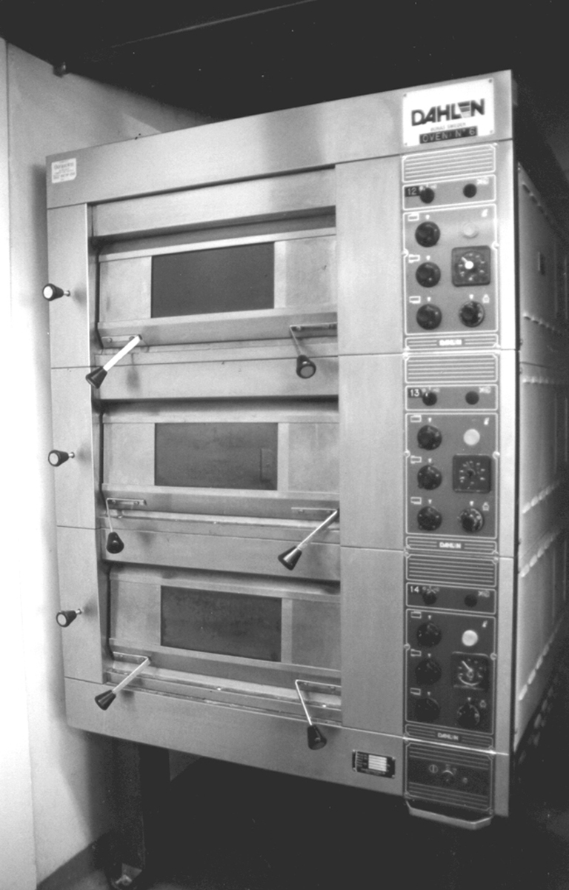
Thicker cookies with less spread
Softer center
Crunchier edges

Fig.1.2.Oven

As oven temperature increases, the outsides of the cookie bake faster, resulting in thicker cookies with undercooked centers.The cookies set sooner as oven temperature increased,
There are two types of baking cookies: oven baked and stove top baked. Oven baked cookies are usually cooked at 350° F while stove top baked cookies are cooked at 375 ° Fahrenheit. Both methods take about 15 minutes to complete. Oven baked cookies are better because they are crispy and chewy. Stove top baked cookies are softer and fluffier.
If you bake your cookies at a lower temperature, they won’t turn out as fluffy and soft. Instead, they will be hard and crunchy. Baking cookies at 325 degrees for 10 minutes will
give you soft and chewy cookies. Baking cookies at 350 degrees for 12 minutes will give you crispy cookies.
Baking cookies at 350 ° Fahrenheit 180 ° Celsius is the ideal temperature for baking cookies. It is the perfect temperature for cookies because it allows the cookie dough to spread evenly throughout the pan. At higher temperatures, the cookie dough tends to get stuck to the sides of the pan. Baking cookies at 375 ° Fahrenheit 190° C is not recommended because it results in dry cookies. Cookies baked at lower temperatures tend to be softer and moister.
Here are the different types of cookies and their general baking times:
- Drop cookies – 8 to 10 minutes
- Bar cookies – 20 to 30 minutes
- Moulded cookies – depending on the size of the mould, 10 to 20 minutes
- No-Bake cookies (cooked) – 0 minutes in the oven
- Pressed cookies – 7 to 10 minutes
- Ice-box cookies – 15 to 20 minutes
- Rolled cookies – 6 to 8 minutes
Note: Baking time may vary depending on the size of the cookie, oven temperature, and thickness of the pan or tray.Knowing how long to bake cookies may also depend on the oven being pre-heated correctly. Most cookie recipes require you to pre-heat the oven at 350 degrees F. It should take 20 to 30 minutes for your oven to reach that temperature.
SELF-CHECK 1 | WRITTEN TEST

Instruction:
Answer the following questions:
Q.1. 180° C or 375° F is the ideal temperature for baking cookies.
(TRUE or FALSE)
Q.2. Chocolate, peanut butter, cinnamon & others add flavour to cookies.
(TRUE or FALSE)
Q.3. One of the following is NOT the function of butter (fat) in cookies preparation.
- It gives layer c) Helps the cookies to spread
- It gives flaky layers d) It contributes to structure the product

Q.4. One of the following is NOT the function of butter (fat) in cookies preparation.
- It gives layer c) Helps the cookies to spread
- It gives flaky layers d) It contributes to structure the product
Q.5.List at least four basic ingredients for cookies preparation.
___________________________________________________________________

Operation sheet1.Cookies.
Operation Title:Producecookies
Purpose:Identify cookies characteristics to produce with the standard
Conditions or situations for the operations:
- Safe working area
- Properly operated tools and equipment
- Appropriate working uniforms fit for the practical performance

Equipment Tools & Ingredients:
-Mixer - scale - flour, icing sugar, butter, flavoring, etc
- Oven - bowl - milk, cacao, coconutG.sugar, etc.
- Scraper, pipingbag, etc.
Quality Criteria: Assured performing of all the activities according to the procedures
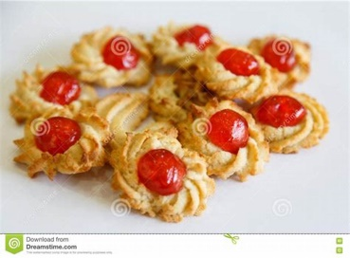
Preparing Cookies
- Sweet pastry 3:2:1 ratio
  - 300g. flour
  - 200g. butter
  - 100g. icing sugar
  - 1 egg
  - A pinch of salt &vanilla for test
Preparation:
  - Sieve the flour add salt, make a ba Fig 1.1.Sweet pastry
  - Cream or rub butter and icing sugar
  - Add the egg ,combine all & wrap and keep
in the fridge for 5-10 min.
  - Roll , shape as required
  - Put on the baking sheet ,bake
  - 170°c for 10 min.
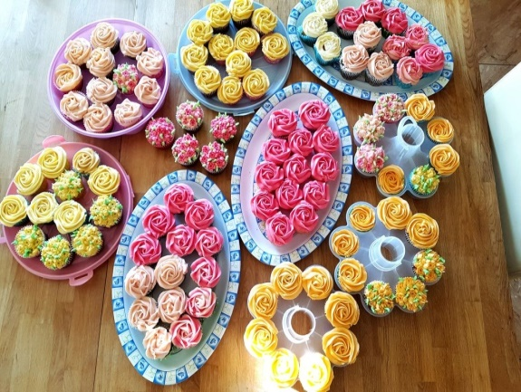
- Piped cookies:
  - 600g. butter
  - 300g. sugar
  - 1100g. flour
  - 1 lemon rind
  - 500ml. water(water)
Preparation:
  - Cream butter and sugarFig.1.2. piped cookies
  - Add warm water drop by drop
  - Fold in the flour combining lemon rind for flavour
  - Mix, give rest ,use a piping bag to shape
  - Baking temperature 170°c for 10-15 min.
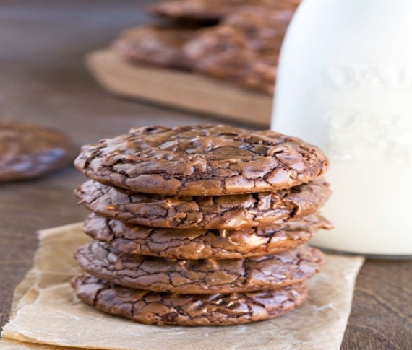
- Brown cookies:
  - 2kg. butter
  - 1kg. icing sugar
  - 3 pc. Eggs
  - 21/2 kg. flour
  - ½ kg. cacao
  - 20g. baking powder
Fig.1.3. Brownie cookies
Preparation:
  - Cream butter and sugar
  - Add the egg one by one
  - Sieve the flour &make portion to have white & brown mixture.
  - Keep in the fridge 10min.
  - Roll or mix differently to have marbled colour
  - Bake at 170 °c for 10-15 min.
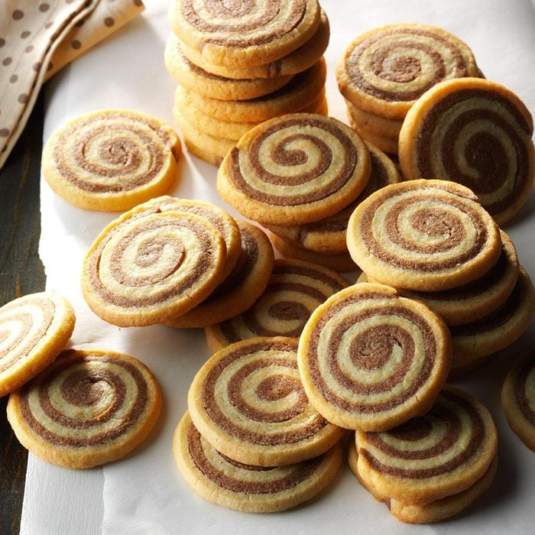
Chocolate pin wheel
Ingredients
- 1 cup butter, softened
- 2 cups sugar3.
- 1/2 cup packed brown sugar
- 2 large eggs
- 3 teaspoons vanilla extract
- 3-3/4 cups all-purpose flour
- 2 teaspoons baking powder
- 1/8 teaspoon salt Fig.4. Basic chocolate pin wheel
- 1/4 cup baking cocoa
- Directions
In a large bowl, cream butter and sugars until light and fluffy. Add the eggs, one at a time, beating well after each. Beat in vanilla. Combine the flour, baking powder and salt; gradually add to the creamed mixture and mix well.
Divide dough in half; add cocoa to one portion. Divide each portion in half. On a baking sheet, roll out each portion between waxed paper into a 12x10-in. rectangle. Refrigerate for 30 minutes.
Remove waxed paper. Place one chocolate rectangle over a plain rectangle. Roll up tightly, jelly-roll style, starting with a long side; wrap in plastic. Repeat with remaining dough. Refrigerate for 2 hours or until firm. Unwrap and cut into 1/4-in. slices.
Place 2 in. apart on lightly greased baking sheets. Bake at 350° for 10-12 minutes or until set. Remove to wire racks to cool.

Lap test 1
Instructions: Given necessary templates, tools and materials you are required to perform the following tasks accordingly.
Task 1: pre-prepare the necessary equipment
Task 2: prepare the necessary ingredients
Task 3: measure the ingredients according to the instruction
Task 4: make variety of decorated cookies
Task 5: prepare & use fillings and icings for decoration
Task 6: Bake &keep cool

Unit two:Decorate cookies
This unit is developed to provide you the necessary information regarding the following content coverage and topics:
Fillings & icing
- Presentation & suitable service ware
This unit will also assist you to attain the learning outcomes stated in the cover page.
Specifically, upon completion of this learning guide, you will be able to:
- Decorate cookies with suitable fillings
- Use icings for decorating cookies
- Present with the appropriate service ware

2.1. Fillings& Icings
Introduction

Frosting or icing, fillings and glazes are typically a sweet, sugar-based soft mixture used to fill, coat, add flavour, and improve the appearance and texture, They are used on baked recipes such as cakes, cupcakes, cookies and pastries, or formed and used when decorating as a Crafty Baker, ranging from simple to elaborate.

Pies and tarts are usually decorated with leftover pastry in a variety of styles:
▪Lattice work–strips of pastry are crossed
▪Leaf decorations–tops are garnished with pastry leaves
▪Fluting–edges of pastry are secured together by a fork
Glazing is a technique where a liquid is coatedonto un-cooked pastry, bread and biscuits so thatonce cooked it adds to the finish of a dish
- Milk–aids browning
- Beaten Egg–aids browning&provide shine
- Sugar Glaze–adds shine (water + sugar)

- Colour Wash–water dyed with food colouring
- Poppy Seeds + Sesame Seeds–sprinkle on bread

How to pipe and fill cookies?
Open a piping bag,
Stick tip inside the bag all the way down so it peeks out of the bag’s narrow opening.
Fill the bag about halfway with cream.
Lay the bag flat on your countertop.
Grab a bench scraper and slide it down the pastry bag, pushing the dough towards the bottom of the bag so you don’t have any dough threatening to spill out.
Select your icing
Glaze
Cookie glaze is thin, satiny, and dries hard. It's perfect for adding a written message, or coating with colourd sugar (see below). Read more about cookie glaze consistency
Frosting
This spreadable frosting is similar to buttercream, and stays soft on your cookies. Add sugar decorations for a fun or elegant touch.
Royal icing
This icing dries hard and opaque, and can be spread or piped a top cookies.
Cookie Frostings and Icings
The two terms are often used interchangeably, but many cooks think of frosting as thick and fluffy, and icing as relatively thinner and glossier. For more on this mini-debate and info on how to make them, check out How to Make Frostings and Icings.
The simplest types of cookie frostings and icings are made using confectioners' sugar, butter or shortening and milk or water:
Decorator Frosting is an example of a basic frosting. It will stay fairly soft even after drying and is the easiest to apply, but it's not your best choice if you want to do elaborate smudge-proof designs.
Sugar Cookie Icing is an example of a basic frosting with corn syrup added to the mix, which results in an icing that dries to a harder finish. You can use this kind of icing to make smudge-proof designs on cookies.
Royal Icing is made with confectioners' sugar, water, and meringue powder or egg whites. It dries to a hard, crunchy finish and is the icing of choice for gluing gingerbread houses together, but it tends to be flavour less unless you add a little vanilla extract.Sugar cookie icing
For the most basic cookie decorating:
Make a bowl of Decorator Frosting and apply it to cooled cookies with a pastry brush, blunt knife, or small spatula. Add your choice of sprinkles and call it a day.
Or dip the front of a cookie in thinned icing and put it on a cooling rack or plate. Add sprinkles and let dry.
If you want to make designs that dry to a hard finish:
Make a bowl of Sugar Cookie Icing or Royal Icing and divide into bowls.
Add food colouring and/or thin to the desired consistency.
At this point, you can outline cookies with your medium icing, flood it with thin icing, let it dry, and then add details with thick icing.
As an alternative, use your small paintbrush or toothpick to add details while the icing is still wet.
Easiest Cookie Decorations
Cookies don't have to have elaborate decorations to be worthy of your holiday cookie trays. Sometimes it just takes a little extra touch to elevate the simplest frosted cookies into party-. Try spreading cookies with frosting or icing, and then sprinkle on colour sugar or other decorations in a contrasting colour.
Here's a perfect example of how a simple sugar cookie can look extra-special with very simple decorations. This technique is so easy,Simply fill a piping bag with a soft frosting like Sugar Cookie Frosting, swirl it on, and finish with sprinkles.

2.2 Attractively presented cookies using suitable service ware

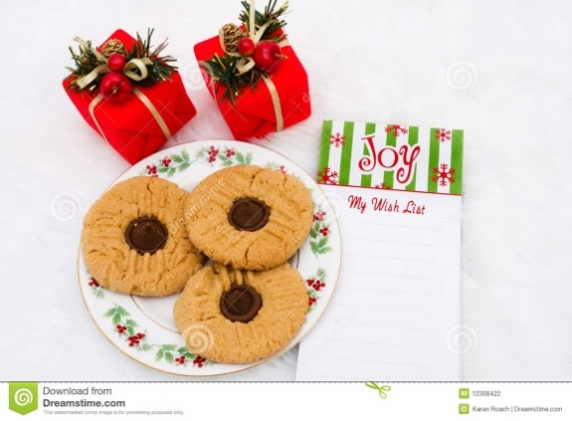
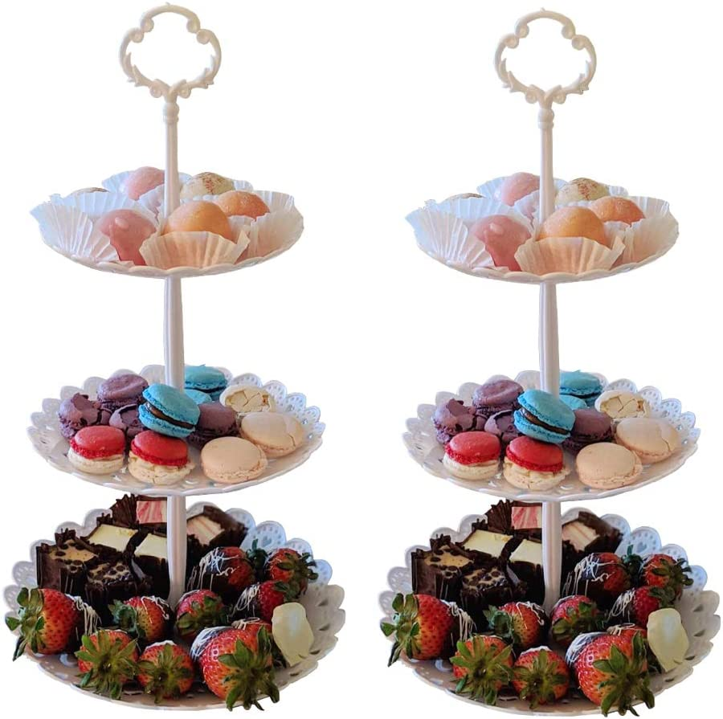
Fig.2.1.cookies display stands Fig.2.2.plate for cookies

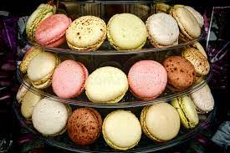
Fig.2.3. cookies display shelf

SELF-CHECK 2 | WRITTEN TEST
Instruction:
Answer the following questions:
Q1. Pies and tarts can be decorated with leftover pastry (True or False)
Q2. Glazing is a technique where a liquid is coated onto un-cooked pastry.(True or False )
Q3.Beaten eggs aids browning and provide shining to decorate cookies. (True or False)
Q4. Icings characteristics:
  - Thinner and glossier
  - Made up of confectionery sugar
  - A and B are answer
Q5. How do you decorate cookies by filling a cream? Elaborate.

Operation sheet 2.DecorateCookies.

Operation Title:Fillings and icing
Purpose:Decorate using fillings and icings
Conditions or situations for the operations:
- Safe working area
- Properly operated tools and equipment
- Appropriate working uniforms fit for the practical performance

Equipment Tools & Materials:
-Mixer - scale - icing sugar,butter,flavoring,etc
- bowl - milk,cacao,coconutG.sugar,etc.
- Scraper, piping bag, etc.

Quality Criteria: Assured performing of all the activities according to the procedures
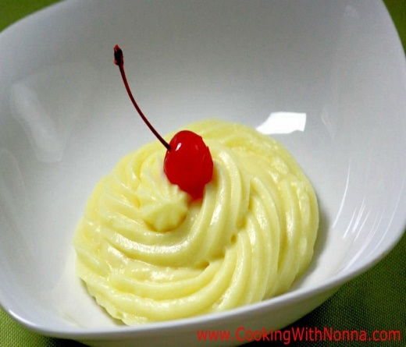
FillingCustard Cream – (Pastry Cream)
Ingredients
1 litter fresh milk
250 grams /9 oz sugar
4 medium-sized eggs
60 grams /2 oz cornstarch Fig.2.1.pastry cream
½ teaspoon vanilla extract
Instructions
- In a cooking pot combine milk, sugar, and vanilla extract. Warm up the mixture over medium heat.
- In a small bowl whisk together the eggs with the corn starch.
- Once the milk gets steamy hot (right before it starts boiling) remove from heat, and using a ladle start pouring it slowly into the eggmixture while whisking the eggs constantly.
- Once you have transferred half of the milk into the eggs, pour the mixture back in the pot.
- Whisk constantly over medium heat until the cream starts to thicken.
- At this point, you may add the butter or any other flavouring you like.
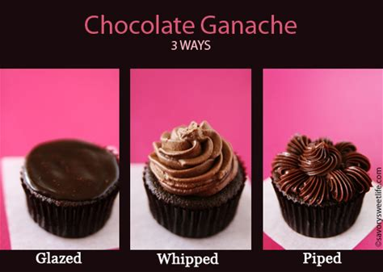
- Remove from heat and serve in small bowls. Or let it reach room temperature before refrigerating and using it as a dessert filling.

Fig.2.2. Chocolate Ganache

Three different ways to use ganache as frosting, filling, and for piping.
Chocolate Ganache
Ingredients
- 12 ounces
- Chocolate (chopped into small pieces)

- 1 cup
- Heavy Cream
- Add
- Flavoured Liquor (optional 3 tablespoons)
Directions
1. Place chocolate pieces in a large bowl. Heat heavy cream on medium high until it comes to a boil. Remove from heat and immediately pour cream over chocolate and stir until completely mixed and glossy. Allow ganache to cool before pouring over cakes, cookies.
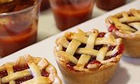
Cherry Pie Filling
Ingredients
- 4 cups pitted tart red cherries
- 1 cup white sugar
- ¼ cup cornstarch

Fig.2.3.Cherry pie filling

Directions
- Place cherries into a saucepan over medium heat. Cover and cook, stirring often, until cherries release their juices and come to a simmer, 10 to 15 minutes.
- Whisk sugar with cornstarch in a bowl until combined; pour mixture into hot cherries and juice. Stir until thoroughly combined.
- Bring to a simmer over low heat; cook until thickened, about 2 minutes. Remove from heat and let cool before using as pie filling.

Jelly filling
- 4 eggs
- 1 cup milk
- ½ cup butter, melted
- 1 cup seedless strawberry jam
- 1 cup powdered sugar
- 2 tablespoons milk
Steps:
- Preheat the oven to 350 degrees F (175 degrees C). Grease a fluted tube pan (such as Bundt®).
- Beat cake mix, eggs, milk, and butter until well combined. Pour into the prepared pan.
- Bake in the preheated oven until a toothpick inserted into the center comes out clean, 35 to 40 minutes. Let cool completely in the pan, 30 minutes to 1 hour.
- Use an apple corer to poke holes along the middle of the cake, making sure not to poke all the way through. Remove cake from the corer before making the next hole. Leave a 1/2-inch border on the inner and outer edges of the pan.
- Microwave strawberry jam for 1 minute. Stir and continue microwaving in 15-second intervals until jam is melted and pourable. Pour jam into the holes and let cake sit in the pan for at least 1 hour.
- Run a table knife around the inner and outer edges of the pan to loosen. Invert cake carefully onto a serving plate.
- Mix powdered sugar and milk together until well combined. Brush glaze over the cake and let sit overnight so flavors can meld.

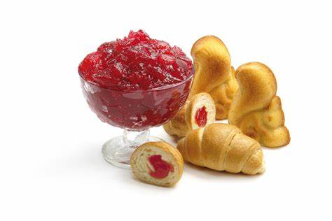

Fig.2.4.Jelly filling

Lap test 2.
Instructions: Given necessary templates, tools and materials you are required to perform the following tasks accordingly.
Task 1: pre-prepare the necessary equipment
Task 2: prepare the necessary ingredients
Task 3: measure the ingredients according to the instruction
Task 4: make variety of fillings and icings
Task 5: prepare & use fillings and icings for decorating different cookies.
Task 6:Decorate the products

Unit three: Store cookies
This unit is developed to provide you the necessary information regarding the following content coverage and topics:
- Material for Storage
- Storage condition
This unit will also assist you to attain the learning outcomes stated in the cover page.
Specifically, upon completion of this learning guide, you will be able to:
- Select storage materials
- Identify storage conditions

3.1. Materials for storage
To store mean: to put (something that is not being used) in a place where it is available, where it can be kept safely.
Use the right container:
To keep your cookies fresh, you need to keep air out. For that reason, we suggest storing cookies in an airtight container—here are our picks for the best cookie storage containers
Make sure nothing gets in the way of the container and its lid, and double-check that the seal is tight.
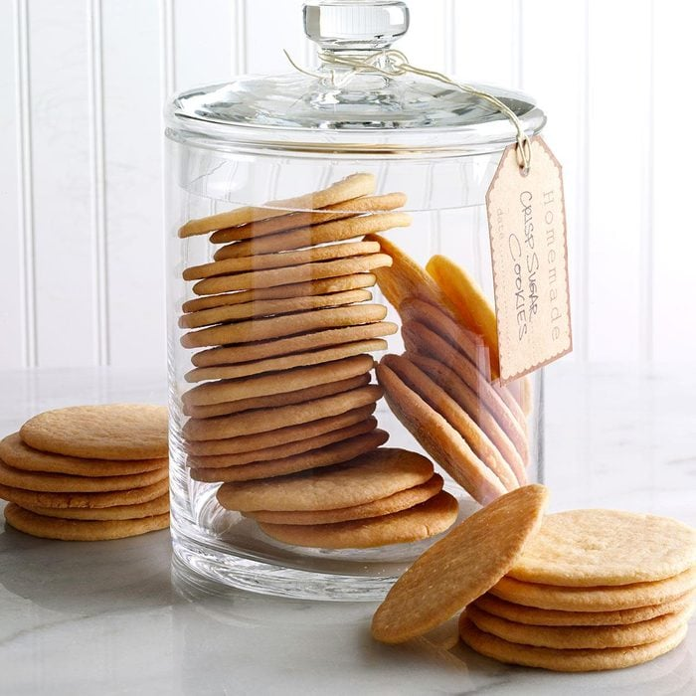

Fig.3.1.Cookie container

Store different types of cookies separately
If you’re storing different varieties of cookies, plan to keep them in separate containers. Otherwise, your soft cookies will moisten your crisp cookies and the flavour profiles of different varieties—say oatmeal cookies stored with gingersnaps—will start to blend together.
In general, it’s OK to store crisp cookies in a container with a looser-fitting cover. But to keep cookies soft and chewy, store them in a container that has a tight-fitting lid.
Pick the right recipes
Some types of cookies freeze better than others. Drop cookies, cutout cookies, icebox cookies, shortbread cookies and hearty bar cookies stand up well to storage. Delicate lace cookies, meringue-based .
Chocolate chip cookies (everyone’s favorite!) generally store well, too. There’s no special trick for storing this ever-popular type of cookie—just keep them in an airtight container, especially if you love soft chocolate chip cookies!
3.2. Storage condition
Store Cookies to Keep Them Fresh
Know how long cookies last
In general, cookies will last for about three days at room temperature—if you store them correctly! They’ll last for up to six months in the freezer.
Here’s a guide on how long different types of cookies last.
Cool cookies completely
Making cookies is a lot of work, so don’t ruin your efforts by rushing the cooling process. Cookies need to be completely cool to the touch before you store them. Otherwise, the trapped heat will create condensation, which ultimately will ruin your cookies.
Making batch after batch? Try this trick for cooling cookies in bulk.
If your cookies get too soft, crisp them up in a 300ºF oven for five minutes. If they’re too crispy, you may be able to soften cookies with a slice of bread.

Store cookies in layers
The last thing you want is for your cookies to stick together! To prevent sticking when you store your cookies, arrange them in a single layer and add a piece of parchment paper or waxed paper between layers. (Here’s why you should bake cookies on parchment paper, too!)
Store cookie bars correctly
When storing cookie bars, the best way to maintain freshness is to keep them in the pan you baked them in. Cover the pan with foil or place it in a large, re-sealable bag. If your cookie bars contain any perishable ingredients—such as a cream cheese glaze—store them in the fridge.
Test Kitchen Tip: If you can’t keep your cookie bars in their original pan, slice them (here’s how to cut dessert bars) and place them in an airtight container. Store the container in the fridge—the cookie bars will stay fresh there for up to two weeks
Keep cookies cool
Your stored cookies will stay freshest in a cool, dry place, such as the back shelf of your pantry. Depending on the variety, they’ll last anywhere from a few days to a few weeks.
You can also freeze cookies for up to six months. To thaw frozen cookies, take them out of their freezing container and spread them out on a clean baking sheet until they come to room temperature. You can revive them in a 325ºF oven, too. Two to three minutes will crisp them up.
Store cookies without frosting, if possible
For best results, avoid frosting cookies before you store them. Not only will the end result look cleaner, but you’ll avoid taking up half of your fridge space with cream cheese-frosted cookies.
To store unfrosted cookies, let them cool completely before wrapping them in plastic wrap and freezing them in an airtight container. Thaw at room temperature before frosting and serving.

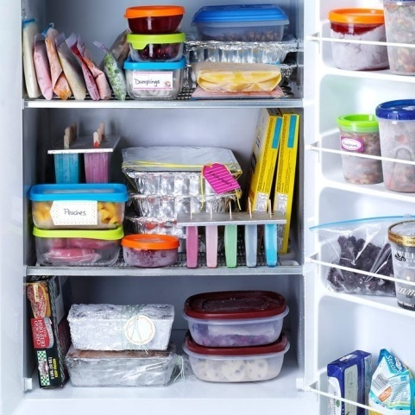

Fig.3.2.cookie fridge

Freeze the cookie dough
Running short on time? Consider freezing cookiedough instead of baking it right away. For drop cookies, place scoops of dough on a parchment-lined baking sheet, then place in the freezer for 30 minutes. When firm, place the dough drops in a re-sealable plastic bag. Bake from frozen for 3 to 5 minutes longer than the original instructions.
You can also freeze cut out cookie dough and other dough that you’d roll out. These types of cookie dough have to chill anyway, so an extended stay in the freezer won’t do them any harm. Just wrap disks of dough tightly in plastic wrap and seal in a zip-top bag to
Store. Frozen cookie dough is best used within 3 months but you can freeze it for up to 6 months. To thaw, let it sit in the fridge overnight.

SELF-CHECK 3 | WRITTEN TEST

Answer the following questions:
Q1. In storing cookies it is not necessary to keep different types of cookies separately
(True or False)
Q2. Wrap cookies in plastic before storing them. (True or False)
Q3. To thaw frozen cookies dough let the dough rest in the fridge overnight.(True or False)
Q4.what is important to keep cookies fresh:
To keep air out
To check the container seal is tight
To use air tight container
All are correct
Q5. For how many days we keep cookies at a room temperature
3 days
6 months
A week
All are correct
.

Reference

- FROM THE INTERNET
- BAKERY & CONFECTIONARY COURSE ,FOOD PRODUCTION DEPARTMENT
KENYA UTALII COLLEGE, NIROBI
- READING MATERIALS ON PASTRY AND BAKERY PRODUCTION

Participants of this Module (training material) preparation
No | Name | Qualification | Educational background | Region | College | Mobile number | E-mail
1 | Mohammed Liben Mohammed | Hotel and Tourism Sector head | - BA degree in Hotel and Tourism management  - MA degree in Disaster Risk Management | Somali | Jigjiga Polytechnic college | 0992326557 | cherechaw@gmail.com
2 | AbrehamMayzamengesha | Instructor | Bed degree in Hotel and Tourism | SNNP | Arbaminch Polytechnic college | 0913711922 | Abrehammayza9@gmail.com
3 | ZelalemAlmawEndalew | Instructor | - BSC degree in Food science and post harvesttechnology | Amhara | Bahirdar Polytechnic College | 0918012521 | Parazolla25@gmail.com
4 | HiwotTedla Belay | Instructor | BA degree in Accounting and finance and diploma in Hotel Management | Hareri | Harer Polytechnic College | 0913789086 | hiwietaba@gmail.com
5 | Zuryash-Work Belay Nigatu | Instructor | BA degree in Hotel Management | Addis Ababa | TTI | 0911643817 | zuriyash@gmail.com

