Bakery and Pastry Production
Level- II
Based on December 2022, Curriculum Version II
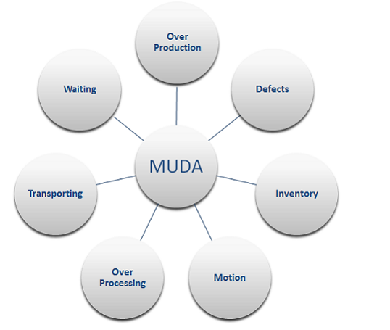

Module Title: Preventing and Eliminating Muda
Module code: CST BPP2 M01 1122
Nominal duration: 32 Hour

Prepared By: Ministry of labor and skills

December, 2022
Addis Ababa, Ethiopia

Acknowledgement

Ministry of Labor and Skills wish to extend thanks and appreciation to the many representatives of TVET instructors and respective industry experts who donated their time and expertise to the development of this Teaching, Training and Learning Materials (TTLM).

Table of Contents
Acknowledgement 2
Acronyms 5
Introduction to the module 6
This module covers the units 6
Learning Objective of the Module 6
Module Instruction 6
Unit one: Prepare for work 7
1.1. OHS Requirements and Safety tools 8
1.2. Work instructions 9
1.3 Job Specification 9
1.4. Safety equipment and tools 10
Self-Check-1 14
Unit Two: MUDA and its problem 15
2.1. Planning for Muda 16
2.2. Kaizen Board 17
2.3. Tools to analyze situation of the work place 19
2.4. Causes and effects of MUDA 19
2.5 Statistical Tools and techniques 21
2.6. Relevant procedures for MUDA Identification 23
Self-check-2 25
Unit Three: Analyze causes of a problem 27
3.1. Listing possible causes of a problem 28
3.2. Analyzing Cause relationships using 4M1E 28
3.3. Finding the root cause of the problem 29
3.4. Creative idea generation to eliminate most critical root causes 30
3.5 Preparing Action plan to implement solutions 32
Unit Four: MUDA Elimination 36
4.1. MUDA elimination using KPI 37
4.2. Tools and techniques to eliminate Muda 38
4.3. Reporting muda improvements 41
Self-check-4 42
Unit Five: Prevent occurrence of wastes and sustain operation 43
5.1. Plan of Muda prevention 44
5.2. Standards required for machines 44
5.3. Creating waste-free workplace 45
Benefits of Addressing Waste 47
5.4. Building capability of the work team 48
Self-check-5 49
References 51
Participants of this Module (training material) preparation 52

Acronyms
TTLM Teaching, Training and Learning Materials
TPM Total Productive Maintenance
OHS Occupational Health and Safety
WHS workplace health and safety
PDCA plan, do, check, act
PFD process flow diagram
WHO World Health Organization
M1E Method, Machine, Material, Man Environment

Introduction to the module
This module covers the knowledge, skills and attitude required by a worker to prevent and eliminate MUDA/wastes in his/her workplace by applying scientific problem-solving techniques and tools to enhance quality, productivity and other kaizen elements on continual basis It covers responsibility for the day-to-day operation of the work and ensures Kaizen Elements are continuously improved and institutionalized.
This module is designed to meet the industry requirement under the bakery and pastry production occupational standard, particularly for the unit of competency: Prevent and Eliminate MUDA.

This module covers the units
- Prepare for work
- Muda and its problem
- Analyzing Causes of a problem
- Muda Elimination
- waste Prevention

Learning Objective of the Module
At the end of this session, the trainees will be able to
- Prepare for work
- Identify MUDA and problem
- Analyze causes of a problem
- Eliminate MUDA
- Prevent wastes

Module Instruction
For effective use this modules trainees are expected to follow the following module instruction:
- Read the information written in each unit
- Accomplish the Self-checks at the end of each unit
- Read the identified reference book for Examples and exercise

Unit one: Prepare for work
This unit is developed to provide you the necessary information regarding the following content coverage and topics:
- OHS requirements and Safety equipment and tools
- Work instructions
- Job Specification
- Safety equipment and tools
This unit will also assist you to attain the learning outcomes stated in the cover page. Specifically, upon completion of this learning guide, you will be able to:
- Use work instructions to determine job requirements
- Read and interpret job specifications
- Use OHS requirements
- Select and prepare materials for work which are appropriate to application.
- Identify and check safety equipment and tools for safe and effective operation.

1.1. OHS Requirements and Safety tools
1.1.1. Definitions of OHS Requirements
OHS requirements are legislation/regulations/codes of practice and enterprise safety policies and procedures. This may include protective clothing and equipment, use of tooling and equipment, workplace environment and safety, handling of material, use of fire-fighting equipment, enterprise first aid, hazard control and hazardous materials and substances. Personal protective equipments include those prescribed under legislation/ regulations/codes of practice and workplace policies and practices. Safe operating procedures include the conduct of operational risk assessment and treatments associated with workplace organization. Emergency procedures include emergency shutdown and stopping of equipment, extinguishing fires, enterprise first aid requirements and site evacuation.

Occupational health and safety (OSH) also commonly referred to as occupational health and safety (OHS) or workplace health and safety (WHS) is an area concerned with the safety, health and welfare of people engaged in work or employment. The goals of occupational safety and health programs include fostering a safe and healthy work environment. OSH may also protect co-workers, family members, employers, customers, and many others who might be affected by the workplace environment. In the United States the term occupational health and safety is referred to as occupational health and occupational and non-occupational safety and includes safety for activities outside work.

As defined by the World Health Organization (WHO) "occupational health deals with all aspects of health and safety in the workplace and has a strong focus on primary prevention of hazards." Health has been defined as "a state of complete physical, mental and social well-being and not merely the absence of disease or infirmity. Occupational health is a multidisciplinary field of healthcare concerned with enabling an individual to undertake their occupation, in the way that causes least harm to their health. It contrasts, for example, with the promotion of health and safety at work, which is concerned with preventing harm from any incidental hazards, arising in the workplace.

1.2. Work instructions
It describes what workers need to be able to do on the job.
- Work functions
- Key activities of each work function
- Performance indicators
It also describes what task to be done or work roles in a certain occupation.
- Work instruction is a description of the specific tasks and activities within an organization. A work instruction in a business will generally outline all of the different jobs needed for the operation of the firm in great detail and is a key element to running a business smoothly. In other words it is a document containing detailed instructions that specify exactly what steps to follow to carry out an activity. It contains much more detail than a Procedure and is only created if very detailed instructions are needed. For example, describing precisely how a request for Change record is created in the Change Management software support tool.

1.3 Job Specification
A statement of workers’ characteristics and qualifications required for satisfactory performance of defined duties and tasks comprising a specific job. It is a statement of the qualifications, personality traits, skills, etc. required by an individual to perform the job.
The job specification derives from the job description; it is one of the most important readable information for the job-hunter as it tells about the eligibility criteria for the certain post. The job specification holds information regarding the eligibilities for the vacancy. It lets applicants know what skills, level of experience, education, and abilities are required for the role. As mentioned in our Candidate series, a good CV (curriculum vitae) is one that is tailored to a job’s specifications. Using a job’s specification in an application is like answering a recruiter’s questions before they have even asked them and sets those apart from others. Job specification is clearly stated below.

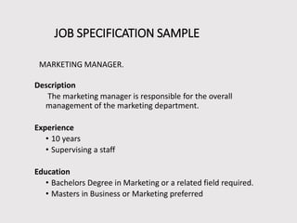
Fig 1.1 Job specification sample

1.4. Safety equipment and tools
Safety is a state in which hazards and conditions leading to physical, psychological or material harm are controlled in order to preserve the health and well-being of individuals and the community. It is an essential resource for everyday life, needed by individuals and communities to realize their aspirations.
Attaining an optimum level of safety requires individuals, communities, governments and others to create and maintain the following conditions, whichever setting is considered:
- A climate of social cohesion and peace as well as of equity protecting human rights and freedoms, at the family, local, national or international level;
- The prevention and control of injuries and other consequences or harm caused by accidents;
- The respect of the values and the physical, material and psychological integrity of individuals; and
- The provision of effective preventive, control and rehabilitation measures to ensure the presence of the three previous conditions.These conditions can be assured by initiatives that focus on the environment (physical, social, technological, political, economic and organizational) and on behavior.
Safety equipment and tools that we use in the workshop are dust masks, safety goggle, glove, work wear, first aid safety shoe.
- Dust masks: - A dust mask is a flexible paper pad held over the nose and mouth by elastic or rubber straps for personal comfort against non-toxic nuisance dusts. They are not intended to provide protection from toxic airborne hazards.
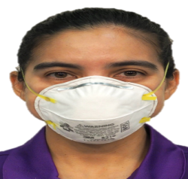
Fig 1.2 an individual with dust mask
- Safety goggles
Safety goggles are intended to shield the wearer's eyes from impact hazards such as flying fragments, objects, large chips, and particles. Goggles fit the face immediately surrounding the eyes and form a protective seal around the eyes. This prevents objects from entering under or around the goggles.
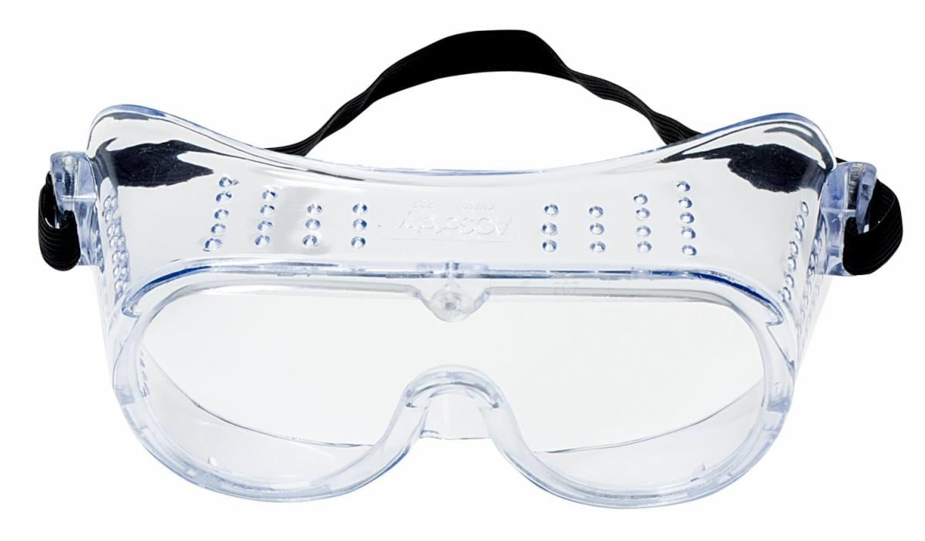
Fig 1.3 Safety goggle

- Glove
Gloves are pieces of clothing which cover your hands and wrists and have individual sections for each finger. You wear gloves to keep your hands warm or dry or to protect them a pair of white cotton gloves.
Gloves protect and comfort hands against cold or heat, damage by friction, abrasion or chemicals, and disease; or in turn to provide a guard for what a bare hand should not touch.

Fig 1.4 glove

- Work wear
Is clothing worn for work, especially work that involves manual labor? Often those employed within trade industries elect to be outfitted in work wear because it is built to provide durability and safety.

Fig 1.5 Work wear
- First aid and safety shoes
First aid is the first and immediate assistance given to any person suffering from either a minor or serious injury, with care provided to preserve life, prevent the condition from worsening, or to promote recovery. During this time, a first aid provider may need a safety shoe. 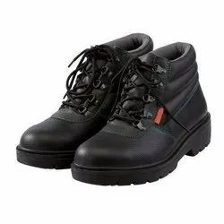
Fig 1.6 safety shoe

Self-Check-1

Part I: Say true or false (each 1 point)
- Personal protective equipment includes those prescribed under legislation/ regulations/codes of practice and workplace policies and practices.
- Occupational safety and health cannot be important for moral, legal, and financial reasons.
- Effective OHS regulation requires that work unsafe provides clear, accessible advice and guidance.
Part II: Choose
- Which type of hazard including repetitive movements, improper set up of workstation, poor design of equipment, workstation design, (postural) or workflow, manual handling.
A. Ergonomic C. Physical
B. Psychological D. None
- Of the following which one is safety equipment?
A. dust mask C. goggle
B. work wear D. all

Part III: short answer
- Write best practice of selecting appropriate materials. (4 points)
- List the requirements of job. (3 points)
- Explain the difference between procedure and work instruction. (4 points)
- Define job specification? (2 points)
- What are the goals of OHS? (4 points)
- List at least four workplace hazards? (4 points)

Unit Two: MUDA and its problem
This unit to provide you the necessary information regarding the following content coverage and topics:
- Planning for Muda
  - Kaizen Board
  - Tools to analyse situation of the work place
  - Causes and effects of Muda
  - Statistical tools and techniques
  - Relevant procedures for Muda identification
This guide will also assist you to attain the learning outcomes stated in the cover page. Specifically, upon completion of this learning guide, you will be able to:
- Follow Kaizen Board.
- Use tools and techniques to draw and analyze, and prepare and implement problem identification.
- Discuss Causes and effects of MUDA.
- Identify and list all possible problems related to kaizen elements using statistical tools and techniques on work place.
- Identify and measure wastes/MUDA based on relevant procedures.
- Report the Identified and measured wastes to relevant personnel.

2.1. Planning for Muda
MUDA is a Japanese word meaning Wasteful Activity which use resources, time or cost without adding value. In other words, it is anything unnecessary in operation that affects the quality of the product/service, productivity, delivery time and also production cost. MUDA can be eliminated immediately.
Planning is the most basic and primary function of management. It is the pre decided outline of the activities to be conducted in the organization. Planning is the process of deciding when, what, when where and how to do a certain activity before starting to work.
2.1.1 Types of MUDA
The most well-known category of wastes is the “seven deadly wastes,” which captures the essence of all the ideas discussed above and simplifies them to help you root out waste throughout your production process. You will need strongly motivated people with an instinct for seeing and removing waste. Identifying and eliminating these seven types of waste will forge the path to lean production.
- Overproduction- To produce things more than necessary in terms of type, time, and volume. It is called “the worst kind of Muda” since it hides all the other wastes.

Fig 2.1 over production

- Inventory- The situation where items such as raw materials, work in process and finished goods are stagnant or which are not having value added to them. Some are located in the warehouses, and others are in-process inventory.
- Motion - These are non-value adding movements or more than necessary movements of workers, equipment, and machines, such as looking for goods, bending, stretching, walking, lifting, reaching etc.
- Transportation - It is unnecessary transportation of parts between processes caused by unnecessary transportation distance, temporary storage, and relocations or re-piling up. Transportation does not create any value added except for transportation companies. Transportation is usually difficult to be totally eliminated but reducing is possible.
- Waiting/ Idle time - Refers to both human and machine waiting.
This includes all kinds of waste of time such as workers or parts waiting:
- For an upstream process to deliver.
- For a machine to finish processing.
- For incoming parts or materials.
- For process that has a long wait time

- Defect making - This includes defects, inspections for defects in-process, and claims, rescheduling, and resource loss.
- Processing - This consists of processing and operations primarily unnecessary. It is processing beyond the standard required by the customer.

2.2. Kaizen Board

Kaizen Visual Management Boards are key visual communication tools that help teams and organizations work harder to manage their continuous improvement efforts. They will help you accelerate improvements, and make sure that all your ideas flow and progress from to do to done'.
Kaizen Visual Management Boards are key visual communication tools that help teams and organizations work harder to manage their continuous improvement efforts. They will help you accelerate improvements and make sure that all your ideas flow and progress from to do to done’. Kaizen Visual management boards are widely used across various sectors including the healthcare and automotive industry, as a way of reducing waste and creating a more streamlined and agile supply chain.
Visual Management Boards are extremely popular in Organizations who are looking to pursue Lean & Continuous Improvement. Implementing Visual Management that works for your business will allow you to reduce visual clutter and establish performance standards for each job and process. Successfully implementing Visual Management will come with a number of benefits including:
- Improve Productivity – Keep your workforce organized and productive whilst reducing downtime.
- Impress Clients – Display to your Visitors that you’re invested in continuous improvement.
- Reduce Waste – Make waste reduction a daily concern through visual management.
- Promote Values – Enact your values and make them part of the culture of your working environment
- Raise Awareness – Ensure all your workforces are complying with your rules & regulations.
Plan corner | Activity corner
Problem corner | Solution corner

Figure 2.2. Kaizen Board

2.3. Tools to analyze situation of the work place
A workplace is a location where someone works for their employer, a place of employment. Such a place can range from a home office to a large office building or factory. For industrialized societies, the workplace is one of the most important social spaces other than the home, constituting "a central concept for several entities: the worker and his/her family, the employing organization, the customers of the organization, and the society as a whole”. The development of new communication technologies have led to the development of the virtual workplace, a workplace that is not located in any one physical space.
To identify Muda, the following tools and equipment are used.
  - Tape/Meter - is used to measure distances or lengths.
  - Stop watch - is used to measure operation/processing or waiting/idling times.
  - Photo Camera - may be necessary to take pictures, such as shop layout, for analysis.
  - Video Camera - may be necessary to record video of each work element to study and identify wastes, such as motion, processing, waiting, etc.
  - Calculator - required making arithmetic calculations.

2.4. Causes and effects of MUDA
Table 2.1 cause and effect of muda
No | Type of muda | Cause | Effect
 | Over production | - Large-lot production  - Anticipatory production (producing product in advance of demand)  - Inability to achieve short changeover times with the large equipment used in mass production systems  - Creating enough stock to replace the number of defective parts produced  - Overstaffing or too much equipment  - Machines that turn out parts too quickly | - Anticipatory buying of parts and materials  - Blocked flow of goods  - Increased inventory  - No flexibility in planning  - Occurrence of defects
 | Inventory | - Acceptance of inventory as normal or as a “necessary evil”  - Poor equipment lay out  - Long changeover times  - Shish-kabob or large lot production  - Obstructed flow of goods  - Anticipatory production  - Defective parts  - Upstream process is too fast for the downstream process | - Waste of space  - Needs for inspection, and transportation  - Expansion of working fund  - Shelf life may expire  - It ties up cash  - Makes FIFO inventory management more difficult
 | Motion | - Isolated operations  - Low employee morale  - Poor work layout  - Lack of training  - Undeveloped skill | - Increase in manpower and processing  - Unstable operation  - Increases production time  - Can cause injury
 | Transportation | - Poor layout  - Shish-skilled workers  - Sitting to perform operations  - The need for conveyance systems is assumed | - Waste of space  - Production deterioration  - Expansion of transportation facilities  - Occurrence of scratches  - Increase production time and cost  - wastes time and energy
 | Waiting | - Obstruction of flow  - Poor equipment layout  - Trouble at the upstream process  - Capacity imbalances  - Large Lot-production | - Waste of manpower, time, & machines  - Increase in the in-process inventory  - Failed delivery dates  - Poor workflow continuity
 | Defect making | - Emphasis on downstream inspection  - No standard for inspection work  - Omission of standard operations  - Material handling and conveyance | - Increase in material cost  - Productivity deterioration  - Increase in personnel & processes for inspection  - Increase in defects and claims  - Invite reworking costs
 | Processing | - Inadequate study of processes  - Inadequate study of operations  - Incomplete standardization  - Materials are not studied | - Unnecessary processes or operation  - Increase in manpower and man-hour  - Lower workability  - Increase in defects  - Can reduce life of components

Statistical Tools and techniques
  - Cause and Effect Diagram
Cause and Effect Diagram is also known as Ishikawa Diagram and Fish bone Diagram. It was developed by Kaoru Ishikawa in 1968.
- Used for identification of root-causes
- Key problem is represented as eye of the fish
- Root-causes are represented as bones and sub-bones of the fish
- 5M represents - Man, Machine, Material, Method, Mother Nature
- 1P represent - people
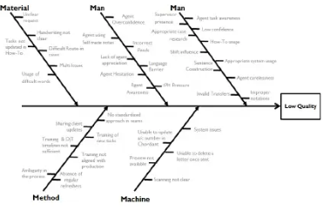
Figure 2.2. Cause and Effect Diagram / Fish bone diagram

  - Check Sheets
Check Sheets is one of the simplest tool that helps us standardize activities. It can be used in any process and can be easily customized for use.
- Used for real time data collection
- A check sheet has marks as described in the figure
- The marks are divided in separate groups
- Mostly used to identify defects in a process
- Also used to standardize activities and as a reminder tool for effective planning

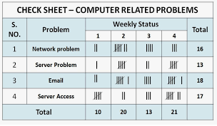
Figure 2.3. Check sheet
  - Control Charts
Control Charts were developed by Walter A. Shewhart in 1920’s. It helps us to understand whether the process is in statistical control.
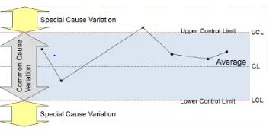
Figure 2.4.Control Charts

2.6. Relevant procedures for MUDA Identification
It is not easy to find waste when you look at the production line or the warehouse or an operation. If you have never been involved in improvement activities you will find it even harder to discover waste that may be right in front of you. Waste is everywhere, in every operation; it is so common and you are so used to it that it is hard to see.
The steps to effective waste identification are:
    - Make waste visible:- Waste can be made visible in several ways such as:
- Shop layout analysis
- Process flow analysis
- Take photos/video
B. Be conscious of the waste: -When something is denied as waste, it also cannot be stopped.
C. Be accountable for the waste: -When one refuses to accept responsibility for the waste, then he/she will not eliminate it.
D. Measure the magnitude of the waste: -When the waste is not measured, people may think it is small or insignificant and therefore will not be motivated to stop it. What is not measured is not improved. Appreciate its size and magnitude.
- Do time study by work element
- Measure Travel distance
- Measure Total steps
- Make list of items/products, who produces them and who uses them & those in warehouses, storages etc.

Self-check-2

Part I: Say true or false (each 1 point)
- Tape is one of the tools to identify Muda/ wastes.
- Planning is the most basic and primary function of management.
- Overproduction is of the 7 types of Muda.
- Eliminating Muda decreases job satisfaction.

Part II: Choose (each 1 point
- Of the following which one is wastage?
A. overproduction C. motion E. all
B. defects D. over-processing
- Making waste visible during waste identification is through
A.Shop layout analysis
B. Process flow analysis
C. Take photos/video
D. all
- Which one of the following is among the eight pillars of TPM?
A. Quality management B. Planned Maintenance
C. Education and Training D. all
- Of the following one is quality control (QC) tool.
A. cause and effect diagram B. Pareto charts C. scatter diagram D. all E. none

Part III: Short answer
1. What are the seven deadly wastes/Muda? (7 points)
2. Write at least two causes and effects of each type of the seven deadly wastes/Muda. (10)
3. What are the benefits of identifying and eliminating wastes/Muda to a company? (4 points)
4. What are the benefits of identifying and eliminating wastes/Muda to the workers of a company? (4 points)
5. Write down the steps to identify wastes/Muda. (4 points)
6. List out at least three ways to make waste visible. (3 points)
7. What are the four factors to be identified in arrow diagram? (4 points)

Unit Three: Analyze causes of a problem
This unit to provide you the necessary information regarding the following content coverage and topics:
  - Listing Possible causes of a problem
  - Analyzing Cause relationships using 4M1E
  - Finding root cause of the problem
  - Creative idea generation to eliminate most critical root causes
  - Preparing Action plan to implement solutions
This guide will also assist you to attain the learning outcomes stated in the cover page. Specifically, upon completion of this learning guide, you will be able to:
- Identify and list possible causes of a problem.
- Analyze cause relationships using 4M1E.
- Select the root cause which is most directly related to the problem.
- List all possible ways to eliminate the most critical root cause using creative idea generation.
- Evaluate the solutions for potential complications.
- Prepare detailed summaries of the action plan to implement the suggested solution.

3.1. Listing possible causes of a problem

Waste of defects can be caused by inefficiencies in manufacturing processes, unclear operating procedures, and poor quality raw materials from suppliers, or staffs who are poorly trained in the use of machinery or tools.
Common causes of Inventory Waste include:
- Overproduction of goods
- Delays in production or 'waste of waiting'
- Inventory defects
- Excessive transportation

3.2. Analyzing Cause relationships using 4M1E
The 4M is a method that allows identifying and group causes that impact to a specific effect. 4M categories (Material, Method, Machine, and Man) and Environment are often used in the Cause-Effect Diagram created by Kaoru Ishikawa.
Table 3.1 sample of 4M1E diagram
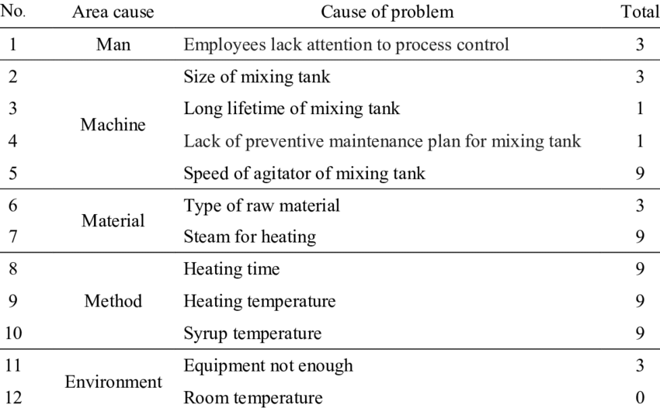

3.3. Finding the root cause of the problem
Root causes are the basic reasons behind the problem or issue you are seeing in the community. Trying to figure out why the problem has developed is an essential part of the "problem solving process" in order to guarantee the right responses and also to help citizens "own" the problems.
3.3.1 "But why" technique
The "But why?" technique is one method used to identify underlying causes of a community issue. These underlying factors are called "root causes." The "But why?" technique examines a problem by asking questions to find out what caused it. Each time an answer is given, a follow-up "But why?" is asked.
For example, if you say that too many people in poor communities have problems with alcoholism, you should ask yourself "but why?" Once you come up with an answer to that question, probe the answer with another "but why?" question, until you reach the root of the problem, the root cause.
3.3.2 The need to identify root causes
Identifying genuine solutions to a problem means knowing what the real causes of the problem are. Taking action without identifying what factors contribute to the problem can result in misdirected efforts, and that wastes time and resources. However, by thoroughly studying the cause of the problem, you can build ownership, that is, by experiencing the problem you will understand it better, and be motivated to deal with it.
The "But why?" technique can be used to discover basic or "root" causes either in individuals or broader social systems:
It can be used to find which individual factors could provide targets of change for your cause, such as levels of knowledge, awareness, attitudes, and behavior.
Do people need more knowledge about nutrition?
Do children need to learn refusal skills to avoid smoking?
Do teenagers need to learn how to use contraceptives?
It can explore social causes. For example, it could help us determine why a certain neighborhood seems to have a higher rate of a specific problem. These social causes divide into three main sub-groups:
- Cultural factors, such as customs, beliefs, and values;
- Economic factors, such as money, land, and resources;
- Political factors, such as decision-making power.
It can uncover multiple solutions for a certain problem and allow the user to see alternatives that he or she might not have seen before. It increases the chances of choosing the right solution, because many aspects of the problem are explored during the "But why?" exercise..

3.4. Creative idea generation to eliminate most critical root causes
Idea generation is defined as the process of creating, developing and communicating abstract, concrete, or visual concepts. To put it simply, it’s the process that requires finding new solutions for practical problems in all fields of life and work.
3.4.1. Elements of creative idea generation
- Focus
- People
- Tools and
- Time
3.4.2. Idea generation methods
Although it may seem like a random set of numbers at first glance, the 5W+H method is a really meaningful way to cope with the creative drought. The technique represents basic questions you need to ask when thinking about a specific topic: Who, what, where, when, why, and how?
  - Social Listening
Idea generation doesn’t mean you have to come up with a great suggestion single-handedly. On the contrary, sometimes it’s enough to do a little bit of social listening and see what the target audience has to say about a certain topic. You can use social networks like Facebook or Twitter to find precious ideas coming from end-users.
Besides that, you can always organize an opinion poll to directly ask people what they want. For example, a platform such as Survey Monkey allows you to launch a simple survey within minutes, so why not use it as the idea generation tool?
  - Brainstorming
Brainstorming is a well-known method that people all over the world use for decades already. What makes this tactic so popular? Well, it’s the fact that no one gets laughed at for proposing a stupid idea. There is no right or wrong here – you just need to say the first thing that comes to your mind and that’s it. After a quick brainstorming session, you just need to filter through all suggestions and find the ones that have the biggest potential to succeed.
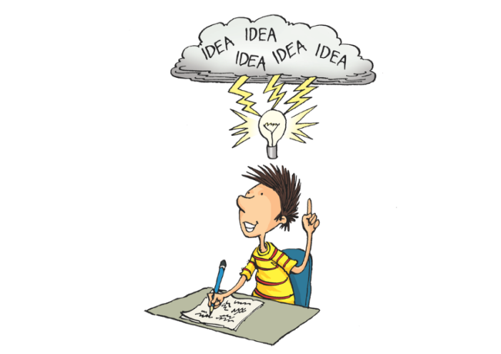
Fig 3.1 Brainstorming
  - Role Playing
Walking in someone else’s shoes is everything but easy, but sometimes it’s the only way to break the barrier and think of a brilliant idea. The process is simple: you just need to switch places with your colleagues and try to embrace their point of view. It doesn’t guarantee immediate results, but it often leads to interesting conclusions and brand new ideas.
  - Use Online Tools
The Internet is filled with interesting tools that can assist you in identifying alternative ideas. You can choose between many different options, but the final decision usually depends on the nature and peculiarities of your business. However, we can definitely recommend a couple of valuable platforms here:
  - Mind Mapping
Mind mapping is another method to get through the creative drought successfully. By definition, a mind map is a diagram for representing tasks, words, concepts, or items linked to and arranged around a central concept or subject using a non-linear graphical layout that allows the user to build an intuitive framework around a central concept.
Let’s say you are writing a screenplay. In this case, you can put the main character in the center of the map and then add links leading to all other elements of your movie – from plot and love relationships to supporting roles.
  - Think in Reverse
The last solution on our list is very amusing. Instead of thinking about how to reach your goal, you can think about how not to achieve it. For example, you can make a plan on how to reduce the number of face book followers instead of increasing it. The so-called negative thinking often leads people to unbelievable conclusions, which in turn brings them a bunch of new ideas.

3.5 Preparing Action plan to implement solutions
Action planning is the process in which you plan what will happen in the project or organization in a given period of time, and clarify what resources are needed to make it possible.
In project management, an action plan is a document that lists the action steps needed to achieve project goals and objectives. Therefore, an action plan clarifies what resources you’ll need to reach those goals, makes a timeline for the tasks or action items and determines what team members you’ll need to do it all. We’ll define what project goals, project objectives, action items and action steps are later on in this guide.
When someone prepares an action plan for Muda identification, the following things have to be considered:
- Define your Goals
- Define your Objectives
- Define Action Steps
- Identify and Prioritize Action Items
- Define Roles & Responsibilities
- Allocate Resources
- Set SMART Goals
- Set a Timeline for your Action Plan
- Use a Project Management Tool

Self-check-3
Part I: Write True for correct statements and False otherwise.
1. The 4M is a method that allows identifying and group causes that impact to a specific effect.
2. Idea generation is the process of creating, developing and communicating abstract, concrete, or visual concepts.
3. Setting SMART Goal is necessary for writing an action plan.
Part II: Choose
1. Of the following which one is a common cause of Inventory Waste?
      - Overproduction of goods
      - Delays in production or 'waste of waiting'
      - Inventory defects
      - Excessive transportation
      - all
2. Waste of defects can be caused by
A. inefficiencies in manufacturing processes C. poor quality raw materials from suppliers
B. unclear operating procedures D. all
E. none
3. Among the following which one is an element of creativity?
A. Focus C. Tools
B. People D. Time

4. From the following which one is not a method for idea generation?
A. brainstorming B. mind mapping C. social listening D. all E. none

Part III: short answer
1. What are the elements of creativity? (4 points)
  - How to write an action plan?(4 points)
  - What is creative idea generation mean? (2 points)

Unit Four: MUDA Elimination
This unit to provide you the necessary information regarding the following content coverage and topics:
  - MUDA elimination using KPI
  - Tools and techniques to eliminate wastes/MUDA
  - Reporting improvements
This guide will also assist you to attain the learning outcomes stated in the cover page. Specifically, upon completion of this learning guide, you will be able to:
  - .Prepare and implement Plan of MUDA elimination by medium KPT members.
  - Adopt necessary attitude and the ten basic principles for improvement to eliminate waste/MUDA.
  - Use tools and techniques to eliminate wastes/MUDA.
  - Reduce and eliminate Wastes/MUDA.
  - Identify tangible and intangible results.
  - Compare tangible results using various types of diagrams.
  - Report improvements gained by elimination of waste/MUDA.

4.1. MUDA elimination using KPI
Key performance indicators tools used for muda elimination. These include
- 5S
- 4M (Machine, Method, Material and Man)
- 4p (Policy, Procedures, People and Plant)
- PDCA cycle
- Basics of IE tools and techniques
To remove a waste in a workplace, follow these steps
1. Identify the Key Areas of Waste
Anything that provides no value to the customer and contributes nothing to your bottom line but has a cost can be classified as waste. It may exist in every department of your company. Thus it’s critical for you to find out the most common areas of waste in your business.
2. Manage Inventory Efficiently
Efficient inventory management means keeping the proper inventory (including raw materials, WIP, and finished goods), thereby reducing the risk of loss, decay, and damage. So, how do you control the procurement of goods at a manufacturing plant? First of all, you must be able to forecast your inventory needs. Then, you need to make sure that the amounts and types of materials you keep are adequate for your production. Also, the goods you will produce follow your customer demands. This step aims to make sure that there will be no more unnecessary purchases.
3. Reduce Packaging Materials Usage
Product packaging is one of the significant contributors to waste. Good packaging designs are sometimes needed to highlight the uniqueness of your product, but that does not mean you have to sacrifice a lot of money for them.
Redesign your product if that’s possible. For example, replace your product packaging with reusable and recyclable materials for starting a zero-waste lifestyle. Also, consider ​​making a new product out of the cardboard boxes or leftover plastics that you use to pack your current products.
  - Establish Routine Maintenance Schedules
Check the condition of your machines and equipment regularly. Equipment damage or failures lead to unplanned downtime in the production process and other activities on the shop floor, which then cause order fulfillment delays. Furthermore, you will end up spending more on new machines and equipment. Therefore, it’s important to schedule regular preventive maintenance.
  - Use Automation for Your Business
You may be thinking that investing in software is not the right solution to reduce waste since you will still need to spend quite a lot of money to implement it. However, the cost you will spend on software is much cheaper than the costs you have to pay regularly on your workers, new machines, reparations, and other unnecessary tools.

4.2. Tools and techniques to eliminate Muda
4.2.1. Adopting the Necessary Attitude
First you must adopt an attitude that supports your ability to see waste. Waste is hard enough to find when you want to find it; if you don’t want to find it, or if your response to find it is denial or resistance, then it will never be possible for you to root out waste and make your work environment stress free. It is very important that you understand that one purpose of discovering waste is to take the frustration out of your work.

Many people will resist seeing the waste in their work. Just don’t let it be you. You may hear yourself or others saying things like: “Let’s not fix what is not broken.” “Can’t we live well enough alone?” “This is just another attempt to make us work harder for the same amount of money.” “It looks good on paper, but it will never work on the floor.” “We tried that twenty years ago. It didn’t work then; it won’t work now.” “That is not my job.” And so on.
4.2.2. The Ten Basic Principles for Improvement
- Throw out all of your fixed ideas about how to do things.
- Think of how the new method will work-not how it will not.
- Don’t accept excuses. Totally deny the status quo.
- Don’t seek perfection. A 50 percent implementation rate is fine as long as it is done on the spot.
- Correct mistakes the moment they are found.
- Don’t spend a lot of money on improvements.
- Problems give you a chance to use your brain.
- Ask “Why?” at least five times until you find the ultimate cause.
- Ten people’s ideas are better than one person’.
- Improvement knows no limit.

4.2.3. Elimination of the seven types of Wastes/Muda
    - Eliminating Overproduction Wastes
In order to balance capacity and load without overproducing, you must implement the advanced methods of lean production:
- Full work
- Line balancing
- Quick-changeover operations.
- Level production - small-lot, mixed production.
- Eliminating Inventory Wastes
- Production leveling
- Regulating the flow of production
- Quick changeover operations
C. Eliminating Motion Wastes
- Create U-shaped cell layout of equipment
- Make standardization in workshop
- Increase operator awareness about motion during an operation
D. Eliminating Conveyance/Transportation Wastes
Basically, conveyance waste is corrected by redesigning equipment layout to create a flow between operations. Then you will be able to take out much of the complexity in the conveyance system and decrease material handling to a minimum. Some of the lean production methods that address conveyance flow:
- U-shaped manufacturing cells
- Flow production
- Multi skill workers
- Standing to perform operations
- Higher utilization rate
E. Eliminating Waiting/Idle Time Wastes
- Production leveling
- Product-specific layout
- Mistake-proofing
- Human automation
- Quick changeover
F. Eliminating Defect Wastes
- Standard operations
- Mistake-proofing devices
- Full-lot inspection
- Building quality in at each process
- Follow production
- Elimination of the need to pick up and set down work pieces
- Improvement of jigs using human automation
- Promotion of value analysis and value engineering
G. Eliminating Processing Wastes
- More appropriate process design
- Review of operations
- Thorough standardization
- Promotion of value analysis(VA) and value engineering(VE) techniques

4.3. Reporting muda improvements

Reporting means relating to the issuing of reports. Reports communicate information which has been compiled as a result of research and analysis of data and of issues. Reports can cover a wide range of topics, but usually focus on transmitting information with a clear purpose, to a specific audience.
4.3.1. Types of report
There are different types of reports. Among those the following are listed below.
- Formal or Informal Reports
- Short or Long Reports
- Informational or Analytical Reports
- Proposal Report
- Vertical or Lateral Reports
- Internal or External Reports
- Periodic Reports
4.3.2. Characteristics of Good or Essential report
- Suitable Title
- Simple
- Promptness
- Comparability
- Consistency.
- Precise and Accurate
- Relevant Information
- Presented to Required Person or Group or Department

Self-check-4
Part I: Say True or False
  - Muda is anything that does not have value or does not add value.
  - A reporting entity is an organization or company, or group of companies that prepares financial reports.
  - Periodic report is one of the types of report.
Part II: Choose
    - Of the following which one is the way to reduce wastes?
A .manage inventory efficiency
B. reduce packaging material usage
C. leverage automation
D. all
E. none
2. Which one isnot Characteristics of Good or Essential Report?
A.Suitable Title C.Promptness E. none
B. Simple D. all
3. How can you Eliminating Inventory Wastes?
A. by Production leveling. B. By Pull production using kanban
C. By regulating the flow of production D. By quick changeover operations E. all
Part III: Short Answer
1. List down the type of report? (4 points)
2. Write at least two methods how to eliminate each of the seven deadly wastes. (5 points)
3. What are the characteristics of essential report? (5 points)

Unit Five: Prevent occurrence of wastes and sustain operation
This unit to provide you the necessary information regarding the following content coverage and topics:
  - Plan of MUDA prevention
  - Standards required for machines
  - Creating waste-free workplace
  - Building capability of the work team
This guide will also assist you to attain the learning outcomes stated in the cover page. Specifically, upon completion of this learning guide, you will be able to:
- Prepare and implement Plan of MUDA prevention.
- Discuss and prepare Standards required for machines.
  - Prevent occurrences of wastes/MUDA using visual and auditory control methods.
  - Create waste-free workplace using 5W and 1H sheet.
  - Do the completion of required operation.
  - Facilitate the updating of standard procedures and practices.
  - Ensure the capability of the work team on the new SOPs.

5.1. Plan of Muda prevention
As the operations in any work are going on every time, wastages are must to be created as a result of production, purchases, motion, time, storage and so on. It is incredible that a manager of any Hotel in hospitality cannot create a Hotel operation without muda. As a Bakery and Pastry production trainee what you are expected to understand that you need to have a plan how to prevent mudas and also to reduce them before the day to day Kitchen activity commences.

5.2. Standards required for machines
Working tools, machines, procedures and the overall operations have their own intended standard. That specified standard enables us to achieve the expected success we need while using that machine. To apply this, tools, machines, procedures and the overall operations must be at their optimum standard level during the operation.
Standard work ensures a safe working environment (reduces Muri), facilitates efficient use of both man and machine (reduces Muda), and makes sure everybody performs a task the same way (reduces Mura). It is also used to preserve knowledge and skills, forms the basis for continuous improvement, is the communication tool for all improvements as well as the documentation of improvements, it is used as training material and is used as a reference for employees.
To implement standard work
- Create a SIPOC (suppliers, input, process, output and customer
- Create process maps
- Evaluate availability of standard operating procedures (sop’s)
- Update current sop’s to single-page documents when possible
- Create missing sop’s
- Build an easy accessible sop-database
However, there are Factors affecting equipment effectiveness including
- Equipment failure (breakdown)
- Setup and adjustment downtime
- Idling and minor stoppages
- Reduced speed
- Process defects
- Reduced yield

5.3. Creating waste-free workplace
There are five important methods you can use for maintaining a waste-free production environment.
      - Standardization
Standardization means establishing standard procedures for every operation so that anyone can understand and use them – and everyone does. There are many aspects to standardization. Standards must be created, documented, well-communicated, adhered to, and regularly re-assessed.
Standards are required for:
- Machines
- Operations
- Defining normal and abnormal conditions
- Clerical procedures
- Procurement
- Visual and Auditory Controls
One way waste enters into operations is when standards are not improved to meet changing conditions. Even standardization fails to sustain waste-free production if not systematically updated to take advantage of new materials, new technology, and worker improvement ideas. If the slightest defect occurs, the standard must be reconsidered.
The factory is a living thing and must constantly be adjusted to stay responsive to changes in the environment. Responsiveness must be systematic so that problems are addressed without losing the solid foundation of the waste-removing methods already established. The best way to do this is through visual and auditory controls.
- Red-tagging –
You probably did this at the beginning of your improvement activities when you implemented 5S. If not, do it now: put a red tag on everything in the factory that is not necessary to the current operations of the production process. Management can decide what to do with them: they can be sold, thrown out, or moved to a location where they are needed. Always keep the production floor free of any thing that is not directly part of the production process.

Fig 5.1 red tag
- Signboards-
The purpose of workstations and the names of the workers who operate them should be displayed at every processing point. Signboards can also identify equipment and processes so that everyone knows what things are and what they are used for. Standard quantities should be included on supply bins or carts. The products produced on each line or in each cell can be displayed, and so on.
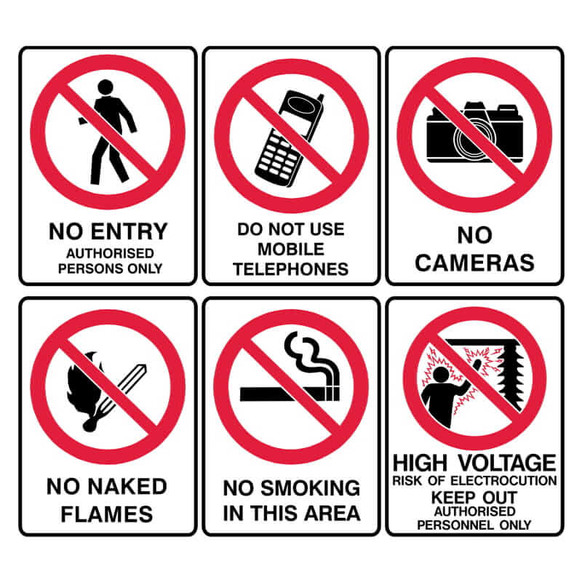
Fig 5.2 safety sign board

- Outlining-
Boarders around tools and equipment, big and small, help people find and return things. Outlining can also create patterns of work-flow by using the floor to indicate where and where not to place things, where to walk, safety zones and danger zones. Outlining to indicate goods to be processed or parts that have been processed becomes a signal to material handlers for replenishing or for delivery to the next process.

Benefits of Addressing Waste
- Save Money -
- Knowledge is power - By understanding the amount and types of wastes your organization produces, you’re better positioned to find ways to reduce hauling costs and negotiate for waste and recycling services that actually fit your needs.
- Streamline reporting and information sharing - Tracking your waste management activities in one platform and using a standard set of metrics, makes it easier to share and report information with stakeholders.
- Enhance sustainability - Managing waste, water, and energy more efficiently are core components of sustainability. Improving your organization’s sustainability can boost your corporate image, attract quality tenants to your properties and positively engage employees.
- Reduce greenhouse gas emissions - Waste prevention and recycling offer significant potential for reducing greenhouse gas emissions.
- Conserve resources - Reuse and recycling conserves natural resources including trees, metals and water.

5.4. Building capability of the work team
Kaizen concept and strategy and its embraced tools emphasize and revolve around Team work activities. So it is worthwhile to present from bibliography types of teamwork with their characteristics that used in specific circumstances and can be adjusted or modified to any company to promote kaizen activities.

One of the most compelling reasons for the movement toward implementing empowered work teams is the fact of teams work. The basic rationale is that the use of teams allows an organization to take advantage of the diverse, backgrounds, and interests of team members. The team effort and cooperation often result in a motivated and entrepreneurial workforce.
According to Laureau and Orsburn et al (30), a work team is a group of employees that is responsible for activities on a "whole" work process that delivers a product or service to internal or external customers. The product could be a chair or a service, such as a fully analysis on a company’s health and safety claims. Work team members are people who have the power to manage the work they do on daily basis. A work team typically consists of two to ten highly trained workers

Self-check-5
Part I: Say True or False (each 1 point)
  - TPM brings maintenance into focus as a necessary and vitally important part of the business.
  - The primary purpose of standardization is to create and sustain a waste-free process.

Part II: Choose
1. Of the following which one helps you to plan Muda prevention?
A. standardization B. 5W + 1 H C. visual and auditory controls D. all
2. From the following identify the target of TPM.
A. productivity B. cost reduction C. safety D. all E. none
3. All of the following are factors that affect equipment effectiveness. Except:
A. breakdown B. process defect C. reduced yield D. none
4. Which one is the benefit of addressing wastes?
A. save money B. enhance sustainability C. conserve resource D. all

Part III: Short Answer
1.How 5W and 1H sheet does maintains a waste free environment? (3 Points)
2. What is Total Productive Maintenance (TPM)? (3 Points)
3.What are the four types of maintenance? (4 Points)
4. Describe the four types of maintenance. (8 Points)
5. List at least 4 disadvantages of breakdown maintenance? (4 Points)
6.What are the advantages of preventive maintenance over breakdown maintenance? (3 Points)
    - What are the eight pillars of TPM? (8 Points)
    - What are the aims of each pillars of TPM? (8 Points)

References
        - Identifying Waste on the Shop floor (1996).
        - Ethiopian Kaizen Manual (2011)
        - https://www.hashmicro.com/blog/how-to-reduce-waste-in-manufacturing/
        - https://www.coursehero.com/file/64035458/Cause-and-effect-of-mudadocx/
        - https://www.nibusinessinfo.co.uk/content/reduce-waste-production
        - https://www.researchgate.net/publication/344467796_Waste_Muda_Elimination_Workshop

Participants of this Module (training material) preparation
No | Name | Qualification | Educational background | Region | College | Mobile number | E-mail
1 | Mohammed Liben Mohammed | Hotel and Tourism Sector head | - BA degree in Hotel and Tourism management  - MA degree in Disaster Risk Management | Somali | Jigjiga Polytechnic college | 0992326557 | cherechaw@gmail.com
2 | Abreham Mayza mengesha | Instructor | Bed degree in Hotel and Tourism | SNNP | Arba minch Polytechnic college | 0913711922 | Abrehammayza9@gmail.com
3 | Zelalem Almaw Endalew | Instructor | - BSC degree in Food science and post harvest technology | Amhara | Bahir dar Polytechnic College | 0918012521 | Parazolla25@gmail.com
4 | Hiwot Tedla Belay | Instructor | BA degree in Accounting and finance and diploma in Hotel Management | Hareri | Harer Polytechnic College | 0913789086 | hiwietaba@gmail.com
5 | ZuryashWork Belay Nigatu | Instructor | BA degree in Hotel Management | Addis Ababa | TTI | 0911643817 | zwb@gmail.com

