Bakery and Pastry Production
Level- II
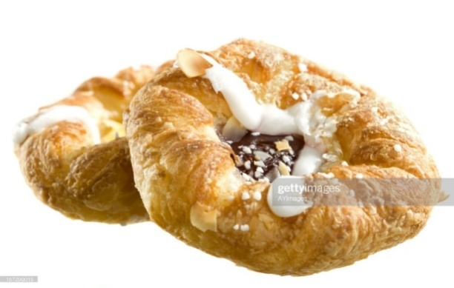
Based on November 2022 Curriculum Version II
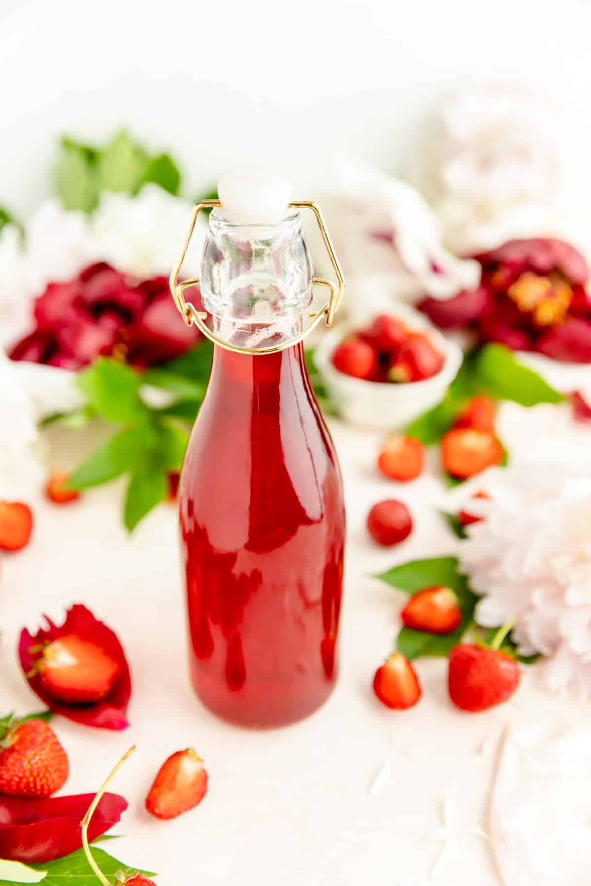
Module Title: preparing Fillings, Sauce and syrup
Module code: CST BPP1 M02 1222
Nominal duration: 32 Hours

Prepared by Ministry of Labor and Skills

December, 2022
Addis Ababa Ethiopia

Acknowledgment
Ministry of Labor and Skills wish to extend thanks and appreciation to the many representatives of TVT instructors and respective industry experts who donated their time and expertise to the development of this Teaching, Training and Learning Materials (TTLM).

Table of Contents
Acknowledgemnt …………………………………………………………………………………1
Unit One: Prepare Fillings 5
1.1 Filling preparation 6
1.2. Preparation temperature 10
SELF-CHECK 1 11
Unit Two: Prepare sauces 21
2.1. Sauces Preparation 22
2.2. Preparing and blending fruits 23
2.3. Garnishes, glazes and finishes preparation 24
SELF-CHECK 2 26
Operation sheet 2. Preparing Fillings, Sauce and Syrup 27
Unit Three: Prepare syrup 41
3.1. Boiling Syrup 42
3.2. FlavoringSyrup 42
SELF-CHECK 3 44
Operation sheet 3. Preparing Fillings, Sauce and Syrup 45
Unit Four: Store filling, sauces and syrups 49
4.1. Storagematerials for filling, sauces and syrups 50
4.1. Determine storage temperature for filling, sauces and syrups 51

Introduction to the Module

Filling is a thick mixture which is used between the layers of cake. It may be some of the frosting to which nuts, marshmallows or fruits are added. Whipped cream and custard mixtures are sometimes used for fillings. Each of these dessert toppings clearly has its place.
Dessert sauce is typically drizzled or poured atop various desserts, and may also be drizzled or poured on the plate. Dessert sauce examples include caramel sauce, custard, crème anglicise, chocolate sauce, dulce de leche, fruit sauces such as blueberry sauce, raspberry sauce and strawberry sauce
The traditional dessert syrup is one part water to one part sugar by weight. Thinner syrups, such as those used as glazes, are made with two parts water. Of course, these are less sweet. Syrups are easy to use to sweeten hot or cold beverages. In the winter, you can mix them with cocoa powder and a pinch of cinnamon to make rich hot chocolate.

This module covers the units:
- Prepare Fillings
- Prepare Sauce
- Prepare Syrup
- Store Filling, sauce and Syrups

Training Objective of the Module
At the end of this season, the students will be able to:
- Prepare Fillings
- Prepare Sauce
- Prepare Syrup
- Store Filling, sauce and Syrups

Module Instruction
For effective use this modules trainees are expected to follow the following module instruction:
- Read the information written in each unit
- Accomplish the Self-checks at the end of each unit
- Perform Operation Sheets which were provided at the end of units
- Do the “LAP test” given at the end of the unit and
- Read the identified reference book for Examples and exercise

Unit One: Prepare Fillings
This unit is developed to provide you the necessary information regarding the following content coverage and topics:
- Filling Preparation
- Fillings the correct temperature

This unit will also assist you to attain the learning outcomes stated in the cover page.
Specifically, upon completion of this learning guide, you will be able to:
- Prepare fillings
- Apply Fillings temperature

Filling preparation

    - Filling
Filling is a thick mixture which is used between the layers of cake. It may be some of the frosting to which nuts, marshmallows or fruits are added. Whipped cream and custard mixtures are sometimes used for fillings. Each of these dessert toppings clearly has its place.
The important of Filling is a Cake Adding filling between layers holds the layers together, giving your cake flavor as well as height.
Bakery filing
- The festivities are here and this is the time to bestow your baking dishes some amazing twists with the ready to use bakery fillings. Bakery fillings shall help you enhance the texture, taste and appearance of your baked creation. They help you infuse more taste and vibrancy to the dish. Choose from a wide variety of bakery fillings available for wholesale and retail bakeries. These bakery fillings shall help you delight your customers with great taste and flavours every time they come to you. Before we proceed further, let us talk a little on the bakery fillings and their role in enhancing your baked dishes
- Bakery fillings are bake stable ready to use fillings used to enhance the taste and flavours of your cakes, cookies, pies, puffs, donuts and more. These bakery fillings are made from the finest quality ingredients coming from the leading brands such as Callebaut, Delta Nutritives, Dawn Foods, Ta-Da!, Apyura and more
Advantages of Using Bakery Fillings
There are plenty of advantages of using bakery fillings similar to the premixes for bakery. We are pleased to share some with you before:

- Bake Stable – they don’t ooze out while baking
- Consistent Taste – Help you retain the taste of your creation for repeat order
- Long Shelf Life – Use as per the requirement of your recipe and keep the rest for next creation, since bakery fillings comes with 12 to 24 months’ self-life.
- Easy & Cost Effective – Element the need to investing in multiple ingredients, eliminate cooking time and make it convenient to use.
While working with the bakery fillings, it is important to achieve the right texture. Make sure to keep a good overview of the texture thereby maintaining the consistency of the filling.

TYPES OF BAKERY FILLINGS
There are plenty of bakery fillings available to get creative with. Nevertheless, the popular varieties are:
- Fruit Fillings – These fillings have high fruit content and concentration.
- Chocolate & Nut Fillings - These fillings are made out of good quality chocolates and nuts to help you add a different taste to your creation.
- Confectionery Fillings – These fillings help you add a great creamy texture to your baked creation
BAKERY FILLING APPLICATION AREAS
The bakery fillings can be used with a number of baked dishes. These can be best used with:
- Cakes
- Pies
- Cookies
- Muffins &
- Cupcake Donuts

Types of Fillings In Baking
- Frosting: The most common type of filling is frosting. ...
- Custard:Custard is generally referred to as a dessert or sweet sauce made with milk, eggs, and sugar Custard is a variety of culinary preparations, based on cooked mixture of milk (cream) and egg yolk.
- Whipped Cream: Whipped cream is also quite common to find as cake's filling. ...
- Buttercream: As an alternative to whipped cream, people often use buttercream filling. ...
- Ganache: is a glaze, icing, sauce, or filling for pastries, made from chocolate and cream.
Jelly filling
A thick, clear, gelatine-like substance made from fruit juice, sugar, and the thickener pectin, which are cooked together to reduce the liquid content, concentrate the flavor, and thicken the mixture. Once set, jelly is used as a spread for bread and toast and as a filling for cakes and pastries
CHOOSE THE RIGHT BAKERY FILLINGs
Choosing the right bakery filling for your baked master piece is very important to enhance the taste and texture of your final creation. These simple tips could help you choose the right bakery filling for your next creation.
- Choose a bakery filling based on the type of dish you are making. For instance, if you are making a pie or a cheese cake, you should pick up a fruit filling and consider nut or chocolate filling while making a cake or dessert.

- Consider the flavour of your creation and ensure that the bakery filling corresponds to the flavour well.
- Take a note of the texture you are looking at. For a crunchy texture, pick up a chocolate & nut filling.
- Be a little careful while using the bakery filling. The quantity should be balanced for an indulgent taste.
May include but not limited to:
- Custard
- fresh cream
- gnash
- Fruit filling
- Jam fillings
- Jelly filing

Filling ingredients

- Fillings are key ingredients in many bakery products such as:
- creams,
- fondants
- chocolate
- truffles
- pralines
- caramels and many more.
- They are incorporated into a variety of pastries and desserts such as donuts, layer cakes, eclairs, pies, turnovers, sandwich-cookies or savory baked goods to impart unique:

- Color
- Taste
- Texture
For the best performance, fillings should be stable during storage, shelf life and baking.

Preparation temperature

Food thermometers come in low-tech, high-tech, and super-high-tech versions. Any of them will tell you the internal temperature of your pie, and the number you are looking for is 175 degrees Fahrenheit. When it's time to add the fillings, make sure they're cool before you add them to the pastry – room temperature at a minimum. Add a hot steamy filling to your blind-baked or raw pastry and you'll find yourself with a soggy bottom If you have leftover vanilla sauce, keep it covered in the fridge for up to a week. Reheat it in a saucepan over low heat on the stove and drizzle it warm over baked goods or fresh fruit.

SELF-CHECK 1 | WRITTEN EXAM

Part I: choose the correct answer
- . is used to between the layers of cake ?
- Baking C. filling
- Flour D. All
- What is the important of Filling?
- giving your cake flavor as well as height C. holds the layers together
- Softer crumb D. A&C
- Which one of the following is the advantages of using bakery fillings?
- Consistent Taste C. they don’t ooze out while baking
- Long Shelf Life D. All

Part II. Matching

“A” “B”
- Whipped Cream A. fondants chocolate
- Custard B. made from chocolate and cream
- Ganache C. dessert or sweet sauce made with milk,
eggs, and sugar
- Filling ingredients D. It also quite common to find as cake's filling

Part III. Answer the following questions:
- List the main ingredients of filling.
- Mention some equipment needed for making yeast goods
- What is the advantages of using bakery fillings
- Write types of filling in baking?

Operation sheet1. Preparing Fillings, Sauce and Syrup

Operation Title: Produce fresh cream
Purpose: to produce yeast goods
Conditions or situations for the operations:
- Safe working area
- Properly operated tools and equipment
- Appropriate working uniforms fit for the practical performance

Equipment Tools and Materials:
-Mixer - scale - flour Fruit
- Oven - bowl - Milk Sugar
- Scraper - butte Egg , etc.
INGREDIENTS
4 large egg yolks
1 2/3 cups whole milk
1/2 cup sugar, divided
2 tsp vanilla extract
3 tbspcornstarch — (can use corn flour) TABLESPOONS
1 oz soft butter — unsalted
US Customary - Metric
Preparation:
- In a large pot pour milk and half of the sugar and bring to a boil. Reduce heat to medium.

- Keep the milk at low simmer. In a bowl whisk egg yolks. In a separate bowl combine the remaining sugar and cornstarch. Add egg yolks to the sugar and cornstarch mixture and whisk to combine.
DO NOT MIX THE sugar, egg yolks and cornstarch too far in advance, do it when the milk is starting to boil and you are ready to add them to it. Add 1 cup from the warm milk and carefully mix, then add mixture to the remaining warm milk and heat gently (on low heat), stirring with a wooden spoon or a whisk. Keep stirring until custard thickens, or for 3-5 minutes. This custard needs to be cooked to 185 F in order for it to become thick and not turn wattery in the fridge.
- Turn off heat and add butter, which will thicken the custard even more, after it cools down. Add vanilla. Stir again and remove from heat. You can strain custard to get rid of any lumps.
- Transfer to a bowl and cover tightly with plastic wrap on top. Cool to room temperature.
- Serve at room temperature or cold
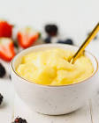
Fig.1.1 fresh cream
- Custard
Ingredients
4 cups whole milk
1 tablespoon vanilla extract
1 teaspoon butter
4 eggs
½ cup white sugar
3 tablespoons cornstarch
Preparation

- Place milk, vanilla extract, and butter in a saucepan. Cook and stir over medium heat until simmering; remove from heat before it comes to a boil.
- Whisk eggs, sugar, and cornstarch together in a bowl until sugar dissolves.
- Set the saucepan back over low heat. Pour in egg mixture slowly, whisking constantly, until custard thickens enough to coat the bottom of a spoon, 5 to 10 minutes.
- Serve warm or transfer custard into a large bowl, cover, and allow to cool before chilling.

Fig.1.2. Custard
Chocolate ganache
Ingredients
9 ounces bittersweet chocolate, roughly chopped
1 cup heavy cream
1 tablespoon dark rum (Optional)
Preparation
- Place chocolate in a medium mixing bowl.
- Heat cream in a small saucepan over medium heat. Bring just to a boil, watching very carefully because if it boils for even a few seconds, it will boil out of the pot.
- As soon as the cream comes to a boil, pour it over the chocolate in the mixing bowl. Whisk until chocolate has melted and mixture is smooth, then stir in rum.
- To use ganache as a cake glaze, cool slightly, 5 to 10 minutes. Start pouring glaze at the center of the cake and work outward.

- For a fluffy frosting or chocolate filling, allow it to cool until thick (up to 1 hour in the refrigerator), and then whip until light and fluffy. Apply it with a spatula like a conventional frosting
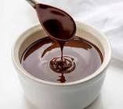

Fig.1.3. Chocolate ganache

- Fruit filling
Ingredients
4 cups fresh seasonal fruit of your choice
1 cup water
½ cup sugar
4 Tablespoons corn starch
2 Tablespoon lemon juice
Preparation

- Cut fruit into small pieces. If using a fruit with a thick skin, like peaches, you may want to peel first.
- In a sauce pan add fruit, water, sugar, corn starch and lemon juice. Bring to a boil and stir. Stirring constantly reduce heat and allow to cook until filling is thickened. (just for a few minutes).

- Makes about 3 cups prepared fruit filling.
Notes
How many cups does this make when finished. A. This recipe reduces down to about 3 cups of fresh fruit filling. It is enough filling for a three layered cake.
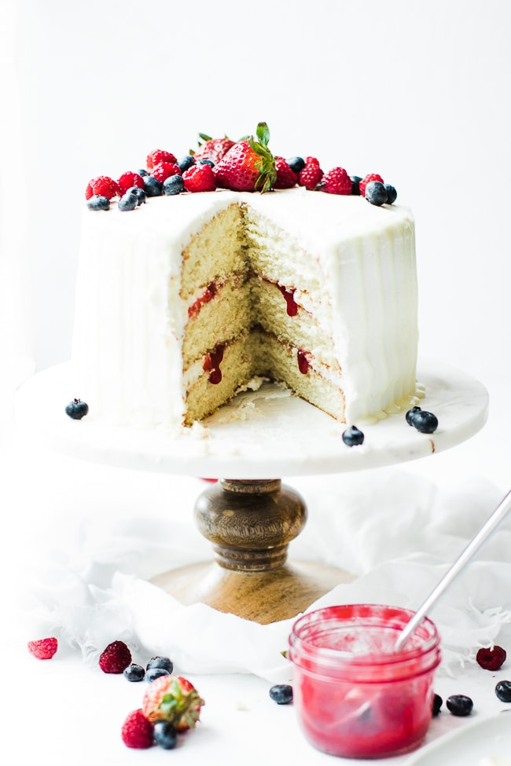
Fig. 1.4. Fruit filling
4.Frangipane filling
Ingredients
1⁄4 cup plus 2 Tbsp. sugar
1⁄4 cup plus 1 Tbsp. (3.5 oz.) almond paste
2 large eggs
1 stick (4 oz.) unsalted butter, at room temperature
3⁄4 tsp. pure vanilla extract
1⁄8 tsp. finely grated orange zest
3 tbsp. unbleached all-purpose flour
1⁄4 tsp. baking powder
1⁄4 tsp. kosher salt
Frangipane can be made up to 2 days in advance and refrigerated in an airtight container; it's far easier to spread and smooth once chilled. During assembly, there's no need to push fruit into the

filling: While baking, the frangipane will rise up and blanket it as it browns. Use as a filling for Almond Frangipane Tart with Cranberries and Honeyed Pistachios.
Preparation

STEP1. In the bowl of a stand mixer fitted with a paddle attachment, beat the sugar, almond paste, and 1 egg on medium speed until blended. Add the butter, vanilla, and zest and beat until smooth. Scrape down the bowl, then beat in the remaining egg.
STEP 2. In a separate bowl, briefly whisk the flour, baking powder, and salt. Add to the butter mixture and beat at low speed until just absorbed. Transfer to a storage container, cover, and chill for at least 1 hour or up to 2 days.
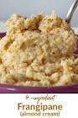
Keep Reading

Fig.1.5. Frangipane filling
- Nut fillings

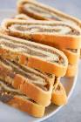
Ingredients
/2 cup packed brown sugar
1/2 cup chopped walnuts or pecans
1 teaspoon ground cinnamon
2 tablespoons butter, softened Fig.1.6Nut fillings

Preparation
In a bowl, combine the brown sugar, walnuts and cinnamon. Use for Braided Coffee Cake or Coffee Cake Ring. Spread butter over dough; sprinkle with sugar mixture
- Chocolate filling
Ingredients
List of ingredients that you can add to your cart by selecting and then choosing "Add Selected to Cart"
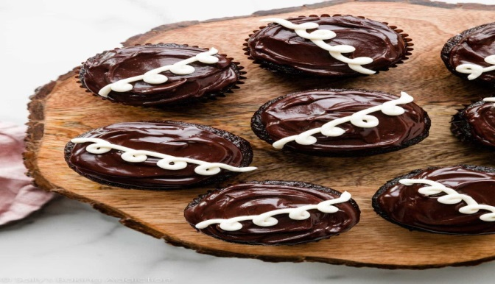
6 tablespoons granulated sugar
3 tablespoons all-purpose flour
1/2 teaspoon salt
1 cup half & half
5 egg yolks
2 teaspoons vanilla extract
1 square (2 ounces) semi-sweet chocolate,

Preparation Fig. 1.7. Chocolate filling
1 .In small saucepan, whisk together sugar, flour, salt, half & half and egg yolks until smooth.
2. Heat over medium heat until mixture is thickened, about 5 minutes, stirring constantly with a spoon or rubber spatula.
3. Remove from heat; stir in vanilla and chocolate. Continue stirring until chocolate is melted. Cool quickly. Fill cupcake.
Notes:
To prevent a skin from forming, brush surface with melted butter. Stir before using.

- Limon jam
Ingredient
16 ounces of blackberries (fresh or frozen)
1 ½ cups sugar
1 tablespoon lemon juice
½ cup bourbon
Preparation
- Put a small plate in the freezer.
- In a wide pot, mix the berries, sugar, lemon juice, and bourbon and set aside for about 30 minutes or until the sugar and bourbon has started to breakdown the blackberries.
- Bring mixture to a boil over medium-high heat, stirring occasionally

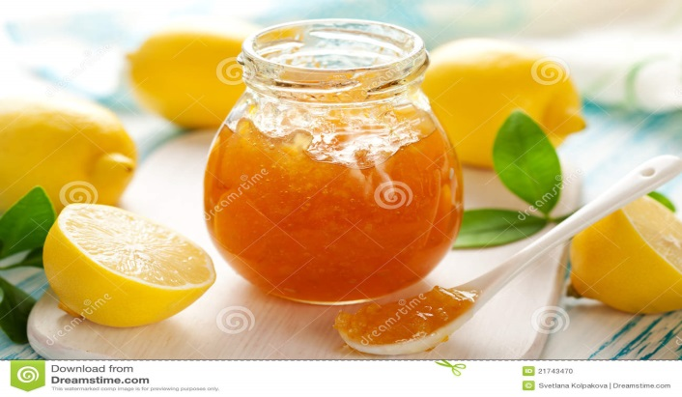
Fig. 1.8. Limon jam

Lap test 1:
Instructions: Given necessary templates, tools and materials you are required to perform the following tasks accordingly.
Task 1: pre-prepare the necessary equipment
Task 2: prepare the necessary ingredients
Task 3: measure the ingredients according to the recipe
Task 4: In a sauce pan add all ingredient
Task 5: stir and cook
Task 6: cool and stored the sauce

Unit Two: Prepare sauces
This unit to provide you the necessary information regarding the following content coverage and topics:
- sauces Preparation
- Preparing and blending fruits
- Garnishes, glazes and finishes preparation
This guide will also assist you to attain the learning outcomes stated in the cover page. Specifically, upon completion of this learning guide, you will be able to:
- Prepare sauces
- Prepare and blend fruits
- Prepare Garnishes, glazes and finishes.

2.1. Sauces Preparation

2.1.1. Essential Dessert Sauces
A dessert sauce is a sauce used for desserts. It is drizzled or poured atop various desserts, and is also used for plate decoration. Dessert sauce adds flavour, moisture, texture and color to desserts, may be cooked or uncooked, and is sometimes prepared as a hard sauce with the addition of alcoholic beverages. It is used in various manners to add flavor to and enhance the visual presentation of desserts
Dessert sauce is typically drizzled or poured atop various desserts, and may also be drizzled or poured on the plate. Dessert sauce examples include caramel sauce, custard, crème anglaise, chocolate sauce, dulce de leche, fruit sauces such as blueberry sauce, raspberry sauce and strawberry sauce.
The main dessert sauce-
- Sauces enhance desserts by both their flavour and their appearance, just as savoury sauces enhance meats, fish, and vegetables. Crème anglaise, chocolate sauce, caramel sauce, and the many fruit sauces and coulis are the most versatile. One or another of these sauces will complement nearly every dessert.
- glace or glaze is
In the culinary arts, the word glace refers to a thick, syrup-like reduction of stock which is in turn used to flavor other sauces. The word glace means "glaze" or "ice" in French and it is pronounced "GLOSS."
A coulis is a form of thin sauce made from puréed and strained vegetables or fruits. A vegetable coulis is commonly used on meat and vegetable dishes, and it can also be used as a base for soups or other sauces.

- Fruit coulis are most often used on desserts. Raspberry coulis, for example, is especially popular with poached apples or Key lime pie.

Butterscotch is a type of soft-crack candy created by slowly heating butter and brown sugar together. Just like caramel, the brown sugar molecules break down and, thanks to the addition of molasses in the sugar, caramelizes into a richer, deeper flavor than classic carame
Eight Essential Dessert Sauces:
- Strawberry Sauce. ...
- Hot Fudge Sauce. ...
- Classic Crème Anglaise. ...
- Salted Caramel Sauce. ...
- Fresh Blueberry Sauce. ...
- Chocolate Shell. ...
- Praline Sauce

2.2. Preparing and blending fruits
- Fruit sauce
- Fruit coulis are most often used on desserts. Raspberry coulis, for example, is especially popular with poached apples or Key lime pie.
- The difference between fruit compote and coulis is
- Compote: Fresh or dried fruits that have been slowly cooked in a sugar syrup and cook in fat at a low temperature (under 200 degrees F).
- Coulis: A pureed and strained fruit sauce.

- berry coulis made of a blend of raspberries, blueberries, blackberries and strawberries brightened with orange and lemon juices

2.3.Garnishes, glazes and finishes preparation

- Instant Garnishes for Desserts:
- Pomegranate Seeds.
- Slivered Almonds.
- Whole Star Anise.
- Toasted Coconut Flakes.
- Cinnamon Sticks.
- Chopped Pistachios.
- Candied Ginger.
- Maraschino
- Cherrie

- Some of the more popular items that can be used as garnishes for desserts are:
- Tuiles. ...
- Meringues (hard) ...
- Sugar. ...
- Chocolate. ...
- Marzipan/rolled fondant. ...
- Dough and Pastry. ...
- Cheese. ...
- Berries and fruit.

SELF-CHECK 2 | Written exam

Part I. Say True or False
- A dessert sauce is a sauce used for desserts. It is drizzled or poured atop various of desserts.
- Fruit coulis are most often used on desserts.
- Caramel sauce, custard, crème anglaise and chocolate sauce are not Dessert sauce
Part II. Short answer
- What is the difference between fruit compote and coulis

.
- List at list five instant garnishes for desserts:
.

- Write type of soft-crackcandy created

Operation sheet2. Preparing Fillings, Sauce and Syrup

Operation Title:Produce Standard Dessert Sauces
Purpose: to produce sauce
Conditions or situations for the operations:
- Safe working area
- Properly operated tools and equipment
- Appropriate working uniforms fit for the practical performance
Equipment Tools and Materials:
-Mixer - scale - flour Fruit
- Oven - bowl - Milk Sugar
- Scraper - butte Egg , etc.
1. Crème Anglaise Sauce -
Preparation :
Boil milk with half the sugar and scrapings of vanilla pod.
Whisk the egg yolks with remaining sugar and add few tablespoons of boiled milk to the yolk and mix it well.
Add the yolk mixture to the milk and keep stirring the sauce over the fire until it coats the back of the spoon.
Keep the sauce refrigerated and use as required.
Ingredients for 2 Kgs Crème Anglaise Sauce
Description | Qty | Unit
Milk | 0.5 | LITRE
Eggs Yolks | 0.1 | KG
Sugar | 0.15 | KG
Vanilla Pod | 0.01 | KG

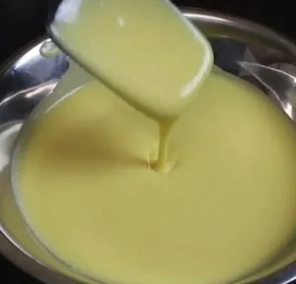

Fig 2.1. Crème Anglaise Sauce -
- Coffee Caramel Sauce -
Ingredients for 2 Kgs Coffee Caramel Sauce
Description | Qty | Unit
Sugar | 0.3 | KG
Glucose | 0.01 | KG
Nescafe | 0.005 | KG
Cream | 0.125 | LITRE
Water | 0.04 | LITRE
Salted butter | 0.025 | KG

Preparation:
- Boil the sugar, glucose and water till light caramel forms.
- Simultaneously boil the cream and add the coffee, add to the first mixture.
- Blend in chilled butter into the sauce and use it as required
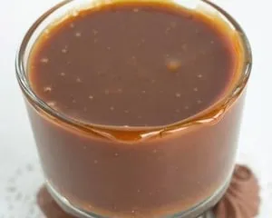

Fig.2.2.Coffee Caramel Sauce

3.Chocolate Sauce - Standard Dessert Sauces

Ingredients for 2 Kgs Chocolate Sauce
Description | Qty | Unit
Water | 2.5 | KG
Chocolate | 0.5 | KG
Sugar | 1 | KG
Corn flour | 0.1 | KG
Cocoa powder | 0.15 | KG
Milk | 0.1 | LITRE

preparation:
  - Boil water sugar and cocoa powder, thicken with corn-flour.
  - Add in melted chocolate.
  - Adjust consistency with milk.

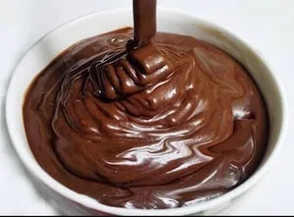

Fig.2.3. Chocolate Sauce
  - Chocolate Glaze - Standard Dessert Sauces
Preparation:
- Soak the gelatine in half of the water.
- Bring sugar liquid glucose and cream to boil.

- Make a slurry of cocoa powder with remaining water and add to the above mixture.
- Remove from the fire and add soaked gelatine.
- When tepid use it for finishing the top of cakes.

It is poured over the cakes just like a truffle.
Ingredients for 2 Kgs Chocolate Glaze
Description | Qty | Unit
Water | 0.1 | KG
Castor sugar | 0.15 | KG
Liquid glucose | 0.02 | KG
Cream | 0.1 | LITRE
Cocoa powder | 0.05 | KG
Gelatin | 0.003 | KG

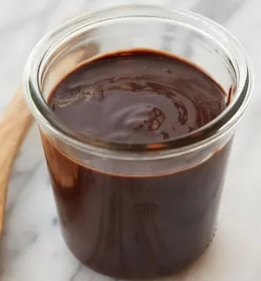

Fig.2.4. Chocolate Glaze
5. Caramel Sauce - Standard Dessert Sauces
Ingredients for 2 Kgs Caramel Sauce
Description | Qty | Unit
Sugar | 1 | KG
Water | 0.25 | LITRE
Lemon Juice | 0.02 | KG
Cooking Cream | 0.75 | KG

Preparation:
  - Mix sugar water and lemon juice and cook the sugar until it reaches a caramelisedcolour.
  - Once done take it off the fire and add fresh cream.
  - Keep the mixture back on fire to dissolve the sugar.
  - Chill and use as required.
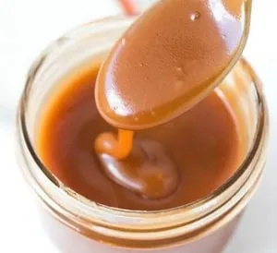

Fig.2.5. Caramel Sauce
6. Butterscotch Sauce - Standard Dessert Sauces
Ingredients for 2 Kgs of Butterscotch Sauce
Description | Qty | Unit
Sugar | 0.4 | KG
Water | 0.4 | LITRE
Butter | 0.1 | KG
Cooking Cream | 0.6 | KG
Preparation:
- Mix sugar and water and cook the sugar until it reaches a caramelized co
- Once done take it off the fire and add fresh cream.
- Keep the mixture back on fire to dissolve the sugar.
4. Remove from fire and blend in chilled butter.

5.Chill and use as required.
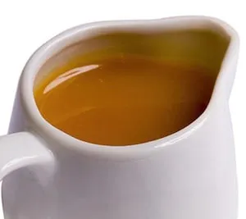

2.6. Butterscotch Sauce
7. Berry Coulis - Standard Dessert Sauces
Ingredients for 2 Kgs Berry Coulis
Description | Qty | Unit
Any berry( raspberry, Blueberry, etc) | 1 | KG
Sugar | 0.5 | KG
Cornflour | 0.05 | KG
Preparation:
- Combine berries with sugar and cook until they soften.
- Add corn flour made into a slurry with few tablespoons of water and add.
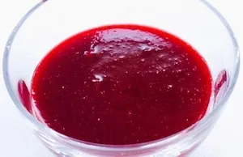
- Cook till the sauce thickens.
- Store refrigerated.

Fig.2.7. Berry Coulis

8. Sabayon sauce (zabaglione)
Ingredients
- 5 large egg yolks
- Pinch of salt
- 1/4 cup plus 2 tablespoons sugar
- 1 cup Muscat de Beaumes-de-Venise, a sweet French dessert wine
- 3/4 cup heavy cream
- 2 teaspoons freshly squeezed lemon juice

Preparation:
1. Prepare a large ice bath, and set aside. Fill a medium saucepan with 2 inches water. Set over medium heat, and bring to simmer.
2. In a large stainless-steel bowl, whisk together egg yolks, salt, and sugar until very pale. Add Muscat; whisk to combine.
3. Place bowl over a pan of simmering water, and whisk until mixture has thickened and has tripled in volume, 8 to 10 minutes. Remove mixture from heat, and immediately transfer to ice bath. Whisk until chilled.
4. In a large chilled bowl, whip cream until soft peaks form. Add lemon juice, and fold the whipped cream into the chilled sabayon. Serve immediately.
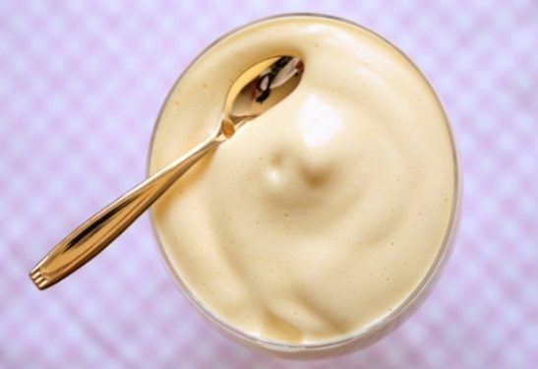

Fig.2.8. Sabayon sauce
7.Vanilla sauce
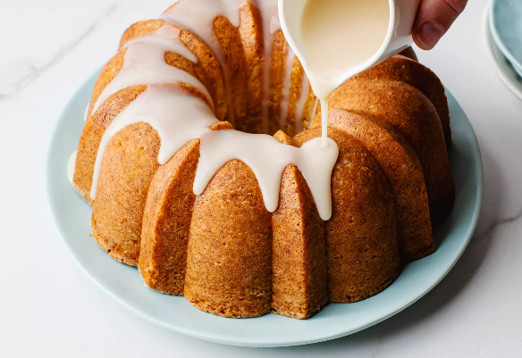
Ingredients
- 3/4 cup water
- 1/2 cup granulated sugar
- 2 tablespoons cornstarch
- 1/4 cup heavy cream
- 2 tablespoons butter
- 2 teaspoons vanilla extract
- 1 pinch salt Fig.2.9. Vanilla sauce

Preparation
- Gather the ingredients.
- Pour the water into a saucepan and place it over high heat. Bring the water to a boil.
- In a small bowl, combine the granulated sugar and cornstarch. Blend well with a whisk or spoon.
- Add the granulated sugar and cornstarch mixture to the boiling water and whisk to blend thoroughly. Reduce the heat to medium and cook, stirring constantly, until the sauce is thick. Whisk the heavy cream into the thickened sauce.
- Remove the thickened sauce from the heat and whisk in the butter, vanilla extract, and salt. Whisk until the butter has melted. Strain the sauce to remove any lumps.
- Spoon or drizzle warm or room temperature vanilla sauce onto a cake, bread pudding, or other dish. Enjoy.
How to Store
If you have leftover vanilla sauce, keep it covered in the fridge for up to a week. Reheat it in a saucepan over low heat on the stove and drizzle it warm over baked goods or fresh fruit.

Recipe Tips
- If the sauce is too thick, thin it with a small amount of milk or cream, as desired.
- To use flour instead of cornstarch, melt the butter in a saucepan and blend in the flour. Stir the sugar into the butter and flour mixture. In a separate saucepan, bring the water

- to a boil; add the boiling water to the sugar and butter mixture and cook until thickened. Add the cream, vanilla, and salt. Heat through.
- Replace the vanilla extract with an equivalent amount of vanilla paste or a vanilla bean. If you use a vanilla bean, split it and scrape the seeds into the water. Add the pods and then bring the water to a boil as directed. Continue with the recipe and remove the pods before serving.

Recipe Variations
- Fruity Vanilla Sauce: Replace a few tablespoons of the water with Cointreau, peach brandy, apple brandy, or another type of fruit-flavored liqueur. Or add up to a teaspoon of finely grated orange, lemon, or lime zest.
- Cinnamon Vanilla Sauce: Add two cinnamon sticks to the water; bring to a boil and continue with the recipe. Remove the cinnamon sticks before whisking in the butter, vanilla, and salt.
- Vanilla Rum Sauce: Replace 2 tablespoons of the water with rum or spiced rum.
- Vanilla Whiskey Sauce: Replace 2 tablespoons of the water with bourbon or whiskey.
- Nutmeg Vanilla Sauce: Add about 1/4 teaspoon of freshly grated nutmeg to the water and continue with the recipe.

How to Use
Drizzle vanilla sauce generously over vanilla sour cream Bundt cake, blueberry yogurt cake, or buttermilk pound cake. The sauce is also delicious on croissant bread pudding, fresh fruit, ice cream, or even cheesecake.
- Strawberry sauce
Ingredients
▢ 500 g fresh or frozen strawberries (notes, 1.1lb)
▢ ¼ cup white sugar (notes)
▢ 3 teaspoons cornflour (cornstarch)
Methods
- If using frozen strawberries, let them thaw first.
- Add all ingredients to a blender and blend to a puree.

- Add the puree to a saucepan over medium heat and stir regularly, letting it come to a bubble.
- Once big, thick bubbles starting breaking the surface cook for a further 2-3 minutes until thick and darkened in colour a little.
- Strain the mixture through a fine mesh strainer. You may need to do this a couple of times to get rid of as many seeds as possible.
Notes
Suggested equipment:
Weck preserving jars, heavy based saucepan.
Serve over pancakes, waffles, cheesecake, cakes, in milkshakes or even in popsicles.
Store up to 4 days in the fridge in airtight preserving jars.
Freeze up to 2 months.
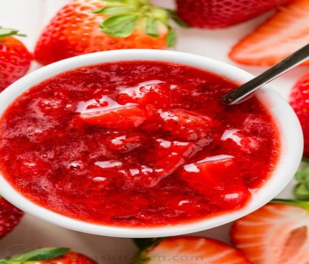
Fig.2.10. Strawberry sauce
- Strawberry coulis sauce
Ingredients
- 1 quart fresh strawberries, hulled and sliced
- 1/3 cup to ¾ cup sugar, honey or maple syrup to taste
- 1 tablespoon lemon juice
- 1 teaspoon vanilla extract

Preparation:
- Stir strawberries, sugar (or other sweetener) and lemon in a medium saucepan.

- Set over medium-low heat and bring to a simmer, stirring often. Simmer until the berries start to break down and the mixture is very juicy, 4 to 5 minutes.
- Transfer the mixture to a blender and add vanilla. Cover, and using caution puree until smooth. Alternatively, puree with an immersion blender.
- Transfer the coulis to a metal bowl and set over another larger bowl of ice water. Chill, by stirring often. Alternatively, chill in the refrigerator overnight. Serve cold.

Notes
Nutritional notes are for using 3/4 cup of sugar.
Storage and Freezing
You can refrigerate it for up to 2 weeks. Store it in a jar or in a small air-tight container. You can freeze it for up to 3 months. I like to use re-usable freezer jam jars to freeze it in smaller batches and only defrost what I need.
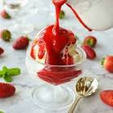
Fig.2.11. Strawberry sauce
- Orange Sauce - Standard Dessert Sauces
Ingredients for 2 Kgs of Orange Sauce
Description | Qty | Unit
Orange juice | 0.75 | LITRE
Liquid glucose | 0.1 | KG
Cornflour | 0.025 | KG
Sugar | 0.15 | KG
Grand Marnier | 0.03 | LITRE

preparation:
  - Reduce orange juice with sugar and liquid glucose, thicken with corn flour and add Grand Marnier.
  - Keep the sauce refrigerated and use as required.
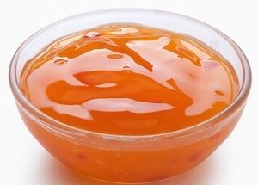

Fig.2.12. Orange Sauce
- Fruit Tarts - Standard Dessert Sauces
Ingredients for 1.8 Kg Fruit Tarts
Description | Qty | Unit
Tart shells (Refer Sweet Paste) | 0.6 | Kg
Chocolate | 0.1 | kg
Pastry cream(see Basic recipe) | 0.25 | kg
Gooseberries | 0.3 | kg
Grapes | 0.2 | kg
Cold Gel | 0.1 | kg
Whipped cream | 0.25 | kg

Preparation:
Line the tart shells with melted chocolate.
Mix the pastry cream with the whipped cream and fill in the tart shell.
Arrange the fruits on the top of the pastry cream and then glaze it with the cold gel.

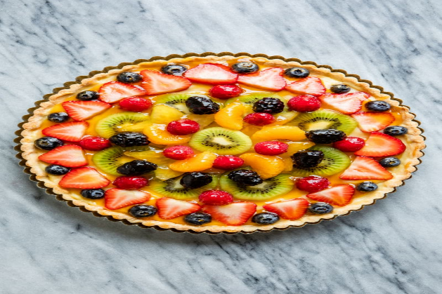
Fig.2.13. Fruit Tarts
. 14. Fruit Compote - Standard Dessert Sauces
Ingredients for 680 gms Fruit Compote
Description | Qty | Unit
Figs | 0.03 | KG
Dates | 0.02 | KG
Raisins | 0.02 | KG
Dried papaya | 0.02 | KG
Dried pineapple | 0.02 | KG
Black currant | 0.02 | KG
Kahlua | 0.04 | KG
Almonds | 0.02 | KG
Diced fresh fruits | 0.4 | KG
Butter | 0.04 | KG
Castor sugar | 0.05 | KG
Preparation:
  - Chop figs, dates, dried pineapple, dried papaya and almonds.
  - Toss in butter and add the castor sugar.
  - Add fresh fruits and finish with Kahlua.
  - You could also cook this until syrupy like consistency.

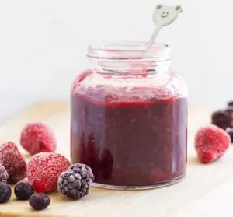

Fig.2.14. Fruit Compote

Unit Three: Prepare syrup
This unit to provide you the necessary information regarding the following content coverage and topics:
- Boiling Syrup.
- Flavoring Syrup
This guide will also assist you to attain the learning outcomes stated in the cover page. Specifically, upon completion of this learning guide, you will be able to:
- Boil Syrup.
- Add flavor to Syrup.

Boiling Syrup
SYRUPS.
- Syrup is essentially sugar dissolved in water, with or without flavors. Candy making relies almost exclusively on the special qualities of hot sugar syrups. Other foods which use them as ingredients are ice creams, baked items, drinks, and preserved fruit
- a thick, sweet liquid made by dissolving sugar in boiling water, often used for preserving fruit..
- Syrups derived from sucrose fall into three general types:
- liquid sucrose,
- invert syrups, and
- molasses

FlavoringSyrup
Original flavoured Syrups - Made with pure cane sugar, natural flavors and cold-filtered water, Toraniflavoured drink syrups provide gold-standard flavors
Make Flavoured Simple Syrups:
If you really want to make up your favorite drinks, desserts, and recipes, you need to learn how to make flavored Simple Syrups that are packed full of fresh flavors.
Step 1: Let’s start with making a plain simple syrup. A simple syrup is equal parts water and sugar mixed together then gently heated up until the sugar completely dissolves. The sugar melts completely for maximum sweetness when heated. Have you ever stirred sugar into cold tea then wondered why it doesn’t taste nearly as good as the sweet tea you might have tried at a restaurant? This article talks a little about the science, but essentially, heating up the sugar water creates a completely fluid, sweeter end product in much less time.
Step 2: Now that you know how to make the plain version of this sweet concoction, let’s talk about Flavored Simple Syrups. They are the easiest way to add flavor to your favorite classic cocktails. You can add herbs, spices, fruits, peppers, or any combination of ingredients once you have brought your simple syrup to a gentle boil and all the sugar is dissolved. Heat will

help to extract flavor from your add-ins, creating a tasty syrup. This is a raspberry blueberry basil syrup.
Step 3: Simmer heartier items like rosemary, lemongrass, or rhubarb longer for a stronger taste.
Tender herbs like thyme or soft berries will fall apart if simmered too long, so remove them from the stove almost immediately. Flavors are extracted while the syrup cools.
Get creative with unique ingredients like black peppercorns, mulling spices, or celery.
Try honey, brown sugar, or agave nectar instead of plain white sugar for different tastes.
The longer Flavored Simple Syrups sit, the stronger the flavors will be. Taste the mixture frequently as it cools. Once you are happy with your creation, strain solids from syrup and discard.
Keep syrups in a closed container in the refrigerator for up to two weeks.
Step 4: Let’s talk about how you can be super creative with these delicious concoctions now that we have the basics covered. Simple syrups are great in cocktails, but they are an equally tasty way to add flavor to iced tea or making a refreshing summer drink like this Strawberry Lemonade. You could also drizzle a simple syrup over oatmeal, pancakes, or your favorite ice cream too! Let your taste buds go wild with the possibilities.

SELF-CHECK 3 | Written exam

Part I chose the correct answer
  - . is essentially sugar dissolved in water without flavors.
- Sauce C. Syrups
- Flavoring D. All
  - Generally syrup is derived .
- liquid sucrose,
- invert syrups, and
- molasses
- All
  - Which one of the following ingredients give us flavor for syrup
- Coffee C. Vanilla
- Cinnamon D. All

Part II. Answer the following questions:
      - What are the three general types of syrup .
- How can you prepare original flavoured Syrups

- What is syrup? .

Operation sheet 3. Preparing Fillings, Sauce and Syrup

Operation Title:Producesugar syrup
Purpose: to prepare syrup
Conditions or situations for the operations:
- Safe working area
- Properly operated tools and equipment
- Appropriate working uniforms fit for the practical performance

Equipment Tools and Materials:
-Mixer - scale - flour Fruit
- Oven - bowl - Milk Sugar
- Scraper - butte Egg , etc.
- sugar syrup
Ingredients
1 cup white sugar
1 cup water
Preparation
Combine sugar and water in a medium saucepan over medium heat; bring to a boil, stirring, until sugar has dissolved. Allow to cool.
Pour into a clean jar and seal with a tight-fitting lid; store in the refrigerator for up to one month.
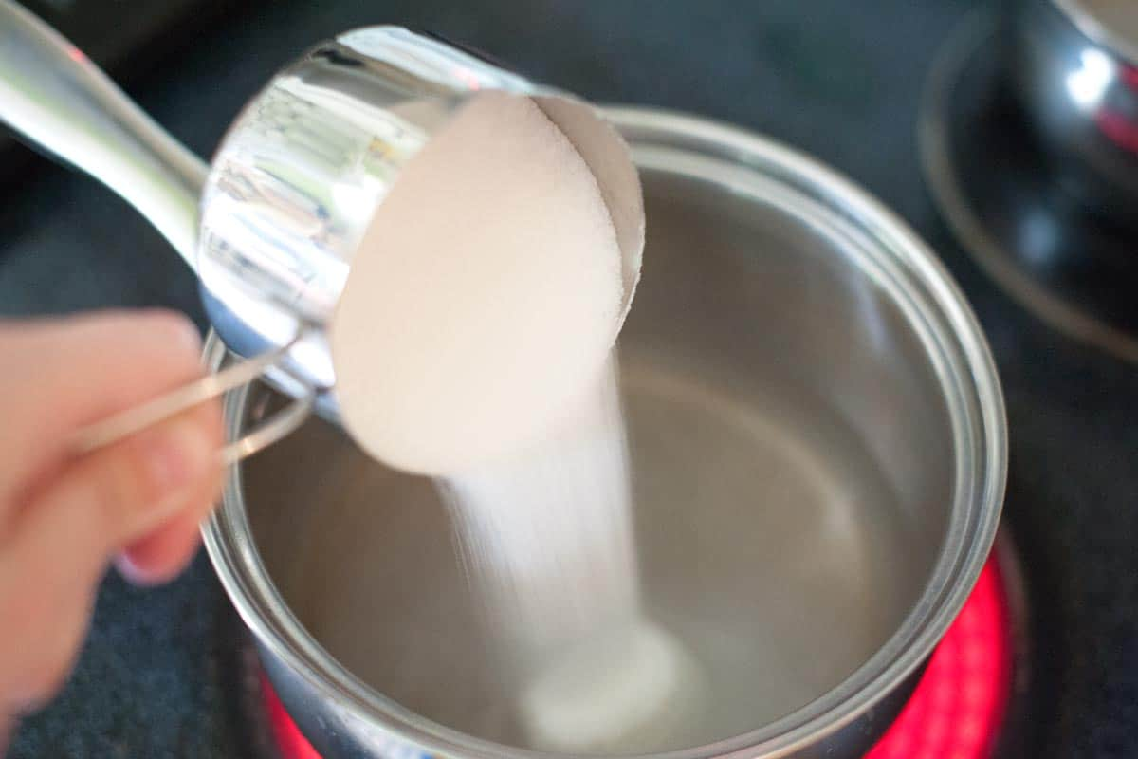
Fig.3.1. sugar syrup

- Espresso syrup
Ingredients
250g brown sugar
250ml strong black coffee
½-1 tsp (optional) vanilla extract
Preparation
STEP 1. In a pan, combine the sugar and coffee over a gentle heat, stirring until the sugar has dissolved. Remove from the heat and stir in the vanilla, if using.
STEP 2. Cool completely and sieve into a sterilised bottle or jar. Keep in the fridge for up to a month.

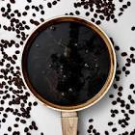
Fig.3.2. Espresso syrup
- Cinnamon syrup
Ingredients
1 cup water
1 cup white or raw granulated sugar
4 cinnamon sticks
1/2 teaspoon pure vanilla extract, optional
Preparation
- Gather the ingredients.
- In a small saucepan, bring the water to a boil and stir in the sugar until completely dissolved.
- Reduce the heat, add the cinnamon sticks. Cover and simmer for about 5 minutes

- Remove the pan from the heat. Keep covered, and allow the syrup to cool and steep for at least 1 hour; for more flavor, let it stand for up to 6 hours.
- Remove the cinnamon sticks and stir in the vanilla extract, if using.
- Transfer the syrup to a bottle with a tight seal.
- Refrigerate and use to sweeten your favorite drinks.
Tips
Store the syrup in the refrigerator; it will keep well for up to 2 weeks.
One or two cinnamon sticks will work and give the syrup a nice flavor. Consider breaking them up into large pieces to increase contact with the syrup and let the syrup steep longer for maximum flavor.
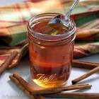
Fig.3.3. Cinnamon syrup
- Berry syrups
Ingredients
- 2 cups berries of your choice (strawberries, raspberries, blackberries, blueberries), fresh or frozen-thawed
- 3/4 cup sugar
- 1/4 cup water
Preparation
In a sauce pan, add all ingredients. Stir and mash berries with fork or potato masher.
Over medium-high heat, bring to a boil. Boil 3-5 minutes or until berries begin to break down and mixture begins to thicken.
Serve immediately or cool and store in refrigerator for up to 5-7 days.

NOTES

If using fresh berries, chop before adding to pot. Fresh berries may extend cooking time.

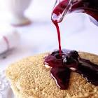
Fig.3.4. Berry syrups
- Honey Nuts syrup
Ingredients
1/2cup pecan or walnut halves
3/4cup honey
1/4cup butter or margarine
Preparation
Steps1. Cook pecans in ungreased heavy skillet over medium-low heat 5 to 7 minutes, stirring frequently until browning begins, then stirring constantly until golden brown.
Steps2. Reduce heat to low; stir in honey and butter. Heat until butter is melted and mixture is hot, stirring occasionally.
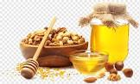
Fig.3.5. Honey Nuts syrup

Unit Four: Store filling, sauces and syrups
This unit to provide you the necessary information regarding the following content coverage and topics:
- storing materials for filling, sauces and syrups
- storing temperature for filling, sauces and syrups
This guide will also assist you to attain the learning outcomes stated in the cover page. Specifically, upon completion of this learning guide, you will be able to:
- store materials for filling, sauces and syrups
- Apply storing temperature for filling, sauces and syrups

Storage materials for filling, sauces and syrups

Store simple syrup in a sealed glass jar such as a Mason jar that you might otherwise use for jellies or preserves. While you can use any type of airtight container, some bartenders favor glass since it won't leach other flavors into your syrup.the shelf life of simple syrup can be lengthened two ways: upping the ratio of sugar to water, or adding neutral spirit.
Store the simple syrup in an airtight container, in the fridge, until ready to use. As mentioned above, basic simple syrup can stay fresh up to 4 weeks, however flavor simple syrups need to be used within a week or two.
To prevent spoilage, maple syrup should be stored in a cool, dark location such as a cupboard, refrigerator, or freezer. In this manner, maple syrup can be safely kept for a year or more. Upon opening, store your syrup container in the freezer or refrigerator, consume within a year from the date of opening.
Keep your syrup in an airtight container (plastic breathes, so repackage if needed), and keep it cool. Don't leave your bottle sitting open on the kitchen table. If you buy a large package and don't think you'll be able to use it within few months, repackage part of it and store it in the freezer.
The storage condition for most of the medications syrup will be at 25-30 degree Celsius. In another word, just leaving your medication syrup under room temperature will be adequate. Do make sure the storage place is cool dry and without any direct sun or heat exposure!
Most baked desserts should be stored at room temperature in an airtight container in order to preserve as much freshness as possible. For cakes, gently place plastic wrap over the portions that have been cut before putting the cake in an airtight container.
Material most dessert packaging is made out of plastic or paper and includes lids. Your lids should be leak-resistant and you should choose the material based on your dessert.

The primary purpose of packaging is to provide physical or barrier protection for your food products. This may include: Protecting against breakage from being dropped, crushed or vibrated during transport.

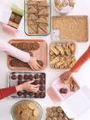
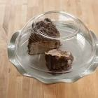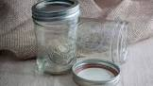
Fig.4.1. storage materials

Determine storage temperature for filling, sauces and syrups

Cakes filled and frosted with butter cream may be refrigerated overnight or frozen. Freeze uncovered until firm, then wrap in plastic wrap, then foil. Defrost wrapped cake overnight in refrigerator. Warm apple or other fresh fruit cakes, pecan or fruit tarts will keep at room temperature, covered, overnight or freeze

SELF-CHECK 4 | WRITTEN EXAM

Part I. Say true or false
- Cake is filled and frosted with butter cream may be refrigerated overnight or frozen.
- Dessert packaging materials is not made from plastic or paper and includes lids
Part II. Answer the following questions:
- How do you store fillings?
- List some storage materials that is appropriate to store fillings
- When Cakes filled and frosted with butter cream stored?

RECOMMENDED READINGS

- FROM THE INTERNET
- BAKERY & CONFECTIONARY COURSE ,FOOD PRODUCTION DEPARTMENT
KENYA UTALII COLLEGE, NIROBI
- READING MATERIALS ON PASTRY AND BAKERY PRODUCTION

Participants
No | Name | Qualification | Educational background | Region | College | Mobile number | E-mail
1 | ZuryashWork Belay Nigatu | Instructor | BA degree in Hotel Management | Addis Ababa | TTI | 0911643817 | zwb@gmail.com
2 | AbrehamMayzamengesha | Instructor | Bed degree in Hotel and Tourism | SNNP | Arbaminch Polytechnic college | 0913711922 | Abrehammayza9@gmail.com
3 | ZelalemAlmawEndalew | Instructor | - BSC degree in Food science and post harvest technology | Amhara | Bahirdar Polytechnic College | 0918012521 | Parazolla25@gmail.com
4 | HiwotTedla Belay | Instructor | BA degree in Accounting and finance and diploma in Hotel Management | Hareri | Harer Polytechnic College | 0913789086 | hiwietaba@gmail.com
5 | Mohammed Liben Mohammed | Hotel and Tourism Sector head | - BA degree in Hotel and Tourism management  - MA degree in Disaster Risk Management | Somali | Jigjiga Polytechnic college | 0992326557 | cherechaw@gmail.com

