

Bakery and Pastry Production
Level- II

Based on December 2022 Curriculum Version II
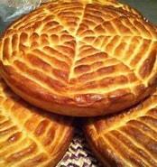

Module Title: Produce Ethiopian bread
Module code: CST BPP M03 1222
Nominal duration: 52 Hour

Prepared by Ministry of labor and skill

December, 2022
Addis Ababa, Ethiopia

Acknowledgment
Ministry of Labor and Skills wish to extend thanks and appreciation to the many representatives of TVT instructors and respective industry experts who donated their time and expertise to the development of this Teaching, Training and Learning Materials (TTLM).

Contents
Acknowledgment 0
Introduction to the module 2
This module covers the units: 2
Learning Objective of the Module 2
Unit oneSelect Ethiopian bread ingredient 3
1.1. Ethiopian Bread ingredients 4
1.2. Preparing Ethiopian bread spices 5
SELF-CHECK 1 6
Unit two Prepare and bake Ethiopian bread products 7
2.1 Equipment to produce bread products 8
2.2 Preparing variety of Ethiopian bread products 9
2.3. Preparing dough: 13
2.4. Techniques to produce bread products 13
2.5. Baking bread: 17
SELF-CHECK 2. 21
Operation sheet 1. 23
Lap test1. 29
Unit three: store bread products 30
3.1. Package bread products: 30
3.2. Store bread products 32
SELF-CHECK 3. 33
RECOMMENDED READINGS 35
Participants of this Module (training material) preparation 36

Introduction to the module

Producing variety of Ethiopian bread in bakery and pastry production field will enhance the Hospitality industry service, serving the customer in full capacity and it is very important to keep the standards of bread and other sweet desserts service. On the other hand it is also a means to create a job for small scale industries and to street food service providers
This module is designed to meet the industry requirement under the bakery and pastry production occupational standard.

This module covers the units:
- Select Ethiopian bread ingredients
- Prepare and bake Ethiopian bread products
- Store bread products

Learning Objective of the Module
At the end or the training session the trainees will be able to:
- Prepare Ethiopian bread products
- Use suitable ingredients
- Store Traditional bread productsproperly
Module Instruction
For effective use this modules trainees are expected to follow the following module instruction:
- Read the information written in each unit
- Accomplish the Self-checks at the end of each unit
- Perform Operation Sheets which were provided at the end of units
- Do the “LAP test” given at the end of the unit and
- Read the identified reference book for Examples and exercise

Unit one: Select Ethiopian bread ingredient
This unit is developed to provide you the necessary information regarding the following content coverage and topics:

- Ethiopian bread ingredient
- preparing Ethiopian bread spices

This unit will also assist you to attain the learning outcomes stated in the cover page.
upon completion of this learning guide, you will be able to:
- Identify equipment to produce bread products
- Prepare a dough to produce variety of Ethiopian bread products
- Apply baking Techniques to produce bread products.

Introduction:
Ethiopian bread is sweet and savoury vegan bread, packed with delicate aroma of ground ginger and cardamom. It pairs really well with hot chain-tea latte or cup of coffee. One of the best bread recipes that can be prepared during Christmas, Holiday season, thanksgiving or any special occasion or celebration.
1.1. Ethiopian Bread ingredients
The unique spices that go into its making arecoriander (milled)‘Absh ‘powder, blackcumin., (only to name a few)
Ingredients :
- Wheat flour
- Maize flour
- Teff flour
- All-purpose flour
- Yeast, ‘yabesha Ersho’(Yetef Ersho)
- Salt
- Oil
- Spices such as black cumin, white cumin, fenugreek,nut meg,coriander.
Purpose of ingredients:
- Wheat flour – it is the main part used as a back bone of the bread
- Yeast or’ yabesha Ersho’—it helps to make the dough rise&soft finally to get a light and fluffy bread.
- Salt –for taste and to the strengthens of the dough.
- Oil – it helps the dough to be soft, to the product gives shiny and brown crusty texture.
- Spices – unique to give special flavour to the product

1.2. Preparing Ethiopian bread spices
Spices for Ethiopian bread preparation are unique with its natural aroma.
preparation:
First we buy the spices from the market, make it clear sort out unnecessary things: separately each spice such as black cumin ,funu greek, white cumin, coriander and roast it until golden brown keep for a while until cool and grind it finely finally store it in a dry clean container keeping the lid on until used.
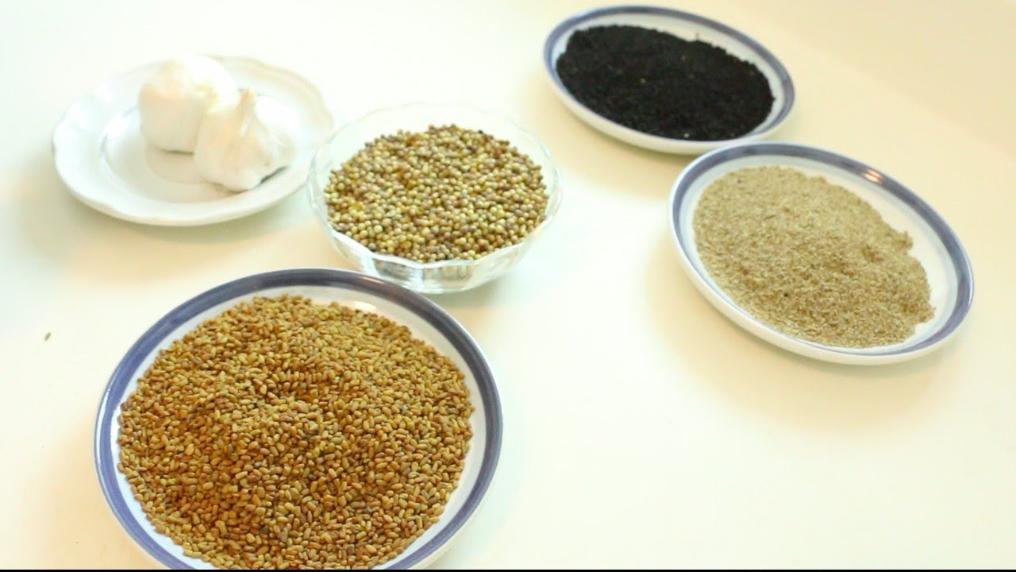

Fig1. Bread spices

SELF-CHECK 1 | WRITTEN TEST
Instruction:
Answer the following questions:
Q1.’ Yabesha ‘Ersho’ is important to give taste to Ethiopian bread. True or False
Q2. Unique spices mostly used in Ethiopian bread:
- Cumin
- Fun Greek
- Coriander
- All of the above
Q3. List all of the necessary ingredients for making Ethiopian bread.

Unit two Prepare and bake Ethiopian bread products
This unit is developed to provide you the necessary information regarding the following content coverage and topics:
- Equipment to produce bread products
- Preparing variety of Ethiopian bread products
- Preparing dough.
- Techniques to produce bread.
- Baking bread products.

This unit will also assist you to attain the learning outcomes stated in the cover page.
upon completion of this learning guide, you will be able to:

- Select Equipment to produce bread products
- Produce variety of Ethiopian bread products
- Prepare dough.
- Apply techniques to produce bread.
- Bake bread products.

2.1 Equipment to produce bread products
- Sefed
- Cups
- Sieve
- Clay metad
- Gebermitad
- Oval gebete
- Moseb
- Kolemishsh / Erbo etc.
Table 1. Traditional equipment

No. | Name of equip. | Picture | Description
1. | Gebeta /kore,  bowl | 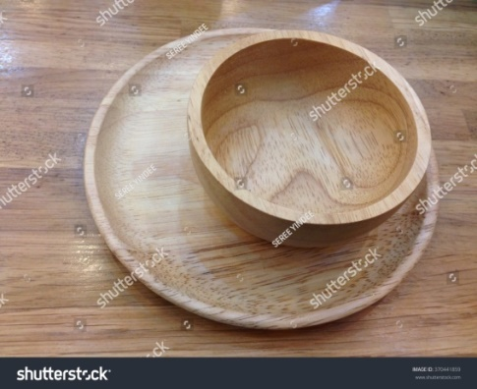 | For mixing ingredients&  making a dough
2. | Sefed | 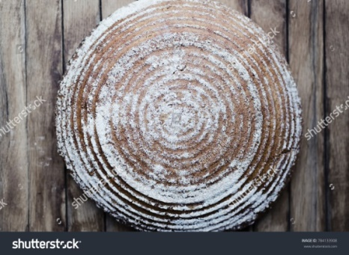 | For making form of flat bread and other uses
3. | Metad | 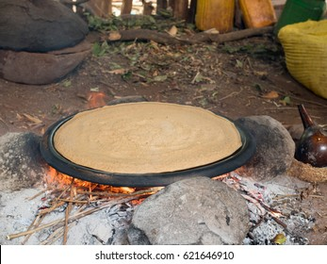 | For baking various types of bread
4.  6. | Mesob  Metad |   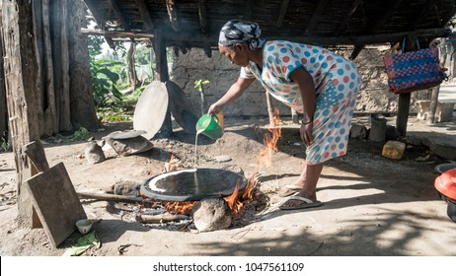 | For presenting and storing bread  Demonstrating how to use mitad

2.2 Preparing variety of Ethiopian bread products

Hambasha
istraditional Ethiopian flatbread consisting of flour, water, yeast, sugar, sesame seeds, and ground cardamom, resulting in a unique combination of sweet and savoury flavours. It is characterized by a decorative wheel pattern that is scored on its top.
Hambasha is popular type of bread in Ethiopia. It is always baked in a circular baking pan.
In Ethiopia, hambasha is traditionally consumed for breakfast after mass, but it is also a popular item at numerous festivities and celebrations. Interestingly, breaking this bread over the back of a child on his first birthday to give him strength is an Ethiopian tradition.
Hambasha is a traditional Ethiopian flatbread consisting of flour, water, yeast, sugar, sesame seeds, and ground cardamom, resulting in a unique combination of sweet and savoury flavors. It is characterized by a decorative wheel pattern that is scored on its top.
Ambasha is popular type of bread in Ethiopia. It is always baked in a circular baking pan.
To bake Ethiopian bread
Then draw concentric circles to form a wheel pattern. Brush with generous amount of butter or oil. Bake for about 20 to 25 minutes or until it is golden in colour.

Difo Dabo
It is a traditional Ethiopian bread of wheat flour, spices, oil, and sugar that’s baked in a pan lined with banana leaves.
Difo dabo/Banana Leaf Wrapped Bread is a very popular type of bread which Ethiopians mostly bake for big holidays, or to take as a gift when they visit family. And it is traditionally baked in a circular baking pan
Dabo is the generic Amharic term for “bread,” and the Ethiopian Nutrition Institute’s book Ethiopian Traditional Recipes, released in 1980, includes a part of bread recipes as well as information on the function of leavened bread in Ethiopian culture.
Dabo is hearty bread made with egg, butter, milk, honey, and fragrant spices. Although honey is available in Ethiopia, it is not commonly used in ordinary baking, nor is the usage of eggs, spices, or milk, so this is a genuinely unique and celebratory product. The dough is sometimes plaited into a challah-like loaf, confirming its Israelite origins ices, or milk, so this is a genuinely unique and celebratory product.
ALL ABOUT Dabo
Dabo is simply the Amharic (the language of modern Ethiopia) word for wheat breadGil Marks in The Encyclopaedia of Jewish Food; the technical name for these spiced Shabbat breads is ambasha. But since Ethiopian Jews rarely ate any other kind of wheat bread, dabo came to be the name more frequently used.
Marks write that in Ethiopia, after Saturday morning prayers women would bring their dabo to their local kes, or priest, to be blessed. This ritual of the blessing of the dabo is still going strong in Israel today on the Ethiopian Jewish holy day of Sigd. Sigd, an Israeli national holiday since 2008, falls 50 days after Yom Kippur and celebrates both the fall harvest and the reaffirmation of the Jews’ belief in the Torah and includes a fast that concludes with the eating of the blessed dabo.
Anyway, back to Shabbat—once the bread was blessed and taken home, the family recited an Amharic blessing, Yitbarek, and ate the dabo, followed by a meal that might consist of doro wot (chicken stew with hard boiled eggs) served with injera and gomen (collard greens).

Kocho
is a traditional Ethiopian flatbread made with enset plant, which is often called false banana, due to visual similarities between the two. The Gurage people of southern Ethiopia chop the plant's thick flesh into a liquid meal, and then shape it into a dough-like mass that gets buried in the ground while wrapped in the plant's large green leaves.
After some time, they dig up the fermented product, shape it into flat loaves or strips, and then cook it on a mitad – a hot plate that is traditionally used to make injera flatbread. Additionally, the dough might be enriched with nitter kibbeh (clarified butter) and various spices.
Kocho is a traditional flatbread in the Gurage cuisine in Ethiopia, usually served with the meat dish called “kitfo,” and / or a cabbage called “Ubasha Cabbage”, which is high in vitamin A.
The bread is made from fermented starch, also called “Kocho,” from the Enset plant
The green leaf sheaths of this plant are scraped with a bamboo scraper. The scrapings are then put in a pit in the ground, lined with Enset leaves, along with some yeast mixed into the scrapings. The pit is then covered with Enset leaves, and rocks. It is allowed to ferment for at least a month; generally much longer — up to two years is not uncommon. The pit might be opened up once and twice, and the contents stirred. The longer it ferments, the better the taste. The scrapings are green before fermentation in the ground; afterwards, they turn white, and have a smell like chee
Kita
Kita is an unleavened Ethiopian flatbread made with wheat flour, water, and salt. The dough is traditionally baked in a pan on both sides until it develops a golden-brown color of the exterior. The flatbread can be additionally spiced with chilli and cardamom.
It is usually served warm with melted butter, or used in a dish called chechebsa.
Ethiopian Chechebsa or Kita Firfir/Kitcha Fit-Fit

Hibist/Steam-baked Bread
Hibist/Steam-baked bread is another popular type of bread in Ethiopia. It is traditionally baked in a circular baking pan, but you can use any shape of a pan..

2.3. Preparing dough:

Dough: mixture of flour and liquid with other ingredients, such as leavening agents, shortening, sugar, salt, eggs, and various flavourings, used to make baked products. A similar mixture, in more liquefied form, is known as batter.
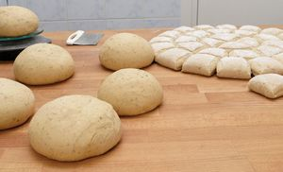
Fig.2.1. prepared dough

Bread doughs are thick and plastic and may be shaped, kneaded, and rolled. They are elastic, allowing much expansion during baking, the degree of elasticity depending upon the amount of elastic protein, or gluten, provided by the flour employed.

2.4. Techniques to produce bread products
Measurements and time, and get straight to the factors that will ensure you have great bread every time.
- Pay Close Attention to Ingredients
Getting ingredients right is crucial with bread baking,. Yeast is a living organism so it will staFlour – while all-purpose flour works fine for bread making purposes, bread flour makes an even better bread. Why? Because a different type of wheat is used to make bread flour and it
is higher in protein. That protein content helps the gluten to develop better, something that can be useful if you are new to bread making..
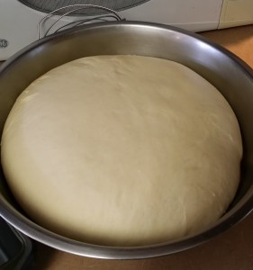
Fig2.2.Proofed dough
Pay Attention to the Environment
Is it oo cold? Make sure you leave your dough to rise in a warm place. If it is too cold in the house I turn my oven on at its lowest temperature and put the dough on the stovetop to rise.
Humidity and altitude can also affect how your bread comes out. Keep notes when you make bread as to the weather and how your bread turns out. Keep notes and you will soon know when and how to make the best bread.
But here is the thing, the amount of flour you use in a recipe is highly dependent on factors exterior to how you are measuring. I can put the exact same amount of flour in my bread on a really dry day as I do on a humid day and I will get very different results.
So I advocate measuring carefully for all of the ingredients but to learn to add flour by eye rather than exact measurements in cups.
When making dough continue adding flour until it just starts to form a ball, slow down on the amount of flour you add at a time, only adding 1 or 2 tablespoons at a time and fully kneading it in before you add more. When the texture of your dough is uniform, slightly tacky but not sticky, and the bread still feels light and soft, then you have added enough flour. NOTE: if you are using a kitchen aid mixer as I do the dough will clean off the sides of the metal bowl leaving it clean, and the dough will no longer stick to the bottom of the bowl when you have enough flour.
Note: Some flours are stickier than others, as are some ingredients. If you are using oatmeal, or rye flour for instance, these dough will always be sticky, use care to make sure you do not add too much flour in these. The same is true for many sweet doughs or those with a lot of eggs.
Letting it Rise
Letting dough rise is also critical to your success. Most recipes give you a certain time or say until double, but again there is a more accurate test.
Room temperature, humidity, the ingredients you use and how much you use, and the condition of the dough, all affect the time it takes your dough to rise. If you use cold ingredients (should be room temp) that can also make the yeast sluggish.
To check if dough is ready push two fingers into the dough about one inch. If the indents remain your dough is ready, if they disappear leave the dough for a while longer.
Once the dough is in the pan, you may not want to do this, simply wait until the dough has risen to the top or above the top of the pan, then it is time to put it in the oven.
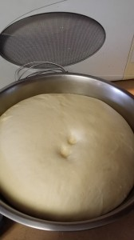
Fig.2.3. proofed dough

2.5. Baking bread:

Baking bread is a lot easier than it seems. It's possible to get lost in the scientific reasons for why certain breads end up certain ways — but it’s also possible to have a delicious homemade loaf without worrying about the whys.
Bread baking is its own world, different from baking cookies, cakes or pies. Its unique combination of ingredients — flour, yeast, water, salt and, most importantly, time — requires you to approach it differently.
First and foremost, bread is alive. Its characteristic texture comes from fermentation, which is the basic activity of yeast, a single-celled fungus (the good kind, not the scary kind). Yeast reacts with the sugars in flour to create carbon dioxide (among other things), which leads to the airy, bubbly texture and the taste we associate with bread.
If you get really into bread making, you can delve deeply into the art and science of the perfect loaf. There's no limit to the level of obsession passionate bread bakers can have. Here’s a 101 primer to help you get started.
Equipment
The equipment and ingredients needed to bake bread aren’t a huge up-front investment. Chances are your pantry is stocked with enough to get started right now.
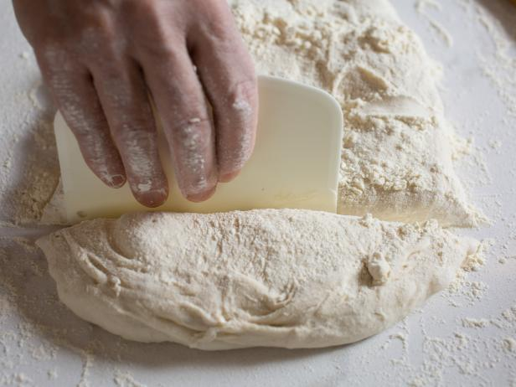

Fig. 2.4. Using plastic scraper for dough making

Plastic dough scraper (pictured above): This flexible, inexpensive little guy is a super-useful tool. Use it to gently ease dough out of a bowl and off work surfaces. It also doubles as a counter scraper for clean-up.
Baking stone: Baking stones absorb and radiate heat and help give your loaves that hard, crackly bottom crust. The thicker the stone, the better. The Baking stone: Baking stones absorb and radiate heat and help give your loaves that hard, crackly bottom crust. The thicker the stone, the better.
Digital scale (pictured above): This is not necessary, but it's likely worth the investment. Though most American published cookbooks offer only standard volume measurements, some also include weight. Weighing is more accurate, and often is actually easier than fiddling with measuring cups. Just tare the scale (reset it to zero) with the empty mixing bowl, then add ingredients.
Loaf pans: Great for baking sandwich breads. Available in various sizes.
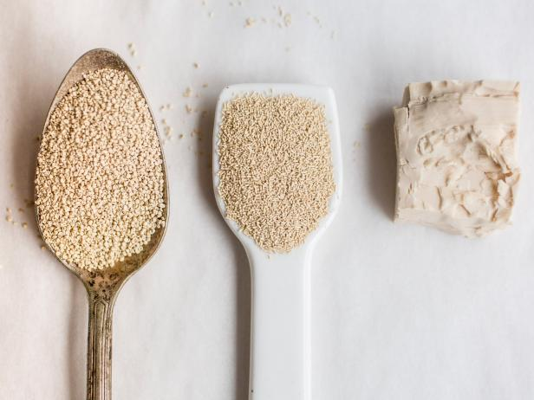

Fig.2.5. Measuring cups and spoons:

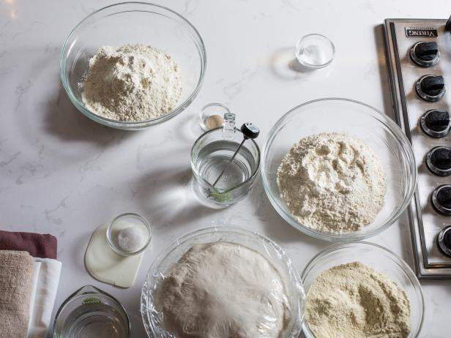

Ingredients
Yeast (Ersho). It needs to hang out in warm water (110 degrees F) for Baking bread is a lot easier than it seems. It's possible to get lost in the scientific reasons for why certain breads end up certain ways — but it’s also possible to have a delicious homemade loaf without worrying about the whys.
Bread baking is its own world, different from baking cookies, cakes its unique combination of ingredients — flour, yeast, water, salt and, most importantly, time — requires you to approach it differently.
First and foremost, bread is alive. Its characteristic texture comes from fermentation, which is the basic activity of yeast, a single-celled fungus (the good kind, not the scary kind). Yeast reacts with the sugars in flour to create carbon dioxide (among other things), which leads to the airy, bubbly texture and the taste we associate with bread.
If you get really into bread making, you can delve deeply into the art and science of the perfect loaf. There's no limit to the level of obsession passionate bread bakers can have. Here’s a 101 primer to help you get started.
Equipment
The equipment and ingredients needed to bake bread aren’t a huge up-front investment. Chances are your pantry is stocked with enough to get started right now
Measuring cups and spoons: See note on measuring flour below.

Mixing bowls: A variety of sizes are handy; you’ll need at least one large one for mixing.
Expert extras: (proofing baskets to give your loaves a professional look), a cloche (works like the Dutch oven), couche (proofing linens that help loaves keep their shape as they rise) and a peel (a wooden or metal paddle to transfer dough to and from a baking stone).

Fig2.6. Measuring cups and bowls
Ingredients:
Yeast
Active dry: You'll usually see this in small packages in the dairy section. It needs to hang out in warm water (110 degrees F) for a few minutes before you use it — this wakes the yeast up and gets it ready for your recipe. Check expiration dates on these, and keep your packets in a cool, dry spot.
Rapid-rise (sometimes called instant or bread machine yeast): This is a hardy strain of yeast, and does not need to be hydrated before using. While it doesn't actually rise more rapidly than any other yeast, you get to skip the step of hydrating, making the process a couple of minutes faster. It is also more concentrated than active dry yeast, so you'll get a fuller rise in some recipes than with the same amount of active dry yeast
a few minutes before you use it — this wakes the yeast up and gets it ready for your recipe. Check expiration dates on these, and keep your packets in a cool, dry spot.

SELF-CHECK 2. | WRITTEN TEST
Instruction:
Answer the following questions:
Q1. Measurement and time are some of the factors that ensure to have you a good bread.
True or False
Q2. Unleavened Ethiopian flat bread made from wheat, flour, water and salt is called kocho.
True or False
Q3. Kita is traditional Ethiopian flat bread made from Enset.
True or False
Q4. Bread baking is the same with making cookies and cakes.
True or False
Q5. What is the other name for false banana?
  - Wofcho
  - Enset
  - Banana
  - All of the above
Q6. Thick, elastic & may shaped, kneaded and rolled:
- Yeast
- Kita
- Bread dough
- All of the above
Q7. List some at least 3 (Three) traditional equipment used for bread preparation.

Operation sheet 1.

Operation Title:Prepare and bake Ethiopian bread products
Purpose:To prepare variety of Ethiopian traditional bread
Conditions or situations for the operations:
- Safe working area
- Properly operated tools and equipment
- Appropriate working uniforms fit for the practical performance

Equipment Tools & Materials:
-Sefed- scale (mizan) - wheat flour,maize flour, etc
-Metad - bowl - oil, salt, bread spices,etc
-Gebeta-cups &jug etc.
Wenfit ( sieve )

Quality Criteria: Assured performing of all the activities according to the procedures
The operation lies on various traditional bread recipes:
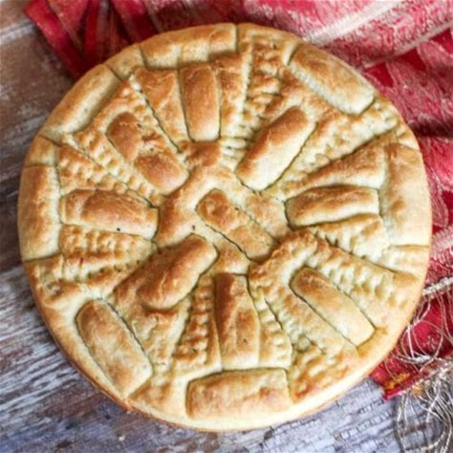
  - Hambasha
Ingredients
5 ounces (150 ml) lukewarm water
1¼ teaspoons dry yeast
½ teaspoon ground fenugreek
¼ teaspoon ground coriander
¼ teaspoon ground cardamom
1 garlic clove, minced
½ teaspoon salt
1 tablespoon vegetable oil Fig.2.1.Hambasha

scant 1 cup (120g) flour
scant 1 cup (120g) whole wheat flour
Preparation procedure:
Dissolve the yeast in the water and set aside for a few minutes to allow it to froth. Meanwhile, mix the garlic, egg, oil and spices and beat slightly.
Sift the flour in a large bowl, add the yeast. Mix to combine.
Prepare your counter with flour and knead for 10 minutes.
Place the dough in a clean bowl, cover and allow to rise for around 2 hours in a warm place.
Gently deflate dough and knead again for 10 minutes. Oil a 12-inch flat cast iron pot well. Form the dough into a flatbread and place into pot. : you will need a cover for this pot to bake it later. Allow to rise in a warm place for 1 hour.
Score with knife to make wedges. Place cover on top of pot and bake for 10 minutes at 350 degrees F (180 degrees C).
Flip the bread over (a bit challenging) and bake for 5 minutes more, without cover. Remove from the pan and spread with some clarified butter.

  - Difo Dabo
Ingredients
5 lbs flour (all purpose, or wheat)
2 tbsp dry yeast
2 tsp salt
1/2 cup sugar (optional)/more or less as desired
Black Caraway Seed
White Cumin Seed (roasted and ground)
Fenugreek (roasted and ground)
2-3 lbs Banana Leaf

Preparation procedure:
- Mix your yeast with warm water in a cup and leave it until it rises
- Mix your flour with the yeast and the other dry ingredients in a bucket (including the ground white cumin seed, Fenugreek, and the black caraway seed)
- Make your dough by adding water little by little to avoid lumps
- Cover your baking pan with banana leaf and pour your dough in the pan covered with banana leaf
- Cover the top of the dough with banana leaf and leave it to rise
- Warm your oven to 400 degrees and bake it for 45-60 minutes
Remove from oven and make it cool on a tray or fabric. Remove the banana leaf from the bread and it is ready for serving.

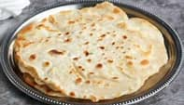
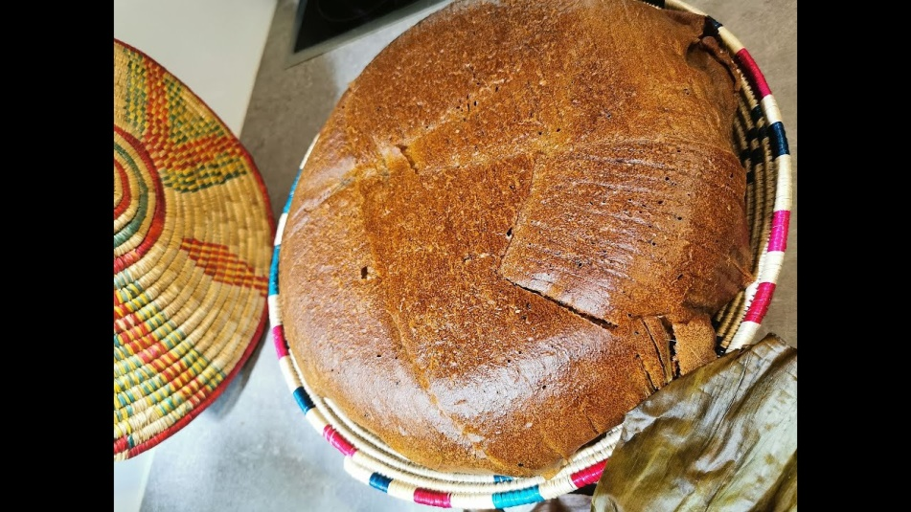
Fig.2.2.Difo dabo

  - Chechebsa
Measurements and Ingredients
1 cup of all-purpose flour
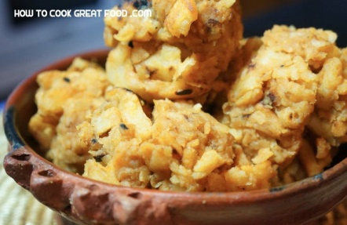
3 or 4 tablespoons of clarified butter or olive oil
2 teaspoons of berbere
Salt
Preparation Method:

The Flat Bread - Kita - Chapatti – Pita

Fig.2.3.Chechebsa

- Start by mixing the flour with a pinch of salt or wait till it is all cooked and done and sprinkle some salt while you are mixing your pieces of flat bread with the berbere and butter.
- In a small bowl, start making a batter by slowly adding water to the flour and mixing it well. The thickness of the kita depends on the thickness of the batter.
- Just be careful to not to make it watery. If you feel it is too thin, just add a little bit more flour. Beat the batter well so it wouldn't have any lumps.
- You can always check the consistence by lifting your beater/stirrer or whatever tool you are using to beat your dough.
- Slowly pour your batter onto the hot pan in a thin layer.
- The thiner the layer, the tastier your Chechebsa becomes.
- If you feel you have put too much batter to one side or at the center of the pan, just move the pan side to side or use the back of a spoon to flatten/spread it out.
- Wait two to three minutes and flip the kita so the top gets fried too.
The light brown spots should be your signals to tell you the kita is fully cooked. Once done
The Chechebsa

Once the kita is cool enough to touch it with your hands, tear it to small pieces on a plate.
Put the butter and berbere in a frying pan and set the oven to medium.
Let the butter melt slowly together with the berbere for a minute or so.
Be careful use very little amount of berbere.
Add the pieces of kita into the pan and stir them all well so all the pieces soak in the butter/berbere mix uniformly.
Take it off the heat and enjoy your Chechebsa.
d.Kocho
Kochocan be removed from the pits as needed for use. The women are in charge of the pits, treating them as household assets. The woman might even take out some for sale at the market, to buy other things.
To make bread from it, the amount needed is taken out of the pit, and chopped for a few minutes with a large knife blade to make sure any fibres remaining are chopped up.
This “dough” is then mixed with spices and butter, and formed into flatbreads. These can be baked on griddles or clay pans, or wrapped in leaves and baked in an oven pit.
The bread will keep for a few days.
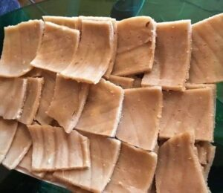
Fig.2.4.Kocho
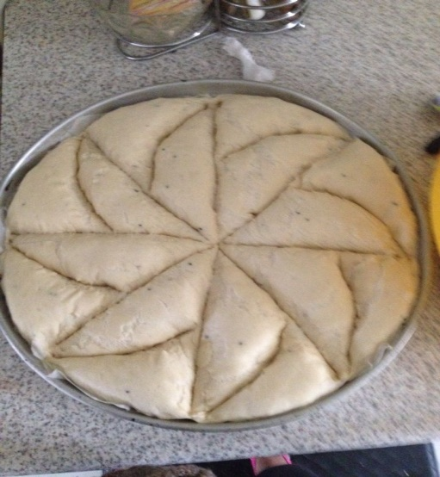

Hibist/Steam-baked Bread
Ingredients
5 lbs flour (all purpose, or wheat)
2 tbsp dry yeast
2 tsp salt
1/2 cup sugar (optional)/
more or less as desired
Black Caraway Seed
White Cumin Seed (roasted and ground)
Fenugreek (roasted and ground)
2-3 lbs Banana Leaf Fig.2.5. steam bread (hibist)
Recipe
- Mix your yeast with warm water in a cup and leave it until it rises
- Mix your flour with the yeast and the other dry ingredients in a bucket (including the ground white cumin seed, Fenugreek, and the black caraway seed)
- Make your dough by adding water little by little to avoid lumps
- Cover your baking pan with banana leaf and pour your dough in the pan covered with banana leaf
- Cover the top of the dough with banana leaf and leave it to rise
- Warm your oven to 400 degrees and bake it for 45-60 minutes
Remove from oven and make it cool on a tray or fabric. Remove the banana leaf from the bread and it is ready for serving.

Lap test1.
Instructions: Given necessary templates, tools and materials you are required to perform the following tasks accordingly.
Task 1: pre-prepare the necessary equipment
Task 2: prepare the necessary ingredients
Task 3: measure the ingredients according to the recipe & given instruction
Task 4: make variety of Ethiopian traditional bread
Task 5: prepare & use traditional bread spices
Task 6: Decorate the products accordingly.

Unit three:store bread products
This unit is developed to provide you the necessary information regarding the following content coverage and topics:
    - Packaging bread products
    - Storing bread products

This unit will also assist you to attain the learning outcomes stated in the cover page.
upon completion of this learning guide, you will be able to:

- Package bread products
- Store bread products

3.1. Package bread products:

Bread shelf-life can be extended by means of various packaging solutions. Traditionally, packaging materials had to be as inert as possible (“passive” packaging), and bread was protected by the main causes of spoilage, such as oxygen and molds, mostly by films made of synthetic polymers with low gas permeability, also coupled with the modification of headspace atmosphere. More recently, a new concept was developed to allow packaging to interact with food, after a provisional safety evaluation. “Active” and “intelligent” packaging, therefore, are made of functional materials deliberately interacting with bread for extending or monitoring its shelf-life, respectively. The most important thing for successfully storing all baked goods is tolet them cool completely.
Packaging also important:
- For bread quality protection & hygiene
- For easy traceability
- For customer convenience and easy transportation
- For advertisement and marketing
Either you’ve got the paper bag. This is mostly used for fresh bread that is supposed to be eaten on the baking day. Leave it in the bag for a day or two and it will dry out. The other way is the plastic bag. This is used for the industrial bread that will keep soft for longer. Perfect to have at home if you want a slice every morning. Freshly baked is nice but most of us don’t have the time to get up early in the morning to bake or go shopping for bread.
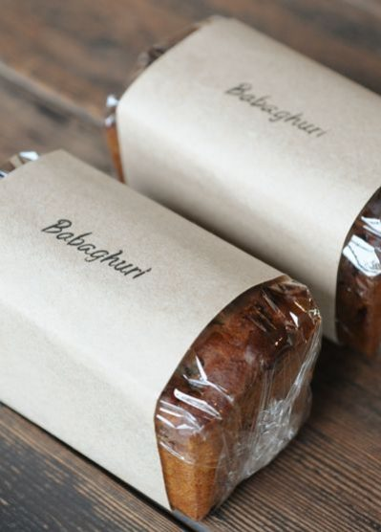

Fig 3.1. Modern packaging material

Packaging Materials
Packaging materials are essential components of the food supply chain. They are available for virtually any type of product and application, including:
- Finished products
- Raw materials
- Additives
- Specialty ingredients
Packaging materials perform many roles. The most important are:¹
- Product protection, containment and preservation of its shelf life
- Customer convenience
- Communication tool (marketing and nutrition labeling)
- Logistics tool for transport and handling
- Traceability mechanism
There are three types of packaging materials: primary, secondary and tertiary packaging.
- Primary packaging: materials in direct contact with the product (e.g. plastic bags)
- Secondary packaging: contains primary packaging (e.g corrugated boxes, paperboard)
- Tertiary packaging: contains secondary packaging (e.g shipping containers, baskets, pallets)

3.2. Store bread products
The Proper Storage Method For Keeping Bread Fresh
The fridge staves off the growth of mold. However, it will also drastically increase the rate at which bread goes stale. See, as soon as bread is removed from the oven and begins to cool, a process occurs called “starch retro gradation,” wherein the starch molecules inside the bread begin to crystallize. Crystallization draws water from the bread, causing the loaf to go stale. Refrigerating bread speeds up this process by six times.
Bread + refrigerator = mold-free longer and totally stale the whole time.
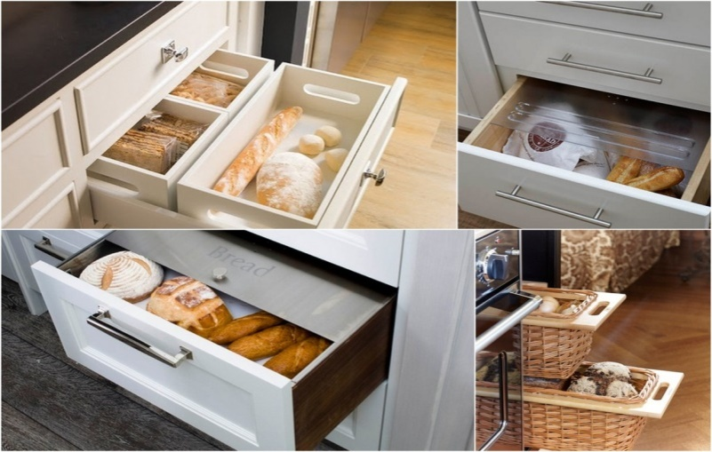

Fig.3.2. Bread storage materials

SELF-CHECK 3. | WRITTEN TEST
Instruction:
Answer the following questions:
Q1. Bread shelf-life cannot be extended by means of packaging solutions. True or False.
Q2. Cooling is the most important thing for successfully storing baked goods. True or False
Q3. Packaging is important:
  - For bread quality protection
  - For customer convenience
  - For the hygiene of bread
  - All are correct
Q4. List three(3) packaging materials and give explanations to each.

RECOMMENDED READINGS

- FROM THE INTERNET
- BAKERY&CONFECTIONARY COURSE ,FOOD PRODUCTION DEPARTMENT
KENYA UTALII COLLEGE, NIROBI
- READING MATERIALS ON PASTRY AND BAKERY PRODUCTIO
- Food and Agriculture Organization of the United Nations. Utilization of Tropical Foods: Trees. 1989. .

Participants of this Module (training material) preparation

No | Name | Qualification | Educational background | Region | College | Mobile number | E-mail
1 | Mohammed Liben Mohammed | Hotel and Tourism Sector head | - BA degree in Hotel and Tourism management  - MA degree in Disaster Risk Management | Somali | Jigjiga Polytechnic college | 0992326557 | cherechaw@gmail.com
2 | Abreham Mayza mengesha | Instructor | Bed degree in Hotel and Tourism | SNNP | Arba minch Polytechnic college | 0913711922 | Abrehammayza9@gmail.com
3 | Zelalem Almaw Endalew | Instructor | - BSC degree in Food science and post harvest technology | Amhara | Bahir dar Polytechnic College | 0918012521 | Parazolla25@gmail.com
4 | Hiwot Tedla Belay | Instructor | BA degree in Accounting and finance and diploma in Hotel Management | Hareri | Harer Polytechnic College | 0913789086 | hiwietaba@gmail.com
5 | Zuryash-Work Belay Nigatu | Instructor | BA degree in Hotel Management | Addis Ababa | TTI | 0911643817 | zuriyash@gmail.com

