Bakery & Pastry Production
Level – II
Based on November 2022Curriculum Version II
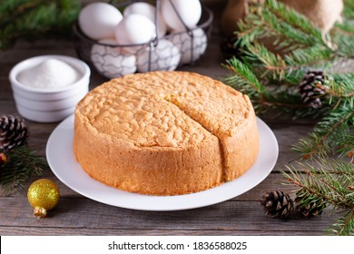
Module Title: Preparing & producing pastries
Module code:CST BPP2 M05 1222
Nominal duration: 65 Hours

Prepare by ministry of labor & skill

December, 2022
Addis Ababa, Ethiopia

Table of Contents
Acknowledgment 2
Unit one: Prepare pastries and pastry products 4
1.1. Ingredientsfor pastry & pastry products 5
1.2. Equipment’s for pastry & pastry products 8
1.3. Techniques to make pastry& pastry product 13
1.4. Portion pastries 18
1.5. Preparing a variety of pastries and pastry products 19
SELF –CHECK #1 23
Unit Two: Decorat and present pastry products 32
2.1. Decorate pastry product 33
2.2. Present pastries 35
SELF-CHECK 2 36
Unit Three: Store pastries 39
3.1. Store pastes and ingredients 40
3.2. Store pastry products 43
SELF-CHECK 3 44

Acknowledgment
Ministry of Labor and Skills wish to extend thanks and appreciation to the many representatives of TVET instructors who donated their time and expertise to the development of this Teaching, Training and Learning Materials (TTLM).

Introduction to the Module
Bakery products have become very popular throughout the country. Breads and biscuits are the most common products but other items like cakes, pastries, cream-rolls, cookies etc. are also not lagging far behind. These items are consumed by people of all age groups across the board. Nature of these products is such that the consumers prefer fresh items. Shelf life of cakes & pastries is limited and thus local manufacturers enjoy distinct advantage. In spite of continuous increase in the consumption of these items during last few years, the per capita consumption is still very low compared to the advanced countries. There is, thus, good scope for these items. A good pastry is light and airy, easily broken in the mouth (what is called 'short' eating), but firm enough to support the weight of the filling. The dough must be well mixed but care must be taken not to over mix the pastry. This results in long gluten strands and toughens the pastry. Thus, the manufacture of good pastry is something of a fine art.
This module is designed to meet the industry requirement under the bakery and pastry production occupational standard
This module covers the units:
- Prepare pastries and pastry products
- Decorate and present pastry products
- Store pastries
Training Objective of the Module
- Prepare pastries and pastry products
- apply Decorate and present pastry products
- Store pastries
Module Instruction
For effective use this modules trainees are expected to follow the following module instruction:
- Read the information written in each unit
- Accomplish the Self-checks at the end of each unit
- Perform Operation Sheets which were provided at the end of units
- Do the “LAP test” given at the end of the unit and
- Read the identified reference book for Examples and exercise

Unit one: Prepare pastries and pastry products
This unit is developed to provide you the necessary information regarding the following content coverage and topics:
  - Ingredients for Pastry & pastry products
  - Equipment’s for Pastry & pastry products
  - Techniques to make pastry& pastry product.
  - Portion pastry
  - Prepare a variety of pastries and pastry products

This unit will also assist you to attain the learning outcomes stated in the cover page.
Specifically, upon completion of this learning guide, you will be able to:
- Identify Ingredients for Pastry & pastry products
- Identify equipment’s for Pastry & pastry products
- Apply Techniques to make pastry& pastry product.
- Perform Portion pastry
- Prepare a variety of pastries and pastry products

1.1. Ingredients for pastry & pastry products

- Introduction:
- Pastry isa branch of the culinary field and involves making bread, pastries, pizzas, quiches, cakes, and pies. However, this branch relies mainly on the use of an oven to bake the food. Unlike chefs, bakers can make both sweet and savoury dishes and can specialize in certain areas.
- Pastry- is a type of dough made with flour, water and shortening. Baked pastry dough can be sweet or savoury, and consumed alone or with fillings.
- Bakery ingredients
- flour
- salt
- fat
- leavening(baking powder, baking soda )
- egg
- sugar
- flavouring
- spices
- colouring agent
- Milk etc…
- Emergency substitution
- Cake Flour – Make your own cake flour, measure out 1 cup of all-purpose flour and remove 2 tablespoons. Replace the 2 tablespoons with corn starch.
- Baking Powder – To replace 1 teaspoon of baking powder, combine 1/4 tsp baking soda and 1/2 tsp of cream of tartar.
- Baking Soda – 4 teaspoons of baking powder can replace 1 teaspoon of baking soda.
- Function of pastry ingredients
- Baking Soda and Baking Powder-are leavening that improve the texture and appearance of baked goods. They create a chemical reaction that produces air bubbles helping batter and dough rise.
- Baking powder.is probably the most common aerating agent in baked products like cakes. It is made up of bicarbonate of soda and cream of tartar. Baking powder is a chemical aeration agent.
- Yeast. Belongs to the fungi family. It ferments carbohydrates (sugars) to produce carbon dioxide gases and alcohol, which aerate bread and other yeasted products, giving it volumeand texture. These by-products of yeast also contribute to the colour and aroma of bread and other yeasted products.
- Butter-if your recipe states to use room temperature butter, you can soften the butter by placing sliced butter in a bowl next to two cups of boiling water in the microwave for about 10 minutes
- Corn Starch- helps create a crumbly and tender texture in baking. It’s also a great thickener in sauces, soups, puddings, and pie fillings.
- Egg. Are another basic ingredient in many baked products.They provide structure, aeration, flavour and moisture. They also tenderise cakes and add colour and nutritive value.
- Milk. Is used in baked products to improve texture and mouth feel. The protein in milk also gives a soft crumb structure in cakes, and contributes to the moisture, colour and flavour of a baked product. Cakes that contain milk also tend to have a longer shelf life.
- Salt.is usually only added in very small amounts to baked products, but it has a noticeable effect on the flavour of baked products. It not only provides its own flavour but brings out the natural flavour of other ingredients. In bread dough, salt strengthens gluten and improves the consistency of the dough. Carbon dioxide given off by the yeast is more easily trapped by the strengthened gluten, which makes a better loaf of bread. Salt is also a good preservative as it absorbs water so there is less free water for bacterial and fungal growth.

There are 7 types of pastrytypes of pastries that you can experiment with
- Puff Pastry
- Short Crust Pastry
- Short Crust and the Art of Blind Baking
- Pate Sucrée (aka Sweet Short crust Pastry)
- Phyllo (Filo) Pastry
- Rough Puff Pastry
- Choux Pastry.
Formulas and measurement
All ingredients must be weighed& measured.
Accuracy of measurement, measurement by weight rather than by volume, because weighing is much more accurate
- A recipe- gives you information on how to prepare food. Recipes include information such as the name of the recipe, a list of ingredients and step-by-step instructions on what to do with each ingredient (such as when to add it and how to prepare it) how to garnish and serve the food.
- Standard recipes-are used to standardize the production of every food item on a menu. They ensure that the food will be consistent in quality, quantity, cost and presentation while a recipe will give you a precise set of instructions about how to prepare a dish, it is assumed that you already have a good knowledge and understanding of culinary terminology
Care needs to be taken when adjusting recipes as mistakes can easily occur and the wrong quantity of just one ingredient (e.g. salt) can spoil the whole product.
Standard features of a recipe:
- The standard features of a recipe include:
- Preliminary preparation
- Equipment
- Quantity of ingredients
- Methods
- Baking temperature
- Baking time
- Number of portions recipe will produce
- Total cost of product

1.2. Equipment’s for pastry & pastry products
- Tools and equipment
Over the years basic equipment used in pastry has changed very little in form of their shapes and functions. However, greater mechanization and automation has been introduced and different materials and modern manufacturing techniques have been employed. It has become easier to maintain, more labour and energy saving, easy to clean, more hygienic and thus more efficient. With this more accuracy has been deployed in pastry works and high standard products are achieved at a shorter time. However, certain rules and regulations on how to handle pastry tools and equipment must be adhered to by all pastry chefs in order to reduce costs and maintain these tools and equipment in good condition.
I). A tool is any items that can be used to achieve a goal. Tools can be non-mechanical as well& do not need power.
II). an equipmentusually denotes a set of tools that are used to achieve to specific objectives. That means it used for mixing, baking, blending, freezing, chilling, processing, and much more.
In commercial kitchen equipment can be divided in to two categories:
A).Hand tools: - are generally small in size and we can put on the shelve or in a drawer.
B).Stationary equipment: - it is heavy& placed in one defined place
Equipmentmay include:

- Measuring Cups (Liquid and Dry) and Spoons
- Fine-Mesh Sieve
- Paring Knife
- Pie Plate
- Parchment Paper
- baking tray
- blenders
- bowl
- deep-fryers
- electric, gas or induction ranges
- food processors
- Grinder Kneader
- microwaves
- mixers
- ovens, including combination ovens
- pastry brush
- pastry wheel
- Proofer
- Refrigeration units
- Roller
- salamanders
- slicers
- steamers
- utensils
- Kitchen Scissors
- Pastry Brus

1.2.1. Type, photo& function of bakery& pastry equipment
Cookie Cutters, Presses, Rosette Makers
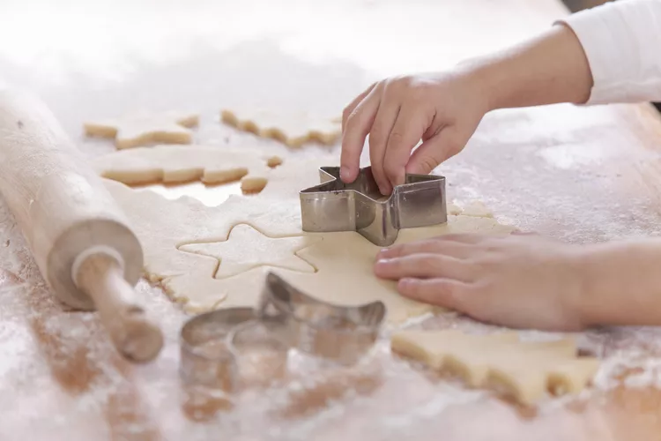
To give a shape to the pastry, cut into a required shape & making flatten.

Minute Timer, Candy Thermometer

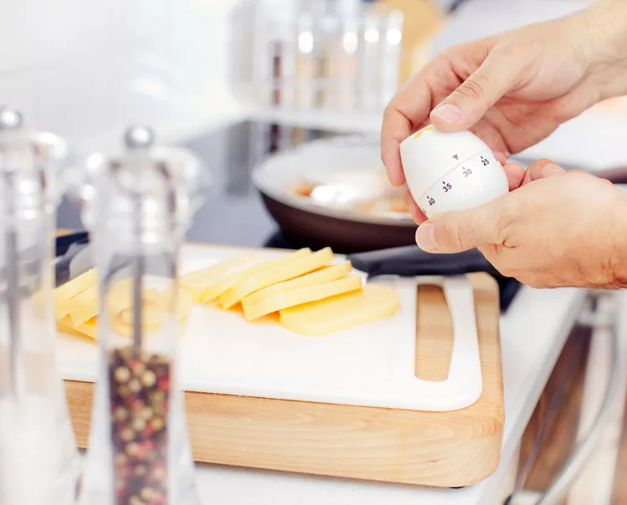
To control the time taken & the temperature required
Pastry Blender, Pastry Cutter
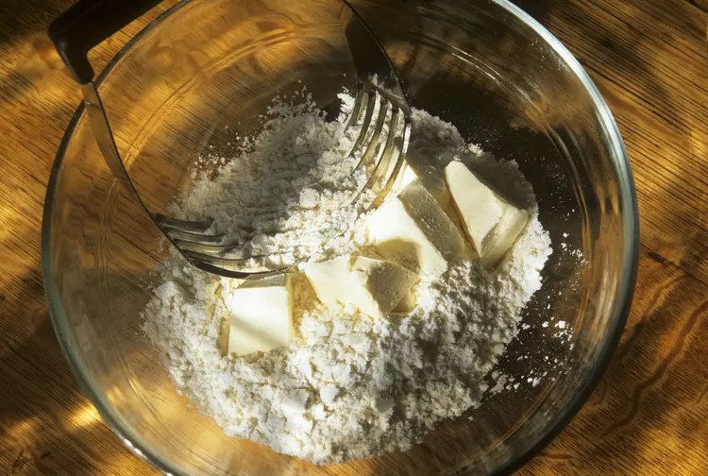
To blend a pastry& cut it

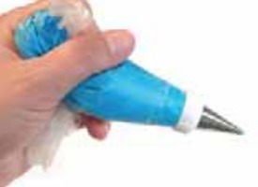 Piping bag and nozzle: used to push out soft mixtures such as cream, icing or mashed potato into attractive shapes.

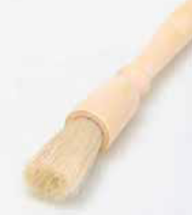 Pastry brush: a brush with thickly packed bristles used for brushing pastry and applying glazes, marinades etc.

Tongs: made from stainless steel or plastic, they are used to lift and turn food
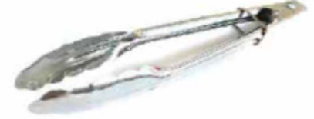

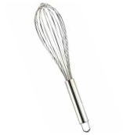 Balloon whisk: used to beat air into and lumps out of a mixture by whisking the food through loops of wire.

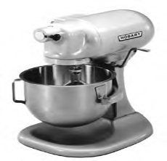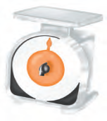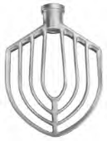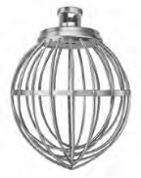-dough arm 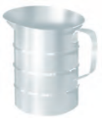
Mixer -scale - paddle - balloon whisk measuring jug

-The paddle: - is a flat blade used for general mixing
-The wire whisk: - is used for such tasks as beating cream, and eggs
-The dough arm: - is used for mixing and kneading dough

Pastry wheel scraper / dough cutter
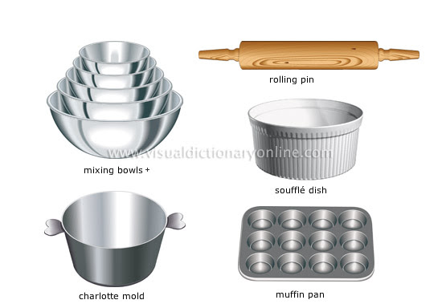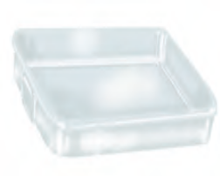Baking
Equipment should be constructed from materials which are non-toxic, non-flaking, corrosion-resistance, smooth and free from breaks, open seams, cracks, chips, and difficult to clean internal corners.
Food contact surfaces will need regular disinfection and care must be taken in selecting materials. The preferred material for most equipment is food-grade stain less steel (18/8 contains18 percent chromium and 8 percent nickel.)
Handles of knives, brushes and other equipment, rolling pins, spoons and paddles and cutting boards can now be obtained from cleansable material.
Safety in the kitchen includes:
- A regular inspection and checking system for mechanical, electrical and gas ranges.
- Any faults in equipment must be reported and repairs carried out.
- Appropriate cleaning and correct handling of tools and equipment
- Metal trays, pans, china or glass that is very hot should never be placed in cold water
- Small metal tubes, cutters, knives or other sharp tools should never be left in the sink
- Always keep equipment in a dust free cupboard and store tidily.
- Operating gas or electrical ranges safely
- Never use any equipment until you are instructed how to operate
- Read the manual of any machine before operating
‘ EVERY THING HAS A PLACE AND THERE IS A PLACE FOR EVERY THING ‘
- When cleaning electrical appliances, switch off power supply, when re-assembling equipment ---make sure it is done correctly
- Use the right tool or equipment for its intended use

1.3. Techniques to make pastry& pastry product
1.3.1. Making process of pastries
The process of making pastry includes mixing of the fat and flour, adding water, chilling and then rolling out the dough. Chilling before rolling is essential since it enables the fat (lard, butter etc) to harden again and thus create flaky layers in the dough.
The fourpastry techniques to achieve perfect textures:
To obtain these textures, we have four basic pastry techniques that we will introduce below: emulsification, aeration, thickening and gelation.
- Emulsification technique
Emulsions play a key role in pastry since they are thestructures responsible for creaminess on, for example, ganache, custards or ice creams. When understanding what an emulsion is, how is it formed or undone and what factors influence its stability, you comprehend why emulsions bring us a creamy mouthfeel, something already upholded in the article "Beyond the lines of traditional pastry – redefining the concept of creaminess".
It is really important to note that creaminess is not directly associated with traditional ingredients, as it is obtained thanks to this texture creating technique: emulsification. Creaminess is obtained by incorporating an emulsifying ingredient composed of citrus fibre

- Aeration technique
Aerated textures, also called foams, are very representative in the world of pastry and bakery: from plated desserts foams, through several kind of meringues, guimauves, mousses and ice cream, to sponge cakes and even bread. There are many aerated textures with different appearance and mouthfeel, but they all have something in common: they are extremely delicate, so it is essential to learn how to create and stabilize them.
- Thickening technique
Thickening is the process of increasing viscosity in recipes. But why is it so essential to control this parameter? Viscosity greatly influences the mouthfeel caused by food and this is as important as the flavor of the product itself. For this reason, when you master the thickening technique, you can improve and refine your textures to create a unique tasting experience.
- Gelation technique
If you think of gelling, the first textures that come to mind are surely those that have a truly gelatinous texture, such as jams, marmalades, compotes or pâté de fruit. However, most pastry and bakery recipes are gelled to maintain their shape and stability, such as mousses, foams or even bread.
As you can see, it is a fundamental technique for the creation and execution of stable recipes and, to work with it, each ingredient and its parameters must be considered. Let’s take the case of working on a recipe with alcohols: their molecular composition will play a role when choosing which gelling agents combine them with, as well as their dosage.
Baking: - is the cooking of food by dry heat in an oven in which the action of the dry convicted heat is modified by steam.
Bringing together a balanced quantity of various ingredients in a proper form is a definition of the art and science of baking. When you consider that most bakery products are made of the same few ingredients; flour, shortening, sugar, eggs, water, or milk and leavenings then you should have no difficulty understanding the importance of accuracy, since slight differences in proportions or procedures can mean great differences in the final product.
Purpose:
- To make food digestible, palatable, and safe to eat
- To create eye appeal through colour and texture
- Baked goods offer variety to the menu and are popular in the diet.

Basic rules in the baking process
- Pre-heat the oven for 10 min.
- Measure the ingredients accurately
- Make a dough based on recipe
- Prepare the baking sheet, moulds in advance
- Bake at correct temperature& time
- Do not open the oven while baking until done

Key baking terms:
Many of the terms used by the baker are the same as those of the rest of the kitchen, but they are defined differently. It is inclusive of the key terms necessary to begin mastery of the art and science of baking.
- Batter: - a mixture of ingredients and liquid that is thin enough to pour
- Caramelize:-to heat sugar slowly until it is melted and brown in colour.
- Coat:-to spread a surface with cream, flour, sugar or other substance.
- Combine:-to mix ingredients thoroughly
- Crimp:-to seal together (for example the edges of a two crust pie) by making a decoration
- Dough: a mixture of ingredients and liquid stiff enough to shape or knead.
- Dust: - to sprinkle lightly with flour, sugar, or other substance.
- Egg wash: - a mixture of egg or egg-yolk with milk or water.
- Garnish:-decorating with whipped cream, butter cream, icing, and fruits.

- Knead:-manipulating dough to achieve a smooth consistency.

- Luke warm:-neither cool nor warn, approximately body temperature.

- Meringue:-egg-whites and sugar beaten to a stiff consistency.

- Pinch: - a pinch is the amount you can hold between your thumb and forefinger.

- Roll out:-to spread the surface of a product with a rolling pin/ to flatten the dough to the desired thickness.

- Scald: - to scald milk is to bring to a point when bubbles appear (before boiling point)

- Punch down: - to hit the proved dough down words with fists.

- Pipe:-to squeeze a soft, smooth textured substance through a pastry tube, thus making a design or decoration.

- Set: allowing an item to go from a soft or a liquid state to a firmer state.

- Sift: - removing possible lumps of dry ingredient through a strainer or sifter.

- Scald: - to scald milk is to bring to a point when bubbles appear (before boiling point)

- Pipe:-to squeeze a soft, smooth textured substance through a pastry tube, thus making a design or decoration.

- Beating: Beating is mixing materials briskly, lifting and dropping them with an appropriate tool. Whether done using an electric mixer or by hand with a fork, spoon, or whisk, to beat is to vigorously mix, blend, or stir a mixture in a circular motion.
- Blending: Blending is a technique where two or more ingredients are combined so they are smooth and equally distributed throughout the mixture. A spoon, fork, rubber spatula, whisk, electric mixer with paddle attachment, food processor, blender or even bare hands can be used for this technique. Blending differs from beating in that its sole purpose is to combine the ingredients, not to incorporate air into the mixture.
- Cutting-in: is a technique used in pastry making (scones, biscuits) involving the mixing of a cold solid fat (butter, margarine, shortening) into dry ingredients (flour mixture) until the mixture is blended but still contains small flour-coated pieces of cold fat. This combining of the cold fat and dry ingredients must be done quickly and with a light hand so that the fat does not melt
- Creaming: is mixing or beating technique that combines ingredients to make a uniform mixture and also incorporates air into this mixture. Softening fat by friction with a spoon, usually followed by gradual incorporation of sugar as in cake-making. The butter should be at room temperature so it incorporates the sugar sufficiently to produce a smooth and creamy batter that is light and fluffy. A whisk, wooden spoon, or electric mixer with paddle attachment can be used.
- Whipping: Whipping is a mixing technique used to incorporate air into an ingredient or mixture (i.e. egg whites, heavy cream) to increase its volume and make it light and fluffy. This is done by vigorously beating in a circular motion using a wire whisk or electric mixer. Egg whites are often whipped and then added to cake batters to make them less dense so they have more volume when baked. Whipped heavy cream can be added to custards or sauces to make them lighter.
- Whisking: is a technique to rapidly beat or whip as much air (volume) as possible into a mixture or one ingredient (usually heavy cream or egg whites). This is accomplished by using a wire whisk or electric mixer
- Folding: is a simple but crucial technique used when combining a light and airy ingredient into a heavier ingredient or mixture in such a way as each ingredient maintains its original volume. This technique must be done quickly but gently and stop 'folding' as soon as the ingredients are blended. Start by placing one quarter of the lighter mixture on top of the heavier mixture. With a rubber spatula cut down vertically through the two mixtures, sweep across the bottom, up the nearest side of the bowl, and over the top of the mixtures (go in clockwise direction). Rotate the bowl a quarter turn counter-clockwise and repeat the down-across-up-over motion. This technique is commonly used to incorporate flour into a sponge cake base and adding egg whites to a cake batter

1.4. Portion pastries
1.4.1. Portion Control Tools
Portioning is a part of any whole, either separated from or integrated with it or an amount of food served for one person; serving; helping.
Maintaining consistent food portions is extremely important. Luckily, portion control tools help restaurant owners and staff maintain control over how much food goes on each plate. So, whether you want to know more about the importance of food portions or you’d like to dive deeper into the functions of each type of portioning tool, we’ll cover that and more in this blog.
Restaurant portion control tools come in many shapes and sizes. Some of the most common tools include portion scales, food dishers, and spoodles. But even everyday kitchen supplies, like measuring cups and ladles, are great tools for controlling portions. Even single-serving packets of condiments (like ketchup or soy sauce) are an example of restaurant portion control.
Portion control not only refers to the amount of food on a plate, but it can also refer to the amount of ingredients in a particular dish. For example, if you own a burrito shop, you probably want your staff to include a consistent ratio of meat and rice in each burrito. That way, customers know what to expect and can return again to enjoy the product they love.
The number one reason why portion control is important is to manage customer expectations and provide a consistent product. But another important reason to pay attention to your food portions is to reduce costs in your restaurant. Not only will portion control help you keep track of how much you’re using of each ingredient, but it can also reduce food waste because customers will be less likely to throw food away if you offer appropriate portion sizes.
Of course, the way you measure portions depends on what specific tool you’re using, but typically, food is measured in one of two ways: by weight or by sight. If you’re dealing with a really expensive ingredient (like black truffle or caviar), it may be a good idea to measure it on a scale before plating. This approach not only ensures that you’re not putting more money on the plate than necessary, but it also keeps flavors consistent for each guest. Portioning by sight is fine for most other applications from cafeterias to fine dining.
Portion spoons and dishers are extremely common in fast casual environments for portioning foods like mashed potatoes and corn, while white tablecloth establishments are more likely to use food molds to shape rice or even salads. However, the same basic principle applies to both.
Pastry Tools or portioning include spatulas, mixing spoons, zesters, pastry knives, icing bags, pastry cutters, and sifters. Cooking sheets and pans round out the collection for all baking needs.

1.5. Preparing a variety of pastries and pastry products
1.5.1. Pastry definition. Pastry:
- is baked food made with a dough of flour, water and shortening (solid fats, including butter or lard) that may be savoury or sweetened.
- Can also refer to the pastry dough,^{[4]} from which such baked products are made. Pastry dough is rolled out thinly and used as a base for baked products.
- is differentiated from bread by having a higher fat content, which contributes to a flaky or crumbly texture. A good pastry is light and airy and fatty, but firm enough to support the weight of the filling. When making a short crust, care must be taken to blend the fat and flour thoroughly before adding any liquid. This ensures that the flour granules are adequately coated with fat and less likely to develop gluten. On the other hand, over mixing results in long gluten strands that toughen the pastry. In other types of pastry such as Danish pastry and croissants, the characteristic flaky texture is achieved by repeatedly rolling out a dough similar to that for yeast bread, spreading it with butter, and folding it to produce many thin layers.some common examples include:
Pies, tarts, donuts, croissants, Danishes, and scone
1.5.2. Sweetened pastries.Pastries:
- Are often described as bakers' confectionery. The word "pastries" suggests many kinds of baked products made from ingredients such as flour, sugar, milk, butter, shortening, baking powder, and eggs. Small tarts and other sweet baked products are called pastries as a synecdoche. Common pastry dishes include tarts, quiches, croissants, and pasties.
The French word pâtisseriepatisserie is also used in English (with or without the accent) for the same foods. Originally, the French word pâtisserie referred to anything, such as a meat pie, made in dough (paste, later pâté) and not typically a luxurious or sweet product.This meaning still persisted in the nineteenth century, though by then the term more often referred to the sweet and often ornate confections implied today.There are five basic types of pastry (a food that combines flour and fat).These are short crust pastry, filo pastry, choux pastry, flaky pastry and puff pastry.
1.5.3. Pastries& pastry product may include but not limited to:
- Short pastry & sweet paste;
- flans
- tarts
- fruit tartlets
- Scotch shortbread, including:
- Viennese wafers
- Linzer and other slices
- savoury and sweet pies
- choux paste, including:
- profiteroles
- éclairs
- Saint Honoré
- puff paste, including:
- millefeuille
- palmiers
- quiches
- croissants
- gateaux pithiviers
- bouchées
- cream horns
- filo or strudel
- Danish pastry

A tart is a baked dish consisting of a filling over a pastry base with an open top not covered with pastry. The pastry is usually short crust pastry; the filling may be sweet or savoury, though modern tarts are usually fruit-based, sometimes with custard.
Tartlet refers to a miniature tart; an example would be egg tarts. The categories of "tart", "flan", "quiche", and "pie" overlap, with no sharp distinctions
Flan is a European and Latin dessert made up of a caramel topping and custard base that’s made with milk, eggs and sweetener (which may already be included in the milk). It is usually baked in a water bath for the best texture, and after baking it is chilled then later inverted onto a platter.
A pie is a baked dish which is usually made of a pastry dough casing that contains a filling of various sweet or savoury ingredients. Sweet pies may be filled with fruit (as in an apple pie), nuts (pecan pie), brown sugar (sugar pie), sweetened vegetables (rhubarb pie), or with thicker fillings based on eggs and dairy (as in custard pie and cream pie). Savoury pies may be filled with meat (as in a steak pie or a Jamaican patty), eggs and cheese (quiche) or a mixture of meat and vegetables (pot pie).
Pies are defined by their crusts. A filled pie (also single-crust or bottom-crust), has pastry lining the baking dish, and the filling is placed on top of the pastry but left open. A top-crust pie has the filling in the bottom of the dish and is covered with a pastry or other covering before baking. A two-crust pie has the filling completely enclosed in the pastry shell. Shortcrust pastry is a typical kind of pastry used for pie crusts, but many things can be used, including baking powder biscuits, mashed potatoes, and crumbs

Preparation techniques of pastry may include:
- chilling ingredients and work surfaces where required
- kneading and handling
- rolling
- cutting and moulding
- resting
- preparing and using appropriate fillings and pre-bake and post-bake finishes and decorations

1.5.4. characteristics of pastry
pastryproduct characteristicsmust include:
- colour
- consistency and texture
- crust stability
- moisture content
- mouth feel and eating properties
- appearance
pastry terminology:
- Pastry: A type of food used in dishes such as pies or strudel.
- Pastry bag or piping bag: A disposable or reusable bag that is often cone-shaped, used to make an even stream of dough, frosting, or flavored substance to form a structure, decorate a baked item, or fill a pastry with a custard, cream, jelly, or other filling.
- Pastry board: A square or oblong board, preferably marble but usually wood, on which pastry is rolled out.
- Pastry brake: Opposed and counter-rotating rollers with a variable gap through which pastry can be worked and reduced in thickness for commercial production. A small version is used domestically for pasta production.
- Pastry case: An uncooked or blind baked pastry container used to hold savory or sweet mixtures.
- Pastry cream: Confectioner's custard. An egg- and flour-thickened custard made with sweetened milk flavored with vanilla. It is traditionally used as a filling for flans, cakes, pastries, tarts, etc. The flour prevents the egg from curdling.
- Pastry cutters: Various metal or plastic outlines of shapes, e.g. circles, fluted circles, diamonds, gingerbread men, etc., sharpened on one or both sides and used to cut out corresponding shapes from biscuit, scone, pastry, or cake mixtures.
- Pastry blender: A kitchen implement used to chop the fat into the flour, which prevents the melting of the fat with body heat from fingers, and improves control of the size of the fat chunks. Usually constructed of wire or plastic, with multiple wires or small blades connected to a handle.
- Viennoiserie: French term for "Viennese pastry," which, although it technically should be yeast raised, is now commonly used as a term for many laminated and puff- and choux-based pastries, including croissants, brioche, and pain au chocolate.

SELF –CHECK #1 | WRITTING

Instruction: Answer the following questions:
Part I. say true or false
  - Flan is caramel topping and custard base that’s made with milk, eggs and sweetener.
  - Equipment is used for mixing, baking, blending, freezing, chilling, processing, and much more.
  - Appearance is one of the characteristics of pastryproduct characteristics
Part II. Choosing
4). which one is the preparation techniques of pastry?
A) rolling
B) cutting and moulding
- resting
D) All
5).---is an egg- and flour-thickened custard made with sweetened milk flavored with vanilla.
A) Pastry C) pastry cream
B) Pastry blender D) none

Operation sheet 1. Prepare and Produce Pastries
Operation Title:Producing Pastries& pastry
Purpose: to perform cake production
Conditions or situations for the operations:
- Safe working area
- Properly operated tools and equipment
- Appropriate working uniforms fit for the practical performance
Equipment Tools and
- Oven - bowl - scale - rolling in
-Mixer - Scraper -Whisker - bowl
-Cooling rack -baking pan

1). Danish Pastries
Materials:
240ml milk
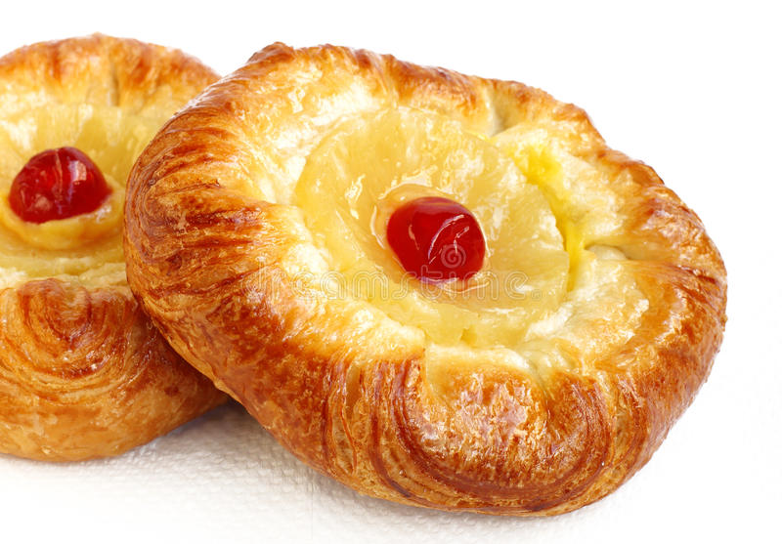
2 tsp instant dried yeast
370g plain white flour
1 tsp salt
4 tbsp butter
150g soft brown sugar
1 egg, beaten
2 tbsp melted butter
250g mixed dried fruit (we like sultanas and cranberries)
For the glaze: Fig.1.1. Danish pastry
2 tbsp caster sugar
4 tbsp boiling water

Methods
- Heat the milk until it is warm and then sprinkle the yeast over it. Mix. Cover with damp tea towel and leave to stand at room temperature for around 10 minutes until the mixture becomes frothy.
- Then in a separate bowl mix flour and salt. Add the butter and rub in until the mix becomes like fine breadcrumbs. Add one third of the brown sugar and then add in the milky yeast mix and a beaten egg until it comes a pliable dough texture.
- Roll into a ball and turn out onto a lightly floured surface and knead well with your knuckles with your hand clenched into a fist. Cover and leave until mix has doubled in size.
- Then using a rolling pin roll out into a rectangle 50cm x 20cm. Brush the dough with melted butter and sprinkle with the mixed fruit and remaining brown sugar. Then roll up to create a Swiss roll shape. Cut into 12 slices and place cut side down onto a lightly greased baking sheet.
- Then cover and leave in a warm place until the buns have doubled in size. This should take half an hour.
- Bake at 200C/400F/gas mark 6 for 20 minutes or until golden brown. If they start to become too brown, then cover loosely with tin foil. Place on a wire rack to cool.
- Then add caster sugar to the boiled water and brush over each bun while they are hot. Leave
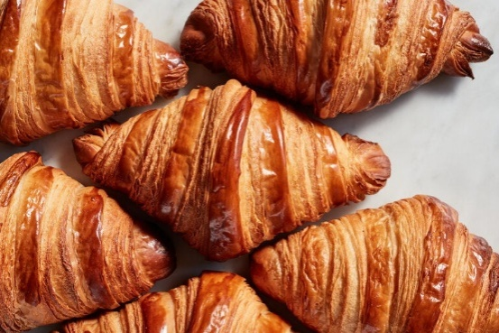
to cool
2. Croissants
Ingredients
- 3 tablespoons warm water (110 degrees F/45 degrees C)
- 1 ¼ teaspoons active dry yeast
- 1 teaspoon white sugar
- 1 ¾ cups all-purpose flour
- ⅔ cup warm milkFig.1.2. croissant
- 2 teaspoons white sugar
- 1 ½ teaspoons salt
- 2 tablespoons vegetable oil
- ⅔ cup unsalted butter, chilled
- 1 large egg
- 1 tablespoon water
Methods
- Combine warm water, yeast, and 1 teaspoon sugar in a small bowl. Let stand until yeast softens and begins to form a creamy foam, about 5 minutes.
- Measure flour into a mixing bowl. Combine warm milk, 2 teaspoons sugar, and salt in a separate bowl; blend milk mixture, yeast mixture, and oil into flour. Mix well and knead until smooth. Cover, and let rise until over tripled in volume, about 3 hours.
- Deflate gently, and let rise again until doubled, about another 3 hours.
- Deflate dough and chill for 20 minutes.
- Massage butter until pliable, but not soft and oily. Pat dough into a 14x8-inch rectangle. Smear butter over top two-thirds, leaving a 1/4-inch margin all around. Fold unbuttered third over middle third, and buttered top third down over that. Turn 90 degrees, so that folds are to left and right. Roll out to a 14x6-inch rectangle. Fold in three again. Sprinkle lightly with flour, and put dough in a resalable plastic bag. Refrigerate for 2 hours.
- Unwrap, sprinkle with flour, and deflate gently. Roll to a 14x6-inch rectangle, and fold again. Turn 90 degrees, and repeat. Wrap and chill 2 hours.
- Preheat the oven to 475 degrees F (245 degrees C).
- To shape, roll dough out to a 20x5-inch rectangle. Cut in half crosswise, and chill half while shaping the other half. Roll out to a 15x5-inch rectangle. Cut into three 5x5-inch squares. Cut each square in half diagonally. Roll each triangle lightly to elongate the point, and make it 7 inches long. Grab the other 2 points, and stretch them out slightly as you roll it up. Place on a baking sheet, curving slightly. Let shaped croissants rise until puffy and light.
- In a small bowl, beat together egg and 1 tablespoon water. Glaze croissants with egg wash.
- Bake in the preheated oven until crisp, flaky, and golden brown, about 12 to 15 minutes.
3).Palmiers
Ingredients
1 cup sugar, divided
1 sheet frozen puff pastry, thawed
Methods
1. Preheat oven to 425°. Sprinkle a surface with 1/4 cup sugar; unfold puff pastry sheet on surface. Sprinkle with 2 tablespoons sugar. Roll into a 14x10-in. rectangle. Sprinkle with 1/2 cup sugar to within 1/2 in. of edges. Lightly press into pastry.
2. With a knife, very lightly score a line crosswise across the middle of the pastry. Starting at a short side, roll up jelly-roll style, stopping at the score mark in the middle. Starting at the other side, roll up pastry jelly-roll style to score mark. Freeze until firm, 20-30 minutes. Cut into 3/8-in. slices.
3. Place cut side up 2 in. apart on parchment-lined baking sheets; sprinkle lightly with 1 tablespoon sugar. Bake for 8 minutes. Turn pastries over and sprinkle with remaining 1 tablespoon sugar. Bake until golden brown and glazed, about 3 minutes longer. Remove to wire racks to cool completely. Store in airtight containers.Fig.1.3. palmiers
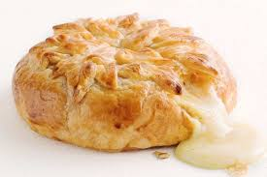
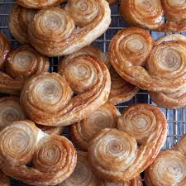

4. Puff pastry
Ingredients
1 cup unsalted butter cold (227g)
2 cups all-purpose flour (240g)
1 Tbsp sugar (12g)
1/2 tsp kosher salt (2g)
8-10 Tbsp cold water (120-150 mL)
Instructions
1. Place butter in the freezer for 10 minutes.Fig.1.4. Puff pastry
2. In a large mixing bowl, whisk together flour, sugar, and salt.
3. Grate the frozen butter into the flour. (Dice the remaining end of butter that you can’t grate.)
4. Toss the butter into the flour mixture with your hands until well coated.
5. Drizzle 6 tablespoons of water over the mixture and fold the mixture together until it clumps together. Continue adding water a tablespoon at a time until a loose and crumble dough forms. (It should hold when squeezed.)
6. Gently knead the dough a few times in the bowl until a cohesive mass is formed. Shape into a ½-inch thick square and wrap tightly in plastic wrap. Chill for 1 hour.
On a lightly floured surface, roll the chilled dough into a 1/2-inch-thick rectangle. Fold the dough in thirds like a letter. Turn 90 degrees. Repeat rolling, folding, and rotating 3 more times.
7. Fold back into thirds, wrap tightly, then chill for at least 2 hours or up to 2 days, or placed in a freezer bag and freeze for up to 2 months.
Notes:
The butter is grated to make the process of laminating quicker and lowers the risk of tearing the dough. If you spend too long trying to roll the dough, you risk the butter getting warm and melting into the dough instead. I do not suggest using cubed butter or roughly chopped butter in place of grated butter.
If it’s summer or you have a humid kitchen, keep a close eye on the dough. If you feel the dough is getting too warm at any point of rolling the dough, put it back into the fridge to chill it.
If the dough feels rubbery or starts shrinking during the laminating process, place it in the fridge to chill.
If you are freezing the dough for later, allow it to thaw in the fridge before you unfold it to avoid cracking or breaking the frozen dough.
When freezing the dough, double wrap it in plastic before placing it in a Ziploc bag to prevent freezer burn.
You can place your mixing bowl in the fridge ahead of time to help keep the dough cool when you knead in it.
Only use as much flour as necessary. If you are over-flouring your surface, you will incorporate more flour into the dough than needed. Too much flour leads to a tougher pastry and prevents the layers from sticking together when laminating.
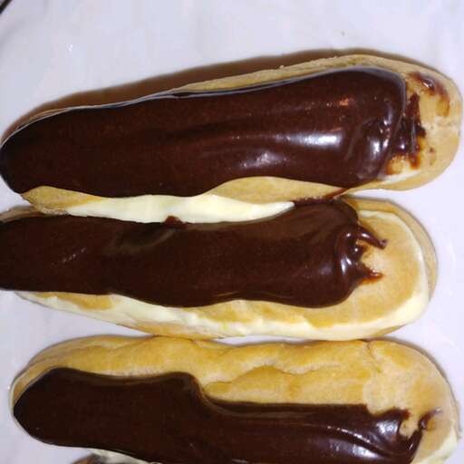
5. shoux paste
A. Éclairs
Ingredients
Choux Pastry:
1 cup water
½ cup butter
1 cup all-purpose flour
¼ teaspoon salt
4 large eggs
Filling:
2 ½ cups cold milk Fig.1.5.Éclairs
1 (5 ounce) package instant vanilla pudding mix
1 cup heavy cream
¼ cup confectioners' sugar
1 teaspoon vanilla extract
Icing:
2 (1 ounce) squares semisweet chocolate
2 tablespoons butter
1 cup confectioners' sugar
1 teaspoon vanilla extract
3 tablespoons hot water

Methods
1. Preheat the oven to 450 degrees F (230 degrees C). Grease a cookie sheet; set aside.
2. Make choux pastry: Combine water and butter in a medium pot. Bring to a boil, stirring until butter melts completely. Reduce heat to low; add flour and salt. Stir vigorously until mixture leaves the sides of the pan and begins to form a stiff ball. Remove from heat.
3. Add eggs, one at a time, beating well after each addition until incorporated. Using a spoon or pastry bag fitted with a No. 10 or larger tip, spoon or pipe dough onto the prepared cookie sheet in 1 1/2x4-inch strips.
4. Bake in the preheated oven for 15 minutes. Reduce heat to 325 degrees F (165 degrees C) and continue baking until the bottoms sound hollow when lightly tapped, about 20 more minutes. Cool completely on a wire rack.
5. Make filling: Combine milk and pudding mix in a medium bowl according to package directions. Beat heavy cream with an electric mixer in a separate medium bowl until soft peaks form. Beat in confectioners' sugar and vanilla. Fold whipped cream into pudding.
6. Cut tops off of cooled pastry shells with a sharp knife. Fill shells with pudding mixture and replace tops.
7. Make icing: Melt chocolate and butter in a medium saucepan over low heat. Stir in confectioners' sugar and vanilla. Stir in hot water, 1 tablespoon at a time, until icing is smooth and has reached desired consistency. Remove from heat and cool slightly.
8. Drizzle chocolate icing over filled eclairs. Store in the refrigerator until serving.

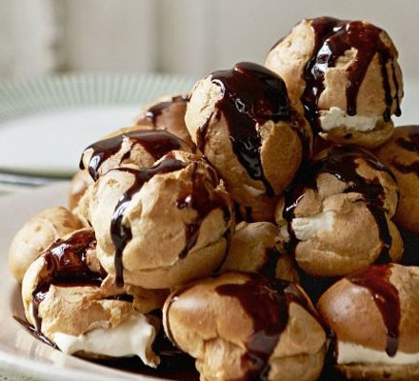
- profiteroles
Ingredients
- 50g butter (preferably unsalted), cut into cubes
- 2 tbsp caster sugar
- 75g strong white flour, sifted with a pinch of fine sea salt
- 2 eggs, lightly beaten
- 300ml double cream
- few drops vanilla extract Fig.1.6. profiteroles
For the sauce
- 50g cocoa powder Fig.1.6.profiteroles
- 175g caster sugar
Method
STEP 1. Heat the oven to 220C/200C fan/gas 7. To make the profiteroles, put the butter and 2 tsp of the caster sugar in a saucepan with 150ml water. Place the pan over a low heat until the butter and sugar have melted, then bring to the boil. Take off the heat, add the flour all at once and beat energetically with a wooden spoon until the dough comes away from the sides of the pan.
STEP 2. Leave to cool for 5 mins, then beat in the eggs bit by bit until you have a stiff, glossy mixture (this process is much easier in a food processor). Rinse two baking trays with cold water, shaking off any excess so they are slightly damp (this helps the pastry to rise). Using 2 teaspoons, spoon blobs of the mixture onto the baking trays. Then place in the oven and cook for about 18-20 mins until well risen and brown. Remove the profiteroles from the oven and cut a small slit in the base of each one so they don’t collapse. Cool on a wire rack.
STEP 3. When they’re cold, whip the cream lightly until just holding its shape. Sweeten to taste with remaining sugar and a few drops of vanilla extract. Cut the profiteroles in half, fill them with the sweetened cream and pile them up on a plate. You can refrigerate them for 1-2 hrs. at this point but not for any longer as the pastry will go soggy.
STEP 4. To make the sauce, sift the cocoa powder into a bowl. Put the sugar in a pan with 100ml water and warm over a low heat until dissolved. Bring to the boil, cook for 1 min, then pour over the cocoa powder and stir well until smooth. Return the sauce to the pan, cook for 1 min then set aside for 15 mins before drizzling over the profiteroles.
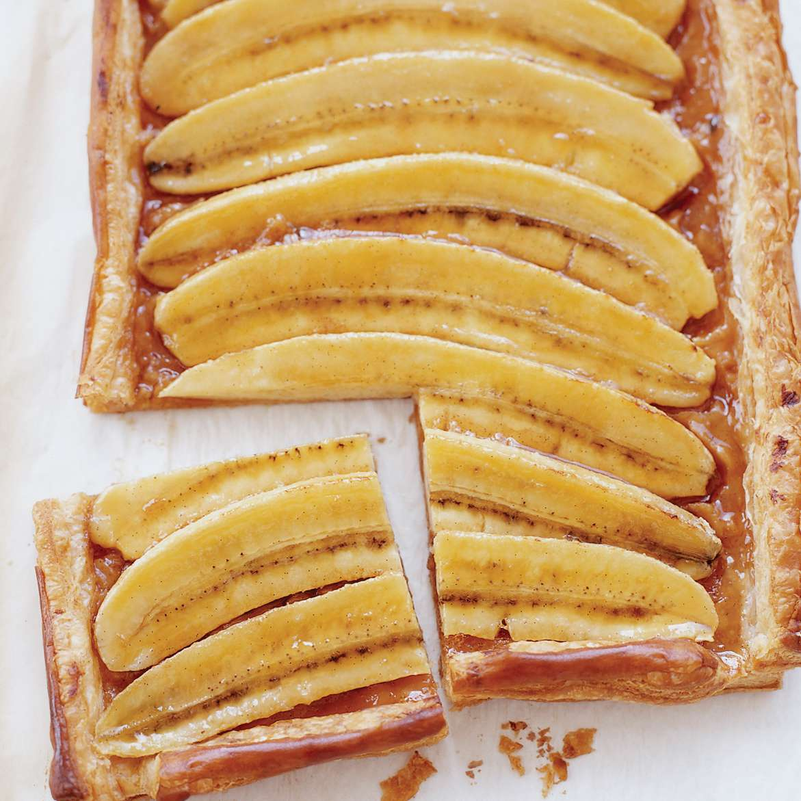
- banana tart
Ingredients
- 1/2 vanilla bean, split, seeds scraped
- 2 tablespoons water
- 1 large egg yolk mixed with 1 1/2 tablespoons water
- 5 small, just-ripe bananas, halved lengthwise
- 1/2 cup sugar
- 14 ounces all-butter puff pastry, thawed in the refrigerator
- Sweetened whipped cream or vanilla ice cream, for serving
- 6 tablespoons unsalted butter
- 1 1/2 tablespoons fresh lemon juice Fig.1.7 banana tart
Methods

Preheat the oven to 375°. Line a baking sheet with parchment paper. On a lightly floured surface, roll out the puff pastry to a rough 10-by-15-inch rectangle, then trim it to a neat 9-by-14-inch rectangle. Using a ruler, cut a 3/4-inch-wide strip of dough from each side; you will have 2 long and 2 short strips. Transfer the rectangle to the prepared baking sheet and brush with the egg wash. Set the strips on each side to form a border, pressing firmly to help the dough adhere; brush the strips with the egg wash. Freeze the tart shell until chilled, about 10 minutes.
Prick the bottom of the tart shell all over with a fork. Bake in the lower third of the oven for about 40 minutes, until the shell is puffed and golden. Press down the center of the shell slightly. Increase the oven temperature to 425°.
Rub the bananas with the lemon juice. In a skillet, cook the sugar over moderate heat, stirring until melted. Cook without stirring until a medium-amber caramel forms, about 5 minutes. Remove from the heat; whisk in the butter, vanilla seeds and water. Add the bananas and gently turn to coat with the caramel. Arrange the bananas in the tart shell, cut sides up, leaving most of the caramel in the skillet. Drizzle 1/4 cup of the caramel over the bananas. Bake the tart for about 20 minutes, until the bananas are slightly tender. Let cool slightly, then serve with whipped cream or ice cream, passing the remaining caramel on the side
- Spanish flan
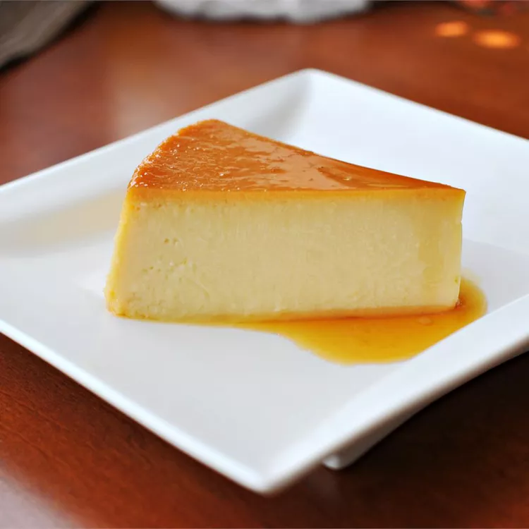
Ingredients
1 cup white sugar
3 large eggs
1 (14 ounce) can sweetened condensed milk
1 (12 fluid ounce) can evaporated milk
1 tablespoon vanilla extract
Methods
1. Preheat the oven to 350 degrees F (175 degrees C).Fig.1.8 Spanish flan
2. Melt sugar in a medium saucepan over medium-low heat until liquefied and golden in color. Carefully pour hot syrup into a 9-inch round glass baking dish, turning the dish to evenly coat the bottom and sides; set aside.
3. Beat eggs in a large bowl. Add condensed milk, evaporated milk, and vanilla; beat until smooth. Pour egg mixture into the baking dish; cover with aluminum foil.
4. Bake in preheated oven for 1 hour. Let cool completely.
5. To serve, carefully invert onto a rimmed serving plate; let caramel sauce flow over flan
9. Pumpkin pie
Ingredients
1(15 ounce) can pumpkin puree
1 (14 ounce) can eagle brand Sweetened Condensed milk
2 large eggs
1 teaspoon ground cinnamon
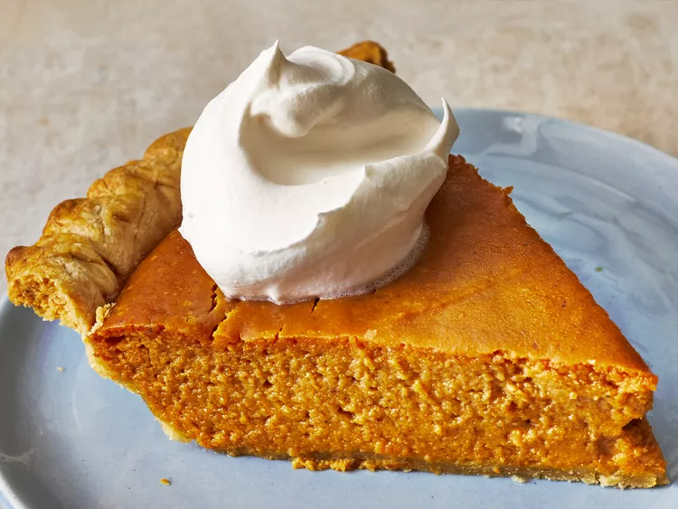
½ teaspoon ground ginger
½ teaspoon ground nutmeg
½ teaspoon salt
1 (9 inch) unbaked pie crust

Fig.1.9. Pumpkin pie

Method
- Preheat the oven to 425 degrees F (220 degrees C).
- Whisk pumpkin puree, condensed milk, eggs, cinnamon, ginger, nutmeg, and salt together in a medium bowl until smooth. Pour into crust.
- Bake in the preheated oven for 15 minutes.
- Reduce oven temperature to 350 degrees F (175 degrees C) and continue baking until a knife inserted 1 inch from the crust comes out clean, 35 to 40 minutes.
- Let cool before serving.
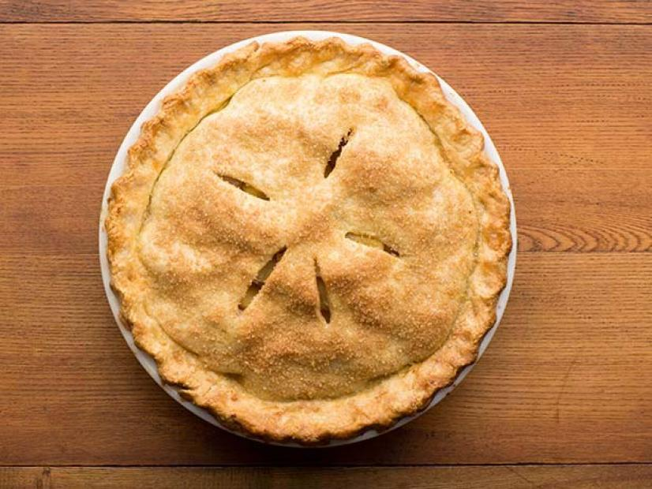
10. Apple pie
Ingredients
Crust
1box (14.1 oz) refrigerated Pie Crusts (2 Count), softened as directed on box
Filling*
6cups thinly sliced, peeled apples (6 medium)
3/4cup sugar
2tablespoons all-purpose flour
3/4teaspoon ground cinnamon
1/4teaspoon salt1/8teaspoon ground nutmeg Fig.1.10. Apple pie

1tablespoon lemon juice
Methods
1.Heat oven to 425°F. Place 1 pie crust in ungreased 9-inch glass pie plate. Press firmly against side and bottom.
2. In large bowl, gently mix filling ingredients; spoon into crust-lined pie plate. Top with second crust. Wrap excess top crust under bottom crust edge, pressing edges together to seal; flute. Cut slits or shapes in several places in top crust.
3. Bake 40 to 45 minutes or until apples are tender and crust is golden brown. Cover edge of crust with 2- to 3-inch wide strips of foil after first 15 to 20 minutes of baking to prevent excessive browning. Cool on cooling rack at least 2 hours before serving.
Variations
Tip 1
One package (12 oz) frozen Pillsbury™ Deep Dish Pie Crusts (2 Count) may be substituted for the refrigerated Pillsbury™ Pie Crusts in this recipe. Place cookie sheet on oven rack. Heat oven as directed. Prepare filling and follow directions on package for Two-Crust Filled Pie.
Tip 2
The flour tossed with the fresh apples turns their juices into a thickened, spiced sauce during baking. Mix it with the sugar and spices before tossing the mixture with the apples.
Tip 3
Two (21-oz.) cans of more fruit apple pie filling can be used if you’re short on time.
Tip 4
Let your apple pie cool for at least 2 hours before cutting into it. The filling will thicken as it cools, making it easier to slice.
Tip 5
To make Caramel-Pecan Apple Pie: right after removing the pie from the oven, drizzle with 1/3 cup caramel ice cream topping. Sprinkle with 2 to 4 tablespoons chopped pecans.
Tip 6
To freeze Baked Pie: Assemble and bake pie as directed in recipe. Cool completely. Wrap pie tightly with plastic wrap. Place pie in a 2-gallon freezer storage bag; seal. Freeze up to 4 months. Thaw frozen baked pie unwrapped at room temperature or unwrap and thaw at room temperature 1 hour, then heat in 375°F oven 35 to 40 minutes or until warm

Lap test 1:
Instructions:Given necessary templates, tools and materials you are required to perform the following tasks accordingly.
- Sieve flour.
- Add butter. Always use soft butter.
- Add the water gently until it forms a soft ball of dough. If you add too much water just add a bit more flour.
- This step is important.
- When you are ready to use the pastry.
- Lightly flour a clean surface and roll out the pastry.

Unit Two:Decorat And Present Pastry Products
This unit to provide you the necessary information regarding the following content coverage and topics:
- Decorate pastry product
- Presenting pastries
This guide will also assist you to attain the learning outcomes stated in the cover page. Specifically, upon completion of this learning guide, you will be able to:
- Apply Decorationto pastry product
- Present pastries

2.1. Decorate pastry product
It is important to decorate finish baked products because it increases the possibility that the customer will engage to buy the product because it is eye-catching. Decorating can make the product attractive and appealing for the buyer's eyes especially if the decorations good, clean, no scratch, new and beautiful.
Proper storage of perishable foods is necessary to ensure safe food and reduce shrink.
A bakery is one store that is hard to resist because bread, cake, and pastries are everyone's comfort food. People of all ages and races eat bread. Thus, they patronize the bakery in their area.
Baking teaches you to be more cognizant of what you put into your body on a daily basis. Once you start baking regularly, you come to learn the actions of certain ingredients or why one recipe worked while another failed miserably.
Decorating pastry is a great way to use up leftover trim as well as add a personalised touch to any dish.
Some techniques of decorating pastry:
- Spatula Icing.
- Piping.
- Fondant Work.
- Hand Painting
- Sugar Work.
- Airbrushing.
- Mirror Glaze.
Filling
Fillings are key ingredients in many bakery products such as creams, fondants, chocolate, truffles, pralines, caramels and many more. They are incorporated into a variety of pastries and desserts such as donuts, layer cakes, éclairs, pies, turnovers, sandwich-cookies or savoury baked goods to impart unique: Colour. Taste.

The most frequently used fillings& toppings you can make for your pastries &pastry goods:
- Frosting. The most common type of filling is frosting.
Custard.custard, mixture of eggs, milk, sugar, and flavourings which attains its consistency by the coagulation of the egg protein by heat. Baked custard contains whole eggs, which cause the dish to solidify to a gel.
Some cakes use custard for its filling.
- Whipped Cream. Whipped cream is also quite common to find as cake's filling
- Ganache.
- Butter cream
Filling for pastry may include:
- fresh or crystallised fruit and fruit purées
- whole or crushed nuts
- cream
- custard
- meringue

2.2. Present pastries
The presentation and display are essential for increasing the sales and footfall for any bakery store. The display strategy also plays a role in keeping your baked items fresh and tasty for a long time. Putting efforts in decorating your finished baked products can help you attract many customers.
There are some ways to present and display pastry products:
- Make use of accessories. Don't limit yourselves to just display boxes and baked goods when presenting your delicious artistry
- avoid empty spaces
- don't forget name cards and toppers
- color coding works too
- Keep sweets and savories separate.
- the bottom line

SELF-CHECK 2

Instruction: Answer the following questions:
Part I Choose the best answer
1. the most frequent filling & topping used to make pastry& pastries is
A. butter cream C. whipped cream
B. custard D. All
2. Which of the following is decoration technique of pastry?
A.Spatula Icing.
B. Piping.
C. Fondant Work
D. All
Part II Write short answer
1. What are the fillings of pastry?

Operation sheet 2. Decorate and present pastry products
Operation Title:DecorPastries& pastry
Purpose: to perform cake production
Conditions or situations for the operations:
- Safe working area
- Properly operated tools and equipment
- Appropriate working uniforms fit for the practical performance
Equipment Tools and
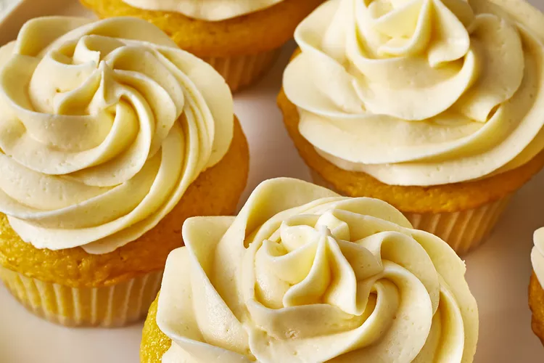
- Bowl
- Scale
- Scraper
-Whisker
1. Butter cream
Ingredients
½ cup unsalted butter, at room temperature
2 cups confectioners' sugar, sifted
1 ½ teaspoons pure vanilla extract
2 tablespoons milk Fig.2.1. Butter cream
3 drops food coloring, or as needed (Optional)

Directions
Cream butter in the bowl of a stand mixer fitted with the paddle attachment until smooth and fluffy. Gradually beat in confectioners' sugar until fully incorporated. Beat in vanilla extract.
Add milk and beat for an additional 3 to 4 minutes. Add food coloring and beat for thirty seconds until smooth or until desired color is reached.
2. Whipped cream
Ingredients
1 cup heavy cream
1 tablespoon confectioners' sugar
1 teaspoon vanilla extract

Directions
1. Whisk cream in a chilled glass or metal bowl with an electric mixer until frothy. Add confectioners' sugar and vanilla; continuing to beat until soft peaks form.

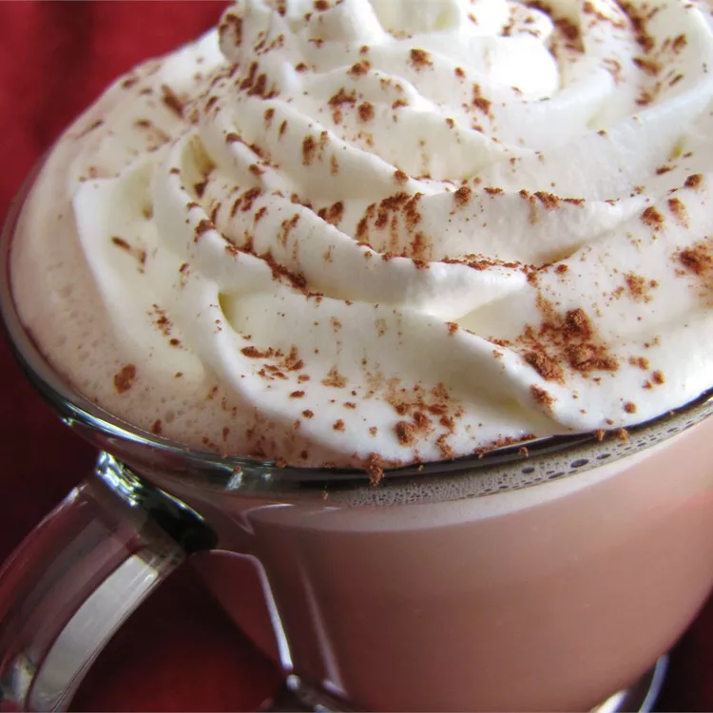

Fig. 2.2. Whipped cream

3.Custard

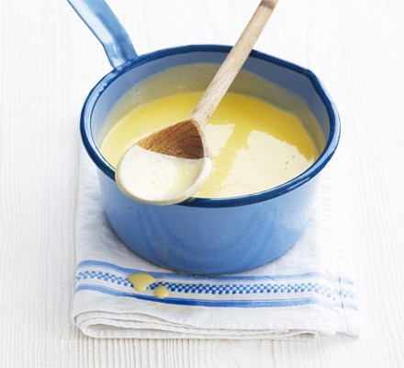
Ingredients
- 200ml double cream
- 700ml whole milk
- 4 large egg yolks
- 3 tbsp cornflour
- 100g caster sugar
- 1 tsp vanilla extract
Method Fig.2.3.Custard
STEP 1
Put the cream and milk into a large pan and gently bring to just below boiling point. Meanwhile, in a large bowl, whisk the yolks, cornflour, sugar and vanilla. Gradually pour the hot milk mixture onto the sugar mixture, whisking constantly.
STEP 2
Wipe out the saucepan and pour the mixture back into it. Heat gently, stirring with a wooden spoon (see Steps 1 and 2, for stirring tips) until the custard is thickened, but before any lumps form. Eat hot or cold.
4. Meringue.(a dessert topping consisting of a baked mixture of stiffly beaten egg whites and sugar)
Ingredients
4 large egg whites
1/4 teaspoon cream of tartar
1/4 cup sugar
Method
1. Remove eggs from the refrigerator and separate, as they will separate best cold.
2. Allow egg whites to reach room temperature to allow them to whip to their fullest.
3. Preheat oven to 350 degrees.
4. Pour eggs whites into a spotlessly-clean bowl.
5. Whip the egg whites until they are glossy and smooth, then add the cream of tartar to help the egg whites hold their form.
6. Slowly add the sugar to the egg whites about a tablespoon at a time, beating after each addition until the sugar is incorporated. Continue beating until stiff peaks form.
7. Spread meringue on top of pre-baked or no-bake dessert, place about 4 inches under the heat and bake for about 10 minutes, until golden.
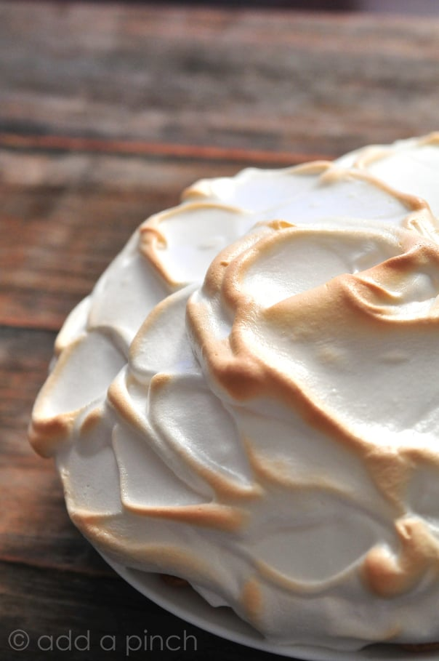

Fig 2.4. Meringue

Unit Three: Store pastries
This unit to provide you the necessary information regarding the following content coverage and topics:
- Storing pastes and ingredients
- Storing pastry products
This guide will also assist you to attain the learning outcomes stated in the cover page. Specifically, upon completion of this learning guide, you will be able to:
- Store pastes and ingredients
- Store pastry products

3.1. Store pastes and ingredients

Proper Storage Techniques for Baking or pastry Ingredients
Much attention goes to the proper storage environment for raw foods, such as meat and vegetables. Baking ingredients have a shelf life, too, as well as the potential to spoil and not work as effectively when storage conditions are not ideal. By practicing proper humidity control for baked goods and following storage recommendations, you’ll maximize the shelf life of ingredients, reduce waste and ensure the quality of manufactured products.
Bread, sweet pastries and savoury pastries, like all other products, must always be stored in freezers until used at a stable temperature of -18 degrees.
The Importance of Humidity Control for Baked Goods
When relative humidity levels are high, dry ingredients absorb the moisture in the air. This affects:

- Their weight
- Their density
- Cook times
- Ingredient quality
- Shelf life
- Interactions with other ingredients
- Flavors
- Nutritional qualities
- Consumer health

In addition to storage conditions, humidity control for baked goods is important during the preparation, baking, and cooling stages. When the air lacks sufficient moisture, for example, yeast bread may not rise appropriately. When relative humidity levels are too high when a freshly baked good rests, the food is vulnerable to mold. Problems that result from not having the correct environment for preparing, baking, and cooling food affects the efficiency and operations of commercial baking facilities.
Tips for Storing Common Baking Ingredients
The rule of thumb for storing baking ingredients that don’t require refrigeration or freezing is to place them in an airtight container in an area that’s cool, dark, and dry. Ideal environments are between 50° and 70° F with a relative humidity level at or below 60 percent.
Many ingredients have a shelf life of up to two years, but it’s always best to observe a manufacturer’s expirationdates.
- Keep the following ingredients dry and covered:

- Baking soda
- Baking powder
- Bouillon granules or cubes
- Dry bread crumbs
- Solid chocolate
- Cornmeal
- Cornstarch
- White wheat flour
- Grits
- Powdered milk
- Dry pasta
- Rice
- Shortening
- Artificial sweeteners
- Sugar, all types
- Cereal
- Tea, all types
- Marshmallows
- Vinegar
- Baking mixes
- Sauce mixes
- Pudding mixes
- Soup mixes
- Dried vegetables
- Salt
- Whole and ground spices and herbs
- Vanilla and other extracts
- Dry beans and peas

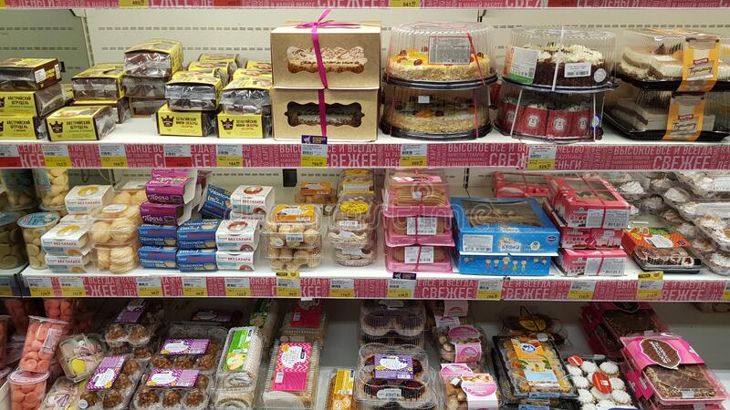
- By keeping the following foods refrigerated, even before opening their packaging, you’ll extend their shelf life:

- Baked goods
- Cornmeal (freeze for indefinite storage)
- Whole wheat and other whole grain flours
- Molasses
- Dried fruit
- Dehydrated vegetable flakes
- Meat substitutes
Nuts

- Dry yeast Fig.3.1. pastries storage

- Refrigerate the following foods after opening:

- Pectin
- Chocolate syrup
- Ground coffee
- Jam and jelly
- Marshmallow cream
- Mayonnaise
- Vegetable oils
- Prepared frosting
- Sauces and condiments
- Parmesan cheese
- Coconut, all forms
- Peanut butter
- Syrups

3.2. Store pastry products
Bread and baked products such as muffins, bagels, quick breads, waffles, pastries, cakes and cookies are safely stored on the counter or in the pantry. Storing in the refrigerator can increase shelf-life by 2-3 weeks by reducing spoilage issues such as mould growth.
You can cover each pastry in plastic wrap to retain and preserve the freshness and taste. Make sure not to squash the pastries while wrapping them. We suggest keeping these baked items in an airtight container for best results
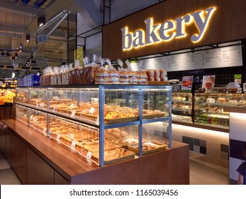
Storing of baked products is necessary to ensure food safety and prolong the freshness of the baked products. In a food production business, everyone should be concerned about the proper storing and how each baked product should be stored.

Fig.3.2. pastry store

SELF-CHECK 3

Instruction: Answer the following questions:
Part I
1. What is baking? How do you define it?
2. List at least 5 key words in combining ingredients in the pastry & baking process.
Part II
3.--------- is a mixture of egg white& sugar?
A).Whipping C) meringue
B). Cream D).All
4.------is used to squeeze a soft, smooth textured substance through a pastry tube, that making
a design or decoration
A).Piping bag C).Scrubber
B).brush D).spatula
5) Baking Soda and Baking Powder-are leavening that improve the texture and appearance of baked goods& helps to double size.
A)True B) False C) None

NOTE:
Chef Hierarchy
Different Types of Chefs
Chefs will generally hold higher-ranked positions in a kitchen. Additionally, a restaurant will usually have managerial chefs and specialized chefs. Each type of chef can cover a variety of different tasks, from organization and training to menu development and recipe creation. Becoming a chef requires years of education and experience, climbing from entry-level positions to the ultimate goal of executive chef.
Managerial Chefs
In managerial chef positions, there is an established hierarchy because these chefs have the most responsibility in the kitchen to ensure the restaurant's overall success.
The following roles are listed in descending order.
Chef-Owner (Group Chef)
A chef-owner is a chef that starts their own restaurant.
- Primary Task: Business management
- Number Per Kitchen: One per kitchen
- Other Duties: Running the establishment and engineering a menu
Executive Chef (Chef de Cuisine, Head Chef)
An executive chef oversees all aspects of the kitchen.
- Primary Task: Kitchen management
- Number Per Kitchen: One per kitchen
- Other Duties: Oversee daily operations, kitchen costs, food preparation, menu planning , and create most of the recipes and dishes for the menu
Sous Chef (Second Chef, Under Chef)
A sous chef is the second in command and will run the kitchen in the executive chef’s absence.
- Primary Task: Team management
- Number Per Kitchen: Can be more than one in a kitchen depending on the size of the establishment
- Other Duties: Train newly hired chefs and cooks and oversee each dish's details
Senior Chef (Chef de Partie, Station Chef)
A senior chef is assigned one specialty on the menu that they excel in.
- Primary Task: Station management
- Number Per Kitchen: Can have more than one
- Other Duties: Specialists on a certain portion of the menu and will ensure that high-quality food leaves their station
Specialized Chefs
A hierarchy generally does not exist between specialized chefs. Each of them is an expert in their specific field.
Pastry Chef (Patissier)
The pastry chef is either the only person or the most senior person in the pastry department.
- Primary Task: Prepare pastries, breads, and desserts
- Number Per Kitchen: Can have just one for a small dessert menu, but there is normally an entire pastry team
- Other Duties: May be in charge of creating the whole dessert menu
Sauce Chef (Saucier, Saute Chef)
A sauce chef is the cook that prepares the sauces. This is mainly a position found in locations that serve French cuisine.
- Primary Task: Choose and prepare sauces and gravies for all meal types
- Number Per Kitchen: Normally one per kitchen
- Other Duties: May also prepare soups and stews
Fish Chef (Poissonier)
The fish chef is in charge of finding responsibly-raised seafood for the menu.
- Primary Task: Prepare and cook seafood
- Number Per Kitchen: Usually one per kitchen
- Other Duties: May also be responsible for sourcing and acquiring the seafood used in an establishment from a local market or non-local vendor
Vegetable Chef (Entremetier)
Handles all vegetables that are included in the various dishes on the menu.
- Primary Task: Prepare and cook vegetables and starches
- Number Per Kitchen: At least two per kitchen
- Other Duties: May also be responsible for some soup and egg dishes
Meat Chef (Rotisseur, Roast Chef)
Ensures all meats on the menu are properly sourced and cooked to meet the restaurant's standards.
- Primary Task: Prepare and cook meats by roasting, braising, broiling, or other methods
- Number Per Kitchen: Depending on menu size, normally just one is needed
- Other Duties: May also be in charge of obtaining the meat from local suppliers and retailers
Pantry Chef (Garde Manger)
The pantry chef, commonly known as garde manger or "garmo", creates decorative culinary centerpieces or buffet presentations.
- Primary Task: Preparing cold food items like salads, cold cuts, hors d’oeuvres, and dressings
- Number Per Kitchen: 1-2 depending on restaurant size
- Other Duties: Responsible for setting up buffet lines and adding centerpieces for an upscale presentation that may include carved and molded ice or fruits
Fry Chef (Friturier)
A fry chef handles any food that involves a fryolator, mainly needed in fast food establishments.
- Primary Task: Ensures foods are perfectly breaded and fried
- Number Per Kitchen: One if the menu is diverse, many more if the menu focuses on fried foods
- Other Duties: Clean out fryers and consult with butcher and vegetable chefs if need be
Grill Chef (Grillardin)
The grill chef will generally grill meats and sometimes vegetables.
- Primary Task: Grill meat, seafood, and vegetables
- Number Per Kitchen: Usually one grill cook
- Other Duties: Consult with butcher and vegetable chefs if need be
Butcher Chef (Boucher)
A butcher chef breaks down and prepares meat for other stations to use. They are mainly needed in larger establishments to keep up with the demand
- Primary Task: Prepare cuts of meat for other station chefs to cook
- Number Per Kitchen: One butcher is needed for restaurant kitchens
- Other Duties: Consult with fry and grill cooks, source and supply meats
Types of Cooks
Cooks will usually occupy entry-level positions in a kitchen and experience training from specialized chefs. They are more likely to cook by following recipes given to them and flow between the different cook positions as needed.
Line Cook (Commis)

A line cook is usually getting experience through the position. They will learn different cooking styles from the specialized chefs in the kitchen
- Primary Task: Cooking where needed and completing an assortment of kitchen tasks
- Number Per Kitchen: Rarely there will be just one in each kitchen, but it is size-dependent
- Other Duties: May be required to do miscellaneous tasks like plating dishes, taking orders, or cutting vegetables
Prep Cook (Kitchen Porter, Kitchen Hand, Kitchen Assistant)
A prep cook's responsibilities revolve around kitchen basics like chopping ingredients, finishing their prep lists, properly labeling containers in storage, and cleaning countertops.
- Primary Task: Daily food prep and kitchen tasks
- Number Per Kitchen: At least one per kitchen, but usually a whole team
- Other Duties: Perform other cooking duties as needed
Relief Cook (Chef de Tourant, Roundsman, Swing Cook)
A relief cook will assist chefs that may be overwhelmed at their stations.
- Primary Task: Fills in wherever needed
- Number Per Kitchen: Normally one relief cook
- Other Duties: Keeps work areas clean and tidy
Short Order Cook
A short order cook is responsible for quickly clearing as many order tickets as possible without sacrificing the quality of the meal
- Primary Task: Prepare quick and simple meals, mainly focusing on making foods like sandwiches and salads
- Number Per Kitchen: Usually 1-2 depending on menu and number of tables
- Other Duties: Manage food quality standards
Chef vs. Cook
The difference between a chef and a cook is that a chef takes on more of a managerial role with their responsibilities. They will also usually have more specialized tasks, such as coming up with an entire menu or monitoring food costs and food orders. A cook is in charge of just that: cooking. Their main task is turning ingredients into beautifully plated works of edible art.

Baking Temperatures and Times
 | Temp (F/C) | Minutes
Breads
Biscuits | 425 - 450 F  218 - 232 C | 10 - 15
Cream Puffs | 375 F  190 C | 60
Popovers | 375 F  190 C | 60
Quick Loaf Breads | 350 - 375 F  177 - 190 C | 60 - 75
Yeast Bread | 400 F  205 C | 30 - 40
Yeast Rolls
Plain | 400 - 425 F  205 - 218 C | 15 - 25
Sweet | 375 F  190 C | 20 - 30
Cakes With Fat
Cupcake | 350 - 375 F  177 - 190 C | 15 - 25
Layer Cake | 350 - 375 F  177 - 190 C | 20 - 35
Loaf Cake | 350 F  177 C | 45 - 60
Cakes Without Fat
Angel Food & Sponge | 350 F  177 C | 50 - 60
Cookies
Drop | 350 - 400 F  177 - 205 C | 8 - 15
Rolled | 375 F  190 C | 8 - 10
Egg, Meat, Milk & Cheese
Souffle (in a hote water pan) | 350 F  177 C | 30 - 60
Custard (in a hot water pan) | 350 F  177 C | 30 - 60
Macaroni & Cheese | 350 F  177 C | 20 - 30
Meat Loaf | 350 F  177 C | 60 - 90
Meat Pie | 400 F  205 C | 25 - 30
Rice Pudding (raw rice) | 300 F  149 C | 120 - 180
Scalloped Potatoes | 350 F  177 C | 60
Pastry
1 Crust Pie (Custard Type) | 400 - 425 F  205 - 218 C | 30 - 40
Shell Only | 450 F  232 C | 10 - 12
2 Crust Pies with Uncooked Filling | 400 - 425 F  205 - 218 C | 45 - 55
2 Crust Pies with Cooked Filling | 425 - 450 F  218 - 232 C | 30 - 45

Reference

- Fellows, P.J. “Baking and Roasting.” Food Processing Technology; Principles and Practice, 4th edition, Woodhead Publishing, Elsevier Ltd., 2017, pp. 733–752.
- Gisslen, W. “Basic Baking Principles” Professional Baking, 7th edition, John Wiley & Sons, Inc., Hoboken, New Jersey, 2017, pp. 93–101.
- Figoni, P. “Overview of the Baking Process” How Baking Works, 3rd edition, John Wiley & Sons, Inc., 2011, pp. 34–44.
- bakery & confectionary course ,food production department
kenya utalii college, nirobi
- Practical cookery,1oth edition

Participants of this Module (training material) preparation

No | Name | Qualification (Level) | Field of Study | Organization/ Institution | Region | Mobile  number | E-mail
1 | Zuriyash-work Belay | B | Hotel Management | TTI Addis Abeba |  | 0911643817 | zuriyashwb@gmail.com
2 | Zelalem Almaw | B | Food Science& post-Harvest Technology | Bahir Dar PTC |  | 0918012521 | Parazolla25@gmail.com
3 | Hiwot Tedla Belay | B | BA degree in Accounting and finance and diploma in Hotel Management | Harer Polytechnic College | Hareri | 0913789086 | hiwietaba@gmail.com
4 | Abreham Mayza Mengesha | A | BA degree in Hotel and Tourism | Arba minch Polytechnic college | SNNP | 0913711922 | Abrehammayza9@gmail.com
5 | Mohammed Liben Mohammed | B | - BA degree in Hotel and Tourism management  - MA degree in Disaster Risk Management | Jigjiga Polytechnic college | Somali | 0992326557 | cherechaw@gmail.com

