Bakery and Pastry Production Level- II
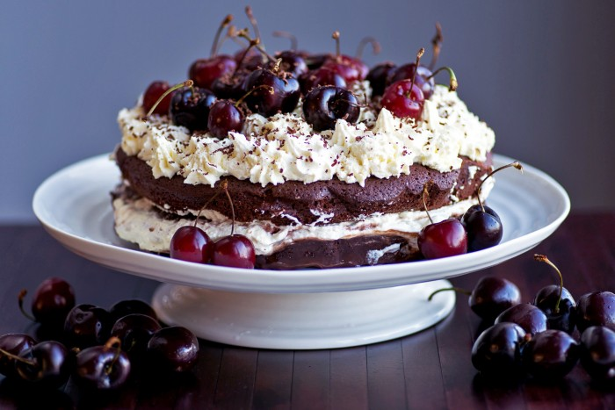
Based on December 2022 Curriculum Version 2
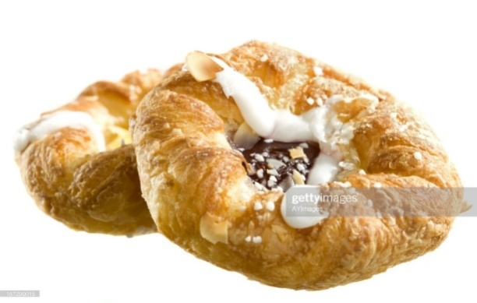
Module Title: Prepare and Present Gateaux
Module code: CST BPP2 M06 1222
Nominal duration: 78 Hours

Prepared by Ministry of Labor and Skills
December, 2022
Addis Ababa, Ethiopia

Acknowledgment

Ministry of Labor and Skills wish to extend thanks and appreciation to the many representatives of TVT instructors and respective industry experts who donated their time and expertise to the development of this Teaching, Training and Learning Materials (TTLM).

Table ofContents
Acknowledgment 1
Introduction to the module 3
This module covers the units: 3
Learning Objective of the Module: 3
Unit One: prepare specialized cakes sponges 4
1.1 Ingredients preparation: 5
1.2. Specialized cakes and sponges: 8
1.3 Appropriate equipment 12
1.4 Cooling sponges and cakes 14
Operation sheet1. 16
Lap test 1 22
Unit Two: Prepare and use fillings 23
2.1. Prepare Fillings: 24
2.2. Layer sponges and cakes: 25
2.3. Coat top and sides of sponges and cakes 30
Operation sheet2. 34
Lap test2. 34
Unit Three:Decorate cakes 35
3.1. Using Icing 35
3.2. Decorating sponges & cakes 38
Operation sheet 3. 41
Lap test.3. 42
Unit Four: Present cake 43
4.1. Equipment for displaying & present cakes 43
4.1.Sweet display plate 46
4.2. Equipment for cake display 46
4.2. Present cakes: 46
4.3. Portion controlled cakes 48
Operation sheet 4. 49
Unit Five:Store cakes 50
5.1storage conditions 50
5.2. Storage methods: 53
Recommended Readings 59
Participants of this Module (training material) preparation 60

Introduction to the module
Producing variety of products in bakery and pastry production field will enhance the Hospitality industry service, serving the customer in full capacity and it is very important to keep the standards of bread and other sweet desserts service. On the other hand it is also a means to create a job for small scale industries and to street food service providers
This module is designed to meet the industry requirement under the bakery and pastry production occupational standard.

This module covers the units:
- Specialized cakes and sponges
- Preparing & use Fillings
- Decorate Cake
- Present cakes
- Store Cake

Learning Objective of the Module:
At the end or the training session the trainees will be able to:
- Prepare specialized cakes and sponges
- Prepare & use Fillings
- Apply cake decorations.
- Present cakes
- Store cakes properly and safely

Module Instruction
For effective use this modules trainees are expected to follow the following module instruction:
- Read the information written in each unit
- Accomplish the Self-checks at the end of each unit
- Perform Operation Sheets which were provided at the end of units
- Do the “LAP test” given at the end of the unit and
- Read the identified reference book for Examples and exercise

Unit One: prepare specialized cakes sponges
This unit is developed to provide you the necessary information regarding the following content coverage and topics
- Ingredient preparation
- Prepare specialized cakes and sponges
- Appropriate equipment
- Cooling sponges &cakes.

This unit will also assist you to attain the learning outcomes stated in the cover page.
Specifically, upon completion of this learning guide, you will be able to:
- Prepare ingredients
- Prepare specialized cakes and sponges
- Appropriate equipment
- Identify Storage conditions of cakes

1.1 Ingredients preparation:

Selecting Required Ingredients
Flour makes up the bulk of the ingredients in pastry:
- All-purpose Flour = contains 10-12% protein and can be used in bread, cake and pastry making.
- Pastry Flour = has enough gluten to produce the desired structure and flakiness. It is good for making cookies, pie dough, biscuits, and muffins. Note: If stronger flour is used, the percentage of shortening be increased to produce more tenderness. The use of too much flour results in a tough, dry, and flavourless recipe. On the other hand, too little flour results in a flat, tough, and flavourless baked product. The ratio of flour to shortening ranges from 1:1/3 to 1:2/3. 2.
- Fat this contributes to the tenderness and flakiness of pastry. a/) Shortening = the most popular fat for pie crust because it has the right plastic consistency to produce a flaky crust. It is firm and mouldable enough to make easily worked dough. b)/. Butter = contributes excellent flavour to pie pastry, but it is not frequently used in volume production for two reasons: it is expensive, and its melts very easily, making the dough difficult to work.
c.) Margarine = this should not be used because it blends too quickly with the flour, making a flaky pastry difficult to achieve.
d.) Oil = makes the pastry very tender, but crumbly rather than flaky.
e). Lard = rendered fat of hogs and mainly used in cooking. Note: If butter is used in place of shortening, the percentage of fat in the formula should be increased by about one-fourth. (If 1 pound shortening is called for, use 1 pound 4 ounces butter, if 500grams shortening are called for, use 65 grams butter). The differences in texture of many pastries have to do with the type of fats and how fats are introduced during the process.
The liquid should be reduced slightly, as butter contains moisture.
3. Leavening Agents a.) Steam = act as the raising agents in puff and flaky pastries. b.) Egg and steam = act as raising agents for choux pastry c.) Yeast = use in making Croissants and Danish pastry
4. Liquid = use to bind and hold together the blended flour-shortening mixture. a). Water = is used to bind and hold together the blended flour-shortening mixture. It should be ice-cold to get the best result. b). Milk = sometimes used instead of water; it produces pastry that browns beautifully but tends to be less tender than made with water. c.) Chilled orange or lemon juice = can be used instead of water to add flavour to the crust. Note: Add cold liquid ingredients on a gradual basis. Since different types of flour have different absorbing properties.
The addition of liquid contributes to flakiness as the temperature of liquids allows fat particles to become well-formed and preserved. Likewise, the flour particles become less saturated with the additional water, thus minimizing swelling.
5. Salt = it has a tenderizing and conditioning effect on the gluten. = its main contribution is to add flavour and it must be dissolved into the liquid before adding to even distribution. Note: Skip using salt if margarine is used.
6. Sugar = it is added to sweeten the pastry dough.
7. Egg = the yolk emulsifies the dough giving the crust characteristics of tenderness, richness, and brown colour.
8. Flavourings such as herbs, spices, essences, and cheeses may be used and be added to the basic pastry dough.
Measuring and Weighing Required Ingredients for Pastry Production Measuring and weighing accurately the required ingredients in pastry making is of great importance.

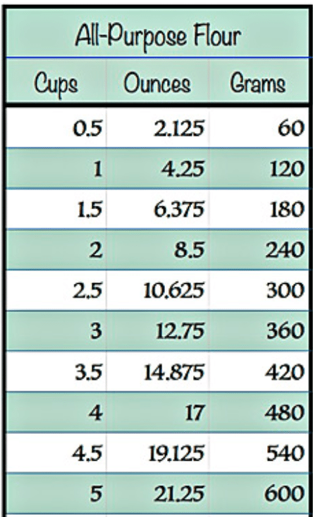

Fig.1.1 Weight chart
Balance of ingredients
Formula balance is the term usually used with regard to the balance of ingredients.
To produce a good quality cake, the essential ingredients must be present in the proper proportions. Various ingredients are tenderising agents–sugar, shortening and egg yolk.
These counteract the toughening or binding agents–flour, egg white and milk solids. Thus an unbalanced cake formula would produce either a tough cake or a crumbly textured cake.
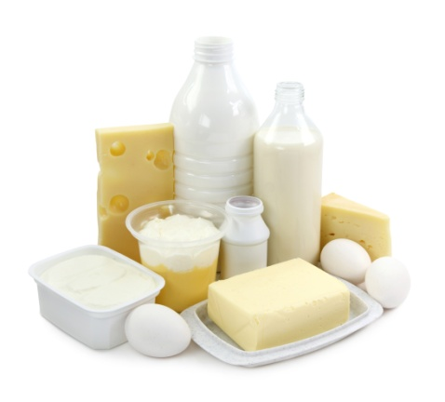
In general it is recommended to use the same quantity of flour to sugar, with the exception of High Ratio formulas where an additional 20% sugar can be used.

Fig.1.1Balance of ingredients
The density of a sponge is determent with the egg content. These more egg compared, to flour and sugar, is used the lighter the sponge.
Some formulas are made with equal parts of sugar, flour and eggs.
These sponges are classified as heavy or dense, but flour and sugar can now be reduced to half or less of the egg quantity, which produce lighter sponges.

1.2. Specialized cakes and sponges:
By definition, a cake is a ‘sweet baked’ product usually containing flour, sugar, eggs and fat. Other typical ingredients are flavouring agents, liquids and leaveners or raising agents, such as baking powder or baking soda.
Gateau in France refers to all Cakes and Pastries of a certain size, usually bigger than one portion. Modern Gateaux finishing includes products which are:
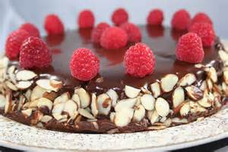
Glazed
Masked
Sprayed
Covered or coated with chocolate
Marzipan
Fresh creamFig.1.2Gatoux
Icings
Butter creams.
Select-- carefully choose as being the best or most suitable
Measure -Ascertain the size, amount, or degree of (something) by using an instrument or device marked in standard units:
Weigh -- find out how heavy (someone or something) is, typically using scales:
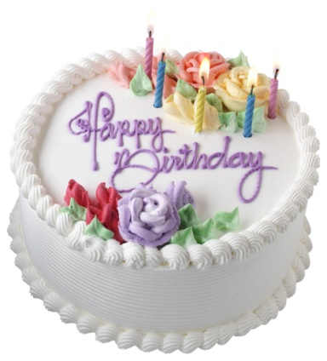
Cakes are generally categorised by their main ingredient or flavouring.
For example:
- Cheesecake
- Chocolate cake or raspberry cake
- Fruit cake.
- Or by their ‘method of preparation:
- Mousse cake
- Chiffon cake
Fig.1.3.Birthday cake

Thedifference between the two (cake&gateau)
On the one hand, gateau is a fancy word for cake, if you take “cake” as a very generic term that covers angel food to flourless chocolate cake to cheesecake to beefcake (hey, wait a mi Cake and gateau are both sweet desserts. But In case of cakes, the focus in mainly of cake it self. Icing is kind of an extra.
But, Classic French Gateau is a layered structure. It consists of icing as a main component. So, it is thickly iced. Also, gateau uses fresh fruit as a main component which cake doesn't necessarily use. So you can store cake for longer because fresh fruits tend to go bad if not eaten within the same day, night.
Traditionally Gateaux and Tortes are described as a cake or sponge soaked with liqueur and layered with fillings, such as:
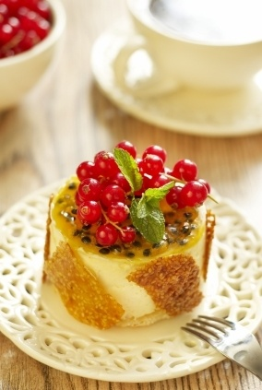
Butter cream
Fresh cream
Mousse
Ganache
Custards
Fruits and jellies.
Pastries such as: Fig.1.4.Fruits and jellies
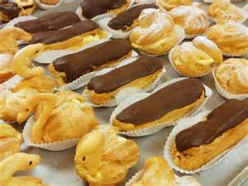
Puff pastry
Short pastry
Choux pastry
Meringue based baked goods.
It is also interpreted as individual decorated Fig.1.5.cream puff
Wedge of a layered cake.
Making Chocolate gateaux
This cake can be made in advance and frozen without the icing. Just defrost completely then ice as before. Why not drizzle with contrasting milk and white melted chocolates.
5 Main Principles behind the Making of Cakes
Principle # 1. Combining of Ingredients:
Careful attention has to be given to the mixing process. The cake mixture has to form a uniform emulsion, so that the water is held in suspension surrounded by fat and other ingredients in the batter. A batter can curdle if the mixture changes to fat in water, with small particles of fat surrounded by water.
Curdling can occur due to the following factors:
i. The quantity of butter should be measured accurately in the given recipe, so as the formula has a balance of both fat and water. Whole eggs, if ever used, will help the batter hold the liquids in the mixture.
ii. Ingredients should not be too cold; a temperature of 21 °C will enable an emulsion to form best.
iii. Mixing of ingredients in the first step too quickly will not be able to incorporate a good quantity of air into the batter.
iv. Adding of liquids too quickly may also cause the batter to curdle hence, they have to be added in steps and a little at a time.
v. Preparing of the molds prior to baking sponges is of utmost importance and is an art in itself. Many chefs lightly grease the cake tins with oil and fill up the tin with cake flour and pour out excess by tapping it slightly. This ensures a thin film of flour on the cake tin and prevents from the batter sticking to the mold. The other method is to line the cake tin with grease roof parchment paper.
Principle # 2. Formation of Air Cells: Formation of air cells in a batter is of great importance since they give the sponge its texture and also act as a leavening agent. The air trapped in the batter expands when subjected to heat and this acts as a natural leavened giving the sponge a good raise even if no chemical agent is used.
Correct temperature of ingredients and a suitable mixing are vital for the formation of good air cells in the batter. In the case of foam cakes the egg and sugar mixture should be slightly warmed to approximately 38°C. Whipping should be done at a high speed first, then at a moderate speed to retain the formation of air cells.
Principle # 3. Texture:
Another important principle in sponge making is the texture of the sponge. The development of gluten in the batter is responsible for the texture of the end product. A very little amount of gluten is required in cake making; hence weak flour will be a better choice. In some sponge recipes, corn starch replaces some of the flour requirement, thereby reducing the gluten content even more. On the other hand certain rich fruit cakes require more gluten to hold the structure and the fruits in the cake.
Since the amount of mixing affects the gluten, the flour in the recipe is always added towards the end of the mixing process after all the ingredients have been added, thus ensuring that there is very little development of gluten. If the batter is mixed for too long after the addition of flour, then the cake is likely to be tough.
Principle # 4. Formula and Balance:
Ingredients and quantities can be changed only to a certain extent in a given recipe. A formula in which the ingredients fall within these limits is said to be in balance.
For the purpose of balancing ingredients can be classified into the following four functions:
i. Tougheners:
They provide structure, for example, flour, eggs (white and yolks).
ii. Tenderizers:
They provide softness or shortening of protein fibers, for example, sugar, butter, and chemical leavener.
iii. Driers:
These are the ingredients that absorb moisture, for example, flours and starches, cocoa powder, and milk solids (powder), etc. A sponge may require formula balancing if even after following all the steps has not come out correctly.
iv. Moisteners:
They provide moisture to the batter, for example, water, milk, liquid sugar, eggs, etc.
The formula would be balanced if toughened equal tenderizers and driers equal moisteners. In other words, a balance has to be maintained between the given ingredients. Egg yolk contains fat which is a tenderizer and at the same time contains protein which is a toughened.
A common practice in balancing a formula is to decide the flour and sugar ratio, then balance the rest of the ingredients against this combination as follows:
i. If liquid is increased, reduce the eggs and the shortening.
ii. If eggs are increased, increase the shortening.

1.3Appropriate equipment
When making sponges it is essential for high quality products that equipment is:
Grease free
Starch free
Tin preparation
Mostly tins are lightly greased and then lined with greaseproof paper. The reasons for lining the tins are as follows:

Maintains the shape of the product
Greasing tin is not always satisfactory
Insulates product during baking
Adds to shelf-life of the product
Hygiene.
To prevent sponges or cakes sticking to the tins, tins can also be prepared as follows:
Using a greasing emulsion (this is a blended mixture of fat and starch)
Brushing tin with fat and then dipping it into flour or almond meal, depending on flavour
Brushing with fat and dipping the tin into sugar using fat only.
Note
Due to different flavours of the greasing agent it is recommended to always use the same fat for greasing as it is used for the product, to retain the best possible flavour. Torte or Gateau rings are not to be greased, as the product would shrink and the centre of the sponge would be higher than the sides. The bases of the rings are covered with
Grease proof paper, Commercial mixers and attachments( balloon whisk, paddle,(dough arm)whiskbeatersspatulas and wooden spoons,cutting implements for nuts and fruits,graters,scales and measures,bowl, cutters, baking ovens, cake and sponge tins and moulds, working table.
Table 1.Some Bakery equipment

No | Name of equip. | Picture | Description
1. | Digital scale | 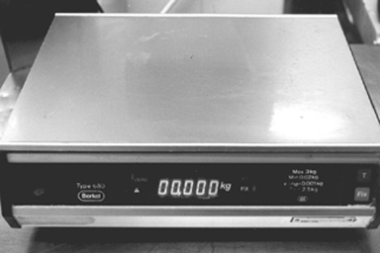 | --For measuring dry and soft ingredients.
2. | Dough kneeding machine | 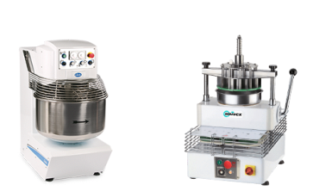
  Need the perfect dough that has the right texture and flavour.
3. | Tongs | 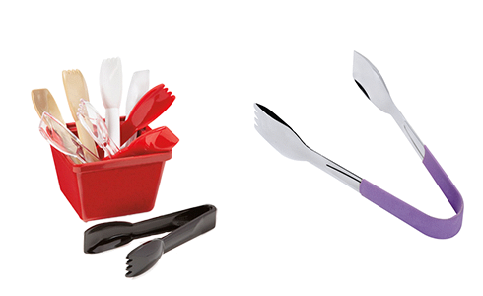 | With kitchen tongs, you can serve freshly made food items like pasta, noodles, or salad. Additionally, you can hold hot pots, pick fries, and other food items with stainless steel tongs.
4. | Mixing machine with attachement | 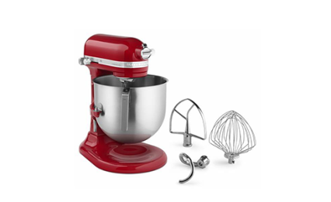 | Commercial Mixers used for everything from whipping up a day’s worth of pizza dough to creating gourmet sauces and soups.

1.4 Cooling sponges and cakes
Depending on what type of cake you are making and how long you have to cool it, there are several things to consider. If you cool your cake improperly you might end up with a cracked or soggy cake. Cooling your cake in the refrigerator is a quicker method, but you can also cool your cake on the countertop or in the oven. You can transfer your cake to a wire rack, let it cool in the pan, or even cool it upside down.
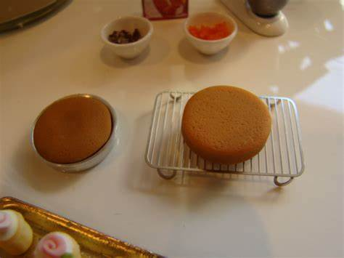
After you bake a cake, you should let it cool before frosting and decorating it. You can

Fig. 1.6 cooling cakes
expedite this simple process by learning how to cool a cake efficiently and effectively.
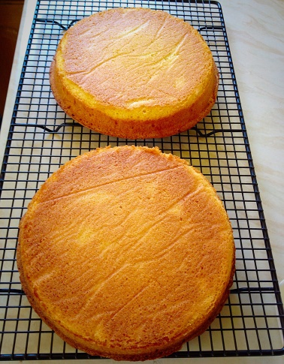

And icing to room temperature and retouch the icing before serving. You may even want to keep a little extra icing on the side to help.
You can also freeze an uncut cake that has been frosted, but the defrost process is well, a bit of a process. Making sure that condensation keeps from forming on the icing is tricky so, unless
A cake “re-sealed” like this can keep on the counter or in the refrigerator just like an uncut cake, but will last only 2-4 more days. Again—this is important —if the cake is iced with cream cheese or whipped cream frosting, skip the counter and go straight to the fridge for the entire storage time.

SELF-CHECK 1. | WRITTEN EXAM

Direction :
Answer the following questions:
Q1. Oil makes the pastry product tender, but crumbly rather than flaky.
True or False
2. Salt has a tenderizing conditioning effect on the gluten in the flour.
True or False
3. what is a cake?
a) A sweet baked product
b) Its recipe contains flour,sugar,eggs.fat & flavouring
c) A recipe contains only sugar and eggs
d) A & B are answer
4. Spatula and wooden spoon
a)Tools in bakery kitchen
b) Small and mobile tools
c) Not necessary for cake making
5. List three (3) flavouring used in the pastry production.

____________________________________________________________

Operation Sheet1.
Operation Title:Prepare specialized cakes and sponges
Purpose: To Prepare specialized cakes and sponges
Conditions or situations for the operations:
- Safe working area
- Properly operated tools and equipment
- Appropriate working uniforms fit for the practical performance

Equipment Tools & Ingredients:
-Mixer - scale - flour, icing sugar, butter, flavoring, etc
- Oven - bowl - milk, cacao, coconut G.sugar, etc.
- Scraper, piping bag, etc.

Quality Criteria: Assured performing of all the activities according to the procedures

Rich French Chocolate Gateaux Recipe:
Ingredients
2 cups chopped semisweet chocolate
3/4 cup (6 ounces) unsalted butter
1/3 cup cocoa powder
1/2 teaspoon instant espresso powder
5 large eggs
3/4 cup plus 3 tablespoons sugar
1 tablespoon all-purpose flour
Steps to Make It
Gather the ingredients.
Preheat the oven to 350 F. Lightly butter a 9-inch springform pan and set aside.
In a medium saucepan, melt the chocolate and butter over the lowest heat, do not rush this process, melting the chocolate too quickly will cause it to "shock" into a hard lump.
Mix in the cocoa powder and espresso powders until smooth and set aside for a few minutes to cool.

While the chocolate is cooling, whisk together the eggs, sugar, and flour until they are completely combined and foamy.
Fold the egg mixture into the chocolate until the color is uniform and pour the batter into the prepared pan.
Place into the center of the preheated oven and bake for 45 minutes or until a toothpick pulls out moist crumbs when inserted near the center of the torte. If the pick is sticky, then cook for a little longer.
Allow the cake to cool in the pan on a rack for 15 minutes. Run a knife or inverted spatula along the edges of the gâteau and loosen the sides of the pan. Cool for 5 minutes and remove the sides of the pan. Invert the cake onto a cake platter and cool completely before serving decorated as you wish.
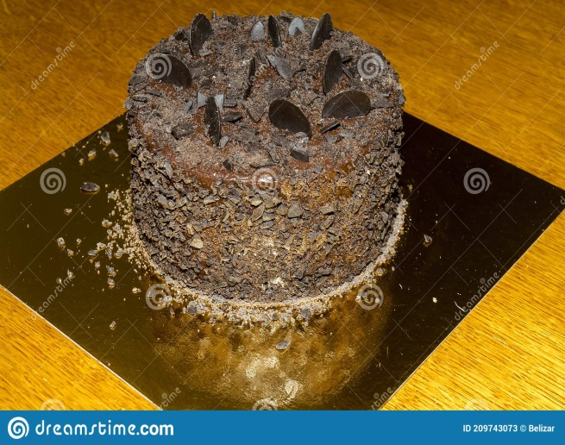
Fig.1.1. chocolate Gateaux
2. Special Birthday Cake
Ingredients
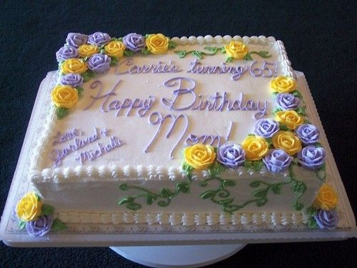
1/3 cup vanilla or white chocolate chips
1/2 cup hot water

1 cup butter, softened
1-1/2 cups sugar
4 eggs, separated
1 cup buttermilk Fig.1.2Birth day cake
1 teaspoon vanilla extract
2-1/2 cups all-purpose flour
1 teaspoon baking soda
White chocolate frosting:
1 cup sugar
1/2 cup plus 1 tablespoon evaporated milk
6 tablespoons butter
3 cups vanilla or white chocolate chips
2-1/4 teaspoons vanilla extract

Directions
In a small bowl, combine the chips and water; stir until chips are melted. In a large bowl, cream the butter and sugar. Add egg yolks, one at a time, beating well after each addition. Add melted chip mixture, buttermilk and vanilla; beat well. Combine flour and baking soda; gradually add to the creamed mixture.
In a small bowl, beat egg whites until stiff peaks form. Gently fold into the creamed mixture.
Pour into three greased and floured 9-in. round baking pans. Bake at 350° for 25-30 minutes or until a toothpick inserted in the center comes out clean. Cool for 10 minutes before removing from pans to wire racks to cool completely.
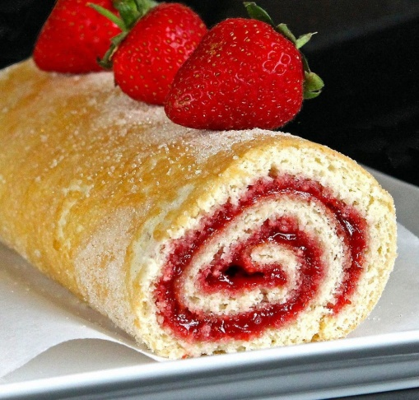
For frosting, combine the sugar, milk and butter in a saucepan; bring to a boil, stirring constantly. Boil for 1 minute; remove from the heat. Stir in chips and vanilla until smooth; cool. Spread frosting between layers and over top and sides of cake.
3. Swiss roll sponge:
Swiss roll
Ingredients
- 4 eggs
- 100 g. castor sugar
Fig 1.3.Swiss roll sponge
- 100 g. flour
Preparation
1. Whisk the egg and sugar over a pan of hot water

2. Continue until double in bulk
3. Remove from the heat and whisk until cold and thick
4. Fold in the flour very gently
5. Line the baking sheet with a grease proof paper
6. Pour in the mixture bake at 200-degree c. for 6 -10 min.
7. Turn out on to a sheet of paper or cloth sprinkled with castor sugar
8. Remove the paper from the Swiss roll
9. Spread quickly with warm jam
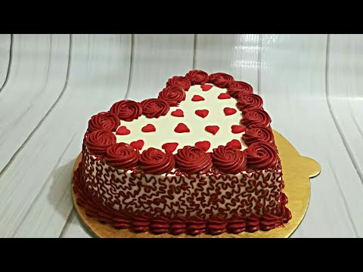
10. Roll in to a fairly tight roll, leaving the paper on the outside keep in the fridge 5-10 min.& slice to serve.

Fig1.4. Vanilla Genoese
4. Genoese sponge
Ingredients
- 4 Eggs
- 100 g. flour (soft)
- 100 g. castor sugar
- 50 g. butter / margarine

Preparation
1. Whisk the eggs and sugar with a balloon whisk in a bowl over a pan of hot water
2. Continue until the mixture is light, creamy, and double in bulk
3. Remove from the heat whisk until cold and thick (ribbon stage)
4. Fold in the flour very gently
5. Fold in the melted butter very gently
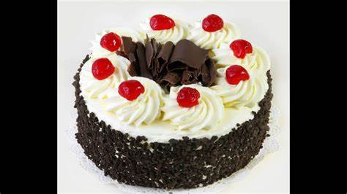
6. Place in a greased, floured Genoese mold
7. Bake in a moderately hot oven 200-degree c,
- Chocolate Genoese
Ingredients
- 75 g. flour
- 10 g. cocoa powder
- 10.g. corn flour
- 4 eggs Fig1.5 Chocolate Genoese
- 100 g. castor sugar
- 50 g. butter
- Preparation
Sift the flour, cocoa and corn flour together and proceed as for Genoese sponge

Lap test 1
Instructions: Given necessary templates, tools and materials you are required to perform the following tasks accordingly.
Task 1: pre-prepare the necessary equipment
Task 2: prepare the necessary ingredients
Task 3: measure the ingredients according to the instruction given by a recipe.
Task 4: make specialized cakes(Gateaux ).
Task 5: prepare various commercial sponge
Task 6. Considering its freshness store it properly

Unit Two: Prepare and use fillings
This unit is developed to provide you the necessary information regarding the following content coverage and topics:
- Prepare filling.
- layer sponges and cakes
- coat top and sides of sponges and cakes

This unit will also assist you to attain the learning outcomes stated in the cover page.
Specifically, upon completion of this learning guide, you will be able to:
- Prepare filling.
- Apply layer on sponges and cakes
- Perform coat top and sides of sponges and cakes

Introduction :

Filling is a thick mixture which is used between the layers of cake. It may be some of the frosting to which nuts or fruits are added. Whipped cream and custardmixtures are sometimes used for fillings.

2.1. Prepare Fillings:
There are many cake filling types that you can select to add to your cake to give it more flavour and interest. A cake with a filling always seems to attract attention and most often someone will select a filled cake over a plain cake because they know the filling will provide extra flavour.
Filling a Cake: Adding filling between layers holds the layers together, giving your cake flavor as well as height. Using a decorating bag filled with icing and fitted with tip 12, pipe a line of icing just inside the outer edge of the layer. This will create a dam that will prevent the filling from seeping out.
Some cake fillings
- American Butter cream. This is the most used cake filling across the world.
- Italian Meringue Butter cream.
- Swiss Meringue Butter cream.
- French Butter cream.
- German Butter cream.
- Chocolate Ganache.
There are many cake filling types that you can select to add to your cake to give it more flavour and interest. A cake with a filling always seems to attract attention and most often someone will select a filled cake over a plain cake because they know the filling will provide extra flavour.
What is the difference between frosting and icing?
The terms are used interchangeably, but frosting is generally thicker and fluffier than icing, which is thinner and tends to set quickly and harden when dry. Icing is generally not spreadable like frosting—it needs to be poured, spooned, or drizzled over baked good.
Tools materials and equipment needed for filling cake layers
7 Essential Tools for makinga cake
Stand Mixer or Hand Mixer. The easiest way to mix up cake batter is with a stand mixer, but that’s not the only way.

Rubber or Silicon Spatula.
Cake Pans.
Cake Tester or Toothpicks.
Paring Knife.
Wire Cooling Racks.
Metal Spatula.

Jam can be used for cake filling
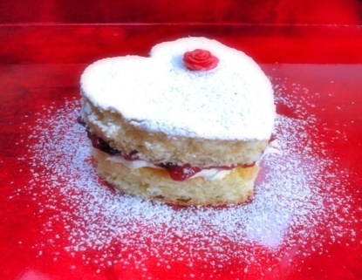
Jams and jellies are also best in combination with other fillings such as buttercream or ganache. To use a jam or jelly as a cake filling or even as a topping, simply stir it to soften, or heat it slightly if it’s too thick. You may also want to strain jams to remove theSeeds for a smoother texture
Fig.2.1 filling a cake

2.2. Layer sponges and cakes:
A layer cake is the cake to make for a special occasion. Whether mile-high or just two simple layers, a cake with filling is definitely in order for birthdays and other festive occasions. Layer cakes consist of multiple stacked sheets of cake, held together by frosting or another type of filling, such as jam or custard, and just about any cake can be turned into one, though butter cakes and sponge cakes are most ubiquitous.
It doesn't take a pro to put together a cake that looks like it was just plucked out of a bakery display case. All you need are a few basic tools And speaking of time, we'd be remiss if we didn't address the cardinal rule of assembling a layer cake: keep it cool. You'll want to make sure the cake layers are completely cooled before you start the process, because warm cake = melting frosting, and that's not good. If you're worried you may not have enough time to bake and assemble the cake all in one day (the entire process will take 4 hours, give or take), split it up, and bake the cake one day and frost it the next. And give it a chill in the fridge in between steps as you're frosting it, to help each layer set up nicely before you move on to the next.
The Hummingbird Carrot Cake pictured here is a great one to start with, since it's not only delicious, but the chopped pecans covering the bottom third of the cake and the candied carrot curls hide any little snags.

To make a layer cake
Prepare the recipe
Prepare and fill the pans
Bake and Cool
Level (torte) the cake
Stack, Assemble and frost
Decorate

To assemble and frost a layer cake
Once your cake is baked, cooled, and levelled it’s time to frost. Evenly frosted layers and using a very stable frosting are two important factors in a stable layer cake.
Step 1: Place a dollop of frosting on a cake board or the plate that you’re stacking your cake on. This helps to prevent the cake from sliding around. Place the bottom layer center on the cake board.
Step 2: Pipe a layer of frosting using a piping bag to ensure it’s even (remember we want nice, flat layers!). Pipe from the outside edge into the middle. You don’t have to use a piping tip, you can snip off the end of the bag as well. Use an angled spatula to smooth it out.
Step 3: Add your second (or third) layer and repeat adding a layer of frosting in between. One you’re ready for the top layer, I recommend inventing it, so the top of the cake is the flattest it can be. You’ll notice that will leave some gaps into between the layers. Don’t worry, we’re going to fix that.
Step 4: Fill in the gaps and add the crumb coat. A crumb coat is a thin layer of frosting added prior to the final layer. The intention of the crumb coat is to pick up any loose crumbs so they don’t get mixed into the final layer of frosting. Use your piping bag to fill in those gaps and continue to spread it around to create the crumb coat. It’s recommended to refrigerate the cake for 5-10 minutes to chill the crumb coat. If you have any holes or gaps, fill them in with the piping bag and rescrape. The crumb coating is optional but recommended.
Step 5: Add the final layer of frosting. You can do this by hand, but I find it’s easiest to continue to use a piping bag fitting with a large open round piping tip,
Step 6: Scrape it evenly using a cake scraper or angled spatula at 90 degrees or perpendicular to your cake. It’s best to use a turntable to rotate the cake and hold the cake scraper still. You don’t need to apply a lot of pressure and you’ll likely make a couple passes in order to get it nice and smooth.
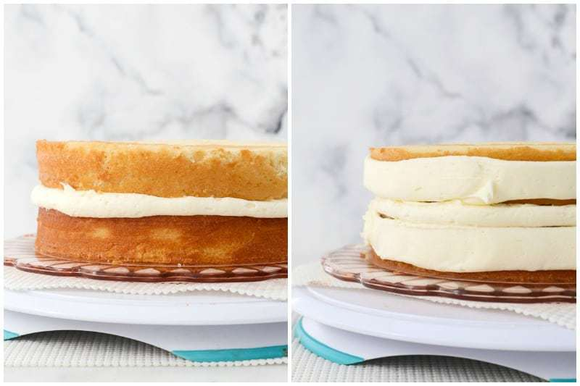

Fig.2.2. layer cake
Chill the cake for 2 hours before you frost it.It hard to be patient, but wait! If you frost the cake before it's cooled, the butter in the frosting will melt and soak into your cake. Plan on chilling the cake for 2 hours before you cover it with buttercream.
Let the cake layers cool to room temperature and wrap them in plastic wrap before you stick them in the fridge. You can chill them overnight as long as they're wrapped well.

Spread a really thin layer of frosting to lock in the crumbs. To do a crumb coat, brush away loose crumbs with a pastry brush. Stir a 1 tablespoon (15 ml) of milk into 1/2 cup (56 g) of your buttercream to loosen it. Then, use an offset spatula to spread it onto the tops and sides of your cakes. Pop them into the fridge to chill for 15 minutes so the buttercream hardens.
You may have heard of a crumb coat—this is just a super-thin coating of buttercream that traps loose crumbs. It also gives your buttercream something to really stick to.
If you're frosting a chocolate cake, you might want to do an extra crumb coat since dark cake crumbs can show up easily in light-colour butter cream.
Use an offset spatula to evenly spread butter cream onto the top and sides.
Set 1 cake layer on a turntable and scoop 1 cup (112 g) of butter cream frosting onto the top. Spread the frosting to the edge of the layer with an offset spatula. Set your other cake layer on top and put the rest of your frosting on top. Then, spread the frosting across the surface and down the sides of the cake. It can help to spin the turntable slowly so you get even coverage.
Remember, you're covering the cakes that have a crumb coat.
If you've got a turntable, you can also hold a flat scraper vertically against the side of the cake slowly rotate the turntable so the scraper smooths the butter cream.
To cover the cake with butter cream
Drag a cake comb across the sides to give your frosting a unique texture. Cake combs are plastic scrapers that have designs along the edge. Once you frost your cake, hold the cake comb vertically against the side of the cake and spin the turntable slowly as you press the comb against it to make ridges, stripes, or cool textures
If you don't want to buy a cake comb, look for things you already have in your kitchen. Drag the tines of a fork along the sides to make thin ridges or swirl the back of a spoon along the frosting to make fun swoops.
Use a piping bag with different tips to make rosettes, ruffles, and scallops.
While a smooth cake is striking, it's fun to play with buttercream accents. Fill a piping bag with your butter cream and choose a tip based on what design you want to make. Use a small round tip if you want to pipe words, for instance, or use a leaf tip to give your cake floral decorations.[10]
To practice your piping skills, lay a piece of parchment paper on a baking sheet and try out different tips before you decorate the cake itself.
To chill your cake, put it into the fridge without a cover or plastic wrap until the frosting hardens a little. Then, cover it with plastic wrap and refrigerate your frosted cake for up to a day or two. Your cake will dry out the longer it's in the fridge.
While Italian and Swiss meringue buttercreams have egg whites, they're safe to keep at room temperature since you heated them thoroughly.
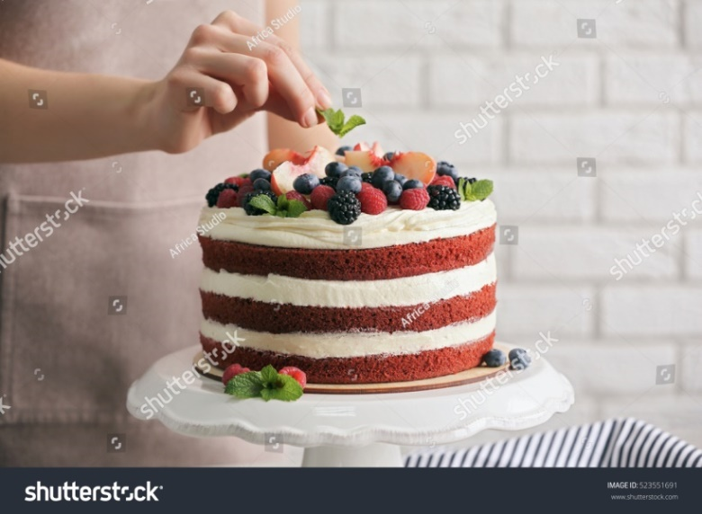

Fig.2.3. Finished Layer cake

2.3.Coat top and sides of sponges and cakes

Step 1:Bake two sponge cakes and pipe a 1/4″ (6mm) dam of buttercream around the bottom cake’s outer edge.

Step 2:Add an even layer of jam, keeping it within the buttercream dam.

Step 3:Add buttercream until the jam is covered and then smooth over

Step 4:Add the second layer of your cake face down.

Step 5:Go back over the join, filling in any gaps

Step 6:Thin the buttercream and apply a thin layer to the top of the cake

Step 7:Apply a thin layer of buttercream to the sides, effectively sealing the cake.

Cool and Use!To crumb coat a cake prepare your baked cake.
First, make sure your cake layers are entirely cool. Frosting a warm cake is an exercise in making iced coffee by adding ice cubes to hot coffee —
Your cake may be entirely crumb-free — or it may be fairly crumb-y, as this one is. Use a pastry brush to brush any obvious crumbs off the top and sides of each layer.
Start by laying three or four strips of waxed paper onto a serving plate, then setting the bottom layer of cake onto the plate. The paper will protect the serving plate from getting messed up as you frost your cake; you’ll pull the strips out once you’re done
Frost the bottom layer
Next, add your middle layer of frosting. Our Classic Cake recipe calls for 1 cup of chocolate frosting.
Use a metal offset spatula (if you have one), a nylon spreader, table knife, or your other favourite tool to spread the frosting atop the cake; you don’t need to worry about any crumbs, as this middle layer of frosting will obviously be hidden inside.
Spread frosting completely over the top surface, going beyond the edge a bit of you like; you don’t need to be careful.
Set the second layer atop the frosted bottom layer. Run a spatula around the cake to flatten any frosting that’s bulging out.
Place the cake in the refrigerator for about 30 minutes (or up to 2 hours), for the frosting to chill and harden a bit. This interim step, while not crucial, means there’s no chance of the top layer sliding around on a slick of warm frosting as you try to apply your crumb coat.
Apply the crumb coat
The chilled cake is now ready for its crumb coat, whose ultimate goal is to capture and trap any stray crumbs, anchoring them in place preparatory to you adding the next layer of frosting.
Start by applying a thin layer of frosting all around the sides of the cake, then across the top.
Chill to set
Place your crumb coated cake in the fridge for another 20 minutes. You want the frosting to set and harden enough that you can apply frosting to it easily, without any drag or sticking. Hint: If you touch the crumb coat with the tip of your finger and your finger comes away clean, it's good to go.
Finish frosting your cake
Now comes the creative part — applying your final beautiful layer of frosting. I like to spread frosting all over the cake rather haphazardly first, then if I feel creative, craft it into a “look.
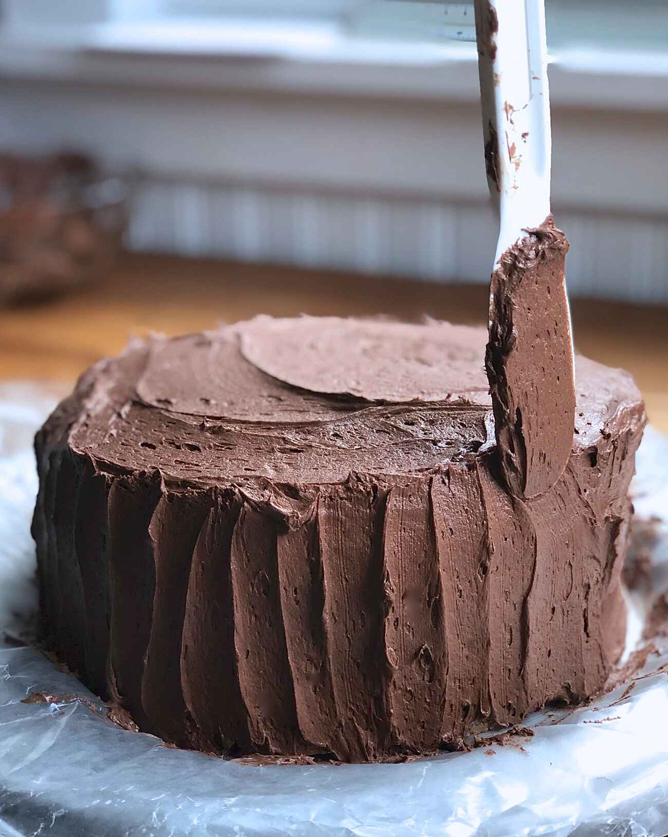

Fig.2.4.coat a cake

SELF-CHECK 2. | WRITTEN EXAM

Direction:
Answer the following questions:-
Q1. A layer cakes are mostly used for special occasions.True or False
Q2. Frosting is thicker and fluffier than icing.True or False
Q3. It is a thick mixture used between the layers of cake (Choose)
  - Assembling
  - Coating
  - Filling
  - decorating
Q4. Some of the equipment& tool needed for filling cake layers are (Choose)
- cake pans
- paring knife
- Spatula
- All of the above
Q5. List some at least three types of cake filling as a cream. (Types of cream) (short answer)

Operation sheet2.
Operation Title:Prepare & use fillings
Purpose: To preparefillings to cover, coat and mask cakes and sponges
Conditions or situations for the operations:

- Safe working area
- Properly operated tools and equipment
- Appropriate working uniforms fit for the practical performance

Equipment Tools &Ingredients:
-Mixer - scale - icing sugar, butter, flavoring,
- Oven - bowl - milk, cacao, coconut,g sugar, etc.
- Scraper, piping bag, etc.
Quality Criteria: Assured performing of all the activities according to the procedures

Lap test2.
Instructions: Given necessary templates, tools and materials you are required to perform the following tasks accordingly.
Task 1: pre-prepare the necessary equipment
Task 2: prepare the necessary ingredients
Task 3: measure the ingredients for making a filling according to the instruction given by a recipe.
Task 4: Fill one of a specialized cake properly following the procedure
Task 5: apply the filling for various commercial sponges.

Unit Three:Decorate cakes
This unit is developed to provide you the necessary information regarding the following content coverage and topics:
- Using Icings
- Decorate cakes and sponges
This unit will also assist you to attain the learning outcomes stated in the cover page.
Specifically, upon completion of this learning guide, you will be able to:
- Use icings to decorate cakes
- Apply different techniques to decorate cakes

.

3.1. Using Icing
Types
Fondant icing
.
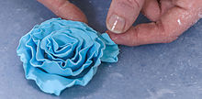
A fondant rose edible cake decoration
Fondant, also known as sugar paste or ready-roll icing, is a soft, thick paste made of sugar, water, gelatine, vegetable fat or shortening and glycerol. Fondant is typically sold in a variety of colours when bought ready-made, is easy to handle and provides a smooth, matte and non-stick cake cover.
Fondant must be rolled out with corn-starch to avoid it sticking to any surfaces. Once smoothed out and thin enough, fondant can be moulded into many different shapes, such as flowers or leaves and may be cut into shapes and applied to a cake to build up decoration. Though primarily used to cover cakes, it is also used to create individual decorations to accompany cakes, consisting only of fondant with no cake inside.
As a relatively heavy form of decoration in comparison to traditional knife-spread frosting, extensive fondant application may weigh a cake down considerably, requiring a suitably sturdy cake base for support. Fondant remains soft once sculpted, unlike other forms of icing, which may harden when exposed to air.
Royal icing
Royal icing is a sweet white icing made by whipping fresh egg whites (or powdered egg whites, meringue powder) with icing sugar. Royal icing produces well-defined icing edges especially when decorating cookies and is ideal for piping intricate writing, borders, scroll work and lacework on cakes. It dries very hard and preserves indefinitely if stored in a cool or dry place, but is susceptible to soften and wilt in high humidity.

Marzipan
Marzipan is often used for modelling cake decorations and sometimes as a cover over cakes, although fondant is typically preferred as an outer layer.
Gum paste
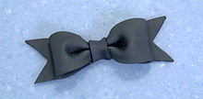
A bow made from gum paste
Gum paste, also known as florist paste, is an edible, brittle material that dries quickly and can be sculpted to make cake decorations such as flowers or moulded designs
Modeling chocolate
Modeling chocolate is a chocolate paste made by melting chocolate and combining it with corn syrup, glucose syrup or golden syrup. The chocolate is formed into a variety of shapes and structures that cannot be easily accomplished with other softer edible materials such as buttercream frosting, marzipan or fondant. Modelling chocolate can be made from white, dark, semi-sweet or milk chocolate.

Edible ink printing
Edible ink printing is also used in decorating cakes. After breakthroughs in nontoxic inks and printing materials in the early 1990s,^{[7]} it became possible to print images and photographs onto edible sheets for use on cakes. The process uses pre-printed images printed with edible food colors, which are then applied to various confectionery products such as cookies, cakes or pastries. Designs made with edible ink can be created with a specialty printer, which transfers an image onto a thin, edible paper, made of starches and sugars. Originally introduced as a specialty service provided by bakeries, this technology can now be used by home consumers using the specialized paper, ink and printers.
Techniques
Decorating a cake usually involves covering it with some form of icing and then using decorative sugar, candy, chocolate or icing decorations to embellish the cake. However, it can be as simple as sprinkling a fine coat of icing sugar or drizzling a glossy blanket of glaze over the top of a cake like a mirror cake style that uses a glaze of gelatine, sugar, water and sometimes chocolate. A cake turntable (or rotating tray) can be used to facilitate the process.
Icing decorations can be made by either piping icing flowers and decorative borders or by moulding sugar paste, fondant or marzipan flowers and figures. An embossing mat is a tool for cake decoration that creates embossed effects on the top of cakes, cupcakes or similar items. The user presses the mat down into cake dough or icing and the pattern embossed in the mat is transferred to the item.] Embossing mats are often made of silicone rubber or similar flexible polymers.
Many icing designs can be made by piping tips; these come in many shapes and sizes. Tutorials are often made to model the different designs created by different piping tips.
“Naked Cakes” are a popular trend, as of 2020. In this decorating style, fillings are used between the cake layers but the outside is left unfrosted or sparsely frosted with much of the cake itself still visible between and through the frosted areas. Naked cakes are often decorated with icing sugar or fresh flowers on top. They are especially popular as wedding and engagement cakes
It may be necessary to secure cake layers in place to prevent sliding or falling, especially for large cakes with several layers. Various forms of wooden skewers or dowels and plastic straws are commonly used for this purpose

3.2. Decoratingsponges &cakes

Definition:
Cake decorating is the art of decorating a cake for special occasions such as birthdays, weddings, national or religious holidays, or as a promotional item. It is a form of sugar art that uses materials such as icing, fondant, and other edible decorations.
Chocolate is commonly used to decorate cakes, as it can be melted and mixed with cream to make a ganache or cocoa powder can be lightly dusted on top of a cake.
There is innumerable ways of decorating a cake. One can choose any of the many toppings available like icing, sprinkles, sugar art, fondant decoration, fruits, chocolate, waffles, yogurt… the possibilities are endless. These add-ons can practically make or break a delicious cake. Here’s No cake is complete without an icing. In fact, a cake looks quite raw and unfinished without that creamy, soft, sweet, delicious, and not to mention beautiful decoration.
Call it icing or frosting… whether it is applied with a spatula, or piped on into frills and designs, trickled onto a cake, rolled on into sheets or simply pasted – regardless of the form and design, the fact still remains that icing is quintessential. It not just beautifies the cake but also gives you that little freedom to express yourself and make it a piece of art, and not to mention enhances and complements its taste. Try not to get carried away and infuse too many flavors of icing. A little colour and flavour goes a really long way. Besides you want to complement the cake and not overpower it with the icing.
Cake with Buttercream Icing
Boiled Frosting
This fluffy white icing is the pride and joy of anyone who has baked a beautiful cake. Its snow white, soft and fluffy appearance is simply to die for. This icing goes well with chocolate cake or yellow cake. This icing is fun and easy to colour due to its white and glossy base.
Making
Making this icing is not as difficult as it sounds. Simply whisk in sugar syrup, egg whites, a pinch of salt, and some vanilla extract/flavour. Be sure to not introduce fats to this cake mix, as it will instantly deflate if mixed with chocolate or whipped cream.
Storage
You should consider using this icing as soon as you make it since it will collapse after 24 hours. However, if you must store it, you will need to keep it at room temperature.
Buttercream
Buttercream icing is also known as America buttercream/confectioners’ sugar icing/butter cream/butter icing/mock cream. This icing can be used to fill in between two layers or, piped onto the cakes in the form of coating, designs, flowers, and writing. The decorations will hold their shape and yet will be soft enough to cut through with a knife. But this icing will weep in warm and humid weather. To prevent this, you can use shortening instead of butter.
Lemon Curd
Lemon curd is a sweet and tarty icing with a thick custard-like consistency. It works better as a filling rather that icing, but it can be used as an icing as well.
Making
Ingredients viz. lemon juice, lemon zest, butter, eggs and sugar are whisked together over a water bath. Whisk in some whipped cream to enrich its texture and taste.
Storage
Because of the ingredients this type of icing will require refrigeration.
Ganache
Ganache is the epitome of sinfully good chocolate. Need I say more? This rich, dark decadent is simply too good to be true. This dark sensation has just one rule, the better the chocolate the better the taste. Obviously, you cannot colour frosting as it is 80% chocolate, and therefore has just one gorgeous-brown colour.
You can choose to replace dark chocolate with white, and add in food colours as per your liking. The method will remain the same. Due to the amount of chocolate present in the panache, it will hold up in a warm climate, but will begin to melt in too much heat.
Making
Chocolate and cream are the only two ingredients needed to make ganache as good as it looks.
Storage
This icing is very durable. It will survive, up to 6 months, around 2 week in the refrigerator, and around 4 days at room temperature, and 2 seconds if you can’t control yourself.

SELF-CHECK 3. | WRITTEN EXAM

Instruction:
Answer the following questions:
Q1. A cake turntable or rotating tray cannotbe used to facilitate the decoration process.
True or False
Q2. Marzipan is often used for cake decoration and as cover over cakes.
True or False
Q3. Decorating cake involves covering with icing and using other decorative agents.
True or False
Q4. It is known as sugar paste or ready –roll icing:
  - Royal icing
  - Fondant
  - Corn starch
  - None
Q5. From the available many types of cake decorating materials list at least 3 (three)
______________________________________________________________________

Operation sheet 3.Decorate sponges and cakes
Operation Title:Decorate cakes
Purpose: To decorate cakes and sponges
Conditions or situations for the operations:
- Safe working area
- Properly operated tools and equipment
- Appropriate working uniforms fit for the practical performance

Equipment Tools & Ingredients:
-Mixer - scale - icing sugar, butter, flavoring,
- Oven - bowl - milk, cacao, coconut Sugar,eggs etc.
- Scraper, piping bag, etc.
Quality Criteria: Assured performing of all the activities according to the procedures

Lap test.3.
Instructions: Given necessary templates, tools and materials you are required to perform the following tasks accordingly.
Task 1: pre-prepare the necessary equipment
Task 2: prepare the necessary ingredients
Task 3: measure the ingredients for decorating cakes and sponges according to the instruction given by a recipe.
Task 4: Decorate one of a specialized cake properly following the procedure
Task 5: apply your creativity for decorating various commercial sponges.

Unit Four:Present cake
This unit is developed to provide you the necessary information regarding the following content coverage and topics:
- Equipment for cakes displaying
- Present cakes
- Portion controlled cakes

This unit will also assist you to attain the learning outcomes stated in the cover page.
Specifically, upon completion of this learning guide, you will be able to:
- Select equipment for cakes displaying
- Present cakes attractively keeping its freshness
- Identify to mark portion controlled cakes

4.1. Equipment for displaying & present cakes

Introduction:
On How to plate andpresent cakes.It is important to learn howto plate cakes properly. Pastrychefs in restaurants spend a lot oftheir time to plate desserts so thatthey look as good as they taste.Go Wild with Coloursome of the most irresistible dessertslook a little uninspiring on the plate. They need ahit of colour to come to life. A handful of berries transform brownish foods like chocolatecake or a Belgian waffle, while a lemon tart becomes even more vibrant when you add aviolet flower or a marbled raspberry coulis
Mix up textures a dessert with multiple texturesisn't just more fun to eat; it's morefun to look at. Pair a smooth ganache with nubbycookiecrumbs your guests won't be able totake their eyes off the plate—atleast until they devour the dessert.
1. Be creative with colour.
A splash of colour can bring your desserts to life. A dark chocolate cake can go from a brown lump to an artful concoction when garnished with vibrant berries; a lemon tart goes from a fairly monotone palette to lively and lovely when presented with the contrast of a violet flower and marbled raspberry coulis.
2. Combine textures.
Adding different textures to the plate adds excitement to the visual appeal of dessert course, and the enjoyment only continues when the eating commences. For example, pairing a smooth, rich ganache with nubbly cookie crumbs and soft, pillowy marshmallows adds just enough “busyness” to draw the eye in to the dessert. The different textures excite the senses, giving an anticipatory sense of the taste pleasures to come
3. Compose your plate as you would a painting.
There are many ways to compose a plate. Consider the plate as if it were a blank canvas or as if you were composing the frame for a photograph. What would fill the space in an interesting way? Will you choose a minimalist approach, aligning different dessert elements as bookends on an oblong plate, as shown above? Or will you have a central focus on a round dessert plate? There is not a right or wrong answer, and you can experiment to see what looks and feels right to you.
4. Consider the vessel.
It may seem like common sense, but consider the experience of eating the dessert when you choose the type of plate. Don’t serve it on a too-tiny plate which may have garnish popping off and on to the table once the tines of a fork hit the dessert. If your dessert is creamy, it’s going to be easier to access in a rounded container or bowl. Don’t get so lost in the form that you forget the function involved in eating the dessert.
5. Contrast temperatures.
There’s nothing like pairing a slice of perfectly prepared pie or a fruit tart with a cool slice of ice cream. Combining temperatures can be a beautiful thing, but your plating does require some consideration. Do not put your dessert on a hot plate. Ice cream will melt too rapidly, obviously, but other desserts may “wilt” too. This can vary depending on the dessert. A slightly chilled plate may be helpful when plating cold desserts, whereas room temperature will do just fine for most cakes or pies.
6. Have a focal point.
Using an element in your dessert as a focal point can help give your plating focus, especially when a dessert isn’t, in and of itself, a showstopper. For instance, a translucent candied banana slice draws the eye in to the deconstructed Bananas Foster featured above, and then spirals out to follow the caramel sauce drizzle. It adds a bit of intrigue to a dessert which otherwise might look generic and, well, slightly boring in its beige colour scheme.
7. Let it be dramatic.
Have a little fun with your dessert. Employ tricks to add some magic to the presentation. Try recreating gravity-defying aspects taught in the craftsy class Gravity-Defying Cake Designs on a mini-scale. Or make a parfait dessert hover with the use of a white chocolate wafer which then melts into it to create an amazing effect. People enjoy a little pomp and circumstance with their meal, and it’s fun to have your dessert course greeted with “Wow, how’d you do that?”
8. Don’t make it too tall or wobbly.
A slice of layer cake looks fantastic standing up on a plate. But if it’s too tall, there’s a strong chance of it toppling over even on a short journey to where it is being served. If it seems too tall or wobbly, it probably is. While many dessert professionals adore the visual of serving a slice of cake upright, the general consensus is that if you’re in doubt, lay it on its side. It can still be prettily appointed, as proven by the above photo of a gorgeous red velvet slice adorned with whipped cream and berries.
9. Garnish with care.
Random mint leaves or raspberries for artful effect? Forget it; it’s more likely to be confusing than anything else. Also, consider the eater when adding finishing touches to your dessert plate. While whole nuts might look pretty scattered on top of a cake, they are impossible to spear with a dessert fork. Keep in mind how the garnish will function on the finished plate.

10. Be consistent.
When plating desserts for a crowd, be consistent in your design and in serving size. It can be confusing to see different presentation on each plate, and nobody likes looking over to the plate across the table and seeing a serving double the size
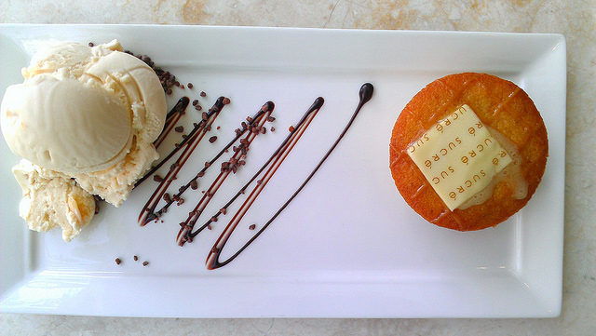

Fig.4.1.Sweet display plate
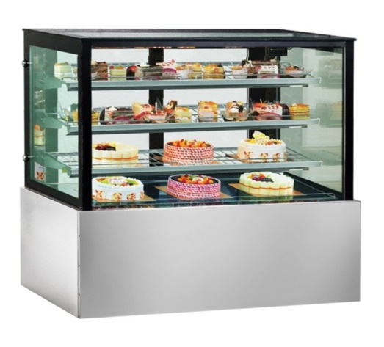

Fig.4.2. Equipment for cake display

4.2. Present cakes:
1. Go Wild with Colour some of the most irresistible desserts look a little uninspiring on the plate. They need a hit of colour to come to life. A handful of berries transform brownish foods like chocolate cake or a Belgian waffle, while a lemon tart becomes even more vibrant when you add a violet flower or a marbled raspberry coulis.
2. Mix Up texturesa dessert with multiple texturesisn't just more fun to eat; it's morefun to look at. Pair a smoothganachewithnubbycookiecrumbs and pillowy marshmallows and your guests won't be able totake their eyes off the plate—atleast until they devour the dessert
3. Compose Your Plate as You Would a Painting.
4. Choose a Bowl that Worksthis may sound like common sense, butalways use the bowl or plate that bestsuits the dessert. Make sure it's bigenough—you don't want anything tolook
Crowded or squeezed. If you'reserving something creamy, a bowl or aplate with raised edges is the way to gopose Your Plate as You Would a Paintingtolook crowded or squeezed. If you'reserving something creamy, a bowl oraplate with raised edges is the way to go.

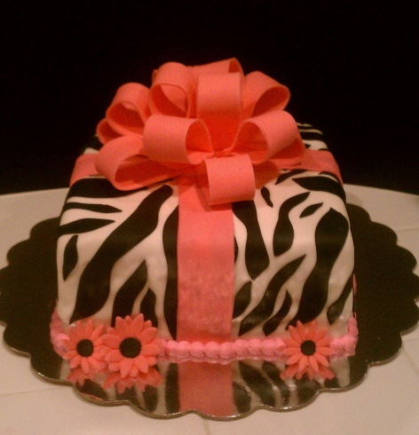
Fig4.3.Cake to be presented


Fig.4.3.2
Happy colleagues presenting cake to a friend!

4.3. Portion controlled cakes
Mark, score or cut portion-controlled cakes evenly and neatly to maximise yield andprofitability
When your patisserie receives an order for a special occasion cake, it’s important toconfirm the customer’s expectations. Cake order forms help expectations by clearly specifying customer requirements, such asdesired type of cake, shape, colour scheme, size or number of serves, inscription anddecoration.
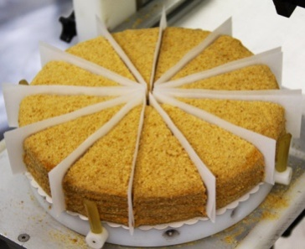

SELF-CHECK 4. | WRITTEN EXAM
Direction:
Answer the following questions:
Q1. Colour contrasting is very important in presenting a cake. True or False
Q2. It is not important to plate a cake properly. True or False
Q3. A slice of layer cake looks fantastic standing up on a plate. True or False
Q4. When plating desserts for a crowd:
    - Be consistent in your design
    - Be consistent in serving size
    - Be over looking
    - A and B are answers
Q5. Adding different textures to the plate:
- Adds excitement to the visual appeal
- Excite the senses
- Commences eating
- All of the above
Operation sheet 4.
Operation Title:Present cakes
Purpose: To mark, score or cut portion-controlled cakes evenly for presentation.
Conditions or situations for the operations:
- Safe working area
- Properly operated tools and equipment
- Appropriate working uniforms fit for the practical performance

Equipment Tools & Ingredients:
Cake stand, knife , cake lifter, cake wrapper,etc.

Quality Criteria: Assured performing of all the activities according to the procedures

Unit Five:Store cakes
This unit is developed to provide you the necessary information regarding the following content coverage and topic
- Storage conditions for cakes
- Storage methods of cakes

This unit will also assist you to attain the learning outcomes stated in the cover page.
Specifically, upon completion of this learning guide, you will be able to:
- Store cakes at the correct temperature in storage conditions.
- Identify storage methods of cake.

5.1storage conditionsfor cake:
Storing baked goods, cakes, pies & cookies
The most important thing for successfully storing all baked goods is to let them cool completely.
Wrapping warm cakes, cupcakes, sweet breads, and baked donuts will capture steam, which is the enemy of fresh food storage.
So be sure to let your cake cool to room temperature, then to preserve it, wrap it tightly all around in plastic wrap. Do not keep it on a platter or plate and wrap that — you want the whole baked item to be as tightly sealed as possible.
Alternatively, you can place donuts and cupcakes (both of which are a pain to wrap individually) in a plastic storage bag. It’s not quite as reliable a method, but should do the job well if you make sure to press out all the air before sealing the bag shut.
As long as your kitchen is fairly cool and dry, you can store plastic wrapped cakes on the counter for 3-5 days. If it’s hot or humid, store them in the refrigerator instead; just make sure to return them to room temperature for serving.
You can also store cakes and similar baked goods without icing in the freezer for up to 3 months. Thaw completely before icing and serving; do this by placing the cake in the refrigerator 24 hours before you plan to frost it.
Note that allowing a frozen cake to thaw at room temperature can cause moisture to collect under the plastic wrap, which will make your cake mushy. So, don’t do that. The best way to store whole, uneaten cakes, cupcakes, sweet breads
You can store a frosted cake like this one at room temperature for 3-5 days but, again, if it’s hot and humid, stick it in the refrigerator instead. You’ll also want to keep it in the refrigerator the whole time if your frosting is made
With cream cheese; never let cream cheese or whipped cream icings sit at room temperature.
You should avoid refrigeration in most cases. Unless your cake features perishable materials that could spoil—like cream frosting, fresh fruit, ice cream, mascarpone, or whipped cream—it’s actually better off at room temperature. The humidity of refrigerators strips cakes of their moisture, leading them to lose their trademark softness. For example, you should refrigerate a pound cake with strawberries and cream cheese frosting, but you will want to store a cake with fondant icing, peanut butter, and pecans outside the fridge.
Keep in mind that how hot and humid your kitchen gets can be a factor in how you store cake. If your kitchen is routinely above 75 degrees Fahrenheit or so, your cake would be better off in the refrigerator than in the heat. You should also place warm cake in the refrigerator for twenty minutes or so before you wrap and store it at room temperature. This helps solidify the frosting so it remains intact throughout the wrapping process.
Storing Cake
Preserving cake properly can help you enjoy this treat for days past its initial serving.
1. Analyse the cake recipe. Before you decide how to store your cake, you need to know what’s in it to settle on the best method. A ganache-covered chocolate cake with buttercream frosting can remain at room temperature, but a cream cake with a fresh fruit filling should stay in the refrigerator. The main thing you’re looking for is whether any ingredients are perishable. Cheesecakes should also remain in the refrigerator since they include different ingredients than regular cake.
2. Fortify with frosting. Frosting serves as a natural preservative so long as it does not include perishable dairy or fruit materials. Once you cut cake open, simply cover the sliced edges with more frosting to help it last longer. This retains the moisture without you having to resort to plastic or aluminium wrapping. Don’t rely on the bits of frosting inside a layer cake to do the job, though—you must lather the entire exposed area with new frosting.
3. Freeze for longer periods. You can always freeze cake if you don’t plan to eat it for a long period of time. If you place an uncut whole cake in the freezer, you can easily get this dessert to last up to three months. Make sure to wrap the cake before putting it in the freezer.
4. Improvise if necessary. You don’t need a specifically manufactured cake stand to store your dessert well. Place the cake on a plate or baking sheet, wrap it with aluminium foil, and place an overturned bowl on top of it for a makeshift storage container. This will keep your cake fresh for three to seven days.
5. Protect the frosting. Place your cake in the refrigerator for twenty minutes or so to harden the frosting before you wrap it for storage. Insert toothpicks on the top and sides of the cake so that the wrapping doesn’t touch the frosting itself.
- 6. Rely on room temperature. You can leave out your covered cake overnight without even wrapping it and it should be fine in the morning. For any amount of time longer than that, make sure to wrap it in something. Rely on room temperature to maximize its shelf life—up to about three to seven days—unless specific ingredients require that it remains refrigerated.
- 7. Wrap the cake. Use aluminium foil or plastic wrap to protect your cake if you’re planning to eat it over several days. If you choose to place the wrapped cake in an airtight container for added security, make sure to leave a tiny portion open. Protect sheet cakes from dust and other dirty elements fluttering around your kitchen, but they still need air to retain their texture.

5.2. Storage methods:

Cake Storage
Plain Butter Cakes, Single or Multiple Layered Cakes, Cake from a Mix  Storage:  Room Temperature | Storage Note:  Be sure to cover tightly but do not refrigerate. If you do not have a cake keeper, cover the cake with a large inverted bowl, cover it with foil, or store in a large airtight container. Store at room temperature for approximately 5 days. Freeze for longer storage, up to 3 months.
Angel Food Cake  Storage:  Room Temperature | Storage Note:  Be sure to cover tightly but do not refrigerate. If you do not have a cake keeper, cover the cake with a large inverted bowl or store in a large airtight container. Store at room temperature for approximately 5 days. Freeze for longer storage, up to 2 months.
Chiffon Cake  Storage:  Room Temperature | Storage Note:  Be sure to cover tightly but do not refrigerate. If you do not have a cake keeper, cover the cake with a large inverted bowl or store in a large airtight container. Store at room temperature for approximately 5 days. Freeze for longer storage, up to 2 months.
Pound Cake  Storage:  Room Temperature | Storage Note:  Be sure to cover tightly but do not refrigerate. Wrap airtight in plastic wrap or in foil unless the recipe indicates differently. Store at room temperature for approximately 5 days. Freeze for longer storage, up to 3 months.
Sponge Cake  Storage:  Room Temperature | Storage Note:  Be sure to cover tightly but do not refrigerate. If you do not have a cake keeper, cover the cake with a large inverted bowl or store in a large airtight container. Store at room temperature for approximately 1 week. Freeze for longer storage, up to 2 months.
Note: The information above pertains to cakes that are unfrosted and without any type of filling. Avoid storing a cake in the refrigerator whenever possible because refrigeration causes the cake to dry out faster and can affect its flavor. When adding frosting or a filling, the cake may require refrigeration if they contain perishable ingredients, such as fresh fruit, whipped cream, meringue type topping, eggs, or custard.

Frosting / Topping Storage
Boiled Icing  Storage:  Room Temperature | Storage Note:  Be sure to cover tightly but do not refrigerate. If it is not stored airtight, it will begin to set. Once a cake has been frosted with boiled icing it can be stored at room temperature. Freezing is not recommended.
Buttercream Frosting  Storage:  Room Temperature | Storage Note:  Buttercream can be stored, refrigerated, in an airtight container for up to 2 weeks before using. Remove it from the refrigerator at least an hour before using so it will warm to room temperature. It can also be frozen for extended storage. A decorated cake with buttercream frosting can be stored at room temperature for up to 3 days. If you want to refrigerate a decorated cake, place it in the refrigerator unwrapped until the frosting hardens slightly. It can then be loosely covered with plastic. Buttercream frosting can be frozen.
Cream Cheese Frosting  Storage:  Refrigerated | Storage Note:  Cream cheese frosting can be stored in the refrigerator for up to 2 weeks before using. Cakes frosted with cream cheese frosting must be stored in the refrigerator. The frosting will firm up when chilled but will soften quickly when it sits at room temperature. Cream cheese frosting can be frozen.

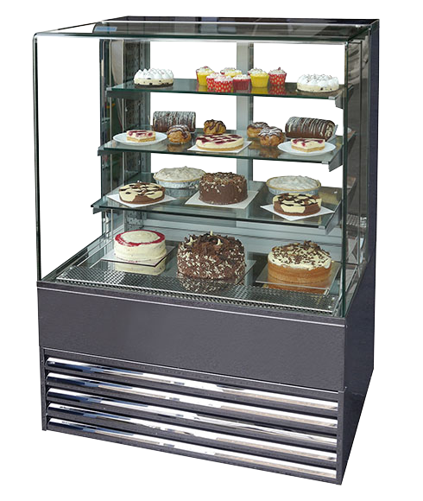Fig.5.1cake storage shelf

SELF-CHECK 5. | WRITTEN EXAM
Direction:
Answer the following questions:
Q1. You can freeze cake if you don’t plan to eat for a long time. True or False
Q2. It is notnecessary to wrap cakes before putting in the fridge. True or false
Q3. In the case of butter cream remove it from the refrigerator at least an hour. True or False
Q4. It serves as a natural preservative for storing cake.
- Freezing
- Frosting
- Drying
- All of the above
Q5. Storing Layered cakes:
- It should be covered tightly
- No need to refrigerate
- At a room temperature
- All of the above

RECOMMENDED READINGS

- FROM THE INTERNET
- BAKERY & CONFECTIONARY COURSE ,FOOD PRODUCTION DEPARTMENT
KENYA UTALII COLLEGE, NIROBI
- READING MATERIALS ON PASTRY AND BAKERY PRODUCTION

Participants of this Module (training material) preparation
No | Name | Qualification (Level) | Field of Study | Organization/ Institution | Region | Mobile  number | E-mail
1 | Zuriyash-work Belay | B | Hotel Management | TTI Addis Abeba |  | 0911643817 | zuriyashwb@gmail.com
2 | Zelalem Almaw | B | Food Science& post-Harvest Technology | Bahir Dar PTC |  | 0918012521 | Parazolla25@gmail.com
3 | Hiwot Tedla Belay | B | BA degree in Accounting and finance and diploma in Hotel Management | Harer Polytechnic College | Hareri | 0913789086 | hiwietaba@gmail.com
4 | Abreham Mayza Mengesha | A | BA degree in Hotel and Tourism | Arba minch Polytechnic college | SNNP | 0913711922 | Abrehammayza9@gmail.com
5 | Mohammed Liben Mohammed | B | - BA degree in Hotel and Tourism management  - MA degree in Disaster Risk Management | Jigjiga Polytechnic college | Somali | 0992326557 | cherechaw@gmail.com

