Bakery and Pastry Production
Level- II
Based on December 2022, Curriculum Version II
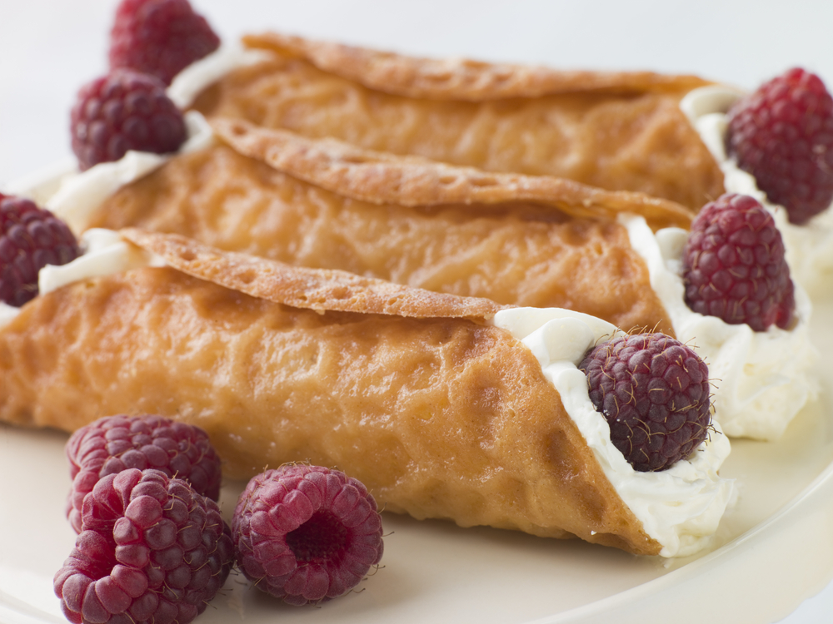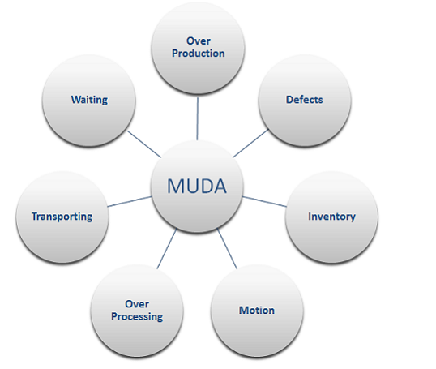

Module Title: Preparing hot and cold dessert
Module code: CST BPP2 M07 1222
Nominal duration: 72 Hour

Prepared By: Ministry of labor and skills
December, 2022
Addis Ababa, Ethiopia

Acknowledgement

Ministry of Labor and Skills wish to extend thanks and appreciation to the many representatives of TVET instructors and respective industry experts who donated their time and expertise to the development of this Teaching, Training and Learning Materials (TTLM).

Table of Contents
Acknowledgement 2
Introduction to the module 5
This module covers the units 5
Learning Objective of the Module 5
Module Instruction 5
Unit one: Prepare and produce desserts and sweets 7
1.1 Selecting Ingredients 8
1.2 Equipment of dessert and sweet preparation 13
1.3 using Standard or enterprise recipes Recipe 13
1.4 Producing creative and innovative desserts and sweets 17
Operation sheet 1: 19
Lap test 1 20
Unit Two: Decorating and portioning desserts and sweets 21
2.1 Decorate desserts and sweets 22
2.2 Portioning & Presenting desserts and sweets 25
Self check 2 28
Unit three: Preparing sweet sauces 29
3.1 Preparing Sauces 30
3.2 Thickening agents 32
3.3 Storing sauce 34
Operation sheet 2: Prepare sweet sauces 35
Lap test 2 40
Unit four: Prepare accompaniments, garnishes and decorations 42
4.1 Accompaniments, garnishes and decorations 43
Operation sheet 3: Prepare accompaniments, garnishes and decorations 47
LAP test 3: 50
Unit five. Store desserts and sweets 51
4.1 Packaging desserts and sweets 51
Recommended reading 56
Developers’ profile 58

Introduction to the module
This module describes the performance outcomes, skills knowledge and attitude required to prepare a range of hot, cold and frozen desserts in a commercial kitchen or catering operation. Desserts may include foods from varying cultural origins, and may be derived from classical or contemporary recipes
This module is designed to meet the industry requirement under the bakery and pastry production occupational standard, particularly for the unit of competency: prepare hot and cold dessert.

This module covers the units
- Prepare and produce desserts and sweets
- Decorate, portion and present desserts and sweets
- Prepare sweet sauces
- Prepare accompaniments, garnishes and decorations
- Store desserts and sweets

Learning Objective of the Module
At the end of this session, the trainees will be able to

- Prepare desserts and sweets
- Produce desserts and sweets
- Decorate desserts and sweets
- Portion desserts and sweets
- Present desserts and sweets
- Prepare sweet sauces
- Prepare accompaniments, garnishes and decorations
- Store desserts and sweets

Module Instruction
- Read the information written in each unit
- Accomplish the Self-checks at the end of each unit
- Do the Lap tests
- Read the identified reference book for Examples and exercise

Unit one: Prepare and produce desserts and sweets
This unit is developed to provide you the necessary information regarding the following content coverage and topics:
  - Selecting, measuring and weighing ingredients
  - Equipment of dessert and sweet preparation
  - Using standard or enterprise recipes
  - Producing creative and innovative desserts and sweets
This unit will also assist you to attain the learning outcomes stated in the cover page. Specifically, upon completion of this learning guide, you will be able to:
  - Select ingredients
  - Measure and weigh ingredients
  - Determine Equipment of dessert and sweet preparation
  - Produce desserts and sweets
  - Produce creative and innovative desserts and sweets

1.1 Selecting Ingredients
I. Sugar
Sugar is used in dessert production to:
- Add sweetness and flavour
- Create tenderness and fineness of texture, partly by weakening the gluten structure
- Give crust colour
- Increase keeping qualities by retaining moisture (it is a humectants)
- Act as a creaming agents with fats and as foaming agents with eggs
- Provide food for yeast
- To preserve.
Sugars are classified by the size of the grains:
- Castor sugar – finer than granulated sugar
- Granulated sugar also known as table sugar – has a coarse grain
- Brown sugar – is regular cane sugar that has not been completely refined
- Icing sugar also known as confectioner sugar – sugar ground to a fine powder
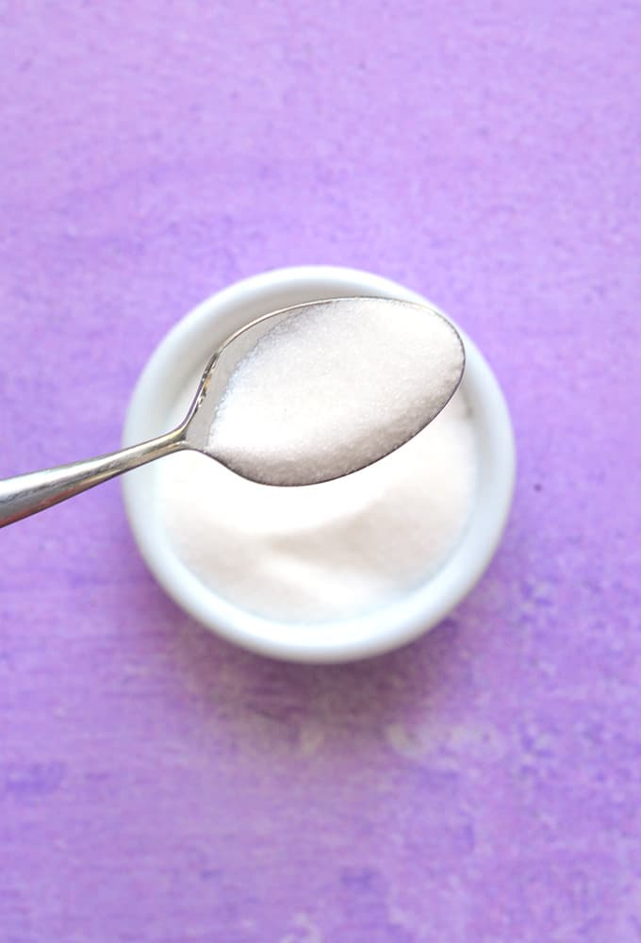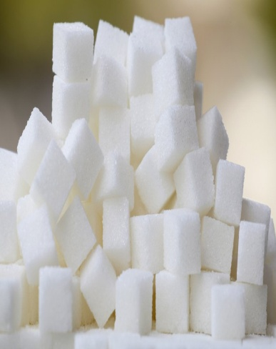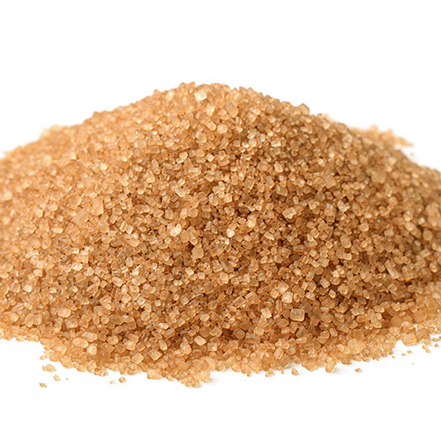
Fig 1.1 Castor sugar Fig 1.2 table sugar Fig 1.3 brown sugar

Honey was the first sugar to be used by man. It is the nectar collected from bees and deposited in their honeycomb. Nectar contains about 80% water and 20% sugar together with essential oils and aromatic compounds that are responsible for the bouquet of honey, the flavour varying from the flowers from which the nectar was gathered.
The darker the colour of the honey the stronger its flavour; it is a natural sugar syrup consisting largely of glucose, fructose and other compounds that give it is flavours. Flavour is the main reason for using honey.
Honey contains invert sugar which helps retain moisture in baked goods and gives a soft chewy texture to cakes and cookies, and is baked at a lower temperature so the invert sugars can caramelise.

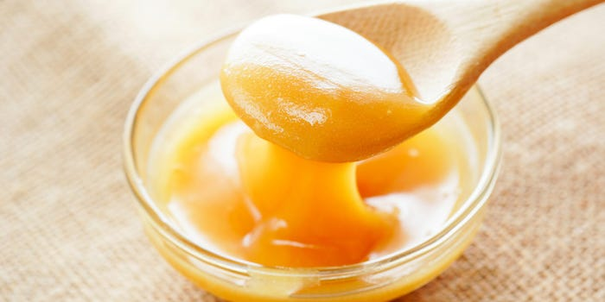

Fig 1.4 Honey

II. Eggs
Functions of egg for dessert production:

- Thickening agent
- Binding agent
- For glaze (gives shiny appearance)
- Aerate when whipped
- Enrich (add flavor & nutrition

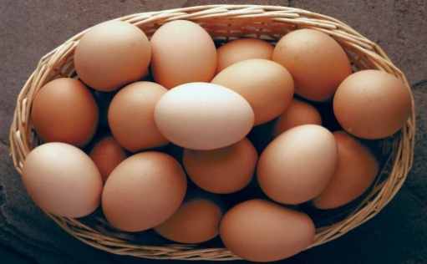
Fig 1.5 Egg

III. Milk:
Butter milk is the “baker‘s friend” it produces very light, delicious results in scones, pancakes, muffins etc.
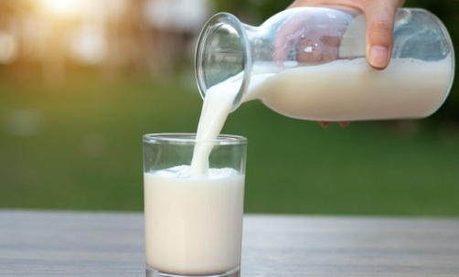
Fig 1.6 milk
- Butter: -
Butters are available salted and unsalted un salted is preferred choice. Butter’s main use in baking is to trap air with sugar during the creaming process this gives lightness ex. Cake making. It also gives superior flavor, color & richness.
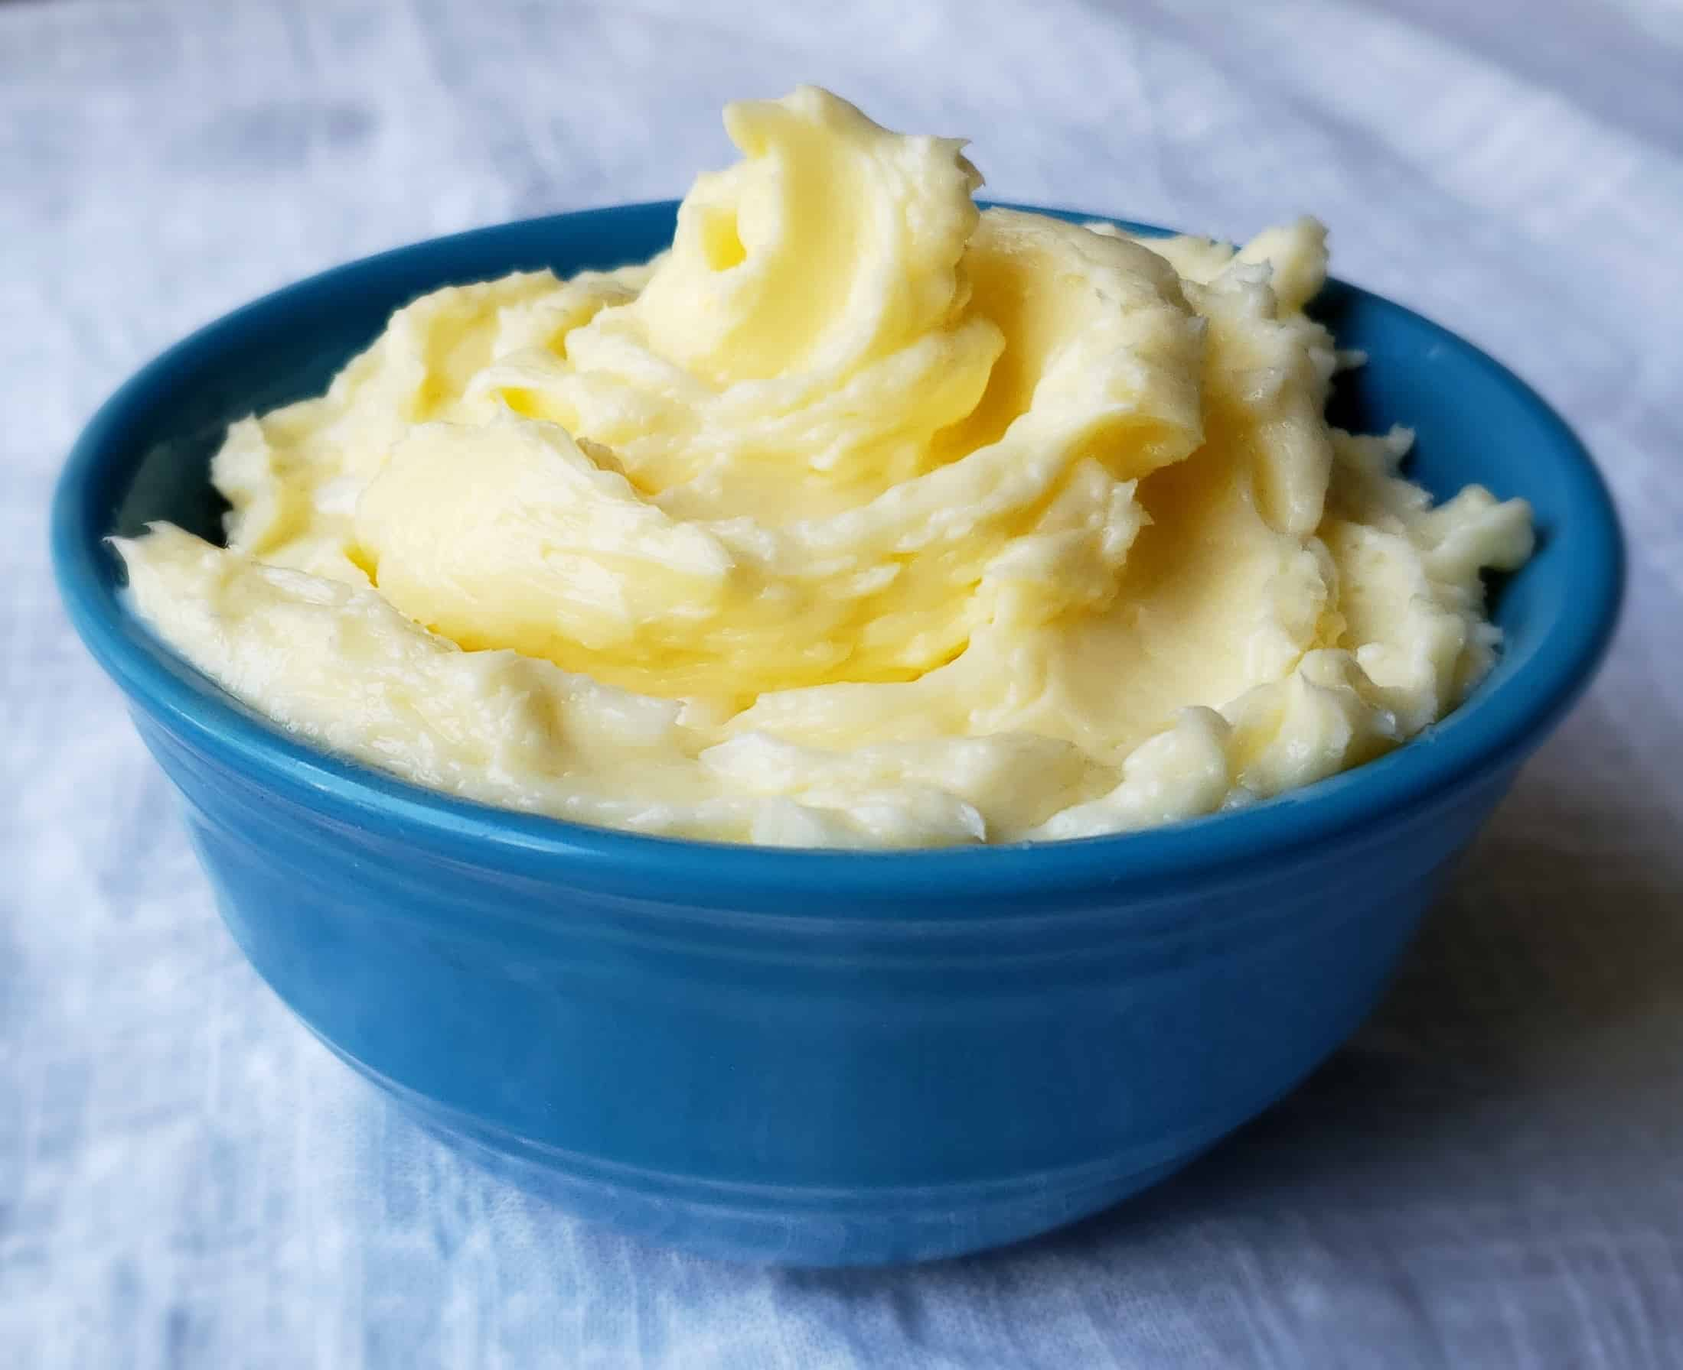
Fig 1.7 butter
- Flour:
Flour provides the skeleton structure that holds cake ingredients together. The flour property that actually does the holding is gluten, a protein that absorbs water when the batter is mixed, and forms a branch- like network during baking.
Functions of flour:
- It is the backbone and structure of baked goods
- It acts as a binding and an absorbing agent
- It gives flavor to the product
- It adds nutritional value to the product
1.1.1 Measuring and weighing ingredients
The importance of measurement is not only for portion & cost control but also for consistency in the quality of the final product. All ingredients must be weighed; accuracy of measurement is very important. To weigh, start by placing your measuring bowl onto the scale and press ‘Tare’. This will remove the weight of the bowl from the reading. Then weigh out your ingredients in this bowl.
The three basic tools used to measure ingredients in cooking are:
- Measuring spoons
- Dry measuring cups
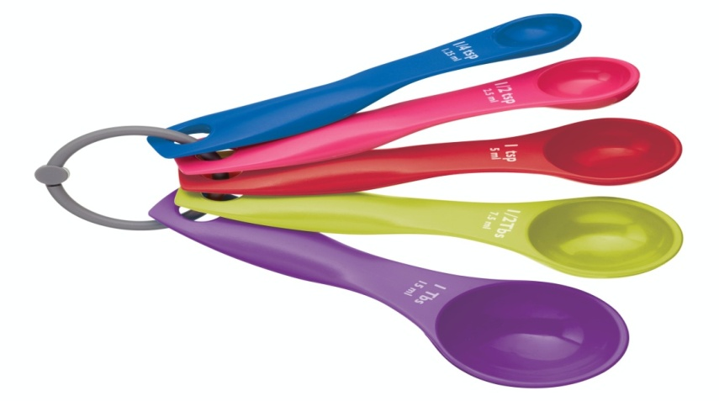
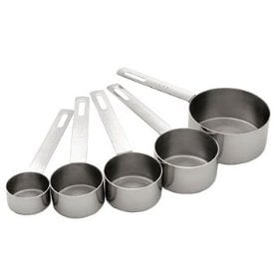
- Liquid measuring cups

Fig 1.9 measuring spoon
Fig 1.8 dry measuring cups
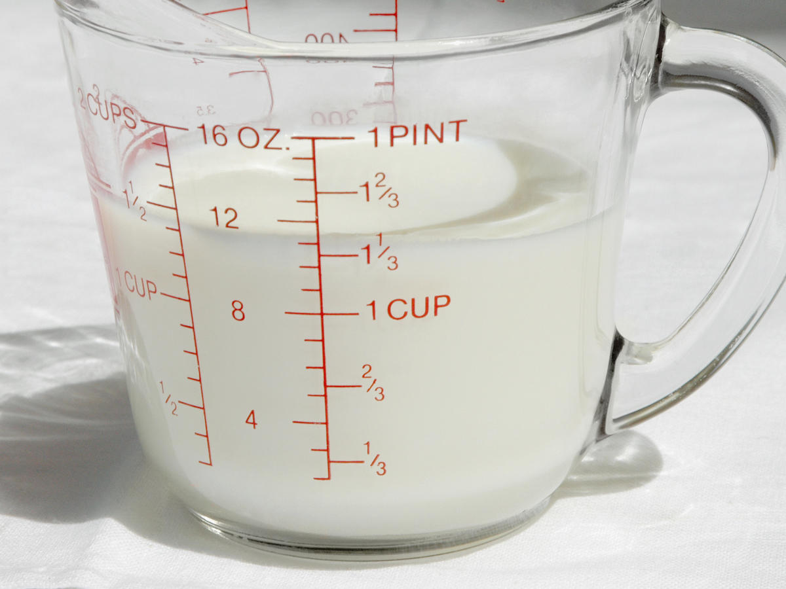

Fig 1.10 liquid measuring cup

Measuring Spoons: A basic set of measuring spoons come with 5 spoons:
- 1/8 teaspoon
- ¼ teaspoon
- ½ teaspoon
- 1 teaspoon
- 1 Tablespoon
Recipes are always written with the small t representing teaspoon and the capital T representing tablespoon.
3 teaspoons = 1 Tablespoon
Even though the words are the same, standard measuring spoons are *not* the same as the teaspoons and tablespoons in the drawer that you use to eat with.

1.2 Equipment of dessert and sweet preparation
The following are some of the equipments needed for the dessert and sweet preparation.

- Measuring spoons and scoop
- Mixing spoons
- Measuring cups
- Spatula
- Rolling pin
- Kneading board
- Flour sifter
- Pastry brush

- Mixer
- Baking oven
- Scraper
- Mixing bowl
- Baking tray
- Molds
- Scales

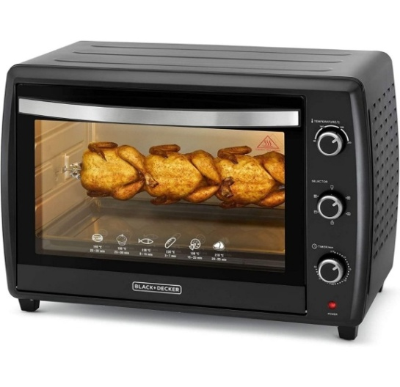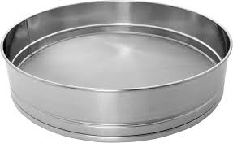
Fig 1.9 black and decker baking oven Fig 1.10 sifter
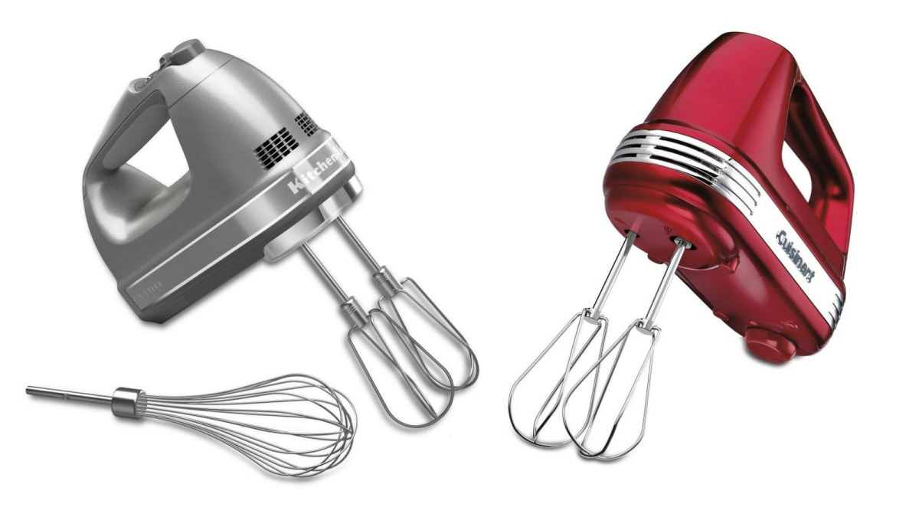

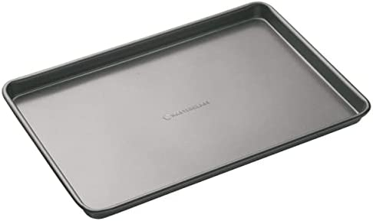

Fig 1.11mixer

Fig 1.12 baking tray
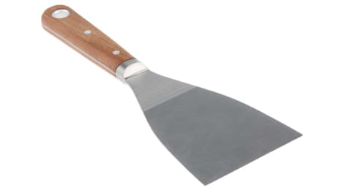
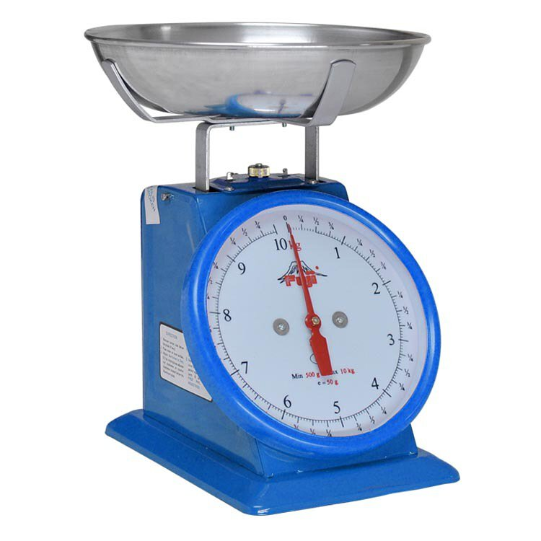

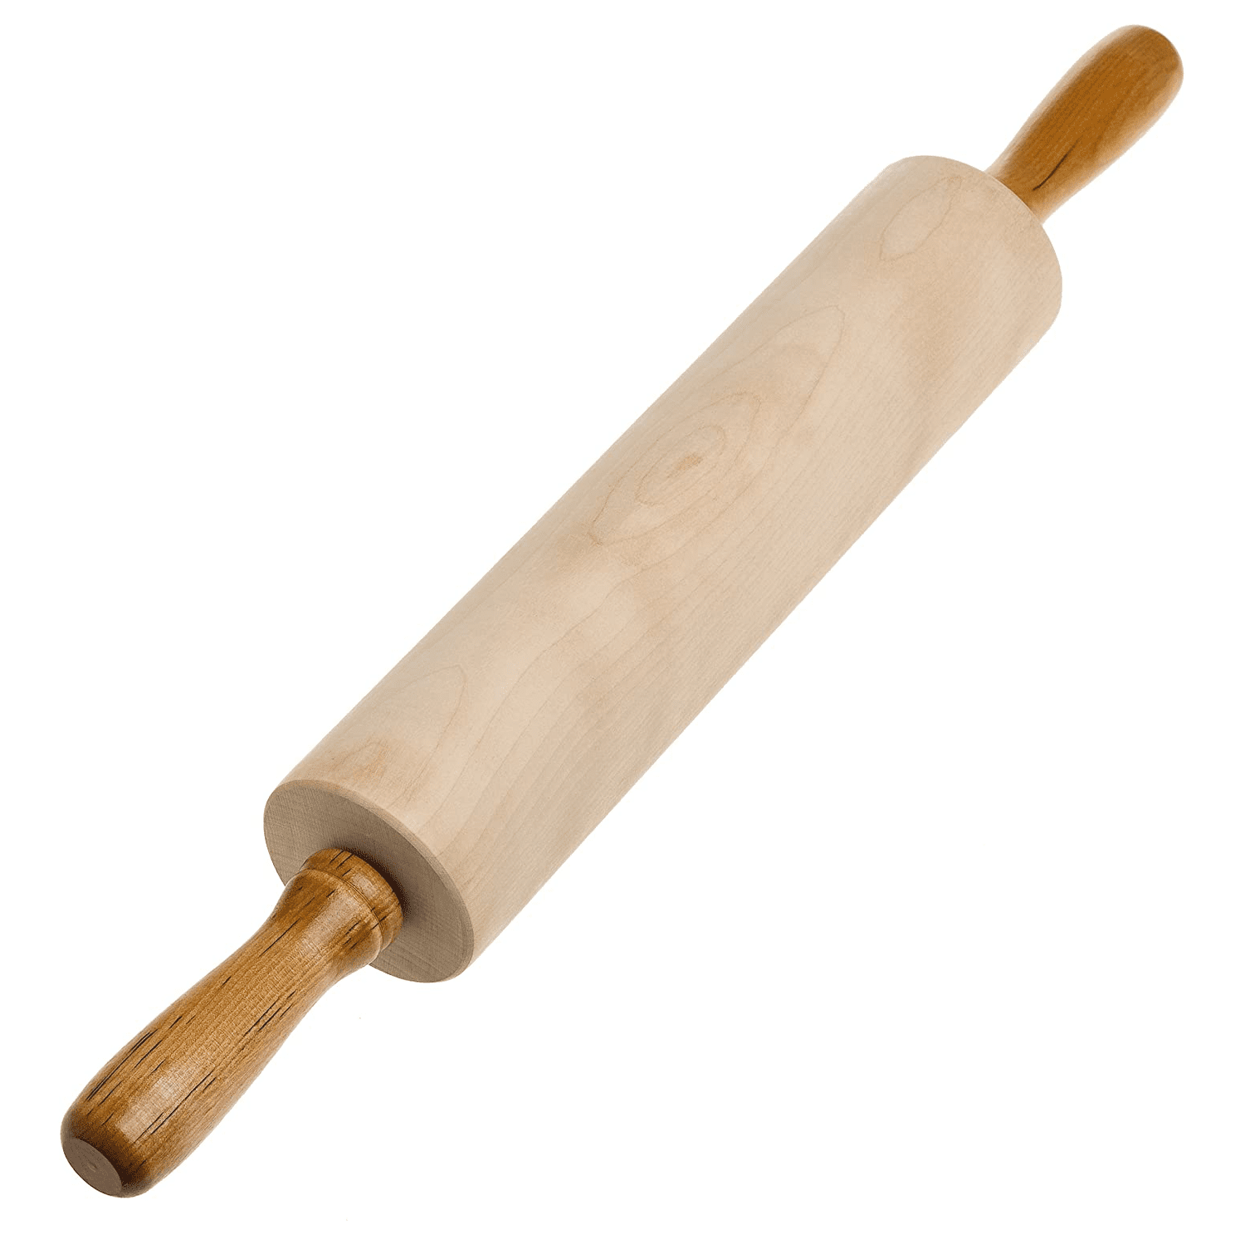
Fig 1.13 scale Fig 1.14 scraper

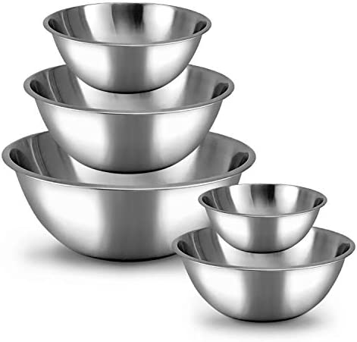
Fig 1.15 rolling pin
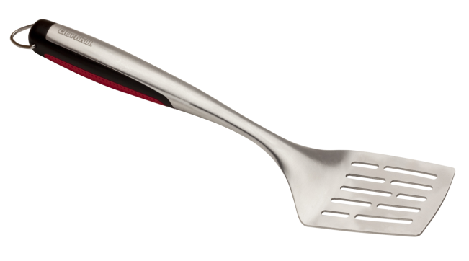
Fig 1.17 spatula

Fig 1.16 mixing bowl

1.3 using Standard or enterprise recipes Recipe
Recipe -is a set of instructions or formula to prepare a mixture of ingredients.
  - Rice pudding
Ingredients-
- 450g. long grain rice
- 3lt. milk
- 20ml. vanilla
- 2gm. Salt
- 2 whole egg
- 450g.sugar
- 1/2liter light cream
- Cinnamon as needed
Procedure
- Boil the rice with the required amount of milk until done
- Combine other ingredients egg-yolk, sugar, cream, whole egg, salt, vanilla
- Mix the rice & combined ingredients
- Boil the remaining milk, stir in the mixture
- Pour in the loaf pan or small tart molds. Top cinnamon as desired
- Bake in water bath (bain-marie) Baking temperature 175-degree c. Time 30-50 min.
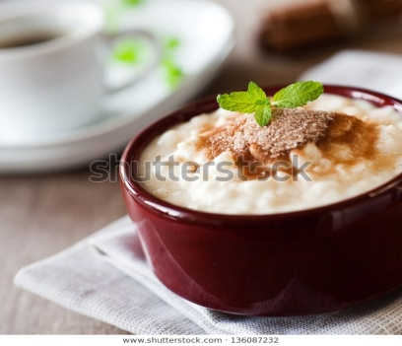

Fig 1.18 rice pudding

Making pumpkin pie
Ingredients

- 11/2 cups of sifted brown sugar
- 1 cup of pumpkin
- 4 eggs
- 3 Tbsp of melted table fat
- 3 Tbsp of molasses
- 2 tsp of cinnamon
- 3/4 tsp of ginger
- ½ tsp of nutmeg
- 11/4 tsp of salt
- 11/2 cups of milk

Procedure
- Roll out the pastry, line pan
- Add the sugar to the pumpkin
- Beat the egg until they become thick and add them with fat, molasses, seasonings, then add milk to the pumpkin mixture and stir it.
- Pour the pumpkin mixture in to pastry lined pans
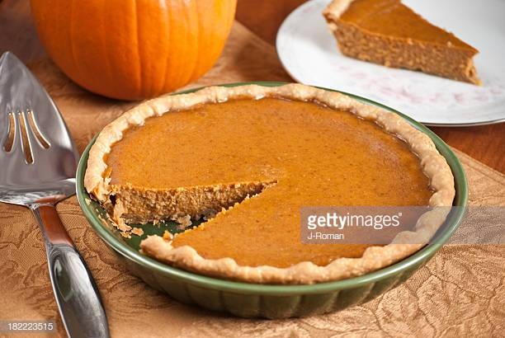
- Bake at 218-degree c. for 10 minutes & reduce the heat to 162-degree c.& bake for more 25 min.

Fig 1.18 pumpkin pie
Making jam tarts
Ingredients
- 100 gm. of flour
- 25 gm. of lard
- Water to mix
- 25 gm. of butter or margarine
- Salt for taste
- 2 Tbsp of jam
Procedure
- Prepare a short paste, mold in to a ball
- Roll it out in to a 3mm.thick round
- Place it carefully on a greased plate
- Cut off any surplus pastry
- Prick the bottom with a fork
- On the short paste, spread on the jam
- Roll out any surplus pastry cut in to strips then decorate the top
- Bake at 200-degree c. for 15 min.

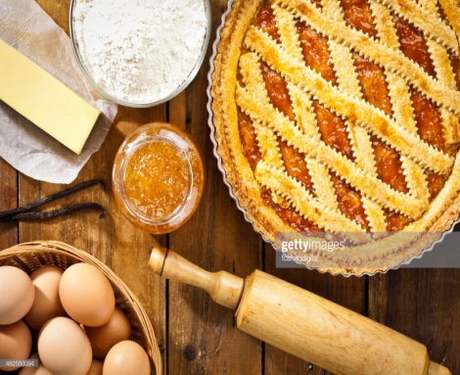

Fig 1.20 jam tarts
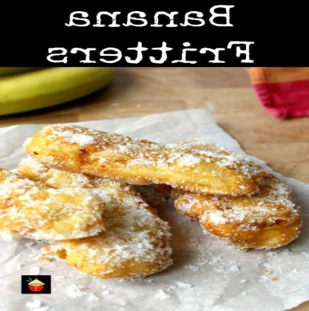
Banana fritters
Ingredients
- 4 bananas
- 150g. Frying batter
- 125ml. apricot sauce (jam +water)
Procedure
- Peel and cut the bananas in half lengthwise then in half across. Fig 1.21 Banana fritters
- Pass through flour, shake surplus
- Dip in to frying batter
- Drain well, dust with icing sugar
- Serve with hot apricot sauce.
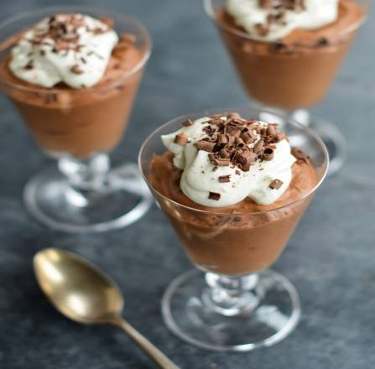
Mousse
Ingredients
- 2 eggs (whole)
- 3 egg-yolk
- 2cc rum
- 2-4 leaf gelatin
- 450 g. black chocolate (cuvetur)
- 1 kg. whipped cream
Procedure
- Combine the egg (whole and yolk) Fig 1.22 Mousses
- Beat continuously over a hot water bath
- Remove from hot water bath whisk until cold (warm and cold method)
- At the same time melt the chocolate and combine with the egg mixture
- On the other hand, combine the gelatin (dissolved) with portion of whipped cream
- Pour back to the egg and chocolate mixture &stir continuously
- Fold in the whipped cream, blend it
- Pour in a rectangular pan and keep it cool (it is a frozen dessert)

1.4 Producing creative and innovative desserts and sweets
Everyone working in the catering industry agrees that putting effort into offering delicious desserts always makes a good impression and is something that many clients remember when making a return visit to a restaurant. Desserts are, without doubt, the most satisfying dish for diners to consume, as they anticipate colorful presentations and sweet flavors.
Pastry is the most innovative and creative of all the departments in the kitchen. It’s important for the pastry chef to keep trying and depicting emotion in what he puts on the plate.

Tips for plating desserts beautifully
- Be creative with color. ...
- Combine textures. ...
- Compose your plate as you would a painting. ...
- Consider the vessel. ...
- Contrast temperatures. ...
- Have a focal point. ...
- Let it be dramatic. ...
- Don't make it too tall or unsteady

Operation sheet 1:
Operation Title: Producing creative and innovative desserts and sweets
Purpose: To prepare desserts and sweets in a creative manner
Conditions or situations for the operations:
- Safe working area
- Properly operated tools and equipment
- Appropriate working uniforms fit for the practical performance

Quality Criteria: Assured performing of all the activities according to the procedures

Equipments
- Sugar.
- Gelatin.
- Egg yolks.
- Egg whites.
- Fruit.
- Cream. ...
- Rice pudding.
- Batters.
- Measuring Cups (Liquid and Dry) and Spoons.
- Wooden Spoon(s)
- Rubber Spatula/Scraper.
- Spatula/Metal Turner.
- Pastry Brush.
- Whisk.
- Kitchen Scissors.
- Rolling Pin.
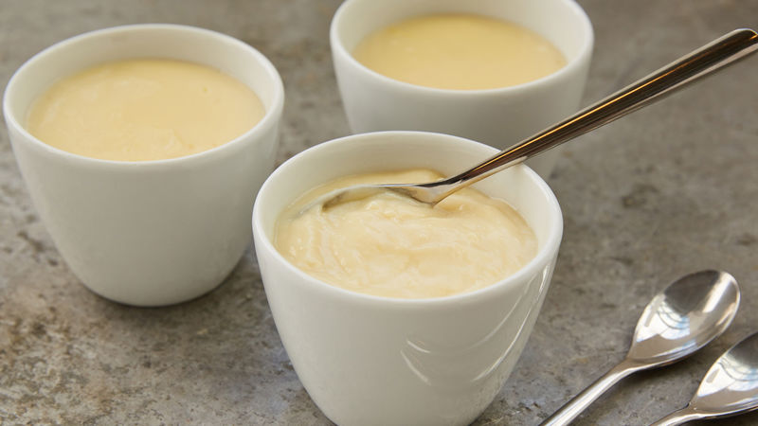
- Pudding
Ingredients
- 2 cups milk
- ½ cup white sugar
- 3 tablespoons cornstarch
- ¼ teaspoon salt fig 1.23 pudding
- 1 teaspoon vanilla extract
- 1 tablespoon butter
Method
- Heat milk in a medium saucepan over medium heat until bubbles form at the edges.
- Mix sugar, cornstarch, and salt together in a small bowl; add to hot milk, a little at a time, stirring until thick enough to coat the back of the spoon. Remove saucepan from heat, and stir in vanilla and butter.
- Spoon pudding evenly into 5 serving dishes; chill in the refrigerator before serving.
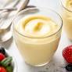
- custards
Ingredients
- 3/4 cup (150g) sugar
- 1/4 cup (28g) cornstarch
- 1/4 teaspoon kosher salt
- 6 large egg yolks
- 2 cups (480ml) whole milk
- 1 cup (240ml) heavy cream
- 2 tablespoons (28g) unsalted butter fig 1.23 custard
- 1 tablespoon vanilla extract
Method
Combine the dry ingredients:
Whisk in the egg yolks:
Bring the milk and cream to a simmer:
Temper the egg yolks:
Cook the custard:
Whisk in the butter:
Strain and chill
Stir, serve, and store:

Lap test 1
Instructions: Given necessary templates, tools and materials you are required to perform the following tasks accordingly.
Task 1: prepare a desert and sweet dish creatively.

Unit Two: Decorating and portioning desserts and sweets
This unit is developed to provide you the necessary information regarding the following content coverage and topics:
- Decorate desserts and sweets
- Portion and present desserts and sweets
This unit will also assist you to attain the learning outcomes stated in the cover page. Specifically, upon completion of this learning guide, you will be able to:
- Decorate desserts and sweets
- portion desserts and sweets
- present desserts and sweets

2.1 Decorate desserts and sweets
The term decorated food is generally used to describe a food that has been filled, iced and has some type of finishing touch on the icing. For example, if the cake is decorated attractively, then it can influence our sales to a great degree. The decoration should tempt the customer to use (try) the product and at the same time it should suggest flavor, and texture of the cake and filling. The decoration is the final wrapping or packaging, designed to our product. Decorating food is to make the finished product look tasteful and elegant (having a quality of grace). Sugar is used for decorating cakes & cookies.
Decorating cake
- The decoration must be put on while the icing is still soft
- Arrange the decoration on a plate before icing the cake
- Keep it as simple as possible
- Match or contrast the color of the decoration to the icing
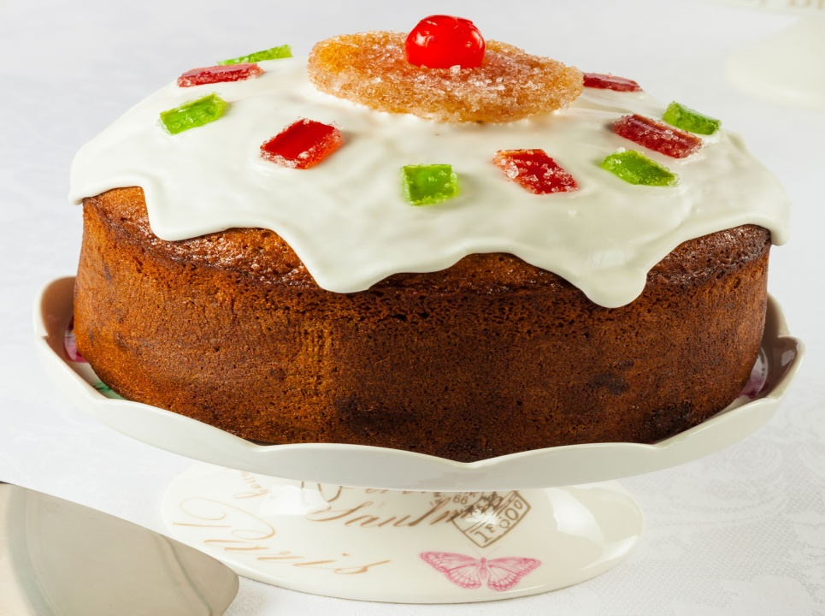
Fig 2.1 Decorated desserts

2.1.1 Cake Decorating Tools
- Piping Bags
Piping Bags are the first tool required to start cake decorating. There are two types of piping bags which you can use for getting a professional finish on your cakes:
- Disposable Piping Bags – These are usually transparent and come in all sizes, Small, Large and Extra Large. Once done using, you need to dispose them in the trash.
- Silicone Piping Bags – These are reusable piping bags which you can wash and reuse again. You also get a tube like piping bags with a push mechanism. These can be avoidable as they make piping difficult.

Fig 2.2 piping bag
2. Nozzles
Nozzles are the second most important tool for piping those beautiful designs on your finished cake. Always go for stainless steel nozzles. Avoid the plastic ones. Also, Stainless Steel nozzles are easier to clean when you immerse them in hot water after using.

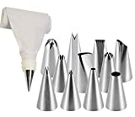
Fig 2.3 nozzle

3. Food Colors: There are three types of food colors that are commonly used in the food industry:
A. Gel-based Food Colors: Always use gel food colors with your icing: be it whipped cream, butter cream or white ganache. Gel Colors do not let the icing separate like water-based colors do.
B. Water-based Food Colors: These are good to use in cooking and not baking as they are water based and will not blend well with the icing cream which is fat-based.
C. Powder-based Food Colors: These can be used in cooking or best avoided as they mostly contain additives and never give the desired color unless you add them in large quantities
4. Silicone Brush: You can use this for soaking your cake layers in simple sugar syrup before layering them with icing.
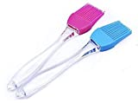
Fig 2.3 Silicone Brush
- Spatulas
These are very important to give a finish to your cakes after you have applied the icing all over the cake layers. These give a smooth finish to the icing if used properly and give your cakes a beautiful look. You can use small spatulas for short cakes and long spatulas for taller cakes.

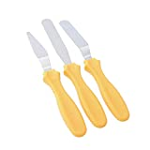
Fig 2.4 spatulas
- Hand Mixer: - This tool is required if you are using Whipped Cream or Butter cream to decorate your cakes. This tool becomes necessary as beating of cream or butter by hand is not ideal also to mention, very energy and time consuming.
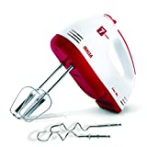
Fig 2.5 Hand mixer

2.2 Portioning & Presenting desserts and sweets
To portion mean to divide in to amounts, it is about their sizes. Serving delicious desserts in diet-friendly portion. Miniature desserts are easy to eat and impossible to resist, and at parties it is all about convenience, which is why finger foods generally go first especially the sweet ones.
Small portion desserts are small bites (petit fur) , single portion desserts implies only one portion & individual portion is a portion for a person (to determine for one person use)
Portion size is the amount of food that one puts on his or her plate for a single sitting or meal. Quite often, we serve ourselves quantities perceivably equivalent to a single portion, when in reality they may be composed of multiple portions. Essentially, portion control involves eating a healthy assortment of varied foods
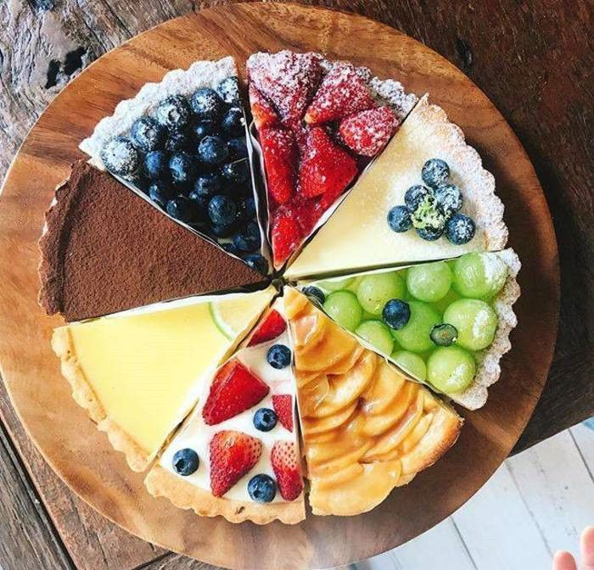
Fig 2.6 Portioned dessert

    - Presenting desserts and sweets
Dessert presentation at a catered event is very important, because it helps add extra value to the dining experience. It also goes a long way in providing more room for a higher mark-up on the served dessert. Most caterers often forget the importance of a dessert to a guest’s overall experience. In fact, the way a dessert is presented and served plays a huge part in the whole meal. Therefore, dessert presentation is something that can make or break the perception of an event. As an individual planning to host an event very soon, you want to work with professional caterers that understand the importance of dessert presentation. This article provides you with reasons as to why this is critical.
As the old saying goes, people eat with their eyes first!!!. Hence, the way the served dessert looks is as important as its taste. The perfect presentation is something that can only be achieved by trained professionals, who possess the ability to set your event apart from others. Expert caterers can comfortably incorporate advanced techniques in various dessert presentation methods. For instance, they can make molding chocolate, wrap it around cake using an extra-fancy pattern, and form it into special ribbons.
Presenting is the way of displaying dessert items in front of a customer for the replying of his/ her order. Here are some tips for plating desserts effectively and beautifully.
- Be creative with color. ...
- Combine textures. ...
- Compose your plate as you would a painting. ...
- Consider the vessel. ...
- Contrast temperatures. ...
- Have a focal point. ...
- Let it be dramatic. ...
- Don't make it too tall or wobbly.
Dessert presentation has three essentials:-
- Good basic baking and pastry skills. A pastry chef cannot make superior plated desserts without having mastered basic skills and techniques. ...
- Professional work habits. ...
- Visual sense.
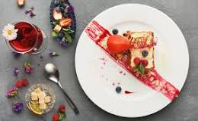
Fig 2.7 dessert presentation

Self check 2
I. Write true for correct statements and false otherwise.
- Portion size is the amount of food that one puts on his or her plate.
- To portion mean to divide in to amounts, it is about their sizes.
- Gel food colors are applicable with icing foods.
- Decoration is the final wrapping or packaging, designed to our product.
- Plastic made nozzles are acceptable worldwide.
- Being creative with color is recommended in portioning dessert and sweet
- People eat first with their Eyes.
- The perfect presentation is something that can only be achieved by trained professionals,

Unit three: Preparing sweet sauces
This unit is developed to provide you the necessary information regarding the following content coverage and topics:
- Preparing sauces
- Thickening agents
- Storing sauce
This unit will also assist you to attain the learning outcomes stated in the cover page. Specifically, upon completion of this learning guide, you will be able to:
- Prepare sauces
- Use thickening agents
- Store sauce

3.1 Preparing Sauces
In cooking, a sauce is a liquid, cream, or semi-solid food, served on or used in preparing other foods. Most sauces are not normally consumed by themselves; they add flavor, moisture and visual appeal to a dish. Sauce is a French word taken from the Latin salsa, meaning salted.
Sauces need a liquid component. Sauces are an essential element in cuisines all over the world. Sauces may be used for sweet or savory dishes. A chef who specializes in making sauces is called a saucier.
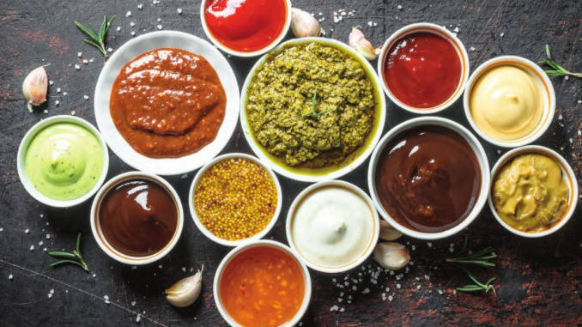
Fig 3.1 sauces
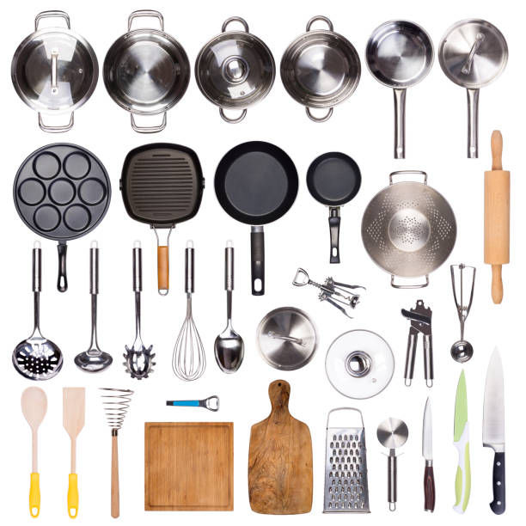
Fig 3.2 sweet sauce equipments

3.1.1 Types of Sauces
- Barbecue Sauce. A thick tomato-based sauce containing a variety of spices and flavorings. ...
- Cocktail Sauce. A sauce similar to ketchup. ...
- Horseradish Sauce. ...
- Hot Sauce. ...
- Taco Sauce. ...
- Soy Sauce. ...
- Tartar Sauce.

3.2 Thickening agents
A thickening agent or thickener is a substance which can increase the viscosity of a liquid without substantially changing its other properties. Edible thickeners are commonly used to thicken sauces, soups, and puddings without altering their taste; thickeners are also used in paints, inks, explosives, and cosmetics.
Thickening agents are often regulated as food additives and as cosmetics and personal hygiene product ingredients. Some thickening agents are gelling agents (gellants), forming a gel, dissolving in the liquid phase as a colloid mixture that forms a weakly cohesive internal structure. Others act as mechanical thyrotrophic additives with discrete particles adhering or interlocking to resist strain.
3.2.1 Types of thickening agent
  - All purpose flour is the most popular food thickener. All-purpose flour is versatile and general use wheat flour. It is milled from hard red wheat or a blend of hard and soft wheat, typically 80:20 ratios. As the name suggests, all-purpose flour is suitable for all types of baked goods such as bread, biscuits, pizza, cookies, muffins, etc.
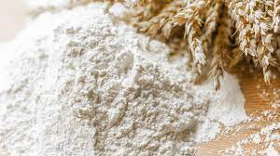
Fig 3.3 all purpose flour
  - Cornstarch: Cornstarch is the most common thickening agent used in the industry. It is mixed with water or juice and boiled to make fillings and to give a glossy semi-clear finish to products. Commercial cornstarch is made by soaking maize in water containing sulphur dioxide. Cornstarch in cold water is insoluble, granular, and will settle out if left standing. However, when cornstarch is cooked in water, the starch granules absorb water, swell, and rupture, forming a translucent thickened mixture. This phenomenon is called gelatinization. Gelatinization usually begins at about 60°C (140°F), reaching completion at the boiling point.
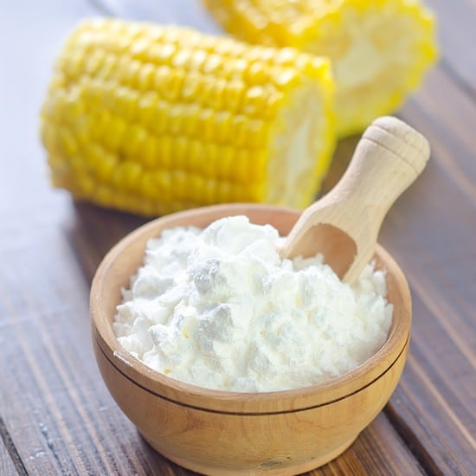
Fig 3.4 cornstarch

3.3 Storing sauce
Sauces and starches should be kept in airtight container and stored in a cool dry place away from the moisture, oxygen, lights, and pests.
The fridge is the best place to store sauces. Store your leftover homemade sauce in the fridge and use within a couple of days or freeze. For leftover shop-bought sauces it's best to follow the storage guidance on the jar. If you have leftover sauce, seal the lid and store the jar in the fridge. Always have clean containers on hand for your finished stocks. You can store liquids in plastic containers with tight-fitting lids in the refrigerator or freezer. Stocks will also hold well in sealed plastic bags. Homemade sauces will typically stay fresh in your refrigerator 3 to 4 days. Once frozen, you can safely store these same sauces for 6 months, sometimes longer
3.3.1 Techniques of storing sauce
Most sauces can be made in advance and refrigerated or frozen, making them perfect as last-minute additions. Place in a small container or bowl filled with plastic in a refrigerator or in a heavy-duty zip bag. A smaller container means less air pollution and less spoilage. Gently reheat sauces to drink warm at low pressure. Caramel and chocolate sauces are better served over simmering water in a double boiler.
Sauces should be packed in airtight containers and kept in a cool dry position away from moisture, water, light and pests. Nutrition made from starches containing eggs, milk, cream and other dairy products is susceptible to bacterial contamination and food borne illness. Sauces made with these ingredients should be kept out of the hazardous temperature zone.

Operation sheet 2: Prepare sweet sauces
Operation Title: Prepare sweet sauces
Purpose: To prepare various sweet sauces
Conditions or situations for the operations:
- Safe working area
- Properly operated tools and equipment
- Appropriate working uniforms fit for the practical performance
Quality Criteria: Assured performing of all the activities according to the procedures

Needed Equipments

- Casseroles ·
- Pressure cooker ·
- Pans and lid ·
- Knives,
- Scissors
- Cutting board ·
- Saucepan,
- Ladle and
- Skimmer.
- Blender
- Large strainer
- Measuring cup
- Grater
- Bowls
- Glass containers
- Airtight bags

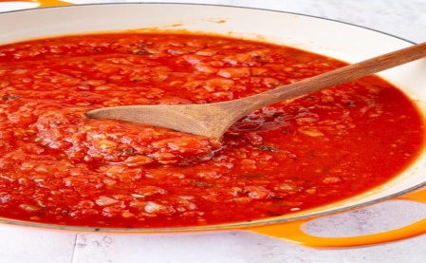
Preparing Easy Pasta Sauce
Ingredients
- 2 tablespoons olive oil
- 1 medium onion finely diced
- 3-5 cloves garlic minced or put through a garlic press Fig 3.5 Easy Pasta Sauce
- 2 teaspoons dried basil
- Pinch red pepper flakes about 1/4 teaspoon
- 1/2 teaspoon kosher salt
- 1/2 teaspoon granulated sugar
- 1 pat butter, about 2 teaspoons
- 1 28 ounce can crushed tomatoes
- 1/4 cup water

Methods
- Heat the olive oil over high heat until it shimmers. Saute the onions, stirring frequently, until they soften and shine, about three minutes. The onions should sizzle and hiss as they cook. Add the garlic. Stir to combine. This prevents the garlic from burning. Cook an additional two minutes. Add the basil, red pepper flakes, salt, and sugar. Stir to combine. Add the butter. Stir, cook for about a minute.
- Add 1/2 can of the crushed tomatoes. Scrape the bottom of the pan to remove any stuck on bits. Reduce heat to low. Add remaining tomatoes. Stir in 1/4 cup water. If the sauce seems too thick, add additional water.
- Allow sauce to simmer for 10 minutes to up to one hour. If simmering for a longer, stir the sauce occasionally and add additional water as needed to keep the sauce at the correct consistency.
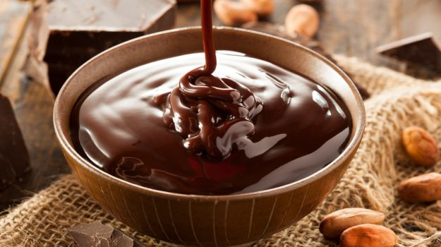
2. Chocolate Sauce
Ingredients
1/2 cup unsweetened cocoa powder
1 cup sugar
1/8 teaspoon kosher salt
1/2 cup cold water fig 3.6 chocolate sauces
1 1/2 teaspoons vanilla

Methods
1. In a cold saucepan, whisk together the cocoa and the sugar until all lumps are removed. Add the salt and the water and bring to a boil over medium to medium high heat.
- Reduce to a simmer; stirring constantly. Simmer for about 30 seconds and then remove from heat. Let cool and then add vanilla. Pour into a glass jar and refrigerate until needed. Enjoy!
Notes
The chocolate sauce will be very thin when it finishes boiling, but it will thicken quite a bit as it cools. The chocolate sauce may be stored in the refrigerator for up to two weeks. Simply reheat before serving. This recipe makes 14oz of chocolate sauce and can easily be doubled if desired.
- Sabayon sauce
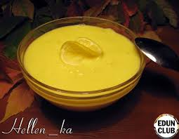
Ingredients
5 large egg yolks
Pinch of salt
1/4 cup plus 2 tablespoons sugar
1 cup Muscat de Beaumes-de-Venise, a sweet French dessert wine
3/4 cup heavy cream
2 teaspoons freshly squeezed lemon juice fig 3.6 sabayon sauce

Method
Step 1. Prepare a large ice bath, and set aside. Fill a medium saucepan with 2 inches water. Set over medium heat, and bring to simmer.
Step 2. In a large stainless-steel bowl, whisk together egg yolks, salt, and sugar until very pale. Add Muscat; whisk to combine.
Step 3. Place bowl over a pan of simmering water, and whisk until mixture has thickened and has tripled in volume, 8 to 10 minutes. Remove mixture from heat, and immediately transfer to ice bath. Whisk until chilled.
Step 4. In a large chilled bowl, whip cream until soft peaks form. Add lemon juice, and fold the whipped cream into the chilled sabayon. Serve immediately.
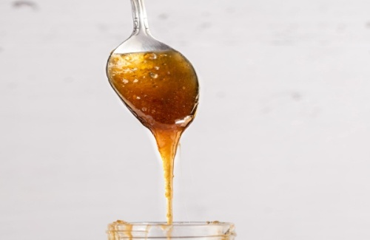
- Sugar syrups
Ingredients
- 1kg Chelsea
- 1 Liter Water

Fig 3.7 sugar syrup

Method of preparation
1. Pour one cup of water in to a clean sauce pan.
2. Add one cup of caster sugar in to the water and put over a low heat
3. Gently stir the sugar and water until most of the sugar has dissolved (the liquid will look mostly clear)
4. Now add the second cup in to the saucepan stirring as you pour it in. Keep going until no granules of sugar are left visible.
5. Heating aids the dissolving of the sugar but be careful not to put the temperature too high – do not let the water boil or even simmer.
6. Optionally, add a small splash of flavorless vodka – this will help preserve the syrup for longer.
7. Once all the sugar has dissolved, allow the syrup to cool completely (leave a lid on the pan so no flies get in!) then pour into bottles.

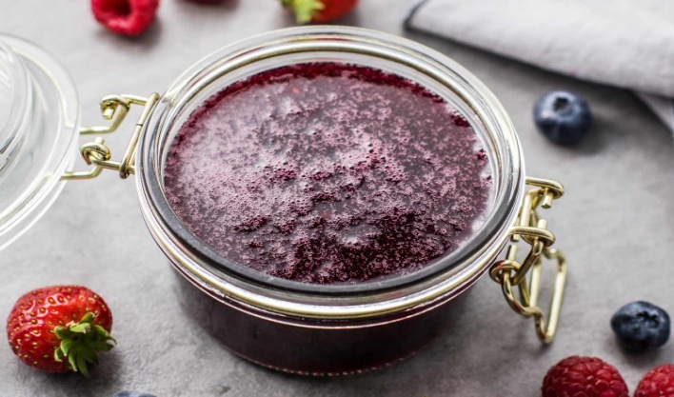
5. Fruit syrups
Ingredients
- 1 cup fruit, fresh or frozen
- 3/4 cup sugar
- 1/3 cup water

Methods
- Gather the ingredients. Fig 3.7 Fruit syrups
- Peel, de-stem, or remove seeds from the fruit, as appropriate.
- Place the fruit, water, and sugar into a pot.
- Cook the fruit with the sugar and water, bringing it to a boil and then lowering the heat to simmer.
- Smash the fruit while it is cooking.
- Simmer until the mixture has thickened to a syrupy consistency. This should take about 10 minutes.
- Once the mixture has thickened, you can press it through a strainer to make thin syrup.
- If you prefer thicker syrup, process the cooked syrup in a food processor.
- Serve with your favorite breakfast item. Enjoy!

Lap test 2
Instructions: Given necessary templates, tools and materials you are required to perform the following tasks accordingly.
Task 1: prepare sweet sauce.

Unit four: Prepare accompaniments, garnishes and decorations
This unit is developed to provide you the necessary information regarding the following content coverage and topics:
- Accompaniments, garnishes and decorations
- Complementing garnishes with desserts
This unit will also assist you to attain the learning outcomes stated in the cover page. Specifically, upon completion of this learning guide, you will be able to:
- Prepare Accompaniments,
- Prepare garnishes
- Apply decorations
- Complement garnishes with desserts

4.1 Accompaniments, garnishes and decorations
4.1.1 Accompaniments
Means food items served along with another food to enhance palatability such as butter, jelly, cream cheese, salad dressing, croutons and condiments. Food accompaniment is the side dish that serves with the main dish, it complements the main food and enriches its taste and flavor. Food accompaniment can be an integral part of the dish or served separately.
Accompaniments can be defined as any additional food items that are served with the main dish.. Accompaniments are generally flavored food and sauces offered with specific main dishes. Appropriate accompaniment enhances the flavor of the dish by providing a balance and contrast to taste. There are various accompaniments that are being served with different dishes in separate monkey bowls.
4.1.2 Garnish
Garnish can be defined as a small bit of foodstuff used as decoration on top of the main dish to enhance the presentation. Different varieties of fresh cream vegetable products, meat items, sauces, gravies, pasta items shell fishes etc are mainly used for garnishing the dishes of particular choice. Careful selections of garnishes that have flavor, color and eye appeal are accepted to make the dish attractive. Main purposes of garnishing dishes are as follows;
- To make the dish attractive in appearance
- To enhance the flavor and appetite
- To help improve the color combination with the main dish.
Garnish can be divided into two types as:
- Simple garnish :- Consists of single food
- Composite/ compound garnish: - is combination of more than one food items used in the decoration of a particular dish.

4.1.3 Food, Accompaniment and Their Garnishes

- Tomato soup: crouton or cream as garnish
- Momo: soup, tomato sauce, pickles
- Pizza / pasta: tomato sauce, grated parmesan cheese
- Roast lamb: mint sauce, roast gravy, bread rolls, butter
- Roast chicken: Roast potato, roast gravy, bread sauce
- Roast pork: apple sauce
- Roast duck: apple sauce, orange sauce
- Fried fish: tartar sauce, lemon
- Pulao: fried cashew nuts and onion
- Dal: whole red chili, coriander leaves, fried onions
- Burger/ sandwiches: potato chips, lettuce, French fry
- Iced-tea: slice of lemon, / lemon wedges with mint spring
- Cream soup: cream and chopped parsley
- Oysters: tobacco sauce, brown bread, butter
- Tandoori chicken
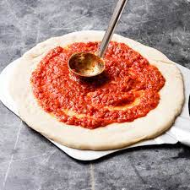
- Onions rings, lemon slices, green salads, mint sauce
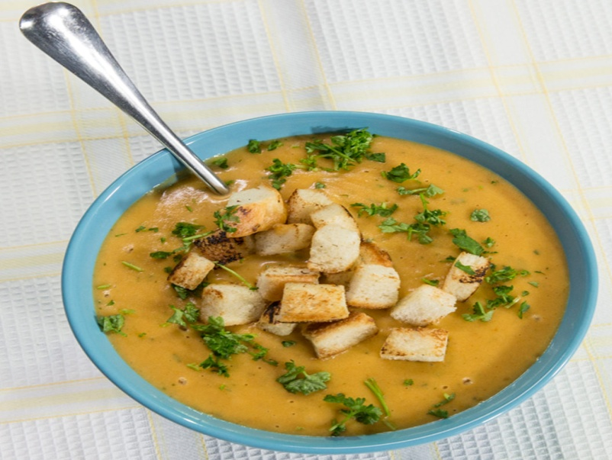
Fig 4.1 crouton accompanying potato sauce Fig 4.2 tomato sauce accompanying pizza

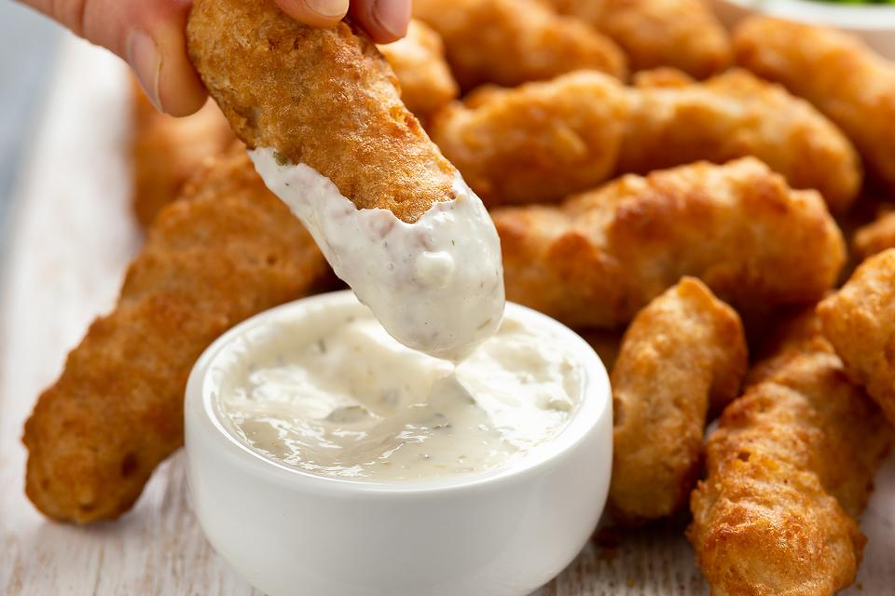
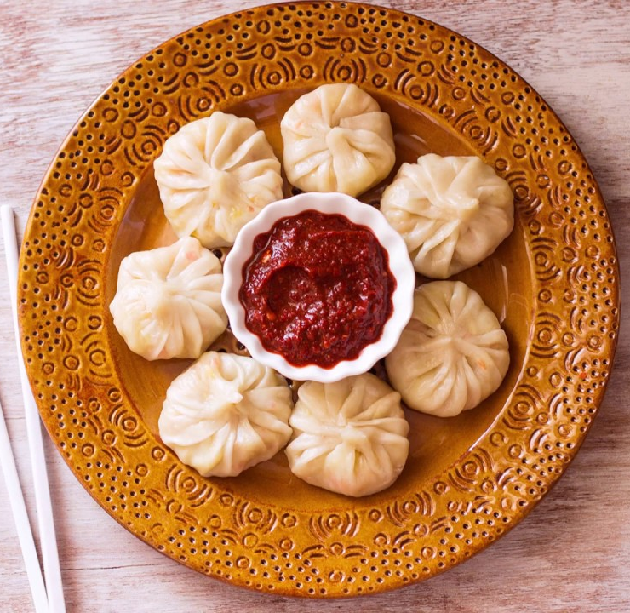
Fig 4.3 momo accompanied with tomato sauce fig 4.4 fried fish with tartar sauce

4.1.4 Dessert decorations
Decorations are mostly used in baked goods like cakes, cupcakes and cake pops. There are different cake decorative items in the market as glitter dust, beads, petal dust, shimmer powder, etc. Some of these ingredients are not edible and should be removed before serving. Therefore, it’s always important to check the labels of food decorations before using them. However, some decorations may be labeled as nontoxic, but this doesn’t mean that they are suitable for consumption. Besides, we can also consider cake toppers and cake figurines as food decorations. Some of these may be made with fondant and are edible. But, some cake toppers are made not made with edible materials.

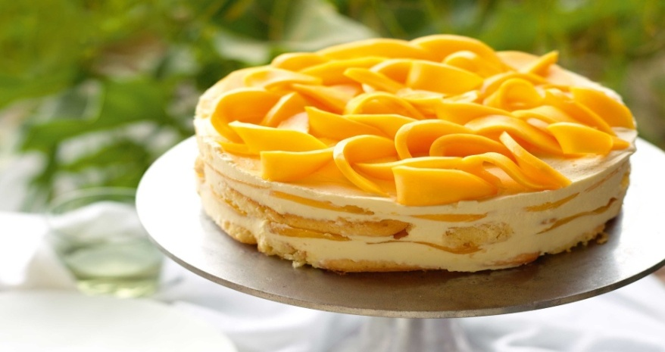

Fig 4.5 mango decorated cake

4.2 Complementing garnishes with desserts
4.2.1 Guidelines of complementing garnishes with desserts
- Garnishes should be edible whenever possible and should complement the food, such as lemons with fish and onions with meat. Keep your menu in mind as you plan your garnishes. If wooden picks are used to fasten leaves or petals, caution your guests as you serve.
- Garnishes should enhance the food with color, not overpower it. Consider the color of your serving dishes and table decorations in creating a total picture. White garnishes can be tinted with liquid food colors for a pastel accent. First add food color to water, then soak the garnish until you have achieved the depth of color you wish. If you prefer, natural dyes such as beet juice, grape juice and carrot juice can be used.
- Keep garnishes simple, natural and fresh. Do not over-garnish. Combine garnishes only if their colors, proportions and shapes are compatible.
- Always use fresh, high quality ingredients. Dried, withered or mealy foods will not produce attractive garnishes.
- Garnishes can add height and shape to a platter of food.
- An arrangement of garnishes can make an attractive centerpiece.

Operation sheet 3: Prepare accompaniments, garnishes and decorations
Operation Title: Preparing accompaniments, garnishes and decorations
Purpose: To prepare various sweet sauces and dessert dishes and to accompany them with the correct accompaniment item
Conditions or situations for the operations:
- Safe working area
- Properly operated tools and equipment
- Appropriate working uniforms fit for the practical performance
Quality Criteria: Assured performing of all the activities according to the procedures

Equipments
- Mixer
- Whisker
- Knife
- Spoon
- Plate
- Cutting board
- Bowl
- Nozzle
- Wiper

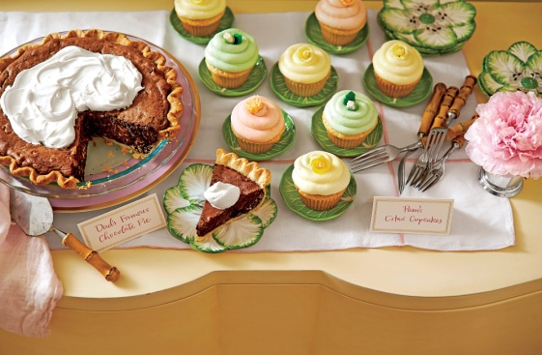
Amaretto Whipped Cream
Ingredients
- cup heavy cream, keep cold in refrigerator until needed
- 2 tablespoons Amaretto
- 3 tablespoons Imperial Sugar Confectioners Powdered Sugar
- 1/2 cup toasted sliced almonds, garnish Fig 4.6 amaretto cream
Methods
Step1. Beat cream and liqueur at medium-high speed with an electric mixer until foamy.
Step 2. Gradually add powdered sugar, beating until soft peaks form.
Step 3. Chill until ready to serve.

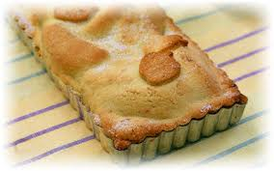
- Apple Shortcake
Ingredient
- 1¾ cups Edmonds Standard Grade Flour
- 2 tsp Edmonds Baking Powder
- 125g butter
- ¾ cup Chelsea caster sugar
- 1 egg, beaten
- 1 Tbsp Meadow Fresh milk fig4.7 apple shortcake
- 1 Tbsp Chelsea caster sugar
- Chelsea icing sugar

Method
- Cook the apples slowly in a covered saucepan with the sugar, water, lemon zest and cinnamon. When they are soft, put them in a bowl to cool.
- Preheat the oven to 180˚C. Lightly grease a 22cm square cake tin and line the base and two sides of the tin with baking paper.
- Sift together the flour and baking powder and rub in the butter with your fingertips until the mixture resembles coarse breadcrumbs, or use a food processor.
- Add the sugar, beaten egg and milk and mix or process until the shortcake clumps together.
- Turn out onto a floured board, flour the top and divide in half. Shape each half into a flat disc, put each on a plate and chill for 20 minutes.
- Roll out one half of the dough and fit into the prepared tin. Spread the cooled apple evenly over the top.
- Roll out the remaining dough, drape it over the rolling pin and lift it over the apples, or roll out the dough on baking paper, then flip it onto the apples and peel the paper away. Tidy up the edges with dampened fingers. Brush the top with water and sprinkle with the caster sugar.
- Bake for 25 minutes until risen and golden. Leave in the tin on a wire rack for 15 minutes, and then use the baking paper to lift the shortcake out of the tin. Transfer to a cutting board, d

LAP test 3:
Instructions: Given necessary templates, tools and materials you are required to perform the following tasks accordingly.
Task 1: prepare accompaniments
Task 2: prepare garnishes
Task 3: prepare decorations

Unit five. Store desserts and sweets
This unit is developed to provide you the necessary information regarding the following content coverage and topics:
  - Packaging desserts and sweets
  - Storing desserts and sweets
This unit will also assist you to attain the learning outcomes stated in the cover page. Specifically, upon completion of this learning guide, you will be able to:
  - Package desserts
  - Package sweets
  - Store desserts
  - Store sweets

4.1 Packaging desserts and sweets

Food packaging is defined as enclosing food to protect it from tampering or contamination from physical, chemical, and biological sources, with active packaging being the most common packaging system used for preserving food products.
Desserts are oftentimes very delicate and come in all shapes and sizes. It’s easy for icing to get smudged or toppings to topple over during the ride from your establishment to your customer’s front door. Being a menu category that relies heavily on presentation, keeping your dessert’s integrity is the top priority when it comes to packaging.
Unfortunately, there’s no one size fits all packaging solution for desserts. Because of the wide variety of desserts available, take into consideration the following factors when choosing a container.

4.1.1 Packaging materials

Most materials used for packaging foods belong to the following classes: metals, glass, paper and polymers. Some packaging media consist of a combination of two or more materials of the classes listed above. Enameled (lacquered) metal and laminates formed by binding together layers of polymer, paper and aluminum foil are common examples of such composite materials.
The chemical composition and physical properties of packaging materials determine their ability to fulfill the various functions expected from the package. The most important properties to be considered in this context are transport properties, optical properties, mechanical properties and chemical reactivity.

Metals
Metal containers offer the advantage of superior mechanical strength, impermeability to mass transfer and to light, good thermal conductivity, and resistance to relatively high temperature.
Can sizes are standardized and specified using standard denominations. In the USA, for example, cylindrical cans are specified by their diameter and their height, with both dimensions given by a three-digit code
table 3.1 Advantage and Disadvantage of some packaging materials
No | Packaging type | Advantage | Disadvantage
1 | Plastic | Durable design protects desserts  Rigid structure secures food in place  Leak-resistant to preserve freshness | Less environmentally friendly than other options
2 | Paper | Lightweight and easy to carry  Tends to cost less than other materials  Microwave-safe for reheating food | If unlined can be saturated with grease and moisture
3 | Aluminium | Oven-safe for baking and serving  Lightweight and easy to carry  Freezer-safe for storing leftovers | Typically less presentation-focused than other options
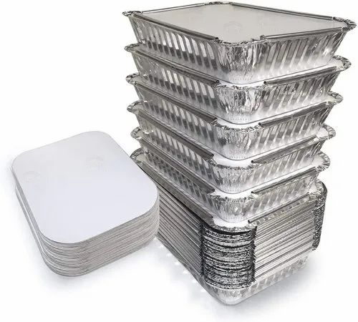

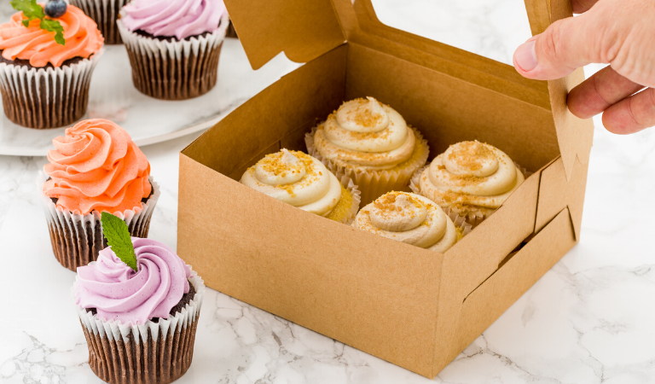

Fig 5.1 paper dessert packaging

Fig 5.3Almuninium dessert packing

5.2. Storing desserts and sweets

A. Cakes and similar baked desserts: If you’re thinking refrigeration, think again. Cakes and most other baked desserts should be stored at room temperature in an airtight container in order to preserve as much freshness as possible. For cakes, gently place plastic wrap over the portions that have been cut before putting the cake in an airtight container. Don’t freeze your cake unless you know you won’t be eating it within a few days.
  - Cookies: We recommend this odd trick for storing cookies. To keep them moist, store them in an airtight plastic freezer bag and place a slice of bread in the bag with them. This will allow them to absorb moisture from another baked good as needed. Decorated Sugar Cookies can be kept in an air-tight container at room temperature for 1 week or in the refrigerator for up to 2 weeks. Please note, discoloration may occur if storing in the refrigerator.

  - Cupcakes: Cupcakes should be stored in an airtight container or plastic bag in a cool, dry place. Refrigeration will dry them out. However, you can freeze cupcakes that you won’t use within two days, as these desserts tend to freeze well. Store them in Room Temperature for 3-5 days. Except for cupcakes with cream cheese butter cream such as Red Velvet and Carrot Cake. Cream cheese must be refrigerated. Refrigeration for cup cake is - up to 1 week. When ready to consume, take out of fridge and let sit for about 5 minutes before eating.

    - Storage conditions for desserts and sweets

Storing cold and hot desserts as many desserts contain egg and dairy products, they present a potential health hazard if not stored properly. Remember: proper storage means cooled desserts must be covered with plastic or placed in lidded containers before storing in the cool room. Observe the following guidelines:
  - Desserts containing uncooked eggs should be handled with extreme care, as raw egg is a medium in which dangerous bacteria such as salmonella can thrive. This means you need to be really careful with foods like chocolate mousse and uncooked cheesecakes that contain egg whites for aeration.
  - Egg custards contain protein, which provides good food for bacteria. If custards are not heated and cooled properly and quickly, bacteria that are present in the custard can grow quickly to dangerous numbers.
  - Any dessert that is not required for immediate consumption must be cooled rapidly and stored in the cool room until required.
  - If you plan to keep a pre-prepared dessert hot until service, make sure that the temperature of the food is over 65oC. Never leave an egg mixture in a Bain-Marie for any length of time. Any dessert that has been kept hot in the Bain-Marie for a while should be discarded at the end of service.
  - If milk and cream are used in desserts like trifle and custards, they must not be left to stand at room temperature for any length of time. They shoub be kept in the refrigerator until the last possible moment to prevent the risk of food poisoning.
  - Many desserts have a limited storage life. Make sure you check with your supervisor and follow organizational requirements.

5.2.2 Packaging Equipment for desserts and sweets
- Chiller
- Freezer
- Refrigerator

Recommended reading
- Graham Dark, Deirdre McLean & Sarah Weatherhead; 2011 (2nd edition); Kitchen Operations; Pearson Australia
- Figoni, Paula; 2004; How baking works: Exploring the fundamentals of baking science;
John Wiley and Sons Inc
- Friberg, Bo; 2004 (4th edition); The Professional Pastrychef; Van Nostrand Reinhold
- Goodman, Clio & Sussman, Adeena; 2013; Puddin': Luscious and Unforgettable Puddings, Parfaits, Pudding Cakes, Pies, and Pops; Spiegel & Grau
- Forster, Felicity; 2010; 300 Chocolate Desserts and Treats: Rich recipes for hot and cold desserts, ice creams, tarts, pies, candies, bars, truffles and drinks; Anness
- Lebovitz, David; 2010; The Perfect Scoop: Ice Creams, Sorbets, Granitas, and Sweet Accompaniments; Ten Speed Press
- Migoya, Francisco & The Culinary Institute of America; 2008; Frozen Desserts ;Wiley

Developers’ profile
No | Name | Qualification | Educational background | Region | College | Mobile number | E-mail
1 | Mohammed Liben Mohammed | Hotel and Tourism Sector head | - BA degree in Hotel and Tourism management  - MA degree in Disaster Risk Management | Somali | Jigjiga Polytechnic college | 0992326557 | cherechaw@gmail.com
2 | Abreham Mayza mengesha | Instructor | Bed degree in Hotel and Tourism | SNNP | Arba minch Polytechnic college | 0913711922 | Abrehammayza9@gmail.com
3 | Zelalem Almaw Endalew | Instructor | - BSC degree in Food science and post harvest technology | Amhara | Bahir dar Polytechnic College | 0918012521 | Parazolla25@gmail.com
4 | Hiwot Tedla Belay | Instructor | BA degree in Accounting and finance and diploma in Hotel Management | Hareri | Harer Polytechnic College | 0913789086 | hiwietaba@gmail.com
5 | ZuryashWork Belay Nigatu | Instructor | BA degree in Hotel Management | Addis Ababa | TTI | 0911643817 | zwb@gmail.com

