BAKERY AND PASTRY PRODUCTION
Level III
Based on September 2023 Curriculum Version II

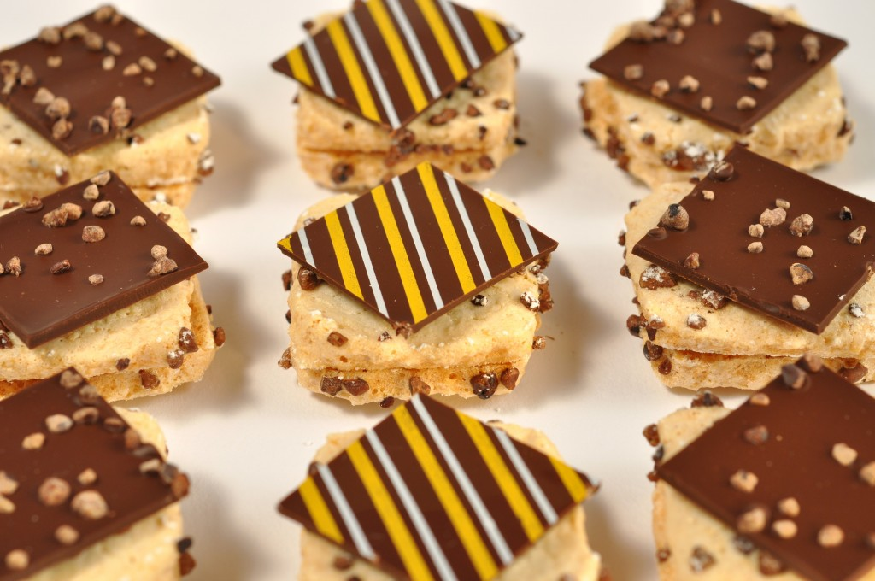
Module Title: Preparing and Displaying Petites Fours
Module code: CST BPP M03 0923
Nominal duration: 78 Hours

September, 2023
Prepared by Ministry of Labor & Skill Addis Ababa, Ethiopia

Table of Contents
Acknowledgment 3
Introduction to the module 4
Unit one: Preparing iced& fresh petit fours 6
1.1. Preparing sponges and bases 7
1.1.1. Cut and assemble bases for petit four glace 10
1.2. Preparing fillings 13
1.3. Applying fondant icing 14
1.4. Decorating iced petit fours 15
1.5. Piping small choux paste shapes 16
1.6. Preparing sweet paste in small moulds 17
SELF-CHECK 1 19
Operation sheet 1 20
Lap test 1 32
Unit Two. Prepare marzipan & caramelized petit fours 33
2.1.3. Display marzipan petit fours 43
2.2. Coating marzipan fruits with pale amber-colored caramel 43
2.2.1. Coating for fruits 43
2.2.2. Coat caramelised petit fours 44
2.3. prepare caramelized petit fours 45
SELF-CHECK 2 47
Operation sheet 2 48
UNIT THREE: DISPLAY AND STORE PETIT FOURS 54
3.1. Petit fours receptacles 55
3.2.1. Store at correct temperature and conditions 56
3.2.2. Maintain maximum eating quality, appearance and freshness 57
Self Check3. 59
RECOMMENDED READINGS 60
Developer’s profile 61

Acknowledgment
The Ministry of Labor and Skills (MoLS) would like to express its gratitude and appreciation to the instructors and experts from regional TVT bureaus, TVT colleges, and industry practitioners who contributed their expertise and experience in preparing the training module for the unit of competency “Prepare and Display Petites Fours” under the occupational standard "Bakery and pastry production level-III."
The ministry also expresses its deepest gratitude to the Tourism Training Institute for its invaluable technical and financial support and collaboration in the module preparation. It is also thankful to MoLS staff members who coordinated the preparation and reviewing process of this training module.

Introduction to the module
Petit fours refers to confections such as miniature (small) cookies, tartlets, and cakes that may accompany use at an afternoon coffee or tea or that are served after a meal. Petit fours are light, delicate, crisp, and refreshing. The common defining characteristic of petit fours is that they can be eaten in one or two bites. Petit fours, which means small ovens in French, refers to the tradition of baking small pastries in a slow oven after large pastries have been removed and oven temperature is reduced.
A petit four (plural: petits fours, also known as mignardises) is a small bite-sized confectionery or savory appetizer. The name is French, petit four (French pronunciation: ​[pə.ti fuʁ]), meaning "small oven".
A petit fours is a very small fancy cake, biscuit, or sweet, typically made with marzipan and served after a meal.
This module is designed to meet the industry requirement under the bakery and pastry production occupational standard, specifically
This module covers the units:
- Preparing iced& fresh petit fours
- Preparing marzipan& caramelized petit
- Displaying& storing petit fours
Training Objective of the Module
- Prepare iced petit fours
- Prepare fresh petit fours
- prepare& apply fillings
- Prepare marzipan& caramelized petit
- Display& store petit fours
Module Instruction
For effective use this modules trainees are expected to follow the following module instruction:
- Read the information written in each unit
- Accomplish the Self-checks at the end of each unit
- Perform Operation Sheets which were provided at the end of units
- Do the “LAP test” given at the end of the unit and
- Read the identified reference book for Examples and exercise

Unit one: Preparing iced & fresh petit fours
This unit is developed to provide you the necessary information regarding the following content coverage and topics:
- Preparing sponges and bases
- Preparing fillings.
- Applying fondant icing
- Decorating Iced petit fours
- Piping small choux paste shapes
- Preparing sweet paste in small moulds

This unit will also assist you to attain the learning outcomes stated in the cover page.
Specifically, upon completion of this learning guide, you will be able to:
- Prepare, cut and assemble sponges and bases according to standard recipes and enterprise requirements and practice.
- Prepare fillings with the required flavours and consistency.
- Bring fondant icing to the correct temperature and consistency to achieve required coating thickness and surface gloss.
- Design and use decorations that enhance customer eye appeal
- Pipe small choux paste shapes
- Prepare sweet paste in small moulds according to standard recipes

Preparing sponges and bases
Definition. The term “petit fours” refers to confections such as miniature cookies, tartlets, and cakes that may accompany an afternoon coffee or tea or that are served after a meal. Petit fours are light, delicate, crisp, and refreshing. The common defining characteristic of petit fours is that they can be eaten in one or two bites. Petit fours, which means small ovens in French, refers to the tradition of baking small pastries in a slow oven after large pastries have been removed and oven temperature is reduced
A petit four (plural: petits fours, also known as mignardises) is a small bite-sized confectionery or savory appetizer. The name is French, petit four (French pronunciation: ​[pə.ti fuʁ]), meaning "small oven". A very small fancy cake, biscuit, or sweet, typically made with marzipan and served after a meal.
- Types Petites fours come in three varieties:
- Glacé ("glazed"), iced or decorated tiny cakes covered in fondant or icing, such as small éclairs, and tartlets
- Salé ("salted"), savory bite-sized appetizers usually served at cocktail parties or buffets
- Sec ("dry"), dainty biscuits, baked meringues, macarons, and puff pastries
In a French patisserie, assorted small desserts are usually called mignardises, while hard, buttery biscuits are called petits fours.
There are several types of petits fours: petits fours salé (“salted,” or savory appetizers), petits fours sec (“dry” as in cookies and macarons), petits fours frais (“fresh,” referring to highly perishable items like éclairs and madeleines which must be eaten that day when kept at room temperature), and petits fours glacé (“glazed,” which are decorated miniature cakes covered in fondant, chocolate or white chocolate and decorated with royal icing).
Petit Fours glacé are generally either glazed with fondant or dipped in chocolate before the final decoration is added.
The term glacé is also used to indicate any iced pastry. Such as a small tartlet or those made from pate a choux or meringue.
They must be small enough to be consumed in one to two bites. Small almond cakes may also be wrapped in marzipan or modelling chocolate and served as petit fours.
Petit four bases can be made from any edible product. Such as Sponge, cakes, short bread, pastry, chocolate, marzipan & choux paste.
The main requirement of a petit four base is that it is strong enough to 'hold' the petit four when it is picked up by the customer to be eaten. i.e:
- Sponge
Normally sponge is baked in thin sheets and they are layered' together with flavoured filling that will act as an adhesive to hold the sheets of sponge together. The sponge sheets can be plain or flavoured. The sheets can be just a carrier for the filling, especially chocolate.
When the sponge sheets are layer with the filling they are stored for a period of time for the sheets and filling to bond and then the sheet is cut into small pieces:
- Cut into a variety of shape
- Most economical is square or rectangular
- Half-moon, triangular or diamond shape
- Round or oval is less efficient as there is more wastage with these shapes.
- Cake
Cake can be baked in shallow trays of depths of 1-2cm, topped with soft topping then cut to shape desired similar to Sponge sheets.
- Shortbread
A mixture of flour, fat and sugar, enriched with egg and has a 'short' eating quality. A firmer variety of shortbread with a formula of 2:1:1. These ratio may write as 2 parts flour, 1 part sugar and 1part butter or fat.
This formula produces a firmer shortbread that will resist the migration of moisture from the filling to the base. It will then hold together better when the customer picks the petit fours up in their fingers.
- Pastry
A savoury pastry like puff pastry can make a suitable base for petit fours when a sweet filling is used.
- Chocolate
When working with ganache, a soft mixture of chocolate and cream can be presented in a base of hard chocolate. This chocolate has been melted and 'tempered' then spread thinly onto parchment paper and allowed to set. At the point of setting it is cut into shapes with a warmed metal knife or cutter.
- Marzipan
Marzipan can be used as a base for petit fours
- Choux pastry
Choux pastry is made by boiling water and fat, adding flour and cooking panada; As the panada cools, eggs are incorporated. This batter is then piped to size and baked and the baked cases are then filled with desired flavoured creams then decorated. The pieces are small and Variety of filling is limited only by the imagination.

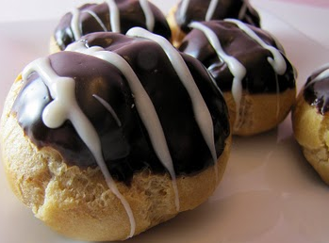
Fig.1.1. Choux paste

1.1.2. Cut and assemble bases for petit four glace

Mise en place, ’everything in place’ before you start. Some base may be cut and assemble:
- Normal
- Sponge sheets, plain vanilla flavour
- Binding agent, normally jam, apricot or
- Flavoured butter cream.
- Chocolate
- Sponge sheets, chocolate
- Raspberry jam
- Ganache.
- Classical Opera cake
- Marzipan and butter enriched sponge sheets
- Ganache
- Coffee flavoured butter cream.
Normal Assembly
- Sponge sheets that are approximately 5mm thick, 3 or 4, depending on thickness
- When assembled the combined height will be approximately 3cm high (1.25 inches)
- Apricot jam, smooth texture, no lumps
- Baking paper 2 sheets.
Method of Assembly
- Lay 1 sponge sheet on a sheet of baking paper
- This is to make it easy to move around the bench
- Make sure the paper the sponge sheet was baked on is removed
- Spread a thin layer of apricot jam over the sponge sheet
- Place a second sheet of sponge on top
- Press firmly into place
- Remove any loose sponge crumbs
- Spread a second layer of apricot jam thinly over sponge sheets
- Take a third sheet of sponge and turn over so bottom of sponge sheet is on top
- Lay sponge sheet on top and place 2nd sheet of paper on top and press sheets of sponge firmly together
- Place a metal tray on top and allow layered sponge sheets and apricot jam to bond
- If using butter cream the product needs to be cooled so the butter cream sets firm
- Product needs to stand, while being weighted down for at least 2 hours
- Butter cream products need to stand in cool environment until they are firm.
Cut bases to the desired shape
The biggest shape that these petit fours are cut into squares to minimise waste.
Any shape can be used but accuracy of cutting is essential. Minimising waste will increase yield therefore profits increase.
- Size
- Variety of shapes
- Consistency in size and shape.
Shapes to cut
Fig.1.2. cutting style

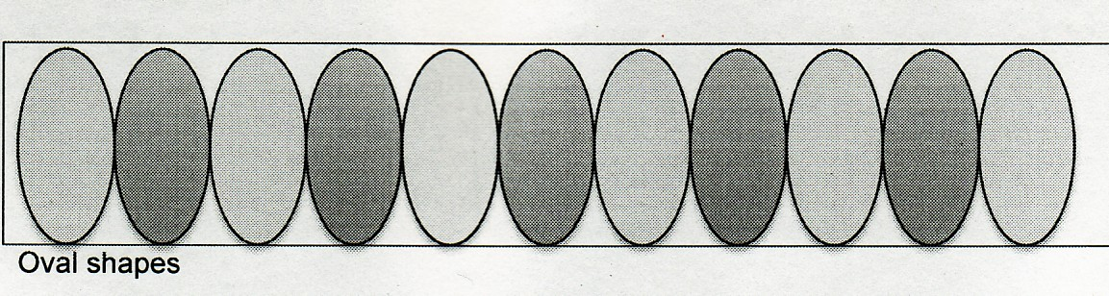 Fig.1.3. oval shape

Triangle Shapes
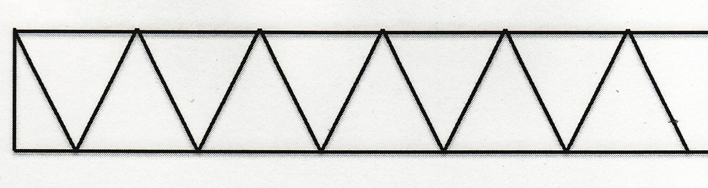Fig.1.4. triangle shape

Square cut
Fig.1.5. square shape

Preparing fillings
Fillings will vary according to selling price, storage requirements and marketplace requirements. These are:
- Jams, various flavours
- Ganache
- Butter creams.
Jams: Jams are high in moisture and carry good flavours. Their role is to bind, add flavour and moisture to a product that is normally dry in texture. These do not need refrigeration.
Jam needs to be blended until a smooth consistency is achieved, no lumps, as they will tear at the fabric of the sponge sheet.
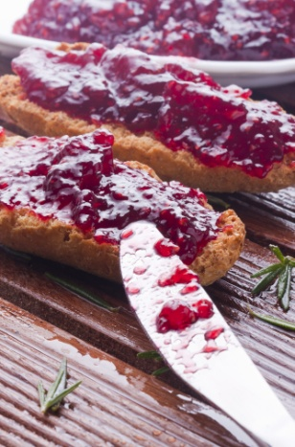
Fig.1.6. jam
Ganache
Ganache is a mixture of chocolate and cream. It is well liked but it is expensive to produce. Ganache will carry alcohol flavours well to add interest to the petit fours.
These can stand in non-refrigerated areas. Ganache needs to be allowed to cool to room temperature and then blended until smooth. When ganache is agitated it must be worked quickly as it will set.
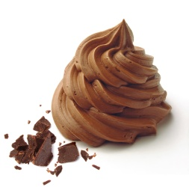
Fig1.7. Ganache
Butter creams
Butter creams can be flavoured to desired standard adds good mouth feel and cuts well when cold.
It needs to be chilled before cutting. It will then need to stand in non-refrigerated environment for short periods of time.
Butter creams are versatile for decorating the tops of petit fours as they can be flavoured and easily piped. But it damages easily when at room temperature.
When butter cream is made it needs to be kept at a temperature that will not give adverse reaction to customers. To use butter cream it needs to be pliable and smooth.

Applying fondant icing
- Fondant icing is also commonly referred to simply as fondant is an icing used to decorate or sculpt cakes and pastries. It is made from sugar, water, gelatin, vegetable fat or shortening, and glycerol. It does not have the texture of most icings; rolled fondant is akin to stiff clay, while poured fondant is a thick liquid. The word, in French, means 'melting,' coming from the same root as fondue and foundry. Types of rolled fondant
- Rolled fondant, fondant icing, which is not the same material as poured fondant, is commonly used to decorate wedding cakes. Although wedding cakes are traditionally made with marzipan and royal icing, fondant is increasingly common due to nut allergies, as it does not require almond meal. Rolled fondant includes gelatin (or agar in vegetarian recipes) and food- is rolled out like a pie crust and used to cover the cake.
Commercial shelf-stable rolled fondant often consists principally of sugar and hydrogenated oil. However, different formulations for commercial shelf-stable fondant are available and include other ingredients, grade glycerine, which keeps the sugar pliable and creates a dough-like consistency. Rolled fondant such as sugar, cellulose gum, and water.
Marshmallow fondant is a form of rolled fondant often made and used by home bakers and hobbyists. Marshmallow fondant is made by combining melted shelf-stable marshmallows, water, powdered sugar, and solid vegetable shortening. Home bakers use this recipe for homemade fondant due to the readily available access to required ingredients.
- Sculpting fondant is similar to rolled fondant but with a stiffer consistency, which makes it a good sculpting material.
- Sugar paste or gum paste is similar to rolled fondant, but hardens completely—and therefore is used for bigger cake decorations, such as bride and groom figures, bigger flowers, etc. Sugar paste is made mainly of egg whites, powdered sugar, and shortening. Tylose can be added to make gum paste more pliable for detailed work.
- Poured fondant is formed by supersaturating water with sucrose. More than twice as much sugar dissolves in water at the boiling point as at room temperature. After the sucrose dissolves, if the solution is left to cool undisturbed, the sugar remains dissolved in a supersaturated solution until nucleation occurs. While the solution is supersaturated, if a cook puts a seed crystal (undissolved sucrose) into the mix, or agitates the solution, the dissolved sucrose crystallizes to form large, crunchy crystals (which is how rock candy is made). However, if the cook lets the solution cool undisturbed and then stirs it vigorously, it forms many tiny crystals, resulting in a smooth-textured fondant.

Decorating iced petit fours
Petit fours are an elegant dessert to serve with coffee or afternoon tea or as part of a sweets tray with other treats, such as individual-sized tarts, éclairs and cream puffs.
Traditionally, petit fours are made by baking large, thin layers of génoise, a classic French sponge cake, splitting them in half to make even thinner layers, sandwiching the thin layers (usually three or four) with raspberry jam (or lemon curd) and buttercream frosting, then icing them with pourable fondant. Contemporary petit fours sometimes substitute plain, lemon or almond pound cake for the génoise. If you don't have the time (or desire) to bake yours from scratch, you can make my quicker, easier, "semi-homemade" petit fours and then focus your efforts on making them beautiful.

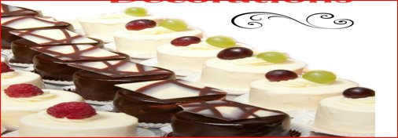
Fig 1.8. Petit fours decoration

Piping small choux paste shapes
Choux pastry is the lightest, crispiest, and most airiest pastry on the market. You can use this to make profiteroles, éclairs, or savory gougres. When it reaches the oven, it puffs up as it is set. A strong enough flour should be used for about 30 choux buns, which is 212 ounces. Preheat the oven to 350F (225C) for 10 minutes, then increase the heat to for another 15-20 minutes.
After you’ve piped choux dough onto a single tray, store the remaining dough in the pastry bag until you’re ready to bake the next batch.
If you don’t have a piping bag, you can cut off the corner of a large Ziploc bag with a sharp knife. It’s also possible to inject the solution with a large syringe without using the needle. The éclair batter can be filled with the bag or syringe, piped onto the baking sheet desired shape, and then left on the baking sheet.
If the choux pastry is thin and runny: a thin mixture indicates that you have added too much liquid, or that your eggs may be too large. When you’re combining the eggs in the mixture, beat each one until it’s thoroughly combined into the mixture before adding the next one.

When it comes to choosing a piping tip for choux pastry, the most important thing to consider is the size and shape of the tip needed for the desired effect. A small round tip will work best for classic choux pastry, while a star tip can be used to create a decorative finish. If you want to pipe shapes such as éclairs, then a plain tip is best. For choux buns, a larger, plain tip is best. If you are creating choux rings, then a large star tip is best. Whatever your choux pastry project, make sure to choose the right piping tip for the best results.

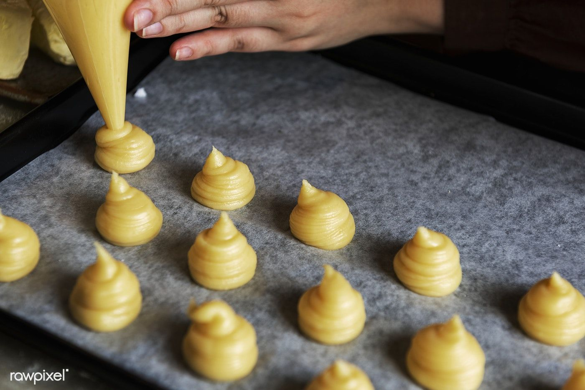
Fig.1.9. piping choux past

Preparing sweet paste in small moulds
There are different types of pastes:
- Short paste or short crust paste is crisp and brittle. It is not elastic and resilient like dough and this shortness in a cookie or many pastry products is much desired to alter the textures and mouth feel of a product. Short crust paste is usually used for making savoury products such as turnovers and pies.
The uses of short crust paste are as follows:
  - Short crust can be used for making tarts, pies, and flans.
  - Short crust can also be rolled and cut into shapes and used as savoury biscuits.
  - It can be crumbled and used as a topping on pies to give a rustic crust.
  - Certain meats are encased in short crust prior to baking.
- Sweet Paste is sweet in taste. It is short and brittle like the short crust paste; but its usage is restricted to sweet products. It is made from fat, flour, sweet& sweetener
- Choux Paste is a versatile, partially precooked paste that can be baked for use in pastries and gateaux, fried for use in potato dishes and fritters, or boiled in gnocchi dishes. Pastry products made from choux paste include éclairs, Paris Brest, gateau St Honoree, profiteroles, and many others. It is made from flour, fat& liquid.
- Marzipan is a paste composed of ground almonds and sugar mixed in varying proportions. Better quality marzipan has more almonds and less artificial flavouring. It is commercially made as it has better taste and texture if made that way.
The use of marzipan:
- It is used for making flowers, decorative figures, and moulds.
- It is used for covering wedding cakes and rich cakes, to make a smooth base for spreading ‘royal icing
- It can be used for modelling purposes and in that case one part of marzipan is mixed with one and a half part of icing sugar
- Marzipan can be used to make high quality cakes.
- Almond Paste is commonly known as ‘frangipani paste’ and composed of ground almonds or marzipan mixed with butter, flour, and eggs. This is used in fillings of many classical cakes such as gateau pithiviers. This paste unlike marzipan is always baked before eating. It can also be used for making pies and tarts. As it is enriched with marzipan, it produces pies and tarts of rich quality.
- Touille Paste is derived from the French word ‘tulips’ and this name is probably given to it, because it is used for making thin petal-like cookies for garnishes and decorations. A design is first drawn onto a cardboard (2-4 mm thick) and then cut out.

SELF-CHECK 1 | Written Test

INSTRUCTION: ANSWER QUESTIONS
Part I. say true or false
- Petit Fours glacé are generally either glazed with fondant or dipped in chocolate before the final decoration is added.
- A petit four (also known as mignardises) is a small bite-sized confectionery or savoury appetizer.
- Petit Fours are not normally served with coffee after the meal.

Part II. Choosing
- Which one is fillings of petit fours?
- Jams, various flavours C. Butter creams
- Ganache D. All
- Which one is used as a glaze in making of petit fours?
A. Jam C. Chocolate E. All
B. Cream D. Fondant

Operation sheet 1: prepare iced& fresh petit fours
Operation Title: Producing a variety of petit fours
Purpose: To prepare and display various petit fours
Conditions or situations for the operations:
- Safe working area
- Properly operated tools and equipment
- Appropriate working uniforms fit for the practical performance

Quality Criteria: Assured performing of all the activities according to the procedures

Equipment
- Half Sheet Pan (bonus points if you have a lid for it!)
- Parchment Paper or Silicone Mats
- Mixing Bowls
- Hand Mixer
- Flexible Cutting Boards
- Cake leveler or large serrated knife
- Ruler
- Skewers (optional) for dipping
- Cooling rack or wire rack

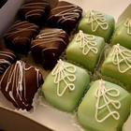
- Petit Fours Icing
Ingredients
Serves: 48
- 400g caster sugar
- 1/8 teaspoon cream of tartar
- 250ml water
- 200g icing sugar, or as needed
Method
Prep: 5min › Cook: 15min › Ready in: 20min
- In a saucepan, stir together the caster sugar, cream of tartar and water. Bring to the boil over medium-high heat, and cook without stirring until the temperature is between 106 to 112 degrees C, or until a small amount of syrup dripped from a spoon can spin a long thread.
- When the syrup comes to the proper temperature, remove from heat, and stir in icing sugar about 50g at a time until the icing is thick enough to coat a metal spoon. Test by pouring over a small piece of cake. Adjust the amount of icing sugar as needed to get a good pouring consistency. Use while warm, or reheat over simmering water. Keep covered with cling film when not in use to prevent a crust from forming on the top.

- Mincemeat cake with caramel cream icing
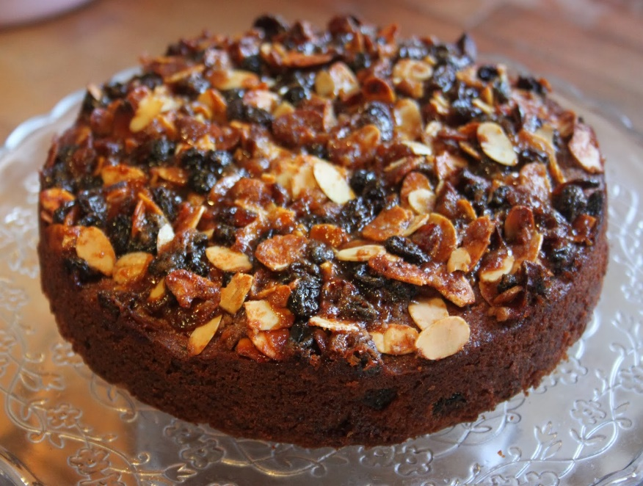
Ingredients
Serves: 12
- 125g butter
- 200g caster sugar
- 2 eggs
- 1 teaspoon bicarbonate of soda
- 250ml buttermilk
- 250g plain flour
- 250g prepared mincemeat

Method
Prep:25min › Cook:50min › Ready in:1hr15min
- Preheat oven to 150 C / Gas 2. Grease and flour two 20cm round cake tins.
- Cream butter or margarine in a large mixing bowl. Gradually add sugar, beating well. Add eggs one at a time, beating mixture well after each addition.
- Dissolve bicarbonate of soda in buttermilk, stirring well. Mix flour into creamed mixture alternately with buttermilk mixture, beginning and ending with flour. Mix well after addition. Stir in mincemeat. Spoon cake mixture evenly into prepared tins.
- Bake for 45 to 50 minutes, or until a wooden skewer inserted in centre comes out clean. Cool cake in tin for 10 minutes. Remove layers from pans, and cool completely. Fill and ice the cake with 1 recipe Caramel Cream Icing.

- Petit Fours Icing

Ingredients
Serves: 48
- 400g caster sugar
- 1/8 teaspoon cream of tartar
- 250ml water
- 200g icing sugar, or as needed

Method
Prep:5min › Cook:15min › Ready in:20min
- In a saucepan, stir together the caster sugar, cream of tartar and water. Bring to the boil over medium-high heat, and cook without stirring until the temperature is between 106 to 112 degrees C, or until a small amount of syrup dripped from a spoon can spin a long thread.
- When the syrup comes to the proper temperature, remove from heat, and stir in icing sugar about 50g at a time until the icing is thick enough to coat a metal spoon. Test by pouring over a small piece of cake. Adjust the amount of icing sugar as needed to get a good pouring consistency. Use while warm, or reheat over simmering water. Keep covered with cling film when not in use to prevent a crust from forming on the top.

- Choux pastry petits fours
Pre. Time. 3 hours 25 min
Some French petits fours are quite elaborate but the ones consisting of choux pastry with a pastry cream filling can be managed even by home bakers. Start by making the custard so it has time to chill.
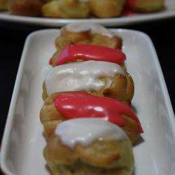

Ingredients
Makes: 35 pastries
- For the custard
- 500ml milk
- 1 vanilla bean or 1 tablespoon vanilla flavour
- 2 eggs
- 100g caster sugar
- 80g plain flour
For the choux pastry
- 250ml water
- 1 tablespoon caster sugar
- 1 pinch salt
- 50g butter
- 150g plain flour
- 4 eggs
- 1 tablespoon unsweetened cocoa
For the icing
- icing sugar
- juice of 1 lemon
- a few drops food colouring (optional)

Method
Prep:1hr › Cook:25min › Extra time:2hr setting › Ready in:3hr25min
Custard:
- In a saucepan, bring milk and vanilla to the boil. Meanwhile combine eggs, sugar and flour in a medium bowl and mix well. Gradually add hot milk, whisking constantly. Pour this mixture back into the saucepan and bring to the boil once again, then reduce heat to low; simmer, stirring constantly with wire whisk, until cream thickens.
- Divide custard into 2 bowls and add the cocoa to one bowl, stir to dissolve. Cover and let cool in refrigerator.
Choux pastry:
- Preheat oven to 210 C / Gas 7 and grease two baking trays.
- In a large saucepan bring water, sugar, salt and butter to the boil. Add flour all at once and stir with a wooden spoon. Remove from heat and add eggs one at a time, mixing well after each egg.
- Pipe small mounds of pastry (round or elongated), using a pastry bag, on prepared baking sheets.
- Bake for 25 minutes; pastries should be golden and puffy. Let cool on rack.
- Pierce tops of pastries with a knife and fill with chilled vanilla or chocolate cream using a pastry bag with a fine tip.
Icing:
- In a small bowl mix enough lemon juice with a bit of icing sugar for a smooth, thick icing. Add a few drops of food colouring for desired colour, if using.
- Brush icing on top of pastries and place on serving plate or platter. Refrigerate for 2 hours before serving.

- Choux pastry swans


Ingredients
Serves: 8
- Choux pastry
- 120ml water
- 55g unsalted butter
- 1 teaspoon caster sugar
- 1 pinch salt
- 60g plain flour
- 2 eggs
- Chocolate ganache
- 120g dark chocolate, chopped
- 120ml whipping cream
Cream
- 250ml whipping cream
- 1 tablespoon caster sugar
- 1 teaspoon vanilla extract
- 1 teaspoon icing sugar, or as needed
Method
Prep:45min › Cook:25min › Extra time:1hr chilling › Ready in:2hr10min
- Preheat oven to 220 C / Gas 6. Line 2 baking trays with silicone baking mats.
- Stir water, butter, 1 teaspoon caster sugar and salt together in a pot; bring up to simmering point. Add flour and stir with a wooden spoon until mixture pulls away from the sides of the pot and forms a thick, paste-like dough. Remove from heat and let cool for 10 to 15 minutes.
- Stir eggs into dough one at a time, mixing until egg is completely incorporated after each addition. Transfer 2/3 the dough to a large resealable food bag. Cut corner of the bag away, about 1cm wide, to form an opening through which to pipe the dough.
- Pipe 8 tapered ovals of dough onto the prepared baking tray to form the 'swan bodies', pulling up at the tapered end to form the 'tail/wingtips'.
- Bake in preheated oven until golden brown, 20 to 25 minutes.
- While the 'swan bodies' are baking, fill a smaller bag with with the remaining 1/3 the dough; cut a small tip from the corner. Pipe out S-shapes to form the swan 'necks'. At the top of each S, pipe out more dough to form the swan 'heads'.
- When the 'bodies' are halfway cooked, bake the 'necks' in the oven together with the swan 'bodies' oven until golden brown, 10 to 12 minutes.
- Turn off the oven, open the oven door slightly, and let pastries cool completely.
- Cut the top 1/3 off of each swan body horizontally, from fatter end to tapered end. Cut each top in half to form the 'wings'.
- Place chocolate in a heat-proof bowl. Bring 120ml cream to the boil in a small saucepan. Pour hot cream over chocolate and whisk until chocolate is completely melted and ganache is shiny and smooth. Spoon or pipe chocolate ganache into the base of each swan 'body'.
- Beat 250ml cream in a chilled glass or metal bowl with an electric mixer until soft peaks form. Add 1 tablespoon sugar and vanilla extract, continuing to beat until stiff peaks form. Transfer whipped cream into a piping bag with a star tip.
- Pipe cream to fill each swan 'body', piping up and out the top to resemble swan 'feathers'. Place 'wings' on each side of the 'body' sticking up out of the cream, and place 'neck' in the base of each swan. Refrigerate until chilled. Dust with icing sugar.

- Choux buns with salted caramel sauce
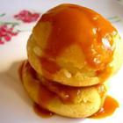
Ingredients
Serves: 6
- For the salted caramel sauce
- 150g caster sugar
- 200ml single cream
- 80g salted butter
- 1 teaspoon fleur de sel (or other fine sea salt)
- Choux pastry
- 4 tablespoons milk
- 4 tablespoons water
- 2 tablespoons caster sugar
- 60g salted butter, cut into cubes
- 70g plain flour
- 2 eggs
For the filling
- 200ml whipping cream, whipped or homemade creme patissiere
Method
Prep:40min › Cook:1hr › Extra time:30min cooling › Ready in:2hr10min
- Preheat the oven to 200 degrees C / Gas 6. Lightly grease a large baking tray.
For Salted caramel sauce:
- Place 150g sugar in a saucepan over low heat; cook, without stirring, until it starts to turn golden brown in colour.
- Heat 200ml of single cream in the microwave for 10 seconds. Add the warm cream, 80g butter and salt to the caramel, stirring constantly. Continue to cook for 2 minutes until smooth. Set aside to cool at room temperature.

Choux pastry:
- Heat milk, water, sugar and butter in a saucepan over medium heat until it starts to boil; remove from heat and beat in flour with a wooden spoon until the dough starts to come off the sides of the pan. Add one egg and mix. Add the second egg and mix until smooth.
- Use 2 tablespoons to drop 12 buns onto the baking tray. Bake for thirty minutes in preheated oven, then turn the oven off but don't open the door; allow the choux buns to continue to cook for 10 minutes or until golden brown. Remove the buns from the oven; transfer to a cooling tray and allow to cool completely.
- To fill the buns; make a small hole in the side of each bun with the tip of a nozzle; pipe whipped cream or creme patissiere into the hole.
- Individual servings: Place one choux bun flat side up on a dessert plate; spoon 1 teaspoon of caramel sauce on top and sandwich with another choux bun. Drizzle caramel sauce on top and decorate the edge of the plate with dots of caramel before serving.

- Almond Paste
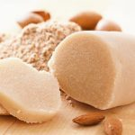
Yield: approx. 2 cups / 1 pound
Ingredient
- 250 g (~1 2/3 cup) whole, blanched almonds
- 125 g (~9 tablespoons) unrefined cane sugar
- 37 g (~2 tablespoons) honey
- 50 g (~3 1/2 tablespoons) water
- 2 teaspoons almond extract OR cherry extract – optional
ts
Instructions
- If your almonds aren't pre-blanched, blanch them (see directions below).
- Place the almonds in a food processor and grind until they are the size of very coarsely ground coffee. Let sit until the sugar mixture is ready.
- Place the sugar, honey, and water in a medium saucepan and bring to a full, rolling boil over medium-high heat. While it's still boiling, pour the syrup over the almonds, then process until smooth, which usually takes 5-10 minutes.
- At some point in the first few minutes of grinding, add the almond extract through the feed tube so that it gets thoroughly worked into the dough.

To Blanch Almonds
Bring a large saucepan of water to a boil, and then add any amount of raw almonds. Let the almonds simmer for about 60 seconds, then drain them and run them under cold tap water to stop the cooking process and completely cool them. Pour them out onto towels and pat them dry. At this point, you should notice the skins beginning to shrivel, so at that point, squeeze and rub each almond gently until the skins begin to peel off. Use the blanched almonds immediately or store the

- Biscuit Vanilla| Petit Four Sec
Yield: About 100 sandwiched petit four sec
8 | (8 oz) | Egg whites | 240 g
½ Cup | (4 oz) | Extra fine granulated sugar (1) | 120 g
2 teaspoons | (2 tsp) | Dried egg whites | 5 g
1 teaspoon | (1 tsp) | Vanilla bean paste | 5 g
1 ½ Cups | (6 oz) | Almond or hazelnut flour-meal | 180 g
¾ Cup | (6 oz) | Extra fine granulated sugar (2) | 180 g
4 Tablespoons | ( 1 oz) | Corn starch | 30 g
Methods
- In a bowl whip the egg whites to slight foam on medium speed. Meanwhile sift sugar (1) and dried egg whites to combine. Gradually add to whipping whites.
- Combine very well the almond flour, sugar (2) and corn starch.
- Add the vanilla to the stiff whipped egg whites and remove from machine.
- Re-whisk the egg whites to make creamy and gradually fold in the dry ingredients. Do not over-fold.
- Stencil or pipe the batter on Silpat(like parchment paper) and sprinkle with cocoa nibs and powdered sugar. Bake in a 320°F (160°C) oven until light golden.
- Let cool and fill with filling of choice.
- Decorate with a chocolate décor.

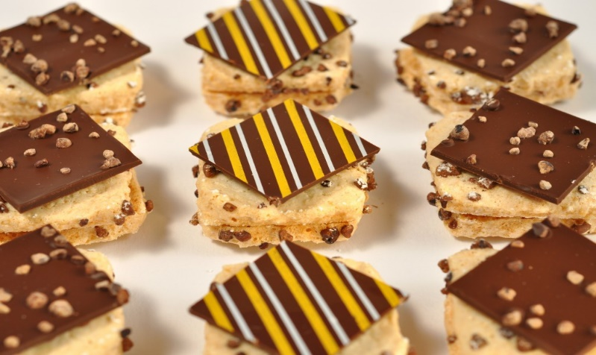
Petit Four Sec

Petit Fours with White Chocolate Glaze
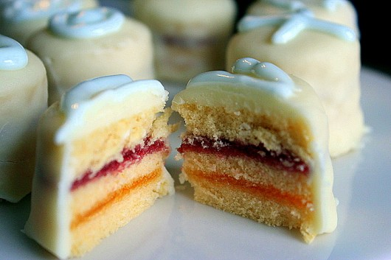

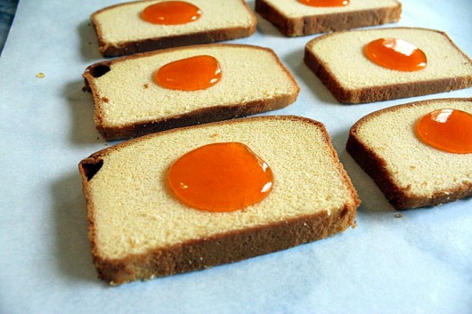

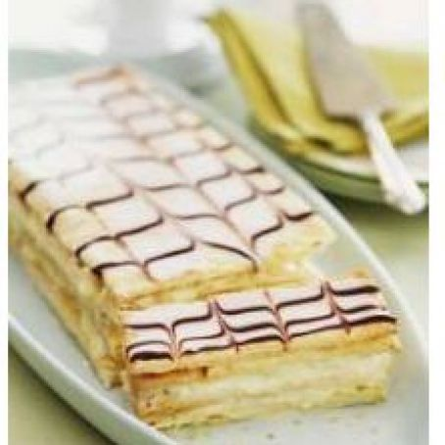
- Napoleon
Ingredients
- 1 ½ (17.5 ounce) packages frozen puff pastry sheets, thawed
- ¼ cup cornstarch
- 4 cups milk, divided
- ⅓ cup cake flour
- ⅞ cup white sugar, divided
- 3 eggs, separated
- 1 tablespoon butter
- 1 teaspoon vanilla extract
- 1 (12 ounce) jar apricot jam
- 3 cups sifted confectioners' sugar
- 1 tablespoon lemon juice
Directions
- Preheat the oven to 350 degrees F (175 degrees C).
- Roll out 3 sheets of puff pastry, each to the same size and a thickness of 1/8 inch. Prick with a fork, and place on baking sheets.
- Bake in preheated oven until golden, about 10 minutes.
- In a medium bowl, combine cornstarch and 1/2 cup milk with your fingers until smooth. Stir in cake flour and half of the sugar. Beat in egg yolks. Set aside.
- In a saucepan over medium heat, bring remaining milk and remaining sugar to a rolling boil. Stir in egg yolk mixture; continue stirring and bring to a boil again. Remove from heat and stir in butter and vanilla. Let cool.
- In a small saucepan or in the microwave, heat jam until runny.
- Place one sheet of pastry on a board. Spread with cooled pastry cream to a thickness of 1/2 inch. Place a second pastry sheet over cream. Brush with fruit glaze. Spread remaining pastry cream over glaze. Top with final pastry sheet and gently compress layers, using a baking sheet to press.
- To make icing, beat together confectioners' sugar and lemon juice with enough egg whites to make a creamy consistency like that of a cream soup. Working quickly, color a small portion of frosting with red food coloring. Frost the top and sides of the assembled pastry with white icing. Pipe parallel lines of red icing on top of the dessert, then draw a pick or knife crosswise through icing to make the traditional design. Let icing set before cutting into bars.

Lap test 1
Instructions: Given necessary templates, tools and materials you are required to perform the following tasks accordingly.
- Step 1- Make the batter Add butter, vanilla extract, and sugar to an electric mixer and blend until fluffy. ...
- Step 2- Bake the cake base Transfer the batter to a pan and bake for 25-30 minutes. ...
- Step 3- slice the cake.
- Step 4- Prepare the icing mixture.
- Step 5- ice the cake

Unit Two. Prepare marzipan & caramelized petit fours
This unit is developed to provide you the necessary information regarding the following content coverage and topics:
- Flavouring and shaping marzipan
- Coating marzipan fruits with pale amber-colored caramel
- Preparing caramelized petit fours

This unit will also assist you to attain the learning outcomes stated in the cover page.
Specifically, upon completion of this learning guide, you will be able to:
- Flavor and shape quality marzipan appropriately, producing mini-size fruits.
- Coat marzipan fruits to preserve desired eating characteristics and where required, soften with egg whites, pipe into shapes and seal or brown with applied heat, according to enterprise practice
- Select and coat fresh fruits or fruit segments with pale amber-colored caramel.
- Sandwich dried fruits or nuts or fill with flavored marzipan and coat with pale amber-colored caramel, according to specifications and enterprise standards

2.1. Flavoring and shaping marzipan
Marzipan is a sweetened mixture of ground almonds, liquid glucose/ & egg whites, corn syrup/sugar syrup and either icing sugar or caster sugar.
It is also known as almond paste. It can be moulded, rolled, sliced or dyed to decorate various shapes or decoration.
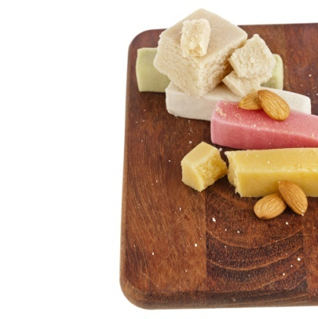
Fig.2.1. marzipan
Marzipan is very versatile paste. Petit Fours based on a marzipan are attractive and popular for their colour and appearance and their delicate pleasing taste.
Marzipan is a confection consisting primarily of sugar, honey, and almond meal (ground almonds), sometimes augmented with almond oil or extract.
It is often made into sweets; common uses are chocolate-covered marzipan and small marzipan imitations of fruits and vegetables. It can also be used in biscuits or rolled into thin sheets and glazed for icing cakes, primarily birthday cakes, wedding cakes and Christmas cakes.

Table 2. Types of marzipan

Group | Ingredients | Quantity
A | Almond meal, blanched  Icing sugar | 200g  275g
B | Brandy  Almond extract | 1tsp  1 drop
C | Sugar syrup  Glucose, warm | 100ml  +/- 40g
Method
- Sift the icing sugar and combine ingredients from group A into a bowl
- Add the ingredients from group B and gradually add the warm glucose
- Knead unit it forms like a dough
- Wrap tightly.
When the marzipan is made it needs to be stored and protected from the air. It will dry and these dry pieces will have an unpleasant mouth feel if allowed to be incorporated into the mix.
After making, marzipan can be prepared in several ways:
- Piped or Cut Out Marzipan
Bake in a hot oven until golden brown. To bake marzipan it must have a higher proportion of sugar. If the proportion of sugar is too high, the marzipan will boil instead of bake. This will adversely affect the taste and appearance of the finish creation.
- Marzipan Fancies
Using marzipan and adding different types of flavoured paste, nuts, liqueurs or preserved fruits.
To stuff dates or prunes, marzipan is flavoured (vanilla, kirsch, rum) and /or coloured.
If too firm it can be softened with stock syrup.
Even sized pieces are cut from thin sausage shaped rolls, then rolled in the palm of the hand first round, then elongated to fit the cavity of the fruit.
About ¼ to 1/5 of the marzipan should be visible. Pitted, firm and small dates or prunes are stuffed with marzipan, and then rolled in the palm of the hand to smooth.
With the back of a small knife, three to four lines are marked on the marzipan that sticks out of the date (prune).
The pieces are now rolled in caster sugar or after having dried, dipped into caramel.
For other varieties, even sized small flavoured and/or coloured pieces are shaped round, then topped with a piece of glace pineapple or half glace cherry or walnut or pecan nut halves, then rolled in sugar or caramelised.
To glace cherry haves or nut quarters are attached (lightly pressed on) to both sides of a small ball of marzipan, then rolled in sugar or coated with caramel.
For display or service, they are set in little petit four paper cups
- Modelled Marzipan
Marzipan modelled into various fruit shapes and vegetable, then coloured and sealed.
To retain the eating quality and to extend the shelf life, the marzipan is sprayed with a thin coat of cocoa butter (commercially available in a spray can).
Marzipan can absorb moisture or dry out so careful storage is essential.
- If it absorbs moisture it will become to dissolve
- If marzipan dries out it will begin to ferment.
To store marzipan, wrap it in plastic (cling) wrap and place it in an airtight container.
Hygiene
When working with marzipan, hygiene and cleanliness of equipment, utensils, work space and hands are of the utmost importance.
Marzipan is a very versatile paste. Petits fours based on marzipan are attractive and popular for their colourful and/or appetising appearance and their delicate pleasing taste.
- Shape marzipan
They can be prepared in several ways:
- Marzipan modelled into various fruit shapes, then coloured and sealed
- Marzipan fancies, using flavoured marzipan with nuts or preserved fruit
- Piped marzipan, browned in a hot oven, coated with glaze while still hot.
Fig.2.2. marzipan shape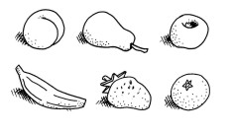
- Modelled marzipan
Quality modelling marzipan, left natural or flavoured (natural flavouring paste, spirit/liqueur concentrates), is rolled into sausage shaped lengths of equal size and thickness.
Cut into uniform small pieces (10–12 g), the marzipan is shaped into seamless round balls.
Using the palm of the hands, the basic form of the fruit to be represented is modelled next.
Marzipan modelling tools are used to further shape the pieces.
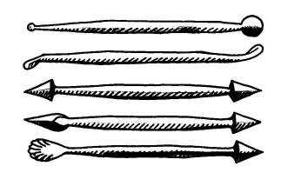
Fig.2.3 Modelling Tools:
The finished fruit is set on to greaseproof or silicon paper with very evenly spaced gaps in between, to allow easy and even access for spraying with colour.
Powdered food colouring is mixed with clear spirit concentrate and sprayed on to the marzipan fruits with an atomiser or air brush and then allowed to dry.
Banana shapes benefit from having a few fine brown lines brushed on, likewise some varieties of apples and pears.
To retain the eating quality (and to extend shelf life) the marzipan is sprayed with a thin coat of cocoa butter (commercially available in spray cans).
Using a small ball of cotton wool dipped into some dried-out starch, e.g. corn starch dried in a warm oven with the oven door left ajar, peach and apricot shapes are gently dabbed for a velvety appearance.
For display or service, the marzipan fruits are set into small petit four paper cups and arranged attractively for service or display.
For storage, they keep quite well if covered for protection from dust and odours in a cool and dry area.
When working with marzipan, hygiene and cleanliness of equipment, utensils, work space and hands are of utmost importance.
A person suffering from sweaty palms (hands) must wear tight-fitting, thin plastic gloves for good hygiene. Marzipan should be exposed to a minimum of handling.
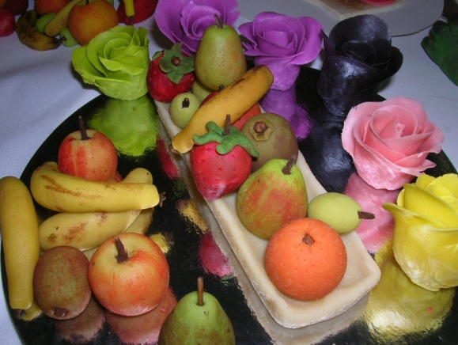
- Marzipan fancies
Marzipan is flavoured and/or coloured and used for stuffing dates or prunes or topped with or sandwiched between nuts and glace fruits.
To stuff dates or prunes, marzipan is flavoured (vanilla, kirsch, rum, etc.) and/or coloured and if rather firm, softened with a little stock syrup.
Even-sized pieces are cut from thin sausage shaped rolls, then rolled in the palm of the hands first round, then elongated to fit the cavity of the fruit. About ¹/₄ to ¹/₅ of the marzipan used should be visible. Fig.2.1. Marzipan fancies
- Pitted, firm and small dates or prunes are stuffed with the marzipan, then rolled in the palm of the hand to smooth
- With the back of a small knife, three to four lines are marked onto the marzipan that sticks out of the date (prune)
- The pieces are now rolled in caster sugar or after having dried, dipped into caramel.
For other varieties, even-sized small flavoured and/or coloured pieces are shaped round, then topped with a piece of glace pineapple or half glace cherry or walnut or pecan nut halves, then rolled in sugar or caramelised.
Similarly, two glace cherry halves or nut quarters are attached (lightly pressed on) to both sides of a small ball of marzipan, then rolled in sugar or coated with caramel.
Remember:
- Pay particular attention to cleanliness and hygiene
- Ensure uniformity in product size
- Always start with a seamless ball when modelling marzipan
- Avoid excessive handling of marzipan
- Adjust marzipan consistency to be just pipe able
- Ensure correct oven temperature when browning piped marzipan
- For display or service, they are set in little petit four paper cups.
2.1.1. Prepare marzipan for glazing
Prior to glazing marzipan to be dry. If the marzipan is still moist; the glaze will not adhere to the surface of the product. Some examples are:
- Jams will need to be applied when boiling so the surface will dry to touch when cool. If the jam is not boiling it will not be ‘dry to touch’ when it has cooled.
- Chocolate can be used but good tempering is required. This is best applied to individual pieces that require no cutting. Pure chocolate will crack when cut.
- Ganache is a mixture of cream and chocolate. A firmer mixing can be applied to flavoured marzipan and after it is dried it will then ‘cut’ well. If pure chocolate is used it may crack and look of finished product will be diminished.
- Fondant is good for glazing but the surface will need to be coated to stop the fondant from soaking into the marzipan.
- Food Lacquer and cocoa butter are available to use. Some are in spray aerosol cans and some can be applied with a brush.
- Gum Accacia (Gum Arabica) is an exudant from acacia trees in Northern Africa. It is hardened gum on the outside of the tree.
Ground to fine white powder: it is added to water and boiled. Apply to product while still hot it will cool with a pleasing sheen (gloss).
- Add 1 part powder to 4-5 parts water
- It is difficult to dissolve and it must be brought slowly to the boil and it must be whisked gently to break up any lumps
- When cool leave it in a clean container until needed
- Apply to hot product immediately upon removal from oven.
Remember:
- Application to hot product will evaporate off excess moisture and a nice sheen (gloss) will remain
- Application to cold product will make the product soggy.
- Sugar water (syrup) does not make a good glaze for marzipan products.
Toffee Candy is used to glaze flavoured marzipan when it is:
- Sandwiched between nuts
- Stuffed into dates.
The toffee candy (caramel) has a very short shelf life as it attracts moisture from the air.
2.1.2. Decorate marzipan petit fours to enhance customer eye appeal
Decorating the finished product, add customer interest and 'eye' appeal. Most marzipan petit fours would be decorated before they are glazed.
- Chocolate
Chocolate can be applied directly to the finished product. This tends to be brittle and breaks easily. Ganache that is firm can be applied and after it is set it can be cut if needed.
- Fondant icing
Fondant is sugar that is boiled to 114°C agitated or stirred as it is cooled. The clear solution turns white and when it is smooth it needs to be sorted until cool and needed.
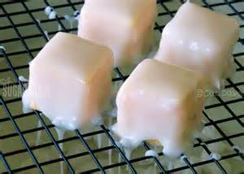
To use fondant (temper):
- Fondant when it is applied to any product it should 'shine' and be touch dry when cool. Meaning it does not stick to the fingers when touched
- To temper fondant it needs to be heated to 39ºc
over a bain-marie Fig.2.3 fondant.
- To thin fondant to the degree you need sugar water (1:1) 1 suger-1water; boiled)
- This is used so the fondant will flow and have a seamless finish with no folds.
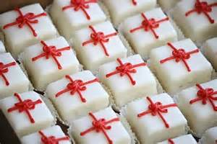
Fondant can be tempered to be very thin so minimal is used. All the time not allowing temperature to rise over 42°C. If temperature rises too much above 32°C is will lose its shine and look dull and unappealing.
- Non-parrels
Small pieces of brightly coloured sugar candy that are used to decorate cakes. Can be applied before baking or after coating with glaze. Rarely used in this level of presentation.
Fig. 2.4. Non-parrels
- Glace fruits
Glace fruits used to be a popular way of preserving fruits. Glace fruits are very stable at room temperature and do not need refrigeration. The shine exuded comes from being dipped in sugar solution many times and being allowed to dry before being dipped again.
There is a wide variety of glace fruits available. They will need to be cut to size and this is very time consuming.
Also would normally be applied to marzipan before baking, glaze then applied to seal.
Decoration may include but not limited to:
- fresh fruits
- glazes
- fondant icing
- chocolate

2.1.3. Display marzipan petit fours
Attractively displayed petits fours are great product for catching the customers’ attention.
They look most attractive when arranged neatly and with thought given to the repetition or alternation of shapes, colours and decorations.
Decorated petits fours (in particular the iced variety) lend themselves to immaculate craftsmanship and decorating skills.
To attract the respect for this work, a neat uncluttered, clean and tidy display is essential.
This greatly affects the visual impact and appreciation of the viewer and will tempt the customer to indulge.
All varieties of petits fours are best if served fresh.
Displaying on ceramics plates and platters, glass mirrors trays can look very effective in buffet style service.
Individual serves of 3-4 pieces per plate is for effective for modern coffee service.

Coating marzipan fruits with pale amber-colored caramel

Coating for fruits
To make the caramel
- Dissolve a portion of sugar in some water; 4 parts sugar to 1 part water
- Slowly heat until boiling, stirring to dissolve sugar before solution boils
- When solution reaches boiling point add 10% liquid glucose of sugar weight
- Stir gently to dissolve glucose
- Skim any scum that rises to the top
- Wash sides of pot down with pastry brush and cold water
- Allow solution to cook until temperature reaches 160ºC
- Do not stir the solution while it boils as this may cause crystallisation to occur
As solution rises above 160ºC it will begin to change colour to light amber colour
- When solution has coloured to desired caramel colour, remove from heat and arrest the cooking process
- Arrest the cooking process by placing base of pot into cold water
- Leave in cold water until solution stops boiling. Now the solution is ready to use.
- Speed and efficiency is needed here because as the solution cools the caramel becomes thicker and harder to work.

Coat caramelised petit fours
Dip the product into the hot caramel. To do this expertise follow the following steps:
- Take a dipping fork into oil and then pick up the product and let it drop into the toffee.
- Use the oil covered parts of the fork to roll the product in the hot caramel and then remove the product from the hot caramel and the caramel covered product should slide off the fork onto the prepared surface that has been smeared with oil to prevent sticking.
- Allow caramel to cool before removing to paper cup for storage.
- Some product can be dipped by holding bottom of product and dipping 2/3 of the product into hot caramel. Care needs to be taken here as the danger of burning fingers is high.
- Hold product above caramel and allow excess to flow back into pot. Sit product on oiled surface to cool.
Recommendation:
- When working with hot caramel it is advisable to have a bowl of cold water next to you.
- If the hot caramel touches the human skin it will cause very bad damage.
- Do not try to wipe the hot caramel off as it will just cause more damage.
- Place the affected area into the cold water. This will cool and set the caramel. It can then be peeled off with minimal damage to skin surface.
- The damage is already done and blisters will ensure.
- This technique is about minimising further damage to other parts of the body.
- Trying to wipe the hot toffee off with the other hand only burns the other hand
- Placing finger into mouth only burns the tongue and roof of mouth.

2.3. prepare caramelized petit fours
• Select fruits/nuts
Caramel is sugar that is cooked until it reaches a temperature of 156°C when it begins to colour. As the temperate increases so does the colour.
Caramel that has reached a temperature of 175°C is burnt, it will have the very dark, almost black colour and from this point on it loses sweetness and becomes bitter
Caramelised sugar can be used to 'glaze' petit fours before they are served.
Caramelised petit fours have a very short shelf life unless the sugar is sprayed with lacquer after it is applied. Sugar breaks down when it stands for too long at room temperature.
'Breaks down' is a term used to describe the action of moisture from the air attaching itself to the sugar and dissolving the sugar. The surface becomes sticky and the sugar just runs off the product.
Caramelised petit fours are mainly roasted nuts and dried fruits with marzipan.
Any product that is going to be coated with caramel will need to be dry in texture.
Strawberry and grapes can be dipped in caramel but only have a life span of a couple of hours.
30-40 minutes is best.
The main problem here is the moisture from the inside of the fruit weeps out and the hard caramel falls off of the product.
Caramelised nuts and marzipan work better as the product is dry and will carry the caramel better. Even here the life span is only a few hours unless a food lacquer is applied.
Dried fruits can be caramelised with success as there is low moisture content.
When fresh fruit is dipped the moisture inside ‘boils’ and structure of the fruit just under the skin breaks down and the resulting moisture weeps through the skin and releases the caramelised sugar from the surface.
Dried fruits stuffed with flavoured marzipan or other dried fruit and sugar/flavour mixtures are excellent candidates for coating with caramel.
The caramel will hold longer as the product is lower in ‘water’.
Fresh dates and dried apricots stuffed with flavoured marzipan.
Nuts like walnuts should be chosen for their whole halves, no chips of breakages to the nut piece. Two walnut halves with a ball of flavoured marzipan between.
- Prepare products
- To caramelise the product it needs to be on a tray.
- All the products need to be clean and dry for the caramel to adhere.
- Any fruit that is to be dipped in caramel needs to be dry and its skin needs to be intact.
- Orange segments needs to have all string and pith removed.
- Grapes need to be in small clusters of 2 or 1.
- Nuts should be slightly roasted; raw nuts have a diminished flavour to them.
- To dip in caramel product and equipment needs to be prepared before the making of the caramel.
- Having a prepared surface to place the caramel dipped product is also important. An oiled surface will allow the caramel to cool and then not bond to the surface.
- If hot caramel is placed onto an unprepared surface it will stick to the surface. The product will then crack when attempting to remove the product from that surface.

SELF-CHECK 2

Part I. True or False
  - Marzipan is a sweet yellow or white paste of ground almonds, sugar, and egg whites, used to coat cakes or to make confectionery.
  - The roasted nuts and dried fruits with marzipan are examples of Caramelised petit fours.
Part II. Give a short answer
  - What is the purpose of caramelised sugar?
  - At what temperature caramelised is cooked to be a sugar?

Operation sheet 2: prepare marzipan & caramelized petit fours
Operation Title:
Purpose: To prepare and produce a variety of marzipan& caramelised petit fours Conditions or situations for the operations:
- Personal protective equipment  - Small hands tools  - Measuring equipment  - Set of knives  - Rolling pins  - Heavy duty equipment  - Piping tube | - Decorative cutters  - Molders  - Pots and pans  - Hand – outs
Quality Criteria: Assured performing of all the activities according to the procedures
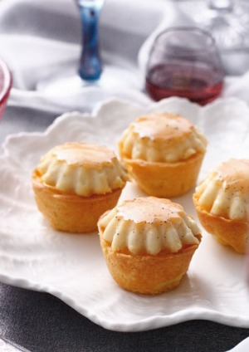
- Cream caramel petit fours
Ingredients
200 ml (7 fl oz) milk
145 ml (4¾ fl oz) cream
1 vanilla bean, split lengthways and seeds scraped
40 g (1½ oz) caster (superfine) sugar
2 large eggs
250 ml (9 fl oz/1 cup) cream, whipped to soft peaks
Pastry
125 g (4½ oz/½ cup) unsalted butter, chilled and cut into cubes
155 g (5½ oz/1¼ cups) plain (all-purpose) flour
60 g (2¼ oz/½ cup) icing (confectioners') sugar, plus extra, sifted, for dusting
1 large egg yolk
Caramel
100 g (3½ oz) caster (superfine) sugar
60 ml (2 fl oz/¼ cup) water
Method
1. To make the pastry, place the butter and flour in the bowl of a food processor and process until the consistency of fine breadcrumbs. Add the sugar and egg yolk and process until the dough just comes together, adding ½ tablespoon of iced water if necessary. Turn out onto a lightly floured work surface and gather into a ball. Wrap in plastic wrap and refrigerate for 30 minutes.
2. Preheat the oven to 180°C (350°F/Gas 4). Lightly grease two 12-hole mini muffin tins.
3. Slice the pastry in half. Roll out each piece between two sheets of baking paper until 2 mm (1/16 inch) thick, scattering with flour where necessary. Use a 6 cm (2½ inch) cutter to cut out 24 rounds. Line each prepared tin with a pastry round and trim off any excess. Prick the bases with a fork. Place in the freezer for 5 minutes. Line the bases with baking paper, pour in some baking beads or uncooked rice and bake for 5–7 minutes. Remove the paper and beads and bake for another 3–5 minutes, or until just golden. Allow to cool.
4. Reduce the oven temperature to 160°C (315°F/Gas 2–3). Grease 24 mini baba tins.
5. To make the caramel, place the sugar and 45 ml (1½ fl oz) water in a heavy-based saucepan. Bring to the boil, stirring to dissolve the sugar, reduce the heat and simmer, without stirring, for
5–7 minutes, or until golden. Brush any sugar on the side of the pan with a wet pastry brush to avoid crystallising. Do not overcook or the toffee will taste burnt. Very carefully add the remaining water to stop the caramel cooking.
(Stand back as the caramel might spit.) Quickly spoon a little of the caramel into the base of each mould before it sets.
6. Combine the milk, cream and vanilla seeds in a medium saucepan and bring to just below boiling point. Remove from the heat. Whisk the sugar and eggs in a bowl until light and creamy. Pour in the hot milk mixture. Strain through a sieve and remove any excess froth with a spoon. Pour into the prepared baba moulds. Stand the moulds in a large baking tin and pour in hot water to come halfway up the sides of the moulds. Bake for 15 minutes, or until the custard is set. Remove the crème caramels from the water bath and allow to sit for 5 minutes. Then transfer to the refrigerator to chill for 30 minutes. Pipe or spoon a generous swirl of cream into each tart case. Invert the crème caramels over the tart cases, breaking the seal with a sharp thin knife. Spoon over any extra caramel. Serve immediately.
Store in an airtight container in the freezer for up to 6 months.


- Éclair
Ingredients
Choux Pastry:
- 1 cup water
- ½ cup butter
- 1 cup all-purpose flour
- ¼ teaspoon salt
- 4 large eggs
Filling:
- 2 ½ cups cold milk
- 1 (5 ounce) package instant vanilla pudding mix
- 1 cup heavy cream
- ¼ cup confectioners' sugar
- 1 teaspoon vanilla extract
Icing:
- 2 (1 ounce) squares semisweet chocolate
- 2 tablespoons butter
- 1 cup confectioners' sugar
- 1 teaspoon vanilla extract
- 3 tablespoons hot water
Directions
- Preheat the oven to 450 degrees F (230 degrees C). Grease a cookie sheet; set aside.
- Make choux pastry: Combine water and butter in a medium pot. Bring to a boil, stirring until butter melts completely. Reduce heat to low; add flour and salt. Stir vigorously until mixture leaves the sides of the pan and begins to form a stiff ball. Remove from heat.
- Add eggs, one at a time, beating well after each addition until incorporated. Using a spoon or pastry bag fitted with a No. 10 or larger tip, spoon or pipe dough onto the prepared cookie sheet in 1 1/2x4-inch strips.
- Bake in the preheated oven for 15 minutes. Reduce heat to 325 degrees F (165 degrees C) and continue baking until the bottoms sound hollow when lightly tapped, about 20 more minutes. Cool completely on a wire rack.
- Make filling: Combine milk and pudding mix in a medium bowl according to package directions. Beat heavy cream with an electric mixer in a separate medium bowl until soft peaks form. Beat in confectioners' sugar and vanilla. Fold whipped cream into pudding.
- Cut tops off of cooled pastry shells with a sharp knife. Fill shells with pudding mixture and replace tops.
- Make icing: Melt chocolate and butter in a medium saucepan over low heat. Stir in confectioners' sugar and vanilla. Stir in hot water, 1 tablespoon at a time, until icing is smooth and has reached desired consistency. Remove from heat and cool slightly.
- Drizzle chocolate icing over filled eclairs. Store in the refrigerator until serving.
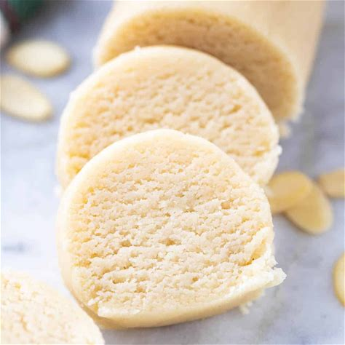
- marzipan
Ingredient
- 2 cups sliced almonds
- 1 ½ cups powdered sugar
- tsp almond extract
- 3 tsp water
- 1 tsp rose water, or 1 tsp more water
Cook Mode Prevent your screen from going dark
Instructions
- Put almonds in a food processor and mix until finely ground.
- Add powdered sugar and almond extract. Mix until combined.
- Then add water, one teaspoon at a time, until the mixture comes together and forms a crumbly dough. Add rose water if desired and mix until incorporated.
- Turn marzipan out onto a surface, sprinkled with a bit of powdered sugar, and use your hands to press crumbs into a log. Add water by the teaspoon if the mixture is too dry.
- Wrap in plastic wrap and store in a dark and cool place until needed.

Lap Test 2. Instructions: Given necessary templates, tools and materials you are required to
Perform the following tasks accordingly.

Task 1. Peel the almonds if using unpeeled almonds, place them in a heatproof bowl and
Cover with boiling water.
Task 2. Dry the peeled almonds. Spread the almonds out on paper towels or a clean tea towel
To dry for a few minutes.
Task 3. Grind the almonds
Task 4. Process with sugar
Task 5. Add flavouring or colouring (Optional)

UNIT THREE: DISPLAY AND STORE PETIT FOURS
This unit is developed to provide you the necessary information regarding the following content coverage and topics:
- Petit fours receptacles.
- Storing petit fours

This unit will also assist you to attain the learning outcomes stated in the cover page.
Specifically, upon completion of this learning guide, you will be able to:
- Select and prepare appropriate receptacles for petit fours.
- Display petit fours creatively to enhance customer appeal
- Store petit fours at correct temperature and conditions to maintain maximum eating characteristics, appearance and freshness

3.1. Petit fours receptacles
Caramelized petit fours can be displayed
- Attractively displayed petits fours are great product for catching the customers’ attention.
- They look most attractive when arranged neatly and with thought given to the repetition or alternation of shapes, colours and decorations.
- To attract the respect for this work, a neat uncluttered, clean and tidy display is essential.
- This greatly affects the visual impact and appreciation of the viewer and will tempt the customer to indulge.
- All varieties of petits fours are best if served fresh.
- Displaying on ceramics plates and platters, glass, mirrors, trays can look very effective in buffet style service.
- Individual serves of 3-4 pieces per plate is for effective for modern coffee service.
- Caramelised petit fours need to be served fresh and in paper containers. This makes it easy for the customer to handle them.
Receptacles of a petit may include:
- glass
- crystal
- ceramic
- metallic platters and trays

3.2. Storing petit fours

3.2.1. Store at correct temperature and conditions
Storing. Petit fours will keep stored in air tight container at room temperature for two days, refrigerated for keep, or frozen for 2-3 months.
Most types of petit fours are highly perishable and have a relative short life span. Storing them in a correct environmental conditions is vital to prevent deterioration of visual appeal, taste and texture of partially and fully completed petit fours.
Fresh petit fours are kept for short periods of time, which varies by product. Freezing is a good option for many of the bases and dough which can be made up ahead of time and held until ready to make assemble.
Petit fours should be stored in an airtight container or wrapped in plastic wrap to prevent them from drying out or absorbing odors from other. Petit fours may be stored in their box at room temperature for up to three days. Unfilled petits fours covered with fondant icing can be placed in a single layer in a sealed, airtight container and stored in a cool area of refrigerated for 1-2 hrs.
To store& serve petit fours, you need to:
  - Refrigerate the petit fours for 1-2 hours, then cover and store in refrigerator for 30 minutes before serving time.
  - Remove from refrigerator, place on serving tray or plate, and bring at room temperature before serving.
  - Serve individual petit fours inside small paper cups, and decorate as desired.
To store petit fours at correct temperature and conditions, it is important to know;
- All prepared petit fours will suffer from too much moisture in the environment.
- A cool dry closed environment is best for storage of all petit fours except those that contain perishable ingredients like fresh cream.
- Caramelised petit four will have a short life span as the caramel is hydroscopic and attracts moisture from the air. This moisture causes the sugar to soften and dissolve. Fig 3.1.store petit
- Product like fruit, grapes and strawberries will ooze moisture from their internal structure causing the caramel to dislodge from the surface of the fruit.
- This is caused by the fact that the moisture just under the surface of the skin boils, breaking the cellular structure of the fruit and the moisture held inside seeps through the damaged skin.
- 90% of petit fours need cool dry environment for storage.

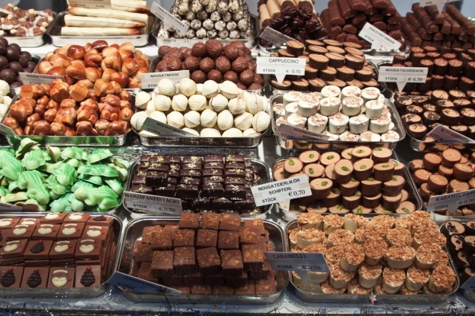
Fig3.1 Display petit fours

3.2.2. Maintain maximum eating quality, appearance and freshness
- It is a mistake to produce more than can be used in defined periods. It may be more economically viable to produce large numbers of a certain product.
- To maintain freshness petit fours need to be finished as needed.
- Part processing can be achieved like making shortbread and freezing.
- Then bake as needed. But this does take space and time in freezer.
- The best way to have fresh petit fours is to produce them regularly and as needed.
- Protect finished petit four from adverse conditions to maintain structural integrity by enclosing in food safe containers.

Self Check3.

Part 1. Say true or false
      - All prepared petit fours are not recommended to store in cool dry environment.
      - Freezing is a good option to store many of the bases and dough of petit fours.
      - Petit fours is recommended to store at refrigerator.
Part II. Give a short answer
- How to maintain the quality, appearance& freshness of petit fours?
- How do you store petit four

RECOMMENDED READINGS

References
- Garrett, Toba. Professional Cake Decorating. Hoboken, N.J.: John Wiley & Sons, 2007. p. 226.
- Kingslee, John. A Professional Text to Bakery and Confectionary. New Delhi, India: New Age International, 2006. p. 244.
- Maxfield, Jaynie. Cake Decorating for the First Time. New York: Sterling Pub, 2003. p. 58.
- Rinsky, Glenn, and Laura Halpin Rinsky. The Pastry Chef's Companion: A Comprehensive Resource Guide for the Baking and Pastry Professional. Hoboken, N.J.: John Wiley & Sons, 2009. p. 214.

Developer’s profile
No | Name | Qualification | Educational background | Region | College | Mobile number | E-mail
1 | Mohammed Liben Mohammed | Instructor | - BA degree in Hotel and Tourism management | Somali | Jigjiga Polytechnic college | 0992326557 | cherechaw@gmail.com
2 | Belachew Merga Lemi | Instructor | BA degree in Hotel Mgmt. | Addis Abeba | Kirkos manufucturing college | 0910330503 | Belachewmerga2011@gmail.com
3 | Zelalem Almaw Endalew | Instructor | - BSC degree in Food science and post-harvest technology | Amhara | Bahir dar Polytechnic College | 0918012521 | Parazolla25@gmail.com
4 | Zuryash-Work Belay Nigatu | Instructor | BA degree in Hotel Management | Addis Ababa | TTI | 0911643817 | zuriyash@gmail.com

