Bakery & Pastry Production
Level III
Based on September, 2023 Curriculum Version II
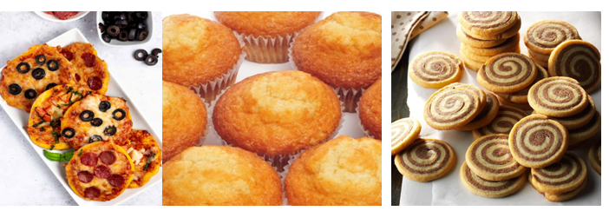
Module Title: Preparing Tea Break pastry product
Module Code: CST BPP3 M04 0923
Nominal duration: 66 hours

Prepared By: Ministry of Lobar and Skill
September, 2023
Addis Ababa, Ethiopia
Table of Content
Acknowledgment 4
Unit one: Prepare tea break pastry 6
1.1. Tea break pastry Equipments and ingredients 7
1.1.1 Preparatory Tools in Baking & Large Equipments 7
1.1.2. Measuring Tools in Baking 12
1.1.3 Mixing Tools in Baking 14
1.1.4. Cutting Tools in Baking 16
1.1.5 Cake Decorating Tools 19
1.1.6. Types of Baking Pans with Different Functions 24
1.2 Techniques of baking tea break pastries 26
1.3. Preparing tea break pastries 28
1.4. Oven temperature and cooking time 28
Self check -1 31
Operation sheet 1: 32
Unit Two: Decorate and present tea break pastry 43
2.1 Finishing tea break pastries items 45
2.2 Decorating tea break pastries 46
2.3 Presenting tea break pastries 47
Self check -2 50
Unit Three: Store tea break pastry 51
3.1.1 Storage conditions of various tea break pastries 53
3.2 Selecting packaging options 54
3.2.1 Packaging options for tea break pastry items 54
3.2.2 Stages of Food product packaging 55
3.2.3. Failures of proper packaging 55
Self check -3 56
Lap test 1: 57
Developers’ profile 58
References 59

Acknowledgment
The Ministry of Labor and Skills (MoLS) would like to express its gratitude and appreciation to the instructors and experts from regional TVET bureaus, TVET colleges and industry practitioners who contributed their expertise and experience in preparing the training module for the unit of competency “Prepare Tea Break pastry product” under the occupational standard “Bakery & Pastry Production level III."
The ministry also expresses its deepest gratitude to the Tourism Training Institute for its invaluable technical and financial support and collaboration in the module preparation. It is also thankful to MoLS staff members who coordinated the preparation and reviewing process of this training module.

Introduction to the Module
This module covers skills and knowledge required to prepare and produce a variety of high-quality tea break pastries. Tea break pastries to be produced may be of varied cultural and ethnic origins and derived from classical or contemporary recipes.
This module is designed to meet the industry requirement under the Bakery & Pastry Production occupational standard, particularly for the unit of competency: Prepare Tea Break pastry product.
This module covers the units
- Preparing tea break pastry
- Decorating and presenting tea break pastry
- Storing tea break pastry
Training Objective of the Module
At the end of this session, the students will able to:
- Identify Tea break pastry Equipments and ingredients
- Understand Oven temperature and cooking time
- present tea break pastries
- Select packaging options
- Store tea break pastry
- Decorate tea break pastries
Module Instruction
For effective use this modules trainees are expected to follow the following module instruction:
- Read the information written in each unit
- Accomplish the Self-checks at the end of each unit
- Perform Operation Sheets which were provided at the end of units
- Do the “LAP test”,

Unit One: Preparing tea break pastry
This learning guide is developed to provide you the necessary information regarding the following content coverage and topics:
- Tea break pastry Equipments and ingredients
- Techniques of Baking tea break pastries
- Preparing tea break pastries
- Oven temperature and cooking time
This guide will also assist you to attain the learning outcomes stated in the cover page. Specifically, upon completion of this learning guide, you will be able to:
- Prepare a variety of tea break pastries according to standard recipes and desired product characteristics.
- Measure, select and weigh suitable ingredients according to recipe requirements, quality, freshness and desired product characteristics.
- use appropriate equipment and utensils to produce required tea break pastries
- Prove Products according to specified temperature and other conditions.
- Make Tea break pastries using correct techniques and ensuring appropriate conditions to optimize quality.
- Select Required oven temperature and cooking time bake goods to ensure the desired characteristics, according to standard recipe specifications and enterprise practice

1.1. Tea break pastry Equipments and ingredients

1.1.1 Preparatory Tools in Baking
- Flour sifter: A flour sifter is used to sift or separate clumps from flour, cocoa powder, etc. The most commonly used sifter is a stainless steel canister type with mesh screens inside and a rotator handle at the side.
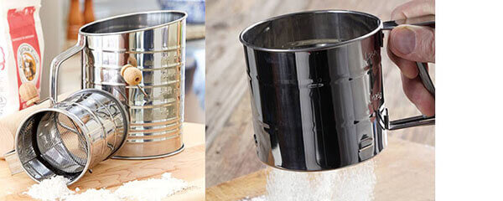
Fig 1.1 Flour sifter
- Rolling pin: A rolling pin is a cylinder used for evenly flattening every kind of dough, which is an essential utensil in baking. Rolling pins are mainly made from wood or marble. Besides, you can find some rolling pins with various special designs, such as carving embossing on the surface.
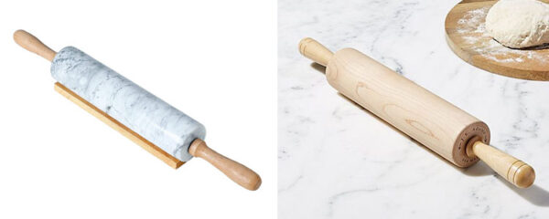
Fig 1.2 rolling pin
- Pastry brush: A pastry brush is used to spread butter, oil or egg washes on food. Pastry brushes are usually made in round or flat shape to suit different activities. At current, most of pastry brushes are made with silicone bristles, while some are still made with natural bristles.
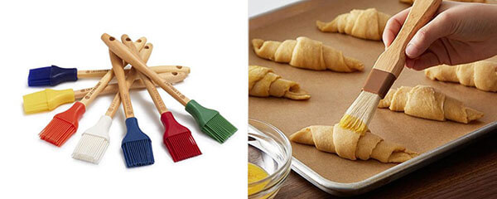
Fig 1.3 Pastry brush
- Cooling rack: A cooling rack is made of metal wire that can make the food out of the oven cool. It allows air to circulate completely around the food in case that the bottom gets soggy because of not removing the moisture.
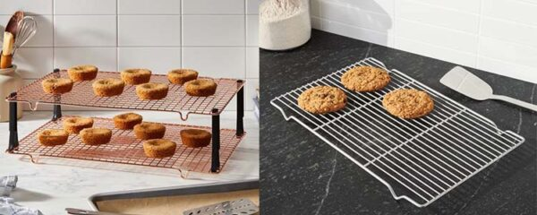
Fig 1.4 Cooling rack
- Egg separator: Most common egg separators are designed to remain the yolk in the device and let the egg whites run through. They usually come in different designs and materials. Moreover, another less common style of egg separator is easy-squeeze silicone items equipped with a mouth to suck the yolk out of the bowl.
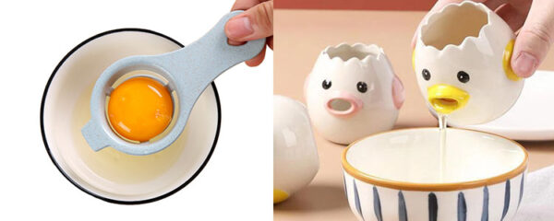
Fig 1.5 Egg separator
f. Pastry mat: A pastry mat provides a non-stick surface to knead, form, and cut the dough. These mats are designed with measurements on the surface to guide people easier to bake. Besides, they are usually made of silicone, marble, or granite
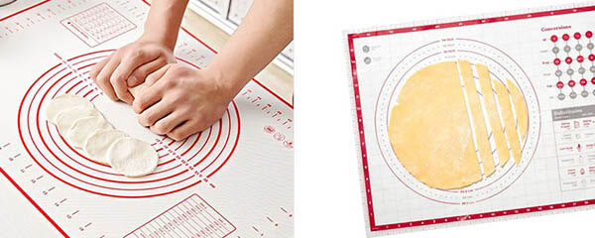
Fig 1.6 Pastry mat
- Baking paper: Baking paper is lined in the baking pans to prevent the food from touching the pan directly, which can bake the food better and also let you free from cleaning the dirty pans. The baking paper commonly used involves silicone mat, wax paper, parchment paper, plastic wrap, and aluminum foil.
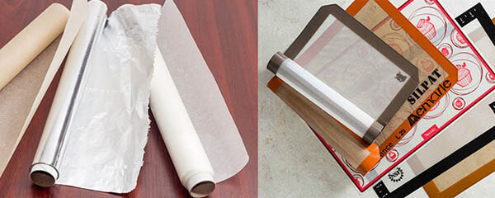
Fig 1.7 Baking paper
- Cake tester: Using a cake tester needle is helpful to test if the cake is cooked without leaving an ugly hole. Besides, some cake testers can be also used as an exhaust needle and a decoration. Usually, the tester is made of stainless steel and wood. If you insert it into the center of the cake, it should come out clean, with no streaks of batter.
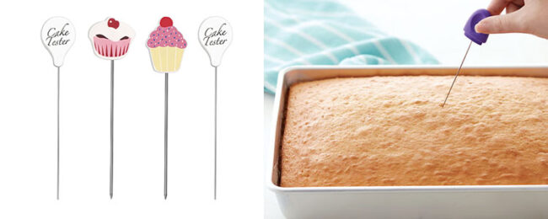
Fig 1.8 Cake tester
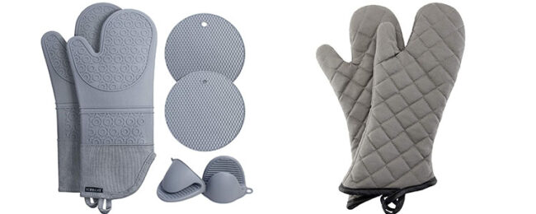
- Oven mitts: Oven mitts are used to protect the hands of people from hot objects like ovens, baking pans, etc. They can be made of leather, cloth, and silicone. Usually, oven mitts are sold singly rather than in pairs.

Fig 1.9 Oven mitts

1.1.2. Measuring Tools in Baking
A. measuring cup: A dry measuring cup is used to weigh dry ingredients like flour, spices, salt, or sugar. Usually, these cups come in plastic, stainless steel, or porcelain. Plus, they also come in 4 standard sizes such as ¼ cups, 1/3 cups, ½ cups, or 1 cup, which allows you to control the volume of different ingredients.
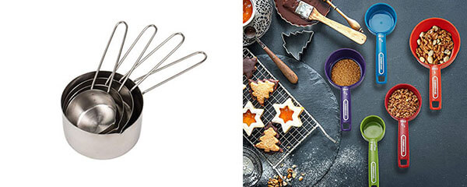

Fig 1.5 Dr measuring cup
b. Liquid measuring cup: Liquid measuring cups come in clear glass or plastic. Due to its transparent outlook, it’s easier to check the quantity of the liquid poured into the cup. Besides, there are always measurement lines on the cup wall to hold the exact amount.
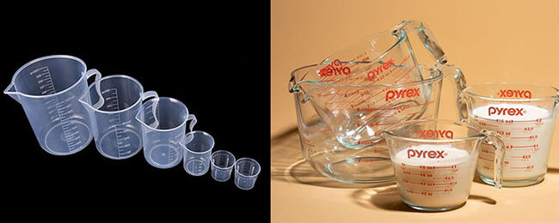
Fig 1.6 Liquid measuring cup
c. Measuring spoon: A measuring spoon is used to measure the number of small ingredients, either liquid or dry. They come in different materials, such as plastic, metal, and other materials. Also, they often come in sets, usually between 4 and 6 spoons with different sizes in a set.
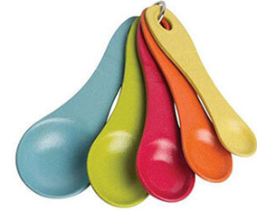
Fig 1.7 Measuring spoon
D. Baking scale: The amount of some ingredients like sugar, flour, and others need to be measured very accurately. Thus, using a baking scale helps you to ensure the results of the food. Now, there are also some spoon scales for measuring small ingredients more conveniently.
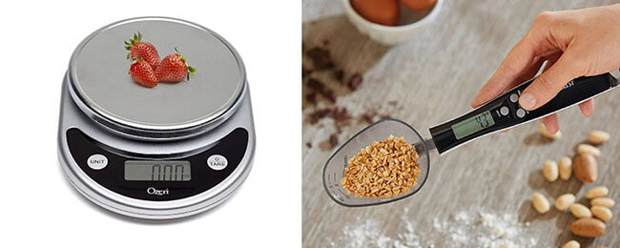
Fig 1.8 baking scale

1.1.3 Mixing Tools in Baking
a. Mixing spoon: A mixing spoon can make it easier to combine the ingredients and scrape the bottom of the mixing containers. These spoons are usually made from metal, wood, porcelain, or plastic. And there are different handle lengths of various spoons to fit different containers.

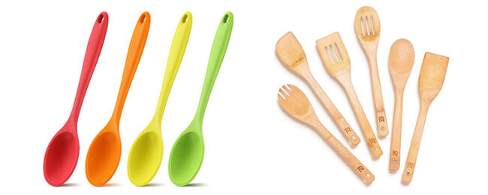
Fig 1.9 Mixing spoon
B. Mixing bowls: Mixing bowls are used for storage and kneading dough, preparing and mixing ingredients, and more. They come in different materials like glass, stainless steel, plastic, and porcelain. Plus, preparing different sizes of bowls is important for different usages.
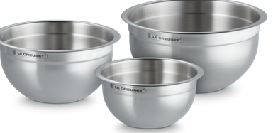

Fig 1.10 Mixing bowls

c. Whisks: A whisk can be used to blend ingredients smoothly. Most whisks consist of a long, narrow handle with a series of wire loops joined at the end. They can be divided into different types, including balloon whisk, French whisk, flat whisk, spring whisk, and ball whisk. Besides, they’re mainly made from metal, and some are made from wood, plastic, or silicone.

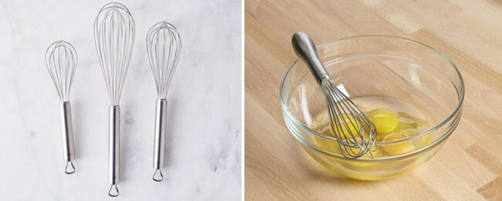
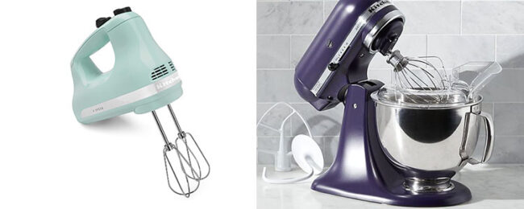 Fig 1.11 whisks
1.1.4. Cutting Tools in Baking
A. Grater: A grater is a kitchen utensils usually made from metal with sharp perforations on the surface. It is used for shredding cheese, lemon, or other food into very small pieces.

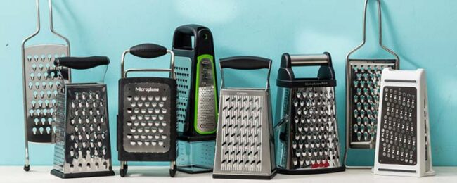
Fig 1.12 grater
b. Cookies cutters: Cookie cutters are various molds with sharp edges for cutting the dough into a particular shape. They are most commonly produced in either metal or plastic with cutting edges on one side and a handle on the other side.

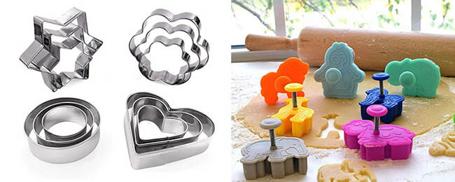
Fig 1.13 Cookies cutters
c. Dough cutter: Most dough cutters feature a sharp and thin blade wrapped with a rubber or plastic handle at one side. Some are also made of thin plastic or rubber. They are used to slice and portion out the dough.

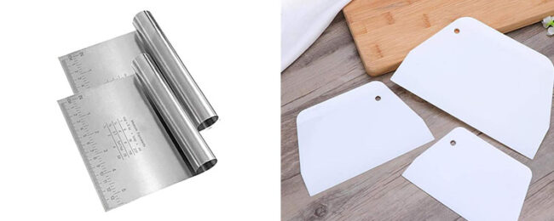
Fig 1.14 Dough cutter
D. Pastry cutting wheel: Pastry cutting wheels consist of a single sharp cutting wheel or two wheels attached to a wood or metal handle. They’re used for cutting dough and creating patterned edges.
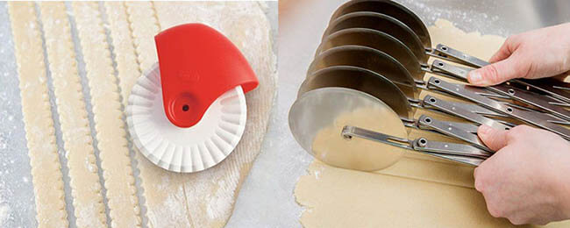
Fig 1.15 Pastry cutting wheel
E. Pastry blender: A pastry blender, also known as a dough blender, is used to work solid fats like butter, shortening, or lard into flour to create dough. A basic blender consists of a handle and a blunt blade that extends from the handle. The blade is used to get under the dough and separate it more precisely.
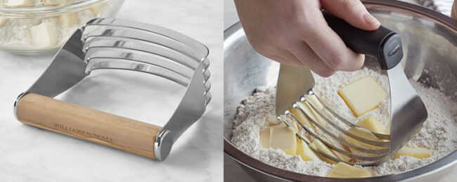

Fig 1.16 Pastry blender

1.1.5 Cake Decorating Tools
a. Cake turntable stand: A cake turntable stand is used by placing an undecorated cake onto its rotating surface, then turning it as you smooth sheets of icing, apply butter cream, pipe frosting, or stick decorations on your bake.

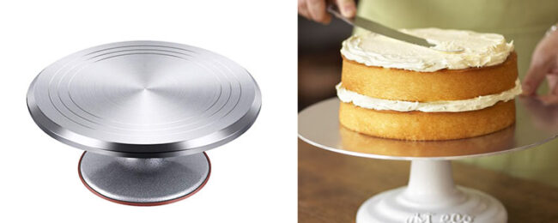

Fig 1.17 Cake turntable stand

b. Piping bag: A piping bag is usually used for decorating pastries by squeezing creams on the surface. They are basically made in the shape of a cone. Usually, they’re used with piping tips that can make different patterns.
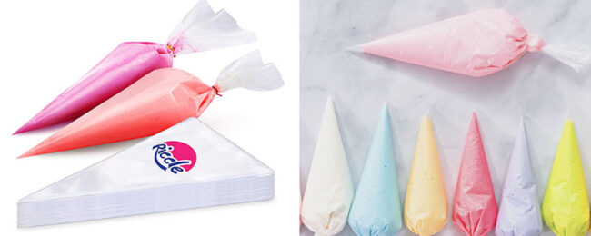
Fig 1.18 Piping bag
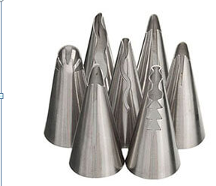
c. Decorating tips: A decorating tip decorates the pastries by being used with a piping bag. They come in various shapes of their opening and sizes. You can make different patterns or write by using different tips. Most decorating tips are made of metal; however, some are also available in plastic.

Fig 1.19 Decorating tips
d. Cake smoother: A cake smoother usually has a grip at the corner ends that makes them easy to hold. They’re typically used to smooth the top surface of a cake or the sides. Some smoothers have a flat surface with a handle; others are designed with a removable scraper and adjustable height.

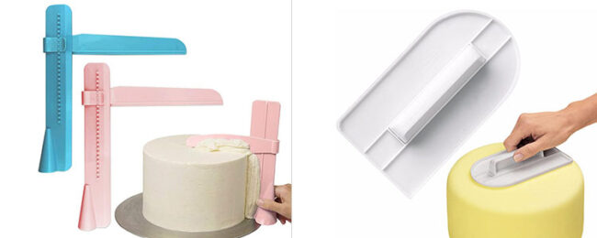
Fig 1.20 Cake smoother
d. Cake spatula; A cake spatula is a narrow spatula built with a thin, flexible stainless steel blade. They’re used for smoothing out the butter cream and icing on the side of a cake to create a flat surface.
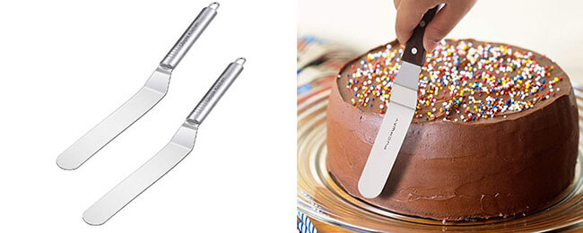
Fig 1.21 Cake spatula
e. Cake Leveler: A cake leveler helps to cut and level the cake, and also ensures the stability of the cake. There are two types of cake levelers: one is a ring cutter used with a knife, the other is equipped with one single thin blade or more blades to slice smoothly through the cakes simultaneously.
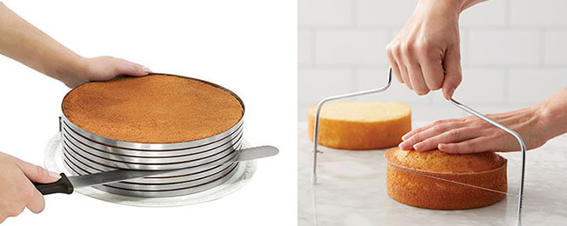
Fig 1.22 Cake Levellers

f. Cake board: A cake board is a thick piece to support cakes to present the cake better. They come in different shapes, colors and materials. The most commonly used styles are single or double wall corrugated cardboard or marble cake board.
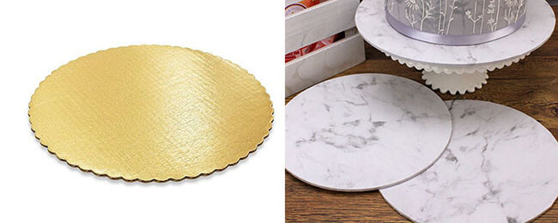
Fig 1.23 Cake board

1.1.6. Types of Baking Pans with Different Functions
a. Muffin pan: A muffin pan is formed of several identical cups usually used for baking muffins or cupcakes. They come in many different sizes. A standard muffin pan has 12 wells that are 2.5 inches wide at the top and 1.5 inches deep.
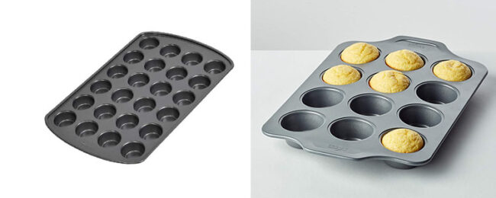
Fig 1.23 Muffin pan
b. Loaf pan: Loaf pans feature narrow rectangular shapes mainly used for baking bread. In common, a standard loaf pan is 8.5 x 4.5 x 2.5 inches. Some loaf pans are designed with a cover as well. Moreover, they’re mainly made from stainless steel, aluminized steel, and glass.
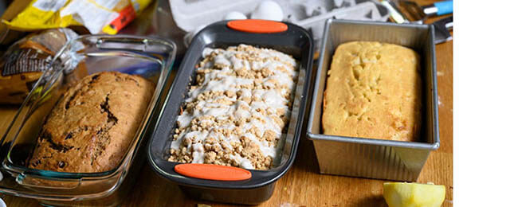 Fig 1.24 Loaf pan
c. Round pan: Round pans are the most commonly used cake baking tools, which come in different sizes and depths. Some round pans have a removable bottom, helping the food keep intact while removing from the pan.
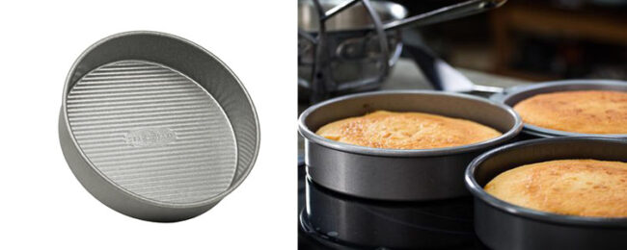
Fig 1.25 Round pans

d. Sheet pan: A sheet pan is a shallow and rectangular metal pan used in an oven. It is often used for baking flat products such as cookies, pizzas, and more.
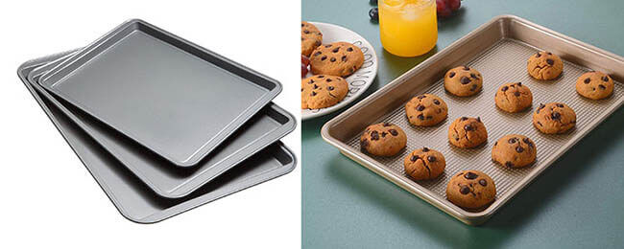
Fig 1.26 Sheet pan

e. Tube centre pan: A tube pan is any type of round baking pan that has a hollow tube in its center. The tube allows for more evenly baking. Some tube pans have fluted sides that give cakes a decorative sculpted shape.
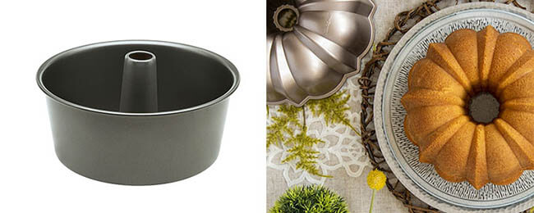

Fig 1.27 Tube centre pan

Techniques of baking tea break pastries
Every baking technique has a goal. Below are a few baking techniques that can simplify the procedure for you.
- Creaming Method: The term “creaming process” refers to a way of combining particular batters and dough. It entails creaming the butter and sugar together before incorporating the eggs. Here, butter and sugar are added and the mixture is continuously mixed until it loses its color and expands in volume, at which point it softens in texture. Simply said, these are the air cells that are created in the mixture when it is being beaten together. These air cells soften the batter and boost the beating volume.
Eggs are progressively added while sugar and butter are being whipped up to ensure proper mixing and the absence of large chunks of egg in the batter. The remaining dry ingredients are added and well combined with the batter once the eggs are added. The dry components and any liquid ingredients are added next.
- Kneading: Kneading is the process of working a dough mixture to form a smooth and cohesive mass. It can be done by hand or mechanically.
- Melting: When mixing the mixture for baking a cake, beating could be a significant issue. However, there is always a solution to a problem. This issue can be resolved by melting and combining. This process involves melting the butter before combining it with the other ingredients. This is frequently done to beat the batter more quickly and with less effort. Eggs and other dry ingredients are frequently added after butter has been melted in a pot. Make sure to thoroughly combine the mixture after adding the remaining dry ingredients; otherwise, the cakes may develop cracks. Beginners who struggle to combine substances like butter and other ingredients frequently utilize this technique. To elevate the cake and properly bake it, we add a chemical ingredient like baking soda.
- Mixing: The ingredients are all placed in a mixing bowl at once and combined. A variation of this technique is to add ingredients sequentially. This mixing process may be done by hand kneading or by machine. Once fermentation has commenced, it will continue until the heat of the oven kills the yeast during baking.
- Baking :
- Whisking Methods: For sponge cakes, meringue, Pavlov and chiffon cakes, whisking or beating is frequently used. The main ingredients in sponge cakes are sugar and butter, which must be continuously beaten while eggs are added. So that baking soda or another chemical rising agent is not used to make the cake rise.
- Rubbing-In Method: During this process, flour and butter are combined using the fingertips. The butter is cut into small pieces, added to the flour and combined with the fingertips to create sticky dough. Although this approach appears straightforward, there are a few strategies to make it quick and precise.

1.3. Preparing tea break pastries
Introduction
Tea break is a short period of time in which a worker stops to rest and have tea; coffee, etc. tea break pastries are various dessert items that are used during the tea break time. Tea break pastry includes the following items:
Muffins:
Banana cakes:
Cookies:
Fasting cakes:
Garlic bread:
Mini pizza:
Quick breads:
Fruit Cuts:
Tea cake:

1.4. Oven temperature and cooking time
An oven temperature refers to the degree at which the oven is set to heat. Whereas, cooking time is the time that something needs to be cooked. Time and temperature are very important for cooking food properly. The way we cook our food is as important as the way we prepare and store it. Inadequate cooking is a common cause of food poisoning. Fortunately, most harmful microorganisms can be destroyed by cooking food for the right time to achieve the desired internal temperature. Time and temperature are very important for cooking food properly.
Cooking time of a recipe can be affected by
- Oven temp, thickness of the food, weather
- Cooking temp. Temperature of the cooker is crucial. ...
- Type of the food to be cooked ...
- Cooking method. .
- Thickness of the cooker.
Table1: Equivalent Oven temperatures
Description | °F | °C
Cool oven | 200 °F | 90 °C
Very slow oven | 250 °F | 120 °C
Slow oven | 300–325 °F | 150–160 °C
Moderately slow | 325–350 °F | 160–180 °C
Moderate oven | 350–375 °F | 180–190 °C
Moderately hot | 375–400 °F | 190–200 °C
Hot oven | 400–450 °F | 200–230 °C
Very hot oven | 450–500 °F | 230–260 °C
Fast oven | 450–500 °F | 230–260 °C

Self check -1
- Write true or false
  - Thickness of the cooker may affect the cooking time of a given dish.
  - Fruits cut artistically can be served as a tea break pastry items.
- Match the following listed items to each other
A. B.
- Sheet pan A. time that something needs to be cooked
- Cake turntable stands b. A thick piece to support cakes to present the cake better.
- Cake Leveler c. used by placing an undecorated cake onto its rotating surface,
- Cake board d. rectangular metal pan used in an oven
- Cooking time e. ensures the stability of the cake

Operation sheet 1:
Operation title: Preparing Tea break pastries
Purpose: To produce standard cakes that is to be consumed during tea break.
Conditions for the operations:
- Safe working area
- Properly operated tools and equipment
- Appropriate working uniforms fit for the practical performance
Equipment and Tools

- Mixing Bowls.
- Cake Pans.
- Weighing Scale.
- Wire Whisker
- Spatulas.
- Silicone Baking Mat.
- Cooling Rack.
- Turntable
- Mixer -
- scale
- Oven
- Scraper

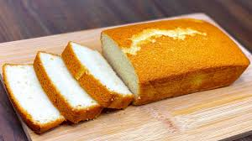
  - Tea cake
Ingredients
- 1 cup butter, softened
- 1-1/2 cups sugar
- 3 large eggs, room temperature
- 1 tablespoon vanilla extract
- 3 cups all-purpose flour
- 2 teaspoons baking powder
- 1/4 teaspoon salt
Preparation methods
- Preheat oven to 375°.
- In a large bowl, mix cream butter and sugar until light and fluffy, 5-7 minutes.
- Add eggs, 1 at a time, beating well after each addition.
- Beat in vanilla. Combine the flour, baking powder and salt; gradually add to the creamed mixture (the dough will be soft).
- Drop by tablespoonfuls 2 in. apart onto greased baking sheets.
- Bake until the edges are golden brown, 7-8 minutes. Remove to wire racks to cool.

  - Banana cakes
Ingredients
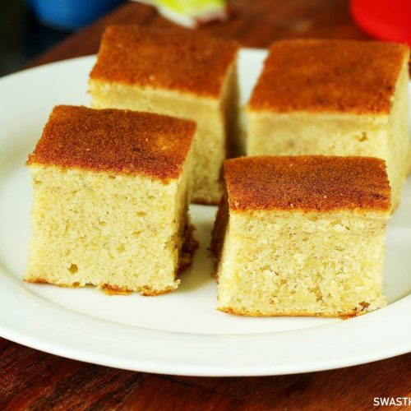
- 2 ½ cups all-purpose flour
- 1 tablespoon baking soda1 pinch salt
- 1 cup white sugar ¾ cup light brown sugar
- ½ cup unsalted butter, softened
- 2 eggs
- 4 ripe bananas, mashed
- ⅔ cup buttermilk ½ cup chopped walnuts
Preparation method:
- Preheat the oven to 350 degrees F (175 degrees C). Grease and flour two 8-inch round pans.
- Whisk together flour, baking soda, and salt in a small bowl then set aside.
- Cream white sugar, brown sugar, and butter in a large bowl until light and fluffy.
- Beat in eggs, one at a time.
- Mix in mashed bananas.
- Add flour mixture alternately with butter milk, mixing well after each addition.
- Stir in chopped walnuts. Pour batter into the prepared pans.
- Bake in the preheated oven until cake springs back when gently pressed, about 30 minutes.
- Remove cake layers from the oven and place them on a damp tea towel to cool.
  - Muffin cake
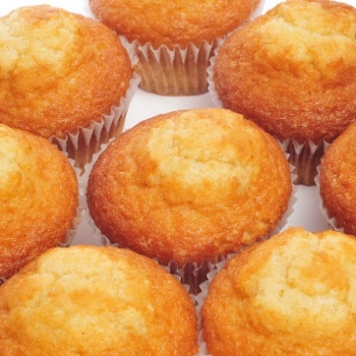
Ingredients
2 cups white flour
1 tablespoon baking powder
½ tea spoon salt
2 tablespoons sugar
1 egg, slightly beaten
1 cup milk
¼ cup melted butter

Method of preparation
- Stir the dry ingredients together and make a well in the center.
- Beat the egg, then whisk in the milk and oil.
- Pour the egg mixture into the flour mixture and stir.
- Spoon the batter into prepared muffin cups.
- Bake until the tops spring back when lightly pressed.

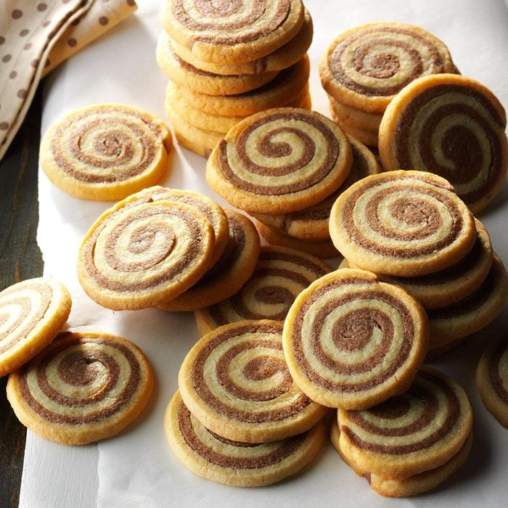
d. Chocolate pin wheel cookies
Ingredients
- 1 cup butter, softened
- 2 cups sugar3.
- 1/2 cup packed brown sugar
- 2 large eggs
- 3 teaspoons vanilla extract
- 3-3/4 cups all-purpose flour
- 2 teaspoons baking powder
- 1/8 teaspoon salt
- 1/4 cup baking cocoa
Method of preparation
- I n a large bowl, mix cream butter and sugars until light and fluffy.
- Add the eggs, one at a time, beating well after each. Beat in vanilla.
- Combine the flour, baking powder and salt; gradually add to the creamed mixture and mix well.
- Divide dough in half; add cocoa to one portion. Divide each portion in half. On a baking sheet, roll out each portion between waxed paper into a 12x10-in. rectangle.
- Refrigerate for 30 minutes.
- Remove waxed paper. Place one chocolate rectangle over a plain rectangle. Roll up tightly, jelly-roll style, starting with a long side; wrap in plastic. Repeat with remaining dough. Refrigerate for 2 hours or until firm. Unwrap and cut into 1/4-in. slices. Place 2 in. apart on lightly greased baking sheets.
- Bake at 350° for 10-12 minutes or until set. Remove to wire racks to cool.

  - Mini pizza
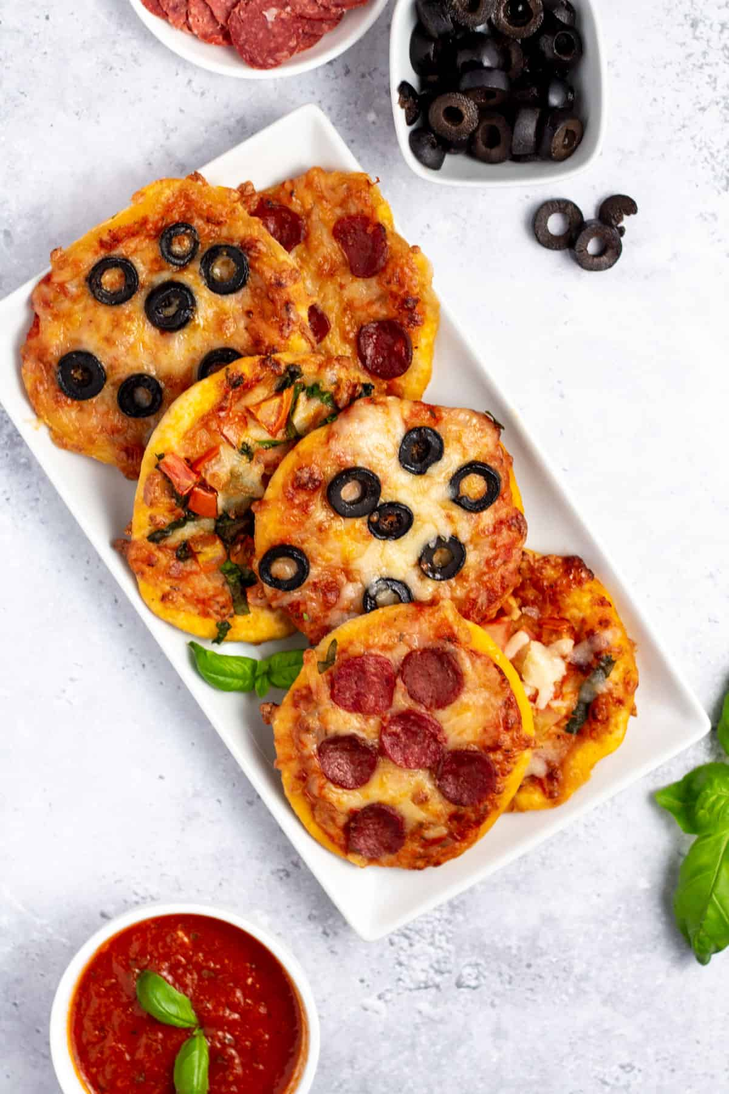
Ingredients
- ▢1 ½ cup warm water
- ▢1 tablespoon active, dry yeast
- ▢2 tablespoon sugar
- ▢¼ cup olive oil
- ▢4 ½ cup bread flour
- ▢1 tablespoon salt
- ▢½ teaspoon dried basil
- ▢½ teaspoon dried oregano
Method of preparation
- Preheat the oven to 500 °. Spray baking sheets with non stick cooking spray and sprinkle with corn meal to prevent sticking or line the pans with parchment paper for easier cleanup.
- Divide the dough into 16 portions. Flatten each portion into a thin round and place on the cooking sheet.
- Spread sauce and sprinkle toppings as desired.
- Bake for 8 to 10 minutes or until the crust is crisp and the cheese melted and lightly browned.
- Garlic bread
Ingredients
- ½ Cup/8 tablespoons unsalted butter (1 stick), melted
- 4 fat garlic cloves, grated
- ½ cup parmesan, grated
- ¼ cup firmly packed chopped flat-leaf parsley
- ¼ teaspoon kosher salt
- Black pepper
- 1baguette or rustic crusty loaf
- ½ pound fresh mozzarella, thinly sliced (optional)

Preparation procedure
Step 1
Heat the oven to 400 degrees. In a small bowl, stir together the butter, garlic, Parmesan and parsley. Add the salt and generously season with pepper. Set aside while you cut the baguette.
Step 2
Cut deep slits into the baguette, 1-inch apart — don’t cut all the way through the loaf — and place the baguette on a large piece of foil. Using a teaspoon or an offset spatula, generously spread the seasoned butter inside each slit. Make sure to reach the bottom of the slit; don’t be shy here.
Step 3
Wrap the baguette in the foil, place on a baking sheet and bake for 15 minutes. Remove the baguette from the oven and unwrap the top (leave the bread on the foil). If you’re adding mozzarella, use the offset spatula or spoon to gently open each slit and tuck a piece of mozzarella in (it’s O.K. if the cheese pops out from the top a little). Return bread to the oven and bake until crisp and golden on top, another 5 minutes. Slice with a serrated knife (or tear with your hands) and serve at once.
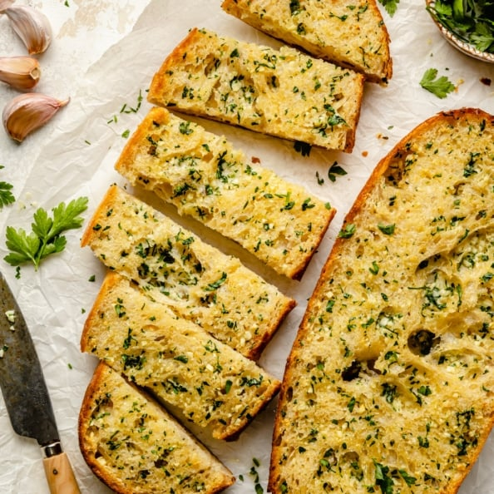

- English pound cake
3 cups white sugar
6 eggs, room temperature
½ teaspoon vanilla extract
¼ teaspoon orange extract
¼ teaspoon almond extract
1 cup sour cream

Directions
- Preheat oven to 350 degrees F (175 degrees C). Grease and flour a 10-inch tube pan.
- Sift together the flour, baking soda and salt. Set aside.
- In a large bowl, cream together the butter and sugar until light and fluffy. It should be noticeably lighter in color. Add eggs one at a time, beating well after each addition. Stir in vanilla, orange and almond extracts. Blend in the flour mixture, alternating with the sour cream, until fully incorporated. Pour batter into prepared pan.
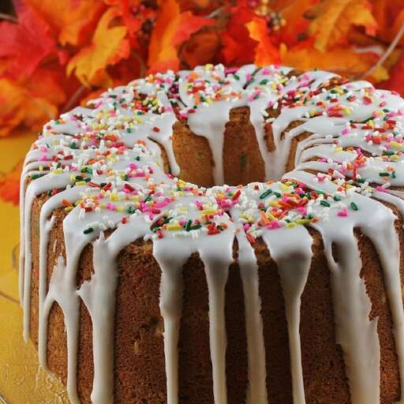
- Bake in the preheated oven until a toothpick inserted into the center of the cake comes out clean, about 70 minutes. Allow cake to cool on rack before removing from pan to cool completely.

  - Thumb print cookies
Ingredients
- 250g plain flour
- 70g icing sugar, plus about 2 tbsp for dusting
- 8g vanilla sugar, or 8g caster sugar plus 1 tsp vanilla extract
- 1 tsp lemon zest
- 150g butter, cut into cubes
- 2 egg yolks
- 100g redcurrant jelly (or raspberry jam)
Preparation
STEP 1: For the short crust pastry, sift the flour and icing sugar into a mixing bowl. Add the vanilla sugar, lemon zest and a pinch of salt. Rub the butter into the flour mixture until it is incorporated and then mix in egg yolks. Knead everything into compact smooth dough. Wrap the dough and chill it for 1 hour.
STEP 2: Remove the dough from the refrigerator and bring it to room temperature for 10 minutes. Form the dough into a long roll and divide it into 60 equal portions. Form a small ball from each portion and place it on a baking sheet covered with baking parchment (you will need two or more sheets). Press a dip (for the jam) into each ball with the handle of a wooden spoon.
STEP 3: Heat the oven to 200C/fan 180C/gas 6. Heat the jelly or jam in a saucepan until it melts. Use a teaspoon to fill the dips in the dough balls.
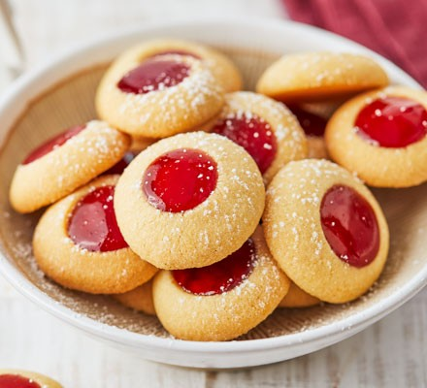
STEP 4: Bake for 12-15 minutes, and then allow cooling completely. Finally, dust the cookies with some icing sugar. The cookies can be stored in an airtight container for several weeks.

  - Fasting cakes
Ingredients
- 230 gr All Purpose Flour
- 230 gr sugar
- 125 gr cold water
- 110 gr Extra Virgin Olive Oil Tsounato ABEA
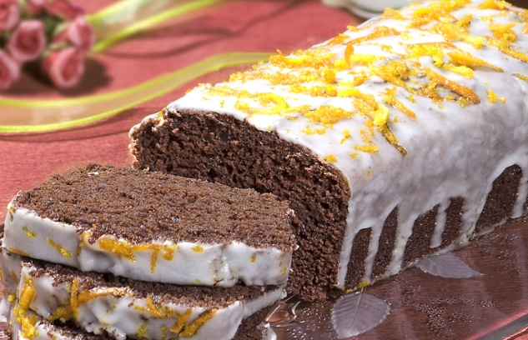
- 130 gr Orange juice
- 50 gr Cocoa
- 5 gr soda
- 5 gr Vinegar
- 2.5 gr Salt
- 1 teaspoon vanilla
- 1 teaspoon orange relish
Direction
- We mix all the solid ingredients in a large bowl and gradually we add all the liquid ingredients, while stirring continuously until the mixture is homogenized.
- We add olive oil in a cake form and we sprinkle with flour and black sugar. We put the mixture in the form
- we bake in a preheated oven for 35 minutes at 180 degrees Celsius. If we want we decorate with glaze, which we make
by beating some caster sugar with the juice of half orange.

  - Quick bread ( pumpkin bread)
Ingredients
- 1 3/4 cups all-purpose flour
- 1 1/4 teaspoons kosher salt
- 1 teaspoon baking soda
- 1 1/2 teaspoons ground cinnamon
- 1/2 teaspoon ground ginger
- 1/4 teaspoon ground cloves
- 1/4 teaspoon ground nutmeg
- 1 (15-ounce) can pumpkin puree (NOT pumpkin pie filling)
- 1/2 cup white sugar
- 3/4 cup packed light brown sugar
- 1/2 cup vegetable oil
- 2 tablespoons milk
- 2 large eggs
- 1/2 cup dark or semi-sweet chocolate chips
- 1/4 cup pumpkin seeds

Directions
- Preheat the oven to 350 degrees F (180 degrees C). Butter a 9x5-inch loaf pan.
- Whisk flour, salt, baking soda, cinnamon, ginger, cloves, and nutmeg together in a bowl.
- In another bowl, combine pumpkin, white sugar, brown sugar, vegetable oil, milk, and eggs. Whisk together until smooth.
- Add the flour mixture, and whisk in gently until the flour almost disappears. Stir in the chocolate chips and pumpkin seeds until evenly distributed.
- Use a spatula to transfer batter into the prepared loaf pan. Tap the pan on the table a few times to bring air bubbles to the surface.
- Bake in the preheated oven until a toothpick or wooden skewer inserted near the center comes out clean, 60 to 70 minutes.
- Let cool in the pan about 45 minutes; remove to a wire rack to cool completely before slicing.

Unit Two: Decorating and presenting tea break pastry
This learning guide is developed to provide you the necessary information regarding the following content coverage and topics:
- Finishing tea break pastries items
- Decorating tea break pastries
- Presenting tea break pastries
This guide will also assist you to attain the learning outcomes stated in the cover page. Specifically, upon completion of this learning guide, you will be able to:
- Decorate tea break pastries
- Present tea break pastries
- Apply suitable fillings and icings to tea break pastries
- Finish tea break pastries according to desired product characteristics.

2.1 Finishing tea break pastries items
To finish tea break pastries items, the following techniques and characteristics are to be considered
- Glazing: Apply a thin layer of glaze on top of pastries for a shiny and attractive appearance. Glazes can be made from ingredients like sugar, honey, or fruit juices.
- Icing: Decorate pastries with icing to add a touch of sweetness and visual appeal. Use powdered sugar or royal icing to create intricate designs or simple drizzles.
- Sprinkles and toppings: Add sprinkles, nuts, or chocolate shavings on top of pastries to give them texture and a burst of flavor.
- Fillings: Inject fillings into pastries using a piping bag or pastry syringe. Common fillings include fruit jams, custard, cream cheese etc.
- Dusting: Dust pastries with powdered sugar, cocoa powder, or cinnamon to add an extra layer of flavor and elegance.
- Garnishes: Use fresh fruits, edible flowers, or mint leaves as garnishes to enhance the visual appeal of pastries.
- Shape and size: Consider the desired shape and size of pastries. Cut them into squares, triangles, rounds, or use cookie cutters to create unique shapes.
- Texture: Aim for a balance of textures in pastries. For example, a flaky crust with a creamy filling or a soft cake with a crunchy crumbles topping.
- Flavor combinations: Experiment with different flavor combinations to create unique pastries. For example, pairing citrus flavors with chocolate or combining fruits with spices like cinnamon or nutmeg.
- Presentation: Finally, arrange the finished pastries on a platter or display them in an appealing way to entice your guests. Consider using colorful plates, cake stands or decorative napkins to enhance the overall presentation.

2.2 Decorating tea break pastries
Tea break pastries are decorated to enhance appearance, using suitable fillings, icings and decorations. Decorating tea break pastries is a fun and creative activity. Fillings include:

- Whole or crushed nuts
- Sliced apples
- Chocolate chips
- Bananas and spices
- Jam
- Custard
- Raisins

Decorations for Tea break pastries include :

- Glazes
- Icings
- Sprinkled icing sugar
- Flavoured and coloured sugars
- Fresh, preserved or crystallised fruits
- Seeds and nuts

2.3 Presenting tea break pastries

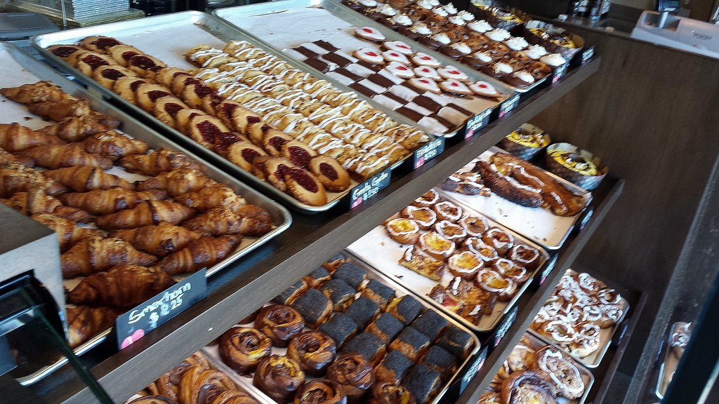
Fig: 2.1 Displayed Danish pastry

The presentation of tea break pastries is an opportunity to create an inviting and visually pleasing experience for your guests. Here are some tips on how to present tea break pastries:

- Choose a visually appealing display: Use a clean and elegant platter, cake stand, or tiered tray to showcase the pastries. Consider the overall theme or ambiance of your event and select a display that complements it.
- Arrange pastries in an organized manner: Place the pastries neatly on the display, leaving some space between each item for easy access. Group similar pastries together to create an organized and visually appealing arrangement.
- Use attractive garnishes: Add garnishes such as fresh fruits, edible flowers, or mint leaves to enhance the visual appeal of the pastries. This can also add a pop of color to the display.
- Provide variety: Offer a diverse selection of pastries to cater to different preferences. Include a mix of flavors, textures, and sizes. Consider including options like cookies, scones, muffins, croissants, tarts, or mini cakes.
- Label the pastries: Use small cards or labels to indicate the name of each pastry. This helps guests easily identify and choose the pastries they desire.
- Avoid Empty Spaces: - Don’t leave any hot spot empty! You can create a comprehensive display to attract more customers and boost the sales figures.
- Pay attention to details: - Ensure that the pastries are fresh, well-baked, and properly presented. Remove any crumbs or spills from the display to maintain a clean and inviting appearance.
- Keep Sweets and Savories Separate: - Don’t let your customers get confused about the baked products. Besides, sorting the sweet and the savory into different spots is a good idea to show the diversity of products available. You can keep the sweet baked goods such as cupcakes, cakes, cake pops, muffins, tarts, and others in plastic trays. Also, you can store cookies in giant-sized jars to shuffle things up. For savory items like loaves of bread, you can present wrap them in liners that match the colors of your bakery shop logo. For other things like quiches, puffs, pies, and more, you can choose to display them on trays lined with doily sheets.
- Consider dietary restrictions: If you have guests with specific dietary restrictions, label or separate pastries that are gluten-free, vegan, or nut-free, for example. This will help guests easily identify options that suit their needs.
- Don’t Forget Name Cards and Toppers: - One of the essential things for bakery product display is name cards. If you have foreign visitors on your doorstep who are not aware of traditional baked goods, the name cards are an excellent way to help them out. What’s more, it also makes your job easier and avoids confusion.
- Provide necessary serving utensils: - Place small tongs, forks, or spoons near the pastries to make it easy for guests to serve themselves without touching the food directly.
- Maintain the display: Regularly check the display throughout the tea break to ensure it remains clean and well-stocked. Refill any empty spaces and replace any pastries that have been consumed.

Self check -2 | Written test

I. Write True or False:
1. Decorating tea break pastries is only about making them visually appealing.
2. Presenting tea break pastries involves arranging them on a platter or cake stand in an organized manner.
3. The decoration of tea break pastries should complement the overall theme or occasion of the event.
II. Choose the true answer.
  - Tea break pastry decorations use one of the following Fillings. Which one?
- Whole or crushed nuts
- Sliced apples
- Chocolate chips
- Bananas and spices
- All
  - How tea break pastry items will be presented? By

- Labeling the pastries
- Avoiding Empty Spaces
- Paying attention to details
- Keep Sweets and Savories Separate
- All

Unit Three: Storing tea break pastries
This learning guide is developed to provide you the necessary information regarding the following content coverage and topics:
- Storing tea break pastries.
- Selecting packaging options
This guide will also assist you to attain the learning outcomes stated in the cover page. Specifically, upon completion of this learning guide, you will be able to:
- Store Tea break pastries in storage conditions required to maintain quality and extend shelf life.
- Select Packaging options appropriate for the preservation of product freshness and eating characteristics.

3.1 Storing tea break pastries
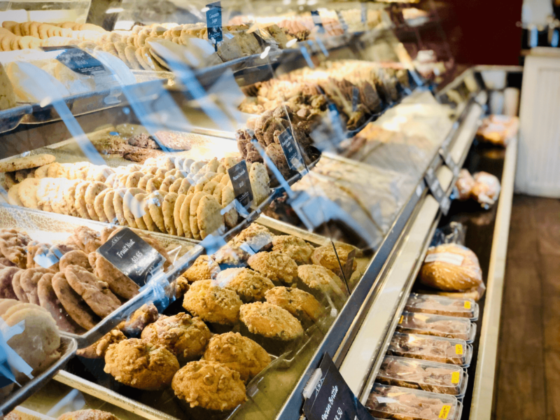
Fig 3.1 bakery products’ storage

Proper storage can help to maintain the freshness and quality of baked goods, and can also help to prevent waste. Finished products should be stored at the appropriate temperature and humidity to prevent spoilage and maintain freshness. For example, bread and other baked goods can be stored at room temperature in a dry place, while more delicate pastries may need to be stored in a cooler environment.
Bread and baked products such as muffins, quick breads, pastries, cakes and cookies are safely stored on the counter or in the pantry. Storing in the refrigerator can increase shelf-life by 2-3 weeks by reducing spoilage issues such as mold growth. All of these baked goods can be safely frozen indefinitely, but will start to suffer quality issues such as changes to flavor and texture if held frozen for longer than 2-3 months (cookies 6-12 months).

3.1.1 Storage conditions of various tea break pastries
Storage conditions of tea break pastries are prerequisites that are expected to be taken in to consideration while we think storage of pastry items. Here are some of them
- Consideration of temperature, light and air exposure
- Use of airtight containers
- Display cabinets, including temperature-controlled cabinets to cool or warm
- Refrigeration, chilling and freezing
    - Muffin: Muffins expel moisture as they age. So, the best way to store them to enhance freshness is to place them in a container with a paper towel. If you have a big batch of muffins, you can also choose to freeze them. Moreover, the expiry date of muffins is much longer than that of other baked goods.
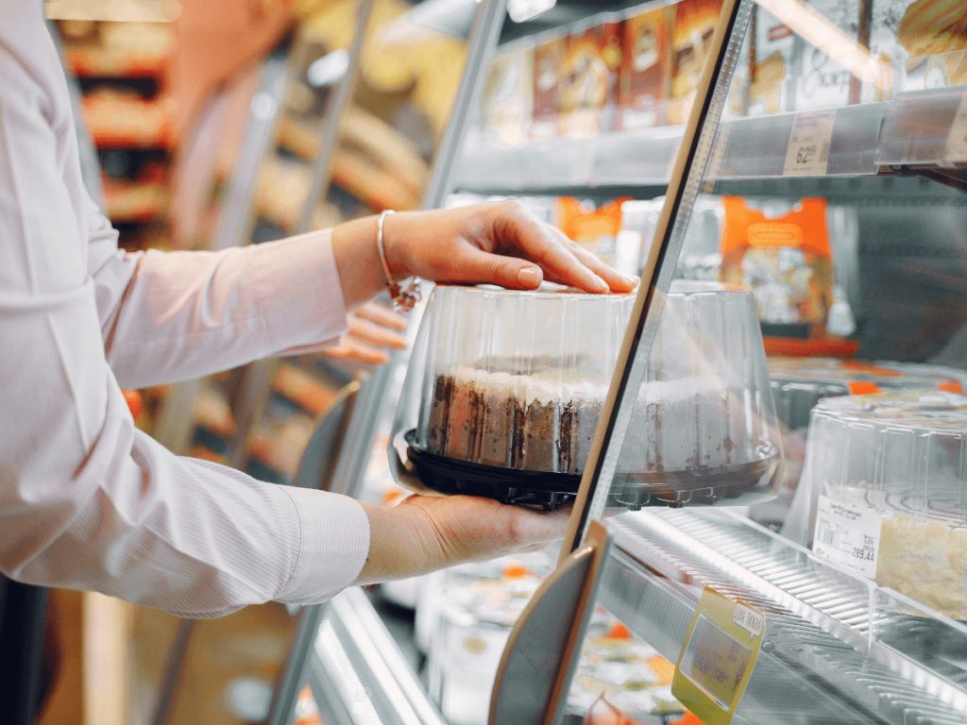

Fig 3.1 Muffin storage
  - Cake: Use aluminum foil or plastic wrap to protect your cake if you’re planning to eat it over several days. If you choose to place the wrapped cake in an airtight container for added security, make sure to leave a tiny portion open. Protect sheet cakes from dust and other dirty elements fluttering around your kitchen, but they still need air to retain their texture. To keep cakes fresh, it’s best to store them in airtight containers in a cool, dry place. If you don’t have an airtight container or cake tin, use can also use an overturned bowl (although it won’t keep the cake as fresh).
  - Cookies: cookies will stay freshest in a cool, dry place, such as the back shelf of food store. Depending on the variety, they’ll last anywhere from a few days to a few weeks. You can also freeze cookies for up to six months. To thaw frozen cookies, take them out of their freezing container and spread them out on a clean baking sheet until they come to room temperature. You can revive them in a 325ºF oven, too. Two to three minutes will crisp them up.

3.2 Selecting packaging options
Definition
Packaging is a combination of technological processes to enclose and protect finished food products to preserve and transport them. The main purpose is to maintain the integrity and sensorial properties of the food by protecting it from microbiological spoilage and staling. Failure to recognize its importance can have a negative impact on consumer acceptability.

3.2.1 Packaging options for tea break pastry items
Picture is needed
1. Individual Wrapping: Wrap each pastry item individually in wax paper or cellophane to keep them fresh and easy to handle.
2. Bakery Boxes: Use bakery boxes made of cardboard or paperboard to hold a selection of pastries. These boxes can be customized with your branding and are great for larger orders.
3. Clear Plastic Containers: These containers are ideal for displaying a variety of pastries and are convenient for grab-and-go customers.
4. Paper Bags: Use paper bags with a grease-resistant lining to hold pastries. These bags are affordable, eco-friendly, and can be customized with your logo or design.
5. Mini Baskets: Offer pastries in mini baskets lined with decorative paper or cloth napkins. This option adds a touch of elegance and is perfect for gifting or special occasions.
6. Takeout Boxes: Consider using takeout boxes made of paper or eco-friendly materials. These boxes are easy to transport and can be sealed to ensure the pastries stay fresh.
7. Display Trays: Use display trays with compartments to showcase a variety of pastries. These trays are ideal for self-service settings or for displaying pastries at events or buffets.

3.2.2 Stages of Food product packaging
- Primary packaging: direct contact with the food product, it is the initial protective barrier, (ex. plastic pouches, paperboard cartons)
- Secondary packaging: physical distribution package, may be used in the display of the product (ex. boxes)
- Tertiary packaging: made up of several secondary packages (stretch-wrapped pallet of corrugated boxes)

3.2.3. Failures of proper packaging
- Microbial spoilage: microbial growth mainly mold
- Staling: decrease of consumer acceptance
- Moisture loss or gain: water exchange between crumb, crust and the surrounding atmosphere affects bread quality
- Rancidity: development of off flavors and odors due to fat oxidation
- Fat bloom: surface discoloration of chocolate- and fat-containing cookies

Self check -3
  - Write true or false
- Failures of proper packaging leads to microbial growth.
- Proper packaging enables us to keep the Physical wellbeing of the pastry dish.
- Cookies will stay freshest in a cool and dry place.

II. Choose the right alternative.
1. Which of the following materials is commonly used for pastry packaging?
A) Plastic
b) Aluminum foil
c) Glass
d) Cardboard
2. Which packaging option is best for pastries that need to be individually wrapped?
a) Clamshell containers
b) Cellophane bags
c) Cardboard boxes
d) Aluminum pans
3. Which of the following packaging features helps to keep pastries fresh for a longer period?
a) Airtight seals
b) Transparent windows
c) Decorative patterns
d) Biodegradable materials
4. Which type of packaging is ideal for displaying pastries in a bakery or retail setting?
a) Clear plastic containers
b) Brown paper bags
c) Styrofoam trays
d) Tin cans
5. Which packaging option is most suitable for shipping pastries long distances?
a) Bubble mailers b) Plastic wrap c) Styrofoam coolers d) Cardboard tubes

Lap test 1:
Instruction: given the needed equipments, perform the following tasks accordingly.
Task 1: prepare muffin and tea cake
Task 2: prepare English cake
Task 3: prepare mini pizza

Developers’ profile
No | Name | Qualification | Educational background | Region | College | Mobile number | E-mail
1 | Mohammed Liben Mohammed | Instructor | - BA degree in Hotel and Tourism management | Somali | Jigjiga Polytechnic college | 0992326557 | cherechaw@gmail.com
2 | Belachew Merga Lemi | Instructor | Bed degree in Hotel Management | Addis Ababa | Kirkos manufacturing college | 0910330503 | Belachewmerga2011@gmail.com
3 | Zelalem Almaw Endalew | Instructor | - BSC degree in Food science and post harvest technology | Amhara | Bahir dar Polytechnic College | 0918012521 | Parazolla25@gmail.com
4 | ZuryashWork Belay Nigatu | Instructor | BA degree in Hotel Management | Addis Ababa | TTI | 0911643817 | zwb@gmail.com

References
- Andre J. Cointreau (). Professional baking: 4th edition.
- Maria Patria R. Andres, Jeannette L. Wang. (2021). Bread and pastry. Adriana printing co.Ltd
- Yogambel Ashokkumar. (2012). Bakery and Confectionery: Second Edition.

