Bakery and Pastry Production
Level-III
Based on September 2023, Curriculum Version II
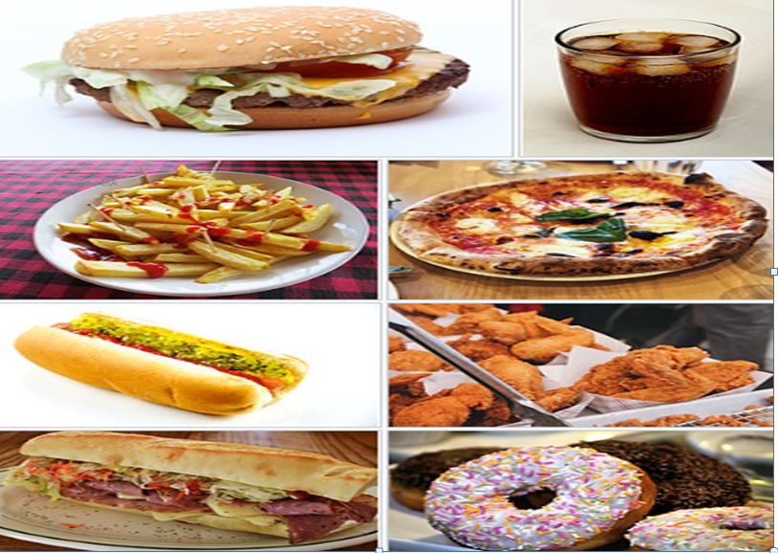
Module Title: Apply Food Production and Handling System
Module code: CST BPP3 M05 1023
Nominal duration: 60 Hours

Prepared by: Ministry of Labor and Skill
September, 2023
Addis Ababa, Ethiopia

Table of Contents
Introduction to Module 5
Unit One: Service Preparation 7
1.1 Preparing Mise en place 8
1.2 Fast Food Items 11
1.2.1 Types of Fast Food Items 11
1.3 Displaying food items 15
Self-Check 1 18
Unit Two: Preparing, Cooking and Serving Foods 19
2.1. Equipment and Ingredient Selection 19
2.1.1. Equipment Selection 19
2.3. Using Suitable Cooking Methods 37
2.3.1. Heat and Cooking 37
2.3.2. Method of Heat Transfer 40
2.4. Methods of Cooking 41
Moist Heat Methods of Cooking 41
2.5. Portion Controlling 57
2.5.1. Portion control Tools 57
2.5.2. Importance of Portion Control Matter 60
2.6. Meeting Customer requirements 60
2.6.1. Common Basic Requirements of Customers 61
2.6.2. Special Dietary Requirements of Customers 62
Self-Check 2 64
Unit Three: Packing Foods 67
3.1. Understanding preconditions of packaging 68
Introduction 68
3.2. Selecting Packaging materials for specific foods 68
3.3. Applying Packaging Procedure 74
3.4. Labeling Foods 75
3.4.1. Meaning of Food Labeling 75
3.4.2. Basic Components of Food Labeling 75
Self-check 3 78
Unit Four: Chilling and Freezing Cooked Food 75
4.1. Meeting Time and temperature standards for blast and water-bath chilling 76
4.1. Storing Chill and Freeze Foods 85
Self-Check 4 88
Unit Five: Reheating Foods 89
5.1. Thawing Foods 90
5.2. Reheating Foods 92
Self- Check 5 93

Acknowledgment
The Ministry of Labor and Skills (MoLS) would like to express its gratitude and appreciation to the instructors and experts from regional TVT bureaus, TVT colleges, and industry practitioners who contributed their expertise and experience in preparing the training module for the unit of competency “Apply food production handling system” under the occupational standard "Bakery and pastery-III."
The ministry also expresses its deepest gratitude to the Tourism Training Institute for its invaluable technical and financial support and collaboration in the module preparation. It is also thankful to MoLS staff members who coordinated the preparation and reviewing process of this training module.

Introduction to Module
In bakery and pastry production field, apply food production and handling system is very important for the good outcome of bakery and pastry production. It helps to know service preparation, preparing, cooking and serving foods, packing foods, chilling and freezing cooked food, and reheating foods.
This module is designed to meet the industry requirement under the Bakery and Pastry Production occupational standard, particularly for the unit of competency: Apply Food Production and Handling System.
This module covers the units:
- Service preparation
- Preparing, cooking and serving foods
- Packing foods
- Chilling and freezing cooked food.
- Reheating foods
Learning Objective of the Module
- Prepare for service
- prepare, cook and serve foods
- Pack foods
- Chill and freeze cooked food
- Reheat foods
Module Instruction
For effective use this modules trainees are expected to follow the following module instruction:
- Read the information written in each unit
- Accomplish the Self-checks at the end of each unit
- Perform Operation Sheets which were provided at the end of units
- Do the “LAP test” giver at the end of each unit and
- Read the identified reference book for Examples and exercise

Unit One: Service Preparation
This unit is developed to provide you the necessary information regarding the following content coverage and topics:
  - Preparing Mise en place.
  - fast food items
  - Displaying food items
This unit will also assist you to attain the learning outcomes stated in the cover page.
Specifically, upon completion of this learning guide, you will be able to:
- Carry out Mise en place to ensure sufficient and appropriate food items are prepared in order to commence service.
- Check and restock Quantities and quality of products and fast food items where necessary.
- Complete mise en place in an efficient and timely manner before
- Display service area and food items in a clean, hygienic and attractive manner

Preparing Mise en place
Introduction
Baking is a cooking method using dry heat. This method could be applied to cooking different kinds of food products, such as fruits or meat dishes. In this module, baking refers to the process of cooking breads, cakes and pastries.
Baking evolved from man’s innovation in the preparation and cooking of grains. Grains are the seeds of cereal grasses, such as wheat and rice. When the grains are pounded and ground, flour is produced. Flour is the basic ingredient of baked products. Baking bread could have begun when man learned to pound or mash grains and with the addition of water to make a paste. When this paste is spread on a hot stone near a fire, flatbread is produced. Then came the discovery of yeast, and other ingredients. New tools and equipment like ovens and mixers were also invented. These discoveries and inventions resulted in the variety of baked products we have today.
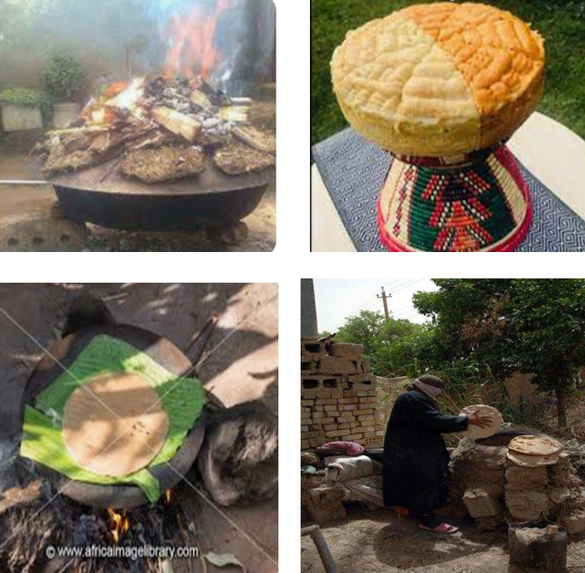
Figure 1.1: Traditional Method of Baking.

    - Concept of Mise-en-Place
One of the first lessons in culinary school is the meaning of mise-en-place. French for “put in place”, it means that ingredients are prepped, tools are gathered, and everything is organized before baking/cooking begins. It’s a grounding philosophy that keeps your head clear and your body poised to make things happen.
On a smaller scale, mise en place refers to the way in which you prepare yourself to make a recipe. The idea is that you gather everything you need and organize yourself before you make the recipe. You set up any equipment you may need, gather & measure out your ingredients, and get everything organized. And this is the kind of mise en place this lesson is going to focus on.
    - Five steps of mise-en-place preparation
Step One: Know your recipe — necessary ingredients, cookware, and baking times
Read the recipe through completely, from start to finish, before you start anything. Ideally, read it more than once! Not reading the recipe carefully before getting started can be one of the most crucial mistakes made in tackling a baking recipe. By reading the recipe through fully, you can gain a clear understanding of the workflow of the recipe and the timing involved. Many baking recipes also call for room temperature ingredients. Reading the recipe thoroughly well before you start making it will prompt you to plan ahead for these things. Gain a clear understanding for the terminology and techniques used in the recipe. After you have read the recipe through, identify any terminology and techniques used in the recipe that you may not be familiar with.
Step Two: Prepare your ingredients — clean, flour, butter… whatever is required
Here is 9 Essential Ingredients That Every Baker Needs

- Flour
- Leaveners
- Sugar
- Salt
- Dairy
- Fats: Oil and Shortening
- Extracts and Flavorings
- Spices
- Add-Ins

Step Three: Arrange your ingredients — appropriate size bowls, positioned logically
Then measure out all of your ingredients before you start combining them. By measuring out all of your ingredients before you start you will ensure that you actually do have all of the ingredients you need on hand. It will also ensure that you don’t accidentally forget to put an ingredient into your recipe or accidentally add it twice.
Step Four: Prepare your workstation — set the oven temperature, clean the utensils. Start with a clean kitchen, an empty sink, and an empty dishwasher, etc.
Step Five: Arrange your tools, similar logic applied to cookware and necessary equipment. Here is the twenty one baking tools and equipment every baker expected to have:-

1. Measuring Spoons
2. Measuring Cups
3. Kitchen Scale
4. Mixing Bowls
5. Spatula
6. Pastry Brush
7. Wire Rack
8. Whisk
9. Cake Pan
10. Cupcake Pan
11. Pie Pan

12. Cookie Pan
13. Loaf Pan
14. Knives
15. Parchment Paper
16. Rolling Pin
17. Decorating Kit
18. Electric Mixer
19. Food Processor
20. Oven
21. Baker’s Peel

Fast Food Items
1.2.1 Concepts of Fast Food
Fast food is a type of mass-produced food designed for commercial resale, with a strong priority placed on speed of service. It is a commercial term, limited to food sold in a restaurant or store with frozen, preheated or precooked ingredients and served in packaging for take-out/takeaway. Fast food was created as a commercial strategy to accommodate large numbers of busy commuters, travelers and wage workers.
The fastest form of fast food consists of pre-cooked meals which reduce waiting periods to mere seconds. Other fast food outlets, primarily hamburger outlets such as McDonald's and Burger King use mass-produced, pre-prepared ingredients (bagged buns and condiments, frozen beef patties, vegetables which are pre-washed, pre-sliced, or both; etc.) and cook the meat and french fries fresh, before assembling "to order".
Fast food is popular because the food is inexpensive, convenient, and tastes good. Fast food may include refined grains instead of whole grains, contain saturated fat, cholesterol, and added sugar, and it can be high in sodium (aka salt) which is used as a preservative and makes food more flavorful and satisfying.
Fast food restaurants are traditionally distinguished by the drive-through. Outlets may be stands or kiosks, which may provide no shelter or seating, or fast food restaurants (also known as quick service restaurants). Franchise operations that are part of restaurant chains have standardized foodstuffs shipped to each restaurant from central locations.

Types of Fast Food Items
As discussed above fast food is a type of processed food that is quickly and easily prepared by a restaurant or takeaway. These foods are meant to be eaten more quickly than a sit-down meal in a non-fast-food restaurant, so they are very convenient. Fast food is usually linked to problems like obesity and poor diets.

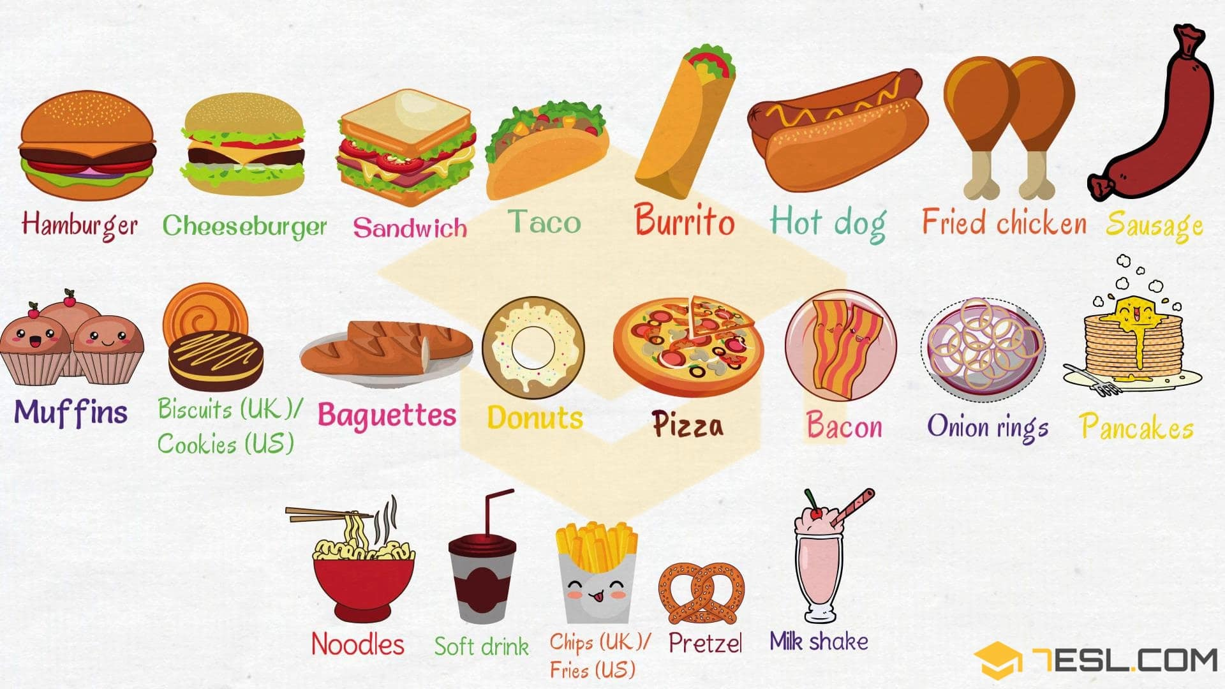
List of Types of Fast Food

- Hamburger
- Cheeseburger
- Sandwich
- Milk shake
- Muffin
- Burrito
- Biscuit (U.K)
- Taco
- Hot dog
- Fried chicken
- Donuts
- Baguette
- Soft drink
- Pizza
- Onion ring
- Sausage
- Pretzel

- Pancake Figure 1. 2: Fast Food Name List with Pictures
- Bacon
- Chip (U.S) Fry (U.K)
- Noodle

    - The main Ingredients of Fast Food
Fast food tends to be high in salt, sugar, saturated fats, trans fats, calories, and processed preservatives and ingredients. A wealth of well-conducted research has proven the negative health effects of consuming too much of these food components.
Top most common ingredients of fast foods are listed below:-
1. Citric Acid: The Most Common Preservative
Salt has been used for centuries to preserve meats and fish. It works to inhibit the growth of bacteria cells, which lose water and become dehydrated in salty environments. Citric acid, an organic acid found in many fruits, especially limes, lemons, and grapefruits, is one of those chemicals. It increases the acidity of a microbe's environment, making it harder for bacteria and mold to survive and reproduce.
2. High-fructose Corn Syrup: The Most Common Sweetener
High-fructose corn syrup is easily more popular than sucrose on fast-food menus. Fast-food restaurants have many different ways to sweeten beverages, baked goods and condiments.
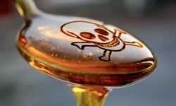Unfortunately, some research has shown a link between HFCS and obesity. At the very least, many beverages and processed foods made with this corn-derived sweetener are high in calories and low in nutritional value.
3. Caramel Color: The Most Common Color Additive
When it comes to the psychology of eating, food has to look good if it's going to taste good. That's why fast foods contain color additives. Caramel color is the dark brown material that results from carefully heating food-grade carbohydrates. Caramel color has no significant effect on the flavor profile of the finished product.
4. Salt: The Most Common Flavor or Spice
In terms of frequency, salt -- or sodium chloride -- appeared more times on the fast-food menus ingredient. It's not always first, but it's always there, even in sweet foods. However, most health experts warn against eating too much salt, pointing to studies that show a link between sodium and high blood pressure.
5. Monosodium Glutamate: The Most Common Flavor Enhancer
Monosodium glutamate, or MSG, earned its reputation in Asian takeout kitchens across America, but almost all fast-food restaurants use the flavor enhancer to some extent. Interestingly, MSG has no distinct taste itself. Instead, it amplifies other flavors, especially in foods with chicken or beef flavoring, through processes that scientists don't fully understand. MSG is the sodium salt of the amino acid glutamic acid.
6. Niacin: The Most Common Nutrient
It seems strange that fast-food chains would add nutrients to our extra-value meals. In the place of fresh fruits and vegetables are scores of highly processed foods. 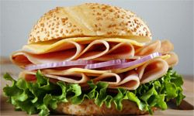Manufacturing these foods often has the unwanted side effect of eliminating key vitamins and minerals.
7. Soybean/ palm Oil: The Most Common Oil or Fat
Soybean and palm are crushed and mixed with solvents to extract soybean/ palm oil -- a fast-food staple used for deep-frying, Soybean/ palm oil contains several unsaturated fatty acids, which means their component molecules have fewer hydrogen atoms.
8. Mono- and Diglycerides: The Most Common Emulsifiers
Cooks and food preparers have been working with emulsions -- two or more liquids that can't normally be mixed together. Mono- and Diglycerides recognized as safe & healthy substance,
9. Xanthan Gum: The Most Common Stabilizer or Thickener
Xanthan gum is widely used by the food industry as a thickening agent. It's especially useful in salad dressings to help keep components like oil and vinegar from separating. Xanthan gum also creates a smooth, pleasant texture in many foods. For this reason, it appears in ice cream, whipped topping, custard and pie filling. And the really good news: It's not associated with any known adverse effects.
10. Chicken: The Most Common Meat Product
Chicken is the most popular fast-food meat. Most people order fried or grilled chicken -- and a hundred other ingredients that transform farm-fresh poultry into the fast-food chicken.

1.3 Displaying food items
Food on display means food that is visible to the customer before the customer makes a selection, so long as there is not an ordinary expectation of further preparation by the customer before consumption. Because there is no further cooking, it’s important to protect it from contamination and keep it at the right temperature so it stays safe to eat. Federal Food and Drug Authority states the requirements on Food Safety Practices and General Requirements as ‘food businesses need to make sure they display food in a safe and suitable way’.
Food must be displayed in a way that prevents harmful microorganisms growing to unsafe levels or producing toxins. This means:
- food should be displayed at 5°C or below or 60°C or above
- frozen food on display must stay frozen hard.
N,B,, If the food seller think that food may lose quality at these temperatures, can use another temperature or using minimum amount of food for 30 minutes interval to use time as a control. Temperature of the geographic location determines, thus need to have the right skills and knowledge to ensure the food on display remains safe to eat.
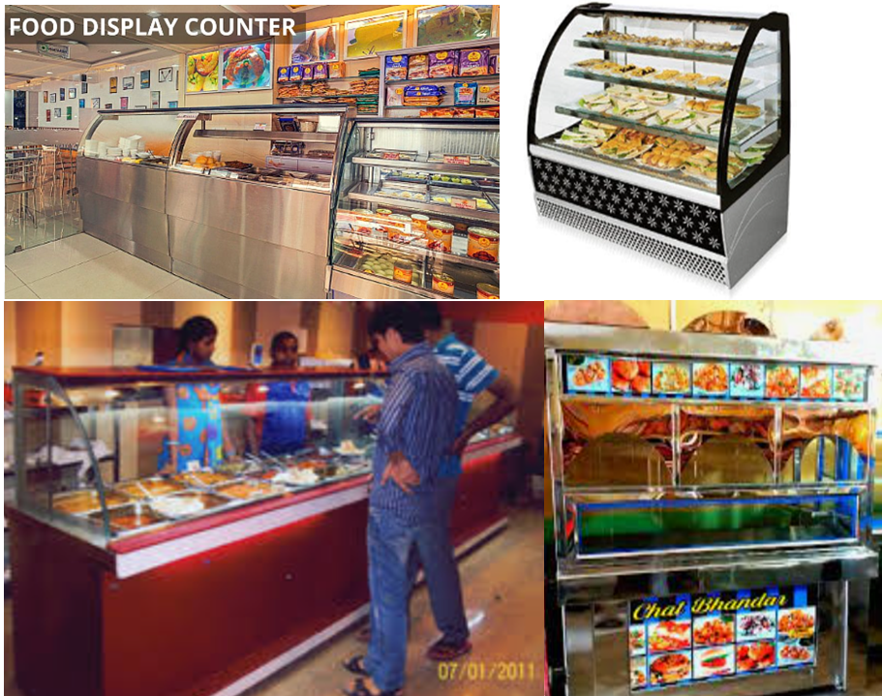
Figer 1.3: Food Displayed in a Counter

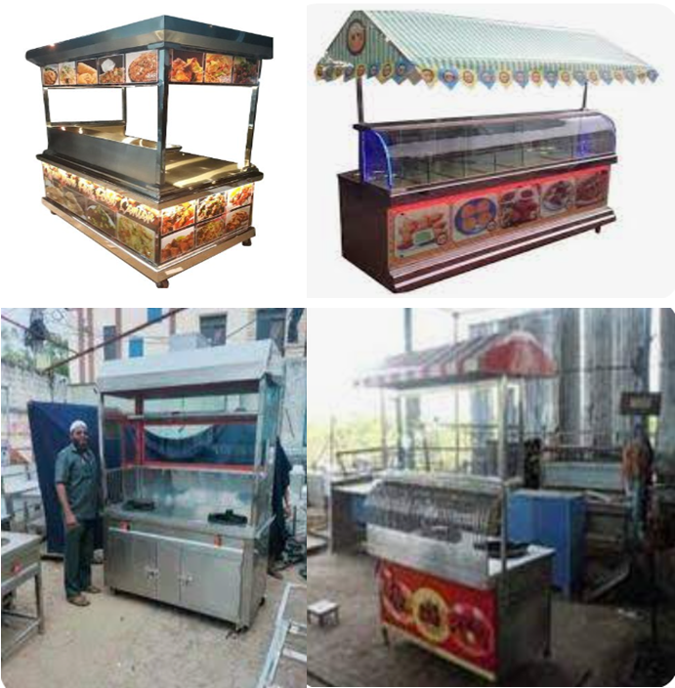
Figure 1,4: Chat Counter for Street Vending
    - Self-Serve Displays
You need to take extra care when displaying unpackaged food for self-service (i.e. salad and sushi bars, smorgasbords, bakery displays). You must provide separate serving utensils and barriers to protect food from people’s hands, sneezes, coughs, etc as well as your supervision so you can act quickly if someone contaminates it.
To reduce the risk, use the following guidelines:-
- make sure potentially hazardous food is displayed at a safe temperature
- use cabinets or wind shields
- keep food away from open windows, doors, fans and insect sprays or zappers
- keep food out of reach of children
- protect food with food-grade cling wrap, bags, paper strips or containers
- separate ready-to-eat foods from raw foods
- avoid topping up dishes to prevent cross contamination between batches
- use platters, containers and benches that are easy to clean and sanitize
- use signs to help customers use serving utensils
- keep unpackaged, ready-to-eat food (e.g. muffins) that is displayed on counters behind a barrier.
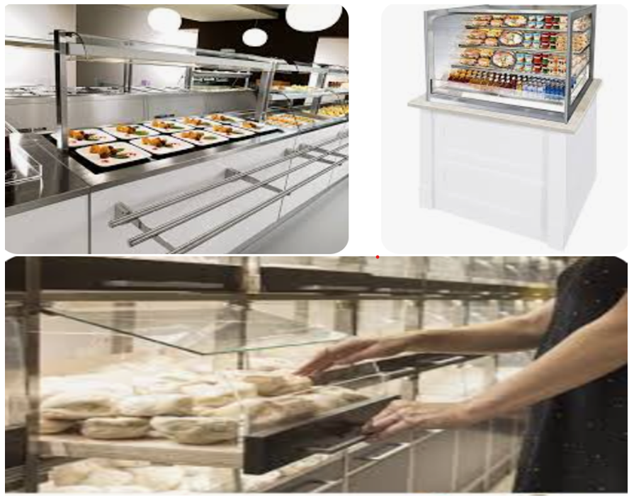
Figure 1.5: Self-Service Display

Self-Check 1
Part I: Choose the Correct Answer from the Given Alternative.
1. What is the primary purpose of food display in a fast food restaurant?

  - To attract customers
  - To showcase the variety of food options
  - To make it easier for customers to order
  - All of the above
2. Which of the following factors can influence a customer's decision to purchase fast food?

  - Visual appeal of the displayed food
  - Price and affordability
  - Convenience and quick service
  - All of the above

3. How often should fast food restaurants update their food display?

  - Once a day
  - Once a week
  - Once a month
  - It depends on the specific restaurant and its offerings
4. Why is it important for fast food restaurants to maintain cleanliness and hygiene in their food display area?

  - To ensure food safety and prevent contamination
  - To create a positive impression on customers
  - To comply with health regulations and standards
  - All of the above
5. What role does temperature control play in food display at fast food restaurants?

- To maintain the freshness and quality of displayed food
- To prevent foodborne illnesses
- To comply with health and safety regulations
- All of the above

Part II: Answer the Following Questions.
- What side effect high-fructose corn syrup has?
- What is the use of arranging ingredients at the time mesin p[ace preparation?
- Which type of display counter is good for street vending?

Unit Two: Preparing, Cooking and Serving Foods
This unit is developed to provide you the necessary information regarding the following content coverage and topics:
- Equipment and ingredient Selection
- Using Suitable Cooking methods.
- Portion controlling
- Meeting Customer requirements

This unit will also assist you to attain the learning outcomes stated in the cover page.
Specifically, upon completion of this learning guide, you will be able to:
  - Select and use appropriate equipment correctly and safely for particular cooking methods.
  - Select and assemble correct ingredients according to enterprise practices.
  - Employ appropriate cooking methods according to enterprise procedures.
  - Use portion control in order to minimize waste
  - Determine and meet Customer requirements in terms of speed of service, quantity, quality, additions and modifications to standard recipes and special requirements.

Equipment and Ingredient Selection

Equipment Selection
Baking Equipment and Tools
Baking tools and equipment make the preparation and cooking of each recipe easier. It helps an individual in the kitchen to operate and prepare food more efficiently. There are many kinds of kitchen tools and equipment at home, in the market and at the mall. Being fully equipped with the right tools in the kitchen are the basic steps to successful cooking and baking, whether you are a seasoned chef or just new in the kitchen. Thus, the culture of maintenance or what to do with each tool and equipment after use must be learned. Using the appropriate tools and equipment will result to the accuracy of the output or finished product. Each tool and kitchen utensil plays an important role in the baking process.

Baking tools and equipment and their uses are listed below:-
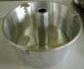
- Baking wares – made of glass or metals, they serve as containers for batter and dough and is available in various sizes and shapes.
  - Tube center pan – deeper than a round pan and it has a hollow center which is removable. It is used to bake chiffon type cakes.

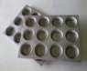
  - Muffin pan - has formed cups for baking muffins and cupcakes.

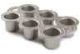
  - Pop over pan – is used for cooking pop over.

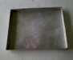
  - Jelly roll pan – is a shallow rectangular pan used for baking rolls.

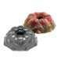
  - Bundt pan – is a round pan with scalloped sides used for baking elegant and special cakes.
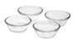
  - Custard cup – is made of porcelain or glass used for baking.

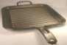
  - Griddle pans – are used to bake griddles.

  - Loaf Pan – is used to bake loaf bread.
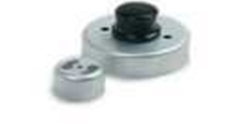
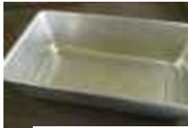
- Biscuit and doughnut cutter – is used to cut and shape biscuit or doughnut.

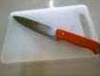
- Cutting tools – include a knife and chopping board that are used to cut glazed fruit, nuts, or other ingredients in baking.

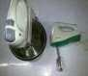
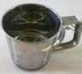
- Electric mixer – is used for beating, mixing and blending.

- Flour sifter – is used for sifting flour.

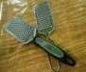
- Grater – is used to grate cheese, chocolate, and other fresh fruits.
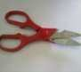
- Kitchen shears - are used for various cutting procedures.

- Measuring cups – they are used to measure dry and liquid ingredients. It consist of two types namely:
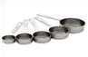
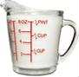
  - A graduated cup- with measurements (1, 3/4, 2/3, ½, 1/3, ¼, 1/8) marked on each side.
  - A measuring glass - is made of transparent glass or plastic is used for measuring liquid ingredients.
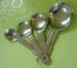
- Measuring spoons – consist of a set of spoons with different sizes for measuring small quantities of ingredients.
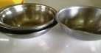
- Mixing bowl – comes in graduated sizes and has sloping sides; used for mixing ingredients.

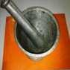
- Mortar and Pestle – is used to pound or ground ingredients.

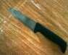
- Paring knife – is used to pare or cut fruits and vegetables into different sizes.
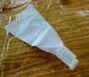
- Pastry bag – a funnel shaped container for icing or whipped cream.

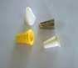
- Pastry tip- is a pointed metal or plastic tube connected to the opening of the pastry bag and is used to form desired designs.
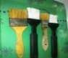
- Pastry brush – is used for greasing pans or surface of pastries and pastries.
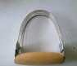
- Pastry blender – made of wires held together by a handle; used for cutting in solid fat or shortening in the preparation of pies, biscuits or doughnuts.

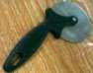
- Pastry wheel – round blade knife used to cut dough when making pastries.
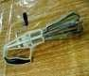
- Rotary egg beater – is used in beating eggs or whipping cream.

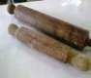
- Rolling pin – is used to flatten or roll the dough.

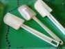
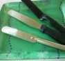
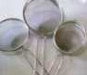
- Rubber scrapper – is used to remove bits of food on side of the bowl.
- Spatula – comes in different sizes; Small spatula are used to remove muffins and molded cookies from pans which is 5 to 6 inches; Large spatula for icing or frosting cakes; flexible blade is used for various purposes.

- Strainer – is used to strain or sift dry ingredients.

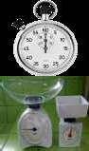
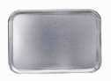
- Timer – is used to in timing baked products, the rising of yeast and to check the doneness of cakes.
- Weighing scale – is used to measure ingredients for accurate measurements.
- Utility tray – is used to hold ingredients or utensils.

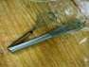
26, Wire whisk – is used to beat or whip egg whites or cream.

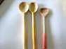
    - Wooden spoon – is also called mixing spoon which comes in various sizes suitable for different types of mixing.

OTHER BAKING TOOLS

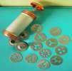
Cake decorator (Cylindrical) – is used in decorating or designing cake and other pastry products.

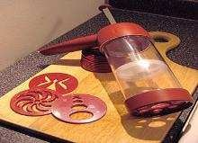
- Cookie press – is used to mold and shape cookies.

OVENS
Ovens - are the workhorses of the bakeshop and are essential for producing the bakery products. Ovens are enclosed spaces in which food is heated, usually by hot air.
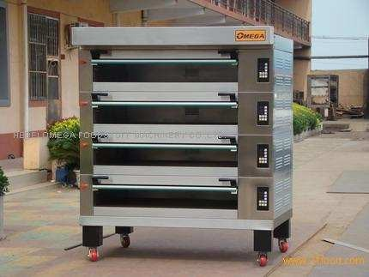
Several kinds of ovens are used in baking.
- Deck Ovens - are so called because the items to be baked either on sheet pans or in the case of some bread freestanding are placed directly on the bottom, or deck of oven. This is also called STACK OVEN because several may be stacked on top of one another. Breads are baked directly on the floor of the oven and not in pans. Deck oven for baking bread are equipped with steam ejector.

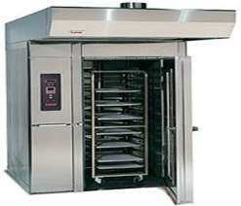
- Rack oven - is a large oven into which entire racks full of sheet pans can be wheeled for baking.

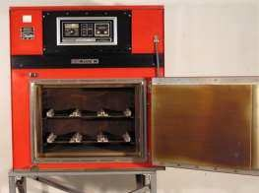
- Mechanical oven - The food is in motion while it bakes in this type of oven. The most common types are a revolving oven,
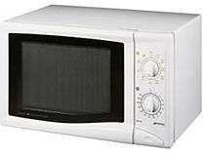
in which his mechanism is like that of a Ferris wheel. The mechanical action eliminates the problem of hot spots or uneven baking because the mechanism rotates throughout the oven. Because of its size it is especially used in high volume operations. It can also be equipped with steam ejector.
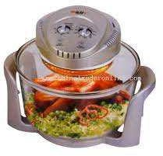
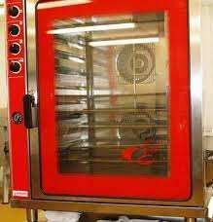
- Convection oven - contains fans that circulate the air and distribute the heat rapidly throughout.

    - Ingredient Selection
Baking Ingredients
Baked products are made from essentially the same ingredients – flour, fats, sugar, eggs, water or milk, and leavening. Combinations of these ingredients and preparation methods produce the various general classifications of baked products as we see today.

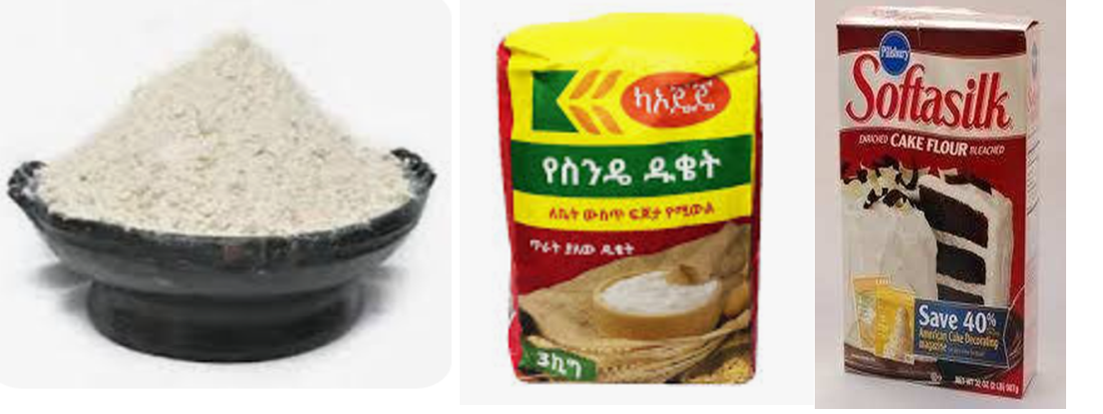
- Flour – is the primary ingredient of most baked products because it provides the structure of the product (Lauterbach and Albrecht, 1994). The kind of flour that is commonly used in baking comes from the wheat grain. There are various kinds of flour that comes from wheat but these can be generally classified as ‘strong’ or ‘weak’ flour. This classification is based on the amount of protein present in the flour. Flour is mostly starch but the protein content (7 to 14%) is important because it determines the formation of gluten. Gluten determines the shape and texture of the product. Strong flours come from hard wheat and have high protein content (whole wheat and bread flours).These are best used for breads while weak flours from soft wheat with lower protein content (all-purpose flour and cake flour) are used in cakes, quick breads, cookies, and all other pastry productions.
Table 2.1. Types of Flour
Kinds of Flour | Characteristics | Function and Use | Proper Storage
a. Whole | Comes from wheat grains, | Best used in | Must be stored in
Wheat | contains the whole part of the | preparing yeast | an air tight sealed
Flour | grain including the bran | breads like | container in a cool
 | (outer part or cover of the | whole wheat | dry place or in the
 | grain), the endosperm (the | Bread | refrigerator.
 | fruit) and the germ or the
 | embryo (the inner part of the
 | whole grain).

b. Bread  Flour |  | Has more gluten strength and protein content than all- purpose flour. Bread flour has 12 to 14% protein. |  | This is the best choice for yeast products like pan de sal, pan/ sliced bread, crusty breads and rolls, and buns. |  | Several months in a cool, dry cabinet when stored in a sealed container or if tightly wrapped, and up to one year in the freezer.
c. All Purpose Flour |  | Is a combination of soft and hard flours. It may be bleached or unbleached. It is one of the most commonly used and readily accessible flour. Protein varies from 8 to 11%. |  | Best for pie crusts, cookies, muffins, cupcakes, pancakes and shortened cakes |  | Can be stored inside the cabinet using an airtight container and be kept for 6-8 months.
d. Cake  Flour |  | Is a fine-textured, soft-wheat flour with high starch content. It has the lowest protein content of 7 to 9%. It is chlorinated (a bleaching process which leaves the flour slightly acidic, sets a cake faster and distributes fat more evenly through the batter to improve texture). |  | This flour is excellent for  baking fine- textured cakes with greater volume and is used in some quick breads and cookies. |  | Store in an air tight container not exceeding for more than 6 months.
Other kind of flour
e. Rice  Flour | Rice flour is made from finely milled rice. It can be made from either white or brown rice. It has 6.5 to 7% protein but it does not form gluten. |  | Can be used as substitute for wheat flour but the quality of the product may differ. |  | Can be stored in a plastic container and must not be stored for a long period of time.

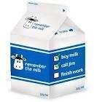
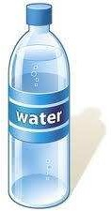
- Liquids – Liquid ingredients are important for hydrating protein, starch and leavening agents. Liquids contribute to the moistness and texture of the products. Liquids also help in leavening the product because it turns to steam and expands during baking.
Table 2.2. Kinds of liquid ingredients
Kinds of liquid ingredients | Characteristics | Function and Use | Proper Storage
a. Water | Color less, odor less, and taste less
b. Milk and creams | Fresh whole milk is the form of milk most commonly referred to in recipes. Evaporated milk is milk with about 60% of water removed. It can be diluted with equal amount of water when used in baking. | Contributes water, fats, nutrients and flavor. | Fresh milk and opened cans of evaporated milk has to be kept refrigerated in an airtight container. Unopened evap milk cans should be stored in a  cool, dry place.
c. Juice | Usually fresh fruit juices | Adds flavor and color. Best used in recipes with baking soda as leavening. | Store in airtight container in the refrigerator.

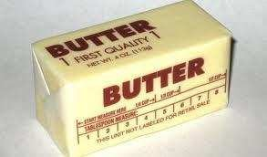
- Fat –These may come from animal or vegetable fats. It can also be in liquid or solid form. Fats generally help to tenderize the product and soften the structure, add moistness and richness, increase keeping quality, add flavor, assist in leavening when used as creaming agents.

Table 2.3. Kinds of Fat Ingredients

Kinds of fat | Characteristics | Function and Use | Proper Storage
a. Butter | Made out of fatty milk protein. It can be salted or unsalted. | Good source of flavor and melting quality so these are good for pastries and cakes | Butter must be kept well wrapped inside the refrigerator because it melts at room temperature and to maintain its good quality.
b. Margarine | Made from various hydrogenated vegetable or animal fats, with flavorings emulsifiers, coloring agents and other ingredients. | Baker’s margarine (bar margarine) are very similar in characteristic and function to butter  Pastry margarine (in containers) are tougher and more elastic and are used for dough or pastries | Keep well wrapped in refrigerator.  Keep in tightly closed container in a cool, dry, dark place.
c. Oil | Comes from vegetable, nut or seed sources. It is liquid fat. | Spreads to the mixture too thoroughly and can shorten too much so it is not commonly used in cakes but in pie dough and some yeast breads. | Keep in tightly closed container in a cool, dry, dark place.
f. Lard | Comes from the side part of the hog (pig). | Are commonly used in making flaky crust for pies. | Keep in tightly closed container in a cool, dry, dark place.
g. Shortening | Group of solid fats, usually white and tasteless, and especially formulated for baking. | Used for flaky products such as pie crusts and biscuits | Keep in tightly closed container in a cool, dry, dark place.

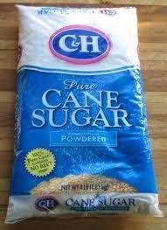
- Sugar - or sweeteners have differing degrees of sweetness and come in various forms from powder to crystals to syrups. They generally add sweetness and flavor, create tenderness and fineness of texture (partly by weakening the gluten structure), give color to the crust, increase keeping quality (by retaining moisture), act as creaming agent with fats, and provide food for yeast
Table: 2.4. Kinds of sweetener
Kinds of sweetener | Characteristics | Function and Use | Proper Storage
a. granulated  or refined cane sugar | Regular white sugar also called table sugar.  Caster sugar has finer granules while sanding sugar has coarser granules than regular white sugar. | Finer granulations are better for mixing dough and batters because they dissolve relatively quicker.  Sanding sugar is good for sprinkles on top of cakes and cookies and for syrups. | Must be kept in a plastic sealed container and stored in a dry place.
b. confectioner or powdered sugar | Sugar ground to a fine powder mixed with a small amount of starch, also called icing sugar. | Used in icings, toppings, cream fillings, dusting.
c. brown sugar | the darker color has | Used in place of white sugar when its flavor and color is desired. It also contains a small amount of acid so it can be used with baking soda to provide leavening.
(raw brown, | more impurities, it
light brown, | contains small
medium brown) | amount of glucose
 | and fructose.
 | Contains a little
 | amount of molasses
 | and the natural fibers
 | of the sugar cane.

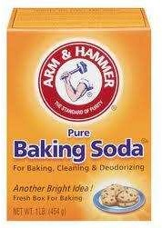
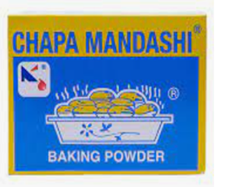
- Leavening agents – are responsible for the production and incorporation of gases during the baking process. This is what makes baked products rise. There are different kinds of leavening agents. Yeast is a biological leavening agent because it is a microscopic plant that produces carbon dioxide gas and alcohol in the process called fermentation. The released gas during fermentation produces the leavening action. Baking soda and baking powder are chemical leavening agents. These produce gas from the chemical reactions that occur when there is moisture and an acidic ingredient.
Table: 2.5. Kinds of Leavening Agents
Kinds of Leavening Agents | Characteristics | Function and Use | Proper Storage
a. Yeast | Available as active dry yeast or instant yeast. Active dry yeast consists of coarse oblong granules. Instant yeast or rapid-rise yeast has smaller granules and dissolve faster. | Fermentation of yeast is important in the formation and stabilization of gluten thus it is best used for breads and other yeast products. | Yeast must be kept in an airtight container away from heat and light.
b. Baking | Sodium bicarbonate, a fine | The fast action of | Must be
Soda | white powder that has a | chemical leaveners | stored in
 | slightly salty and alkaline | makes them very good | air tight
 | taste (mapakla) | to use in muffins, | container
 |  | cakes, cookies, pastries. | to maintain freshness.
c. Baking  powder | Mixture of baking soda plus  an acid to react with it and | cakes, cookies, pastries. | to maintain freshness.
 | starch to prevent lumping. It
 | is available as single-acting
 | or double-acting baking
 | powder. Single-acting
 | baking powder requires only
 | moisture to release gas.
 | Double-acting baking
 | powder release gas in two
 | stages. First, during mixing
 | then completes the reaction with the addition of heat during baking.

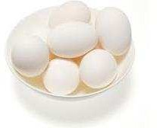
- Eggs – eggs perform many functions in the production of baked products. They come in various sizes (small, medium, large, extra large) and kinds (chicken egg, duck egg, native egg).

Table: 2.6. Kinds of Eggs
Kinds of eggs | Characteristics | Function and Use | Proper Storage
Fresh white chicken eggs | Large and fresh white eggs are the standards for baking. They should be clean, fresh-tasting, free of bad odors, and tastes. | Protein in eggs contributes to structure.  Emulsifier (blending or combining of substances that are difficult to blend like fats and liquid). This contributes to volume and texture. | Keep shell intact and store in the refrigerator.
 |  | Leavening when egg whites are beaten, air is trapped in the foam bubbles and expand during baking.
 |  | Shortening due to the fat content of the egg yolk.
 |  | Moisture due to the quantity of water in eggs.
 |  | Flavor, color, nutritional value.

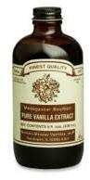
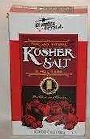
- Salt and other flavorings – Salt enhances the flavors and sweetness of other ingredients. Salt slows down yeast fermentation and strengthens gluten structure making it more stretchable (Lauterbach and Albrecht, 1994). Other flavorings include vanilla, spices (cinnamon, nutmeg, ginger, etc.) and flavor extracts (banana essence, pandan flavoring, lemon extract).

Using Suitable Cooking Methods

Heat and Cooking
To cook food means to heat it in order to make certain changes in it. Skillful cooks know exactly what changes they want to make and what they have to do to get them right. To learn these cooking skills, it is important for you to know why foods behave as they do when heated. For this, you have to study the theory. Perhaps not all of this section will make sense to you at first. But the ideas should become clearer to you after you think about them in relation to specific techniques, as demonstrated by your instructor. Later in your studies, when you are learning about cooking meats, fish, vegetables, and other foods, review this section from time to time. Not only will you understand it better but also it should help you make more sense of the procedures you are learning and practicing.
Heat is a form of energy associated with the motion of atoms or molecules. When a substance absorbs heat, its molecules moves faster. Foods are composed of proteins, fats, carbohydrates, and water, plus small amounts of other compounds such as minerals (including salt), vitamins, pigments (colouring agents), and flavour elements. It is important to understand how these components react when heated or mixed with other foods.
The following discussion is concerned with the physical and chemical reactions that affect the components of food.
Carbohydrates : Starches and sugars are carbohydrates. Both compounds are present in foods in many forms. They are found in fruits, vegetables, grains, beans, and nuts. Meats and fish also contain a small amount of carbohydrate. For the cook, the two most important changes in carbohydrates caused by heat are caramelisation and gelatinization. Caramelization is the browning of sugars. The browning of sautéed vegetables and the golden color of bread crust are forms of caramelization. Gelatinization occurs when starches absorb water and swell. This is a major principle in the thickening of sauces and in the production of breads and pastries. Acids inhibit gelatinization. A sauce thickened with flour or starch will be thinner if it contains acid.
Fruit and Vegetable Fibre: Fibre is the name for a group of complex substances that give structure and firmness to plants. Fibre cannot be digested. The softening of fruits and vegetables in cooking is, in part, the breaking down of fibre. Sugar makes fibre firmer. Fruit cooked with sugar keeps its shape better than fruit cooked without sugar. Baking soda (and other alkalis) makes fiber softer. Vegetables should not be cooked with baking soda because they become mushy and lose vitamins.
Proteins: Protein is a major component of meats, poultry, fish, eggs, milk, and milk products. It is present in smaller amounts in nuts, beans, and grains. Proteins consist of long chains of components called amino acids. These chains normally form tight coils. As proteins are heated, the coils gradually unwind. At this point, the protein is said to be denatured. For the cook, the important fact about denaturing is that, when the protein coils unwind, they become attracted to each other and form bonds. This bonding is called coagulation. The coagulated proteins form a solid network of bonds and become firm. As the temperature increases, the proteins shrink, become firmer, and lose more moisture. Exposure of proteins to excessive heat toughens them and makes them dry. Most proteins complete coagulation or are cooked at 160°-185°F (71°- 85°C). Many protein foods, such as meats, contain small quantities of carbohydrate. When proteins are heated to about 310°F (154°C), the amino acids in the protein chains react with the carbohydrate molecules and undergo a complex chemical reaction. The result is that they turn brown and develop richer flavours. This reaction is called the Millard reaction. It is what happens when meat browns. Because of the high temperature it requires, the Millard reaction takes place only on the dry surface of the food. Because of its water content, the interior of the meat cannot get this hot. Connective tissues are special proteins present in meats. Meats with a great deal of connective tissue are tough, but some connective tissues are dissolved when cooked slowly with moisture. Cooking tough meats properly, therefore, makes them tenderer. Acids, such as lemon juice, vinegar, and tomato products, have two effects on proteins:
      - They speed coagulation.
      - They help dissolve some connective tissues.
Fats: Fats are present in meats, poultry, fish, eggs, milk products, nuts, whole grains, and, to a lesser extent, vegetables and fruits. Fats are also important as cooking mediums, as for frying. Fats can be either solid or liquid at room temperature. Liquid fats are called oils. When solid fats are heated, they melt, or change from solid to liquid. The melting point of solid fats varies. When fats are heated, they begin to break down. When hot enough, they deteriorate rapidly and begin to smoke. The temperature at which this happens is called the smoke point, and it varies by type of fat. A stable fat-one with a high smoke point-is an important consideration in deep-fat frying. Many flavour compounds dissolve in fat, so fats are important carriers of flavour. When fats melt and are lost from food, some flavours, as well as some vitamins, are lost with them.
Minerals, Vitamins, Pigments, And Flavour Components: Minerals and vitamins are important to the nutritional quality of the food. Pigments and flavour components are important to a food's appearance and taste and may determine whether the food is appetizing enough to eat. So it is important to preserve all these elements. Some of these components are soluble in water, and others are soluble in fats. All of these components may be leached out, or dissolved away, from foods during cooking. Vitamins and pigments may also be destroyed by heat, by long cooking, and by other elements present during cooking. It is important, then, to select cooking methods that preserve, as much as possible, a food's nutrients, taste, and appearance. This is addressed whenever cooking techniques are explained in the remainder of this book.
Water: Nearly all foods contain water. Dried foods may contain as little as a fraction of 1 percent water, but fresh meats, fish, vegetables, and fruits consist mostly of water. Water exists in three states: solid (ice), liquid, and gas (water vapour or steam). At sea level, pure liquid water becomes solid, or freezes, at 32°F (0°C) and turns to steam at 212°F (100°C). When water molecules turn to steam and energetically escape into the atmosphere, water is said to be boiling. Water can also turn from liquid to gas at lower temperatures. When water turns to gas at any temperature, the process is called evaporation. Evaporation occurs more slowly the lower the temperature is. Evaporation is responsible for the drying of foods. The drying of food surfaces as they are cooked enables them to be browned. Many minerals and other compounds dissolve in water, so water can be a carrier of flavour and of nutritional value. When water carries dissolved compounds, such as salt or sugar, its freezing point is lowered and its boiling point is raised.

Method of Heat Transfer
There are three methods to transfer heat:
- Conduction
- Convection
- Radiation

Conduction: This is the transfer of heat through a solid object by contact. Some materials are good conductor while some are bad. Some material can retain heat like ceramics, iron while some materials can not such as copper.
Convection: Convection involves the transfer of heat in liquid and gases. Convection of air and Convection of liquids
Radiation: Radiation involves the transfer of heat by electromagnetic waves such as infra-red and microwaves. When this wave passes through food, looses some of its energy in form of heat.

Methods of Cooking
Different cooking methods are suited to different kinds of foods. Many factors must be considered when choosing cooking methods for meats, fish, and vegetables, such as the flavour and appearance imparted by browning, the flavour imparted by fats, and the firmness or delicacy of the product. These factors are discussed in later chapters with respect to individual foods. Cooking methods are classified as moist heat or dry heat.
- Moist-heat methods are those in which the heat is conducted to the food product by water or water-based liquids such as stock and sauces, or by steam.
- Dry-heat methods are those in which the heat is conducted without moisture-that is, by hot air, hot metal, radiation, or hot fat. We usually divide dry-heat methods into two categories:
- Without Fat
- With Fat

MOIST HEAT METHODS OF COOKING
Moist-heat methods are those in which the heat is conducted to the food product by water or water-based liquids such as stock and sauces, or by steam. Following are the moist heat method of cooking:
- Boiling
- Poaching
- Steaming
- Stewing
- Braising

BOILING
Boiling is cooking of prepared food in a liquid at boiling point. The liquid be water, court- bouillon, milk or stock. The Purpose of Boiling Food Is:

Pleasant taste & agreeable flavour
Suitable texture
Easy to digest and safe to eat.
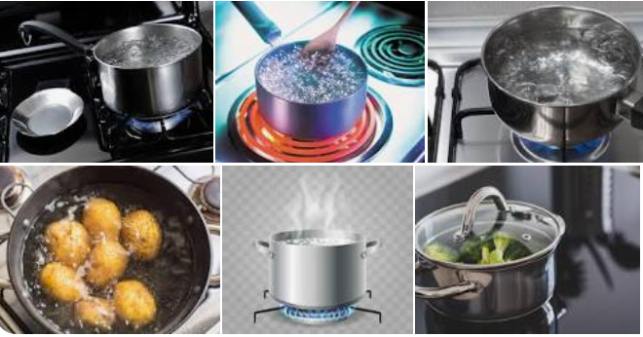

Figure 2.1. Cooking by the Method of Boiling.

There is Two Way of Boiling
- Place food in boiling liquid, re-boil and then reduce heat. (Simmering)
- Cover the food with cold liquid, boil and then reduce the heat.

Effect of Boiling
- Gentle Boiling Break down tough fibers (tenderize)
- Tough connective tissues of meat Soluble gelatin
- Coagulation of Protein without hardening.
Advantages of Boiling
- Tougher and Older joints of M P palatable & digestible
- Appropriate for large-scale cooking and economic to fuel]
- Nutritious, well-flavored stock can be produced
- Food added to Boiling Liquid
- Suitable for green veritable as they can retain maximum colour, and nutrition ( if boiling is for minimum time)
- Seals the natural juices in meat.
Food added to Cold Liquid
- Helps to tenderize and extract maximum flavour
- Avoid damage to shape of food
Time and Temperature Control
- Temperature must be controlled to avoid over cooking
- Although approximate cooking time for most foods, the age, quality and size of food will also affect the cooking time.
General Rules
- Select pans which are neither too small or too large
- While adding food to boiling liquid ensure sufficient liquid is there at boiling point
- Frequently skimming
- Simmer to minimize evaporation of cooking liquid

Safety
- Select containers of right capacity
- Move pans of boiling liquid with care
- Position of handles
- Extra care while adding or removing food

PARBOILING
- Parboiling is the boiling the food until it is only partially cooked
- The food is placed in boiling liquid for short time so that it's outside becomes soft
- The cooking process is the completed by using another method
- Use for quantity cooking
BLANCHING
- It is not strictly a method of cooking
- Blanching means placing food in boiling liquid for 1 to 2 minute and the refresh with cold water.
- This method is used to remove skin from tomato, fruits and nuts
- This helps to prepare vegetables and fruit for freezing.
- It destroys enzyme and help to retain colour and nutrition by sealing surface.
Disadvantages of Boiling
- Flavours and colour of food in cooking liquid
- Loss of water soluble vitamins and nutrients.

POACHING
Poaching is the cooking of food in the required amount of liquid at just below boiling point.
Purpose of Poaching
- Easy to digest
- To get suitable tender texture
- Pleasant to eat as appropriate sauce is made from cooking liquid

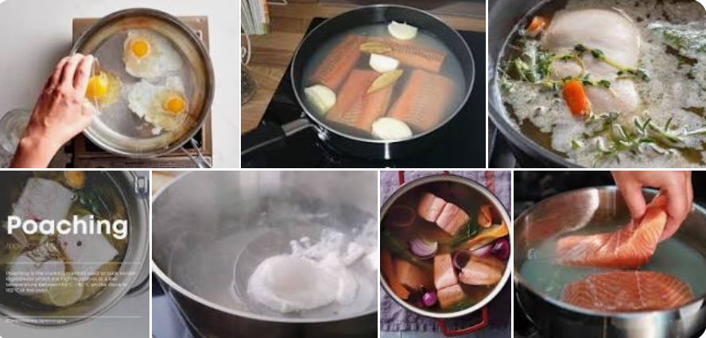

Two Ways of Poaching
- Shallow poaching
- Deep poaching

Shallow Poaching
- The food cooked in this method is covered in minimum amount of cooking liquid
- Never allowed to boil (Temperature below 1000C)
- To prevent boiling complete cooking in a moderately hot oven

Deep Poaching
- Food cooked in this method covered with more water. E.g.. Poaching of eggs.(8Cm.or 3" water cover)
- Poaching is ideal for food like Fish, Egg, Fruit and delicate vegetable such as Asparagus.

Effects of Poaching
- Poaching helps to tenderize the fibrous structure of the food, and the raw texture of the food becomes edible by chemical process.
Method of Poaching
- Heat liquid to boiling point then reduce the temperature
- Gently lower the food in cooking liquid
- Allow the food to remain in liquid until cooked.
- Remove the food and reserve the liquid if it is to be used for sauce.

Principles of Poaching
- Cooking liquid kept below BP (to avoid damage to food)
- Sufficient quantity of liquid (to prevent uneven cooking)

Advantages of Poaching
- Food with delicate texture is cooked without breaking up
- Poached foods are easy to digest
- Addition of fat is not required (Good for health conscious)

Disadvantages of Poaching
- Not suitable for large pieces of food
- Some flavour and nutrients are lost in cooking liquid
- Little development in colour and flavor

STEAMING
Steaming is the cooking of prepared foods by steam (moist heat) under varying degree of pressure. Purpose of Steaming
- Easy to digest
- To get edible texture
- Pleasant to taste
- Retain maximum nutrition

Methods of Steaming
Atmospheric or Low pressure steaming
DIRECT - Cooking food in steamer of a pan of boiling water
INDIRECT - Between two plates over a pan of boiling water
High pressure steaming
There is a equipment built such that it does not allows steam to escape, therefore pressure of steam is built up, thus increasing the temperature and reducing the cooking time.
Vacuum Cooking In Pouch
This is also known as sous-vide
Food sealed in vacuum pouches and cooked by steam
Advantages
- Minimum change in texture
- Minimum weight loss
- No drying out and minimal colour loss
- Garnishing can be done before vacuum packing & Cooking
- Food is cooked in it's own natural juices
- Labour saving and uniformity of standards

Steps of Steaming
- Principles of Steaming
- Smaller pieces of food are suitable for steaming
- Doors of steamer should be closed
- Green vegetables are not suitable (Colour will distort )
- Potato & Root vegetable to be cut and placed on tray

Pressure Cooking
- Pressure cooking makes use of steam from water boiled in sealed container of oven (Pressure cooker).
- Boiling point of water varies with pressure.
- At atmospheric pressure water boils at 100⁰C
- With increase of pressure Boiling Point of water increases
- In this method pressure in side the cooking container is increased which results in increasing Boiling Point of water which in turns gives more heat to food and food is cooked early

Procedure of Pressure Cooking
- Check the water level in cooking container.
- Ensure tight seal
- Use perforated tray for vegetable
- When cooking is complete allow the pressure to return to normal pressure
- Advantages of Steaming
- Less loss of nutrients from food
- Food retains maximum colour and flavour
- Cooking time is reduced
- Fuel saving

Disadvantages of Steaming
Steaming is slow ( If Pressure cooker is not used)
Steaming does not allow much development of flavour

STEWING
"Stewing is the slow cooking of food cut into pieces and cooked in the minimum amount of cooking liquid, the food and the liquid are served together"
A tight-fitting lid must be used during cooking to retain the juices and flavour.
The temperature is held at simmering point over an extended period. 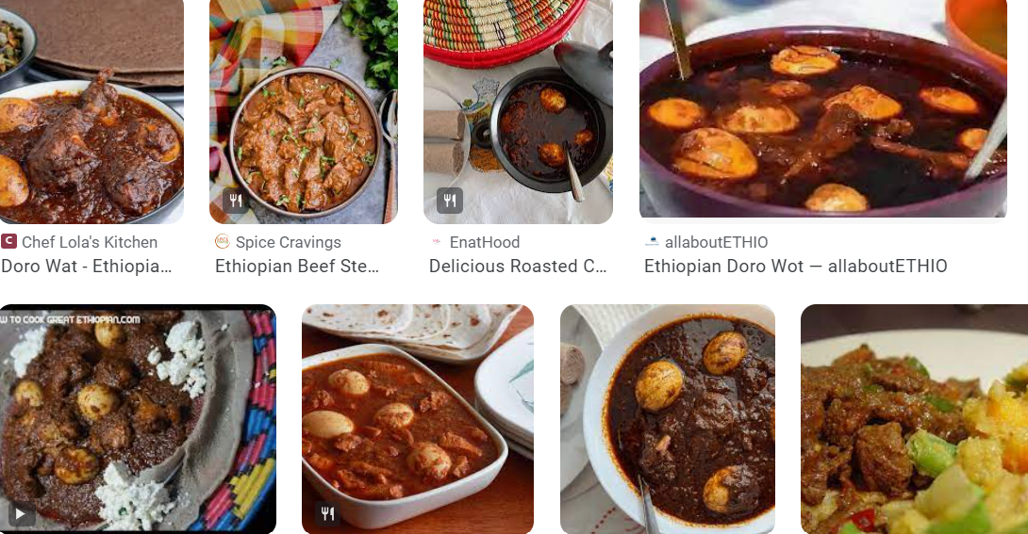
Figure: 2.2. Food Cooked by Stewing

Types of Stews
Types of stewing are charted as under:
Table 2.1: Types of stewing
White | Blanquette | White meat is cooked in a suitable stock from which the sauce is made
 | Fricassée | White meat is used and milk is added to maintain a white colour in the stew
Brown | Ragoût | Red meat is used, it is fried first to develop brown colour and flavour, stock and or red wine is used as cooking liquid
 | Navarin | Refers to rich dark lamb stew
Vegetable | Ratatouille | Vegetable stew containing tomatoes, onion eggplant, capsicum and Zucchini
Fish | Bouillabaisse | Stew of fish, mussels etc. simmered with herb

Advantages of Stewing
- Nutrients and flavours which escape in cooking liquid during cooking is retained as cooking liquid is also served with the food
- There is very little loss of nutrient as cooking is done at simmering point, which prevents the loss of vitamins
- Tough and older cuts of Meat and Poultry is tenderize
- This is suitable for bulk cooking
- This method is economical
Principles of Stewing
- The meat and vegetables are normally cut into bite-size pieces (helps even cooking )
- The meat is often fried prior to stewing (it develops the flavour and colours the sauce)
- Sometimes white meat is blanched (to remove any impurity which may discolour the sauce)
- Seasoning and flavouring are added to the cooking liquid (to enhance the taste of sauce)
- Cooking time should be long and slow (This enables tougher cuts to tenderize)
Disadvantages of Stewing
- Stewing requires longer cooking time.
- If correct process is not followed, result in high rate of evaporation of cooking liquid which will lead to toughening of protein fibbers in meat
- This is a slow cooking method

BRAISING
"Braising is a method of cooking in the oven; unlike roasting or baking, the food is cooked in liquid in covered pan, casserole or cocotte. This is combination of stewing and pot roasting"
Purpose of Braising
- To give variety to menu and diet
- Food becomes tender, palatable, digestible & safe to eat
- To produce and enhance flavour, texture, and eating quality of food
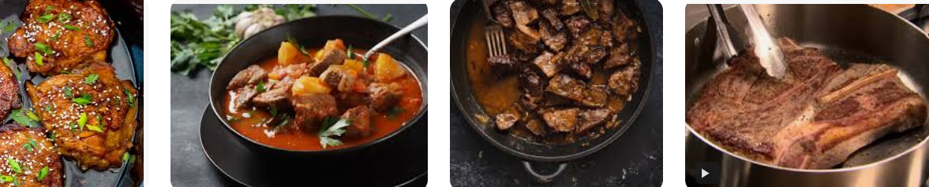
Figure: 2.3. Food cooked by Braising
Methods of Braising
There are two methods of Braising
- Brown Braising
- White Braising

Brown Braising: Joints and portioned size meat is marinaded, larded and sealed by browning on all side in oven. Sealing helps to retain flavour, nutrition and good brown colour. Joints are then placed on bed of root vegetables in a braising pan with liquid and other flavourings and then covered with lid and cooked slowly in oven.
White Braising: White braising is used for vegetables and sweetbreads. Food is blanched, refreshed and cooked on bed of root vegetables. Food is then placed in a covered pan with white stock and placed in oven.
Advantages of Braising
- Tougher and less expansive meat and poultry can be cooked using this method
- Maximum flavour and nutrition can be retained
- It gives a variety to food presentation and menu

II. DRY HEAT METHODS OF COOKING
Dry-heat methods are those in which the heat is conducted without moisture-that is, by hot air, hot metal, radiation, or hot fat. We usually divide dry-heat methods into two categories: without fat and with fat. Dry heat methods of cooking are as under:
- Baking
- Roasting
- Grilling

BAKING
"Baking is cooking of food by dry heat in an oven in which the action of dry heat is modified by steam"
Purpose of Baking
- To make food palatable, digestible and safe to eat
- To create eye-appeal through colour and texture
- To produce an enjoyable eating quality
- To lend variety in the menu card
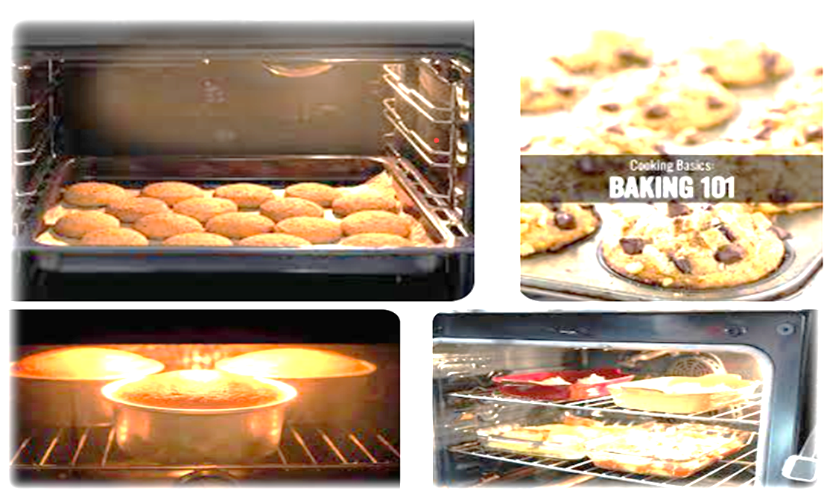
Figure 2.4. Food Cooked by Baking

Effect of Baking
There is chemical action on ingredients like sugar, yeast, baking powder etc. Changes the raw structure of food which depends upon the different ingredients and ways of mixing the same.
Principles of Baking
- The conventional convection oven should be pre-heated (This gives the correct starting temp.)
- Products should be placed evenly in the oven (This allows the even hot air circulation)
- Products should be placed in greased or lined tins or tray ( Helps to remove finished food easily)
- Items taking long time should be placed in lined tin at lower shelf (prevent drying & burning of crust )
Dry Baking
In this method when food is placed in pre-heated oven, steam arises from water content of food, this steam combines with the dry heat of the oven is used to cook food.
Using this method Cakes, Pastry, Baked jacket potatoes etc. are prepared.
Baking With Increased Humidity
In this method while baking the humidity of oven is increased by placing a bowl of water of injecting steam thus increasing water content in food which improves eating quality of the food. This is used to bake bread.
Baking With Heat Modification
In this method food is placed in container. Food items such as egg custard is baked in this way, this prevents the over cooking of food.
Advantages of Baking
- A wide variety of sweet and savory food is prepared
- Baking yields appetizing, eye-appealing food with mouth watering aroma
- Uniformity in color and degree of cooking can be achieved even in bulk cooking
- Temperatures can be effectively controlled
- Adding and removing food for baking is very easy
General Rules
- Oven should always be pre-heated
- Accuracy is essential in measuring and weighing and controlling temperature
- Trays and moulds should be greased or lined
- Once process of baking starts minimize the opening the doors of oven
- Use thick dry oven mitts while placing or removing food in oven
- Trays and oven should not be overloaded
- One should be very careful while placing food in oven and while removing the same

ROASTING
"Roasting is to cook food over a source of radiant heat such as on spit, open fire or oven". Now the term roasting is also used to describe cooking of food in an oven with the addition of fat or oil. Thus oven roasting is a combination of convection and radiation.
Types of Roasting
- Oven Roasting
- Spit Roasting
- Pot Roasting
- Tandoori Cooking
Oven Roasting: It is cooking food in an oven. In this method hot convection of air is produced inside the oven which is responsible for cooking of food. Heat conducted from the base of cooking try is responsible for browning of food which is desirable with some food e.g. Potatoes, where a crisp golden brown colour is required.
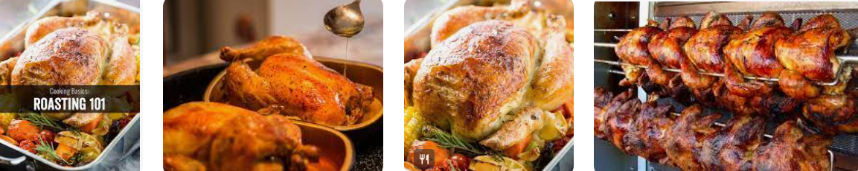
Spit Roasting: Food is cooked over spit (live charcoal) or open fire. Food is rotated slowly over the source of heat, and is cooked by radiant heat and convection of air depending upon the position of food in relation to fire. Usually large joints of meat are cooked by this method. This method produces its own distinct colour, flavour and texture in cooked food.
Pot Roasting: Pot roasting is cooking food on bed of root vegetable in a covered pan. This is not a true roast as moist heat (steam) trapped under the lid of closed utensil is used to cook the food. This method is also known as POÊLÉ. Using this method will result in retention of maximum flavor of ingredients.
Tandoori Cooking: Tandoori cooking is done in a clay oven known as tandoor using dry heat. Although the source of heat is at the base of the oven but heat is evenly distributed as clay radiates heat evenly.
Method
- The marinated food (marinating may be done 20Min to 2 Hr. in advance depending upon the type of food)
- such as meat, fish & poultry is placed vertically inside the oven.
- Naan etc are slapped on the wall of the tandoor
- The temperature of tandoor is 375⁰C or 700⁰F
Advantages of Roasting
- Good quality of meat and poultry is tenderized and succulent when roasted
- Meat juices oozing from the joints are used for gravy and enhance flavor
- Energy and oven temperature can be controlled
- Ovens with transparent doors enable cooking to be observed
- Access, adjustment and removal of food is very easy
- This method involves the minimum risk of Fire

GRILLING
This is a fast method of cooking by radiant heat and is also known as "Broiling". This is of following four types.
- Over heat
- Under heat
- Between heat
- Barbecuing
Over Heat: Food is cooked over hot grill bars. Grill bars are pre-heated and brushed with oil otherwise food will stick to the bars. The cooking time will depend upon the thickness of food and temperature of grill bars.
Under Heat: The source of heat to cook the food, is over the food (salamander)
Between the Heat: This is grilling the food in between electrically heated grill bars or plates. This method is used for small cuts of meat
Barbecuing: This is grilling of food on pre-heated, greased bars over fierce heat (gas, Charcoal or wood) when solid fuel is used care should be taken that food is placed on bars when flame and smoke dies out. Food is marinated a brushed with barbecue sauce during cooking
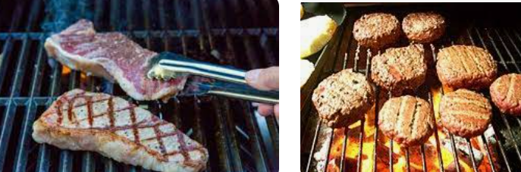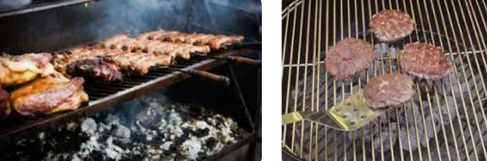
Figure 2. . Food cooked by Grilling Method
Advantages of Grilling
- Speed of grilling enables the food to be cooked to order
- Charring of food gives a distinctive appearance and flavor
- Control of cooking is aided because food is visible while cooked
- Variety is given to menu and diet
- Grill may be suitable in view of customer

Portion Controlling
Portion control is the establishment of standard sized portions for all your menu items and then following those standards in the preparation ad serving of meals. Portion control is the process of serving the menu items in the planned portion sizes. Portion control is not limiting the amount of food being served to measure calories, as we noted, this is a generous portion size, one any restaurant patron would find satisfying. Portion control for foodservice is about planning the size for all your menu options and then accurately serving the specified portion every time that menu item is prepared. For this example, it translates to making sure that each meatball is 2 ounces, and each serving of pasta is 1-1/2 cups with ¾ cup of sauce. Without portion control, you will run into several problems:
Consistency is important when you are delivering on a promised standard. Not too much or too little food, you have to use in the kitchen to keep your portion sizes consistent.
    - Portion control Tools
There are a wide variety of tools available to ensure that you can control portion sizes and provide consistent servings with every meal.
Portion Scales – Portion scales can be used with all types of dry ingredients, meats, breads even pastas. There are a wide variety of scales available but the digital scales are the easiest for measuring small quantities accurately.
Portion Utensils – from dishers to spoodles, portion utensils are designed to serve a certain amount of a menu item. A 2 oz. portion of eggs can be dished out with a 2 oz portion server. For sticky items, like mashed potatoes, a disher can be used like the 6 oz. exact capacity Rite-Size- Disher.
Batter Dispensers – These are great tools for portioning out any types of batter, from muffins to pancakes. They work well with any viscous liquid.
Portion Control Servers- Portion control servers are great for dishing out products and are commonly used in buffets and salad bars. How Do They Work? These are spoons to serve items such as fruits and vegetables, mashed potatoes, and practically any item that should be scooped on a bar or in a buffet-style setting.
Portion Control Dishers- Portion control dishers are great tools that allow you to measure and scoop rice, ice cream, vegetables, cookie dough, and other soft foods. How Do They Work?
Dishers typically have a spring clip on the handle that can be activated by pressing a thumb lever. This will help release the food items onto a plate or bowl.
Food Scales- A kitchen scale (also known as a food scale) helps you follow a recipe more accurately than using dry or liquid measuring cups. How Do They Work? Scales save you time because you won’t have to count out nuts, tomatoes, or other food items manually. You won’t have to try to guess what a 4-ounce serving of pasta or a four-ounce serving of salmon looks like.
Portion Cups- Portion cups are typically used to hold a set amount of dressing, condiments, or any product. How Do They Work? These cups hold a certain amount of product, so by filling them with product you can portion out the amount in ounces.
Measuring Cups_ A measuring cup is a kitchen tool used to measure the volume of a solid or liquid ingredient like sugar or flower. How Do They Work? By filling the cup to the desired amount—using the marked graded amounts—you can portion out the exact amount of ingredients to go into a dish/meal.

Importance of Portion Control Matter
Many foodservice organizations and commercial kitchens are focused on portion control because:
1. Helps Manage Food Costs
For one, portion control allows you to better manage food costs by giving you regulated portions with each meal. Managing portions ensures there are no surprise food costs.
2. Helps Manage Food Waste
Not only does it help lower your food cost, but portion control also helps to reduce food waste. Finding the right portion sizes will help you better manage food waste.
3. Helps Maintain a Consistent Customer Experience
The practice of portion control in your business leads to increased customer satisfaction through consistency in your meals. Without it, your portions may vary widely in size, leaving customers unsure of what they’ll receive. Without consistency you’ll see a smaller number of loyal customers and less returning eaters.

Meeting Customer Requirements
Customer requirements refer to the specifications or features of a product or service that are deemed necessary by customers. These requirements motivate customers to buy a product or service. To determine customer requirements, companies can research their target market to understand their desires and needs.
Customers’ requirements vary based on the foods or services sold by a restaurant. Restaurants can combine various requirements to ensure that they meet as many of the customers’ needs or desires as possible.

Common Basic Requirements of Customers
The following are common and basic requirements of customers for any type organizations

- Price
- Quality
- Functionality
- Reliability
- Performance
- Sustainability
- Transparency
- Convenience
- Efficiency
- Risk reduction
- Safety
- Compatibility
- Options
- Control
- Experience
- Design
- Accessibility
- Privacy
- Empathy
- Information

Special Dietary Requirements of Customers
Special Diets are meal plans that control the intake of certain foods or nutrients. It could be part of the treatment of a medical condition, religion, allergy condition, and/ or personal preference.
- Vegetarian and Vegan
Being vegan and vegetarian are usually mentioned in the same category of dietary restrictions, but one is significantly more restrictive than the other. Both vegetarian and vegan diets avoid animal products, with veganism being the more restrictive of the two.
Vegetarians avoid all meat – including chicken, turkey, beef, pork, and fish. Pescetarians are typically included in the vegetarian bucket – they don’t eat beef or poultry, but do consume fish products. Both vegetarians and pescetarians eat dairy products and eggs.
Veganism is a stricter form of vegetarianism, and vegan restrictions avoid all animal products, including meat, dairy, and eggs. Raw vegans take this one step further, only eating uncooked fruits, vegetables, grains, and other non-animal products.

- Lactose Intolerance
Lactose is a type of sugar that is found in milk and other dairy products. Those who are lactose intolerant lack the enzyme to break down lactose, causing digestive problems and discomfort. Lactose pills can be taken to help replace this enzyme, but those who are lactose intolerant tend to avoid high-lactose dairy products overall. Plant-based milks and low-lactose dairy products (like hard cheeses, yogurt, and butter) are both good options for lactose-intolerant people.

- Gluten Intolerance
Gluten is a protein found in wheat, barley and rye. Those who are intolerant to gluten are split into two main categories: celiac disease, and non-celiac gluten intolerance.
Celiac disease is an auto-immune disease triggered by gluten, and causes gastrointestinal discomfort and inflammation of the small intestine. Over time, those with celiac disease who consume gluten can cause irreparable damage to their digestive tract.
Non-celiac gluten intolerance causes similar symptoms (GI discomfort), but without the autoimmune response. In both cases, those with any sort of gluten sensitivity avoid gluten as a whole, and instead look for items made with gluten-free grains like oats, rice and quinoa.

- Peanut Allergies
Allergies are the most severe of dietary restrictions meaning that you need to take a whole new level of precaution with food preparation.
Peanut allergies are extremely common. Children are the most likely to have a peanut allergy (and eventually outgrow it), but 1 - 2% of adults are allergic to peanuts as well. Reactions can vary – some individuals with a peanut allergy experience minor discomfort or itching, while others can experience severe anaphylaxis and require an epipen and a trip to the hospital.

- Religious Food Restrictions
While not an exhaustive religious dietary restrictions list, here are two common religious food restrictions:
- Kosher
Kosher food is in compliance with Jewish dietary laws. Kosher foods are broken down into three categories: meat, dairy, and pareve (or neutral). Essentially, those who keep kosher do not mix meat and dairy products. There are other guidelines as well, including not using the same utensils or equipment for meat and dairy, as well as certification requirements from kosher organizations.
- Halal
Halal is the Islamic dietary standard. Halal foods must be produced in a specific manner, specifically animal raising and slaughtering, and have certain foods prohibited. Similarly to kosher rules, in order for a food to be halal, it must be certified by an accredited bureau.

Self-Check 2
Part I: Choose the Correct Answer from the Given Alternatives.
- Which of the following is an essential baking equipment for measuring ingredients accurately?

  - Mixing bowls
  - Whisk
  - Measuring cups and spoons
  - Rolling pin
  - Baking sheet

- What is the purpose of a pastry brush in baking?

  - Mixing ingredients
  - Cutting dough
  - Spreading glazes or egg wash
  - Shaping cookies
  - Cooling baked goods

- Which of the following is a common sweetener used in baking?

  - Salt
  - Baking soda
  - Vanilla extract
  - Honey

- Which baking equipment is used to create decorative patterns or cutouts on dough or pastry?

- Pastry brush
- Rolling pin
- Cookie cutter
- Whisk
- Oven thermometer

5. Which of the following is a leavening agent commonly used in baking?

- Baking powder
- Salt
- Sugar
- Flour
- Butter

6. What is the primary purpose of using eggs in baking?

- Adding flavor
- Binding ingredients together
- Adding moisture
- Providing structure
- Enhancing color
- Yeast

7. Which baking equipment is used to evenly distribute heat and ensure even baking of cakes and cookies?

  - Oven thermometer
  - Baking mat
  - Cooling rack
  - Electric mixer
  - Baking pa
9. What is the main purpose of using butter or oil in baking?

- Adding flavor
- Binding ingredients together
- Providing structure
- Adding moisture
- Enhancing color

10. Which of the following is a common flour used in baking?

- All-purpose flour
- Baking powder
- Salt
- Sugar

11. Which of the following is a leavening agent commonly used in baking?

Baking powder

Salt

Sugar

Flour

Butter

12. What is the primary purpose of using eggs in baking?

Adding flavor

Binding ingredients together

Adding moisture

Providing structure

Enhancing color

13. Which of the following is a common sweetener used in baking?

Salt

Baking soda

Vanilla extract

Honey

Yeast

14. What is the main purpose of using butter or oil in baking?

Adding flavor

Binding ingredients together

Providing structure

Adding moisture

Enhancing color

15. Which of the following is a common flour used in baking?

All-purpose flour

Baking powder

Salt

Sugar

Yeast

16. Which cooking method involves cooking food in a small amount of fat over high heat?

Grilling

Roasting

Sauteing

Steaming

Braising

17. Which cooking method involves cooking food in a liquid at a low temperature for a long period of time?

Boiling

Grilling

Roasting

Braising

Frying

18. Which cooking method involves cooking food in an oven with dry heat?

Boiling

Grilling

Roasting

Braising

Frying

19. Which cooking method involves cooking food in a liquid that is brought to a boil and then reduced to a simmer?

Boiling

Grilling

Roasting

Braising

Frying

20. Which cooking method involves cooking food directly over an open flame or heat source?

Boiling

Grilling

Roasting

Braising

Frying

Part II: Answer the Following Answers
- Explain the similarity and difference of food scales, portion cups, and measuring cups.

Unit Three: Packing Foods
This learning guide is developed to provide you the necessary information regarding the following content coverage and topics:
  - Understanding preconditions of packaging
  - Selecting Packaging materials for specific foods
  - Applying Packaging procedure
  - Labeling foods

This guide will also assist you to attain the learning outcomes stated in the cover page. Specifically, upon completion of this learning guide, you will be able to:
- Ensure food meets requirements prior to packaging in terms of quality, shelf life, microbiological condition and portion control
- Select packaging materials appropriate to specific foods, storage or transport requirements according to enterprise procedures
- make sure packaging is suitable for transportation and handling
- Pack Food items using appropriate packaging procedures according to enterprise specifications.
- Label foods according to the international standard regulations

Understanding preconditions of packaging

Introduction
Packaging is the scientific method of containing food products against physical damage, chemical changes, further microbial contamination and to display the product in the most attractive manner for consumer preferences.
Food packaging lies at the very heart of the modern restaurants and fast food outlets and very few foods are sold unpackaged. Good packaging prevents waste and ensures that the food retains its desired quality throughout its use and shelf life.

- Functions of packaging
Packaging has the following main functions:-
- It contains the food product for ease and safety during transport.
- Protects against spillage, evaporation or pilferage losses.
- Protection from contamination.
- Prevention of degradation from exposure to environmental factors
- Convenient means of dispensing
- Attraction of consumer
- .Identification of manufacturer’s brand, quantity quality and type of product
- .Educate the consumer
- Characteristics of package
Packaging represents a multifaceted aspect of product presentation that requires careful attention to a range of features. It’s understandable that incorporating all these different elements into your packaging design may feel overwhelming.

Selecting Packaging materials for specific foods
Packaging is important because it aids food distribution, and rapid and reliable distribution helps remove local food surpluses, allows consumers more choice in the foods available and helps to reduce malnutrition. Packaging also reduces post cooking losses, which together with giving access to larger markets, allows producers to increase their incomes.
Packaging materials can be grouped into two main types:
Shipping containers, which contain and protect the contents during transport and distribution but have no marketing function. Examples include sacks, corrugated fiberboard (cardboard) cartons, shrink-wrapped or stretch-wrapped containers, crates, barrels or drums.
Retail containers: which protect and advertise the food for retail sale and home storage. Examples include metal cans, glass or plastic bottles and jars, plastic tubs, pots and trays, collapsible tubes, paperboard cartons and flexible plastic or paper bags, sachets and overwraps.
Frequently more than one type of material is used to package a single product.

Types of packaging materials
- Traditional materials
These materials have been used since the earliest times for domestic storage and local sales of foods. However, with the exception of glazed pottery, they have poor barrier properties and are only used to contain foods and keep them clean. A summary of the main types of traditional materials and possible current uses are as follows:
- Leaves, Vegetable Fibers and Textiles
Leaves are cheap and readily available, and are used as wrappers for products such as cooked foods that are quickly consumed. Banana or plantain leaves are used forS wrapping traditional cheese and fruit confectionery such as guava cheese. Maize leaves are used to wrap corn paste or blocks of brown sugar, and 'Pan' leaves are used for wrapping spices in India. Other examples are green coconut palm, papyrus leaves and bamboo and rattan fibers, which are woven into bags or baskets.
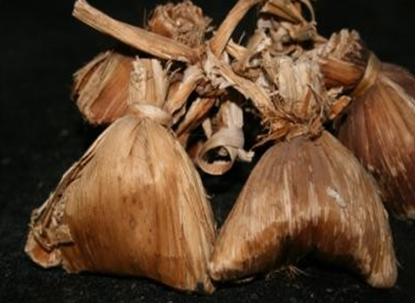
Fig. 2. Traditional leaf packaging of coffee beans.
- Wood
Wooden containers protect foods against crushing, have good stacking characteristics and a good weight-to-strength ratio. Wooden boxes, trays and crates have traditionally been used as shipping containers for a wide variety of solid foods including fruits, vegetables and bakery products.
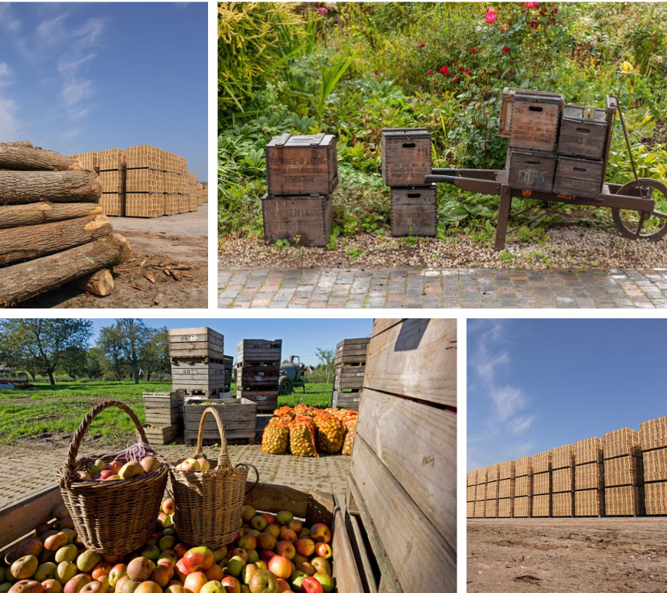
Figure 5: Wood Packaging
- Leather
Leather containers made from camel, pig or kid goat hides have traditionally been used as flexible, lightweight, non-breakable containers for water, milk and wine.
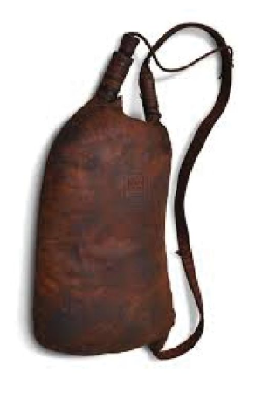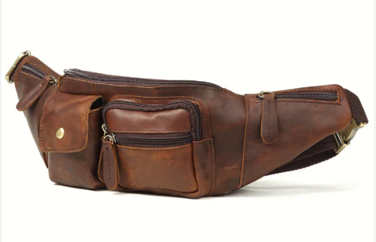
Figure 6: Traditional Leather packaging

- Earthenware
Pottery is still used domestically for storage of liquid and solid foods such as yoghurt, beer, dried foods, honey, etc.. Corks, wooden lids, wax or plastic stoppers, or combinations of these are used to seal the pots. If they are glazed and well-sealed, they prevent oxygen, moisture and light from entering the food and they are therefore suitable for storing oils and wines. They also restrict contamination by micro-organisms, insects and rodents.

- Industrial materials
These materials have been developed over the last 200-300 years and are the main types of packaging used in recent time food processors.
- Metal containers
There are two basic types of metal cans: those that are sealed using a ‘double seam’ and are used to make canned foods and those that have push-on lids or screw-caps that are used to pack dried foods (e.g. milk or coffee powder, dried yeast) or cooking oils respectively. Double-seamed cans are made from tinplated steel or aluminium and are lined with specific lacquers for different types of food. Cans have a number of advantages over other types of containers when sealed with a double-seam they provide total protection of the contents; they are tamperproof; and they can be made in a wide range of shapes and sizes.
- Glass
Glass bottles and jars have some of the advantages of metal cans: they are impervious to micro- organisms, pests, moisture, oxygen and odours; they do not react foods or have chemicals that migrate into foods; they can be heat processed; they are recyclable, and (with new lids) they are re-useable; they are rigid, to allow stacking without damage; and unlike metal cans, they are transparent to display the contents.
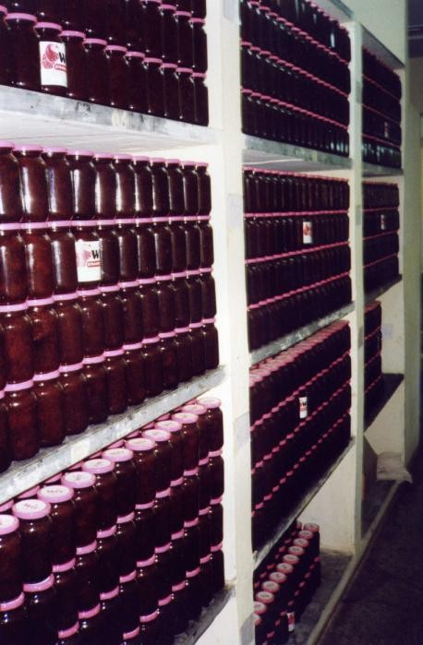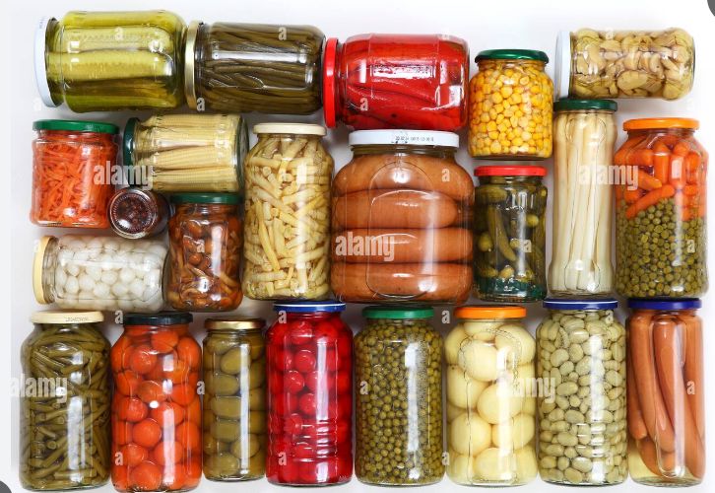
Fig. 3.1. Glass jars used by a small- scale jam maker

- Paper and cardboard

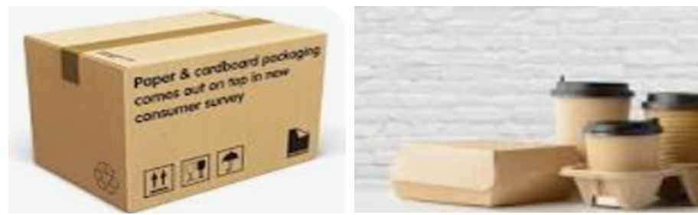
Paper and boards are made from wood pulp and additives are mixed into the pulp to give strengthens. Particular properties to the packaging, including:

Fillers such as china clay, to increase the brightness of paper and improve surface smoothness and printability. Binders, including starches, vegetable gums, and synthetic resins to improve the strength. Resin or wax sizing agents to reduce penetration by water or printing inks.
Pigments to colour the paper and other chemicals to assist in the manufacturing process.

- Flexible plastic films
In general, flexible plastic films have relatively low cost and good barrier properties against moisture and gases; they are heat sealable to prevent leakage of contents; they add little weight to the product and they fit closely to the shape of the food, thereby wasting little space during storage and distribution; they have wet and dry strength, and they are easy to handle and convenient for the manufacturer, retailer and consumer. The main disadvantages are that (except cellulose) they are produced from non-renewable oil reserves and are not biodegradable. Concern over the environmental effects of non-biodegradable oil-based plastic packaging materials has increased research into the development of ‘bio plastics’ that are derived from renewable sources, and are biodegradable.
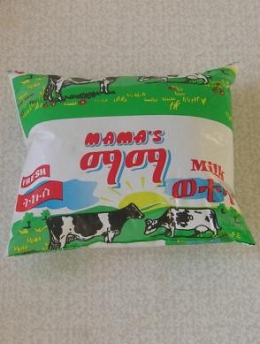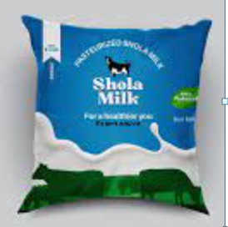
Fig. Milk packaged in flexible film.

A Summary of the Main Different Types of Flexible Plastic Films
Cellulose
Plain cellulose is a glossy transparent film that is odourless, tasteless and biodegradable (within approximately 100 days). It is tough and puncture resistant, although it tears easily. It has dead-folding properties that make it suitable for twist-wrapping (e.g. sugar confectionery). However, it is not heat sealable and the dimensions and permeability of the film vary with changes in humidity.
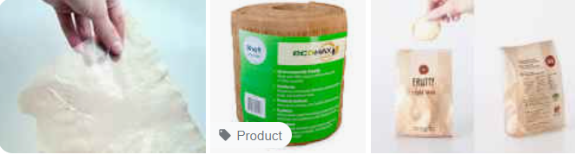
Figure 3.2: Cellulose Packing

Polyethylene (or polythene)
Low-density polyethylene (LDPE) is heat sealable, inert, odour free and shrinks when heated. It is a good moisture barrier but is relatively permeable to oxygen and is a poor odour barrier. It is less expensive than most films and is therefore widely used for bags, for coating papers or boards and as a component in laminates. LDPE is also used for shrink- or stretch-wrapping
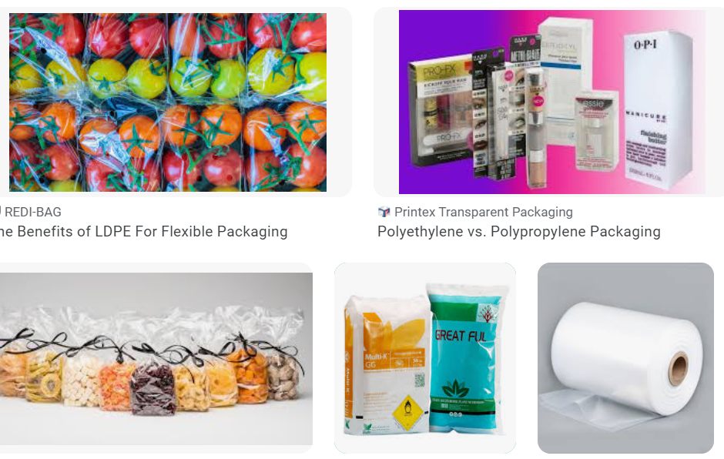
Figure 3.3: Polyethylene Packaging

Polypropylene
Polypropylene is a clear glossy film with a high strength and puncture resistance. It has a moderate barrier to moisture, gases and odours, which is not affected by changes in humidity. It stretches, although less than polyethylene. It is used in similar applications to LDPE. Oriented polypropylene is a clear glossy film with good optical properties and a high tensile strength and puncture resistance. It has moderate permeability to gases and odours and a higher barrier to water vapour, which is not affected by changes in humidity. It is widely used to pack biscuits, snack foods and dried foods.
Other films
Polyvinylidene chloride is very strong and is therefore used in thin films. It has a high barrier to gas and water vapour and is heat shrinkable and heat sealable. However, it has a brown tint which limits its use in some applications. Polyamides (or Nylons) are clear, strong films over a wide temperature range (from – 60 to 200°C) that have low permeability to gases and are greaseproof. However, the films are expensive to produce, require high temperatures to heat seal, and the permeability changes at different storage humidity.

Coated films
Films are coated with other polymers or aluminums to improve their barrier properties or to impart heat salability.

Laminated films
Lamination (bonding together) of two or more films improves the appearance, barrier properties or mechanical strength of a package.

Coextruded films
Coextrusion is the simultaneous extrusion of two or more layers of different polymers to make a film. Coextruded films have three main advantages over other types of film: they have very high barrier properties, similar to laminates but produced at a lower cost.
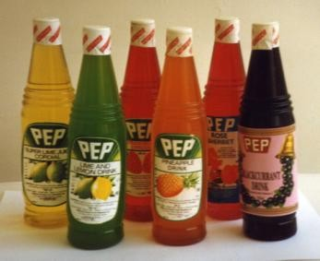

Rigid and semi-rigid plastic containers

There is a wide range of plastic bottles, pots, jars, trays and tubs made from single or coextruded plastics that are increasingly used for processed foods.

Applying Packaging Procedure
Food packaging procedures refer to the steps and regulations followed to ensure that food products are packaged safely and hygienically. These procedures are crucial to maintain the quality, freshness, and safety of the food throughout its shelf life.

Here is Food Packaging Procedures:
Step 1. Sanitization: All packaging equipment and surfaces should be thoroughly cleaned and sanitized before use to prevent contamination.
Step 2. Quality control: Regular inspections and quality checks should be conducted to ensure that the packaging materials are in good condition, free from defects, and meet the required standards.
Step 3. Product handling: Proper handling techniques should be followed to avoid any physical damage to the food products during packaging. This may include using appropriate tools and equipment, as well as ensuring cleanliness and hygiene of the workers.
Step 4. Product labeling: Each packaged food item should be properly labeled with essential information such as product name, ingredients, nutritional facts, allergen warnings, and expiration date. This helps consumers make informed choices and ensures compliance with labeling regulations.
Step 5. Packaging materials: The selection of suitable packaging materials is important to protect the food product from external factors such as light, moisture, and oxygen. Packaging materials should be food-grade, safe, and capable of maintaining the product's quality and freshness.
Step 6. Seal integrity: Proper sealing techniques should be employed to prevent any leakage or contamination. This may involve using heat sealing, vacuum sealing, or other appropriate methods depending on the type of packaging.
Step 7. Storage and transportation: Packaged food products should be stored and transported under appropriate conditions to maintain their quality and safety. This may include temperature control, protection from physical damage, and avoiding exposure to harmful substances.
Step 8. Compliance with regulations: Food packaging procedures should adhere to local, national, and international regulations regarding food safety, labeling, and packaging standards.
It is important for food producers and processors to implement these procedures consistently to ensure the safety and quality of their products.

Labeling Foods

Meaning of Food Labeling
Food labeling tells consumers about the, ingredients, and nutritional composition of packaged food for sale. Labels may also contain information about the conditions under which the food was produced. Food labels should give you information about the food inside the packaging, shelf life and storage instructions to help you make informed decisions about the foods you buy. Food labels should also show an ingredients list with the most common allergens clearly emphasized so they stand out from the other ingredients.
Food labeling is designed to protect the health and well- being of consumers. It allows customers to: know what ingredients are in the food determine the relative amounts of each ingredient determine how much of selected vitamins, minerals, and other nutrients a food contains. This information may be given either by weight OR as a percentage of a daily requirement value examine foods for potential allergens, additives, or ingredients that they wish to avoid learn about the conditions under which certain ingredients were produced (e.g. organic, free-range) compare the price per unit volume or weight of similar products determine if nutrients have been added or removed from the base food (e.g. enriched, reduced fat)

Basic Components of Food Labeling
Basic Elements on Your Food Product Labels
Most countries have precise requirements for what to include on food packaging labels. If you’re selling cannabis or packed food products, you’ll want to check out the labeling requirements.
Here are the five elements that must go on every food label:
1: Statement of Identity
Your product must be clearly identified on the package label. For example, a sauce jar label could have something like “Ethiopian Sauce. Made wiyh 35 herbs and spices.”
You must also indicate the intended use. For instance, a honey jar could say, “Raw Organic Honey from the Rocky Mountains. Mix in your coffee or drizzle on top of your favorite toast.”
Most people know how to use the package’s food; however, suggestions are a great way to inspire a purchase.
2: Net Weight
The net weight is the weight of the food or contents without packaging. Your net quantity statement needs to be on the front bottom 30% of your food label. It should also be on the outer package or box.
3: Manufacturer Information
Include the name and address of the manufacturer, packer, or distributer. You’ll also need to include a qualifying phrase that describes your company’s relationship to the firm (‘distributed by,’ ‘manufactured for,’ etc.).
4: Nutrition Facts
These next two are the big ones. They’re what your consumers are looking for while shopping.
Place the nutrition facts and ingredients on the same panel to make it easier for consumers to quickly find the information they need. The nutritional panel should include:
Serving Size
Nutrients
Vitamins and Minerals
The information must be perfectly readable. The FDA recommends using well-contrasted text and background colors. Basically, print the panel in black or dark text on a white or light background.
Font size, hairlines, and type are essential here as well. Ensure your intended audience can easily read the facts.
Keep in mind the serving size requirements. You’ll need to ensure the serving size is the recommended portion by authorities for your specific food product.
5: Ingredients
The ingredients can be challenging because everything that went into the food or liquid needs to be on the label. And they need to be listed in order of most to least in the amount used for the product.
Be sure to include any disclaimers about allergens, such as “this product was made in a facility that uses peanuts, lactose, etc.

Self-check 3
Part I: Choose the Correct Answer from the Given Alternative.
1. What is the purpose of labeling food items in a fast food display?

  - To provide nutritional information to customers
  - To indicate allergens or potential food sensitivities
  - To help customers make informed choices
  - All of the above
2. How can fast food restaurants cater to customers with dietary restrictions or preferences in their food display?

a) Clearly labeling vegetarian or vegan options
b) Providing gluten-free or allergen-free alternatives
c) Offering customizable food options
d) All of the above
3. How can food restaurants ensure that their food display is visually appealing?
a) Using vibrant colors and fresh ingredients

b) Arranging food in an organized and attractive manner
c) Regularly refreshing the display to maintain freshness
d) All of the above

Part II: Answer the Following Questions
- List the food packaging procedures.
- What is the functions of packaging?

Unit Four: Chilling and Freezing Cooked Food
This unit is developed to provide you the necessary information regarding the following content coverage and topics:
- Meeting Time and temperature standards for blast and water-bath chilling
- Freezing Foods
- Storing Chill and Freeze Foods
- Labeling frozen food items
This unit will also assist you to attain the learning outcomes stated in the cover page.
Specifically, upon completion of this learning guide, you will be able to:
- Meet Time and temperature standards for blast and water-bath chilling.
- Freeze Food according to appropriate food safety standards.
- Select appropriate containers for storage.
- label frozen food items according to relevant food standards and codes of practice storage temperatures are accurately monitored and recorded

Meeting Time and temperature standards for blast and water-bath chilling
Introduction
Food safety is of utmost importance in all food industries. Time and temperature relationship are critical to the growth and spread of contamination. Bacteria multiplies very fast between +5°C and +65°C (Danger Zone). The faster cooked foods chills and passes through this danger zone, the less chance there will be of bacteria growth. As a bacterium can split into 2 in every 20 minutes and multiply almost 69 million within 12 hours.
Prepared food that will not be eaten right away should be cooled as soon as possible, stored at the right temperature, and heated thoroughly before being eaten. Do not leave prepared food at room temperature for too long.
We cool hot cooked food down for various reasons, for example:
Prepare meat stew or poon choi in batches ahead of time and chill it to be served later.
Cool freshly made soybean milk to serve cold.
Cool hot steamed rice to make it dry for preparing fried rice.
It is important to keep cooked foods out of the Temperature Danger Zone, which is between 4°C and 60°C, for as little time as possible after cooking to stop the growth of microorganisms that can cause foodborne diseases (food poisoning).
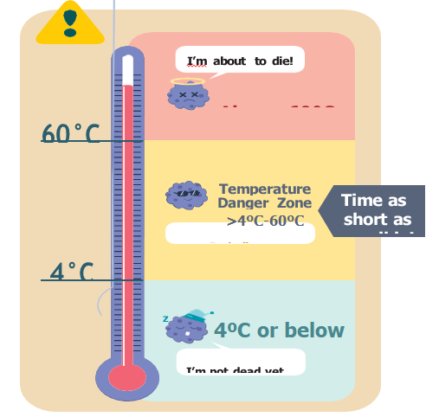
Figure: 4.1. Temperate danger Zone.
It is true that thorough cooking or reheating can kill bacteria and viruses in food that make you sick. However, the longer it takes to cool down the food, the more time the food is exposed to Temperature Danger Zone. Harmful bacteria can grow in food that is left to cool down slowly. Sometimes, these bacteria can produce heat-resistant toxins, which cannot be got rid of even by reheating.
Therefore, keeping food away from Temperature Danger Zone is equally important in addition to thorough cooking. This can be done by cooling food quickly and storing it at proper temperatures after cooling.

- Prepared foods that require extra care
Extra care should be taken with these foods to reduce the risk of food poisoning, particularly related to Bacillus cereus: because keeping food in temperature zone give this microorganism give chance to spread red the note on the following figure.
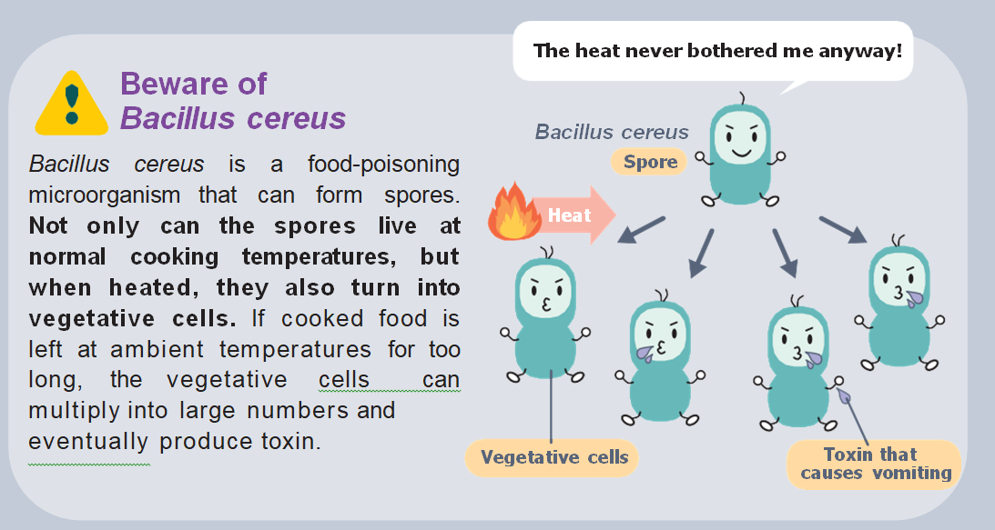Figure 4.2: Re-heating resistant Bacillus Cereus
Therefore, keeping food away from Temperature Danger Zone is equally important in addition to thorough cooking. This can be done by cooling food quickly and storing it at proper temperatures after cooling.

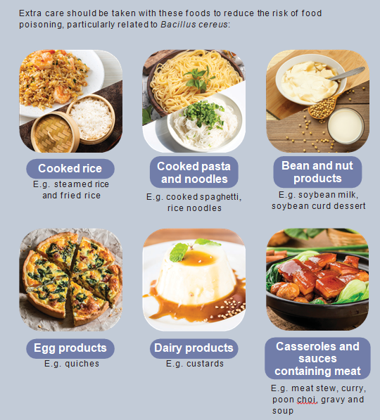
Figure: 4.3. Food need Extern Care
- Safe cooling down and storing of cooked food
Estimate how much food is needed carefully so as to avoid overproduction that can lead to running out of room for hot-holding, cooling and refrigeration
Plan the production schedule ahead of time so that food would not be made too far in advance and kept at unsafe temperatures for too long.
Food should be served immediately after cooking. If not, hot food should be stored at above 65°C. Otherwise, food should be cooled down fast and kept at 5°C or below.
Food should be kept as hot as possible or as cold as possible
- Hot holding
For hot holding, set up the equipment so that food stays above 65°C and use a thermometer to check the temperature of the food in the containers. Food that has been kept below 65°C for more than four hours should be thrown away.
- Cooling
Small amounts of hot cooked food can be readily cooled in a refrigerator. However, hot cooked food in bulk may need to be cooled quickly before being put in the fridge.
- Two Steps of Cooling
Step 1: Cooked food must be cooled to 20°C within two hours, and then cooled further from 20°C to 4°C in a refrigerator within two to four hours
Step 2: There are a few ways to speed up the cooling of food:
Cut the food into smaller pieces and put them in shallow, covered containers in an area with good air circulation.
Spread out food, like rice, on a tray.
Place pans of hot food in an ice water bath with stirring.
Separate cooked food from raw food during cooling
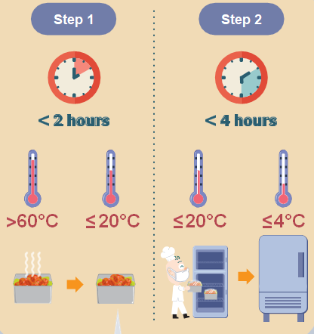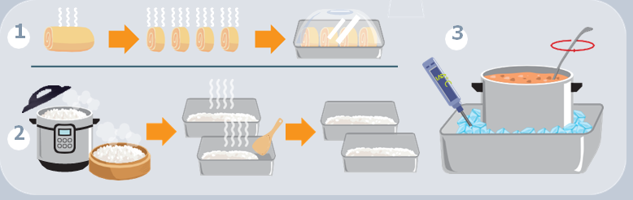
Figure --: Steps of Cooling
- Blast Chilling
Blast chilling is a method of chilling often used in large-scale restaurants, central kitchens, factories, and hotel kitchens.
Food can be divided into small portions and placed in shallow containers before being rapidly chilled to 4°C in a blast chiller within
1.5 hours. When blast chilling is done, place the food in the refrigerator or freezer.
The starting and ending temperatures, as well as the time of the entire blast chilling process, must be recorded.
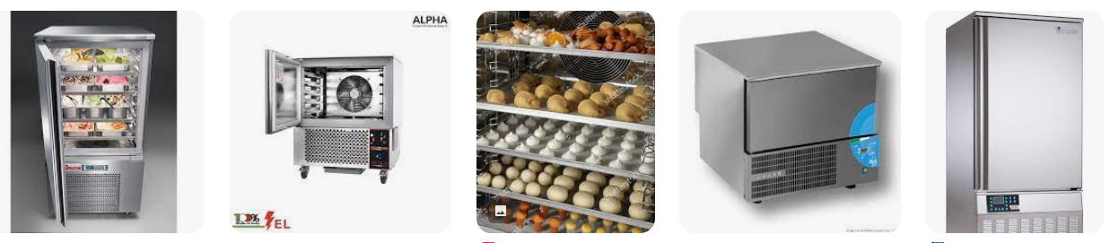
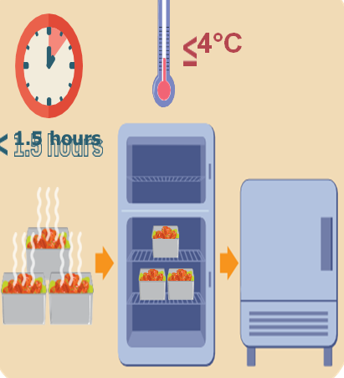
Figure: 4.4: Blast Chiller

- Freezing and Deep Freezing Foods (need amendment on curriculum)
Freezing is a great way to store food. It will help you save money by planning ahead. And it will help you to cut the amount of food you waste if you get it in the freezer before it goes off. If food is properly frozen it will stay safe to eat indefinitely, although after a time the taste and texture may hurt. Whether you have a chest freezer or upright freezer, the principles of good freezing are the same.

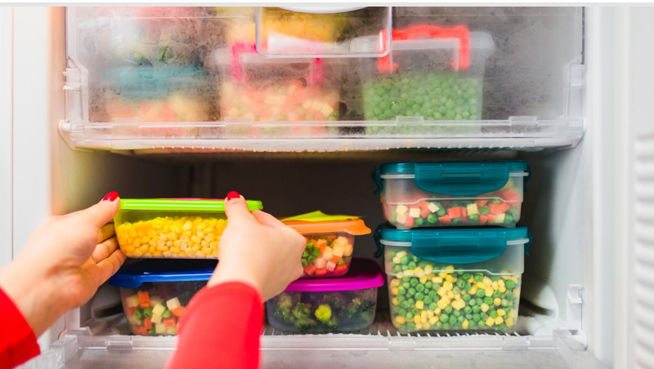Figure: Figure: 4.5. Proper Way Of Keeping to be Freezed Food

What is the correct storage time and temperature for foods in my freezer?
Storage times for frozen foods differ depending on the type of food and type of freezer you have. Freezers have a star rating to let you know how long the food can safely be stored. You should check the star rating, as well as the instructions on packaged frozen food. This will allow you to work out how long you can store the packaged frozen food in your freezer. Also, be aware that freezers should ideally run at -18°C.
Table 4.1. Correct Freezing Time and Temperature
* Frozen food compartment | Runs at - 6° C and should only store food for up to one week
** Frozen food compartment | Runs at -12° C and should only store food for up to one month
*** Frozen food compartment | Runs at -18° C and should only store food for up to three months
**** Freezer | Runs at -18° C and is suitable for long-term storage (three months or longer)

Deep Freeze Foods Items and Duration
Frozen food will remain safe indefinitely if frozen properly.
Table 4.2. Correct Deep Freezing Time and Temperature
Food type | Recommended freezing time frames (if your freezer runs at -18ºC)
Uncooked meat (roasts, steaks, chops etc) | 4-12 months
Uncooked mince meat | 3-4 months
Cooked meat | 2-3 months
Cured meats (ham & bacon ) | 1-2 months
Uncooked poultry (chicken, turkey etc) | 9-12 months
Cooked poultry | 4 months
Fish-raw & cooked | 2-4 months
Frozen dinners ( e.g. lasagne, pizza, shepherd’s pie) | 3-4 months
Soups, stews and casseroles | 2-3 months
Milk | Up to 1 month
Butter | Up to 3 months
Grated cheese | Up to 4 months
Vegetables | Up to 12 months
Fruit | Up to 6 months
Eggs – either separate the yolk and white, or beat the eggs before freezing | Up to 6 months
Cakes and baked goods without icing | 6-8 months
Bread | Up to 3 months
Raw pastry | 6 months

Food you can't freeze
Some foods simply are not freezer friendly.
Table 4.3. Food cannot be Frozen
Foods with a crumb base | These can go soggy when defrosted and reheated
Vegetables and fruits with a high water content, like lettuce, cucumber, bean sprouts, radishes and watermelons | These go limp and mushy
Soft herbs, like parsley, basil and chives | These will go brown
Egg-based sauces, such as mayonnaise | They will separate and curdle
Milk based sauces | They will separate
Plain yogurt, low-fat cream cheese, single cream and cottage cheese | These will go watery
Raw eggs in their shells | These will expand and crack
Hard-boiled eggs | These go rubbery
Canned foods

Top Guidelines for Using Freezer
1. Cool the food before freeze it
Freezing food when hot will raise the temperature of the freezer and could cause other foods to start defrosting. Dividing the food into smaller parts can speed up the cooling process.
2. Wrap the food properly or put it in sealed containers
If food is not sealed the food it can get “freezer-burn”. This means that water escapes from the food and moves to the coldest part of the freezer – leaving your food dehydrated. While this affects the quality of the food, it will still be safe to eat.
3. Freeze food in realistically sized portions
4. Label everything food that is freeze
If not labeled foods or ingredients clearly, it might not be remembered. Always add the date it was frozen.
5. Check the use-by date
Do not freeze any foods after their "use-by-date", because they will not be safe to eat.
6. Don’t let ice build up
An icy freezer is an inefficient one, so make sure you defrost your freezer if ice builds up. Don't worry about the food; most things will remain frozen in the fridge for a couple of hours while the freezer defrosts.
7. If in doubt, throw it out. Freezing does not kill bacteria.
8. Follow these steps to freeze fresh vegetables
Boil a handful of vegetables at a time for 30 sec in a pot of boiling water - this will stop them going brown when frozen.
Scoop them out into a bowl of heavily iced water - this is called blanching.
Once chilled, drain the veg and scatter them onto a tray lined with kitchen paper.
Freeze them on the tray and then transfer them to a freezer bag.
Cook the vegetables from frozen in a large pan of boiling water. Do not steam them, as they tend to go soggy.

Storing Chill and Freeze Foods
All of the steps included in the frozen food cold chain, need to be considered to provide high quality and safety.
Follow the guidelines below for storing food in the refrigerator and freezer. The short time limits for refrigerated foods will help keep them from spoiling or becoming dangerous to eat.
The guidelines for freezer storage are for quality only—frozen foods stored continuously at 0°F (-18°C) or below can be kept indefinitely.

Table 4.4. Guidelines below for storing food in the refrigerator and freezer

Food | Type | Refrigerator [40°F (4°C) or below] | Freezer [0°F (-18°C) or below]
Salad | Egg, chicken, ham, tuna, and macaroni salads | 3 to 4 days | Does not freeze well
Hot dogs | Opened package | 1 week | 1 to 2 months
Hot dogs | Unopened package | 2 weeks | 1 to 2 months
Luncheon meat | Opened package or deli sliced | 3 to 5 days | 1 to 2 months
Luncheon meat | Unopened package | 2 weeks | 1 to 2 months
Bacon and sausage | Bacon | 1 week | 1 month
Bacon and sausage | Sausage, raw, from chicken, turkey, pork, or beef | 1 to 2 days | 1 to 2 months
Bacon and sausage | Sausage, fully cooked, from chicken, turkey, pork, or beef | 1 week | 1 to 2 months
Bacon and sausage | Sausage, purchased frozen | After cooking, 3-4 days | 1-2 months from date of purchase
Hamburger, ground meats and ground poultry | Hamburger, ground beef, turkey, chicken, other poultry, veal, pork, lamb, and mixtures of them | 1 to 2 days | 3 to 4 months
Fresh beef, veal, lamb, and pork | Steaks | 3 to 5 days | 4 to 12 months
Fresh beef, veal, lamb, and pork | Chops | 3 to 5 days | 4 to 12 months
Fresh beef, veal, lamb, and pork | Roasts | 3 to 5 days | 4 to 12 months
Ham | Fresh, uncured, uncooked | 3 to 5 days | 6 months
Ham | Fresh, uncured, cooked | 3 to 4 days | 3 to 4 months
Ham | Cured, cook-before-eating, uncooked | 5 to 7 days or “use by” date | 3 to 4 months
Ham | Fully-cooked, vacuum-sealed at plant, unopened | 2 weeks or “use by” date | 1 to 2 months
Ham | Cooked, store-wrapped, whole | 1 week | 1 to 2 months
Ham | Cooked, store-wrapped, slices, half, or spiral cut | 3 to 5 days | 1 to 2 months
Ham | Country ham, cooked | 1 week | 1 month
Ham | Canned, labeled "Keep Refrigerated," unopened | 6 to 9 months | Do not freeze
Ham | Canned, shelf-stable, opened  Note: An unopened, shelf-stable, canned ham can be stored at room temperature for 2 years. | 3 to 4 days | 1 to 2 months
Ham | Prosciutto, Parma or Serrano ham, dry Italian or Spanish type, cut | 2 to 3 months | 1 month
Fresh poultry | Chicken or turkey, whole | 1 to 2 days | 1 year
Fresh poultry | Chicken or turkey, pieces | 1 to 2 days | 9 months
Fin Fish | Fatty Fish (bluefish, catfish, mackerel, mullet, salmon, tuna, etc.) | 1 - 3 Days | 2 - 3 Months
Fin Fish | Lean Fish (cod, flounder, haddock, halibut, sole, etc.) | 1 - 3 Days | 6 - 8 Months
Fin Fish | Lean Fish (pollock, ocean perch, rockfish, sea trout.) | 1 - 3 Days | 4 - 8 Months
Shellfish | Fresh Crab Meat | 2 - 4 Days | 2 - 4 Months
Shellfish | Fresh Lobster | 2 - 4 Days | 2 - 4 Months
Shellfish | Live Crab, Lobster | 1 day . | Not recommended
Shellfish | Live Clams, Mussels, Oysters, and Scallops | 5 - 10 Days | Not recommended
Shellfish | Shrimp, Crayfish | 3 - 5 Days | 6 - 18 Months
Shellfish | Shucked Clams, Mussels, Oysters, and Scallops | 3 - 10 Days | 3 - 4 Months
Shellfish | Squid | 1 - 3 Days | 6 - 18 Months
Eggs | Raw eggs in shell | 3 to 5 weeks | Do not freeze in shell. Beat yolks and whites together, then freeze.
Eggs | Raw egg whites and yolks  Note: Yolks do not freeze well | 2 to 4 days | 12 months
Eggs | Raw egg accidentally frozen in shell  Note: Toss any frozen eggs with a broken shell | Use immediately after thawing | Keep frozen, then  refrigerate to thaw
Eggs | Hard-cooked eggs | 1 week | Do not freeze
Eggs | Egg substitutes, liquid, unopened | 1 week | Do not freeze
Eggs | Egg substitutes, liquid, opened | 3 days | Do not freeze
Eggs | Egg substitutes, frozen, unopened | After thawing, 1 week or refer to “use by” date | 12 months
Eggs | Egg substitutes, frozen, opened | After thawing, 3 to 4 days or refer to “use by” date | Do not freeze
Eggs | Casseroles with eggs | After baking, 3 to 4 days | After baking, 2 to 3 months
Eggs | Eggnog, commercial | 3 to 5 days | 6 months
Eggs | Eggnog, homemade | 2 to 4 days | Do not freeze
Eggs | Pies: Pumpkin or pecan | After baking, 3 to 4 days | After baking, 1 to 2 months
Eggs | Pies: Custard and chiffon | After baking, 3 to 4 days | Do not freeze
Eggs | Quiche with filling | After baking, 3 to 5 days | After baking, 2 to 3 months
Soups and stews | Vegetable or meat added | 3 to 4 days | 2 to 3 months
Leftovers | Cooked meat or poultry | 3 to 4 days | 2 to 6 months
Leftovers | Chicken nuggets or patties | 3 to 4 days | 1 to 3 months
Leftovers | Pizza | 3 to 4 days | 1 to 2 months

Self-Check 4
Part I: Choose the Correct Answer from the Given Alternatives.
1. What is the temperature range that fever microorganisms?

  - 45°C
  - 5 to 65°C
  - 16 to 5°C
  - 180°C

2. What is the recommended temperature for cooling cooked food before refrigerating it?
  - 50°F (10°C)
  - 70°F (21°C)
  - 90°F (32°C)
3. Which method is the most effective for rapidly cooling hot food?
  - Leaving it uncovered at room temperature
  - Placing it in the refrigerator immediately
  - Submerging it in an ice bath
4. How long should you wait before refrigerating hot leftovers?
  - 1 hour
  - 2 hours
  - 4 hours5
5. What are the benefits of cooling cooked food before refrigerating it?
  - It helps prevent the growth of bacteria and foodborne illnesses.
  - It helps retain the quality and freshness of the food.
  - It allows for better organization and storage in the refrigerator.
6. What are the benefits of freezing food?
  - It extends the shelf life of food, allowing for longer storage.
  - It helps preserve the nutritional value of the food.
  - It provides convenience by allowing for pre-prepared meals or ingredients.

Part II. Answer the Following Questions.
    - Explain the steps that is used to cool food.
    - What is the difference between freezing and deep freezing?

Unit Five: Reheating Foods
This unit is developed to provide you the necessary information regarding the following content coverage and topics:
  - Thawing foods.
  - Reheating foods
This unit will also assist you to attain the learning outcomes stated in the cover page.
Specifically, upon completion of this learning guide, you will be able to:
- Remove and allow food items from the freezer
- Thaw according to enterprise procedures and food safety requirements.
- Transport food safely to the point of production and service, maintaining correct temperatures
- Prepare Food products for reheating appropriately.
- Space Reheating containers to allow airflow

5.1. Thawing Foods
Thawing:- Thawing is the process of taking a frozen product from frozen to a temperature (usually above 0°C) where there is no residual ice, i.e. “defrosting”.
When food is frozen at 0oC and below, some of the bacteria found in the food may be inactive but are still alive. When frozen food is thawed, its core temperature rises and bacteria may start to be active again and multiply. Frozen food should therefore not be left to thaw at room temperature, to prevent food poisoning bacteria that may be present from multiplying to high levels. Frozen food is recommended to be thawed in the chiller or by using a microwave oven. They can also be thawed under running water or in tap water but it must be placed in a leakproof package or container. Food handlers must plan ahead to allocate sufficient time and space; and use the appropriate method of thawing. Harmful bacteria can grow in food that is not thawed properly. Keep food safe by using a safe thawing method and by cooking thawed food thoroughly.
- Guidelines of Thawing
Thawing of Food
a) Thaw food thoroughly before cooking. Frozen or partially frozen food will require longer cooking time. The external surfaces of this food could be cooked, but the inner portion might remain uncooked and harmful bacteria within the food may not be killed.
b) Check for ice crystals in the food using your hand or a skewer. If food is not fully thawed, continue to thaw the food until no ice crystals are present. Test again before cooking or reheating. For poultry, check that the joints are flexible.
c) Cook thawed meat right away and do not refreeze thawed food. Improper handling and refreezing of food may lead to the growth of bacteria.
d) Thaw only the amount of food you require for cooking.
e) Follow the food manufacturer’s instructions on how to prepare food that does not need to be reheated after thawing, e.g. cheesecakes. When possible, thaw such food in the refrigerator.
f) Remember to separate raw meat from cooked or ready-to-eat food to prevent cross-contamination when thawing food.
g) Remember not to thaw food on the floor.

2) Three Ways to Thaw Food Safely
a) Thawing in the Refrigerator or Chiller Room
i. Plan ahead for sufficient time and space to defrost small amounts of food in the refrigerator. If you have limited space in your chiller, apportion food into smaller quantities before freezing. Place the required amount in the chiller when you need to thaw the food.
ii. Thaw food in the refrigerator or chiller room at all times until it is used or consumed. Thawing food in the refrigerator or chiller room will keep it at a safe temperature.
iii. Thaw raw food at the lowest shelf of the refrigerator or chiller room or below ready-to-eat food to prevent cross-contamination. Place food on a tray or in a container to prevent drippings from meat and poultry onto other food.
b) Thawing in Microwave Oven
i. Place food in the microwave oven on the ‘defrost’ setting.
ii. Stir or turn food over to facilitate thawing.
iii. Cook the food immediately after thawing. Some areas of the food may become warm and begin to cook during the thawing process, bringing the food to the “Temperature Danger Zone”.
iv. Refrain from thawing large food items in the microwave.
v. Clean the microwave thoroughly after using it for thawing.
c) Thawing under Running Water or in Cold Water
i.Place food to be thawed in a clean leak-proof package or plastic bag. Put the package in a clean container and thaw the food under running water, or submerge the package in a container of clean tap water, changing the water every 30 minutes as the food continues to thaw. Do not place food directly in the sink or into container of water without packaging it.
ii. Cook thawed food immediately.
iii. Avoid cross-contamination from water dripping off the food or splashing onto other food, preparation surfaces and utensils
iv. Thaw food without opening the package to prevent contamination.
v. Ensure that the sink is clean and empty before using it to thaw food under running water. The sink should be cleaned and sanitized after being used for thawing.

Reheating Foods
Reheating is the thermal process to heat foods that have been previously cooked and cooled in a food service establishment. Proper reheating can eliminate a major portion of pathogens (disease-causing organisms).
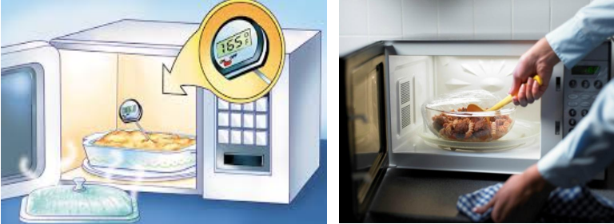
Reheating foods, when reheating foods for eating or serving, it is important to know the precautions and dangers of that process. Food that has already been prepared and will be reheated for hot holding and/or serving will again pass through the temperature danger zone between 41°F and 135°F. It is important that all foods are rapidly reheated to reduce the amount of time in the danger zone. Food safety code requires potentially hazardous food that is cooked, cooled and reheated for hot holding to be reheated so that all parts of the food reach a temperature of at least 165°F / 73.89ºC for 15 seconds. Food then must then maintain a temperature of 135°F/ 57.22°ºC or higher. When reheating leftovers, be sure they reach 165° F/ 73.89ºC as measured with a food thermometer. A crockpot is never to be used for reheating foods.

Self- Check 5
Part I: Choose the Correct Answer from the Given Alternatives.
1. What is the recommended temperature for storing frozen food?
a) -18°C
b) 0°C
c) 10°C
d) 20°C
2. How long can you safely store frozen meat before it should be consumed?
a) 1 month
b) 3 months
c) 6 months
d) 12 months
3. True or False: It is safe to refreeze thawed food if it has been cooked.
a) True
b) False
4. Which of the following is NOT a safe method for thawing frozen food?
a) Thawing in the refrigerator
b) Thawing in cold water
c) Thawing in the microwave
d) Thawing at room temperature
5. True or False: It is safe to eat frozen food that has been partially thawed and then refrozen.
a) True
b) False
Part II. Answer the Following Questions
    - Mention the procedures of reheating frozen Food
    - What is the use of thawing?

Reference
1. "The Professional Pastry Chef: Fundamentals of Baking and Pastry" by Bo Friberg
2. "Bread: A Baker's Book of Techniques and Recipes" by Jeffrey Hamelman
3. "Advanced Bread and Pastry: A Professional Approach" by Michel Suas
4. "The Art of French Pastry" by Jacquy Pfeiffer and Martha Rose Shulman
5. "On Baking: A Textbook of Baking and Pastry Fundamentals" by Sarah R. Labensky, Priscilla A. Martel, and Eddy Van Damme
5. Food Safety and Inspection Service. (2021). Refrigeration and Food Safety. Retrieved from https://www.fsis.usda.gov/wps/portal/fsis/topics/food-safety-education/get-answers/food-safety-fact-sheets/safe-food-handling/refrigeration-and-food-safety/CT_Index
6. National Center for Home Food Preservation. (n.d.). Freezing Basics. Retrieved from https://nchfp.uga.edu/how/freeze.html
7. Food and Drug Administration. (2021). Freezing and Food Safety. Retrieved from https://www.fda.gov/food/buy-store-serve-safe-food/freezing-and-food-safety
8. www.fsis.usda.gov (https://www.fsis.usda.gov/wps/portal/fsis/topics/food-safety-education/get-answers/food-safety-fact-sheets/safe-food-handling/refrigeration-and-food-safety/CT_Index)
9. Home | Food Safety and Inspection Service
- The Food Safety and Inspection Service is responsible for ensuring that meat, poultry, Siluriformes, and eggs are safe and are properly labeled and packaged. Learn more about our inspection services and process.

R. No. | Name | Qualification | Field of Study | E-mail | Mobil No.
1 | Hiwot Tibebu | A (MA) | - Hotel Management  - Regional and Local Development | Hiwottibebu13@gmail.com | 0911974648

