Bakery and Pastry preparation
Level-III

Based on September 2023, Curriculum Version II
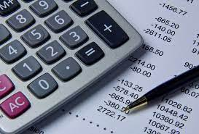


Module Title: Maintaining Financial Records
Module code: CST BPP3 M06 0923
Nominal duration: 64 Hour

Prepared by: Ministry of Labor and Skill

September, 2023
Addis Ababa, Ethiopia

Table of Contents
Introduction to the Module 3
Unit One: Basic Accounting Review 4
1.1 Definition of Accounting 5
1.2. Principles of Accounting: GAAP Vs IFRS 5
1.3. Accounting as a source of information 7
1.4. Users of Accounting Information 8
1.5. Financial Elements 10
1.6. Basic Accounting Equation 12
1.7. The Rules of Debit and Credit 13
1.8. Hospitality Accounting Management 13
Self-Check 1 16
Unit Two: Maintain Financial Records 18
2.1. Accounting Cycle 19
2.1.1. Identify and analyze transactions 19
2.1.2. Record Journal Entry 21
2.1.3 Post to General Ledger 25
2.1.4 Prepare unadjusted trial balance 29
2.1.5. Make adjusting Entries 31
2.1.6. Prepare Adjusted Trial Balance 34
2.1.7. Prepare financial statement 36
Self-Check 2 39
Operating Sheet 2.1: Financial Records in Hotels 40
Lap Test 41
Unit Three: Monitor Cash Control 43
3.1. Meaning of Cash Control 44
3.2. Effective cash flow management strategies 44
Self-Check 3 49
REFERERNCE 51

Acknowledgment
The Ministry of Labor and Skills (MoLS) would like to express its gratitude and appreciation to the instructors and experts from regional TVT bureaus, TVT colleges, and industry practitioners who contributed their expertise and experience in preparing the training module for the unit of competency “Maintain financial record” under the occupational standard "Bakery and pastry-III."

The ministry also expresses its deepest gratitude to the Tourism Training Institute for its invaluable technical and financial support and collaboration in the module preparation. It is also thankful to MoLS staff members who coordinated the preparation and reviewing process of this training module.

Introduction to the Module

Every profit or non-profit business entity requires a reliable internal system of accountability. A business accounting system provides this accountability by recording all activities regarding the creation of monetary inflows of revenue and monetary outflows of expenses resulting from operating activities. The accounting system provides the financial information needed to evaluate the effectiveness of current and past operations. In addition, the accounting system maintains data required to present reports showing the status of asset resources, creditor liabilities, and ownership equities of the business entity; particularly in the hospitality industry.

This module is designed to meet the industry requirement under the Culinary Art Occupational Standards, particularly for the unit of competence: Maintain Financial Records.
This module covers the units:
- Basic Accounting Review
- Maintaining financial records
- Monitoring cash control
Learning Objective of the Module
- Understand Accounting Review
- Maintain financial records
- Monitor cash control

Module Instruction
For effective use this modules trainees are expected to follow the following module instruction:
- Read the information written in each unit
- Accomplish the Self-checks at the end of each unit
- Perform Operation Sheets which were provided at the end of units
- Do the “LAP test” given at the end of the module and
- Read the identified reference book for examples and exercise

Unit One: Basic Accounting Review
This unit is developed to provide you the necessary information regarding the following content coverage and topics:
- Definition of Accounting
- Principles of Accounting: GAAP Vs IFRS
- Accounting as a source of information
- Users of Accounting Information
- Financial Elements
- Basic Accounting Equation
- The Rules of Debit and Credit
- Hospitality Accounting Management

This unit will also assist you to attain the learning outcomes stated in the cover page.
Specifically, upon completion of this learning guide, you will be able to:
- Understand the definition of Accounting
- Identify the principles of accounting: GAAP Vs IFRS
- Understand accounting as a source of information
- Identify the users of accounting information
- Determine the financial elements
- Determine the basic accounting equation
- Identify the rules of debit and credit
- Understand hospitality accounting management

1.1 Definition of Accounting

Some prominent definitions of accounting to help us better understand the meaning of basic accounting.

According to the Committee of Terminology of American Institute of Certified Public Account:” Accounting is the art of recording, classifying summarizing in a significant manner and in terms of money, transaction, and events which are, in part at least of a financial character and interpreting the results thereof.”

According to Bierman and Drebin:” Accounting may be defined as identifying, measuring, recording and communicating of financial information”

The American Accounting Association defines accounting as "the process of identifying, measuring and communicating economic information to permit informed judgments and decisions by the users of the information."

According to AICPA (American Institute of Certified Public Accountants) it is defined as "the art of recording, classifying and summarizing in a significant manner and in terms of money, transactions and events which are in part at least of a financial character and interpreting the result thereof."

Therefore accounting can be defined as” the process of recording, classifying summarizing, reporting and analyzing required financial information relating to the economic events of an organization to the interested users for making decisions.

1.2. Principles of Accounting: GAAP Vs IFRS
GAAP (Generally Accepted Accounting Principles) and IFRS (International Financial Reporting Standards) are two sets of accounting standards used by companies to prepare and present their financial statements. While GAAP is primarily followed in the United States, IFRS is used in many countries around the world. Here are some key principles of accounting under GAAP and IFRS:
A. GAAP Principles:
1. Entity Concept: The financial statements should represent the financial position and performance of the specific entity, separate from its owners or related entities.
2. Historical Cost Principle: Assets and liabilities should be recorded at their original cost when acquired, rather than at their current market value.
3. Revenue Recognition Principle: Revenue should be recognized when it is earned and realized or realizable, and when it is reasonably certain to be collected.
4. Matching Principle: Expenses should be recognized in the same period as the revenues they help generate, following the concept of "matching" costs with revenues.
5. Full Disclosure Principle: The financial statements should provide all necessary and relevant information to users, including any significant information or events that may impact decision-making.
6. Consistency Principle: Accounting methods and principles should be consistently applied from one period to another, ensuring comparability of financial statements.
7. Materiality Principle: Only significant and material items should be disclosed in the financial statements, while immaterial items can be aggregated or omitted.

B. IFRS Principles:
1. Fair Presentation and Compliance with IFRS: The financial statements should present a true and fair view of the entity's financial position and performance, and comply with all IFRS requirements.
2. Going Concern Assumption: Financial statements are prepared under the assumption that the entity will continue its operations in the foreseeable future.
3. Accrual Basis Accounting: Transactions and events are recorded when they occur, regardless of when cash is received or paid.
4. Revenue Recognition Principle: Revenue should be recognized when it is probable that economic benefits will flow to the entity, and when the revenue can be reliably measured.
5. Substance over Form: Transactions should be accounted for based on their economic substance, rather than just their legal form.
6. Consistency and Comparability: Like GAAP, consistency and comparability of financial statements are important under IFRS as well.
7. Materiality and Aggregation: Similar to GAAP, only material items need to be disclosed separately, and immaterial items can be aggregated or omitted.
It's important to note that while there are significant similarities between GAAP and IFRS, there are also some differences in specific accounting treatments and reporting requirements. Companies operating in multiple jurisdictions may need to reconcile their financial statements to comply with both sets of standards.

1.3. Accounting as a source of information
Accounting is regarded as the language of a business. It is used as a means of communication between a business organization and its shareholders. The accounting process is a source of information; it uses business data and processes it to generate relevant information. Let us have a look.
Accounting is the management information system of any organization and is concerned with providing necessary information to the management, i.e. it is a source of information. In the account, every step involves either generation or processing accounting information. It serves as a means as well as an end of providing information to all stakeholders who need information to make a proper decision.
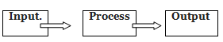

Accounting serves following purposes relating to generating and processing information:-
- The accounting records business transaction which is the source of generating information.
- Proper accounting system makes information more reliable.
- Accounting ensures it is a reliable source of information.
- Accounting works as a management information system to the organization. It helps the management to manage the organization in a proper way.
- Accounting system generator various information in the form of different accounts. These documents have to be to true and fair.
- Accounting shows the performance of any business organization. Oil anyone who wants to know about the progress of an organization can only not through the use of accounting.
- Accounting provides information on activities that affect the society.

As we know all like titles in accounting is done by a person known as an accountant. An accountant generates accounting information by observing, screening and recognizing events and transactions in the business.

He measures and processes information and compile reports comprising accounting information that is communicated to the users. Then these are interpreted and uses by management and other user groups. It is the responsibility of the accountant that the information provided must be relevant adequate and reliable for decision making.

1.4. Users of Accounting Information
Accounting information is used by many parties for making decisions in business. All those who use accounting information about the business to make decisions called Users. They are basically users of accounting information. These are different parties in the business who have some stake in the business. Users have a stake in the business in the form of
- Investment in business
- Loans to the business
- Goods sold on credit to the business
- Job in the business.
- Consumers of goods and services produced by the business etc.
But the main purpose of all the users is that all of them want to know about the performance, progress, and working of the business organization. The users of accounting information are divided broadly into two categories:-
- Internal users
- External users

1. Internal Users
These are the parties who have directly involved with the management and working of the organization. They work with the organization and have the power to influence the working of an organization. For them too, accounting is a source of information. Internal uses include owners, partners, directors, managers, and employee etc. Different users need different information from the accounting. It can be discussed in the following manner:

a. Owners/Proprietor/Partners
They want to know about the probability of an organization. These are interested in getting a good return on their investment. These are all interested to know how the financial position of the business organization is. e It is their responsibility to take a decision about the future policies and performance of the business in the future according to this data.

b. Management
The success of the management depends on the success of an organization. The performance of the management is evaluated according to the profits of a business. If the business grows, salaries of management staff will also grow. Management is also responsible to know whether a business is able to pay its liabilities or not. The management will be interested to know if the business is showing overall growth and performance of the business. Their source of information, in this case, will be the accounts of the company.

c. Employees and Workers
These are interested to know that business is earning profits or not. If the business is in loss then it is the possibility that some employees may be removed from a job. These are also interested to know if they should continue the same organization. This will depend on the future prospect of an organization.
2. External Users
All those parties and individual who are not directly involved in the management and operation of the business now is external users. These do not have the power to influence the working of the organization. Such users include investors, creditors, suppliers, customers, banks, financial institutions, government, existing shareholders, potential shareholder and supplier of raw materials etc.
Every different user needs a different kind of accounting information. It can be discussed in the following manner –

a. Bankers/Lenders
These want to know interest on their loans. They will be able to get interested when the businesses are earning profits. The financial position of the business is good then it will be able to pay back the loans.

b. Creditors
These want their money back from the business and it depends upon the financial position of the business.

c. Customers
These want to know the future policies of the business. If the business will continue in the future then the demand for customer increases.

d. Government
Government is interested to know how the trade in an industry is doing in the country. The government departments collect data related to revenues, sales, production, the number of employees etc. of business to know the condition of the economy. It is also interesting to know how much taxes have been paid by the business

e. Society
The business organization uses the resources of society. Therefore society expects the business to generate employment for them. Therefore society would like to know how many people are employed in the business.
Society is also interested to know how many welfare activities are done by a business organization for them. Societies want to know the policies of CSR (corporate social responsibility). A successful business provides a lot of services to the people in the society like hospitals, schools, thinking water, food to school children, making road etc. Thus accounting as the language of business is used to exchange information between business and its partners.

1.5. Financial Elements
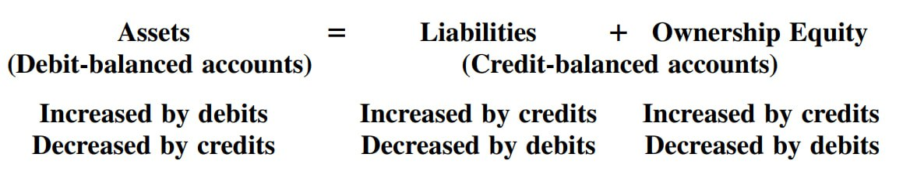

Financial elements refer to the components or elements that make up a company's financial statements. These elements provide information about the company's financial performance, position, and cash flows. The main financial elements include:

1. Assets: Assets are resources owned or controlled by the company that have economic value. Examples of assets include cash, accounts receivable, inventory, property, plant, and equipment.

2. Liabilities: Liabilities are obligations or debts owed by the company to external parties. They represent claims on the company's assets. Examples of liabilities include accounts payable, loans, and accrued expenses.

3. Equity: Equity represents the residual interest in the assets of the company after deducting liabilities. It represents the ownership interest of the shareholders or owners in the company. Equity is typically made up of contributed capital (common stock, preferred stock) and retained earnings.

4. Revenue: Revenue is the income generated by the company from its primary activities, such as sales of goods or services. It represents an increase in assets or a decrease in liabilities.

5. Expenses: Expenses are the costs incurred by the company to generate revenue. Examples of expenses include cost of goods sold, salaries and wages, rent, utilities, and marketing expenses.

6. Net Income: Net income, also known as net profit or net earnings, is the difference between total revenue and total expenses. It represents the company's profitability after all expenses have been deducted from revenue.

7. Cash Flow: Cash flow refers to the inflows and outflows of cash and cash equivalents. It provides information about the company's ability to generate cash from its operations, as well as its investing and financing activities.

These financial elements are typically reported in a company's financial statements, including the income statement, balance sheet, and cash flow statement. They are important for assessing the company's financial health, performance, and ability to meet its obligations.

1.6. Basic Accounting Equation
The resources controlled by a business are its assets. Examples of assets include cash, land, buildings, and equipment. The rights or claims to the assets are divided into two types: (1) the rights of creditors and (2) the rights of owners. The rights of creditors are the debts of the business and are called liabilities. The rights of the owners are called owner’s equity. The following equation shows the relationship among assets, liabilities, and owner’s equity:
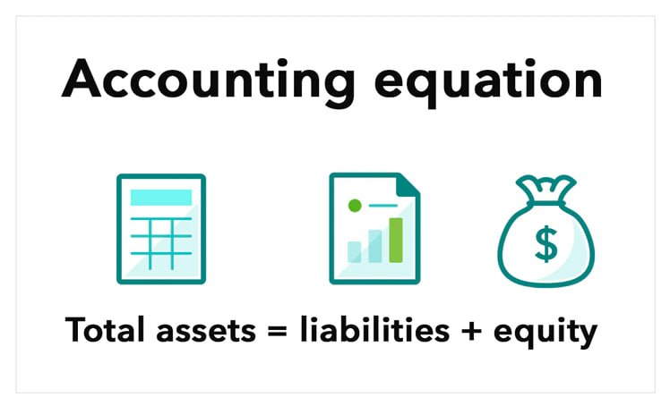

It is customary, to place “liabilities” before” owner’s Equity” in accounting equation because creditors have preferential rights to assets. Any increase or decrease in assets results in corresponding increase or decrease in liabilities or owner’s Equity or both. The two sides of the equation must always be equal. The statement that shows assets equal liabilities plus capital is called the accounting equation. The equation is true to all complete balance sheets.
Assets are resources controlled by the enterprise. They may be tangible (physical asset) such as supplies, equipment, land and building and or intangible such as patent, good will. They increase as they are acquired, or donated or invested in to the business; their decrease is mainly through utilization and sales of these assets in order to generate the period’s revenue.
Liabilities are the debts (obligations) of the enterprise. They arise through the purchase of assets or services form others on credit and through cash borrowing to finance the business.
Owners’ Equity is the residual calm of the owners to the assets after deducting the liabilities from the assets. It’s driven from two sources:
- Contributed Capital the owners in the business and
- Retained earnings the accumulated profit of the business less loss and also less all accumulated withdrawal by the owner.

The owner’s equity /capital/ is affected as following
- Increased by: Investment /Initial and also additional/, Revenues
- Decreased by: Withdrawal of investment, Expenses

1.7. The Rules of Debit and Credit

Assets are debit-balanced accounts and are increased by debits and decreased by credits. Liabilities and ownership equity accounts are credit-balanced and increased by credits and decreased by debits. The debit–credit rules as applied to balance sheet accounts are summarized as follows:
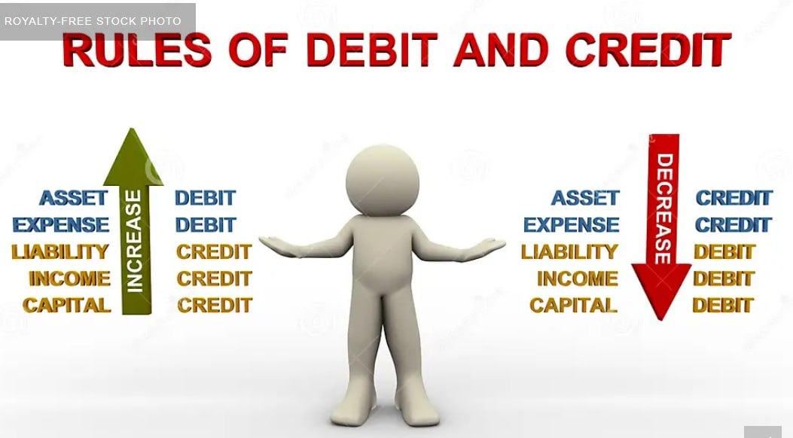

1.8. Hospitality Accounting Management

Hospitality management accounting is concerned with providing specialized internal information to managers that are responsible for directing and controlling operations within the hospitality industry. Internal information is the basis for planning alternative short- or long-term courses of action and the decision as to which course of action is selected. Specific detail is provided as to how the selected course of action will be implemented. Managers direct the needed material resources and motivate the human resources needed to carry out a selected course of action. Managers control the implemented course of action to ensure the plan is being followed and, as necessary, modified to meet the objectives of the selected course of action.

Hospitality business operations, as well as others, are generally identified as having a number of different cyclical sales revenue cycles. First, there is the daily operating cycle that applies particularly to restaurant operations where daily sales revenue typically depends on meal periods. Second, there is a weekly cycle. On the one hand, business travelers normally use hotels, motels, and other hospitality operations during the week and generally provide little weekend hospitality business. On the other hand, local people most often frequent restaurants on Friday through Sunday more than they do during the week. Third, there is a seasonal cycle that depends on vacationers to provide revenue for hospitality operations during vacation months. Fourth, a generalized business cycle will exist during a recession cycle and hospitality operations typically experience a major decline in sales revenue.

The various repetitive accounting cycles encountered in hospitality operations create unique difficulties in forecasting revenue and operating costs. In particular, variable costs (e.g., cost of sales and labor costs) require unique planning and procedures that assist in budget forecasting. Since hospitality operations are people-oriented and people-driven, it is more difficult to effectively automate and control hospitality costs than it is in other non hospitality business sectors.

Unfortunately, most accounting textbooks and generalized accounting courses emphasize accounting systems using procedures and applications that are applicable to services, retailing, and manufacturing businesses. These types of businesses do not normally require the use of the unique accounting procedures and techniques required by hospitality operations. In manufacturing operations, all costs are generally assigned to products or product lines and identified as direct costs and indirect costs. Direct costs include all materials and labor costs that are traceable directly to the product manufactured. Indirect costs generally refer to manufacturing or factory overhead, and include such items as factory supporting costs such as administrative salaries, wages and miscellaneous overhead, utilities, interest, taxes, and depreciation. The basic nature of indirect costs presents difficulties isolating specific costs since they are not directly traceable to a particular product. Portions of supporting indirect costs are assigned by allocation techniques to each product or product line.

However, a hospitality operation tends to be highly departmentalized with separate operating divisions that provide rooms, food, beverage, banquet, and gift shop services. A hospitality accounting system must allow an independent evaluation of each operating department and its operating divisions. Costs directly traceable to a department or division are identified as direct costs. Typically, the major direct costs include cost of sales (cost of goods sold), salary and wage labor, and specific operating supplies. After direct costs are determined, they are deducted from revenue to isolate contributory income, which represents the department’s or division’s contribution to support undistributed indirect costs of the whole operation.

Indirect costs are those costs not easily traceable to a department or division. Generally, no attempt is made at this stage of the evaluation to allocate in direct costs to the department or divisions. Managers review operating results to ensure that contributory income from all departments or divisions is sufficient to cover total indirect costs for the overall hospitality operation and provide excess funds to meet the desired level of profit.

Self-Check 1
Part I: Write True or False
1. Accounting is the process of recording, summarizing, and analyzing financial transactions of a business or organization.
2. The primary purpose of accounting is to calculate and report taxes owed by a business or organization.
3. Accounting involves the preparation of financial statements, such as the balance sheet, income statement, and cash flow statement.
4. GAAP and IFRS are identical in all aspects, with no differences between them.
5. Management is not a user of accounting information.
6. Employees do not use accounting information to understand their compensation and benefits.
7. The rule of debit and credit applies only to cash transactions.
8. If a liability account is credited, it means the liability has increased.
9. If an expense account is debited, it means the expense has been incurred.
10. Hospitality management accounting focuses solely on revenue generation.

Part-II: Choose the correct answer
1. Which of the following is a financial element that represents the obligations of a company to pay back borrowed funds?
A) Assets B) Liabilities C) Equity D) Revenue
2. Which financial element represents the ownership interest in a company and is calculated as assets minus liabilities?
A) Assets B) Liabilities C) Equity D) Revenue E) expense
3. Which financial element represents the economic resources that a company owns or controls, expected to provide future benefits?
A) Assets B) Liabilities C) Equity D) Revenue
4. Which financial element represents the inflows of assets or settlements of liabilities resulting from the primary activities of a company?
A) Assets B) Liabilities C) Equity D) Revenue
5. Which financial element represents the costs incurred by a company in order to generate revenue?
A) Assets B) Liabilities C) Equity D) Revenue
6. What is the fundamental accounting equation?
A) Assets = Liabilities + Equity C) Assets - Liabilities = Equity
B) Revenue - Expenses = Net Income d) Assets + Liabilities = Revenue
7. Which financial statement shows the financial position of a company at a specific point in time?
a) Income statement c) Statement of cash flows
b) Balance sheet d) Statement of retained earnings
8. Which of the following accounts is classified as a liability?
a) Accounts receivable b) Prepaid expenses c) Common stock d) Accounts payable

Unit Two: Maintain Financial Records
- This unit is developed to provide you the necessary information regarding the following content coverage and topics:
  - Accounting Cycle
  - Identify and Analyse Transactions
  - General Journal
  - General Ledger
  - Unadjusted Trail Balance
  - Adjusting Entry
  - Financial Reports

This unit will also assist you to attain the learning outcomes stated in the cover page.
Specifically, upon completion of this learning guide, you will be able to:
  - Understand Accounting Cycles
  - Identify and Analyze Transactions
  - Recording Journal Entry
  - Posting Entry
  - Prepare Unadjusted Trail Balance
  - Prepare Adjusting Entry
  - Prepare Financial Reports

2.1. Accounting Cycle
The Accounting Cycle helps you turn your raw financial information into financial statements that you can use to manage and grow your business. It explains the process of recording transactions, creating financial statements, and closing accounts for the next period. Once you close your books, the cycle starts again for the New Year.

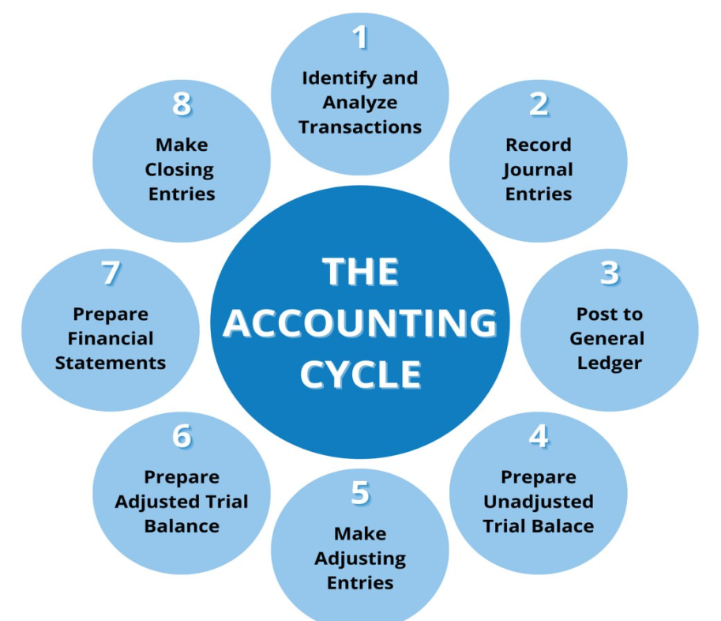
Depending on who you ask, the Accounting Cycle may have a different number of steps based on how you divide up the tasks, but they are all essentially the same. For the purpose of this post, we will use 8 steps to explain the accounting cycle.

2.1.1. Identify and analyze transactions

Identifying Transactions is the initial step of the accounting cycle. Identifying a transaction means determining if it exists and whether It is a monetary transaction related to business. However, in books of accounts, only transactions related to business will be recorded that are separate from owners’ transactions. After a transaction has been identified, then it is analyzed. The analysis is deciding which accounts will be affected by that Transaction and what changes it will have on the books of accounts.

Example .1

Michal owns a restaurant. He buys two stoves so that staff can prepare more meals in less time.

We would recognize this as a transaction because it is an exchange, i.e., Michal is buying two stoves in exchange of money for goods (stoves).

Example.2

Several months later, one of the stoves stops working and Michael throws it out.

This event will directly cause the financial position of the business to change. Michal is throwing out the stove means that the company will have fewer assets than before. Therefore, we would recognize this as a transaction.

Example.3

Michal is considering hiring some more employees.

We would not identify this as a transaction because it does not directly affect the financial position. However, it can affect the financial position if Michal hires employees.
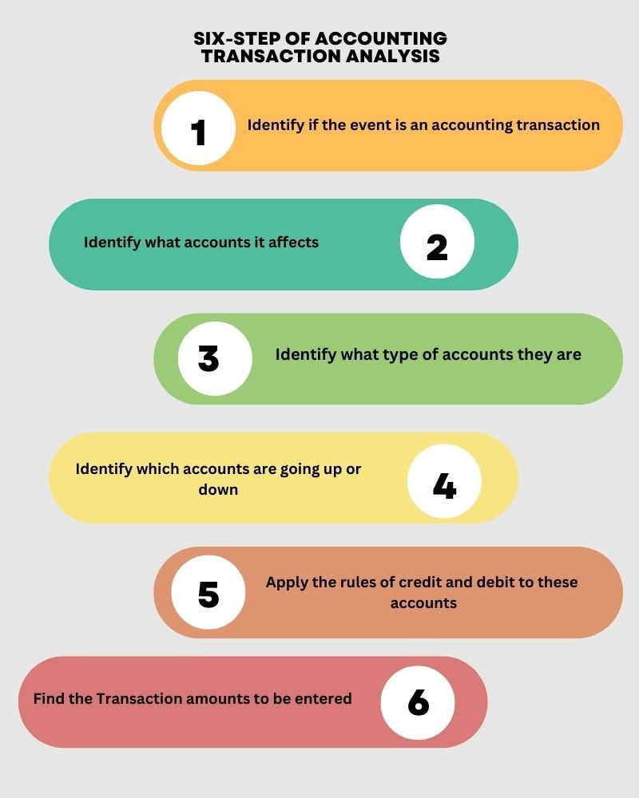

2.1.2. Record Journal Entry
Journalizing refers to the process of recording business transactions in journals.
The following steps may be carried out to journalize business transactions:
- Collect source documents - Source documents show that a transaction has really occurred and give complete information about the transaction such as date of the transaction, parties and amount of money involved, terms of payment, etc.
- Analyze transactions - This involves determining specific accounts affected (cash, fees earned, etc) by the transaction, classification of the accounts affected (asset, liability, etc), direction of the effect (increase or decrease), monetary amount of the effect ($400, $100, etc) and how to record the increase and decrease (debit or credit).
- Journalize - Record the dual effects of transactions in chronological order using the rules of debits and credits. Below are sample general journal and additional steps needed to journalize business transactions
General Journal Page No.
Date |  | Description | PR | Debit | Credit
Year  i  iii  iv  v  vi  ii  Month | Date | Name of Account to be Debited  Name of Account to be Credited  Brief explanation about the transaction |  | XXX | XXX

Note the following when journalizing transactions.

i. Write the year, month and date of the transaction in the date column. The year and month need not be repeated for subsequent entries until a new page or a new month/year begins while the date may be repeated in as much as the number of independent entries to be recorded.

ii. Write the name of the account to be debited on the first line customarily placed at the extreme left of the description column. Enter the corresponding debit amount on the same line in the extreme left of the debit column. An entry which includes more than one debit or more than one credit is called a compound journal entry. Regardless of how many debits or credits are contained in a compound journal entry, all the debits are entered before any credit.

iii. Write the name of the account to be credited on the line below the debit entry somehow indented i.e. placed about 1 inch in to the right side of the description column. Enter the corresponding credit amount on the same line in the extreme left of the credit column.

iv. Write a brief explanation of the transaction on the line immediately below the last account credited. This explanation includes any data needed to identify the transaction, such as the name of the customer or supplier. The explanation needs not to be indented.

v. Leave a blank line below each entry. This spacing causes each journal entry to stand out clearly as a separate unit and makes the journal easier to read.

vi. Leave the PR (which stands for posting reference) column blank at the time of making the journal entry. When the debits and credits are later transferred to accounts in the ledger, the identification numbers of the accounts which the entries are posted to will be listed in this column to provide a cross reference with the ledger.

Whether a transaction results in single or compound entry, equal dollar amounts of debits and credits should be recorded

Example 2.1
Study the Texana restaurant transactions for the month of March 2023 shown below, and prepare the following journal entry for the month of March 2023
March 1: Owner opened a business account and deposited $65,000 in the bank.
March 2: Owner borrowed and deposited $20,000 on a note payable to the bank.
March 3: Owner paid one year of rent in advance on the restaurant space, $14,400 cash.
March 4: Equipment was purchased for $44,000—$15,000 in cash and the balance on account.
March 5: Furnishings were purchased for $28,400 cash.
March 6: Owner purchased $3,000 of food inventory on account and paid $4,000 cash for beverage inventory.
March 7: Owner purchased supplies for $4,650 on cash.
March 8: purchase beverage inventory 6000 on cash

March 8: Owner purchased $3,800 of food inventory on account.
March 9: Owner paid $2,400 for a one-year liability and casualty insurance policy.
March 10: Employees were paid wages of $12,800 and salaries of $32,400.
March 11: Revenue for food and beverage sales was $62,800—92 present cash, 6 present on credit cards, and 2 present on accounts receivable.
March 12: Owner paid $12,000 on accounts payable.
March 13: Owner paid $2,000 on notes payable, plus interest of $200.
March 28: food and beverage sale on cash $50,000

The following expenses are recognized and paid on March 28:
- Laundry expense …………………. $ 2000
- Kitchen fuel expense ……………... $ 1500
- China and tableware expense …….... $1800
- Glassware expense ………………… $2200
- Contract cleaning expense…………. $2100
- License expense ………………… $500
- Miscellaneous expense …………….. $700
- Administrative general expense…… $3000
- Marketing expense ………………… $1500
- Utility expense ………………/… $500

General Journal Page 1
Date |  | Description | PR | Debit | Credit
2023 March, | 1 | Cash  Texana capital |  | $65,000 | $65,000
2023 March, | 2 | Cash  Note payable |  | 20,000 | 20,000
2023 March, | 3 | Prepaid Rent  Cash |  | 14,400 | 14,400
2023 March, | 4 | Equipment  Cash  Account Payable |  | 44,000 | 15,000  29,000
2023 March, | 5 | Furnishing  Cash |  | 28,400 | 28,400
2023 March, | 6 | Food Inventory  Account payable |  | 3000 | 3000
2023 March, | 6 | Beverage Inventory  Cash |  | 4000 | 4000
2023 March, | 7 | Supply  Cash |  | 4650 | 4650
2023 March, | 8 | Beverage Inventory  Cash |  | 6000 | 6000
2023 March, | 8 | Food Inventory  Account payable |  | 3800 | 3800
2023 March, | 9 | Prepaid Insurance  Cash |  | 2400 | 2400
 | 10 | Wage Expense  Cash |  | 12800 | 12800
 | 10 | Salary Expense  Cash |  | 32400 | 32400
 | 11 | Cash  Account Receivable  Credit Card Receivable  Food and Beverage Revenue |  | 57776  3768  1256 | 62800
 | 12 | Account Payable  Cash |  | 12000 | 12000
 | 13 | Note Payable  Cash |  | 2000 | 2000
 | 13 | Interest Expense  Cash |  | 200 | 200
 | 28 | Cash  Food and Beverage Revenue |  | 50,000 | 50,000
 | 28 | Laundry Expense  Cash |  | 2000 | 2000
 | 28 | Kitchen fuel expanse  Cash |  | 1500 | 1500
 | 28 | China and Tableware  Cash |  | 1800 | 1800
 | 28 | Glassware Expense  Cash |  | 2200 | 2200
 | 28 | Contract clean expense  Cash |  | 2100 | 2100
 | 28 | License Expense  Cash |  | 500 | 500
 | 28 | Miscellaneous Expense  Cash |  | 700 | 700
 | 28 | Administration Expense  Cash |  | 3000 | 3000
 | 28 | Marketing Expense  Cash |  | 1500 | 1500
 | 28 | Utility Expense  Cash |  | 500 | 500

2.1.3 Post to General Ledger

A ledger is a record-keeping system that is used to track and organize financial transactions. It is a principal book or account that contains a complete record of all financial activities of a business or individual.

Ledgers are typically divided into different accounts, such as cash, accounts receivable, accounts payable, inventory, and expenses. Each transaction is recorded in the appropriate account, with details such as the date, description of the transaction, and the amount involved.

Ledgers serve as a central repository for financial information and are essential for tracking and managing the financial health of a business or individual. They provide a chronological and organized view of all financial activities, making it easier to analyze and report on financial data.

After you record transactions in your journal, it’s time to transfer them to your general ledger. To keep your books accurate, post every transaction from your journal to your general ledger. Use your ledger to classify and organize transactions. When posting entries to the ledger, move each journal entry into an individual account.

Transfer the debit and credit amounts from your journal to your ledger account. Your journal entries act like a set of instructions. When posting journal entries to your general ledger, do not change any information. For example, if you debit an account in a journal entry, debit the same account in your ledger. Keep in mind that your general ledger lists all the transactions in a single account.

2.1.3.1. Steps to post journal entries to the general ledger:
Step 1: Create journal entries
Step 2: Make sure debits and credits are equal in your journal entries
Step 3: Move each journal entry to its individual account in the ledger (e.g., Checking account)
Step 4: Use the same debits and credits and do not change any information
Step 5: Calculate account balances in your general ledger

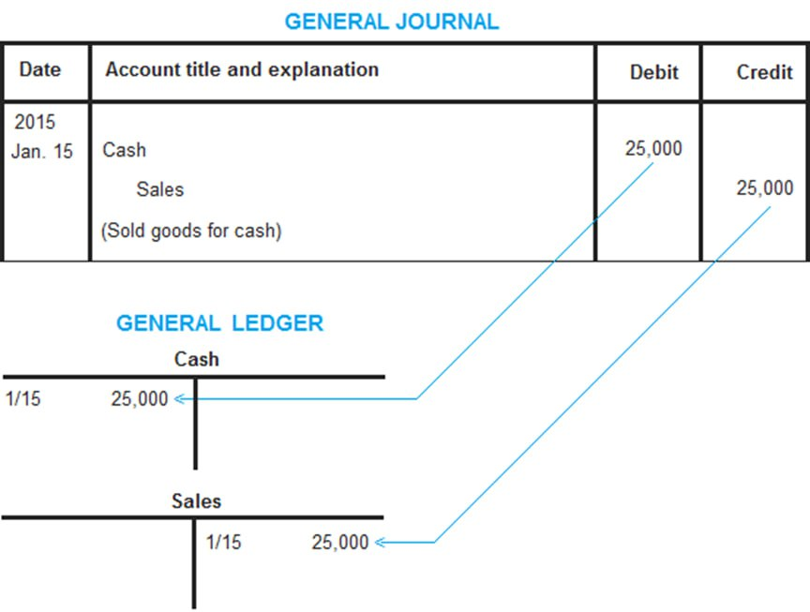
A T account ledger is an informal way of addressing a double-entry bookkeeping system. On the top, the name of the ledger is mentioned, the left side is for debit entries, and the right side is for credit entries within the ledger. It is essentially a visual or graphical representation of the company’s accounts which can be used to present, scrutinize, or review.

Example 2.2

Based on example 2.1 prepare general ledger for Texana restaurant by using T account
 | 1. Cash Account
March | Debit | Credit
1 | 65,000
2 | 20,000
3 |  | 14,400
4 |  | 15,000
5 |  | 28,400
6 |  | 4,000
7 |  | 4,650
8 |  | 6,000
9 |  | 2,400
10 |  | 12,800
10 |  | 32,400
11 | 57,776
12 |  | 12,000
13 |  | 2,000
13 |  | 200
28 | 50,000
28 |  | 2000
28 |  | 1500
28 |  | 1800
28 |  | 2200
28 |  | 2100
28 |  | 500
28 |  | 700
28 |  | 3000
28 |  | 1500
28 |  | 500
 | 192,776 | $150,050
 | $42,726
 | 2. Texana capital
1 |  | 65,000
 | 3. Note Payable
2 |  | 20,000
13 | 2,000
 |  | 18,000
 | 4. Account Payable
4 |  | 29,000
6 |  | 3,000
8 |  | 3,800
12 | 12,000
 | 12,000 | 35,800
 |  | 23,800
 | 5. Prepaid Rent
3 | 14,400
4 | 6. Equipment
 | 44,000
 | 7. Furnishing
5 | 28,400

 | 8. Beverage Inventory
6 | 4,000
8 | 6,000
 | 10,000
 | 9. Food Inventory
6 | 3,000
8 | 3,800
 | 6,800
 | 10. Supplies
7 | 4,650
 | 11. Prepaid Insurance
9 | 2,400
 | 12. Wage
10 | 12,800
 | 13. Salary
10 | 32,400
 | 14. Account Recievable
11 | 1,256
 | 15. credit card
11 | 3,768
16. Food and Beverage Revenue
11 |  | 62,800
28 |  | 50,000
 |  | 112,800
 | 17. Interest expense
13 | 200
 | 18. Laundry Expense
28 | 2000
 | 19. kitchen fuel expense
28 | 1500
 | 20. china and Tableware
28 | 1800
28 | 21. Glassware
 | 2200
 | 22. Contract clear expense
28 | 2100
 | 23. license expense
28 | 500
 | 24. miscellaneous expense
28 | 700
 | 25. Administration expense
28 | 3000
 | 26. marketing expense
28 | 1500
 | 27. utility expense
28 | 500

2.1.4 Prepare unadjusted trial balance

An unadjusted trial balance is a list of all the general ledger accounts and their respective balances before any adjustments are made. It serves as a preliminary step in the accounting cycle and is used to ensure that the total debit balances equal the total credit balances.

Here's how an unadjusted trial balance is prepared:

1. Obtain the account balances: Gather the balances of all the general ledger accounts, including assets, liabilities, equity, revenue, and expense accounts, from the general ledger.

2. List the accounts: Create a table with two columns: one for the account names and another for the balances. List all the account names in the left column and enter their respective balances in the right column.

3. Calculate the totals: Add up the debit balances and the credit balances separately. The total of the debit column should equal the total of the credit column if the accounts are balanced.

4. Verify accuracy: Review the unadjusted trial balance to ensure that the total debit and credit balances match. If they don't, it indicates an error in the recording or posting of transactions.

The unadjusted trial balance is an important step in the accounting process as it helps identify any discrepancies or errors before making necessary adjustments. Once the trial balance is balanced, adjustments can be made to correct any errors or omissions before preparing the adjusted trial balance and financial statements.

Example 2.3
Prepare unadjusted trial balance based on the information given on Example 2.2

Texana Restaurant
Unadjusted Trial Balance
31-Mar-23
Account | Debit | Credit
Cash | 42,726
Supplies | 4,650
Prepaid Rent | 14,400
Prepaid Insurance | 2,400
Food Inventory | 6,800
Beverage Inventory | 10,000
Equipment | 44,000
Furnishing | 28,400
Account Receivable | 1,256
Credit Card Receivable | 3,768
Note Payable |  | 23,800
Account Payable |  | 18,000
Texana Capital |  | 65,000
Food and Beverage Revenue |  | 112,800
Wage Expense | 12,800
Salary Expense | 32,400
Interest Expense | 200
Laundry expense | 2,000
Kitchen fuel expense | 1,500
China and tableware expense | 1,800
Glassware expense | 2,200
Contract cleaning expense | 2,100
License expense | 500
Miscellaneous expense | 700
Administrative general expense | 3,000
Marketing expense | 1,500
Utility expense | 500
 | 219,600 | 219,600

2.1.5. Make adjusting Entries

Adjusting entries are needed to ensure that correct amounts of sales revenue and expenses are reported in the income statement, and to ensure that the balance sheet reports the proper assets and liabilities. Adjusting entries are also used for items that, by their nature, are normally deferred. These consist of two types of adjustments.
1. The use or consumption of an asset and recognition of it as an expense. This type of adjustment typically adjusts supplies, prepaid expenses, and depreciable assets.
2. The reduction of a liability and recognition of revenue. This adjustment concerns the recognition of unearned revenue as being recognized as earned.

Example 2.4

After journalizing and posting the operating transactions in example 2.1 and 2.2, journalize and posting the following adjusting entries:

March 31: Estimated closing value of food and beverage inventory was $400 and $300 respectively
March 31: Wages earned by employees but unpaid are $300
March 31: One-twelfth of the prepaid insurance has been consumed.
March 31: One-twelfth of the prepaid rent has been consumed.
March 31: Equipment depreciation is based on a life of 5 years with a $2,000 residual value, straight-line depreciation.
March 31: Furnishings depreciation is based on 10 year life with a $1,000 residual (salvage) value, straight-line depreciation.
March 31: Supplies used during the first month are $650.

Entries
 | Food inventory Expense | 6,400
2023 31  March, | Food inventory |  | 6,400
31 | Beverage inventory Expense | 9,700
 | Beverage inventory |  | 9,700
31 | Wage Expense | 300
 | Wage Payable |  | 300
31 | Insurance expense | 200
 | prepaid insurance |  | 200
31 | Rent expense | 1,200
 | Prepaid Rent |  | 1,200
31 | Depreciation expense for Equipments | 8,400
 | Equipments |  | 8,400
31 | Depreciation expense for Furnishing | 2,740
 | Furnishing |  | 2,740
31 | Supply expense | 650
 | Supply |  | 650
 |  | 29,590 | 29590

Posting the Adjusting Entry
Existed Account |  |  |  |  | New Account
Food inventory |  |  |  |  | Food inventory Expense
6,800 | 6,400 |  |  |  | 6,400
400
Beverage inventory |  |  |  |  | Beverage inventory Expense
10,000 | 9,700 |  |  |  | 9,700
300
Wage Expense |  |  |  |  | Wage Payable
12,800 |  |  |  |  |  |  | 300
300
13,100
prepaid insurance |  |  |  |  | Insurance expense
2,400 | 200 |  |  |  | 200
2,200
Prepaid Rent |  |  |  |  | Rent expense
14,400 | 1,200 |  |  |  | 1,200
13,200
Equipments |  |  |  |  | Depreciation expense for Equipments
44,000 | 8,400 |  |  |  | 8,400
35,600
Furnishing |  |  |  |  | Depreciation expense for Furnishing
28,400 | 2,740 |  |  |  | 2,740
25,660
Supply |  |  |  |  | Supply expense
4,650 | 650 |  |  |  | 650
4,000

2.1.6. Prepare Adjusted Trial Balance
An adjusted trial balance is a list of all the general ledger accounts and their respective balances after adjusting entries have been made at the end of an accounting period. It is prepared to ensure that the financial statements reflect accurate and up-to-date information.
Here's how an adjusted trial balance is prepared:
1. Obtain the adjusted account balances: Gather the adjusted balances of all the general ledger accounts, including the effects of any adjusting entries made at the end of the accounting period. These adjustments may include accruals, deferrals, and other necessary corrections.
2. List the accounts: Create a table with two columns: one for the account names and another for the adjusted balances. List all the account names in the left column and enter their respective adjusted balances in the right column.
3. Calculate the totals: Add up the debit balances and the credit balances separately. The total of the debit column should equal the total of the credit column if the accounts are balanced.
4. Verify accuracy: Review the adjusted trial balance to ensure that the total debit and credit balances match. If they don't, it indicates an error in the recording or adjusting of transactions.
The adjusted trial balance is an important step in the accounting process as it serves as the basis for preparing the financial statements, including the income statement, balance sheet, and statement of cash flows. It ensures that the financial statements accurately reflect the financial position and results of operations for the accounting period, taking into account any necessary adjustments.

Texana Restaurant
Adjusted Trial Balance
31-Mar-23
Account | Debit | Credit
cash | 42,726
Supplies | 4,000
Prepaid Rent | 13,200
Prepaid Insurance | 2,200
Food Inventory | 400
Beverage Inventory | 300
Equipment | 35,600
Furnishing | 25,660
Account Receivable | 1,256
Credit Card Receivable | 3,768
Note Payable |  |  | 23,800
Account Payable |  |  | 18,000
Wage Payable |  |  | 300
Texana Capital |  |  | 65,000
Food and Beverage Revenue |  |  | 112,800
Wage Expense | 13,100
Salary Expense | 32,400
Interest Expense | 200
Laundry expense | 2,000
Kitchen fuel expense | 1,500
China and tableware expense | 1,800
Glassware expense | 2,200
Contract cleaning expense | 2,100
License expense | 500
Miscellaneous expense | 700
Administrative general expense | 3,000
Marketing expense | 1,500
Utility expense | 500
Food Inventory Expense | 6,400
Beverage Inventory Expense | 9,700
insurance expense | 200
Rent Expense | 1,200
Depreciation expense for Equip't | 8,400
Depreciation expense for Furnishing | 2,740
Supply expense | 650
 | 194,900 |  | 194,900

2.1.7. Prepare financial statement
A financial report is a document that provides an overview of an organization's financial performance and position. It presents financial information in a structured and standardized format, allowing stakeholders to assess the company's profitability, liquidity, solvency, and overall financial health. Financial reports are typically prepared on a regular basis, such as quarterly or annually, and are used by management, investors, creditors, and other interested parties to make informed decisions.
There are several types of financial reports, including:
1. Income Statement: Also known as the profit and loss statement, the income statement shows a company's revenues, expenses, and net income or loss over a specific period. It provides insights into the company's ability to generate profits from its operations.
2. Balance Sheet: The balance sheet provides a snapshot of a company's financial position at a specific point in time. It presents the company's assets, liabilities, and shareholders' equity, allowing stakeholders to evaluate its financial stability and resources.
3. Cash Flow Statement: The cash flow statement tracks the inflows and outflows of cash during a specific period. It categorizes cash flows into operating, investing, and financing activities, providing insights into the company's liquidity and cash management.
4. Statement of Shareholders' Equity: This statement shows changes in shareholders' equity over a specific period. It includes information on share capital, retained earnings, and other components of equity, providing insights into the company's ownership structure and changes in equity.
In addition to these primary financial reports, companies may also prepare supplementary reports, such as footnotes, management discussion and analysis (MD&A), and other disclosures that provide additional context and explanations about the financial statements.
Financial reports are prepared following generally accepted accounting principles (GAAP) or international financial reporting standards (IFRS) to ensure consistency and comparability across different organizations. They play a crucial role in providing transparency and accountability in financial reporting.

Example
Based on example 2.1 prepare the following financial report
- Income statement
- Owners’ equity statement
- Balance sheet
Texana Restaurant
Income Statement
31-Mar-23
Revenue
 | Food and Beverage Revenue |  | $112,800
Expenses
 | Wage Expense | 13,100
 | Salary Expense | 32,400
 | Interest Expense | 200
 | Laundry expense | 2,000
 | Kitchen fuel expense | 1,500
 | China and tableware expense | 1,800
 | Glassware expense | 2,200
 | Contract cleaning expense | 2,100
 | License expense | 500
 | Miscellaneous expense | 700
 | Administrative general expense | 3,000
 | Marketing expense | 1,500
 | Utility expense | 500
 | Food Inventory Expense | 6,400
 | Beverage Inventory Expense | 9,700
 | insurance expense | 200
 | Rent Expense | 1,200
 | Depreciation expense for Equip.’s | 8,400
 | Depreciation expense for Furnishing | 2,740
 | Supply expense | 650
 |  | 90,790 | (90,790)
profit |  |  | 22010

Texana Restaurant
Owner Equity
31-Mar-23
Beginning Capital | 65,000
Add: Profit/Additional Investment | 0
Deduct: Loss/Drawing | 22010
Ending Owner Capital | 87,010

Texana Restaurant
Balance Sheet
31-Mar-23
Asset |  |  |  | Liabilities
 | cash | 42,726 |  |  | Note Payable |  | 23,800
 | Supplies | 4,000 |  |  | Account Payable |  | 18,000
 | Prepaid Rent | 13,200 |  |  | Wage Payable |  | 300
 | Prepaid Insurance | 2,200 |  | Total Liability |  |  | 42,100
 | Food Inventory | 400 |  | Capital
 | Beverage Inventory | 300 |  | Texana Capital |  |  | 87,010
 | Equipment | 35,600 |  | Total Capital |  |  | 87,010
 | Furnishing | 25,660
 | Account Receivable | 1,256
 | Credit Card Receivable | 3,768
Total Asset |  | 129,110 |  | Total Liability& Capital |  |  | 129,110

Self-Check 2
Part I: Write True or False
1. Identifying and analyzing transactions is not necessary for accurate financial reporting.
2. Journal entries are always recorded in the general ledger.
3. Posting entries involves transferring information from the general ledger to the journal.
4. An unadjusted trial balance is prepared before adjusting entries are made.
5. Adjusting entries are made to correct errors in the general ledger.

Part-II: Choose the correct answer
1. Which of the following is the first step in the accounting cycle?
a) Preparing financial statements c) Posting journal entries to the general ledger
b) Analyzing and identifying transactions d) closing the books
2. Adjusting entries are made to:
a) Correct errors in the financial statements
b) Record transactions that occurred during the accounting period
c) Allocate expenses to specific departments
d) Ensure that revenues and expenses are properly recognized
3. What is the purpose of a trial balance?
a) To calculate the net income or loss for the period
b) To ensure that all transactions have been recorded accurately
c) To prepare financial statements
d) All of the above
4. Which of the following is true about a journal?
a) It is used to calculate the net income or loss for the period
b) It shows the balances of all accounts, including assets, liabilities, and equity
c) It is a book of original entry where transactions are initially recorded
d) It is prepared after adjusting entries have been made
5. What is the purpose of posting from the journal to the ledger?
a) To calculate the net income or loss for the period
b) To ensure that all transactions have been recorded accurately
c) To prepare financial statements
d) To summarize account balances and update individual accounts

Operating Sheet 2.1: Financial Records in Hotels
Operation Title: Performing Financial Records
Purpose: To know and perform financial records in the Hotel
Conditions or situations for the preparation:
- Organized data from the appropriate sources
- Properly organized material and tools for operating the activities
Steps:
Step1. Identify and analyze transactions
Step2. Journalize the transactions
Step3. Post to the general ledger
Step4. Prepare an unadjusted trial balance
Step5. Make adjusting entries
Step6. Prepare an adjusted trial balance
Step7. Prepare financial statements

Quality Criteria: Assured performing of all the activities according to the procedures/steps.

Lap Test

Instructions: Based on the given information shown below, you are required to perform the following tasks.

Given information

The newly opened motel is maintaining the financial records for the upcoming fiscal year. The following transactions occurred for a new motel prior to and during the first month of business operations.

2023
January, 1. Owner invested $360,000 cash deposited in the business bank account.
2. Owner paid $128,000 cash for land.
5. Owner borrowed $330,000 on a mortgage payable at 6% interest.
7. Owner paid cash for building $395,400.
10. Equipment was purchased for $62,000, paying $22,000 cash and the balance on a note payable.
11. Furnishings were purchased for $98,000 cash.
12. Linen inventory was purchased for $6,474 on account.
15. Supplies were purchased for $2,800 on account.
16. Vending inventory was purchased for $380 cash.
17. Room revenue during month was $44,000 cash.
22. Vending revenue from vending machines was $800 cash.
22. Wages of $2,900 cash were paid.
25. Owner paid $2,200 on accounts payable.
26. Owner paid $4,800 on annual liability and casualty insurance policy.
27. Owner paid $1,000 on the mortgage payable and $1,650 for interest

Adjusting Entry
- Estimated closing value of the linen inventory is $5,700.
- Wages earned by employees but unpaid are $400.
- One-twelfth of the prepaid insurance has been consumed.
- Interest owing, but not yet paid, on the equipment notes payable account is 1 percent of the balance owing at month-end.
- Equipment depreciation is based on a life of 12 years with a $5,000residual value, straight-line depreciation.
- Furnishings depreciation is based on an eight-year life with a $4,000residual (salvage) value, straight-line depreciation.
- Building has a 20-year life with a residual (salvage) value of $45, 000, straight-line depreciation.
- Supplies used during the first month are $600.

Using the information provided, maintain the financial records for the motel.
Task 1: Identify and analyze transactions
Task 2: Journalize the transactions
Task 3: Post to the general ledger
Task 4: Prepare an unadjusted trial balance
Task 5: Make adjusting entries
Task 6: Prepare an adjusted trial balance
Task 7: Prepare financial statements

Unit Three: Monitor Cash Control
This unit is developed to provide you the necessary information regarding the following content coverage and topics:
- Meaning of Cash Control
- Steps of Cash control
- Effective cash flow management strategies
- Techniques of Cash management
This unit will also assist you to attain the learning outcomes stated in the cover page.
Specifically, upon completion of this learning guide, you will be able to:
  - Understand the meaning of Cash Control
  - Identify effective cash flow management strategies
  - Determine the steps of cash control
  - Identify the techniques of cash management

3.1. Meaning of Cash Control
Cash Control means managing and monitoring credit and collection policies, cash allocation, and disbursement policies, accounts payable policies and the invoicing cycle.

Cash is the most important liquid asset of the business. A business concern cannot prosper and survive without proper control over cash. In accounting, cash includes coins; currency; deposited negotiable instruments such as cheques, bank drafts, and money orders; amounts in chequing and savings accounts and demand certificates of deposit.

A certificate of deposit (CD) is an interest-bearing deposit that can be withdrawn from a bank at will (demand CD) or at a fixed maturity date (time CD).

A business concern maintains two types of cash accounts in its general ledger – cash and petty cash. But in the balance sheet, the balances of these two accounts are shown together as cash. Since most of the transactions of a business concern are cash transactions, cash is considered an important liquid asset. Misuse of cash may happen easily through stealing or due to carelessness.

3.2. Effective cash flow management strategies
Implementing effective cash flow management strategies is essential for maintaining a healthy financial position. These strategies enable stability, growth, and financial resilience by optimizing revenue, reducing expenses, and maintaining a healthy cash flow cycle.

Five Ways to manage cash flow for business.
Learning to manage cash flow is an elementary building block for your business finances. Many profitable companies turned bankrupt due to a lack of a proper cash flow management strategy. Adequately managing cash flow lets you get a significantly better and more accurate read on the financial position of your business.

The most crucial aspect of managing cash flow is constant monitoring. Complete visibility of the money your company is bringing in and how much of that money you have in hand to use is another vital aspect. When you have an accurate idea of your company’s cash flow cycle, you can work to correct any inconsistencies in it.

Following these essential tips can help you manage your company’s cash flow effectively:

1. Cash flow forecasting

The most important thing you can do to notify yourself of problems before they arise is to make regular and accurate cash flow projections. Good forecasting and estimates using a cash flow forecast method, template or tool will help you to make timely decisions.

It also helps if you constantly review and update it and correct any assumptions you made when creating the forecast. Also, stress-testing your projections from time to time are a must.

2. Revenue estimation
The next step is to make an accurate assessment of how your sales will go and how much revenue this will bring in (based on the forecast). Also, it would be best to consider the timelines for getting paid for these sales.

Correct revenue estimation is an important part of your cash flow planning and determines how much you will have to pay for key business outlays.

3. Identification of expenses
Next, identify all your payments and expenses (salaries & wages, rent, investment in new assets, etc.). Also, add interest charges and insurance premiums to your expenses.

You must pay attention to the cash flow projection and look at the line item expenses disproportionate to your sales. You can refer to last year’s bank statements as a checklist while predicting new incomings and outgoings. Continually review your company’s overall cost structure to locate efficiency gaps and implementations that can be modified to increase savings.

4. Financial reporting
Ensuring that your financial statements & reports are up to date is crucial. Otherwise, it won’t be a true reflection of your financial standing. You will also need a reasonably accurate view of your opening and closing financial position.

Further, ensure that you keep an eye on your cash flow statement (inflow/outflow), as this shows your viability in the short term and helps you manage your bills.

5. Leveraging technology
Companies lacking practical liquidity monitoring usually cannot perform accurate cash flow forecasts. Embracing technology can enable decision-makers to manage liquidity in a targeted and simple way.

With the right technology and business strategies, you can worry less about cash flow and dedicate more time to running your business. Moreover, using software to create a budget and preview cash flow projections help to streamline your business processes and increase efficiency.

Here are some strategies to consider:[
1. Accurate cash flow forecasting: Develop a realistic cash flow forecast by analyzing historical data, sales trends, payment terms, and customer behavior. Regularly review and update your forecast to adapt to changes in your business environment.
- Advantages and disadvantages

- Advantages of cash flow projection
- Anticipate bottlenecks
The biggest advantage of a cash flow forecast is that it can be used to anticipate cash flow shortages. It can therefore help prevent insolvency because, if detected early, managers can take measures to mitigate the effects of the shortage. For example, a loan can be applied for in time, investments postponed or other assets liquidated to maintain cash flow.

- Plan investments better
If you can see in the cash flow forecast that you can expect high surpluses in the coming months, it is easier to plan when to invest. In this way, you can explore in advance how best to invest the surpluses in the company: do you build up reserves, do you invest in the capital market, or do you expand production capacity? All these questions can be answered with the cash flow forecast.
- Play through scenarios
With the help of a cash flow forecast, various scenarios can be run through. For example, you can look at how a supply bottleneck will affect future cash flow, or what will happen if customer demand drops rapidly. How long will the cash reserves last then? In this way, those responsible can explore their room for man oeuvre and come up with a plan B as to what they will do if one of the scenarios occurs.
- Better cost control
By looking at monthly expenses in detail on the cash flow forecast, it is easier to see what the company is spending money on. This can prompt those responsible to put individual cost factors to the test. The forecast also enables efficient cost control and helps companies to work at optimal costs in the long run.
- Better receivables management
The cash flow forecast can also help with receivables management. For example, if you see that you often have cash flow problems because customers do not pay their invoices on time or because you give them too long a period to pay, you can optimize this too.
- Disadvantage/ risks/ of cash flow projection

- No 100% security.
A cash flow forecast is ultimately only an estimate of the future. It is not guaranteed that the revenues and expenses will actually occur as predicted. Depending on how much time is spent on market and customer analysis, the forecast may be closer or less close to reality.

Some things can't be predicted either. We saw this during the Corona crisis, which caught companies completely unprepared. That's why it's good to take precautions with worst-case scenarios so that you know roughly what to expect in the worst case.

- Planning difficult in the long term
A cash flow forecast prepared at the beginning of the year for the entire business year will rarely be correct until the end of the year. Relying only on this one-time planning could therefore lead to wrong decisions. Therefore, in addition to long-term cash flow planning, it is better to do short-term planning, e.g. on a monthly or even weekly basis.

Those responsible thus gain more control over the company's cash flow, and then see during the course of the year through a target/actual comparison whether the planned values for the long-term forecast correspond to the actual values.

- Efficient accounts receivable management: Establish clear credit terms, send prompt and accurate invoices, and implement a proactive collection process. Incentivize early payments and follow up on overdue payments to encourage timely settlements.

- Optimized accounts payable: Negotiate favorable payment terms with suppliers while ensuring quality. Take advantage of discounts for early payments, but maintain sufficient cash reserves for opportunities.

Self-Check 3
Part I: Write True or False
1. Cash control involves implementing procedures to safeguard cash and ensure its proper handling.
2. A cash control system should include segregation of duties to prevent fraud or errors.
3. Cash control procedures are only important for large businesses and not necessary for small businesses.
4. Cash control measures are designed to prevent theft or unauthorized use of cash.
5. Cash control procedures are primarily concerned with preventing errors in cash handling and recording.

Part-II: Choose the correct answer
1. Which of the following is an effective cash control strategy?
a) Allowing employees to handle both cash receipts and cash disbursements
b) Requiring dual signatures on checks
c) Not conducting bank reconciliations
d) None of the above
2. Which of the following is an effective cash control measure?
a) Allowing multiple employees to handle cash without supervision.
b) Performing regular bank reconciliations.
c) Not implementing any segregation of duties.
d) Using cash for all business transactions.
3. Which of the following is an advantage of cash flow management?
a) Increased profitability c) Improved customer satisfaction
b) Higher employee morale d) All of the above
4. Which of the following is a potential disadvantage of cash flow management?
a) Reduced risk of bankruptcy
b) Difficulty in adapting to changing market conditions
c) Enhanced ability to meet financial obligations
d) None of the above
5. Cash flow forecasting helps businesses:
a) Track actual cash flows against projected cash flows
b) Identify cash flow gaps or surpluses
c) Plan for short-term and long-term financing needs
d) All of the above

REFERERNCE

- Weygandt, J. J., Kieso, D. E., & Kimmel, P. D. 2008 (4th edition).Hospitality Financial Accounting.Wiley.
- Martin G. Jagels, Michael M. Coltman.2004(8th edition)Hospitality management accounting 8th edWiley.
- Andrew, William P &Schmidgall, Raymond; 2007 (2nd edition); Financial management for the hospitality industry; Pearson Prentice Hall
- Bragg, Steven; 2009 (1st edition); Financial Analysis: A Controller's Guide; McGraw-Hill Education
- Bull, Richard; Financial Ratios: 2011(1st edition); How to use financial ratios to maximise value and success; McGraw-Hill Education
- Chatfield, Robert E &Dalbor, Michael; 2012 (1st edition); Hospitality financial management; Pearson Prentice Hall
- Cornett, Marcia Millon& Adair, Troy; 2012 (3rd edition); Finance: applications & theory; McGraw-Hill Education
- DeFranco, Agnes L &Lattin, Thomas; 2007 (2nd edition); Hospitality financial management; John Wiley & Sons
- Futura Training; 2008; Manager's guide to hospitality financial management; Futura Training
- Guilding, Chris 2013 (1st edition); Accounting essentials for hospitality managers; Oxon Routledge
- Jagels, Martin & Ralston, Catherine E; 2007 (9th edition); Hospitality management accounting; John Wiley & Sons
Participants of this Module (training material) preparation

No | Name | Qualification (Level) | Field of Study | Organization/ Institution | Mobile number | E-mail
1 | Daniel Bekele | MA Degree | Project Management | TTI | 0911511823 | Dbekele92@gmail.com
2 | Etaferahu Sisay | MA Degree | Marketing Management | TTI | 0961281371 | Lulsweet21@gmial.com

