

BAKERY AND PASTRY PRODUCTION
Level -III-
Based on September 2023 Curriculum Version II
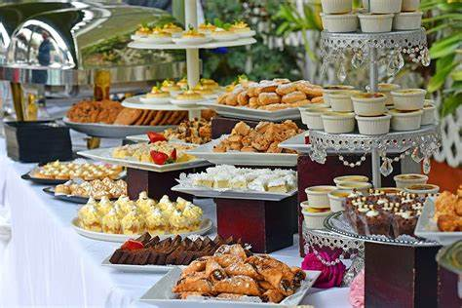

Module Title: Preparing and Displaying Dessert Buffet
Module code: CST BPP3 M07 0923
Nominal duration: 56 Hours
September, 2023
Addis Ababa, Ethiopia

Acknowledgment
The Ministry of Labor and Skills (MoLS) would like to express its gratitude and appreciation to the instructors and experts from regional TVT bureaus, TVT colleges, and industry practitioners who contributed their expertise and experience in preparing the training module for the unit of competency “ prepare and display dessert buffet” under the occupational standard " Bakery and pastry production L-III’
The ministry also expresses its deepest gratitude to the Tourism Training Institute for its invaluable technical and financial support and collaboration in the module preparation. It is also thankful to MoLS staff members who coordinated the preparation and reviewing process of this training module.

Table of Contents
Acknowledgment 1
Introduction to the module 3
Module Units 3
Training Objective of the Module 3
Module Instruction 3
Unit One: Planning Dessert buffet 4
1.1 Planning Dessert buffet 5
1.1.2. Selecting Appropriate equipment 12
SELF-CHECK 16
WRITTEN EXAM 16
Unit Two: - Preparing centres and fillings 17
2.1. Producing a variety of Dessert buffet 18
Operationsheet.1. 20
21
2.2. Assembling Dessert buffet 32
Fig2.2.1.Images of assembling dessert buffet 33
2.3. Decorating Dessert buffet 34
Fig2.2.3.Images of decorated dessert buffet 35
Fig2.2.4.Images of decorated dessert buffet 36
Unit Three: - Displaying Dessert buffet 37
3.1. Displaying Dessert buffet 38
3.2. Storing dessert buffet 40
SELF-CHECK 3. 42
WRITTEN EXAM 42
Lap test 1: 43
Task1. Produce variety of dessert buffet 43
RECOMMENDED READINGS 44

Introduction to the module
Producing variety of products in bakery and pastry production field will enhance the Hospitality industry service, serving the customer in full capacity and it is very important to keep the standards of sweet desserts service. On the other hand it is also a means to create job.
This module is designed to meet the industry requirement under the bakery and pastry production occupational standard.

Module Units
- Planning Dessert buffet
- Preparing centers and fillings
- Displaying Dessert buffet

Training Objective of the Module
At the end of the training session the trainees will be able to:
- Plan Dessert buffet
- Prepare centers and fillings
- Display Dessert buffet

Module Instruction
- Read the information written in each unit
- Accomplish the Self-checks at the end of each unit
- Perform Operation Sheets which were provided at the end of units
- Do the “LAP test” given at the end of each unit and
- Read the identified reference book for Examples and exercise

Unit One: Planning Dessert buffet
This unit is developed to provide you the necessary information regarding the following content coverage and topics
- Planning Dessert buffet
- Selecting Appropriate equipment

This unit will also assist you to attain the learning outcomes stated in the cover page.
Specifically, upon completion of this learning guide, you will be able to:
  - Plan Dessert buffet appropriate for the occasion, allowing adequate time or working within time available preparation.
  - Produce Sketches or outlines of forms and shapes required to identify colors, decorations and supports.
  - Select and use appropriate equipment and materials

Planning Dessert buffet
Dessert: is a course that concludes a meal. The course consists of sweet foods, such as. Some sweeten foods consist of pastry, cake, ice cream, pudding, or fresh or cooked fruit. The term dessert can apply to many sweets, such as biscuits, cakes, cookies, custards. Fruit is also commonly found in dessert courses because of its naturally occurring sweetness. Some cultures sweeten foods that are more commonly savoury to create desserts.
Types of dessert:
Desserts can be classified into different types based on their characteristics. Some of the most common types of desserts are:
- Custards and puddings: These desserts usually have a thickened dairy base
Deserts, on the other hand, are classified by their geographical location and dominant weather pattern
- Frozen desserts examples include ice creams,sorbert and gelatos
- Cake
- Cookies
- pies
HOW TO PLAN A DESSERT BUFFET
- Plan a menu with a variety of desserts that are both chocolate and non-chocolate.
- Bake ahead and freeze desserts if possible.
- Serve smaller items so that guests can taste many different bites.
- Take help from the store and friends/family, don’t try and make everything yourself.
- Use a table that is big enough to display all of the desserts without being too cluttered.
- Have a variety of items to serve desserts on and be creative {i.e. turn over a wooden crate}.
- Be sure to have varying heights of serving dishes to create dimension.
- Add a framed print or photo to bring the theme of the party to the food table.
- Serve drinks on the other side of the room, so that guest will move around.
- Make yourself a list of things to do a month before, week before, and day before.

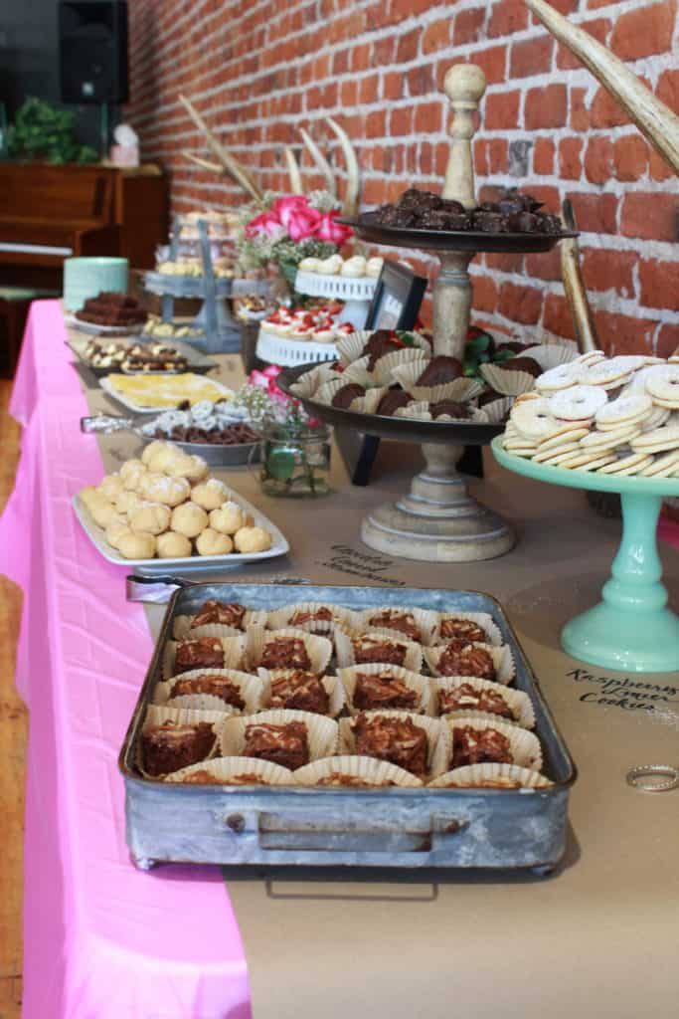
Fig.1.1. Dessert buffet

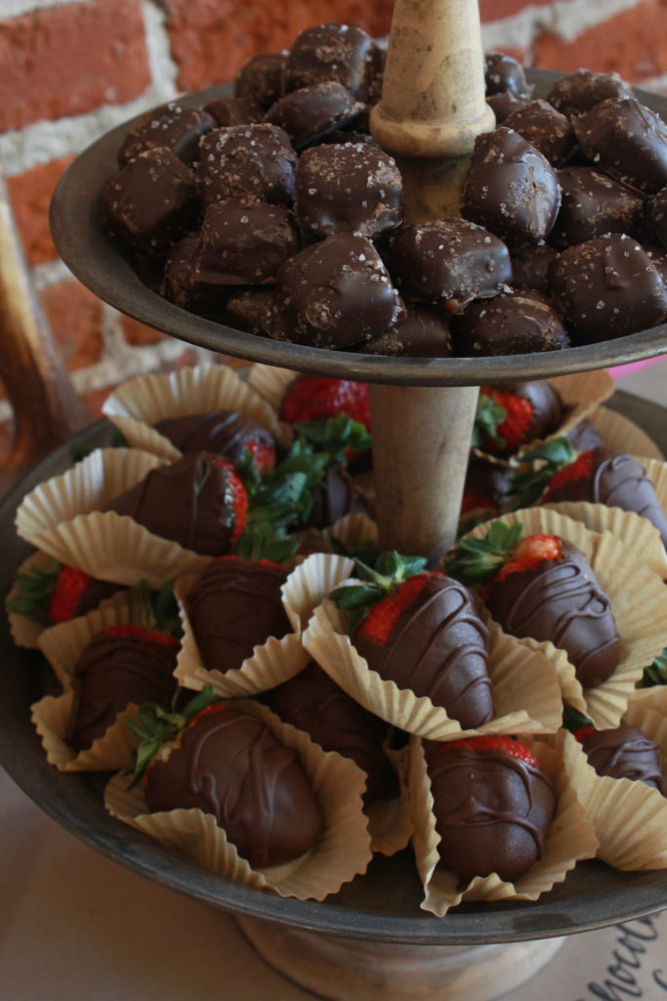
Fig.1.2. Dessert buffet

USING SERVING DISHES FOR HEIGHT AND DIMENSION
You can see that variety of serving dishes in different heights and textures to create dimension and interest. For most of the party we use metal, wood and white elements add colour with a couple of cake plates and the flower arrangements.
Now you can see the second purpose for the brown paper.. Write the dessert names directly on it, so that guests would know what they are eating & love when menu items are identified.
Serving items in cupcake liners both the caramels on the top tier are cute and functional.
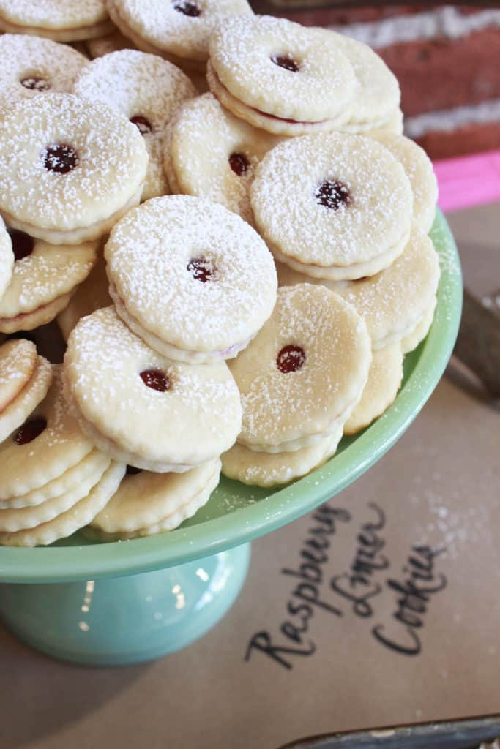
The table was the same colour as the dessert plates the guest used.
. Fig. 1.3. Dessert buffet raspberry linzer

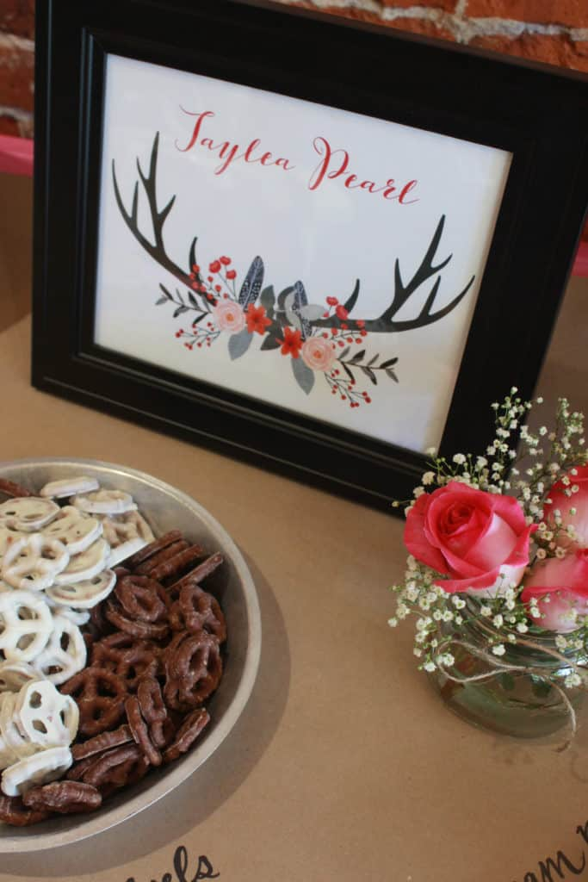

Fig 1.4. Special touch of dessert buffet
This is an angle from the other side of the table. Same desserts, just a different view.

DON’T FORGET THE DRINK TABLE
We can’t forget the drink table when we talk about how to plan a dessert buffet. It was located on the other side of the room serving iced tea, water and lemonade in large jars gave a good variety.
Prepare and Plan Dessert Menus
Finding inspiration and developing a great plated dessert is a chore in itself. But having to plan an entire dessert menu, to strike a balance of items to be offered, to choose items that will be attractive to your customers and promote good sales takes planning.
Establishments that have the most success with their dessert menu (and sales) tend to stick to the most popular flavours. Innovation just for innovation’s sake is generally not a good idea. Non-traditional ingredient pairings may work, for example, and chocolate always sells well—but if it is combined with something like beets, it will turn most people off. There is a time and place for uncommon dessert ingredients: special events, tasting menus, catering events. Desserts are a comfort food to most people, and to have an approachable menu with popular flavours will lead to the highest customer satisfaction.
A good starting point is the 5 Cs:
- Chocolate
- Citrus
- Coffee
- Custard or cheesecake
- Caramel
Other principles to consider preparing dessert menu
- Keep the wording simple and straightforward.
- Try not to repeat ingredients. If bananas are used in one item, keep it that way. Why have two desserts with the same ingredient?
- You don’t always have to use fruit. If you are in an area that doesn’t produce much fruit in the shoulder seasons, use other ingredients.
- When it’s in season, use fruit. It is a great way to showcase an ingredient that people want to taste after a year of not having it. Using fruit will also lower your food costs, and you will have an ingredient that requires little manipulation.
- Not every dessert requires a frozen component.
- The number of dessert items on the menu depends on how the kitchen can handle serving them during busy production times, without compromising the customers’ experience. Normally five to eight items on the dessert menu is a reasonable amount.
- Design a dessert menu that suits the style and cuisine type of the establishment, as well as the type of customers being served.
- Think about seasonality: offer lighter desserts in summer, richer, warmer desserts in the winter.
- Put the popular items on the very top and bottom of the menu so that customers will see the other options and perhaps choose them. Also, statistically, when a person views a menu, the eye will be drawn to the top, right-hand side of the page. Placing a less popular item in this area can help promote sales of desserts that are not the “stars.”
- Keep it small. There is nothing that better promotes customer satisfaction than to have them wishing for a “little bit more” of a dessert. You don’t want to serve a dessert that is so big it can’t be finished. This will have an effect on the customer (“I’ve had too much”), and is wasteful. Food costs can be lowered if reasonable portion sizes are used. By serving smaller amounts, greater yield can come from the recipes.

Planning Ahead Creates a Great Gathering
Standing in line, holding a plate, seems to be a welcome holiday ceremonial. From Thanksgiving to the company luck of the draw and from the family Christmas Eve to the New Year’s Eve gathering, buffets are a timeless tradition.
As a host or hostess, giving some thought to how-to organize your buffet makes all the difference in the world. A good flow, to and from the food and drinks, makes the gathering more pleasant for everyone.

Work ahead:
There is a lot of work involved in setting out a buffet. Try to accomplish some of the related tasks well ahead of time. This includes wrapping and tying silverware, creating a centre piece, polishing silver and pressing linens.
Sometimes, it is easier on the hostess for food to have an identifying card. It keeps the guests from repeatedly asking about a dish. If you wish to set out small tags naming each dish, those may also be made ahead.

Finish Organizing:
The last step to buffet organization is to create a checklist. You will not want to realize after the party is over that the salad was plain and that the dressing is still in the fridge. Make a checklist of everything that goes out on the buffet, right down to those very important little details such as ice, butter, dressing, salt and pepper.

Here are steps to get started planning dessert menu:
- Determine the occasion: Consider the event or occasion for which you are planning the dessert. This will help you decide on the type of dessert, flavour, and presentation.
- Choose the dessert: Once you have determined the occasion, choose a dessert that is appropriate for it. You can choose from a variety of desserts such as cakes, pies, tarts, cookies, and more.
- Consider your audience: Think about who will be eating the dessert. Consider their dietary restrictions, preferences, and allergies.
- Plan the menu: Once you have chosen the dessert, plan the rest of the menu around it. Consider pairing it with complementary flavours and textures.
- Decide on presentation: Presentation is key when it comes to desserts. Think about how you want to present your dessert. You can use different platters, cake stands, or even create a dessert table.
- Prepare in advance: If possible, prepare your dessert in advance to save time on the day of the event.
- Serve with style: Finally, serve your dessert with style. You can add garnishes such as fresh fruit or whipped cream to make it look more appealing.

1.1.2. Selecting Appropriate equipment
- commercial mixers with attachments
- whisk attachments
- paddle attachments
- hook attachments
- spatulas and wooden spoons
- Cutting implements for nuts and fruits
- graters box
- scales and measurement bowl
- Cutters
- piping bags and nozzles
- ovens
- cake and sponge tins and moulds
working marble table
- specialised equipment for preparing, moulding, decorating and arranging display tables
- trolley

Table 1.2. Equipment for buffet dessert preparation
No. |  | Name of tools &equipment |  | Picture |  | Description
1. |  | - commercial mixers with attachments |  | 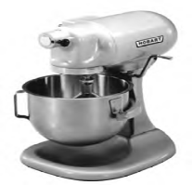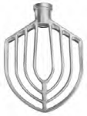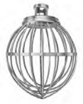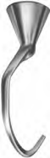 |  | Used for mixing mixture, cookies &making a dough
2. |  | - spatulas and wooden spoons |  | 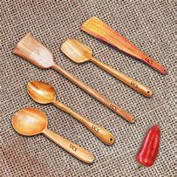 |  | Used for mixing and fold in mixture
3. |  | - grater box |  | 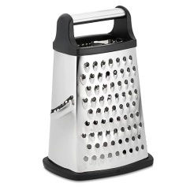 |  | A rolling pin is a cylindrical food preparation utensil used to shape and flatten dough.
4. |  | - scales and measurement bowl |  | 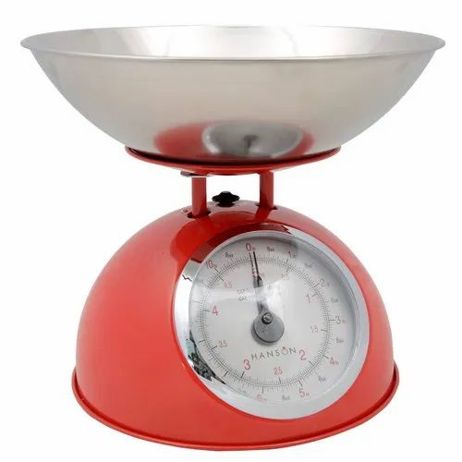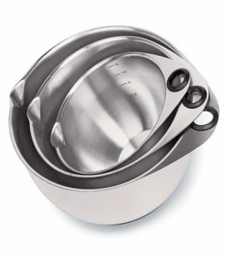 |  | Used for measuring ingredients
5. |  | Cutters |  | 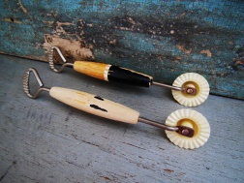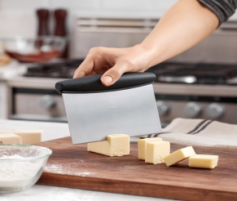 |  | Used for cutting & shaping as required
6. |  | - piping bags and nozzles |  | 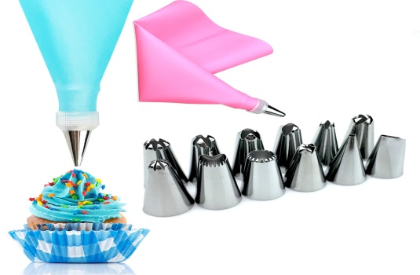 |  | Used for decorating pastry products
4. | Display tables |  | 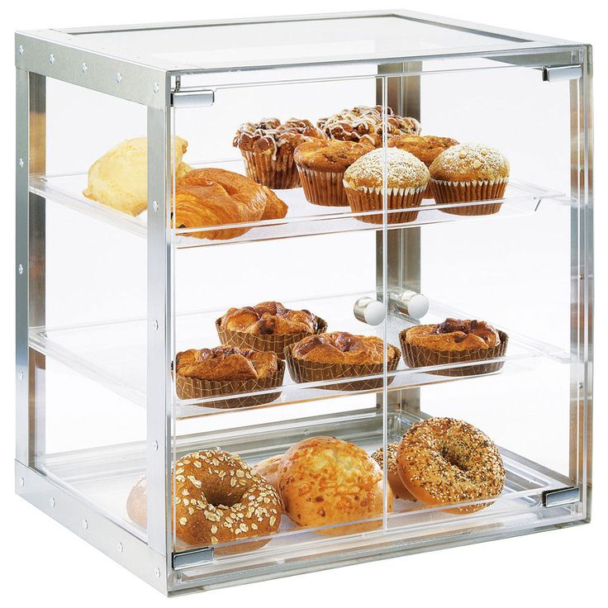 |  | Used to display bakery and pastry products
5. | pastry brush |  | 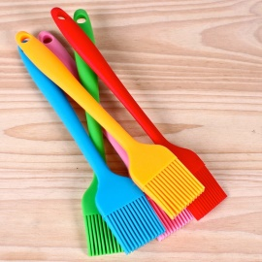 |  | A pastry brush is a small brush that is used to paint an egg wash on top of dough before baking to give the top a nice brown color.

6. | Whisker | 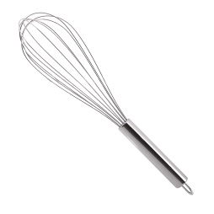 | Whisks are used to either add air into a mixture or thoroughly blend ingredients together.
7. | baking molds | 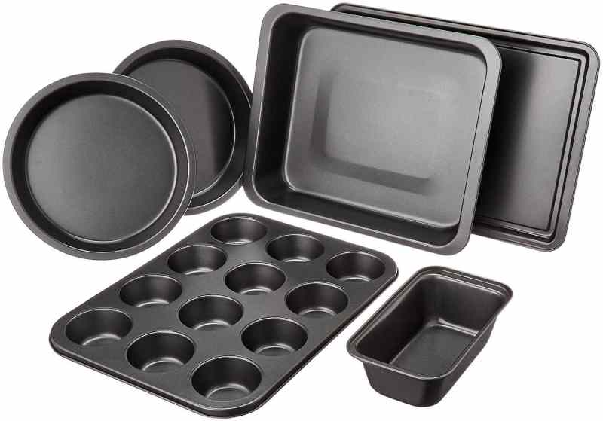 | A sheet pan, baking tray or baking sheet is a flat, rectangular metal pan used in an oven. It is often used for baking bread rolls, pastries and flat products such as cookies, sheet cakes, Swiss rolls and pizzas.

SELF-CHECK | WRITTEN EXAM
Answer the following questions:
Part1. Say True or False:
- To plan a dessert buffet, variety of desserts is required.
- Team work is Not important to plan for dessert
Part2. Choose the correct answer:
- For most of dessert buffet we use
- Metal
- Wood
- A & B
- None of the above
- When we talk about planning a dessert buffet we don’t forget
- Iced tea
- Water
- Soft drink
- All of the above
Part3. Short answer:
- Explain about works ahead in setting out dessert buffet.
- List necessary equipment &tools required for making dessert buffet.

Unit Two: - Preparing centres and fillings
This unit is developed to provide you the necessary information regarding the following content coverage and topics
- Producing A variety of Dessert buffet
- Assembling Dessert buffet
- Decorating Dessert buffet

This unit will also assist you to attain the learning outcomes stated in the cover page.
Specifically, upon completion of this learning guide, you will be able to:

- Produce a variety of Dessert buffet to industry standards and enterprise requirements.
- Select materials shaped into desired forms, using appropriate techniques and creative flair and skills.
- Assemble Dessert buffet considering balance, proportion, color and strength.
- Finish Dessert buffet artistically and decorate ensuring appropriateness for the occasion and creating customer appeal.
- choose appropriate materials that are, suitable for the occasion decorations

2.1. Producing a variety of Dessert buffet
There are many options for a dessert buffet. Here are some popular ones:
- Brownies: Fudgy brownies, blondies, and chocolate brownies are some of the most cakes: Chocolate cake, vanilla cake, cheesecake, carrot cake, red velvet cake, and fruitcake are some of the most common cakes served at dessert buffets ¹.
- Pies: Apple pie, pumpkin pie, pecan pie, and key lime pie are some of the most popular pies served at dessert buffets ¹.
- Cookies: Chocolate chip cookies, oatmeal cookies, sugar cookies, and peanut butter cookies are some of the most common cookies served at dessert buffets ¹.
- Popular brownies served at dessert buffets ¹.
- Fruit: Fresh fruit such as strawberries, raspberries, blueberries, kiwi, pineapple, and watermelon can be a refreshing addition to a dessert buffet

Operationsheet.1
Operation Title: Producing a variety of Dessert buffet
Purpose: to produce a variety of Dessert buffet
Conditions or situations for the operations:
- Safe working area
- Operation tools and equipment
- Appropriate work uniforms fit for preparing Dessert buffet

  - Frosted Banana Bars

Ingredients
- 1/2 cup butter, softened
- 2 cups sugar
- 3 large eggs, room temperature
- 1-1/2 cups mashed ripe bananas (about 3 medium)
- 1 teaspoon vanilla extract
- 2 cups all-purpose flour
- 1 teaspoon baking soda
- Dash salt
Directions
- Preheat oven to 350°. In a large bowl, cream butter and sugar until light and fluffy, 5-7 minutes. Beat in the eggs, bananas and vanilla. Combine the flour, baking soda and salt; stir into creamed mixture just until blended.
- Transfer batter to a greased 15x10x1-in. baking pan. Bake for 20-25 minutes or until a toothpick inserted in the centres comes out clean. Cool in pan on a wire rack.
- For frosting, in a small bowl, beat cream cheese and butter until fluffy. Add confectioners' sugar and vanilla; beat until smooth. Frost bars.

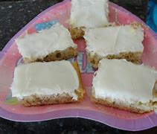
Fig.2.1.Frosted banana bar
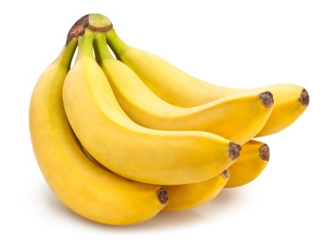
Banana Bars Tips
How do you ripen bananas quickly?
To ripen bananas quickly, just pop your bananas in a paper bag, fold over to close and check in a day. The enclosed environment traps ethylene, the compound responsible for ripening bananas. For even better results, add an apple to the bag (it also releases ethylene). Don’t want to wait a day? You can ripen bananas in minutes or hours using an oven or freezer.

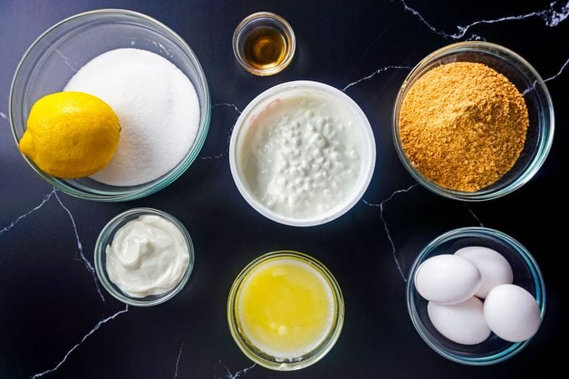
How to Make Cottage Cheese Cheesecake
Fig. 2.2.Ingredients
This recipe makes one 9-inch cheesecake, which is about 10 to 12 servings.
Ingredients
- 1-1/2 cups fine graham cracker crumbs (about 12 whole graham cracker sheets)
- 1/4 cup granulated sugar
- 5 tablespoons unsalted butter, melted
Filling:
- 1 cup granulated sugar
- 1 tablespoon lemon zest
- 3 cups (24 ounces) full-fat cottage cheese, room temperature
- 1/2 cup plain or vanilla Greek yogurt
- 2 teaspoons pure vanilla extract
- 1/4 teaspoon salt
- 4 eggs, room temperature
- Optional toppings: Fresh berries, whipped cream, chocolate or caramel sauce

Directions

Step 1: Preheat and prep
Preheat your oven to 350°F. / 176.67°
Prepare a 9-inch spring form p+9by spraying the bottom and sides with non-stick cooking spray and lining the bottom with a piece of parchment paper. Wrap the bottom exterior of the pan with foil to prevent leaks. Set aside.

Step 2: Make the crust
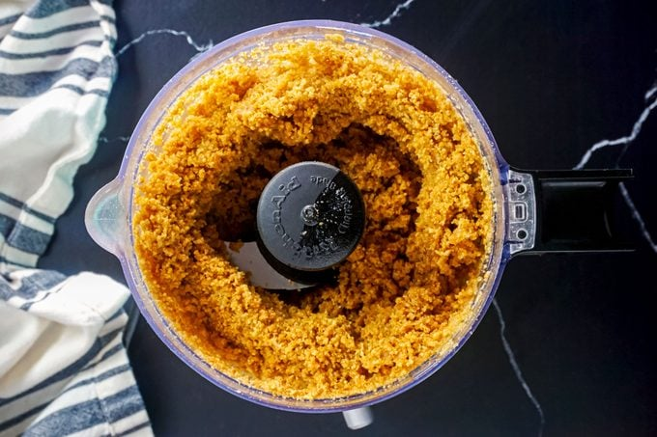

In a small food processor, combine the graham crackers, melted butter and sugar. Pulse until the mixture resembles wet sand and then transfer to the prepared pan. Using the bottom of a glass, press the crust evenly into the bottom and about one inch up the sides of the pan.
Bake crust for six to eight minutes, then remove and cool on a wire rack.

Step 3: Puree the cottage cheese
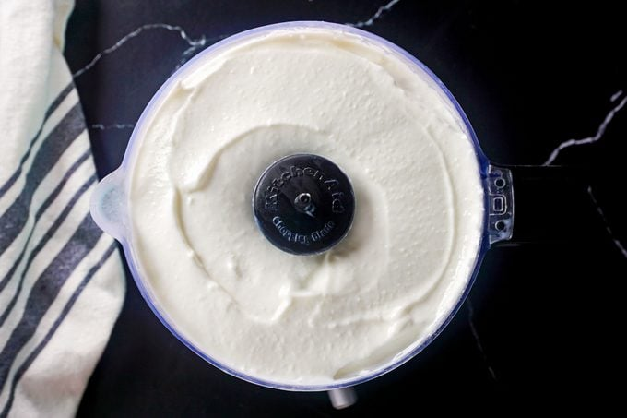
Add the cottage cheese to a food processor or high-powered blender. Puree until smooth and creamy, and then transfer to the bowl of a stand mixer fitted with a paddle attachment.

Step 4: Make the filling
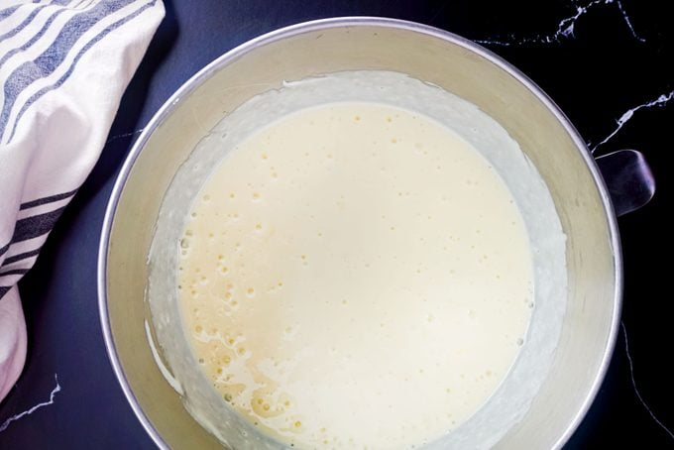

Add the yogurt, sugar, lemon zest, vanilla and salt. Beat together for one minute and then add the eggs, one at a time, blending until smooth after each addition. We like adding 1/2 cup of Greek yogurt to the filling since it lends the cheesecake a bit of that classic tang. If you don’t have Greek yogurt, you can substitute the yogurt for an additional 1/2-cup of blended cottage cheese. Just know that the cheesecake will have a more mild flavour.

Step 5: Bake
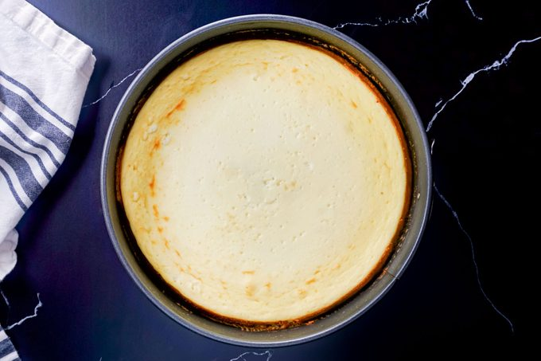

Pour the batter into the cooled crust, and then bake for 45 to 60 minutes. The cheesecake is done when the centre is just set, and the cheesecake jiggles slightly when gently shaken. Remove promptly to a cooling rack (keeping the outer ring of the pan on). Cool completely then chill for at least eight hours (or up to 24 hours) before serving.

Step 6: Serve
Cut the cheesecake into slices and serve plain or with toppings of your choice. Warm chocolate sauce, fresh berries and whipped cream are all excellent options.
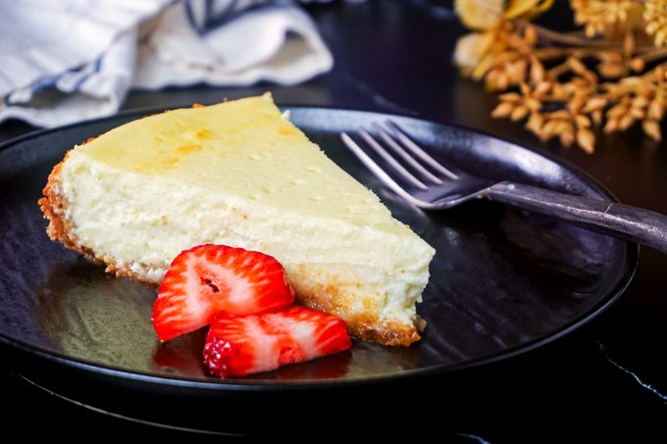
Fig 2.3. Cottage cheese cheese cake
b) Nutty Cheesecake Squares
Ingredients
- 2 cups all-purpose flour
- 1 cup finely chopped walnuts
- 2/3 cup packed brown sugar
- 1/2 teaspoon salt
- 2/3 cup cold butter
- filling:
- 2 packages (8 ounces each) cream cheese, softened
- 1/2 cup sugar
- 2 large eggs, room temperature, lightly beaten
- 1/4 cup 2% milk
- 1 teaspoon vanilla extract

Directions
- In a large bowl, combine the flour, walnuts, brown sugar and salt; cut in butter until the mixture resembles coarse crumbs. Set half aside; press remaining crumb mixture onto the bottom of a greased 13x9-in. baking pan. Bake at 350° for 10-15 minutes or until lightly browned.
- In a large bowl, beat filling ingredients until smooth; pour over crust. Sprinkle with reserved crumb mixture.
- Bake at 350° for 20-25 minutes or until a knife inserted in the center comes out clean. Cool on a wire rack for 1 hour. Store in the refrigerator.
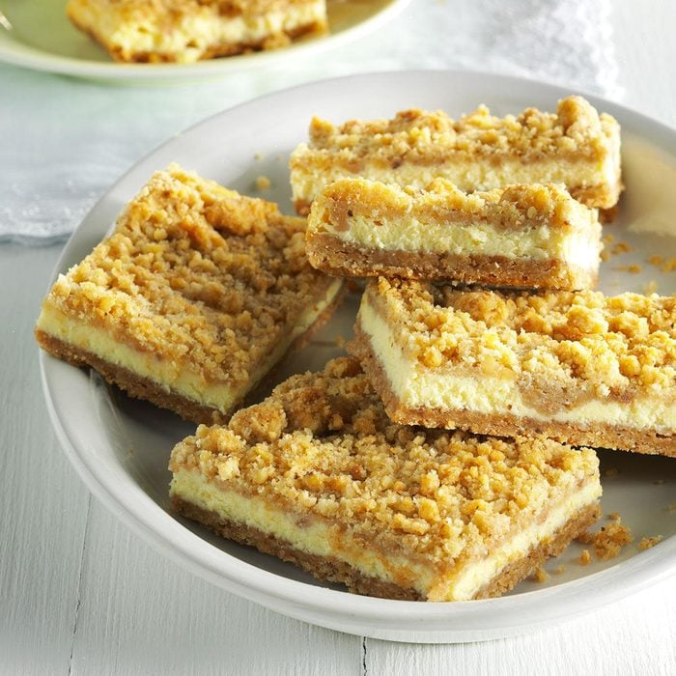

Fig.2.4. Nutty Cheesecake Squares
c) Strawberry topped Cheesecake
Ingredients
- 3/4 cup ground pecans
- 3/4 cup graham cracker crumbs
- 3 tablespoons butter, melted
Filling:
- 4 packages (8 ounces each) cream cheese, softened
- 1-1/4 cups sugar
- 1 tablespoon lemon juice
- 2 teaspoons vanilla extract
- 4 large eggs, lightly beaten
Topping:
- 2 cups sour cream
- 1/4 cup sugar
- 1 teaspoon vanilla extract
Strawberry glaze:
- 2 tablespoons corn starch
- 1/4 cup water
- 1 jar (12 ounces) strawberry jelly
- Red food colouring, optional
- 3 tablespoons orange juice
1 quart whole fresh strawberries, hulled
Directions
- In a small bowl, combine the pecans and cracker crumbs; stir in the butter. Press onto the bottom of a 10-in. spring form pan. Set aside.
- In a large bowl, beat the cream cheese until smooth. Add the sugar, lemon juice and vanilla; beat well. Add eggs; beat on low speed just until combined. Spoon over crust. Place pan on a baking sheet.
- Bake at 350° for 45-50 minutes or until the centre is almost set. Remove from the oven and let stand 15 minutes (leave oven on). For topping, combine all the ingredients; spoon around edge of cheesecake. Carefully spread over filling. Bake 5 minutes longer. Cool pan on a wire rack for 10 minutes. Carefully run a knife around the edge of pan to loosen; cool 1 hour longer. Refrigerate overnight.
- Several hours before serving, prepare glaze. In a saucepan, combine corn starch and water until smooth; add jelly. Bring to a boil over medium-height heat; cook and stir for 1-2 minutes or until jelly is melted and glaze is thickened. Remove from the heat; stir in orange juice and food colouring if desired. Cool to room temperature.
- Just before serving, remove sides of pan. Arrange strawberries on top of cheesecake with pointed ends up. Spoon glaze over berries, allowing some to drip down sides of cake. Refrigerate leftovers.
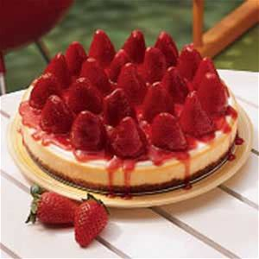
Fig 2.5.Strawberry topped Cheesecake

d) Lemon Cheesecake Squares
Ingredients
- 3/4 cup shortening
- 1/3 cup packed brown sugar
- 1-1/4 cups all-purpose flour
- 1 cup rolled oats
- 1/4 teaspoon salt
- 1/2 cup seedless raspberry jam
filling:
- 4 packages (8 ounces each) cream cheese, softened
- 1-1/2 cups sugar
- 1/4 cup all-purpose flour
- 1/3 cup lemon juice
- 4 teaspoons grated lemon zest
- 4 large eggs, lightly beaten
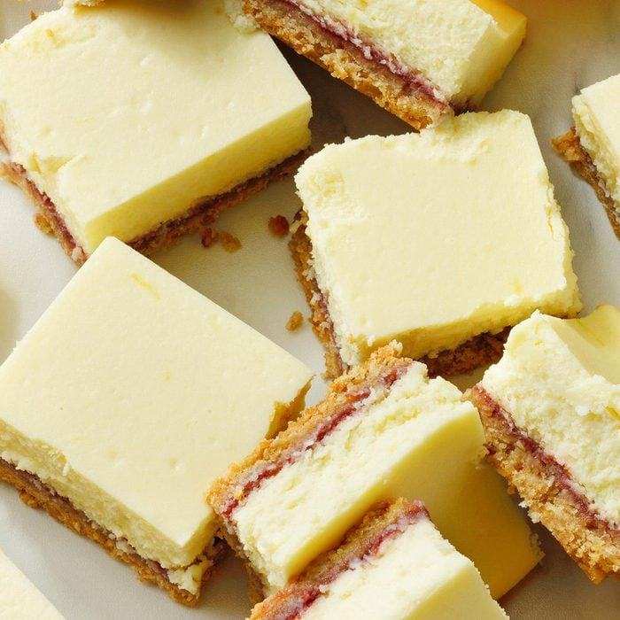
Fig.2.6. Lemon Cheesecake Squares
e)Mini Cheese cake with Vanilla Wafers
Ingredients
- 1 (12 ounce) package vanilla wafers
- 2 (8 ounce) packages cream cheese
- ¾ cup white sugar
- 2 eggs
- 1 teaspoon vanilla extract
- 1 (21 ounce) can cherry pie filling
Directions
- Preheat the oven to 350 degrees F (175 degrees C). Line two 24-cup miniature muffin tins with paper liners.
- Crush vanilla wafers. Place 1/2 teaspoon of crushed vanilla wafers into each paper cup.
- Beat cream cheese, sugar, eggs, and vanilla in a mixing bowl until light and fluffy.
- Fill each miniature muffin liner with this mixture, almost to the two third fill.
- Bake in the preheated oven for 15 minutes until the cheesecake is set.
- Cool.
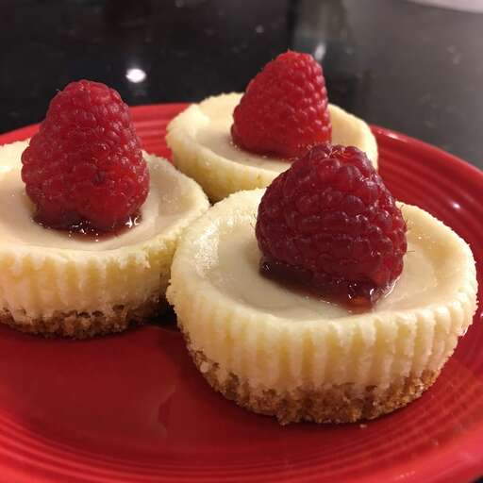
- Top with a teaspoonful of cherry pie filling.

Fig.2.7.Cheese cake with Vanilla Wafers

2. Assembling Dessert buffet
Assembling means: to make something by joining separate parts together.
Dessert buffet is assembled considering balance, proportion, color and strength.
Unless you’re treating your guests to a board, dessert is going to be the last course of any party. This means it’s also probably the one most people are going to remember, so putting just a little extra effort in can make all the difference. Obviously it has to taste good, but even the most amazing dessert in the world isn’t going to excite the senses if it’s just thrown together on a plate. That’s why presentation is the utmost importance, creating desserts that look like works of art. ‘Presentation is key in all aspects of cooking, ‘But I think there is a lot more freedom when it comes to pastry and desserts as there are so many different techniques that allow you to showcase the food in a variety of ways. People say you eat with your eyes, the taste is also more important. Think that guests will remember the amazing flavour of a dessert & how it looks.
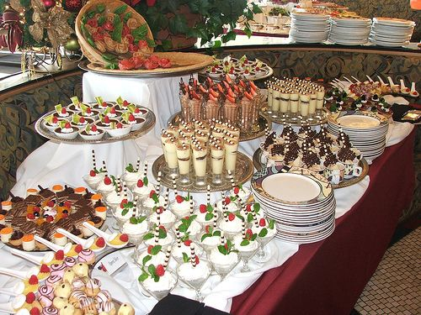

Fig2.2.1.Images of assembling dessert buffet

Fig2.2.2.Images of assembling dessert buffet

2.3. Decorating Dessert buffet
Decoration means to make (something) look more attractive by adding extra items or images to it, to add something to an object or place, especially in order to make it more attractive:
Dessert buffet artistically is finished and decorated ensuring appropriateness for the occasion and creating customer appeal
- Add light layers to your buffet decor
- A mix of larger and medium-sized items is preferred over lots of mini objects on a buffet
- Use faux(artificial) blooms and plants liberally making sure they are very realistic
- Experiment and play with your accessories
- Less is more
- Backdrop: Add a large decorative item as the backdrop to your buffet table, such as a large mirror, two medium-sized mirrors, or a large picture or wall art piece¹.
- Tall Decor: Place taller items on either end of the buffet table. Consider using items like planters with plants, vases with tall greenery or flowers, candlesticks, lamps, or a tiered tray full of decorative items¹.
- Tall Decor: Place taller items on either end of the buffet table. Consider using items like planters with plants, vases with tall greenery or flowers, candlesticks, lamps, or a tiered tray full of decorative items¹.
- Repetitive Decor: Consider being repetitive with one item to create an appealing look. For example, you can use multiple mirrors layered to give dimension or add garland to dress up a mirror¹.
- Seasonal Inspiration: Explore past looks of buffet tables decorated for different seasons to find inspiration for your own decor¹.

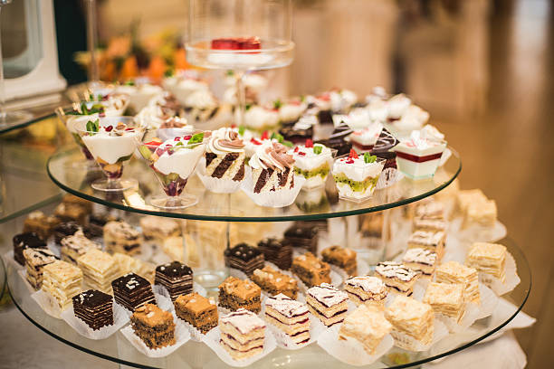

Fig2.2.3.Images of decorated dessert buffet

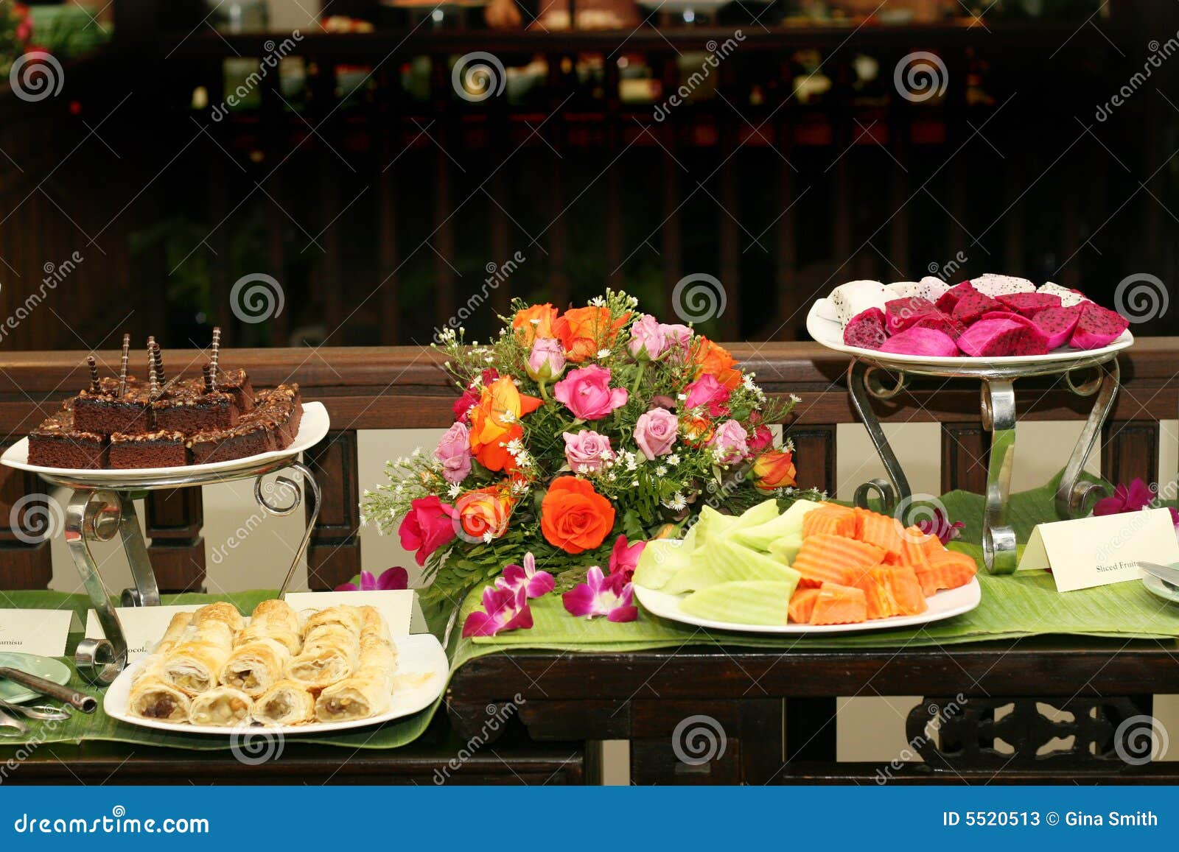

Fig2.2.4.Images of decorated dessert buffet

Unit Three: - Displaying Dessert buffet
This unit is developed to provide you the necessary information regarding the following content coverage and topics
- Displaying Dessert buffet.
- Storing dessert buffet
This unit will also assist you to attain the learning outcomes stated in the cover page.
Specifically, upon completion of this learning guide, you will be able to:

- Display Dessert buffet attractively to enhance Dessert buffet displays.
- Use Dessert buffet to complement, harmonize and balance the displayed food.
- Store Dessert buffet according to establishment procedures and ensure that they are protected from humidity, dust and heat

3.1. Displaying Dessert buffet
Displaying means: to arrange something or a collection of things so that it can be seen by the public.
A collection of objects arranged for people to look at, or performance or show for people to watch.
To show something or a collection of things in an organized way for people to see.
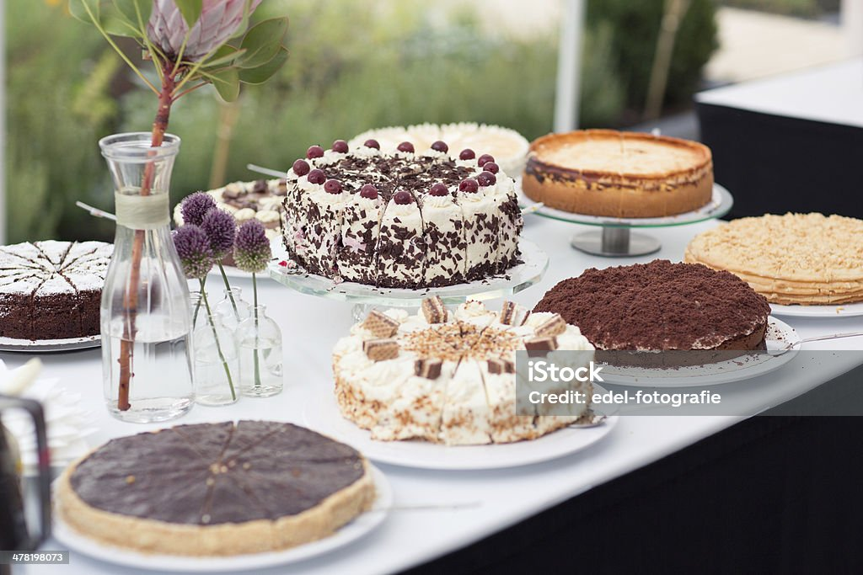
Fig 3.1.1.Displayed Cake Buffet

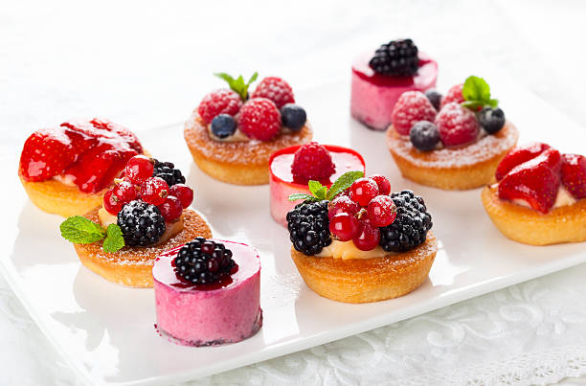
Fig 3.1.2.Displayed dessert buffet
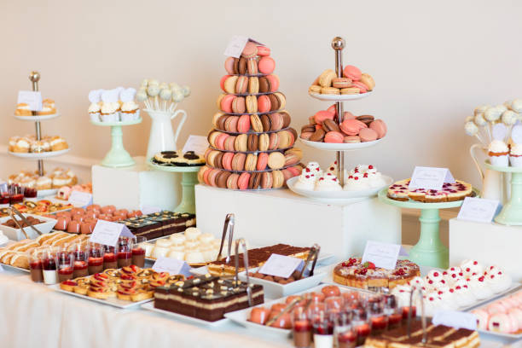
Fig 3.1.3.Displayed dessert buffet
3.2. Storing dessert buffet
Storing means: to put or keep things in a special place for use in the future:
Storing cold and hot desserts as many desserts contain egg and dairy products, they present a potential health hazard if not stored properly. Remember proper storage means cooled desserts must be covered with plastic or placed in lidded containers before storing in the cool room.
Desserts containing uncooked eggs should be handled with extreme care, as raw egg is a medium in which dangerous bacteria such as salmonella can thrive.
Cool rooms and other temperature-controlled environments, use of packaging materials and cases are important for storage.
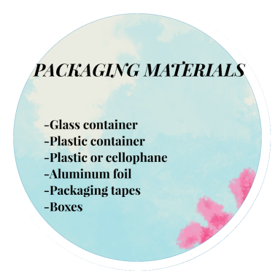
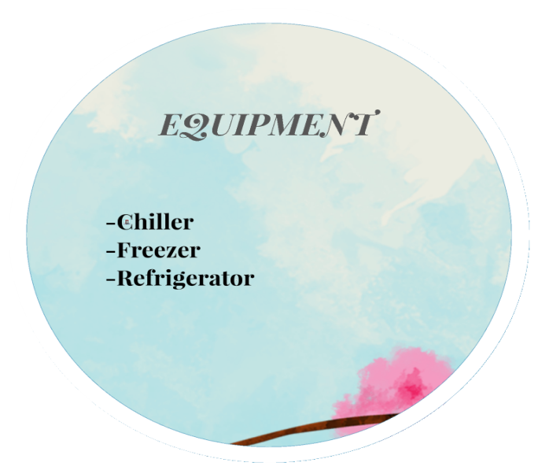
Fig.3.2.1.packaging materials Fig.3.2.2.Equipment
Packaging Materials for Storing Desserts:
- glass container
- plastic container
- plastic/cellophane
- aluminium foil
- packaging tapes
- boxes Equipment
- chiller
- freezer
- refrigerator Sanitary Practices When Storing Desserts
- Handle the food properly to prevent spoilage and contamination.
- Wash utensils and equipment thoroughly.

- Keep away from food when you are ill.
- Store foods and ingredients properly.
- Safeguard the food during distribution and service.

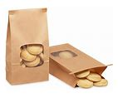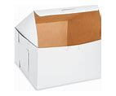
Fig.3.2.3.packaging material Fig.3.2.4.packaging material

SELF-CHECK 3. | WRITTEN EXAM

Answer the following questions:
  - True or false questions
- It is important to store cold desserts than hot desserts.
- If desserts are not stored properly they may result health hazard.
  - Short answer
- What is storing? What is storage? Explain and identify the difference.
- List some materials necessary for storage and packaging desserts.

Lap test 1:
Instruction: Given necessary templates, tools and materials you are required to perform the following tasks accordingly.
Task1. Produce variety of dessert buffet
Task2.Assemble Dessert buffet
Task 3.Decorate Dessert buffet
Task 4.Display desserts

RECOMMENDED READINGS

- FROM THE INTERNET
- BAKERY & CONFECTIONARY COURSE ,FOOD PRODUCTION DEPARTMENT
KENYA UTALII COLLEGE, NIROBI
- READING MATERIALS ON PASTRY AND BAKERY PRODUCTION

Developers’ profile
No | Name | Qualification | Educational background | Region | College | Mobile number | E-mail
 | Zuriyash-work Belay | BA Degree | Hotel Management | A.A | TTI | 0911643817 | zuriyashwb@gmail.com
 | Mohammed Liben | BA Degree | Hotel and Tourism Management | Somali | Jigjiga Polytechnic College | 992326557 | cherechaw@gmail.com
 | Zelalem.Almaw | BA Degree | Food Science& Post Harvest Technology | Amhara | Bahir Dar Polytechnic College | 0918012521 | parazolla25@gmail.com
 | Belacehew Merga Lemi | BA Degree | Hotel mgt & Masters of Business A dministration | A.A | Kirkos manufacturing college | 0910330503 | belachewmera2011@gmail.com

