Bakery & Pastry Production
Level IV
Based on September, 2023 Curriculum Version II
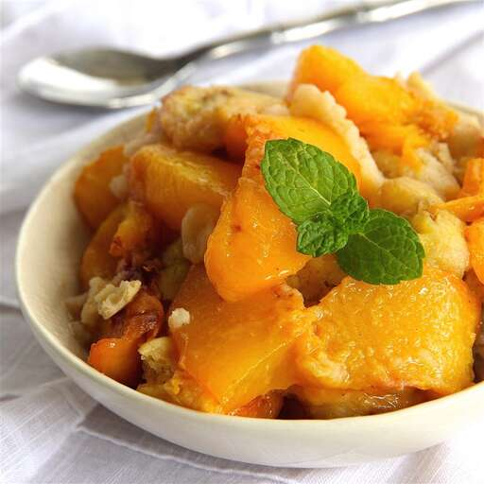

Module Title: Preparing pastry for Dietary and Cultural Needs
Module Code: CST BPP3 M04 0923
Nominal duration: 60 hours

Prepared By: Ministry of Lobar and Skill
September, 2023
Addis Ababa, Ethiopia
Contents
Acknowledgment 3
Unit One: Preparing Dietary desserts 4
1.1 Concept of dietary requirement 5
1.2 Ingredients for dietary requirements 7
1.3 Nutritional guidelines in producing dietary desserts 8
Self check -1 10
Unit Two: Preparing sauces and Storing for dietary desserts 11
2.1. Preparing Hot & Cold dietary Sauces 12
2.2. Storing dietary desserts 12
Self check -2 14
Operation sheet 2: 14
Reference 22
Developers’ profile 23

Acknowledgment
The Ministry of Labor and Skills (MoLS) would like to express its gratitude and appreciation to the instructors and experts from regional TVET bureaus, TVET colleges and industry practitioners who contributed their expertise and experience in preparing the training module for the unit of competency “Preparing pastry for Dietary and Cultural Needs” under the occupational standard “Bakery & Pastry Production level IV."
The Ministry also expresses its deepest gratitude to the Tourism Training Institute for its invaluable technical and financial support and collaboration in the module preparation. It is also thankful to MoLS staff members who coordinated the preparation and reviewing process of this training module.

Introduction to the Module
This module describes the performance outcomes, skills and knowledge required to prepare of a range of desserts where aspects of nutrition, diet or allergies influence the composition and the ingredients able to be used. This would include diabetic desserts, low fat or low sugar desserts, or desserts that are free of ingredients such as yeast, gluten or flour and other potential allergens or substances that can cause reactions in customers
This module is designed to meet the industry requirement under the Bakery & Pastry Production occupational standard, particularly for the unit of competency: Prepare pastry for Dietary and Cultural Needs.
This module covers the units:
- Preparing dietary desserts
- Preparing sauces and Storing for dietary desserts
Training Objective of the Module
At the end of this session, the students will able to:
- Prepare dietary desserts
- Prepare sauces
- Store sauces
Module Instruction
For effective use this modules trainees are expected to follow the following module instruction:
- Read the information written in each unit
- Accomplish the Self-checks at the end of each unit
- Perform Operation Sheets which were provided at the end of units
- Do the “LAP test” given at the end of each unit

Unit One: Preparing Dietary desserts
This learning guide is developed to provide you the necessary information regarding the following content coverage and topics:
- Concept of dietary requirement
  - Ingredients for dietary requirements
  - Nutritional guidelines in producing dietary desserts
This guide will also assist you to attain the learning outcomes stated in the cover page. Specifically, upon completion of this learning guide, you will be able to:
- Use appropriate ingredients according to criteria for particular dietary requirements.
- Measure and weigh ingredients required, ensuring they are at the correct temperature according to recipe requirements.
- Follow special dietary recipes or nutritional guidelines in producing dietary desserts

1.1 Concept of dietary requirement
Dietary needs means that the diet as a whole containing a mix of nutrients for physical and mental growth, development and maintenance, and physical activity that are in compliance with human physiological needs at all stages throughout the life cycle and according to gender and occupation.
Dietary requirements are the needs of someone who has specific and/or a restricted diet.
Cultural foods may involve beliefs about how certain foods are prepared or used. They may also symbolize a group’s overall culture.
Some of the most common dietary requirements are those founded on religious or allergy-related grounds.

- Allergy: Allergies are very common. A food allergy is when the body’s immune system reacts badly to a specific food. Food allergies can be mild but in some cases, they can be very serious and sometimes life-threatening if the diner goes into anaphylactic shock. Some of the most common food allergies are:
- Milk (normally in children
- Eggs
- Peanuts
- Strawberries
- Soy
- Wheat and other grains with gluten, including barley, rye and oats
- Fish (normally in adults)
- Shellfish (normally in adults)
- Intolerance: Food intolerances are generally less serious than food allergies and symptoms normally are concentrated around the digestive system. Despite being less serious than allergies, they should still not be taken lightly as they can be uncomfortable and painful for the sufferer. Some common food intolerances are:
- Milk and dairy: Many people experience some degree of difficulty in digesting dairy products. According to the National Health Insurance, 68% of the world’s population cannot easily digest lactose (naturally occurring milk sugars) and for some, this results in full lactose intolerance.
- Gluten (protein compound in wheat flour): Gluten is the result of proteins in flour mixing with water and forming stretchy strands that give bread and other baked goods their structure. A small percentage of the population is unable to digest gluten (this is called celiac disease), and it can result in a host of health problems. Some find they feel better when limiting gluten in their diet.
- Vegetarian and vegan: Both vegetarian and vegan diets avoid animal products, with veganism being the more restrictive of the two.
- Religious dietary restrictions
Some religions have dietary laws which prohibit certain foods, or the mixing of foods. For example, certain meats may be forbidden, such as pork (Judaism or Islam) or beef (Hinduism), or meat may be required to be prepared according to religious ritual and law, such as Kosher (Judaism) or Halal (Islam).
Muslim diet dictates that only meat from animals slaughtered under strict guidelines is allowed to be eaten. Pork is famously forbidden; as is alcohol. There are also some strict guidelines for fasting during festivals, specifically Ramadan. Separate cutlery and utensils may be required to ensure that milk and meat are not eaten together; or Halal meat is not stored or cooked with non-Halal meat; or kosher food stored or cooked with non-kosher food. For clarity and to avoid misunderstandings, it is advisable to find out the specific requirements of members of staff and to assess how these, where practicable, can be accommodated.
Kosher foods are foods that conform to the Jewish dietary regulations of kashrut (dietary law). The laws of kashrut apply to food derived from living creatures and kosher foods are restricted to certain types of mammals, birds and fish meeting specific criteria; the flesh of any animals that do not meet these criteria is forbidden by the dietary laws. Furthermore, kosher mammals and birds must be slaughtered according to a process known as shechita and their blood may never be consumed and must be removed from the meat by a process of salting and soaking in water for the meat to be permissible for use. All plant-based products, including fruits, vegetables, grains, herbs and spices, are intrinsically kosher, although certain produce grown in the Land of Israel is subjected to other requirements, such as tithing, before it may be consumed.
Kosher food also distinguishes between meat and dairy products. Meat products are those that comprise or contain kosher meat, such as beef, lamb or venison, kosher poultry such as chicken, goose, duck or turkey, or derivatives of meat, such as animal gelatin; non-animal products that are processed on equipment used for meat or meat-derived products are also considered to belong to this category. Dairy products are those which contain milk or any derivatives such as butter or cheese; non-dairy products that are processed on equipment used for milk or milk-derived products are also considered as belonging to this category. Because of this categorization, meat and milk or their respective derivatives are not combined in kosher foods, and separate equipment for the storage and preparation of meat-based and dairy-based foods is used in order for food to be considered kosher.

1.2 Ingredients for dietary requirements
Some people have special dietary habits like vegetarian & non-vegetarian food. Some people even have allergies to selected food like egg, peanut butter and other items. Diabetic patients prefer low sugar items. Cardiac patients need low cholesterol food. People have special food requirements due to Medical conditions, Cultural needs, Religious needs and individual habits.
Ingredients for dietary requirements need to get special attention in culinary world. Selecting suitable ingredients is necessary when preparing meals for customers with specific dietary need. You need to be aware of common dietary regimes like:
- Those without known allergic reactions
- Gluten-free flour and non-sugar sweeteners
- Low-fat or fat-free ingredients: Low-fat diets involve the reduction of the percentage of fat in one's diet. Calorie consumption is reduced because less fat is consumed.
- Low-sugar or sugar-free ingredients
- Low carbohydrate: Foods high in carbohydrates (e.g., sugar, bread, pasta) are limited, and replaced with foods containing a higher percentage of fat and protein (e.g., meat, poultry, fish, shellfish, eggs, cheese, nuts, and seeds), as well as low carbohydrate foods (e.g. spinach, kale, chard, collards, and other fibrous vegetables).
- Dairy free: A dairy-free diet is one that has no animal milk in it, or any products made from milk. People may go on a dairy-free diet because they have a milk allergy or intolerance, are on an elimination diet (they stop eating some types of food for a set amount of time, then re-add to their diet to see if it causes symptoms), follow a special diet (such as a vegan diet, which has no animal products in it).
- Reduced salt: a diet that limits the intake of salt (sodium chloride); often used in treating hypertension or certain other disorders.
- Vegan: A vegan diet is based on plants (such as vegetables, grains, nuts and fruits) and foods made from plants. Vegans do not eat foods that come from animals, including dairy products and eggs.

1.3 Nutritional guidelines in producing dietary desserts
A special diet is one that cannot be selected freely from the main choices available. This could be due to an allergy, intolerance or other medical need or because children are following a religious or cultural diet or a vegetarian or vegan diet. Tips to be followed during the dietary desserts preparation:
- Base your meals on starchy foods:
- Eat lots of fruit and vegetables: It is recommended that fruit and vegetables make up approximately one third of our diet. Fruit and vegetables provide us with essential nutrients that help our bodies fight disease. They are high in vitamin C, which helps our immune system. Fruit and vegetables also contain antioxidant properties that protect our cells from damage, reducing the risk of cardiovascular disease (CVD) and cancers.
- Eat more fish – including a portion of oily fish each week
- Cut down on saturated fat and sugar
- Eat less salt – no more than 6g a day for adults
- Get active and try to be a healthy weight
- Don't get thirsty
- Don't skip breakfast

Self check -1 | Written test

  - Write true or false
  - Pastry preparations can easily be modified to meet dietary requirements such as gluten-free or vegan diets.
  - Pastry preparations can be influenced by cultural traditions, resulting in unique flavors and ingredients.
  - Pastry preparations can be adapted to accommodate cultural dietary restrictions, such as avoiding pork or seafood.
II. Choosing
1. Which of the following ingredients is commonly used in gluten-free pastry preparations?
a) All-purpose flour
b) Almond flour
c) Bread flour
d) Whole wheat flour
2. Which of the following dietary requirements would typically avoid the use of animal products in pastry preparations?
a) Gluten-free
b) Low-fat
c) Vegan
d) Low-carb
3. Which of the following dietary requirements would typically avoid the use of fatty food items products in pastry preparations?
a) Gluten-free b) Low-fat c) Vegan d) Low-carb

Unit Two: Preparing sauces and Storing for dietary desserts
This learning guide is developed to provide you the necessary information regarding the following content coverage and topics:
- Preparing hot & cold dietary sauces.
- Storing dietary desserts
This guide will also assist you to attain the learning outcomes stated in the cover page. Specifically, upon completion of this learning guide, you will be able to:
- Prepare hot or cold sauces to the required consistency, using appropriate flavors and ingredients, according to dietary requirements
- Store dietary desserts at the appropriate temperature and under the correct conditions to maintain quality, freshness and customer appeal.

2.1. Preparing Hot & Cold dietary Sauces
2.1.1 What is Sauce?
Sauce is a French word taken from the Latin salsa, meaning salted. In cooking, a sauce is a liquid, cream, or semi-solid food, served on or used in preparing other foods. Most sauces are not normally consumed by themselves; they add flavor, moisture, and visual appeal to a dish. Sauces need a liquid component. Sauces are an essential element in cuisines all over the world.
Sauces may be used for sweet or savory dishes. They may be prepared and served cold, like mayonnaise, prepared cold but served lukewarm like pesto, cooked and served warm like béchamel or cooked and served cold like apple sauce. They may be freshly prepared by the cook, especially in restaurants, but today many sauces are sold premade and packaged like Worcestershire sauce, HP Sauce, soy sauce or ketchup. Sauces for salad are called salad dressing. Sauces made by deglazing a pan are called pan sauces. A chef who specializes in making sauces is called a saucier.
Hot sauce is a type of condiment, seasoning, or salsa made from chili peppers and other ingredients. Many commercial varieties of mass-produced hot sauce exist. Hot sauce often infuses the hotness of various peppers, usually using vinegar, and adds other flavors. It is any sauce, salsa, or seasoning made primarily from chili peppers, found in the genus Capsicum, combined with other ingredients.
Cold sauce: cold sauces include a wide variety of preparations from basic oil-and-vinegar combinations to relishes, salsas, and pesto. Vinaigrette and mayonnaise styles of dressings fill a major role in this category because of their versatility and endless variations.

2.2. Storing dietary desserts
The fridge is the best place to store sauces. Store your leftover homemade sauce in the fridge and use within a couple of days or freeze. For leftover shop-bought sauces it's best to follow the storage guidance on the jar. If you have leftover sauce, seal the lid and store the jar in the fridge
Storing sauces properly is important not only to preserve the quality, nutritional and organoleptic properties of food products, but also maintain the food in adequate safety conditions. Food is affected mainly by the action of bacteria, which are very active at room temperature. When storing homemade sauces or transferring store-bought sauces, always use airtight containers. This helps to prevent air exposure, which can lead to oxidation and spoilage.

Self check -2
I. Choose the true alternative
1. What is the main purpose of storing hot desserts at a specific temperature?
a) To prevent spoilage
b) To enhance flavor
c) To maintain texture
d) To speed up cooking process
2. Which of the following is NOT a suitable storage container for hot desserts?
a) Glass jars
b) Plastic containers
c) Aluminum foil
d) Stainless steel pans
3. A liquid, cream, or semi-solid food, served on or used in preparing other foods is
A. Milk
B. Kosher
C. Sauce
D. Vegan
4. Which one is the best place to store sauce?
A. fridge b. carton C. plastic bag d. cannot be store

Operation sheet 2: Prepare hot and cold dietary sauces
Purpose: To produce hot and cold dietary sauces
Conditions for the operations:
- Safe working area
- Properly operated tools and equipment
- Appropriate working uniforms fit for the practical performance
Equipment and Tools
Casseroles
Pans and lid
Knives, scissors and cutting board
Saucepan, ladle and skimmer
Blender
Strainer Kitchen scale or measuring cup
Grater
Bowls of different sizes
A. Vegan Chocolate Sauce
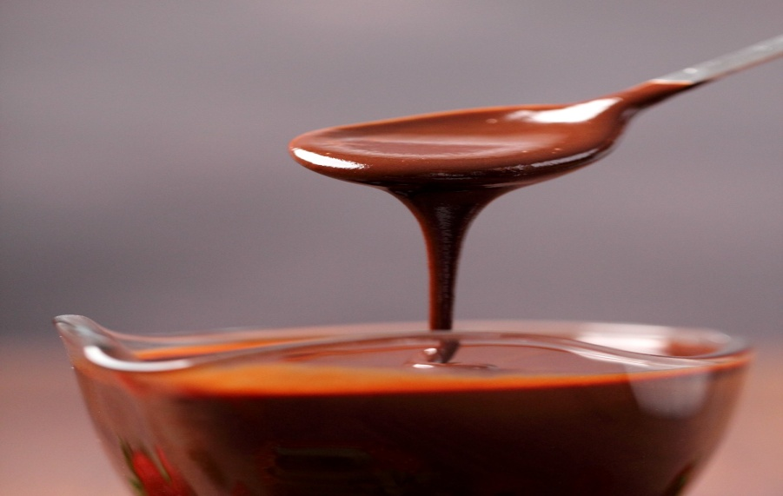
Ingredients:
- 1 cup coconut milk
- 1/2 cup dairy-free dark chocolate chips
- 2 tablespoons maple syrup
- 1 teaspoon vanilla extract

Fig 2.1 Vegan Chocolate Sauce

Instructions:
1. In a small saucepan, heat the coconut milk over medium heat until it begins to simmer.
2. Remove from heat and add the chocolate chips, maple syrup and vanilla extract.
3. Stir until the chocolate chips are completely melted and the sauce is smooth.
4. Let it cool for a few minutes before serving over vegan ice cream, cakes, or fruit.

  - Gluten-Free Caramel Sauce
Ingredients:
- 1 cup coconut cream
- 1/2 cup coconut sugar
- Tablespoons coconut oil
- 1 teaspoon vanilla extract
- Pinch of salt
Instructions:
- In a small saucepan, combine the coconut cream, coconut sugar, coconut oil, vanilla extract, and salt.
- Heat the mixture over medium heat until it starts to bubble.
- Reduce the heat to low and let it simmer for about 10-15 minutes, stirring occasionally.
- Remove from heat when the sauce thickens and turns golden brown.
- Allow it to cool slightly before drizzling over gluten-free cakes, pancakes, or desserts.

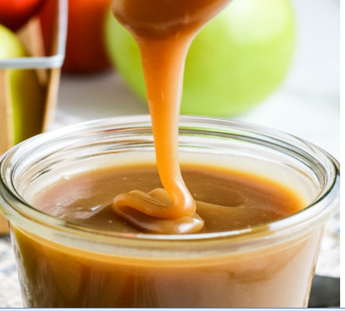
Gluten free caramel sauce
  - Low-Sugar Berry Sauce
INGREDIENTS
- cups blueberries (fresh or frozen)
- 1/2 cup + 2 Tbsp water
- 1 Tbsp maple syrup
- 1/8 tsp cinnamon
- 1 Tbsp lemon juice
- 1/2 tsp vanilla extract
- pinch of salt
- 1/2 tsp arrowroot powder

INSTRUCTIONS
- Place 1 1/2 cup blueberries into a small saucepan. Add 1/2 cup of water, maple syrup, cinnamon, lemon juice, vanilla extract, and a pinch of salt. Mix and start heating the blueberries over medium heat.
- In the meantime, dissolve the arrowroot powder in 2 tablespoons of water.
- When the blueberries start to simmer, cook them for 1 minute stirring occasionally.
- To add the dissolved arrowroot powder, pour it slowly into the saucepan making sure to constantly stir the blueberries.
- Add the rest of the blueberries (1 1/2 cup).
- Mix and bring the sauce to a simmer.
- Cook for 10 more seconds and take off the heat.
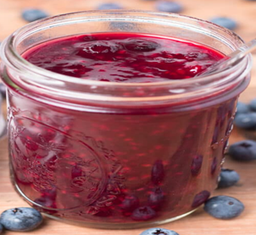
Low-Sugar Berry Sauce

  - Sugar Free Peach and Banana Cobbler
Ingredients
- 8 white peaches, pitted and sliced
- bananas, sliced
- tablespoons all-purpose flour
- 1 teaspoon sugar substitute
- 1 cup all-purpose flour
- 2 teaspoons baking powder
- ½ teaspoon salt
- ½ teaspoon ground cinnamon
- ½ cup skim milk
- 1 egg
- 1 tablespoon corn oil
- 2 teaspoons sugar substitute
- ½ teaspoon vanilla extract
Directions
- Preheat the oven to 350 degrees F (175 degrees C). Grease an 8x8-inch baking dish.
- Mix white peaches, bananas, 2 tablespoons flour, and 1 teaspoon sugar substitute in a bowl until fruit is coated; spread into bottom of the prepared baking dish.
- Whisk 1 cup flour, baking powder, salt, and cinnamon in the same bowl used to mix fruit; stir in skim milk, egg, corn oil, 2 teaspoons sugar substitute, and vanilla extract to make a batter. Pour batter in an even layer over fruit.
- Bake in the preheated oven until cobbler is golden brown and a toothpick inserted into the middle comes out clean, about 30 minutes. Cool in pan on rack at least 20 minutes before serving.

  - Gluten-Free Chocolate Chickpea Cupcakes
Ingredients
- 1 ½ cups semisweet chocolate chips
- ¼ cup coconut oil
- 1 (15 ounce) can chickpeas (garbanzo beans), drained
- 4 eggs
- ½ cup white sugar
- 1 teaspoon baking powder
- 1 teaspoon vanilla extract
Directions
- Preheat oven to 350 degrees F (175 degrees C). Grease 12 muffin cups or line with paper liners.
- Melt chocolate chips and coconut oil in the top of a double boiler over simmering water, stirring frequently and scraping down the sides with a rubber spatula to avoid scorching.
- Blend chickpeas, eggs, sugar, baking powder, and vanilla extract together in a blender or food processor until smooth. Add chocolate mixture and blend until smooth. Pour batter into prepared muffin cups.
- Bake in the preheated oven until a toothpick inserted in the center comes out clean, 20 to 25 minutes

Lap test 1
Given the necessary tools and equipments, do the following task accordingly.
Task 1: prepare sauces for dietary requirement

References
  - Michel suas. (2008). Advanced Bread and Pastry. 1st Edition.
  - Wayne gisslen.( 2016). Professional Baking. Wiley, 7th edition.
  - Daniel M. pliska. (2014). Pastry & Dessert Techniques 1st Edition. American Technical Publishers; 1st edition.
  - John Wiley & Sons. (2002). Fundamentals of Baking and Pastry.

Developers’ profile
No | Name | Qualification | Educational background | Region | College | Mobile number | E-mail
1 | Mohammed Liben Mohammed | Instructor | BA degree in Hotel and Tourism management | Somali | Jigjiga Polytechnic college | 0992326557 | cherechaw@gmail.com
2 | Belachew Merga Lemi | Instructor | Bed degree in Hotel Management | Addis Ababa | Kirkos manufacturing college | 0910330503 | Belachewmerga2011@gmail.com
3 | Zelalem Almaw Endalew | Instructor | - BSC degree in Food science and post harvest technology | Amhara | Bahir dar Polytechnic College | 0918012521 | Parazolla25@gmail.com
4 | ZuryashWork Belay Nigatu | Instructor | BA degree in Hotel Management | Addis Ababa | TTI | 0911643817 | zwb@gmail.com

