Bakery & Pastry Production
Level – IV
Based on September 2023Curriculum Version II
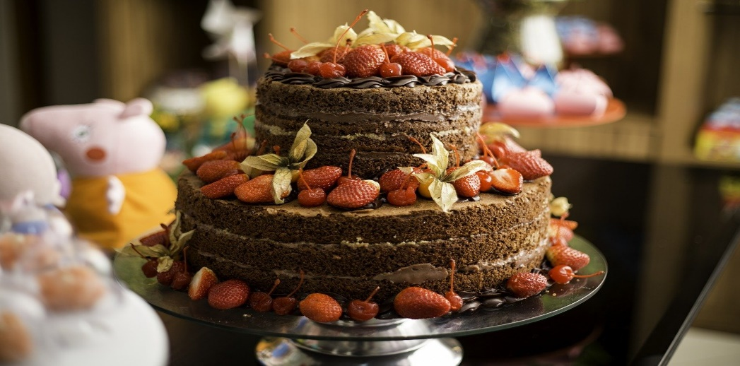
Module Title: Preparing Desserts for Asian Cuisines
Module Code: CST BPP4 M05 0923
Nominal Duration: 68 Hours

September 2023
Prepare by ministry of labour & skill Addis Abeba, Ethiopia

Contents
Acknowledgment 3
Introduction to the Module 4
Unit One: Preparing Desserts For Asian Cuisines… 5
1.1 Identifying Asian Cuisines Desserts 6
1.2 Asian Desserts Commodities 10
1.2 Characteristics Of Asian Desserts And Service 11
Self –Check #1 …13
Unit Two: Preparing and producing desserts 14
2.1 Selecting Equipment And Ingredients For Desserts 15
2.1.1 Selecting Tools And Equipment 15
2.2 Specialized Techniques and Cookery Methods 17
2.3 Preparing Varieties Of Asia Desserts 18
Operation Sheet 1. Produce Chocolate Based Products 19
Unit Three: Preparing Sweet Sauces 28
3.1 Preparing A Range Of Hot And Cold Sauces 29
3.2 Thickening Agents 31
Self –Check #2 33
Unit Four. Preparing Accompaniments, Garnishes And Decorations 35
4.1 Accompaniments, Garnishes and Decorations: ……………………………………………………………………36
4.2 Ensuring Flavours And Textures Complement Desserts:……………………………………..59
Unit Five. Storing Desserts and Sweets 59
5.1 Using Suitable Packaging: 60
Self-Check 3- 65
Lap Test 1: 66
Recommended Readings Error! Bookmark not defined.

Acknowledgment
The Ministry of Labor and Skills (MoLS) would like to express its gratitude and appreciation to the instructors and experts from regional TVT bureaus, TVT colleges, and industry practitioners who contributed their expertise and experience in preparing the training module for the unit of competency “Prepare Desserts For Asian Cuisines” under the occupational standard “Bakery & Pastry Production Level -IV."

The ministry also expresses its deepest gratitude to the Tourism Training Institute for its invaluable technical and financial support and collaboration in the module preparation. It is also thankful to MoLS staff members who coordinated the preparation and reviewing process of this training module.

Introduction to the Module
This module covers the knowledge, skills and attitude required to handle chocolate, prepare individual chocolates and make chocolate-based confectionery. Chocolate includes covertures (pure coating chocolate) in dark, milk and white, and various compounds. Chocolate confectionery may be moulded, Cuts or dressed, with hard or soft centres, hand coated, machine enrobed or made using prepared hollow shells
This module is designed to meet the industry requirement under the bakery and pastry production occupational standard.

This module covers the units:
- Select desserts for Asian cuisines
- Prepare and produce desserts.
- Prepare sweet sauces
- Apply accompaniments, garnishes and decorations
- Store desserts and sweets
Training Objective of the Module
At the end this session, students will be able to
- Selecting desserts for Asian cuisines
- Preparing and produce desserts.
- Preparing sweet sauces
- Applying accompaniments, garnishes and decorations
- Storing desserts and sweets
Module Instruction
For effective use this modules trainees are expected to follow the following module instruction:
- Read the information written in each unit
- Accomplish the Self-checks at the end of each unit
- Perform Operation Sheets which were provided at the end of units
- Do the “LAP test” given at the end of the unit and
- Read the identified reference book for Examples and exercise

Unit One: Preparing Desserts or Asian Cuisines
This unit is developed to provide you the necessary information regarding the following content coverage and topics:
Selecting desserts for Asian cuisines.
  - Identifying Asian cuisines desserts
  - Asian desserts commodities
  - Characteristics of Asian desserts and service
This unit will also assist you to attain the learning outcomes stated in the cover page.
Specifically, upon completion of this learning guide, you will be able to:
- Identify desserts for Asian cuisines.
- Select a range of key commodities used in Asian desserts.
- Identify cookery methods required for particular menu items and cuisines.
- Identify key characteristics of Asian desserts and service, according to cuisine, enterprise requirements and customer preferences.

1.1 Identifying Asian Cuisines Desserts
The Asian dessert scene is incredibly diverse and varied, with each country and region having its own unique treats. Each dessert showcases unique flavors, ingredients, and techniques that make them special to their respective cultures.
Some popular Asian desserts based on bakeries and confectioneries include:
- Bánh Pía (Vietnam): Flaky pastries filled with mung bean or durian paste, often enjoyed as a snack or gift.
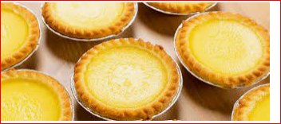
Fig.2 Bánh Pía (Vietnam)
- Mochi (Indian): Soft and chewy rice cakes often filled with sweet bean paste, fruit, or ice cream.
- Mochi is a popular Indian sweet made from glutinous rice flour. Here's a simple recipe for making Mochi at home:
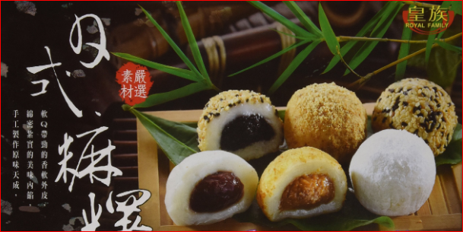
Fig. 1 Mochi (Japan)

- Red Bean Buns (China): Steamed or baked buns filled with sweet red bean paste, commonly found in Chinese bakeries.
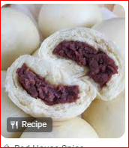

Fig.3 Red Bean Buns
- Mango Sticky Rice (Thailand): A popular Thai dessert made with sweet sticky rice, fresh mango slices, and coconut milk.
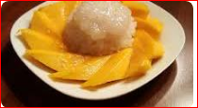
Fig.4 Mango Sticky Rice
- Egg Waffles (Hong Kong): Crispy and fluffy waffles shaped like small eggs, often served with toppings like ice cream or chocolate sauce.
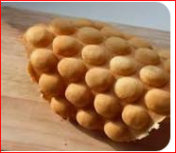
Fig.5 Egg Waffles
- Baklava – Turkey, Middle East
Baklava is a sweet dessert comprised of various layers of filo pastry with crushed nuts, sweetened with honey or syrup.
Traditional Turkish baklava uses filo pastry, finely crushed pistachios, butter, and syrup, but there are many other variations. Syrups are often scented with lavender or rosewater, whilst the pistachios are sometimes replaced with walnuts and sprinkled with cinnamon, like in Greek baklava.
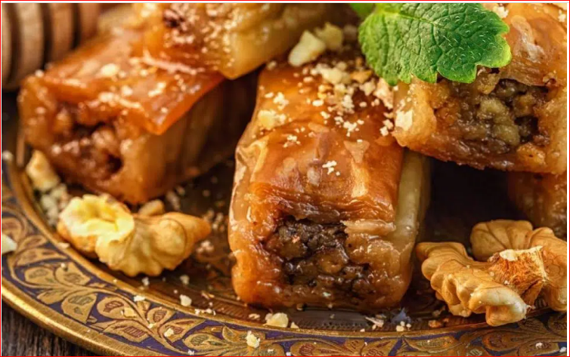
Fig.6 Baklava

- Pisang Goreng – Indonesia & South East Asia
Pisang Goreng is a delicious and highly popular dessert in Indonesia and South East Asia. Pisang Goreng are bananas coated in a light batter and deep-fried in hot oil. Once deep-fried, the outside is deliciously crispy and the inside irresistibly sweet and tender.Whilst it may seem simple, the dessert takes practice and skill to perfect.Bananas at their peak ripeness are key to Pisang Goreng, as they will increase in sweetness as they are deep-fried. Street vendors typically sell them as is; however, upscale cafés and restaurants will add toppings such as sugar, cinnamon, and ice cream.
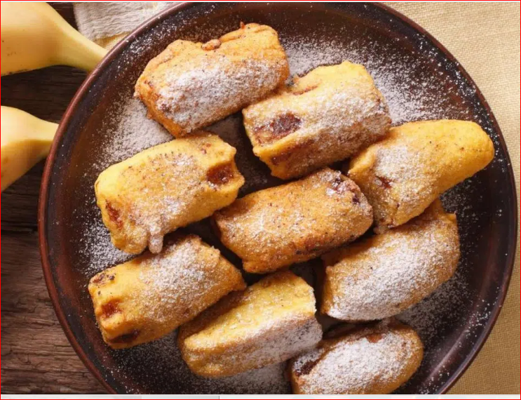
Fig.7 Pisang Goreng
Asia is commonly known for its large rice and noodle culture, but there is so much more that must be experienced. Some of the most delicious and well-known desserts can be found throughout Asia.
Whilst some of the desserts may include rice, many Asian countries make use of other local ingredients, as well as traditions to make desserts to die for.

1.2 Asian Desserts Commodities
Some commonly used commodities in Asian desserts include:
- Rice: Rice is a staple ingredient in many Asian desserts, such as mochi and mango sticky rice.
- Beans: Sweet bean paste, made from red beans or mung beans, is a common filling in many Asian desserts like mochi and red bean buns.
- Coconut: Coconut milk and shredded coconut are often used in Asian desserts to add a creamy and tropical flavor, such as in chendol and coconut tarts.
- Matcha: Matcha, a finely ground green tea powder, is used to flavor desserts like matcha roll cake and matcha ice cream.
- Durian: Known as the "king of fruits" in Southeast Asia, durian is often used as a filling in pastries like bánh pía.
- Tapioca: Tapioca pearls are commonly used in Asian desserts, such as in bubble tea or in sweet soups like sago gula melaka.
- Eggs: Eggs are used in many Asian desserts as a binding agent or to add richness, such as in egg waffles and sponge cakes.
- Flour: Various types of flour, including glutinous rice flour and wheat flour, are used to make doughs and batters for Asian desserts like tteok and sweet potato balls.
- Fruits: Fresh fruits like mangoes, lychees, and jackfruit are often used as toppings or fillings in Asian desserts to add natural sweetness and freshness.
- Sugar: Sugar is a common sweetener used in Asian desserts to balance flavors and add sweetness to dishes
These commodities contribute to the unique flavors, textures, and aromas found in Asian desserts, making them distinct and beloved treats around the world.

1.2 characteristics of Asian Desserts and Service

Asian desserts are known for their unique flavour, and are often characterized by their use of ingredients like rice, coconut, and beans. They offer a diverse range of tastes and textures, with many also said to be delightfully cooling – perfect for warmer weather!
Especially when buying sweets, then definitely ask about ingredients it is made of. This is because some are allergic to specific food items, and if they eat them, they can get sick. In particular, many people are allergic to peanuts, chocolate, gelatin, coffee which are also used in sweets.

Dessert consist of variations of tastes, textures, and appearances. Desserts can be defined as a usually sweeter course that concludes a meal. This definition includes a range of courses ranging from fruits or dried nuts to multi-ingredient cakes and pies. Many cultures have different variations of dessert.
A dessert needs to have the same variety and balance of textures, flavors, temperatures, colors, shapes and heights as any other dish

These commodities contribute to the unique flavors, textures, and aromas found in Asian desserts, making them distinct and beloved treats around the world.
- Variety: Asian desserts offer a wide range of flavors, textures, and presentations. From sticky rice desserts to light and refreshing fruit-based sweets, there is something to suit every taste preference.
- Balance of flavors: Asian desserts often aim for a balance of sweet, salty, and sometimes even savory flavors. This creates a harmonious taste experience that is not overly sugary.
- Use of natural ingredients: Many Asian desserts emphasize the use of fresh and natural ingredients, such as fruits and herbs, to enhance the flavors and add a touch of authenticity.
- Artful presentation: Asian desserts are often meticulously presented, with attention to detail and aesthetics. This adds to the overall dining experience and makes the desserts visually appealing.
- Texture play: Asian desserts often incorporate a variety of textures, such as chewy, creamy, crunchy, or jelly-like. This creates a more interesting and enjoyable eating experience.
- Traditional techniques: Many Asian desserts are made using traditional cooking techniques that have been passed down through generations. This adds to the authenticity and cultural significance of the desserts.
- Sharing culture: Asian desserts are often meant to be shared among family and friends. This promotes a sense of community and togetherness during meal times.
- Seasonal ingredients: Asian desserts often utilize seasonal ingredients, reflecting the changing flavors and availability of produce throughout the year.
- Symbolism: Some Asian desserts have symbolic meanings associated with them, such as representing good luck or prosperity. This adds a deeper cultural significance to the desserts.
- Warm hospitality: Asian dessert service often emphasizes warm hospitality and attentiveness to ensure that customers feel welcomed and satisfied with their dining experience.

Self –Check #1 | Written Test
Instruction: Answer the following questions:
Part I. say true or false
Match is commonly used in Asian desserts, especially in Japanese cuisine.
4. True or False: Mooncakes are traditional Chinese pastries often enjoyed during the Mid-Autumn Festival.
5. True or False: Asian desserts are typically light and not overly sweet compared to Western desserts.
Part II. Here Are Five Multiple-Choice Questions About Common Commodities Used In Asian Desserts:
1. Which Of The Following Is A Common Commodity Used In Asian Desserts?
A) Rice B) Wheat C) Corn D) Quinoa
2. True Or False: Coconut Milk Is A Popular Commodity Used In Many Asian Desserts.A) True B) False
3. What Is The Primary Commodity Used To Make Traditional Japanese Dessert Mochi?
A) Rice Flour B) Wheat Flour C) Cornstarch D) Tapioca Starch
4. Which Commodity Is Used To Make The Gelatinous Texture In The Filipino Dessert Halo-Halo?
A) Agar Agar B) Gelatin C) Tapioca Pearls D) Rice Flour
5. True Or False: Red Bean Paste, Made From Azuki Beans, Is A Common Commodity Used In Various Asian Desserts.
A) True B) False

Unit Two: Preparing and producing desserts
This unit is developed to provide you the necessary information regarding the following content coverage and topics:
Selecting desserts for Asian cuisines.
- Selecting equipment and ingredients for desserts
- Specialized techniques and cookery methods
- Preparing varieties of Asia desserts
- Special occasions desserts
This unit will also assist you to attain the learning outcomes stated in the cover page.
Specifically, upon completion of this learning guide, you will be able to:
- Select, weigh and use commodities and other ingredients required for particular dessert items, recipes and cuisines.
- Use cookery methods, specialized techniques and assembled equipment as required for particular dessert items and cuisines.
- Prepare fillings where required, to correct consistency.
- Prepare desserts according to recipe and enterprise requirements for consistency and temperature.
- Prepare and produce desserts for special occasions according to instructions and requirements.
- Follow food hygiene and OHS regulations and requirements in all tasks.

2.1 Selecting Equipment and Ingredients for Desserts

2.1.1 Selecting Tools And Equipment

There are different types of tools and equipment it used for preparation of Asian desert
- Mixing bowls: Used for combining ingredients and mixing batters or doughs.
- Measuring cups and spoons: Essential for accurately measuring ingredients.
- Whisk: Used for whisking or beating ingredients together, creating a smooth texture.
- Spatula: Helps to scrape down the sides of bowls and fold ingredients together.
- Pastry brush: Used for applying glazes or brushing butter onto pastries.
- Rolling pin: Used to roll out dough for pastries or crusts.
- Baking pans: Various sizes and shapes are used for baking cakes, cookies, and other desserts.
- Piping bags and tips: Used for decorating cakes and pastries with frosting or cream.
- Oven mitts: Protect hands from heat when handling hot baking pans or dishes.
- Cooling racks: Used to cool baked goods and allow air circulation to prevent them from becoming soggy.
- Pastry cutter: Used to cut and blend butter or shortening into flour for making pie crusts or pastry dough.
- Zester or grater: Used to grate citrus zest or chocolate for adding flavor to desserts.
- Electric mixer: Makes mixing and beating ingredients easier and faster.
- Food processor: Helps with chopping nuts, blending ingredients, or making smooth purees.
- Sifter: Used to remove lumps and aerate dry ingredients like flour or powdered sugar.
- Kitchen scale: Ensures accurate measurement of ingredients by weight.
- Double boiler: Used for melting chocolate or gently heating delicate ingredients without burning them.
- Candy thermometer: Essential for making candies or syrups, ensuring they reach the correct temperature.
- Ice cream maker: Used to churn and freeze ice cream or sorbet mixtures.
- Parchment paper or silicone baking mats: Prevents sticking and makes cleanup easier when baking.
Examples of some tools and equipment with the figures
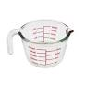Measuring cup

Pastry brush
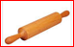Rolling pin
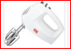
Mixer
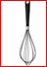
Whisk
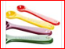
Measuring spoon

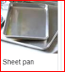 Sheet pan

2.2 Specialized Techniques and Cookery Methods
The Special techniques and cookery methods preparation of Asian Desert are the following.
  - Steaming: Used in many Asian desserts, such as steamed cakes or dumplings.
  - Deep frying: Common in Asian desserts like crispy spring rolls or fried doughnuts.
  - Boiling: Used to cook ingredients like beans or tapioca pearls for desserts like red bean soup or bubble tea.
  - Gelatinization: Often used in Asian desserts made with rice flour or sweet potato starch, creating a jelly-like texture.
  - Fermentation: Used in desserts like Chinese rice wine or Korean rice cakes, where ingredients are fermented to develop unique flavors.
  - Molding: Many Asian desserts are shaped using molds, such as mooncakes or agar agar jelly.
  - Grilling or toasting: Used for desserts like Japanese grilled mochi or toasted sesame balls.
  - Infusing: Common in Asian desserts like Thai tea or pandan-infused desserts, where flavors are extracted from ingredients.
  - Layering: Seen in desserts like Vietnamese che ba mau or Filipino halo-halo, where different ingredients are layered for a visually appealing dessert.
  - Syrup making: Used to make sweet syrups for drizzling over desserts or soaking ingredients like sponge cake.

2.3 Preparing Varieties of Asia Desserts

To prepare a variety of Asian desserts, you can try the following steps:
  - Choose a few different dessert recipes from various Asian cuisines that interest you.
  - Gather all the necessary ingredients for each recipe.
  - Read through the recipes thoroughly to understand the steps and techniques involved.
  - Start with simpler desserts if you are new to Asian cooking, and gradually work your way up to more complex ones.
  - Follow each recipe step by step, ensuring that you measure ingredients accurately and follow cooking times and temperatures.
  - Pay attention to specific techniques mentioned in each recipe, such as steaming, deep frying, boiling, or gelatinization.
  - Use appropriate equipment for each technique, such as a steamer for steaming, a deep fryer or a deep pot with oil for deep frying, and a saucepan or pot for boiling.
  - Take your time and be patient, as some Asian desserts may require longer cooking or cooling times.
  - Experiment with flavors and ingredients to add your own personal touch to the desserts.
  - Once the desserts are prepared, present them beautifully on serving plates or bowls, garnishing them with appropriate toppings or sauces.
  - Enjoy your homemade Asian desserts with family and friends, and don't forget to savor the unique flavors and textures that each dessert offers.

Operation Sheet 1. Produce Chocolate Based Products
Purpose: To perform Chocolate based products
Conditions or situations for the operations:
- Safe working area
- Properly operated tools and equipment
- Appropriate working uniforms fit for the practical performance
Equipment and Tools

- Oven - bowl
Scale - rolling in
- Scraper Whisker - bowl -Mixer

  - Bánh Pía (Vietnam) recipe
Ingredients:
2 cups all-purpose flour
1/2 cup vegetable oil
1/2 cup water
1 cup mung bean paste
1/2 cup sugar
Pinch of salt
Egg wash (1 beaten egg)
Methods
1. In a bowl, mix together the all-purpose flour, vegetable oil, and water until a smooth dough forms.
2. Divide the dough into small balls and flatten each ball into a thin circle.
3. In a separate bowl, mix together the mung bean paste, sugar, and salt.
4. Place a spoonful of the mung bean mixture onto each dough circle and fold the edges to seal it.
5. Place the filled dough circles onto a baking sheet and brush them with egg wash.
6. Bake in a preheated oven at 350°F (175°C) for about 15-20 minutes or until golden brown.
7. Let the Bánh Pía cool before serving
Fig.2 Bánh Pía (Vietnam)

  - Mochi (indian) recipes
Ingredients:
- 1 cup glutinous rice flour
- 1/4 cup water
- 1/4 cup sugar
- 1/4 cup grated coconut (optional)
- Food coloring (optional)
- Cornstarch or potato starch (for dusting)
Methods
  - In a microwave-safe bowl, mix the glutinous rice flour and water until well combined. If using food coloring, add a few drops and mix until the desired color is achieved.
  - Cover the bowl with plastic wrap and microwave on high for 2 minutes. Remove from the microwave, stir well, and microwave for another 2 minutes. Repeat this process until the dough becomes sticky and translucent.
  - In a separate saucepan, combine the sugar and 1/4 cup of water. Cook over medium heat until the sugar dissolves completely and the syrup thickens slightly.
  - Dust a clean surface with cornstarch or potato starch to prevent sticking. Transfer the cooked dough onto the surface and knead it gently for a few minutes until it becomes smooth and elastic.
  - Divide the dough into small portions and shape them into balls or any desired shape. If desired, you can stuff the mochi with grated coconut by placing a small amount in the center of each portion and wrapping the dough around it.
  - Dip each mochi ball into the sugar syrup, coating it evenly. Roll it in grated coconut if desired
Mochi (Japan)
3. Red Bean Buns at home:
Ingredients:
2 cups all-purpose flour 1 teaspoon active dry yeast
1/2 cup warm water 1/4 cup sugar
1 cup sweetened red bean paste 1/4 cup vegetable oil
Instructions:
  - In a small bowl, dissolve the yeast in warm water and let it sit for about 5 minutes until it becomes frothy.
  - In a large mixing bowl, combine the flour and sugar. Make a well in the center and pour in the yeast mixture and vegetable oil. Mix until a dough forms.
  - Transfer the dough onto a lightly floured surface and knead it for about 5-7 minutes until it becomes smooth and elastic.
  - Place the dough in a greased bowl, cover it with a clean kitchen towel, and let it rise in a warm place for about 1 hour or until it doubles in size.
  - Punch down the dough to release any air bubbles. Divide it into small portions and shape them into balls.
  - Flatten each dough ball with your palm and place a spoonful of red bean paste in the center. Gather the edges and pinch them together to seal the filling inside.
  - Place the filled buns on a baking tray lined with parchment paper. Cover them with a kitchen towel and let them rise for another 30 minutes.
  - Preheat your oven to 350°F (175°C). Bake the buns for about 15-20 minutes or until they turn golden brown.
  - Remove the buns from the oven and let them cool on a wire rack before serving.
Red Bean Buns
4. Mango Sticky Rice Recipe
Ingredients:
- 1 cup glutinous rice
- 1 cup coconut milk
- 1/4 cup sugar
- 1/2 teaspoon salt
- 2 ripe mangoes
- Sesame seeds (optional, for garnish)
Instructions:
  - Rinse the glutinous rice under cold water until the water runs clear. Soak the rice in water for at least 4 hours or overnight.
  - Drain the soaked rice and transfer it to a steamer basket lined with cheesecloth or a banana leaf. Steam the rice over medium heat for about 20-25 minutes or until it becomes tender and translucent.
  - In a small saucepan, heat the coconut milk, sugar, and salt over low heat until the sugar dissolves. Remove from heat and set aside.
  - Once the rice is cooked, transfer it to a bowl and pour the coconut milk mixture over it. Mix well until the rice is evenly coated with the sweetened coconut milk. Let it sit for about 15 minutes to allow the flavors to meld together.
  - While the rice is resting, peel and slice the mangoes into thin strips or cubes.
  - To serve, place a scoop of the sticky rice on a plate or bowl and top it with mango slices. Drizzle some additional coconut milk over the mangoes if desired. Sprinkle with sesame seeds for garnish.
Mango Sticky Rice
- Egg Waffles recipe
Ingredients:
2 cups all-purpose flour
2 tablespoons cornstarch
1/2 teaspoon baking powder
1/4 teaspoon salt
1/2 cup granulated sugar
3 large eggs
1/2 cup melted butter
1 cup milk
1 teaspoon vanilla extract
Instructions:
  - In a large bowl, whisk together the flour, cornstarch, baking powder, salt, and sugar.
  - In a separate bowl, beat the eggs until frothy. Add the melted butter, milk, and vanilla extract. Mix well.
  - Pour the wet ingredients into the dry ingredients and stir until just combined. Be careful not to overmix.
  - Preheat your waffle iron according to its instructions. Once heated, lightly grease the waffle iron with cooking spray or melted butter.
  - Pour about 1/3 cup of batter onto each section of the waffle iron. Close the lid and cook for about 3-4 minutes, or until the waffles are golden brown and crispy.
  - Carefully remove the waffles from the iron and transfer them to a wire rack to cool slightly.
  - Serve the egg waffles warm and enjoy them as a tasty snack or dessert!
Egg Waffles
- Baklava recipe
Ingredients:
1 package of phyllo dough (16 oz)
1 cup unsalted butter, melted
2 cups finely chopped nuts (such as walnuts, pistachios, or almonds)
1/2 cup granulated sugar
1 teaspoon ground cinnamon
1/2 teaspoon ground cloves
1 cup honey
1/4 cup water
1 teaspoon lemon juice
Optional: powdered sugar for dusting
Instructions:
1. Preheat your oven to 350°F (175°C).
2. In a medium bowl, combine the chopped nuts, sugar, cinnamon, and cloves. Mix well.
3. Brush a 9x13 inch baking dish with melted butter.
4. Carefully unroll the phyllo dough and place a sheet in the baking dish. Brush it with melted butter. Repeat this process, layering and buttering each sheet until you have used about half of the phyllo dough.
5. Sprinkle about half of the nut mixture evenly over the layered phyllo dough.
6. Continue layering and buttering the remaining phyllo dough sheets on top of the nut mixture.
7. Sprinkle the remaining nut mixture over the top layer of phyllo dough.
8. Using a sharp knife, cut the baklava into diamond or square shapes.
9. Bake in the preheated oven for about 45-50 minutes, or until golden brown and crispy.
10. While the baklava is baking, prepare the syrup by combining the honey, water, and lemon juice in a saucepan. Bring it to a boil, then reduce the heat and simmer for about 10 minutes.
11. Once the baklava is done baking, remove it from the oven and immediately pour the hot syrup evenly over the top.

12. Allow the baklava to cool completely in the baking dish before serving. This will help the syrup to soak into the layers.
13. Optional: Dust the cooled baklava with powdered sugar before serving for an extra touch of sweetness.
14. Serve and enjoy this delicious, sweet treat!
Baklava recipe

- Pisang Goreng Recipe
Ingredients:
- Ripe bananas (preferably plantains) - 4
- All-purpose flour - 1 cup
- Rice flour - 1/2 cup
- Baking powder - 1 teaspoon
- Salt - 1/4 teaspoon
- Sugar - 2 tablespoons
- Water - 1 cup
- Vegetable oil - for frying
Instructions:
1. Peel the bananas and cut them into halves or slices, depending on your preference.
2. In a mixing bowl, combine the all-purpose flour, rice flour, baking powder, salt, and sugar.
3. Gradually add water to the dry ingredients while whisking until you get a smooth batter. The consistency should be thick enough to coat the bananas.
4. Heat vegetable oil in a deep pan or pot over medium heat.
5. Dip each banana slice into the batter, ensuring it is fully coated.
6. Carefully place the coated banana slices into the hot oil and fry them until they turn golden brown and crispy. Flip them occasionally to ensure even cooking.
7. Once cooked, remove the Pisang Goreng from the oil and drain them on a paper towel to remove excess oil.
8. Serve the Pisang Goreng while still warm. They can be enjoyed on their own or served with a sprinkle of powdered sugar, chocolate sauce, or a scoop of ice cream.

Note: You can also experiment with different types of chocolate by melting them and drizzling it over the Pisang Goreng for an extra indulgent treat.
Pisang Goreng recipe

Unit Three: Preparing Sweet Sauces
This unit is developed to provide you the necessary information regarding the following content coverage and topics:
Selecting desserts for Asian cuisines.
- Preparing a range of hot and cold sauces
- Thickening agents
This unit will also assist you to attain the learning outcomes stated in the cover page.
Specifically, upon completion of this learning guide, you will be able to:
- Prepare a range of hot and cold sauces to a desired consistency and flavor.
- Use thickening agents suitable for sweet sauces where appropriate.
- Store sauces to retain desired quality and characteristics

3.1 Preparing a range of Hot and Cold Sauces

• sugar syrups
• fruit syrups
• fruit purées, sauces and coulis
• chocolate-based sauces

• sabayon and zabaglione
• custards and cremes
• flavoured butters and creams.
Preparing a range of hot and cold sauces can elevate your dishes with different flavors and textures. Here are recipes for three popular sauces: a hot sauce, a vinaigrette, and a creamy cold sauce.
- Hot Sauce - Homemade Sriracha Sauce:
Ingredients:
- 1 pound fresh red chili peppers (e.g., Fresno or red jalapenos)
- 4 cloves garlic, minced
- 2 tablespoons brown sugar
- 1 teaspoon salt
- 1/2 cup distilled white vinegar
- 1 tablespoon fish sauce (optional, for added umami)
Instructions:
- Stem the chili peppers and roughly chop them.
- In a blender or food processor, combine the chili peppers, minced garlic, brown sugar, salt, vinegar, and fish sauce (if using). Blend until smooth.
- Pour the mixture into a saucepan and simmer over medium-low heat for about 15-20 minutes, stirring occasionally.
- Let the hot sauce cool completely before transferring it to a sterilized jar or bottle. Store it in the refrigerator for up to 1 month. The flavors will intensify over time.
2. Vinaigrette - Balsamic Vinaigrette:
Ingredients:
- 1/4 cup balsamic vinegar
- 3/4 cup extra virgin olive oil
- 1 teaspoon Dijon mustard
- 1 teaspoon honey (or maple syrup for a vegan option)
- 1 clove garlic, minced (optional)
- Salt and pepper to taste
Instructions:
- In a bowl or a jar, whisk together the balsamic vinegar, Dijon mustard, honey, minced garlic (if using), salt, and pepper.
- Slowly drizzle in the olive oil while whisking continuously until the vinaigrette is well emulsified and thickened.
- Taste and adjust the seasoning as needed.
- Pour the vinaigrette into a bottle or jar and store it in the refrigerator. Allow it to come to room temperature before using. It will keep for about 1-2 weeks.

3. Creamy Cold Sauce - Garlic Aioli:
Ingredients:
- 1/2 cup mayonnaise
- 1-2 cloves garlic, minced or pressed
- 1 tablespoon lemon juice
- 1/4 teaspoon Dijon mustard
- Salt and pepper to taste
Instructions:
- In a small bowl, combine the mayonnaise, minced garlic, lemon juice, and Dijon mustard. Mix well.
- Season with salt and pepper to taste. Adjust the amount of garlic according to your preference.
- Transfer the aioli to a jar or container with a lid and refrigerate for at least 30 minutes to let the flavors meld together.
- Serve the aioli as a dip for fries, a spread for sandwiches, or as a accompaniment for seafood or roasted vegetables. It will keep for about 1 week in the refrigerator.
These sauces can be customized to suit your taste preferences. Feel free to adjust the ingredients and quantities to achieve the desired flavor and consistency. Enjoy experimenting with these versatile sauces to enhance your favorite dishes!

3.2 Thickening Agents
Thickening agents are ingredients used to increase the viscosity and create a thicker consistency in various dishes, such as soups, sauces, and desserts. They help improve texture, stability, and mouthfeel. Here are some common thickening agents:
- Flour: All-purpose flour is a traditional and versatile thickening agent. You can create a roux by cooking equal parts flour and fat (usually butter) and adding it to a hot liquid, resulting in a thickened sauce. Alternatively, you can create a slurry by mixing flour with a small amount of cold water or broth and then stirring it into the hot liquid. Be sure to cook the mixture adequately to remove the raw flour taste.
- Cornstarch: Cornstarch is a popular gluten-free thickener that creates a smooth and glossy texture. To use cornstarch, create a slurry by mixing it with cold water, then add it to the hot liquid you want to thicken. Cook it briefly until the desired consistency is achieved. Be careful not to overcook, as excessive heat can cause the sauce to thin out.
- Arrowroot: Arrowroot powder is similar to cornstarch and can be used as a substitute in most recipes. It creates a clear, glossy texture and works well in high-acid ingredients. Use it in the same way as cornstarch, creating a slurry and adding it to the hot liquid.
- Tapioca Starch: Tapioca starch, derived from the cassava root, is another gluten-free option for thickening. It creates a slightly chewy texture and is often used in pies and fruit fillings. Mix tapioca starch with a small amount of liquid to create a slurry, then add it to the hot liquid and cook until thickened.
- Gelatin: Gelatin is derived from animal collagen and is commonly used in desserts, jellies, and custards. It sets when cooled, giving a firm but smooth texture. To use gelatin, bloom it by sprinkling it over cold water and allowing it to soften. Then, heat and dissolve it in a hot liquid.
- Agar-Agar: Agar-agar is a plant-based thickener derived from seaweed and is often used as a gelatin substitute in vegetarian or vegan recipes. It sets at room temperature and is dissolved in hot liquid. Follow package instructions for the correct usage ratio.
- Xanthan Gum: Xanthan gum is a natural thickening and stabilizing agent. It is commonly used in gluten-free baking and as a thickener in sauces and dressings. It requires only a small amount to achieve the desired consistency.

When using thickening agents, it is essential to follow the instructions and quantities recommended in the recipe or ingredients' packaging to ensure proper results. Additionally, the amount of thickening agent needed can vary depending on the dish and personal preference, so adjustments may be required.

Remember to add thickening agents gradually and be mindful of the overall flavors and textures of the dish. Enjoy experimenting with these options to achieve the perfect consistency in your culinary creations!

Self –Check #2 | Written Test

Instruction: Answer the following questions:
Part II. Here are five multiple-choice questions about thickening agents:
1. Which of the following is a common thickening agent used in cooking and baking?
a) Gelatin
b) Baking powder
c) Vinegar
d) Salt
2. True or False: Cornstarch is a popular thickening agent used in sauces and gravies.
a) True
b) False
3. Which thickening agent is derived from seaweed and is often used in desserts and dairy products?
a) Xanthan gum
b) Agar agar
c) Pectin
d) Guar gum
4. What is the primary thickening agent used in making custards and puddings?
a) Tapioca starch
b) Arrowroot powder
c) Rice flour
d) Cornstarch
5. True or False: Egg yolks can also act as a thickening agent in certain recipes.
a) True
b) False

Part I. say true or false there are five true or false questions about the range of hot and cold sauces:
1. True or False: Hot sauces are typically made with spicy ingredients like chili peppers.
2. True or False: Cold sauces are often served chilled and can be used as a dressing or dip.
3. True or False: Hot sauces are only used to add heat to dishes and do not contribute to the overall flavor.
4. True or False: Cold sauces are commonly made with ingredients like mayonnaise, yogurt, or sour cream.
5. True or False: Both hot and cold sauces can be customized with various herbs, spices, and seasonings to enhance their taste.

Unit Four. Preparing Accompaniments, Garnishes and Decorations
This unit is developed to provide you the necessary information regarding the following content coverage and topics:
  - Accompaniments, garnishes and decorations
  - Ensuring flavors and textures complement desserts
This unit will also assist you to attain the learning outcomes stated in the cover page.
Specifically, upon completion of this learning guide, you will be able to:
- Use accompaniments, garnishes and decorations to enhance taste, texture and balance.
- Ensure that flavors and textures of garnishes complement desserts

4.1 Accompaniments, Garnishes and Decorations:
Accompaniments: Means food items served along with another food to enhance palatability such as butter, jelly, cream cheese, salad dressing, croutons and condiments. Food accompaniment is the side dish that serves with the main dish, it complements the main food and enriches its taste and flavour. Food accompaniment can be an integral part of the dish or served separately.
Accompaniments can be defined as any additional food items that are served with the main dish.. Accompaniments are generally flavoured food and sauces offered with specific main dishes. Appropriate accompaniment enhances the flavour of the dish by providing a balance and contrast to taste. There are various accompaniments that are being served with different dishes in separate monkey bowls.
A Garnish Is An Item Or Substance Used As A Decoration Or Embellishment Accompanying A Prepared Food Dish Or Drink. In Many Cases, It May Give Added Or Contrasting Flavor. Some Garnishes Are Selected Mainly To Augment The Visual Impact Of The Plate, While Others Are Selected Specifically For The Flavor They May Impart.^{[2]} This Is In Contrast To A Condiment, A Prepared Sauce Added to Another Food Item Primarily For Its Flavor. A Food Item Which Is Served With Garnish May Be Described As Being Garni, The French Term For "Garnished."
The Difference Between Garnish And Decoration Is Garnish Is Edible. Plastic Grass For Sushi Presentation Is Considered A Decoration, Not A Garnish

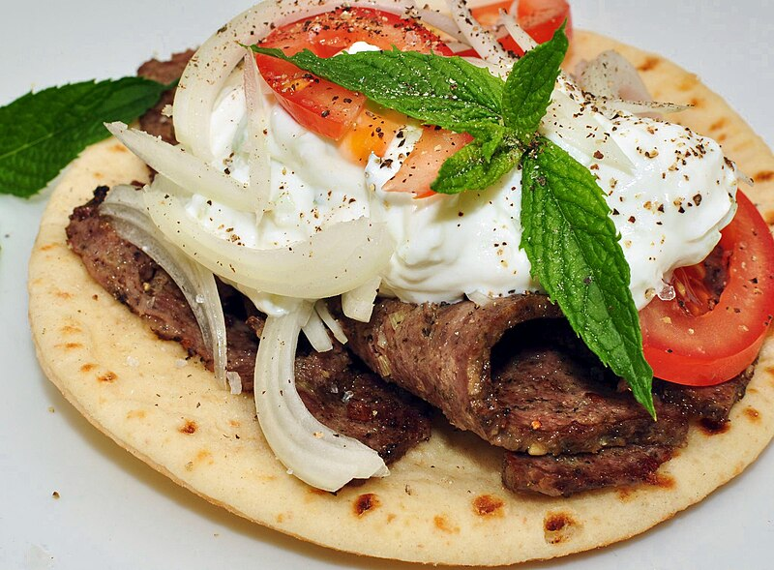
Fig4.1.1 A gyro sandwich garnished with mint leaves

Chinese dessert:
Chinese desserts (simplified Chinese; traditional Chinese: pinyin: Zhōngshì tiándiǎn) are sweet foods and dishes that are served with tea, along with meals^{[1]} or at the end of meals in Chinese cuisine. The desserts encompass a wide variety of ingredients commonly used in East Asian cuisines such as powdered or whole glutinous rice, sweet bean pastes, and agar. Due to the many Chinese cultures and the long history of China, there are a great variety of desserts of many forms. Panfried water chestnut cake a type of Chinese Gao dessert
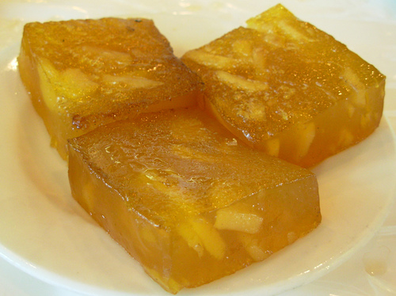
Fig.4.1.2 pan-fried water chestnut cake

Asian-Inspired Design Ideas:

Cake designers must have a keen eye for detail, as well as a deep understanding of baking and pastry techniques. They must be able to translate a client's vision into a beautiful and delicious cake, often incorporating intricate design elements and personal touches.
From chinoiserie to Zen, Asian style is influencing modern home designs in the Western world. Browse through our 15 favorite Asian-inspired spaces, and slip into a state of peace and tranquillity.

Iconic Influence
One of the most recognizable figures in Asian design is Siddhartha Gautama, better known as Buddha or the "Enlightened One." Gautama was a spiritual teacher in the 5th century B.C. and the founder of Buddhism. The iconic figure of Buddha is represented worldwide with harmonious proportions from head to toe, including elongated earlobes, a notable head elevation, broad, even shoulders and a mark between the eyebrows. Adding a modern-day Buddha statue to your decor is an easy way to bring Asian influence into your home. Design by Marie Burgos. Photography by Francis Augustine.

Design Principles for Plating Food A checklist:
- Flow from left to right
- Splash of colour on left
- Height on right side
In the western world, we read from left to right. When a new image is presented to us, we tend to scan it from the left side to the right side. You can use this knowledge to influence the placement of food on the plate. If you have a bit of colour on the left side of the plate (sauce, fresh fruit, etc.), the eye will be attracted to that. If you plan to have height on the right side of the plate (garnish, ramekin, etc.), it will draw the eye across the plate.

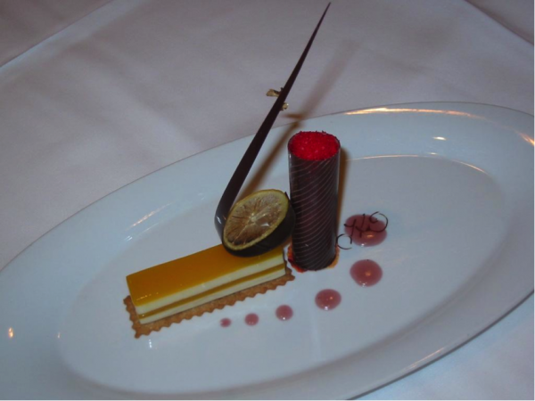
Figure 4.1.3 plated dessert
Your eye should be able to flow across the components. There should be movement on the plate. An upward curve of a tuile or chocolate garnish, a connection between two components with a caramel stick, or the flow of coulis can help direct movement and create a focal point. All these items combined will make a plate more appealing visually and attract the eye of the diner before the dessert is eaten.
The main component of the dessert does not always need to be centred, but can be placed slightly offset. Generally, sauce, ice cream or sorbet, and the main garnishes should radiate from the main component without a lot of separation. This allows the plate to have a balance of white space and not look too busy or confusing. Keeping components away from the outside edge of the plate will also help balance the presentation.

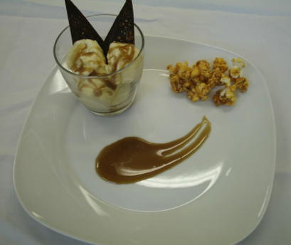
Placement on the plat

Fig.4.1.4 Dessert placement
On the plate in Figure 7a, the two main components are pushed to the outside of the plate, causing the eye to focus on the emptiness (or negative space) in the middle. On the plate in Figure 7b, the components have been brought together, making a connection between all three items. This creates visual harmony.

Using the serving area of the plate well
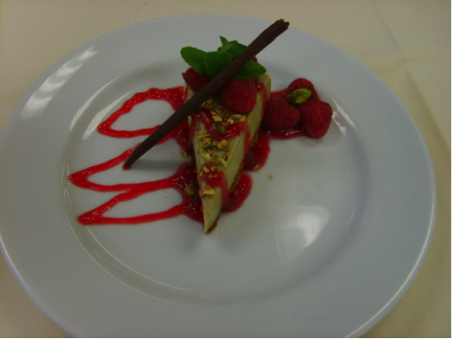
Fig.4.1.5 The serving area of the plate
Figure 8a shows the correct design principles (colour on the left, and a garnish that is high on the right side), which do cause the eye to move left to right, but the cake is pushed back almost to the very edge of the plate. The sauce is all on the left side. The combination of the two uses only about half of the surface area. This highlights the negative space on the plate.
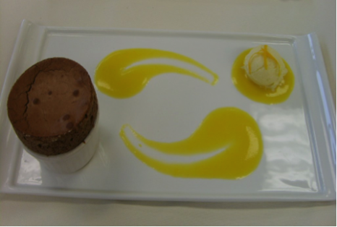
In Figure 8b, the sauce is piped across the entire surface of the plate, and the cake is brought almost to the centre, creating more balance.

Flow

Fig4.1.6 Flow
Figure shows a dessert with a lot of sauce, done in similar shapes. The highest item is placed incorrectly, in the bottom left corner.
In Figure 9b, the presentation is simplified. Movement is controlled, drawing the eye to the tallest component. To help balance the plate, perhaps another component could have been added in the middle. Think about what might make an appropriate addition.
Garnishes for foods and entrees include:
- Celery
- Caramel
- Chocolate (shaved or curled)
- Cocoa powder
- Flaked coconut^{[21]}
- Confetti candy – confectionery food
- Edible flower – Flowers that may be consumed safely
- Sliced fruit – Seed-bearing part of a flowering plant
- Gomul – dressing powder
- Honey – Sweet and viscous substance made by bees mostly using nectar from flowers
- Maraschino cherry – Preserved, sweetened cherry
- Mint – Family of flowering plants that includes sage and mint
- Sprinkles – Tiny multi-coloured candy topping
- Syrup – Thick, viscous solution of sugar in waters
- Vark – Metallic leaf used on South Asian sweets
Garnishes for desserts and sweets include:
- Caramel
- Chocolate (shaved or curled)
- Cocoa powder
- Flaked coconut
- Confetti candy – confectionery food
- Coulis – Thin sauce made from vegetables or fruits (raspberry coulis, for example)
- Edible flower – Flowers that may be consumed safelys
- Sliced fruit – Seed-bearing part of a flowering plant
- Gomul – dressing powder
- Honey – Sweet and viscous substance made by bees mostly using nectar from flowers
- Maraschino cherry – Preserved, sweetened cherry
- Mint – Family of flowering plants that includes sage and mint
- Sprinkles – Tiny multi-coloured candy topping
- Syrup – Thick, viscous solution of sugar in waters
- Vark – Metallic leaf used on South Asian sweets
- Wafer – Thin type of biscuit
- Nuts
- Walnut pieces and candied walnuts
- Wedding cake topper
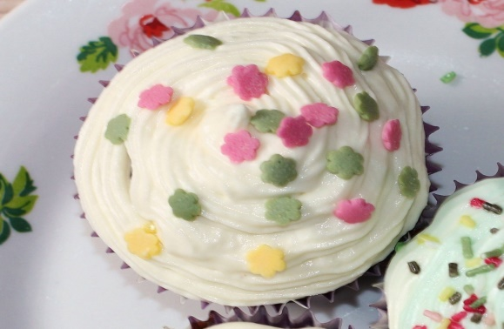
- Whipped cream

Fig.4.1.6. a frosted muffin garnished with confetti candy.

The art of decorating desserts:
We eat with our eyes. It’s been said so often and for so long that it’s become a cliché. But it’s true, and it applies even more when the final, (usually) sweet, course arrives on the table. There are some really, really simple tricks that go a long way:

Sprinkle with cake crumbs
A sprinkling of cake crumbs looks attractive and is delightfully crunchy on top of all “soft” desserts from panna cotta, to chocolate mousse and ice cream. Pick your favourite biscuits, bake a trayful and crumble the amount you need. Oat flakes, shortbread or ginger biscuit
fridge for an hour or two. Once it’s cold and hard, shave off attractive flakes with a cheese slice.

You can never go wrong with toasted nuts
Check first that no-one coming to dinner has any nut allergies. If the coast is clear, toast those nuts! Halved or chopped hazelnuts, cashews, pistachios or walnuts add little bits of crunch that go with most things in the dessert line.
Toast the nuts in a frying pan until they are gently browned, and the skin has come off the hazelnuts. Be extra careful when toasting cashews and walnuts as they burn easily. You can also toast nuts in the oven at 190°C/374°F.

Toasted almonds
Almonds need to be blanched before toasting. Then you can toast them without their skins just like any other nut.

Toasted sesame seeds
Toasted sesame seeds aren’t reserved for Asian cuisine, they make desserts taste even better too. If you have a weakness for sesame biscuits, mix the seeds with a little cane sugar before you start.

Decorate with fruit and berries
Pick the best-looking ones for your decoration and put the rest in a pie, compote or jam. Kiwis, strawberries, raspberries, star fruit, passion fruit and pomegranates are little works of art in their own right. You can make it more complicated by carving them into ambitious shapes, but most fruit is beautiful just as it comes, or maybe sliced.

We eat with our eyes. It’s been said so often and for so long that it’s become a cliché. But it’s true, and it applies even more when the final, (usually) sweet, course arrives on the table.

Sprinkle with cake crumbs
A sprinkling of cake crumbs looks attractive and is delightfully crunchy on top of all “soft” desserts from panna cotta, to chocolate mousse and ice cream here are some really, really simple tricks that go a long way:
Other garnishes that can be used to help present a frozen component are:
- Tuiles, which will also add visual, flavour, and texture (crunchy) elements
- Sliced fruit
- Meringue disk
- Small cookie
- Chocolate garnish
- Crumbs (cake, crushed nuts, or brittle)

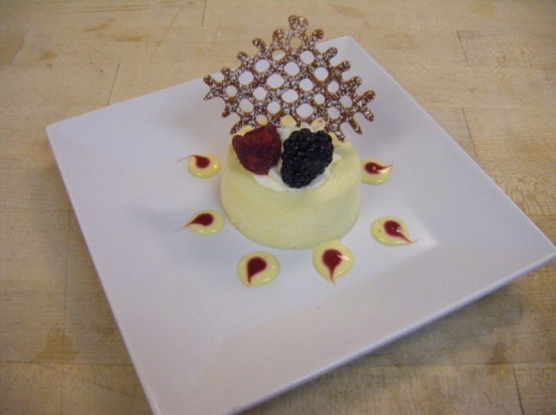 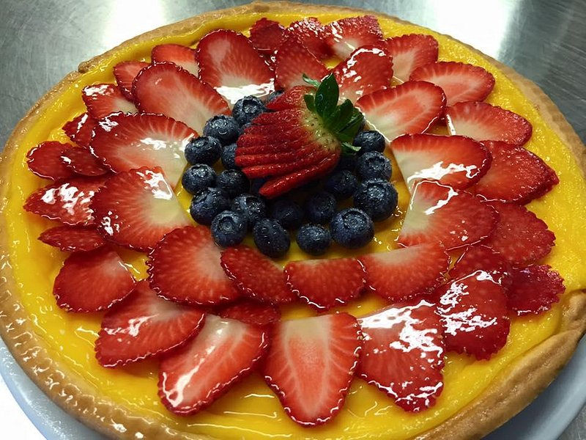 Fig.1.1.5 Tuiles garnish Fig.1.1.6 Fruit garnish 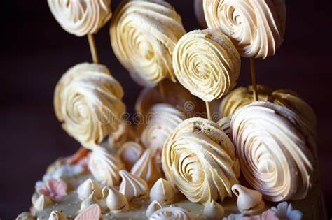 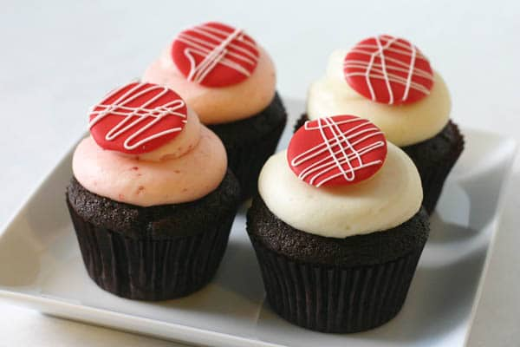
Fig.1.1.6 Meringue disk garnish Fig.1.1.7 small cookies garnish

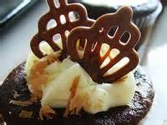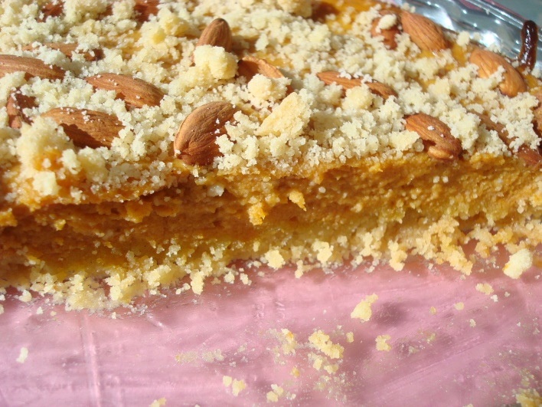
Fig.1.1.8 chocolate garnish Fig.1.1.9 crumbs

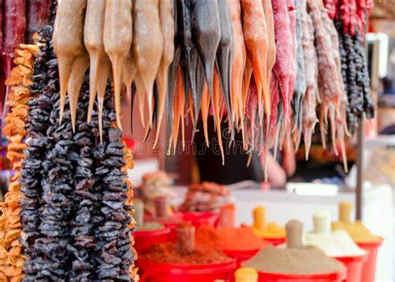
Fig.1.1.10 Traditional Asian churchkhela

Self-Check | Written Exam

Part I- True or False questions:
1. Whipped cream is a common dessert accompaniment.
2. True or False: Fresh fruit can be used as a garnish for desserts.
3. Sprinkling powdered sugar on top of a dessert is a form of decoration.
4. Chocolate sauce is not typically used as a dessert accompaniment.
5. Edible flowers are often used as a decorative element in desserts.

Part 2- choose the correct answer:

1. Which of the following is a common garnish for Asian cuisine desserts?

a) Fresh mint leaves
b) Cinnamon powder
c) Whipped cream
d) Chocolate shavings
2. Matcha powder is often used as a decoration in Asian cuisine desserts.
3. Which of the following is a traditional accompaniment for Asian desserts like mochi or sticky rice?
a) Coconut milk
b) Maple syrup
c) Honey
d) Caramel sauce
4. True or False: Sesame seeds are commonly used as a garnish in Asian cuisine desserts.
5. Which of the following is a popular decorative element in Asian desserts?
a) Edible gold flakes
b) Sprinkles
c) Fresh berries
d) Shredded coconut

Operationsheet.1
Operation Title: Preparing desserts for Asian cuisines
Purpose: to produce a variety of Garnishes
Conditions or situations for the operations:
- Safe working area
- Operation tools and equipment
- Appropriate work uniforms fit for preparing Dessert buffet
- Tuiles garnish:

Recipe: Rice Flour gluten-free flour blend or all-purpose Flour 5 oz. Icing Sugar 4 oz. Egg Whites 5 oz. Butter, melted METHOD: Mix icing sugar and flour together in a mixer. Add egg whites and mix to blend. Add melted butter (cooled slightly) and

Ingredients:

95g water

10g all-purpose flour

Food colouring

Method:
- Whisk all of the ingredients together until smooth.
- In a pan (size depending on your needs), coat the pan with about a mm or two of neutral oil with a high smoke point.
- Wait for the oil to heat up then pour some of the tuile batter into the pan.
- Cook for a few minutes until the bubbles subside and the surface of the tuile starts to look matte.
- The edges should also start to lift away from the pan. At this point, take an offset or small pair of tongs or tweezers and gently remove the tuile.
- Place it on parchment paper to absorb excess liquid.
You can color these however you like, one popular method is using squid ink in these tuiles instead of food color but they can be dyed essentially any colour you’d like.
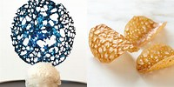
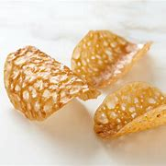
Tuiles garnish picture

- Asian fruit garnish

Recipe:

Ingredients:
- Assorted fruits (such as mango, pineapple, dragon fruit, kiwi, or lychee)
- Fresh mint leaves
- Lime or lemon juice (optional)
Instructions:
1. Wash and prepare the fruits by peeling, slicing, or cutting them into desired shapes. You can use a melon baller or cookie cutters to create interesting shapes.
2. Arrange the fruit pieces on a serving platter or individual dessert plates.
3. If desired, squeeze a little lime or lemon juice over the fruits to add a tangy flavor and prevent browning (especially if using apples or bananas).
4. Garnish the fruit platter with fresh mint leaves for a pop of color and added freshness.
5. Serve the fruit garnish alongside your favorite Asian desserts, such as mango sticky rice, coconut tapioca pudding, or green tea ice cream.

Note: Feel free to get creative and experiment with different fruit combinations and presentation styles to suit your dessert.

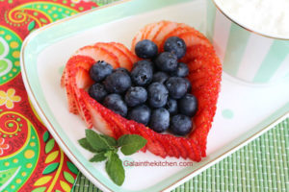

Strawberries garnishes
- Chocolate garnish
- Grated Chocolate: Rub a solid piece of semisweet, sweet chocolate, milk chocolate, or a white baking bar across the grating section of a handheld grater¹.
- Chocolate Lace Shards: Pipe melted white baking bar or candy coating onto a baking sheet lined with waxed paper; pipe a continuous line that curves and loops over the entire surface. When firm, spread tempered chocolate or melted candy coating over top of piped lines 1/8 inch thick.
- Chocolate Leaves: Brush one or two coats of chocolate on one side of each leaf (such as mint, lemon, ivy, rose, or strawberry). Place leaves, chocolate side up, on a baking sheet lined with waxed paper; let dry.
- Chocolate Curls: Let milk chocolate or white baking bar come to room temperature, then carefully draw a vegetable peeler across the bar.
- Rolled Chocolate: Melt your chocolate in 30 second intervals until it’s fully melted. Begin piping your garnish by piping circles the length of your parchment paper. Roll the parchment paper and make sure the chocolate does not touch itself when closing the circle of parchment paper.
- Chocolate Snowflake: Melt your chocolate in 30 second intervals until it’s fully melted. Use a spoon to mix your chocolate in between intervals.
Remember to handle the garnishes carefully as they can melt if held for too long. Enjoy your dessert making!
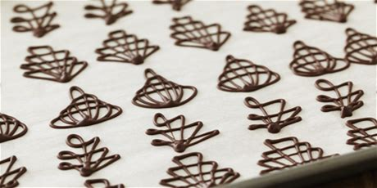

Chocolate Lace Shards

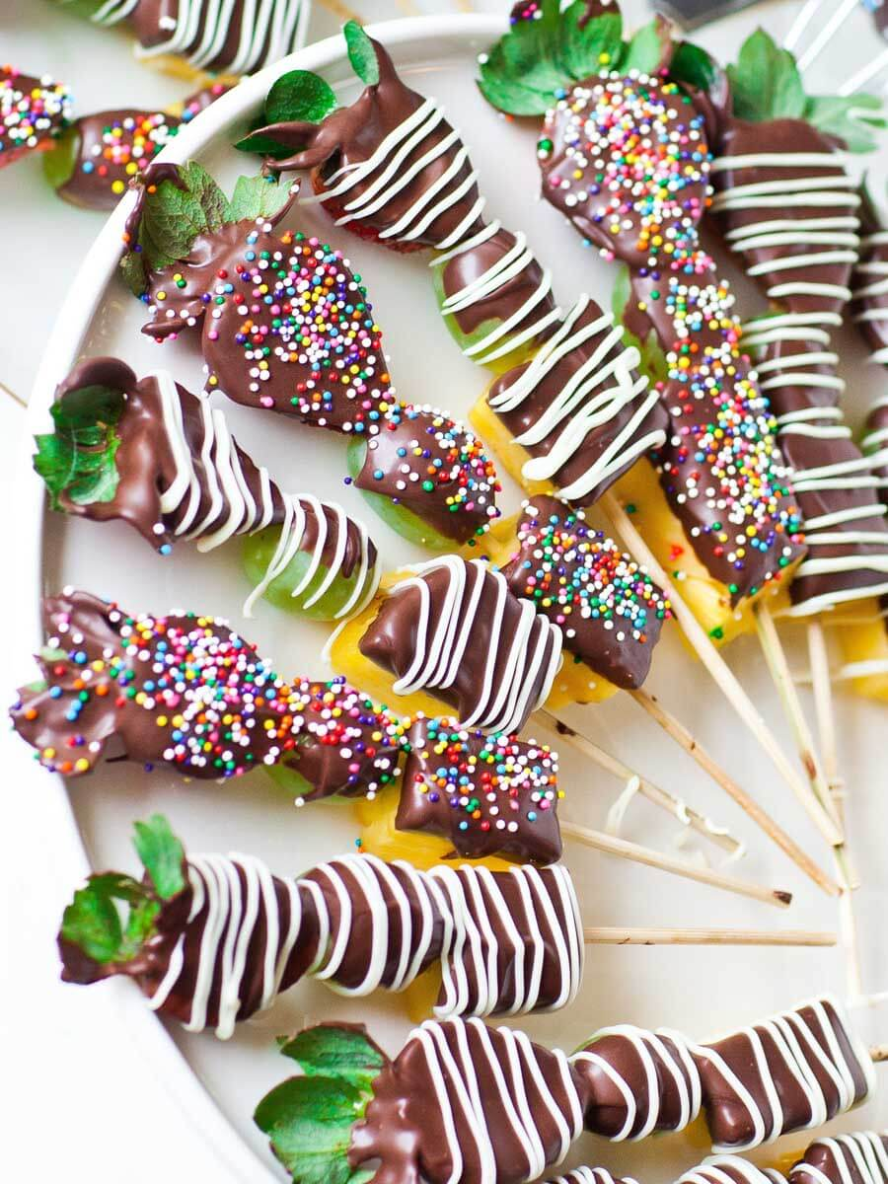
Chocolate Fruit Kabobs

Ingredients
- 20 strawberries
- 1 fresh pineapple, chopped
- 1/2 pound green grapes
- 14 to 16 bamboo skewers
- 2 cups chocolate melting wafers
- 1/4 cup white chocolate chips
- Sprinkles

Instructions
- I used strawberries, grapes and pineapple but feel free to include your favorite fruit. Here are some suggestions: bananas, apples, red grapes, kiwi, balled melons and/or cantaloupe, raspberries, blackberries, blueberries. Wash the fruit ahead of time and allow to dry.
- Skewer the fruit onto the bamboo skewers in desired order and place onto paper towels to absorb any remaining moisture.
- Prepare the chocolate. I recommend using chocolate melting wafers. Melt them in the microwave or on the stove top using a double boiler. Stir until the chocolate is smooth.
- Dip the fruit skewers into the chocolate until the fruit is half covered. Place the fruit chocolate side up on a cooling rack and allow the chocolate to set. IF you want to add sprinkles, add them when the chocolate is still melted.
- To add the white chocolate drizzle, melt some white chocolate chips and place into the a ziplock bag. Cut off the tip and drizzle the chocolate over the fruit skewers. Allow the chocolate to set for about 1 hour. If you're in a hurry, place the chocolate into the refrigerator for 15 minutes.
- Enjoy the fruit kabobs the same day, or within 24 hours. Can also be prepared in the evening for the next day!

4.1 Ensuring Flavours and Textures Complement Desserts:

Importance of textures in a good dessert
Texture is an important aspect of desserts, as it can make them more interesting and exciting¹. When creating dessert menus, it is important to consider the balance of textures to create delicious, compelling work that endures bite after bite². Favor multiple crispy textures and bring moisture to your desserts through multiple crispy garnishes, fresh fruits, sauces and syrups.

A really good dessert should have quite a few textures to make it more interesting and exciting. If the same texture is all throughout the dessert, people may not want to eat it often or really enjoy and appreciate it. Even if the dessert is just a simple cake, despite being really soft, and moist, people may not like to eat it. But when you add a sauce, a syrup or a glaze of some kind to the same cake, it becomes much better. A cake that has a nutty or a crunchy element and texture also is loved and preferred by all.
A classic dessert the focus of which is a cake should also have a nutty and crunchy element and texture, or a crumb of some kind, a sauce, glaze or syrup or even icing and frosting and maybe even served along with a scoop or two of ice-cream and even topped with a fruit such as cherry or a strawberry and some leaves of some kind, peppermint, sage or basil to add more fresh colour and aroma to it and make it look more appealing and appetizing.
You can make such a grand and exotic dessert, all you need is your favorite ice-cream, chocolate sauce or a jam, or even just caramel syrup, fresh fruits, some dry fruit and nuts.

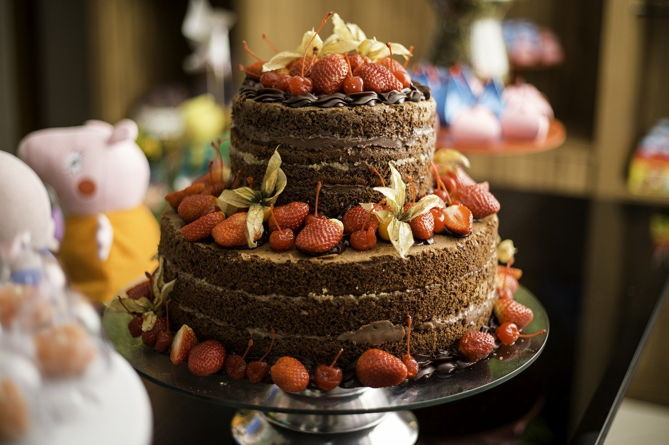

Fig.4.2.1 Textures complement desserts
Do you endlessly scour restaurant menus for the perfect combination of flavours and textures? Is your mouth watering when you think about perfectly paired dishes? If so, this article is designed just for you. We'll explore the delicate art of food pairing, from understanding different levels of flavour intensity to balancing complex tastes.

Fundamental rules to remember before you get started with food pairing:

The central tenet of food pairing is balance. It means striving for a harmonious balance between ingredients with similar intensity levels, such as light and delicate flavours or bold and intense ones. Texture also plays an essential role in food pairing – this refers to how each ingredient feels when it enters your mouth.
Try to create contrast by combining different textures, such as crunchy with smooth or creamy with crisp. Flavours should complement one another, not compete. Look for complimentary flavour combinations that bring out the best in each other rather than clashing together and cancelling out their unique qualities.
The art of food pairing: Combining flavours and textures for maximum… For example, pork goes well with apple sauce and tomato sauce; garlic is delicious with fish; and chocolate pairs nicely with orange.
Finally, keep in mind the overall impact of your dish. Consider all aspects – colour, texture, and presentation – to create a visually appealing and compelling meal.

Combining flavours – different techniques like contrast, harmony, and more:

When it comes to food pairing, there are different techniques that you can use to combine flavors. The most common approaches are contrast and harmony. Contrast involves combining ingredients with opposing qualities, such as light and heavy, sweet and savory, or sour and spicy. For example, pairing a light fish dish with a rich tomato sauce creates an exciting flavor contrast – each ingredient enhances the other's unique qualities without overpowering them.

Harmony is when two ingredients share similar qualities or feature complementary flavour profiles. This approach emphasizes the subtle nuances of each ingredient while allowing them to work together in perfect synergy. For instance, creamy peanut butter pairs beautifully with bananas or apples; smoked salmon works harmoniously with cream cheese, and basil and tomatoes make a classic combination.

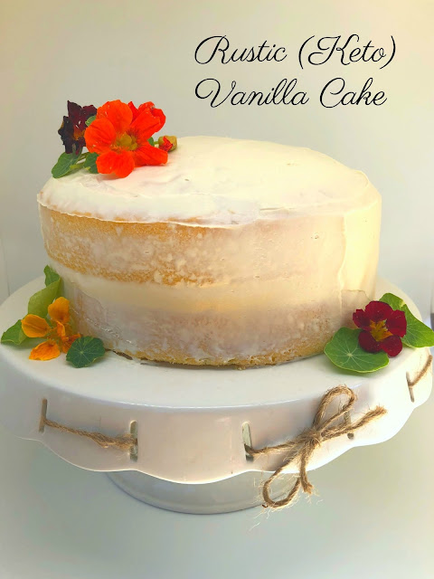
Fig4.2.2 Rustic (keto) vanilla cake

Self-Check 4 | Written Exam

Part I- True or False questions:
  - Spicy flavours can complement sweet desserts.
  - Adding a crunchy texture to a dessert can enhance its overall taste
  - Salty flavours are not commonly used to complement desserts.
  - Creamy textures are often paired with fruity desserts.
  - Sour flavours do not complement sweet desserts.
Part 2. Choose question:
1. Which of the following flavours can complement chocolate desserts?
a) Citrus
b) Cinnamon
c) Mint
d) All of the above
Answer: d) All of the above
2. True or False: Adding a creamy texture to a tart dessert can balance the flavors.
Answer: True
3. Which of the following flavors can complement fruit-based desserts like apple pie or berry crumble?
a) Vanilla
b) Nutmeg
c) Ginger
d) All of the above
Answer: d) All of the above
4. True or False: Adding a crunchy texture to a creamy dessert can create an interesting contrast.
Answer: True
5. Which of the following flavors can complement a rich and decadent dessert like cheesecake?
a) Salted caramel
b) Espresso
c) Raspberry
d) All of the above
Answer: d) All of the above

Unit Five. Storing Desserts and Sweets
This unit is developed to provide you the necessary information regarding the following content coverage and topics:
5.1 suitable packaging for desserts and sweet
5.2 Storing desserts and sweets
This unit will also assist you to attain the learning outcomes stated in the cover page.
Specifically, upon completion of this learning guide, you will be able to:
- Store desserts and sweets at the appropriate temperature and under the correct conditions to maintain quality, freshness and customer appeal.
- Select and use suitable packaging to preserve taste, appearance and eating characteristics

5.1 Using Suitable Packaging:
Desserts are oftentimes very delicate and come in all shapes and sizes. It’s easy for icing to get smudged or toppings to topple over during the ride from your establishment to your customer’s front door. Being a menu category that relies heavily on presentation, keeping your dessert’s integrity is the top priority when it comes to packaging.
Unfortunately, there’s no one size fits all packaging solution for desserts. Because of the wide variety of desserts available, take into consideration the following factors when choosing a container.

Material

Most dessert packaging is made out of plastic or paper and includes lids. Your lids should be leak-resistant and you should choose the material based on your dessert. Weigh the pros and cons of each material and investigate whether it can properly contain your desserts. To learn about their traits and help you pick the perfect container, take a look at our examples of the most commonly used materials below.

Plastic 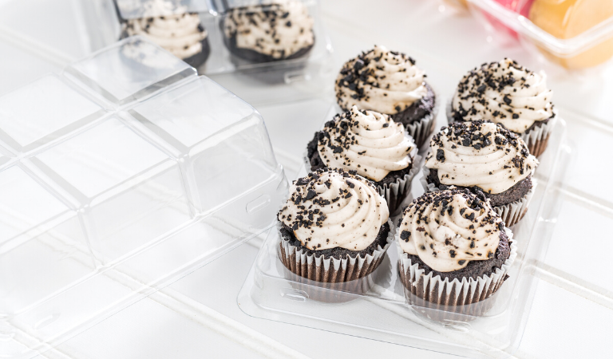
Fig.5.1.1 Plastic package
Pros:
- Durable design protects desserts
- Rigid structure secures food in place
- Leak-resistant to preserve freshness
Cons:
- Less environmentally friendly than other options
Paper 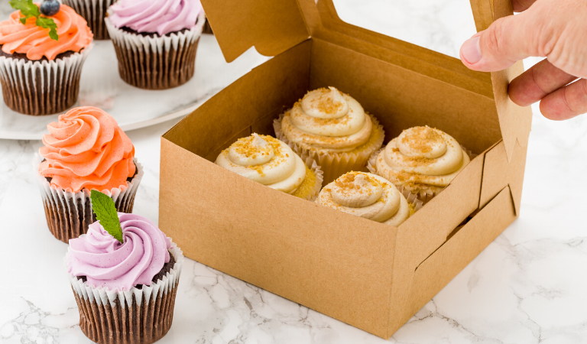
Fig 5.1.2 paper box
Pros:
- Lightweight and easy to carry
- Tends to cost less than other materials
- Microwave-safe for reheating food
Cons:
- If unlined can be saturated with grease and moisture

- Oven-safe for baking and serving
- Lightweight and easy to carry
- Freezer-safe for storing leftovers
Cons:
- Typically less presentation-focused than other options

Design
After you’ve decided on a material, inspect the overall design of the container while keeping in mind the type of dessert you will be packaging. Check to see if the container can securely hold your dessert item and keep it from moving during transport so it can arrive in one piece. Look for the following design details to improve your packaging presentation and prevent damages during delivery.
Colour When picking a container’s colour, make sure it matches your restaurant’s theme, logo, or dessert. Your restaurant’s colours and food packaging design contribute to your overall presentation and make it easier for customers to remember your establishment.

Window 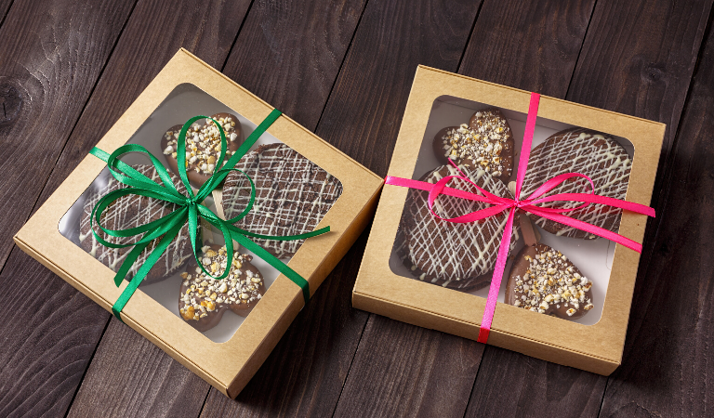

Fig.5.1.3 window

Packaging Materials for Storing Desserts:
• glass container
• plastic container
• plastic/cellophane
• Aluminium foil
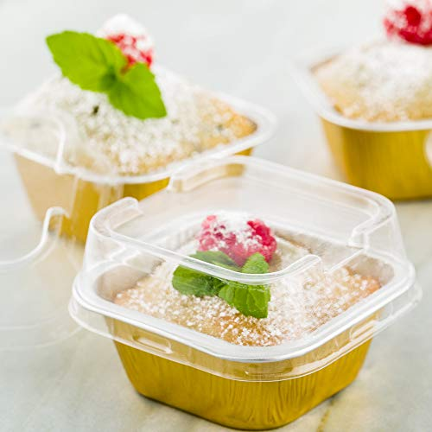
• Packaging tapes
• boxes Equipment
• chiller
• freezer
• refrigerator
Sanitary Practices When Storing Desserts:

Fig 5.1.4 packaging dessert boxes
• Handle the food properly to prevent spoilage and contamination.
• Wash utensils and equipment thoroughly
. • Keep away from food when you are ill.
• Store foods and ingredients properly.
• Safeguard the food during distribution and service.
5.2 Storage:
Proper storage of desserts is essential to maintain their freshness, texture, and flavor. Here are some general guidelines for storing different types of desserts:
1. Cakes and Cupcakes:
- Unfrosted cakes and cupcakes can be stored at room temperature in an airtight container for 2-3 days.
- Frosted cakes and cupcakes should be stored in the refrigerator to prevent the frosting from melting or becoming too soft.
- To keep the cake or cupcakes moist, cover them with plastic wrap or place them in a cake storage container.
2. Cookies:
- Most cookies can be stored in an airtight container at room temperature for up to a week.
- For soft and chewy cookies, adding a slice of bread or a piece of apple to the container can help maintain moisture.
- If you need to store cookies for a longer period, you can freeze them in a zip-top bag or airtight container for up to 3 months.
3. Pies and Tarts:
- Fruit pies and tarts can be stored at room temperature for 1-2 days, covered loosely with foil or plastic wrap.
- Cream or custard-based pies should be stored in the refrigerator, tightly covered, for up to 3-4 days.
- To prevent the crust from becoming soggy, place a paper towel on top of the pie before covering.
4. Cheesecake:
- Cheesecake should always be stored in the refrigerator due to its perishable ingredients.
- Cover the cheesecake with plastic wrap or place it in an airtight container to prevent it from absorbing other odours in the fridge.
- Cheesecake can be stored for up to 5-7 days in the refrigerator.
5. Ice Cream and Frozen Desserts:
- Keep ice cream and frozen desserts in the freezer at a temperature of -18°C (0°F) or below.
- To prevent ice crystals from forming, press a layer of plastic wrap directly onto the surface of the ice cream before covering with the lid.
- Frozen desserts can generally be stored for several weeks, but the texture may become less creamy over time.

Remember to always check the specific storage recommendations for each dessert, as some may have different requirements based on their ingredients and preparation methods

Self-Check 6 | Written Exam

Part I- True or False questions:
1. It is safe to store all types of desserts at room temperature.
2. Leftover cake should be stored in the refrigerator to maintain its freshness.
3. It is okay to store different types of desserts together in the same container.
4. Frozen desserts can be stored in any part of the freezer.
5. It is safe to eat a pie that has been left at room temperature for more than 24 hours.
6. Cookies can be stored in the refrigerator to keep them fresh for a longer period.
7. It is important to wrap desserts tightly to prevent them from absorbing odors from the refrigerator.
Part2. Choose the correct answer:
1. Which of the following is the best method to store a frosted cake?
a) Room temperature
b) Refrigerator
c) Freezer
2. True or False: It is recommended to store different types of cookies together in the same container.
3. How should you store leftover pie to maintain its freshness?
a) Room temperature
b) Refrigerator
c) Freezer

Lap Test 1:
Instruction: Given necessary templates, tools and materials you are required to perform the following tasks accordingly.
Task1. Produce variety of Garnishes
Task2. Prepare Garnish for Asian cuisine
Task 3.Decorate Desserts
Task 4.store desserts properly according to the types

Reference

- From The Internet
- Bakery & Confectionary Course ,Food Production Department
Kenya Utalii College, Nirobi
- Reading Materials On Pastry And Bakery Production

Participants of this Module (Training Material) Preparation

No | Name | Qualification (Level) | Field of Study | Organization/ Institution | Region | Mobile  number | E-mail
1 | Zuriyash-work Belay | B | Hotel Management | TTI Addis Abeba |  | 0911643817 | zuriyashwb@gmail.com
2 | Zelalem Almaw | B | Food Science& post-Harvest Technology | Bahir Dar PTC |  | 0918012521 | Parazolla25@gmail.com
4 | Belachew Merga Lemi | A | BA degree in Hotel Mgmt & Masters of Business Adminitration | Kirkos Manufacturing College | A.A | 0910330503 | Belachewmerga2011@gmail
5 | Mohammed Liben Mohammed | A | - BA degree in Hotel and Tourism management  - MA degree in Disaster Risk Management | Jigjiga Polytechnic college | Somali | 0992326557 | cherechaw@gmail.com

