Bakery and Pastry Production
Level IV
Based on December 2022 Curriculum Version 2

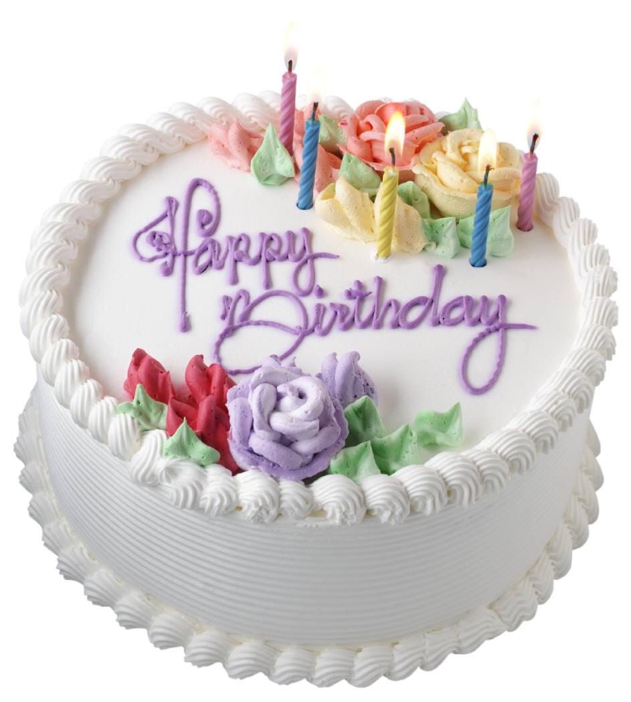

Module Title: Prepare and Present Cakes
Module code: CST BPP4 M06 0923
Nominal duration: 78 Hours
September, 2023
Minster of labor and skill Addis Ababa, Ethiopia

Acknowledgment

The Ministry of Labor and Skills (MoLS) would like to express its gratitude and appreciation to the instructors and experts from regional TVT bureaus, TVT colleges, and industry practitioners who contributed their expertise and experience in preparing the training module for the unit of competency “Prepare and Present Cakes” under the occupational standard "Bakery and pastry production level-IV."
The ministry also expresses its deepest gratitude to the Tourism Training Institute for its invaluable technical and financial support and collaboration in the module preparation. It is also thankful to MoLS staff members who coordinated the preparation and reviewing process of this training module.

Table of Contents
Acknowledgment 1
Definition of Terms 4
Introduction to the module 6
Unit One: prepare specialized cakes sponges 7
1.1 Selecting Ingredients and equipment 7
1.1.2 Use appropriate equipment 10
1.2. Specialized cakes and sponges 12
1.3. Using Techniques 17
1.4. Cooling sponges and cakes 19
SELF-CHECK 1. 21
WRITTEN EXAM 21
Operation Sheet1. 22
Lap test 1 28
Unit Two: Prepare and use fillings 29
2.1. Prepare Fillings 30
2.2. Filling and assembling specialized sponges and cakes 31
2.3. Coat top and sides of sponges and cakes 35
SELF-CHECK 2. 38
Operation sheet2. 38
Lap test2. 44
Unit Three: Decorating and presenting cakes 45
3.2. Using icings and decorations 47
3.3. Presenting Cakes attractively 50
3.4 Equipment and Arranging Cakes for display 53
SELF-CHECK 3. 54
WRITTEN EXAM 54
Operation sheet 3. Decorate sponges and cakes 55
Lap test.3. 60
Unit Four: store cake 61
4.1. Storage conditions for cake 62
4.2. Storage methods 64
RECOMMENDED READINGS 68
Developer’s profile 70

Definition of Terms
Term | Explanation
Agar Agar | Setting agent derived from seaweed. Much stronger than gelatine and harder to use. More stable.  Vegetarian alternative to gelatine.
Allergen | A substance that is foreign to the body and can cause an allergic reaction in certain people.
Compound chocolate | A bakers chocolate made with cocoa mass and vegetable fat.  Can be used without tempering.  Not as flavoursome but cheaper and very practical to use.
Couverture chocolate | A good quality chocolate made with cocoa mass and cocoa butter.  Need to be tempered before using as garnish. Expensive and best flavour.
Daquoise | A cake sponge made with a meringue and nuts folded through.
Fillings | An ‘insert’ in between of the cake to enhance the taste and the layering of the cake.
French Pastries | ‘Individual cake/pastries’ with approximate size of 5 to 6 cm, a term commonly used as ‘assorted French Pastries’ in the Industry.
Ganache | A chocolate paste/filling made from boiling of cream and stirring it into the chocolate.
Gateau | French name given to structured layered cake interspersed with flavoured cream or mousse, décor applied to sides.
Gelatine | Setting agent derived from animals bones and skins, used to stabilise creams.
Jellying Agent | An agent used to set (soft solid food), e.g. Gelatine, Agar-agar, Pectin.
Joconde Sponge | A thin sponge sheet made from almond or marzipan past.
Kahlua | Coffee liqueur.
Marzipan | Almond paste made from icing sugar and almonds.
Mascarpone cheese | A cream cheese that has tartaric acid added to give a sour flavour.  Fat content will range from 25% to 75 %, depending on manufacturer. Used in Tira Misu Dessert.
Petit Gateaux | Small individual cakes of the larger variety.
Tempering | Process of heating, cooling and warming up chocolate to appropriate temperature to align the cocoa butter crystals thus setting the chocolate.
Torte | Similar to gateau but of Austrian, German, Italian and Eastern European origins.  The name can be applied to either.  Tortes can have pastry layers and more fruit and nuts tend to be used in some structures.
Trimoline | Invert sugar – mixture of dextrose and fructose in approximately equal proportions, created by treating sucrose with an enzyme – Sucrose +Water =  Dextrose + Fructose

Introduction to the module
Producing variety of products in bakery and pastry production field will enhance the Hospitality industry service, serving the customer in full capacity and it is very important to keep the standards of bread and other sweet desserts service. On the other hand it is also a means to create a job for small scale industries and to street food service providers
This module is designed to meet the industry requirement under the bakery and pastry production occupational standard.

This module covers the units:
- Preparing Specialized cakes and sponges
- Preparing & use Fillings
- Decorating& Presenting cakes
- Storing Cake
Learning Objective of the Module:
At the end or the training session the trainees will be able to:
- Prepare specialized cakes and sponges
- Prepare & use Fillings
- Apply cake decorations.
- Present cakes
- Store cakes properly and safely
Module Instruction
For effective use this modules trainees are expected to follow the following module instruction:
- Read the information written in each unit
- Accomplish the Self-checks at the end of each unit
- Perform Operation Sheets which were provided at the end of units
- Do the “LAP test” given at the end of the unit and
- Read the identified reference book for Examples and exercise

Unit One: prepare specialized cakes sponges
This unit is developed to provide you the necessary information regarding the following content coverage and topics
- Selecting Ingredients and equipment
- Techniques of specialized sponges and cake preparation
- Preparing Specialized sponges and cakes
- Cooling sponges and cakes

This unit will also assist you to attain the learning outcomes stated in the cover page.
Specifically, upon completion of this learning guide, you will be able to:
- Prepare ingredients
- Select appropriate equipment
- Use techniques
- Prepare specialized cakes and sponges
- Identify Storage conditions of cakes

Selecting Ingredients and equipment

1.1.1. Selecting Required Ingredients
A commodity is an item that is required to meet a need of the end user. For the pastry cook making Gateaux and Tortes the list below is what they will be looking to acquire.
Flour makes up the bulk of the ingredients in pastry:
- All-purpose Flour = contains 10-12% protein and can be used in bread, cake and pastry making.
- Pastry Flour = has enough gluten to produce the desired structure and flakiness. It is good for making cookies, pie dough, biscuits, and muffins. Note: If stronger flour is used, the percentage of shortening be increased to produce more tenderness. The use of too much flour results in a tough, dry, and flavourless recipe. On the other hand, too little flour results in a flat, tough, and flavour less baked product. The ratio of flour to shortening ranges from 1:1/3 to 1:2/3. 2.
- Fat this contributes to the tenderness and flakiness of pastry.
A). Shortening = the most popular fat for pie crust because it has the right plastic consistency to produce a flaky crust. It is firm and mouldable enough to make easily worked dough.
B). Butter = contributes excellent flavour to pie pastry, but it is not frequently used in volume production for two reasons: it is expensive, and its melts very easily, making the dough difficult to work.
- Margarine = this should not be used because it blends too quickly with the flour, making a flaky pastry difficult to achieve.
- Oil = makes the pastry very tender, but crumbly rather than flaky.
- Lard = rendered fat of hogs and mainly used in cooking. Note: If butter is used in place of shortening, the percentage of fat in the formula should be increased by about one-fourth. (If 1 pound shortening is called for, use 1 pound 4 ounces butter, if 500grams shortening are called for, use 65 grams butter). The differences in texture of many pastries have to do with the type of fats and how fats are introduced during the process. The liquid should be reduced slightly, as butter contains moisture.
- Leavening agents is a substance used in dough to make it rise, such as yeast or baking powder and baking soda.
- Steam = act as the raising agents in puff and flaky pastries.
- Egg and steam = act as raising agents for choux pastry
- Yeast = use in making croissants and Danish pastry
- Liquid = use to bind and hold together the blended flour-shortening mixture.
A).Water = is used to bind and hold together the blended flour-shortening mixture. It should be ice-cold to get the best result.
B).Milk = sometimes used instead of water; it produces pastry that browns beautifully but tends to be less tender than made with water.
C) Chilled orange or lemon juice = can be used instead of water to add flavour to the crust. Note: Add cold liquid ingredients on a gradual basis. Since different types of flour have different absorbing properties.
- The addition of liquid contributes to flakiness as the temperature of liquids allows fat particles to become well-formed and preserved. Likewise, the flour particles become less saturated with the additional water, thus minimizing swelling.
- Salt = it has a tenderizing and conditioning effect on the gluten. = its main contribution is to add flavour and it must be dissolved into the liquid before adding to even distribution. Note: Skip using salt if margarine is used.
- Sugar = it is added to sweeten the pastry dough.
- Egg = the yolk emulsifies the dough giving the crust characteristics of tenderness, richness, and brown colour.
- Flavourings such as herbs, spices, essences, and cheeses may be used and be added to the basic pastry dough.
Measuring and Weighing Required Ingredients for Pastry Production Measuring and weighing accurately the required ingredients in pastry making is of great importance.
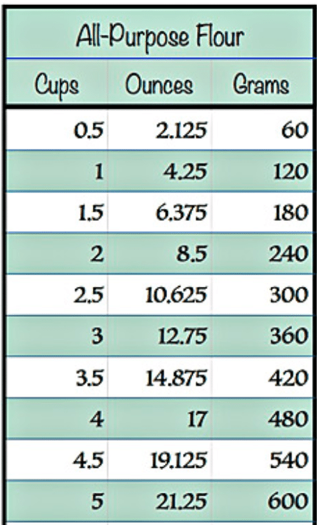

Fig.1.1 Weight chart
Balance of ingredients
Formula balance is the term usually used with regard to the balance of ingredients.
To produce a good quality cake, the essential ingredients must be present in the proper proportions. Various ingredients are tenderising agents–sugar, shortening and egg yolk.
These counteract the toughening or binding agents–flour, egg white and milk solids. Thus an unbalanced cake formula would produce either a tough cake or a crumbly textured cake.
In general it is recommended to use the same quantity of flour to sugar, with the exception of high Ratio formulas where an additional 20% sugar can be used.
The density of a sponge is determent with the egg content. These more egg compared to flour and sugar is used the lighter the sponge.
Some formulas are made with equal parts of sugar, flour and eggs.
These sponges are classified as heavy or dense, but flour and sugar can now be reduced to half

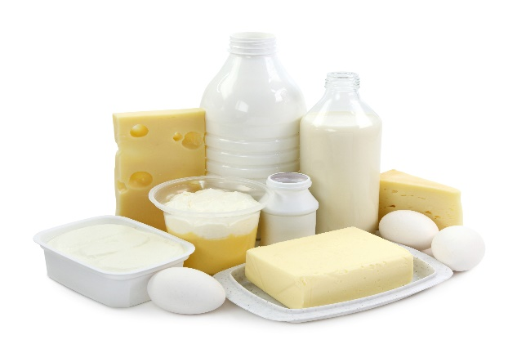
Fig.1.1Balance of ingredients
1.1.2 Use appropriate equipment
When making sponges it is essential for high quality products that equipment is:
- Grease free
- Starch free
- Tin preparation
Mostly tins are lightly greased and then lined with greaseproof paper. The reasons for lining the tins are as follows:
- Maintains the shape of the product
- Greasing tin is not always satisfactory
- Insulates product during baking
- Adds to shelf-life of the product
To prevent sponges or cakes sticking to the tins, tins can also be prepared as follows:
- Using a greasing emulsion (this is a blended mixture of fat and starch)
- Brushing tin with fat and then dipping it into flour or almond meal, depending on flavour
- Brushing with fat and dipping the tin into sugar using fat only.

Note
Due to different flavours of the greasing agent it is recommended to always use the same fat for greasing as it is used for the product, to retain the best possible flavour. Torte or Gateau rings are not to be greased, as the product would shrink and the centre of the sponge would be higher than the sides.
The bases of the rings are covered with grease proof paper, Commercial mixers and attachments( balloon whisk, paddle,(dough arm)whisk beaters spatulas and wooden spoons,cutting implements for nuts and fruits,graters,scales and measures,bowl, cutters, baking ovens, cake and sponge tins and moulds, working table.
Some Bakery equipment:
Mixer, Pastry Bags Cooling Racks
Rubber Cake Turn Table Convection Oven
Spatulas, Mixing Bowls Serrated Knife,
Offset Spatulas, Pastry Brush, Cake Pans, Cake Decorating Tips, Paring Knife, Gel Food Colouring,
Parchment paper, Whisker, Cake Stand,
Digital scale Measuring Spoons and Measuring Cups

1.2. Specialized cakes and sponges
By definition, a cake is a ‘sweet baked’ product usually containing flour, sugar, eggs and fat. Other typical ingredients are flavouring agents, liquids and leaveners or raising agents, such as baking powder or baking soda.
Gateau in France refers to all Cakes and Pastries of a certain size, usually bigger than one portion. Modern Gateaux finishing includes products which are:
- Glazed
- Masked
- Sprayed
- Covered or coated with chocolate
- Marzipan
- Fresh cream
- Icings
- Butter creams.
Cakes are generally categorised by their main ingredient or flavouring: For example:
- Cheesecake
- Chocolate cake or raspberry cake
- Fruit cake.
- Or by their ‘method of preparation:
- Mousse cake
- Chiffon cake

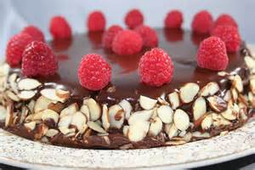

Fig.1.2 Gateaux
Fig.1.3.Birthday cake

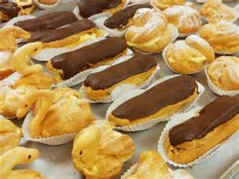
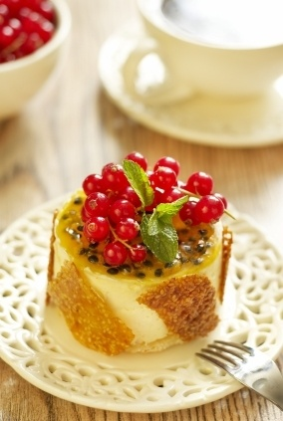
Fig.1.4. Fruits and jellies
Fig.1.5.cream puff
The difference between the two (cake & gateau)
On the one hand, gateau is a fancy word for cake, if you take “cake” as a very generic term that covers angel food to flourless chocolate cake to cheesecake to beefcake (hey, wait a mi Cake and gateau are both sweet desserts. But In case of cakes, the focus in mainly of cake itself. Icing is kind of an extra.
But, Classic French Gateau is a layered structure. It consists of icing as a main component. So, it is thickly iced. Also, gateau uses fresh fruit as a main component which cake doesn't necessarily use. So you can store cake for longer because fresh fruits tend to go bad if not eaten within the same day or night.
Traditionally Gateaux and Tortes are described as a cake or sponge soaked with liqueur and layered with fillings, such as:
- Butter cream
- Fresh cream
- Mousse
- Ganache
- Custards
- Fruits and jellies.
- Pastries such as:
- Puff pastry
- Short pastry
- Choux pastry
- Meringue based baked goods.
Making Chocolate gateaux
This cake can be made in advance and frozen without the icing. Just defrost completely then ice as before. Why not drizzle with contrasting milk and white melted chocolates.
The 5 Main Principles behind the Making of Cakes:
Principle 1. Combining of Ingredients:
Careful attention has to be given to the mixing process. The cake mixture has to form a uniform emulsion, so that the water is held in suspension surrounded by fat and other ingredients in the batter. A batter can curdle if the mixture changes to fat in water, with small particles of fat surrounded by water. Curdling can occur due to the following factors:
i. The quantity of butter should be measured accurately in the given recipe, so as the formula has a balance of both fat and water. Whole eggs, if ever used, will help the batter hold the liquids in the mixture.
ii. Ingredients should not be too cold; a temperature of 21 °C will enable an emulsion to form best.
iii. Mixing of ingredients in the first step too quickly will not be able to incorporate a good quantity of air into the batter.
iv. Adding of liquids too quickly may also cause the batter to curdle hence, they have to be added in steps and a little at a time.
Preparing of the molds prior to baking sponges is of utmost importance and is an art in itself. Many chefs lightly grease the cake tins with oil and fill up the tin with cake flour and pour out excess by tapping it slightly. This ensures a thin film of flour on the cake tin and prevents from the batter sticking to the mold. The other method is to line the cake tin with grease roof parchment paper.
Principle 2. Formation of Air Cells: Formation of air cells in a batter is of great importance since they give the sponge its texture and also act as a leavening agent. The air trapped in the batter expands when subjected to heat and this acts as a natural leavened giving the sponge a good raise even if no chemical agent is used.
Correct temperature of ingredients and a suitable mixing are vital for the formation of good air cells in the batter. In the case of foam cakes the egg and sugar mixture should be slightly warmed to approximately 38°C. Whipping should be done at a high speed first, then at a moderate speed to retain the formation of air cells.
Principle 3. Texture:
Another important principle in sponge making is the texture of the sponge. The development of gluten in the batter is responsible for the texture of the end product. A very little amount of gluten is required in cake making; hence weak flour will be a better choice. In some sponge recipes, corn starch replaces some of the flour requirement, thereby reducing the gluten content even more. On the other hand certain rich fruit cakes require more gluten to hold the structure and the fruits in the cake.
Since the amount of mixing affects the gluten, the flour in the recipe is always added towards the end of the mixing process after all the ingredients have been added, thus ensuring that there is very little development of gluten. If the batter is mixed for too long after the addition of flour, then the cake is likely to be tough.
Principle 4. Formula and Balance:
Ingredients and quantities can be changed only to a certain extent in a given recipe. A formula in which the ingredients fall within these limits is said to be in balance.
For the purpose of balancing, ingredients can be classified into the following four functions:
i. Tougheners: They provide structure, for example, flour, eggs (white and yolks).
ii. Tenderizers: They provide softness or shortening of protein fibers, for example, sugar, butter, and chemical leavener.
iii. Driers: These are the ingredients that absorb moisture, for example, flours and starches, cocoa powder, and milk solids (powder), etc. A sponge may require formula balancing if even after following all the steps has not come out correctly.
iv. Moisteners: They provide moisture to the batter, for example, water, milk, liquid sugar, eggs, etc. The formula would be balanced if toughened equal tenderizers and driers equal moisteners. In other words, a balance has to be maintained between the given ingredients. Egg yolk contains fat which is a tenderizer and at the same time contains protein which is a toughened.
A common practice in balancing a formula is to decide the flour and sugar ratio, then balance the rest of the ingredients against this combination as follows:
A. If liquid is increased, reduce the eggs and the shortening.
B. If eggs are increased, increase the shortening.

1.3. Using Techniques
There are 4 main methods (techniques) of making cakes
- The Rubbing-In Method - The fat is rubbed into the flour. Then the other dry ingredients are added, followed by the wet ingredients like eggs, milk and oil.
Example:
- American Blueberry Cheesecake
- Classic Fruit Scones with Orange Zest| British Baking Classic
- Chocolate Digestive Biscuits | British Baking Classic
- Cheese and Chive Scones
- Mary Berry´s Bakewell Tart (Short crust Pastry)
- The Creaming Method - The butter and sugar are first worked together in a mixing bowl until they are light and fluffy. Then the eggs are added, followed by the flour.
Example;
- Sticky Toffee Cake with Pecan Praline
- Mary´s Frosted Walnut Layer Cake with Boiled Icing
- Chocolate and Vanilla Checkerboard Cake with Chocolate Ganache
- Strawberry Flan Cake | Erdbeerboden | German Baking Classic
- Paul Hollywood´s Pineapple Upside Down Cakes | Bake Off Technical Challenge
- Red Velvet Cake with Cream Cheese Frosting
- The Sponge Cake Method or Whisking method - The eggs and sugar are whisked together until light and creamy, and the flour is then lightly folded in.

Example:
- Swiss Roll with Strawberries and Cream
- Black Forest Gâteau | Schwarzwälder Kirschtorte | German Baking Classic
- Mary Berry´s Strawberry Fraisier Cake
- Mini Chocolate and Raspberry Sandwich Cakes
- German “Baumkuchenspitzen” with Rum for Christmas (includes grilling cake!)
- The Melting Method - The fat is melted, along with any syrup, sugar or treacle in the recipe (This method is often used for gingerbread.) Then add the flour, followed by the beaten eggs and milk. Example:
Best Chocolate Brownies ever with Pecan Nuts
- M&M Chocolate Brownies
- White Chocolate and Raspberry Brownies
- Mini Chocolate and Raspberry Sandwich Cakes
- Salted Peanut and Apricot Florentines
- All-in-one method- all the ingredients are added to the mixing bowl at once and combined to make a thick, smooth, batter. It is unusual method of cake making. Example:
- Best-ever Carrot Cake Tray bake
- Madeira Cake | British Baking Classic
- Vanilla Cupcakes with Vanilla Buttercream
- Blackberry and Cinnamon Crumble Cake
- Mary Berry´s Lemon Drizzle Cake
- Easy Victoria Sponge Cake with Raspberry Jam and Cream
- Lemon and Poppy Seed Bundt Cake
- Spiced Carrot Cake with Orange Cream Cheese Frosting
- Lemon Cupcakes with Lemon Curd
- Honeycomb Cake with Apricot and Mascarpone Cream
The following techniques are also apply when you making various cakes:
- Weighing or measuring and sieving dry ingredients.
- Adding fats and liquids to dry ingredients.
- whisking ,creaming and aerating to achieve required consistency and texture
- whisking, folding, piping and frosting
- selecting and preparing appropriate baking sheets, cake and sponge tins and moulds
- using required amount of batter according to desired characteristics of finished products
- preparing and using appropriate pre-bake finishes and decorations
- selecting baking conditions and temperatures
- portioning evenly, accurately and neatly
- decorating

1.4. Cooling sponges and cakes
Depending on what type of cake you are making and how long you have to cool it, there are several things to consider. If you cool your cake improperly you might end up with a cracked or soggy cake. Cooling your cake in the refrigerator is a quicker method, but you can also cool your cake on the countertop or in the oven. You can transfer your cake to a wire rack, let it cool in the pan, or even cool it upside down.
After you bake a cake, you should let it cool before frosting and decorating it. You can expedite this simple process by learning how to cool a cake efficiently and effectively.
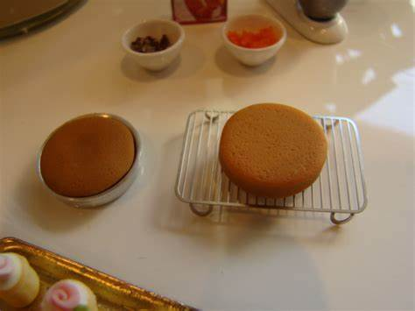
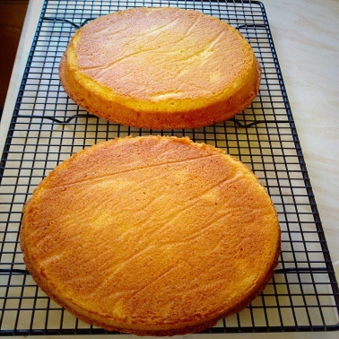

Fig. 1.6 cooling cakes
And icing to room temperature and retouch the icing before serving. You may even want to keep a little extra icing on the side to help.
You can also freeze an uncut cake that has been frosted, but the defrost process is well, a bit of a process. Making sure that condensation keeps from forming on the icing is tricky so, unless
A cake “re-sealed” like this can keep on the counter or in the refrigerator just like an uncut cake, but will last only 2-4 more days. Again—this is important —if the cake is iced with cream cheese or whipped cream frosting, skip the counter and go straight to the fridge for the entire storage time.

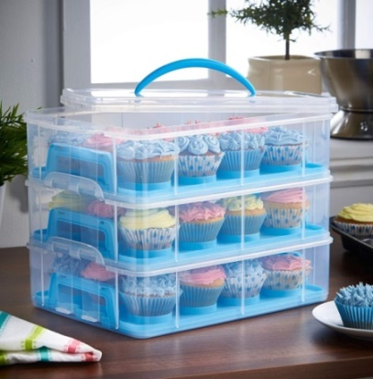
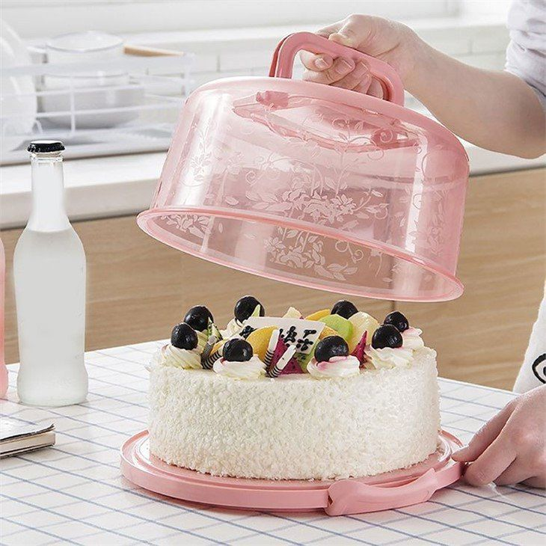
Fig1.6.cake storage

SELF-CHECK 1. | WRITTEN EXAM

Direction :
Answer the following questions:
- Gateau in France refers to all Cakes and Pastries of a certain size, usually bigger than one portion. (True or False)
- Whisking method is preparation techniques in which all the ingredients are added to the mixing bowl at once and combined to make a thick, smooth, batter. (True or False)
- A cake is a sweet baked product usually containing flour, sugar, eggs and fat. (True/False)
- Shortening is a substance used in dough to make it rise, such as yeast or baking powder and baking soda. (True or False)
- Write some ingredients and equipments that used in cake making (at least three in each).
----------------- -------------------------------
---------------- ----------------------------
----------------- ----------------------------
- Mention and elaborate the main preparation techniques of cake.

Operation Sheet1.
Operation Title: Prepare specialized cakes and sponges
Purpose: To Prepare specialized cakes and sponges
Conditions or situations for the operations:
- Safe working area
- Properly operated tools and equipment
- Appropriate working uniforms fit for the practical performance
Equipment &Tools
-Mixer - scale - cake pan -whisker
- Oven - bowl -brush measuring cup& spoons
- Scraper -piping bag, etc.

Quality Criteria: Assured performing of all the activities according to the procedures
- Rich French Chocolate Gateaux Recipe:
Ingredients
2 cups chopped semisweet chocolate
3/4 cup (6 ounces) unsalted butter
1/3 cup cocoa powder
1/2 teaspoon instant espresso powder
5 large eggs
3/4 cup plus 3 tablespoons sugar
1 tablespoon all-purpose flour
Steps to Make It
Gather the ingredients.
Preheat the oven to 350 F. Lightly butter a 9-inch spring form pan and set aside.
In a medium saucepan, melt the chocolate and butter over the lowest heat, do not rush this process, melting the chocolate too quickly will cause it to "shock" into a hard lump.
Mix in the cocoa powder and espresso powders until smooth and set aside for a few minutes to cool.
While the chocolate is cooling, whisk together the eggs, sugar, and flour until they are completely combined and foamy.
Fold the egg mixture into the chocolate until the color is uniform and pour the batter into the prepared pan.
Place into the center of the preheated oven and bake for 45 minutes or until a toothpick pulls out moist crumbs when inserted near the center of the torte. If the pick is sticky, then cook for a little longer.
Allow the cake to cool in the pan on a rack for 15 minutes. Run a knife or inverted spatula along the edges of the gâteau and loosen the sides of the pan. Cool for 5 minutes and remove the sides of the pan. Invert the cake onto a cake platter and cool completely before serving decorated as you wish.
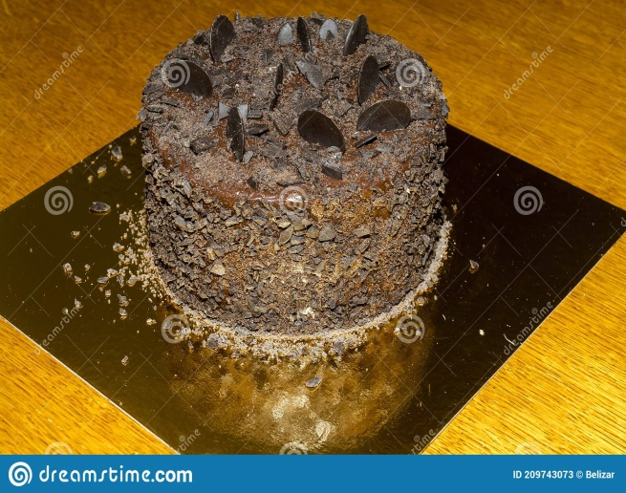 Fig.1.1. chocolate Gateaux

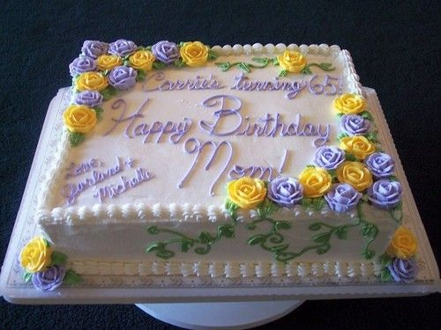
2. Special Birthday Cake
Ingredients
1/3 cup vanilla or white chocolate chips
1/2 cup hot water

Fig.1.2Birth day cake

1 cup butter, softened
1-1/2 cups sugar
4 eggs, separated
1 cup buttermilk
1 teaspoon vanilla extract
2-1/2 cups all-purpose flour
1 teaspoon baking soda
White chocolate frosting:
1 cup sugar
1/2 cup plus 1 tablespoon evaporated milk
6 tablespoons butter
3 cups vanilla or white chocolate chips
2-1/4 teaspoons vanilla extract
Directions
In a small bowl, combine the chips and water; stir until chips are melted. In a large bowl, cream the butter and sugar. Add egg yolks, one at a time, beating well after each addition. Add melted chip mixture, buttermilk and vanilla; beat well. Combine flour and baking soda; gradually add to the creamed mixture.
In a small bowl, beat egg whites until stiff peaks form. Gently fold into the creamed mixture.
Pour into three greased and floured 9-in. round baking pans. Bake at 350° for 25-30 minutes or until a toothpick inserted in the center comes out clean. Cool for 10 minutes before removing from pans to wire racks to cool completely.
For frosting, combine the sugar, milk and butter in a saucepan; bring to a boil, stirring constantly. Boil for 1 minute; remove from the heat. Stir in chips and vanilla until smooth; cool. Spread frosting between layers and over top and sides of cake.
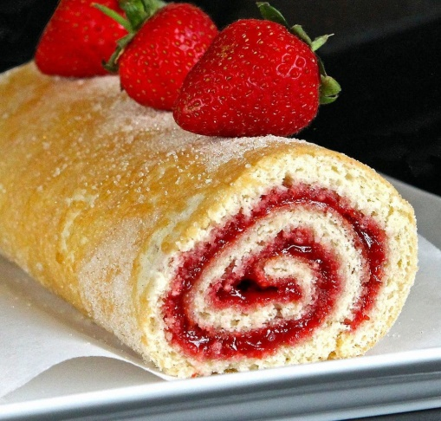
3. Swiss roll sponge:
Swiss roll
Ingredients
- 4 eggs
- 100 g. castor sugar
- 100 g. flour
Preparation
1. Whisk the egg and sugar over a pan of hot water Fig 1.3.Swiss roll sponge

2. Continue until double in bulk
3. Remove from the heat and whisk until cold and thick
4. Fold in the flour very gently
5. Line the baking sheet with a grease proof paper
6. Pour in the mixture bake at 200-degree c. for 6 -10 min.
7. Turn out on to a sheet of paper or cloth sprinkled with castor sugar
8. Remove the paper from the Swiss roll
9. Spread quickly with warm jam
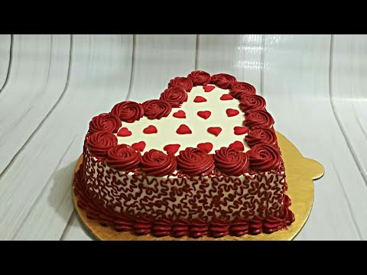
10. Roll in to a fairly tight roll, leaving the paper on the outside keep in the fridge 5-10 min.& slice to serve.
4. Genoese sponge
Ingredients
- 4 Eggs
- 100 g. flour (soft)
- 100 g. castor sugar
- 50 g. Butter / margarine Fig1.4. Vanilla Genoese
Preparation 1. Whisk the eggs and sugar with a balloon whisk in a bowl over a pan of hot water
2. Continue until the mixture is light, creamy, and double in bulk
3. Remove from the heat whisk until cold and thick (ribbon stage)
4. Fold in the flour very gently
5. Fold in the melted butter very gently
6. Place in a greased, floured Genoese mold
7. Bake in a moderately hot oven 200-degree c,
- Chocolate Genoese
Ingredients

- 5 g. flour
- 10 g. cocoa powder
- 10.g. corn flour
- 4 eggs
- 100 g. castor sugar
- 50 g. butter
Preparation: Sift the flour, cocoa and corn flour together and proceed as for Genoese sponge

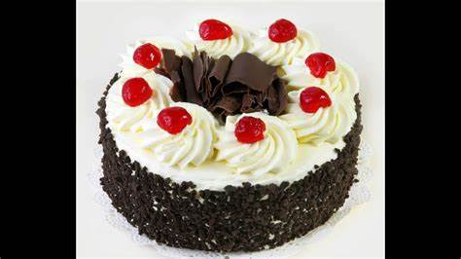

Fig1.5 Chocolate Genoese

Lap test 1
Instructions: Given necessary templates, tools and materials you are required to perform the following tasks accordingly.
Task 1: pre-prepare the necessary equipment
Task 2: prepare the necessary ingredients
Task 3: measure the ingredients according to the instruction given by a recipe.
Task 4: prepare specialized cakes.
Task 5: prepare various commercial sponge
Task 6. Considering its freshness store it properly.
Task 7. Serve it as needed.

Unit Two: Prepare and use fillings
This unit is developed to provide you the necessary information regarding the following content coverage and topics:
- Prepare filling.
- Filling and assembling specialized sponges and cakes
- Coat top and sides of sponges and cakes

This unit will also assist you to attain the learning outcomes stated in the cover page.
Specifically, upon completion of this learning guide, you will be able to:
- Prepare the selection of fillings to required consistency using appropriate flavourings.
- Fill and assemble the sliced or layered Sponges and cakes according to standard recipe specifications, enterprise practice and customer preference.
- Mask, cover or coat the top and sides of sponges and cakes as appropriate to achieve even, straight and smooth surfaces, or characteristics and appearance required by recipe specifications.

2.1. Prepare Fillings
- Introduction
Filling is a thick mixture which is used between the layers of cake. It may be some of the frosting to which nuts or fruits are added. Whipped cream and custard mixtures are sometimes used for fillings.
There are many cake filling types that you can select to add to your cake to give it more flavour and interest. A cake with a filling always seems to attract attention and most often someone will select a filled cake over a plain cake because they know the filling will provide extra flavour.
Filling a Cake: Adding filling between layers holds the layers together, giving your cake flavor as well as height. Using a decorating bag filled with icing and fitted with tip 12, pipe a line of icing just inside the outer edge of the layer. This will create a dam that will prevent the filling from seeping out. Example of cake fillings
- American Buttercream. This is the most used cake filling across the world.
- Italian Meringue Buttercream.
- Swiss Meringue Buttercream.
- French Butter cream.
- German Butter cream.
- Chocolate Ganache.
There are many cake filling types that you can select to add to your cake to give it more flavour and interest. A cake with a filling always seems to attract attention and most often someone will select a filled cake over a plain cake because they know the filling will provide extra flavour.
The difference between frosting and icing:
The terms are used interchangeably, but frosting is generally thicker and fluffier than icing, which is thinner and tends to set quickly and harden when dry. Icing is generally not spreadable like frosting—it needs to be poured, spooned, or drizzled over baked good.

- Tools materials and equipment needed for filling cake layers, seven essential Tools for making a cake:
- Stand Mixer or Hand Mixer. The easiest way to mix up cake batter is with a stand mixer, but that’s not the only way.
- Rubber or Silicon Spatula.
- Cake Pans.
- Cake Tester or Toothpicks.
- Paring Knife.
- Wire Cooling Racks.
- Metal Spatula.
- Jam can be used for cake filling
Jams and jellies are also best in combination with other fillings such as buttercream or ganache. To use a jam or jelly as a cake filling or even as a topping, simply stir it to soften, or heat it slightly if it’s too thick. You may also want to strain jams to remove the Seeds for a smoother texture
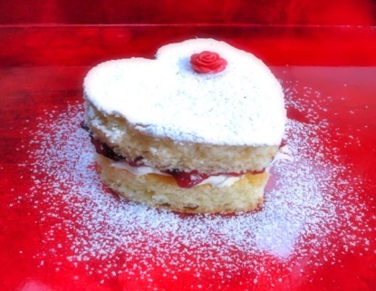
Fig.2.1 filling a cake

2.2. Filling and assembling specialized sponges and cakes
A layer cake is the cake to make for a special occasion. Whether mile-high or just two simple layers, a cake with filling is definitely in order for birthdays and other festive occasions. Layer cakes consist of multiple stacked sheets of cake, held together by frosting or another type of filling, such as jam or custard, and just about any cake can be turned into one, though butter cakes and sponge cakes are most ubiquitous.
It doesn't take a pro to put together a cake that looks like it was just plucked out of a bakery display case. All you need are a few basic tools and speaking of time, we'd be remiss if we didn't address the cardinal rule of assembling a layer cake: keep it cool. You'll want to make sure the cake layers are completely cooled before you start the process, because warm cake = melting frosting, and that's not good. If you're worried you may not have enough time to bake and assemble the cake all in one day (the entire process will take 4 hours, give or take), split it up, and bake the cake one day and frost it the next. And give it a chill in the fridge in between steps as you're frosting it, to help each layer set up nicely before you move on to the next.
To make a layer cake, assemble and frost a layer cake;
Once your cake is baked, cooled, and levelled it’s time to frost. Evenly frosted layers and using a very stable frosting are two important factors in a stable layer cake.
Step 1: Place a dollop of frosting on a cake board or the plate that you’re stacking your cake on. This helps to prevent the cake from sliding around. Place the bottom layer center on the cake board.
Step 2: Pipe a layer of frosting using a piping bag to ensure it’s even (remember we want nice, flat layers!). Pipe from the outside edge into the middle. You don’t have to use a piping tip, you can snip off the end of the bag as well. Use an angled spatula to smooth it out.
Step 3: Add your second (or third) layer and repeat adding a layer of frosting in between. One you’re ready for the top layer, I recommend inventing it, so the top of the cake is the flattest it can be. You’ll notice that will leave some gaps into between the layers. Don’t worry, we’re going to fix that.
Step 4: Fill in the gaps and add the crumb coat. A crumb coat is a thin layer of frosting added prior to the final layer. The intention of the crumb coat is to pick up any loose crumbs so they don’t get mixed into the final layer of frosting. Use your piping bag to fill in those gaps and continue to spread it around to create the crumb coat. It’s recommended to refrigerate the cake for 5-10 minutes to chill the crumb coat. If you have any holes or gaps, fill them in with the piping bag and rescrape. The crumb coating is optional but recommended.
Step 5: Add the final layer of frosting. You can do this by hand, but I find it’s easiest to continue to use a piping bag fitting with a large open round piping tip,
Step 6: Scrape it evenly using a cake scraper or angled spatula at 90 degrees or perpendicular to your cake. It’s best to use a turntable to rotate the cake and hold the cake scraper still. You don’t need to apply a lot of pressure and you’ll likely make a couple passes in order to get it nice and smooth.
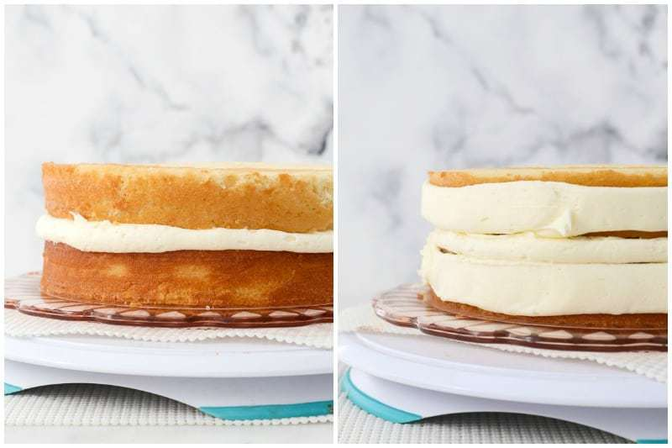

Fig.2.2. layer cake
Chill the cake for 2 hours before you frost it. It hard to be patient, but wait! If you frost the cake before it's cooled, the butter in the frosting will melt and soak into your cake. Plan on chilling the cake for 2 hours before you cover it with buttercream.
Let the cake layers cool to room temperature and wrap them in plastic wrap before you stick them in the fridge. You can chill them overnight as long as they're wrapped well.

Spread a really thin layer of frosting to lock in the crumbs. To do a crumb coat, brush away loose crumbs with a pastry brush. Stir a 1 tablespoon (15 ml) of milk into 1/2 cup (56 g) of your buttercream to loosen it. Then, use an offset spatula to spread it onto the tops and sides of your cakes. Pop them into the fridge to chill for 15 minutes so the buttercream hardens.
You may have heard of a crumb coat-this is just a super-thin coating of buttercream that traps loose crumbs. It also gives your buttercream something to really stick to.
If you're frosting a chocolate cake, you might want to do an extra crumb coat since dark cake crumbs can show up easily in light-colour buttercream.
Use an offset spatula to evenly spread buttercream onto the top and sides.
Set 1 cake layer on a turntable and scoop 1 cup (112 g) of buttercream frosting onto the top. Spread the frosting to the edge of the layer with an offset spatula. Set your other cake layer on top and put the rest of your frosting on top. Then, spread the frosting across the surface and down the sides of the cake. It can help to spin the turntable slowly so you get even coverage.
Remember, you're covering the cakes that have a crumb coat.
If you've got a turntable, you can also hold a flat scraper vertically against the side of the cake slowly rotate the turntable so the scraper smooth the buttercream.
To cover the cake with buttercream, drag a cake comb across the sides to give your frosting a unique texture. Cake combs are plastic scrapers that have designs along the edge. Once you frost your cake, hold the cake comb vertically against the side of the cake and spin the turntable slowly as you press the comb against it to make ridges, stripes, or cool textures
If you don't want to buy a cake comb, look for things you already have in your kitchen. Drag the tines of a fork along the sides to make thin ridges or swirl the back of a spoon along the frosting to make fun swoops.
Use a piping bag with different tips to make rosettes, ruffles, and scallops.
While a smooth cake is striking, it's fun to play with buttercream accents. Fill a piping bag with your buttercream and choose a tip based on what design you want to make. Use a small round tip if you want to pipe words, for instance, or use a leaf tip to give your cake floral decorations.
To practice your piping skills, lay a piece of parchment paper on a baking sheet and try out different tips before you decorate the cake itself.
To chill your cake, put it into the fridge without a cover or plastic wrap until the frosting hardens a little. Then, cover it with plastic wrap and refrigerate your frosted cake for up to a day or two. Your cake will dry out the longer it's in the fridge.
While Italian and Swiss meringue buttercreams have egg whites, they're safe to keep at room temperature since you heated them thoroughly.
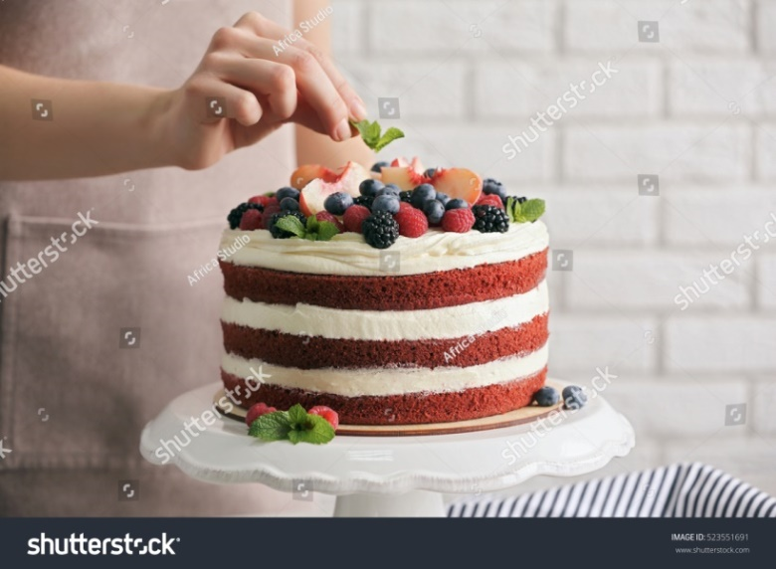

Fig.2.3. Finished Layer cake

2.3. Coat top and sides of sponges and cakes

When coating sponge cakes, the following points should be considered:

Step 1: Bake two sponge cakes and pipe a 1/4″ (6mm) dam of buttercream around the bottom cake’s outer edge.

Step 2: Add an even layer of jam, keeping it within the buttercream dam.

Step 3: Add buttercream until the jam is covered and then smooth over

Step 4: Add the second layer of your cake face down.

Step 5: Go back over the join, filling in any gaps

Step 6: Thin the buttercream and apply a thin layer to the top of the cake

Step 7: Apply a thin layer of buttercream to the sides, effectively sealing the cake.

Cool and Use!
To crumb coat a cake, prepare your baked cake:
- First, make sure your cake layers are entirely cool. Frosting a warm cake is an exercise in making iced coffee by adding ice cubes to hot coffee.
- Your cake may be entirely crumb-free or it may be fairly crumb-y, as this one is. Use a pastry brush to brush any obvious crumbs off the top and sides of each layer.
- Start by laying three or four strips of waxed paper onto a serving plate, then setting the bottom layer of cake onto the plate. The paper will protect the serving plate from getting messed up as you frost your cake; you’ll pull the strips out once you’re done
- Frost the bottom layer
- Next, add your middle layer of frosting. Our classic cake recipe calls for 1 cup of chocolate frosting.
- Use a metal offset spatula (if you have one), a nylon spreader, table knife, or you’re other favourite tool to spread the frosting atop the cake; you don’t need to worry about any crumbs, as this middle layer of frosting will obviously be hidden inside.
- Spread frosting completely over the top surface, going beyond the edge a bit of you like; you don’t need to be careful.
- Set the second layer atop the frosted bottom layer. Run a spatula around the cake to flatten any frosting that’s bulging out.
- Place the cake in the refrigerator for about 30 minutes (or up to 2 hours), for the frosting to chill and harden a bit. This interim step, while not crucial, means there’s no chance of the top layer sliding around on a slick of warm frosting as you try to apply your crumb coat.
- Apply the crumb coat
The chilled cake is now ready for its crumb coat, whose ultimate goal is to capture and trap any stray crumbs, anchoring them in place preparatory to you adding the next layer of frosting.
Start by applying a thin layer of frosting all around the sides of the cake, then across the top.
- Chill to set
Place your crumb coated cake in the fridge for another 20 minutes. You want the frosting to set and harden enough that you can apply frosting to it easily, without any drag or sticking. Hint: If you touch the crumb coat with the tip of your finger and your finger comes away clean, it's good to go.
- Finish frosting your cake
Now comes the creative part -applying your final beautiful layer of frosting. I like to spread frosting all over the cake rather haphazardly first, then if I feel creative, craft it into a “look.
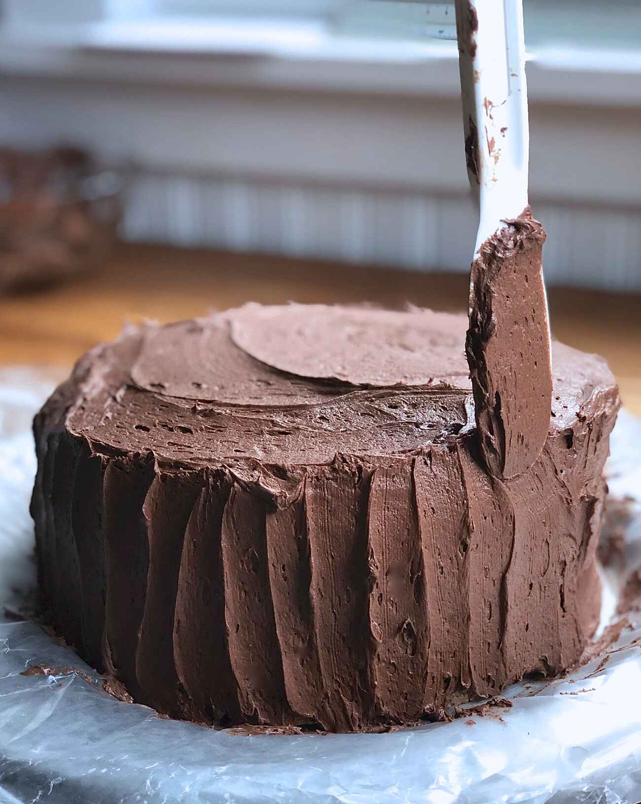

Fig.2.4.coating a cake

SELF-CHECK 2. | WRITTEN EXAM

Direction:
Answer the following questions:-
1. A layer cakes are mostly used for special occasions. (True or False)
2. Frosting is thicker and fluffier than icing. (True or False)
3. Filling is a thick mixture which is used between the layers of cake. (True or False)
4. It is a thick mixture used between the layers of cake. (Choose)
  - Assembling
  - Coating
  - Filling
  - decorating
5. List some at least three types of cake filling as a cream. (Types of cream) (short answer)
6. Write the steps of making a layer cake

Operation sheet2.
Operation Title: Prepare & use fillings
Purpose: To prepare fillings to cover, coat and mask cakes and sponges
Conditions or situations for the operations:

- Safe working area
- Properly operated tools and equipment
- Appropriate working uniforms fit for the practical performance

Equipment and Tools
-Mixer
-scale
- Oven
- Bowl
- Scraper,
- piping bag, etc.
Quality Criteria: Assured performing of all the activities according to the procedures
- Butter cream
Ingredients
- 325g of unsalted butter, room temperature
- 650g of icing sugar
- 1 dash of milk, if needed
Method
- Whisk the butter until light and fluffy
- Sift over half of the icing sugar and whisk until fully combined
- Sift over the second half of the icing sugar and whisk again.
- You can add a dash of milk to slacken the mixture if necessary

Variations
Add a generous splash of vanilla extract (or any other flavouring you like) to the base buttercream recipe.
For peanut buttercream, simply whisk a couple of tablespoons’ worth of smooth peanut butter into the icing.
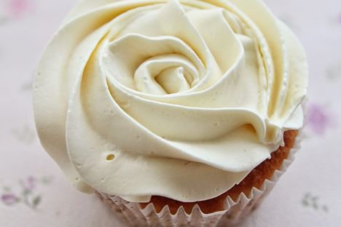

- Chocolate Mousse
Ingredients
- 4large egg yolks
- 1/4cup sugar
- 1/2cups heavy whipping cream
- 8oz semisweet baking chocolate, chopped
Steps
Beat egg yolks in small bowl with electric mixer on high speed about 3 minutes or until thick and lemon colored. Gradually beat in sugar.
Heat 1 cup whipping cream in 2-quart saucepan over medium heat until hot. Gradually stir at least half of the hot whipping cream into egg yolk mixture; stir back into hot cream in saucepan. Cook over low heat about 5 minutes, stirring constantly, until mixture thickens (do not boil). Stir in chocolate until melted. Cover and refrigerate about 2 hours, stirring occasionally, just until chilled.
Beat 1 1/2 cups whipping cream in chilled medium bowl with electric mixer on high speed until stiff. Fold whipped cream into chocolate mixture. Pipe or spoon mixture into serving bowls. Refrigerate until serving.
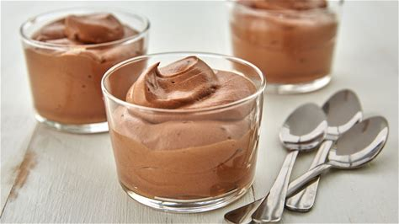

- Fruit custard
Ingredients
- 2.5 cups whole milk
- ▢5 tablespoons sugar
- ▢3 tablespoons custard powder
- ▢3 tablespoons whole milk warm or at room temperature
- ▢1.5 to 2 cups chopped mixed fruits – apples, mangoes, banana, pears, strawberries, pomegranate

Instructions
Making Custard Sauce
- Take milk in a thick bottomed pan or saucepan and keep it on the stove top. Bring the milk to a gentle heat or simmer.
- Whilst the milk is getting heated, in a small bowl, take 3 tablespoon warm milk from the saucepan. Add 3 tbsp custard powder.
- You can opt to take the 3 tablespoons of warm milk from the milk which is getting heated up in the pan or warm 3 tablespoons milk separately in a microwave oven or on the stove top.
- With a whisk stir very well to make a smooth slurry or paste without any lumps.
- When the milk has come to a gentle heat, add the sugar. Stir very well so that the sugar dissolves.
- Keep the heat on a low and then add the custard paste at a time in small portions.
- As soon as you add one portion of the custard slurry or paste, stir quickly so that lumps are not formed. Finish off all the custard paste this way.
- Keep on stirring often while the custard is cooking, so that lumps are not formed. Cook for about 5 to 6 minutes on a low heat.
- The mixture will thicken slowly. For a thicker custard, cook for a few more minutes. Allow the custard to cool at room temperature. Also keep in mind, that as the custard cools, it will thicken more. You can also keep the custard in fridge to chill it before adding the fruits.
Making Fruit Custard
- Chop the fruits. Use seasonal fruits. Avoid citrus fruits and melons. The fruits I used – apples, papaya, banana, strawberries and pomegranate.
- Once the custard has cooled, add the mixed fruits. Combine to mix.
- Serve fruit custard garnished with some more fruits and pomegranate arils or add some chopped nuts or dry fruits.

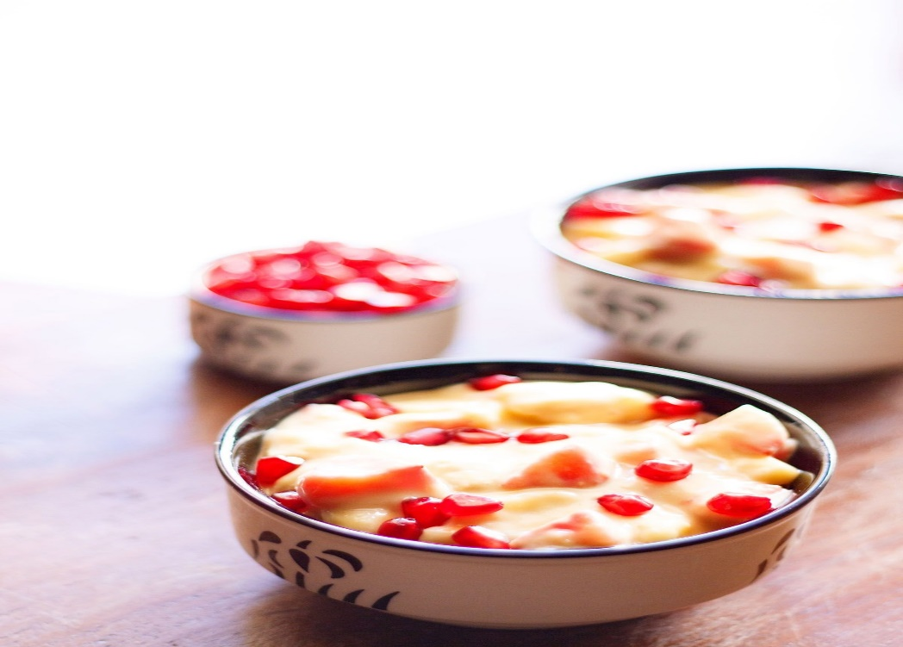
- Strawberry jam
Ingredients
- pounds fresh strawberries, hulled
- cups white sugar
- ¼ cup lemon juice
Directions
1. Crush strawberries in a wide bowl in batches until you have 4 cups of mashed berries.
2. Combine mashed strawberries, sugar, and lemon juice in a heavy-bottomed saucepan; stir over low heat until sugar is dissolved. Increase heat to high, and bring the mixture to a full rolling boil. Continue to boil, stirring often, until the mixture reaches 220 degrees F (105 degrees C).
3. Check doneness after 10 to 15 minutes by dropping a small spoonful of jam onto a frozen plate. Let sit for 1 to 2 minutes; if jam appears to gel, it is ready. Continue cooking if jam appears thin and runny.
4. Transfer jam into hot sterile jars, filling to within 1/4 inch of the top. Top with lids and screw rings on tightly.
5. Place a rack in the bottom of a large stockpot and fill it halfway with water. Bring to a boil and lower jars 2 inches apart into the boiling water using a holder. Pour in more boiling water to cover jars by at least 1 inch. Bring to a rolling boil, cover, and process for 10 minutes. Remove the jars from the stockpot and let rest, several inches apart, for 12 to 24 hours. Store in a cool, dark area.
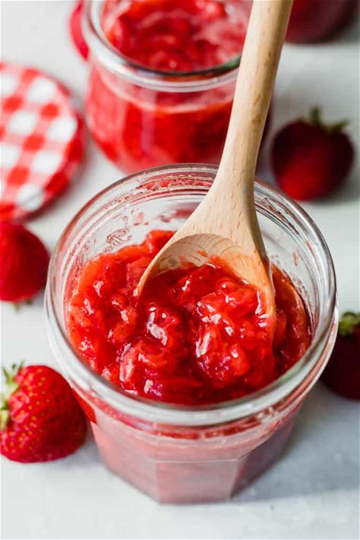

Lap test2.
Instructions: Given necessary templates, tools and materials you are required to perform the following tasks accordingly.
Task 1: Arrange ingredients
Task 2: Filling with jam
Task 3: Filling with syrup
Task 4: Buttercream filling
Task 5: Other filling ideas

Unit Three: Decorating and presenting cakes
This unit is developed to provide you the necessary information regarding the following content coverage and topics:
- Decorating Sponges and cakes
- Using icings and decorations
- Presenting Cakes attractively
- Use equipment and arranging Cakes for display

This unit will also assist you to attain the learning outcomes stated in the cover page.
Specifically, upon completion of this learning guide, you will be able to:
- Decorate Sponges and cakes using designs and techniques suited to the product and occasion and according to standard recipes and enterprise practice.
- Use suitable icings and decorations according to standard recipes, enterprise standards and customer preferences
- Present cakes attractively using suitable service ware and decorations.
- Select and use appropriate equipment for display and service.
- Arrange Cakes for display in an appealing manner

3.1. Decorating Sponges and cakes
- Definition: Cake decorating is the art of decorating a cake for special occasions such as birthdays, weddings, national or religious holidays, or as a promotional item. It is a form of sugar art that uses materials such as icing, fondant, and other edible decorations.
Chocolate is commonly used to decorate cakes, as it can be melted and mixed with cream to make a ganache or cocoa powder can be lightly dusted on top of a cake.
There is innumerable ways of decorating a cake. One can choose any of the many toppings available like icing, sprinkles, sugar art, fondant decoration, fruits, chocolate, waffles, yogurt etc. These add once can practically make or break a delicious cake.
- Cake with Buttercream Icing
- Boiled Frosting. This fluffy white icing is the pride and joy of anyone who has baked a beautiful cake. Its snow white, soft and fluffy appearance is simply to die for. This icing goes well with chocolate cake or yellow cake. This icing is fun and easy to colour due to its white and glossy base. It is simply whisk in sugar syrup, egg whites, a pinch of salt, and some vanilla extract/flavour. Be sure to not introduce fats to this cake mix, as it will instantly deflate if mixed with chocolate or whipped cream. Since it will collapse after 24 hours, it will need to keep it at room temperature.
- Buttercream Icing- is also known as America buttercream/confectioners’ sugar icing/butter cream/butter icing/mock cream. This icing can be used to fill in between two layers or, piped onto the cakes in the form of coating, designs, flowers, and writing. The decorations will hold their shape and yet will be soft enough to cut through with a knife. But this icing will weep in warm and humid weather. To prevent this, you can use shortening instead of butter.
- Lemon Curd- is a sweet and tarty icing with a thick custard-like consistency. It works better as a filling rather than icing, but it can be used as an icing as well. It can be made from lemon juice, lemon zest, butter, eggs and sugar are whisked together over a water bath. Whisk in some whipped cream to enrich its texture and taste. This icing will require refrigeration.
- Ganache- Chocolate and cream are the only two ingredients needed to make ganache as good as it looks. This icing is very durable. It will survive, up to 6 months, around 2 week in the refrigerator, and around 4 days at room temperature, and 2 seconds if you can’t control yourself.

3.2. Using icings and decorations
3.2.1 Types of frosting for cakes
A. Basic Buttercream- Made with butter (or vegetable shortening), powdered sugar, and any flavor of extract. Example;
- Creamy, sweet, delicate, bright (depending on the extract used)
Best uses:
- Piping on cupcakes
- Piping rosettes on cakes
- Tiramisu
- Any variety of cakes and cupcakes
B. Cream Cheese Frosting- made by buttercream frosting with cream cheese added. Example;
Bright, slightly tart, sweet
Best uses:
- Red velvet cake
- Carrot cake
- Hummingbird cake
- Banana Spice cake
- Pumpkin Spice cake
C. French Meringue Buttercream
Meringue buttercream using egg yolks in place of egg whites.
- Rich, silky, sweet
Best uses:
- White cakes
- Any variety of cakes and cupcakes
D. Ganache- made by heating heavy cream, adding dark chocolate, and cooling until it is set. Example;
- Rich, decadent, bittersweet
Best uses:
- Devil’s food cakes
- Peanut butter layer cakes
- Salted caramel cakes
- Tiramisu
- Fudge-chocolate bundt cakes
- Coconut cakes
- Vanilla cake
- Cheesecakes
- Soufflé cakes
E. Whipped Cream Frosting- made by whipping heavy cream with powdered sugar, vanilla extract, cornstarch, and occasionally cream cheese. Example;
- Light, fluffy, mild
Best uses:
- Piping on cupcakes
- Strawberry shortcake
- Angel food cakes
- White cakes
- Fruit cakes
F. Royal Icing- made from egg whites, confectioners’ sugar, and lemon or lime juice. Example;
- Hard, white, sugary
Best uses:
- Wedding cakes
- Birthday cakes
- Any variety of cakes and cupcakes
- Piping on cakes and cupcakes
- Piping rosettes or decorations on cakes and cupcakes
G. Fondant- made from sugar, water, gelatin, vegetable fat or shortening and glycerol. Example;
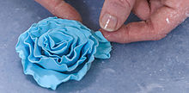
- Thick, sugary consistency, clay-like, extremely sweet
Best uses:
- Wedding cakes
- Birthday cakes
- Ornately decorated cakes and cupcakes

Fig3.1 fondant rose edible cake decoration
H. Marshmallow Icing- made by beating egg whites, sugar, water, and syrup over a double boiler then adding marshmallows and vanilla extract. Example;
- Candy-sweet, fluffy, slightly sticky
Best uses:
- Vanilla-buttermilk cakes or cupcakes
- Dark or milk chocolate cakes
- Confetti cake
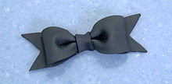
I. Gum paste- gum paste, also known as florist paste, is an edible, brittle material that dries quickly and can be sculpted to make cake decorations such as flowers or moulded designs

Fig A bow made from gum paste

J. Naked Cakes - this decorating style, fillings are used between the cake layers but the outside is left unfrosted or sparsely frosted with much of the cake itself still visible between and through the frosted areas. Naked cakes are often decorated with icing sugar or fresh flowers on top. They are especially popular as wedding and engagement cakes.
Cakes can be decorated by using:
- glazes and jellies
- icings
- chocolate
- sprinkled icing sugar
- fresh, preserved or crystallised fruits
- fruit purées
- whole or crushed nuts
- colour and flavoured sugar
- marzipan coatings

3.3. Presenting Cakes attractively
The following points should be considered during presenting of cakes:
1. be creative with colour.
A splash of colour can bring your desserts to life. A dark chocolate cake can go from a brown lump to an artful concoction when garnished with vibrant berries; a lemon tart goes from a fairly monotone palette to lively and lovely when presented with the contrast of a violet flower and marbled raspberry coulis.
2. Combine textures.
Adding different textures to the plate adds excitement to the visual appeal of dessert course, and the enjoyment only continues when the eating commences. For example, pairing a smooth, rich ganache with nubbly cookie crumbs and soft, pillowy marshmallows adds just enough “busyness” to draw the eye in to the dessert. The different textures excite the senses, giving an anticipatory sense of the taste pleasures to come
3. Compose your plate as you would a painting.
There are many ways to compose a plate. Consider the plate as if it were a blank canvas or as if you were composing the frame for a photograph. What would fill the space in an interesting way? Will you choose a minimalist approach, aligning different dessert elements as bookends on an oblong plate, as shown above? Or will you have a central focus on a round dessert plate? There is not a right or wrong answer, and you can experiment to see what looks and feels right to you.
4. Consider the vessel.
It may seem like common sense, but consider the experience of eating the dessert when you choose the type of plate. Don’t serve it on a too-tiny plate which may have garnish popping off and on to the table once the tines of a fork hit the dessert. If your dessert is creamy, it’s going to be easier to access in a rounded container or bowl. Don’t get so lost in the form that you forget the function involved in eating the dessert.
5. Contrast temperatures.
There’s nothing like pairing a slice of perfectly prepared pie or a fruit tart with a cool slice of ice cream. Combining temperatures can be a beautiful thing, but your plating does require some consideration. Do not put your dessert on a hot plate. Ice cream will melt too rapidly, obviously, but other desserts may “wilt” too. This can vary depending on the dessert. A slightly chilled plate may be helpful when plating cold desserts, whereas room temperature will do just fine for most cakes or pies.
6. Have a focal point.
Using an element in your dessert as a focal point can help give your plating focus, especially when a dessert isn’t, in and of itself, a showstopper. For instance, a translucent candied banana slice draws the eye in to the deconstructed Bananas Foster featured above, and then spirals out to follow the caramel sauce drizzle. It adds a bit of intrigue to a dessert which otherwise might look generic and, well, slightly boring in its beige colour scheme.
7. Let it be dramatic.
Have a little fun with your dessert. Employ tricks to add some magic to the presentation. Try recreating gravity-defying aspects taught in the craftsy class Gravity-Defying Cake Designs on a mini-scale. Or make a parfait dessert hover with the use of a white chocolate wafer which then melts into it to create an amazing effect.
8. Don’t make it too tall or wobbly.
A slice of layer cake looks fantastic standing up on a plate. But if it’s too tall, there’s a strong chance of it toppling over even on a short journey to where it is being served. If it seems too tall or wobbly, it probably is. While many dessert professionals adore the visual of serving a slice of cake upright, the general consensus is that if you’re in doubt, lay it on its side. It can still be prettily appointed, as proven by the above photo of a gorgeous red velvet slice adorned with whipped cream and berries.
9. Garnish with care.
Random mint leaves or raspberries for artful effect? Forget it; it’s more likely to be confusing than anything else. Also, consider the eater when adding finishing touches to your dessert plate. While whole nuts might look pretty scattered on top of a cake, they are impossible to spear with a dessert fork. Keep in mind how the garnish will function on the finished plate.
10.Be consistent.
When plating desserts for a crowd, be consistent in your design and in serving size. It can be confusing to see different presentation on each plate, and nobody likes looking over to the plate across the table and seeing a serving double the size.

3.4 Equipment and Arranging Cakes for display
Displaying cakes is a great way to increase sales. The two most common ways to display cakes are as follows:
- In a display fridge
- Displayed on a dessert buffet.
A well-presented display increases eye appeal and may persuade costumers to order a slice or buy a whole cake when they see it.
It is important to keep your cakes seasonal as rich chocolate and cream cakes will sell well in winter but in summer light cakes with fresh fruits sell better.
When displaying cakes for any situation it is important to keep everything clean, neat and tidy.
When you are displaying a cake you don’t want to leave it in the display if 1/3 of the cake is left and crumbs are lying around the plate.
Appropriate silver cake servers can also be used to make an impression on the customer.
To be carried away, the cake need to be rested on a cake board slightly larger than the actual cake.
A lace doyley placed under the cake adds to the visual pleasure but make sure the cake is cut before hand as not to damage the doyley.

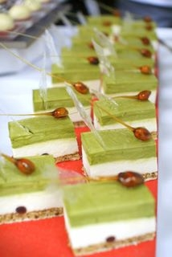
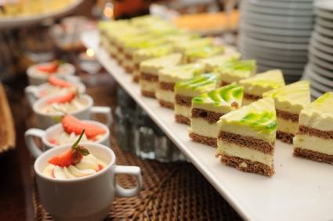

Fig 3.2 Displayed cakes
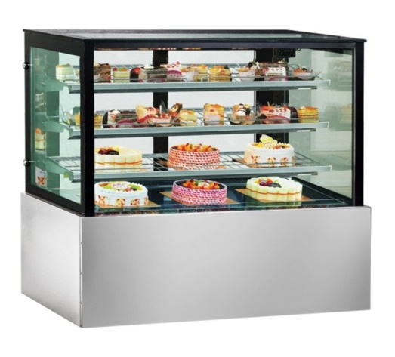
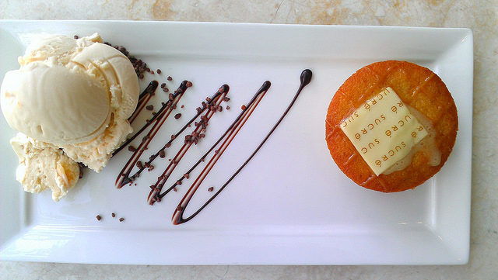

Fig 3.3 Equipment for cake display Fig3.4 sweet display plate

SELF-CHECK 3. | WRITTEN EXAM

Instruction:
Answer the following questions:
1. A cake turn table or rotating tray cannot be used to facilitate the decoration process.
True or False
2. Marzipan is often used for cake decoration and as cover over cakes. (True or False)
3. Decorating cake involves covering with icing and using other decorative agents.
True or False
4. It is known as sugar paste or ready –roll icing:
A. Royal icing
B. Fondant
C. Corn starch
D. None
5. List at least 3 (three) cake decorating materials

Operation sheet 3. Decorate sponges and cakes
Operation Title: Decorate cakes
Purpose: To decorate cakes and sponges
Conditions or situations for the operations:
- Safe working area
- Properly operated tools and equipment
- Appropriate working uniforms fit for the practical performance
Equipment & Tools
-Mixer
- Scale
- Oven
- Bowl
- Scraper,
-piping bag, etc.
Quality Criteria: Assured performing of all the activities according to the procedures
Methods one. Piping or Spreading Frosting
- Select a frosting for the cake. Use any frosting that's thick enough to stick to the top and sides of the cake. If your frosting is too runny to pipe or spread using an offset spatula, mix in powdered sugar until it thickens. Consider using:
- Buttercream or Vienna cream
- Cream cheese frosting
- Marshmallow frosting
- Royal icing
- Swiss or Italian meringue buttercream
- Ganache
- Use an icing smoother to create evenly frosted sides. Use an icing tip on a pastry bag to pipe thick bands of frosting around the sides of the cake. Keep going up around the sides until they're coated with frosting. Then hold an icing smoother or bench scraper vertically against the side of the cake. Run the smoother around the cake to create an even surface. It's easier to use the icing smoother if the cake is on a turntable. Then you can slowly rotate the cake while holding the icing smoother against the side. If you choose to leave the sides of the cake "naked," spread just a few thin patches of frosting along the sides so the layers of cake are still visible.
- Fill a piping bag and pipe a pattern onto the cake. Choose a piping tip that helps you create the design you want. For example, select a petal tip to pipe a ruffled edge along the cake or use a plain round tip to pipe dots across the top of the cake. If you don't have a piping bag, put the frosting into a food-safe plastic bag and cut off the bottom tip of the bag. You won't be able to control the level of piping detail, but it will give you a simple piping bag. Such as: Popular patterns include basket weave, ruffles, scallops, stars, and lace.
- Use piping tips to create decorative shapes, flowers, or words. Once you've covered the cake with the frosting of your choice, decide if you want to add a few embellishments. Change the tip on the piping bag so you can write words or pipe flowers. Some tips are designed for specific shapes, such as leaves.
For example, to make an elegant fleurs-de-lis, use a star tip to pipe 3 reverse shells. You can also use the star tip to pipe the frosting into a simple rosette.
- Use the back of a spoon to make swirls in the frosting. Ensure that the cake has at least 1 to 2 inches (2.5 to 5.1 cm) of frosting on the top and sides. Take a spoon and hold the back so the tip is pressing gently into the frosting. Twist the spoon in a half-circle motion to create a wave. Keep doing this across the sides and top of the cake.
To create an easy zigzag pattern, drag the tines of a fork through the frosting in a back and forth motion.
Method two. Working with Fondant
- Cover the entire cake for an even surface. To create the smoothest surface for your cake, purchase or make fondant. Sprinkle your work surface with powdered sugar and roll the fondant until it's about 1⁄4 inch (0.64 cm) thick. Lay the rolled fondant circle over a cake that you've lightly frosted. Then smooth the fondant over the top and sides of the cake so it sticks. The crumb coat of frosting will help the fondant adhere to the cake. Trim away the excess fondant from the bottom edge of the cake. Save the scraps and use them for other decorations.
- Apply fondant fringe, ribbons, or swag. Add texture to the cake by cutting pieces of fondant and trimming them into fringe. Then drape the fringe or roll and drape the fondant along the sides of the cake. You can also fold strips of fondant to create ribbons or bows. Attach them to the top or sides of the cake. For a bold cake, make a single, large bow and place it on top of the cake. If you'd like a fun cake, make several rows of brightly colored fondant fringe. Wrap these around the sides of the cake.
- Shape fondant into flowers or figures. To create a flower, roll a piece of fondant and cut it into long strips. Fold the strip in half and wrap it tightly around itself. Then pinch the base of the flower and apply it to the cake. You can also use fondant to create any figure you like such as a person, animal, or plant.
Tip: To make fondant impressions, roll a piece of fondant and press impression moulds, lace, or leaves on it. Remove the item to reveal a decorative piece of fondant that you can attach to the cake.
- Paint an image or design on the fondant. Pour a little vodka into a small dish and stir in a few squirts of gel-paste food coloring to make a simple food-safe paint. Then dip a fine paint brush into it and paint the surface of the fondant. It's easy to create abstract designs or spend time painting a specific image.
Method three. Adding Quick Decorations
- Place fresh flowers on the top or sides of the cake. To add an elegant or rustic touch to your cake, purchase pesticide-free flowers and gently insert the stems into the cake. To keep the cake fresher for longer, wrap the stems with an edible sealer before sticking them in the cake.
Types of edible flowers include:
- Chamomile
- Marigolds
- Carnations
- Cornflowers
- Daisies
- Fuchsia
- Hibiscus
- Pansies
- Roses
- Lavender
- Top the cake with crunchy or chewy textures. If you want to cover the frosting or add a burst of colour and texture, scatter sprinkles, chopped nuts, caramels, meringues, or candy over the top or sides of the cake. To add them to the sides of the cake, use your palms to gently press them into the frosting so they stick. Toffee or spun sugar makes an impressive decoration that has a slight crunch.
Tips:
- Use shredded or colour coconut flakes for a tropically themed cake.
- Sort candies by colour and arrange them in a rainbow pattern.
- Place 2 mini-candy canes together to create a heart shape.
- Set a topper or figurines on the cake. If you're decorating a wedding cake, the couple might request brides, grooms, bells, or hearts on top. Look for sturdy toppers or figurines that won't sink down too far into the cake. Keep in mind that toppers and figurines aren't just for weddings. For example, top birthday cakes with clean:
- Arrange fruit on the cake. Try to use whatever fruit is in season that works with the flavor of the cake. For example, if you're decorating a summery lemon cake, top it with fresh berries such as blueberries, blackberries or strawberries. If you're decorating an autumn gingerbread cake, place slices of dried apples or pears around the edge. To make the fruit look sparkly, consider dipping it in a sugar glaze and letting it harden. Or use crystallized fruits or citrus peel for a little extra shine.
- Dust a plain cake with sifted cocoa or powdered sugar. If you don't want to put frosting on a cake that's already richly flavored, hold a fine mesh strainer or flour sifter over the cake. Fill it with powdered sugar or cocoa powder and shake so the cake is dusted with the sugar or cocoa. To create a lacy pattern, set a paper doily on the cake before you dust it. Then lift away the doily to reveal the decorative pattern.
- Add chocolate drizzle, shavings, or pieces. Chocolate is one of the most versatile decorations since you can easily place chocolate curls, shavings, chips, or chunks on the cake. For example, drop finely chopped white chocolate around the edge of the cake to make a quick border. You can also melt your favorite chocolate and drizzle or pipe it over the cake. Create abstract designs or use the chocolate to pipe a pattern.
- Dollop freshly whipped cream on the top. For a simple decoration that looks great with fresh fruit, spoon whipped cream on top of the cake just before serving. If you'd like to be able to pipe the whipped cream, stabilize it with gelatin, marshmallow fluff, or pudding mix first. To flavor the whipped cream, beat in a few drops of vanilla, almond, lemon, or coffee extract.

Lap test.3.
Instructions: Given necessary templates, tools and materials you are required to perform the following tasks accordingly.
Task 1: pre-prepare the necessary equipment
Task 2: prepare the necessary ingredients
Task 3: measure the ingredients for decorating cakes and sponges according to the instruction given by a recipe.
Task 4: Decorate one of a specialized cake properly following the procedure
Task 5: apply your creativity for decorating various commercial sponges.

Unit Four: store cake
This unit is developed to provide you the necessary information regarding the following content coverage and topics:
- Storage conditions for cake
- Storage methods for cake
This unit will also assist you to attain the learning outcomes stated in the cover page.
Specifically, upon completion of this learning guide, you will be able to:
- Store cakes at the correct temperature in a good storage conditions to maintain quality and extend shelf life.
- Identify Storage methods of cakes to minimize spoilage and wastage.

4.1. Storage conditions for cake
Some specialized cakes like Gateaux and Tortes can be harder to store than other bakery products.
The common storage condition of cakes are:
- consideration of temperature, light and air exposure
- use of airtight containers
- display cabinets, including temperature-controlled cabinets
- refrigeration, chilling and freezing
Product needs to be stored at correct temperature and conditions may relate to:
- Away from strong odours
All gateaux need to be protected from strong odours like onion, garlic that may be present in some cool rooms in kitchens.
In larger kitchens there will be dedicated controlled storage for gateaux and tortes.Controlled storage is a term that covers ‘chilled, enclosed spaces’ and ‘room temperature, enclosed spaces’ areas.
- Cool room temperature
Most Gateaux will need to be chilled because of the nature of the ingredients. All food cool rooms must operate below 4ºC. Some tortes do not need to be chilled and should not be chilled because chilling will spoil the flavour of the product.
- Appropriate containers
Placing gateaux and tortes into boxes when sold is the best way of ensuring that the product travels to the place on consumption intact. Care needs to be taken that edges and top decorations are not damages when packages do not get damaged. When applying decorations packages sizes need to be taken into considered.
- Labelling
Labelling is required in the modern world. Labelling must be adhered to outside packages.
It informs the customer who is able to make a choices and it does protect the manufacturer against unfounded complaints.
- Cool room placement
Delicate products need to be stored in an area where the possibility of damage is minimised.
- Length of time in cool storage
Fresh products have ‘different lifetimes’ at what sage do they become ‘unsaleable’ and ‘inconsumable’:
- Unsaleable Food: All purchasers have the right to be able to purchase food that will last a certain period of time past the time of purchase. This will vary from food product to food product
- Inconsumable food: Food that is not fit for human consumption. This food should not be sold. Manufacturer must accept the loss.
- Freezer temperature
The Storage temperature for long term must be at -18ºC or less and storage of ice cream for service can be at -10ºC.
- Length of time in freezer storage
Time in the freezer will vary. Patisserie products like gateaux and tortes should only be in freezer for weekly (7 days) periods. Freezing will have a drying effect on products. The longer product is in frozen state the more likely quality will diminish. Freezer space is also expensive, so the longer it is in freezer the more it has cost to produce.
- Staling
All bakery products will stale. Staling is the process where the optimum eating fades.
Staling can be occur in several forms:
- Air passes through the product and dries the product out
- Moisture from the air enters the product so it loses some of the eating quality:
Crisp product goes soft.
To maintain the eating quality of bakery items:
- Use as soon as possible
- Cover to protect from environment
- Keep chilled
- Keep dry.

Storage methods
In order to increase the shelf life of cakes, it is important to know and apply the recommended storage methods or reservations. These are some tips for storing Cake
Preserving cake properly can help you enjoy this treat for days past its initial serving.
- Analyze the cake recipe. Before you decide how to store your cake, you need to know what’s in it to settle on the best method. A ganache-covered chocolate cake with buttercream frosting can remain at room temperature, but a cream cake with a fresh fruit filling should stay in the refrigerator. The main thing you’re looking for is whether any ingredients are perishable. Cheesecakes should also remain in the refrigerator since they include different ingredients than regular cake.
- Fortify with frosting. Frosting serves as a natural preservative so long as it does not include perishable dairy or fruit materials. Once you cut cake open, simply cover the sliced edges with more frosting to help it last longer. This retains the moisture without you having to resort to plastic or aluminum wrapping. Don’t rely on the bits of frosting inside a layer cake to do the job, though—you must lather the entire exposed area with new frosting.
- Freeze for longer periods. You can always freeze cake if you don’t plan to eat it for a long period of time. If you place an uncut whole cake in the freezer, you can easily get this dessert to last up to three months. Make sure to wrap the cake before putting it in the freezer.
- Improvise if necessary. You don’t need a specifically manufactured cake stand to store your dessert well. Place the cake on a plate or baking sheet, wrap it with aluminum foil, and place an overturned bowl on top of it for a makeshift storage container. This will keep your cake fresh for three to seven days.
- Protect the frosting. Place your cake in the refrigerator for twenty minutes or so to harden the frosting before you wrap it for storage. Insert toothpicks on the top and sides of the cake so that the wrapping doesn’t touch the frosting itself.
- Rely on room temperature. You can leave out your covered cake overnight without even wrapping it, and it should be fine in the morning. For any amount of time longer than that, make sure to wrap it in something. Rely on room temperature to maximize its shelf life—up to about three to seven days—unless specific ingredients require that it remains refrigerated.
- Wrap the cake. Use aluminum foil or plastic wrap to protect your cake if you’re planning to eat it over several days. If you choose to place the wrapped cake in an airtight container for added security, make sure to leave a tiny portion open. Protect sheet cakes from dust and other dirty elements fluttering around your kitchen, but they still need air to retain their texture
Table.4.1 Storage condition of cake
Cake Storage
Plain Butter Cakes, Single or Multiple Layered Cakes, Cake from a Mix  Storage:  Room Temperature | Storage Note:  Be sure to cover tightly but do not refrigerate. If you do not have a cake keeper, cover the cake with a large inverted bowl, cover it with foil, or store in a large airtight container. Store at room temperature for approximately 5 days. Freeze for longer storage, up to 3 months.
Angel Food Cake  Storage:  Room Temperature | Storage Note:  Be sure to cover tightly but do not refrigerate. If you do not have a cake keeper, cover the cake with a large inverted bowl or store in a large airtight container. Store at room temperature for approximately 5 days. Freeze for longer storage, up to 2 months.
Chiffon Cake  Storage:  Room Temperature | Storage Note:  Be sure to cover tightly but do not refrigerate. If you do not have a cake keeper, cover the cake with a large inverted bowl or store in a large airtight container. Store at room temperature for approximately 5 days. Freeze for longer storage, up to 2 months.
Pound Cake  Storage:  Room Temperature | Storage Note:  Be sure to cover tightly but do not refrigerate. Wrap airtight in plastic wrap or in foil unless the recipe indicates differently. Store at room temperature for approximately 5 days. Freeze for longer storage, up to 3 months.
Sponge Cake  Storage:  Room Temperature | Storage Note:  Be sure to cover tightly but do not refrigerate. If you do not have a cake keeper, cover the cake with a large inverted bowl or store in a large airtight container. Store at room temperature for approximately 1 week. Freeze for longer storage, up to 2 months.
Note: The information above pertains to cakes that are unfrosted and without any type of filling. Avoid storing a cake in the refrigerator whenever possible because refrigeration causes the cake to dry out faster and can affect its flavor. When adding frosting or a filling, the cake may require refrigeration if they contain perishable ingredients, such as fresh fruit, whipped cream, meringue type topping, eggs, or custard.

Frosting / Topping Storage
Boiled Icing  Storage:  Room Temperature | Storage Note:  Be sure to cover tightly but do not refrigerate. If it is not stored airtight, it will begin to set. Once a cake has been frosted with boiled icing it can be stored at room temperature. Freezing is not recommended.
Buttercream Frosting  Storage:  Room Temperature | Storage Note:  Buttercream can be stored, refrigerated, in an airtight container for up to 2 weeks before using. Remove it from the refrigerator at least an hour before using so it will warm to room temperature. It can also be frozen for extended storage. A decorated cake with buttercream frosting can be stored at room temperature for up to 3 days. If you want to refrigerate a decorated cake, place it in the refrigerator unwrapped until the frosting hardens slightly. It can then be loosely covered with plastic. Buttercream frosting can be frozen.
Cream Cheese Frosting  Storage:  Refrigerated | Storage Note:  Cream cheese frosting can be stored in the refrigerator for up to 2 weeks before using. Cakes frosted with cream cheese frosting must be stored in the refrigerator. The frosting will firm up when chilled but will soften quickly when it sits at room temperature. Cream cheese frosting can be frozen.

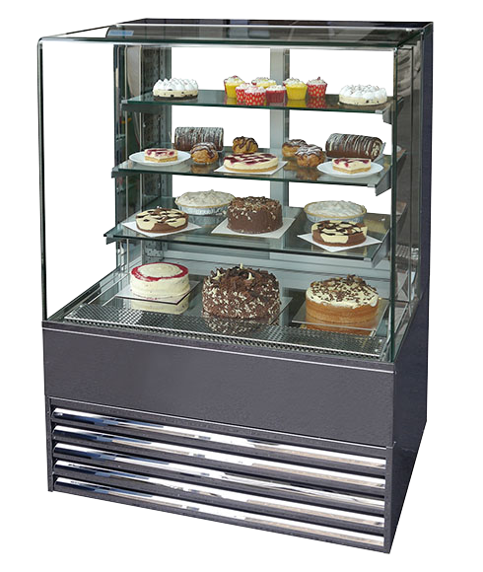

Fig.4.1.cake storage shelf

SELF-CHECK 4. | WRITTEN EXAM
Direction:
Answer the following questions:
- Buttercream cannot be stored, refrigerated, in an airtight container more than a 2 weeks before using. (True or False)
- Refrigeration, chilling and freezing is one storage condition of cake. (True or False)
- A sponge cake can be stored in a sealed, airtight container at room temperature for about three days. (True or False)
- What are the conditions to be applied to increase the eating quality of cakes?

- Use as soon as possible
- Cover to protect from environment
- Keep chilled
- All are corrects

- How to store cakes at correct temperature and conditions?

RECOMMENDED READINGS

- Bakery & confectionary course ,food production department
Kenya Utalii College, Nairobi
- Prepare and produce cakes and pastries Association of Southeast Asian Nations
- Bakery and Confectionery EIILM University
- Dessert Lovers Food book My food book
- Baking 4. Cakes, Pies and Pastries
- Desserts (pastry and pies) U.S.

Developer’s profile
No | Name | Qualification | Educational background | Region | College | Mobile number | E-mail
1 | Mohammed Liben Mohammed | Instructor | - BA degree in Hotel and Tourism management | Somali | Jigjiga Polytechnic college | 0992326557 | cherechaw@gmail.com
2 | Belachew Merga Lemi | Instructor | BA degree in Hotel Mgmt. | Addis Abeba | Kirkos manufucturing college | 0910330503 | Belachewmerga2011@gmail.com
3 | Zelalem Almaw Endalew | Instructor | - BSC degree in Food science and post-harvest technology | Amhara | Bahir dar Polytechnic College | 0918012521 | Parazolla25@gmail.com
4 | Zuryash-Work Belay Nigatu | Instructor | BA degree in Hotel Management | Addis Ababa | TTI | 0911643817 | zuriyash@gmail.com

