CULINARY ART

Level – III

Based on September 2023, Curriculum Version II
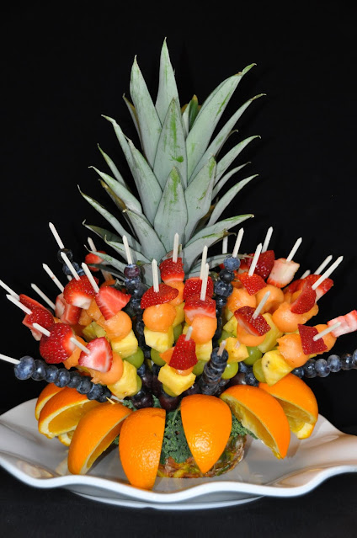

Module Title: Preparing fruit and vegetable Carving
Module code: CST CUA3 M03 0923
Nominal duration: 60 Hours

Prepared by: Ministry of Labor and Skill
September, 2023
Addis Ababa, Ethiopia

Table of Contents

Contents
Pages

Acknowledgment 3
Introduction to the module 4
Unit One: Making Mise en place 5
1.1 Understanding fruit and vegetable carving 6
1.2. Identifying Tools 6
1.3. Applying Safety Practices 9
1.4. Selecting Fruits and Vegetables 9
1.4.1. Additional criteria used while choosing fruits and vegetables 10
1.4.2. Fruit Types for Carving 11
1.4.3. Types of vegetables for carving 11
Self-Check -1 12
Operation Sheet 1.1: Identifying Tools 14
Unit Two: preparing fruit and vegetable carvings 15
2.1. Techniques of carving fruits & vegetables 16
2.1.1 Types of fruit and vegetable carving 17
2.1.2 Important steps to get carving 18
2.2. Design and prepare fruit and vegetable carving 19
2.2.1 Guidelines for preparing fruit and vegetable carvings 20
Self-Check -2 29
Operation Sheet 2: Preparing fruit and vegetable carving 31
LAP Test 41
Unit Three : preserving fruit and vegetable carving 42
3.1 . Applying Preservation techniques 43
3.2 Handling of fruits and vegetables carving 43
Self-Check -3 45
Unit Four : Displaying and storing carved fruits and vegetables 46
4.1 Sorting according to intended use 47
4.2 Storing carved fruit and vegetables 48
4.3 Displaying fruit and vegetable carving 49
Self-Check -4 50
References 51
Participants of this Module (training material) preparation 52

Acknowledgment

The Ministry of Labor and Skills (MoLS) would like to express its gratitude and appreciation to the instructors and experts from regional TVT bureaus, TVT colleges, and industry practitioners who contributed their expertise and experience in preparing the training module for the unit of competency “Prepare fruit and vegetable carving” under the occupational standard "Culinary Art level-III."
The ministry also expresses its deepest gratitude to the Tourism Training Institute for its invaluable technical and financial support and collaboration in the module preparation. It is also thankful to MoLS staff members who coordinated the preparation and reviewing process of this training module.

Introduction to the module

In Culinary art, fruit and vegetable Carving is the art of carving fruit and vegetable, a very common technique particularly popular in Thailand, China, and Japan. The most popular one that artists use are watermelons, apples, strawberries, pineapples, and cantaloupes.
The main purpose of fruit and vegetable carving is to make food more attractive, more appetizing, and also easier to eat.
This module is designed to meet the industry requirement under the Culinary Art occupational standard, particularly for the unit of competency: prepare fruit and vegetable carving
This module covers the units:
- Making Mise en place
- preparing fruit and vegetable carvings
- Preserving carved fruits and vegetables
- Displaying and storing carved fruits and vegetables
Learning Objective of the Module
- Make Mise en place
- prepare fruit and vegetable carvings
- Preserve carved fruits and vegetables
- Display and store carved fruits and vegetables
Instruction
For effective use this modules trainees are expected to follow the following module instruction:
- Read the information written in each unit
- Accomplish the Self-checks at the end of each unit
- Read the identified reference book for Examples and exercise
- Accomplish the Self-checks
- Perform Operation Sheets
- Do the “LAP test”

Unit One: Making Mise en place
This learning guide is developed to provide you the necessary information regarding the following content coverage and topics:
- Understanding fruit and vegetable carving
- Identifying tools
- Applying safety practices
- Selecting fruits and vegetables carving
This guide will also assist you to attain the learning outcomes stated in the cover page. Specifically, upon completion of this learning guide, you will be able to:
- Understanding fruit and vegetable carving
- Identifying tools
- Applying safety practices
- Selecting fruits and vegetables carving

  - Understanding fruit and vegetable carving
Fruit and vegetable carving is the art of carving fruit and vegetables that is a very common technique in Europe and Asian countries, particularly popular in Thailand, China, and Japan. The most popular one that artists use are watermelons, apples, strawberries, pineapples, and cantaloupes while Vegetable Carving - the art of carving vegetablea to form beautiful objects such as flowers or birds. The purpose of fruit and vegetable carving is to make food more attractive, more appetizing, and also easier to eat.
The intricate art of fruit carving has gained a lot of popularity over recent years. People give great importance to aesthetics, and this is a way to a man’s stomach helped by his visual senses as well. Sculpted pieces of fruits simply attract. Any vegetable or fruit can be turned into a stunning piece of art with imagination,.
In the areas of employment once you have mastered the art of vegetable and fruit carving, you can be self-employed or can work with hotels, caterers and cruise liners. You can also teach the skills to others. “It’s an added skill and helps in the catering industry. Professionals with carving skills are in demand in India and abroad in the hospitality industry.
  - Identifying Tools
There are a numerous carving knife sets are available. These instruments are special which maintain to create fruit carving much easier. You can start carving with just a small number of essential knives. There are some points given below on the fruits and vegetable carving tools and their special usage:

Paring knife is most important tool to be considered. You can use this paring knife possibly to give up shape, which is also entitled, a "bird's beak" knife. This knife has a sharp edge that bend inward. You must see to that these types of knife sense fine in your hand. The extended backwards part of the knife blade supposes to go off deep into the grip, and anything should not feel unstable

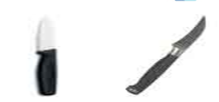
Figure1.1: Paring knife.

Peel Zester: these tools comprise the type of peel zester that permits you to depart grooves and formulate strips such as a "v" formed cutter and melon baller. If you want to connect special pieces of fruit simultaneously than you would also require wood skewers and tooth picks.

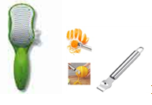
Figure1.2: Peel Zester

Melon baller
This melon baller made to scrape melon into absolutely tiny round balls. With the help of this melon baller you could create easy carvings of cube by using two types of melon.

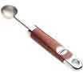
Figure1.3: Melon baller
'U' shaped garnishing tool: these tools are Ideal for carving out internal soft tissue or fragmenting away at the outer skin of fruits. With the help of these fruits carving tools strawberry slits are cut to create the strawberry's fleshy tissue unwrap out like petals of flower. This look like a strawberry rose. You can really enhance your carving skills with the help of these carving tools.

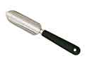
Figure1.4: 'U' shaped garnishing tool
"V" formed cutter: with the help of the fruits carving tools like "v" cutter, you can make apple swan. This "v" cutter cuts into whichever side is possible of a bisect apple to create wings by pushing back each slice.
Peel Zester: this tool is used to create strips and grooves. Melon Baller: can be used for a variety of fruit to add ball shaped fruit carvings to the display. U shaped garnish tool: used to cut the outer layer of the fruit.
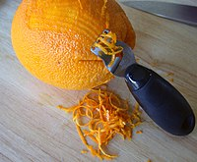
Figure1.5: peel zester
Carving knife: mostly used for giving carving shape

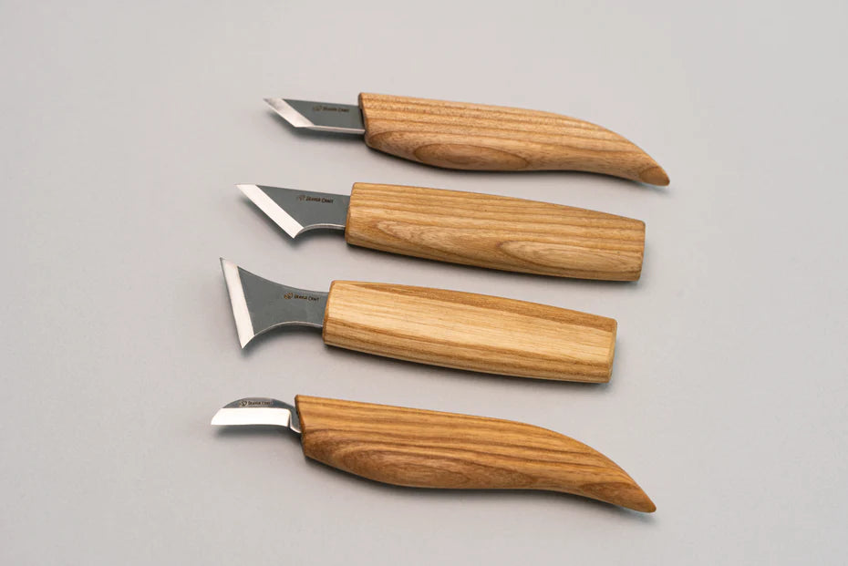
Figure1.6: carving knife

  - Applying Safety Practices
- Wash your hands, kitchen utensils, and food preparation surfaces, including chopping boards and countertops, before and after preparing fruits and vegetables.
- Clean fruits and vegetables before eating, cutting, or cooking, unless the package says the contents have been washed.
- Wash or scrub fruits and vegetables under running water—even if you do not plan to eat the peel. Germs on the peel or skin can get inside fruits and vegetables when you cut them.
- Washing fruits and vegetables with soap, detergent, or commercial produce wash is not recommended. Do not use bleach solutions or other disinfecting products on fruits and vegetables.
- Cut away any damaged or bruised areas before preparing or eating. Germs can more easily get into fruits and vegetables if the peel or skin is damaged or bruised.
- Get rid of any torn or bruised leaves. Also, get rid of the outer leaves of cabbages and lettuce heads because they are likely to have more dirt and germs on them.
- Dry fruit or vegetables with a clean paper towel.
- Keep fruits and vegetables separate from raw foods that come from animals, such as meat, poultry, and seafood.
- Refrigerate fruits and vegetables within 2 hours after you cut, peel, or cook them (or 1 hour if exposed to temperatures above 90°, like a hot car or picnic). Chill them at 40°F or colder in a clean container.
  - Selecting Fruits and Vegetables
While selecting fruits and vegetables for carving, please follow these steps:
- When selecting fruit and vegetables, make sure they are fresh and not overripe, with a smooth skin. Overripe fruit will be difficult to carve and handle. Also select fruit and vegetables that are colorful and you think would look great once carved.
- Wash and dry and refrigerate fruit and vegetables so they stay fresh and are easy to carve.
- Ensure that the knife used is stainless steel and very sharp.
- Handle fruit and vegetables very gently.
- After finishing a carving, rinse with ice water, cover with plastic wrap, and refrigerate. They can keep for up to 3-4 days when stored in this manner. Some fruit can even keep up to a week.
- If you display fruit in room temperature for a long period of time, spray with ice water every couple hours so that it stays fresh and the colors remain vivid.
- Vegetables that will change color after carving should be put in cold water that has lemon juice or vinegar. For example, potatoes and apples should be cared for in this way.
    - Additional criteria used while choosing fruits and vegetables
When choosing a fruit for carving, there are a few factors to consider. Here are some tips on how to choose the right fruit for carving:
1. Firmness: Select fruits that are firm and not overly ripe. This will make carving and shaping easier, as softer fruits may not hold their shape well.
2. Size: Choose fruits that are large enough to allow for carving and shaping without being too small or too large. The size should be appropriate for the design or pattern you have in mind.
3. Texture: Look for fruits with smooth and even textures. Fruits with blemishes, bruises, or uneven surfaces may be more challenging to carve and may not yield the desired results.
4. Thickness of rind or skin: Consider the thickness of the rind or skin of the fruit. Thicker rinds or skins can be easier to carve and provide more stability for intricate designs.
5. Stability: Choose fruits that have a stable and solid structure. Fruits with a good balance of firmness and juiciness, such as watermelon or pineapple, are often preferred for carving due to their stability.
6. Longevity: Some fruits, like apples or pears, oxidize and discolor quickly once cut. If you want your carving to last longer, consider fruits like watermelon or cantaloupe, which tend to stay fresh-looking for a longer period.
7. Availability: Consider the availability of the fruit in your area and the season. Choose fruits that are readily available and in their peak season for the best flavor and quality.
Remember to always wash and dry the fruit thoroughly before carving. Additionally, it's a good idea to practice on smaller or less expensive fruits before attempting more intricate designs on larger or more expensive fruits.
    - Fruit Types for Carving
For fruit carving you will need approximately the same tools as for figured carving of vegetables. But at the same time, it must be borne in mind that fruits have a softer and looser texture, so when working with them, in no case should you press the knife hard. If the novice master remembers this, he will be able to create a real masterpiece with his own hands. Fruit carving at a children's party will look especially beautiful.
At a fruit carving master class, beginners are usually offered to make a picture with their own hands from:
- apples of different varieties
- citrus fruits (oranges and lemons, less often - tangerines);
- watermelons;
- Melons (choose those varieties that have fairly hard pulp).
To master the art of vegetable carving, you will need the following tools:
- a special knife with a narrow and short sharp blade;
- knife with a wide blade for the manufacture of large elements of the composition;
- knife with a long narrow blade;
- small scissors for trimming the edges of vegetables;
- Thin wooden sticks (like toothpicks) for holding vegetables together.
    - Types of vegetables for carving

- pepper (hot or sweet);
- radish;
- cucumbers;
- cabbage;
- pumpkin;
- Tomato.

Self-Check -1 | Written Test

Name……………………………………..Id………………….Time Allowed…………….

Directions: Answer all the questions listed below. Illustrations may be necessary to aid some explanations/answers. (15 points)
Test I. Write “true” if the statement is correct and “false” if the statement is incorrect
  - The main purpose of fruit and vegetable carving is to make food more attractive, more appetizing, and also easier to eat.
  - "V" formed cutter: with the help of the fruits carving tools like "v" cutter, you can make apple swan
  - Washing fruits and vegetables with soap, detergent, or commercial produce wash is recommended.
  - Refrigerate fruits and vegetables within 2 hours after you cut, peel, or cook them
  - Before and after preparing fruits and vegetables, wash chopping boards and countertops.
Test II. Choose the correct answer for the following
  - Which one is true about selecting fruit and vegetables,
    - make sure they are fresh and not overripe
    - with a smooth skin
    - select fruit and vegetables that are colorful
    - all are correct
  - After finishing carving,
    - rinse with ice water,
    - Cover with plastic wrap,
    - Refrigerate.
    - All are correct
  - After carving fruits and vegetables, why we add lemon juice and vinegar in cold water ?
    - Prevent browning / oxidation reaction
    - Retain color and freshness
    - A and B are correct
    - None

Test III: Short Answer questions:
- What is fruit and and vegetable carving?
- What is the purpose of fruit and vegetable carving?
- List at least 4 types of fruit and vegetable carving by name? (for each)

Operation Sheet 1.1: Identifying Tools
Necessary materials required to identify fruit and vegetable carving are :
- Pen
- Pencil
- Marker
- A-4 paper
Instructions
- Ready and select 5 fruit and vegetable carving tools on the working table
- Identify the name orally and write on your notebook
- Explain the function of each tools orally
- Submit your answer sheet

Unit Two: preparing fruit and vegetable carvings
This learning guide is developed to provide you the necessary information regarding the following content coverage and topics:
- Techniques for carving fruits & vegetables
- Designing and preparing fruit and vegetable carving
This guide will also assist you to attain the learning outcomes stated in the cover page. Specifically, upon completion of this learning guide, you will be able to:
- Techniques for Carving Fruits & Vegetables
- Design and prepare fruit and vegetable carving

2.1. Techniques of carving fruits & vegetables
Here are some common carving techniques to get you started:
Basic cutting: This technique involves using a sharp knife to make simple cuts and shapes. You can create straight or curved lines, remove sections of the fruit or vegetable, or cut out basic shapes like triangles, squares, or circles.
V-Cut: The V-cut technique involves using a V-shaped knife or a V-shaped carving tool to create grooves or lines that resemble the letter "V." This technique is great for adding texture and depth to your carvings.
U-Cut: Similar to the V-cut, the U-cut technique involves using a U-shaped knife or carving tool to create grooves or lines that resemble the letter "U." This technique is often used to create rounded or concave shapes.
Shaping and sculpting: With this technique, you can use a small paring knife or carving tool to shape the fruit or vegetable into various forms. You can create petals, leaves, curls, or even three-dimensional shapes.
Relief carving: Relief carving involves carving into the surface of the fruit or vegetable to create a design that stands out in relief. This technique is commonly used to create intricate patterns or detailed designs.
Stencil carving: Stencil carving is a technique where you use a stencil or template to guide your carving. You can place the stencil on the fruit or vegetable and trace the design with a knife or carving tool, creating precise and detailed carvings.
Hollowing and scooping: This technique involves using a melon baller or a small spoon to hollow out parts of the fruit or vegetable. You can create cavities or remove sections to create space for other fruits, fillings, or decorative elements.
Remember to practice your carving techniques on smaller and simpler designs before attempting more complex ones. It's also helpful to watch video tutorials or take classes to learn specific techniques and gain inspiration. With practice and patience, you'll improve your fruit and

2.1.1 Types of fruit and vegetable carving
1. Traditional Thai carving: Also known as Thai fruit carving or "kae-sa-lak," this style originated in Thailand and is known for its intricate and detailed designs. It often features flowers, animals, and decorative patterns carved into fruits and vegetables like watermelon, pumpkin, and cucumber.
2. Western-style carving: This style of fruit and vegetable carving is popular in Western countries and often focuses on creating decorative displays or centerpieces. It may involve sculpting fruits and vegetables into various shapes, like baskets, bowls, or animals, and incorporating other elements like flowers or foliage.
3. Edible arrangements: Edible arrangements involve arranging a variety of carved fruits and vegetables in a visually appealing and artistic way. This style often incorporates different types of fruits, such as melons, berries, grapes, and citrus fruits, and may include decorative elements like skewers or toothpick attachments.
4. Garnishing and decorative carving: This type of carving focuses on enhancing the presentation of dishes by adding decorative elements made from fruits and vegetables. It may involve creating simple shapes, such as flowers, leaves, or curls, to garnish plates or platters.
5. Fruit and vegetable sculpture: Fruit and vegetable sculpture involves creating three-dimensional sculptures or art pieces using fruits and vegetables. This style often requires advanced carving techniques and may involve combining different fruits and vegetables to create complex designs or scenes.
6. Modern and creative carving: This style encompasses a range of creative and innovative carving techniques and designs. It often involves experimenting with different carving tools, incorporating mixed media elements, or using unconventional fruits and vegetables to create unique and imaginative carvings.

2.1.2 Important steps to get carving
1. Choose the right fruit: Select fruits that are firm and easy to carve, such as watermelon, cantaloupe, pineapple, or honeydew melon.
2. Gather the necessary tools: You will need a sharp knife, a melon baller, a small paring knife, and various carving tools like V-shaped or U-shaped knives.
3. Plan your design: Decide on the design you want to create. You can find inspiration from books, online tutorials, or simply use your imagination.
4. Prepare the fruit: Wash the fruit thoroughly and pat it dry. Cut off the top or bottom of the fruit to create a stable base. If using a watermelon, you can also slice a small portion off the bottom to create a flat surface.
5. Carve the fruit: Use the larger knife to remove the skin of the fruit, following the outline of your design. Be careful not to cut too deeply and remove too much flesh. Use the smaller knife or carving tools to add details and intricate patterns.
6. Enhance the design: Use the melon baller to scoop out small balls or use cookie cutters to create shapes from other fruits. You can attach these decorations to the carved fruit using toothpicks or skewers.
7. Display your creation: Once you finish carving, place the fruit on a serving tray or use it as a centerpiece. Keep it refrigerated until ready to serve to keep it fresh.
Remember to be cautious while handling sharp tools and always supervise children if they are involved in the carving process. Enjoy the process and have fun with your fruit carving!

2.2. Design and prepare fruit and vegetable carving
Designing fruit and vegetable carvings involves planning and creativity. Here are some tips to help you design your carvings:
- Research and gather inspiration: Look for inspiration from various sources like books, magazines, online tutorials, or images. Explore different styles, themes, and techniques to find designs that appeal to you.
- Consider the occasion or purpose: Think about the purpose of your fruit or vegetable carving. Is it for a special event like a wedding or a birthday party? Is it for a specific theme like a tropical luau or a holiday celebration? Tailor your design to fit the occasion or theme.
- Start with a simple design: If you're new to fruit and vegetable carving, begin with simple designs. Choose designs that have fewer intricate details and focus on basic shapes and patterns. As you gain more experience and confidence, you can progress to more complex designs.
- Sketch your design: Before carving, sketch your design on paper. This will help you visualize the final product and plan the placement of different elements. Make adjustments and revisions as needed until you're satisfied with the design.
- Consider the shape and size of the fruit or vegetable: Take into account the natural shape and size of the fruit or vegetable you're working with. Use the existing contours and features to enhance your design. For example, a watermelon can be carved into a basket or a pineapple can be transformed into a tropical bird.
- Play with textures and patterns: Incorporate different textures and patterns into your design to add visual interest. You can create smooth surfaces, rough textures, or intricate patterns like spirals, waves, or checkerboards. Experiment with different carving techniques to achieve the desired effect.
- Add decorative elements: Consider adding other fruits, vegetables, or edible garnishes to complement your carving. For example, you can use carved flowers or leaves made from cucumbers or carrots to enhance the overall design. Fresh herbs, edible flowers, or small fruits can also be used as decorative accents.
- Experiment and have fun: Fruit and vegetable carving is a creative process, so don't be afraid to experiment and try new ideas. Let your imagination guide you and enjoy the process of bringing your design to life.
Remember: You can find a variety of fruit and vegetable carving designs by searching online. There are many websites, blogs, and social media platforms dedicated to showcasing fruit and vegetable carving art. You can also find books, tutorials, and videos that provide step-by-step instructions and visual references for different carving designs. These resources can serve as inspiration and help you develop your own unique designs for fruit and vegetable carving.

2.2.1 Guidelines for preparing fruit and vegetable carvings
- Choose the right fruits and vegetables: Select fresh produce that is firm and easy to carve. Some popular choices for fruit carvings are watermelon, cantaloupe, pineapple, honeydew melon, and papaya. For vegetable carvings, consider using carrots, cucumbers, radishes, and bell peppers.
- Wash and dry the produce: Thoroughly wash the fruits and vegetables under running water to remove any dirt or residue. Pat them dry with a clean towel or paper towels.
- Select your carving tools: You'll need various tools for carving, such as a sharp knife, a melon baller, a small paring knife, and a set of carving tools with different blade shapes like V-shaped or U-shaped knives. You can find these tools at kitchen supply stores or online.
- Plan your design: Decide on the design you want to create. You can draw it on paper or find inspiration from books, online tutorials, or images. Start with simple designs if you're a beginner and gradually progress to more complex ones.
- Prepare the fruits and vegetables: Cut off any stems or leaves from the produce. For fruits like watermelon or pineapple, you might need to slice off the top or bottom to create a stable base. If using a watermelon, you can also slice a small portion off the bottom to create a flat surface.
- Carve the fruits and vegetables: Use the larger knife to remove the skin or rind, following the outline of your design. Take your time and be careful not to cut too deeply or remove too much flesh. Use the smaller knife or carving tools to add details and intricate patterns.
- Enhance the design: You can further enhance your carvings by adding other fruits or vegetables. For example, you can attach carved flowers or shapes made from cucumbers or carrots to your main carving using toothpicks or skewers.
- Display your creation: Once you finish carving, place your fruit and vegetable carvings on a serving tray or use them as centerpieces. You can also garnish them with fresh herbs or edible flowers for an extra touch.
Some selected fruit and vegetable carving
- Apple Swan

Creating an apple swan is a popular fruit carving technique that can add an elegant touch to your display. Here's a step-by-step guide to making an apple swan:
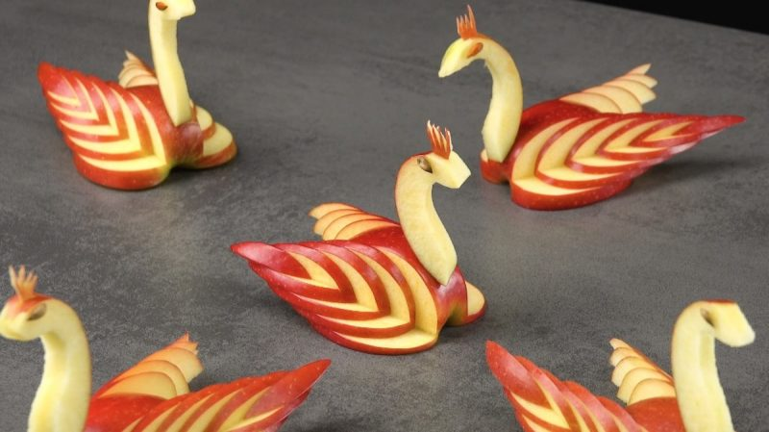
Figure 2.1: apple swan

- Watermelon Cactus

It is important and better way to spice up a party than by using flavorful dishes and drinks.
Creating a cucumber fruit cactus can be a fun and creative way to incorporate a unique element into your fruit and vegetable display. Here's a step-by-step guide to making a cucumber fruit cactus:

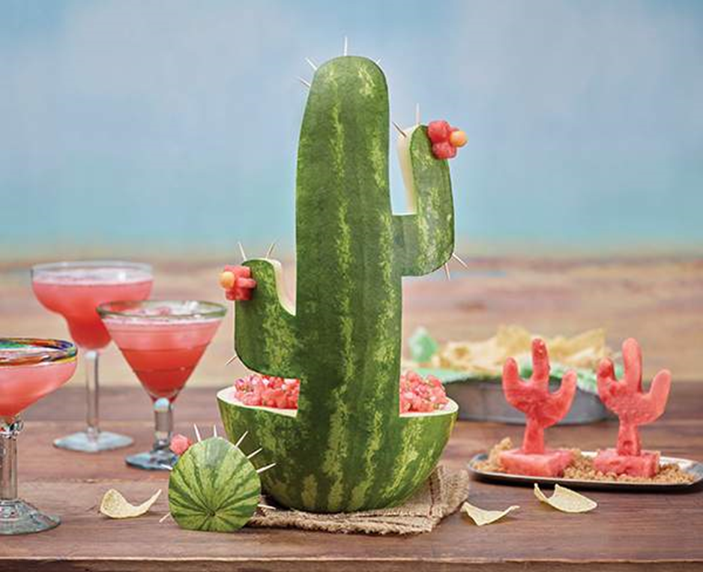

Figure 2.2: watermelon cactus
- Mandarin Orange Rose

Mandarin Twist Sweetheart Roses are a bright and beautiful addition to any bridal shower, wedding bouquet, or special occasion! The unique colors of tropical orange with coral pink on the edges will surely add even more excitement to the Big Day. Mandarin Twist Sweethearts feature a semi-open shape with deep layers to add a delicate touch to any centerpiece! Compliment the sweetheart roses by pairing with Tulips French Orange Flowers and the Antique Orange Petite Rose for a gorgeous monochromatic look.

To create a Mandarin orange rose, you will need the following:
- Mandarin oranges (one or more, depending on how many roses you want to make)
- Paring knife
- Cutting board
Mandarin orange roses can be a lovely addition to fruit salads, desserts, or as a decorative element for special occasions. Enjoy the process of creating these delicate and vibrant citrus flowers!


Figure 2.3: Mandarin Orange Rose
- Apple Compass

- This art can be used as a centerpiece for different dishes
- To do this carving , apple and different paring knife is necessary

To create an apple fruit compass, you will need the following:

- 1 apple (preferably a round and symmetrical one)
- Paring knife
- Cutting board

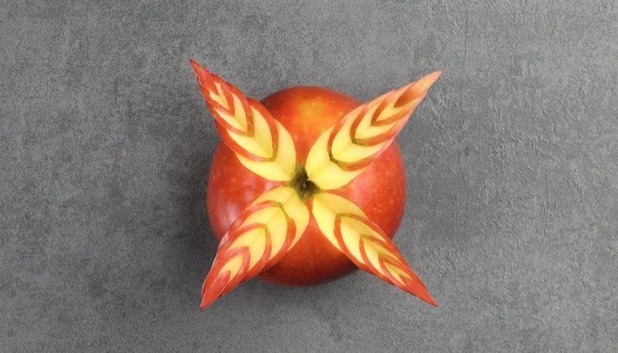
Figure 2.4: Apple compass

- Melon Butterfly
Mellon butterfly and flowers are perfect for a little girl’s birthday party, or baby shower, or a get-together with friends.
To create a melon butterfly, you will need the following:
- 1 ripe melon (such as a cantaloupe or honeydew)
- Paring knife
- Melon baller or spoon
- Toothpicks
- Optional: additional fruits or vegetables for decoratio
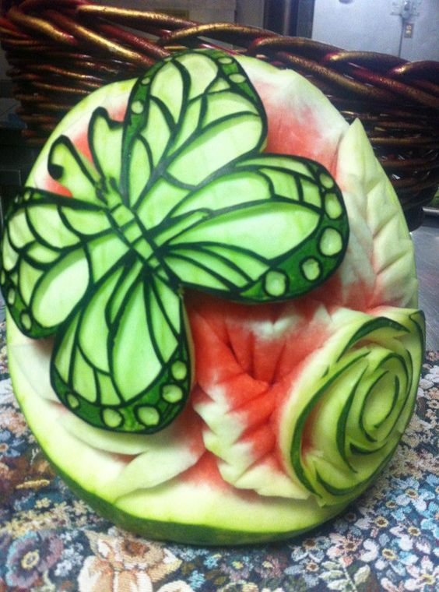
Figure 2.4: Melon Butterfly

- Orange Bear

- Used for table decoration
- Orange, gloves, Black olive and toothpicks are necessary to make orange bear
- It Can be used for decoding salads and meat dishes
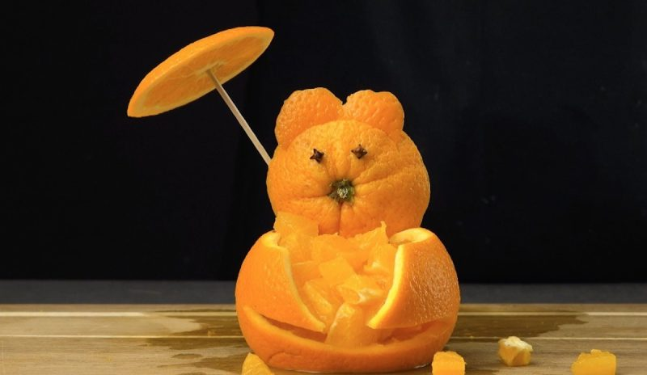
Figure 2.5: Orange Bear

- Carving a Watermelon Bowl
Create a fruit bowl with a carved melon. After carving a watermelon into a bowl shape, you can fill the bowl with melon balls or your favorite fruit salad. Choose fruits that go well with watermelon. For example, you could make a salad with blueberries, strawberries, cantaloupe, and watermelon.
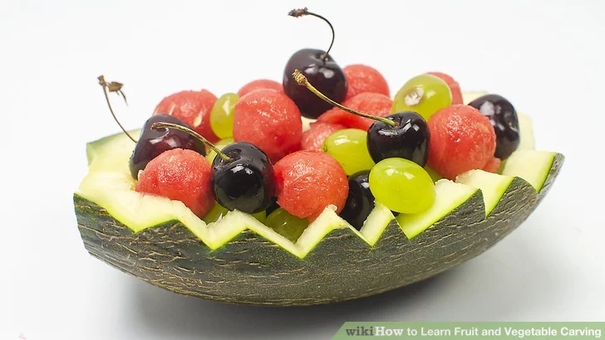

Figure 2.6: sweetmellon Bowl
- Tomato flower
- It needs ripe but firm potato
- Used to garnish the platters and make your delicious food look more presentable in a party.
To create a tomato flower, you will need the following:
- 1 medium-sized tomato
- Paring knife
- Optional: toothpicks, fresh herbs, or other decorative elements

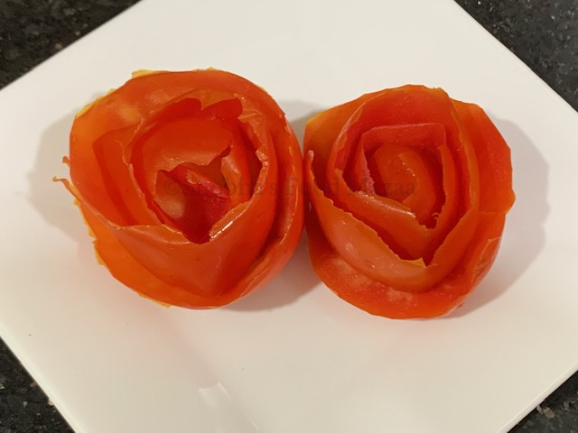
Figure 2.7: tomato rose

Self-Check -2 | Written Test

Name……………………………………..Id………………….Time Allowed…………….

Directions: Answer all the questions listed below. Illustrations may be necessary to aid some explanations/answers. (10 points)
Test I. Write “true” if the statement is correct and “false” if the statement is incorrect
  - Relief carving involves carving into the surface of the fruit or vegetable to create a design that stands out in relief
  - Before carving, sketch your design on paper.
  - Once you finish carving, place it in refrigerated until ready to serve.
Test II. Choose the correct answer for the following
  - Which one is not basic carving techniques for creating shapes and designs
      - V- Shape
      - U- shape
      - Hollowing and scooping
      - Use improper tools
  - Which one not is true while choose a fruit for carving?
      - fruits with smooth and even textures
      - Large size and firm
      - Fruits that have a stable and solid structure.
      - Choose most ripe fruits and vegetables
  - Which one is used for fruit and vegetable carving
      - Mortodella
      - Marzipan
      - Apple

  - Which one the step to get stared carving
      - Choose the right fruit:.
      - Gather the necessary tools:
      - Plan your design
      - All

Test III: Short Answer questions:
      - What are some tips for practicing and improving your fruit carving skills?
      - How can you use fruit carvings as decorative elements for different occasions or events
      - What are some tips to help you design your carvings?

Operation Sheet 2: Preparing fruit and vegetable carving

  - Apple Swan

Material Required
- Apple
- Paring knife

Procedures:

- Choose a suitable apple: Select a large, firm, and symmetrical apple for best results. A red or green apple works well, but you can use any variety you prefer.
- Wash and dry the apple: Thoroughly wash the apple under running water to remove any dirt or residue. Pat it dry with a clean towel to ensure a good grip while carving.
- Prepare the tools: You will need a sharp paring knife, a small spoon or melon baller, and toothpicks for securing the parts of the swan together.
- Cut the base: Start by cutting a thin slice from the bottom of the apple to create a stable base. This will allow the swan to sit upright.
- Carve the wings: On one side of the apple, about a third of the way from the top, make a diagonal cut with the paring knife. Repeat on the other side to create the wings. The cuts should meet at the base of the apple.
- Shape the neck and head: From the top of the apple, carve a curved shape down towards the base to form the neck. Leave some space at the top for the head. Use the paring knife to carefully round off the top to create the swan's head.
- Carve the beak: From the front of the head, make a small triangular cut using the paring knife to create the beak. Be careful not to cut too deep.
- Hollow out the body: Use a small spoon or melon baller to gently scoop out the flesh inside the body of the swan, creating a hollow space. Be careful not to puncture the outer skin.
- Adjust and refine: Take your time to adjust and refine the shape of the wings, neck, and head as needed. Smooth out any rough edges or uneven cuts.
- Attach the wings: Secure the wings to the body of the swan using toothpicks. Insert the toothpicks diagonally through the wings and into the body, ensuring they are firmly in place.
- Display and garnish: Place your apple swan on a suitable platter or display surface. You can add additional garnishes like fresh mint leaves or fruit slices around the swan to enhance the presentation.

  - Watermelon Cactus

Procedures:
1. Choose a suitable cucumber: Select a straight and firm cucumber for the base of the cactus. The size of the cucumber will depend on how big you want your cactus to be.
2. Wash and dry the cucumber: Thoroughly wash the cucumber under running water to remove any dirt or residue. Pat it dry with a clean towel.
3. Prepare the tools: You will need a sharp paring knife, a small spoon or melon baller, and toothpicks for securing the parts of the cactus together.
4. Cut the base: Cut a thin slice from the bottom of the cucumber to create a stable base. This will allow the cactus to stand upright.
5. Carve the ridges: Using the paring knife, make vertical cuts along the length of the cucumber to create ridges. Space the cuts evenly and make sure not to cut too deep into the flesh.
6. Hollow out the top: Cut off the top of the cucumber, leaving about 1-2 inches intact. Use a small spoon or melon baller to gently scoop out the flesh from the top, creating a hollow space.
7. Create the arms: Cut the remaining cucumber into smaller sections to form the arms of the cactus. Determine the desired length and angle of the arms and make diagonal cuts accordingly.
8. Attach the arms: Using toothpicks, attach the arms to the sides of the cucumber base. Insert the toothpicks diagonally through the arms and into the base, ensuring they are firmly in place.
9. Garnish and decorate: You can enhance the appearance of your cucumber cactus by adding small fruit or vegetable pieces as decorations. Consider using cherry tomatoes, sliced bell peppers, or even small pieces of pineapple to create a colorful and appealing display.
10. Display and enjoy: Place your cucumber fruit cactus on a platter or display surface. You can add additional garnishes or greenery around the base to complete the presentation.
Remember to handle the paring knife with care and exercise caution while carving to avoid any injuries. With creativity and attention to detail, you can create a unique and eye-catching cucumber fruit cactus for your display.

2. 3 Mandarin Orange Rose
To create a Mandarin orange rose, you will need the following:

- Mandarin oranges (one or more, depending on how many roses you want to make)
- Paring knife
- Cutting board
Procedures:

1. Select a Mandarin orange: Choose a Mandarin orange that is firm and has a smooth skin. This will make it easier to peel and shape into a rose.
2. Peel the orange: Start by using a paring knife to carefully remove the peel of the Mandarin orange. Try to keep the peel in one long, continuous strip if possible.
3. Roll the peel: Take the long strip of orange peel and gently roll it up, starting from one end. This will create the center of the rose.
4. Continue rolling: Keep rolling the orange peel around the center, gradually adding more layers to form the petals of the rose. Adjust the tightness and shape of the roll as you go, so that it resembles the shape of a rose.
5. Secure the rose: Once you have rolled the entire strip of orange peel, tuck the loose end underneath the rose to secure it in place. You can also use a toothpick or a small skewer to hold the rose together if needed.
6. Optional: Trim the stem: If desired, you can leave a portion of the orange peel intact to serve as a stem for the rose. Trim the end of the peel to create a neat and even stem.
7. Repeat for more roses: If you want to make multiple Mandarin orange roses, repeat the process with additional Mandarin oranges.
8. Display and serve: Arrange the Mandarin orange roses on a platter or serving dish. You can add fresh mint leaves or other decorative elements around the roses for an added touch. Serve them as a beautiful and edible garnish or centerpiece.
Mandarin orange roses can be a lovely addition to fruit salads, desserts, or as a decorative element for special occasions. Enjoy the process of creating these delicate and vibrant citrus flowers!
  - Apple Compass

To create an apple fruit compass, you will need the following:

- 1 apple (preferably a round and symmetrical one)
- Paring knife
- Cutting board
Procedures:

1. Wash and dry the apple: Start by thoroughly washing the apple under running water to remove any dirt or residue. Pat it dry with a clean towel.
2. Cut the base: Slice a thin portion off the bottom of the apple to create a stable base for the compass.
3. Create the outer edge: Using a paring knife, carefully make a circular cut around the top of the apple, about 1/3 of the way down from the stem. This will create the outer edge of the compass.
4. Divide the apple: Make two vertical cuts from the top of the apple down to the base, dividing it into four equal sections. These cuts should intersect at the center of the apple.
5. Label the sections: On each of the four sections, use the paring knife to carve or write the cardinal directions - North, South, East, and West. You can also add additional markings or labels as desired.
6. Carve the needle: From the remaining portion of the apple, carve a small triangular shape to represent the compass needle. Attach it to the center of the apple, using a toothpick if necessary.
7. Optional: Add decorative elements: If desired, you can add decorative elements to enhance the appearance of the apple fruit compass. This could include small pieces of other fruits, such as berries or grapes, placed around the compass or on the base.
8. Display and serve: Place your apple fruit compass on a platter or serving dish, and it is ready to be displayed or served. It can be a fun and unique addition to a fruit platter or a centerpiece for a themed event or gathering.
Remember to handle the paring knife with care and exercise caution while carving to avoid any injuries. Enjoy the process of creating your apple fruit compass and have fun exploring your fruity directions
2.5 Melon Butterfly
To create a melon butterfly, you will need the following:
- 1 ripe melon (such as a cantaloupe or honeydew)
- Paring knife
- Melon baller or spoon
- Toothpicks
- Optional: additional fruits or vegetables for decoration
Procedures:
1. Wash and dry the melon: Start by thoroughly washing the melon under running water. Pat it dry with a clean towel.
2. Cut the melon in half: Use a paring knife to carefully cut the melon in half lengthwise. Choose the half that has a more symmetrical shape for the butterfly body.
3. Carve the butterfly body: Use a melon baller or spoon to scoop out the flesh from the melon half, creating a hollow space. Leave about 1/4 inch of flesh intact around the edges to give it stability. Set aside the scooped out melon balls for later use.
4. Create the butterfly wings: Take the other half of the melon and cut it into two equal halves. Place one of the halves flat side down on the cutting board. Use the paring knife to carefully carve out a butterfly wing shape from the melon half. Repeat this step with the other melon half.
5. Attach the wings: Insert toothpicks into the curved edge of each melon wing. Attach the wings to the back of the melon body, positioning them so that they fan out like butterfly wings.
6. Decorate the wings: Take the melon balls that were set aside and use toothpicks to attach them to the butterfly wings. You can also use other fruits or vegetables like berries, grapes, or cucumber slices to add color and detail to the wings
7. Optional: Add antennae and eyes: Use toothpicks to attach thin slices of cucumber or other fruits to the top of the melon body as antennae. You can also use small pieces of fruits or edible decorations to create eyes for the butterfly.
8. Display and serve: Place your melon butterfly on a platter or serving dish, and it is ready to be displayed or served. It can be a beautiful and refreshing centerpiece for a fruit platter or a fun addition to a themed event or party.
Remember to handle the paring knife and toothpicks with care and exercise caution while carving and attaching the pieces. Get creative with your melon butterfly and enjoy the process of bringing this delightful fruit creation to life
  - Orange Bear

To create an orange bear, you will need the following:

- 1 medium-sized orange
- Paring knife
- Toothpicks
- -Optional: additional fruits or candies for decoration
Procedures:
1. Wash and dry the orange: Start by thoroughly washing the orange under running water. Pat it dry with a clean towel.
2. Cut the top of the orange: Use a paring knife to carefully slice off the top of the orange, about 1/4 of the way down from the stem end. Set aside the top piece for later use.
3. Hollow out the orange: Use a spoon or melon baller to scoop out the flesh from the orange, creating a hollow space. Leave about 1/4 inch of flesh intact around the edges to give it stability. Set aside the scooped out orange segments for later use.
4. Create the bear ears: Take the top piece of the orange that was set aside and cut it in half. These halves will serve as the bear's ears. Attach each ear to the top of the hollowed-out orange using toothpicks.
5. Optional: Decorate the ears and face: If desired, you can use toothpicks to attach small pieces of other fruits or candies to the ears and face of the orange bear, such as blueberries or chocolate chips for eyes, or a small slice of strawberry for the nose.
6. Place the orange segments: Take the scooped out orange segments and place them inside the hollowed-out orange, filling it up to create the bear's body.
7. Optional: Add additional fruits or candies: If desired, you can add more fruits or candies around the bear to create a decorative base or backdrop. You can use grapes, berries, or other small fruits for this purpose.
8. Display and serve: Place your orange bear on a platter or serving dish, and it is ready to be displayed or served. It can be a cute and tasty addition to a fruit platter, a fun snack for kids, or a playful centerpiece for a themed event or party.

Remember to handle the paring knife and toothpicks with care and exercise caution while cutting and attaching the pieces. Get creative with your orange bear and have fun bringing this adorable citrus creation to life!

  - sweet melon Bowl
To create a watermelon bowl, you will need the following:
- 1 large watermelon
- Paring knife
- Spoon or melon baller
- Optional: additional fruits or salad ingredients for filling
Procedures:
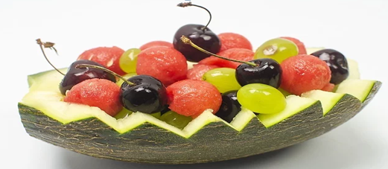
1. Wash and dry the watermelon: Start by thoroughly washing the watermelon under running water. Pat it dry with a clean towel.
2. Cut the top of the watermelon: Use a paring knife to carefully slice off the top portion of the watermelon, about 1/4 to 1/3 of the way down from the stem end. Set aside the top piece for later use.
3. Create the bowl shape: With the paring knife, cut along the inside edge of the watermelon, following the natural curve. Cut deep enough to create a bowl-like shape, but be careful not to cut through the bottom of the watermelon.
4. Scoop out the flesh: Use a spoon or melon baller to scoop out the flesh from the watermelon, creating a hollow space. You can save the scooped-out watermelon flesh to use in a fruit salad or other recipes.
5. Optional: Carve decorative patterns: If desired, you can use the paring knife to carve decorative patterns or designs on the outside of the watermelon bowl. This can add an extra touch of creativity and visual appeal.
6. Optional: Add additional fruits or salad ingredients: Fill the watermelon bowl with your choice of additional fruits, such as berries, grapes, or cubed melons. You can also add salad ingredients like cucumber, mint leaves, or feta cheese for a refreshing summer salad.
7. Place the watermelon bowl on a serving platter: Once you have filled the watermelon bowl, carefully place it on a serving platter. You can add some ice to the platter to help keep the watermelon cool and fresh.
8. Display and serve: Your watermelon bowl is now ready to be displayed or served. It can be a refreshing and eye-catching centerpiece for a summer gathering or a fun way to serve fruit salad. Enjoy!
  - Tomato flower
Procedures:
- 1 medium-sized tomato
- Paring knife
- Optional: toothpicks, fresh herbs, or other decorative elements
Procedures:
1. Wash and dry the tomato: Start by thoroughly washing the tomato under running water. Pat it dry with a clean towel.
2. Cut the top of the tomato: Use a paring knife to carefully slice off the top portion of the tomato, about 1/4 of the way down from the stem end. Set aside the top piece for later use.
3. Create the petals: Make four vertical cuts into the tomato, starting from the top where the stem was attached, and stopping about halfway down the tomato. These cuts should be evenly spaced around the tomato, creating four equal-sized sections.
4. Shape the petals: Take each section and gently bend it outwards to create a petal shape. Repeat this step with all four sections, so that you have four petals.
5. Optional: Secure the petals: If needed, you can use toothpicks to secure the petals in place. Insert a toothpick through the base of each petal and into the tomato to hold them in position.
6. Optional: Add decorative elements: To enhance the appearance of the tomato flower, you can insert fresh herbs, such as basil or parsley, into the center of the tomato. You can also use toothpicks to attach small edible decorations or garnishes around the base of the tomato.
7. Place the tomato flower on a plate or serving dish: Once you have shaped and decorated the tomato, carefully place it on a plate or serving dish. You can add some greens or other vegetables around the tomato to create a visually appealing presentation.
8. Display and serve: Your tomato flower is now ready to be displayed or served. It can be a beautiful and unique addition to a salad, vegetable platter, or as a garnish on a dish. Enjoy!!

LAP Test | Practical Demonstration

Name : _____________________________ Date : ________________

Time started : _____________________________ Time finished : ________________
Instructions:
1. You are required to perform any of the following:
Request your teacher to arrange for you all necessary tools, materials and equipment. Submit your outputs to your teacher for evaluation.
Request a set of tools, materials, equipment for the tasks then perform the following tasks in front of your teacher:
Prepare:-
- Tomato rose
- Apple swan
- Cucumber compass
- Watermelon bowl
- Melon Butterfly

Unit Three: Preserving fruit and vegetable carving
This learning guide is developed to provide you the necessary information regarding the following content coverage and topics:
- Preserving techniques
- Handling techniques
This guide will also assist you to attain the learning outcomes stated in the cover page. Specifically, upon completion of this learning guide, you will be able to:
- Apply techniques of preservations
- Handle of fruits and vegetables

  - . Applying Preservation techniques
Preserving fruit and vegetable carvings can be challenging since they are perishable by nature. However, there are a few techniques you can try to extend the lifespan of your carvings:
1. Refrigeration: Fruit and vegetable carvings should be stored in the refrigerator when not on display. Place them in an airtight container or cover them with plastic wrap to prevent drying out and to protect them from moisture.
2. Spraying with water: Mist the carving lightly with water to help maintain moisture and prevent dehydration. However, be cautious not to oversaturate the carving, as it can cause the design to become mushy or lose its shape.
3. Lemon or citrus juice: Applying lemon or citrus juice to the exposed surfaces of the carving can help slow down browning and oxidation. This is particularly useful for carvings made from fruits like apples, pears, or bananas.
4. Edible coatings: Applying a thin layer of food-safe coatings like gelatin or vegetable oil can help seal the surface of the carving and extend its lifespan. This technique may work well for carvings made from fruits like watermelon or cucumber.
5. Freezing: Freezing can help preserve fruit and vegetable carvings for a longer duration. However, keep in mind that freezing can alter the texture and appearance of the carving. Thaw the carving slowly in the refrigerator before displaying or consuming.
It's important to note that even with these preservation techniques, fruit and vegetable carvings will eventually deteriorate and lose their freshness. It's recommended to create carvings closer to the time of the event or occasion to ensure they are at their best.
  - Handling of fruits and vegetables carving
Handling fruit and vegetable carvings requires care and attention to maintain their shape and appearance. Here are some important handling techniques to keep in mind:
- Clean hands and tools: Before handling the fruit or vegetable, make sure your hands are clean and free from any oils, dirt, or contaminants. It's also essential to use clean and sharp carving tools to achieve precise cuts and minimize damage to the carving.
- Gentle handling: Handle the fruit or vegetable carving with gentle and delicate movements. Avoid applying excessive pressure or squeezing the carving, as it can cause the flesh to deform or break.
- Supportive base: When working with larger carvings or intricate designs, provide a stable and supportive base. This can be a non-slip mat, a cutting board with a damp cloth underneath, or a specialized carving stand. This will help prevent the carving from moving or sliding during the carving process.
- Proper carving technique: Use appropriate carving techniques to achieve clean and precise cuts. Start with shallow cuts and gradually deepen them as needed. Take your time and be patient, especially when working on intricate details or complex designs.
- Temperature control: Ensure that the fruit or vegetable is at the right temperature for carving. Some fruits and vegetables are easier to carve when chilled, while others may be more pliable at room temperature. Experiment with different temperatures to find what works best for the specific fruit or vegetable you are working with.
- Storage and transportation: When not on display, store the carved fruit or vegetable in the refrigerator to maintain its freshness. If you need to transport the carving, place it in a secure container or use protective coverings to prevent damage during transportation.
- Display considerations: When displaying the fruit or vegetable carving, choose a stable and level surface. Avoid placing it in direct sunlight or near heat sources, as this can cause the carving to wilt or spoil more quickly.

Self-Check -3 | Written Test

Name……………………………………..Id………………….Time Allowed…………….

Directions: Answer all the questions listed below. Illustrations may be necessary to aid some explanations/answers. (10 points)
Test I. Write “true” if the statement is correct and “false” if the statement is incorrect
- Fruit and vegetable carvings should be stored in the refrigerator when not on display.
- When you carving , start with shallow cuts and gradually deepen them as needed
- Ensure that the fruit or vegetable is at the right temperature for carving
- Handle the fruit or vegetable carving with gentle and delicate movements
- Mist the carving lightly with water to help maintain moisture and prevent dehydration
Test II. Choose the correct answer for the following
- Which one is not true about freezing fruit and vegetable carving
    - To preserve
    - alter the texture and appearance
    - can be caused for freeze burn
    - Store at 10 0c
- Which one is good handling techniques?
    - Clean hands and tools
    - Temperature control
    - Display considerations
    - Place at room temperature

Test III: Short Answer questions:
- Mention at least four important handling techniques of fruit and vegetable carving
- What are preservation techniques of fruit and vegetable carving?
- Why are applying lemon or citrus juice during fruit and vegetable carving

Unit Four: Displaying and storing carved fruits and vegetables
This learning guide is developed to provide you the necessary information regarding the following content coverage and topics:
- Sorting according to intended use.
- Storing Carved fruits and vegetables
- Displaying fruit and vegetable carving

This guide will also assist you to attain the learning outcomes stated in the cover page. Specifically, upon completion of this learning guide, you will be able to:
- Sort according to intended use.
- Store Carved fruits and vegetables
- Display fruit and vegetable carving

4.1 Sorting according to intended use
When handling fruits and vegetables for carving, it's important to consider their suitability for the intended design and the carving techniques you plan to use. Here are some handling techniques to keep in mind:
- Choose fresh produce: Select fruits and vegetables that are fresh, firm, and free from blemishes or bruises. The quality of the produce will impact the ease of carving and the final appearance of your design.
- Wash and clean: Thoroughly wash the fruits and vegetables before carving to remove any dirt, debris, or pesticide residue. Use a mild produce wash or vinegar solution to ensure cleanliness.
- Peel, if necessary: Depending on your design, you may need to peel certain fruits and vegetables before carving. Use a vegetable peeler or a knife to remove the skin carefully, ensuring not to remove too much flesh.
- Remove seeds and pits: For fruits like melons or papayas, remove the seeds or pits before carving. Scoop them out using a spoon or a melon baller, being careful not to damage the surrounding flesh.
- Chill, if required: Some fruits and vegetables, like watermelons or cucumbers, are easier to carve when chilled. Place them in the refrigerator for a short period to firm them up before carving.
- Use appropriate tools: Choose the right tools for the specific carving techniques you plan to use. Common tools for fruit and vegetable carving include paring knives, carving knives, melon ballers, channel knives, and various carving gouges.
- Start with a stable base: When carving fruits or vegetables that have irregular shapes, consider creating a stable base by cutting a small flat surface on the bottom. This will help the carving sit securely and prevent it from rolling or moving during the carving process.
- Work slowly and carefully: Take your time while carving and work with steady hands. Start with shallow cuts and gradually deepen them as needed. Pay attention to the details and make precise cuts to achieve the desired design.
- Keep scraps for garnishing: Save the leftover fruit and vegetable scraps as they can be used for garnishing or creating additional decorative elements for your carving.
Remember to always prioritize safety while handling sharp tools and to exercise caution to avoid any injuries. Practice and patience are key to improving your fruit and vegetable carving skill

4.2 Storing carved fruit and vegetables
Once you have completed your fruit and vegetable carving, it's important to handle and store them properly to maintain their freshness and appearance. Here are some tips for storing carved fruits and vegetables:
- Refrigeration: Carved fruits and vegetables should be stored in the refrigerator to slow down the decay process. Place them in an airtight container or cover them with plastic wrap to prevent drying out and to protect them from moisture.
- Separate storage: If you have multiple carved pieces, store them separately to prevent any flavors or juices from transferring between different fruits or vegetables.
- Moisture control: To help retain moisture, you can lightly mist the carved surfaces with water or cover them with a damp paper towel. However, be cautious not to oversaturate the carving, as excessive moisture can cause the design to become mushy or lose its shape.
- Lemon or citrus juice: Applying a small amount of lemon or citrus juice to the exposed surfaces of the carving can help slow down browning and oxidation. This is particularly useful for carvings made from fruits like apples, pears, or bananas.
- Edible coatings: Applying a thin layer of food-safe coatings like gelatin or vegetable oil can help seal the surface of the carving and extend its lifespan. This technique may work well for carvings made from fruits like watermelon or cucumber.
- Display considerations: If you plan to display the carved fruits and vegetables, make sure they are kept in a cool and dry area away from direct sunlight, heat sources, or drafts.
- Timely consumption: Carved fruits and vegetables are best enjoyed when they are fresh. It is recommended to consume them within a day or two of carving to ensure the best taste, texture, and appearance.

4.3 Displaying fruit and vegetable carving
Displaying fruit and vegetable carvings can be a beautiful and eye-catching way to showcase your creations. Here are some important points for effectively displaying your fruit and vegetable carvings:
- Choose an appropriate surface: Select a clean, flat surface that complements the colors and shapes of your carvings. This could be a decorative platter, a wooden cutting board, or a glass tray.
- Consider the backdrop: Place your carvings against a backdrop that enhances their visibility. A solid-colored tablecloth or a neutral wall can help make the carvings stand out.
- Use props and decorations: Enhance the overall presentation by adding props or decorations that complement the theme or design of your carvings. This could include fresh flowers, greenery, or themed accessories.
- Arrange strategically: Position your carvings in a visually appealing arrangement. Consider the size, shape, and colors of the carvings to create balance and harmony. You can use pedestals, risers, or varying heights to add dimension to the display.
- Lighting: Proper lighting can make a significant difference in showcasing the details and textures of your carvings. Natural light or soft, diffused lighting can work well. Avoid harsh or direct lighting, as it can cast unwanted shadows.
- Add garnishes: Enhance the visual appeal by adding additional fruits, vegetables, or edible garnishes around the carvings. This can add color, texture, and variety to the display.
- Labeling: If your carvings are part of a display for an event or exhibition, consider adding labels or signage to provide information about the fruits, vegetables, or the carving techniques used. This can help engage viewers and provide them with a better understanding of your work.
- Maintain freshness: If the display will be up for an extended period, periodically check and refresh the carvings to ensure they remain fresh and appealing. Replace any pieces that show signs of deterioration.

Self-Check -4 | Written Test

Name……………………………………..Id………………….Time Allowed…………….

Directions: Answer all the questions listed below. Illustrations may be necessary to aid some explanations/answers. (10 points)
Test I. Choose the correct answer for the following
- Which one is not true about handling techniques of fruit and vegetable carving
    - Choose fresh ingredients
    - Wash and clean
    - Remove seeds and pits
    - Store together with fish and chicken
- Which technique is not important to maintain freshness and appearance of fruit and vegetable carving?
    - Refrigeration
    - Separate storage
    - Moisture control
    - Store long time in deep freezer
- Which one is true about display fruit and vegetable carving
    - Choose an appropriate surface
    - Use props and decorations
    - Lighting
    - All are correct
Test III: Short Answer questions:
- Why proper Proper lighting is important while carving fruits and vegetables?
- Why we chiiled some fruits and vegetables, like watermelons or cucumbers?

References

  - pajanonot, a. (2014). Kitchen Artworks : Fruits and Vegetable.

  - https://www.educationtimes.com/article/careers-offbeat/69560337/fruit-carving retrieved at Posted August 07, 2009 04:13 PM
  - https://www.linkedin.com/pulse/art-fruit-carving-its-benefits-tanawan-tantrasai/
  - https://www.howandwhat.net/a-brief-introduction-to-fruit-and-vegetable-carving/
  - HTTPS://CAFFEILCARRO.RU/EN/DESSERTS/POSHAGOVAYA-INSTRUKCIYA-KARVINGA-IZ-FRUKTOV-KARVING-IZ-OVOSHCHEI-I-FRUKTOV/
  - http://thai-creations.com/2012/04/how-to-prepare-for-fruit-and-vegetable-carving/
  - https://www.scrumdiddlyumptious.com/8-fruit-and-veggie-carvings/
  - www.https://chat.chatgptdemo.net/
  - http://www.warintek.ristek.go.id/pertanian/jambu_biji.pdf
  - Http://jpn.penang.gov.my/
  - ttps://www.youtube.com- Rikako Simizudani Channel

Participants of this Module (training material) preparation
No | Name | Qualification (Level) | Field of Study | Organization/ Institution | Mobile number | E-mail
1 | Mamit Ayalew | B | Hotel Mgt | Bishoftu P.College | 0911723484 | mamitayalew@gmail.com
2 | Marksew Shiferew | A | Food security | Misrak P.College | 0937645184 | markisews@gmail.com
3 | Wale Getaneh | A | Food Technology/TVET Leadership & Mgt | Bole M.College | 0929241229 | waleg917@gmail.com
4 | Biruk Adamu | B | Hotel Mgt | TTI | 0921355741 | birukadamu50@gmail.com
5 | Efrem kitila | B | Hotel Mgt | Woliso P.College | 0917289283 | efremkitila922@gmail.com
6 | Helen Adugna | B | Hotel Mgt | Selam TVET College | 0915573757 | helenadugna12@gmail.com
7 | Ali Kassaw | B | Hotel Mgt | Bardar P.College | 0918573970 | Kassawali2004@gmail.com
8 | Solomon Bekele | A | Hotel Mgt | G.winget PTC | 0911149147 | Soladvent06@gmail.com

