CULINARY ART
Level-III
Based on September 2023, Curriculum Version II

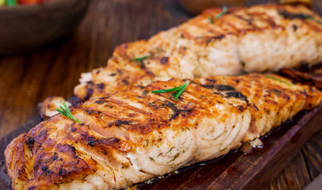

Module Title: Preparing Fish Dishes
Module Code: CST CUA3 M04 0923
Nominal Hours: 70hrs

Prepared by: Ministry of Labor and Skill
September, 2023
Addis Ababa, Ethiopia

Table Content
Contents Pages
Table Content 2
Acknowledgment 3
Introduction to the Module 4
Unit one: Ingredients for fish preparation 5
1.1. Identifying fresh fish 6
1.1.1. Common criteria for choosing fish 8
1.1.2. Types of Fish 9
1.2. Hygiene practices 10
1.3. Preparation techniques of Fish 12
Self-Check -1 15
Operation Sheet 1.1: Fish filleting 16
LAP Test 18
Unit Two: Producing fish dishes 19
2.1. Preparing Marinades 20
2.2. Producing Fish dishes 20
2.3. Producing sauces for fish dish 25
2.4. Cookery Techniques 27
2.4.1. Basic Fish Cooking Techniques 28
Self-Check -2 32
Operation Sheet 2.1: Producing Fish dishes 33
Operation Sheet 2.2: Producing sauces for fish dish 42
LAP Test 49
Unit Three: Presenting fish dishes 50
3.1. Presenting Fish dishes 51
3.2. Storing Fish items 52
Self-Check -3 54
REFERENCE 55
Participants of this Module (training material) preparation 56

Acknowledgment

The Ministry of Labor and Skills (MoLS) would like to express its gratitude and appreciation to the instructors and experts from regional TVT bureaus, TVT colleges, and industry practitioners who contributed their expertise and experience in preparing the training module for the unit of competency “Prepare Fish Dishes” under the occupational standard "Culinary Art level-III."
The ministry also expresses its deepest gratitude to the Tourism Training Institute for its invaluable technical and financial support and collaboration in the module preparation. It is also thankful to MoLS staff members who coordinated the preparation and reviewing process of this training module.

Introduction to the Module

In Culinary Art filed; Preparing Fish Dishes, refers to select, prepare and cook a variety of fish dish items along with sauces and accompaniments to meet customer requirements by following standardized recipes and hygiene procedures of the establish.
This module is designed to meet the industry requirement under the Culinary Art occupational standard, particularly for the unit of competency: Prepare Fish Dishes
This module covers the units:
- Ingredients for fish preparation
- Producing fish dishes
- Presenting fish dishes
Learning Objective of the Module:
- Select and prepare ingredients for fish preparation
- Produce a range of fish dish items
- Present fish dish items.
Module Instruction
For effective use this modules, trainees are expected to follow the following module instruction:
- Read the specific objectives of this Learning Guide.
- Follow the instructions described below.
- Read the information written in the information Sheets
- Accomplish the Self-checks
- Perform Operation Sheets
- Do the “LAP test”

Unit one: Ingredients for fish preparation
This learning guide is developed to provide you the necessary information regarding the following content coverage and topics:
- Identifying fresh fish
- Hygiene practices
- Preparation techniques
This guide will also assist you to attain the learning outcomes stated in the cover page. Specifically, upon completion of this learning guide, you will be able to:
- Identify a range of fresh fish, other ingredients and accompaniments required by the recipes.
- Identify tools and equipment to select and prepare ingredients.
- Use protective equipment to minimize risks of cross contamination.
- Follow appropriate hygiene practices to avoid potential food borne illnesses.
- Prepare and portion ingredients according to recipe specifications, using appropriate preparation techniques.

Identifying fresh fish

Fish is defined as, any of various cold-blooded, aquatic vertebrates, having gills, commonly fins, and typically an elongated body covered with scales.
Fish and shellfish contain high quality protein and other essential nutrients and are an important part of a healthful diet. In fact, a well-balanced diet that includes a variety of fish and shellfish can contribute to heart health and aid in children’s proper growth and development.
There are thousands of species of saltwater and freshwater fish. When cooking and eating them, freshness is keys to ensuring their quality. Preparing a whole fresh fish requires knowledge of the type of fish and a certain amount of dexterity.
Fresh fish should be used as soon as possible, but it can be stored overnight. Rinse, pat dry, cover with cling film and store towards the bottom of the refrigerator. Ready-to-eat cooked fish, such as ‘hot’ smoked mackerel, prawns and crab, should be stored on shelves above other raw foodstuffs to avoid cross contamination.
When buying whole fish the following points should be looked for to ensure freshness.
- Eyes: bright, full and not sunken; no slime or cloudiness.
- Gills: bright red in color; no bacterial slime.
- Flesh: firm, translucent and resilient so that when pressed the impression goes quickly; the fish must not be limp.
- Scales: flat, moist and plentiful.
- Skin: should be covered with a fresh sea slime, or be smooth and moist, with a good sheen and no abrasions or bruising; there should be no discoloration.
- Smell: pleasant, with no smell of ammonia or sourness.
- Fish should be purchased daily, if possible, direct from the market or supplier.
- The fish should be well iced so that it arrives in good condition.
- Fish may be bought on the bone or filleted. (The approximate loss from boning and waste is 50% for flat fish, 60% for round fish.)
- Medium-sized fish are usually better than large fish, which may be coarse; small fish often lack flavor.
- Fish should smell fresh and mild, not fishy, sour, or ammonia-like.
- A fish’s eyes should be clear and shiny.
- Whole fish should have firm flesh and red gills with no odor. Fresh fillets should have firm flesh and red blood lines, or red flesh if fresh tuna. The flesh should spring back when pressed.
- Fish fillets should display no discoloration, darkening, or drying around the edges.
- Shrimp, scallop, and lobster flesh should be clear with a pearl-like color and little or no odor.
- Some refrigerated fish may have time/temperature indicators on their packaging, which show if the product has been stored at the proper temperature. Always check the indicators when they are present and only buy the seafood if the indicator shows that the product is safe to eat.
- Fresh fish and fish fillets sold as “Previously Frozen” may not have all the characteristics of fresh fish (e.g., bright eyes, firm flesh, red gills, flesh, or bloodlines), however, they should still smell fresh and mild, not fishy, sour, or rancid.
- Fish is a healthy product, but choosing a good fish when you are a beginner in the kitchen can be tricky. I want to share with you some tips to properly judge the quality and freshness of the fish before buying it.
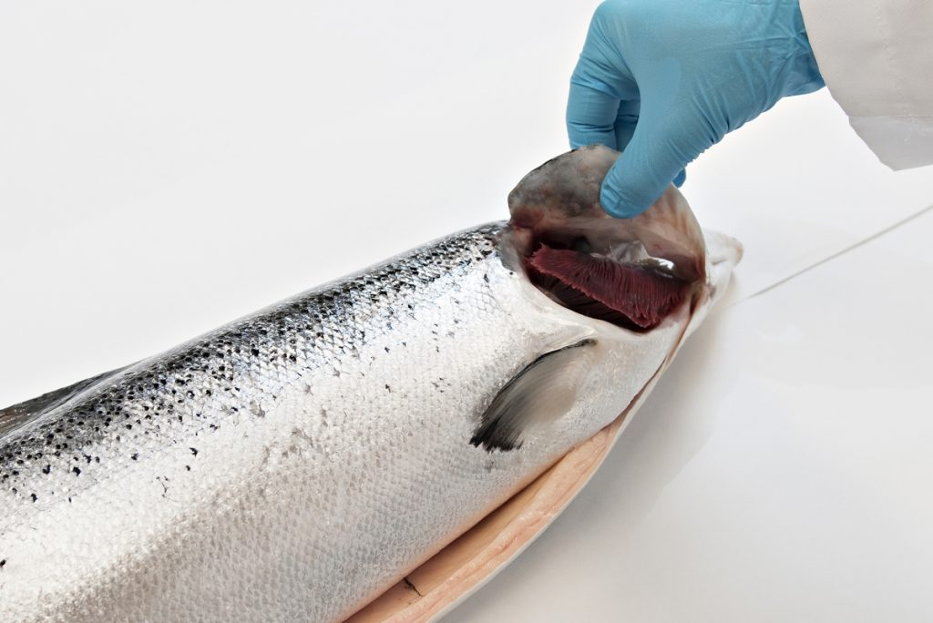
Fig. 1.1: Checking gill for Freshness of fish

Common criteria for choosing fish
- The body of the fish must be rigid or arched.
- The fish should be bright, with a metallic luster.
- The eye should be bright, vivid, and brilliant.
- The gills should be bright, wet, pink or red.
- The smell should be pleasant and mild.
- Scales should be shiny and not detach themselves.
- The abdomen should not be stretched or have green spots.
- The skin should be shiny, and slippery to the touch.

Table 1.1: Checklist for Freshness of Fish
Characteristics | Fresh fish | Not-so-fresh fish
Odor | Fresh and mild. No off odors | Strong “ fishy” odors
Eyes | Clear, Shiny, Bulging | Cloudy, Sunken
Gills | Red or pink | Grey or brown
Texture of flesh | Firm, elastic | Soft, dents easily
Scales | Shiny, tight on skin | Loose, not shiny

    - Types of Fish
- Salmon
Salmon is a super food boasting loads of protein and healthy fats. Another bonus: Just a mere 4-oz. serving of wild salmon serves up a full day’s requirement of vitamin D. And that same piece of fish contains over 50 percent of vital nutrients like B12, niacin, and selenium. Salmon also proves an impressive source of B6 and magnesium.
- Nile perch
The Nile perch also known as the African snook, Goliath perch, African barramundi, Goliath barramundi, Giant lates or the Victoria perch, is a species of freshwater fish in family Latidae of order Perciformes. It is widespread throughout much of the Afrotropical realm, being native to the Congo, Nile, Senegal, Niger and Lake Chad, Volta, Lake Turkana, and other river basins. It also occurs in the brackishwaters of Lake Maryut in Egypt. The Nile perch is a fish of substantial economic and food-security importance in East Africa.
- Tilapia
Tilapia is quickly becoming one of the most popular types of seafood in the nation. This fish makes for a superlative source of phosphorus, niacin, selenium, vitamin B12, and potassium. Its naturally mild flavor and ability to absorb flavors while cooking make it an ideal type of fish to serve children and picky eaters.
- Tuna
Even two servings of tuna a week can help prevent a lot of undesirable health outcomes like low density cholesterol, stroke, obesity, type II diabetes, and several types of cancer including oral, gastric, and colon cancers. Tuna’s rich concentration of folic acid and vitamin B6 can reduce homocysteine, which means less chance of atheroscleorosis, the hardening of arteries. It’s also high in omega-3 and low in both carbohydrates and fat.
- Red snapper
Red snapper is one of the most popular of all white fish. It is naturally found all over the world with most of the fish harvests coming from the Gulf of Mexico and Indonesia. Red snapper has a firm texture and a sweet, nutty flavor that lends itself well to everything from hot chilies to subtle herbs. Whole red snapper can be broiled, grilled, pan-fried, steamed, baked or deep-fried. Fillets are good pan-fried or steamed. Red snapper is also a nice ingredient in fish stew, such as cioppino.
- White fish
Whitefish, any of several valuable silvery food fishes (family Salmonidae, or in some classifications, Coregonidae), generally found in cold northern lakes of Europe, Asia, and North America, often in deep water. Whitefish are like trout in having an adipose (fleshy) fin but have larger scales, weaker teeth, and smaller mouths. They eat insect larvae and other small animals and spawn in fall.
Lake whitefishes (Coregonus) are deep-bodied forms. The largest and most valuable, C. clupeaformis of the Great Lakes region, is known by such other names as Lake Superior whitefish, whiting, and shad. It averages about 2 kg (4.5 pounds) in weight.
- Sole fish
The Sole fish is a slender flatfish belonging to the Soleidae family. Sole fish India is one of the most widely available varieties of tender and light fish. In fact, Sole never tastes “fishy”, making it an excellent choice for those people who are new to fish or don't favour strong tasting fish.
- Cod
Cod, like tilapia, is mild in flavor tasting less “fishy” than many types of seafood. Its high levels of protein are easily absorbed in the human body. Cod’s large amounts of vitamin B12 and vitamin B6 help keep homocysteine levels low, thus reducing risk for heart attack and stroke. In addition, eating cod can have anti-inflammatory effects within human skin — sometimes able to even protect against sunburn.
  - Hygiene practices
Fish and shellfish are an important part of a healthful diet because they contain high-quality protein and other essential nutrients. In fact, a well-balanced diet that includes a variety of fish and shellfish can contribute to heart health and aid in children's proper growth and development.
As with any food, it's important to handle seafood safely to avoid food borne illness, sometimes called food poisoning. Follow these safe handling tips for buying, preparing, and storing fish and shellfish – and you and your family can safely enjoy the fine taste and good nutrition of seafood.
When preparing fresh or thawed seafood, it's important to make sure bacteria from raw seafood doesn't spread to ready-to-eat foods. Take these steps to avoid cross-contamination:
- When buying unpackaged cooked seafood, make sure it is physically separated from raw seafood. It should be in its own display case or separated from raw product by dividers.
- Wash your hands for at least 20 seconds with soap and water after handling any raw food.
- Wash cutting boards, dishes, utensils, and countertops with soap and hot water between the preparation of raw foods, such as seafood, and the preparation of cooked or ready-to-eat foods.
- For added protection, kitchen sanitizers can be used on cutting boards and countertops after use. Or use a solution of one tablespoon of unscented, liquid chlorine bleach per gallon of water.
- If you use plastic or other non-porous cutting boards, wash them, along with plastic, metal, or ceramic utensils, in the dishwasher after use.
Steps to Safely Prepare Fish

Thawing
Thaw frozen fish gradually by placing it in the refrigerator overnight. If you have to thaw fish quickly, either seal it in a plastic bag and immerse it in cold water (changing the water every 30 minutes), or — if the food will be cooked immediately thereafter microwave it on the "defrost" setting and stop the defrost cycle while the fish is still icy but flexible.

Cooking
Most fish should be cooked to an internal temperature of 145°F. If you don't have a food thermometer, there are other ways to determine whether seafood is done. Fish: The flesh is opaque and separates easily with a fork. If you smell sour, rancid, or fishy odors in raw or cooked fish, do not eat it. If you smell either a fleeting or persistent ammonia odor in cooked fish, do not eat it.

Serving
Follow these serving guidelines once your fish is cooked and ready to be enjoyed.
- Never leave fish or other perishable food out of the refrigerator for more than 2 hours or for more than 1 hour if exposed to temperatures above 90°F. Bacteria that can cause illness grow quickly at temperatures between 40°F and 140°F.
- For party planning, keep hot seafood hot and cold seafood cold:
  - Keep cold chilled seafood refrigerated until time to serve.
  - Serve cold seafood on ice if it is going to stay out longer than 2 hours.
  - Keep hot seafood heated until time to serve or divide the seafood into smaller containers and keep them in a refrigerator until time to reheat and serve.
  - Serve hot seafood under a heat source (e.g., hot lamp, crock pot, hot plate, etc.) if it is going to stay out longer than 2 hours or discard the seafood after 2 hours.
  - Preparation techniques of Fish

All fish should be washed under running cold water before and after preparation. Whole fish are trimmed to remove the scales, fins and head using fish scissors and a knife. If the head is to be left on (as in the case of a salmon for the cold buffet), the gills and the eyes are removed.

The following are some of the preparation techniques of fish:

- Filleting
- Portioning
- Cutting
- Skinning and peeling
- Cleaning and gutting
- Dicing
- Slicing
- Trimming
- Chopping
- Marinating
- Tenderising
- Coating
- Mincing
- Deboning
- Staffing
- Grilling
- Stewing
- Poaching
- Steaming
- Smoking
- Drying
- Baking

    - Dressing fish
The following are steps of Dressing of fish:

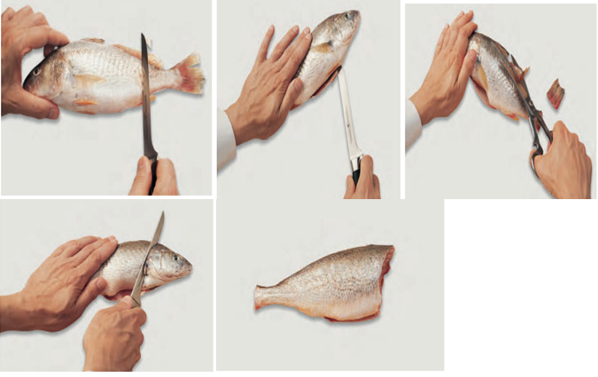
- Scale the fish: Lay the fish flat on work surface, Rub a scaling tool or the back of a knife against the scales from tail to head, Repeat until all scales are removed and Rinse. (Exceptions: Trout, with very tiny scales, and scaleless fish, like catfish, are not scaled.)
- Eviscerate: Slit the belly and pull out viscera. Rinse cavity.
- Cut off tail and fins: Scissors are easiest to use.
- Remove head: Cut through flesh just behind gills. Cut or break backbone at the cut and pull off head.
- The fish is dressed.

Fig. 1.2: Steps of fish dressing
    - Filleting fish
There are two basic shapes of fish: flatfish (like flounder and sole) and round fish (like cod and trout).They are filleted differently. Flatfish have four fillets; round fish have two fillets.

- Flatfish filleting
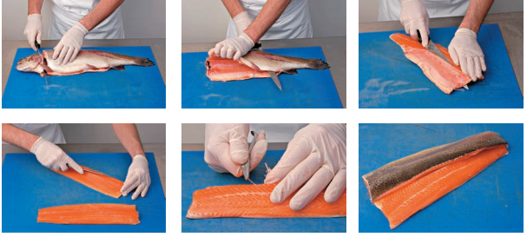
The following are steps of flatfish filleting.
- cutting off the head;
- cutting down the back;
- cutting into the flesh to remove the ribcage;
- trimming;
- pin boning;
- finished the fish
Fig. 1.3: steps of flatfish filleting
- Round fish filleting
The following are steps of round fish filleting:
- Remove the head and clean thoroughly.
- Remove the first fillet by cutting along the backbone from head to tail.
- Keeping the knife close to the bone, remove the fillet.
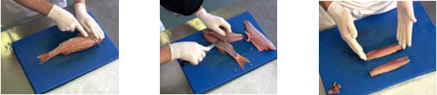
- Reverse the fish and remove the second fillet in the same way, this time cutting from tail to head. Note: Fish bones may be degored by soaking in water.

Fig. 1.3: Filleting of round fish

Fig. 1.4: steps of round fish filleting

Self-Check -1 | Written Test

Name……………………………………..Id………………….Time Allowed…………….

Directions: Answer all the questions listed below. Illustrations may be necessary to aid some explanations/answers. (20 points)
Part I. Write “true” if the statement is correct and “false” if the statement is incorrect
- Fish is any of various cold-blooded, aquatic vertebrates, having gills, commonly fins, and typically an elongated body covered with scales.
- Fish may be bought on the bone or filleted.
- Dressing is not the preparation techniques of fish.
- Filleting is one of the preparation techniques of fish.
- Trimming is one of the preparation techniques of fish.

Part II. Choose the correct answer for the following

Which one of the following is ensuring the freshness of fish?

Odor B. Eyes C. Gills D. all
- One of the following is Steps to Safely Prepare Fish

Thawing, Cooking and serving

Thawing, serving and cooking

Cooking, Thawing and serving

All

………….. is a super food boasting loads of protein and healthy fats.

Tilapia B. Salmon C. Cod D. Tuna

Part III: Short Answer questions:
      - What is fish dressing?
      - List filleting step.
      - What are the sign of fish freshness?

Note: Satisfactory rating - 10 points Unsatisfactory - below 10 points
You can ask you teacher for the copy of the correct answers.

Operation Sheet 1.1: Fish filleting
Equipment required:
- Chopping board
- Large knife
- Kitchen scissors
- Filleting knife or medium knife with flexible blade (as sharp as possible)
- Tweezers or pliers
Round Fish filleting methods:
- Remove head by cutting at an angle just under the fins near the head on each side, and then under the fin on the underside.
- Snap the head off, removing any innards.
- Make an incision along the skin on the back of the fish, to one side of the dorsal fin.
- Place the tip of the knife in and run from the head to the tail, along the bones. Midway along the fish, place the knife down and through to the underside of the fish, and then run the knife along the whole fillet, to the tail. Remove the fillet by stroking the knife under the fillet from the midpoint of the fish, towards the head, then remove it from the frame. Repeat on the other side. Trim skin around the fillets to neaten them.
- Pinbone the fillet, using tweezers to pull out the sturdy bones from the centre of the fillet, or cut along either side of them and pull the whole strip of bones out.
  - Flat fish filleting
Methods:
- Remove the head by scoring through the skin with a sharp knife and then using scissors to cut through.
- Using a flexible fish filleting knife, cut down the central line until you come into contact with bone. Cut a small incision across the tail.
- Rest the knife on the backbone and draw it down, listening for the knife pinging along the bones, repeating until you begin to get underneath the fillet.
- Use a long sweeping action to stroke the fillet from the bone and pull the fillet away. Repeat on the other side, then turn the fish over and repeat until you have four fillets.
- Skin the fillets by placing skin-side down and turning the fillet so that the narrowest side is towards you. Hold the fillet with one hand, then position the knife so it’s nearly flat with the board, but slightly angled so you’re cutting down towards the skin. Use a sawing motion, trying not to cut into the flesh as you go.
- Cook as desired. The fish can be simply fried in butter on a high heat, after being rolled in seasoned flour.

LAP Test | Practical Demonstration

Name : _____________________________ Date : ________________

Time started : _____________________________ Time finished : ________________
Instructions:
1. You are required to perform any of the following:
Request your teacher to arrange for you all necessary tools, materials and equipment. Submit your outputs to your teacher for evaluation.
Request a set of tools, materials, equipment for the tasks then perform the following tasks in front of your teacher:
Prepare:-
    - Flat fish filleting
    - Round fish filleting

  - Request your teacher for evaluation and feedback

Unit Two: Producing fish dishes
This learning guide is developed to provide you the necessary information regarding the following content coverage and topics:
- Preparing marinades
- Producing Fish dishes
- Producing sauces for fish dish
- Cookery techniques
This guide will also assist you to attain the learning outcomes stated in the cover page. Specifically, upon completion of this learning guide, you will be able to:
- Produce marinades according to enterprise practices.
- Produce fish dishes along with varieties of sauces following standard recipes accurately according the requirements and enterprise practices and specifications.
- Use Suitable cookery techniques according to requirements of ingredients

  - Preparing Marinades
Marinating is one of the best ways to add flavour to fish without adding a ton of fat or calories. Too often we rely on store-bought marinades when preparing one from scratch is not only easy but healthier too.
A typical marinade is made up of three essential components: an acid (such as vinegar, wine, or citrus), an oil (such as olive oil or sesame oil), and a flavouring agent (such as herbs and spices). These elements work together to transform the taste and texture of your dish in different ways. The acid breaks down the proteins, which allows the meat to absorb more flavour while retaining its natural juices. The oil penetrates the meat and helps prevent moisture loss during cooking. Finally, the herbs and spices infuse your meat with flavour.
Marinating is a method of preserving fish using common salt and acetic acid along with spices and condiments. The salt and acetic acid guard the fish products against infection and development of microorganisms.
Fish marinades don’t require a long time to infuse the fish with flavor, so you can whip up an elegant, flavorful meal on short notice.
  - Producing Fish dishes
Fish and fish products are consumed as food all over the world. With other seafoods, they provides the world's prime source of high-quality protein; 14–16 percent of the animal protein consumed worldwide. Over one billion people rely on fish as their primary source of animal protein.
Fish and other aquatic organisms are also processed into various food and non-food products.
Live, fresh or chilled is often the most preferred and highly priced form of fish and represents the largest share of fish for direct human consumption, 45 percent in 2016, followed by frozen (31 percent), prepared and preserved (12 percent) and cured (dried, salted, in brine, fermented smoked) (12 percent). Freezing represents the main method of processing fish for human consumption.
Major improvements in processing as well as in refrigeration, ice-making and transportation have allowed increasing commercialization and distribution of fish in a greater variety of product forms in the past few decades. However, developing countries still mainly use fish in live or fresh form (53 percent of the fish destined for human consumption in 2016), soon after landing or harvesting from aquaculture.
- Grilled fish fillets
Grilled fish fillet: the fish is cooked quickly over medium or high heat coals or over burners set to medium or high heat on a gas grill. Direct heat is used when grilling thinner fillets and steaks.
FFig.2.1: Grilled fish fillet
- Grilled Salmon
Like a steak, the ideal grilled salmon has a seared crust and a crispy skin and yet is still medium-rare inside. This method works best with king salmon but you can safely use it with any kind of salmon: sockeye, silver, pink, even famed Atlantic salmon.

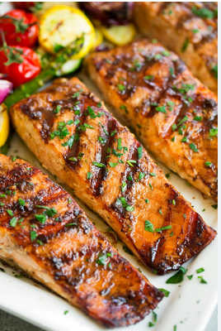
Fig. 2.2: grilled Salmon
- Fish kedgeree
Kedgeree is made by poaching the fish, then cooking the rice in the poaching liquid. The rice is then tossed in a flavourful curried butter before tossing the fish back in and finishing with boiled eggs.
Kedgeree (or occasionally kitcherie, kitchari, kidgeree, kedgaree, kitchiri, khichuri, or kaedjere) is a dish consisting of cooked, flaked fish (traditionally smoked haddock), boiled rice, parsley, hard-boiled eggs, curry powder, butter or cream, and occasionally sultanas.
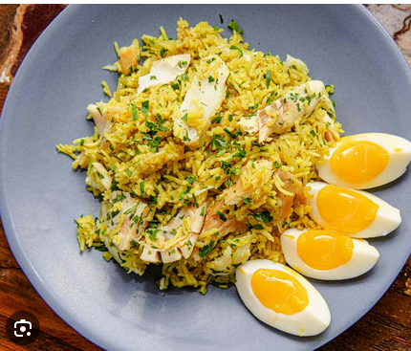
Fig. 2.3: Fish kedgeree
- Whole baked fish
Roasting whole fish can seem intimidating, but it’s actually quite simple to do! If you buy the whole fish already gutted and scaled, all that’s left for you to do is adding delicious flavors and baking to perfection.
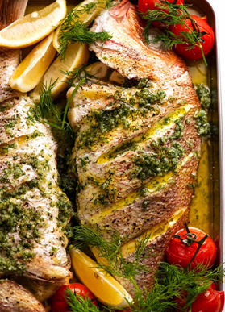
Fig 2.4: Whole baked fish
- Fish meunière
Meunière means "in the style of the miller's wife"; this refers to the coating of flour used for dredging fish before pan-frying it.
There are two primary ways to prepare the fish (most popularly, sole or trout). One is by sautéing first dredging the fish in seasoned flour (white flour or corn flour) and then cooking in a hot sauté pan with a small amount of clarified butter. The alternative method is to pan-fry or deep fry the floured fish. In pan frying, oil or a combination of oil and butter is used up to perhaps 2 cm deep. Deep frying is done in either a large fry pot or in a stand-alone deep fryer. The floured fish is completely submerged in the hot oil. The frying techniques result in a crisper texture, but the sauce will need to be made separately. The sautéed fish will have a softer skin by comparison, but allows for the possibility of creating the sauce à la minute after the fish has been removed by adding fresh butter, parsley, and lemon.
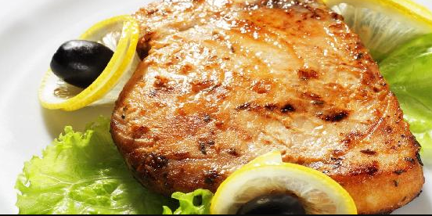
Fig. 2.5: Fish meunière
- Poached fish
Poaching is a good technique for cooking lean fish like tilapia, cod, sole, haddock, snapper, or halibut as well as fatty fish like salmon or trout. It is a type of moist-heat cooking technique that involves cooking by submerging a food item in a liquid usually at a low temperature.
- Fish cutlet
This recipe is very popular appetizers made with fish; veggies and spices are coated in flour mix and breadcrumbs, and deep fried to perfection. Prep Time: 30 minutes. Total Time: 45 minutes.

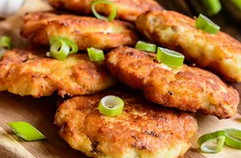
Fig. 2.6: Fish Cutlet
- Fish pie
The pie is usually made with fresh and smoked fish (for example cod, haddock, salmon or halibut) or seafood in a white sauce or cheddar cheese sauce made using the milk the fish was poached in. Hard boiled eggs are a common additional ingredient. Parsley or chives are sometimes added to the sauce.
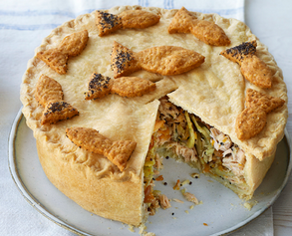
Fig. 2.7: Fish Pie

Producing sauces for fish dish

Fish sauce is a liquid condiment made from fish or krill that have been coated in salt and fermented for up to two years. It is used as a staple seasoning in East Asian cuisine and Southeast Asian cuisine, particularly Myanmar, Cambodia, Laos, Philippines, Thailand, and Vietnam. Some garum-related fish sauces have been used in the West since the Roman times.
Due to its ability to add a savory umami flavor to dishes, it has been embraced globally by chefs and home cooks. The umami flavor in fish sauce is due to its glutamate content.
Fish sauce is used as a seasoning during or after cooking, and as a base in dipping sauces. Soy sauce is regarded by some in the West as a vegetarian alternative to fish sauce though they are very different in flavor.
Now that you know how to masterfully score and season fish fillets, thanks to this Mad Genius Tips video, all you need to make fantastically flavorful fish is the right sauce. Here, 10 great sauces that will take any fish dish over the top.
The following some sauces are used to fish dishes:
    - Lemon butter
Also known as lemon curd or lemon spread, lemon butter is a delicious spread or filling made from fresh lemons, sugar, eggs and of course butter. Use it as a tart, pie or cupcake filling, or as a spread on toast, scones or pancakes.
The Lemon Butter Sauce is just made with butter and lemon. But it's not “just” butter and lemon. It's brown butter and lemon. If you're new to brown butter, this is going to change your world – it's addictive. Brown butter is everything you love about melted butter, boosted with an incredible nutty, toasty aroma.
    - Parsley butter
This parsley sauce recipe is made of fresh parsley, butter, English mustard, milk, and flour. It's a great way to give a basic white sauce a gentle flavor and use an abundance of parsley. The creamy parsley sauce is ready in about 20 minutes and pairs perfectly with baked or pan-fried fish or baked ham.
    - Spicy tomato sauce
Also known as Chraime this fish in tomato sauce takes less than 30 minutes to prepare. Made with fresh tomatoes, spicy paprika, and smoky cumin, this dish is bursting with flavor. It can be served as a meal on its own with rice, couscous or crusty bread.
    - Veloute sauce
Velouté is one of the five "mother sauces" of classical cuisine. It can be made with any white stock, but this version, the fish velouté, is made with fish stock. There's also a veal velouté and a chicken velouté
    - Fresh herb sauces
All you need for this sauce are parsley, arugula, marjoram, oregano, vinegar, and garlic
    - Mint sauce
Fresh mint blends with garlic, vinegar and sugar for a room-temperature sweet-and-sour sauce that's traditional in England with roasted lamb—and is also perfect for a full-flavored fish like tuna.
    - Sweet and sour sauce
Sweet and sour dishes trace their origin from Chinese cuisine with the original sweet and sour sauce said to have come from Hunan, a province in China. It was a combination of light vinegar and sugar and was initially used as a condiment or dipping sauce for meat and fish rather than cooking.
  - Cookery Techniques
Fish has very little connective tissue. This is one of the most important differences between fish and meat. It means that: -
- Fish cooks very quickly, even at low heat (just enough heat to coagulate the proteins).
- Fish is naturally tender. Toughness is the result not of connective tissue but of the toughening of the protein by high heat.
- Moist-heat cooking methods are used no to create tenderness but to preserve moistness and provide variety.
- Cooked fish must be handled very carefully or it will fall apart.
Special Problems in Cooking Fish
Doneness and flaking:-
- When fish is cooked; the flesh breaks apart in to its natural separations. This is called flaking.
- Fish continues to cook in its retained heat even when removed from the fire; it is often dreadfully over cooked by the time it reaches the customer.
- Fish is very delicate and is easily over cooked observe these tests for doneness:-
- The fish just separates in to flakes: - that is beginning to flake but does not yet fall apart easily.
- If bone is present, the flesh separates from the bone, and the bone is no longer pink.
- The flesh has turned from translucent to opaque (usually white, depending on the kind of fish).
*--Remember, the major flaw in fish is over cooking

2.4.1. Basic Fish Cooking Techniques
To maintain the quality and food safety of fish and shellfish dishes, it is advisable to check the internal temperature by use of a probe. The following temperatures are recommended: all fish and shellfish 62⁰C.
- Poaching
This is suitable for small whole fish, cuts or fillets, barely cover the fish with fish stock, cover with a buttered paper, and bring to the boil and cook in the oven without allowing the liquid to boil. The cooking liquor is usually used for the sauce which masks the fish.
- Steaming
Any fish which can be poached or boiled may also be cooked by steaming which has a number of advantages.
- It is an easy method of cooking.
- Cooking by steam can be rapid, thus conserving flavor, color and nutrients.
- It is particularly suitable for large scale operations.
Fish to be steamed is prepared for cooking in the same way as for poaching. The sauce can be prepared separately, but the liquor from the steamed fish should be strained off, reduced and incorporated into the sauce.
- Grilling
This method suitable for small whole fish, cuts and fillets. The fish is passed through seasoned flour, brushed with oil and grilled on both sides. When fish is grilled under the salamander, grill bar marks may be made with a red-hot poker before cooking.
Grilling may also be done on a barbecue, in which case the fish whole, in cuts or in kebabs, may be marinated for a short time then the marinade used to baste the fish whilst cooking. Whole fish can have sprigs of fresh herbs placed in the belly cavity and they can also be wrapped in oiled foil and cooked on a barbecue.
- Baking
Many fish whole, portioned or filleted may be baked in an oven. In order to retain the natural moisture it is necessary to protect the fish from the direct heat.
- Whole fish (sea bass, bream, mullet, etc.)
- Completely cover in a thick coating of sea-salt and bake.
- Wrap in pastry (puff, brioche or filo) and bake.
- Stuff with a duxelle-based mixture of breadcrumbs, herbs, chopped onion, shallots or garlic, lean minced veal or/and bacon, and brush with oil or butter prior and during cooking.
- Portions of fish (cod, haddock, hake, sea bass, tuna).
- Place in a buttered or oiled dish and bake slowly, basting frequently. Different herbs and suitable finely sliced vegetables can be added to vary flavor.
- Make a crust of a duxelle base with additional ingredients (tomato, garlic, herbs, spices, lemon juice, and bread crumbs) to cover the fish portions and then bake.
- Make a crust of a duxelle base with additional ingredients (tomato, garlic, herbs, spices, lemon juice, and bread crumbs) to cover the fish portions and then bake.
- Roasting
Thick cuts of any fish, e.g. cod, salmon, turbot, sea-bass, monkfish etc., are suitable for roasting. Depending on size, the fish may be roasting. Depending on size, the fish may be roasted whole e.g. sea bass.
The fish is usually portioned, skin left on or removed, lightly seared in oil in a frying pan and then roasted in an oven for a few minutes. Finely sliced vegetables and springs of herbs can be added to the roasting tray and when the fish is cooked the tray can be deglazed with a suitable wine or/and fish stock to form the basis of an accompanying sauce, e.g. fresh tomato sauce: page 60. If the fish is skinned, a light crust of breadcrumbs mixed with a good oil or melted butter, fresh herbs or duxelle based mixture, or a light coating of creamed horseradish can be used.
Fish is a very versatile food and can be cooked in many different ways. In most recipes a similar species can be substituted for another, for example you could use lemon sole instead of plaice. Fish cooks very quickly, so take care not to overcook it. To recognize that it's cooked, fish loses its translucent look and will flake easily.
- Barbecuing
This is cooking over a radiant heat - usually a charcoal or gas barbecue. It is fast and popular during fine summer weather. Oil-rich fish are suitable for barbecuing as the natural oils keep the flesh moist. Baste whitefish often to keep it moist. Protect the fish from strong heat and from breaking up by using foil or special wire holders.
- Braising
This is an "all-in-one" method of cooking where the fish is cooked together with vegetables, either on the hob or in the oven. Lightly sauté the selected vegetables. Add the fish, seasonings and liquid. Cover and cook until fish is cooked through.
- Frying
Frying is probably the most popular method of cooking fish.
- Shallow frying: The fish should be seasoned and lightly coated with flour or crumb before frying to protect it and seal in the flavour. Use a mixture of oil and butter when frying and turn the fish only once during cooking, to avoid breaking up.
- Deep Frying: The fish should be seasoned and coated before frying, usually with a batter or an egg and breadcrumb mixture. Use a suitable container and heat the oil to 190°C/375°F. Test the temperature before cooking fish. Drain the fish after cooking on absorbent paper.
- Stir Frying: This is a very fast and popular method of cooking. Use a wok or deep frying pan and a high cooking temperature. Food should be cut into thin strips and prepared before cooking begins. This is a very suitable method of cooking firm-fleshed fish.
- Microwave Cooking
Fish cooks perfectly in a microwave oven because of its high water content and loose texture. Use a non-metallic dish and arrange the thickest part of fish towards the edge of the dish. Fold tailpieces underneath to prevent uneven cooking. As cooking will continue when removed from the oven, allow the fish to stand for 2-3 minutes before serving.

Self-Check -2 | Written Test
Name……………………………………..Id………………….Time Allowed…………….
Directions: Answer all the questions listed below. Illustrations may be necessary to aid some explanations/answers. (20 points)
Test I. Write “true” if the statement is correct and “false” if the statement is incorrect
  - Marinating is one of the best ways to add flavour to fish without adding a ton of fat or calories.
  - Poaching is a good technique for cooking lean fish like tilapia, cod, sole, haddock, snapper, or halibut as well as fatty fish like salmon or trout.
  - Fish sauce is a liquid condiment made from fish or krill that have been coated in salt and fermented for up to two years.
  - Velouté is not one of the five "mother sauces" of classical cuisine.
  - Fish cooks very quickly, even at low heat.
Test II. Choose the correct answer for the following
  - ………………..is a liquid condiment made from fish or krill that have been coated in salt and fermented for up to two years.

Fish sauce B. Grilled fish C. Gills D. all

Which of the following sauces are used to fish dishes?
    - Lemon butter

Spicy tomato sauce

Mint sauce

All

Which of the following are basic fish cooking techniques?
    - Poaching B. Grilling C. Baking D. All
Test III: Short Answer questions:
  - List the 3 frying methods of cooking fish.
  - What is marinating mean?
  - List at least 5 fish dishes.

Operation Sheet 2.1: Producing Fish dishes

      - Grilled fish fillet

Ingredients:
- 1 to 1-½ lbs fish fillets from a firm white fish (4-6 fillets) such as Louisiana Drum, cod, pollock, tilapia, etc.
- 1 ½ teaspoon Kosher salt
- 1 teaspoon freshly ground black pepper
- ½ cup olive oil
- 1 or 2 lemons cut into wedges
- ½ cup chopped parsley optional

Methods:
- Turn your grill on to high heat and allow it to heat for 5-10 minutes until the grill is very hot.
- Rinse the fish and lay it onto paper towels.
- Sprinkle half the salt and half the pepper over the fish. Carefully drizzle half of the olive oil over the seasoned fish.
- Flip the fish over on the rack and repeat with remaining salt, pepper, and oil. Let the fish rest and marinade until your grill is hot.
- Use a brush to scrape the grill grate clean and then lower the grill temperature to low.
- Place the fish on the grill, close the lid, and leave the fish to cook with the lid closed, without turning for 7 to 10 minutes
      - Grilled Salmon
Ingredients:
- 1 ½ pounds salmon fillets
- lemon pepper to taste
- garlic powder to taste
- salt to taste
- ⅓ cup soy sauce
- ⅓ cup brown sugar
- ⅓ cup water
- ¼ cup vegetable oil
Methods:
- Season salmon fillets with lemon pepper, garlic powder, and salt.
- Stir soy sauce, brown sugar, water, and vegetable oil together in a small bowl until sugar is dissolved. Place fish in a large resealable plastic bag; add soy sauce mixture, seal, and turn to coat. Refrigerate for at least 2 hours.
- Preheat an outdoor grill for medium heat and lightly oil the grate.
- Place salmon on the preheated grill, and discard marinade. Cook salmon until fish flakes easily with a fork, about 6 to 8 minutes per side.
      - Fish kedgeree

Ingredients:

4 cups/ 1 litre chicken stock/broth , low-sodium

500g/1 lb smoked haddock or cod , skin-on (or other smoked fish, Note 1)

2 1/4 cups long grain rice , uncooked

75g / 5 tbsp unsalted butter

15 curry leaves (Note 2)

6 green cardamom pods , lightly crushed (Note 3)

1 brown onion , diced

2 garlic cloves , finely minced

2 tsp curry powder (anything! Use spicy if you want, I use mild)

1/2 tsp turmeric powder

1 cup frozen peas , thawed

1/2 cup coriander/cilantro leaves , roughly chopped (sub green onion or parsley)

3 hard boiled eggs , halved or quartered (9 minute cook)

Methods:
  - Poach fish – Bring chicken stock to a boil in a large saucepan or small pot. Place fish in (it should all be just about submerged, Note 4) and adjust heat so the stock is barely rippling. Poach it gently for 8 minutes or until the fish flakes apart. Remove fish onto a large plate.
  - Flake fish – When cool enough to handle, discard skin (gently scrape with a butter knife) and flake fish into large pieces, checking for any bones.
  - Reserve stock – Measure out 1/2 cup of the poaching liquid and set aside for later (drizzle on at end to juice up the rice).
  - Cook rice 13 min – Add rice into the poaching liquid in the saucepan. Bring to a simmer over high heat. Cover with lid then reduce heat to low. Cook for 13 minutes.
  - Rest rice 10 min – Remove the saucepan from the stove with the lid on and rest for 10 minutes. Fluff rice using a rubber spatula.
  - Curried butter – While the rice is resting, melt the butter in a very large (30cm/12") non stick skillet or pot, over medium-high heat. Add the cardamom pods and curry leaves and stir for 30 seconds. Add the onions, garlic and sauté for 5 minutes until browning at the edges, stirring regularly.
  - Toss rice – Lower heat to medium. Stir in the curry powder and turmeric, and then the rice. Toss the rice in the spiced butter until well coated and uniformly yellow. Pour over the reserved 1/2 cup of fish poaching stock, and toss to mix through (it moistens the rice).
  - Peas & fish – Stir through the peas and most of the coriander (hold some back for garnish). Then gently fold through the fish, taking care to keep some pieces in large chunks.
  - Serve – Spoon out rice onto one large platter or individual plates to serve. Top with boiled egg halves, and garnish with the remaining coriander.
      - Whole baked Fish

Ingredients:
- 2 x 800g / 1.6 lb whole snapper or other whole fish , scaled, gutted and cleaned (Note 1)
- 1 1/2 tsp salt , kosher/cooking (not table salt)
- 1/2 tsp black pepper
- 2 tbsp extra virgin olive oil

Stuffing:
- 1/2 cup fresh dill sprigs, packed
- 1/2 cup parsley leaves, packed
- 4 garlic cloves , finely sliced
- 1 lemon , sliced (8 slices each lemon)

Dill Garlic Butter:
- 150g / 10 tbsp unsalted butter , cut into cubes
- 2 tsp garlic , finely minced
- 1 tbsp fresh dill , finely chopped

Methods:
  - Preheat oven to 220°C/430°F (200°C fan). Line a tray with parchment/baking paper.
  - Trim fins: Cut all fins off the fish using scissors – both fins on the side, and the fins on the back and underside of the fish (but not the tail).
  - Slash flesh: Cut 3 slashes on each side of the fish, cutting through flesh down to the bone (see photos in post and/or video, helpful!).
  - Stuff fish (Note 2): Sprinkle a bit of salt and pepper inside the cavity of the fish. Scatter the cavity with garlic slices, then stuff with parsley and dill. Layer lemons on top of herbs.
  - Tie fish (Note 3): Using kitchen string make 3 ties to hold fish together.
  - Season skin: Sprinkle remaining salt and pepper on the skin (both sides), including a bit on the head of the fish. Then drizzle with olive oil. Rub all over the fish, including in the slashes.
  - Bake 20 minutes (Note 4): Place fish on prepared tray. Bake for 20 minutes or until the internal temperature is 55°C/131°F (insert thermometer in the thickest part of the fish, not against the bone).
  - Rest: Remove from oven, transfer to serving platter and leave it to rest for 5 minutes. The internal temperature will rise to 58°C / 136.5F ("medium", ie. just-cooked and not raw at all, very juicy and moist).
  - Serve with Garlic & Dill Butter Sauce on the side. Either pour over the butter just prior to serving the fish, or let everyone help themselves.

Garlic & Dill Butter Sauce:
- Melted butter: Place butter in a saucepan over medium-high heat. Once melted, add garlic and cook, stirring, for 45 seconds to 1 minute until it smells ridiculously good and you're salivating!
- Add dill: Remove from heat. Stir in dill. Use per recipe.
      - Fish meunière

Ingredients:
- 85 g - fish fillets
- 3 tbsp -plain flour
- juice of 2 lemons
- 2 tbsp - parsley, chopped
- 175 g -unsalted butter
- lemon wedges for garnish
- black pepper, ground as required
- parsley sprigs
- salt as required

Methods:
- Mix the salt and pepper with the flour.
- Coat the fish lightly with the flour and set aside.
- Heat 115 g butter in a frying pan and then add the fish fillets in batches and cook over moderate heat.
- Remove the fish fillets from the pan when crisp and transfer to plates.
- Add the remaining butter in the pan and heat until golden brown.
- Stir in lemon and parsley and immediately pour over the fish fillets.
- Garnish with parsley and lemon wedges and serve hot.
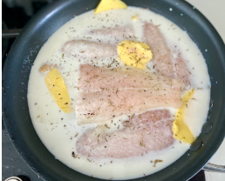
      - Poached fish
Ingredients:
- Deselect All
- 4 (6-ounce) salmon fillets, skin removed
- 3 cups fish stock
- 1 cup dry white wine
- 2 sprigs tarragon
- A few blades chives
- Classic Creamy Herb Vinaigrette, recipe follows
- Roasted Vegetables, recipe follows
Classic Creamy Herb Vinaigrette:
- 4 tablespoons heavy cream
- 1/2 cup French Vinaigrette, recipe follows
- 2 tablespoons minced fresh green herbs (chives, tarragon, oregano)
- 1/2 lemon, juiced
- 1 tablespoon vegetable oil
- 1/4 teaspoon salt
- Pinch freshly ground black pepper
Roasted Vegetables:
- 2 small Japanese eggplants, halved lengthwise and cut into 3/4-inch half circles
- 2 zucchini, sliced into 3/4-inch thick rounds
- 4 plum tomatoes, halved lengthwise
- 1 tablespoon thyme leaves
- Salt and freshly ground black pepper
- Oil
Methods:
- In a pan large enough to poach the fish in, combine the stock, wine, parsley, and chives. Bring to a boil and reduce the heat so the water is barely simmering.
- Slowly lower the fish into the poaching liquid. Poach the fish until it is just cooked through, about 6 minutes. Remove and serve with Classic Creamy Herb Vinaigrette. and Roasted Vegetables.
Classic Creamy Herb Vinaigrette:
Yield: about 3/4 cup
- Whip the cream until soft peaks form. Slowly whisk the vinaigrette into the whipped cream until combined. Whisk in the herbs, lemon juice, and vegetable oil. Taste and adjust the seasonings. Use at once or cover and refrigerate.
- Serve with poached fish and grilled vegetables.
Roasted Vegetables:
Yield: 4 servings
- Preheat the oven to 400 degrees F.
- Toss the vegetable with the thyme, salt, pepper, and enough oil to lightly coat. Spread in a roasting pan or on a baking sheet. Roast until the vegetables are tender, about 25 minutes. Cool slightly before serving

Fish Cutlets

Ingredients:
For the fish:
- 1 small ginger
- 2 Green chillies
- 3 Garlic cloves
- 3-4 Rawa fillets
For the base:
- 100 gms bread crumbs
- 1 Egg
- 2 Garlic cloves
- 1 small ginger
- 1 Chilli
- A few leaves of mint
- to taste salt
- 1 tsp turmeric
- 1 tsp red chilli powder
- 1 tsp saunf
- 4-5 Peppercorns
- 1 Bread slice
- 1 tsp oil
- Water
- 1/2 Lemon (juiced)
- 1 potato (mashed), boiled
- 2 tbsp flour (to coat)
- Oil (to pan fry)
- for garnishing mint leaves
Methods:
- In a pan, steam the fish in a strainer with boiled water, ginger, green chilly, garlic and cover the pan.
- In a blender, mix bread crumbs, egg, garlic, ginger, green chillies, fresh mint leaves, salt, turmeric powder, red chili powder, slice of bread, refined oil and juice of half lime.
- In a mortar and pestle smash fennel and black pepper, add them into blender.
- Add a little water and blend them together.
- Add the steamed fish into the blender and grind them well.
- Transfer them into a bowl and add one boil potato for starch. Mix them well. Make cutlets out of it and coat in some flour.
- Keep it in the fridge for 10 minutes.
- Add little refined oil in the pan and fry the cutlets both sides.
- Garnish with mint leaves. Serve hot.

- Fish pie

Ingredients:
- béchamel (thin) 250 ml
- cooked fish (free from skin and bone) 200 g
- mushrooms, cooked and diced 50 g
- egg, hard-boiled and chopped 1
- parsley, chopped
- salt, pepper mashed or duchess potatoes 200 g
- egg wash or milk, to finish

Method:
- Bring the béchamel to the boil.
- Add the fish, mushrooms, egg and parsley. Correct the seasoning.
- Place in a buttered pie dish.
- Place or pipe the potato on top. Brush with egg wash or milk.
- Brown in a hot oven or under the salamander and serve.

Operation Sheet 2.2: Producing sauces for fish dish

  - Lemon butter Sauce

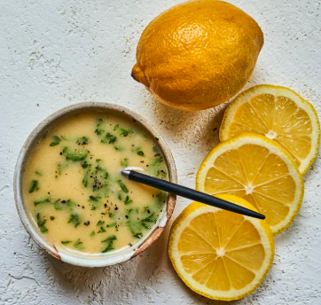
Ingredients:
- ½ cup butter
- 1 teaspoon minced garlic
- juice of ½ lemon
- ¼ cup low sodium chicken broth
- ¼ cup heavy cream

Methods:
- In a medium sauce pan, melt butter over medium heat.
- Stir in garlic for 1-2 minutes until fragrant.
- Stir in lemon juice, broth, and heavy cream.
- Bring sauce to a simmer. Cook 4-6 minutes until sauce thickens enough to coat the back of a spoon.
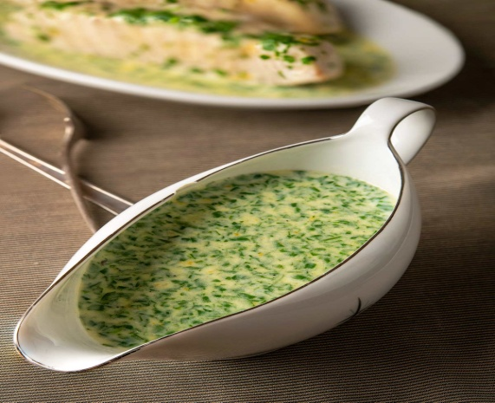
- Serve sauce over your favorite fish. Garnish with freshly chopped parsley and cracked black pepper if desired.
  - Parsley butter Sauce
Ingredients:
- 2 tablespoons/25 grams butter
- 2 tablespoons/20 grams all-purpose flour
- 1 1/2 teaspoons English mustard, optional
- 1 cup/250 milliliters milk, more as needed
- 1 handful fresh flat-leaf parsley, chopped
- Sea salt, to taste
- Freshly ground pepper, to taste
Methods:
- In a medium-sized saucepan, melt the butter over medium heat.
- Stir in the flour and mustard (if using). Stir thoroughly to form a thick paste. Cook gently for 2 to 3 minutes more, watching the heat to ensure the paste does not burn.
- Gradually whisk in the milk. Bring to a boil, lower the heat, and simmer for 5 minutes, frequently whisking to make sure there are no lumps.
- Add the fresh parsley and stir well. Season with a good pinch of sea salt and a few black pepper grinds. Taste and add more as needed.
- Keep the sauce warm, on low heat, until needed. If keeping sauce warm for more than 15 minutes, laying a piece of buttered parchment paper on the surface will prevent a skin from forming. If a slight skin does form, whisk thoroughly over heat, and it should disappear.
  - Spicy tomato sauce

Ingredients:
- 2 lb (500 g) Fish ((halibut, sea bass, tilapia, grey mullet))
- 2 tbsp Olive oil
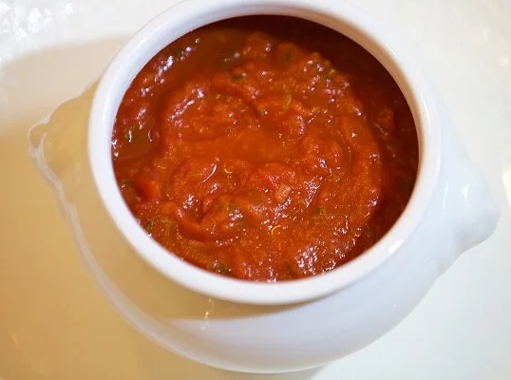
- 4 – 5 large Garlic cloves (finely chopped)
- 2 cup Onion (finely chopped)
- 2 tbsp Tomato paste
- 4 cup (450 g) Fresh tomatoes (finely chopped )
- 2 tbsp Smoked paprika
- 1 tbsp Hot paprika
- 1 tbsp Cumin powder ((I used 1 tsp) )
- 1 tsp Kosher salt
- 1 tsp Black pepper
- 1 cup (240 ml) Water
- ¼ cup Fresh Cilantro or parsley (Chopped)

Methods:
  - Saute – In a large skillet over medium heat add the olive oil and garlic. Cook for 30 seconds then add the onions and saute until lightly caramelized about 3 to 4 minutes.
  - Spices – Add the spices and tomato paste. Saute for another 2 minutes until fragrant.
  - Tomatoes – Add the chopped tomatoes and combine well. Cover the pot and let simmer for 10 minutes. Then, mash the softened tomatoes with a vegetable masher.
  - Fish – Add the water and combine well. Then gently place the fish pieces in the tomato sauce making sure to tuck them into the sauce.
  - Simmer – Cover the pan and simmer for 10 minutes. Flip the fish and season with salt and pepper. Sprinkle some cilantro or parsley. Cover the pan and cook another 5 to 8 minutes until the fish is ready.
  - Garnish – when done taste and adjust the seasoning. Garnish with fresh cilantro or parsley.
  - Enjoy!

  - Veloute sauce

Ingredients:
- 400ml White Fish Stock (white stock just means the bones were not roasted)
- 40g Unsalted Butter
- 40g Plain Flour
- Salt & Pepper

Allergens
- Fish
- Celery
- Milk
- Wheat (Gluten)

Method:
- Bring the stock to a simmer in a large saucepan.
- In a separate saucepan, melt the butter over low heat (don't let it burn) and add the flour.
- Raise the heat to medium and stir the butter and flour together for about 2 minutes. This is your roux.
- Whisk the simmering stock into the roux and keep heating and whisking. When the stock begins to simmer again, turn down the heat to low and cook until the sauce thickens. A thin skin may form; just skim it away with your spoon.
- Season with salt and pepper
- Strain through a fine sieve or chinois if you have one.
- When using this sauce as a base for another sauce cover the top with a cartouche, as this will stop a skin from forming on the surface.
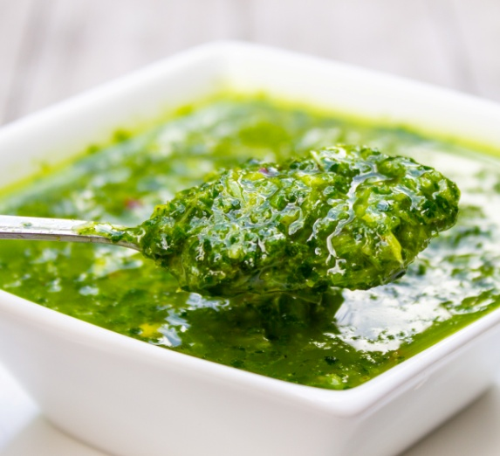
  - Fresh herb sauces

Ingredients:
- 1/2 cup herbs
- 2 small garlic cloves, minced
- 2 green onions
- zest of 1 lemon plus 1 tablespoon fresh lemon juice, optional
- 1/2 teaspoon salt
- 1/2 teaspoon ground pepper
- 1/4 teaspoon -1/2 tsp red pepper flakes for medium heat adjust to your taste
- 6 tablespoon olive oil

Methods:
  - Make Herbs Sauce: Finely chop herbs and green onions. Stir together with other dressing ingredients except oil. Slowly whisk in oil. Alternatively (do this): put all herb dressing ingredients in a processor and pulse to blend well. Or use an immersion blender. Taste and adjust seasonings to your liking. Serve at room temperature.
  - Mint sauce
Ingredients:
- 1/2 cup chopped fresh mint
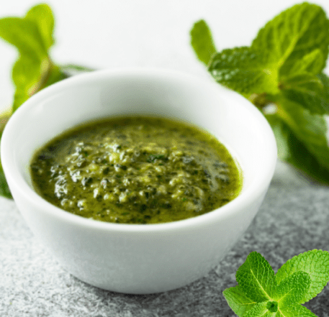
- 3 tablespoons water
- 2 tablespoons sugar
- 1/2 cup white-wine vinegar
- 2 cloves garlic, minced
- 3/4 teaspoon salt
- 4 tuna steaks, about 1 inch thick (about 2 pounds in all)
- 1 tablespoon olive oil
- 1/4 teaspoon fresh-ground black pepper
Methods:
- Put 1/3 cup of the mint in a medium glass or stainless-steel bowl. In a small stainless-steel saucepan, bring the water to a simmer over moderate heat. Add the sugar and stir until completely dissolved. Stir in the vinegar, garlic, and 1/4 teaspoon of the salt. Pour the mixture over the mint in the bowl. Let sit 15 minutes.
- Light the grill or heat the broiler. Coat the tuna with the oil. Season with the remaining 1/2 teaspoon salt and the pepper. Cook the tuna for 4 minutes. Turn and cook until done to your taste, 3 to 4 minutes longer for medium rare.
- Strain the mint sauce through a sieve into a sauceboat or serving bowl. Stir in the remaining mint. Pass the sauce with the fish.

Sweet and sour sauce

Ingredients:
- 1 pound tilapia fillets, cut into 2-inch pieces
- 2 tablespoons soy sauce
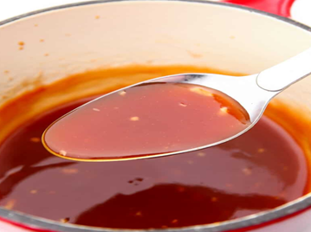
- ½ cup flour
- ½ cup cornstarch
- salt and pepper to taste
- 1 egg, well beaten
- canola oil
- 1 red bell pepper, seeded, cored, and cut into cubes
- 1 onion, peeled and sliced thinly

For Sweet and Sour Sauce
- 1 cup pineapple juice
- ½ cup rice vinegar
- ¼ cup ketchup
- ½ cup brown sugar
- 1 tablespoon cornstarch
- 1 teaspoon salt

Methods:
- In a bowl, combine fish and soy sauce. Marinate for about 30 minutes in the refrigerator. Drain well.
- In a bowl, whisk egg until frothy.
- In another bowl, combine flour, cornstarch, and salt and pepper to taste.
- Dredge fish fillets in flour mixture, dip in the beaten egg, and then dredge again in flour mixture to fully coat.
- In a pan over medium heat, heat about 1-inch deep of oil. Add battered fish fillets and cook, turning once or twice, until golden and cooked through. Remove from pan and drain on paper towels.
- In a bowl, combine pineapple juice, vinegar, ketchup, sugar, cornstarch, and salt. Stir until smooth.
- In a pan over medium heat, heat about 1 tablespoon oil. Add bell peppers and onions and cook, stirring regularly, until half cooked. Remove from pan and set aside.
- In the pan, add sauce mixture and bring to a boil, whisking regularly, for about 2 to 3 minutes or until thickened.
- Add bell peppers and onions and cook for about 1 minute or until tender yet crisp.
- Add fried fish fillets and cook and toss quickly just until coated with sauce. Serve hot.
  - White wine sauce
Ingredients:
- fish velouté 250 ml
- dry white wine 2 tbsp
- butter 50 g
- cream 2 tbsp
- salt, cayenne
- few drops of lemon juice
Methods:
- Boil the fish velouté. Whisk in the wine.
- Remove from the heat.
- Gradually add the butter. Stir in the cream.
- Correct the seasoning and consistency, add the lemon juice.
- Pass through a double muslin or fine strainer.

LAP Test | Practical Demonstration

Name : _____________________________ Date : ________________

Time started : _____________________________ Time finished : ________________
Instructions:
1. You are required to perform any of the following:
Request your teacher to arrange for you all necessary tools, materials and equipment. Submit your outputs to your teacher for evaluation.
Request a set of tools, materials, equipment for the tasks then perform the following tasks in front of your teacher:
Prepare:-
      - Grilled fish fillet
      - Grilled Salmon
      - Fish kedgeree
      - Whole baked Fish
      - Fish meunière
      - Poached fish
      - Fish Cutlets
      - Fish pie
  - Request your teacher for evaluation and feedback

Unit Three: Presenting fish dishes
This learning guide is developed to provide you the necessary information regarding the following content coverage and topics:
- Presenting fish dishes
- Storing Fish Items
This guide will also assist you to attain the learning outcomes stated in the cover page. Specifically, upon completion of this learning guide, you will be able to:
- Present Fish dishes items attractively using appropriate service ware that takes into consideration shape, color and texture, and according to the enterprise requirements.
- Store Fish dish items as required according to food hygiene and safety, under correct conditions and temperatures to maintain quality extend shelf life and maximize appearance and eating characteristics.

  - Presenting Fish dishes
Start with a well-sourced fish and a whole grain, gather up your repertoire of garnishes, and collect an assortment of white plates.
When plating, it is a particularly efficient way to showcase smaller components, without overcrowding them. The eye has enough white space to capture the individual entities.
To start, place two of the same items in succession - instead of finishing one portion to completion and replicating the next. This style works great as a duo or a trio and is often a welcome presentation for tapas, appetizers or portions to be shared. Try a rectangular plate for a more elongated surface area.
To achieve a sauce ‘teardrop’ or ‘swoosh’ effect, place a drop of thickened sauce in a squeeze bottle and squeeze a large circular drop onto the plate.
A perfectly cooked piece of fish deserves perfect presentation. There’s a lot of variety, some species of fish, pieces of fish and shellfish are small works of art in their own right. Others have a greater need for an appetizing setting. Here are a few tips:
    - Not Straight to the Plate
Always put a piece of boiled, steamed or poached fish on a cloth or piece of kitchen towel before putting it on the plate. If you don’t, excess liquid from the water bath will run out on the plate and dilute the sauce or make the garnish go soggy.
    - Don’t Stack Coated Fish
Fried, coated pieces of fish shouldn’t be put on top of each other. It will make the pretty, tasty surface go damp and fall apart.
    - Warm Plate, Cold Plate
A piece of fish weighing 150g with a temperature of about 50°C doesn’t stand a chance against half a kilo of icy cold china. Use warm plates.
Small, delicious pieces of chilled fish or shellfish quickly lose freshness on a china plate warm from the dishwasher. Use warm plates and cold plates for the right things.

    - Keep It Simple
With the day’s catch on the plate, you only need to do a minimum to create a culinary experience. Serve a simple meal in which every component has something to contribute. Unleash your imagination and your skills, but don't let your focus stray from the ingredients.
    - More Garnishes
Being on top of the right garnishes (see Choosing) is a big step towards more variety and tastier fish on your dinner table. Build a repertoire that includes lemon, browned butter, parsley, chives, dill, eggs, prawns, asparagus, horseradish, spinach, mushrooms, bacon, air-dried ham, capers, beetroot, tomato, garlic, tapenade....
    - Think Color and Consistency
A dish based on fish can easily turn into a rather pallid experience on the plate. Work with garnishes that add color. Work with textures that interact with the mild flavor and flaky consistency of the fish. Crunchy vegetables or a little crisp-fried bacon. Green herbs, yellow onion, red tomatoes, attractive shellfish, etc. But avoid ingredients that don’t contribute to the whole.
    - Think Sauce
In a fish dish, the sauce often brings the other ingredients together. It adds fat, umami, sourness, salt and sweetness where the other ingredients are often more timid in flavor.
    - Think Again
Do something new with something old. Serve fish with half a lemon, fried or grilled, cut side down. This is more than a “variation”, cooking the lemon creates new, exciting flavors. Think the same way about other accompaniments. Oven-bake the tomatoes, fry or pickle the vegetables, season and color the mayonnaise, for example.
  - Storing Fish items
After cooking, store seafood in the refrigerator 3 to 4 days. Any frozen fish or shellfish will be safe indefinitely; however, the flavor and texture will lessen after lengthy storage. For best quality, freeze (0 °F / -17.8 °C or less) cooked fish for up to 3 months.
Cooked fish can last in the fridge for three to four days. Place cooked fish in an airtight container to protect it from any odors in the fridge. Unlike raw fish, cooked fish can go on any shelf, excluding the bottom shelf where raw meat, fish or poultry is stored, in the fridge.
Table 3.1: Safe Handling of Fish in Cold Storage
No | Product | Refrigerator (40 °F) | Freezer (0 °F)
1. | Fresh Fish | 1-2 Days | 2-3 Months
2 | Cooked Fish | 3-4 Days | 1 Month
3 | Frozen Fish | Use Immediately | 3-6 Months
4 | Lightly Smoked Fish  (Like Salmon) | 1-2 Days | Not Recommended;  After 6 Months Loses Quality
5 | Heavily Smoked Fish  Kippered Cod, Smoked Whiting) | 6-7 Days | Not Recommended;  After 6 Months Loses Quality
6 | Dried or Pickled | 1 Week | Not Recommended;  After 6 Months Loses Quality
7 | Bisques, Broth, Chowders,  and Stews | 1-2 Days | 3-6 Months

Self-Check -3 | Written Test
Name……………………………………..Id………………….Time Allowed…………….
Directions: Answer all the questions listed below. Illustrations may be necessary to aid some explanations/answers. (20 points)
Test I: Short Answer questions:
  - Mention Storage temperature for cooked fish.
  - List at least 5 fish dishes presentation tips.

Note: Satisfactory rating - 10 points Unsatisfactory - below 10 points

You can ask you teacher for the copy of the correct answers.

REFERENCE
Waye Gisslin (2010), Professional cooking, 7th edition.
John Campbell (2011), Practical cookery, 11th edition.
Mark Bittman(1998), How to cook everything completely.
FDA Consumer Protection. Selecting and Serving Fresh and Frozen Seafood Safely. March, 2019

Participants of this Module (training material) preparation
No | Name | Qualification (Level) | Field of Study | Organization/ Institution | Mobile number | E-mail
1 | Mamit Ayalew | B | Hotel Mgt | Bishoftu P.College | 0911723484 | mamitayalew@gmail.com
2 | Marksew Shiferew | A | Food security | Misrak P.College | 0937645184 | markisews@gmail.com
3 | Wale Getaneh | A | Food Technology/TVET Leadership & Mgt | Bole M.College | 0929241229 | waleg917@gmail.com
4 | Biruk Adamu | B | Hotel Mgt | TTI | 0921355741 | birukadamu50@gmail.com
5 | Efrem kitila | B | Hotel Mgt | Woliso P.College | 0917289283 | efremkitila922@gmail.com
6 | Helen Adugna | B | Hotel Mgt | Selam TVET College | 0915573757 | helenadugna12@gmail.com
7 | Ali Kassaw | B | Hotel Mgt | Bardar P.College | 0918573970 | Kassawali2004@gmail.com
8 | Solomon Bekele | A | Hotel Mgt | G.winget PTC | 0911149147 | Soladvent06@gmail.com

