Culinary Art
Level-III

Based on September 2023, Curriculum Version II
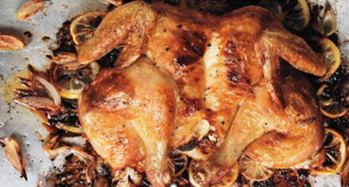

Module Title: Preparing Chicken Dishes
Module code: CST CUA3 M05 0923
Nominal duration: 70 Hours

Prepared by: Ministry of Labor and Skill

September, 2023
Addis Ababa, Ethiopia

Table of Contents
Contents
Pages
Acknowledgment 3
Introduction to the Module 4
Unit One: Selection of ingredients 5
1.2.Selecting and Preparing Ingredients 7
1.2.1. Misen En Place 7
1.3.Qualities of chicken 9
1.4.Preparation Techniques 9
1.4.1. Rubs, Marinades, and sauces 11
1.4.2. Coating and breading Chicken 14
Self-Check -1 16
Unit Two: Producing Chicken Dishes 17
2.1. Producing chicken dishes 18
2.2. Preparing sauce and accompaniment 22
2.2.1. Sauces 22
2.2.2. Accompaniment foods 23
Self-Check -2 24
Operation Sheet 2.1: Producing Chicken dishes 25
LAP Test 40
Unit Three: Presenting chicken products 41
3.1. Dishes presentation 42
3.1.1. Presentation and plating Techniques 42
3.2. Storing chicken dishes 43
Self-Check -3 46
Participants of this Module (training material) preparation 48

Acknowledgment

The Ministry of Labor and Skills (MoLS) would like to express its gratitude and appreciation to the instructors and experts from regional TVT bureaus, TVT colleges, and industry practitioners who contributed their expertise and experience in preparing the training module for the unit of competency “Prepare Chicken Dishes” under the occupational standard "Culinary Art level-III."
The ministry also expresses its deepest gratitude to the Tourism Training Institute for its invaluable technical and financial support and collaboration in the module preparation. It is also thankful to MoLS staff members who coordinated the preparation and reviewing process of this training module.

Introduction to the Module

In Culinary art field, preparing chicken dishes, refers to select, prepare and present a variety of chicken dishes with appropriate sauces and accompaniments in line with the standardized recipes by following the right hygiene procedures.
This module is designed to meet the industry requirement under the Culinary Art occupational standard, particularly for the unit of competency: Prepare Chicken Dishes
This module covers the units:
- Selecting and preparing ingredients
- Producing chicken products
- Presenting chicken products
Learning Objective of the Module
- Select and prepare Ingredients
- Produce Chicken products
- Present chicken Dishes

Module Instruction
For effective use this modules trainees are expected to follow the following module instruction:
- Read the information written in each unit
- Accomplish the Self-checks at the end of each unit
- Perform Operation Sheets which were provided at the end of units
- Do the “LAP test” giver at the end of each unit and
- Read the identified reference book for Examples and exercise

Unit One: Selection of ingredients
This unit is developed to provide you the necessary information regarding the following content coverage and topics:
  - Hygiene Practice
  - Selection of ingredients
  - Qualities of chicken
  - Preparation techniques
This unit will also assist you to attain the learning outcomes stated in the cover page.
Specifically, upon completion of this learning guide, you will be able to:
  - Apply safe occupational health and food hygiene practices for preparing, cooking, presenting and storing chicken
  - Identify tools and equipment to handle ingredients
  - Use protective equipment to minimize risk of contamination
  - Select fresh or frozen ingredients required by recipes
  - Prepare and portion ingredients according to recipe specification
  - Use appropriate preparation techniques

  - Hygiene practice
Food hygiene is the practice of handling, preparing, and storing food in a way that prevents food borne illnesses. Also, it's a set of guidelines designed to keep food safe from contamination and spoilage. Practice these points for handling and preparing chicken dishes to avoid contamination:
- Always cook chicken thoroughly: Chicken must reach at least 75°C for 2 minutes or longer in the thickest part of the meat - always use a thermometer to check the temperature.
- Check the juices when cooking: Juices should run clear (not pink) when the meat is pierced with a fork or skewer
- Never wash raw chicken: Washing raw chicken can splash bacteria-contaminated juices onto the sink, preparation surfaces and equipment such as chopping boards
- Always wash your hands: Do this before handling raw chicken (to prevent bacteria from your hands contaminating the meat) and after handling raw chicken (so that you don't cross-contaminate other objects)
- Clean and sanitize preparation equipment: Ensure knives, chopping boards, kitchen surfaces and containers are all thoroughly cleaned and sanitized after coming into contact with raw chicken
- Use separate and utensils: Have separate equipment and utensils for preparing raw chicken and other meats, and never use these items for foods that don't need to be cooked such as fruits and vegetables used in salads
- Store raw chicken carefully: Keep raw chicken in tightly sealed containers, and ensure that the outside surfaces of storage containers don't come into contact with raw meat. Always store raw chicken below cooked and ready-to-eat items in the refrigerator
- Never defrost chicken at room temperature: Always defrost chicken in the refrigerator or in the microwave (in fact, it's best practice to never defrost any food at room temperature)
- Freeze chicken that won't be consumed within 2 to 3 days: Freezing chicken prevents the growth of harmful bacteria. If you've purchased chicken that won't be eaten within 72 hours then freeze it and defrost it later.
- If in doubt, throw it out: The golden rule of food safety. If any of the previous tips haven't been followed, or you're unsure about the safety of any food, don't take chances - throw it out!

Selecting and Preparing Ingredients

Misen En Place

Mise En Place is a French kitchen phrase that means “putting in place" or “gathering.” It refers to the discipline and organization a good chef exhibit in the kitchen. To practice Mise En Place, a chef should have all of their ingredients and supplies prepared and organized before they begin cooking.
- Importance of Mise En Place
Whether you're a baker, a chef, or a restaurant manager, Mise En place is an essential habit to learn. The key benefits associated with Mise En Place and how they relate to your workplace:
- Efficiency: Mise En Place facilitates efficiency in the kitchen. By doing prep work before they begin cooking, your staff will save time and move seamlessly through the steps of each recipe.
- Organization: An organized workplace is the first step towards success. It reduces confusion in the workplace and cuts down on wasted product. By keeping all of your equipment and ingredients in one place, your staff won't have to navigate the kitchen while they cook.
- Preparation: With Mise En Place, identify missing ingredients before they cook. This ensures that orders are completed on time and recipes are prepared correctly.
- Decreased waste: By measuring your ingredients beforehand, you can reduce food waste. Over time, this can help save money.

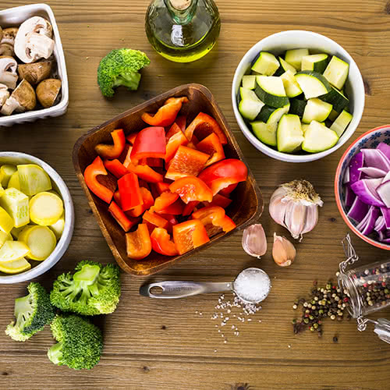
Figure1.1: Mise En Place
- These are steps for preparing ingredients and tools for chicken preparation:-
Step 1: Read over the recipe and develop a plan.
- Take an inventory of all the required ingredients. Identify what ingredients you have on hand, and what ingredients are still required. You may have to run to the local supermarket to stock up on missing items before you begin cooking.
- Select of all the necessary kitchen tools such as pots, pans, ladles, measuring cups…etc. Are you missing anything?
- Identify and allow for any longer lead prep items such as marinated foods. The recipe may take longer than anticipated because the chicken needs 6 hours to marinate for example.
- Analyze each step in the recipe and develop a plan. Determine the best way to combine ingredients during the pre-portioning process to be the most efficient. Measure and pre-portion ingredients into groups based on when they are deployed into the recipe.
Step 2: Gather all ingredients and organize kitchen tools on the countertop.
Step 3: Dice, chop, slice, and mince all ingredients as required by the recipe.
Step 4: Pre-measure and portion all ingredients into portion cups or bowls.
- If possible combine multiple ingredients into 1 portion cup or bowl based on, when they are added to the recipe.
Step 5: Organize pre-portion ingredients on the countertop in the order they are added to the recipe.
Step 6: Clean as you go.
- Prepare a sink of hot soapy water with clean dish towels and sanitizer. It’s amazing how much better it feels to work in a clean working environment. There is less chance of cross-contamination between foods. A clean kitchen environment is less stressful because there is less clutter from dirty dishes and counters. The last big bonus is there are hardly any dishes left to wash at the end of the day.

Qualities of chicken

The following list indicates the quality points to look for when purchasing poultry.
  - Plump breasts
  - White unbroken skin
  - Pliable breast bone
  - Pleasant smell
  - Dry to the touch

Preparation Techniques

It's hard to imagine a more popular food than chicken, or an easier food to fix. Chicken pieces and boneless, skinless chicken breasts and thighs are especially versatile and easy to prepare.
There are a few techniques that are frequently used to add flavor and excitement to chicken. Here are some general guidelines for using these techniques successfully.

Flattening, Slicing and Dicing chicken

There are many different ways to prepare chicken. Flattening, slicing, and dicing chicken remain among the most popular because so many chicken recipes call for these preparation techniques.
When you flatten chicken, you pound to an even thickness. If a recipe calls for sliced chicken, cut across the grain for even, consistent pieces. Start dicing chicken once you have already cut it into strips.
      - Flattening
Many of the world's greatest chicken dishes -- such as chicken Marsala, chicken parmigiana, and chicken Florentine -- star boneless, skinless chicken cutlets. To promote even cooking, the uncooked chicken is gently pounded to an even thickness -- usually about 1/2 inch, though some scaloppini dishes call for even thinner cutlets. The solution is easy to achieve.
Remove the tenderloin from the underside of each cutlet. Place the uncooked chicken between two sheets of waxed paper or plastic wrap. Using the flat side of a meat mallet, a flat circular meat tenderizer, a rolling pin, or even the bottom of a small pan, gently pound the chicken from the center to the outside until the desired thickness is reached.
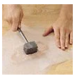
Figure 1.2: Flattening

      - Slicing and Dicing
Whole pieces of boneless, skinless chicken make great entree dishes. But if Asian stir-fry is more your speed, boneless, skinless chicken can make this fast favorite even speedier.
For perfect pieces, place the uncooked chicken on a cutting board. Using a sharp knife, slice the chicken crosswise across the grain into 1/4-inch strips. These strips also make great Buffalo chicken tenders.
If a recipe calls for diced uncooked chicken, line up the strips on the cutting board and cut them again into chunks.
Once you have the cut of chicken you want, there may be other steps involved in getting it ready to cook, namely flavorful rubs, marinades, and coatings. We'll look at the best ways to marinade and coat chicken in the next section.
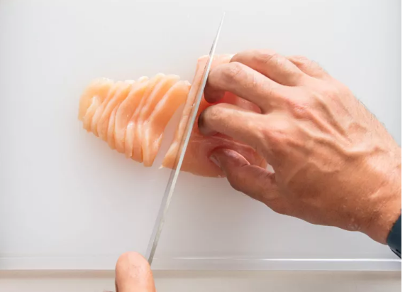
Figure 1.3: Slicing
    - Rubs, Marinades, and sauces
It's only natural, given the ease of cooking chicken pieces, breasts, and thighs, that there should be equally simple ways to add extra flavor and excitement to these favorites. Rubs and marinades take two different approaches to achieving this goal.
- Rubs
Rubs add flavor, seal in juices, and, in some cases, form a delicious crust. They can be applied just before cooking, or applied to the food and refrigerated for several hours before cooking for more pronounced flavor.
Dry rubs are seasoning blends rubbed onto foods. They often include coarsely ground black or white pepper, paprika, and garlic powder. Sometimes mustard powder, brown sugar, and ground red pepper are used. Crushed herbs, such as sage, basil, thyme, and oregano are other good choices.
Paste rubs are dry seasonings held together with small amounts of wet ingredients, such as oil, crushed garlic, prepared mustard, soy sauce, Worcestershire sauce, or horseradish.
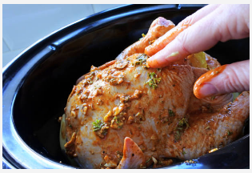
Figure 1.4: Rubbing
- Marinades
Marinades add flavor and also moisten the surface of the chicken to prevent it from drying out during cooking.
Flavoring marinades work quickly with chicken, especially boneless, skinless chicken pieces, so they are only marinated for a short period of time -- 15 minutes to two hours. You can choose to marinate chicken pieces in a plastic bag for easy clean-up.
Tenderizing marinades include an acidic ingredient tenderizing enzymes. These include, pineapple, papaya, kiwi, and figs. Bone-in chicken pieces can be marinated in a tenderizing marinade for a few hours. Boneless, skinless chicken pieces should be marinated in a tenderizing marinade for just a few minutes to impart flavor. Such as wine, vinegar, yogurt, tomatoes, lemon juice, and lime juice, combined with herbs, seasonings, and oil.
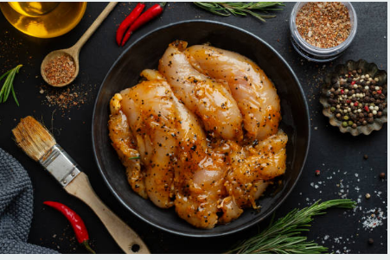
Figure 1.5: Marinade
- Basting and dipping sauces
Basting and dipping sauces can add another boost to chicken. Basting is the process of brushing, spooning, or pouring liquids over the chicken, as it cooks. This helps to preserve moistness, adds flavor, and gives foods an attractive appearance. Melted butter, pan drippings, broth, or a combination of these ingredients are frequently used.
While sometimes seasonings or flavorings are added to a basting sauce, you can prepare a separate recipe, if you prefer. Or, you can simply reserve some of the marinade before adding the chicken and use it to make a dipping sauce or to baste the meat while it is cooking.
Dipping sauces, such as barbecue sauce, are generally reserved for table use. Many dishes call for a separate dipping sauce recipe, but for a more simple presentation, bring in elements from the recipe, such as soy sauce, for the dipping sauce during the meal.
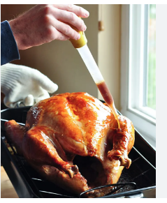
Figure 1.6: Basting in roasting pan

    - Coating and breading Chicken
Chicken is especially delicious when it's coated or breaded with flavorful ingredients before cooking. Yet too often, the delicious coating falls off and ends up in the pan instead of on the chicken. in this section, we'll show you how to coat and bread chicken.
- Bread chicken
Bread chicken to provide a crisp outer layer. The crumbs may be seasoned with herbs for additional flavor.
To bread chicken:
- First, dip the pieces into a beaten egg that has been thinned with oil, water, or both, so it leaves only a thin layer of egg on the chicken.
- Hold the dipped piece over the bowl for a couple of seconds so the excess drips off.
- Roll the chicken through a shallow plate of flour or place the flour in a resealable plastic food storage bag.
- Add the chicken a few pieces at a time, seal the bag, and shake to coat the chicken.

- Coating Chicken
As a general rule, chicken pieces should be thoroughly wiped dry with a paper towel so the coatings adhere, especially if the chicken has been marinated. Next, a thin coating of flour can help the breading stick better.
To coat chicken with a batter:
Dip each piece directly into the batter, or hold each piece over the bowl and use a spoon to pour the batter down over the chicken; shake off the excess. Or, to coat floured strips or chunks of chicken with a batter, use a fork to dip each piece in the batter and shake off the excess.
Use your fingertips to dip larger pieces.
Light, dry coatings can be used with or without the flouring step outlined above. Dip the pieces in beaten egg or melted butter. Combine the coating ingredients in a large reseal able plastic food storage bag. Add the chicken pieces a few at a time, closing tightly, and shaking to coat the chicken completely.
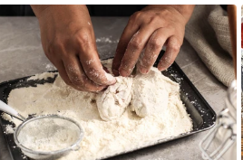
Figure 1.7: Coating

Self-Check -1 | Written Test

Name……………………………………..Id………………….Time Allowed…………….
Directions: Answer all the questions listed below. Illustrations may be necessary to aid some explanations/answers. (20 points)
Part-I: Choose the correct answer
- Which one of the following is good hygiene practice
- Only washing hands after preparation
- Wash row chicken
- Use one chopping board for chicken and vegetable
- Deforest chicken in refrigerator
- Which one of the following is chicken preparation techniques
- Flatting
- Coating
- Rubbing
- All of the above
- Plump breast is
- Quality of chicken
- Sign of spoilage
- Wastage

Part-II: write the short answer
- Write at least 4 points about hygiene practice?
- Write the importance of Mise En Place?

Note: Satisfactory rating - 10 points Unsatisfactory - below 10 points
You can ask you teacher for the copy of the correct answers.

Unit Two: Producing Chicken Dishes
This unit to provide you the necessary information regarding the following content coverage and topics:
  - Producing chicken dishes
  - Preparing sauces and accompaniments
  - Cookery techniques
This guide will also assist you to attain the learning outcomes stated in the cover page. Specifically, upon completion of this learning guide, you will be able to:
- Prepare chicken dishes with suitable sauce and accompaniments
- Effects of cooking Techniques on nutrition, taste, texture and appearance
- Apply cookery techniques. According to requirements of ingredients

Producing chicken dishes

Producing chicken dishes involves preparing and cooking chicken in various ways to create delicious and satisfying meals. There are countless chicken dishes from different cuisines around the world, each with its own unique flavors and cooking techniques. Here are a few examples of popular chicken dishes.
- Chicken a la king
Chicken a la king is easy and elegant. It's a great way to use leftover chicken or turkey. Green pepper and red pimientos make this a pretty dish to serve at Christmas or anytime. Serve over cooked rice, toast, or noodles. Can be made ahead and reheated.
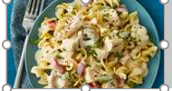
Figure.2.1: Chicken a la king
- Chicken fricassee
The original French comfort food, chicken fricassee is a classic—with as many variations as there are grandmothers in France. It's halfway between a sauté and a stew, simmered chicken with hearty vegetables in a rich, silky sauce. The dish relies on humble ingredients and is made in just a single pot. Traditionally it's served over rice, creamy mashed potatoes, or lightly buttered egg noodles. You'll also want to have a loaf of crusty bread on hand to sop up the extra sauce.
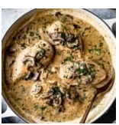
Figure 2.2: Fricassee
- Chicken Stew
Chicken Stew has juicy chicken in a savory broth with a perfect blend of seasonings, potatoes, and vegetables. It’s easy to make on the stove top and is full of homemade flavor
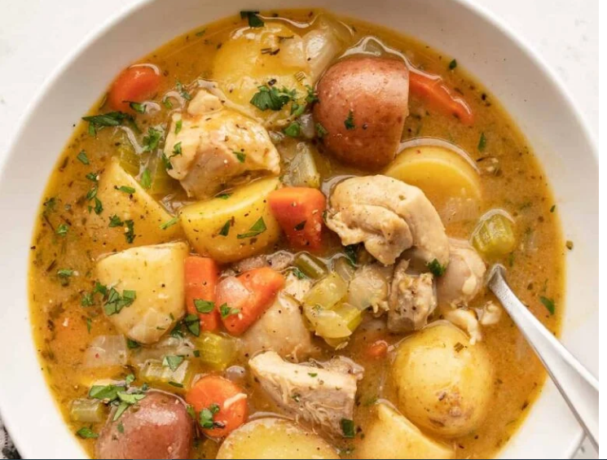
Figure 2.3: Stew
- Chicken Pie
Discover the secrets to a great chicken pie. We use an easy one-pan filling, and bake it in a cake tin so it can be easily turned out and cut into neat wedges
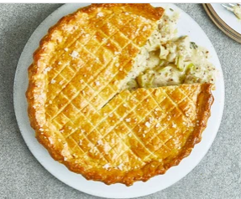
Figure 2.4: chicken Pie

- Roasted Chicken
The best roast chicken has garlic herb butter under and on the skin, is stuffed with lemon and herbs, roasted until it’s crispy and deep golden on the outside, and juicy on the inside.

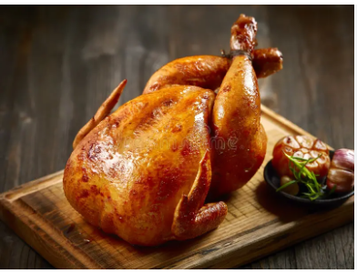
Figure 2.5: Roasted chicken
- Spachcoack chicken
The technique of spatchcocking requires splitting and flattening the chicken. It exposes more skin, which really crisps up at high temperatures. See our step-by-step guide to spatchcocking a chicken, then use this recipe to put together two other delicious meals: Chicken-and-Rice Soup and Escarole Salad with Lardons and Poached Eggs.
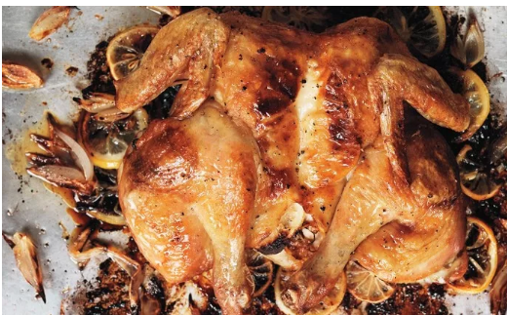
Figure 2.6: spachcoack
- Chicken sauté with mushrooms
This easy one pan 30 minute meal is perfect for a weeknight family meal. Sautéed chicken and mushroom is made with simple ingredients and loaded with flavor.

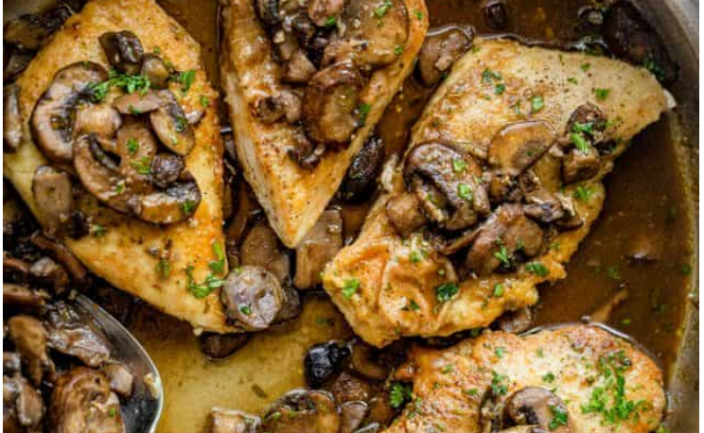
Figure.2.7: sauté chicken

- Teriyaki Chicken
Sticky Asian-style teriyaki chicken for a speedy weeknight supper – it takes just 20 minutes to make! Serve it with sticky rice and steamed greens.
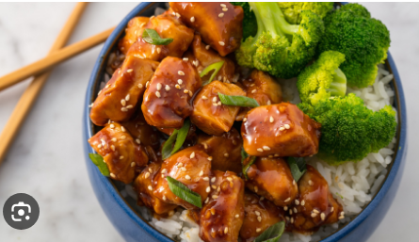
Figure 2.8: Teriyaki
- Grilled Caesar Chicken
Marinated overnight in creamy Caesar dressing, this grilled Caesar chicken recipe is juicy, tender and full of flavor.

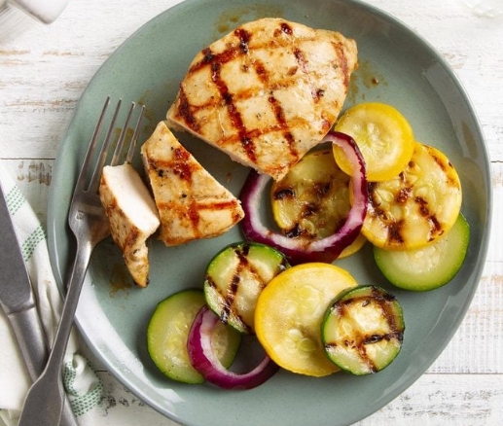
Figure.2.9: Caesar

- Stuffed chicken with spinach and ricotta cheese
Chicken is stuffed with a spinach ricotta cheese filing to create an easy dinner any day of the week.
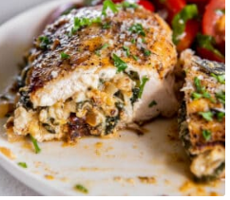
Figure 2.10: Stuffed chicken
k. Baked chicken thigh with white wine sauce
A gourmet-style dish with crisp, golden baked chicken thighs smothered in a white wine sauce with mushrooms. This mouthwatering dish is baked right in the pan! Easy and delicious!
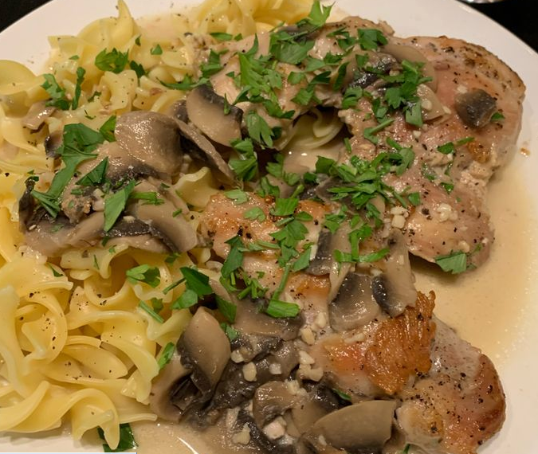
Figure 2.11: baked chicken

Preparing sauce and accompaniment

    - Sauces

A sauce may be defined as a flavorful liquid, usually thickened, used to season, flavor, and enhance other foods.
A sauce adds the following qualities to foods:
- Moistness
- Flavor
- Richness
- Appearance (color and shine)
- Interest and appetite appeal
Sauce for chickens
- Mush room sauce
- White wine sauce
- Lemon sauce
    - Accompaniment foods
Accompaniment food is something added to or served with food or a meal. This dish can be served as an accompaniment to/for most meat main dishes. This wine is a good accompaniment for/of spicy foods.
Recipes Go With Chicken dishes
- Sauteed Green Beans.
- Ranch Roasted Potatoes.
- Steamed Broccoli.

Self-Check -2 | Written Test

Name……………………………………..Id………………….Time Allowed…………….
Directions: Answer all the questions listed below. Illustrations may be necessary to aid some explanations/answers. (20 points)

Part-I: Give short answer
- Write sauce used for chicken dishes
- What types of foods used for an accompaniment of chicken dishes
- Write the use of sauce

Note: Satisfactory rating - 10 points Unsatisfactory - below 10 points
You can ask you teacher for the copy of the correct answers.

Operation Sheet 2.1: Producing Chicken dishes

- Chicken ala king

Ingredients Quantity
Button mushrooms 100 g
Butter or margarine 25 g
Red pimento 50 g
Cooked boiled chicken 400 g
Sherry 30 ml
Chicken volute 125 ml
Cream or non-dairy cream 30 ml
Procedure:
- Wash, peel and slice the mushrooms.
- Cook them without color in the butter or margarine.
- If using raw pimento, discard the seeds, cut the pimento in dice and cook with the mushrooms.
- Cut the chicken in small, neat slices.
- Add the chicken to the mushrooms and pimento.
- Drain off the fat. Add the sherry.
- Add the volute, bring to the boil.
- Finish with the cream and correct the seasoning.
- Place into a serving dish and decorate with small strips of cooked pimento.
Note: 1 or 2 egg yolks may be used to form a liaison with the cream mixed into the oiling mixture ate the last possible moment and immediately removed from the heat. Chicken a la king may be served in a border of golden brown duchesse potato or a pilaf of rice may be offered as an accompaniment. It is suitable for hot buffet dish.

- Chicken fricassee
Ingredients quantity

Chicken 1 ¼ -1 ½ kg 1
Butter or margarine 50 g
Flour 35 g
Chicken stock ½ lit
Yolks of eggs 1-2
Cream 4 tbsp.
Chopped parsley

Procedure:
- Cut the chicken as for sauté an season with salt and pepper.
- Place the butter in a sauté pan. Heat gently.
- Add pieces of chicken. Cover with a lid.
- Cook gently on both sides without coloring. Mix in the flour.
- Cook out carefully without coloring. Gradually mix in the stock.
- Bring to the boil and skim. Allow to simmer gently until cooked.
- Mix the yolks and cream in a basin /liaison/.
- Pick out the chicken into a clean pan.
- Pour a little boiling sauce on to the yolks and cream and mix well.
- Pour all back into the sauce, combine thoroughly but do not re-boil.
- Correct the seasoning and pass through a fine strainer.
- Pour over the chicken, reheat without boiling.
- Serve sprinkled with heart-shaped croutons, fried in butter.

Note: A fricassee of chicken with button onions and mushrooms can be made similarly with the addition of 50-100 g button onions and 50-100 g button mushrooms. They are peeled and the mushrooms left whole, turned or quartered depending on size and quality. The onions are added to the chicken as soon as it comes to the boil and the mushrooms 15 minutes later. Heart-shaped croutons may be used to garnish. This is a classic dish known as fricassee de
- Chicken stew
Ingredients:
- 1 yellow onion ($0.28)
- 3 ribs celery ($0.64)
- 4 cloves garlic ($0.32)
- 1/2 lb. carrots
- 1.75 lbs. boneless, skinless chicken thighs
- 4 Tbsp all-purpose flour, divided
- 2 Tbsp butter
- 1 Tbsp olive oil
- 1.5 lbs. baby potatoes
- 1 tsp dried parsley
- 1/2 tsp dried thyme
- 1/2 tsp dried rosemary
- 1/2 tsp dried sage ($0.05)
- 1/4 tsp freshly cracked black pepper
- 2 cups chicken broth ($0.26)
- 2 cups vegetable broth ($0.26)
- 1 Tbsp chopped fresh parsley (optional) ($0.10)

Procedure:
- Dice the onion and celery, mince the garlic, slice the carrots, and cut the baby potatoes in half before you begin.
- Cut the chicken thighs into 1-inch pieces. Sprinkle 2 Tbsp of the flour over the chicken and toss until the chicken is evenly coated.
- Add the butter and olive oil to a large pot. Heat the butter and oil over medium until they are hot and sizzling.
- Add the flour-coated chicken to the pot with the butter and oil and allow the chicken to brown on all sides (avoid stirring until browned on the bottom). When the chicken is browned and there is a nice brown layer of flour on the bottom of the pot, remove the chicken to a clean bowl with a slotted spoon. The chicken does not need to be cooked through at this point, just browned on the outside.
- Add the onion, celery, garlic, and carrots to the pot and continue to sauté until the onions are soft. Use the moisture released by the vegetables to dissolve and scrape the browned bits off the bottom of the pot.
- Once the vegetables are slightly softened, add the remaining 2 Tbsp flour to the pot and continue to sauté over medium for about two minutes more. The flour will begin to coat the bottom of the pot again.
- Return the browned chicken to the pot. Also add the potatoes, parsley, thyme, rosemary, sage, pepper, chicken broth, and vegetable broth. Stir to combine and dissolve any flour off the bottom of the pot.
- Place a lid on the pot and allow it to come up to a boil. Once it reaches a boil, remove the lid and turn the heat down to medium-low. Allow the stew to simmer over medium-low, without a lid and stirring occasionally, for about 30 minutes or until the potatoes are tender and the broth has thickened.
- Taste the stew and add salt if needed (I did not add any, but it will depend on the salt content of the broth you used). Add a tablespoon of fresh chopped parsley if desired, and serve hot.

- Chicken pie
Ingredients:
- 50g butter
- 1 leek, finely sliced
- 8 skinless, boneless chicken thighs, cut into chunks
- 1 thyme sprig, leaves picked
- 2 bay leaves
- 2 tbsp plain flour
- 100ml white wine or dry sherry
- 300ml chicken stock
- 100ml crème fraîche or double cream
- 1 tbsp mustard (we used wholegrain, but use whatever variety you have)
For the Pastry
- 150g cold butter, cut into cubes, plus extra for the dish
- 400g self-raising flour, plus extra for dusting
- 1 egg, beaten
Procedure:
      - Melt the butter in a casserole dish over a low heat. Add the leek, chicken, herbs and seasoning, and cook for 10-12 mins until the chicken is cooked, the leeks have softened, and the mixture is simmering. Stir in the flour and cook for 3 mins until the mix resembles a sandy paste. Pour in the wine or sherry, and bubble for 1 min, then stir in the stock, crème fraîche or cream and the mustard. Bring to a simmer. Cook for 10 mins until the chicken is cooked through. Season to taste, remove from the heat and leave to cool completely. Tip into a container and chill for 2 hrs, or overnight. Will keep chilled for up to two days.
      - To make the pastry, rub the butter into the flour with a large pinch of salt until completely combined. Add half the beaten egg and 4 tbsp ice-cold water, and bring together into a dough using your hands, adding a little more water if needed. Knead for a minute so it completely comes together, then chill for 1 hr.
      - Butter a 20cm loose-bottomed cake tin. Roll two-thirds of the pastry out until large enough to line the tin with some overhanging. Use it to line the tin, then spoon in the filling. Roll out the remaining pastry until large enough to cover the pie. Brush the edge of the pastry with a little of the remaining beaten egg, then drape over the pie to close it. Trim the edge, then press with a fork to seal. Chill until you’re ready to cook. Will keep chilled for up to 24 hrs.
      - Heat the oven to 220C/200C fan/gas 7 with a baking sheet inside. Brush the pie with some of the remaining beaten egg, then lightly score a criss-cross pattern on top using a sharp knife. Bake on the hot sheet for 20 mins, then brush with the rest of the egg, season with sea salt flakes and bake for 15-20 mins more until deep golden. Remove from the oven and rest for 10 mins, then carefully remove from the tin, put on a board and cut into wedges to serve.
      - Roast chicken
Ingredient:
- 1 kilograms chicken
- For Marination
- 1 teaspoon chilli flakes
- 1/2 teaspoon paprika
- 1 teaspoon lime zest
- 2 teaspoon canola oil/ rapeseed oil
- 2 pinches powdered black pepper
- 4 cloves crushed garlic
- 1 teaspoon oregano
- 60 ml red wine vinegar
- salt as required
For Garnishing
- 2 handful chopped coriander leaves
Procedures:

Step 1 Wash the chicken
Roasted chicken recipe is a simple yet delicious chicken dish, which can be prepared in a few minutes at the comfort of your home. Here’s how you can prepare this delicious recipe. Wash the chicken pieces and scoop out the stomach. Then wash it in the running water and drain out the excess water.

Step 2 Marinate the chicken
In the meantime, preheat the oven at 200 degree C. Then, take a small bowl and make the chicken marinade by using chilli, garlic, paprika, oregano, lemon zest, vinegar, oil, salt and pepper. Mix well to combine. You can add some spices and herbs as per your taste preference.

Step 3 Bake
Grease/ brush the baking tray with some oil. Then, place the chicken on the baking tray and pour over the chilli mixture and spread it all over to coat the chicken. Ensure the mixture is well coated. Now place the chicken in preheated oven and brush it well with some oil. Once the chicken is well coated, let it cook for 45 minutes or till done. Keep checking the chicken and if you find it to be too dry, brush it with some more oil.

Step 4 Serve hot
Remove from the oven, let it cool and garnish with chopped coriander leaves. You can also serve it with some creamy mashed potatoes, this will make it taste more delicious

      - Chicken Spachcoack
Ingredients:
- 1 whole 4-pound chicken
- 2 tablespoons plus 1 teaspoon extra-virgin olive oil, divided
- Kosher salt and freshly ground pepper
- 2 lemons, thinly sliced, divided
- 6 small shallots (6 ounces), peeled and quartered lengthwise
Procedure:
- Preheat oven to 425 degrees. Place chicken, breast side down, on a work surface. Starting at thigh end, cut along 1 side of backbone with kitchen shears. Turn chicken around; cut along other side. Discard backbone or save for stock. Flip chicken, and open it like a book. Press firmly on breastbone to flatten.
- Rub chicken with 1 tablespoon oil, and season with 1 tablespoon salt and 1/2 teaspoon pepper. Brush 1 tablespoon oil in the center of a rimmed baking sheet slightly larger than the size of the chicken, and place half the lemon slices in a single layer on top of oil. Place chicken, skin side up, on lemons. Beginning at the neck end of breast, carefully loosen skin from flesh of breast and thighs with your fingers. Slide remaining lemon slices under skin in a single layer.
- Roast chicken 20 minutes. Toss shallots with remaining teaspoon oil, and scatter around chicken. Continue to roast chicken until a thermometer inserted into thickest part of breast reaches 165 degrees, 25 to 30 minutes more.
- Transfer chicken to a carving board, and let rest 10 minutes. Cut chicken into 8 pieces, and serve with roasted lemons, shallots, and pan juices. If using chicken for soup and salad, let chicken cool completely. Remove and discard skin, lemon under skin, and bones, and shred meat into bite-size pieces. Chicken, roasted lemons, shallots, and pan juices can be refrigerated up to 2 days. Store meat and pan juices in separate containers; lemons and shallots can be stored together.
      - Sauté chicken with Mush room

Ingredients:
- 4 6 ounces chicken breasts
- Salt and pepper
- ¼ cup all-purpose flour
- 3 tablespoon olive oil
- 1 teaspoon dried thyme
- 1 pound button mushrooms trimmed and quartered
- ½ cup vegetable broth
- ¼ cup chopped parsley
Procedure:
- Place flour in a shallow dish. Season chicken with salt and pepper, then coat with flour, shaking off excess.
- In a large skillet, heat oil and 1 tablespoon olive oil over medium-high. In batches, cook chicken until browned and cooked through, about 3 minutes per side. Transfer to a plate and tent loosely with foil.
- Reduce heat to medium, add thyme, mushrooms, and remaining 2 tablespoons olive oil, and cook until softened, 6 minutes.
- Add broth and cook, stirring, until reduced by half, 3 minutes. Season with salt and pepper. Return chicken to pan along with any accumulated juices; top with parsley.

      - Teriyaki chicken
- 2 tbsp toasted sesame oil
- 6 skinless and boneless chicken thighs, sliced
- 2 large garlic cloves, crushed
- 1 thumb-sized piece ginger, grated
- 50g runny honey
- 30ml light soy sauce
- 1 tbsp rice wine vinegar
- 1 tbsp sesame seeds, to serve
- 4 spring onions, shredded, to serve
- sticky rice, to serve
- steamed bok choi or spring greens, to serve
Procedure:
- Heat the oil in a non-stick pan over a medium heat. Add the chicken and fry for 7 mins, or until golden. Add the garlic and ginger and fry for 2 mins. Stir in the honey, soy sauce, vinegar and 100ml water. Bring to the boil and cook for 2 - 5 mins over a medium heat until the chicken is sticky and coated in a thick sauce.
- Scatter over the spring onions and sesame seeds, then serve the chicken with the rice and steamed veg.

      - Grilled Caesar Chicken

Ingredients:
- 1/2 cup creamy Caesar salad dressing
- 3 tablespoons olive oil
- 3 tablespoons Dijon mustard
- 6 garlic cloves, minced
- 4 boneless skinless chicken breast halves (6 ounces each)

Procedure:
- In a shallow dish, combine dressing, oil, mustard and garlic. Add chicken; turn to coat. Cover and refrigerate for 8 hours or overnight.
- Drain chicken, discarding marinade. Grill chicken, covered, over medium heat or broil 4 in. from the heat until a thermometer reads 165°, 7-8 minutes on each side.
      - Stuffed chicken with spinach and ricotta cheese
Ingredients:
- 4 boneless skinless chicken breasts
- Kosher salt, to taste
- Black pepper, to taste
- tablespoons extra virgin olive oil, divided
- 1/2 cup yellow onion, diced
- 3 cloves garlic, minced
- 2 cups fresh spinach, chopped
- 2 tablespoons fresh parsley, chopped
- 1/2 cup ricotta cheese
- 1/4 cup shredded mozzarella
- 1/4 cup grated Parmesan
- 1 egg yolk
- 1 teaspoon dried oregano
- pinch nutmeg

Procedures:
- Preheat the oven to 375 degrees Fahrenheit.
- Pat the chicken breasts dry. Lay a chicken breast flat on a cutting board. Using a sharp knife, carefully cut a 3-4 inch wide pocket into the thickest part of the breast, being sure not to split the breast completely. Repeat with each breast, then season on both sides with salt and pepper to taste.
- In a large skillet, heat 1 tablespoon of olive oil over medium heat. Add onion and garlic and saute for 3-5 minutes, stirring often, until softened.
- Stir in spinach and parsley, and cook for 2-3 minutes, until spinach wilts and moisture evaporates. Transfer to a bowl and allow to cool completely. Clean out the skillet and set it aside.
- Meanwhile, in a large bowl, mix together the ricotta, mozzarella cheese, Parmesan cheese, egg yolk, oregano, nutmeg, salt and pepper. When the spinach mixture has cooled, stir it into the cheese mixture until combined.
- Divide the stuffing mixture into the pocket of each chicken breast.
- In the clean skillet, heat remaining olive oil over medium-high heat until hot. Add the chicken in and cook on one side for 5-7 minutes until golden, then carefully turn over and cook on the other side for another 5 minutes. Place the skillet in the oven and bake for 16-20 minutes, or until the internal temperature in the thickest part of the chicken is 165 degrees F.
- Transfer the chicken to a serving platter and allow it to rest for 3-5 minutes before serving. Serve with a salad or your favorite vegetables and starches

      - Baked chicken thigh with white wine sauce
Ingredients:
- 8 boneless skinless chicken thighs
- Salt/Pepper
- 1 tbsp vegetable oil, separated
- 1 c white wine
- 4 tbsp butter
- 1 tbsp garlic, minced
- 1 tsp lemon juice
- 8 ounces white button mushrooms, washed and sliced
- ¼ c heavy cream, optional
- Parsley, roughly chopped, to garnish

Procedures to make Baked Chicken Thighs in White Wine Sauce:
- Use a paper towel to remove excess moisture from the chicken thighs.
- Season the chicken thighs with salt and pepper.
- In a cast-iron skillet, heat a tbsp oil over medium-high heat.
- Sear 4 pieces of chicken thighs smooth-side down for about 13 minutes.
- Loosen the chicken by rotating the pan to move the oil around. Carefully lift the chicken using a thin spatula and place on a plate.
- If the oil starts to splatter, adjust the heat to medium and sear the rest of the chicken thighs.
- Prepare the oven. Preheat it to 350 degrees.
- Saute the mushrooms in butter using the same pan for about 8 minutes until the mushrooms start to brown and caramelized.
- Pour white wine into the pan. Scrape up the chicken scraps with a metal spatula to deglaze the pan.
- Add in the garlic and lemon juice and cook for another minute.
- Stir in the heavy cream before adding the chicken thighs back into the pan, sear side up. Continue to cook for 5 minutes more.
- Place the pan in the preheated oven and bake for about 15 minutes.
- Before serving, garnish with parsley. This dish is best to serve alongside brown rice or roasted green beans.
Sauces
            - Mush room sauce
Ingredients:
- 2 tbsp dried porcini mushrooms
- 1 tsp butter
- 2 shallots, finely diced
- 200g chestnut mushrooms, sliced
- 200gcrème fraîche
Procedures:
STEP 1:
Pour 100ml of boiling water over the dried porcini and leave to stand for 5 mins. In a saucepan, heat the butter and add the shallots, frying gently until they are soft and translucent. Add the chestnut mushrooms and cook for 5 mins more. When they are cooked, pour in 1 tbsp of the liquor from the porcini and discard the rest. Chop the porcini and add them to the pan. Fold in the crème fraîche, bring to a simmer then season.
            - White wine sauce
Ingredients:
- 1 Onion
- 1 Chicken stock cube
- 150ml White wine
- 300ml Double or single cream
- Crushed garlic clove (optional)
- Spinach (optional)
- Olive Oil
Procedures:
      - Fry the chopped onions in the oil in a frying pan until soft.
      - Next add the stock to the pan along with the white wine and simmer for 10 minutes.
      - Pour in the cream and add the spinach and garlic and simmer for further 10 minutes or until a desirable thickness is achieved.

      - Lemon sauce
Ingredients:
- 2cups chicken broth
- ¹⁄₂cup fresh lemon juice
- ³⁄₄cup sugar
- 1lemon, zest of
- ¹⁄₄cup cornstarch
- ¹⁄₄cup cold water
Procedures:
- In saucepan bring chicken stock to a boil and then add lemon juice, sugar and zest.
- Return mixture to a boil.
- Blend together cornstarch and cold water and stir into the lemon sauce.
- Cook until thickened, stirring frequently and adjust seasoning to taste.
Accompaniment
            - Sautéed Green Beans
Ingredients:
- 1 tablespoon extra-virgin olive oil
- 3/4 pound green beans ends trimmed
- 1/4 teaspoon kosher salt
- 2 teaspoon soy sauce or another pinch of kosher salt
- 1 teaspoon rice vinegar apple cider vinegar, or freshly squeezed lemon juice

Procedures:
- Heat a large skillet over medium heat until it’s good and hot. Add the oil, swirl to coat, and then add the green beans, spreading them into an even layer.
- Add the salt, and then cover (if your pan doesn’t have a lid, cover it with a baking sheet). Cook for 2 minutes, stir and spread the green beans back into an even layer, the recover and continue cooking 2 minutes more.
- Stir in the soy sauce. Recover and cook until the green beans are crisp-tender and browning in spots, about 4 to 6 minutes more. Stir them every 2 minutes to make sure they brown evenly. If at any point the green beans start to burn, reduce the heat and add a little water to the pan as needed. Watch the green beans carefully to make sure they don’t overcook and become mushy.
- Remove from the heat. Stir in the vinegar. Taste and adjust the seasoning as desired

LAP Test | Practical Demonstration

Name : _____________________________ Date : ________________

Time started : _____________________________ Time finished : ________________
Instructions:
1. You are required to perform any of the following:
Request your teacher to arrange for you all necessary tools, materials and equipment. Submit your outputs to your teacher for evaluation.
Request a set of tools, materials, equipment for the tasks then perform the following tasks in front of your teacher:
Task 1: Prepare Chicken a la king
Task 2: Prepare Chicken fricassee
Task 3: Prepare Chicken stew
Task 4.: Prepare Chicken pie
Task 5 : Prepare Roasted chicken
Task 6: Prepare Chicken spatchcock
Task 7: Prepare Chicken sauté with mushrooms sauce
Task 8: Prepare Teriyaki chicken
Task 9: Prepare grilled Caesar Chicken with grilled Beans
Task 10: Prepare Stuffed chicken with spinach and ricotta cheese
Task 11: Prepare baked chicken thigh with white wine saucePerform battery slow charging

            - Request your teacher for evaluation and feedback

Unit Three: Presenting chicken products
This learning guide is developed to provide you the necessary information regarding the following content coverage and topics:
- Dish presentation
- Storing chicken products
This guide will also assist you to attain the learning outcomes stated in the cover page. Specifically, upon completion of this learning guide, you will be able to:
- Select service ware
- Present chicken dishes attractively
- Present chicken products with suitable sauce
- Store chicken products hygienically

  - Dishes presentation

    - Presentation and plating Techniques
Step into the wonderful world of food presentation and plating, where culinary artistry meets visual delight. Beyond the delicious flavors, how a dish looks can make the dining experience even more special.
- ‍Keep It Simple: Less is More
‍Embrace simplicity. Avoid overcrowding the plate with too many things that might confuse the diner. Let the main dish shine and add small touches of garnish and color to enhance the overall presentation.
- Play with Colors and Textures
‍Colors and textures can make a dish more appealing. Create contrasts by combining bright ingredients with neutral ones. Add different textures, like crispy and creamy, to make the dish more interesting.
- Mindful Portioning: Balance is Key
‍Proper portioning makes a dish look balanced and attractive. Be thoughtful about the sizes of each element on the plate. Arrange them in a way that makes the dish look inviting and harmonious.
‍Picture a delectable Indonesian Sate platter, showcasing succulent skewers of grilled meat accompanied by a medley of pickled vegetables and a generous drizzle of peanut sauce.
- The Rule of Thirds: Creating Balance
‍Use the rule of thirds, a classic artistic guideline. Imagine the plate divided into three sections and place the main components accordingly. This technique adds movement and interest to the dish.
- Temperature and Timing: Serve It Fresh
‍Consider the temperature and timing when plating. Serve hot items while they're still fresh and maintain the temperature contrast between hot and cold elements. A well-timed plate ensures that the flavors are at their best, captivating the diner's senses.
- Edible Garnishes: Beauty and Flavor
‍Garnishes should not only look good but also be edible and go well with the dish. Fresh herbs, edible flowers, or microgreens can add color and flavor, turning the plate into a work of art.
- Avoid Common Plating Mistakes
‍Be mindful of common plating mistakes. Avoid overcrowding the plate, using clashing colors, or placing sauces randomly. Simplicity, balance, and elega7nce are the keys to a great presentation.
- ‍Choose the Right Plate
‍Select the right plate to showcase your creation. Consider the plate's shape and size to ensure the dish fits nicely and allows the colors and arrangement to stand out.

  - Storing chicken dishes
- Proper Storage
Chicken should be stored at a temperature outside of the temperature zone in which bacteria, that causes foodborne illness, grows quickly. The danger temperature zone is a range between 40°F and 140°F. Raw chicken can be stored in a refrigerator for several days. If it is not going to be used within the recommended time, it should be frozen to prevent it from perishing. Leftover cooked chicken should be wrapped tightly and refrigerated as soon as possible. Do not leave the chicken at room temperature for more than two hours. If cooked chicken is not going to be used within four days of cooking, it should be frozen.
- Refrigerating
Raw or cooked chicken can be stored safely in a refrigerator at 40°F or lower for several days. The amount of time that it can be refrigerated will depend on the freshness of the meat when purchased, the temperatures it is exposed to in transporting from the store to home refrigeration and the type of packaging used.
If the raw juices are leaking from the original package, it should be removed and the chicken placed in a bowl and covered with wax paper, foil or rewrapped tightly in plastic before placing in the refrigerator. The package should be placed on a dish with sides to prevent any meat juices from dripping on other foods. It should be kept away from other foods so they do not come in contact with the raw juices. The meat should be stored in the coldest section of the refrigerator.
Chicken can be stored safely for 2 or 3 days in the refrigerator at 40°F or less. Chicken giblets and ground poultry should only be stored in the refrigerator for 1 day. If you are storing for a longer period of time, the chicken products should be frozen. Remove chicken from the refrigerator just before you are ready to cook it.
Chicken leftovers should be cooled and refrigerated as soon as possible, limiting the amount of time it is exposed to room temperatures. Never leave the chicken at room temperature for more than two hours. Cooked chicken can be store for up to three or four days in a refrigerator at 40°F or less. If leftovers are not going to be used within this time, they can be frozen and stored for up to three or four months. Leftover stuffing should be removed from the chicken as soon as possible to minimize the possibility of bacterial growth and then stored in a covered container in the refrigerator. The stuffing can be stored for up to three days, but if it is not going to be used within that time it should be frozen. Stuffing can be kept in the freezer for up to a month.
- Freezing
Fresh chicken should be stored in the refrigerator at 40°F or lower. It should be used within two days of the date on the package and if it is not going to be used within that time, it should be frozen. Freezing should be avoided if possible because it causes the chicken to be less tender and juicy but if it will not be used within that time, it should be frozen to prevent it from perishing.
The chicken should be frozen as quickly as possible. The quicker it freezes the better it will be when thawed. To speed up the freezing process, place the package on the floor or against the wall of the freezer since these are the coldest parts. It is always best to freeze and store frozen food in a freezer unit, rather than a refrigerator freezer. The freezer units will maintain a temperature of 0°F or below, which will allow food to be stored for longer periods of time. A refrigerator freezer will generally only maintain a temperature of 10°F to 25°F and is opened more often, which causes fluctuation in temperature. If meat is stored in a refrigerator freezer, it should be used within two or three months. Whole chicken stored in a freezer unit can be stored safely for up to a year, and chicken pieces can be stored up to nine months.
Storage Times
(Suggested times for maximum quality)
 | Refrigerator (40°F) | Freezer (0°F)
Whole Chicken | Two to Three Days | Twelve Months
Chicken Parts | Two to Three Days | Nine Months
Giblets | One Day | Three Months
Ground Chicken | One Day | Three Months
Cooked Chicken | Three to Four Days | Three to Four Months
Note: If storing longer than the storage times shown above, double wrapping is suggested to help keep in moisture.
Freezing Tips:
- Use moisture proof wrap or bags when freezing chicken. Wax paper is not moisture proof and should not be used because it would not hold the moisture in the meat.
- Be sure all packages are marked with the content and the date it was frozen.
- Wrapping individual chicken parts in foil or with freezer wrap and then placing in a freezer bag will allow you to take out only the number of pieces you will need.
- Freeze fresh chicken as soon as possible to maintain the best quality.
- Store frozen chicken in a freezer unit to obtain maximum storage time.
- Thaw frozen chicken using one of three methods: in the refrigerator; in cold water, changing every 30 minutes; or in the microwave. NEVER thaw chicken at room temperature.

Self-Check -3 | Written Test
Name……………………………………..Id………………….Time Allowed…………….
Directions: Answer all the questions listed below. Illustrations may be necessary to aid some explanations/answers. (20 points)

I. Write the short answers:
1. How many days store whole chicken in refrigerator?
2. How many days stored cooked chicken in refrigerators?

Reference
Waye Gisslin (2010), Professional cooking, 7th edition.
John Campbell (2011), Practical cookery, 11th edition.
Mark Bittman(1998), How to cook everything completely.

Participants of this Module (training material) preparation
No | Name | Qualification (Level) | Field of Study | Organization/ Institution | Mobile number | E-mail
1 | Mamit Ayalew | B | Hotel Mgt | Bishoftu P.College | 0911723484 | mamitayalew@gmail.com
2 | Marksew Shiferew | A | Food security | Misrak P.College | 0937645184 | markisews@gmail.com
3 | Wale Getaneh | A | Food Technology/TVET Leadership & Mgt | Bole M.College | 0929241229 | waleg917@gmail.com
4 | Biruk Adamu | B | Hotel Mgt | TTI | 0921355741 | birukadamu50@gmail.com
5 | Efrem kitila | B | Hotel Mgt | Woliso P.College | 0917289283 | efremkitila922@gmail.com
6 | Helen Adugna | B | Hotel Mgt | Selam TVET College | 0915573757 | helenadugna12@gmail.com
7 | Ali Kassaw | B | Hotel Mgt | Bardar P.College | 0918573970 | Kassawali2004@gmail.com
8 | Solomon Bekele | A | Hotel Mgt | G.winget PTC | 0911149147 | Soladvent06@gmail.com

