CULINARY ART

Level – Iii
Based on September, 2023, Curriculum Version II

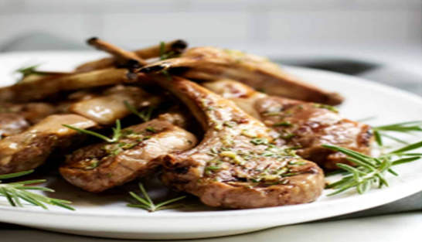
Module Title: Preparing Meat Dishes
Module Code: CST CUA3 M06 0923
Nominal duration: 90 hours

Prepared By: Ministry of Lobar and Skill
September, 2023
Addis Ababa, Ethiopia
Table of Contents
Contents Pages
Acknowledgement 4
Introduction to the Module 5
Unit one: Selecting and preparing ingredients 6
1.1. Identify mise en place 7
1.1.1. Introduction 7
1.1.2. Mise en Place 7
1.1.3. Important of Mise En Place 7
1.2. Using protective equipment 11
1.3. Hygiene practices and OHS regulations 12
1.3.1. Personal Hygiene 12
1.3.2. OHS Regulations 14
1.4. Identifying a range of meat 15
1.4.1. Identifying and selecting suppliers for purchasing of product 15
1.4.2. Types of lamb cuts 15
1.4.3. Identify the primary meat cuts 16
1.4.4. Types of Meat or Flesh 16
1.4.5. Identify the secondary meat cuts 16
1.4.6. Identify commercial establishment cuts’ specifications 20
Self check list 1 24
Unit Two: Producing a range of meat dishes 25
2.1. Produce meat dishes 26
2.1. 1. Types of meat 26
2.2. Cookery Techniques Error! Bookmark not defined.
2.2.1. Specialized techniques 33
Self check 2 34
Operation Sheet 2.1: producing meat dishes 35
Operation Sheet 2.2: preparing meat dishes sauce 55
Operation Sheet 2.3: preparing meat dishes accompaniment 59
LAP Test 63
Unit Three: Presenting and storing meat items 64
3.1. Presenting meat dish 65
3.2.1 Temperatures 65
3.2. Store meat items 66
3.2.1 Fresh and/or vacuum packed items are stored correctly 66
3.2.2. Prepare and maintain correct thawing of meat 67
3.2.3. Labelling of Meat 67
Self check 3 69
Reference 70
Participants of this Module (training material) preparation 71

Acknowledgement
The Ministry of Labor and Skills (MoLS) would like to express its gratitude and appreciation to the instructors and experts from regional TVT bureaus, TVT colleges, and industry practitioners who contributed their expertise and experience in preparing the training module for the unit of competency “Prepare Meat Dishes” under the occupational standard "Culinary Art level-III."
The ministry also expresses its deepest gratitude to the Tourism Training Institute for its invaluable technical and financial support and collaboration in the module preparation. It is also thankful to MoLS staff members who coordinated the preparation and reviewing process of this training module.

Introduction to the Module
In culinary art filed; Prepare meat, dish helps to prepare various meat dishes in a commercial kitchen or catering operation. Meat is a form of food to us from animal flesh. In general, meat is considered a protein source, but it is also composed of water and fats. During prehistoric times, meat is consumed raw, but today it is usually eaten after it is cooked with delicate culinary techniques and skills (Learn some meat cooking tips here). The consumption of meat has been increasing rapidly since the early 1900s that lead to the commercialization of meat with aid from the slaughterhouse.
This module is designed to meet the industry requirement under the Culinary Art occupational standard, particularly for the unit of competency: Prepare meat dish.
This module covers the units:
- Selecting and preparing ingredients
- Producing a range of meat dishes
- Presenting and Storing meat items
Training Objective of the Module:
- Select and prepare ingredients
- Produce a range of meat dishes
- Present and Store meat items
Module Instruction
For effective use this modules, trainees are expected to follow the following module instruction:
- Read the specific objectives of this Learning Guide.
- Follow the instructions described below.
- Read the information written in the information Sheets
- Accomplish the Self-checks
- Perform Operation Sheets
- Do the “LAP test”

Unit one: Selecting and preparing ingredients
This learning guide is developed to provide you the necessary information regarding the following content coverage and topics:
  - Identifying mise en place
  - Using protective equipment
  - Hygiene practices and OHS regulation
  - Identifying a range of meat
This guide will also assist you to attain the learning outcomes stated in the cover page. Specifically, upon completion of this learning guide, you will be able to:
  - Identify tools and equipment
  - Use protective equipment
  - Follow hygiene practices and OHS regulation
  - Identify a range of meat

Identify mise en place
    - Introduction
Mise en place is a French kitchen phrase that means “putting in place" or “gathering.” It refers to the discipline and organization good chef exhibits in the kitchen. To practice mise en place, a chef should have all of their ingredients and supplies prepared and organized before they begin cooking.
The phrase grew prominent in the late 19th century and is used in professional kitchens, cooking classes, and a variety of other settings to this day. By following mise en place, a cook can ensure they have everything they need at their workstation.

Mise en Place

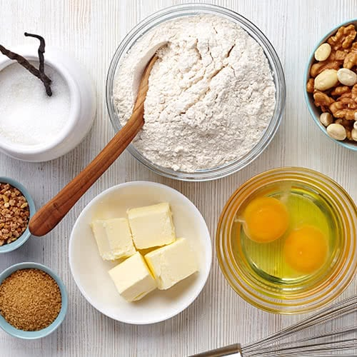
- Professional kitchens: Chefs across the globe use mise en place to prepare a variety of ingredients.
- Hibachi style cooking: Hibachi chefs cook on large, open surfaces and use many ingredients at once. In this setting,
- Cutting meat: Whether you’re preparing cuts of beef, pork, or another meat, practicing mise en place ensures that every cut is sorted and accounted for. Fig.1. 1: mise en place
- Gathering supplies: Using mise en place to organize cooking accessories and equipment helps a chef work efficiently. Not only can they find equipment with ease, but their workplace will be clean and easy to navigate.
    - Important of Mise En Place
- Efficiency: Mise en place facilitates efficiency in the kitchen. By doing prep work before they begin cooking, your staff will save time and move seamlessly through the steps of each recipe.
- Organization: An organized workplace is the first step towards success. It reduces confusion in the workplace and cuts down on wasted product. By keeping all of your equipment and ingredients in one place, your staff won't have to navigate the kitchen while they cook.
- Preparation: With mise en place, your staff can identify missing ingredients before they cook. This ensures that orders are completed on time and recipes are prepared correctly.
- Decreased waste: By measuring your ingredients beforehand, you can reduce food waste. Over time, this can help save money
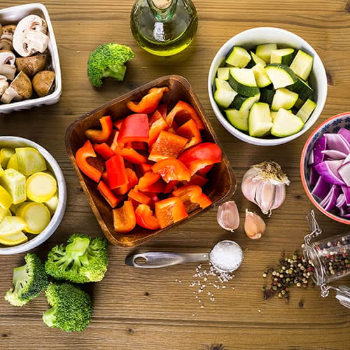
Mise en place is a relatively easy concept to practice. It requires preparation, organization, and attention to detail. To properly use mise en place in your workplace, follow these simple guidelines:
- Plan: Read through your recipe and develop a strategy before you begin cooking.
- Gather ingredients and supplies: Once you've read the recipe, go through the kitchen and acquire all necessary ingredients and supplies. Fig.1. 2: mise en place
- Prepare ingredients: One by one, take the time to wash, cut, dice, chop, or measure your ingredients as directed.
- Sort: Place each ingredient into an appropriately sized dish, bowl, or container. Doing so ensures that every ingredient is easy to identify.
- Place ingredients: Set your ingredients around your cooking station and align them for easy access.
Many pieces of equipment can be used to prepare meat but the most used is still the knife.
Knives of varying sizes may be required along with bandsaws that will be used to cut the carcass of the animal into smaller sizes that make it easier to handle.
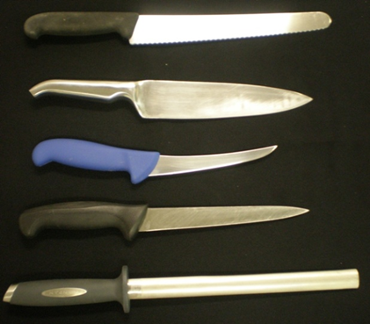
Fig. 1.3: handling tool

When handling tools and equipment:
A well-equipped kitchen makes cooking simpler, efficient, and faster. However, knowing the best way of handling the tools and other supplies will make the cooking safer.
When handling kitchen tools you should not:
- Keep your knives sharp
- Use a cutting and chopping board
- Use knives only when you want to cut
- Clean the knives with care
- Carry and handle the knives with extreme care

Meat Equipment includes:
Knives, cleaver, saw, band saw, mallet
 | 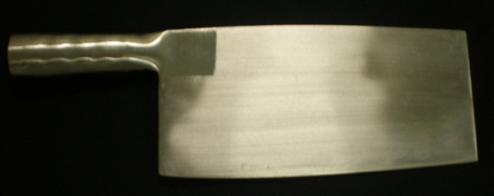
Sharpening Steel/Knife sharpeners | Cleaver
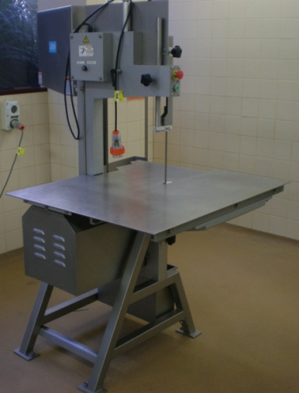 | 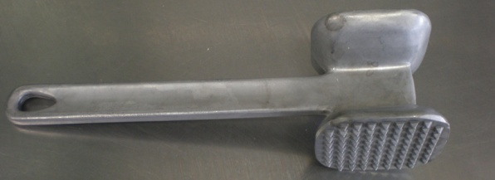
Band saw | Meat mallet
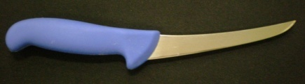 | 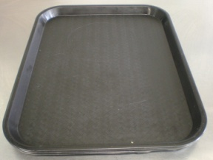
Boning knife | Meat storage tray
Figure 1.4: Meat Equipment
- Tenderizer
- Use to tenderize tougher cuts like flank, skirt, and steaks.
- These long muscle strands are part of what makes them chewy; interrupting them with a blade creates a tendered cut, and it also helps salt and marinades to penetrate below the top layer of meat, which makes for more tender and flavorful meat.
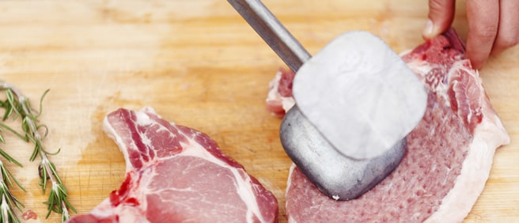
Figure1.5: tenderizer
b. Boning knife
There is a knife for pretty much every task in your kitchen, but truthfully, all a home cook really needs is good chef’s knife, a small paring knife, and, if you prepare a lot of meat at home, a boning knife. Boning knives are generally 5 to 8 inches in length, and their super thin blade makes deboning and filleting meat simpler.
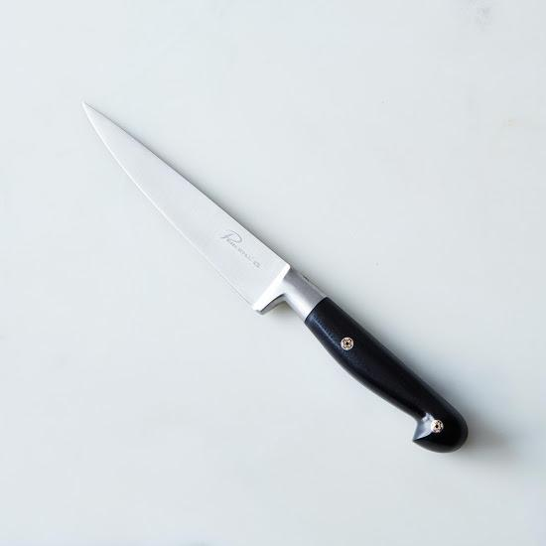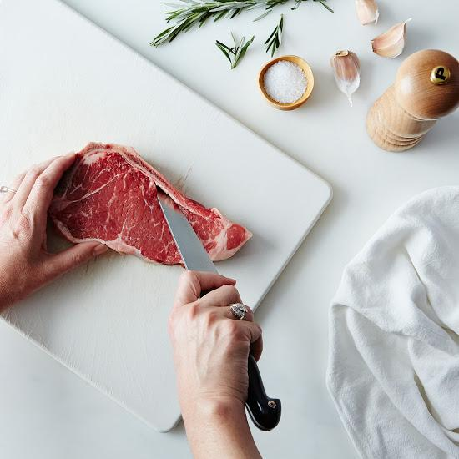
Figure1.6: Boning knife

Using protective equipment
Wearing the proper personal protective equipment (PPE) in meat processing helps minimize exposure to physical, environmental, chemical and biological hazards. To ensure you are using the proper equipment, start by assessing the work you will be performing and what potential hazards exist. Examples of meat processing workplace hazards include moving objects, electric connections, high noise levels, meat bacteria and other airborne disease as well as the presence of chemicals. The next step is selecting and wearing the appropriate PPE based on the risks identified with the job and the environment in which it is performed. PPE only works when it is right for the job and the environment.

Types of PPE include:
Clothing and footwear: The importance of choosing the proper protective clothing is often overlooked and its benefits cannot be underestimated. This form of PPE covers the largest portion of your body and can help protect you from a variety of workplace hazards.
Hand protection: Gloves are an inexpensive and simple way to guard against many hazards, from chemicals to cuts and punctures. Hand protection comes in an assortment of styles, materials and sizes that can even be customized for a specific industry or hazard.
Head, Eye and face protection: Using proper head, eye and face protection can help prevent injury and even blindness. Bump caps should be worn when there is a risk of something overhead striking or falling on someone. Safety glasses, goggles or shields protect the eyes and face from chemical or bodily fluid splashes, flying fragments, dust, sand, dirt and other environmental hazards.

  - Hygiene practices and OHS regulations

Personal Hygiene
Many diseases and conditions can be prevented or controlled through appropriate personal hygiene and by regularly washing parts of the body and hair with soap and water. Good body washing practices can prevent the spread of hygiene-related diseases.






Fig. 1.7: personal hygiene

    - OHS Regulations
The Occupational Health and Safety Regulation (Regulation) contains legal requirements that must be met by all workplaces under the inspectional jurisdiction of Work Safe.
This includes most workplaces in except mines and federally chartered workplaces such as banks, interprovincial and international transportation, telephone systems, and radio, television, and cable services.
The purpose of the Regulation is to promote occupational health and safety and to protect workers and other persons present at workplaces from work-related risks to their health, safety, and well-being.
The requirements are not an end in them, but are a foundation upon which to build an effective health and safety program.
Work Safe is committed to the regular review of the requirements of the Regulation based on regulatory experience and changes in knowledge, technology, and work practices.
Note: The requirements of the Occupational Health and Safety Regulation are adopted under the authority of the Workers Compensation Act as amended from time to time.
Occupational Health and Safety (OHS) regulations in meat preparation focus on ensuring the health and safety of workers involved in the processing, handling, and preparation of meat products. These regulations aim to prevent accidents, injuries, and illnesses by establishing guidelines and standards that employers must follow. Here are some key areas covered by OHS regulations in meat preparation:
  - Personal Protective Equipment (PPE): Employers must provide and ensure the use of appropriate PPE, such as gloves, aprons, goggles, and safety boots, to protect workers from cuts, burns, chemical exposure, and other hazards.
  - Equipment Safety: Employers must regularly inspect and maintain equipment used in meat preparation to ensure they are safe to use. This includes machinery like meat slicers, grinders, and saws, which should have safety guards and emergency stop buttons.
  - Hazardous Substances: Employers must identify and assess the risks associated with hazardous substances used in meat preparation, such as cleaning chemicals or sanitizers. They should provide proper training on handling these substances safely and provide Material Safety Data Sheets (MSDS) for employees' reference.
  - Ergonomics: OHS regulations emphasize the importance of ergonomics in meat preparation tasks to prevent musculoskeletal disorders. Employers are required to provide training on proper lifting techniques, adjustable workstations, and tools designed to reduce strain on workers' bodies.
  - Training and Education: Employers must provide comprehensive training to workers on safe work practices, including proper handling of knives, machinery operation, sanitation procedures, and emergency response protocols.
  - Sanitation and Hygiene: OHS regulations require employers to maintain clean and hygienic work environments to prevent contamination and the spread of food borne illnesses. This includes regular cleaning of equipment, surfaces, and personal hygiene practices like hand washing.
  - Emergency Preparedness: Employers must develop and implement emergency response plans that address potential hazards, such as fires, chemical spills, or power outages. Workers should be trained on emergency procedures and evacuation routes.
It's important to note that OHS regulations can vary by jurisdiction, so it is essential for employers in the meat preparation industry to consult with local health and safety authorities to ensure compliance with specific regulations in their area

Identifying a range of meat

Identifying and selecting suppliers for purchasing of product
Introduction
It is important to purchase your meats from a reputable supplier. A reputable supplier is a supplier that is registered as a business in the area where they are operating.
This means they are following quality hygiene practices and laws set out by the Local or State Governments so you can be assured that the hygiene quality of the meat purchased by yourself is of the highest standard.
When selecting a supplier you need to consider the following:
- Are they registered with local authorities?
- Will they allow you to inspect their operating premises?
- Can they consistently supply you with the product you need?
    - Types of lamb cuts

- Leg:
- Silverside
- Rump
- Topside
- Knuckle
- Midline:
- Rack
- Loin
- Tenderloin (fillet)
- Shoulder:
- Square cut
- Back strap
- Fore shank
- Breast flap.

Students are encouraged to access diagrams to aid them in their identification of various cuts form different animals
    - Error! Reference source not found.
Meat for human consumption will come from various sources.
For the purposes of this unit, these will be the sources from the list below:
- Primary cuts of Lamb and Goat
- Leg
- Loin, rib-loin, mid-loin
- Shoulder.
- Primary cuts of Beef and Pork
- Hindquarter
- Forequarter.
    - Types of Meat or Flesh
Meat is a generic term used to describe the flesh of animals. Flesh meat is the muscle of the animals. Offal is the term for the edible organs and other parts of the animal.
Some cultures eat everything from the animals, eyes, testicles, puzzles etc.
- Beef Cuts
- Lamb Cuts
- Pork Cut

    - Identify the secondary meat cuts
Primary or primal cuts are how carcass of animals will come out of the abattoir.
These are then cut into secondary cuts.
From these you will get your restaurant cuts that are prepared, cooked and served to the public in hotels, restaurants, cafes and fast food outlets.

Table 1.1: Beef cuts
Beef Cuts | Secondary Cuts | Restaurant Cuts
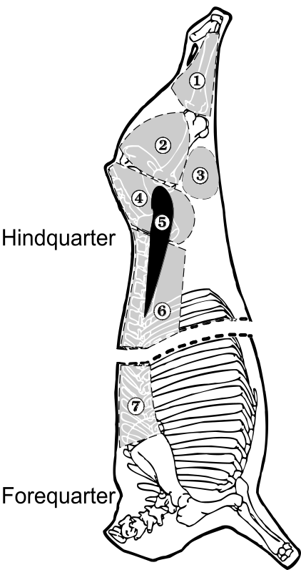 | 1 Shin | Osso bucco cut or diced
 | 2 Topside (silverside and girello behind) | Escalloped pieces – mince – diced – whole roast
 | 3 Round (knuckle) | Whole roast – diced
 | 4 Rump | Rump Steak – main eye muscle roast
 | 5 Tenderloin (fillet) | Eye fillet – tournedos - medallions – strips – tartare – minute steak – chateaubriand
 | 6 Sirloin/strip loin | Sirloin Steak – t-bone - porterhouse – whole roast
 | 7 Rib eye | Scotch fillet – cutlets – rolled – standing rib/rack, Rib eye steak

Table 1.2: Lamb cuts
Lamb Cuts | Secondary Cuts | Restaurant Cuts
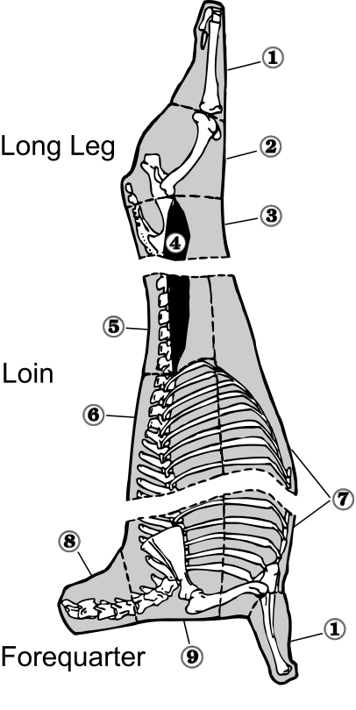 | 1 Shank (hindquarter and forequarter) | Frenched shank
 | 2 Short leg | Whole boned – topside – round – silverside
 | 3 Chump | Chump – chops
 | 4 Tenderloin (fillet) | Fillet
 | 5 Short loin (mid loin) | Rolled loin – chops – eye denuded – rosettes
 | 6 Rack (rib loin) | Racks – cutlets – chops
 | 7 Breast | Epigrams – diced. mince
 | 8 Neck | Diced – chops- mince
 | 9 Square cut shoulder | Boned rolled – diced – chops - mince

Table 1.3: Pork Cuts
Pork Cuts | Secondary Cuts | Restaurant Cuts
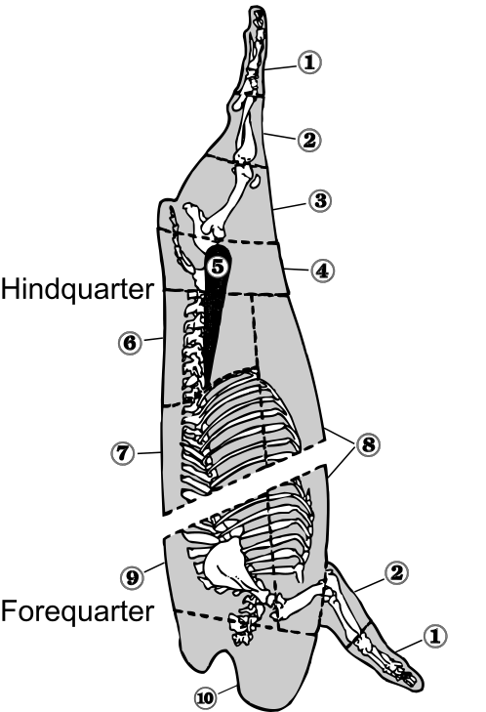 | 1 Trotter (hindquarter and forequarter) | Boned and farced
 | 2 Hock (hindquarter and forequarter) | Boned – smoked
 | 3 Leg | Whole boned – topside escalope – round – silverside – dice – mince
 | 4 Rump | Steak – chop – dice – stir fry strips – mince
 | 5 Tenderloin (fillet) | Fillet – medallion – butterfly steak
 | 6 Mid loin | Rolled – chops – steak
 | 7 Rib loin | Cutlet – rolled loin – rack
 | 8 Spring | Spare ribs – rolled – diced
 | 9 Foreloin (shoulder) | Whole boned – chops - diced – pork scotch – mince
 | 10 Neck | Whole boned – escalopes – diced

Error! Reference source not found.
Meat can be purchased in the following:
Beef: Very heavy, so not economical to purchase whole or half carcass
Beef is normally purchased in secondary cut mode.
Lamb, Pork and Goat:Can be purchased by full or half carcass
Restaurants would purchase by secondary cuts and breakdown for their own need or purchase from butcher pre-cuts into portion sizes
Cleaning and trimming meats for restaurant service would be then done by the end user.
Table 1.4: Beef Cuts
Hindquarter
Topside |  | 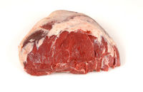
Eye round |  | 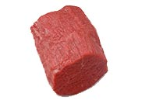
Hindquarter (Continued)
Rump | 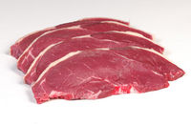
Knuckle | 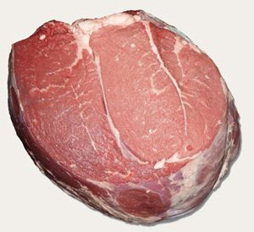
Flank steak | 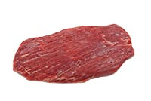
Strip loin | 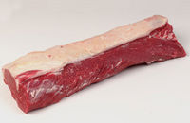
Tenderloin | 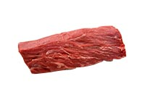
Forequarter
Chuck |  | 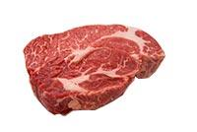
Blade |  | 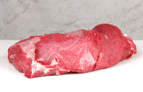
Brisket |  | 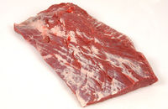
Short ribs |  | 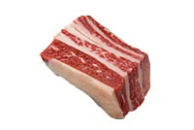

Table 1.5: Lamb Cuts
Leg
Silverside | 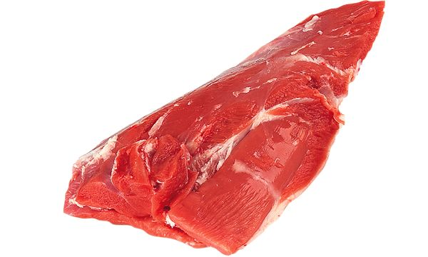
Rump | 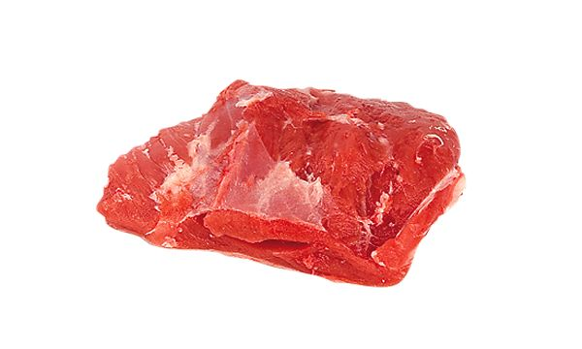
Topside | 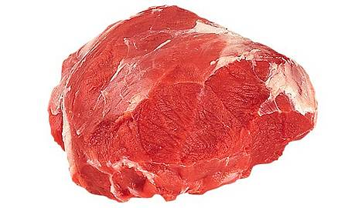
Knuckle | 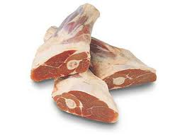
Mid loin
Rack | 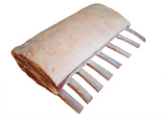
Loin | 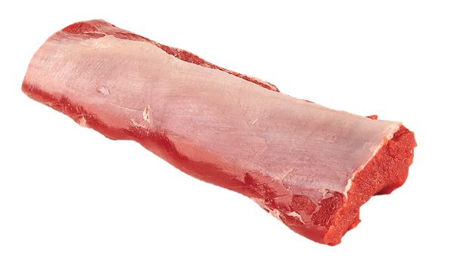
Tenderloin (fillet) | 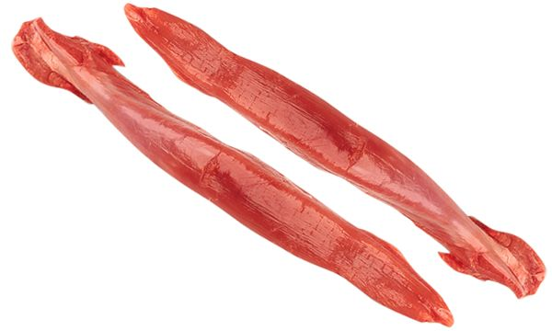
Shoulder
Square cut | 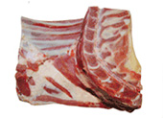
Back strap | 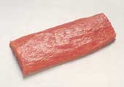
Fore shank | 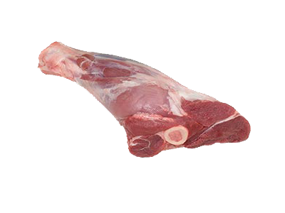
Breast flap | 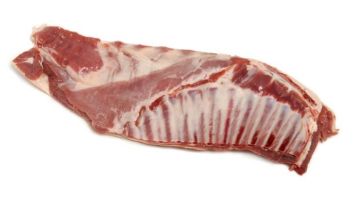

Name………………………….. ID……………………………….. Time Allowed……….

Self check list 1
PART I. Choose the best answer from the given alternative.
- Choose the best answer from the given alternatives
- ----- meat is cooked to develop_____
- Its decease flavor B , Its reduce aroma C, Improve palatability D none,
- -----The small and the soft parts of a beef is _____
- Fillet B. Top side C. Sirloin D. Wing ribs

- Write true or false for the following questions

_____1. The protein food are very favorable for bacteria survival.
______ 2. Food born disease can transfer from food worker (cook)
_______3. The old animals’ meat cooked by moist methods of cook
PART III. Matching ‘A’ column with ‘B’ column
‘A’ ‘B’
______1. Fat A. is fat deposited with in the muscle
______2. marbling B. yellow color
______ 3. carbohydrate C. 5 percent of muscle tissue.
D. very small amount

Unit Two: Producing a range of meat dishes
This learning guide is developed to provide you the necessary information regarding the following content coverage and topics:
- Producing meat dishes
- cookery techniques
This guide will also assist you to attain the learning outcomes stated in the cover page. Specifically, upon completion of this learning guide, you will be able to:
- Produce meat dishes
- Use cookery techniques

2.1. Produce meat dishes

2.1. 1. Types of meat Dishes
- Mutton Stew
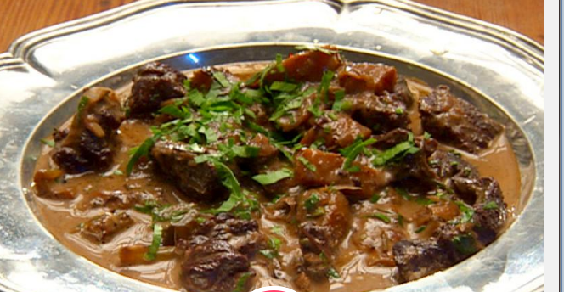
Lamb stew is a preparation in which tough cuts of lamb (by definition, taken from a sheep younger than one year of age in Europe or younger than two years of age in the United States, at the time of slaughter) or mutton (lamb's counterpart on the older side of the dividing line) are cut into small pieces, seared in hot fat, and simmered slowly in a flavored liquid until moist and tender; in the process, its liquid medium becomes a glossy sauce rich with the flavors of the meat. The tender, high-status rack portion of the lamb comprises only four percent of its live weight.

Fi
Fig. 2.1: Mutton Stew
- Grilled Lamb chops
The grilled lamb chop is one of the classic Western dishes that is adored by Malaysians across generations. Unlike a steak, the lamb chop usually contains a higher percentage of fats, making it juicier and tastier.
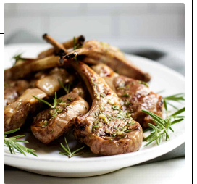
Unlike the typical lamb chop, the grilled lamb chop is cooked on a hot grill and served immediately. Most of us pair it with black pepper sauce or mushroom sauce and a side of French fries, coleslaw or mashed potatoes.

Fig. 2.2: Grilled Lamb chops

- Lamb chops
Lamb chops are cuts of lamb which are made by cutting at an angle perpendicular to the spine, generating a single serving of meat which is traditionally cooked and served with the bone in. Parts of the ribs and vertebrae are usually present in lamb chops, depending on the region of the lamb the chops are cut from.
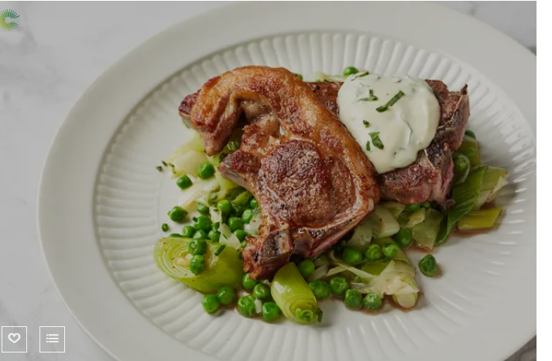
Fig. 2.3: Lamb chops
- Mixed Grill
The term “mixed grill” generally refers to a combination of items roasted on the same grill surface. Grilling is the roasting of any food on a flat grid above a flame or heat. Although mixed grilling was originally used as a term for a collection of grilled meats, its use has become significantly broader over time.
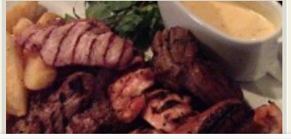
Fig. 2.4: Mixed Grilled
- Roasted lamb leg
Lamb leg is a large and succulent cut from the hind legs that can be butchered into smaller cuts. Lamb leg is a popular Sunday dinner roasting joint, though, this is not the only way this tasty joint can be prepared.
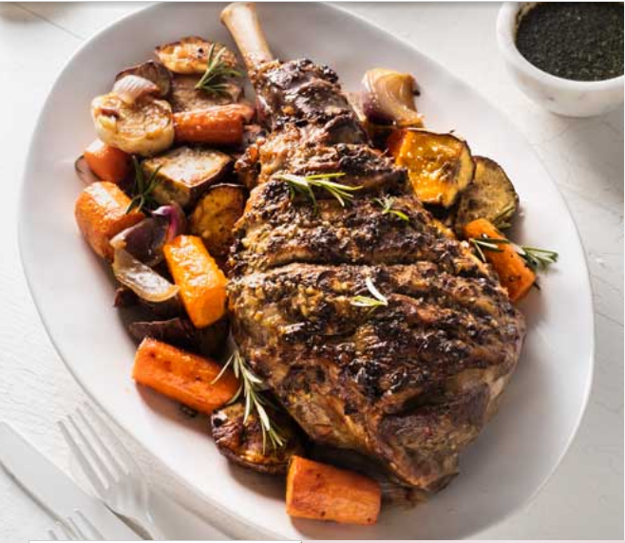
Fig. 2.5: Roasted lamb leg

- Boiled lamb
Alright, technically its lamb, but boiled lamb probably sounds even less appealing to you. But don’t be misled, there was a reason this dish was a Victorian classic.
You take a piece of lamb (or mutton) and essentially poach it slowly with herbs and vegetables and you end up with beautiful moist meat that falls away from the bone and a deep meaty broth that makes the perfect basis for soup.
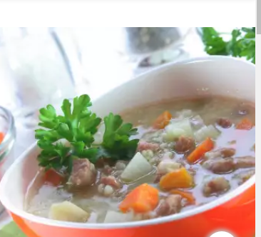
Fig. 2.6: Boiled lamb
- Chilli con carne
Chili con carne (also spelled chili con carne or ChilII con carne and shortened to chili or chili; Spanish pronunciation: [ˈtʃili koŋ ˈkaɾne]), meaning "chili with meat", is a spicy stew containing chili peppers (sometimes in the form of chili powder), meat (usually beef), tomatoes, and often pinto beans or kidney .

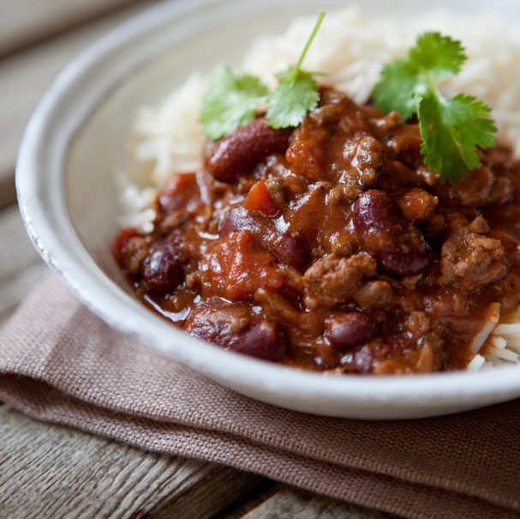
Fig. 2.7: Chili con carne
- Beef medallion
Filet medallion actually refers to how the butcher cuts the meat. A butcher cuts filets into smaller, thick circles rather than one larger filet to create filet medallions. This cut makes it possible for you to cook filet mignon in different ways, like in recipes that call for smaller beef chunks.
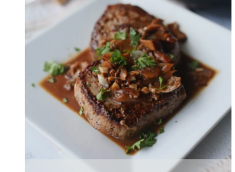
Fig. 2.8: Beef medallion
- Beef cordon blue
The French term cordon bleu is translated as "blue ribbon". According to Larousse Gastronomique, the cordon bleu "was originally a wide blue ribbon worn by members of the highest order of knighthood, L 'Ordre des chevaliers du Saint-Esprit, instituted by Henri III of France.

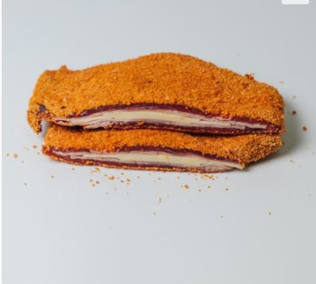
Fig. 2.9: Beef cordon blue
- Roasted veal
Roast veal - cut of veal suitable for roasting. Veal roast. Roast, joint - a piece of meat roasted or for roasting and of a size for slicing into more than one portion. Breast of veal - usually stuffed and roasted. Fricandeau - larded veal braised and glazed in its own juices.

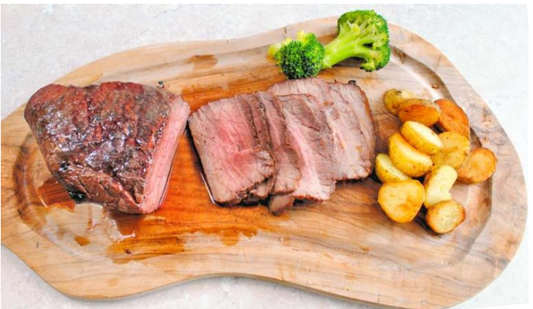
Fig. 2.10: Roasted veal
- Osso bucco
Osso Bucco is from a beef shank which is a cross-cut of meat that comes from the lower leg of the cow. Beef Osso Busso also contains a bone with marrow in the center. While you can make Osso Bucco with either veal or beef, it is more common to use beef because it is widely available and less expensive than veal.

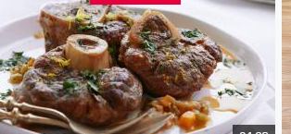
Fig. 2.11: Osso Bucco
- Meat loaf
Meatloaf is a dish of ground meat that has been combined with other ingredients and formed into the shape of a loaf, then baked or smoked. The final shape is either hand-formed on a baking tray, or pan-formed by cooking it in a loaf pan. It is usually made with ground beef, although ground lamb, pork, veal, venison, poultry, and seafood are also used, sometimes in combination. Vegetarian adaptations of meatloaf may use imitation meat or pulses.

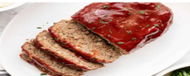
Fig. 2.12: Meatloaf
- Veal escalope
The French verb escalope means "to scallop," which is exactly how it translates in culinary technique. Though the term can be used to describe any thinly sliced meat that is pounded flat, veal escalope is perhaps the most abundantly prepared and embraced. This meat can be used in a range of recipes, from sandwiching ham and cheese for the famous veal cordon bleu to being simply breaded and pan-fried with a simple squeeze of lemon to finish it off.

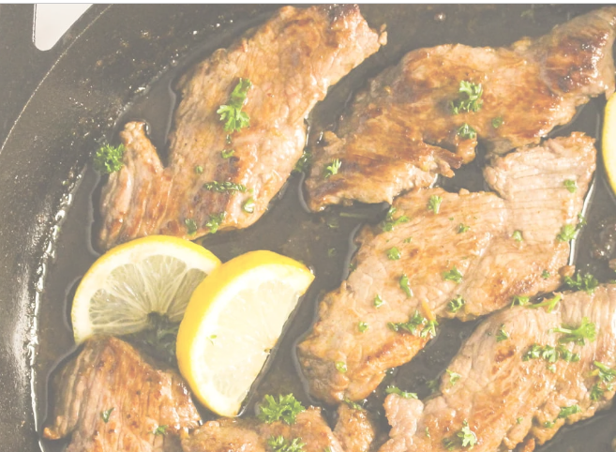
Fig. 2.13: veal escalope
- Veal escalopini
Scaloppini (plural and diminutive of scaloppa—a small scallop, i.e., a thinly sliced cut of meat; is a type of Italian dish that comes in many forms. It consists of thinly sliced meat, most often beef, veal, or chicken, that is dredged in wheat flour and sautéed in one of a variety of reduction sauces.

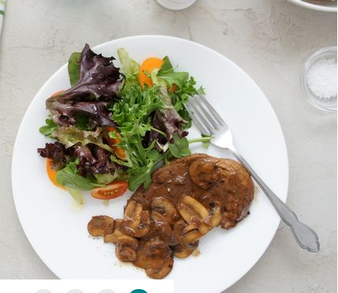
Fig. 2.14: Veal escalopini

- Veal ragout
Well, ragù is defined as meat simmered with vegetables, but doesn't specifically identify tomato. What is this? In the case of Veal Ragù, a recipe adapted from Food and Wine Magazine, the vegetables are merely onions and garlic, with the addition of fresh, fragrant herbs.

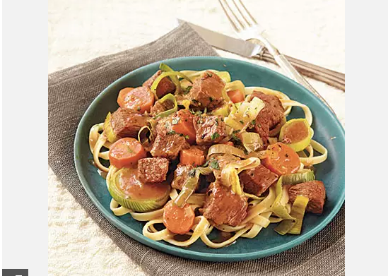
Fig. 2.14: Veal ragout

Error! Reference source not found.
The method of cooking will be determined the quality, age and cut of the meat.
The flavour of the meat is determined by the sex of the animal and the type of food it was raised on being either green pastures or harsh dry grassland.
Older male animals tend to have a stronger flavour but these are sorted at the time of slaughter and will be sent the specific markets: human or animal consumption.
The muscle cut and quality of the meat determines the method of cookery.
- Tender cuts
Can be: Poached: a wet method
Fried grilled or roasted; quick dry methods.
- Tougher cuts
It will need to be: Braised or stewed; slow wet methods, to breakdown the tough connective tissues of collagen and easting that holds the muscle fibres together.
Collagen will gelatinise and soften with long slow cooking but elating will not soften so will need to be cut out during meat preparation.
Connective tissues with lots of collagen and easting are found in the shoulder neck and lower leg cuts of lamb pork and beef.
Offal like liver and kidneys are best if it is cooked to order as they dry very quickly.
Tripe cooked in wet base sauce need long cooking to tenderise structure to make pleasant eating.

2.2.1. Specialized techniques
It is a requirement of this Unit you complete Work Projects as advised by your Trainer. You must submit documentation, suitable evidence or other relevant proof of completion of the project to your Trainer by the date agreed to.
The student will need to show evidence that the following has been achieved.
Proof is best proven in presence of trainer or competent third party. Select four (4) meat dishes that you will prepare using 4 different cooking methods:
The dishes can be from any meat source but should be more than just one.
- Roast
- Braise
- Fry
- Steam
- Grill

Self check 2

Name………………………….. ID……………………………….. Time Allowed……….
PART I. Choose the best answer from the given alternative.
______1. The connective tissue of a beef is called_____
A, soft B, Medium C, Hard D, All are answer
______2. is a dish of ground meat that has been combined with other ingredients and formed into the shape of a loaf, then baked or smoked.
- Veal escallop B. meat loaf C. beef golden blue D. Lamb Leg
- Write true or false for the following questions
______1. The old animals’ meat cooked by moist methods of cook.
______ 2. muscle tissue consists of three major components protein, fat and mineral.
PAR T III. Matching ‘A’ column with ‘B’ column
‘A’ ‘B’
1.-----collagen connective A. white color
2.------Elastin connective tissue B. yellow color
C. very small amount of
Contains in meat

Operation Sheet 2.1: producing meat dishes
- Mutton stew

Ingredients

- Deselect All
- 1/4 cup grape seed oil
- white onions, roughly diced
- garlic cloves, chopped
- carrots (washed, but not peeled), roughly diced
- 1 head celery, roughly diced
- sprigs fresh rosemary, left whole
- 1 leg mutton (approximately 4 pounds sheep or lamb), diced off the bone
- 1 bottle red wine
- 1/4 cup tomato paste

- 4 cups vegetable stock or water
- Salt
- Freshly ground black pepper
- Idaho potatoes, scrubbed and roughly diced
- 1/4 cup butter

Method:
- In a large Dutch oven, heat the oil over medium heat until it begins to glisten.
- Stir in the onions, garlic, carrots, celery and fresh rosemary, and cook until the onions are translucent, about 5 minutes.
- Add the mutton and stir until all sides of the meat have browned.
- Add the wine and tomato paste and allow to cook for about 10 minutes.
- Then add the vegetable stock or water, reduce heat to medium-low and allow to simmer for 4 to 6 hours, periodically checking to make sure the liquid doesn't dissipate, and adding water if needed.
- When the meat is beginning to become tender, add the potatoes. Season with salt and pepper.
- The stew is finished when the meat is very tender (the flavor should be intense and very tasty).
- Adjust the seasoning, as needed, and whisk in the butter just before serving to make the sauce a little richer.
- Grilled Lamb chops

Ingredients
- 8 lamb chops ¾ inches thick
- 3 tablespoons extra-virgin olive oil
- 1 tablespoon finely chopped fresh rosemary dried rosemary is not a good substitute here
- 3 cloves garlic minced
- 1 teaspoon kosher salt or ½ teaspoon fine sea salt
- freshly ground black pepper to taste
Method:
1. Preheat your grill or stove top grill pan to medium-high
2. Combine all marinade ingredients (olive oil through pepper) in a small bowl. Spoon this mixture evenly over both sides of lamb chops.
3. Grill lamb chops for 2 to 4 minutes on each side to desired doneness, 135°F for medium-rare. Transfer to platter and let rest for 5 minutes before serving.
- Lamb chops
Ingredients
- 2 lamb chops
- 1 knob of butter
- 1 sprig of rosemary
- 1 garlic clove, bashed, in skin
- salt
- freshly ground black pepper

Methods:
  - Place a large frying pan over a medium heat. Season the chops on both sides with salt and pepper and once the pan is hot, stand the chops upright in the pan with the thin fatty edge touching the pan
  - Render down the fat for a few minutes until golden and crisp. If not much fat has rendered out and the pan is still quite dry, add a small dash of oil
  - Knock the chops onto their sides and cook for 2 minutes
  - Flip the chops over and cook for 1 minute before adding a knob of butter with the rosemary and garlic. Baste in the rosemary and garlic-infused butter for 1 minute, then remove the chops from the pan onto a plate and pour over the butter and juices
- Mixed Grill
Ingredients
- 12 homemade bangers or good quality fresh pork link sausages
- olive oil for brushing
- 12 large tomatoes, halved
- 12 creaming mushrooms, cleaned and stems removed
- 12 thick slices of lean bacon
- 1½ pounds blood sausage (about 12 links)
- 12 small lamb chops, bone-in, about 4 ounces each
- 2½ pounds boneless sirloin steak, about ½-inch thick, cut into 12 portions
- 12 lamb kidneys, halved
- few sprigs of watercress for garnish
Methods:
- Heat the oven to 350°F. Put the bangers in a lightly oiled roasting pan and cook in the oven until they are golden and just cooked through, 15–20 minutes, turning them over halfway. Set aside.
- Prepare the barbecue.
- First, cook the tomatoes and mushrooms: Place the tomatoes (cut-side up) and the mushrooms (gill-side up) on a lightly oiled baking sheet.
- Drizzle some olive oil over them and season well with salt and pepper.
- Place the baking sheet on the grill and cook until the tomatoes are just soft and the mushrooms are golden brown, 5–7 minutes, turning the vegetables over halfway through the cooking.
- Transfer to a large, warm platter and keep warm, preferably in a low oven, or simply covered with a piece of foil.
- Place the bacon and bangers on the grill.
- Cook for 2–2½ minutes on each side, turning them occasionally.
- Brush the blood sausages with a little oil, add to the grill, and cook for 2–3 minutes on each side.
- Remove them all to a large platter and keep warm.
- Brush the lamb chops, steaks, and kidneys with olive oil and season well with salt and pepper.
- Grill them in batches: The lamb chops will take 1–1½ minutes on each side for medium rare; the steaks need only 40–50 seconds per side; and the kidney halves require about a minute on each side.
- As the meats are grilled, transfer to another warm platter.
- Let the meats rest a little, then garnish the platters with watercress and serve.

- Roasted lamb leg

Ingredients
- 4 garlic cloves, finely chopped
- 1 tbsp chopped fresh rosemary sprigs
- 1 tbsp chopped fresh thyme
- 1 tbsp Dijon mustard
- 2 tbsp Palms Olive Oil
- 1 teaspoon sea salt
- ½ teaspoons freshly ground black pepper
- 1.7 – 2 kg leg of lamb
- 2 tbsp Palms Olive Oil, extra
Vegetables  - 1 kg kumara, cut into large chunks  - 1 kg carrots, peeled and cut into chunks  - 2 red onions cut into wedges  - 1 bulb garlic cut in half  - 2 sprigs rosemary  Methods: | Mint Sauce  - ¼ cup white wine vinegar  - 2 tbsp Palms Caster Sugar  - 2 tbsp water  - 1 cup fresh mint leaves, finely chopped
- Preheat the oven to 200°C. Combine the garlic, rosemary, thyme, mustard, olive oil, salt and pepper in a small bowl.
- Score the top side of the lamb with a sharp knife and place in a large roasting dish.
- Spread the garlic and herb mixture over the lamb, rubbing into the scored cuts.
- Drizzle with extra olive oil.
- Roast in the preheated oven for 1 hour 30 minutes for medium, or until the lamb is cooked to your liking. Baste frequently.
- After 50 minutes, add the vegetables, garlic bulb and sprigs of rosemary.
- Toss to coat in oil. Season with salt and pepper.
- Cook the vegetables for 40 minutes, or until they are tender and golden.
- Meanwhile, prepare the mint sauce.
- Place the vinegar, caster sugar and water into a small saucepan and stir over low heat until the sugar dissolves.
- Remove from the heat and allow to cool slightly before stirring in the chopped mint.
- Slice the lamb and serve with the roast vegetables and mint sauce.
- Boiled lamb
Ingredients
- lamb - from the neck or chest 21 oz (600 g)
- Onions - 3. small heads
- Carrots - 3.
- celery - 1 small head
- Tomatoes - 3. medium
- Potatoes - 2.
- salt - 1 and 1/2 tsp
- vegetable spice - 1 tsp
- red wine - 3 tbsp
- celery - 1 tbsp cut leaves
- mint - 1 tbsp
- pepper – ground

Methods:
- Cut the meat into pieces as large as a match box.
- Peel the skin of the tomatoes and cut them in halves.
- Wash the other vegetables and cut them into large pieces.
- Put the meat in a saucepan with 8 cups (2 liters) of cold water on the fire and leave it on high heat to boil. After 2-3 minutes, first remove the bloody and frothy water, wash the meat and pour new water in.
- Put it to boil again, and if new foam comes, remove it with a spoon. Add salt, flavored with the veggie mix. After about 20 minutes add the carrots and celery, and after another 15 minutes- the potatoes and tomatoes.
- Leave the dish to simmer on low heat about 30 minutes making sure all products are cooked well, if necessary, add a little salt.
- Remove the soup from the fire, forging it with red wine. When serving, sprinkle it with chopped herbs.

- Chilli con carne

Ingredients

- 500g lean minced beef (10% or less fat)
- 2 medium onions, chopped
- 3 garlic cloves, peeled and ﬁnely chopped
- 1–2 tsp hot chili powder
- 2 tsp ground cumin
- 2 tsp ground coriander
- 2 tbsp plain ﬂour
- 150ml red wine or extra stock
- 300ml beef stock, made with 1 beef stock cube
- 400g can of chopped tomatoes
- 400g can of red kidney beans, drained and rinsed
- 3 tbsp tomato purée
- 1 tsp caster sugar
- 1 tsp dried oregano
- 1 bay leaf
- ﬂaked sea salt
- freshly ground black pepper

Methods:
- Place a large non-stick saucepan over a medium heat and add the beef and onions
- . Cook together for 5 minutes, stirring the beef and squishing it against the sides of the pan to break up the lumps.
- Add the garlic, 1–2 teaspoons of chilli powder, depending on how hot you like your chilli, and the cumin and coriander.
- Fry together for 1–2 minutes more. Sprinkle over the ﬂour and stir well.
- Slowly add the wine and then the stock, stirring constantly.
- Tip the tomatoes and kidney beans into the pan and stir in the tomato purée, caster sugar, oregano and bay leaf.
- Season with a pinch of salt and plenty of freshly ground black pepper.
- Bring to a simmer on the hob, then cover loosely with a lid.
- Reduce the heat and leave to simmer gently for 45 minutes, stirring occasionally until the mince is tender and the sauce is thick.
- Adjust the seasoning to taste and serve.
- Beef medallion
Ingredients
- 4– Beef Round Cuts
- 1/2 tbsp. Kosher or sea salt
- 1/2 tbsp. Coarse black pepper
- 2 tbsp. Olive oil
- 4 tbsp. Unsalted Butter
- 3 garlic cloves, minced
- 4 oz. mushrooms, chopped
- 1/2 c. pearl onions
- 1/2 c. beef broth
- 1/2 c. red wine
- 2 tbsp. Heavy cream
- 1 tsp. Cornstarch
- 1/2 tsp. Dried thyme or 2 fresh thyme sprigs
- Garnish: chopped parsley

Methods:
  - Season the beef cuts on both sides with salt and pepper.
- Place uncovered in the fridge for 30 minutes or longer if needed.
- Remove from the fridge and let sit at room temperature for 15 minutes.
- In a large skillet turn the heat on medium-high heat, closer to high heat. Once the skillet is hot, add the two tablespoons of olive oil add two of the beef round cuts, and allow to cook on both sides for 3-5 minutes.
- There should be a nice sear and crust on both sides. Once the beef round cuts have cooked on both sides, remove them from the pan place them on a baking sheet, and cover with aluminum foil.
- Using the same pan, reduce the heat to medium and add the butter to melt.
- Add the minced garlic and allow to cook until fragrant, about 3 minutes.
- Add the mushrooms and pearl onions and cook for about 5 minutes.
- Add the red wine and beef broth to the pan and allow to simmer and the sauce will begin to reduce. Allow the sauce to simmer for about 5 minutes. Next add the heavy cream, dried thyme or fresh thyme, add salt and pepper to taste.
- Take the cornstarch and add it to a small bowl. Add about two spoonfuls of the sauce to the cornstarch and mix. Pour the cornstarch mixture back in with the sauce and stir. The sauce will thicken.
- Turn the heat to low. Add the steaks to a pan and spoon the sauce on top of the steaks. Or, spoon sauce on top of the steaks and serve
- Beef cordon blue
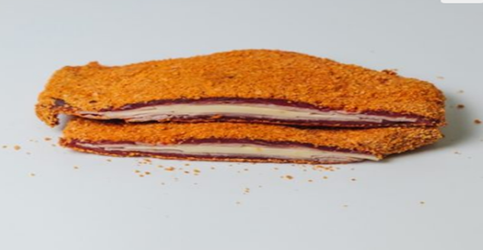

Ingredients

- 8 beef minute steaks
- 4 slices lean leg ham (deli) thick
- 4 slices Swiss cheese
- 1 cup plain flour
- cup dried breadcrumbs
- egg lightly beaten
- tbs milk
- 50 g butter
- tbs vegetable oil

Methods:
- Trim ham and cheese slices to smaller than the minute steaks.
- Place a piece of cheese on the steak, add a piece of ham, then top with 2nd minute steak.
- Secure edges with a tooth pick.
- When all steaks are prepared, combine egg and milk and mix well.
- Place egg mix, flour and breadcrumbs into separate shallow dishes.
- Lightly flour meat parcels, dip into egg mix then roll in breadcrumbs.
- Heat oil and butter in fry-pan over medium heat.
- Add crumbled steak parcels, cook gently on both sides until golden brown, approximately 5 minutes on each side.
- Drain on a paper towel and remove tooth picks before serving.
- Serve with a lemon wedge, boiled vegetables, or a salad.
- Roasted veal

Ingredients
- a topside joint of rose veal, about 600-800g (2 pounds)
- salt and black pepper
- tbsp. oyster sauce
- 2 tbsp. pomegranate molasses (or maple syrup)
- a little oil to drizzle
Methods:
- Preheat the oven to maximum, 240C/475F
- . Let the veal stand in room temperature for at least an hour.
- Brush the oyster sauce and the molasses or syrup all over the meat, season with salt and pepper and drizzle with oil.
- Roast the veal for 20 minutes at maximum temperature, then turn the heat down to 180C/350F
- Now roast it for 10 minutes per pound of weight for rare, 15 minutes per pound for medium. I should not recommend aiming for well-done as it will become tough and dry.
- Remove from the oven and let it rest for at least 15 minutes before carving very thinly.
- Osso Bucco

Ingredients

- Deselect All
- 1sprig fresh rosemary
- 1 sprig fresh thyme
- 1 dry bay leaf
  - whole cloves
- Cheesecloth
- Kitchen twine, for bouquet garni and tying the veal shanks
  - whole veal shanks (about 1 pound per shank), trimmed

- Sea salt and freshly ground black pepper
- All purpose flour, for dredging
- 1/2 cup vegetable oil
- 1 small onion, diced into 1/2-inch cubes
- 1 small carrot, diced into 1/2-inch cubes
- 1 stalk celery, diced into 1/2 inch cubes
- 1 tablespoon tomato paste
- 1 cup dry white wine
  - cups chicken stock
- tablespoons fresh flat-leaf Italian parsley, chopped
- 1 tablespoon lemon zest

Methods:
- Place the rosemary, thyme, bay leaf and cloves into cheesecloth and secure with twine. This will be your bouquet garni.
- For the veal shanks, pat dry with paper towels to remove any excess moisture.
- Veal shanks will brown better when they are dry. Secure the meat to the bone with the kitchen twine. Season each shank with salt and freshly ground pepper. Dredge the shanks in flour, shaking off excess.
- In a large Dutch oven pot, heat vegetable oil until smoking.
- Add tied veal shanks to the hot pan and brown all sides, about 3 minutes per side. Remove browned shanks and reserve.
- In the same pot, add the onion, carrot and celery.
- Season with salt at this point to help draw out the moisture from the vegetables.
- Sauté until soft and translucent, about 8 minutes.
- Add the tomato paste and mix well. Return browned shanks to the pan and add the white wine and reduce liquid by half, about 5 minutes.
- Add the bouquet garni and 2 cups of the chicken stock and bring to a boil.
- Reduce heat to low, cover pan and simmer for about 1 1/2 hours or until the meat is falling off the bone. Check every 15 minutes, turning shanks and adding more chicken stock as necessary. The level of cooking liquid should always be about 3/4 the way up the shank.
- Carefully remove the cooked shanks from the pot and place in decorative serving platter.
- Cut off the kitchen twine and discard.
- Remove and discard bouquet garni from the pot.
- Pour all the juices and sauce from the pot over the shanks. Garnish with chopped parsley and lemon zest.
- Meat loaf

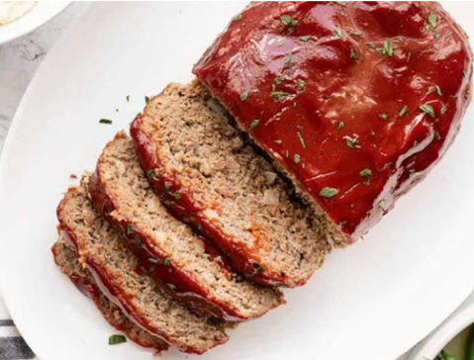

Ingredients
- 1 large egg
- 1/3 cup milk
- 1 tsp Worcestershire sauce
- 1/2 cup plain breadcrumbs
- 1 tsp Italian seasoning
- 1/2 tsp garlic powder
- 1 tsp salt
- 1/4 tsp freshly cracked black pepper
- 1/2 cup minced onion
- 1.5 lbs. ground beef (85/15)
- For Glaze
- 1/2 cup ketchup
- 1 Tbsp brown sugar
- 1 Tbsp Worcestershire sauce
- 1 tsp yellow mustard

Methods
- Preheat the oven to 350ºF. In a small bowl whisk together the egg, milk, and Worcestershire sauce.
- In a separate small bowl, stir together the breadcrumbs, Italian seasoning, garlic powder, salt, and pepper. Mince the onion.
- Add the ground beef, egg mixture, breadcrumb mixture, and minced onion to a large bowl. Use your hands to mix the ingredients together until evenly combined.
- Avoid over mixing.
- Place the meatloaf mixture on a rimmed baking dish and shape it into a loaf that is approximately 4-inches wide, 8-inches long, and 2-inches tall.
- In a separate small bowl, stir together the glaze ingredients (ketchup, brown sugar, Worcestershire sauce, and mustard). Spread the glaze evenly over the top and sides of the meatloaf.
- Bake the meatloaf for 50-55 minutes, or until the internal temperature reaches 165ºF. Allow the meatloaf to rest for 5-10 minutes after baking, then slice and serve.

- Veal Escalope

Ingredients
- 8 small veal escalope’s about 3 oz/ 85 g each
  - lemons divided
- 6 tablespoons olive oil divided
- teaspoons unsalted butter ice-cold
- Fine sea salt and ground black pepper to taste
- sprigs of parsley
Methods
- Pound meat: Place the veal escalope’s between two pieces of cling film on a cutting board. Pound them carefully to make them thinner, about 0.2 inch/ 5 mm.
- Season lightly with salt and pepper on both sides. Place in a non-metallic container.
- Marinade: Wash and zest the organic lemon. Juice it as well. Whisk 4 tablespoons olive oil and the lemon juice in a small bowl, stir in the lemon zest.
- Pour over the scallops. Marinate in the fridge for 30 minutes and up to 1 hour
- Cook: Heat a large cast-iron pan or nonstick pan. Add the remaining 2 tablespoons of olive oil. Remove the meat from the marinade (reserve marinade), shake them to remove the excess.
- Fry them for 2 minutes per side. If the pan is not large enough, fry the meat in 2 batches (Note 4). Remove from the pan and keep warm.
- Lemon sauce: Pour the reserved marinade back into the pan.
- Add the juice of the second lemon. Let bubble well for 1 minute. Gradually, stir in the cubed ice-cold butter.
- Finish: Adjust the taste with salt and pepper. Return the escalope’s to the pan and warm for 1 minute.
- Sprinkle with chopped parsley and a dash of freshly ground black pepper. Serve immediately.
- Veal escalopini

Ingredients
- 4 veal steaks
- 1 onion finely chopped small
- 125 g mushrooms sliced
- 30g butter
- 1/4 cup dry sherry
- tsp plain flour
- 1/2 cup water
- 1/2 tsp Massel Beef Stock Powder
- 1 pinch salt and pepper *to taste
- 2 tbs cream
Methods
- Pound steaks out thinly.
- Melt butter in a shallow pan, add veal steaks and cook quickly for 3-4 minutes, turning once.
- Remove from pan.
- Add onion, cook for 2 minutes, then pour in sherry and bring to the boil.
- Stir in flour, mix well. Remove from heat and stir in water and beef stock.
- Return to heat, stir until sauce comes to the boil.
- Return steaks to pan, add mushrooms and mix well.
- .Season with salt and pepper.
- . Cover pan, simmer very gently for 8 minutes then stir through cream. Stir until heated through but do not boil land serve.
o. Veal ragout

Ingredients

- 1 (2 1/2-pound) boneless veal tip round roast, trimmed
- 1 ½ teaspoons paprika
- ¾ teaspoon freshly ground black pepper
- ½ teaspoon salt
- 1 tablespoon olive oil, divided
- ½ cup dry white wine
- cups sliced leek (about 3 large)
- garlic cloves, minced
- All-purpose flour (about 1/3 cup)
- 1/2-ounce) can chicken broth
- cups (1/2-inch) slices peeled carrot
- thyme sprigs
- 1 bay leaf
- 8 cups hot cooked fettuccine (about 16 ounces uncooked pasta)
- tablespoons chopped fresh flat-leaf parsley
Methods:
- Cut veal into 1-inch cubes. Sprinkle paprika, pepper, and salt over veal.
- Heat a large nonstick skillet over medium-high heat.
- Add 1 teaspoon oil to pan; swirl to coat. Add half of veal; sauté 4 minutes or until browned. Place browned veal in a 6-quart electric slow cooker. Repeat procedure with 1 teaspoon oil and remaining veal.
- Add wine to skillet; cook 1 minute, scraping pan to loosen browned bits. Pour over veal in slow cooker.
- Heat skillet over medium-high heat. Add remaining 1 teaspoon oil to pan; swirl to coat. Add leek and garlic; sauté 3 minutes. Spoon leek mixture over veal in slow cooker.
- Place flour in a small bowl; gradually add broth, stirring until well blended. Pour broth mixture into slow cooker. Add carrot, thyme sprigs, and bay leaf; stir well. Cover and cook on LOW for 3 to 5 hours or until veal is tender. Discard thyme sprigs and bay leaf.
- Serve veal mixture over pasta; sprinkle with parsley

Operation Sheet 2.2: preparing meat dishes sauce
Sauce Preparation
    - Pepper corn sauce
Ingredients:

      - 1 tablespoon of black peppercorns
      - 1 tablespoon of green peppercorns
      - 1 tablespoon of white peppercorns
      - 2 tablespoons of butter
      - 1/2 cup of beef stock
      - 1/2 cup of heavy cream
      - Salt to taste

Methods:
1. Crush all the peppercorns in a pestle and mortar until they are coarsely ground.
2. In a medium saucepan, melt the butter over medium heat until it starts to foam.
3. Add the crushed peppercorns and stir for a minute until fragrant.
4. Pour in the beef stock and whisk until well combined.
5. Reduce the heat to low and simmer the mixture for 5 minutes.
6 Add the heavy cream and stir until the sauce thickens.
7. Taste the sauce and adjust the seasoning with salt.
8. Continue cooking the sauce for another 2-3 minutes until it reaches the desired consistency.
9. Remove from heat and serve with steak or any other grilled meat.
Note: You can also add a splash of brandy or cognac to the sauce for an extra depth of flavor.
    - Mushroom sauce
Ingredients:
- 2 cups sliced mushrooms
- 2 cloves garlic, minced
- 2 tablespoons butter
- 2 tablespoons all-purpose flour
- 1 cup beef or chicken broth
- 1/2 cup heavy cream
- Salt and pepper to taste
- Fresh chopped parsley (optional)
Methods:
1. In a skillet, melt butter over medium heat. Add sliced mushrooms and minced garlic and sauté until the mushrooms are cooked through and browned, about 5-7 minutes.
2. Sprinkle flour over the mushroom mixture and stir until the flour is well incorporated.
3. Pour in beef or chicken broth while continuously stirring until the mixture thickens.
4. Reduce the heat to low and add heavy cream, stirring constantly for about 5 minutes, letting the sauce thicken.
5. Season the sauce with salt and pepper to taste.
6. For a smooth texture, place the mushroom sauce in a blender and blend until smooth.
7. Serve hot with your favorite dish, garnished with chopped parsley if desired.
    - Red wine sauce

Ingredients:
- 1 cup red wine
- 1 cup beef broth
- 1 shallot, finely chopped
- 2 cloves garlic, minced
- 2 tablespoons unsalted butter
- 1 tablespoon all-purpose flour
- Salt and black pepper, to taste
Methods:
1. In a small saucepan, melt the butter over medium heat.
2. Add the shallot and garlic, and cook until softened and fragrant.
3. Whisk in the flour and cook for 2-3 minutes until lightly browned, stirring constantly.
4. Slowly pour in the red wine and beef broth, whisking constantly to prevent lumps.
5. Bring the sauce to a simmer and cook for 10-15 minutes, or until it has reduced in volume and thickened slightly.
6. Taste and season with salt and black pepper as desired.
7. Serve the sauce warm with your favorite grilled or roasted meat or vegetables.
    - Gravy sauce

Ingredients:
- 2 tablespoons butter
- 2 tablespoons all-purpose flour
- 2 cups chicken or vegetable broth
- Salt and pepper to taste
- Optional: herbs and spices of your choice (e.g. thyme, rosemary, garlic)
Methods:
1. Melt the butter in a medium saucepan over medium heat.
2. Whisk in the flour and cook, stirring constantly, for 1-2 minutes until the mixture turns a light brown color (this is called a roux).
3. Slowly pour in the broth while whisking continuously to avoid lumps.
4. Add salt, pepper, and any desired herbs and spices.
5. Bring the sauce to a simmer and cook for 5-10 minutes, stirring occasionally, until the sauce has thickened.
6. If the sauce is too thick, add more broth or water. If it's too thin, cook it for a bit longer to reduce it further.
7. Taste and adjust seasoning as desired.
8. Serve warm over your favorite dish. Enjoy!

Operation Sheet 2.3: preparing meat dishes accompaniment

  - Accompaniment
  - Risotto Rice
Ingredients:
      - 1 cup of Arborio rice
      - 3 cups of chicken or vegetable broth
      - 1 tablespoon of olive oil
      - 1 tablespoon of butter
      - 1/2 finely diced onion
      - 1/2 cup of white wine
      - 1/4 cup of grated parmesan cheese
      - Salt and pepper to taste
Methods:
1. Heat the broth in a pot and keep it warm on low heat.
2. In a separate pot, heat the olive oil and butter over medium heat.
3. Add the onions to the pot and sauté until they become soft and translucent.
4. Add the rice to the pot and stir until it becomes coated with the butter and oil.
5. Pour the white wine into the pot and stir continuously until the liquid is absorbed by the rice.
6. Add a ladle of warm broth to the pot and stir continuously until the rice absorbs the liquid.
7. Keep adding the broth, one ladle at a time, and stirring until the rice has absorbed the liquid before adding more broth.
8. Keep adding broth and stirring until the rice is cooked to your desired consistency. It should be creamy but still have a slight bite to it.
9. Turn off the heat and stir in the grated parmesan cheese.
10. Season with salt and pepper to your taste.
Your risotto rice is now ready to serve. Enjoy it as a side dish or add your favorite meats and vegetables for a complete meal.
  - Mashed potatoes
Ingredients
- pounds of potatoes
- 1/2 cup of milk
- 1/4 cup of butter
- Salt and pepper to taste
Methods:
1. Peel and rinse the potatoes. Cut them into small pieces and place them in a large pot.
2. Cover the potatoes with water and add a pinch of salt. Bring the water to a boil and cook the potatoes until they are soft and tender. This should take about 20-25 minutes.
3. Once the potatoes are done, drain them and return them to the pot.
4. Add the butter and milk to the pot with the potatoes. Using a masher or a hand mixer, mash the potatoes until they are smooth and creamy. Add more milk or butter as needed to achieve your desired consistency.
5. Season the mashed potatoes with salt and pepper to taste.
6. Serve the mashed potatoes hot as a side dish with your favorite meal. Enjoy!
  - Steamed Broccoli
Ingredients:
      - 1 pound of broccoli
      - 1 tablespoon of olive oil
      - Salt
      - Pepper
      - Lemon wedges
Methods:
1. Cut the broccoli into small florets.
2. Rinse it thoroughly in cold water and pat dry with a paper towel.
3. Place a steamer basket in a pot and add enough water to reach the bottom of the basket.
4. Bring the water to a boil over high heat.
5. Once the water boils, add the broccoli florets to the steamer basket and cover the pot with a lid.
6. Steam the broccoli for 5-7 minutes until it's bright green and tender but still firm.
7. Remove the lid and transfer the broccoli to a serving platter.
8. Drizzle olive oil over the broccoli and season with salt and pepper to taste.
9. Serve immediately with lemon wedges on the side. Enjo
  - Roasted Potato

Ingredients
- 1 lb. potatoes, washed and diced into small pieces
- tbsp. olive oil
- 1 tsp. garlic powder
- 1 tsp. dried rosemary
- 1 tsp. dried thyme
- Salt and pepper, to taste
Methods:
1. Preheat the oven to 400°F.
2. Place the diced potatoes in a large bowl.
3. Drizzle the olive oil over the potatoes and toss to coat evenly.
4. Sprinkle the garlic powder, dried rosemary, dried thyme, salt, and pepper over the potatoes, and toss again to evenly distribute the spices.
5. Spread the potatoes out on a baking sheet in a single layer.
6. Roast the potatoes in the preheated oven for 25-30 minutes, or until they are golden brown and crispy around the edges.
7. Serve the roasted potatoes hot, garnished with fresh herbs if desired.

LAP Test
Name : _____________________________ Date : ________________
Time started : _____________________________ Time finished : ________________
Instructions:
1. You are required to perform any of the following:
Request your teacher to arrange for you all necessary tools, materials and equipment. Submit your outputs to your teacher for evaluation.
Request a set of tools, materials, equipment for the tasks then perform the following tasks in front of your teacher:
Prepare:-
- Lamb chops
- Grilled lamb
- Mixed grill
- Mutton stew
- Roasted lamb leg
- Boiled lamb
- Chilli concarne
- Beef medallion
- Beef cordonblue
- Roasted veal
- Osso bucco
- Meat loaf
- Veal escalope
- Veal escalopini
- Veal ragout

  - Request your teacher for evaluation and feedback

Unit Three: Presenting and storing meat items
This learning guide is developed to provide you the necessary information regarding the following content coverage and topics:
- Presenting meat dish
- Storing meat items
This guide will also assist you to attain the learning outcomes stated in the cover page. Specifically, upon completion of this learning guide, you will be able to:
- Present meat dish
- Store meat items

Error! Reference source not found.
An essential part of portioning and plating food, is to ensure there are sufficient supplies of clean and undamaged crockery is available at temperatures appropriate to the food being served.
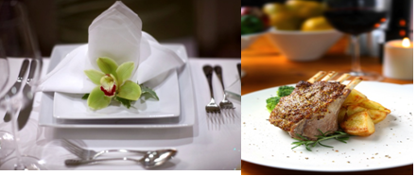
All crockery and cutlery – including glassware and any other sort of service gear such as flatware, platters, jugs etc. – must be ‘clean’.
By definition, clean means being free from visible debris – this means it must be clean to the naked eye:
The definition extends to also being free from odour. Fig 3.1: presenting plate
In a commercial setting, crockery, cutlery etc. should also be sanitised after it has been cleaned, and as part of the cleaning process.

3.2.1 Temperatures
In presenting food there is an absolute need to:
- Present hot food, hot
- Present cold food, cold.
The amount of time it takes for a meal to be plated and served should be much less than five minutes, so the chance of any food poisoning bacteria multiplying to dangerous levels is nil.
- Hot Dishes – this means using hot plates to serve the food so the hot food keeps its temperature for longer thereby increasing the customer’s enjoyment of the food.
- Portion control
Another essential element in plating and presenting food is to ensure that food items are portioned correctly in accord with enterprise policies or standard recipes.
Portion control simply means controlling the size of serves given to guests.

- Costs
When a dish is prepared especially when using a standard recipe the head chef will know how much the ingredients cost (called the ‘cost of goods sold or used’) and have an expectation of the yield the recipe will produce

Error! Reference source not found.items

3.2.1 Error! Reference source not found.

Vacuum packaging
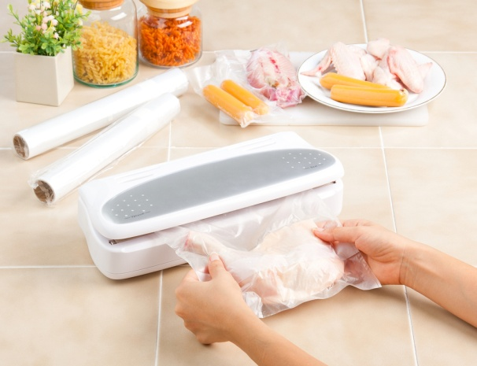
This is a system by which meat is placed in special plastic bags. All the air is then withdrawn using a special machine, which then heat seals the bag.
Meat packaged this way is normally stored at minus one degree to zero degrees Celsius (1ºC to 0ºC).
This extends the storage life refrigerated meat:
- Beef up to twelve (12) weeks.
- Lamb up to ten (10) weeks
- Pork up to three (3) weeks. Fig.3.2 food packaging
Note: Sometimes after long storage then opening the smell can be quite strong.
- This will dissipate when left in the open air for a few minutes.
- If the smell lingers, seek advice before using.
- If in doubt, throw it out.
Advantages of vacuum packing:
- Vacuum packing is a good way of tenderising meats due to due to natural enzyme breakdown
- Gives a longer shelf life
- Reduces weight loss
- Is a cleaner way of storing meats
Disadvantages:
- Can give inconsistent results
- Some odour from meats after opening meats, this should fade after several minutes
- Some cut meat weeps excessively so there is a greater weight loss.
- Vacuum packing allows for longer shelf life of meats in the fresh state because oxygen is removed and this slows down the rate of decomposition

3.2.2. Error! Reference source not found.
Fresh meats can be frozen successfully and stored for between three and six months depending on the type of meat and provided it is kept between -18ºC and -24ºC.
- Fluctuations in temperature will cause loss in quantity and decrease in the shelf life of the meat:
- Never freeze large quantities stacked on top of each other
- Boneless meat freezes quickest
- Thicker cuts of meat take longer to freeze
- Excess fat cover slows freezing
- Guard against freezer burn by looking after frozen meats and using sound stock rotation
- Freeze in strong bags, eliminating as much air as possible from the bags
- Label and date all items to be frozen
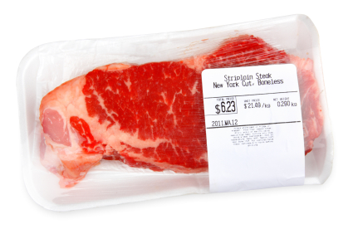
- Thaw frozen meats in the refrigerator at 1ºC – 3ºC

3.2.3. Error! Reference source not found.

- Labelling of meat products is vitally important.
- Label must contain:
- Description of the product: Beef Fig.3.2 Meat labelling
- Name of the product: Sirloin, 150gm steaks
- Date product was packed: June 15th 2012
- Who packed the product: William the cook
- Use by date: August 15th 2012
- Storage conditions: Store below 1ºC
- If purchased from outside supplier the label must contain:
- Name of the processor: Marty Meats
Labels must be legible. If they cannot be read by the end user then they are a waste of time.
In-correctly labelled products can cause problems due to food not being acceptable for human consumption.
Some labels can be colour coded but best colour to print is Black writing on white paper.
Handwritten labels must be written in water stable product. If you label food and it dissolves when it gets wet then all is wasted.

Self check 3
Name………………………….. ID……………………………….. Time Allowed……….
PART I. Choose the best answer from the given alternative
____1. Fresh meats can be frozen successfully and stored for between --------- ºC
- 23 ºC B. -18ºC and -24ºC. C. 10 ºC D. none
_____2. From the fooling question one is the advantages of vacuum packing
- Gives a short shelf life
- Is un cleaner way of storing meats
- Reduces weight loss
- D. natural enzyme an breakdown
PARTII. write true or false for the following questions
______1. Some labels can be not colour coded but best colour to print is Black writing on white paper.
_______2. All crockery and cutlery – including glassware and any other sort of service gear such as flatware, platters, jugs etc. – must be ‘clean’.
PAR T III. Matching ‘A’ column with ‘B’ column
‘A’ ‘B
_____1. Hot Dishes A. using hot plates to serve the food
______2. Labelling B. Fridge
______3. 1--5 ºC C. write product and expired date

Reference
Waye Gisslin (2010), Professional cooking, 7th edition.
John Campbell (2011), Practical cookery, 11th edition.
https://chat.chatgptdemo.net/
Internet

Participants of this Module (training material) preparation
No | Name | Qualification (Level) | Field of Study | Organization/ Institution | Mobile number | E-mail
1 | Mamit Ayalew | B | Hotel Mgt | Bishoftu P.College | 0911723484 | mamitayalew@gmail.com
2 | Marksew Shiferew | A | Food security | Misrak P.College | 0937645184 | markisews@gmail.com
3 | Wale Getaneh | A | Food Technology/TVET Leadership & Mgt | Bole M.College | 0929241229 | waleg917@gmail.com
4 | Biruk Adamu | B | Hotel Mgt | TTI | 0921355741 | birukadamu50@gmail.com
5 | Efrem kitila | B | Hotel Mgt | Woliso P.College | 0917289283 | efremkitila922@gmail.com
6 | Helen Adugna | B | Hotel Mgt | Selam TVET College | 0915573757 | helenadugna12@gmail.com
7 | Ali Kassaw | B | Hotel Mgt | Bardar P.College | 0918573970 | Kassawali2004@gmail.com
8 | Solomon Bekele | A | Hotel Mgt | G.winget PTC | 0911149147 | Soladvent06@gmail.com

