CULINARY ART
Level III
Based on September 2023, Curriculum version II
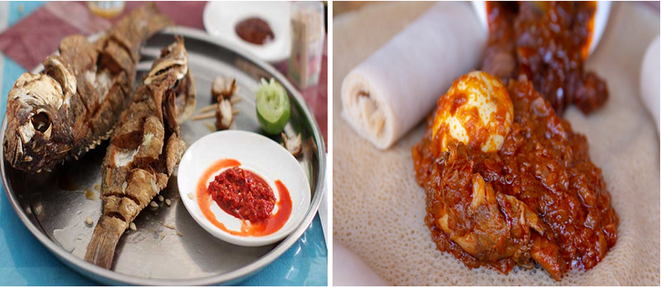
Module Title: Preparing Ethiopian cultural Fish and
Chicken Dishes
Module Code: CST CUA3 M07 0923
Nominal Duration: 100 Hours

Prepared By: Ministry of Lobar and Skill

September, 2023
Addis Ababa, Ethiopia

Table of Content
Table of Content 2
Acknowledgment 3
Introduction to the Module 4
UNIT ONE: Preparing mis-en-place 5
1.1.Mis-en-place 6
1.2. Hygiene practice 7
Self-Check 1 9
UNIT TWO: Preparing and presenting fish dishes 10
2.1. Preparing fish dish 11
2.2. Using accompaniments for fish dish 14
2.3. Presenting fish dish with cultural tools 15
Self-Check 2 17
Operation Shit 1 18
LAP Test 1 25
UNIT THREE: Preparing and presenting chicken dishes 26
3.1. Preparing chicken dishes 27
3.2. Using sauces and accompaniment for chicken dish 28
3.3. Presenting chicken dish with cultural tools 30
Self-Check 3 31
Operation Shit 2 32
Preparing and presenting chicken dishes 32
LAP Test 2 38
UNIT FOUR: Storing fish and chicken dishes 39
4.1. Portioning cooked fish and chicken dishes 40
4.2. Storing cooked fish and chicken dishes 41
Self-Check 4 43
Reference 44
Participants of this Module (training material) preparation Error! Bookmark not defined.

Acknowledgment
The Ministry of Labor and Skills (MoLS) would like to express its gratitude and appreciation to the instructors and experts from regional TVT bureaus, TVT colleges, and industry practitioners who contributed their expertise and experience in preparing the training module for the unit of competency “Prepare Ethiopian Cultural Fish and Chicken Dish” under the occupational standard "Culinary Art level-III."
The ministry also expresses its deepest gratitude to the Tourism Training Institute for its invaluable technical and financial support and collaboration in the module preparation. It is also thankful to MoLS staff members who coordinated the preparation and reviewing process of this training module.

Introduction to the Module
This module describes the knowledge, skills and attitude required to prepare a variety of Ethiopian fish and chicken dishes. They can be made from a range of ingredients, including fish, chicken, game and vegetables.
This module is designed to meet the industry requirement under the culinary Art production occupational standard Unit of Competency: Prepare Ethiopian cultural Fish and Chicken Dishes.
This module covers the units: -
- Preparing mis-en-place
- Preparing and presenting Ethiopian cultural fish dishes
- Preparing and presenting Ethiopian cultural chicken dishes
- Storing Ethiopian cultural fish and chicken dishes
Training Objective of the Module:-
- Prepare mis-en-place
- Prepare and present Ethiopian cultural fish dishes
- Prepare and present Ethiopian cultural chicken dishes
- Store Ethiopian cultural fish and chicken dishes
Module Instruction
For effective use this modules trainees are expected to follow the following module instruction:
1. Read the information written in each unit
2. Accomplish the Self-checks at the end of each unit
3. Perform Operation Sheets which were provided at the end of units
4. Do the “LAP test” giver at the end of each unit and
5. Read the identified reference book for Examples and exercise.

UNIT ONE | Preparing Mise en place
This learning guide is describes knowledge, skills and attitude required for food sanitation and safety in a commercial kitchen or catering operation.
- Preparing mise en place
- Hygiene practices

This guide will also assist you to attain the learning outcomes stated in the cover page. Specifically, upon completion of this learning guide, you will be able to:
- Prepare mise en place
- Follow appropriate hygiene practices

  - Mise en place
    - Select and assemble ingredients
Ethiopian cuisine characteristically consists of vegetable and often very spicy meat dishes like fish, chicken and beef dishes. This is usually in the form of wat, a thick stew, served on top of injera. Major ingredients to prepare fish and chicken cultural dishes are:

- Onions
- Niter Kibe
- Injera
- Spices
- Mitmita
- Legumes and Vegetables
- Shiro
- Chicken local
- Fish
- Garlic
- Ginger
- Cardamom
- Mekelesha
- Turmeric
- Egg
- Lemon
- Salt
- Dry Teji
- Oil
- Berebere
- Vegetables
- Wine

    - Select and assemble tools and equipment’s
Tools and equipment’s includes:

- Bowl (small and large)
- Mincers
- Knife
- Filleting knife
- Sauce pan
- Sauté pan
- Pot
- Chopping board
- Scale
- Tray
- Spoon
- Wooden spoon
- Lemon squeezer
- Tenderizer
- Stove
- Long-spouted copper pitcher and basin

Common cultural serving tools and equipment’s
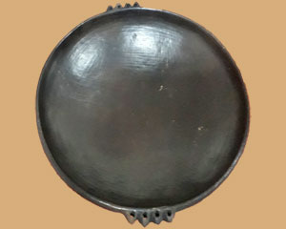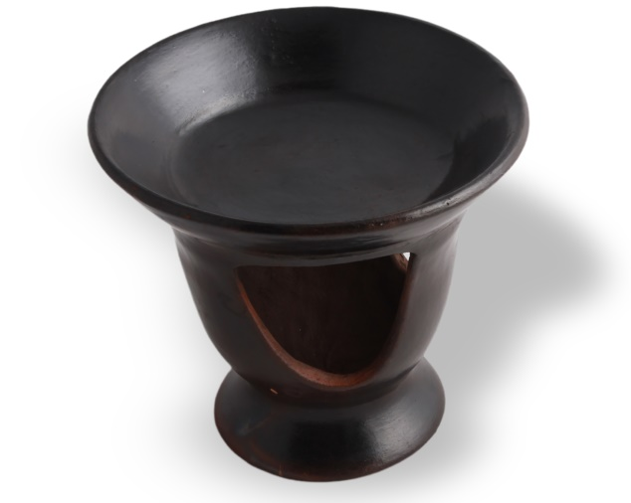
Fig: 1.1. Taba(kitfo serving plate) Fig: 1.2. Clay Tibs serving plate
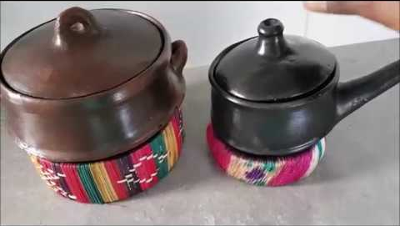
Fig: 1.3. Clay Pot (serving wet)
  - Hygiene practice
- Hygiene
Hygiene is the practice of keeping yourself and your surroundings clean, especially in order to prevent illness or the spread of diseases. Be extra careful about personal hygiene.
- Hazard
A hazard is anything that has the potential to harm or injure people, property, or equipment.
Workplace hazards are the sources of potential harm or damage to someone or something in any work environment. It can be material or any activity that has the likelihood to cause injuries under specific conditions. It should be eliminated as soon as they are identified to prevent workplace incidents or fatalities.
A hazard report is an account of any potential risk to the health or safety of any person, property or equipment in the workplace.
- Using personal protective equipment’s
It is important to keep ourselves safe in the kitchen because that will save you from spending money seeking treatment. Because safety in the kitchen is vital, a number of protective tools have been invented. Examples of personal protective equipment in the kitchen;
- Oven gloves
- Apron
- Hairnet
- Plastic glove
- Chef shoes

Self-Check 1 | Written Test

Part 1: Write true if the statement is correct or false if it is incorrect.
______1. Waste can be used as a by-product.
______2. Chefs have to wash their hands in the wash hand basin in the toilet after using the
toilet, and then wash their hands again when they re-enter the kitchen area.
______3. Wearing an apron when cooking will protect your clothes from stains that would otherwise make you look untidy.
______4. Wearing jewellery has no problem for food handlers if it is small.
Part 2: Identify the letter of the choice that best completes the statement or answers the question.
_______1. Which one is unsafe practice in the kitchen?

- Using equipment’s without manual
- Over fill pans and pots
- Using PPE
- All except C

_______2. One is used to seasoning fish and chicken wot?

- Mekelesha
- Turmeric
- Berbere
- All
Part 3: Answer the following questions correctly
- List tools and equipment’s used to prepare cultural dishes?

UNIT TWO | Preparing and presenting fish dishes
This learning guide is describes knowledge, skills and attitude required for food sanitation and safety in a commercial kitchen or catering operation.
- Preparing fish dish
- Using accompaniments for fish dish
- Presenting fish dish with cultural tools
This guide will also assist you to attain the learning outcomes stated in the cover page. Specifically, upon completion of this learning guide, you will be able to:
- Prepare fish dish
- Use accompaniments for fish dish
- Present fish dish with cultural tools

2.1. Preparing fish dish
While catching a fish can be as simple as casting out a line with bait and being patient, filleting a fish takes a little more finesse. Knowing the correct process to fillet a fish can make the difference between getting barely enough meat for a side dish and harvesting enough for a fish feast. Plus, freshly cut fish fillets taste much better than pre-cut.

Fish has always been consumed in the lake regions of Ethiopia but has now become a bigger part of the cuisine as more liberal Orthodox Christians eat fish during the fasting (vegan) days. With just three days left of the Easter fast, fish restaurants are nearing the end of their two-month busy season.

Fish eaten in the larger cities of Ethiopia, away from the lakes, is mainly tilapia and small amounts of Nile perch. But rockfish, carp and catfish are eaten in the fishing towns.

There are several variations of fish commonly eaten in Ethiopia.

Koroso is deep fried fish cut in a checkerboard style so that in can be eaten without cutlery. It is served with lime and a spicy cochcocha dipping sauce. This is the most common preparation of fish.

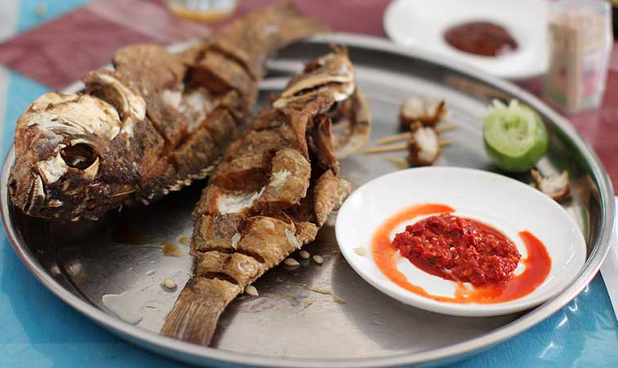

Fig: 2.1. Koroso

Asa lebleb is lightly cooked fish in a flavourful sauce. The spices used in the sauce vary throughout Ethiopia. Asa lebleb is usually only found in fishing towns where the fish is very fresh.

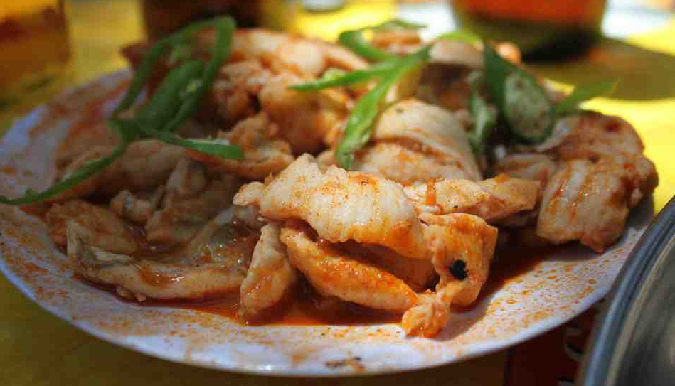

Fig: 2.2. Asa lebleb

Asa Goulash is deep fried fish served in a spicy sauce with tomato and onions and eaten with injera. It has no resemblance to goulash whatsoever but this is the name used throughout the country.

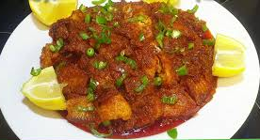

Fig: 2.3. Asa Goulash

Tere Asa is raw fish served only at a fish market or early in the day (when the fresh fish comes in) in a nearby restaurant. It is usually served with lime and a spicy dipping sauce. The most common fish to eat raw is carp.

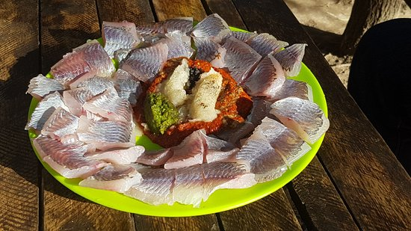

Fig: 2.4. Tere Asa

Asa shorba is fish soup. This is perhaps the dish that varies the most throughout Ethiopia.

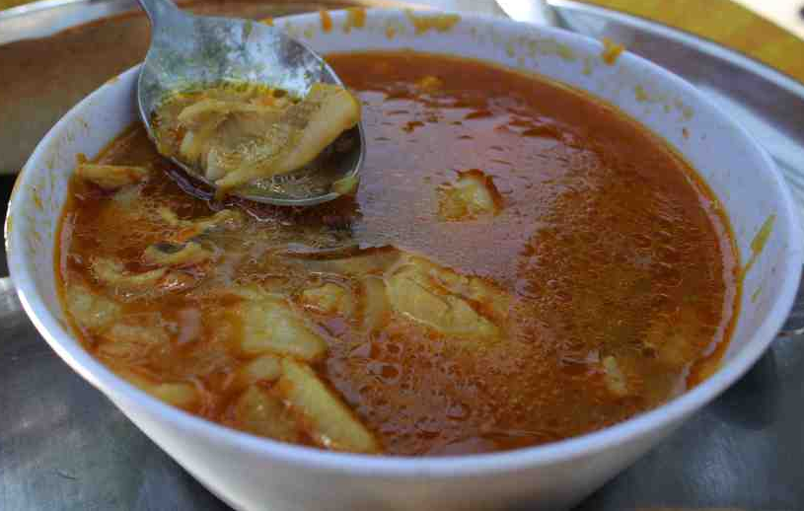

Fig: 2.5. Asa shorba

Using binding agents

A binding agent is a term referring to a wet ingredient you apply to meat before adding dry rubs or other spices. It is there to keep the spice coating on the meat and helps form that delectable crust on meats.

These are most-common binding agents used in cooking:
- Egg
- Flour
- Corn starch
- Shiro powder

Binding agents used to keep mixtures from separating, add structural support to delicate bakes.

Using accompaniments for fish dish

Ethiopian cuisine is renowned for its rich flavours, aromatic spices, and diverse array of dishes. While the main courses often steal the spotlight, the side dishes play an equally important role in creating a complete Ethiopian dining experience. These delectable accompaniments add layers of flavour, texture, and colour to the meal, complementing the main dishes and enhancing the overall dining experience.

Accompaniments for fish dish
- Lemon
- Kochikocha (Data) traditional hot sauce:

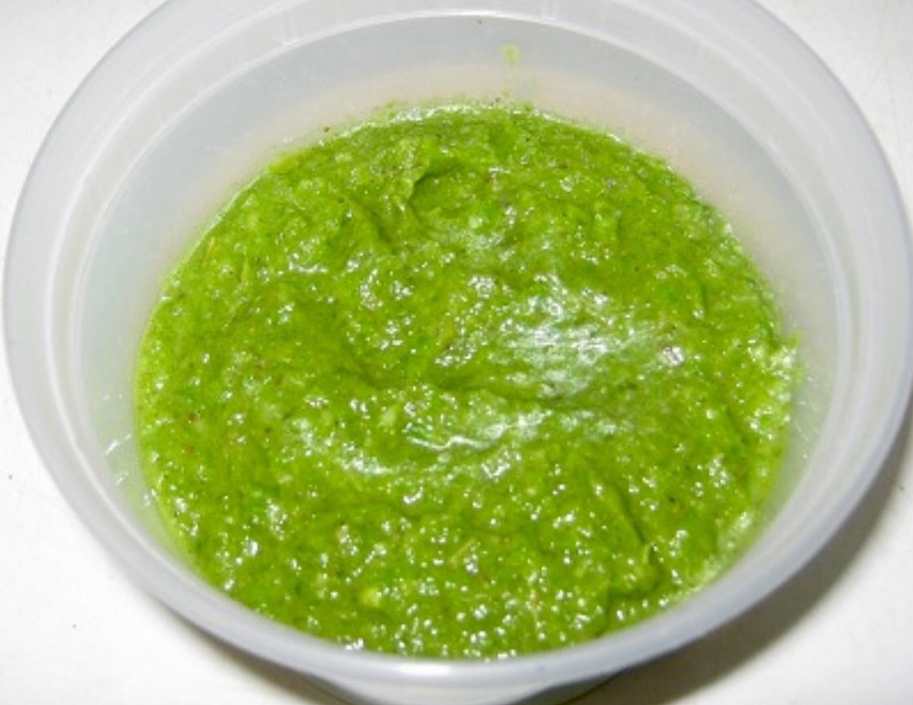

Fig: 2.6. Kochekocha
- Awaze: also known as Dilih in some parts of Ethiopia is one of the most popular Ethiopian traditional Ethiopian sauces.
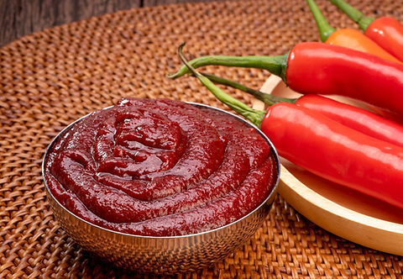
Fig: 2.7. Awaze

- Mitemita powder

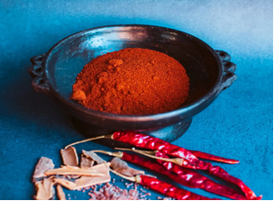
Fig: 2.8. Mitemita
- Injera, bread or kita
- Senafich is a spicy mustard sauce that has a bit more liquid to it than western mustard and is used as a dip rather than a spread. Senafich is made from ground mustard seeds, vinegar or lemon, garlic, oil and salt – although, like most everything, it is prepared differently at every restaurant.

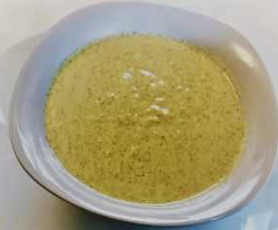

Fig: 2.9. Senafich
  - Presenting fish dish with cultural tools
- Cleaning and service
- Used equipment’s and tools are cleaned and stored in their proper place.
- Kitchen area is cleaned and sanitized in accordance with OHS procedures and regulation.
- Cooking utensils are washed and stored properly following work place hygiene.
- Extra ingredients are stored in hygienic place following OHS procedures.
- To present food
- Appearances must be checked for cleanness and freshness.
- Presented in a manner appealing to the eyes.
- Arrange foods on the table in accordance with style of service and number.
- Presenting fish dish with cultural tools for example: -
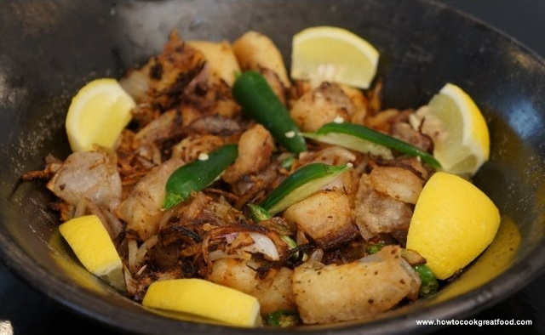
Fig: 2.10. Fish Tibs
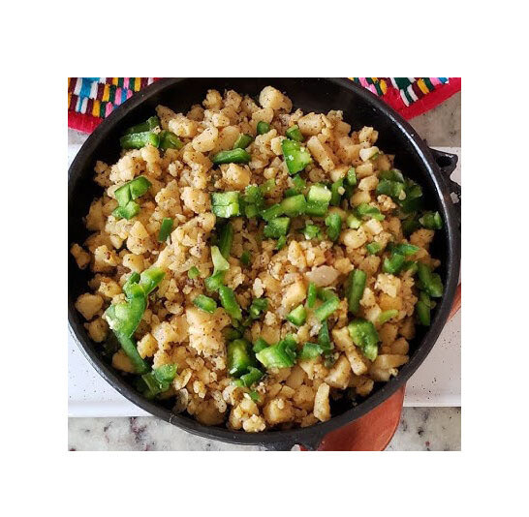
Fig: 2.11. Fish Dulet

Self-Check 2 | Written Test

Part 1: Write ‘true’ if the statement is correct or ‘false’ if it is incorrect.

______1. Binding agents used to add structural support to delicate bakes.

______2. When we present fish cultural dishes appearances must be checked for cleanness and freshness.

______3. Shiro powder is a binding agent to prepare cultural fish dish.
Part 2 Instruction፡ Match column “A” with the appropriate answer under column “B”
A |  | B
- Senafich |  | A | Traditional hot sauce prepared from green pepper
- Awaze |  | B | Made from ground mustard seeds,
- Kochekocha |  | C | also known as Dilih

Part 3: Answer the following questions correctly
- List tools and equipment’s used to serve fish and chicken cultural dishes?

Operation Shit 2 | Preparing and presenting fish dishes

  - Ye’assa key wat
INGREDIENTS:
- 3 medium fish filets
- 2 cups red onions (chopped)
- 1 cup oil
- 1 ½ cups water
- ¼ cup red pepper (berbere) or red
- Pepper paste (awaze)
- ½ cup t’ej or wine
- ¼ tsp. black pepper
- To taste salt
Procedure
- Cut the fish fillets in small pieces and grill without oil in a medium frying pan and set aside.
- In a separate pan, cook red onions until brown.
- Add oil and red pepper and stir.
- Add t’ej or wine, a little at a time, and keep on stirring.
- Make sure it does hot burn by adding water a little at a time, cook sauce for 30 minutes.
- Add the grilled fish, black pepper and salt to taste.
- Cook on low heat for 10 minutes and serve hot. 4-6 servings store in refrigerator.
Ye’assawe’t:-is popular during the fasting season or among vegetarians.

  - Ye’assa misir kik wat
INGREDIENTS:
- 3 medium fish filets
- 1 cup cracked lentil
- 2 cups red onions (chopped)
- 1 cup oil
- 1 ½ cups water
- ¼ cup red pepper (berbere) or red
- Pepper paste (awaze)
- ½ cup t’ej or wine
- ¼ tsp. black pepper
- To taste salt
Procedure
- Cut the fish fillets in small pieces and grill without oil in a medium frying pan and set aside.
- In a separate pan, cook red onions until brown.
- Add oil and red pepper and stir.
- Add t’ej or wine, a little at a time, and keep on stirring.
- Make sure it does hot burn by adding water a little at a time, cook sauce for 30 minutes.
- Add washed lentil in to the sauce.
- Cook until the lentil is cooked.
- Add fried fish and stir for a second then add little water.
- Simmer, season and serve hot with injera.

  - Ye’assa dulet
Ingredients
- 1 tblspn chopped garlic
- 1 tablespoon chopped ginger
- 1 teaspoon mitmeta
- 1 teaspoon corrorima
- 3 tablespoons butter
- 1 tablespoon oil
- 2 tablespoon chopped onion
- 1 pound of fish (chopped into small pieces)
Procedure
- Season fish with mitmita, corrorima/cardamom/, ginger.
- Sauté a seasoned fish with caramelize onion, garlic, diced tomatoes/if it is needed/ and green peppers in Ethiopian butter.
- Serve with injera or bread.

  - Ye’assa shorba
Ingredients
- 1 pc fish
- 4 Tbsp oil
- ½ cup onion chopped
- ¼ tsp. ginger mashed
- ¼ tsp. garlic mashed
- 15 cups water
- To taste salt
Procedure
- Wash fish thoroughly in water, debone fish and soak in to water with slice of lemon.
- Cook onion with oil over a low heat stirring constantly so that color does not change and to prevent it from sticking.
- Add the garlic and ginger and cook for 6 to 10 minutes more.
- Add 10 cups of lukewarm and bring to boil for 15 minutes.
- Serve hot. Makes 4 servings.

  - Ye’assa minchet
Ingredients
- 2 cups dried fish
- 2cups red onions(chopped)
- ¼ cup red pepper(berbere)
- ¼ cup oil
- ¼ cup t’ej or wine
- 1 cup water
- ¼ Tbsp. flax (powdered)
- ¼ tsp. fenugreek
- ¼ tsp. black pepper
- To taste salt
Procedure
- Cook red onions and flax at low heat until it is brown.
- Add oil and red pepper/berbere/ stir gently for 15 minutes adding t’ej or wine a little at a time.
- In the frying pan fry dried fish over a low fire until crisp, pound to a fine powder.
- Add fenugreek and powdered fish to cooking sauce.
- Add water and simmer gently for 5 minutes.
- Add black pepper and salt and stir gently.
- Serve hot. Make 6 serving.
Ye’assa minchet Abish, also served during the fasting period, is very delicious with injera or bread and may be served on special occasions.

  - Ye’assa Lebeleb
Ingredients
- 2 pounds your favorite white flesh fish
- 1 1/2 tablespoons berbere
- salt to taste
- oil for frying
- 1 thinly sliced onion
- 2 finely chopped garlic cloves
- 3 finely chopped small chiles
- juice of 1 lime

Procedure
- Sprinkle berbere over fish and leave for 1 hour to marinate.
- Heat enough oil in a large skillet for deep frying. Add fish pieces and fry until golden on all sides and cooked through. Remove to a paper towel lined plate to absorb excess oil. Sprinkle with a little salt.
- Add onions and cook until golden and caramelized, about 10 minutes. Most of the oil will have evaporated. Add garlic and chiles. Cook for 1 more minute.
- Return fish to the pan. Add lime juice and toss to combine.
- Serve with lime and an extra garnish of more berbere.

  - Ye’assa firfir key wat/Key Yeassa Firfir/
Ingredients
- 3 medium fish filets
- 2 cups red onions (chopped)
- 1 cup oil
- 1 ½ cups water
- ¼ cup red pepper (berbere) or red
- Pepper paste (awaze)
- ¼ tsp. black pepper
- To taste salt
- 1 Injera
- 1 Green pepper
Procedure
  - Cut the fish fillets in small pieces and grill without oil in a medium frying pan and set
aside.
  - In a separate pan, cook red onions until brown.
  - Add oil and red pepper and stir.
  - Make sure it does hot burn by adding water a little at a time, cook sauce for 30 minutes.
  - Add the fried fish, black pepper and salt to taste.
  - Cook on low heat for 2 minutes.
  - Add Injera and mix slowly. Add green pepper as a garnish.
  - Serve hot. 4-6 servings.

  - Derek yetamese assa
Ingredients
- 4 medium fish fillet
- ¼ cup berbere or awaze
- 1 cup cooking oil
- ½ cup t’ej or wine
- ¼ tsp. black pepper
- 2 chopped green pepper-fresh
- To taste salt
Procedure
  - Cut fish in to small pieces.
  - Mix berbere or awaze with oil, wine or t’ej, salt and black pepper.
  - Chop green pepper, add to fish and the red pepper mixture and cook for 5 minutes in low heat.
  - Makes 4-6 servings.
Yeassa Immis is like Yeassa Kitfo. Eat with injera or bread.
  - T’re Assa
Ingredients
- 3-4 fillet fresh
- ¼ cup very hot red pepper(mitmita) or red pepper(berbere) or red pepper paste(awaze)
Procedure
- Wash fish and remove skin.
- Cut fish in to edium sized cubes.
- Serve to room temperature with side dish of very hot red pepper, red pepper paste or red pepper (berbere) and with injera or bread.
- Make about 6 serving.
  - Ye’assa kitfo
Ingredients
- 2 pounds of fish
- 2.5 tbsp of oil
- 1 tbsp of finely chopped red onions
- 1 tbsp of Awaze (Ethiopian Spicy Dipping Sauce)
- 1 lemon juice
- 1 thinly sliced hot green pepper
- 0.25 tsp of black pepper
Procedure
- First, use a large bowl and add in the thinly sliced green pepper, finely chopped the onion, and lemon juice.
- Then add the olive oil, Awaze, salt, and black pepper. Mix them all together.
- Now, carefully remove the fish’s skin and pat it dry with a clean cloth.
- Use a sharp knife and cut the fish into very little cubes.
- Then add the chopped fish into the previous mixture and mix thoroughly, and add sliced green peppers as a garnish.
- Serve attractively with proper serving tools.
NOTES: If you prefer, you can replace the Awaze with Mitmita.

LAP Test 1 | Practical Demonstration

Name: _____________________________ Date: ________________
Time started: ________________________ Time finished: ________________
Instructions: Given necessary templates, tools and materials you are required to perform the following tasks within 4 hour.
Perform the following tasks in front of your teacher:
Task 1: Yeassa keywet
Task 2: Yeassa lebeleb
Task 3: Yeassa shorba
Task 4: Yeassa kitfo

UNIT THREE | Preparing and presenting chicken dishes
This learning guide is describes knowledge, skills and attitude required for food sanitation and safety in a commercial kitchen or catering operation.
- Preparing a range of chicken dishes
- Using sauces and accompaniment for chicken dish
- Presenting chicken dish with cultural tools
This guide will also assist you to attain the learning outcomes stated in the cover page. Specifically, upon completion of this learning guide, you will be able to:
- Prepare a range of chicken dishes.
- Use sauces and accompaniment for chicken dish
- Present chicken dishes with cultural tools and equipment’s.

3.1. Preparing chicken dishes
The secret of a good wet is to fry the onions until they are limp and be mashed with a spoon for easy blending in with the berebere and butter mixture, after which the different ingredients form a smooth consistency. When the different constituents separate it is a bad wet.
Constant stirring is also absolutely necessary, especially during the initial stage of cooking. Otherwise the onion and berebre will stick to the bottom of the cooking pot and burn giving a bad aroma to the wet that we call it “megorenat”.
Cultural chicken dishes may include:
- Ye’doro key wat is a most popular Ethiopian dish served on special occasions with injera and a side order of yoghurt or homemade cottage cheese.
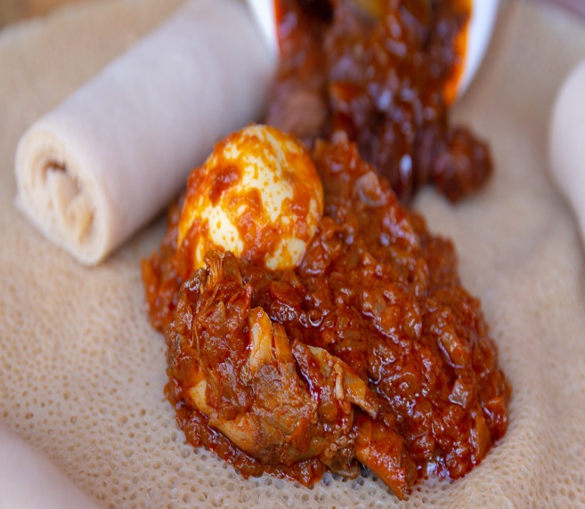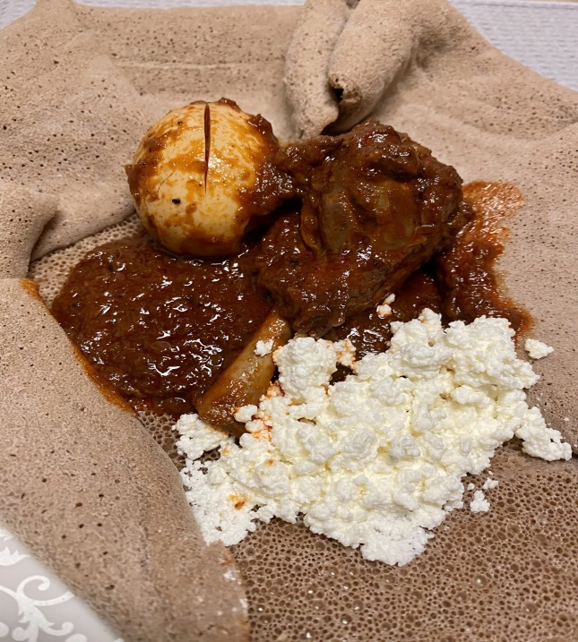
Fig: 3.1. Ye’doro key wat
- Ye’doro Alicha wat is just like Doro Wet without the red pepper. It is a very delicious dish as well.
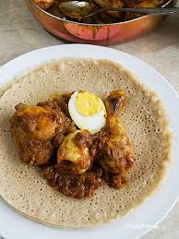
Fig: 3.2. Ye’doro Alicha wat
- Ye’doro enfile is best eaten with injera, and the sauce mixed with some yogurt or served by itself as a main dish.
- Ye’doro dabbo is tasty bread especially prepared for parties.

Fig: 3.3. Ye’doro Dabo

3.2. Using sauces and accompaniment for chicken dish
- Using sauces
Basic sauces to prepare chicken dishes especially yedoro wet we use key/hot/ sauce and alicha/turmeric/ sauce. To add sour test we can also add yogurt on the top of sauce.
- Accompaniments includes:
- Boiled eggs
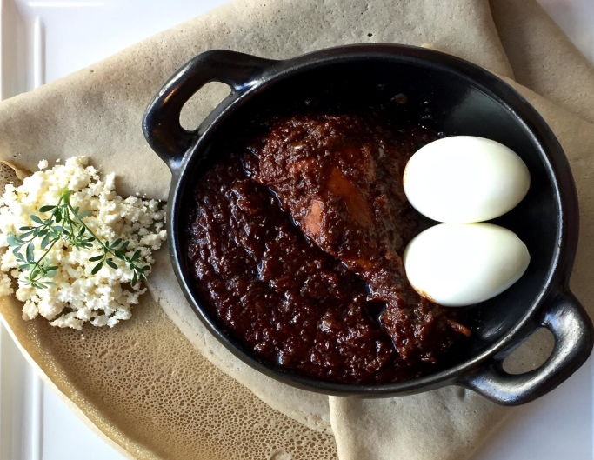
Fig: 3.4. Doro wot with boiled egg

- Yoghurt
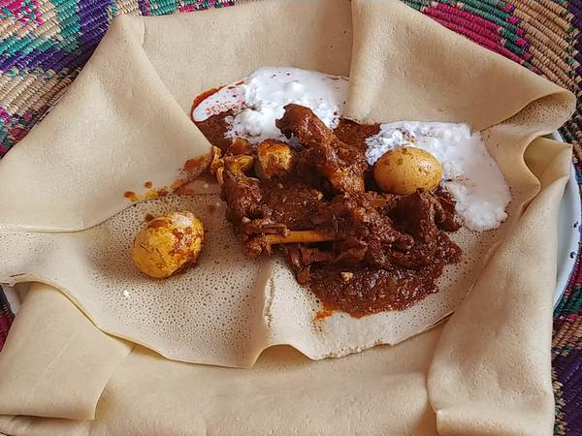
Fig: 3.5. Doro wot with yogurt
- Cottage cheese
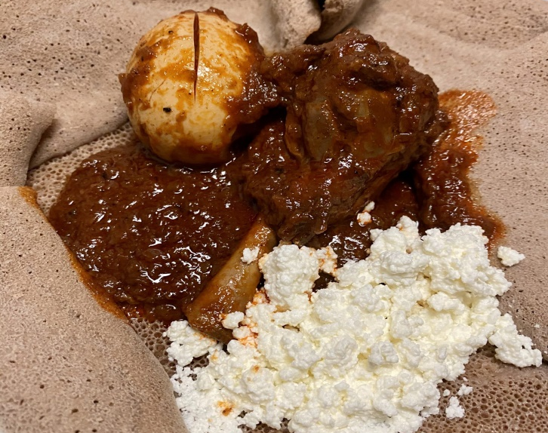
Fig: 3.4. Doro wot with cottage cheese
- Injera
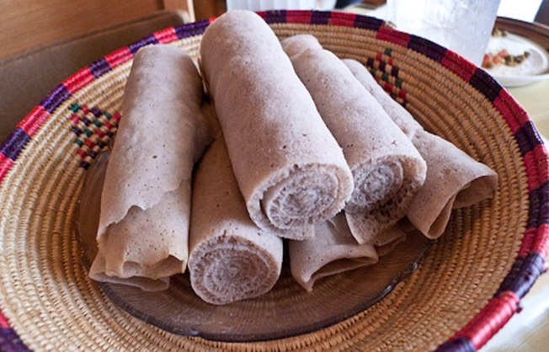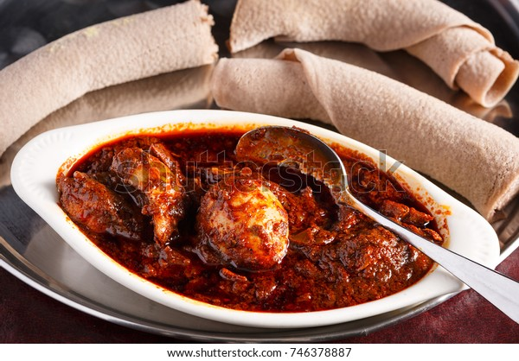
Fig: 3.4. Doro wot with Injera

  - Presenting chicken dish with cultural tools
- Cleaning and service
- Used equipment’s and tools are cleaned and stored in their proper place.
- Kitchen area is cleaned and sanitized in accordance with OHS procedures and regulation.
- Cooking utensils are washed and stored properly following work place hygiene.
- Extra ingredients are stored in hygienic place following OHS procedures.
- To present food
- Appearances must be checked for cleanness and freshness.
- Presented in a manner appealing to the eyes.
- Arrange foods on the table in accordance with style of service and number.
- Presenting chicken dish with cultural tools for example: -
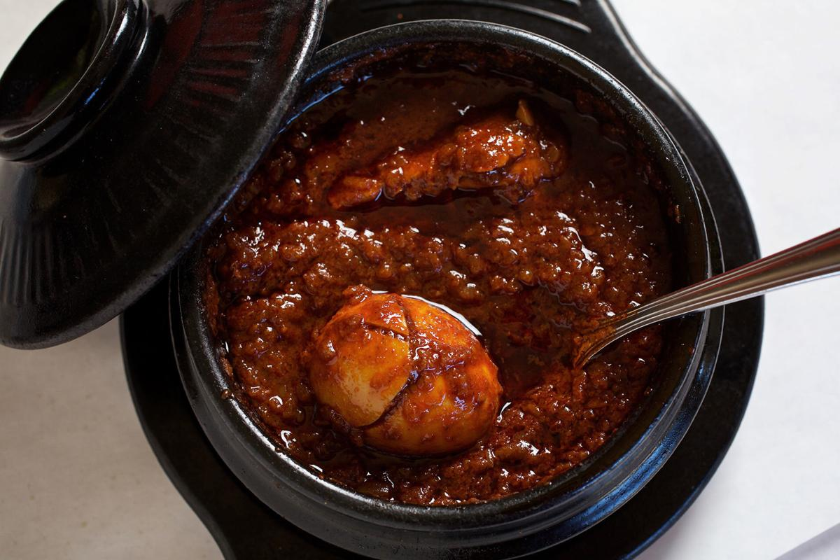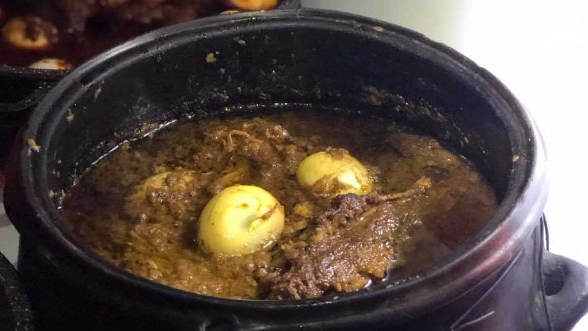
Fig: 3.7. Chicken dish with traditional serving plate

Self-Check 3 | Written Test

Part 1: Write ‘true’ if the statement is correct or ‘false’ if it is incorrect.

______1. Constant stirring is absolutely necessary to make a good wet.

______2. When we present chicken cultural dishes appearances must be checked for cleanness and freshness.

______3. Cottage cheese cannot be served with side Yedoro wet.
Part 2 Instruction፡ Match column “A” with the appropriate answer under column “B”
A |  | B
- Side dish for doro wet |  | A | The result of lacking continuous stirring
- Using turmeric |  | B | Yogurt
- Megornat |  | C | Yedoro alicha wet

Part 3: Answer the following questions correctly
  - List chicken cultural dishes?

Operation Shit 2 | Preparing and presenting chicken dishes
  - Ye’doro key wat
Ingredients
- 1 whole chicken
- 6 cups red onions (chopped)
- 1 cup red pepper (beerber)
- 2 cups butter (spiced)
- ¼ tsp. false cardamom
- ¼ tsp. black pepper
- ¼ tsp. bishop’s weed
- ¼ tsp. garlic powder
- ¼ tsp. ginger
- To taste salt
- ½ cup t’ej or red wine
- 4 cup water
- 6 medium eggs (hard boiled)
- 1 medium lime
Procedure
- Remove skin from chicken, cut into the usual parts, and wash several times in water.
- Wash and cut lime into 4 pieces and to a large bowl of clean water and soak chicken in it.
- In a medium pan cook onions until golden brown.
- Add butter. Add red pepper and mix well. Add about ½ cup of water and stir. Add t’ej or wine.
- Add the spices and blend well.
- Add prepared chicken pieces and cook for about 30 – 40 minutes.
- Add more water and stir gently so as not to separate the meat from the bones.
- Add salt and stir. When sauce begins to thicken, sprinkle with black pepper.
- Add hard boiled eggs to the sauce and serve hot makes 6 servings store in refrigerator.
  - Ye’doro Alicha wat
Ingredients
- 1 whole chicken
- 6cups red onions(chopped)
- 2 cups butter(spiced)
- ¼ cups turmeric
- ¼ tsp. black pepper
- ¼ tsp. bishop’s weed
- ¼ tsp. garlic powder
- ¼ tsp. ginger
- ½ cup t’ej or white wine
- To taste salt
- 4 cups water
- 6 edium eggs(hard boiled)
- 1 medium lime
Procedure
- Remove skin from chicken, cut into the usual parts, and wash several times in water.
- Wash and cut lime into 4 pieces and to a large bowl of clean water and soak chicken in it.
- In a medium pan cook onions until golden brown.
- Add butter. Add turmeric and mix well. Add about ½ cup of water and stir. Add t’ej or wine.
- Add the spices and blend well.
- Add prepared chicken pieces and cook for about 45 minutes.
- Add more water and stir gently so as not to separate the meat from the bones.
- Add salt and stir.
- When sauce beings to thicken, sprinkle with black pepper.
- Add hard boiled eggs to the sauce.
- Serve hot. Makes 6 servings.

  - Ye’doro enfile
Ingredients
- 1 whole chicken
- 1 cup red onions(chopped)
- ¼ cup red pepper(berbere)
- 1 cup butter-spiced
- 2 cups water
- To taste salt
- ¼ tsp. black pepper
- 1 Tbsp. ginger
- 1 Tbsp. garlic
Procedure
- Skin chicken and cut in to usual pieces. Put aside smaller pieces(neck, wings, etc.).
- Leave the meat attached to the bones and cut chicken in to strips and put aside.
- In a medium pan brown with one cup butter and add berbere and stir gently.
- Add one cup of water at a time and stir well.
- Take large chicken pieces and add to cooked onions.
- Add salt and the rest of ginger, garlic and black pepper.
- Cook for 20-30 minutes adding the remaining water.
- In another pan boil the rest of the small pieces of chicken with some onion for 15 minutes.
- Remove the smaller chicken parts from the water and dip in to prepared sauce.
- Serve hot. Good for about 6 servings.

  - Ye’doro dabbo
Ingredients
- 3lbs. wheat flour
- 2 pkt. Yeast
- 1 tsp. sugar
- 4 cups hot water
- ¼ tsp. bishop’s weed
- 1 lb. butter or margarine
- 1 cup red onion-chopped
- 1/3 cup berbere or awaze
- 2 pieces boneless chicken thighs
- ¼ tsp. cloves
- ¼ tsp. false cardamom
- ¼ tsp. ginger
- ¼ tsp. garlic
Procedure
Chicken Sauce
  - Brown onions in medium frying pan on very low heat.
  - Cut chicken in to cubes and add to the onions along with butter.
  - Stirring occasionally, add berbere or awaze.
  - Add spices: bishop’s weed, cloves, false cardamom, ginger and garlic and simmer for
about 10-15 minutes.
  - Remove from the heat and set aside. Boil eggs, peel and set aside.
Dough
- Add yeast, sugar and 1 cup of flour to 4 cups of hot water in large mixing bowl.
- Rub between fingers until yeast and sugar dissolve.
- Add remaining flour and keep rubbing until a soft dough is formed.
- Set aside for a few seconds until it rises.
- Skim a small amount of grease from the top of the chicken sauce and add half of the skimmed grease to the dough, still rubbing with fingers.
- Put half of the dough in to a baking pan.
- Spread all of the sauce with the boiled eggs on top of the dough.
- Put the remaining dough on the top.
- Let the dough rise to the rim of the pan.
- Place the pan in 350º pre heated oven. Bake for 20-30 minutes, checking until crisp and brown.
- Remove from oven and spread top the remaining half of the skimmed chicken sauce grease.
- Serve hot. Do not use knife when cutting but reak with fingers.

  - Yenqulal wet
Ingredients
- 1cup onions-chopped
- ¼ cup berbere
- 1cup butter-spiced
- ¼ cup t’ej or red cooking wine
- 6 egg yolks
- 1 tsp. ginger-freshly minced
- ¼ tsp. black pepper
- To taste salt
- 4 cups water
Procedure
- Cook red onions brown without grease in medium cooking pot.
- Add ½ cup water and stir.
- Add red pepper and butter and cooking pot boil the eggs with 2 cups of water for 10 minutes and separate the yolks from the whites.
- In small bowl break the yolks and add 1 ½ cups of water stirring until completely smooth.
- Pour slowly in to cooking sauce, stir gently to avoid limps and cook well.
- Add ¼cup t’ej or red cooking wine and stir.
- Add all spices and mix well.
- Serve hot. Makes about 6 servings.
Yenqulal Wet may be used as a substitute for meat stews for people who don’t eat meat. When properly cooked, it can be much more delicious than meat stews.

  - Yedoro Minchet Abish(Hot minced chicken stew)
Ingredients
- 1 medium chicken-whole
- 2 cups red onions-chopped
- ½ cup berbere
- 2 cup water
- 2 cup butter-spiced
- ¼ tsp. garlic
- ¼ tsp. ginger
- ¼ tsp. black pepper
- ¼ tsp. cardamom
- ½ cup t’ej or wine
- To taste salt
Procedure
- Skin chcken, wash good, debone and mince the meat only.
- Brown in medium pan or pot until cooked well and soft.
- Add butter, berbere and salt and cook for 20 minutes and then add ginger and wine.
- Add minced chicken meat and cook gently for 10 minutes.
- Add water and spices and cook stirring gently for another 15 minutes or until the water evaporates and is thick.
- Makes 6 servings.
Yedoro Minchet Abishis a very versatile hot stew. Eat it hot with injera or bread.

LAP Test 2 | Practical Demonstration

Name: _____________________________ Date: ________________
Time started: ________________________ Time finished: ________________
Instructions: Given necessary templates, tools and materials you are required to perform the following tasks within 4 hour.
Perform the following tasks in front of your teacher:
Task 1: Yedoro key wet
Task 2: Yedoro Dabbo
Task 3: Yedoro Enfile

UNIT FOUR | Storing fish and chicken dishes
This learning guide is describes knowledge, skills and attitude required for food sanitation and safety in a commercial kitchen or catering operation.
- Portioning cooked fish and chicken dishes
- Storing cooked fish and chicken dishes
This guide will also assist you to attain the learning outcomes stated in the cover page. Specifically, upon completion of this learning guide, you will be able to:
- Portion cooked fish and chicken dishes
- Store cooked fish and chicken dishes

Portioning cooked fish and chicken dishes
- Portioning and labelling cooked fish and chicken food in a commercial kitchen minimizes foodborne illness. By placing food rotation labels on your storage bins you can easily label the type of food in the storage container, the date it was added to the storage bin, and the date the food will expire.
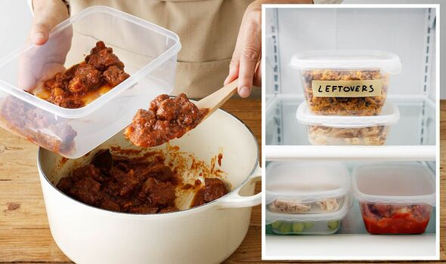
Fig: 4.1. Portioning and labelling
- All time and temperature controlled foods require these three key pieces of information:
- Type of food
- Date food was added
- Date food expires
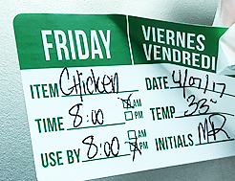
Fig: 4.2. Labelling
- Food that is served after the use by, or expiration date, could cause food-related illness to your restaurant patrons.
  - Storing cooked fish and chicken dishes
- Take special care with high-risk foods
Food poisoning bacteria can grow and multiply on some types of food more easily than others. High-risk foods include:
- Raw and cooked meat - such as chicken, and foods containing them, such as curries and sauces.
- Dairy products - such as dairy-based foods
- Eggs and egg products - such as mousse
- Seafood - such as seafood salad, stews containing seafood and fish stock
Food that comes in packages, cans and jars can become high-risk foods once opened, and should be handled and stored correctly.
- Choose strong, non-toxic food storage containers
- Make sure your food storage containers are clean and in good condition, and only use them for storing food.
- Cover them with tight-fitting lids, foil or plastic film to minimize potential contamination.
- Transfer the contents of opened cans into suitable containers.
- Storing food in the fridge
- Your fridge temperature should be at 5 °C or below.
- The freezer temperature should be below -15 °C.
Note: Use a thermometer to check the temperature in your fridge.
- Beware of the temperature danger zone
- Food poisoning bacteria grow and multiply fastest in the temperature danger zone between 5 °C and 60 °C.
- It is important to keep high-risk food out of this temperature zone.
- Storing cooked food safely
When you have cooked food and want to cool it:
- Put hot food into shallow dishes or separate into smaller portions to help cool the food as quickly as possible.
- Don't put very hot food into the refrigerator. Wait until steam has stopped rising from the food before putting it in the fridge.
- Avoid refreezing thawed food
- Food poisoning bacteria can grow in frozen food while it is thawing, so avoid thawing frozen food in the temperature danger zone. Keep defrosted food in the fridge until it is ready to be cooked. If using a microwave oven to defrost food, cook it immediately after defrosting.
- As a general rule, avoid refreezing thawed food. Food that is frozen a second time is likely to have higher levels of food poisoning bacteria. The risk depends on the condition of the food when frozen, and how the food is handled between thawing and refreezing.

Self-Check 4 | Written Test

Part 1: Write ‘true’ if the statement is correct or ‘false’ if it is incorrect.

______1. Date food expires is one of the information for proper storage.

______2. Put hot food into shallow dishes or separate into smaller portions cannot help cool the food as quickly as possible.
______3. Food storage containers must be clean and in good condition to minimize contamination.
______4. Portioning and labelling cooked fish and chicken food in a commercial kitchen can’t minimizes foodborne illness.
Part 2 Instruction፡ Match column “A” with the appropriate answer under column “B”
A |  | B
- Fridge temperature should be |  | A | below -15 °C
- Freezer temperature should be |  | B | between 5 °C and 60 °C
- Danger zone temperature |  | C | Sea foods
- Special care with high-risk foods |  | D | 5 °C or below

Part 3: Answer the following questions correctly
- What is the use of avoiding refreezing thawed foods?
- Temperature controlled foods require three key pieces of information what are they?

Reference

Exoitic Ethiopian Cooking pdf Mesfin Danil Jotte/2004

http://ca.wiley.com/WileyCDA/WileyTitle/productCd-EHEP001716.html
- http://goaddistours.com/20150409asa-ethiopias-vegan-fish/
- https://www.bigdogspices.com.au/blog/what-is-a-binding-agent/
- https://theethiopianfood.com/most-popular-ethiopian-side-dishes/
- https://theethiopianfood.com/awaze-recipe-how-to-make-ethiopian-spicy-dipping-sauce/
- https://theethiopianfood.com/asa-kitfo-fish-steak-tartar-recipe/

Participants of this Module (training material) preparation
No | Name | Qualification (Level) | Field of Study | Organization/ Institution | Mobile number | E-mail
1 | Mamit Ayalew | B | Hotel Mgt | Bishoftu P.College | 0911723484 | mamitayalew@gmail.com
2 | Marksew Shiferew | A | Food security | Misrak P.College | 0937645184 | markisews@gmail.com
3 | Wale Getaneh | A | Food Technology/TVET Leadership & Mgt | Bole M.College | 0929241229 | waleg917@gmail.com
4 | Biruk Adamu | B | Hotel Mgt | TTI | 0921355741 | birukadamu50@gmail.com
5 | Efrem kitila | B | Hotel Mgt | Woliso P.College | 0917289283 | efremkitila922@gmail.com
6 | Helen Adugna | B | Hotel Mgt | Selam TVET College | 0915573757 | helenadugna12@gmail.com
7 | Ali Kassaw | B | Hotel Mgt | Bardar P.College | 0918573970 | Kassawali2004@gmail.com
8 | Solomon Bekele | A | Hotel Mgt | G.winget PTC | 0911149147 | Soladvent06@gmail.com

