Culinary Art Level - IV
Based on September 2023, Curriculum Version II

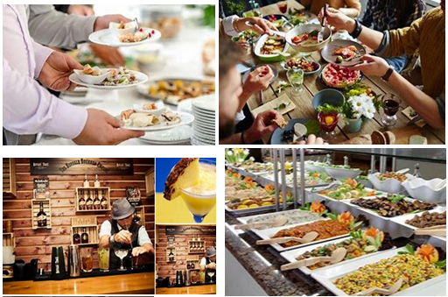
Module Title: Planning and Operating Catering Events
Module code: CST CUA4 M05 0923
Nominal duration: 90 Hours

Prepared by: Ministry of Labor and Skill
September, 2023
Addis Ababa, Ethiopia

Table of content
Acknowledgment 3
Introduction to the Module 4
Unit One: Catering Events 5
1.1 Concepts of event 6
1.2 Purposes of event 11
1.3 Customer needs 12
Self-Check 1 13
Unit Two: - Catering proposal 14
2.1 Event and venue operational information 15
2.2 Operational factors influencing catering 17
2.3 Creative element of catering concept and theme 18
2.4 Catering proposal presentation 27
Self-Check 2 30
Unit Three: - Catering operational plan 31
3.1 Operational plan 32
3.2 Risk management issues 34
3.3 Providing information 36
3.4 Implementing and monitoring catering plan 37
3.5 Evaluating event 39
Self-Check 2 41
Operation sheet 3.1: Catering operational plan 42
Operation sheet 3.2: Implementing and monitoring catering plan 43
Operation sheet 3.3: Evaluating event 45
Lap Test 46
Reference 47

Acknowledgment
The Ministry of Labor and Skills (MoLS) would like to express its gratitude and appreciation to the instructors and experts from regional TVT bureaus, TVT colleges, and industry practitioners who contributed their expertise and experience in preparing the training module for the unit of competency “Plan and Operate Catering Events” under the occupational standard "Culinary Art level-IV."
The ministry also expresses its deepest gratitude to the Tourism Training Institute for its invaluable technical and financial support and collaboration in the module preparation. It is also thankful to MoLS staff members who coordinated the preparation and reviewing process of this training module.

Introduction to the Module
In the culinary art field, planning and operating catering events, this module describes the performance outcomes, skills, and knowledge required to plan and operate catering events. It involves developing the catering concept and planning and developing an operational plan to meet requirements.
This module applies to catering for any type of event. It may be relevant in any industry context, but has particular application to the cultural, community, hospitality, sporting and tourism sectors. This module is relevant to a caterer or other cookery specialist involved in event catering, but also to non-catering specialists like event managers. The skills to actually provide catering are covered in other cookery and catering units. While catering is the major focus of the unit, it also refers to additional services that may be offered by a caterer, such as those related to decor and theme.
This module covers the units:
- Catering Events
- Catering proposal
- Catering operational plan
Learning Objective of the Module
- Identify purpose and scope of the event
- Prepare catering proposal
- Prepare and implement operational plan.

Module Instruction
For effective use this modules trainees are expected to follow the following module instruction:
- Read the information written in each unit
- Accomplish the Self-checks at the end of each unit
- Perform Operation Sheets which were provided at the end of units
- Do the “LAP test” giver at the end of each unit and
- Read the identified reference book for Examples and exercise

Unit One: Catering Events
This unit is developed to provide you the necessary information regarding the following content coverage and topics:
  - Concepts of event
- Definition of event
- Classification of Event
- Types of Event Catering
  - Purposes of event
  - Customer needs
This unit will also assist you to attain the learning outcomes stated in the cover page.
Specifically, upon completion of this learning guide, you will be able to:
  - Understand concepts of event
  - Explain types of event
  - Discuss and clarify purposes of event
  - Identify and determine customer needs

1.1 Concepts of event
Introduction
Events create opportunities for people to connect with an area, spend time together, celebrate and experience the diversity of cultures and foster creativity and innovation. They allow a community to come alive and provide an opportunity for a destination to showcase its experience and increase economic activity. Events contribute significantly to community building, lifestyle and leisure enhancement, cultural development, tourism promotion and increased visitation, volunteer participation, fundraising and economic development. Most importantly, events create a sense of fun and vibrancy, resulting in a strong sense of community connectivity, pride and a sense of place.
1.1.1 Definition of event
An event can be described as a public assembly for the purpose of celebration, education, marketing or reunion. “Events are temporary occurrences …They have a finite length, and for planned events, this is usually fixed and publicized.” He further comments that “events are transient, and every event is a unique blending of its duration, setting, management, and people”.
1.1.2 Classification of Event
Events offer a unique form of tourist attraction, ranging in scale from small community festivals, through to international trade fairs, and on to the largest of global sporting events, such as the Olympic Games and the FIFA Football World Cup. One of the key differences between events and traditional attractions is the period of time over which they impact the host community or region. Events are short term by definition, often lasting only one or two days, although some larger events can last significantly longer (e.g. weeks ) while fixed attractions tend to draw visitors seasonally, or over an extended period When considering the scale and impact of events, they fall into four broad categories: Mega Events, Hall mark events, Major events and local events. The key factors typically recognized as determining the perceived scale and impact of events are the level of participation, audience/spectators, and media coverage; and the degree to which an event generates significant international demand for each.

Mega events: are events with international appeal and true global reach typically fall into the categories of major or mega-events. Such events have the potential to act as catalysts for local development, and to deliver a range of economic, socio-cultural, environmental and other benefits associated with image, branding, and expansion of the visitor economy, just to name a few.

Figure: 1.1. Mega events
- Hallmark event: These are the events with the distinctive quality of the program. Hallmark events are so identified with the spirit and soul of a host community that they become synonymous with the name of the place, and gain widespread recognition and awareness.
Hallmark events are of special importance and attractiveness both for participants and visitors, they attract great attention of the public, contribute to the image of destination and maintain and revitalize the tradition.
- Major events: Major event is a large-scale event, with strong public interest and media coverage. Major events attract large numbers of visitors, and help the organizers achieve good economic results. In practice of management of events, these events are often sports-oriented, with an international reputation, and defined structure of competition.
- Local events: Local event is an event that is targeted mainly for local audiences and staged primarily for their social, fun and entertainment value. These events often produce a range of benefits, including engendering pride in the community, strengthening a feeling of belonging and creating a sense of place. They can also help with exposing people to new ideas and experiences, encouraging participation in sports and arts activities, and encouraging tolerance and diversity.

Categories of Events
Another common way of classifying events is by their form or content:
- Cultural celebrations
- Arts and Entertainment
- Business and Trade
- Sport competitions
- Recreational
- Educational and Scientific
Political and state Figure: 1.2. Categories of events
1.1.3 Types of Event Catering
- Corporate Catering
Corporate catering provides food and drinks to business and corporate functions. These functions could cover a wide range of options, from onsite, small office gatherings like meetings to offsite, upscale dinners and large events. The cost of a corporate catering event will also depend on the size and the formality of the function that you want to host.
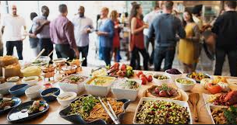
There are several types of corporate catering, including:
- Breakfast
- Lunches
- Barbecues
- Conventions, trade shows, and conferences
- Board meetings Figure 1.3. Corporate catering
- Product launches
- Buffet Catering
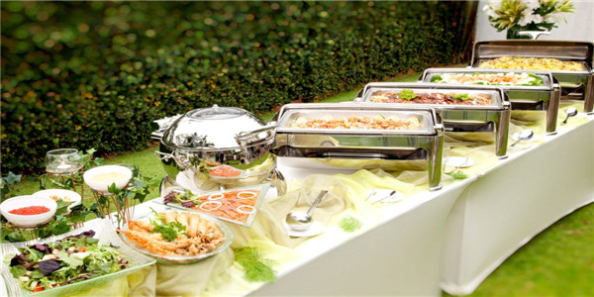
For buffet catering, different kinds of dishes, including hot and cold options, are set out on large tables for guests to choose from. These dishes will usually be laid out in a line, and the guests at your event will come to the buffet line to serve themselves (or be served) from the dish or dishes that they choose.
Figure1.4. Buffet catering
- Social Event Catering
Social event functions are usually more intimate affairs and need more attention to detail by your caterer. This category covers all kinds of special events, such as birthday parties, retirement celebrations, grand openings, housewarming parties, and bridal and baby showers.
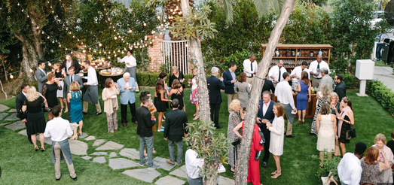
Figure 1.5: social event catering

- Office Delivery Catering
For delivery catering to your office, the caterer prepares the food somewhere away from the office, packs it up into disposable containers and delivers it to your office for you.
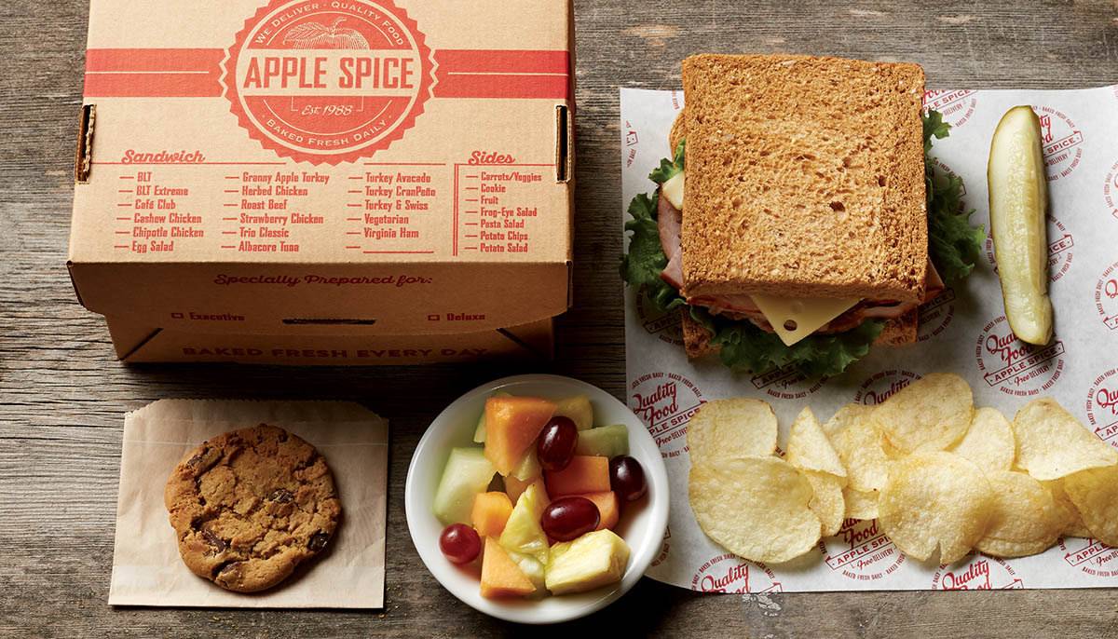
Figure 1.6: Office Delivery Catering
- Restaurant Catering
With this kind of catering, an event is held at the premises of the caterer. The restaurant will usually be customized and decorated to fit the needs and wants of the guests. An event like this is most suitable for social events, such as birthday parties.

Figure 1.7: Restaurant Catering

1.2 Purposes of event
The purposes of an event can vary depending on the nature and purpose of the event. However, most events have one or more of the following purposes:
- Promoting a product or service: Events are often used to promote a new product or service to potential customers. The objective of these events is to showcase the product or service and generate interest and sales.
- Building brand awareness: Events can also be used to build brand awareness and loyalty among the audience. The objective of such events is to create positive associations with the brand, which will translate into increased sales and customer loyalty.
- Networking: Events can provide an opportunity for individuals and businesses to meet and network with others in their field. The objective of these events is to build professional relationships and create new business opportunities.
- Fundraising: Events can be used to raise funds for a specific cause or organization. The objective of these events is to generate donations and support for the cause.
- Education and training: Events can be used to provide education and training to attendees. The objective of these events is to impart knowledge and skills that will help attendees in their personal or professional lives.
- Entertainment: Some events are purely for entertainment purposes. The objective of these events is to provide attendees with an enjoyable and memorable experience.
In general the purposes of an event depend on the type of event and the audience it is targeting. It is important for event organizers to define clear objectives before planning the event, as this will help them to create a focused and effective event.

1.3 Customer needs
When it comes to catering events, customers can have a range of needs depending on the type of event and their personal preferences. Some common customer needs in catering events may include:
- Menu customization: Customers may have specific dietary requirements or preferences that they want the catering service to accommodate. This could include options for vegetarians, gluten-free or dairy-free diets, or a desire for certain types of cuisine.
- Quality of food: Customers may expect high-quality ingredients, fresh and well-prepared dishes, and attractive presentation. They may also expect a variety of options, including appetizers, entrees, and desserts.
- Professional service: Customers may expect professional and well-trained staff who are knowledgeable about the food being served, can answer questions about the menu, and provide excellent service during the event.
- Flexibility: Customers may need to make changes to their catering order leading up to the event or have specific requests during the event. A catering service that can accommodate last-minute changes and unique requests may be highly valued by customers.
- Timeliness: Customers may expect prompt delivery and set up of the catering service, and timely arrival of the staff during the event. They may also expect food to be served in a timely manner so that guests can enjoy the meal together.
- Cost-effective options: Customers may be looking for catering options that fit within their budget while still providing high-quality food and service.
By understanding these customer needs and providing excellent service to meet them, catering companies can ensure a satisfied and happy customer base.

Self-Check 1

Part-I: Choose the correct answer
  - _________ can be described as a public assembly for the purpose of celebration, education, marketing or reunion.

- Event
- Catering
- Service
- Ceremony

  - One of the following is classifying events is by their form or content

- Mega events
- Hall mark events
- Major events
- Cultural celebrations

- __________ provides food and drinks to business and corporate functions.

- Corporate Catering
- Buffet Catering
- Social Event Catering
- Office Delivery Catering

- The purposes of an event can vary depending on the nature and purpose of the event. all of the bellows are the objectives of an event except

- Promoting a product or service
- Building brand awareness
- computing with governments
- Networking

- Which one the following is not customers’ needs

- Menu customization
- Budget
- Quality of food
- Timeliness

Unit Two: - Catering proposal
This unit to provide you the necessary information regarding the following content coverage and topics:
- Event and venue operational information
- Operational factors influencing catering
- Creative element of catering concept and theme
- Catering proposal presentation
This guide will also assist you to attain the learning outcomes stated in the cover page. Specifically, upon completion of this learning guide, you will be able to:
  - Understand event and venue operational information
- Analyze and consult operational factors influencing catering
- Contribute creative elements of catering concept and theme
- Present Catering proposal

2.1 Event and venue operational information
Event and venue operational information refers to the details and guidelines related to the management, operation, and execution of an event in a specific venue. This information is typically provided by the venue and outlines the key policies, procedures, and requirements that event organizers need to follow when hosting an event in that venue. Here are some examples of event and venue operational information:
- Space layout: The layout of the event space, including available seating, staging areas, and storage areas.
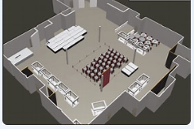
Figure 2.1 The layout space of event venue
- Equipment and services: Details about equipment and services, including audio-visual technology, lighting, catering, and security services.

Figure 2.2 Equipment and services of event
- Access and security: Information on how to access the building or event space, security policies, and requirements for entry and exit.
- Parking and transportation: Information on parking options, shuttle services, and public transportation options nearby.
- Noise and environmental concerns: Guidelines on music volume, waste management, and other environmental concerns that may affect the event.
While most venues will provide a dedicated event coordinator to support your planning, it's important to review all operational information provided to ensure that you are familiar with the venue's policies and procedures before the event.
By understanding the event and venue operational information, organizers can ensure that they are compliant with venue rules and regulations, and that the event runs smoothly, safely, and successfully.

2.2 Operational factors influencing catering
There are several broad factors that can influence catering, both in terms of how the catering is provided and the type of food and service that is offered. Here are some of the main factors:
- Client preferences: Caterers must take into account the preferences of their clients, such as their dietary restrictions, cultural preferences, and personal taste preferences. This can impact the type of cuisine that is offered as well as the ingredients, spices and cooking techniques used.
- Budget: The budget of the client will significantly affect the overall catering options. A higher budget may allow for more luxurious or exotic food choices or new presentation techniques, while a lower budget can mean simpler, more affordable cuisine options.
- Event location: The location of the event can also impact catering. For example, if the event is being held outdoors, it might require more simple or refreshing food and drinks. If the event is hosted indoors, it may require more sophisticated presentation options and specific preparation for plating like using wamers or air-fryers
- Type of event: The type of event being hosted will also play a role in determining the catering options. For example, catering for a wedding will have a different set of requirements than catering for a corporate event. A formal dinner may require more elaborate food presentation and specific plating techniques, while a casual gathering may require more relaxed catering options like a coffee cart, bar services or a food truck rental.
- Season and Weather: The time of year, local produce and weather may affect the availability and cost of certain ingredients, and the presentation of the dishes. For instance, summertime events may necessitate a focus on fresh and light food options that are easy to prepare and transport. Depending on the climate, outdoor events might require attention to food temperature control or ways to make cold or frozen desserts last longer than usual.
- Health and safety regulations: It is important for the catering company to comply with health and safety regulations to ensure that the food being served is safe to eat and prepared correctly. This factor must be considered during all phases of catering from the preparation to the transportation, handling, cooking, and plating.
Overall, catering involves various considerations such as customer preferences, budget, location, season and weather, type of event, and health and safety regulations. The more catering companies and event organizers understand and incorporate these factors, the more successful and satisfying the catering will be for everyone involved.

2.3 Creative element of catering concept and theme
Creativity is a key aspect of catering concept and theme, as it allows caterers to bring a unique and memorable experience to the event. Here are some creative elements to consider when developing the catering concept and theme:
1. Menu Innovation
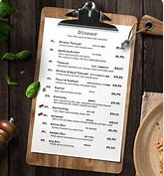
Menu innovation in the creative element of catering concept and theme involves offering unique and inventive dishes, flavors, and food presentation techniques that go beyond traditional options. It is about breaking boundaries, experimenting with new ingredients, techniques, and culinary styles to create a distinctive and memorable menu experience.
Here are some key aspects of menu innovation: 2.3. Menu innovation

- Unconventional Flavor Combinations: Menu innovation can involve combining unexpected flavors and ingredients to create exciting and unique taste profiles. For example, incorporating exotic spices into familiar dishes or pairing unusual ingredients together to create a delightful surprise for the taste buds.
- Fusion Cuisine: Bringing together elements from different culinary traditions to create innovative and exciting fusion dishes. This can involve blending flavors, ingredients, and cooking techniques from different cultures or cuisines to create a one-of-a-kind culinary experience
- Molecular Gastronomy: Incorporating modern cooking techniques, such as sous vide, foam, or edible "caviar," can add a touch of molecular gastronomy to the menu. This involves using science and innovative culinary methods to transform the texture, presentation, and flavor of traditional dishes.
- Customizable Options: Offering customizable menu options allows guests to personalize their dining experience. This could include build-your-own stations, where guests can choose from a variety of ingredients, sauces, and toppings to create their own dish according to their preferences.
- Imaginative Presentation: Menu innovation includes dynamic and creative food presentation that goes beyond traditional plating. This could involve artistic arrangements, edible garnishes, or visually captivating techniques like smoke, edible flowers, or molecular gastronomy-inspired presentations.
- Incorporating Local and Seasonal Ingredients: Menu innovation can also involve showcasing regional or seasonal ingredients in unique ways. By featuring local produce, sustainable seafood, or ethically sourced ingredients, caterers can offer menus that celebrate the flavors and specialties of the specific region or season.
The goal of menu innovation is to surprise and delight guests with culinary creations that are visually captivating, innovative in flavor combinations, and showcase the creativity and skill of the catering team. Through menu innovation, caterers can provide a memorable culinary experience that aligns with the catering concept and theme, leaving a lasting impression on guests.
2. Signature Drinks
Signature drinks in the creative element of catering concept and theme are unique and specially crafted beverages that are designed specifically for an event. These drinks are created to reflect and enhance the event's concept, theme, or brand identity in a creative and memorable way.
Here's what signature drinks entail:

- Customized Recipes: Signature drinks involve the creation of custom recipes that incorporate unique combinations of spirits, mixers, fruits, herbs, or other flavor enhancers. These recipes are specifically designed to align with the event's concept and theme, offering guests a distinct and memorable taste experience.
Figure: 2.4: Customized recipes
- Theme-Infused Presentation: The presentation of signature drinks goes beyond regular beverage service. It includes creative and visually appealing elements that tie into the overall event theme or concept. This can involve the use of themed glassware, garnishes, colorful straws, or customized drink stirrers. The presentation itself becomes a part of the overall experience, adding an extra level of creativity and engagement.
- Playful Naming: Signature drinks are often given unique and catchy names that reflect the event concept or brand. This adds an element of fun and personality to the beverage offerings, making them more memorable to guests. Creative and thematic names can evoke a sense of intrigue and enhance the storytelling aspect of the event.
- Innovative Mixology Techniques: Signature drinks can incorporate innovative mixology techniques to create intriguing flavor profiles or visual effects. This may include techniques like muddling, infusions, using molecular gastronomy-inspired elements (such as foams or smoke), or incorporating homemade syrups or infusions.
- Customized Pairings: Signature drinks can be designed to pair well with specific menu items or enhance certain flavors. Considerations can be made for complementary or contrasting flavors to create a well-rounded dining experience.
By offering signature drinks, caterers can provide a unique and personalized beverage experience that aligns with the event's theme and enhances the overall guest experience. These creatively crafted drink options not only add a touch of excitement and exclusivity but also contribute to the overall atmosphere and theme of the event, making it more memorable and enjoyable.
3. Experiential Food Stations
Experiential food stations refer to interactive and engaging setups where guests can participate in the creation, customization, or selection of their food items. These stations offer a unique dining experience that goes beyond traditional buffet or plated service. Here's what experiential food stations entail:
- Build-Your-Own Stations: These stations allow guests to create their own dishes by choosing from an array of ingredients, toppings, sauces, or proteins. Common examples include build-your-own taco stations, salad bars, or customized pasta stations. Guests have the freedom to personalize their meals according to their taste preferences and dietary needs.
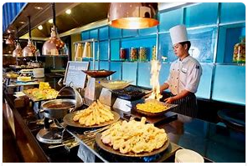
Live Cooking Stations: These stations feature chefs or culinary experts showcasing their skills by preparing dishes in front of guests. Guests can observe the cooking process, interact with the chefs, and have their dishes cooked to order. Examples include live grill stations, teppanyaki stations, or street food-style cooking stations.
Figure: 2.5. Cooking station
- Interactive Displays: These stations offer interactive and playful displays, inviting guests to engage with the food in a hands-on manner. For instance, a gourmet popcorn station where guests can add their own flavored seasonings, a make-your-own ice cream sundae bar with various toppings, or a chocolate fountain station with dipping options.
- Beverage Mixology Stations: Not limited to food, experiential stations can also involve beverage mixology. These stations allow guests to customize their own cocktails or mocktails by selecting ingredients, mixing flavors, and garnishing. Bartenders or mixologists may provide guidance, demonstrations, or recommendations.
- Chef-Hosted Demonstrations: These stations involve chef-hosted demos or interactive workshops where guests can learn cooking techniques, watch culinary presentations, or even participate in small-group cooking classes. This adds an educational and entertaining element to the food stations, providing guests with valuable culinary insights.
Experiential food stations foster guest engagement, creativity, and customization, offering a memorable and interactive dining experience. They encourage guests to take an active role in their dining experience, explore different flavors, and create personalized meals according to their preferences. By incorporating experiential food stations, catering events can elevate the overall guest experience, making it more enjoyable, interactive, and fun
4. Innovative Presentation
Innovative presentation in the context of catering means introducing creative and unique ways to visually showcase and serve food and beverages. It involves thinking beyond traditional plating techniques and exploring inventive methods to present dishes, which can leave a lasting impression on guests. Here are some elements of innovative presentation:
- Artistic Plating: Creating visually appealing and artistic arrangements of food on the plate to enhance the overall presentation. This can involve using geometric shapes, intricate patterns, or arranging ingredients in a visually appealing way to showcase their colors, textures, and flavors.
- Edible Garnishes: Using edible elements as garnishes to add visual interest and additional flavors to the dishes. This might include edible flowers, microgreens, herb sprigs, or even creative use of fruits and vegetables to elevate the overall presentation.
- Unique Serving Vessels: Choosing unconventional serving vessels that add an element of surprise and uniqueness to the presentation. This could involve using glass jars, mini frying pans, slate boards, or even edible containers like taco shells or bread bowls. The choice of serving vessel can enhance the visual appeal and create a playful and memorable experience.
- Molecular Gastronomy Techniques: Employing molecular gastronomy techniques to create unique presentations and textural elements. This may involve using foams, gels, liquid nitrogen, or other innovative methods to transform the texture and appearance of ingredients and dishes.
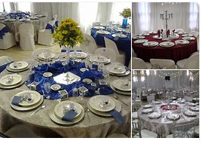
- Interactive Presentations: Incorporating interactive elements within the presentation to engage guests. This could include tableside preparations, where dishes are prepared or finished right in front of guests, or interactive food stations that allow guests to personalize their plates or participate in the assembly of their dishes.
Thematic Props and Decor: Using props and decor that align with the event concept or theme to enhance the presentation. This might involve incorporating themed accessories, props, or decorative elements that create a cohesive and visually appealing atmosphere. Figure: 2.6: Thematic decor
Innovative presentation is about thinking outside the box and finding creative ways to make the food visually striking and appealing to all the senses. By incorporating these techniques, caterers can elevate the dining experience, engage guests on a visual and interactive level, and create an overall memorable and immersive event.
5. Theme-Infused Décor
Theme-infused décor refers to the use of decorative elements and design choices that align with the overall theme or concept of an event. It involves utilizing props, colors, textures, and other decorative elements to create a cohesive and immersive atmosphere that enhances the overall event experience.
Here are some aspects of theme-infused décor:
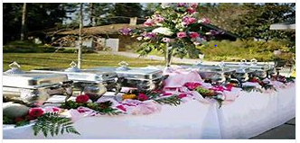
Color Palette: Selecting a color scheme that complements and reinforces the theme of the event. The chosen colors can be incorporated into various décor elements such as linens, flowers, lighting, signage, and table settings, creating a visually cohesive and harmonious ambiance.
Figure: 2.7: color plating
- Themed Props and Accessories: Incorporating props and accessories that are associated with the event's theme. For example, if the theme is tropical paradise, using elements such as seashells, palm trees, or colorful paper umbrellas can create a distinct and immersive décor.
- Cultural or Period Elements: Drawing inspiration from a specific culture, historical period, or era to infuse the décor. This can include incorporating traditional artifacts, antiques, or decorative elements that represent the chosen culture or period.
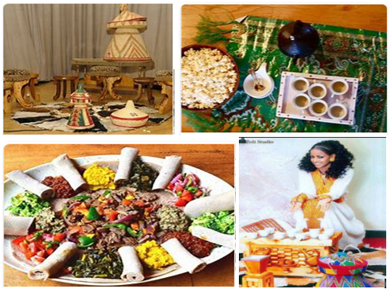
Figure 2.8: Examples of cultural or period elements
- Thematic Centerpieces and Floral Arrangements: Designing centerpieces and floral arrangements that reflect the theme. For example, using rustic lanterns and wildflowers for a rustic-themed event, or incorporating elegant crystal vases and roses for a classic and formal affair.
- Themed Lighting: Utilizing lighting designs and effects that align with the event theme. This can involve colored lighting, patterned projections, or specific lighting techniques to create the desired ambiance. For instance, using blue lighting to create an underwater atmosphere for an underwater-themed event.
- Backdrops and Set Designs: Designing customized backdrops or set designs that serve as the focal point and enhance the theme. Backdrops can be created using fabric, props, or printed graphics, helping to transform the event space and create an immersive setting.
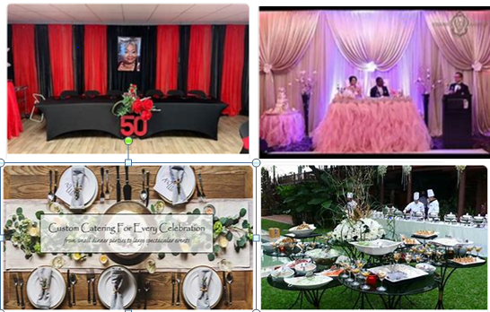
Figure 2.9: Examples of backdrops and set designs
By incorporating theme-infused décor, event planners and caterers can create a visually captivating, immersive, and cohesive experience for guests. The overall décor, when aligned with the chosen theme, can transport guests to a specific time, place, or atmosphere, making the event more memorable and engaging.
6. Interactive Food Experiences
Interactive food experiences refer to culinary activities and setups that actively engage guests in the preparation, customization, or exploration of food. These experiences go beyond traditional dining by encouraging participation and creating a sense of entertainment and enjoyment. Here are some examples of interactive food experiences:
- Cooking Demonstrations: Hosting live cooking demonstrations in which professional chefs showcase their culinary skills and teach guests about various cooking techniques and recipes. Guests have the opportunity to learn, ask questions, and even participate in the cooking process.
- Food and Beverage Pairing Workshops: Conducting sessions where guests can explore the art of food and beverage pairing. This could involve tasting different combinations of food and drinks, learning about flavor profiles, and understanding the principles of pairing to enhance the overall dining experience.
- Interactive Tastings: Offering tastings that allow guests to sample a range of flavors or ingredients. This could include cheese tastings with different types and varieties, chocolate tastings with various cocoa percentages, or wine tastings with different varietals. It gives guests the chance to explore and appreciate the nuances of different flavors.

- Food Art or Food Design Activities: Engaging guests in hands-on activities where they can express their creativity through food. This may involve sculpting fruits or vegetables, creating edible art pieces, or decorating desserts. It allows guests to showcase their artistic flair while enjoying a unique and interactive experience.
Figure: 2.10: Food art

Interactive food experiences create an engaging and entertaining atmosphere, allowing guests to connect with the food in a more active and personal way. These experiences foster interaction, learning, and creativity, enhancing the overall enjoyment of the event and leaving a memorable impression on guests.

2.4 Catering proposal presentation
When presenting a proposal on the range and style of catering products and services, it's important to keep the client's needs and preferences in mind. Here are some tips for how to present your proposal effectively:
- Start with an introduction: Begin by introducing yourself and giving some background information on your catering business, such as your mission, vision, and values.
- Outline your catering products and services: Provide an overview of the range of catering products and services that your business offers. This may include a variety of options such as appetizers, entrees, desserts, cocktails, and bar services.
- Highlight your unique selling points: Differentiate your catering business from others by highlighting what makes your products and services unique. This could include your use of local ingredients, customizable menus, or personalized service.
- Include sample menus: Give the client a feel for what a catering event with your business might look like by providing sample menus. These should include a range of options to suit different dietary restrictions, tastes, and budgets.
- Discuss service and staffing options: Explain the staffing options that you offer for events based on the client's needs, such as servers, bartenders, and event coordinators. Specify how many staff members will be provided for the event.
- Provide pricing and payment options: Clearly outline all the pricing aspects of your proposal, including any additional fees, taxes, and gratuities. Include payment options such as credit card, check, or online payment.
- End with a clear call to action: End your proposal with a clear call to action, inviting the client to make a decision about your services or encouraging them to ask any questions they may have.
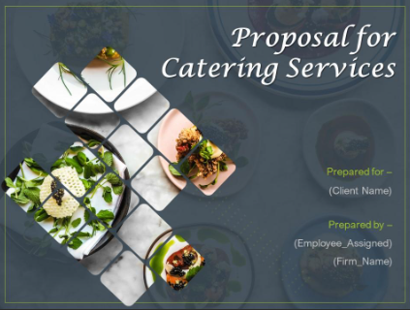
Figure 2.11: sample of catering proposal presentation
Overall, your proposal should be visually appealing, easy to read, and engaging, with plenty of visual and textual aids to help clients understand your catering products and services. Be sure to also provide contact information so that clients can easily follow up with you if they have any questions or concerns.

Self-Check 2
Part-I: Choose the correct answer
- ________________ is the overall idea or concept that drives the event and gives it a cohesive and unifying theme.
- Event Theme
- Event Concept
- Event Format
- None

- ___________ is an essential component of any event and can significantly affect the overall guest experience.
- Event
- Catering
- Production
- Celebration

- The following are the key catering elements. Except
- Quality of Food and Beverages
- Menu Selection
- Food Service
- All

- _________ is importance in catering to protect the health and well-being of guests.
- Menu Selection
- Food Service
- Food safety
- Professional Staff
- In catering events, _________ refers to the allocated amount of money or resources that the event organizer, client, or catering company has set aside for the catering service.
- Accounting
- Budget
- Event location
- Production
- It is about breaking boundaries, experimenting with new ingredients, techniques, and culinary styles to create a distinctive and memorable menu experience.

- Menu innovation
- Signature Drinks
- Innovative Presentation
- Theme-Infused Décor

Part-II: Answer the following questions accordingly
- List down the main professional staff of catering events?
- List down the main special dietary needs and restrictions?
- Write and explain some points which use how to present your proposal effectively?

Unit Three: - Catering operational plan
This unit to provide you the necessary information regarding the following content coverage and topics:
- Operational plan
- Risk management issues
- Providing information
- Implementing and monitoring catering plan
This guide will also assist you to attain the learning outcomes stated in the cover page. Specifically, upon completion of this learning guide, you will be able to:
- Prepare operational plan
- Incorporated risk management issues
- Provide information on the catering concept and operational plans
- Implement and monitor catering plan
- Evaluating event

3.1 Operational plan
A catering operational plan outlines the specific steps and considerations for successfully executing the catering aspect of an event. Here are some key components to include in a catering operational plan:
- Event Overview: Provide a brief overview of the event, including the date, time, location, and expected guest count. This sets the context for the operational plan.
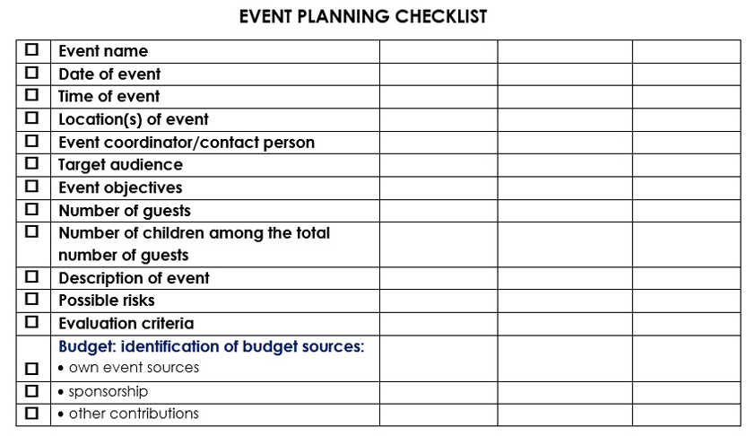
Table 3.1 sample event overview check list

- Menu Selection and Planning: Detail the menu options, including appetizers, main courses, desserts, and beverages. Consider dietary restrictions, cultural preferences, and ingredient availability. Document the recipes, portion sizes, and presentation guidelines for each menu item.
- Ingredient Procurement and Inventory: Identify the required ingredients and create a procurement strategy. Establish relationships with trusted suppliers and outline a process for ensuring the quality and freshness of ingredients. Develop an inventory management system to track and maintain ingredient stock levels.
- Food Preparation: Clearly define the food preparation process. Include timelines for cooking, baking, plating, and other necessary food preparation activities. Assign responsibilities to staff members and specify the required equipment and tools.
- Staffing and Training: Determine the staffing needs based on the event size and complexity. Hire qualified personnel and provide proper training on food safety, menu items, service standards, and customer interaction. Assign roles and responsibilities, including chefs, cooks, servers, bartenders, and event coordinators.
- Equipment and Supplies: Assess the required equipment, cookware, serving utensils, and other necessary supplies. Ensure that all equipment is in working order, and schedule maintenance or repairs ahead of the event. Create a checklist to ensure that all necessary equipment and supplies are available for the event.
- Logistics and Transportation: Detail the logistics for transporting the food, equipment, and supplies to the event location. Determine the most suitable transportation methods, considering the volume of food and distance to be covered. Coordinate delivery and setup times to ensure timely arrival.
- Presentation and Decor: Outline the presentation and decor elements, such as table settings, linens, centerpieces, and thematic decorations. Document the desired ambiance and design details to create a cohesive visual experience.
- 9. Service and Guest Interaction: Specify the service style, such as plated service, buffet, or food stations. Detail the service protocol, including the order of service, water and beverage refills, clearing tables, and overall guest interaction. Emphasize the importance of providing professional, friendly, and efficient service.
- Health and Safety: Implement and document comprehensive health and safety protocols. Emphasize food handling practices, cleanliness, personal hygiene, and compliance with local health regulations. Conduct regular inspections and ensure that staff members understand and follow these protocols.
- Contingency Plans: Develop contingency plans for unforeseen circumstances, such as equipment failure, staff absences, or changes in guest count. Outline backup options and alternative solutions to minimize disruption and maintain quality service.
- Timeline and Event Coordination: Create a detailed timeline of all activities, from food preparation to setup and service. Coordinate with event planners, organizers, and other vendors to ensure smooth coordination and seamless execution.
Regularly review and update the catering operational plan, incorporating lessons learned from previous events. Adapt the plan to the specific needs and requirements of each event, ensuring a consistently high standard of service.

3.2 Risk management issues
When preparing and implementing an operational plan for event catering, it is essential to address and mitigate potential risk management issues.
Here are some common risk areas to consider and strategies to manage them:
  - Food Safety Risks: Implement proper food handling practices to prevent foodborne illnesses. Develop standard operating procedures for food preparation, storage, and handling. Train staff on food safety protocols and conduct regular inspections to ensure compliance
  - Dietary Restrictions and Allergies: Collect accurate and detailed information about guests' dietary restrictions and allergies in advance. Communicate these requirements to the kitchen and service staff to prevent cross-contamination and ensure appropriate accommodations is made.
  - Equipment Failure or Malfunction: Regularly maintain and service equipment to minimize the risk of breakdowns during the event. Have backup plans in place, such as spare equipment or alternative suppliers, to address potential equipment failures.
  - Staffing Issues: Hire a sufficient and well-trained staff to handle the event. Ensure clear communication channels and proper training to avoid miscommunication, errors, and understaffing issues. Have contingency plans in place in case of staff absences or emergencies.
  - Vendor and Supplier Reliability: Develop a network of reliable vendors and suppliers. Conduct due diligence by verifying their reputation, quality of products, and delivery reliability. Communicate your requirements clearly and maintain open lines of communication to address any issues promptly.
  - Weather and Environmental Factors: Consider potential weather conditions or environmental factors that may impact the event, such as extreme heat, rain, or transportation disruptions. Have contingency plans in place to mitigate these risks, such as alternative indoor venues or plans for transportation delays.
  - Financial Risks: Ensure proper budgeting and financial management practices to monitor costs and revenue. Plan for contingencies, such as unexpected expenses or changes in guest numbers. Regularly review financial performance and adapt accordingly to stay within the allocated budget.
  - Contractual and Legal Considerations: Comply with all contractual obligations and legal requirements. Ensure that necessary permits, licenses, and insurance coverage are in place. Review contracts thoroughly, including cancellation policies and liability clauses, to protect your interests.
  - Reputation and Guest Experience: Prioritize guest satisfaction and adhere to service standards. Respond promptly and effectively to guest concerns or complaints, seeking to resolve issues in a professional and customer-centric manner. Maintain a positive reputation through consistent quality and diligent customer service.
To effectively manage these risk areas, regularly review and update your risk management strategies and ensure ongoing communication with stakeholders. By being prepared and proactive, you can minimize potential risks and enhance the overall success and safety of your event catering operations.

3.3 Providing information
When providing information in a catering event, it is essential to ensure clear communication and effectively convey the necessary details to guests, clients, or event attendees. Here are some key aspects to consider when providing information in a catering event:
- Event Details: Clearly communicate the essential event information, including the date, time, and location of the event. Specify any additional relevant details, such as dress code, parking instructions, or event-specific requirements.
- Menu Information: Provide comprehensive information about the menu offerings. Clearly list the dishes, including their names, descriptions, and any special dietary considerations (e.g., vegetarian, gluten-free, or allergen information).
- Food Allergies and Dietary Restrictions: Request and collect information about any specific food allergies or dietary restrictions from guests in advance. Ensure proper communication and coordination with the catering team to accommodate these requirements and provide suitable alternatives if needed.
- Service Flow and Timelines: Communicate the flow of service, including the order in which courses or food stations will be presented. Provide estimated timelines for each phase of the service to give attendees an idea of what to expect.
- Beverage Options: Detail the available beverage options, including alcoholic and non-alcoholic selections. Specify any signature drinks, wine pairings, or specialty cocktails that may be offered. Provide information on any additional charges or limitations for specific beverage choices.
- Event Schedule and Activities: If the catering event is part of a larger event or includes specific activities, provide a schedule or itinerary highlighting the various components and timing. This information helps attendees plan their time and align their expectations with the event flow.
- Contact Information: Include contact details for the catering team or event organizers to address any questions, concerns, or special requests. Provide clear points of contact for attendees to reach out and obtain further information or assistance.
- Signage and Displays: Use clear signs and displays to highlight key information, such as menu descriptions, dietary labels, or allergen warnings. Ensure that signage is easily visible and well-placed to guide attendees throughout the event space.
- Digital Communication: Utilize digital platforms, such as event websites, emails, or event apps, to provide detailed information about the catering aspects. This allows guests to access and review the information at their convenience and enhances communication efficiency.
- Visual and Written Communication: Employ visual aids, such as menu cards, signage, or digital presentations, to support the written information. Ensure that the fonts, colors, and layouts are clear, aesthetically pleasing, and consistent with the event's theme or branding.
By providing clear and comprehensive information in a catering event, you enhance the experience for attendees, minimize confusion or misunderstandings, and address their specific needs and preferences. Clear communication fosters a positive and informed atmosphere, allowing guests to fully enjoy and appreciate the catering offerings and overall event experience.

3.4 Implementing and monitoring catering plan
Implementing and monitoring a catering plan involves putting the plan into action and regularly assessing its progress and effectiveness. Here are some steps to help you effectively implement and monitor a catering plan:
- Assign Responsibilities: Clearly assign roles and responsibilities to the catering team members, ensuring each person understands their tasks and expectations. This includes designating individuals for food preparation, service, coordination, and setup. Communicate the plan and expectations to the team.
- Execution of the Plan: Follow the operational guidelines and timeline established in the catering plan. Ensure effective coordination among the catering team members, vendors, and event staff to execute the plan smoothly. Monitor the progress of tasks and address any issues that arise promptly.
- Quality Control: Regularly assess the quality of food, presentation, and service to ensure they align with the established standards and client expectations. Conduct ongoing checks, taste tests, and visual inspections to maintain consistency and identify areas for improvement.
- Guest Satisfaction: Continuously gauge guest satisfaction and collect feedback on the food, service, and overall experience. Monitor guest interaction and address any concerns or special requests promptly. Use comment cards, surveys, or direct communication to gather feedback and identify areas of improvement.
- Communication and Coordination: Maintain effective communication channels among the catering team, event organizers, and clients throughout the event. Regularly update stakeholders on the progress and address any changes or unforeseen circumstances promptly. Ensure efficient coordination to address any last-minute adjustments or requests.
- Ongoing Evaluation: Continuously monitor and evaluate the implementation of the catering plan. Assess its effectiveness, cost-efficiency, customer satisfaction, and adherence to timelines. Identify potential areas for improvement or modifications that can enhance future operations.
- Adaptation and Flexibility: Stay flexible and adaptable throughout the event. Prepare contingency plans for unforeseen circumstances and be ready to make adjustments as needed. Address any challenges or deviations from the plan promptly and take corrective actions.
- Record Keeping: Maintain comprehensive records, including food orders, delivery receipts, vendor invoices, and guest feedback. These records provide valuable data for future performance analysis, financial tracking, and client satisfaction assessments.
- Post-Event Evaluation: Conduct a thorough evaluation after the event to assess the overall success of the catering plan. Gather input from the catering team, clients, and guests to obtain different perspectives. Identify strengths, weaknesses, and lessons learned to inform future planning and improvements.
- Continuous Improvement: Use the insights gained from implementing and monitoring the catering plan to refine and enhance future catering operations. Apply the lessons learned to optimize processes, improve customer satisfaction, and elevate the quality of service.
By effectively implementing and monitoring the catering plan, you can ensure that the event runs smoothly, guests are satisfied, and future operations are optimized. Regular assessment, communication, and flexibility are key to adapting to changing circumstances and delivering exceptional catering experiences.

3.5 Evaluating event
Evaluating an event is an important step to assess its success, identify areas for improvement, and gather valuable insights for future planning. Here are some key aspects to consider when evaluating an event:
- Objectives Assessment: Refer back to the objectives set for the event and evaluate whether they were successfully achieved. Assess the extent to which the event met its goals in terms of attendance, revenue, guest satisfaction, or any other specific objectives.
- Guest Feedback: Gather feedback from attendees through surveys, comment cards, or other feedback mechanisms. Ask for their opinions on various aspects of the event, including the catering, overall experience, organization, and any areas that could be improved. Analyze the feedback to identify common themes, strengths, and areas for enhancement.
- Vendor and Staff Feedback: Solicit feedback from vendors, suppliers, and the catering team involved in the event. Seek their perspectives on aspects such as communication, collaboration, and the overall execution of the catering services. Their insights can provide valuable inputs for future improvements.
- Financial Evaluation: Assess the financial performance of the event by comparing actual costs and revenue against the budget. Evaluate profitability, cash flow, and return on investment. Identify any areas of overspending or potential cost-saving measures for future events.
- Operational Efficiency: Evaluate the efficiency of the catering operations in terms of timeliness, coordination, and overall execution. Assess factors such as food preparation, service flow, staff organization, and adherence to timelines. Identify opportunities to streamline processes and improve operational effectiveness.
- Guest Experience: Analyze the overall guest experience, taking into consideration factors such as hospitality, customer service, attention to detail, and customization of catering services. Assess the impact of the catering on guest satisfaction and measure the likelihood of attendees recommending the event to others.
- Successes and Areas for Improvement: Identify the event's successes and areas that need improvement. Celebrate achievements and acknowledge the team's efforts in delivering outstanding service. Determine specific areas, such as menu selection, food quality, presentation, or service protocols, that can be enhanced in future events.
- Lessons Learned: Document the key lessons learned from the event evaluation. These can include insights about guest preferences, logistical challenges, vendor coordination, or new industry trends. Use these lessons as a guide to make informed decisions and improvements in future events.
- Action Plan: Based on the evaluation findings, develop an action plan detailing specific steps and enhancements to be implemented for future events. Assign responsibilities and establish timelines for these improvements to ensure accountability and streamline implementation.
- Continuous Improvement: Celebrate the successes and incorporate the lessons learned into future planning and operations. Establish a culture of continuous improvement, using each event evaluation as an opportunity to refine and enhance the catering services provided.
By conducting a thorough evaluation of the event, you can gather valuable insights, identify areas for growth, and drive continuous improvement in your future catering operations. Use this evaluative process as a foundation for delivering superior service and creating exceptional experiences for clients and guests.

Self-Check 2

Part-I: Answer the following questions accordingly
- List down the main some key aspects to consider when providing information in a catering event?
- List down the main some key components to include in a catering operational plan?
- Prepare brief overview of the event, including the date, time, location, and expected guest count.

Operation sheet 3.1: Catering operational plan

Operation Title: Catering operational plan
Purpose: To prepare catering operational plan
Conditions or situations for the operations:
- Safe working area
- Properly operated tools and equipment
Equipment Tools and Materials:
- stationary
  - paper
  - pen, pencil
  - flip chart
Steps in doing the task
- Formulating the strategic plan for the event.
- Executing the operational tasks.
- Organizing resources
- Matching equipment needs to the requirements of the food and service.
- Implementing the plan.
- controlling the event by use of financial tools and predetermined standards
- Obtaining insurance coverage and ensuring all legal concerns are covered by a contract.

Quality Criteria: Assured performing of all the activities according to the procedures
Precautions:
- Preparing all necessary materials
- Make working area comfortable
- Read and interpret manual which guide you how to use tools and equipment.

Operation sheet 3.2: Implementing and monitoring catering plan

Operation Title: Implementing and monitoring catering plan
Purpose: To Implementing and monitoring catering plan
Conditions or situations for the operations:
- Safe working area
- Properly operated tools and equipment
Equipment Tools and Materials:
- Stationary
  - Paper
  - Pen, pencil
  - Flip chart
Steps in doing the task
- Develop a food safety program.
- Establish a monitoring system.
- Record keeping
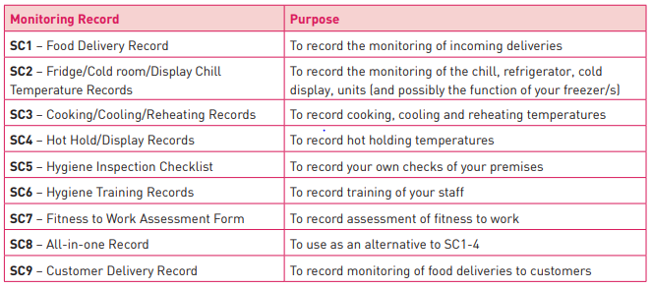
- Take corrective action
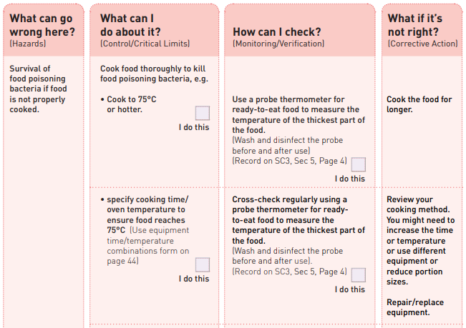
Quality Criteria: Assured performing of all the activities according to the procedures
Precautions:
- Preparing all necessary materials
- Make working area comfortable
- Read and interpret manual which guide you how to use tools and equipment.

Operation sheet 3.3: Evaluating event

Operation Title: Evaluating event
Purpose: To evaluating event
Conditions or situations for the operations:
- Safe working area
- Properly operated tools and equipment
Equipment Tools and Materials:
- Stationary
  - Paper
  - Pen, pencil
  - Flip chart
Steps in doing the task
- Use SMART goals.
- Compare your event to your competitors.
- Make observations during the event
- Ask guests for feedback on site.
- Track guest attendance.
- track your event budget
- Hold a debriefing with your team.

Quality Criteria: Assured performing of all the activities according to the procedures
Precautions:
- Preparing all necessary materials
- Make working area comfortable
- Read and interpret manual which guide you how to use tools and equipment.

Lap Test
Instructions: Given necessary templates, tools and materials you are required to perform the following tasks accordingly.
Task 1: Perform catering operational plan
Task 2: Perform implementing and monitoring catering plan
Task 3: perform evaluating event

Reference
- A Complete Guide to the Event Evaluation Process | Hubilo
- Safe Catering - your guide to making food safely
- Safe Catering - your guide to making food safely
- https://www.airmeet.com/hub/blog/virtual-event-goals-objectives-planning/
- Plan catering for an event or function Evidence Guide (ntisthis.com)
- Catering Business Plan Operations Plan (growthink.com)
- Guide to Evaluating Events: 10 Steps to Measure Your Success (billetto.co.uk)
- Operational Planning: How to Make an Operations Plan (projectmanager.com)

