CULINARY ART

Level – IV

Based on September 2023, Curriculum Version II

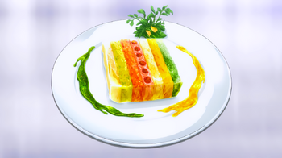

Module Title: Preparing Pâtés and Terrine
Module code: CST CUA4 07 0923
Nominal duration: 80 Hours

Prepared by: Ministry of Labor and Skills

September, 2023
Addis Ababa, Ethiopia

Table of Contents
Contents pages
Acknowledgement 3
Introduction to the module 4
Unit One: Selecting pâtés and terrines item 5
1.1 Understanding about pâtés and terrines 6
1.1.1Cooking techniques for pâté and terrine 8
1.1.2 Classification of Terrine and Pates 8
1.2 Selecting equipment and tools 9
1.3 purchasing quality ingredients for pate and terrines ingredients 11
Self-Check -1 12
Unit Tow: Preparing Pâté and terrine 13
2.1 Selecting ingredients 14
2.2 preparing and lining molds using ingredients 15
2.3 Preparing a range of binding agents used in forcemeat 16
2.4 Preparing standard recipes 17
2.4.1 Pate Recipes 18
2.4.2 Terrine Recipes 23
2.5 Storing pates and terrines according to HACCP procedure 25
Self-Check -2 28
Operation sheet 2 29
LAP Test 41
Unit Three: presenting Pâtés and Terrines 42
3.1. Presenting Pâtés and terrines 43
3.2. Decorate pâtés and terrines 44
Self-Check -3 45
References 46
Participants of this Module (training material) preparation 48

Acknowledgement

The Ministry of Labor and Skills (MoLS) would like to express its gratitude and appreciation to the instructors and experts from regional TVT bureaus, TVT colleges, and industry practitioners who contributed their expertise and experience in preparing the training module for the unit of competency “prepare pate and terrine” under the occupational standard "Culinary Art –level IV."
The ministry also expresses its deepest gratitude to the Tourism Training Institute for its invaluable technical and financial support and collaboration in the module preparation. It is also thankful to MoLS staff members who coordinated the preparation and reviewing process of this training module.

Introduction to the module

In Culinary art, pâté and terrine are both popular dishes, known for their rich flavors and versatility. They are often enjoyed as appetizers or as part of a charcuterie board.
The purpose of terrine and pâté is to create flavorful and versatile dishes that can be enjoyed as appetizers or as part of a larger meal. Overall, the purpose of terrine and pâté is to delight the taste buds with their rich flavors, provide an enjoyable culinary experience, and enhance the overall dining experience.
This module is designed to meet the industry requirement under the Culinary Art occupational standard, particularly for the unit of competency: Preparing Pâtés and Terrine
This module covers the units:
- Selecting pâtés and terrines item
- Preparing Pâté and terrine
- presenting Pâtés and terrines
Learning Objective of the Module
- Selecting pâtés and terrines item
- Preparing Pâté and terrine
- presenting Pâtés and terrines

Instruction
For effective use this modules trainees are expected to follow the following module instruction:
- Read the information written in each unit
- Accomplish the Self-checks at the end of each unit
- Read the identified reference book for Examples and exercise
- Accomplish the Self-checks
- Perform Operation Sheets
- Do the “LAP test”

Unit One: Selecting pâtés and terrines item
This learning guide is developed to provide you the necessary information regarding the following content coverage and topics:
- Understanding about pâtés and terrines
- Selecting equipment and tools
- purchasing quality ingredients for pate and terrines
This guide will also assist you to attain the learning outcomes stated in the cover page. Specifically, upon completion of this learning guide, you will be able to:
- Understanding about pâtés and terrines
- Selecting equipment and tools
- purchasing quality ingredients for pate and terrines

  - Understanding about pâtés and terrines
Pâté is a smooth and creamy spread made from finely ground meat, liver, or a combination of both. It is typically seasoned with herbs, spices, and sometimes alcohol. Pâté can be made from various types of meat, such as chicken, duck, pork, or beef. It is usually cooked by baking or poaching and is commonly served chilled or at room temperature. Pâté is often spread on bread or crackers, adding a burst of flavor to any bite. Pâtés (pastes) more often are smooth, light and will predominantly, but not exclusively, be made of duck or chicken liver. They can be created with fish, vegetables, beans, or pulses.
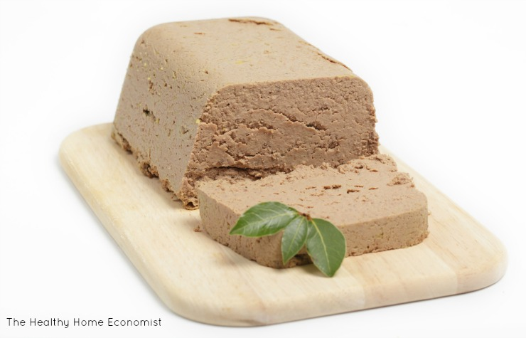
Figure 1.1 Chicken Liver Pates

Terrine, on the other hand, refers to a dish made by layering ground meat, seafood, or vegetables in a loaf-shaped container or mold. The ingredients are mixed with other seasonings, herbs, and sometimes vegetables before being cooked. Terrines are usually cooked in a water bath or in the oven until they are set and firm. Once chilled, they are sliced and served cold. Terrines have a coarser texture compared to pâté, with visible layers of ingredients, and they offer a delightful combination of flavors and textures. A terrine is an entirely different thing to pâté, with the clue to how different they are in the translation from the French word pâté becoming "paste" in English.
A traditional terrine, on the other hand, is an entirely different method of cooking, which creates a robust, chunky, textured dish and can consist of one through to several types of strongly flavored meats or fish and seafood. The ingredients in a terrine are often layered with forcemeat of minced, spiced, seasoned meats or fish to work as glue to support the different layers.
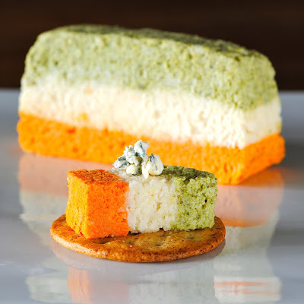
Figure 1.2 tri -color vegetable terrine
The literal translation of terrine in French is a "large earthenware pot". The English derivative of the word is tureen; a word still used today to describe a cooking pot.The origins of the cooked dish are without any doubt French, who are masters of the terrine. The careful layering of differing tastes and textures, precise spicing, seasoning and gentle cooking can so quickly spoil in the wrong hands, but in the excellent ones of a French chef or cook, is an art form.
Both pâté and terrine offer endless possibilities for creativity in the kitchen. They can be made with different combinations of meats, seafood, and vegetables, allowing for a wide range of flavors. Whether enjoyed on their own, as part of a charcuterie platter, or as a complement to other dishes, pâté and terrine are sure to please the taste buds of those who appreciate savory and indulgent flavors.

    - Cooking techniques for pâté and terrine
- Baking
Pâté and terrine can be cooked by baking in the oven. The mixture is typically placed in a loaf-shaped container or mold and then baked until it is cooked through and set. Baking allows for even cooking and helps to develop flavors.
- Poaching
Another method for cooking pâté and terrine is poaching. This involves cooking the mixture in simmering liquid, such as broth or stock. Poaching helps to retain moisture and can result in a tender and flavorful end product.
- Water Bath
A water bath, also known as a bain-marie, is a common technique used for cooking terrines. The filled terrine mold is placed in a larger pan filled with hot water, creating a gentle and even heat distribution during the cooking process. This method helps to prevent the terrine from drying out and ensures a smooth and moist texture.

1.1.2 Classification of Terrine and Pates
Terrines and pâtés can be classified in various ways based on their ingredients, preparation methods, or culinary traditions. Here are some common classifications:

- Meat-based vs. Vegetarian: Terrines and pâtés can be classified based on whether they are made with meat or are vegetarian. Meat-based terrines and pâtés typically feature ingredients like pork, beef, chicken, or game meats. Vegetarian versions can be made with vegetables, legumes, grains, or even tofu.

- Classic vs. Contemporary: Terrines and pâtés can be classified based on their traditional or modern interpretations. Classic versions often adhere to traditional recipes and techniques, while contemporary variations may incorporate innovative ingredients, flavors, or presentation styles.

- Country-style vs. Fine-dining: Terrines and pâtés can also be classified based on their intended style of presentation and dining. Country-style terrines and pâtés are typically rustic and hearty, while fine-dining versions are often more refined and elegant, featuring intricate layering or artistic presentations.

- Fish/Seafood vs. Meat: Another classification is based on the primary ingredient used. Fish or seafood terrines and pâtés can include ingredients like salmon, shrimp, or lobster. Meat-based versions can include various meats, such as pork, beef, or poultry.

- Hot vs. Cold: Terrines and pâtés can be served hot or cold. Hot versions are often cooked and served warm, while cold versions are typically chilled and served at room temperature or slightly cool.
  - Selecting equipment and tools

Here is a list of common tools and equipment used for making terrines and pâtés:

Tools and Equipment | Name | Uses
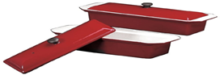 | Terrine Mold | A rectangular or loaf-shaped mold made of metal, ceramic, or glass, used to shape and set the terrine or pâté mixture
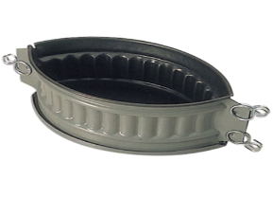 | Pâté Mold | Similar to terrine molds, but often smaller and designed specifically for making pâtés.
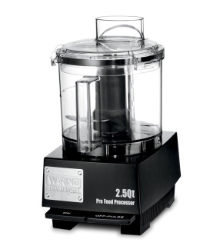 | Food Processor or Blender | Used to finely grind or puree the ingredients for the pâté or terrine mixture.
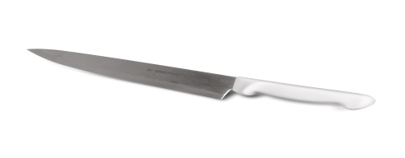 | Chef knife | Essential for chopping and preparing the ingredients for the terrine or pâté.
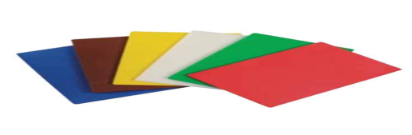 | Cutting Board | Provides a sturdy surface for chopping and preparing ingredients.
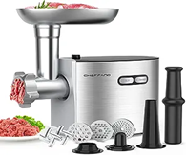 | Meat Grinder | Meat grinder can be used to grind the meat to the desired consistency.
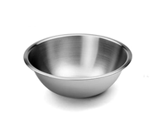 | Mixing Bowls | Used for combining and mixing the ingredients for the terrine or pâté mixture.
 | Kitchen Scale | Helpful for accurately measuring ingredients, especially when following specific recipes
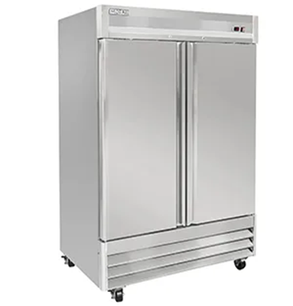 | Refrigerator: | Necessary for chilling and setting the terrine or pâté before serving
 | Thermometer | Used to ensure the terrine or pâté reaches the desired internal temperature during cooking.
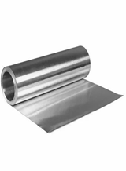 | Aluminum Foil: | Can be used to cover the terrine or pâté during baking or to create a seal for poaching

Table 1: Tools and equipment used for making terrines and pâtés:

  - purchasing quality ingredients for pate and terrines ingredients
When purchasing ingredients for pate and terrines, there are several criteria to consider:
1. Freshness: Choose fresh vegetables that are firm and vibrant in color. For gelatin or agar-agar, make sure to check the expiration date and choose a reputable brand.
2. Quality: Choose for high-quality ingredients to ensure the best flavor and texture in your terrine. Look for organic or locally sourced vegetables if possible.
3. Seasonality: Select vegetables that are in season for the best taste and affordability. This will also ensure that the vegetables are at their peak freshness.
4. Size and Thickness: Choose vegetables that are similar in size and thickness to ensure even cooking and layering in the terrine.
5. Flavor Pairings: Consider the flavors of the vegetables and how they will complement each other in the terrine. For example, beets and carrots have earthy flavors that pair well with sweet bell peppers.
6. Dietary Restrictions: If you or your guests have any dietary restrictions or allergies, make sure to choose ingredients that accommodate those needs. For example, agar-agar is a suitable alternative for vegetarians or vegans who do not consume gelatin.
7. Price: Compare prices of different brands and varieties of vegetables to find the best value for your budget.
By considering these purchasing criteria, you can ensure that you have the best ingredients for your pate and terrines, resulting in a delicious and visually appealing final dish.

Self-Check -1 | Written Test

Name……………………………………..Id………………….Time Allowed…………….
Directions: Answer all the questions listed below. Illustrations may be necessary to aid some explanations/answers. (15 points)
Part I. Choose the correct answer for the following
- Which one is not true about pate
- Pâté is a smooth and creamy spread made from finely ground meat, liver
- It is usually cooked by baking or poaching
- It is commonly served chilled or at room temperature
- none
- which one is not true about terrine
- terrine dish made by layering ground meat, seafood or vegetable
- Terrines are usually cooked in a water bath or in the oven
- Terrines have a coarser texture compared to pâté
- None
- Which one is the correct cooking technique for pate and terrine?
- Baking
- Deep fry
- Stir fry
- Grill
Part II: Short Answer questions:
- What are the classification of terrine and pates? Explain
- What are the tools and equipment used for terrine and pate preparation?
- What are the ingredient selection criteria for terrine and pate?
- What are the common ingredients used for terrine and pate?

Unit Tow: Preparing Pâté and terrine
This learning guide is developed to provide you the necessary information regarding the following content coverage and topics:
- selecting ingredients
- preparing and lining molds using ingredients
- Preparing a range of binding agents and forcemeat
- Preparing standard recipes
Storing pates and terrines according to HACCP procedure
This guide will also assist you to attain the learning outcomes stated in the cover page. Specifically, upon completion of this learning guide, you will be able to:
  - selecting appropriate ingredients
  - preparing and lining molds using suitable ingredients
  - Preparing a range of binding agents used in forcemeat
  - Preparing standard recipes
- Storing pates and terrines according to HACCP procedure

2.1 Selecting ingredients
Some common ingredients for pate and terrines include:
- Meat: Such as chicken, duck, pork, beef, or game meats like venison or rabbit.
- Liver: Chicken liver, duck liver, or other types of organ meat.
- Fats: Butter, lard, or rendered animal fats.
- Aromatics: Onions, garlic, shallots, herbs, and spices.
- Eggs: Used as a binding agent and to add moisture.
- Bread or breadcrumbs: Used as a filler or to help bind the ingredients together.
- Gelatin: Used to set the pate or terrine and give it a smooth texture.
- Seasonings: Salt, pepper, and other spices to enhance the flavor.
- Alcohol: Wine, brandy, or cognac can be used to add depth of flavor.
- Optional Ingredients: Nuts, dried fruits, mushrooms, truffles, or other ingredients for added texture or flavor.
It is important to consider the freshness, sourcing, and quality of each ingredient. Choose fresh, high-quality cuts of meat such as pork, veal, beef, or poultry. Look for meats that are well-marbled and have a vibrant color. Opt for organic or pasture-raised meats if possible. Liver is a key ingredient in pate and terrines, so it's crucial to choose fresh, high-quality liver. Look for liver from reputable sources, preferably organic or free-range. Chicken livers are commonly used, but you can also experiment with other types like duck or veal liver.

Pate and terrines require fat to achieve a smooth and creamy texture. Choose high-quality fats such as pork fatback, duck fat, or bacon fat. Look for fats that are fresh and have a good balance of lean meat and fat. Herbs and Spices: Fresh herbs and spices add flavor to pate and terrines. Opt for organic herbs whenever possible and choose spices that are aromatic and of good quality. Common herbs used in pate include thyme, rosemary, sage, and parsley. Aromatics: Onions, garlic, shallots, and other aromatics add depth to the flavor profile of pate and terrines. Choose fresh and flavorful aromatics to enhance the taste of your dish.

Quality sea salt and freshly ground black pepper are essential seasonings for pate and terrines. Choose sea salt without additives or anti-caking agents for the best flavor. Depending on your recipe, you may need other ingredients such as eggs, cream, wine, or brandy. Choose fresh eggs from free-range chickens and select high-quality dairy products for the best results. Consider adding garnishes such as truffles, pistachios, or dried fruits to enhance the presentation and flavor of your pate or terrine. Choose these additional ingredients based on personal preference and the overall flavor profile you want to achieve.
  - preparing and lining molds using ingredients
When preparing and lining molds for pate and terrines, it is important to use suitable ingredients. This means using ingredients that will not only enhance the flavor and texture of the dish but also ensure proper cooking and setting of the pate or terrine.
Lining molds in terrines and pates refers to the process of covering the inside of the mold with a layer of ingredients before adding the main mixture. This layer serves multiple purposes, including preventing sticking, adding flavor, and enhancing the texture of the final dish. The lining ingredients can vary depending on the recipe and desired outcome, but commonly used options include fat (such as bacon or pork fat), vegetables (such as carrots or leeks), bread or pastry, and gelatin. These ingredients help create a barrier between the main mixture and the mold, ensuring proper cooking and setting of the pate or terrine.
Suitable ingredients for lining molds may include:
- Fat: Using a layer of fat, such as bacon or pork fat, to line the mold can help prevent sticking and add flavor to the pate or terrine.
- Vegetables: Thinly sliced or grated vegetables, such as carrots, leeks, or zucchini, can be used to line the mold. This not only adds visual appeal but also adds moisture and flavor to the dish.
- Bread or pastry: In some cases, a layer of bread or pastry may be used to line the mold. This can help absorb excess moisture and provide structure to the pate or terrine.
- Gelatin: Gelatin can be used to line the mold and help the pate or terrine set properly. It is dissolved in a liquid, such as stock or wine, and poured into the mold before adding the pate or terrine mixture.
  - Preparing a range of binding agents used in forcemeat
A binding agent in terrine and pate refers to an ingredient or combination of ingredients that help hold the mixture together and give it a cohesive texture. Common binding agents used in terrines and pates include eggs, cream, gelatin, breadcrumbs, or a combination of these. These ingredients help to solidify the mixture and keep it from falling apart when cooked and sliced. They also contribute to the smooth and creamy texture of the final dish.
Forcemeat is a mixture of ground or finely chopped meat, fat, and other ingredients that form the base of terrines and pates. It is typically made by combining lean meat (such as pork, veal, or poultry), fat (such as pork fatback or butter), and seasonings (such as herbs, spices, and aromatics). The forcemeat is then processed or mixed until it becomes a smooth paste or emulsion. This mixture forms the main flavor and texture component of terrines and pates.
Some common binding agents used in forcemeat:
1. Eggs: Beaten eggs are a popular binding agent as they provide both moisture and protein to help bind the ingredients together. Use whole eggs or just the yolks, depending on the desired richness.
2. Breadcrumbs: Fresh or dried breadcrumbs can be added to absorb excess moisture and help bind the forcemeat. They also add texture and structure to the final product.

3. Gelatin: Dissolved gelatin can be used as a binding agent, particularly in pates and terrines that need to set. It helps solidify the mixture and provides a smooth texture.
4. Panade: A panade is a mixture of bread soaked in milk or another liquid. It acts as a binding agent and adds moisture to the forcemeat. The panade should be well-mashed or blended before adding it to the mixture.
5. Starches: Starches like flour or cornstarch can be used as binding agents, especially in recipes where a firmer texture is desired. These starches absorb moisture and help hold the ingredients together.
6. Vegetables: Finely grated or pureed vegetables like onions, carrots, or mushrooms can act as binding agents due to their natural moisture and fiber content. They also add flavor and enhance the overall texture.
7. Emulsifiers: Emulsifiers like mustard or mayonnaise can be added to forcemeat to improve its texture and help bind the ingredients together. These ingredients contain natural emulsifying properties that create a smooth and cohesive mixture.
  - Preparing standard recipes
- To prepare a standard recipe for pate using the binding agents mentioned above, you can follow these steps:
1. Start by selecting your choice of meat or combination of meats. Common options include chicken livers, pork, veal, or a mixture of these.
2. Trim any excess fat or gristle from the meat and cut it into small pieces. Season with salt, pepper and any desired herbs or spices.
3. In a pan, heat some butter or oil and cook the meat until it is cooked through and no longer pink. Remove from heat and let it cool slightly.
4. In a food processor, combine the cooked meat with your chosen binding agents. For example, add beaten eggs, breadcrumbs, a dissolved gelatin mixture, a panade made from soaked bread, or a combination of these.
5. Add any additional flavorings such as sautéed onions, garlic, herbs, or spices to enhance the taste.
6. Process the mixture until it becomes smooth and well combined. If needed, adjust the consistency by adding more binding agents or liquid.

7. Taste the mixture and adjust the seasoning according to your preference.
8. Transfer the forcemeat mixture into a terrine dish or individual ramekins, ensuring it is packed tightly and evenly.
9. To cook the pate, you can either bake it in a water bath at a low temperature (around 300°F/150°C) until it reaches an internal temperature of 160°F/71°C or until a skewer inserted into the center comes out clean. Alternatively, you can steam the pate in a covered dish for about 1-2 hours.
10. Once cooked, remove the pate from the oven or steamer and let it cool to room temperature. Refrigerate for several hours or overnight to allow the flavors to meld and the pate to set.
11. Serve the pate chilled, sliced, and accompanied by crusty bread, crackers, or pickles.
- Steps to prepare standard terrine recipes
1. Start by selecting your choice of meat or combination of meats. Common options include pork, veal, chicken, or a mixture of these.
2. Trim any excess fat or gristle from the meat and cut it into small pieces. Season with salt, pepper and any desired herbs or spices.
3. In a pan, heat some butter or oil and cook the meat until it is cooked through and no longer pink. Remove from heat and let it cool slightly.
4. In a food processor, combine the cooked meat with any additional ingredients you desire such as sautéed onions, garlic, herbs, or spices to enhance the flavor.
5. Process the mixture until it becomes smooth and well combined. If needed, adjust the consistency by adding more liquid or binding agents such as eggs, breadcrumbs, or soaked bread.
6. Taste the mixture and adjust the seasoning according to your preference.
7. Line a terrine dish with plastic wrap or bacon slices to prevent sticking and add flavor. Alternatively, you can use individual ramekins or molds.
8. Transfer the mixture into the prepared terrine dish, pressing it down firmly to remove any air pockets.
9. Cover the terrine with plastic wrap or bacon slices and place a weight on top to compress the mixture. This will help to create a dense and firm texture.
10. Refrigerate the terrine for several hours or overnight to allow the flavors to meld and the terrine to set.

11. To serve, remove the terrine from the refrigerator and carefully unmold it onto a serving platter. Remove any plastic wrap or bacon slices.
12. Slice the terrine into thin slices and serve chilled, accompanied by crusty bread, crackers, or pickles.

    - Pate Recipes

- Classic Chicken Liver Pate:
Chicken liver pate is a type of meat pate that specifically uses chicken liver as the main ingredient. It is made by finely mincing or grinding chicken livers and combining them with other ingredients such as onions, garlic, herbs, spices, and sometimes alcohol for added flavor. The mixture is then cooked slowly to develop flavors and ensure food safety. After cooking, the pate is chilled until set and can be served chilled or at room temperature. Chicken liver pate is often spread on bread or crackers and enjoyed as an appetizer or part of a charcuterie board. It is known for its rich and creamy texture and distinct flavor.

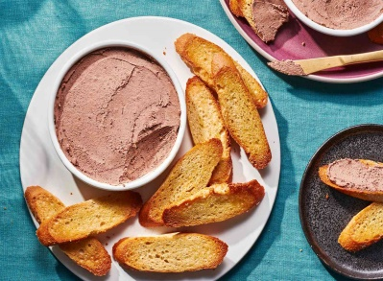

Figure 2.1: classic chicken liver pate
- Mushroom Pate:
A vegetarian option made with sautéed mushrooms, onions, garlic, herbs, and cream cheese for a creamy and earthy flavor. Mushroom pate is a vegetarian or vegan alternative to meat pate that uses mushrooms as the main ingredient. It is made by sautéing or roasting a variety of mushrooms, such as cremini, Portobello, or shiitake, until they are cooked and tender.

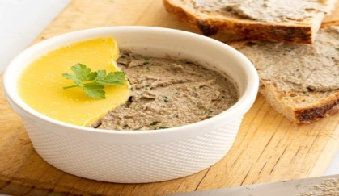
The mushrooms are then finely chopped or pureed and combined with other ingredients such as onions, garlic, herbs, spices, and sometimes nuts or breadcrumbs for added texture. The mixture is typically cooked slowly to develop flavors and can be seasoned with salt, pepper, or other seasonings to taste. After cooking, the pate is chilled until set and can be served chilled or at room temperature. Mushroom pate is often spread on bread or crackers and enjoyed as an appetizer or part of a vegetarian or vegan charcuterie board. It is known for its earthy and savory flavor.

Figure 2.2 mushroom pate
- Pork and Pistachio Pate:
A hearty pate made with ground pork, pork fat, pistachios, herbs, and spices for a delicious combination of flavors and textures. Pork and Pistachio Pate is a traditional meat pate that combines ground pork and pistachio nuts as the main ingredients. It is typically made by blending or grinding cooked pork meat, along with other ingredients such as pistachios, onions, garlic, herbs, spices, and sometimes breadcrumbs or eggs to bind the mixture together.

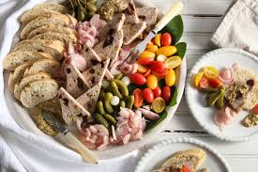
The pate is seasoned with salt, pepper, and other seasonings to enhance its flavor. After preparation, it is usually cooked in a terrine or loaf pan, often in a water bath, until it is fully cooked and set. Pork and Pistachio Pate is typically served chilled or at room temperature and can be enjoyed as a spread on bread or crackers, as part of a charcuterie board, or as an appetizer. It is known for its rich and savory taste, with the pistachios adding a nutty and crunchy texture to the pate. Fig.2.3: Pistachio pate

- Smoked Salmon Pate:
A creamy and flavorful pate made with smoked salmon, cream cheese, lemon juice, dill, and optional ingredients like capers or horseradish for added zing. Smoked Salmon Pate is a type of spread or dip made from smoked salmon as the main ingredient. It is typically prepared by blending or mixing smoked salmon with other ingredients such as cream cheese, lemon juice, dill, onions, and sometimes mayonnaise or sour cream to achieve a smooth and creamy texture. The pate is seasoned with salt, pepper, and other herbs and spices to enhance its flavor. Some variations may also include additional ingredients like capers or horseradish for added tanginess or heat.

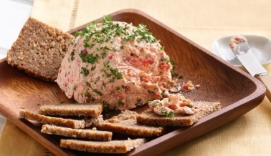
After preparation, Smoked Salmon Pate is usually chilled to allow the flavors to meld together. It is commonly served as an appetizer or hors d'oeuvre, often spread on crackers, toast points, or baguette slices. It can also be used as a filling for sandwiches or as a topping for baked potatoes or pasta dishes. Smoked Salmon Pate is known for its rich and smoky flavor, with the creaminess of the cheese balancing out the intense taste of the smoked salmon. It is a popular choice for seafood lovers and is often enjoyed during special occasions or gatherings. Fig.2.4: smoked salmon pate

- Vegetable Pate
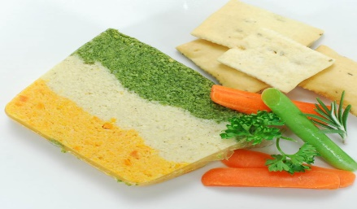
A versatile pate made with a variety of vegetables like roasted eggplant, bell peppers, tomatoes, and onions, blended together with herbs, spices, and sometimes nuts or cheese for added texture and flavor. Vegetable Pate is a spread or dip made primarily from vegetables as the main ingredient. It is typically prepared by blending or pureeing cooked vegetables, such as mushrooms, carrots, onions, or peppers, with other ingredients like herbs, spices, and sometimes nuts or legumes. The mixture is seasoned with salt, pepper, and other flavorings to enhance its taste.

After preparation, Vegetable Pate is often chilled to allow the flavors to develop and the mixture to firm up. It can be served as an appetizer or as part of a vegetarian meal. Vegetable Pate is commonly spread on crackers, bread, or toast, and can also be used as a filling for sandwiches or as a topping for salads or roasted vegetables. Fig.2.5: Vegetable pate

Vegetable Pate is known for its versatility and can be customized with various combinations of vegetables and seasonings to suit individual preferences. It is a popular choice for vegetarians or those looking for a lighter alternative to meat-based spreads. Vegetable Pate offers a flavorful and nutritious option for those seeking a plant-based option.

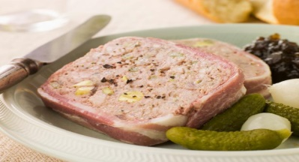
- Meat pate:
Meat pate, also known as meat paste, is a spreadable food made primarily from ground meat, mixed with other ingredients such as herbs, spices, vegetables, and sometimes fat. It is typically cooked and then blended or processed into a smooth or chunky texture.
Fig. 2.6: Meat pate
- key points about meat pate:
- Types of meat: Pates can be made from various types of meat, including chicken, turkey, pork, beef, veal, and game meats like duck or venison. Some popular pates include liver pate, chicken liver pate, or country-style pate.
- Ingredients: Besides the main meat component, pates often include additional ingredients to enhance flavor and texture. These can include onions, garlic, herbs (such as thyme, sage, or parsley), spices (like black pepper or nutmeg), wine or spirits (such as brandy or cognac), and sometimes eggs or cream.
- Preparation: The preparation of meat pate usually involves cooking the meat, often with other ingredients, until it is fully cooked and tender. It is then ground or finely chopped and mixed with the remaining ingredients. The mixture is typically processed in a food processor or blender until it reaches the desired consistency.
- Texture: Pates can have varying textures, ranging from smooth and creamy to coarser and chunkier, depending on personal preference and the specific recipe.
- Serving and usage: Meat pate is commonly served as a spread on bread or crackers, as an appetizer or part of a charcuterie board. It can also be used as a filling for sandwiches, stuffed pastries, or as an ingredient in various recipes.
- Storage: Meat pate should be refrigerated and consumed within a few days. It can also be frozen for longer storage, but it is best to check the specific recipe for any storage recommendations.
- Variations: Pates can be quite versatile, with many regional and cultural variations. Some examples include liverwurst, terrine, or rillettes, which have different ingredients and preparation methods.

- Pork Liver Pate with Caramelized Onions
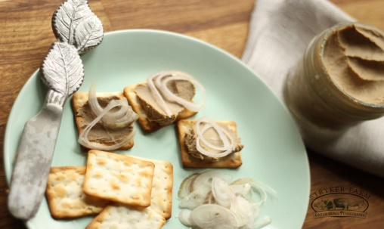
Pork liver pate with caramelized onions is a rich and savory spread made from cooked pork liver, onions, and various seasonings. The liver is typically sautéed until cooked through and then blended with caramelized onions, which are onions that have been slowly cooked until golden brown and sweet. Additional ingredients such as butter, garlic, herbs, and spices may be added to enhance the flavor. The mixture is then usually pureed until smooth and creamy. Pork liver pate with caramelized onions is often served as a spread on bread or crackers and can be enjoyed as an appetizer or as part of a charcuterie board. Fig. 2.7:pork liver pate
    - Terrine Recipes
- Salmon and Dill Terrine
A refreshing terrine made with fresh salmon, cream cheese, dill, lemon juice, and gelatin for a light and elegant appetizer. Salmon and Dill Terrine is a dish made with layers of cooked salmon and dill-infused cream. It is typically prepared by poaching or baking salmon fillets and then flaking them into small pieces. The salmon is then mixed with a creamy mixture that includes ingredients such as heavy cream, sour cream, mayonnaise, lemon juice, and fresh dill.
To assemble the terrine, the salmon mixture is layered in a loaf pan or mold, alternating with layers of dill sprigs for added flavor and visual appeal. The terrine is then chilled for several hours or overnight to allow it to set and firm up.
Salmon and Dill Terrine is often served as an appetizer or as part of a seafood platter. It can be sliced and served on crackers or toasted bread, or enjoyed on its own. The combination of the rich and creamy salmon with the fresh and aromatic dill creates a delightful flavor profile that is loved by seafood enthusiasts.
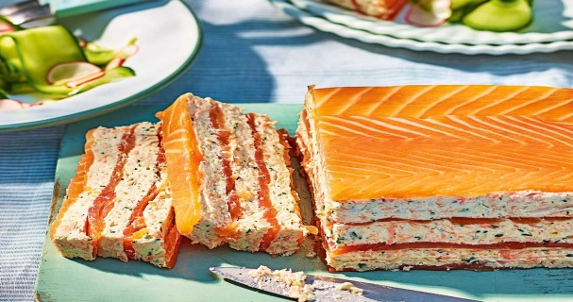
This dish is versatile and can be customized with additional ingredients such as chopped onions, capers, or lemon zest to enhance the taste. Salmon and Dill Terrine offers a delicious and elegant option for those looking to impress guests or enjoy a special seafood treat. Fig. 2.8: Salmon and dill terrine
- Vegetarian Lentil Terrine:
A healthy and protein-packed terrine made with cooked lentils, vegetables, herbs, and spices for a satisfying vegetarian option. Vegetarian Lentil Terrine is a dish made with layers of cooked lentils and vegetables, typically prepared by boiling or simmering lentils until they are tender. The lentils are then mixed with a variety of vegetables, such as carrots, bell peppers, zucchini, or spinach that have been sautéed or roasted for added flavor.
To assemble the terrine, the lentil and vegetable mixture is layered in a loaf pan or mold, compacted to create a firm texture. Some recipes may also include a layer of cooked rice or breadcrumbs to provide additional structure. The terrine is then chilled for several hours or overnight to allow it to set and firm up.

Vegetarian Lentil Terrine can be served as a main course for vegetarians or as a side dish for those looking for a healthy and flavorful option. It can be sliced and served on its own or accompanied by a sauce or dressing for added taste. The combination of the hearty lentils and the various vegetables creates a satisfying and nutritious dish that is loved by vegetarians and non-vegetarians alike.
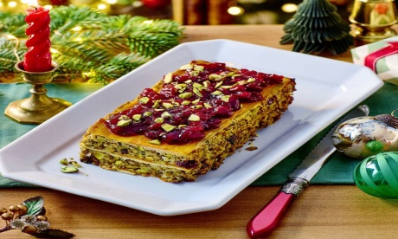
This dish is versatile and can be customized with additional ingredients such as herbs, spices, or cheese to enhance the flavor profile. Vegetarian Lentil Terrine offers a delicious and wholesome option for those looking to incorporate more plant-based meals into their diet or enjoy a meatless alternative. Fig. 2.9: Vegetarian Lentil Terrine
- Rainbow Terrine
A visually stunning terrine made with layers of colorful vegetables like beets, carrots, zucchini, and bell peppers, set in a gelatin or agar-agar base for a beautiful and impressive dish.
Rainbow Terrine is a colorful and visually appealing dish that is similar in preparation to the Vegetarian Lentil Terrine. It is made by layering different types of vegetables, typically in rainbow colors, to create a beautiful striped effect when sliced.
The vegetables used in a Rainbow Terrine can vary depending on personal preference and availability, but commonly include ingredients such as roasted or sautéed bell peppers, carrots, zucchini, eggplant, and spinach or other leafy greens. Each vegetable is cooked separately to retain its vibrant color and distinct flavor.
To assemble the terrine, the cooked vegetables are layered in a loaf pan or mold, similar to the Vegetarian Lentil Terrine. The layers are compacted to create a firm texture and the terrine is chilled to allow it to set.

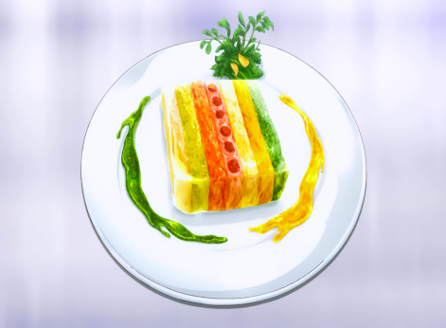
- Rainbow Terrine can be served as a stunning appetizer or side dish, adding a burst of color to any meal. It can be sliced and served on its own or accompanied by a sauce or dressing for added flavor. The variety of vegetables used in the terrine provides a range of nutrients and flavors, making it a healthy and visually appealing option for vegetarians and non-vegetarians alike.
Fig. 2.10: Rainbow Terrine
Like the Vegetarian Lentil Terrine, Rainbow Terrine can be customized with additional ingredients such as herbs, spices, or cheese to enhance the flavor profile. It offers a creative and delicious way to incorporate more vegetables into your diet and impress guests with its vibrant presentation
  - Storing pates and terrines according to HACCP procedure
HACCP (Hazard Analysis Critical Control Point) procedures are a systematic approach to identifying and controlling potential hazards in food production processes.
- General HACCP procedures that can be applied to pate and terrine production:
1. Conduct a hazard analysis: Identify potential biological, chemical, and physical hazards associated with pate and terrine production. This may include hazards such as bacterial contamination, allergen cross-contamination, foreign object contamination, etc.
2. Determine critical control points (CCPs): Identify the points in the production process where hazards can be controlled or eliminated. For pate and terrine production, some CCPs may include raw material inspection, cooking, cooling, storage, and packaging.
3. Establish critical limits: Set specific criteria for each CCP to ensure that hazards are controlled. For example, establish a minimum internal temperature of 165°F (74°C) for cooking the pate or terrine to eliminate bacterial contamination.
4. Establish monitoring procedures: Develop procedures to regularly monitor the critical control points. This may involve temperature monitoring, visual inspections, or testing for contaminants.
5. Establish corrective actions: Define the steps to be taken if a deviation from the critical limits or a potential hazard is identified. This may include adjusting cooking times or temperatures, re-inspecting raw materials, or removing contaminated products from the production line.
6. Establish verification procedures: Regularly verify the effectiveness of the HACCP plan through internal audits, testing, and review of records. This ensures that the plan is consistently implemented and effective in controlling hazards.
7. Establish record-keeping procedures: Maintain detailed records of critical control point monitoring, corrective actions taken, and verification activities. This provides evidence of compliance and allows for traceability in case of any food safety issues.
It's important to note that these procedures are general guidelines, and specific HACCP plans should be developed based on the unique processes, ingredients, and risks associated with each pate and terrine production facility. It is recommended to consult with a food safety professional or regulatory authority to develop a comprehensive HACCP plan tailored to your specific operation.
- Guidelines for storing pates and terrines according to HACCP procedures:
- Temperature control: Store pates and terrines at appropriate temperatures to prevent bacterial growth. The general recommendation is to store them at or below 41°F (5°C). This can be achieved by refrigerating them promptly after production.
- Separate storage: Store pates and terrines separately from raw meats, poultry, and seafood to avoid cross-contamination. Use separate containers or wrap them securely to prevent any contact with raw products.
- Proper packaging: Use airtight and food-grade containers or packaging materials to maintain the quality and prevent contamination. Make sure the packaging is intact and not damaged.
- Labeling: Clearly label the storage containers with the product name, date of production, and use-by or expiration date. This helps ensure proper rotation of stock and prevents the use of expired products.
- Storage time: Establish and adhere to a maximum storage time for pates and terrines to ensure freshness and safety. This time should be determined based on the specific product characteristics, ingredients, and regulations in your region.
- First-in, first-out (FIFO): Implement a FIFO system to ensure that older products are used or sold first and newer ones are stored behind them. This helps prevent spoilage and waste.
- Regular monitoring: Regularly monitor the storage conditions, including temperature, to ensure compliance with the recommended guidelines. Use temperature monitoring devices, such as thermometers, to verify that the storage temperature remains within the safe range.
- Record-keeping: Maintain accurate records of storage temperatures, storage times, and any corrective actions taken in case of deviations or issues. These records will serve as evidence of compliance with HACCP procedures and can be useful for traceability purposes.

Self-Check -2 | Written Test

Name……………………………………..Id………………….Time Allowed…………….
Directions: Answer all the questions listed below. Illustrations may be necessary to aid some explanations/answers. (15 points)
Part I. Choose the correct answer for the following
- Which one is not true about pate
- Pâté is a smooth and creamy spread made from finely ground meat, liver
- It is usually cooked by baking or poaching
- It is commonly served chilled or at room temperature
- none
- which one is not true about terrine
- terrine dish made by layering ground meat, seafood or vegetable
- Terrines are usually cooked in a water bath or in the oven
- Terrines have a coarser texture compared to pâté
- None
- Which one is the correct cooking technique for pate and terrine?
- Baking
- Deep fry
- Stir fry
- Grill
Part II: Short Answer questions:
- What are the classification of terrine and pates? Explain
- What are the tools and equipment used for terrine and pate preparation?
- What are the ingredient selection criteria for terrine and pate?
- What are the common ingredients used for terrine and pate?

Operation sheet 2 | Preparing standard recipes

1. Classic Chicken Liver Pate:
- 1lb (450g) chicken livers
- 1 medium onion, finely chopped
- cloves of garlic, minced
- tbsp butter
- 1/4 cup brandy or cognac
- 1 tsp dried thyme
- Salt and pepper to taste
Procedures
1. Rinse the chicken livers under cold water and pat them dry with paper towels.
2. In a pan, melt the butter over medium heat. Add the onions and garlic and cook until softened.
3. Add the chicken livers to the pan and cook until they are browned on the outside but still slightly pink on the inside. This should take about 5-7 minutes.
4. Remove the pan from heat and let the mixture cool slightly.
5. Transfer the mixture to a food processor and add the brandy, dried thyme, salt, and pepper.
6. Process the mixture until it becomes smooth and well combined. You may need to scrape down the sides of the food processor bowl a few times to ensure everything is evenly mixed.
7. Taste the pate and adjust the seasoning if needed by adding more salt, pepper, or thyme.
8. Line a loaf pan or ramekins with plastic wrap, leaving enough overhang to cover the pate later.
9. Pour the pate mixture into the prepared pan(s) and smooth the top with a spatula.
10. Fold the plastic wrap over the top of the pate to cover it completely.
11. Place the pate in the refrigerator and let it chill for at least 4 hours, or overnight, to allow it to set.
12. When ready to serve, remove the pate from the refrigerator and carefully lift it out of the pan using the plastic wrap overhang.
13. Remove the plastic wrap and transfer the pate to a serving plate.
14. Serve with crusty bread or crackers and enjoy!

2. Mushroom Pate:
Ingredients:
- 500g mushrooms (such as button or cremini), finely chopped
- 1 small onion, finely chopped
- cloves garlic, minced
- tablespoons butter
- tablespoons olive oil
- 1 tablespoon fresh thyme leaves, chopped
- 1 tablespoon fresh parsley, chopped
- 1 tablespoon lemon juice
- 100g cream cheese
- Salt and pepper to taste
Procedures:
1. Heat the butter and olive oil in a large skillet over medium heat.
2. Add the chopped onions and minced garlic to the skillet and sauté until the onions are translucent and fragrant.
3. Add the finely chopped mushrooms to the skillet and cook until they release their moisture and start to brown.
4. Stir in the fresh thyme leaves, parsley, lemon juice, salt, and pepper. Cook for another 2-3 minutes to allow the flavors to meld.
5. Remove the skillet from the heat and let the mixture cool slightly.
6. Transfer the mushroom mixture to a food processor and pulse until it reaches your desired consistency. You can make it smooth or leave it slightly chunky.
7. Add the cream cheese to the food processor and blend until well combined and creamy.
8. Taste and adjust the seasoning if needed.
9. Transfer the mushroom pate to a serving dish or individual ramekins.
10. Cover the dish with plastic wrap and refrigerate for at least a few hours, or preferably overnight, to allow the flavors to meld and the pate to set.
11. Serve the mushroom pate chilled or at room temperature with toasted bread, crackers, or vegetable sticks
- Pork and Pistachio Pate:
Ingredients:
- 500g ground pork
- 100g pork liver, finely chopped
- 100g bacon, finely chopped
- 1 small onion, finely chopped
- cloves garlic, minced
- 100g shelled pistachios, roughly chopped
- tablespoons fresh parsley, chopped
- 1 tablespoon fresh thyme leaves, chopped
- 1 tablespoon brandy or cognac
- 1 tablespoon Dijon mustard
- Salt and pepper to taste
Procedures:
1. Preheat your oven to 180°C (350°F).
2. In a large bowl, combine the ground pork, chopped pork liver, chopped bacon, finely chopped onion, minced garlic, chopped pistachios, parsley, thyme, brandy or cognac, Dijon mustard, salt, and pepper. Mix well to combine.
3. Transfer the mixture to a greased loaf pan or terrine mold, pressing it down firmly.
4. Cover the pan or mold tightly with aluminum foil.
5. Place the pan or mold in a larger baking dish or roasting pan. Fill the larger dish with enough hot water to come halfway up the sides of the pan or mold.
6. Carefully transfer the dish to the preheated oven and bake for about 1 hour or until the pate is cooked through and firm to the touch.
7. Remove the pate from the water bath and let it cool to room temperature.
8. Once cooled, refrigerate the pate for at least 4 hours or overnight to allow it to set completely.
9. To serve, run a knife along the edges of the pan or mold to loosen the pate. Invert the pan or mold onto a serving platter and gently tap to release the pate.
10. Slice the pate and serve chilled with crusty bread or crackers.
- Smoked Salmon Pate:
Ingredients:
- 8 oz (225g) smoked salmon, chopped
- 8 oz (225g) cream cheese, softened
- tablespoons fresh lemon juice
- tablespoons fresh dill, chopped
- 1 tablespoon capers, drained and chopped
- Salt and pepper, to taste

Procedures:
1. In a food processor or blender, combine the smoked salmon, cream cheese, lemon juice, dill, and capers. Process until smooth and well combined.
2. Taste the mixture and season with salt and pepper, adjusting to your preference.
3. Transfer the mixture to a serving bowl or ramekins, cover, and refrigerate for at least 1 hour to allow the flavors to meld and the pate to set.
4. Serve chilled with crackers, bread, or vegetable sticks.

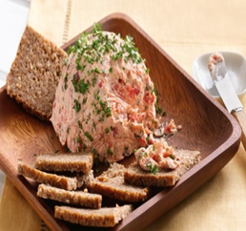
Note: You can also garnish the pate with additional chopped dill or capers before serving, if desired. Enjoy!

- Vegetable Pate:

Ingredients:
- 1 cup mixed vegetables (such as carrots, zucchini, mushrooms, bell peppers), finely chopped
- 1 small onion, finely chopped
- cloves garlic, minced
- 1/2 cup breadcrumbs
- 1/2 cup rolled oats
- 1/4 cup sunflower seeds
- tablespoons olive oil
- tablespoons soy sauce
- 1 tablespoon nutritional yeast (optional)
- 1 teaspoon dried herbs (such as thyme, rosemary, or oregano)
- Salt and pepper, to taste

Procedures:
1. Preheat the oven to 350°F (175°C). Grease a loaf pan or line it with parchment paper.
2. In a large skillet, heat the olive oil over medium heat. Add the chopped vegetables, onion, and garlic. Sauté until the vegetables are tender, about 5-7 minutes.
3. In a food processor, combine the sautéed vegetables, breadcrumbs, rolled oats, sunflower seeds, soy sauce, nutritional yeast (if using), dried herbs, salt, and pepper. Pulse until well combined and the mixture holds together when pressed between your fingers.
4. Transfer the mixture to the prepared loaf pan, pressing it down firmly and smoothing the top.
5. Bake in the preheated oven for 30-35 minutes, or until the pate is firm and golden brown on top.
6. Remove from the oven and let it cool in the pan for 10-15 minutes before transferring to a wire rack to cool completely.
7. Once cooled, slice and serve the vegetable pate with crackers, bread, or vegetable sticks.
- Meat pate
Ingredients:
- 1/2 lb (225g) chicken livers
- 1/2 lb (225g) pork liver
- 1/2 lb (225g) ground pork
- 1 medium onion, finely chopped
- cloves of garlic, minced
- tbsp butter
- 1/4 cup brandy or cognac
- 1 tsp dried thyme
- Salt and pepper to taste
Procedures
1. In a large skillet, heat olive oil over medium heat. Add diced onions and minced garlic, and sauté until onions are translucent and garlic is fragrant.
2. Add ground beef, ground pork, and ground chicken to the skillet. Cook until meat is browned and cooked through, breaking it up with a spoon as it cooks.
3. Stir in dried thyme, dried rosemary, dried sage, salt, and pepper. Cook for an additional 2-3 minutes to allow the flavors to meld together.
4. Remove the skillet from heat and let the mixture cool slightly.
5. Transfer the mixture to a food processor and add eggs, breadcrumbs, and Worcestershire sauce.
6. Process the mixture until it becomes smooth and well combined. You may need to scrape down the sides of the food processor bowl a few times to ensure everything is evenly mixed.
7. Taste the pate and adjust the seasoning if needed by adding more salt, pepper, or herbs.
8. Line a loaf pan or ramekins with plastic wrap, leaving enough overhangs to cover the pate later.
9. Pour the pate mixture into the prepared pan(s) and smooth the top with a spatula.
10. Fold the plastic wrap over the top of the pate to cover it completely.
11. Place the pate in the refrigerator and let it chill for at least 4 hours, or overnight, to allow it to set.
12. When ready to serve, remove the pate from the refrigerator and carefully lift it out of the pan using the plastic wrap overhang.
13. Remove the plastic wrap and transfer the pate to a serving plate.
14. Serve with crusty bread or crackers and enjoy!
- Pork Liver Pate with Caramelized Onions
Ingredients:
- 1 lb (450g) pork liver
- medium onions, thinly sliced
- tbsp butter
- tbsp brown sugar
- 1/4 cup red wine
- 1 tsp dried thyme
- Salt and pepper to taste
Procedures
1. Rinse the pork livers under cold water and pat them dry with paper towels.
2. In a pan, melt the butter over medium heat. Add the onions and cook until they start to caramelize and turn golden brown. This should take about 15-20 minutes.
3. Add the pork livers to the pan and cook until they are browned on the outside but still slightly pink on the inside. This should take about 5-7 minutes.

4. Remove the pan from heat and let the mixture cool slightly.
5. Transfer the mixture to a food processor and add the brandy, dried thyme, salt, and pepper.

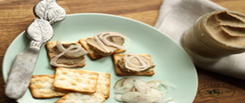
6. Process the mixture until it becomes smooth and well combined. You may need to scrape down the sides of the food processor bowl a few times to ensure everything is evenly mixed.
7. Taste the pate and adjust the seasoning if needed by adding more salt, pepper, or thyme.
8. Line a loaf pan or ramekins with plastic wrap, leaving enough overhang to cover the pate later.
9. Pour the pate mixture into the prepared pan(s) and smooth the top with a spatula.
10. Fold the plastic wrap over the top of the pate to cover it completely.
11. Place the pate in the refrigerator and let it chill for at least 4 hours, or overnight, to allow it to set.
12. When ready to serve, remove the pate from the refrigerator and carefully lift it out of the pan using the plastic wrap overhang.
13. Remove the plastic wrap and transfer the pate to a serving plate.
14. Serve with crusty bread or crackers and enjoy!

- Pork and Pistachio Terrine
Ingredients:
- 500g ground pork
- 100g pork liver, finely chopped
- 100g bacon, finely chopped
- 1 small onion, finely chopped
- cloves garlic, minced
- 100g shelled pistachios, roughly chopped
- tablespoons fresh parsley, chopped
- 1 tablespoon fresh thyme leaves, chopped
- 1 tablespoon brandy or cognac
- Salt and pepper to taste
Procedures:
1. In a large bowl, combine the ground pork, chopped pork liver, chopped bacon, finely chopped onion, minced garlic, chopped pistachios, parsley, thyme, brandy or cognac, salt, and pepper. Mix well to combine.
2. Line a terrine mold or loaf pan with plastic wrap, leaving excess wrap hanging over the sides.
3. Transfer the mixture to the lined mold, pressing it down firmly.
4. Fold the excess plastic wrap over the top of the mixture to cover it completely.
5. Place a weight (such as a can of beans) on top of the terrine to compress it.
6. Refrigerate the terrine for at least 24 hours to allow the flavors to meld and the terrine to set.
7. To serve, remove the weight and unwrap the terrine.
8. Slice the terrine and serve chilled with crusty bread or crackers.

- Salmon and Dill Terrine
Ingredients:
- 500g fresh salmon fillets, skinless and boneless
- 250g smoked salmon slices
- tablespoons fresh dill, chopped
- 1 tablespoon fresh lemon juice
- 250g cream cheese
- 150ml heavy cream
- Salt and pepper to taste
- Lemon wedges and dill sprigs for garnish
Procedures:
1. Preheat your oven to 180°C (350°F). Grease a loaf pan or terrine mold with butter or cooking spray.
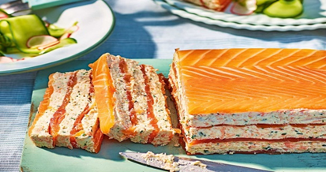
2. In a food processor, combine the fresh salmon fillets, smoked salmon slices, dill, lemon juice, cream cheese, heavy cream, salt, and pepper. Blend until smooth and well combined.
3. Pour the mixture into the greased loaf pan or terrine mold, smoothing the top with a spatula.
4. Cover the pan or mold tightly with aluminum foil.
5. Place the pan or mold in a larger baking dish or roasting pan. Fill the larger dish with enough hot water to come halfway up the sides of the pan or mold.

6. Carefully transfer the dish to the preheated oven and bake for about 1 hour or until the terrine is set and firm to the touch.
7. Remove the terrine from the water bath and let it cool to room temperature.
8. Once cooled, refrigerate the terrine for at least 4 hours or overnight to allow it to set completely.
9. To serve, run a knife along the edges of the pan or mold to loosen the terrine. Invert the pan or mold onto a serving platter and gently tap to release the terrine.
10. Garnish with lemon wedges and dill sprigs.
11. Slice the terrine and serve chilled with crusty bread or crackers.

- Vegetarian Lentil Terrine:
Ingredients:
- cups cooked green or brown lentils
- 1 onion, finely chopped
- cloves garlic, minced
- 1 carrot, grated
- 1 zucchini, grated
- 1 red bell pepper, finely chopped
- 1 cup breadcrumbs
- 1/2 cup grated Parmesan cheese (optional)
- tablespoons chopped fresh herbs (such as parsley, thyme, or rosemary)
- tablespoons tomato paste
- tablespoons olive oil
- Salt and pepper to taste
Procedures:
1. Preheat your oven to 375°F (190°C). Grease a loaf pan and set aside.

2. In a large skillet, heat the olive oil over medium heat. Add the onion and garlic and sauté until translucent and fragrant.

3. Add the grated carrot, zucchini, and red bell pepper to the skillet. Cook for about 5 minutes until the vegetables are tender.

4. In a large mixing bowl, combine the cooked lentils, sautéed vegetables, breadcrumbs, Parmesan cheese (if using), chopped herbs, tomato paste, salt, and pepper. Mix well until all the ingredients are evenly combined.

- Transfer the mixture into the greased loaf pan, pressing it down firmly to pack it in.
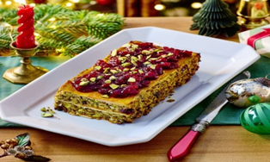
- Cover the loaf pan with aluminum foil and bake in the preheated oven for 40-45 minutes, or until the terrine is set and golden brown on top.

- Once baked, remove the terrine from the oven and let it cool in the pan for about 10 minutes. Then, carefully remove it from the pan and allow it to cool completely on a wire rack.

- Once cooled, slice the terrine into thick slices and serve. It can be enjoyed warm or chilled.
- Rainbow Terrine
Ingredients:
- 1 red bell pepper, roasted and peeled
- 1 yellow bell pepper, roasted and peeled
- 1 orange bell pepper, roasted and peeled
- 1 green bell pepper, roasted and peeled
- 1 small eggplant, sliced lengthwise into thin strips
- 1 zucchini, sliced lengthwise into thin strips
- 1 yellow squash, sliced lengthwise into thin strips
- 1 cup baby spinach leaves
- 1 cup ricotta cheese
- 1 cup shredded mozzarella cheese
- 1/4 cup grated Parmesan cheese
- tablespoons chopped fresh basil
- tablespoons chopped fresh parsley
- Salt and pepper, to taste
- Olive oil, for brushing
Procedures:
1. Preheat your oven to 400°F (200°C). Line a baking sheet with parchment paper.
2. Place the roasted bell peppers in a food processor and blend until smooth. Set aside.
3. Arrange the eggplant, zucchini, and yellow squash slices on the prepared baking sheet. Brush them with olive oil and season with salt and pepper.
4. Roast the vegetables in the preheated oven for about 10-12 minutes, or until they are tender and slightly browned. Remove from the oven and set aside to cool.
5. In a small bowl, combine the ricotta cheese, mozzarella cheese, Parmesan cheese, basil, parsley, salt, and pepper. Mix well.
6. Line a loaf pan with plastic wrap, leaving enough overhangs on the sides for easy removal later.
7. Start assembling the terrine by spreading a thin layer of the red bell pepper puree at the bottom of the pan.
8. Next, layer the roasted vegetables on top of the puree, alternating colors to create a rainbow effect. Press down gently after each layer.


9. After every second or third vegetable layer, spread a thin layer of the ricotta cheese mixture.
10. Repeat the layering process until all the vegetables and cheese mixture are used, finishing with a layer of red bell pepper puree on top.
11. Fold the overhanging plastic wrap over the top of the terrine, pressing down gently to compact the layers.
12. Place the terrine in the refrigerator and let it chill for at least 4 hours, or overnight, to set.
13. When ready to serve, remove the terrine from the loaf pan by lifting it out using the plastic wrap. Unwrap and slice into thick slices.
14. Serve the Rainbow Terrine chilled as an appetizer or a side dish. Enjoy!

LAP Test | Practical Demonstration

Name : _____________________________ Date : ________________

Time started : _____________________________ Time finished : ________________
Instructions:
1. You are required to perform any of the following:
Request your teacher to arrange for you all necessary tools, materials and equipment. Submit your outputs to your teacher for evaluation.
Request a set of tools, materials, equipment for the tasks then perform the following tasks in front of your teacher:
Prepare:-
- Rainbow terrine
- Salmon and Dill Terrine
- Meat pate
- Classic chicken liver pate

Unit Three: presenting Pâtés and Terrines
This learning guide is developed to provide you the necessary information regarding the following content coverage and topics:

- Presenting Pâtés and terrines
- Decorating pâtés and terrines

This guide will also assist you to attain the learning outcomes stated in the cover page. Specifically, upon completion of this learning guide, you will be able to:

- Present Pâtés and terrines attractively for various uses
- Decorate pâtés and terrines appropriately

3.1. Presenting Pâtés and terrines
Presenting pates and terrines attractively can enhance the dining experience and make them more visually appealing. Here are some important points for presenting pates and terrines for various uses:
1. Plating: When serving pates and terrines as a standalone dish, consider using individual serving plates or small ramekins. Use a ring mold to create neat, uniform shapes. Garnish the plate with fresh herbs, microgreens, or edible flowers to add color and freshness.
2. Slicing: For sliced presentations, ensure that the pates and terrines are properly chilled and firm. Use a sharp knife to slice them into even portions. Arrange the slices neatly on a platter or serving board. You can fan them out or stack them for an attractive display.
3. Accompaniments: Consider the accompaniments that go well with pates and terrines. Serve them with toasted baguette slices, crackers, or crostini. You can also include condiments like chutneys, mustards, pickles, or fruit compotes to provide contrasting flavors and textures.
4. Garnishes: Use garnishes to enhance the visual appeal. Sprinkle fresh herbs, such as parsley, dill, or chives, on top of the pate or terrine. Add a drizzle of flavored oil, such as truffle oil or herb-infused oil, for an elegant touch. You can also sprinkle some cracked black pepper or paprika for a pop of color.
5. Molds and shapes: Consider using decorative molds or silicone molds to create unique shapes for your pates and terrines. This can add an element of creativity and make the presentation more interesting. For example, use a heart-shaped mold for a romantic occasion or a rectangular mold for a more modern look.
6. Layering and textures: Create layers or textures within the pate or terrine itself for visual interest. This can be achieved by adding different fillings, such as roasted vegetables, herbs, or nuts, between layers. Ensure that the layers are distinct and well-defined when sliced.
7. Platter presentation: If serving pates and terrines as part of a buffet or charcuterie platter, arrange them alongside other complementary items, such as cured meats, cheeses, olives, and fresh fruits. Consider using different shapes, sizes.
  - Decorate pâtés and terrines
When it comes to presenting pâtés and terrines, there are several ways to make them look attractive and appealing. Here are some ideas for decorating and presenting pâtés and terrines:

- Garnish with fresh herbs: Sprinkle fresh herbs, such as parsley, dill, or chives, on top of the pâté or terrine. This adds a pop of color and freshness to the dish.
- Use edible flowers: Decorate the plate or platter with edible flowers, such as nasturtiums or pansies. These delicate blooms can add a touch of elegance and visual interest.
- Add sliced vegetables: Arrange thinly sliced vegetables, such as cucumbers, radishes, or cherry tomatoes, around the pâté or terrine. This not only adds color but also provides a refreshing and crunchy element to the dish.
- Drizzle with sauces or dressings: Create artistic patterns or drizzles on the plate using complementary sauces or dressings. For example, you can use a balsamic reduction, aioli, or flavored oils to enhance the presentation.
- Serve with condiments: Offer a variety of condiments, such as mustard, chutney, pickles, or relish, alongside the pâté or terrine. These add different flavors and textures and can be arranged nicely on the plate.
- Use decorative molds: Consider using decorative molds to shape the pâté or terrine into interesting shapes, such as hearts or flowers. This adds a unique and visually appealing element to the presentation.
- Arrange on a platter: Place the pâté or terrine on an attractive serving platter or board. You can layer it with fresh lettuce leaves or arrange it on a bed of arugula or microgreens to create a visually appealing base.
- Consider the overall presentation: Pay attention to the overall presentation by using complementary serving dishes, utensils, and table settings. This helps create a cohesive and visually pleasing table arrangement.

Self-Check -3 | Written Test

Name……………………………………..Id………………….Time Allowed…………….
Directions: Answer all the questions listed below. Illustrations may be necessary to aid some explanations/answers. (15 points)
Part I. Write “true” if the statement is correct and “false” if the statement is incorrect
- Plating is important for presenting pate and terrine
- Garnishes are used to enhance the visual appeal of pate and terrine
- Terrine and pate molds are used to make more attractive and good presentation
Part II: Short Answer questions:
- Mention four important tips while presenting terrine and pate?
- What are the techniques used to enhance eye appeal and attractiveness to pate and terrine?

References

1. McGee, Harold. "On Food and Cooking: The Science and Lore of the Kitchen." Scribner, 2004.
2. Child, Julia, et al. "Mastering the Art of French Cooking." Knopf, 2009.
3. Pépin, Jacques. "Jacques Pépin New Complete Techniques." Black Dog & Leventhal, 2012..
4. Ruhlman, Michael, and Brian Polcyn. "Charcuterie: The Craft of Salting, Smoking, and Curing." W. W. Norton & Company, 2013.
5. Goldstein, Joyce, et al. "The Mediterranean Kitchen: Recipes and Food Stories from the Mediterranean Shores of Spain, France, Italy, Greece, Turkey, North Africa, and the Middle East." Chronicle Books, 2005.
6. Olney, Richard. "Simple French Food." Houghton Mifflin Harcourt, 1992.
7. Child, Julia. "Julia's Kitchen Wisdom: Essential Techniques and Recipes from a Lifetime of Cooking." Knopf, 2009.
8. Lebovitz, David. "My Paris Kitchen: Recipes and Stories." Ten Speed Press, 2014.
9. Willan, Anne. "The Country Cooking of France." Chronicle Books, 2007.
10. Bastianich, Lidia Matticchio, et al. "Lidia's Mastering the Art of Italian Cuisine: Everything You Need to Know to Be a Great Italian Cook." Knopf, 2015.
11. https://chatgptdemo.net/chat/

Participants of this Module (training material) preparation
No | Name | Qualification (Level) | Field of Study | Organization/ Institution | Mobile number | E-mail
1 | Mamit Ayalew | B | Hotel Mgt | Bishoftu P.College | 0911723484 | mamitayalew@gmail.com
2 | Marksew Shiferew | A | Food security | Misrak P.College | 0937645184 | markisews@gmail.com
3 | Wale Getaneh | A | Food Technology/TVET Leadership & Mgt | Bole M.College | 0929241229 | waleg917@gmail.com
4 | Biruk Adamu | B | Hotel Mgt | TTI | 0921355741 | birukadamu50@gmail.com
5 | Efrem kitila | B | Hotel Mgt | Woliso P.College | 0917289283 | efremkitila922@gmail.com
6 | Helen Adugna | B | Hotel Mgt | Selam TVET College | 0915573757 | helenadugna12@gmail.com
7 | Ali Kassaw | B | Hotel Mgt | Bardar P.College | 0918573970 | Kassawali2004@gmail.com
8 | Solomon Bekele | A | Hotel Mgt | G.winget PTC | 0911149147 | Soladvent06@gmail.com

