Culinary Art
Level-III
Based on September 0923, Curriculum Version II
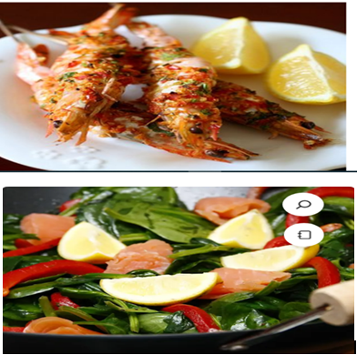
Module Title: Preparing Sea food
Module code: CST CUA4 M08 0923
Nominal duration: 70 Hours

Prepared by: Ministry of Labor and Skill
September, 2023
Addis Ababa, Ethiopia

Table of Contents
Acknowledgment IV
Introduction to the Module V
Unit One: Selecting and storing sea foods 1
1.1 Selecting Sea foods 2
1.1.1 By Categories 2
1.1.2 By Commercial cuts 5
1.1.3 Portion weights 7
1.2 Handling and Storing sea foods 7
1.2.1 Handling 7
1.2.2 Storing 9
1.3 Frozen seafood’s 13
1.4 Checking date stamps and codes 14
Self-Check -1 16
Unit Two: Preparing and cooking fish and shellfish 17
2.1 Cleaning, gutting of seafood 18
2.2 Waste minimization techniques 22
2.3 Cooking methods for seafood 24
2.3.1 Basic cookery techniques for shellfish 28
2.3.2 Preparing variety of fish and shellfish dishes 29
Self-Check -2 31
Operation sheet 2 32
2.1 Crispy Grilled Prawn with lemon butter sauce 32
2.2 Broiled fish with citrus and herbs 33
2.3 Smoked salmon with spinach sauté 34
2.4 Olive-oil Poached Fish 35
2.5 Steamed fish with ginger 36
2.6 Slow roasted 37
2.7 Smoked fish 37
LAP Test 39
Unit Three:- Presenting Fish and Shelfishes 40
3.1 Preparing suitable sauces and dips. (Refer to Module 5 of level 3) 41
3.2 Plating and garnishing techniques of seafood’s 42
3.2.1 Plating tools 51
Self-Check -3 53
Participants of this Module (training material) preparation 1

Acknowledgment

The Ministry of Labor and Skills (MoLS) would like to express its gratitude and appreciation to the instructors and experts from regional TVT bureaus, TVT colleges, and industry practitioners who contributed their expertise and experience in preparing the training module for the unit of competency “Prepare Sea foods” under the occupational standard “Culinary Art level IV"
The ministry also expresses its deepest gratitude to the Tourism Training Institute for its invaluable technical and financial support and collaboration in the module preparation. It is also thankful to MOLS staff members who coordinated the preparation and reviewing process of this training module.

Introduction to the Module

In Culinary art field, Preparing Sea food Dishes, refers to Select, Store, Prepare and Present a variety of sea food dishes with appropriate sauces and accompaniments in line with the standardized recipes by following the right hygiene procedures.
This module is designed to meet the industry requirement under the Culinary Art occupational standard, particularly for the unit of competency: Prepare Sea food Dishes
This module covers the units:
- Selecting and storing sea foods
- Preparing and cooking fish and shellfish
- Presenting fish and shellfish
Learning Objective of the Module
- Select and store seafood
- Prepare and cook fish and shellfish
- 0Present fish and shellfish
Module Instruction
For effective use this modules trainees are expected to follow the following module instruction:
- Read the information written in each unit
- Accomplish the Self-checks at the end of each unit
- Perform Operation Sheets which were provided at the end of units
- Do the “LAP test” giver at the end of each unit and
- Read the identified reference book for Examples and exercise

Unit One: Selecting and storing sea foods
This unit is developed to provide you the necessary information regarding the following content coverage and topics:
  - Selecting sea foods
  - Handling and storing sea foods
  - Frozen seafood’s
  - Checking date stamps and codes
This unit will also assist you to attain the learning outcomes stated in the cover page.
Specifically, upon completion of this learning guide, you will be able to:
- Select seafood according to quality, seasonal availability, price and requirements for specific menu items.
- Estimate yields accurately for various types of seafood.
- Maintain and kill live seafood, where used, in a humane manner and according to government regulations.
- Handle and store seafood hygienically and correctly.
- Thaw frozen seafood to ensure maximum quality, hygiene and nutrition
  - Check date stamps and codes to ensure quality control

1.1 Selecting Sea foods

1.1.1 By Categories

- White flesh fish (saltwater)
Barramundi
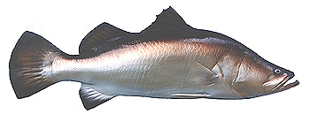
Wild barramundi is revered for its flavour. Can be fresh water or salt water depending on age.
Known by several name such as Sea Bass; Asian Sea bass and is found throughout the Indian and Pacific Ocean regions where it can grow up to 60 kg.
Farmed barramundi can be purchased as baby barramundi plate size 400-600gm.
White coloured flesh; distinctive mild flavour.

Flake
Shark meat; Firm flesh with distinct flavour. Economical large flesh from each fish.
Pinkish raw in colour can have a darker flesh when cooked and can have a fishy flavour.
Versatile and budget priced. Low fat content.
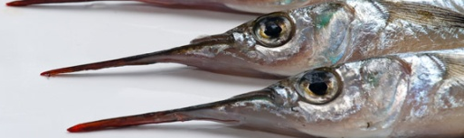
Garfish
Small slender fish with a distinctive spear nose; with low yield.
Can be cooked whole or filleted. Flesh is mild tasting with many fine bones which can be eaten. Low to medium fast content.
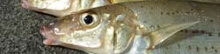
Whiting
White flesh with a delicate flavour. Small thin fillets with low fat content.
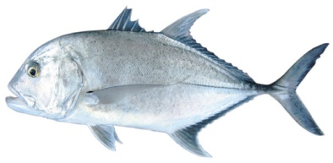
Trevally
Darker flesh which turns white when cooked.
Ling
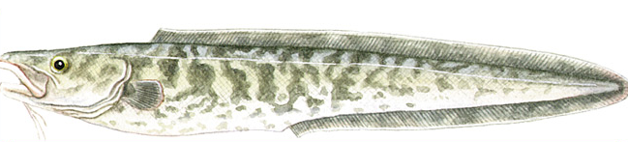
Densely textured fish with fresh white flesh that holds shape when cooked.
Low to medium fat content, with mild to bland tasty fish.
Lings have proven to be popular species for home and commercial cooking because of the large, boned-out fillets and thick steaks, which hold their shape well in cooking.
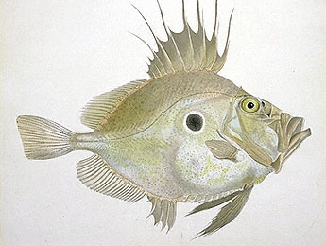
They are lovely tasting fishes with many uses, well suited to grilling, frying, barbecuing and baking. Try baking with a crust of brioche, thyme and lemon zest or prepare as kebabs.
Dory
John Dory is regarded as the best and is the most expensive but Silver and Mirror dory are also excellent tasting fish.
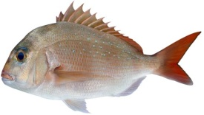
Delicate mild to sweet flavour white flesh that is firm to tender in texture. Versatile can be poached, grilled, steamed or baked.
Snapper
Part of bream family with white to pinkish flesh. Textured medium flakes with low fat content; delicate sweet mild flavour.
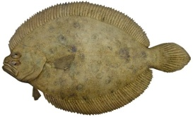
Flounder
Flat fish, can be served whole or filleted; 4 small fillets.
Flathead
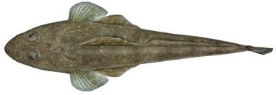
A flat fish with 2 distinct fillets, which can be fried or baked; distinctive mild flavour; 40% loss in weight when filleted.
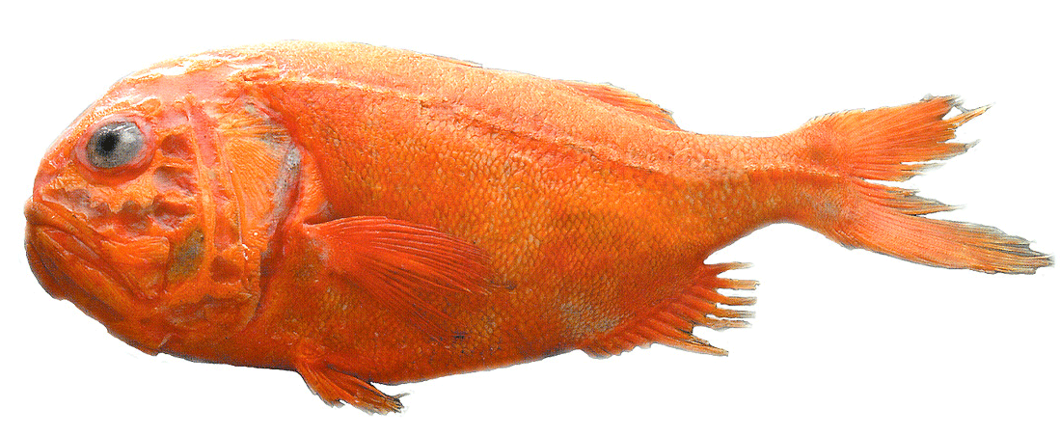
Orange Roughy
Deep sea fish; slow growing; pearly white flesh with medium to high fat content.
Texture is medium to firm; taste is mild but because of high fat content it can taste rich.
Dark oily fish (saltwater)
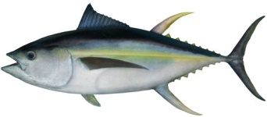
Tuna
Yellow Fin, Big eye, Southern Blue fin, Albacore and Bonito are just some of the names that refer to tuna; Pink to red flesh with low to high fat content; rich in flavour, best cooked rare.
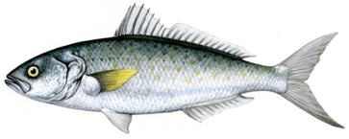
Salmon
Dark flesh with a strong meaty flavour suited to smoking, baking or made into fish cakes; Different to Atlantic salmon; strong flavour, fishy flavour; course to medium texture.
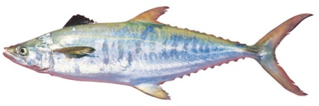
Mackerel
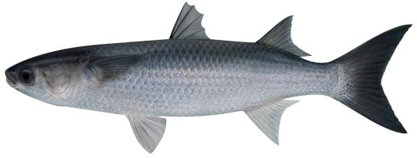
Like their close cousins the tuna, they’re prized for their meaty, oily flesh; School Mackerel have a strong flavour with high oil content. Spanish Mackerel has much less oil content, and is the lighter flavored variety of the species.
Mullet
Rich, strong fishy flavour which is quite distinctive depending on the species; high oil content.
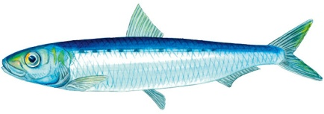
Pilchard (Sardine)
Dark oily fish; young pilchards are referred to as Sardines; sourced from all over the world.
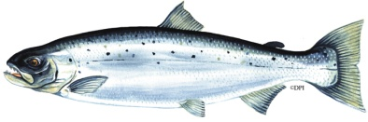
Atlantic salmon
Pink orange in color; medium size flakes; very high fat content; mild distinctive flavour; Purchased fresh or smoked.

1.1.2 By Commercial cuts

Different recipes require different cuts so you may want to check out our recipe selection for ideas.
Table 1:1 Different cuts of fish
Cut | Description
Whole | As it comes from the water ("in the round")
Gilled & gutted (G & G) | Whole finfish with gills and guts removed
Dressed | Gilled, gutted and scaled. Head, tail and fins removed or trimmed
Trunk | Main body section of a finfish, without the guts, gills, head or fins, but with the tail intact
Barrel(log) | Similar to a trunk, but the tail is also removed. Often used in the case of shark
Cutlet | A thick slice of flesh cut vertically through a finfish. Bones and skin are still attached.
Darne | A cutlet taken from a round fish
Tronçon | A cutlet taken from a large flatfish
Steak | A cutlet or piece of flesh (portion) with the bones and skin removed. Steaks are often confused with cutlets.
Supreme | Similar to steak but cut at an angle instead of vertically, anywhere along the barrel. Be careful when cooking because the ends can be thinner and therefore cook quicker.
Fillet | A side of flesh removed from the backbone. The fillet may be skin on or skin off and bones in or boned-out.
Loin | A whole fillet from a large round fish such as tuna or swordfish
Roast | A large cutlet, darne, steak or loin
Escalope | A thin slice of flesh, cut diagonally from a large fillet, without bones or skin
Butterfly fillet (boned-out) | Two single fillets joined by the skin or by a thin piece of flesh. Can be stuffed or opened out like a butterfly cut
Butterfly cut | Any piece of flesh that is cut almost through and then opened out
Medallion | A small round portion of flesh
Wing (lug) | A triangular fleshy section usually forward of and including the pectoral fin
Cheek | A small fleshy section usually directly below but  sometimes below and behind the eye
Fold (delice) | A small fillet, trimmed and folded 1/2 to 2/3 of the way across, with the skin surface on the inside
Roll (paupiette) | A thin fillet rolled into a cylinder shape (with skin surface on the inside), and pinned or wrapped if necessary. Used mainly on flatfish or other thin fillets. The fillet can be spread with a filling before being rolled.
Large roll (roulade) | Similar to a roll (paupiette), but larger
Finger (goujon) | Fillet cut into finger lengths or strips about 6 cm by 1/2 cm

1.1.3 Portion weights

While whole fish costing can be sold by the weight of the live fish; not all restaurants wish to carry the heavy infrastructure cost of maintaining live fish tanks.
In some cultures it is acceptable to see the fish being extracted from the live tank display and serving the fish 20 minutes later at the table.
Larger fillets are easiest to portion to specific weights:
- Entrée size 80 gm-100 gm
- Main course size 150 gm-180 gm.
But off cuts need to be utilised or discarded.
If discarded then wastage needs to be measured and cost of wastage applied to number of portions.

1.2 Handling and Storing sea foods

1.2.1 Handling

Fish and shellfish are an important part of a healthful diet because they contain high-quality protein and other essential nutrients. In fact, a well-balanced diet that includes a variety of fish and shellfish can contribute to heart health and aid in children's proper growth and development.
As with any food, it's important to handle seafood safely to avoid foodborne illness, sometimes called food poisoning. Follow these safe handling tips for buying, and storing fish and shellfish –
- Only buy fish that is refrigerated or displayed on a thick bed of fresh ice (preferably in a case or under some type of cover).
- The color of a fish can be affected by several factors including diet, environment, treatment with a color fixative such as carbon monoxide or other packaging processes, so color alone is not an indicator of freshness.
- Fish should smell fresh and mild, not fishy, sour, or ammonia-like.
- A fish's eyes should be clear and shiny.
- Whole fish should have firm flesh and red gills with no odor. Fresh fillets should have firm flesh and red blood lines, or red flesh if fresh tuna. The flesh should spring back when pressed.
- Fish fillets should display no discoloration, darkening, or drying around the edges.
- Shrimp, scallop, and lobster flesh should be clear with a pearl-like color and little or no odor.
- Some refrigerated seafood may have a time/temperature indicator on its packaging. The indicator shows whether the product has been stored at the proper temperature. Always check the indicators when they are present and only buy the seafood if the indicator shows that the product is safe to eat.
- Fresh fish and fish fillets sold as "Previously Frozen" may not have all the characteristics of fresh fish (e.g., bright eyes, firm flesh, red gills, flesh, or bloodlines). However, they should still smell fresh and mild, not fishy, sour, or rancid.
Selecting shellfishes
- Look for the label: Look for tags on sacks or containers of live shellfish (in the shell) and labels on containers or packages of shucked shellfish. These tags and labels contain specific information about the product, including the processor's certification number. This means that the shellfish were harvested and processed in accordance with national shellfish safety controls.
- Discard Cracked/Broken Ones: Throw away clams, oysters, and mussels if their shells are cracked or broken.
- Do a "Tap Test": Live clams, oysters, and mussels will close when the shell is tapped. If they don't close when tapped, do not select them.
- Check for Leg Movement: Live crabs and lobsters should show some leg movement. They spoil rapidly after death, so only live crabs and lobsters should be selected and prepared.
Purchasing frozen foods
- Frozen seafood can spoil if the fish thaws during transport and is left at warm temperatures for too long before cooking.
- Don't buy frozen seafood if its package is open, torn, or crushed on the edges.
- Avoid packages with signs of frost or ice crystals, which may mean the fish has been stored a long time or thawed and refrozen.
- Avoid packages where the "frozen" fish flesh is not hard. The fish should not be bendable.

1.2.2 Storing

Storing seafood need not be a tricky affair. Although seafood has a reputation for being particularly disastrous if not stored properly, storing your seafood is simple enough, and requires consideration both of the seafood in question, and the other contents of your refrigerator. Whether you are storing your seafood in the freezer, the fridge, storing live seafood, or storing leftovers, following simple protocols will help keep your food fresh and safe.
  - Storing in the Freezer
Transport your fish home in a freezer bag. Even if your home is only 5 minutes away from your local grocer, use a freezer bag to keep your frozen seafood safe, rather than letting it sit in your car in a regular plastic or cloth grocery bag. Even ten minutes of thawing can render fish unsafe.
  - If your storage bag has been sitting in a warm car, make sure you pick up some ice or another method of keeping items cold.
Check packaging for tears or holes. Before placing your fish in the freezer, check the packaging it came in. If you find any holes or tears, wrap your fish in wax paper or foil to preserve flavor and moisture.
  - Direct exposure to the frigid temperatures of a freezer can cause dryness and freezer burn. Do not skip this step to ensure high-quality, tender fish.
Place seafood on the lowest shelf possible. Rather than storing seafood on the middle or top shelves, store it away from other items in the freezer, preferably on the lowest shelf. Although frozen fish should not be dripping juice or sauce, storing fish away from other foods avoids the risk of cross-contamination.
Once thawed, do not refreeze. Once you have thawed your fish, avoid placing it back in the freezer. Instead, use your fish immediately. If you cannot cook it right away, you can place it in a crockpot or other slow-cooking tool and come back to it later. This is partly due to taste (re-frozen fish tends to have a dry texture and loss of flavor), and partly due to safety, as the thawing process may have allowed bacteria to grow.
  - Storing in the Fridge
- Wrap your fish tightly in wax paper, plastic wrap, or foil. To keep in freshness, it is best to have a tight wrapping around the fish, rather than placing it into a large container. Wrapping will help seal in moisture and flavor, while placing in a larger tin or container may cause the fish to dry out.
- Keep fresh fish on ice. Although a freezer is too cold for fresh fish, a refrigerator is often too warm an environment. The solution is to place your fish on ice (directly, or still wrapped) inside of the fridge. As the ice melts, you’ll need to drain it, so keep this in mind when choosing a storage method.
  - When you purchase fresh fish, it should be in a similar configuration: over ice, in a sealed container. If your fresh fish is not stored properly prior to purchasing it, skip it.
- Sort through shellfish, and throw away any with cracked or broken shells, as they may have been contaminated.
- Seal your storage containers. Once your fish has been wrapped (if flesh is exposed) and properly covered in ice, seal the container you’ve placed them in. This will help maintain freshness and discourage bacterial growth.
- Drain melted ice periodically. Because your fish should not be placed into water, make sure you remove any melted ice during the storage period. You can place the ice in a colander, then place the colander into a bowl, or you can place your ice into a plastic bag for easy clean-up.
- Cook fresh fish within 2 days. Fresh fish can spoil quickly and easily, so use whatever fresh fish you have within 2 days of catching or purchase. If you cannot get to it within that time frame, cook it and store the cooked fish, which will last a bit longer, and will not run as high a risk of spoiling.
  - If you cannot get to your fresh fish within two days, follow the freezing recommendations to salvage the fish you’ve not gotten to.

  - Storing Live Seafood
- Avoid fresh water. Seafood does not live in fresh water, and will not survive in it. Do not store live seafood such as a lobster in fresh water. You run the risk of killing the creature and ruining the meat.
- Live seafood does require some moisture, but instead of placing water in your storage container, place damp paper towels or even moist seaweed in the container. This will provide additional moisture without risking the creatures’ lives.
- Store in an open container. Unlike already-deceased fish, you want to store live seafood in an open container to facilitate oxygen circulation. A sealed container cuts off oxygen, and will kill your dinner well before you’ve had a chance to cook it. Whether you use a cardboard box, an open cooler, or a paper bag, make sure your live seafood has a means of getting air.[9]
- If the prospect of having a lobster in an open container makes you uncomfortable, you can also place live seafood into a cardboard box and cut holes in the top.
- Keep your seafood cool using a fridge or cooler. Although bacteria will not accumulate on live seafood, seafood is accustomed to cold temperatures. To thrive, live seafood does best in temperatures under 40 degrees F (4.44 C). To make sure your seafood is not harmed, place a thermometer in your fridge and make sure it reads less than 40 degrees F (4.44 C).
- Most refrigerators are set to temperatures below 40 degrees F (4.44 C). If this is the case with your fridge, a temporary solution such as an ice-filled sink, or ice-filled cooler will work.

- Do not freeze. Live seafood is sold that way for a reason. Avoid the temptation to freeze the critters you are set to imbibe, and keep them alive and healthy until the time to cook them has arrived. Freezers are best for already-frozen fish and seafood, as the packaging and freezing method have been tailored to keep these items fresh and moist.
- Cook the same day. Live seafood is not meant to be kept for extended periods. If you know you are not going to be able to get too cooking one day, save lobster for another time. You cannot effectively store live seafood for extended periods.
- Although some seafood can last for 2-3 days after purchase, you will experience the best taste and texture if your seafood is eaten the same day as it is purchased.

  - Storing Leftovers
- Store in airtight containers. As with fresh fish, store your leftovers in airtight containers to prevent the growth of bacteria and limit the risk of cross-contamination.
- Refrigerate within 2 hours of cooking. Even cooked fish should be handled carefully, and should be left out no longer than 2 hours after being cooked. The longer food is left out after cooking, the higher the risk is of bacteria developing and growing. If you have left food out past this time frame, the safest option is to throw the food away.
- Avoid temperatures between 40 and 140 degrees F (4.44-60 C). This temperature range is often called the “danger zone,” as it provides the ideal breeding ground for germs and bacteria. When storing your leftovers, make sure your fridge is set to a temperature below 40, and while cooking, make sure your oven has reached a temperature higher than 140.
- Store seafood separately from other foods. If you’ve made a dinner of fish and broccoli, for instance, store each in their own container. Fish goes dry and rancid faster than most vegetables, grains, and even other meats. Whenever possible, store fish with fat or marinades intact.
- Eat within 2-3 days. Ideally, you should consume your leftover fish within 1-2 days. Any longer, and your fish may become dry or develop a slimy covering. Fish that has gone beyond this window should be thrown out.

1.3 Frozen seafood’s

Never defrost seafood at room temperature. The best and safest way to defrost seafood is in the refrigerator overnight, but if you’re in a hurry, you can also thaw it under cool running water or in the microwave.
To thaw in the refrigerator:
- Place the seafood in a clean container or leak-proof platter.
- Place the container or platter on the bottom shelf of the refrigerator.
- Cook it immediately after it is thawed.
To thaw under cool running water:
- Thoroughly clean and sanitize the sink before thawing the seafood.
- Make sure it's wrapped in leak-proof plastic to prevent cross-contamination.
- Run cool, potable drinking water on it until it has thawed.
To thaw in the microwave:
- Use the defrost setting on the microwave and stop the cycle when the seafood is still icy but pliable.
- Only use this method if you will be cooking the seafood immediately.

1.4 Checking date stamps and codes

Foods have a date stamped on the label. These dates can help you choose foods that are fresh and safe to eat.
Many foods have a date stamped on the label, but what do they really mean? They are intended to be helpful, but the differences between sell-by, best-if-used-by, use-by and pack dates can be confusing. Here are the most common:
- Pull-By of Sell-By Dates
These dates are used on foods like milk, cheese, and packaged meats. They are the last date the product should be sold. These foods are usually stored in the refrigerator. They will stay fresh and safe for few days after this date if you store them properly.
- Freshness or Best-If-Used-By Dates
These dates are used on products like bakery goods or packaged cereals. The date is the last day the product can keep its best quality. After this date, the food may lose some of its freshness and nutritional value.
- Expiration or Use-By Dates
These dates are the last day the food should be eaten or used. They are used mostly on products such as refrigerated dough and yeast.
- Pack Date
this type of date is the day the food was manufactured or processed and packaged. It is used for foods that can be kept for a long time, like canned goods.
Meat, fish and ready meals are often the most expensive things we buy, so it helps to get into the habit of regularly checking the dates on perishable items in your fridge. Move them into the freezer if you don’t think you’ll have time to eat them or cook them for tonight’s supper. When you get home with your shopping, it is a good idea to transfer as much as you can straight into the freezer. If you have large packets of chicken pieces or fish, divide them up and freeze individual portions.
- Date stamps can help you choose foods that are fresh and safe to eat, especially if you learn what the different labels imply.

Self-Check -1 | Written Test
Part-I: Choose the correct answer
- Which one of the following is a method of selecting fish
- By categories
- By portion weights
- By commercial cuts
- All
- Which one of the following is White flesh fish (saltwater)
- Barramundi
- Flake
- Ling
- All of the above
- Plump breast is
- Quality of chicken
- Sign of spoilage
- Wastage
- Which one of the following is correct protocol for storing sea food?
  - Storing in the Freezer
  - Storing in the Fridge
  - Storing live sea food
  - All
- Which one of the following is not correct about Storing live sea food?
  - Avoid fresh water
  - Store in an open container
  - Keep your seafood cool using a fridge or cooler
  - None
Part-II: write the short answer
- Write method of selecting shellfishes?
- Write type of Dark oily fish (saltwater)?
- Write type of commercial cuts?
- Explain portion weights?
- Explain at least 3 types of date stamps?

Unit Two: Preparing and cooking fish and shellfish
This unit to provide you the necessary information regarding the following content coverage and topics:
- Cleaning, gutting of sea fishes
- . waste minimization techniques
- Cooking methods for seafood
- Preparing variety of fish and shellfish foods

This guide will also assist you to attain the learning outcomes stated in the cover page. Specifically, upon completion of this learning guide, you will be able to:
- Clean, gut and fillet fish correctly and efficiently according to enterprise standards.
- Clean and prepare shellfish and other types of seafood according to enterprise standards.
- Cook seafood to enterprise standards using a variety of cookery methods.
- Use fish and shellfish by-products appropriately for a variety of dishes and menu items

2.1 Cleaning, gutting of seafood

If you are planning on cooking your fish whole or if you are going to steak it, rather than filleting it, you must learn how to gut a fish.
- Gutting
For most purposes, finfish are gutted through the stomach. This is a quick and convenient method:
1. slit open the belly from the ventral opening to the gills.
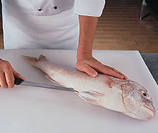
2. Ease out the guts.
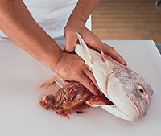
Note that gutting through the gills is suitable for sashimi tuna and smaller finfish that are to be cooked whole, or finfish that are to be cut into steaks. Gutting through the gills is used in these situations because it preserves the shape of the finfish.
3. Rinse out the gut cavity with cold running water.
Depending on the species, you may need to use a spoon or knife to scrape along the vertebrae in the gut cavity, to remove the kidney and any remaining blood. Once this is done use the fish as soon as possible to limit bacterial growth.
- Gilling
Gills are best removed because they are bitter tasting and cause the finfish to go "off" more quickly due to their blood content and high level of unwanted bacteria.
1. Fan out the gill flap and cut along its top. Repeat on the other gill flap.
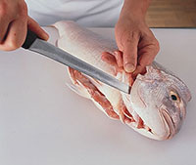
2. Pull out the gills.
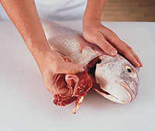
- Scaling
If the finfish is to be skinned scaling is unnecessary as both skin and scales can be removed together. In some cases the scales assist the skinning process by holding the skin together.
To scale:
  - Use short firm strokes with a scaler or the back of a knife, from the tail towards the head (shown here with a yellowfin bream). Repeat on the other side.
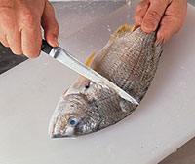
- Wash the finfish in clean, cold running water to remove any loose scales.
- Trimming
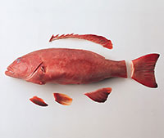
If you are serving finfish whole, the fins and tail can be trimmed to an attractive shape. Trimming is not necessary if you are going to fillet.
To fully trim, use a pair of heavy-duty food scissors and cut the fins and the tail as close as possible to their base. If you wish to leave the tail on, it is best to trim the end so that it keeps its shape, but does not burn and shrivel when cooked. Scoring
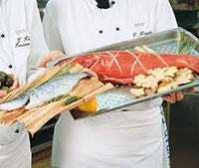
Scoring will help:
- More even cooking;
- Reduce cooking time, which also helps maintain nutritional value;
- Give an attractive appearance.
- Be careful, as scoring too deeply will cause:
- Shrinkage of the skin;
- The flesh around the score to cook too quickly and burn;
- Drying out of the flesh around the score;
- An unattractive appearance.
Whole finfish or thick fillets are often scored before being baked, grilled or barbecued:
- With a sharp knife, just nick the finfish three or four times on each side. A deeper cut (3–15 mm) can be made on thicker finfish. Attractive patterns can also be created by scoring, for example a crisscross pattern to create a "pineapple" appearance.
- Scoring a whole finfish can also include a shallow cut along the middle of each side (parallel to the backbone).
Removing the head
- If you intend to serve a whole finfish dressed, remove the head before cooking as there will be less chance of damaging the cooked flesh.
- When scaling, remove the head after scaling—use it for a better grip.
- When gutting and gilling, remove the head after gutting and gilling.
When filleting, do not remove the head.
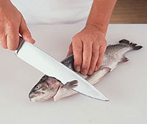
Place the knife behind the gill cover and pectoral fin and cut all the way through.
Flat head
Separate gill cover and body. Insert the knife at 45° to the board and then in one action cut right through the backbone. This will leave the fillet with the bones in and the wing (lug) on.
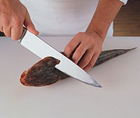

2.2 Waste minimization techniques

Waste Minimization is reduction in the quantity of hazardous wastes achieved through a conscientious application of innovative or alternative procedures. Simple adjustments to a process producing wastes (e.g. a teaching lab experiment, a vehicle cleaning operation, etc.)
Benefits of waste minimization
While it is obvious that waste minimization supports sound business and economic practices in addition to protecting the environment, other benefits include the following:
- Improved product quality – New technological practices and innovation will not only reduce the generation of waste but also contribute to improved input quality that translates to improved products.
- Economic benefits – Efficiency in product use translates to reduced costs when purchasing materials, thus significantly affecting financial performance.
- The efficiency of production practices – Waste minimization will attain more output of the product for every part of raw material.
- Environmental responsibility – eliminating or minimizing the generation of waste will make it easy for you to achieve environmental policies, standards and regulations.
- Public image – Embracing waste minimization will boost the reputation of your company, as it is a reflection of proactive movement in the quest to protect the environment.
- New customers –People love to buy their goods from companies that are dedicated to improving our environment. Some consumers exclusively seek these organizations out, so you have an opportunity to reach a wider audience. It brings in new customers and generates new money. This is due to your commitment to protecting the environment.
- Fewer Accidents – It reduces the occurrence and likelihood of worker exposure and workplace accidents.
- Protect the environment – Waste minimization increases the efficiency of production. You are able to reduce carbon, air, and water emissions while you work to conserve natural resources. Thus it saves resources and energy, reduces pollution, and diminishes demand for landfill space. All these boost environmental performance.
- Stay ahead of the competition – Reducing waste both in the final product and the manufacturing process, decreases regulatory burdens associated with disposal. More time and money allow you to invest in new ideas and products.

3 R’ Waste Minimization
  - .Reduce
This calls for using resources that are just enough to cater to your needs, for instance, building a smaller house. This is an effective way of conserving resources as it also lowers the costs. This can be achieved through attaining accuracy when ordering to ensure that there is no waste or no material is sitting on the site for long periods that it is damaged.
  - Reuse
Here, you will do well to reuse existing materials and buildings, effectively reducing the need for resources while lowering waste volumes and saving money. A huge percentage of resources are incorporated in the construction of homes owing to the mixed materials that are used, yet the end destination for most of them is landfill.
Thus, renovating a house is a much better option than bringing it down to put up another one because a negligible fraction of the old house may be reused/recycled.
  - Recycle
Using leftover resources or those resources that have reached the end of their life minimizes the need for new materials as well as lowers the volume that ends up in landfills. Thus, it is advisable to use materials that are recyclable as this creates a market for the resources that are recycled while also raising the price that recyclers pay for resources that are recovered even as the recycling viability increases.

2.3 Cooking methods for seafood

The top eight methods used for cooking seafood. The methods are:
  - Grill
Seafood is just wonderful on the grill. One has to select seafood that can withstand the heat of the grill, and can stand up to the hot iron grills. Use seafood, such as tuna, lobsters, prawns, etc., which are sturdy and do not fall or flake apart. Marinating in oil ensures that the fish does not stick to the grill. Using wood for grilling could also add flavour to the fish.
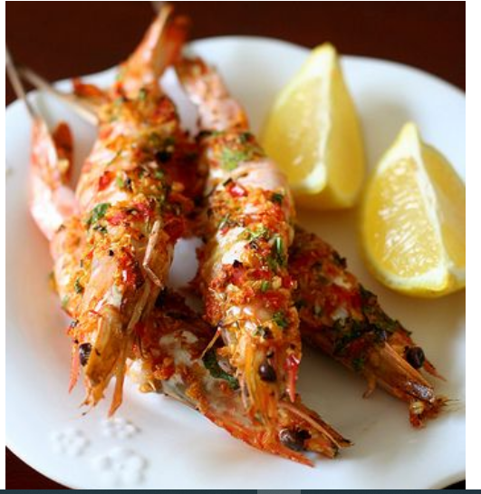
Figure.2.1. Grilled sea foods

Best Broiling:
Due to the high temperatures, some seafood is better for broiling than others. Here’s a list of the best types of seafood to broil.
Bluefish, Cod, Grouper, Haddock, Halibut, Kingfish, King Mackerel, Kona Kampachi, Large/Jumbo shrimp, Lobster tail, Mahi Mahi, Monkfish, Mullet, Perch, Pike, Pollock, Pompano, Rockfish, Roughy, Salmon, Sablefish, Sea Bass, Shark, Striped Bass, Swordfish, Trout, Tuna, and Walleye.
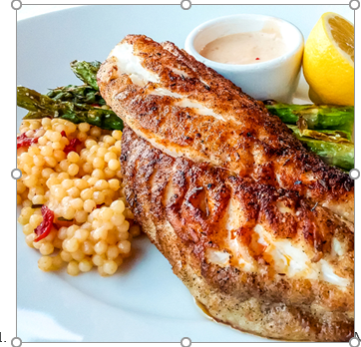
Figure.2.2. Broiled sea food

Sautéing:
Sautéing is probably the most common method of cooking seafood. It is a quick way of cooking seafood while maintaining optimum flavour. For best results, when you sauté, cook the side with the skin first (if it is left on).
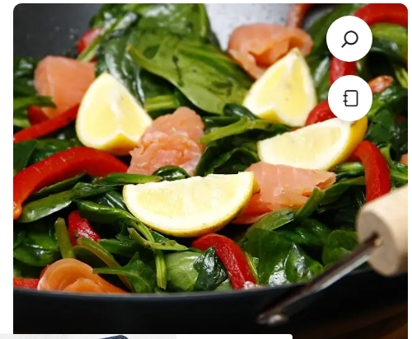
Figure.2.3. sautéd Seafood

Olive Oil Poaching:
Poaching seafood in olive oil is a great way to slowly cook the fish. Cooking seafood in barely warm oil keeps the protein from coagulating. Olive oil poaching lessens the release of natural fat and oil from the fish, which helps to keep it moist. These slow cooking results in a succulent, perfectly cooked piece of fish. This method of cooking is usually used for oily ish rather than lean fish.
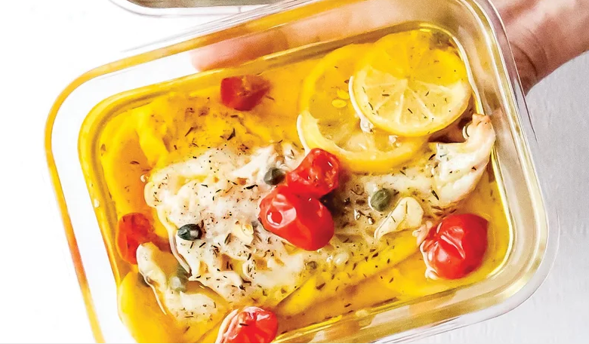
Figure.2.4. Poached seafoods

Steaming:
Steaming fish keeps it extremely moist and flaky. In fact, steaming is a great way to prepare many low-fat dishes and not just delicately flavored fish. Steaming is very common to many Oriental preparations.
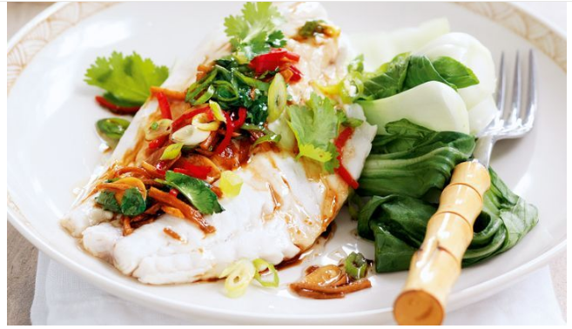
Figure2.5.Steamed sea food

Roasting and Slow Roasting:
The only difference between slow roasting and roasting is the temperature. Regular roasting takes place between 160 and 200°C. Slow roasting on the other hand takes place at temperatures as low as 80°C and barely cooking fish would take as long as 20 to 25 minutes. When you slow roast fish the end result is a piece that is so moist that it melts in your mouth and falls apart when you touch it.
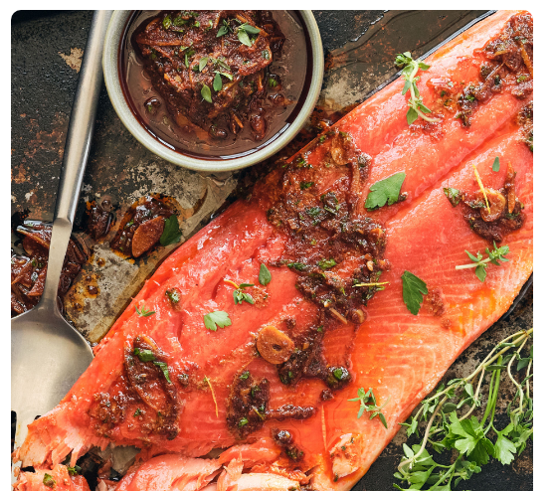
Figure.2.6. Slow roasted sea food

Smoking or Curing:
A number of popular fish products are smoked or cured or both or they are dried, pickled, or otherwise treated to enhance their taste and prolong their usability. Smoked salmon, pickled herring, smoked oysters, caviar (salted fish roe) belong to this group of fish foods.
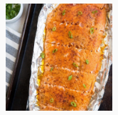
Figure.2.7.smoked sea fish

2.3.1 Basic cookery techniques for shellfish

Most shellfish can be cooked using any of the basic techniques for fish while observing similar guidelines. Shellfish generally has more connective tissue and therefore will firm up when cooked. Small crustaceans and mollusks will be tenderer than larger ones. In all cases using slower and gentler cooking methods with a minimal amount of time will result in a moist and tender outcome.
- Crustaceans should be cooked minimally because they can get dry and rubbery if overcooked.
- Shrimp are commonly prepared by steaming, simmering, sautéing, grilling and poaching.
- Lobsters can be poached, steamed, grilled, broiled and sautéed.
- Because most crab meat is cleaned and cooked they can be used in a variety of preparations from simply heating the crab legs, or prepared in stuffing and crab cakes. Fresh crab can be steamed or in the case of soft-shell crabs sautéed or deep fried.
- Mollusks will be chewy but tender when minimally cooked but can toughen when cooked too long. Similar to meat, they must be cooked for an extended period to tenderize them again.
- Clams are used in chowders, soups, and stews. Smaller clams can be eaten raw or steamed. Larger clams can be stewed, braised or deep-fried. The large geoduck is usually pounded to tenderize it and sliced thin.
- Mussels are commonly steamed or stewed and can also be fried
- Oysters are eaten raw but can also be used in soups, stews, deep-fried or baked.
- Octopus flesh is tenderized through pounding or tumbling. It is also tenderized through braising, simmering or steaming. Octopus can also be eaten raw in ceviche and sushi.
- Squid, also called calamari, can be tenderized by scoring the connective tissue of the body. It is often deep-fried but can also be stewed or braised. Quick cooking is best because squid can become quite tough and will need to be cooked a long time to tenderize.
- Cuttlefish can be treated similar to squid in cooking and handling techniques.
- Conch meat has a mild, sweet clam-like flavor but is extremely tough and must be pounded, chopped, or marinated in lime juice to tenderize it before cooking. Some common preparations include fritters, chowder, steaks and marinated raw salads.
- Sea urchin is eaten raw in ceviche-style preparations.

2.3.2 Preparing variety of fish and shellfish dishes

Before cooking, rinse seafood under cold water to remove surface bacteria. Always marinate fish and shellfish in the refrigerator, never at room temperature. Discard the marinade after use. Make sure that juices from raw seafood don't drip onto cooked foods; this leads to cross-contamination.
The top methods used for cooking seafood. The methods are:
- Crispy Grilled Prawn with lemon butter sauce
- Broiled fish with citrus and herbs
- Smoked salmon with spinach sauté
- Olive-oil Poached Fish
- Steamed fish with ginger
- Slow roasted
- Smoked fish

Self-Check -2 | Written Test
Part-I: Choose the best answer
- Which one of the following is the method of gutting
  - slit open the belly from the ventral opening to the gills
  - Ease out the guts.
  - Rinse out the gut cavity with cold running water.
  - All
- What is the method of cooking sea food?
    - Best Broiling
    - Smoking
    - Steaming
    - All
- What is 3 R’ Waste Minimization
    - Reuse
    - Repeat
    - Refurbished
    - None
- Shrimp are commonly prepared by
    - simmering
    - sautéing
    - poaching
    - All
- Basic cookery techniques for shellfish
  - Crustaceans
  - Mollusks
  - Octopus
  - All
Part-II: Give short Answer
    - Explain Benefits of waste minimization?
    - What is trimming a sea food?
    - What does mean Sea urchin?
    - What does mean Olive Oil Poaching?
    - Mention the top methods used for cooking seafood?

Operation sheet 2 | Producing sea foods dishes

2.1 Crispy Grilled Prawn with lemon butter sauce

Ingredients;

Lemon garlic butter:
- 90g / 6 tbsp butter , unsalted
- 1/4 tsp salt
- 3 tsp garlic , very finely chopped (do not use mincer, Note 1)
- 1.5 tbsp lemon juice , plus more to taste

SHRIMP/PRAWNS:
- 500g/ 1 lb large shrimp / prawns , raw, peeled and deveined (Note 2)
- 1 tsp garlic powder
- 1 tsp smoked paprika (plain or sweet ok too)
- 1/4 tsp cayenne pepper
- 1 tbsp lemon juice (skip if using stove)
- 2 tbsp olive oil
- 1/2 tsp salt
- 1/4 tsp pepper

SERVING (OPTIONAL):
- 1 lemon , halved, grilled if desired
- Lemon wedges or slices
- 2 tbsp finely chopped parsley

Preparation:
1. Brush BBQ grills with oil, then preheat on high until very hot.
2. If shrimp are small and might fall through grills, skewer them (use 2 skewers, Note 3)

Make sauce:
1. Melt butter in a small saucepan over medium high heat.
2. Add garlic and salt. Stir until garlic is LIGHT golden brown, then immediately remove from stove (residual heat will make garlic golden & crispy).
- Stir through lemon.

Shrimp/prawns (stove: note 4):
1. Pat shrimp dry with paper towels (to ensure crispiness!)
2. Just prior to cooking, place in bowl, sprinkle/drizzle over remaining ingredients. Toss gently to coat.
3. Working quickly, place shrimp on BBQ and cook each side for 2 minutes until golden and crusty.
4. Immediately remove shrimp onto serving plate.

Serving:
  - Drizzle over all the Lemon Garlic Butter, sprinkle with parsley and serve immediately with fresh lemon.
  - Crusty bread to mop up the crazy delish butter on the plate is essential!
Recipe notes
Garlic - don't use a mincer/garlic crusher, the garlic will burn too quickly before the butter infuses with garlic flavor. Best to finely chop. Plus, we want little crispy golden bits of garlic in the sauce!

2.2 Broiled fish with citrus and herbs

If you are looking for a delicious, healthy recipe, we recommend Whole Foods Market’s broiled fish with citrus and herb recipe.
Ingredients
- 3/4 cup orange juice or lemon juice
- 1/2 minced shallot
- 1/4 tsp dried tarragon
- 4–6 oz white fish fillet (like sole, tilapia or cod)
- 1/2 tsp extra-virgin olive oil
- Salt and ground black pepper, to taste
- 3 chopped pitted Kalamata olives (optional)
Preparations
- Mix together the citrus juice, minced shallot and tarragon in a small saucepan.
- Simmer over medium high until thickened (approximately 15–20 minutes) then cover and set aside.
- Preheat the broiler.
- Pat down the fish fillets with a paper towel. Then brush both sides with olive oil and sprinkle with salt and pepper.
- Lay the fish fillets down on a broiling pan after covering the pan with foil.
- Broil for 5 minutes or until the fish are opaque and flake when speared with a fork.
- Plate the fish fillets, spoon the sauce over it and top with olives. Then serve.
This recipe pairs well with a side of rice pilaf or cous cous and roasted peppers.

2.3 Smoked salmon with spinach sauté

Ingredients
- 250 grams fresh spinach leaves
- 1 dried chili
- 1 tsp. dried basil
- 1 Tbsp. dried parsley
- olive oil (to taste)
- salt
- ground black pepper
- 1 red pepper (roasted and peeled)
- 1 Tbsp. soy sauce
- 4 slices smoked salmon
- 1 lemon (small, wedges)
Preparations

- Sauté the spinach with the chili, basil, and parsley in a wok or frying pan with a drizzle of olive oil.
- Season with salt and pepper.
- Add the strips of red pepper and the soy sauce.
- Remove from heat.
- Serve with smoked salmon and lemon wedges

2.4 Olive-oil Poached Fish

Ingredients
- 1 large lemon, sliced into thin rounds, divided
- 4 6-oz skinless cod or halibut fillets
- ½ tsp each sea salt and ground black pepper
- 1 lb grape or cherry tomatoes, optional
- 1 tbsp drained capers 5 sprigs fresh thyme
- 1 bay leaf
- 3 cloves garlic, sliced
- 2 cups extra-virgin olive oil
- 5 sprigs fresh thym
- 1 bay leaf
Preparations
- Preheat oven to 250ºF. Lay half the lemon slices in a 9 x 13-inch baking dish. Pat fish dry, sprinkle with salt and pepper and place on top of lemon slices. Top with tomatoes (if using), capers, garlic and remaining lemon slices. Pour oil over top. Add thyme and bay leaf, pushing to submerge in oil.
- Bake fish until cooked through and flakes easily, 30 to 40 minutes.
You can drizzle the extra oil over a salad or roasted vegetables if using right away, but it’s not safe to store it for future use.

2.5 Steamed fish with ginger

Ingredients
- 4 (200g each) firm white fish fillets
- 1/4 cup fresh coriander leaves
- 2 green onions, thinly sliced
- 1 long red chilli, deseeded, thinly sliced
- 3cm piece fresh ginger, peeled, cut into thin matchsticks
- 1 garlic clove, thinly sliced
- 1 tsp caster sugar
- 1 tbsp soy sauce
- 1 1/2 tbsp peanut oil
- 1 tsp sesame oil
Steamed jasmine rice, to serve
Steamed Asian greens, to serve
Preparations
Bring 2 cups cold water to a simmer in a large wok over medium heat. Line a 30cm bamboo steamer with baking paper. Place steamer over water. Place fish in steamer. Cover. Steam for 5 to 10 minutes or until just cooked through (see note). Carefully transfer to a plate. Cover to keep warm.
- Meanwhile, combine coriander, onion and chilli in a bowl.
- Combine ginger, garlic, sugar and soy sauce (1 tbsp soy sauce) in a heatproof bowl. Place peanut oil and sesame oil in a saucepan over high heat. Cook for 2 minutes or until starting to smoke. Carefully pour over ginger mixture (mixture will spit).
- Drizzle ginger mixture over fish. Top with coriander mixture. Serve with rice and greens.

2.6 Slow roasted

Ingredients
- 1 1/2 pounds king or sockeye salmon fillet, pin bones removed
- 1 tablespoon extra virgin olive oil
- Kosher salt, to taste
- Pepper, to taste
Preparation
- Preheat oven to 275°F. Line a rimmed baking sheet, large enough to hold salmon, with parchment paper.
- Place salmon, skin side down, on baking sheet. Drizzle with olive oil and season with salt and pepper, to taste.
- Roast salmon in preheated oven until a probe thermometer inserted into its thickest part registers 125°F, about 15 minutes.
- Serve topped with chermoula or keep it simple with a sprinkle of lemon zest and squeeze of lemon juice.

2.7 Smoked fish

Ingredients
- 1 large salmon fillet 2 to 4 pounds, pin bones removed
- 1 to 2 Tbsp avocado oil as needed
- 2 tsp garlic powder
- 2 tsp paprika
- 1 tsp sea salt to taste
- Lemons for serving
Preparations
- Preheat your smoker to 225 degrees Fahrenheit.
- Place a long sheet of foil (a couple of inches longer than your fillet) on a large baking sheet.
- Pat the salmon dry with a paper towel and place it on the sheet of foil. Fold up the sides of the foil around the salmon, creating a sort of boat.
- Sprinkle salmon with sea salt, garlic powder, paprika, and black pepper.
- Transfer the salmon to the preheated smoker and close the lid. Smoke for 30 to 60 minutes, or until the salmon reaches an internal temperature of 145 degrees F. Begin checking the temperature using a thermometer after 30 minutes. Note: the salmon will continue cooking after it is taken off of the smoker, so you can pull it off around 140 to 143 and it will raise temperature while resting.
- Allow the salmon to rest 10 to 15 minutes before slicing and serving.

LAP Test | Practical Demonstration

Instructions:
Given necessary templates, tools and materials you are required to perform the following tasks accordingly.
Task 1: Prepare Grilled Prawn with lemon butter sauce
Task 2: Prepare Broiled fish with citrus and herbs
Task 3: Prepare Smoked salmon with spinach sauté
Task 4: Prepare Olive-oil Poached Fish
Task 5: Prepare Steamed fish with ginger
Task 6: Prepare Slow roasted
Task 7: Prepare smoked seafood

Unit Three:- Presenting Fish and Shelfishes
This learning guide is developed to provide you the necessary information regarding the following content coverage and topics:
- Prepare suitable sauce and dips
- Plating and garnishing techniques of sea foods
- Understanding culinary terms
This guide will also assist you to attain the learning outcomes stated in the cover page. Specifically, upon completion of this learning guide, you will be able to:
- Prepare and present fish and shellfish for service.
- Prepare suitable sauces and dips according to standard recipes and as required to accompany menu items.
- Select plate presentations and garnishing techniques and use according to recipes and enterprise standards.
- Carry out service according to enterprise methods and standards

3.1 Preparing suitable sauces and dips. (Refer to Module 5 of level 3)
Sea food sauce
Seafood sauce is a popular condiment in many cultures and can be used as a dip, sauce, or dressing, as an appetizer, or as an accompaniment to dishes. It is typically a mixture of butter, garlic, onion, and spices.
Next, we will give you the best seafood sauce recipes so that you can surprise your loved ones with a delicious seafood dish with an authentic touch.
How to make seafood sauce?
Seafood sauce is the perfect combination for your seafood dishes and it’s so easy to make at home. The base of this sauce is melted butter, onion, and garlic. The different variations and flavors of sauces are given by the species you use and the complementary ingredients.
The preparation is the same only the ingredients vary. First, prepare all the ingredients you need.
- Mix all the species. It varies depending on the flavor you want to give it, below I leave you some of the most delicious seafood sauces.
- Cut into very small pieces or crush (if you have a food processor, onion and garlic (make sure you put enough garlic).
- Have a saucepan and the other ingredients on hand.
*Attention: for more detail refer to Module5 of Level III

3.2 Plating and garnishing techniques of seafood’s

An understanding of food plating techniques will help your staff improve your meal presentation and enhance the dining experience for your guests. For a visual guide, check out our video on how to plate food like a chef.
How to plating
While there are no fixed food presentation rules, there are several important concepts to keep in mind as you arrange your meals.
- Remember your plate is your canvas.
- Arrange food items using the rule of thirds.
- Entice the eyes with visual stimulants.
- Use the sauce as paint for your plate.
- Garnish to enhance both appearance and flavor.
Plating Techniques
Conceptualize plating as an art form: you are the artist; the plate is your canvas, and the food is your medium. Master the following plating techniques to perfect your craft.
  - Plating presentation techniques
Selecting the right plate for your meal is the first step in the food presentation process. Consider the following to choose the ideal plate for your food presentation:
- Plate Size - Your plate should be big enough to make your food stand out and petite enough to prevent your portions from appearing small.
- Light vs Dark Plates - Use light and dark plates to make your meal stand out. White plates are popular because they offer a neutral background for brightly colored foods. Dark plates lend beautifully to light-colored dishes, such as a whitefish or creamy polenta.
- Plate Color - A plate’s color can stimulate or reduce appetites. Red increases the appetite, so serving appetizers on red plates keeps customers interested in ordering large entrees and desserts. Professional platers consider blue dinnerware unappetizing because there are few naturally occurring blue foods.
- Restaurant Style - If you operate a fine dining establishment, classic China dinnerware pairs well with traditional plating styles. A trendy gastropub should invest in unique plates with unconventional shapes that facilitate maximum plating creativity.
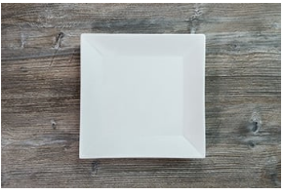
Fig.3.1: Plating techniques
  - Food arrangement Techniques
How you arrange your food determines your meal’s aesthetic tone, structural integrity, and flavor dispersion. Here are a few of the most important food arrangement techniques:
- The Rule of Thirds - When applied to cooking, the rule of thirds prescribes placing the focal point of your dish on either the left or right side of the plate, rather than the center. Use white space by thinking of the rim as your frame and highlight your plate’s focal point(s).
- View Your Plate as a Clock - As you place your ingredients, picture the face of a clock. From the diner’s point of view, your protein should be between 3 and 9, your starch/carbohydrate from 9 to 12, and your vegetable from 12 to 3.
- Don’t Overcrowd Your Plate - Keep your design simple by focusing on one ingredient (usually the protein). Having a focal point helps you arrange your accompanying items to complement your standout item.
- Moist Ingredients First - Plate moist ingredients first and prevent them from running by topping them with other foods. For example, you can angle sliced meat against mashed vegetables.
- Create Flavor Bites - Flavor bites are forkfuls of food that combine all the ingredients in your dish into one bite. Flavor bites are essential to quality plating as they please both the eyes and the taste buds.
- Mix Textures - Contrasting a smooth vegetable puree with crunchy onion straws or topping a steak with crumbled blue cheese yields appealing texture combinations that are classic in high-end cuisine.
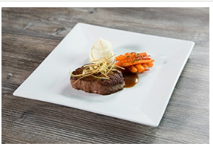
Fig. 3.2: food arrangement techniques
  - Visual plating techniques
Maximizing the visual elements of your meal is a key plating technique. While your arrangement develops around your protein, manipulating the colors and sizes of the other elements on your plate enhances your focal point and creates a gourmet presentation.
- Serve Odd Quantities - If you’re serving small foods like shrimp, scallops, or bite-sized appetizers, always give guests odd quantities.
- Color Diversity - Colorful dishes build the expectation of a flavorfully complex meal before your patrons take their first bite. Add green vegetables or brightly colored fruits that contrast with your focal point.
- Monochromatic Meals - Plating color-coded items together visually builds the expectation that the dish only offers one flavor. When the palate receives multiple textures and flavors instead, it surprises the taste buds, causing them to engage with the dish.
- Add Height to Your Plate - Stimulate your guests' eyes by building height. While compactly stacking ingredients isn’t as popular as it was 5-10 years ago, building layers of food for guests to explore offers an exciting experience.
- Create Visual Balance - Balance your plate’s landscape by leaning long, flat items against taller elements (ex: leaning asparagus spears at a 45-degree angle across a stack of lamb lollipops).
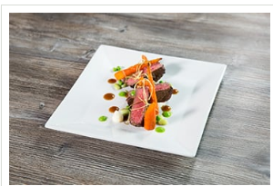
Fig.3.3: Visual plating techniques
  - Sauce plating techniques
With your principal ingredients plated, you’re ready to top your dish with delicious sauces that enhance your food presentation. Think of your squeeze bottle or spoon as a paintbrush, and your sauce as a medium. Once you're done adding your sauce, make sure you wipe down the edge of your plate with a towel, so no drippings distract from your presentation. We explain some of the simplest, most fail-proof sauce plating techniques below.
- Smeared Sauce Plating Technique - Fill a squeeze bottle with your sauce. Squeeze a thick layer of sauce and form a large, filled-in circle on your plate. Take a spoon or plating wedge and dip it into the middle of the sauce where it’s thickest. Quickly pull the sauce across your plate.
- Accent Dots Plating Technique - Fill a squeeze bottle with your desired sauce. Analyze your plate from the perspective of the rule of thirds, then add accent dots. Use multiple sauces to create additional color contrast.
- Smeared Accent Dots Plating Technique - Alternate between two sauce accent dots in a curved line along the side of your plate. Then, take a small plating wedge and place it at the center of the first accent dot in your row. Drag the plating wedge through the accent dots, creating a multicolored, single-sided edge.
- Swirled Sauce Plating Technique- Fill a squeeze bottle with your desired sauce. Place your plate atop a cake turntable. Point your squeeze bottle face down at the center of the plate. Spin your stand while simultaneously squeezing your bottle. Adjust your wrist to vary your swirled design. You can use multiple sauces to create more visual contrast.
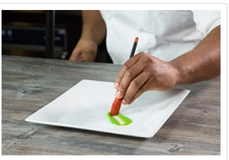
Fig.3.4: Sauce plating techniques
  - Garnishing Techniques
In the past, chefs casually threw a piece of kale and an orange slice onto every plate. However, these garnishes added nothing exciting to the dish, and few guests ate them. Modern garnishes pair thoughtfully with the meal to create flavor bites. Follow these garnishing techniques and guidelines to master the last step of food presentation.
- Edible Garnishes - As you finish plating, remember that garnishes should always be edible and enhance the dish. To determine whether a garnish belongs, ask yourself whether you would want to consume it in the same bite as the meal it accompanies.
- Intentional Placement - Never heap garnishes in one corner of the plate. Instead, disperse them thoughtfully to add color or texture. For example, place crispy carrot shoestrings atop a delicate filet of fish nested in a curry sauce and decorate the plate with pomegranate seeds.
- Less Is More - Never clutter your plate for the sake of a garnish. If your plate is full, opt for a drizzle of flavor-infused vinegar or oil to enhance the taste and appearance of your dish without overcrowding your plate.
- Garnishes to avoid - Avoid using unappetizing garnishes like raw herbs, large chunks of citrus, and anything with a strong odor. Also, avoid garnishes that take a long time to apply.
Food plating methods
There are three popular plating methods: classic, free form, and landscape. Master each method to create meals worth photographing. We provide ideas on how to plate food using each method below. We’ve selected a white square plate as our canvas. Filet mignon, potato puree, carrots, demi-glace, pea puree, lima bean and pea blend, thyme, and fried leeks are our materials.
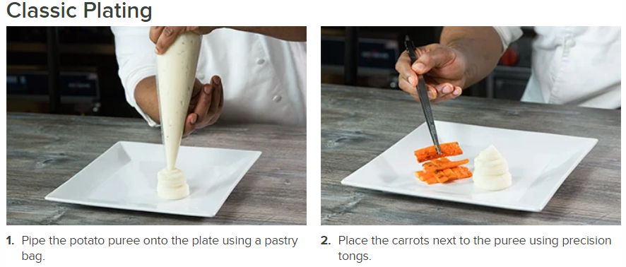
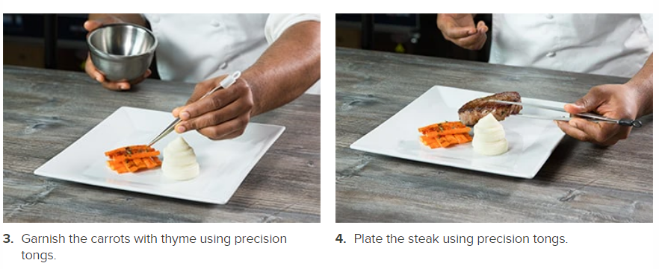
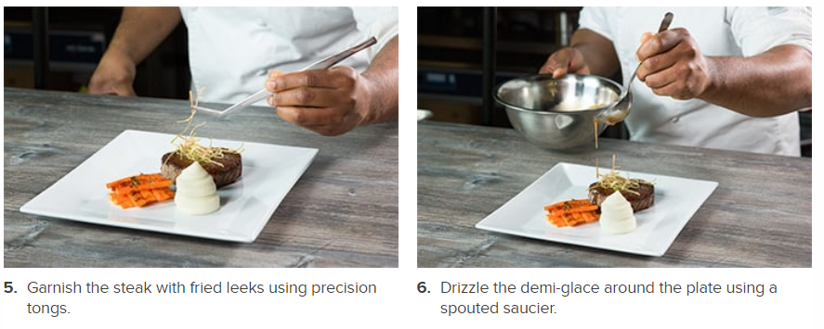
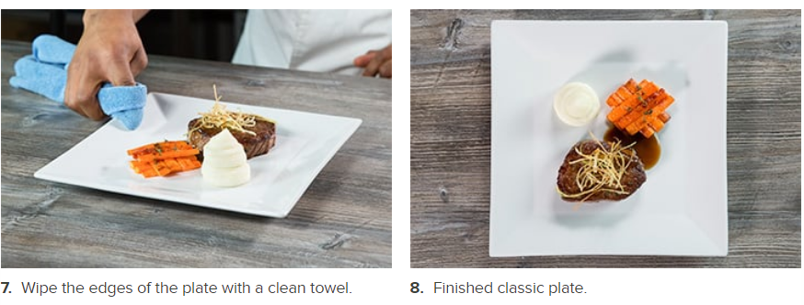

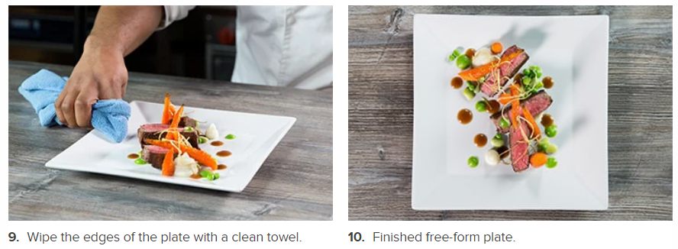

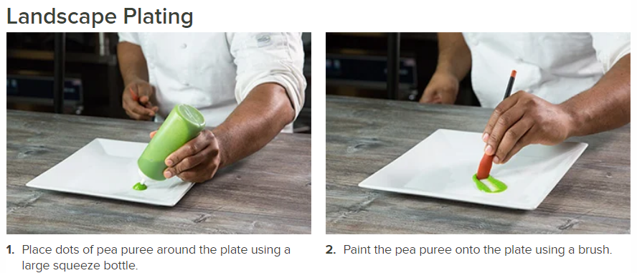
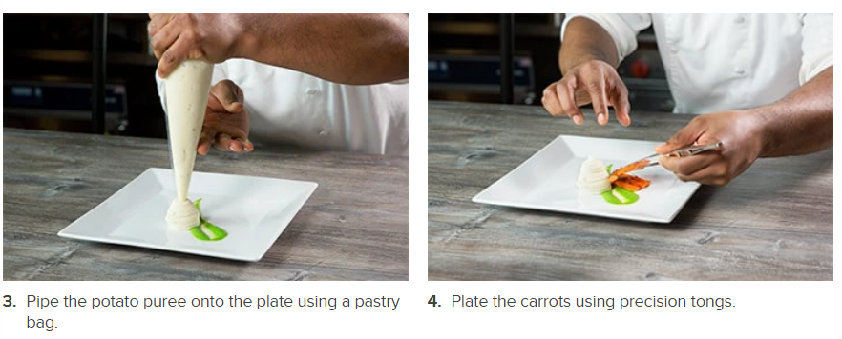
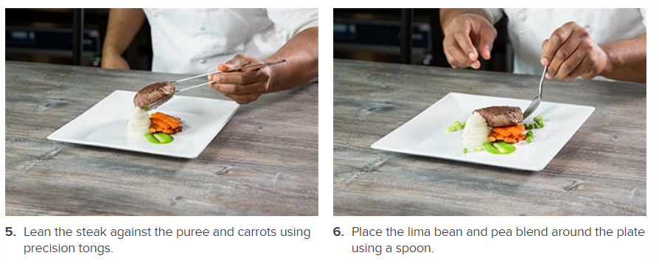
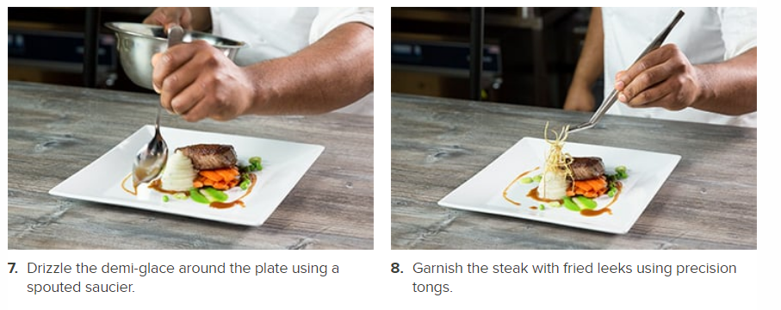
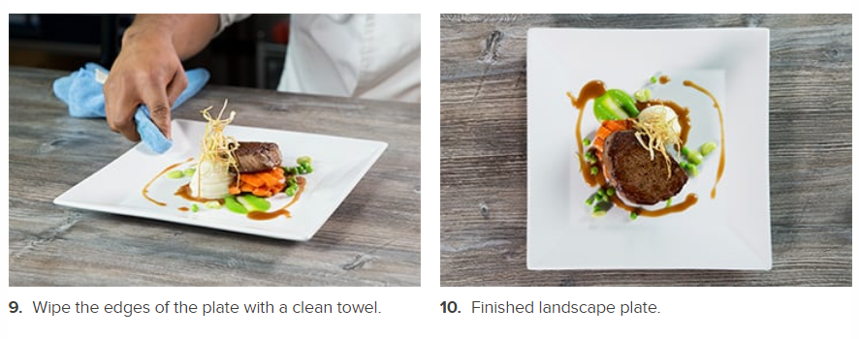

3.2.1 Plating tools

Having professional tools is essential for commercial plating. We’ve rounded up the foundational items you need to create restaurant-quality food presentations.
- Decorating brushes aid in detailed line work and broad sauce strokes. You can also use decorating brushes to create a puree or coulis base for meats or vegetables.
- Garnishing kits come with everything you need to garnish your signature dishes, including plating wedges, tongs, squeeze bottles, and brushes.
- Molds keep plates clean and increase visual appeal by cutting ingredients to specific shapes and sizes. Ring molds help you develop height and structure when stacking ingredients.
- Precision tongs help you place garnishes or small, delicate items. Many tongs feature micro-serrations for improved grip and stability.
- Plating wedges come pre-cut with flat, round, or pointed edges and are perfect for smearing soft ingredients and creating sauce designs.
- Shavers allow you to top your dishes with shaved or grated chocolate, hard cheese, or soft vegetables.
- Plating Spoons in varying sizes are essential to the art of food presentation. Saucier spoons help you drag sauce across your plate and slotted spoons quickly separate solids from liquids.
- Squeeze bottles help you apply sauce and aioli to your finished plate. Many come with adjustable precision control tips.

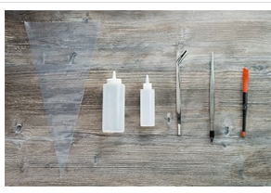
Fig.3.5: plating tools

Self-Check -3 | Written Test

Part-I: Give short answer
- Mention at least 4 Platting tools?
- Describe food platting method?
- Explain Sauce plating techniques?
- Explain Food arrangement Techniques?
- Describe Plating presentation techniques?

References
Professional cooking: Wayne Gisslen; photography by J. Gerard Smith. -- 7th edition
Practical cookery: Jone campbell 2011

Participants of this Module (training material) preparation
No | Name | Qualification (Level) | Field of Study | Organization/ Institution | Mobile number | E-mail
1 | Mamit Ayalew | B | Hotel Mgt | Bishoftu P.College | 0911723484 | mamitayalew@gmail.com
2 | Marksew Shiferew | A | Food security | Misrak P.College | 0937645184 | markisews@gmail.com
3 | Wale Getaneh | A | Food Technology/TVET Leadership & Mgt | Bole M.College | 0929241229 | waleg917@gmail.com
4 | Biruk Adamu | B | Hotel Mgt | TTI | 0921355741 | birukadamu50@gmail.com
5 | Efrem kitila | B | Hotel Mgt | Woliso P.College | 0917289283 | efremkitila922@gmail.com
6 | Helen Adugna | B | Hotel Mgt | Selam TVET College | 0915573757 | helenadugna12@gmail.com
7 | Ali Kassaw | B | Hotel Mgt | Bardar P.College | 0918573970 | Kassawali2004@gmail.com
8 | Solomon Bekele | A | Hotel Mgt | G.winget PTC | 0911149147 | Soladvent06@gmail.com

