

Food and Beverage Service Level-III
Based on September 2023, Curriculum Version 2

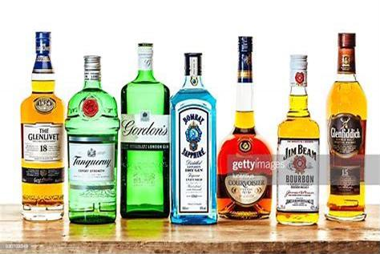

Module Title:Advice on Alcoholic Beverage Module code: CTH FBS3 M03 0923 Nominal duration: 60 Hours
Prepared by: Ministry of Labor and Skill

September, 2023 Addis Ababa, Ethiopia

Acknowledgment
The Ministry of Labor and Skills (MoLS) would like to express its gratitude and appreciation to the instructors and experts from regional TVT bureaus, TVT colleges, and industry practitioners who contributed their expertise and experience in preparing the training module for the unit of competency “Provide and Advice Alcoholic Beverage to Customer Level-IV” under the occupational standard "Food and Beverage Service"
The ministry also expresses its deepest gratitude to the Tourism Training Institute for its invaluable technical and financial support and collaboration in the module preparation. It is also thankful to MoLS staff members who coordinated the preparation and reviewing process of this training module.

Introduction to the Module 4
Unit One: Alcoholic Beverages 5
  - Concepts of Alcoholic Beverages 6
  - Fermented alcoholic beverages 8
  - Distilled Spirits 16
  - Liqueur and aperitifs 29
Self-check 1 33
Unit Two: Handling, Storing, Monitoring Beverages 36
  - Storing and cellaring alcoholic beverages 37
  - Monitoring and Recognizing Drink Quality 40
  - Serving Alcoholic Beverage 41
Self-Check 2 48
Operation sheet 2.1. Handling and receiving Alcoholic beverage 50
Operation sheet 2.2 Storing Alcoholic Beverage 51
Operation sheet 2.3 Serve red wine 52
Operation sheet 2.4 Service Whiskey 53
UNIT THREE; Advise Customers on wines, beers, spirits and liqueurs. 55
  - Advice local and imported alcoholic beverages 56
  - Assisting Customers in Selecting beverages 57
Self-Check 3 60
Operation sheet 3.1 advice alcoholic beverage to customer 62
Lap Tests 63
UNIT FOUR. Extend and Update Knowledge of wines, beers, spirits and liqueurs. 64
  - Formal and informal research on alcoholic beverage 65
  - Identifying customer taste and trends on alcoholic beverage 67
Self-Check 4 69
Reference 70

Introduction to the Module

Alcoholic beverage is one of major part of hotel product that generate revenue to the Hotel in food and beverage service filed, servicing and advising alcoholic beverage needs great knowledge and skills. It helps to know basic alcoholic beverages characteristics and concepts, methods of beverage production and servicing technics as well as alcoholic contents.
This module is designed to meet the industry requirement under the occupational standard, particularly food and beverage service for the unit of competency:

module covers the unit
- Alcoholic beverage
- Handle, store and monitor products
- Advise customers on wines, beers, spirits and liqueurs.
- Extend and update knowledge of wines, beers, spirits and liqueur

Learning Objective of the Module
- Identify overall alcoholic beverages
- Receive and store beverages on the right temperature
- Advise customers on wines and other alcoholics drinks
- Identify fermented and distilled alcoholics drinks

Module Instruction
- For effective use this modules trainee is expected to follow the following module instruction:
- Read the information written in each unit
- Accomplish the Self-checks at the end of each unit
- Perform Operation Sheets which were provided at the end of units
- Do the ―LAP test‖ given at the end of each unit and
- Read the identified reference book for Examples and exercise

Unit One: Alcoholic Beverages
This unit is developed to provide you the necessary information regarding the following content coverage and topics:
- Concept of alcoholic beverage
- Fermented alcoholic beverages
- Distilled alcoholic beverages
- Liqueurs and aperitifs
This unit will also assist you to attain the learning outcomes stated in the cover page. Specifically, upon completion of this learning guide, you will be able to:
- Understand all fermented beverage
- Understand distilled alcoholic beverages
- Identify the classification of liqueurs and aperitifs

Concepts of Alcoholic Beverages
All beers, wines, and spirits are alcoholic beverages. An alcoholic beverage is any potable, or drinkable, liquid containing ethyl alcohol. It might have as little as 1⁄2- percent alcohol by volume, or as much as 95 percent. (The 1⁄2 percent was a figure chosen by the federal government at the time of the Prohibition Amendment, as it was groping to define an intoxicating beverage. At 1⁄2 percent you would have to drink 4 to 5 gallons of a beverage to become intoxicated, but the figure remains in the government’s definition.)
All alcoholic beverages begin with the fermentation of a liquid food product containing sugar. An alcoholic beverage (also called an adult beverage, alcoholic drink, strong drink, or simply a drink) is a drink that contains ethanol, a type of alcohol that acts as a drug and is produced by fermentation of grains, fruits, or other sources of sugar.
The consumption of alcoholic drinks, often referred to as "drinking", plays an important social role in many cultures. Most countries have laws regulating the production, sale, and consumption of alcoholic beverages, and the temperance movement advocates against the consumption of alcoholic beverages. Regulations may require the labeling of the percentage alcohol content (as ABV or proof) and the use of a warning label. Some countriesban such activities entirely, but alcoholic drinks are legal in most parts of the world.

Discovery of late Stone Age jugs suggest that intentionally fermented drinks existed at least as early as the Neolithic period (c. 10,000 BC). Several other animals are affected by alcohol similarly to humans and, once they consume it, will consume it again if given the opportunity, though humans are the only species known to produce alcoholic drinks intentionally.

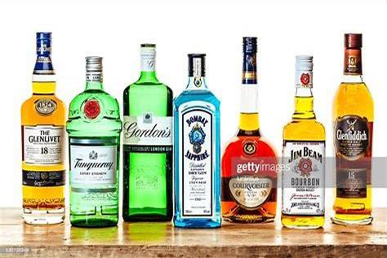
Figure 1.1 bottle of alcoholic drinks

Alcoholic beverages are legal and socially accepted. As such, they are used infrequently or moderately, they may be consumed in large quantities, or they may produce alcohol abuse, alcoholism, or dependents for some users.
There are various types of alcoholic beverages, each made through different processes and ingredients. Some popular types include:

- Wine: Made from fermented grapes, wine can be red, white, or rosé, depending on the grape variety and production method.
- Beer: Typically made from fermented barley, beer is one of the oldest and most widely consumed alcoholic beverages in the world. It can also be made from other grains such as wheat, corn, or rice.
- Spirits: These are distilled alcoholic beverages with a higher alcohol content than wine or beer. Examples include vodka, whiskey, rum, tequila, gin, and brandy. These spirits are made from various ingredients such as grains, fruits, or sugarcane.
- Sake: A traditional Japanese alcoholic beverage, sake is made from fermented rice. It has a distinct taste and is often served warm or cold.

- Cider: Made from fermented apples, cider is a popular alcoholic beverage in many countries. It can be dry or sweet and is often consumed during the fall season.
- It's important to note that while alcoholic beverages can be enjoyed responsibly in moderation, excessive consumption can lead to negative health effects and impaired judgment. It is always recommended to drink responsibly and be aware of one's alcohol tolerance.

Fermented alcoholic beverages
Fermented alcoholic beverages are beverages that are produced through the process of fermentation. Fermentation is a natural metabolic process where yeast or bacteria convert sugars into alcohol and carbon dioxide. This process occurs when microorganisms, such as yeast, consume the sugars present in ingredients like grapes, barley, rice, or apples, and produce ethanol as a byproduct.
During fermentation, the yeast or bacteria consume the sugars and convert them into ethanol, which gives the beverage its alcoholic content. The length of fermentation and other factors like temperature and ingredients used can affect the taste, aroma, and alcohol content of the final product.
Fermented alcoholic beverages have been enjoyed by humans for thousands of years and are an integral part of many cultures and social gatherings. They provide a wide range of flavors and options for individuals to choose from, whether it be wine, beer, spirits, sake, or cider.

However, it's important to consume fermented alcoholic beverages responsibly and in moderation. Excessive consumption can lead to various health problems, including liver damage, addiction, impaired judgment, and increased risk of accidents or injuries. It's always advisable to be aware of one's alcohol tolerance and to drink responsibly.
Fermentation is the action of yeast upon sugar in solution, which breaks down the sugar into carbon dioxide (CO2) and alcohol. The CO2 gas escapes into the air. The alcohol, a liquid, remains behind in the original liquid, which then becomes a fermented beverage.

Beer
Beer is a fermented alcoholic beverage made from malted grains, such as barley, and flavored with hops. It is one of the oldest and most widely consumed alcoholic drinks in the world.

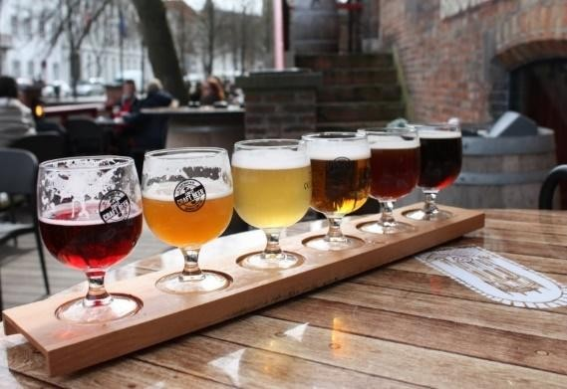
There are several types of beer, each with its own distinct characteristics:
    - Lager: Lagers are fermented at lower temperatures and typically have a clean, crisp taste. They are known for their light to medium body and golden color. Examples include Pilsner, Helles, and Bock.
    - Ale: Ales are fermented at warmer temperatures and have a wider range of flavors and aromas. They can range from light and refreshing to rich and full-bodied. Examples include Pale Ale, India Pale Ale (IPA), Stout, and Porter.
    - Wheat beer: Wheat beers are made with a significant proportion of wheat in addition to barley. They often have a cloudy appearance and a light, refreshing taste. Examples include Hefeweizen, Witbier, and Berliner Weisse.
    - Sour beer: Sour beers have a distinct tart or acidic taste due to the presence of specific bacteria during fermentation. They can range from mildly tart to intensely sour. Examples include Lambic, Gose, and Flanders Red Ale.
    - Stout and Porter: Stouts and porters are dark beers with roasted malt flavors and a creamy texture. Stouts are typically stronger and more robust, while porters are lighter-bodied with a balance of malt sweetness and bitterness.

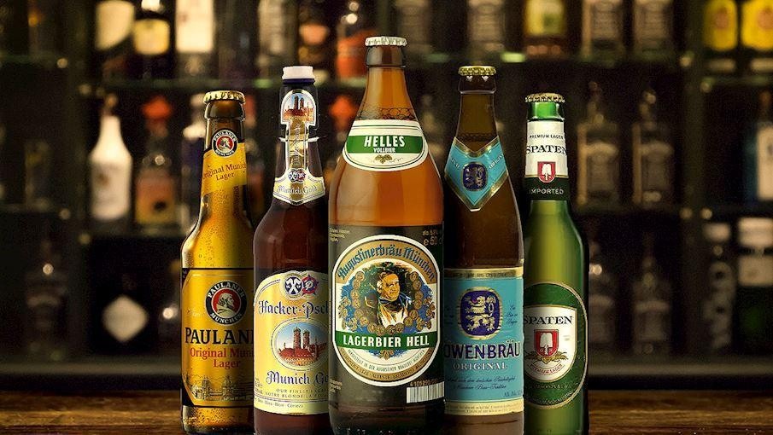
Beer can vary in alcohol content, ranging from low-alcohol options like light beers to higher- alcohol varieties like barleywine or imperial stouts. The
flavor profile of beer can also be influenced by factors such as the type of yeast used, the brewing process, additional ingredients like fruits or spices, and the region where it is produced.
Overall, beer offers a wide range of flavors, aromas, and styles to cater to different preferences, making it a versatile and popular choice among fermented alcoholic beverages.
figure 1.2 bottle of beer samples Composition in the beer:
- Water: 89-90%
- Alcohol: 4-7%

- Sugar: 3-4%
- Protein: 0.4 - 0.5%
- Mineral: 2%
- CO2: 0.4 - 0.5%

Figure 1.3 beer characteristic’s

Beer Ingredients
The main ingredients in beer are water, malted barley, hops, and yeast. Additional ingredients may be used to add flavor and complexity, depending on the style of beer. Some common additional ingredients include:
- Adjunct grains: These are grains other than barley that can be used in the brewing process to add fermentable sugars and affect the flavor and mouthfeel. Examples include corn, rice, wheat, oats, and rye.
- Other malts: Besides barley, other malted grains such as wheat, rye, or oats can be used to add different flavors and textures to the beer.
- Hops: Hops are flowers that contribute bitterness, aroma, and flavor to beer. Different varieties of hops can have varying levels of bitterness and impart different aromas, such as floral, citrusy, piney, or spicy notes.
- Yeast: Yeast is responsible for fermentation, converting the sugars in the malt into alcohol and carbon dioxide. There are two main types of yeast used in brewing: ale yeast (Saccharomyces cerevisiae) and lager yeast (Saccharomyces pastorianus). Each type of yeast produces different flavors and aromas.
- Water: Water is a crucial ingredient in beer, making up the majority of its composition. The mineral content and pH of the water can affect the flavor and character of the beer.

- Additional flavorings: Depending on the style, brewers may add various flavorings such as fruits, spices, herbs, coffee, chocolate, honey, or even barrel-aged spirits to enhance or complement the beer's flavor profile.

It's important to note that not all beers include these additional ingredients, and some styles adhere to strict guidelines that limit the use of certain ingredients.

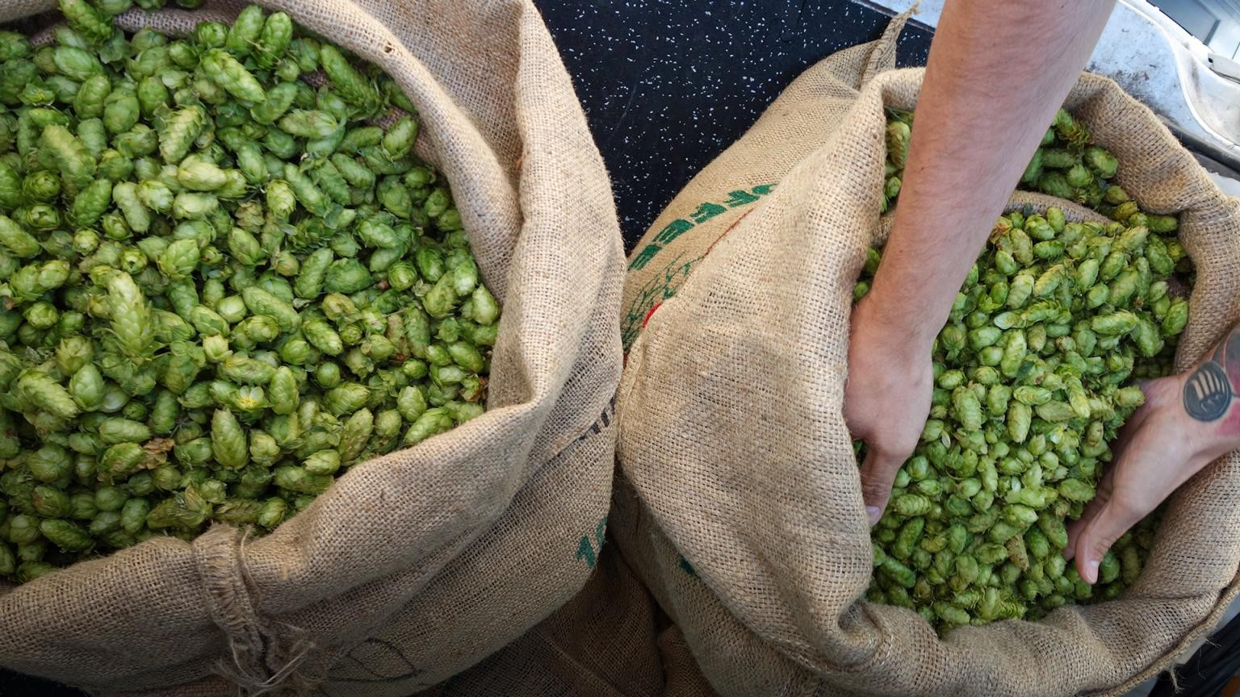

Figure 1.4Organic Hops

Wines
Wine is an alcoholic beverage made with the fermented juice of grapes.
Technically, any fruit is capable of being used for wine (i.e., apples, cranberries, plums, etc.), but if it just says ―wine‖ on the label, then it’s made with grapes. (wine grapes are
table grapes).
different than
The difference between two popular drinks, wine and beer, is that brewing beer involves fermented grains. Simply, wine is made from fruit, and beer is made from grains. There are exceptions –that push the boundaries of beer, –but that story is for another time
There are thousands of different varieties within the Vitis vinifera species–the most common is Cabernet Sauvignon.

The Origin of the term “Vintage”
Wine grapes take an entire season to ripen, and thus, wine is produced just once a year. Hence, the origin of the term vintage. Vint stands for ―Winemaking‖ and Age for the year it was made.
a vintage year listed on the label, that’s the year the grapes were picked and made into wine. The harvest season in the northern hemisphere (Europe, US) is from August–September, and the harvest season in the southern hemisphere (Argentina, Australia) is from February–April.

Non-Vintage (NV) Wine
Occ this is a blend of several vintages together; and in the case of Champagne, it will be labeled with ―NV‖ which stands for ―non-Vintage.‖
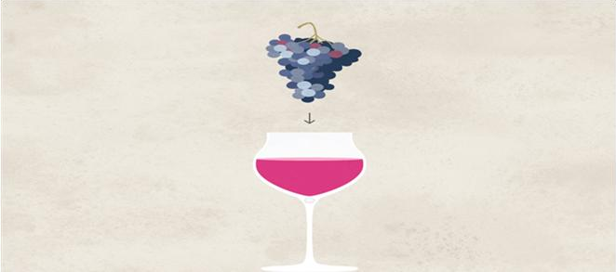
Figure1.5 single grape

single-varietal wine is made primarily with one type of grape. It’s common to see these wines labeled by the name of that grape variety. For example, a bottle of Riesling is made with Riesling grapes. It’s useful to note that each country has different rules for how much of the variety should be included to be labeled as a varietal wine.
Percentage of grapes required to be labeled as a single-varietal wine.
- 75% USA*, Chile, South Africa, Australia, Greece
- 80% Argentina
- 85% Italy, France, Germany, Austria, Portugal, Spain, New Zealand
- *Oregon requires 90% of the varietal

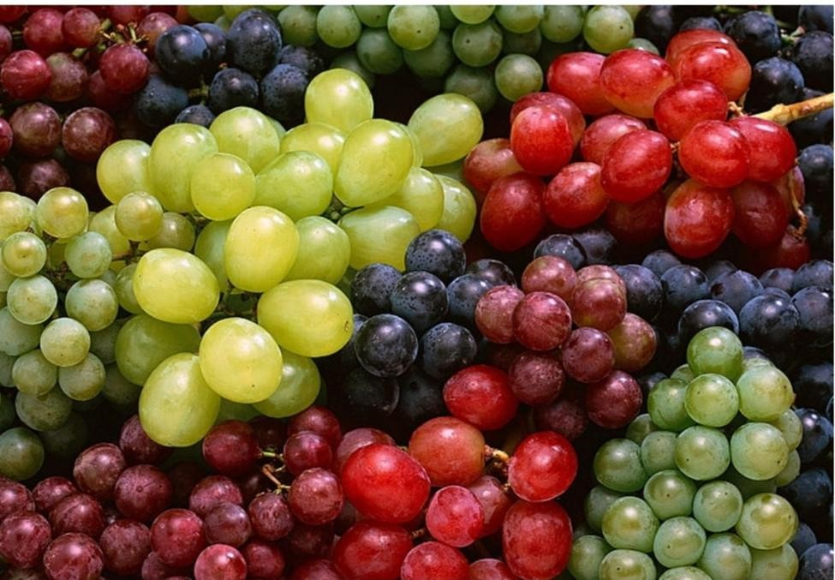
Figure 1,6 white, red and black grapes

Classification of wine
Wine classfied by color,by age,by taste,and by grapes
Watural Wine / Table Wine
Wine is the result of direct fermentation of grape juice (grape juice). Alcohol content of 10-12%. There are three natural wine / table wine by its color:

White wine
Made of black or white grape grape, as long as it is fermented grape juice not following its skin. Served in the cold (7-10 degrees Celsius) as are the glass used.

Red wine
Brownish red made from red grape and fermented together at once so dark skin of the grape skin is absorbed by it. Served at room temperature is around 18 degrees

Rose wine
Colored pink (pink) color is obtained by means of skin includes red grape fermentation takes place at the time but only a few hours. Then after getting a red color as the skin of red grape used and grape fermentation takes place without it. Served in the cold (7-10 degrees C) as did the glass used.

Aromatized Wine

Wine is mixed with or given the aroma / flavor of roots, herbs, leaves, or herbs (herb) others. This species is often called the Vermouth. Brands: Martini (dry, rosso, bianco), moilly Prat, einzano, and others.

Fortified Wine
Kadaar alcohol wine that is played or coupled with a chemical process that is coupled with the brandy. The alcohol content is 16-21%
The types of fortified wines
  - Sherry Spain
  - Port Portugal
  - Madeira Portugal
  - Malaga Spain
  - Marsala Italy

Sparkling wine / champagne
Wine is fermented hadil double (2x) re fermentation , of white wine. It was said, because nearly all sparkling wine is made from white wine, but remember some are not of white wine. The alcohol content is 14% contained Co2. In France there is an area called "champagne" of this region produces a very nice grape for making sparkling wines it produces are labeled (name of brand ) champagne and sparkling wines from other regions should not be called champagne, though there are many other countries and regions who wrote the label for the production of champagne.
Sparkling wine was discovered by accident / coincidence by a monk (priest) named Dom Prignon. By accident he leaven for the second time the finished wine. The next process is investigated and perfected. Until now the finest sparkling wine is champagne and the finest champagne brand Dom Perignon is:-
At the champagne kind of flavors are as follows (listed on the bottle label):

- Brut or nature: very, very dry (sugar ½ - 11.2%)
- See Extra: extra dry (sugar ½ - 3%)
- dry: dry medium (sugar content 3-5%)
- For see: quite sweet (sugar content 5-7%)
- Doux: very sweet (sugar content 7% more)

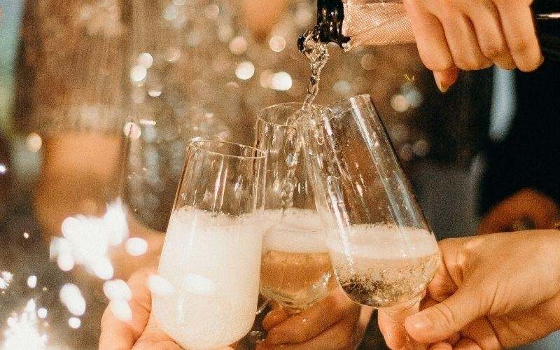
Figure1.7 champagen glass

Understanding the five basic characteristics of wine
Wine is a fermented beverage made from grapes or other fruits. The characteristics of wine can vary depending on various factors such as grape variety, region, climate, winemaking techniques, and aging. Here are some key characteristics of wine:

- Color: Wine can range in color from pale yellow or greenish hues in white wines to various shades of red, purple, or even brown in red wines. Rosé wines have a pink color.

- Aroma: The aroma of wine is often referred to as its "nose" or "bouquet." It can be influenced by the grape variety, fermentation process, aging, and other factors. Common aromas in wine include fruity notes (such as citrus, berries, or tropical fruits), floral scents, herbal or vegetal aromas, and sometimes earthy or mineral undertones.
- Taste: Wine's taste can be described in terms of sweetness, acidity, tannins, and acohol content.

- Sweetness: Wines can range from bone dry (no perceptible sweetness) to very sweet. The sweetness level is determined by the amount of residual sugar left after fermentation.
- Acidity: Acidity gives wine freshness and liveliness. Higher acidity can make wines taste crisp and tart, while lower acidity can give a softer and rounder mouthfeel.
- Tannins: Tannins are naturally occurring compounds found in grape skins, seeds, and stems. They contribute to the structure and mouthfeel of red wines, often giving them a dry and slightly bitter sensation. Tannins are less prominent in white wines.
- Alcohol content: The alcohol content of wine can vary but typically ranges between 11% and 15%. Alcohol provides body and warmth to the wine.
- Body: Wine's body refers to its weight and texture on the palate. It can be light-bodied (e.g., some white wines), medium-bodied (e.g., many red wines), or full-bodied (e.g., robust red wines).
- Complexity: Some wines exhibit a wide range of flavors and aromas, often referred to as complexity. This complexity can develop through aging, blending different grape varieties, or using specific winemaking techniques.
- Finish: The finish is the lingering taste and sensation after swallowing the wine. It can be short, medium, or long-lasting, and it may leave flavors or sensations such as fruitiness, spiciness, or dryness
- It's important to note that wine characteristics can vary significantly between different grape varieties, regions, and winemakers' styles. Exploring different wines can provide a rich and diverse tasting experience.

Distilled Spirits
Distilled spirits, also known as hard liquor or liquor, are alcoholic beverages that are produced through the process of distillation. Distillation involves heating a liquid (such as fermented grains, fruits, or sugarcane) to create steam, which is then condensed and collected to separate the alcohol from other components. Here are some key points about distilled spirits:
Distilled including whiskey, vodka, rum, tequila, gin, brandy, and liqueurs. Each type has its own unique production process, ingredients, and flavor profile.
    - Alcohol content: Distilled spirits have a higher alcohol content compared to other alcoholic beverages like wine or beer. The alcohol content typically ranges from 40% to 60% or more, depending on the type of spirit.

    - Flavor: The flavor of distilled spirits can vary greatly depending on the ingredients used and the distillation process. Some spirits, like whiskey or rum, can have complex flavors with notes of caramel, vanilla, or spices. Others, like vodka or gin, are often more neutral in taste.
    - Mixing and serving: Distilled spirits are commonly enjoyed straight or on the rocks (with ice) to appreciate their flavors and aromas. They are also frequently used as a base for cocktails and mixed drinks, where they can be combined with other ingredients like juices, sodas, or syrups.
    - Aging: Some distilled spirits, such as whiskey or brandy, are aged in wooden barrels for a period of time to develop additional flavors and characteristics. The aging process allows the spirit to interact with the wood, imparting flavors like oak, caramel, or vanilla.
    - Regulations: The production and sale of distilled spirits are regulated by government authorities in most countries. These regulations often specify the minimum aging requirements, labeling guidelines, and taxation policies for spirits.
    - Responsible consumption: Due to their higher alcohol content, distilled spirits should be consumed in moderation. It's important to be aware of the alcohol content and drink responsibly to avoid any negative health or safety consequences.
    - Overall, distilled spirits offer a wide range of flavors and options for those looking to explore different alcoholic beverages. Whether enjoyed neat, on the rocks, or in cocktails, they provide a diverse and enjoyable drinking experience.

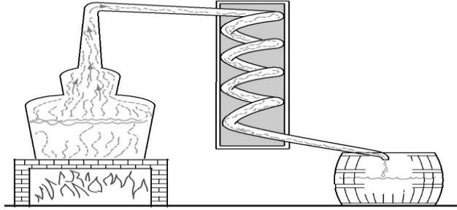

Figure 1.9 distillation process

1,2,1 whiskey

whiskey, also spelled whisky, any of several distilled liquors made from a fermented mash of cereal grains and including Scotch, Irish, and Canadian whiskeys and the various whiskeys of the
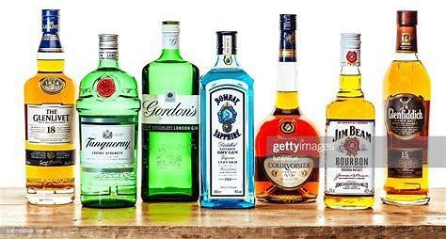
figure 1.10 sample of spirits drink
United States. Whiskey is always aged in wooden containers, usually of white oak. The name, spelled 10without an e by the Scots and Canadians and with an e in Ireland and the United States, comes from the Celtic usquebaugh (Irish uiscebeathadh, Scots Gaelic uisgebeatha, both adaptations of the Latin phrase aqua vitae, meaning ―water of life‖). The earliest direct account of whiskey making is found in Scottish records dating from 1494.

The whiskeys produced in each country are distinctive in character because of differences in the method of production, the type and character of the cereal grains, and the quality and character of the water employed.
Straight whiskeys are unmixed or mixed only with whiskey from the same distillation period and distiller. Blended whiskeys include mixtures of similar products made by different distillers and in different periods (Scotch) and also whiskeys made with combinations of the neutral whiskeys (which have no distinctive flavor characteristics) and straight whiskeys (United States and Canada). Small quantities of other flavoring materials (e.g., sherry, fruit juices) may be included in blends. Governments may require that some whiskeys be aged under their supervision for specific periods.
Scotch whiskeys are somewhat light in body, with a distinctive smoky malt flavor. They are made primarily from barley that is malted and then heated over a peat fire, the oily, acrid smoke of which flavors the malt. Variations among whiskies of the Highlands, Lowlands, Campbelltown, and Islay regions are caused partly by differences in the amount of heating the

malt receives. The flavored malt is combined with water, producing a mash, and then fermented to make a beer. When the beer is distilled, it produces a whisky containing 70 percent alcohol by volume (i.e., 140 U.S. proof). This product is successively reduced with water to about 43 percent by volume.
Irish whiskeys taste much like Scotch but without the smoky quality. They are produced by methods similar to those for Scotch whisky, but the malt is not exposed to smoke during roasting. Irish whiskeys pass through three distillations and are sometimes blended with neutral grain whiskeys to produce a lighter-bodied product.

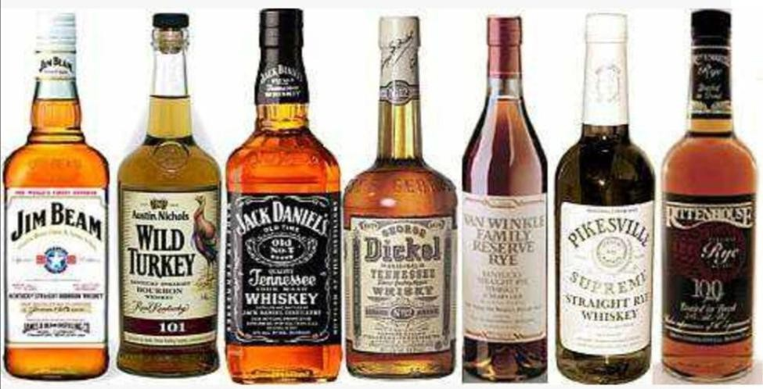
The Canadian whisky industry began in the early 19th century. Canadian whiskies are light in body and flavor and are always blends of both highly flavored and neutral grain whiskies. They are made from mashes composed of combinations of corn, rye, wheat, and barley malt prepared according to the formula of the individual producer. Canadian whiskies are usually aged for at least six years, then reduced with water to an alcoholic content of about 45 percent by volume before bottling

.

Figure1.11 American whisky
In the United States, whiskey production began early in the 18th century. Major distillation centers are established in Kentucky, Pennsylvania, and Indiana. Their product is made with malt and other grains (usually corn or rye), producing a beer that is distilled to make a whiskey of 80 percent alcohol content by volume. This distillate, high in flavoring substances derived from the original raw materials, is reduced with water to about 50–52 percent alcohol and aged in unused charred white-oak barrels. Straight whiskeys may be stored in government-bonded warehouses.

Bourbon is characterized by the flavor of corn (maize), used as the main raw material. It was first produced in Bourbon County, Kentucky, and the name bourbon eventually became a general term for similar corn-mash whiskeys. Sour mashes, used mainly in bourbon production, are fermented with yeast, including a portion of previously fermented yeast; other whiskeys are made from sweet mashes, employing only fresh yeast.
In the United States, straight whiskeys are named for the grains predominating in the mash, with at least 51 percent required for whiskeys designated as straight. If a mash of at least 51 percent barley malt is employed, the product is straight malt whiskey; if rye malt is used, it is straight rye whiskey. Straight bourbon mashes contain at least 51 percent corn; straight corn-whiskey mashes contain at least 80 percent. Combinations of similar straight whiskeys of different distillation periods or from different distillers are designated as blended, rather than straight.

Whiskeys are consumed both unmixed and mixed in cocktails, punches, and highballs. The United States is the world’s largest producer and consumer of whiskey.

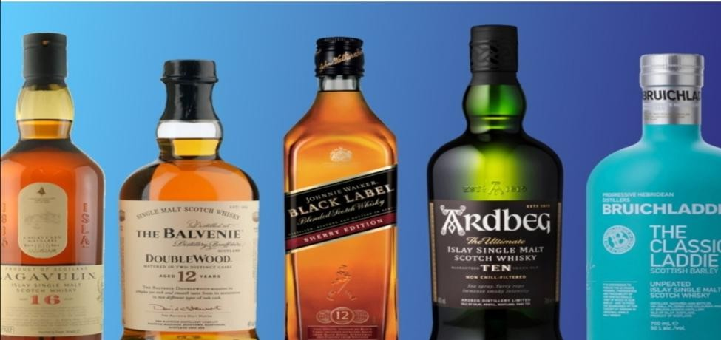

Figure 1.12 Irish whiskey

VODKA
vodka, distilled liquor, clear and colorless and without definite aroma or taste, ranging in alcoholic content from about 40 to 55 percent. Because it is highly neutral, flavoring substances having been mainly eliminated during processing, it can be made from a mash of the cheapest and most readily available raw materials suitable for fermentation. Cereal grains were

traditionally employed in Russia and Poland; later potatoes were used increasingly there and in other vodka-producing countries.
A, types of Vodka
- Plain vodkas
- Flavored vodkas
- Fruit vodkas
- Grain vodkas

- Plain vodkas This type of vodka has an extremely high alcohol content, in the higher 90s. Many consider this a benchmark drink and don’t really care a lot about the taste. This is your base drink for other cocktails. They are pretty pure, with a very minute amount of impurities, and
- Flavored Vodkas These vodkas have become insanely popular in the last few years for one reason; they are a lot less work because they already have a flavor profile. You don’t need to buy mixers and juices to be able to enjoy them once you find a flavor you like. And the flavor profiles can be quite astounding —Cinnamon, blueberry, orange, green apple, lemon, lime, and so much more.

Major brands producing vodkas come from Russia, Finland, Sweden, and the USA. Vodka is of the highest-selling drinks, surpassing the numbers for whiskey, gin, and brandy
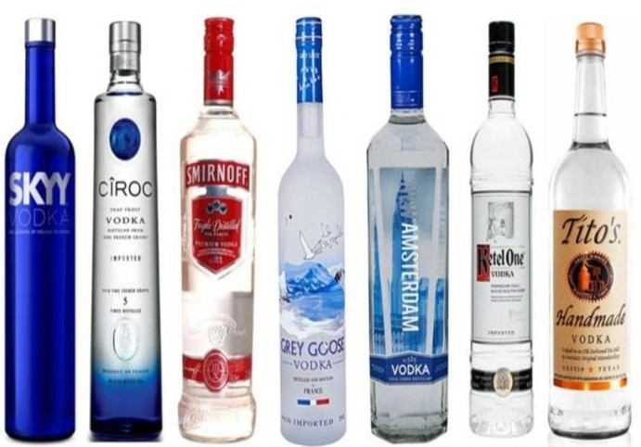

Figure1.13 popular vodka

- Flavored vodkas are not the same as fruit vodkas. But they start similar to how plain vodka is created, with 95% alcohol, and through distillation, the flavor profile is infused to give a distinct taste. All these vodkas are 40% proof.
The basic ingredients remain the same as plain vodka. You can produce vodka from fruits, grains, potatoes, etc. Then at least 5% sugar is added in the drink to smoothen out the harsh notes of the plain drink. This type of vodka is considered dry. The sugar quantity increases to around 40% of what is called crème. In the middle of this spectrum, you have the semi-sweet variety, which can contain about 22% sugar.
It usually varies from one brand to another what kind of taste profile they are going to create. As a result, when you buy lime vodkas from two different brands, you will not find the same taste. There might be some experimentation involved in figuring out the perfect flavored vodka, but it is worth every drink you take.

- Fruit vodka as the name suggests, these types of vodkas come from fruit infusions. There are also herb-flavored vodkas that are created in the same method and can be clubbed in this category. Producing these kinds of vodkas takes much longer than normal, plain vodka. But their flavor profile, smell, and color are simply much richer than any other type of vodka that is made in bulk for mass consumption.
The base of these vodkas starts with 50 to 80% alcohol. This is infused with the fruit blend for up to three weeks to soak out the complete fruit flavor in the liquor. After the three weeks are over, the rind is filtered carefully not to disturb the alcohol.
At this point, the vodka could be mixed with any other flavors to give it a more complex body and profile. And then the drink is set down to age for a time where it develops the rich flavor. The aging process, which is similar to other expensive liquors like wine, and whiskey, is what contributes to a majority of the flavor profile of the drink. It slowly builds up the volatiles, which are particles in the drink that hold the flavor and slowly release it.
- Grain Vodkas This is one of the driest types of vodka to exist and starts from over 96% concentrated alcohol. The alcohol is usually pure rye, and this is mixed with water to start the

infusion and distillation process. Safe to say, this is not everyone’s cup of tea, and only extreme vodka enthusiasts try and love this kind.
Usually, most of the grain vodkas are sold in countries that have extremely strong winter seasons, and this drink is considered great for warming up during this time. Needless to say, you will not find this type in your average supermarket liquor aisle.
Although this sounds like the making of the purest, burning and sharp plain alcohol, grain vodkas do go through some enhancement that does not take away from the alcohol content but adds a flavor to it. Usually, lemon or lime skins, pepper, bison grass are common ingredients for flavoring these types of vodkas.

GIN
It is flavored, distilled, colorless to pale yellow liquor made from purified spirits usually obtained from a grain mash and having the juniper berry as its principal flavoring ingredient. It includes both the malty-flavored and full-bodied Netherlands types and the drier types, characterized by distinct botanical flavoring, produced in Britain and the United States.
The name of the beverage comes from the French name for the juniper berry, Genève, altered by the Dutch to Genève and shortened by the English to gin. Its origin is attributed to Franciscus Sylvius, a 17th-century professor of medicine at the University of Leiden in Holland, who distilled the juniper berry with spirits to produce an inexpensive medicine having the diuretic properties of juniper-berry oil. The beverage became popular and was introduced to England by soldiers returning from the Low Countries. In the 18th century excessive consumption of the inexpensive beverage presented a social problem, as depicted in William Hogarth’s engraving
―Gin Lane.‖

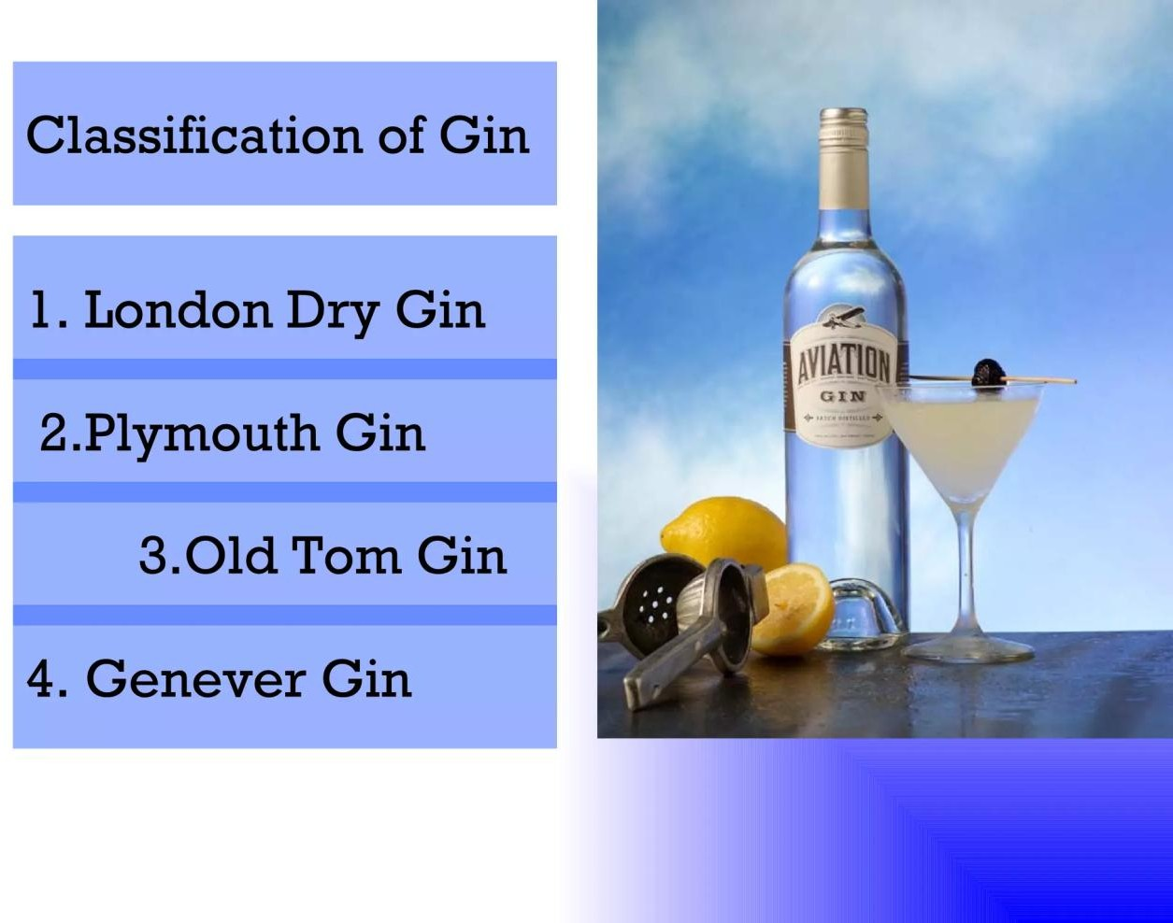
Netherlands gins, known as Hollands, Geneva, jenever, or Schiedam, for a distilling Centre near Rotterdam, are made from a mash containing barley malt, fermented to make beer. The beer is distilled, producing spirits called malt wine, with 50–55 percent alcohol content by volume. This product is distilled again with juniper berries and other botanicals, producing a final product having alcoholic content of about 35 percent. English and American gins are distilled from malt wine purified to produce an almost neutral spirit, without flavor or aroma, having alcohol content of 90–94 percent by volume. This is reduced with distilled water, combined with the flavoring agents, and distilled and reduced again, producing a final product of 40–47 percent alcoholic content (80–94 U.S. proof). The dry gins have more added flavoring ingredients than Dutch types. Each producer employs a secret formula, including, in addition to the juniper berries, combinations of such botanicals as orris, angelica, and licorice roots, lemon and orange peels, cassia bark, caraway, coriander, cardamom, anise, and fennel.
United States producers sometimes age their gins, imparting pale-golden color. Dutch gins may have similar color, resulting from the addition of caramel coloring. Old Tom is a slightly

sweetened gin, and various fruit-flavored gins are made by adding the appropriate flavorings to finished gin. Sloe gin is not a true gin but a sweet liqueur, flavored with sloe berries, the small, sour fruit of the blackthorn.
Dutch gins, too distinctive in taste to combine well with other beverages, are usually served unmixed or with water. The drier types, sometimes called London dry, may be served unmixed or may be combined with other ingredients to make such cocktails as the martini and gimlet and such long drinks as the Tom Collins and the gin and tonic.

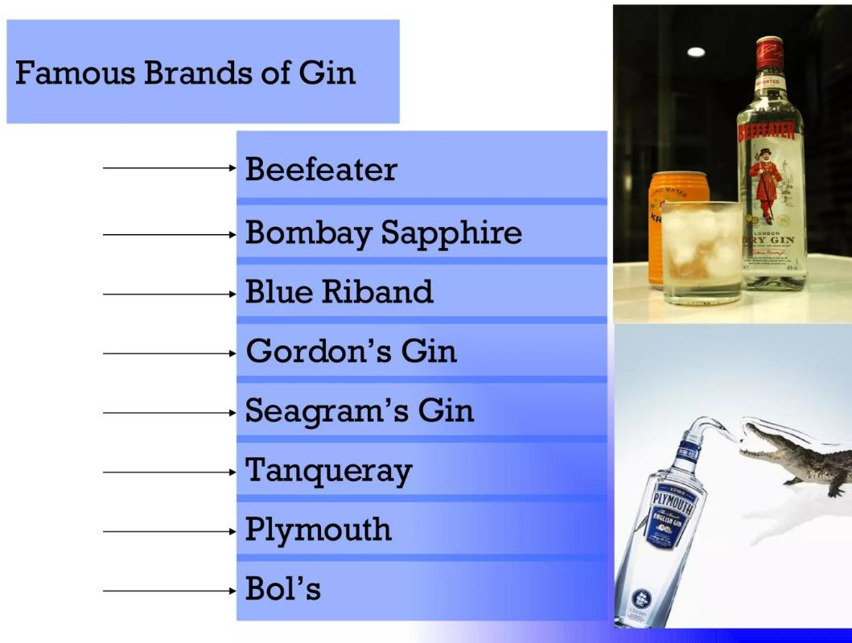

RUM
Rum, distilled liquor made from sugarcane products, usually produced as a by-product of sugar manufacture. It includes both the light-bodied rums, typified by those of Cuba and Puerto Rico, and the heavier and fuller-flavored rums of Jamaica.
Rums originated in the West Indies and are first mentioned in records from Barbados in about 1650. They were called ―kill-devil‖ or ―rum bullion‖ and by 1667 were simply called rum. Rum figured in the slave trade of the American colonies: slaves were brought from Africa and traded to the West Indies for molasses; the molasses was made into rum in New England; and the rum was then traded to Africa for more slaves. British sailors received regular rations of rum from the 18th century until 1970. Rum, the major liquordistilled during the early history of the United

States, was sometimes mixed with molasses and called blackstrap or mixed with cider to produce a beverage called stonewall.
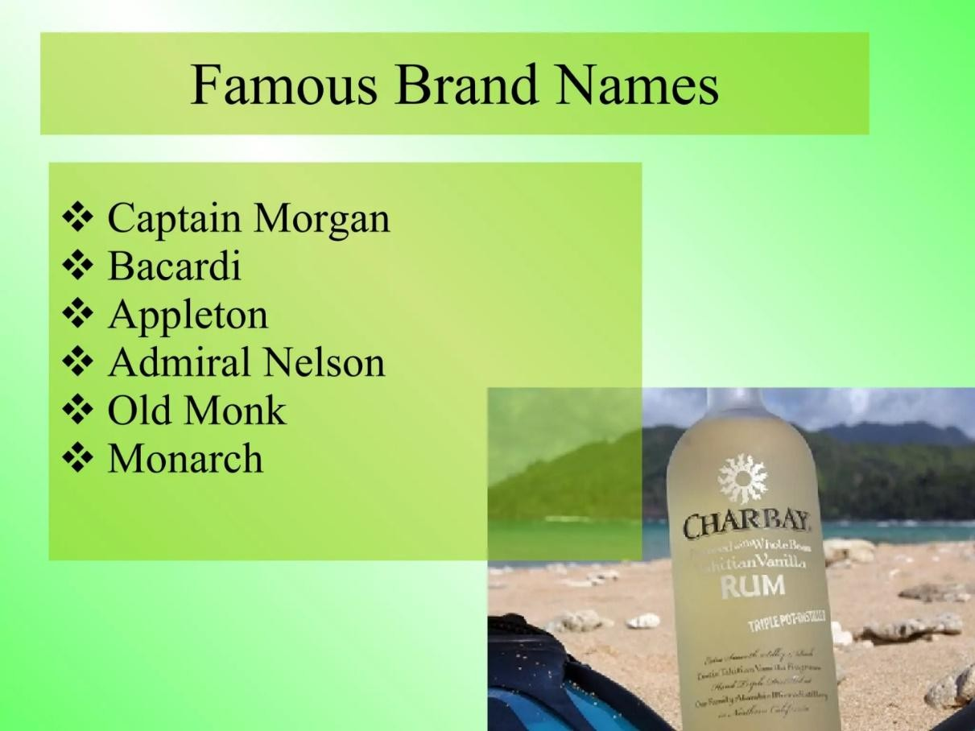
Most rums are made from molasses, the residue remaining after sugar has been crystallized from sugarcane juice, containing as much as 5 percent sugar. Some countries import molasses for use in rum production. Where sugar industries are undeveloped, rum is often made with sugarcane juice. A low-quality spirit, called tafia, is made from impure molasses or other sugarcane residue, but it is not considered a true rum and is seldom exported.
The sugar necessary for fermentation is already present in the raw material, and rum retains more of the original raw-material taste than most other spirits. The characteristic flavour of specific rums is determined by the type of yeast employed for fermentation, the distillation method, aging conditions, and blending.
The heavy, dark, and full-bodied rums are the oldest type and have strong molasses flavour. They are primarily produced in Jamaica, Barbados, and Demerara in Guyana. Such rums are usually produced from molasses enriched with the skimmings, or dunder, remaining in the boilers used for sugar production. This liquid attracts yeast spores from the air, resulting in spontaneous, or natural, fermentation. The resulting slow fermentation period allows full development of flavor substances. The rum is distilled twice in simple pot stills, producing a

distillate of clear color that turns to a golden hue as the distillate takes up substances from the oak of the wooden puncheons used for storage during the aging period. Colour is deepened by the addition of caramel after aging. The Jamaican rums are always blended and are aged for at least five to seven years. They are usually marketed with an alcohol content of 43–49 percent by volume (86–98 U.S. proof). New England rum, made in the United States for over 300 years, has strong flavor and high alcohol content. Batavia arak is a pungent rum produced on the Indonesian island of Java.
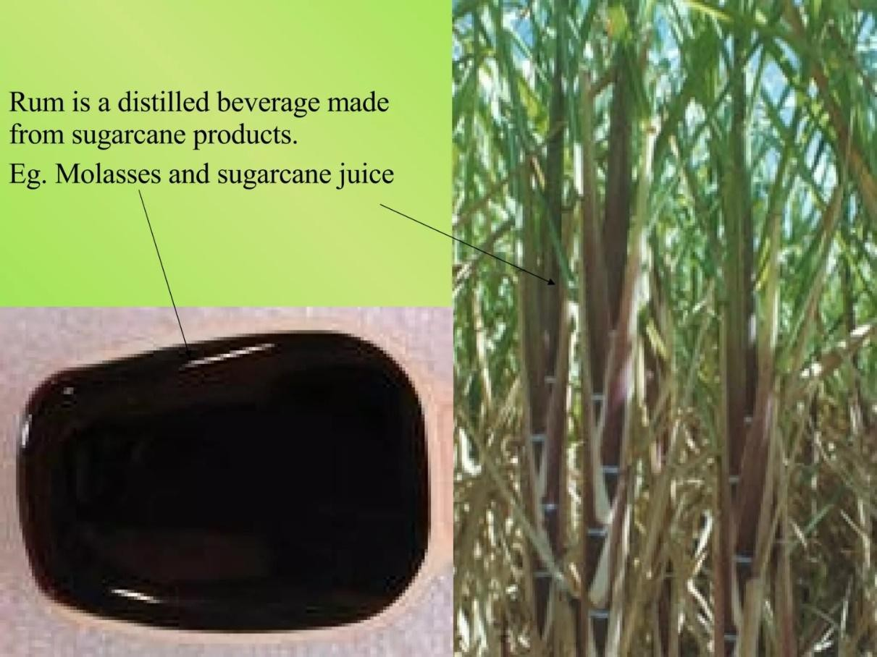
The production of dry, light-bodied rums began in the late 19th century. This type, produced mainly in Puerto Rico and the Virgin Islands, employs cultured yeast in fermentation, and distillation is accomplished in modern, continuous-operation patent stills. The rums are usually blended and are aged from one to four years. Those rums marketed as white-label types are pale in color and mild in flavor; a gold-label rum has a more amber color and more pronounced and sweeter flavor, resulting from longer aging and the addition of caramel.

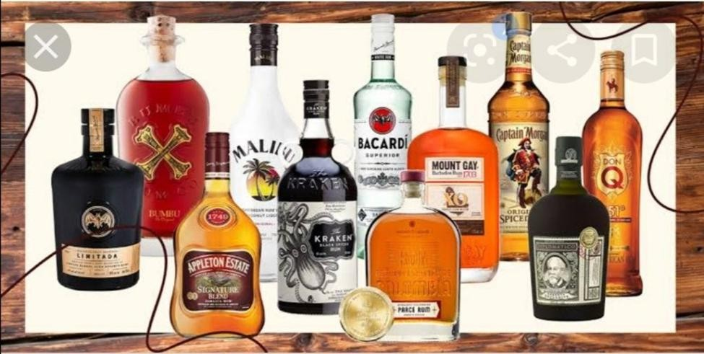
Figure 1.14 popular Rum

2.5 TEQIULE
Tequila is a distilled spirit made from the agave plant that can only be produced in certain regions of Mexico. There are several styles of tequila and specific regulations that distillers must follow. Tequila is enjoyed globally and is most often consumed in Mexico and the U.S. While it is an essential ingredient in margaritas and a variety of tequila shots, there are many other tequila cocktail recipes to explore.

Tequila vs. Mezcal
Mezcal is the name for any distilled spirit made from the maguey (agave)
plant. Technically, tequila is a mezcal, but all mezcals are not tequila, similar to how bourbon and scotch are types of whiskey. Both have laws governing their production, though mezcal can use a greater variety of agave grown in nine Mexican states and must be produced in those areas. The most significant difference is in how the agave is prepared.

Tequila is made by distilling the fermented juices of the Weber blue agave plant (Agave tequila). A member of the lily family, it looks like a giant aloe vera plant with spiked barbs on the tips. After seven to 10 years of growth, the agave plant is ready to be harvested.

The fermented agave juice is distilled in either pot or column stills and often distilled twice to produce a high-alcohol concentrate called tequila ordinario. Depending on the style of tequila, it updating may rest briefly in tanks or age in barrels, and some tequila is filtered or blended.

Before bottling, the distillate is cut with water to obtain the bottling strength. Tequila is typically 35 to 40 percent alcohol by volume (ABV, 70 to 80 proof) but may not be stronger than 55 percent ABV (110 proof).

Liqueur and aperitifs

A, Liqueur
A liqueur, or cordial, is a sweetened distilled spirit. Flavored with a variety of fruits, nuts, herbs, and spices, as well as things like chocolate and coffee, liqueurs contribute more flavor than alcohol to cocktails and mixed drinks.
As drink ingredients, liqueurs are just as important as the base liquors in the bar. Liqueurs like triple sec, amaretto, and Irish cream, are used more often than others. If vodka, gin, whiskey, and the like are the rock stars of the cocktail, then liqueurs

Liqueur vs. Liquor
Let's begin with the confusing part: liqueurs are liquors, but not all liquors are liqueurs.
The definition of a liquor is a distilled alcoholic beverage. That means the word liquor includes all of the "base spirits" (e.g., gin, rum, vodka, whiskey, etc.) as well as all liqueurs.
The word liqueur is typically reserved for the sweetened and/or lower-proof distilled spirits. The spelling of the two words is the real issue, particularly if you read or write it quickly.
Some distilled spirits get classified as a liqueur, but they don't technically qualify. Absinthe is a great example: It may appear with anise liqueurs in bars and liquor stores, but it is not sweet, so it's a liquor and not a liqueur. This tends to happen with vermouth as well; it is wine fortified with a distilled spirit, but neither a liquor nor a liqueur.

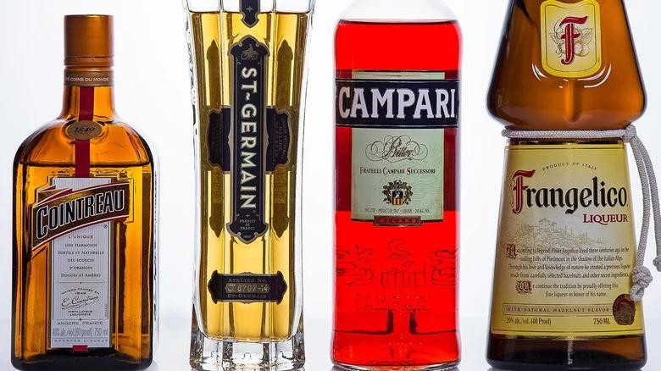
Figure 1,15liqueur and aperitifs

Amaretto, meaning "a little bitter" in Italian, is a popular almond-flavored liqueur that's typically made from apricot pits, but it can also include additional spices and flavors depending on the brand. Sip it solo, add a little club soda or a splash of orange juice.
Baileys Irish Cream When you hear the word Baileys, do you immediately envision yourself curled up in a blanket on the couch by the fireplace with an Irish cream-spiked hot chocolate? The combination of Irish whiskey, cream and chocolate makes it a delicious drink on its own or mixed in a cocktail.
Campari This dark red liqueur is made from a combination of herbs and fruit, and is often served on the rocks or in popular cocktails, such as the Negroni.
Cointreau an orange-flavored liqueur that's a big player in many cocktail recipes, it is the perfect combination of bitter and sweet and used in classics like the Cosmopolitan (ahem, my mom's signature drink). Don't forget to garnish with a squeeze of lime.
Frangelico This delicate liqueur is made from toasted hazelnuts and has hints of cocoa and vanilla. Similar to many sweet liqueurs, it can be mixed in a variety of cocktails or simply enjoyed on the rocks.
Kahlua Meet the number one-selling coffee liqueur in the world. Our resident bartender says the most popular cocktail requests she gets using the coffee liqueur are White and Black Russians.

St-Germain Flavored with elderflowers and carrying hints of sweet and floral notes, St-Germain has a subtle taste but can hold its own among other spirits, such as gin, Champagne, vodka and rum.
Sambuca is a strong, colorless Italian liqueur that's flavored with anise and licorice. An Italian after-dinner favorite is a Sambuca, ghiaccio e mosche ("Sambuca, ice and flies"), which consists of a couple shots of sambuca with coffee beans

B, Aperitif
An aperitif is a refreshing alcoholic drink that is served before a meal to stimulate the appetite. Sort of a liquid appetizer, aperitifs may be served to mingling guests during a dinner party (with or without food) or while preparing your own dinner on an average night. They are also an excellent way to unwind from the day. From Campari and Aperol to cocktails like the martini, aperitifs offer a delightful and flavorful drinking experience.
The word aperitif (plural, aperitif’s) is French, and its Italian counterpart is aperitivo (plural, aperitive). They stem from the Latin "apierire," meaning "to open, or uncover." These short, often aromatic, drinks are designed to whet the appetite and prepare the palate and stomach for food and the taste sensations that come with it.
Aperitifs are very common in Europe, particularly in France and Italy. They're often served as parlor drinks before dinner. A full-course meal is not required, though. In some countries, it's also popular to meet friends after work to enjoy aperitif’s, maybe with some light appetizers. Similar to the American happy hour, it's an opportunity to relax and slow down.
There are many types of aperitifs, though all favor a general taste profile:
Sugar tends to limit the amount of non-sugary foods that a person wants to eat, so aperitif’s lean toward a drier, more bitter (or herbal) flavor.
The appetite is also diminished when there's too much alcohol in the system, and that is why aperitifs are often low-proof.
Aperitifs include wines and fortified wines, botanical or bitter spirits, and many are served with carbonated beverages.

Aperitif vs. Digestif
The opposite of an aperitif is a digestif, which is typically served at the end of a meal to aid digestion. While both styles of drink often include botanicals, the digestif tends to be more bitter and sweet with less acidity than the aperitif. Digestifs include brandy and amaro’s, and most

have a higher alcohol content than the bitters and fortified wines that are more often enjoyed as aperitifs.

Types of Aperitifs
The word aperitif refers to both a class of alcoholic beverages and the cocktails they're found in. It is a vast category that includes a great variety of styles. The only common ground is that they typically involve herbs or other ingredients that arouse the drinker's appetite.
Aperitifs are an age-old tradition and have been produced for centuries. Some of the most popular use a signature recipe that has been used for a century or more or is proprietary and held under a single brand name.
Amer Picon: This bittersweet French aperitif has a unique flavor dominated by orange with a dry finish.
Anise Spirits: From ouzo or pastis, anise-flavored spirits are popularly enjoyed as aperitifs. Aperol: An Italian aperitivo, the orange flavor matches its bright orange color, though herbs and roots are included to give it a bitter twist. It's often enjoyed as an Aperol spritz.
Campari: Possibly the most famous aperitif, this red Italian spirit has a very distinct bitter profile and is used in cocktails like the famous Negroni.
Cynar: While it has an artichoke base, that is not the dominant flavor of this bitter herbal liqueur. It's often mixed with orange juice and topped with soda or tonic water.
Dry Wine: When in doubt, any still or sparkling dry wine makes an excellent aperitif. Dubonnet: Available as Rouge (more popular) or Blanc, Dubonnet is a proprietary fortified wine flavored with "herbs, spices, and peels." It includes quinine, which gives it a drier profile than vermouth.
Lillet: This aperitif brand produces Blanc, Rosé, and Rouge. It's also similar to vermouth, though the proprietary recipes give them a distinct taste. Lillet Blanc is the best-known and was originally Kina Lillet, which included quinine.
Pimm's: One of those liqueurs that can serve as an aperitif or digestif, Pimm's is sweet with an herbal-spice flavor accented by caramelized orange. Before dinner, a Pimm's Cup with sparkling lemonade is a refreshing choice.

Self-check 1

Part I; choice the best answers from a given alternatives
- Which of the following is a popular type of alcoholic beverage made from fermented grapes?

  - Vodka
  - Whiskey
  - Tequila
  - Wine

- Which of the following alcoholic beverages is typically made from fermented barley?

  - Rum
  - Gin
  - Beer
  - Cider

- Which of the following is a traditional Japanese alcoholic beverage made from fermented rice?

  - Sake
  - Brandy
  - Absinthe
  - Mead

- Which of the following is a Mexican alcoholic beverage made from the blue agave plant?

  - Rum
  - Tequila
  - Vodka
  - Whiskey

- Which of the following alcoholic beverages is typically made from fermented apples?
  - Wine
  - Whiskey
  - Cider
  - Gin

B. PART II;say[true ) if the statementis correct or say false if the statement is incorect.
- All alcholic beverage have the same alcoholic contents
- Beer is produced by distillation .
- Wheskey and whisky are the same.
- Wine is product of malt.
- Liquere and liqor are the same

PART III;match the follwing from columen B to columan A
A B
1 vintage A, after meal drink
2 fortified wineB,yeare of grape hearvested
3 beer C, Italian appertifes
4 liquereD,an instrument used to measure alcoholic contents
5appertifes Ehigh alcoholic wine
6campariFbefore meal drinks
7dry wineG not sweetwine
8 proof H low alcoholic drinks

Part-II: Answer the following questions accordingly

- List five spirits ?

- what are the three alcoholic beverage production systems?

- list at least three fermented alcoholic beverages?

- describe five basic wine charactristic?

Part-III: WORK OUT
Describe wine
  - By color
  - By year
  - By taste

Unit Two:Handling, Storing, Monitoring Beverages
This unit is developed to provide you the necessary information regarding the following content coverage and topics:
- Storing and cellaring alcoholic beverages.
- Monitoring and recognizing drink quality
- Serving alcoholic beverages
This guide will also assist you to attain the learning outcomes stated in the cover page. Specifically, upon completion of this learning guide, you will be able to:
- Apply Storage of alcoholic beverages and cellar
- Monitor Drink quality based on in depth knowledge of drinks.
- Serve Alcoholic beverage to customer.

Storing and cellaring alcoholic beverages
Storing and cellaring alcoholic beverages, including spirits, is an important aspect to consider in order to maintain their quality and flavor over time.
some key considering points to store and cellar alcoholic beverages as follows
- bottle positioning

- temperature
- light
- air exposure
- Ageing:

Proper sealing

Temperature: Alcoholic beverages, especially spirits, should be stored at a consistent temperature. Ideally, this temperature should be cool, around 15-20 degrees Celsius (59-68 degrees Fahrenheit). Fluctuations in temperature can cause the liquid to expand and contract, potentially damaging the bottle and affecting the taste.

Light: Exposure to direct sunlight or strong artificial light can degrade the quality of alcoholic beverages. Ultraviolet rays can break down the compounds in the liquid, leading to off-flavors and deterioration. It is best to store spirits in a dark or dimly lit area.
Air exposure: Unlike wine, spirits do not benefit from prolonged exposure to air. Oxygen can cause oxidation, which can lead to changes in flavor and aroma. Once a bottle of spirit is opened, it is recommended to consume it within a reasonable period of time to maintain its quality.
Bottle positioning: Spirits should be stored upright, especially those with cork closures. This helps prevent the cork from drying out and potentially allowing air to enter the bottle. However, some experts argue that storing certain spirits on their side can help maintain moisture in the cork, so it's worth considering the specific recommendations for each type of spirit.
Ageing: While some spirits, like whiskey and brandy, benefit from aging in wooden barrels before bottling, once they are bottled, the aging process generally stops. Unlike wine, spirits do not typically improve with further aging in the bottle. However, some

collectors may choose to cellar certain limited-edition or vintage spirits as a form of investment or for personal enjoyment.

Proper sealing: To ensure the integrity of the spirit over time, it is important to store it in a properly sealed bottle. Make sure the cap or cork is tightly sealed to prevent any air or liquid leakage.

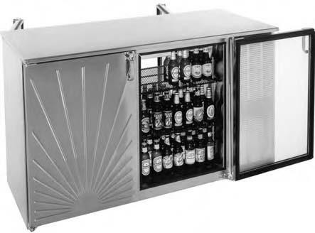
FIGEURE 2.1UP Right storage unit

HOW TO STORE SPIRITS
Gin, vodka, tequila, whiskey, absinthe, amaro — these are all spirits. Their ABV falls in the range of 20%-60% and can be stored according to the following principles:
For long-term storage, keep them in a cabinet away from heat and light. If the bottle is sealed with a cork, it’s best to store the bottle on its side so that the cork does not dry out and crack.
If you’re going to display and serve spirits in, say a decanter, return the unused portion to the original bottle once you’re done.

STORING LIQUEURS VS SPIRITS
Liqueurs are also spirits, but due to their flavoring components like fruit, dairy, nuts and spices plus their relatively low ABV (Chambord, for instance is 16.5%), you need to take a little extra care. Unopened, these bottles will keep for years in a cool, dark place, but once you crack the seal, you introduce oxygen into the bottle, and the clock is ticking. If you have space, the refrigerator (or a wine fridge) is a great place to store opened liqueur bottles. It’s rare to see an

expiration date on a liqueur bottle, but my rule is to consume within six months, which is why I always recommend buying the smallest bottle possible, so as to avoid any waste. That said, pretty much the worst that can happen to a too-old liqueur is that it will turn brownish and not taste amazing.

STORING SPIRITS IN THE FRIDGE
Speaking of refrigeration, it is perfectly okay to store any and all spirits in the fridge or freezer. You might want to pre-chill a bottle of gin for your next Martini or get that whiskey extra cold for a frosty highball. Certain brown spirits might get cloudy when chilled — this is fine. What’s happening is that some of the oils (which give spirits their flavor) are coming out of suspension due to the reduced temperature. Once warmed back up, they’ll go back to being clear.
How to Store Fortified Wines (Like Vermouth and Sherry)
Now, what about things with alcohol that aren’t, strictly speaking, spirits? I’m talking about things like, vermouth, aperitif wine, and sherry, to name a few. These all fall under the category of ―fortified wines‖ this means that they start with a base of wine to which distilled spirits are added to it to increase the ABV and allow flavorings to dissolve in the liquid more readily. It also helps to increase their shelf life but not by leaps and bounds. My general approach to storing fortified wines is to treat them as I would a fresh wine: Unopened they can be stored in a cool, dry place or even a wine fridge, and once opened you should keep them in the refrigerator and consume within two weeks. I always say that vermouth gets a bad rap because there’s a good chance that someone’s first experience with the stuff was out of a crusty bottle that had been sitting on a shelf for years, allowing the flavors to oxidize. Treat your fortified wines with respect, and they’ll reward you for it!
Drinking, serving, and learning about spirits and cocktails should be as fun and as stress-free as possible. Fortunately, the vast majority of spirits are quite durable.

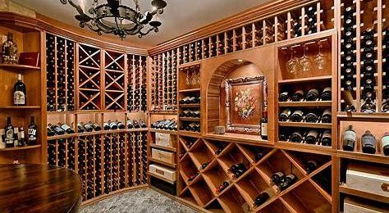
Figure 2.12 red wine storage

Monitoring and Recognizing Drink Quality
    - Monitoring and recognizing drink quality can be subjective, as it depends on personal preferences and taste. However, here are some general guidelines to help assess the quality of alcoholic beverages:
    - Appearance: Observe the color and clarity of the drink. Spirits should generally have a clear and vibrant appearance, free from any sediment or cloudiness.
    - Aroma: Take a moment to smell the drink. A high-quality spirit will have a pleasant and inviting aroma, with distinct notes that are characteristic of its type. Avoid any off-putting or unpleasant smells, which could indicate a lower quality or potential issues with the drink.
    - Taste: Take a small sip and let the liquid coat your palate. Pay attention to the balance of flavors, complexity, and depth. Look for a harmonious combination of sweetness, bitterness, acidity, and any other distinctive flavors associated with the specific spirit.
    - Finish: Notice the lingering taste and sensation after swallowing. A good-quality spirit will have a smooth and satisfying finish, without any harsh or unpleasant aftertaste.
    - Consistency: If you have tasted a particular brand or type of spirit before, compare it to previous experiences. Consistency in flavor profile and overall quality is an important aspect of recognizing drink quality.
    - Expert opinions: Consider seeking guidance from knowledgeable experts, such as professional tasters or sommeliers, who can provide insights and recommendations based on their expertise.

    - Remember that personal taste preferences play a significant role in determining drink quality. What may be enjoyable for one person may not be the same for another. Experimentation and exploration of different brands and styles can help develop your own understanding and appreciation of drink quality.

Safe Handling
Team-lifting a whole pallet of alcohol and gently placing it on a pillowy surface isn’t feasible, consider employing more realistic best practices when handling canned alcohol:
Assign or hire strong and organized people to move the beer to and from the truck. Move and store pallets on furniture blankets to prevent further bumps and shakes.
Handle smaller packaging—like six- or twelve-packs—with equal care, making sure not to carry more than you can handle or stack boxes high enough to topple.
Quality products are vital to the beverages industry; in contrast, most of the beverage companies do not succeed in ensuring the quality of the products to consumers. Beverage safety can be ensured by the sequence of assessments like the monitoring of raw material quality, production processes, packaging examinations, microbial analysis, and sensory analysis. All these tests include generally the identification of ingredients, pesticides, contamination evidences, and plastic and coloring additives. Analysis of the nutritional values and the quality of ingredients of the products is very important to ensure the safety and quality of the beverages. In the last, sensory investigation by means of color, taste, odor, and textural analysis is efficient for the assessment of the final beverage quality. Quality management system (QMS) including good manufacturing practice. This chapter will mainly deal with the quality issues and control system in beverages.

Serving Alcoholic Beverage Wine service
The basics on serving wine including tips from picking the right wine glasses to pouring wine without spilling. Some of these tips will even improve the flavor of wine
Wine is a peculiar beverage. Serving it in different glasses can change the way it tastes. This simple guide aims to help with the basics of serving wine and picking glassware to ensure that wine tastes the best it possibly can.

proper glass will make any wine taste better

The line featured different glass shapes for different types of wine. It caused a lot of confusion. .
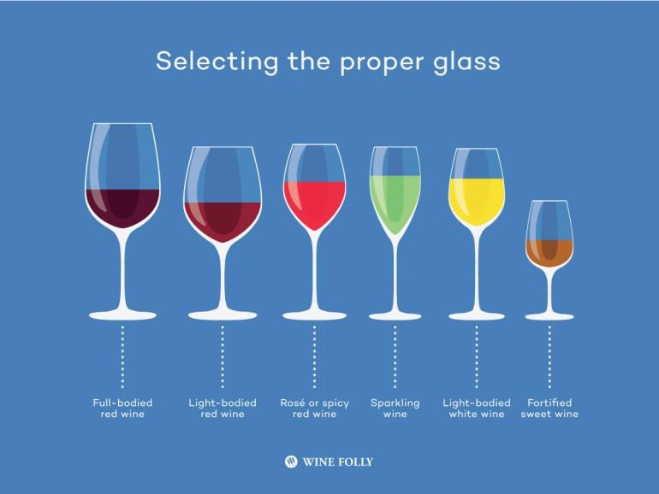

Learn why certain wine glass shapes are better for certain types of wine than others. Use this knowledge to find the best 1 or 2 glass shapes for your own home collection.

Wine tastes better served slightly cool
The delicate floral aromatics in fine wines are completely subdued at overly cool temperatures or burn off too quickly when the wine is too warm.
Red Wine: tastes better when served slightly below room temperature from 53 – 69°F (12.5 – 15.5°C) (light red wines like Pinot Noir taste better at the cooler end of the spectrum)
White Wine: tastes great from about 44 – 57°F (7.5 – 12°C). (zesty whites on the cool side and oak-aged whites on the warm side)
Sparkling Wine: Affordable sparklers do great at 38 – 45°F (3.5 – 7.5°C)(serve high-quality Champagne and sparkling wines at white wine temperatures)

Perfect the Ritual to Open a Bottle of Wine
There are many different types of wine openers and the most popular with pros is the waiter’s friend. Most of us instantly get the logic of inserting a corkscrew into a cork and using a lever arm to hoist the cork out, however it’s the little details that bewilder us.

Cutting the foil
Wine sommeliers cut the foil at the bottom lip. This is the tradition because foils were previously made out of lead. Also, this method tends to reduce stray drips when pouring at the table. Foil cutters, on the other hand, are designed to cut the top of the lip. Cutting the top lip is more visually appealing and ideal for moments where the wine is on display (like at a wine tasting).

Keep the cork from breaking

It takes about seven turns to insert the worm into the best spot, although wine openers vary. Basically, the corkscrew should be inserted into the cork about one turn less than all the way in.

Nearly every red wine taste better decanted
Decanting is the one thing we always forget to do that will greatly improve the flavor of red wine.
The classic method is to pour wine into a glass pitcher or wine decanter and let it sit for about 30-45 minutes. The faster way is to use a wine aerator which decants wine almost instantaneously.

Pouring a Standard Wine Serving
A bottle of wine contains slightly over 25 ounces of wine. Bottles are commonly portioned into five servings – 5 oz/150 ml. A typical wine glass is 17-25 oz. and designed to hold aroma.
Try not to overfill, protect your aroma!
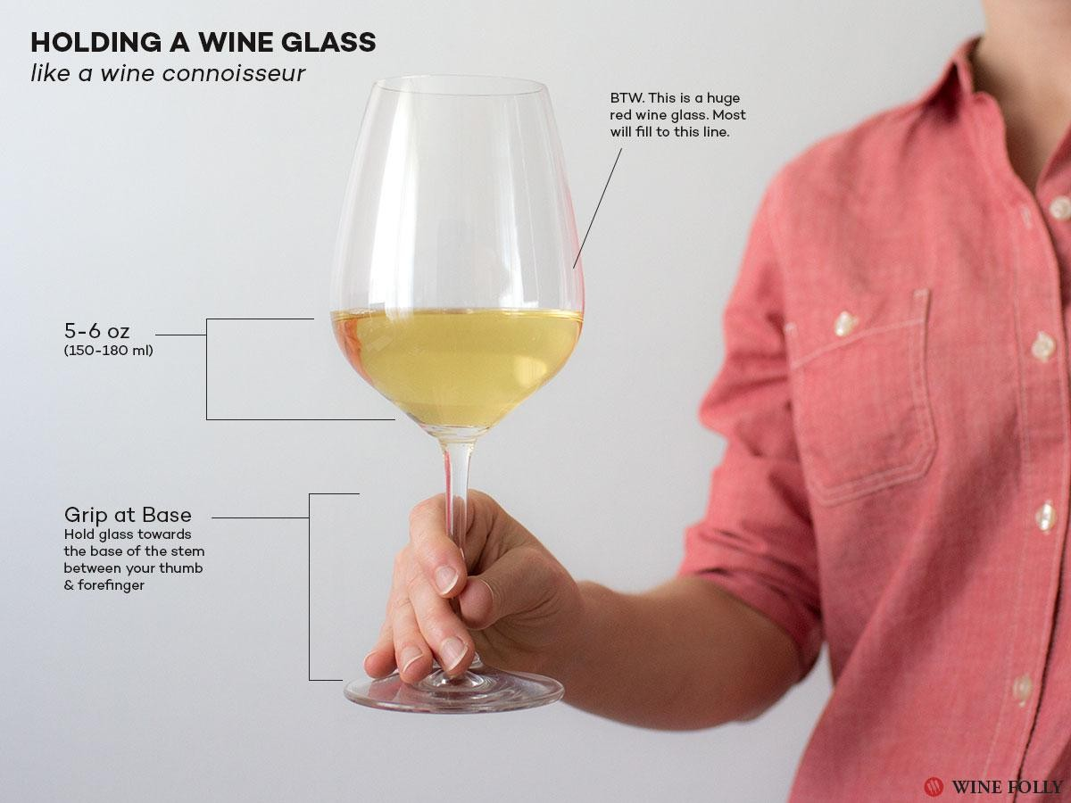
figure2.3Holding a wine glass

How long does wine keep after opened?
Most wine won’t last through the night if the bottle is left open. Here are a few tips to preserve open wines for much longer:
Store open wines in the fridge (or wine fridge if you have one!). This cold storage will slow down any development of the wine, keeping it fresh.
Keep wine away from direct sunlight and sources of heat (like above your fridge or oven.)

Some wines release the scent faster at room temperature. They must be cooled, otherwise, they will make people feel the scent is too rich. Some wines show the suitable drinking temperature on the labels, so you may pay attention to it before drinking.

Beer service
Beer is a low-alcoholic beverage, and the best drinking temperature is 7˚C-10˚C (44.6˚F-50˚F). Otherwise, you are not able to taste its aroma if the temperature is too low. For example, Belgian ales must reach 10˚C (50˚F) to release the aroma. But some beer, such as pale ale, needs to be refrigerated at around 5˚C (41˚F). If you choose dark beer, the temperature should be lower. The popular method is to put the beer in the refrigerator and cool it until there is a thin layer of frost on the surface of the bottle.
People like pouring beer into a glass for drinking. in some professional pubs, we can see that the bartender takes the glass out of the back bar cooler. The purpose of refrigerating the glass is to keep the temperature of glass consistent with the refrigerated beer. This can prevent the beer from heating up by being introduced into the glass at room temperature so that the best taste of the beercan be protected. Some pubs will even add a glass foster special for refrigerating glasses, to meet the most of the consumers’ needs while leaving them a deep impression.
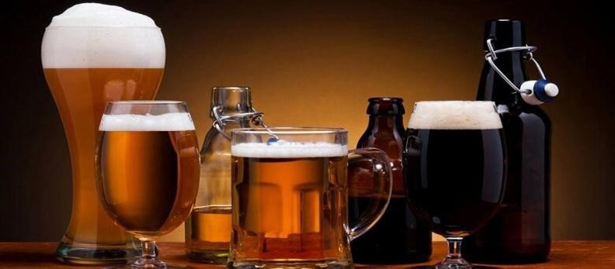

Figure 2.4 beer service Local beers
Ethiopia is famous for many things, but one thing it doesn’t get enough credit for is its beer. And Ethiopians love a beer. Or five.

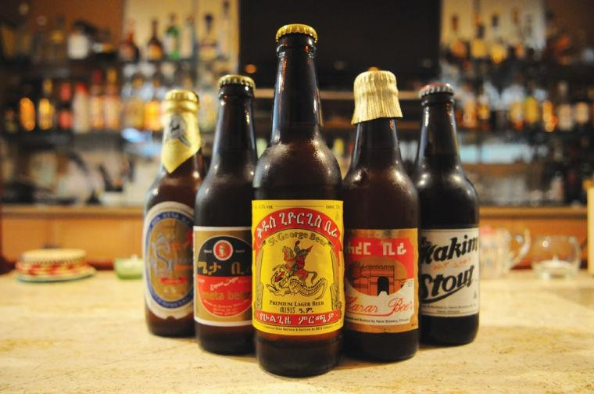
Figure 2.5 local beers

Ethiopian wines
Most wine drinkers claim that Ethiopia has the best locally produced wine. There are a range of Ethiopian produced wines in the market at reasonable prices. The labels of Kemila and Awash Cristal are the best-known white ones, while Axumite and Gouder are the red wine brands. When the Ethiopian embassy in Stockholm some years ago tried to introduce the Ethiopian wines to the Scandinavian market, the rumors say that a slogan proposed was "French Wine is good, but Ethiopian Wine is Gouder", trying to establish Gouder as an export article. Although this initiative never succeeded, Gouder won gold medals for its quality in Eastern Europe in the late 1970s.

Wine and food matching
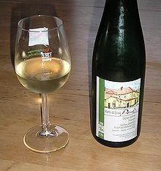
Wine and food matching is the process of pairing food dishes with wine to enhance the dining experience. In many cultures, wine has had a long history
of being a staple at the dinner table and in some ways both the winemaking and culinary traditions of a region will have evolved together over the years. Rather than following a set of rules, local cuisines were paired simply with local wines. The modern "art" of food pairings is a relatively recent phenomenon, fostering an industry of books and media with guidelines for pairings of particular foods and wine. In the restaurant industry, sommeliers are often present to make food pairing recommendations for the guest.

3.4 Liquor and Spirits service Figure 2.6 local wine
- Whiskey: 15˚C (59˚F)
- Vodka: 7˚C (44.6˚F)
- Brandy: 20˚C (68˚F)
Many people drink vodka with ice. In bars, they usually put a large piece of ice into the glass with whiskey. This is called whiskey on the rock.

The low-temperature vodka is in stark contrast to its own hot taste, allowing people to experience the two extreme feelings at the same

Bar terminology
- Decant pouring wine carefully from a bottle in which loose sediments would otherwise become stirred up
- Dry it is not sweet/Highball a glass used to service drink
- Highballs any liqueur served with ice. Soda
- Jigger an instrument used to measure alcoholic drinks sometimes called a shot
- On the rock a beverage served over ice without adding water or other mixers
- Oenology a wine making science/Brown goods whiskey and brandy
- Hangover symptom associated with over indulgence in alcohol headache queasiness stomach cramps dizziness dehydration
- Happy hour limited period of a day during which drink prices are reduced.
- White goods, rum vodka gin tequila/Neat is used to order a drink that is served with no ice or mixers.
- Up usually describes a drink that is chilled with ice—either shaken or stirred—and strained into a glass without ice..
- Straight up can bring the most confusion because drinkers use it to refer to both neat and up drinks.
- Straight Some use straight when they order a straight pour of darker spirits.

Self-Check 2

Part-I: Choose the correct answer
- which of the following practices is important, when handling alcoholic beverages,
  - Properly labeling and storing different types of alcohol
  - Understanding and adhering to local laws regarding serving and selling alcohol
  - Practicing responsible serving and monitoring customer consumption
  - Ensuring proper hygiene and cleanliness in the serving area
  - All of the above
- Which of the following factors should be considered when storing wine?
  - Temperature and humidity control
  - Exposure to light
  - Proper positioning of the bottles
  - Storage location (e.g., cool and dark place)
  - All of the above
- What temperature range is generally recommended for storing most beers?

  - 0-5°C (32-41°F)
  - 10-15°C (50-59°F)
  - 20-25°C (68-77°F)
  - 30-35°C (86-95°F)

- When serving spirits neat (without mixers or ice), what type of glassware is typically used?

  - Highball glass
  - Champagne flute
  - Rocks glass
  - Shot glass

- Which of the following is not a common garnish used in cocktails?

  - Lime wedge
  - Maraschino cherry
  - Celery stalk
  - Mint sprig

PART II;match the follwing from columen B to columan A
A B
1 net drinks A, alcholic beverage serve with ice
2 stright up B, alcholic beverage serve with out ice
3 on rock C, alcholic beverage serve with out ice
4 corcksvrew D, an instrument used to measure alcoholic portion
5 TejE oldest traditonal lokal drink
6 jigger F flute
7 champagen glass G wine opener Part-II: Answer the following questions accordingly
1. How store beer and wine?
- What are three alcoholic storage areas?
- What mean the term UP alcoholic beverages?
- What are shelf life of un opened spirits and opened sprits
- Opened fortified wine is keep for wine

Operation sheet 2.1. Handling and receiving Alcoholic beverage
Operation Title: Handling and Receiving Alcoholic Beverage Purpose: To Handle and Receive Alcoholic Beverage Conditions or situations for the operations:
  - Safe working area
  - Properly operated tools equipment Equipment Tools and Materials:
- Trolly
- pen
Steps in doing the task
- Prepare receiving area
- Check quantity, brand, size, leakage ullaged
- Receive drinks.
- Record each drink.
- Place drinks separately
Quality Criteria: Assured performing of all the activities according to the procedures Precautions:
  - Handle the bottle body not neck
  - Transport carefully
  - Avoid if any spoilage or ullage

Operation sheet 2.2 Storing Alcoholic Beverage

Operation Title: Storing Alcoholic Beverage Purpose: To store alcoholic beverages Conditions or situations for the operations:
  - Safe working area
  - Properly operated tools equipment Equipment Tools and Materials:
- Refrigetore
- Trolly
- Note
Steps in doing the task
- Prepare storing area
- Clean bottle of drinks.
- Store on appropriate place.
Quality Criteria: Assured performing of all the activities according to the procedures Precautions:
  - Handle the bottle body not neck
  - Check instruction to store
  - Display the drink brandy visibly

Operation sheet 2.3 Serve red wine Operation Title: to Serve alcoholic beverage Purpose: To servicered wine
Conditions or situations for the operations:
- Clear uniform
- Clean serving equipment’s
- Equipment Tools and Materials:
- Service tray
- Crock screw
- Service cloth
- Bar knife
Steps in doing the task:

- Paper napkin
- saucer
- Pen
- Bill folder
- Side table
- Red wine glass

  - Place the red wine glass on the right-hand side
  - Check if the order is correct.
  - Present it to the host from his right-hand side.
  - Announced wine and the right wine is presented.
  - Cut the foil
  - Wipe the bottleneck with a napkin before uncorking.
  - Insert the sharp tip of the corkscrew into the center of the cork and open .
  - Wipe the mouth of the bottle with the napkin. Pour wine into the host’s glass for tasting.
  - After receiving the approval from the host, start serving the ladies first moving clockwise.

Quality Criteria: Assured performing of all the activities according to the procedures Precautions:
- Cary wine carefully
- Serve on the right side of customer

Operation sheet 2.4Service Whiskey

Operation Title: Alcoholic beverage service
Purpose: Toserve whiskey
Conditions or situations for the operations:
- Safe working area
- Properly operated tools equipment Equipment Tools and Materials:
  - Ice
  - Mixers
  - Service tray Steps in doing the task
- Take customer order
- Choice the right glass
- Add ice or lemon

- Whisky glass
- jigger
- lemon

Quality Criteria: Assured performing of all the activities according to the procedures Precautions:
  - Never serve toxin customer and teenagers

Page 53 of 71 | Ministry of Labor and Skills Author/Copyright | Advice on Alcoholic Beverage | Version -2
Page 53 of 71 | Ministry of Labor and Skills Author/Copyright | Advice on Alcoholic Beverage | September, 2023

Lap Tests
Instructions: Given necessary templates, tools and materials you are required to perform the following tasks accordingly.
Task 1: Perform receiving and sorting alcoholic beverage. Task 2: Perform serving red wine.
Task 3: Perform serving whisky?

UNITTHREE;Advise Customers on wines, beers, spirits and liqueurs.
This unit is developed to provide you the necessary information regarding the following content coverage and topics:
- Advise local and imported alcoholic beverages.
- Assist customers in selecting beverages
This guide will also assist you to attain the learning outcomes stated in the cover page. Specifically, upon completion of this learning guide, you will be able to:
- Provide accurate advice about local and imported beers, wines, spirits and liqueur.
- Provide advice and make adjustments
- Assist customer in selecting beverages

Advice local and imported alcoholic beverages.
Advising customers about local and imported wine, beer, and spirits, is important to consider various listed factors that can influence their choices.

    - Taste and flavor,
    - Cultural and Regional Significance
    - . Price and Affordability
    - Accessibility and Availability
    - Supporting Local Producers:
    - Personal Preferences and Exploration

Taste and Flavor Profiles: Highlight the differences in taste and flavor profiles between local and imported options. Local varieties may have unique characteristics that reflect the terroir and winemaking traditions of the region, while imported options can offer diverse and distinct flavors from different parts of the world. Discussing these flavor nuances can help customers determine which option aligns better with their preferences.
Cultural and Regional Significance: Share information about the cultural and regional significance of both local and imported beverages. Local products often showcase the traditions, heritage, and local winemaking techniques of a particular area. On the other hand, imported beverages can provide customers with an opportunity to explore different wine regions, beer styles, or spirit origins, expanding their cultural appreciation and palate.

Accessibility and Availability: Consider the accessibility and availability of both local and imported products. Local beverages may be more readily available and affordable due to lower transportation costs. Imported options, while potentially offering unique choices, may have limited availability or higher price points due to importation and distribution factors. It's essential to find a balance between customer preferences and availability.

Price and Affordability: Discuss the price range and affordability of local and imported beverages. Local options often provide customers with cost-effective choices, especially if they're looking for budget-friendly selections. Imported beverages may be associated with a higher price tag due to factors such as production costs, tariffs, and transportation expenses. Educate customers about the value and quality they can expect within their desired price range.

Supporting Local Producers: Emphasize the importance of supporting local producers and the positive impacts it can have on the local economy and community. Local wineries, breweries, and distilleries often embody craftsmanship, sustainability practices, and a connection to the local culture. This aspect can add an extra layer of appreciation to the experience of consuming local beverages.
Personal Preferences and Exploration: Ultimately, it's crucial to understand and respect the customer's personal preferences. Some customers may prioritize supporting local businesses and experiencing the regional offerings, while others may seek diversity and exploration through imported options. By actively listening to their preferences, you can provide tailored recommendations that meet their desires.
Remember to provide information without bias, allowing customers to make an informed choice based on their preferences, budget, and interest in exploring the local or imported options. By offering a balanced perspective and highlighting the unique attributes of both local and imported beverages, you can assist customers in selecting a drink that they will truly enjoy. Cheers to a delightful and educational drinking experience!
Knowledgeable and Approachable Staff; The importance of well-trained staff with both wine and spirit knowledge is crucial. Staff must also be approachable and personable. Being conversant on the various growing regions, varietal, technical aspects and taste profiles are expected by your customers.
The top retailers have their staff visit prominent growing regions and invest in their training. And as new categories like whiskey become hot, they need to follow the trends and expand their expertise.

Assisting Customers in Selecting beverages
When assisting a customer with selecting an alcoholic beverage, it's important to consider a variety of factors to ensure a tailored recommendation. By understanding the customer's preferences and needs, you can provide an enjoyable and satisfying experience. Here are some key points to keep in mind:

Understand the Customer's Taste Preferences: Ask the customer about their preferred flavors, whether they enjoy sweet or dry, light or bold profiles. This information will help guide you towards suitable options within their taste preferences.

Consider the Occasion or Purpose: Determine the occasion or purpose for which the customer is seeking the alcoholic beverage. Is it for a casual gathering, a formal event, or a specific celebration? This will influence the type, style, and presentation of the beverage you recommend.
Take into Account Alcohol Content and Tolerance: Be mindful of the customer's alcohol tolerance and preferences for lower or higher alcohol content. Some individuals prefer lighter options with lower ABV (Alcohol by Volume), while others seek stronger spirits or specific wine styles.

Offer Food Pairing Suggestions: If the customer is looking for a beverage to pair with a meal or specific cuisine, provide suggestions on suitable pairings. For example, certain wines complement seafood, while specific beers enhance the flavors of grilled meats.

Consider the Customer's Budget: Inquire about the customer's price range or budget to offer options that align with their financial preferences. Provide recommendations within their budget that still meet the desired quality and flavor expectations.

Acknowledge Cultural or Regional Preferences: If the customer has a specific cultural or regional preference, take that into account when suggesting beverages. Some customers may be interested in exploring local or traditional options from a particular country or region.

Highlight Seasonal Offerings: Inform the customer about any seasonal offerings or limited editions that may be available. This adds a unique touch to their selection and allows them to explore something new and exciting.

Remember, customer satisfaction is paramount. Actively listening to their preferences, asking insightful questions, and providing well-informed recommendations will ensure a positive experience. Always encourage responsible consumption and offer alternatives if necessary.

By considering these factors, you can assist customers in selecting a beverage that aligns with their preferences, occasion, and budget, resulting in a more personalized and enjoyable experience for them. Cheers to happy and informed decision-making!
Offer Specialty Coffee These days it seems a new coffee shop is popping up on every corner. There’s no reason your restaurant can’t capitalize on this trend. It will surely please your customers and keep them coming back.

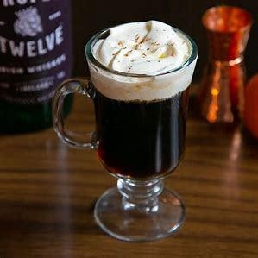

Figure 3.1liquere coffee

Self-Check 3

Part-I: Choose the correct answer
- When recommending a wine to a customer, which of the following factors should you consider?

  - Grape variety and region
  - Sweetness level and acidity
  - Food pairing options
  - Age and vintage
  - All of the above

- Which of the following factors are important to consider when suggesting a beer to a customer?

  - Beer style (e.g., lager, IPA, stout)
  - Bitterness level (measured in IBUs)
  - Alcohol content (ABV)
  - Aroma and flavor profiles
  - All of the above

- When advising a customer on spirits (e.g., vodka, rum, whiskey), which factors should be taken into account?

  - Base ingredients and production methods
  - Aging and maturation process
  - Flavor profiles and tasting notes
  - Mixing or sipping preferences
  - All of the above

- Which of the following considerations are important when recommending liqueurs?
) Flavor profiles and sweetness levels

- Serving suggestions and cocktail compatibility
- Origin and cultural significance
- Unique ingredients and production techniques
- All of the above

- someone who specialized with wine knowledge and who advice wine to customer is

  - Waiter
  - Bartender
  - server
  - sommelier
  - All of the above

- Which of the following food is accompanied with red wine?

  - steak
  - fish C, lamp

- Rice

Part-II: Answer the following questions accordingly
  - how advice to customer a liqueur?
  - When advice to customer an aperitif?
  - What is meal alcoholic drinks?
  - How advice a customer order whiskey before a meal?
  - An Ethiopian Doro wot is recommended with local or imported wine?
  - How advice if customer is ordering sweet foods?
  - What your advice customer order European dish?

Operation sheet 3.1 advice alcoholic beverage to customer
Operation Title: advising alcoholic beverage to customer Purpose:to advisingalcoholic beverageto customer Conditions or situations for the operations:
    - Safe working service area
    - Properly serving bar equipment Equipment Tools and Materials:
    - Refrigerator
    - Different types of Beverages
    - Serving equipment’s
    - Wine and drink lists
    - Menu cards
    - powder coffee Steps in doing the task:
    - Study drinks lists.
    - Prepare misen place
    - Communicate with customer.
    - Advice the right drink with foods.
Quality Criteria: Assured performing of all the activities according to the procedures Precautions:
    - Understand the customer needs
    - Know the customer food order
    - Avoid advising two drinks at a time

Lap Tests

Instructions: Given necessary templates, tools and materials you are required to perform the following tasks accordingly.
Task 1: Perform advising local wine to customer Task 2: Perform advising aperitifs to customer Task 2: Perform advising spirits and liqueurs

UNIT FOUR. Extend and Update Knowledge of wines, beers, spirits and liqueurs.
This unit is developed to provide you the necessary information regarding the following content coverage and topics:
- Formal and informal research on alcoholicbeverage
- Identifying customer taste and trends
- Obtaining information on beverage service trend.
This guide will also assist you to attain the learning outcomes stated in the cover page. Specifically, upon completion of this learning guide, you will be able to:
- Conduct formal and informal research about beers, spirits and liqueurs.
- Identify Customer taste and trends based on customer contact and workplace interactions
- Source Information on current and beverage service

Formal and informal research on alcoholicbeverage
Formal and informal research on alcoholic beverage can be conducted by academic research and market research reports.
    - Academic Studies: Numerous academic studies have been conducted on various aspects of alcoholic beverages, including their production, consumption patterns, health effects, and economic impact. These studies are often published in peer-reviewed journals and provide in-depth analysis and data.
    - Market Research Reports: Market research firms regularly publish reports on the alcoholic beverage industry, providing insights into market trends, consumer preferences, and sales data. These reports can be valuable for businesses and individuals looking to understand the market dynamics and make informed decisions.
    - Informal Research on Alcoholic Beverages:
It is important to note that while informal research can provide valuable insights and opinions, it may not always be backed by scientific evidence or expert knowledge. Therefore, it is advisable to cross-reference information obtained through informal channels with formal research or expert opinions when making informed decisions about alcoholic beverages. attending trade shows and product tastings joining associations and industry bodies reading general and trade media and supplier information reading reference books talking to product suppliers, winemakers or brewers using the internet.
      - Online Forums and Communities: There are numerous online forums and communities where people discuss and share their experiences with different alcoholic beverages. Platforms specialized alcohol-related forums allow users to ask questions, share recommendations, and engage in discussions about various alcoholic beverages.
      - Social Media: Social media platforms like Instagram, Facebook, or Twitter can also be a source of informal research on alcoholic beverages. Many influencers, bloggers, and enthusiasts share their opinions, reviews, and recommendations through posts or videos. Following relevant accounts or hashtags can provide insights and inspiration.

- Personal Experiences: Informal research can also involve personal experiences and experimentation with different alcoholic beverages. Trying new drinks, visiting local breweries or wineries, attending tastings, or participating in events can all contribute to expanding knowledge and understanding of different beverages.

Attend local wine tastings
Many wine shops host tastings once a week or more. Often, they’re even free. Get on their mailing lists to stay in the know about upcoming events.
If your neighborhood has a local wine shop, take the opportunity to get to know the owner or staff. They’re there because they love wine and will be eager to share their knowledge about the wines they’re pouring and other wines in the store. They should be able to tell you about the varietals, wineries and walk you through some tasting notes.
Some of the big-box wine stores take a less educational approach to their tastings, but they’re still worth attending because you’ll get to try bottles you may not have otherwise pulled off the shelf.
  - Take a notebook and write notes about each wine you’re tasting — or, in today’s high- tech world, download a wine app to help you keep track of bottles you like. You can even use your phone to snap a picture of the label!
    - Take a classTake wine education up a notch and enroll in a tasting class. Bring a friend and enjoy learning from a pro; check your local wineries to see if they offer classes. Many wine shops offer courses, as do some community colleges and even private wine educators. Often, they’re reasonably priced when you take into account the cost of the

wine poured at each class. Tap into Yelp or ask at your local wine shop for recommendations to find a class that will challenge you wherever you are in your wine journey.
    - Host a tasting clubThe best way expanded alcoholic beverage knowledge is through tasting of different Wines of the World.
Every two months, the host picks a region or varietal, researches it and presents a PowerPoint (nerd alert!). We generally include information about climate and how it affects the grapes, any interesting stories or scandals about the region and its wines, and the typical flavors and aromas of the wines.
Of course, the best part is the wine. The host buys several bottles of the subject wine and we all get to taste. We split the cost of the bottles evenly across the group to keep things fair from meeting to meeting. Guests bring a little snack to share

Identifying customer taste and trends on alcoholic beverage
Identifying customer taste and trends on alcoholic beverages can be done through a combination of formal and informal research methods. Here are some approaches:
Surveys and Questionnaires: Conducting surveys or questionnaires can help gather data on customer preferences, tastes, and trends in the alcoholic beverage industry. Questions can be designed to understand preferred types of alcohol, flavors, packaging, pricing, and consumption patterns. These surveys can be conducted online, at events, or through targeted sampling.

Focus Groups: Organizing focus groups with alcohol consumers can provide qualitative insights into their tastes and preferences. These sessions involve a moderated discussion where participants share their opinions, experiences, and thoughts on different alcoholic beverages. Focus groups can help identify emerging trends, understand consumer motivations, and explore potential areas for innovation.
Online Reviews and Ratings: Monitoring online reviews and ratings on platforms like Amazon, Google, or specialized alcohol review websites can provide valuable insights into customer tastes and trends. Analyzing the feedback and comments can help identify popular brands, flavors, or styles of alcoholic beverages, as well as any emerging preferences.

Social Media Listening: Tracking conversations and mentions of alcoholic beverages on social media platforms can provide real-time insights into customer tastes and trends. By monitoring

relevant hashtags, keywords, or brand mentions, businesses can identify popular drinks, influencers, or emerging preferences among consumers.

Industry Reports and Analysis: Market research firms regularly publish reports on the alcoholic beverage industry, which include information on consumer preferences and trends. These reports can provide an overview of the market landscape, identify key growth areas, and highlight changing consumer tastes.

Collaboration with Bartenders and Sommeliers: Bartenders and sommeliers are often at the forefront of customer interactions in the hospitality industry. Collaborating with them can provide valuable insights into customer preferences, emerging trends, and popular drinks. They can offer firsthand observations from their interactions with customers and provide expert opinions on taste profiles and preferences.
By combining these formal and informal research methods, businesses can gain a comprehensive understanding of customer tastes and trends in the alcoholic beverage industry. This knowledge can help inform product development, marketing strategies, and overall business decision- making

Self-Check

Part-I: Choose the correct answer
- Which of the following is not a primary ingredient used in brewing beer?

  - Barley
  - Hops
  - Grapes
  - Water

- Which wine region is known for producing Chardonnay?

  - Napa Valley, California
  - Bordeaux, France
  - Marlborough, New Zealand
  - Tuscany, Italy

- Which spirit is traditionally made from sugarcane juice or molasses?

  - Tequila
  - Vodka
  - Rum
  - Whiskey

- What is the primary ingredient in gin that gives it its distinctive flavor?

- Grapes
- Juniper berries
- Malted barley
- Corn

- Which liqueur is made from orange peels and is commonly used in cocktails like Cosmopolitan and Margarita?

  - Amaretto
  - Triple sec
  - Baileys
  - Sambuca

Part I answer the following questions accordingly?
- what are listed factors that help to extended knowledge of alcoholic beverage?
- What is wine Bible
- List five local brewers?
- How you get information from winemakers?

Reference

  - "Alcohol and Health: The Good, the Bad, and the Ugly" by David J. Hanson -
  - "The World Atlas of Beer: The Essential Guide to the Beers of the World" by Tim Webb and Stephen Beaumont -
  - "Wine Folly: The Essential Guide to Wine" by Madeline Puckette and Justin Hammack -
  - "The Craft of the Cocktail: Everything You Need to Know to Be a Master Bartender" by Dale DeGroff -
  - "The Oxford Companion to Spirits and Cocktails" edited by David Wondrich–

Developers profile:

No | Name | Sex | Qualificati  on (Level) | Field of  Study | Experience | Institution | Mobile  number | E-mail
1 | Zerfu Negash | M | B | Hotel mgt | 14 years | Woliso PTC | 0915957805 | nzerfu@gmail.com
2 | Rahmato  Mohammed | M | A | Hotel mgt | 4 years | Gofaindustrial  college | 0922477512 | rahmetomoha@gmail.com
3 | TesemaNeka | M | B | Hotel mgt | 10 years | Alatawando  PTC | 0926129107 | tesemaneka1@gmail.com
4 | Yonas Abaya | M | B | Food Technology & process  Engineering | 4 | General Winget Poly technic  College | 0913922765 | yonasabeya33@gmail.co m
5 | AmareAlalign | M | A | MA | 10 | TTI | 0915698433 | amarealelign70@gmail.co  m
6 | MeleseWorku | M | A | Hotel mgt | 10 years | Hawassa PTC | 0926274491 | meleseworku555@gmail.  com
7 | MulatuEyob | M | A | MA |  | TTI | 0913022557

