hardware and network servicice
Level III

Based on March 2022, Curriculum Version 1

Module Title:- CONFIGURE AND ADMINISTER SERVER
Module code: EIS HNS3 03 1221
NOMINAL DURATION: 120 Hrs.

Prepared by: Entoto Poly Technic College

Sept, 2023 Addis Ababa, Ethiopia

Table of content

Contents

Chapter 1 6
Confirm server specification 6
  - Overview of Server Operating System 6
  - Confirming network operating system, server applications and server Design 11
  - Identifying product, vendor architecture and equipment 18
  - Identifying technology and resource 19
Self-Check 21
Chapter 2 22
Verify server compatibility and inter-operability 22
  - Reviewing Hardware and software to ensure compatibility 22
  - Obtaining all hardware required 26
  - Installing required operating system and software 28
  - Installing additional tools or third-party software 29
  - Patching operating system and applications 30
Self-Check 31
Chapter 3 32
Configure and test server 32
  - Active Directory domain services (ADDS) 32
  - DNS server 34
  - Active Directory Lightweight directory services (ADLDS) 35
  - DHCP servers 36
  - Hyper-V 38
  - Active directory certificate services 42
  - File services 44
  - Print services 45
  - Streaming media services 48
  - Windows server Update Server (WSUS) 53
  - Active directory rights management server 57
  - Web server (IIS) 59
  - Routing and remote access server 60
  - Defining scope and applicability of testing 62
  - Developing test plan 63
  - Running system test 63
  - Analyzing error report and making changes 65
  - Validating changes or additions against specifications 67
Self-Check 68
- Operation Sheet 69
  - Install Active Directory Domain Services via Server Manager 79
  - Install DNS Server 88
  - Creating an Organizational Unit, Groups and Users 92
  - Join Client Computer to the Server 99
  - DHCP Installation and configuration 109
  - Install Hyper-V on Windows 10 120
  - Installing Active Directory Rights Management Services 124
  - Install and configure IIS 126
  - Installing the Routing and Remote Access Service 130
Practical Assessment 131
Reference Books 133

Figures
Figure 1 Window Server Logo Figure 2 Server Manager Interface Figure 3 Network Operating System
Figure 4 three-tier architecture server application

Tables
Table 1 Minimum Hardware Requirements for server 2008

Acronym
DC Domain Controller
ADDS Active Directory domain services DNS Domain Naming Service
ADLDS Active Directory Lightweight directory services PKI Public key infrastructure
ADCS Active Directory Certificate Services FSRM File Server Resource Manager RTSP Real Time Streaming Protocol WSUS Windows server Update Server
ADRMS Active Directory Rights Management Services RRAS Routing and Remote Access service

CSP | Cloud Service Providers
NAT | Network Address Translation
VPN | Virtual Private Network
VM | Virtual Machine
LAN | Local Area Network
WAN | Wide Area Network
CPU | Central Processing Unit
RAM | Random Access Memory
OS | Operating System
NOS | Network Operating System
AD | Active Directory
DHCP | Dynamic Host Configuration Protocol
IIS | Internet Information Service
CRM | Content Resource Management
SaaS | Software As A Service
GUI | Graphical User Interface
TCP/IP | Transmission control Protocol/ Internet Protocol
UDP | User Datagram Protocol
P2P | Peer to Peer

Chapter 1

Confirm server specification

Overview of Server Operating System

Introduction

Server operating systems are made for computers that function as web servers, application servers, database servers, email servers, or other systems that run on a dedicated server.
Unlimited user connections, increased memory, and sophisticated network optimizations are just a few advantages that server operating systems have over regular operating systems.

What is a Server Operating System?

A sophisticated operating system created specifically to run on servers is called a server operating system. It possesses the characteristics and supporting systems required for client-server architecture operation and client request service.
A server OS is created from the bottom up with capabilities appropriate for multi- user, mission-critical applications. It offers a centralised user interface for administering security, user management, and other administrative procedures. A server operating system's main priorities are often security, stability, and cooperation.
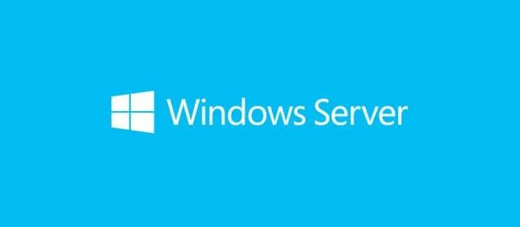

Figure 1 Window Server Logo

Server operating systems facilitate the implementation of various server platforms, such as:

- Web servers. When a client requests a web page or other web-based service, a web server hosts the corresponding programs and data and fulfills the request. Microsoft Internet Information Services (IIS) and Apache are the most popular web servers.
- Application servers: This is used to run business-critical applications, whether that's a self-hosted CRM or a SaaS. A server OS usually functions as a shared environment for various collaborative applications.
- Database servers: which facilitates dynamic web page building based on the database contents and database integration
- Mail servers: allows users to forward and receive emails for and from their business and controls individual email accounts based on a specific domain.
- File servers: is a shared storage location used by a company to store documents or other data.
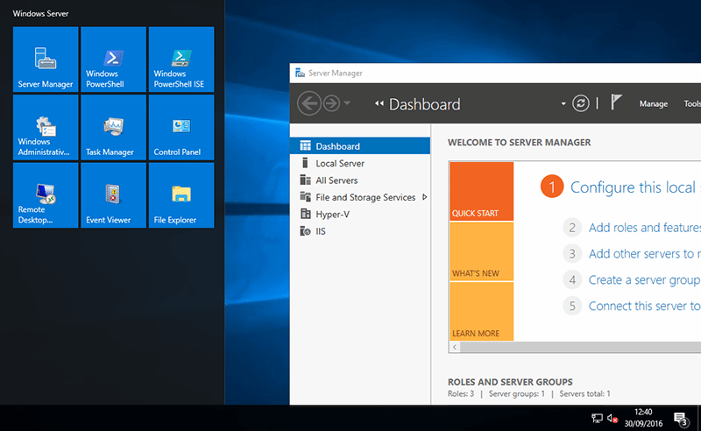
Figure 2 Server Manager Interface

- Print servers: server operating systems facilitate is print sharing, allowing multiple machines to use a single printer.

Server operating systems are capable of handling several of the features mentioned above if the tasks don't require too many resources. Some of the key features of a server operating system include:
    - Provides central interface to manage users, implement security and other administrative processes
    - Its capability to be accessed via both a graphical user interface (GUI) and a command-level interface.
    - Manages and monitors client computers
    - Advanced-level hardware, software and network configuration services

Widely used Server Operating Systems

These days, there are a ton of operating systems available. Approximately 80% of servers utilize some form of Linux, whereas 20% of servers run Windows, according to certain statistics.
The main variations between Linux and Windows, Because Linux is open source and doesn't require user-based licensing like Windows does, the sharp discrepancy in market share is probably due to this.

Each OS has advantages and disadvantages, and how easy it is to use depends on how technically competent the user is. The list of server operating systems that follows is not all-inclusive but does include the most popular ones.

Windows Server

The Windows family of operating systems was created by Microsoft for both personal use and professional use in servers. The Windows Server OS facilitates business-level management, data storage, and a wide range of applications.
The desktop GUI interface, multitasking, virtual memory management, and support for a variety of peripheral devices are all characteristics of Windows Server. Standard Windows Server support from Microsoft lasts for ten years.

The advantages of a Windows server OS include the user-friendly GUI, support for symmetric multi-processor systems, excellent third-party program support, and a variety of versions. The disadvantages include the requirement for user-based

licensing and a higher prevalence of virus security concerns than on other platforms.

Linux

An operating system family that resembles UNIX and has all of its characteristics is called Linux. It supports operations involving multiple users, multiple processes, and multiple threads and is open-source and free. When it comes to installation, maintenance, and problem patching, Linux servers demand higher technical expertise. The three most well-known Linux server distributions are Fedora, Ubuntu Server, and Debian Server.
High security, a large selection of distributions, integrated open-source software, including high-level language compilers, and the capacity to be controlled via a GUI are the benefits of a Linux server OS.

Cons include some distributions' lack of long-term support and some difficult tasks, like system updates.

MacOS Server

A server operating system based on macOS called the macOS Server was created by Apple. The OS extends the capabilities of macOS and includes tools for managing iOS and macOS devices, as well as server capability. Given its capability to simply add features for Mac clients, the macOS Server is a fantastic option if you employ Mac clients in your network.
The advantages of macOS Server include simple management, a clear user interface, excellent support, and simple task distribution across numerous servers. As a result, increasing processing power is simple. The OS includes an unrestricted user license.

The drawbacks of macOS Server include the fact that it can only run on expensive Apple hardware and that there aren't many third-party applications. Additionally, even though Apple uses open-source software in its system, adjustments made specifically for macOS necessitate getting past some problems that aren't present in Linux.

UNIX-Based Operating Systems

UNIX was initially designed as a time-sharing operating system for compact computers, but it has since evolved into one of the most popular client-server

environment operating systems. The C programming language used by UNIX made it easier to develop UNIX ports for several devices.

A multi-user environment, integrated TCP/IP support, and a high level of reliability and security are some advantages of UNIX. There is no standard UNIX version, which is a drawback, and it is paid for by different suppliers who sell different UNIX versions.

NetWare

The server-based network operating system Novell NetWare needs a dedicated server to run. It was a widely used OS in the first LANs.
The benefits of using NetWare include its support for multiple CPUs, its large- capacity physical memory management, its superior file sharing and printing capabilities in corporate networks, and more. Additionally, the OS provides a variety of management interfaces, including a Web interface.
Cons include the cost, subpar support, difficult installation, and limited third- party app support.

Confirming network operating system, server applications and server Design

What is a network operating system (NOS)?
An operating system for computers called a network operating system (NOS) is primarily made to serve workstations, PCs, and, in certain cases, older terminals that are connected to a LAN. Multiple devices in a network can connect and share resources thanks to the software powering NOS. A traditional NOS is no longer necessary, though, as the majority of operating systems come with network stacks that enable the client-server approach.
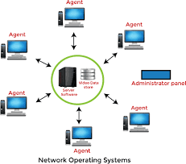
Figure 3 Network Operating System
A NOS orchestrates the operations of numerous computers throughout a network. Devices like PCs, printers, file servers, and databases linked to a local network can be included in this. The basic network services and capabilities that handle numerous input requests concurrently in a multiuser environment are the responsibility of the NOS.

Types of Network Operating Systems
There are two basic types of network operating systems:
- Peer-to-peer (P2P) network operating systems (OSes) enable users to share network resources saved in a shared, reachable location. All devices are handled similarly in this design in terms of functionality. P2P typically performs better on small and medium LANs and costs less to set up than the client-server approach.
- Client-server networks OSes give users access to resources via a server. In this design, each function and application is centralized under a single file server that can be utilized to carry out certain client operations from any place. Client-server typically costs more to set up and maintain technically than P2P. The client-server architecture has the benefit of centrally controlling the network, making it simpler to implement updates or new technological advancements.
The common features of network operating systems include: Functions related to user administration, system maintenance, and resource management are frequently found in network operating systems. They consist of the following:
  - Basic support for OSes, including protocol and processor support, hardware detection, multiprocessing and Internetworking
  - Directory services, Backup and web services
  - Printer and application sharing.
  - Common file system and database sharing.
  - Network security capabilities, such as user authentication and access control.

Network Operating Systems examples
A true network operating system (OS) is software that adds network functionalities to an operating system to improve its functionality.
The following are examples of current network OSes and their providers:
- Microsoft Windows Server: The most popular NOS created by Microsoft is this one. For enterprise-level management, data storage, networking, and application hosting, Windows servers have become known for their robust features, availability, stability, and high security. The first iteration of Windows Server was 2003. Eight other versions have now been released. The newest version is Windows Server 2022, which debuted in August 2021.
- UNIX OS: Bell Laboratories, a division of AT&T Corporation, created the Unix OS for the first time in the late 1960s. It is a laptop, desktop, and web server-specific system that is portable, reliable, multiuser, and multitasking. The kernel, the shell, and the programs make up the three primary components of the Unix OS. There are numerous varieties of UNIX in use today, including IBM Advanced Interactive eXecutive, FreeBSD, and Oracle Solaris.
- Cisco Internetwork OS (IOS): Both service providers and businesses use the Cisco IOS family of proprietary network operating systems. A variety of Cisco Systems' router and network switch models come with IOS. It offers a comprehensive set of switching, routing, internetworking, and communications features built within a multitasking OS.

Application Server: is a program that resides on the server-side, and it’s a server programmer providing business logic behind any application. This server can be a part of the network or the distributed network.
They mostly function in a web application with three-tier architecture. Following is a description of where the application server fits in:
- Tier 1 – This is a GUI interface that resides at the client end and is usually a thin client (e.g. browser)
- Tier 2 – This is called the middle tier, which consists of the Application Server.
- Tier 3 – This is the 3rd tier which is backend servers. E.g., a Database Server.
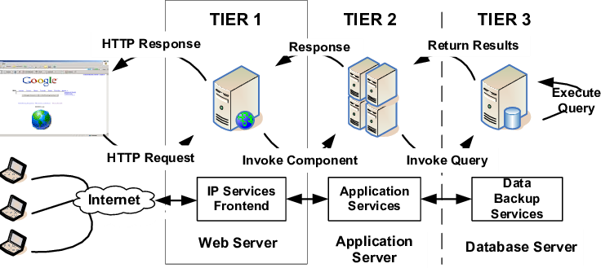
Figure 4 three-tier architecture server application

The webserver receives a request from the client first. The application server, which is in the middle tier, receives it from the third tier (such as the database server) and sends it back to the web server. The web server then transmits it to the middle tier, or the application server. The client then receives the necessary information from the web server. The processing of requests by web servers involves a variety of techniques, including JSP (Java Server Pages), CGI, ASP (Active Server Pages), Java Scripts, Java Servlets, etc.
Application servers are utilized in a significant number of applications today. The following are a few examples: JBoss, Websphere, Weblogic, Glassfish, Tcat Server, Apache Geronimo, JRun, Oracle OC4J, Sun GlassFish Enterprise Server, SAP Netweaver AS, and Sybase Enterprise Application Server.

Use of Application Servers
The main purpose of the application server is given below:
A mechanism for reducing the size and complexity of the client programs. For the need to cache and control the data flow for better performance.
A mechanism for implementing security for data as well as end-user traffic.

Advantages of Application Servers
  - Offers a way to manage all the parts and conduct operations like session management and synchronous and asynchronous client notifications.
  - Any configuration change, including relocating the Database server, may be handled centrally from a single place.
  - It enables fault tolerance with the ability to recover/failover recovery.
  - It makes it possible to assign requests to various servers in accordance with their availability. Load balancing is used to accomplish this.
  - It becomes very easy to install applications in one place.
  - Patches and security updates are easy to deploy through them.
  - It provides security to applications.
  - We can save a lot of time if we don't have to install a copy of the configurations on each machine separately.
  - It supports transaction support.
  - When it comes to performance, the application server greatly improves application performance as it is based on the client-server model.

Types of Application Server
- Active Application Server – For business logic that is involved on the server side and is described in the form of rules, components, and objects, this server is used to give support and a rich environment. These servers are also known as stateful servers.
- Web Information Server – By using HTML templates, this kind of server creates pages using data from a database. Stateless servers are another name for these kinds of servers.
- Component Server – Software like COBRA, DLL, and Java Bean primarily rely on this program to give them access to databases. It also offers assistance with requests for transaction processing.

Server Design
Confirm server design with client: Confirming that the project information is accurate and up-to-date and that the customer accepts the defined specs and design is the first stage in creating and installing a server.
You will need to reconfirm with the client
    - The role of the server,
    - How it will function with the remaining IT infrastructure, and the required configuration.
Functional requirements: capture the system's intended behavior. The system must carry out this behavior, which might be described as a service, task, or function.
The functional requirements documents serve as the project's "blueprint" for execution.
Requirements issues: Confirming client needs and making sure they agree that the requirements have been accurately collected and signed off on are some of the first and most crucial tasks to start when verifying server specifications. Documenting the requirements is one of the tasks involved in confirming the client's needs.
This may include identifying: business case, IT infrastructure, cost, Security (user level access & privilege), overlapping requirements, maintenance and backup requirements, bandwidth issue, nature of the data (text, multimedia, etc.),

Functional requirements specification
The functional specification describes what the system will do, as opposed to how it will be done. This distinction is important because
- The client may not be interested in the details of how a function is implemented, and the technical details may simply cause confusion for the client
- The implementation details may need to change during the design and development of the project
- You don’t want to have to negotiate changes to the functional specification just to change details of implementation
- The technical specification for large projects will be detailed in a separate document, and you should not entangle one with the other.

User requirements
- How many users are expected to use the system?
- How many people will be utilising the solution at one time?
- Where the users will be located (e.g. overseas, interstate or at home?

Technical requirements
- What types of computers/operating systems will the users operate?
- Are their desktops all the same?
- What bandwidth restrictions occur presently?
- What security (login) will they need?
- What backup policies need to be in place?
- Who will have administration rights?
- What does management expect the system will do and won’t do?

Hardware
- Compatibility: will the solution work with existing systems?
- Support for proprietary formats: will the existing systems and architecture support all types of data?
- Will the new system be supported by existing resources within the company?
- What is the backup strategy? Has this been costed?
- Does the system need to be redundant, load balanced or clustered?
- Will there be time delays to purchase and install hardware?

Software
- What is the true cost of the software?
- Are there licensing issues? As the system is in development, should you pay for all the licensing now or when the system is in live mode?
- Can the software be licensed for use by multiple users who use it on different machines? (Concurrent licensing)
- What happens if the software company becomes insolvent? Who supports it?
- Who owns the source code?
- Does the solution work with all other company software systems?
- If web-based, does the solution function on all common browsers?
- Does the software support all file formats?
- Is the software easy to use, or are there major training issues/costs?

Identifying product, vendor architecture and equipment
Server Product refers to the elements of Licensed Products running on the devices serving as hosts for any AOL Services. The Server Product's features include exchanging data with the Client Product, storing data, exchanging data via gateways used by third-party services, and managing such AOL Services.

A "server product" is a product that is hosted on a server and offers features that users can access by connecting to the server through client software or mobile apps.

Identify specifications

It's time to consider finding products that meet the solution when requirements have been established and client wants have been addressed. In this situation, our attention must be on potential server solutions. Keep in mind that a server is made up of hardware, Software and Network connections.
When choosing equipment, several server design types must be taken into account. There are numerous server architectures available, such as Mainframe architecture, File sharing architecture, Client/server architecture; Web based architecture, thin client architecture and Blade architecture.

Platform selection
Early in the project lifecycle, platform selection is a crucial factor. The majority of projects cannot be changed mid-project due to the several aspects, including protocols and file formats, which are set needs.
Server platforms come in a variety of shapes and sizes and are made to handle a wide range of tasks. The platform used by a server will primarily depend on the service being offered. A server can provide a number of different tasks, including mail services, web services, transactional processing services, streaming media services, remote access services, file storage and retrieval services, network access, and application services.

Vendor architecture
The architecture of a server determines how it works. The arrangement of a server when it is functioning as a server is referred to as server architecture.

Identify vendor architecture
Specific server architectures and platforms are supported by each manufacturer in the market.
You must take into account each vendor's hardware and software platforms when choosing the server's hardware.
In computing, the term "hardware platform" describes the system's hardware components.
When we talk about software platforms, we're talking about the operating system or programming language created for the hardware. In the IT business, words like Wintel, Lintel, Mac, Mainframe, UNIX, Alpha AXP, and Java are used to define the many types of platforms.
A server's architecture can be defined by:
- How it communicates with other devices
- The types of operating systems it uses
- Hardware and software components
- Storage and computing capabilities
- The security functions within its systems

Identifying technology and resource

Hardware and software specifications
The server manuals and the manufacturer's website both contain comprehensive information regarding server hardware.
The server vendor will, at the very least, have a list of the server's components.

Identify and evaluate resources

Identify server technologies
The state of information technology is rapidly evolving and changing all the time. Processors, Random Access Memory, Storage, and Optical Drives are common hardware technologies.

System requirements
You must make sure that any minimal system requirements for hardware and software components are met.
These details can be found on manufacturer websites in the form of whitepapers, installation guides, and product overviews.
- In order to use software, your computer must meet the following minimal requirements: operating system, RAM, type and speed of the CPU, and accessible disc space.
- for hardware components you will need to ensure compatibility with the existing system
  - processor — ensure motherboard support for new CPU is available
  - memory — ensure type and size is compatible with the motherboard
  - Hard drives and optical drives — ensure that there is an available drive bay, power cable and interface connection.
  - Expansion cards — ensure that there is a suitable expansion slot for installation of the expansion card.

Software
How many licences are needed will affect the price of the software while it is being evaluated.
A licence is a contract with specific terms that permits the usage of software.
Buying the appropriate types and combinations of licences is a crucial component of managing software licences. The following software licences are available:
- A site licence for a number of computers at a particular office
- A licence assigned to a specific computer
- A licence assigned to one specific user.

Self-Check
- What does a network operating system mean?

- What various network operating system types are there?

- What are the fundamental characteristics of a network operating system?
- Give an instance of a network operating system.

- Discuss Application Server in light of this course.

- Why would you need an application server?

- State the prerequisites for server design.

- What kind of products, vendor architectures, and equipment standards are required to identify as per a system?
- Assuming you have a system, list its resources and technologies while keeping in mind the needs of the business.

Chapter 2

Verify server compatibility and inter-operability

Reviewing Hardware and software to ensure compatibility
Numerous elements, including the operating system, hardware, browser, network, and software, have an impact on compatibility with various environments. For instance, you should test your program on many versions, updates, and configurations of operating systems including Windows, Linux, Mac, Android, and iOS.
You should also test your program on a variety of hardware, including desktops, laptops, tablets, smartphones, CPUs, RAM, hard drives, screen sizes, and resolutions. The same applies to testing your software on many web browsers, including Chrome, Firefox, Safari, and Edge with the most recent upgrades and configurations.
You should also test your software under various network situations, such as bandwidth latency, packet loss, firewalls, and proxies, among others. Finally, you should test your software against various software dependencies, including their updates, versions, and compatibility. These dependencies include libraries, frameworks, plugins, drivers, etc.
In order to guarantee that software functions flawlessly on a variety of platforms and devices, compatibility testing is essential. Operating systems, screen resolutions, device kinds, and browser versions are among the variables to take into account. Device emulators and tools like Lambdatest, BrowserStack, Sauce Labs, and others aid in simulating various settings.
Prioritizing testing scenarios is also made easier with the help of user demographic analysis. Compatibility ensures a consistent user experience, increases user reach, and reduces bugs. Utilize the appropriate tools for reliable software performance and conduct a thorough evaluation of compatibility criteria to stay ahead.

Factors:
Operating Systems, Browsers, Mobile Devices, Network Environments, Hardware Compatibility, Third-Party Software, and Localization: If your software is intended for a global audience, ensure it supports multiple languages, character encodings, and cultural preferences.

Tools for compatibility testing
The use of several tools can make compatibility testing simpler. A cloud- based platform called BrowserStack enables users to test software on actual hardware and browsers while using various operating systems and network configurations. When compared to BrowserStack, Sauce Labs offers more capabilities including live debugging, video recording, and statistics.
Another cloud-based testing tool is LambdaTest, which offers performance, visual, responsive, and cross-browser testing. In contrast to VMware, which is commercial software and has more sophisticated functionality and support, VirtualBox is free and open-source software that enables the operation of numerous virtual machines on a computer.

Benefits of compatibility testing
Compatibility testing has several benefits for your organization and software development process. One of the main advantages of compatibility testing is that it helps you to provide users with consistent, satisfying experiences, which increases user retention and happiness.
Additionally, by identifying and resolving any flaws early on, compatibility testing helps raise the caliber and dependability of your product. Finally, by supporting a variety of situations and scenarios, it can increase your market reach and competitiveness by enabling you to draw more clients from various areas, categories, and preferences.
Making sure that your product functions flawlessly across several platforms and operating systems is crucial if it is utilized by millions of users.
We use BrowserStack to run our tests in the cloud across various browsers, operating systems and even platforms including MacOS, Windows, Android and iOS.

We have also automated these tests so we can watch and debug whenever there are failures for any specific platforms.

Challenges of compatibility testing
Compatibility testing can provide challenges that must be overcome, including high costs and complexity since it necessitates the acquisition, upkeep, and updating of numerous hardware, software, and network resources or the use of third-party services that demand fees.
Additionally, testing your software across a variety of contexts and scenarios, then analyzing and reporting the results, may be time- and resource-consuming. Keeping up with the many upgrades and changes to the platforms, gadgets, browsers, and networks you support can also be difficult.

Best practices for compatibility testing
You should define your compatibility requirements and scope, use tools and processes that are appropriate for your purposes, and test frequently in order to optimize the advantages of compatibility testing and overcome the difficulties. Concentrate testing efforts on the environments and scenarios that are most pertinent to your program and target market after identifying and ranking them.
Select the methods and technologies that will enable you to recreate, automate, or emulate the environments and scenarios that you must test. Make sure they adhere to your criteria for quality, cost, and timeliness. Conduct compatibility testing from design to deployment, continuously updating tests to reflect changes to supported environments and situations.

Ensuring Hardware Compatibility
- Networking is hardware-dependent, and not all hardware products are compatible.
- In order for two computers to communicate, they must use the same protocol.
- Computer hardware raises similar issues. In some instances, two pieces of hardware simply can't communicate with each other. For example, consider an analogy to automobile parts: two parts might look alike and be able to perform the same function, but each is designed to work in a different car.
This lesson examines the issue of ensuring hardware compatibility and what you can do to resolve incompatibilities.
After this lesson, you will be able to:
    - Determine hardware compatibility issues.
    - Take steps to avoid unnecessary hardware problems.

Obtaining all hardware required
Hardware compatibility issues are an everyday occurrence. A huge number of manufacturers create hardware and software in the modern computer industry.
Each developer will offer a different answer because they each have a different viewpoint on how to complete a given task. The situation is made more challenging by copyright and patent issues.
A significant portion of network installation planning involves assessing and choosing hardware. You'll probably need to build a network using a collection of hardware that already exists. In such circumstances, there is a very high probability that issues brought on by incompatible hardware may develop. Sometimes it is more economical to throw out the old equipment and start over.
The most common incompatibilities occur between hardware and software. Changing or upgrading a computer or network operating system can lead to major problems.
Reading the Documentation
Read every piece of documentation related to the products at hand. There could be a recurrent issue with the hardware or software, or it could be incompatible with another product.
Usually, the manufacturer will list these issues and offer a resolution. You could get in touch with the product's maker and request any unresolved conflicts if you cannot find the answer in the provided documentation.

Checking Minimum Requirements
Make sure you have more resources than what is required for the computer as a first step before installing. These resources include the memory, disk space, and CPU performance. Table outlines some necessary server 2008 hardware.

Criteria | 2008 |  | 2008R2
Criteria | Minimum | Recommended | Minimum | Recommended
CPU | 1 GHz (IA-32)  1.4 GHz (x86- 64 or Itanium) | 2 GHz or faster | 1.4 GHz (x86- 64 or Itanium) | 2 GHz or faster
RAM | 512 MB | 2 GB or greater | 512 MB | 2 GB or greater
HDD | Other editions, 32-bit: 20 GB  Other editions, 64-bit: 32 GB  Foundation: 10 GB | 40 GB or greater | Foundation: 10 GB  Other editions: 32 GB | Foundation: 10 GB or greater  Other editions: 32 GB or greater
Devices | DVD drive, 800 × 600 or higher display, keyboard and mouse
Table 1 Minimum Hardware Requirements for server 2008

Network Hardware
Software is more susceptible to conflicts and incompatibilities than network hardware.
The fundamentals of the operation of repeaters, bridges, routers, and gateways are covered in the section on connectivity devices. These devices are less likely to cause conflicts because they are common to many different kinds of networks and mostly use data packets. These items' producers uphold tight adherence to IEEE 802.x specifications.
Any device that complies with an IEEE standard can therefore communicate with another device that complies with the same standard. Only when two devices adhere to various standards may incompatibility problems be anticipated to occur.

Installing required operating system and software
Operating system setup refers to the process of installing the OS and starting it up. The most typical installation method for a home or small business is with CDs or DVDs, even though it is possible to install an OS over a network from a server or from a local hard drive.
Depending on the operating system version you are installing, the procedures for installing an operating system, such as Linux or Windows, may vary. Each version is exclusive to that operating system and has various procedures, prerequisites, and options. Each operating system also has different needs in order for your computer to function properly.
There are two types of installation for your selection:
    - Guided Install: Install an operating system and device drivers in an unattended mode.
    - Manual Install: Install an operating system and device drivers manually.
Detection during Installation
Your computer will typically make an effort to identify the hardware in the system during the installation process of a new computer or network operating system and load the necessary drivers for it.
Verify that the hardware listed in the list matches what is already installed in the machine. The install application will automatically check your computer for hardware such as hard drives, CD-ROM drives, and NICs if you are installing Novell's Intranet Ware, for instance. The correct drivers will then be loaded for the detected devices if the devices are recognized.

Installing additional tools or third-party software
A computer program known as third-party software is one that was created or developed by a company other than the one that created the computer's operating system. For instance, third-party software is any application that runs on a Microsoft machine but was not developed by Microsoft.
Outside of the Android Market, third-party Android app stores like AppStore, SlideMe, Handango, and GetJar as well as game companies like Gameloft have been selling their products for some time.
Every day, you probably use a lot of third-party applications. Products from Microsoft Office, such as Word and Excel, email services like Outlook or Gmail, and antivirus programs like McAfee or Norton are a few examples.
Why use third-party software?
What are the chief benefits of third party software?
Using third-party software, developers add new features quickly with existing components instead of writing new codes from the beginning. For instance, if a developer plans to create an app to deliver an online service, the addition of a chat box into the app would be helpful.

Patching operating system and applications
What is OS patching?
Operating system patching is the process of installing software updates to operating systems that are already installed in your environment to keep them safe, secure, and shielded from outside dangers. The IT environment is evolving. BYOD, different operating systems, and even end users accessing corporate systems through public networks all pose difficulties for IT departments trying to manage an ever-expanding infrastructure of dependencies. Keeping track of new OS patch releases from vendors and providers, as well as the danger of cyber threats to the service ecosystem, increases as complexity rises. With those difficulties in mind, maintaining cross-platform patch management and developing a strong patching strategy are more important than ever.
Why is OS patching important?
OS patching can make the difference between a system that is well-supported and one that is susceptible to unexpected downtime and performance problems. Here are some important advantages of a thorough method for OS patching
    - Compliance: A regular patching schedule is now mandated by regulations or insurance instructions in many organizations. Penalties for non- compliance might be very harsh.
    - Availability: As an IT expert, you are only as good as your most recent error, which is a terrible fact. Maintaining system patches will avoid prolonged system outages brought on by security threats and emergency/remedial patch activity.
    - Performance: Software flaws can cause devices to crash, so by keeping your services patched, you can ensure that they have the most recent security updates and bug fixes.
    - Security: The absence of operating system patches is a frequent reason for network security breaches. Regular patching reduces the possibility of data loss and infrastructure damage by hastening the installation of upgrades. :
    - New features: Patches are not always about protection from malware or fixing bugs. Sometimes patches can include new features that can give users greater functionality.

Application Patching
Computers under management have their software updated to utilize secure versions. The following programs are among those that will need to be patched: 7- Zip, Adobe Acrobat, Adobe Reader, Adobe Flash Player, AnyConnect Secure Mobility Client (Campus VPN), FileZilla, Firefox, Google Chrome, ITS QuickSupport, iTunes, Java, Microsoft Office, and Sophos SafeGuard.
If we are aware that vulnerable versions are in use and we have the ability to deploy updates, we may fix other programs for security reasons.

Self-Check
- Which hardware and software elements are examined for compatibility?
- What hardware is necessary for installing servers?

- What are the prerequisites for installing a window server?

- What software and operating system must be installed in a system for it to function properly?
- What exactly are third-party programs? Why are they there?

- Why are application software patches and operating system patches used?

Chapter 3 Configure and test server
Before you begin the actual installation of Windows Server 2008, you must make several decisions. How well you plan these steps will determine how successful your installation is.
    - Verifying Minimum Hardware Requirements: The first step of the installation is verifying that your hardware meets the system requirements.
    - Choosing a New Installation or an Upgrade: If you have an existing Windows environment, you may need to perform a new installation or upgrade an existing server.
    - Determining the Type of Server to Install: You have the choice of making your server a domain controller (DC), a member server, or a standalone server.
    - Gathering the Information Necessary to Proceed: During the installation of Windows Server 2008, you will have to tell the Setup Wizard how you want your server configured.

Active Directory domain services (ADDS)

Information on networked objects is kept in a directory, which is a hierarchical structure. In order to store directory data and make it accessible to network users and administrators, a directory service, such as Active Directory Domain Services (AD DS), is provided. For instance, AD DS keeps user account information, including names, passwords, phone numbers, and other details, and allows other authorized users on the same network to access it.
In order to make it simple for administrators and users to access and use this information, Active Directory saves information about network objects. Information about directories is logically and hierarchically organized by Active Directory using a structured data store as the foundation.
The directory, which is another name for this data store, houses details on Active Directory objects. Common examples of these things are shared resources like servers, volumes, printers, network users, and computer accounts.

Active Directory integrates security through login authentication and access control to directory items. Administrators may control directory information and organization throughout their whole network with a single network logon, and authorized network users can access resources anywhere on the network. Even the most complicated network can be managed more easily with policy-based administration.
Active Directory includes:

    - The directory's classes of objects and attributes, the restrictions and limitations placed on instances of these objects, and the format of their names are all defined by a set of rules known as the schema.
    - a comprehensive database that details each item in the directory. This makes it possible for users and administrators to access directory information independent of which directory domain actually houses the information.
    - a query and index method that allows network users or programmes to search for and find objects and their properties.
    - a service that replicates directory data and disperses it throughout a network. A domain's domain controllers all take part in replication and have a complete copy of the domain's directory data on them.

Requirements for Active Directory Domain Services
Let's go through some of the requirements for a fresh install of Active Directory Domain Services. Some of these will be required to be done before hand; others as noted can be done during the install:

      - Install Windows Server 2008

      - Configure TCP/IP and DNS networking configurations

      - The disk drives that store SYSVOL must be on a local drive configured NTFS
      - Active Directory requires DNS to be installed in the network. If it is not already installed you can specify DNS server to be installed during the Active Directory Domain Services installation.

DNS server
The phonebook of the Internet is the Domain Name System (DNS). DNS is in charge of determining the correct IP address for websites when users enter domain names like "google.com" or "nytimes.com" into web browsers. When communicating with origin servers or CDN edge servers to obtain website content, browsers use such addresses. All of this is made possible by DNS servers, which are computers that only deal with DNS inquiries.
A server is a tool or program created specifically to offer services to other program, sometimes known as "clients." The majority of contemporary desktop and mobile operating systems include DNS clients that let web browsers communicate with DNS servers. The Client-Server Model has more information.
How do DNS servers resolve a DNS query?
Recursive resolvers, root nameservers, TLD nameservers, and authoritative nameservers are the four servers that collaborate to give an IP address to the client in a normal DNS query without any caching.
The DNS recursor, also known as the DNS resolver, is a server that processes requests from DNS clients and searches among other DNS servers for the right IP address. The resolver really acts as a client after receiving the client's request and queries the other three categories of DNS servers to find the correct IP.
The resolver first makes a query to the root nameserver. The root server is the initial place where human-readable domain names are converted (resolved) into IP addresses. The address of a TLD DNS server (such as.com or.net), which holds the data for its domains, is then returned to the resolver by the root server.
The resolver then makes a query to the TLD server. The authoritative nameserver for the domain's IP address is returned by the TLD server in response. The authoritative nameserver will respond with the IP address of the origin server when the recursor has contacted it.

Active Directory Lightweight directory services (ADLDS)
AD LDS provides dedicated directory services for applications. It provides a data store and services for accessing the data store. It uses standard application programming interfaces (APIs) for accessing the application data. The APIs include those of Active Directory, Active Directory Service Interfaces, Lightweight Data Access Protocol, and System Directory Services.
AD LDS operates independently of Active Directory and independently of Active Directory domains or forests. It operates either as a standalone data store, or it operates with replication. Its independence enables local control and autonomy of directory services for specific applications. It also facilitates independent, flexible schemas, and naming contexts.
The infrastructure capabilities of Active Directory are not shared by AD LDS.
Since directory services for the Windows operating system are not included in AD LDS, it focuses on the needs of certain applications. AD LDS can use Active Directory for authentication if it's running in an Active Directory environment. Microsoft Exchange cannot use AD LDS because it does not support the Messaging Application Programming Interface.
The use of AD LDS complements Active Directory.
Although Active Directory and AD LDS can coexist in the same network, AD LDS caters to the needs of particular applications. It is possible to create an instance of AD LDS for a particular application without having to worry about the dependencies that Active Directory needs. You can install AD LDS without it having an impact on Active Directory. A single AD LDS installation can support many instances of AD LDS, each serving a different application.
User Groups and Organizational Units are two great ways of keeping your Active Directory organized and controlled.

DHCP servers
Dynamic Host Configuration Protocol (DHCP) is a core infrastructure service on any network that provides IP addressing and DNS server information to PC clients and any other device. DHCP is used so that you do not have to statically assign IP addresses to every device on your network and manage the issues that static IP addressing can create. More and more, DHCP is being expanded to fit into new network services like the Windows Health Service and Network Access Protection (NAP).
A client/server protocol called Dynamic Host Configuration Protocol (DHCP) automatically assigns an Internet Protocol (IP) host with its IP address and other necessary configuration data like the subnet mask and default gateway. The Internet Engineering Task Force (IETF) defines DHCP as a standard based on the Bootstrap Protocol (BOOTP), a protocol with which it shares many implementation specifics, in RFCs 2131 and 2132. With DHCP, hosts can get the necessary TCP/IP setup data from a DHCP server.
A networking server role that you can deploy on your network to lease IP addresses and other information to DHCP clients is included in Windows Server 2008 called DHCP Server. The DHCP client is a component of TCP/IP that is present in all Windows-based client operating systems, and it is always turned on by default.
Why use DHCP?
To connect to a TCP/IP-based network and use its resources, each device needs a distinct unicast IP address. Without DHCP, it is necessary to manually assign IP addresses for new computers, computers that are transferred from one subnet to another, and computers that are withdrawn from the network.
This entire procedure is mechanized and centralized with DHCP. Any DHCP- enabled client that joins the network receives a lease on an IP address from the DHCP server, which manages a pool of IP addresses. As opposed to static (permanently allocated) IP addresses, which are dynamic (leased) instead, addresses that are no longer in use are automatically returned to the pool for reallocation.
Advantages of DHCP
DHCP offers the following advantages.

- Dependable setting of IP addresses. DHCP reduces setup problems brought on by manual IP address configuration, such as typos or address conflicts brought on by simultaneously assigning IP addresses to multiple computers.
- Decreased network management. The following characteristics of DHCP are included to minimize network administration:
- TCP/IP configuration that is automated and centralized.
- a central location from which to define TCP/IP setups.
- the capacity to use DHCP options to assign a broad variety of additional TCP/IP configuration settings.
- a wireless network's ability to handle IP address changes for clients that must be updated often, such as portable devices that travel to different locations, in an effective manner.
- the transmission of the first DHCP messages

Hyper-V
Ever since Microsoft Hyper-V was released on Windows Server 2008, this hypervisor has been one of the most popular virtualization options on the market. With Microsoft Hyper-V you can create and run virtual machines without maintaining physical hardware.
Microsoft Hyper-V is important because it allows users to transcend beyond the limitations of physical hardware. Managing physical hardware is incredibly complex for larger organizations, who have to manage often disparate and out-of- date hardware. Managing these devices is not only time-consuming for administrators but also very costly.
Purchasing new hardware adds up very quickly, particularly when you take into account the amount of extra office space needed to fit these devices in. Enterprises have started to attempt to reduce costs and manage devices more efficiently. At the same time, modern devices have the storage, CPU, and RAM to be able to sustain a variety of virtual OS’s from one location making this even more effective.

Microsoft Hyper-V Definition
Hyper-V is a Microsoft virtualization product allowing you to create and run multiple VMs on a physical host.
Hyper-V is Microsoft's hardware virtualization product. It lets you create and run a software version of a computer, called a virtual machine. Each virtual machine acts like a complete computer, running an operating system and programs. When you need computing resources, virtual machines give you more flexibility, help save time and money, and are a more efficient way to use hardware than just running one operating system on physical hardware.
Hyper-V runs each virtual machine in its own isolated space, which means you can run more than one virtual machine on the same hardware at the same time. You might want to do this to avoid problems such as a crash affecting the other workloads, or to give different people, groups or services access to different systems.

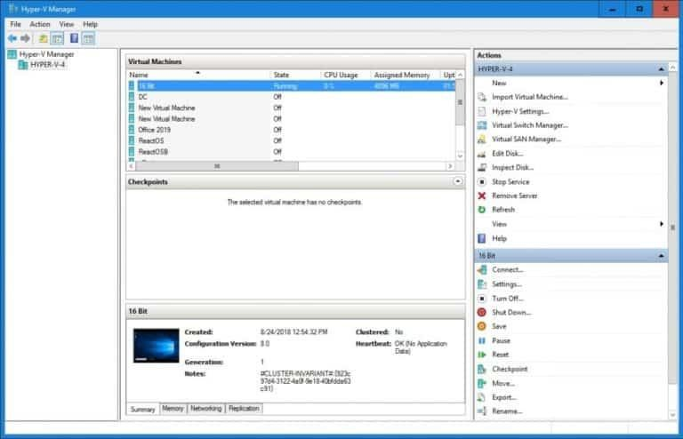

Advantages of using Microsoft Hyper-V
- Microsoft Hyper-V is a type of hypervisor. A hypervisor is a program used to host multiple virtual machines on one single piece of hardware. Every virtual machine has its own applications and programs separate from the underlying hardware. Hyper-V is one of, if not the, most famous hypervisor in the world.
- Hypervisors like Hyper-V are used for many different reasons depending on the environment in which they are deployed. In general, Hyper-V helps network administrators create a virtualized computing environment in a format that is easy to manage. From one piece of hardware an administrator can manage a range of virtual machines without having to change computers.
- Hyper-V can be used for many different purposes but it is most commonly used to create private cloud environments. You deploy Hyper-V on servers to produce virtual resources for your users.
Specifically Hyper-V Can be used for:

- Capability to create a virtual switch: The role of a virtual switch is to allow VMs to have better communication with each other. Hyper-V creates such switches to intelligently inspect and forward data packets before routing communication or moving them to their destination.
- Effective use of hardware resources: It helps consolidate servers and reduce workloads by isolating virtual OSes and uses less power, human resources, and infrastructure resources such as systems, storage, CPU, and memory.
- Establishes the private cloud environment: It’s highly scalable and provides flexibility to use a single physical Hyper-V server as multiple virtual servers. It also offers on-demand IT services by expanding the use of shared resources.
- Business agility and data security: By establishing and expanding virtual desktop infrastructure with Hyper-V, you can centralize business-critical information, applications, and OSes for better data management and data integrity. It also helps to track, simplify, and streamline various business operations.
- Efficient development and testing: Hyper-V allows you to install multiple VMs with different OSes on a single Hyper-V server, making it easier and more convenient to develop and test applications.

Microsoft Hyper-V features
Hyper-V offers many features. This is an overview, grouped by what the features provide or help you do.
- Computing environment - A Hyper-V virtual machine includes the same basic parts as a physical computer, such as memory, processor, storage, and networking. All these parts have features and options that you can configure different ways to meet different needs. Storage and networking can each be considered categories of their own, because of the many ways you can configure them.
- Disaster recovery and backup - For disaster recovery, Hyper-V Replica creates copies of virtual machines, intended to be stored in another physical location, so you can restore the virtual machine from the copy. For backup, Hyper-V offers two types. One uses saved states and the other uses Volume Shadow Copy Service (VSS) so you can make application-consistent backups for programs that support VSS.

- Optimization - Each supported guest operating system has a customized set of services and drivers, called integration services, that make it easier to use the operating system in a Hyper-V virtual machine.
- Portability - Features such as live migration, storage migration, and import/export make it easier to move or distribute a virtual machine.
- Remote connectivity - Hyper-V includes Virtual Machine Connection, a remote connection tool for use with both Windows and Linux. Unlike Remote Desktop, this tool gives you console access, so you can see what's happening in the guest even when the operating system isn't booted yet.
- Security - Secure boot and shielded virtual machines help protect against malware and other unauthorized access to a virtual machine and its data.
How to get Hyper-V
Hyper-V is available in Windows Server and Windows, as a server role available for x64 versions of Windows Server. On Windows, it's available as feature in some 64- bit versions of Windows. It's also available as a downloadable, standalone server product, Microsoft Hyper-V Server. The Minimum Requirements of Microsoft Hyper-V: Windows Server 2008, Windows 8, 4GB RAM and CPU
How Hyper-V works
Hyper-V is a hypervisor-based virtualization technology. Hyper-V uses the Windows hypervisor, which requires a physical processor with specific features.
In most cases, the hypervisor manages the interactions between the hardware and the virtual machines. This hypervisor-controlled access to the hardware gives virtual machines the isolated environment in which they run. In some configurations, a virtual machine or the operating system running in the virtual machine has direct access to graphics, networking, or storage hardware.
What does Hyper-V consist of?
Hyper-V has required parts that work together so you can create and run virtual machines. Together, these parts are called the virtualization platform. They're installed as a set when you install the Hyper-V role. The required parts include Windows hypervisor, Hyper-V Virtual Machine Management Service, the virtualization WMI provider, the virtual machine bus (VMbus), virtualization service provider (VSP) and virtual infrastructure driver (VID).

Active directory certificate services
What is Active Directory Certificate Services?
Active Directory Certificate Services (AD CS) is a Windows Server role for issuing and managing public key infrastructure (PKI) certificates used in secure communication and authentication protocols.

Issue and manage certificates
Digital certificates can be used to encrypt and digitally sign electronic documents and messages as well as for authentication of computer, user, or device accounts on a network. For example, digital certificates are used to provide:
    - Confidentiality through encryption.
    - Integrity through digital signatures.
    - Authentication by associating certificate keys with the computer, user, or device accounts on a computer network.

Key features of Active Directory Certificate Services
AD CS provides the following important features:
    - Certification authorities: Root and subordinate Certificate Authorities (CAs) are used to issue certificates to users, computers, and services, and to manage certificate validity.
    - Web enrollment: Web enrollment allows users to connect to a CA with a Web browser in order to request certificates and retrieve certificate revocation lists (CRLs).
    - Online Responder: The Online Responder service decodes revocation status requests for specific certificates, evaluates the status of these certificates, and sends back a signed response containing the requested certificate status information.
    - Network Device Enrollment Service: The Network Device Enrollment Service allows routers and other network devices that don't have domain accounts to obtain certificates.
    - TPM key attestation: Lets the certification authority verify the private key is protected by a hardware-based TPM and that the TPM is one that the CA trusts. TPM key attestation prevents the certificate from being exported to an unauthorized device and can bind the user identity to the device.

    - Certificate Enrollment Policy Web Service: The Certificate Enrollment Policy Web Service enables users and computers to obtain certificate enrollment policy information.
    - Certificate Enrollment Web Service: Certificate Enrollment Web Service enables users and computers to perform certificate enrollment through a web service. Together with the Certificate Enrollment Policy Web Service, this enables policy-based certificate enrollment when the client computer isn't a member of a domain or when a domain member isn't connected to the domain.

Benefits of Active Directory Certificate Services
You can use AD CS to enhance security by binding the identity of a person, computer, or service to a corresponding private key. AD CS gives you a cost- effective, efficient, and secure way to manage the distribution and use of certificates. In addition to binding of identities and private keys, AD CS also includes features that allow you to manage certificate enrollment and revocation.
You can use existing endpoint identity information in Active Directory to register certificates, meaning you can have information automatically inserted into certificates. AD CS can also be used to configure Active Directory group policies to designate which users and machines are allowed which types of certificates. Group policy configuration enables role-based or attribute-based access control.
Applications supported by AD CS include Secure/Multipurpose Internet Mail Extensions (S/MIME), secure wireless networks, virtual private network (VPN), Internet Protocol security (IPsec), Encrypting File System (EFS), smart card sign in, Secure Socket Layer/Transport Layer Security (SSL/TLS), and digital signatures.

File services
File Server Resource Manager (FSRM) is a role service in Windows Server that enables you to manage and classify data stored on file servers. You can use FSRM to automatically classify files, perform tasks based on these classifications, set quotas on folders, and create reports monitoring storage usage.
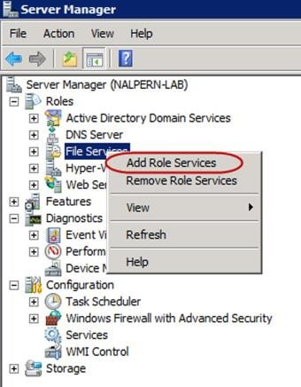

Features
FSRM includes the following features:
    - Quota management: Limit the space that is allowed for a volume or folder. These limits can be automatically applied to new folders that are created on a volume. You can also define quota templates that can be applied to new volumes or folders.
    - File Classification Infrastructure: Gain insight into your data by automating classification processes so that you can manage your data more effectively. You can classify files and apply policies based on this classification. Example policies include dynamic access control for restricting access to files, file encryption, and file expiration. Files can be classified automatically by using file classification rules or manually by modifying the properties of a selected file or folder.

    - File Management Tasks: Gain the ability to apply a conditional policy or action to files based on their classification. The conditions of a file management task include the file location, the classification properties, the date the file was created, the last modified date of the file, or the last time the file was accessed. The actions that a file management task can take include the ability to expire files, encrypt files, or run a custom command.
    - File screening management: Control the types of files that the user can store on a file server. You can limit the extension that can be stored on your shared files. For example, you can create a file screen that doesn't allow files with an MP3 extension to be stored in personal shared folders on a file server.
    - Storage reports: Use these reports to help you identify trends in disk usage and how your data is classified. You can also monitor a selected group of users for attempts to save unauthorized files.
You can configure and manage the FSRM features by using the FSRM app or by using Windows PowerShell.
NB: FSRM supports volumes formatted with the NTFS file system only. The Resilient File System isn't supported.

Print services

What is a print server?
A print server is a software application, network device or computer that manages print requests and makes printer queue status information available to end users and network administrators. Print servers are used in both large enterprise and small or home office (SOHO) networks.
Print servers accept print requests from computers, queue the requests, and then send the requests to specific printers. Print servers can also be physical or cloud- based.
Print servers help accommodate print requests that are received faster than can be handled. If an organization has many devices, or has these devices in different geographical locations, then print servers help provide more management and control over print requests.
In a large organization, a single dedicated computer acting as a print server might manage hundreds of printers. In a small office, a print server is often a specialized plug-in board or small network device about the size of a hub that performs the

same function as a dedicated print server, but frees up valuable disk space on the office's limited number of computers.
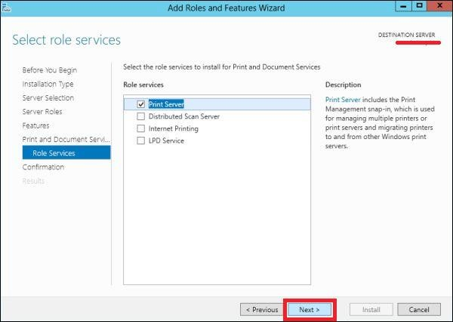
How does a print server work?
Software required for a print server can be either part of a server, network device, application or installed onto a computer operating system. The software is what enables dedicated network devices or computers to manage network printing.
- If servers are used, then the server connects to computers over a network, enabling them to communicate with available printers.
- Dedicated print server devices are connected to a printer through a USB, parallel or wireless connection. Devices typically have a connection to the local area network (LAN) and multiple other printers.
- Print servers installed on a computer are networked with multiple printers.
- Printers might also have built-in print servers.
Print servers operate on a client-server model. Print servers directly connect to network printers to maintain control over print queues. When a user under an authorized client requests to print a file, the print server is what receives the

request. The print server then processes request data like file and print specifications. The request is then sent to a specific network printer and queued. The files are then printed in the queued order on the specific printer.
Print servers might also support different standard and proprietary printing protocols. Printing protocols communicate between the clients making requests and the printers processing those requests.
These protocols are split between the following:
- Dedicated protocols, such as Jetdirect or Line Printer Daemon, which handle specific print operations.
- Generic protocols, such as Server Message Block (SMB), which treat printers as remote disks.
- Wireless protocols, such as AirPrint, which enable printers to be used by devices wirelessly.

Why an organization might need a print server
Print servers are most useful for organizations that have multiple printers and the need to print large amounts of documents. In this instance, they aid in managing the print queues for each connected printer. Other reasons why print servers are useful include the following:
- For managing multiple printers from a centralized location. This makes monitoring printer health, updating software and preventing bottlenecks easier for printers spread out in an office or across buildings.
- To improve efficiency, as print servers can manage the queue of each connected printer. Print servers can also send requests to faster local printers to better accommodate users.
- Processing power needed for printers to manage large queues are offloaded to a specific device.

Streaming media services
Windows Media Server or Web Server?
You can deliver digital media audio and video files and live streams either from a Windows Media server (a server that is running Windows Media Services) or from a Web server (a server that is running Internet Information Services (IIS)). Clients use different methods to receive digital media content from Windows Media servers and Web servers: they stream digital media from a Windows Media server and download digital media from a Web server.
With the broader availability of high-bandwidth networks and new media delivery features for IIS 7 and above, the differences that previously favored the use of a Windows Media server over a Web server for delivering digital media content have blurred. In non-multicast streaming scenarios, depending upon your business need, a Windows Media server or a Web server can both be viable options for digital media content delivery today.
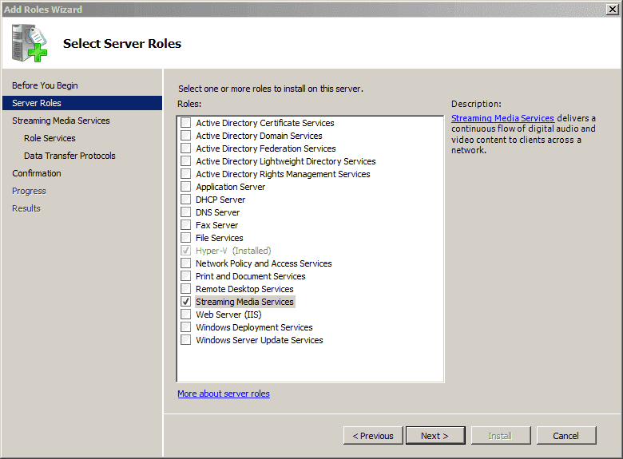

Windows Media servers
A Windows Media server is designed specifically for streaming on-demand and live digital media to clients. It provides high-quality streaming over a wide range of bandwidths to Windows Media Player and to Web browsers that use the Windows Media Player 9 Series ActiveX control or the Microsoft Silverlight browser plug-in. It is especially useful for streaming large amounts of data over busy, congested networks and low-bandwidth connections. Streaming uses bandwidth more efficiently than downloading because it sends data over the network only at the speed that is necessary for the client to render it correctly. This helps prevent the network from becoming overloaded and helps maintain system reliability.
Users that connect to a stream can start to play it almost immediately. If streaming on-demand content was indexed during encoding, they can use Seek functions (Fast-Forward and Rewind) on their player to jump to any part of the stream without waiting for a download to finish. Streaming prevents users from downloading files directly to their hard disk because the streaming data packets are delivered directly to the client application and discarded by the client application after they are rendered.
A Windows Media server supports delivery of a limited number of popular digital media file formats, including Windows Media Audio (WMA), Windows Media Video (WMV), and MP3. It also supports the use of JPEG files as media elements in server-side playlists or as banner graphics to be displayed in Windows Media Player.

Streaming vs. Downloading
Streaming: User Datagram Protocol (UDP) has long been the preferred transport protocol for traditional streaming media. It is a fast, lightweight protocol without any retransmission or data-rate management functionality, making it an ideal protocol for transmitting real-time audio and video data, which can tolerate some lost packets. UDP also has higher priority than Transmission Control Protocol (TCP)-based HTTP for Internet traffic, giving streaming audio and video data higher priority over file and Web page transfers and increasing the likelihood of uninterrupted viewing on congested networks. A Windows Media server also uses UDP Resend, an intelligent UDP-retransmission scheme that ensures that it only retransmits lost packets that can be sent to a player in time to be played, instead of the blind retransmission scheme employed by TCP. This smart-resend feature conserves additional bandwidth on congested networks.

A Windows Media server may stream digital media by using the Real Time Streaming Protocol (RTSP) with UDP-based transport (RTSPT) to take advantage of UDP-based streaming efficiencies. On networks that don't support UDP, the server is normally configured to use a process called protocol rollover to try TCP-based streaming, first by using RTSP, and if that doesn't work, it uses its own version of HTTP for firewalls that allow Web traffic through port 80. This enables corporate users to view Internet content without compromising firewall security and ensures that all users on all networks can access all streaming media content. For more information about the streaming protocols that are used by Windows Media Services, see Comparing HTTP Streaming Protocol with RTSP.
Downloading: The bandwidth-management capabilities that are present in a Windows Media server are lacking in a standard Web server. When a client requests digital media from a Web server, the Web server downloads the content to the client as fast as the network will allow without monitoring the quality of the delivery and adjusting the bit rate for the client in the way that a Windows Media server does. A client can start to play the content as soon as enough data is downloaded to its Internet cache (this is referred to as progressive downloading); however, in bandwidth-constrained systems, simultaneous requests from multiple clients can quickly saturate the available network bandwidth and clients must buffer more data to the cache before starting or resuming playback.
Downloading also uses the available bandwidth less efficiently than streaming. Web server content delivery uses HTTP, the standard Web protocol that is used by all Web servers and Web browsers for communication between the server and the client. HTTP operates on top of the TCP transport protocol, which handles all data transfers. TCP is optimized for non-real-time applications such as file transfer and remote log-in; therefore, it maximizes data transfer rates while ensuring overall stability and high throughput for the whole network. TCP achieves reliable data transfer by re-transmitting all lost packets, but it can't ensure that all resent packets will arrive at the client in time to be played, and so sometimes wastes bandwidth.

Windows Media Services
With its built-in bandwidth-management capabilities, a Windows Media server is an ideal way to deliver digital media content to large numbers of concurrent users using traditional streaming.
A Windows Media server sends data at the same bit rate as the content, leaving more bandwidth available for servicing concurrent client requests for content and

resulting in better quality audio and video for connected clients. There is typically a delay between the time the stream is received by a player and the point at which it starts to play because the player must first buffer some data in case there are delays or gaps in the stream. This buffer allows the media to continue playing uninterrupted, even during periods of high network congestion. Because data streaming and rendering occurs almost simultaneously, streaming also enables you to deliver live content. Windows Media Services contains many additional features that are used to optimize network throughput. This section describes two of the most important: Intelligent streaming and Fast Streaming.

Intelligent streaming
The most difficult task of streaming audio and video over a network is maintaining a continuous presentation to the user in a highly changeable environment. Buffering is the biggest problem of streaming digital media. It is caused when the client runs out of data in memory (the buffer) and must wait for more to arrive. The client will always run out of data if the bit rate of the incoming stream exceeds the current available bandwidth.
Unpredictability of bandwidth is taken for granted on the Internet. The actual bandwidth at any given point is determined by network conditions and traffic, which are constantly fluctuating. To ensure a continuous presentation during traditional streaming delivery, Windows Media technologies use intelligent streaming, which adjusts the bit rate of the content stream to counteract changes in available bandwidth. When a client first connects to a stream, intelligent streaming ensures that the client receives content at the bit rate that is most appropriate for the current bandwidth. As the stream plays, intelligent streaming is designed to dynamically and seamlessly adjust the bit rate of the streaming content as the available bandwidth changes.
Intelligent streaming progresses through a series of strategies to modify the bit rate of the stream so that it plays continuously on the client regardless of the current bandwidth. As bandwidth fluctuates between server and client, the server detects the changes and adopts the best strategy. The strategies are as follows:
- The server and client automatically determine the current available bandwidth, and then the server selects and delivers the stream with the most appropriate bit rate. This requires that the content be encoded as a multiple-bit-rate (MBR) stream.
- During transmission, if the bandwidth decreases, the server automatically detects the change and switches to a stream with a lower bit rate. If

bandwidth improves, the server switches to a stream with a higher bit rate, but never higher than the original bit rate. The process of selecting the appropriate stream is transparent to the user.
- If the bandwidth can no longer support streaming video, the client and server intelligently degrade image quality to avoid buffering. This method of decreasing the bit rate to accommodate the current bandwidth is called stream thinning. The server decreases the video frame rate first. If the bit rate is still too high, the server stops sending video frames.
- After the server stops sending video frames, it uses intelligent streaming to try to maintain a continuous audio stream. If audio quality starts to degrade, the client reconstructs parts of the stream to preserve quality.
IIS Media Services
IIS Media Services extensions are designed to add media delivery capabilities to a Web server that is running Internet Information Services (IIS) 7. The IIS Media Services extensions take advantage of the broader market availability of high- bandwidth networks, which make a Web server an increasingly practical option for digital media content delivery. This section describes the following streaming and bandwidth management extensions that are available in IIS Media Services:
IIS Media Services includes additional extensions that add Windows Media Services-like capabilities, such as server-side playlists and rich client logging, to Web servers running IIS. For more information about these extensions, and additional extensions that may be developed to enhance delivery of digital media content from Web servers,

Windows server Update Server (WSUS)

WSUS Definition
Windows Server Update Services (WSUS) enables information technology administrators to deploy the latest Microsoft product updates. You can use WSUS to fully manage the distribution of updates that are released through Microsoft Update to computers on your network. This article provides an overview of this server role and more information about how to deploy and maintain WSUS.

WSUS Server role description
A WSUS server provides features that you can use to manage and distribute updates through a management console. A WSUS server can also be the update source for other WSUS servers within the organization. The WSUS server that acts as an update source is called an upstream server. In a WSUS implementation, at least one WSUS server on your network must be able to connect to Microsoft Update to get available update information. As an administrator, you can determine, based on network security and configuration, how many other WSUS servers connect directly to Microsoft Update.
Update management is the process of controlling the deployment and maintenance of interim software releases into production environments. It helps you maintain operational efficiency, overcome security vulnerabilities, and maintain the stability of your production environment. If your organization can't determine and maintain a known level of trust within its operating systems and application software, it might have a number of security vulnerabilities that, if exploited, could lead to a loss of revenue and intellectual property. Minimizing this threat requires you to have properly configured systems, use the latest software, and install the recommended software updates.

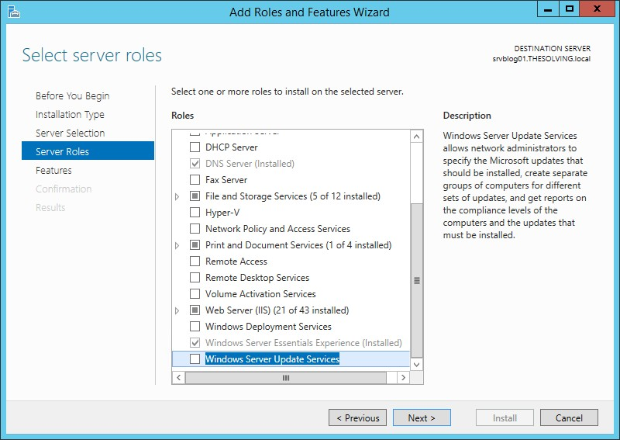

The core scenarios where WSUS adds value to your business are:
- Centralized update management
- Update management automation

Benefits of WSUS
Microsoft regularly releases several updates for its products, including critical updates, security updates, drivers, service packs, and tools, among others. Installing these updates on client machines is essential to patch security vulnerabilities and ensure client machines work as expected.
However, manually reviewing, approving, and installing updates is a tedious, time- consuming process. Moreover, manually ensuring all client machines received appropriate updates is error-prone and can make your IT environment vulnerable to cyber threats.

Using Windows Server Update Services, you can centralize and automate update management for Microsoft products. This helps you determine how and when to distribute updates and which machines require a specific update.
You can also scan to discover client machines pending update installations and schedule updates without interrupting employee productivity. This approach also helps save your corporate internet bandwidth as WSUS servers use your corporate intranet to distribute updates.
If you maintain a downstream server in a different branch location, you can allow the downstream server in your branch location to receive updates directly from Microsoft Update. With this approach, you can overcome bandwidth limitations between your central and branch locations.
As WSUS is a server role component of Windows Server operating system, it doesn’t require additional licensing if you’ve already purchased Windows Server licenses.

How does WSUS work?
WSUS works as a Windows Server role. You can deploy one or more WSUS servers depending on the number of client machines—including server machines whose updates you want to manage through WSUS—and other technical considerations in your organization’s IT network.
If you deploy more than one WSUS server, you can decide to connect one or more WSUS servers to Microsoft Update. The servers connected to Microsoft Update can act as an update source for the other WSUS servers in the IT network.
The WSUS servers that provide updates to other WSUS servers are called upstream servers. You can limit the number of upstream servers to one since one WSUS server can synchronize all other WSUS servers. This approach also helps limit the number of WSUS servers exposed to the internet.
However, if many downstream servers try to synchronize from an upstream server simultaneously, it can create intranet bandwidth and performance issues. Therefore, you should optimize the synchronization process for efficient performance.
You can deploy multiple WSUS servers as needed in multi-tier hierarchies to distribute updates more effectively to client machines located across various geo- locations. If you also manage mobile devices that join and leave your

organization’s IT network infrequently, you can allow them to get updates from the nearest WSUS server.
Once you have finalized the architecture and set up the upstream and downstream servers, you should allow and connect client machines to get updates from WSUS servers. Accordingly, whenever updates are available, you can review and test those updates and then distribute them to specific client machines. You can also define groups to manage client machines categorically and distribute updates based on group policies.

What are WSUS Server modes?
You can deploy WSUS servers in two different modes:
- Autonomous Mode
- Replica Mode
Autonomous Mode: This is the default installation option for Windows Server Update Services, and it helps implement distributed administration. A WSUS server set up in this mode only gets updates from an upstream server, but you should separately review, approve, and distribute the updates to the client machines connected to this server.
Replica Mode: This mode helps implement centralized administration. You don’t need to manage WSUS servers deployed in this mode separately. These servers get updates, approval statuses, and distribution policies from the upstream server.

Active directory rights management server
What is Active Directory Rights Management Services?
Sensitive information in an Active Directory environment can cause a great deal of trouble if it reaches the wrong hands. Every organization should do all in its power to avoid such a situation. Active Directory Rights Management Services (AD RMS) is a server role in Windows Active Directory, which aims to do just that. It has its own set of tools to help organizations work with security technologies and manage the rights on an organization’s intellectual property (that includes email messages, Microsoft Office documents, project information, contacts, etc.).
NTFS too can be used to specify access permissions on files and folders. However, NTFS permissions do not work outside the domain network, meaning no protection is offered to an organization’s information that is taken offsite. What makes it different from NTFS is that AD RMS has usage policies that follow the document wherever they are moved to. It also specifies a time period during which users can exercise control over the documents and perform actions such as modify, forward or print. Following its expiration, the documents become inaccessible to users. Note that even if a user gets full access through NTFS and only read-only permission through AD RMS, then the policies set by AD RMS holds.
AD RMS usage policy templates are customizable to suit the organization’s needs. For example, a template for a piece of confidential information may allow users to just view the content and not more. A template for the information that has to be renewed periodically can set an expiry date or validity period on the content. All such templates are stored in the configuration database.
AD RMS features are fully integrated into the Microsoft Office Suite. They can be extended to work with third-party applications using appropriate AD RMS Software Development Kits (SDKs), or other servers in a domain if they are AD RMS enabled.
What constitutes an AD RMS system?
It works on the basis of client-server interaction. To get the service up and running, the following are required:
- A Windows server that runs the AD RMS role. It takes care of licensing and handling certificates, and manages users, applications, and settings relevant to content access policies.

- A Windows AD RMS client. It takes care of encrypting and decrypting data in addition to acquiring licenses and certificates from the above-mentioned server.
- A database server such as a Microsoft SQL server that stores all information about the usage policies
How does AD RMS work?
The information that is to be protected is encrypted by AD RMS and stored in the AD RMS server. A user will be able to read or access the encrypted file only if he/she possesses the encryption key to decrypt this information. If a user is privileged to access the information, he/she will automatically be able to retrieve the key from the server and open the file. Even if the AD RMS-protected document is taken offsite, the user would need to contact the RMS server to retrieve the key.
As already mentioned the Active Directory Rights Management Services limits access to files or emails with the help of various certificates and licenses. The following are some of them:
- Server Licensor Certificate (SLC) contains the public key that encrypts the content key in a publishing license and allows the server to extract the content key and issue End User Licenses (EULs) against the publishing key.
- Rights Account Certificate (RAC) is issued when a user tries to access an AD RMS-protected content for the first time. The RAC helps to identify specific users.
- Client Licensor Certificate (CLC) allows a user to publish AD RMS-protected content to the client computer. The CLC public key encrypts the content key and includes it in the publishing license that it issues. CLCs are specific to a user’s RAC.
- Publishing License determines the rights applied to an AD RMS-protected content. It contains the content key, which is encrypted using the public key of the licensing service. It also has the URL and the digital signature of the AD RMS server.
- End User License (EUL) is needed to access the AD RMS-protected content. Every document is issued an EUL by the server.

Web server (IIS)

What is IIS?
The term "IIS" stands for Internet Information Services, which is a general-purpose webserver that runs on the Windows operating system. The IIS accepts and responds to the client's computer requests and enables them to share and deliver information across the LAN (or Local Area Network) such as a corporate intranet and the WAN (or Wide Area Network) the internet. IIS (Internet Information Services) or Windows Web Server is a web server that hosts websites and web applications. As it stands, IIS is the second most popular Windows web server in the world (second only to Apache HTTP).It hosts the application, websites, and other standard services needed by users and allows developers to make websites, applications and virtual directories to share with their users.
A web server provides the users with information in several different forms, such as File exchanges as a download, uploads, Images files, HTML pages, and text documents. The webservers are commonly used as a portal for sophisticated and highly interactive websites, applications that tie middleware and back-end applications together to make enterprise-grade-systems. For example, AWS enables media services such as Netflix to provide real-time streaming content.
Amazon web services also enable public cloud administration all through the webservers. Generally, the IIS is also compared with the Apache, which is also a kind of web server that is freely available for everyone. We can simply say that both works the same except that the apache web server can be used almost on any operating system such as Windows, Linux, and Mac, While the IIS is only available for windows. However, the IIS integrates with Microsoft's other products, such as the .NET Framework, the ASP scripting language.
The IIS also has its own helpdesk to manage and solve issues while, on the other hand, the Apache webserver's supports almost come from the user community. Additionally, the IIS has the security features, which makes it a more secure and efficient option than the Apache.

How IIS works
It works through several different standard languages and protocols. HTML is used for creating a variety of elements. For example, texts, buttons, hyperlinks, and direct/indirect behaviors. The HTTP (or Hyper Text Transfer Protocol) is used for exchanging the information between the two or more servers and users.

HTTPS (HyperText Transfer Protocol Secure) over the SSL (or Secure Sockets Layer) → uses SSL (secure sockets layer) to encrypt the communication to add additional data security. The FTP (or File Transfer Protocol), or its secure variant, FTPS, can transfer files.
Differences between IIS and Apache
- The IIS is only available for the Windows Operating System, but the Apache can be used on a variety of operating systems such as Mac, Linux, and Windows etc.
- The IIS has its own help desk to fix the issues, but in Apache's case, almost all of its support is provided by the user community.
- Internet Information Services can also integrate with the other several offspring or languages of Microsoft, such as ASPX scripting language.
- The security features of the IIS are more reliable than the Apache web server, which makes it a better option than the Apache.

Routing and remote access server
The Routing and Remote Access service (RRAS) supports remote user or site-to- site connectivity by using virtual private network (VPN) or dial-up connections.
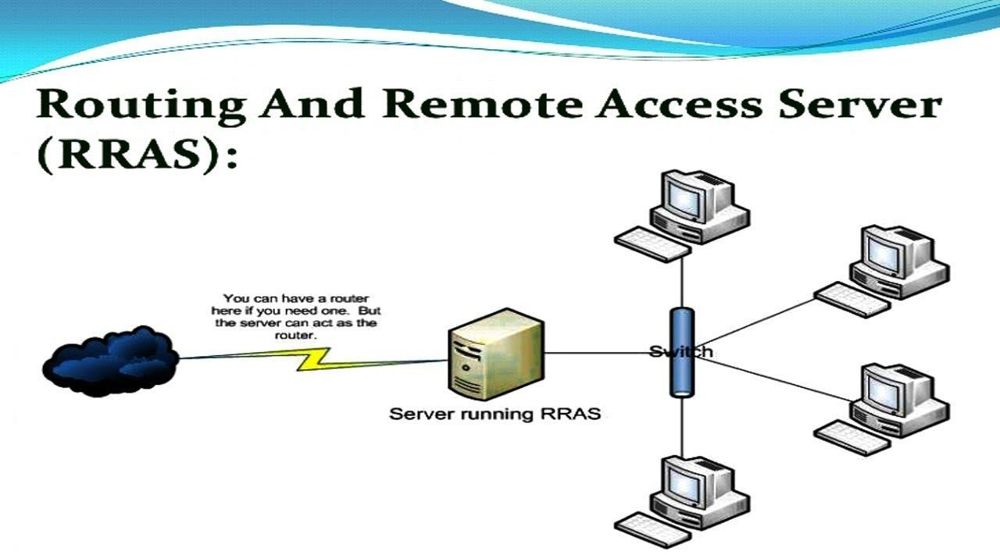

RRAS provides the following features.
    - RRAS Multitenant Gateway. If you are using Hyper-V Network Virtualization or you have VM networks deployed with VLANs, you can deploy RRAS as a virtual machine (VM)-based software gateway and router that allows Cloud Service Providers (CSPs) and Enterprises to enable datacenter and cloud network traffic routing between virtual and physical networks, including the Internet. With the RRAS Multitenant Gateway, tenants can VPN to their VM network resources in the datacenter from anywhere. You can also provide tenants with site-to-site VPN connections between their remote sites and your datacenter. In addition, you can configure the RRAS Multitenant Gateway with Border Gateway Protocol for dynamic routing, and you can enable Network Address Translation (NAT) to provide Internet access for VMs on VM networks.
    - Remote Access. By using RRAS, you can deploy VPN connections to provide end users with remote access to your organization's network. You can also create a site-to-site VPN connection between two servers at different locations.
    - Routing. RRAS is a software router and an open platform for routing and networking. It offers routing services to businesses in local area network (LAN) and wide area network (WAN) environments or over the Internet by using secure VPN connections. Routing is used for multiprotocol LAN-to- LAN, LAN-to-WAN, VPN, and network address translation (NAT) routing services.

Defining scope and applicability of testing
- Integrated tests are performed during a server development project
- A test is performed on the interoperability of each component.
- When complete, the testing process should verify that all the tests performed support the acceptance by the user of the totally integrated product.
- Tasks performed during stress and load testing of an integrated platform include

  - Establishing testing acceptance criteria and procedures
  - Performing test events
  - Diagnosing test results
  - Resolving software defects.

- Test events are designed to establish operational levels at which the new server starts to fail and to measure how it performs under overloaded conditions. The failure and performance levels are compared with the acceptance criteria and are either accepted or rejected.
- Test events aim to reveal failures such as
  - Total system crashes
  - Bottlenecks in interfaces between components
  - Data corruption
  - process overloading
  - Performance degradation below a usable level.

Developing test plan
    - The purpose of planning the testing process is to identify, conduct and review test events.
    - The planning process accesses user documentation and identifies the hardware and software components of the product.
    - Documents used for planning include the
- project plan, which states the objectives of the product and the operational environment
- Test plan, which details the scheduling and resources for all test events
- Functional specifications, which contain technical details of software modules.
    - When objectives, scope and tests have been identified, they are used to prepare the requirements documentation for each test.
    - Test requirements include
- Test objectives: list what the test is supposed to test
- Acceptance criteria: conditions for the test passing or failing
- Test environment: conditions under which the test is to be performed
- Roles and responsibilities
- Test script: steps to be performed during the test steps
- Results: procedures for processing and authorizing results.

Running system test
Windows Server testing is primarily stress-oriented testing that includes client/server I/O, network stress, CPU consumption, and memory consumption. The specific test you must run depends on the features that you implement on the server.
This section only describes System Server tests. A complete Windows Server Certification requires several tests that are comprised of System. Client, System Fundamentals and System Server tests. Windows Hardware Lab Kit (Windows HLK) Studio detects all features on a server.

System functionality tests

The system functionality tests are individual tests of the capabilities of the system. Some tests are run for every system, and some tests only run if the capability exists in the system.

Minimum required server test
The following is a minimum list of tests that you must run on all servers. For minimum test listed under System Client or System Fundamentals, you must review the appropriate prerequisite section for each test.

Required Server Test | Test Category
ACPI Logo Test | System.Fundamentals
Boot Test (SYSTEM) | System.Fundamentals
Debug Capability Test (Logo) | System.Fundamentals
Disk Stress (SYSTEM) | System.Server
Hal timer tests (HCT) | System.Fundamentals
NX Test | System.Fundamentals
PCI Hardware Compliance Test For Systems | System.Fundamentals
Secure Boot Logo Test | System.Fundamentals
Secure Boot Manual Logo Test | System.Fundamentals
Signed Driver Check (CheckLogo) | System.Fundamentals
SMBIOS HCT | System.Fundamentals
System - PNP (disable and enable) with IO Before and After (Certification) | System.Fundamentals
System - Sleep and PNP (disable and enable) with IO  Before and After (Certification) | System.Fundamentals
System - Sleep with IO Before and After (Certification) | System.Fundamentals
USB Boot test (SYSTEM) | System.Fundamentals
USB Exposed Port System Test | System.Fundamentals
USB xHCI Register System test | System.Fundamentals
USB3 Termination | System.Fundamentals
Verify virtualized environment | System.Server
Verify processor virtualization support | System.Server
WHEAHCT Logo | System.Server
Win8 LoadGen Server Stress - Run First - Set Machine Policies | System.Server
Win8 LoadGen Server Stress - Run Last - Reset Machine Policies | System.Server
Win8 LoadGen Server Stress - Start Test for Server | System.Server

Analyzing error report and making changes
You can use system and database tools to monitor report server activity. You can also view report server trace log files, or query the report server execution log for detailed information about specific reports. If you are using Performance Monitor, you can add performance counters for the Report Server Web service and Windows service to identity bottlenecks in on-demand or scheduled processing.
View the Report Server Logs
Reporting Services records many internal and external events to log files that record data about specific reports, debugging information, HTTP requests and responses, and report server events. You can also create performance logs and select performance counters that specify which data to collect.
Analyze Problem Reports with Report Data Cached on the Client
When a report author creates a report in Business Intelligence Development Studio, the authoring client caches data as an .rdl.data file, which is used when you preview a report. Every time the query changes, the cache is updated. To debug report problems, it is sometimes useful to prevent the refresh for report data so that the data does not change when you are debugging.
Windows Error Reporting and the Problem Reports and Solutions feature work together to make it easy to find online solutions for computer issues:
Windows Error Reporting: Windows Error Reporting is a feature that allows Microsoft to track and address errors that are relating to the operating system, and Windows features and applications. Windows Error Reporting gives administrators the opportunity to send data about errors to Microsoft and to receive information about solutions.
Solution information can include instructions for working around an issue, or a link to the Windows Update website or another website for updated drivers, patches, or Microsoft Knowledge Base articles. Microsoft developers can use Windows Error Reporting as a problem-solving tool to address customer issues in a timely manner and to improve the quality of Microsoft products.
Problem Reports and Solutions: The Problem Reports and Solutions feature in Action Center helps you track problem reports and solution information that you have received from Microsoft. Action Center helps you store the

solution information, which is displayed by using a web browser. However, all Internet communication that is related to the problem reports and solutions is handled by Windows Error Reporting.
Consent levels in Windows Error Reporting
Windows Error Reporting has the following consent levels to help you control how Windows Error Reporting prompts you before sending data:
- Automatically check for solutions. Windows Error Reporting sends the minimum data that is required to check for an existing solution, for example, the application name and version, module name and version, and exception code. After sending this data, Windows Error Reporting prompts you for consent before sending any additional data that is needed to solve the issue.
- Automatically check for solutions and send additional report data, if needed. Windows Error Reporting automatically checks for solutions and sends additional information that is needed to solve the issue (typically, the user is not prompted).
- Each time a problem occurs, ask me before checking for solutions. Windows Error Reporting always prompts for consent before sending an error report.
- Never check for solutions (not recommended). This setting disables Windows Error Reporting.
- Send all data (Group Policy setting only). This setting can only be configured through Group Policy, not through the Initial Configuration Tasks interface, Server Manager, or Control Panel. Any data that is requested by Microsoft is sent without prompting the user.

Validating changes or additions against specifications
System Validation is a set of actions used to check the compliance of any element (a system element, a system, a document, a service, a task, a system requirement, etc.) with its purpose and functions. These actions are planned and carried out throughout the life cycle of the system.
Validation is a generic term that needs to be instantiated within the context it occurs. When understood as a process, validation is a transverse activity to every life cycle stage of the system. Particularly during the development cycle of the system, the validation process is performed in parallel with the system definition and system realization processes and applies to any activity and product resulting from this activity.
The validation process is not limited to a phase at the end of system development, but generally occurs at the end of a set of life cycle tasks or activities, and always at the end of each milestone of a development project. It may be performed on an iterative basis on every produced engineering element during development and may begin with the validation of the expressed stakeholder requirements.
When the validation process is applied to the system when completely integrated, it is often called final validation. It is important to remember that while system validation is separate from verification, the activities are complementary and intended to be performed in conjunction.

Self-Check
- What specifications must be met technically for server configuration?
- Explain the testing's scope and applicability are determined in relation to the technical criteria.
- Describe a test plan. What effect does it have on the network and resources?
- How does system testing work? Does system testing follow the test plan and keep track of results?
- How are error reports analyzed, and what adjustments are made when necessary?
- What do changes or additions mean as compared to specifications?

4. Operation Sheet

- Insert the appropriate Windows Server 2008 installation media into your DVD drive. If you don’t have an installation DVD for Windows Server 2008, you can download one for free from Microsoft’s Windows 2008 Server Trial website.
- Reboot the computer.
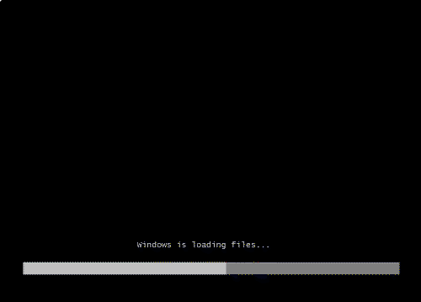
- When prompted for an installation language and other regional options make your selection and press next.
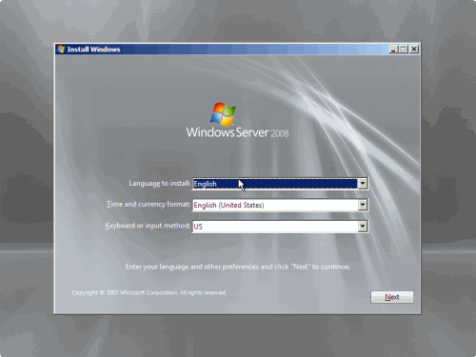

- Next, press Install Now to begin the installation process.

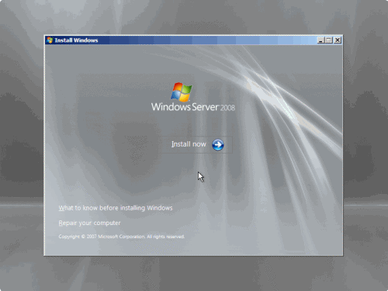

- Product activation is now also identical with that found in Windows Vista. Enter your Product ID in the next window, and if you want to automatically activate Windows the moment the installation finishes, click next.
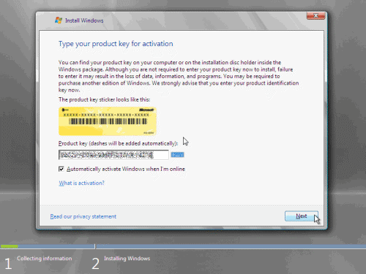

If you do not have the Product ID available right now, you can leave the box empty, and click next. You will need to provide the Product ID later, after the server installation is over. Press No.

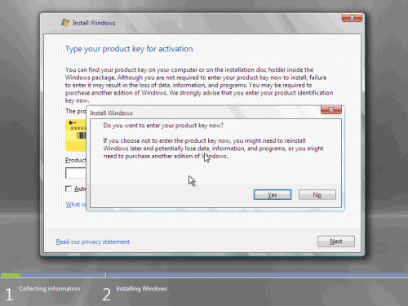

- Because you did not provide the correct ID, the installation process cannot determine what kind of Windows Server 2008 license you own, and therefore you will be prompted to select your correct version in the next screen, assuming you are telling the truth and will provide the correct ID to prove your selection later on.
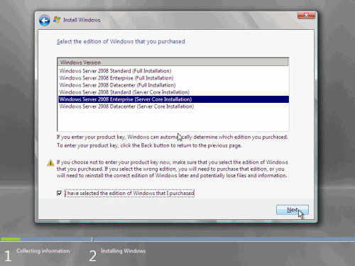

- If you did provide the right Product ID, select the Full version of the right Windows version you’re prompted, and click next.

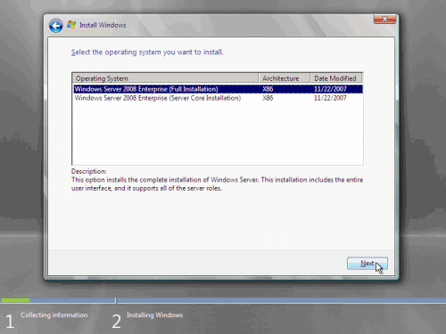

- Read and accept the license terms by clicking to select the checkbox and pressing next.
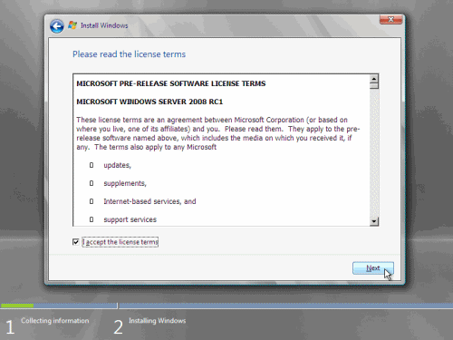

- In the “Which type of installation do you want?” window, click the only available option – Custom (Advanced).

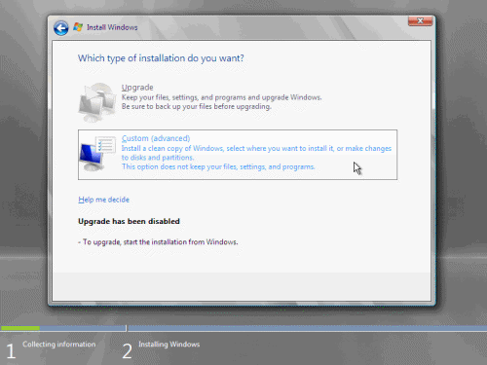

- In the “Where do you want to install Windows?”, if you’re installing the server on a regular IDE hard disk, click to select the first disk, usually Disk 0, and click Next.
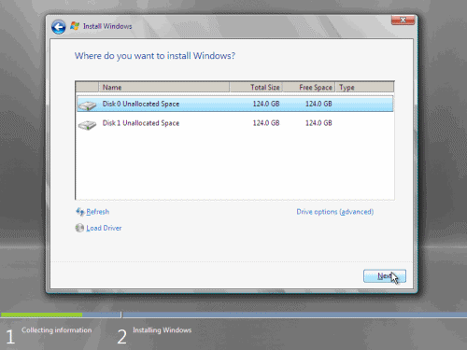

If you’re installing on a hard disk that’s connected to a SCSI controller, click Load Driver and insert the media provided by the controller’s manufacturer.
If you’re installing in a Virtual Machine environment, make sure you read the “Installing the Virtual SCSI Controller Driver for Virtual Server 2005 on Windows Server 2008”
If you must, you can also click Drive Options and manually create a partition on the destination hard disk.
- The installation now begins, and you can go and have lunch. Copying the setup files from the DVD to the hard drive only takes about one minute. However, extracting and uncompressing the files takes a good deal longer. After 20 minutes, the operating system is installed. The exact time it takes to install server core depends upon your hardware specifications. Faster disks will perform much faster installs… Windows Server 2008 takes up approximately 10 GB of hard drive space.
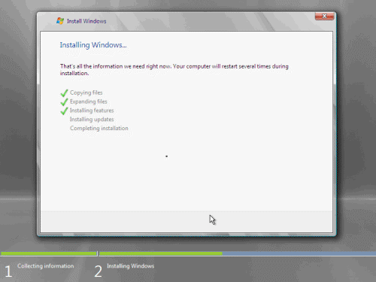

The installation process will reboot your computer, so, if in step #10 you inserted a floppy disk (either real or virtual), make sure you remove it before going to lunch, as you’ll find the server hanged without the ability to boot (you can bypass this by configuring the server to boot from a CD/DVD and then from the hard disk in the booting order on the server’s BIOS)

- Then the server reboots you’ll be prompted with the new Windows Server 2008 type of login screen. Press CTRL+ALT+DEL to log in.
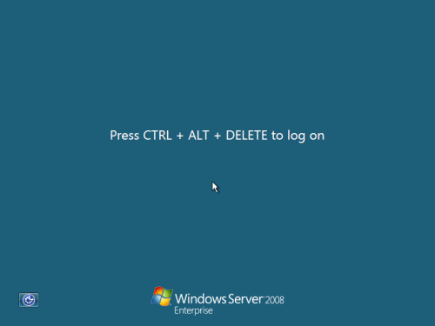

- Click on Other User.
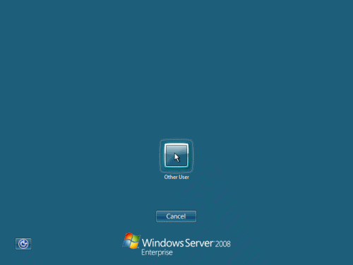

- The default Administrator is blank, so just type Administrator and press Enter.

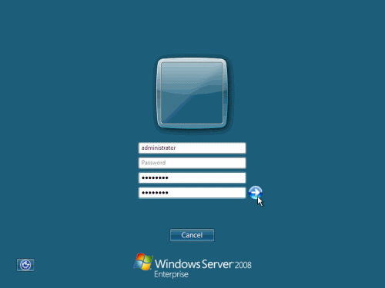

- You will be prompted to change the user’s password. You have no choice but to press Ok.
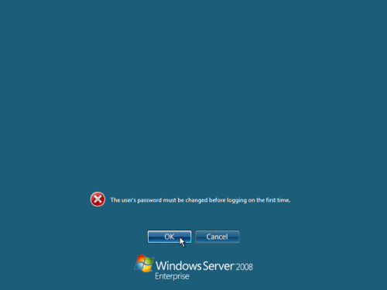

- In the password changing dialog box, leave the default password blank (duh, read step #15…), and enter a new, complex, at-least-7- characters-long new password twice. A password like “top-secret” is not valid (it’s not complex), but one like “T0pSecreT!” sure is. Make sure you remember it.

- Someone thought it would be cool to nag you once more, so now you’ll be prompted to accept the fact that the password had been changed. Press Ok.
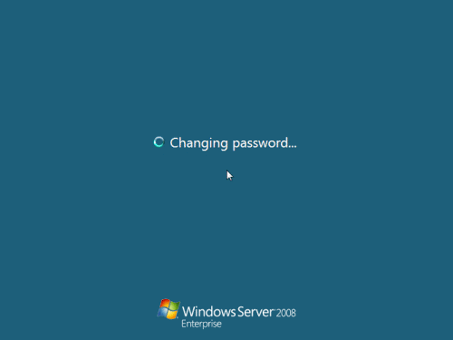

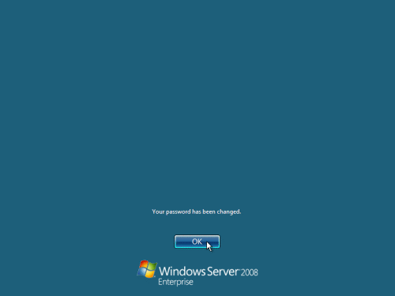

- finally, the desktop appears and that’s it, you’re logged on and can begin working. You will be greeted by an assistant for the initial server configuration, and after performing some initial configuration tasks, you will be able to start working.

  - Install Active Directory Domain Services via Server Manager

For the first example let's start by installing Active Directory through Server Manager. This is the most straight forward way, as a wizard will guide you through the steps necessary.
- Start Server Manager.
- Select Roles in the left pane, and then click on Add Roles in the center console.
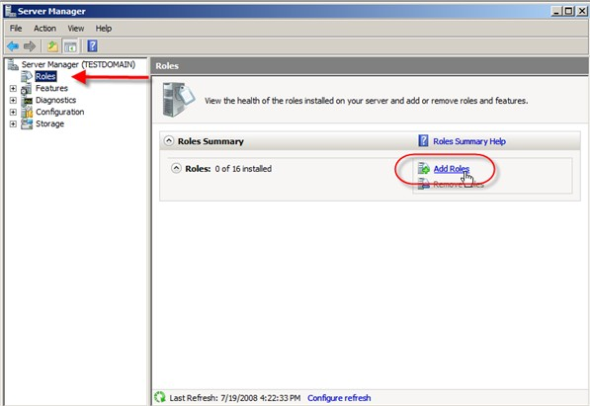

- Depending on whether you checked off to skip the Before You Begin page while installing another service, you will now see warning pages telling you to make sure you have strong security, static IP, and latest patches before adding roles to your server. If you get this page, then just click next.

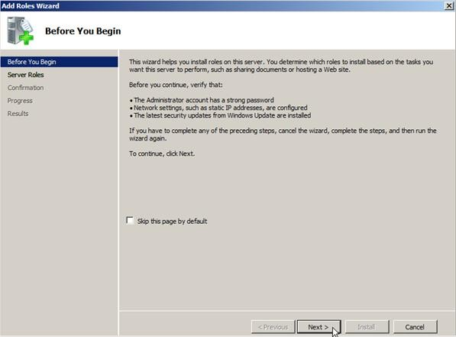

- In the Select Server Roles window we are going to place a check next to Active Directory Domain Services and click next.
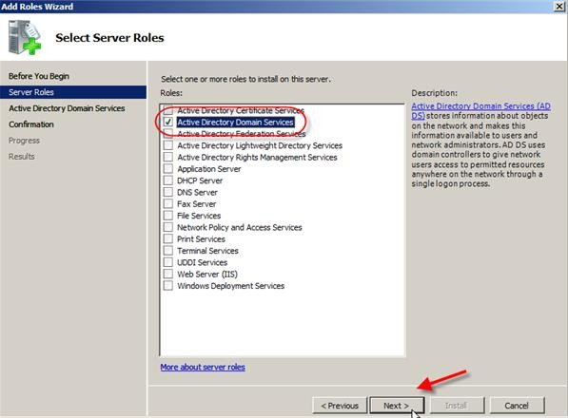

- The information page on Active Directory Domain Services will give the following warnings, which after reading, you should click next:

  - Install a minimum of two Domain Controllers to provide redundancy against server outage (which would prevent users from logging in with only one)
  - AD DS requires DNS which if not installed you will be prompted for
  - After installing AD DS you must run dcpromo.exe to upgrade to a fully functional domain controller
  - Installing AD DS will also install DFS Namespaces, DFS Replication, and Filer Replication services which are required by Directory Service
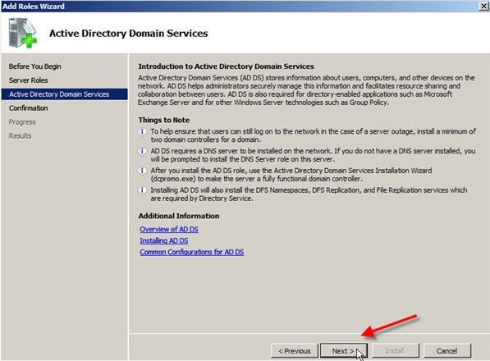

- The Confirm Installation Selections screen will show you some information messages and warn that the server may need to be restarted after installation. Review the information and then click next

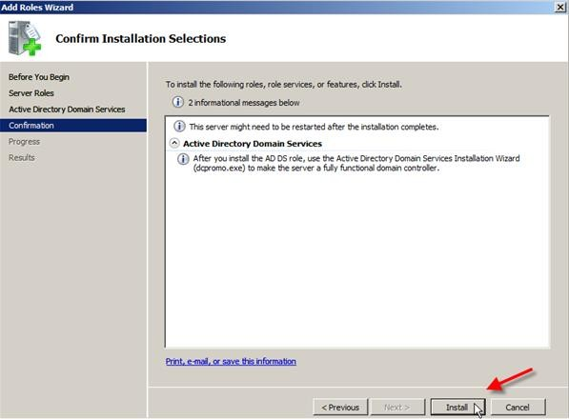

- The Installation Results screen will hopefully show Installation Succeeded, and an additional warning about running dcpromo.exe (I think they really want us to run dcpromo). After you review the, click close
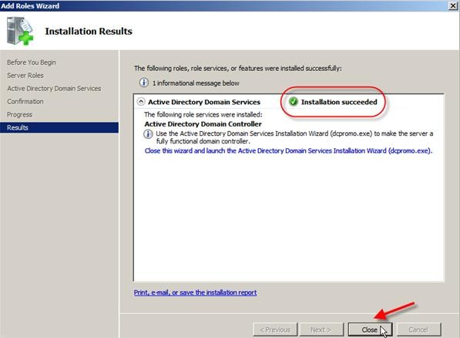

- After the Installation Wizard closes you will see that server manager is showing that Active Directory Domain Services is still not running. This is because we have not run dcpromo yet.
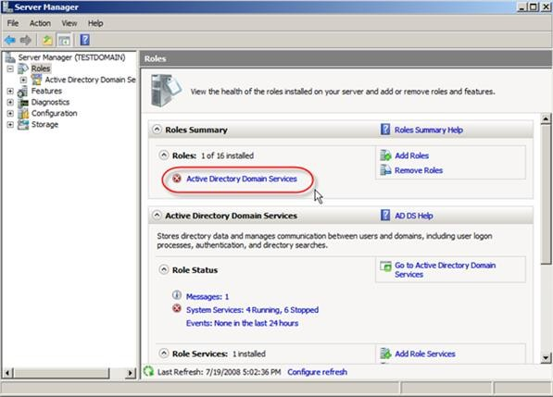
- Click on the Start button, type dcpromo.exe in the search box and either hit Enter or click on the search result.
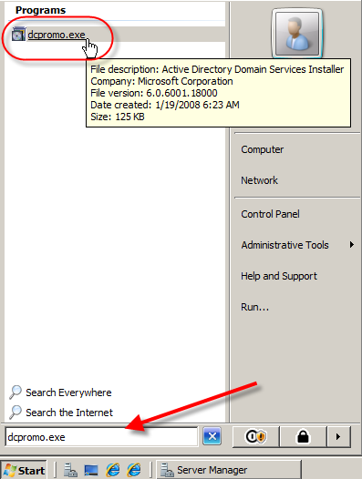
- The Active Directory Domain Services Installation Wizard will now start. There are links to more information if you want to learn a bit more you can

follow them or you can go ahead and click Use advanced mode installation and then click Next.
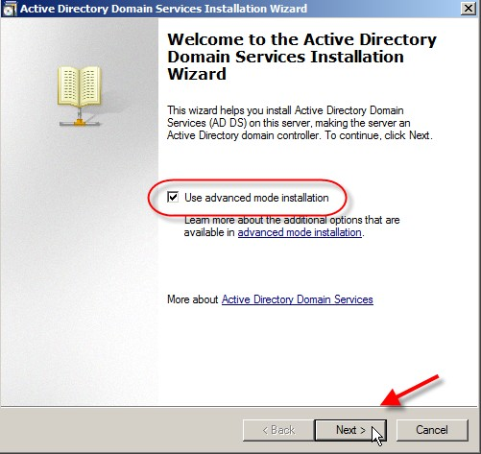

- The next screen warns about some operating system compatibility with some older clients.
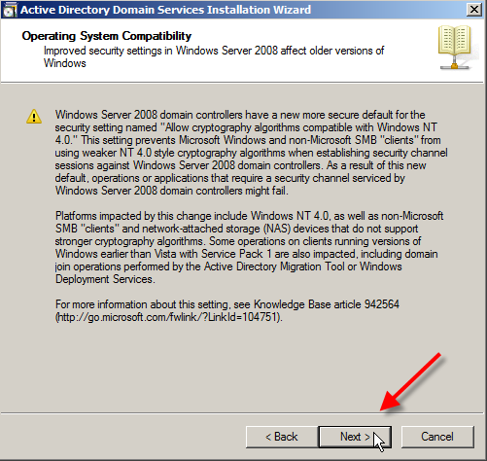

- Next is the Choose Deployment Configuration screen and you can choose to add a domain to an existing forest or create a forest from scratch. Choose create a new domain in a new forest and click next.
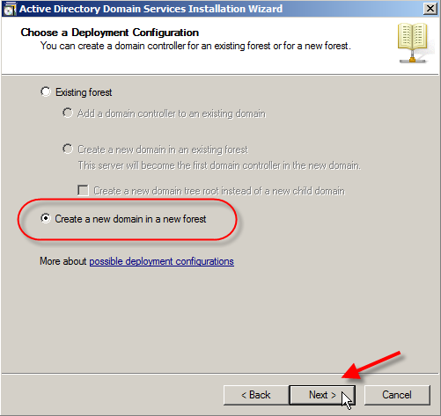

- The Name the Forest Root Domain wants you to name the root domain of the forest you are creating. For the purposes of this test we will create ADExample.com. After typing that goes ahead and clicks next.
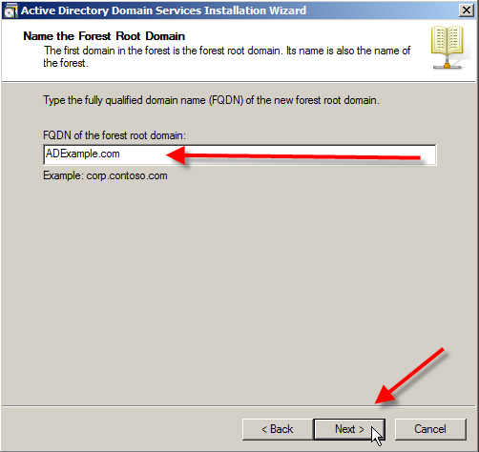

- The wizard will test to see if that name has been used, after a few seconds you will then be asked for the NetBIOS name for the domain. In this case I will leave the default in place of ADEXAMPLE, and then click next.
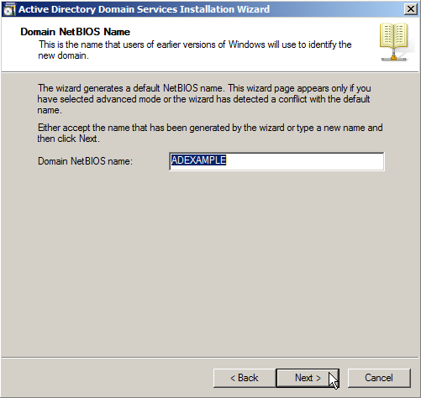

- The next screen is the Set Forest Functional Level that allows you to choose the function level of the forest.
Since this is a fresh install and a new forest with no additional prior version domains to worry about I am going to select Windows Server 2008. If you did have other domain controllers at earlier versions or had a need to have Windows 2000 or 2003 domain controllers (because of Exchange for example), then you should select the appropriate function level.

Select Windows Server 2008 and then click next.

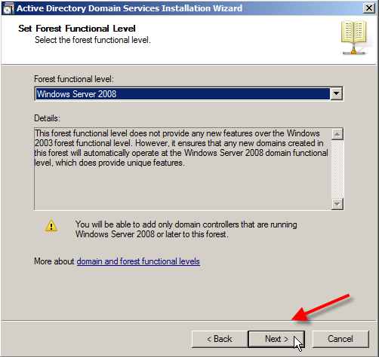

- Now we come to the Additional Domain Controller Options where you can select to install a DNS server, which is recommended on the first domain controller.
If this was not the first domain controller you would have the options of installing Global Catalog and/or setting this as a Read-only Domain Controller. Since it is the first domain controller, Global Catalog is mandatory, and a RDOC controller is not an available option.

Install DNS Server
Let's install the DNS Server by placing a check next to it and clicking Next
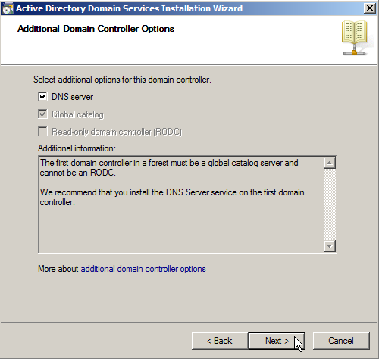

- You will get a warning window about delegation for this DNS server cannot be created, but since this is the first DNS server you can just click yes and ignore this warning.
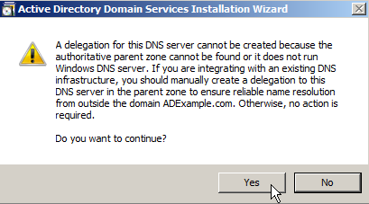

- Next you can choose to place the files that are necessary for Active Directory, including the Database, Log Files, and SYSVOL.

It is recommended to place the log files and database on a separate volume for performance and recoverability. You can just leave the defaults though and click next
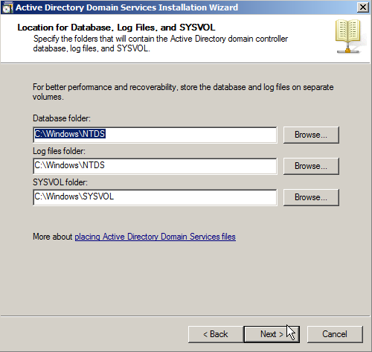
- Now choose a password for Directory Services Restore Mode that is different than the domain password. Type your password and confirm it before hitting next.
Note: You should use a STRONG password for this and will be warned if it doesn't meet criteria.
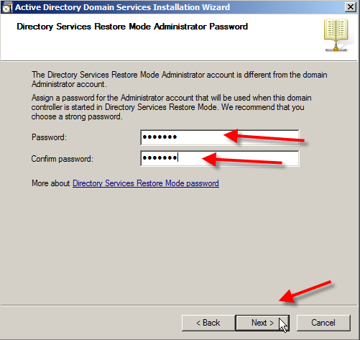

- Next you will see a summary of all the options you have went through in the wizard. If you plan on creating more domain controllers with the same settings hit the Export settings … button to save off a txt copy of the settings to use in an answer file for a scripted install. After exporting and reviewing settings click on Next.
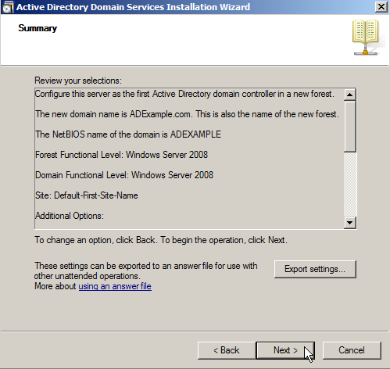
- Now the installation will start including the DNS server option if selected. You will notice a box to Reboot on completion that you can check to reboot soon as everything is installed (A reboot is required you can do it manually or use this function to do it automatically).
NOTE: This can be from a few minutes to several hours depending on different factors.
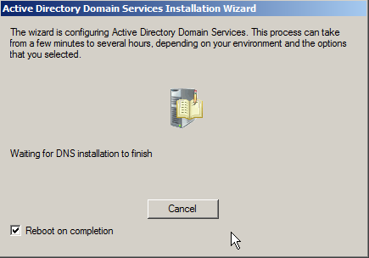

Confirming Active Directory Domain Services Install
When you reboot you will be asked to login to the domain, and be able to open Active Directory Users and Computers from the Administrative menu. When you do you will see the domainADExample.com and be able to manage the domain.
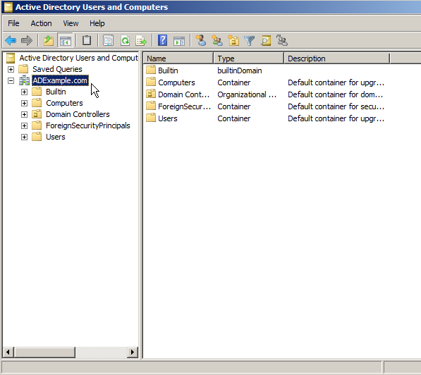

You have now successfully installed Active Directory Domain Services and the first Domain Controller.

Creating an Organizational Unit, Groups and Users
- Start by opening up your Server Manager, and then expand the Roles section.
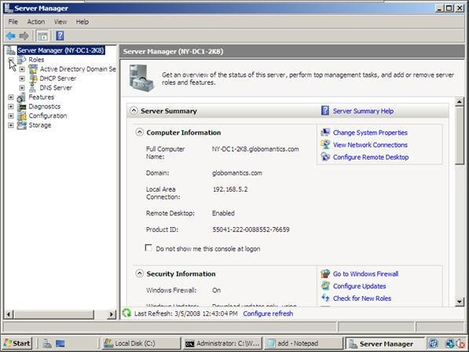
- Next expand the Active Directory Domain Services section and click on Active Directory Users and Computers.

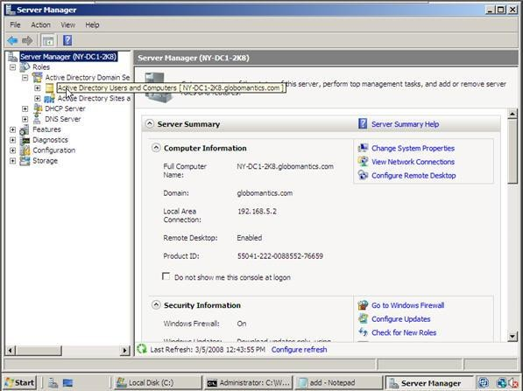

- At this point you should be able to see your domain. In our example we are using the Globomantics domain. Go ahead and expand your domain.
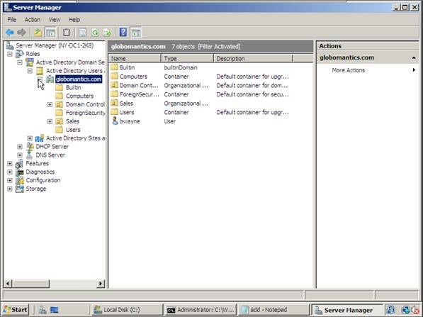
- Now we need to create an Organizational Unit for a group to live in. In our example we are going to create an OU for our Ops Team. To create a new

Organization Unit, right-click on your domain name, point to the new option and then select Organizational Unit.
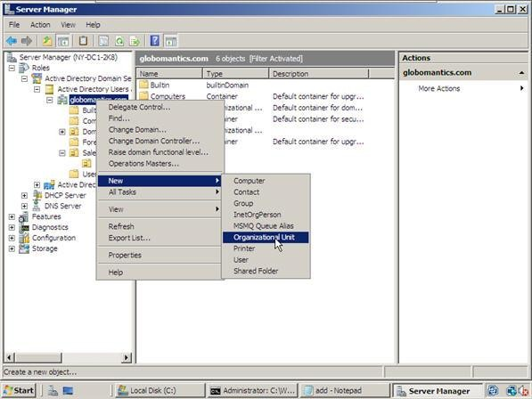

- Type in the name of your OU and make sure that the box is checked next to Protect container from accidental deletion. When done, click OK.
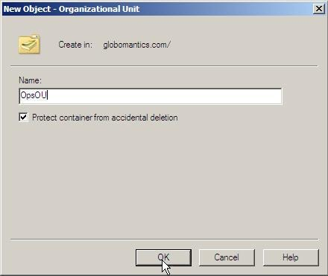

- We now have a new Organizational Unit in our Active Directory called OpsOU.

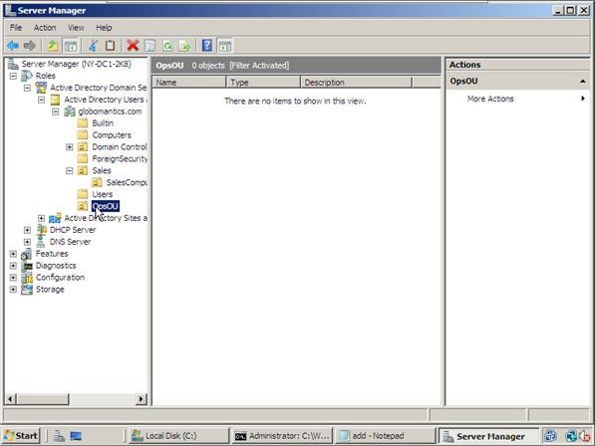

Creating a New Group
- After you create an Organizational Unit in your Active Directory, you are ready to create your first group. Go ahead and select your OU and then right-click in the blank area.
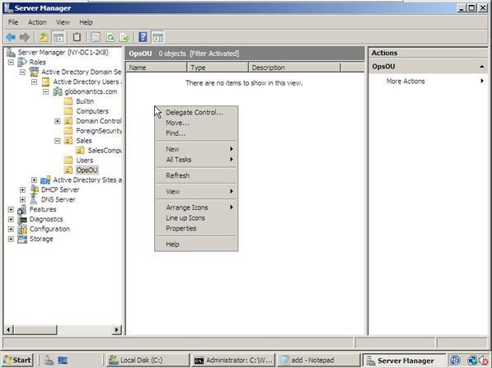

- Next, point to New and then select Group.

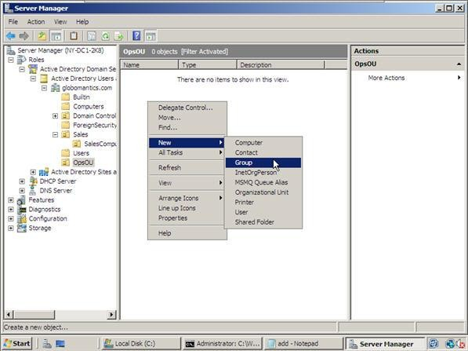

- The next step is to name your Group, select the scope and then select the type. In this example we are going to name our group OpsUSers. We are also going to leave the default selections for group scope, which is Global, and group type, which is Security. When you are ready, click OK.
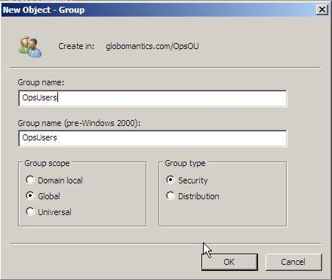

- Our new group has been created!

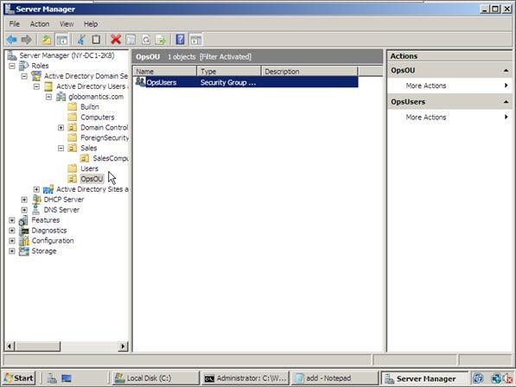

Moving Accounts In to a Group
- In order to move pre-existing accounts into a group, you need to hold down the Control key and click on all the User or Computer accounts that you want to move into that group.
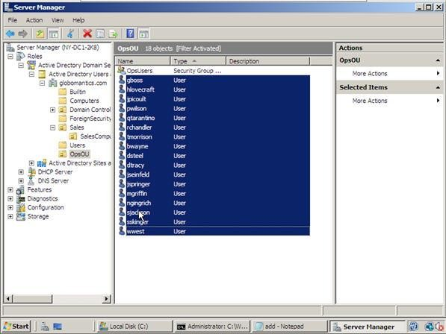

- Then you need to right-click on any one of those accounts and select Add to a group.

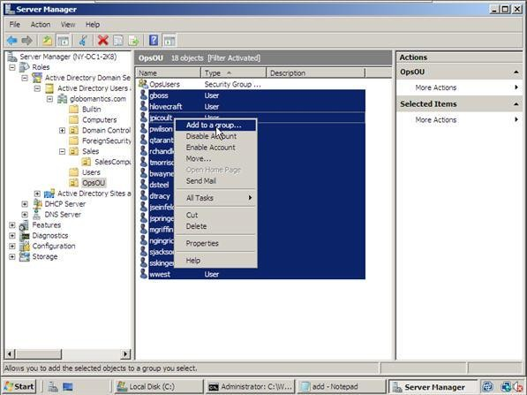

- Next, you need to type in the group name and let the machine find it. In our example, I will type in OpsUSers and then click on the Check names button. Once the name is verified and group name is found, the text will become underlined and you can click the OK button. Since we know our group exists, we are going to click OK without verification.
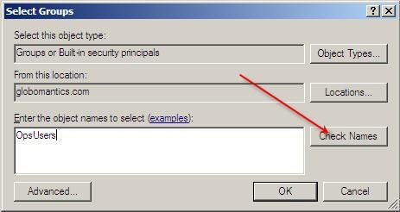

- Now all of these accounts are part of our OpsUsers group.
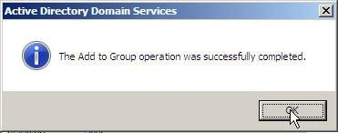

Join Client Computer to the Server
Before joining your Windows 7 machine to a domain, make sure you properly understand the following prerequisites:
    - Use Windows 7 Professional, Ultimate or Enterprise – Only Windows 7 these editions can join a domain. No, Windows 7 Home can’t. Don’t try it.
    - Have a network Interface Card (NIC) – Duh, but unless you have one (or a wireless connection) how do you expect to connect to the server?
    - Be physically be connected to the LAN – Windows 7 (and previous OSs) has an LAN auto sensing feature. Whenever you disconnect from the network, a balloon appears in the tray area notifying you of the disconnection status. Note that Windows 7 can be joined in an offline mode to a Windows Server 2008 R2 domain, but that’s a topic for a different article.
    - Has a valid IP address – Valid for the network you’re connected to. You can configure one manually, receive one from a local DHCP Server, or leave it as is and receive an APIPA address (whatever starts with 169.254.X.Y). If it’s an APIPA address you’re asking for potential problems, as APIPA and AD do not go together hand-in-hand.
    - Have all-time connectivity to the Domain Controller – Or at least one of them. The IP address you’ve configured (or leased) should be good enough to enable you to connect to one of the Domain Controllers on your Domain. You may test your connectivity with PING, but make note that a successful PING does not guarantee that you’ve got proper connection to the DCs.
    - Has a properly configured DNS server – Without a properly configured
DNS server your workstation will not be able to connect to the domain. Even if it did (for example you had a working DNS server but you somehow messed it up or shut it down) it will take a lot of time to actually log-on, and many AD related administration tasks will not work. The DNS server must hold a zone with the exact name of the AD domain you’re trying to join. It also must hold 4 SRV folders (you can tell by the “_” in their name). If it doesn’t, you either misspelled the domain name or DNS zone, or the zone is not configured to accept dynamic registrations, or it’s not a Windows 2000/2003/2008 DNS server, or the Domain Controller does not have a working connection with the DNS server (firewall problems, improper IP configuration, IPsec etc.)

    - Have all-time connectivity to the DNS server – Test your connection to the DNS server by PINGing it and performing an NSLOOKUP query.
    - Possess local Administrative power – A simple user won’t do. You must be
the local Administrator.
    - Know the correct domain name, Administrator’s name and password – Misspelled your domain name? You won’t get to the Username and Password prompt!

Got your domain name right? You’ll be asked for a valid username and password. To be safe, enter one that has Domain Admins rights, although you could get away with less, depending on your AD configuration (by default, any domain user has the right to join up to 10 machines to the domain. But this setting may have been altered by the domain admin).

- Open System by clicking the Start button, right-click “Computer”, and then click “Properties”.
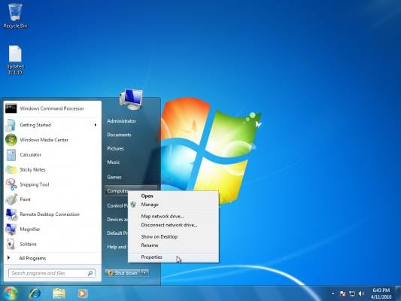

- Under “Computer name, domain, and workgroup settings”, click “Change settings”.

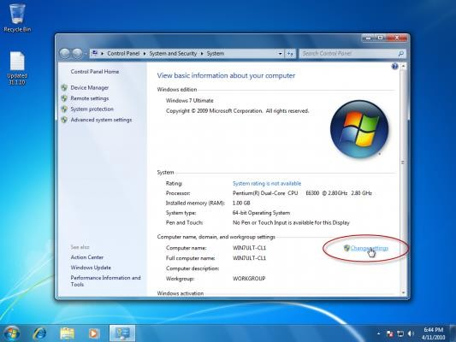

Actually, you can also click on “Advanced system settings” and click on the “Computer Name” tab.
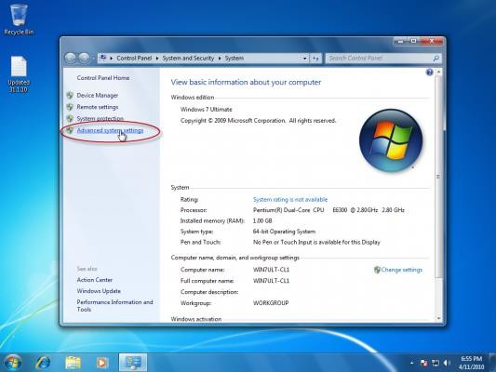

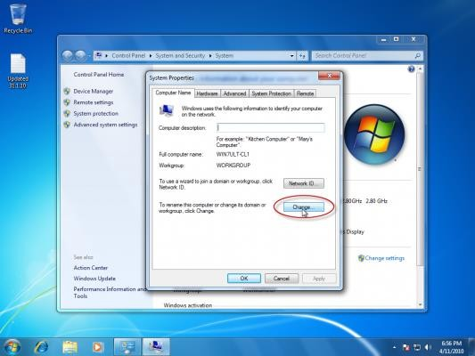

A third method to get to the same place is to use the Control Panel. Type “Domain” in the search box, then click on “Join a domain” link.
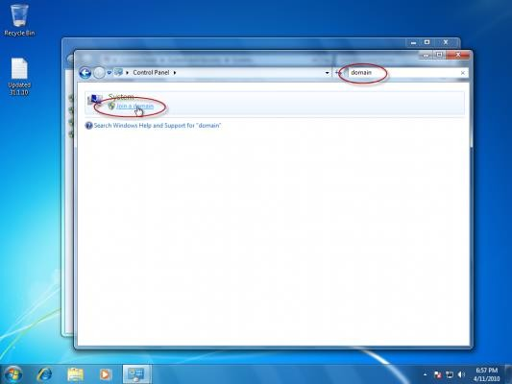

Either way, you’re there. If you’re prompted for an administrator password or confirmation, type the password or provide confirmation.

- Click the Computer Name tab, and then click “Change”.
- Under Member of, click Domain.

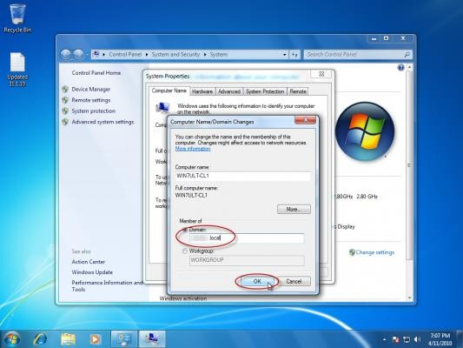
- Type the name of the domain that you want to join, and then click OK.

You will be asked to type your user name and password for the domain.
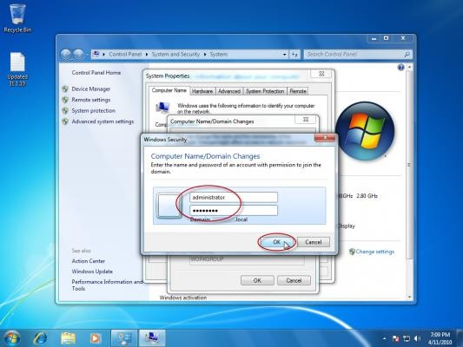

Once you are successfully joined to the domain, you will be prompted to restart your computer. You must restart your computer before the changes take effect.

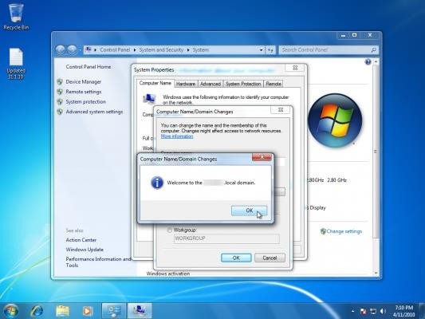
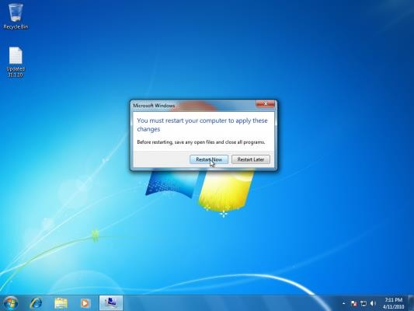

Alternatively, you can click “Network ID” to use the Join a Domain or Workgroup wizard to automate the process of connecting to a domain and creating a domain user account on your computer. This is a longer way and I’m not sure why people would want to use it, but I’ll document it anyway. Go through the steps of the wizard. Make sure you select “This computer is part of a business network”.

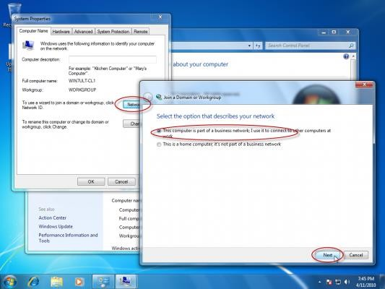

Then select “My Company uses a network with a domain”.
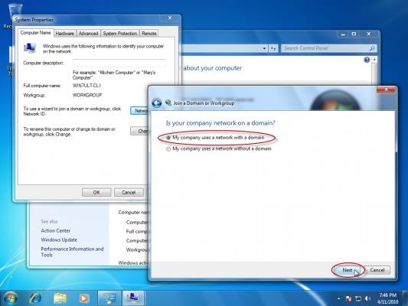

Provide the domain name and proper credentials.

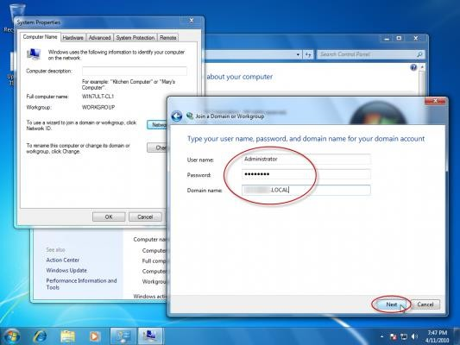
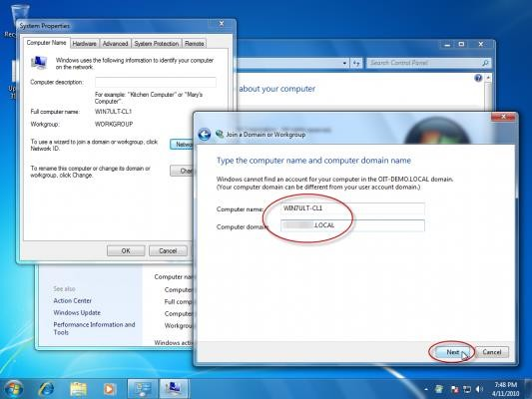

And again

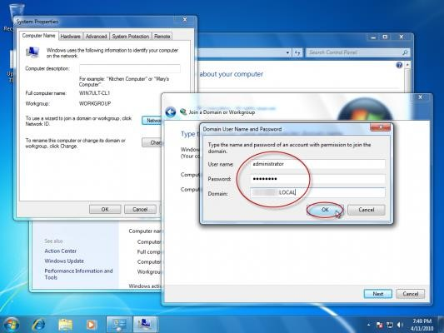

You will still need to restart when the wizard is done.

Alternative – Using NETDOM
By using NETDOM you can accomplish the task of joining a domain from the command prompt, and do it all in one line.

NETDOM is now included in the core OS, unlike Windows 2000/XP/2003 where you had to install the Support Tools to get it.

Open a Command Prompt window with Administrative credentials and type the following line:

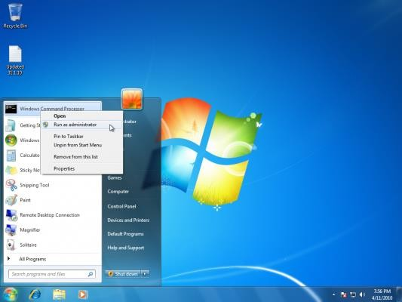

Notes: Replace DOMAIN.COM and DOMAIN with your correct domain name, and of course, enter the proper user credentials. Also note there’s an additional “d” in “user” and “password” that is NOT a typo.

DHCP Installation and configuration

Installing Windows Server 2008 DHCP Server
Installing Windows Server 2008 DCHP Server is easy. DHCP Server is now a “role” of Windows Server 2008 – not a windows component as it was in the past. To do this, you will need a Windows Server 2008 system already installed and configured with a static IP address. You will need to know your network’s IP address range, the range of IP addresses you will want to hand out to your PC clients, your DNS server IP addresses, and your default gateway. Additionally, you will want to have a plan for all subnets involved, what scopes you will want to define, and what exclusions you will want to create.

Server Management Tools for Windows Server: Available features
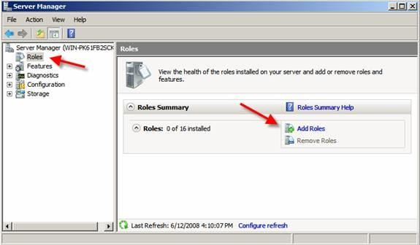
To start the DHCP installation process, you can click Add Roles from the Initial Configuration Tasks window or from Server Manager / Roles / Add Roles.
Adding a new Role in Windows Server 2008
When the Add Roles Wizard comes up, you can click Next on that screen. Next, select that you want to add the DHCP Server Role, and click Next.

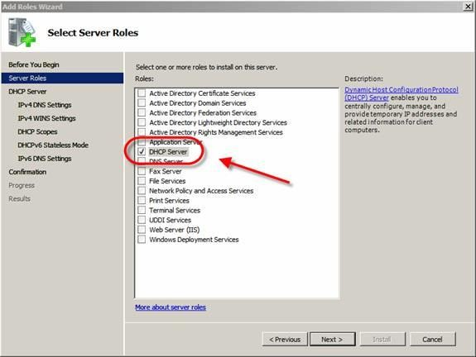

Selecting the DHCP Server Role
If you do not have a static IP address assigned on your server, you will get a warning that you should not install DHCP with a dynamic IP address.
At this point, you will begin being prompted for IP network information, scope information, and DNS information. If you only want to install DHCP server with no configured scopes or settings, you can just click next through these questions and proceed with the installation.
On the other hand, you can optionally configure your DHCP Server during this part of the installation.
In my case, I chose to take this opportunity to configure some basic IP settings and configure my first DHCP Scope.
I was shown my network connection binding and asked to verify it, like this:

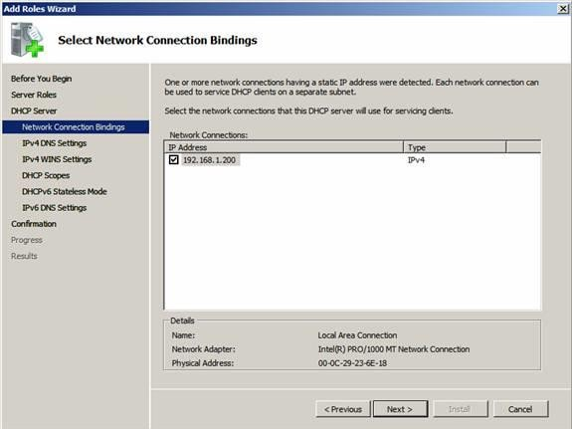

Network connection binding
What the wizard is asking is, “what interface do you want to provide DHCP services on?” I took the default and clicked next.
Next, I entered my Parent Domain, Primary DNS Server, and Alternate DNS Server (as you see below) and clicked next.

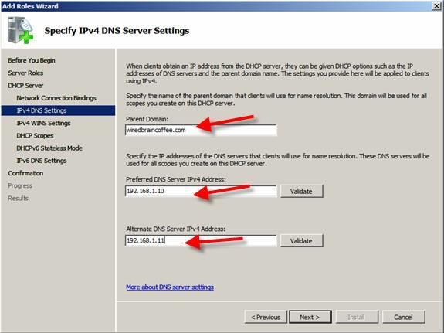

Entering domain and DNS information
I opted NOT to use WINS on my network and I clicked next.
Then, I was promoted to configure a DHCP scope for the new DHCP Server. I have opted to configure an IP address range of 192.168.1.50-100 to cover the 25+ PC Clients on my local network. To do this, I clicked Add to add a new scope. As you see below, I named the Scope WBC-Local,
- Configured the starting and ending IP addresses of 192.168.1.50- 192.168.1.100,
- Subnet mask of 255.255.255.0,
- Default gateway of 192.168.1.1, type of subnet (wired), and activated the scope.

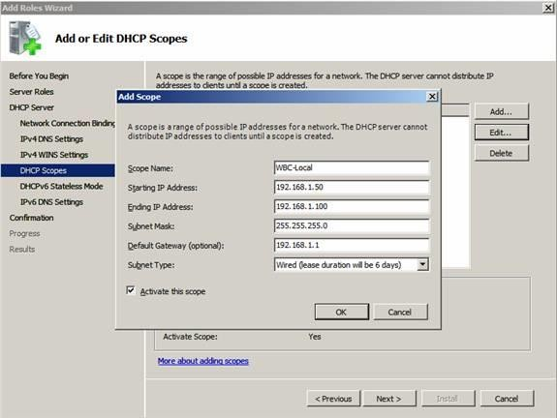

Adding a new DHCP Scope
Back in the Add Scope screen, I clicked next to add the new scope (once the DHCP Server is installed).
I chose to Disable DHCPv6 stateless mode for this server and clicked next.
Then, I confirmed my DHCP Installation Selections (on the screen below) and clicked Install.

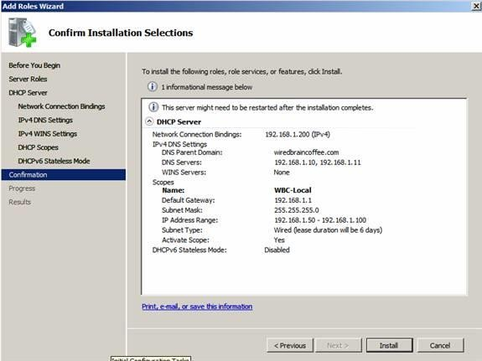

Confirm Installation Selections
After only a few seconds, the DHCP Server was installed and I saw the window, below:
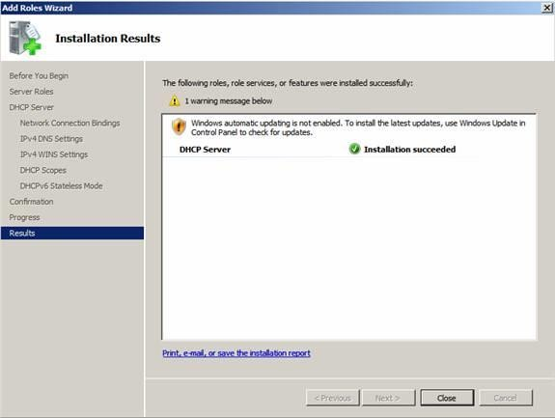

Windows Server 2008 DHCP Server Installation succeeded

I clicked Close to close the installer window, then moved on to how to manage my new DHCP Server.

How to manage your new Windows Server 2008 DHCP Server
Like the installation, managing Windows Server 2008 DHCP Server is also easy. Back in my Windows Server 2008 Server Manager, under Roles, I clicked on the new DHCP Server entry.
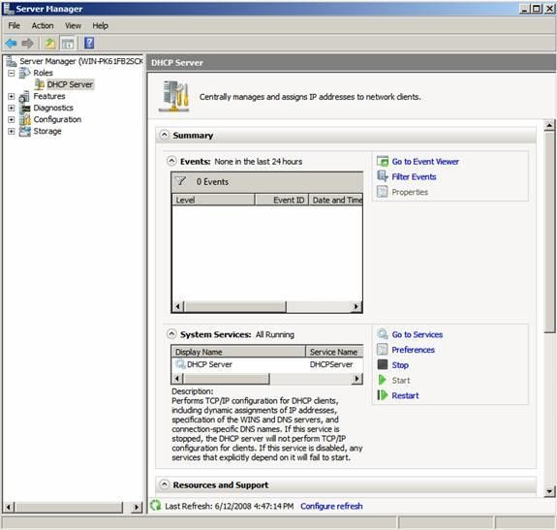

DHCP Server management in Server Manager
While I cannot manage the DHCP Server scopes and clients from here, what I can do is to manage what events, services, and resources are related to the DHCP Server installation. Thus, this is a good place to

go to check the status of the DHCP Server and what events have happened around it.
However, to really configure the DHCP Server and see what clients have obtained IP addresses, I need to go to the DHCP Server MMC. To do this, I went to Start / Administrative Tools / DHCP Server like this:
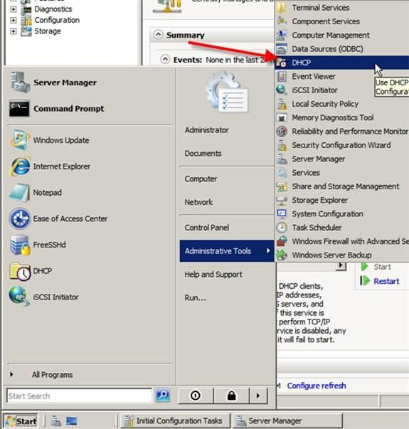

Starting the DHCP Server MMC
When expanded out, the MMC offers a lot of features. Here is what it looks like:

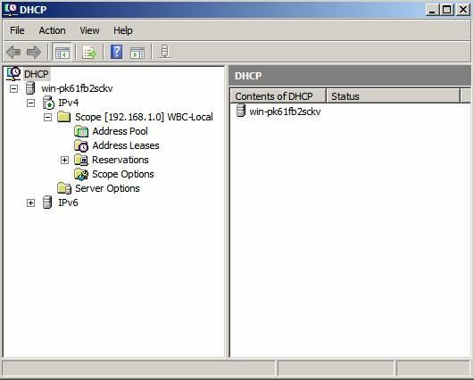

The Windows Server 2008 DHCP Server MMC
The DHCP Server MMC offers IPv4 & IPv6 DHCP Server info including all scopes, pools, leases, reservations, scope options, and server options.

If I go into the address pool and the scope options, I can see that the configuration we made when we installed the DHCP Server did, indeed, work. The scope IP address range is there, and so is the DNS Server & default gateway.

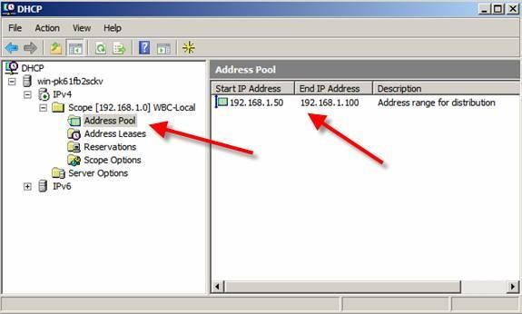
DHCP Server Address Pool
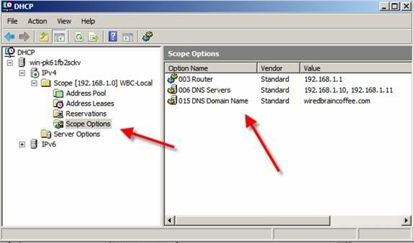

DHCP Server Scope Options
So how do we know that this really works if we do not test it? The answer is that we do not. Now, let’s test to make sure it works.

How do we test our Windows Server 2008 DHCP Server?

To test this, I have a Windows Vista PC Client on the same network segment as the Windows Server 2008 DHCP server. To be safe, I have no other devices on this network segment.
I did an IPCONFIG /RELEASE then an IPCONFIG /RENEW and verified that I received an IP address from the new DHCP server, as you can see below:
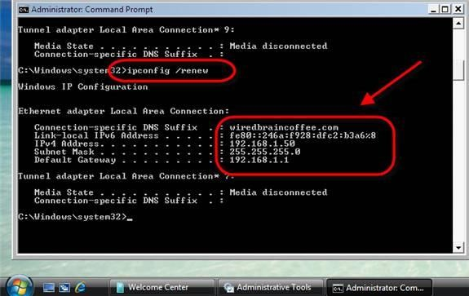

Vista client received IP address from new DHCP Server

Install Hyper-V on Windows 10
If you have the four requirements covered then you can install Hyper-V. These instructions show the menu structure for HP computers; your computer may have a different menu. The first thing to do is turn on hardware virtualization support by going to the computer’s BIOS settings, clicking Security > System Security and setting Virtualization Technology (VTx) to Enabled. This is shown in the image below:
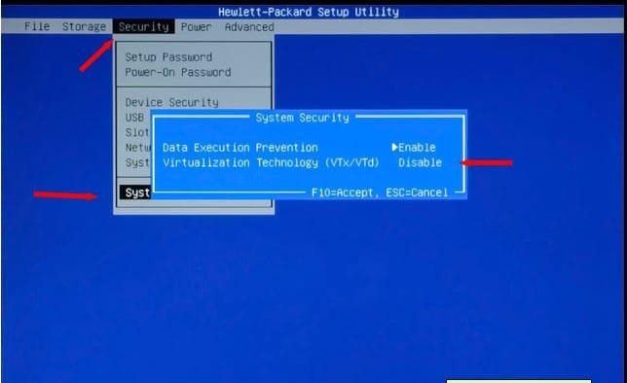
- Save these settings and boot up the computer. Once the computer has finished loading, go to the Taskbar and click the Search icon.
- In the search field type the following: Turn windows features on or off
- Once the Turn windows features on or off option is displayed, click on it. You should see the following screen:

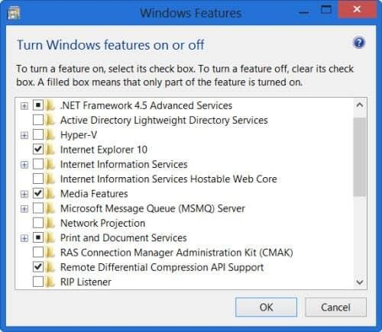

- Enable Hyper-V by selecting the check mark. Please note, if you didn’t have Hyper-V enabled you need to reboot the computer for the changes to take effect.
- Once Hyper-V Is enabled go back to the Search icon and enter the following: Hyper-V Manager
- Now click Hyper-V Manager.
- In the Hyper-V Manager type Hyper-V and open the Virtual Switch Manager (located in the Actions panel). The Virtual Switch Manager is shown in the image below:

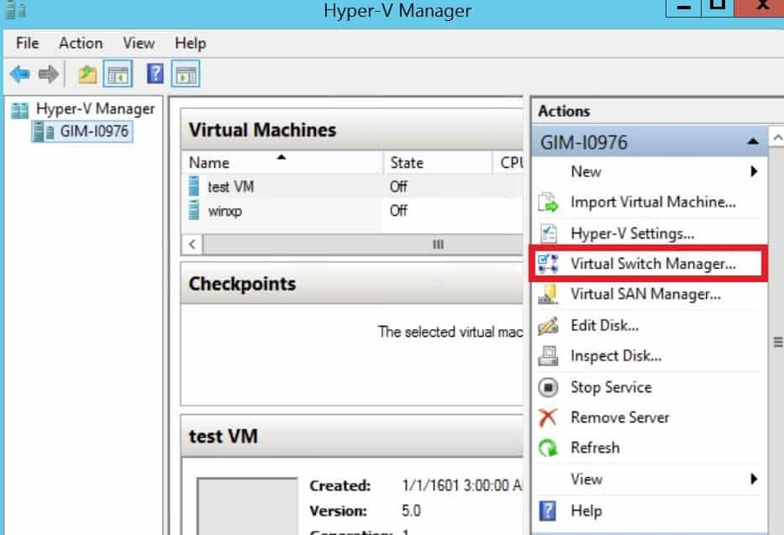

- Next click Create Virtual Switch (make sure that External is highlighted).

How to Use Hyper-V: Networking, Creating and Running a Virtual Machine
Before you create a virtual machine, it is necessary to set up networking. Without networking, Hyper-V won’t be able to connect to the network. To begin:
  - Open the Hyper-V Manager and click the name of your local computer to view networking options.
  - Open the Virtual Switch Manager and select External.
  - Press the Create Virtual Switch button.
  - Assign a name to the virtual switch and click Ok.
  - Verify the External network connection is checked and linked to the correct network.
Once this is done you are ready to start creating your first virtual machine.

How to Create and Run A Virtual Machine
One of the first things you’re going to want to do after Hyper-V is installed is to create a virtual machine.
To begin, go to the Actions pane and click New > Virtual Machine
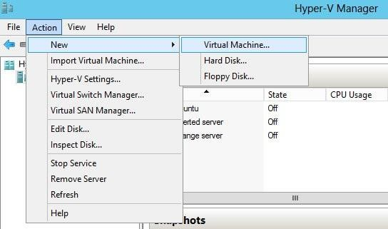
The New Virtual Machine Wizard will open. Here you can assign a name to your virtual machine and start configuring it.
Once the Configure Networking pane is displayed, select the virtual switch that you just created. At this point, you can use an ISO file to provide the installation files of your operating system (Hyper-V will place this into the virtual disc drive. Hyper-V will then install the files after you have booted your computer).
After completing the New Virtual Machine Wizard your new virtual machine will be shown in the Hyper-V Manager list. To boot the machine up, click on it and press Action > Start in the right-hand sidebar.
Now right-click on the virtual machine and press the Connect button. The virtual machine will then open in a new window. You will then see onscreen options that will guide you through the installation process of the new virtual machine.
Install the OS then go back to the Hyper-V Manager. Select Action → Insert Integration Services Setup Devices.

Now go to Windows File Manager and install the integration services with the virtual disc to finish. You’re now ready to use the virtual machine.
Once you’ve finished using it, turn it off via the Hyper-V Manager.
It is important to note that closing the window will leave the virtual machine running in the background (and sapping system resources). Closing virtual machines via the Hyper-V Manager is the correct way to go.

Installing Active Directory Rights Management Services
The following steps illustrate how to perform the installation:
- Go to Start Menu → Administrative Tools → Server Manager
- Click Add Roles and check the Active Directory Rights Management Services box from the list of server roles. Click on Add Required Role Services in the Add Roles Wizard, to proceed and click next.
- In the left pane, select AD RMS Cluster to create one. Click Next.
- Among the database configuration options, select Use a different database server and specify the sever on which the RMS database is to be hosted. Click on Validate.
- Select Service Account, and select the required Service account and click Next.
- Select Cluster Key Storage and choose the Use AD RMS centrally managed key storage option and enter a Cluster Key Password.
- For Cluster Web Site, choose Default Web Site and click Next.
- For Cluster Address, select Use an SSL-encrypted connection and mention the FQDN and click Validate.
- For Server Authentication Certificate for SSL Encryption, select Choose an existing certificate for SSL encryption and click Import. Retain the default name that appears for the Server Licensor Certificate and proceed by clicking Next.
- Finally, under SCP Registration, choose Register the AD RMS service connection point now option and click Next on the window that follows.

- Click Install on the confirmation page.
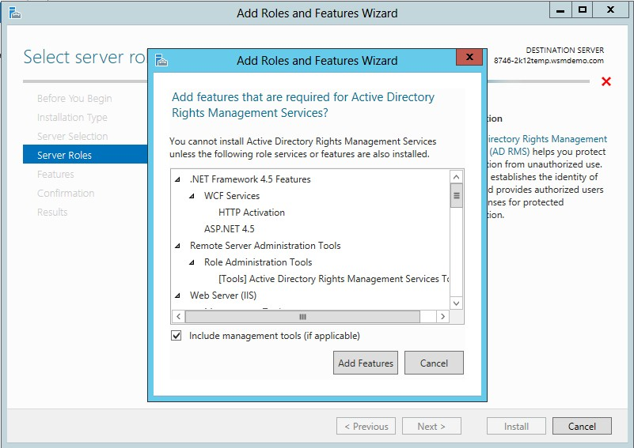

Install and configure IIS
To install the IIS on the server running on the Microsoft Windows, follow the following given instructions.
These are the following instruction to install IIS (Internet Information Services):
- First of all, open the control panel by double-tapping on its icon.
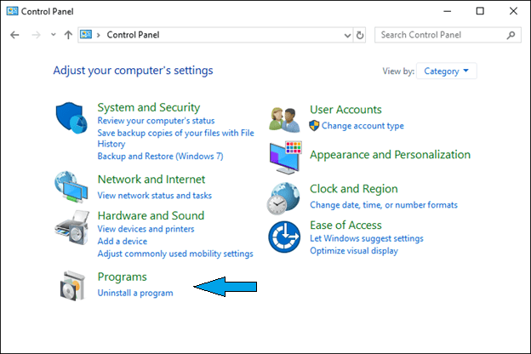
- Search the option "Programs" from the following available options and click on it.
- Now click on the option "Turn Windows feature on and off, possibly given under the "Programs and Features as shown in the below image.
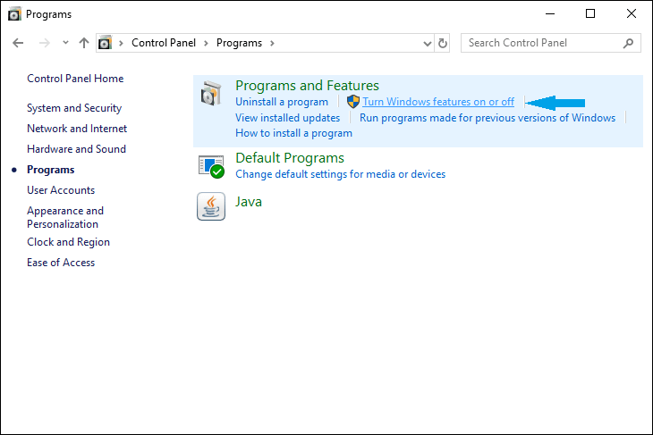

- On clicking on the “Turn Windows features on and off" option, a prompt will open, as shown below:
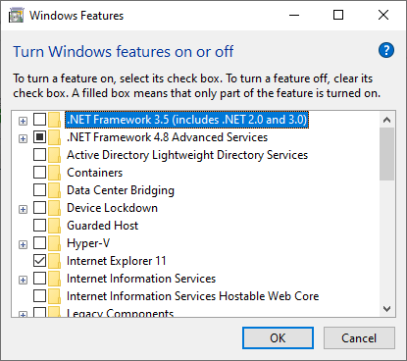
When the prompt gets opened, search for the "Internet information Services among the following given options and marked it as checked to expand the other option.
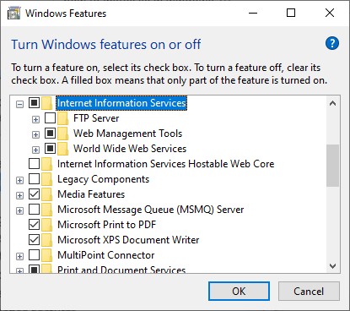
- Now click on the 3rd option, which is "World Wide Services."

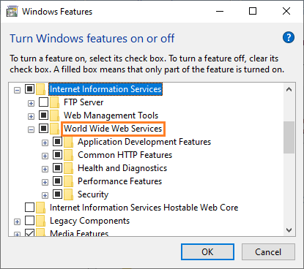

- Double click on the first option, "Application Development Features," given below the "World Wide Services."
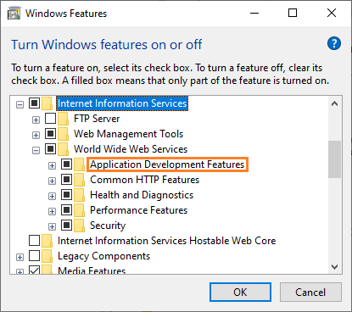

- Mark the "CGI" option as checked, and you can also choose several other options if you needed them.
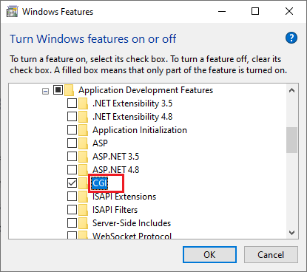
- Click on the "Ok" button and wait till the changes get applied.
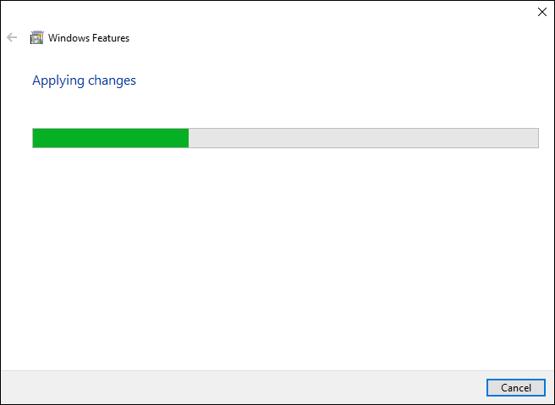

After the process of implementing changes, it may ask to restart the system, so just allow it, and after that, the installation is complete. Now you can use the Internet Information Services by typing "IIS" in the Windows search box.

Installing the Routing and Remote Access Service
By default, the Routing and Remote Access service is installed automatically during the Windows Server 2003 installation, but it is disabled.

To Enable the Routing and Remote Access Service

- Click Start, point to Administrative Tools, and then click Routing and Remote Access.
- In the left pane of the console, click the server that matches the local server name.
If the icon has a red arrow in the lower-right corner, the Routing and Remote Access service isn't enabled. Go to step 3.
For a green arrow pointing up in the lower-right corner, the service is enabled. If so, you may want to reconfigure the server. To reconfigure the server, you must first disable Routing and Remote Access. You may right- click the server, and then click Disable Routing and Remote Access. Click Yes when it is prompted with an informational message.
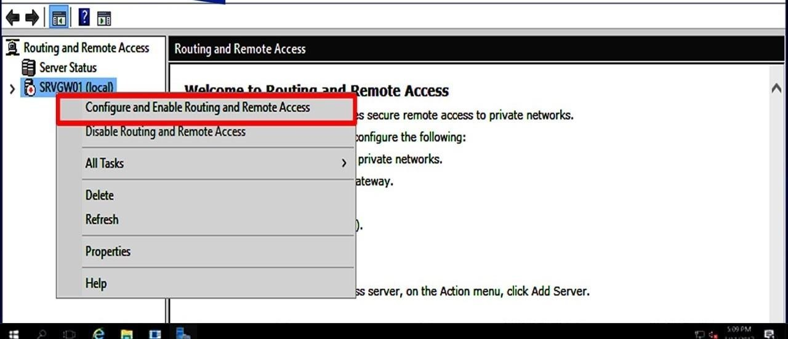

- Right-click the server, and then click Configure and Enable Routing and Remote Access to start the Routing and Remote Access Server Setup Wizard. Click Next.
- Click Remote access (dial-up or VPN) to permit remote computers to dial in or connect to this network through the Internet. Click Next.

- Click VPN for virtual private access, or click Dial-up for dial-up access, depending on the role you want to assign to this server.
- On the VPN Connection page, click the network interface that is connected to the Internet, and then click next.
- On the IP Address Assignment page, do one of the following:
  - If a DHCP server will be used to assign addresses to remote clients, click automatically, and then click next. Go to step 8.
  - To give remote clients addresses only from a pre-defined pool, click from a specified range of addresses.

The wizard opens the Address Range Assignment page.
- Click New.
- In the Start IP address box, type the first IP address in the range of addresses that you want to use.
- In the End IP address box, type the last IP address in the range. Windows calculates the number of addresses automatically. Click OK to return to the Address Range Assignment page. Click Next.

- Accept the default setting of No, use Routing and Remote Access to authenticate connection requests, and then click Next.
- Click Finish to enable the Routing and Remote Access service and to configure the remote access server. After you set up the server to receive dial-up connections, set up a remote access client connection on the client workstation.

Practical Assessment

Install operating systems and set up the network
Building and configuring a desktop computer and server with Active Directory, DNS, and DHCP on a server and client computer. The steps below should be followed in order to build this:
Tools and equipment

R  No | Needed Items | Qty | Unit | Minimum Requirements
1 | Server Computer | 1 | Pcs | CPU 2 GHz or faster, RAM 2 GB or  greater, HDD 40 GB or greater, 800 × 600 or higher display
2 | Client Computers | 2 | Pcs | CPU 2 GHz or faster, RAM 2 GB or  greater, HDD 40 GB or greater, 800 × 600 or higher display

3 | Switch | 1 | Pcs | 8 port standard switch
4 | Window server 2008 | 1 | Pcs
5 | Window 10 | 1 | Pcs

Based on the information given, carry out the following activities.

- Prepare the provided PCs for the installation and configuration of the Windows Server 2008 and Windows 10 systems.
- Install Microsoft Windows 10 on the client computer and Windows Server 2008 (Standard edition) on the server.
- Use the subsequent configuration.
  - Default Gateway (192.168.1.1), Server IP (192.168.1.1), Subnet (255.255.255.0)
  - Default Gateway (192.168.1.1), Client IP (192.168.1.2), and Subnet (255.255.255.0)
  - Remember to use the proper DNS configuration for both the server and the client.
- Using connection testing commands, you can examine the connection between the Server and the Client.
Set up Windows Server 2008
Based on the information given, carry out the following actions.
- Set up Entoto.com as a domain in Active Directory on the server computer.
- Install and configure a DNS server to map the IP address of the web server to the Entoto.com host name.
- Installing and configuring IIS to host a default web page
- Initialize and configure DHCP. (Hint: - Do not forget to remove Client PC
  - IP address before to setup DHCP).
  - IP Range for DHCP (192.168.1.3 to 192.168.1.20)
  - Block the IP address range (192.168.1.11 to 192.168.1.14).

- Based on the following table, create two organization units, two groups, and four users.
Full  Name | Login  Name | Password | Group | OU
Solomon Brhane | Solbrh | sol@123 | Sales | Finance
Sosena bantu | Sosban | sos@123 | Marketing | Promotion
Habtamu Ellu | Habell | hab@123 | Marketing | Promotion
Helen  Bekena | Helbek | hel@123 | Sales | Finance

- Join the client computer to the domain so that only the marketing team may access it.
- Change the Sosena login hour from 8:30 AM to 12:00 AM every day.
- Permit Solomon to use Entoto-pc, but only Sosena may do so.
- Establish a group policy stating that sales shall expire after 60 days.
- Create a new user and set up the server so that the client can access it from the remote.
- Set quota limits of up to 10MB for purchase groups and 5MB for sales.
- Log on with the sosban account from the client computer and show that the user has full access to the marketing_data folder but none at all to the sales_data folder.

Reference Books
- Microsoft Window Official Website https://learn.microsoft.com/en-us/windows- server/
- Microsoft Windows Server 2008 (Author Rand Morimoto)
- The Complete Idiot's Guide to Upgrading and Repairing PCs (5th Edition) (Complete Idiot's Guides) (Author Jennifer Fulton)
- A+ Complete Lab Manual, 3rd Edition (Author Donald R. Evans)
- A+ Guide to Hardware: Managing, Maintaining and Troubleshooting, Fourth Edition (Author Jean Andrews)

