Web Development and Database Administration
Level-III
Based on March 2022, Curriculum Version 1
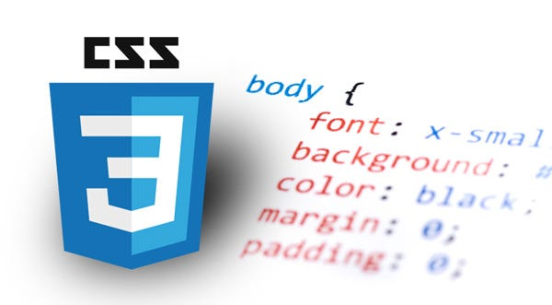

Module Title: - Develop Cascaded style sheets
Module code: EIS WDDBA3 05 1221
Nominal duration: 90 Hour

Prepared by: Entoto PTC - Department of IT

September, 2023
Addis Ababa, Ethiopia

Introduction to the Module

In web development and database administration filed; Develop Cascaded style sheets helps to achieve the performance outcomes, skills and knowledge required to use web authoring tools to create, modify and test CSS in a website.
This module is designed to meet the industry requirement under web development and database administration occupational standard, particularly for the unit of competency: Develop Cascaded style sheets
This module covers the units:
- Determine requirements and develop CSS
- Use CSS techniques to create web pages
- Ensure web page and CSS are validated and tested

Learning Objective of the Module
- Acquire clear understanding of CSS
- Use CSS techniques to create web pages
- Ensure web page and CSS are validated and tested

Module Instruction
For effective use these modules trainees are expected to follow the following module instruction:
- Read the information written in each unit
- Accomplish the Self-checks at the end of each unit
- Perform Operation Sheets which were provided at the end of units
- Do the “LAP test” giver at the end of each unit and
- Read the identified reference book for Examples and exercise

Unit one: Determine requirements and develop CSS
This unit is developed to provide you the necessary information regarding the following content coverage and topics:
- Introduction to CSS and basic design principles
- Obtaining user requirements for style
- Developing CSS to match user requirements
This unit will also assist you to attain the learning outcomes stated in the cover page. Specifically, upon completion of this learning guide, you will be able to:
- Introduction to CSS and basic design principles
- Obtaining user requirements for style
- Developing CSS to match user requirements

Unit One: Determine requirements and develop CSS
Introduction to CSS and basic design principles
CSS, just like HTML, is one of the core languages of the World Wide Web. While you add text to a website using HTML and structure it semantically, you define the design of its content using CSS.
Although HTML and CSS are used in combination, the CSS design instructions and the HTML elements exist separately from one another. This means that a machine can read an electronic document even without CSS. With the help of CSS, browser content is visually prepared and presented in an appealing way.
CSS is a “living standard” that continues to be developed by the World Wide Web Consortium. For this reason, there are always new functions and practical applications to discover. The widespread stylesheet language emerged in the 1990s.
The idea of using stylesheets to display web content was no longer entirely new at that time. But CSS differed in one important aspect from other display-oriented elements that already existed in HTML: users now had the option to define design rules for groups of elements across multiple documents and in a single stylesheet.
Advantages and areas of application of CSS
A successful website doesn’t just depend on content, but also on a good design. Users quickly lose interest in websites that aren’t user-friendly or well-structured. Here, CSS offers a range of design options that are not available in pure HTML.
For example, CSS lets you control some specifications centrally. This means that similar elements (such as all hyperlinks or images) within a single document can be recognized and formatted using a single command. The design instructions do not have to be in the form of an internal style sheet in the HTML document itself. If you save the CSS instructions in an external stylesheet, i.e., a separate file, this can also be used for other documents.
In addition to basic display instructions relating to the colors, shapes, and typography of the HTML elements, there are now more sophisticated modules in CSS. With these you can, for example, define animations or different representations depending on the output medium. In this way, the same HTML document can be prepared identically for all possible media. Since the content and design are separate in this document, the code of the website is clearer. The related style language SASS offers even more possibilities, but it doesn’t entirely replace CSS.
CSS – Syntax
The fundamental objective of the Cascading Stylesheet (CSS) language is to permit a document to add style components of the page with explicit elements, similar to tones, situating, or designs. The property is an identifier, which is an intelligible name, which characterizes which element is thought of. The worth depicts how the element should be dealt with by the motor. Every property has a bunch of legitimate qualities, characterized by a conventional syntax, just as a semantic significance, executed by the program motor.
Hence, the syntax of CSS is as follows:
Selector {
Property1: value1;
Property2: value2;
.
.
}
This is the HTML component name toward the beginning of the ruleset. It characterizes the element(s) to be styled (in this model, <p> components). To style an alternate component, change the selector.

- Properties
These are manners by which you can style an HTML component. (In this model, shading is a property of the <p> components.) In CSS, you pick which properties you need to influence in the standard.
- Values
To one side of the property—after the colon—there is the property estimation. This picks one out of numerous potential appearances for a given property. (For instance, there are many shading esteems notwithstanding red.)
- Note the other significant pieces of the syntax:
Aside from the selector, each ruleset should be enclosed by wavy supports. ({})
Inside every statement, you should utilize a colon (:) to isolate the property from its worth or qualities.
Inside each ruleset, you should utilize a semicolon (;) to isolate every affirmation from the following one.

Obtaining user requirements for style
User requirements are the specific needs and wants of a user that must be taken into account during the web design quality assurance process. The user requirements gathering process includes surveys, interviews, focus groups, and more. Once you determine user requirements and set an acceptance criteria checklist for each, you should put them in a website requirements document. Those will help you with the UX design process by specifying what the visitor should see on the website, how it should work, and any special considerations that need to be taken into account.

Accessibility guidelines to keep in mind during the UX design process
Website accessibility guidelines WCAG are a set of best practices that help people with disabilities use the internet. These guidelines help web designers to make websites easier to use, by ensuring they are accessible to everyone. Guidelines cover everything from how text should be formatted, how images and other design elements can be used, to how software should be designed to be user-friendly. To ensure that your website will be accessible to your visitors, you need to keep WCAG guidelines in mind when creating user requirements for a website design and during all the phases of your website building project. Those guidelines are sorted into the following categories:
- Operable
You need to make sure that every task is performable on both keyboard and mouse, that users have enough time to complete a task, that they can easily find the content of their interest, that your content won’t cause seizures, and similar. For example, if there are time-limited tasks on your website, including an option for users to turn off or extend the limit should be written in your website development checklist.
- Perceivable
You need to ensure that all users can easily perceive your content. Provide text alternatives for videos and images, plan on implementing audio alternatives for textual content, and ensure it can be consumed by visitors who use screen readers.
- Understandable
Maximizing the chances that visitors will be able to make sense of your content is vital in web design. You can do it by avoiding complex words and instructions, explaining error messages and interactive website design elements in detail. This will improve the readability and predictability of your website, making it more accessible to users.
- Robust
Through quality assurance, you need to ensure that your website is accessible from all the different browsers and devices people use to explore the internet. This means that your content should be displayed in the way you intended, and the website functions without any errors no matter the browser or device.

Developing CSS to match user requirements
What do users want from your website?
Before you start writing user requirements for a website design you need to deeply understand your target audience. This will help you plan your web project’s UX design and content strategy to fit the needs of your ideal customer. The key point is that the quality assurance phase starts long before coding, and continues even after the website is launched. You need to constantly seek for audience’s feedback, and conducting interviews with your customers will allow you to improve the quality of your UX design. However, as there are a few things that all the audiences have in common – when creating a website project checklist, keep the following in mind:
Build trust with customers
As people mostly buy products and services from businesses they trust, the e-Commerce development process needs to be focused on building a website that invokes trustworthiness. First impressions are lasting impressions, and there are several ways in which web strategists can secure positive ones:
Mirror the words of your target audience
Imitating the tone of your target audience can enormously increase a website’s conversion rates. Avoid industry jargon that your ideal customer might not be able to quickly understand. By using words that match your target audience’s vocabulary, you can appear more trustworthy.
Evoke emotions with visuals
Powerful way to connect with the target audience is by including photos and videos that evoke trust across your landing pages. The human brain perceives visual information much faster, and by not using them you are missing a large opportunity to create a more credible look for your website.
Useful and creative content
Most users will come to your website with one goal – to find useful information. To improve customer retention for your business, you need to ensure that only high-quality content ends up on your website. But to be able to deliver engaging content, you need to plan the content structure in advance, of course, with end users in mind. When defining user requirements for a website design, you need to:
Plan a site map: Planning a site map upfront will make the whole design process smoother. It will allow you to organize your content in a user-friendly manner and secure that visitors can find any page quickly. The best practice is to include the exact location of each page in your website requirements documents.
Create page templates: To secure the best possible user experience on your website, it is important to adjust the design of pages with different types of content. Including page templates for your homepage, service pages, blog posts, and more in your website design requirements list will help you keep your web build projects on track.
Define types of content: Define different types of content your users might look for on your website, such as blog articles, products, testimonials, and similar. This will allow you to plan your navigation more efficiently.
Make it easy to navigate
Before starting a user experience design process, it is crucial to put yourself in the website visitor’s shoes. Just upon arriving on your website, people will quickly skim to see how design elements are organized and then search for the information they were looking for in the first place. When writing user requirements for a website design project, you need to plan an intuitive user interface design your website visitors will be able to quickly get used to.
You need to ensure that the navigation menu is simple to understand and placed exactly where users expect it to be. The best practice is to limit the number of items to seven and give each category a relevant name that won’t confuse users. Let’s see what types of navigation menus exist, so that you can include the one that best suits your target audience in your quality assurance for website development checklist:
- Horizontal navigation bar
Probably the most popular navigation menu type, that is usually located at the top of the page, just below the header. The horizontal navigation bar goes in the left-to-right direction. This type of menu will leave more space for placing other website design elements in the body area of your pages. As it is used on most websites, a horizontal navigation bar is the safest bet when designing a user experience. In your website requirements document, write down the website pages that need to be placed in the navigation menu since most of your visitors will look for them once they arrive.
- Vertical sidebar navigation menu
This type of menu appears on the right or left side and usually stretches from the top to the bottom of the page. Because it allows web strategists to create a clear hierarchy of navigation items, vertical sidebar menus are often used when building websites with a lot of content. Another scenario in which you might want to ask your web development team to build a vertical sidebar menu is when you want to insert longer link texts.
- Dropdown navigation menu
Another type of navigation menu you can put in your website requirements document when building websites that are content-rich. This approach will allow you to list the most pages in the top-level menu while providing links to other sections in a dropdown menu. That’s why it is ideal to utilize the dropdown menu when building e-commerce sites, which usually have many categories.
- Hamburger navigation menu
This is a type of navigation menu that appears when you hover your mouse or click over a “hamburger” button. It is the most popular menu type for mobile website design because it occupies the least space until the user clicks on it. However, during the quality assurance phase, you need to ensure that the hamburger navigation menu functions well across different devices to avoid ruining the user experience and be able to balance your mobile vs desktop conversion rates.

- Footer navigation menu
One of the website design elements that you shouldn’t overlook when creating a web development checklist is the footer navigation menu. As its name suggests, it appears at the bottom of your web pages and provides links to other useful parts of your website, such as the home page, the about us page, contact pages, service pages, etc. You can also use it to provide more information about your website that is not of vital importance to most users.

- Typography
When writing user requirements for a website design, it is also crucial not to overlook the importance of typography in UX design. To enhance the readability and accessibility of your web design define the following elements in your website requirements document:
- Typefaces
When writing user requirements for a website design it is important to define the typeface classes you are going to use in your web project. The two most popular are serif and san serif typefaces. Serif typefaces are characterized by the small, decorative lines that run along the edges of the letters. San serif typefaces do not have these lines and are less formal. They are often used for headlines or other text that is meant to be read quickly. You can combine serif and san serif typefaces for achieving the optimal user experience.
- The number of fonts
To create a high-converting digital landscape, it is vital not to lose the preferred number of fonts out of your website design process focus. The best practice is to use a maximum of two fonts on your website. To create better contrast and guide users smoothly, we recommend using one serif and one san serif font. However, you won’t make a mistake if you stick to only one font in your web project, just ensure that it is listed in your website requirements document to avoid confusing your design teams.
- Line heights
Line height is the distance between the lines in a text or graphic element on a web page. It affects how easy it is to read the text or see the graphics. A line height of 1.5 (150% of the font size) is common, but you can specify another line height in your website design requirements document if you believe it will make the text or graphics more legible.
- Letter spacing
Letter spacing is the distance between letters in a word or phrase. It is measured in points and is set in pixels. The default setting for most browsers is 16px. When you change the letter spacing, it will affect all the text on the page. You can also use CSS to set letter spacing for individual elements. It is vital to write down the preferred letter spacing in your website requirements document so that your design teams can follow the plan and quality assurance goes smoother.
- Is your site mobile responsive?
As more and more people are using smartphones and tablets to browse the internet, your web development team needs to ensure the mobile-friendliness of the website during the design process. If your website is hard to use on mobile devices, most users will leave before even exploring your offers. That’s why it is crucial to utilize the power of responsive web design to make your website look and function equally well on desktop and mobile devices. Mobile-friendly web design will secure a better user experience and give you an SEO boost. A quality assurance checklist is unfinished until it contains the detailed plan for testing a website on various screen sizes.

Importance of UX
User experience is the totality of a user’s interaction with your website design. It encompasses all aspects of the design and development process, from the initial conception of the system to the final delivery to the end user. Poor user experience can lead to frustrated customers and lost business opportunities. It can be caused by a variety of factors, such as poorly designed websites, difficult-to-use interfaces, slow response times, and more. That’s why you need a comprehensive UX design quality assurance checklist and a website requirements document that will help your development and design teams easily keep the website building project on track.
As you can see, creating a list of user requirements for a website design project can help you organize your team and build a visually appealing website that is also bug-free.

Self-Check 1
- 1. What is CSS?
a) CSS is a style sheet language
b) CSS is designed to separate the presentation and content, including layout, colors, and fonts
c) CSS is the language used to style the HTML documents
d) All of the mentioned
- Which of the following tag is used to embed css in html page?
a) <css>
b) <!DOCTYPE html>
c) <script>
d) <style>
- Which of the following CSS selectors are used to specify a group of elements?
a) tag
b) id
c) class
d) both class and tag
- Which of the following has introduced text, list, box, margin, border, color, and background properties?
a) HTML
b) PHP
c) CSS
d) Ajax
- Which of the following type of HTML tag is used to define an internal style sheet?
a) <script>
b) <link>
c) <class>
d) <style>

Lap Test 1
- List and explain the four categories of accessibility guidelines.
- What are some techniques to find user requirements?
- Discuss some advantages of CSS

Unit Two. Use CSS techniques to create web pages
This unit is developed to provide you the necessary information regarding the following content coverage and topics:
- Styling elements of a web page by using CSS techniques
- Creating page layout using CSS
- Positioning document elements using CSS
- Applying style sheets to multiple pages in a website
- Creating web pages that will function in a variety of screen resolutions
- Application of browser-specific rules
This unit will also assist you to attain the learning outcomes stated in the cover page. Specifically, upon completion of this learning guide, you will be able to:
- Style elements of a web page by using CSS techniques
- Create page layout using CSS
- Position document elements using CSS
- Applying style sheets to multiple pages in a website
- Creating web pages that will function in a variety of screen resolutions

Unit Two. Use CSS techniques to create web pages

Styling elements of a web page by using CSS techniques

CSS Syntax
A CSS comprises of style rules that are interpreted by the browser and then applied to the corresponding elements in your document. A style rule is made of three parts −
- Selector − A selector is an HTML tag at which a style will be applied. This could be any tag like <h1> or <table> etc.
- Property − A property is a type of attribute of HTML tag. Put simply, all the HTML attributes are converted into CSS properties. They could be color, border etc.
- Value − Values are assigned to properties. For example, color property can have value either red or #F1F1F1 etc.
You can put CSS Style Rule Syntax as follows –
selector { property: value }
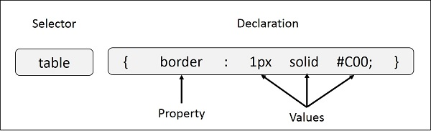
Example − You can define a table border as follows −
table{ border :1px solid #C00; }
Here table is a selector and border is a property and given value 1px solid #C00 is the value of that property.
You can define selectors in various simple ways based on your comfort. Let me put these selectors one by one.
- The Type Selectors
This is the same selector we have seen above. Again, one more example to give a color to all level 1 headings −
h1 {
color: #36CFFF;
}

- The Universal Selectors
Rather than selecting elements of a specific type, the universal selector quite simply matches the name of any element type –
* {
color: #000000;
}

This rule renders the content of every element in our document in black.
- The Descendant Selectors
Suppose you want to apply a style rule to a particular element only when it lies inside a particular element. As given in the following example, style rule will apply to <em> element only when it lies inside <ul> tag.
ul em {
color: #000000;
}
- The Class Selectors
You can define style rules based on the class attribute of the elements. All the elements having that class will be formatted according to the defined rule.
.black {
color: #000000;
}
This rule renders the content in black for every element with class attribute set to black in our document. You can make it a bit more particular. For example –
h1.black {
color: #000000;
}
This rule renders the content in black for only <h1> elements with class attribute set to black.
You can apply more than one class selectors to given element. Consider the following example −
<p class = "center bold">
This para will be styled by the classes center and bold.
</p>
- The ID Selectors
You can define style rules based on the id attribute of the elements. All the elements having that id will be formatted according to the defined rule.
#black {
color: #000000;
}
This rule renders the content in black for every element with id attribute set to black in our document. You can make it a bit more particular. For example –
h1#black {
color: #000000;
}

This rule renders the content in black for only <h1> elements with id attribute set to black.
The true power of id selectors is when they are used as the foundation for descendant selectors, For example −
#black h2 {
color: #000000;
}
In this example all level 2 headings will be displayed in black color when those headings will lie with in tags having id attribute set to black.
- The Child Selectors
You have seen the descendant selectors. There is one more type of selector, which is very similar to descendants but have different functionality. Consider the following example −
body > p {
color: #000000;
}
This rule will render all the paragraphs in black if they are direct child of <body> element. Other paragraphs put inside other elements like <div> or <td> would not have any effect of this rule.
- The Attribute Selectors
You can also apply styles to HTML elements with particular attributes. The style rule below will match all the input elements having a type attribute with a value of text –
input[type = "text"] {
color: #000000;
}
The advantage to this method is that the <input type = "submit" /> element is unaffected, and the color applied only to the desired text fields.

There are following rules applied to attribute selector.
Multiple Style Rules
You may need to define multiple style rules for a single element. You can define these rules to combine multiple properties and corresponding values into a single block as defined in the following example −
h1 {
color: #36C;
font-weight: normal;
letter-spacing: .4em;
margin-bottom: 1em;
text-transform: lowercase;
}
Here all the property and value pairs are separated by a semicolon (;). You can keep them in a single line or multiple lines. For better readability, we keep them in separate lines.
For a while, don't bother about the properties mentioned in the above block. These properties will be explained in the coming chapters and you can find complete detail about properties in CSS References
- Grouping Selectors
You can apply a style to many selectors if you like. Just separate the selectors with a comma, as given in the following example −
h1, h2, h3 {
color: #36C;
font-weight: normal;
letter-spacing: .4em;
margin-bottom: 1em;
text-transform: lowercase;
}
This define style rule will be applicable to h1, h2 and h3 element as well. The order of the list is irrelevant. All the elements in the selector will have the corresponding declarations applied to them.
You can combine the various id selectors together as shown below −
#content, #footer, #supplement {
position: absolute;
left: 510px;
width: 200px;
}

CSS – Inclusion
There are four ways to associate styles with your HTML document. Most commonly used methods are inline CSS and External CSS.

Embedded CSS - The <style> Element
You can put your CSS rules into an HTML document using the <style> element. This tag is placed inside the <head>...</head> tags. Rules defined using this syntax will be applied to all the elements available in the document. Here is the generic syntax –
<!DOCTYPE html>
<html>
<head>
<style type = "text/css" media = "all">
body {
background-color: linen;
}
h1 {
color: maroon;
margin-left: 40px;
}
</style>
</head>
<body>
<h1>This is a heading</h1>
<p>This is a paragraph.</p>
</body>
</html>
It will produce the following result –
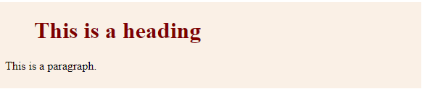

- Attributes
Attributes associated with <style> elements are –
Attribute | Value | Description
type | text/css | Specifies the style sheet language as a content-type (MIME type). This is required attribute.
media | screen  tty  tv  projection  handheld  print  braille  aural  all | Specifies the device the document will be displayed on. Default value is all. This is an optional attribute.

Inline CSS - The style Attribute
You can use style attribute of any HTML element to define style rules. These rules will be applied to that element only. Here is the generic syntax –
<element style = "...style rules....">
Attributes
Attribute | Value | Description
style | style rules | The value of style attribute is a combination of style declarations separated by semicolon (;).
Example
Following is the example of inline CSS based on the above syntax –
<html>
<head>
</head>

<body>
<h1 style = "color:#36C;">
This is inline CSS
</h1>
</body>
</html>
It will produce the following result –


External CSS - The <link> Element
The <link> element can be used to include an external stylesheet file in your HTML document.
An external style sheet is a separate text file with .css extension. You define all the Style rules within this text file and then you can include this file in any HTML document using <link> element.
Here is the generic syntax of including external CSS file –
<head>
<link type = "text/css" href = "..." media = "..." />
</head>
Attributes
Attributes associated with <style> elements are –
Attribute | Value | Description
type | text css | Specifies the style sheet language as a content-type (MIME type). This attribute is required.
href | URL | Specifies the style sheet file having Style rules. This attribute is a required.
media | screen  tty  tv  projection  handheld  print  braille  aural  all | Specifies the device the document will be displayed on. Default value is all. This is optional attribute.
Example
Consider a simple style sheet file with a name mystyle.css having the following rules −
h1, h2, h3 {
color: #36C;
font-weight: normal;
letter-spacing: .4em;
margin-bottom: 1em;
text-transform: lowercase;
}
Now you can include this file mystyle.css in any HTML document as follows –
<head>
<link type = "text/css" href = "mystyle.css" media = " all" />
</head>

Imported CSS - @import Rule
@import is used to import an external stylesheet in a manner similar to the <link> element. Here is the generic syntax of @import rule.
<head>
@import "URL";
</head>
Here URL is the URL of the style sheet file having style rules. You can use another syntax as well –
<head>
@import url("URL");
</head>
Example
Following is the example showing you how to import a style sheet file into HTML document –
<head>
@import "mystyle.css";
</head>

- CSS Rules Overriding
We have discussed four ways to include style sheet rules in a an HTML document. Here is the rule to override any Style Sheet Rule.
- Any inline style sheet takes highest priority. So, it will override any rule defined in <style>...</style> tags or rules defined in any external style sheet file.
- Any rule defined in <style>...</style> tags will override rules defined in any external style sheet file.
- Any rule defined in external style sheet file takes lowest priority, and rules defined in this file will be applied only when above two rules are not applicable.

CSS Comments
Many times, you may need to put additional comments in your style sheet blocks. So, it is very easy to comment any part in style sheet. You can simple put your comments inside /*.....this is a comment in style sheet.....*/.
You can use /* ....*/ to comment multi-line blocks in similar way you do in C and C++ programming languages.
Example
<!DOCTYPE html>
<html>
<head>
<style>
p {
color: red;
/* This is a single-line comment */
text-align: center;
}
/* This is a multi-line comment */
</style>
</head>

<body>
<p>Hello World!</p>
</body>
</html>
It will produce the following result –


CSS – Units
Values and units, in CSS, are significant as they determine the size, proportions, and positioning of elements on a web page.
CSS Units, define the measurement system used to specify the values. CSS offers a number of different units for expressing length and measurement. CSS unit is used to specify the property size for a page element or its content.
There are a number of ways to specify and measure length in CSS. It is used to specify margins, padding, font size, width, height, border, etc.
For example- font-size: 50px, here number 50 has a suffix px i.e., pixel, it is a CSS measurement unit.
There should be no whitespace between the number and the unit. The unit can be left out when the value is 0.
Following table shows the different types of values and units that we mostly use in CSS styling:
Data type | Description | Example
<integer> | Represents a whole number | 55, -55, etc.
<number> | Represents a decimal number. It may or may not have a decimal point. | 1.5, 234, -1.5, etc.
<dimension> | Represents a <number> with a unit attached to it. Also includes value types such as <length>, <angle>, <time> and <resolution> | 5px, 30deg, 2s, 2.5dpi
<percentage> | Represents a fraction of other value, that is, it is always relative to other value. | 80%, 25%, etc.

CSS Length Units
Length units can be categorized into two types:
- Absolute units
- Relative units
- Absolute Length Units
These units are categorized as fixed-length units, which means that lengths specified with absolute units maintain an exact, unchanged size on the screen.
These units prove to be very effective when the browser has comprehensive information about the properties of the screen, the printer being used, or other appropriate user agents.
The following table contains all the types of absolute units:
Unit | Description | Equivalent value | Example
mm | Millimetre | 1mm = 1/10th of 1cm | font-size: 10mm;
cm | Centimetre | 1cm = 37.8px = 25.2/64in | font-size: 5cm;
Q | Quarter-millimeters | 1Q = 1/40th of 1cm | font-size: 5Q;
in | Inches | 1in = 2.54cm = 96px | font-size: 1in;
pt | Points | 1pt = 1/72 of 1in | font-size: 20pt;
pc | Picas | 1pc = 1/6th of 1in | width: 6pc;
px | Pixels | 1px = 1/96th of 1in | font-size: 15px;

Absolute units prove valuable for projects where responsiveness is not a priority. However, they are less beneficial for responsive websites because they do not adjust when screen dimensions change.
Example
Here is an example of absolute units (mm, cm, in, Q):
<html>
<head>
<style>
.unit-mm {
font-size: 5mm;
}
.unit-cm {
font-size: 1cm;
}
.unit-inch {
font-size: 0.5in;
}
.unit-quarter {
font-size: 40Q;
}
</style>
</head>
<body>
<h1 class="unit-mm">Font size 5mm</h1>
<h1 class="unit-cm">Font size 1cm</h1>
<h1 class="unit-inch">Font size 0.5inch</h1>
<h1 class="unit-quarter">Font size 40Q</h1>
</body>
</html>

Output
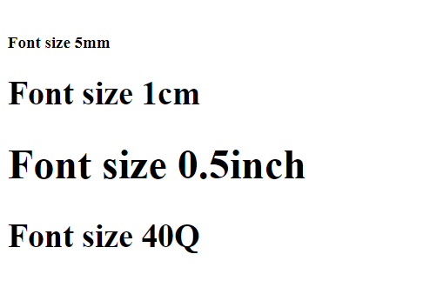
Here is an example of absolute units (px, pt, pc):
<html>
<head>
<style>
.unit-px {
font-size: 20px;
}
.unit-pt {
font-size: 25pt;
}
.unit-pc {
font-size: 3pc;
}
</style>
</head>
<body>
<h1 class="unit-px">Font size 20px</h1>
<h1 class="unit-pt">Font size 25pt</h1>
<h1 class="unit-pc">Font size 3pc</h1>
</body>
</html>
Output
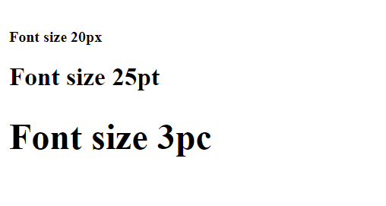
- CSS Relative Length Units
CSS Relative length units are called such because they are measured in relation to other elements. Relative units are great for styling responsive websites because they can be adjusted proportionally based on window size or parent elements. These units define lengths relative to other length properties.
The following table contains all the types of relative units:
Unit | Description | Example
em | Relative to the font-size of the element. | font-size: 4em;
ex | Relative to the x-height of the current font. | font-size: 4ex;
ch | Relative to width of the "0". | font-size: 4ch;
rem | Relative to font-size of the root element. | font-size: 2rem;
lh | It is relative to the line height of the element. | font-size: 4lh;
rlh | It is relative to the line height of the root element. | font-size: 4rlh;
vh | It is relative to the height of the viewport. 1vh = 1% or 1/100 of the height of the viewport. | font-size: 4vh;
vw | It is relative to the width of the viewport. 1vw = 1% or 1/100 of the width of viewport. | width: 4vw;
vmin | It is relative to the smaller dimension of the viewport. 1vmin = 1% or 1/100 of the viewport's smaller dimension. | width: 4vmin;
vmax | It is relative to the larger dimension of the viewport. 1vmax = 1% or 1/100 of the viewport's larger dimension. | width: 4vmax;
vb | It is relative to the size of the initial containing block in the direction of the root element's block axis. 1vb = 1% of containing block's size (block axis). | font-size: 4vb;
vi | It is relative to the size of the initial containing block in the direction of the root element's inline axis. 1vb = 1% of containing block's size (inline axis). | font-size: 4vi;
svw, svh | It is relative to the width and height of the smaller viewport. 1svw = 1% or 1/100 of the smaller viewport's width and 1svh = 1% or 1/100 of the smaller viewport's height. | width: 40svw; height: 40svh;
lvw, lvh | It is relative to the width and height of the larger viewport. 1lvw = 1% or 1/100 of the larger viewport's width and 1lvh = 1% or 1/100 of the larger viewport's height. | width: 40lvw; height: 40lvh;
dvw, dvh | It is relative to the width and height of the dynamic viewport. 1dvw = 1% or 1/100 of the dynamic viewport's width and 1dvh = 1% or 1/100 of the dynamic viewport's height. | width: 40dvw; height: 40dvh;

Example - em Unit
This unit sets the size relative to the font-size of the element:
<html>
<head>
<style>
div {
font-size: 20px;
border: 2em solid green;
}
</style>
</head>
<body>
<div>
This div will have a border of 20 * 2 = 40 pixels.
</div>
</body>
</html>

Output
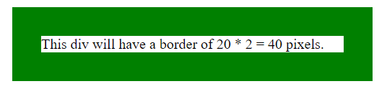

Example - ex Unit
This unit sets the size relative to the x-height of the current font:
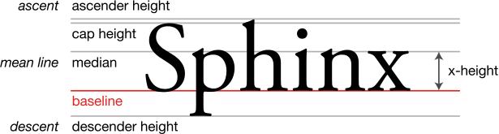
<html>
<head>
<style>
div {
font-size: 20px;
border: 2ex solid green;
}
</style>
</head>
<body>
<div>
This div will have a border of 2 * x-height of the line.
</div>
</body>
</html>

Output
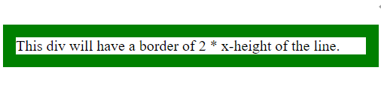
Example - ch Unit
This unit sets the size relative to width of the "0" (zero) character in the chosen font. It is primarily used to create responsive designs that scale with the font size:
In the following example we set the input width to 10ch (which means it will show 10 characters). Try changing the font-size value and see how input still shows 10 characters or numbers.
<html>
<head>
<style>
input{
font-size: 2em;
width:10ch;
}
</style>
</head>
<body>
<div>
<input type="text" name="id" id="userID" placeholder="enter PIN">
</div>
</body>
</html>
Output

Example - rem Unit
This unit sets the size relative to font-size of the root element, typically the HTML element itself:
<html>
<head>
<style>
html {
font-size: 12px;
}
p {
font-size: 2rem;
border: 1px solid green;
}
span{
font-size:24px;
border: 1px solid red;
}
</style>
</head>
<body>
This is root element whose font-size is 12px.
<p>This is child element whose font is 2rem which means 12 * 2 = 24px.</p>
<span>This is child element whose font is 24px.</span>
</body>
</html>
Output
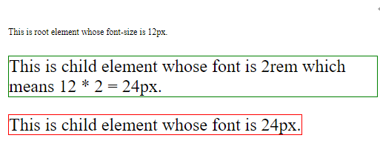
Example - lh and rlh Unit
lh unit sets the size relative to the line height of the element.
rlh unit sets the size relative to the line height of the root element.
Following example demonstrates usage of both lh and rlh units (Try changing font-size to 10px, 2em, or 300%; in body > div:first-of-type):
<html>
<head>
<style>
:root {
font-size: 100%;
/*
Changing the value of line height also changes
the used value for any declaration that uses
line height units.

In this case, it affects the entire document
because this ruleset matches the root element.
*/
line-height: 1;
}
body > div:first-of-type {
/*
Changing the font size here only affects the
first two blocks of text. Those blocks of text
use lh units.

The last block of text use rlh or root
line height units. Its text size gets calculated
relative to the font size of the :root element.

Try changing this to 10px, 2em, or 300%;
*/
font-size: 1lh;
display: grid;
grid-template-columns: auto auto auto auto;
gap: 24px;
margin-block-end: 2rem;
}
.lh {
font-size: 1.5lh;
background: #87cefa66;
}
.rlh {
font-size: 1.5rlh;
background: #da70d666;
}
body > p {
font-family: sans-serif;
font-size: 1.5rem;
}
[lang] {
padding: 5px;
}
[lang="en"] {
font-family: "Lora", serif;
align-self: start;
}

p {
margin-block: 0 1rem;
}

</style>
</head>
<body>

<div>
<div lang="en" class="lh">
<p>Lorem Ipsum is simply dummy text of the printing and typesetting industry. </p>

<p>Lorem Ipsum is simply dummy text of the printing and typesetting industry. </p>
</div>
<div lang="en" class="rlh">
<p>Lorem Ipsum is simply dummy text of the printing and typesetting industry.</p>

<p>Lorem Ipsum is simply dummy text of the printing and typesetting industry.</p>
</div>
</div>

</body>
</html>
Output
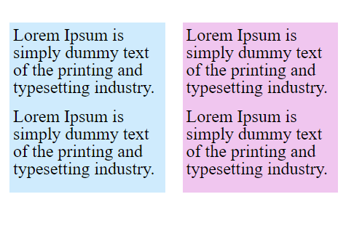
Example - vh Unit and vw Unit
vh (viewport height) unit sets the size relative to the height of the viewport. 1vh = 1% or 1/100 of the height of the viewport.
vw (viewport width) unit sets the size relative to the width of the viewport. 1vw = 1% or 1/100 of the width of viewport.
For example, we set the width to 20vw and the height to 20vh. Say viewport width and height are respectively 1200px and 1000px. In this scenario, the value of 20vw will be 240px and that of 20vh will be 200px.
<html>
<head>
<style>
body {
height:500vh;
}
.container{
display:flex;
}
.box-1{
background-color: lightgreen;
height:50vh;
width:50vw;
}
</style>
</head>
<body>
<div class="box-1"></div>
<p>Resize the height of the browser window to see how the box-size (height and width) changes. 1vh = 1% of viewport height and width respectively.</p>
</body>
</html>
Output
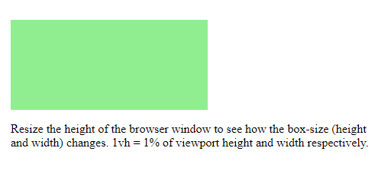
Example - vmin (viewport minimum) and vmax (viewport maximum) Unit
- vmin (viewport minimum) unit sets the size relative to the smaller dimension of the viewport. 1vmin = 1% or 1/100 of the viewport's smaller dimension. For example, if the viewport is 1000px wide and 800px high. If we set the width of an element to 30vmin, it will be 30% of the height. So 30% of 800px is 240px.
- vmax (viewport maximum) unit sets the size relative to the larger dimension of the viewport. 1vmax = 1% or 1/100 of the viewport's larger dimension. For example, if the viewport is 1000px wide and 800px high. If we set the width of an element to 30vmax, it would be 30% of the width, or 300px.
<html>
<head>
<style>
div {
box-sizing: border-box;
color: white;
margin-bottom: 4px;
padding: 4px;
overflow: scroll;
}
.vwvh {
background: lightcoral;
width: 60vw;
height: 70vh;
}
.vmin {
color: black;
background: lightblue;
width: 80vmin;
height: 20vmax;
}
</style>
</head>
<body>
<div class="vwvh">
width = 50vw (50% of the viewport's width)<br />
height = 30vh (30% of the viewport's height)
</div>
<div class="vmin">
width = 80vmin (should be viewport's height)<br />
height = 10vmax (should be viewport's width)
</div>
</body>
</html>
Output
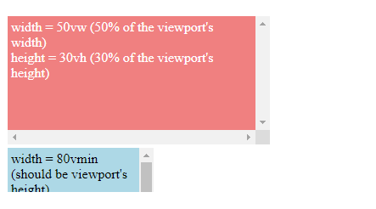
Example - vb Unit
This unit sets the size relative to the size of the initial containing block in the direction of the root element's block axis. 1vb = 1% of containing block's size (block axis):
<html>
<head>
<style>
body {
font-size:20px;
}
.container{
height:80vb;
}
p{
font-size:50vb;
}
</style>
</head>
<body>
<div class="container">
<p>Resize the height of the browser window to see how the font changes.</p>
</div>
</body>
</html>
Output
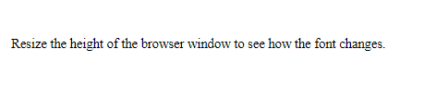

Example - vi Unit
This unit sets the size relative to the size of the initial containing block in the direction of the root element's inline axis. 1vi = 1% of containing block's size (inline axis):
<html>
<head>
<style>
body {
font-size:20px;
}
.container{
width:80vi;
}
p{
font-size:5vi;
}
</style>
</head>
<body>
<div class="container">
<p>Resize the height of the browser window to see how the font changes. 1vh = 1% of viewport height and width respectively.</p>
</div>
</body>
</html>
Output
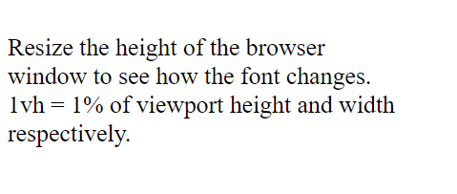
Following example demonstrates using <resolution> data type, where the image resolution is set as 500dpi:
<html>
<head>
<style>
img {
width: 300px;
height: 200px;
margin-right: 0.5in;
}
</style>
</head>
<body>
<h2>Image Resolution dots per inch</h2>
<h3>500dpi</h3>
<img style="image-resolution: 500dpi;" src="images/pink-flower.jpg" alt="500dpi">
</body>
</html>

Output
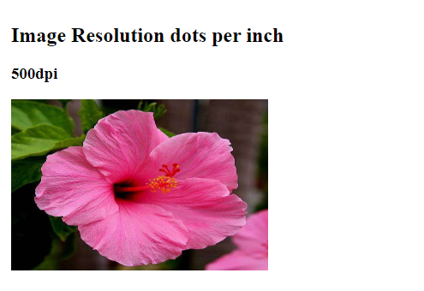

Example - Percentages
A percentage value is always set in relation with another value. For example, when a percentage value is passed as height or width of an element, it will be calculated as percentage of the height or width of the parent element.
<html>
<head>
<style>
.main {
height: 400px;
border: 5px solid rgb(19, 12, 218);
display: inline-block;
}
.box {
border: 2px solid black;
padding: 5px;
margin: 10px;
display: inline-block;
}
.length-value {
height: 100px;
}
.percent-value {
height: 40%;
}
</style>
</head>
<body>
<div class="box length-value">Box height is 100px</div>
<div class="box percent-value">Box height is 40%</div>
<div class="main">
<div class="box length-value">Box inside the main box is 100px high</div>
<div class="box percent-value">Box height is 40% of main box</div>
</div>
</div>
</body>
</html>
Output
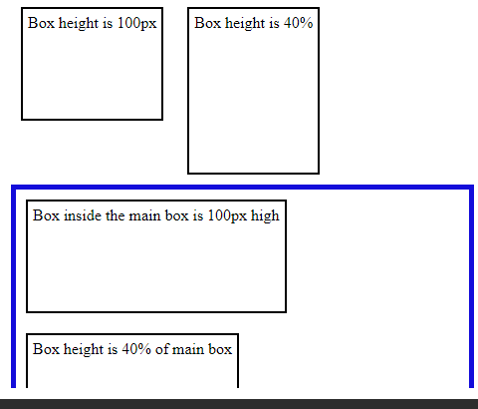
Let us see one more example of usage of percentage, where the nested values of a list are calculated based on the value of parent element font-size:
<html>
<head>
<style>
.font-value {
font-size: larger;
}
li {
font-size: 60%;
}
</style>
</head>
<body>
<div>
<h2>Beverages</h2>
<ul>
<li class="font-value">Tea
<ul>
<li>Assam tea</li>
<li>Darjeeling tea</li>
</ul>
</li>
<li class="font-value">Coffee
<ul>
<li>Hot coffee</li>
<li>Cold Coffee</li>
</ul>
</li>
<li class="font-value">Juices
<ul>
<li>Orange</li>
<li>Mango</li>
<li>Sweet Lime</li>
</ul>
</li>
</ul>
</div>
</body>
</html>
Output
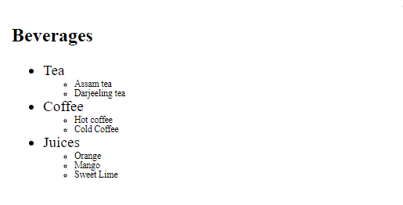
There are some properties that accept a length or a percentage value, some properties that only accept length. If the permitted value indicates <length-percentage>, the value passed can be either length or percentage; and when the permitted value indicates <length>, the value passed should be only length and not percentage.
Example - Numbers
There are some properties of CSS that accepts the value types as numbers, without any unit attached to it. Properties such as opacity, line-height, etc.
For instance, the value for opacity can range from 0 to 1.
Here is an example for opacity:
<html>
<head>
<style>
.wrapper {
display: flex;
}
#common-style {
background-color: #d3360b;
width: 150px;
height: 100px;
border: 3px solid black;
margin: 5px;
}
p {
text-align: center;
}
.decimal-opacity {
opacity: 0.4;
}
.opacity-0 {
opacity: 0;
}
.opacity-1 {
opacity: 1;
}
</style>
</head>
<body>
<div class="wrapper">
<div class="decimal-opacity" id="common-style">
<p>CSS Opacity to 0.4</p>
</div>
<div style="border: 2px solid green">
<p>CSS Opacity to 0</p>
<div class="opacity-0" id="common-style"></div>
</div>
<div class="opacity-1" id="common-style">
<p>CSS Opacity to 1</p>
</div>
</div>
</body>
</html>
Output
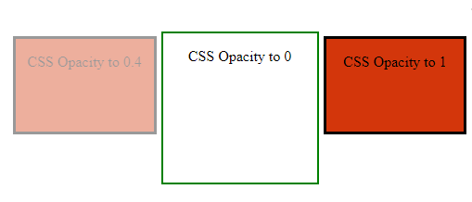

CSS – Colors
CSS uses color values to specify a color. Typically, these are used to set a color either for the foreground of an element (i.e. its text) or else for the background of the element. They can also be used to affect the color of borders and other decorative effects.
- Syntax
CSS allows to set colors of an element in a variety of ways. Let's check all the possible available syntax to set the height of an element.
- Named Colors
A CSS named color is the name of a color, such as red, blue, black, or light-green.
color: blue;
border: 1px solid red;
background: aliceblue;
- RGB Hexadecimal Colors
color: #f09;
border: 1px solid #ff0099;
background: #eee;
RGB (Red, Green, Blue) Colors
color: rgb(255 0 153);
border: 1px solid rgb(255 0 153);
background: rgb(255 0 153 / 80%);
HSL (Hue, Saturation, Lightness) Colors
color: hsl(150 30% 60%);
border: 1px solid hsl(150 30% 60%);
background: hsl(150 30% 60% / 0.8);

- HWB (Hue, Whiteness, Blackness) Colors
color: hwb(12 50% 0%);
border: 1px solid hwb(12 50% 0%);
background: hwb(194 0% 0% / 0.5);
- LAB (Lightness, A-axis, B-axis) Colors
color: lab(50% 40 59.5);
border: 1px solid lab(50% 40 59.5);
background: lab(50% 40 59.5 / 0.5);
LCH (Lightness, Chroma, Hue) Colors
color: lch(52.2% 72.2 50);
border: 1px solid lch(52.2% 72.2 50);
background: lch(52.2% 72.2 50 / 0.5);
- Oklab (Lightness, A-axis, B-axis) Colors
color: oklab(59% 0.1 0.1);
border: 1px solid oklab(59% 0.1 0.1);
background: oklab(59% 0.1 0.1 / 0.5);
- Oklch (Lightness, Chroma, Hue) Colors
color: oklch(60% 0.15 50);
border: 1px solid oklch(60% 0.15 50);
background: oklch(60% 0.15 50 / 0.5);

These formats are explained in more detail in the following sections –

CSS Colors - Keyword
CSS supports the color names to be directly passed to the property background-color and color. 140 standard color names are supported by CSS.
Few of the examples are listed in the table below:
Color | Color Name
 | Black
 | Red
 | Blue
 | Green
 | Aquamarine
Example
Here is an example:
<html>
<head>
<style>
div {
background-color: aqua;
padding: 10px;
}
</style>
</head>
<body>
<h3>Color Keyword - example</h3>
<p>As the keyword passed is aqua, the background will appear as aqua colored..</p>
<div>
This div element has a colored background based on the color keyword passed, i.e aqua.
</div>
</body>
</html>
Output
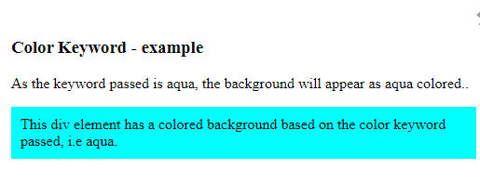

CSS Colors - Hexadecimal Codes
A hexadecimal is a 6 digit representation of a color. The first two digits(RR) represent a red value, the next two are a green value(GG), and the last are the blue value(BB).
A hexadecimal value can be taken from any graphics software like Adobe Photoshop, Jasc Paintshop Pro, or even using Advanced Paint Brush.
Each hexadecimal code will be preceded by a pound or hash sign '#'. Following are the examples of hexadecimal notation.
To specify the hexadecimal codes, you can use upper case or lower case letters.
Color | Color Hexadecimal Code
 | #000000
 | #FF0000
 | #00FF00
 | #0000FF
 | #FFFF00
 | #00FFFF
 | #FF00FF
 | #C0C0C0
 | #FFFFFF
Example
Here is an example:
<html>
<head>
<style>
div{
background-color: #00ff00;
padding: 10px;
}
</style>
</head>
<body>
<h3>Hexadecimal code - example</h3>
<p>As the hexadecimal code is #00ff00 the background will appear green.</p>
<div>
This div element has a green background.
</div>
</body>
</html>
Output
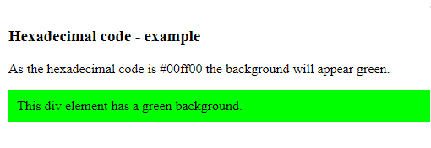

CSS Colors - Short Hexadecimal Codes
This is a shorter form of the six-digit notation. In this format, each digit is replicated to arrive at an equivalent six-digit value. For example: #6A7 becomes #66AA77.
A hexadecimal value can be taken from any graphics software like Adobe Photoshop, Jasc Paintshop Pro, or even using Advanced Paint Brush.
Each short hexadecimal code will be preceded by a pound or hash sign '#'. Following are the examples of short hexadecimal notation.
Color | Short Hexadecimal Code
 | #000
 | #F00
 | #0F0
 | #0FF
 | #FF0
 | #0FF
 | #F0F
 | #FFF

Example
Here is an example:
<html>
<head>
<style>
div{
background-color: #00f;
padding: 10px;
color:#fff;
}
</style>
</head>
<body>
<h3>Short Hexadecimal code - example</h3>
<p>As the short hexadecimal code is #00f the background will appear blue.</p>
<div>
This div element has a blue background.
</div>
</body>
</html>
Output
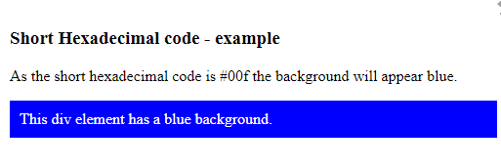

CSS Colors - RGB Values
- This color value is specified using the rgb( ) property.
- It takes three values, one each for red, green, and blue.
- The value can be an integer between 0 and 255 or a percentage.
All the browsers does not support rgb() property of color so it is recommended not to use it.
Following is the example to show few colors using RGB values.
Color | Color RGB
 | rgb(0,0,0)
 | rgb(255,0,0)
 | rgb(0,255,0)
 | rgb(0,0,255)
 | rgb(255,255,0)
 | rgb(0,255,255)
 | rgb(255,0,255)
 | rgb(192,192,192)
 | rgb(255,255,255)
Example
Here is an example:
<html>
<head>
<style>
div{
background-color: rgb(255,0,255);
padding: 10px;
}
</style>
</head>
<body>
<h3>RGB - example</h3>
<p>As the rgb(255,0,255) is set the background will appear accordingly.</p>
<div>
This div element has a colored background based on the rgb values.
</div>
</body>
</html>
Output
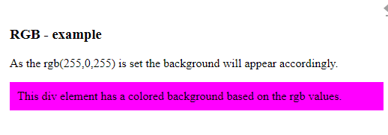

CSS Colors - HSL Values
- This color value is specified using the hsl() function.
- HSL stands for hue, saturation and lightness.
- Hue is represented in degrees (0-360), saturation and lightness are represented as percentages (0% - 100%).
Following is the example to show few colors using HSL property.
Color | Color HSL
 | hsl(0,0%,50%)
 | hsl(255,80%,70%)
 | hsl(290,100%,60%)
 | hsl(360,70%,20%)
 | hsl(89,80%,67%)
Example
Here is an example:
<html>
<head>
<style>
div{
background-color: hsl(355,70%,50%);
padding: 10px;
}
</style>
</head>
<body>
<h3>HSL - example</h3>
<p>As the hsl(355,70%,50%) is set the background will appear based on the hsl values passed.</p>
<div>
This div element has a colored background based on the hsl values hsl(355,70%,50%).
</div>
</body>
</html>
Output
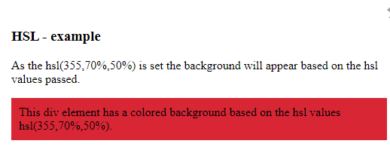

CSS colors - currentcolor keyword
The currentcolor keyword takes the value of the color property of an element. It can be passed to any other styling property using the keyword currentcolor.
Example
Here is an example:
<html>
<head>
<style>
div{
color: red;
border: 5px solid currentcolor;
}
</style>
</head>
<body>
<h2>The currentcolor Keyword</h2>
<p>As the currentcolor keyword is used for border after color property is set as red, the border will also appear red.</p>
<div>
This div element has a red text color and a red border.
</div>
</body>
</html>
Output
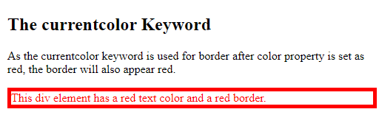

CSS – Backgrounds
This chapter teaches you how to set backgrounds of various HTML elements. You can set the following background properties of an element –
- The background-color property is used to set the background color of an element.
- The background-image property is used to set the background image of an element.
- The background-repeat property is used to control the repetition of an image in the background.
- The background-position property is used to control the position of an image in the background.
- The background-attachment property is used to control the scrolling of an image in the background.
- The background property is used as a shorthand to specify a number of other background properties.
Following is the example which demonstrates how to set the background color for an element.
<html>
<head>
</head>

<body>
<p style = "background-color:yellow;">
This text has a yellow background color.
</p>
</body>
</html>
This will produce following result −
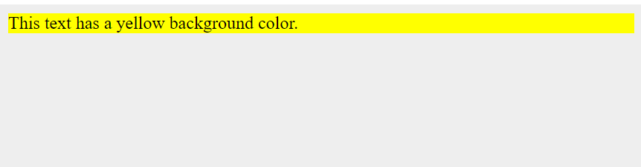
- Set the Background Image
We can set the background image by calling local stored images as shown below –
<html>
<head>
<style>
body {
background-image: url("/css/images/css.jpg");
background-color: #cccccc;
}
</style>
</head>

<body>
<h1>Hello World!</h1>
</body>
<html>
Repeat the Background Image
The following example demonstrates how to repeat the background image if an image is small. You can use no-repeat value for background-repeat property if you don't want to repeat an image, in this case image will display only once.
By default background-repeat property will have repeat value.
<html>
<head>
<style>
body {
background-image: url("/css/images/css.jpg");
background-repeat: repeat;
}
</style>
</head>

<body>
<p>ENTOTO PTC</p>
</body>
</html>

Set the Background Image Position
The following example demonstrates how to set the background image position 100 pixels away from the left side.
<html>
<head>
<style>
body {
background-image: url("/css/images/css.jpg");
background-position:100px;
}
</style>
</head>

<body>
<p>ENTOTO PTC</p>
</body>
</html>
Set the Background Attachment
Background attachment determines whether a background image is fixed or scrolls with the rest of the page.
The following example demonstrates how to set the fixed background image.
<!DOCTYPE html>
<html>
<head>
<style>
body {
background-image: url('/css/images/css.jpg');
background-repeat: no-repeat;
background-attachment: fixed;
}
</style>
</head>

<body>
<p>The background-image is fixed. Try to scroll down the page.</p>
<p>The background-image is fixed. Try to scroll down the page.</p>
<p>The background-image is fixed. Try to scroll down the page.</p>
<p>The background-image is fixed. Try to scroll down the page.</p>
<p>The background-image is fixed. Try to scroll down the page.</p>
<p>The background-image is fixed. Try to scroll down the page.</p>
<p>The background-image is fixed. Try to scroll down the page.</p>
<p>The background-image is fixed. Try to scroll down the page.</p>
<p>The background-image is fixed. Try to scroll down the page.</p>
</body>
</html>
The following example demonstrates how to set the scrolling background image.
<!DOCTYPE html>
<html>
<head>
<style>
body {
background-image: url('/css/images/css.jpg');
background-repeat: no-repeat;
background-attachment: fixed;
background-attachment:scroll;
}
</style>
</head>

<body>
<p>The background-image is fixed. Try to scroll down the page.</p>
<p>The background-image is fixed. Try to scroll down the page.</p>
<p>The background-image is fixed. Try to scroll down the page.</p>
<p>The background-image is fixed. Try to scroll down the page.</p>
<p>The background-image is fixed. Try to scroll down the page.</p>
<p>The background-image is fixed. Try to scroll down the page.</p>
<p>The background-image is fixed. Try to scroll down the page.</p>
<p>The background-image is fixed. Try to scroll down the page.</p>
<p>The background-image is fixed. Try to scroll down the page.</p>
</body>
</html>

CSS – Fonts
This chapter teaches you how to set fonts of a content, available in an HTML element. You can set following font properties of an element −
- The font-family property is used to change the face of a font.
- The font-style property is used to make a font italic or oblique.
- The font-variant property is used to create a small-caps effect.
- The font-weight property is used to increase or decrease how bold or light a font appears.
- The font-size property is used to increase or decrease the size of a font.
- The font property is used as shorthand to specify a number of other font properties.
- Set the Font Family
Following is the example, which demonstrates how to set the font family of an element. Possible value could be any font family name.
<html>
<head>
</head>

<body>
<p style = "font-family:georgia;">
This text is rendered in either georgia, garamond, or the
default serif font depending on which font you have at your system.
</p>
</body>
</html>
- Set the Font Style
Following is the example, which demonstrates how to set the font style of an element. Possible values are normal, italic and oblique.
<html>
<head>
</head>

<body>
<p style = "font-style:italic;">
This text will be rendered in italic style
</p>
</body>
</html>
This will produce following result −
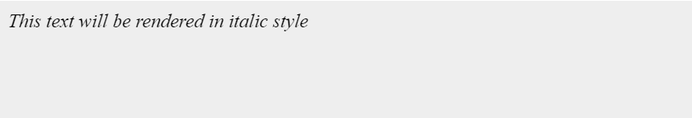

- Set the Font Variant
The following example demonstrates how to set the font variant of an element. Possible values are normal and small-caps.
<html>
<head>
</head>

<body>
<p style = "font-variant:small-caps;">
This text will be rendered as small caps
</p>
</body>
</html>
This will produce following result −
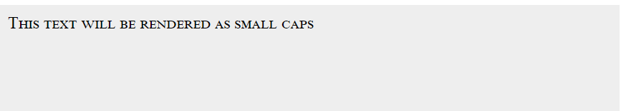
- Set the Font Weight
The following example demonstrates how to set the font weight of an element. The font-weight property provides the functionality to specify how bold a font is. Possible values could be normal, bold, bolder, lighter, 100, 200, 300, 400, 500, 600, 700, 800, 900.
<html>
<head>
</head>
<body>
<p style = "font-weight:bold;">
This font is bold.
</p>

<p style = "font-weight:bolder;">
This font is bolder.
</p>

<p style = "font-weight:500;">
This font is 500 weight.
</p>
</body>
</html>
This will produce following result –
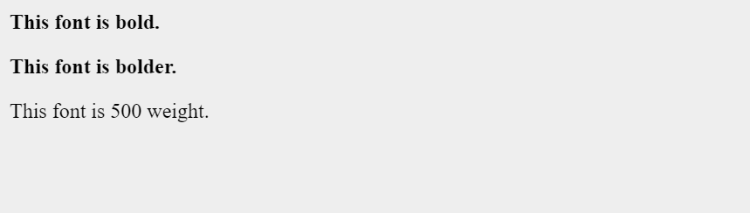

- Set the Font Size
The following example demonstrates how to set the font size of an element. The font-size property is used to control the size of fonts. Possible values could be xx-small, x-small, small, medium, large, x-large, xx-large, smaller, larger, size in pixels or in %.
<html>
<head>
</head>

<body>
<p style = "font-size:20px;">
This font size is 20 pixels
</p>

<p style = "font-size:small;">
This font size is small
</p>

<p style = "font-size:large;">
This font size is large
</p>
</body>
</html>
This will produce following result –
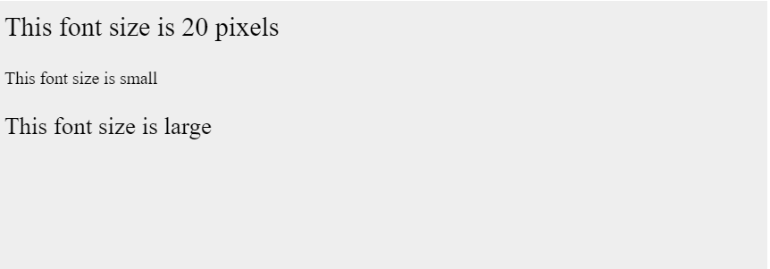

- Set the Font Size Adjust
The following example demonstrates how to set the font size adjust of an element. This property enables you to adjust the x-height to make fonts more legible. Possible value could be any number.
<html>
<head>
</head>

<body>
<p style = "font-size-adjust:0.61;">
This text is using a font-size-adjust value.
</p>
</body>
</html>
This will produce following result –
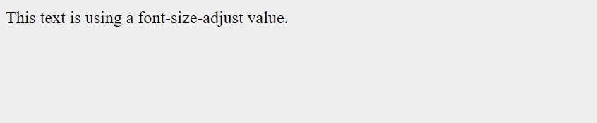
Shorthand Property
You can use the font property to set all the font properties at once. For example –
<html>
<head>
</head>

<body>
<p style = "font:italic small-caps bold 15px georgia;">
Applying all the properties on the text at once.
</p>
</body>
</html>
This will produce following result –


CSS – Text
A text refers to a piece of written or printed information in the form of words or characters that can be read and understood. Texts can include content such as books, articles, emails, messages, web pages, etc. Styling a text involves modifying its appearance to make it more visually appealing or to convey a particular message.
Text Formatting using CSS
CSS provides a number of properties to format text in beautiful way. This tutorial demonstrates how to format text using CSS properties. Following properties provided by CSS can be used to format the text:
- color: Sets the color of the text.
- text-align Sets the alignment of the text.
- text-align-last: Sets the alignment of the last line of a block of text.
- direction: Sets the direction of the text of an element.
- text-indent: Sets the indentation of the first line of the text.
- letter-spacing: Specifies the space between the letters or characters that make up a word or text.
- word-spacing: Specifies the space between the words in a text.
- white-space: Controls the white space flow inside the text in an element.
- text-decoration: Adds an underline, overline, and strikethrough over a piece of text.
- text-decoration-skip: Determines what part of the content of the element, where text decoration is affecting, needs to be skipped.
- text-decoration-skip-ink: Specifies how the overline and underline text decoration lines are drawn around glyph ascenders and descenders.
- text-transform: Converts text to uppercase or lowercase letters.
- text-emphasis: Applies emphasis marks to text (except spaces and control characters).
- text-shadow: Adds shadow to the text.
- line-break: Controls how to set the rule for a line break.
- word-break: Controls how to set the rule for a word break.

- CSS - Setting Text Color
Altering the color of the text can add visual interest or align with a specific design scheme.
The CSS color property is used to set the color of the text. The possible values for this property are as follows:
- Color Name: Example = red, blue, green.
- Hexadecimal value: Example = #ff00ff.
- RGB value: Example = rgb(125, 255, 0).

Example
Here is an example:
<html>
<head>
</head>
<body>
<h2>Text Color</h2>
<p style = "color: blueviolet;">
Color Name
</p>
<p style = "color:#ff00ff;">
Hexadecimal value
</p>
<p style = "color: rgb(255,124,100);">
RGB value
</p>
</body>
</html>
- CSS - Setting Text Alignment
The position or placement of text on a page is called its alignment. The text is aligned based on the left and right margins of the page.
The CSS property text-align defines the alignment of the text on a web page. The text-align property is used to set the horizontal alignment of the text.
Following are the possible values which can be used to set text-align property.
- start: Same as left, if direction is LTR and right if direction is RTL.
- end: Same as right, if direction is LTR and left if direction is RTL.
- left: Aligned with the left-margin.
- right: Aligned with the right-margin.
- center: Aligned at the center of the page.
- justify: Aligned with both the margins.
- justify-all: Same as justify, making the last line justified as well.
- match-parent: Similar to inherit. Values of start and right taken from parent's value and replaced by left and right.
When the value of direction is ltr, the default alignment is left-aligned and when the value of direction is rtl, the default alignment is right-aligned.
Example
Here is an example:
<html>
<head>
</head>
<body>
<h2>Setting Text Alignment using CSS</h2>
<p style="text-align: left;">Text Left Alignment.</p>
<p style="text-align: right;">Text Right Alignment.</p>
<p style="text-align: center;">Text Center Alignment.</p>
<p style="text-align: justify; border: 2px solid red; width: 200px; height: 100px;">
Text Justify Alignment. This alignment aligns the text based on both the margins, left and right.
</p>
</body>
</html>
- CSS - Setting Vertical Alignment
The CSS vertical-align property sets Vertical Alignment of an inline, inline-block or table-cell box.
The vertical-align property can have one of the following values:
baseline: Baseline of the element is aligned with the baseline of its parent element.
sub: Baseline of the element is lowered to the point appropriate for subscripted text.
super: Baseline of the element is raised to the point appropriate for superscripted text.
top: Top of the element's box is aligned with the top of the line box, in the context of inline content, or with the top of the table cell in the context of tables.
text-top: Top of the element's box is aligned with the top of the highest inline box in the line.
middle: Baseline of the element is aligned with the point defined by the baseline of the parent element plus half the x-height of the parent element's font, in the context of inline content.
bottom: Bottom of the element's box is aligned with the bottom of the line box, in the context of inline content, or with the bottom of the table cell in the context of tables.
text-bottom: Bottom of the element's box is aligned with the bottom of the lowest inline box in the line.
percentage: Baseline of the element is raised or lowered by the given percentage of the value for the property line-height.
length: Baseline of the element is raised or lowered by the given length value. Negative length values are permitted for this property. A length value of 0 for this property has the same effect as the value baseline.

Example
Here is an example. You can try this example using different values for vertical-align:
<html>
<head>
<style>
table, td {
height:100px;
width:400px;
border:1px solid red;
}
</style>
</head>
<body>
<h4>Setting Text Vertical Alignment</h4>
<table>
<tr>
<td style="vertical-align: baseline">baseline</td>
<td style="vertical-align: top">top</td>
<td style="vertical-align: middle">middle</td>
<td style="vertical-align: bottom">bottom</td>
<td><p>No vertical alignment </p></td>
</tr>
</table>
</body>
</html>

- CSS Text Direction
Text direction refers to the orientation of text characters within a document or element. It determines whether text should be displayed from left to right (LTR) or right to left (RTL) based on the writing system used.
In CSS, you can set the text direction using the direction property. The direction property accepts two main values:
- LTR (Left-to-Right): Default value, used for languages that are written from left to right, like English. You don't need to specify this value explicitly unless you want to override an inherited right-to-left direction.
- RTL (Right-to-Left): Used for languages that are written from right to left, such as Arabic or Hebrew. When using rtl, text will be aligned right by default.
Additionally, CSS provides a shorthand property, unicode-bidi, to control the bidi algorithm, which specifies how characters with different writing directions are displayed when they appear in the same paragraph. The most common value for unicode-bidi is normal, which allows the browser to handle text direction automatically.
Example
Here is an example:
<html>
<head>
</head>
<body>
<p style = "direction: rtl;">
Right to Left
</p>
<p style = "direction: ltr;">
Left to Right
</p>
</body>
</html>

Example
Let us see an example for usage of unicode-bidi:
<html>
<body>
<h2>Text Direction</h2>
<p>Check for the text direction.</p>
<p style="direction: rtl;unicode-bidi: bidi-override;">Check for the text direction.</p>
</body>
</html>
- CSS - Text Decoration
The CSS text-decoration property helps in adding extra decoration to the text, such as, adding a line (underline, strikethrough, overline) and color, style and thickness to the line.
It is a shorthand property to the following properties:
- text-decoration-line: Sets the type of decoration line (underline, strikethrough or overline).
- text-decoration-color: Sets the color to the text decoration.
- text-decoration-style: Sets the style to the text decoration (dotted, dashed, solid, wavy, double, etc.)
- text-decoration-thickness: Sets the thickness to the text decoration.
Example
Here is an example:
<html>
<head>
<style>
.overline{
text-decoration: overline solid red 5px;
}
.line-through{
text-decoration: line-through solid green 1px;
}
.underline{
text-decoration: underline dashed 2pt blue;
}
</style>
</head>
<body>
<h2>Text Decoration using CSS</h2>
<p class="overline">Overline text decoration.</p>
<p class="line-through">Line-through text decoration.</p>
<p class="underline">Underline text decoration.</p>
</body>
</html>
- CSS - Text Decoration Skip
The text-decoration-skip property determines what part of the content of the element, where text decoration is affecting, needs to be skipped.
The text-decoration-skip property can have following values:
- none: Skips nothing and text decoration is applied for all the text content.
- objects: Skips the whole margin box of the element,such as for an image or inline-block.
- spaces: Skips all spacing.
- leading-spaces: Same as spaces, skipping only leading spaces.
- trailing-spaces: Same as spaces, skipping only trailing spaces.
- edges: Edges such as start and end of text insets slightly. Separate underlines for adjacent elements.
- box-decoration: Skips the text decoration over margin, border and padding areas of a box.
- initial: Sets the text-decoration-skip value to its default value (none).
- inherit: Inherits the text-decoration-skip value from its parent element.
- unset: Removes any previously set text-decoration-skip value.
Example
Here is an example. You can try this example using different values of text-decoration-skip property:
<html>
<head>
<style>
.edges{
font-size:1.5em;
text-decoration: underline solid red 5px;
text-decoration-skip: edges;
}
.spaces{
font-size:1.5em;
text-decoration: underline solid green 5px;
text-decoration-skip: spaces;
}
</style>
</head>
<body>
<h2>Text Decoration Skip</h2>
<p class="edges">Observe the edges of the line.</p>
<p class="spaces">Its text decoration skip spaces.</p>
</body>
</html>
Output
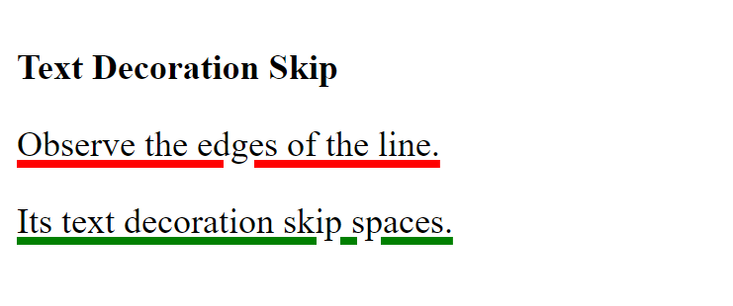

- CSS - Text Decoration Skip Ink
The text-decoration-skip-ink property specifies how the overline and underline text decoration lines are drawn around glyph or character ascenders and descenders.
The text-decoration-skip-ink property can have following values:
- none: Skips nothing and text decoration is applied for all the text content.
- auto: Skips the whole margin box of the element,such as for an image or inline-block.
- all: Skips all spacing. (Supported only on Firefox and Safari)
Example
In the following example observe how the descenders of letters (p,g) and ascender (h) get affected with this property:
<html>
<head>
<style>
.auto{
font-size:3em;
text-decoration: underline solid red 5px;
text-decoration-skip-ink: auto;
}
.none{
font-size:3em;
text-decoration: underline solid green 5px;
text-decoration-skip-ink: none;
}
</style>
</head>
<body>
<h2>Text Decoration Skip Ink</h2>
<p class="auto">paragraph</p>
<p class="none">paragraph.</p>
</body>
</html>

Output
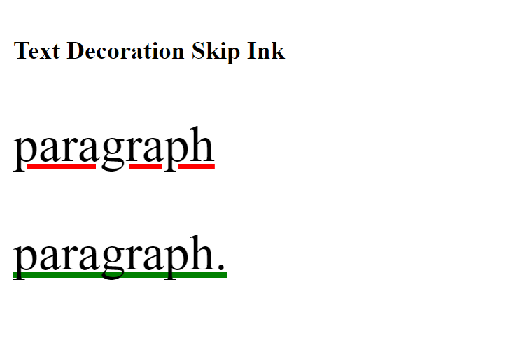
- CSS - Text Emphasis
CSS provides a property to apply emphasis marks on a block of text using the property text-emphasis. These marks are typically used to highlight specific content or to indicate pronunciation or stress in certain languages.
It allows the designer to apply emphasis to individual characters or phrase within a block of text.
It is a shorthand for text-emphasis-style and text-emphasis-color.
The text-emphasis property can have one of the following values:
- none: Sets no emphasis mark.
- filled: Fills the element with solid color. Default value.
- open: Sets the shape as hollow.
- dot: Marks displayed as small circles, either open or filled dot.
- circle: Marks displayed as large circles, either open or filled circle. Default shape in horizontal writing.
- double-circle: Marks displayed as double circles, either open or filled double circle.
- triangle: Marks displayed as triangles, either open or filled triangle.
- sesame: Marks displayed as sesames (~), either open or filled sesame. Default shape in vertical writing.
- <string>: Marks displayed as the passed string value.
- <color>: Sets the color of the mark.
Here is an example:
<html>
<head>
</head>
<body>
<h2>Text Emphasis Examples</h2>
<p style="text-emphasis: dot;">The emphasis is a dot.</p>
<p style="text-emphasis: circle red;">The emphasis is a circle.</p>
<p style="text-emphasis: triangle;">The emphasis is a triangle.</p>
<p style="text-emphasis: none;">No emphasis to the text.</p>
<p style="text-emphasis: double-circle green;">The emphasis is a double-circle.</p>
<p style="text-emphasis: open;">The emphasis is open.</p>
<p style="text-emphasis: sesame;">The emphasis is a sesame.</p>
<p style="text-emphasis: 'u' #00ff00;">The emphasis is a string.</p>
</body>
</html>
Output
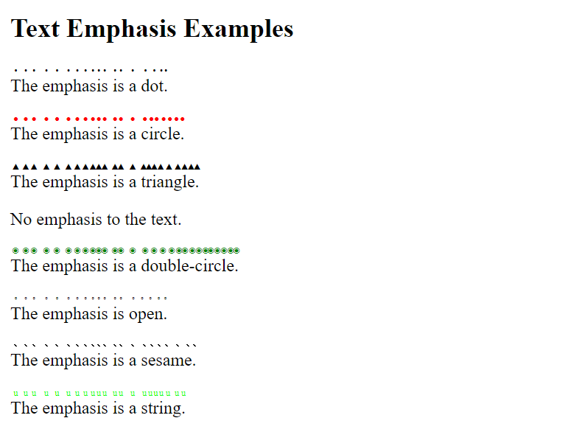
- CSS - Text Indentation
Indentation is the space between the margin and the first line of text. Proper indentation enhances the readability and clarity of text on a page.
CSS also provides a property to set the text indentation and that is text-indent. The following values can be passed to this property:
- length: Any specific length {pixels (px), points (pt), ems (em), etc}. Default value is 0.
- percentage (%): The value passed is in relation to the percentage of the width of the parent element.
- each-line: Affects the first line of a block of text along with each line after a forced line break.
- hanging: Indentation is inverted, except for the first line.
- initial: Sets the text-indent to its default value.
- inherit: Allows to inherit the text-indent value from its parent element.
Note: As of the now, the values each-line and hanging are not supported by any of the browsers.
<html>
<head>
</head>
<body>
<h2>Text indentation Examples</h2>
<p style="text-indent: 2cm;">Text indentation at 2 cm.</p>
<p style="text-indent: 2in;">Text indentation at 2 inches.</p>
<p style="text-indent: 20%;">Text indentation at 20%.</p>
</body>
</html>
Output
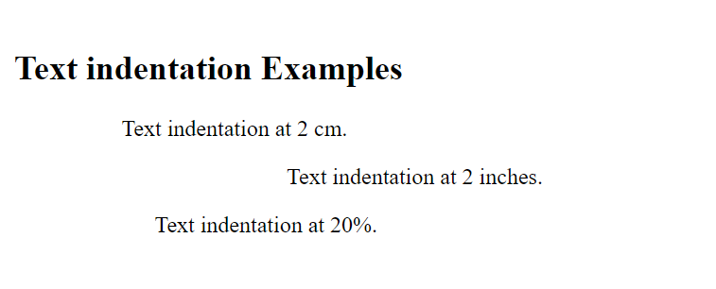
- CSS - Text Letter Spacing
The CSS property letter-spacing is used to adjust the space between the letters of a text. The space can either be increased or decreased between the letters.
Following are the possible values that this property can have:
- normal: Default value and represents the normal amount of space between letters.
- length: Any specific length {pixels (px), points (pt), ems (em), or percentages (%)}.
- initial: Sets the letter-spacing to its default value.
- inherit: Allows to inherit the letter-spacing value from its parent element.
The actual spacing between letters may vary depending on the font being used.
Example
Here is an example:
<html>
<body>
<h2>Letter Spacing Examples</h2>
<p style="letter-spacing: normal;">Letter spacing normal. </p>
<p style="letter-spacing: 5px;">Letter spacing increased. </p>
<p style="letter-spacing: -1px;">Letter spacing decreased. </p>
</body>
</html>
- CSS - Text Word Spacing
CSS provides property to adjust the spacing between the words in a piece of text, just like letter spacing. The property to adjust the space between words is word-spacing.
This property can take any of the following values:
- normal: Default value and represents the normal amount of space between words.
- length: Any specific length {pixels (px), points (pt), ems (em), or percentages (%)}.
- initial: Sets the word-spacing to its default value.
- inherit: Allows to inherit the word-spacing value from its parent element.

Example
Here is an example:
<html>
<head>
</head>
<body>
<h2>Word Spacing Examples</h2>
<p style="word-spacing: normal;">Word spacing normal.</p>
<p style="word-spacing: 15pt;">Word spacing increased.</p>
<p style="word-spacing: -1px;">Word spacing decreased.</p>
</body>
</html>
- CSS - Text Shadow
The text-shadow property is used to add a shadow effect to text. It allows you to specify the color, offset, blur-radius, and spread-radius of the shadow. Following is the syntax of text-shadow:
/* offset-x | offset-y | blur-radius | color */
text-shadow: 1px 1px 2px black;

/* color | offset-x | offset-y | blur-radius */
text-shadow: #fc0 1px 0 10px;

/* offset-x | offset-y | color */
text-shadow: 5px 5px #558abb;

/* color | offset-x | offset-y */
text-shadow: white 2px 5px;

/* offset-x | offset-y
/* Use defaults for color and blur-radius */
text-shadow: 5px 10px;

The CSS text-shadow property accepts following values:
- <color>:
  - Sets the color of the shadow.
  - It is optional.
  - It can be specified either before or after the offset values.
  - Any value for color can be specified, such as, name, HEX or RGB value.
- <offset-x><offset-y>:
  - Any length value, specifying the x and y values.
  - x value represents the shadow's horizontal distance from text.
  - y value represents the shadow's vertical distance from text.
  - If x and y values equal 0, the shadow appears behind the text.
- <blur-radius>
  - Any length value, specifying the value of blur-radius.
  - It is optional.
  - To make the blur look bigger, you need to provide higher value.
  - If no value is passed, it is taken as 0.
Example
Here is an example:
<html>
<head>
</head>
<body>
<h2>Text Shadow Examples</h2>
<p style="text-shadow: 2px 5px yellow;"> Simple Text shadow </p>
<p style="text-shadow: 5px 5px 2px #ff00ff;">Text shadow with blur radius</p>
<p style="text-shadow: 1px 1px 2px green, 0 0 1em yellow, 0 0 0.2em red;">Multiple shadows</p>
<p style="text-shadow: 0px 0px 10px rgb(26, 69, 105); ">Text shadow with RGB colors</p>
</body>
</html>

Output
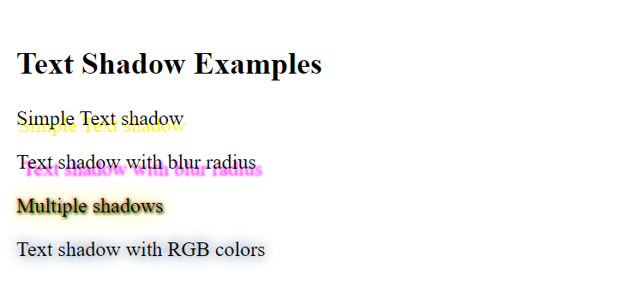

- CSS - Text Line Break
CSS provides property line-break that is useful in determining how to break lines in a block of text.
Following are the values that this property can have:
- auto: Default line break rule applied.
- loose: Least restrictive line break rule applied.
- normal: Most common line break rule applied.
- strict: Most stringent line break rule applied.
- anywhere: Allows the browser to apply line break rule anywhere, at any character.
- initial: Set the initial value.
- inherit: Inherits the value of the parent element.
Example
Here is an example:
<html>
<head>
<style>
p {
border: 2px solid blue;
width: 200px;
}
.normal {
line-break: normal;
}
.loose {
line-break: loose;
}
.strict {
line-break: strict;
}
.auto {
line-break: auto;
}
.anywhere {
line-break: anywhere;
}
</style>
</head>
<body>
<h2>Line Break Examples</h2>
<p class="normal">Normal - CSS provides property <b>line-break</b> that is useful in determining how to break lines in a block of text.</p>
<p class="loose">Loose - CSS provides property <b>line-break</b> that is useful in determining how to break lines in a block of text</p>
<p class="strict">Strict - CSS provides property <b>line-break</b> that is useful in determining how to break lines in a block of text</p>
<p class="auto">Auto - CSS provides property <b>line-break</b> that is useful in determining how to break lines in a block of text</p>
<p class="anywhere">Anywhere - CSS provides property <b>line-break</b> that is useful in determining how to break lines in a block of text</p>
</body>
</html>
- CSS - Text Word Break
The CSS word-break property in CSS is used to specify how words should be broken or wrapped in case they exceed the available width of an element. It determines if the browser should allow the words to break at any point or if they should be kept together.
Following are the values that this property can have:
- normal: Uses default line break rule.
- break-all: Word breaks to be applied between any two characters, in order to prevent overflow.
- keep-all: Word breaks not to be used for Chinese, Japanese and Korean (CJK) text; and for other languages or non-CJK text behavior is the same as for normal.
- break-word: This behaves same as overflow-wrap: anywhere, i.e. word break at any word is applied. But this value is deprecated.
Example
Here is an example:
<html>
<head>
<style>
p {
border: 2px solid green;
width: 200px;
}
.normal {
word-break: normal;
}
.all {
word-break: break-all;
}
.keep {
word-break: keep-all;
}
.wordbreak {
word-break: break-word;
}
</style>
</head>
<body>
<h2>Word Break Examples</h2>
<p class="normal">normal - CSS provides property <b>word-break</b> that is useful in determining how to break words in a block of text</p>
<p class="all">break-all - CSS provides property <b>word-break</b> that is useful in determining how to break words in a block of text</p>
<p class="keep">keep-all - CSS provides property <b>word-break</b> that is useful in determining how to break words in a block of text</p>
<p class="wordbreak">break-word - CSS provides property <b>word-break</b> that is useful in determining how to break words in a block of text</p>
</body>
</html>

CSS - Using Images
Images play an important role in any webpage. Though it is not recommended to include a lot of images, but it is still important to use good images wherever required.
CSS plays a good role to control image display. You can set the following image properties using CSS.
- The border property is used to set the width of an image border.
- The height property is used to set the height of an image.
- The width property is used to set the width of an image.
- The -moz-opacity property is used to set the opacity of an image.
The Image Border Property
The border property of an image is used to set the width of an image border. This property can have a value in length or in %.
A width of zero pixels means no border.
Here is the example –
<html>
<head>
</head>
<body>
<img style = "border:0px;" src = "/css/images/logo.png" />
<br />
<img style = "border:3px dashed red;" src = "/css/images/logo.png" />
</body>
</html>

- The Image Height Property
The height property of an image is used to set the height of an image. This property can have a value in length or in %. While giving value in %, it applies it in respect of the box in which an image is available.
Here is an example –
<html>
<head>
</head>
<body>
<img style = "border:1px solid red; height:100px;" src = "/css/images/logo.png" />
<br />
<img style = "border:1px solid red; height:50%;" src = "/css/images/logo.png" />
</body>
</html>

- The Image Width Property
The width property of an image is used to set the width of an image. This property can have a value in length or in %. While giving value in %, it applies it in respect of the box in which an image is available.
Here is an example –
<html>
<head>
</head>
<body>
<img style = "border:1px solid red; width:150px;" src = "/css/images/logo.png" />
<br />
<img style = "border:1px solid red; width:100%;" src = "/css/images/logo.png" />
</body>
</html>

CSS – Links
This chapter teaches you how to set different properties of a hyper link using CSS. You can set following properties of a hyper link −
We will revisit the same properties when we will discuss Pseudo-Classes of CSS.
- The :link signifies unvisited hyperlinks.
- The :visited signifies visited hyperlinks.
- The :hover signifies an element that currently has the user's mouse pointer hovering over it.
- The :active signifies an element on which the user is currently clicking.
Usually, all these properties are kept in the header part of the HTML document.
Remember a:hover MUST come after a:link and a:visited in the CSS definition in order to be effective. Also, a:active MUST come after a:hover in the CSS definition as follows –
<style type = "text/css">
a:link {color: #000000}
a:visited {color: #006600}
a:hover {color: #FFCC00}
a:active {color: #FF00CC}
</style>
Now, we will see how to use these properties to give different effects to hyperlinks.
Set the Color of Links
The following example demonstrates how to set the link color. Possible values could be any color name in any valid format.

<html>
<head>
<style type = "text/css">
a:link {color:#000000}
</style>
</head>
<body>
<a href = "">Link</a>
</body>
</html>

Set the Color of Visited Links
The following example demonstrates how to set the color of visited links. Possible values could be any color name in any valid format.
<html>
<head>
<style type = "text/css">
a:visited {color: #006600}
</style>
</head>

<body>
<a href = ""> link</a>
</body>
</html>
Change the Color of Links when Mouse is Over
The following example demonstrates how to change the color of links when we bring a mouse pointer over that link. Possible values could be any color name in any valid format.
<html>
<head>
<style type = "text/css">
a:hover {color: #FFCC00}
</style>
</head>

<body>
<a href = "">Link</a>
</body>
</html>

- Change the Color of Active Links
The following example demonstrates how to change the color of active links. Possible values could be any color name in any valid format.
<html>
<head>
<style type = "text/css">
a:active {color: #FF00CC}
</style>
</head>
<body>
<a href = "">Link</a>
</body>
</html>

CSS – Tables
A table is an HTML element used to display data in a structured format with rows and columns. It is created using the <table> tag in HTML and can be styled using CSS properties.
Styling Tables using CSS
Following is a simple HTML table which has been styled using CSS :
<html>
<head>
<style>
table {
font-family: Arial, Helvetica, sans-serif;
border-collapse: collapse; width: 100%;
}
td, th {
border: 1px solid #ddd; padding: 8px;
}
tr:nth-child(even){background-color: #f2f2f2;}
tr:hover {background-color: #ddd;}
th {
padding-top: 12px; padding-bottom: 12px;
text-align: left; background-color: #40a944; color: white;
}
</style>
</head>
<body>
<h1>CSS Styled Table</h1>
<table>
<tr>
<th>Name</th>
<th>Address</th>
<th>Country</th>
</tr>
<tr>
<td>Nuha Ali</td>
<td>My Home Bhooja</td>
<td>India</td>
</tr>
<tr>
<td>Zara Ali</td>
<td>Students Roosters</td>
<td>England</td>
</tr>
<tr>
<td>Mahira</td>
<td>Orland Park</td>
<td>Chicago</td>
</tr>

</table>
</body>
</html>

CSS Properties of a Table
You can set the following CSS properties of a table −
- The border-collapse specifies whether the browser should control the appearance of the adjacent borders that touch each other or whether each cell should maintain its style.
- The border-spacing specifies the width that should appear between table cells.
- The caption-side specifies where the table caption should be displayed (top or bottom).
- The empty-cells specifies whether the border should be shown if a cell is empty.
- The table-layout allows browsers to speed up layout of a table by using the first width properties it comes across for the rest of a column rather than having to load the whole table before rendering it.
- The width and height properties set the height and width of a table.
- The text-align property sets the horizontal alignment of the text content within table cells.
- The border property can be used to set border to table and its cells.
- The background-color property can be applied to the table itself, the table cells, or table rows.
- The font-size, font-family, font-weight, font-coloretc style the table font.
Collapse Table Border using CSS
The property border-collapse ensures that borders between table cells collapse into a single border, creating a cleaner look. Property border-collapse can have values collapse or separate (default).
Example
The following example shows how we can use border-collapse property to merge the borders to remove the spacing between the table cells.
<html>
<head>
<style>
table {
border-collapse: collapse;
border: 3px solid;
width: 100%; padding:5px;
}
th, td {
border: 1px solid black;
}
</style>
<body>
<table>
<tr>
<th>Name</th>
<th>Address</th>
<th>Country</th>
</tr>
<tr>
<td>Nuha Ali</td>
<td>My Home Bhooja</td>
<td>India</td>
</tr>
<tr>
<td>Zara Ali</td>
<td>Students Roosters</td>
<td>England</td>
</tr>
<tr>
<td>Mahira</td>
<td>Orland Park</td>
<td>Chicago</td>
</tr>
</table>
</body>
</html>

- Setting Table Border Spacing
The border-spacing property specifies the distance that separates adjacent cells' borders in a table. This property may be specified as either one or two values.:
- border-spacing: 2px;: If one value is passed, the spacing is applied to both vertical and horizontal borders.
- border-spacing: 1cm 2em;: If two values are passed, the first value defines the horizontal spacing between cells (i.e., the space between cells in adjacent columns), and the second value defines the vertical spacing between cells (i.e., the space between cells in adjacent rows).
Example
Now let's modify the previous example and see the difference –
<html>
<head>
<style>
table {
border-collapse: separate; border-spacing: 1em; width: 100%;
padding: 5px; border: 3px solid #40a944;
}
td {
width: 1.5em; height: 1.5em; background: #d2d2d2;
text-align: center; vertical-align: middle;
}
</style>
<body>
<table>
<tr>
<th>Name</th>
<th>Address</th>
<th>Country</th>
</tr>
<tr>
<td>Nuha Ali</td>
<td>My Home Bhooja</td>
<td>India</td>
</tr>
<tr>
<td>Zara Ali</td>
<td>Students Roosters</td>
<td>England</td>
</tr>
<tr>
<td>Mahira</td>
<td>Orland Park</td>
<td>Chicago</td>
</tr>
</table>
</body>
</html>
The border-spacing property only works when border-collapse is set to separate. If you set border-collapse to collapse, the border-spacing property will have no effect, and the borders will collapse into a single line.
Setting Table Caption using CSS
The caption-side property in CSS is used to control the placement or alignment of the table caption in relation to the table. The caption-side property can have one of following values:
- top: The caption placed above the table.
- bottom: The caption placed below the table.
- block-start: The caption box is positioned at the block start edge of the table.
- block-end: The caption box sis positioned at the block end edge of the table.
- inline-start: The caption box is positioned at the inline start edge of the table.
- inline-end: The caption box is positioned at the inline end edge of the table.
- inherit: The value is inherited from the caption-side property of the parent element.

Example
Let us see an example:
<html>
<head>
<style>
table {
border-collapse: separate; border-spacing: 1em; width: 100%;
padding: 5px; border: 3px solid #40a944;
}
.top caption {
caption-side: top;
}
.bottom caption {
caption-side: bottom;
}
table {
border: 1px solid red;
}
td {
border: 1px solid blue;
}
</style>
<body>
<table class="top">
<caption>
Caption ABOVE the table
</caption>
<thead>
<tr>
<th>Header 1</th>
<th>Header 2</th>
<th>Header 3</th>
</tr>
</thead>
<tbody>
<tr>
<td>Data 1</td>
<td>Data 2</td>
<td>Data 3</td>
</tr>
</tbody>
</table>
<br />
<table class="bottom">
<caption>
Caption BELOW the table
</caption>
<thead>
<tr>
<th>Header 1</th>
<th>Header 2</th>
<th>Header 3</th>
</tr>
</thead>
<tbody>
<tr>
<td>Data 1</td>
<td>Data 2</td>
<td>Data 3</td>
</tr>
</tbody>
</table>
</body>
</html>
The caption-side property only applies to tables that have a <caption> element within them. The <caption> element is used to provide a title or description for the table. If the table does not have a caption, the caption-side property won't have any effect.
Hide Empty Cells in a Table
The empty-cells property in CSS is used to control the rendering of cells in a table that have no content or are otherwise considered "empty." It only applies to tables and table cells.
This property can have one of the two values:
- show: It indicates that empty cells should be shown with borders and spacing as if they contained content. It is the default value.
- hide: It indicates that empty cells should be hidden and not take up any space. Borders and spacing for empty cells will not be displayed, contributing to a more compact layout.
Example
Here is the empty-cells property used to hide borders of empty cells in the <table> element.
<html>
<head>
<style>
table {
width: 100%;
border:1px solid #aaa;
border-collapse: separate;
empty-cells: hide;
}
td,th {
padding: 5px;
border: 1px solid #aaa;
}
</style>
</head>
<body>
<table>
<thead>
<tr>
<th>Header 1</th>
<th>Header 2</th>
<th>Header 3</th>
</tr>
</thead>
<tbody>
<tr>
<td>Data 1</td>
<td>Data 2</td>
<td></td>
</tr>
</tbody>
</table>
</body>
</html>

In the following example the empty-cells:show property is used to show borders of empty cells in the <table> element.
<html>
<head>
<style>
table {
width: 100%;
border:1px solid #aaa;
border-collapse: separate;
empty-cells: show;
}
td,th {
padding: 5px;
border: 1px solid #aaa;
}
</style>
</head>
<body>
<table>
<thead>
<tr>
<th>Header 1</th>
<th>Header 2</th>
<th>Header 3</th>
</tr>
</thead>
<tbody>
<tr>
<td>Data 1</td>
<td>Data 2</td>
<td></td>
</tr>
</tbody>
</table>
</body>
</html>

- Setting Table Layout using CSS
The table-layout property helps you control how a browser should render or lay out a table.
This property can have one of the following values:
- auto: When table-layout is set to auto, the browser will calculate the width of columns and cells based on their content.
- fixed: When table-layout is set to fixed, the browser will allocate a fixed width to each column based on the first row of the table. This means that all subsequent rows will adhere to the same column widths, regardless of their content.
Using table-layout: fixed can be beneficial when you want to create tables with consistent column widths, especially when dealing with large amounts of data or when you want to maintain a specific design.
Example
The following example shows the use of table-layout: fixed:
<html>
<head>
<style>
table {
width: 100%;
border:1px solid #aaa;
border-collapse: collapse;
table-layout: fixed;
}

th, td {
border: 1px solid black;
padding: 8px;
text-align: center;
}
</style>
</head>
<body>
<table>
<tr>
<th>Header 1</th>
<th>Header 2</th>
<th>Header 3</th>
</tr>
<tr>
<td>This is some longer content in Column 1</td>
<td>Short content</td>
<td>Even longer content that might wrap in Column 3</td>
</tr>
<tr>
<td>Row 2, Column 1</td>
<td>Row 2, Column 2</td>
<td>Row 2, Column 3</td>
</tr>
</table>
</body>
</html>
The following example shows the use of table-layout: auto:
<html>
<head>
<style>
table {
width: 100%;
border:1px solid #aaa;
border-collapse: collapse;
table-layout: auto;
}
th, td {
border: 1px solid black;
padding: 8px;
text-align: center;
}
</style>
</head>
<body>
<table>
<tr>
<th>Header 1</th>
<th>Header 2</th>
<th>Header 3</th>
</tr>
<tr>
<td>This is some longer content in Column 1</td>
<td>Short content</td>
<td>Even longer content that might wrap in Column 3</td>
</tr>
<tr>
<td>Row 2, Column 1</td>
<td>Row 2, Column 2</td>
<td>Row 2, Column 3</td>
</tr>
</table>
</body>
</html>
- Setting Table Height and Width
CSS provides height and width properties to set a table height and width respectively.
Example
<html>
<head>
<style>
table {
width: 600px;
height: 200px;
border-collapse: collapse;
border: 1px solid #aaa;
}

th, td {
border: 1px solid #aaa;
}
</style>
</head>
<body>
<table>
<thead>
<tr>
<th>Header 1</th>
<th>Header 2</th>
<th>Header 3</th>
</tr>
</thead>
<tbody>
<tr>
<td>Data 1</td>
<td>Data 2</td>
<td>Data 3</td>
</tr>
<tr>
<td>Data 1</td>
<td>Data 2</td>
<td>Data 3</td>
</tr>
</tbody>
</table>
</body>
</html>
Setting Table Text Align
The text-align property sets the horizontal alignment of the text content within table cells (<th> or <td>). It can take following values:
- left
- right
- center
- justify
The content of <th> element is center-aligned and that of <td> element is left-aligned, by default.
Example
Let us see an example of text-align: center:
<html>
<head>
<style>
table, td, th {
border: 1px solid black;
}
table {
border-collapse: collapse;
width: 100%;
}
td {
text-align:center;
}
</style>
</head>
<body>
<h2>Text-align Property</h2>
<table>
<tr>
<th>Header 1</th>
<th>Header 2</th>
<th>Header 3</th>
<th>Header 4</th>
</tr>
<tr>
<td>Data 1</td>
<td>Data 2</td>
<td>Data 3</td>
<td>Data 4</td>
</tr>
<tr>
<td>Data 1</td>
<td>Data 2</td>
<td>Data 3</td>
<td>Data 4</td>
</tr>
<tr>
<td>Data 1</td>
<td>Data 2</td>
<td>Data 3</td>
<td>Data 4</td>
</tr>
</table>
</body>
</html>

Similarly, to align the text to left or right use the property text-align: left or text-align: right, respectively.
The value text-align: justify ensures that text is aligned both on the left and right sides of each cell, creating a clean and organized appearance.
- Setting Table Vertical Align
The property vertical-align sets the vertical alignment of content in <th> or <td>.
It can take following values:
- top
- middle
- bottom
The vertical alignment of content of <th> and <td> elements is middle, by default.
Example
Let us see an example for setting the vertical-alignment to top:
<html>
<head>
<style>
table, td, th {
border: 2px solid black;
}
table {
border-collapse: collapse;
width: 100%;
}
td {
height: 50px;
vertical-align: middle;
}
</style>
</head>
<body>
<h2>Vertical-align Property</h2>
<table>
<tr>
<th>Header 1</th>
<th>Header 2</th>
<th>Header 3</th>
<th>Header 4</th>
</tr>
<tr>
<td>Data 1</td>
<td>Data 2</td>
<td>Data 3</td>
<td>Data 4</td>
</tr>
<tr>
<td>Data 1</td>
<td>Data 2</td>
<td>Data 3</td>
<td>Data 4</td>
</tr>
<tr>
<td>Data 1</td>
<td>Data 2</td>
<td>Data 3</td>
<td>Data 4</td>
</tr>
</table>
</body>
</html>
- CSS Table Background color
The background-color property can be applied to the table itself, the table cells, or table rows.
In order to set the background color use the following code:
table {
background-color: #f2f2f2;
}
td {
background-color: #f2f2f2;
}
tr {
background-color: #ffffff;
}
Example
Let us see an example:
<html>
<head>
<style>
table {
background-color: rgb(237, 181, 237);
border: 2px solid black;
border-collapse: collapse;
width: 100%;
}
td {
height: 50px;
vertical-align: middle;
text-align: center;
}
</style>
</head>
<body>
<h2>Background color property</h2>
<table>
<tr>
<th>Header 1</th>
<th>Header 2</th>
<th>Header 3</th>
<th>Header 4</th>
</tr>
<tr>
<td>Data 1</td>
<td>Data 2</td>
<td>Data 3</td>
<td>Data 4</td>
</tr>
<tr>
<td>Data 1</td>
<td>Data 2</td>
<td>Data 3</td>
<td>Data 4</td>
</tr>
<tr>
<td>Data 1</td>
<td>Data 2</td>
<td>Data 3</td>
<td>Data 4</td>
</tr>
</table>
</body>
</html>
- CSS Table Font styles
The font of the content of a table can be styled using the font-related properties, such as font-size, font-family, font-weight, etc. on the <th> and <td> elements.
Example
Let us see following example:
<html>
<head>
<style>
table.one {
border-collapse: collapse;
width: 400px;
}
th {
font-size: large;
font-family: 'Lucida Sans', sans-serif;
}
td {
font-size: small;
font-family: Verdana, Geneva, Tahoma, sans-serif;
}
</style>
</head>
<body>
<h2>font styles</h2>
<div>
<table class = "one" border = "1">
<th>Heading</th>
<tr>
<td>Cell value</td>
</tr>
<tr>
<td>Cell value</td>
</tr>
</table>
</div>
</body>
</html>
- CSS Table Other Styles
Various CSS properties are available to style the table design further. For example, you can add padding, margin, dividers, etc. to a table.
Example
Let us see few examples:
Padding
In order to add padding to the table or its cells, use the property padding. Refer the example below:
<html>
<head>
<style>
table {
border: 2px solid black;
background-color: rgb(175, 239, 194);
border-collapse: collapse;
}
td,th {
border: 2px solid black;
padding: 30px;
vertical-align: middle;
height: 50px;
}
</style>
</head>
<body>
<h2>Padding property</h2>
<table>
<tr>
<th>Header 1</th>
<th>Header 2</th>
<th>Header 3</th>
<th>Header 4</th>
</tr>
<tr>
<td>Data 1</td>
<td>Data 2</td>
<td>Data 3</td>
<td>Data 4</td>
</tr>
<tr>
<td>Data 1</td>
<td>Data 2</td>
<td>Data 3</td>
<td>Data 4</td>
</tr>
</table>
</body>
</html>
- CSS Table Margin
In order to add the margin of table or its cells, use the property margin. Refer the following example:
<html>
<head>
<style>
table {
border: 2px solid black;
background-color: rgba(237, 181, 237);
border-collapse: collapse;
margin-top: 50px;
}
td,th {
border: 2px solid black;
vertical-align: middle;
height: 50px;
}
</style>
</head>
<body>
<h2>Border property</h2>
<table>
<tr>
<th>Header 1</th>
<th>Header 2</th>
<th>Header 3</th>
<th>Header 4</th>
</tr>
<tr>
<td>Data 1</td>
<td>Data 2</td>
<td>Data 3</td>
<td>Data 4</td>
</tr>
<tr>
<td>Data 1</td>
<td>Data 2</td>
<td>Data 3</td>
<td>Data 4</td>
</tr>
<tr>
<td>Data 1</td>
<td>Data 2</td>
<td>Data 3</td>
<td>Data 4</td>
</tr>
</table>
</body>
</html>
- CSS Table Dividers (vertical / horizontal)
In order to add vertical or horizontal dividers, you can add the property border-right or border-bottom to the <th> and <th> elements.
Example
Let us see an example:
<html>
<head>
<style>
table {
border: 2px solid black;
background-color: rgb(175, 239, 194);
border-collapse: collapse;
margin-top: 50px;
}
th {
border-bottom: 2px solid black;
}
td{
border-right: 2px solid black;
vertical-align: middle;
height: 50px;
}
</style>
</head>
<body>
<h2>horizontal & vertical divider</h2>
<table>
<tr>
<th>Header 1</th>
<th>Header 2</th>
<th>Header 3</th>
<th>Header 4</th>
</tr>
<tr>
<td>Data 1</td>
<td>Data 2</td>
<td>Data 3</td>
<td>Data 4</td>
</tr>
<tr>
<td>Data 1</td>
<td>Data 2</td>
<td>Data 3</td>
<td>Data 4</td>
</tr>
</table>
</body>
</html>

Striped Table
In order to make the table look striped, where alternative rows are colored, you can use the nth-child() selector and add a background-color, to all the odds / even rows of the table.
Example
Let us see an example:
<html>
<head>
<style>
table {
border-collapse: collapse;
width: 100%;
}

th, td {
text-align: left;
padding: 8px;
}

tr:nth-child(odd) {background-color: rgb(230,125,111);}
</style>
</head>
<body>
<h2>Striped table</h2>
<table>
<tr>
<th>Header 1</th>
<th>Header 2</th>
<th>Header 3</th>
<th>Header 4</th>
</tr>
<tr>
<td>Data 1</td>
<td>Data 2</td>
<td>Data 3</td>
<td>Data 4</td>
</tr>
<tr>
<td>Data 1</td>
<td>Data 2</td>
<td>Data 3</td>
<td>Data 4</td>
</tr>
<tr>
<td>Data 1</td>
<td>Data 2</td>
<td>Data 3</td>
<td>Data 4</td>
</tr>
<tr>
<td>Data 1</td>
<td>Data 2</td>
<td>Data 3</td>
<td>Data 4</td>
</tr>
</table>
</body>
</html>

- Responsive Table
Responsive table refers to a table that adjusts and adapts its layout and formatting based on different screen sizes and resolutions. It ensures that the table is easily readable and accessible on various devices.
CSS provides features through which we can make a table responsive. You can use the property overflow-x: auto to add a horizontal scroll bar to the table, when screen in small and entire content is not seen.
You need to add a container element, such as <div>, with the property overflow-x: auto around the <table> element, in order to make the table responsive.
Example
Let us see an example. You can resize your screen to see the responsiveness of the table.
<html>
<head>
<style>
table {
border-collapse: collapse;
width: 100%;
}
th, td {
text-align: left;
padding: 8px;
}
tr:nth-child(odd) {background-color: rgb(230,125,111);}
</style>
</head>
<body>
<h2>Responsive table</h2>
<div style="overflow-x: auto;">
<table>
<tr>
<th>Header</th>
<th>Header</th>
<th>Header</th>
<th>Header</th>
<th>Header</th>
<th>Header</th>
<th>Header</th>
<th>Header</th>
</tr>
<tr>
<td>Data 1</td>
<td>Data 2</td>
<td>Data 3</td>
<td>Data 4</td>
<td>Data 5</td>
<td>Data 6</td>
<td>Data 7</td>
<td>Data 8</td>
</tr>
<tr>
<td>Data 1</td>
<td>Data 2</td>
<td>Data 3</td>
<td>Data 4</td>
<td>Data 5</td>
<td>Data 6</td>
<td>Data 7</td>
<td>Data 8</td>
</tr>
<tr>
<td>Data 1</td>
<td>Data 2</td>
<td>Data 3</td>
<td>Data 4</td>
<td>Data 5</td>
<td>Data 6</td>
<td>Data 7</td>
<td>Data 8</td>
</tr>
<tr>
<td>Data 1</td>
<td>Data 2</td>
<td>Data 3</td>
<td>Data 4</td>
<td>Data 5</td>
<td>Data 6</td>
<td>Data 7</td>
<td>Data 8</td>
</tr>
</table>
</div>
</body>
</html>

- CSS Table - Related Properties
Following is the list of CSS properties for styling tables:
Property | Description
border-collapse | Sets the table border rendering algorithm.
border-spacing | With separate borders set the spacing between borders. One value sets vertical and horizontal spacing and two values sets horizontal and vertical spacing respectively.
caption-side | Sets the position of a table caption.
empty-cells | With separate borders, hides empty cells in a table.
table-layout | Determines the table-rendering algorithm.

CSS – Borders
The border of an HTML element is simply one or more lines that surround the content and padding of an element. Every border has three aspects: its width, or thickness; its style, or appearance; and its color.
- CSS Borders
The CSS border properties allow you to specify how the border of the box representing an element should look. There are three properties of a border you can change −
- border-style - Specifies whether a border should be solid, dashed line, double line, or one of the other possible values.
- border-color - Specifies the color of a border. The default value is the foreground color of the element and if element is blank, then color of the parent element
- border-width - Specifies the width of a border. The default value is medium.
Now, we will see how to use these properties with examples.
- CSS Border Style
The border-style property specifies what kind of border to display. Following values can be passed to border-style:
Value | Description
none | No border
hidden | A hidden border, same as 'none' except for table elements
dotted | A series of dots
dashes | A series of short dashes
solid | A single solid line
double | Two parallel lines with a small gap between them
groove | A border that appears to be carved into the page
ridge | A border that appears to be slightly raised above the page
inset | A border that appears embedded into the page
outset | A border that appears slightly raised out of the page

The border-style property can have upto four values in one statement where we can specify the border style for top, right, bottom and left border.
Example
The following example to show border-style properly with different values −
<html>
<body>
<p style="border-style: none;">No border.</p>
<p style="border-style: hidden;">Hidden border.</p>
<p style="border-style: dotted;">Dotted border.</p>
<p style="border-style: dashed;">Dashed border.</p>
<p style="border-style: solid;">Solid border.</p>
<p style="border-style: double;">Double border.</p>
<p style="border-style: groove;">Groove border.</p>
<p style="border-style: ridge;">Ridge border.</p>
<p style="border-style: inset;">Inset border.</p>
<p style="border-style: outset;">Outset border.</p>
<p style="border-style: none dashed solid dotted;">A mixed border.</p>
</body>
<html>

- CSS Border Style - Single Side
CSS provided following four properties to control the style of each single-side of an element.
- border-top-style
- border-right-style
- border-bottom-style
- border-left-style
Example
Let us see an example:
<html>
<head>
<style>
p {
border-top-style: dotted; border-right-style: solid;
border-bottom-style: dashed; border-left-style: double;
border-width:5px; padding: 2em;
}
</style>
</head>
<body>
<h2>border-style (single-side)</h2>
<p>Different border styles on all the sides.</p>
</body>
<html>

- CSS Border Width
The border-width property is next in line after setting border style and this property is used to set the border width. Following values can be passed to border-width:
Value | Description
thin | a thin border
medium | a medium width border
thick | a thick border
length | any length specified in px, pt, cm, em, etc
The border-width property can have upto four values in one statement where we can specify the border width for top, right, bottom and left border.
We should declare a border-style before declaring border-width, else the border effect will not be seen.
Example
Let us see an example:
<html>
<body>
<h2>border-width with different values</h2>
<p style="border-style: double; border-width: thin;">Thin width.</p>
<p style="border-style: dashed; border-width: medium;">Medium width.</p>
<p style="border-style: solid; border-width: thick;">Thick width.</p>
<p style="border-style: dotted; border-width: 5px">Specific length width border.</p>
<p style="border-style: solid; border-width: 2px 4px 5px 10px">Mixed length width border.</p>
</body>
</html>

- CSS Border Width - Single Side
The property border-width can be set independently for each single-side. The same set of values can be passed to each single-side for border-width:
- border-top-width
- border-right-width
- border-bottom-width
- border-left-width
Example
Let us see an example:
<html>
<head>
<style>
p {
border-style: solid; padding: 2em;
border-top-width: thin; border-right-width: thick;
border-bottom-width: medium; border-left-width: 10px;
}
</style>
</head>
<body>
<h2>border-width (single-side)</h2>
<p>Different border styles on all the sides.</p>
</body>
<html>

- CSS Border Color
The border-color property is the third constituent property of border. It sets the color of the border.
- border-color property can have one, two, three or all four values.
- If you don’t declare a color, the default color is the foreground color of the element.
- Any type of color value can be passed, such as Name, RGB, RGBA, Hexadecimal, etc.
Following values can be passed to border-color:
Value | Description
color | The border will be of the color specified
transparent | The border will be transparent
inherit | The parent element's value is inherited
You should declare a border-style before declaring border-color, else the border color effect will not be seen.
The border-color property can have upto four values in one statement where we can specify the border color for top, right, bottom and left border.
Example
Let us see an example of border-color:
<html>
<body>
<h2>border-color with different values</h2>
<p style="border-style: double; border-color: red;">Red Color Border.</p>
<p style="border-style: dashed; border-color: #40a944;">Green Color Border</p>
<p style="border-style: solid; border-color: rgb(255,200,0);">Yellow Color Border</p>
<p style="border-style: dotted; border-color: hsl(0, 50%, 50%)">Brown Color Border</p>
<p style="border-style: solid; border-color: red blue green yellow">Mixed Color Borders</p>
</body>
</html>
- CSS Border Color - Single Side
The property border-color can be set independently for each single-side. The same set of values can be passed to each single-side for border-color:
- border-top-color
- border-right-color
- border-bottom-color
- border-left-color
Example
Let us see an example:
<html>
<head>
<style>
p {
border-style: solid; padding: 2em;
order-top-color: red; border-right-color: #0000ff;
border-bottom-color: rgb(100,123,111); border-left-color: rgba(50,123,111,0.4)
}
</style>
</head>
<body>
<h2>border-color (single-side)</h2>
<p>Different border colors on all the sides.</p>
</body>
</html>

- CSS Border - Single-Side Shorthand Properties
In case you want to apply all the border properties, such as style, width and color, along just one side of an element, you can make use of the border shorthand properties.
For example, if the border properties are to be applied to top side of an h2 element, you can use the following syntax:
h2 {border-top: thin solid red;}
Four shorthand properties, based on each side of any element, are as follows:
- border-top
- border-right
- border-bottom
- border-left
Example
Let us see an example:
<html>
<head>
<style>
p {
border-top: red dashed thick;
border-right: solid #0000ff medium;
border-bottom: 10px double rgb(100,123,111);
border-left: rgba(50,123,111,0.4) 15px solid;
padding: 10px;
}
</style>
</head>
<body>
<h2>Shorthand single-side border properties</h2>
<p>Check the borders!!!</p>
</body>
</html>

- CSS Border - Global Shorthand Property
The smallest possible shorthand property for border for all sides of an element is border.
Syntax
h2 {border: thick dotted green;}
The above code will add a green, dotted and thick border on all the four sides of h2 element.
Example
Let us see an example:
<html>
<head>
<style>
p {
border: green dashed thick; padding: 10px;
}
</style>
</head>
<body>
<h2>Border Shorthand Property</h2>
<p>Check the borders!!!</p>
</body>
</html>
But you still have the option of overriding the border shorthand property with any individual property passed exclusively. See the following sample code to clarify this point:
h2 {border: thin solid gray;}
h2 {border-bottom-width: 15px;}
The above code will have a thin, solid and gray border on all the sides except for the bottom where the width will be of 15px.
Let us see an example:
<html>
<head>
<style>
p {
border: #40a944 dashed thick; border-bottom-width: 15px; padding: 10px;
}
</style>
</head>
<body>
<h2>Border Shorthand Property</h2>
<p>Check the borders!!!</p>
</body>
</html>

- CSS Rounded Borders
We can use border-radius property to add rounded borders to an element.
Syntax
p {
border: 2px solid #40a944; border-radius: 5px;
}
The above code will add a rounded border around paragraph element.
Example
<html>
<head>
<style>
p {
border: 2px solid #40a944; border-radius: 5px; padding:10px;
}
</style>
</head>
<body>
<h2>Round Borders</h2>
<p>Check the borders!!!</p>
</body>
</html>
- CSS Borders - Inline Elements
Borders can be given to any inline HTML element. The border's thickness will not have any effect on the line height of element. If left and right borders are specified in an inline element, it will displace the text around the border.
Syntax
strong {border-top: thin solid green; border-bottom: 5px dotted #ff00ff;}
Above code will apply the border to strong text in the paragraph as green, thin and solid border on the top and magenta-colored, 5px dotted border on the bottom side.
Example
Let us see an example:
<html>
<head>
<style>
strong {
border-top: thick solid green; border-bottom: 5px dashed #ff00ff;
background-color: silver;
}
</style>
</head>
<body>
<div>
<h2>CSS Borders on Inline Elements</h2>
<p>Check the <strong>inline elements with borders</strong> and rest has no border.</p>
</div>
</body>
</html>

CSS – Margins
Setting up a margin around an HTML element is one of the things that sets CSS so far above traditional web markup. This article will teach you CSS margin property and its constituent properties.
- CSS Margin
The CSS margin property is a shorthand property to set the margin area around an HTML element. Consider you want to set a quarter-inch margin on h1 elements then following is the syntax:
<html>
<head>
<style>
div {
border:1px dotted
}
h1 {
margin: 0.25in; background-color: #eee;
}
</style>
</head>
<body>
<div>
<h1>This h1 element has quarter-inch margin around it!</h1>
</div>
</body>
</html>
You can set margin using any units, whether in pixels, inches, millimeters, or ems. The default value for margin is 0 (zero), so if you don’t set a margin value then no margin should appear around the element. To set a margin of 20 pixels around h1 element, above code will be written as follows:
<html>
<head>
<style>
div {
border:1px dotted
}
h1 {
margin: 20px; background-color: #eee;
}
</style>
</head>
<body>
<div>
<h1>This h1 element has 20 pixels margin around it!</h1>
</div>
</body>
</html>
- CSS Margins - Single-Side Properties
CSS provides four separate properties to set margins for left, right, top and bottom for an element.
- margin-bottom
- margin-top
- margin-left
- margin-right
Following example demonstrates how we can set different margins around h1 elements:
<html>
<head>
<style>
div {
border:1px dotted
}
h1 {
margin-top: 20px; margin-right:40px; margin-bottom:10px;
margin-left:0px; background-color: #eee;
}
</style>
</head>
<body>
<div>
<h1>This h1 element has different margins around it!</h1>
</div>
</body>
</html>
- CSS Margins - Shorthand Property
You can use margin property to set all the sides margin at different values. Following is the syntax to use margin as shorthand property:
h1 {margin: top right bottom left}
Here the value of top, right, bottom and left could be in pixels, inches, ems, or centimeters etc. So using the above syntax we can write our previous HTML code as follows:
<html>
<head>
<style>
div{
border:1px dotted
}
h1 {
margin: 20px 40px 10px 0px; background-color: #eee;
}
</style>
</head>
<body>
<div>
<h1>This h1 element has different margins around it!</h1>
</div>
</body>
- CSS Margins - Set Three Values:
We can set margin at three values as margin: 20px 40px 10px, in this case top margin will be 20px, right and left margins will be 40px and bottom margin will be 10px. Following is the example. You should try to compare the output with previous example:
<html>
<head>
<style>
div {
border:1px dotted
}
h1 {
margin: 20px 40px 10px; background-color: #eee;
}
</style>
</head>
<body>
<div>
<h1>This h1 element has different margins around it!</h1>
</div>
</body>
- CSS Margins - Set Two Values:
We can set margin at two values as margin: 20px 40px, in this case top and bottom margins will be 20px, right and left margins will be 40px. Following is the example. You should try to compare the output with previous example:
<html>
<head>
<style>
div {
border:1px dotted
}
h1 {
margin: 20px 40px; background-color: #eee;
}
</style>
</head>
<body>
<div>
<h1>An h1 element with grey background!</h1>
</div>
</body>
We have seen that setting a single value for margin, applies margin equally to all the sides - top, right, bottom and left. You can check very first example to understand this case.
- CSS Margins - Mix up Units:
CSS allows to mix up the types of length value you use while specifying different margins in a shorthand property. You are not restricted to using a single length type in a given rule as shown below:
<html>
<head>
<style>
div{
border:1px dotted
}
h1 {
margin: 20px 5em .5in 4ex; background-color: #eee;
}
</style>
</head>
<body>
<div>
<h1>An h1 element with grey background!</h1>
</div>
</body>
- CSS Negative Margins
CSS allows to specify negative margins for an element. This will cause the element’s box to stick out of its parent or to overlap other elements.
<html>
<head>
<style>
div {
border:1px dotted
}
h1 {
margin: 20px 40px; background-color: #eee;
}
p {
margin: -20px 40px; background-color: #eee;
}
</style>
</head>
<body>
<div>
<h1>An h1 element with grey background!</h1>
<p>This paragraph has negative margin.</p>
</div>
</body>
</html>

- CSS Margins - Percentages
It is very much possible to set percentage values for the margins of an element. Percentage margins values are computed in relation to the width of the parent element’s content area, so they can change if the parent element’s width changes.
<html>
<head>
<style>
h1 {
margin:10%; background-color: #eee;
}
</style>
</head>
<body>
<div style="width: 600px; border: 1px dotted;">
<h1>An h1 element with grey background!</h1>
</div>

<div style="width: 400px; border: 1px dotted;">
<h1>An h1 element with grey background!</h1>
</div>;
</body>
</html>
- CSS Margins - Inline Elements
Margins can also be applied to inline elements but top and bottom margins do not have any effect on the line height of these nonreplaced elements and these margins are always transparent. Though when you apply margins to the left and right sides of an inline nonreplaced element then it will show the effect as shown in the following example.
<html>
<head>
<style>
div {
border:1px dotted
}
strong {
margin-top: 25px; margin-bottom: 50px;
margin-left: 25px; background-color: #eee;
}
</style>
</head>
<body>
<div>
<p>This text has some <strong>strong text</strong> with grey background</p>
</div>

</body>
</html>

Here margin-left created some extra space before the highlited strong text. We can create same space before and after the element as follows:
<html>
<head>
<style>
div {
border:1px dotted
}
strong {
margin: 25px; background-color: #eee;
}
</style>
</head>
<body>
<div>
<p>This text has some <strong>strong text</strong> with grey background</p>
</div>
</body>
</html>
- CSS Margins - Auto Value
In order to center an element inside its parent, use margin: 0 auto as shown in the following example:
<html>
<head>
<style>
div {
width:600px; border:1px dotted
}
h1 {
margin:0 auto;
}
</style>
</head>
<body>
<div>
<h1>An h1 element with center position!</h1>
</div>

</body>
</html>
Though if you are using an old browser, then above code will not work and with modern browser, you should use the following code:
<html>
<head>
<style>
div {
width:600px; border:1px dotted
}
h1 {
display: flex; justify-content:center;
}
</style>
</head>
<body>
<div>
<h1>An h1 element with center position!</h1>
</div>

</body>
</html>
- CSS Margins - Related Properties
Property | Description
margin | A shorthand property for setting all the margin properties in one declaration
margin-bottom | Sets the bottom margin of an element
margin-left | Sets the left margin of an element
margin-right | Sets the right margin of an element
margin-top | Sets the top margin of an element
margin-trim | Allows the container to trim the margins of its children

CSS – Lists
What are Lists?
Lists are useful as they present the information in a structured and organized manner. Lists improve the readability and comprehension of content on a web page. So, if the content is listed, it is easy to follow.
Lists are commonly used to display items, steps, options, or any other type of related information that should be presented sequentially or in a group.
This chapter will discuss how to control list type, position, style, etc., using CSS. Before that let us understand what are different types of lists in HTML.
HTML Lists
HTML provides mainly two kinds of lists - <ol> (ordered list) and <ul> (unordered list).
- Ordered List
Ordered lists are used when the items need to be presented in a specific order marked with numbers or letters. Following is the syntax to create HTML ordered lists:
<ol>
<li>First</li>
<li>Second</li>
<li>Third</li>
</ol>
- Unordered List
Unordered lists are used when the items need to be presented in a specific order marked with simple bullets. Following is the syntax to create HTML ordered lists:
CSS Lists - Properties
CSS provides a set of properties that can be applied to any list, which are as follows:
- The list-style-type allows you to control the shape or appearance of the list markers (bullet points).
- The list-style-position allows to specify the position of the list-item markers.
- The list-style-image specifies an image for the marker rather than a bullet point or number.
- The list-style serves as shorthand property for to manage the markers.
- CSS Lists - Marker Types
CSS allows you to control the shape of the list markers (bullet points). The following example shows how CSS property list-style-type sets different markers for the ordered and unordered lists. The same property can be used for both ordered and unordered lists.
Unordered Lists Example
<html>
<head>
<style>
ul.a {
list-style-type: circle;
}
ul.b {
list-style-type: square;
}
</style>
</head>
<body>
<h2>Unordered List Example</h2>
<ul class="a">
<li>First</li>
<li>Second</li>
<li>Third</li>
</ul>

<ul class="b">
<li>First</li>
<li>Second</li>
<li>Third</li>
</ul>

</body>
</html>

Ordered Lists Example
<html>
<head>
<style>
ol.a {
list-style-type: decimal;
}
ol.b {
list-style-type: lower-alpha;
}
</style>
</head>
<body>
<h2>Ordered List Example</h2>
<ol class="a">
<li>First</li>
<li>Second</li>
<li>Third</li>
</ol>

<ol class="b">
<li>First</li>
<li>Second</li>
<li>Third</li>
</ol>

</body>
</html>
You can check CSS property list-style-type detail to check all the possible marker's types for the lists.
- CSS Lists - Image Marker
You might prefer to use an image as an item list marker. The CSS list-style-image property can be used to to specify an image as an item list marker.
You can use your own bullet style. If no image is found, then default bullets are printed. Following is an example to show the usage of list-style-image property.
<html>
<head>
<style>
ul {
list-style-image: url('/images/icon-bullet.png');
}
</style>
</head>
<body>
<h2>CSS Lists - Image Marker</h2>
<ul>
<li>First</li>
<li>Second</li>
<li>Third</li>
</ul>

</body>
</html>
- CSS Lists - Marker Position
The CSS list-style-position property indicates whether the marker should appear inside or outside of the box containing the bullet points. It can have one of the following values −
- none
- inside
- outside
- inherit
Following is an example to show the usage of list-style-position property.
<html>
<head>
<style>
ul.a {
list-style-position: outside;
}
ul.b {
list-style-position: inside;
}
</style>
</head>
<body>
<h2>CSS Lists - Marker Position</h2>
<ul class="a">
<li>First</li>
<li>Second</li>
<li>Third</li>
</ul>

<ul class="b">
<li>First</li>
<li>Second</li>
<li>Third</li>
</ul>

</body>
</html>

- CSS Lists - Default Marker Position
If the CSS list-style-position property is set to none, then it will remove the markers/bullets. While setting this propert to none, then we need to set margin:0 and padding:0 −
Following is an example to show the usage of list-style-position=none property.
<html>
<head>
<style>
ul {
list-style-position: none; margin:0; padding:0;
}
</style>
</head>
<body>
<h2>CSS Lists - Default Marker Position</h2>
<ul>
<li>First</li>
<li>Second</li>
<li>Third</li>
</ul>

</body>
</html>
- CSS Lists - Shorthand Property
The CSS list-style property allows you to specify all the three list properties into a single expression. −
Following are the values that list-style can hold:
- <list-style-type>
- <list-style-image>
- <list-style-position>
The order of the values passed to the list-style is not fixed and any of the three values can be omitted. If any of the value(s) is missing, it will be filled by the default value for the same. But there has to be minimum one value passed.
Following is an example to show the usage of list-style property.
<html>
<body>
<h2>CSS Lists - Shorthand Property</h2>
<h3>Three values passed</h3>
<ul style = "list-style: url('/images/icon-bullet.png') circle outside;">
<li>All the three values have been provided</li>
<li>The item marker is an image, position as outside.</li>
<li>It is used in cases we do not need to follow a sequence.</li>
</ul>

<h3>Two values passed</h3>
<ul style = "list-style: square inside">
<li>The item marker is square, with style position as inside and no image.</li>
<li>It is used in cases we do nit need to follow a sequence.</li>
</ul>

<h3>One value passed</h3>
<ul style = "list-style: disc">
<li>The item marker is disc, with style position as outside (default) and no image (default - none).</li>
<li>It is used in cases where we need not follow a sequence.</li>
</ul>

</body>
</html>
- CSS Lists - Controlled Counting
Some time we might want to count differently on an ordered list — e.g., starting from a number other than 1, or counting backwards, or counting in steps of more than 1.
There are following three CSS attributes which helps in controlling the list numbering.
- <start> - allows you to start the list counting from a number other than 1.
- <reversed> - starts the list counting reverse or down instead of up.
- <value> - allows you to set your list items to specific numerical values.
Following is an example to show the usage of all these three attributes.
<html>
<body>
<h2>CSS Lists - Controlled Counting</h2>
<h3>start attribute</h3>
<ol start="4">
<li>Java.</li>
<li>HTML.</li>
<li>CSS.</li>
<li>React.</li>
</ol>

<h3>reverse attribute</h3>
<ol reversed>
<li>Java.</li>
<li>HTML.</li>
<li>CSS.</li>
<li>React.</li>
</ol>

<h3>value attribute</h3>
<ol>
<li value="2">Java.</li>
<li value="3">HTML.</li>
<li value="1">CSS.</li>
<li value="4">React.</li>
</ol>

</body>
</html>

- CSS Lists - Setting Colors
We can make lists look more stylish and colorful using CSS styling as demonstared in the following example. As we see any styling added to the <ul> or <ol> tag will affect the entire list, whereas the addition to the individual <li> tag will affect only the items of the corresponding list.
Following is an example to show the usage of setting up different CSS properties for a list.
<html>
<head>
<style>
ol {
list-style: upper-latin; background: Aquamarine; padding:20px;
}
ol li {
background: silver; padding:10px; font-size:20px; margin:10px;
}
ul {
list-style: square inside; background: teal; padding:20px;
}
ul li {
background: olive; color:white; padding:10px; font-size:20px; margin:10px;
}
</style>
</head>
<body>
<h2>CSS Lists - Setting Colors</h2>

<ol>
<li>Java.</li>
<li>HTML.</li>
<li>CSS.</li>
<li>React.</li>
</ol>
<ul>
<li>Java.</li>
<li>HTML.</li>
<li>CSS.</li>
<li>React.</li>
</ul>

</body>
</html>
- CSS Lists - Related Properties
Property | Description
list-style | A shorthand property for setting all the list properties in one declaration.
list-style-image | Sets an image as a list item's marker.
list-style-position | Sets the position of the list-item markers (bullet points)
list-style-type | Sets the type of list-item marker

CSS – Paddings
The CSS padding property is used to specify the space between the content of an element and its borders. This article will teach you CSS padding property and its constituent properties.
The value of CSS padding should be either a length, a percentage, or the word inherit. A padding property does not allow negative values. If the value is inherit, it will have the same padding as its parent element. If a percentage is used, the percentage is of the containing box.

- CSS Padding
The CSS padding property is a shorthand property to set the padding space around an HTML element. Let us see a simple example to set padding with a single length value, which is applied equally to all four padding sides. Here we add 5px padding on h2 element :
<html>
<head>
<style>
div{
border: 1px solid #aaa;
}
h2{
padding: 5px; background-color: #eee;
}
</style>
</head>
<body>
<div>
<h2>The padding can be seen around the text.</h2>
</div>
</body>
</html>
You can set padding using any units, whether in pixels, inches, millimeters, or ems. The default value for margin is 0 (zero), so if you don’t set a padding value then no padding should appear around the element. To set a padding of quarter inche around h2 element, above code will be written as follows:
<html>
<head>
<style>
div{
border: 1px solid #aaa;
}
h2{
padding: 0.25in; background-color: #eee;
}
</style>
</head>
<body>
<div>
<h2>A 0.25 inch padding can be seen around the text.</h2>
</div>
</body>
</html>
- CSS Padding vs No-padding
Consider the following example where first h2 element is having a padding around it where as next h2 element does not have any padding around it. Check out the difference by seeing its output:
<html>
<head>
<style>
div{
border: 1px solid #aaa;
}
h2.a{
padding: 10px; background-color: #eee;
}
h2.b{
background-color: #eee;
}
</style>
</head>
<body>
<div>
<h2 class="a">The padding can be seen around this text.</h2>
<h2 class="b">There is no padding around this text.</h2>
</div>
</body>
</html>
- CSS Paddings - Single-side Properties
CSS provides four separate properties to set padding for top, right, bottom, and left for an element. These properties are:
- padding-top
- padding-right
- padding-bottom
- padding-left
Following example shows how different padding properties can be set around an h2 element:
<html>
<head>
<style>
div{
border:1px solid #aaa
}
h2 {
padding-top: 20px; padding-right:40px;
padding-bottom:10px; padding-left:0px;
background-color: #eee;
}
</style>
</head>
<body>
<div>
<h2>This h2 element has different paddings around it!</h2>
</div>
</body>
</html>
- CSS Paddings - Shorthand Property
CSS allows to set all the paddings using single statement. Following is the syntax to use padding as shorthand property:
h2 {padding: top right bottom left}
The value for padding properties can be in pixels, inches, ems, or centimeters, apart from percentage. So using the above syntax we can write our previous HTML code as follows
<html>
<head>
<style>
div{
border:1px solid #aaa
}
h2 {
padding: 20px 40px 10px 0px;
background-color: #eee;
}
</style>
</head>
<body>
<div>
<h2>This h2 element has different paddings around it!</h2>
</div>
</body>
</html>
- CSS Paddings - Set Three Values
Three values can be passed to the padding as padding: 20px 40px 10px. In this case top padding will be 20px, right and left paddings will be 40px and bottom padding will be 10px.
Following is the example for the same:
<html>
<head>
<style>
h2 {
padding: 20px 40px 10px; background-color: #eee;
}
</style>
</head>
<body>
<div>
<h2>This h2 element has different paddings around it!</h2>
</div>
</body>
</html>
- CSS Paddings - Set Two Values
Two values can be passed to the padding as padding: 20px 40px. In this case top and bottom paddings will be 20px, right and left paddings will be 40px.
Following is the example for the same:
<html>
<head>
<style>
h2 {
padding: 20px 40px; background-color: #eee;
}
</style>
</head>
<body>
<div>
<h2>This h2 element has different paddings around it!</h2>
</div>
</body>
</html>
We have already seen an example for a single value passed as padding, which is applied to all the sides i.e. top, right, bottom and left equally. You can check the very first example to understand this scenario.
- CSS Paddings - Mix up Units
CSS does not restrict usage of multiple units for specifying the values of padding, while specifying in shorthand property. That means one can pass values of length as pixel along with ems or inches, etc.
<html>
<head>
<style>
h2 {
padding: 20px .5in 3em 4ex; background-color: #eee;
}
</style>
</head>
<body>
<div>
<h2>This h2 element has different paddings around it!</h2>
</div>
</body>
</html>
CSS does not allow a negative value for either of the padding properties, where as you can set negative margin values for CSS margin properties.
CSS Paddings - Percentages
CSS Padding property can have a percentage value. Percentages are calculated in relation to the width of the parent element’s content area. For example a parent width is 500px and we set 10% padding for its child element then CSS will calculate 10% padding of 500px, ie. 50px pixles padding for the child element. Following is an example for the same:
<html>
<head>
<style>
div {
width: 500px; border:1px solid #aaa;
}
h2 {
padding: 10%; background-color: #eee;
}
</style>
</head>
<body>
<div>
<h2>H2 element with some paddings around it!</h2>
</div>
</body>
</html>
We can also mix the percentage values with other length units for padding, though the meaning of percentage padding will remain same as explained above:
<html>
<head>
<style>
div {
width: 500px; border:1px solid #aaa;
}
h2 {
padding-top: 0.5in; padding-bottom: 10%; background-color: #eee;
}
</style>
</head>
<body>
<div>
<h2>H2 element with some paddings around it!</h2>
</div>
</body>
</html>
- Padding - Inline Elements
Padding can also be applied to inline elements but it will have absolutely no effect on the line height of these non-replaced elements.
An inline non-replaced element with a background color and padding will have a background that extends above and below the element, which can be observed in the following example:
<html>
<head>
<style>
strong {
padding-top: 0.5em; padding-bottom: 10%; background-color: #eee;
}
</style>
</head>
<body>
<div>
<h2>This example is to demonstrate the padding applied for <strong>inline non-replaced elements, which is 0.5em</strong>. This will not have an effect on the line height.</h2>
</div>
</body>
</html>
However, when padding values are set for the left and right side of the element, the case is different. Here you can see the space or padding applied.
<html>
<head>
<style>
strong {
padding-left: 50px; padding-right: 50px; background-color: #eee;
}
</style>
</head>
<body>
<div>
<h2>This example is to demonstrate the padding left and right applied for <strong>inline non-replaced elements, which is 50px</strong>. This will not have an effect on the line height.</h2>
</div>
</body>
</html>
- Padding and Replaced Elements
Padding can be applied to replaced elements whether it is block-level or inline, such as an image, iframe, or video elements. Padding of an inline replaced element does have an effect on the line height.
Replaced elements are those whose representation is outside the scope of CSS. Some of the common replaced elements are:
- <iframe>
- <video>
- <embed>
- <img>
Let us see an example for padding applied to a replaced element (<img>):
<html>
<head>
<style>
img {
padding: 25px; background:#eee; border:1px solid #aaa
}
</style>
</head>
<body>
<div>
<h5>This example demonstrates the padding applied to a replaced elements.</h5>
<img src="/images/logo.png" alt="logo">
</div>
</body>
</html>
- Padding - Related Properties
You can explore more examples on padding properties by visiting the sub topics listed in the following table:
Property | Description
padding | A shorthand property that is used for setting all the padding properties in one declaration.
padding-top | Sets the top padding of an element.
padding-right | Sets the right padding of an element.
padding-bottom | Sets the bottom padding of an element.
padding-left | Sets the left padding of an element.

CSS - Cursor
The CSS cursor property determines the appearance of the mouse cursor when hovering over an element to which this property is applied. This property is only applicable in environments with mouse and cursor functionality. It's main purpose is to improve usability by visually representing certain functions.
Possible Curosr Values
The cursor property can have following values:
- <url>: (optional) You have the flexibility to use a series of url() values separated by commas, with each url() pointing to an image file.
- <x> <y>: (optional) You have the option to specify x and y coordinates that define the hotspot of the cursor and specify the exact position within the cursor image that the cursor points to.
- <keyword>:A keyword value is required that specifies either the cursor type to use or the alternate cursor to use if none of the specified symbols can be loaded.

Keyword Based Cursor Values
The following table lists the available keywords.
Keyword | Example | Description
auto |  | The displayed cursor is determined by the user agent based on the current context. This is the default property that the browser uses to define the cursor.
default |  | The default cursor, which varies depending on the platform, is usually displayed as an arrow.
none |  | There is no cursor displayed.
context-menu |  | The displayed cursor is context menu cursor, showing there is access to a context menu.
help |  | The displayed cursor is help cursor, showing information for assistance is accessible.
pointer |  | The displayed cursor is pointer cursor, showing the cursor serves as an indicator pointing to a hyperlink.
progress |  | The displayed cursor is progress cursor, showing the program is performing background tasks, allowing the user to maintain interaction with the interface instead of having to wait for its completion.
wait |  | The displayed cursor is cursor, The program is currently occupied, and the user cannot engage with the interface, this state is sometimes represented by an image of an hourglass or a watch.
alias |  | The displayed cursor is alias cursor, showing there is need to generate an alias or shortcut.
copy |  | The displayed cursor is copy cursor, showing there is a requirement to create a copy of something.
move |  | The displayed cursor is move-cursor, showing something can be relocated.
no-drop |  | The displayed cursor is no-drop cursor, showing it may not be possible to place the item in its current location.
not-allowed |  | The displayed cursor is not-allowed cursor, showing the requested action will not be performed.
grab |  | The displayed cursor is grab cursor, showing that can grab the element and can be dragged to relocate it.
grabbing |  | The displayed cursor is grabbing cursor, showing something is being held or pulled to facilitate its movement.
cell |  | The displayed cursor is cell cursor, showing the option to select the table cell or a group of cells.
crosshair |  | The displayed cursor is Crosshair cursor, commonly used to indicate the selection of elements in a bitmap.
text |  | The displayed cursor is text cursor, showing you can select the text that is normally indicated by an I-shaped cursor.
vertical-text |  | The displayed cursor is veritcal text cursor, showing you can select the vertical text, which is often indicated by a side-aligned I bar.
zoom-in |  | The displayed cursor is zoom-in, showing an object can be enlarged through zooming .
zoom-out |  | The displayed cursor is zoom-out, showing an object can be shrunk through zooming .
all-scroll |  | The displayed cursor is all scroll cursor, can scroll something in any direction, which is also referred to as panning.
col-resize |  | The displayed cursor is coloumn-resize cursor, showing element or column may be subject to horizontal resizing, often represented as arrows pointing left and right, separated by a vertical bar.
row-resize |  | The displayed cursor is row-resize cursor, showing element or line may be subject to vertical resizing, usually represented by arrows pointing both upward and downward, separated by a horizontal bar.
n-resize |  | The displayed cursor is north direction resize cursor, showing north side can be moved or shifted.
e-resize |  | The displayed cursor is east direction resize cursor, showing east side can be moved or shifted.
s-resize |  | The displayed cursor is south direction resize cursor, showing south side can be moved or shifted.
w-resize |  | The displayed cursor is west direction resize cursor, showing west side can be moved or shifted.
ne-resize |  | The displayed cursor is north-east resize cursor, showing cursor for bidirectional resizing.
nw-resize |  | The displayed cursor is north-west resize cursor, showing cursor for bidirectional resizing.
se-resize |  | The displayed cursor is south-east resize cursor, showing cursor for bidirectional resizing.
sw-resize |  | The displayed cursor is south-west resize cursor, showing cursor for bidirectional resizing.
ew-size |  | The displayed cursor is east-west resize cursor, showing cursor for bidirectional resizing.
ns-resize |  | The displayed cursor is north-south resize cursor, showing cursor for bidirectional resizing.
nesw-resize |  | The displayed cursor is north-east south-west resize cursor, showing cursor for bidirectional resizing.
nwse-resize |  | The displayed cursor is north-west south-east resize cursor, showing cursor for bidirectional resizing.

Applies to
All the HTML elements.
DOM Syntax
object.style.cursor = "pointer";
Some points to note:
- The cursor property is characterized by a combination of values, which can range from zero to many <url>, separated by commas followed by a mandatory keyword (all keywords listed in table in the following section) value.
- Each <url> should point to an image file.
- The browser will try to load the first image specified, falling back to the next if it can't, and falling back to the keyword value if no images could be loaded (or if none were specified).
- CSS Cursor - Keyword Value
Here is the example which shows various types of cursors in css −
<html>
<head>
<title>All CSS Cursors</title>
<style>
.demo-cursor {
display: inline-block;
background-color: LightYellow;
width: 100px;
height: 100px;
margin: 10px;
border: 3px solid #ccc;
cursor: pointer;
}
.default { cursor: default; }
.auto { cursor: auto; }
.crosshair { cursor: crosshair; }
.pointer { cursor: pointer; }
.move { cursor: move; }
.text { cursor: text; }
.wait { cursor: wait; }
.help { cursor: help; }
.not-allowed { cursor: not-allowed; }
.progress { cursor: progress; }
.alias { cursor: alias; }
.copy { cursor: copy; }
.no-drop { cursor: no-drop; }
.e-resize { cursor: e-resize; }
.n-resize { cursor: n-resize; }
.ne-resize { cursor: ne-resize; }
.nw-resize { cursor: nw-resize; }
.s-resize { cursor: s-resize; }
.se-resize { cursor: se-resize; }
.sw-resize { cursor: sw-resize; }
.w-resize { cursor: w-resize; }
.ew-resize { cursor: ew-resize; }
.ns-resize { cursor: ns-resize; }
.nesw-resize { cursor: nesw-resize; }
.nwse-resize { cursor: nwse-resize; }
.col-resize { cursor: col-resize; }
.row-resize { cursor: row-resize; }
.zoom-in { cursor: zoom-in; }
.zoom-out { cursor: zoom-out; }
.grab { cursor: grab; }
.grabbing { cursor: grabbing; }
</style>
</head>
<body>
<h1>All CSS Cursors, hover the mouse on the blocks.</h1>
<div class="demo-cursor auto"><h3 style="text-align:center;">Auto</h3></div>
<div class="demo-cursor default"><h3 style="text-align:center;">Default</h3></div>
<div class="demo-cursor crosshair"><h3 style="text-align:center;">Crosshair</h3></div>
<div class="demo-cursor pointer"><h3 style="text-align:center;">Pointer</h3></div>
<div class="demo-cursor move"><h3 style="text-align:center;">Move</h3></div>
<div class="demo-cursor text"><h3 style="text-align:center;">Text</h3></div>
<div class="demo-cursor wait"><h3 style="text-align:center;">Wait</h3></div>
<div class="demo-cursor help"><h3 style="text-align:center;">Help</h3></div>
<div class="demo-cursor not-allowed"><h3 style="text-align:center;">Not-allowed</h3></div>
<div class="demo-cursor progress"><h3 style="text-align:center;">Progress</h3></div>
<div class="demo-cursor alias"><h3 style="text-align:center;">Alias</h3></div>
<div class="demo-cursor copy"><h3 style="text-align:center;">Copy</h3></div>
<div class="demo-cursor no-drop"><h3 style="text-align:center;">No-drop</h3></div>
<div class="demo-cursor e-resize"><h3 style="text-align:center;">e-resize</h3></div>
<div class="demo-cursor n-resize"><h3 style="text-align:center;">n-resize</h3></div>
<div class="demo-cursor ne-resize"><h3 style="text-align:center;">ne-resize</h3></div>
<div class="demo-cursor nw-resize"><h3 style="text-align:center;">nw-resize</h3></div>
<div class="demo-cursor s-resize"><h3 style="text-align:center;">s-resize</h3></div>
<div class="demo-cursor se-resize"><h3 style="text-align:center;">se-resize</h3></div>
<div class="demo-cursor sw-resize"><h3 style="text-align:center;">sw-resize</h3></div>
<div class="demo-cursor w-resize"><h3 style="text-align:center;">w-resize</h3></div>
<div class="demo-cursor ew-resize"><h3 style="text-align:center;">ew-resize</h3></div>
<div class="demo-cursor ns-resize"><h3 style="text-align:center;">ns-resize</h3></div>
<div class="demo-cursor nesw-resize"><h3 style="text-align:center;">nesw-resize</h3></div>
<div class="demo-cursor nwse-resize"><h3 style="text-align:center;">nwse-resize</h3></div>
<div class="demo-cursor col-resize"><h3 style="text-align:center;">col-resize</h3></div>
<div class="demo-cursor row-resize"><h3 style="text-align:center;">row-resize</h3></div>
<div class="demo-cursor zoom-in"><h3 style="text-align:center;">Zoom-in</h3></div>
<div class="demo-cursor zoom-out"><h3 style="text-align:center;">Zoom-out</h3></div>
<div class="demo-cursor grab"><h3 style="text-align:center;">Grab</h3></div>
<div class="demo-cursor grabbing"><h3 style="text-align:center;">Grabbing</h3></div>
</body>
</html>
- CSS Cursor - <url> Value
Here is the example which shows using image as cursor value−
<html>
<head>
<title>All CSS Cursors</title>
<style>
.demo-cursor {
display: inline-block;
background-color: LightYellow;
width: 100px;
height: 100px;
margin: 10px;
border: 3px solid #ccc;
cursor: url(images/try-it.jpg), pointer;
}
</style>
</head>
<body>
<h1>Image CSS Cursors, hover the mouse on the block.</h1>
<div class="demo-cursor"><h3 style="text-align:center;">Image Cursor</h3></div>
</div>
</body>
</html>
- CSS Cursor - <url> Multiple Values
Here is the example which shows using multiple images (comma separated) as cursor values−
<html>
<head>
<title>All CSS Cursors</title>
<style>
.demo-cursor {
display: inline-block;
background-color: LightYellow;
width: 100px;
height: 100px;
margin: 10px;
border: 3px solid #ccc;
cursor: url(images/try-it.jpg),url(images/cursor-pointer.png), crosshair;
}
</style>
</head>
<body>
<h1>Image CSS Cursors, hover the mouse on the block.</h1>
<div class="demo-cursor"><h3 style="text-align:center;">Image Cursor</h3></div>
</div>
</body>
</html>
Try renaming first image file name to try-it-1.jpg (so that image is not found) and then execute the progarm. We see the fallback effect, i.e. when first image is not found the source, control falls back on second image and that is used as a cursor even if that cursor is not found then it falls back to crosshair.

CSS - Outlines
CSS Outlines
CSS defines a special sort of element decoration called an outline which is drawn outside the element's border. CSS outlines are very similar to borders, but there are few major differences as well −
- An outline does not take up space.
- Outlines do not have to be rectangular.
- Outline is always the same on all sides; you cannot specify different values for different sides of an element.
CSS Outlines - Example
Following is rectangle having a black border of 5px and green outline of 30px.
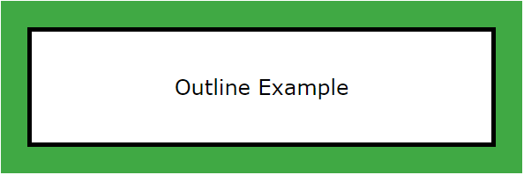
This tutorial will teach us how to set different properties associated with outlines. CSS alows us to control an outline width, its color, style etc.
- CSS Outline Width
The outline-width property specifies the width of the outline to be added to the box. Its value should be a length or one of the values thin, medium, or thick, just like the border-width attribute.
- thin = 1px
- medium = 3px
- thick = 5px
- A specific size (in px, pt, cm, em, etc)
A width of zero pixels means no outline.
Example
Here is an example to set outline width at different sizes −
<html>
<body>
<p style = "outline-width: thin; outline-style:solid; padding: 5px">
This text is having thin outline.
</p>
<p style = "outline-width: medium; outline-style:solid; padding: 5px">
This text is having thick outline.
</p>
<p style = "outline-width: thick; outline-style:solid; padding: 5px">
This text is having 5px outline.
</p>
<p style = "outline-width: 7px; outline-style:solid; padding: 5px">
This text is having 7px outline.
</p>
</body>
</html>
- CSS Outline Style
The outline-style property specifies the style for the line (solid, dotted, or dashed) that goes around an element. It can take one of the following values −
- auto − Default outline provided by the browser.
- none − No outline is used. The outline-width is 0.
- solid − Outline is a single solid line.
- dotted − Outline is a series of dots.
- dashed − Outline is a series of short line segments.
- double − Outline is two solid lines.
- groove − Outline looks as though it is carved into the page.
- ridge − Outline looks the opposite of groove.
- inset − Outline makes the box look like it is embedded in the page.
- outset − Outline makes the box look like it is coming out of the canvas.
Example
Here is an example −
<html>
<body>
<p style = "outline-width:thick; outline-style:solid; padding:5px;">
This text is having solid outline.
</p>
<p style = "outline-width:thick; outline-style:dotted; padding:5px;">
This text is having dotted outline.
</p>
<p style = "outline-width:thick; outline-style:dashed; padding:5px;">
This text is having dashed outline.
</p>
<p style = "outline-width:thick; outline-style:double; padding:5px;">
This text is having double outline.
</p>
<p style = "outline-width:thick; outline-style:groove; padding:5px;">
This text is having groove outline.
</p>
<p style = "outline-width:thick; outline-style:ridge; padding:5px;">
This text is having ridge outline.
</p>
</body>
</html>

- CSS Outline Color
The outline-color property is used to specify the color of the outline. Its value should either be a color name, a hex color, or an RGB value, as with the color and border-color properties.
- Name - Example red, blue or green
- HEX - Example #ff0000
- RGB - Example rgb(255,0,0)
- HSL - Example hsl(0, 100%, 50%)
- invert - inverts the color with background
Example
Here is an example −
<html>
<body>
<p style = "outline-width:thick; outline-style:solid; outline-color:red;padding:5px;">
Outline color set with name "red".
</p>
<p style = "outline-width:thick; outline-style:solid; outline-color:#40a944; padding:5px;">
Outline color set with Hex code "#40a944".
</p>
<p style = "outline-width:thick; outline-style:solid; outline-color:rgb(255,200,0); padding:5px;">
Outline color set with RGB code "rgb(255,200,0)".
</p>
<p style = "outline-width:thick; outline-style:solid; outline-color:hsl(0, 50%, 50%); padding:5px;">
Outline color set with HSL code "hsl(0, 50%, 50%)".
</p>
<p style = "outline-width:thick; outline-style:solid; outline-color:invert; padding:5px;">
Outline color set with invert option.
</p>
</body>
</html>

- CSS Outline Offset
The outline-offset property is used to specify the space between an outline and the border edge of an element. The space between the outline and the element is transparent.
The following example show an outline 20px outside the border of the element:
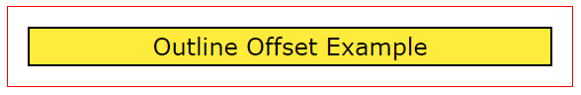
The above example shows that the space between an element's border and its outline is transparent.
Example
Here is an example −
<html>
<body>
<p style = "border:1px solid #000; outline:1px solid red; outline-offset:20px;margin:25px">
Outline offset 20px;
</p>
<br>
<p style = "border:1px solid #000; outline:1px solid red; outline-offset:10px;margin:15px">
Outline offset 10px;
</p>
<br>
<p style = "border:1px solid #000; outline:1px solid red; outline-offset:5px;margin:10px">
Outline offset 5px;
</p>
</body>
</html>
- CSS Outline Shorthand
The outline property is a shorthand property that allows you to specify values for any of the three properties, style, color and width. You can specify these properties in any order using the follwing syntax.
Syntax
outline: width style color;
Example
Here is an example −
<html>
<body>
<p style = "outline:thin solid red; padding:5px;">
This text is having thin solid red outline.
</p>
<br />

<p style = "outline:thick dashed #009900; padding:5px;">
This text is having thick dashed green outline.
</p>
<br />

<p style = "outline:5px dotted rgb(13,33,232); padding:5px;">
This text is having 5x dotted blue outline.
</p>
</body>
</html>
- CSS Outline vs Border
The two obvious differences are that outlines cannot have a hidden style where as a borders can be hidden second an outline can have auto style where as border can't have it. Following table illustrates more differences between outline and border:
Outline | Border
Outline is a non-rectangular shape that surrounds an element, usually with a solid color. | Border is a rectangular shape that is drawn around the content of an element, can be solid, dashed, or dotted, and can have different colors and sizes.
It does not take up any space in the layout and does not affect the size or position of the element. | It affects the size and position of the element, as it adds width to the element.
It is typically used to highlight or emphasize an element, such as when an element is focused or activated. | It can be used for various purposes, such as separating elements, creating boxes, and adding visual emphasis.
It can be created using the outline property in CSS. | It can be created using the border property in CSS.

- CSS Outline - Related Properties
You can explore more examples on CSS outline properties by visiting the sub topics listed in the following table:
property | Description
outline | A shorthand property for setting all the outline properties in one declaration
outline-color | Sets the outline color of an element
outline-style | Sets the outline style of an element
outline-width | Sets the outline width of an element
outline-offset | Sets the outline offset of an element

CSS - Height & Width (Dimension)
The dimesions of HTML elements is often specified with CSS width and height properties and we can use these properties to set the dimension of the elements.
CSS also provides properties like max-width, min-width, max-height and min-height to set the maximum/minimum width and height of an element.
Setting Height and Width using CSS
The height and width properties allow you to set the height and width of an element. These properties can hold following values:
- length: The height and width of an element can be of any unit of length (px, pt, em, in, etc.)
- percentage (%): The value can be passed as a percentage value, which is in percent of the containing block.
- auto: Browser calculates the height and width of the element. It is the default value.
- initial: Sets the value of height and width to its default value.
- inherit: The value of height and width is inherited from its parent value.
The height and width properties do not add anything to the layout of the element i.e they do not include padding, margin or borders. They set the height and width of the area inside the padding, border, and margin of the element.
Example
Following example demonstrates using height and width for a div.
<html>
<head>
<style>
div {
height: 100px; width: 80%; background-color: #eee;
}
</style>
</head>
<body>
<h2>Setting Height and Width Properties</h2>
<div>This div element has a height of 100px and a width of 80%.</div>
</body>
</html>
- Setting Max-Height Using CSS
CSS can limit the maximum height of an element using max-height property. This property allows to specify maximum height of an element. The value of the max-height property can be:
- none: No maximum height value is set. This is the default value.
- length: Sets the maximum height in terms of length units (px, pt, em, in, etc.)
- percentage (%): The value is relative to the percent of containing block.
- initial: Sets the value of height and width to its default value.
- inherit: The value is inherited from its parent value.
Example
Here is an example to set max-height using CSS –
<html>
<head>
<style>
div.a {
max-height: 100px; width: 80%; overflow: auto;
background-color: #eee; padding:10px;
}
</style>
</head>
<body>

<div class="a">
<h2>max-height: 100px and width:80%</h2>
<p>The <i>max-height</i> property allows you to specify maximum height of an element. The value of the max-height property can be various, but this div can be maximum 100px high and so it is creating a scrollbar to fit the content.</p>
</div>
</body>
</html>
- Setting min-height using CSS
CSS can limit the minimum height of an element using min-height property. This property allows to specify minimum height of an element. It specifies the smallest height that an element can have, ensuring that it will never shrink below that value. The value of the min-height property can be:
- length: Sets the minimum height in terms of length units (px, pt, em, in, etc.)
- percentage (%): The value is relative to the percent of containing block.
- initial: Sets the value of height and width to its default value.
- inherit: The value is inherited from its parent value.
The minimum height will be applied, when the content is smaller than the minimum height. And when the content is larger than the minimum height, the value of min-height has no effect on the element.
Example
Here is an example to set min-height using CSS −
<html>
<head>
<style>
div.a {
min-height:200px; width: 80%; overflow: auto;
background-color: #eee; padding:10px;
}
</style>
</head>
<body>

<div class="a">
<h2>min-height: 200px and width:80%</h2>
<p>The <i>min-height</i> property allows you to specify minimum height of an element. The value of the min-height property can be various, but this div can not shrink below to 200px even if you reduce the screen height less than 200px.</p>
</div>
</body>
</html>
- Setting max-width using CSS
CSS can limit the maximum width of an element using max-width property. This property allows to specify maximum width of an element. The value of the max-width property can be:
- none: No maximum width value is set. This is the default value.
- length: Sets the maximum width in terms of length units (px, pt, em, in, etc.)
- percentage (%): The value is relative to the percent of containing block.
- initial: Sets the value of height and width to its default value.
- inherit: The value is inherited from its parent value.
The max-width value overrides the value of width property. If the content within the element is larger than the specified max-width, it will automatically adjust the height of the element to accommodate the content within the element. If the content within the element is smaller than the specified max-width, the max-width property has no effect.
Example
Here is an example to set max-width using CSS −
<html>
<head>
<style>
div.a {
max-width: 600px; overflow: auto;
background-color: #eee; padding:10px;
}
</style>
</head>
<body>

<div class="a">
<h2>max-width: 600px </h2>
<p>The <i>max-width</i> property allows you to specify maximum width of an element. This div can have maxmum width of 600px and if it has larger content than its width then it will adjust the height to fit the content.</p>
</div>
</body>
</html>
- Setting min-width using CSS
CSS can limit the minimum width of an element using min-width property. This property allows to specify minimum width of an element. It specifies the smallest width that an element can have, ensuring that it will never shrink below that value. The value of the min-width property can be:
- length: Sets the minimum width in terms of length units (px, pt, em, in, etc.)
- percentage (%): The value is relative to the percent of containing block.
- initial: Sets the value of height and width to its default value.
- inherit: The value is inherited from its parent value.
If the content with the element is larger than the min-width, the min-width property has no effect but if the content with the element is smaller than the specified min-width, the minimum width will be applied.
Example
Here is an example to set min-width using CSS −
<html>
<head>
<style>
div.a {
min-width:400px; width: 80%; overflow: auto;
background-color: #eee; padding:10px;
}
</style>
</head>
<body>

<div class="a">
<h2>min-width: 400px and width:80%</h2>
<p>The <i>min-width</i> property allows you to specify minimum width of an element. This div can not shrink below to 400px even if you reduce the screen width less than 400px.</p>
</div>
</body>
</html>

- Setting line-height using CSS
The line-height property allows you to set the space between lines of text. The value of the line-height property can be:
- length: The value passed is used in the calculation of line box height (px, pt, em, in, etc.)
- percentage (%): The value is relative to the font size of the element.
- number: It is a unitless number, that is multiplied by the element's own font-size.
- normal: It is a keyword. The default value is 1.2, but it depends on the element's font-family..
Example
Here is an example to set line-height using CSS −
<html>
<head>
<style>
div.a {
line-height: 1.0in; background-color: #eee; margin-bottom: 2px;
}
div.b {
line-height: 50px; background-color: #eee; margin-bottom: 2px;
}
div.c {
line-height: 5; background-color: #eee; margin-bottom: 5px;
}
div.d {
line-height: normal; background-color: #eee; margin-bottom: 2px;
}
</style>
</head>
<body>
<h2>Setting up line-height Property</h2>
<div class="a">This div element has a line-height of 1.0 inche.</div>
<div class="b">This div element has a line-height of 50px.</div>
<div class="c">This div element has a line-height of 5 (unitless number)</div>
<div class="d">This div element has a line-height of normal.</div>
</body>
</html>

CSS - Scrollbars
There may be a case when an element's content might be larger than the amount of space allocated to it. For example, given width and height properties do not allow enough room to accommodate the content of the element.
CSS provides a property called overflow which tells the browser what to do if the box's contents is larger than the box itself. This property can take one of the following values −
Sr.No. | Value & Description
1 | visible  Allows the content to overflow the borders of its containing element.
2 | hidden  The content of the nested element is simply cut off at the border of the containing element and no scrollbars is visible.
3 | scroll  The size of the containing element does not change, but the scrollbars are added to allow the user to scroll to see the content.
4 | auto  The purpose is the same as scroll, but the scrollbar will be shown only if the content does overflow.
Here is an example –
<html>
<head>
<style type = "text/css">
.scroll {
display:block;
border: 1px solid red;
padding:5px;
margin-top:5px;
width:300px;
height:50px;
overflow:scroll;
}
.auto {
display:block;
border: 1px solid red;
padding:5px;
margin-top:5px;
width:300px;
height:50px;
overflow:auto;
}
</style>
</head>

<body>
<p>Example of scroll value:</p>
<div class = "scroll">
I am going to keep lot of content here just to show you how
scrollbars works if there is an overflow in an element box.
This provides your horizontal as well as vertical scrollbars.
</div>
<br />

<p>Example of auto value:</p>

<div class = "auto">
I am going to keep lot of content here just to show you how
scrollbars works if there is an overflow in an element box.
This provides your horizontal as well as vertical scrollbars.
</div>
</body>
</html>

CSS - Inline Blocks
CSS inline-block Property
The CSS inline-block property value for display is used to display an element as an inline-level block container. Inline-block elements do not start on a new line, but they can be set to a specific width and height.
Here are some of the characteristics of the inline-block property:
- The element will be displayed on the same line as other inline elements.
- The element will have a width and height, but it will not have a margin or padding by default.
- The element can be floated or positioned.
- The element can be cleared of floats.
The display: inline-block property is a combination of the display: inline and display: block properties. It allows an element not only to behave like an inline element, but also have the ability to take up space on a line like a block element.
inline vs block vs inline-block
Difference between display: inline, display: block and display: inline-block:
inline | block | inline-block
The element is displayed on the same line. | The element is displayed on a new line. | The element is displayed on the same line .
It does not take up the full width of the container. | It takes up the full width of the container. | It does not take up the full width of the container.
It does not have a margin or padding by default. | It has a margin and padding by default. | It has a margin and padding by default.

Following diagram shows the different layout behavior of inline, block, and inline-block elements:
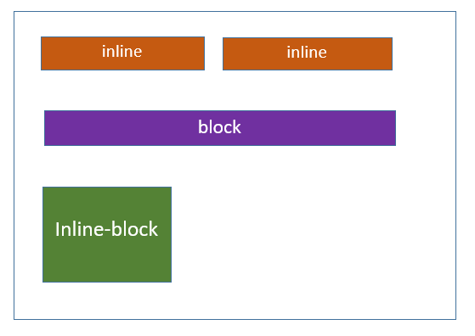
Example
Here's an example that demonstrates the different behaviors of the display: inline, display: block and display: inline-block properties
<html>
<head>
<style>
span{
background-color: #40a944;
border: 2px solid #000000;
padding: 5px;
}
.display-inline {
display: inline;

}
.display-block {
display: block;
}
.display-inline-block {
display: inline-block;
}
</style>
</head>
<body>
<h2>Display Inline</h2>
<div>One <span class="display-inline">Two</span> Three

<h2>Display Block</h2>
<div>One <span class="display-block">Two</span> Three

<h2>Display Inline Block</h2>
<div>One <span class="display-inline-block">Two</span> Three

</body>
</html>

- Navigation Links Using Inline Block
The inline-block property is used to create horizontal navigation menus or lists, where each navigation item is displayed as a block-level element, but remains inline with other items.
Example
Here is an example −
<html>
<head>
<style>
ul {
list-style-type: none;
margin: 0;
padding: 15px;
background-color: #1f9c3f;
}
li {
display: inline-block;
}
a {
padding: 10px;
color: rgb(247, 247, 247);
text-decoration:none;
}
a:hover{
background: rgb(53, 200, 91);
}
</style>
</head>
<body>
<ul>
<li><a href="#">Entoto</a></li>
<li><a href="#">Home</a></li>
<li><a href="#">Articles</a></li>
<li><a href="#">Courses</a></li>
<li><a href="#">About us</a></li>
</ul>
</body>
</html>
- Button Groups Using Inline Block
You can create button groups that are displayed horizontally using the inline-block property. The buttons will be displayed together on the same line, and they will have a specific width and height.
Example
Here is an example –
<html>
<head>
<style>
.button-group {
display: inline-block;
background-color: #d1d1d1;
}
button {
padding: 5px;
margin: 5px;
background-color: #1f9c3f;
border: none;
color: #ffffff;
width: 80px;
height: 40px;
}
</style>
</head>
<body>
<div class="button-group">
<button>Submit</button>
<button>Cancel</button>
<button>Reset</button>
</div>
</body>
</html>
- Images And Text Using Inline Block
The inline-block property causes the image and span to be displayed on the same line, allowing them to be aligned horizontally within the block.
Example
Here is an example –
<html>
<head>
<style>
div {
display: inline-block;
}
img {
width: 100px;
height: 100px;
}
span {
padding: 10px;
}
</style>
</head>
<body>
<div>
<img src="images/tutimg.png" alt="Image">
<span>Tutorialspoint</span>
</div>
</body>
</html>
- Progress Bars Using Inline Block
We can create progress bars using the inline-block property. This property is displayed on the same line as other inline elements.
Example
Here is an example −
<html>
<head>
<style>
.progress-bar {
display: inline-block;
width: 100%;

height: 25px;
background-color: blue;
border-radius: 15px;
overflow: hidden;
}
.progress-bar-fill {
width: 70%;
background-color: #1f9c3f;
height: 100%;
}
</style>
</head>
<body>
<div class="progress-bar">
<div class="progress-bar-fill"></div>
</div>
</body>
</html>

CSS – Visibility
The CSS visibility property allows you to show or hide an element without changing the layout of a document, while hidden elements take up space.
The visibility property can be used to create a variety of effects, such as hiding elements that are not yet ready to be displayed, or hiding elements that are only relevant to certain users.
The visibility property can take any of the following values:
- visible − The element is visible.
- hidden − The element is hidden, but it still takes up space on the page.
- collapse − Remove table rows, columns, column groups, and row groups from a table. collapse has the same meaning as hidden if it is used on nontable elements.
- initial − Sets the visibility of an element to its default value.
- inherit − Inherits the visibility property from its parent element.

- CSS Visibility - Making Elements Visible
The CSS property visibility: visible makes an element visible. This is the default value for the visibility property.
Example
Here is an example –
<html>
<head>
<style>
h2 {
visibility: visible;
}
</style>
</head>
<body>
<h2>This element will remain visible</h2>
</body>
</html>
- CSS Hidden - Making Elements Hidden
The CSS property visibility: hidden hides an element from the user's view, but it does not remove it from the document layout.
The element will still be accessible to screen readers and will affect the layout of the page, even though it is not visible.
Example
Here is an example -
<html>
<head>
<style>
.visible {
visibility: visible;
}
.hidden {
visibility: hidden;
}
</style>
</head>
<body>
<h2 class="visible">This element will be visible</h2>
<h2 class="hidden">This element will be hidden</h2>
</body>
</html>
- CSS Visibility Collapse
To remove a table row or column without affecting the layout of the table, you can set the visibility property of the row or column to collapse. This value is only valid for table elements.
Example
Here is an example -
<html>
<head>
<style>
.collapse {
visibility: collapse;
}
table {
border-collapse: collapse;
color: #ffffff;
width: 100%;
background-color: #35DC5A;
border: 2px solid black;
}
th, td {
border: 2px solid black;
padding: 8px;
text-align: left;
font-size: 20px;
}
</style>
</head>
<body>
<table>
<tr>
<td>Orange</td>
<td>Magoes</td>
<td class="collapse">Carbs</td>
</tr>
<tr>
<td>Banana</td>
<td>Dates</td>
<td>Nuts</td>
</tr>
</table>
</body>
</html>

CSS - overflow
Description
The overflow property determines how content which overflows its element's content area should be handled.
Possible Values
- visible − Overflowing content should be displayed.
- hidden − Overflowing content should not be displayed.
- scroll − Overflowing content should not be displayed, but the user agent should provide some means of accessing the hidden content (e.g., a set of scrollbars).
- auto − The behavior caused by this value is dependent on the browser.

Applies to
All the HTML elements.
Example
Here is the example −
<html>
<head>
<style type = "text/css">
.scroll {
display:block;
border: 1px solid red;
padding:5px;
margin-top:5px;
width:300px;
height:50px;
overflow:scroll;
}
.auto {
display:block;
border: 1px solid red;
padding:5px;
margin-top:5px;
width:300px;
height:50px;
overflow:auto;
}
</style>
</head>

<body>

<p>Example of scroll value:</p>

<div class = "scroll">
I am going to keep lot of content here just to show you how
scrollbars works if there is an overflow in an element box.
This provides your horizontal as well as vertical scrollbars.
</div>
<br />

<p>Example of auto value:</p>

<div class = "auto">
I am going to keep lot of content here just to show you how
scrollbars works if there is an overflow in an element box.
This provides your horizontal as well as vertical scrollbars.
</div>

</body>
</html>

This will produce following result –
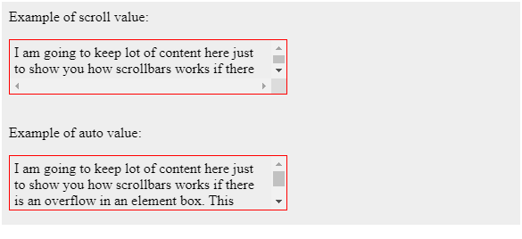

CSS - Resize Elements
CSS resize is a property that allows users to adjust the size of an element, either vertically, horizontally, both, or none, based on the specified value.
Resize property adds a handle at the bottom-right corner of an element on a webpage. This handle allows users to click and drag to change the size of an elements, making it larger or smaller according to their preference.
The CSS resize Property
This chapter will cover the use of CSS resize property which can take one of the following values −
- none − No user-controllable method for resizing an element is possible. This is default value.
- vertical − User can resize an element in the vertical direction.
- horizontal − User can resize an element in the horizontal direction.
- both − User can resize an element both horizontally and vertically.
- block − User can resize an element in the block direction (either horizontally or vertically, depending on the writing-mode and direction value).
- inline − User can resize an element in the inline direction (either horizontally or vertically, depending on the writing-mode and direction value).
The block and inline properties are supported only in Firefox and Safari browsers.
- CSS to Disable Resizability of Textareas
Following example demonstrates use of CSS resize property set to none value. Here we see user is prevented from resizing the element in any direction. The resize: none is a default value.
<html>
<head>
<style>
textarea {
resize: none;
background-color: #e7ef0e;
overflow: auto;
height: 100px;
width: 600px;
}
</style>
</head>
<body>
<textarea>There are many variations of passages of Lorem Ipsum available, but the majority have suffered alteration in some form, by injected humour, or randomised words which don't look even slightly believable. If you are going to use a passage of Lorem Ipsum, you need to be sure there isn't anything embarrassing hidden in the middle of text. All the Lorem Ipsum generators on the Internet tend to repeat predefined chunks as necessary, making this the first true generator on the Internet.</textarea>
</body>
</html>
- CSS Resize Elements Vertically
Following example demonstrates use of CSS resize property set to vertical. Here we see user is allowed to resize the height of the <div> element vertically by dragging the bottom-right corner.
<html>
<head>
<style>
div {
resize: vertical;
background-color: #e7ef0e;
overflow: auto;
height: 100px;
width: 600px;
}
</style>
</head>
<body>
<h3>Click and drag the bottom-right corner to change the size of an element vertically.</h3>
<div>
<h2 style="color: #0f5e02; text-align: center;">Tutorialspoint</h2>
<p>There are many variations of passages of Lorem Ipsum available, but the majority have suffered alteration in some form, by injected humour, or randomised words which don't look even slightly believable. If you are going to use a passage of Lorem Ipsum, you need to be sure there isn't anything embarrassing hidden in the middle of text. All the Lorem Ipsum generators on the Internet tend to repeat predefined chunks as necessary, making this the first true generator on the Internet.</p>
</div>
</body>
</html>

- CSS Resize Elements Horizontally
Following example demonstrates use of CSS resize property set to horizontal. Here we see user is allowed to modify the width of a <div> element horizontally by dragging the bottom-right corner.
<html>
<head>
<style>
div {
resize: horizontal;
background-color: #e7ef0e;
overflow: auto;
height: 150px;
width: 550px;
}
</style>
</head>
<body>
<h3>Click and drag the bottom-right corner to change the size of an element horizontally.</h3>
<div>
<h2 style="color: #0f5e02; text-align: center;">Tutorialspoint</h2>
<p>There are many variations of passages of Lorem Ipsum available, but the majority have suffered alteration in some form, by injected humour, or randomised words which don't look even slightly believable. If you are going to use a passage of Lorem Ipsum, you need to be sure there isn't anything embarrassing hidden in the middle of text. All the Lorem Ipsum generators on the Internet tend to repeat predefined chunks as necessary, making this the first true generator on the Internet.</p>
</div>
</body>
</html>
- CSS Resize Elements Horizontally & Vertically
Following example demonstrates use of CSS resize property set to both. Here we see user is allowed to resize the element both horizontally and vertically.
<html>
<head>
<style>
div {
resize: both;
background-color: #e7ef0e;
overflow: auto;
height: 150px;
width: 550px;
}
</style>
</head>
<body>
<h3>Click and drag the bottom-right corner to change the size of an element vertically and horizontally.</h3>
<div>
<h2 style="color: #0f5e02; text-align: center;">Tutorialspoint</h2>
<p>There are many variations of passages of Lorem Ipsum available, but the majority have suffered alteration in some form, by injected humour, or randomised words which don't look even slightly believable. If you are going to use a passage of Lorem Ipsum, you need to be sure there isn't anything embarrassing hidden in the middle of text. All the Lorem Ipsum generators on the Internet tend to repeat predefined chunks as necessary, making this the first true generator on the Internet.</p>
</div>
</body>
<html>

- CSS Resize Elements Inherits Resizability
Following example demonstrates use of CSS resize property set to inherit on a child element. Here we see it will have the same resizing behavior as its parent element.
<html>
<head>
<style>
.box1 {
resize: horizontal;
background-color: #e7ef0e;
overflow: auto;
height: 250px;
width: 550px;
}
.box2 {
resize: inherit;
background-color: #eee;
height: 150px;
width: 250px;
overflow: scroll;
}
</style>
</head>
<body>
<h3>Click and drag the bottom-right corner to change the size of an element.</h3>
<div class="box1">
<p>This is parent box which can be resized horizontally.</p>
<div class="box2">
<h2 style="color: #0f5e02; text-align: center;">Tutorialspoint</h2>
<p>There are many variations of passages of Lorem Ipsum available, but the majority have suffered alteration in some form, by injected humour, or randomised words which don't look even slightly believable. If you are going to use a passage of Lorem Ipsum, you need to be sure there isn't anything embarrassing hidden in the middle of text. All the Lorem Ipsum generators on the Internet tend to repeat predefined chunks as necessary, making this the first true generator on the Internet.</p>
</div>
</div>
</body>
</html>
- CSS Resize Arbitrary Elements
It is possible to create a resizable <div> container with a resizable <p> (paragraph) element inside it, where user can click and drag the bottom-right corner to change the size of both the container and the paragraph. Following example demonstartes this behavior.
<html>
<head>
<style>
.box {
resize: both;
background-color: #e7ef0e;
overflow: scroll;
border: 2px solid black;
}
div {
height: 250px;
width: 550px;
}
p {
height: 150px;
width: 250px;
}
</style>
</head>
<body>
<h3>Click and drag the bottom-right corner to change the size of an element.</h3>
<div class="box">
<h2 style="color: #0f5e02; text-align: center;">Tutorialspoint</h2>
<p class="box"> There are many variations of passages of Lorem Ipsum available, but the majority have suffered alteration in some form, by injected humour, or randomised words which don't look even slightly believable. If you ar going to use a passage of Lorem Ipsum, you need to be sure there isn't anything embarrassing hidden in the middle of text. All the Lorem Ipsum generators on the Internet tend to repeat predefined chunks as necessary, making this the first true generator on the Internet.</p>
</div>
</body>
</html>

CSS - quotes
What is a quote?
CSS quotes property allows browser to render quotation marks for the content. The CSS quotes can be added to any element. They seek the benefit of pseudo-elements ::before and ::after to insert the quotation marks at the beginning and at the end of a quote. These pseudo-elements are defined by the content property.
This CSS quotes specifies how the browser should render quotation marks that are added using the open-quote and close-quote values of the content property.
CSS Quotes Values
The quotes property can take one of the following values −
- none: The open-quote and close-quote values of the content property produce no quotation marks.
- string string,+: One or more pairs of string values for open-quote and close-quote. The first pair represents the outer level of quotation. The second pair is for the first nested level and next pair for next nested level and so on.
- initial: Depends on user agent
- auto: Appropriate quote marks will be used for whatever language value is set on the selected elements (i.e. via the lang attribute).

- Quotation Mark Characters
Following table describes the various quotation mark characters:
Quotes | Description | Entity Number
" | double quotes | \0022
' | single quote | \0027
< | single, left angle quote | \2039
> | single, right angle quote | \203A
<< | double, left angle quote | \00AB
>> | double, right angle quote | \00BB
>> | double, right angle quote | \00BB
‘ | left quote (single high-6) | \2018
’ | right quote (single high-9) | \2019
“ | left quote (double high-6) | \201C
” | right quote (double high-9) | \201D
„ | double quote (double low-9) | \201E
- CSS Quotes - None
The none value for the quotes property indicates that open-quote and close-quote values of the content property produce no quotation marks. Following example demonstartes this:
<html>
<head>
<style>
p {
quotes: none;
}
p:before {
content: open-quote;
}
p:after {
content: close-quote;
}
</style>
</head>
<body>
<p>Tutorialspoint CSS Quotes set to <i>none</i></p>
</body>
</html>
- CSS Single Quotes
Following example demonstrates specifies which quotation marks to use when string, string,+ value is used.
The first value specifies the first level of quotation embedding, the next two values specifies the next level of quote embedding, and so on
<html>
<head>
<style>
#quote1 {
quotes: '‘' '’';
}
#quote2 {
quotes: '"' '"';
}
#quote3 {
quotes: '<' '>';
}
#quote4 {
quotes: '\2018' '\2019';
}
</style>
</head>
<body>
<p><q id="quote1">Tutorialspoint CSS Quotes.</q></p>
<p><q id="quote2">Tutorialspoint CSS Quotes.</q></p>
<p><q id="quote3">Tutorialspoint CSS Quotes.</q></p>
<p><q id="quote4">Tutorialspoint CSS Quotes.</q></p>
</body>
</html>
- CSS Quotes Initial
Followig example demonstrates use of the quotes: initial; property value. This values sets default values to quotes.
<html>
<head>
<style>
q {
quotes: initial;
}
</style>
</head>
<body>
<p><q>Tutorialspoint CSS Quotes.</q></p>
</body>
</html>
- CSS Auto Quotes
Sets the quotes property to the value auto that automatically determines the correct quotation marks based on the language - as demonstrated in the following example:
<html>
<head>
<style>
q {
quotes: auto;
}
</style>
</head>
<body>
<div lang="fr">
<q>Tutorialpoint est un site de cours d'anglais.</q>
</div>
<hr />
<div lang="ru">
<q>Tutorialpoint — сайт курсов английского языка.</q>
</div>
<hr />
<div lang="de">
<q>Tutorialpoint is een Engelse cursuswebsite</q>
</div>
<hr />
<div lang="en">
<q>Tutorialpoint is an english course website.</q>
</div>
</body>
</html>

- CSS Quotes: lang pseudo-class
You can also use the :lang pseudo-class to define different styles for quotation marks based on the language attribute (lang) within the elements.
- The :lang(en) rule defines styles for elements with the English language attribute.
- The :lang(fr) rule defines styles for elements with the French language attribute.

Example
Let us see an example −
<html>
<head>
<style>
:lang(en) {
quotes: "#" "#" "<<" ">>";
}
:lang(fr) {
quotes: '\2039' '\203A';
}
</style>
</head>
<body>
<p><q lang="en">Tutorialspoint CSS <q lang="en">Quotes</q>.</q></p>
<p>Tutorialspoint CSS <q lang="fr">Quotes</q>.</p>
</body>
</html>

CSS – Hover
CSS Cursor Hover
The CSS :hover pseudo-class is used to target an element when the user hovers over it with the mouse cursor. Its purpose is to apply styles or trigger specific behaviors to enhance the user experience or provide additional visual feedback.
The CSS cursor hovering is a tool to make interactive elements more dynamic and engaging without requiring any user input beyond moving the mouse.
CSS Syntax
:hover {
/* ... */
}
- CSS Hover - Link Color Change
Following is an example of changing the background color of a link when mouse cursor comes over it:
<html>
<head>
<style>
a {
background-color: #40a944;
color: #fff;
font-size: 1rem;
padding: 10px;
}
a:hover {
background-color: #cfe9d0;
color: #000;
}
</style>
</head>
<body>
<div>
<h2>Bring your cursor on the below link</h2>
<a href="#">Hover over to see the color change!!!</a>
</div>
</body>
</html>

- CSS Hover - Background Color Change
Here is an example of changing the background color of a button when mouse cursor comes over it:
<html>
<head>
<style>
button {
background-color: greenyellow;
padding: 10px;
font-size: large;
}
button:hover {
background-color: gold;
}
</style>
</head>
<body>
<h2>Bring your cursor on the below button</h2>
<button>Hover me!!!</button>
</div>
</body>
</html>
- CSS Hover - Change Cursor Shape
Here is an example of changing the cursor shape when mouse cursor comes over the button:
<html>
<head>
<style>
button {
background-color: greenyellow;
padding: 10px;
font-size: large;
}
button:hover {
cursor:pointer;
}
</style>
</head>
<body>
<h2>Bring your cursor on the below button</h2>
<button>Hover me!!!</button>
</div>
</body>
</html>
- CSS Hover - Change Border Shape
Here is an example, where border of the link is changing on hover:
<html>
<head>
<style>
.link {
color: #40a944;
text-transform: uppercase;
padding: 20px;
border: 4px solid #40a944;
border-radius: 10px;
display: inline-block;
}
.link:hover {
color: #494949;
border-radius: 45px;
border-color: #494949;
}
</style>
</head>
<body>
<h2>Hover effect on border of the link</h2>
<div class="button"><a class="link" href="#">Check my borders on hover</a></div>
</body>
</html>
- CSS Hover - Adding Box Shadow
Here is an example, where box-shadow is added to the link on hover:
<html>
<head>
<style>
a {
font-size: 2rem;
color: #071402;
margin: 0 .25rem;
padding: 0 .25rem;
transition: color .3s ease-in-out, box-shadow .3s ease-in-out;
}
a:hover {
box-shadow: inset 100px 0 0 100px #9ce2cc;
color: rgb(240, 32, 32);
}
</style>
</head>
<body>
<div>
<a href="#">Hover over me!!</a>
</div>
</body>
</html>
- CSS Hover - Growing Background
Here is an example, where the background grows over a link on hover:
<html>
<head>
<style>
a {
text-decoration-line: underline;
color: #18272F;
font-size: 2rem;
position: relative;
}
a::before {
content: '';
background-color: rgba(118, 213, 83, 0.75);
font-size: 2rem;
position: absolute;
left: 0;
bottom: 3px;
width: 100%;
height: 10px;
z-index: -1;
transition: all .5s ease-in-out;
}
a:hover::before {
bottom: 0;
height: 100%;
}
</style>
</head>
<body>
<div>
<a href="#">Hover over me!!</a>
</div>
</body>
</html>
- CSS Hover - Ranbow Color Effect
Here is an example, where the underline of the link gives a rainbow color effect on hover:
<html>
<head>
<style>
a {
color: black;
text-decoration: none;
}
a {
background:
linear-gradient(
to right,
rgb(179, 232, 168),
rgb(185, 162, 215)
),
linear-gradient(
to right,
rgba(255, 0, 0, 1),
rgba(255, 0, 180, 1),
rgba(0, 200, 50, 1)
);
background-size: 100% 5px, 0 5px;
background-position: 100% 100%, 0 100%;
background-repeat: no-repeat;
transition: background-size 700ms;
}
a:hover {
background-size: 0 5px, 100% 5px;
}
body {
display: grid;
font-family: Verdana, Geneva, Tahoma, sans-serif;
font-size: 2rem;
height: 100vh;
}
</style>
</head>
<body>
<div>
<a href="#">Hover over me!!</a>
</div>
</body>
</html>
CSS Hover - Shadow Effect
Here is an example, where the a shadow effect is given to a button on hover:
<html>
<head>
<style>
body {
width: 100%;
height: 100vh;
display: grid;
}
.glow {
padding: 10px;
width: 250px;
height: 50px;
border: none;
outline: none;
color: #fff;
background: #111;
cursor: pointer;
position: relative;
z-index: 0;
border-radius: 20px;
}
.glow:before {
content: '';
background: linear-gradient(60deg, #ff0000, #ff7300, #fffb00, #48ff00, #00ffd5, #002bff, #7a00ff, #ff00c8, #ff0000);
position: absolute;
top: -4px;
left:-4px;
background-size: 400%;
z-index: -1;
filter: blur(15px);
width: calc(100% + 6px);
height: calc(100% + 6px);
animation: glowing 20s linear infinite;
opacity: 0;
transition: opacity .3s ease-in-out;
border-radius: 10px;
}
.glow:active {
color: rgb(246, 235, 235)
}
.glow:active:after {
background: transparent;
}
.glow:hover:before {
opacity: 1;
}
.glow:after {
z-index: -1;
content: '';
position: absolute;
width: 100%;
height: 100%;
background: #111;
left: 0;
top: 0;
border-radius: 10px;
}
@keyframes glowing {
0% { background-position: 0 0; }
50% { background-position: 400% 0; }
100% { background-position: 0 0; }
}
</style>
</head>
<body>
<button class="glow" type="button">Hover & Click!</button>
</body>
</html>

CSS - Height
CSS Height Property
The CSS height property sets the height of an element's content area. In case, the box-sizing is set to border-box, the property height sets the height of the border area.
The value specified by the height property gets oevrriden by the values defined by min-height and max-height properties.
Syntax
CSS allows to set height of an element in a variety of ways. Let's check all the possible available syntax to set the height of an element.
Length Value
height: 120px;
height: 10em;
height: 100vh;
Percentage Value
height: 75%;
height: 50%;
Keyword Value
height: auto;
height: max-content;
height: min-content;
height: fit-content(20em);
Global Value
height: inherit;
height: initial;
height: revert;
height: revert-layer;
height: unset;
Negative values like height: -200px are not accepted.
CSS Height - Length Value
CSS allows to set the height of an element to a specific length value such as pixels (px), centimeters (cm), inches (in), etc. Here is an example of adding height to a div element in length units:
<html>
<head>
<style>
div {
border: 1px solid black;
margin-bottom: 5px;
padding:10px;
}
div.a {
height: 100px;
background-color: rgb(230, 230, 203);
}
div.b {
height: 1.5in;
background-color: rgb(230, 230, 203);
}
</style>
</head>
<body>
<div class="a">This div element has a height of 100px.</div>
<div class="b">This div element has a height of 1.5 inches.</div>
</body>
</html>
- CSS Height - Percentage Value
CSS allows to set the height of an element to a percentage of the height of the containing element. Here is an example of adding height to a div element in percentage values:
<html>
<head>
<style>
.parent{
border: 1px solid black;
height: 100px;
background-color: rgb(230, 230, 203);
}
.child{
border: 1px solid black;
height: 80%;
background-color: rgb(76 175 80);
}
</style>
</head>
<body>
<div class="parent">
<div class="child">
<p>This div element has a 80% height of the parent.</p>
</div>
</div>
</body>
</html>
- CSS Height - auto Values
Following is an example of adding height to a div element set as auto. Here the browser will calculate the height automatically based on the content. It is the default height of an element.
<html>
<head>
<style>
div.auto {
height: auto;
background-color: yellow;
padding: 20px;
margin-bottom: 5px;
}
</style>
</head>
<body>
<div class="auto">This div element has a height set as auto.</div>
</body>
</html>
- CSS Height - max-content/min-content
Here is an example of height equal to max-content and min-content. The max-content defines the intrinsic preferred height where as min-content defines the intrinsic minimum height
<html>
<head>
<style>
div {
border: 1px solid black;
margin-bottom: 5px;
}
div.c {
height: max-content;
background-color: bisque;
}
div.d {
height: min-content;
background-color: darkseagreen;
}
</style>
</head>
<body>
<div class="c">This div element has a height as max-content. This div element has a height as max-content.
This div element has a height as max-content. This div element has a height as max-content. This div element has a height as max-content.</div>
<div class="d">This div element has a height of min-content.</div>
</body>
</html>
- CSS Height - clamp() function
This enables selection of a middle value within a range of values, specified between minimum and maximum height. Here is the example where clamp() function is used for setting height:
<html>
<head>
<style>
p{
display: inline-flex;
border: 1px solid black;
background-color: yellow;
height: clamp(20px, 100px, 180px);
width: clamp(50px, 100px, 200px);
padding: 1em;
margin: 2em;
}
</style>
<body>
<div>
<p>The clamp function is used for height & width, where the background color is selected for the value between the
min and max ranges of height and width.</p>
</div>
</body>
</html>

CSS - width
CSS Width Property
The width property sets the width of an element's content area. In case, the box-sizing is set to border-box, the property width sets the width of the border area.
The value specified by the width property remains within the values defined by min-width and max-width properties.
Refer the image for the understanding of width of an element.
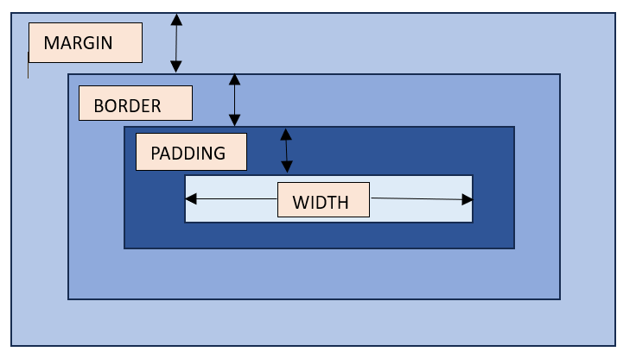

Syntax
CSS allows to set width of an element in a variety of ways. Let's check all the possible available syntax to set the width of an element.
Length Value
width: 120px;
width: 10em;
width: 100vh;
Percentage Value
width: 75%;
width: 50%;
Keyword Value
width: auto;
width: max-content;
width: min-content;
width: fit-content(20em);
Global Value
width: inherit;
width: initial;
width: revert;
width: revert-layer;
width: unset;
Negative values like width: -200px are not accepted.
- CSS Width - Length Value
CSS allows to set the width of an element to a specific length value such as pixels (px), centimeters (cm), inches (in), etc. Here is an example of adding a width to a div element in length units:
<html>
<head>
<style>
div {
border: 1px solid black;
margin-bottom: 5px;
padding:10px;
}
div.a {
width: 100px;
background-color: rgb(230, 230, 203);
}
div.b {
width: 5em;
background-color: rgb(230, 230, 203);
}
</style>
</head>
<body>
<div class="a">This div element has a width of 100px.</div>
<div class="b">This div element has a width of 5em.</div>
</body>
</html>
- CSS Width - Percentage Value
CSS allows to set the height of an element to a percentage of the width of the containing element. Here is an example of adding a width to a div element in percentage values:
<html>
<head>
<style>
.parent{
border: 1px solid black;
width: 400px;
background-color: rgb(230, 230, 203);
}
.child{
border: 1px solid black;
width: 50%;
background-color: rgb(76 175 80);
}
</style>
</head>
<body>
<div class="parent">
<div class="child">
<p>This div element has a 50% width of the parent.</p>
</div>
</div>
</body>
</html>

- CSS Width - auto Values
Here the browser will calculate the width automatically based on the content. It is the default width of an element. Here is an example of adding a width to a div element as auto:
<html>
<head>
<style>
div {
border: 1px solid black;
margin-bottom: 5px;
}
div.auto {
width: auto;
background-color: yellow;
}
</style>
</head>
<body>
<div class="auto">This div element has a width set as auto.</div>
</body>
</html>
- CSS Width - max-content/min-content
Here is an example of width equal to max-content and min-content. The max-content defines the intrinsic preferred width where as min-content defines the intrinsic minimum width.
<html>
<head>
<style>
div {
border: 1px solid black;
margin-bottom: 5px;
}
div.c {
width: max-content;
background-color: bisque;
}
div.d {
width: min-content;
background-color: darkseagreen;
}
</style>
</head>
<body>
<div class="c">This div element has a width as max-content.</div>
<div class="d">This div element has a width of min-content.</div>
</body>
</html>
- CSS Width - fit-content
Here is an example of fit-content value set for width of a list:
<html>
<head>
<style>
ul {
background-color: beige;
width: fit-content;
padding: 1.5em;
border: 2px solid black;
}
li {
display: inline-flex;
background-color: orange;
border: 2px solid black;
padding: 0.5em;
}
</style>
<body>
<ul>
<li>Item1</li>
<li>Item2</li>
<li>Item3</li>
<li>Item4</li>
</ul>
</body>
</html>
- CSS Width - Related Properties
Following is the list of related CSS properties of width:
property | value
max-width | Sets an upper bound on the width of an element.
min-width | Sets an lower bound on the width of an element.

CSS - Opacity
CSS Opacity Property
The CSS opacity property controls the transparency of an element. Opacity determines how much of a hidden element's content is visible.
You can use the opacity property on various elements, whether they contain text, images, or serve as backgrounds.
This property is used to creating various visual effects, such as fading in/out, creating overlays, or making background images less prominent.
Syntax
This chapter will cover the use of CSS opacity property which can take one of the following value: −
- number − It represented as a decimal number from 0 to 1.
- percentage − It represented as a percentage from 0% to 100%.
Following table showing the different opacity values:
Value | Description
0 | The element is fully transparent and not visible.
0.5 | The element is half transparent.
1 | The element is fully opaque and visible.
- CSS Opacity - Value
We can make an element's background partially transparent but keeping the text inside visible by setting the element's opacity property to a value between 0 and 1.
Here is an example −
<html>
<head>
<style>
div {
background-color: #d3360b;
opacity: 0.4;
padding: 10px;
width: 150px;
height: 110px;
}
</style>
</head>
<body>
<div>
<h3>CSS Opacity to 0.4</h3>
</div>
</body>
</html>
- CSS Opacity - Percentage
You can also use the opacity property with a percentage value to make an element's background partially transparent by setting the element's opacity property to a value between 0% and 100%.
Here is an example −
<html>
<head>
<style>
.my-opacity {
background-color: #d3360b;
opacity: 70%;
padding: 10px;
width: 150px;
height: 110px;
}
</style>
</head>
<body>
<div class="my-opacity">
<h3>CSS Opacity to 70%</h3>
</div>
</body>
</html>
- CSS Opacity for Images
The following example shows how to use the opacity property to make an images partially transparent.
<html>
<head>
<style>
div {
display: flex
}
.first-img {
opacity: 0.1;
margin: 10px;
width: 170px;
height: 130px;
}
.second-img {
opacity: 0.5;
margin: 10px;
width: 170px;
height: 130px;
}
.third-img {
opacity: 1;
margin: 10px;
width: 170px;
height: 130px;
}
</style>
</head>
<body>
<div>
<img class="first-img" src="images/tutimg.png" alt="Tutorialspoint">
<img class="second-img" src="images/tutimg.png" alt="Tutorialspoint">
<img class="third-img" src="images/tutimg.png" alt="Tutorialspoint">
</div>
</body>
</html>
- CSS Opacity for Image Hover Effect
The following example demonstrates how to use the opacity property to make transparent image when the cursor hovers over it.
<html>
<head>
<style>
div {
display: flex
}
.opacity-image {
opacity: 1;
margin: 10px;
width: 170px;
height: 130px;
}
.opacity-image:hover {
opacity: 0.3;
}
</style>
</head>
<body>
<h3>Hover Over an image</h3>
<div>
<img class="opacity-image" src="images/tutimg.png" alt="redFlower">
</div>
</body>
</html>
- CSS Opacity With RGBA color values
The opacity property will make an element and all of its child elements transparent. To prevent this, you can use RGBA color values, which allow you to set the opacity of a color without affecting its child elements.
<html>
<head>
<style>
div {
width: 200px;
padding: 10px;
text-align: center;
}
.my-opacity1 {
background-color: rgba(227, 220, 11);
opacity: 0.1;
}
.my-opacity2 {
background-color: rgba(227, 220, 11);
opacity: 0.3;
}
.my-opacity3 {
background-color: rgba(227, 220, 11);
opacity: 0.6;
}
.my-opacity4 {
background-color: rgba(227, 220, 11);
opacity: 0.9;
}
.rgba-opacity1 {
background-color: rgba(227, 220, 11, 0.1);
}
.rgba-opacity2 {
background-color: rgba(227, 220, 11, 0.3);
}
.rgba-opacity3 {
background-color: rgba(227, 220, 11, 0.6);
}
.rgba-opacity4 {
background-color: rgba(227, 220, 11, 0.9);
}
.transparent-container {
margin-left: 50px;
float: left;
}
.regba-container {
margin-left: 50px;
float: left;
}
</style>
</head>
<body>
<div class="transparent-container">
<h4>Tranparent element</h4>
<div class="my-opacity1">
CSS Opacity 0.1
</div>
<div class="my-opacity2">
CSS Opacity 0.3
</div>
<div class="my-opacity3">
CSS Opacity 0.6
</div>
<div class="my-opacity4">
CSS Opacity 0.9
</div>
</div>
<div class="regba-container">
<h4>With RGBA color values</h4>
<div class="rgba-opacity1">
CSS Opacity 10%
</div>
<div class="rgba-opacity2">
CSS Opacity 30%
</div>
<div class="rgba-opacity3">
CSS Opacity 60%
</div>
<div class="rgba-opacity4">
CSS Opacity 90%
</div>
</div>
</body>
</html>
The following example shows how the opacity of an element changes to the specified value when the user clicks a button.
<html>
<head>
<style>
.opacity-container {
display: flex;
justify-content: space-between;
margin-top: 10px;
}
.opacity-button {
background-color: #0cc42b;
border: none;
padding: 10px;
border-radius: 5px;
cursor: pointer;
width: 90px;
height : 40px;
}
#heading {
background-color: #d7e20c;
width: 250px;
padding: 5px;
transition: opacity 0.3s ease;
text-align: center;
margin-left: 35%;
}
</style>
</head>
<body>
<p>Click the buttons to see how the opacity changes.</p>
<div class="opacity-container">
<button class="opacity-button" onclick="changeOpacity(0)">0 opacity</button>
<button class="opacity-button" onclick="changeOpacity(0.3)">0.3 opacity</button>
<button class="opacity-button" onclick="changeOpacity(0.6)">0.6 opacity</button>
<button class="opacity-button" onclick="changeOpacity(0.9)">0.9 opacity</button>
<button class="opacity-button" onclick="changeOpacity(1)">1.0 opacity</button>
</div>
<h3 id="heading">Tutorialspoint CSS Opacity</h3>
<script>
function changeOpacity(opacityValue) {
var selectElement = document.getElementById("heading");
selectElement.style.opacity = opacityValue;
}
</script>
</body>
</html>

CSS – Navbar
CSS Navigation Bar
A navigation bar is a section of a graphical user interface (GUI) that helps users navigate through a website, app, or other software. It is essential for users to quickly and easily navigate to the content they are looking for.
The navigation bar can be horizontal or vertical, that contains links to important pages or features. Navbars can also contain other elements, such as the logo of the website or app, search bar, or social media icons. Navbars can be styled using CSS to change their appearance.
- CSS Horizontal Navbar
Following example shows a horizontal navigation bar, which is the most common type of navigation bar displayed across the top of a web page as shown below −
<html>
<head>
<style>
ul {
background-color: #28bf17;
overflow: hidden;
list-style-type: none;
margin: 0;
padding: 0;
}
li {
float: left;
}
li a {
display: block;
color: #f2f2f2;
text-align: center;
padding: 10px;
text-decoration: none;
font-size: 17px;
}
li a:hover {
background-color: #dd9ede;
color: black;
}
.active-link {
background-color: #f53319;
color: white;
}
</style>
</head>
<body>
<ul>
<li><a href="#" class="active-link">Tutorialspoint</a></li>
<li><a href="#">Home</a></li>
<li><a href="#">Articles</a></li>
<li><a href="#">Courses</a></li>
<li><a href="#">eBook</a></li>
</ul>
<h1>Welcome to TutorialsPoint</h1>
<h3>Simple Easy Learning at your fingertips</h3>
</body>
</html>
- CSS Vertical Navbar
A vertical navigation bar is also known as a sidebar menu. It is typically positioned on the left or right side of the screen.
Here is an example −
<html>
<head>
<style>
ul {
background-color: #28bf17;
list-style-type: none;
margin: 0;
padding: 0;
width: 200px;
}
li {
text-align: center;
}
li a {
display: block;
color: #f2f2f2;
text-align: center;
padding: 10px;
text-decoration: none;
font-size: 17px;
}
li a:hover {
background-color: #dd9ede;
color: black;
}
.active-link {
background-color: #f53319;
color: white;
}
</style>
</head>
<body>
<ul>
<li><a href="#" class="active-link">Tutorialspoint</a></li>
<li><a href="#">Home</a></li>
<li><a href="#">Articles</a></li>
<li><a href="#">Courses</a></li>
<li><a href="#">eBook</a></li>
</ul>
</body>
</html>
- CSS Dropdown Navbar
A dropdown navbar is a navigation bar with a drop-down menu that appears when a user hovers over a link. Dropdown menus are a way to show a list of related items in a small space.
Here is an example −
<html>
<head>
<style>
.navbar {
background-color: #28bf17;
overflow: hidden;
}
.navbar a {
display: block;
float: left;
color: #f2f2f2;
text-align: center;
padding: 10px;
text-decoration: none;
font-size: 15px;
}
.navbar a:hover {
background-color: #dd9ede;
color: black;
}
.active-link {
background-color: #f53319;
color: white;
}
.dropdown {
float: left;
}
.dropdown .dropbtn {
border: none;
color: #f2f2f2;
padding: 10px;
background-color: #28bf17;
}
.dropdown-content {
display: none;
position: absolute;
background-color: #c7385a;
min-width: 120px;
}
.dropdown-content a {
float: none;
color: #f2f2f2;
padding: 10px;
display: block;
text-align: left;
}
.dropdown-content a:hover {
background-color: #dd9ede;
color: black;
}
.dropdown:hover .dropdown-content {
display: block;
}
</style>
</head>
<body>
<nav class="navbar">
<a href="#" class="active-link">Tutorialspoint</a>
<a href="#">Home</a>
<div class="dropdown">
<button class="dropbtn">Articles</button>
<div class="dropdown-content">
<a href="#">HTML</a>
<a href="#">CSS</a>
<a href="#">Bootstrap</a>
</div>
</div>
<a href="#">Courses</a>
<a href="#">eBook</a>
</nav>
<h1>Welcome to TutorialsPoint</h1>
<h3>Simple Easy Learning at your fingertips</h3>
</body>
</html>
- CSS Fixed Navbar
A fixed navbar is a navigation bar that sticks to the top of the screen when the user scrolls down the page. To make a navbar fixed, you can use the position: fixed property.
Here is an example −
<html>
<head>
<style>
body {
margin: 0;
}
.navbar {
position: fixed;
top: 0;
width: 100%;
margin: 0;
padding: 0px;
overflow: hidden;
background-color: #28bf17;
}
.navbar a {
display: block;
float: left;
color: #f2f2f2;
text-align: center;
padding: 10px;
text-decoration: none;
font-size: 17px;
}
.navbar a:hover {
background-color: #dd9ede;
color: black;
}
.active-link {
background-color: #f53319;
color: white;
}
.heading {
padding-top: 170px;
text-align: center;
background-color: #e6e451;
padding-bottom: 300px
}
</style>
</head>
<body>
<nav class="navbar">
<a href="#" class="active-link">Tutorialspoint</a>
<a href="#">Home</a>
<a href="#">Articles</a>
<a href="#">Courses</a>
<a href="#">eBook</a>
</nav>
<div class="heading">
<h1>Welcome to TutorialsPoint</h1>
<h2>Tutorialspoint CSS Fixed Navbar</h2>
<h3>Simple Easy Learning at your fingertips</h3>
</div>
</body>
</html>
- CSS Sticky Navbar
You can use the position: sticky property to create a sticky navbar, which will stay at the top of the screen even when the user scrolls down the page.
Here is an example −
<html>
<head>
<style>
body {
margin: 0;
}
.navbar {
position:sticky;
top: 0;
width: 100%;
margin: 0;
padding: 0px;
overflow: hidden;
background-color: #28bf17;
}
.navbar a {
display: block;
float: left;
color: #f2f2f2;
text-align: center;
padding: 10px;
text-decoration: none;
font-size: 17px;
}
.navbar a:hover {
background-color: #dd9ede;
color: black;
}
.active-link {
background-color: #f53319;
color: white;
}
.heading {
padding-top: 170px;
text-align: center;
background-color: #e6e451;
padding-bottom: 300px
}
h2 {
text-align: center;
}
</style>
</head>
<body>
<h2>Scroll down to see the effect</h1>
<nav class="navbar">
<a href="#" class="active-link">Tutorialspoint</a>
<a href="#">Home</a>
<a href="#">Articles</a>
<a href="#">Courses</a>
<a href="#">eBook</a>
</nav>
<div class="heading">
<h1>Welcome to TutorialsPoint</h1>
<h2>Tutorialspoint CSS Sticky Navbar</h2>
<h3>Simple Easy Learning at your fingertips</h3>
</div>
</body>
</html>
- Divider Lines for Navbar
You can also add a divider line between the links in the navbar using the border-right property as shown below −
<html>
<head>
<style>
.navbar {
background-color: #28bf17;
overflow: hidden;
}
.navbar a {
display: block;
float: left;
color: #f2f2f2;
text-align: center;
padding: 10px;
text-decoration: none;
font-size: 17px;
border-right: 2px solid #f013c8;
}
.navbar a:hover {
background-color: #dd9ede;
color: black;
}
.active-link {
background-color: #f53319;
color: white;
}
</style>
</head>
<body>
<nav class="navbar">
<a href="#" class="active-link">Tutorialspoint</a>
<a href="#">Home</a>
<a href="#">Articles</a>
<a href="#">Courses</a>
<a href="#">eBook</a>
</nav>
<h1>Welcome to TutorialsPoint</h1>
<h2>Tutorialspoint CSS Navbar with borders</h2>
</body>
</html>
- Fixed Vertical Navbar
The following example demonstrates how the position: fixed property can be used to create a fixed vertical navbar, which ensures that the navbar stays on the left side of the screen, even when the user scrolls down the page.
<html>
<head>
<style>
ul {
position: fixed;
background-color: #28bf17;
list-style-type: none;
margin: 0;
padding: 0;
width: 200px;
height: 100%;
}
li {
text-align: center;
border-bottom: 2px solid #f013c8;
}
li a {
display: block;
color: #f2f2f2;
text-align: center;
padding: 10px;
text-decoration: none;
font-size: 17px;
}
li a:hover {
background-color: #dd9ede;
color: black;
}
.active-link {
background-color: #f53319;
color: white;
}
.heading {
padding-top: 170px;
text-align: center;
background-color: #e6e451;
padding-bottom: 300px
}
</style>
</head>
<body>
<ul>
<li><a href="#" class="active-link">Tutorialspoint</a></li>
<li><a href="#">Home</a></li>
<li><a href="#">Articles</a></li>
<li><a href="#">Courses</a></li>
<li><a href="#">eBook</a></li>
</ul>
<div class="heading">
<h1>Welcome to TutorialsPoint</h1>
<h2>Tutorialspoint CSS Fixed Vertical Navbar</h2>
<h3>Simple Easy Learning at your fingertips</h3>
</div>
</body>
</html>

CSS – Alignment
CSS Alignment
The term alignment, in context of web design and CSS, refers to the positioning and arrangement of elements or content within a layout, typically with respect to specific guidelines or reference points. Alignment is used to create visually pleasing and organized designs by ensuring that elements are positioned relative to each other or to the layout structure in a consistent and harmonious way.
Alignment can be applied to various types of elements, including text, images, buttons, and more, to create a cohesive and polished design. CSS provides various properties that can be used to align the elements.
There are two main aspects of alignment:
Horizontal alignment
This refers to the positioning of elements along the horizontal axis, which typically runs from left to right. Common horizontal alignment options include:
- Left alignment: Elements are aligned to the left side of a container or layout.
- Center alignment: Elements are positioned in the center of a container or layout horizontally.
- Right alignment: Elements are aligned to the right side of a container or layout.
Vertical alignment
This refers to the positioning of elements along the vertical axis, which typically runs from top to bottom. Common vertical alignment options include:
- Top alignment: Elements are aligned to the top of a container or layout.
- Middle or Center alignment: Elements are centered vertically within a container or layout.
- Bottom alignment: Elements are aligned to the bottom of a container or layout.
CSS Alignment - Using Position
With the use of the CSS property position, the alignment of elements can be adjusted.
Example
Here is an example of setting alignment using position:
<html>
<head>
<style>
.right-alignment {
position: absolute;
right: 0px;
width: 100px;
border: 3px solid #0d1601;
background-color: rgb(244, 244, 135);
padding: 10px;
}
.left-alignment {
position: relative;
left: 0px;
width: 100px;
border: 3px solid #0c1401;
background-color: blanchedalmond;
padding: 10px;
}
.center-alignment {
margin: auto;
border: 3px solid black;
padding: 5px;
background-color: rgb(241, 97, 126);
width: 120px;
position: relative;
}
</style>
</head>
<body>
<div class="right-alignment">
<h3>Right align</h3>
<strong>Right align with position:absolute</strong>
</div>
<div class="left-alignment">
<h3>Left align</h3>
<strong>Left align with position:relative</strong>
</div>
<div class="center-alignment">
<h3>Center align</h3>
<strong>Vertically & horizontally centered using position:relative and margin:auto.</strong>
</div>
</body>
</html>

CSS - Image Gallery
CSS image gallery is a collection of images that is displayed using CSS. CSS can be used to control the layout of the images, their size, spacing, and other visual properties.
CSS image galleries are commonly used on websites to display products, portfolios, or other visual content in a visually appealing way.
The following example shows a simple image gallery layout that is displayed in a row −
<html>
<head>
<style>
.image-gallery {
display: flex;
flex-flow: row wrap;
justify-content: space-between;
align-items: center;
}
.image-gallery img {
width: 25%;
height: 250px;
}
</style>
</head>
<body>
<div class="image-gallery">
<img src="images/red-flower.jpg" alt="Red Flower">
<img src="images/white-flower.jpg" alt="White Flower">
<img src="images/orange-flower.jpg" alt="Orange Flower">
</div>
</body>
</html>

CSS - Comments
CSS - Comments
In CSS, comments are useful in adding explanatory notes or annotations within your stylesheet that are not interpreted as styling instructions by the web browser. CSS comments are intended for the benefit of developers and are ignored by the browser when rendering a web page. They are useful in documentation, debugging, etc.
In CSS, there are two main ways to create comments:
- Single-line Comments: Single-line comments are created using /* to start the comment and */ to end it.
- Multi-line Comments: Multi-line comments allow you to add comments that span multiple lines. They are also enclosed within /* and */.
While using <style> element, you may use <!-- --> to hide CSS from the browser. Though this is not recommended.
Syntax
CSS comments can be placed wherever white space is allowed within a style sheet. They can be used on a single line, or traverse multiple lines.
/* This is a single line comment */

/*
A comment
which spans
over several
lines
*/

/* The comment below is used to
disable specific styling */
/*
span {
color: #eee;
font-size: 2.5em;
}
*/
CSS does not allow the nesting of the comments, which means a /*...*/ can't have another comment inside it.
CSS Comments - Single and Multi-Line comments
Following example demonstrates CSS comments (single and multi-line):
<html>
<head>
<style>
div {
background-color: rgb(194, 152, 233); /* Set the background color */
height: 50px; /* Set the height of div element */
width: 200px; /* Set the width of div element */
padding: 5px; /* Set the padding of div element */
border: 5px solid black; /* Set the border around the element */
}

/* The p tag
color is set to red
font color */
p {
color: red;
font-size: 20px;
}

</style>
</head>
<body>
<div>
Checking for CSS comments.
</div>
<p>The styling on p tag has multi-line comments.</p>
</body>
</html>
- CSS Comments - HTML And CSS comments
Here is an example showing html comment and CSS comment format:
Note: Remove the multi-line comment syntax from <p> to see the styling applied.
<html>
<head>
<style>
div {
background-color: rgb(194, 152, 233); /* Set the background color */
height: 50px; /* Set the height of div element */
width: 200px; /* Set the width of div element */
padding: 5px; /* Set the padding of div element */
border: 5px solid black; /* Set the border around the element */
}

/*
p {
color: red;
font-size: 20px;
}
*/
</style>
</head>
<body>
<!-- This is an html comment format -->
<div>
Checking for CSS comments.
</div>
<p>The styling is commented so its not applied on p tag.</p>
</body>
</html>

CSS3
CSS3 is a latest standard of css earlier versions(CSS2). The main difference between css2 and css3 is follows −
- Media Queries
- Namespaces
- Selectors Level 3
- Color
- CSS3 modules
CSS3 is collaboration of CSS2 specifications and new specifications, we can called this collaboration is module. Some of the modules are shown below −
- Selectors
- Box Model
- Backgrounds
- Image Values and Replaced Content
- Text Effects
- 2D Transformations
- 3D Transformations
- Animations
- Multiple Column Layout
- User Interface
- CSS3 - Rounded Corners
CSS3 rounded corners are created using the border-radius property. This property allows you to specify the radius of the corners of an element's outer border edge.
Possible Values
- <length>: Size of circle radius is denoted, using length values. Negative values are not valid.
- <percentage>: Size of circle radius is denoted, using percentage values.
  - Horizontal axis percentage is referred to the width of the box.
  - Vertical axis percentage is referred to the height of the box.
  - Negative values are not valid.
Applies to
All the HTML elements, except for table and inline-table elements with border-collapse set to collapse. Applies to ::first-letter.
Syntax
object.style.borderRadius = "length";
The following diagram demonstrates the different border-radius corners for reference:
The following table shows the possible values for rounded corners as follows −
Value | Description
radius | Is a <length> or a <percentage> that sets the radius for all four corners of the element. It is used only in the one-value syntax.
top-left and bottom-right | Is a <length> or a <percentage> that sets the radius for the top-left and bottom-right corners of the element. It is used only in the two-value syntax.
top-right and bottom-left | Is a <length> or a <percentage> that sets the radius for the top-right and bottom-left corners of the element. It is used only in the two- and three-value syntaxes.
top-left | Is a <length> or a <percentage> that sets the radius for the top-left corner of the element. It is used on three and four value syntaxes.
top-right | Is a <length> or a <percentage> that sets the radius for the top-right corners of the element. It is used only in the four-value syntax.
bottom-right | Is a <length> or a <percentage> that sets the radius for the bottom-right corners of the element. It is used only in the three and four-value syntaxes.
bottom-left | Is a <length> or a <percentage> that sets the radius for the bottom-left corners of the element. It is used only in the four-value syntax.
Individual border radius properties, such as border-top-left-radius, cannot inherit from their parent element. Instead, you must use the individual longhand properties to set the border radius of each corner.
CSS Border Radius - Length Value
The following example demostrates how to use the border-radius property to create rounded corners for all four corners of a box −
<html>
<head>
<style>
.rounded-box {
width: 200px;
height: 100px;
background-color: pink;
line-height: 100px;
border-radius: 20px;
}
</style>
</head>
<body>
<div class="rounded-box">
This is a rounded corner box.
</div>
</body>
</html>
You can use the border-radius property to create rounded corners on box, borders, and images.
Here is an example −
<html>
<head>
<style>
.rounded-box {
width: 200px;
height: 100px;
background-color: pink;
border-radius: 20px;
margin-bottom: 10px;
}
.border-box {
width: 200px;
height: 100px;
border-radius: 2em;
border: 3px solid green;
margin-bottom: 20px;
}
.img-border-radius {
background-image: url(images/tree.jpg);
background-size: 100% 100%;
border-radius: 20%;
width: 200px;
height: 150px;
}
</style>
</head>
<body>
<div class="rounded-box">
This is a rounded corner box.
</div>
<div class="border-box">
This is a rounded corner box.
</div>
<div class="img-border-radius">
This is a rounded corner image.
</div>
</body>
</html>
You can use the border-radius property to create different rounded corner styles on an element.
Here is an example –
<html>
<head>
<style>
.rounded-box {
width: 200px;
height: 100px;
background-color: pink;
margin: 10px;
padding: 5px;
}
.rounded-box.tl {
border-radius: 30px 0 0 0;
}
.rounded-bo x.tr {
border-radius: 0 2em 0 0;
}
.rounded-box.bl {
border-radius: 0 0 0 15%;
}
.rounded-box.br {
border-radius: 0 0 30px 0;
}
.rounded-box.tl-br {
border-radius: 2em 0 2em 0;
}
.rounded-box.tr-bl {
border-radius: 0 15% 0 15%;
}
</style>
</head>
<body>
<div class="rounded-box tl">
top-left rounded corner.
</div>
<div class="rounded-box tr">
top-right rounded corner.
</div>
<div class="rounded-box bl">
bottom-left rounded corner.
</div>
<div class="rounded-box br">
bottom-right rounded corner.
</div>
<div class="rounded-box tl-br">
top-left and bottom-right rounded corners.
</div>
<div class="rounded-box tr-bl">
top-right and bottom-left rounded corners.
</div>
</body>
</html>
- CSS Rounded Corner Images
You can use the border-radius property to create different rounded corner styles on elements.
Here is an example −
<html>
<head>
<style>
img {
width: 200px;
height: 100px;
margin: 10px;
}
.top-left {
border-radius: 30px 0 0 0;
}
.top-right {
border-radius: 0 2em 0 0;
}
.bottom-left {
border-radius: 0 0 0 15%;
}
.bottom-right {
border-radius: 0 0 30px 0;
}
.tl-br {
border-radius: 2em 0 2em 0;
}
.tr-bl {
border-radius: 0 15% 0 15%;
}
</style>
</head>
<body>
<h4>top-left rounded corner.</h4>
<img class="top-left" src="images/tree.jpg" />
<h4>top-right rounded corner.</h4>
<img class="top-right" src="images/tree.jpg" />
<h4> bottom-left rounded corner.</h4>
<img class="bottom-left" src="images/tree.jpg" />
<h4>bottom-right rounded corner.</h4>
<img class="bottom-right" src="images/tree.jpg" />
<h4>top-left and bottom-right rounded corners.</h4>
<img class="tl-br" src="images/tree.jpg" />
<h4>top-right and bottom-left rounded corners.</h4>
<img class="tr-bl" src="images/tree.jpg" />
</body>
</html>
We can create a circle and an ellipse using the CSS border-radius property.
Here is an example –
<html>
<head>
<style>
.rounded-circle {
width: 100px;
height: 100px;
background-color: pink;
text-align: center;
border-radius: 50%;
}
.rounded-ellipse {
width: 200px;
height: 100px;
background-color: pink;
text-align: center;
border-radius: 50%;
}
</style>
</head>
<body>
<div class="rounded-circle">
circle
</div>
<div class="rounded-ellipse">
ellipse
</div>
</body>
</html>
- CSS border-radius - Related Properties
Following is the list of CSS properties related to border-radius:
property | value
border-top-left-radius | Sets the roundness of the top-left corner of an element's border.
border-top-right-radius | Sets the roundness of the top-right corner of an element's border.
border-bottom-right-radius | Sets the roundness of the bottom-right corner of an element's border.
border-bottom-left-radius | Sets the roundness of the bottom-left corner of an element's border.
border-start-start-radius | Sets the roundness of the block-start and inline-start corner of an element's border.
border-start-end-radius | Sets the roundness of the block-start and inline-end corner of an element's border.
border-end-start-radius | Sets the roundness of the block-end and inline-start corner of an element's border.
border-end-end-radius | Sets the roundness of the block-end and inline-end corner of an element's border.

- CSS3 - Multi Background
Multi Background
CSS Multi background property is used to add one or more images at a time without HTML code, We can add images as per our requirement.A sample syntax of multi background images is as follows −
#multibackground {
background-image: url(/css/images/logo.png), url(/css/images/border.png);
background-position: left top, left top;
background-repeat: no-repeat, repeat;
padding: 75px;
}
The most commonly used values are shown below –
Sr.No. | Value & Description
1 | background  Used to setting all the background image properties in one section
2 | background-clip  Used to declare the painting area of the background
3 | background-image  Used to specify the background image
4 | background-origin  Used to specify position of the background images
5 | background-size  Used to specify size of the background images
Example
Following is the example which demonstrate the multi background images.
<html>
<head>
<style>
#multibackground {
background-image: url(/css/images/logo.png), url(/css/images/border.png);
background-position: left top, left top;
background-repeat: no-repeat, repeat;
padding: 75px;
}
</style>
</head>
<body>
<div id = "multibackground">
<h1>www.tmptc.com</h1>
<p>
Entoto Polytechnic College (EPTC) the former Taferi Mekonen School was established in 1917 E.C as a primary school and worked as complementary school. The college has today’s name and task starting from 1994 E.C. The college provides vocational training in 11 occupational sectors namely: fine arts and aesthetic, automotive, manufacturing, construction, electrical electronics, information and communication technology, textile leather and garment, woodwork, business, surveying, drafting, and urban and land, business, and urban agriculture. </p>
</div>

</body>
</html>
Size of Multi background
Multi background property is accepted to add different sizes for different images.A sample syntax is as shown below −
#multibackground {
background: url(/css/imalges/logo.png) left top no-repeat, url(/css/images/boarder.png) right bottom no-repeat, url(/css/images/css.gif) left top repeat;
background-size: 50px, 130px, auto;
}
As shown above an example, each image is having specific sizes as 50px, 130px and auto size.

CSS3 - Colors
CSS3 has Supported additional color properties as follows −
- RGBA colors
- HSL colors
- HSLA colors
- Opacity
RGBA stands for Red Green Blue Alpha.It is an extension of CSS2,Alpha specifies the opacity of a color and parameter number is a numerical between 0.0 to 1.0. A Sample syntax of RGBA as shown below −
#d1 {background-color: rgba(255, 0, 0, 0.5);}
#d2 {background-color: rgba(0, 255, 0, 0.5);}
#d3 {background-color: rgba(0, 0, 255, 0.5);}

HSL stands for hue, saturation, lightness.Here Huge is a degree on the color wheel, saturation and lightness are percentage values between 0 to 100%. A Sample syntax of HSL as shown below –
#g1 {background-color: hsl(120, 100%, 50%);}
#g2 {background-color: hsl(120, 100%, 75%);}
#g3 {background-color: hsl(120, 100%, 25%);}

HSLA stands for hue, saturation, lightness and alpha. Alpha value specifies the opacity as shown RGBA. A Sample syntax of HSLA as shown below –
#g1 {background-color: hsla(120, 100%, 50%, 0.3);}
#g2 {background-color: hsla(120, 100%, 75%, 0.3);}
#g3 {background-color: hsla(120, 100%, 25%, 0.3);}
opacity is thinner paints need black added to increase opacity. A sample syntax of opacity is as shown below –
#g1 {background-color:rgb(255,0,0);opacity:0.6;}
#g2 {background-color:rgb(0,255,0);opacity:0.6;}
#g3 {background-color:rgb(0,0,255);opacity:0.6;}
The following example shows rgba color property.
<html>
<head>
<style>
#p1 {background-color:rgba(255,0,0,0.3);}
#p2 {background-color:rgba(0,255,0,0.3);}
#p3 {background-color:rgba(0,0,255,0.3);}
</style>
</head>

<body>
<p>RGBA colors:</p>
<p id = "p1">Red</p>
<p id = "p2">Green</p>
<p id = "p3">Blue</p>
</body>
</html>
It will produce the following result –
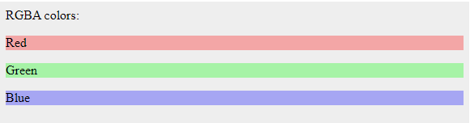
The following example shows HSL color property.
<html>
<head>
<style>
#g1 {background-color:hsl(120, 100%, 50%);}
#g2 {background-color:hsl(120,100%,75%);}
#g3 {background-color:hsl(120,100%,25%);}
</style>
</head>

<body>
<p>HSL colors:</p>
<p id = "g1">Green</p>
<p id = "g2">Normal Green</p>
<p id = "g3">Dark Green</p>
</body>
</html>
It will produce the following result –
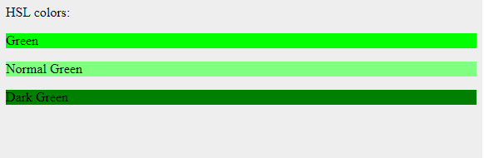
The following example shows HSLA color property.
<html>
<head>
<style>
#d1 {background-color:hsla(120,100%,50%,0.3);}
#d2 {background-color:hsla(120,100%,75%,0.3);}
#d3 {background-color:hsla(120,100%,25%,0.3);}
</style>
</head>

<body>
<p>HSLA colors:</p>
<p id = "d1">Less opacity green</p>
<p id = "d2">Green</p>
<p id = "d3">Green</p>
</body>
</html>
It will produce the following result –
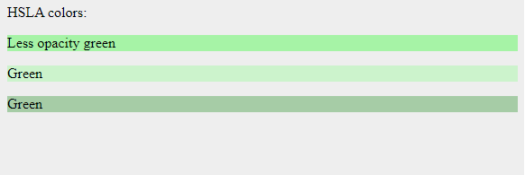
The following example shows Opacity property.
<html>
<head>
<style>
#m1 {background-color:rgb(255,0,0);opacity:0.6;}
#m2 {background-color:rgb(0,255,0);opacity:0.6;}
#m3 {background-color:rgb(0,0,255);opacity:0.6;}
</style>
</head>

<body>
<p>HSLA colors:</p>
<p id = "m1">Red</p>
<p id = "m2">Green</p>
<p id = "m3">Blue</p>
</body>
</html>
It will produce the following result –
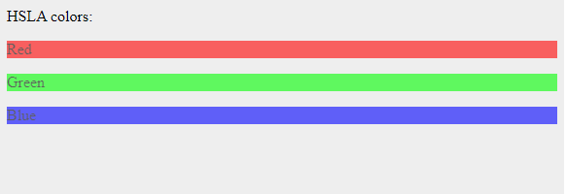

CSS3 - Gradients
What is Gradients?
Gradients displays the combination of two or more colors as shown below −
Types of gradients
- Linear Gradients(down/up/left/right/diagonally)
- Radial Gradients
Linear gradients
Linear gradients are used to arrange two or more colors in linear formats like top to bottom.
Top to bottom
<html>
<head>
<style>
#grad1 {
height: 100px;
background: -webkit-linear-gradient(pink,green);
background: -o-linear-gradient(pink,green);
background: -moz-linear-gradient(pink,green);
background: linear-gradient(pink,green);
}
</style>
</head>

<body>
<div id = "grad1"></div>
</body>
</html>
It will produce the following result –
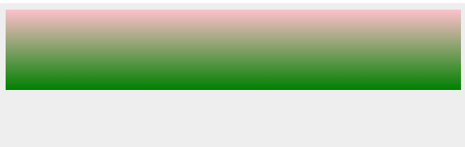
Left to right
<html>
<head>
<style>
#grad1 {
height: 100px;
background: -webkit-linear-gradient(left, red , blue);
background: -o-linear-gradient(right, red, blue);
background: -moz-linear-gradient(right, red, blue);
background: linear-gradient(to right, red , blue);
}
</style>
</head>

<body>
<div id = "grad1"></div>
</body>
</html>
It will produce the following result –
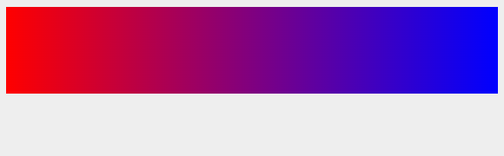
Diagonal
Diagonal starts at top left and right button.
<html>
<head>
<style>
#grad1 {
height: 100px;
background: -webkit-linear-gradient(left top, red , blue);
background: -o-linear-gradient(bottom right, red, blue);
background: -moz-linear-gradient(bottom right, red, blue);
background: linear-gradient(to bottom right, red , blue);
}
</style>
</head>

<body>
<div id = "grad1"></div>
</body>
</html>
It will produce the following result −
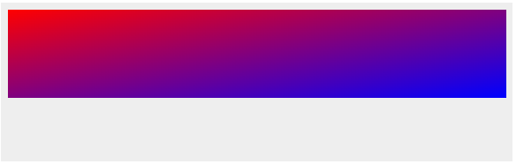
Multi color
<html>
<head>
<style>
#grad2 {
height: 100px;
background: -webkit-linear-gradient(red, orange, yellow, red, blue, green,pink);
background: -o-linear-gradient(red, orange, yellow, red, blue, green,pink);
background: -moz-linear-gradient(red, orange, yellow, red, blue, green,pink);
background: linear-gradient(red, orange, yellow, red, blue, green,pink);
}
</style>
</head>

<body>
<div id = "grad2"></div>
</body>
</html>
It will produce the following result –
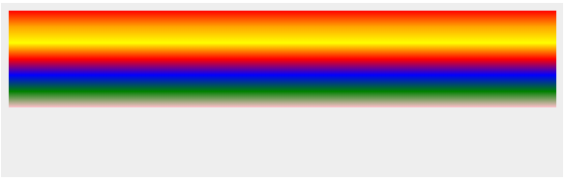
CSS3 Radial Gradients
Radial gradients appears at center.
<html>
<head>
<style>
#grad1 {
height: 100px;
width: 550px;
background: -webkit-radial-gradient(red 5%, green 15%, pink 60%);
background: -o-radial-gradient(red 5%, green 15%, pink 60%);
background: -moz-radial-gradient(red 5%, green 15%, pink 60%);
background: radial-gradient(red 5%, green 15%, pink 60%);
}
</style>
</head>

<body>
<div id = "grad1"></div>
</body>
</html>
It will produce the following result –
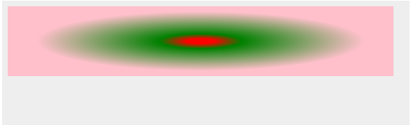
CSS3 Repeat Radial Gradients
<html>
<head>
<style>
#grad1 {
height: 100px;
width: 550px;
background: -webkit-repeating-radial-gradient(blue, yellow 10%, green 15%);
background: -o-repeating-radial-gradient(blue, yellow 10%, green 15%);
background: -moz-repeating-radial-gradient(blue, yellow 10%, green 15%);
background: repeating-radial-gradient(blue, yellow 10%, green 15%);
}
</style>
</head>

<body>
<div id = "grad1"></div>
</body>
</html>
It will produce the following result −
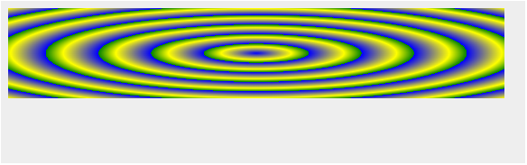

CSS3 - Shadow
CSS3 supported to add shadow to text or elements.Shadow property has divided as follows −
- Text shadow
- Box Shadow
Text shadow
CSS3 supported to add shadow effects to text. Following is the example to add shadow effects to text −
<html>
<head>
<style>
h1 {
text-shadow: 2px 2px;
}
h2 {
text-shadow: 2px 2px red;
}
h3 {
text-shadow: 2px 2px 5px red;
}
h4 {
color: white;
text-shadow: 2px 2px 4px #000000;
}
h5 {
text-shadow: 0 0 3px #FF0000;
}
h6 {
text-shadow: 0 0 3px #FF0000, 0 0 5px #0000FF;
}
p {
color: white;
text-shadow: 1px 1px 2px black, 0 0 25px blue, 0 0 5px darkblue;
}
</style>
</head>

<body>
<h1> Entoto PTC </h1>
<h2> Entoto PTC </h2>
<h3> Entoto PTC </h3>
<h4> Entoto PTC </h4>
<h5> Entoto PTC </h5>
<h6> Entoto PTC </h6>
<p>Entoto PTC</p>
</body>
</html>
box shadow
Used to add shadow effects to elements, Following is the example to add shadow effects to element.
<html>
<head>
<style>
div {
width: 300px;
height: 100px;
padding: 15px;
background-color: red;
box-shadow: 10px 10px;
}
</style>
</head>

<body>
<div>This is a div element with a box-shadow</div>
</body>
</html>

CSS3 – Text
CSS3 contained several extra features, which is added later on.
- text-overflow
- word-wrap
- word-break
There are following most commonly used property in CSS3 −
Sr.No. | Value & Description
1 | text-align-last  Used to align the last line of the text
2 | text-emphasis  Used to emphasis text and color
3 | text-overflow  used to determines how overflowed content that is not displayed is signaled to users
4 | word-break  Used to break the line based on word
5 | word-wrap  Used to break the line and wrap onto next line
Text-overflow
The text-overflow property determines how overflowed content that is not displayed is signaled to users. the sample example of text overflow is shown as follows −
<html>
<head>
<style>
p.text1 {
white-space: nowrap;
width: 500px;
border: 1px solid #000000;
overflow: hidden;
text-overflow: clip;
}
p.text2 {
white-space: nowrap;
width: 500px;
border: 1px solid #000000;
overflow: hidden;
text-overflow: ellipsis;
}
</style>
</head>

<body>

<b>Original Text:</b>

<p>
ENTOTO PTC originated from the idea that there exists a class of
readers who respond better to online content and prefer to learn new
skills at their own pace from the comforts of their drawing rooms.
</p>

<b>Text overflow:clip:</b>

<p class = "text1">
ENTOTO PTC originated from the idea that there exists
a class of readers who respond better to online content and prefer
to learn new skills at their own pace from the comforts of their
drawing rooms.
</p>

<b>Text overflow:ellipsis</b>

<p class = "text2">
ENTOTO PTC originated from the idea that there exists
a class of readers who respond better to online content and
prefer to learn new skills at their own pace from the comforts
of their drawing rooms.
</p>

</body>
</html>

CSS3 Word Breaking
Used to break the line, following code shows the sample code of word breaking.
<html>
<head>
<style>
p.text1 {
width: 140px;
border: 1px solid #000000;
word-break: keep-all;
}
p.text2 {
width: 140px;
border: 1px solid #000000;
word-break: break-all;
}
</style>
</head>

<body>

<b>line break at hyphens:</b>
<p class = "text1">
ENTOTO PTC originated from the idea that there exists a
class of readers who respond better to online content and prefer
to learn new skills at their own pace from the comforts of
their drawing rooms.
</p>

<b>line break at any character</b>

<p class = "text2">
ENTOTO PTC originated from the idea that there exists a
class of readers who respond better to online content and
prefer to learn new skills at their own pace from the comforts
of their drawing rooms.
</p>

</body>
</html>
- CSS word wrapping
Word wrapping is used to break the line and wrap onto next line.the following code will have sample syntax −
p {
word-wrap: break-word;
}

CSS3 - Web Fonts
Web fonts are used to allows the fonts in CSS, which are not installed on local system.
Different web fonts formats
Sr.No. | Font & Description
1 | TrueType Fonts (TTF)  TrueType is an outline font standard developed by Apple and Microsoft in the late 1980s, It became most common fonts for both windows and MAC operating systems.
2 | OpenType Fonts (OTF)  OpenType is a format for scalable computer fonts and developed by Microsoft
3 | The Web Open Font Format (WOFF)  WOFF is used for develop web page and developed in the year of 2009. Now it is using by W3C recommendation.
4 | SVG Fonts/Shapes  SVG allow SVG fonts within SVG documentation. We can also apply CSS to SVG with font face property.
5 | Embedded OpenType Fonts (EOT)  EOT is used to develop the web pages and it has embedded in webpages so no need to allow 3rd party fonts
Following code shows the sample code of font face –
<html>
<head>
<style>
@font-face {
font-family: myFirstFont;
src: url(/css/font/SansationLight.woff);
}
div {
font-family: myFirstFont;
}
</Style>
</head>

<body>
<div>This is the example of font face with CSS3.</div>
<p><b>Original Text :</b>This is the example of font face with CSS3.</p>
</body>
</html>
It will produce the following result –
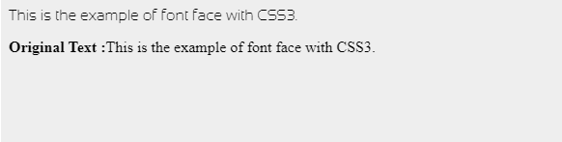
Fonts description
The following list contained all the fonts description which are placed in the @font-face rule −
Sr.No. | Value & Description
1 | font-family  Used to defines the name of font
2 | src  Used to defines the URL
3 | font-stretch  Used to find, how font should be stretched
4 | font-style  Used to defines the fonts style
5 | font-weight  Used to defines the font weight(boldness)

Creating page layout using CSS

CSS Website Layout
Website Layout
A website is often divided into headers, menus, content and a footer:
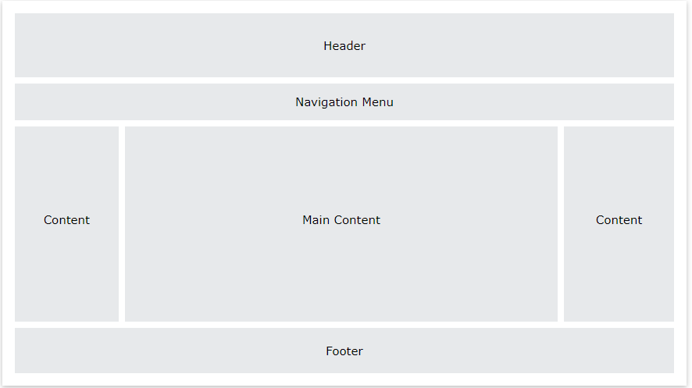
There are tons of different layout designs to choose from. However, the structure above, is one of the most common, and we will take a closer look at it in this tutorial.
Header
A header is usually located at the top of the website (or right below a top navigation menu). It often contains a logo or the website name:
Example
.header {
background-color: #F1F1F1;
text-align: center;
padding: 20px;
}
Result


Navigation Bar
A navigation bar contains a list of links to help visitors navigating through your website:
Example
/* The navbar container */
.topnav {
overflow: hidden;
background-color: #333;
}
/* Navbar links */
.topnav a {
float: left;
display: block;
color: #f2f2f2;
text-align: center;
padding: 14px 16px;
text-decoration: none;
}
/* Links - change color on hover */
.topnav a:hover {
background-color: #ddd;
color: black;
}
Result
Content
The layout in this section, often depends on the target users. The most common layout is one (or combining them) of the following:
- 1-column (often used for mobile browsers)
- 2-column (often used for tablets and laptops)
- 3-column layout (only used for desktops)
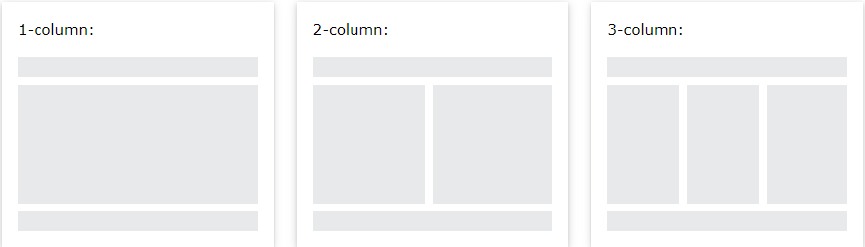
We will create a 3-column layout, and change it to a 1-column layout on smaller screens:
Example
/* Create three equal columns that float next to each other */
.column {
float: left;
width: 33.33%;
}
/* Clear floats after the columns */
.row:after {
content: "";
display: table;
clear: both;
}
/* Responsive layout - makes the three columns stack on top of each other instead of next to each other on smaller screens (600px wide or less) */
@media screen and (max-width: 600px) {
.column {
width: 100%;
}
}
Result
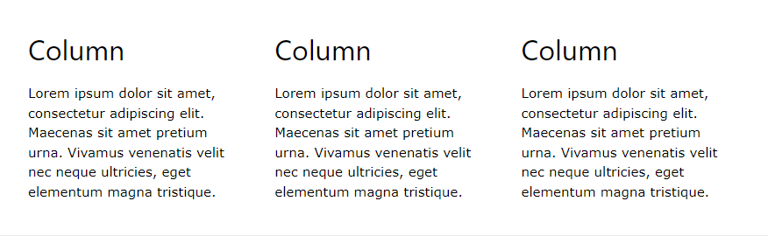
Unequal Columns
The main content is the biggest and the most important part of your site.
It is common with unequal column widths, so that most of the space is reserved for the main content. The side content (if any) is often used as an alternative navigation or to specify information relevant to the main content. Change the widths as you like, only remember that it should add up to 100% in total:
Example
.column {
float: left;
}
/* Left and right column */
.column.side {
width: 25%;
}
/* Middle column */
.column.middle {
width: 50%;
}
/* Responsive layout - makes the three columns stack on top of each other instead of next to each other */
@media screen and (max-width: 600px) {
.column.side, .column.middle {
width: 100%;
}
}
Result
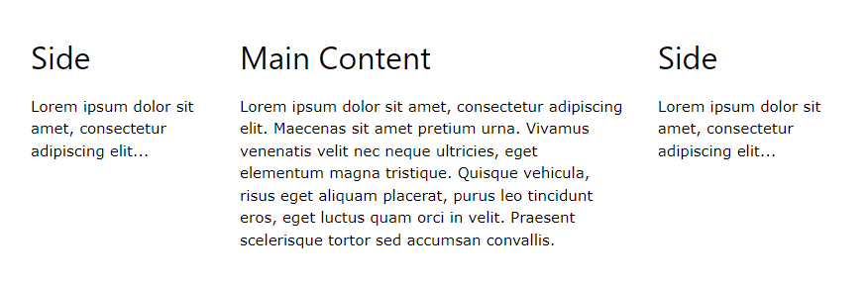
Footer
The footer is placed at the bottom of your page. It often contains information like copyright and contact info:
Example
.footer {
background-color: #F1F1F1;
text-align: center;
padding: 10px;
}
Result
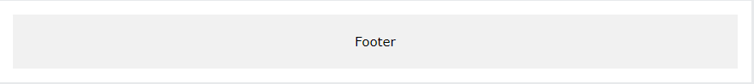

Positioning document elements using CSS
CSS helps you to position your HTML element. You can put any HTML element at whatever location you like. You can specify whether you want the element positioned relative to its natural position in the page or absolute based on its parent element.
Now, we will see all the CSS positioning related properties with examples −
Relative Positioning
Relative positioning changes the position of the HTML element relative to where it normally appears. So "left:20" adds 20 pixels to the element's LEFT position.
You can use two values top and left along with the position property to move an HTML element anywhere in the HTML document.
- Move Left - Use a negative value for left.
- Move Right - Use a positive value for left.
- Move Up - Use a negative value for top.
- Move Down - Use a positive value for top.
NOTE − You can use bottom or right values as well in the same way as top and left.
Here is the example −
<html>
<head>
</head>

<body>
<div style = "position:relative; left:80px; top:2px; background-color:yellow;">
This div has relative positioning.
</div>
</body>
</html>
It will produce the following result −
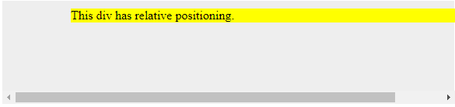
Absolute Positioning
An element with position: absolute is positioned at the specified coordinates relative to your screen top-left corner.
You can use two values top and left along with the position property to move an HTML element anywhere in the HTML document.
- Move Left - Use a negative value for left.
- Move Right - Use a positive value for left.
- Move Up - Use a negative value for top.
- Move Down - Use a positive value for top.
NOTE − You can use bottom or right values as well in the same way as top and left.
Here is an example −
<html>
<head>
</head>

<body>
<div style = "position:absolute; left:80px; top:20px; background-color:yellow;">
This div has absolute positioning.
</div>
</body>
</html>
Result
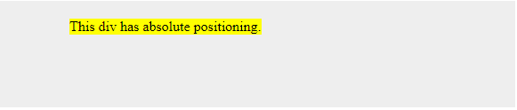
- Fixed Positioning
Fixed positioning allows you to fix the position of an element to a particular spot on the page, regardless of scrolling. Specified coordinates will be relative to the browser window.
You can use two values top and left along with the position property to move an HTML element anywhere in the HTML document.
- Move Left - Use a negative value for left.
- Move Right - Use a positive value for left.
- Move Up - Use a negative value for top.
- Move Down - Use a positive value for top.
NOTE − You can use bottom or right values as well in the same way as top and left.
Here is an example −
<html>
<head>
</head>

<body>
<div style = "position:fixed; left:80px; top:20px; background-color:yellow;">
This div has fixed positioning.
</div>
</body>
</html>
Result


Applying style sheets to multiple pages in a website
You can use a single CSS for multiple webpages.
External CSS - The <link> Element
The <link> element can be used to include an external stylesheet file in your HTML document.
An external style sheet is a separate text file with .css extension. You define all the Style rules within this text file and then you can include this file in any HTML document using <link> element.
Here is the generic syntax of including external CSS file −
<head>
<link type = "text/css" href = "..." media = "..." />
</head>
Attributes
Attributes associated with <style> elements are −
Example
Consider a simple style sheet file with a name mystyle.css having the following rules −
h1, h2, h3 {
color: #36C;
font-weight: normal;
letter-spacing: .4em;
margin-bottom: 1em;
text-transform: lowercase;
}
Now you can include this file mystyle.css in any HTML document as follows –
head>
<link type = "text/css" href = "mystyle.css" media = " all" />
</head>
Imported CSS - @import Rule
@import is used to import an external stylesheet in a manner similar to the <link> element. Here is the generic syntax of @import rule.
<head>
@import "URL";
</head>
Here URL is the URL of the style sheet file having style rules. You can use another syntax as well –
<head>
@import url("URL");
</head>
Example
Following is the example showing you how to import a style sheet file into HTML document −
<head>
@import "mystyle.css";
</head>

Creating web pages that will function in a variety of screen resolutions

CSS - Responsive
- CSS3 Responsive Web Design
Responsive web design provides an optimal experience, easy reading and easy navigation with a minimum of resizing on different devices such as desktops, mobiles and tabs).
Responsive structure
Below image shows the responsive structure of web pages.

Flexible Grid demo
<html>
<head>
<style>
body {
font: 600 14px/24px "Open Sans",
"HelveticaNeue-Light",
"Helvetica Neue Light",
"Helvetica Neue",
Helvetica, Arial,
"Lucida Grande",
Sans-Serif;
}
h1 {
color: #9799a7;
font-size: 14px;
font-weight: bold;
margin-bottom: 6px;
}
.container:before, .container:after {
content: "";
display: table;
}
.container:after {
clear: both;
}
.container {
background: #eaeaed;
margin-bottom: 24px;
*zoom: 1;
}
.container-75 {
width: 75%;
}
.container-50 {
margin-bottom: 0;
width: 50%;
}
.container, section, aside {
border-radius: 6px;
}
section, aside {
background: #2db34a;
color: #fff;
margin: 1.858736059%;
padding: 20px 0;
text-align: center;
}
section {
float: left;
width: 63.197026%;
}
aside {
float: right;
width: 29.3680297%;
}
</style>
</head>

<body>

<h1>100% Wide Container</h1>

<div class = "container">
<section>Section</section>
<aside>Aside</aside>
</div>

<h1>75% Wide Container</h1>

<div class = "container container-75">
<section>Section</section>
<aside>Aside</aside>
</div>

<h1>50% Wide Container</h1>

<div class = "container container-50">
<section>Section</section>
<aside>Aside</aside>
</div>

</body>
</html>
It will produce the following result –
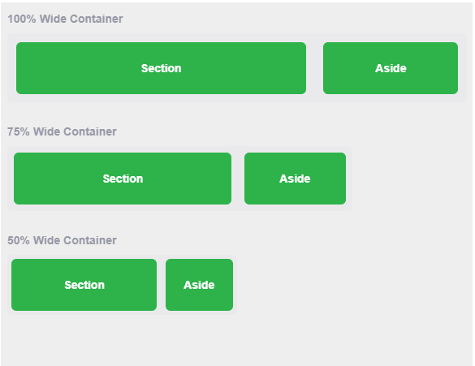
- Media queries
Media queries is for different style rules for different size devices such as mobiles, desktops, etc.,
<html>
<head>
<style>
body {
background-color: lightpink;
}
@media screen and (max-width: 420px) {
body {
background-color: lightblue;
}
}
</style>
</head>

<body>
<p>
If screen size is less than 420px, then it will show lightblue
color, or else it will show light pink color
</p>
</body>
</html>
It will produce the following result –
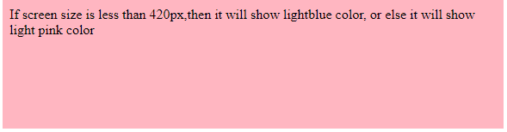

Application of browser-specific rules
When CSS is used on a web page, it is generally applied to all browsers that can view the page. However, there may be times when you want to apply CSS specifically to one browser or a group of browsers. This is where browser-specific CSS comes in. Browser-specific CSS is CSS that is targeted at a specific browser or group of browsers. This can be done by using a CSS selector that is only supported by the target browser, or by using a CSS hack that is only recognized by the target browser. Browser-specific CSS is generally used to work around browser bugs, or to provide browser-specific features that are not available in all browsers. For example, you might use browser-specific CSS to add support for a new CSS property that is only supported by the latest version of a particular browser.
In general, it is best to avoid using browser-specific CSS unless absolutely necessary. When possible, it is better to use CSS that is compatible with all browsers, or to use a CSS polyfill that will provide the desired browser-specific behavior in all browsers.

Self-Check 2
- What type of CSS is the following code snippet?

<h1 style="color:blue;">A Blue Heading</h1>

- Inline
- Internal
- External
- None of the above

- Which HTML tag is used to declare internal CSS?

- <style>
- <link>
- <script>
- None of the above

- How can we select an element with a specific ID in CSS?

- #
- .
- ^
- None of the above

- How can we write comments in CSS?

- /* */
- //
- #
- All of the above

- The CSS property used to specify the transparency of an element is?
- opacity
- visibility
- filter
- None of the above

Lap test 2

  - Write down the generic CSS syntax.
  - What are four ways to associate styles with your HTML document?
  - What are the main differences between css2 and css3

Unit Three: Ensure web page and CSS are validated and tested
This unit is developed to provide you the necessary information regarding the following content coverage and topics:
- Validating CSS against industry standards
- Testing a web page in various browsers
- Rectifying browser differences to ensure website is accessible
This unit will also assist you to attain the learning outcomes stated in the cover page. Specifically, upon completion of this learning guide, you will be able to:
- Validate CSS against industry standards
- Test a web page in various browsers
- Rectify browser differences to ensure website is accessible

Unit Three: Ensure web page and CSS are validated and tested

Validating CSS against industry standards
Validation of CSS code for standards compliance has some advantages and is no different from HTML validation. A document with CSS code will be considered valid if it has passed the corresponding check and does not contain errors.
If you use stylesheets predominantly in an external file, this makes it much easier to check your code because you have to check only one file, not each page individually. If you make mistakes when writing style sheet code, you can also use a validator to not look for errors manually.
How to use the validator?
You can use a CSS validator to check CSS code for errors and standards compliance, which provides three ways to check:
URL verification
Just enter the URL of the web page you want to check and click the Check button.
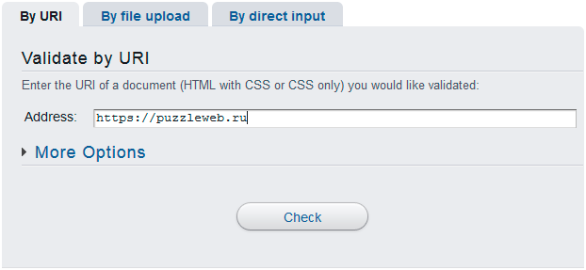
After validating the code with a validator, you will see one of two inscriptions-either that everything was successful and you congratulate with the valid code, or that your CSS code found errors that you are about to fix.
Checking the downloaded file
This method allows you to download the scanned document to the server. To do this, click the Browse button and select the file that you want to check.
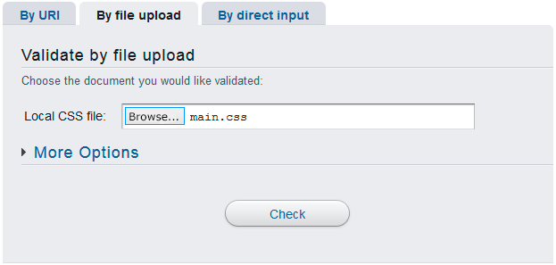
The server will automatically recognize the type of file you are downloading.
Checking pasted code
This method is ideal for validating part of a CSS file. You only need to copy the code into the text box.
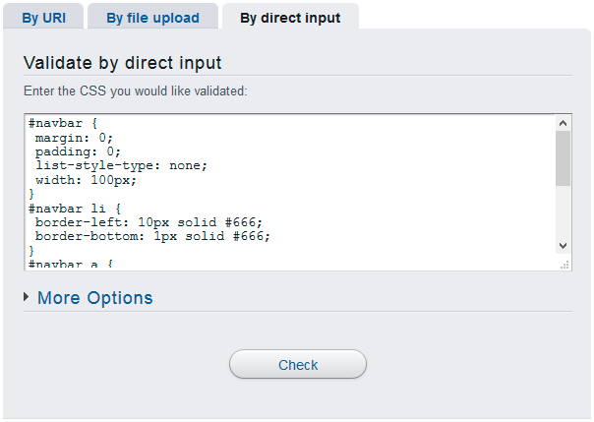

Testing a web page in various browsers
Browser compatibility or cross-browser testing is a process of evaluating whether the functionality of a web application remains consistent when the end-user visits your web-application from a different browser. It is also used to validate browser compatibility for desktop and web applications.
What Features Are Analyzed in a Browser Test?
1. Basic functionality: To ensure that simple stuff is working on most browser-OS combinations
- All input fields and their validation
- Dialog boxes and menus are working as expected
- Input touch on mobile devices
2. Design: To make sure fonts, styles, images, and layouts are matching requirements that were sent by designers
3. Responsiveness: Verify that design is solid and not broken in some layers after you change the resolution/orientation of a browser
How To Choose Browsers?
There are two easy ways to choose from all the variety of browsers
1. Based on popularity: Choose browsers that can overcome the 5% barrier in global statistics. So, for example, in 2020 you would choose Google Chrome, Safari, Mozilla Firefox, Microsoft Edge, and IE. Regarding IE, it is a bit tricky because there are a lot of versions of this browser. Our recommendation is to support only IE 10, the reason being that IE 8 and 9 are too old and hard to support.
2. Based on the analysis: If you have some analytics tools (Google Analytics, etc.) that are tracking all traffic stats, you will have a full understanding of what your customers are using, and it will be an easy decision to make. If not, you may try to know your customer better by creating some polls, etc. Would it be worth to support all the versions of different browsers? It depends on if you agree that development and testing time will be higher every time. Either way, in the long run, you will have to sacrifice supporting old versions.
The decision on which browsers and platforms to choose depends on the business team and the marketing team.

Rectifying browser differences to ensure website is accessible
Cross-browser compatibility issues can be a major pain for web developers as different browsers often render web pages differently. However, with proper planning and the use of CSS, these issues can be resolved. In this article, we will explore how to solve cross-browser compatibility issues with CSS.
Normalize CSS: One of the first steps in solving cross-browser compatibility issues is to use a CSS normalization library such as Normalize.css. This library makes sure that default styles are consistent across different browsers, which can help resolve many common compatibility issues.
Use vendor prefixes: Vendor prefixes are special CSS properties and values that are used to ensure that styles are rendered consistently across different browsers. For example, the CSS property “transform” is prefixed with “-webkit-” for Webkit-based browsers like Chrome and Safari, “-moz-” for Mozilla Firefox, and “-ms-” for Microsoft Internet Explorer.
Test on multiple browsers: To ensure that your styles are compatible with different browsers, it is important to test your styles on multiple browsers. This can be done by installing different browsers on your development machine or by using online tools such as BrowserStack or CrossBrowserTesting.
Use CSS Resets: CSS Resets are a set of styles that are used to reset the default styles of different elements to a consistent state. This can help resolve compatibility issues by ensuring that the styles applied to an element are the same across different browsers.
Avoid browser-specific hacks: Browser-specific hacks are CSS styles that are specifically designed to work with a particular browser and are often used to resolve compatibility issues. However, these hacks can make your stylesheet difficult to maintain and can also cause compatibility issues with other browsers.
Use feature detection: Feature detection is a technique that is used to determine whether a particular feature is supported by the user’s browser. This can be useful in solving compatibility issues by allowing you to apply styles only to browsers that support a particular feature.
Use CSS frameworks: CSS frameworks such as Bootstrap and Foundation can be useful tools in solving cross-browser compatibility issues as they provide a consistent set of styles that are tested across multiple browsers.
In conclusion, cross-browser compatibility issues can be a major challenge for web developers. However, with proper planning and the use of tools such as Normalize.css, vendor prefixes, CSS resets, feature detection, and CSS frameworks, these issues can be resolved. By taking the time to ensure that your styles are compatible across different browsers, you can ensure that your web pages are accessible to the widest possible audience.

