Web Development and Database Administration

Level-III
Based on March 2022, Curriculum Version 1

Module Title: Using Basic Structured Query Language Module code: EIS WDDBA3 M07 0322
Nominal duration: 90 Hour

Prepared by: Entoto Poly Technic College

September, 2023 Addis Ababa, Ethiopia

Table of Contents

Contents
Acknowledgment 4
Acronym 5
Introduction to the Module 6
Unit one: Write an SQL statement to retrieve and sort data 7
  - Understanding DBMS fundamental 8
    - Install SQL Server 18
    - SQL Statement/ commands 20
    - SQL Statements 40
  - Identifying database information requirement 60
  - Retrieving all data from a table following work procedure 68
  - Retrieving data from a specific column in a single table 70
  - Using clause to sort query output 71
  - Retrieving restricted rows by placing a specific criteria in the clause 73
  - Retrieving restricted rows by placing a specific criteria in select statement 75
  - Using comparison operators in the clause to compare numeric, character, string, date and time data 76
  - Using Boolean operators with correct precedence 78
  - Using criteria in the where clause in 79
    - Checking for a range of values 80
    - selecting values from a list 80
    - Checking for Values that Match a Pattern 80
  - Using SQL syntax to supress duplicate values from query result 81
Unit 2 Write SQL statements that use functions 83
  - Using arithmetical operators with the correct precedence 83
  - Using String Functions and Operators 84
  - Using Mathematical Functions 85
  - Using Date Functions 85

AVG() Syntax 86
Example 86
Example 86
SUM() Syntax 87
Unit 3: Write SQL statements that use aggregation and filtering 88
  - Using Clause to Aggregate Data by Multiple Columns 88
  - Sorting Aggregate Data in Query Output 91
Unit 4: Write and execute SQL sub-queries 94
  - Constructing Single and Nested Sub-Queries 94
  - Constructing Sub-Queries That Return Single Row and Multiple Rows 95
  - Using Correlated Sub-Queries to Retrieve Required Data 96
  - Writing Sub-Queries Using Aggregates 97

Acknowledgment
Ministry of Labor and Skills wish to extend thanks and appreciation to the many representatives of TVET instructors and respective industry experts who donated their time and expertise to the development of this Teaching, Training and Learning Materials (TTLM).

Acronym
DBMS – Database Management System SQL – Structured Query Language DBA – Database Administrator
DML - Data Manipulation Language DDL - Data Definition Language DCL - Data Control Language

Introduction to the Module
This learner’s guide is prepared to help you achieve the required competence in “Web Development and Database Administration”. This will be the source of information for you to acquire knowledge and skills in basic structured query language (SQL) to define, create and manipulate database structures and associated data in a relational database.
This module covers the units:
- Write an SQL statement to retrieve and sort data
- Write SQL statements that use functions
- Write SQL statements that use aggregation and filtering
- Write and execute SQL sub-queries

Learning Objective of the Module
- Learn structured query language (SQL) to an intermediate/advanced level.
- Be able to write data retrieval queries and evaluate the result set.
- Be able to write SQL statements that edit existing data.
- Be able to write SQL statements that create database objects.
- Understand the structure and design of relational databases.
- Understand the importance and major issues of database security and the maintenance of data integrity.

Module Instruction
For effective use this modules trainees are expected to follow the following module instruction:
- Read the information written in each unit
- Accomplish the Self-checks at the end of each unit
- Perform Operation Sheets which were provided at the end of units

- Do the “LAP test” given at the end of each unit and
- Read the identified reference book for examples and exercise

Unit one: Write an SQL statement to retrieve and sort data
This learning unit is developed to provide the trainees the necessary information regarding the following content coverage and topics:
  - Understanding DBMS fundamental
  - Identifying database information requirement
  - Retrieving all data from a table following work procedure
  - Retrieving data from a specific column in a single table
  - Using clause to sort query output
  - Retrieving restricted rows by placing a specific criteria in the clause
  - Retrieving restricted rows by placing a specific criteria in select statement
  - Using comparison operators in the clause to compare numeric, character, string, date and time data
  - Using Boolean operators with correct precedence
  - Using criteria in the where clause in
  - Checking for a range of values
  - Selecting values from a list
  - Checking for values that match a pattern
  - Using SQL syntax to supress duplicate values from query result
  - Taking action to execute null values from a query result

Understanding DBMS fundamental
A database is a shared collection of related data used to support the activities of a particular organization. A database can be viewed as a repository of data that is defined once and then accessed by various users
Database Management System (DBMS) fundamentals are the core concepts and principles that underpin the design, use, and management of databases. Here are some fundamental aspects of DBMS:
Data Model: A data model is a high-level abstraction that defines how data is organized and structured within a database. Common data models include the relational model, document model, hierarchical model, and more. The choice of a data model depends on the specific requirements of the application.
Schema: A database schema defines the structure of the database, including tables, columns, relationships, constraints, and integrity rules. It provides a blueprint for how data is organized.
Tables: Tables are the primary means of organizing data in a relational database. They consist of rows (records) and columns (attributes). Each row represents a single data entity, and each column represents a specific property or field of that entity.
Keys: Keys are used to uniquely identify records in a table. The primary key is a unique identifier for each row, while foreign keys establish relationships between tables.
Query Language: SQL (Structured Query Language) is the standard language for interacting with relational databases. It's used to retrieve, manipulate, and manage data.
Normalization: Normalization is the process of organizing data in a database to minimize redundancy and ensure data integrity. It involves breaking down tables into smaller, related tables.
Indexing: Indexes are data structures used to speed up data retrieval operations. They provide a quick way to access data based on certain columns.

ACID Properties: In the context of transactions, the ACID properties (Atomicity, Consistency, Isolation, and Durability) ensure that database operations are reliable and maintain data integrity. Concurrency Control: DBMS systems must handle multiple users or processes accessing the database simultaneously. Concurrency control mechanisms ensure that data remains consistent even in a multi-user environment.
Data Security: DBMS systems provide mechanisms to control who can access the data and what actions they can perform. This includes user authentication and authorization.
Backup and Recovery: Regular database backups and recovery mechanisms are essential to safeguard data and restore it in case of failures.
Data Integrity: Data integrity constraints, such as unique constraints, check constraints, and referential integrity constraints, help maintain the accuracy and consistency of data.
Transactions: A transaction is a sequence of one or more SQL statements treated as a single, indivisible unit. Transactions ensure that data changes are made in a consistent and reliable manner.
Data Redundancy: Minimizing data redundancy is a fundamental principle in database design to prevent anomalies and maintain data consistency.
Scalability: A well-designed DBMS should be able to scale to handle a growing amount of data and increasing numbers of users.
These are some of the fundamental concepts that are crucial to understand when working with database management systems. The choice of DBMS, such as MySQL, PostgreSQL, Oracle, or SQL Server, will also impact how these concepts are implemented in practice.

DBMS (Database Management System)
- Software programs, allows users to create, edit and update data in database files, and store and retrieve data from those database files.
- Programs that manage the database structure and control shared access to data in the database. Current DBMSs also store the relationships between the database components; they also take care of defining the required access paths to those components
- Its main function is to provide efficient and reliable methods of data retrieval to many users.
- Provides the interface between users and databases.

It is a shell which surrounds database through which all interactions take place with the database. The interactions catered for by most existing DBMS fall into four main groups:
- Data definition: Defining new data structures for a database, removing data structures from the database, modifying the structure of existing data.
- Data maintenance: Inserting/deleting data into/from existing data structures, updating data in existing data structures.
- Data retrieval: Querying existing data by end-users and extracting data for use by application programs.
Data control: Creating and monitoring users of the database, restricting access to data in the database and monitoring the performance of databases.
- Relational DBMS implement the relational model of tables and relationships.
- A program that lets one or more computer users create and access data in a database.
- Manages requests (from user/other programs) so that users and other programs are free from having to understand where the data is physically located, who else may be accessing the data.
- DBMS ensures
  - Data Integrity: making sure it is accessible and is consistently organized as intended
  - Data Security: making sure only authorized users can access the data.
- DBMS can be thought as file manager that manages data in DB rather than files in file systems.
- DBMSs are commonly used to manage:
  - Membership and subscription mailing lists
  - Accounting and bookkeeping information
  - The data obtained from scientific research
  - Registrar information
  - Customer information
  - Inventory information
  - Personal records

  - Library information, etc…

DBMSs Vs File Management Systems
- Computerized file management systems are not considered true DBMSs, because files can’t be easily linked to each other. However, they can serve as useful data management functions by providing a system for storing information in files. For example; file management system might be used to store a mailing list or a personal address book.
- When files need to be linked, a relational database should be created using DBMS such as Oracle, Microsoft Access, IBM DB2, SQL or FileMaker Pro.

Components of DBMS
DBMS has four components. These four components are important for understanding and designing the database system. These are: Data, Hardware, Software and Users

Characteristics of DBMS
- Self-contained nature: DBMS contains data plus a full description of the data called “metadata” (data about data - data formats), record structures, locations, how to access, indexes metadata is stored in a catalog and is used by DBMS software to know how to access the data. Application programs need to know the structure and format of records and data.
- Program-data independence: Data independence is immunity of application programs to changes in storage structures and access techniques. E.g. adding a new field, changing index structure, changing data format.
- Data abstraction: DBMS provides users with a conceptual representation of data (for example, as objects with properties and inter-relationships). Storage details are hidden. Conceptual representation is provided in terms of a data model.
- Support for multiple views: DBMS may allow different users to see different “views” of DB, according to requirement. For Example, someone interested in student transcripts might get a view which is formed by combining information from separate files or tables.
- Centralized control of the data resource: DBMS provides centralized control of data in an organization. This brings a number of advantages:

  - Reduces redundancy
  - Avoids inconsistencies
  - Data can be shared
  - Standards can be enforced
  - Security restrictions can be applied
  - Integrity can be maintained Advantages and Disadvantages of DBMS Advantages:
  - Improved availability/Shared data: same information can be available to different users.
  - Centralized control: using DBMS, data can be controlled centrally
  - Minimized redundancy: information appears just once.
  - Accuracy: Improved data integrity
  - Reduced updating errors and increased consistency: file formats and system programs are standardized. This makes easier to maintain because the same rules and guidelines are applied.
  - User-friendly: Data is easier to access
  - Improved security: Through the use of passwords, certificates, etc database management systems can be used to restrict data access to only those who should see it.
  - Less danger of a single-point failure
  - Faster data access
  - Improved communication
  - Reduces operating costs
  - Flexible conceptual design
  - Facilitated development of new applications program

Disadvantages:
  - Cost: Implementing a DBMS system can be expensive and time-consuming,
    - Training,
    - The need for multiple external databases,

    - The need to hire database-related employees
    - Computer system and software need to be purchased, Substantial hardware and software start-up costs
    - Extensive conversion costs in moving from a file-based system to a database system, etc
  - Complex, difficult, and time-consuming to design
  - Complex programmer environment;
  - Longer running time for individual applications; and,
  - Highly dependent DBMS operations.
  - Catastrophic program failures; Damage to a database affects virtually all applications programs
  - Increase unemployment
  - Needs computer literate employees
  - Security

Introduction to SQL
Structured Query Language (SQL) is a specialized language for updating, deleting, and requesting information from databases. SQL is an ANSI and ISO standard, and is the de facto standard database query language. A variety of established database products support SQL, including products from Oracle and Microsoft SQL Server. It is widely used in both industry and academia, often for enormous, complex databases.

What is SQL?
  - SQL (pronounced "ess-que-el") stands for Structured Query Language.
  - SQL is used to communicate with a database.
  - According to ANSI (American National Standards Institute), it is the standard language for relational database management systems.
  - Some common relational database management systems that use SQL are: Oracle, Sybase, Microsoft SQL Server, Access, Ingres, etc.
  - SQL lets you access and manipulate databases
  - SQL is a standard language for accessing and manipulating databases.

  - SQL is a nonprocedural language.
  - We can use SQL to tell what data to retrieve or modify without telling it how to do its job.
  - SQL does not provide any flow of- control programming constructs, function definitions, do-loops, or if-then-else statements.
  - SQL is a widely used database language, providing means of data manipulation (store, retrieve, update, delete) and database creation.

History of SQL
During the 1970s, a group at IBM San Jose Research Laboratory developed the System R relational database management system, based on the model introduced by Edgar F. Codd in his influential paper, A Relational Model of Data for Large Shared Data Banks.
The acronym SEQUEL was later changed to SQL because "SEQUEL" was a trademark of the UK-based Hawker Siddeley aircraft company.
SQL became a standard of the American National Standards Institute (ANSI) in 1986, and of the International Organization for Standardization (ISO) in 1987. Since then, the standard has been revised to include a larger set of features. Despite the existence of such standards, though, most SQL code is not completely portable among different database systems without adjustments.

Function of SQL What Can SQL do?
- SQL can create new databases
- SQL can create new tables in a database
- SQL can create stored procedures in a database
- SQL can create views in a database
- SQL can execute queries against a database
- SQL can retrieve data from a database
- SQL can insert records in a database
- SQL can update records in a database
- SQL can delete records from a database

- SQL can set permissions on tables, procedures, and views
- Although SQL is an ANSI (American National Standards Institute) standard, there are many different versions of the SQL language.
- However, to be compliant with the ANSI standard, they all support at least the major commands (such as SELECT, UPDATE, DELETE, INSERT, WHERE) in a similar manner.
- provides a fixed set of data types in particular for strings of different length char(n), varchar(n), longvarchar(n)

Categories of SQL
At the highest level, SQL statements can be broadly categorized as follows into three types:
- Data Manipulation Language (DML), which retrieves or modifies data
- Data Definition Language (DDL), which defines the structure of the data
- Data Control Language (DCL), which defines the privileges granted to database users.

SQL Data Definition Language (DDL)
  - DDL and DCL statements are commonly used by a database designer and database administrator for establishing the database structures used by an application.
  - The DDL part of SQL permits database tables to be created or deleted. It also defines indexes (keys), specify links between tables, and impose constraints between tables. The most important DDL statements in SQL are:
- CREATE DATABASE - creates a new database
- ALTER DATABASE - modifies a database
- CREATE TABLE - creates a new table
  - Creates a table with the column names the user provides. The user also needs to specify the data type for each column. Unfortunately, data types vary slightly from one RDBMS to another, so that user might need metadata to establish the data types used for a particular database.

  - It is normally used less often than the data manipulation commands because a table is created only once, whereas inserting and deleting rows or changing individual values generally occurs more frequently.
- ALTER TABLE - modifies a table
  - Adds or removes a column from a table.
  - This command is used in connection with ADD, MODIFY and DROP.
- DROP TABLE - deletes a table
  - -Deletes all rows and removes the table definition from the database.
- CREATE INDEX - creates an index (search key)
- DROP INDEX - deletes an index
Changes to the structure of a database are handled by a different set of SQL statements, called the SQL data Definition Languages, or DDL.
In short, using DDL statements, you can:
- Define and create a new table, using CREATE
- Remove a table that’s no longer needed, using DROP
- Changes the definition of an existing table, using ALTER
- Define a virtual table(or view) of a data
- Establish security controls for a database
- Build an index to make table access faster
- Control the physical storage of data by the DBMS

SQL Data Manipulation Language (DML)
SQL can be divided into two parts: The Data Manipulation Language (DML) and the Data Definition Language (DDL).
The query and update commands form the DML part of SQL:
- The category of DML contains four basic statements. These statements are used most often by application developers.

  - SELECT - extracts data from a database
    - Which retrieves rows from a table.
    - The SELECT statement specifies which columns to include in the result set.
    - The vast majority of the SQL commands used in applications are SELECT statements.
  - UPDATE - updates data in a database
    - Which modifies existing rows in a table.
    - In other words it changes an existing value in a column of a table.
  - DELETE - deletes data from a database
    - Which removes a specified row or a set of rows from a table.
  - INSERT INTO/ insert - inserts new data into a database
    - -Which adds rows to a table.
    - -INSERT is used to populate a newly-created table or to add a new row (or rows) to an already-existing table.

SQL Data Control Language (DDL)
- A data control language (DCL) is syntax similar to a computer programming language used to control access to data stored in a database. In particular, it is a component of Structured Query Language (SQL).
Examples of DCL commands include:
- GRANT: to allow specified users to perform specified tasks.
- REVOKE: to cancel previously granted or denied permissions.

DENY:
The operations for which privileges may be granted to or revoked from a user or role may include CONNECT, SELECT, INSERT, UPDATE, DELETE, EXECUTE, and USAGE.

Install SQL Server
Hardware and Software Requirements for Installing SQL Server 2005
The following system requirements cover SQL Server 2012 Standard Edition on 32-bit and x64 platforms, as well as Itanium-based systems.

SQL Server 2012 64-bit Hardware Requirements:

Component | Minimum Requirement | Recommended Requirement
Processor | x64 Processor with at least 1.4 GHz | 2.0 GHz or faster, 4 or more cores
RAM (64-bit) | 1 GB for Express, 2 GB for all others | 4 GB or more
Hard Disk Space (Database Engine) | 3.5 GB minimum, 10 GB or more recommended | 40 GB or more
Hard Disk Space (Analysis Services) | 250 MB minimum, 2 GB or more recommended | 40 GB or more
Hard Disk Space (Reporting Services) | 3 GB minimum, 10 GB or more recommended | 40 GB or more
Hard Disk Space (Integration Services) | 1.5 GB minimum, 2.5 GB or more recommended | 40 GB or more
Hard Disk Space (Full Installation) | 3.8 GB minimum, 10 GB or more recommended | 40 GB or more

SQL Server 2012 64-bit Software Requirements:
- Operating System: SQL Server 2012 supports a variety of Windows Server and Windows client operating systems. The specific editions of SQL Server 2012 (Enterprise, Standard, etc.) may have different requirements. It's important to check the official documentation for the exact operating system requirements for your specific edition.
- .NET Framework: SQL Server 2012 requires the .NET Framework. The installer will typically install the required version of .NET Framework for you.

- SQL Server 2012 Edition: Make sure you have the correct edition of SQL Server 2012 (e.g., Enterprise, Standard, and Express) for your needs and licensing.
- SQL Server 2012 Service Pack: It's advisable to install the latest service pack or cumulative update for SQL Server 2012 for bug fixes and enhancements.
Please keep in mind that these requirements are subject to change based on updates and service packs. Always refer to the official Microsoft SQL Server documentation for the most accurate and up-to-date information, especially if you have specific needs or configurations.

SQL Server 2012 32-bit Hardware Requirements:

Component | Minimum Requirement | Recommended Requirement
Processor | x86 or x64 Processor with at least  1.4 GHz | 2.0 GHz or faster, 4 or more cores
RAM (32-bit) | 1 GB for Express, 2 GB for all others | 4 GB or more
Hard Disk Space (Database Engine) | 2.2 GB minimum, 10 GB or more recommended | 40 GB or more
Hard Disk Space (Analysis Services) | 250 MB minimum, 2 GB or more recommended | 40 GB or more
Hard Disk Space (Reporting Services) | 2.1 GB minimum, 10 GB or more recommended | 40 GB or more
Hard Disk Space (Integration Services) | 1.5 GB minimum, 2.5 GB or more recommended | 40 GB or more
Hard Disk Space (Full Installation) | 2.5 GB minimum, 10 GB or more recommended | 40 GB or more

SQL Server 2012 32-bit Software Requirements:
- Operating System: SQL Server 2012 32-bit supports a variety of 32-bit and 64-bit Windows Server and Windows client operating systems. The specific editions of SQL Server 2012 (Enterprise, Standard, etc.) may have different supported operating systems. Check the official documentation for exact details.
- .NET Framework: SQL Server 2012 requires .NET Framework 3.5 SP1 for installation. The installer will typically install this for you. You may also need .NET Framework 4.0 or later for some features.
- SQL Server 2012 Edition: Make sure you have the correct edition of SQL Server 2012 (e.g., Enterprise, Standard, Express) for your needs and licensing.
- SQL Server 2012 Service Pack: It's advisable to install the latest service pack or cumulative update for SQL Server 2012 for bug fixes and enhancements.

SQL Statement/ commands
The SQL languages consist of many statements, which are summarized below. Each statement requests a specific action from the DBMS, such as creating a new table, retrieving data, or inserting new data into the database.

Statement | Descriptions
Data Manipulation
SELECT | Retrieve data from the database
INSERT | Adds new rows of the data to the database
DELETE | Removes rows of the data from the database
UPDATE | Modifies existing database data
Data Definition
CREATE TABLE | Adds a new table to the database

DROP TABLE | Removes a table from the database
ALTER TABLE | Change the structure of an existing table
CREATE VIEW | Adds a new view to the database
DROP VIEW | Removes a view from the database
CREATE INDEX | Builds an index for a column
DROP INDEX | Remove an index for a column
CREATE SYNOMY | Define an alias for a table name
DROP SYNOMY | Remove an alias for a table name
COMMENT | Defines a remarks for a table or column
LABEL | Defines a little for a table or column
Access Control
GRANT | Grant user access privileges
REVOKE | Removes user access privileges
DENY

Major SQL statement
All SQL statements have the same basic form. i.e all SQL statements has similar structures Example:
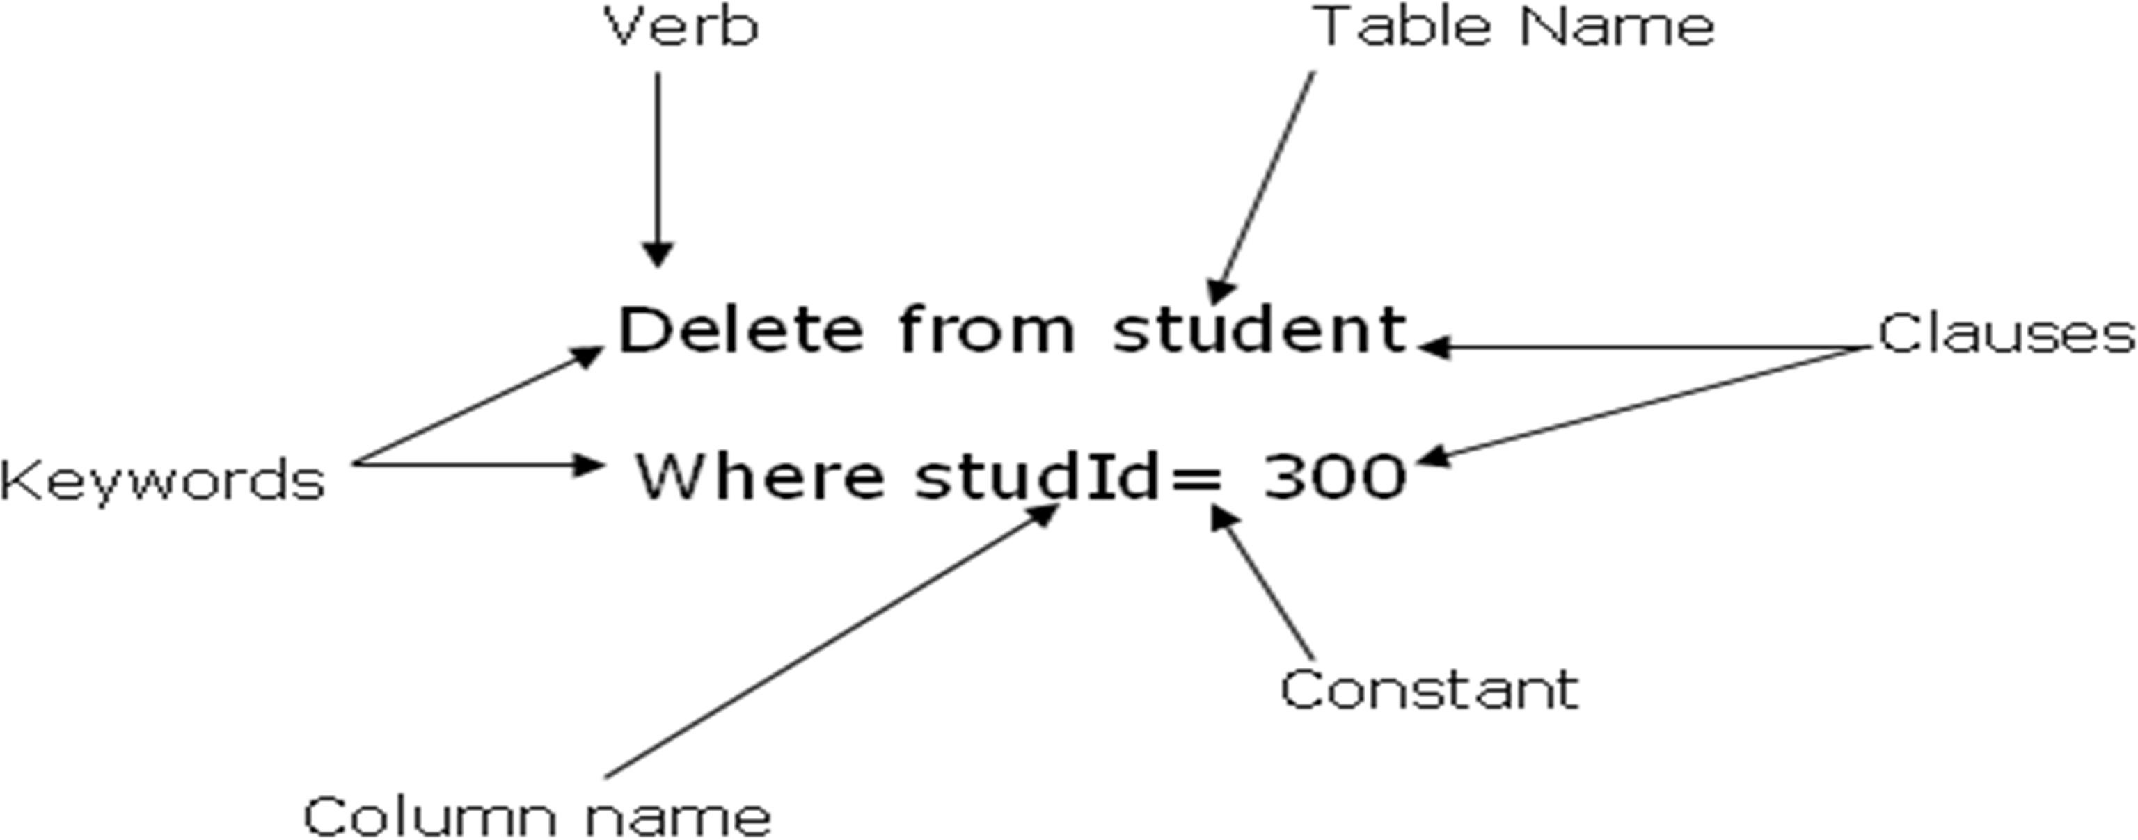

Every SQL statement begins with a verb, a keyword that describes what the statement does. CREATE, INSERT, and DELETE are typical verbs. The statement continues with one or more clauses. A clause may specify the data to be acted upon by the statement, or provide more detail about what the statement is supposed to do.
Every clause also begins with a keyword, such as WHERE, FROM, INTO, and HAVING. Some clauses are optional; others are required.

SQL key words
The SQL keywords are words that are reserved words that are not used as a user defined data. The most commonly used SQL key words according to ANSI/ISO SQL keywords are as follows:

ADA | DEC | GRANT | NUMERIC
ALL | DECIMAL | GROUP | OF
AND | DECLARE | HAVING | ON
ANY | DEFUALT | IN | OPEN
AS | DELETE | INDICATOR | OPTION
ASC | DESC | INSERT | OPEN
AUTHORIZATION | DISTNICT | INT | OPTION
AVG | DOUBLE | INTEGER | OR
BEGIN | END | INTO | ORDER

BETWEEN | ESCAPE | IS | PRIMARY
BY | EXEC | KEY | REAL
C | EXISTS | LANGAUGE | SELECT
CHAR | FETCH | LIKE | SET
CHARACTER | FLOAT | MAX | SOME
CHECK | FOR | MIN | SUM
CLOSE | FOREIGN | MODULE | TABLE
COBOL | FORTRAN | NOT | TO UNION
COMMIT | FOUND | NULL | UPDATE
CONTINUE | FROM |  | USER
COUNT | GO |  | VIEW
CREATE | GOTO |  | WHERE
CURRENT |  |  | WITH
CURSOR |  |  | WORK

Name
The objects in a SQL-based database are identified by assigning them unique names. Names are used in SQL statements to identify the database object on which the statement should act.
The ANSI/ISO SQL standard specifies tables names (which identify tables), column names (which identify columns), and user names (which identify users of the database)
The SQL database Name should not be empty and special characters. The ANSI/ISO standards specifies that SQL names must contain 1 to 18 characters, begin with a letter, and my not contain any spaces or special punctuation characters.
Table Name
When you specify a table name in a SQL statement, SQL assumes that you are referring to one of your own tables (that is, a table that you created). With the proper permission, you can also refer to tables owned by other users using a qualified table name.

Column Name
When you specify a column name in a SQL statement, SQL can normally determine from the context which column you intend. A column name should not be blank and the same in the same database.

Data Types
There is a standard that specifies various types of data that can be stored in SQL-based database and manipulated by the SQL languages.
Character strings:

Data type | Description | Storage
char(n) or character(n) | Fixed-length character string. Maximum 8,000 characters | n
varchar(n) | Variable-length character string. Maximum 8,000 characters
varchar(max) | Variable-length character string. Maximum 1,073,741,824 characters
text | Variable-length character string. Maximum 2GB of text data

Unicode strings:

Data type | Description | Storage
nchar(n) | Fixed-length Unicode data. Maximum 4,000 characters
nvarchar(n) | Variable-length Unicode data. Maximum 4,000 characters
nvarchar(max) | Variable-length Unicode data. Maximum 536,870,912 characters

ntext | Variable-length Unicode data. Maximum 2GB of text data
Binary types:

Data type | Description | Storage
bit | Allows 0, 1, or NULL
binary(n) | Fixed-length binary data. Maximum 8,000 bytes
varbinary(n) | Variable-length binary data. Maximum 8,000 bytes
varbinary(max) | Variable-length binary data. Maximum 2GB
image | Variable-length binary data. Maximum 2GB
Number types:

Data type | Description | Storage
tinyint | Allows whole numbers from 0 to 255 | 1 byte
smallint | Allows whole numbers between -32,768 and 32,767 | 2 bytes
int | Allows whole numbers between -2,147,483,648 and 2,147,483,647 | 4 bytes
bigint | Allows whole numbers between -9,223,372,036,854,775,808 and 9,223,372,036,854,775,807 | 8 bytes
decimal(p,s) | Fixed precision and scale numbers.  Allows numbers from -10^38 +1 to 10^38 –1.  The p parameter indicates the maximum total number of digits that can be stored (both to the left and to the right of the decimal point). p must be a value from 1 to 38. Default is 18.  The s parameter indicates the maximum number of digits stored to | 5-17  bytes

 | the right of the decimal point. s must be a value from 0 to p. Default value is 0
numeric(p,s) | Fixed precision and scale numbers.  Allows numbers from -10^38 +1 to 10^38 –1.  The p parameter indicates the maximum total number of digits that can be stored (both to the left and to the right of the decimal point). p must be a value from 1 to 38. Default is 18.  The s parameter indicates the maximum number of digits stored to the right of the decimal point. s must be a value from 0 to p.  Default value is 0 | 5-17  bytes
smallmoney | Monetary data from -214,748.3648 to 214,748.3647 | 4 bytes
money | Monetary data from -922,337,203,685,477.5808 to 922,337,203,685,477.5807 | 8 bytes
float(n) | Floating precision number data from -1.79E + 308 to 1.79E + 308.  The n parameter indicates whether the field should hold 4 or 8 bytes. float(24) holds a 4-byte field and float(53) holds an 8-byte field. Default value of n is 53. | 4 or 8 bytes
real | Floating precision number data from -3.40E + 38 to 3.40E + 38 | 4 bytes

Date types:

Data type | Description | Storage
datetime | From January 1, 1753 to December 31, 9999 with an accuracy of 3.33 milliseconds | 8 bytes
datetime2 | From January 1, 0001 and December 31, 9999 with an accuracy of 100 nanoseconds | 6-8 bytes

Page 26 of 98 | Entoto Poly Technic College Author/Copyright | Using Basic Structured Query Language | Version -1
Page 26 of 98 | Entoto Poly Technic College Author/Copyright | Using Basic Structured Query Language | September , 2023

smalldatetime | From January 1, 1900 to June 6, 2079 with an accuracy of 1 minute | 4 bytes
date | Store a date only. From January 1, 0001 to December 31, 9999 | 3 bytes
time | Store a time only to an accuracy of 100 nanoseconds | 3-5 bytes
datetimeoffset | The same as datetime2 with the addition of a time zone offset | 8-10 bytes
timestamp | Stores a unique number that gets updated every time a row gets created or modified. The timestamp value is based upon an internal clock and does not correspond to real time. Each table may have only one timestamp variable
Other data types:

Data type | Description
sql_variant | Stores up to 8,000 bytes of data of various data types, except text, ntext, and timestamp
uniqueidentifier | Stores a globally unique identifier (GUID)
xml | Stores XML formatted data. Maximum 2GB
cursor | Stores a reference to a cursor used for database operations
table | Stores a result-set for later processing
- Fixed-length character strings: columns holding these types of data typically store names of people and companies, addresses, descriptions, and so on.
- Integers: columns holding this types of data typically store counts, quantities, ages, and so on. Integer’s columns are also frequently used to contain Id numbers, such as customers, employee. And order numbers.
- Decimal numbers: columns with this type store numbers that have fractional parts and must be calculated exactly, such as rates and percentages. They are also frequently used to store money amounts.
- Floating point numbers: columns with this types are used to store scientific numbers which calculated and its values are estimated in powers of numbers. Example: weights, and longer distances

Extended data Types
- Variable-length Character string: SQL which supports VARCHAT data. Which allows a column to store character strings that vary in length from row to row, up to some maximum length.
- Dates and times: supports for date/time values.
- Boolean data: supports logical(TRUE or FALSE) values as an explicit type.

Data Types Differences
The differences b/n the data types offered in various SQL implementation is one of the practical barriers to the portability of SQL based applications.
Example: Date/time data provides an excellent example of theses differences.
Date: w/c stores a date like June 30, 2009 or 30 June 2009

Constants
In some SQL statements a numeric, character, or date data value must be expressed in text form.
For example: INSERT statement, w/c adds a student to the database:
INSERT INTO student(Fname, SID, Dept, year) VALUES (‘Alemayehu’, 200, ‘Comp Science’, 2)

The value for each column in the newly inserted row is specified in the VALUES clause. Constant data values are also used in expression such as in the SELECT statement
SELECT city FROM offices
WHERE TARGET >(1.1* SALES) +1000.00
    - Numeric constant
Integers and decimal constants ( also called exact numeric literals) are written as ordinary decimal numbers in SQL statements, with an optional leading plus or minus sign
Example: 200 +345.95 -500 789.00

Use a comma between the digits of a numeric constant
2.4.2. String Constant
The ANSI/ISO standard specifies that SQL constants for character data be enclosed in single quotes
(‘……’)
Example: ‘Waksum Motuma’ ‘Addis Ababa’
If a single quotes is to be used included in the constant text, it is written within the constant as two consecutive single quote characters. This is constant value:
Example: “I can’t”
2.4.3. Date and time constants
In SQL products the supports date/time data. Constant values for dates, times, and time intervals are specified as string constants. The format of these constants varies from one DBMS to the next.
Example:
SELECT Name, dept FROM student
WHERE hire-date= To-date(‘June 30, 2009’, ‘mon DD yyyy’)
  - Expressions
Expressions are used in the SQL Languages to calculate values that are retrieved from the database and to calculate values used in searching the database.
Example1: The query that calculates the sales of each offices as a percentage of its target:
SELECT city, target, sales,(sales/target)*100 FROM offices
Example2:
SELECT city FROM offices
WHERE sales > target +50000.00

Missing data (Null Values)
It is a value whose value is missing, unknown, or don’t apply.
SQL supports missing, unknown, or inapplicable data explicitly through the concepts of null values.
A null Value is an indicator that tells SQL (and the user) that the data is missing or not applicable.

Example: given a student table below that has missing values
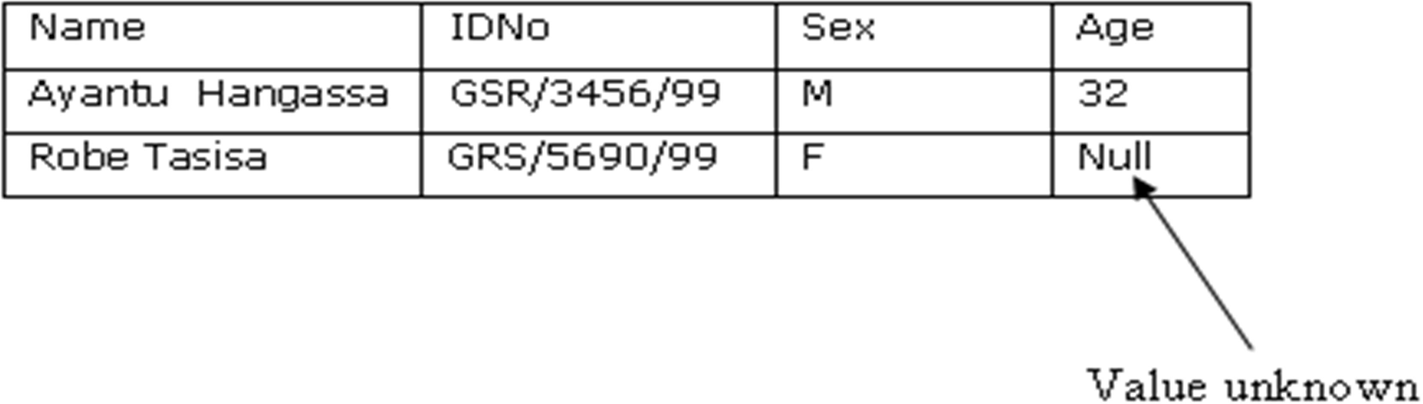

Working with SQL Commands
Creating SQL DB

The CREATE DATABASE Statement
The CREATE DATABASE statement is used to create a database.

SQL CREATE DATABASE Syntax
CREATE DATABASE database_name
CREATE DATABASE Example
- Now we want to create a database called "my_db".
- We use the following CREATE DATABASE statement:
CREATE DATABASE my_db
Database tables can be added with the CREATE TABLE statement.

Creating SQL Table

The CREATE TABLE Statement Database Tables
- A database most often contains one or more tables. Each table is identified by a name (e.g. "Customers" or "Orders"). Tables contain records (rows) with data.
- Below is an example of a table called "Persons":

P_Id | LastName | FirstName | Address | City
1 | Aberu | Ola | AA | Areda Subsity
2 | Chala | sanyi | W/shoa | Ambo

Page 30 of 98 | Entoto Poly Technic College Author/Copyright | Using Basic Structured Query Language | Version -1
Page 30 of 98 | Entoto Poly Technic College Author/Copyright | Using Basic Structured Query Language | September , 2023

3 | Mohammad | Kari | Arsi | Asella
- The table above contains three records (one for each person) and five columns (P_Id, LastName, FirstName, Address, and City).
- The CREATE TABLE statement is used to create a table in a database.

SQL CREATE TABLE Syntax
CREATE TABLE table_name (
column_name1 data_type, column_name2 data_type, column_name3 data_type,
....
)
CREATE TABLE Example
Now we want to create a table called "Persons" that contains five columns: P_Id, LastName, FirstName, Address, and City.
We use the following CREATE TABLE statement:
CREATE TABLE Persons (
P_Id int,
LastName varchar(255), FirstName varchar(255), Address varchar(255), City varchar(255)
)
The P_Id column is of type int and will hold a number. The LastName, FirstName, Address, and City columns are of type varchar with a maximum length of 255 characters.
The empty "Persons" table will now look like this:

P_Id | LastName | FirstName | Address | City
The empty table can be filled with data with the INSERT INTO statement.
SQL Constraints
- Constraints are used to limit the type of data that can go into a table.
- Constraints can be specified when a table is created (with the CREATE TABLE
statement) or after the table is created (with the ALTER TABLE statement).
- We will focus on the following constraints:
  - NOT NULL

  - UNIQUE
  - PRIMARY KEY
  - FOREIGN KEY
  - CHECK
  - DEFAULT
The next chapters will describe each constraint in details.

SQL PRIMARY KEY Constraint
- The PRIMARY KEY constraint uniquely identifies each record in a database table.
- Primary keys must contain unique values.
- A primary key column cannot contain NULL values.
- Each table should have a primary key, and each table can have only one primary key.

SQL PRIMARY KEY Constraint on CREATE TABLE
The following SQL creates a PRIMARY KEY on the "P_Id" column when the "Persons" table is created:
CREATE TABLE Persons (
P_Id int NOT NULL PRIMARY KEY,
LastName varchar(255) NOT NULL, FirstName varchar(255),
Address varchar(255), City varchar(255)
)

To allow naming of a PRIMARY KEY constraint, and for defining a PRIMARY KEY constraint on multiple columns, use the following SQL syntax:
CREATE TABLE Persons (
P_Id int NOT NULL,
LastName varchar(255) NOT NULL, FirstName varchar(255),
Address varchar(255), City varchar(255),
CONSTRAINT pk_PersonID PRIMARY KEY (P_Id,LastName)
)

SQL PRIMARY KEY Constraint on ALTER TABLE
To create a PRIMARY KEY constraint on the "P_Id" column when the table is already created, use the following SQL:
ALTER TABLE Persons ADD PRIMARY KEY (P_Id)
To allow naming of a PRIMARY KEY constraint, and for defining a PRIMARY KEY constraint on multiple columns, use the following SQL syntax:
ALTER TABLE Persons
ADD CONSTRAINT pk_PersonID PRIMARY KEY (P_Id,LastName)
Note: If you use the ALTER TABLE statement to add a primary key, the primary key column(s) must already have been declared to not contain NULL values (when the table was first created).

To DROP a PRIMARY KEY Constraint
To drop a PRIMARY KEY constraint, use the following SQL:
ALTER TABLE Persons
DROP CONSTRAINT pk_PersonID

SQL FOREIGN KEY Constraint
A FOREIGN KEY in one table points to a PRIMARY KEY in another table. Let's illustrate the foreign key with an example. Look at the following two tables: The "Persons" table:
P_Id | LastName | FirstName | Address | City
1 | Hansen | Ola | Timoteivn 10 | Sandnes
2 | Svendson | Tove | Borgvn 23 | Sandnes
3 | Pettersen | Kari | Storgt 20 | Stavanger
The "Orders" table:

O_Id | OrderNo | P_Id

Page 33 of 98 | Entoto Poly Technic College Author/Copyright | Using Basic Structured Query Language | Version -1
Page 33 of 98 | Entoto Poly Technic College Author/Copyright | Using Basic Structured Query Language | September , 2023

1 | 77895 | 3
2 | 44678 | 3
3 | 22456 | 2
4 | 24562 | 1
  - Note that the "P_Id" column in the "Orders" table points to the "P_Id" column in the "Persons" table.
  - The "P_Id" column in the "Persons" table is the PRIMARY KEY in the "Persons" table.
  - The "P_Id" column in the "Orders" table is a FOREIGN KEY in the "Orders" table.
  - The FOREIGN KEY constraint is used to prevent actions that would destroy link between tables.
The FOREIGN KEY constraint also prevents that invalid data is inserted into the foreign key column, because it has to be one of the values contained in the table it points to.

SQL FOREIGN KEY Constraint on CREATE TABLE
The following SQL creates a FOREIGN KEY on the "P_Id" column when the "Orders" table is created:
CREATE TABLE Orders (
O_Id int NOT NULL PRIMARY KEY,
OrderNo int NOT NULL,
P_Id int FOREIGN KEY REFERENCES Persons(P_Id)
)
To allow naming of a FOREIGN KEY constraint, and for defining a FOREIGN KEY constraint on multiple columns, use the following SQL syntax:
CREATE TABLE Orders (
O_Id int NOT NULL, OrderNo int NOT NULL, P_Id int,
PRIMARY KEY (O_Id),
CONSTRAINT fk_PerOrders FOREIGN KEY (P_Id) REFERENCES Persons(P_Id)
)

SQL FOREIGN KEY Constraint on ALTER TABLE
To create a FOREIGN KEY constraint on the "P_Id" column when the "Orders" table is already created, use the following SQL::
ALTER TABLE Orders ADD FOREIGN KEY (P_Id)
REFERENCES Persons(P_Id)

To allow naming of a FOREIGN KEY constraint, and for defining a FOREIGN KEY constraint on multiple columns, use the following SQL syntax:
ALTER TABLE Orders
ADD CONSTRAINT fk_PerOrders FOREIGN KEY (P_Id)
REFERENCES Persons(P_Id)

To DROP a FOREIGN KEY Constraint
To drop a FOREIGN KEY constraint, use the following SQL:
ALTER TABLE Orders
DROP CONSTRAINT fk_PerOrders

SQL NOT NULL Constraint
- By default, a table column can hold NULL values.
- The NOT NULL constraint enforces a column to NOT accept NULL values.
- The NOT NULL constraint enforces a field to always contain a value. This means that you cannot insert a new record, or update a record without adding a value to this field.
- The following SQL enforces the "P_Id" column and the "LastName" column to not accept NULL values:
CREATE TABLE Persons (
P_Id int NOT NULL,
LastName varchar(255) NOT NULL, FirstName varchar(255),
Address varchar(255), City varchar(255)
)

SQL UNIQUE Constraint

  - The UNIQUE constraint uniquely identifies each record in a database table.
  - The UNIQUE and PRIMARY KEY constraints both provide a guarantee for uniqueness for a column or set of columns.
  - A PRIMARY KEY constraint automatically has a UNIQUE constraint defined on it.
  - Note that you can have many UNIQUE constraints per table, but only one PRIMARY KEY constraint per table.

SQL UNIQUE Constraint on CREATE TABLE
The following SQL creates a UNIQUE constraint on the "P_Id" column when the "Persons" table is created:
CREATE TABLE Persons (
P_Id int NOT NULL UNIQUE,
LastName varchar(255) NOT NULL, FirstName varchar(255),
Address varchar(255), City varchar(255)
)
To allow naming of a UNIQUE constraint, and for defining a UNIQUE constraint on multiple columns, use the following SQL syntax:
CREATE TABLE Persons (
P_Id int NOT NULL,
LastName varchar(255) NOT NULL, FirstName varchar(255),
Address varchar(255), City varchar(255),
CONSTRAINT uc_PersonID UNIQUE (P_Id,LastName)
)

SQL UNIQUE Constraint on ALTER TABLE
To create a UNIQUE constraint on the "P_Id" column when the table is already created, use the following SQL:
ALTER TABLE Persons ADD UNIQUE (P_Id)
To allow naming of a UNIQUE constraint, and for defining a UNIQUE constraint on multiple columns, use the following SQL syntax:
ALTER TABLE Persons
ADD CONSTRAINT uc_PersonID UNIQUE (P_Id,LastName)

DROP a UNIQUE Constraint

To drop a UNIQUE constraint, use the following SQL:
ALTER TABLE Persons
DROP CONSTRAINT uc_PersonID

SQL CHECK Constraint
The CHECK constraint is used to limit the value range that can be placed in a column.
If you define a CHECK constraint on a single column it allows only certain values for this column.
If you define a CHECK constraint on a table it can limit the values in certain columns based on values in other columns in the row.

SQL CHECK Constraint on CREATE TABLE
The following SQL creates a CHECK constraint on the "P_Id" column when the "Persons" table is created. The CHECK constraint specifies that the column "P_Id" must only include integers greater than 0.
CREATE TABLE Persons (
P_Id int NOT NULL CHECK (P_Id>0),
LastName varchar(255) NOT NULL, FirstName varchar(255),
Address varchar(255), City varchar(255)
)
To allow naming of a CHECK constraint, and for defining a CHECK constraint on multiple columns, use the following SQL syntax:
CREATE TABLE Persons (
P_Id int NOT NULL,
LastName varchar(255) NOT NULL, FirstName varchar(255),

Address varchar(255), City varchar(255),
CONSTRAINT chk_Person CHECK (P_Id>0 AND City='Sandnes')
)

SQL CHECK Constraint on ALTER TABLE
To create a CHECK constraint on the "P_Id" column when the table is already created, use the following SQL:
ALTER TABLE Persons ADD CHECK (P_Id>0)
To allow naming of a CHECK constraint, and for defining a CHECK constraint on multiple columns, use the following SQL syntax:
ALTER TABLE Persons
ADD CONSTRAINT chk_Person CHECK (P_Id>0 AND City='Sandnes')

To DROP a CHECK Constraint
To drop a CHECK constraint, use the following SQL:
ALTER TABLE Persons
DROP CONSTRAINT chk_Person

SQL DEFAULT Constraint
The DEFAULT constraint is used to insert a default value into a column.
The default value will be added to all new records, if no other value is specified.

SQL DEFAULT Constraint on CREATE TABLE
The following SQL creates a DEFAULT constraint on the "City" column when the "Persons" table is created:

 | CREATE TABLE Persons (
Page 38 of 98 |  | Entoto Poly Technic College Author/Copyright | Using Basic Structured Query  Language | Version -1
 |  | Entoto Poly Technic College Author/Copyright | Using Basic Structured Query  Language | September , 2023

P_Id int NOT NULL,
LastName varchar(255) NOT NULL, FirstName varchar(255),
Address varchar(255),
City varchar(255) DEFAULT 'Sandnes'
)
The DEFAULT constraint can also be used to insert system values, by using functions like GETDATE():
CREATE TABLE Orders (
O_Id int NOT NULL, OrderNo int NOT NULL, P_Id int,
OrderDate date DEFAULT GETDATE()
)

SQL DEFAULT Constraint on ALTER TABLE
To create a DEFAULT constraint on the "City" column when the table is already created, use the following SQL:
ALTER TABLE Persons
ALTER COLUMN City SET DEFAULT 'SANDNES'

To DROP a DEFAULT Constraint
To drop a DEFAULT constraint, use the following SQL:
ALTER TABLE Persons
ALTER COLUMN City DROP DEFAULT

SQL Statements
Most of the actions you need to perform on a database are done with SQL statements. The following SQL statement will select all the records in the "Persons" table:
SELECT * FROM Persons
In this tutorial we will teach you all about the different SQL statements.

Keep in Mind That...
      - SQL is not case sensitive

Semicolon after SQL Statements?
Some database systems require a semicolon at the end of each SQL statement.
Semicolon is the standard way to separate each SQL statement in database systems that allow more than one SQL statement to be executed in the same call to the server. For most systems, every SQL statement is terminated by a semicolon (;).
We are using MS Access and SQL Server 2000 and we do not have to put a semicolon after each SQL statement, but some database programs force you to use it.
An SQL statement can be entered on one line or split across several lines for clarity.
For most systems SQL is not case sensitive. We can mix uppercase and lowercase when referencing SQL keywords (such as SELECT and INSERT), tables names, and column names. However, case does matter when referring to the contents of a column.
Before we can create a table we have to create a database.

SQL Insert statement
SQL INSERT INTO Statement
The INSERT INTO statement is used to insert new records in a table.

SQL INSERT INTO Syntax
It is possible to write the INSERT INTO statement in two forms.
The first form doesn't specify the column names where the data will be inserted, only their values:
INSERT INTO table_name VALUES (value1, value2, value3,...)
The second form specifies both the column names and the values to be inserted:
INSERT INTO table_name (column1, column2, column3,...) VALUES (value1, value2, value3,...)

SQL INSERT INTO Example
We have the following "Persons" table:

Now we
P_Id | LastName | FirstName | Address | City
1 | Hansen | Ola | Timoteivn 10 | Sandnes
2 | Svendson | Tove | Borgvn 23 | Sandnes
3 | Pettersen | Kari | Storgt 20 | Stavanger

want to
insert a new row in the "Persons" table. We use the following SQL statement:
INSERT INTO Persons
VALUES (4,'Nilsen', 'Johan', 'Bakken 2', 'Stavanger')
The "Persons" table will now look like this:

P_Id | LastName | FirstName | Address | City
1 | Hansen | Ola | Timoteivn 10 | Sandnes

Page 41 of 98 | Entoto Poly Technic College Author/Copyright | Using Basic Structured Query Language | Version -1
Page 41 of 98 | Entoto Poly Technic College Author/Copyright | Using Basic Structured Query Language | September , 2023

2 | Svendson | Tove | Borgvn 23 | Sandnes
3 | Pettersen | Kari | Storgt 20 | Stavanger
4 | Nilsen | Johan | Bakken 2 | Stavanger

Insert Data Only in Specified Columns
It is also possible to only add data in specific columns.
The following SQL statement will add a new row, but only add data in the "P_Id", "LastName" and the "FirstName" columns:
INSERT INTO Persons (P_Id, LastName, FirstName) VALUES (5, 'Tjessem', 'Jakob')
The "Persons" table will now look like this:

P_Id | LastName | FirstName | Address | City
1 | Hansen | Ola | Timoteivn 10 | Sandnes
2 | Svendson | Tove | Borgvn 23 | Sandnes
3 | Pettersen | Kari | Storgt 20 | Stavanger
4 | Nilsen | Johan | Bakken 2 | Stavanger
5 | Tjessem | Jakob

SQL SELECT Statement

This chapter will explain the SELECT and the SELECT * statements. The SQL SELECT Statement
The SELECT statement is used to select data from a database. The result is stored in a result table, called the result-set.

SQL SELECT Syntax
SELECT column_name(s) FROM table_name

and
SELECT * FROM table_name
Note: SQL is not case sensitive. SELECT is the same as select.

An SQL SELECT Example
The "Persons" table:

P_Id | LastName | FirstName | Address | City
1 | Hansen | Ola | Timoteivn 10 | Sandnes
2 | Svendson | Tove | Borgvn 23 | Sandnes
3 | Pettersen | Kari | Storgt 20 | Stavanger

Now we want to select the content of the columns named "LastName" and "FirstName" from the table above.
We use the following SELECT statement:
SELECT LastName,FirstName FROM Persons
The result-set will look like this:

LastName | FirstName
Hansen | Ola
Svendson | Tove
Pettersen | Kari

SELECT * Example
Now we want to select all the columns from the "Persons" table. We use the following SELECT statement:
SELECT * FROM Persons

Tip: The asterisk (*) is a quick way of selecting all columns! The result-set will look like this:

P_Id | LastName | FirstName | Address | City
1 | Hansen | Ola | Timoteivn 10 | Sandnes
2 | Svendson | Tove | Borgvn 23 | Sandnes
3 | Pettersen | Kari | Storgt 20 | Stavanger

Navigation in a Result-set
Most database software systems allow navigation in the result-set with programming functions, like: Move-To-First-Record, Get-Record-Content, Move-To-Next-Record, etc.
Programming functions like these are not a part of this tutorial.

SQL SELECT DISTINCT Statement
In a table, some of the columns may contain duplicate values. This is not a problem, however, sometimes you will want to list only the different (distinct) values in a table.
The DISTINCT keyword can be used to return only distinct (different) values.

SQL SELECT DISTINCT Syntax
SELECT DISTINCT column_name(s) FROM table_name

SELECT DISTINCT Example
The "Persons" table:

P_Id | LastName | FirstName | Address | City
1 | Hansen | Ola | Timoteivn 10 | Sandnes
2 | Svendson | Tove | Borgvn 23 | Sandnes
3 | Pettersen | Kari | Storgt 20 | Stavanger
Now we want to select only the distinct values from the column named "City" from the table above.
We use the following SELECT statement:

SELECT DISTINCT City FROM Persons
The result-set will look like this:

City
Sandnes
Stavanger

SQL WHERE Clause
- The WHERE clause is used to filter records.

The WHERE Clause
The WHERE clause is used to extract only those records that fulfill a specified criterion.

SQL WHERE Syntax
SELECT column_name(s) FROM table_name
WHERE column_name operator value

WHERE Clause Example
The "Persons" table:

P_Id | LastName | FirstName | Address | City
1 | Hansen | Ola | Timoteivn 10 | Sandnes
2 | Svendson | Tove | Borgvn 23 | Sandnes
3 | Pettersen | Kari | Storgt 20 | Stavanger

Now we want to select only the persons living in the city "Sandnes" from the table above. We use the following SELECT statement:
SELECT * FROM Persons

WHERE City='Sandnes' The result-set will look like this:
P_Id | LastName | FirstName | Address | City
1 | Hansen | Ola | Timoteivn 10 | Sandnes
2 | Svendson | Tove | Borgvn 23 | Sandnes

Quotes around Text Fields
SQL uses single quotes around text values (most database systems will also accept double quotes).
Although, numeric values should not be enclosed in quotes. For text values:
This is correct:
SELECT * FROM Persons WHERE FirstName='Tove' This is wrong:
SELECT * FROM Persons WHERE FirstName=Tove
For numeric values:
This is correct:
SELECT * FROM Persons WHERE Year=1965 This is wrong:
SELECT * FROM Persons WHERE Year='1965'

Operators Allowed in the WHERE Clause
With the WHERE clause, the following operators can be used:

Operator | Description
= | Equal
<> | Not equal
> | Greater than

Page 46 of 98 | Entoto Poly Technic College Author/Copyright | Using Basic Structured Query Language | Version -1
Page 46 of 98 | Entoto Poly Technic College Author/Copyright | Using Basic Structured Query Language | September , 2023

< | Less than
>= | Greater than or equal
<= | Less than or equal
BETWEEN | Between an inclusive range
LIKE | Search for a pattern
IN | If you know the exact value you want to return for at least one of the columns
Note: In some versions of SQL the <> operator may be written as !=

SQL AND & OR Operators
The AND & OR operators are used to filter records based on more than one condition.

The AND & OR Operators
The AND operator displays a record if both the first and the second condition is true.
The OR operator displays a record if either the first condition or the second condition is true.

AND Operator Example
The "Persons" table:

P_Id | LastName | FirstName | Address | City
1 | Hansen | Ola | Timoteivn 10 | Sandnes
2 | Svendson | Tove | Borgvn 23 | Sandnes
3 | Pettersen | Kari | Storgt 20 | Stavanger
Now we want to select only the persons with the first name equal to "Tove" AND the last name equal to "Svendson":
We use the following SELECT statement:
SELECT * FROM Persons WHERE FirstName='Tove' AND LastName='Svendson'
The result-set will look like this:

P_Id | LastName | FirstName | Address | City
2 | Svendson | Tove | Borgvn 23 | Sandnes

OR Operator Example
Now we want to select only the persons with the first name equal to "Tove" OR the first name equal to "Ola":
We use the following SELECT statement:
SELECT * FROM Persons WHERE FirstName='Tove' OR FirstName='Ola'
The result-set will look like this:

P_Id | LastName | FirstName | Address | City
1 | Hansen | Ola | Timoteivn 10 | Sandnes
2 | Svendson | Tove | Borgvn 23 | Sandnes

Combining AND & OR
You can also combine AND and OR (use parenthesis to form complex expressions).
Now we want to select only the persons with the last name equal to "Svendson" AND the first name equal to "Tove" OR to "Ola":
We use the following SELECT statement:
SELECT * FROM Persons WHERE LastName='Svendson'
AND (FirstName='Tove' OR FirstName='Ola')
The result-set will look like this:

P_Id | LastName | FirstName | Address | City
2 | Svendson | Tove | Borgvn 23 | Sandnes

SQL ORDER BY Keyword

The ORDER BY keyword is used to sort the result-set.

The ORDER BY Keyword
The ORDER BY keyword is used to sort the result-set by a specified column. The ORDER BY keyword sort the records in ascending order by default.
If you want to sort the records in a descending order, you can use the DESC keyword.

SQL ORDER BY Syntax
SELECT column_name(s) FROM table_name
ORDER BY column_name(s) ASC|DESC
ORDER BY Example
The "Persons" table:

P_Id | LastName | FirstName | Address | City
1 | Hansen | Ola | Timoteivn 10 | Sandnes
2 | Svendson | Tove | Borgvn 23 | Sandnes
3 | Pettersen | Kari | Storgt 20 | Stavanger
4 | Nilsen | Tom | Vingvn 23 | Stavanger
Now we want to select all the persons from the table above, however, we want to sort the persons by their last name.
We use the following SELECT statement:
SELECT * FROM Persons ORDER BY LastName
The result-set will look like this:

P_Id | LastName | FirstName | Address | City
1 | Hansen | Ola | Timoteivn 10 | Sandnes
4 | Nilsen | Tom | Vingvn 23 | Stavanger
3 | Pettersen | Kari | Storgt 20 | Stavanger

Page 49 of 98 | Entoto Poly Technic College Author/Copyright | Using Basic Structured Query Language | Version -1
Page 49 of 98 | Entoto Poly Technic College Author/Copyright | Using Basic Structured Query Language | September , 2023

2 | Svendson | Tove | Borgvn 23 | Sandnes

ORDER BY DESC Example
Now we want to select all the persons from the table above, however, we want to sort the persons descending by their last name.
We use the following SELECT statement:
SELECT * FROM Persons ORDER BY LastName DESC
The result-set will look like this:

P_Id | LastName | FirstName | Address | City
2 | Svendson | Tove | Borgvn 23 | Sandnes
3 | Pettersen | Kari | Storgt 20 | Stavanger
4 | Nilsen | Tom | Vingvn 23 | Stavanger
1 | Hansen | Ola | Timoteivn 10 | Sandnes

SQL UPDATE Statement
The UPDATE statement is used to update existing records in a table.

SQL UPDATE Syntax
UPDATE table_name
SET column1=value, column2=value2,... WHERE some_column=some_value
Note: Notice the WHERE clause in the UPDATE syntax. The WHERE clause specifies which record or records that should be updated. If you omit the WHERE clause, all records will be updated!

SQL UPDATE Example
The "Persons" table:

P_Id | LastName | FirstName | Address | City

Page 50 of 98 | Entoto Poly Technic College Author/Copyright | Using Basic Structured Query Language | Version -1
Page 50 of 98 | Entoto Poly Technic College Author/Copyright | Using Basic Structured Query Language | September , 2023

1 | Hansen | Ola | Timoteivn 10 | Sandnes
2 | Svendson | Tove | Borgvn 23 | Sandnes
3 | Pettersen | Kari | Storgt 20 | Stavanger
4 | Nilsen | Johan | Bakken 2 | Stavanger
5 | Tjessem | Jakob
Now we want to update the person "Tjessem, Jakob" in the "Persons" table. We use the following SQL statement:
UPDATE Persons
SET Address='Nissestien 67', City='Sandnes'
WHERE LastName='Tjessem' AND FirstName='Jakob'
The "Persons" table will now look like this:

P_Id | LastName | FirstName | Address | City
1 | Hansen | Ola | Timoteivn 10 | Sandnes
2 | Svendson | Tove | Borgvn 23 | Sandnes
3 | Pettersen | Kari | Storgt 20 | Stavanger
4 | Nilsen | Johan | Bakken 2 | Stavanger
5 | Tjessem | Jakob | Nissestien 67 | Sandnes

SQL UPDATE Warning
Be careful when updating records. If we had omitted the WHERE clause in the example above, like this:
UPDATE Persons
SET Address='Nissestien 67', City='Sandnes'
The "Persons" table would have looked like this:

P_Id | LastName | FirstName | Address | City
1 | Hansen | Ola | Nissestien 67 | Sandnes
2 | Svendson | Tove | Nissestien 67 | Sandnes
3 | Pettersen | Kari | Nissestien 67 | Sandnes
4 | Nilsen | Johan | Nissestien 67 | Sandnes
5 | Tjessem | Jakob | Nissestien 67 | Sandnes

SQL DELETE Statement
The DELETE statement is used to delete rows/ records in a table.

SQL DELETE Syntax
DELETE FROM table_name WHERE some_column=some_value
Note: Notice the WHERE clause in the DELETE syntax. The WHERE clause specifies which record or records that should be deleted. If you omit the WHERE clause, all records will be deleted!

SQL DELETE Example
The "Persons" table:

P_Id | LastName | FirstName | Address | City
1 | Hansen | Ola | Timoteivn 10 | Sandnes
2 | Svendson | Tove | Borgvn 23 | Sandnes
3 | Pettersen | Kari | Storgt 20 | Stavanger
4 | Nilsen | Johan | Bakken 2 | Stavanger
5 | Tjessem | Jakob | Nissestien 67 | Sandnes
Now we want to delete the person "Tjessem, Jakob" in the "Persons" table. We use the following SQL statement:

DELETE FROM Persons
WHERE LastName='Tjessem' AND FirstName='Jakob'
The "Persons" table will now look like this:

P_Id | LastName | FirstName | Address | City
1 | Hansen | Ola | Timoteivn 10 | Sandnes
2 | Svendson | Tove | Borgvn 23 | Sandnes
3 | Pettersen | Kari | Storgt 20 | Stavanger
4 | Nilsen | Johan | Bakken 2 | Stavanger

Delete All Rows
It is possible to delete all rows in a table without deleting the table. This means that the table structure, attributes, and indexes will be intact:
DELETE FROM table_name or
DELETE * FROM table_name
Note: Be very careful when deleting records. You cannot undo this statement!

SQL CREATE INDEX Statement
The CREATE INDEX statement is used to create indexes in tables.
Indexes allow the database application to find data fast; without reading the whole table.

Indexes
An index can be created in a table to find data more quickly and efficiently.
The users cannot see the indexes, they are just used to speed up searches/queries.
Note: Updating a table with indexes takes more time than updating a table without (because the indexes also need an update). So you should only create indexes on columns (and tables) that will be frequently searched against.

SQL CREATE INDEX Syntax

Creates an index on a table. Duplicate values are allowed:
CREATE INDEX index_name ON table_name (column_name)

SQL CREATE UNIQUE INDEX Syntax
Creates a unique index on a table. Duplicate values are not allowed:
CREATE UNIQUE INDEX index_name ON table_name (column_name)
Note: The syntax for creating indexes varies amongst different databases. Therefore: Check the syntax for creating indexes in your database.

CREATE INDEX Example
The SQL statement below creates an index named "PIndex" on the "LastName" column in the "Persons" table:
CREATE INDEX PIndex
ON Persons (LastName)
If you want to create an index on a combination of columns, you can list the column names within the parentheses, separated by commas:
CREATE INDEX PIndex
ON Persons (LastName, FirstName)

SQL DROP INDEX, DROP TABLE, and DROP DATABASE
Indexes, tables, and databases can easily be deleted/removed with the DROP statement.

The DROP INDEX Statement
The DROP INDEX statement is used to delete an index in a table.
DROP INDEX table_name.index_name

The DROP TABLE Statement
The DROP TABLE statement is used to delete a table.
DROP TABLE table_name

The DROP DATABASE Statement
The DROP DATABASE statement is used to delete a database.
DROP DATABASE database_name

The TRUNCATE TABLE Statement
What if we only want to delete the data inside the table, and not the table itself? Then, use the TRUNCATE TABLE statement:
TRUNCATE TABLE table_name

SQL ALTER TABLE Statement
The ALTER TABLE statement is used to add, delete, or modify columns in an existing table.

SQL ALTER TABLE Syntax
To add a column in a table, use the following syntax:
ALTER TABLE table_name ADD column_name datatype
To delete a column in a table, use the following syntax (notice that some database systems don't allow deleting a column):
ALTER TABLE table_name DROP COLUMN column_name
To change the data type of a column in a table, use the following syntax:
ALTER TABLE table_name
ALTER COLUMN column_name datatype

SQL ALTER TABLE Example
Look at the "Persons" table:

P_Id | LastName | FirstName | Address | City
1 | Hansen | Ola | Timoteivn 10 | Sandnes
2 | Svendson | Tove | Borgvn 23 | Sandnes
3 | Pettersen | Kari | Storgt 20 | Stavanger
Now we want to add a column named "DateOfBirth" in the "Persons" table. We use the following SQL statement:
ALTER TABLE Persons ADD DateOfBirth date
Notice that the new column, "DateOfBirth", is of type date and is going to hold a date. The data type specifies what type of data the column can hold.
The "Persons" table will now like this:

P_Id | LastName | FirstName | Address | City | DateOfBirth
1 | Hansen | Ola | Timoteivn 10 | Sandnes
2 | Svendson | Tove | Borgvn 23 | Sandnes
3 | Pettersen | Kari | Storgt 20 | Stavanger

Change Data Type Example
Now we want to change the data type of the column named "DateOfBirth" in the "Persons" table.
We use the following SQL statement:
ALTER TABLE Persons
ALTER COLUMN DateOfBirth year
Notice that the "DateOfBirth" column is now of type year and is going to hold a year in a two- digit or four-digit format.

DROP COLUMN Example
Next, we want to delete the column named "DateOfBirth" in the "Persons" table. We use the following SQL statement:
ALTER TABLE Persons DROP COLUMN DateOfBirth
The "Persons" table will now like this:

P_Id | LastName | FirstName | Address | City
1 | Hansen | Ola | Timoteivn 10 | Sandnes
2 | Svendson | Tove | Borgvn 23 | Sandnes
3 | Pettersen | Kari | Storgt 20 | Stavanger

SQL AUTO INCREMENT Field
Auto-increment allows a unique number to be generated when a new record is inserted into a table.

AUTO INCREMENT a Field
Very often we would like the value of the primary key field to be created automatically every time a new record is inserted.
We would like to create an auto-increment field in a table.

Syntax for SQL Server
The following SQL statement defines the "P_Id" column to be an auto-increment primary key field in the "Persons" table:
CREATE TABLE Persons (
P_Id int PRIMARY KEY IDENTITY,
LastName varchar(255) NOT NULL, FirstName varchar(255),
Address varchar(255), City varchar(255)

)
The MS SQL Server uses the IDENTITY keyword to perform an auto-increment feature.
By default, the starting value for IDENTITY is 1, and it will increment by 1 for each new record.
To specify that the "P_Id" column should start at value 10 and increment by 5, change the identity to IDENTITY(10,5).
To insert a new record into the "Persons" table, we will not have to specify a value for the "P_Id" column (a unique value will be added automatically):
INSERT INTO Persons (FirstName,LastName) VALUES ('Lars','Monsen')
The SQL statement above would insert a new record into the "Persons" table. The "P_Id" column would be assigned a unique value. The "FirstName" column would be set to "Lars" and the "LastName" column would be set to "Monsen".
SQL Views
A view is a virtual table.
This chapter shows how to create, update, and delete a view.

SQL CREATE VIEW Statement
In SQL, a view is a virtual table based on the result-set of an SQL statement.
A view contains rows and columns, just like a real table. The fields in a view are fields from one or more real tables in the database.
You can add SQL functions, WHERE, and JOIN statements to a view and present the data as if the data were coming from one single table.

SQL CREATE VIEW Syntax
CREATE VIEW view_name AS SELECT column_name(s) FROM table_name
WHERE condition
Note: A view always shows up-to-date data! The database engine recreates the data, using the view's SQL statement, every time a user queries a view.

SQL CREATE VIEW Examples
If you have the Northwind database you can see that it has several views installed by default.

The view "Current Product List" lists all active products (products that are not discontinued) from the "Products" table. The view is created with the following SQL:
CREATE VIEW [Current Product List] AS SELECT ProductID,ProductName
FROM Products
WHERE Discontinued=No
We can query the view above as follows:
SELECT * FROM [Current Product List]
Another view in the Northwind sample database selects every product in the "Products" table with a unit price higher than the average unit price:
CREATE VIEW [Products Above Average Price] AS SELECT ProductName,UnitPrice
FROM Products
WHERE UnitPrice>(SELECT AVG(UnitPrice) FROM Products)
We can query the view above as follows:
SELECT * FROM [Products Above Average Price]
Another view in the Northwind database calculates the total sale for each category in 1997. Note that this view selects its data from another view called "Product Sales for 1997":
CREATE VIEW [Category Sales For 1997] AS
SELECT DISTINCT CategoryName,Sum(ProductSales) AS CategorySales FROM [Product Sales for 1997]
GROUP BY CategoryName
We can query the view above as follows:
SELECT * FROM [Category Sales For 1997]
We can also add a condition to the query. Now we want to see the total sale only for the category "Beverages":
SELECT * FROM [Category Sales For 1997] WHERE CategoryName='Beverages'

SQL Updating a View
You can update a view by using the following syntax:

SQL CREATE OR REPLACE VIEW Syntax

CREATE OR REPLACE VIEW view_name AS SELECT column_name(s)
FROM table_name WHERE condition
Now we want to add the "Category" column to the "Current Product List" view. We will update the view with the following SQL:
CREATE VIEW [Current Product List] AS SELECT ProductID,ProductName,Category FROM Products
WHERE Discontinued=No

SQL Dropping/delete a View
You can delete a view with the DROP VIEW command.
SQL DROP VIEW Syntax
DROP VIEW view_name

Identifying database information requirement
Identifying database information requirements is an important step in designing a database system that meets the needs of a business or organization. Here are some key steps and considerations to help you identify database information requirements:

Understand the Business Processes:
Start by understanding the business processes, operations, and activities for which the database will be used. Identify the key tasks and activities that rely on data.

Business Requirements
  - Relates directly to the tasks performed by individuals within an organization.
  - Deals with how the business functions currently, as well as how the business plans to work or conduct business in a future.
  - As technology and information needs are constantly advancing, it is very important to consider the future needs of the business, which turns out to be a common point of failure for many inexperienced firms attempting to design a database for the first time.

  - All organizations deal with data. It is the responsibility of the development team to find out what the data is and how the business uses the data.
  - Data and processes within an organization are always closely related.
    - Processes can be used to determine data, as data can be used to determine processes. In fact, it is important to compare processes to data during modelling to ensure that all requirements have been completely gathered.
    - Processes are performed by individuals who belong to organizational units. An organizational unit is normally a department within an organization. For example, common organizational units include human resources, data entry, customer service, accounting, mail room, and management.
    - During the business requirements gathering portion of the design process, the main goal is to break an organization into organizational units and associate data and processes with each organizational unit.
    - Some processes that are performed can be specific to a particular organizational unit, or can be shared between organizational units. Likewise, data can also be shared.
  - After basic data and processes are determined, business rules must also be determined. Business rules are directly associated with data and processes that are used to manage the data.
    - Business rules are moulded around the data by customer because the DB belongs to them.
    - Business rules affect the way data can be accessed for operations such as queries, inserts, updates, and deletions. Also help determine how data relates to other data, and will eventually be used to design entities and their relationships.
Some of the following basic questions can be used to begin the process of determining business requirements:
- Who will perform the tasks?
- How are tasks performed?
- What different organizational units will deal with business data?
- What processes are specific to certain organizational units?
- What data is associated with each individual process?
- How do the processes interact with one another?
- How do the organizational units interact with one another?
- What outside factors exist that affect business processes and data?

Gather User Requirements:

- Engage with end-users, stakeholders, and subject matter experts to gather their specific data requirements. What data do they need to perform their tasks effectively?

User requirements
Without user all database components (data, hardware & software) are meaning less. User can collect the data, operate and handle the hardware. Also operator feeds the data and arranges the data in order by executing the software. There are mainly four types of users. These are:

Naïve user:
  - Naïve user has no knowledge of database system and its any supporting software. These are used at the end form.
  - Are like a layman, which have little bit knowledge of computer system.
  - Mainly used for collecting the data on the notebooks or on the pre-deigned forms.
  - Naïve user can work on any simple GUI (Graphical User Interface) base menu driven system. Internet using non-computer based person are in this form.

End User or Data Entry Operators
  - Data entry operators are preliminary computer based users.
  - Their function is only to operate the computer (start! stop the computer) and feed or type the collected information (data) in menu driven application program and to execute it according to the analyst’ requirement.
  - These user are also called Online users, communicate the database directly via an on line terminal or indirectly via a user interface.
  - They require certain amount of expertise in the computer programming language, but require complete knowledge of computer operations.

Application/simple programmer:
  - Develop new project i.e. program for a particular application or modify an existing program.
  - Works according to some instructions given by database administrator (DBA).
  - They can handle all the programming language like Fortran, Cobol, dbase etc.

DBA (Data Base Administrator):
  - DBA is also called an overall controller of the organization. In computer department of a firm either system analysts or an EDP (Electronic Data Processing) Manager works as DBA. In other words DBA is the overall controller of complete hardware and software.
  - DBA is a major user, can be either a single person or a group of persons.

  - Is the custodian of the business firm or organization but not owner of the organization. As bank manager is the DBA of a bank, who takes care about the bank money and not use it.
  - Can handle information collected by end user and give the instructions to the application programmer for developing a new program or modifying an existing program.

Responsibilities of DBA
- Controls the data, hardware, and software and gives the instructions to the application programmer, end user and naive user.
- Decides the information contents of database and the suitable database file structure for arrangement of data. He/She uses the proper DDL techniques.
- Compiles the whole data in a particular order and sequence.
- Decides where data can be stored i.e. take decision about the storage structure.
- Decides which access strategy and technique should be used for accessing the data.
- Communicates with the user by appropriate meeting, co-operates with user.
- Define and, apply authorized checks and validation procedures.
- Takes backup of data on a backup storage device so that if data is lost then it can be recovered and compiled. DBA also recovers the damaged data.
- Changes the environment according to user/industry requirement and monitor the performance.
- Makes good decision, the decision taken by DBA should be correct, accurate & efficient.
- DBA should have leadership quality.
- Liaises with the user in the business to take customer confidence about availability of data.

Define Data Entities:
Identify the main data entities or objects that the database will store and manage. These could be customers, products, employees, orders, etc.

Determine Data Attributes:
For each data entity, define the attributes or fields that need to be captured. What specific pieces of information are associated with each entity? For example, a "customer" entity might have attributes like name, address, email, and phone number.

Establish Relationships:
Determine how data entities are related to each other. Establish relationships, such as one-to- many or many-to-many relationships, to reflect how different entities interact.

Consider Data Integrity Rules:
Define any data integrity rules or constraints, such as unique keys, primary keys, and foreign keys. These rules ensure data accuracy and consistency.

Identify Data Sources:
Determine the sources of data that will populate the database. Is data collected from user input, external systems, or other sources? Understanding data sources is crucial for data integration.

Analyze Data Usage:
Consider how frequently data is accessed and updated. This can help determine the database's performance and scalability requirements.

Security and Access Control:
Identify who should have access to specific data and what level of access they require. Data security and access control are critical considerations.

Reporting and Analysis Needs:
Determine the reporting and analysis requirements. What types of reports and queries will users need to generate from the data?

Data Volume and Growth:
Estimate the expected data volume and growth over time. This helps in choosing the appropriate database technology and hardware.

Compliance and Regulatory Requirements:
Consider any industry-specific regulations or compliance requirements that may impact data storage and access.

Determining technical specifications
Following are some things to consider when you are working on a technical specification:
- What are the hardware and software requirements to run this system?
- List all of the tables to be included in the database and a brief description (one or two sentences) to describe each table.
- List the relationships among the tables. (This is most commonly done as a graphic but you may write it out if you prefer.)
- For each table, describe the file structure
File Structures For each table, a good technical specification includes a list of the fields with at least the following information for every field:
  - Field name: a brief name which is easy to remember (e.g. "artist_name")
  - Field description: a description of the information (e.g. "the name of the artist")
  - Field data type: character, numeric, logical, date, or other; specifiy any specific data type such as a URL or an image. For example, the artist's name would be a character field.
  - Field length: This applies to character and numeric fields. Numeric fields can be described with a specific length for integers (e.g. "8").

  - Remarks: Be sure to list any important validation rules here. For example, if the field contains the room number in a hotel reservation system, be sure that the room number applies to an actual room. Indicate here whether a field is a primary key (and if it is a foreign key, if you know that yet). Also, specify here if a field should be checked against another table (e.g. the artist's name should be validated against the table containing a list of artists on file).
Sample File Structure
Artist Table: This table contains a list of artists represented by this gallery. Data fields include:

field name | field description | data type | field length | remarks
artist_name | the full name of the artist | character | 30 | Stored as "last, first" e.g. "Pollack, Jackson".  This field is the primary key for this table.  This field is a foreign key for the table of paintings.
artist_school | the school or style this artist is associated with primarily | character | 15 | This field should be checked against a list of values e.g. abstract, Baroque, Impressionist, etc.
artist_born | year or  approximate year of the artist's birth | character | 4 | Use century or mid-century approximations where necessary. Be sure this date does not exceed the current year.
artist_death | year or  approximate year of the artist's death | character | 4 | Use century or mid-century approximations where necessary. Be sure this date does not exceed the current year.
artist_nationality | the nationality this artist is associated with primarily | character | 15 | This field should be checked against a list of values e.g. American, Mexican, Flemish, etc.

Documentation:

Maintain thorough documentation of the identified information requirements. This documentation will be invaluable during the database design and development phases.
Once you have identified these information requirements, you can use them as a foundation for designing the database schema, selecting the appropriate database management system (DBMS), and building the database to meet the needs of the organization.

Steps to identify database requirement Step 1: Gather a Selection Team
  - May help to create a "selection team" or committee that can work together to identify your organization's database needs.
  - This includes a representative from each of the groups who will be using the software – e.g., staff, board, members, volunteers, etc.
  - Having all users involved should ensure that you identify not only all of the key requirements, but also set realistic expectations of both the software choice and the skills
  - Be sure this team includes the expertise you need to:
    - Fully understand your current database needs and organizational processes
    - Recognize the short-comings of your current system/process
    - Identify your longer-term needs (e.g., over the next 2-3 years)
    - Appreciate all users’ skill levels

Step 2: Review Your Current Situation and Long-term Goals
The Selection Team takes stock of your existing system or process – its pros and cons – what’s working and what needs to change. In other words, why are you thinking of making the change?
You should also clearly identify your objectives for the search, including your short- and longer-term goals (e.g., 3-5 years). For example:

- Do you expect your data is going to grow exponentially over the next couple of years?
- Are you planning to create data levels that will require to track information differently?
- Will you be launching events or programs for which you will need to cross-reference data or capture different financial data?

Step 3: Identify Your Needs
Create a detailed list of what you want the software to help you with. Here are some of the things to consider in creating your list of database requirements:

USER NEEDS:
Who will use this database?
User's needs:
- Remote access versus in-office access
- View vs. edit access
- Their technical proficiency
- Their organizational/technical skills
TYPE OF DATA YOU NEED TO STORE:
What type of records do you need to store:
How many total records will you need to store?
What information do you need to capture?
- Basic data for all records (name, email, address, tel #, etc.)
- Data specific for certain types of records
- Membership: renewal date / status / member ID
- Account balance
- Any committees/groups
- Event history, donation history
- Volunteering history
- Relationships (e.g. spouse, multiple records under same corp. membership)
- Communication preferences (e.g. send newsletters/not)

- Professional certification
- Continuing education credits
FUNCTIONS
What functions do you need:
- Report generation (what kinds of reports?)
- Support for linked/hierarchical records
- Integrated contact database
- Quick search/advanced search
- Automation of renewals
- Mail merge functions (e.g., for email and postal, name badges)
- Export for use in any other tools/systems
- Internal workflows (communications, actions, notes)

Step 4: Define and Prioritize Your Requirements
- Now that you’ve created an inclusive list of your needs, you’ll need to rank or prioritize these so you can determine which are absolutely essential or “Required” and which simply “Nice-to have” are.
- By clearly identifying and ranking your needs and by taking a team approach, you should avoid one of the pitfalls that often occurs - making a quick selection based solely on one individual's personal preference or vendor pitches rather than on your organization's specific needs.

Retrieving all data from a table following work procedure
Retrieving all data from a table in a database typically involves using SQL (Structured Query Language) to query the database. Here's a step-by-step guide on how to retrieve all data from a table using a SQL SELECT statement, following a standard work procedure:

Connect to the Database:
Ensure you have access to the database you want to retrieve data from. You may need to use a database client, command-line tool, or programming language with database connectivity.

Select the Database:

If the database has multiple databases or schemas, select the appropriate one using the USE or USE DATABASE statement. For example, in MySQL, you can use:
USE database_name;
Write the SQL SELECT Statement:
Use the SQL SELECT statement to retrieve data from a specific table. The basic syntax is as follows:
SELECT * FROM table_name;
Replace table_name with the name of the table you want to retrieve data from.
If you want to retrieve specific columns rather than all columns, replace * with a comma- separated list of column names.

Execute the SQL Query:
Execute the SQL query using your database client, command-line tool, or programming language. The exact method of execution depends on the tool or language you are using.
In many database clients, you can execute the query by clicking a "Run" or "Execute" button. If you're using a command-line tool, you can run the query by entering it and pressing Enter.
In programming languages like Python or Java, you'll use database libraries to execute the query.

Retrieve and Display Data:
After executing the query, you should see the retrieved data displayed in the database client or receive the data in your programming language as a result set.
If you're using a programming language, you can iterate through the result set to access and work with the retrieved data.
Here's a simplified example in SQL to retrieve all data from a hypothetical "employees" table: SELECT * FROM employees;
This query will retrieve all rows and columns from the "employees" table.

Keep in mind that access and permissions to retrieve data from a table depend on your database setup, and you may need appropriate user privileges to perform this operation. Always follow best practices for handling and securing data, especially in a production environment.

Retrieving data from a specific column in a single table
Retrieving data from a specific column in a single table is a common database operation. You can do this using a SQL SELECT statement. Here's how to retrieve data from a specific column in a table following a standard procedure:

Connect to the Database:
Ensure you have access to the database you want to retrieve data from. Use a database client, command-line tool, or a programming language with database connectivity to connect to the database.

Select the Database (if necessary):
If the database contains multiple databases or schemas, select the appropriate one using the USE or USE DATABASE statement. This step might not be needed in some databases.

Write the SQL SELECT Statement:
Use the SQL SELECT statement to retrieve data from a specific column in a table. The basic syntax is as follows:
SELECT column_name FROM table_name;
Replace column_name with the name of the specific column you want to retrieve data from, and table_name with the name of the table.

Execute the SQL Query:
Execute the SQL query using your database client, command-line tool, or programming language. How you execute the query depends on the tool or language you are using.

Retrieve and Display Data:
After executing the query, you will see the retrieved data displayed in your database client, or you will receive the data in your programming language as a result set.

If you're using a programming language, you can access and work with the retrieved data from the specific column as needed.
Here's a simple SQL example to retrieve data from the "email" column in a hypothetical "employees" table:

SELECT email FROM employees;
This query retrieves data from the "email" column of the "employees" table.
Keep in mind that your access and permissions to retrieve data from a specific column depend on your database setup, and you may need appropriate user privileges. Always follow best practices for handling and securing data, especially in a production environment.

Using clause to sort query output
To sort the query output in SQL, you can use the ORDER BY clause in your SELECT statement. The ORDER BY clause allows you to specify one or more columns by which you want to sort the result set. You can sort the data in ascending (default) or descending order for each specified column. Here's the basic syntax for using the ORDER BY clause:
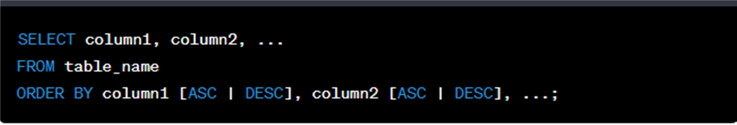
- column1, column2, etc.: The columns you want to retrieve.
- table_name: The name of the table from which you want to retrieve data.
- ORDER BY: The clause indicating that you want to sort the result set.
- column1, column2, etc.: The columns by which you want to sort the data.
- [ASC | DESC]: Optional. Use ASC for ascending (default) or DESC for descending order. If not specified, it defaults to ascending order.
Here's an example of using the ORDER BY clause to sort a query result in ascending order based on a specific column:

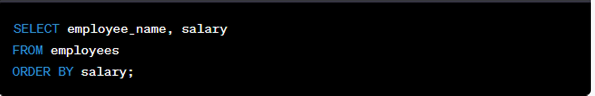
This query retrieves data from the "employee_name" and "salary" columns of the "employees" table and sorts the result in ascending order based on the "salary" column.
If you want to sort the data in descending order, you can use DESC:
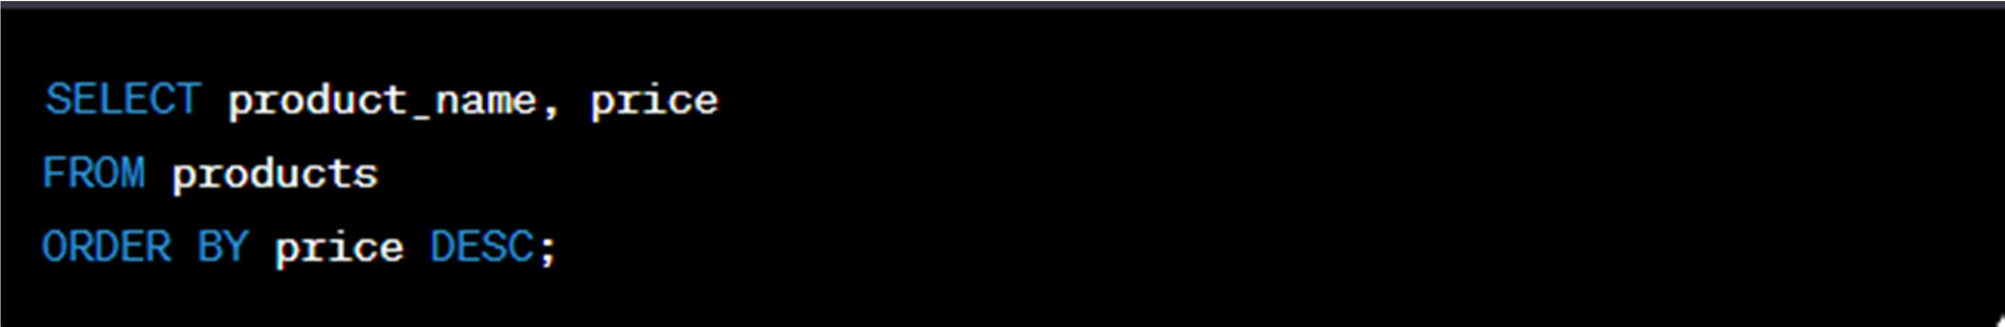
This query retrieves data from the "product_name" and "price" columns of the "products" table and sorts the result in descending order based on the "price" column.
You can also sort by multiple columns. In this case, the first column specified in the ORDER BY clause takes precedence, and if values are equal in the first column, it sorts by the second column, and so on. For example:
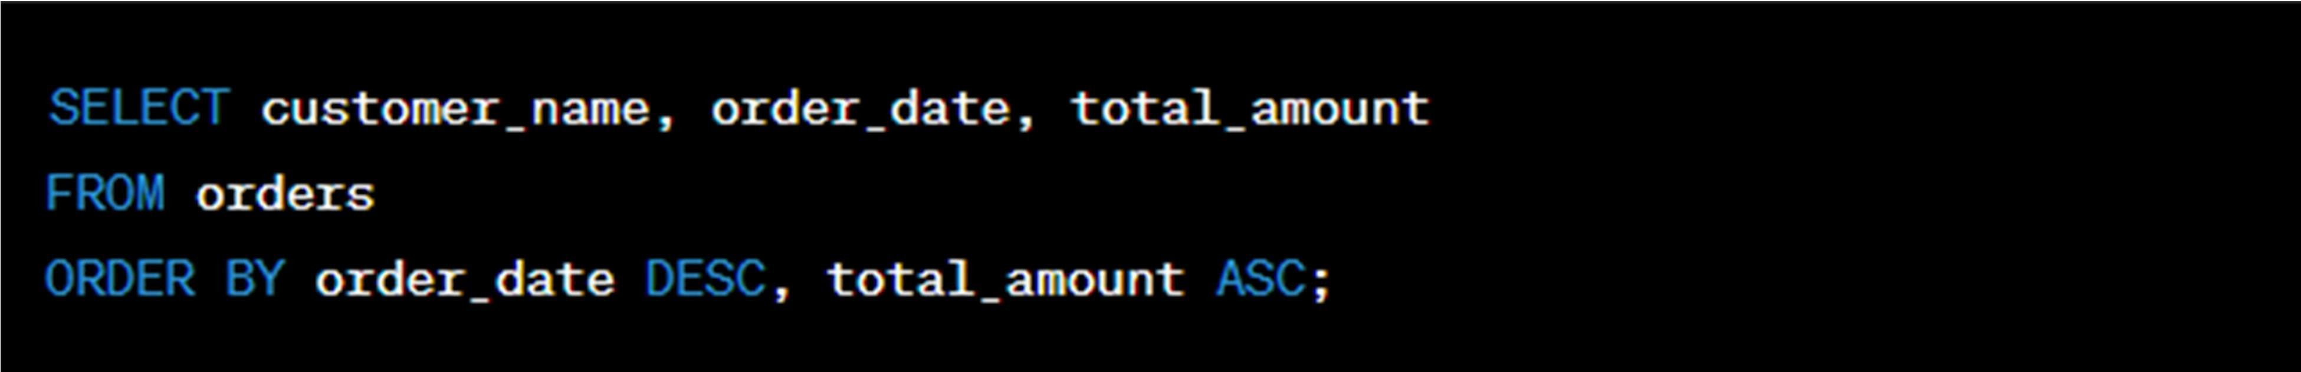
This query retrieves data from the "customer_name," "order_date," and "total_amount" columns of the "orders" table. It first sorts the result in descending order based on "order_date" and then in ascending order based on "total_amount."

Using the ORDER BY clause is useful for controlling the presentation of your query results and can be beneficial when you need data in a specific order for reporting or analysis.

Retrieving restricted rows by placing a specific criteria in the clause
To retrieve specific rows that meet certain criteria in SQL, you can use the WHERE clause in your SELECT statement. The WHERE clause allows you to filter rows based on specified conditions. Here's the basic syntax for using the WHERE clause:
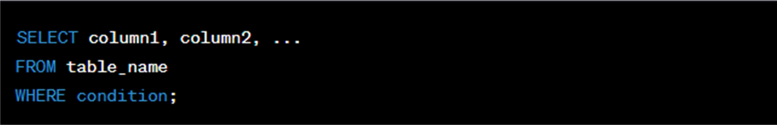
- column1, column2, etc.: The columns you want to retrieve.
- table_name: The name of the table from which you want to retrieve data.
- WHERE: The clause indicating that you want to filter rows based on a condition.
- condition: The condition that specifies the criteria for filtering rows.
Here's an example of using the WHERE clause to retrieve rows that meet a specific criteria:
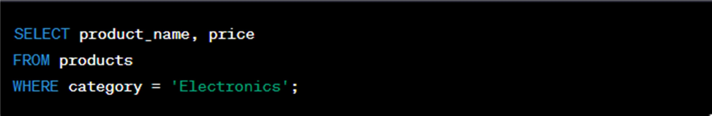
In this query, we retrieve data from the "product_name" and "price" columns of the "products" table. The WHERE clause filters the results to include only rows where the "category" column is equal to 'Electronics'.
You can use various operators in the condition to specify different criteria. Here are some commonly used operators:
• =: Equal to
- <> or !=: Not equal to
- <: Less than
- >: Greater than

- <=: Less than or equal to
- >=: Greater than or equal to
- AND: Logical AND
- OR: Logical OR
- NOT: Logical NOT
- IN: Matches any value in a list
- LIKE: Matches a pattern (using wildcards % and _)
For example, you can retrieve data for products with a price greater than $100 as follows:
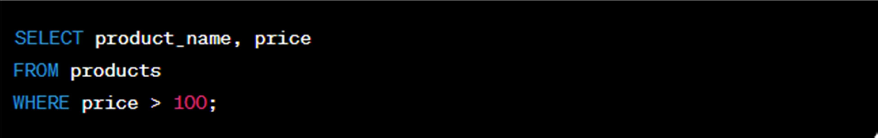

You can also combine multiple conditions using AND or OR to create more complex criteria. Here's an example:
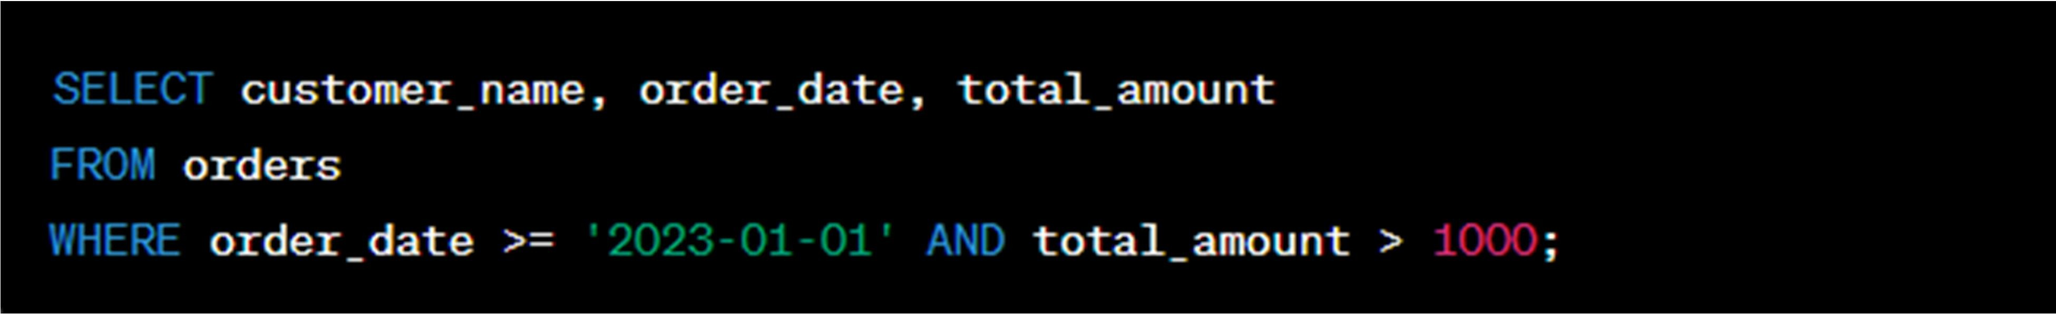
In this query, we retrieve data from the "customer_name," "order_date," and "total_amount" columns of the "orders" table, filtering rows where the "order_date" is on or after January 1, 2023, and the "total_amount" is greater than $1000.
Using the WHERE clause allows you to narrow down the results and retrieve only the rows that meet specific criteria, making your queries more focused and meaningful.

Retrieving restricted rows by placing a specific criteria in select statement
To retrieve specific rows by placing specific criteria directly in the SELECT statement in SQL, you can use a combination of conditional expressions and the CASE statement. This allows you to include or exclude rows based on conditions within the SELECT statement itself.
Here's an example of how to retrieve restricted rows with specific criteria in a SELECT
statement:
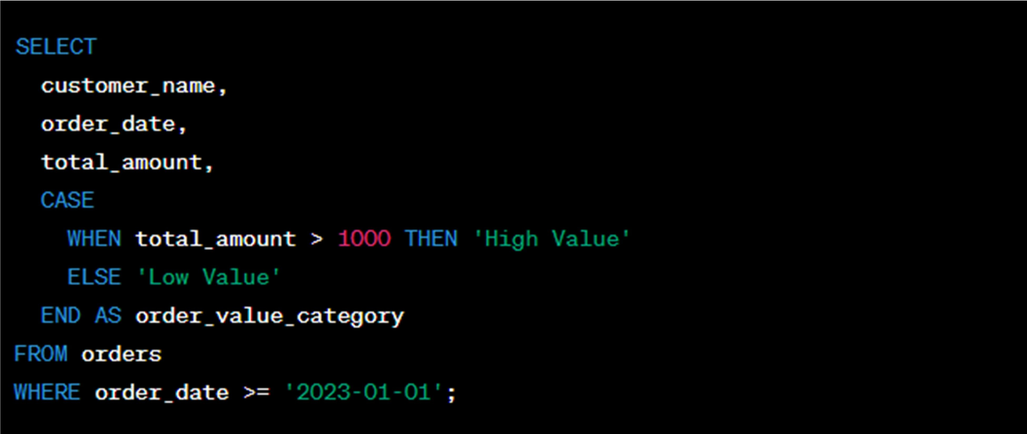
In this query:
- We're selecting data from the "customer_name," "order_date," and "total_amount" columns of the "orders" table.
- We use a CASE statement within the SELECT statement to categorize orders as either 'High Value' or 'Low Value' based on the "total_amount" column. If the "total_amount" is greater than 1000, it's categorized as 'High Value,' otherwise, it's 'Low Value.'
- We apply a WHERE clause to restrict the result to include only rows where the "order_date" is on or after January 1, 2023.
The result set will include the selected columns, and each row will also have an additional column called "order_value_category" that indicates whether the order is 'High Value' or 'Low Value' based on the "total_amount."

This approach is useful when you need to perform calculations or logic within the SELECT statement itself and include the results in the output. It can help simplify your SQL queries and make them more expressive.
Please note that the specific syntax and capabilities may vary depending on the database management system you are using (e.g., MySQL, PostgreSQL, SQL Server). Be sure to consult your database system's documentation for details on using conditional expressions and the CASE statement.

Using comparison operators in the clause to compare numeric, character, string, date and time data
You can use comparison operators in SQL to compare various data types, including numeric, character, string, date, and time data. Here are some common comparison operators and how to use them in SQL:

Numeric Comparison Operators:
• = (Equal to): Compares if two numeric values are equal.
  - != or <> (Not equal to): Compares if two numeric values are not equal.
  - < (Less than): Checks if one numeric value is less than another.
  - > (Greater than): Checks if one numeric value is greater than another.
  - <= (Less than or equal to): Checks if one numeric value is less than or equal to another.
  - >= (Greater than or equal to): Checks if one numeric value is greater than or equal to another.
Example:


Character and String Comparison Operators:
• = (Equal to): Compares if two character or string values are identical.
  - != or <> (Not equal to): Checks if two character or string values are not identical.
  - LIKE: Compares a character or string value with a pattern, often using wildcard characters (% and _).
Example:


Date and Time Comparison Operators:
• = (Equal to): Compares if two date or time values are equal.
  - != or <> (Not equal to): Compares if two date or time values are not equal.
  - < (Less than): Checks if one date or time value is earlier than another.
  - > (Greater than): Checks if one date or time value is later than another.
  - <= (Less than or equal to): Checks if one date or time value is earlier than or equal to another.
  - >= (Greater than or equal to): Checks if one date or time value is later than or equal to another.

Example:

When using these comparison operators in your SQL queries, be sure to match the data types appropriately. For example, when comparing dates, make sure the date format matches the one used in your database. Also, consider the collation (sorting and comparison rules) for character and string data when using comparison operators for text-based data.

Using Boolean operators with correct precedence
Boolean operators are used in SQL to combine multiple conditions in a query. The three primary Boolean operators in SQL are AND, OR, and NOT. These operators allow you to create complex conditions by combining simpler conditions. It's essential to use Boolean operators with the correct precedence to ensure that your query behaves as expected. The usual precedence order is NOT, AND, and OR.
Here's how to use Boolean operators with correct precedence:
- AND Operator (AND):
  - The AND operator is used to combine multiple conditions, and all the conditions must be true for the combined condition to be true.
Example:

OR Operator (OR):
  - The OR operator is used to combine multiple conditions, and at least one of the conditions must be true for the combined condition to be true.
Example:

SELECT * FROM employees WHERE department = 'Sales' OR department = 'Marketing'; This query retrieves employees who work in either the 'Sales' or 'Marketing' departments

NOT Operator (NOT):
The NOT operator is used to negate a condition, making it true if the original condition is false and vice versa.
Example:
SELECT * FROM customers WHERE NOT status = 'Inactive'; This query retrieves customers who do not have an 'Inactive' status.

Parentheses for Grouping:
To control the order of evaluation and ensure correct precedence, you can use parentheses to group conditions.
Example:
SELECT * FROM employees WHERE (age >= 30 OR experience_years >= 5) AND department = 'Engineering';
In this query, the conditions inside the parentheses are evaluated first, and then the AND condition is applied to the results.
Using parentheses is especially important when combining AND and OR operators in the same query to make your intentions explicit and avoid unexpected behavior.
Understanding the correct precedence and using parentheses when necessary is crucial to ensure that your SQL queries produce the desired results and correctly evaluate complex conditions.

Using criteria in the where clause in
You can use the WHERE clause in SQL to filter rows based on specific criteria, and there are various ways to do this, including checking for a range of values, selecting values from a list, and checking for values that match a pattern.

Checking for a range of values
You can use comparison operators to filter rows based on a range of values. For example, to retrieve products with prices between $50 and $100:
SELECT * FROM products WHERE price >= 50 AND price <= 100;
This query retrieves rows from the "products" table where the "price" is greater than or equal to 50 and less than or equal to 100.

selecting values from a list
You can use the IN operator to filter rows based on a list of values. For example, to retrieve orders from customers in New York or California:
SELECT * FROM orders WHERE customer_state IN ('New York', 'California');
This query retrieves rows from the "orders" table where the "customer_state" is either 'New York' or 'California'.

Checking for Values that Match a Pattern
You can use the LIKE operator with wildcard characters to match values that fit a specific pattern. For example, to retrieve products with names starting with 'Laptop':
SELECT * FROM products WHERE product_name LIKE 'Laptop%';
This query retrieves rows from the "products" table where the "product_name" starts with 'Laptop'. The '%' wildcard matches any sequence of characters, so it matches 'Laptop,' 'Laptop Pro,' 'Laptop 2023,' and so on.
You can also use the NOT LIKE operator to exclude rows that match a particular pattern. For example, to retrieve products with names that don't start with 'Accessory':
SELECT * FROM products WHERE product_name NOT LIKE 'Accessory%';
This query retrieves rows where the "product_name" does not start with 'Accessory'.
These SQL techniques are commonly used to filter and retrieve specific data from a database based on various criteria, making it easier to work with the data that meets your specific requirements.

Using SQL syntax to supress duplicate values from query result
To suppress or remove duplicate values from the result of an SQL query, you can use the DISTINCT keyword with the SELECT statement. The DISTINCT keyword is used to retrieve only unique values from the specified column(s). Here's how you can use it:
Syntax:
SELECT DISTINCT column1, column2, ... FROM table_name;
column1, column2, etc.: The columns for which you want to retrieve distinct (unique) values. table_name: The name of the table from which you want to retrieve data.
For example, if you have a "products" table and you want to retrieve a list of unique product categories, you can use the following query:
SELECT DISTINCT category FROM products;
This query will return a list of unique product categories, removing any duplicate values from the "category" column.
It's important to note that DISTINCT operates on all selected columns. If you want to retrieve distinct combinations of values from multiple columns, you can use GROUP BY. For instance, if you have a "sales" table and want to find unique combinations of customer and product, you can use GROUP BY like this:
SELECT customer_name, product_name FROM sales
GROUP BY customer_name, product_name;

The GROUP BY clause allows you to group rows based on specific columns, effectively suppressing duplicate combinations of those columns in the result set.
Using DISTINCT or GROUP BY is a valuable tool when you want to retrieve unique values or combinations from your database, helping you simplify and clean your query results.

Taking action to execute null values from a query result
In SQL, you can take action to handle and filter out null values from a query result using the IS NULL and IS NOT NULL operators. Here's how you can use them:

Filtering Rows with Null Values (IS NULL):
To retrieve rows that contain null values in a specific column, you can use the IS NULL
operator. For example, to retrieve all products with null values in the "description" column:
This query will return rows where the "description" column is null.

Filtering Rows without Null Values (IS NOT NULL):
To retrieve rows that do not contain null values in a specific column, you can use the IS NOT NULL operator. For example, to retrieve all products with a non-null value in the "price" column:
SELECT * FROM products WHERE price IS NOT NULL;
This query will return rows where the "price" column is not null.

Handling Null Values in the Result (COALESCE):
If you want to replace null values in the query result with a specific default value, you can use the COALESCE function. For example, if you want to replace null values in the "description" column with "No description available":
SELECT product_name, COALESCE(description, 'No description available') AS description FROM products;
This query uses the COALESCE function to replace null values with the specified default value in the result set.

Handling null values is important to ensure the accuracy and completeness of your query results. The methods mentioned above allow you to filter and manage null values effectively in your SQL queries.

Unit 2 Write SQL statements that use functions

Using arithmetical operators with the correct precedence Arithmetic Operators
You can use arithmetic operators in Multidimensional Expressions (MDX) for any arithmetic computations, including addition, subtraction, multiplication, and division.
MDX supports the arithmetic operators listed in the following table.

Operator Description

+ (Add) Adds two numbers.

/ (Divide) Divides one number by another number.

* (Multiply) Multiplies two numbers.

- (Subtract) Subtracts two numbers.

^ (Power) Raises one number by another number.

Note:
MDX does not include a function to obtain the square root of a number. To obtain the square root of a number, raise it to the power of 0.5 using the ^ operatior.

Order of Precedence
The following rules determine the order of precedence for arithmetic operators in an MDX expression:
- When there is more than one arithmetic operator in an expression, MDX performs multiplication and division first, followed by subtraction and addition.

- When all arithmetic operators in an expression have the same level of precedence, the order of execution is left to right.
- Expressions within parentheses take precedence over all other operations.

In SQL, you can perform arithmetic operations using operators such as +, -, *, and /. It's important to understand operator precedence when combining multiple operators in an expression.
Example: Suppose you have a table called "Products" with columns "Price" and "Quantity." You want to calculate the total cost for each product, considering the unit price and quantity. The SQL statement would be:
SELECT ProductName, (Price * Quantity) AS TotalCost FROM Products;
In this example, the * operator is used to multiply the "Price" and "Quantity" columns to obtain the "TotalCost."

Using String Functions and Operators:
SQL provides various string functions and operators for working with text data. For instance, you can use the CONCAT function to concatenate strings.
Example:
Suppose you have a table called "Employees" with columns "FirstName" and "LastName." You want to create a single string representing the full name. The SQL statement would be:

In this example, the CONCAT function is used to combine the "FirstName" and "LastName" columns with a space in between.

In SQL Server It is not possible to perform any calculations on String values (such as Varchar or Char).

- SELECT last_name , first_name + 300
- FROM employees
3
- (error)

Using Mathematical Functions:
SQL offers mathematical functions for performing operations like rounding, absolute value, square root, etc.
Example:
Suppose you have a table called "Orders" with a "TotalAmount" column. You want to calculate the square root of the total amount. The SQL statement would be:

SELECT OrderID, SQRT(TotalAmount) AS SquareRootAmount FROM Orders;
In this example, the SQRT function calculates the square root of the "TotalAmount."

Using Date Functions:
SQL provides various date functions for working with date and time data. Example:
Suppose you have a table called "Events" with a "EventDate" column, and you want to find the events that occurred within the last 30 days. The SQL statement would be:

SELECT EventName, EventDate FROM Events
WHERE EventDate >= DATEADD(day, -30, GETDATE());
In this example, the DATEADD function subtracts 30 days from the current date (GETDATE()), and the WHERE clause filters events that occurred after that date.

  - Using SQL Aggregate Functions:
SQL aggregate functions are used to perform calculations on sets of values.

AVG () - The AVG() function returns the average value of a numeric column.

AVG() Syntax
SELECT AVG(column_name) FROM table_name
WHERE condition;

Example
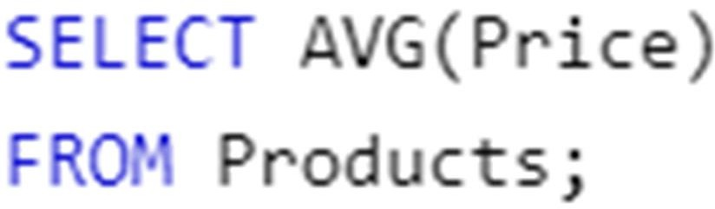

COUNT() – The COUNT() function returns the number of rows that matches a specified criterion.
COUNT() Syntax
SELECT COUNT(column_name) FROM table_name
WHERE condition;

Example

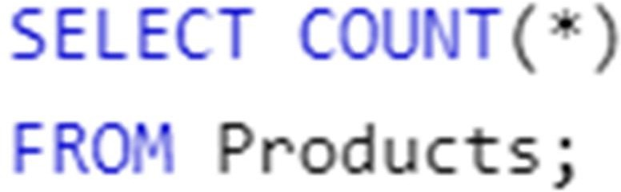

FIRST() - Returns the first value

LAST() - Returns the last value MAX() - Returns the largest value MIN() - Returns the smallest value
SUM() - The SUM() function returns the total sum of a numeric column.

SUM() Syntax
SELECT SUM(column_name) FROM table_name
WHERE condition;

Example:
Suppose you have a table called "Orders" with an "OrderAmount" column, and you want to find the total sales for a specific period. The SQL statement would be:
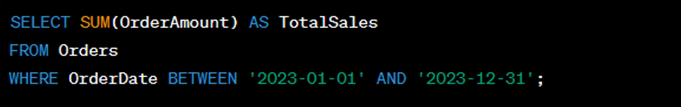
In this example, the SUM function calculates the total sales for orders placed between January 1, 2023, and December 31, 2023.
These examples demonstrate the use of arithmetical, string, mathematical, date, and aggregate functions in SQL queries to obtain the desired query output, depending on the data and calculations you need.

Unit 3: Write SQL statements that use aggregation and filtering

Using Clause to Aggregate Data by Multiple Columns:
When you want to aggregate data based on multiple columns, you can use the GROUP BY clause. This clause allows you to group rows by one or more columns and apply aggregate fun SQL GROUP BY Statement
The GROUP BY statement is used in conjunction with the aggregate functions to group the result-set by one or more columns.

SQL GROUP BY Syntax
- SELECT column_name, aggregate_function(column_name)
- FROM table_name
- WHERE column_name operator value
- GROUP BY column_name
SQL GROUP BY Example1
We have the following "Orders" table:

O_Id | OrderDate | OrderPrice | Customer
1 | 2008/11/12 | 1000 | Hansen
2 | 2008/10/23 | 1600 | Nilsen
3 | 2008/09/02 | 700 | Hansen
4 | 2008/09/03 | 300 | Hansen
5 | 2008/08/30 | 2000 | Jensen
6 | 2008/10/04 | 100 | Nilsen
Now we want to find the total sum (total order) of each customer.

We will have to use the GROUP BY statement to group the customers. We use the following SQL statement:
- SELECT Customer,SUM(OrderPrice) FROM Orders
- GROUP BY Customer
The result-set will look like this:

Customer | SUM(OrderPrice)
Hansen | 2000
Nilsen | 1700
Jensen | 2000
Let's see what happens if we omit the GROUP BY statement:
- SELECT Customer,SUM(OrderPrice) FROM Orders
The result-set will look like this:

Customer | SUM(OrderPrice)
Hansen | 5700
Nilsen | 5700
Hansen | 5700
Hansen | 5700
Jensen | 5700
Nilsen | 5700
The result-set above is not what we wanted.

Explanation of why the above SELECT statement cannot be used: The SELECT statement above has two columns specified (Customer and SUM(OrderPrice). The "SUM(OrderPrice)" returns a single value (that is the total sum of the "OrderPrice" column), while "Customer" returns 6 values (one value for each row in the "Orders" table). This will therefore not give us the correct result. However, you have seen that the GROUP BY statement solves this problem.

GROUP BY More Than One Column
We can also use the GROUP BY statement on more than one column, like this:
•
SELECT
Orders
Customer,OrderDate,SUM(OrderPrice)
FROM
- GROUP BY Customer,OrderDate
Now we want to find if the customers "Hansen" or "Jensen" have a total order of more than 1500.
We add an ordinary WHERE clause to the SQL statement:
- SELECT Customer,SUM(OrderPrice) FROM Orders
- WHERE Customer='Hansen' OR Customer='Jensen'
- GROUP BY Customer
- HAVING SUM(OrderPrice)>1500
The result-set will look like this:

Customer | SUM(OrderPrice)
Hansen | 2000
Jensen | 2000
ctions to each group.

Example: 2
Suppose you have a table called "Sales" with columns "Product," "Region," and "Revenue." To aggregate data by both "Product" and "Region" and calculate the total revenue for each combination, you can use the following SQL statement:
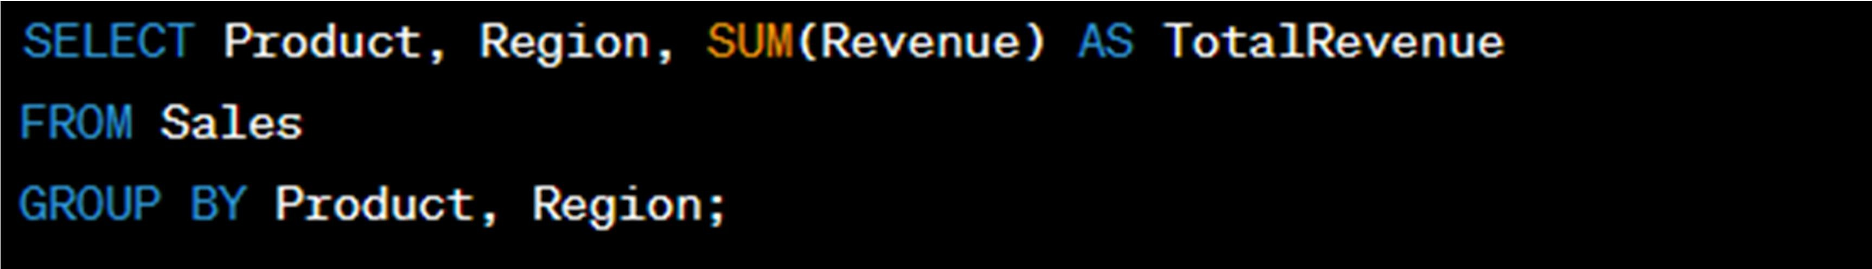
In this example, the data is grouped by both "Product" and "Region," and the SUM function is applied to calculate the total revenue for each group.

Sorting Aggregate Data in Query Output:
You can sort the aggregate data in the query output using the ORDER BY clause. This allows you to specify the order in which the results should be displayed.
Use ORDER BY if you want to order rows according to a value returned by an aggregate function like SUM(). The ORDER BY operator is followed by the aggregate function (in our example, SUM()). DESC is placed after this function to specify a descending sort order. Thus, the highest aggregate values are displayed first, then progressively lower values are displayed. To sort in ascending order, you can specify ASC or simply omit either keyword, as ascending is the default sort order.
Example1:
Continuing with the "Sales" table, if you want to see the total revenue for each product and region combination, sorted in descending order of revenue, you can use the following SQL statement:

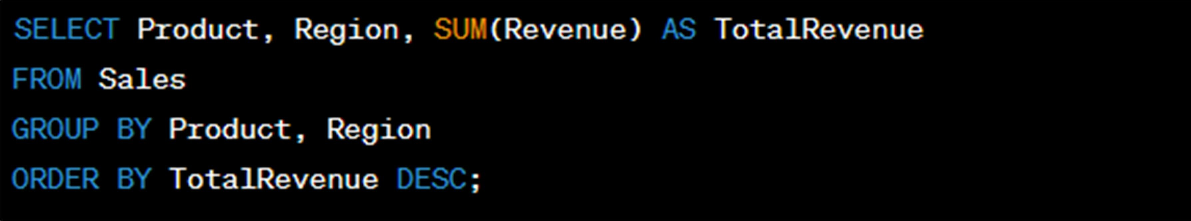

In this example, the data is first aggregated, and then the results are sorted in descending order of the "TotalRevenue" column.

Filtering Aggregate Data Using the HAVING Clause:
The HAVING clause is used to filter the results of aggregate functions. It allows you to specify conditions that the aggregated data must meet.

SQL HAVING Syntax
- SELECT column_name, aggregate_function(column_name)
•
•
FROM table_name
WHERE column_name operator value
- GROUP BY column_name
- HAVING aggregate_function(column_name) operator value

SQL HAVING Example1
We have the following "Orders" table:

O_Id | OrderDate | OrderPrice | Customer
1 | 2008/11/12 | 1000 | Hansen
2 | 2008/10/23 | 1600 | Nilsen
3 | 2008/09/02 | 700 | Hansen

Page 92 of 98 | Entoto Poly Technic College Author/Copyright | Using Basic Structured Query Language | Version -1
Page 92 of 98 | Entoto Poly Technic College Author/Copyright | Using Basic Structured Query Language | September , 2023

4 | 2008/09/03 | 300 | Hansen
5 | 2008/08/30 | 2000 | Jensen
6 | 2008/10/04 | 100 | Nilsen

Now we want to find if any of the customers have a total order of less than 2000. We use the following SQL statement:
SELECT Customer,SUM(OrderPrice) FROM Orders GROUP BY Customer
HAVING SUM(OrderPrice)<2000
The result-set will look like this:
Customer | SUM(OrderPrice)
Nilsen | 1700

Example2:
Suppose you want to find product-region combinations with a total revenue greater than
$10,000. You can use the following SQL statement:

SELECT Product, Region, SUM(Revenue) AS TotalRevenue FROM Sales
GROUP BY Product, Region HAVING TotalRevenue > 10000;
In this example, the HAVING clause filters the results to include only those combinations where the "TotalRevenue" is greater than $10,000.
These SQL statements demonstrate how to aggregate data, sort the results, and filter aggregated data using the GROUP BY, ORDER BY, and HAVING clauses, respectively. These clauses are essential for summarizing and manipulating data in SQL queries.

Unit 4: Write and execute SQL sub-queries

Constructing Single and Nested Sub-Queries:
A single sub-query is a query that is embedded within another query, and a nested sub-query is a sub-query inside another sub-query.
Single Sub-Query Example:
Suppose you have a table called "Employees" and want to find employees who earn more than the average salary. You can use a single sub-query as follows:

SELECT EmployeeName FROM Employees
WHERE Salary > (SELECT AVG(Salary) FROM Employees);
In this example, the sub-query (SELECT AVG(Salary) FROM Employees) calculates the average salary, and the main query retrieves employees with a salary greater than that average.
Nested Sub-Query Example:
You can nest sub-queries to create more complex queries. For example, if you want to find the department with the highest average salary, you can use a nested sub-query like this:
SELECT DepartmentName FROM Departments WHERE DepartmentID = (
SELECT DepartmentID

FROM Employees GROUP BY DepartmentID HAVING AVG(Salary) = (
SELECT MAX(AvgSalary) FROM (
SELECT AVG(Salary) AS AvgSalary FROM Employees
GROUP BY DepartmentID
) AS DepartmentAverages
)
);
Here, multiple sub-queries are nested to find the department with the highest average salary.

Constructing Sub-Queries That Return Single Row and Multiple Rows:
A sub-query can return either a single row or multiple rows. Single-row sub-queries are used with operators like =, >, <, etc., while multi-row sub-queries are used with operators like IN, ANY, or ALL.
Single-Row Sub-Query Example:
Suppose you have a table called "Products" and want to find the product with the highest price. You can use a sub-query to achieve this:

In this case, the sub-query (SELECT MAX(Price) FROM Products) returns a single maximum price.

Multiple-Row Sub-Query Example:
Suppose you have a table called "Orders" and you want to find orders placed by customers in a specific list of countries. You can use a sub-query with the IN operator:

SELECT OrderID FROM Orders
WHERE CustomerID IN (SELECT CustomerID FROM Customers WHERE Country IN ('USA', 'Canada', 'UK'));
In this example, the sub-query returns multiple customer IDs based on the specified countries, and the main query retrieves orders from those customers.

Using Correlated Sub-Queries to Retrieve Required Data:
Correlated sub-queries are sub-queries that reference columns from the outer query, making them dependent on the outer query.
Example:
Suppose you have a table called "Orders" and you want to find orders with a value greater than the average order value for the same customer. You can use a correlated sub-query like this:
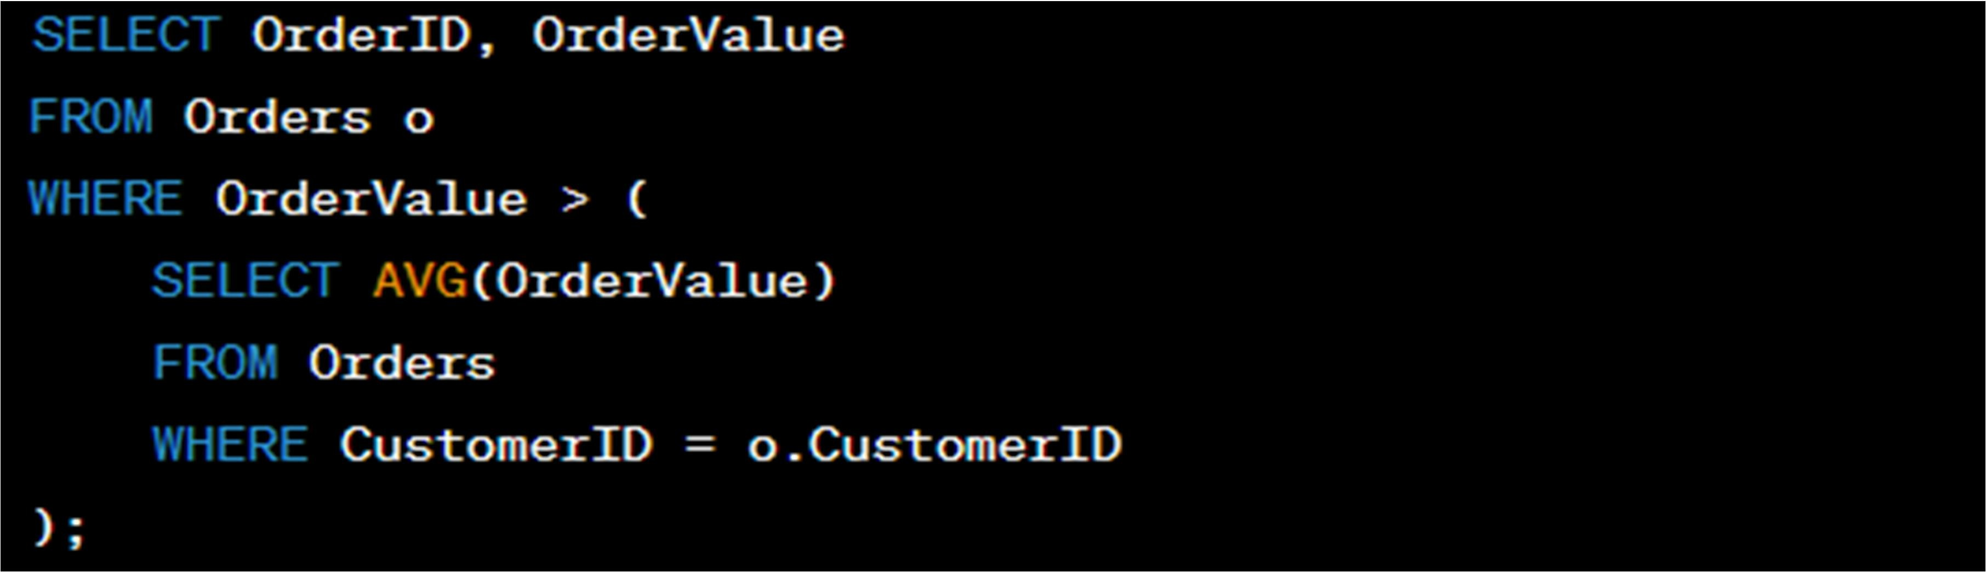
In this case, the sub-query calculates the average order value for each customer and is correlated to the outer query by referencing the CustomerID column.

Writing Sub-Queries Using Aggregates:
You can use sub-queries with aggregates to perform complex calculations. Example:
Suppose you have a table called "Employees" and you want to find employees with salaries above the department's average salary. You can use a sub-query with an aggregate like this:

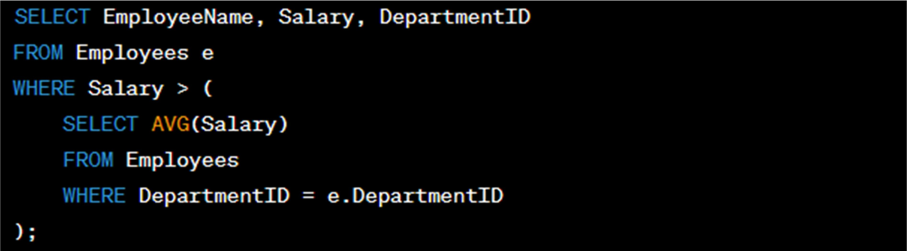
In this example, the sub-query calculates the average salary for each department and is correlated to the outer query by referencing the DepartmentID column.
These examples demonstrate the use of single and nested sub-queries, both returning single and multiple rows, and using correlated sub-queries and aggregates to retrieve specific data in SQL queries.

