Footwear Production
Level I

Based on December 2021, Curriculum Version 1
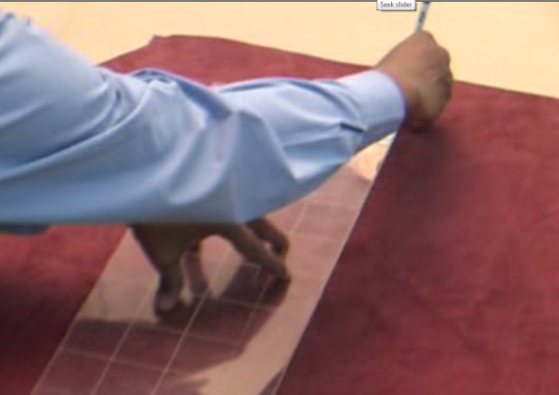

Module Title: Performing Leather Grading
Module Code: IND FWP1 M02 1221
Nominal duration: 36 Hours

Prepared by: Ministry of Labor and Skills

August, 2022
Addis Ababa, Ethiopia
Table of Contents
Introduction to the Module 5
Unit One: Identify, Prepare and Use Hand Tools and Equipment 6
1.1 Identifying hand tools and equipment 7
1.2 Checking tools for serviceability and safety 9
1.3. Cleaning, Checking, Maintaining and Storing Tools and Equipment 10
Self-check 1 14
Unit Two: - Describe Principles, and Concepts of Leather Grading 15
2.1 Describing the principle and concepts of leather grading 15
2.2 Explaining the methods of leather grading 17
2.3 Describing the objective of the leather grading 19
Self-Check – 2 21
Unit Three: Determine Defects of Leather 23
3.1 Describing the types and identifying defects on leather 23
3.2 Describing the Effect of Defects on the Footwear 32
Self-Check – 3 34
Unit Four: Determining and Measurement of Defective Area 36
4.1 Identifying the method of determining the area using different techniques 36
4.2 Describing the method of determination of the area 42
4.3 Describing the method of measuring of leather 45
Self-Check – 4 51
Operation sheet 1– Leather Area Measuring by Grid Method 51
Lap Test 56
Unit Five: Perform Quality Check on Leather 57
5.1 Describing and performing various physical tests on the leather 57
5.2. Method of sample selection in leather testing 63
5.3 Checking characteristics of the leather 68
Self-Check -5 71
Unit Six: Assess the Grade of the Leather 72
6.1 Evaluating leather cutting value and its suitability 73
6.2 Performing storage and bundling of the leather 77
6.3 Performing the reassessment on the value of received consignment 80
6.4 Determining the purchase cost variance from the consignment 83
6.6 Performing reports and documentation work 86
Self-Check – 2 91
References 93
Experts Who Developed This Learning Guide 94

Acknowledgment
Ministry of Labor and Skills wishes to extend thanks and appreciation to the many representatives of TVET instructors and respective industry experts who donated their time and expertise to the development of this Teaching, Training and Learning Materials (TTLM)

Introduction to the Module
Leather grading is the process of sorting out of finished leather into different groups e.g. A, B, C or I, II, III etc., as per the quality and cutting value. Cutting value is defined as the % usable area i.e., the % area of leather which is free of any defect. This module is designed to meet the industry requirement under the Footwear Production occupational standard, particularly for the unit of competency: Performing Basic Stitching
This module covers the units:
- Identifying and use hand tools and equipment
- Describing principles, and concepts of leather grading
- Determining defects of leather
- Determining and performing measurement of defective area
- Performing quality check on the leather
- Assessing grade of the leather and determine financial implication on its procurement
Learning Objective of the Module
- Identify and prepare use hand tools and equipment
- Describe principles, and concepts of leather grading
- Determine defects of leather
- Determine and perform measurement of defective area
- Perform quality check on the leather
- Assess grade of the leather and determine financial implication on its procurement
Module Instruction
For effective use this modules trainees are expected to follow the following module instruction:
- Read the information written in each unit
- Accomplish the Self-checks at the end of each unit
- Perform Operation Sheets which were provided at the end of units
- Do the “LAP test” giver at the end of each unit and
- Read the identified reference book for Examples and exercise

Unit One: Identify, Prepare and Use Hand Tools and Equipment
This unit is developed to provide you the necessary information regarding the following content coverage and topics
      - Identifying hand tools and equipment
      - Checking tools for serviceability and safety
      - Clearing work area Cleaning, checking, maintaining and storing hand tools and equipment
This unit will also assist you to attain the learning outcomes stated in the cover page. Specifically, upon completion of this learning guide, you will be able to:
      - Identify hand tools and equipment
      - Check tools for serviceability and safety
      - Clear work area, Clean check, maintain and store hand tools and equipment

1.1 Identifying hand tools and equipment
Introduction
This topic covers the knowledge, attitudes and skills required to identify, use and proper handling of tools and equipment.
- A Tool is an item or implement used for a specific purpose. A tool can be a physical object such as mechanical tools including saws and hammers
- A hand tool is a device for performing work on a material or a physical system using only hands. The hand tools can be manually used employing force, or electrically powered, using electrical current. Virtually every type of tool can be a hand tool and many have also been adapted as power tools, which get their motive power from motors or engines rather than from human mechanical action.
- Equipment is defined as a set of tools, devices, kit, etc., assembled for a specific purpose.
The difference between hand tool and equipment is usually that hand-tools usually refer to manual tools. Equipment is usually referring to anything that is powered by either electricity or by a motor off some sort
Grading tools
Hand tools are selected consistent with needs of the job. So before starting any operations selecting the tools for that needed job must be done. Some of the grading tools are: -
Measuring grid
A tool used in measuring of hides and skins with defects or without defects then this will help in setting out of grades. To set out a grade for leathers grading tool is used. This area measuring grid tool (commonly is used in footwear factory for the purpose of regarding and very close to the actual and accurate size.)
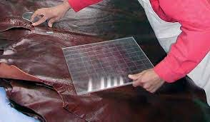
Fig 1.1 Measuring Grid
Thickness measuring gauge
The thickness of the leather is measured comparing with the reference sample leather and with the help of thickness gauge.
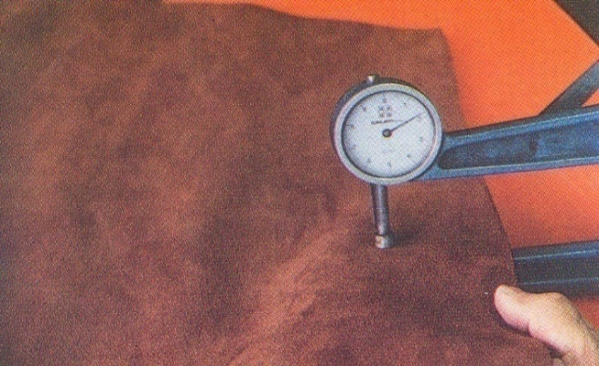
Fig 1.2. Thickness measuring gauge
Ruler
Whenever measurement is needed steel ruler can be used.
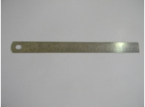
Fig 1.3. Ruler

Silver Marketing pen: Marking the work before required operation.
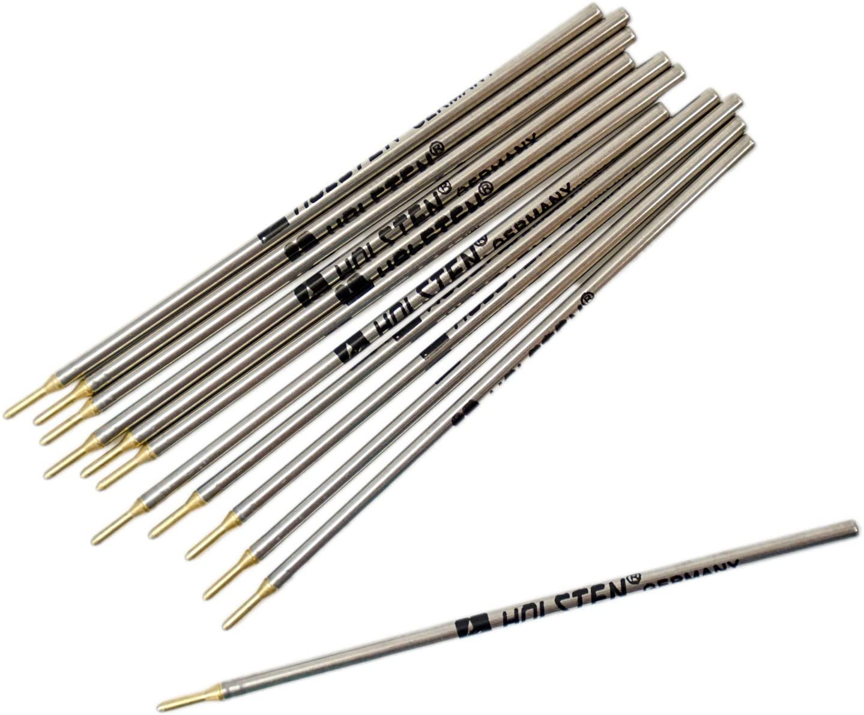
Fig 1.4. Silver Marketing pen
White pencil: - while performing leather grading by using griding tool, it used for glass marking of the defected area and edge of the area.
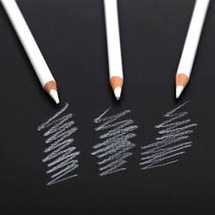
Fig 1.5. White pencil

1.2 Checking tools for serviceability and safety
2.11 Tools Serviceability
Before any use of the tools there must be checking practice. Tools are checked for the sake of serviceability and safety, and faults to be reported. Some of check points for the tools can be:
I. Checking the breakage of tools: We should check tools for any breakage. We should check the tools properly before starting the work.
II. Checking the accuracy: After checking any breakage of tools, we should check its accuracy of working. If it is working properly than we should start our actual work.
Safety Measures While Using the Hand Tools
Generally, safety measures are those actions taken to improve or ensure the safety of a particular place, activity, group, function, or piece of equipment/tools. One of the key issues associated with hand tool safety is choosing and using the right tool. Unfortunately, many people use tools improperly, where they improvise with what they have on hand. Also, many people view hand tools as simple to use, so there is little concern for safety. In reality, a person using hand tools, no matter what they are, should always follow safety precautions. Approximately 8 percent of industrial incidents result from the improper use of hand tools, according to studies. Injuries range from simple cuts, contusions and abrasions to amputations, fractures and punctures. For instance, when we perform cutting operation manually by using cutting tools, methods for holding the tools and operating must be clearly known for the sake of safety, unless damage will occur in our fingers or hand
Safety rules for hand tool usage include
- Selecting the correct tool and the right sized tool for the job
- Inspecting tools for damage before attempting a task
- Keeping tools clean and cutting tools sharp
- Carrying tools in a manner that prevents cuts to yourself or someone else, especially if you should fall
- Always passing tools to others handle first and never throwing tools to another person
- Ensuring workers have proper training before using a particular tool for the first time
- Wearing proper personal protective equipment (e.g., safety glasses, face shields, gloves, etc.) when using hand tools
- Cutting away from your body to avoid injury if the cutting device should slip
- Taking advantage of the ergonomically shaped handles available on some tools and holding tools in a manner that minimizes stress to the hand, wrist and arm.

1.3. Cleaning, Checking, Maintaining and Storing Tools and Equipment
1.3.1 Cleaning work area and Hand Tools
The working area is defined, as the area of the workplace where tasks are performed. Cleaning the work area after performing a given task is vital, kept free from waste to ensure a safe working environment for self, fellow workers and others in the workplace.
Work area should be cleaned by following workplace standard procedures: -
Dust bins for bio-degradable waste materials: -Bio-degradable garbage (waste materials) means the garbage or waste materials that are capable of being destroyed by the action of living beings.
Dust bins for non-biodegradable waste materials: -A Non-bio-degradable waste material (garbage) means the garbage or waste materials that are not capable of being destroyed by the action of living beings.
Cleaning of workshop: -Clean floors and decking at the end of each shift and place all rubbish and waste in approved containers for disposal
Safety check
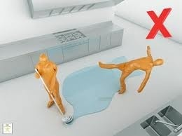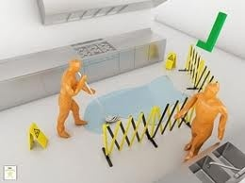
Fig1. 6. Safety check
- Some cleaning agents are toxic. Refer the instructions on any cleaning agent and follow any recommendations before using it.
- Make sure designated walkways are kept clear of any obstructions.
- Always wear protective clothing and the appropriate safety equipment.
- Make sure that you understand and observe all legislative and personal safety procedures when carrying out the maintenance tasks. If you are unsure of what these are, ask your Instructor.
You have to be: -
- Clear and clean the area
- Store any reusable materials
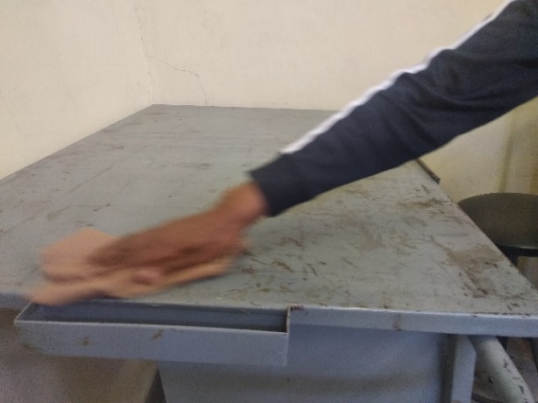
Fig 1.7. Cleaning work table
Cleaning of leather stores
In footwear manufacturing the leather must have good quality in order to be used for footwear production. Leather stores plays a big role in taking care of the leather stored so housekeeping of leather stores must be given an emphasis. The store must be clean and free of dusts and other waste materials.
The following points should be followed:
- Sort reusable equipment, components and materials from waste
- Reusable materials are correctly stored
- All tools and equipment are properly stored.
Every time a piece of equipment is used, the general rule is to clean it straight away so it is ready for the next person to use. The manufacturers’ instructions should be strictly followed when maintaining and cleaning equipment.
Skills and actions need to clean up tools: -
- Select and use an appropriate method for cleaning
- tools and specialist equipment
- Restore your work area to a safe and tidy condition
- Make sure that any materials, components, tools and equipment that you may need for the next task are set up ready for use.
1.3.2 Cleaning, maintaining and storing of hand Tools
Clean your hand tools after every project for better performance and lifespan. Keep your hand tools in good, clean condition with two sets of rags. One rag should be lint-free to clean or handle precision instruments or components. The other should be oily to prevent rust and corrosion.
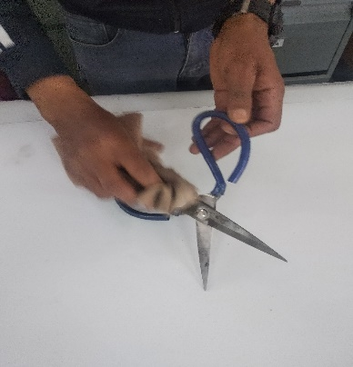
Fig 1.8. Cleaning and keeping tools
To maintain cleaning equipment and keep it in a good working condition, it must be thoroughly cleaned and stored correctly every time it is used. If regular maintenance does not occur, the equipment may, over time, become dangerous to individuals.
Storing of hand tools
- Location: Hand tools should be safely located when not in immediate use.
- Safety: Hand tools should be used safely and effectively according to their intended use.
- Systematically arrangement: Hand tools should be clamped or fixed in position.
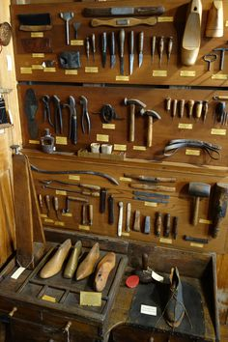
Fig 1. 9. Storing the tools

Self-check 1 | Written test

Name…………………………………………… ID………………………… Date…….
Directions: Answer all the questions listed below. Examples may be necessary to aid some explanations/answers.
Short Answer Questions:
Directions: Answer all the questions listed below. Examples may be necessary to aid some explanations/answers. (Total Points: 9x2+2 =20)
- What is hand tool?
- Discus the difference between hand tool and equipment?
- List hand tools which used in leather grading?
- What are the check points of the hand tools? (2 points)
- What are the safety aspects of the hand tools? (2 points)
- What is the difference between Bio-degradable and Non-bio-degradable waste materials? (Points: 4)
- Why cleaning is important for leather stores? (Points: 2)
- What is the purpose of cleaning and storing of hand tools?
- How can we keep the hand tools?

Note: Satisfactory rating - 20 points Unsatisfactory - below -20 points
You can ask you teacher for the copy of the correct answers

Unit Two: - Describe Principles, and Concepts of Leather Grading
This unit is developed to provide you the necessary information regarding the following content coverage and topics:
- Describing the principle and concepts of leather grading
- Explaining the methods of leather grading
- Describing the objective of the leather grading
This unit will also assist you to attain the learning outcomes stated in the cover page. Specifically, upon completion of this learning guide, you will be able to:
- Describe the principle and concepts of leather grading
- Explain the methods of leather grading
- Describe the objective of the leather grading

2.1 Describing the principle and concepts of leather grading
2.1.1 Concepts of leather grading
Leather is a durable and flexible material obtained from animal hide or skin, primarily cattle hide. The hide or skin is converted into leather by a process known as tanning.
Leather grading is the process of sorting out of finished leather into different groups. E.g. A, B, C or I, II, III etc., as per the quality and cutting value Cutting value is defined as the % usable area i.e., the % area of leather which is free of any defect.
In other words
Cutting value (C.V.) = 100 – % defective area
% defective area = (Total defective area / area of leather) × 100.
Example 4.1
Net detective area = 5sdm,
Leather area = 110sdm.
∴ Defective area 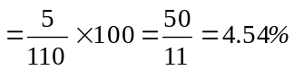
∴ Cutting volume (100 – 4.5) % = 95.5%
Upper leather varies in nature; no two skins are the same. Because of this a method of sorting for cutting value is recommended. Skin of similar cutting value can be group together and allocated a grade or point value e.g. the skin of cutting value between 100 to 97% are grouped in grade A 0r 1. Similarly skims of cutting value between 96% to 92% are grouped in grade B or 2 etc. Each tanner has his own standards. Some tanners grade by A.B.C. etc. and some by 1.2.3. Etc.
Generally, Leather grading is done to assess the financial implications and quality implications after purchasing.
    - Principles of leather Grading
- Calculation of Cutting Value and percentage of defects
As we have seen earlier, the cutting value is calculated as a percentage on 1st grade skin we have an allowance of up to 3% defected area. The following table shows the various grading allowances. The grades after 1st grade all vary by 5%.
Table 1. Cutting Value and percentage of defects
Grade | Cutting Value | %Wastage(defects)
A or 1 | 100% to 97% | Up to 3%
B or 2 | 96% to 92% | 8%
C or 3 | 91% to 87% | 13%
D or 4 | 86% to 82% | 18%
E or 5 | 81% to 77% | 23% etc.

- Units of measurements
The common units of leather measurement in footwear factories and leather manufacturing tanneries are: -
      - Square feet (sq.ft): the most commonly used measuring unit.
      - Square decimeter(sq.dm)
      - Square meter(sq.m)
      - Square centimeter (sq.cm)
- Conversions of units of measurements
As described above, the most commonly used leather measuring unit as compare to the other units in different leather measurement in footwear factories and leather manufacturing tanneries is Square feet (sq.ft).the following table shows how to convert from one leather measuring unit to the others.
Table 2. Conversions of units of measurements
1 feet = 0.3048 meter = 30.48 centimeter = 3.048 decimeter
1 Square feet (sq.ft) = 9.29 Square decimeter(sq.dm)
1 Square feet (sq.ft) = 929 Square centimeter ( sq.cm)
1 Square feet (sq.ft) = 0.0929 Square meter( sq.m)

2.2 Explaining the methods of leather grading
Introduction
The leather grading system employed by leather upholstery manufacturers and suppliers is used as a means of differentiating and marketing individual types of leather by price, based on quality or style. The grading system is the method manufacturers use to present their pricing structures to retail dealers. Leather suppliers also use a grading system to distinguish their leathers and prices to manufacturers. This classification works efficiently and is simple to understand within the context of each individual leather line, but problems crop up if one attempts to compare or contrast leathers from line to line or from manufacturer to manufacturer.
With lower grades typically beginning at "A" or "1", one producer's "C" may be another's "5" or "6". Problems arise because the system is far from uniform.
While some leather manufacturers, including Harry Cierler, director of U.S. marketing and sales for Chateau d'Ax, argue that standardized regulations should be instituted, others contend such standardization will never be instituted due to the segmentation within the leather industry. Since not all resources deal in splits (a lesser-quality leather covering), eight-way hand-tied construction or larger scaling, for instance, opponents argue that such inconsistencies in application forgo any ranking considerations.
"The thing about grades that makes it confusing is there is no industry standard," said Bruce Schronce, Century's manager of merchandising and product development for leather. "Everyone has a different grade. Basically, each grading system serves the company's own standards. It would be too difficult to organize a standard for everyone."
Luana Davis, vice president of product development for Leather Trend, which runs four grades/four price points, agreed. "Everyone grades based on their own needs and their own price points. However now a day most tannery persons has been started leather grading by selected grade and table runner. Whereas the footwear manufacturers are commonly used grading with and without the reference of design. Additionally, other might use different from the above four leather grading system.
2.2.1 Tannery’s Method of Grading
- Selected Grade (S.G.)
In this method the buyer orders the grade of leather required for a particular shoe style. Although the buyer has ordered a particular grade, it is still recommended that the leather be graded to check for grade variation. In this way, accurate evaluation of the price will be obtained and any price variation can be claimed from the tannery.
Remember there is no standard for tanners grading and these standards vary between tanneries. When regarding has been completed it is recommended that a price variance account be kept to monitor the gains or losses, resulting from such regarding.

- Table run (T.R)
A table run of leather is a mixed selection of various grades. The buyer and the tannery normally agree on a price which is on the middle grade.
Example: If grade 1, 2,3,4,5 was to be accepted then the buying price they would be based on third grade. The leather received from the tannery would also be expected to contain reasonable % of all grades. When buying T. R. leather, it is essential to regarded the leather into the individual grades, to assess, if the company has received value for money.
2.2.2 Method of Grading within Shoe Factory
- Grading with respect to design
In this method the leather grader takes into account the design of the shoe to be cut, and grades the leather to those requirements. For example, a shoe with 20 per/pair, it is profitable to cut this from a lower grade leather may be 4th grade leather as per the tannery’s method of grading. But when we issue that leather to a cutter, we upgrade the leather we may issue it as 2nd grade leather as in this case the total defective (waste) area of leather is reduced since we are in a position to utilize the defective area too due to so many small components. This method is called grading with reference to design
- Grading Without Reference to Design
In many factories grading is done similarly to the method used in tanner’s that is the leather is graded on area defects only. The design is not considered at all while doing leather grading.

2.3 Describing the objective of the leather grading
Introduction
Leather grading is the process of sorting out of finished leather into different groups. Leather grading is done to assess the financial implications and quality implications after purchasing
2.3.1 The objective of Leather Grading
The purpose of leather grading can be dividing into two areas፡
- Financial implications, and
- Quality implications.
- Financial Implications
By this we are establishing whether the company has brought the consignment of leather at correct price or not i.e. if the company has paid 20,000/- birr for purchasing 500 sq.ft of leather whether they have received the material worth 60,000 or not.
- Quality Implications
This is the grading of the leather into various grades to allow the cutting room to issue certain grades of leather for certain styles.
Examples: Ladies single cut court shoe would be cut from 1st and 2nd grade leather whereas Ladies strap sandal could be cut from 3rd and 4th grade.
In strap sandals we can utilize the defective area of leather too in certain portion. We can also establish true profit and loss figures for each clicker
Basically, the purpose and importance of grading the leathers are:
- As a footwear factory, in order to calculate and know the area discrepancy (It is the difference in area received end area marked on leather) after buying the leather and to have tangible reason for complain.
- As a footwear factory, instead of categorizing the leather by SC or TR, leather grading helps to know the actual cuttable area of the leather (i.e.: A, B, C, D, E).
- While conducting grading of leather, defected areas will be identified and this helps the cutters to increase the productivity.
- As a footwear factory, purchase variance account be kept to monitor the gains and losses resulting from regarding of leather. These records may help to obtain refunds from tanneries or may influence decision to change tanneries or accept a price increase.
- As a footwear factory, results from grading of leather helps the management to make decision at which grade of leather the shoes or the product would be suitable to produce with respect to the product quality.
Self-Check – 2 | Written test

Name…………………………………………… ID………………………… Date…….
Directions: Answer all the questions listed below. Examples may be necessary to aid some explanations/answers. (Total marks 48)
Part 1: Short answer questions (8x2=16 points)
- What is the common type of leather measuring units?
- Convert 5,500sq.dm into sq.ft.
- Convert 15,550sq.cm into sq.ft.
- What are the methods of leather grading in Tanneries?
- What are the methods of leather grading in Shoe factory?
- Briefly define the selected grade method of leather grading in tannery?
- Briefly define Tannery method leather grading? (2 points)
- How does the required quality level of a shoe affect the grade of leather?

Part 2:-Match group A with group B (5x2=10 points)
Group A Group B
- A Grade leather a) 91% to 87% cuttable area
- B Grade leather b) 16% wastage
- C Grade leather c) 100% to 97% cuttable area
- D Grade leather d) 27% wastage
- E Grade leather e) 96% to 92% cuttable area
f) 20% wastage

Part 3:- Choose the correct answers (2x3=6 points)
- Which one is the commonly used type of leather measuring units? (1 points)
- Sq.mtr b) sq.ft c) sq.cm d) all
- The conversion factor between sq.dm to sq.ft is _______. (1 points)
- 29.9 b) 9.29 c) 92.9 d) 929
- The main purpose and importance of leather grading are:(2 points)

- To calculate and know the area discrepancy
- Helps to know the actual cuttable area
- To make decision based on purchase cost variance
- To know and control the productivity of cutters.
- all

Fill the right value in blank space (8x2=16 points)
- 5,500sq.dm equal to sq.ft. (1 point)
- 15,550sq.cm equal to sq.ft. (1 point)
- In Table runner (TR) method of leather grading buyer and the tannery normally agree on a price which is on the grade. (1 point)
- --- And --- are commonly used methods of leather grading in Tanneries.
- ___________is a process of sorting out of finished leather into different groups as per the quality and cutting value. (1 point)
- Leather grading is done to assess the __________and ________after purchasing. (1 point)
- ________ is the difference in area received and area marked on leather. (1 point)

Note: Satisfactory rating - 48 points Unsatisfactory - below 48 points

Unit Three: Determine Defects of Leather
This unit is developed to provide you the necessary information regarding the following content coverage and topics:
- Describing the types and identifying defects on leather
- Describing Effect of defects on the footwear
This unit will also assist you to attain the learning outcomes stated in the cover page. Specifically, upon completion of this learning guide, you will be able to:
- Describing the types and identifying defects on leather
- Describe Effect of defects on the footwear

3.1 Describing the types and identifying defects on leather
    - Identifying the Defects on Leather
Leather is a durable and flexible material obtained from animal hide or skin, primarily cattle hide. The hide or skin is converted into leather by a process known as tanning. There are various defects, which may finally appear on finished leather. These defects on the leather imposes different problem on footwear production. So that in order to reduce the cost and to be effective and efficient in utilizing the leather, every skin/hide for upper leather shall be examined. On this module some of the common type of leather defect, major cause and identifications and impact of defect on the footwear production are tried to explain below.
3.1.2 Describing Types of defects on leather
The common types of defects on leather can be classified in to closed and open defects.
- Closed defect: usually small and does not show clearly or boldly. Can be easily cover by using different finishing mechanism and it is possible to reduce and eradicate the effect. So that this kind of defect does not able to affect the production of shoes highly.
- Open defect: relatively this may affect the utility of the leather. It is clearly and boldly seen. Some of the open defects are as follows.
- Scratches or Blemishes:
One of the most common damages of hide and skins is the grain scratches and tears. The main causes are barbed wire, nails, thorns, horns, etc. which encounter the animals during their grazing time, fighting each other or rubbing of the animal to get relief from insect bites, sores, etc.
- Brand Marks:
It is burning of the hide/skin protein with a red-hot iron. The animals are normally burned so deep that the scar tissue forms through the skin and the brands are visible on the flash side. Brands are made:

- As a sign of ownership.
- As a cure from disease.

- Growth Marks:
It is a wrinkle on the neck and shoulder area of the leather which is naturally occurs when the cattle get older (aged).
- Warble hole, pock mark and Tick Marks
These are small pricing or holes, ugly white spot and dots and bad stain marks on leather. These are due to the blood sacking bird/insect and fungus/bacterial infections.
- Vein Marks
Usually results from the use of skins of animals found dead of natural causes, from improper or delayed curing after flaying, or for some reason wherein the blood is not drained from the animal immediately after laughter. Here the branching lines of the blood can be seen on the flesh side.
- Flay Cuts
These flaying defects reduce considerably the value of a hide (skin). The damages can all be avoided since they are caused by carelessness or flaying by inexperienced person or by using improper tool.
- Coarse finish
This is poor/ uneven leather finishing while in manufacturing process. Leather has not uniform finish.
- Tick Marks
Leave scars or pits on the hide (skin) or on the finished or semi-finished leather. While rubbed to get relief from the itching leads to grain scratching or tearing and secondary infection. Ticks usually attack the tender part of the skin/hide (bellies). Grain correction cannot remove all damages.
- Warble Holes
The larvae of the warble fly known as grab live in the flesh and lower depths of the corium makes holes through the hide for breathing and later on for escaping from the animal. Warble flies are found in hot countries.
- Loose Fibers:
This looseness on leather is due to less compacted fiber structure on the flesh side.
3.2.3 Identifications of the defects on the leather
Defects that can be found in the finished leather can be classified into two basic groups. These are natural and man-made defects.
- Natural defects: Some of the natural defects are vein marks, growth marks, tick marks, warble-fly marks and etc.
- Man-made defects: are brand marks, barbed wire marks, flay cuts, flesh cuts and etc. mostly the man- made defects affects the quality and cutting value of the leathers.
- Looseness and Pipeness:
The leather becomes abnormally soft, weak and fragile. Commonly looseness happened on belly and flank region. We can say that pipeness is the looseness on the gain surface. These might be due to nature, looseness seen on the butt and shoulder where the concentrations of fat are more in flash side. Other the side tanning process can be the cause for looseness due to the concentration of different chemical and finishing problem.
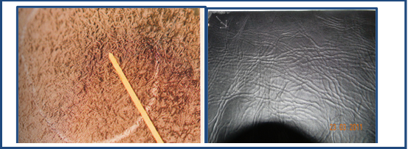
Fig 3.1 Looseness and Pipeness
In order to check whether the leather is loose and pipeness or not, by putting the palm of on the flash of the leather and by pressing the palm area down from the grain side using the other hand. While pressing down, if the looseness or pipeness comes that area of leather is defected.
- Thickness:
Since the leather is a natural substance it is difficult to expect uniform /the same/thickness without some variation. But in pre-tanning operation while removing flash by the blade, thickness might vary. On certain level, the evenness problem can be improved by using shaving machine. So, this is happening when the skin is below the expected thickness.
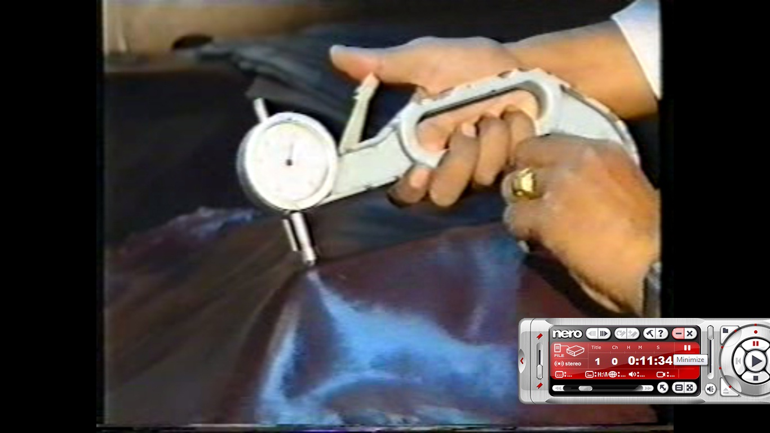
Fig 3.2 measuring leather thickness by measuring gauge
So, for the thickness of the leather it is good to use on the range (like: 1.2 – 1.4 mm) by taking 0.2 mm tolerance. Check the thickness of the leather using the thickness gauge at different point of the leather.
- Scratch and Scar marks:
It happens when the cow grassing though bush different tree branch and other sharp materials grazes the animal. This kind of defect is open and it became more visible while the leather stretched during lasting. Also Scratch defect may be happened when the animals fight by horn and scratch by horns commonly closed, it is not seen clearly.
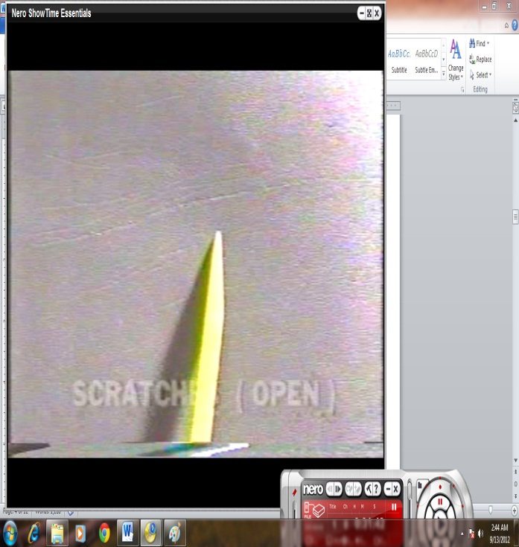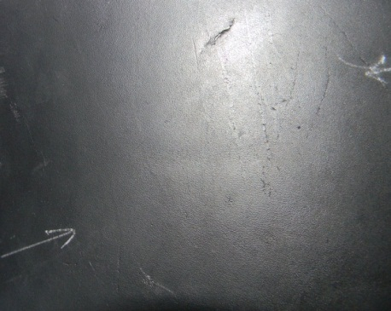
Fig 3.3. Scratch and Scar marks
Usually this defect seen on the gain side of the leather lined as long or short scratch. And by pulling the leather it become more visible.
- Brand marks
Commonly rural farmers/ pastoral/ have and rare a lot of cattle, goat and sheep. In order to manage and differentiate one’s from another’s, they used different identification mechanism/ brand marks/. The brand marks might be numbers, name or different symbols/stamp/ using paints and hot materials. Even though the pastorals use it as an identification ID, the leather has been damaged.
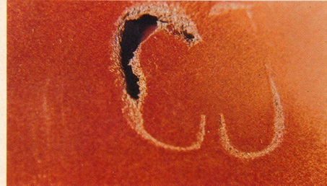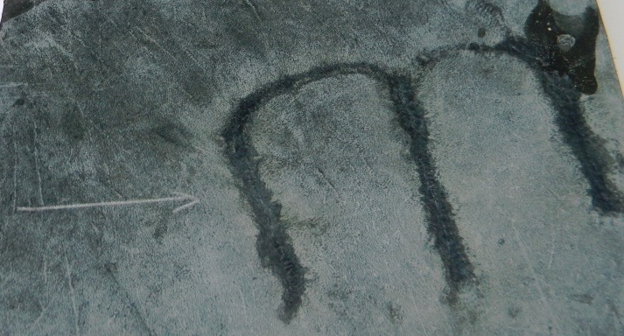
Fig 3.4. As shown in the figure, the brand mark defects are easily identified.
- Flay cuts
The damages are caused by carelessness of flayer person or when flaying is cried out by inexperienced person or by using improper tool. Prominent Flay cut highly affect and damage the quality of leather
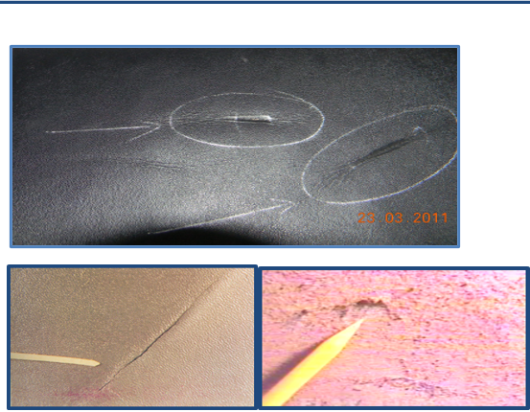
Fig 3.5. Flay cuts
It is easy identified on the flesh side of the leather like a long groove and the effect made poor impression on the grain side.
- Cracking
The leather loose/lack/ its humidity, flexibilities and natural smoothness. By this the leather becomes hard, ridged and stiff. One of the reasons for such problem is poor leather manufacturing process. On other hand, keeping/storing/ the leather in suffocation for a long period of time and when it exposed to direct sun light grain crackness occur.
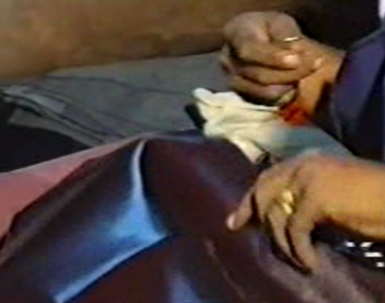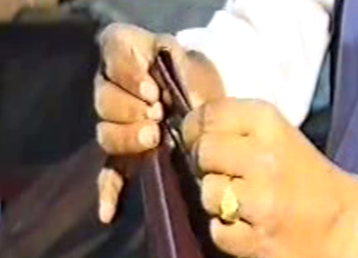
Fig 3.6. Key test and Four-fold test
Four-fold and key test are used to check leather cracknels.
- Bleeding
It is the diffusion of uncombined materials from the interior of leather to the grain surface where they may contaminate other materials or mar the appearance of the leather. This usually occurs at elevated temperatures and is commonly designated as staining.
- Tearing:
The common causes for leather tearing problem are when the thickness of the leather and fiber strength is below the normal and if the tanning process have a problem tearing might be happened. Normally suede and split leather have weak grain fiber strength so that the tendency to be tearing is more.
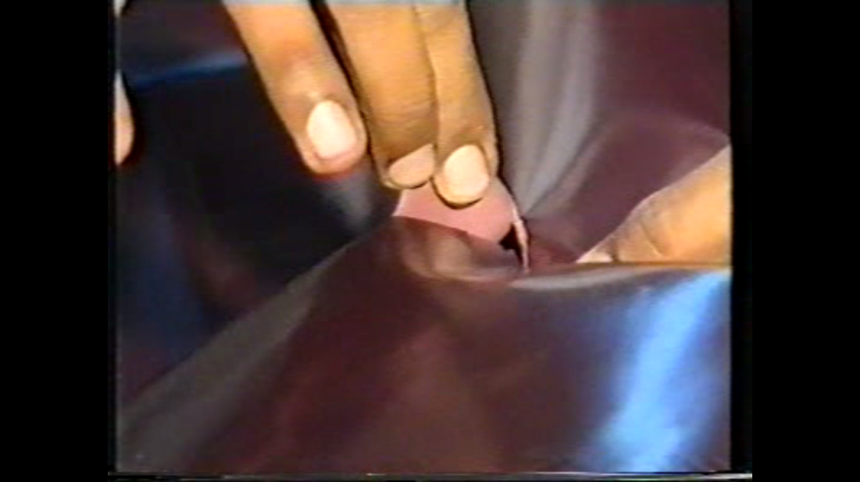
Fig 3.7 checking tears
To check the whether the leather is weak and easily tear able or not, first select one or two points at any region of the leather and cut the leather at 90° as show in the figure. Then gently try to tear the leather, if the leather starts to tear easily, then it is possible to decide the quality of leather is poor.
- Warble hole, pock mark and Tick mark
These defects leave scars or pits on the hide (skin), grain scratching, holes and secondary infection and bad white spot due to fungus/bacteria. These are due to when the cattle rubbing to get relief from the itching, blood sacking birds or insects and due to sanitary problem. Ticks usually attack the tender part of the skin/hide (bellies).
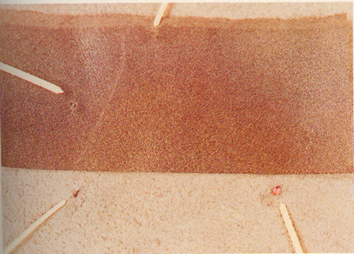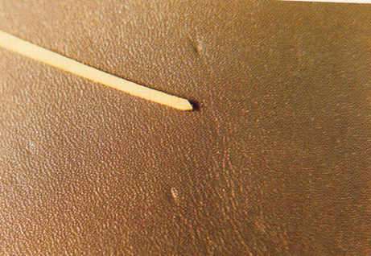
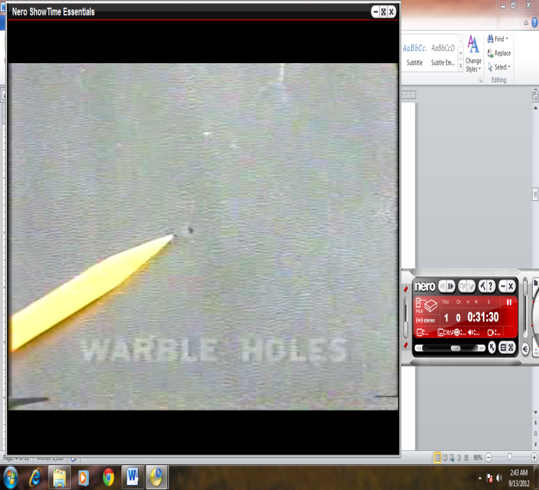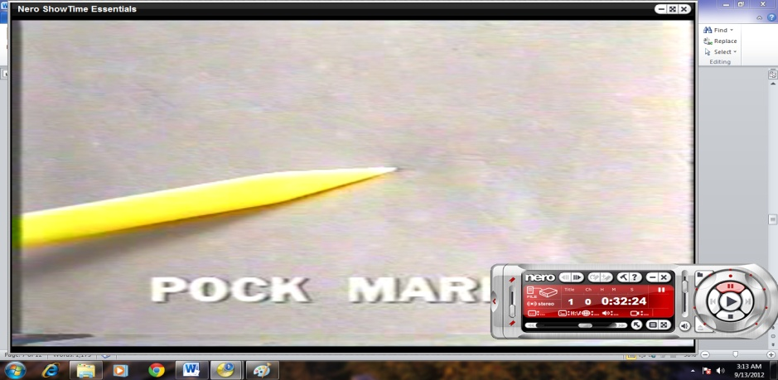
Fig 3.8. Warble hole, pock mark and Tick mark
Tick mark, warble hole by birds and insects and white spot due to infection on the leather are visible by neck eyes while we stretched it.
- Growth marks:
This defect where naturally happened on the neck and shoulder region of the leather when the cattle get older. These defects seem as a wrinkle which lined parallel around neck and shoulder.
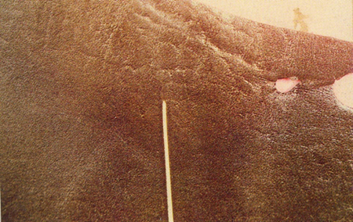
Fig 3.9. Growth marks
- Vein marks – blood vessel on both side of the leather
This is when the cattle had been stressed and frazzled for a long period of time or affected by the disease. By this, the steam mark of blood vessel and veins are observed on flesh and grain side of the leather.
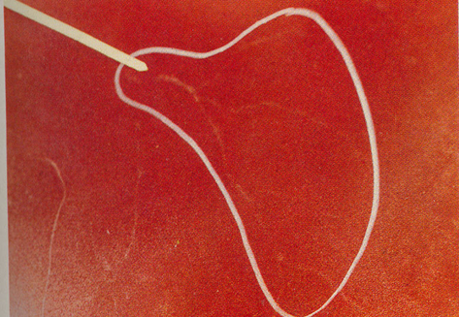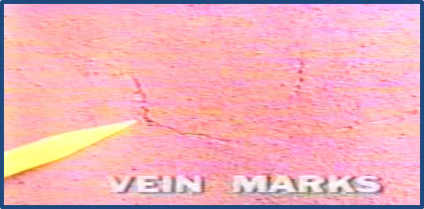
Fig 3.10. Vein marks

3.2 Describing the Effect of Defects on the Footwear
Products that are manufactured from leather are directly and indirectly influenced by the quality of leather. Generally, defect on leather prominently affects the quality of products, production quantity and productivity of the workers.
3.2.1 The Effects of leather defects on footwear
- Affect Quality of product /shoes/
Even though defect of leather is group in to closed and open and from this some of the defects are less visible and have less effect on production, commonly defected leather affects the quality of products. If we use those defected leather for footwear purpose, it affects the quality of the shoe (products) and reduced the appearance. Generally, products that are manufactured from defected leathers have degraded value in front of the customer.
Still availability of different types of defects on the leather are one of the reasons that enforced the major footwear producers to use materials other than leather (synthetic, textile, canvas etc.…) even though those substitute material does not have natural breathing characteristic as leather, because they are fully defect free materials producers forcefully chooses it. In addition to this, it incurs additional costs for leather manufacturing tanneries to avoid or hid those defects. So that using these synthetic or corrected leather materials in footwear production directly reduce the quality of products.

- Reduce Price of leather and leather products/shoe:
When the percentage area of defect is being going more as compare to the percentage cuttable area of leather, thus directly affect and reduced the grade of leather which in turn reduce the value /price of the leather. And those products/shoes that are manufactured from defect leathers, the price will be lower as compare to product from high quality genuine leather.
- Affect production and productivity:
If cutter uses and tries to cut defected leather, they will take more time. The more the defected the leather the efficiency of cutter’s reduced. This affects the productivity of the cutter and the cutting section/department. On other hands, while using loose leather and leather that easily tear in stitching and lasting section also affect the production and productivity of the section and workers. On this, leather defect indirectly affects the manufacturing cost of a product and leads to rise/ increase it.

Self-Check – 3 | Written test

Name…………………………………………… ID………………………… Date…….
Directions: Answer all the questions listed below. Examples may be necessary to aid some explanations/answers.
Part 1: choose the correct answer (5points)
1------ Is a durable and flexible material obtained from animal hide or skin?
a/ leather b/ synthetic c/peu foam d/ none
Part 2: Short answer questions (5x2=10 points)
- What are the two classifications of defects on leather? Briefly explain
- What are the two causes of leather defects? Briefly explain
- Define how the defect on leather can affect Quality of product /shoes/?
- Define how the defect on leather can affect Price of leather and products/shoe?
- Define how the defect on leather can affect production and productivity of the sections?
Part 3: Say true or false for the following question (8x2=16 points)
              - Looseness and Pipeness are scars or pits, grain scratching, holes and secondary infection and bad white spot due to fungus/bacteria.
              - Since the leather is a natural substance it is difficult to expect uniform /the same/thickness without some variation.
              - Cracking is not come when leather lacks its humidity, flexibilities and natural smoothness and by this the leather becomes hard, ridged and stiff.
              - The common causes for leather tearing problem are when the thickness of the leather and fiber strength is below the normal and if the tanning process have a problem tearing might be happened.
              - Warble hole, pock mark and Tick mark are abnormally of leather and become soft, weak and fragile. Commonly happened on belly and flank region commonly products that are manufactured from defected leathers have degraded value in front of the customer.
              - Those products/shoes that are manufactured from defect leathers, the price will be increased as compare to product from high quality genuine leather.
              - The more the defected the leather the efficiency of cutter’s reduced.
              - Using synthetic or corrected leather materials in footwear production directly could not affect the quality of products.

Note: Satisfactory rating – 31 points Unsatisfactory – 31 below
You can ask you teacher for the copy of the correct answers.

Unit Four: Determining and Measurement of Defective Area
This unit is developed to provide you the necessary information regarding the following content coverage and topics:
- Identifying the method of determining the area using different techniques
- Describing the method of determination of the area by grid method
- Describing and performing the method of measuring by fist method
- Describing the method of measuring of leather
This unit will also assist you to attain the learning outcomes stated in the cover page. Specifically, upon completion of this learning guide, you will be able to:
- Identify the methods of determination the area by using different techniques.
- Describe and perform on paper the method of determination of the area by grid method
- Describe and perform the method of measuring by fist method
- Describe the method of measuring of leather.

4.1 Identifying the method of determining the area using different techniques
Introduction
Area is a measure of how much space there is on a flat surface. For example, two sheets of paper have twice the area of a single sheet, because there is twice as much space to write on. Different shapes have different ways to find the area. Area tells us the size of a shape or figure. It tells us the size of squares, rectangles, circles, triangles, other polygons, or any enclosed figure. In the real world it tells us the size of pieces of paper, computer screens, rooms in houses, baseball fields, towns, cities, countries, and so on. Knowing the area can be very important. Think of getting a new carpet fitted in a room in your home. Knowing the area of the room will help make sure that the carpet you buy is big enough without having too much left over.
4.1.1 Determining the Area of Different Shapes
For many shapes there are ways to calculate the area. Some these are: -
Area of Square and Rectangle
The simplest and most commonly used for calculating a given area of rectangular or square shapes are by multiplying the width with its length.
For squares
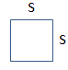
Area=$S^{2}$
Fig 4.1. Area for squares
For rectangles
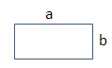
Area= a*b
Fig 4.2. Area for squares rectangles
Area of Triangle
It can be useful to think of a rectangle as half of a square or parallelogram.
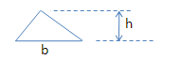
Area=½b*h
Fig 4.3. Area for squares Triangle
Area of circle
In order to calculate the area of a circle needs its radius or diameter. The diameter of a circle is the length of a straight line from one side of the circle to the other that passes through the central point of the circle. The diameter is twice the length of the radius (diameter = radius × 2)
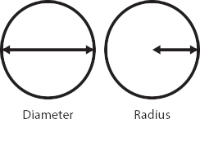
Area=$πr^{2}$
Fig 4.4. Area for squares circle
Determining the Area of Irregular Shapes
- Grid Method
When a shape is drawn on a scaled grid you can find the area by counting the number of grid squares inside the shape.
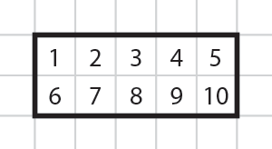
Fig 4.5. Area measuring by grid

In order to find an area value using the grid method, we need to know the size that a grid square represents. This example uses centimeters, but the same method applies for any unit of length or distance. You could, for example be using inches, meters, miles, feet etc.
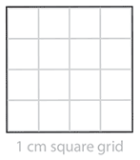
Fig 4.6 Area measuring by grid
In this example each grid square has a width of 1cm and a height of 1cm. In other words, each grid square is one 'square centimeter’. Count the grid squares inside the large square to find its area. There are 16 small squares so the area of the large square is 16 square centimeters. In mathematics we abbreviate 'square centimeters’ to cm². The ² means ‘squared’. Counting squares on a grid to find the area works for all shapes – as long as the grid sizes are known. However, this method becomes more challenging when shapes do not fit the grid exactly or when you need to count fractions of grid squares.
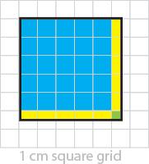
Fig 4.7 Area measuring by grid
In this example the square does not fit exactly onto the grid. We can still calculate the area by counting grid squares.
There are 25 full grid squares (shaded in blue).
10 half grid squares (shaded in yellow) – 10 half squares is the same as 5 full squares.
There is also 1 quarter square (shaded in green) – (¼ or 0.25 of a whole square).
Add the whole squares and fractions together: 25 + 5 + 0.25 = 30.25.
The area of this square is therefore 30. 25cm2.You can also write this as 30¼cm².
- Offset Method
The offset method simply divides the irregular shape into many smaller rectangles to estimate the area.
Step 1. Determine the longest line and label the ends A and B.
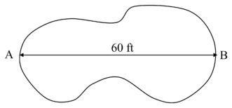
Fig 4.8 Area measuring by Offset Method
Step 2. Mark offset lines at right angles to the longest line. Choose the number of offset lines so that they divide the length line into equal parts. Tip: The closer the offset lines are to one another, the more accurate the estimation of the square footage. 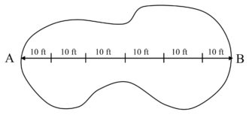
Fig 4.9 Area measuring by Offset Method
Step 3. Measure the length from one edge of the lawn to the other at each offset line. 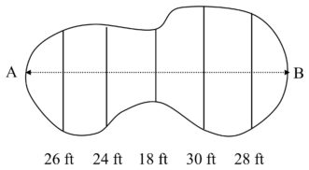
Fig 4.10 Area measuring by Offset Method
Step 4. Add the lengths of all of the offset lines and multiply by the distance between the offset lines.
26+24+18+30+28 = 126 ft
The average width = 126 ft/5 = 25.6 ft
(25.6 ft) (10 ft) = 1536 ft²
- Average Radius Method
Another way to determine the area of irregular circles is to measure the radius at 10 to 20-degree intervals and calculate the area from the average.
Step 1. Find the center or near center of the circular area
. 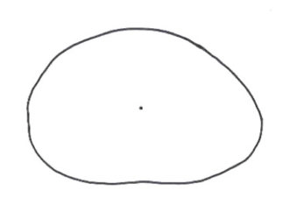
Fig 4.11 Area measuring by Average Radius Method
Step 2. Record measurements, to the nearest foot, from the edge of the area to the center of the circle every 10 to 20 degrees
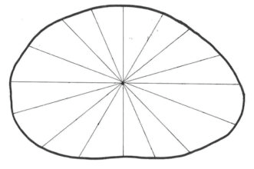
Fig 4.12. Area measuring by average Radius Method
Step 3. Average the measurements
Average radius = 17 ft
Step 4. Estimate the area using the formula for the area of a circle.
Area = π r²
Area = (3.14) r²
Area = (3.14) (17)²
Area = 907 ft²

4.2 Describing the method of determination of the area
4.2.1 Describing the method of determination of the area by grid method
To measure the area on random basis we may use a plastic grid called area measuring grid manufactured from a transparent plastic material. A gauge of 10 sq.dm. Graduated in square decimeters either of two shapes will prove suitable. When a shape is drawn on a scaled gride you can find the area by counting the number of grid squares inside the shape.
Calculating Area Using the Grid Method
When a shape is drawn on a scaled grid you can find the area by counting the number of grid squares inside the shape. In this example there are 10 grid squares inside the rectangle. In order to find an area value using the grid method, we need to know the size that a grid square represents. This example uses centimeters, but the same method applies for any unit of length or distance. You could, for example be using inches, meter, miles, feet etc. In this example each grid square has a width of 1cm and a height of 1cm. In other words, each grid square is one 'square centimeters’. Count the grid squares inside the large square to find its area. There are 16 small squares so the area of the large square is 16 square centimeters. In mathematics we abbreviate 'square centimeter’s to cm2.The 2 means ‘squared’. Each grid square is 1cm2.The area of the large square is 16cm2.Counting squares on a grid to find the area works for all shapes – as long as the grid sizes are known. However, this method becomes more challenging when shapes do not fit the grid exactly or when you need to count fractions of grid squares. Although using a grid and counting squares within a shape is a very simple way of learning the concepts of area it is less useful for finding exact areas with more complex shapes, when there may be many fractions of grid squares to add together. Area can be calculated using simple formulae, depending on the type of shape you are working with. The remainder of this page explains and gives examples of how to calculate the area of a shape without using the grid system.
4.2.2 Method of measuring defected area by fist method
This method of measuring defected area of leather is better than measuring/guessing by eye but it is not more accurate as grid method very small deviation may be there. But if we used the one that have almost the same as one sq.dm hand fist, the result become almost accurate and it also save measuring time.
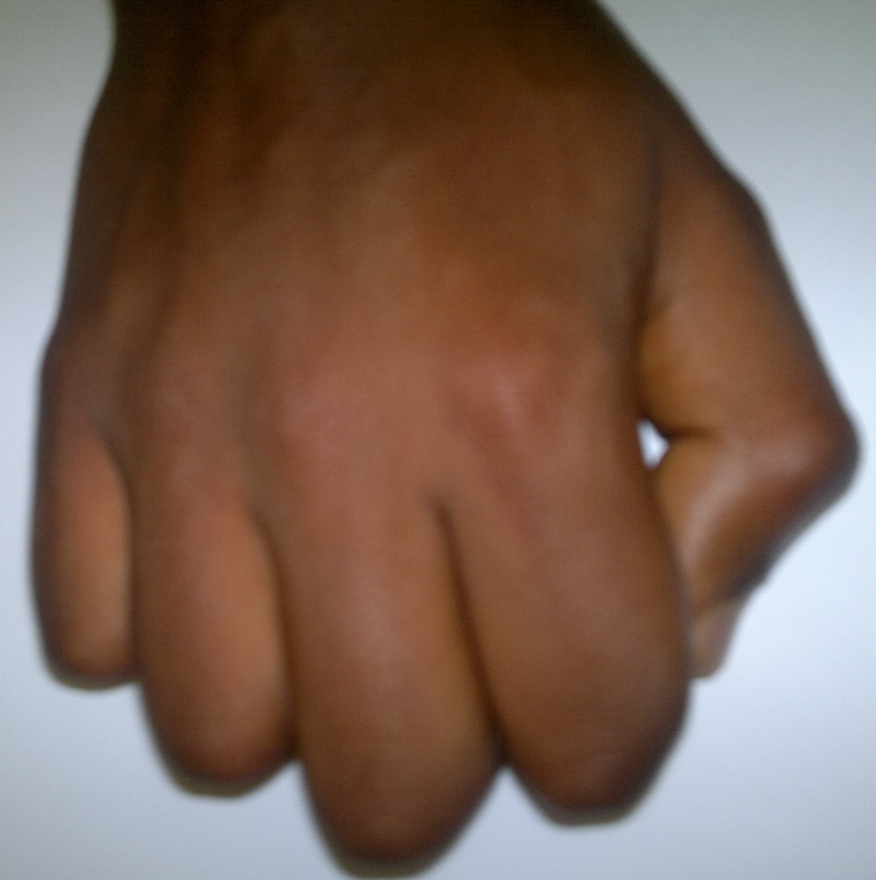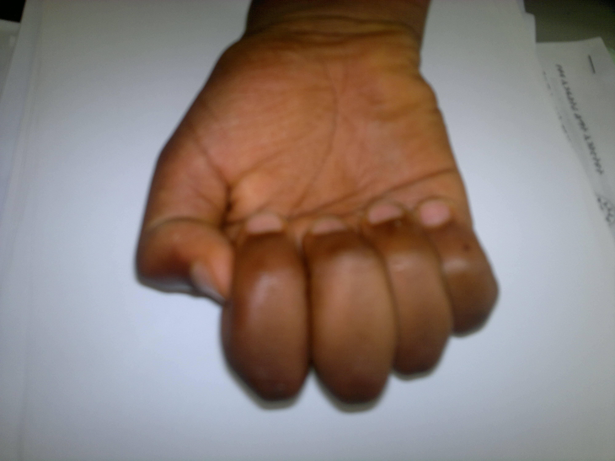
Figure 4.20
- For a big Hand-clenched fist – it is comparatively equal to one decimeter square. (9 -10 fists equal to 1 sq.ft)
- While in using clenched fist – commonly certain groups takes 13 average clenched fists as approximately equal to one sq.ft.(13 fists equal to 1sq.ft)
- It is possible to use one of the two way based on the size of the clenched fist we have/used while in measuring the defect.

The entire steps used to measure the defect area of leather by fist method are almost the same as grid method. The only different is in fist method instead of using grid tool hand fist is substitutable used.
- Select the leather from the sample
- Prepare the leather on the flat surface to measure the total area
- Use grading tool ( grid plate which is commonly 10 sq. dm size)
- white pencil to sketch/mark the plate
- Then drawing the grading plate on the leather using the white pencil.
- Then measure the leather size by counting the sketched grading plate on the leather.
- After sum up all the measurement, convert the decimeter square into feet square by dividing the result by 9.29. At this point the exact value/size of the leather in sq.ft is known which might be the same as or different from the written size on leather by the tannery.
- Then compare the final result with the written size on leather by this it is possible to check the area discrepancies or whether the written size on the leather is correct or not.
- After this it is possible to move to check the defect area of leather by assessing the major and minor defect on the leather. All defects on the leather which aren’t used for footwear production should be identified. (The possible types of defect on the leather are Looseness and Pipeness, Thickness, Scratch and Scar marks, Brand marks, Flay cuts, Cracking, Bleeding, Tearing, Warble hole, pock mark and Tick mark, Growth marks, Vein marks, etc.)
- If any types of defect are detected while in assessing on the leather, mark/circle the defected region using white pencil. If the space between two marked/circled defected region cannot allow to insert in between one derby quarter (number 8 size by English sizing system or 42 size by French sizing system), then should consider those two defected regions as one and marked/circled as one defect region.

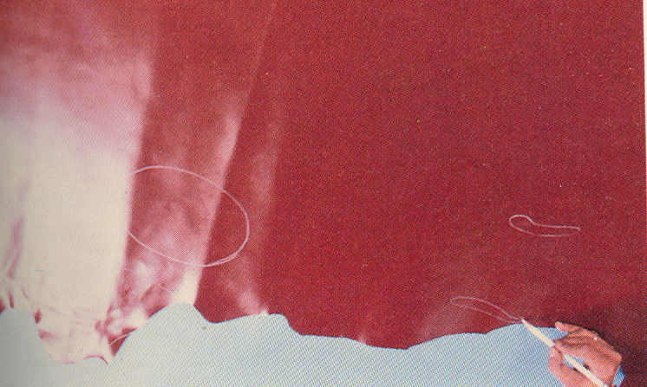
Fig4.21
- After complete marking all the defected area, measure each of the identified defected regions using hand-fist and put the exact size in dm.sq.

4.3 Describing the method of measuring of leather
Introduction
The visual inspection systems for textured surfaces have application in different areas for analysis of defects in textile, lumber, automobile paints, etc. Leather as a natural material with its variety of visual appearances – non homogeneous in color, thickness, brightness, wrinkleless, etc. is a complex object for control and analysis. The surface defects on leather affect the aesthetic appearance of leather goods and the amount of usable area. The presence of defects is critical factor for adjustment of the leather for manufacturing of particular good, because the existence of areas with leather defects may be considered as unusable or useful only for particular purposes. There are well known different methods for analysis of leathers surface defects and classifications. Classification basic indexes of surface defects on leathers are the shape, size, area, depth, color, origin of the defect, etc. The proposed classifications are based only on part of these indexes because of which is obtained non-complete description of the defects.
4.3.1Area Measurement
A shoe factory must measure and check all the incoming material immediately upon
arrival against supplier’s delivery notes. So far leather area is concerned; there should not
be more than 5% discrepancy from the supplier and the factory. Large discrepancy must
be notified to the supplier because leather cost constitutes about 60 to 70% cost of the
shoe and even a slight variation can cause to suffer a heavy loss by the shoe factory. Uppers materials especially leather is purchased/sold by area.
1 sq. = 9.29 sq.dm

- Steps in doing the Area Measurement
- Select the leather from the sample
- Prepare the leather on the flat surface to measure the total area
- Then drawing the grading plate on the leather using the white pencil.
- Then measure the leather size by counting the sketched grading plate on the leather.
- After sum up all the measurement, convert the decimeter square into feet square by dividing the result by 9.29. At this point the exact value/size of the leather in sq.ft is known which might be the same as or different from the written size on leather by the tannery.
- Then compare the final result with the written size on leather by this it is possible to check the area discrepancies or whether the written size on the leather is correct or not.
- After this it is possible to move to check the defect area of leather by assessing the major and minor defect on the leather. All defects on the leather which aren’t used for footwear production should be identified. (The possible types of defect on the leather are Looseness and Pipeness, Thickness, Scratch and Scar marks, Brand marks, Flay cuts, Cracking, Bleeding, Tearing, Warble hole, pock mark and Tick mark, Growth marks, Vein marks, etc.)
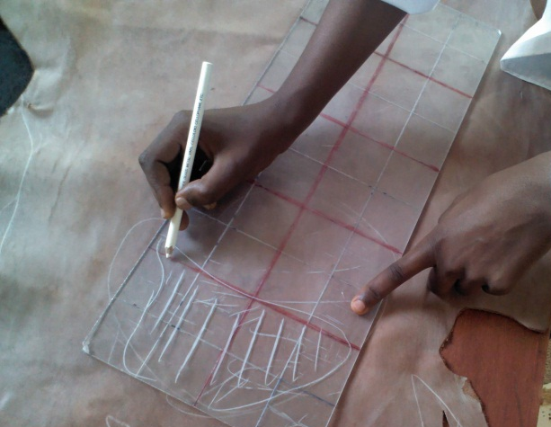
Figure given for operation sheet Fig 4.29 Figure given for operation sheet Fig 4.30
- After complete marking all the defected area, measure each of the identified defected regions using grading tool (grid plate) and put the exact size in dm.sq.
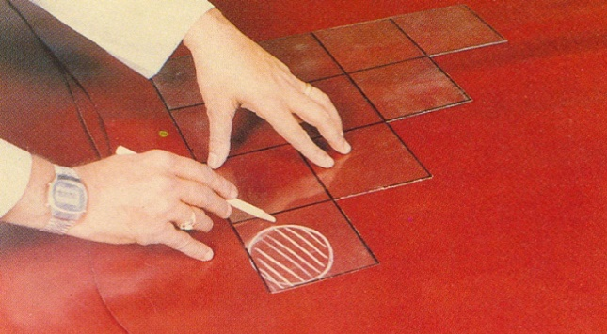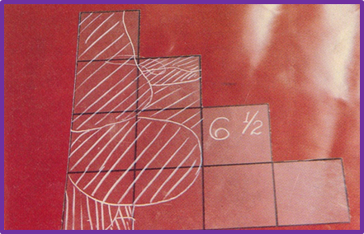
Figure given for operation sheet Fig 4.31 Figure given for operation sheet Fig 4.32
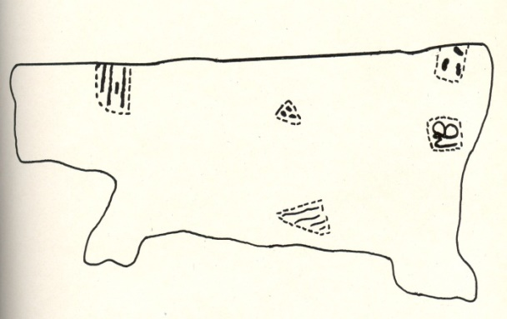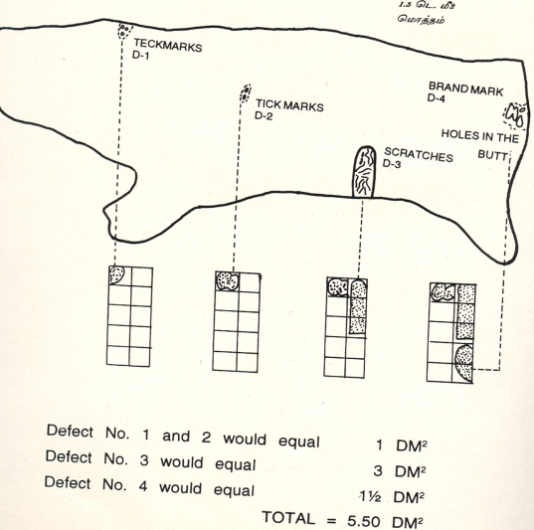
Figure given for operation sheet Fig 4.27 Figure given for operation sheet Fig 4.28

              - Then sum up the exact size of defected region in dm.sq on the leather, and convert the decimeter square into feet square by dividing the result by 9.29.At this point the exact value/size of defects on the leather is known by sq.ft. From this it is possible to calculate the percentage of wastage
Percentage of wastage = Total defect area of leather
Total area of leather *100

              - After we calculate the percentage of wastage the grade of leather.
              - While categorizing leather according to the calculated value it may came new grade that is different from formally described by the tannery. Or the new calculated grade is the same as that of the previous one.
              - If the regarded value is different, Purchase cost variance calculation will come after. This used to show the loss of cuttable leather value and how much money we lost by paying for the wrong grade. Based on the result of regarding and purchase cost variance calculation the foot wear factories can appeal to the tannery on the losses.
Calculation of Cutting Value
The total defective area is then calculated as a % against total skin area and classified according to the cutting value table mentioned below:

Table .3 given format for percentages of defective area and grade
Grade | Cutting Value | Wastage
A or 1 | 100% to 97% | Up to 3%
B or 2 | 96% to 92% | 8%
C or 3 | 91% to 87% | 13%
D or 4 | 86% to 82% | 18%
E or 5 | 81% to 77% | 23% etc.
4.3.2 The Major Leather Methods of Measuring Area
- Leather area measuring machine
Area of leather is measured generally by the tannery using electronic area measuring machine which gives rapid and accurate result. The accuracy can be checked time to time with the measuring device supplied by the manufacturer. Generally, the accuracy is checked using a piece of material of known area but even plastic grids can be used for this purpose. Unfortunately, this machine is too expensive to be installed in small scale footwear units.
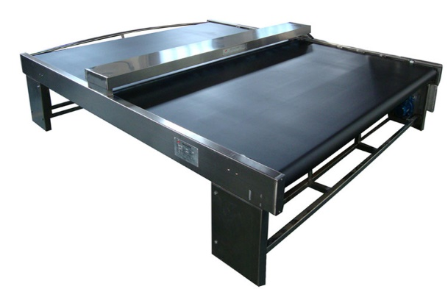
Fig 4.22. Leather area measuring machine
- Leather Area Measurement by Grid
To measure the area on random basis we may use a plastic grid called area measuring grid manufactured from a transparent plastic material. A gauge of 10 sdm. Graduated in square decimeters either of two shapes will prove suitable. It is the most effective leather measuring area but, time consuming and cannot be used for bulk checking.
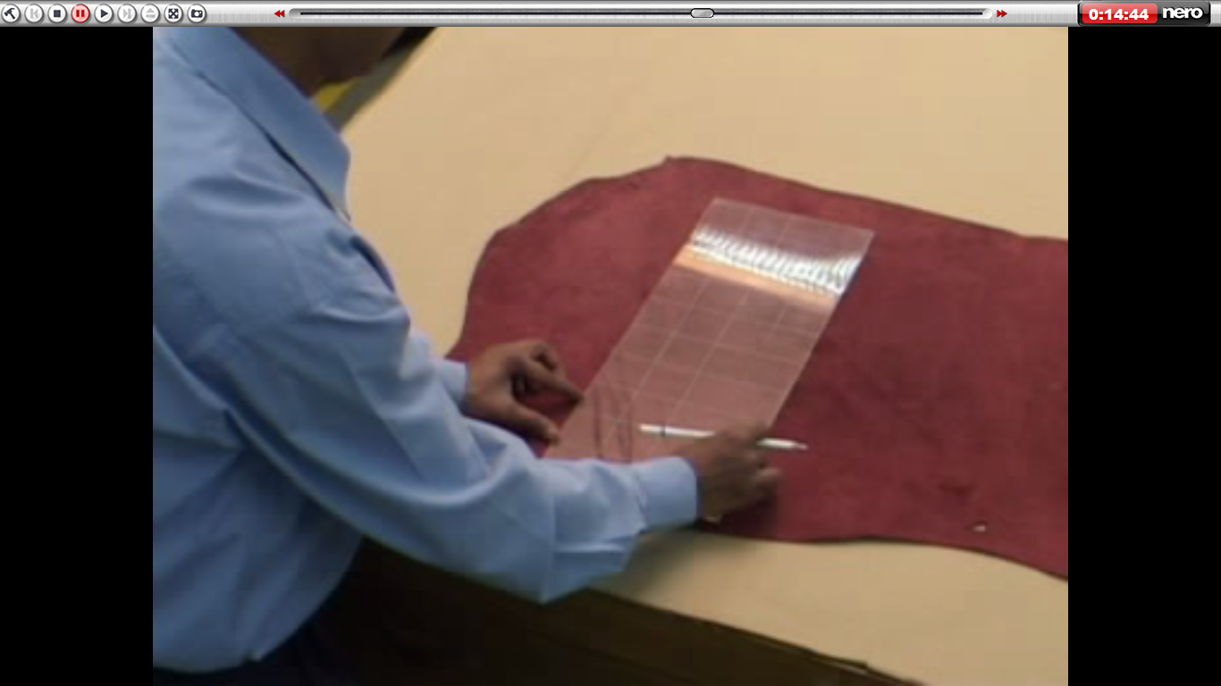
Fig 4.23. Leather area measurement by Grid
4.3.3. Leather Defect Measuring Methods
A defective area is an area containing defects which cannot appear on cut components, thus, causing the cutting position to be changed.it affect the value of the leather by reduce the cuttable area of it. It is not only actual area of the defects but those peripheral parts round the defects which, because of location in the skin, cannot be used. As experienced man will be able to assess defects and hence grade leather visually without mechanical aids. However, it is essential that one has an accurate & rapid method of calculating the defective and to verify. For this, we have plastic grid as mentioned above.
The Common leather defect measuring methods are:
- By necked eyes (observation and judgment) –it required experience but not an accurate method.
- By using hand-fist (resemble/close to accuracy.)
- By using measuring grid tool (widely used and the most accepted one. Still it is not 100% accurate)
In addition to the above method, there are other method used in different countries and institutes. Now a day, digital computerized leather defect sensor instrument also innovated. Who knows in the near future this instrument might be one of the commonly used leather defect measurement method?
Area Discrepancy
A shoe factory must measure and check all the incoming leather as well as other materials immediately upon arrival against suppliers’ delivery notes. so far leather area is concerned; the area discrepancy should not be more than 4 to 5% Area discrepancy from the supplier and factory. Large discrepancy must be notified to the supplier as the material/leathers should not be used before the difference are not agreed because leather cost constitute about 60 to 70 cost of the shoe and even a slight variation can cause to suffer a heavy loss by the shoe factory. is the area shortage.
Formula for area discrepancy =
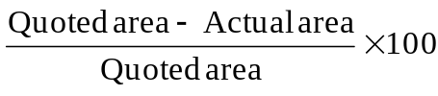
Example 4.1
Let area quarter to be 120 SDM:
Actual area = 100 SDM
% area discrepancy =
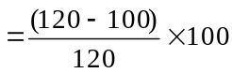
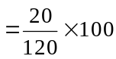
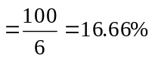
An explained group will be able to assess defects and large grade leather visually without mechanical. However, it is essential that one has an accurate rapid method of the measurement.
Random Check of Area
Since, it is very difficult for a shoe factory to check each and every skin area, it is recommended to take several bundles of skin from a newly arrived shipment and to select 5-15 skins of each bundle for area check.
Self-Check – 4 | Written test

Name…………………………………………… ID………………………… Date…….
Directions: Answer all the questions listed below. Examples may be necessary to aid some explanations/answers.
Part 1: - Short Answer (8x2=16points
- What is area?
- List irregular shape area determining methods?
- Describe area measurement by grid? (by comparing with other area measuring methods)
- What is the major leather area measuring method?
- What are the common leather defect area measuring methods? explain
- Define area discrepancy?
- Define while in using grid method leather area measuring, what types of tool are used and what is the size of the tool?
- Why we use random sampling method while we measure the leather defect and area of leather?
Work out (2x3=6points)
- Calculate the area of a circle with a radius of 30cm?
- Calculate the area of a triangle where the base is 60 cm and the height is 30 cm.
Note: Satisfactory rating – 25 points Unsatisfactory - below -25 points

Operation sheet 1– Leather Area Measuring by Grid Method
- Operation title: Measuring defected area by fist method
- Purpose: - To find the area by counting the number of grid squares inside the shape.
- Instruction: Using the figure below and given equipment’s measure the length of each line. You have given 50Minut for the task and you are expected to write the answer on the given line.
- Steps in doing the task
Main steps for leather area measuring by grid method are: -
Step 1 Collect the leather from the bundle.
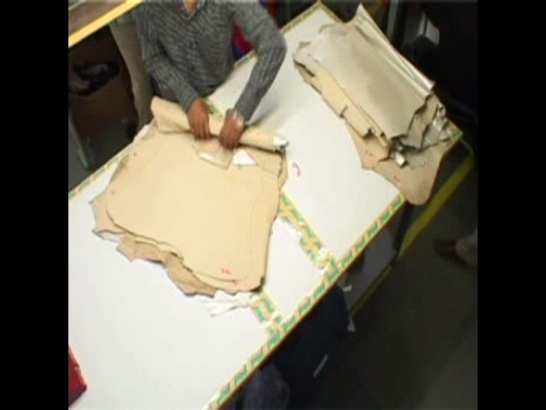
Figure given for operation sheet 4.13
Step 2 Keep and prepare the leather on the flat table and it should be suitable to measure the total area of the leather.
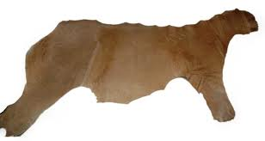
Figure given for operation sheet 4.14

Step 3 Use grading tool (grid plate which is commonly 10 sq. dm size)
1 | 2 | 5 | 7 | 9
2 | 4 | 6 | 8 | 10
1 | 2 | 3 | 4
5 | 6 | 7
8 | 9
10
=10 sq.dm

= 10 sq.dm
Figure given for operation sheet 4.15
- Block = 1 sq.dm.
Step 4
- Then drawing the grading plate sequentially step by steps on the full size of leather using the white pencil.
- If the space is enough to draw the full size of grid plate it is good.
- Unfortunately, due to the irregular shape of leather it can be difficult to get the space for the whole plate to draw, so it is possible to draw/mark even the spare/fraction of leather part using the grid and measure in decimeter.
Step 1 prepare the grid to measure and put the leather on flat area
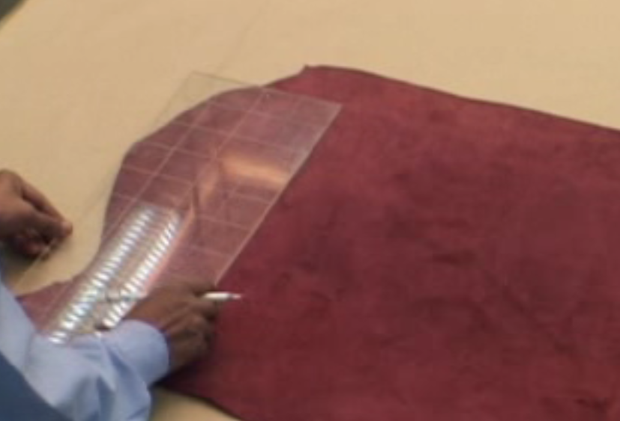
Figure given for operation sheet.4.16
Step 2 put the grid on to flash side of the leather
Figure given for operation sheet 4.17
Step 3 Trace the grid by using white pencil.
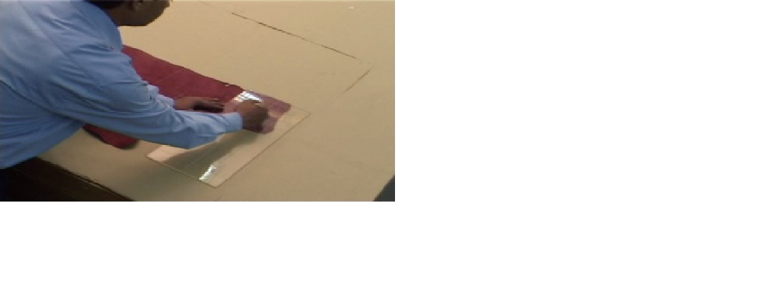
Figure given for operation sheet 4.18
Step 5 then measure the leather size by counting the sketched grading plate on the leather. Measure each space/block that drawn on the leather in decimeter.
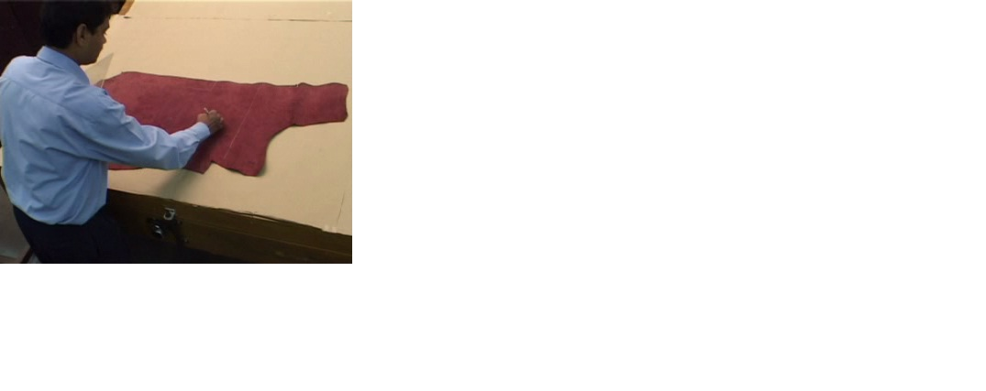
Figure given for operation sheet.4.19
Step 6 Sum up each block and calculate the total area of leather in decimeter and convert in to square feet (1sq.ft = 9.29 sq.dm).
Step 8 then compare the actual measured value of leather with the area that is written on the back of the leather by the tannery.
- Required, tools and equipment: scale grid, White pencil, leather, Leather area measuring machine, flat table
- Conditions or situations for the operations: All tools, equipment’s and materials should be available on time when required Appropriate table, working area/ workshop to Measuring Leather Area by Grid Method
- Precautions:
- Care should be taken while Measuring Leather Area by Grid Method
- Preparing materials, tools and equipment are according to inseminator command.
- Quality criteria
- Did personal protective equipment worn Measuring Leather Area by Grid Method
- Precautions
- Preparing materials, tools and equipment are according to inseminator command.
- Quality criteria
- Did personal protective equipment worn Measuring Defected Area of Leather by Grid

Lap Test | Demonstration

Name……………………………….ID…………………………….. Time started: ________________________ Time finished: ________________
Instructions: Given necessary templates, tools and materials you are required to perform the following tasks within 1 hour. The project is expected from each student to do it.

Task 1 Measure the leather area of the skin having an area of 10 sq.ft with the help of grid
Task 2 Measure the defective area of the skin having an area of 110 sq dm with the help of grid.

Unit Five: Perform Quality Check on Leather
This unit is developed to provide you the necessary information regarding the following content coverage and topics:
- Describing and performing various physical tests (non-laboratory) on the leather
- Describing and demonstrating method of sample selection
- Checking characteristics of the leather
This unit will also assist you to attain the learning outcomes stated in the cover page. Specifically, upon completion of this learning guide, you will be able to:
- Describe and perform Various physical tests (non-laboratory) on the leather
- Describe and demonstrate Method of sample selection.
- Check Characteristics of the leather

5.1 Describing and performing various physical tests on the leather
Leather is a very complex material, which must be subjected to laboratory tests for accurate assessment. This may not always be possible as most tanneries do not have adequate testing facilitating and some of the tests are very lengthy for any buyer to wait. There are, however, a few crude and quick tests, which can help the buyer in taking correct decision. These tests will give a danger signal, regarding the whole consignment. Selection of leather in tannery consists of two stages i.e., random tests and selection of whole consignment. Samples are selected on random basis. It is difficult to assess for quality.
5.1.1 Physical Tests (non-laboratory tests) on Leather
In random test the following activities are carried out.
- Selection of samples: -At least one sample leather is picked up from each bundle or from each sub-variety of batch. This sample leather is used as a reference for comparing the hides to be tested with it.
- Substance/thickness: -The thickness of the leather is measured comparing with the reference sample leather and with the help of thickness gauge.
- Finish appearance: -The finish appearance of the leather is checked by comparing with the reference sample leather.
- Feel/softness and stretch: -Feel/softness of the leather is checked by filling up with palm with it at different places and comparing with the reference sample leather.
- Adhesion of finish: -The leather surface is checked for its good finishing by using scotch tape and stick four inches on leather grain comparing with the reference sample leather.
- Cracking: -Any tendency of pigment or grain cracking of the leather is checked comparing with the reference sample leather.
- Wet and dry rub: -Any transfer of finish or any removal of finish of is checked by using dry and wet white fabric around your finger comparing with the reference sample leather.
- Strength: -Strength of the leather is checked by tearing it and comparing with the reference sample leather.
- Fading: -Any fading or change in color of the leather is checked by keeping a cut piece in the sun and comparing with the reference sample leather.
- Water repellency: -Physical deterioration of leather is checked by dipping a small piece in water and rubbing the grain with fabrics.
- Chemical resistance: -Damage of the finish is checked by applying chemicals to the grain side of the leather.
5.1.2 Performing Methods of Physical Testing
The following methods of physical testing are applied for checking the quality of given leather.
- Selection of test samples
Pick up at least one hide from each bundle of 50 or from each sub-variety of batch. This is to ensure that the selected hides consist of full spectrum and are true representative of the consignment. If these are good, then the consignment should also be good. The assessment of these hides should indicate troubled areas for thorough screening.
- Substance/thickness
Measure substances at various locations the substance in butt region should be within the specified range.
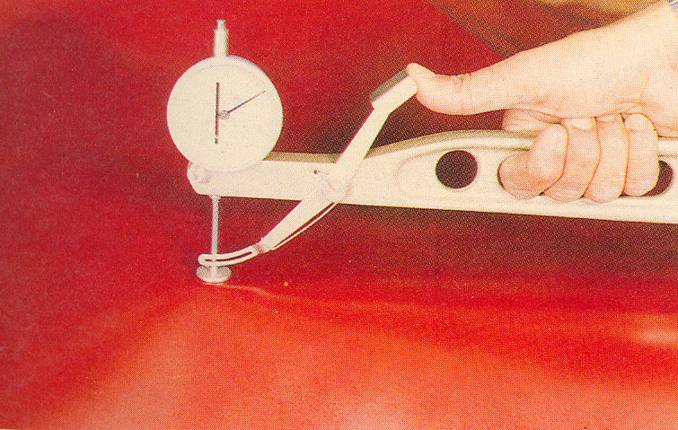
Fig 5.1. Measuring thickness
- Finish appearance
Closely look at the top surface and compare with the reference sample. Is the material (i.e. cow, buff etc.) as ordered? Is the color and finish as ordered? If there is some marginal variation, will this leather produce shoes of acceptable variation?
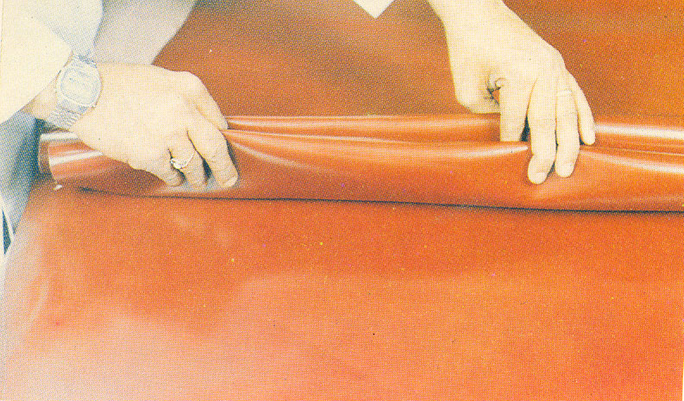
Fig 5.2. Checking finishing appearance
- Feel/softness and stretch
Feel the leather by filling up your palm with it at different places. Is it same as your reference sample? Stretch the hides along the width. Are you able to stretch approximately 5cm with 75% of your total strength? If the leather is very soft and hardly requires any effort to stretch, it is likely to be weak and cause lasting problems.
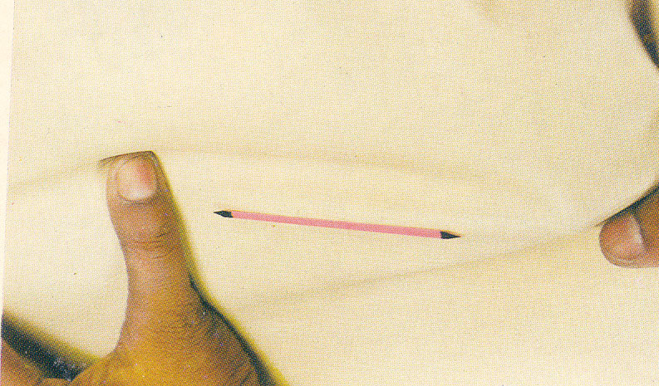
Fig 5.3. Feel/softness and stretch
- Adhesion of finish
Take five inches of scotch tape and stick four inches on leather grain. Press as best you can. Pick the loose end and rip the tape off leather in one quick motion. Check the tape and leather to see if any finish is sticking to the tape and found removed from the leather surface.
- Cracking
Double fold leather at least 4 places per hide to see whether there is any tendency of pigment and or grain cracking.
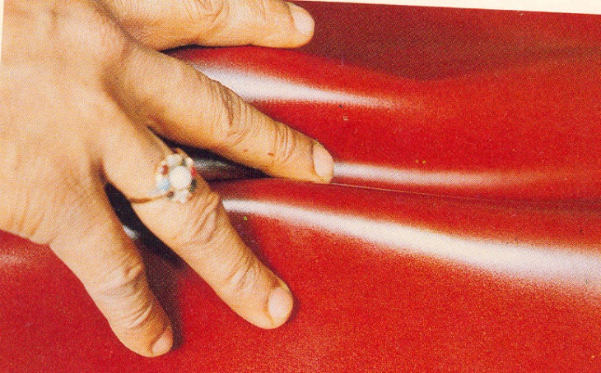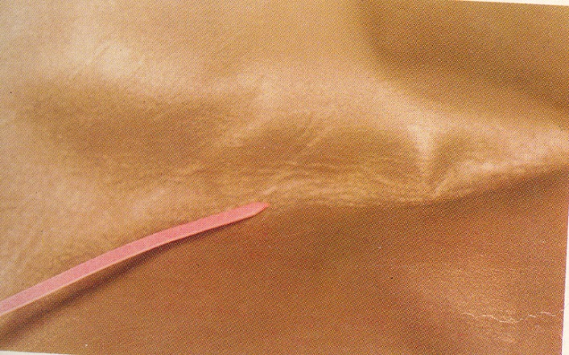
Fig5 .4. Cracking
- Wet and dry rub
Rub the grain side 25 times approximately 5 inches with a white fabric around your finger (as if you are trying to erase a pencil mark on paper with an eraser). Examine the cloth for any transfer of finish. Wet the cloth (and squeeze) and rub 5 times at some other location. Examine the cloth for any transfer of finish and leather for any removal of finish. This test can be done for suede and flesh side also.
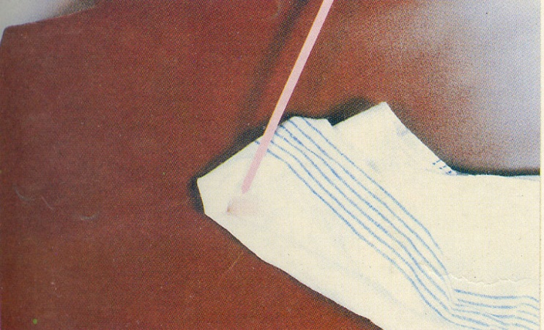

Fig 5.5. Wet and dry rub
- Strength
In the butt region, make a half inch cut from an edge with a scissor. Hold leather on two sides of cut with thumb and a finger. Try your best to tear it further. It must take lot of your effort to tear. Compare your effort with that required for reference sample.
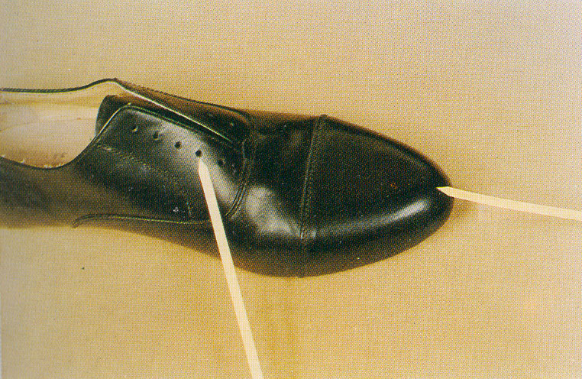
Fig5.6. Strength
- Fading
In case of white or very light leathers, keep a cut piece in the sum for three hours and then compare with the other piece for any fading, yellow and change in color.
- Water repellency
Dip a small piece in water for 5 minutes. Observe amount of water absorbed by it; rub the grain with fabric to see physical deterioration of leather.
- Chemical resistance
Drop some water on grain and allow drying. See it there is any stain. Apply some latex, Neoprene and PU; allow drying and then rubbing off with crape. Does it damage the finish?
5.1.3 Laboratory Tests on Leather
Leather can be tested (non-laboratory) within the factory .in addition to this; leather can be tested with in the laboratory. Laboratory test include both physical and chemical tests. Some of the major laboratory leather tests are:
Tear strength
Leather tear strength tester is suitable for testing tear strength of all kinds of dermis and synthetic leather materials. It is used to test tear strength of dermis and synthetic leather under external force.
Tensile Strength
These properties are related to the force required to break a test specimen. This test can be applied as uppers, outsoles, insoles, eyelets, decorative pieces and other materials.
Color Fastness
Color fastness is the persistence of color. Several tests can be made to simulate use and evaluate the color fastness in several conditions. This property can be evaluated by several means and in diverse materials. It can be evaluated by simulating human perspiration or by water contact and rubbing for analyses of the maintenance of the material’s color.
Abrasion Resistance
Abrasion is the property related with the resistance that a material can addle, when it is subject to friction. The abrasion tests evaluate the surface resistance of uppers, linings, in socks, insoles, outsoles, laces and eyelets when rubbed with an abradant fabric or by action of a mechanical machine, according to the applicable method.
Flexing
Leather Freezing Flexing tester is used for testing the upper leather, synthetic leather and other cold level, in order to fully understand the material or finished products to adapt to low temperature climate or cold areas of performance.
Grain Crack
Leather Grain Crack Tester is intended to determine the propensity of the grain of a leather to crack during bending and suitable to test all kinds of sole leather.
- Water Vapor Permeability
- Water absorption
- Fungus Test
- PH Value (chemical test)
- Chromium VI (chemical test) etc.
Conducting products tests in Laboratory is very important and it increases the products value and that able to standardized the products. Especially conducting the test in the certified lab ensures the products acceptance and helps the manufacturer to produce their products as per the standard using quality and adequate materials. Standardizing the products enable the manufacturers, traders, customers and even the countries - to speak common language. So that the market acceptance and sell volume will be increased

5.2. Method of sample selection in leather testing
Introduction
The way the sample reference leather taken is very important since the other leather quality is measured relative to this sample. Therefore, at least one hide is picked up from each bundle of 50 or from each sub-variety of batch and used as a reference. This is to ensure that the selected hides consist of full spectrum and are true representative of the consignment. If these are good, then the consignment should also be good. The assessment of these hides should indicate troubled areas for thorough screening. Sample is selected according to established principles. These are:
- The sample must be representative of the entire population/batch.
- One must be able to extrapolate inferences, within known and acceptable margins of error, from the sample to the wider population
    - Common steps and words in sampling:
- Define Target Population: Target Population: is the population to be studied/ to which the investigator wants to generalize his results
- Selection of a sampling frame: Sampling frame is the list of all the sampling units from which sample is drawn.
- Sampling scheme/method for sampling/: Method of selecting sampling units from sampling frame. (Probability or Non-probability sampling)
- Sampling Unit: smallest unit from which sample can be selected.
- Calculate error/chance of fluctuation
5.3.3 Purpose of Sampling
- Get information about large populations.
- When it’s impossible to study the whole population
- To be cost effective, to be accurate and time saving.

5.2.2 Method of Sampling
- Probability samples
Are sometimes known as random samples they are the most accurate of the sample selection methods. When using a probability sample, each element in the population has a known and non-zero chance of being selected into the sample usually, each member of the population has the same chance of being included in the probability sample. With a probability sample, the first step is usually to try to find a sampling frame. Using this frame, individuals or households are numbered, and some numbers are chosen at random to determine who is surveyed. If no frame is available, other methods are used to ensure that every population member has an equal, or known, chance of inclusion in the survey.
- Random Sampling: the purest form of probability sampling. Assures each element in the population has an equal chance of being included in the sample.
- Stratified Sampling: Sub-samples are randomly drawn from samples within different strata that are more or less equal on some characteristic
- Cluster Sampling: The primary sampling unit is not the individual element, but a large cluster of elements. Either the cluster is randomly selected or the elements within are randomly selected
- Systematic sampling: relies on arranging the target population according to some ordering scheme and then selecting elements at regular intervals through that ordered list.
- Non probability sampling
Any sampling method where some elements of population have no chance of selection (these are sometimes referred to as 'out of coverage'/'under covered'), or where the probability of selection can't be accurately determined. It involves the selection of elements based on assumptions regarding the population of interest, which forms the criteria for selection. Hence, because the selection of elements is nonrandom, nonprobability sampling not allows the estimation of sampling errors.

- Quota sampling: The population is first segmented into mutually exclusive sub-groups, just as in stratified sampling. Then judgment used to select subjects or units from each segment based on a specified proportion. For example, an interviewer may be told to sample 200 females and 300 males between the age of 45 and 60.It is this second step which makes the technique one of non-probability sampling.
- Convenience sampling: Sometimes known as grab or opportunity sampling or accidental or haphazard sampling. A type of nonprobability sampling which involves the sample being drawn from that part of the population which is close to hand. That is, readily available and convenient. The researcher using such a sample cannot scientifically make generalizations about the total population from this sample because it would not be representative enough. For example, if the interviewer was to conduct a survey at a shopping center early in the morning on a given day, the people that he/she could interview would be limited to those given there at that given time, which would not represent the views of other members of society in such an area, if the survey was to be conducted at different times of day and several times per week. This type of sampling is most useful for pilot testing.
- Judgmental sampling: - The researcher chooses the sample based on who they think would be appropriate for the study. This is used primarily when there is a limited number of people that have expertise in the area being researched.
- Snowball samples: In some communities (especially those in developing countries), the only feasible way to find its members is by asking other members. The first step in this procedure is to find a few members of the population using any method. This step is denoted as the first round. Then you ask each of these first-round members if they know of any others. The names given will form the second round. Then you go to each of those second-round people, and ask them for more names. This process is repeated for several more rounds. The process is stopped when you start hearing about the same people over and over again. The methodology used to stop the procedure can be described as follow. For each round, count the number of names you get and the number of new names obtained in this round. Then calculate the percentage of new names to the total number of names. For example, if the second round gives you 100 names, but 30 of them are for people who were mentioned in the first round, then the percentage of new names for that round is 70 per cent. This percentage of new names is high at first, but then drops sharply. When the percentage of new names drops to around 10 per cent, then stop. This often happens at the fourth or fifth round. After performing this, something close to a list of the whole population is available, and many of the population members will know that you are planning some research. Using that list, you can draw a random sample. Snowball sampling works well when members of a population know each other. The problem with snowball sampling is that isolated people will not be included in the study.
Since probability samplings are the most accurate and commonly used sample selection methods as compare to the non - probability samplings. While using a probability sample; each element in the population has a known and non-zero chance of being selected into the sample. Usually, each member of the population has the same chance of being included in the probability sample. so, in order to conduct random leather inspection random sampling method is applicable.
- Local tanneries, commonly in leather manufacturing process, when they categorized one batch or population means the quantity of leather in one drum.
- Even though the capacity of the drums to collect (bring together) the leathers may varies but the average size of drums which is commonly used in production in most tanneries can collect up to 3000 skin and can hold up to 300 full hide or up to 600 half hide (calf) of leather.
- Foot wear factories, to conduct random sampling/random leather inspection/ before shipment, to setting population/batch size, commonly the expected batch/population size can be 50-3000 skin or 50 -300 full hide or 50 - 600 half hide/calf/.
- While fixing sample frame/size: the whole batch/population will be discarded or rejected if the sample results are not accepted as per the required parameters. The quantity of leather used for sampling/sample size/ should fixed in considering that will give accurate, precise and liable to pass or reject the whole consignment/batch/population.
- To get the right results, for skin leather, the minimum sample sizes are 10 – 15 skin shall be randomly selected from the batch/population.
- For hide leather, the minimum sample sizes are 5-10 hide shall be randomly selected from the batch/population. it can be applicable for full or half size hide.
- Additional sample can be added more than the above-mentioned quantity based on the result found after the inspection of the sample. Sometimes the variation may be occurred among the sample. So as much as possible fluctuation/variation shall be reduced. so that additional sample (5-10 skin/hide) can be taken from the batch based on the results in order to reduce the variation and to increase the liability of the test.

5.3 Checking characteristics of the leather
Introduction
Leather is one of the most versatile materials known. This is due to the unique arrangement of complex natural fibers that give the variations on the different types of hides and skins. Chemical and physical processes are tailored to give specific properties and performance to the hides and skins as they are being converted into leather. For definition: The skins from small animals are called skins, and those from large animals are called hides.
Here we highlight some of the most important variations of key leather properties and characteristics:
A Water-Resistant
Leather can be made to absorb water, resist water or be completely waterproof. Most leathers manufactured for the shoe, bag, upholstery and leather goods industries offer a degree of water resistance that enables the leather to get wet yet, after drying, retain the properties of elasticity and shape. Many leathers for leather goods are treated to avoid marks from water spotting in light rain. Waterproofing can be made for specific applications, particularly for outdoor shoes and boots that allow for walking several hours in the rain without getting wet feet. Most waterproof leathers are made from cattle hides.
B Thickness
Skins produce thin leathers that can be used for bookbinding, gloves, lining and garments; they have outstanding softness. Cow leather can have a great variation of thicknesses because they can be split in layers. When split thin, leathers can be used for garment, gloves and leather goods. Medium thickness leathers, on the other hand, are more widely used for upholstery, automotive parts, shoes, bags and leather goods, whereas thick leathers are used for footwear soles and crafts.
C Softness
The softness of leather is usually associated with its thickness. The thinner the leather, the softer it will be. But there are other variables that make leather softer, particularly the type of tannage: generally speaking, chrome tanned will be softer; aldehyde type tanning less soft and vegetable tanned leather firmer. For more information on different types of tanning see our fact sheet, Tanning Methods. The amount of fatty materials added also influences the softness; the higher the amount of fatty material added to the leather, the greater the softness. Process variations allow us to get a wide range of softness, from a leather glove to a footwear sole from the same raw material.
D Water Absorption & Desorption (release of absorbed moisture)
This is one of leather’s unique properties, allowing the leather to absorb the moisture and with time release it into the environment. For shoes, this property creates outstanding comfort that is not replicated by any other material. Perspiration is drawn from the foot into the leather and then evaporates from the outer surface of the shoe. Leather can hold large quantities of moisture without feeling damp so the foot stays dry and comfortable without the chill of fast evaporation or puddling of cooling perspiration. So, your feet don’t sweat in natural leather shoes and boots the way they tend to do when wearing synthetic and rubber footwear.
E Water Vapor Permeability
Often called ‘breathability’, this characteristic allows moisture and air to permeate through the leather. This property is particularly important for shoes’ comfort; as the foot sweats it can produce large amounts of moisture that move through the leather to the outside, keeping the inside of the shoe drier and more comfortable, with a lower moisture level. Waterproof leathers that are engineered to maintain breathability while providing protection from wet conditions will provide an outstanding combined performance.
F Aesthetics & Surface Pattern
There are many variations to the color, texture, feel, smell, surface resistance and handle of leather that makes this product extremely unique and valuable. Leathers can be as natural as observed in pure vegetable leather or as refined with outstanding performance as an automotive seat. Leather is fashionable in all colors while maintaining outstanding technical performance.
I Heat Insulation
One of the main reasons why leather is comfortable on the human skin is because of its strong thermal insulation capabilities. Heat insulation is a measure of the rate at which heat passes through a material. And because leather contains a large volume of air (which is a poor conductor of heat), the heat travels incredibly slowly through the material.
J Malleability
Another factor that makes leather such a favorable material is because of its ability to be mounded into a new shape. It can be made to either stiffen or can be made to be flexible and will retain its new shape as required. This is very important in footwear, since both feet are rarely exactly the same size and shape. With a little wear they soon adapt to fit perfectly.

Self-Check -5 | Written Test
Name: _________________________ID--------------------Date: ________________
Directions: Answer all the questions listed below.
Part I: Say true or false (5x2=10points)
- Take five inches of scotch tape and stick four inches on leather grain. Press as best you can. Pick the loose end and rip the tape off leather in one quick motion to check grain Crankiness.
- Double fold leather at least 4 places per hide to see whether there is any tendency of pigment and/or grain cracking.
- Apply some latex, Neoprene and PU, allow it to dry and then rub off with crape. Then check whether the finish is damaged or Chemical resistance.
- At least five or six hides is picked up from each bundle of 50 or from each sub-variety of batch and used as a reference.
- Even though lab testing method is time taking operation as compare to the non-laboratory (random) leather testing method it makes the manufactured to be more beneficial.
Part II: Choose the correct answer (1x3=3points)
- Which one of the following is not included in random leather sample tests? (1 points)
- Substance/thickness B) Cracking C) PH value D) Fading E) all
Part III: Short answer questions (9x2=18points)
- How do you check strength of leather?
- How do we measure the thickness of leather?
- Briefly explain random testing of leather
- Explain how to check the following parameters leather.

- Finish appearance
- Thickness
- Feel/softness
- Adhesion of finish

- What is the purpose of sampling?
- List and discus the methods of sampling?
- List down the properties of characteristics of leather?
- Describe Heat Insulation properties of leather?
- Describe Water-Resistant properties of leather?
Note: Satisfactory rating - 31 points Unsatisfactory - below -31points

Unit Six: Assess the Grade of the Leather
This unit is developed to provide you the necessary information regarding the following content coverage and topics:
- Evaluating leather cutting value and its suitability
- Performing storage and bundling of the leather
- Performing the reassessment on the value of received consignment
- Determining the purchase cost variance from the consignment
- Checking accessories and equipment
- Performing reports and documentation work
This unit will also assist you to attain the learning outcomes stated in the cover page. Specifically, upon completion of this learning guide, you will be able to:
- Evaluate leather cutting value and its suitability
- Perform storage and bundling of the leather
- Perform the reassessment on the value of received consignment
- Determine the purchase cost variance from the consignment
- Check accessories and equipment
- Perform reports and documentation work

6.1 Evaluating leather cutting value and its suitability
Introduction
Before any leather dispatched/issued to cutters all leather should be checked and evaluated whether its suitability for the required shoe model to be produced. While checking, it is not just simply inspecting the quality of leather instead sorting and identifying the leather as per the shade, grade and types for the required shoe model is very important. common steps to identified and evaluate the leather suitability for cutting are starts before received or buying the whole leather from the tanneries and the inspection shall be continued in the store while receiving from the supplier and before dispatch it to the cutters.
Random testing these are conducted in the tanneries before shipping or sign the agreement. Randomly the sample is inspected and the whole batch may be pass or fall.
- Incoming leather inspection.
- After received the whole consignment and before it used in production the following should be carried out: The main difference between random sampling testing method from that of reassessment/regrading, in random sampling method only one or two leather from the lot/batch are tested if this tested sample pass the whole batch will pass. But while conducting re grading/reassessment of the consignment the whole /piece/ or each of the leather in the batch should be evaluated and checked.
- As per the sample quality and quantity should be checked.
- Selection of samples
- Substance/thickness
- Finish appearance
- Feel/softness and stretch
- Adhesion of finish
- Cracking
- Wet and dry rub
- Strength
- Fading
- Water repellency
- Chemical resistance
Based on the above criteria’s, tried to check the quality of the products of the lot/batch. Based on this the lot will be accepted or reject before the shipment is conducted.
- Re-grading and purchase cost variance shall be conducted.
Reassessing the grade and sorting into a new grade group if required. Re-grading is sorting the leathers in a new grade. Because the received leathers may not have the quality as written grade on the leather so that grouping as per the actual cuttable area of the leather into a new grade (1st to 5th grade) is very important.
    - Leather sorting
- Reason for leather sorting
Leather is a natural product and is subject to variation from one skin to another, even though most tanneries try to ensure uniformity within batch. In some batch’s variation may be slight, in order they may be more noticeable. Even variation of leather not only might happen on the same batch of different leathers, variation of grain, color and shade may also happen on the same(one) leather.
Variation in leather may include the following
- Color: different skin can show color variation which is a very normal phenomenon with aniline dyed leather.
- Substance: skin of the same area and from the same type of animal can often considerably in substance, (thickness) correct leather sorting will ensure that the various substance can be selected and allocated for different styles.
- Amount of stretch: the direction of stretch does not very but the amount of stretch does zone the tanning process the leather can be made finer or softer, which influence the amount of stretch but it is impossible to make the amount of stretch totally uniform.
- Grain: the grain of the leather can vary from skin to skin even within single skins; changes in grain structure can also affect color and dyer glass.
- Defect and marks: these one caused by numerous natural and man-made sources and vary widely in degree.
- The sorting is done as follows

- Sorting of Leather Done by a Cutter (If Necessary)

Once a cutter receives material according to his ticket, he may sort skins from standard size, grain and shade. This increases his productivity.
Before starting cutting the cutter must check
- Knives and patterns
- Work tickets
- Production samples and production guide
The perfect state of clicking dies has the important task at clicking out. At the check the clicker concentrates on
- Cutting edge quality
- Dimension (time to time the dies are checked with the master pattern in production)
- Design
- Faults
The material is put on the leather horse according to the following rules
  - At first, he can put thinner leather and thicker ones are put up.
  - Color shades are put from the darkest to the lightest one’s step by step (for an easier pairing).
  - Whole leather is over loaded at the longitudinal axis by grain up and shifted out slightly.

6.2 Performing storage and bundling of the leather
Introduction
After grading operation is completed, the skin should be stored properly. The leather received in bundles and plastic bags of max of 10 skin of the same grade should be re-bundle for storage attaching each bundle a ticket showing:
- Tannery or supplier name
- Types of leather
- Color
- Thickness
- Quantity
- Grade of leather
6.2.1 Roll/bundle method of leather storage
Commonly leathers are stored in the roll/bundle form and 8 to 12 leathers are included in one roll/bundle. Roll method are preferable to utilize the space than stack on method. because once it is rolled/bundled it is possible to keep it on the rack so that more leather can store within the small area/space. But when we tried to store leather using roll/bundle form, we have to be taken cure for the leather because grain crack and damaging might happen due to improper rolling, excess bundling of leather together and over lapping of one roll over the others. While bundling, if we use the 10 leather in one bundle, 9 leather rolls inside by keeping the grain side of the leather outside and visible and the flesh side inside. The remaining one leather will be on the top of the other nine leathers and rolled in opposite form (flesh side outside and grain side by keep inside.). This leather used as a cover / wrapping leather for the other nine leathers.

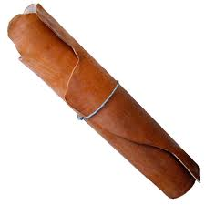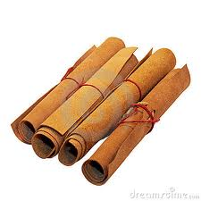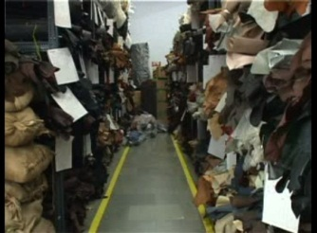
Fig 6.1. Bundling of leather
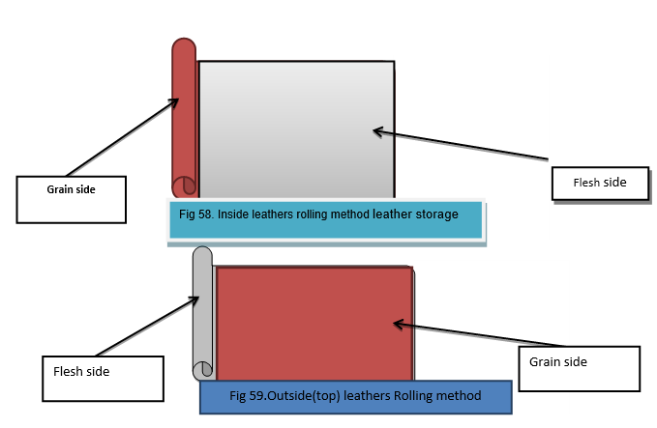
Figure 6.2
6.2.2 Stack on method of leather storage
This kind of leather storage system commonly applicable if the quantity of leather are few or if there is wide and enough space in the store Stack on or flat method of leather storage is better to keep the leather safely without any kind of damage as compare to roll/bundle method. Usually sheep /goat skin are stored by this method. But if we have the space it also applicable to cow and other big types of leather Even though there is no standard that have been set before about the number of quantity that have to be stored in stack on/flat form at a time, most footwear factories and even tanneries used to store 120 – 150 skin/hide once.

Fig 6.3. Stack on method: laying one over the other
Avoid various factors that can affect the performance/usage of leathers and its natural property.

Proper storage and handling are also including below:
- Temperature: most leather best stored should not be more than 10°c -20 °c temperature. Very high storage temperature may cause finish blocking and finish cracking caused by the finish adhering itself or taking the imprint of the flesh side of the text skin. Rapid decrease in temperature normally during winter nights may cause space formation. Room with external wall area the most susceptible to such temperature fluctuation and should not be used as leather store. If this is unavoidable some heating in the leather store during the winter months. This reduces the risks of finish cracking, a potential problem when unwrapping bundles of leather which have been stored at low temperature.
- Humidity: the ideal atmospheric humidity level is between 50 – 60% RH. Above this there likely to be an increased risk of mould growth whilst below it grains in cracking can be a problem. In addition, since the grain crack resistances of the leathers are relative to its moisture content, prolonged storage in the low humidity environment tends to increase the risk of grain crankiness in lasting.
- Lighting: avoid strong light or direct sunlight. Prolonged exposure of leather to strong light, whether natural or artificial often leads to color changes or fading. in extreme cases it may even cause un-brittleness and loss of suppleness. As a general rule the best types of lighting to use in the skin room defuse day light or some form of relatively weak artificial light source.
- Method of storage: in order to minimize the risk of cracking all leather should be ideally stored flat or hung over a horse. Unfortunately, flat storage more space than is available therefore, they are stored in rolls. It is good practice to restrict the number of rolls that are stacked one on top of other. Particularly if wire storage racks are available since these can inflict pressure marks on the bottom roll if overloaded. Also, there should not be excess overlap of leather and suffocation in the store.
- Duration of storage: if leathers are not used immediately, it is not preferable to maintain long time stock.
- Leather storage: - Different types of leather (in color, in types, in grain and in size) should not be stored together. Similar types of leather are preferable to keep together.
- Proper labeling: - in order to easily identified each types of leather and to distinguish one types of leather from the others proper labeling is required. The label should include the required dates.
Problem due to improper storage and handling
- Grain crack
- Finish crack
- Fungal growth
- Color fades.
Leather labeling: include: -
- Color
- Leather grade
- Leather types
- Number of leathers in the bundle(quantity)
- Total area in the bundle or shelf (total area/quantity)

6.3 Performing the reassessment on the value of received consignment
Introduction
Leather is a very complex material, which must be subjected to laboratory tests for accurate assessment. This may not always be possible as most tanneries do not have adequate testing facilitating and some of the tests are very lengthy for any buyer to wait. There are, however, a few crude and quick tests, which can help the buyer in taking correct decision. These tests will give a danger signal, regarding the whole consignment.so before buying and simply receiving the whole ordered leather depending only on the tanneries’ leather grading system, while receiving the order by using random tests method reassessing is very crucial. Then, after receiving the whole order before using it directly for production, conducting reassessment/re-grading of the whole consignment is important. This enables the footwear factories to re-appeal and give feedback regards of the quality of the leather as well they can able to complain on the price based on purchase cost variance calculation.
In random test the following activities are carried out.

Reassessment of the received consignment
After received the whole consignment and before it used in production the following should be carried out:
- The main difference between random sampling testing method from that of reassessment/regrading, in random sampling method only one or two leather from the lot/batch are tested if this tested sample pass the whole batch will pass. But while conducting regrading/reassessment of the consignment the whole /piece/ or each of the leather in the batch should be evaluated and checked.
- As per the sample quality and quantity should be checked.
- Reassessing the grade and sort into a new grade group if required. Regrading is sorting the leathers in a new grade. Because the received leathers may not have the quality as written grade on the leather so that grouping as per the actual cuttable area of the leather into a new grade (1st to 5th grade) is very important.
- Selection of samples
- Substance/thickness
- Finish appearance
- Feel/softness and stretch
- Adhesion of finish
- Cracking
- Wet and dry rub
- Strength
- Fading
- Water repellency
- Chemical resistance
Based on the above criteria tried to check the quality of the products of the lot/batch Based on this the lot will be accepted or reject before the shipment is conducted.
Importance of reassessment and purchase cost variance calculation
The one of the main importance of making reassessment and calculating purchase cost variance for the whole consignment before we start production are tried to explain below:
- Some of the tanneries would not sell their product as per the agreement. They might try to cheat after the agreement while before shipping. Especially such kind of discrepancy/cheating is commonly happened on the quantity and grade of leather.so that Conducting the Reassessment on whole consignment enables us to know whether we are cheated by our supplier or not.
- Conducing the reassessment and purchase cost variance calculation can able the footwear factories to complain on the tanneries if area discrepancy and grade variance seen after the regarding.
- As we said above, reassessment and purchase cost variance calculation help us (footwear factories) to know whether we are cheated by the quantity and by the grade and the data used as a confidential fact and by this we complain, also help us so as to make decision in order to see for the new customer/supplier for the new order. Although, if a big deviation of quality happen on the whole consignment as compare to the sample and from what we expected, this regraded value help us the make decision by this leather we model/article of shoes shall/should be produced.so that we can’t just simply discard the whole leather instead we can make decision on to use it for other model or to sell it to others.
- Sometimes the order quantity and grade of the leather and the actual quantity and grade may be varied. For example if we order 1500 sq.ft of leather on the TR grade (average grade) on the price of 40 br for the 3rd grade. But after we reassessed the whole consignment, the actual value becomes 1440 sq.ft. So, we lost 60sq.ft of leather and expect grade value. from this discrepancy on average we loss 1800birr.by regrading and performing the purchase cost variance calculation we able to know the loss and gain of the consignment.so that the management can able to accommodate and redistribute the loss while cost of a product is calculated in preparation of the price. Generally, we can say that reassessment and purchase cost variance calculation help (footwear factories) to readjusting the profit margin.

6.4 Determining the purchase cost variance from the consignment
6.4.1 Purchase cost variance
Purchase cost variance is just what the name would imply. The difference for an item or service between the amount per unit actually paid and the budgeted amount per unit multiplied by the number of units bought. The purchase price variance of input materials can significantly affect production costs for a manufacturing business that does not have control over the cost of its production inputs. In cost accounting it’s the difference between the standard cost and actual purchase cost. If your standard cost for a component is $1.00 and you buy it at $1.10 then the purchase price variance is $0.10. A positive variance means you are paying more for production and therefore less profitable than plan or simply show loss. If you have a negative variance you are paying less than plan and will be more profitable or show the profit. It’s used to get a quick gauge of status so that management can address cost of goods quickly. The purchase price variance is the operational result, it is not a cost before that decision/buying When regarding is completed it is recommended that a purchase variance account be kept to monitor the gains and losses resulting from such regrading. These records may help to obtain refunds from tanneries or may influence decision to change tanneries or accept a price increase.
Remember: sometimes the cheapest price leather is not the best value for money.
6.4.2 Financial Influence of Leather Grading
To give an example of how leather grading may influence the profit or loss of a clicking room of factory
Example:
A complete delivery of locally tanned leather has been delivered to your factory of the following quantity and price.
Quantity = 2750 sq.ft.
Price = 40 birr per sq.ft.
Total Value of Leather = 110,000 birr
On receipt of the leather, the leather grader regraded and while regrading a discrepancy obtained which is different from the expected grade and quantity of leather as shown below:
Table 4. Expected grade with respect to price:
Grade | Quantity ratio | Expected quantity
1st Grade | 0.1 | 275 sq.ft
2nd Grade | 0.2 | 550 sq.ft
3rd Grade | 0.4 | 1100sq.ft
4th Grade | 0.2 | 550 sq.ft
5th Grade | 0.1 | 275 sq.ft

Table 5. Regraded quantity with price
Grade | Actual regraded quantity
1st Grade | 170 sq.ft.
2nd Grade | 500 sq.ft.
3rd Grade | 1050 sq.ft.
4th Grade | 530 sq.ft.
5th Grade | - .ft.

In leather grading, normally the price is fixed on the middle grade and the rates of other grades vary by 5%. The buying price, that is the price paid by the factory for the shipment would be the middle grade price (40 birr) per material. All grades above this middle grade would increase by 5% in price and all grades below the middle grade would reduce by 5% in price e.g. in the above example, the rate i.e. 40 br prs./sq.ft., is fixed on 3rd or C grade which is the middle grade and the rate of 2nd grade will be 5% more than the middle rate., i.e. (40 + (5% of 40)) = 42 prs./sft., and the rate of 4th grade will be 5% less than 3rd grade i.e., the middle grade i.e., (40 – (5% of 40)) = 40 – 2 = 38br prs./sq.ft.
Table 6. The rates of different grades in the above-mentioned examples are:
Grade | rate | Price per Sq. ft.
1st Grade | + 10% | 44 birr
2nd Grade | + 5% | 42 birr
3rd Grade | Avg. price | 40 birr
4th Grade | - 5% | 38 birr
5th Grade | - 10% | 36 birr
To calculate the value of the leather shipment multiply the graded amount by the price per grade then subtract the total graded price from the actual price paid to the tannery, this would show a buying loss.
Table 7.
Grade | Quantity/sq. ft. | Price per sq. ft. | Value (birr)
1st Grade | 170 sq.ft. | 44 birr | 7,480
2nd Grade | 500 sq.ft. | 42 birr | 21,000
3rd Grade | 1050 sq.ft. | 40 birr | 42000
4th Grade | 530 sq.ft. | 38 birr | 20140
5th Grade | 500 sq.ft. | 36 birr | 18000
 |  | Re graded total value = 108,620 birr
Re graded value is the value or the price worth which the leather is received.
- Subtract the re graded value from the actual price paid 110,000 birr paid to tannery.
- 108,620 birr actual values after regarding.
Result = 110,000 birr - 108,620 birr
= 1380 birr which is a loss on purchase
Since; we have received the material of lesser value (1380 birr) than what we have paid to the tannery (110,000 birr.)
If the actual piece paid was lower than the graded price then this would show a purchasing profit.

6.6 Performing reports and documentation work
Introduction
Documentation is defined as paperwork giving information, instructions or references. The act or an instance of the supplying of documents or supporting references or records Documentation help ensure consent and expectations. It helps to tell the narrative for decisions made, and how yourself or the client responded to different situations. In this same manor, it is important to record information that can help support the proper treatment plan and the reasoning for such services.
6.6.1 Important of Reports and Documentation
- If you have no documentation, operational risk will increase when a talented member from your back-office leaves the firm, as the departed employee will take their portfolio accounting know-how with them. As a result, you and your staff are left haphazardly scrambling to finish the daily reconciliation reports. Documenting all procedures from start to finish will reduce risk when turnover occurs, and following process documentation best practices will have you feeling more secure the next time someone leaves your organization.
- When performing tasks relying solely on memory, there is always the possibility of forgetting something. For example, you might not remember to create backup files, or you’ll forget to remove or edit certain data points.
- We’re human, and we make mistakes, but if you have process documentation that reminds you not to ignore the aforementioned missed points, then you’ve taken another proactive step to mitigate risk.

6.6.2 Record and documentation in leather grading
The area measurement results can be recorded as follows
Table .8 Area Measurements of Samples
S.N. | Consign. | Date of receipt | Name of supplier | Total area by Supp. | Total area by vendor | Discrepancy %

In Procurement of Leather we have to record data of received leather by grade the received and also the following format is used to calculate purchase cost variance and riding of the whole consignments.
Table 9. Leather inspection sheet
Leather inspection sheet
sr. no. | Description |  |  |  |  |  |  | date
1 | leather type:
2 | category |  | upper/ lining |  |  | others
3 | reference article |  |  |  |  | customer ref.
4 | lot ref. number |  |  |  |  | p.o.no. |  | date
5 | customer
6 | color |  |  |  |  | thickness required
7 | quantity ordered |  |  |  |  | quantity received
8 | balance quantity |  |  |  |  | rejected quantity
9 | lab test report no.(if applicable) |  |  |  |  | pass |  | fail
10 | selection method |  | selected grade |  |  | table run
basic test description |  |  | pass | fail |  | Remark
A |  | feel(as per sample)
B |  | thickness |  |  |  | sample: actual:
C |  | four fold test
D |  | wet rub test
E |  | dry rub test
F |  | adhesion to finish test
G |  | tear test
H |  | looseness
12 |  | actual area received
13 |  | shade as per the sample |  |  |  | shade variation
14 |  | average size of the side
15 |  | grain appearance (if applicable)
16 |  | Whether approved for production or not.
17 |  | grade description | pl. fill the qty. in each grade
ref. grade
A |  | 0-3% | B |  | 4-8% | C | 9-13% | D | 14-18%
coeff. |  | 0.99 |  |  | 0.95 |  | 0.9 |  | 0.85
qty.
cuttable area
E |  | 19-23% | F |  | 24-28% | G | 29-33% | H | 34-38%
coeff. |  | 0.8 |  |  | 0.75 |  | 0.7 |  | 0.65
qty.
cuttable area
total area |  |  |  |  | cuttable area
variance in qty. |  |  |  |  | grade variance
purchase cost variance =
prepared by |  |  |  |  | checked by |  | approved by

The following data should be record in the store regarding the leather:
- Stock number
- Delivery date
- Invoice number
- Area
- Number of skin/hide
- Grade
- Supplier name
- Rate
- Issued quantity
- Received quantity
- Balance/stock quantity, etc.…

Self-Check – 2 | Written test

Name…………………………………………… ID………………………… Date…….
Directions: Answer all the questions listed below. Examples may be necessary to aid some explanations/answers.
Part I: Choose the correct answer: (2x5=10 points)
- Which one of the following is the common variation that may happen on the leathers?
- Color b) grain C) substance D) amount of stretch E) all
- Leather variation not only might happen on the same batch of different leathers, instead following may also happen on the same (one) leather:
- size/area b) grain C) grade D) all
- Which one of the following is not happen due to improper storage and bundling of leather?
- Grain crack B) finish crack C) brand mark and scratch D) all
- Leather labeling include: -
- Color B) Leather grade C) Leather type D) All
- While in conducting the reassessment/regrading of the whole consignment which of the main results that has to be documented?
- Consignment number B) Date checked C) Name of supplier
D) Date of receipt E) all
Part II: Fill in the blanks (10x2=20points)
- The main reason for leather sorting is in order to minimize leather ______ in the same batch and to maximize _______.
- Sorting of leather is conduct as per the _______, _____?
- Before starting cutting the cutter must check ----------, -----------?
- Leather is a -------------------------- and is subject to ------------- from one skin to another?
- Randomly the ----------------- is inspected and the whole batch may be pass or fall
- The grain of the leather can vary from ------------------- even within single skins.
- Stored in the factory in _________ and/or ______ forms.
- Avoid strong light or direct ------------------- while storing the leather.
- Most leather best stored not be more than ---------------- temperature.
- The ideal atmospheric humidity level is between ------------------.
Part III: Short answer(3x2=6points)
- Define documentation (3points)
- Write the important of documentation and records? (3 points)
Part IV: Numerical question (1x5=5 points)
- Check whether the following shows positive and negative variance and calculate the quantity gain or lost. ( 5 points)
Footwear factory xyz purchase the following quantity of leather by 5% pricing rate.
Quantity = 2750 sq.ft.
Price = 40 birr per sq.ft.
Total Value of Leather = 110,000 birr
On receipt of the leather, the leather grader regraded the following result shown.
- Re-graded quantity
Grade | Quantity ratio | Expected quantity | Actual regraded quantity
1st Grade | 0.1 | 275 sq.ft | 280 sq.ft.
2nd Grade | 0.2 | 550 sq.ft | 670 sq.ft.
3rd Grade | 0.4 | 1100sq.ft | 1275 sq.ft.
4th Grade | 0.2 | 550 sq.ft | 530 sq.ft.
5th Grade | 0.1 | 275 sq.ft | 275 sq.ft.

Note: Satisfactory rating - 43 points Unsatisfactory – below- 43 points

References
Book:
- Use hand Tools and equipment learning guide
- Leather grading learning guide
Web Addresses
    - https://www.yourdictionary.com/documentation
    - https://hgic.clemson.edu/factsheet/measuring-the-area-of-a-home-lawn/
    - https://www.skillsyouneed.com/num/area.html
    - https://www.leathernaturally.org/Education/Fact-Sheets/Benefits/Why-use-leather-The-characteristic-and-properties

Experts Who Developed This Learning Guide
No | Name | Educational Background | Region | E-mail
1 | Abdi Angerasa | MSc in Footwear Technology, MSc in Industrial Engineering | Addis Ababa, LIDI | abdinago2@gmail.com  0923995950 // 0931430551
2 | Molla Demeke | BSc in Leather and Leather Product Technology | Amhara, Woldia Poly Technic College | mollademeke9@gmail.com  0927633940
3 | Birhanu Bariso | BSC in Leather Technology | SNNPR, Sodo Poly Technic College | birhnubariso@gmail.com  0916785483
4 | Genanaw Dagne | BA in Curriculum Study | Addis Ababa, LIDI | genanewd28@gmail.com  0920247691

