Footwear Production Level I

Based on November 2021, Curriculum Version 1

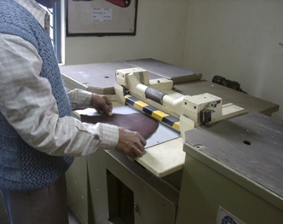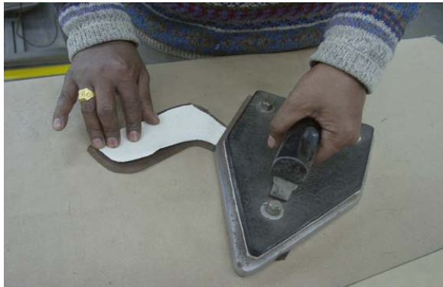

Module Title: Performing Préfabrication Works
Module code: IND FWP1 M06 1221
Nominal duration: 54 Hours

Prepared by: Ministry of Labor and Skills

August, 2022
Addis Ababa, Ethiopia

Contents
Acknowledgment 5
Introduction to the Module 6
Module Instruction 7
Unit one: Identify and use hand tools, equipment and machines 8
1.1. Identifying prefabrication hand tools and equipment 9
1.2. Checking tools for serviceability, safety and faults 11
1.3. Clean, Check, Maintain and Store Hand Tools and Equipment 12
1.4 Obtaining work instructions, specifications and operation details of prefabrication machines 13
1.5. Identifying safety with regard to operator and workplace, tools, equipment and machines 17
Self-Check 1 19
Unit two: Set-up machine and associated equipment/ accessories 20
2.1 Identifying the different prefabrication operations 21
2.2. Determining and confirming product and/or work specification 22
2.3 Checking machines and its blade functionality 23
2.4. Band knife/ bell knife sharpening procedures 27
2.5. Checking and replacing Stamping foil as required 29
2.6. Lubricating, cleaning and maintaining prefabrication Machineries 31
2.7. Setting up work station applying the ergonomics 33
Self-Check -2 40
Unit three: Conduct sample run 41
3.1. Obtaining material for sample run 42
3.2 Running machines according to sample run 42
3.3. Testing machine outputs 51
3.4. Organize machine outputs 56
Self-Check -3 57
Unit four: Adjust machine settings 58
4.1 Interpreting test results to determine machine adjustment requirements. 59
4.2 Assessing machine adjustment changes 62
4.3 Reporting new machine set up 71
Self-Check -4 75
Unit five: Split components 76
5.1. Assessing components 77
5.2 Checking components 78
5.3. Following of work ticket specification 79
5.4 Splitting and checking parts 81
Self -check 5 83
Operation sheet-1 83
Lap test 84
Unit six: Emboss, stamp and mark components 85
6.1 Checking components as per Ticket Specification 86
6.2 Performing stamping and marking operations manually 87
6.3 Adjusting dies for stamping machine 88
6.4 Following work ticket specifications in Pairs and Pieces 89
6.5 Embossing and/or stamping parts to quality standards 91
6.6. Marking parts to specification by hand or marking device 93
Self-check-6 94
Operation sheet-1 94
Lap test 95
Unit seven: Skive components 96
7.1 Selecting components for skiving 97
7.2 Performing skiving operation manually 97
7.3 Performing skiving machine adjustment, and skiving of component 98
7.4. Following Work ticket specifications 110
7.5 Checking skived parts 111
Self-Check -7 113
Operation sheet-1 113
Lap test 114
Unit eight: prepare and use hand tools, materials and equipment 115
8.1 Selecting components to be fused 116
8.2 Performing fusing operation manually 116
8.3 Performing machine fusing adjustment to the required standards. 117
8.4 Fusing components by machine 119
8.5 Following work ticket specifications 122
Self-Check 5 124
Unit nine: Complete work 125
9.1. Observing and Referring Problems with tools and machines for repair or correction 126
9.2. Cleaning, checking, maintaining and storing hand tools and equipment 126
9.3 Documenting, maintaining and reporting records 128
Self-Check-9 136
References 137
Experts Who Developed This Learning Guide 138

Acknowledgment

Ministry of Labor and Skills wish to extend thanks and appreciation to the many representatives of TVET instructors and respective industry experts who donated their time and expertise to the development of this Teaching, Training and Learning Materials (TTLM).

Introduction to the Module
Hand cutting is one of the method of cutting leather or any other shoe making material. Hand cutting is done with the use of hand knife and cutting patterns. This requires a high degree of skill. Hand cutting is a slow process in comparison to press cutting but it is sometimes necessary especially for low order of production or for low order of production
This module is designed to meet the industry requirement under footwear production occupational standard, particularly for the unit of competency: cut materials by hand.
This module covers the units:
- hand tools, equipment and machines
- Set-up machine and associated equipment/ accessories
- Conduct sample run
- machine settings
- Split components
- Emboss, stamp and mark components
- Skive components
- Fuse components
- Complete work
Learning Objective of the Module
- Identify and use hand tools, equipment and machines
- Set-up machine and associated equipment/ accessories
- Conduct sample run
- Adjust machine settings
- Split components
- Emboss, stamp and mark components
- Skive components
- Fuse components
- Complete work

Module Instruction
For effective use this modules trainees are expected to follow the following module instruction:
- Read the information written in each unit
- Accomplish the Self-checks at the end of each unit
- Perform Operation Sheets which were provided at the end of units
- Do the “LAP test” giver at the end of each unit and
- Read the identified reference book for Examples and exercise

Unit one: Identify and use hand tools, equipment and machines
This unit is developed to provide you the necessary information regarding the following content coverage and topics:
  - Identifying prefabrication hand tools and equipment
  - Checking tools for serviceability, safety and faults.
  - Clearing work area, and cleaning, checking, maintaining and storing hand tools and equipment
  - Obtaining work instructions, specifications and operation details of prefabrication machines
  - Identifying safety with regard to operator and workplace, tools, equipment and machines
This unit will also assist you to attain the learning outcomes stated in the cover page. Specifically, upon completion of this learning guide, you will be able to:
  - Identify prefabrication hand tools and equipment
  - Check tools for serviceability, safety and faults.
  - Clear work area, and clean, check, maintain and stor hand tools and equipment
  - Obtain work instructions, specifications and operation details of prefabrication machines
  - Identify safety with regard to operator and workplace, tools, equipment and machines

1.1. Identifying prefabrication hand tools and equipment

Tool is an item or implement used for a specific purpose. A tool can be a physical object such as mechanical tools including saws and hammers .A hand tool is a device for performing work on a material or a physical system using only hands. The hand tools can be manually used employing force, or electrically powered, using electrical current. Virtually every type of tool can be a hand tool and many have also been adapted as power tools, which get their motive power from motors or engines rather than from human mechanical action.
Equipment is defined as a set of tools, devices, kit, etc., assembled for a specific purpose. The difference between hand tool and equipment is usually that hand-tools usually refer to manual tools. Equipment is usually referring to anything that is powered by either electricity or by a motor off some sort.
There are different tools and equipment is used in pre-fabrication some of these are: -
Marking Tools
- Silver pen for temporarily marking on leather rubs off with water. Very useful for closing uppers and marking the heel points during shoe making. Manual marking can be done by hand with the help silver pencil and patter. Marking by hand is done by putting the pattern on the component and tracing with silver pencil.
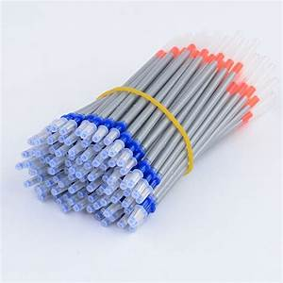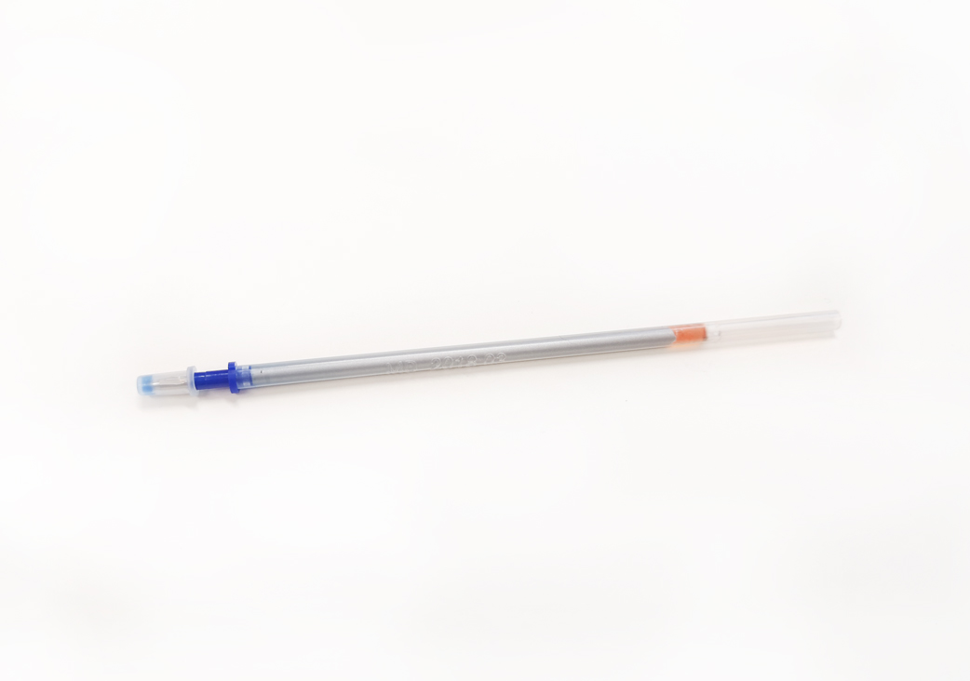
Figure1.1. silver pen
Measuring Tools
- Thickness measuring gauge: -Leather thickness gauges are tools that measure the thickness of leather.
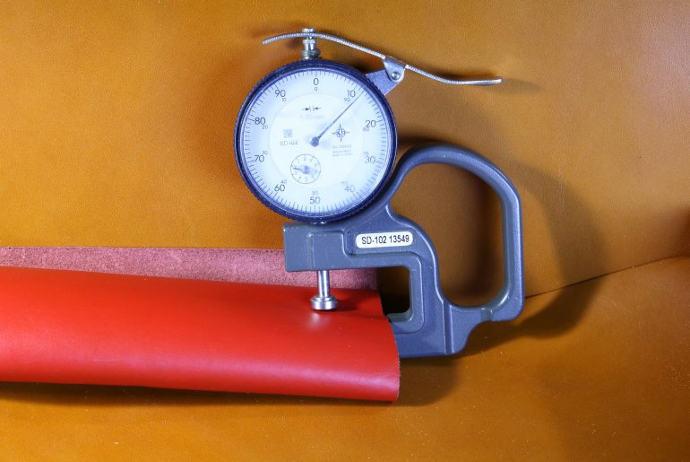
Figure1.2. • Thickness measuring gauge
- Measuring tape is a type of flexible distance measuring device. It is essentially a ruler printed onto a flexible material, such as plastic. This allows it to easily measure organic curves and shapes
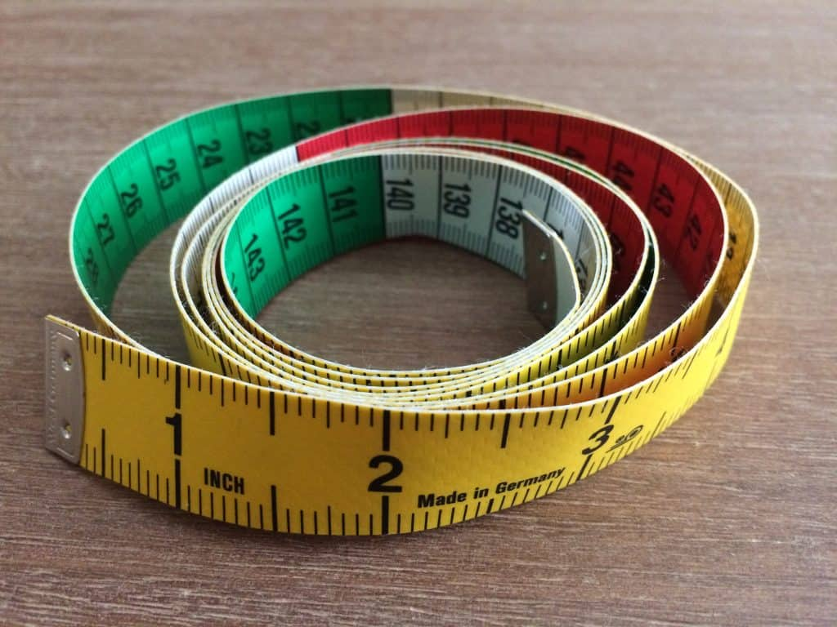
Figure 1.3. Measuring tape
- Metal ruler: - This is especially helpful when using it to mark long lines that should remain straight. They’re also helpful for using as a metal guiding cutting edge, suitable for drawing a knife blade against it.
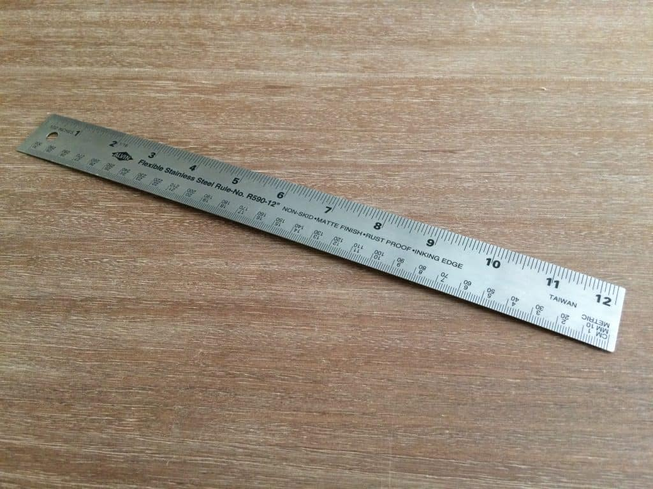
Figure 1.4.metal ruler
Cutting tools
- Scissors: -are hand-operated shearing tools. A pair of scissors consists of a pair of metal blades pivoted so that the sharpened edges slide against each other when the handles opposite to the pivot are closed.
- Olfa knife:- Whenever cutting is needed olfa knife can

1.2. Checking tools for serviceability, safety and faults
Tools Serviceability
Before any use of the tools there must be checking practice. Tools are checked for the sake of serviceability and safety, and faults to be reported. Some of check points for the tools while performing pre-fabrication operations can be: -
- Checking the breakage of tools: We should check tools for any breakage. We should check the tools properly before starting the work.
- Checking the accuracy: After checking any breakage of tools, we should check its accuracy of working. If it is working properly than we should start our actual work.
- Checking the sharpness of cutting tools: -Before using cutting tools in pre-fabrication, first we should check the sharpness of the cutting tools.
Safety Measures While Using the Hand Tools
Generally, safety measures are those actions taken to improve or ensure the safety of a particular place, activity, group, function, or piece of equipment/tools. One of the key issues associated with hand tool safety is choosing and using the right tool. Approximately 8 percent of industrial incidents result from the improper use of hand tools, according to studies. Injuries range from simple cuts, contusions and abrasions to amputations, fractures and punctures.
Safety rules while using hand tool in pre-fabrication include: -
- Selecting the correct tool and the right sized tool for the job
- Inspecting tools for damage before attempting a task
- Keeping tools clean and cutting tools sharp
- Always passing tools to others handle first and never throwing tools to another person
- Cutting away from your body to avoid injury if the cutting device should slip
- Taking advantage of the ergonomically shaped handles available on some tools and holding tools in a manner that minimizes stress to the hand, wrist and arm
    - Cleaning Work Area
The working area is defined, as the area of the workplace where tasks are performed. Cleaning the work area after performing a given task is vital, kept free from waste to ensure a safe working environment for self, fellow workers and others in the workplace.
The benefits of a clean work area
- Increased productivity
- Comply with Health and Safety regulations
- Clear and clean the area
- Store any reusable materials

1.3. Clean, Check, Maintain and Store Hand Tools and Equipment
Cleaning of Tools and Equipment
Every time a piece of equipment is used, the general rule is to clean it straight away so it is ready for the next person to use. The first step to healthy tools is keeping them clean. Your tools to clean them after use will improve their lifespan.
Skills and actions need to clean up tools: -
- Select and use an appropriate method for cleaning
- tools and specialist equipment
- Restore your work area to a safe and tidy condition
- Make sure that any materials, components, tools and equipment that you may need for the next task are set up ready for use.
Storing and maintaining of hand tools
Storing your tools will not only help you stay organized but keep your tools away from the elements. Air circulation and dryness are also important factors when storing gardening tools. Getting into a habit of cleaning and maintaining your tools will make more expensive and better-made tools a lifetime investment.
- Location: - Hand tools should be safely located when not in immediate use.
- Safety: - Hand tools should be used safely and effectively according to their intended use.
- Systematically arrangement: - Hand tools should be clamped or fixed in position.
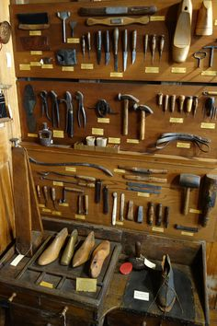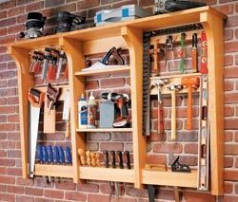
Figure 1.4 Storing hand tools

1.4 Obtaining work instructions, specifications and operation details of prefabrication machines
Work Instruction are documents that clearly and precisely describe the correct way to perform certain tasks that may cause inconvenience or damage if not done in the established manner.
Work instructions are also called work guides, Standard Operating Procedures (SOPs), job aids or user manuals, depending on the situation.
The purpose of the work instructions is to clearly explain how a particular work task is performed. More than nine out of 10 workplace accidents are due to human error
Importance of work instruction
Work instructions, or SOPs, build and preserve the knowledge inside a company. When “how things are done” are passed on verbally, there is room for interpretation and human error. And knowledge about how to most efficiently perform a task is lost when said employee leaves the company and takes the knowledge with them. Good work instructions avoid all this
- Work instructions reduce risk
- Avoid errors and “the blame game”
- Save time
1Work Instructions for pre-fabrication machines
A. Work instruction for Splitting machines
- Splitting machine is a type of machine used to split leather upper components.
- Switch the main switch placed on the panel that bears the electric control.
- Push the start button
- Turn the pressure roller adjustment hand wheel control: clockwise for down position and anti-clockwise for up position. This raises or lower the bar and feed roller to allow the distance between the knife and the roller for splitting above the top of the knife.
- Place a piece of leather on working place table for splitting and set thickness required.
- Pass the leather piece through the feed roller and check thickness of leather.
- Also check the thickness uniformity of split component. If this is not perfected you can correct it in the following ways: -
- Reducing or increasing the pressure of work by a pressure roller adjustment hand wheel.Sharpen band knife: use sharpening wheel adjustments knob for sharpening knife on both sides (upper and lower together)
- On of completion of splitting work, switch off the machine.
B. Work instruction for Skiving machine
Skiving is the process of reducing the thickness of the material from the edge. skiving machine is a type of machine used for reducing the thickness of material.
- Adjust Skiving guide (Width adjustment guide) and Pressure foot asper the required work.
- Power on the machine
- Push control pedal
- Put the material before operation in left side
- place the material by grain surface to the guide
- Check the thickness and uniformity of skived component, if this is not perfected as per requirement re-adjusts the Skiving guide (Width adjustment guide) and Pressure foot as per the required work.
- On of completion of skiving work, switch off the machine.
C. Work instruction for stamping machines
Stamping machine is a type of machine used for the stamping of upper /lining with electro pneumatic control with the use of a counter with composing disk and plasticized foil.
- Switch on the main switch placed on the panel
- Set the sample to stamp on working table.
- Push the control pedal and stay from 5-8 second.
- Check the cleanness of stamp.
- If this is not perfect you can correct it in the following ways:
- Reducing or increasing the pressure of work
- Reducing or increasing the temperature by electronic thermos-regulator placed on the control panel or electric control.
- On of completion of stamping work, switch off the machine.
D. Work instruction for fusing machines
- Check Points before using Fusing Machine
- Check the physical condition of the pressure roller.
- Check the set temperature of the heater, by using a thermal strip at different areas of the rubber roller.
- check the pressure exerted by the pressure roller of fusing machine for required work
- Check for all electrical connections.
- check the solid-state relay switch
- Proper personal protective equipment i.e. gloves, visors, and aprons must be used.
- This machine is used in high temperature, so pay attention to your hands and clothes not to be burned.
- Always wait until the machine is fully stationary.
- Do not push finger/ hand through the heated chamber.
- Avoid wearing loose wears.
- First aid equipment such as first aid kit, stretcher, and dressing material box must be stationed in the vicinity. Carefully observe announce location and operation of fire extinguishers.

D. Fusing Machine Operating Procedure
- Turn on the power Batten
- Each day before start of production, the pressure on the left, right and center of the rollers shall be checked. One of the strips shall be passed through the fusing press and while holding the other end tight. When the end passes out of the press, the strip will be pull to feel the pressure of the rollers.
- Once the Fusing machine is ready for operation, the inter-lining will be set in proper position of the material, the appropriate time will be set and a test run through the machine will be made.
- On of completion of fusing work, switch off the machine.

1.5. Identifying safety with regard to operator and workplace, tools, equipment and machines
1.5.1 Safety with regard to machines
Safe work practices in shops are critical to preventing work-related injuries. Crushed hands and arms, amputations, and other injuries can occur when shop work is done without proper care. Machine parts, functions, or processes that may cause injury must always be controlled or eliminated whenever possible. Never use machinery without proper training or appropriate guards. Ask your supervisor for training if you do not know how to use a piece of machinery or a power tool.
1.5.2. Pre fabrication Machinery Safety Guidelines
- Get trained on each machine before using.
- Follow instruction manuals.
- Select the appropriate machine/tool for the job.
- Use required PPE and guards.
- Set up before starting. Change dull blades, clamp work, secure bits, and remove chuck keys.
- Make sure operating controls are clearly labeled and easy to reach.
- Turn off machinery when unattended.

Dos and Don’ts of machinery safety for workers
A. Do…
- Check the machine is well maintained and fit to be used, i.e. appropriate for the job and working properly and that all the safety measures are in place – guards, isolators, locking mechanisms, emergency off switches etc.
- use the machine properly and in accordance with the manufacturer’s instructions
- make sure you are wearing the appropriate protective clothing and equipment required for that machine, such as safety glasses, hearing protection and safety shoes
- Don’t…
Use a machine or appliance that has a danger sign or tag attached to it. Danger signs should only be removed by an authorized person who is satisfied that the machine or process is now safe
- wear dangling chains, loose clothing, rings or have loose, long hair that could get caught up in moving parts
- distract people who are using machines
- remove any safeguards, even if their presence seems to make the job more difficult

Self-Check 1
Instructions: Write all your answers in the provided answer sheet on page no.
PART I: Short Answer Questions:
Directions: Answer all the questions listed below. Examples may be necessary to aid some explanations/answers.
1. What is pre-fabrication?
2. List and discus operations in pre-fabrication?
PART II fills in the blank space
- The cut component comes from the clicking room in -----------------------?
- --------------------------- includes sorting of cut component in order to make batches and lots as per the order break up and delivery schedule.

Unit two: Set-up machine and associated equipment/ accessories
This unit is developed to provide you the necessary information regarding the following content coverage and topics
  - Identifying the different prefabrication operations
  - Determining and confirming product and/or work specification
  - Checking machines and its blade functionality
  - Band knife/ bell knife sharpening procedures
  - Checking and replacing Stamping foil as required
  - Lubricating, cleaning and maintaining prefabrication Machineries
  - Setting up work station applying the ergonomics
This unit will also assist you to attain the learning outcomes stated in the cover page. Specifically, upon completion of this learning guide, you will be able to:
  - Identify the different prefabrication operations
  - Determine and confirming product and/or work specification
  - Check machines and its blade functionality
  - Band knife/ bell knife sharpen procedures
  - Check and replace Stamping foil as required
  - Lubricate clean and maintain prefabrication Machineries
  - Set up work station applying the ergonomics

2.1 Identifying the different prefabrication operations
Pre-fabrication is, as the name suggests, a series of operations in preparing sections for the ultimate stitching.
The following operations are included in the pre-fabrication: -
- Checking
The first operation is usually to check the cut components against the work tickets to ensure the availability of all components before feeding them in to the conveyer. This makes the consecutive operations convenient and eliminates any kind of discrepancies during various operations. The purpose of this operation is to help in continuous feeding and ensure the loading in time. During checking, the checker must keep in mind against article No, batch No, lot No, sizes, no of upper components, no of lining components, quantity of pairs, color and any other specification provided by the customer. Responsible person is required for this job with a detailed knowledge of the various operation sequences of production. He makes the record of each feed lot of cut component and maintains the continuity in feeding. Recording at different production levels eases the traceability and helps in better planning.
- Stitch Marking
In this operation, marks are put on the upper material to enable the operatives to position/fit the components together accurately before stitching. This enables the fitting operations easy and convenient during upper making. Stitch marking ensures for the position of any kind of fancy stitching to be done on upper and also help in identifying the position of eyelets, buckles, ornaments, punching etc.
Following are different marking methods available in footwear industry:-
- Manual marking by silver refill or white pencil
- Prick marking
- Pricking awl
- Stitching- marking machines

- Stamping
When a person buys a pair of shoes, how do they know what size or fitting of the shoes is? The size might be stamped or molded on the sole, it may say on the in sock stuck at the heel of the shoe – but almost certainly the size will be stamped somewhere on the upper. The stamping details includes: size, fitting article no, shoe number, work ticket number, factory code, last and type of material used.
- Splitting
The process of dividing a hide or skin horizontally into two or more layers is known as splitting. There are different types of splitting machines are available in footwear industry as per their requirements. This process is done to obtain desired thickness of leather.
- Interlining Attachment (Fusing)
The word fusing is used for fixing a sugar-coated fabric to a particular material for reinforcing and strengthen purpose by fusing machine. Different kinds of material are used in shoe making and leather is rated best to make a comfortable and hygienic shoe.
- Edge Coloring
Edge color is done on the raw edges left in the component as per specification given. During edge color, care should be taken against sipping or flowing of color on the grain or flesh side of the component.
- Skiving
Skiving is the process of reduction of thickness of the material either from grain or flesh side of material in order to aid and eases the various closing operations at different levels. A layer of substance is removed under this process without hampering the existing strength of the material.

2.2. Determining and confirming product and/or work specification
This Module information sheet aims the development of skills, attitudes and knowledge to product and work specifications in pre-fabrication. It covers the initial part of production, where all upper cut components are prepared for closing operations. This makes upper closing easy and more convenient.
Depending upon the space productivity and availability the preparation section may be found in:
- Cutting room
- Independent section
- In closing room.
The cut component comes from the clicking room in batches or lots, normally in multiples of 10 or 12 pairs. Along with the lot, there is usually a work ticket, which contains details related to the particular batch is to be made. For example, for the closing room, it would state- Article No, size; lot No, color and type of thread, size and type of eyelets or elastics, etc. Sometimes buyer’s name is also specified in the detail given. The preparatio
n department has its own advantages and disadvantages to be with the cutting room, independent section and with upper closing department.
The method of receiving work from the clicking department and number of pairs per lot will vary with different firms. It is customary to use a type of carton or similar receptacle with divisions for accommodating the sections which must be kept in their correct order of
sizes to avoid trouble at a later stage. For this reason small parts, such as back-strips, must be tied up. The amount per carton is dependent upon the procedure adopted in making—size of rack, type of production etc. It is essential that a regular flow of work should enter the department from the clicking room; once again the method employed e.g. day sheet system, will determine the intervals and amounts
  - Checking machines and its blade functionality.
    - Splitting Machines
The process of dividing components horizontally into two or more layers is known as splitting. There are different types of splitting machines are available in footwear industry as per their requirements.
This process is done to obtain desired thickness of leather. Leather being a natural material is never having same thickness all over the hide or skin. a hide was reduced in thickness by the process called shaving during tanning. The modern splitting machine has a flexible knife in the form of an endless band moving at high speed over a pair of large pulleys.. The propelling rollers are made up of a large number of small ring rolls with rubber centers, which allow for initial variations in the thickness of the hide. The knife can be adjusted to slice through the thickness of the hide at any desired depth below the grain surface by adjusting the level of the rollers. While the machine is in operation, grinders attached on its underside automatically sharpen the band knife.
- Pre-operation check:
- Receive the material with work-ticket. Verify the material for quality and quantity issued.
- Knife should not be touching to any parts of the machine.
- Feed roller should not be touching the knife.
- There should not be any jammed material in the m/c.
- Machine operation:
- Set the correct thickness before starting splitting of components
- Match the split component with the thickness gauge once a day.
- Do not split leather in layers.
- Clean your work place after completing your work.
- Empty the leather waste in to waste bin only.
- After completing your work, switch off the m/c.
- Stamping Machines
The details are usually stamped on the lining using heated metal dies set in a stamping machine. The attached dies are pressed down on a foil ribbon, which transfers the coating of the ribbon onto the component. Sometimes some material like Fur linings is impossible to stamp. So in this case, it is usual to stamp the details on a suitable material and either stick or stitch this with Fur lining in required place.
- Pre-operation check:
- Receive the material with work-ticket. Verify the material for quality and quantity issued.
- Receive the cut-components with upper job card on 10 Pairs basis.
- No. of upper and lining components should be counted properly
- Temperature of the machine should be correct
- Pressure in the machine should be correct.
- Printing foils should be of correct color according to the specification
- Machine operation:
- Set the digits as per article no., batch no, lot no, sizes and any other specification provided by the customer while stamping on the components
- Match the stamped component with the sample.
- Do not split leather in layers.
- Check for the temperature of the heated number plate / die (70-80 degree Celsius).
- Clean your work place after completing your work.
- Empty printing foils waste in to waste bin only.
- Place each component on machine platform carefully with specified margin/place on the components.
- Keep the hands away from the heated number plate/die.
    - Skiving Machines
Skiving is the process of reduction of thickness of the material either from grain or flesh side of material in order to aid and eases the various closing operations at different levels. A layer of substance is removed under this process without hampering the existing strength of the material. When we join or attach two components together without any skiving, it doubles the substance and creates problems for next operations to perform during shoe making and cause discomfort to wearer. Hence the importance of skiving can be noticed and specified results could be achieved.
- Pre-operation check:
- Knife should not be touching the pressure foot.
- Feed roller should not be touching the knife.
- Pressure foot should not be touching the feed roller.
- Make sure the sharpening stone is not touching the knife.
- There should not be any jammed material in the m/c.
- Machine operation:
- Position the guide and Pressure foot.
- Switch on the m/c.
- Depress the treadle.
- Stack your work on the bench top to the left of the m/c.
- Feed in the leather with the grain side up.
- Keep the leather to the guide.
- Run straight through.
- Place the skived piece of leather upside down on the m/c bed.
- Pick up the next piece and skive as before.
- After completing your work, switch off the m/c.
    - inter-lining Attaching (Fusing)
The word fusing is used for fixing a sugar-coated fabric to a particular material for reinforcing and strengthens purpose by fusing machine.. Leather being a natural material has fibrous structure, which can have loose flesh, soft feel and thin substance. To make a good presentable shoe out of this type of material, we need to have a special treatment called reinforcing or interlining attaching. Some of the material is as follows:
  - Thin leather pieces
  - Fabric
  - Sugar coated material
  - Pressure sensitive material (heat base)
  - Solvent base
  - Self-adhesive nylon or cotton tapes
- Pre-operation check:
- Receive the material with work-ticket. Verify the material for quality and quantity issued.
- Receive the cut-components with upper job card on 10 Pairs basis.
- No. of upper and lining components should be counted properly
- Temperature of the machine should be correct
- Pressure in the machine should be correct.
- Interlining material should be checked properly and as per specification.
- Reinforcement material should be compatible with corresponding material.
- Woven (stretch) reinforcement material should be selected for fixing under stretching areas (lasting pulls) of upper.
- Non-woven reinforcement material should be selected for fixing under punching and perforated areas like eyelets and brogue punches.
- Braided reinforcement (nylon) material should be used for fixing under folding and top lines.
Machine operation:
- Match the attached interlining components with the sample.
- Check for the temperature of the machine.
- The temperatures must be kept constant, with minimal fluctuations throughout the day.
- Clean your work place after completing your work.
- Place each component on machine platform carefully with specified margin/place on the components.
- Keep the hands away from the heated plate
- In case of heat activated reinforcement is used; make sure that the temperature and dwell time is correct. Check for correct adhesion and placement of reinforcement. Use an electronic thermometer, melting crayons or temperature sensitive papers. Do not rely on the temperature gauge and timer fixed when carrying out these checks.
- Ensure for stitching over reinforcement.
- Reinforcement fixing should be avoided over lasting margins (especially in cement lasting), as it hinders the pasting operation during lasting.
- Non-woven reinforcement material should be used under perforations.
- Woven or knitted reinforcement material should be used all around lasting pulls.

Band knife/ bell knife sharpening procedures
Bell Knife is called so because it is having a shape of bell. The idea behind giving bell shape is to increase the life of the knife, which is continuously wearing off during sharpening process. The sharpening of knife is frequently required to obtained the quality skiving. The bell knife always moves away from an operator during skiving, which keeps the dust particles away from an operator.
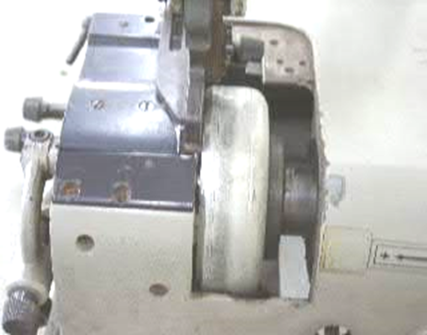
Bell Knife
Figure 2.1. Bell knife
The Bell knife will produce bad cuts as it becomes dull during usage, so you need to sharpen the knife according to the following procedures.
(1) Knife sharpening clutch device
A. The sharpening stone rotates when you turn the shifting knob① clockwise.
B. When sharpening is complete, you must lift the clutch lever up and stop the sharpening stone
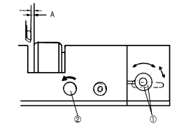.
Figure 2.2. Knife sharpening clutch device
(2) The distance(A) between the knife and the presser foot should be about 0.5mm.
(3) If you turn the stone control grip② slowly counterclockwise, the sharpening stone③ will come into close contact with the knife and start the sharpening process.
Note Be careful not to bring the sharpening stone too close to the knife, because the knife can get overheated and this may lead to knife oscillation.
(4) If the sharpened edge of the knife has the sharp-end shifted to the opposite direction, bring the rod stone in parallel contact with the knife’s inner surface to re-sharpen the blade to its proper direction.
(5) After sharpening process is complete, return the sharpening stone to its original place and turn the clutch off
A. Thin material 0.2~0.3mm
B. Medium material 0.3~0.5mm
C. Thick and strong material 0.5~0.8mm

2.5. Checking and replacing Stamping foil as required
Stamping foil
Note: -Before intervening on the counter remember to:
- Stop the machine (selector MAIN SWITCH in position 0);
- Disconnect the electric feeding cable;
- Close the tab for the air placed next to the group of filter-reducer set on the side of the machine and discharged all the compressed air from the pneumatic system.
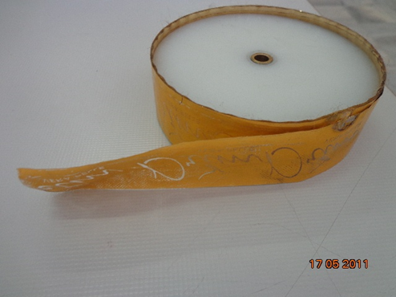
Figure2.3. Setting or Substitution of the Printing Foil

In order to set the printing foil, operate as follows:
1. Unscrew the blocking knob and take away the fixing spring from the support pivot from the device that bears the foil;
2. Take away the anterior flange from the support pivot of the device that bears the foil;
3. Unroll the beginning of the printing foil making it do the way indicated in the picture, going on the device to protect hands;
4. In order to be close to the transport of the printing foil take up manually the pressure roll placed on the tractor pulley and going over the strength of the spring of return and dispose the foil under the pressure roll itself.
The transport of the foil is done after every printing during the phase of the going up of the printing group, thanks to the angular rotation done by the tractor pulley made of rubber and action by a control connecting rod. A device with free wheel allows the rotation of the tractor pulley only in the direction on going on.
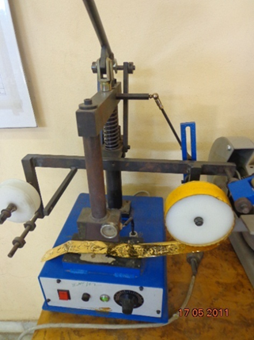
Figure 2.4. Transport of the printing foil
Adjusting the Transport of the Printing Foil
In order to make the adjusting of the transport of the printing foil, work as follows:
Unscrew the blocking lever and move the pivot placed on the side of the rod for the control on the hole placed in the adjusting lever for the transport, according to the dimensions of the die;
- After having done the adjusting close again the blocking lever.
Adjusting the Tension of the Printing Foil
The tension of the printing foil is determined by the pressure exerted by the screw placed in the same axis to the pivot that bears the spool on the anterior flange. The adjusting of the tension is done varying the charge on the spring by the pressure bushing.

2.6. Lubricating, cleaning and maintaining prefabrication Machineries
2.6.1. Blade alignment
- Belt Blade Adjustment
Procedures that follow to adjust the blade alignment.
- Switch off the machine (Stop button) and leave the main switch on (). Remove the lids, the work top and the central casing.
- Put the machine in to Maintenance mode.
- Disengage the upper blade pusher wedges and the lower blade pusher.
- Check by how much the blade juts out from the lower counter blade as shown in the diagram. If it exceeds 4.0 millimeters on both sides release the nut and slightly loosen both screws of the blade stop rollers.
- Start up the machine (Start button) allowing it to run for a few seconds then switch off (Start button) allowing it to run for a few seconds then switch off (Stop button). The blade will have retreated slightly.
Note: - this is a very dangerous operation to be carried out only by authorized personnel.
- With the machine on check the pressure by slightly squeezing them with your fingers.
- If it is not possible it is necessary to reduce the pressure by slightly tightening the screws. If the pressure needed to stop the rollers is different from each other it is necessary to slightly tighten the screw of the roller that poses the greatest resistance.
- When the pressure necessary to halt the two rollers becomes the same tighten the nuts.
- While if the measured value is less than 3.9 it is necessary to proceed by tightening the screws verifying the pressure on the rollers as previously described.
- Re-position the upper and lower blade pusher wedges.
- Remove the maintenance key and press the button.
- Close the machine.
    - Lubricate, clean and maintain machineries
Lubrication can be defined as the application of oily or greasy substances, also called 'lubricants', in order to reduce friction and allow moving machine parts to slide smoothly past each other. Despite the fact that correct lubrication is one of the most crucial aspects of a reliability program for rotating equipment, lubrication is often perceived as a lowly job that doesn’t require much experience or skill.
Important of lubrication
Most people believe that lubrication is only important because it makes the parts ‘slippery’. In reality, lubricants are substances which play a major role in bearing and machinery function and longevity by:
- Reducing wear of moving parts
- Reducing friction between rotating parts and stationery ones
- Absorbing shock
- Reducing operating temperatures
- Minimizing corrosion of metal surfaces
- Keeping contaminants out of the system
- Sealing and protecting components

Clean and maintain machineries
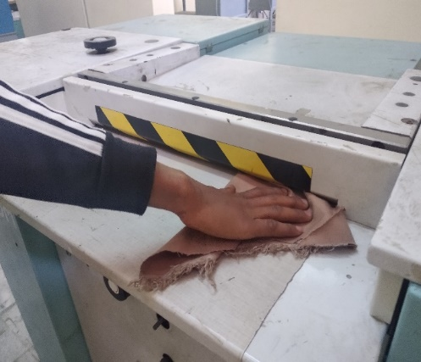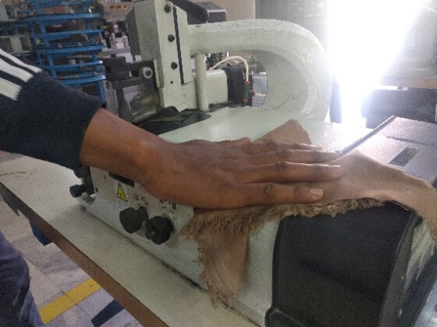
Figure 2.5 Cleaning spliting machine Figure 2.6Cleaning skiving machine

Setting up work station applying the ergonomics
Ergonomics
Ergonomics is the study of the relationship between the worker and the working environment. Work plays a central role in people’s lives, since most workers spend at least eight hours day in the workplace, whether it is on a plantation, in an office, factory etc. therefore, work environments should be safe and healthy. Yet this is not the case for many workers. Every day workers all over the world is faced with a multitude of health hazards, such as:
- Dust
- Gases;
- Noise;
- Vibration;
- Extreme temperatures.
Unfortunately, some employers assume little responsibility for the protection of workers health and safety. In fact, some employers do not even know that they have the moral and often legal responsibility to protect workers. As a result of the hazard and lack of attention given to health and safety, work related accidents and diseased are common in all parts of the world.
The main health & Safety hazards can be classified as:
- Due to machine and equipment
- Due to working environments and conditions.
- Due to machine and equipment
Many workers suffer injuries and disease that result from manual works and the increased mechanization of work. One the result of manual work, as well as the increase in mechanization, is that more and more workers are suffering from backaches, neck aches, sore wrists, arms and legs, and eyestrain. To avoid this we should improve poor working conditions e.g. prevent bad design from being built into a job if applied when a job, tools or workstation are set up. Workers are often forced to adapt themselves to poor working condition which is not good as this causes loss of productivity.
- Due to working environments and conditions
Workplace environment and conditions influence workers performance to a great extent.
Temperature & humidity, noise and quality of light are some key conditions. These can have an effect safety and health of workers and can be improved simple means.
Temperature & humidity:
Good ventilation and air circulation in the work area and insulation of buildings against outside health and cold will contribute to pleasant temperature and reduction of humidity. At eh same time, overall ventilation also reduces the concentration of airborne contaminant.
Ideally factors such as direction of wind and facing northern direction for sunshine should be always considered when planning the construction of a tannery.
- Use natural ventilation and air circulation to achieve low cost overall ventilation first, taking advantage of horizontal air movement around and though buildings or the tendency of hot air to rise. Simple modifications such as removal of separating walls or increase of wall opening will improve the natural airflow.
- Install fans, where natural air ventilation and circulation are not sufficient.

Insulation against heat and cold
Before resorting to expensive equipment to control temperature, be aware that heat and cold are also caused by outside climatic conditions. Heat and cold may get inside the factory directly through opening such as windows, doors, gaps, skylights, or indirectly though conduction through walls and roots. While ventilation is one way to remove heat from the work place, also consider to:
- Improving the heat reflection of walls and roofs by plastering or whitewashing;
- Improving the insulation of the roof by using insulating material or double layer roof;
- Using radiant heat from machines and process to warm the work place in cold climate;
- Using shades for the walls opening to deflect heat from direct sun shine;

Quality of light
Poor lighting leads to low productivity and poor quality, as workers will start suffering from eye strain, fatigue and headache. Better lighting does not mean that more light bulbs have to be fixed in many cases, rearrangement of existing lighting and proper maintenance and cleanliness of reflectors/fittings will result in improvements
- Make full use of natural daylight by installing skylights or modifying size and location of window. Keeps window clean all the time. You save the electricity cost of artificial lighting.
- Paint callings and inner walls in lighter colors. This provides better reflection and distribution of existing light sources besides resulting in better visual condition and a pleasant work environment.
- Avoid direct and indirect glare, glare can distract the workers concentration, possibly resulting in poorer quality or even accidents.
Noise
Not all sound is noise –noise is sound that people do not like. Noise can be annoying and it can interfere with your ability to work by causing stress and disturbing your concentration. Noise can cause accident by interfering with communication and warning signals. Noise can cause chronic health problems. Noise can also cause you to lose your hearing. Hearing loss from exposure to noise in the workplace is one of the most common of all industrial diseases. Workers can be exposed to high noise level in workplaces as varied as construction industries, foundries and textile industries. Short-term exposure to excessive nose can cause temporary hearing loss, lasting from a few seconds to a few days. Exposure to noise over a long period of time can cause permanent hearing loss. Hearing loss that occurs over time is not always easy to recognize and unfortunately, most workers do not realize they are going deaf until their hearing is permanently damaged. Industrial noise exposure can be controlled – often for minimal cost and without technical difficulty. The goal in controlling industrial noise is to eliminate or reduce the noise at the source producing it.
The health effect of noise exposure depends on the level of the noise and the length of the exposure.
Temporary hearing loss:
After spending a short time in a noisy workplace, you may have noticed that you cannot hear very well and you have a ringing in your ears. This condition is called temporary threshold shift. The ringing and the feeling of deafness normally war off after you have been away from the noise for the short time. However, the longer you are exposed to the noise, the longer it takes several hours for a workers may find it difficult to hear what other people are saying or may want the radio or television on louder that the rest of the family.
Suspect hearing loss if a person complains that he or she cannot hear something when you can.
Permanent hearing loss:

Eventually, after you have been exposed to excessive noise for too long, uour ears do not recover and the hearing loss becomes permanent. Permanent hearing loss can never be repaired. This type of damage to the ear can be caused by long –term exposure to loud noise or, in some case, by short exposures to very loud noises.
When a work begins to lose his or her hearing, he or she may first notice that normal talking unclear. Worker often adapt himself or herself to hearing loss produced by harmful noise at work.
It is important to be aware of science of hearing loss.
Other effects:
In addition to hearing loss, exposure to noise in the workplace can cause a variety of other problems, including chronic health problem for example:
- Decrease of coordination and concentration.
- Noise increases stress, which can lead to a number of health problems, including heart, stomach and nervous disorders. Noise is suspected of being one of the causes of heart disease and stomach ulcers.
2.7.2 Ergonomic Principles
In a well-designed workplace, the worker has the opportunity to choose from among a variety of well-balanced working positions and to change between them frequently.
Working tables and benches should be adjustable. Being able to adjust the working height is particularly important to match the workstation to the worker's individual body size and to the worker's particular task. Adjustability ensures that the worker can carry out work in well-balanced body positions. If the workstation cannot be adjusted, platforms to raise the shorter worker or pedestals on top of workstations for the tall worker should be considered.
Organizing the workspace is another important aspect. There should be enough room to move around and to change body position. Providing built-in foot rails or portable footrests allows the worker to shift body weight from one leg to the other. Elbow supports for precision work help reduce tension in the upper arms and neck. Controls and tools should be positioned so the worker can reach them easily and without twisting or bending.
Where it is possible, a seat should be provided so that the worker can do the job either sitting or standing. The seat must place the worker at a height that suits the type of work being done. For work that requires standing only, a seat should be provided in any case to allow the worker to sit occasionally. Seats at the workplace expand the variety of possible body positions and give the worker more flexibility.
Standing (Splitting, Stamping and Interlining Attaching):
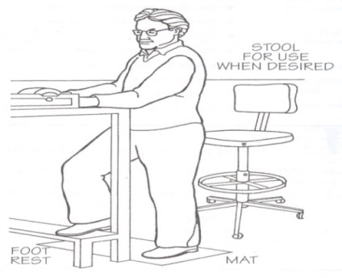
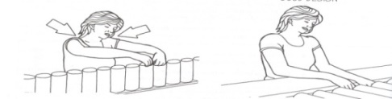
- Standing for long periods of time to perform a job should be avoided
Fig 2.7 Standing (Splitting, Stamping and Interlining Attaching
Long periods of standing works station can cause health problems. For example: A chair, footrest, a mat to stand on, and an adjustable work surface are essential components for a standing workstation.
How job design can reduce effects of working in a standing position
The basic principles of good job design for standing work are:
- Change working positions frequently so that working in one position is of a reasonably short duration.
- Avoid extreme bending, stretching and twisting.
- Pace work appropriately.
- Allow workers suitable rest periods to relax; exercises may also help.
- Provide instruction on proper work practices and the use of rest breaks.
- Allow workers an adjustment period when they return to work after an absence for vacation or illness so they can gradually return to a regular work pace.
How work practices can reduce effects of working in a standing position:
A well-designed workplace combine with a well-designed job make it possible to work in a balanced position without unnecessary strain on the body. Although the actual performance of the task depends on the worker (including how the worker stands, moves or lifts), work practices can make the job either safer or more hazardous. Proper training shapes individual work habits and by a supervisor who encourages the worker to use the skills they have learned.
Example of a workstation designed for a standing worker
Workplace design should fit the variety of workers' shapes and sizes and provide support for the completion of different tasks.
Different tasks require different work surface heights:
- Precision work, such as writing or electronic assembly - 5 cm above elbow height; elbow support is needed.
- Light work, such as assembly line or mechanical jobs - about 5-10 cm below elbow height.
- Heavy work, demanding downward forces - from 20-40 cm below elbow height.
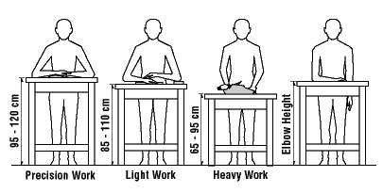
Fig 2.8 standing workers

Self-Check -2
Instructions: Write all your answers.
Directions: Answer all the questions listed below. Examples may be necessary to aid some explanations/answers.
Part I: Short Answer Questions:
- What is Ergonomics?
- Mention two classifications of the main health & Safety hazards.
Part I: say “True” if the statement is correct and say “False” if the statement is incorrect.
1. Standing for long periods of time to perform a job should be avoided wherever possible
2. Non-woven reinforcement material should be used under perforations.
- Woven or knitted reinforcement material should be used all around lasting pulls.

Unit three: Conduct sample run
This unit is developed to provide you the necessary information regarding the following content coverage and topics:
  - Obtaining material for sample run
  - Running machines
  - Testing machine outputs
  - Organizing machine outputs to interpret test results
This unit will also assist you to attain the learning outcomes stated in the cover page.
  - Obtain material for sample run
  - Run machines
  - Test machine outputs
  - Organize machine outputs to interpret test results

3.1. Obtaining material for sample run
    - Sample products
A type of product which is used as samples or models their function is to use as a reference for the production process. So, in the prefabrication operations machines should be operated according to these specified sample products and following the standard procedures.
A workplace procedure is a step-by-step description of how some job function is to be done. It is most useful if written in clear language and readily available to those who perform that function.
Advantages of sample run
- Easy to Execute and Understand.
- Control and Sense of Process.
- Clustered Selection Eliminated.
- Low Risk Factor.
- Assumes Size of Population Can Be Determined.
- Need for Natural Degree of Randomness.
- Greater Risk of Data Manipulation.

3.2 Running machines according to sample run
Standard operating procedures
Having a written standard operating procedure gives you a document to refer to if anyone has questions. So, in the prefabrication operations machines should be operated according to these specified sample products and following the standard procedures.
Splitting machine
Set machine for the required thickness:
- Starting up: Turn the main switch on. Press the green START button.
- First the blade sharpening operation is undertaken by operating the knob.
- Turn the wheel to raise or lift the foot (or the upper conveyor roller if mounted instead of the latter). The desired cutting measurement will appear on the viewer..
- It is possible to increase the pressure applied by the lower roller on the material to be processed. Light pressure is advisable for thin and soft materials. For thicker and harder materials greater pressure is advised. A special indicator shows how much pressure is applied.
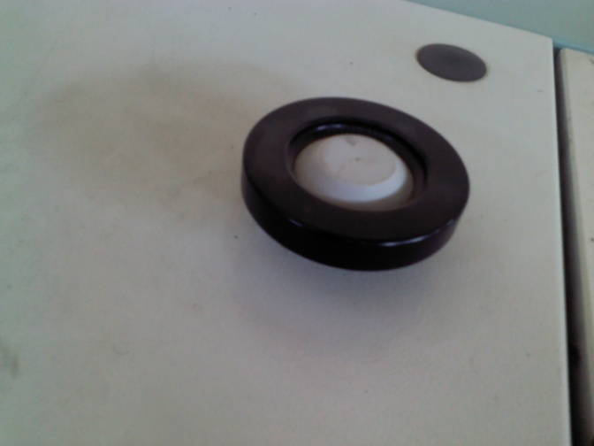
Pressure Regulator
Fig 3.1. Splitting machine pressure regulator
Stamping machines
Set temperature & pressure
Acting on the knob of thermo regulator you set the desired value of temperature for the heating of the metal dies set in a stamping machine.
- Never set the temperature more than 150ºc on the electric resistance for the heating of the counter.
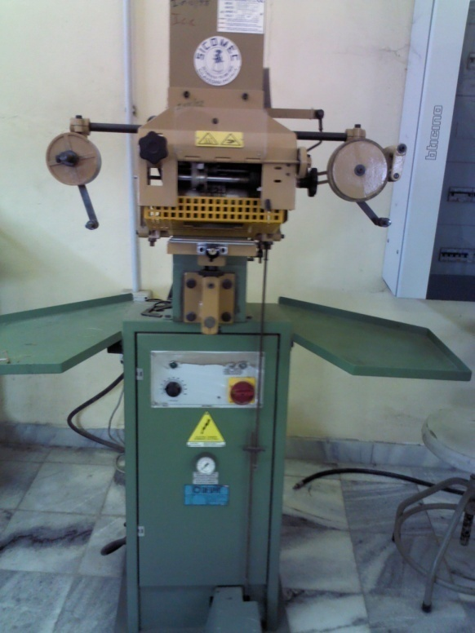
Fig 3.2. Stamping machine

Description of the cycle of running
The sequence of running is the following:
- Action the MAIN SWITCH placed on the panel that bears the electric controls.
- Push the button START.
- Set on the electronic timer Temperature of the Electric Resistance the desired value of temperature.
- When the electric resistance has reached the set temperature, the light on the control panel turns off.
- Set the object to print on the working plan.
- Push the control pedal.
- Following to the action of a lever device you have the sequence of work:
- The device to protect hands goes down to the working plan;
- You push the micro switch that controls the going down of the printing group by a pivot;
- When the printing time set on the timer has passed, the printing group begins its going up.
During the going up phase, you have the transport of the printing foil. The transport of the printing foil allows submitting to the die a new portion of printing foil.
- Check the clearness of the printing. If this is not perfect, you can correct it in the following ways:
- Reducing or increasing the pressure of work by a pressure reducer placed on the side of the bearing column, paying attention of not go over the value of 6 bar;
- Reducing or increasing the temperature of the die acting on the electronic thermo regulator; the value of the temperature of the counter will depend from the kind of printing foil used.
Changing the printing time by the timer Printing Time placed on the panel of electric controls.
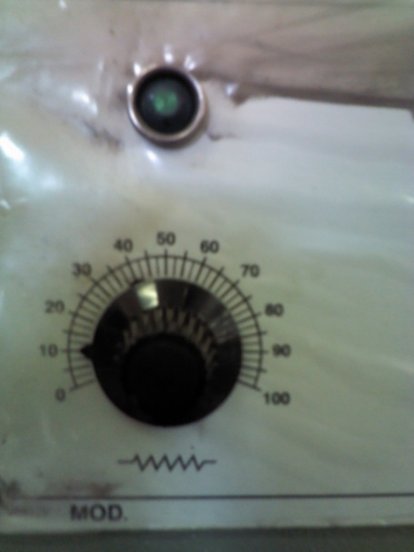
Figure 3.3.Temperature controlling knob
Key:
- Device to protect hands
- Control pedal
- Lever that controls the sequence of work
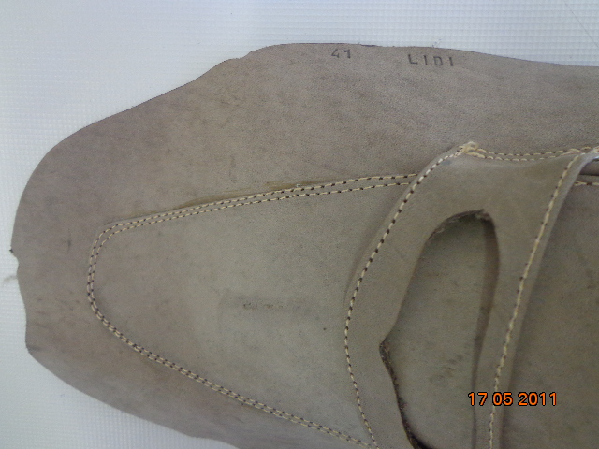
stamp
Figure3.4 stamp
Marking
Then after checking patterns with the marking patterns, the marking operation using the marking patterns is followed.
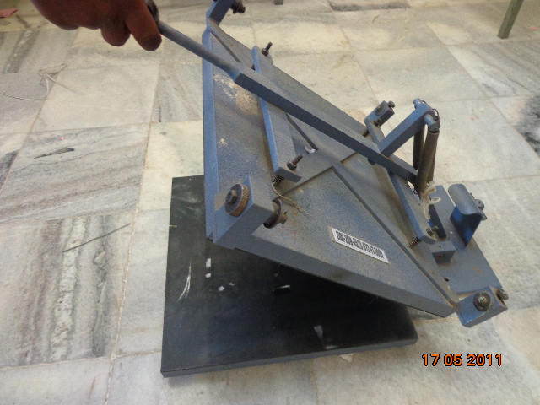
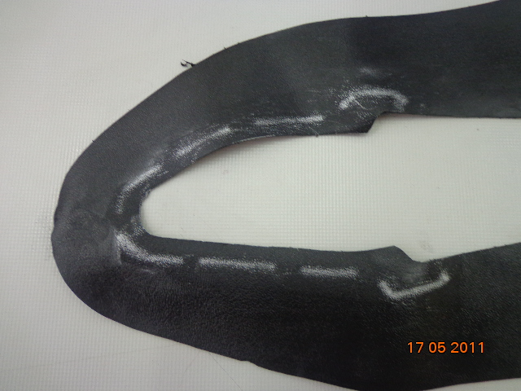
Figure 3.4. Marked Component
Check with master patterns
Finally, the marking must be checked using the master patterns whether it is as per the specification or not.
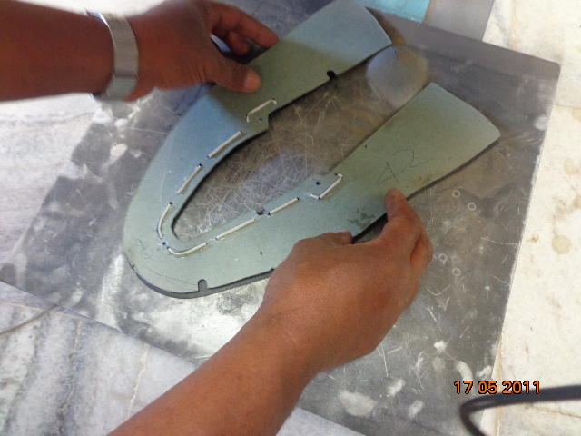
Figure 3.5 Checking of Component with Master Pattern
Skiving
Check Pressure Foot
. The main function of the pressure foot is to press the material and determined the width and angle of skiving been done. The material touching part of pressure foot should be smooth and fine as it always touches the grain surface of material and can damage the top surface in case of roughness or scratches on it.. The design and shape of the pressure foot vary according to the type of skiving required.
- Parallel shape of pressure foot is requiring for folding skiving. (Parallel as per knife and roller).
- Flat forepart of pressure foot is requiring for raw edge and underlay skiving. (Width & angle of skiving).
- Grooved in between the pressure foot is requires to make grooved skiving.
- Teflon material pressure foot or Teflon tape wrapped foot is used for skiving on synthetic material.
Check guide:
Skiving guide is fixed near the pressure foot and used to determine the skiving width during skiving. We should check the guide and adjust properly.
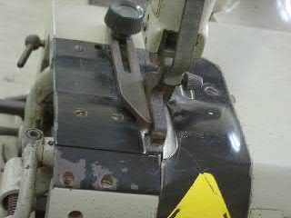
Figure 3.6 Check Guide
Sample run:
There are following procedures for the sample run:
- Switch on the machine.
- Set the pressure foot and width adjustment guide to the desired setting.
- Feed through a piece of material with the grain side up. Release your grip on the material as soon as machine begins to feed.
- Check the width and depth of skiving. If not correct, alter the machine setting until you are skiving the required specifications.
- Hold your sample with the grain side up.
- Feed the sample again through the machine:
- Feed through the piece from left to right.
- While this is feeding through grip the next piece out of your left.
- As the first piece just clears the feed rollers, insert the next piece in.
- Repeat the procedure until the all pieces have been skived.
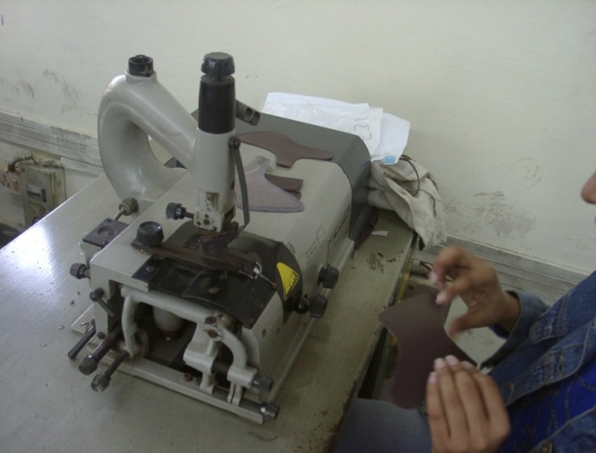
Figure Sample Run
Interlining Attachment
Set temperature and pressure
After checking, there is setting temperature and pressure. Make sure that the temperature and dwell time is correct. The pressing plate temperature has to be regulated according to the material employed. Operate the thermo regulator, placed on the control panel, to schedule the wanted temperature. We advise to hold the temperature between 80* and 100*C. Do not schedule the temperature over 100*C, in order to avoid damages to the material employed.
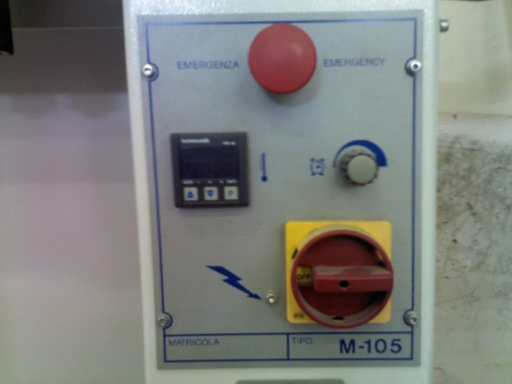
Figure 3.8 Temperature and Pressure Adjustment Knob

Place inter-lining
Interlining or reinforcement material must be the same to the specification and also checking for correct adhesion and placement of reinforcement is very important. So Interlining or reinforcement should be:
- Compatible with corresponding material.
- Woven (stretch) reinforcement material should be selected for fixing under stretching areas (lasting pulls) of upper.
- Non-woven reinforcement material should be selected for fixing under punching and perforated areas like eyelets and brogue punches.
- Braided reinforcement (nylon) material should be used for fixing under folding and top lines.
Press:
- First switch on the machine and operate the regulations needed.
- Then, put the material to be worked on the rotating table.
- Rotate clockwise the table by hand, until the material employed is under the pressing plate.
- Now, press at the same time the two starter buttons placed on the base of the machine:
- the pressing plate will lower and press the material, according to the previously scheduled pressure value.
- As the time scheduled on the potentiometer sops, the plate will rise, allowing drawing out the coupled material and putting in the new one.
- The later should have been put on the table during the pressing cycle.
We have to regulate the pressing time according to the kind of the material employed and the pressing plate temperature. If the pressing plate temperature is high, we advise to schedule a short pressing time and vice versa.

Figure 3.8. Pressure Indicator
Operating button
These buttons are used for operating the machine. There are two green buttons in the machine.
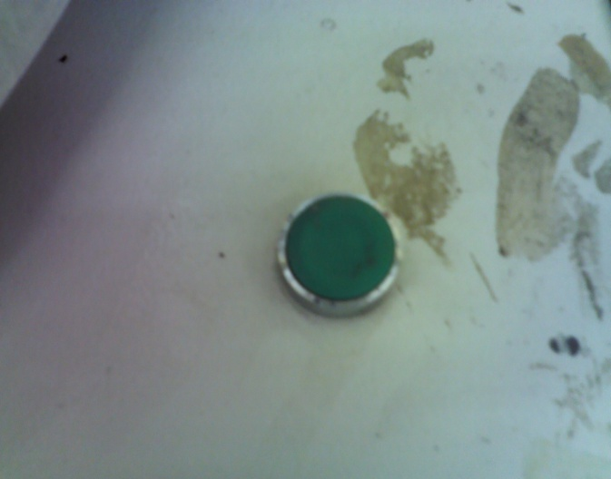
Figure 3.9 Operating Buttons

3.3. Testing machine outputs
3.3.1 Quality
Quality standard is a document established by agreement and approved by a recognized body that provides for common and repeated use.
- International standard: a standard adopted by an international standardization organization
- European standard: a standard adopted by a European standardization body
- National standard: a standard adopted by a national standardization body and made available to the public.
In order to meet this quality standards machine outputs should be tested in accordance with the company procedures.
Using a standard test method, perhaps published by a respected standards organization, is a good place to start. Sometimes it is more useful to modify an existing test method or to develop a new one. Again, documentation and full disclosure are very necessary.
A well-written test method is important. However, even more important is choosing a method of measuring the correct property or characteristic. Not all tests and measurements are equally useful: usually a test result is used to predict or imply suitability for a certain purpose. For example, if a manufactured item has several components.
- Quality is the totality of features and characteristic of a product or a service
that affect its ability to satisfy the stated or implied needs of a customer.
- Quality is not absolute. It is relative to other goods and services.
- Quality changes with time and customers perceptions.
- Quality cannot be achieved by inspection only. It can only be improved be
small continuous product and process improvements.
- Quality consistency requires us to concentrate on the process rather than on
the product alone.
- Good quality requires a clear understanding of Design principles that 80% of
quality problems are attributable to management. Workers are NOT the real
problems.
- Quality brings customer loyalty.
- Team work is the key to quality.
Keys to a Good Quality System
- Everyone must know what to check and how to check
- List major and minor defects and display the critical operations.
- Check all inputs materials for quality/quantity.
- Make specifications clear to the supplier at the time of ordering material.
- Do not dilute your standards.
- When a mistake occurs look for corrective and preventive action. Corrective Action Immediate action taken to solve problem. Preventive action - Steps taken to prevent a recurrence of the problem.
- Keep a defect file as a learning system.
- Clearly fix responsibility for quality in each department.
- Quality cannot be controlled at the end of line. It must be built into the
system.
- Continuous improvement in small steps in the key to success.
- Have a good monitoring system.
- Good housekeeping is important for good quality.

Quality Checking of the Machine Outputs
- Check thickness by thickness measuring machine or gauge
After splitting the thickness of the product must be checked or compared to the specification using thickness measuring gauge.
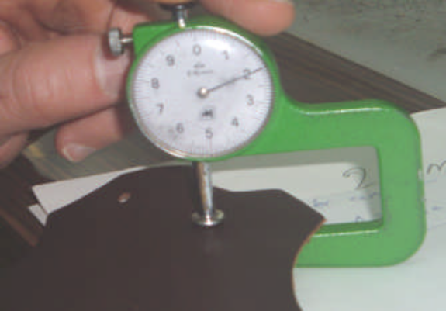
Fig 3.9. Thickness Gauge

Check marked component with the master pattern
After marking, component should be checked with the master pattern.
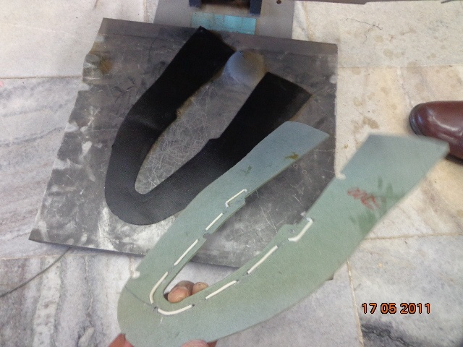
Fig 3.10 Checking of Patterns with Master Pattern
Fig 3.11 Matching the Pattern with the Master Pattern

Check marking quality
Fig 3.12Check Marking Quality
Check raw edge, Underlay and folding skiving Depth and width:
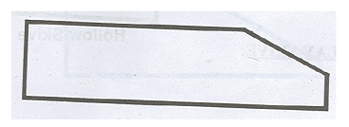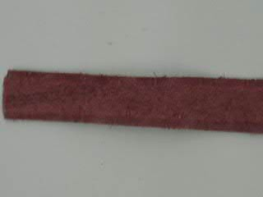
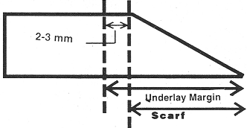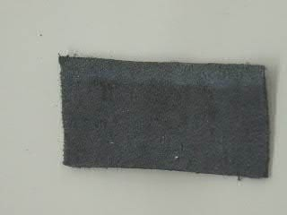
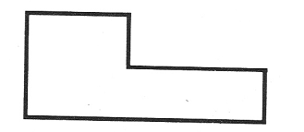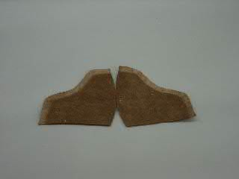
Fig 3.13 Skiving Specifications
Check attachment
Finally, the interlining attaching must be checked for placement of reinforcement is correct and the specifications are fulfilled.
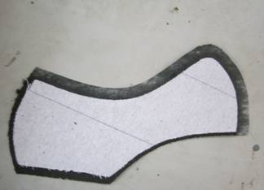
Fig 3.14 Interlining Pasting
Check the stamping quality
Finally, the stamping quality must be checked. Quality means the stamping detail are according to the specification and stamping is visible properly or not.

3.4. Organize machine outputs
It is necessary for every organization to standardize all its processes and procedures. This way, it is able to ensure uniformity for all tasks. Each employee in the organization performs a task in the same manner as another. The company should document all the procedures and maintain both hard and soft copies of standard operating procedures it is use full to organize and document machine outputs and this will provide an understanding if the test results are according to company procedure.

Self-Check -3
Instructions: Write all your answers in the provided answer sheet on page no.
PART I: Short Answer Questions:
Directions: Answer all the questions listed below. Examples may be necessary to aid some explanations/answers.
1. Write the Keys points to a Good Quality System
2. What are the functions of Skiving guide?
PART II fills in the blank space
1. The main function of the pressure foot is -------------------------------
2. Never set the temperature more than -----------------------------degree centigrade on the electric resistance for the heating of the counter

Unit four: Adjust machine settings
This unit is developed to provide you the necessary information regarding the following content coverage and topics:
  - Interpreting test results to determine machine adjustment requirements.
  - Assessing machine adjustment changes
  - Reporting new machine set up
This unit will also assist you to attain the learning outcomes stated in the cover page. Specifically, upon completion of this learning guide, you will be able to:
  - Interpret test results to determine machine adjustment requirements.
  - Assess machine adjustment changes
  - Report new machine set up

4.1 Interpreting test results to determine machine adjustment requirements.
Interpreting test results
Adjustment is the act of bringing something into conformity with external requirements. All the machines in the pre-fabrication department need adjustment or setup before any operation. Machine adjustment is important so as to fulfill the customer requirements of a specific product or product specification. And also, it protects accidents with respect to health and safety.
    - Specification
Is the exact statement of the particular needs to be satisfied or essential characteristics that a customer requires (in a good material, method, process, service, system, or work). Specification is written usually in a manner that enables both parties (the customer and the producer) to measure the degree of conformance.
In footwear manufacturing, in order to ensure the quality of the product specifications are used as a reference and also quality control is done with respect to the specifications.
Specifications can be driven from standards or from customers.
• Standard specification of article
It is a specification for an article derived from a standard.
• Special instruction from buyer/customer
Product specification
When we receive the cut components, we have to check these cut components with the work ticket. We have to verify the material for quality and quantity issued. We have to check the following details in the work ticket:

  - Order no.
  - Article no.
  - Type of leather
  - Color
  - Thickness after splitting
  - No. of pairs to be splitted

    - Importance of machine adjustment:
The thickness of the material is different if measured at the ends or is different in the central part while it is the same at the ends. The foot is worn and must therefore be replaced.
The material thickness is not constant. Check the position of the blade. Check whether the upper plate rests on the blade along its entire length. If not, it may be that the lower part is dirty or the counter-blade fixed to it may be worn and must therefore be replaced.
Importance of stamping machine adjustment in relation to product specification:
Product Specifications:
Stamping details are obtained from the product specification and this specification contains the following points:
• Article number
• Size
• Pair number
• Date
- Importance of machine adjustment
We should check the clearness of the printing on the basis of the above-mentioned specification. If this is not perfect, we can correct it on the basis of the following ways:
• Reducing or increasing the pressure of work through the pressure reducer placed on the left side of the bearing column, paying attention of not go over the value of 6 bars.
• Reducing or increasing the temperature of the die acting on the electric thermo regulator Temperature of the Electric Resistance: the value of temperature of the die will depend from the printing foil used:
• Changing the printing time by the electronic timer Printing Time placed on the panel that bears the electric controls.
Importance of skiving machine adjustment in relation to product specification:
- Skiving specification
It is important to check the specification of the product that is going to be skived. The specification contains the following details:
1. Width of skiving
2. Depth of skiving
3. Type of skiving
Importance of machine adjustment:
If the depth and width of the skiving is not as per the specification, we can correct it on the basis of the following ways:
1. If the width of the skived component is not as per specification, we should adjust the width adjustment guide.
2. If the depth of the skived component is not as per the specification than we should adjust the angle of the pressure foot according to the requirement and we can also change the pressure foot as per our need.
Importance of interlining attachment machine adjustment in relation to product specification:
Product specification:
To make a good presentable shoe out of upper and lining materials, we need to have a special treatment called reinforcing or interlining attaching. So, it is important to check the following specification of the material for the interlining attaching:
1. Interlining should be attached after skiving and should not be attached on the skived part of the components.
2. Temperature should be as per the material attached.
3. Thickness of the material should not be more than 8mm.
4. Pressing time should be as per the thickness and type of material
Importance of machine adjustment
1. Keep in mind that the maximum thickness of the coupled material should be of 8 mm. For this shield adjustment has to be done according to the thickness of the material employed.
2. The pressing plate temperature has to be according to the material employed. We advise to hold the temperature between 80* and 100*C.
3. We have to regulate the pressing time according to the kind of the material employed and the pressing plate temperature. If the pressing pate temperature is high, we should schedule a short pressing time and vice versa.

4.2 Assessing machine adjustment changes
Machine adjustment is different for different machines; we can define it as follows for different machines:
    - Skiving Machine
It is necessary to make some adjustments according to the skiving requirements.
- When the desired skiving thickness of the parts for footwear components varies, please adjust the height of pressure foot correspondingly. In the case of even skiving and slope skiving adjust the pressure foot for the type of skive that is going to be used.
- When it is necessary to change the feeding speed, please change the position of the V belt on the belt pulley.
- The clearance between the feed roller and the knife can be adjusted by turning the side knobs which is connected with the bottom feed roller assembly, which allows setting distance between knife and feed roller according to the thickness of the SCARF to be passes. Be sure that feed roller can’t collide with knife.
- When knife is blunt, turn the first knob clockwise which is connected with the sharpening stone and used to bring it near the bell knife for sharpening.
- After the knife is damaged, move the knife axis leftwards slightly by turning the knob. The proper distance between the right surface of the pressure foot and the knife edge is 0.1-0.5mm.
The skiving machine makes the work easy and increases the productivity; hence it is suitable for mass production in footwear industry. This machine can be adjusted as per the required thickness and width to be skived. The different machine parts involved to make the required skiving are:
- Pressure Foot
- Bell Knife
- Bottom Feed Roller
- Sharpening stone
- Width adjustment guide
- Top pressure adjusting assembly
- Front adjusting Knobs

    - Splitting Machine
- Adjust the gap between the upper roller and the band knife according to the product specification or material thickness.
- When the band knife is blunt grind it using the sharpening button which is connected to the sharpening stone.
- Before splitting process, leather thickness must be measured using thickness measuring gauge.
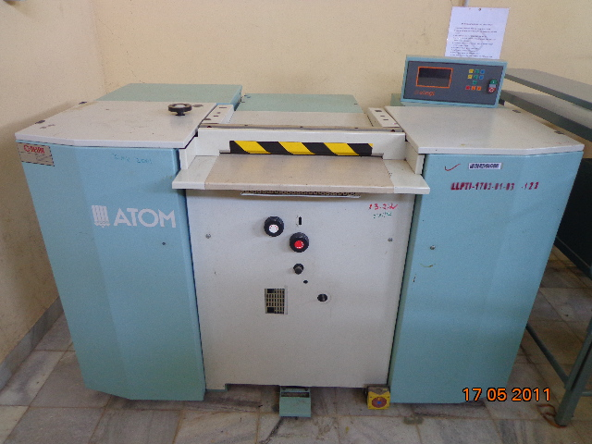
Figure 4.1 Splitting Machine
Control Panel Control Panel Description
- Display
- START (Ι) and STOP (0) button.
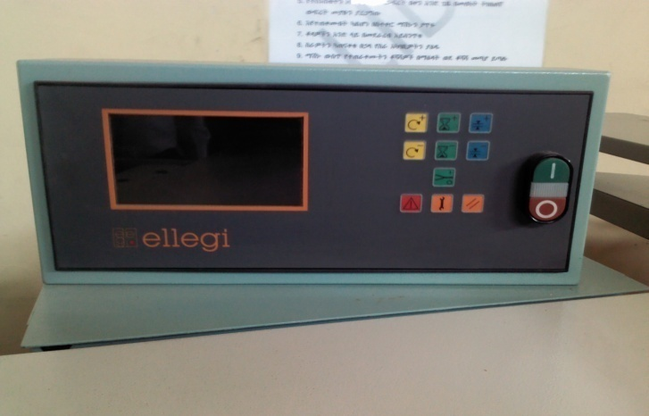
Figure 4.2. Control Panel
Control Panel Keyboard Description:
- Keys for the correction of the splitting measurement. Pressing + it increases, pressing- it diminished,
- Keys for transport speed setting. Pressing + it increases pressing – it decreases,
- Keys for splitting time setting. Pressing + it increases, pressing – it decreases.
- Counter – splitter engagement key.
- Emergency indicator key.
- Maintenance indicator key.
- Maintenance reset key.
Graphic Viewer Description:

- Cutting thickness symbol
- Cutting thickness measurement
- Graduated scale indicating the degree of correction
- Transport speed
- Counter – splitter symbol
- Splitting time symbol
- Value of set splitting time
- Emergency signals
- Maintenance signals

Machine use Blade Sharpening
The blade sharpening operation is undertaken by operating the knob (1- ). It must be rotated for half a turn in an anti- clockwise direction. Once sharpening will take place on carrying out the above operation. Completely turn the knob in an anti- clockwise direction, then push it towards the machine, and whilst keeping it pressed, gently turn it in an anti-clockwise direction until it clicks. Release the knob and proceed with sharpening as described above.
Cutting Thickness Regulation
Turn the wheel to raise or lift the foot (or the upper conveyor roller if mounted instead of the latter). The desired cutting measurement will appear on the viewer. However, it may be that this measurement does not correspond to that taken on the piece that has just been processed as it depends on the type of material and the pressure applied by the lower conveyor roller.
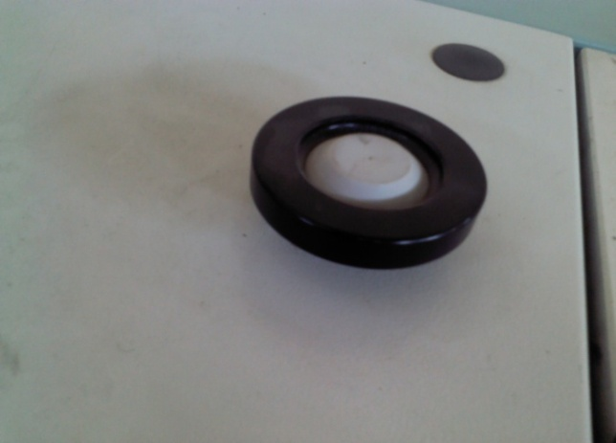
Figure 4.3. Thickness Adjustment Wheel
Lower Conveyor Roller Pressure Adjustment
It is possible to increase the pressure applied by the lower roller on the material to be processed. Light pressure is advisable for thin and soft materials. For thicker and harder materials greater pressure is advised. A special indicator shows how much pressure is applied.
Lower Roller Height Regulation
The minimum distance existing between the lower roller and the blade is of approximately 0.2 millimeters and it is pre- determined by the manufacturing company by means of special fixed stops. Warning: these stops must not be tampered with under any circumstances! In the event of particular workmanship that generates a very thick processing Scrap it is possible to vary this minimum measurement by means of a special knob. For this, press the pedal down fully and tighten the knob. Release the pedal and check by how much the roller has been lowered. Proceed in the same way until the desired measurement is obtained. To restore the machine to the original conditions completely loosen the knob.
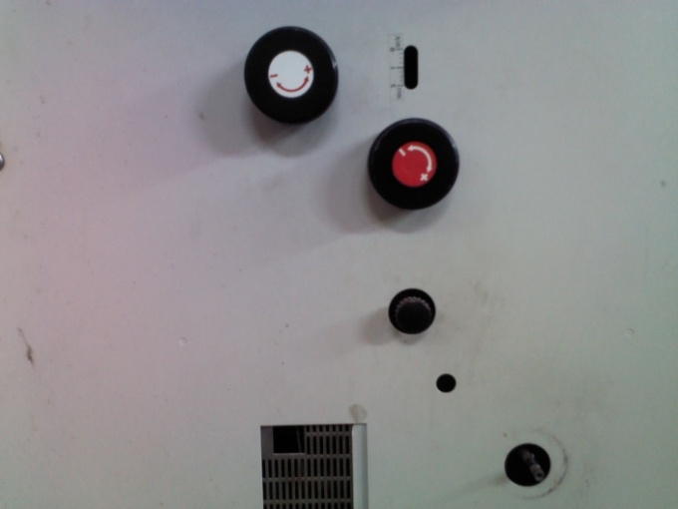
Figure 4.4 Height Adjustment Knob
Transport Speed Regulation
The transport speed is regulated by means of two buttons and positioned on the control panel
A graduated scale will appear on the viewer near the symbol indicating the parameters set.
Emergency Stop
In the event of an emergency the machine can be stopped by pressing the red STOP button on the control panel or by pressing the emergency button with the feet. To then re-start the machine, it is firstly necessary to press the restore button. Then press the green START button on the control panel.
Upper Roller and Fixed Foot
The use of the fixed foot or the upper conveyor roller depends on the material to be processed. The foot is recommended for very precise workmanship and for materials that have no sliding difficulty; permitting the processing of minimum thickness of 0.2 millimeters.
While the conveyor roller is used when the material to be processed slides with difficulty and permits the processing of thicknesses of up to a minimum of 0.6 millimeters.

Counter – splitter
Warning: - the counter – splitter must be used only with the upper conveyor roller mounted.
Press key I key to activate the counter – splitter function.
O
Press keys + or - to modify the splitting time parameters. An hour – glass
Symbol will appear on the viewer and numbers indicating the set time. Insert the material in the work zone. Once the processing time set has past the roller rotation will be inverted and the material will come out automatically.
Emergency signal
When the  symbol flashes on the control panel it means that the machine is in emergency state and therefore intervention is immediately required to ensure efficient function.
Press the  key and a page will appear with a list of maintenance operations; flashing signal indicates the emergency situations to be corrected like:

- Worn blade
- Loose blade
- Emergency active
- Open guard
- Scrap box full
- Dirty conveyor roller
- Blade motor alarm
- Transport motor alarm
- Sharpening motor alarm
- Fan alarm
- Open line contactor
- Machine maintenance in progress

Basic Adjustments
Note: -When carrying out adjustment operations always take the greatest care as you are working near the blade.
Fixed foot adjustment
Note: -In the event that the thickness of the processed material differs between the left and right side it is necessary to remove the foot. Using the wheel completely lower the foot so that the distance from the blade is as short as possible, as indicated in point 3.3.
- Switch off the machine (STOP button) and leave the main switch on (Ι). Remove the lids and the work surface.
- Put the machine into maintenance mode, start it up (START button) and remove the sharp edge of the blade.
- Switch off THE MACHINE (STOP button).
- Dismantle the work top, and slightly loosen the screws that fix the foot. Use the screw positioned on the part, on which the thickness of the processed piece is highest and turn so that the foot is lowered. Use a thickness gauge to measure the thickness existing between the blade and the foot at the two ends; it must be of 0.2 millimeters and the same on both sides.
- Tighten the screws.
- Remove the maintenance key and press the button.
- Re-assemble the casing.
Lower Conveyor Roller Vertical Adjustment:
- Switch off the machine (Stop button) and leave the main switch on (Ι). Remove the lids, the work top and the central casing.
- Put the machine into maintenance mode, start it up (Start button) and remove the sharp edge of the blade.
- Switch off the machine (Stop button).
- Using a thickness gauge, check that the distance measured from both parts, between the conveyor roller and the blade is equal. If not, release the stop screws and using a screwdriver turn the screws until the distance is the same from both parts.
- Secure the screw.
- Belt Blade Adjustment:
Note: - this operation must be carried out with the knife sharpened.
- Switch off the machine (Stop button) and leave the main switch on (Ι). Remove the lids, the work top and the central casing.
- Put the machine in to Maintenance mode.
- Disengage the upper blade pusher wedges and the lower blade pusher.
- Check by how much the blade juts out from the lower counter blade as shown in the diagram. If it exceeds 4.0 millimeters on both sides release the nut and slightly loosen both screws of the blade stop rollers.
- Start up the machine (Start button) allowing it to run for a few seconds then switch off (Start button) allowing it to run for a few seconds then switch off (Stop button). The blade will have retreated slightly.
Note: - this is a very dangerous operation to be carried out only by authorized personnel.
- With the machine on check the pressure by slightly squeezing them with your fingers.
- If it is not possible it is necessary to reduce the pressure by slightly tightening the screws. If the pressure needed to stop the rollers is different from each other it is necessary to slightly tighten the screw of the roller that poses the greatest resistance.
- When the pressure necessary to halt the two rollers becomes the same tighten the nuts.
- While if the measured value is less than 3.9 it is necessary to proceed by tightening the screws verifying the pressure on the rollers as previously described.
- Re-position the upper and lower blade pusher wedges.
- Remove the maintenance key and press the button.
- Close the machine.

    - Interlining Attaching Machine Adjustment
Starting the Machine- Electric Supply
After having put the compressed air into the machine it is possible to connect the electric supply in the following way:
- Turn the general switch on the left side of the machine to the “1” position. The heated parts of the machine are quite big, therefore the heating time from room temperature to that of work set by the thermo-regulators is about 20-30 minutes. We advise switching on the machine at least 30 minutes before work should start.
Switching off Machine
To switch off the machine at the end of the working day it is sufficient to turn the main switch to the “0” position. It is necessary to switch off the pneumatic supply.
Shield Adjustment
The shield adjustment has to be done according to the thickness of the material employed. Loosen the screws and adjust the shield height, so that the employed material can enter the pressing area passing through the access slit. Once adjusted the shield, tighten the screws again. Keep in mind that the maximum thickness of the coupled material should be of 8 mm.
Pressure Plate Temperature Regulation
The pressing plate temperature has to be regulated according to the material employed. Operate the thermo regulator, placed on the control panel, to schedule the wanted temperature. We advise to hold the temperature between 80* and 100*C. don not schedule the temperature over 100*C, in order to avoid damages to the material employed.
Pressing Time Regulation
We have to regulate the pressing time according to the kind of the material employed and the pressing plate temperature. If the pressing plate temperature is high, we should schedule a short pressing time and vice versa. To regulate the pressing time, we have to rotate clockwise the potentiometer, placed on the control panel, in order to increase the pressing time. If we want to diminish it, rotate the potentiometer anticlockwise
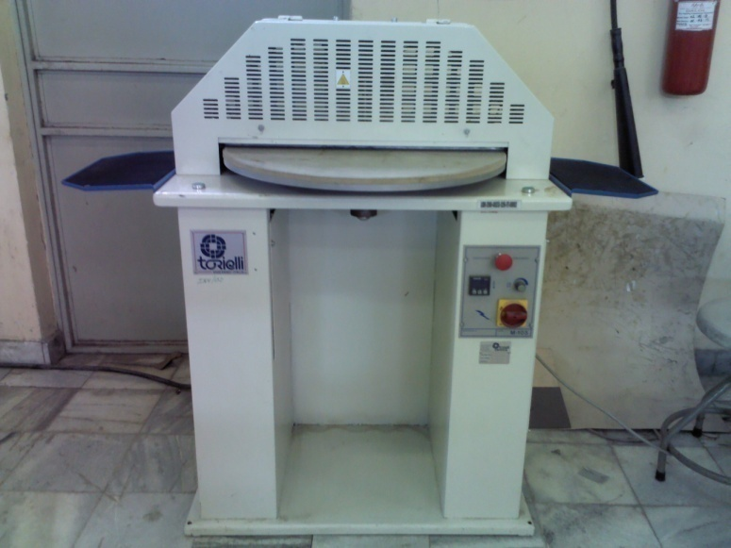
Figure 4.5. Interlining Attaching Machine

4.3 Reporting new machine set up
4.3.1 Leather Cleaner
Choosing leather cleaner is highly dependent on the type of leather being cleaned. There are specialized leather cleaners and more general ones that are safe for many leathers. The cleaner helps to loosen and remove dust, dirt, debris, and grime from the leather surface. This ensures that when you apply the conditioner, it’s not trapping any dirt in, and instead going right into the leather where it needs to be
Leather oil is a type of leather conditioner. There are many different types and formulations available. Some cater to specific leather products (shoes, boots, bags, etc.). Others to the conditions the leather will be used in. And even others that have more general formulations that work well on most leathers.
Leather oils can be just oils, or combinations of oils, waxes, and other natural and/or synthetic ingredients aimed at conditioning and protecting the leather
Creaser/Embosser Machine
When working on a project that benefit from a heated creaser, there is a machine to the rescue! The electric creaser machine feeds electricity to a hand-held creaser. On the end is metal tip that gets warm from the electricity, and delivers a consistent temperature over the leather.
When finishing the edges naturally or with added protectants such as wax, al electric creaser will make a huge difference. These are often used on very high-end leather work
Strap Cutter Machine
When doing higher-volume or repetitive strap cutting, a machine is available to definitely help. These come in both manually operated versions (hand crank) and electrically-powered versions.
The width of the cut is set, the leather positioned, then mechanically drawn through the cutter resulting in straps or laces just the way you need them. These are definitely more expensive than the hand-held strap cutters, though likely worth it if you plan on doing a lot of work that involves straps or laces.
Leather Scissors
Scissors usually have symmetrically-sized finger holes and are shorter than 6” in length. They can be held in the air while cutting, or rested on the cutting surface while making the cut. Leather cutting scissors are usually made with strong, sharp blades that can smoothly handle thinner and thicker leathers when cutting.
Leather Shears
Shears are usually longer than 6” in length and have asymmetrically-sized finger holes, one is larger than the other to more comfortably fit four fingers. The thumb can comfortably rest in the smaller hole. Sometimes shears are intended to rest on and flow along the cutting surface for smooth, stable cuts.
Leather cutting scissors are usually made with strong, sharp blades that can smoothly handle the thinner and thicker leathers that require a bit of heft when making cuts.
Thread Scissors
Thread scissors will most likely be helpful if you’re hand-sewing or machine-sewing a fair amount of your leather work. They are usually small, only a few inches long, with small, very sharp blades.
Their size allows them to get into tough-to-reach places and angles, who their sharpness will shear the thread leaving a crisp end without frays. Thread scissors can also help during edging and finishing if you need to trim any extra-long fibers that come up on the leather’s edge after a cut.
Lacing Cutter
Lacing cutters are specialized versions of strap cutters, in that they are intended only for lace cutting (smaller widths of leather). They usually allow for cuts up to about 3”, and down to about 1/8”. This is good for most straps and strips that will be used for laces, belts, braiding lace, fringe, and tie-straps.
Lacing cutters come in both hand-held, and table-top versions. The table-top versions usually secure to the table, making it easier to pull the lacing through. This is especially helpful with more frequent or high volume work.
Leather Working Clicker Press
A clicker press is a tool that applies tremendous force to a small area in order to cut out designs in leather. They fit on a tabletop; have a base, usually several cutting board surfaces, and a lever that drives the press.
Due to leverage, when the lever is pressed by hand, it generates literally tons of force onto a very small are through a die. The dies are metal, and pre-formed into a shape. For example a rosette, a shape, or even wallet pieces.
The benefit of a clicker press, with its related dies, is that a specific cut in leather can be done much faster than by hand. They can also effectively cut through thicker leathers with ease. Clicker presses are relatively expensive, though for the leather worker that is producing similar products in volume, it can certainly help with scale, productivity, and efficiency.
Leather Cutting Dies
Leather cutting dies are pre-formed, metal shapes with a sharp cutting edge, used to cut shapes out of leather. They are laid on top of leather material, and struck with a maul, mallet, or hammer. The force drives the sharp edges into the leather, resulting in a cut out piece in the shape of the die.
Dies are helpful when one finds themselves cutting many of a similar pattern out by hand. An example is a wallet maker with a great design. They need many pieces to produce a lot of wallets, though cutting them out one by one by hand can be time consuming.
Leather cutting dies can be custom made to any shape or size. Generally they can be put into a clicker press for even easier cutting, or manually stuck by hand. Although there’s usually an initial investment to make or purchase a die, if it will get used often it is usually a worthwhile investment.

Self-Check -4
Instructions: Answer all the questions listed below. Examples may be necessary to aid some explanations/answers.
Part I: fill in the blank space
- ------------------------ is the act of bringing something into conformity with external requirements.
- Specifications can be driven from standards or from ------------.
Part I: say “True” if the statement is correct and say “False” if the statement is incorrect.
    - The pressing plate temperature has to be regulated according to the material employed
    - The use of the fixed foot or the upper conveyor roller depends on the material to be processed
    - The pressing plate temperature has to be according to the material employed

Unit five: Split components
This unit is developed to provide you the necessary information regarding the following content coverage and topics:
  - Assessing components against job specifications.
  - Adjusting thickness gauge, and checking components according to work ticket specifications
  - Following of work ticket specification in pairs and pieces
  - Splitting and checking parts against quality standard
This unit will also assist you to attain the learning outcomes stated in the cover page. Specifically, upon completion of this learning guide, you will be able to:
  - Assess components against job specifications.
  - Adjust thickness gauge, and checking components according to work ticket specifications
  - Follow of work ticket specification in pairs and pieces
  - Split and check parts against quality standard

Assessing components
• After splitting the cut component are checked that they should be even.
• No thickness variation is permissible at any area of component.
• For that component can be checked at the different portion

5.2 Checking components
5.2.1. Ticket Specification
The components that are going to be splitted should be checked against the work ticket specification before starting splitting of the components.
5.2.2. Job Specification of Material
When we receive the cut components, we have to check these cut components with the work ticket. We have to verify the material for quality and quantity issued. We have to check the following details in the work ticket:
- Order no.
- Article no.
- Type of leather
- Color
- Thickness after splitting
- No. of pairs to be splitted
Components Checking Procedures:
Upper and Lining Components:
- The thickness of the processed material differs from the left and right side.
- The processed side of the material has one or more creases. The blade is inadequately sharpened or it has splinters and it must therefore be sharpened.
- The thickness of the material is different if measured at the ends or is different in the central part while it is the same at the end. The foot is worn and must therefore be replaced.
- The material thickness is not constant. Check the position of the blade.
Adjusting and using of thickness gauge
The manual thickness gauge that used for measuring different splitting material thickness and should be adjusted to the specification provided before splitting process is started. Before splitting process, leather thickness must be measured by using micrometer or thickness gauge.
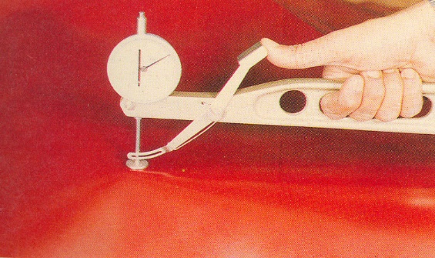
Figure 5.1.Thickness Gauge

5.3. Following of work ticket specification
The work tickets can vary from company to company. Information’s regarding the product that are required for starting the next operation are mentioned in the work ticket. There are two requirements of a work ticket are:
- To give clear work instructions.
- To control material usage.
With the help of work ticket, we can know the type of material, color, style/model, size pairs and no. of pieces in upper, lining and interlining. On the basis of these Information’s checking of various types of components is very easy.

work ticket
Name of the organization: ________________________
Splitter’s name: ________________________
Date: ____________________
Material: _______________________
Color: __________
Style/ model: _____________________
Sr.No. | Size | Pairs | Pieces
Sr.No. | Size | Pairs | Upper | Lining | Interlining
 | Total
Department’s signature:

Work ticket

5.4 Splitting and checking parts
Splitting parts
Steps 1. Turn on the machine
- At the main supply
Steps2. Split some scrap material by feeding the material between the rollers with the grain side up.
Steps 3. Check the material for thickness at several points to ensure the machine is splitting evenly.
Steps 4. Adjust the roller height until the material is being split up to the desired thickness.

Fig 5.2. Adjust the roller height
Steps 4. Repeat the procedure until the all pieces have been split.
Steps5. Always make your final check with a fresh piece of material.
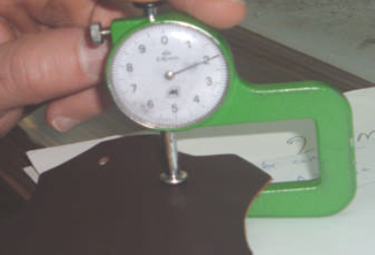
Fig 5.3.Checking parts
Steps6. Evenness
- After splitting the cut component are checked that they should be even.
- No thickness variation is permissible at any area of component.
- For that component can be checked at the different portion.

Steps 7. Accuracy
- The accuracy of the cut component should be checked with the help of thickness measuring machine and it should be uniform from all sides.
- After splitting there should not be any crease on the material.
- No variation is considered within the compone

Self -check 5
Instructions: Answer all the questions listed below. Illustrations may be necessary to aid some explanations/answers.
Part I: fill the blank space
    - The components that are going to be splitted should be checked against the work ticket specification before ----------------------------
    - ---------------------check that the distance measured from both parts, between the conveyor roller and the blade is equal
- Part I: give Short answers
    - Write down the two requirements from work ticket
    - What is the function of of thickness gauge

Operation sheet-1
Operation title: Splitting and checking parts against quality standard
Operation objective: Perform splitting operation
Tools and equipment’s
- Thickness gauge
- Split machine
- Table
Procedures of Splitting and checking parts against quality standard
Step 1. Turn on the machine
- At the main supply
Step 2. Split some scrap material by feeding the material between the rollers with the grain side up.
Step 3. Check the material for thickness at several points to ensure the machine is splitting evenly.
Step 4. Adjust the roller height until the material is being split up to the desired thickness.
Step 4. Repeat the procedure until the all pieces have been split.
Step 5. Always make your final check with a fresh piece of material.
Step 6. Evenness
- After splitting the cut component are checked that they should be even.
- No thickness variation is permissible at any area of component.
Step 7. Accuracy
- No variation is considered within the components

Lap test
Name………………………………. ID…………………………….. Date…………………………………….
Time started: ________________________ Time finished: ________________
Instructions: Given necessary templates, tools and materials you are required to perform the following tasks within 1 hour. The project is expected from each student to do it.
Task-1 Performing splitting operation?

Unit six: Emboss, stamp and mark components
This unit is developed to provide you the necessary information regarding the following content coverage and topics:
  - Checking components as per work ticket
  - Performing stamping and marking operations manually
  - Adjusting dies for embossing and stamping machine
  - Following of work ticket specification in pairs and pieces
  - Embossing and/or stamping parts to quality standards
Parts are marked to specification either by hand or by marking deviceThis unit will also assist you to attain the learning outcomes stated in the cover page. Specifically, upon completion of this learning guide, you will be able to:
  - Check components as per work ticket
  - Perform stamping and marking operations manually
  - Adjust dies for embossing and stamping machine
  - Follow of work ticket specification in pairs and pieces
  - Emboss and/or stamping parts to quality standards
  - Mark parts to specification

6.1 Checking components as per Ticket Specification
The components that are going to be should be Stamp and Emboss checked against the work ticket specification before starting splitting of the components.
    - Job Specification of Material
When we receive the cut components, we have to check these cut components with the work ticket. We have to verify the material for quality and quantity issued. We have to check the following details in the work ticket:
- Order no.
- Article no.
- Pair no.
- Plan Number
- Date
- Size
Stamping and Embossing details are obtained from the product specification and this specification contains the following points:
- Article number
- Size
- Pair number
- Date
Marking in this case we check the patterns that are used to mark on the upper materials. All patterns should check with the master patterns.

6.2 Performing stamping and marking operations manually
It is necessary to provide some method of identification for the benefit of later stages of closing when the upper is being assembled, and it is also necessary to give identification of size and possibly fitting during most operations.
It is essential also in the case of colored work to give information of shade coding. Methods adopted by various organizations are as follows:
(1) Crayon Marking—This is no doubt the original method—marking size and color by crayon on the back of the leather plus ticket number on at least one section of vamps, quarters, caps, etc.
(2) Notch Marking—This method is of more concern when uppers are cut on the press, consisting of a code of notches in the lasting edges of cut parts. It is essential to mark lot numbers by crayon on the back of the leather.
(3) Color Marking—A series of colored paints is coded to sizes, and the lasting edges of cut sections are then painted the
Lining Marking
. The quarter lining is the usual position chosen, but in some cases the tongue has to be used, or even a small tab specially stitched inessentials to be stamped are the size, fitting, last and shoe number. Other details to assist in repeat orders being executed correctly can be ticket numbers, order numbers and date code.
Closing
Essential to provide a means of supplying the necessary marks to enable the operators to perform their work accurately.
The methods used are:
(1) Slotted Patterns—Board patterns of the same shape and size as the cut sections are slotted along the required design lines; these are placed on the leather and a pen with a colored ink, or alternatively, a dull awl, is run along the slot.
(2) ‘Pimple’ Marking—The required design is punched on to a metal pattern so as to give a row of depressions along the design line.

6.3 Adjusting dies for stamping machine
The dies that used for stamping different stamping details should be adjusted as per the detail to be stamped and specification before stamping process is started. The stamping details could include: size, fitting, article no, shoe number, work ticket number, factory code, last & type of material used.
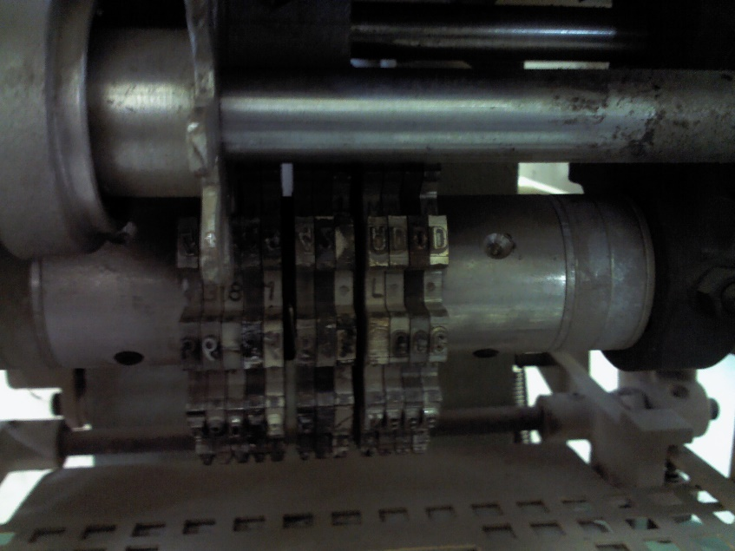
Stamping Dies
Fig 6.1 Stamping Machine
Article number
Each product in the production chain has unique article number. This number is stamped on the component by using stamping machine with adjusted stamping dies as per specification. This number is used for identifying each component from each other.
Size
The size stamping on upper components can be done as per the specification given and could be in following ways:
- Size can be marked in various size systems like English and French sizes.
- It also can be marked as 41
- It also can be marked as 42
- It also can be marked as 43
- And so on
For English size marking “V” shape notch shows size 5. For 6 sizes it shows
This information might be used to:
- Trace faulty footwear back to the unit that made it.
- Order new stocks of the same styles, sometimes known as “repeats”.
- Ensure that any returned shoes can repair on the correct size and shape lasts.
- Enable the production units to see what size uppers they are dealing with.
Plan Number:
Plan number is stamped on the component for identification of different orders that the company is working with. This number is stamped on the component by stamping dies adjusted as per the specification.
Pair Number:
Pair number is used to identify pairs in case of leathers with different variety shades colors and grain difference. In this case the pair number is stamped on each pair easy differentiation of each pair shade, grain difference and color.
Date:
Date is stamped on the component for easy identification of the time the component is prepared and also used to indicate the life span of the component from the starting date.

6.4 Following work ticket specifications in Pairs and Pieces
Work ticket with standard format and having specification should be prepared and applied through the skiving operation. This work ticket gave clear information for the person performing the skiving operation. The skiving should be done based on the information given in the work ticket or work ticket specification. A sample work ticket is shown below.

Work Ticket
Skiving job ticket
Name of the organization: ________________________
Skiver’s name: ________________________
Date: ____________________
Material: _______________________
Color: __________
Style/ model: _____________________
Size | Pairs | Pieces
Total
Department’s signature:

Embossing and/or stamping parts to quality standards
6.5.1 Stamping:
Stamping is done against the size, article no, batch no, and etc.
The details are usually stamped on the upper and lining using heated metal dies set in a stamping machine. The attached dies are pressed down on a foil ribbon, which transfers the coating of the ribbon onto the component.
Machine stamping is suitable for upper components. In this case stamping is done with the help of heated die and foil.
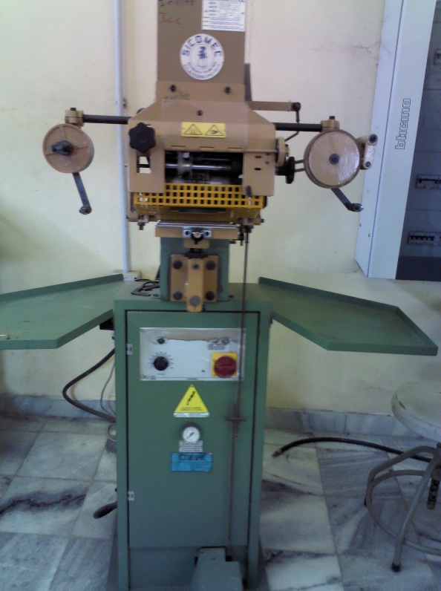
Figure 6.2 Stamping Machine
Color of stamping
The stamping is done with the help of heated die and foil, which enhances the appearance of shoe. Mostly stamping is done with ribbon foil or golden foil that enhances the appearance of the stamped details.

Procedures:
The sequence of running is the following:
- Action the main switch placed on the panel that bears the electric controls.
- Push the button START.
- Set on the electronic timer Temperature of the Electric Resistance the desired value of temperature.
- When the electric resistance has reached the set temperature, the light on the control panel turns off.
- Set the object to print on the working plan.
- Push the control pedal.
- Check the clearness of the printing. If this is not perfect, you can correct it in the following ways:
- Reducing or increasing the pressure of work by a pressure reducer placed on the side of the bearing column, paying attention of not go over the value of 6 bar;
- Reducing or increasing the temperature of the die acting on the electronic thermo regulator; the value of the temperature of the counter will depend from the kind of printing foil used.
Changing the printing time by the timer Printing Time placed on the panel of electric controls.
Figure 6.3Temperature controlling knob

6.6. Marking parts to specification by hand or marking device
Marking is the process to identify the fitting places for other components like eyelets, ornaments, decoration stitch and cording. Marking operation can be done either by hand or marking machine.
Hand
Manual marking can be done by hand with the help silver pencil and patter. Marking by hand is done by putting the pattern on the component and tracing with silver pencil.
Machine
Marking can be done during clicking operation by picker and other stitch marking materials assembled with the clicking knives or dies.

Self-check-6
Instructions: Answer all the questions listed below. Illustrations may be necessary to aid some explanations/answers.
Part I: Part I: say “True” if the statement is correct and say “False” if the statement is incorrect.
- Marking is the process to identify the fitting places for other components like eyelets, ornaments, decoration stitch and cording.
- Mostly stamping is done with ribbon foil or golden foil that enhances the appearance of the stamped details
- Pair number is used to identify pairs in case of leathers with different variety shades colors and grain difference.
Part II write short answers
- What is the function of Crayon Marking?
- Define Notch Marking
- Define Color Marking
- What is the function of of thickness gauge

Operation sheet-1
Operation title: Embossing and/or stamping parts to quality standards
Operation objective: Performing Embossing/stamping operation
Tools and equipment’s: Foils, Stamping die, embossing machine
Procedures of Embossing/stamping and checking parts against quality standard
Step: 1Action the main switch placed on the panel that bears the electric controls.
Step: 2 push the button START.
Step: 3 set on the electronic timer Temperature of the Electric Resistance the desired value of temperature.
Step: 4 when the electric resistance has reached the set temperature, the light on the control panel turns off.
Step: 5 set the object to print on the working plan.
Step: 6 push the control pedal.
Step: 7 check the clearness of the printing

Lap test
Name………………………………. ID…………………………….. Date…………………………………….
Time started: ________________________ Time finished: ________________
Instructions: Given necessary templates, tools and materials you are required to perform the following tasks within 1 hour. The project is expected from each student to do it.
Task-1 performing embossing /stamping operation manually

Unit seven: Skive components
This unit is developed to provide you the necessary information regarding the following content coverage and topics:
  - Selecting components for skiving
  - Performing skiving operation manually.
  - Performing skiving machine adjustment, and skiving of component
  - Following work ticket specifications
  - Checking skived parts .
This unit will also assist you to attain the learning outcomes stated in the cover page. Specifically, upon completion of this learning guide, you will be able to:
  - Select components for skiving
  - Perform skiving operation manually.
  - Perform skiving machine adjustment, and skiving of component
  - Follow work ticket specifications
  - Check skived parts

7.1 Selecting components for skiving
Components are to be stitched together by overlapping
Underlay Skive: It is done on the bottom component where two components (top and bottom) are to be stitched together by overlapping It is done on the bottom component where two components (top and bottom) are to be stitched together by overlapping.
Skiving width must be 2- 3mm behind the stitch Pointing line/ underlay margin
Components to give a smooth top line with no stitching visible
Fold Skive for Bagged/Roll Top Edge: It is done to give a smooth top line with no stitching visible. Skive is same as shallow/ wedge fold skive. Enough substance must be left at the edge to hold the stitching
Components to give a folded appearance without the stitching showing.
Fold Skive for Blind/Invisible Seam is done on components to give a folded appearance without the stitching showing.
Components to give smooth and uniform finish
Closed Raw Edge Used in case of closed seams in order to give smooth and uniform finish by removing excess bulkiness from the edges
Components to give a smooth and uniform finish/look along the edge of the component and to remove loose fibers
Open raw edge is used when the upper sections are to be left with raw edges, especially on heavy leathers with/ without any sort of edge treatment such as gimping/punching/ binding, to give a smooth and uniform finish/look along the edge of the component and to remove loose fibers from the edge.
The depth of skive is normally 1/3rd of the material thickness and width of skive must not be more than the edge stitching distance, i.e., 1.5 -2 mm.

7.2 Performing skiving operation manually
Local shoe manufacturers are producing small quantity of uppers and facing financial backlogs. Various tools and accessories are used during this skiving are, Ramp, work stone and sharpening stone. This type of skiving is mostly done on piece rate bases by the operatives and hence the quality and material strength are needed to be check during skiving. The work stone should be neat and clean before placing the component over it. The hand tool is then operated in skilled manner for the various skiving obtained. Therefore, this skiving is required more skill. Normally an operator can do approximate 80-90 pairs (depends on No of components in upper) in eight hours shift with quality.
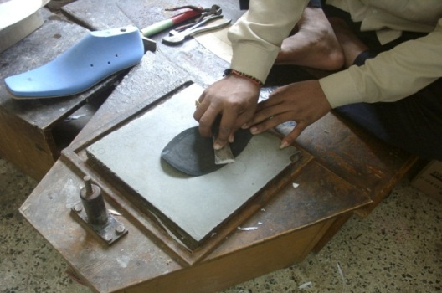
Fig 7.1. Hand Skiving

7.3 Performing skiving machine adjustment, and skiving of component
The skiving machine makes the work easy and increases the productivity; hence it is suitable for mass production in footwear industry. This machine can be adjusted as per the required thickness and width to be skived.
The different machine parts involved to make the required skiving are:

- Pressure Foot
- Bell Knife
- Bottom Feed Roller
- Sharpening stone
- Skiving guide
- Top pressure adjusting assembly
- Front adjusting Knobs
- Side adjusting Knobs
- Top lever

Guide adjustment (skiving guide)
Skiving guide is fixed near the pressure foot and used to determine the skiving width during skiving. It should be properly locked or unlocked during setting.
Guide Adjustment Knob
Fig 7.2 Skiving Machine
Pressure foot
There are various kinds of pressure foot exists in closing room to obtained different kinds of skiving. The main function of the pressure foot is to press the material and determined the width and angle of skiving been done.
- Parallel shape of pressure foot is requiring for folding skiving. (Parallel as per knife and roller).
- Flat fore part of pressure foot is requiring for raw edge and underlay skiving. (Width and angle of skiving).
- Grooved in between the pressure foot is requires to make grooved skiving.
- Teflon material pressure foot or Teflon tape wrapped foot is used for skiving on synthetic material.
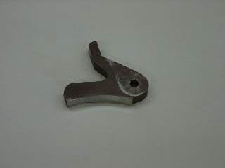
Fig 7.3. Pressure Foot
Feed rollers (Bottom feed roller)
Bottom feed roller helps in feeding the material by gripping the flesh side of the material without damaging it.
- Adjustments
Feed roller is adjusted by using side adjusting knob connected with the bottom feed roller assembly. This side adjusting knob set the distance between knife and feed roller according to the thickness of the scarf to be passes. The minimum distance between the roller and the bell knife should not be set less than 0.5 mm. However, this distance may vary accordingly.
- Types of feed rollers
There are different types of feed rollers available with machine mechanism for different types of material to be skived. Following are the types of rollers available to suit the particular material.
- Emery Roller
- Rubber Roller
- Metallic Roller
Emery Roller
This roller is made of emery stone and available in three types are coarse, medium and fine emery. The term course, medium and fine is used for the roller surface, which always comes in the contact of material during skiving.
The roller, which is having medium surface, is used for medium structure and thickness of material to feed it under the pressure foot in order to have proper grip from beneath the material during skiving. This type of roller is used in medium duty skiving machine.
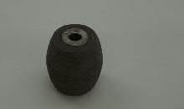
Fig 7.4. Emery Feed Roller
Rubber Roller
This roller is made of rubber in order to incorporate with the very fine and thin material to be skived. Therefore, rubber rollers are noticed most suitable for skiving fine, thin and delicate materials.
Metallic Roller
This roller is made of steel in order to incorporate with the thick and thermoplastic material to be skived. The melted adhesive stick over the feed roller and during removing it damages the surface by leaving patches on it. These patches disturb the feed and hence metallic rollers are most suitable for skiving thermoplastic materials.
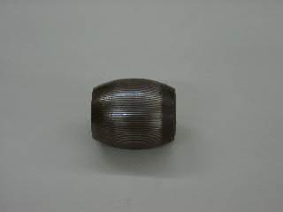
Fig 7.5.Metal Feed Roller
Grinding stone (Sharpening stone)
Sharpening stone is in round shape and used to sharpen the bell knife. The surface of the stone is very fine and also required dressing during sharpening the knife.. This movement includes bringing the stone towards the knife and send back after sharpening the knife.
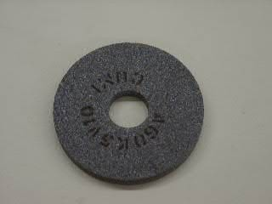
Fig 7.6Grinding Stone

Bell knife adjustment
Bell Knife is called so because it is having a shape of bell. The idea behind giving bell shape is to increase the life of the knife, The sharpening of knife is frequently required to obtained the quality skiving. The bell knife always moves away from an operator during skiving, which keeps the dust particles away from an operator.
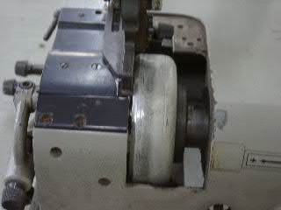
Bell Knife
Fig 7.7 Bell knife adjustment
Top pressure adjusting assembly
Top pressure adjusting assembly helps in setting the required pressure on material to be skived. The top pressure is determined according to the skiving required and thickness of the material.
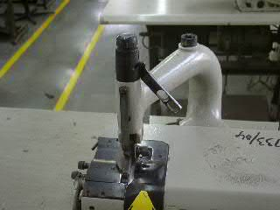
Top Adjustment Assembly
Fig 7.8 Top Adjustment Assembly

The second knob is connected with the bell knife and allows the knife to move left or right side of pressure foot accordingly.
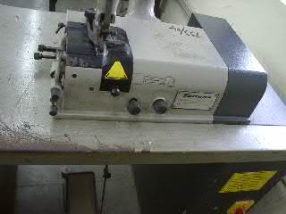
Front Adjustment Knob
Fig 7.9 Front Adjustment Knob
Side adjusting knob
Side adjusting knob is connected with the bottom feed roller assembly, which allows to set distance between knife and feed roller according to the thickness of the scarf to be passes. Normally the minimum distance between the roller and the bell knife should not be set less than 0.5 mm. This distance may vary accordingly.
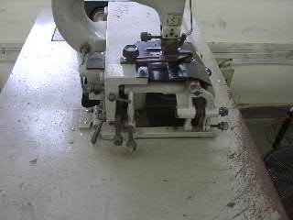
Side Adjustment Knob
Fig 7.10 Side Adjustment Knob

Top lever
Top lever is connected with the top vertical pressure adjusting assembly and used to lift the pressure foot during skiving according to the situation arises.
Top Lever
Fig 7.11Skiving of component
Skiving Types and Procedures
It is obvious that skiving improves the appearance of the footwear, by removing any sort of bulkiness caused by the over lapping of component or by joining of components. Skiving operation is done as per work specification requirement.
The skiving operation is required to perform to achieve various treatments in upper closing like folding, back seam, attaching component together, cording, binding, bag top line, French binding etc. Different types of skiving are required to do different kinds of operations.
- Raw edge skiving
- Open Raw Edge
Open raw edge is used when the upper sections are to be left with raw edges, especially on heavy leathers with/ without any sort of edge treatment such as gimping/punching/ binding, to give a smooth and uniform finish/look along the edge of the component and to remove loose fibers from the edge.
The depth of skive is normally 1/3rd of the material thickness and width of skive must not be more than the edge stitching distance, i.e., 1.5 -2 mm.
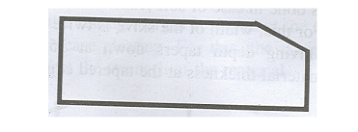
Fig 7.11Open Raw Edge Skiving
- Closed Raw Edge
Used in case of closed seams in order to give smooth and uniform finish by removing excess bulkiness from the edges.
A steep angle skive of 35 degrees is made, the width of which is approximately 2-3 mm and depth is 2/3rd of the material thickness.
Width and depth of skive could vary depending upon the material thickness and strength. On thin and soft materials, there is no need to go for closed edge skives. Care must be taken not to affect the strength of the material.
Figure 7.12 Close Raw Edge Skiving
- Burnished Edge
It is actually a variation of the folding skive. Skive is done at an angle of 40- 45 degrees. Skive must be uniform because after skiving, the edge has to be passed under a heated iron. The heat causes the leather to contract and turn inwards towards the flesh side thus giving a folded appearance.
- Underlay skiving
- Underlay Skive for Lapped Seams
It is done on the bottom component where two components (top and bottom) are to be stitched together by overlapping.
It is done to avoid any bumps or ridges on the upper, which could cause problems in stitching as well as print- through after lasting.
These bumps also cause the uneven featheredge, uneven roughing and leaves gapping during sole lying.
Normally, underlay skive is done on the flesh side, but in case of unlined footwear, it can be done on the grain side of the component, to give a better appearance inside the footwear.
Skiving depth must taper down gradually to the finest possible edge to prevent a print- through after lasting.
Skiving width must be 2- 3mm behind the stitch Pointing line/ underlay margin, so that at least the first row of stitching comes on full thickness of both the materials, to give enough strength and durability to the seam. Hence, it is necessary to do stitch Pointing before underlay skiving.
Fig 7.13 Underlay Skiving
- Folding skiving
It is necessary to remove the bulk so that the leather returns to its original thickness after folding over.
- Hollow Fold Skive
Hollow Fold Skive is done in case of heavy leathers. Depth of skive is half of the material thickness and width is usually twice the folding margin plus 1mm roll over allowance.
Figure 7.14Hollow Fold Skive
- Shallow/Wedge Fold Skive
Shallow/Wedge Fold Skive is done in case of comparatively thin and soft leathers.
Depth of skive tapers down at 35-degree angle leaving 1/3rd of material thickness at the tapered edge and width is twice the folding margin.
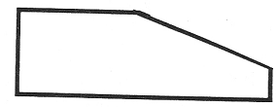
Figure 7.15 Shallow Fold Skive
- Fold Skive for Bagged/Roll Top Edge
It is done to give a smooth top line with no stitching visible. Skive is same as shallow/ wedge fold skive. Enough substance must be left at the edge to hold the stitching. The lining must also be skived in a similar manner in order to eases the folding operation before turning the lining.
- Fold Skive for Blind/Invisible Seam
Fold Skive for Blind/Invisible Seam is done on components to give a folded appearance without the stitching showing.
The bottom component is underlying skived and the top component is shallow/ wedge fold skived for soft leathers and hollow skived for hard leathers.
Then the two components are stitched face-to-face, top component folded over and stuck to the bottom component. Grain skiving is being done sometimes in order to stick the surface while turning the component after stitching.
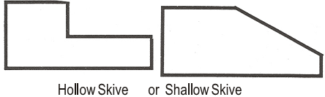
Fig 7.16 hallow/shallow skive
- Lasting margin skiving
On heavy leathers, the lasting margin is skived at the toe to reduce bulkiness during lasting and to ease pleating. For this, the skiving must be wide but not deep so as not to affect the strength of the material.
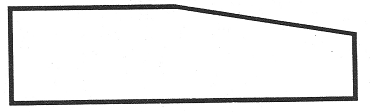
Figure 7.17Lasting Margin Skiving
- Toe-puff and Counter stiffener skiving
The skiving done these is similar to shallow/wedge skive and this is done in order to avoid the print through on the toe and counter and also, to make lasing easier in case of counter.
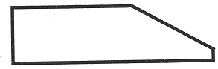
Figure7.18 Toe-puff and Counter stiffener Skiving
Open raw edge skiving
Type of leather: Heavy Leather
Depth of skiving: 1/3rd of material thickness
Width of skiving: 1.5-2 mm
Close raw edge skiving
Type of leather: Medium and hard leather
Depth of skiving: 2/3rd of material thickness
Width of skiving: 2-3 mm
Hollow fold skiving
Type of leather: Heavy leather
Depth of skiving: Half of material thickness
Width of skiving: Twice the folding margin
Shallow fold skiving
Type of leather: Thin and soft leather
Depth of skiving: Tapered down at 35* angle
Width of skiving: Twice the folding margin

7.4. Following Work ticket specifications
    - Pairs and Pieces
Work ticket with standard format and having specification should be prepared and applied through the skiving operation. This work ticket gave clear information for the person performing the skiving operation. The skiving should be done based on the information given in the work ticket or work ticket specification. A sample work ticket is shown below.
Work Ticket
Skiving job ticket
Name of the organization: ________________________
Skiver’s name: ________________________
Date: ____________________
Material: _______________________
Color: __________
Style/ model: _____________________
Size | Pairs | Pieces
Total

Department’s signature: -

Table7.1 Work Ticket

7.5 Checking skived parts
    - Quality Standards and Specifications
The components or the parts of a shoe must be skived according to quality standards requirement and it should be checked against the specifications. There is quality standards requirement for various types of skiving. These are:
- In open raw edge skiving should be done at a steep angle skive of 35 degrees and the width of skiving is approximately 2-3 mm and depth of skiving is 2/3rd of the material thickness.
- In case of closed edge skiving the depth of skive is normally 1/3rd of the material thickness and width of skive must not be more than the edge stitching distance, i.e., 1.5 -2 mm.
- Skiving depth must taper down gradually to the finest possible edge to prevent a print- through after lasting in underlay skive for lapped seams.
- Skiving width must be 2- 3mm behind the stitch Pointing line/ underlay margin in case of underlay skive for lapped seams.
- In case of hollow fold skive the depth of skive is half of the material thickness and width is usually twice the folding margin plus 1mm roll over allowance.
- In case of shallow/wedge fold skive the depth of skive tapers down at 35-degree angle leaving 1/3rd of material thickness at the tapered edge and width is twice the folding margin.
Approved samples
Samples are used as a reference for performing skiving operation. The samples that that are used for this purpose must be approved by the respective body and put in place for using it as guide during skiving parts or components of a given shoe. This sample must be prepared for each part that is going to be skived.
Approved show boards
The skiving show board is used for the purpose of defining skiving requirements including types of skiving to be carried out. These show boards help in reducing or for minimization of the skiving rejects. The show board serves as guidance for skiving parts or components of a shoe. The parts must be skived according to the skiving specification displayed on the skiving show board.
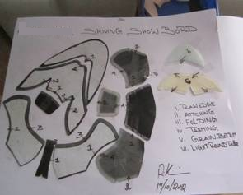
Figure7.19 skive parts

Self-Check -7
Instructions: Answer all the questions listed below. Illustrations may be necessary to aid some explanations/answers.
Part I: say “True” if the statement is correct and say “False” if the statement is incorrect
    - On heavy leathers, the lasting margin is skived at the toe to reduce bulkiness during lasting and to ease pleating.
    - The bottom component is underlying skived and the top component is shallow/ wedge fold skived
    - Bottom feed roller helps in feeding the material by gripping the flesh side of the material without damaging it
Part II Fill the blank space
    - Parallel shape of pressure foot is requiring for----------------
    - -------------------- is fixed near the pressure foot and used to determine the skiving width during skiving
Part III gives short answer
- Write the different machine parts involved to make the required skiving.
- Define the following skiving operations

  - Underlay Skive
  - Fold Skive
  - Closed Raw Edge skive
  - Open raw edge skive

Operation sheet-1
Operation title: skiving operation manually
Operation objective: Performing skiving operation manually
Tools and equipment’s
- Cutter
- Thickness gauge
- Skiving machine
Procedures of skiving parts against quality standard
Step 1 adjusting skiving parts

- Bell Knife
- Bottom Feed Roller
- Sharpening stone
- Skiving guide
- Top pressure adjusting assembly
- Front adjusting Knobs
- Side adjusting Knobs
- Top lever

Step 2 apply skiving types

- Raw edge skiving
- Underlay skiving
- Folding skiving
- Lasting margin skiving
- Toe-puff and Counter stiffener skiving

Step 3 Checking skived parts
- The components or the parts of a shoe must be skived according to quality standards requirement
Step 4 Approved samples
- Samples are used as a reference for performing skiving operation
Step 5 Approved show boards
- The show board serves as guidance for skiving parts or components of a shoe. The parts must be skived according to the skiving specification displayed on the skiving show board.

Lap test
Name………………………………. ID…………………………….. Date…………………………………….
Time started: ________________________ Time finished: ________________
Instructions: Given necessary templates, tools and materials you are required to perform the following tasks within 1 hour. The project is expected from each student to do it.
Task-1 performing skiving operation manually

Unit eight: prepare and use hand tools, materials and equipment
This unit is developed to provide you the necessary information regarding the following content coverage and topics:
  - Selecting components to be fused
  - Performing fusing operation manually
  - Performing machine fusing adjustment to the required standards.
  - Fusing components by machine
  - Following work ticket specifications
This unit will also assist you to attain the learning outcomes stated in the cover page. Specifically, upon completion of this learning guide, you will be able to:
  - Select components to be fused
  - Perform fusing operation manually
  - Perform machine fusing adjustment to the required standards.
  - Fuse components by machine
  - Follow work ticket specifications

8.1 Selecting components to be fused
Interlining attachment should be attached after skiving and should not be attached on the skived part of the components
Interlining or reinforcement material must be the same to the specification and also checking for correct adhesion and placement of reinforcement is very important. So, Interlining or reinforcement should be:
- Compatible with corresponding material.
- Woven (stretch) reinforcement material should be selected for fixing under stretching areas (lasting pulls) of upper.
- Non-woven reinforcement material should be selected for fixing under punching and perforated areas like eyelets and brogue punches.
- Braided reinforcement (nylon) material should be used for fixing under folding and top lines

8.2 Performing fusing operation manually
The word fusing is used for fixing a sugar-coated fabric to a particular material for reinforcing and strengthens purpose. Different kinds of material are used in shoe making and leather is rated best to make a comfortable and hygienic shoe. To make a good presentable shoe out of this type of material, we need to have a special treatment called reinforcing or interlining attaching. This makes the upper component durable during production and provides better shape retention to the finished shoe. In order to reinforce the concerned material, different kinds of reinforce material can be used according to their purpose, uses and benefits. Some of the material is as follows:

- Thin leather pieces
- Fabric
- Sugar coated material
- Pressure sensitive material (heat base)
- Solvent base
- Self-adhesive nylon or cotton tapes

Self-adhesive tapes are ready made rolls and used during upper making. Reinforcement can be fixed with the required material in following ways:
    - Attaching with the help of adhesive
    - Pressing under the heat
    - Fixing of self-adhesive tapes
Figure 8.1 Fixing of self-adhesive tapes.

8.3 Performing machine fusing adjustment to the required standards.
- Starting the Machine- Electric Supply
After having put the compressed air into the machine it is possible to connect the electric supply in the following way:
Turn the general switch on the left side of the machine to the “1” position. The heated parts of the machine are quite big, therefore the heating time from room temperature to that of work set by the thermo-regulators is about 20-30 minutes. We advise switching on the machine at least 30 minutes before work should start.
- Switching off Machine:
To switch off the machine at the end of the working day it is sufficient to turn the main switch to the “0” position. It is necessary to switch off the pneumatic supply.
- Shield Adjustment:
The shield adjustment has to be done according to the thickness of the material employed. Loosen the screws and adjust the shield height, so that the employed material can enter the pressing area passing through the access slit. Once adjusted the shield, tighten the screws again. Keep in mind that the maximum thickness of the coupled material should be of 8 mm.
- Pressure Plate Temperature Regulation
The pressing plate temperature has to be regulated according to the material employed. Operate the thermo regulator, placed on the control panel, to schedule the wanted temperature. We advise to hold the temperature between 80* and 100*C. don not schedule the temperature over 100*C, in order to avoid damages to the material employed.
- Pressing Time Regulation
We have to regulate the pressing time according to the kind of the material employed and the pressing plate temperature. If the pressing plate temperature is high, we should schedule a short pressing time and vice versa. To regulate the pressing time, we have to rotate clockwise the potentiometer, placed on the control panel, in order to increase the pressing time. If we want to diminish it, rotate the potentiometer anticlockwise

8.4 Fusing components by machine
To make a good presentable shoe out of upper and lining materials, we need to have a special treatment called reinforcing or interlining attaching. So, it is important to check the specification of the material for the interlining attaching. Interlining should be attached after skiving and should not be attached on the skived part of the components.
Fig 8.2.Interlining attachment
- Set temperature and pressure
After checking, there is setting temperature and pressure. Make sure that the temperature and dwell time is correct. The pressing plate temperature has to be regulated according to the material employed. Operate the thermos regulator, placed on the control panel, to schedule the wanted temperature. We advise to hold the temperature between 80* and 100*C. Do not schedule the temperature over 100*C, in order to avoid damages to the material employed.
Fig 8.3.Figure Temperature and Pressure Adjustment Knob
- Place inter-lining
Interlining or reinforcement material must be the same to the specification and also checking for correct adhesion and placement of reinforcement is very important. So, Interlining or reinforcement should be:
- Compatible with corresponding material.
- Woven (stretch) reinforcement material should be selected for fixing under stretching areas (lasting pulls) of upper.
- Non-woven reinforcement material should be selected for fixing under punching and perforated areas like eyelets and brogue punches.
- Braided reinforcement (nylon) material should be used for fixing under folding and top lines.
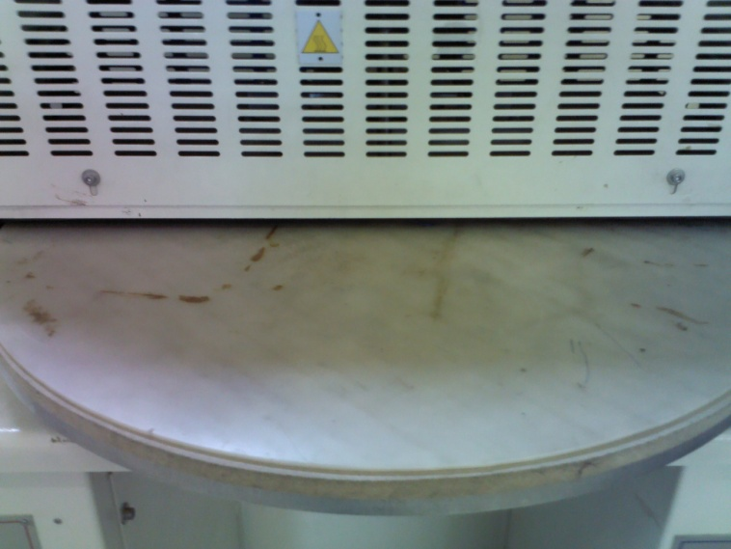
Figure 8.4. Interlining Attaching Machine
- Press
First switch on the machine and operate the regulations needed. Then, put the material to be worked on the rotating table. Rotate clockwise the table by hand, until the material employed is under the pressing plate. Now, press at the same time the two starter buttons placed on the base of the machine: the pressing plate will lower and press the material, according to the previously scheduled pressure value. As the time scheduled on the potentiometer sops, the plate will rise, allowing drawing out the coupled material and putting in the new one. The later should have been put on the table during the pressing cycle.

We have to regulate the pressing time according to the kind of the material employed and the pressing plate temperature. If the pressing plate temperature is high, we advise to schedule a short pressing time and vice versa. To regulate the pressing time, you have to rotate clockwise the potentiometer, placed on the control panel, in order to increase the pressing time. If you want to diminish it, rotate the potentiometer anticlockwise.
Figure 8.5. Pressure Indicator
- Check attachment
Finally, the interlining attaching must be checked for placement of reinforcement is correct and the specifications are fulfilled.
Figure 8.6 Interlining Pasting

Operating button
These buttons are used for operating the machine. There are two green buttons in the machine.
Figure 8.7.Operating button

8.5 Following work ticket specifications
Pairs and Pieces
Work ticket with standard format and having specification should be prepared and applied through the fusing operation. This work ticket gave clear information for the person performing the fusing operation. The fusing should be done based on the information given in the work ticket or work ticket specification. A sample work ticket is shown below.

Work Ticket
fusing job ticket
Name of the organization: ________________________
Fusing’s name: ________________________
Date: ____________________
Material: _______________________
Color: __________
Style/ model: _____________________

Size | Pairs | Pieces
Total
Department’s signature: -

Self-Check 5
Instructions: Answer all the questions listed below. Illustrations may be necessary to aid some explanations/answers.
Part I: Short answer questions:
- List the information’s contains in Work Ticket?
- What are the adjustments ‘during fusing operations
- Write the advantages of fusing.

Unit nine: Complete work
This unit is developed to provide you the necessary information regarding the following content coverage and topics:
  - Observing and referring problems with tools and machines for repair or correction
  - Cleaning, checking, maintaining and storing hand tools and equipment
  - Documenting, maintaining and reporting records
This unit will also assist you to attain the learning outcomes stated in the cover page. Specifically, upon completion of this learning guide, you will be able to:
  - Observe and referring problems with tools and machines for repair or correction
  - Clean, check, maintain and stor hand tools and equipment
  - Document, maintain and report records

9.1. Observing and Referring Problems with tools and machines for repair or correction
During the pre-fabrication operation tools and machines are observe problems or faults referee for repair or correction the number of possible mechanical machines faults is nearly endless. However, up to 90% of the time, machine faults fall into one of four main categories misalignment, imbalance, looseness or bearing wear.
Imbalance: a heavy spot on the shaft causes forces in all radical direction that lead to excessive vibration and increase the wear of components including bearing seals
Looseness: the shaft, foundation or a component has come loose, which causes forces that lead to excessive vibration and increase the wear of components including bearing and seals.
Bearing wear: bearings will wear from excessive loads, other machine faults, poor lubrication or installation, etc. If not corrected the bearing will eventually fail.
Root cause analysis in a method of determining hoe an issue occurred in the first place. Using root cause analysis can help you identify where a problem began and what caused it.
Performing a root cause analysis is similar to retracting your steps. From there, you can take your knowledge about what happened and why to find ways to prevent it from happening again.
First, identify the boundaries of the problem. Where did it began and ways to where did it end? What are the variables, and what are the constants? What if, anything, changed to make the problem possible? Depending on the situation, it may be easier to trace a failure back to the event that set it in motion, or it may be easier to consider multiple possible catalysts and chart a path forward from each of two those toward the failure.

9.2. Cleaning, checking, maintaining and storing hand tools and equipment

Cleaning of Tools and Equipment
Every time a piece of equipment is used, the general rule is to clean it straight away so it is ready for the next person to use. The first step to healthy tools is keeping them clean. Your tools to clean them after use will improve their lifespan.
Skills and actions need to clean up tools: -
- Select and use an appropriate method for cleaning
- tools and specialist equipment
- Restore your work area to a safe and tidy condition
- Make sure that any materials, components, tools and equipment that you may need for the next task are set up ready for use.
Storing and maintaining of hand tools
Storing your tools will not only help you stay organized but keep your tools away from the elements. Air circulation and dryness are also important factors when storing gardening tools. Getting into a habit of cleaning and maintaining your tools will make more expensive and better-made tools a lifetime investment.
- Location: - Hand tools should be safely located when not in immediate use.
- Safety: - Hand tools should be used safely and effectively according to their intended use.
Systematically arrangement: - Hand tools should be clamped or fixed in posit

9.3 Documenting, maintaining and reporting records
During upper pre-fabrication department, production goes according to the production sheet and capacity loading is done according to the production resources and standard time of operations. Operation sequences passes through the various hands (Multi skilling, high skill, skilled, semi-skilled and unskilled) and operators having different mental calibers. In order to have sufficient transparency in all production’s levels, we have to have an easy expressing method to evaluate the quality and productivity during production.
To achieve the product as per the buyer’s specifications, we need to designs a set of documents called pre-fabrication document, which are very convenient and useful to achieve the quality targets during production. Various documents like order break up sheet; specification sheet, plan sheet and route sheet are designed to enhance the quality and productivity of pre-fabrication department.
Order Sheet
This document refers to the size of order along with all the other details of the particular shoe style or design for production. This includes all information regarding:
- Customer details,
- Style/design code or article No,
- Style/design details according to the season,
- Order quantity according to the season,
- Dispatch schedule and
- Concerned port and previous references.
Route Sheet
This document refers to the route of the production for different styles according to the design and their constructions. Shoe designs/styles can be made in many ways and they convert the route of the product during production.
For convenience and quality production, shoe manufacturing can be divided in to following areas, where the particular section of shoe is completed. Each department has their separate entity and sometimes two departments may club together according to the situations. These areas are:
- Sourcing and designing,
- Cutting or clicking section,
- Pre-fabrication
- Upper sewing or closing section,
- Bottom components,
- Lasting section and
- Finishing and packing department.
The shoe making resources travels in a particular sequence from one department to another department till the final shoe is not packed. Therefore, individual route sheet is made for every single design of shoe and WIP goes accordingly.
Route sheet is very helpful in identifying the particular shoe style placement during production. It is filled by the manager production and it pinpoints the exact position of WIP of shoe during production. There may be one route sheet for the one order breakup or separate sheets as different departments.
Date | Dept. | Order No | Article No | Plan No | Size | Input  (Prs) | WIP  (Prs) | Rejection  (Prs) | Output  (Prs) | Packing  (Prs)

Lot No.
To follow the safeguard and convenience during shoe production is to divide the complete shoe order in to the quantities or lots as per the dispatch schedule. This is because of:
- Buyers are very rear asks for the whole order quantity at once,
- Different destination suggested to ship,
- Storage cost or any damage against heavy loading unloading.
- Payment releases and Working capital.
The planned dispatch quantities of shoes are divided in to the small lots and Lot No is allocated accordingly. The Lot No is stamped over the components edges or (suitable area), which helps to recognize the component against any happening during production.
Example
Suppose on I st January, 5000 pairs of shoe uppers order has been received from buyer, which is to be dispatched according to following:
Pairs 500 to be dispatched by 31st January,
Pairs 500 to be dispatched by 31st March,
Pairs 1200 to be dispatched by 3oth April,
Pairs 1400 to be dispatched by 31st May,
Pairs 1400 to be dispatched by 3oth June,
Now for the convenience during the production is to divide the Ist dispatch quantity in following ways:
Order break up of first 500 pairs will divided in to five equal lots.
One Lot of 100 pairs (even number) is considered suitable for calculation purposes during recording and planning.
Serial all the concerns Lots in numbers like 1, 2, 3, 4 and 5 (100 each).
This 100 pair Lot is allocated further by providing numbering in following ways:
Take lot number one of 100 pairs and start planning the serial number from one to hundred.
Material to be issued for cutting will be according to the lot number one.
Stamping done on above lot material will be given as serial number like order number/article number/size/lot number/serial number.
Job Card
WIP during upper closing is passes from one operation another by different mode of transports. These transporting systems are used according to the capacity and convenience of the product. Some of them are as follows:
- Basket,
- Trolleys and
- Shoebox.
When above carriers are moving on the conveyers, they might be not recognized for their existence. To find out the suitable production lot in these carriers, must carry some details along with them. The concerned detail is recorded on a card called job card. These details can be:
- Plan Number
- Article Number,
- Size,
- Number of pairs,
- Lot Number and
- Department concern.

XYZ Company, New Delhi
Job card
Order No |  | Date |  | QC
Article No |  | Plan No
Lot NO |  | Style No
Size |  | Pairs | Cutting
35 | 1
36 | 2 |  | Closing
37 | 3
38 | 4 |  | Bottom components
39 | 5
40 | 6 |  | Lasting
41 | 7
42 | 8 |  | Finishing
43 | 9
44 | 10 |  | Packing
45 | 11
46 | 12 |  | Dispatch
Total Number of Pairs

Daily Production Report
The shoe making resources travels in a particular sequence from one department to another department till the final shoe is not packed. Therefore, individual route sheet is made for every single design of shoe and WIP goes accordingly.
Daily production report is very helpful in identifying the particular shoe style placement during production. It is filled by the manager production and it pinpoints the exact position of WIP of shoe during production. There may be one daily productive report for the one order breakup or separate sheets as different departments.
Daily Production Report:
Date | Day | Order No | Article No | Plan No | Size | Input  Pars | WIP | Output pars | Packing pars
 | Monday
 | Tuesday
 | Wednesday
 | Friday
 | Saturday

Daily Productivity Report
According to production capacity, daily productivity report is designed and full lot (particular number) is feeder in to the production conveyor during upper making. It helps in building a momentum in production and displays clear picture of production. It also helps in day-to-day planning against any failure or changes to be made to the resources in upper closing department.

To achieve the production targets, production norms are fixed and work is enforced accordingly in to the concerned department. To obtain the predetermined results against targets, following activities are found most suitable:

Display of worker’s skill inventory chart,
Display daily attendance chart,
Display concern sample or specification sheet in the department,
Display sequence of operation chart,
Display list of machines break down during production hours,
Display hourly production chart,
Display reasons that affecting the production,
Make show boards for every operation, which feels complicated.
Display necessary feedback of customer.
Any other instruction charts.
Daily Productivity Report
Date | 8.30 9.30 | 9.30 10.30 | 10.30 11.30 | 11.30 12.30 | Total Production | 1 to 2 | 2 to 3 | 3 to 4 | 4 to 5 | Total Production
Monday
Tuesday
Wednesday
Thursday
Friday
Saturday
Total
Daily Rejection/Repair Report
To achieve consistency in quality, inspections are mandatory in various stages of the closing department. Due to deviation in the production related factors mistakes are bound to occur and defective shoes are separated during inspection and categorized in reparable and non-reparable category. The components of repairing are either cut or re- processed or re- issued and the defective pair is run through various processes. Therefore, a format must be maintained so that the excess cost of the repairing can be controlled and ultimate cost of production can be computed. An illustrative format (fig: 1) of in process rejection/ repair report used in the factory is shown in the fig no---.

Date | Dept.  Pre-fab. | Order No | Article No | Plan No | Size | Input  Pars | WIP | Percentage | Rejection  Pars
Monday
Tuesday
Wednesday
Thursday
Friday
Saturday
Total
Daily Dispatch Report
On the basis of this report we can know how much material has been packed and transferred to the pre-fabrication department.

Daily Dispatch Report

Date | Day | Order No | Article No | Plan No | Size | Input  Pars | Rejection  Pars | WIP | Packing | Dispatch
 | Monday
 | Tuesday
 | Wednesday
 | Thursday
 | Friday
 | Saturday
 | Total

Self-Check-9
Instructions: Write all your answers in the provided answer sheet.
Directions: Answer all the questions listed below. Examples may be necessary to aid some explanations/answers.

Test I: Short answer questions: (Total points: 10)
1. List Order Sheet document

References

https://www.libertyleathergoods.com/leather-thickness-gauge/
https://www.brushtec.com/maintain-clean-organised-factory-warehouse/
https://klariti.com/2017/06/13/how-to-write-work-instructions/
https://www.gluu.biz/how-to-write-work-instructions/
https://www.plantengineering.com/articles/machine-safety-tips-to-prevent-plant-injuries/
https://www.osha.gov/Publications/osha3080.html

Experts Who Developed This Learning Guide

No | Name | Educational Background | Region | E-mail
1 | Abdi Angerasa | MSc in Footwear Technology, MSc in Industrial Engineering | Addis Ababa, LIDI | abdinago2@gmail.com  0923995950 // 0931430551
2 | Molla Demeke | BSc in Leather and Leather Product Technology | Amhara, Woldia Poly Technic College | mollademeke9@gmail.com  0927633940
3 | Birhanu Bariso | BSC in Leather Technology | SNNPR, Sodo Poly Technic College | birhnubariso@gmail.com  0916785483
4 | Genanaw Dagne | BA in Curriculum Study | Addis Ababa, LIDI | genanewd28@gmail.com  0920247691

