Footwear Production
Level II
Based on November, 2021, Curriculum Version 1
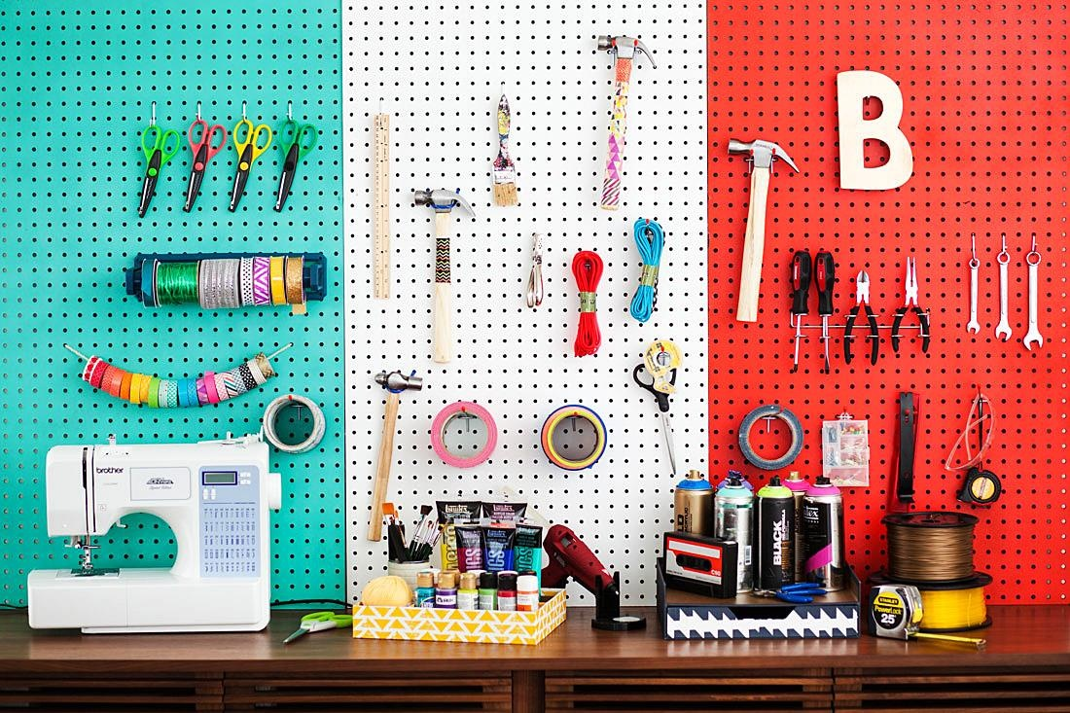
Module Title: Performing Minor Maintenance
Module code: IND FWP2 M02 1221
Nominal duration: 42 Hours

Prepared by: Ministry of Labor and Skill

September, 2022
Addis Ababa, Ethiopia

Contents
Acknowledgment 3
Acronym 4
Introduction to the Module 5
Unit one: Preparation for basic routine maintenance 6
1.1. Basic routine maintenance tools and supplies 7
1.2. Carry out routine pre-operational checks 10
1.3. Identification of unsafe machinery and equipment for repair or replacement 13
1.4. Identification and reporting OHS hazards to the supervisor 16
Self check 1 25
Unit two: basic routine maintenance for cutting, prefabrication and stitching machines 27
2.1. Suitable personal protective equipment 28
2.2. Greasing and Lubrication 31
2.3. Routine adjustments and repairs 36
Self check 2 46
Operation sheet 2.1: basic routine maintenance for stitching machine 47
Lap Test-Practical Demonstration 48
Unit three: Complete basic routine maintenance 49
3.1. Cleaning, returning to operating order and storing tools 50
3.2. Follow environmental procedures 52
3.3. Cleaning and maintaining work area 58
3.4. Reporting malfunctions, faults, wear or damage tools 62
3.5. Recording maintenance and documentation 64
Self check 3 68
Operation sheet 3.1: Clean hand tools 69
Operation sheet 3.2: preventive maintenance and adjusting sewing machine 70
Lap Test-Practical Demonstration 73
Reference 74
Experts Who Developed this Learning Guide 75

Acknowledgment

Ministry of Labor and Skills wish to extend thanks and appreciation to the many representatives of TVET instructors and respective industry experts who donated their time and expertise to the development of this Teaching, Training and Learning Materials (TTLM).

Acronym
FDA-food and drug administration
PPE-personal protective equipment
PVC (polyvinyl chloride) frame
MM- milli meter
SDM-
G-gross area
T.R- table run
S.G-selected grade

Introduction to the Module
In Footwear Production filed; Prepare for basic routine maintenance, carry out basic routine maintenance for cutting, prefabrication and stitching machine and complete basic routine maintenance for Footwear Production.
This module is designed to meet the industry requirement under the Footwear Production Occupational standard, particularly for the unit of competency: Preparing Footwear Upper Material Requirement.
This module covers the units:
- Preparation for basic routine maintenance
- basic routine maintenance for cutting, prefabrication and stitching machines
- Completing basic routine maintenance
Learning Objective of the Module
- Prepare for basic routine maintenance
- Carry out basic routine maintenance for cutting, prefabrication and stitching machines
- Complete basic routine maintenance

Module Instruction
For effective use this modules trainees are expected to follow the following module instruction:
- Read the information written in each unit
- Accomplish the Self-checks at the end of each unit
- Perform Operation Sheets which were provided at the end of units
- Do the “LAP test” given at the end of unit if it’s provided.
- Read the identified reference book for Examples and exercise

Unit one: Preparation for basic routine maintenance
This unit is developed to provide you the necessary information regarding the following content coverage and topics:
- Basic routine maintenance tools and supplies
- Carry out routine pre-operational checks
- Identification of unsafe machinery and equipment for repair or replacement
- Identification and reporting OHS hazards to the supervisor
This unit will also assist you to attain the learning outcomes stated in the cover page. Specifically, upon completion of this learning guide, you will be able to:
- Identify, select, Basic routine maintenance tools and supplies
- Carry out routine pre-operational checks
- Identify of unsafe machinery and equipment for repair or replacement
- Identify and report OHS hazards to the supervisor

Basic routine maintenance tools and supplies
Routine maintenance is a procedure to ensure equipment is kept in good condition, and provide a long operating life. Routine maintenance may also discover potential problems, which could cause equipment failure. Potential problems can then be corrected, with a minimum of down time. ‘Quality control’ procedures, to ensure correct operation and calibration, are also a part of routine maintenance.
Carrying out routine maintenance produces good knowledge of the equipment, and in case of a problem, this knowledge will help to locate the cause. Where there is a more serious problem, accurate reporting for assistance will allow faster and more economic response. For example, the service engineer can then arrive with suitable parts and test equipment.
A major part of routine maintenance is just inspection of equipment. This should be done as if seeing the equipment for the first time. At the same time, make note of less understood operation areas, and refer to the operation manual for explanation.
- The nature of the problem is properly investigated and documented.
- If needed, a ‘follow up’ reminder is sent to the service provider.
Table 1.1 Basic routine maintenance tools and supplies
Basic routine maintenance tools and supplies | Uses or functions | Images
- Wrenches | - The most commonly used wrenches for various repairs and maintenance works are open-end wrenches  - They are used to tighten or loose bolts and nuts. Box-end wrenches surround a nut or bolt and apply pressure to all its corners.  - They are less likely to ruin a fastener than an open-end wrench, which bears on only two corners. Adjustable open-end wrench is a general-purpose tool and it will fit nuts and bolts up to the maximum opening of its jaws. | 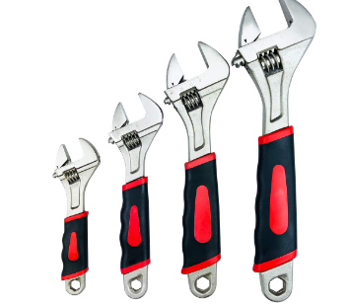
- Portable  electric hand drill | - Portable electric hand drills are the most commonly used power tools. Variable speed and reversible drills allow the tool to be used for driving and removing screws and other low-speed jobs.  - A power drill is a versatile tool that can drill holes in metal, wood, plastics, etc. and can take dozens of accessories for sanding, grinding, shaping, stripping, buffing, etc. | 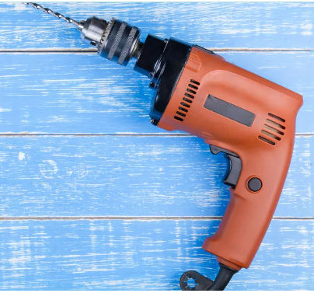
- Oil stone | - Sharpening oilstone consists of thousands of tiny, harder than steel sharp-edged points with spaces in between. As the knife is pushed over the stone under pressure, these points grind off particles of steel.  - The initial grinding removes metal rapidly but leaves the surface and more particularly the edge rough and ragged.  - At this stage, the knife may feel sharp and indeed for a time may cut better than it did before. | 
- Oil can | - Oilcan is used to lubricate various leather goods tools, equipment and machines with suitable machine oils | 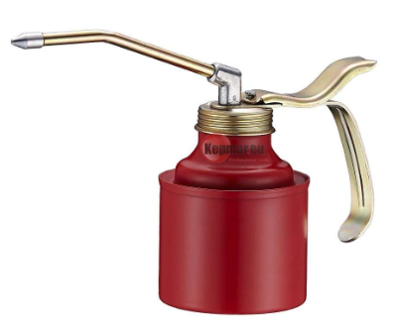
- Brush | - A flat artist's paintbrush in 1/2-inch size is useful, and a soft blush or makeup brush with a short, stubby handle is also effective. The long, soft bristles of the makeup brush clean without damage and hold lint well. | 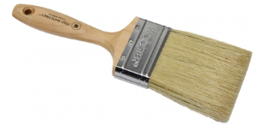
- Tweezers | - The special type Tweezers are used for picking and handling screws and small parts in „Sewing Machine‟.  - They are also used to clean out the shuttle area of sewing machines. | 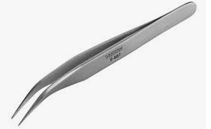
- Pliers | - Useful in a leather products manufacturing workshop for cutting and bending, pulling small fittings and holding metal fittings that are to be filed or hammered.  - Nose pliers are used for cutting and bending thin wires and small fittings. Diagonal cutting pliers are sometimes called as wire cutters. | 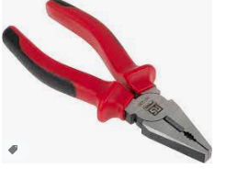
- grease gun | - The grease gun is used for greasing the machine through grease nipples | 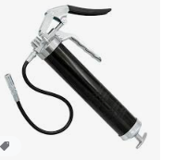
- Spanner sets | - Typically consist of a selection of different spanner sizes, bought together as a single kit that offers users a full range of options and on-hand flexibility when tackling nuts and bolts of any size. | 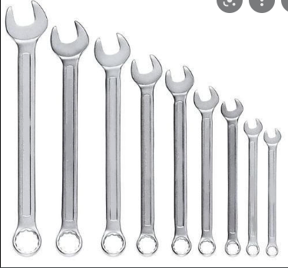
- screw driver | - part of the design of a screw that allows it to be turned into place using a mating tool like a screwdriver or Allen wrench.  - Most screw heads come in a range of styles, including a Phillips fillister head or a slotted flat head, as well as in various sizes. | 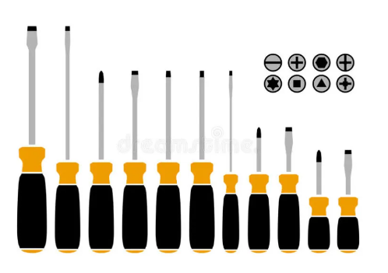

Carry out routine pre-operational checks
Maintenance is the routine job for keeping sewing machine fit for footwear manufacturing. Every factory assigns maintenance team to ensure the proper functioning of a machine. Machine maintenance team makes Schedule and takes preventive action. Proper maintenance of the machine will ensure long-lasting service. For this reason, the cost per unit will be less. This is the reason importance is given for machine maintenance in footwear.
    - Routine pre-operational checks of machine and equipment

The machine has been left idle for long period of time pre-operational checks must be carried out. This procedure will ensure that the machines set up for that type of working you will be doing.
- Check all input air and air gauges for the correct air pressure as per requirement

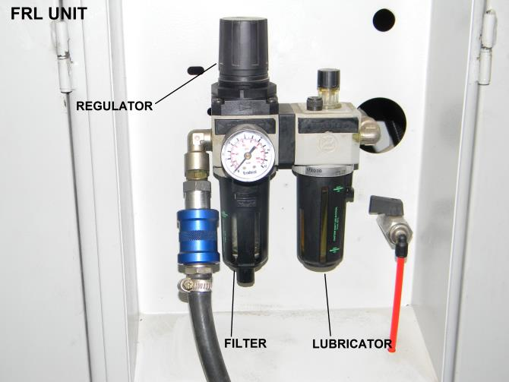

Figure 1.1: air and air gauges

- Make sure the safety guard is in place.

On Strap Cutting Machine on Rotary Fusing Press Machine
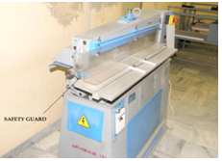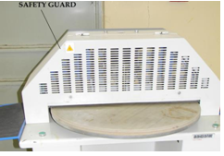

Figure 1.2: Strap Cutting Machine and Rotary Fusing Press Machine

- If available make sure the water level is correct when required. fill tank with distilled water. Never remove tank inlet filter. Connect tank water hose to hose holder above air filter.

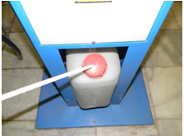

Figure 1.3: tank water
- Turn the main switch ON.

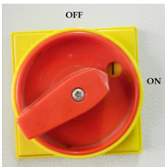

Figure 1.4: switch

- Turn the power ON if temperature or other controlling switch if available. Some machine must be switch ON 30 minutes before operation.
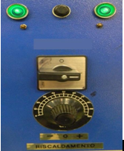

Figure 1.5: temperature or other controlling switch

- Make sure all operational setting like pressure, speed, height and length, etc. (For more knowledge also refer Learning Modules: Footwear Manufacturing and Leather Goods Manufacturing.

For example:
a) On Toe lasting machine:
- Check the thermoplastic adhesive and pump for the correct length.
- Make sure there are two thermo plastic adhesive rod rolls feed in to the machine.
- Make sure the toe band front and side pressure is correct.
- Turn the wiper plates power switch ON and make sure the temperature is on the correct setting.
- Make sure the wiping pressure is set.
- Check the insole rest angle.
b) On Splitting Machine:

- Make sure the bottom feed roller and guide pressure
- Check guide height setting according to required thickness.
c) On Plating and embossing Machine:

- Turn the heater power switch ON and make sure the temperature is on the correct setting on plate.
- Make sure the oil pressure is set.

d) On Edge Inking Machine:

- Check the dying color tank angle.

Identification of unsafe machinery and equipment for repair or replacement
1.3.1. What Are Machinery And Plant?
Machinery is a collective term for machines and their parts. A machine is considered to be any apparatus that has interrelated parts and is used to perform work.
Plant is a general name for machinery, equipment, appliance, implement or tool and any component or fitting or accessory of these. It can range from electric drills, lifts, escalators, tractors, hand trolleys, cranes. Fittings, connections and accessories are also considered to be plant.
1.3.2. Identify faulty machinery and plant used
Start by identifying all items of machinery and plant used and not used at the workplace. An inspection should be carried out looking for any of these items. Include common items that may not normally be thought of as machines or plant.
Safety check
- Do not use tools and equipment that have been tagged as faulty.
- Make sure that you understand and observe all legislative and personal safety procedures when carrying out the following tasks. If you are unsure of what these are, ask your supervisor.
Points to note

- Lock out and tags out procedures have been developed to prevent avoidable and unnecessary workshop accidents.
- The tag notifies other users that the tool or component is dangerous to use. Any equipment that is found to be faulty needs to be identified so that other users are not put at risk. Smaller equipment should also be tagged and placed in a location where it is not forgotten. Notify your supervisor so that repairs or a replacement can be organized.
- If a machine is faulty, the tag out process is slightly different. Large workshop equipment is permanently wired to the electrical supply, and it will have an isolation switch that will disconnect the electrical power. A defect tag should be placed on the isolation switch as well as the equipment. Turn the machine off at the power and master switches, attaching the tag in a manner that prevents the switches from being turned on. Once again, notify your supervisor so repairs can be arranged.

- The lock out and tag out procedure is also used to notify other operators that a machine is not in function.

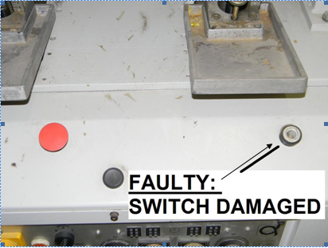
Figure 1.6: Faulty Machines

Regular maintenance of equipment is an important and necessary activity. The term maintenance covers many activities, including inspection, testing, measurement, replacement And adjustment, and is carried out in all sectors and workplaces.
It has a vital role to play in reducing the risk associated with some workplace hazards and providing safer and healthier working conditions. Insufficient/inadequate maintenance can cause serious (and potentially deadly) accidents or health problems. PUWER (the Provision and Use of Work Equipment Regulations 1998) states that all work equipment be maintained in an efficient state, in efficient order and in good repair. Machinery that has a maintenance log needs to be kept up to date and maintenance operations need to be carried out safely.
There are two types of maintenance: routine maintenance is planned and focuses on preventing future problems, while corrective maintenance is reactive and happens when equipment goes wrong and needs to be fixed.
Maintenance is also heavily subcontracted by organizations that consider maintenance to be a specialized activity which does not belong to their core business or which requires expertise not present in the company. In some environments, this may increase risk as the outsourced workers may be unfamiliar with the working environment.

A risk assessment should be carried out before any maintenance work begins and work should be planned. It is best practice to keep a maintenance log which is regularly updated. Workers should be involved in the risk assessment process as those carrying out a maintenance task are often in the best position to identify hazards and the most efficient ways of dealing with them. The work area should be made safe (e.g. preventing unauthorized access) and the people performing the maintenance work should be equipped with the proper tools and equipment to do the work safely (including personal protective equipment – PPE). The work should be monitored and safe working procedures need to be followed at all times. The process needs to end with checks to ensure that the job has been completed satisfactorily.

Identification and reporting OHS hazards to the supervisor
Occupational safety and health policy

The employer, in consultation with workers and their representatives, should set out in writing an OHS policy to which they are committed and which is communicated to all workers.
Occupational safety and health objectives
Consistent with the OHS policy and based on the initial or subsequent reviews, measurable OSH
Objectives should be established, which are:
- Specific to the organization, and appropriate to and according to its size and nature of activity;
- Consistent with the relevant and applicable national laws and regulations, and the technical and business obligations of the organization with regard to OHS;
- focused towards continually improving workers‟ OHS protection to achieve the best OSH Performance;
- realistic and achievable
- Documented, and communicated to all relevant functions and levels of the organization and periodically evaluated and if necessary updated.

Type of Hazards

Once all machinery and plant have been identified, the hazards associated with them can be identified.

Physical hazards are such as noise, heat/cold, radiation, microwaves, etc.

Chemical hazards are derived from chemical used in the work place including toxic gases, noxious fumes and flammable/ corrosive liquids.

Ergonomic hazards are related to physical dimensions of equipment, the placement of equipment and accessibility of a storage area, the weight of equipment or the support of furniture.

Movement hazards are caused by a manual handling such as lifting or moving loads and repetitive movement.
Physical hazards
Heat
- Wear heat resistant gloves when carrying hot parts and equipment.
- Avoid working conditions with poor ventilation may lead to heat stress.
Electricity

- Electricity is a serious hazard because electric shock can be fatal.

Things you can do to minimize the risk

- Don’t use frayed or damaged electrical leads.

- Don’t overload power outlets with double adapters and extensions leads.

- Keep leads away from hot surfaces, walkways or other places where they could be damaged.

- Wear rubber soled shoes but don’t rely on them to provide protection.

Chemical
Hazards gas
Gas is a quick, efficient energy source, but you are at risk from:

- Burns from naked flames

- Gas leaks

- Gas bottle explosions

Things you can do to minimize the risk.

- Follow safe work practices
- Make sure you know where the gas valve is shut-off.
- Make sure you know the emergency drill for gas leaks.
Chemicals

A chemical burns and exposure can cause considerable harm and even be fatal.

Example:

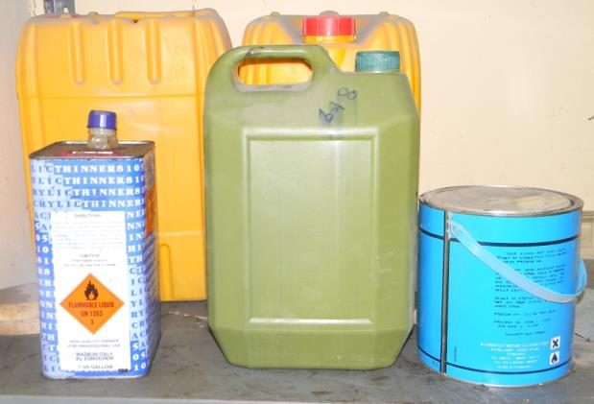
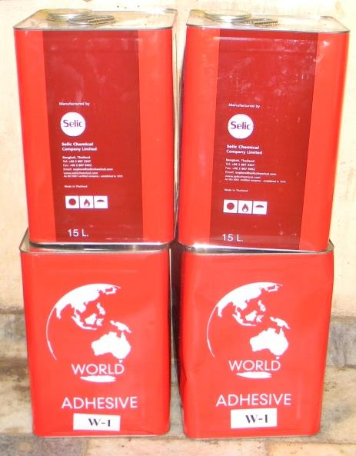

Figure 1.7: chemicals
House keeping
Maintain all areas in a safe and tidy condition:
- Keep access and egress paths safe and clear;
- Erect general safety signs and keep in good condition;
- Make a safe system for collecting, storing and disposing of waste materials at the workplace;
- Store materials and plant safely; and
- Ensure protruding objects do not pose a hazard (for example exposed nails).
- Fire exits, evacuation routes to exits and firefighting appliances must be kept clear and Unobstructed at all times. Evacuation routes include any doorways, corridors, stairways, landings or passage ways forming the path of travel to an exit from any place within the building through a final exit door, to a place of safety outside the building.
Safety Signs:
- Exit/Fire Exit:
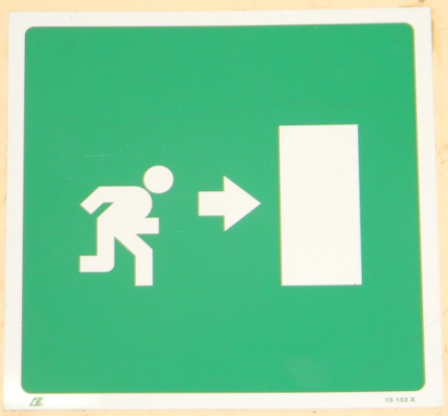
Figure 1.8: Exit/Fire Exit
- Other common signs:
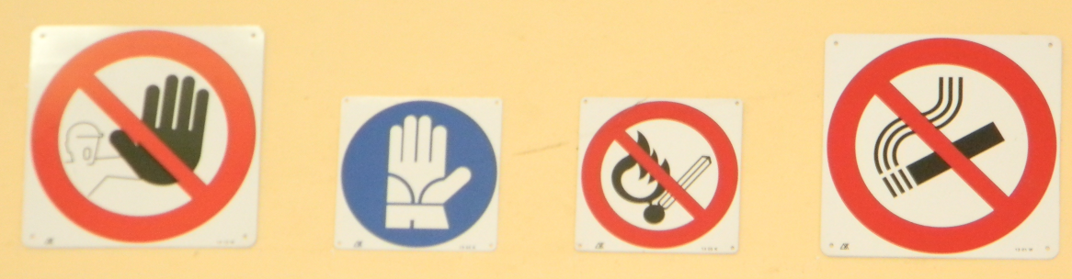
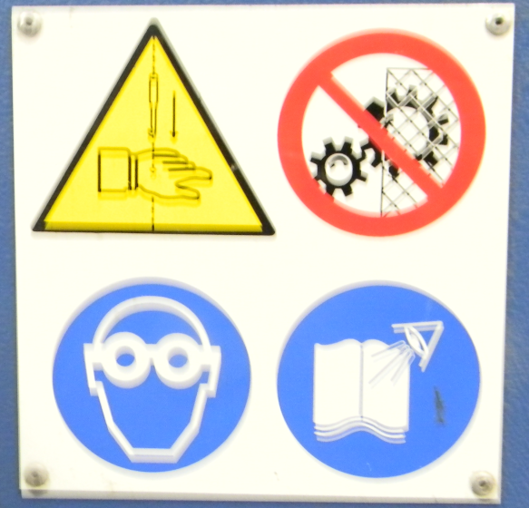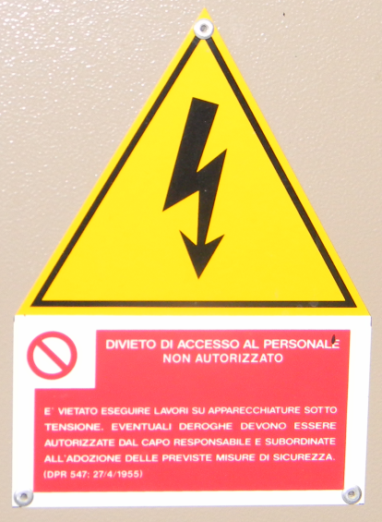
Figure 1.9: common signs

- Fire Alarm, Fire Extinguisher and Fire Hydrant:
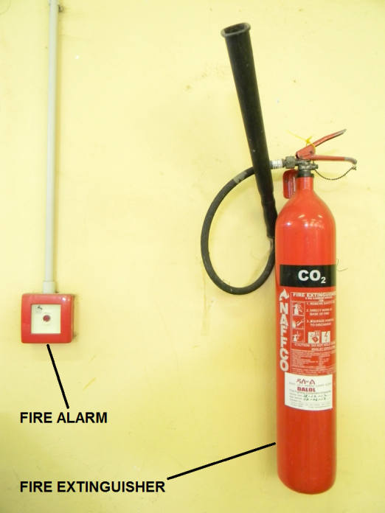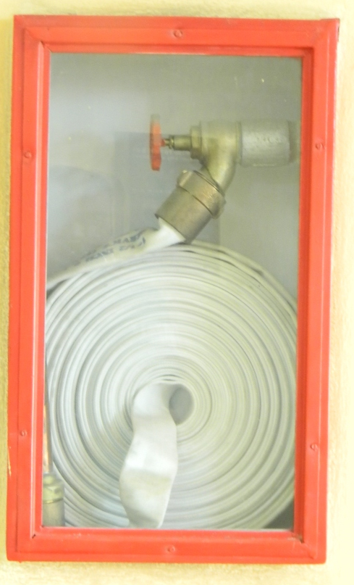
Figure 1.10: Fire Alarm, Fire Extinguisher and Fire Hydrant
- Aisle and Yellow Line:
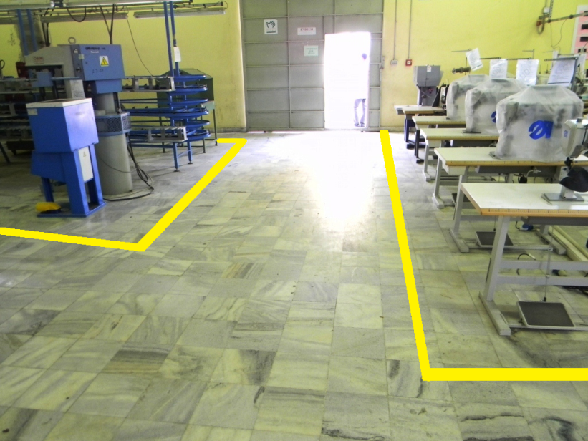
Figure 1.11: Aisle and Yellow Line

Safety points at our plant & machine

Use Emergency Release Button

Turn OFF machine when not in use.

Keeps hand away from moving and heated parts

Use both hands for operation when required.

Do not use your fingers to remove leather that has become caught between the blades and guide fingers. Use pliers only.

Do not attempt any electrical repairs. If anything is wrong, tell your instructor.

Safety Guard: This must always be in place when operating the machine.

Always wear approved footwear and clothing in the workshop.

If your hair is longer than shoulder length, use a hair net of tie it back

Know your fire drill.

One operator at a time on the machine

Do not fool around

If you injure yourself, no matter how minor, tell your supervisor. If necessary seek medical attention.
Manual handling

Manual handling is not simply lifting items. It concerns all aspects of manually maneuvering: loads ex: pushing, pulling, lifting, carrying, tilting etc.

Things you can do to minimize the risk

- Test the load (if uncertain) to ensure that you can handle it safely-if not , ask for assistance.
- Use a wide stance and make sure you have a firm footing.
- For improved balance, keep heel down and feet turned straight outwards.
- tighten your stomach muscles
- Do not hold your breath- exhale at the moment of greatest exertion.
- make sure you have a firm grip on the load
- Keep the load close to your body to reduce strain and keep the heaviest side of the load next to your body.
- Keep your head level and trunk tall to maintain the spines natural curvature.
- Lift steadily with your legs- NOT YOURBACK
- Keep your shoulders level and facing in the same direction as your hips.
- Point your feet in the direction of the move – DO NOT TWIST
- Place the load down by squatting, keeping the spine correctly aligned.
- If precise positioning of the load is necessary, put it down first then slide it into its required position.
- Lift steadily with your legs- NOT YOURBACK
What are the hazards of working around machinery?
- Hazards associated with working near or on machinery vary depending on the exact machine used but can include exposure to:
- Moving parts (e.g., risk of injuries from entanglement, friction, abrasion, cutting, severing, shearing, stabbing, puncturing, impact, crushing, drawing in or trapping, etc.)
- Energy (e.g., electrical, electromagnetic, magnetic, etc.)
- heat or cold
- noise
- vibration
- radiation
- Gas or liquid under pressure (e.g., injuries from injection or ejection by hydraulic systems, pneumatic systems, compressed air, paint sprayers, etc.)
- Psychosocial hazards (e.g., stress, job content, work organization, cognitive factors, etc.)
- Because there are many different types of machines and processes, a risk assessment should be conducted for each machine or situation, and in some cases, before each use. It may be necessary to involve individuals with specialized or technical expertise (i.e., engineer, safety professional, manufacturer, etc.).
How do I work safely with machinery?
Each piece of powered equipment should be assessed using the following process:
- Understand how the machine is designed.
- Understand how to use the machine safely.
- Identify all tasks performed by and associated with the machine:

- What hazards may occur from use and misuse of the machine?
- What moving parts and corresponding safeguards are currently in place?
- Identify who will be using the machine, and how often the machine will be used.
- Determine what materials are used with the machine (e.g., sheet metal, wood, metalworking fluid, oil, etc.).
- Estimate the risk of each hazard by considering the:
- Severity of possible injuries and or incidents, and
- Probability or likelihood of occurrence.
- Eliminate the hazard(s) where possible.
- Use protective measures to control the risk of each hazard including considering:
- The design,
- Safeguarding and protective devices,
- Administrative controls, or
- Other measures.
- Re-assess to estimate the new risk level.
- Re-assess to estimate the new risk level.
- Repeat the process if the risk level has not been eliminated or effectively controlled
What should be considered when assessing the severity and probability of a risk?
Severity of the injury can be determined by asking two main questions:
- What type of mechanical or other hazard is involved?
- What type(s) of injury could happen?
The probability of the injury should be determined by reviewing information about the machine’s operation such as:
- Exposure to a machine that could cause the injury while working with or around the machine (e.g., entanglement, contact with blade, etc.)
- potential human behavior while performing these tasks
- Reports of machine breakdowns, etc
- These three factors can be combined to determine the probability of injury from a particular task.

- Determine a risk rating for each type of injury by assuming no protective measures have been installed on the machine. This evaluation will help when determine if sufficient action has been taken to prevent injury.

Self check 1
Test-I fills in the blank
Instruction: select the correct answer for the give choice. You have given 1 Minute for each question. Each question carries 2 Point.
- ________________ used to tighten or loose bolts and nuts.
- ________________ is a versatile tool that can drill holes in metal, wood, plastics. (1point)
- ___________ used to lubricate various leather goods tools, equipment and machines with suitable machine oils.
- ___________is used for greasing the machine through grease nipples
Test-II Matching
Instruction: select the correct answer for the give choice. You have given 1 Minute for each question. Each question carries 2 Point.
A B
1. Wrenches a. greasing the machine
2. Oil can b. for various repairs and maintenance
3. Brush c. lubricate various leather goods tools, equipment
4. Pliers d. clean without damage and hold lint well
5. Grease gun e. for cutting and bending, pulling small fitting

Part III: Short answer writing
Direction: Give short answer to the following questions. Time allowed for each item is 2 minute and each question carry 4 point.
- List hand tools and equipment required and their requirements in Basic routine maintenance tools and supplies?
- What is Routine maintenance?
- List hand tools and equipment required in upper material estimation?
- Explain about Brush?
- In which areas of footwear Tweezers is used?

Note: Satisfactory rating – above 60% Unsatisfactory - below 60%
You can ask you teacher for the copy of the correct answers

Unit two: basic routine maintenance for cutting, prefabrication and stitching machines
This unit is developed to provide you the necessary information regarding the following content coverage and topics:
- suitable personal protective equipment
- greasing and lubrication
- Routine adjustments and repairs

This unit will also assist you to attain the learning outcomes stated in the cover page. Specifically, upon completion of this learning guide, you will be able to:
- Store, select, use and maintain suitable personal protective equipment
- Cary out greasing and lubrication
- Make Routine adjustments and repairs

Suitable personal protective equipment
Personal protective equipment is any type of specialized clothing, eye shield or facial barrier that is used to protect the wearer from serious injuries or illnesses. Personal protective equipment acts as a barrier between infectious materials and your skin, mouth, nose, or eyes (mucous membranes).The barrier has the potential to block the spread of infection from blood, body fluids, or respiratory secretions.
All personal protective equipment cleared by food and drug administration (FDA) must meet specific performance standards for protection. These standards vary depending on the specific type of equipment. Thus neither FDA, nor a manufacturer, knows to what extent PPE will protect you against influenza. Keep in mind that other infection control practices, such as hand washing, using alcohol-based hand sanitizers, isolating sick patients, and using appropriate coughing etiquette, are also important to minimize your risk of infection.
Most personal protective equipment is designed to be used one time. It is not intended to be used over and over. There are a few exceptions (for example some types of protective Equipment used during routine maintenance of cutting and prefabrication machines).
All PPE clothing and equipment should be of safe design and construction, and should be maintained in a clean and reliable fashion. List of personal protective equipment are;

Figure 2.1: personal protective equipment

Eye Protection: Safety Goggles, provided with a polycarbonate lens and a PVC (polyvinyl chloride) frame.

Figure 2.2: Goggles

Ear Protection: Ear protectors made from PVC (polyvinyl chloride).

Figure 2.3: Ear protectors

Head protection: helmet made from pvc (polyvinyl chloride).

Figure 2.4: helmet

Filtering mask

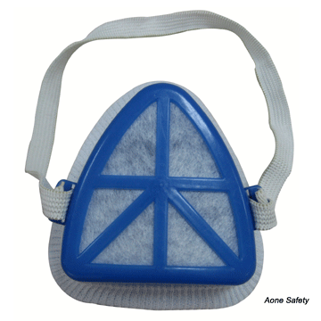
Figure 2.5: face mask

Hand protection: gloves

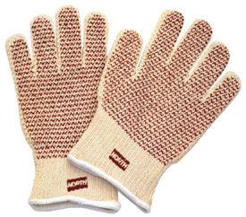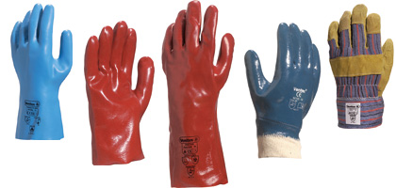

Figure 2.6: gloves

Foot protection: safety footwear

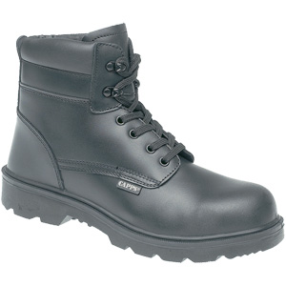

Figure 2.7: safety footwear

Work cloths/body protection: aprons or overcoat

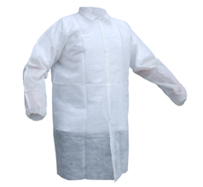
Figure 2.8: aprons or overcoat

Greasing and Lubrication
2.2.1. Basic servicing of machineries
Maintenance -considerations should include providing ready access to areas identified during design requiring regular maintenance, such as cleaning, lubrication and adjustment.
Machine maintenance is vital for keeping any piece of equipment in to operating condition. If maintenance is not maintained to the recommended regulations, the machine parts will soon deteriorate resulting in a major repair operation. Extreme care must be taken When selecting lubricants specifications are not followed precisely the machine pneumatic system will be damaged.
Maintenance and repairs must be carried out by specially trained personnel, with the machine switched off. To facilitate maintenance and repairs and improve visibility when carrying out interventions inside the base of the machine, the fixed shields on both sides of the machine must be removed. The machine must undergo regular checks and routine maintenance to ensure that there is no modification of the production and safety conditions set by the manufacturer.
Greasing
Greasing is also the lubricant process, or technique employed to reduce wear of one or both surfaces in close proximity, and moving relative to each other, by interposing a substance called grease between the surfaces to carry or to help carry the load (pressure generated) between the opposing surfaces.

Example: on heel seat & side lasting machine:

Every month grease the kinematics of the heel band opening chain and the chains of the left and right winder opening motors. On machines with the side nail variation also grease the part of the templates in contact with the hammer-carrier arms (right and left).

Every four months use a pressure syringe to grease the lubricators on the last support, the lubricators next to the winders and on machines with the side nail variation, the lubricators near the nailing arm cylinders (right and left)

While grease comes in many different flavors, the important part is to get it in between the parts, and use the right grease for the job.

Recommended grease
Table 2.1: grease brand
Brand | Name
GENERAL CHEMIE | CHEMIFET K2
TOTAL | MULTIS MS
TEXACO | MOLTITEX GREASE
SHELL | RETINAX AM
Lubrication
Lubrication is the process, or technique employed to reduce wear of one or both surfaces in close proximity, and moving relative to each other, by interposing a substance called lubricant between the surfaces to carry or to help carry the load (pressure generated) between the opposing surfaces. Adequate lubrication allows smooth continuous operation of equipment, with only mild wear, and without excessive stresses or seizures at bearings. When lubrication breaks down, metal or other components can rub destructively over each other, causing destructive damage, heat, and failure.
Lubrication is required for correct operation of mechanical systems pistons, pumps, cams, bearings, turbines, cutting tools, etc.
CLEANING
The machine must be cleaned once a month: after disconnecting the energy supplies (electrical and pneumatic.) carefully remove dirt accumulated during work and check for any oil leaks or damage to components.
Examples: General maintenance of cutting machine
- The machine should be cleaned each day.
- After the operation, use tap water to wash and dry the rock residue on the work room and workbench surface.
- Regularly clean the oil stains on the drag board; guide rail and guide rail drive screw, and timely add lubricating oil.
Daily maintenance:
- The dirt of the machine tool and guide rail must be cleaned every working day to keep the bed clean. The air source and power source should be turned off at the end of work, and the excess air in the pipe belt of the machine tool should be emptied at the same time.
- If leaving the machine for a long time, turn off the power to prevent non-professionals from operating.
- Pay attention to whether there is lubricating oil on the surface of transverse and longitudinal guide rail and rack of the machine, so as to keep it well lubricated! Weekly maintenance and maintenance.
General maintenance of skiving machine
- Work that has to be carried out in the switch cabinet and at the electrical control system must be carried out by skilled personnel only.
- Changes and reconstructions of the machine should be carried out with the approval of FORTUNA only.
- It is not allowed to inactivate safety devices or safety guards or to impair their effectiveness.
- Take utmost care when certain installation work of the machine requires to switch off safety devices.
- The power supply to the machine must be interrupted (main switch off) during the maintenance and cleaning work.
- The danger reference marks in the switch cabinet must be strictly observed (e. g. ‘Attention: machine is voltage-carrying even when the main switch is off’).
- It is obligatory to blunt the knife prior to opening the covering or changing the knife. Even when the knife is dull there is a risk of injury. Therefore, the use of steel mesh safety gloves is mandatory.

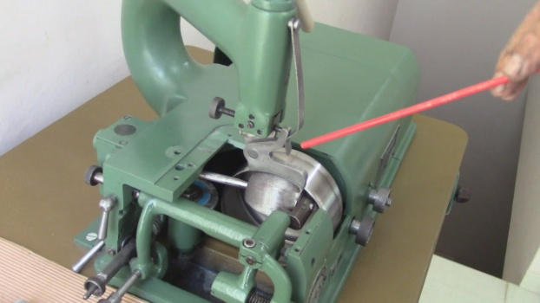
Figure 2.9: skiving machine
- The machine must be secured (e. g. by locally closing it with a warning tape) against unauthorized start-up by switching off the main switch when the machine is left unattended during maintenance work.
- Spare parts and replacement parts subject to wear must be examined prior to their installation and must comply with the manufacturer’s specifications (this applies specially to knives and grinding wheels).
- Appropriate measures must be taken when cleaning and degreasing the machine with aggressive and inflammable agents.
- The machine is subject to the inspection obligation for electric systems.
- The machine must be checked regularly according to the regulations of the industrial sector and the local regulations.
- Obvious damages and the function of the tensioning equipment of the knife, all drive elements and the guide elements which are in contact with the knife must always be inspected when the knife is replaced.
- The function of the safety switches must be inspected when maintenance work is carried out.

Routine adjustments and repairs

Routine adjustments should be designed to be carried out with the machine stopped but without the need for removal of safeguards or dismantling of machine components. Where frequent access is required, interlocked guards should be used.
Self-lubrication or central lubrication of parts should be considered if access is difficult and Positive lock-off devices should be provided to prevent unintentional restarting of machinery particularly after a machine has shut down unintentionally.

Routine maintenance activities on:

Leather Splitting Machine: Make: ATOM- KS520.

Machines for splitting the leather are designed to split the leather operation on the cutting stage for the manufacture of leather goods and footwear. The meaning of the splitting operation is that the leather material is evenly cut in two pieces in thickness over the entire area.

The work piece is tightly fixed and with the help of special rollers is fed at high speed to a sharp and thin knife blade. The upper part of the leather, namely the first layer, after such actions is used to produce leather from which any leather product can subsequently be made.

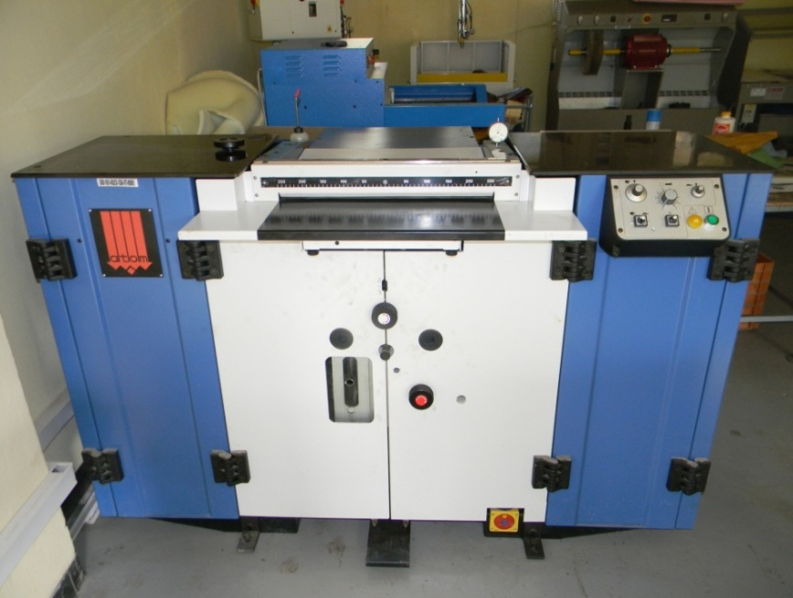
Figure 2.9: Leather Splitting Machine: Make: ATOM- KS520

Proceed by first removing the cutting edge of the blade making use of a hard stone (see below) supplied introducing it in the hole.

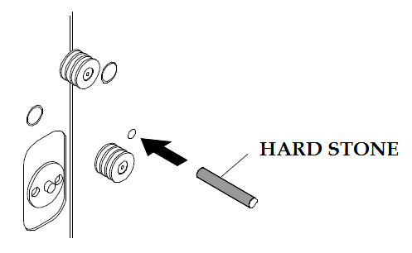

Figure 2.9: hard stone

Daily routine activities:

Warning! These operations must be undertaken with the machine off.

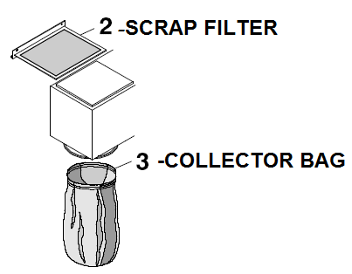

Figure 2.10: scrap filter and collector bag

Empty the scrap box

Clean the entire machine of processing scrap

Clean the scrap filter (2)

Clean the dust collector bag (3)

Warning! Don’t use compressed air!

Weekly routine activities:

Warning! In Order to avoid serious damages to the mechanisms to open the front guards and carefully to suck up entirely the machine from the sharpening dusts.

Clean carefully inside the drawer (1) and its container (2) by means of the brush equipped with the machine; also clean the extractor fan (4) and the filter (3).

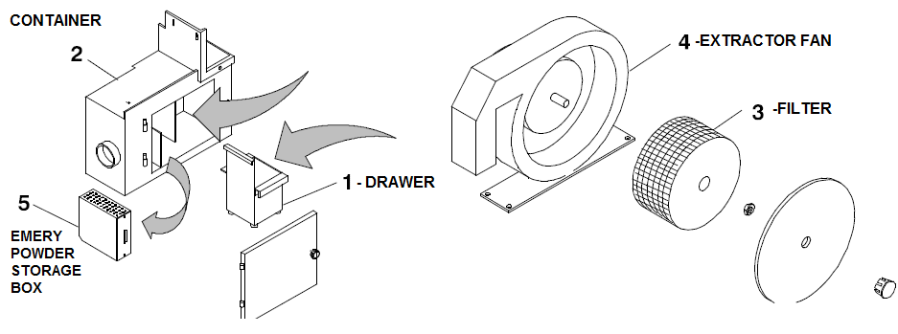

Figure 2.11: filter, extraction fan

Warning! Clean the proper little box with clay filter

To carry out this operation, it is necessary to pull out the little box and shake it to remove the emery powder kept inside it.

Warning! Do not open the little box to avoid that the clay contained inside it is scattered.

Lubricate the blade lightly soaking the felt with oil which should also be introduced in to the appropriate tanks. Use LR/150 oil.

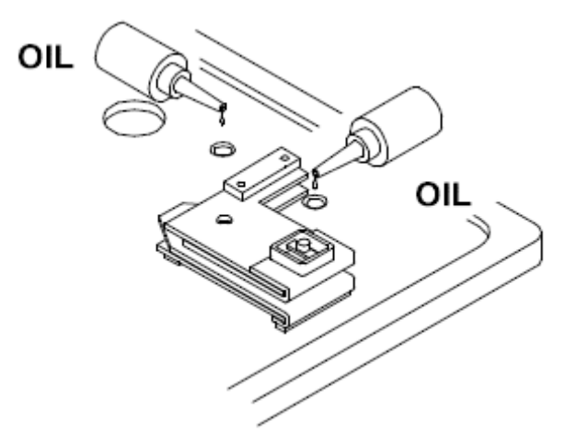

Figure 2.12: oiling

Monthly routine activities:

Check the belt tightening and wear then add a few drops of oil to the foot movement belt

Move the foot making it go up and down a few times until the oil penetrates into the chain rollers.

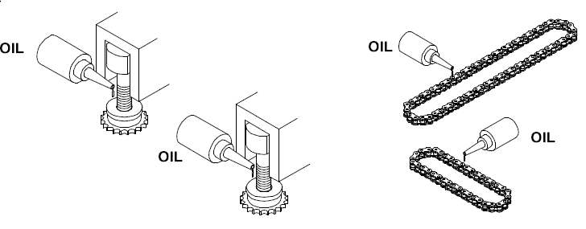

Figure 2.13: belt oiling

With Each Blade Change:

Warning! In order to avoid serious damages to the mechanisms it is compulsory, at every blade replacement, to carefully suck up the collected sparks inside the sharpening/suction devices boxes and on all the surrounding sides.

Clean the flywheel scraper

Clean the three dismountable felt units.

Clean the wheels by means of the provided tool; max

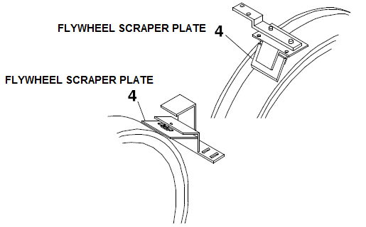

Figure 2.14: fly wheel scraper plate

Leather splitting machine: make: COMOGA

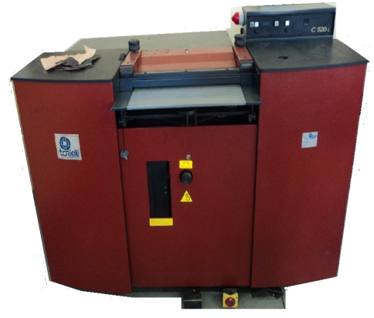

Figure 2.15: Leather splitting machine: make: COMOGA

For the correct use of the machine over a long period carryout the following operations:

Warning! Do not use compressed air

Daily routine activities:

Clean the machine

Empty the scrap pan and clean the dust filter

Clean scrap dust inner filter

Clean scrap dust filter.

Weekly routine activities:

Clean knife wheel scrapers

Clean RH upper felt plate

Clean the grinding unit

Clean emery dust bag

Clean emery dust front chamber and emery dust side chamber

Lubricate upper felts with Vaseline oil or Light mineral paraffinic.

Every 8-12 knife replacement (depending on normal or heavy splitting) the following parts should be replaced:

Top and bottom feed roll bearings

Guide rollers

Guide gibs

Upper knife back guides

Lower knife back guides

Roughing and scouring machine:

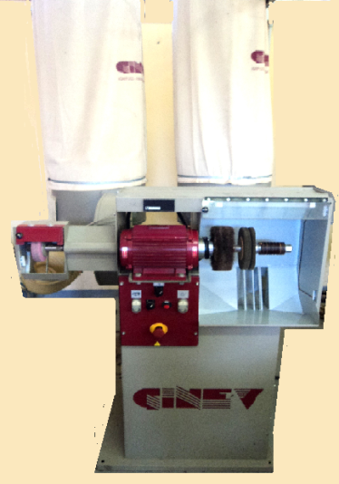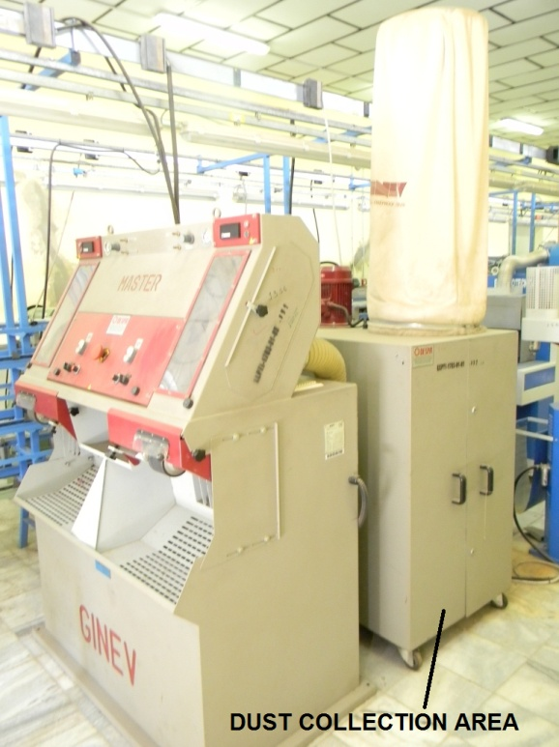

Figure 2.16: Roughing and scouring machine:

Weekly routine activities:

Pneumatic oil lubrication: It is important that in the lubricator’s tank there is never a lack of oil, when the level is low; add oil using the technical one in endowment.

Filters of the inverter: The two inverters are endowed of the two filters for the refreshing air. When they are dirty, clean them blowing them with compressed air from the inside of the control panel towards the outside.

Pneumatic plant condense: In correspondence of the pneumatic attack, located on the machine, there is a pressure adjuster (already set by the manufacturer) endowed with a condense tank with discharge device located in the lower part, which, if put in action, discharge the water.

Finishing and polishing machine with double aspiration

Make: volber

Weekly routine activities:

Filters: Clean the cloth filters every week by removing and shaking well. Replace the cloth filters after every 1000 work hours, and in any case, every time they show signs of wear or pressure.

Collector Bags:

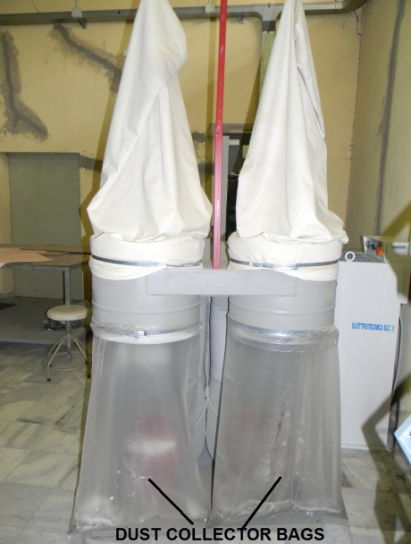

Figure 2.17: Finishing and polishing machine with double aspiration

Empty the collector bags each time they are half full, and in any case, always empty at the end of each work day.

Sewing machine: make: PFAFF & durkopp adler (all models)

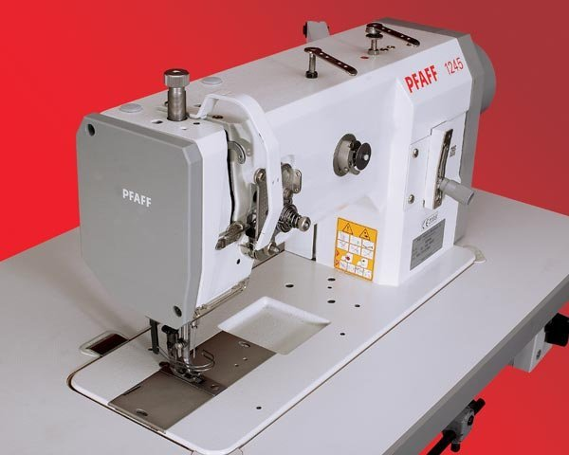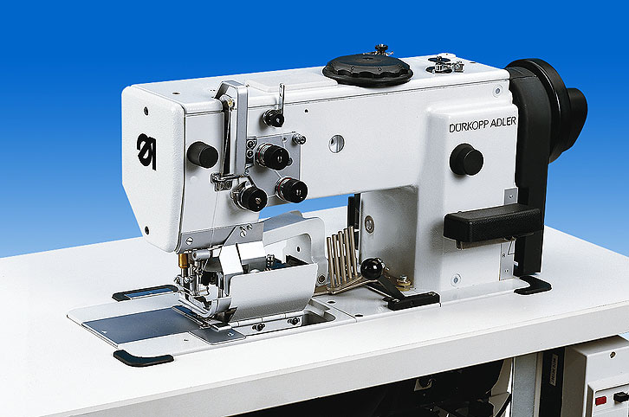

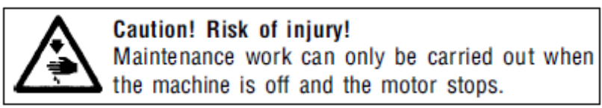

Figure 2.18: Sewing machine

Maintenance works which must be carried out and the intervals between them and set out in the following routine activities.

DAILY ACTIVITIES:

Remove throat plate and clean daily.

Clean circular feed dog, hook, and space around feeding wheel of material and thread residues. To clean it, use brush. It is prohibited to use compressed air for cleaning without protective guards preventing injury of persons with flying impurities.

Lubrication of the hook path a few oil drops.

Monthly activities:

Checking the oil level in the hook lubrication oil tank

Checking the oil level in the oil tank of the central distribution

For the lubrication of this machine ESSO SP-NK 10, DA 10 or an equivalent quality lubricating oil is recommended (Viscosity at 40º C: 10 mm²/S; flash point: 150º C).

The oil tank (1) of the central distribution is to be filled the hole (2) up to the mark MAX. The oil tank for lubricating the hook is filled, after having removed the cover cap (3), through the hole (4) up to the top edge.

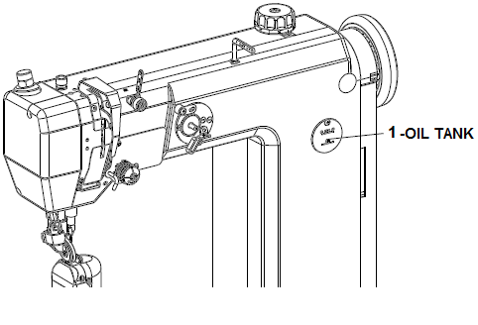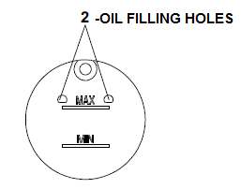
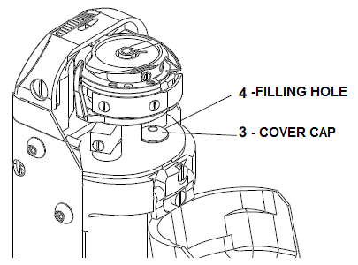

Figure 2.18: Sewing machine and oil feeling

Self check 2

Test-I choice the best answer.
Instruction: select the correct answer for the give choice. You have given 1 Minute for each question. Each question carries 2 Point.

___________ provided with a polycarbonate lens and a PVC (polyvinyl chloride) frame.
- goggle
- face mask
- filter mask
- A and B
- Which of the following is personal protective equipment?
      - wrench
      - ear protection
      - pliers
      - All of the above are correct

Part II: Short answer writing
Direction: Give short answer to the following questions. Time allowed for each item is 2 minute and each question carry 4 point.
- List down personal protective equipment?
- What is lubrication means?
- Write the main objectives of greasing?
- Write about General maintenance of skiving machine?
- Write about General maintenance splitting machine?

Note: Satisfactory rating – above 60% Unsatisfactory - below 60%
You can ask you teacher for the copy of the correct answers

Operation sheet 2.1: basic routine maintenance for stitching machine
Operation title: basic routine maintenance for stitching machine
Purpose: To practice and demonstrate the knowledge and skill required in basic routine maintenance for stitching machine
Instruction: For this operation you have given 3Hour and you are expected to provide the answer on the given table.
- Tools and requirement:
- This operation sheet
- Different type of Allen
- Needle Nose Pliers
- Screw Driver
- Oil can
- Cleaning cloth/ textile
- Precautions: Measure at least three times before recording the result on the given format
- Procedures in doing the task
- Activates and adjusts machine controls to regulate stitching speed and length
- Adjust the thread tension
- Activates sewing machine to join, reinforce, or decorate materials
- Positions materials through feed rollers and guides, or positions and maneuvers under sewing machine presser foot and needle during operation.
- Examines the finished articles to verify conformance to standards
- Places spools of thread, cord, or other materials on spindles, inserts bobbin, and threads ends through machine guides and components
- Removes finished materials from sewing machine.
- Replaces needles, sands rough areas of needles with sandpaper, and cleans and oils sewing machines to maintain equipment
- Folds or fits together materials to prepare for machine sewing
Quality Criteria: the given basic routine maintenance for stitching machine must function appropriately
Precautions: keep the entire given rule of maintenance tools accordingly

Lap Test-Practical Demonstration
Instructions: You are given one hour to complete the above mentioned task. Request your teacher for evaluation and feedback of your work.

Task 1: perform basic routine maintenance for stitching machine

Unit three: Complete basic routine maintenance
This unit is developed to provide you the necessary information regarding the following content coverage and topics:
- Cleaning, returning to operating order and storing tools
- Follow environmental procedures
- Cleaning and maintaining work area
- Reporting malfunctions, faults, wear or damage tools
- Recording maintenance and documentation
This unit will also assist you to attain the learning outcomes stated in the cover page. Specifically, upon completion of this learning guide, you will be able to:
- Clean, return to operate order and storing tools
- Following environmental procedures collect, treat and dispose or recycle waste from maintenance activities.
- Clean and maintain work area
- Report malfunctions, faults, wear or damage tools
- Record maintenance and documentation

Cleaning, returning to operating order and storing tools
Proper storage of tools and equipment the proper care and storage of tools and equipment are not only the concern of the management but of the workers who use the equipment.
Importance of proper storage of tools and equipment
- It is an important factor for safety and health as well as good business.
- Improves appearance of general-shop and construction areas.
- Reduces overall tool cost through maintenance.
- This also ensures that tools are in good repair at hand.
- Teaches workers principles of (tool) accountability.
Points to follow in storing tools and equipment
- Have a designated place for each kind of tools.
- Label the storage cabinet or place correctly for immediate finding.
- Store them near the point of use.
- Wash and dry properly before storing.
- Store knives properly when not in use with sharp edge down.
- Put frequently used items in conveniently accessible locations.
- Gather and secure electrical cords to prevent entanglement or snagging.
- Cutting boards should be stored vertically to avoid moisture collection.
- Metal equipment can be stacked on one another after drying such as storage dishes and bowls.
- Make sure the areas where you are storing the equipment are clean, dry and not overcrowded.
    - Proper Storage
Always store tools in a dry, climate-controlled environment Moist and dirty environments can cause hand tools to rust and dull, and storing power tools in damp areas can degrade electrical components and cause parts to corrode over time. While fitting power tools back into their cases can be a pain, the case will go a long way towards protecting its tool from the environment.
    - Clean Often
It might seem like overkill at first, but be sure that each of your power tools gets cleaned every time you finish using it. Cleaning methods will vary from tool to tool, but most of the time everyday cleaning can be as simple as wiping dirt and dust from the casing. Something as simple as a good wipe down will keep particles from building up and getting into your tool’s internal mechanisms. Tighter areas like filters can be kept dust free with a few blasts from a can of compressed air.
Remember to Regularly Inspect Your Tools
If you are in the habit of using a power tool every day, it can be easy to fail to notice when that tool’s performance gradually drops over time. That’s why it is important to at least semi-regularly take a moment and inspect your most-used tools, paying close attention to signs of wear and performance issues. Run a few basic operations with a tool, paying close attention to warning signs like weaker than normal power levels, any sort of burning smell, and strange buzzes and noises coming from inside the tool. Any of these is a pretty strong indicator that there’s something off with your tool and it may require some extra attention.
Keep Tools Lubricated
Lubrication is an often neglected maintenance step that can really drag down tool performance, causing issues like chafing that can cause parts to quickly deteriorate. Most likely, each of your tools will have a section in their owner’s manual explaining proper lubrication practices. Follow the recommended steps to ensure that your power tools remain the well-oiled machines they are meant to be.
Battery Maintenance
Batteries for your power tools are expensive. The good news is that proper care can extend the life of your batteries and keep your tools operating at their highest levels. Batteries should be stored in controlled environments where the temperature remains consistent. Heat kills battery performance, so don’t leave them in direct sunlight and always let them cool down after use and after charging. Also, try not to let your batteries drain completely before recharging, as this can degrade their lifespan.
    - Cleaning
Sewing Machine Oil & Cleaning Tools
Whether you use your sewing machine for your business or your hobby, you know how important it is to take good care of it. Good regular maintenance is a vital part of protecting your investment.
Regularly maintenance includes cleaning and adding sewing machine oil as needed to prevent wear and damage to your machine and keep it running efficiently. Whatever type of machine you or your business uses, proper oiling and cleaning will keep your machine in top condition for years to come.

Follow environmental procedures
When following environmental procedures there is standard environmental maintenance procedure that is a detailed list of steps that describes how to perform a maintenance task and is also a documented standard to which the job or task should be performed. When considering
- Annual waste declaration.
- High of acceptance documents.
- Registration of small producers of toxic and hazardous waste.
- High as a producer of toxic and hazardous waste.
- Annual packaging declaration.
- Statutory waste minimization study.
- Completion of the registration of waste.

    - Environmental Equipment Preventative Maintenance

A few rules apply universally as preventive maintenance for environment equipment
- Keep or get a copy the instrument or equipment manual
- Familiarize yourself with the recommended service schedule
- Create log book of maintenance and calibration
- Know what you are comfortable doing your self
- Plan on expert service every six months or at least once a year
- Clean the instrument or equipment after each use
- Follow equipment and storage guidelines

Preventative maintenance can save you great expense later on. Whether the environmental equipment you use is a stainless steel meter the size of a pen or a big air blower, it contains vulnerable parts like sensors, filters and electronics.
There are guidelines and standards for everything from water meters and pumps to fisheye cameras and data collectors that measure conductivity and magnetic susceptibility.
A few rules apply universally as preventative maintenance for environmental equipment:

- Keep or get a copy of the instrument or equipment manual
- Familiarize yourself with the recommended service schedule
- Create a log book of maintenance and calibration
- Know what you are comfortable doing yourself
- Plan on expert service every six months or at least once a year
- Clean the instrument or equipment after each use
- Follow equipment and storage guideline

Collecting, treating and disposing or recycling waste from maintenance activities

Waste management is the collection, transport, processing, recycling or disposal, and monitoring of waste materials. The term usually relates to materials produced by human activity, and is generally undertaken to reduce their effect on health, the environment or aesthetics. Waste management is also carried out to recover resources from it. Waste management can involve solid, liquid, gaseous or radioactive substances, with different methods and fields of expertise for each.
Waste management practices differ for developed and developing nations, for urban and rural areas, and for residential and industrial producers. Management for non-hazardous residential and institutional waste in metropolitan areas is usually the responsibility of local government authorities, while management for non-hazardous commercial and industrial waste is usually the responsibility of the generator.
Waste management concepts

There are a number of concepts about waste management which vary in their usage between countries or regions. Some of the most general, widely-used concepts include:

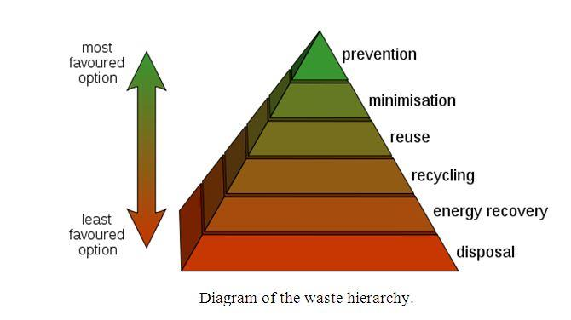

Diagram 3.1 waste hierarchy
Waste hierarchy – The waste hierarchy refers to the “3 Rs” reduce, reuse and recycle, which classify waste management strategies according to their desirability in terms of waste minimization. The waste hierarchy remains the cornerstone of most waste minimization strategies. The aim of the waste hierarchy is to extract the maximum practical benefits from products and to generate the minimum amount of waste.
Extended producer responsibility – Extended Producer Responsibility (EPR) is a strategy designed to promote the integration of all costs associated with products throughout their life cycle (including end-of-life disposal costs) into the market price of the product. Extended producer responsibility is meant to impose accountability over the entire lifecycle of products and packaging introduced to the market. This means that firms which manufacture, import and/or sell products are required to be responsible for the products after their useful life as well as during manufacture.
Polluter pays principle – the Polluter Pays Principle is a principle where the polluting party pays for the impact caused to the environment. With respect to waste management, this generally refers to the requirement for a waste generator to pay for appropriate disposal of the waste.
Footwear Wastage
The footwear industry is a manufacturing sector which utilizes a wide variety of materials and processes to produce a range of distinctly different products, from sandals to specialized safety footwear. Shoes are designed to fulfill an array of consumer requirements relating to function and fashion, and incorporate varied range of designs and styles. In addition, a range of distinctly different materials such as leather, synthetic materials, rubber and textile are commonly used in shoe manufacturing.
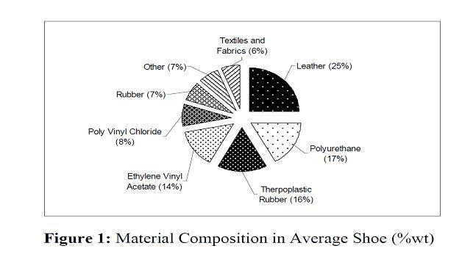

Figure 3.1: material composition in average shoe
Waste management
This European Standard incorporates such a tool, designed specifically for the footwear industry. In order to improve the waste management, the footwear manufacturer should perform the following tasks:
- reduce the quantity of waste,
- reuse the waste,
- recycle the waste,
- incinerate and recover energy from the waste,
The footwear industry is a diverse manufacturing sector which employs a wide variety of materials to make products ranging from different types and styles of footwear to more specialized shoes. Leather, synthetic materials, rubber and textile materials are amongst the basic materials most commonly used in shoe manufacture; each material has its own specific characteristics. Materials significantly influence, not only the life of the footwear but also the end-of-life treatment of the product.
Approximately 40 different materials can be used in the manufacturing of a shoe nowadays; the shoe industry is facing many of the same challenges as the consumer products and food industries. To meet the needs of customers and be competitive, footwear companies must face two key challenges: being quick to market changes and stay relevant in order to identify or establish new consumer trends. This leads to a shorter life cycle of shoes, and an even increasingly shorter product development cycle for the footwear industry.
A shorter life cycle of shoes means that more shoes have been produced over the years, so leading to a higher level of EoL waste by the footwear industry. From 1990 to 2004, worldwide footwear production has increased by 70% to around 17 billion pairs of shoes while by 2010 experts in the sector expect the global footwear output to reach 20 billion pairs. Shoe production and consumption is definitely rising. Western Europe and United States consume 2 billion pairs of shoes each every year. In the UK alone, more than 330 million pairs of shoes, with a total market value of more than £5 billion are consumed every year.
Wastage system
Properly disposition of a discarded or discharged material in accordance with local environmental guidelines or laws
Final placement or riddance of wastes, excess, scrap, etc., under proper process and authority with (unlike in storage) no intention to retrieve
Disposal may be accomplished by abandonment, destruction, internment, incineration, donation, sale, etc.
Processing and or removal to final resting place or transfer to a place for re-use or recovering of waste
The process of getting rid of unwanted, broken, worn out, contaminated or spoiled materials in an orderly, regulated fashion
Public Health importance of solid waste

- It can be best media for the growth of microorganisms
- Attraction of arthropods such as common housefly, mosquito, etc
- Attraction of rodents and other animals e.g. rats mice dogs cats
- Open dump can contaminate water sources
- Can contaminate food supply and cause food borne disease
- Hospital and pathological wastes are potential disease carrying waste products
- Radioactive wastes are highly dangerous
- It can create fire accident
- Slum areas
- It can create nuisance: Bad odor, smoke, dust Aesthetical problem Discomfort: sneezing, coughing
Disposal: Those activities associated with ultimate disposal of solid wastes Interrelationship of functional elements comprising a solid waste management system.

Main sources of solid waste generation
- Residential (domestic or house hold)
- Commercial
- Institutional
- Construction Demolition
- Treatment plant sites
- Industrial
- Agricultural

Waste handling and separation, storage and processing at the source
- The best place to separate waste materials for reuse and recycling is at the source of generation
- Home owners should be aware of separation of Newspaper, and cardboard, bottles, yard wastes, aluminum cans, ferrous materials and especially hazardous wastes
- Waste processing is used to reduce the volume, recover usable materials, and alter the physical form of the solid wastes

Cleaning and maintaining work area
Cleaning in Maintenance means an activity carried out to keep general work areas, tools, machinery or equipment, excluding application equipment, in clean and good operational condition.

Figure 3.2: clean and good operational condition
Whenever you perform a task in the workshop you must use personal protective clothing and equipment. Among other items, this may include:
- Work clothing - such as coveralls and steel-capped footwear
- Eye protection - such as safety glasses and face masks
- Ear protection - such as earmuffs and earplugs
- Hand protection - such as rubber gloves and barrier cream
- Respiratory equipment - such as face masks and valved respirators
If you are not certain what are appropriate or required, ask your Instructor.
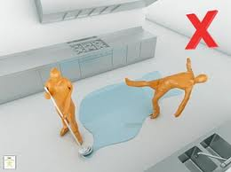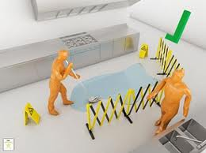
Figure 3.3: hazard clean
- Some cleaning agents are toxic. Refer the instructions on any cleaning agent and follow any recommendations before using it.
- Do not use flammable cleaners or water on electrical equipment.
- Make sure designated walkways are kept clear of any obstructions.
- Always wear protective clothing and the appropriate safety equipment.
- Make sure that you understand and observe all legislative and personal safety procedures when carrying out the maintenance tasks. If you are unsure of what these are, ask your Instructor.
- Clean tools and equipment helps work more efficiently. At the end of each working day clean the tools and equipment you used and check them for any damage. If you note any damage, tag the tool as faulty and organize a repair or replacement.
- Electrical current can travel over oily or greasy surfaces. Keep electrical power tools free from dust and dirt and make sure they are free of oil and grease.
- All workshop equipment should have a maintenance schedule. Always complete the tasks described on the schedule at the required time. This will help to keep the equipment in safe working order.
- Store commonly used tools in an easy-to-reach location. If a tool, or piece of equipment, is too difficult to return, it could be left on a workbench or on the floor where it will become a safety hazard.
- Keep your work area tidy. This will help you work more efficiently and safely.
- Always use chemical gloves when using any cleaning material because excessive exposure to cleaning materials can damage skin.
- Some solvents are flammable. Never use cleaning materials near an open flame or cigarette.
- The fumes from cleaning chemicals can be toxic, so wear appropriate respirator and eye protection wherever you are using these products.
- When cleaning products lose their effectiveness they will need to be replaced. Refer to the suppliers' recommendations for collection or disposal. Do not pour solvents or other chemicals into the sewage system. This is both environmentally damaging and illegal.
    - Cleaning of equipment
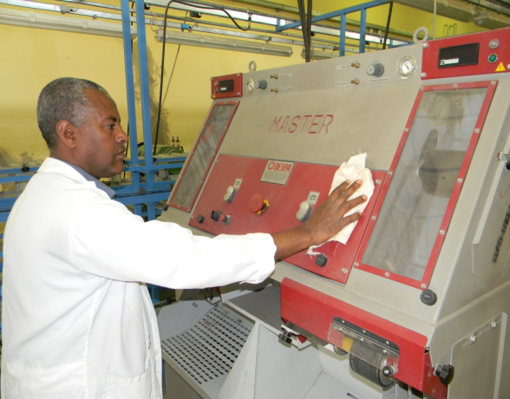
Figure 3.4: activity clean
To maintain cleaning equipment and keep it in a good working condition, it must be thoroughly cleaned and stored correctly every time it is used. If regular maintenance does not occur, the equipment may, over time, become dangerous to individuals. Equipment and Floor that will need cleaning includes:
- Garbage receptacles
- Pans
- Brooms, dusters and brushes
- Mops and buckets
- Electrical equipment, Ex: vacuum cleaners, polishers, scrubbers.

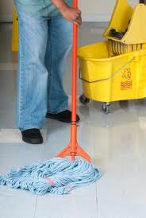
Figure 3.5: cleaning materials

Cleaning and clearing techniques
- Select and use an appropriate method for cleaning
- tools and specialist equipment
- any leakages
- Restore your work area to a safe and tidy condition
- Make sure that any materials, components, tools and equipment that you may need for the next task are set up ready for use.
Material storage techniques
- Sort reusable equipment, components and materials from waste
- Reusable materials are correctly stored
- All tools and equipment are properly stored.
Safe disposal techniques
- Handle and dispose of waste materials appropriately according to organizational and legal requirements
- Recognize what materials are hazardous and require special procedures
- Report any problems associated with cleaning, storing or disposing of materials and equipment to the relevant person.
Hazardous and non-hazardous materials
- Types of waste material generated in the work area
- Know how to handle hazardous waste and reusable materials safely including: Fluids, Adhesives and Solvents.
- Personal protective equipment is required and how to use it.

Reporting malfunctions, faults, wear or damage tools
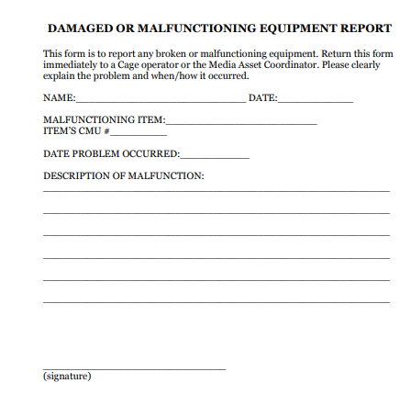
Figure 3.5: malfunction equipment reporting format

Following are some of the sewing faults and machine problems with its cause and the remedies as well.

Corrective Maintenance: The maintenance carried out after a failure has occurred and intended to restore an item to a state in which it can perform its required function. While preventing breakdowns is desirable, corrective maintenance can't be avoided completely. There's no way to predict an unexpected breakdown, defect, or fault. Even perfectly maintained equipment could be vulnerable to defects or external factors such as power surges or even intentional sabotage from a disgruntled employee. Careless operation of the equipment could also require corrective measures.
Run-to-Failure (Corrective Maintenance Only): To estimate the cost and average availability that can be expected for a run-to-failure (corrective maintenance only) maintenance strategy, the analyst must provide the following information:
- The amount of time that the equipment will operate
- An indication of whether the failure is detectable during normal operation.
- The amount of time that the equipment is expected to be down each time corrective maintenance. is required. This can include the time to perform the maintenance as well as any logistical delays (i.e., waiting for labor and/or materials required).
Failures / causes and remedies of sewing machine

Table3.1: Failures / causes and remedies of sewing machine

Needle Thread Breakage
Causes | Remedies
Misaligned off winding from thread package. | Ensure that the overhead guide is directly above cop stand pin, at 2½ times the height of the thread package. Use a foam pad to prevent package tilting.
Thread trapped at thread guide. | Can occur after thread breaks. Rethread correctly.
Excessive tension. | Use a stronger thread or adjust tension
Sharp edges on throat plate, hook point,  Needle guard, bobbin case, needle groove or eye. | Polish rough edges and replace if necessary. Replace the  needle being used with a higher quality needle.
Thread fraying at needle. | Use finer thread or coarser needle, as appropriate.
Use finer thread or coarser needle, as  appropriate. | Ensure adequate oil supply. Check the needle to hook  Clearance
Poor quality thread. | Change to a correctly finished thread of better quality.

Table 3.2: Failures / causes and remedies of sewing machine

Bobbin or Looped Thread Breakage
Badly wound thread on the bobbin. | Adjust bobbin winder alignment. Use pre-wound Bobbin
Tension too tight or bobbin over-running | Adjust bobbin case tension. Insert a washer or a spring to prevent over-running.
Sharp edges on bobbin case or spring or looped eyelet. | Polish edges and correct surfaces.
Bobbin case not fitting correctly. | Check the size/type of bobbin for flange distortion.
Skipped Stitches
Hook, looped or needle failing to enter thread loops at the correct time | Check machine clearances and timings. Check if the needle is inserted and aligned correctly. Use a needle with a deeper scarf.
Thread loop failure caused by incorrect needle size / style for thread size / type. | Change needle size / style.
Flagging of fabric due to poor presser foot control or too large a throat plate hole. | Re-adjust the presser foot pressure. Change the throat plate to match the needle.

Recording maintenance and documentation

The report and record of machine maintenance submitted by the person who is accomplished the work, which verifies that the equipment is either safe to use or should be disposed after accomplished their work. This record of maintenance, with the status, should be kept by the supervisor as part of a permanent file about the piece of equipment.
For each piece of machine used during the day, the supervisor must assure entry of the amount of time that each piece of equipment was used on each activity. Also he must assure the entry of the appropriate materials, location, quantity used, and material code of each material used. This allows the cost of the supplied material to be charged to the work activity.
Do not perform any of maintenance work without written documentation that includes:

- Name and ID number of contact person requesting the work.
- Location of the work
- Accurate, complete description of the work to be done with estimated costs (if available).
- Identification of materials to be used.
As work is performed, the supervisor must properly and accurately record and complete with all details.
  - Document-1: Maintenance –Inspection Report

This report is an important evaluation involving examination, measurement, testing, gauging, and comparison of materials or items of inspected machine.

Table 3.3: Maintenance –Inspection Report
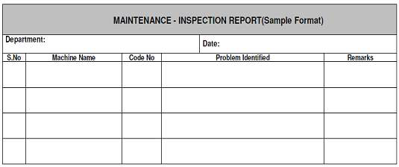

2. Document-2: Material Request Form

With help of inspection report the required materials to be listed in below format and submitted to the supervisor. The form may be forwarded to the store (or) purchasing department. The all required materials should be arranged and collected before starting maintenance work.
Table 3.4: Material Request Form

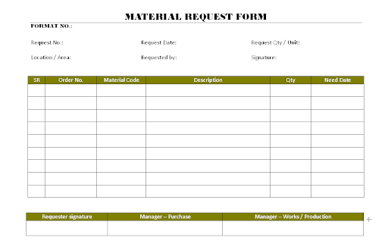
3. Document-3: Daily Activities Report

This is summary of all work carried out during maintenance of each machine. Daily maintenance activities report can be prepared after work carried out and accomplished as prescribed format as shown below.
Table 3.4: Daily Activities Report
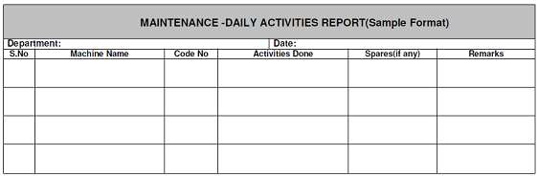

4. Document-4: Spare Parts Status Tag

During maintenance the damaged (or) reusable spares can be remarked and tag out as prescribed format as shown below.
Table 3.5: Spare Parts Status Tag

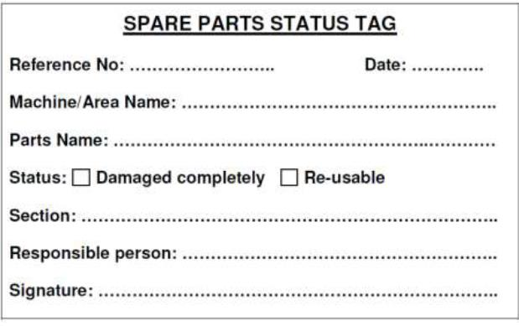

5. Document-5: Maintenance- Job Card
In case of any malfunctioning in machine, duly filled „JOB CARD’ on the prescribed format is shown below. The Maintenance personnel thoroughly will inspect the machine for tracing the fault. The procedure for tools replacement and machine setting is the same as ‘JOB CARD‟.

Self check 3
Test-I choice the best answer.
Instruction: select the correct answer for the give choice. You have given 1 Minute for each question. Each question carries 2 Point.

___________ Rules apply universally as preventive maintenance for environment equipment.
- Keep or get a copy the instrument or equipment manual face mask
- Create log book of maintenance and calibration
- Know what you are comfortable doing your self
- All
  - In order to improve the waste management, the footwear manufacturer should perform the following tasks?
    - reduce the quantity of waste
    - reuse the waste,
    - recycle the waste,
    - incinerate and recover energy from the waste,
    - All of the above are correct
Part II: Short answer writing
Direction: Give short answer to the following questions. Time allowed for each item is 2 minute and each question carry 4 point.
  - What are Importance of proper storage of tools and equipment?
  - What are Points to follow in storing tools and equipment?
  - Write about General maintenance of skiving machine?
  - Write about General maintenance splitting machine?

Note: Satisfactory rating – above 60% Unsatisfactory - below 60%
You can ask you teacher for the copy of the correct answers

Operation sheet 3.1: Clean hand tools
Operation title: Clean hand tools
Purpose: To practice and demonstrate the knowledge and skill required in clean hand tools
Instruction: For this operation you have given 1 Hour and you are expected to provide the answer on the given table.
Tools and requirement:
- This operation sheet
- solvent
- kerosene
- Cleaning cloth/ textile
Precautions: Measure at least three times before recording the result on the given format
Procedures in doing the task

Step 1: Keep your hand tools in good, clean condition with two sets of rags
Step 2: One rag should be lint-free to clean or handle precision instruments or components
Step 3: The other should be oily to prevent rust and corrosion
Step 4: Use kerosene/solvent for cleaning tools
Step 5: Clean tool and keep their place
Step 6: Wipe off any oil or grease on the floor and check for fluid leaks. If you find any, top up the hydraulic fluid. Occasionally, apply a few drops of lubricating oil to the wheels and a few drops to the posts of the safety stands.

Quality Criteria: the given basic routine maintenance for stitching machine must function appropriately
Precautions: keep the entire given rule of maintenance tools accordingly

Operation sheet 3.2: preventive maintenance and adjusting sewing machine
Operation title: preventive to machine Adjusting and equipment regularly
Purpose: To practice and demonstrate the knowledge and skill required in preventive to machine Adjusting and equipment regularly
Instruction: For this operation you have given 1 Hour and you are expected to provide the answer on the given table.
Tools and requirement:
- This operation sheet
- brush
- solvent
- kerosene
- Cleaning cloth/ textile
Precautions: Measure at least three times before recording the result on the given format
Procedures in doing the task
- Clean it out:
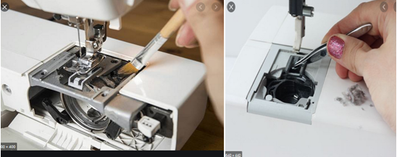
- Rethread your machine:
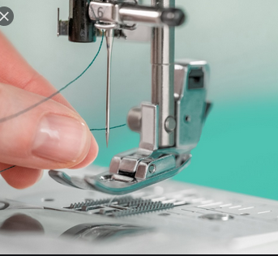

- Check needle clamp and needle thread

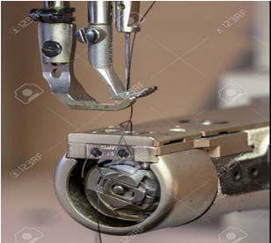

- Check pressure foot and needle plate

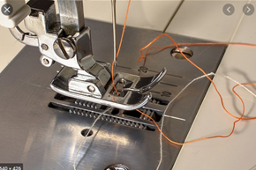

- Check and clean Hook set

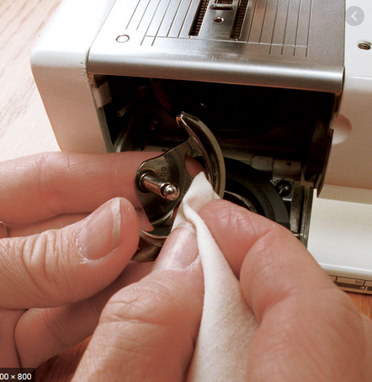

Step 6.Bobbin case Check

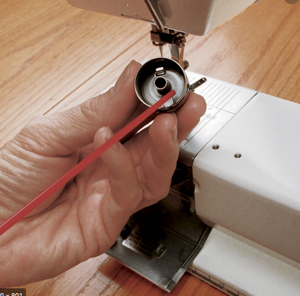

- Oil lubrication system check

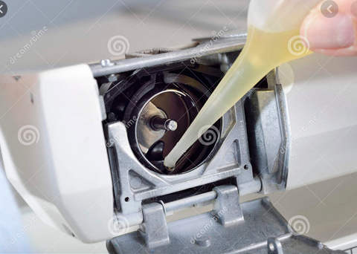

- Adjust and check Lopper thread

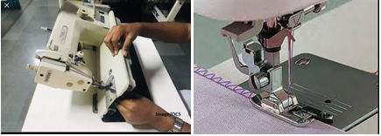

Quality Criteria: the given sewing machine must function according to requirement after preventive to machine Adjusting and equipment regularly done
Precautions: keep the entire given rule of maintenance tools accordingly

Lap Test-Practical Demonstration
Instructions: You are given one hour to complete the above mentioned task. Request your teacher for evaluation and feedback of your work.

Task 1: perform clean hand tools with accordance of standard occupational safety and health
Task 2: perform preventive maintenance and adjusting sewing machine

Reference

- Basic leather minor maintenance (Elizabeth Letcavage – editor Bill Hollis – leather and consultant)
- Structural Textile Design: Interlacing and Interlooping by Yasir Nawab, Syed Talha Ali Hamdani, & Khubab Shaker
- http://textilelearner.blogspot.com/2012/07/basic-woven-fabric-structure-plain.html
- https://www.slideshare.net
- Past learning guides

Experts Who Developed this Learning Guide

No | Name | Educational Background | Region | E-mail | Remarks
1 | Yohannes Fisseha | BSC in Leather Engineering | Addis Ababa, Lideta Manufacturing college | yohannesfiseha71@gmail.com | module Developers Team Members
2 | Yabetse Fikadu | BSC in Leather Engineering | oromia: bishoftu polytechnic college | Yabets1030@gmail.com | module Developers Team Members
3 | H/Gebrale Abebe | BSC in leather and leather product technology | Addis Ababa,Misrak poly technic colleget | haile3a@yahoo.com | module Developers Team Members

