Footwear Production
Level-II
Based November, 2021 Version 1 curriculum
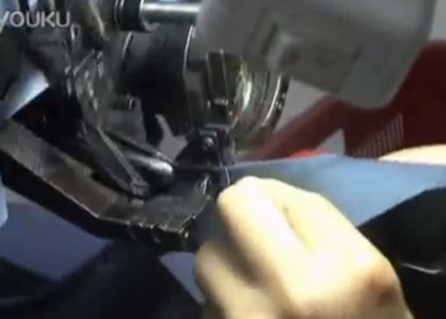
Module Title: - Performing Moccasin Stitching Operations
Module code: IND FWP2 M05 1221
Nominal duration: 60 Hours
Prepared by: Ministry of Lobar and Skill
August, 2022
Addis Ababa, Ethiopia

Acknowledgment 3
Acronym 4
Introduction 5
Unit one: Prepare tools, materials, equipment and machines 6
1.1. Tools and materials required for moccasin stitching 7
1.2. Work instructions, specifications, and operational details 17
1.3. Proper functionality of tools and materials 20
Self-check 1 22
Unit Two : Set up Workstation 23
2.1. Arrangement of Work station 24
2.2. Tools equipment and patterns preparation 25
2.3. Materials in preparation for stitching 31
Self-check 2 32
Unit Three : Prepare tools, materials, equipment and machines 33
3.1. Hand stitching type or work procedures/techniques 34
3.2. Prepare the for the hand stitching 36
3.3. Stitching components manually 42
Self check 3 46
Operation Sheet 1- manual moccasin stitching 47
LAP TEST 1 49
Unit Four Set up machine 50
4.1. Set up and adjust machine for operation 51
4.2. Set temperature and steam according to specification 58
4.3. cleaning and maintaining machine routinely 59
Self-check Four 68
Unit 5: Prepare tools, materials, equipment and machines 69
5.1.Accurate Position of material 70
5.2. Sewing moccasin 71
5.3. Carrying out sewing of the components and molding according to OHS 73
Self-check 5 74
Operation Sheet-2 Machine stitching of moccasin 75
LAP TEST 2 76
Unit 6: Prepare tools, materials, equipment and machines 77
6.1. Arranging stitched upper pairwise 78
6.2. Quality of upper 79
6.3. Faults and irregularities following standard procedures 83
6.4. Necessary records and dispatches 85
Self-check 6. 92
Reference Materials 93

Acknowledgment

Ministry of Labor and Skills wish to extend thanks and appreciation to the many representatives of TVET instructors and respective industry experts who donated their time and expertise to the development of this Teaching, Training and Learning Materials (TTLM).

Acronym
OHS- Organizational health and safety

Introduction
Moccasin is a soft leather heelless shoe or boot with the sole brought up the sides of the foot and over the toes where it is joined with a puckered seam to a U-shaped piece lying on top of the foot and regular shoe having a seam on the forepart of the vamp imitating the seam of a moccasin. For sewing moccasins, you'll only need to use one type of stitch, a whipstitch, which is easy to master
This module covers the units:
- Preparing tools and materials
- Set up workstation
- Stitching upper material manually
- Set up machine
- Stitching upper material
- Checking for quality and dispatch
Learning Objective of the Module
- Prepare tools and materials
- Set up workstation
- Stitch upper material manually
- Set up machine
- Stitch upper material
- Check for quality and dispatch
Module Instruction
For effective use this modules trainees are expected to follow the following module instruction:
- Read the information written in each unit
- Accomplish the Self-checks at the end of each unit
- Perform Operation Sheets which were provided at the end of units
- Do the “LAP test” giver at the end.
- Read the identified reference book for Examples and exercise

Unit one: Prepare tools, materials, equipment and machines
This unit is developed to provide you the necessary information regarding the following content coverage and topics:
  - Tools and materials required for moccasin stitching.
  - Work instructions, specifications, and operational details.
  - Proper functionality of Tools and materials
This unit will also assist you to attain the learning outcomes stated in the cover page. Specifically, upon completion of this learning guide, you will be able to:
  - Identify tools and materials required for moccasin stitching.
  - Obtain work instructions, specifications, and operational details relevant to the tasks.
  - Check tools and materials for proper functionality

Tools and materials required for moccasin stitching
    - Introduction
Moccasin is a soft leather heelless shoe or boot with the sole brought up the sides of the foot and over the toes where it is joined with a puckered seam to a U-shaped piece lying on top of the foot and regular shoe having a seam on the forepart of the vamp imitating the seam of a moccasin. For sewing moccasins, you'll only need to use one type of stitch, a whipstitch, which is easy to master.
1.1.2. Tools used in moccasin stitching operation
a. Punches
- rotary punch or round hand punches
- pounding board or end-cut wood cutting board for pounding hand punches
- maul for pounding punches
b. Needles
- Harness needles
- Glover’s needles (leather needle) The pointy end of the needle has a three cornered knife edge. It really makes sewing leather much easier than using a regular needle. Be careful. Leather needles are sharp!
c. Cutting tools
- Leather-cutting scissors if using leather, or scissors for felt or fabric.
- Scissors – assorted styles, high carbon stainless scissors make cutting
- leather rotary cutter, pad, and ruler set, optional
d. Skivers
- sandpaper – skiver, also called beveling knife, and blades
- safety glass or marble – skiving surface
e. Chisels
- Osborne thonging chisel #483, prongs 1/8” apart
- single-prong 1/8″ thonging chisel
- 1/2″ chisel, optional
f. Other tools
- inexpensive felt for making mock-ups
- waxed braided cord
- Eco-weld water-based contact cement
- silver gel pen for temporarily marking leather
- double-sided tape
- 1/2″ acid brushes for cement
- compass for marking with pen, pencil and/or gel pen
- wing dividers
- belt sander
- Bead Graph Paper – developed by Crazy Crow for lazy stitch used on moccasins

1.1.2. Hand tools, patterns and materials
Introduction
A hand tool is any tool that is powered by hand rather than a motor. Categories of hand tools include wrenches, pliers, cutters, files, striking tools, struck or hammered tools, screwdrivers, vises, clamps, snips, saws, drills, and knives. Portable power tools are not hand tools.
Hand tools in moccasin stitching operation
- Needles
- You will need two good sharp thick hand sewing needles with a big eye to hand sew leather
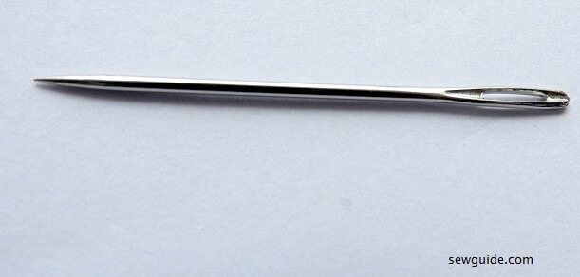
Figure1.1. hand sewing needles
- There are Leather needles which make holes as they sew – they are needles (also called Glovers) with a sharp tip shaped like a triangle for cutting into thick leather.

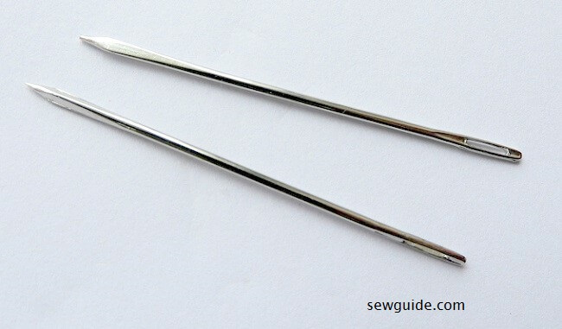
Figure 1.2. hand sewing needles
- Leather needles with longer triangular point at the end are called sail makers needles
Figure 1.3 hand sewing needles
- And you will also find other hand sewing needles like the long upholstery needle and curved needle handy for some of the projects.
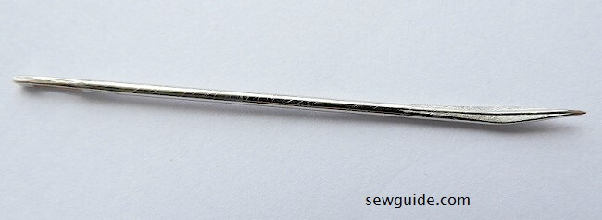
Figure 1.4 Hand sewing needle
- Diamond Awl: This is used to make holes on the leather before you sewing. you get them in many sizes
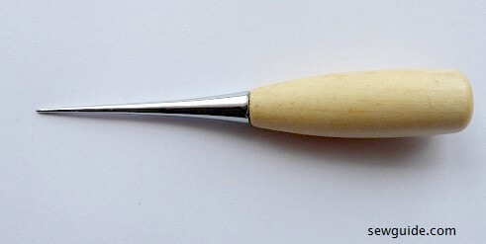
Figure 1.5. Diamond Awl
- Rulers: The long metal ones, as well as transparent rulers, are used to mark the stitching lines on leather
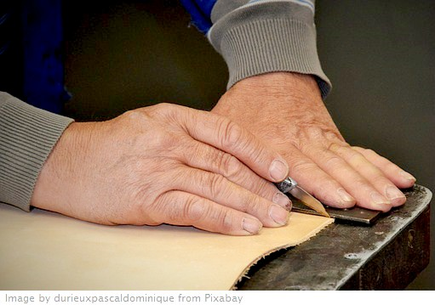
Figure 1.6 Rulers
- Good quality sharp scissors: self-explanatory-what is sewing without a good pair of scissors
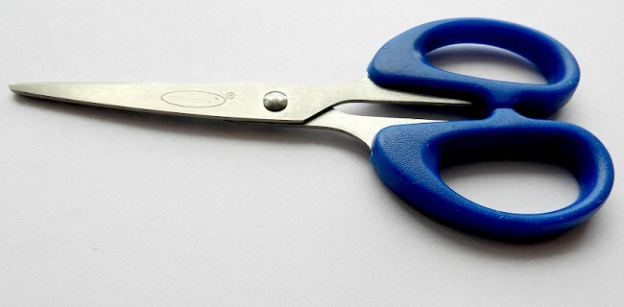
Figure 1.7 scissors
- Clips: as you already know you cannot use pins or basting stitches on leather instead you can use blinder clips to hold leather pieces together. you can even use(wooden) cloth pegs for thin leather. there are other shortcuts like using masking tapes, using stapler pins on the seam allowances where that is applicable etc
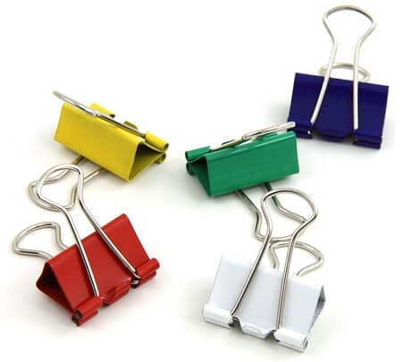
Figure 1.8 Clips
- Glue: you can buy shoe glue or leather glue. This is needed for attaching things before sewing them permanently.
- Knife/rotary cutter: cutting straight cuts, round corners properly is best done with knife. Even skiving is done with a good knife
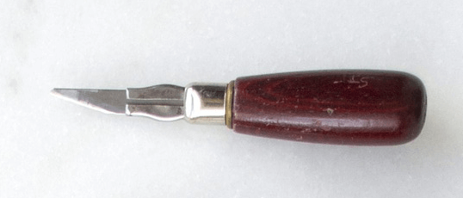
Figure 1.9 Knife/rotary cutter
- Cutting mat: if you are cutting with a rotary cutter or knife/knives you need to protect the cutting surface with a mat-you can use boards or rubber mats.

    - Materials used in moccasin stitching operation
- Good quality leather: Super soft and lightweight leather is most preferred for making handbags – it is easy to sew and soft to touch. 7 to 8 ounce (2.8- 3.4 mm) thick leather is used for making belts. Buy pre-dyed leather if you are a beginner and would rather not bother about the dyeing processes. They are tooled and hand dyed and finished with a stain.
- Thread:
- Linen thread is recommended by many experts for hand sewing leather.
- The pre waxed nylon thread is good enough for most jobs.
- Cotton thread is not usually used by the experts as it may disintegrate easily.
- A synthetic thread with a diameter upwards of 0.6 mm can be used.
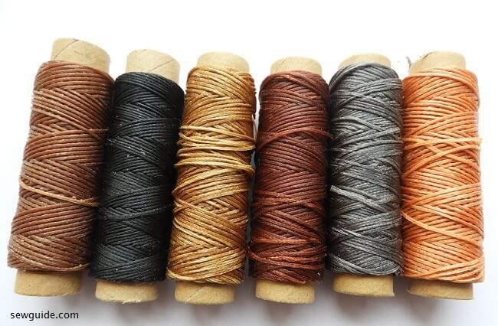
Figure 1.10 Thread

    - Patterns for moccasin
The two components of moccasin are apron and mudguard
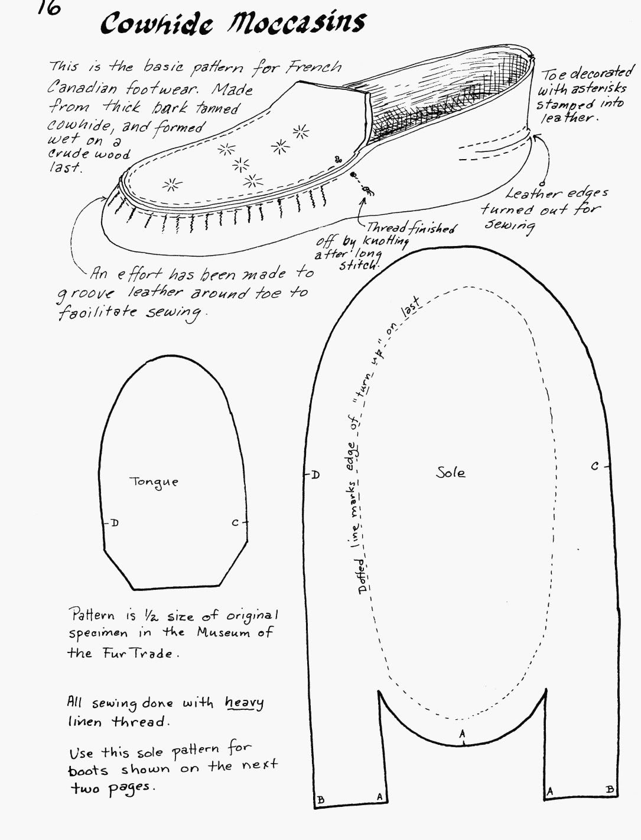
Figure1 11 Moccasin are apron and mudguard

1.1.4. Materials for moccasin stitching operation
a. Leather
Moose, elk and deer hides are recommended. They are softer and stretchier than other leather like cowhide and pig suede. Deer is thinner than moose and elk but it is easier to do the gathering stitch.
Commercially tanned leather has a rough and smooth side and you can put either on the outside of the moccasin. Split moose hide is rough on both sides. Stroud
Stroud, or Melton cloth, is closely woven wool often used for making winter coats. It can be used for the vamps of the moccasins and is especially good for doing beadwork or embroidery on. You can buy it at most fabric stores.
b.Fur
You will need two strips of fur, each 1-2” wide and about 16-18” long. Try buying an old fur coat or collar at a second-hand store. Fox fur is long and fluffy and comes in white, grey, black and other colors. Mink is the most durable kind of fur. It is short and is usually dark brown or black. When cutting fur, don’t use scissors or you will cut the fur as well as the skin. Use a knife and hold the fur up off the table to make sure you cut only through the skin.
c.Artificial sinew
This is used instead of regular thread for sewing leather. It is a strong waxed thread that can be split into strands like embroidery thread. Use 1 or 2 strands to sew your moccasins together. If you cannot find artificial sinew, use a strong thread such as buttonhole or quilting thread.
Upper material – chap-splits, 4-5 ounce suede, soft-temper bull hide from hidehouse.com, maybe elk or moose if it’s lined (these hides are very soft)
d.Deer hide or pigskin lining (optional)
e.Bottom sole – natural rubber sheet soling, vegetable-tanned leather soling, dance suede
Lining-The lining should be made out of a soft material such as polar fleece or sweatshirt fleece. It is sewn together with regular thread.

f.Leather for Moccasin Uppers
- Buckskin – Commercial Tan – white, gold, willow; sizes from 4-6 sf – 14-16 sf
- Smoked German-Tan Buckskin – best quality for moccasins & clothes
- Elk Hides – white, gold; sizes from 10-13 sf – 16-19 sf
- Cowhide – various types & grades; good substitute for more expensive deer & elk
g.Leather for Moccasin Soles
- Moccasin Soles: White Latigo – heavy leather, approx 1/4″ thick; tough & long wearing
- White Latigo Sides – avg size 20-22 sf; great idea if doing lots of mocs
h.Needles • Thread • Lacing
- Glovers Needles – heavy needles with sharp triangular edges for sewing hides
- Sharps Needles – short, stiff needles best suited for lazy stitch or appliqué beading
- Genuine Sinew – clean & ready for use in craft projects – the ‘original’ thread!
- Simulated Sinew – excellent substitute for the real thing, extremely strong
i.Seed Beads
- Czech Seed Beads
- French Old Time Seed Beads
- French Seed Beads
- German Old Time Seed Beads
- Italian Seed Beads
j.Cones: Tin, Aluminum, Copper, Brass
- Genuine Tin Cones – sizes: ¾”, 1″, 1-1/8″, 1¼”
- Aluminum Cones – sizes: ¾”, 1″, 1-1/8″, 1¼”
- Brass Cones – sizes: ¾”, 1″, 1-1/8″, 1¼”

Work instructions, specifications, and operational details
    - Introduction
A document describing specific activities and tasks containing a great amount of detail as a component of a process, defines how one or more activities in a procedure should be executed in detail, using technology or other resources.
A Document containing detailed instructions that specify exactly what steps to follow to carry out an Activity. A work instruction contains much more detail than a Procedure and is only created if very detailed instructions are needed. A detailed set of instructions the describe exactly how a low-level activity must be carried out.
- Work Instructions vs. Procedures
1.Work Instructions describe:
- How the activity is performed.
- Can be used inter-changeably in many situations.
Work instructions are documents that clearly and precisely describe the correct way to perform certain tasks that may cause inconvenience or damage if not done in the established manner. That is, describe, dictate or stipulated the steps that must be followed to correctly perform any specific activity or work.
A work instruction is a tool provided to help someone to do a job correctly. This simple statement implies that the purpose of the work instruction is quality and that the target user is the worker.
Work instruction: including plans, specifications, quality requirements and operations details relevant to the task should be obtained, confirmed and applied to the allotted task.
2.Procedures describe:
- What the activity is.
- When it is performed.
- Who performs it?
- When it is performed.
Procedures: provides information as to what is to be done to meet the requirements of the standard or the company.
- Work instruction for sewing machine:
- According to Safety:
- Switch off the machine when not in use
- Do not make your own electrical repairs
- Know your fire drill
- In case of an accident, no matter how minor, inform your instructor
- Keep your work area tidy
- Wear your approved footwear and clothing
- Avoid wearing loosing clothing
- In case of long hair, tie your hair back
- Do not push the material with your hands, let the machine feed work
- According to machine operation:
- Switch on the machine
- Insert the component to the stitched beneath the pressure roller by raising and then lowering the pressure roller
- Press the foot paddle for stitching While starting stitching, hold both the top and bottom threads for the first-3stitches
- After completing your work switch off the machine
- Specification stitching operator is an important job-role associated with the footwear sector. With the growing demand for the skills, the importance of an operator with specialized knowledge and skills in stitching operation have increased.
- Brief job description: the primary responsibility of a stitching operation is to perform stitching operation to the upper components of the footwear as per the design instruction given by the designing section.
- Personal attributes: stitching operator should have good hand -eye coordination, motor skills and vision ( including near vision, distance vision, color vision, peripheral vision depth perception and ability to change focus).
- Specification
- Standard specification of article
- It is a specification for an article derived from a standard.
- Special instruction from buyer
In this case customers are the owners of the specification/requirement. And also the product must feet or conform to known customer or buyer requirements.
- Quality requirements
The first requirement for a shoe upper material is that it should take the desired shape during making. The second requirement is that, it should retain the shape during storage and wear. Lastly it should be able to take new shape to adjust to the feet of the wearer. And also attaching of the upper with the sole requires some quality requirements. In order to achieve this quality requirements one should realize and fulfill the following key points.
- Quality specification sheet:-
It is a sheet that contains the exact statement of the particular needs to be satisfied and the requirement for a particular material or component.

Proper functionality of tools and materials
    - General Hand tools checklist
- Keep tools clean. Dirty tools are harder to use safely and properly.
- Do not modify hand tools. Keep the manufacturer’s design intact.
- Secure all hand tools and store them away properly. Tools left out are much more likely to get lost, stolen, or damaged.
- Use tools how they are designed to be used. This will keep the tool in good condition longer and you safe when using it.
Hammers:
- Ensure that the handle is not broken or chipped. If a handle is taped, more than likely it is broken and needs replaced.
- On any tool, tape is not a manufacturer’s approved fix for a needed repair.
- Ensure the head of the hammer is tight on the handle.
- Throw the hammer away if part of the claw is broken off.
Screwdrivers:
Ensure the handle is not chipped or broken. Many people will use the screwdriver as a chisel and hit the back end of it with a hammer. This causes damage to the screwdriver and will damage the handle. If the head of the screwdriver is chipped or worn down, replace the screwdriver.
Chisels: Check the back of the chisel. Often times, the back will begin to mushroom. When mushrooming occurs the chisel either needs to be repaired properly or replaced.
Wrenches: Check that the wrench is not bent. Replace any wrench that is chipped or excessively worn. Losing the grip on a bolt due to a worn or broken wrench can easily. cause hand injuries to the user.
X-Acto: is a brand name for a variety of cutting tools and office products owned by Elmer's Products, Inc. Cutting tools include hobby and utility knives, saws, carving tools and many small-scale precision knives used for crafts and other applications.
Leather Scissor: it is differ from standard craft scissors because they're meant to be stronger and more durable than a pair of scissors that are only designed to handle cutting something more fragile like paper.
    - Materials
Beaver fur: is luxurious and fluffy and is a traditional fur for moccasin trim.
When cutting fur, don’t use scissors or you will cut the fur as well as the skin. Use a knife and hold the fur up off the table to make sure you cut only through the skin.
Moose skin leather: Thicker than deer skin, moose skin is chosen for its durability. Grain vs split leather: Grain leather comes from the smooth external side of the hide.

Self-check 1
Name__________________________________ ID_____________Date __________
Directions: Answer all the questions listed below. Examples may be necessary to aid some explanations/answers.
Test l Say True or False Harness needles and Glover’s needles makes sewing leather much easier than using a regular needle.
- Lining should be made out of a soft material such as polar fleece or sweatshirt fleece. It is sewn together with regular thread.
- Cowhide and pig suede are softer and stretchier than moose leather .
- silver gel pen, double-sided tape and 1/2″ acid brushes for cement are not mainly used in moccasin stitching operation
- Artificial sinew is a strong waxed thread that can be split into strands like embroidery thread
Test2 Answer the following shortly
- Briefly explain Hand tools in moccasin stitching operation?
- What are uses of clips in moccasin stitching?
- What is Sand paper
- Shortly define the steps used in pattern making process?
- What is stitching pony/stitching clam?
- What is grain leather?
Test 3: Give long answer
1) Describe about the needle types for hand stitching?
2) Describe about the hand tools used in moccasin stitching?
3) What are the components of moccasins shoe

Unit Two : Set up Workstation
This unit is developed to provide you the necessary information regarding the following content coverage and topics:
  - Arrangement of Workstation
  - Tools, equipment and patterns
  - Materials in preparation for stitching
This unit will also assist you to attain the learning outcomes stated in the cover page. Specifically, upon completion of this learning guide, you will be able to:
  - Set-up and arrange workstation
  - Select and prepare tools, equipment and patterns
  - Collect, sort and lay out materials in preparation for stitching

2.1. Arrangement of Work station
2.1.1. Characteristics of a good workstation layout
- All works (components) should be placed as closer as possible to the operator for easy reach.
- Work should be presented correct way for easy unbundling and quick pick up
- Nothing should stuck operators during picking up and disposing components.
- Keep bins or other means to dispose finished work.
- Operators must have enough space on the table to handle the garment parts. If required add table extension near operator and left side of the machine.
- Enough space in between two machine for operator movement.
- Use jig and folders where required.
- If you provide trimmer (for thread cutting) to operator define a space for it.
- Provide height adjustable chair
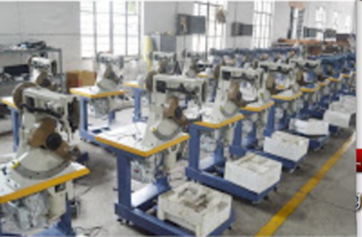
Figure 2.1 arrangement of work station

2.2. Tools equipment and patterns preparation
2.2.1. Check to see if the machines are being kept clean
- Machines should be blown off every day to remove lint and trash
- On lockstitch machines, the hook should be blown off regularly during the day to prevent lint or dirt from building up in the oil ports in the race of the hook
- Check to see that the machines are being lubricated regularly
- Oil levels should be checked daily and additional oil added if necessary
- Randomly check the oil levels in the machines
- Technical bulletin
- A high quality white machine oil should be used that will not stain
- Check availability of proper machine oil in the factory
- Check to make sure the oil is not contaminated
- Check to see that oil reservoir pump filters are cleaned regularly
- If compressed air is used, make sure the air system is regulated properly and has humidity dryers, filters and lubricator in the air lines.
- Check for rusted areas due to excessive moisture in production area
- Check Machines for wear on critical moving parts
- Check for shake in needle bar due to worn needle bar bushings
- Check for excessive movement in stitch forming devices, etc.
- Check condition of critical screws
- Check for missing screws
- Check for defective screws that are difficult to tighten properly
- Check condition of mechanics tools to see that they are being maintained properly. With buttonhole or other specialized equipment, cleaning of the machine should not be done with compressed air but with a soft bristle brush.
Every sewing machine has three basic systems used to form and set the stitch.
These three systems include:
- Stitch forming system;
- Thread handling System; and
- Feed System.
- Stitch forming system
- The sewing machine needle should be inspected regularly during the day and replaced if there are signs of wear or damage
- The correct type & size of needle should be used
- Woven - sharp pointed needles
- On light weight fabrics where structural jamming can cause seam puckering, the finest needle size should be used with a long-point
- Knits - ball pointed needles of the finest size should be used
- The correct needle size - thread size relationship should be maintained
- Lockstitch machines
- Check the hook for sharp surfaces and burrs on the hook point
- Check for other sharp surfaces on other thread contact surfaces
- Technical bulletin
- Check for excessive wear in the raceway which will allow excessive movement in the basket
- Chainstitch & Overedge machines
- Check the looper points for sharp surfaces or burrs*
- Observe excessive wear of looper
- Check to make sure loopers are shaped properly according to original factory condition
- Observe method of removal of entangled thread on loopers. Sharp objects that can nick orburr the loppers should NOT be used.
- Thread handling system
- Check to make sure thread is being stored properly
- Cones should store properly to insure that they are not contaminated with dirt, excessive lint, etc.
- Check to make sure wind on part cones does not affect take-off the cone
- Check to make sure the correct thread type and sizes are being used
- If thread vendor is specified, check order book and inventory to make sure the proper thread is being used
- Thread stands are in proper condition and the top eyelets are oriented properly
- Optimum distance between the top of cone & top eyelet (should be no more than one cone higher than cone size being used)
- Thread stand eyelets are smooth and not grooved or damaged
- Cone is held in a vertical stationary position
- Machine eyelets and guides are smooth and not grooved, rusted or damaged
- Machine thread tensions are as light as possible but still give balanced stitches
- Observe how much of the tension post is exposed beyond the tension nut
- Generally the more of the tension post that is visible, the more tension that is being applied to the sewing thread
- Observe the condition of the tension discs, take-up spring, etc.
- Technical bulletin
- Check the bottom tension to make sure it is as loose as possible and still give a balance stitch
- Lockstitch machines
- Bobbin winder in good condition & making correct wind on bobbins
- Condition of bobbins & bobbin tension
- Look for nicks on edge of bobbins indicating incorrect needle height
- Look for damaged or bent bobbins
- Check bobbin tension (minimum tension recommended)
- Bobbin tension of bobbin case
- Bobbin tension with bobbin case laying on a flat surface
- Bobbin tension after bobbin thread has been pulled up through the hole in the needle plate
- Needle thread
- Machines are properly threaded
- Needle thread tension is as light as possible but still give a balanced stitch
- Take-up spring in proper positioned and working properly
- Proper thread size / needle size relationship is being maintained
- Proper needle thread size / bobbin thread size is being used
- Feed system
- Needle Plates are in good condition
- Make sure the needle hole size /needle size relationship is correct
- Generally the needle hole size should be twice the diameter of the needle being used
- Check to make sure the needle hole in the needle plate is not damaged
- Look for needle damage and sharp edges
- Check to see if the needle plate is flat and not bent down at the needle hole
- Chain stitch needle plates
- Observe to see that the length of the needle hole slot is greater than the stitch length
- Technical bulletin
- Observe to see that the underside of the needle hole is shaped correctly to aid in forming a proper triangle
- Feed Dogs are in good condition and correct for the application
- Check to make sure the feed are not broken or damaged
- Observe the teeth per inch on the feed dog
- Generally the following should be found: light weight sewing - 20 - 24 teeth per inch;
- medium weight sewing - 14 - 18 tpi; heavy weight sewing - 10 - 12 tpi Overedge Needle Plates
- Check for needle damage or burrs on the needle hole and stitch tongue
- Make sure the trimming knives are adjusted to the width of the needle plate stitch tongue Presser Foot
- Correct foot is being used for the application
- Make sure the needle hole size/needle size relation is correct & the needle has sufficient clearance
- Check to make sure the needle hole is not damaged
- Check for proper pressure both in front and in back of the needle
- With the foot flat on the needle plate, you should not be able to insert a thin piece of
- paper between the foot and the needle plate from the front or back side of the needle
- Check presser foot for excessive wear causing side-to-side play
- The pressure on the Presser Foot should be as light as possible and give a uniform stitch length
- Check to make sure the correct stitch length is being used
- Other systems
- Material Trimming Systems
- Check to see that the cutting knives are sharp and are trimming properly. This can be
- checked by placing a single end of thread between the knives and observing if the thread is cut by the knives
- Thread Trimming System
- Check to see that the chain cutters are cutting the chain to the proper length that minimizes trim & inspect
- Folders & Guides
- Technical bulletin
- Observe to see that the correct capacity folder is being used for the upper being sewn
- Check for additional folds caused by excessive folder capacity
- Check for excessive stretching of the upper causing additional seam puckering
- Stitch & seam quality
- Lockstitch seams
- Check to see that the stitch looks the same on both the top and bottom of the seam
- If back tacking is required, make sure the correct number of stitches are used in the back tack
- Make sure the proper SPI are being used
- Make sure the correct seam allowance (margin) is being maintained
- Chain stitch seams
- Make sure the stitch is balanced properly
- Check for excessive seam grinning
- Looper thread should roll over
- Overedge seams
- On overedge seams, check for proper stitch balance
- Check for excessive seam grinning
- Check for proper seam extensibility or stitch elongation
- Check to make sure that the purl is on the edge of the seam
- Check to make sure the knives are trimming the fabric cleanly
- Check to make sure the correct seam allowance (margin) is being maintained
- Observe operator handling for excessive trim
- If latch-tacking, make sure the chain is sewn into the seam properly
- Skipped Stitches
- Check areas where frequent skips have been observed
- Observe where one seam crosses another seam
- Check if skip occurs on thickness or after thickness

2.3. Materials in preparation for stitching
2.3.1. Materials
Stitching operation is performed by combination of operator, material to be stitched and stitching machine. Needle and thread are selected according to the material, operation and specifications given.
Material may vary according to purpose, fashion and design of shoe. It may be leather, textile or synthetic (manmade).
Leather is a natural material having all the qualities and characteristics to make an ideal shoe. The fibrous structure makes it compact and hence required different kinds of needle and needlepoints during stitching. Selection of right threads and needle for particular material is essential to perform various operations during stitching. As the hole made by needle blade on material makes the big difference during lasting pulls in various directions. For example for back seam, one can choose needle Point (P) in order to cope-up with the direction pulls and stitch density.
Textile is also known as fabric material, generally used for lining and school shoes. It is weaved by warps and wept fibers. The fibrous structure makes the surface soft and breathable during wear. Light duty sewing machine and ROUND point Needle is used to stitch this material. The warp and wept fibers of the fabric are disperse by the (R) point needle results no fiber breakage during piercing of needle in to the material.
Synthetic material (PVC, PU coated fabrics) is a man-made material having fibrous backing and soft structure. During stitching it requires light medium duty sewing m/c and ROUND point Needle. The light duty sewing machine is not only suitable to avoid the pressure roller impression after stitching but also provides smooth feed by having compound feeding system.

Self-check 2
Name____________________________________ ID_____________ Date ___________

Directions: Answer all the questions listed below. Examples may be necessary to aid some explanations/answers.
Test 1: Give answer shortly(Total marks=15)
1.What are the characteristics of a good workstation layout?
2. Discuss about something about thread handling?
3. What to see when to prepare the machines for operations?
4. Discuss about preparation of materials for operations

Unit Three : Prepare tools, materials, equipment and machines
This unit is developed to provide you the necessary information regarding the following content coverage and topics:
  - Hand stitching type or work procedures/techniques
  - work for hand stitching
  - Stitch components manually
This unit will also assist you to attain the learning outcomes stated in the cover page. Specifically, upon completion of this learning guide, you will be able to:
  - Identify hand stitching type or work procedures/techniques
  - Prepare the work for hand stitching
  - Stitch components manually

3.1. Hand stitching type or work procedures/techniques
3.1.1. Hand Sewing Stitches
a. Running stitch:
A running stitch, also known as a basting stitch, is a long, straight stitch. This stitch is generally used as a basting stitch, which means it will temporarily hold two pieces of leather together and can be easily taken out later.The running stitch is one of the most common and basic stitches you can do, both by hand and by machine. Sewing by machine assures precision and firmness. But sewing by hand is great for a speedy stitcher and quick stitches and for stitching together narrow spaces that cannot be reached by machine
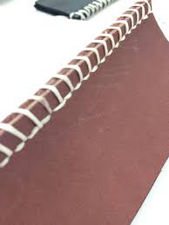
Figur-e 3.1 running stitching
- See the following steps to make this stitch:
- Take the needle in and out of the fabric up to your desired stitch length.
- You may also make several stitches by popping your needle in and out the fabric at equidistant lengths before pulling your needle through the fabric.
- Make sure stitches are locked once done.
- Backstitch:
Backstitch is a basic hand embroidery stitch that creates a line of stitches without a break between them, so it looks like a continuous straight line of thread.

- How to sew by Hand
The back stitch features small stitches that can hold a great amount of strength. This hand stitching technique works well with mending seams or in a seam that will resist a lot of strains and pulls. Learn how to make this stitch by going through these steps:
- Pull your threaded needle from the underside of your leather.
- Make a single running stitch.
- From the underside of your leather, pull the thread to keep the stitch taut.
- Bring your needle up again, piercing through the fabric at a distance equivalent to the length of your single running stitch. Use the photo above for reference.
- Repeat the process until you finish your stitches.
    - Cross stitch:
Cross stitch is a type of decorative stitch comprised of two straight stitches crossing at the center to form an ex. It is generally stitched on special leather, which has a grid of tiny holes to guide the cross-stitch pattern, and the stitching forms a series of exes to make a pattern.
    - Blanket stitch:
The blanket stitch is a decorative seam-finishing technique that is meant to be visible. This stitch is generally used in hand embroidery or to finish the edges of quilts or pillows.
- Slip stitch:
The slip stitch creates a mostly invisible seam and is a great stitch for hemming. Use a thread color similar to that of the item and the seam will blend into the leather.
    - Whipstitch:
Whipstitch is a simple seaming technique that is comprised of a line of short diagonal stitches that are invisible on the right side of the leather

3.2. Prepare the for the hand stitching
- Here's how to make them:
Step 1. Cut out a very rough outline of your foot and soak it in water. This will make it a lot softer and easier to cut out precisely afterwards. Also cut some pieces for the heels and soak them as well.
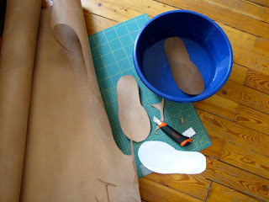
Figure 3.1
Step 2.Draw the outline of your foot on a piece of paper, making sure you are always holding the pencil perpendicular to the paper. Then draw the outline of your sole based on your foot. You can take away some width at the instep, as you see in the picture below.
Draw a line through the center of your heel and through approximately your second toe. Then draw a line square to the first line, at the height where you'll want your flap:
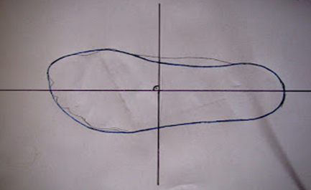
Figure 3.2
Step 3.Now step onto your drawing with a string under your foot. Hold the string over your foot and mark where you'll want the sides of your shoes to go to:
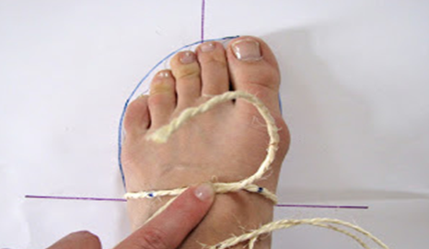
Figure 3.3
Step 4.Then you lay the string out flat and transfer the mark to the paper pattern. Do that in several places and connect the dots. Mine came out this way (the slight curve at the height of the ankle had to be corrected and smoothed out later):
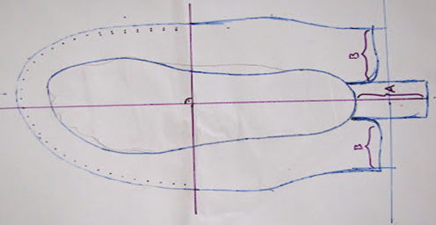
Figure 3.4
Step 5.Cut it out and "try it on". In my case I decided to add some length to the heel part, just to be on the safe side. It was shortened again later
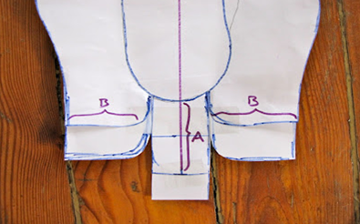
Figure 3.5
Step 6.This is your main pattern piece. Cut out your upper leather (I found a big box of leather scraps in different colors on EBay). I used a regular crafting knife. A rotary cutter works brilliantly too, but don't use the same one you want to use for fabric again later... Always remember to cut one left and one right side...
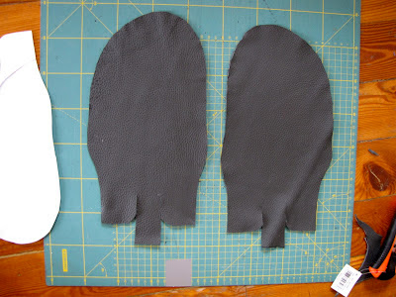
Figure 3.6
Step 7.Transfer the pattern for the sole onto a separate piece of paper and cut out. Now use the soaked leather for the soles and cut two soles and several heel-parts (I used three per shoe).
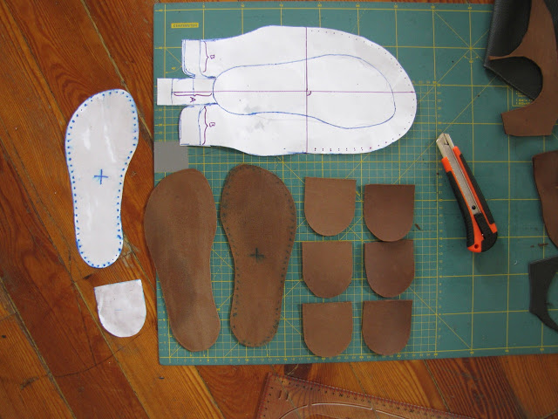
Figure3.7
Step 8.Use sandpaper to make the surfaces of the leather rough. It will be holding together so much better that way
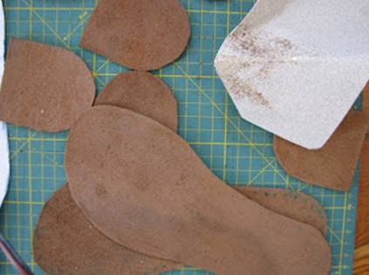
Figure 3.8
Step 9: Use great glue. Glue made for shoes and leather. Read the package. Mine had to be applied to both surfaces, then let dry for about 15 minutes, then glued together and hammered. Not how long you hold it together, but how hard you hammer will decided how well it will be glued!
Glue the heel pieces together, and glue the soles to the outside of your upper leather. Be careful with the correct placement, it is crucial to get it right:
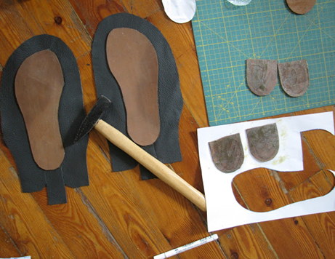
Figure 3.9
Step 10.Now used a hole-puncher and sewed the soles to the upper leather. Using a leather needle would actually be better, as the shoes would then stay water-proof. Leather "mends" again after going through it with a needle and closes up entirely. Obviously that isn't the case if you make holes.

Step 11.Leather needle has a very small eye though, no way I could have fit a big enough string through it. Use heavy duty string. Ideally, you would wax it, too. Mine is special string for shoe-making.
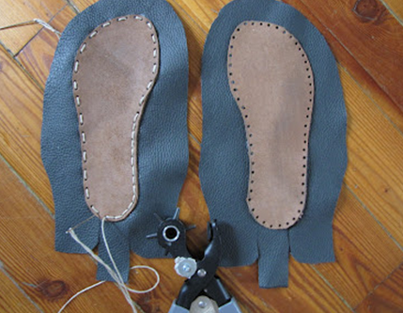
Figure 3.10
Step 11.Next I cut out an inner sole, transferring my pattern to store-bought insoles, which I then wrapped in fabric. I only laid them into the shoes, but you could glue them if necessary:
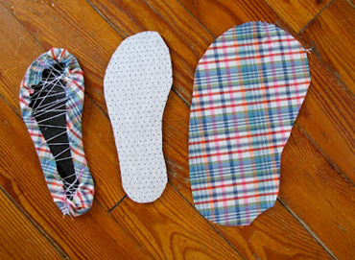
Figure 3.11
Step 12.Punch the holes around the toe-part of the upper. Mine are 1 cm apart (3/8 inch). It has to be an even number of holes, so the string doesn't go in at the bottom and come out on top.
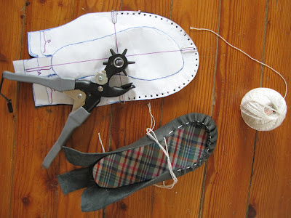
Figure 3.12

3.3. Stitching components manually
Step 1.Pull a string through and put on your shoe. If you had made the sides higher than me, they could be worn like this as sandals. I wanted to make a flap though. Stick a piece of paper in place of the flap and draw the pattern, marking the holes and calculating in the extra "seam allowance" needed.
Step 2.This is what my pattern piece looked like. I had drawn the line with the little marks while wearing the shoe, then I drew in the dots afterwards - that is where the holes really had to be:
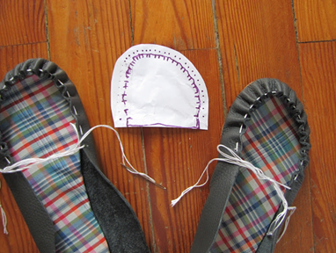
Figure 3.13
Step 3.After taking the string back out and attaching the flap, you adjust the back. Hold it tightly to your foot and mark a line through the center of your heel.
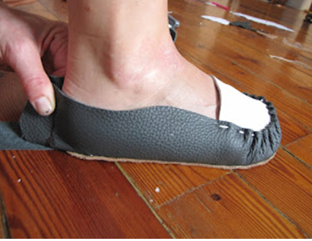
Figure 3.14
Steps 4.Roughly sew together the two side parts, which you have cut back to the line. Then with nicer stitches attach the heel flap over it. I did this with a leather needle, not by punching holes. If it is long, you could even fold it over to the inside. I didn't, as I was going to put another leather stripe over that edge anyway
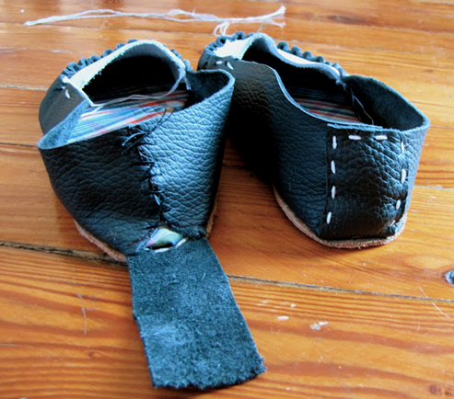
Figure 3.15
Step 5.The shoes are basically done now and could be worn. I added some fringe to the front and enhanced the side edge with another stripe of leather. Both pattern pieces were made while wearing the shoes and holding/folding paper to them. In the photo below you see what they looked like (the fringe-piece is already torn apart a bit...). You also see how I attached the leather stripe with paperclips first, then punched the holes through all three layers at once before pulling the string through
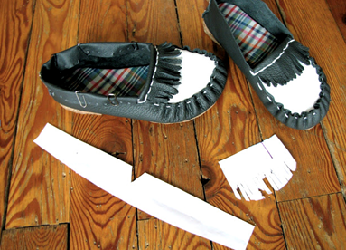
Figure 3.16
Finally I used a dreamer to smooth out the heel-sides. Be careful not to touch the outer leather of From the bottom the shoe though
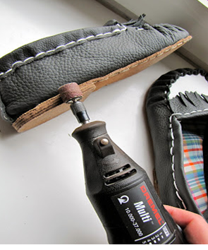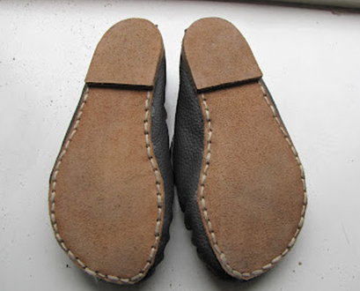
Figure 3.17
Here is the overview of all the pattern pieces that were needed. The pattern can be varied endlessly, making no flaps but higher sides, making the flap higher etc.

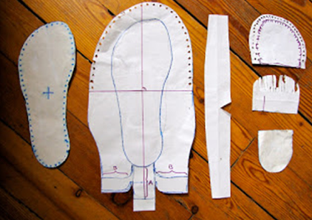
Figure 3.18

Self check 3
Name____________________________________ ID_____________ Date ___________
Directions: Answer all the questions listed below. Examples may be necessary to aid some explanations/answers.
Test 1: Give answer shortly
1. List out the types of hand stitches ?
2. describe about the running stitches for
Test 2: Give answer briefly
- write step by step for preparation of the hand stitching
- write step by step for stitching of the hand stitching

Operation Sheet 1- manual moccasin stitching
Operation title Manual moccasin stitching
Purpose: To practice and demonstrate the knowledge and skill required in manual Moccasin stitching
Instruction: Use the given figure below, the tools Manual moccasin stitching For this operation you have given 1:30 Hour and you are expected to provide the answer on the given table
Tools and requirement.
- Auger
- Cutting Knife
- Awl
- hand stitching needle /moccasin needle
- Ruler
- Thickness
- Scisors
- Hammer
Precautions: Measure at least three times before stitching the result on the given format
Steps in doing the task:
Steps for making moccasin stitching
Step 1:-Prepare materials tools and equipment and patterns
Step 2:-check tools for serviceability
Step 3:- apply OHS practices
Step 4:- select the mudguard and apron pattern and then cut the components
Step 5:- mark the components to be stitched
Step 6:- perforate the leather to be stitched
Step 7:- select thread and leather sewing needle for stitching operation
Step 8:- hold the two components together and perform sewing operations
Step 9:- after sewing perform thread cleaning

LAP TEST 1
Name____________________________________ ID_____________ Date ___________
Time started: ________________________ Time finished: ________________
Instructions: Given necessary templates, tools and materials you are required to perform the following tasks within 1 hour. The project is expected from each student to do it.
Task-1 perform hand stitching of moccasin shoe

Unit Four Set up machine
This unit is developed to provide you the necessary information regarding the following content coverage and topics:
  - Set up and adjust machine for operation.
  - Set tension
  - Set temperature and steam
  - Machine routinely.
This unit will also assist you to attain the learning outcomes stated in the cover page. Specifically, upon completion of this learning guide, you will be able to:
  - Set -up and adjust machine for operation.
  - Set tension according to specifications
  - Set temperature and steam according to specifications
  - Clean and maintain machine routinely

4.1. Set up and adjust machine for operation
4.1.1.Introduction
Sewing machine control is the basic necessity and important part for stitching by machine. Operator should learn to stitch at various machine speeds and be able to negotiate stitching of components at various curves and edges. The operator should learn to operate the machine with foot paddle control and by activating it in various ways; needle can be positioned accordingly during stitching.
- Required Knowledge For Sewing Machine Operators
- Mechanical- Knowledge of machines and tools, including their designs, uses,
Repair and maintenance
- Production and Processing- Knowledge of raw materials, production processes, quality control, costs, and other techniques for maximizing the effective manufacture and distribution of goods.
Abilities Required For Sewing Machine Operators
Manual Dexterity- The ability to quickly move your hand, your hand together with your arm, or your two hands to grasp, manipulate, or assemble components.
Arm-Hand Steadiness- The ability to keep your hand and arm steady while moving your arm or while holding your arm and hand in one position
Visualization- The ability to imagine how something will look after it is moved around or when its parts are moved or rearranged
Finger Dexterity- The ability to make precisely coordinated movements of the fingers of one or both hands to grasp, manipulate, or assemble very small objects.
Near Vision- The ability to see details at close range (within a few feet of the observer).
Control Precision -- The ability to quickly and repeatedly adjust the controls of a machine to exact positions.
Visual Color Discrimination- The ability to match or detect differences between colors, including shades of color and brightness
Wrist-Finger Speed- The ability to make fast, simple, repeated movements of the fingers, hands, and wrists
Problem Sensitivity- The ability to tell when something is wrong or is likely to go wrong. It does not involve solving the problem, only recognizing there is a problem.
4.1.2. Threading the machine
Top threading: Machines vary as to how exactly they are threaded, but all have certain common features. The thread runs from the spool holder, through a tension device and down through the needle. The tension device controls the tension on the thread. It consists of a groove that the thread slides through. The mechanism for setting the tension may be a dial or buttons (computerized machines).
The thread runs from the tension device, down to the needle area. There are usually small grooves in the arm that holds the needle, for the thread to pass through. This holds the thread close to the needle arm. The thread then runs down to and through the eye of the needle.
When threading, make sure that the presser foot is raised and the needle is in the highest position. If the presser foot is lowered the tension discs will be closed. Make sure the thread is placed between the tension discs. Occasionally when we are in a hurry or not really paying attention we inadvertently place the thread next to the tension discs instead of making sure it is firmly seating between them.
  - Top Thread the Machine-
- Turn hand wheel toward you to raise take-up lever to its highest position.
- Place spool of thread on spool pin.
- Lead thread through the top-threading guide just above the thread spool on the thread stand. The distance between the thread guide and thread spool must be at least twice the length of the spool, from the top of the spool being used.
- Now lead the thread through the threads guides from top to bottom on the machine head.
- Press the knee press and pass the thread through the tension assembly and over the check spring.
- Lead the thread through the take up lever from right to left.
- Pass the thread from top to bottom through the thread guides near faceplate.
- Press knee press and lift the pressure roller out towards left side.
- Then pass the thread through the thread guide on needle bar.
- Thread through the needle eye from left to right.
- Draw about 3 inches of thread through the needle.
- Press knee press and pull the pressure roller down to original position.
  - Bottom Threading:
- Ensure machine is switched off.
- Take a full bobbin and insert it in bobbin case as far as it will go.
- Make sure thread comes out of the bobbin in clockwise direction.
- Pull the thread through the case and under the tension spring on the case.
- Allow about 3 inches of thread to hang free from bobbin case.
- Place the bobbin case into the machine with the bar of the case in the slot of the shuttle.\
- Press on the bobbin case until you hear or feel it click into position.
- Hold top thread in left hand.
- Now turn the balance wheel towards yourself by right hand, until bottom thread loop comes out through throat plate.
- Now grip the loop and pull the bottom thread through throat plate.
- Pull about 10 cm of thread and place it on machine bed.
  - To Replace the Bobbin Case -
- Hold bobbin case by latch, with thread leading off top of case.
- Slide case on to stud as far as it will go.
- Release latch, and allow about 3 inches of thread to hang free from bobbin case.
  - BOBBIN THREADS REWINDING:
For most machines, the thread must be taken out of the needle in order to wind the bobbin. There is normally a bobbin holder on head of the machine or a separate bobbin winding assembly is there. The thread runs from the spool through a sequence of guides etc. that are specific to the type of machine.
- Place empty bobbin on bobbin-winder spindle.
- Press bobbin winder down against motor belt.
- Place spool of thread on spool pin.
- Thread bobbin winder and bobbin.
- Hold thread end and start machine.
- When bobbin is full, stop machine.
- Cut thread.
- Lift bobbin winder away from belt and remove bobbin.
- After the bobbin is wound, the machine is re-threaded, the needle is engaged and the bobbin is placed in its area under the throat plate.
- Once the bobbin is in place and the machine is threaded, gently turn the wheel of the machine while holding the needle thread off to the side (it should go from the needle under the presser foot and off to the side). This will bring down the needle. The needle will pass down through the throat plate and the needle thread will catch the bobbin thread and pull it up through the throat plate when it comes back up again.
  - If Thread Does Not Wind Evenly on Bobbin:
- Loosen screw that holds bobbin-winding thread guide on bed of machine.
- Move thread guide to left if thread winds high on right of bobbin.
- Move thread guide to right if thread winds high on left of bobbin.
- Tighten thread guide screw.
  - NEEDLE CHANGING:
When inserting a new needle:
- Raise the needle bar to its highest position.
- Hold the needle with the clearance cut side facing towards the hook.
- Loosen the needle clamp screw sufficiently to allow the new needle to be fully inserted.
- Insert the shank of the needle as far as it will go
- Tighten the needle clamp screw.
- Before sewing, check the needle by turning the hand wheel one complete rotation and to make sure the needle is securely in place and does not hit against anything. This is particularly true when using and selecting a stitch for twin needles.
  - STITCH LENGTH REGULATION
Stitch Length Regulation: The numbers on either side of the lever represent the approximate number of stitches per inch. The higher the number, the shorter the stitch. In general, lightweight materials require short stitches (a high number setting) and heavyweight materials require longer ones (a low number setting).
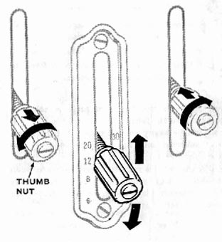
  - To set stitch length:
- Loosen thumbnut by turning it to the left.
- Move lever to desired stitch length setting.
- Tighten thumbnut by turning it to the right until it touches the numbered indicator plate
.
  - PRESSURE REGULATION
- To increase pressure, turn thumbscrew in clockwise direction. Figure 28
- To decrease pressure, turn screw in anti-clockwise direction.
- This screw regulates the degree of pressure that the presser foot exerts on the material.
- Pressure should be heavy enough to prevent the material from slipping sideways and light enough to carry the material without marking it.
- In general, heavy materials require heavier pressure than lightweight materials. But surface finish and material texture must also be considered: crisp fabrics, for example, require more pressure than soft fabrics.

4.1.2. Set tension
Tension Adjustment:
Tension refers to the force that is applied by the machine on your thread. You can also effect tension by the amount of pull or push you apply to the material as you feed it through under the needle - you should not apply force. Instead, just use your hands to guide the material through. Let the feed dogs actually feed the material through.
There are two areas in which you can adjust tension. The upper thread (needle thread - coming from the spool) and the bobbin thread each have tension.
Too little tension can cause weak seams, which can be pulled apart easily and final seam will loose. Adjust to a higher tension. Too much tension causes a seam puckering due to high stress and pressure on thread. Rectify it by lowering the related tension assemblies.
When both threads have an even amount of tension, a smooth, "balanced" stitch is produced. The needle and bobbin threads are locked between the two layers of material with no loops on top or bottom and no puckers.
- Proper Stitch Balance
- The lockstitch should be formed at the center of the material thickness.
- The lock should not be formed at the top or bottom of the material surface.
- Poor Stitch Balance - Too Loose
- Needle Thread Tension: This is the most likely place to find a problem. Generally the tension ranges from low to high in number, with high being the tightest.
The numbers on the dial represent the degree of tension on the needle thread. The higher the number, the tighter the thread.
Correct needle-thread tension is important because too tight a thread will cause material to pucker. Too loose a thread, on the other hand, will produce slack stitches and weak seams.
- Bobbin Tension: With some machines, a screw is present which controls the bobbin tension.

4.1.2.Making adjustments:
Before you start adjusting your tension, make these three checks. This is very important.
- Be certain your machine is threaded properly. Even long time sewers can miss a thread guide.
- Be sure your bobbin is properly installed.
- Make sure your needle is inserted properly. After going through the three checks, you may have to adjust the tension in order to sew a good stitch. Each time you have adjusted, sew a line of stitching. You should only have to make small, slight adjustments to correct your stitch

4.2. Set temperature and steam according to specification
Purpose of toe humidifying/conditioning
The purpose of upper humidifying is to make the leather malleable soft so that the process can be done easily. It is the conditioning of upper in order to avoid upper crack, wrinkles and the break of counter.
Material related parameters the temperature of top and bottom plates

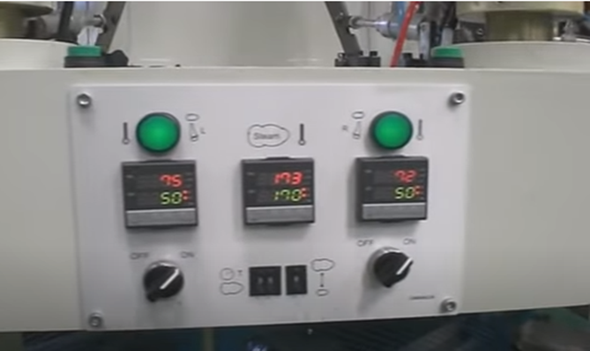
Figure-4.1: the temperature

cleaning and maintaining machine routinely
4.3.1.General Cleaning
As you clean the machine, it is best to clean one area at a time. Remove only the parts that are involved and be sure to note where each part is from, its position, and which side is top.
When removing parts, remember that ―left is loose and right is tight‖ on practically all screws and bolts. When using a screwdriver, put the pressure on the push, not on the twist. If a screw will not loosen easily, soak it with cleaning fluid. Then set the screwdriver in the slot and tap sharply with a hammer before attempting to loosen. The screwdriver blade should be as wide as the slot in the screw is long. Always use a wrench—not pliers—on bolts.
First, remove the needle, presser foot, slide plate, throat plate, bobbin case, and the face plate. Put them in a pan and cover with cleaning fluid. Set aside to soak while cleaning other areas.
Next, wrap the motor (if necessary) and wire with plastic wrap to protect them from oil and cleaning sol- vent. Be sure the machine has been unplugged!
Now, it is time to begin work to clean the machine head. With a sharp pointed tool, clean out all oil holes. Then, with your hand, turn the hand wheel to run the machine. At the same time, squirt cleaning fluid into all the oil holes, on all bearings, and on all other places where one part rubs against or turns within another.
If the machine begins to run hard, it is a sign that dirt or lint has jammed inside a bearing. Continue running the machine and flushing with cleaning fluid until the dirt and gummed oil are washed from the bearing. When the machine runs easily again, tip the head and flush the parts underneath the machine—all oil holes, bearings, and places that rub against or within one an- other. Continue running the machine by hand until it functions smoothly.
To remove any remaining dirt and oil, dip a cloth or brush in cleaning fluid and scrub all parts of the ma- chine that can be reached. Use a needle, knife, or other pointed instrument to dig or scrape away any remaining gummed dirt or lint in the feed dog, around the bobbin case, and in other areas.
Check the lower tension of the bobbin case and the upper thread tension discs. Pull a thread under the tension of the bobbin to remove dirt. Pull a piece of cloth soaked in cleaning fluid back and forth between the discs of the upper tension. Repeat with a dry cloth to be sure no lint or thread is caught between them.
Areas Needing Attention
In addition to general cleaning, three areas need special attention: the hand wheel bearing and the clutch assembly, the needle bar and presser foot, and the hook and bobbin area assemblies. When the hand wheel assembly gets gummy and dirty, it must be cleaned for the clutch to work properly. The clutch disengages the needle bar when winding a bobbin.
Some newer sewing machines refill the bobbin in its regular position and a clutch is not necessary. In such machines, it is often not necessary to remove the hand- wheel to clean this area.
- Bobbin and Hook Area
Lint is the primary offender in this area. The bobbin case can be removed on all makes of machines. Use a dry brush to clean out all lint. Remove any thread that may be wound up around the hook shaft. On many machines, the hook assembly can also be removed for more complete cleaning. Place one drop of oil on the exterior perimeter of the hook and the bobbin race (the ledge that the hook sits on) to lubricate it after cleaning.
The face plate on most machines is held in place with one or two screws. By removing these, the plate can be easily removed for cleaning both the needle and presser foot bars. On some newer machines, the face plate is a part of a housing that is mounted on hinges, which makes it easy to move the entire housing away from the bars and mechanisms behind it. No other parts need to be removed for cleaning in this area. First use a dry brush to clean out all lint and other foreign material. A small piece of cloth with a little solvent on it can be used to clean the needle bar and presser bar of any gummy grease.
After thoroughly cleaning, place a drop or two of oil on each shaft where it slides through the housing. Oil all other moving parts according to your instruction book before replacing the face plate.
To remove the clutch and hand wheel, loosen the small screw in the face of the lock nut (the lock nut is the part that is turned to the left to release the clutch for operating the bobbin winder. Next, unscrew the lock nut and remove the washer and hand wheel. Most machines will have a washer that looks like one of the three shown. Some machine models will be slightly different. Notice the position of the washer so you can put it back in the same position. You may want to make a small scratch to identify the side that goes ―out.‖
The hand wheel should slide off the shaft easily. If the machine is driven by an external belt, this belt will have to be removed before the hand wheel will come off. If the machine has an internal drive belt or the wheel obviously will not come off, do not remove the hand wheel. Replace the parts you have removed and skip this area. Gear-driven machines will have a gear on the inside of the hand wheel.
Clean the hand wheel, washer, and shaft. Lubricate the shaft with two drops of oil and place a small amount of grease on all gears. Reassemble the hand wheel and clutch. If the clutch fails to operate, either because it will not hold or fails to release, remove the lock nut again and turn the washer one half turn (180°) and reassemble. The clutch should then work properly.
After thoroughly cleaning these areas, reassemble the machine and run it by hand. It should run smoothly if all parts have been replaced correctly.
Do not plug the machine in until all the cleaning fluid is dry.
Oiling and Lubricating the Machine Allow the machine to stand overnight so excess cleaning fluid can evaporate before oiling and lubricating it. Check your machine instruction booklet to determine the type of oil lubricant to use and where to use it.
Some machines have bearings that are nylon or graphite-impregnated bronze and do not require oil or lubricant. Also, some machines do not need
- Care of the Motor
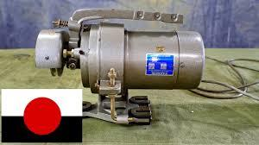
Figure 4.2. Care of the Motor
Lubricate the electric motor of your sewing machine according to the manufacturer’s directions.
Several newer machines have electric motors with sealed bearings that never need oiling. Lubricate motors that require oil or grease once a year. One or two drops per bearing is sufficient; over-oiling may ruin the mo- tor. A sewing machine company oil or a good-quality light oil is satisfactory to use. If you select lightweight household oil, be sure it says ―non-gum forming‖ and ―non- corrosive‖ on the container. On a grease-fitted
- Needle
Short Groove bearing, fill the grease cups once a year.
Check to see that all electric connections to the mo- tor control and motor are tight. If the cord covering is not in good condition, tape it with good-quality electrical tape or replace the cord. The belt that connects the motor to the hand wheel should have just enough tension to keep it from slipping. On some machines, the belt can be adjusted by slightly shifting the position of the motor.
Take good care of the rubber driving ring or wheel on motors that drives machines by friction contact with the hand wheel. If this driving ring or wheel has become flat-sided or unevenly worn, causing excessive vibration, replace it with a new one. Keep the hand wheel clean and dry, and the driving ring adjusted firmly to the hand wheel and in line, so the machine will run with a minimum of vibration.
- Adjusting the Machine
Next, thread the machine and sew (using scraps of fabric) to test the stitching.
First, be sure the needle is the proper length. Use the needle length or number recommended in your manual.
Second, use a needle with a diameter that is suitable for the fabric and thread size you intend to sew on. Charts in your operator’s manual, in a sewing machine centre, or reputable online websites give the recommended size for sewing with different thread sizes. Using a larger diameter needle results in an unattractive stitch with larger than necessary needle holes in the fabric.
Third, be sure the needle is straight and does not have a dull point or burr.
Fourth, choose needles for sewing special fabrics, such as a ballpoint needle for knits and a wedge needle for leather The needle should be inserted in the needle bar clamp with the long groove of the needle facing the side from which you thread the needle. It should be inserted all the way into the clamp until it hits the stop pin. On machines with an adjustable needle bar housing, adjust the position of the needle bar until the needle goes through the centre of the needle hole in the needle plate
- Needle Plate (Throat Plate)
Manufacturers of some machines recommend using the needle plate with the round hole for straight stitching and the elongated hole for the zig-zag stitch. Unless you use the proper needle plate, you may experience skipped stitches when making a straight stitch. This is especially true when sewing some synthetic fabrics. Check the needle (throat) plate for rough places and remove them with an emery paper or cloth.
- Feed Dog
The teeth on the feed dog should project above the needle plate so that the bottom of the teeth, or serrations, are level with the top of the needle plate when the dog moves the material before the next stitch is made by the needle.
A good general setting is one that results in 10 to 12 stitches per inch of seam. On very thin and fine mate- rial, it may be necessary to use a shorter stitch such as 14 to 16 stitches per inch of seam. On leather or vinyl, a longer stitch may be more desirable, such as 6 to 10 stitches per inch of seam.
- Presser Foot
There should be just enough pressure on the presser foot to hold the fabric on the feed dog so that a uniform length of stitch is made. As a general rule, heavy fabrics require light pressure. Pressure may be increased by pushing down on an inner pin, or decreased by releasing an outer ring. Some machines may have a thumb screw or a dial to regulate pressure. Check your machine booklet for instructions on how to adjust the presser foot of your machine.
On slippery fabrics, loosely knit fabrics, vinyl, or velvet a roller-type presser foot may produce better feeding than the standard presser foot.
When darning, either reduce the pressure on the presser foot or lower the feed dog on machines with a drop feed button, or use a cover plate.

- Thread Tension
Upper and lower tension must be balanced to produce a perfect stitch. The upper tension is located differently on different machines. It may be on the face plate, on the face of the needle bar housing, on the front of the needle bar housing, or on the upper arm of the machine head.
The lower tension, located on the shuttle or bobbin case, is adjusted by a screw. If two screws fasten the lower tension spring to the bobbin case, adjust by turning the screw nearest the centre of the spring—not the screw on the end.
If, during the cleaning, the lower tension spring has been removed or its adjustment changed, the adjusting procedure is the same as in the ordinary use of the machine. That is, assume the lower tension to be correct until proved wrong. Make all adjustments on the upper tension first.
If the lower tension has been disturbed, set both lower and upper tension so there will be a slight drag on each thread. Use the same size thread on both bobbin and spool. After adjusting the tension, take a look at the stitching the machine makes. To help you to see the stitches clearly, use contrasting colours of thread on the spool and in the bobbin. Set the stitch-length control for a medium stitch length. Fold a 6- to 8-inch square of sheeting or average weight cloth and stitch diagonally across it at an angle of about 45°.
Now inspect the stitching. In a perfect stitch, threads are locked in the centre, midway between the two layers of cloth, with no loops on the top or bot- tom of the seam and no puckers in the cloth.
If loops of the bobbin thread show on the top side of the seam and the top thread is straight, the upper tension is tighter than the lower. In this case, loosen the top tension.
If loops of the spool thread show on the underside of the seam and the lower thread is straight, the upper tension is looser than the lower and should be tightened.
- Operating Tips
- Always be sure the machine is oiled and properly threaded, and that the bobbin is lint-free before starting to sew.
- Use a needle size suitable for the fabric and thread weight. Be sure the needle is the correct length, straight, and sharp. Change needles frequently when sewing synthetic fabrics. Ball point needles help prevent damage to knit fabrics.
- Use the same thread in the bobbin as on the spool unless you are creating a special effect.
- Pull the bobbin thread through the needle hole in the needle plate before starting to stitch.
- As you start to stitch, place both threads under the presser foot and hold them to the back of the machine.
- Turn the hand wheel toward you to start the stitching, if needed.
- Start and stop the machine with the needle and thread take-up lever in their highest position.
- Once the tension on the upper thread and bobbin thread are balanced, change only the upper thread tension for slight variation, as needed.
- To turn a corner, stop the machine while the needle is still in the fabric. Raise the presser foot and turn the fabric, using the needle as a pivot point. Then lower the presser foot and resume sewing.
- Protect your clean sewing from machine dust and grime between sewing projects by covering it or put- ting it inside the sewing cabinet or machine case
- Key points for Maintenance of Floristry Equipment
Maintain Tools and Identify when equipment requires maintenance.
- Regularly check all equipment
- Recognize and report unsafe equipment
- Identify and be aware of scheduled maintenance
- Be aware of manufacturer’s instructions
- Use safety equipment and guards as instructed
- Report all equipment issues with supervisors
- Use organizations appropriate documentation as supplied
- Maintain Tools and Identify when equipment requires maintenance.
- Regularly check all equipment
- Recognize and report unsafe equipment
- Identify and be aware of scheduled maintenance
- Be aware of manufacturer’s instructions
- Use safety equipment and guards as instructed
- Report all equipment issues with supervisors
- Use organizations appropriate documentation as supplied

- Key points for Maintenance of Floristry Equipment
Store tools and equipment
- Choose Correct conditions to store tools
- Store in an appropriate safe location in accordance to the correct conditions
- Store safely when transporting
- Consider the environment when cleaning equipment.
A well-made sewing machine—new or old, used often or only occasionally—will sew perfectly for many years if it is given proper care. It may need to be adjusted or a part may need to be replaced, but a sewing machine that is given proper maintenance and cleaned regularly seldom actually wears out Sewing machines generally require basic maintenance of cleaning, oiling, and lubricating.
- Getting at the Problem
When you have trouble with your sewing machine, a good rule to follow is ―clean it first.‖ Many problems are caused by dust, lint, or thread ends that have collected on the working parts of the machine.
Simply brushing lint and dust from the machine each time it is used is a good way to prevent many problems. Use the soft nylon brush that comes with the machine or a narrow paint brush to dust away lint in the bobbin case, under the needle plate, and around the feed dog. A needle or tweezers can be used to remove pieces of thread or lint that cannot be brushed away.
In time, lint and dust that are allowed to accumulate in a sewing machine can become soaked with oil and/ or lubricant and interfere with the operation of the machine. When this gummy grime is removed, the ma-chine will work more freely, and adjustment may not be necessary. Removing this unwanted buildup requires more care and time than everyday maintenance.
The following procedures do not apply to all manual and electric machines–specifically those with bearings packed in grease and chain-stitch machines. They do apply to older models of electric lock-stitch machines and treadle machines. Check your machine instruction booklet if you have one to determine the procedure recommended to clean it, then use this guide along with your booklet.

- Supplies and Equipment
It is really helpful if you can find a few tools to use. You need the following equipment and supplies for the job:
• Pie or cake pan for soaking parts in cleaning fluid
• Small screwdriver
• Large screwdriver
• Small adjustable wrench
• Hammer (optional)
• Small oil can (clean) for cleaning fluid
• Cleaning brush (narrow, nylon)
• Paring knife (or pocket knife)
• Long needle or small crochet hook
• Tweezers
• Cleaning cloths
• Fabric to test stitching
•Can of sewing machine oil (check your machine instruction booklet for the type recommended)
• Tube of sewing machine lubricant (check your machine instruction booklet for the type recommended)
• Small bottle or can of cleaning solvent that will not flash flame at temperatures below 120°F. It is usually available at gasoline stations or cleaning establishments. Never use gasoline; it is highly flammable.
After assembling all supplies and equipment, unplug and move the machine to a cleaning area that is well lit. Protect the floor and table top with newspapers. A good floor or table lamp to light the work area from over your shoulder will be helpful. A flashlight is also helpful for adding light in hard-to-see areas

Self-check Four
Name____________________________________ ID_____________ Date ___________
Directions: Answer all the questions listed below. Examples may be necessary to aid some explanations/answers.
Test 1: Give long answer
- How will you change the stitch length?
- Which part of the machine is used for top tension adjustment?
- Write the name of parts use for bobbin rewinding?
- Write the name of the part use for putting thread cone?
- Write down the name of part in which bobbin is fixed?
Test 2: Short answer questions :
- What are the causes of bottom tension?
- What is the roll of tension disk assembly in adjusting the tension?
- Define the roll of bobbin case assembly in adjusting the tension.
- What is the roll of threading guides regarding tension?
- What should be the minimum distance between the spool and first guide on the thread stand?
- what is the purpose of toe humidifying or conditioning?
- write some points about cleaning machines?

Unit 5: Prepare tools, materials, equipment and machines
This unit is developed to provide you the necessary information regarding the following content coverage and topics:
  - Accurate Position of material
  - Material sewing and molding
  - Component sewing and molding of stitched upper
This unit will also assist you to attain the learning outcomes stated in the cover page. Specifically, upon completion of this learning guide, you will be able to:
  - Position material accurately consistent with stitch requirement
  - Sew and mold material
  - Carry out sewing of the components and molding of stitched upper

5.1.Accurate Position of material
    - positions the material for stitching operation
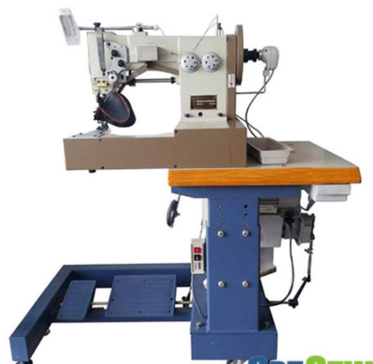
Figure 5.1. moccasin stitching machine
In order to stitch the upper material of moccasin it must be properly positioned.
- Make sure the needle is down into the leather to start sewing.
- Press the Start/Stop button or if you have a foot controller attached to your machine press down on the foot controller to start sewing.
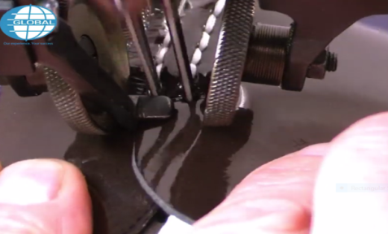
Figure 5.2 positioning

Sewing moccasin
There are several methods of sewing moccasin by machine according to the stitch forming
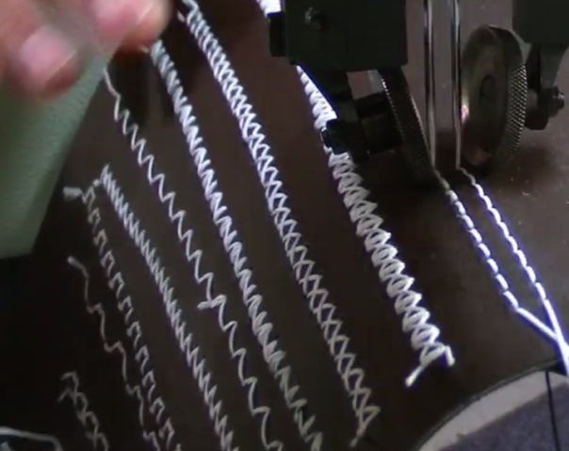
Figure 5.3. different methods of stitching formation
- Sewing moccasin by machine
The components of moccasins to stitched together are apron and mudguard
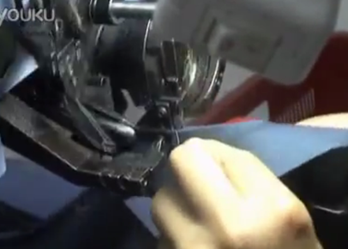
Figure 5.4. sewing moccasin by machine

After sewing
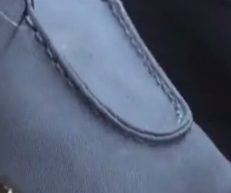
Figure 5.5 sew Moccasin
Upper insertion
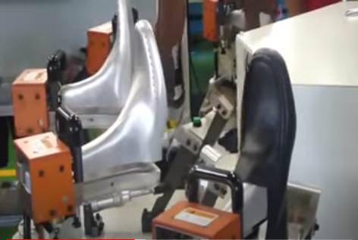upper insertion
Figure 5.6-Preforming process
The machine is set with the required temperature and moisture
For more information and explanation view this video
https://youtu.be/yh4eaXctC7M

Carrying out sewing of the components and molding according to OHS
    - Sewing machine: Important Safety Rules & Instructions
Safety is important to everyone and it is your responsibility to maintain a safe working place. To maintain a safe environment, learn these safety rules and practice them at all times.
Safety instructions
All safety devices must be in position when the machine is ready for work or in operation. The operation without the specified safety devices is not allowed. Read the Instruction Manual before you use the machine. In addition, keep this Instruction Manual so that you may read it at any time when necessary.
Use the machine after it has been ascertained that it conforms to safety rules standards valid in yourCountry.
General maintenance and inspection work and also repair, remodeling and adjustment works must only be done by appropriately trained technicians or personnel.
For personal protection, wear safety glasses. Tampering with the live parts and devices is prohibited.
For the following, turn off the power switch or disconnect the power plug of the m/c from the receptacle:
1. For threading needle(s), looper, spreader etc. and reo placing bobbin.
2. For replacing part(s) of needle, presser foot, throat plate, looper, spreader, feed dog,
needle guard, folder, cloth guide etc.
3. For repair work.
4. When leaving the working place or when the working place is unattended.
5. When using clutch motors without applying brake, wait until the motor stops totally.
If you should allow oil, grease, etc. used with the machine and devices to come in contact with your eyes or skin or swallow any of such liquid by mistake, immediately wash the contacted areas and consult a doctor

Self-check 5
Name: _________________________ Date: _______________

Directions: Answer all the questions listed below. Illustrations may be necessary to aid some explanations/answers
Test 1: Short answer questions
1. Describe about with the positioning of stitching operation?
2. Describe some points about safety according to OHS practices

Operation Sheet-2 Machine stitching of moccasin
Operation title: stitching moccasin with machine
Purpose: To practice and demonstrate the knowledge and skill required in stitching moccasin with machine
Instruction: Use the given figure below, the tools stitching moccasin with machine For this operation you have given 1Hour and you are expected to provide the answer on the given table.
Tools and requirement
- Scisors
- Hammer
- Cutting Nippers
- Cutting Knife
Steps for stitching moccasin with machine
Step 1:-Prepare materials, machines, tools and equipment and patterns
Step 2:-check tools and machine for serviceability and thread winding and set tension
Step 3:- apply OHS practices
Step 4:- select the mudguard and apron pattern and then cut the components
Step 5:- mark the components to be stitched
Step 6:- position the stitched component on the machine
Step 8:- hold the two components together and perform sewing operations
Step 9:- after sewing perform thread cleaning

LAP TEST 2
Name………………………………ID…………………………….Date……………………………
Time started: ________________________ Time finished: ________________
Instructions: Given necessary templates, tools and materials you are required to perform the following tasks within 1 hour. The project is expected from each student to do it.
Task 1 perform machine stitching for moccasin

Unit 6: Prepare tools, materials, equipment and machines
This unit is developed to provide you the necessary information regarding the following content coverage and topics:
  - The arrangement of stitched upper pair wise
  - Quality of upper
  - Faults and irregularities following standard procedures.
  - Necessary records and dispatches
This unit will also assist you to attain the learning outcomes stated in the cover page. Specifically, upon completion of this learning guide, you will be able to:
  - Arrange stitched upper pair wise
  - Check the quality of upper against job specifications and enterprise quality standards.
  - Address faults and irregularities following standard procedures.
  - Carry out necessary records and dispatching are in accordance with work procedures and standard format

6.1. Arranging stitched upper pairwise
Alignment of upper:
while placing two components the alignment of each part should be carefully done because, the effect is seen on the finished shoe for instance, if the alignment of quarter to vamp is not uniform, during inspection it can be considered as big problem.
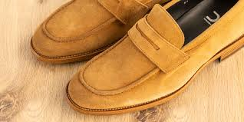
Figure 6.1 arrangement of stitched upper

6.2. Quality of upper
6. 2.1 Check uppers
To achieve consistency in quality, inspections are mandatory in various stages of the stitching department. Due to deviation in the production related factors mistakes are bound to occur and defective shoes are separated during inspection and categorized in reparable and non- reparable category.
Therefore a format must be maintained so that the excess cost of the repairing can be controlled and ultimate cost of production can be computed. Inspection of upper can be done at the beginning, in the middle and at the end of the process. Upper can be inspected from different parameters and these parameters are listed below:

- Leather defects
- Needle scratches
- Stitch length
- Needle point
- Thread number
- Needle holes
- Re-enforcements
- Alignment of upper
- Adhesive marks
- Lining stamping
- Loose threads
- Skiving
- Lock stitch

- Parameters of upper inspection
- Leather defects: is a major defect so during inspection it should be given big attention especially on the visible parts. Leather defect are like wrinkle, vein mark, flay cut, warble fly etc.
- Needle scratches: is a scratch which is created on the upper through different reasons like when an operator is pulling out the material from the stitching machine, the needle can make scratch on the material so in inspection of an upper, it should be seen, stitch length on pair should be checked and corrected. Mostly, in shoe manufacturing
- Stitch length: refers to the length of one stitch on the stitching and it should depend on the material that we use and type of shoe. However during inspection of an upper the consistency of.5mm -3.0mm is used.
- Needle point: is the point of the needle that is used in stitching operation. And there are different types of needle point and using the appropriate one is essential. For instance, p point should be used for back seam because of its shape of the point and it has high density. Thus, during upper inspection the type of needle point used is should be checked or inspected.
- Thread number: refers the number that is found on the thread. The different types of thread numbers are; 8, 10, 15, 20, 30, 40, 60, 80. Using the write thread number with appropriate material thickness and stitching machine is key point in stitching.
- Needle holes: created when the needle is going inside the material. Needle holes are assumed as a defect when it is wider hole than it supposed to be. For example in stitching of hard and dry leather, if needle point other than 134kk is used, big needle hole will be created and this can be one defect in the process of inspection of upper. Therefore, using the right needle system which can be matched with the material thickness and machine type is one major thing in stitching operation.
- Re-enforcements: are used to give extra strength to the weaker areas of the shoes, which are prone to failure. In shoe making reinforcement are small pieces of leather or other martial or tapes which are stitched to the upper between the upper shell and lining shell to strengthen the points where strain and wear are greatest for example, the top lines back seam, punches and derby stay etc. different types of reinforcements are available in percent shapes or tapes and sheet to suit the different category of footwear. Now a day’s various martial’s like nylon, polyester, cotton, paper etc. are being used as reinforcement for footwear. Reinforcement is available in different width and color and thickness of reinforcement may vary from 0.2mm to 0.5mm. It enhances the final get up and appearance or shape of the shoe and helps in overcoming shoemaking problems by preventing stretching of material.
- Alignment of upper: while placing two components the alignment of each part should be carefully done because, the effect is seen on the finished shoe for instance, if the alignment of quarter to vamp is not uniform, during inspection it can be considered as big problem.
- Adhesive marks: unnecessary adhesive should be removed from the component regardless of the appropriate portion of the component for example; in nubuck types of leather adhesive marks in the wrong part has high impact on the quality of the shoe. Thus, while inspecting the upper adhesive mark can be treated as one main defect in the upper.
- Lining stamping: stamping is an identification marking that is carried on by a stamping machine using a metal foil. The shoe components of right and left, shoe last number, brand name of the shoe, date of fabrication, the factory at which it is fabricated, name of the firm and style are all shown by some identification on the lining and the marking is using code number of latter and color. the lining is placed between the strip of marking foil the die is then pressed down on to the foil the design is transferred on the lining the foil is then automatically drawn for ward ready for the next operation.
- Loose threads: in the type of stitch formation is the lock stitch; loose thread can be created through poor loop formation of the upper and bottom thread. While inspection Loose thread can be checked by rubbing the stitched part with a hand or by any material.
- Skiving: is the process of reduction of thickness of the material either from grain of flesh side of material in order to aid and eases the various closing operations at different level. A layer of substance is removed under this process without hampering the existing strength of the material. When we join or attach two components together without out any skiving, it doubles the substance and creates problems for next operations to perform during shoe making and cause discomfort to wearer. Skiving can be performed either in manual (hand) skiving by using various tools and accessories like Rampi, work stone and sharpening stone or machine skiving by using skiving machine.
- Lock stitch: is done during starting and end of edge stitch to prevent against opening from the corners. Maximum three and minimum two stitches has overlapped to perform the locking operation. Locking is not suitable for decoration stitches, when one is performing the stitching by heavy thread. It is very essential to look in to the needle and thread combination along with the suitable sewing machine.
- Component size: refers to the sizes of the components (parts) of an upper. Let say a piece of shoe has four components (parts) and all four components should have same size unless and otherwise the parts will not feet to each other while assembling or stitching. Therefore, in inspection of an upper the component size should be checked well and report to the concerned party.

6.3. Faults and irregularities following standard procedures
Studies by the Pedorthic Footwear Association show that no two pairs of feet, and no individual's two feet, are exactly alike. Therefore, perfect shoe fit is impossible. As you read this section on the principles of shoe fitting, you will see the complexity of proper fit and why you need to leave the fit of the shoes up to the professionally trained shoe fitterMost shoe fitting is done on a two dimensional scale: overall length and ball width. Yet the foot and shoe are three-dimensional objects. Thus, what we have is a shoe of one size, shape, and sectional proportions attempting to fit a foot of many or varying sizes, shapes, and proportions. It is obviously impossible for the shoe to fit and feel the same under all these variables. Now add to these challenges the fit of the foot while in the shoe when at non-weight bearing, weight bearing, walking, under conditions of heat, humidity and moisture, and faulty biomechanics of the leg and foot. As you can see, a perfect fit is next to impossible. Therefore, a professionally trained shoe fitter attempts to fit both feet proportionally.
This often requires some adjustments to the shoes to accommodate the intricacies of each foot.
Shoes that fit properly help you do the things you enjoy. They provide comfort and improved performance. They can also keep your foot healthy, which means you can stay as active as you want to be now and in later years. Here are the steps taken at Murray's Shoes in assuring as proportional a fit as possible. It is important to note before starting that whatever size we end up with does not matter at all. What does matter is the fit.
- Some common faults in shoe:
- Edge stitching more than 1.5mm from the edge.
- Double row stitching distance is more than 1.8mm from the first row.
- For lapped seam and top line stitching, stitch density is more than 4- 4.5 St. / cm.
- Derby lock is not at stitch mark
- Missed stitching.
- Thread tension.
- Dirty upper.
- Using maximum solution on upper.
- Loose thread.
- Eyeleting not proper.
- Correct size and color of eyelet not used.
- Distance for eyeleting is not 10mm from the top and 15mm between the eyelets.
- Eyelets are not properly clenched and loose or damaged.
- Thread color should not match the color of leather or as per the sample given.
- Folding is not neat.
- Upper is twisted.
- Lining is too short at the lasting edges.
- Lining is trimmed smoothly.
- Wrinkle in lining or tongue.

6.4. Necessary records and dispatches
6.4.1. Introdaction
During moccasin stitching, production goes according to the production sheet and capacity loading is done according to the production resources and standard time of operations. Operation sequences passes through the various hands (Multi-skilling, high skill, skilled, semi-skilled and unskilled) and operators having different mental calibers. In order to have sufficient transparency in all productions levels, we have to have an easy expressing method to evaluate the quality and productivity during production.
To achieve the product as per the buyer’s specifications, we need to designs a set of documents called sewing room document, which are very convenient and useful to achieve the quality targets during production. Various documents like order break up sheet, specification sheet, plan sheet; route sheet and sequence of operations are designed to enhance the quality and productivity of upper closing department.
During designing the sequence of operations, one should be very careful regarding the standard time data of each operation. This helps in better planning and controlling during upper closing. It is suggested during planning is that the sequence operations should break in to smaller content and thus proper work distribution could be achieved.
6.4.2 Daily Production Report
The shoe making resources travels in a particular sequence from one department to another department till the final shoe is not packed. Therefore individual route sheet is made for every single design of shoe and WIP goes accordingly.
Daily production report is very helpful in identifying the particular shoe style placement during production. It is filled by the manager production and it pinpoints the exact position of WIP of shoe during production. There may be one daily productive report for the one order breakup or separate sheets as different departments.

Table: Daily production report
Date | Day | Order No | Article No | Plan No | Size | Input  Pars | WIP | Output pars | Packing pars
 | Monday
 | Tuesday
 | Wednesday
 | Friday
 | Saturday
6.4.3 Daily Productivity Report
According to production capacity, daily productivity report is designed and full lot (particular number) is feeder in to the production conveyor during upper making. It helps in building a momentum in production and displays clear picture of production. It also helps in day-to-day planning against any failure or changes to be made to the resources in upper closing department.
To achieve the production targets, production norms are fixed and work is enforced accordingly in to the concerned department. To obtain the predetermined results against targets, following activities are found most suitable:
- Display of worker’s skill inventory chart,
- Display daily attendance chart,
- Display concern sample or specification sheet in the department,
- Display sequence of operation chart,
- Display list of machine break down during production hours,
- Display hourly production chart,
- Display reasons that affecting the production,
- Make show boards for every operation, which feels complicated.
- Display necessary feedback of customer.
- Any other instruction chart.

Table: Daily productivity report
Date | 8.30 9.30 | 9.30 10.30 | 10.30 11.30 | 11.30 12.30 | Total Production | 1 to 2 | 2 to 3 | 3 to 4 | 4 to 5 | Total Production
Monday
Tuesday
Wednesday
Thursday
Friday
Saturday
Total

6.4.4 Daily Rejection/Repair Report
To achieve consistency in quality, inspections are mandatory in various stages of the closing department. Due to deviation in the production related factors mistakes are bound to occur and defective shoes are separated during inspection and categorized in reparable and non-reparable category. The components of repairing are either cut or re- processed or re- issued and the defective pair is run through various processes. Therefore a format must be maintained so that the excess cost of the repairing can be controlled and ultimate cost of production can be computed. An illustrative format (fig: 1) of in process rejection/repair report used in the factory is shown in the fig no---

Table: Daily Rejection/Repair Report
Date | Dept.  STITCHING | Order No | Article No | Plan No | Size | Input  Pars | WIP | Percentage | Rejection  Pars
Monday
Tuesday
Wednesday
Thursday
Friday
Saturday
Total

6.4.5 Daily Dispatch Report
Table: Daily Dispatch Report
Date | Day | Order No | Article No | Plan No | Size | Input  Pars | Rejection  Pars | WIP | Packing | Dispatch
 | Monday
 | Tuesday
 | Wednesday
 | Thursday
 | Friday
 | Saturday
 | Total

6.4.5. Work Order Sheet
The most important document is the work order sheet. This document gives the details of the buyers order and for the companies ‘The current order position’. The planning department of the organization to prepare this keeping the customer’s priority listed. The order is broken down to the pair’s basis. The delivery dates are also mentioned to ensure that goods are required to be delivered on time.
    - Lot Number
To follow the safeguard and convenience during shoe production is to divide the complete shoe order in to the quantities or lots as per the dispatch schedule. This is because of:
- Buyers very rare asks for the whole order quantity at once,
- Different destination suggested to ship,
- Storage cost or any damage against heavy loading or unloading.
- Payment releases and
- Working capital.
The planned dispatch quantities of shoes are divided in to the small lots and Lot No is allocated accordingly. The Lot No is stamped over the components edges or (suitable area area), which helps to recognize the component against any happening during production.
      - Plan Sheet
The work orders are broken in to plans. This typical plan sheet indicates breaking up of the order in to small lot. Usually the production is broken down in to small lots of 10pairs in every size though; the lot size is variable from company to company. The breaking of the order is necessary to track the pairs and ensure that the pair mix-up is not taking place. Also the company – for the buyer they remain in the fair position to check that whether the orders are reaching on time or in case of delay how much delay can occur.
The plan sheet depicted indicated here shows the article/design details for tracking and then breakup of the plan.
      - Daily plan sheet
Table-: daily plan sheet
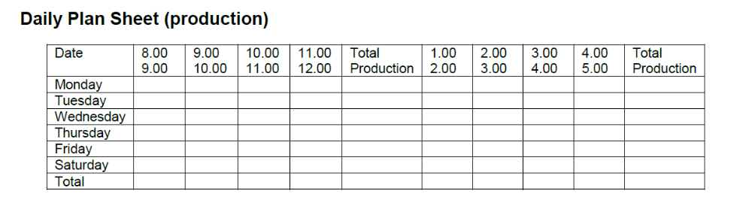
      - Work Loading Chart
Based on the planning sheet the daily loading chart is prepared this is necessary for loading the individual workstation.
The example shown here is for the daily load plan for any workday. For the preparation of the day plan following things are required:
- Capacity of the department
- Availability of the material
- Capacity of the individual cutter
- Size assortment to be cut
- Delivery dates
- Types of material to be cut on individual machine
      - Specification Sheet:
Generally, specification sheet is designed according to the order sample and maximum time it is sent by customer along with the order sheet. This helps in identifying the material concern for the shoe upper to be made and dictate all production terms as per the sample. This is a kind of agreement between buyer and manufacturer regarding deal of particular products.
Manufacturer cannot neglect the given specifications during making the shoe and buyer will have to accept the related product, if it is to be made according to the specifications given. Specification can be of regarding following types:
- Material specifications,
- Technical specifications
- Machinery specifications,
- Method specifications and
- Packing and dispatch specifications.
These specifications are collected from the buyer and recording has been done at various levels of the system. All the concerned information is sent to the respective departments and necessary considerations are taken care of. Transparency is made at all levels of production for the necessary specifications to be followed and necessary steps are taken for the remedial action

Self-check 6.
Name:_________________________ Date_______________
Directions: Answer all the questions listed below. Illustrations may be necessary to aid some explanations/answers
Test 1: Short answer questions
- How to align and Arrangement of stitched upper?
- What upper inspection mean?
- When do you propose that upper inspection should be done?
- Write down about the needle hole.
- How does loose thread occur?
- Write the method of skiving?
- Write down about the three types of shoe faults?
- Write some points on common faults and irregularities?
- What is the use of daily production report?
- Define the purpose of daily productivity report?
- What do you mean by daily repair report?
- What is the purpose of daily dispatch report?
- What are the types of specification

Reference Materials
Books
Previous TTLM Performing closing of uppers
Advanced mechanized Lasting
WEB ADDRESSES
https://www.masterclass.com/articles/types-of-hand-sewing-stitches#4-common-machine-sewing-stitches
https://sewing.com/hand-sewing-stitching-basics/
https://www.instructables.com/Make-Your-Own-Shoes-at-Home/

No | Name | Educational Background | Region | E-mail | Remarks
1 | Yohannes Fisseha | BSC in Leather Engineering | Addis Ababa, Lideta Manufacturing college | yohannesfiseha71@gmail.com | module Developers Team Members
2 | Yabetse Fikadu | BSC in Leather Engineering | oromia: bishoftu polytechnic college | Yabets1030@gmail.com | module Developers Team Members
3 | H/Gebrale Abebe | BSC in leather and leather product technology | Addis Ababa,Misrak poly technic colleget | haile3a@yahoo.com | module Developers Team Members

