Footwear Production
Level-II
Based November, 2021 Version 1 curriculum
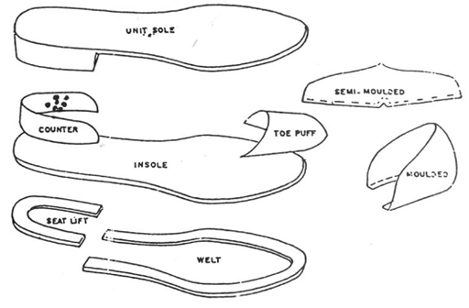
Module Title: - Performing Bottom component operations
Module code: IND FWP2 M06 1221
Nominal duration: 48Hour
Prepared by: Ministry of Lobar and Skill
August, 2022
Addis Ababa, Ethiopia

Table of Content
Acknowledgment 3
Acronym 4
Unit one: Prepare tools, materials, equipment and machines 6
1.1. Bottom component materials 7
1.2. Identifying and making tools and machines ready for operation 11
1.3. Performing handling and care requirements for materials 39
1.4. Identify Common problems and faults of materials 59
1.5.Identifying suitable Personal protective equipment 63
1.6.Identifying safety of operator and work place in component section 65
Self-check-1 68
Unit Two: Perform bottom component operations 70
2.1.Identifying types and sequence of operation 71
2.2. Performing interlocking for major components 75
2.3. Preparing and cutting toe puff and stiffener materials 77
2.4. Preparing different types of insole 78
2.5. Preparing leather sole. 88
2.6.Preparing and attaching heels to the leather sole 103
2.7. Cleaning and maintaining work area 108
Self-check-2 112
Operation sheet 2.1 checking material faults and preparing continental insole 113
Operation sheet 2.2. Preparing leather sole 115
LAP TEST 1 117
Unit Three: Assess final quality of the bottom components and dispatch 118
3.1. Identifying quality check points and critical stages of the inspections. 119
3.2. Performing quality checks in relation to the design of footwear and last. 124
3.3. Identifying and analyzing problems and faults. 130
3.4. Maintaining report and record 131
3.5. Dispatch completed work 136
Self-check 3 137
Reference 140

Acknowledgment

Ministry of Labor and Skills wish to extend thanks and appreciation to the many representatives of TVET instructors and respective industry experts who donated their time and expertise to the development of this Teaching, Training and Learning Materials (TTLM).

Acronym
FWP - Footwear Production
OHS- Organizational health and safety

Introduction
The anatomy of a shoe can be divided broadly in an upper part and bottom part. Section of the upper part includes vamp, quarter, toecap, topline etc. the section of the lower shoe (bottom part) consist of an insole, outsole, shank and heel. Various areas of the shoe have different names.
Bottom part mainly consists of sole, insole. Heel, Heel lifts and top piece etc.
This module covers the units:
- Prepare tools, materials, equipment and machines
- Perform bottom component operations
- Assess final quality of the bottom components and dispatch
Learning Objective of the Module
- Identify tools, materials, equipment and machines.
- Perform bottom component.
- Assess final quality bottom component.
Module Instruction
For effective use this modules trainees are expected to follow the following module instruction:
- Read the information written in each unit
- Accomplish the Self-checks at the end of each unit
- Perform Operation Sheets which were provided at the end of units
- Do the “LAP test” giver at the end.
- Read the identified reference book for Examples and exercise

Unit one: Prepare tools, materials, equipment and machines
This unit is developed to provide you the necessary information regarding the following content coverage and topics:
  - Bottom component materials
  - Identifying making tools and machines ready for operation
  - Performing handling and care requirements for materials.
  - Identifying common problems and faults of materials.
  - Identifying suitable personal protective equipment
  - Identifying safety of operator and work place in component section
This unit will also assist you to attain the learning outcomes stated in the cover page. Specifically, upon completion of this learning guide, you will be able to:
  - Identify and select materials used as bottom component are as per supervisor requirement
  - Identify tools and machines and make ready for operation
  - Perform Handling and care requirements for materials.
  - Identify common problems and faults of materials.
  - Identify suitable personal protective equipment for safety with regards to tools, equipment and machines.
  - Identify Safety of operator and work place in component section.

1.1. Bottom component materials

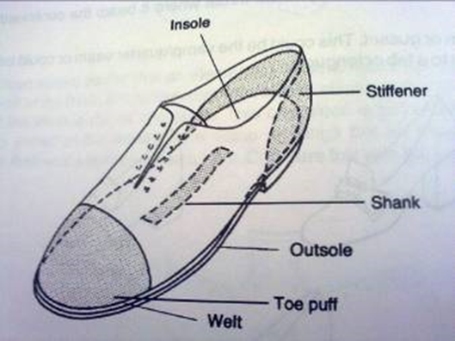
Figure 1.1. parts of footwear
    - The principal part of the shoe
The anatomy of a shoe can be divided broadly in an upper part and bottom part. Section of the upper part includes vamp, quarter, toecap, topline etc. the section of the lower shoe (bottom part) consist of an insole, outsole, shank and heel. Various areas of the shoe have different names.
Bottom part mainly consists of sole, insole and heel. Some of the main bottom parts are explained below:-
    - BOTTOMS COMPONENTS
This is a term which refers to the whole of the bottom of shoe as opposed to the upper. It generally includes some of the following, depending on type of construction.
- Insole
- Sole.
- Welt.
- Bottom fillings.
- Heel, heel lifts and top piece.
    - COMPONENTS:
This is collective term which is used to describe items which is in Corporate in shoe and includes the following.
- Toe puff.
- Stiffener.
- Shank.
- Socks
- Insole:
A layer of material shaped to the bottom of the last and sandwiched between the outsole (or midsole) and the sole of the foot inside the shoe. The insole covers the join between the upper and the sole in most methods of construction and provides attachment for the upper, welting. This provides a platform upon which the foot can operate and separates the upper from the lower. This is the inner sole of the shoe which is next to the foot under the shoe sock. Athletic shoe wear will often have a sock liner, a piece of material placed over the top of the insole board (glued in position or removable).
- Sole:
The term sole derives from ‘solea’ a latin word meaning soil or ground. This is the outer most sole of the shoe, which is directly exposed to abrasion and wear. Traditionally made from a variety of materials, i.e. leather, pure rubber, resin rubber compound, plastic etc. the outsole is constructed in different thickness and degrees of flexibility. the layer of material which covers the bottom of the shoe and the walking surface of that shoe.
- Welt:
Welt is strip of material that joins the upper to the sole. Most shoes will be bonded by Goodyear welted construction. Some shoes use an imitation welt stitched around the top flat edge of the sole for decorative purpose, but it is not a functional part of the shoe.
- Bottom Filling:
This is used to fill the cavity between the insole and the sole or middle sole. Bottom filling is usually made of a granulated cork mixture, leather or felt cut to shape. It is essential, as it goes in the forepart of the shoe, that whatever is used is flexible.Filler means the materials which fills the cavity or gap. Bottom filler is a kind of material which fills the cavity formed during the lasting. Almost all types of footwear needed bottom filler. It may be in the forepart, heel portion or whole of the bottoms area.
- Heel:
The heel is the raised component under the rear of the shoe. Heel consist of a variety of shapes, heights and materials and are made of a series of raised platforms. The part of the heel next to sole is usually shaped to fit the heel, this is called the heel seat or heel base. The heel breast describes front face of the heel. The ground contact section is called the top piece. Heels raise the rear of the shoe above the ground. A shoe without a heel or midsole wedge may be completely flat. When the heel section sits lower than the forefoot the style is called a ‘negative heel’. The under part of the shoe which supports the heel of the foot, and may be stuck or nailed to the shoe bottom. Can be made of leather, wood, plastic, rubber, leather board, etc.
- The Type of the heel
- Heel Base
- Heel Breast
- Heel Seat
- Heel lift
- Top piece

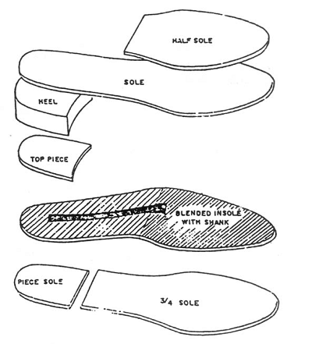
Figure 1.2- Bottom parts
- Heel Base: That part of the heel next to the sole, usually concave to fit the heel seat.
- Heel Breast: The forward face of the heel, often concave towards the shank.
- Heel Seat: The part of the sole to which the heel is attached, often beveled to form a rounded top which fits into the concave heel base.
- Heel lift: layers of material such as leather or leather board which are built up together and shaped to form built heels.
- Top piece: The top surface or walking surface heel is called as top piece.
- Toe Puff:
A stiffening which is inserted between the upper and lining at the toe of the shoe. The purpose of this is to reproduce the shape of the toe of the last and to retain that shape throughout the life of the shoe.
- Stiffener:
A stiff material which may be molded to the shape of the last back part or, alternatively, inserted flat and molded during subsequent processes. It is normally inserted between the lining and upper to support the back of the shoe and to grip the foot.
- Shank:
The shank bridges between the heel breast and the ball tread. The shankpiece or shank spring can be made from wood, metal, plastic and consists of apiece approximately 10 cm long and 1.5 cm wide. The shankpiece reinforces the waist of the shoe and prevents it from collapsing or distorting in wear. The contour of the shank is determined by heel height. Shoes with low heels or stiff soles do not require a shank because the torque between the rear and forefoot does not twist the shoe.
- Socks:
A piece of material shaped to cover the whole or part of the insole. It is inserted into the completed shoe and usually bears the maker’s name and the shoe brand name.
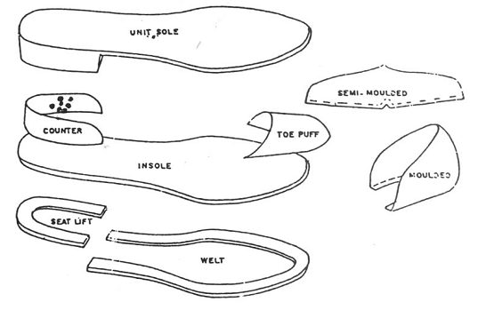
Figure 1.3 - component parts

1.2. Identifying and making tools and machines ready for operation
- Spring dividers
Used for measuring various allowances of patterns.
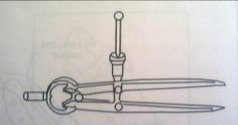
Figure 1.4 -spring dividers
- MEASURING TAPE:
Used for measuring foot length, shoe size, height, etc.
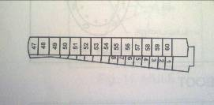
Figure 1.5. Measuring tape
- INDENTING SCISORS:
Used for giving a decorative edge treatment to sock, especially for ladies footwear.
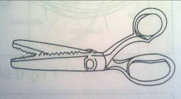
Figure1. 6 indenting scissors
- FUDGE WHEEL:
Tool to give decorative treatment to sole edges.
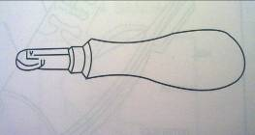
Figure1. 7- Fudge wheel
- STITCH MARKER:
Used to make the decorative stitches for the guidance of the stitchers
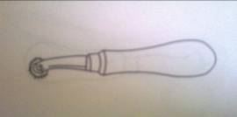
Figure1.8 stitch marker
- SEAT WHEELING TOOL:
A tool to give a decorated serrated marking at the top of the heel.
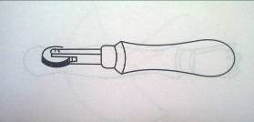
Figure 1.9- SEAT WHEELING TOOL

- STITCH SEPARATING WHEEL:
Used on the welt of the sole stitching. The wheels can be changed to suit the size of stitches.
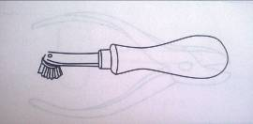
Figure 1.10- Stitch separating wheel
- CUTTING NIPPERS:
Generally Used for cutting and extracting nail like heel nails.
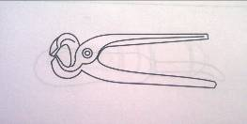
Figure 1.11 cutting nippers
- STITCH MARKER:
Used to make the decorative stitches for the guidance of the stitches’
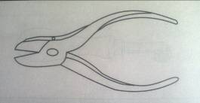
Figure 1.12 stitch marker

- SHARPEING STONE:
Used for sharpening various kinds of knives in the shoes manufacture.
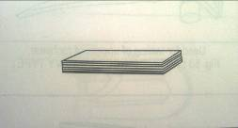
Figure 1.13- sharpening stone
- CHANNEL OPENER:
Open the channel has been cut, this tool is used for opening the channel properly to facilitate the stitching of soles.
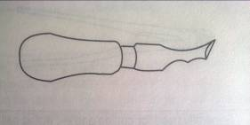
- PARKING KNIFE:
Used at various stages in the shoe manufacture for cutting sole leather.
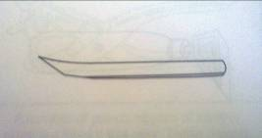
Figure 1.15- parking knife

- SCISSORS:
Used by the closing room workers for trimming thread ends, cutting slots and for other similar works.
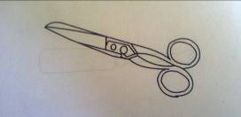
Figure 1. 16 scissors
- CUTTING KNIFE:
Generally used for cutting leather of heavy type.
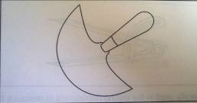
Figure 1.17 cutting knife
- SHOE HAMMER:
A general purpose hammer used in the shoe trade.
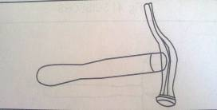
Figure 1.18- shoe hammer
- NAIL PULLER:
Used for extracting pins like heel pins.
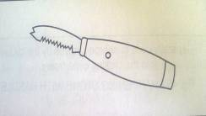
Figure 1. 19- Nail puller
- SHOE KNIFE:
Used specially in ranging of sole leather.
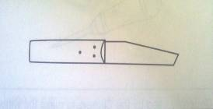
Figure 1.20- shoe knife
- LEATHER THICKNESS (MEASURING GAUGE):
Used for measuring thickness of upper and lining leather.
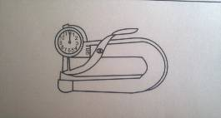
Figure 1.21- thickness measuring gauge
2.2 Machinery/equipment used for unit insole making
- Travelling Head Cutting Machine: Machine is used for cutting insole & shank board.
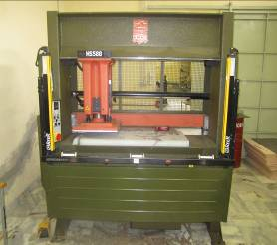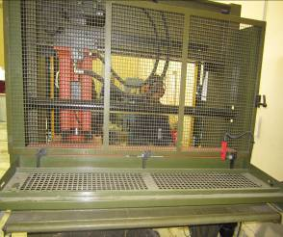
Figure1. 22 Front side figure 1.23 Back side
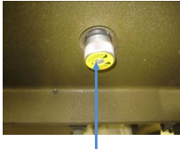

Figure 1.24 Hydraulic Pressure Adjustment

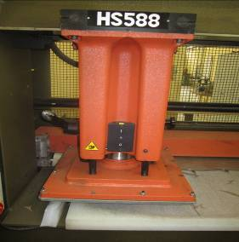

Figure 1.25 travelling Cutting Head

- Normal mode
- Adjustment mode


Figure1.26.controller
- The Cutting Beam Movement Speed Control
- Feed Roller Controller
- Power Switch

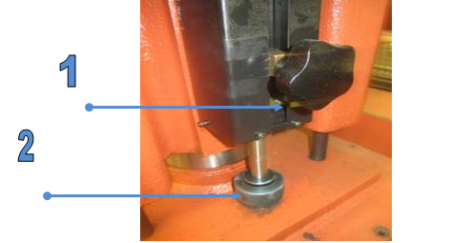
Figure 1.27. Height and pressure adjustment
- Height Adjustment
- Die Cutting Pressure

- Matrix Skiving Machine: Machine is used for matrix skiving on the forepart of the shank board in making insole.
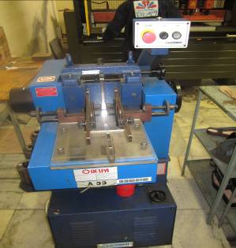
Figure 1.28.matrix skiving machine
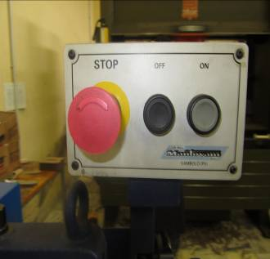

Figure 1.29 Emergency Button

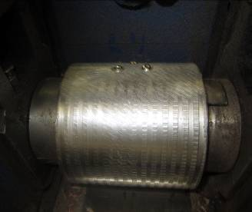

Figure 1.30 Matrix Skiving Roller
- Steel Shank Riveting Machine: To put the rivet in steel shank for attaching with Shank board.
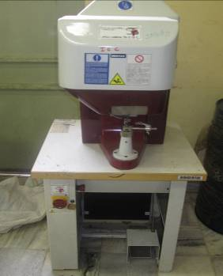
Figure 1.31 steel shank riveting machine

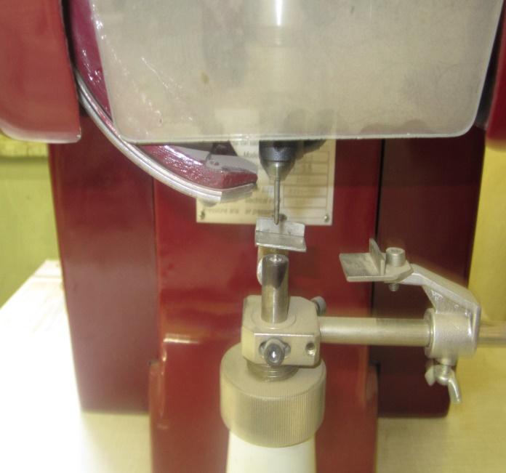

Figure 1.32 steel shank riveting zoom
- Eyelet Feeding
- Hammering Rod
- Height Adjustment
- Shank Grooving Machine: Machine is used for reduce the material for shank board according to measurement of shank.
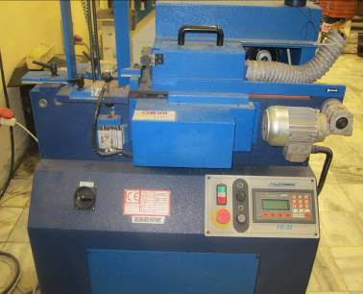

Figure 1.33 shank grooving machine



Figure 1.33 shank grooving machine controller
- Automatic
- Manual
- PLC(Program Logic Control)



Figure 1.34 shank grooving machine setting

- For Cutter Switch On
- Shank Length adjustment for Shank Cut
- Press 0 Button For Change Value
- Then Press Enter For Save

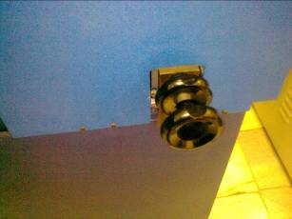
Figure 1.34 Shank Heel Length Gap Adjustments from Back Side
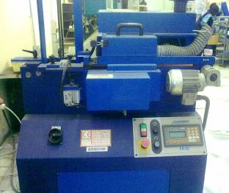

Figure 1.35 matrix skiving machine controller positions

Insole Molding Machine: To give the pressure on insole according the last bottom profile.

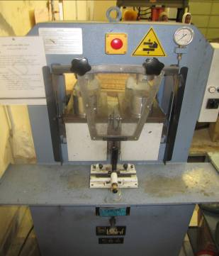
Figure 1.36 insole molding machine
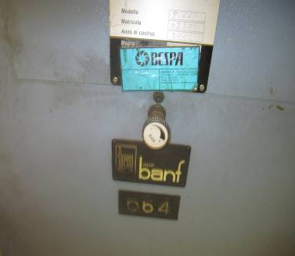

Figure 1.37 insole molding machine Hydraulic Pressure Regulator

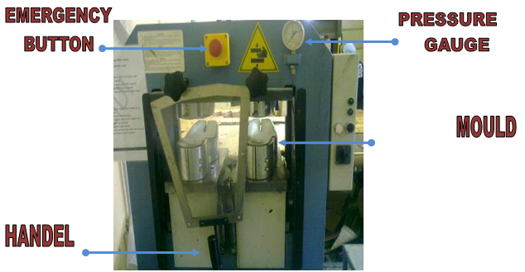
Figure 1.39 insole molding machine
- Insole Moulds:
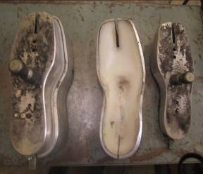
Figure 1.40 insole moulds

- Beveling m/c: This m/c is used for cutting the back part of the insole according to the bevel angle of the last.

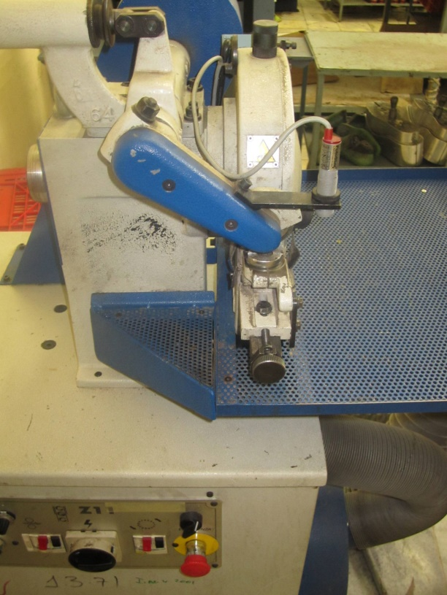

Figure 1.41 beveling machine parts
- Guide Roller
- Feed Roller
- Edge Trimming Cutter
- Pressure Foot Adjustment for Feed Roller
- Photo Electric Sensor for Insole Turning Speed Controlling
- Guide Roller Front & Back Movement
- Angle Adjustment for Guide Roller



Figure 1.42 beveling machine controllers
- Photo sensor With deduction speed controller
- Photo sensor Without deduction Speed controlling
- Cutting dies:
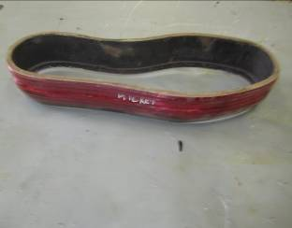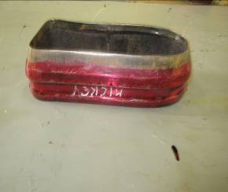
Figure 1.44 cutting dies for insole and shank board

- Cementing (Plain) : This m/c is used for only Insole board.
Cementing (flexible) : This m/c is used for only shank board.

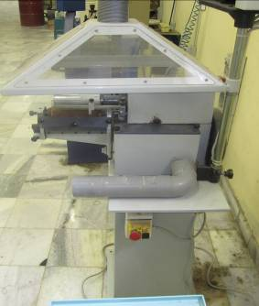

Figure 1.45 cementing machine
- Glue Apply Roller
- Allowance Guide
- Glue Tank

1.2.3. MACHINERY AND EQUIPMENT REQUIRED FOR UNIT SOLE MAKING
- Travelling head cutting press: Machine is used for cutting sole & heel.
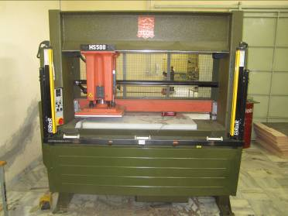
Figure 1.46 Travel head cutting press
- Splitting machine: This machine is use for split the leather for uniform thickness as per the requirement of substance
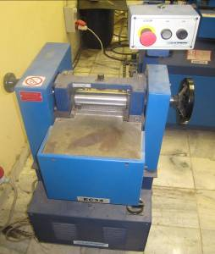

Figure 1.47 splitting machine
- Thickness Adjustment
- Feed Roller & Knife
- Roughing m/c: This is the process to raise the fiber for deeper penetration of adhesive during sole pressing.
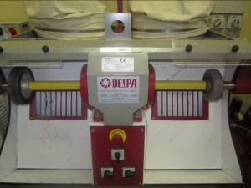

Figure 1.48 roughing machine
- Dust collector
- Emery wheel
- Sole Edge trimming machine: This outsole trimming machine adapts to make the edge of outsole round shape, flat & straight arc according to desired craftwork of outside appearance of high quality leather shoes, which make the edge of leather shoes more beautiful and elegant.
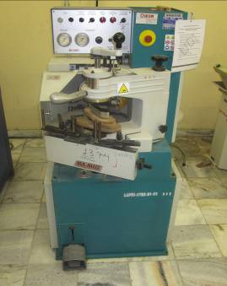

Figure 1.49 sole edge trimming machine

- Height adjustment
- Pattern holder
- Holder up & down switch Pattern holding clamp
- Arm
- Foot paddle
- Cutter


Figure 1.50 sole edge trimming machine controller
- Speed Controller
- Pressure Regulator
- Pneumatic Pressure Gauge
- Heel cupping machine: Heel cupping machine give special shape to heel so that seat of lasted upper can sit properly on the heel cup to avoid gaping on the edges.
- Sole grooving machine: This machine is self-possessed of powerful mechanism, cutting and decorating mechanism. The lift of worktable is controlled by pneumatic device, electrical equipment system controlled by integrated loop circuit and replaceable accessories of different specification.

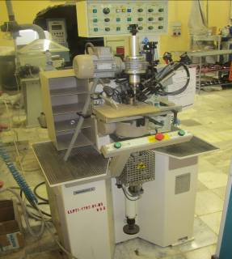
Figure 1.51 sole grooving machines

Figure 1.52 sole grooving machine controllers
- Track roughing machine:
Track roughing machine remove the filters in certain width & depth of flash side of the sole. So that lasted upper can sit properly in to the track.\
h. Sole edge coloring machine:
Coloring or inking machine with chromed rollers for coloring men's and women's flat soles, heel covers, strips of leather or skins etc. with perfect results, using water, alcohol, or wax based inks. Dosing is very simple and coloring results are perfect. Stainless steel extractable ink tank making color change and cleaning rapid and easy.
i. Sole stamping machine:
Stamping machine for marking size, brand name etc on the sole. Molding plate with designs makes the stick to leather surface firmly by heating, which will never become lighter.
j. Sole buffing machine: This machine gives finishing tech to the sole. Buffing on sole with fine emery paper 150-180.
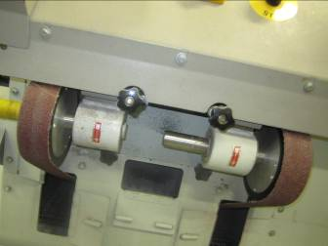

Emery Paper

Figure 1.53 sole buffing machines
- Sole polishing machine: Feature of this machine are mainly for after-processing's polishing (surface decoration, waxing, coloring, etc), Natural carnauva application on woolen brush & finishing the sole with the R.P.M. of 1600.
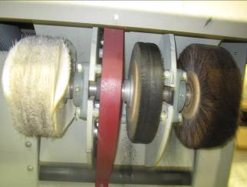
Figure 1.54 sole polishing machine
L. Heel trimming & shaping machine: This machine is used for remove the extra material from heel and gives proper shape.
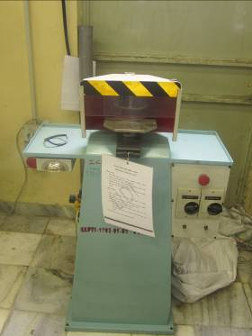
Figure 1.55 heel trimming and shaping machine
Cutting dies:
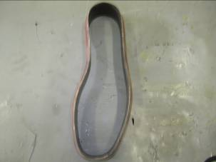
Figure 1.56 cutting dies

1.2.4. MACHINE AND EQUIPMENT REQUIRED FOR TOE-PUFF AND COUNTER STIFFENERS
- Travel head cutting machine: This m/c is used for cutting toe-puff and stiffener sheet.
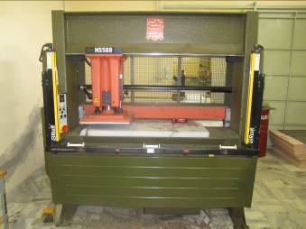
Figure 1.57 travel head cutting machine
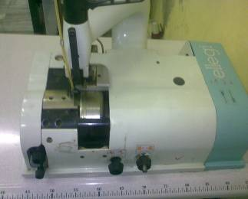
- Heavy duty Skiving machine: skiving machine is use to reduce the thickness of toe-puff & stiffener from the edge.

Figure 1.58 heavy duty skiving machine
- Pressure Foot
- Allowance Guide
- Feed Roller
- Bell Knife
- Knife Grinding Adjustment
- Knife Movement
- Feed Roller Adjustment
- Cutting dies:
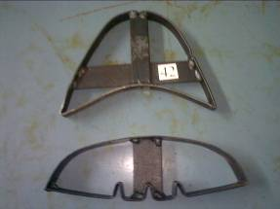
Figure 1.59 Cutting dies toe-puff and counter stiffener

1.3. Performing handling and care requirements for materials
3.1.1. Handling of different materials
Material may be defined as the regulation of the organization relating to procurement, storage and usage of material in such a way as to maintain an even flow of production without excessive investment in material stock. Material control involves control of three important functions.
- Procurement
- Storage
- Usage
Just as the handling of cash is of utmost important in case of non-manufacturing business, an efficient handling of materials is vital importance in the case of a manufacturing business.
Material constitutes an important part of cost of production of an article. This cost account for nearly 60 per cent of the cost of production of a large number of private and public sector organizations. Therefore, proper control in handling the material of a business plays a vital role in the success of the business. If the raw material or other spare parts are not available readily, there could be chances of losing machine time and labor cost and which ultimately result in production loss.
The material can be divided into two categories:
- Direct Materials: The materials which can easily be identified and attributed to the individual units are known as direct materials. These materials from part of the finished product. Leather, insole board used for manufacture of shoes is examples of direct materials. All cost which is incurred to obtain direct materials are known as: direct material cost.
- Indirect materials: Indirect materials do not form part of the finished product and cannot be conveniently are accurately allocated to a particular unit of product. Examples of such materials are lubricating oils, cotton wastes and consumable spare parts required for the maintenance of machines etc. cost associated with indirect materials are known as “Indirect material cost”.

Objectives of Material Handling:
Following are the objectives of material control:
- Continuous availability of all types of materials in the factory ensures uninterrupted production. Lack of material may interrupt continuous production.
- It can prevent losses caused by over stocking materials.
- It can help maximum utilization of economy. Working capital may stick up by over stocking materials.
- Material control provides information regarding exact position of stock available to the management. Frequent stock position is essential for better management of the business.
- It helps the maximum utilization of storages capacity of the organization and can prevent losses during storage.
- It can ensure the quality of material. Quality of material may decrees, if it is not stored properly.
- Ordering right quantity of goods can save transport cost and handling charges.
Advantages of Material Control:
Following are the main advantages of material control.
- It minimizes capital investment in the stock of materials.
- It eliminates wastage and loss of materials arising on account of spoilage, theft etc.
- It ensures uninterrupted production.
- It reduces the cost of storages and transportation.
- It aids the management to create proper purchase policies regarding materials.
- It ensures the purchase of material at the reasonable price.
- It facilitates the inventory control and valuation of closing stock.

1.3.2 Care requirements of insole materials
Insole is the base of the shoe on which the upper is lasted. When a shoe is used, the foot rests on the stage of insole and brings to bear all type of mechanical stresses. It therefore, provides protection to the foot along with the outer sole and also takes up moisture in the form of perspiration from the foot. Insoles may be half or full depending upon the construction and design of the shoe.
The requirements for an ideal insole material are:
- To absorb moisture readily and dry out quickly.
- Durable enough to stand up to friction in wear.
- Flexibility, and does not harden and harden and crack in wear.
- Dimensionally stable (does not alter in shape in manufacture or wear).
- Uniformity in thickness and quality.
- Lightness in weight
- Ability to hold tacks, adhesive, or stitches.
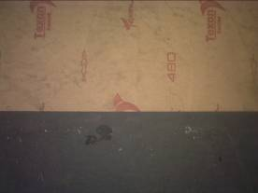
Figure 1.60: insole board
In footwear industry the following boards are used for insole making.
- Insole board/cellulose board
- Shank board/Becker board
- Leather board
- Leather
- Steel shank
Insole board/Cellulose board:- Cellulose board for insole are made from wood pulp, resin and bonded with latex. As with leather boards it is supplied in sheet in various thicknesses, and in different grade. This material has better dimensional stability than leather boards.(i.e. does not shrink or grow). It is a flexible board. Common trade names are Texon, Bontex.
Typically women’s insole use cellulose board of thickness 1.25 – 1.75 mm and men’s insoles boards of thickness 1.5 – 2.25 mm. from a standard sized sheet of dimensions 150 x 100 cm about 33 pairs of men’s insole can be obtained which translates to a usages norm of 450 square centimeter per pair of insoles. Similarly for women’s insoles about 38 pairs can be produced from a sheet of 150 x 100 centimeter which is equivalent to suage norm of 395 square centimeter per pair of insole.
The characteristics of this material are:
- Its ability to absorb moisture
- Uniformity of substances
- Resistance to shrinkage or growth (in change of humidity and heat)
- Resistance to hardening or cracking due to moisture or perspiration.
Shank board/Becker board:- This is a very hard and strong fiber board, able to withstand the tremendous loads which occur in the waist and heel of the shoe. It is again produced in much the same as way as paper. However the main raw material is mixture of waste and recycled paper which, together with the vegetal bonding resins used in its manufacture, make shank board a very environmental friendly product. The molding quality of this type of board is less than cellulose board.
The standard sheet size of shank boards are 100 x 100 centimeter and the thickness is 2 – 3 mm.
The following raw materials are used for the manufacture of backer board;
- Paper pulp
- Dye
- Hard resin binder
- Aluminum sulphate
- Preservative
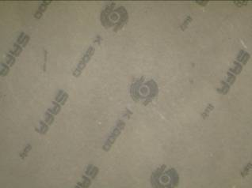
Figure 1.61: shank/Becker board
- Leather: - leather is not much used because of high cost and the lack of uniformity in thickness. Leather insole were usually cut from bellies (sometimes shoulders), and are now used only in very high quality footwear e.g. men’s welted.
- Leather board: - A flexible manufactured board made up with at least 75% leather fibers, which gives it the ability to absorb perspiration. It is made in sheets in various thicknesses (mm), and in different grade to suit particular shoe making requirements e.g. tack holding, cement bonding, high pressure/heat for injection molding. Common trade names are Ferrersflex, Articor. Many grades of leather board are available and this material extensively used in the footwear trade as a insole material as well as toe puff and stiffener.
Leather board is manmade material widely used by shoe industry. It is a compound of fibrous substance, vegetable matter and leather scrape bound together with latex rubber. Resin and alum are used in it while mixing. It helps to make the board more waterproof. The alum takes part to thicken with the latex.
General characteristics of a leather board:
- Width, length, thickness can be made to order, as opposed to the varying thickness and sizes of leather pieces.
- It has most of the quality and properties of leather.
- Cheaper than leather.
- For superior flexibility and durability as compared with card board or any other types of boards.
- It retains the leather look, which other types of boards do not have.
- Economic in manufacturing, the ingredients being are waste materials and by-products of trimmings and shavings from chrome tanned leather.
Shank/shank steel:-
A shank steel is one of the most vital components in a shoe. In providing essential support for the arch of the shoe, it has to withstand heavy bending and stresses whilst maintaining alignment of forepart and heel throughout all the stresses of shoe’s life.
The Shank is a metal strip that from part of the insole. It maintains the longitudinal arch of the foot. Generally shanks are made of high grade carbon steel which is properly tempered in order to impart the required material properties. In ladies high heeled shoes, the shank is shaped in such a way that it extends into the heel. Dimensions of typical shank are 10 mm width x 1 mm thickness and length of 85, 95, 105 mm as per size of footwear.
There are various material used for making shank.
Metal : are manufactured from steel. Two thickness of steel are commonly used 1.2 m.m. and 1.42m.m, the first being the more common. These are available in two widths: 9.5 m.m. and 12.7 m.m. although other widths and thickness are used.
Table 1. Shank metal types
Shank length (m.m.) | Minimum Total Shank Depths (m.m) for:
Shank length (m.m.) | 9.5 mm wide shanks | 12.7 mm wide shank
Less than 50 | 2.18 | 1.22
50-74 | 2.82 | 2.18
75-99 | 3.40 | 2.82
100 and over | Not recommended | 3.45

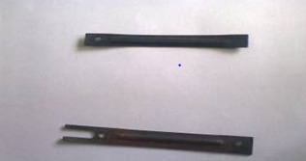
Figure 1.62 shank steel
Wood: wooden shanks are not as strong as steel shank. But they are light in weight. Bamboo shanks are also used for a low heel shoes. In welted footwear a special board wooden shank is used which ultimately covers the space between welt ribs, doing an important job both filler and a shank. Wooden shanks are skived to give a tapered edge at each end and along the side.
Plastic: the plastic shanks are the edition among the shank materials. It is generally used for the PVC unit soles. The shanks are made from polystyrene or polypropylene injection moldings. It is hard plastic but less inflexible than wood or steel shank.

3.3 Care requirements of sole materials
Soling material if we go back at 60 years in the shoe industry we will find that only vegetable tanned leather were used as a soling material. But during last 50-60 years there has been a significant change in soling material used in the footwear trade. The first major changes took place during 1940-50 when rubber was introduced as a soling material to replace leather mainly from cheap grade shoes but its durability attracts industry. The most significant development took place during 1960-62 were the introduction of shoe bottom molded directly using PVC or plastisol and subsequently introduction of PVC injection on process. This D.I.P. (direct injection process) made the shoe production faster and comparatively trouble free. The polyurethane soling material was introduced in the footwear trade in early 1970. Due to its light weight and higher durability it captured the massive market of platform unit sloes used for fashionable ladies shoes and sandals. Almost at the same time with P.U. soling/Thermo Plastic Rubber (T.P.R.) was also introduced in the market. This material provides a combination effect of both rubber and plastic. The soling material may be broadly classified in to two groups.
- Natural soling material
- Synthetic soling material
Sole the main function of the outsole is to provide grip as well as to reduce wear on the midsole thereby increasing the overall durability of the shoe. Early outsole units were made of leather or rubber and were modified according to the athlete’s need. For example, early running shoes used for track events could best be described as leather shoes with nails driven through them. Today, the outsole for track shoes have plastic plates molded into them that allow a runner to change the spikes used depended on the day’s event.
Early basketball shoes used a rubber compound that provide some cushioning but tended to wear out pretty easily. Little thought was given to traction relative to specific movements in basketball, like running vs turning, as well as to the type of surface the game was being played on. Today, basketball shoes reflect the need to address the differences between surface types, indoor wooden courts vs. outdoor concrete courts, as well as the understanding that frictional needs differ, depending on movement, in different areas of the outsole.
The ideal requirements for a soling material are:

- Durability
- Flexibility
- Waterproof
- Lightness in weight
- Non Slip
- Uniformity

Natural soling material
Vegetable tanned leather: is accepted in the trade as the most suitable soling material for high quality footwear, because it has all the essential qualities of good soling material except durability. The reason that is has now been superseded is due to the fact that it is too expensive for most types of shoe.
Most soles today are pre finished and because leather is not a uniform material in texture or substance, it does not lend itself to pre finishing.
Leather used soling is buff leather and various thicknesses from 4mm – 7mm. it is available as in Kg. weight unit.
Leather sole has the following advantages-
- It is one of the most ‘hygienic’ soling materials with case of perspiration as the upper leather.
- It gives product the unique/antique class & appearance as desired in high class footwear.
- Good sole bonding with upper cement due to fibrous structure present.
The main disadvantages of its usages are-
- It is very expensive sole and the cost further increases due to restriction of various regions.
- It is inflexible and sufficient heavy.
- Its processing is quite time taking, skilled and expensive.
- It is less durable especially in wet conditions.
- Cannot blend with modifiers as in polymeric soles to give a variety of properties.
Synthetic soling material
- Resin Rubbers: In recent years, shoe sole of a type has now come to be Resin-rubber have become very popular, especially for ladies and children footwear because of its hard wearing properties. This product was first of all launched in market under the name of ‘Neolite’. Similar to sole leather in general appearance.
It has the following characteristics-

- Hard wearing
- Waterproof
- Easily processed
- Readily stuck, sewn or nail –in

Note: The main defect of resin rubber is tendency to extend in wear, giving a cold feel in wear.
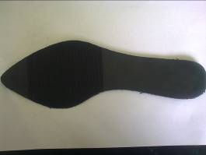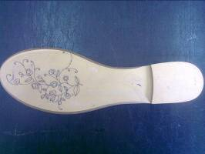
Figure 1.63: resin rubber soles
- Microcellular Rubber (MCR): It is very widely used as a soling material in the shoe industry because it is very light in weight. It has a very good abrasion resistance and can be made in any colour as per the choice of the customer. The micro rubber has pores which are extremely small.

Advantages are:-
- Lighter in weight, provides more comfort.
- Better shock absorption than solid rubber.
- High flex crack and slip resistance.
- Abrasion resistance is better than vegetable tanned leather sole but not as good as most solid rubber compound.
- Good ground insulating qualities.
Disadvantages:
- Micro cellular rubber has a tendency to shrink about nearly 10% of the original expansion after it removes from the press.
- Wear resistance is not very good.
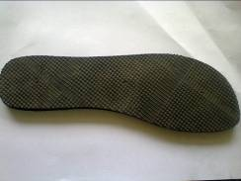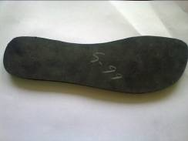
Figure 1.64: MCR rubber soles
- Mesonite Heels: Mesonite is a type of hardboard made of steam-cooked and pressure-molded wood fibers. Forming the fibers into boards on a screen, the boards are then pressed and heated to form the finished product with a smooth burnished finish .The long fibers give Mesonite a high bending strength, tensile strength, density and stability.
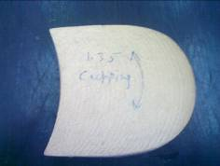
Figure 1.65 Mesonite heels
- Plastic Heel:
Although the function of the heel in footwear design is difficult to justify, heels have been important part footwear since the 16th country. The last three decades, in particular, have seen major development in design, materials, and method of manufacture. Heel have aborned shoes in variety of shapes and size, from short and thick to tall and slim, from wedge – shaped to square – shaped.
More recently new materials have been introduced, providing fresh design scope and new methods of shoe making, wood, the traditional heel and associated shoemaking problems. We shall examine type of heel, their manufacture, and the evaluation of heels and their attachment.
Many different heel types are used in modern footwear. The most common types for women’s shoes in injection – molded plastic, although turned wood heels and built heels are still used. Built heels, however are used mainly on men’s shoes.
This is molded heel and any type of plastic material, which is capable of being molded to shape, may be used for this purpose. But considering the various requirements of heels “high Impact Polystyrene” (HIPS) is the most suitable material for this purpose to make a heel.

- Injection – molded heels:
The two main styles of heel made by the injection – molded process are the cavity – molded ‘chunky’ heels for both men and women and stiletto heels.
- Chunky heels:
The most common materials used for this type of heel are polystyrene, ABS (Acrylo nitrile-butadiene-styrene), polypropylene and expanded plastic.Nearly all chunky heels used now –a –days are molded from high coloured. The latter need to lacquered as they don’t give very good quality finish. The best grades must be used so as to avoid brittleness and cracking on attachment, which is the main fault with chunky heels. The use of ABS in chunky heels has been limited to heels intended for electroplating it is harder than most grades of polystyrene and so heel – attaching pin require greater pressure for insertion. Consequently, its pin-holding strength is greater. ABS is available in self-colored form and lacquering is necessary.Polypropylene has been used only on a limited scale for chunky heels because it is more difficult to mould than polystyrene and is slightly more expensive. It has excellent impact and fatigue resistance and does not become brittle. Although expanded plastic would appear to be a good choice for covered chunky heels particularly where lightness of weight is required because of its inadequate pin holding strength, it is not recommended unless a solid insert is used in the seat to take the attachment grindery.
Plastic chunky heels are produced by conventional injection molding techniques. All heels are molded in a multi-cavity mould. The mould used is called a hot runner mould. Heels are injected close to centre of the seat surface. After release from the mould, the heels are immersed in water for cooling.
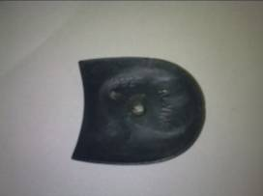
Figure 1.66 : chunky heels
- Stiletto heels:
For stiletto heels, the most widely used plastic is polystyrene, but other materials used include ABS(Acrylo nitrile-butadiene-styrene), polypropylene, polyacrylate, nylon and expanded polystyrene.
When stiletto heels were fashionable in the 1950’s they were usually made from polystyrene, which was relatively cheap and freely available other plastics were tried, but most were eventually dropped in favor of polystyrene, which was stronger, easier to mould and lacquer, and less expensive. With the return of the stiletto heel in the late 1970’s the best grades of high-impact, toughened polystyrene were still being recommended.
Most of the strength of a stiletto heels in its steel reinforcement. Nevertheless, a plastic compound with adequate impact and fatigue resistance must be used to prevent stem breakage. Breakage in wear occurs in two ways- either by a sudden sharp impact or wrench, such as in stepping off a bus or getting caught in a grating, or else by fatigue built up by the repeated small impacts of normal walking. To combat both type of failure, the plastic must have good fatigue resistance and brittle grades must be avoided.
Like chunky heels, plastic stiletto heels are produced by conventional injection-molding techniques. Hot runner molding was adopted during the 1960’s when stiletto heels were in fashion. It superseded gate molding, which involved injection the heel from the centre of the breast edge. One reason for changing the position of the injection point was to change the direction of flow of the stream of plastic to eliminate flow lines that formed down the stems near the tip. This was not important when heels were covered, but it was unsightly on lacquered heels.
Steel rod reinforcing inserted are either molded in or inserted after molding. when they are molding in, they have to be located on a spigot at the trip end of the mould cavity.
This delays the moulding cycle, and for this reason some manufacture prefer to reinforce after moulding by inserting the steel inserts into drilled stems.
Many different types of reinforcing insert have been used, but steel is the most satisfactory and allows for extreme heel shape. Medium –hard steel is suitable for the most heels, and if failure occurs in wear, the inserts usually bend rather than break, minimizing injury to the wearer. Some grades of hard steel that have not been correctly heat treated will break readily, usually when the plastic breaks.
Three types of steel insert are suitable for stiletto heels – solid rods (drilled at the tip), tension pins, and solid rod inserts with top-pieces attached.
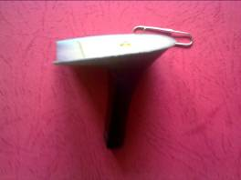
Figure 1.67: stiletto heels
1.3.4 Care requirements of toe puff and counter stiffeners
Even with the current demand of less structure footwear, particularly in the search for foot comfort, the toe- puff & stiffener are still one of the most important ingredients in the production of footwear. Whether it is the high fashion, welted, or even sports shoes most of it requires reinforcement at the front and back side of the shoe. We have a wide variety of both the materials and also the several application techniques to suit both the application as well as artistic look of the footwear.
From the wearer’s point of view both perform a similar function in maintaining the shape of the footwear and both must have a good wear performance which necessitates the ability to retain their shape & strength when repeatedly collapsed or exposed to moisture. Additionally, a toe-puff should be able to flex with the foot in wear without causing discomfort or creasing. The required hardness of the toe-puff and stiffener depends on the type of footwear. In lightweight casual shoes, soft materials are sufficient. Also the properties and shape of toe-puffs & stiffeners are influenced by fashion trends.

- Flat Stiffener
This could be both solvent activated and Heat Activated and Cut from the sheets as per pattern to insert at the time of lasting.
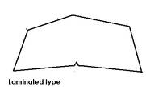

Figure 1.68 flat stiffener
- Semi Molded Stiffener
Stiffener is added in closing section itself, Stiffener is finger molded before insertion. This type of stiffener is thermoplastic and needs to be softened by heat at some stage of lasting process.
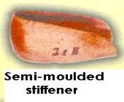

Figure 1.69 semi molded stiffener
- Fully Molded Stiffener
High quality shoemakers who wish to use high-grade leather board stiffeners often use this type of stiffener. The stiffener manufacturer molds it to the shape of the back of the last and the flange is molded in.

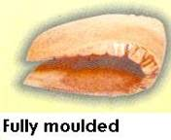

Figure 1.70 fully molded stiffener
- Solvent Activated
These puff are impregnated with either nitrocellulose or polystyrene resin. Polystyrene has recently become popular as the impregnating resin in solvent activated puffs. Production of the polystyrene sheet material is similar to that for the nitrocellulose type. The solvent blend to activate the puff should contain toluene, which dissolves more readily then the resin.
With all solvent activated materials, thorough activation is essential so that the materials easily conforms the shape of the back & fore part of the last. It is also essential that some portion of solvent is still present while lasting. However too much solvent’s presence leaves the stain marks in the lining as well as upper.
The toe-puff must immediately be applied to the upper. The bonding takes place only when the toe-puff has sufficient amount of solvent in it.
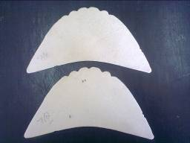
Figure 1.71 solvent activated toe puff

2. Thermoplastic Materials:
Adhesive coating on heat – activated puff (for heated press application) are based on P.V.A ( poly vinyl acetate), E.V.A.(ethylene vinyl acetate),polyacrylate, polyurethane. Resin and plasticizer are added to impart the required adhesive properties. More recently, hot melt adhesive have been used. The adhesive is heated to 120-140 C and is applied as single coating.
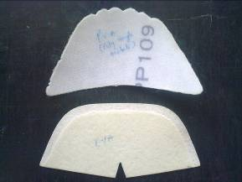
Figure 1.72 thermoplastic materials
The following recommended uses of various types and thickness of puff are given as guidelines rather than as hard and fast rules.

Table 2 uses of various types and thickness
 | Solvent activated fabric-based puffs |  | Thermoplastic
 | Cellulose – Nitrate impregnated | Polystyrene impregnated | Polystyrene impregnated
Women’s shoes | 0.7-0.9 mm | 0.5-0.8 mm | 0.4-0.7 mm
Women’s heavy shoes and boots and children’s and men’s light shoes. | 0.9-1.2 mm | 0.8-1.0 mm | 0.7-1.0 mm
Men’s and Boy’s shoes | 1.2-1.6 mm | 1.0-1.2 mm | 1.0-1.2 mm
Men’s heavy shoes industrial boots and sports shoes | 1.6-2.0 mm | 1.2-1.6 mm | 1.2-1.5 mm
3. Steel Toe- Cap: These toe caps we use in safety shoe Steel protective toe caps are extremely hard and difficult to damage They are heavier than aluminum or plastic toe caps, and bend under pressure, anti-rusty.
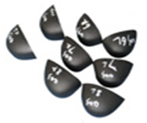
Figure 1.73: steel toe caps
4. Plastic Toe- Cap
Superior strength-to-weight ratios. At the same strength, thermoplastic plastic shoe toe is 50% and 20% lighter than using steel and thermosetting plastic respectively. No rusting, excellent corrosion, chemical and climate resistance.
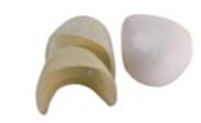
Figure1.74: plastic toe-cap

1.4. Identify Common problems and faults of materials
4.1.1. Common problems and faults of different materials
- Leather sole
Leather defects that can be found in the finished leather can be classified into two basic groups.
- NATURAL Growth marks ,tick marks and etc.,,,,,
- MAN MADE Brand marks, Flay cuts, Flesh cuts and etc.,,,
From these defects, mostly the man-made defects affect the quality and cutting value of the bottom leather and as such, these defects are described below.
- BRAND MARKS:
These are identification marks made on the skin of the animal, by the owner, using hot branding irons, which causes deep marks, resulting in damage to the skin or hide and resulting finished leather. Normally the brand marks are inserted in the butt area which is the area with the best leather.
- FLAY CUTS:
These operation by which the skin or hide is removed from the animal, is referred to as flaying. During the flaying operation, due to bad handling of the knife, sometimes deep knife cuts are made into the skin or hide, resulting in damage.As these cuts are taken from the flesh side, of the skin or hide, they are not so visible from the grain side of the finished leather. Therefore when cutting bottom leather, the grain side as well as the flesh side, should be carefully inspected for such deep cuts.
- FLESH CUTS:
The removal of the excess flesh (soft tissue) from the skin or hide preparing it for the tanning process is referred to as fleshing and this operation is carried out by hand or by machine.
Specially during hand flashing, sometimes deep cuts are made on the skin or hide, due to the careless handling of the knife by the flashing operator.
They are also similar to flay cuts and should be inspected carefully from the grain side and flesh side of the finished leather, before cutting.
Common problem in leather sole:
- Leather issued without considering grade.
- Loss Leather.
- Brand marks on the finished leather
- Flay cuts on flash side
- Flesh cuts on flash side
- Thickness variation
- Defects: Defects of leather include fiber quality, soft spots, brands, cockle, scratches, wrinkles, insect bites, grain damages, grub damage, cuts, skiving defects and fleshiness.
- Natural markings: The subtle markings on leather are analogous to finger prints. They distinguish genuine leather from manmade materials. Other marks which can appear on the surface of leather are healed scratches and scars, barbed wire marks, stretch marks, vein marks, wrinkles, brands and insect holes.
INSOLE BOARD:
Common problems of insole boards:
- No uniformity of thickness
- Creaking due to moisture
- No flexibility
- No resistance to shrinkage or growth
- Dust and dirt on the board
- No ability to hold tacks adhesives or stitches.
- More bulky

- Factors of deterioration :
Deterioration is a change of original state of any material by interaction between the object and the factors of destruction. The different types of deterioration of the cellulose board materials are reflected in wear and tear, shrinkage, cracks, discoloration, abrasion, hole, dust and dirt etc.
- Humidity and Moisture:
Humidity is the amount of moisture in the atmospheric air. The moisture is measured in terms of relative humidity. All organic objects absorbs water to a greater or lower extent and the water goes inside the object through surrounding air. Because of this absorbency property, the fiber board absorbs more moisture when there is high humidity. Certain amount of humidity is necessary for the flexibility of fiber board but in prolonged high humid condition, board becomes wet and the moisture weakens the fibers of board.
C. Dust and Dirt:- Fine dry particles of any matter present in the air are known as dust. Since dust is air borne it settles down on any surface of the object
HEEL
Common problems and faults of heel materials:
- Not good quality finish.
- Color not matching.
- Cracking on attachment.
- Last bottom profile not match with heel
- Size not matching
- Inadequate pin holding strength
TOE PUFF AND STIFFENER SHEET
Common problems and faults of toe puff and stiffener sheets:

- No uniformity of thickness.
- Less tack retention.
- No ability to survive molding and shape retention.
- Skiving problem.
- Coating of adhesive not goo

SHANK
Common problems and faults of shank/Becker materials:
- Variation of thickness
- Strength or performance
- Length & width problem
- Shank design not match
- Problems and faults due to the brands of the manufacturer
Below there are Generic trade name of material which are suitable and perfect to footwear manufacturing
- Common trade names are Texon, Bontex, Novatex. (insole board)
- Common trade names are Ferrersflex, Articor (leather board)
- This product was first of all launched in market under the name of ‘Neolite’. (Resin rubber sole)
- Common trade names are Gypsum board (shank board)

Identifying suitable Personal protective equipment
PPE is equipment that will protect the user against health or safety risks at work. It can include items such as safety helmets, gloves, eye protection, high-visibility clothing, safety footwear and safety harnesses. It also includes respiratory protective equipment (RPE)
In addition to being aware of the mechanical hazards in the component section, it is important that you use the correct protective clothing and equipment. Wearing personal protective equipment (PPE) can prevent accidents from happening. As a worker, you are responsible for the following:
- Making sure your uniform is well fitted.
- Keeping all uniforms clean and in good condition, not frayed or badly worn.
- Making sure sleeves are kept buttoned at the wrist, cuffs on overalls and trousers are be eliminated, and trouser legs are long enough to hang outside boots.
- Wearing specific personal safety equipment such as goggles, hearing protection, gloves, and aprons when required.
To ensure that you are protecting yourself, your personal protective equipment (PPE) list should include the following items.
    - Clothing
This includes well-fitted pants and jackets with all buttons fastened. Sleeves should be close fitting because sleeves that are loose and flowing are potential fire hazards when working over open gas burners. Health regulations require that all machine operator wear hair nets or use other approved methods for keeping hair under control. Aprons should be made of non-combustible and flame-resistant materials that do not melt under heat.
    - Footwear
The OHS Regulation requires that approved footwear must be worn by employees in all industrial occupations. Ensure your footwear is sturdy and provides enough back support to not cause future back problems. Footwear suitable for commercial foodservice establishments must have a non-slip sole and a closed toe and closed back.
Your footwear should be sturdy and comfortable, and if the environment you work requires steeled toes, such footwear should be worn. High leather tops on shoes are a good idea as they will protect your feet from hot grease or liquids.
    - Hand protection
The most common type of gloves used in component section are natural rubber latex gloves, synthetic rubber gloves, and vinyl gloves.
    - Eye protection
Eye protection in the form of safety goggles or masks should be worn whenever there is a chance of eye injury. Particles flying through the air can easily land in your eye and possibly do permanent damage.
    - Hearing protection
Approved hearing protection must be worn when high-level noise conditions exist.
    - Respirators
Respirators should be used to protect yourself from inhaling harmful fumes or vapours. The respirator unit should be properly fitted to provide the best protection. Check the components to ensure they are not broken, cracked, or torn and that they do not have holes. Replace faulty components before use. Each unit will have a filter that should be checked regularly and replaced before the expiration date.

Identifying safety of operator and work place in component section
    - Operator and work place Safety
Safety and health occupies a very significant position and in hazardous occupations. It aims to protect the health and strength of all workers. It prevents employment in occupations unsuitable for the age and strength of the workers. It is the policy of the state to make provisions for securing just and humane conditions of work. The constitution provides a broad framework under which policies and programmes for occupational health and safety could be established.
The factory occupier must facilitate the following facilities for worker’s welfare and their health:
- To ensure cleanliness of the workplace;
- Make effective arrangement for treatment and disposal of waste and effluent;
- Make suitable and effective provisions for adequate ventilation;
- Maintain temperatures to secure reasonable comfort for workers;
- Remove any dust or fumes from the workplace which may be injurious to workers;
- Prevent overcrowding by maintaining a specific cubic area for each worker;
- Provide sufficient and suitable light;
- Make suitable arrangements to provide clean drinking water conveniently situated for all workers and;
- Provide suitable latrines and urinals to specified standards.
The factory occupier must provide basic safety measures including:
- Securely guarding all parts of dangerous machinery;
- Precautions for working on machinery;
- Emergency devices for cutting off power;
- Maintain hoists and lifts;
- Lifting machines, chains, ropes, and other lifting tackle must be maintained in good condition;
- Ensure walking surfaces are of sound construction;
- Provide protective equipment;
- Measures to remove gas and dust before entering confined places;
- Measures to prevent fires.
The factory occupier must disclose information about:
- Dangers, health hazards, and measures to protect workers from substances or materials in manufacture, transportation, storage etc. to the workers, the chief factory inspector, and the local authority;
- Safety and policy;
- Quantity and characteristics and disposal of substances and waste;
- Emergency plans to workers and the local public;
- Handling, using, transportation, storage and disposal of hazardous substances to workers and the local public.
The employer should maintain up-to-date health records of workers, and to appoint a person experienced in handling hazardous substances to supervise handling, and provide protective measures and regular medical examinations.
Equipment Safety: Extreme care should be taken when operating equipment. Before you attempt to operate any tool or piece of equipment, you must be fully trained by an experienced operator. Make sure that all guards are in place and function properly and that all electrical connections are properly made. You should observe the following precautions when using equipment:
- Understand the correct operating procedures and safety precautions before operating a piece of equipment.
- Ensure that all guards are in place and functioning before any machine is started.
- Report defective or unsafe equipment to a responsible individual to prevent serious injury.
- Do not distract or interfere with the equipment operator.
- Make sure that the cords to electrically powered tools are in good condition, with no frayed parts or bare wires showing and make sure that the tools are properly grounded.
- Keep edge-cutting tools properly sharpened so that they do the job well and do not have to be forced because of dull edges.
- Use tools only for their intended use and make sure the size of the tool is right for the job.
- Report to your immediate supervisor any tool or piece of equipment that is broken or does not function properly.

Self-check-1
Directions: Answer all the questions listed below. Examples may be necessary to aid some explanations/answers.
Test I: Choose the best answer
1. Which material is join the upper and sole
(a) Welt (b) Toe puff (c) Stiffener (d) Heel
2. Which material is used for sole manufacturing
(a) V.T. Leather (b) Chrome leather (c) both of them (d) none
3. Heel lift is a layer of
(a) sole (b) Material (c) Insole (d) none
4. Bottom filler is used
(a) To fill the cavity (b) To improve sole appearance
(c) To improve sole bonding (d) All of them
5. Insole is match with
(a) To match foot shape (b) To match last bottom shape
(c) To match upper thickness (d) To match sole profile
6. Which component is come under bottom component (Mark 1)
(a) Vamp (b) Quarter (c) Lining (d) Socks
7. For machine lasting, Toe puff used is
(a) Solvent activated (b) Heat activated (c) Ceramic (d) Leather
8. Abrasion resistance of Shoe Sole helps
(a) Longevity of Shoe (b) Flexibility of Shoe (c) Both (d) None
9. Toluene is use for
(a) thermo-plastic toe puff (b) Solvent activated (c) Leather toe puff (d) None
10. Soling material may be broadly classified in to
(a) One groups (b) Two groups (c) three groups (d) four groups
11. Cellulose board for insole are made from
(a) Leather (b) wood pulp (c) paper pulp (d) none
12. Edge Beveling is necessary for
(a) Lasting (b) Insole Making (c) Better Look (d) None
13. Insole Molding is used:
(a) To match foot shape (b) To match last bottom shape
(c) To match upper thickness (d) To match sole profile
Test II: say true or false for the following questions
- Socks are use between sole and insole.
- Toe puff is use in back part of shoe.
- Shank is use for making sole.
- Insole of shoe which is next to the foot under the shoe sock.
Test III Match the following
A) Toluene 1) for leather sole
B) Matrix skiving 2) Toe puff solvent
C) Insole molding pressure 3) Tool
D) Channel opener 4) 60- 80 bar
E) Sole trimming machine 5) 25 M.M
Directions: Answer all the questions listed below. Examples may be necessary to aid some explanations/answers.
Test IV Short answer
- What is the use of matrix skiving m/c?
- What is the purpose of shank grooving m/c?
- What is the function of track roughing m/c?
- What is the function of sole trimming machine?
- Write about common problems in leather sole?
- What is a factor of deterioration of insole board?
- Write all the common names of insole boards and shank board?
Part V long answer
- What does it mean by personal protective equipment?
- List out and describe some of the personal protective equipment’s?
- Describe briefly about a factory occupier must facilitate related to operator and workplace safety?
- Describe about equipment safety in component section?
Test VI. Fill in the blank spaces
1. Full name of P.V.A. is ………………….
2. Full name of MCR is …………………

Unit Two: Perform bottom component operations
This unit to provide you the necessary information regarding the following content coverage and topics:
  - Identifying types and sequence of operation.
  - Performing interlocking for major components.
  - Preparing and cutting toe puff and stiffener materials
  - Preparing different types of insole.
  - Preparing leather sole.
  - Preparing and attaching heels to the leather sole
  - Cleaning and maintaining work area
This guide will also assist you to attain the learning outcomes stated in the cover page. Specifically, upon completion of this learning guide, you will be able to:
- Identify types and sequence of operation for the preparation of the bottom components.
- Perform interlocking for major components.
- Prepare and cut toe puff and stiffener materials as per the specification of the footwear and procedure.
- Prepare different types of insole as per the specification of the footwear and procedure.
- Prepare leather sole as per the specification of the footwear and procedure.
- Prepare and attach heels to the leather sole as per the specification of the footwear and procedure.
- Clean and maintain work area according to OHS practices and enterprise requirements.

Identifying types and sequence of operation
There are different types of insoles these are listed with sequence of operation
2.1.1 Continental insole
- Cutting of Insole board.
- Cutting of shank board.
- Stamping.
- Grooving of shank board
- Matrix skiving of shank board.
- Riveting/Attaching of steel shank on shank board
- Cementing (a) Plain roller for Insole board.
(b) Flexible roller for shank board.
- Attaching of Insole Board and Shank Board
- Moulding.
- Beveling.
- Final Checking and packing.
Note: - Quality should be checked in every operation.
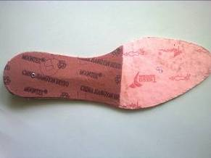
Figure 2.1 continental insole
2.1.2. Sandwich insole
- Cutting of shank board.
- Cutting of Insole board.
- Stamping.
- Grooving of shank board
- Matrix Skiving of Shank board.
- Skiving of Insole Board
- Riveting/Attaching of steel shank on shank board.
- Cementing: a) Plain roller for Insole board.
b) Flexible roller for shank board.
- Attaching of Insole board and shank board
- Molding.
- Beveling.
- Final Checking and packing.
- Used for sport shoes
Note:- Quality should be checked in every operation.
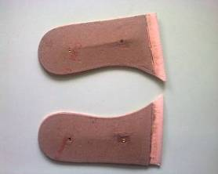
figure 2.2. Sandwich insole
    - Welted insole:-
- Cutting of Insole board.
- Stamping.
- Marking on insole board
- Attach the rib through adhesive
- Attach the cotton cloth
- Final Checking and packing.

- Used for welted constructions
Note:- Quality should be checked in every operation.
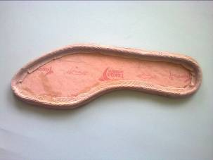
Figure 2.3. Welted insole
    - BLENDED INSOLE:-
- Cutting of shank board.
- Cutting of Insole board.
- Stamping.
- Grooving of shank board.
- Matrix skiving of shank board.
- Skiving of Insole board. (Underlay skiving minimum 20mm.)
- Riveting/Attaching of steel shank on shank Board.
- Adhesive application on fore part insole board and shank board.
- Attaching of forepart Insole board and shank board
- Moulding.
- Beveling.
- Final Checking and packing.
- Note:- Quality should be checked in every operation.
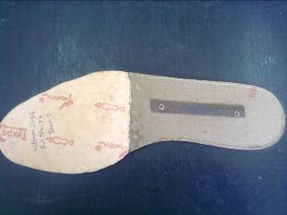
Figure 2.4. Blended insole
    - Skeletal/ripped insole
- These types of insole have different shape related to other types of insoles.
- Used for constructing sandal shoes
- The shape of these insoles used for preparing the straps for sandal shoes
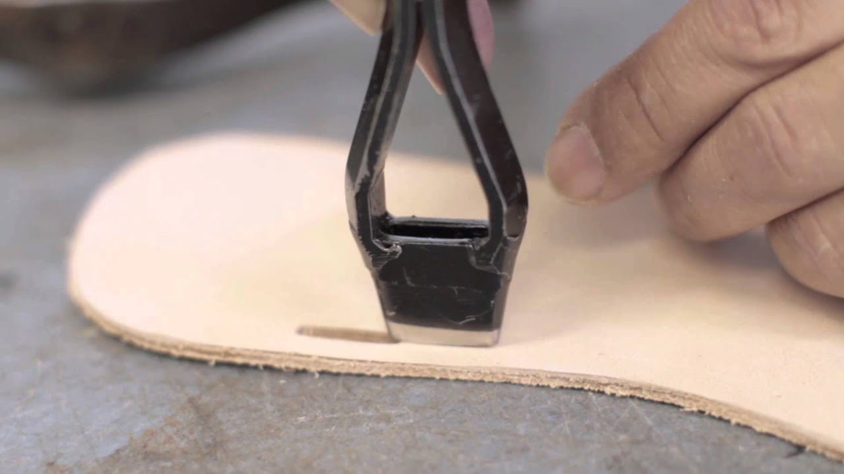
Figure 2.5. Skeletal insole

2.2. Performing interlocking for major components
2.2.1. Interlocking major components
Major components are insole, shank, toe puff and counter. The principle interlocking is similar to these materials; if participants understand the concept of interlocking they can apply it for other.
Insole interlocking exercise
Interlocking concept is to minimize waste and to achieve appropriate quality of component. So typically women’s insole use cellulose board of thickness 1.25 – 1.75 mm and men‟s insoles boards of thickness 1.5 – 2.25 mm. from a standard sized sheet of dimensions 150 x 100 cm about 33 pairs of men‟s insole can be obtained which translates to a usages norm of 450 square centimeter per pair of insoles. Similarly for women‟s insoles about 38 pairs can be produced from a sheet of 150 x 100 centimeter which is equivalent to suage norm of 395 square centimeter per pair of insole.
Using 150 x 100 centimeter sized paper exercise nesting of insole
So according to the direction of positioning insole pattern will be traced

Figure 2.6. Insole board positioning
Start from left bottom to the right and continue (gap between interlocking 1mm)
Trace 1st left and 2nd right in reverse direction, it should have 2mm space between them
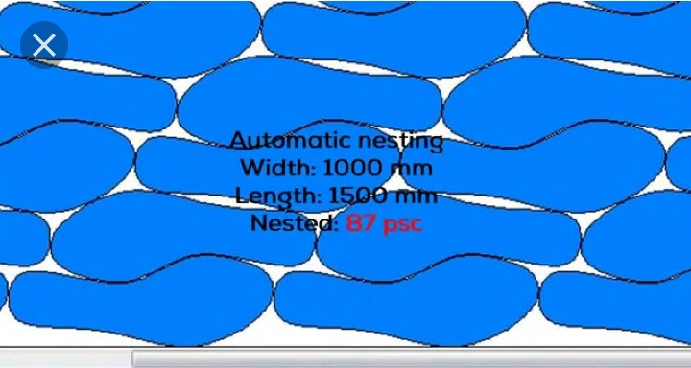
Figure 2.7. : Interlocking method of insole

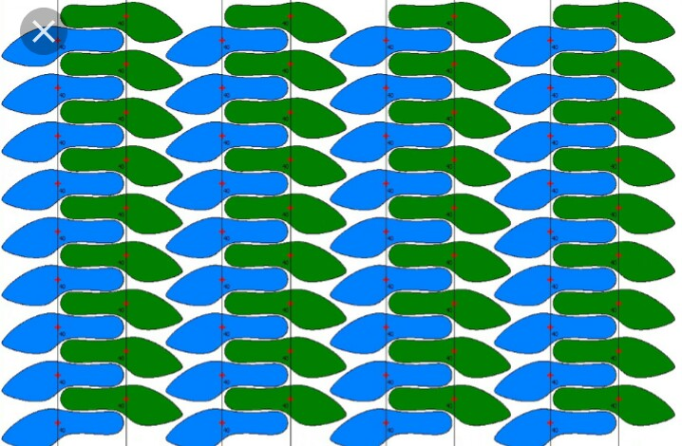
Figure 2.8. Interlocking of women’s footwear insole

2.3. Preparing and cutting toe puff and stiffener materials
2.3.1 Prepare and cut toe puff and stiffener materials
Toe puff and counter stiffener cutting will be done in layers most of the time 4 sheets will be cut at the same time. In one clicking 2pairs of either toe puff or stiffener will be cut
1st prepare the clicking dies for toe puff and counter stiffener.
Figure 2.9. Toe puff an counter stiffener guide
2nd prepare and lay out the sheets on travel head cutting machine
3rd properly position the dies on the sheets
Then operate the machine to cut
Figure 2.10. The cut components of toe puff and counter stiffener

2.4. Preparing different types of insole
2.4.1. Preparing different types of insole.
1. Preparation of continental insole
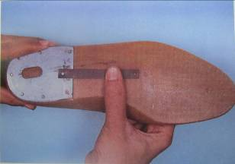
Selecting the steel shank.
Note: The following points to observe when selecting the steel shank.
- The shank is the correct width and length and thickness.
- Shank is fitted 1mm back from highest point.
- Shank follows the bottom profile of the last. Specify shank by angle.
- Shank should end 20 mm under seat of heel.
- Fill all the relevant details in on a sample card.

Figure 2.11. selecting steel shank

Staple insole board
Note: The following points should be observed when selecting a suitable insole board.
- Check the type of shoe construction.
- The climate/market that the finished shoe is destined.
- Board in pairs with plain side facing each other and printed sides always on the outside.

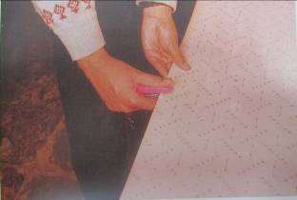
Figure 2.12. staple insole boards

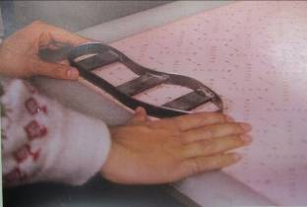
Cut insole
Note: The following points should be observed when cutting insole.
- Insole should be full to pattern.
- Insole should be cut 1 pair at a time when using cold bend knives. 32 mm single edge.
- Cut according to direction marked on insole board as above.
- Cut 1 pair or 2 pair at a time.
- 19 mm die- 1 pair
- 32 mm die- 2 pairs
- Forged knife – 3-4 pairs

Figure 2.13. Positioning cutting die on insole board
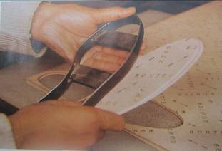
Figure 2.14. Cutting insole boards
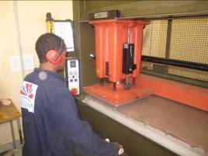
Cut shank board.
Note: The following points should be observed when cutting the fiber shank board.
- Shank should be full on pattern.
- Cut with the grain of material
- Never stamp on forepart of insole on plain side.
- Stamp last no. & size no. on insole.
- Size no. can also be indicated by notches in the die.

Figure 2.15. Cutting shank boards

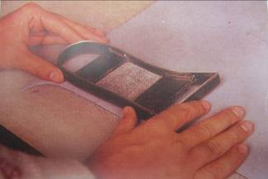
Figure 2.16. Positioning shank

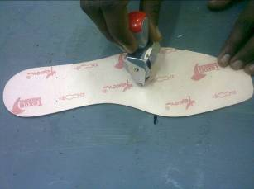
Stamping Insole.
Note: the following points should be observed when stamping insoles
- Check insoles on pattern before size stamping.
- Stamp is clearly readable.
- Stamped to customers specifications
- Use rubber pad inside the die for ejection of shank board.

Figure 2.17. Stamping insole

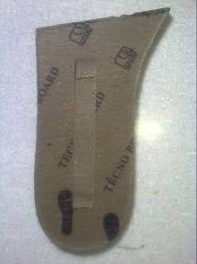
Grooving of shank board
Note: The following points should be observed when grooving of the shank board.
- Grooving should be centre of the sank board
- Grooving as per the length of shank
- According of shank width set the cutter

Figure 2.18. Grooving of shank board
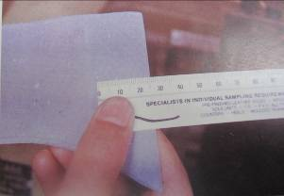
Matrix skiving of shank board.
Note: The following points should be observed when skiving the fiber shank board.
- The end skive of 25 mm should taper to a fine edge. This allows for flexibility.
- Edge skive should be to specification i.e. skive to zero

Figure 2.19. Measuring matrix skiving
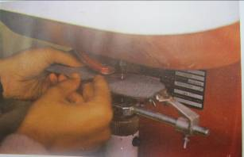
Riveting/Attaching of steel shank on shank board
Note: The following points should be observed when attaching the steel shank to the fiber board.
- Shank is attached at the correct distance from the seat edge.
- shank is attached in the correct line of the shank board.
- The correct steel shank is fitted to suit the height of heel being used.
- That the rivets or eyelets are clinched this will hold the shank in place.
- Fluted size of shank i.e. with recess should be facing upwards for pasted insoles and for plain half insoles fluted side face shank board.

Figure2.20. riveting shank board

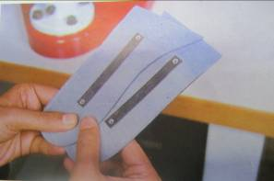
Figure 2.21. Attaching shank board

Cement Insole.
Note: The following points should be observed when cementing insoles.
- A dust free environment should be used.
- Insole should only be cemented upto the length of shank board using a guide.
- Coating of cement should not be too heavy.
- Insole should be kept clean of excess cement.
- Test cement for bond strength.
- Machine should run continuously.
- Use cementing machine with metal roller on and flexible roller at the bottom.

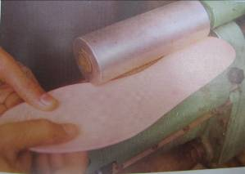

Figure 2.22 cementing insole
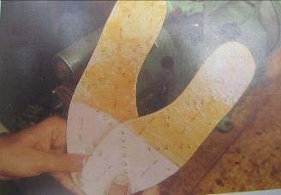
Figure 2.23. Cemented insole

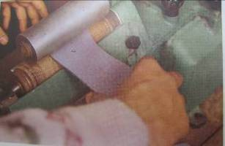
Cement shank board.
Note: The following points should be observed when cementing the shank board.
- A dust free environment should be used.
- Not too heavy a coat of cement on board.
- No excess cement on shank.
- Test cement for bond strength.

Figure 2.24. Cementing shank

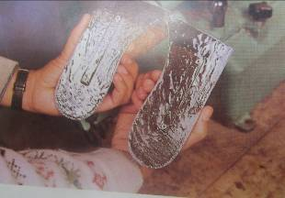
Attaching of Insole Board and Shank Board
Note: The following points should be observed when attaching the shank board to the insole.
- Cement must dry on both surfaces.
- Cement is not too wet as this will cause the shank when pressed.
- When fiber shank is attached to insole it is evenly positioned
- When positioned correctly you should press the two surfaces together in an air press.

Figure 2.25.cemented shank
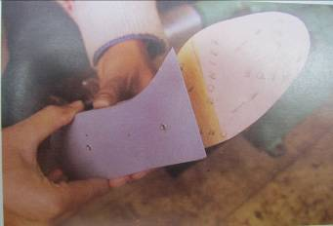
Figure 2.26. Attaching insole and shank
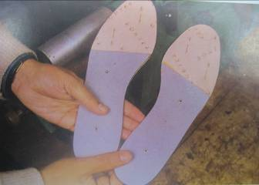
Mould Insole.
Note: The following points should be observed when molding insole.
- Always mold the insole to the shape of the last.
- Make sure there is no wing in the insole when molded.(no gap between last and insole)
- Never over mold insole as this will cause a break down in the materials.
- Check at frequent intervals that moldings correctly done.

Figure 2.27. attached insole and shank

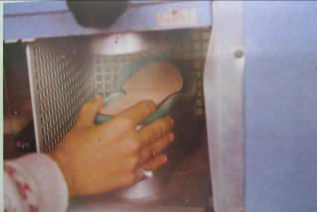
Figure 2.28. mould insole

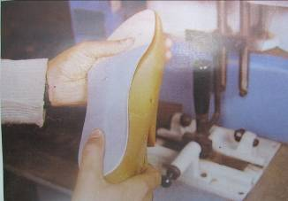
Figure 2.29. Checking the insole for beveling

Beveling.

Note: the following points should be observed when beveling insoles.
- Angle of bevel will suit the heel to be used start and finish the bevel at the shank board joint.
- Edge of the insole has a smooth and not rough bevel.
- There is only one beveling angle for a last.

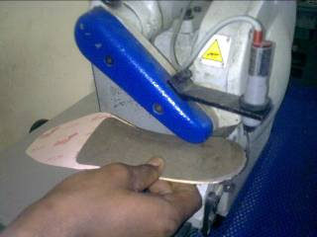

Figure 2.30. Beveling operation

Other types of insole
CONTINENTAL INSOLE SANDWICH INSOLE

Figure 2.31 CONTINENTAL INSOLE Figure 2.32.SANDWICH INSOLE
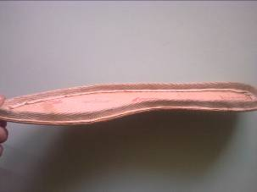
Figure 2.33. WELTED INSOLE
Figure 2.34. BLENDED INSOLE

2.5. Preparing leather sole.
    - preparing leather sole
Sequence of operations for making leather close trim sole
- Clicking (cutting of leather sole)
- Splitting (reducing thickness)
- Leveling and roughing of flesh side
- Edge pre-trimming
- Stamping
- Decoration/grooving
- Edge inking
- Track roughing
- Sole seat roughing
- Heel breast buffing with fine emery
- Heel breast coloring and finishing
- Buffing of the heel surface
- Adhesive application on sole seat & heel
- Heel attaching, pressing & stapling
- heel scouring
- Water application on edge and heel
- Buffing with fine emery paper 150 no.
- Filler application on heel and buffing with 180 no. emery paper
- Color application on edge
- Application of abrasive wax on cotton cloth brush & brushing the edge with the R.P.M. of 800.
- Application of natural carnuva wax on woolen brush & finishing the sole with the R.P.M. of 1600
- Final checking and packing

Note: If we want to make colored bottom sole, then after L&R, we will do snuffing color application before edge pre trimming and remaining process will be same
Sequence of operations for making leather welted unit sole:
- Clicking (cutting of leather sole)
- Splitting (reducing thickness)
- Leveling and roughing of flesh side
- Edge pre-trimming
- Stamping
- Decoration/grooving
- Sole seat roughing
- Heel breast buffing with emery
- Heel breast coloring and finishing
- Buffing of the heel surface
- Adhesive application on welt & flesh side of sole
- Welt attaching
- Adhesive application on sole seat & heel
- Heel attaching, pressing & stapling
- Heel scouring
- Water application on sole edge and heel edge
- Buffing with fine emery paper 150 no.
- Filler application on heel and buffing with 180 no. emery paper
- Color application on edge
- Application of abrasive wax on cotton cloth brush & brushing the edge with the R.P.M. of 800.
- Application of natural carnuva wax on woolen brush & finishing the sole with the R.P.M. of 1600
- Final checking and packing.
Clicking (cutting of leather sole):

Note: the following points should be observed when clicking the leather sole.
- Check the cutting die with master pattern.
- Check the quality of sole leather (substance). Due to less thickness of material, sole can be rejecting.
- Don’t cut from lose area.
- Before cutting, check the leather, there is no defects on grain side.
- Cut small piece like heel lift, top piece from bellies & shoulder area.
- Maximum utilize the leather, due to costly material.

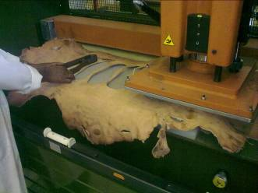
Figure 2.35.clicking leather sole

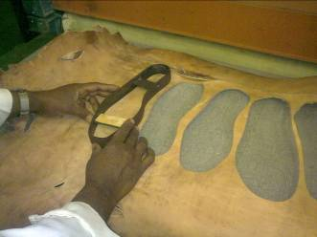
Figure 2.36. Positioning die

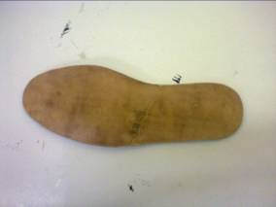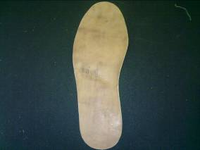
Figure 2.37. Cut leather sole

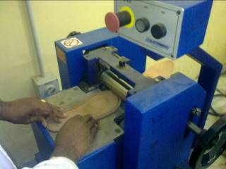
Splitting (reducing thickness):
Note: the following points should be observed when splitting the leather sole.
- Check the gauge before splitting.
- Set machine according of leather sustenance is required.

Figure 2.38. splitting (reducing thickness)

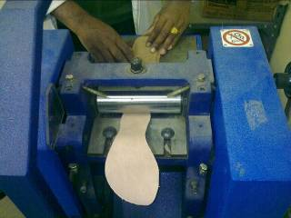
Leveling and roughing of flesh side
Note: the following points should be observed when leveling and roughing of leather sole.
- Do not accept the loose fibers during leveling & roughing.

- Suppose the required thickness is 4.5 mm, & after getting leveled & roughed to this thickness the fibers are still loose, in that case we can remove the fibers up to 4.3 mm for getting tight structure. (2 mm is acceptable)

Figure 2.39. Leather sole leveling

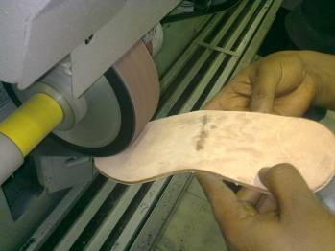

Figure 2.40. Leather sole roughing

Edge pre-trimming
Note: the following points should be observed when edge pre-trimming of leather sole.
- Set the edge trimming machine before start working.
- Tin pattern should not flexible & fix tightly in the machine.
- Check cutter (as per the design/required edge of sole)
- After trimming check with outsole pattern.
- During edge pre-trimming care should be taken to avoid burning effect on edges.
- The R.P.M. of the cutter is 9000 to 10000, so the flow of the hand should be continues during operation.
- Edge pre-trimming should be according to specification of customer.

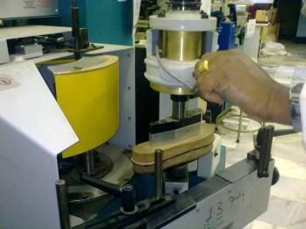
Figure 2.41. Edge pre trimming process

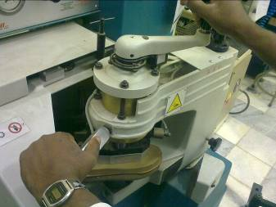
Figure 2.42. trimming leather sole

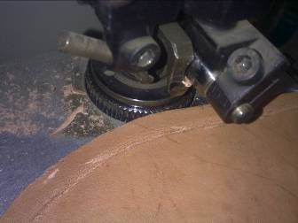
Decoration/Grooving:
Note: the following points should be observed when grooving of leather sole.
- Set guide roller (for how much distance from sole edge to groove/decoration).

- Grooving/Decoration as per design & material substance.

- Grooving/Decoration as per customer specification.

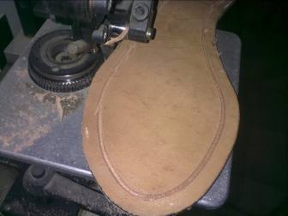
Figure2.43.decoration/grooving

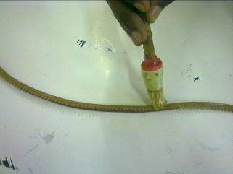
Adhesive application on welt & flesh side of sole:
Note: the following points should be observed when adhesives applying on welt & sole.
- Clean the surface of sole (where welt to be attach).
- Clean the welt.
- Apply past on sole & welt uniformity.
- Give proper drying time.
- Adhesive should be according of material.

- Adhesive apply only welt area of flesh side of the sole.

Figure 2.44. adhesion application on welt

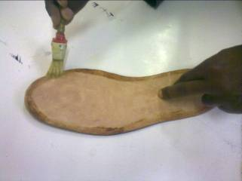

Figure 2.45. adhesion applications on sole

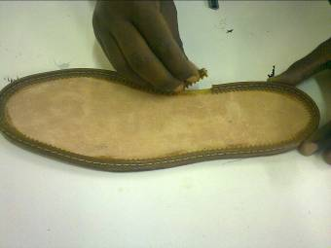
Welt attaching:
Note: the following points should be observed when welt attaching on sole.
- Welt should be attached properly as per the design of the sole
- After attachment of welt with sole press properly.
- Check with inner rand pattern (must be perfect).
- Welt should not open.
- No cavity between sole & welt.

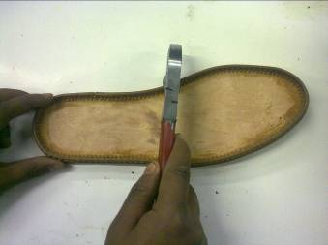
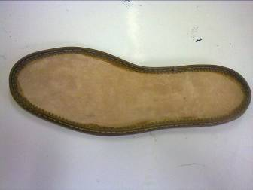

Figure 2.46. Welt attaching

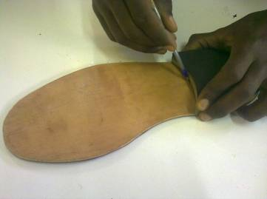
Sole seat marking:

Note: the following points should be observed when sole seat marking.
- Marking as per heel design.
- Roughing 2 mm short from heel marking at seat portion.
- Marking should be grain side of sole.

Figure 2.47. Sole seat marking

Sole seat roughing:
Note: the following points should be observed when sole seat roughing.
- Roughing should not over from marking its 2 mm short from heel marking at seat portion.
- Roughing should be grain side of sole.

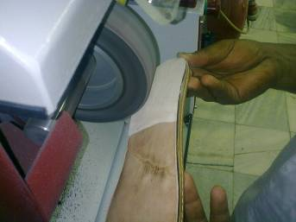
Figure 2.48. Sole seat roughing

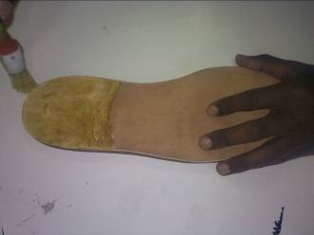
Adhesive application on sole seat & heel:

Note: the following points should be observed when adhesive apply on sole & heel.
- Clean the surface of sole (where heel to be attach).
- Clean the heel.
- Apply adhesive on sole & heel uniformity.
- Give proper drying time.
- Adhesive should be according of material.

- Adhesive apply up to roughing area of the sole.

Figure2.49. sole seat adhesive application

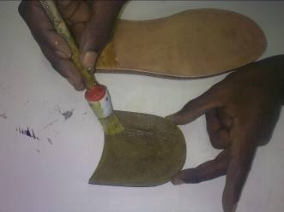
Figure 2.50. Heel adhesive application

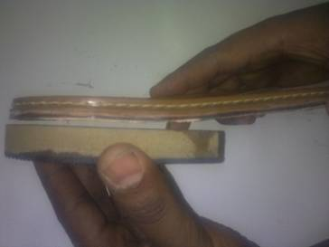
Heel attaching, pressing & stapling

Note: the following points should be observed when heel attaching, pressing & stapling.

- Heel height should be same & pair wise in case of leather left & top.
- Top piece design should be pair wise.
- Heel cupping should be fixing with the sole without any cavity
- There is no gap between sole, welt & heel
- Heel nail or staple pin should be attached properly.

Figure 2.51. Heel attaching
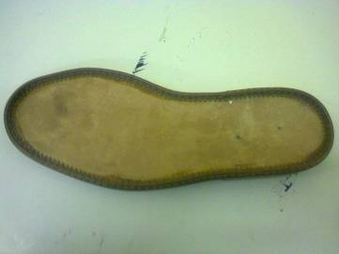
Figure 2.52.Attached sole
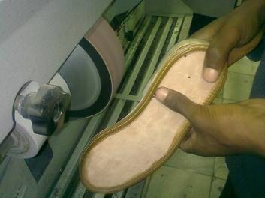
Heel scouring:

Note: the following points should be observed when doing heel scouring.
- Heel scouring is done after heel attaching process. In this process we carefully do scouring without damage the heel, welt & sole.
- Scouring with fine emery paper.

Figure 2.53. Heel scouring
- Edge Inking:

Note: the following points should be observed when doing edge inking.

- Apply color on the edges (wait for 15 minutes or according to weather).
- Color should be pair wise & match.
- Edge inking we have to do carefully otherwise ink tech to the other part of the sole, & it’s not remove because leather absorb the ink.

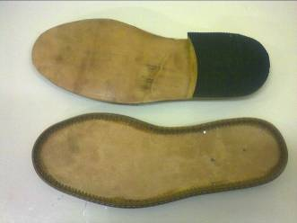
- Bottom polish:

Note: the following points should be observed when doing bottom polish.
Bottom polish is part of finishing process. Here we use the polish according of sole material like in leather sole we use abrasive wax & natural carnuava
- Abrasive wax application on cotton brush & brushing the edge with R.P.M. 800.
- Natural carnauva application on woolen brush & finishing the sole with the R.P.M. of 1600.
- Bottom polish should be match pair wise.

Figure 2.54. Finished welted insole
Sequence of operations for making resin rubber sole.
- Clicking (cutting of resin sheet sole)
- Stamping
- Decoration/grooving ( according of design & material)
- Track roughing (if required)
- Heel Marking on sole
- Sole seat roughing
- Adhesive application on sole seat & heel
- Heel attaching, pressing & stapling
- Buffing with fine emery paper 180 no.
- Color application on edge
- Final checking and packing

Sequence of operations for making resin rubber welt sole.
- Clicking (cutting of sole)
- Stamping
- Decoration/grooving ( according of design & material)
- Welt attaching
- Heel Marking on sole
- Sole seat roughing
- Adhesive application on sole seat & heel
- Heel attaching, pressing & stapling
- Buffing with fine emery paper 180 no.
- Color application on edge
- Final checking and packing

3.1.4.

Preparing and attaching heels to the leather sole
    - preparing and attaching heels to the leather sole
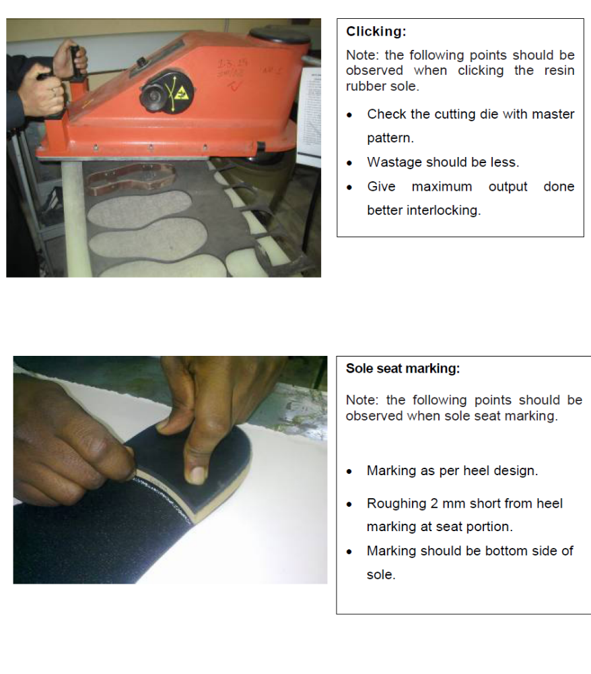Figure2.55.preparing and attaching heels to leather sole

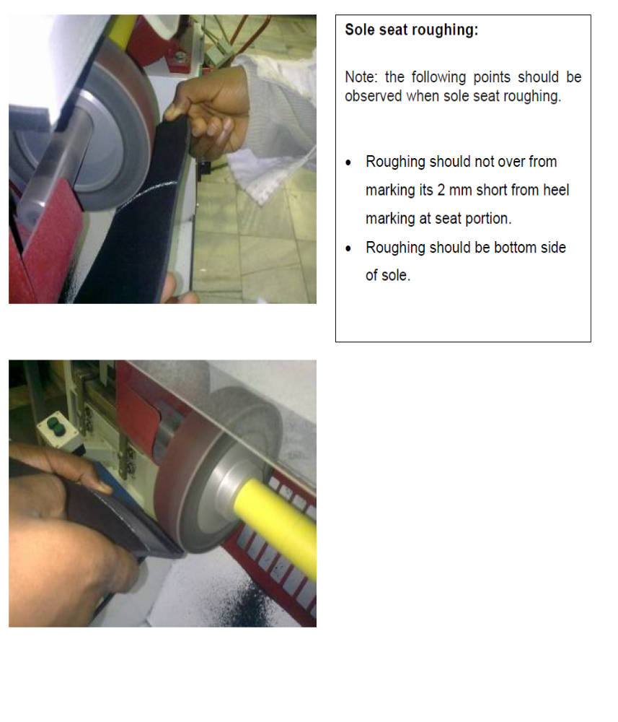
Figure 2.56. Sole seat roughing

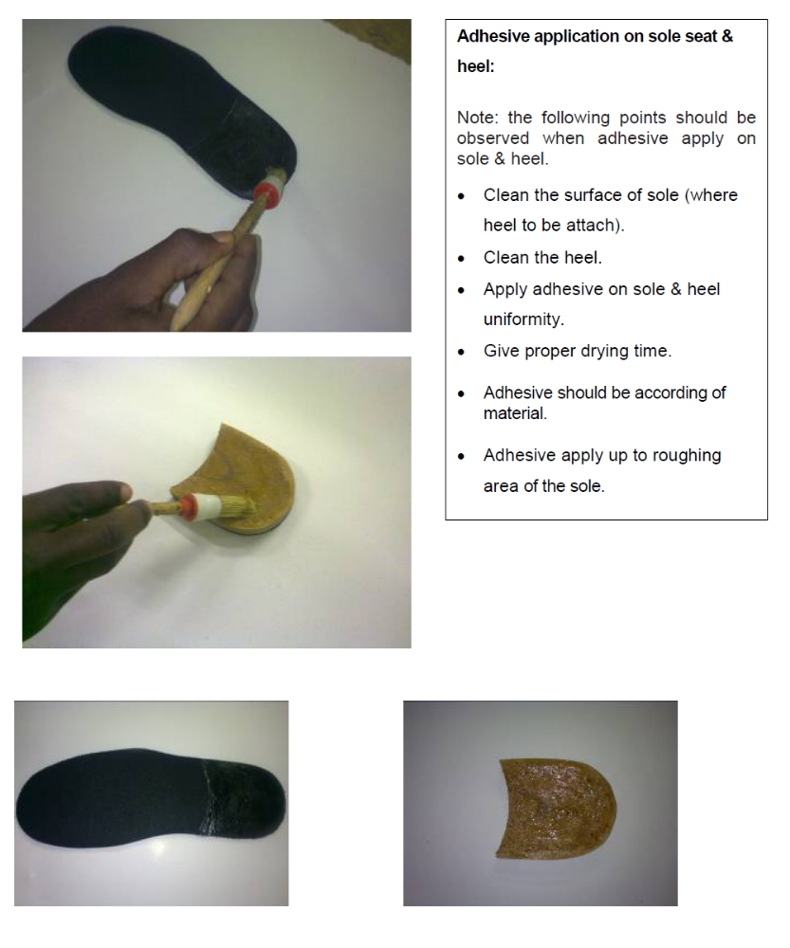Figure 2.57. Adhesive applications on sole seat and heel
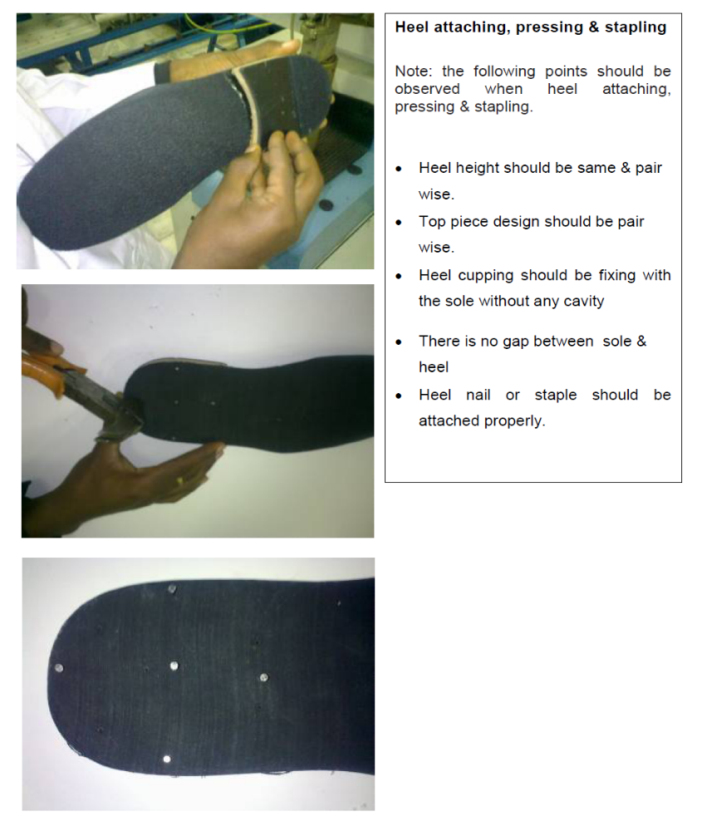
Figure 2.58. Heel attaching, pressing and stapling

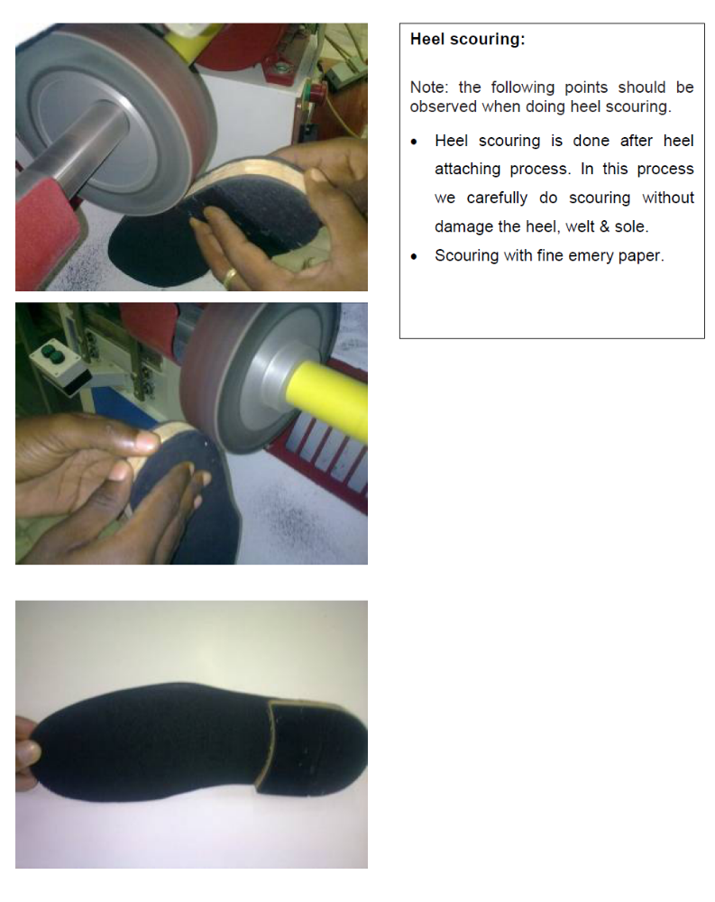
Figure 2.59. Heel scouring

2.7. Cleaning and maintaining work area
2.7.1. Cleaning and maintaining work area
The objective of this information sheet is to show you how to keep work areas and tool clean and operational. At the end of each working day clean the tools and equipment you used and check them for any damage. If you note any damage, tag the tool as faulty and organize a repair or replacement.
Work area should be cleaned as per standard procedure:
Work area should be cleaned by following workplace standard procedures:
- Dust bins for bio-degradable waste materials
Bio-degradable garbage (waste materials) means the garbage or waste materials that are capable of being destroyed by the action of living beings.
- Dust bins for non-biodegradable waste materials
A Non-bio-degradable waste material (garbage) means the garbage or waste materials that are not capable of being destroyed by the action of living beings.
- Cleaning of workshop
Clean floors and decking at the end of each shift and place all rubbish and waste in approved containers for disposal.
- Some cleaning agents are toxic. Refer the instructions on any cleaning agent and follow any recommendations before using it.
- Do not use flammable cleaners or water on electrical equipment.
- Make sure designated walkways are kept clear of any obstructions.
- Always wear protective clothing and the appropriate safety equipment.
- Make sure that you understand and observe all legislative and personal safety procedures when carrying out the maintenance tasks. If you are unsure of what these are, ask your Instructor.
Cleaning of Work Area you have to be:
- Clear and clean the area
- Store any reusable materials
- Check, clean and store away any tools and equipment
- Dispose of hazardous and non-hazardous waste according to legal and workplace requirements.
Cleaning of Tools and Equipment
Equipment and tools that will need cleaning includes:
- Garbage receptacles
- Pans
- Brooms, dusters and brushes
- Mops and buckets
- Electrical equipment, Ex: vacuum cleaners, polishers, scrubbers.
Every time a piece of equipment is used, the general rule is to clean it straight away so it is ready for the next person to use. The manufacturers’ instructions should be strictly followed when maintaining and cleaning equipment.
Skills and actions need to clean up tools
Cleaning and clearing techniques:
- Select and use an appropriate method for cleaning
- tools and specialist equipment
- any leakages
- Restore your work area to a safe and tidy condition
- Make sure that any materials, components, tools and equipment that you may need for the next task are set up ready for use.

Safe disposal techniques:
- Handle and dispose of waste materials appropriately according to organizational and legal requirements
- Recognize what materials are hazardous and require special procedures
- Report any problems associated with cleaning, storing or disposing of materials and equipment to the relevant person.
Hazardous and non-hazardous materials:
- Types of waste material generated in the work area
- Know how to handle hazardous waste and reusable materials safely including:
- Fluids
- Adhesives
- Solvents.
- Personal protective equipment is required and how to use it.
Step by Step Instructions:
Clean tools
Keep your hand tools in good, clean condition with two sets of rags. One rag should be lint-free to clean or handle precision instruments or components.
The other should be oily to prevent rust and corrosion.
- Use kerosene/solvent for cleaning tools
- Clean tool and keep their place
Points to Note:
- Clean tools and equipment helps work more efficiently. At the end of each working day clean the tools and equipment you used and check them for any damage. If you note any damage, tag the tool as faulty and organize a repair or replacement.
- Electrical current can travel over oily or greasy surfaces. Keep electrical power tools free from dust and dirt and make sure they are free of oil and grease.
- All workshop equipment should have a maintenance schedule. Always complete the tasks described on the schedule at the required time. This will help to keep the equipment in safe working order.
- Store commonly used tools in an easy-to-reach location. If a tool, or piece of equipment, is too difficult to return, it could be left on a workbench or on the floor where it will become a safety hazard.
- Keep your work area tidy. This will help you work more efficiently and safely.
- Always use chemical gloves when using any cleaning material because excessive exposure to cleaning materials can damage skin.
- Some solvents are flammable. Never use cleaning materials near an open flame or cigarette.
- The fumes from cleaning chemicals can be toxic, so wear appropriate respirator and eye protection wherever you are using these products.
- When cleaning products lose their effectiveness they will need to be replaced. Refer to the suppliers' recommendations for collection or disposal. Do not pour solvents or other chemicals into the sewage system. This is both environmentally damaging and illegal.
To maintain cleaning equipment and keep it in a good working condition, it must be thoroughly cleaned and stored correctly every time it is used. If regular maintenance does not occur, the equipment may, over time, become dangerous to individuals.
Maintaining equipment
According to the type of machine and method of maintenance the component section machineries must be maintained properly by their schedule
Machine oiling is done almost every day when the machine is in use. There are several parts which must be oiled.

Self-check-2
Name…………………………………………… ID………………………… Date……
Directions: Answer all the questions listed below. Examples may be necessary to aid some explanations/answers.
Part I short answer (Each question has 2 marks)

- Write down the types of insole?
- What type of insole is used to construct sandal shoes?
- Write the sequence of operation for welted insole?
- What type of insole used for sport shoes?
- What is the objective of interlocking?
- Write some important points when interlocking insole?
- Write about how to cut toe puff and counter stiffener?
- Write about some points to select shank steel?
- write some points about matrix skiving operations
- Write the sequence of operations for welted leather sole making?
- write some points about welt attaching techniques
- Write down some points about heel and sole seat ?
- what is heel scouring?
- Write the standard procedures to clean work area?
- Write down the safe disposal techniques?
- Describe about maintaining equipment

Operation sheet 2.1 checking material faults and preparing continental insole
Operation title: checking material faults and preparing continental insole
Purpose: To practice and demonstrate the knowledge and skill required in checking material faults and preparing continental insole
Instruction: Use the given figure below, the tools checking material faults and preparing continental insole For this operation you have given 1Hour and you are expected to provide the answer on the given table.
Tools and requirement
- Measuring Tape
- Fudge Wheel
- Cutting Nippers
- Parking Knife
- Cutting Knife
- Nail Puller
- Shoe Knife
Precautions: Measure at least three times before recording the result on the given format
Steps in doing the task:
Selection of material and checking common problems and faults
Step 1 select materials for making insole and check the ideal properties of insole materials
Step 2 check the materials quality for the needed purpose
Step 3 after selecting Cut of Insole board. With insole die
Step 4 Cutting of shank board.
Step 5 Stamping of insole and shank
Step 6 Grooving of shank board
Step 7 Matrix skiving of shank board.
Step 8 Riveting/Attaching of steel shank on shank board
Step 9 Cementing (a) Plain roller for Insole board.
(b) Flexible roller for shank board.
Step 10 Attaching of Insole Board and Shank Board
- Moulding.
- Beveling.
- Final Checking and packing.

Operation sheet 2.2. Preparing leather sole
Operation title: Preparing leather sole
Purpose: To practice and demonstrate the knowledge and skill required in Preparing leather sole
Instruction: Use the given figure below, the tools Preparing leather sole For this operation you have given 1Hour and you are expected to provide the answer on the given table.
Tools and requirement
- Measuring Tape
- Indenting Scissors
- Cutting Nippers
- Parking Knife
- Cutting Knife
- Shoe Hammer
- Nail Puller
- Shoe Knife
- Leather Thickness (Measuring Gauge)
Precautions: Measure at least three times before recording the result on the given format
Steps in doing the task:
- Clicking (cutting of leather sole)
- Splitting (reducing thickness)
- Leveling and roughing of flesh side
- Edge pre-trimming
- Stamping
- Decoration/grooving
- Sole seat roughing
- Heel breast buffing with emery
- Heel breast coloring and finishing
- Buffing of the heel surface
- Adhesive application on welt & flesh side of sole
- Welt attaching
- Adhesive application on sole seat & heel
- Heel attaching, pressing & stapling
- Heel scouring
- Water application on sole edge and heel edge
- Buffing with fine emery paper 150 no.
- Filler application on heel and buffing with 180 no. emery paper
- Color application on edge
- Application of abrasive wax on cotton cloth brush & brushing the edge with the R.P.M. of 800.
- Application of natural carnuva wax on woolen brush & finishing the sole with the R.P.M. of 1600
Final checking and packing

LAP TEST 1 | Performance Test

Name………………………………. ID…………………………….. Date…………………………………….

Time started: ________________________ Time finished: ________________

Instructions: Given necessary templates, tools and materials you are required to perform the following tasks within 1 hour. The project is expected from each student to do it.

Task 1. Prepare 1 pair of continental insole ?
Task 2. Prepare 1 pair of leather sole ?

Unit Three: Assess final quality of the bottom components and dispatch
This learning guide is developed to provide you the necessary information regarding the following content coverage and topics:
  - Identifying quality check points and critical stages of the inspections.
  - Performing quality checks in relation to the design of footwear and last.
  - Identifying and analyzing problems and faults.
  - Maintaining report and record
  - Dispatch completed work
This guide will also assist you to attain the learning outcomes stated in the cover page. Specifically, upon completion of this learning guide, you will be able to:
  - Identify Critical stages of the inspections.
  - Check Quality in relation to the design of footwear and last is performed.
  - Identify and analyze Problems and faults.
  - Maintain report and record.
  - Dispatch completed work

3.1. Identifying quality check points and critical stages of the inspections.
3.1.1. Critical stages of inspections
Inspection: is most generally an organized examination or formal evaluation exercise. In engineering activities inspection involves the measurements, tests, and gauges applied to certain characteristics in regard to an object or activity.
Insole
- Cutting stage :
Cutting the Insole board or shank board. We must follow the cutting direction. Insole board there are arrow marks given on sheet and those are along the length of the sheet. Because it’s clear that along the length Flexibility is always more.
Inspection in process of manufacturing Insole-
- Insole should be full to pattern.
- Insole should be cut 1 pair at a time when using cold bend knives 32 mm single edge.
- Cut according to direction marked on insole board as above.
- Cut 1 pair or 2 pair at a time.
- 19 mm die- 1 pair
- 32 mm die- 2 pairs
- Forged knife – 3-4 pairs
- Size stamping stage :
Inspection in process of manufacturing Insole-
- Check insoles on pattern before size stamping.
- Stamp is clearly readable.
- Stamped to customers specifications
- Use rubber pad inside the die for ejection of shank board.
After cutting the insole and shank board we will make the LOT of 20 or 25 pairs and put the master pattern over it, so that master pattern can fit with the full lot and we can start stamping.
- Shank board skiving stage:
Inspection in process of manufacturing Insole-
- The matrix skiving is done on the forepart of the shank board.
- Matrix skiving is always 25 mm.
- Skiving should be 0 on the edge.
- Set the matrix roller according of shank board substance.
The purpose of skiving is for:-
- Proper placement of the metal shank and
- Proper attaching with the insole board.
- Steel shank positioning stage :
Inspection in process of manufacturing Insole-
- Grooving should be centre of the shank board.
- Grooving as per the length of shank.
- According of shank width set the cutter.
The necessity of the grooving is for proper fixing of the metal shank on shank board. When we are doing the grooving care should be taken that the length and the depth of the groove should be according to:-
- Length, width and thickness of the Metal Shank.
- The thickness of the shank board.
- Seat Position
The purpose of grooving is that after shank riveting the level of the shank will match with the level of shank board.
- Selection of mould stage:
Inspection in process of manufacturing Insole-
- Always mold the insole to the shape of the last.
- Make sure there is no wing in the insole when molded.(no gap between last and insole)
- Never over mold insole as this will cause a break down in the materials.
- Check at frequent intervals that moldings correctly done.
Selection of mould should be according to the last bottom profile. For that one odd of each size of the last must be on the molding machine. So that after molding we can check the molding of each size.
The pressure of the machine should be done on 60 to 80 Bar for the soft material. First molding should be done on 60 Bar. If it is satisfactory then go for 80 Bar.
- Beveling angle:
Inspection in process of manufacturing Insole-
- Angle of bevel will suit the heel to be used start and finish the bevel at the shank board joint.
- Edge of the insole has a smooth and not rough bevel.
- There is only one beveling angle for a last.
Soles
- Size:
- Check the cutting die with master pattern.
- Check the quality of sole leather (substance).
- Due to less thickness of material, sole can be rejecting.
- Before start stamping confirm the size of cut sole.
- Set pressure of stamping machine head & temperature.
- Set the guide for maintain the proper place of stamping.
- Edge trimming:
- Set the edge trimming machine before start working.
- Tin pattern should not flexible & fix tightly in the machine.
- Check cutter (as per the design/required edge of sole)
- After trimming check with out sole pattern.
- During edge pre-trimming care should be taken to avoid burning effect on edges.
- The R.P.M. of the cutter is 9000 to 10000, so the flow of the hand should be continues during operation.
- Edge pre-trimming should be according to specification of customer.

- Rand attachment:
- Clean the surface of sole (where welt to be attach).
- Clean the welt.
- Apply past on sole & welt uniformity.
- Give proper drying time.
- After attachment of welt with sole press properly.
- Check with inner rand pattern (must be perfect).
- Welt should not open.
- Heel attachment:
- Roughing 2 mm short from heel marking at seat portion.
- Heel nail or pin should be attached properly.
- Heel height should be same & pair wise in case of leather left & top.
- Top piece design should be pair wise.
- Heel cupping should be fixing with the sole without any cavity.
During heel attachment process heel cupping is a process where special shape is given to heel so that seat of the lasted upper can sit properly on the heel cup to avoid gaping on the edges.
- Heel scouring:
- Heel scouring is done after heel attaching process. In this process we carefully do scouring without damage the heel.
- Scouring with fine emery paper.
- There is no gap between sole, welt & heel
- Edge Inking:
- Apply color on the edges (wait for 15 minutes or according to weather).
- Color should be pair wise & match.
- Edge inking we have to do carefully otherwise ink tech to the other part of the sole, & it’s not remove because leather absorb the ink.
- Bottom polish:
Bottom polish is part of finishing process. Here we use the polish according of sole material like in leather sole we use abrasive wax & natural carnuava.
- Abrasive wax application on cotton brush & brushing the edge with R.P.M. 800.
- Natural carnauva application on woolen brush & finishing the sole with the R.P.M. of 1600.
- Bottom polish should be match pair wise

3.2. Performing quality checks in relation to the design of footwear and last.
3.2.1 Perform quality check in relation to design of footwear and last
- Insole.
- Direction of cutting:
- Checking with master pattern during stamping.
- Shank grooving should be in centre and depth should be according to length, width, thickness of metal shank and shank board.
- Matrix skiving should be 25 mm and 0 skiving on the edge.
- Shank riveting should be according to work detail card.
- Cementing should not exceed the limits.
- Drying time must be proper.
- Attaching must be proper.
- Molding should be according to last bottom profile.
- Beveling angle must match with last and heel.
- Cutting direction:
Insole board there are arrow marks given on sheet and those are along the length of the sheet. Because it’s clear that along the length Flexibility is always more. So when we are cutting the Insole board or shank board. We must follow the cutting direction.
When we are following the direction cutting there is too much wastage of the material, in that case we can avoid the wastage by cutting small size like 3,4,5,6 across the direction. The reason of cutting of these sizes, because the person having those sizes have got less body weight. So that material can retain its value and quality.
Note : Because the material is very costly we cannot avoid the across cutting but only in small size.
- Size stamping:

After cutting the insole and shank board we will make the LOT of 20 or 25 pairs and put the master pattern over it, so that master pattern can fit with the full lot and we can start stamping as required because we will have to fit:-
- Correct size of shank.
- Distance from seat portion.
- Attaching of shank board.
- Shank attachment:
Shank Riveting:- The purpose of the shank riveting is:
- During walking shank will not lose its place.
- And properly stick with the shank board.
- Shank is attached at the correct distance from the seat edge.
- Shank is attached in the correct line of the shank board.
- The correct steel shank is fitted to suit the height of heel being used.
- That the rivets or eyelets are clinched this will hold the shank in place.
Shank riveting should be according to work detail card. In work detail card the seat position is mentioned for the given size range.
Note: The length and the width of rivet must be according to thickness of the metal shank, shank board and the diameter of the hole.
- Cementing:-
Cementing should not come either on the reverse side of the component as well as not exceed the limit.
Note: Care should be taken to avoid the adhesive to go on the reverse side through rivets hole.
- Drying:- Drying time must be according to:-
- Time and method given by supplier
- Condition of weather and (Temperature and Humidity)
- Standard
Note: Dust should not come in contact of the adhesive.
- Attaching:-
During attaching the shank board with the insole care must be taken that shank board should fixed exactly over the edge of insole.
Note: If the edge will not proper we cannot get the proper beveling angle, and one operation will be increased (buffing).
- Insole molding:
Selection of mould should be according to the last bottom profile. For that one odd of each size of the last must be on the molding machine. So that after molding we can check the molding of each size.
The pressure of the machine should be done on 60 to 80 Bar for the soft material. First molding should be done on 60 Bar. If it is satisfactory then go for 80 Bar.
Note : The pressure 60 bar to 80 bar is for soft and thin material but for hard and thick material like, 2.5 mm or 3 mm, the pressure will be 80 to 90 bar.
- Insole beveling:
Beveling angle is unique for a given last.
Note: Beveling angle should be checked with particular last for the checking of the angle for all insoles only one odd of last is sufficient.
- Sole quality check in relation to design.
Before edge trimming quality should be checked on this process -
- Thickness of sole: Thickness of sole is very important and referred by customer. If the requirement of thickness is 4.5 mm, we will cut leather out of 4.75 or 5mm thick leather. In that case splitting is not required & directly we can go for leveling & roughing.
- If the sole is natural bottom, thickness should be 4.5 mm after leveling & roughing.
- If the sole is colored bottom, thickness should be 4.6 or 4.7 mm after leveling & roughing, because material will remove during snuffing.
- Leveling & Roughing: This is the process to make sole thickness even so that it will sit properly in to the groove of the cutter & raise the fibers for deeper penetration of adhesive during sole pressing.
Note: Do not accept the loose fibers during leveling & roughing, suppose the required thickness is 4.5 mm, & after getting leveled & roughed to this thickness the fibers are still loose, in that case we can remove the fibers up to 4.3 mm for getting tight structure. (2 mm is acceptable)
- Trimmed edge: During edge pre-trimming care should be taken to avoid burning effect on edges. There are different types of edge pre-trimming cutter round straight, half round or grooved. Edge pre-trimming should be according to specification of customer.
Note: because the R.P.M of the cutter is 9000 to 10000, so the flow of the hand should be continues during operation.
- After trimming sole should be match with pattern.
- No burning effect on edges.
- Sole edge should be according of design.
- Track roughing: Track roughing is a process on the edges of flesh side of the sole (except welted) to remove the filters in certain width & depth (according to specification & type of sole) so that lasted upper can sit properly in to the track.
Note: There should be some thickness on the track. Suppose the thickness of the sole is 4.5 mm so during track roughing will be reduced on the edges comparison to going more and more inside.
- Size stamping:
- Check sole pattern before size stamping.
- Check pressure of stamping machine head & temperature.
- Check the guide for maintains the proper place of stamping.
- Stamp is clearly readable.
- Stamped to customers specifications
- Logo quality:
- Check the guide for maintains the proper place of logo.
- Logo design should be is clearly visible.
- Logo as per customer’s specifications.
- Heel cupping:
Heel cupping is a process where special shape is given to heel so that seat of the lasted upper can sit properly on the heel cup to avoid gaping on the edges.
Note: Mesonite heels are heavy, so we can do some drilling in the center of the heel for reducing the weight.
During drilling care should be taken that, the depth of the hole should be according to the height of the heel. Suppose there are four heel lifts & one rubber top piece, in that case drilling should be up to third lift.
- Rand attachment:
- Welt should be attached properly with sole.
- No cavity between welt & sole.
- Heel scouring:
Heel scouring is done after heel attaching process. In this process we carefully do scouring without damage the heel.
- Finishing process:
- Edge Inking & Bottom polish:
This is the main process of the sole making. If finishing will be wrong, the earlier process will be waste.
- After heel attaching buff with 36 no. emery.
- Apply water on the edges.
- Buff with 180 no. emery paper.
- Apply filler (and wait for 5 minutes).
- Buff with 200 no. emery paper.
- Apply colour on the edges (wait for 15 minutes or according to weather).
- Abrasive wax application on cotton brush & brushing the edge with R.P.M. 800.
- Natural carnauva application on woolen brush & finishing the sole with the R.P.M. of 1600.
Bottom polish is part of finishing process. Here we use the polish according of sole material like in leather sole we use abrasive wax & natural carnuava.

3.3. Identifying and analyzing problems and faults.
3.3.1 Identifying and analyzing problems and faults
A.Insole problems and faults
- Missing the direction of cutting insole
- Unable to fit with master pattern during stamping.
- Problems on shank grooving according to length, width, thickness of metal shank and shank board.
- Over/under sized Matrix skiving on the edge.
- Missing position of Shank riveting according to work detail card.
- Exceed the limits cementing.
- Improper drying time.
- Improper attaching.
- Defects of Molding according to last bottom profile.
- Missing Beveling angle
B.Sole problems and faults
- Faults in thickness of sole
- Leveling & Roughing defects
- edge Trimming defects
- Size stamping errors
- Logo quality problems
- Edge Inking & Bottom polish faults

3.4. Maintaining report and record
3.4.1. Report and record:
Definition
Report
Summarizes the services of the person or personnel and of the agency.
Records
Is a permanent written communication that documents information relevant to clients Most businesses use an electronic record keeping system to make it easier to capture information, generate reports, and meet tax and legal reporting requirements
- Importance of records
- Important for their content and as evidence of communication, decisions, actions and history.
- Is vital in regards to meeting the financial commitments of the business and providing information on which decisions for future of the business and providing information on which decisions for the future of the business can be based
4.2 Preparation of reports
There are different kinds of formats; below there are some reports and record format:
- Daily insole production report
- Sole production report
- Transfer slip
- Daily inspection/rejection report :bottom component

Date:____/____/_____

XYZ SHOE FACTORY
DAILY INSOLE PRODUCTION REPORT

Customer :
Order Arriving Date:
Delivery Date:

Order | Group | Article | Color | SIZE
 |  |  |  | 39 | 40 | 41 | 42 | 43 | Total

PREPARED BY:__________________

SIGN:_______________

XYZ SHOE FACTORY
SOLE PRODUCTION REPORT

CUSTOMER: DATE:____/___/______
ORDER ARRIVING DATE:
DELIVERY DATE:

ORDER | GROUP | COLOR | SIZE
ORDER | GROUP | COLOR | 40 | 41 | 42 | 43 | 44 | 45 | TOTAL

PREPARED BY:__________________

SIGN:_______________

ABC Shoe Factory
Transfer Slip
Date: |  |  |  |  | From: |  |  |  |  |  | To:
S/N | Plan No | Article No | Color | Produced Qty
 |  |  |  | 39 |  | 40 | 41 | 42 |  | 43 |  | 44 | Total
Supervisor Name/signature:___________________ |  |  |  |  |  | Received By Name/Signature:_____________________

XYZ SHOE FACTORY
DAILLY INSPECTION/REJECTION REPORT :BOTTOM COMPONENT
DATE:
CUSTOMER:
ORDER NO:
MODEL/COLOUR:
PAIRS CHECKED:
PAIRS PASSED:
PAIRS REJECTED:
S. NO | DEFECT | Prs. | % | Prs. | % | Prs. | % | Prs. | % | total %
1
2
3
4
5
6
7
8
9
Inspector
Supervisory
Quality head

3.5. Dispatch completed work
5. Dispatch completed work
Dispatch means transferring completed work/product to the next operation section. So in components section the works are:
- Finished Insole
- Finished Sole
- Toe puff
- Counter stiffener
Then this works will packed according to the size and article no and using transfer slip it will transfer to the lasting department.
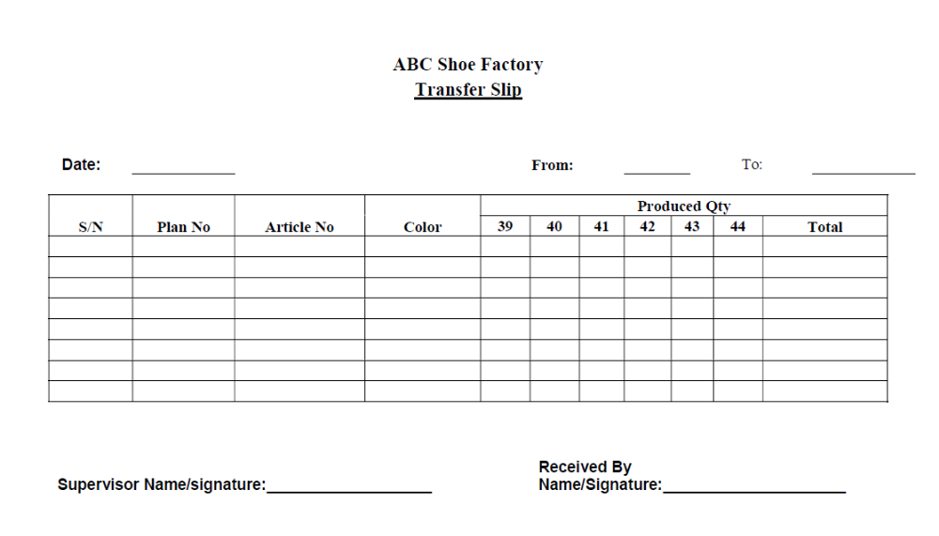

Self-check 3 | Written test

Name: _________________________ Date: _______________
Directions: Answer all the questions listed below. Illustrations may be necessary to aid some explanations/answers. (Total marks 10)
Part I long answers (2 mark for each)
- What precaution should be taken before size stamping?

- Write about direction of cutting insole?

- Write two points for edge trimming?

- Write about quality check point of shank attachment?

- Write about critical inspection for bottom polish?
Choose the correct answer :( Each question 1 mark) (Total marks 4)
  - Matrix skiving should be
- 30 mm
- 20 mm
- 25 mm
- None of them
  - Mould selection is depend on
- Sole
- Last
- Insole
- None of them
  - Half insole is use for
- Goodyear welted
- Moccasin shoe
- Stitch down shoe
- moulded shoe
  - Natural carnauva finishing is done by
- Cotton brush
- Woolen brush
- Synthetic brush
- None of them

Short answer questions: (Each question has 1 marks) (Total marks 6)

Part I short answers
1. Write down the problems and faults of insole?
2. Write down the problems and faults of soles?
3. Write about quality check point of insole according to design?
4. What is daily production report of Insole?
5. Write down about inspection/rejection report of sole?
6. Make a format of transfer slip from component section to lasting section?
7. Define dispatch?
8. What is the completed work in component section?

Reference
Book:
- Shoe making manual
- Previos TTLM performing bottom components
- Au, E.Y.L. & Goonetilleke, R.S. (2007). A qualitative study on the comfort and fit of ladies’ dress shoes. Applied Ergonomics, 38 (6): 687-696
- https://www.researchgate.net/publication/225380208_Getting_to_the_bottom_of_footwear_customization

Participants of this Module (training material) preparation

No | Name | Educational Background | Region | E-mail | Remarks
1 | Yohannes Fisseha | BSC in Leather Engineering | Addis Ababa, Lideta Manufacturing college | yohannesfiseha71@gmail.com | module Developers Team Members
2 | Yabetse Fikadu | BSC in Leather Engineering | oromia: bishoftu polytechnic college | Yabets1030@gmail.com | module Developers Team Members
3 | H/Gebrale Abebe | BSC in leather and leather product technology | Addis Ababa,Misrak poly technic colleget | haile3a@yahoo.com | module Developers Team Members

