Footwear Production
Level-II
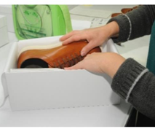
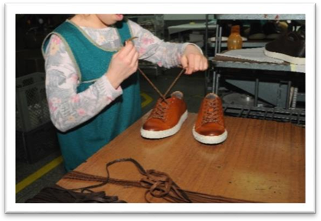
Based on November, 2021 Curriculum Version 1

Module Title: Performing Footwear Finishing and Packaging
Module Code: IND FWP2 M08 1221
Nominal duration: 30 hours

Prepared By: Ministry of Lobar and Skill

August, 2022
Addis Ababa, Ethiopia

Acknowledgment
Ministry of Labor and Skills wish to extend thanks and appreciation to the many representatives of TVET instructors and respective industry experts who donated their time and expertise to the development of this Teaching, Training and Learning Materials (TTLM).

TABLE OF CONTENTS
Acknowledgment ii
Introduction to the Module iv
Unit one: Preparation of Tools, Materials Equipment’s and Machines 5
1.1.Materials and components for finishing 6
1.2.Tools and equipment 17
1.3.Common problems and faults of materials 23
1.4. Personal protective equipment 25
1.5. Safety of operator and work place 26
Self chek-1 30
Unit Two: Preparation of workstation and set up the machine 32
2.1.Setting up and arranging work station 33
2.2.Collecting, sorting, laying out and preparing footwear for finishing operation 34
2.3.Setting-up, adjusting, cleaning and maintaining finishing machineries 36
Self chek-2 48
Unit Three: Perform Finishing and packaging of the work 49
3.1.Types of leather finishes 50
3.2.Finishing processes 55
3.3.Finishing operations 57
3.4.Packaging and labeling materials 72
3.5.Checking products 75
3.6.Packaging operations 76
3.7.Prevent accidents and to eliminate risks to personal safety 82
3.8.Completing production and other records 84
Self chek-3 86
Operation sheet 3.1: Finishing and packaging 88
LAP Test 5
Unit Four: Checking final quality of the finished pair and dispatch 6
4.1. Identifying quality check points 7
4.2. Checking footwear 10
4.3. Identify rectify and return faults 14
4.4. Quality records and documentation 19
Self chek-4 24
REFERENCES 25

Introduction to the Module
The process, which enhances the appearance and restores the inherent characteristics of the Upper leather, is called Shoe Finishing. Finishing is done to upgrade the quality and the aesthetic appeal of the product or to give some special appearance, e.g. Shadow effect or Antique effect. It also imparts the desired color and level appearance to the material.
This module is designed to meet the industry requirement under the footwear production occupational standard, particularly for the unit of competency: Performing Footwear Finishing and Packaging
This module covers the units:
- tools, materials, equipment and machine preparation
- workstation preparation and machine set up
- Finishing and packaging of the work
- final quality of the finished pair and dispatch
Learning Objective of the Module
At the end of this session, the students will able to:
- Prepare tools, materials, equipment and machine
- Prepare workstation and set up the machine
- Perform Finishing and packaging of the work
- Check final quality of the finished pair and dispatch
Module Instruction
For effective use this modules trainees are expected to follow the following module instruction:
- Read the information written in each unit
- Accomplish the Self-checks at the end of each unit
- Perform Operation Sheets which were provided at the end of units
- Do the “LAP test” if it is provided at the end of units and
- Read the identified reference book for Examples and exercise

Unit one: Preparation of Tools, Materials Equipment’s and Machines
This learning unit is developed to provide the trainees the necessary information regarding the following content coverage and topics:
  - Materials and components for finishing.
  - Tools and equipment.
  - Common problems and faults
  - Personal protective equipment
  - Safety of operator and work place
This guide will also assist you to attain the learning outcomes stated in the cover page. Specifically, upon completion of this learning guide, you will be able to:
- Identify and select Materials and components used for footwear finishing as per the required specification.
- Identify and made ready Tools and equipment as per the required work specification for operation.
- Identify and rectify Common problems and faults of materials
- Identify Suitable personal protective equipment for safety with regards to tools, equipment and machines.
- Describe Safety of operator and work place for finishing operation.

Materials and components for finishing
1.1.1 Introduction
Shoe making is a rough and tough process. Most of the operations during its manufacture are meant for giving it a proper shape. During process, the upper material is subjected to a wide variety of abrasive and stretching operations, which can adversely affect its appearance and sometimes even in heart its characteristics.
The process which enhance the appearance and restores the inherent characteristics of the upper leather is called “ shoe finishing”. Finishing is done to upgrade the quality and the aesthetic appeal of the product or to give some special appearance like shadow effect or Antique effect. It also impart the desired color and level appearance to the material. Hence good shoe finishing will enhance the image of our enterprise and product brand image
1.1.2 Common materials and components used in finishing operation
Waxes
Waxes are used for burnishing, repairing and polishing. They are of different types as shown below:
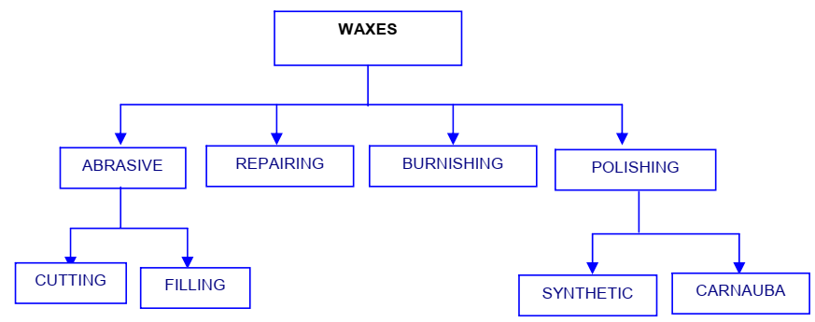

Figure 1. 1 Types of wax
Abrasive Wax: Used for cutting or smoothening of grain surface, and for filling and special effects, for example brush-off and burnish effect. These are available in three colors: black, brown and natural. This is to be applied on cotton roller.
Repair Wax: these are gap-filling crayons and do not shrink on flexing.
Burnishing Wax: It is a medium-hard dyed wax, which enhances the burnishing effect on burnished leather. This is to be applied on cotton roller.
Polishing Wax: Used as the final operation to polish and protect the finish that is done in the shoe finishing room. It also enhances the gloss of the shoe. This is to be applied on woolen roller.
Two types of polishing wax are used:
- Synthetic and
- Carnauba.
Available in three colors Black, Brown and Natural. White Polishing wax is synthetic carnauba wax whereas natural carnauba wax is yellowish in colour.
Spray gun and spray booth for spraying operation;
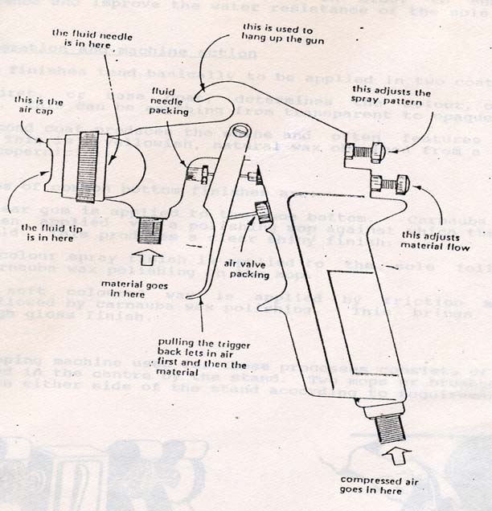
Figure 1. 2 Spray gun and spray booth for spraying operation
Spraying Technique
The technique of spraying is defined in the above figure
- Spray must be applied evenly;
- The spray gun is always started before applying the spray which
prevents heavy application of dressing;
- Spray in smooth strokes; and
- The airflow and dressing flow should be adjusted which ensures neither dry dressing nor flooded wet dressing. Flooding will result in increase of drying times and tear marks.

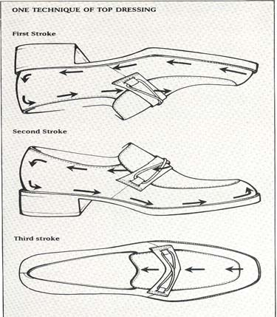
Figure 1. 3 Spraying Technique

Cream
Shoe cream is a type of shoe polish that contains dye. In addition to restoring shine and suppleness to your leather shoes, shoe cream can brighten up the color of your shoes and cover faded spots and scratches. Once you’ve picked the right cream polish, take a little time to clean and prep your shoes. Then you’re ready to apply the shoe cream and get your shoes looking brand new again!
Creams could be soft, medium or hard. Soft and medium creams are those that require to be polished, and are referred to as the creams to be polished. Hard creams are available as self-shining creams. That is, they don’t require cutting or brushing operation necessarily. Creams are applied by sponge – sea sponge or synthetic sponge.
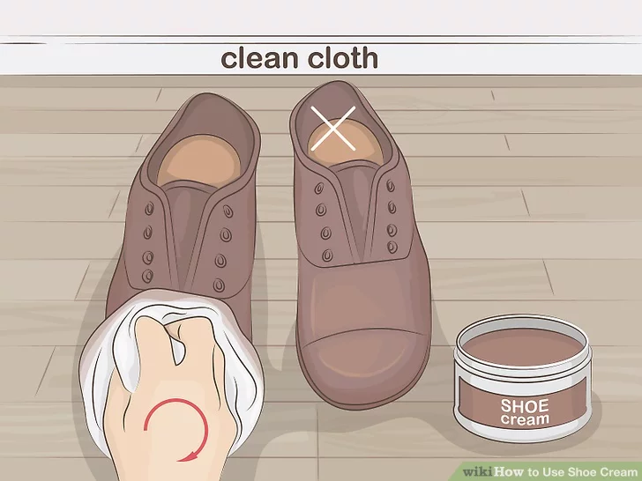
Figure 1. 4 Applying cream
Cleaner / polishers
Before starting finishing operation, ensure that the surface to be finished has been clean. The purpose of cleaning is that no any dust or contaminant are present on the upper surface of the shoe.
The main purpose is to remove:
- The Dirt
- Adhesive overspill
- Other unwanted marks and contamination
Cleaning can be done before or after removing the last from the shoe. The latter is preferable for better shape retention of the shoe. When necessary, cleaning of lining is also done.
Cleaner/ polishers are supplied as gels and contain solvent cleaners and polishing agents, which remain on the surface after the solvents have evaporated.
Application is by sponge or cloth and after drying can be polished on a power mob.
These are very suitable for patents and PU coated fabrics, and have the advantage of giving an acceptable semi- bright finish without having to spray.
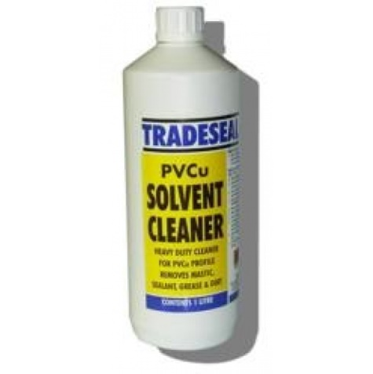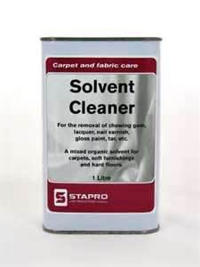
Figure 1. 5 solvent cleaners
Sole edge colors
A water base edge containing pigment waxes and gums is applied by hand to the sole edge. A machine may be used. The edge must be completed and evenly covered with the ink, but there must be no ink on the upper and stitching.
Sole edge colors are very important to improve the appearance of the bottom parts of the shoe, with the application of these coloring materials, the water resistance of the heel increases. Its final appearance is like shined looks a original finish on heels and soles.
Features and directions-
- Shake well with cap on.
- Shoe must be clean and dry.
- Invert bottle and gently press applicator against shoe to release product.
- Spread polish evenly and allow to dry to a shine.
- Rinse applicator with water after use and blot dry to keep foam soft, replace cap.
- If spilled, clean up before dry, Gently dab spill with a dry cloth, the wipe with a damp cloth.
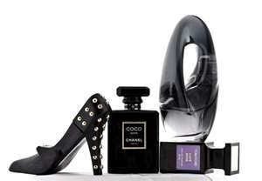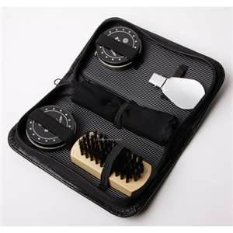

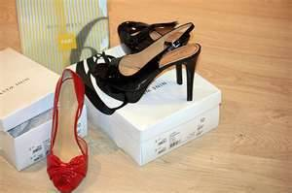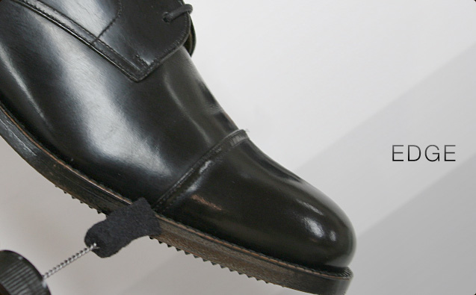
Figure 1. 6 sole edge colours

Pigments for repairing
Pigment represent a very important constituents of present day leather and shoe finishing composition. The use of pigments in the finishing had its start in America during the World War First, because the supply of dyestuff from Germany was cut off. While pigmented finishes lacked the brilliance and beauty of finishes based on the dyestuffs, they have the advantages of covering stains and defects and presenting a uniform color over the whole skin or hide. This advantages becomes more and more important as time went on since increasing amount of buffed side leather and decreasing amount of full- grain leather ( calf )were being finished. As a result, even when dyestuffs become available again, the use of pigments was never given up. The pure aniline finish is still used on a considerable amount of calf and this is covered by the use of dye solution and small amount of pigment if needed.
Glazed kid is also finished with aniline finishes as are a number of novelty leathers. In a general way, the big volume leathers are finished with coating which contains pigments.
Table 1. 1 pigments normally use in leather finishes
White | Titanium dioxide
Black | Carbon black, bone black, iron oxide
Yellow | Lead chromate
Orange | Lead chromate
Brown | Iron oxide
Blue | Iron blue
Green | Chrome green
Red | Cadmium sulphide
For repairing of any major or minor defects we take any suitable pigment with addition of filler and adhesives. Apply the season in suitable amount, then dry well. After that removing the excess season with the help of fine emery paper then finishing.
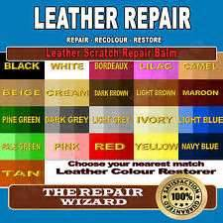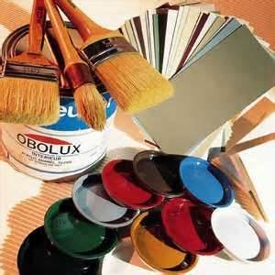
Figure 1. 7 repairing pigments
Labels/tags
There should be two labels on your shoes; the first label tells you the origin of the manufacturing and the second label is a breakdown of the construction of the shoe. Footwear must be labelled with the main materials used for the upper, lining and sock, .and outer sole where multiple materials are used, the two main materials in the composition of the footwear must be stated.
The label must be attached to at least one item of footwear in each pair and may be affixed by way of printing, sticking, embossing or use of an attached label; it must be visible, securely attached and accessible. The label may also appear on the packaging but it must be on the footwear itself.
Pictograms for the parts of the footwear
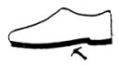
Upper: Lining and sock: Outer sole:
Figure 1. 8 Components of the footwear
Pictograms for the materials used in footwear composition

Leather: Coated leather: Textile: Other materials:
Figure 1. 9 materials used in footwear composition
Shoe Boxes:
- All shoes should be packed in a shoebox
- Each shoebox must have a finger hole on the lid of each box. The box should be of a good grade cardboard.
- The lid needs to be fixed to the box.
- The box should not be of a slick coating that will make the box hard to handle.
- All shoes must face one direction.
- All footwear shoeboxes are required to be labeled with a UPC-A, EAN or interleaved 2of 5 labels.
- Stickers should be placed on the lower left or right-hand corner of one end of the box so as not to cover product information. The sticker should not be applied to the box lid except in cases when the lid covers most or whole of the box (overlay lid).
- A sticker with the Foot Locker SKU should be affixed on same side as the barcode sticker.
- American size (as ordered on PO) must always be clearly marked on box 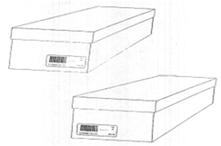
Figure 1. 10 Shoe box
- Shoeboxes should be placed vertically in single layer. Bar code to face up.
- Only one SKU and one size per master carton, unless specified differently on the
purchase order (i.e. case lots)
NOTE: In cases when shoes are not packed in a shoebox, f.e. flip-flops it should be packed in a polybag, the barcode sticker should than be affixed to the polybag.
Tissue paper
It is recommended that you wrap shoes in tissue paper and place them in the original shoeboxes to prevent damage from contact with other shoes. This will protect patent finishes and ornaments from accidental damage during transit. Do not use newsprint to wrap your shoes!
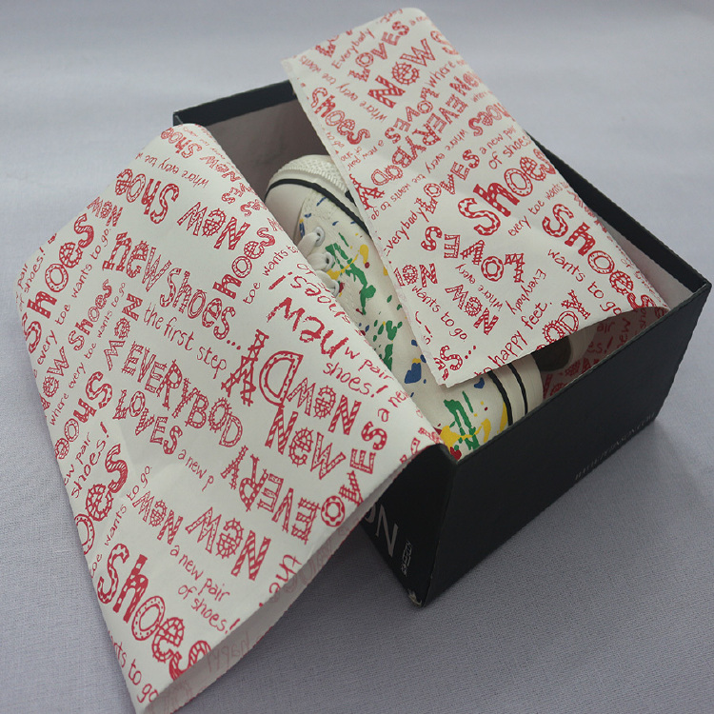
Figure 1. 11 Tissue paper
Silica gel
Shoe Manufacturers Use Silica Gel for Moisture-Control. From manufacturing to storing, delivery, and product pick-up, the shoe manufacturers add silica gel packets to the box to keep shoes safe from mold, odor, and bacteria growth, especially if they're made of leather
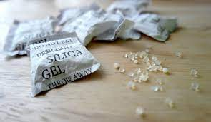
Figure 1. 12 Silica gel
Dye/colorant
The kind of leather will dictate what type of dye you should use to achieve the right dye color and the right leather finish. Consider these different leather dyes and their applications:
- Shoe polish: Shoe polish works as a more temporary kind of leather dye. The polish does not penetrate the leather’s fibers, making this dye less permanent, though it is quick and easy to apply.
- Alcohol-based leather dyes: These dyes penetrate the surface of the leather, creating more vivid colors that last a long time. Alcohol may strip the moisture out of the leather, stiffening the material, so you may need a leather conditioner or finisher to restore the material.
- The sun: The sun can be a natural way to dye leather. Leaving your veg-tanned leather out in the sun will darken its hue. This process will take at least an hour, more depending on how dark you want your leather as the sun’s ultraviolet rays will take a lighter leather and turn it to a dark brown over time.
- Oil-based leather dyes: Unlike alcohol-based dyes, oil-based ones do not strip the leather of liquids. Oil-based dyes cut through the surface of the leather to color the fibers to a richer saturation. These may work best for full and top grain leather without surface finishes applied, meaning those fibers will dry out more readily.
- Water-based leather dyes: Water-based dyes have fewer toxins than other dyes but produce more muted colors. They will leave your leather supple.
- Resolene: You can apply leather resolene, or acrylic dye, in thin layers as a leather finish. After drying, the thin layers of acrylic will harden into a shiny, solid, and protective surface atop your leather; this can work for corrected grain leather, whose fibers will have been sanded down so the resolene offers a durable finish. Different finishes and colors are available for resolene, making it a versatile leather dye option.
- Resin: A leather finisher made from natural resin will produce a subtler and softer finish and provide some protection from dirt. Resin-based finishers are not water-resistant and can work well.
To properly dye leather, you’ll need a well-ventilated space and several materials, which you can find at crafting or leather goods store:
- Deglazer: A leather deglazer is a solution that cleans the leather and prepares it for an efficient dye process.
- Spray bottle: After deglazing, you’ll want to spray your leather gently with some water to help it more easily absorb your first coat of dye.
- Paint brush: You will use a paint brush or wool dauber to apply your coat of dye.
- Leather dye: The kind of dye you select will determine the color and affect your leather’s outcome, feel, and quality.
- Scrap rag: An old scrap piece of cloth will be helpful to have during the dyeing process to wipe away excess dye and sop up spills.
- Gloves: Dye can get messy, so you’ll want to wear gloves that cover your forearm for protection. Dishwashing gloves will get the job done.
- A ventilated and protected workspace. You’ll want your work area to be well-ventilated as the dye can release fumes that are dangerous to breathe. Open your windows and turn on a fan if indoors, and if outdoors, be sure it’s a dry day and stay out of direct sunlight. Use a drop cloth or cut open a large trash bag and tape it down on your workspace to keep your station clean.

Tools and equipment
Blunt knife
In the lasting operation, the complete surface of the bottom of the shoe is coated with a rubber solution or thermoplastic adhesive ( hot melt ). The blunt knife is used to remove wax and thermoplastic adhesives ( hot melt ). Could be used on suede and nubuck leather and for repair work
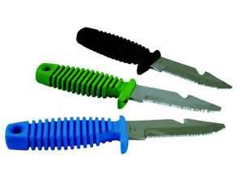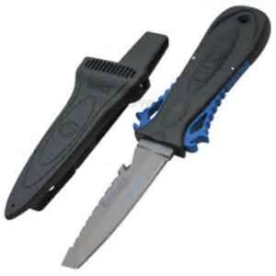
Figure 1. 13 blunt knife
Crepe and resin rubber
Generally used to remove polyurethanes, latex, and rubber adhesives from grained upper and lining.
- Crepe rubber
It is a natural product produced by coagulation the latex from the rubber tree. Latex is formed into thin sheets, and then laminating and pressing a good number of sheets together to give a specific thickness. Chemically it is a polymer made from “ Isoprene” monomer units which has sufficient strength not to need vulcanizing. The crepe which is harder and lighter in color provides better wear comfort.
Advantages
- It is comparatively cheap to process.
- It has good wear resistance.
- It has self-sealing ability and provides a very good resistance to flex crack but slips on dry surface.
- It is very light in weight (0.88 gms. / c.c.)
- Resilience is high and the strength is moderate.
Disadvantages
- It is very sensitive to heat and become soft and sticky in worm condition. It has tendency to spread under body weight.
- It has a poor resistance to ageing. If it is exposed to heat of sunlight it shows surface hardening and cracking.
- It is sensitive to solvents mainly petroleum and oil.
- Natural rubber
Natural rubber is a cultivation based product. It depends upon the suitability of the plantation of heveabrasiliensis tree. The research work to develop an artificial rubber began. The styrene and butadiene are the two main raw materials. A styrene butadiene copolymer made in emulsion with a charge ratio of 25% styrene and 75% butadiene were chosen as the best possible general purpose rubber.
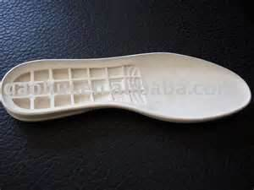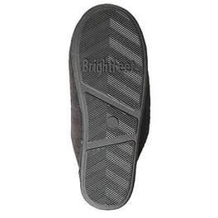
Figure 1. 14 natural rubber
Sponge
Shoe Shine Sponge is an easy-to-use application that gives your shoes a bright and long-lasting shine. Acord shoe shine sponge is a great tool that can use to shine your shoes with a matter of seconds by quick swipes anywhere you are, whether in the office or even on the go as it easy to carry and take no space.
Step to shine shoes with a sponge
Start by wiping away any loose dirt or dust from the shoe with a cloth. Then apply the shoe sponge. Polish will be automatically released from the sponge. Simply glide the shoe-shine sponge lightly over the leather until you're satisfied with your shine.
Emery paper
Emery paper is a type of paper that can be used for sanding down hard and rough surfaces. Emery paper is sold in sheets of varying sizes. Emery products choose on the base of the level of abrasiveness or grit. In the shoe industry it is used for the following purposes
- To roughen the pleats/ crease on lasted shoe bottom.
- To roughen the surface of lasted upper and bottoms material to be attached with adhesives.
- To roughen ( finish ) the edge of micro rubber sole.
- To roughen the surface of bottom ( leather ) of shoe sole to give a smooth surface before applying bottom finish.
- Crust leather is scoured with 300- 360 grit of abrasive to smooth the surface of leather before making corrected grain leather.
Emery paper available in the market in various nos. Such as No- 24- 60, No- 80- 120, No- 150- 240, No- 300- 360 etc. These numbers represent the grits of the abrasive paper. An international system is used by the abrasive determines the number of grits to a squire inch of material. As such the number grits is bigger it means more numbers of grits are within one squire inch area, and that will be fine grit. In the same manner for smaller grit it will be reverse. The coarser grit is commonly used for roughing edge of the upper before cementing however a fine grit is used to scour the grain of leather sole to give a smooth surface.
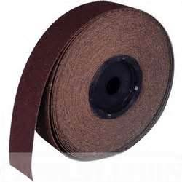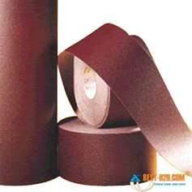
Figure 1. 15 emery paper
Inking brushes
Brushes are differ greatly in terms of size, texture, material and cost. It is made from goat, Siberian weasel, pig, mouse, buffalo, wolf and rabbit hair while exotic once can be made from tiger, fowl, deer, and even human hair.
The inking brushes are three types.
- Big size brushes
- Medium size brushes
- Small size brushes
The smallest brushes are used for very small pieces and for fashioning designs for seals. Medium brushes are most widely used because it can produce a variety of thickness of line , from very thin to fairy thick. The larger brushes are used only for very large pieces. In footwear, the brushes are used to color the edges. A water based edge finish containing pigment, waxes and gums is applied by hand to the sole edge. A machine may be used. The edge must be completely and evenly covered with ink, but there must be no ink on the upper and sole. The flesh side of the sole has a ¼ inch margin of ink applied. This is done to minimize the danger of ink being applied to the upper when the sole in edge ink during finishing.
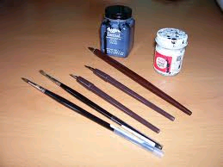
Figure 1. 16 inking brushes
Suede (wire) brush
This is soft brass wire brush. Used to remove dust and loose foreign substances from suede and nubuck leather. Brushed lightly in one direction to give same nap.
Suede brush cleans and brushes up the knap in the suede. If the suede is shiny use a little piece of 120 grit sand paper they bring up the knap even more. In this way we use shoe brush 100% horse hair they provides the high gloss shine in suede leather. Similarly use shoe shine cloth, after polishing, it provides extra- bright high gloss shine. The bars removes shiny marks and stains. The brush brings the nap of the leather to its original appearance.
Suede and nubuck wire brush to raise the nap of the leather on shoes, boots, hand bags or any other suede / nubuck items. Especially good for reaching hard- to- get place.
For the cleaning of suede and nubuck product manufacturer use the following products for their long life preservation.
- Suede and nubuck protector
- Suede and nubuck cleaner
- Tarra go suede dye: - To restore color to old suede shoes and accessories.
- Suede and nubuck protector
Suede and nubuck protector provides protection against water and stains. Keep suede and nubuck shoes, boots, coats, bags etc. Looking new. Coats footwear with a special polymer that creates an invisible shield to provide maximum protection against water and stains.
- Suede and nubuck cleaners
The cleaners cleans, conditions and softens suede and nubuck leather. Removes dust and dirt from shoes, boots, belts, clothing and more. The cleaners built in bristle top makes application and cleaning easy and mess free.
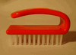
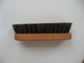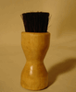
Figure 1. 17 suede & nubuck cleaners

Common problems and faults of materials
1.3.1 Faults of finishing
Many faults can occur in finishing. Some of them are due to wrong finishing method or some due to environmental factors. Some common faults and their causes are listed in table below:

Table 1. 2 finishing faults and their cause
Faults | Causes
Mist or fog | Air pressure is too high. Gun far away
Uneven finish | Wrong dressing selection. Poor cleaning
Rough finish | Insufficient fluid feed. Gun too far away. Air pressure too high.
Streaks | Uneven spray pattern. Disturbance of finish during cleaning or filling. Gun not square to work
Runs, sags, tear marks | Over application –flooding .gun not square on worker movement too slow
1.3.2 Problems with Dressings
Table 1. 3 Problems with Dressings
Problem | Causes | Remedy
Flaking | Dressing and material finish is not compatible  Inadequate cleaning  Contaminated cleaner pots and dirty sponges  Other contamination | Check suitability of dressing  Clean more thoroughly  Identify and eliminate source
bloom | High humidity, water in solvents or air supply. Heat or solvent cause fat to move to surface.  Solvents may cause whitening | Some anti-bloom cleaners are available or check air supply warm gently to disperse bloom, excessive heat is avoided usually cured by over spraying with butyl acetate (B.A) special cleaners and finishes are required

1.4. Personal protective equipment
In addition to being aware of the mechanical hazards in the finishing section, it is important that you use the correct protective clothing and equipment. Wearing personal protective equipment (PPE) can prevent accidents from happening. As a worker, you are responsible for the following:
- Making sure your uniform is well fitted.
- Keeping all uniforms clean and in good condition, not frayed or badly worn.
- Making sure sleeves are kept buttoned at the wrist, cuffs on overalls and trousers are be eliminated, and trouser legs are long enough to hang outside boots.
- Wearing specific personal safety equipment such as goggles, hearing protection, gloves, and aprons when required.
To ensure that you are protecting yourself, your personal protective equipment (PPE) list should include the following items.
- Clothing
This includes well-fitted pants and jackets with all buttons fastened. Sleeves should be close fitting because sleeves that are loose and flowing are potential fire hazards when working over open gas burners. Health regulations require that all machine operator wear hair nets or use other approved methods for keeping hair under control. Aprons should be made of non-combustible and flame-resistant materials that do not melt under heat.
- Footwear
The OHS Regulation requires that approved footwear must be worn by employees in all industrial occupations. Ensure your footwear is sturdy and provides enough back support to not cause future back problems. Footwear suitable for commercial foodservice establishments must have a non-slip sole and a closed toe and closed back.
Your footwear should be sturdy and comfortable, and if the environment you work requires steeled toes, such footwear should be worn. High leather tops on shoes are a good idea as they will protect your feet from hot grease or liquids.
- Hand protection
The most common type of gloves used in component section are natural rubber latex gloves, synthetic rubber gloves, and vinyl gloves.
- Eye protection
Eye protection in the form of safety goggles or masks should be worn whenever there is a chance of eye injury. Particles flying through the air can easily land in your eye and possibly do permanent damage.
- Hearing protection
Approved hearing protection must be worn when high-level noise conditions exist.
- Respirators
Respirators should be used to protect yourself from inhaling harmful fumes or vapors. The respirator unit should be properly fitted to provide the best protection. Check the components to ensure they are not broken, cracked, or torn and that they do not have holes. Replace faulty components before use. Each unit will have a filter that should be checked regularly and replaced before the expiration date.

1.5. Safety of operator and work place
Safety and health occupies a very significant position and in hazardous occupations. It aims to protect the health and strength of all workers. It prevents employment in occupations unsuitable for the age and strength of the workers. It is the policy of the state to make provisions for securing just and humane conditions of work. The constitution provides a broad framework under which policies and programs for occupational health and safety could be established.
The factory occupier must facilitate the following facilities for worker’s welfare and their health:
- To ensure cleanliness of the workplace;
- Make effective arrangement for treatment and disposal of waste and effluent;
- Make suitable and effective provisions for adequate ventilation;
- Maintain temperatures to secure reasonable comfort for workers;
- Remove any dust or fumes from the workplace which may be injurious to workers;
- Prevent overcrowding by maintaining a specific cubic area for each worker;
- Provide sufficient and suitable light;
- Make suitable arrangements to provide clean drinking water conveniently situated for all workers and;
- Provide suitable latrines and urinals to specified standards.
The factory occupier must provide basic safety measures including:
- Securely guarding all parts of dangerous machinery;
- Precautions for working on machinery;
- Emergency devices for cutting off power;
- Maintain hoists and lifts;
- Lifting machines, chains, ropes, and other lifting tackle must be maintained in good condition;
- Ensure walking surfaces are of sound construction;
- Provide protective equipment;
- Measures to remove gas and dust before entering confined places;
- Measures to prevent fires.
The factory occupier must disclose information about:
- Dangers, health hazards, and measures to protect workers from substances or materials in manufacture, transportation, storage etc. to the workers, the chief factory inspector, and the local authority;
- Safety and policy;
- Quantity and characteristics and disposal of substances and waste;
- Emergency plans to workers and the local public;
- Handling, using, transportation, storage and disposal of hazardous substances to workers and the local public.
The employer should maintain up-to-date health records of workers, and to appoint a person experienced in handling hazardous substances to supervise handling, and provide protective measures and regular medical examinations.
Equipment Safety: Extreme care should be taken when operating equipment. Before you attempt to operate any tool or piece of equipment, you must be fully trained by an experienced operator. Make sure that all guards are in place and function properly and that all electrical connections are properly made. You should observe the following precautions when using equipment:
- Understand the correct operating procedures and safety precautions before operating a piece of equipment.
- Ensure that all guards are in place and functioning before any machine is started.
- Report defective or unsafe equipment to a responsible individual to prevent serious injury.
- Do not distract or interfere with the equipment operator.
- Make sure that the cords to electrically powered tools are in good condition, with no frayed parts or bare wires showing and make sure that the tools are properly grounded.
- Keep edge-cutting tools properly sharpened so that they do the job well and do not have to be forced because of dull edges.
- Use tools only for their intended use and make sure the size of the tool is right for the job.
- Report to your immediate supervisor any tool or piece of equipment that is broken or does not function properly.

Self chek-1
Directions: Answer all the questions listed below. Examples may be necessary to aid some explanations/answers.
Test I: True or False
- Dispersing and emulsifying agents are water based cleaners.
- In suede leather grains are visible.
- Abrasive wax is a good polishing wax to provide the high gloss.
Test II: Multiple Choice
- Which type of wax are used as the final operation to polish and protect the finish that is done in the shoe finishing room. It also enhances the gloss of the shoe
- Burnishing wax
- polishing wax
- repair wax
- abrasive wax
- Which one of the following is used to brighten up the color of shoe and cover faded spots and scratches in addition to restoring shine and suppleness to your leather shoe?
- Cream,
- cleaner,
- tags
- tissue paper
- Which one of the following are problems with dressing
- Uneven finish,
- rough finish
- flaking
- none
- which type of products manufacturers use For the cleaning of suede and nubuck product for their long life preservation.
- Suede and nubuck protector,
- suede and nubuck cleaner ,
- A and B,
- none
Test III: Fill in the blanks:
- Shoe finishing is a _______and __________process.
- ____________machine is used to provide the glaze on glace goat leather.
Test IV: Short Answer Questions:
Instruction: write short answer for the given question.
- List out and describe some of the personal protective equipment’s?
- Describe briefly about a factory occupier must facilitate related to operator and workplace safety?

Unit Two: Preparation of workstation and set up the machine
This learning unit is developed to provide the trainees the necessary information regarding the following content coverage and topics:
  - Setting -up and arranging workstation
  - Collecting, sorting, laying out and preparing footwear for finishing operation.
  - Setting-up, adjusting, cleaning and maintaining finishing machineries.
  - Cleaning and maintaining routine finishing machineries.
This guide will also assist you to attain the learning outcomes stated in the cover page. Specifically, upon completion of this learning guide, you will be able to:
- Set-up and arrange workstation according to work specifications and OHS practices.
- Collect, sort, laid out and prepare Footwear for finishing operation.
- Set-up and adjust clean and maintain Finishing machineries adjusted for operation according to task requirements.

Setting up and arranging work station
Workstations are used primarily to perform computationally intensive scientific and engineering tasks. They have also found favor in some complex financial and business applications.
2.1.1 Work station set up
To Set up Your Workstation follow the following steps
- Push your hips as far back as they can go in the chair.
- Adjust the seat height so your feet are flat on the floor and your knees are equal to, or slightly lower than, your hips.
- Adjust the backrest to a 100°-110° reclined angle.
- Adjust the armrests so that your shoulders are relaxed.
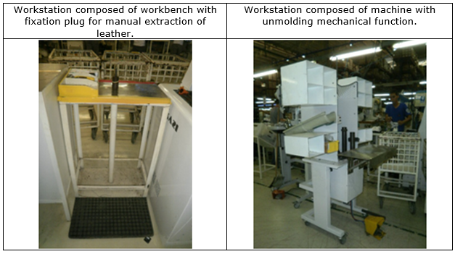
Figure 2. 1 Workstation setup

Collecting, sorting, laying out and preparing footwear for finishing operation
2.2.1 Preparation of footwear for finishing operation
Insock Fitting
This operation consists of placing and/or gluing the insock. Nowadays preformed insocks are used, which are only inserted inside the shoe, and there is no need to glue to fix the insock. This type of insocks is used mainly in sports or casual footwear.

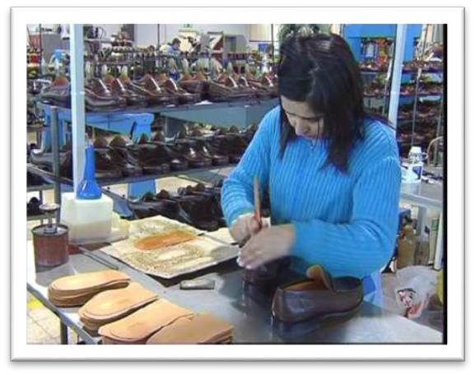
Figure 2. 2 Insock fitting
For gluing the insock there are several processes used, namely:
- Mechanical glue application: the glue is applied onto the insock by means of a machine with a glue roller, where the insock passes before an operator inserts it into the shoe,
- Manual glue application: An operator applies the glue with a brush on the back of the insock and then fits it into the shoe.
Edge Inking
This operation is performed when upper leather edges (open edges) are visible and do not have the color of the upper leather (for leather which has not been through-dyed), or when the lining edge is visible.
In these cases, it is necessary to dye the edges in the hue of the upper leather.

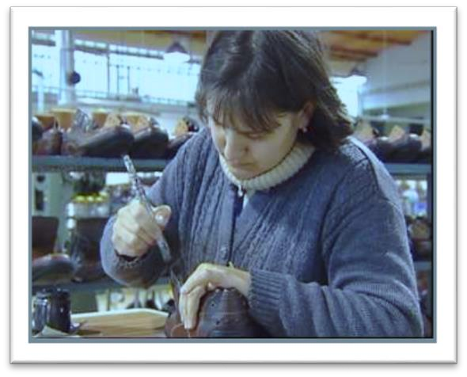
Figure 2. 3 Edge Inking
Cleaning / Repair
At this stage the shoe is checked and cleaned, which consists of removing glue residues, which can be found in the area where the sole is joined to the upper and inside the upper. Various tools, equipment and products can be used for cleaning. The type of cleaning to be performed depends on the shoe materials. To remove the glue from the assembling edge, the glue cleaning machine can be used. For the materials in which this process cannot be used, use a rubber crepe, a wooden spatula, a water sandpaper or a flannel cloth soaked in a suitable cleaning liquid.
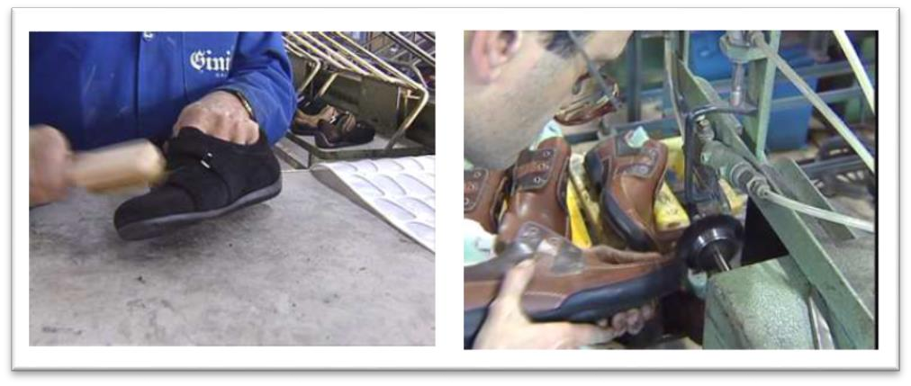
Figure 2. 4 Cleaning / Repair
Burning Thread Ends
With this operation it is intended to eliminate the small thread ends that sometimes stay from the sole stitching or from the upper stitching.
For the execution of this operation a small burner with an open flame can be used (but be careful not to leave burn marks on the shoe).

Setting-up, adjusting, cleaning and maintaining finishing machineries
- Brushing machine
This operation is required for finishing of leather and to give shining or polishing effect on upper leather. This is also converting or merges the course grain leather into fine grain upper leather. To produce or bring the burnishing effect, two tone effect, polishing effect to the upper part of the shoes with the help of suitable waxes.
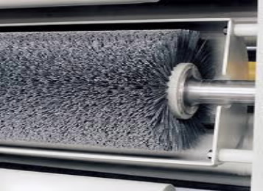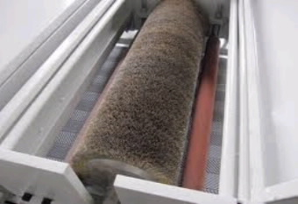
Figure 2. 5 brushing machine
Generally this operation carried out in shoe room with the help of brushing machine, with provision for cotton and wool brushing for cutting and polishing purpose. In polishing, normally use roller of brushing machine at low speed with the use of polishing i, e, synthetic wax or carnauba wax. Whereas when high abrasive action is not required then rollers of brushing machine at medium speed with the use of abrasive wax. If rules do not follow the above method provides uneven shining and creates problem in shoe finishing.
Brushing machine have surface preparation abrasive brush with all the necessary technical devices required to obtain a perfect finish on the flat surface. Machines are designed to suit individual customers applications and requirements. It provides the uniform brushing effect on the grain surface of the shoe.
The technical specification of this machine is-
- Height 175 cm
- Width 130 cm
- Depth 85 cm
- Weight 350 kg
- Power 3 Kw
Machine setups and adjustments
- Switch on the machine whenever required.
- Grain leather to be brushed well, as well as poromeric materials also.
- Use either the soft / hard cloth or woolen brush as per the requirements of finishing.
- We must maintain the following-
- Machine speed should be 900- 1100 rpm, 400- 500 rpm from cloth brushing as well as woolen brushing respectively.
- Use appropriate wax for finishing.
Cloth brushing--------- Abrasive wax
Woolen brushing------ Carnauba wax
- The course grain surface to be polished or merged well.
- To bring the shining or polishing effect to the shoe.
Machine operation instructions
Safety
- Switch off the machine when not in use.
- Switch on the dust extractor while operating the machine in order to prevent spreading of harmful dust.
- Operators are required to tie their wearing cloths of similar loose parts of their dress at their back.
- Do not work more than one person on the machine at a time in one place.
- Wear the mask while on working on the machine.
- Clean the machine thoroughly every day.
- Do not wear loose sleeved garments as the sleeves may become caught while operating the machine, wear tight on overalls.
Ironing machine (long boots)
Specifications
- Long boot ironing machine is a two station forming machine with heated metal lasts, suitable for long boot.
- Each station is equipped with an independent regulators to adjust the stretching of uppers according to the type and number of the uppers.
- Each last is equipped with a separate mini- safety switch protecting each resistance independently.
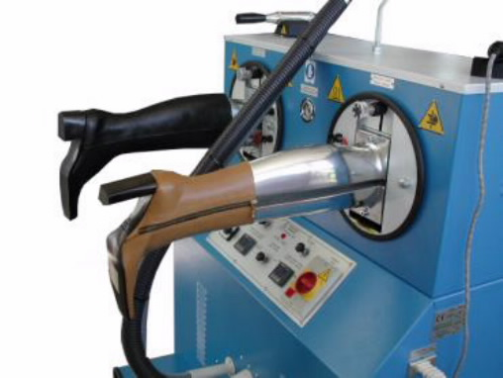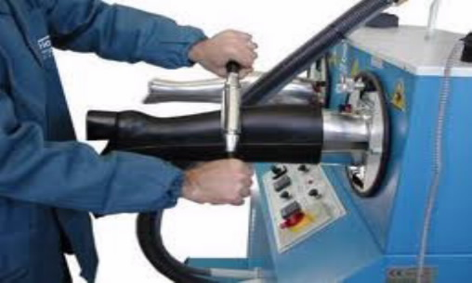
Figure 2. 6 ironing machine
This machine is well equipped and it is useful for ladies shoes, Gentlemen shoes, Ironing leather. It contains and used in boot ironing machine, aluminum molds, heating device, ironing long boots, pedant switch etc.
Features
- This machine equips with heating device.
- The aluminum mold is separated to upper and lower parts. They expands long boots.
- The aluminum mold can be rotated 180 degree. It is for the convenience of ironing long boots.
- A pedant switch is equipped in the machine for easy operations.
- It is automatic machine saves man power and increases efficiency.
- Electric counter device to control weight for easy replacement.
- Low breakdown rate, high machinery life- span.
- High revolving speed results in large production. Compact machine size contribute to factory space saving.
- Two styles of aluminum molds can be loaded simultaneously. This machine equips with heating device.
This machine is useful to chase the wrinkle in ladies and gents long boot with the help of heating rollers.
Machine operation instructions
Safety
- Switch off the machine when not in use.
- Operators are required to tie their wearing cloths of similar loose parts of their dress at their back.
- Do not work more than one person on the machine at a time in one place.
- Clean the machine thoroughly every day.
- Wear the mask while on working on the machine.
- Do not wear loose sleeved garments as the sleeves may become caught while operating the machine, wear tight on overalls
Hand irons
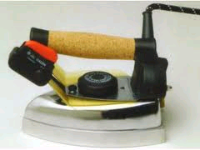
Figure 2. 7 hand irons
Hand irons are used in footwear and garments industry to remove the wrinkles and fold marks. It is used to improve the quality and produce the shining of apparel and allied products.
Generally the quality of the footwear and garments is measured in three characteristics:
- Durability
- Utility
- Emotional appeal
With respect to the raw materials used, the product design and the constructions of the product. Durability factors are tensile strength, tear- strength, abrasive resistance, color fastness and cracking and bursting strength. Utility factors are air permeability, water permeability, thermal conductivity, crease retention, wrinkle resistance, shrinkage and soil resistance. Appeal factors are eye appeal of fabric or leather / leather garments face, tactile response to the fabric surface, fabric hand and eye appeal of the leather garments face, design and drape. The principals involved are the same whether the garments is made of leather, plastic, foam or textile such as women, knit or felt fabric.
Pressing and molding process
Molding is the process that change the surface characteristics or topography of a garment or shoe or one of its section by application of heat, moisture or pressure. Pressing, pleating, blocking, mangling, steaming, creasing, curing and casting are trade terms for various molding processes in producing clothing and footwear.
- Pressing has two major divisions.
- Buck pressing
- Iron pressing
A buck press is a machine for pressing a garments or section between two contoured and heated pressure surfaces that may have steam and vacuum systems in either or both surfaces. Before 1905, all garments pressing was done by hand irons heated directly by gas flame, stove plate heat or electricity.
In iron pressing, a hand iron functions as top pressure surface. The two major types of hand irons are steam ejectors and dry irons. Electric hand irons are equipped with thermostats that regulate temperature. Steam heated irons, whether ejection or dry, have fixed temperatures depending on the pressure of the steam supplied to the iron. Many hand irons are equipped with lift devices and gear devices to control stroke rate and minimize operator fatigue. Hand irons are made in a variety of sizes, weights, shapes and surfaces, the specific usage determines the combination.

Top- line forming machine

Figure 2. 8 top-line forming machine
This machine is applicable to final moulding and finishing, before removed and packed, melt the glue of the heel deformed with electric heating and then cool it down for moulding. The heel after moulding will have a straight and perfect shape. In addition, the heating and cooling will remove the damp so as to keep it from mold growth.
- Free regulated temperature and heating time upon the material of vamp.
- Time can be adjusted when the temperature reaches 150 degree centigrade. It has a good moulding effect.
Machine operation instructions
Safety
- Switch off the machine when not in use.
- Operators are required to tie their wearing clothes of similar loose parts of their dress at their back.
- Do not work more than one person on the machine at a time in one place.
- Wear the mask while on working on the machine.
- Clean the machine thoroughly every day.
- Do not wear loose sleeved garments as the sleeves may become caught while operating the machine, wear tight on overalls.
Spray cabin
On most spray guns for top spraying, the following adjustment are required-
- Adjust material flow by the screw that controls how much liquid is being sprayed when trigger is fully depressed.
- Adjust the spray patterns.
- The shape of the spray pattern on some guns can be altered between round and oval.
- “ Pear drop “ and “ banana” shape are incorrect and likely to lead to uneven coverage.
- Take care of the spray pattern position. This is important on oval spray patterns which should be vertical.
- Adjust air pressure.
Note that air pressure is not controlled on the gun, but usually on an air pressure controller somewhere near.
The quality depends on: -
- Supply of clean, compressed air
- Selection of suitable guns, nozzle sizes and air caps.
- Good maintenance of the equipment.
- Adequate extraction of the fume generated during spraying.
- Spraying method.

Maintenance of spray gun
Correct cleaning of the gun will give the following results-
- It provides trouble free running. At the end of the day flush out the gun and cup with water or spirit such as acetone. The cleaner can be left in the gun overnight providing the equipment is clean.
- Never totally immerse the spray gun in sprit. This can damage the packing.
- Oil the needle and air valve daily.
- Clean air and fluid holes with compressed air or a bristle. NEVER USE WIRE.
Spraying technique
A technique should be developed to obtain an overall even coat of the dressing, without streaks, runs, misted or rough finish. The following are some factors that are important-
- Check spray patterns
The spray patterns should be checked momentarily spraying on a piece of waste material such as cardboard held squire to the gun. Uneven patterns are usually due to obstructions or damage at the fluid tips.
- Check air pressure to the gun. This should be 2.8 to 3.5 Bar. Or ( 40 to 50 psi ).
- Hold the shoes and boots putting the hand inside the best. The hand is used to present the shoe at the correct angle ( not to move it past the gun ). The hand will protect the inside of the shoe from over spray.
- A glove should be worn for protection.
- By holding the shoe on the top of the heel may result in leaving marks on successive shoes from the accumulation of spray on the thumb and fingers . The shielding effect of fingers and thumb can also leave noticeable areas not sprayed on the side of the heel.
- Have correct altitude, and distance of the gun from the shoe—
The nozzle of the gun should be kept squire to the upper surface, at the distance of 30 cm. ( 12 inches ). The fluid flow should be adjusted to give sufficient dressing to “ wet out “ causing runs.
The best method may be to start at the toe, moving along the feather edge, up to back seam, along the top- line , over the instep, along the other side top line, down the back seam, along the feather to the toe, and up the center of the vamp to the top of the quarters.
The gun must be moved with one hand, while the other presents the shoe in the right altitude. The spray should be started and finished JUST OFF the shoe, and must be kept moving at a constant speed over the surface.
- Ensure drying
Once spray is completed, very great care must be taken to avoid touching the wet surface, or allow anything to contact it until it is thoroughly dry.
Application procedure
- Use good quality sponges and clean the same with water before and after application.
- For cleaning the shoe use clean starch free cotton cloth and change the cotton cloth regularly.
- Always allow some time ( 5 minutes ) for drying all water based products, in between each operation.
- Before and after spraying water based products, clean the gun with water only.
- Solvent based products to be sprayed at less pressure ( 45Psi ).
- Before and after spraying solvent based products, clean the gun with solvent thinner or acetone only.
- Water based products at more pressure (60- 70 Psi).
- For safety measure clean the surface of shoe ( degrease ) after application of abrasive and before applying the top dressing.
Machine operation instructions
Safety
- Switch off the machine when not in use.
- Operators are required to tie their wearing cloths of similar loose parts of their dress at their back.
- Do not work more than one person on the machine at a time in one place.
- Wear the mask while on working on the machine.
- Clean the machine thoroughly every day.
- Do not wear loose sleeved garments as the sleeves may become caught while operating the machine, wear tight on overalls.
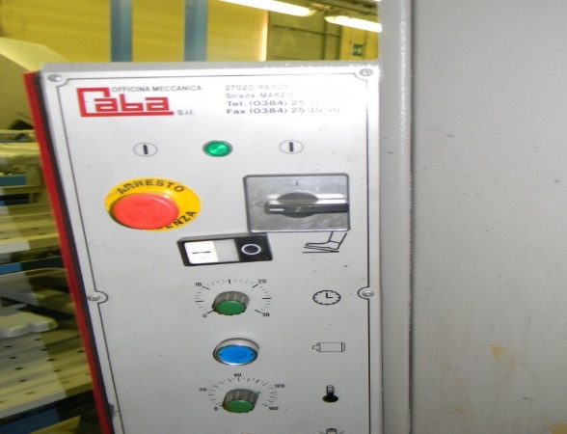
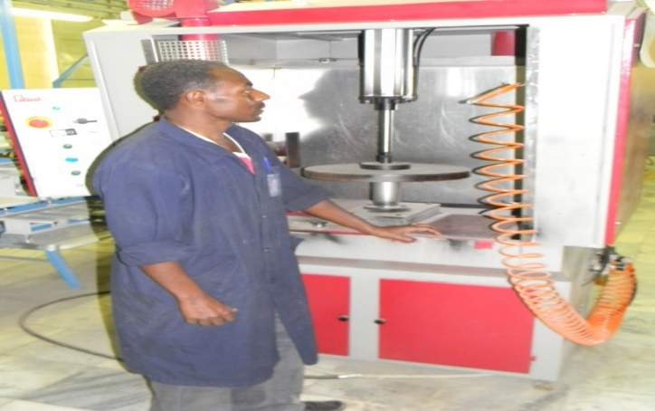
Figure 1 machine operation

Self chek-2
Directions: Answer all the questions listed below. Examples may be necessary to aid some explanations/answers.
Test I: Multiple Choice
1 which one of the following is intended to eliminate the small thread ends that sometimes stay from the sole stitching or from the upper stitching
- Burning thread ends,
- cleaning,
- edge inking,
- insock fitting
2----------------is the machine that change the surface characteristics or topography of a garment or shoe or one of its section by application of heat, moisture or pressure.
- Ironing machine
- spray cabin,
- molding machine,
- none
Test II: Short Answer Questions:
Instruction: write short answer for the given question.
  - How to setup workstation?
  - Describe the basic concepts of cleaning and maintaining?
  - Describe about benefits of cleaning and maintaining machineries of finishing section?

Unit Three: Perform Finishing and packaging of the work
This learning unit is developed to provide the trainees the necessary information regarding the following content coverage and topics:
  - Types of leather finishes.
  - Finishing processes I and II.
  - finishing operations
  - packaging and labeling materials
  - Checking products as per customer specification
  - packaging operations
  - Taking action to prevent accidents and to eliminate risks to personal safety.
  - Completing production and other records.
This guide will also assist you to attain the learning outcomes stated in the cover page. Specifically, upon completion of this learning guide, you will be able to:
- Identify different types of leather finishes.
- Identify and describe finishing processes I and II.
- Perform finishing operations
- Identify and sort packaging and labeling materials
- Check products as per customer specification
- Perform packaging operations
- Taking action to prevent accidents and to eliminate risks to personal safety.
- Complete production and other records.

Types of leather finishes
Those are the common finishes available in leather used for upper making
Aniline finish
This is the most natural type of leather which earned it the names Pure Aniline or Full Aniline. It is dyed with soluble dyes in vats so that the colour goes all the way through the hide giving the leather its lush and rich colour. In order to maintain the natural feel and look of the hide no protective coating or surface pigmentation is applied. Additionally, the leathers maintain their natural markings and texture which contributes to the authenticity of the leather. However, the lack of treatment might render the leathers more susceptible to scratching, staining, or fading and might show some colour variations on the surface of the hide.
Some aniline leathers are sanded of buffed to create an open nap; the result is called Nubuck. These leathers are the softest kind available and have a beautiful, almost velvety, feel. Yet, they are also the most susceptible to fading or staining due to the open nap.
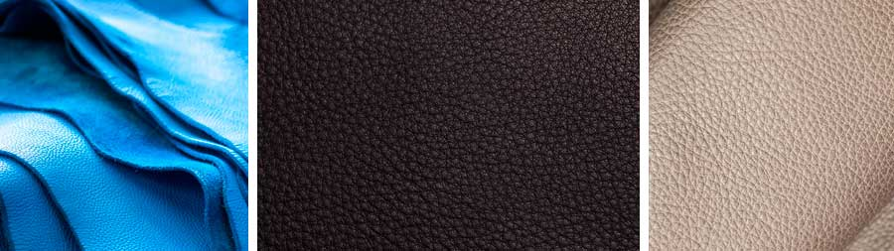Figure 3. 1Aniline finish
Why use them?
Quality, natural looks, design aesthetic. They are generally the higher price pointed leathers. And have a very natural surface appearance. You will generally require more aniline leather if you do not wish to see imperfections. Aniline hides fade and mark—they build up a natural patina over time.
Semi Aniline Leathers
First things first: In this case "semi" is actually a misnomer, as it does not mean partial. A more appropriate name for semi aniline leather would be aniline plus pigment due to the way it is created. The process starts the same way as for aniline leathers. However, whereas the treatment of full aniline stops after the dying, semi aniline leathers are further treated. So, after the leather is aniline dyed, a slight protective coating, which can contain some additional pigmentation, is applied to the top of the hide to guarantee a consistent colour. Due to the pigmented coating some blemishes will be concealed leaving a more uniform surface texture. Additional finishes can then be applied to the leather either by hand or by machine (e.g. antique looks or exotic leather optics). In the end, a clear protective coating is applied to make the leather stain repellent and sun resistant. The sheen of this coating can be adjusted to give a matte or glossy finish.
Why use them?
Amazing range of colors, practical leathers, Smoother surface. Or you simply
prefer this look. They are generally the mid-price pointed leathers. And have a light painted type appearance.
Corrected grain or Pigmented:
Just like the other two types above, it is dyed all the way through the hide. However, the surface is then coated with a heavy protective topcoat which includes pigmentation. Any kind of blemishes or imperfections are removed through buffing or sanding and then embossed with an artificial grain. At the expense of a deep rich colour and a luxurious feel, pigmented leathers are treated with spray coating which makes it more durable. Therefore, pigmented leathers are the least natural grain leather but also the most durable.
Why use them?
Hardwearing, practical leathers, great range of colors. Or you simply prefer this look. They are generally the lower price pointed leathers. And have a painted type appearance.
Burnish:
Burnishing is the process of buffing leather edges to a slick, glossy finish. Burnishing is aesthetic it looks nice to have the shiny edge. But it also serves a functional purpose. When you burnish leather, you seal the cut edge by applying friction. The heat from the burnishing tool compresses the fibers of the leather together. By sealing the edge in this way, the leather retains its natural oils and moisture and won’t dry out. It also creates a waterproof barrier so the leather won’t absorb moisture. This helps prevent your thread from rotting.
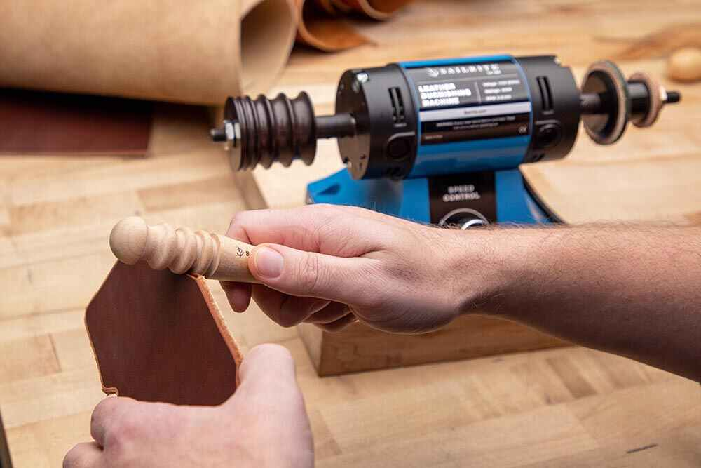
Figure 3. 2 Burnishing
Burnishing works best on vegetable tanned leather, as even thin, lightweight veg tan is stiff enough to hold up to the friction of a burnishing tool. You can burnish before or after dyeing a leather edge, though we recommend burnishing after to maintain a high gloss finish. This finish is normally given on F/G leather.
Brush Off:
Brush off leather is leather which if brushed by heavy cotton brush gives a two tone effect. Normally, the leather in tannery is finished with two or three coats of finish. The two finish layers are either in contrast colour or contrast shade. The top coat is not fixed and on brushing hard gets off. Hence, the name given to the finish is Brush off. You brush the surface and the top finish is off making the bottom finish layer visible giving leather a two-tone effect. This leather is called brush off.
The brush-off leather consists of a skin whose surface has been sanded and subsequently covered with a layer of uniform dye, it can be glossy or opaque and the ideal use of this leather is footwear, but it can also be used for belts and leather goods in general. Among the various types of leather processing, the brush-off one is very particular as the finishing that is performed on the leather which makes it very uniform to the eyes and to the touch. In practice, it is a polishing that is performed by hand or by machine with precise movements, only an expert craftsman can perfectly succeed in this task. With this treatment, the skin is without any imperfections and the processing guarantees excellent resistance.
Metallic:
Metallic leather or Metallized leather is leather with a metallic look. Metallic effects are generally only found on smooth leather. This effect is achieved by using metal colours in finish, used for ladies or kids shoes Metallic effects are commonly used for fashion reasons in leather shoes, clothing and bags.
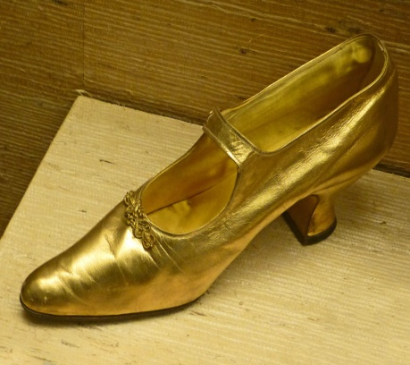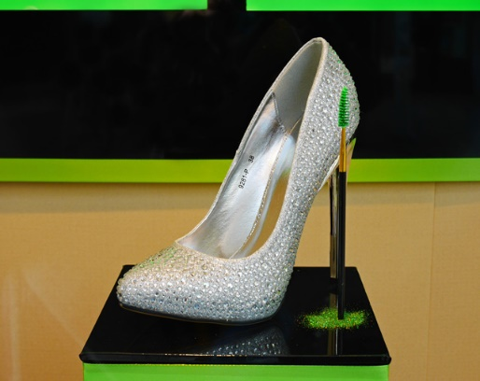
Figure 3. 3 Metallic leather shoes from 1859 and 2014
Pull Up:
Pull up is a finishing technique, not strictly speaking a type of leather any kind of leather can be pull up. A popular finishing technique for top grain leather, the pull up finishing technique infuses hot oil and/or wax into the hide. The intricate finish allows for lines to form in the leather when pulled or stretched. This pulling creates the desirable “two tone effect.” “To me, the beauty of pull up isn’t that it looks older or aged, it’s the gorgeous two tone color variation it can achieve,” says Tucker Gasho, the owner of K&H Leatherworks, What makes leather pull up or not is if you get the color change when it’s manipulated. ”
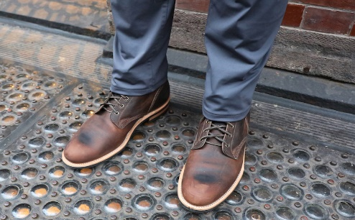
Figure 3. 4 Pull Up
Full grain leather.
Full grain is leather from the upper part of the hide, and the outer surface has not been polished or corrected. If you look very closely at the leather, you can actually see the hair follicles
Full grain leather has no surface alterations. The hide’s natural pores and grain textures are intact and it will develop a patina over time. The tiny pinholes dotting the surface indicate the hide’s open hair follicles. The presence of these hair follicles demonstrates a high quality surface which has not been altered to conceal flaws. This full grain surface breathes. It keeps the user comfortable as it adjusts to body temperature. Full grain leather is the highest quality, most beautiful, and most comfortable leather available.
Characteristics of Full Grain Leather
No matter how advanced the tannery, each and every piece of leather produced is unique in character. A quality hide’s natural origins are displayed on its surface. Look for these essential characteristics of full grain quality:
- Fat wrinkles or growth lines: subtly shaded bands on the grain side of a hide
- Natural variations in grain texture and shading.
- Small scars: on a quality product they do not render large portions of the hide unusable.
- A similar shade of color on the suede side: this demonstrates superior base dye penetration.
- The depth and shading of color on the grain side is comparable to that of a transparent color stain on a piece of fine hardwood furniture
Choosing full grain leather is the smart, long-term solution if comfort, quality, and durability are important.

Finishing processes
There are 2 types of shoe finishing system or methods.
- System I shoe finishing process
- System II shoe finishing process
- System I shoe finishing process
It is done separately after lasting and sole attaching operations. This system is used for all types of leather finishes /shoe finishing.
System I shoe finishing process as follow: -
- Cleaning
- Thread burning or cutting – Loose thread is cut or burn using split lamp, hot blower or thread trimmer
- Edge coloring - done using pigment, dye, or cream to color the edge of shoe
and to make it similar with shoe surface.
- Shoe repairing
- Shoe ironing
- Base coat application
- Cutting
- Top coat cream application
- Light cutting - using cotton roller, just light touch of shoe surface
- Polishing – using woolen roller
- Socks attaching
- Lacing
- Stuffing - is inserting tissue paper in to the shoe to maintain the shape of shoes.
- Quality checking
- Packing
- System II shoe finishing process
This system is mostly used for pigmented or corrected grain finish leather which heavily coated, cream applied and pass-through heat setting for more penetration finish or cream. The finishing process started before heat setting and sole attaching, after Lasting Operation completed.
System II shoe finishing process as follow: -
- Cleaning
- Thread burning or cutting
- Edge coloring
- Shoe repairing
- Shoe ironing
- Cutting
- Base coat application
- Pass through heat setting
- Ironing
- Cutting operation
- Do rest of lasting operations to de-lasting
- Dry cleaning
- Base coat application as
- film coat
- Drying
- Light cutting
- Top coat application
- Light cutting
- Polishing
- Socks attaching
- Lacing
- Stuffing
- Quality checking
- Packing

Finishing operations
Following are the basic Footwear finishing operations
- Cleaning (Sole and Upper)
Sole cleaning in lasted upper is done after sole attaching operation due to remove the excessive adhesive. In addition of that upper surface is also clean to remove dirt, adhesive and other unwanted marks prepare the surface for further finishing operations. Cleaning can be done by two ways: -
• Dry cleaning - Dry cleaning in sole can be done by Edge brushing machine, crape rubber or resin rubber. In upper dry cleaning can be done by cotton cloth, crape rubber or brushes.
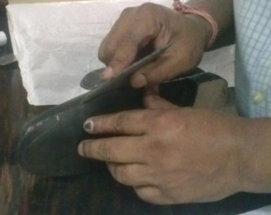
Figure 3. 5 Dry cleaning
• Wet cleaning - Wet cleaning in upper can be done by mild soap or cleaner depending upon the material of Upper.
Before starting the finishing operation, ensure that the surface to be finished has been cleaned.
The purpose of cleaning the upper of the shoe is to remove,
- The dirt
- Adhesive overspill
- Other unwanted marks and contamination
And prepare the shoe surface to accept dressing and other finishing treatments.
Cleaning can be done before or after removing the last from the shoe. The latter is preferable for better shape retention of the shoe.
Principles to follow when cleaning
- Relate the choice of cleaner and the method of cleaning to the types of contamination that is being removed and the types of finish on the upper.
For example- Solvent based cleaners should be used to soften natural rubber ( because water based will not ). However, do not try to remove rubber solution from suede with a solvent- based cleaner or “ tide marks” will result. Suede has to be cleaned dry by rubbing with crepe rubber.
- Use dry methods in preference to wet.
- Use the mildest treatment possible that will effectively remove the contaminations.
- The stronger the cleaner, the more finish it will remove in cleaner.
- Start with the mildest cleaner, and dry progressively stronger cleaners until the dirt is removed.
Cleaning methods
Cleaning can be done both wet and dry methods. It can be done by hand or by machine.
- Cleaning dry by hand
The items used for this cleaning methods are-
- Crepe rubber- for removing adhesive.
- Soft sponge rubber- for brushing the suede nap.
- Brushes- wire and stiff bristle type. For removing general dust and dirt from suede. For brushing up the suede nap.
- Scouring pads- for removing general dust and dirt from suede.
- Dull knives- for scraping away hard substances like waxes. Sometimes warming the knife slightly to get the knife under to lift contaminants from the surface.
- Emery paper- Various fine grades of grit for raising and even up any suede nap that has been badly treated or discolored.
Cleaning dry also is the method on all types of fabrics, as liquids leave “ tide marks”. The best solution is to avoid getting the shoe dirty in the first place as heavy staining is impossible to remove.
- Cleaning dry by machine
The machine can have power driven, revolving brushes of various shapes. The method requires that the upper finish of material will stand up to friction and the heat generated by brush.
Apply just sufficient pressure to remove dirt without damaging the finish. Usually, removing some stubborn contaminants by hand method is necessary.
- Cleaning wet by hand
Advantages of hand cleaning is that selective cleaners can be used and an operative can give to each shoes individual treatment .
- Apply the cleaner by cloth ( white cotton pieces are best ) wrapped round the fingers by rubbing gently over the surface. Or by sponge when very little rubbing pressure is required. Stubborn dirt may need extra rubbing or application of a more suitable cleaners. Crepe rubber and dull knives can be used.
- Change cloths frequently and wash out sponges regularly.
- Cleaning wet by machine
The machine has an application for cleaner and usually a mild water - based type is chosen for general cleaning.
- Adjust the amount of cleaner applied to the revolving brush to “ wet- out” the material without being excessive.
- Take care not to over brush and damage the finish.
- Follow the following work method.
- Clean the feather area with the small welt cleaning brush.
- Clean the upper with bigger wet brush.
- Dry the upper on the cloth mop.
- Polish on the woolen brush.
Wetting out and drying out
A cleaner to be effective must “ wet- out” the material being cleaned. If the liquid does not spread out on the surface, but runs over the drops, it is not wetting the finish and should not be used.
After cleaning upper must be allowed to thoroughly dry out before other operations are carried out, otherwise there were be a lack of adhesion with the next coat of dressing. Bloom may be develop later on the box.
Table 3. 1 cleaning for various soiling materials
Cleaning materials | Cleaning agent
Color code Paint ( on material edge ) | Detergent
Thread lubricant | Detergent
Spray marking | Detergent
Silver pen | Solvent
Grease | Solvent
Thermoplastic adhesive | Solvent / Detergent
Rubber adhesive | Blunt knife
PU adhesive | Crepe rubber/ Adhesive
Neoprene adhesive | Rubber / solvent

II Repairing
Repairing in shoe refers to bring the shoe in good slandered before continuing with other operation. It can be done by Repair crayons, Repair paste, brush or spray in upper material. The paste spray can be either water or sprit based
During the shoe making process upper material is subjected to a variety of abrasive and stretching actions, which can adversely affect the appearance of the shoe.
The damage may be due to the following reasons:
- Over roughing along the featheredge
- Scuffing of the finish during handling.
- Damage to the finish by solvents and heat.
- Grain crack during lasting.
- Increase in shade variation of upper leather.
Repairing includes both upper and bottom repairs, of a minor nature, such as scratched uppers at upper roughing, heel scouring and very slight cuts during upper clicking, lasting etc.
For bottoms, main repairs area may be in the heel, especially at the seat and heel breast.
The purpose of these repairs is to bring the shoe to a good standard, before continuing with the other operations in the finishing. It can be done by repair crayons, repair pastes, and spray paints for grainy upper materials. The paste or spray can be either water or spirit based.
- Never repair deep scratches, cuts etc. on the upper as their repair will only leave marks which would be seen on the finished shoe and therefore should not be accepted.
- For minor scratches, cuts, use very fine grit size abrasives to first even the surface, then apply repair crayons or pigment paste and finish off with renovators etc.
- Pigment and dyes must match the color of the upper.
- If only the finish is damaged, then use uniformers or renovators.
- For repair of soles use-
- PU paint for PU soles
- TPR paint for TPR soles
- Creams and polishes + color of leather soles.
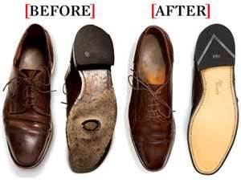
Figure 3. 6 repairing
- Wrinkle Chasing
Removing the wrinkle on the lasted upper by applying heat. This done by ironing the wrinkled surface or hot air blow. This technique is to apply heat and steam to the surface of the upper, or lining materials, to shrink the surface slightly and tightening the grain thereby removing the creases.
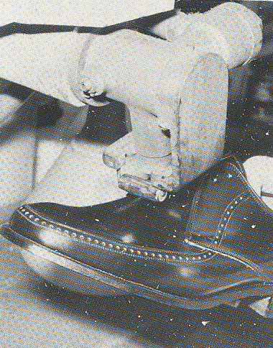
Figure 3. 7 Wrinkle Chasing
- Ironing
Ironing in leather upper required hand irons which are controlled by thermostats used for removing wrinkles. Sometimes the whole leather surface is ironed to improve the finished quality.
Teflon paper is used to protect leather surface from hot metal parts to avoid burning.
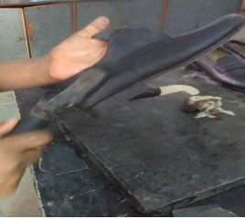
Figure 3. 8 teflon paper ironing
Special electrically heated hand irons which are thermostatically controlled are used for removing wrinkles. Sometimes the whole leather surface is ironed to improve the finished quality.
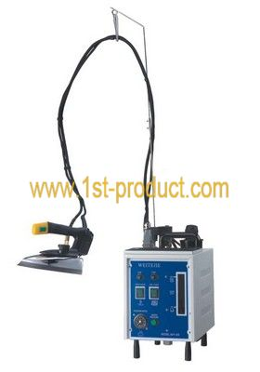
Figure 3. 9 thermostatic ironing
- Filler or base coat application
Filler of base coat application is done to remove the “open and hungry look” of leather after the lasting process. The purpose is to seal the surface for subsequent dressing. It ensures that topcoat does not sink in and minimum quantity of dressing material used for the desired appearance and luster.
Fillers are available either in cream or liquid forms. These products are used to fill upper leathers, which have developed an “ open or hungry” look after lasting. They act as a base coat for subsequent top dressings. They seal the surface so that the top coat does not sink in and only minimum quantity has to be applied to give the desired appearance and luster. Fillers also enhance the gloss and are necessary for inferior quality leather.
They are available as follows:
Table 3. 2 filler or base coat application
Degree of “ fill” | Usage
Light | For light leather finishes ( protein finish )
Medium | For resin finished leather
Heavy | For leather with open or hungry look
They are usually available in black for black leathers and colorless for other leather colors. Occasionally the base coats can be color matched with helps to lessen shade variations. They are usually applied by hand using sponges and they should dry out “steak free”. Use of correct fillers will also help in cases where there are problems of adequate adhesion between the top coat and the shoe upper.
Table 3. 3 fillers for leather finish
Leather finish | Leather | Base/ filler
Protein | Aniline calf, glazed kid | Light filler
Resin | Resin, semi-aniline  Rub off, pearlized | any type when necessary
Pvc | Patent, coated split | None, only color match
Wax | Burnish, oil pull-up | Light filler if required
Suede, nubuck | Suede, nubuck | None
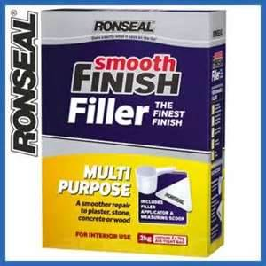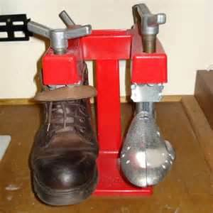
Figure 3. 10 smooth finish filler
- Top coat application
The operation is often the final treatment, which gives the shoe its luster and determines its final appearance. Top dressing is either water based or solvent based.
- Mainly wax based: - after brushing they give natural shine
- PU based: -does not require brushing, gives artificial shine
- Protectors: -silicon oil /fluorocarbon
- Renovators: -oil or emulsion
The success of the dressing rests on-
- Correct and through cleaning.
- Compatibility of the dressing with the material finish.
- Condition of the upper before applying the dressing.
- Correct application.
- Correct spray gun adjustment and technique.
Types of dressing and application
- Water based dressing
Water based top sprays of older types were based on wax emulsion and protein. The modern sprays are made from acrylic resin emulsions and suitable for use on protein and nitrocellulose coated leathers but not for polyurethane. They are colorless or with colors. Liquid dressing are of two types. Wax based and PU based.
Wax based dressing requires brushing, which gives a natural shine to the shoe.
PU based dressing normally does not require brushing. It gives an artificial shine.
- Check compatibility of the dressing with upper material because non- compatibility shows as cracks, peel off or white marks.
- Apply dressing by hand or spraying according to finishing system selected.
- Solvent based dressing
Solvent based dressing from strong coating, which are compatible with a wide range of upper materials. They are fast drying and are based on cellulose derivatives, acrylics or polyurethane. They can be clear or colored and are available in a wide range of luster from matt to high gloss.
- Check compatibility of the dressing with the upper material.
- Apply dressing by hand or spraying.
- PU based dressing
It is not repairable if something goes wrong during finishing and one want to refinish after the removal of first finish.

- Cutting
Upper smoothing with help of cotton brush (abrasive action) for core filling to get smooth waxed surface for further operation is called cutting. Mainly cotton brushes are used for doing cutting in shoe surface.
- Polishing
Polishing is done after the application of final coat on upper material. This process is with woolen brushing on which carnauba or polishing wax is applied. It gives luster and gloss to the upper of the shoe.
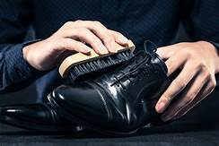
Figure 3. 11 polishing
Shoe polish is a waxy paste cream, or liquid used to polish to provide shine, water proof and restore the appearance of leather shoes, boots etc. And extending the footwear life.
Various substances have been used as shoes finish for hundreds of years, starting with natural substances such as wax and tallow. Modern polish formulas were introduced early in the 20th century and many of those original formulations are still in use today. Shoe polish is usually made from a mix of natural and synthetic materials including naptha, turpentine, dyes and gum arabic, using a chemical processes. Shoe polish is usually flammable, can be toxic and if misused can stain skins. It should be used in a well-ventilated area with care taken to protect cloths, carpet and furniture.
Polishes and creams are non- film forming. Normally wax polishes are used and are widely available either neutral or pigmented to match the color. Surface waxes can impart a measure of water repellency to footwear although they cannot be regarded as water proofing agents. Waxes and creams are also suitable for gloss enhancement or to give some special appearance ( antique effect ) on leather look synthetic material. Cream could be soft, medium or hard. Soft and medium creams are those that require to be polished, and are referred to as the creams to be polished. Hard creams are available as self- shining creams. They do not require polishing or brushing operation.
Examples of Finishing Procedures for Full Grain Calf Leather -Aniline, Semi aniline
The characteristic of this leather is the color transparency and brightness. For finishing this type of leather some of the systems are:
- Clean the Shoe
- Apply the sealing cream;
- Once dry put a small quantity of abrasive wax on a cotton brush and then brush it at a medium speed; and
- Polish it with a woolen brush treated with carnauba wax.
- Clean the Shoe
- Apply the sealing cream;
- Once dry put a small quantity of abrasive wax on a cotton brush and then brush it at a medium speed;
- Apply the top dressing; and
- Polish it with a woolen brush treated with carnauba wax, once the shoe is dry.
- Clean the Shoe
- Apply the sealing cream;
- Once dry put a small quantity of abrasive wax on a cotton brush and then brush it at a medium speed;
- Apply a self-shining cream by sponge; and
- Once dry, brush it with a cotton brush and then polish it with a woolen brush treated with carnauba wax.
- Brush-off Leather
The characteristic of this leather is that it gives a two-tone effect on brushing on a cotton brush.
The suggested systems are:
For Natural Gloss Elegant Look
- Clean the shoe;
- Once dry, brush on a cotton brush at 700-800 RPM with abrasive wax;
- Clean the shoe;
- Apply a suitable cream;
- Once dry, brush on a cotton brush at 700-800 RPM with abrasive wax; and
- Polish it with a woollen brush treated with carnauba wax 700-800 RPM.
For High Gloss
- Clean the shoe;
- Once dry, brush on a cotton brush at 700-800 RPM with abrasive wax;
- Clean the shoe;
- Apply a filler (sealing cream/liquid);
- Once dry, apply a suitable top coat; and
- Polish it with a woolen brush treated with carnauba wax.
For High Gloss
- Clean the shoe;
- Once dry, brush on a cotton brush at 700-800 RPM with abrasive wax;
- Clean the shoe;
- Apply a high shine top dressing, one or two coat as per the requirement; and
- Polish it with a woolen brush treated with carnauba wax.

Packaging and labeling materials
- Packaging
There are a lot of definitions for packaging, but a broad and well-established one can be: packaging is “a coordinated system of preparing goods for transport, distribution, storage, retailing, and their end-use; the means of ensuring the safe delivery to the final consumer in a sound condition at minimum cost; a techno-economic function aimed at minimizing the costs of delivery while maximizing sales (and hence profit)”.
Packaging material
Packaging can be made from diﬀerent kinds of material. Most important are: paper and cardboard, plastic, textile, wood, metal, glass, and composite materials. In shoemaking production, paper and cardboard are the most often used packaging materials. Less important are plastics and/or metal cans, glass bottles for liquids, and chemicals and wood for wooden pallets for the transportation of goods.
Paper and cardboard
Paper and cardboard are one of the oldest materials which still cover the largest proportion of packaging. They are the most widely used materials in the footwear industry as well. Mostly, they are used as:
- shoe stufng paper or fller paper to preserve the shape of
the shoe
- wrapping paper to protect the footwear in a pair box
- pair box to protect the fnished pair of shoes before delivery to the customer (Figure 3.12 above)
- transport packaging for transporting the fnished products (shoes) from the place of production to the place of sale (Figure 3.12 below)
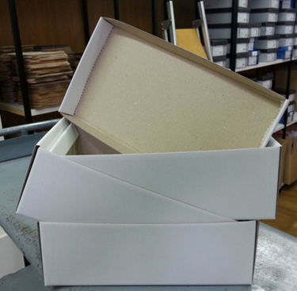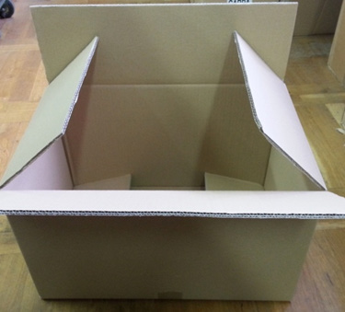
Figure 3. 12 Example of a pair box and transport box made from corrugated paper
Packaging made from corrugated paper
A corrugated box is a shipping container made of corrugated fiberboard. These are most commonly used to transport and warehouse products during distribution, and are rated according to the strength of the material or the capacity of the finished box. This kind of packaging is probably the most used type of packaging in the footwear industry.
- Labeling
Labelling is a process of inserting identification on boxes or the packaging that’s done. Labelling is the process of writing important information on the packing boxes for identification and forward information regarding the care, moving, types of item, number and other related issues to the customers.
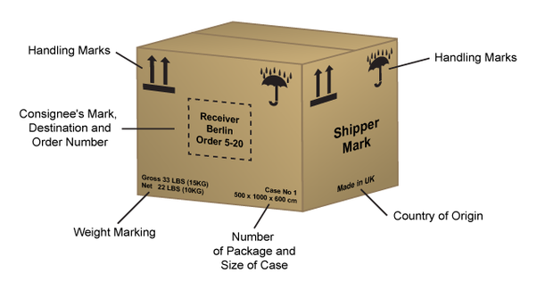
Figure 3. 13 labling
Information Provided in Carton Boxes: -
- Some of the information’s to be provided are:-

- Carton box number
- Order number
- Style and color of the product
- Number of pieces in each color and style
- Total number of pieces
- Contact number
- Net weight
- Dimension of the carton box

The label must be attached to at least one item of footwear in each pair and may be affixed by way of printing, sticking, embossing or use of an attached label; it must be visible, securely attached and accessible. The label may also appear on the packaging but it must be on the footwear itself. If pictograms are used in a retail shop a notice must be displayed that explains to consumers what the symbols mean. The notice must be large enough so that the information can be seen and understood by consumers. If pictogram labels are used where footwear is sold from a place consumer do not have access to (for example, mail order or internet sales) the consumer must be clearly informed of the meaning of the pictograms used.
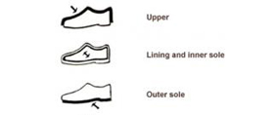
The pictograms for the parts of the footwear

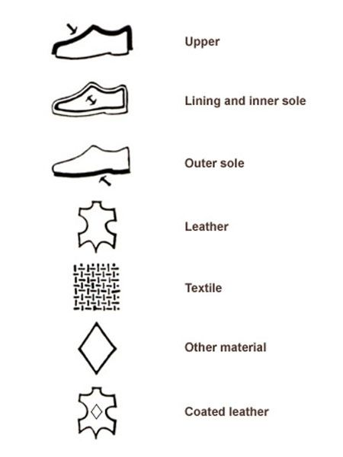
The pictograms for the materials used in footwear composition

Figure 3. 14 parts of footwear & material used in footwear composition

Checking products
The shoe must be submitted for a final examination before boxing. Any damages to the upper must be repaired if possible, or the shoes rejected or returned to be pulled up and put in order. If a damage is of such a nature that a part of the upper is shown to be peeling up, this should be firmly stuck down with a glue, such as Croid or something similar that is contained in a tube ready for use. Rubber solution must not be used as it leaves a slight ridge at the edge of the tear, which when rubbed may cause the damage to open up again. After the glue or cement has thoroughly dried, the area around the defect should be finely scoured and the surface filled in with a repairing crayon of an identical color to the original leather. Scratches or cuts that are not too deep can also be finely scoured and filled in in the same way taking care, of course, to brush away any surplus scouring before using the crayon. Damages in the feather caused by the stitching machine, usually because the leather guard has worn and allowed the awl to contact the upper, are difficult to repair, but are best dealt with by melting some crayon on the end of a hot knife and filling in the incisions. The surplus wax is rubbed off with a cloth wrapped around the end of the finger. Sometimes a series of grinning holes appears round the toe due to bad welt sewing. These can also be filled in in the same way. Damages are not the only things to be looked for; sometimes an eyelet is missing, and even a row of stitching may have been missed. Heel breasting may be the cause of many returns, if the knife has been allowed to go too deep, particularly in rubber soles. This, therefore, requires constant vigilance.
It is also not only the outside of the shoe that must be examined but also
the inside. There must be a final check to see that no nails are left sticking
through the insole. Torn linings, burst seams, damaged insoles due to the
welt sewer striking through, are other points that must be checked.

Packaging operations
Packing is the science, art and technology of enclosing products for distribution, storage, sales and different methods of uses. Packaging also refers to the process of design, evaluation and production of packages.
Lacing
Shoelaces, also called shoestrings (US English) or bootlaces (UK English), are a system commonly used to secure shoes, boots, and other footwear. They typically consist of a pair of strings or cords, one for each shoe, finished off at both ends with stiff sections, known as aglets. Each shoelace typically passes through a series of holes, eyelets, loops or hooks on either side of the shoe. Loosening the lacing allows the shoe to open wide enough for the foot to be inserted or removed. Tightening the lacing and tying off the ends secures the foot firmly within the shoe. The laces can be tied in different shapes, most commonly a simple bow.
Common lacing methods
- Straight-bar lacing
Straight-bar lacing appears horizontal and parallel when viewed from the exterior. Formal shoes usually demand straight-bar lacing to preserve their clean, neat look. This is especially true for dress shoes using a closed lacing system such as Oxfords, because the central shoelace crossovers of crisscross lacing prevent the sides of the shoe from coming together in the middle
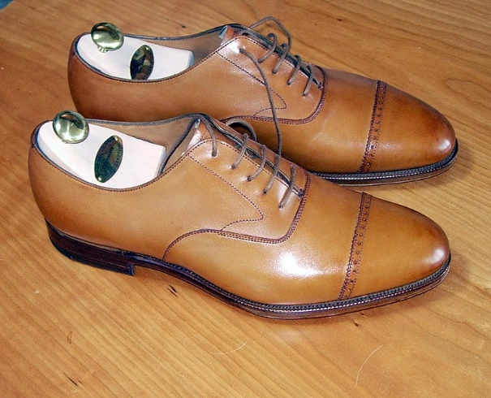
Figure 3. 15 An Oxford shoe with straight lacing
- Crisscross lacing
The most common lacing method, termed crisscross lacing, is also one of the strongest and most efficient. However, they are reserved for more casual footwear, such as sneakers and boots. Derbies can be straight-bar laced or crisscross laced

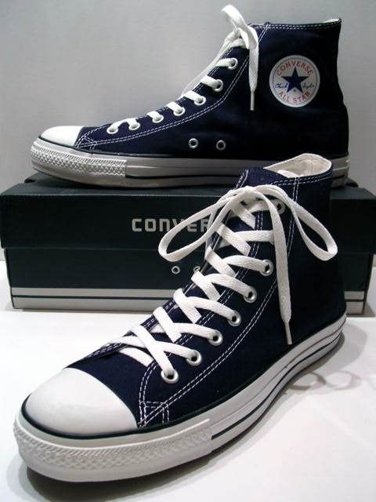
Figure 3. 16 Chuck Taylor All-Stars with crisscross lacing
- Other lacing methods
Many shoe lacing methods have been developed with specific functional benefits, such as being faster or easier to tighten or loosen, binding more tightly, being more comfortable, using up more lace or less lace, adjusting fit, preventing slippage, and suiting specific types of shoes. One such method, patented in 2003 as "Double helix shoe lacing process", runs in a double helix pattern and results in less friction and faster and easier tightening and loosening. Another method, called "Rinlers Instant Lace Up", use additional accessories for instant tightening and loosening.
Many other lacing methods have been developed purely for appearance, often at the expense of functionality. One of the most popular decorative methods, checkerboard lacing, is very difficult to tighten or loosen without destroying the pattern. Shoes with checkerboard lacing are generally treated as "slip-ons".

Stuffing
Acid-free paper is absorbent and maintains a shoe's proper moisture level while protecting the shoes from deteriorating. When using paper to stuff shoes for moderate or long-term storage, opt for acid-free tissue instead of newsprint.

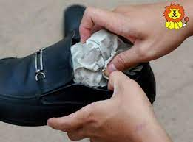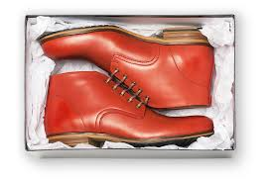
Figure 3. 17 Shoe stuffing and wrapping paper
Attaching labels
When you describe the materials and indicate the parts of the footwear, you should use the pictograms or a written indication. Your labelling must describe the materials of the three main parts of the footwear:
- Upper
- Lining and insole
- Outer sole
In each case, the label should state whether the material is made of:
- Leather
- Coated leather
- Textile
- Other materials
If no single material accounts for at least 80% of the product, the label should indicate the 2 main materials used.
Here’s an example of a label that was attached to the sole of the shoe by sticker:
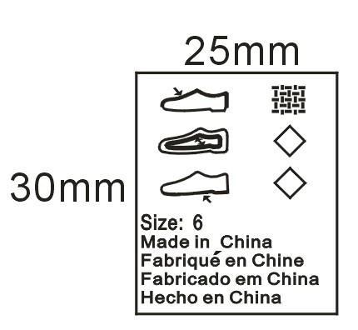
How do you attach the footwear label?
You must attach the labelling to at least one of the pair of shoes. You can do this by printing, sticking, embossing or tying the label to the shoe. The labelling must be visible, securely attached and accessible, and the dimensions of the pictograms must be sufficiently large to make it easy to understand.
Bundling
Bundling is offering several products or services for sale as one combined product or service package. It is a common feature in many imperfectly competitive product and service markets
Most firms are multi-product or multi-service companies faced with the decision whether to sell products or services separately at individual prices or whether combinations of products should be marketed in the form of "bundles" for which a "bundle price" is asked. In a bundle pricing, companies sell a package or set of goods or services for a lower price than they would charge if the customer bought all of them separately. Pursuing a bundle pricing strategy allows a business to increase its profit by using a discount to induce customers to buy more than they otherwise would have.
Boxing
Everyone needs a shoe shipping box. They are the most important thing in the delivery of your shoes and will help you keep them in good condition until they get to their destination. You can spend less money by buying one and more time and effort by ordering it directly from the company (and in many cases, it is delivered free).
You can either tape up your shoebox and wrap with paper, or place it into a larger box for added protection. Use tissue paper, bubble wrap or polystyrene to fill the space in the box. Some shoes, such as soft ballet pumps and flip-flops, will fit into a large jiffy bag and are unlikely to be damaged.
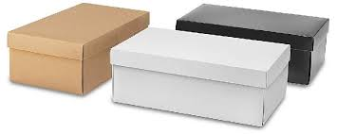
Figure 3. 18 Boxing
Packing
You may be tempted to toss all of your shoes into the bottom of a box when packing for an upcoming move. This not only puts them at risk for physical damage, but also makes it that much more difficult to unpack when you arrive at your destination. If you have shoe boxes, pack the shoes in the boxes, otherwise some packing paper will protect the shoes from scuffing and other damage. It is a good idea to let shoes air out for a couple of days after wearing before packing them.
For shoes in shoe boxes, wrap each shoe in a half piece of packing paper to protect from rubbing or scuffing. Line a box with crumpled paper. Put boxes and shoes in the box. Shoes without boxes can be wrapped as a pair in a single piece of packing paper. Fill in gaps with crumpled paper. Close the box and secure with packing tape. Label the box.
Things to note when packing shoes
- Footwear May Contain Moisture There is a chance that your shoes could mold during moving and storage if they aren’t properly prepped and packed. Be sure to air out leather athletic and work shoes prior to packing so that they are free of moisture when you place them in the box. As an extra measure of security, you may want to powder the insides to ensure all moisture is drawn out of the leather and fabric.
- Protect Your Dress Shoes’ Finish it is recommended that you wrap shoes in tissue paper and place them in the original shoeboxes to prevent damage from contact with other shoes. This will protect patent finishes and ornaments from accidental damage during transit. If you’d like to avoid wrapping and boxing shoes in pairs, you can also place them in a closet door shoe hanger.
- Folded carefully, this innovative storage solution can keep your shoes organized and firmly in place during your move.
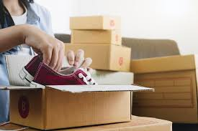
Figure 3. 19 Packing
Dispatching
A basic procedure in the expedition of products is the preparation of the Packing List. Packing List is a document which identifies the contents of the package. It should be either inside of the packaging, or in an attached shipping pouch. Some companies use packing list as a bill or invoice since it often indicates charges to be paid.
Packing List is included with a shipment to inform transport agencies, government authorities, and customers, about the contents of a package. Some companies simply include a copy of the invoice in place of a packing list, however this may cause confusion, and does not provide all the necessary details about the content of a package. The preparation of the packing list is usually done at a computer level and follows the guidelines issued by the customer when sending the order or orders. Unlike an invoice, typical packing list does not show financial information. It also has some fields a typical invoice may not have, for example:
- Number of boxes
- Packing Date
- Packed by
- Checked by
- Unit weight
- Unit volume
The product is placed in boxes, usually paperboard, following the customer's instructions. They can be closed manually or with the support of specific equipment such as the stripping machine.
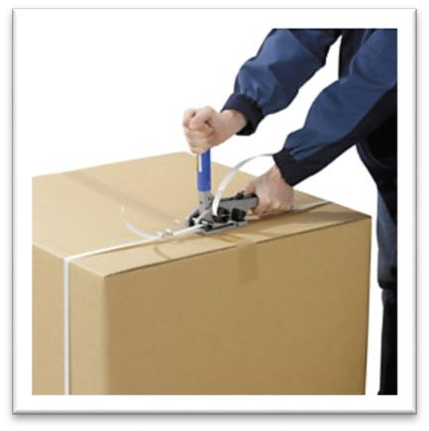
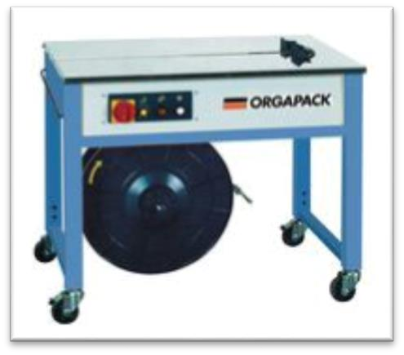
Figure 3. 20 Dispatching

Prevent accidents and to eliminate risks to personal safety
The finishing department is more related to use of solvents and chemicals at the working floor. Hence it should cover four main points:
- Health risks resulting from exposure to solvent hazards at work
- Solvent fire and explosion hazards
- Principle of prevention
- Emergency procedures employed
3.7.1 Health risks
The effects of the solvents can be acute or chronic depending upon concentration and length of exposure to the body. Main effects are irritation and allergic reaction to skin, eyes and respiratory tract.
3.7.2 Fire hazards
Solvents in the work place are major fire and explosive hazards. The improper storage, handling or transport may result in minor fire to major disaster resulting in loss of human life.
Fire in principle needs three elements to survive:
- Fuel
- Heat
- Oxygen
To check any fire, hazard these elements should be controlled. In this respect we can classify the chemicals used in finishing department in two categories:
- Water based products:
There is no risk of flammability during drying or application but some of the residues may ignite if exposed to a naked flame. Soil deposits must be disposed of correctly.
- Solvent based products
Most of them contain low flash point solvents and they will ignite instantly if come in the contact of naked flame or hot surface. Safety precautions must be respected.
3.7.3 Principals of prevention
It should base on organizational as well as operational control.
Four basic principle of operational control are:
- Eliminate the hazard (replace as for as possible, solvent based chemicals to that of water based).
- Put a distance / shield between the solvent and worker. The items being sprayed must kept within the work area of spray booth and there should not be over spraying. The inhalation of fumes is dangerous and can be avoided by using a proper spray booth, spraying technique and wearing a mouth cover.
- Provide general and local ventilation e.g. Spray booth with exhaust fans and running water to reduce concentration of airborne contaminants such as fumes, gases, vapors and mists.
- Protect the worker by using personal protective equipment like dust mask respirators, protective goggles, gloves etc. Water based and spirit products, mainly the spirits, degrease the skin if kept in contact for a prolonged period of time. Use of after work creams are suggested.
- Spillage, disposal, cleaning. Major spillage of solvent products should be immediately soaked by dust or sand to prevent spreading and in particular to avoid contaminating drains.

Completing production and other records
After finalizing the packaging processes all relevant paperwork and documentation is prepared in accordance with enterprise procedures.
A packing list is a very important document for the leather garment and goods industry. Generally, merchandisers or packing in-charge is responsible to make and delivering packing lists to related departments. The packing section does pack as per customer packing requirements that solid or asserts/ratio pack. Packing is done when a PO packing is completed, without giving packing list buyer QC never does a final quality inspection, packing list confirm buyer QC that a PO’s packing is closed. The packing list is very important to export documents, without the packing list commercial department cannot submit exports document for the products shipment, that’s why the packing list consider as important documents.
Documents to be prepared include: -
- product maker, Specific style and buyer name
- Total and size-wise order quantity
- Style description and color
- Size-wise Cut vs. Order vs. pack quantity, carton quantity
- Carton wise case number
- Size-wise carton net and gross weight
- Carton measurements and Total carton
- Total over or short pack quantity

Self chek-3
Directions: Answer all the questions listed below. Examples may be necessary to aid some explanations/answers.
Test I: Multiple Choice
1. In which type of leather finish the surface is coated with a heavy protective topcoat which includes pigmentation.
- Aniline,
- corrected grain or pigmented,
- semi aniline ,
- none
2 -----------------is the process of buffing leather edges to a slick, glossy finish.
- Brush off ,
- Burnishing,
- A and B ,
- none
3 -------------------is a leather which if brushed by heavy cotton brush gives a two tone effect
- Brush off,
- burnishing
- A and B ,
- none
4 which one of the following are not essential characteristics of full grain quality leather
- Fat wrinkles or growth lines: subtly shaded bands on the grain side of a hide,
- Natural variations in grain texture and shading. ,
- Small scars: on a quality product they do not render large portions of the hide unusable,
- none
5 which one of the following are the purpose of cleaning upper of the shoe
- Remove dirt,
- remove adhesive overspill,
- remove unwanted marks and contamination,
- All
6 -------is a process of inserting identification on boxes or the packaging that’s done
- Labeling,
- lacing,
- packaging ,
- none
7-----------is a process of inserting acid free paper which absorbs and maintains a shoe's proper moisture level while protecting the shoes from deteriorating.
- Stuffing,
- lacing,
- label attaching,
- bundling
Test IV: Short Answer Questions:
Instruction: write short answer for the given question.
- List and describe types of leather finish
- List the sequence for system I shoe finishing process?
- List the basic Footwear finishing operations?
- What is labeling?
- What is packing?
- List and describe purpose of packing?

Operation sheet 3.1: Finishing and packaging
- Operation title: performing finishing and packaging operation
- Purpose: To perform finishing and packaging operation
- Instruction: Using the provided steps and given equipment’s perform finishing and packaging operation.
- Tools and equipment:

- Insole
- Polishing machine
- Spray gun
- lace
- box
- sulphite paper

- Steps in doing the task
Stepe-1: Cut excess lines and put finishing insole
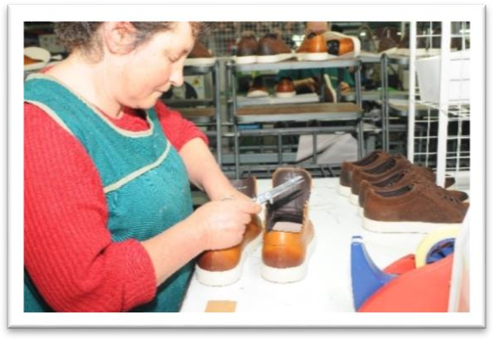
Step-2: Polishing manually
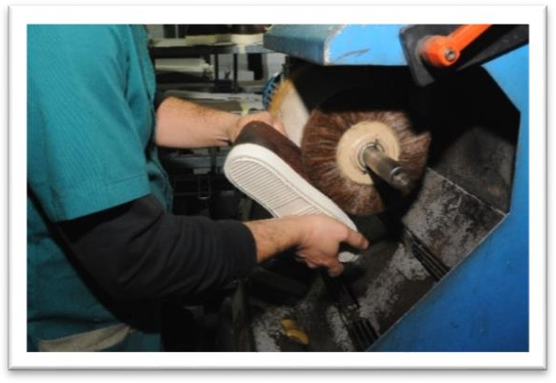
Step-3: Polishing through the spraying tool
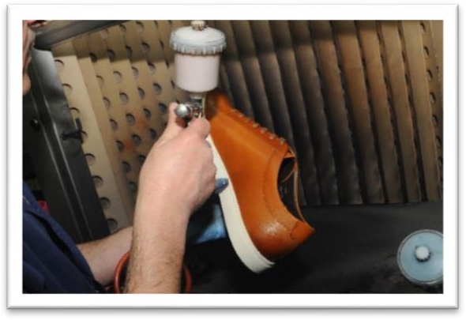

Step-4: Applying laces
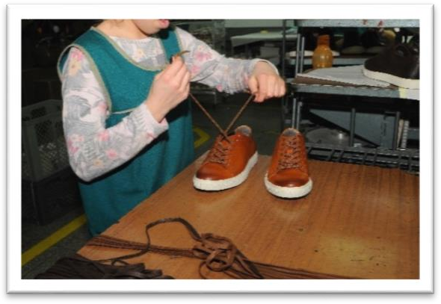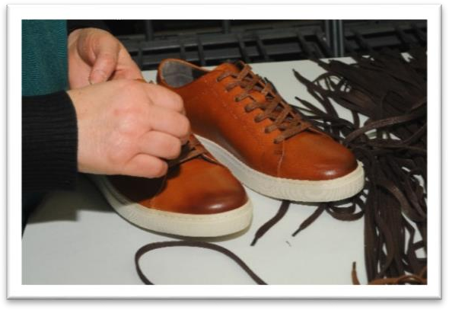
Step-5: Confirmation sample
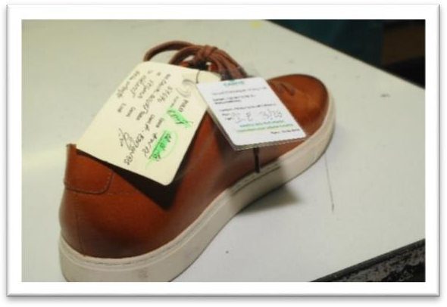
Step-6: Finishing final control - Control of each foot individually
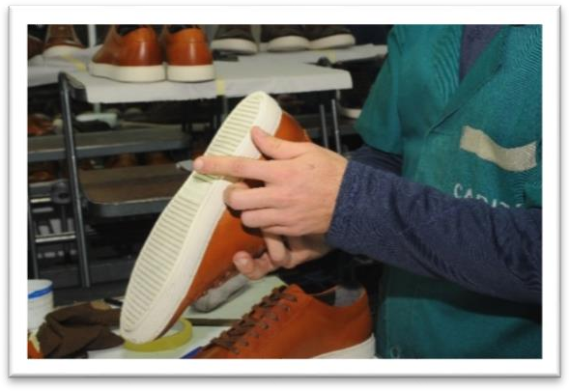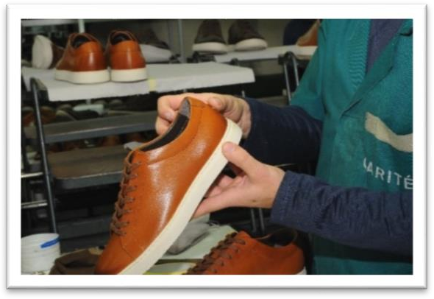

Step-7: Control of two feet at the same time
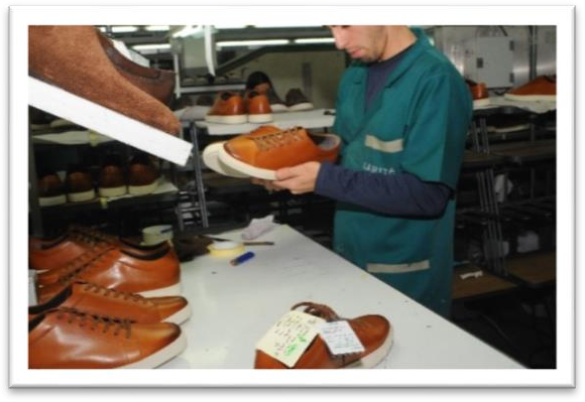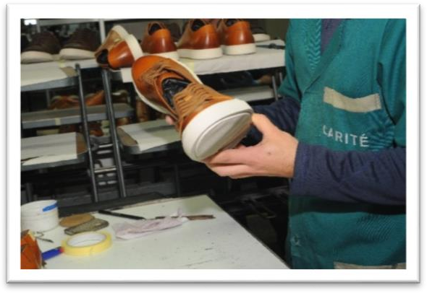
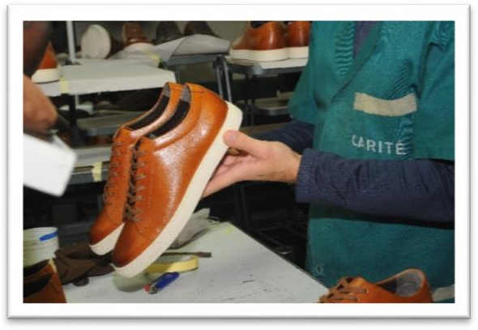
Step-8: Preparation of the box to pack the footwear by placing sulphite paper in the base and Placing the foot in the box
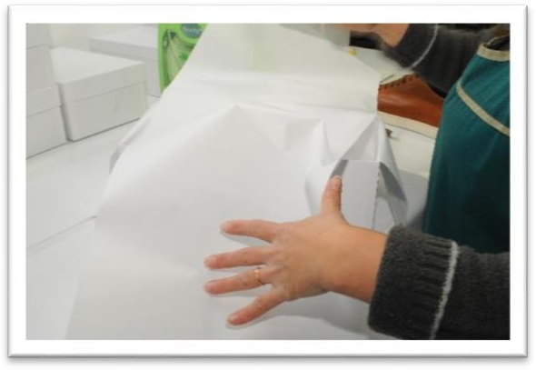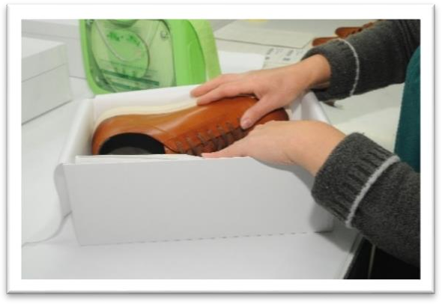
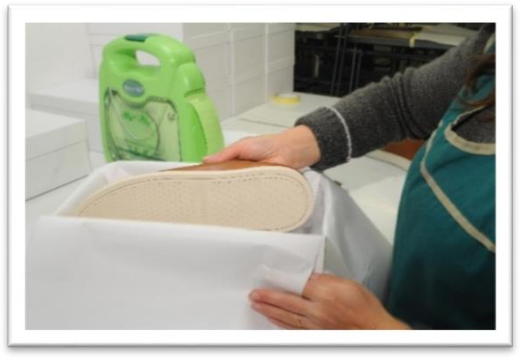
Step-9: Wrap and close the pair with the sulphite paper
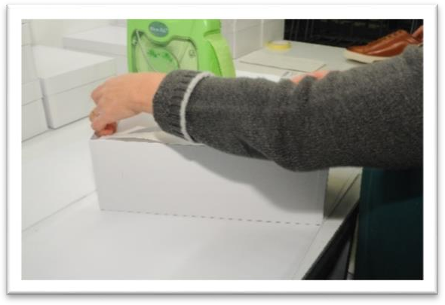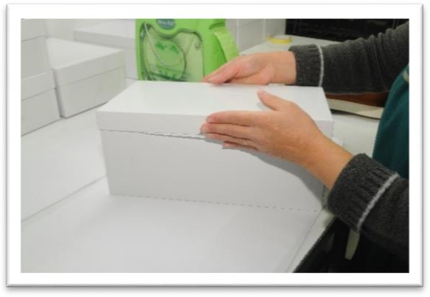
Step-10: Put identification label on the box
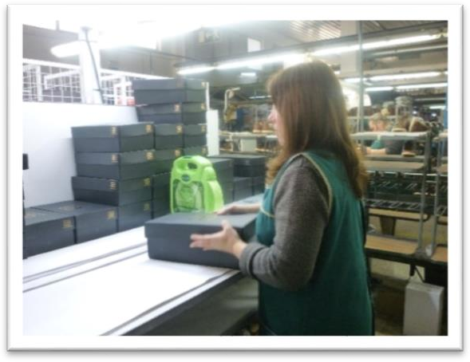
Step-18: Place the box with product in the proper location (structure) to follow to finished product warehouse
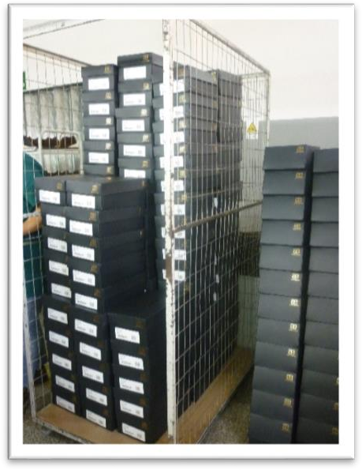
Precaution: Be careful on faults caused by finishing operations.
Quality requirement: good finished shoe with the perfect packaging

LAP Test | Performance test
Name: _____________________________ Date: ________________
Time started: ________________________ Time finished: ________________
Instruction I: Given necessary templates, tools and materials you are required to perform the following task. The project is expected from each student to do it.

Task 1: perform finishing and packaging operation.

Unit Four: Checking final quality of the finished pair and dispatch
This learning unit is developed to provide the trainees the necessary information regarding the following content coverage and topics:
  - Identifying quality check points
  - Checking footwear against final quality inspection standards.
  - Identifying, rectifying and returning faults to appropriate section for repair.
  - Completing and dispatching quality records and documentation
This guide will also assist you to attain the learning outcomes stated in the cover page. Specifically, upon completion of this learning guide, you will be able to:
- Identify quality check points
- Check footwear against final quality inspection standards.
- Identify, rectify and return faults to appropriate section for repair.
- Complete and dispatch quality records and documentation

4.1. Identifying quality check points
4.1.1 Quality
Quality is the totality of features and characteristics of a product or a service that affect its ability to satisfy the stated or implied needs of a customer and it is not absolute It is relatively to other goods and services. Quality cannot be achieved by inspection only. It can only be improved by small continuous product and process improvements. Quality consistency requires us to concentrate on the process rather than on the product alone. In a good organization each error is part of training and learning. The key to success is to ensure that a mistake is not repeated again in the organization. Company must recognize that quality is the key to survival in business.
4.1.2 Quality check points
The shoe sample after finishing must be checked for any damage in finish as it may give rise to customer’s complaints. Solvent based dressing may be reasonably durable but wax based dressing may be lost early in wear.
Shoe after finishing must be checked for:
- Uniform gloss and colour;
- Proper colour fastness;
- No damage to the surface;
- No damage to the sole (especially rubber soles). One should be careful while brushing the shoe on cotton rollers, especially if it is a rubber sole. In case the sole comes in contact with the brush, it may be damaged and the dirt could migrate to the leather surface;
- Improper drying may lead to sticking of fibers on leather surface, which are difficult to remove. One may have to go back to the cleaning operation all over again;
- One should not press the shoe hard against the cotton roller. It may lead to excess cooking of wax on the surface;
- ‘Whiteness’ occurs either due to leather spew or improper finishing method.
- For example, excess loading of self-shining cream, especially natural coloured cream on coloured leather. It may also be due to an excess of neutral-coloured hard wax on the roller;
- Cracking of shoe finish;
- Tackiness; and
- Colour variations on different parts etc.
4.1.3 Keys to a good quality system
- Everyone must know what to check and how to check.
- List major and minor defects and display it.
- Check all inputs materials for quality / quantity.
- Make specifications clear to the supplier at the time of ordering materials.
- Do not dilute your standards.
- When a mistake occurs look for corrective and preventive action. Corrective action is immediate action taken to solve problem. Preventive action- Step taken to prevent a recurrence of the problem.
- Keep a defect file a learning system.
- Clearly fix responsibility for quality in each department.
- Quality cannot be controlled at the end of line. It must be built into the system.
- Continuous improvement in small steps is the key to success.
- Have a good monitoring system.
- Good housekeeping is important for good quality.
4.1.4 How Can a Supervisor Control quality on his line?
In most factories supervisors spend their time pushing production and do not have time to check quality. Many supervisors are not aware of what they should check or how they should check. Lastly the right tools like gauges, scales etc. must be provided to the person to enable him do the job well.
- It is important for a supervisor to drawn up a time table of how to spend the day.
- In the time table at least 2 – 3 hours should be allocated for monitoring quality. This could be over four half hour sessions.
- During the first session he could look at 3 operators in his line and study their operations in depth. For example- if a sewing supervisor is checking a particular operation the following steps are essential.
- Check cleanliness of machine and surroundings.
- Stop machine and check needle and threads used to see if this is as per specifications.
- Check if assembly instructions are available to operator.
- Pick a tray of 10 pairs and check 100% for this operations. See % of defects. If it is more than 5% stop the operations and find out reason for faults.
- Demonstrate to operator how to correct fault.
- Ask operator to do one pair correctly based on your instructions. If this is okay allow him to proceed for 10 prs & recheck tray.
- Discuss quality problems with operators and invite his suggestions.
- If a guide is to be used make sure it is used. Guide improve quality and productivity.
- Repeat such quality checks with other operators also. You should be able to cover all operators in your line at least once a day. This will prevent any major errors since you have checked all operations in detail.
- Check the first five pairs of shoes coming out of production daily to see if there are major problems to be attended immediately.
- Spend half an hour a day listening carefully to workers on how to improve quality. They can offer excellent solutions.
- When you spot a problem take action to correct it and stop production, many supervisors simply allow the problem to multiply further. For example- if there is a machine fault and stitching is incorrect stop the machine and rectify the fault.
- Always look for corrective and preventive action in each case. If the same mistake is requiring for 3- 4 days the supervisor is not doing his job.
- The biggest problems with supervisors are that they see a mistake but allow it to continue on the ground that they can do very little in this case, if this happens more than once suck the supervisor immediately.

4.2. Checking footwear
Inspection of footwear totally depends upon the quality control in different stages. This system is based on the following principles:
- Well defined specifications.
- Checking and testing all input materials.
- In- process quality control.
- Final quality check.
- Monitoring quality.
The main objective is to achieve a consistent quality standard for the product.
- Inconsistent Quality: Some consignment is above the required standard and some below the standard. The variation is too large and not acceptable to customers.
- Lack of Clear Understanding of Quality: Each staff member of a company has a different view on quality and there is no clear company standard for materials or clear identification of major and minor faults.
- Tendency to Save Money on Testing: Testing is the fix parameter of the company. If the company doing not testing, then it will cause a great loss of the company.
- Insufficient planning to ensure quality.
- Lack of Top management commitment to quality.
- Tendency to monitor quality at the end of the line instead of in- process quality control.
- Poor documentation.
- Tendency to take only corrective action but not preventive action.
- Lack of understanding on how to achieve quality.
- In most factory good quality is only a matter of chance.
4.2.1 Inspection of footwear
Quality Assessment
It is a normal in the footwear industry to inspect pair by pair at the end of the process. The following guideline will help to ensure that the inspection is done correctly:
- Do not inspect unless there is an approved sample signed by the customer.
- A Technical Specification sheet for each style approved by the Production manager/ customer.
- Sufficient light should be available on a clean table. Lighting levels should be 1300 lux.
- A list approved by the production manager showing major and minor defects is allowed & 2- 3% minor defects are allowed. Without a list of major and minor defects no inspections is possible. In case a major defects occurs not listed in the defect list, the quality controller should not be blamed. This new defects should be added to the list for future lots.
- Keep a tape, scale 12” and 6”, crepe rubber piece and stitch gauge with you always.
- Inspect plan wise and keep track of size arise pairs passed as shown in the chart below-
Plan no. Model. Color. Pairs

Size 5 6 7 8 9 10

Order 60 95 70 198 40 32

Pairs 495
This chart immediately gives the status of inspection size wise and ensures that wrong sizes are not sent.
- Major defects should be destroyed or punched , so that they are not recycled or mixed with good shoes. Keep the defective shoes with you till you get replacement.
- Keep track of defects as shown in the quality inspection report. This report gives number of pairs defect wise. Look for the top three defects and take steps to correct them immediately. Stoppage of production could also be one of such measures. If the same defect reoccurs for three days the quality control has failed and the quality control inspector is responsible. One should remember that recording of defects is not the main job. Corrective and preventive action is the main job of the quality control inspector.
- Take a 10 minute break after every two hours otherwise inspection fatigue occurs. During these periods go to the line and look at ways to correct quality problems.
- A shoe must be inspected by looking at it with the toes facing and with the back strap flack seam facing you. Shoes must inspected pair wise always.
- Have a 10 minutes discussion daily with production supervisors, about major problems and how to correct these. If these are not attended, to stop inspection and report to the production manager.
- Quality inspectors suddenly change standards of inspections when a complaint is received. Many times he rejects up to 70 – 80%. This is simply ridiculous because with such a high rate of rejection it means that the quality control system has collapse and the quality control inspector is responsible.
- The following chart must be clearly displayed at the quality control table-
- Back height chart
- Major and minor defects list
- Key points raised by the customer if any
- Approved sample and defect file.
- Keep a defect file for each customer. Whenever a complaint is received keep a copy in this file along with corrective and preventive action taken. The purpose of this file is to catalogue defects and ensure that they do not recur.
- Final inspection by self is not enough. This must be supported by laboratory test reports on materials and the final shoes. Fit and wear trials immensely in quality control.
- Remember that final inspection is only a post- mortem. It is much better to spend time on in process quality control. You follow the following rule always “ DO IT RIGHT THE FIRST TIME”.

4.3. Identify rectify and return faults
4.3.1 Finishing faults
- Brushing
Generally this operation carried out in shoe room with the help of brushing machine, with provision for cotton and wool brushing, for cutting and polishing purpose.
Rollers are also called the Brushes of the Brushing machines. The machines rotates at variable speeds, polishing is normally recommended at low speeds with the use of polishing wax. Cotton brush can be applied at variable speed , high speed for leather, which needs more abrasive action, e.g. Burnishing leather, Brush- off leather and corrected grain leather with heavy pigmentation.
In polishing normally use rollers of brushing machine at low speed with the use of polishing i.e. Synthetic wax or carnauba wax.
Whereas when high abrasive action is not required then roller of brushing machine at medium speed with the use of abrasive wax.
If rules do not follow the faults will occurs.
These are the main reasons for improper brushing-
- Dressing and materials finish is not compatible or inadequate cleaning.
- Due to the dirty sponges and contaminated cleaner pots.
- Due to high humidity, water in solvent, or faulty air supply.
- Due to excessive heat supply in process.
- Due to over spraying with butyl acetate.
- Leather with low absorbency.
- Low adhesion of finish caused by silicon, oil , greases etc. On the surface of the leather.
- Spew in the process is the fault of tannery, degrease and then apply the base coat.
- Cracking of the grain during lasting normally caused by insufficient elastic rectangle. Apply a softener on the grain / flesh side few minutes before lasting.
- Whiteness appearance due to heavy filler used without its absorption capacity. It deposit on the leather surfaces, then refinish the above shoes.
- Streaks on upper
In shoe room, during finishing of upper faults like streaks on upper occurs. Normally this fault arises during liquid dressing due to uneven spray pattern. Distribution of finishing during cleaning and filling i.e. If cleaning and filling does not done properly as per quality and standard norms. This fault also arises due to poor quality of spraying.
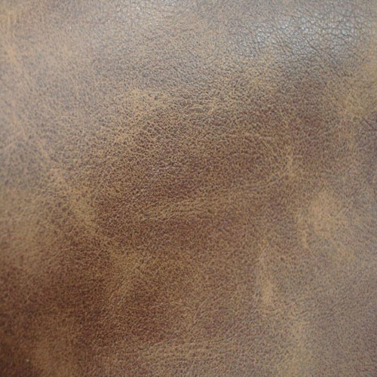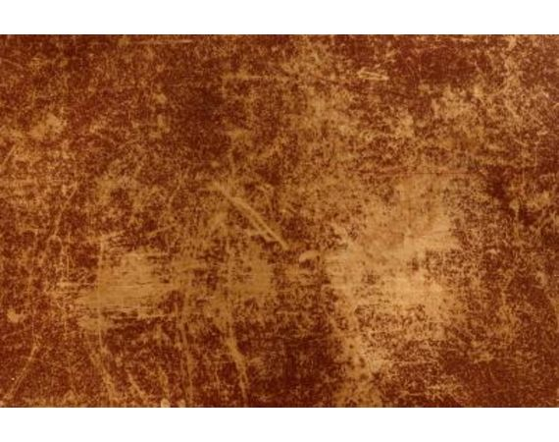
Figure 4. 1 strike on upper
When leather is new, it has a rich, smooth appearance, overtime, the leather will begin to fade in spots where it is repeatedly warn. The color will appear uneven, with light streaks appearing throughout the leather. This happens to leather furniture, such as on the seats or leather jackets at the crease of the arms. Fortunately, a warn leather finish can be restored to an almost new appearance with the right materials.

- Instructions
- Apply a leather cleaners to a clean rag, wipe the entire surface of the leather item to be cleaned. This not only removes the surface dirt , but it opens the pores in the material , allowing the re-coloring balm to work more effectively.
- Select a re- coloring balm in the appropriate shade. The shade usually come in a few basic color and can fit a range to shades in that color family.
- Apply the balm to a clean cloth. Beginning at the top of the item to be restored, rub the cloth in a circular pattern. This will work the color into the leather. As the color seeks into the pores, the streaks will disappear and the color will be restored. Add additional amounts of balm to the cloth, as necessary.
- Buff the leather surface with a clean cloth once the entire item has been covered with the balm. Continue buffing until there is no longer a color transfer between the item and the cloth. The buffing will create a smooth, even appearance.
- Apply a leather cream to protect your leather item against further wear and fading.
- Stain marks
During finishing operation, like incorrect dressing , uneven cleaning, contaminated dressing as well as atmospheric contaminations. Due to above reasons generally fault like stain found on the upper surface of the finished leather, because of tackiness and not proper penetration of finishes as well as uneven dryness of the finished film.
This problems also arises due to poor spray pattern, due to shaking of liquid or season not done before apply it on the surface.

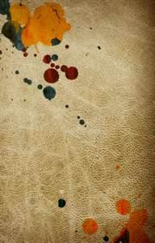
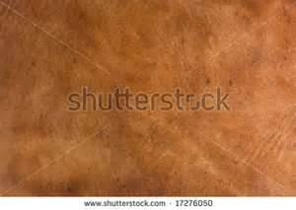
Figure 4. 2 stain marks
- Stain on upper finish
- Determine the types of leather:
- Put a drop of water on the surface of the leather, if the water soaks in the leather is unfinished and will requires more tanning chemicals. If it breaks up, the leather is finished and you can begin cleaning.
- Take unfinished leather ( like suede ) directly to a dry cleaners for stain removal.- Unfinished leather is extremely absorbent and the stain will be very difficult to remove.
- Determine the depth of the stain
- If the stain is fresh and only on the surface of the leather item, begin cleaning according to the steps.
- If the stain is older or has soaked into the leather, you will likely have to re dye the leather professionally to remove the stain.
- Cleaning your leather
- Read carefully the instruction of your leather, if possible because the manufacturer may recommend a certain conditioner or cleaner to remove stain.
- Wipe the leather gently with a cloth dampened with hot soapy water or use a leather shampoo to clean the affected area. Treat your leather on a regular basis with quality protection products.
- Uneven shine
This fault arises due to uneven dressing, cutting as well as uneven polishing. Apart from this using un appropriate wax as per the finish on leather surface also results as uneven shine on the upper
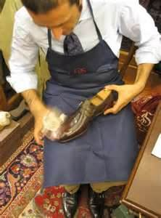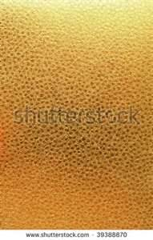
Figure 4. 3 uneven shine
Besides this different absorptions of dye or finish on different parts of skin and hide also cause uneven shine. In correct adjustment of the spray gun applying the final coat or top coat also results as uneven shine. Then there is a possibility of low glass and shine as well as full appearance of shoe upper and finally we cannot get the required quality in finished shoe.
One of the reason that leather is so popular that in addition to its great natural richness, it also take well to a large variety of finishes. There is literally something for every person taste.
Uneven shine finish is called distressed types of finish. In this , finish is a combination of physically ‘ DISTRESSING” the leather. For example the process might include using a hairbrush and then applying wipes of pigments to produce an uneven color. The goal is to make a item look old or worn.
Another way to distress leather is to spot with water and then as it dries, it will shrink slightly giving it a pinched look. If you prefer, you can simply wear it and let natural take its course.

4.4. Quality records and documentation
4.4.1 Preparation of Daily Production Report
Daily production (Feeding & Packing) report must be prepared by the lasting in-charge on same day and must be placed on table of the production manager by 9.00 AM. The report must have the details of feeding & packing of shoes in all the lines. Only packed shoes will be considered as the production of the department rest everything must be considered as WIP of lasting department. The format for the daily production report is given below-
Table 4. 1 daily production report chart
XYZ SHOE FACTORY
LASTING DEPARTMENT
DAILY FEEDING & PACKING REPORT
DATE: |  |  |  |  |  |  |  |  | ATTENDANCE:
 |  |  |  | TYPE | SIZES |  |  |  |  |  |  | TOTAL
 |  |  |  | M | 38 | 39 | 40 | 41 | 42 | 43 | 44 | TOTAL
FEEDING |  |  |  | W | 34 | 35 | 36 | 37 | 38 | 39 | 40 | TOTAL
LINE NO. | PLAN NO. | MODEL | COLOUR | C | 33 | 34 | 35 | 36 | 37 | 38 |  | TOTAL
TOTAL
PACKING
LINE NO. | PLAN NO. | MODEL | COLOUR |  |  |  |  |  |  |  |  | TOTAL
TOTAL
REMARKS:
PERPARED BY: |  |  |  |  |  |  |  |  |  | APPROVED BY:

XYZ SHOE FACTORY
Final packing report
PACKING REPORT
DATE: |  |  |  |  |  |  |  |  | ATTENDANCE:
PACKING LABEL: |  |  |  | TYPE | SIZES |  |  |  |  |  |  | TOTAL
 |  |  |  | M | 38 | 39 | 40 | 41 | 42 | 43 | 44 | TOTAL
 |  |  |  | W | 34 | 35 | 36 | 37 | 38 | 39 | 40 | TOTAL
 | PLAN NO. | MODEL | COLOUR | C | 33 | 34 | 35 | 36 | 37 | 38 |  | TOTAL
 |  |  |  |  |  | SIZES
TOTAL
PACKING
LINE NO. | PLAN NO. | MODEL | COLOUR |  |  |  |  |  |  |  |  | TOTAL
TOTAL
REMARKS:
PERPARED BY: |  |  |  |  |  |  |  |  |  | APPROVED BY:
The ready shoes must be packed in the shoe boxes with the packing slip duly filled.
The dispatch of the shoes must be done in specific size assortment.
Table 4. 2 footwear inspection certificate

Footwear inspection certificate
Style ref: 4130368 |  | Order No: 27732 |  | Customer: DUNNES STORES
Supplier:XYZ |  | Location: India |  | Quantity to Inspect: 84 pairs
Inspected by: GUSTO FOOTWEAR |  | Date Inspected 31-01-13 |  | Order Qty- 804 Pairs
Previous most common fault: |  |  | Inspected carton -No.'s 13,67,50,32,25,1&10
Confirmation Sample Available: YES
Size Range From 37 to 42 |  |  | Sizes Inspected- ALL SIZES
FAULTS | MAJOR | MINOR | FAULTS | MAJOR | MINOR
Dirty/Stained on heel grip | Nill | nill | Dirty/col-Stained on sole | NIL | NIL
Socks pasting problem | NIL | NIL | Heel Fault | NIL | NIL
Colour Fault (VP) | NIL | NIL
Stitching problems | NIL | NIL
Lining/Counter flaw/faults | NIL | NIL | Poor Sole Attachement |  | 1
Adhesive mark on leather | NIL | NIL | Poor Heel Attachement | NIL | NIL
Sole balancing problem | 1 | NIL | Toe Shape/ tillted | NIL | NIL
Spot mark on leather | NIL | NIL | Damage welt | NIL | NIL
Qtr Fixing/ Eyelet facing prob | NIL | NIL
Trim/Buckle/Wrinkle on top ine binding | NIL | NIL | Over roughing |  | 1
Yellowing/Loose leather | 2 | NIL | Poor finishing |  | 1
Wrinkle on vamp | 1 | NIL | GRAND TOTAL | 4 | 3
PACKAGING & LABELLING
Swing Tickets(MN) | NIL | NIL | BAR CODE STICKER REF | NOT OK | NOT OK
Damaged box end label(MJ) | NIL | NIL | Egg crates(MJ) | NIL | NIL
EAN number in lining(MJ) | NOT OK | NOT OK
Shipping mark(RP/Bulk)(MJ) | NIL | NIL | Ticketing incur. Position(MJ) |  | NIL
COMMENTS ON DEFECTS & ACTIONS TO BE TAKEN
7 pair of major & minor are above mentioned faults were found in this shipment.
Date referred to QC Dept |  |  |  | RESULT Pass | Pass
Packing Details
Note: Quality is ok but packing is not ok by my end so pleases recheck it again
 | Signature of Inspector with Company seal.

Self chek-4
Directions: Answer all the questions listed below. Examples may be necessary to aid some explanations/answers.
Test I: Multiple Choice
1 one of the following is Key to a good quality system
- Everyone must know what to check and how to check,
- List major and minor defects and display it,
- Check all inputs materials for quality / quantity,
- all
2 which one of the following are the main reasons for improper brushing-
- Due to the dirty sponges and contaminated cleaner pots,
- Due to high humidity, water in solvent, or faulty air supply,
- Due to excessive heat supply in process,
- all
3 which type of fault mostly arises due to uneven dressing, cutting as well as uneven polishing
- Un even shine,
- streaks on upper,
- A and B ,
- none
Test II: Short Answer Questions:
Instruction: write short answer for the given question.
- What is quality?
- How Can a Supervisor Control quality on his line?
- What are main area of quality control?
- What is the main objective to achieve a consistent quality standard for the product?
- Describe footwear dispatching?

REFERENCES
- Former TTLM level ii perform footwear finishing operation
- www.researchgate.net
- www.nzdl.org

Experts Who Developed this Learning Guide

No | Name | Educational Background | Region | E-mail | Remarks
1 | Yohannes Fisseha | BSC in Leather Engineering | Addis Ababa, Lideta Manufacturing college | yohannesfiseha71@gmail.com | module Developers Team Members
2 | Yabetse Fikadu | BSC in Leather Engineering | oromia: bishoftu polytechnic college | Yabets1030@gmail.com | module Developers Team Members
3 | H/Gebrale Abebe | BSC in leather and leather product technology | Addis Ababa,Misrak poly technic colleget | haile3a@yahoo.com | module Developers Team Members

