Leather processing
Level-I
Based on December 2021, Curriculum Version 1
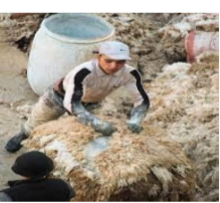
Module Title: Performing unhairing Operations
Module code: IND LEP1 M04 1221
Nominal duration: 45 hour

Prepared by: Ministry of Labour and Skill
August, 2022
Addis Ababa, Ethiopia

Acknowledgment
Ministry of Labor and Skills wish to extend thanks and appreciation to the many representatives of TVET instructors and respective industry experts who donated their time and expertise to the development of this Teaching, Training and Learning Materials (TTLM).

Table of Contents
Acknowledgment 1
Acronym 3
Introduction to the module 4
Unit one: Confirm requirements 5
1.1 Occupational health and safety procedures 6
1.2 Unhairing chemicals, tools and equipment 9
1.3 the Workplace for unhairing 14
1.4 Pre -operational duties to fulfill legislative/regulatory requirements 16
Self-check 1 20
Unit two: Preparation of hides/skins for unhairing 23
2.1. Identification of unhairing methods 24
2.2 hides/skins for unhairing based on processing methods 29
2.3 assessing the hair loosening and removal manually or by machine 31
Self-check-2 35
Unit three: unhairing methods 36
3.1 Techniques of hair removal 37
3.2. Checking the effectiveness of hair removal 38
3.3. Managing the hair waste 41
3.4. Maintain records in unharing operation 42
Self-check 3 44
Operation sheet-3.1 46
LAP TEST 3 47
Reference 48

Acronym
OHS- occupational health and safty
Be-baume
PH- polarity of hydrogen
PPE -personal protective equipment
RPM-Revolution per minute
LAP- learning activity performance

Introduction to the module
In leather processing field: knowing the types of hides and skins ,the requirements as well as the chemicals needed the methods ,that we follow to perform unhairing or liming processes is essential
This module is designed to meet the industry requirement under the leather processing occupational standard, particularly for the unit of competency: perform unhairing operation
This module covers the units:
MODULE CONTENTS:
- Confirm requirements
- Preparation of hides/skins for unhairing
- Unhairing methods
Learning Objective of the Module
- Confirm requirements
- prepare hides/skins for unhairing
- To perform unhairing
Module Instruction
For effective use this modules trainees are expected to follow the following module instruction:
- Read the information written in each unit
- Accomplish the Self-checks at the end of each unit
- Perform Operation Sheets which were provided at the end of units if there is?
- Do the “LAP test” given at the end of the unit if available and
- Read the identified reference book for Examples and exercise

Unit one: Confirm requirements
This unit is developed to provide you the necessary information regarding the following content coverage and topics:
- Occupational Health and Safety Procedures
- unhairing chemicals, tools and equipment
- workplace for unhairing
- pre-operation duties to fulfill Legislative/regulatory requirements
This unit will also assist you to attain the learning outcomes stated in the cover page. Specifically, upon completion of this learning guide, you will be able to:
- Know Occupational Health and Safety Procedures
- Understand unhairing chemicals, tools and equipment
- know workplace for unhairing
- confirm and apply pre operation duties to fulfill Legislative/regulatory requirements

Occupational health and safety procedures
Occupational health and safety is a process of ensuring that people stay safe and healthy in the workplace to increase workers capacity to perform, the workplace has become an integral part to the viability of business for employers.
It is a specialized field that promotes and maintains physical, mental and social well-being of workers, and it prevents the adverse health effects on social well-being of workers, and it prevents the adverse health effects on employees caused by hazardous work process and work environment
Occupational health and safety issues associated with the operation of tanning and leather finishing facilities primarily include exposure to chemicals, biological hazards and Physical hazard.
Chemical Hazards
More than 250 different chemicals are used in the production of leather. Workers in the tannery are exposed to these chemicals in various ways, Though each chemical is not necessarily hazardous to human health, one must be aware that the inherent source of the hazard can be either the chemical itself, any emission generated during the use or handling of the chemical (e.g. vapors, fumes, effluent) or the containers used for storage and transport of these chemicals. To avoid the negative consequences of chemical hazards include the following:
- Implement management procedures for discharge of floats from paddles and drums
- Use air extraction systems and ventilation in areas / machines for dry shaving, buffing, spraying, and weighing (e.g. chemicals
- Use of personal protection equipment (e.g. gloves, glasses boots, aprons, masks, hoods, respirators) should be used when handling powder and liquid chemicals.
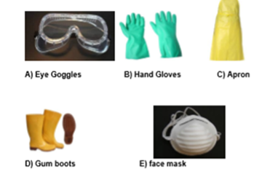
Figure 1.1 Personal protective equipment
Biological Hazards:
Workers may be exposed to disease-agents such as bacteria, fungi, mites which may be present in the hides or as part of the manufacturing process management measures that can be taken to avoid the negative consequences of worker exposure to biological hazards include the following:
Inform workers of potential risks of exposure to biological agents and provide training in recognizing and mitigating those risks
Provide personal protective equipment to reduce contact with materials potentially containing pathogens
Physical hazard:
Workers may be exposed to physical problems such as injury, slips and falls which may be present in the manufacturing process. Management role that can be taken to avoid the negative consequences of worker exposure to physical hazards include the following: fallow the safety instructions& HSE department order. use of personal protection equipment (e.g. gloves, glasses boots, aprons, masks, hoods, respirators)
The Environmental hazard:
Environmental issues associated with tanning and leather finishing include the Waste water, Air emissions, and Solid waste, Hazardous materials. The tanning industry poses many dangers to both the environment and those that work within it. the primary environmental threat involves the dumping of solid and liquid waste that contains chromium and other hazardous compounds even in fully modernized and carefully managed facilities, it is nearly impossible to reclaim all of the pollutants generated by the tanning process .
Managing health and safety:
Health and safety management should be a straight forward part of managing your workplace as a whole. It involves practical steps that protect people from harm and at the same time protect the future success and the growth of your business. Good practice in health and safety makes sound business sense. Managing health and safety is an integral part of managing your business. You need to do a risk assessment to find out about the risks in your workplace, put sensible measures in place to control them, and make sure
They stay controlled, you need to consider when managing health and safety and assessing the risks in your workplace to provide information which shows how you can follow a ‘Plan, Do, Check, and Act’ approach:
Plan: Describe how you manage health and safety in your business (your legally required policy) and plan to make it happen in practice.
Do: Priorities and control your risks – consult your employees and provide training and information.
Check: Measure how you are doing.
Act: Learn from your experience.

Unhairing chemicals, tools and equipment
Unhairing: - referring particularly to the process of removing the hair from the grain side raw hide or skin. The main purpose of this process is to separate the hair from the hides or skin. The net result is hairless hides or skin which are very greasy.
It can be done manually as well as using machine. This is a very important operation as all beautification works are done on the grain side only generally. The mechanism of unhairing process was described to be through the destruction of cementing substances, such as, keratin and glycoprotein, in the root of the hair. The addition of liming agent helps to break the disulfide bond on amino acid cystine, which is part of the keratin structure.
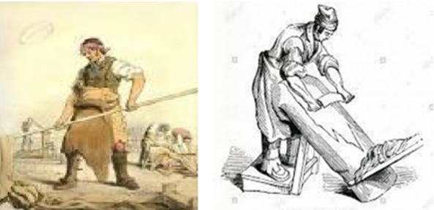
Figure 1-2 Unhairing action.

Unhairing chemicals
- Lime.
The starting chemical of unhairing is quick lime (CaO), which is then converted into slaked lime (Ca (OH)2) with water. The purity of lime is an important factor in the liming operation. The solubility of lime is always very less and the best temperatures for solubility of lime are in the range of 20-25O C. One part of quick lime powder is equivalent to about three parts of slaked lime and the ratio can be well used in the preparation of paste or while measuring the chemicals.
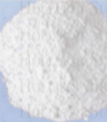
Figure 1-3 lime
- Sodium sulfide (Na2S):
The best sharpening agent and the widely used is sodium sulfide which on hydrolysis is liberated into Na+ and SH- ions. The rate of reaction is faster than of the sodium hydro sulfide being used in the industry. Concentrations above 3 g of Na2S/litter destroy the hair of the skin/hide. Normally, the active content of sodium supplied is about 60% It is the one responsible for the conversion of cystine into cysteine and removal of hair. is a sharpening agent. At times, certain wetting agents are also involved to make the unhairing chemicals penetrate into the skins effective.
- Sodium hydro sulfide:
It is also one of the widely used sharpening agents next to sodium sulfide and it is of lesser alkalinity than the former. The addition of sodium hydro sulfide in the place of sodium sulfide has a decreasing effect of reaction and hence uniform swelling and removal of hair is obtained. Sharp liming is not possible and the action is always milder
- sodium hydroxide
Is added to liming of the hides having a high natural fat content

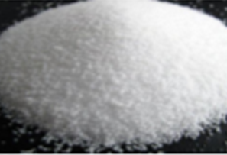
Figure 1-4.sodium hydroxide
- Enzyme.
Other additives – wetting agents, dispersing agents, thickening agents etc.,
Unhairing equipment’s and tool.
Tools for measurement: -
- indicator papers,
- indicator solution and Baume meter
- Indicator papers and solution
- Baume meter
Baume meter is used to measure the specific gravity of the lime paste, in case of paste liming: The Baume scale is a hydrometer developed by French pharmacist Antoine Baume in 1768 to measure density of various liquids The readings are notated as °Be.
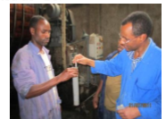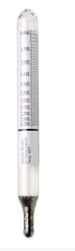
Figure 1.5 boume meter
Tools and machines
- drum
- wooden paddle
- wooden palate,
- Brushes,
- Coverage PVC plastic,
- unhairing wooden beam or knife
- unhairing machines the following equipment’s are used for unhairing of hide and skin except from wool sheep skin
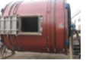

Figure1.6 Wooden liming drum
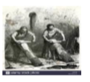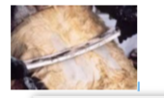
Figure 1.7 Unhairing wooden beams

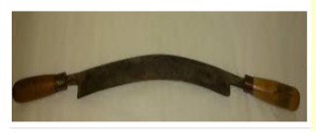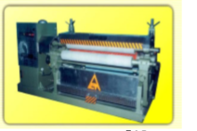
Figure 1.8 unhairing knife Figure 1.9 unhairing machine
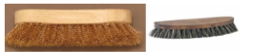
Figure1.10. Brushes used for applying lime/sulfide paste

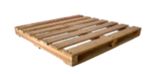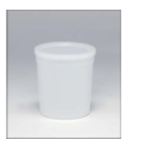
Figure 1.11 Wooden pallets. Figure1.12. Mixing container

the Workplace for unhairing
Arranging and clarifying workplace is important before starting the work. Along with arranging and clarifying of a work place unhairing requirement has a vital role to get organized work environment and quality product. By this the tannery will also run more efficiently.
Unhairing requirements:
The various requirements of unhairing are:
1. Safety requirements: The case of PPE’s.
2. Properly soaked skins/hides
3. Equipment’s/tools to measure the pH of the soaked skins/hides
4. Chemical requirements: Lime powder, Sodium sulfide and sodium hydro sulfide etc.
5. Vessels for mixing the chemicals (containers) and for liming and re-liming operations
6. Baume meter to measure the specific gravity of the lime paste, in case of paste liming
7. Tools for applying the paste, in case of paste liming
8. Equipment’s/Machinery for pulling wool, in case of hair saving methods.
9. Miscellaneous requirements
Safety requirements: The case of PPE’s
All the chemicals used in the unhairing are high alkalinity and corrosive in nature and hence proper PPEs are highly recommended.
Safety goggles to protect the eyes. Selecting the most suitable eye and face protection for employees should take into consideration the following elements:
- Ability to protect against specific for hazards chemicals.
- Should fit properly and be reasonably comfortable to wear.
- Should provide unrestricted vision and movement
- Should be durable and cleanable.
- Should allow unrestricted functioning of any other required PPE
Non-corrosive hand gloves to protect the hands. Chemical-resistant gloves are made with different kinds of rubber.
Aprons (Rubber, rubberized fabrics, neoprene and plastics) protect the body against certain chemicals and physical hazards. When chemical or physical hazards are present, check with the clothing manufacturer to ensure that the material selected will provide protection against the specific hazard, Gum boots to protect the feet, Face mask to protect respiratory organ
Properly soaked skins/hides:
A properly soaked raw stock is the basic requirement of unhairing. Under- soaked skins/hides cause poor diffusion of the unhairing chemicals into the substrate and make the hair removal very difficult. On the other hand, over soaking would create problems such as looseness, hair slip etc., Also the soaked skins should be completely drained before unhairing, in the case of painting sheep skin , as the concentration of lime/sulfide paste would get diluted . This might lead to ineffective unhairing in the end.
Dispersing cum Emulsifying agents to aid in the unhairing when there is much of flesh and fat in the flesh side
Lime solubilizing agents such as Glucose or Molasses can be added to increase the solubility of lime thus accelerating the operation

Pre -operational duties to fulfill legislative/regulatory requirements
Prevention measures to be taken care of by the user:
- Do not wear any loose fitting clothes, long hair or jewels that could get caught in the moving parts of the machine
- . The surface on which the machine is installed must be kept clean at all times
- Abide by all the danger and caution indications
- Always wear the following individual protective gear: work gloves, ear protection, face mask.
- Check daily, before starting work that all the switches and safety devices are in proper working order.
- Keep the sleeker cylinder and grinder carriage completely clean and perfectly efficient.
- Switch the machine on only when it is free from external objects and there are no unauthorized people in the vicinity
- All guards and protections must be in place when the machine is running.
- Turn the electricity power sources off at the end of each shift or work cycle.
- When the machine is being repaired or serviced turn the electricity off via the main switch (turning it round to position “O”).
- Serious accidents, sometimes fatal, can be caused to people if the machine is serviced, repaired or cleaned with the electricity left on.
- All electrical adjustments must be made by qualified electrical adjustments must be made by a qualified electrician using insulated tools.
- Only qualified people should be allowed to use, service and repair the machine.
- The user can only carry out operations and interventions on the machine that lie within his province.

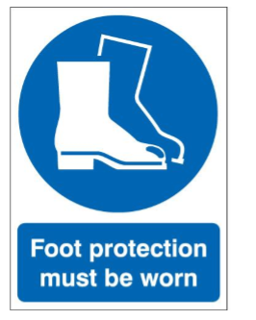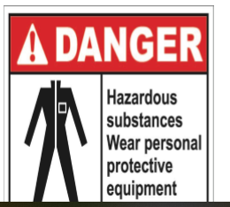

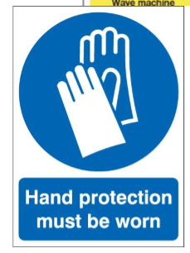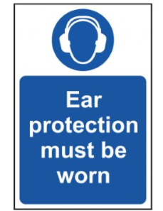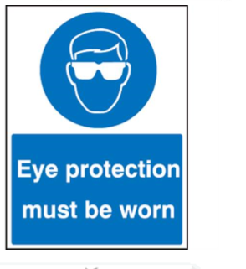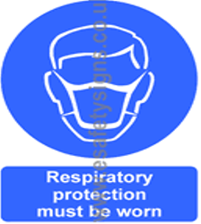
Figure1.13. Hazard and safety Symbols for Machines

Self-check 1
Part. I True/ false
Instruction: say true if the statement is correct or false if the statement is incorrect. You have given 1 Minute for each question. Each question carries 1 Point.
1. Occupational health and safety is a process of ensuring that people stay safe and healthy in the workplace to increase workers capacity.
2. Unhairing referring particularly to the process of removing the hair from the grain side raw hides or skin
3. Liming is to open up the fiber structure of the substrate in hand.
4. The purity of lime is not an important factor in the liming operation.
5. Gum boots is used to protect the ear.
Part II .Short Answer writing
Instruction: write short answer for the given question. You have 3 minutes for each question and each point has 5Points
1. List at least 5 requirements of uhairing
2. What problems are occurring if the raw stock is not properly soaked?
3. What is the difference between sodium sulfide and sodium hydrosulfide?
4. Define what dose Baume meter means and write the Baume meter range of paste solutions
5. List and describe the uses of tools that are used in the cases of paste liming .
6. Aprons
7. Lime blast
8. Paddle
9. PH
Part 3: multiple choices
Instruction: chose the correct answer for the following statement and circle the letter.
1. Which one of the following is added to liming of the hides having a high natural fat content?
A.sodium hydro oxide
B.Sodium hydrosulfide
C. sodium sulfide
D .none
2. Which one of the following is used to measure the specific gravity of the lime paste?
A. indicator papers
B.Boume meter
C. centi meter
D .All
3. Which one of the following is the best sharpening agent chemical?
A. Sodium hydrosulfide
B. sodium sulfide
C .sodium hydro oxide
D.All
4. Which one of the following Measure how you are doing?

A. plan B.do
C. check D. act
E .all
5. Which one of the following is the requirements of unhairing ?
A. Safety requirements.
B. Properly soaked skins/hides.
C. Equipment’s/tools to measure the pH of the soaked skins/hides
D.Lime powder, Sodium sulfide and sodium hydro sulfide.
E.all

Note: Satisfactory rating – above 60% Unsatisfactory - below 60%
You can ask you teacher for the copy of the correct answers

Unit two: Preparation of hides/skins for unhairing
This unit is developed to provide you the necessary information regarding the following content coverage and topics:
  - Identification of unhairing methods
  - Preparing hides/skins for unhairing based on processing methods
  - Assessing the hair loosening manually
This unit will also assist you to attain the learning outcomes stated in the cover page. Specifically, upon completion of this learning guide, you will be able to:
- Identify unhairing methods
- know hides/skins for unhairing based on processing methods
- perform the hair loosening manually

2.1. Identification of unhairing methods
Methods of Unhairing:
Liming is commonly done in the following methods:
- Paint unhairing/liming
- Paddle unhairing/liming
- Drum unhairing/liming
Paddle or Drum liming method /Hair burning
Paddle or drum liming methods are generally followed for larger cow hides, Goat skin and once after the completion of unhairing of the sheep skins the leathers are limed in the drums only. It is generally followed when the hair is of less importance. All the hair gets digested in the drum itself. Normally the RPM of the drums should be in the range of 2-3 to avoid more mechanical action. One has to be very much careful regarding the RPM and the amount of the chemicals used. The choice of methods depends on the facilities available in a tannery and the end product being manufactured. Pit/paddle/drum methods destroy the hair. Even if the short hairs are there at the end, they are removed using a beam as stand and unhairing knife. Commonly, 5-7 % lime, 2-3 % Na2S is used. If it is drum 80-100 % water is used and 300 % water for paddle method of liming. Cow sides need 24-36 hours for effective unhairing in paddle. Usually, drum method is faster. If the wool/hair of the goat/sheep is of low value, drum/paddle is resorted to even for the ovine skins such as goat and sheep. The major advantages are that the time consumed is less and the efficiency being more whereas getting looseness and drawn grain sometimes is one of the disadvantages.
Painting (Na2S-Lime paste method)
This is traditional hair-save method for calf, sheep or long-haired goat skins. It is used in cases where the hair/wool is valuable. This method is deliberately done by hand if the wool is of good value. Otherwise, pit/paddle/drum method is followed in turn the hairs are destroyed. The washed or soaked skins are piled to drain off surplus water In this method, appropriately Na2S, NaHS, lime and a wetting agent are thoroughly mixed and the paste is applied all over the flesh side. The skins are piled flesh to flesh and covered using PVC plastic. Based on the time of influx of soaked skins into the unhairing area, the process may take 5-12 hours depending on thickness of the skin, tightness of fiber structure, and amount of fat and flesh left on the skin. Majority of the times, the hair removal is done by hand, especially when the Laborers are more. The PPEs are very mandatory here. The skins after removal of the hair are taken for re-liming. The hairs are stored separately for further processing or for safe disposal. Paste solution can be prepared: Sodium sulfide and sodium hydro sulfide (1.5-3%) are first added on 20% of water, and Baume is adjusted to the range of 14 – 16 and lime powder (6-8%) is next added and the Baume is adjusted to the range of 28 – 32oBe.
RPM required for liming in the range of 3 – 5.
Advantages of the process:
Strong alkali (lime) and sodium sulphide prevent putrefaction therefore give better skin. with reasonable control, hair loosening is reliable.
Unhairing is quicker and owing to shortage of water in painted skins, the strong alkali cannot cause undue swelling, buckling and distortion of the skin.
The amount of paint can be varied over the area of the skin, giving more to thicker backbone and less to thinner, loose flanks and bellies.
Disadvantages of the process:
- requires more labor
- wool yield is less (owing to the disintegration of wool roots)
Lime and sodium supplied damage hair and wool, causing a hardness to the touch or weakening of strength and eventually complete disintegration. This action is a function of supplied concentration.
Enzyme application method unhairing application using SSF protease.

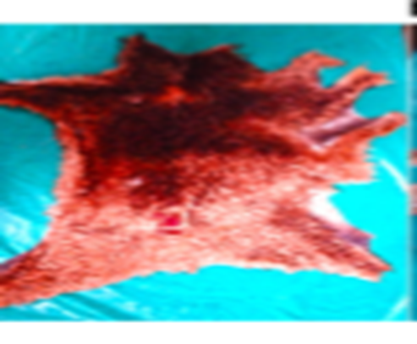
Figure 2.1 soaked sheepskin
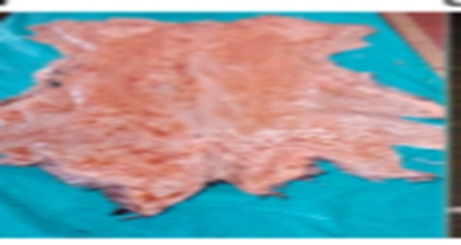
Figure 2.2 unhairing enzyme manually applied a paste on flesh side

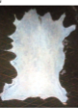
Figure 2. 3 unhaired sheepskins
Recently, enzymes are used for unhairing. Microbes are applied and kept under controlled pH and temperature. The enzymes secreted by the microbes attack the hair bulb and loosen the hairs. The hair removal is made easy in this method. The favorable temperature is 30 - 32° C. After the hair removal, the skins are taken for re-liming. The skins after unhairing by the enzymatic method are showing smoother and tighter grain. The load of pollution is also reduced drastically. Enzyme application method aims at either removal or minimization of sulfides in unhairing. Enzyme unhairing is a controlled process. Enzyme preparations that preferentially attack the keratin cells at base of hair roots or epidermis are available. Enzymes are specific in their action and are active within a narrow range of temperature and pH. Since optimum temperature for unhairing enzymes are close to those for bacterial growth, it is essential to use some disinfectant to prevent bacterial putrefaction. Enzymatic processes may give some difficulties in a tannery. Enzyme attack may be very vigorous, too much protein may be removed from the skin and collagen may be partly decomposed. The resultant hides are then thin and stiff. If the enzyme action is too weak, insufficient amount of protein will be digested, and additional operations necessary, like e.g., Alkali swelling of hides before pickling (after liming). The enzymatically unhaired hides as a rule have to be tanned and dyed in a different way than hides processed by other techniques.
Enzymatically unhairing is commonly doing by the following methods
A.Enzyme assisted chemical unhairing
- Conventionally hair burning can be accelerated by the presences of ‘alkali stable’ proteolytic enzymes obtained from bacterial fermentations.
- Keratin break down is faster as the degradation of the non-structural protein as well as the collagen itself.
- Hence, there is danger of loosening the corium structure if the reactions go too far. This makes the process high risk.
The outcome of this process is as follow: -
- Cleaner grain, better for dyeing
- More opening up, so the leather is softer
- Allows a reduction in sulfide offer or a reduction in process time
- Removes the need for a bating step
- Growth mark is removed, so the leather is more uniformly flat;
- The skin is thinner, with greater surface area, because the elastin is degraded.
- Strength per unit thickness is increased
- Leather is less stretchy
- These changes are early only suitable for some leathers, such as upholstery or clothing, where softness and drape are useful properties.
Pollution is also reduced drastically. Enzyme application method aims at either removal or minimization of sulfides in unhairing.
B.Chemical assisted enzyme unhairing
- It is a version of hair saving, the process can be summarized as follow.
- Conventional soak
- Disrupt the epidermis with conventional unhairing agent, e.g sulfide
- Drain the solution for recycling
- Apply alkali stable enzyme
- Run and filter loosed hair
- Re-lime for short hairs

2.2 hides/skins for unhairing based on processing methods
Preparation of skin/hide for unhairing Identification or suitability of the soaked skins for unhairing process and confirming the unhairing process can be further divided in to two steps.
Identification of skin/Hide for unhairing process First of all the skins/hides should be prepared for the next operation of unhairing.
As to the process of unhairing the soaked hides should be well drained properly by piling it on a horse (U shaped) wooden frame and all the excess water is to be drained.
The process or steps for preparation can be listed as below.
- Ensure the completion of soaking.
- Then take the skins/hides from the drum or the paddle or any other vessel draining all the water.
- Check the effectiveness of draining.
- Then check for the amount of unwanted flesh present in the flesh layer.
- If more amount of flesh is present the soaked skins should be green fleshed.
- Then we can go to the step of identification of skin/Hide for unhairing process.
Identification of skin/Hide for unhairing process can be done by the following methods
a. Type of material (Skins):- before ensuring or deciding the unhairing recipe one has to clearly know about the type of raw material which is going to be processed. It has to be clearly identified between skins and hides. One has to clearly know what types of skins are going to be processed.
b. Origin of the raw material. The origin of raw material plays an important role in deciding the process. The origin based upon its own breeding, rearing and climatic
Conditions play a major role on the quality of raw material and hence without knowing the origin if the recipe is ensured it will be chaos at the end.
For example within Ethiopian skins once has to clearly know whether it is a highland sheep skins or Wanke sheep skins or Adal sheep skins before ensuring the process.
c. Average size and Thickness of raw material. The size and the average thickness play a major role during the process by the ways of penetration of chemicals. As long as the thickness, Compactness and the size are more, the consumption of chemicals and time is more. The process has to be ensured in such ways.
d. The amount of hair and unwanted flesh present in the raw material: - The removal of hair and unwanted flesh being the two major objectives of unhairing are to be well taken into account before ensuring any recipe. All the chemical requirements and type of process are to be designed in such a way that everything is removed properly. When the flesh is more it takes longer time for the chemicals to get penetrated inside.
e. The type of vessel being used for the operation of Unhairing:- The type of vessel being used for the operation of Unhairing The mechanical action is one important factor during the process and the dimensions and types of vessels are to be appropriately choosen depending upon the skins.
f. The favorable climatic conditions for the process to be done. The favorable climatic conditions for the process to be done for doing any process, climatic conditions have to be really favorable. For example, Lime is best soluble at 20-25 o C and hence under very cold or very hot conditions the solubility of lime is poor and the efficiency of the recipe goes down. Also if we are going to employ the enzymes for unhairing, they act only at a particular temperature as enzymes are more specific action.
Ensuring unhairing process based upon different factors
The appropriate process can be ensured upon the following factors.
a) Availability of the machineries: - Depending upon the type of skin/Hide and the volume to be processed the machines are choose. The main machineries used are pits, paddles and Drums.
b) Type of skin/hide: - Depending upon the type of skin/hide processed the method of liming is decided. For cow hides, since the hair is less important and the size and weight of the hides are also more paddles or drums are preferred. Whereas in the case of goat skins, paddles are preferable and just paint liming by hand is enough for sheep skins as the wool is of great value.
c) Skill sets and skilled personnel available: - If one has to do the process effectively the proper men, material and knowledge are important and hence these factors are to be taken into account before formulating the recipe.
d) Favorable climatic conditions and quality of chemicals for the process. The climatic factors and other major factors such as quality and availability of water are to be taken into account. The purity factors of chemicals going to be used also plays a major role. Just for the better efficiency of the process to be effectively achieved these factors should be assessed before formulating the recipe
Amongst these, the first two methods are very popular due to its ease of operation and cheap cost.

2.3. Assessing the hair loosening and removal manually or by machine
Methods of assessing the accuracy of un-haring requirements
Any material being used in the un-haring process (Generally in the industry) has to be assessed for quality and accuracy i.e. consistency. Quality or accuracy can be described as
A measure of excellence or a state of being free from defects, deficiencies and significant variations brought about by strict and continuous adherence to measurable and verifiable standards.
Both the physical and chemical parameters are involved in the un-haring operation and the ways of assessing their accuracy are described below
Assessing soaked skins/hides:
Soaked skins/hides should be assessed for the following aspects:
- The moisture content of skins:
Soaked skins should have been completely drained. The excessive water in the skins will lead to the dilution of the chemicals in the lime/sulfide paste and reduction in activity.
- Cleanliness:
The soaked skins should be free of blood, dung and dirt and other impurities. It should be clean enough. The flesh side of a soaked skin
- Rehydration state:
The skins should be rehydrated and should have regained the green condition nearly.
- Flexibility:
After soaking the skins should be more flexible. There should be no rough edges. There should not be any variations within the area of the skin.
- The degree of soaking:
For proper penetration of un-haring chemicals, especially, the lime/sulfide paste into
The skins/hides, good soaking is a must.
- Symptoms of putrefaction
- Foul smell: should be absent.
- Hair slip: should be absent.
- Grain off: should be absent.
Normally in many of the tanneries the wool/hair of the sheep skins are generally removed by hand after the completion of paint liming operation. Proper care has to be taken while removing the wool/hair since the chemicals used such as sodium sulphide and Lime are highly alkaline and corrosive. Proper PPE should be worn before we begin to remove the wool. Also one has to check the removal of hair/wool along the backbone region around the neck area before the start of pulling wool. Also after the painting operation the wool has to come freely while being pulled and more pressure should not be exerted as it will damage the grain.
PH of the soaked skins/hides:
The pH of the soaked skins/hides should always be less than 9-9.5. It can be measured with pH papers or indicator solutions. If the pH is beyond 9.5, there is this risk of immunization of keratin and subsequently hair removal will become a challenge in itself. A worker checking the pH of a soaked skin and also the PH of liming is better to be 12.
Assessing quality of containers used in the paste preparation:
All the containers used in the preparation should be non-corrosive and nonreactive and wide mouthed for better stirring.
Assessing quality of the tools used in application of the paste.
The brush used for application of the lime paste should not be very hard since it will abrade the skin and the quality should be always confirmed by uniform application all over the skins/hides.
Assessing the vessels used in un-haring/Liming:
All the vessels used in the liming should be of proper dimension and the RPM of the drums used for liming is critical and should be in the range of 3-5.
Assessing the machines used in Un-haring:
The knives used in unhairing should be blunt enough as it should not damage the grain layer of the skin.
The unhairing machines should be checked for knife quality and should be well maintained.
Checking the Baume for consistent values and ensuring the specific gravity of the paste.
The Baume is the measure of the specific gravity of the paste prepared for unhairing. It should be in the range of 28-32o Be. China clay can be used to thicken the lime/sulfide paste and in turn increase the Baume of the paste. Thus, consistency of Baume is ensured for proper unhairing.

Self-check-2
Part I: short answer writing.
Directions: Answer all the questions listed below. Each has 5 points and the time allowed for each 3 minute.
1. Write the process or preparation steps of hide/skin for unhairing)
2. How to affect unhairing process by climate conditions. explain
3. Write advantage and disadvantage of painting (Na2S-limepaste method
4. Why enzymatic process may give some difficulties in a tannery?
5. If the PH of soaked skin/hide can beyond 9.5 what will happen ?
6. What are the symptoms of putrefaction?
7 define the following words.
A.skin
B.Limeblast
C.hide
D.Rehydration
Part 2.long answer writing
- Discuss the identification mechanisms of skin/Hide for unhairing process?
- Discuss enzymatic unhairing methods.
Note: Satisfactory rating – above 60% Unsatisfactory - below 60%
You can ask you teacher for the copy of the correct answers

Unit three: unhairing methods
This unit is developed to provide you the necessary information regarding the following content coverage and topics:
  - Techniques of hair removal
  - Checking the effectiveness of hair removal
  - Managing the hair waste
  - Maintaining records in unharing operation.
This unit will also assist you to attain the learning outcomes stated in the cover page. Specifically, upon completion of this learning guide, you will be able to:
- Techniques of hair removal
- Check the effectiveness of hair removal
- Manage the hair waste
- Maintain records in unharing operation

3.1 Techniques of hair removal
Techniques or procedures of hair removal
This is generally done by two methods
- By Hand
Normally in many of the tanneries the wool/hair of the sheep skins are generally removed by hand after the completion of paint liming operation. Proper care has to be taken while removing the wool/hair since the chemicals used such as sodium sulphide and Lime are highly alkaline and corrosive. Proper PPE should be worn before we begin to remove the wool. Also one has to check the removal of hair/wool along the backbone region around the neck area before the start of pulling wool. Also after the painting operation the wool has to come freely while being pulled and more pressure should not be exerted as it will damage the grain.
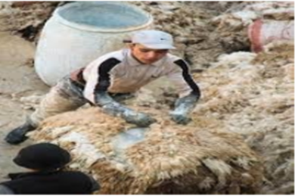
Figure 3.1 unhairing by hand
- By Machine
In some of the cases where the amount of wool/hair is more and the pressure exerted on the skins to remove the wool/hair is slightly high, machines are generally used. Normally the pelts are fed into the unhairinmachine by placing them on the feed roller with the grain side up and pressed against the unhairing roller. The pressure applied is uniformly exerted on the skin. Care must be taken to optimize the pressure applied, otherwise will result in the damage of the grain layer. Normally the hair/wool removed will be passed on to the moving conveyor at the back of the machine which can be easily collected.
Procedure for removal of wool/hair (By hand and machine)
A) Check the completion of paint liming operation.
B) Now the person who is going to remove the wool has to wear the necessary PPE.
C) First pull the wool along the backbone region around the neck area of the skin. If the wool removes easily from the area it gives an indication that the wool can be easily removed from other places.
D) Then the pelts should be carefully transported to the area where the wool is either removed by hand or machine.
F) Now the wool can be either removed by hand by pulling it gently or removed by the machine by pressing against the unhairing roller. Care should be taken for applying uniform pressure

3.2. Checking the effectiveness of hair removal
After the completion of unhairing/liming operation the wool/hair is generally removed. For the effective removals of hair/wool there are different factors which affect the removal of wool. If unhairing/liming operation is done by considering those factors the hair/wool can be removing effectively
Factors that affect hair removals
A) Penetration of liming chemicals.
Normally the ions of the chemicals attack the base of the hair roots and break the bonds there leading to the operation of unhairing. Hence if the unwanted flesh is more the penetration of chemicals will be faces a problem. Also if the soaking is improper and the globular proteins are not properly removed the chemicals cannot easily penetrate and the efficiency of the process will come down.
B) Strength of hair roots to get broken.
The strength of the hair roots plays a major role. If the bonding is stronger the breaking of hair roots are difficult. More amount or concentration of chemicals is required to break the roots of hair. Also the bonding may differ from sheep, goat and cow. Hence the species and origin are always to be taken into account.
- Thickness of the skins
The thickness of the skins/hide has a factors , Since most of the penetration happens through the flesh side and attacks the hair root. If skin/hide has more thickness the penetration time is longer hence the time has to be increased for the operation of unhairing/liming.
- Concentration of the chemicals used.
Normally the hair roots are destroyed by the SH- ions in the presence of OH- ions. Hence the concentration of chemicals plays a major role. If the concentration tends to be low or high both the ways it is going to affect the operation. Suppose if the float gets higher and the quantity of chemicals are same the dilution factor gets more and ionic concentration gets lower and hence the operation of unhairing/liming becomes inefficient. Therefore proper floats, required quantity of chemicals are to be strictly followed If the above all factors are maintain properly the hair can be remove effectively and then we can get good quality of pelt.
Handling of Limed Pelts
The skins are generally called as pelts after the unairing/liming operation and some of the characteristics of the limed pelt are
A) Highly slippery and handling is difficult.
B) More swollen and plumped.
C) Hair is removed and the grain layer is susceptible to the atmospheric conditions.
D) Chances of getting lime blast are more when more exposed to open air conditions.
The strength of the leather is poor and care to be taken in handling as miss handling may rupture the internal structure.
Taking all these conditions into consideration limed pelts should be properly handled. Care should be taken to properly transport the material without getting damaged.
First of all the pelts should be transferred after wearing the necessary PPE. Then the limed pelts are to be loaded into proper vessels and transported to the drums for the next operation either Reliming or Deliming
Avoidance of Lime Blasts:
Lime blasts are nothing but insoluble calcium deposition on the skin. The main causes for the lime blast formation on the skins are either the skins are left carelessly in the open air for a longer period of time or inadequately immersed in the lime liquor during the liming operation. Also the usage of water with bicarbonate hardness or free carbonic acid may lead to the formation of lime blasts.
The effects of lime blasts on the skins are
- Rough or brittle grain
- Uneven Tanning effect
- Dark stains after vegetable tanning
In order to avoid these problems proactively the skins should be always completely immersed in the lime liquor during the operation and once out of the bath and the removal of wool and flesh, the skins are to be adequately covered and transported to the next operation. Not much time should be taken for the next operation. Also the addition of complexing agents in the bath will reduce the problem. Once the lime blasts are formed we can use poly phosphate salts and wash them but it cannot remove completely so must take a care to avoid the problem.

3.3. Managing the hair waste
In this sub topic we are going to discuss first about waste management in general and then waste management during the unhairing process.
Waste management
Waste management is the collection, transport, processing or disposal, managing and monitoring of waste materials. The term usually relates to materials produced by human activity, and the process is generally undertaken to reduce their effect on health, the environment or aesthetics. Waste management is a distinct practice from resource recovery which focuses on delaying the rate of consumption of natural resources. All waste materials, whether they are solid, liquid, gaseous or radioactive fall within the remit of waste management. Management for nonhazardous commercial and industrial waste is usually the responsibility of the generator subject to local, national or international authorities.
There are a number of concepts about waste management which vary in their usage between countries or regions. Some of the most general, widely used concepts include:
Waste hierarchy - The waste hierarchy refers to the "3Rs" reduce, reuse and recycle, which classify waste management strategies according to their desirability in terms of waste minimization. The waste hierarchy remains the cornerstone of most waste minimization strategies. The aim of the waste hierarchy is to extract the maximum practical benefits from products and to generate the minimum amount of waste.
Polluter pays principle - the Polluter Pays Principle is a principle where the polluting party pays for the impact caused to the environment. With respect to waste management, this generally refers to the requirement for a waste generator to pay for appropriate disposal of the unrecoverable material.
Waste management during unhairing:
Applying all these concepts right from prevention to disposal we can apply the concepts of Minimization, Recycling, Energy recovery and Disposal with respect to the unhairing operation.
- Minimization:
During the unhairing operation, by optimizing the amount of chemicals to be used the waste can be minimized. By reducing the float levels and optimizing it the waste can be minimized. By using the latest and eco-friendly techniques such as enzymatic unhairing various environmental hazard impacts can be minimized. Thus by applying various techniques the wastes generated can be minimized.
- Recycling:
Normally the lime liquors used during the reliming operations can be used again. The spent lime liquors are always mellow and whenever we want to use longer liming techniques. Such liquors are helpful.
- Energy recovery:
Energy recovery can otherwise be classified under by-product utilization. Some of the wastes generated are Hair, Wool and flesh and many of them can be widely used for variety of purposes. The hair and wool can be used for making brushes, blankets, carpets, sweaters and for a variety of uses. The flesh generated can be used in the manufacture of glue and gelatin. The lime sludge can be used as a construction material when it modified
- Disposal.
Disposal is the worst case of waste management. Whereas in leather production there is a chance to use each and every waste generated.

3.4. Maintain records in unhairing operation
Documentation process
• Standards and formats
• Types and uses of documents and records
• recording the process information Documentation Standards and Format:
Documentation standards and formats are important because documents are the only tangible way of representing the process. Standardized documents have a consistent appearance, structure and quality, and should therefore be easier to read and understand the system.
There are three types of documentation standards:
A) Documentation Process Standards: These standards define the process that should be followed for document production.
B) Document Standards: These standards govern the structure and presentation of documents.
C) Document Interchange Standards: These standards ensure that all electronic copies of documents are compatible.
Formats for recording the information regarding the unhairing machine Operation:
One standard format may be used during performing the unhairing operation. Although this format is not being used universally, but it may be took as an example format writing of the pre–tanning operation. This format will provide the general information has been followed during the concern operation, like thickness between two operating cylinder, speed of the operating cylinder etc. These records will guide in future as document for further communication.

Self-check 3
Part I: short answer writing.
Directions: Answer all the questions listed below. Each has 5 points and the time allowed for each 3 minute.
1. Write the process or preparation steps of hide/skin for unhairing
2. How to affect unhairing process by climate conditions. Explain?
3. Write advantage and disadvantage of painting (Na2S-limepaste method
4. Why enzymatic process may give some difficulties in a tannery?
5. List out the factors that are affecting the effectiveness of hair removal?
6. Write the characteristics of lime blast?
7. What is the cause of lime blast and how to avoid the problem?
8. What is waste management means
9. Describe the most general, widely used concepts of waste management
10. List out the concepts of waste management during unhairing
11. What is waste management means
12. Describe the most general, widely used concepts of waste management
13. What waste hierarchy is refers
14. List out the concepts of waste management during unhairing
Part II: multiple choices
Instruction: chose the correct answer and circle it .the time allowed to do this question is 2 minute for each and each has 3 points.
1 which one of the following is the types of documentation standards
- Documentation Process Standards
- Document Interchange Standards
- Document Standards
- ALL
2 which one of the following is the characteristics of limed pelt.
A) Highly slippery and handling is difficult.
B) More swollen and plumped.
C) Hair is removed and the grain layer is susceptible to the atmospheric conditions.
D) Chances of getting lime blast are more when more exposed to open air conditions
E) None
3. Which one of the following factor affects hair removal?
- Penetration of liming chemicals
- Strength of hair roots to get broken.
- Thickness of the skins
- All

Operation sheet-3.1
Operation title: Identify the Proper Process for Unhairing.
Purpose: To know the Proper Process of Unhairing method
Quality criteria: the hair roots are completely removed and the pelt achieves basicity.
Precautions: use personal protective equipment’s and waits touching anything before the instructor to do so.
Steps to be followed:

Step 1: Check the effectiveness of unhairing operation.

Step 2: Start pulling the wool/hair by hand or machine.

Step 3: Check the effectiveness of wool/hair removal.

Step 4: Carefully handle the material and avoid keeping the pelts for longer time exposing to atmospheric conditions.
Step 5: Transfer the wool/hair and pelt appropriately.

LAP TEST 3
Instructions: Given necessary raw materials, tools, chemicals, you are required to perform the following tasks within 3 hours.
Task 1: Ensure the completion of unhairing.
Task 2: Start pulling the hair/wool.
Task 3: Completely pull the wool/hair and transfer it.
Task 4: Transfer the pelt carefully avoiding lime blast.
Task 5: Calculate the pelt weight and proceed to the next operation.
Request your teacher for evaluation and feedback of your work

Reference
1.Heidemann, E. (1993).Fundamentals of Leather Manufacture. Eduard Roether KG. P.211 ISBN 3-7929-0206-0.
2.Bienkiewiecz, K. (1983). Physical Chemistry of Leather Making. Robert E. Krieger. P.298. ISBN 0-89874-304-4.
3.Sharphouse, J.H. (1983). Leather Technician's Handbook. Leather Producer's Association. p. 212. ISBN 0-9502285-1-6.
4. DUTA

Participants of this Module (training material) preparation
no | Name | Qualification (Level) | Field of Study | Organization/ Institution | Mobile number | E mail
1 | Yetemarew mengist | B (BSC) | leather | Fnoteselam poly | 0938283957 | yetumengist@gmail.com
2 | Ahmed | B(BSC) |  | Enjibara poly | 0902419574 | Anuru3076
3
4
5
6
7

