Leather processing
Level-I
Based on December 2021, Curriculum Version 1
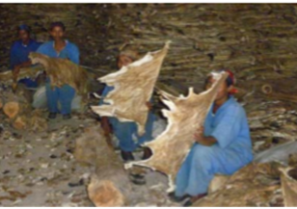
Module Title: - Perform Trimming and Pilling
Module code: IND LEP1 M05 1221
Nominal duration: 27 hours

Prepared by: Ministry of Labour and Skill
August, 2022
Addis Ababa, Ethiopia

Acknowledgment
Ministry of Labor and Skills wish to extend thanks and appreciation to the many representatives of TVET instructors and respective industry experts who donated their time and expertise to the development of this Teaching, Training and Learning Materials (TTLM).

Contents
Acknowledgment 2
Acronym 4
Introduction to the Module 5
Unit one: trimming and piling tools/ equipment 6
1.1 personal safety equipment 7
1.2. Trimming Knives 10
1.3. Pallets, trimming tables and trolleys 15
1.4 Trimming and piling requirements 19
Self-check 1 23
Operation Sheet 1.1 25
LAP Test 1. 25
Unit two: Trimming and piling operations 26
2.1. Raw hides/skins and output products of various stage 27
2.2. Trimming and piling tasks 29
2.3 Monitor and dispose trimming-wastes 30
Self-check 2 33
Unit three: Clean and store tools and equipment 34
3.1 clean used tools and equipment’s 35
3.2 Storing mechanisms of trimming tools and equipment 36
Self-check 3 37
Reference 39

Acronym
TTLM: teaching training and learning material.
LAP: learning activity performance.
PPE: personal protective equipment

Introduction to the Module
In leather processing filed: knowing the types of hides and skins ,the requirements as well as the trimming and piling tools ,that we follow to trim and pile the ides and skins is essential
This module is designed to meet the industry requirement under the leather processing occupational standard, particularly for the unit of competency: perform trimming and piling operation
This module covers the units:
MODULE CONTENTS:
- Trimming and piling tools/ equipment
- Trimming and piling operations
- Clean and store tools and equipment
Learning Objective of the Module
- Identify and Prepare trimming and piling tools/ equipment
- Perform Trimming and piling operations
- Clean and store tools and equipment
Module Instruction
For effective use this modules trainees are expected to follow the following module instruction:
- Read the information written in each unit
- Accomplish the Self-checks at the end of each unit
- Perform Operation Sheets which were provided at the end of units if available.
- Do the “LAP test” giver at the end of the unit if there is.
- Read the identified reference book for Examples and exercise

Unit one: trimming and piling tools/ equipment
This unit is developed to provide you the necessary information regarding the following content coverage and topics:
- Personal safety equipment
- Trimming-Knives
- Pallets, trimming tables and trolleys
- Trimming and piling requirements
This unit will also assist you to attain the learning outcomes stated in the cover page. Specifically, upon completion of this learning guide, you will be able to:
- Identify and use required personal safety equipment
- Select and sharpen trimming-Knives
- Arrange the pallets, trimming tables and trolleys
- Confirm Trimming and piling requirements

1.1 personal safety equipment
The Occupational Safety and Health (OHS) practice requires employers to protect their employees from workplace hazards through the use of engineering or work practice controls. Employers are required to assess the workplace to determine if hazards are present, or likely to be present, that would require the use of Personal Protective Equipment (PPE).
1.1.1 Personal Protective equipment
Personal protective equipment is protective clothing, helmets, goggles, or other garments or equipment designed to protect the wearer's body from injury or infection. The hazards addressed by protective equipment include physical, electrical, heat, chemicals, biohazards, and airborne particulate matter. If PPE is to be used to reduce the exposure of employees to hazards during trimming, a PPE program should be developed and maintained.
The components the program should contain:
- Identification and evaluation of hazards in the workplace (during trimming)
- Procedures on personal protective equipment selection for trimming of hides skins and leather
- Procedures on personal protective equipment maintenance
- Procedures for the evaluation of the effectiveness of the personal protective equipment
- Procedure to trains employees on effective use of PPE during trimming
Using personal protective equipment requires hazard awareness and training on the part of the user during trimming. Employees must be aware that the equipment does not eliminate the hazard. If the equipment fails, exposure will occur. To reduce the possibility of failure, equipment must be properly fitted and maintained in a clean and serviceable condition. Selection of the proper personal protective equipment for a job is important. Employers and employees must understand the equipment’s purpose and its limitations.
1.1.2 Identify personal protective equipment
Identify the protective equipment that ensures a level of protection greater than the minimum required to protect employees from the hazards. Careful consideration must be given to comfort and fit. Personal protective equipment must fit properly to be effective. For the worker’s comfort and protection, proper fit is critical. Continued wearing of PPE is more likely if it fits the worker comfortably. Personal protective equipment is generally available in many sizes. Care should be taken to ensure that the correct size is selected. Defective or damaged personal protective equipment shall not be used.
1.1.3. Hazard Assessment
Employers are required to assess the workplace to determine if hazards that require the use of PPE are present or are likely to be present. During the hazard assessment survey, managers and supervisors should identify any hazards that require the use of eye, face, and hand or foot protection. Employers must certify in writing that a workplace hazard assessment has been performed and keep it on file.
1.1.4 Training
Before doing trimming requiring the use of personal protective equipment, employees must be trained to know:-
- When personal protective equipment is necessary
- What type is necessary based on job function
- How it is to be worn – don, adjust, doff (remove) and wear
- The limitations of the personal protective equipment
- Proper care, maintenance, useful life, and disposal of PPE
- Each affected employee must demonstrate an understanding of the required training and the ability to use PPE properly, before being allowed to perform work requiring the use of PPE.
- Employers must certify in writing that training has been carried out and that employees understand and can demonstrate the proper use of the PPE.
- Each written certification shall contain the name of each employee trained, the dates of training, and identify the subject certified.
1.1.5 Specify the right PPE
Personal protective equipment (PPE) needs to be provided for eyes, hands, body and feet as highlighted from your risk assessment. Users are far more likely to use the PPE properly if they help to select it. Once provided, its use needs to be properly supervised if injuries are to be prevented. Never allow exemptions for those jobs which take “just a few minutes”. All PPE comes in a variety of sizes and the range of sizes needed by the workforce should be provided at the outset (with spares available as replacements). Care should be taken in selecting the right size for each individual, particularly with gloves where people are less likely to be familiar with the size ranges available.
1.1.6 Different types of PPE’s which can be used during Trimming Operations
Eye protection: - There is a possibility of hide/skin and leather trimmings and dusts arising out of crust leather during trimming, which would affect the eyes. Also, there is a possibility of broken particles of knife hitting the eyes. Hence, safety glasses or safety goggles are needed to be worn during the trimming operation, which can safeguard the eye from above mentioned particles.
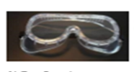
Figure 1.1 eye goggles
Hand protection: - During trimming, there is a possibility of cuts due to improper usage of trimming knives or blades. Hence, it is suggested to wear hand gloves during trimming operatio 
Figure 1.2 gloves
Body and foot protection: - Use protective clothing such as apron or cover jackets or boots is required to safeguard the body against broken blades or knives during trimming.

Figure 1.3 gum boots
1.1.7 Eliminate Potential for Cut Injuries during trimming of hides, skins and leather
Try to eliminate the use of hand knives or sharp machine parts from all or part of the task by:
- Redesign the tooling or process to eliminate/ reduce trimming
- Enclose or protect sharp machine parts and use a safer cutting tool (e g. ceramic knife or blade)

1.2. Trimming Knives
Knife is a cutting tool with a cutting edge, hand held or otherwise with or without handle. Considering the range of knives available, it is required to choose the knife that can suit the task
1.2.1 Trimming Knives
Based on the utility and availability, the knives as provided below can be considered.
- Retractable blades
- Round-ended blades
- Blades with a reduced cutting edge
- Handles which allow a firm and comfortable grip
- Left and right-handed types
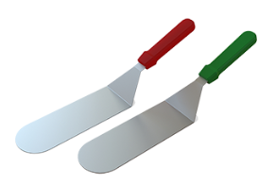
Figure 1.4 round blade knife
Trimming scissors: are tools which can be used for raw salted skin trimming, pickled pelt trimming and also for finished leather trimming.

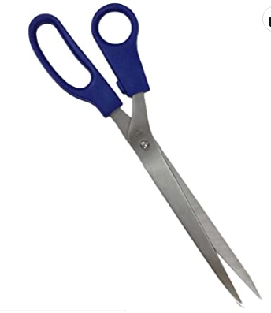
Figure: 1.5 trimming scissor

1.2.2. General Precautions while using a knife
- Good knives, specifically selected for the task, must be kept clean and in good condition if safe, satisfactory results are to be achieved.
- Safe, accurate cuts can only be made if the blade of the knife is sharp and clean.
- A blunt knife slips. Accidents are more likely to occur with a blunt knife than with a sharp one.
- Accidents can occur because the blade is too long. A careful examination of the material and the cutting action required should take place, in order to establish the ideal blade appropriate to the task.
- When the knife is not in use, whether it be placed on a bench, hung up or kept in a drawer the blade should be guarded, .e g. in a scabbard or knife holder. Discarded blades should be disposed of in a suitable container.
- A knife with a fixed blade guarded or not, should never be carried in the pocket.
- Hand knife injuries usually happen when the knife blade slips during cutting or trimming. In most cases the blade comes into contact with the workers other hand, causing a cut to the hand and/or fingers
1.2.3 The knife in use
Many knives are used in wet and/or greasy working conditions, and the knife should possess an adequate grip and guard to prevent the hand slipping forward to the blade. The guard may consist of a metal or plastic stop fitted at the base of the handle.
The user should never cut directly toward the body unless appropriate precautions have been taken.
The free hand must never be placed forward of the advancing knife blade.
- Where cuts have to be made in close proximity to the free hand a chain mail glove should be utilized to protect that other hand.
- Never turn around with a knife held in the hand, there may be someone in the way.
- Do not hold the knife in the hand whilst carrying out other tasks.
- Open bladed hand knives should NOT be used unless there are no reasonable safer alternatives, and only authorized/competent persons should be using knives.
1.2.4 .Safe handling of Knives
Preventing Cuts during Trimming DO’s:-
- Let a falling knife fall
- Use a firm grip and even pressure when cutting
- Cut in the direction away from the body where possible
- If possible, retract the blade of the knife before passing to a co-worker
- Ensure sufficient working area, to avoid risk of being bumped
- Place used blades in an appropriate container
- Wear chainmail or cut resistant gloves
- Use safety retractable blade knives
DON’T’s:-
- Try to catch a falling knife
- Walk around with an open blade knife in your hand
- Use a knife blade without a handle
- Leave a knife with the blade extended out
- Place knives near the edge of worktops
- Use a dull knife blade
- Use a knife as a screwdriver or other tool
1.2.5 Knife sharpening
Knife sharpening is the process of making a knife or similar tool sharp by grinding against a hard, rough surface, typically stone, or a soft surface with hard particles, such as sandpaper. Additionally, a leather razor strop, or strop, is often used to straighten and polish an edge. Knife sharpening proceeds in several stages, in order from coarsest (most destructive) to finest (most delicate). These may be referred to either by the effect or by the tool. Knife sharpening proceeds in several stages, in order from coarsest (most destructive) to finest (most delicate). These may be referred to either by the effect or by the tool. Naming by effect, the stages are:
Sharpening:-removing metal to form a new edge rough sharpening (using either water stones, oil stones, or medium grits of sandpaper in the scary sharp method of sharpening) fine sharpening (using the same tools as above, but in finer grits)
Straightening:-straightening the existing metal on the blade, but not removing significant quantities of metal
Polishing (also called stropping):-giving a mirror finish, but not significantly altering the edge. Polishing may be achieved by buffing a blade: instead of moving the knife against a flat leather strop loaded with fine abrasive, the knife is held still and a powered circular cloth wheel is moved against the knife.
Named by tools, the three stages are:
Grinding (on a grinding wheel) or Whetting (on a whetstone)
Steeling, using a honing steel
Stropping, on a razor strop or buffing on a wheel
The finest level of sharpening is done most frequently, while the coarser levels are done progressively more rarely, and sharpening methods differ between blades and applications.
Grinding stones are slabs of stone that Aboriginal people used to grind and crush different materials. Bulbs, berries, seeds, insects and many other things were ground between a large lower stone and a smaller upper stone
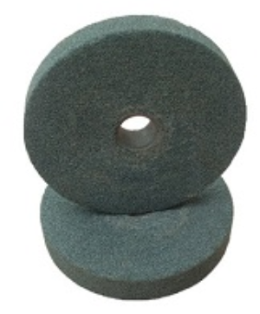
Figure 1.6.Grinding stone.

1.3. Pallets, trimming tables and trolleys
A pallet is a support or platform for boards to stack the load. They are rigid frames on which the goods are placed, distributed in a homogenous way at height and on the pallet surface. The pallets, and consequently the load, will be transported from one side of the racking or the ware house to the other by means of fork lift or pallet trucks.
1.3.1 How do you arrange pallets?
Include the bottom row of boxes, along with about three inches of the pallet, in your first three to four passes around the freight. As you move up the stack, wrap each new row twice. Overlap another three inches when your reach the top edge of the stack.
Pallets can be classified as block or stringer pallets. Block pallets provide more options for pallet entry by material handling equipment. Pallets with solid stringers typically allow two-way entry (at each end of the pallet) while notched stringers allow partial four-way entry (by forklifts through the notches, as well as full access from the ends), while block pallets typically allow full four-way entrance. Block pallets allow for 4-way entry, as opposed to stringer pallets, which can be accessed predominantly at the two ends. Partial stringer pallets with notches permit forklifts to also enter from the side, but not pallet jacks.
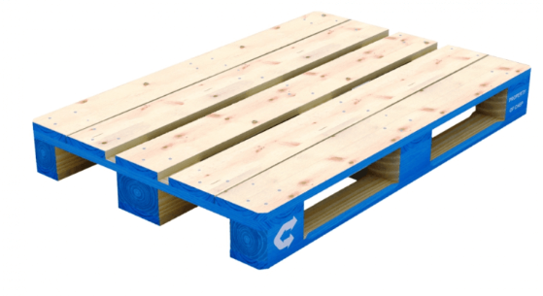
Figure1.7 four way entries pallet.
1.3.2. How do you arrange pallets in a warehouse?
As one of the key components of the warehouse and transportation environment, pallets helped modernize and improve materials handling efficiency in a way that has literally endured for decades. And while pallet materials and designs have morphed over time, their basic purpose still remains the same: help move and store materials quickly, reduce product damage and minimize the risk of worker injury. Also, customers typically prefer to receive palletized goods, which are easier to maneuver using materials handling equipment compared to other styles of unit load bases. Warehouse Layout
- Organize Floor Plan for Optimum Process Flow.
- Stay Organized with Labels and Signage.
- Provide Maps.
- Review Storage Capacity.
- Classify Inventory.
- Compartmentalize Inventory with Totes, Bins and Dividers.
- Implement a Slotting Strategy.
Implement an Efficient Receiving Process

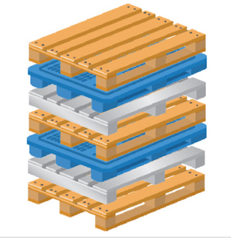
Figure1.8. pallet arrangement

1.3.3. Trimming tables and trolleys
Trimming is a process of removing the excess materials from hides or skins using knife, blades or scissors. This operation helps in getting a good shape for the hides or skins. Trimming is also carried out in order to remove the unwanted portions of the hides or skins, which will enable the reduction of chemical usage. Before trimming of hides or skins, it is required to know the need for trimming and how the trimming would be carried out for different types of raw materials. Trimming of hides or skins are generally carried out on trimming table using trimming tools.

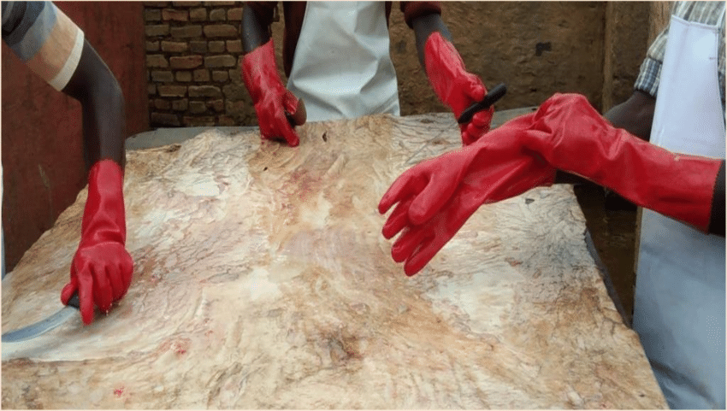
Figure:-1.9 Trimming Tables
Types of Trolleys and Their Functions
Trolley is a tool used to transport something by being pushed. This tool usually has various types according to their needs. Trolleys are usually also used in hotels, factories, or others that require a tool to transport goods.
Many different types of trolleys have appeared until now. These types of trolleys certainly have their own functions. In this article you will understand the trolleys that are in the factory.

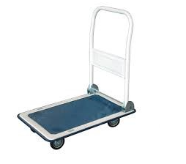
Figure1.10. goods trolley
As the name implies, goods trolleys are used to transport goods that are usually needed. The goods trolley is strong and sturdy enough to transport various types of goods.
So it is very suitable for transporting heavy and large items without having to spend a lot of energy to move these items.
Generally, the function of the goods trolley is to transport goods, but here are some other functions of the goods trolley.
- To transport necessary machinery or components inside the factory .
- To send engine parts.
- Transport company warehouse equipment.
- Transporting consumer goods such as gallons of water, or others.

1.4 Trimming and piling requirements
Tools for trimming are sharpened using sharpening equipment’s, which will result in a better trimming and also the efficiency of trimming can also be improved by using a sharp trimming tools. The trimming techniques differ based on the type of raw material which is trimmed.
1.4.1 Trimming requirements
Proper trimming shall be ensured by comprehension of standard trimming procedures and norms, which are set as per ETHIOPIAN STANDARDS ES 1196:2008
1.4.2 Trimming of raw Goat and sheep skins
Goat and sheep skins are brought to the tannery in various conditions like, salted skins (Wet and dry salted), air dried skins and fresh skins. At this stage, the trimming is carried out to remove the unwanted portions from skins. The general procedures for trimming of skins are as follows:-
- Trim the neck if it is too lengthy
- Trim the fore shanks (front legs)
- Trim the hind shanks (rear legs)
- Trim the tail not more than 40 mm from the butt
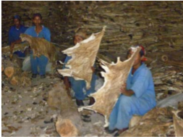
Figure 1.11Trimming of Dry salted skins
1.4.3 Trimming of raw cattle hides
Cow and buffalo hides brought to the tannery in various conditions like, salted hides (Wet and dry salted), air dried hides and fresh hides from the slaughter house. At this stage, the trimming is aimed at removing unwanted portions from the hides. The general procedure followed for trimming of hides are as follows:
- Head cut straight behind the ears
- Trim the neck if it is too lengthy
- Trim the fore shanks (front legs)
- Trim the hind shanks (rear legs)
- Trim the tail not more than 100 mm from the butt
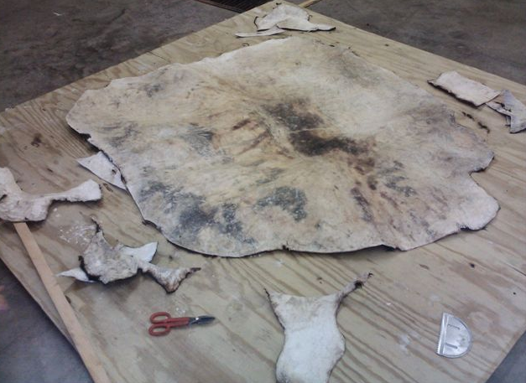
Figure 1.12. hide trimming
1.4.4 Trimming of Pickled, wet blue, dyed crust and finished leathers
In some tanneries, which import pickled skins, or produce glove leather, the skins are assorted and graded at pickled stage. During this assortment, the pickled pelts would be trimmed off to remove the unwanted portions. Similarly, in some tanneries the assortment would be carried out after tanning, where the person, tend to trim the tanned leathers. Owing to this, there is a possibility of reduction in the yield of the finished leather. Hence, it is suggested that trimming of pickled pelt, tanned leathers or crust leathers should be carried out only when it is required. By practicing this, a good amount of area loss can be avoided and in turn would result in sale value. Hence this should be discussed with the management and Production Head to practice trimming only at the required stage for each article. In case of crust leathers or leathers after post tanning, are set, hooked to dry, staked, trimmed, assorted, measured and packed or sent to the finishing yard. If the leathers are exported at the crust stage, then it is essential to do trimming of skins. On the other hand, if the leather is to be exported after finishing, trimming can be carried out after finishing also. The trimming knife used should always be sharp, so that the efficiency and the neatness of the trimmed leathers would be maintained. Hence, it is essential to sharpen the trimming tool after specific period using the sharpening tools.
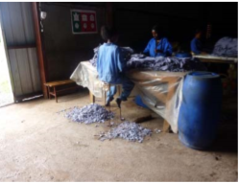
Fig1.13. Trimming of pickled pelt


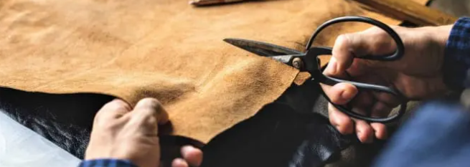
Figure 1.14.Trimming finished leather.

Self-check 1
Part I: true/false
Instruction: say true if the statement is correct or false if the statement is incorrect. You have allowed 2 minute for each and each has 1points
- Trimming is a process of removing the excess materials from hides or skins using knife
- Trimming the tail of the hide is more than 100 mm from the butt.
- A pallet is a support or platform for boards to stack the load.
- Knife sharpening is the process of making a knife or similar tool sharp by grinding against a hard, rough surface,
- Personal protective equipment needs to be provided for eyes, hands, body and feet as highlighted from your risk assessment
Part II: multiple choices
Instruction: chose the best answer and circle the letter having 2 minute for each and each has 2 points.
1. Which one of the following are the general procedures for trimming of skins
- Trim the neck if it is too lengthy
- Trim the fore shanks (front legs)
- Trim the hind shanks (rear legs)
- Trim the tail not more than 40 mm from the butt
- None
2. based on the utility and availability trimming knife can be
- Retractable blades
- Round-ended blades
- Blades with a reduced cutting edge
- all
3. Which one of the following is a types of PPE’s which can be used during Trimming Operations
- Eye protection
- Hand protection
- body protection
- foot protection
- all
Part III .Short Answer writing
Directions: - Answer the questions listed below. Time allowed for each 5 minute and has 3 points each.
- Explain what you mean by Personal safety Equipment?
- List and define different types of personal protective equipment?
- Explain what you mean by trimming tools?
- Explain how to prevent cut injuries.
- Explain how to provide safe storage for knives/blades?
- Explain how to sharpen trimming tools?
- Define and describe how a sharp, keen knife edge is produced by the blending of two distinct processes?
- Define pallet?
- How do you arrange pallets in a warehouse?
- What are precautions steps taken before trimming of skin/hide?
- Explain what you mean by trimming tables and trolley?
- Define trimming process? List the purpose of trimming operation?
- Explain instructions for personal protective equipment analysis?

Operation Sheet 1.1: Prepare materials, tools and equipment for trimming hide and skin, semi-finished and finished leather
Operation Title: Selecting appropriate tools and equipment for trimming.
Purpose: To use the right tool for trimming
Equipment, Tools and Materials: ,scissors, knifes, tables,
Conditions: Before the trimming operation takes place all the necessary tools and equipment’s.
Procedure:
step1. Wear personal protective clothes while preparing tools and equipment’s for trimming.
Step2. Identify materials, tools and equipment’s helps for trimming.
Step3. Check weather all materials and equipment’s are properly work or not.
step4. Follow correct grinding of tools and equipment’s for trimming.
Step5. Prepare and list the role of tools and equipment’s used for trimming.
Precautions: Be sure if the materials properly prepared
Quality Criteria: Did materials and tools identified properly? Did all materials and tools are checked properly and accordingly?

LAP Test 1.
Instructions: Given necessary templates, tools and materials you are required to
Perform the following tasks within 3 hour.
Task 1- Identify types of tools and equipment used in hides, skin and output leather trimming.
Task 2- Determine types of PPE used in this operation

Unit two: Trimming and piling operations
This unit is developed to provide you the necessary information regarding the following content coverage and topics:
- Raw hides/skins and output products of various stages
- Trimming and piling tasks
- Monitor and dispose trimming-wastes
- Clean and store used tools and equipment
This unit will also assist you to attain the learning outcomes stated in the cover page. Specifically, upon completion of this learning guide, you will be able to:
- Prepare raw hides/skins and output products of various stages
- Perform trimming and piling tasks
- Monitor and dispose trimming-wastes
- Clean and store used tools and equipment

2.1. Raw hides/skins and output products of various stage
2.1.1 Hides and skins
Hides and skins of animals are made into leather. Those from large and adult bovines are suitable for sale, harness, belting, or heavy leathers.
Skins from small animals, such as sheep, goats, calves, deer, and antelope, are made into light and fancy leathers. While there are other commercial sources of hides and skins, the important ones are the usual domesticated farm and range animals
A hide or skin is an animal skins treated for human use. The word hide is related to the German word Haut which means skin. The industry defines hides as skins of large animals e.g. cow, buffalo etc. Common commercial hides include leather from cattle and other livestock animals. All are used for shoes, clothes, leather bags, belts, or other fashion accessories. Leather is also used in cars, upholstery, interior decorating, and horse tack
2.1.2 Output products (crust, wet blue, finished leather).
A) Crust: Crust leather is tanned and dried, but not dyed. Depending on the tanning process, it is called either chrome crust or vegetable crust. However, crust leather is not processed until it is dyed. It has all the physical properties including size, thickness, fullness, looseness of grain, and grain damages.it can be trimmed for further leather processing purpose.
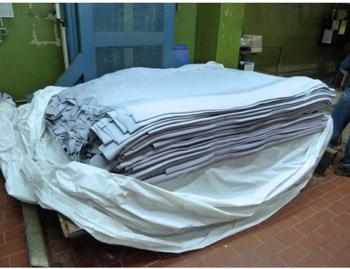
Figure 2.1 curst leather
B) Wet Blue: is the term used for processing and converting raw hides to tanned leather using chromium salts. The blue color that gives these skins its name as wet blue or in the blues is the chromium tanning agents, they create the light blue colour during its tanning process.
Wet Blue Leather has a blue tone to it. This is gained by the chrome tanning process, producing Amoist leather that’s wet, at this stage it has no colouring, it’s not finished, and neither is it dyed. At the stage of a wet blue hide, this means it’s tanned and free of hair, tanneries buy wet blue hides to use for a multitude of leather, converting them to usable hides and colouring them and sealing them.
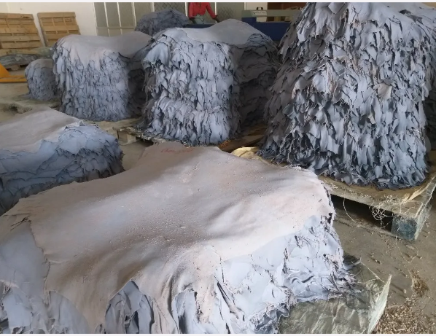
Figure 2.2 piled Wet blue tanned hide and skins
C) Finished leather: in leather industries there are so many finished leather types. From these full grain leather, corrected leather, etc. leather can be used for many purpose like shoe making leather garments and different leather goods. Trimming is done for finished leathers.

2.2. Trimming and piling tasks
2.2.1. In task requirements
- Safety requirements: Ensure proper Personal protective equipment’s such as aprons, gloves, goggles and boots are provided for the workers
- Equipment’s/tools: Ensure availability of good quality trimming tools and equipment’s such as trimming table, knives, scissors, sharpening tools etc.
- Work force: Ensure workers and supervisors have knowledge about trimming procedures for different types of raw materials.
- Materials requirements: Ensure that the raw materials are available for trimming. The workers and supervisors should be ensured of the need of trimming for specific types of raw material.

2.2.2 .In work place procedures.
The procedure involves the use of trimming tools such as knife or scissor to remove the unwanted portions form raw hides or skins, pickled pelts, crust leathers or finished leathers.
In general, the procedure involved in the trimming is listed below;
- Ensure proper tools are available for trimming
- Wear Personal protective equipment’s before starting the trimming procedure;
- Know what is the raw material (raw hides or skins, pickled pelts, crust leather or finished leather) that needs to be trimmed
- See the route card or job card provided along with the raw material batch and decide on the job
- Employ the suitable workers for specific jobs and Assess the quality of the raw material in hand
- Based on the requirement and instruction from the supervisors trim the leathers
- Periodically sharpen the trimming tools.
- After trimming, fill up the route card and make sure that all the leathers are trimmed and Send the trimmed leathers for next unit operation
2.2.3. Quality standard and manual procedure
A standard is often defined as a level of compliance standards have also been defined more broadly, for example by the department of leather for the Standards for Better quality leather assessment, where standards are described as “a means of describing the level of quality that leather quality care organizations are expected to meet or to aspire to”. When used to give broad statements of quality, they do not necessarily define measurable threshold. Proper trimming shall be ensured by comprehension of standard trimming procedures and norms, which are set as per ETHIOPIAN STANDARDS ES 1196:2008

2.3 Monitor and dispose trimming-wastes
Waste management is the collection, transport, processing or disposal, managing and monitoring of waste materials. Waste management practices can differ for developed and developing nations, for urban and rural areas, and for residential and industrial producers. Management for non-hazardous waste residential and institutional waste in metropolitan areas is usually the responsibility of local government authorities, while management for non-hazardous commercial and industrial waste is usually the responsibility of the generator subject to local, national or international controls.
2.3.1 Waste generated during trimming
Significant quantity of solid waste is generated during trimming operation. The solid waste is in the form of;
Raw trimmings: - The left out materials after trimming of raw or salted or dried hides or skins
Pickled pelt trimmings:-The left out materials after trimming of pickled pelts
Crust leather trimmings:-The left out materials after trimming of crust leathers
Finished leather trimmings:-The left out materials after trimming of finished leathers
Broken blades or knifes:-Broken and fully used blades or knife also form part of solid waste, which comes out of this trimming operation.
Waste Monitoring in Trimming: - The waste monitoring may focus on minimization of waste or proper disposal of waste.
2.3.2 Minimization of waste during trimming
The worker and the supervisor should have adequate knowledge and training in the trimming of hides or skins.
The tools used should be sharp to provide an efficient trimming
Do trimming only when required
2.3.3 Disposal of waste after trimming
The trimming wastes need to be collected in a container or ensure that the trimmed materials accumulated in one place so that the disposal of the materials becomes easy. The materials need to be handled with care, so that the materials would not spoil the area. Different trimming wastes can be segregated and stored separately, so that it would ease the disposal process. Each and every waste has its own value. For example, the raw and pickled trimmings can be sold to glue and gelatin manufacturer; wet blue trimming can be sold to leather board manufacturer and the crust or finished leather trimmings can be sold to small leather goods manufacturer. Hence, proper handling and disposal of the trimming waste would bring value.
2.3.4 Waste management of broken blades and knives
The broken knives, blades and scissors should be put in separate bins after use. It should be ensured that they are packed securely so as not to cause injury to any persons. With the introduction of wheelie bins everything is done by machine so that likelihood of injury has been vastly reduced. However it is still advisable to package the broken and the used knives securely. All metal wastes can be taken to your local waste disposal site where they can be sold to the scrap metal vendor.

Self-check 2
Part I Matching
Instruction: select the correct answer for the give choice. You have given 1 Minute for each question. Each question carries 2 Point.
A | B
---------1. Skin | - Remove excess/unwanted leather
---------2. Knife | - Out coverage of small animals
---------3. Hide | - Trimming tool
---------4. Crust leather | - Out coverage of large animals
---------5. Trimming | - Crust leather is tanned and dried, but not dyed
Part II .Short Answer writing
Directions: - Answer the questions listed below. Time allowed for each 3 minute and has 2 points each.
- Explain different techniques of trimming for hides, skins and leather?
- Explain different methods of trimming for different sections?
- Explain what you mean by waste management?
- List and explain different methods of waste disposals?
- What are all the various wasted generated during trimming operation?
Part III .long answer writing
Instruction: Discuss the following briefly
- How to Monitor and dispose trimming-wastes
- Types of hides and skins

Unit three: Clean and store tools and equipment
This unit is developed to provide you the necessary information regarding the following content coverage and topics:
- Clean used tools and equipment
- Storing mechanisms of trimming tools and equipment
This unit will also assist you to attain the learning outcomes stated in the cover page. Specifically, upon completion of this learning guide, you will be able to:
- Know tools and equipment cleaning mechanism.
- Understand trimming tools and equipment storing mechanism.

3.1 clean used tools and equipment’s
To maintain the scissors, knifes and blades in a good working condition, it must be thoroughly cleaned and stored correctly every time it is used. If regular maintenance does not occur, the materials may, over time, become dangerous to individuals. Even the trimming tables need to be maintained properly; otherwise it may also lead to damage of the leathers, especially the finished leathers. Various materials, that needs to be cleaned after trimming operation are:-
- Knives/blades and scissors
- Trimming table
- Waste collection containers
- Brooms, dusters and brushes
- Mops and buckets
Every time a piece of equipment is used, the general rule is to clean it straight away so it is ready for the next person to use. The trimming table should be cleaned well before the next batch of raw materials is taken for trimming. This will ease the working condition of the trimmers. At the end of the business day, each piece of material should be wiped over and where appropriate washed and rinsed to prevent buildup of dirt.
Any area that is in contact with bacteria (while working with raw hides and skins) must be sanitized. Sanitizing reduces the harmful bacteria. Before cleaning any area you should know which areas need to be sanitized and what chemicals are safe to be used. After the materials or work areas are sanitized they need to be dried. This can be done by either allowing them to air dry or drying them with a towel. Air-drying is safe if the materials are left in a well-ventilated area so the drying process is quick.
Knives should be hand washed and towel-dried before storing. Pots and pans should be hand washed and then hung up on hooks or placed on wire racks to dry. Every organization should have a maintenance schedule for items of equipment like sharpening tools, which specifies when each item of equipment should be checked for maintenance. It is important that this schedule includes cleaning equipment and that all items of cleaning equipment are regularly checked for damage. Sub-standard cleaning equipment increases the risk of a breach in the organization’s hygiene standards.

3.2 Storing mechanisms of trimming tools and equipment
It is important to prevent situations where knives are left lying loose on work benches/surfaces or where individuals carry them in their hands from one place to another. Such poor practice has led to injuries to both the knife user and others, including people walking into each other, with exposed blades. You should:
- Provide suitable storage facilities, e g. racks, slots, boxes etc. adjacent to the place of work;
- Allocate suitable belts or sheathes to employees who need to move around carrying knives;
- Strictly enforce rules prohibiting the carriage of knives in the pocket or in the hand from one place of work to another;
- Provide used blade disposal points, e g sharps containers.
It is recommended that proper instruction is given, and a record kept, on good working practice to all employees who will use a knife or come into contact with a sharp blade. A competent person should provide such training as outlined below:
- The general use, care and maintenance of hand knives (including typical accidents, cutting away from the body and the danger of blunt knives and the sharpening of knives)
- The correct tool and protective equipment for each task they have to perform
- The correct way of working at any particular job and any safe operating procedures that need to be followed (e g the frequency of blade changes or the criteria for rejects) and in-house company rules (e g on storage or carriage of knives)

Self-check 3
Part I: multiple choices
Instruction: chose the best answer and circle the letter
1. Which one of the following material needs to be cleaned after trimming operation?
- Knives/blades and scissors
- Trimming table
- Mops and buckets
- all
2. Which one of the following is true about tool storing?
- Store tools without cleaning
- tools can be hold with pockets
- tools can be stored in a clean manner
- none
3. Should be hand washed and towel-dried before storing
- knife
- Pots
- a and b
- all
Part II .Short Answer writing
Directions: - Answer all the questions listed below.
- Explain what you mean by proper cleaning and storing equipment.
- List some general points about the cleaning and storing equipment.
- To understand your duties and safety requirements with what things you should be familiar?
- Explain the risks which should have been occurred if the equipment’s are not properly cleaned and stored.

Reference
- Sharphouse, J.H. (1983). Leather Technician's Handbook. Leather Producer's Association. p. 212. ISBN 0-9502285-1-6.
- Leather processing books.
- Covington, A. D. (2006). The chemistry of trimming materials. In Conservation of leather and related materials (pp. 44-57).
- Mann, I. 1962. Hides skins and glue stock. In Animal by- products processing and
Utilization. Pp80- 137.

Participants of this Module (training material) preparation
No | Name | Qualification (Level) | Field of Study | Organization/ Institution | Mobile number | E mail
1 | Yetemarew mengist | B (BSC) | leather | Fnoteselam poly | 0938283957 | yetumengist@gmail.com
2 | Ahmed | B(BSC) |  | Enjibara poly |  | anuru3076.gmail.com
3 | Ashenafi mulat |  |  | Gonder poly
4 | Weldeyesus wendeson | A(BSC) |  | Fedral tvet
5
6
7

