Leather processing
Level-I
Based on December 2021, Curriculum Version 1
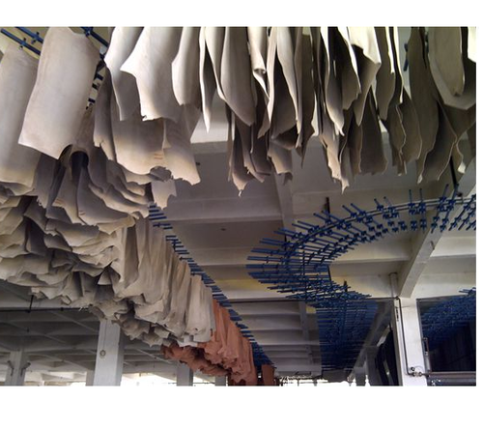
Module Title: - Performing Drying Operation
Module code: IND LEP1 M06 1221
Nominal duration: 30 Hours
Prepared by: Ministry of Labour and Skill
August, 2022
Addis Ababa, Ethiopia

ACKNOWLEDGMENT
Ministry of Labor and Skills wish to extend thanks and appreciation to the many representatives of TVET instructors and respective industry experts who donated their time and expertise to the development of this Teaching, Training and Learning Materials (TTLM).

Contents
ACKNOWLEDGMENT 1
ACRONYM 3
INTRODUCTION TO THE MODULE 4
UNIT ONE: CONFIRM REQUIREMENTS 5
1.1 Introduction to drying 6
1.2 Confirmation of instructions flow: 6
1.3 The drying requirements 7
1.4 Prepare for drying 8
1.2. Assessing drying facilities and tools 9
Self-check 1 11
UNIT TWO: PREPARE FOR DRYING 12
2.1. Methods of drying 13
2.1. Equipment adjustment. 17
Self-check 2 19
Operation sheet 2.1 20
Operation sheet 2.2 21
Operation sheet 2.3 22
LAP test 3 23
UNIT THREE: CARRY OUT DRYING TASKS 24
3.1. Leather drying and handling 25
3.2. Monitoring leather drying operation 25
3.3. Documentation in drying operation 26
Self-check 3 28
REFERENCE 29

ACRONYM
OHS ------------occupational health standard
PPE ------------personal protective equipment

INTRODUCTION TO THE MODULE
Drying is an important process in leather making in which tanning agents, dyestuffs and fat liquoring agents combine with collagen further and water is evaporated to fulfil the demands of final leather product, therefore drying has significant influence on leather chemical and mechanical properties. Just as critical is how we remove that moisture once we're ready to actually finish the leather (in the industry, finishing typically refers to a whole department that applies and adjusts color, luster, temper or softness, and general appearance). There are four basic techniques that we use - air drying, pasting, vacuum drying, and toggling. So this module will discuss on the different types of drying methods and the procedure of operation of different machines which is used for leather drying.
This module covers the units:
MODULE CONTENTS:
- Confirm requirement
- Prepare for drying
- Carry out drying tasks
Learning Objective of the Module
- To determine the requirement of drying
- To prepare the hide and skin for drying
- To carry out drying operation
Module Instruction
For effective use this modules trainees are expected to follow the following module instruction:
- Read the information written in each unit
- Accomplish the Self-checks at the end of each unit
- Perform Operation Sheets which were provided at the end of unit two
- Do the “LAP test” given at the end of unit two and
- Read the identified reference book for Examples and exercise

UNIT ONE: CONFIRM REQUIREMENTS
This unit is developed to provide you the necessary information regarding the following content coverage and topics:
- Leather drying requirements
- Drying facilities and tools
This unit will also assist you to attain the learning outcomes stated in the cover page. Specifically, upon completion of this learning guide, you will be able to:
- Know requirements of Leather drying
- Assess drying facilities and tools

Introduction to drying
Drying is the process to remove the water from leather. After the post-tanning process crust leathers are unloaded from drum and then piled overnight. Next day samming (To remove water) and setting (To get flat grain) operations are carried out. After samming and setting operations crust leathers are contain some amount of water. In order to carry out the subsequent mechanical operations crust leather has to be in completely dried condition. So, drying operation is generally carried out in tannery to bring the leather to a practically usable form and also to enhance the chemical reaction between post-tanning chemicals (Retan, Dye, Fatliquor) and leather matrix. Therefore, drying is physical as well as chemical activity and is of great importance to the practical quality of leather. Types of drying process and rate of drying are influence the final properties of crust leathers for example softness property. If the drying process is carried out rapidly, the final leather become stiff, cracky, and horny and may have boaty shape which results in area shrinkage. So, the subsequent mechanical operation for example staking and toggling operation may be difficult. Also very slow dried leathers generally show fungus and molds on leather surfaces, especially vegetable tanned leathers.
The mechanism of drying operation is very simple. When we apply the heat or blow the hot air to the environment, where the crust leathers are hanged, and then the water present in the crust leather converted into water vapour and goes to the atmosphere. When we apply to the rapid heat to the surroundings, the rate of drying will be fast. Two steps are involved in drying process
- Conversion of water into water vapour.
- Removal of water vapor from the leather surroundings.

Confirmation of instructions flow:
Leather from re-tanning yard ------ Setting ------ Drying
- Ensure the availability of the drying yard and the capacity of the drying yard before taking the batch of leather for setting out operation
- Decide on type of drying method based on the type of leather being produced
- Ensure the working condition of the vacuum dryer, if the leathers are to be dried by the same
- The temperature controller and the vacuum pump to be checked for the working condition
- Educate the operator and the workers regarding the conditions to be set in the drying equipment
- Ensure, that the leathers are placed grain side down on the plate of vacuum drying equipment
- Natural drying may occupy more area, so you should know the area requirement for drying
- The operators and the workers need to be educated on the use of hygrometer and thermometer to measure the humidity and temperature of drying yard

The drying requirements
Following factors influence the rate of drying process. Although how and to what extent each parameters of air will influence the drying process is not clearly and fully understood, it is better to have glimpse over air parameters.
- Humidity - refers to amount of water vapor present in the air. Lower the humidity, quicker the drying process.
- Temperature - is the heat source for evaporation of water from leather. Air is being the medium, the rate of drying of leather increases with the increase in air temperature. The drying media (usually air) must transfer enough heat energy to water and converted it into vapor to complete the drying process. If the temperature is high then the water present on the surface will evaporate suddenly and surface became hard which render the migration of water from inner layer to surface.
- Air flow rate - as mentioned above, the vapor evaporated from the leather is taken away by circulation of air, the drying rate of leather will decrease with increase of vapor content in drying chamber, until the drying process stops. In order to continue the drying process and maintain stable temperature, the circulation of air must be controlled; the quicker the flow rate the more exchange of air is, and resultant is the increase the drying rate.

Prepare for drying
The natural state of hides and skins is the fully hydrated fiber network with a water content of about 60-70%. During the tanning, retanning, dyeing and fatliquoring additional substances are taken up by the fiber network in the amount equal to about half the weight of dry protein present. But, the water may be assumed to be unaffected by the presence of these substances because the nature of the fibre-moisture (water) bond remains essentially unchanged. It is obviously true that tanning imparts permanent resistance to bacterial action and provides increased resistance to chemical attack & heat to the skin/hide. Retanning, dyeing and fatliquoring operations undoubtedly impart extra quality to the leather. Though this is the case, leather at this stage is by no means made to be sold as the leather should be made dried and finished.
Generally, there are about nine processes/operations to be performed after tanning, where shaving being carried out prior to commencing these operations. These are namely:
- Neutralization
- Retanning
- Fatliquoring
- Dyeing
- Sammying & setting out
- Drying
- Pre-finishing operations (conditioning, staking, buffing )
- Finishing
- Mechanical operations (plating, embossing, glazing)
The first four besides wet shaving though regarded as post-tanning, are part of wet end activities in the tannery. The remaining processes are mainly concerned with the improving the physical characteristics and surface enhancement of the leather, but the moist leather should be dried in any case.
After a wet end operation of post-tanning, the leather is/or should be normally piled overnight. Summing and setting out are two operations, which always are conducted before drying. Mechanical water removal is cheaper than removal by drying. The sammying operation removes excess water and reduces the water content of the product to 50 to 55%. This operation in turn help when setting out operation performed, to remove the wrinkles. However care should be taken to not have very high pressure as it would damage the leathers.
Setting out operation is carried out so as to smoothen out the natural wrinkles and growth marks and makes the grain surface of the leather as smooth as possible. Part of the skin/hide most affected by growth marks are the neck and shoulder areas. Moreover, setting out is done to spread the product out so as to increase the area yield. After drying is accomplished, the leather will be ready to commence finishing operation. The purpose of drying is to remove the moisture and bring the moisture down to about 8 to 12 % and finally bring the leather to a practical useable form (esp. for mechanical softening).

Assessing drying facilities and tools
Toggling clamp
Toggle clamp is a piece of equipment used most commonly for holding leather at different edge together, or holding them stationary by applying fixed pressure. It's a very versatile piece of equipment, whether it be the widely used manual type or a powered version for heavier work
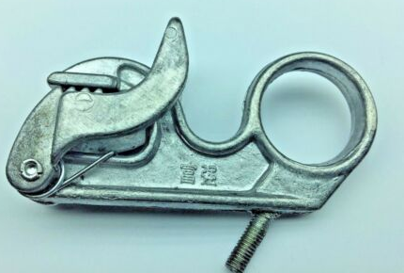
Figure 1-1Toggling clamp
Vacuum sleeker
An equipment which is used when Intensive pressure is applied when drying leather through vacuum sealing, and this can damage your precious leather. The leather will acquire creases and wrinkles, so it used taking away its smooth and flattened

Self-check 1
Part one: - chose the best answer for the following question,(1o points)
- -------- is used when Intensive pressure is applied when drying leather
- Toggle clamp
- Vacuum sleeker
- Paste drying
- None
- Which one of the following is drying requirement
- Temperature
- Humidity
- Air flow rate
- All
- Is an tool which is used to hold leather at different edge
- Toggle clamp
- Vacuum sleeker
- Toggle
- None
Part two: - Give Short answer for the following question 15 points.
- What is drying?
- Explain the causes of ineffective drying?
- Explain the process of drying?
- What is the need of drying leather?
- What are the two machinery operations accompanied before drying process and why?
- Pressure is an important parameter in summing operation for water removal. Why?

Note: Satisfactory rating – above 60% Unsatisfactory - below 60%
You can ask you teacher for the copy of the correct answers

UNIT TWO: PREPARE FOR DRYING
This unit is developed to provide you the necessary information regarding the following content coverage and topics:
- Leather drying methods
- Procedures and equipment adjustment for drying
This unit will also assist you to attain the learning outcomes stated in the cover page. Specifically, upon completion of this learning guide, you will be able to:
  - Identifying Leather drying methods
  - Procedures and equipment adjustment for drying

2.1. Methods of drying
2.1.2 Introduction
Tanned or untanned material is exposed to dry air leads to water evaporation from its surface. There are three distinct drying periods/phases in the drying of leather, which are mentioned below:
- Evaporation occurs from the surface of water at a constant rate, which is directly proportional to the surface area of the leather
- The plane of evaporation retreats into the interior and evaporation proceeds from within the leather- slower phase
- Unsaturated surface stage of drying reflects the migration and evaporation of inner, hygroscopic water which is weekly bound to the surface of the fibrils. This kind of water migrates easier than the structural water which, being chemically bound, behaves like crystalline water and is removed in the last and slowest phase of drying
Leather drying has two aspects:
- The different design for apparatus and processes in which streaming air of different humidity and temperature is used as carrier for water during drying
- The behavior of leather during drying and its resulting properties.
Both aspects influence each other mutually and drying is one of the most important processing steps affecting the leather quality.
2.1.3. Types of drying
Leather is dried usually at a rather low temperature in order to prevent structural and chemical changes. In the initial process, temperature is lower (usually 40 to 50o C for chrome leathers, 35 to 45o C for veg. tanned ones). Then as the water content decreases, temperature increases, however, never higher than 8 to 10o C below the shrinkage temperature. This is done to avoid local overheating and deterioration of the component introduced in subsequent operations. If, for instance, the drying conditions are sever enough to remove water close to the triple helix, the fiber structure can approach close enough to allow the formation of additional chemical bonds. This adversely affects the strength of leather by embrittling the fiber structure and the handle or feel of the leather is stiffened. When leather is dried at a high temperature, the stiffness is generally found to be high. Therefore, it is commonly believed that the stiffness has a high dependency on the drying temperature. And hence, drying of the leather should be at controlled conditions.
Drying on the variation in existing conditions and final intended products, different drying methods can be used. Whatever conventional drying methods made used, the temperature of drying should not exceed 80 ˚C so as to avoid any denaturing effect on the skin fibers and rupture or crystallization of treatment oils would otherwise occur at the surface.
2.1.4. Suspension drying
It is one method of drying where leather is simply hung up in the drying room or tunnel, which has controlled conditions of heating, humidity and air circulation. It is also called hang drying which indeed is an example of conventional drying method.
If the conditions of temperature, humidity and air circulation are such that the leather dries slowly, case hardening is avoided and nearly a good uniformity in drying will result. The rate at which the air passes over the skins during this drying will determine the rate at which drying occur. It is affected by the conditions of surrounding atmosphere unless special control made to it. This method of drying is suitable for garment, glove leather drying and in general is employed when soft, full and excellent extension leather is required. Leather dried with such method feel full and round with good softness but has a disadvantage in that area and smoothness is lost. Hence, all such leathers must be toggled after staking.

2.1.5. Conveyor/natural drying
Air drying involves hanging the hides on hooks so that moisture can evaporate naturally; this is the slowest process and results in shrinkage of the hide. Bad for yield, but great for giving leather a “full” or “round” hand. An air dried hide will routinely shrink by 25% (approximately 6 square feet). This also yields an article that is pliable with a bit of stretch. The advantages of air drying are
- low investment cost,
- no heat input,
- only little chance of case hardening,
- Simplicity of operation. The drawbacks of the system are its low productivity and low area yield.
Overhead dryer adjustment
- Adjust the speed of the conveyer, it is possible to adjust 2 – 15 meter per minute .If the speed is higher the circulation will be fast so the drying time is short; the leather will have more moisture.
- The drying is more inter linked with the atmospheric temperature and humidity.
- If drying tunnel is available it is necessary to adjust the temperature accordingly.
Figure 0-1 Conveyor/Natural Drying

1.1.6. Paste drying
Pasting is the application of leather to large glass, steel, or ceramic “plates.” A plant based starch is mixed into a paste, which is used to adhere the hide to the plate. The drying process takes about 5 hours and utilizes steam, heat, and moving air. The machines have more than of these vertical plates (100-200) and are 20-40 meters long. The leather passes through a number of sections which have well controlled drying conditions and allow the drying rates to be progressively set to the different stages described above. In this method of drying, the leather can be fully extended and the grain fibers so oriented as to give maximum smoothness and area yield (up to 10%) and also better grain characteristics can be achieved than with suspension or toggling techniques though the resultant leather needs some more softening.
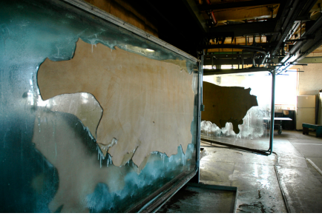
Figure 0-2 paste drying
This yields a leather with “flat,” uniform grain. By sticking the leather against a medium that is static, it keeps the leather from shrinking. Good for yields and good for products that need to not stretch – like load bearing straps.

1.1.7. Vacuum drying
The most significant advancement in the drying technique applied to the leather is the development of the vacuum dryer. It is this principle that makes vacuum dryer come into use which reduces the time of drying and to retain those properties of the drying materials which are susceptible to temperature.
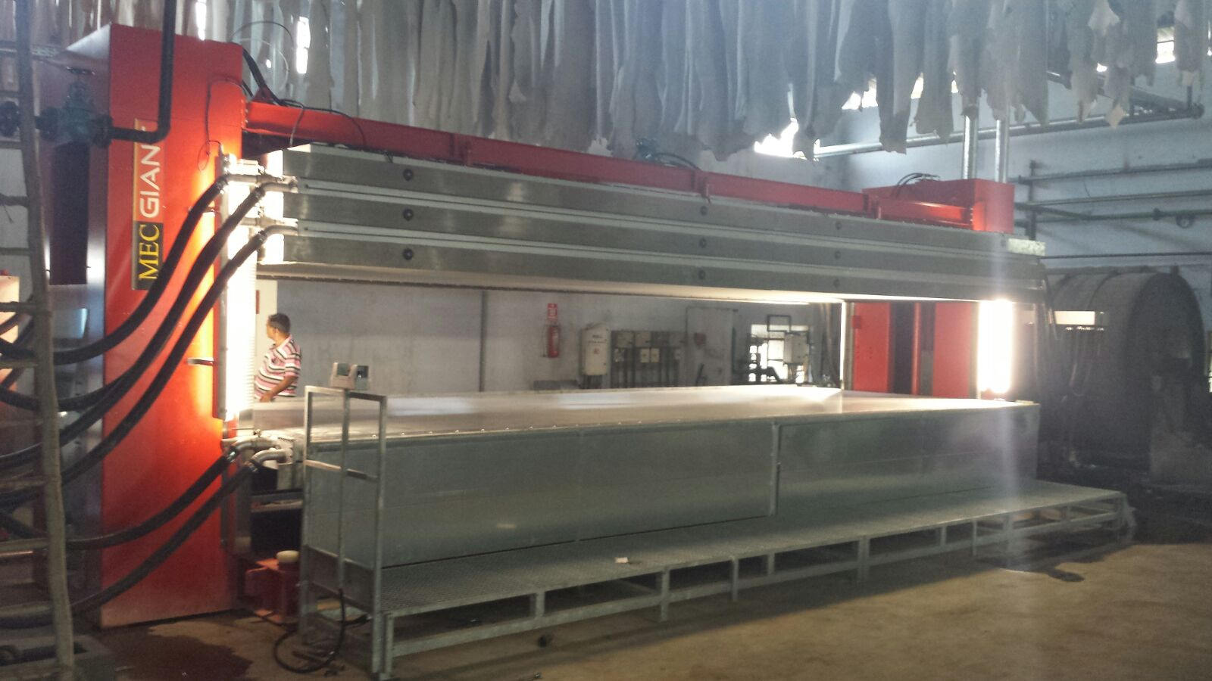
Figure 0-3 vacuum dry
Vacuum drying is becoming increasingly popular of late for most full grain, aniline leathers whilst it is also perfectly satisfactory for corrected grain types. In vacuum drying the setout leathers are laid flat, grain down, on to smooth stainless steel table where they are also stretched out firmly by hand slickers as their shape dictates. Heat is applied to this surface by a built-in head exchanger under the table. This temperature is maintained by thermostatic control of circulating hot water, and a hood is placed over the plate and then evacuated to aid in drying the leather. Since the heat is supplied directly to the skins, evaporation will take place in the fibers inside the leather, and the problems arising from migration of the tanning materials and oils are greatly decreased.

2.1. Equipment adjustment.
Vacuum dryer adjustment
- Set the temperature 40 – 60o C.
- Set the time 1 - 3 min.
- Set the pressure 4 – 6 bar
Overhead dryer adjustment
- Adjust the speed of the conveyer, it is possible to adjust 2 – 15 meter per minute .If the speed is higher the circulation will be fast so the drying time is short; the leather will have more moisture.
- The drying is more inter linked with the atmospheric temperature and humidity.
- If drying tunnel is available it is necessary to adjust the temperature accordingly.

Toggle drying
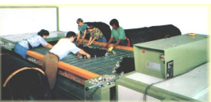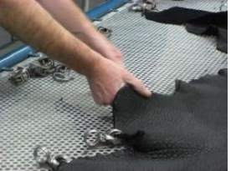
Figure 0-4 Toggle Drying
A toggling unit consists of a number of screens placed in a dryer having controlled temperature and humidity. The leather is stretched and held in place by a number of toggles that look into the screens. Advantages of toggle drying are
- Drying the large quantities of leather in a relatively small space
- Provides stretching to the leather during drying. There are some disadvantages, constant temperature and humidity conditions are difficult to maintain and control.
Adjustment
- Adjust the temperature 70 – 90o C, as the type of leather needed.
- Adjust the staying period 3 – 4 min.
- If it is automatic adjust stretching size and speed 3-4 meter per mint.

Self-check 2
Part one: chose the best Answer for the questions listed below.( 12 points)
- Which one of the following is the operation temperate of toggling machine
- 70 – 90º C
- 100 – 190º C
- 7 – 10º C
- None
- Which one of the following is the pressure of vacuum dryer
- pressure 4 – 6 bar
- pressure 5 – 7 bar
- pressure 7– 10 bar
- pressure 1– 2 bar
- which one of the following is the staying time for toggling machine
- staying period 3 – 4 min
- staying period 4-5 min
- staying period 1 – 2min
- none
- which one of the following is not advantage of conveyer air drying
- low investment cost,
- have heat input,
- only little chance of case hardening
- Simplicity of operation.
Part two: give short answer for the questions listed below.(15 points)
- List out different drying techniques?
- Write the merits and demerits of different drying methods?
- Describe three distinct phase in drying of leather.
Note: Satisfactory rating – above 60% Unsatisfactory - below 60%
You can ask you teacher for the copy of the correct answers

Operation sheet 2.1
Title: - Operating Procedures of Toggling Machine
Instruction: - by using operation instruction, you have to operate Toggling Machine after liming
Objective: - be able to develop the skill of the trainee by performing the correct Operating Procedures of Toggling Machine for drying operation
Tools and equipment that needed for the operations: -
- Toggling
- Clamper
Precautions:-try to operate Toggling Machine for different crust leather more than one times
Procedure
Step 1:- Stretch the leather in the mesh of the toggling table by using clips.
Step 2:- Put the mesh in the drying chamber and close the door. If it is automatic switch on the conveyer.
Step 3:- After the set time remove the leather. Step
Step 4:- Switch off the machine.
Quality Criteria: accurately operation by given temperate

Operation sheet 2.2
Title: - Operating Procedures of Vacuum dryer Machine
Instruction: - by using operation instruction, you have to operate to operating Vacuum dryer Machine after liming
Objective: - be able to develop the skill of the trainee by performing the correct Operating Procedures of Vacuum dryer Machine for drying operation
Tools and equipment that needed for the operations: -
- Vacuum dryer
Precautions:-try to operate Vacuum dryer Machine for different crust leather more than one times
Procedure
Step 1:-Lean the skin uniformly by using Teflon and stainless steel plat to flat the leather in the leather in the dryer plat.
Step 2:-Switch on the vacuum dryer with safety precision.
Step 3:-Check the leather and adjust the temperature and pressure
Quality Criteria: accurately operation by given temperate

Operation sheet 2.3
Title: - Operating Procedures of Overhead dryer conveyer
Instruction: - by using operation instruction, you have to operate to operating overhead dryer conveyer after post tanning
Objective: - be able to develop the skill of the trainee by performing the correct Operating Procedures of overhead dryer conveyer for drying operation
Tools and equipment that needed for the operations: -
- Vacuum dryer
Precautions:-try to operate overhead dryer conveyer for different crust leather more than one times
Procedure
Step 1:- Hook the leather in the conveyor hookers/place on the tube and move the loaded part.
Step 2:- Do vice versa to unload the leather
Quality Criteria: accurately operation by given temperate

LAP test 3
Instructions: Given necessary templates, tools and materials you are required to perform the following tasks. The project is expected from each student to do it.
Task -1 given crust leather you are required to perform drying using toggling machine
Task -2 given crust leather you are required to perform drying using vacuum drying machine
Task -3 given crust leather you are required to perform drying using conveyer drying machine
You are given three (3) hours to complete the abovementioned
Request your teacher for evaluation and feedback of your work

UNIT THREE: CARRY OUT DRYING TASKS
This unit is developed to provide you the necessary information regarding the following content coverage and topics:
- Leather drying and handling
- Monitoring leather drying operation
- Documentation in drying operation
This unit will also assist you to attain the learning outcomes stated in the cover page. Specifically, upon completion of this learning guide, you will be able to:
  - Understand Leather drying and handling
  - Monitor leather drying operation
  - Know documentation in drying operation

3.1. Leather drying and handling
The key to maintaining grain quality during drying is the proper moisture and temperature management. Becoming familiar with the interaction between these two conditions and how they control drying process is essential to successful drying of crust leather. Improper management provides conditions for grain damage during vacuum and toggle drying. In fact, if there is damage the product may not be marketable if damage is extensive.

Monitoring leather drying operation
Monitoring of drying process Monitoring of drying process is done by using a standardize equipment called moisture meter. Moisture meters are used to measure the percentage of water in a given substance. This information can be used to determine if the material is ready for use, unexpectedly wet or dry, or otherwise in need of further inspection.
Leather moisture meters
The moisture content of hides is a crucial factor during all stages of leather processing. A moisture meter can be an invaluable tool for monitoring the moisture content of leather to ensure a high-grade end product. The leather moisture meter is the perfect quality control tool for tanneries everywhere. Don't leave the quality of your product to chance. Check moisture content with the leather moisture meter.
The measuring principle of the leather moisture meter is based on the electrical conductivity of the material which always bears a fixed relation to the moisture. All changes in resistance inside the measuring ranges of interest are sufficiently pronounced to ensure a high degree of accuracy for the readings obtained with the leather moisture meter.
- Crust leather Sammying - 45-55% (m/m) water is squeezed out of the leather
- Conditioning - Water is added to the leather to a level of 18-28%
- Drying - The leather is dried to various moisture levels (commonly 14-25%)
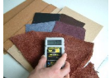
Figure 0-1 moisture meters

3.3. Documentation in drying operation
3.3.1. Aim and Importance of process documentation:
Process documentation is a method of concisely capturing and sharing critical project concepts, plans and information as they are developed, so that impacted parties can share this information, make informed decisions, and keep the project moving forward without having to revisit old discussions. The basic aim of Process Documentation (PD) is to learn from implementation experience and in the light of this modify the strategy and ultimately, policy of a program, project or organization.
Documentation of processes helps in creating systematic information to articulate the intervention strategies and develop the flow chart of a program. This helps the project or organization to find out more about the needed field intervention methods, coordination, management requirements, financial management and human resource development policies. Not only the project conducting process documentation takes benefit from this but also other similar projects and agencies can use the outcome as a model in their formulation and implementation methods.
Most of the process-oriented methodologies are meant to record programs as they occur and feed the information back to managers, researchers and policy makers to help them understand the working of the project better. However, there are several other purposes, equally important, for which processes are sought. They are used by agencies undertaking new and complex forms as part of expansion of programs, which need Understanding about stakeholder participation. Such information is often needed to validate the approach/program and consequent policy formation. An important aspect of any process is the documentation that accompanies it, such as logging trouble calls, requesting system changes, or executing disaster recovery plans. Let us now discuss the methods and tools of process documentation.
Process steps involved in documentation:
- Recognition, Collection and Recordation
- reporting, Distribution, and Transmission
- Initial Use
- Storage
- Retrieval.
The first stage, recognition, collection and recordation, is the most vital stage in your documentation process. Without it, the others will be moot. In this stage you will evaluate all real time events (process or operation), will select those that appear to be of future value and will commit them to a permanent record
The second stage, reporting, distribution and transmission, occurs when you send documents or information to other parties. •
The third stage, initial use, in some cases may be optional. You may not want to review all documentation coming in from the field in the office. What you do not review, send directly to storage.
In the fourth stage, storage, you file information so that you can retrieve it later.
In the fifth stage, retrieval, you should be able to reverse your storage process.

Self-check 3
Part one: - Answer all the questions listed below. (25 points)
- How to handle leather drying process?
- How to measure the drying level of leather?
- What is documentation?
- Write the purpose of documentation
- What are all the methods of documentation?
- Write the steps involved in documentation
Note: Satisfactory rating – above 60% Unsatisfactory - below 60%
You can ask you teacher for the copy of the correct answers

REFERENCE
- Covington, A. D. (2009). Tanning chemistry: the science of leather. Royal Society of Chemistry.
- Covington, A. D. (2006). The chemistry of tanning materials. In Conservation of leather and related materials (pp. 44-57). Routledge.
- Han, W., Zeng, Y., & Zhang, W. (2016). A Further Investigation on Collagen-Cr (III) Interaction at Molecular Level. Journal of the American Leather Chemists Association, 111(03), 101-106
- Leather Technicians Hand book by, J.H. Sharphouse, BSc. Revised edition 1983
- Process vessel and machine operation manual, Machine manufacturer

Participants of this Module (training material) preparation
No | Name | Qualification (Level) | Field of Study | Organization/ Institution | Mobile number | E-mail
1 | Yetemarew mengist | BSc. | Leather engineering | Fnote damot poly technique collage | 0938283957 | yetumengist@gmail.com
2 | ahmed nuru | BSC | Leather technology | Enjibara | 0902419574
3 | Weldeyesus wendeson | Msc | Leather engineering and Fashion Technology | TVTI | +251915854419 | Abay1015@gmail.com

