Leather processing
Level-II
Based on December 2021, Curriculum Version 1
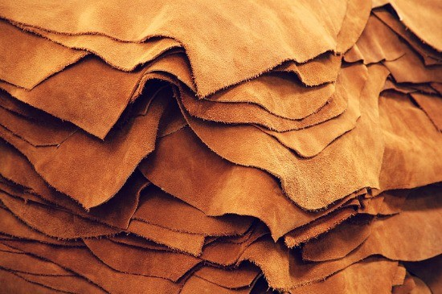

Module Title: - PERFORM POST-TANNING AND CRUST OPERATIONS
Module code: IND LEP2 M05 1221
Nominal duration: 119 hour
Prepared by: Ministry of Labour and Skill
August, 2022
Addis Ababa, Ethiopia

ACKNOWLEDGMENT
Ministry of Labor and Skills and Ministry of Health wish to extend thanks and appreciation to the many representatives of TVET instructors and respective industry experts who donated their time and expertise to the development of this Teaching, Training and Learning Materials (TTLM).

TABLE OF CONTENT
ACKNOWLEDGMENT 1
TABLE OF CONTENT 2
ACRONYM 4
INTRODUCTION TO THE MODULE 5
UNIT ONE: INSTRUCTIONS AND OPERATIONAL REQUIREMENT IN POST TANNING 6
1.1 Types of drum and machine used in post-tanning operations 7
1.2 Required facilities for process vessels and machines 7
1.3 Work instructions and procedures for process and mechanical operations 8
1.4 Necessary settings and preparation for process vessels 10
Self-check 1 11
Operation sheet 1.1 12
Lap test 1.1 14
2 UNIT TWO: OPERATE DRUM TO PROCESS TANNED LEATHER 15
2.1 Drum loads and process batches 16
2.2 Checking status of tanned leather for drum processing 17
2.3 Operating drum as per workplace procedures 19
2.4 Post –tanning operations 23
2.5 Checking process control parameters 33
2.6 Drum operations outputs 35
Self-check 2 39
Operation sheet 2.1 41
Operation sheet 2.2 43
Operation sheet 2.3 44
Lap test 2.1 45
3 UNIT THREE: OPERATE MACHINERIES TO PRODUCE CRUST LEATHER 46
3.1 Operating post-tanning machineries 47
3.2 Checking process control parameters in machine operations 65
3.3 Controlling post tanning machine operations outputs 65
Self-check 3 69
Operation sheet 3.1 71
Operation sheet 3.2 72
Operation sheet 3.3 74
Operation sheet 3.4 74
Operation sheet 3.5 76
Operation sheet 3.6 77
Operation sheet 3.7 78
Operation sheet 3.8 79
Operation sheet 3.9 80
Lap test 3 81
REFERENCE 82

ACRONYM
ETP ------------effluent treatment plant
OHS ------------occupational health standard
PPE ------------personal protective equipment
RPM------------revolution per minute

INTRODUCTION TO THE MODULE
Leather making is a complex process, which undergoes various physical and chemical changes during soaking to finishing. During this leather making, properties such as softness, fullness, and colour and water resistance are incorporated in to the leathers for different applications. So The post-tanning stage is made up of further chemical treatments designed to improve the appearance of the leathers and make them suitable for commercial uses. After tanning, the leather still appears rigid and wet and has the colour typical of the tanning process used. This module deals with different post tanning process and the mechanical operations during post tanning.
This module covers the units:
MODULE CONTENTS:
- instructions and operational requirement
- Operate drum to process tanned leather
- Operate machineries to produce Crust leather
Learning Objective of the Module
- To Apply Instructions and operational requirement
- To Operate drum for process of tanned wet blue
- To Carry out Mechanical Operations
Module Instruction
For effective use this modules trainees are expected to follow the following module instruction:
- Read the information written in each unit
- Accomplish the Self-checks at the end of each unit
- Perform Operation Sheets which were provided at the end of units
- Do the “LAP test” giver at the end of each unit and
- Read the identified reference book for Examples and exercise

UNIT ONE: INSTRUCTIONS AND OPERATIONAL REQUIREMENT IN POST TANNING
This unit is developed to provide you the necessary information regarding the following content coverage and topics:
- Types of drum and Machine used in post-tanning operations
- Work instruction for drum and Machines operation in post-tanning
This unit will also assist you to attain the learning outcomes stated in the cover page. Specifically, upon completion of this learning guide, you will be able to:
- Know Types of drum and post-tanning machines
- Know the work instructions and procedures for dram and machinery

Types of drum and machine used in post-tanning operations
In this content we have to discuss about the drum or vessel, which used for post tanning process/dye house process and discuss about load and batches of drum. The most widely employed equipment in dye house operations is a drum. Drum is a cylindrical shape container fitted with internal with shelves or pegs. This is normally made by wood or stainless steel. Leathers have been put into the drum together with the bath consisting of a water solution of various concentrations of chemical substances. The purpose of drum is to facilitate the penetration into the leathers of all the wet finishing chemicals substances that can modify the characteristics of the leather. On rotation, the leathers are lifted up by the shelves or beg during rotation, higher than the axle of the drum, then fall off to the bottom of the drum, resulting in considerable mechanical action.
Now a days, there are two types of drums are using for wet-end (crusting) operations.
a. The tumbler drum
b. The washing-machine drum (Stainless steel drum)
The drum, which derives from the standard wine tun, still it has its original structure of wooden staves pressed together by steel hoops. This drum is called “tumbler drum”. The principle of operation of tumbler drum is a big hollow cylinder that is mounted and supported above the floor level and rotates around its horizontal axis. In general, 50% of this hollow cylinder is filled with materials and a water solution of chemical products.

Required facilities for process vessels and machines
Facility is a building, piece of equipment or services provided for a particular purpose. The tannery location must carefully consider the infrastructures and facilities which is critical for successful operations. Of particular importance is the problem of TDS (salinity), and no tannery should be planned without the ability to discharge its (pre-treated) effluents into municipal sewage. The required facilities one tannery to consider is described as follows:
  - Outside residential area, preferably within industrial zone
  - Sufficient supply of water of appropriate quality
  - Stable and reliable power supply
  - Proximity of tannery sanitary sewage network and wastewater works and solid waste utilization and disposal facilities
  - Easy access for employees and trolley/forklift

Work instructions and procedures for process and mechanical operations
In drum or vessel process there are chemicals which have a specific function for each operation (wet back, re-chroming, neutralization, re-tanning, dyeing, and fat-liquoring ) the operator should take great care in doing of such chemical preparation. He/she should identify hazardous chemicals and should practice OHS concept. Measure chemicals correctly by using weight balance or volumetric measurement. Now the chemicals are ready to add to the drum/vessel by adjusting the necessary adjustments as per the ‘’process recipe’’.

Work Instructions
This in turn calls for functional operator responsibilities to plan, produce, maintain and innovate day-to-day work and the same are listed below:
- Choose the proper process method for the type of final leathers to be produced.
- Improve the efficiency of operations by suitable choice of chemicals and maintaining correct temperature and float.
- Carry out these operations to ensure lot to lot uniformity and monitor the same.
- Ensure optimum results based on the resources available to you. When any problem arises investigate and find out the causes for the same and suggest remedial measures.
- In case of process modifications, analyze the entire system of drum operations and arrive at a suitable work system and implement the same.
- Coordinate with the drum yard supervisors, develop and improve their skill. Thus ensuring delivery of properly to the next department.
- Plan the allocation of work accordingly bearing in mind the capacity of the drums and the product range envisaged.
- Evaluate the work performances and correct whenever they go wrong to keep the production schedule as envisaged.
- As the workers are handling chemicals like acids, salts and enzymes, ensure and follow safety precautions to prevent health hazards.
- Carryout work without spoiling health. As an operator, maintain proper records about working performance and productivity, which will help you to achieve quality leathers ultimately.
- Freely communicate and discuss with other supervisors in your department as well as other departments, the problems arising during production and arrive at suitable remedies for the same.

Procedures for process and mechanical operations
It is the work responsibility of the drum worker in post tanning and crust preparation sections to perform drum work operations productively and efficiently, as otherwise uptake of post tanning chemicals will be affected which in turn affect the final quality of leather. In this connection, we list the work procedures under post tanning processes/operations so as to facilitate you to implement them correctly
- Wetting back - semi-processed leather is rehydrated.
- Sammying- 45-55 %( m/m) water is squeezed out the leather.
- Splitting - the leather is split into one or more horizontal layers.
- Shaving- the leather is thinned using a machine which cuts leather fibres off.
- Neutralisation - the ph of the leather is adjusted to a value between 4.5 and 6.5.
- Retanning- additional tanning agents are added to impart properties.
- Dyeing- the leather is coloured.
- Fatliquoring - fats/oils and waxes are fixed to the leather fibres.
- Filling - heavy/dense chemicals that make the leather harder and heavier are added.
- Stuffing - fats/oils and waxes are added between the fibres.
- Stripping - superficially fixed tannins are removed.
- Whitening - the colour of the leather is lightened.
- Fixation - all unbound chemicals are chemically bonded/trapped or removed from the leather
- Setting - area, grain flatness are imparted and excess water removed.
- Drying - the leather is dried to various moisture levels (commonly 14- 25%).
- Conditioning - water is added to the leather to a level of 18-28%.
- Softening - physical softening of the leather by separating the leather fibres.
- Buffing - abrasion of the surfaces of the leather to reduce nap or grain defects.

Necessary settings and preparation for process vessels
Before doing the process vessel operations check and set the following things about process vessel.
- Check if any braking device is applied to the drum or in safe condition before loading.
- Check whether the gear box is in correct mode and the gears are aligned and matching properly.
- Ensure level of gear oil in the gear box. Also check the gear lubrication.
- Ensure the belt/chain guards are properly fixed and the safety device (optional) is functioning correctly.
- Ensure the water supply and the dosing vats are in proper condition.
- Switch on the electric mains.
- Set the program in the display panel/timers/temperature controller etc.
- After completion of the above steps, raw hides/skins shall be put by using ether a forklift or manually as per the instructions provided.
- Start the drum or vessel and follow the process/recipe.
- Stop the drum or vessel when process is completed.
- Empty the drum and wash/rinse as applicable.
- Switch off the mains when not in use.

Self-check 1
Part one: - Give Short answer for the following question (each question have 2 points)
- Write the importance of the drum or vessels in dying process?
- Write the types of drum used in process?
- What is the required facility for operating beam house operation?
- What is the necessary setting for process vessel?
- Necessary setups of drum operation?
- What are the Safety Precautions before Operation of dram?
- Why paddle is more usable for soaking of dry salted hide and skin

Note: Satisfactory rating – above 60% Unsatisfactory - below 60%
You can ask you teacher for the copy of the correct answers

Operation sheet 1.1
Title: - Drum or vessel operation in accordance with standard operating instructions
Instruction: - by using operation instruction, you have to operate processes vessel in a given 10 minute
Objective: - able to develop the skill of the trainee by drum or vessel operation in accordance with standard operating instructions
Tools and equipment that needed for the operations: - Drum
Before doing the process vessel operations check and set the following things about process vessel.
Precautions:-try to operate more than one times
Procedure
Step 1:- Check if any braking device is applied to the drum or in safe condition before loading.
Step 2:- Check whether the gear box is in correct mode and the gears are aligned and matching properly.
Step 3:- Ensure level of gear oil in the gear box. Also check the gear lubrication.
Step 4:- Ensure the belt/chain guards are properly fixed and the safety device (optional) is functioning correctly.
Step 5:- Ensure the water supply and the dosing vats are in proper condition.
Step 6:- Switch on the electric mains.
Step 7:- Set the program in the display panel/timers/temperature controller etc.
Step 8:- After completion of the above steps, raw hides/skins shall be put by using ether a forklift or manually as per the instructions provided.
Step 9:- Start the drum or vessel and follow the process/recipe.
Step 10:- Stop the drum or vessel when process is completed.
Step 11:- Empty the drum and wash/rinse as applicable.
Step 12:- Switch off the mains when not in use
Quality Criteria: the operation will head in different speed

Lap test 1.1
Instructions: Given necessary templates, tools and materials you are required to perform the following tasks. The project is expected from each student to do it.
Tasks-1: operate drum based on the procedure
You are given three (1) hours to complete the abovementioned
Request your teacher for evaluation and feedback of your work

UNIT TWO: OPERATE DRUM TO PROCESS TANNED LEATHER
This unit is developed to provide you the necessary information regarding the following content coverage and topics:
- drum loads and process batches
- status of tanned leather for drum processing
- Operating drum as per workplace procedures
- Checking process control parameters
- drum operations outputs
- Cleaning work area and recording drum operation in post-tanning
This unit will also assist you to attain the learning outcomes stated in the cover page. Specifically, upon completion of this learning guide, you will be able to:
- Determine drum loads and process batches
- Check status of tanned leather for drum processing
- Operating drum as per workplace procedures
- Checking process control parameters
- Controlling drum operations outputs
- Cleaning work area and recording drum operation in post-tanning

Drum loads and process batches

Selection of the drum
Following are some of the factors to be considered when selecting a drum for making crust leathers.
- Size of the drum
- Its speed
- Weight of the leathers (i.e. batch weight)
- Process to be used
- Process recipe

Drum load
Load capacity of the drum based on the following points
- D/L ratio
Drums are universally furnished according to their outside parameters and length. For better mechanical action, that the drum is required to perform on the leathers, certain diameter/length (D/L) ratios are very important. For wet-end operations of leathers, D/L ratio should be greater than one (i.e., 1.0-1.2)
- Drum Volume and Hide float ratio
The maximum capacity in volume of a drum is half of its internal volume, because a drum cannot be filled up beyond the height of the hollow axle. For dyeing house operation, loading where the volume of skins plus float is 40 % of total drum volume. For wet-end operations, Loading of 40% of total drum volume including 100% float and volume of skins, there is enough liquor to flow away from the lifted skins to create a pool of liquor and leathers at the bottom of the drum into which the falling skins descend and this reduces the impact. In case high loading where the volume of skins plus float is more than 40% and the float more than 100% on leather weight or where the loading is low but the float higher than 80%, the impact or mechanical action will be less. Conclusively, approximately 40% of the total volume of drum is taken only as load capacity of the drum, which is inclusive of raw material and water to be used for processing.

Batches
For the determination of the batches can be calculated based on the following information
- Capacity of the drum i.e., size of the drum
- Process to be used
- Processing lead-time (approximate time required to start and finish one full cycle of process. For example, wet back to fixing.

Checking status of tanned leather for drum processing
Post tanning requirement can be interpreted as input materials such as tanned leather as raw material. For e.g. wet blue, input chemicals for processing, machineries, trained labor force and so on are the essential things to fulfill the process requirements. Quality or performance requirement of a dye house is in accordance with certain fixed regulation which can be quality standard of the final product.
So it is important to discuss the required inputs and what is the requirement of the process using these inputs to fulfill the required final product quality.
Raw material:
- The raw material for the dye house process should be a tanned one either as wet blue or in the form of pickled for chrome free or vegetable tanning.
- The tanned leather has to be shaved to the required thickness as desired for the final product
- Well defined or meaningful sorting of the tanned hide/skin is required to match the final product requirement
- The raw material prepared for the dye house process has to be maintained well without dried up as otherwise rewetting is difficult
Wet Blue refers to moist chrome-tanned leather. In this phase, the leather is tanned, but not dried, dyed nor finished. The bluish colouring is produced by the chrome tanning agent (Chromium (III) oxide), which is blue and is contained in the leather after tanning.
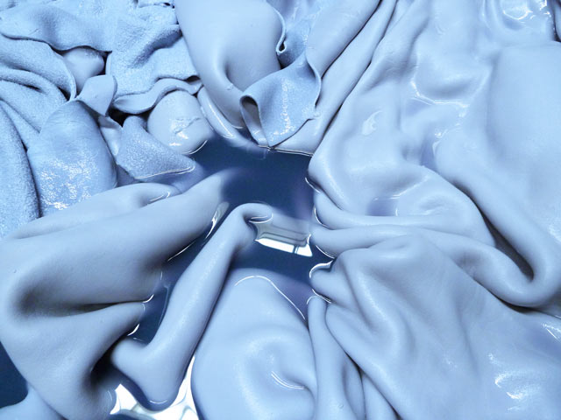
Figure 2-1 Wet blue

Wet blue completion requirements
- Diffusion of chromium salts into leather: In the processes, preceding tanning collagen fibers have to be separated and the interfibrillar substances removed. The tanning agents in turns penetrate the hide more readily if they are of low molecular weight.
- Binding of the tanning agent to collagen: Collagen is positively charged at a low pH (about The tanning agent easily penetrates, but it is not easily bound at this pH an increase of basicity and of the pH of the liquor increases on the one hand dissociation of carboxyl groups, which reaches 75% at pH=3, and 100% at pH=5; on the other hand the chromium complexes grow at the same time in size.
- Composition of the complexes: The more masking groups in the complex, the weaker and slower is its binding to collagen.

Analysis of shaved hides
Wet Blues had an initial thickness of 2.4 mm to 2.5 mm. After the process, a thickness of 1.9 mm was achieved. The Wet White hides had an initial thickness of 1.8 mm to 1.9 mm and a target thickness of 1.0 mm. The different target thickness of wet White and Wet Blue hides is due to the different requirements of the final products made from these skins.
The common thickness ranges for some products can include:
- Garment: 0.6-0.9mm
- Upper-
- skin: 0.9-1.1mm
- Hide: 1.2-2.2mm
- Lining-
- skin: 0.3-1.0mm
- Hide: 0.9-1.2mm
- Dress Glove-
- ladies: 0.3-0.45mm
- Men: 0.55-0.65mm
- Upholstery: 1.2-1.4mm
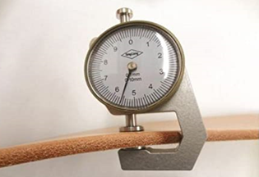
Figure 2-2 Thickness gauge

Operating drum as per workplace procedures

Load process vessel
Many chemical processes in the tanneries are carried out in big wooden drums. These drums are always supported by concrete structures. Drums are provided with doors for loading/ unloading hides/skins. The opening and closing require special skill because for bigger drums, the doors are heavy. In certain cases, the operator has to enter the drum to take out the leather. In such instance necessary care has to be taken to ensure that no gases are evolved (especially hydrogen sulphide, Ammonia) and proper personal protective gear is to be used.
Proper in let and out let are to be provided in the drums for feeding and draining the chemicals. Care should be taken to avoid contacting the drums while in motion. To prevent this, fixed barrier guards are to be provided on three sides.
All the hides are loaded in to the drum at the start of the cycle. The bath, consisting of water and chemical products, is modified and changed during the processing according to the particular recipe. The liquid and solid materials are put into the drum; solid materials must be introduced through the main or auxiliary door while the drum is not running.
The liquids are put in through holes located in to in the support shafts. This can be done while the drum is rotating.
The solid materials are loaded in to the drum from the top side, using a platform located at the drum axis level. This platform is constructed when the drum is installed. The operator can load the hides and solid chemical products fairly easily from this position using the large door, and he can take bath samples and make small additions of chemical products through the small auxiliary door.
The treated hides/skins are unloaded from underneath through the main door and fall into large containers.
Before unloading the hides, almost all the bath is drained out of the drum through the valves located at the ends of the cylindrical surface. The valves drain the bath in to small channels located on the side of the drum.
In newer tanneries, the drums are located about 1.5 meters above the floor so that a dolly can be positioned under the drum for receiving the hides/skins as they are unloaded from the drum. In the more sophisticated installations, the hides and chemical products are loaded on to conveyors that are provided with automatic measuring and unloading instruments.

Drum Operation
Before doing so, check and set the following things about drum or vessel.
- Check if any braking device is applied to the drum or in safe condition before
loading.
- Check whether the gear box is in correct mode and the gears are aligned and
matching properly.
- Ensure level of gear oil in the gear box. Also check the gear lubrication.
- Ensure the belt/chain guards are properly fixed and the safety device
(optional) is functioning correctly.
- Ensure the water supply and the dosing vats are in proper condition.
- Switch on the electric mains.
- Set the program in the display panel/timers/temperature controller etc.
- After completion of the above steps, tanned leather/ wet blue shall be put by using ether a forklift or manually as per the instructions provided.
- Start the drum or vessel and follow the process/recipe.
- Stop the drum or vessel when process is completed.
- Unload and Empty the drum and wash/rinse as applicable.
- Switch off the mains when not in use.

Safety Precautions before Operation Re-tanning drum
- Check if any braking device is applied on.
- Check whether the gear box is correct and the gears are aligned and matching properly
- Ensure level of gear oil in the gear box. Also check the gear lubrication.
- Ensure the belt/chain guards are properly fixed and the safety device (optional) is functioning correctly.
- Ensure the water supply and the dosing vats are in proper condition.
- Switch on the electric mains.
- Set the program in the display panel/ timers/temperature controller etc.
- Feed as per instructions/recipe and use the drum accordingly.
- Empty the drum after process and wash it.
- Switch off the mains when not in use.

Loading of the wet blue
Wet blue for post-tanning can be loaded in to the drum by using forklift or manually.

Chemical dosing system
Based on the ‘’process recipe’’ the specified chemicals at each process stage should be measured carefully by using a balance, acid should be diluted by adding the “acid to the water” to avoid the spillage cause and use the chemical feeding line to feed in while the drum is running. Feed the chemicals through the door for all type of powder chemicals. Again by following the” process recipe” calculate the required amount of water and adjust the water meter and feed it.

OHS procedure of loading
Safe Work Practices
- Wear appropriate personal protective equipment such as work gloves when handling objects with sharp edges and safety footwear when handling heavy objects.
- Ensure there is adequate clearance for safe lifting/material handling.
- Ensure storage areas are kept tidy, well organized and free of clutter.
- Use a hand truck, cart, dolly, wheelbarrow, etc to move heavy, awkward or bulky objects.
- Ask for assistance.
- Know how to safely handle controlled WHMIS products.
- Reduce repetition as much as possible by pacing your work and by varying tasks.
- Use a stepladder or stepstool to reach high places.
- Use a power grasp for loads with handles.
- Use a ledge grasp for loads without handles.
- Wherever possible use an elevator to move supplies and equipment between floors.
- Do not lift or carry items by the packing straps or cords.
- Do not use a box, desk or chair to reach high objects.
- Do not lift a load if you are not sure that you can handle it safely.
- Safe Work Procedure
- Wear appropriate personal protective equipment.
- Warm up your muscles (light stretching) for a few minutes before you start lifting.
- Know the approximate weight of the item before you attempt to lift it.
- Use a mechanical lifting device (e.g. trolley, hand truck, cart, etc.) to move a heavy or bulky load wherever possible.
- Do not attempt to lift a load that is too heavy or too bulky for you. Ask for assistance

Post –tanning operations
Post tanning: - unit-operation next to tanning stage at which enormous product diversification starts as per customers’ demand and the tanner’s know-how, skill and experience are tested.
In general, wet post tanning operation comprises mechanical operations like setting and shaving besides drum process. The drum process includes wetting back, rechroming, neutralization, retanning, dyeing and fatliquoring. The common properties of upper leather viz. tightness, uniform tight grain break and shade, softness and flexibility, roundness and fullness etc.

Objective of post tanning
During post tanning, the leathers are treated with different leather chemicals aiming at:-
- Imparting fullness to the leathers
- Imparting color to the leathers
- Incorporating softness to the leathers
- Improving the water resistance of the leathers

Why do we need post tanning
- During post tanning, the leathers are treated with different leather chemicals aiming at:-
- Imparting fullness to the leathers
- Imparting color to the leathers
- Incorporating softness to the leathers
- improving the water resistance of the leathers

Unit operations during post tanning
The term post tanning refers to the operations carried out after tanning. The unit operations in this process stage include:
- Wet back
- Re-chroming
- Neutralization
- Re-tanning and dyeing
- Fat liquoring

Wetting back
This unit operation is conducted for the purpose of rehydration of the wet blue leathers to ease the penetration of the chemicals in the subsequent operations.

Chemicals used:-
- Wetting agents
- Formic acid and
- Water
- Wetting back is the process of rehydration or moisturizing (to about 67%) of a relatively dewatered wet blues after mechanical operations or possible light /heat / exposure.
- Acid Wash, this is performed to wash away any unfixed /loosely held chrome and also adjust the PH for re-chroming
- The chemicals used include an acid, mostly acetic acid and a fat and chrome dispersing agent (an amphoteric agent most of the times).
- Sometimes, oxalic acid is also used to scavenge hexavalent chromium if any in the leather or in the case of white or pastel colored leathers.
NB: - The formic acid used here serves as a rehydrating agent as well as to develop extra positive charge on the wet blue leathers and hence enhance the uptake of chrome and chrome syntan in the re-chroming stage.

Control parameters: -
- Temperature
- pH

Re-chroming:-
As can be seen from its name, this is the unit operation where we use chrome and chrome syntan to treat the wet blue leathers.

Purpose
The purpose of re-chroming for chrome tanned leathers is to get more uniform chromium content in a pack of leathers procured from different sources
- and/or to get uniform layer-wise distribution of chrome in thicker bovine leathers or
- To get the required amount of chrome as required by the type of leathers or as demanded by the buyers.
- Another reason for re-chroming is to get fresh cationic charge in the aged wet blue leathers to improve affinity for dyes and fat-liquors.

Chemicals used:-
- Basic chromium sulphate
- Chrome syntan
- Electrolyte/chrome stable fatliquors to get internal softness
- Basifying agents (sodium formate and sodium bicarbonate)

Neutralization
Chemical neutralization is relatively a more thorough de-acidification of mineral tanned leather with mild neutralizing salts than the simple surface flooding off of the free acids, unbound basic chromes and acids attached with them. If we need our ultimate leather to be softer, level dyed, well lubricated, inner fibers are full and round, relatively complete neutralization is a must.
This unit operation is carried out to remove the unbound free acids on the wet blue leathers. This unit operation is also called de-acidification. The degree of neutralization determines the uptake of the dyes, retanning materials and fatliquors. The neutralization pH is the most crucial stage, where the tanner should take care of its completion. The tanner/ technologist should check the completion of neutralization by treating the cross-section with Bromo- Cresol Green (BCG)

Purpose
- Neutralization is an important process in wet finishing operation to get the desired final product.
This is the process in which the charge characteristics of the leathers are adjusted by the neutralization of the free acid present/liberated from the chrome complexes due to olation during aging in the chrome tanned leathers. The extent of neutralization will depend on the softness of the final leather required. The extent of neutralization required for different types of leathers are as follows
- Corrected grain upper leather - pH 4.8-5.0
- Softy upper - pH 5.0-5.2
- Suede leathers - pH 5.2-5.5
- Nappa garment leather - pH 5.5-6.0
- Glove leather - pH 6.0-6.5
- Apart from the type of finished leathers, the nature of raw material should also be taken into account to decide about the extent of neutralization.
- The loosely structured skins and hides should not be subjected to extensive neutralization; if otherwise may lead to further loosening of the leathers.
- Sometimes, it is better to use only neutralizing syntans and buffering salts in such cases.

Chemicals used
- The chemicals commonly used in neutralization are mild alkalis in combination with basic buffering salts.
- Sodium bicarbonate in combination with sodium formate is commonly employed for neutralization, neutralizing syntan also used along with sodium formate .
- Sodium formate is a buffering salt with slight alkalinity and performs the role of not allowing the pH to shoot up suddenly.
- If the pH shoots up suddenly during the fast addition of alkali, there is a possibility of grain becoming coarse or non-uniformity in colour due to local precipitation of chrome or in worst cases chrome patches also can happen.
- Though presence of buffering salt to a large extent can avoid the problem, However care must be exercised to add the alkalis in feeds slowly to avoid such occurrence.

Re-tanning
Any second tannage following the first tannage is considered as retannage or retanning regardless of the fact that the first tannage is only a slight pretannage. Of course, this is generally done to influence (usually positively) the physical and chemical properties or behaviors of the ultimate leather or to get any desired character of the final leather.
Strong filling influence thickness. But if the filling level is beyond the required level for the different products, then the fiber density in a given cross section is reduced; this in turn reduces the tensile and tear strength, the elasticity of the leather. This is usually undesired character for very soft leather like garment and dress glove.

Main objective of re-tanning
Most of the purposes of retannage are derived from the customers’ or producers’ interest for the characters of leather to be imparted. Thus the main purposes are to
- Improve the handle and feel of the leather, softer or firmer as desired by the customer or market /chrome syntans, polymer resins, aldehydes /
- Change the color of the chrome tanned leather for white leathers and pastel shades /Al, Zr tannins, aldehydes white or light fast replacement Syntans, especially dihydroxynaphthalene sulphonics).
- Improve the buffing properties for corrected leathers, suede and nubuck (Al/Zr syntans, dispersed resins and vegetable tannins).
- Improve embossability(vegetable tannins, syntans)
- Adjust the dyeing properties (dispersing syntans i.e. naphthalene sulphonic compounds)
- Produce crust leathers with the right properties for fast and level spray dyeing or aniline finish ( i.e. to get fine grain by using less astringent synthetic tannins)
- Improve certain specific properties like perspiration resistance, fastness to washing, thermal conductivity, flammability/aldehyde tannins, synthetic tannins/
- Support water resistance / high molecular polymer resins, chrome stearate etc.
Thus, as a summary, the leather properties, which can be improved or influenced as objectives or desires, by the retannage can include:
- Fullness
- Grain tightness/roundness
- Grain fineness and smoothness
- Softness
- Fat distribution, e.g. by aldehyde tannins
- Leather color, degree of whiteness
- Dyeing properties, levelness of dyeing
- Light fastness
- Dry drumming properties/grain break/
- Embossing properties/print retention/
- Buffing properties/short and strong nap, fuzzy or velvety feel/
- Physical properties/ tensile, tear strength etc./
- Water resistance
- Chemical or analytical results as required/chrome content, ash content etc/. E.g. relatively low chrome content for dress glove and high chrome content for suede.

Control parameters
The most important parameters to take care of during this unit operation include
- Neutralization pH
- Float length
- Temperature (suitable if it is at room temperature)
- Concentration of chemicals

Dyeing
The concept of dye and dyeing is directly related to the concept of light and color. As you know, “white light “or simply light energy is one region of the different electromagnetic radiations (-rays, x-rays, UV, visible/light rays/, IR, µ-waves and radio waves) with a standard or proportional mixture of electromagnetic waves of wave length between 400—750nm that can be detected by human eyes.
Thus dyeing of leather is the process of imparting color to the leather fibbers. Nowadays, many types of leathers, except some heavy leathers and some corrected leathers, are drum or spray dyed.

Objective
- The main objective of dyeing is to impart the colour as desired by the customer or marketing and sales forecast
- To plan the base colour before finishing for grain based finished articles
- To get uniform shade in case of suede and nubuck articles /dyeing is the final operation for such product.

Process variables for dyeing
The minimum quality requirements of dyeing for high quality leather include:
- Perfect levelness of shade
- Maximum depth of shade achieved with minimum amount of dye/exhaustion/ or up-takes
- Good covering of defects
- High color fastness
- Complete penetration and distribution
To achieve these quality issues, we have to control the following influencing factors called process variables.

Fat liquoring process
One of the main natural constituents of the raw or untreated skins is oils & fats that make the former flexible, heat resistant and energy source.
But, these natural fats & oils should be removed mechanically (fleshing, scudding) and chemically by degreasing for the following reasons:
- The Presence of them can accelerate skin degradation /rancidification/in storage of pickle or wet blue
- They are not the components of the ultimate leather structure
- The fat layers prevent chemical penetration during tanning, retanning, dyeing etc.
However, the undesired consequence of removing of these natural fats /oils is that the leather can become stiff after drying, due to sticking/gluing or adhesion of fibers. Thus in order to make the skins or leathers flexible, less stiff or soft after tanning, retanning & dyeing, artificially applying of fats & oils (technically called fatliquoring is important.

Purposes
The main objectives of fatliquoring processes include:
- To give the leather the desired softness/ to avoid hardening by drying / & handle i.e. full and round /properties at the same time
- Correction & control of the physical properties (Additional strength) like tensile, tear splits strength & elongation, extensibility /run or stretch/ abrasive resistance.
- Wetting properties or water repelling capacity, water proofness (oils /fats & waxes are generally, water repellent products)
- Permeability to air & water vapor, water absorption & moisture storage capacity by splitting of the fibers
- Resistance of thermal & electrical conductivity & chemical attack
- To make slide fibers one another as the leather made flexed and avoid breakage in bent

Fixing

Objectives
- To fix the dyes and fat-liquors permanently with the leather
- To avoid bleed even in dry condition and rubbing

Control Parameters
- Ensure the quality of fixing agents
- Fixing with acid (formic) or cationic fixing agent shall be carried out at appropriate stages or as mentioned in the process sheet
- The dilution protocol and the order of addition shall be followed sincerely as mentioned in the process sheet
- Examine visually the bath for exhaustion as prescribed in the process sheet
- Check the pH of the leather after fixing.
Figure 2-3 output of post tanning

Techniques of unloading crust leather
Loads are handled at an appropriate and safe rate from any mobile load shifting machinery. Loads are placed to ensure stability protection of material and avoid any of
hazards on site. Lowering of loads especially from forklift truck it needs big care.
See the following procedures how to unload the skin/hide or leather.
You must check the following before unloading
- Make sure the load is stable.
- Rack capacity.
- Top and side clearance of racks
- The forks are clear of the rack before lowering.
Remember the following when unloading
- Do not strike the rack with the forks or the load.
- The forks are clear before pulling out.
- Keep the mast vertical.
- Never reach through the mast for any reason.
- Never let anyone reach through the mast.
How to unload the load:
- Turn the forklift slowly into position.
- If unloading onto a truck, before driving straight in, make sure the rear
wheels of the truck are chocked, the brakes are locked, the dock plate is
secure and won’t move and trailer jacks are in place. Then drive in,
position the load, tilt it forward and release it.
- If you are unloading onto a stack, position the forklift properly before
lifting the forks - the forklift is top heavy, remember? You don’t want to tip over.
- Check for overhead clearance before raising the load.
- Raise and position the load to the correct height - two inches above the
stack.
- Move the load slowly into position.
- Allow for two to three inches of clearance at the sides and back of the
load.
- Tilt the load forward and then lower it.
- Level the forks so they are no longer tilted.
- Pull the forks back slowly.
- Sound the alarm and back up slowly, looking over your shoulder.
- Once clear of obstructions, stop the forklift and lower the forks to about
six to eight inches off the ground. Now you’re ready for the next load.

Checking process control parameters

Control parameters during re chroming
- Temperature
- PH
Concentration of chemicals and float length concentration of chemicals and float length

Control parameters during neutralization
- Concentration of chemicals
- Float length
- pH (4.8-6, depending on the softness required)

Control parameters during retaining
The most important parameters to take care of during this unit operation include
- Neutralization pH
- Float length
- Temperature (suitable if it is at room temperature)
- Concentration of chemicals

Control parameter during dying
- To bring aesthetic look for final/finished leather
- Ensure the good working condition of the drum with ideal RPM
- Ensure the quality and applicability of the dyestuffs
- The compatibility of dyes shall be ensured if more than one is used
- Bath temperature and volume shall be maintained as per the process protocol
- Follow the established procedure of dye addition/feeding to the drum
- Strictly adhere to the process duration
- Check the penetration of dye as advised in the process sheet
- Examine visually the dye bath and leather
- Fixing with acid (formic) or cationic fixing agent shall be carried out at appropriate stages or as mentioned in the process sheet
- Fresh bath shall be considered for where ever necessary viz. sandwich dyeing, top/basic dyeing etc.

Process Controls parameters during fat liquoring
To ensure that fatliquors give generally uniform & consistent results under varying conditions, we have to follow up some basic variables as guidelines.
- Temperature:
- Length of Emulsion standing period:
- Water Quality
- Over emulsion or over stabilization:
- PH Level:
- Mechanical Action:
- Drumming Duration:
- Float length

Drum operations outputs

Checking quality of natural or dyed crust
Quality is the measurement of degree of excellence.
Definition of Inspection:
- An inspection is, most generally, an organized examination or formal evaluation exercise.
- The results are usually compared with specified requirements and standards for determining whether the item or activity is in line with these targets.
- Inspections are usually non-destructive.
- By “inspection”, it is usually meant that, at certain stages in the course of leather or any production, a comparison is made between already produced product and requirement.
- The standard of reference may be a specification that should meet drawing or a visual quality standard. The inspection which has been made must be appropriate to the job.
- The evaluation must be made with suitable measuring instruments or parameter.
Different forms of inspection
Depending upon the production flow, the inspection may be divided into:
  - Incoming inspection
  - In-process inspection
  - Final inspection
In-process inspection
- In-process inspection aims to prevent the products of unacceptable
quality from being manufactured during the particular operation (unhairing, fleshing and lime splitting).
- The inspection will be conducted as per the standard of the company or the customer requirement for the final product.
- The inspection also provides information to take decisions on the product that are required for correction on the spot or for the next process.
Continuous inspection in Drum processing
- Automated equipment, sensors, supervision
- Monitor the critical control point (CCP)
- Temperature
- Time
- pH
- Moisture
Provide assurance that all the products produced have met criteria for acceptability

Quality requirements
Upper leathers
- Grain tightness
- Fullness
- Water resistance
- Air and water vapor permeability
- Optimum softness
- High tear and tensile strength
- High grain burst/crack resistance
Garment leathers
- Drape property (falling like cloth)
- Color fastness ( on wet and dry rubbing)
- Color uniformity
- Good size (pattern value)
Glove leathers
- Softness
- Run property (minimum of 25%)
- Color uniformity
- Light weight

Types and discharging liquid wastes in post-tanning
Process effluent handling Effluents generated from post tanning yard mainly:
- Chrome discharge
- dye discharge(Sulphur dye )
- Synthetic re-tanning material
The waste of post tanning yard mostly contain dye and chrome bearings. These wastes must be discharged properly since it have adverse effect.
- The working area must be cleaned regularly and free from any wastes to make the area suitable for working.
- The discharge lines should be regularly monitored for their proper working and should be well connected with the effluent treatment plant.]
- The discharge and drainage channels shall be well cleaned and maintained to avoid choking and spilling over to the work place or process yard.
Effluent segregation and screening Tannery effluents contain many types of pollutants, which are present in all forms from large solids through colloids to dissolved salts. The flow and composition of the effluent also varies considerably during the day and from the various stages of the post tanning process. Pre-treatment is especially important in the treatment of tannery wastewater to remove coarse solids and to equalize flow variations in order to protect and optimize the subsequent processes. Particles, which can be easily retained or separated by physical and/or mechanical means, are usually removed from the liquid effluent at the earliest possible stage. This prevents problems of blockage and damage on pumps, pipe work, liquid flow channels and other subsequent treatment equipment. The main components which should be considered for separation are:
- High and low salinity effluent
- Sulphide and non-sulphide containing liquors
- Chrome and non-chrome containing liquors

Self-check 2
Part one: chose the best Answer for the questions listed below. (each question have 1 points)
- Which one of the following is NOT a post tanning process
A. Fatliquoring
B. Dyeing
C. Rechroming
D. Retanning
E. None of the above
- Which one of the following post tanning operation impart fullness
A. Fatliquoring
B. Dyeing
C. Rechroming
D. Retanning
- Which one of the following post tanning operation impart softness
A. Fatliquoring
B. Dyeing
C. Rechroming
D. Retanning
- Which one of the following post tanning operation impart color for the leather
A. Fatliquoring
B. Dyeing
C. Rechroming
D. Retanning
- Which one of the following is property of Upper leathers
A, Grain tightness
B. Fullness
C. Water resistance
D. Air and water vapor permeability
Part two: Give short answer for the following question (each question have 2 points)
- Write safety Procedures before Operation Re-tanning drum?
- What are controlling parameters during retaining?
- What should be the height of the drum from the ground?
- Write the safe work practice while loading the wet blue?
- What are the most post tanning operations?
- Write Chemicals used in wet-back operation?
- Write Chemicals used in Neutralization operation?
- Explain Control parameters taken during Fat liquoring process?
Note: Satisfactory rating – above 60% Unsatisfactory - below 60%
You can ask you teacher for the copy of the correct answers

Operation sheet 2.1
Title: - Preparation to Load the Material into Drum
Instruction: - by using operation instruction, you have to operate load wet blue in to processes vessel in a given 20 minute
Objective: - able to develop the skill of the trainee by performing the correct loading of wet blue in to drum
Tools and equipment that needed for the operations: -
- Drum
- Dram opening steel bar
- Forklift
Precautions:-try to load drams by hand and forklift more than one times
Procedure
Step 1: Identify the material to be loaded into the drum
Step 2: Ensure the identified lot is with tag/route card and process sheet and no deviation or damages. If any deviation found, report to the supervisor
Step 3: Identify the drum assigned
Step 4: Ensure the assigned drum is in working condition, clean, static and in OFF condition. If not so, report to the concerned official
Step 5: Decide the mode of loading; manual/forklift
Step 6: If manual, wear gloves and protective equipment’s or OHS as described for the activity
Step 7: Load the material without affecting personal safety
Step 8: If through forklift, check the working condition of the assigned forklift
Step 9: Ensure the material is placed on the palette
Step10: Using the forklift load the material into the drum
Step 11: Try to avoid overloading the palette or forklift
Step 12: Avoid hitting or causing injuries to the self and others while loading and transporting
Step 13: Report/consult the supervisor or section in charge if any problems encountered
Quality Criteria: accurately load processed wet blue in to dram without any damage

Operation sheet 2.2
Title: - produce crust leather
Instruction: - by using operation instruction, you have to operate loaded wet blue to produce crust leather
Objective: - be able to develop the skill of the trainee by performing the correct post tanning operation for wet blue
Tools and equipment that needed for the operations: -
- Drum
- Chemicals
- Dram opening steel bar
- Forklift
Precautions:-try to produce different articles like sheep, goat, caw, with different preservation method more than one times
Procedure
Steps to be followed to produce the tanned leather:
Step 1: Receive the wet blue.
Step 2: Choose the appropriate process.
Step 3: confirm the availability of materials and quality of chemicals going to be used.
Step 5: Measure the chemicals.
Step 6: Choose the vessel type if needed.
Step 7: Perform the process using the working procedure listed in the information sheet or by using the tannery process sheet
Step 8: Check the quality parameters.
Step 9: Finish the operation.
Step 10: Ensure the effectiveness each operations.
Quality Criteria: accurately production of tanned leather for different article

Operation sheet 2.3
Title: - unload crust leather in each operation
Instruction: - by using operation instruction, you have to operate to unload crust leather in each process
Objective: - be able to develop the skill of the trainee by performing the correct unloading operation in post tanning
Tools and equipment that needed for the operations: -
- Drum
- Dram opening steel bar
- Forklift
Precautions:-try to unload drams more than one times
Procedure
Step 1:- Ensure the surrounding is clean
Step 2:- Drum or process vessel should be in off condition
Step 3:- Drain the water first from the process vessel through lattice door
Step 4:- Make arrangements clearly to place the perforated wooden collection rack to collect the material
Step 5:- Then unload the material
Step 6:- Make sure the load is stable and rack capacity.
Step 7:- Keep the forklift or material shifting equipment ready
Step 8:- The pathways to move the unloaded material should be free of obstacles
Quality Criteria: accurately unload processed hides and skins in clean place without any damage

Lap test 2.1
Instructions: Given necessary templates, tools and materials you are required to perform the following tasks. The project is expected from each student to do it.
Tasks-1: all prepared raw wet blue to load or feed to the drum or vessel using loading machine or manually by hand
Task 2 Move to tannery and apply the above post tanning operation working procedures.
Task3: - after the completion of each process unload the crust leather for the next operation
You are given three (5) days to complete the abovementioned
Request your teacher for evaluation and feedback of your work

UNIT THREE: OPERATE MACHINERIES TO PRODUCE CRUST LEATHER
This unit is developed to provide you the necessary information regarding the following content coverage and topics:
- Check status of tanned leather for machine operation
- Operating post-tanning machineries
- Check process control parameters in machine operations
- Controlling post tanning machine operations outputs
- Cleaning work area and recording post-tanning operation
This unit will also assist you to attain the learning outcomes stated in the cover page. Specifically, upon completion of this learning guide, you will be able to:
- Check status of tanned leather for machine operation
- Operating post-tanning machineries
- Check process control parameters in machine operations
- Controlling post tanning machine operations outputs
- Cleaning work area and recording post-tanning operation

Operating post-tanning machineries
There are different Machines used for crusting after tanning operation
- Sam/Setting
- Samming
- Tanning Splitting
- Shaving (wet and dry)
- Setting out

Samming Machine
Samming is used to reduce the amount of water in the leather by applying pressure by a pair of rollers (hydraulically pressurized). The typical samming machines consist of a pair of rollers (spring or hydraulically pressurized) plus a bladed cylinder directly behind to spread out any creases. This pressure will reduce the hides’ water content from 100% when it is saturated, to 50-55%, after it has been squeezed and the hides must be flattened sufficiently without any wrinkles.
In samming operation two specific operations are carried out
- Spreading to make it flat and well spread
Pressing to squeeze out water from hides presses that were derived from the ones used for pressing olives and grapes were used the problems created were
- Improper water removal
- Wrinkle formation which give rise to permanent grain damage Cylinders taken from the paper industry were used to avoid the above problems
- Pressing to squeeze out all excess water
The cylinders rotate in a converging manner and are covered with thick felt sleeves
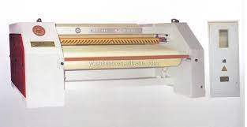
Figure 3-1 Samming Machine
There are two families of machines for samming hides after tanning
- Alternating cylinder machines
- Through feed felt type machines
Parts of a samming machine
- Feed roller covered with the felt.
- Felt
- Spreader
- Hydrailic cylinder applying pressure
- Samming cylinder
Adjustments on the samming machine
- The machine comes in contact with water particles and so it is desirable to maintain the machine clean and neat.
- Oil or grease the moving parts of the machine regularly.
- Maintain the felt sleeves properly for the samming machine.
- Since the machine is operated by hydraulic pressure use the hydraulic oil properly and maintain the pivoted joints properly.
- Check the clutch mechanism periodically.
Operation parameters for sammying process:
In sammying operation most of the contained water must be removed from the hide. The water content should be reduced to 30-45%. This renders the wet blue leathers suitable for splitting and shaving in the case of hides/sides and shaving in the case of skins.
- Check the function of all devices in the machine.
- Check the speed of the feeding felt roller.
- Confirm the pressure between feeding felt and sammying felt
- Confirm the stretching cylinder is in correct position, and it will not touch the felt
Monitor the quality of product after sammying operation:
- Check after sammying the hides must be flattened sufficiently without any wrinkles. Otherwise leather should damage in splitting or shaving operation.
- Check the sammyed leathers without pleats/folds/creases as it would damage the material during shaving
- Check the moisture content after Sammying should be uniform throughout the Wet blue. Otherwise this may give the uneven thickness in shaving operation.
- Check the tanned leather (wet blue) after sammying should be segregated based on thickness before shaving, If not segregate it will give undue splitting or shaving.
- Check the pelt must be free of any stains from the machine.

Wet blue splitting
One of the mechanical sub-activities practiced in post-tanning operations is splitting of hide, if it was not done at lime pelt stage.
Do you remember the actions of cambering and decambering activities and the relevant advantages while lime splitting? Splitting why? What are the three main layers of skins?
As you may know, in most cases, lime splitting is an environmentally better option than blue splitting as the former allows:
- The grain and the split layers to take different routes of tannage as per the requirement for end uses
- The split which is not usable to leather making but to use it for the manufacture of gelatin or collagen castings for food stuffs
- To reduce the consumption of inputs/chemicals, water etc./ and improve drum capacity by avoiding non leather making rubbishes
- To shorten process time due to the reduction of overall thickness that in turn facilitates penetration of pretanning and tanning chemicals, like those chemicals having weak penetration power as CO₂ for deliming purpose.
- Reduces waste, especially tanned solid waste and
- Better area yield due to maximum relaxation of the grain surface, especially for spread upholstery. But a tanned hide is a little more stiff and wrinkled
But there are cases where wet blue splitting is more advantageous than lime spitting. These technical reasons or the strict specification of the final product can include:
  - Accuracy and ease of handle i.e. tanned and sammed/set wet blues are more comfortable to handle and reduce pelt damage and thickness variation while splitting than the limed pelt and the former helps to split the leather to more uniform and accurate thickness. E.g. pelt splitting provides a maximum precision of ±0.25mm, wet blue splitting provides a precision±0.15mm, but shaving provides a precision of as high as ±0.05mm.
  - Resolving the other disadvantages/limitations of lime splitting like:
    - If there is no means to split at lime stage or the material at hand is already tanned blue
    - To maximize the use of split/ in area yield, thickness, accuracy etc.
    - Preference to leather types that need to be firmer or needs only weak liming and open-up or where swelling and high water penetration at liming stage are not recommended, e.g. for firm shoe upper.
General instructions of machine
- Tanned hides arrive at the splitting machine selected and well-arranged on benches.
- Splitting machines also have a working width that exceeds 3000 mm.
- Two operators take are of introducing the hides into the machine.
- A stacker is located on the outlet side of the machine, which takes place the split grain and deposits it on a pallet.
- Splitting is carried out at a good pace and the production rate is generally 100-120 hides per hour, with just the use of 2 or 3 operators.
Adjustments on the splitting machine
- Adjustment of knife:
- Band kinfe is moving on two wheels and these wheels must be in a line lfit if it does not occur, slip results in.
- The tension of knife in between the wheels are important.
- Tension - more: knife breaks
- Tension - less: uneven splitting
- Jaw plates: Adjust the bottom and top knife jaws according to the thickness of blade and a clearance of 1mm has to be maintained.
- Grip roller (Guage roller): Adjust the grip rollers and support rollers such that they have the clearance of 1mm. Support rollers are provided to avoid the bending of grip rollers.
- Section or ring rollers: Clamp the section roller tight and it should rotate free with the rubber roller. Clean section roller with oil every day.
- Rubber roller: Maintain even gap maintained between knife and section roller throughout the length.
- Grinding system: Adjust the grinding wheels in such a way to get correct cutting values.
Operational parameters for splitting machine:
Splitting is the operation preformed on the hide to adapt its thickness to the final leather, a constant thickness throughout its surface. Hides of certain thickness split the part separated from the grain, called flesh side is called split.
- Check the proper function of all devices in the machine.
- Check that the machine is clean and free from foreign objects
- Check that the band knife, grinding wheels and jaw plates are in correct positions.
- Check the speed of feed roller and speed of endless band knife.
- Check the upper and lower grinding devices are functioning properly.
- Check the tension of band knife, tension is not too high or too low.
- Check the gap between the feed and pressure roller is same in all position.
- Check the emergency switches are functioning properly
- Ensure that all the safety devices are engaged in the proper position.
Monitor the quality of product after splitting operation:
- Check whether the thickness is correct throughout the leather, free of any defect.
- Check the thickness usually in splitting should keep above 0.2 mm than the shaving thickness required.
- Check the leather is free from vibration marks.
- The splitting should be uniform in all area of skin or hide.
- Check the leather with in a precision of + or – 0.15mm thickness to the required thickness, not more than that.
- Check the hide should be free of gouges, holes and stairs

Sam/Setting
Samming is dewatering of leather (eg, wet blue, retanned leather) mechanically by pressure as part of wet end operation. Whereas, setting out is flattening and slight stretching of leather with reversely moving bladed rollers. The latter is one of the mechanical mechanisms to achieve better area yield.
Usually in modern tanneries these two operations are done simultaneously by through feed Sam/setting machine.
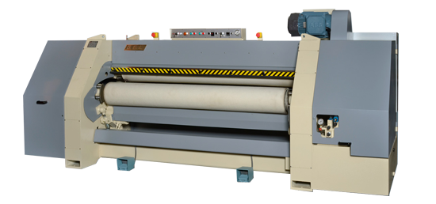
Figure 3-2 Sam/setting machine
Purposes of Sam/setting:
Sammying is to: Bring the moisture content of the leather into suitable range of working condition. If the leather is too wet /dump/or too soft/less resilient/, it will be dragged and torn by cylinder of the shaving machine/the subsequent operation/.On the other hand, if it is too dry/hard or horny/, it will not be pliable enough to lie snuggly against the guiding bolster of the shaving machine and also be difficult to wet back.
Slightly reduce the water content of wet blue and reduce the weight and transportation costs, especially if the product is to be sold at this process stage.
Setting out is to: Avoid creasing/pleating/of leather so that we can achieve area yield not only by flattening by blunt blades but also by avoiding/reducing/tearing during shaving .It has also some drying/sammying effect.
N.B: Do not allow over drying (dried chrome tanned skins cannot easily wet back and take up dyes or fatliquors unevenly)
Process control Sam/setting machine
Day to day works control of Sam/setting process variables is necessary in order to achieve consistent results of quality and quantity. In this duty, the drying or effectiveness of water reduction is mainly a function of the pressure between the rollers and the feed speed, in other words the pressing time. Thus, we have at least three aspects to control:
- The relatively uniform moisture content/level of the sammed leather throughout the area,
- Flatness or crease free leather and
- Pressure and speed adjustment of the Sam/setting machine.
N.B: The moisture content of leather can be measured using any oven from a laboratory or using any readymade moisture meter especially for semi dried or dried leather. Pressure is adjusted according to the type of input to be processed (sammed/set) and the type of machine to be used. But the consistency of the pressure applied is controlled by reading the pressure gauge installed. Besides, the rate of production is inspected by following up of the conveyor and operators speed.

Setting-out
- This operation makes the leather flat and smooth and removes the wrinkles before going for vacuum dry or overhead chain drive.
- Hide spreading, wrinkle elimination and grain side flattening operations are performed by the blunt knife cylinder widens spreads and flattens the grain side of the leather.
- For skins first the head side and followed by tail side or side wise half the skin along the backbone and reversed.
- Setting operation Improve the area yield.
- Setting which reduces the residual moisture in the hide from 100% to 65- 70%.
- Hide widening, which dislocate the material, left on the tender, elastic part during shaving.
Adjustments on the setting machine:
- Adjust the lever maintain suitable pressure of feed roller.
- Adjust the pressure on the nip roller with the help of hand wheel provided on the top of the nip roller.
- Adjust the pressure of setting cylinder with the help of adjusting device.
- Lubricate all the moving parts periodically.
- Maintain the felt sleeves or rubber feed roller properly.
Operational parameters for setting machine:
This operation make the leather flat and smooth and removes the wrinkles before going for vacuum dry or overhead chain drive. Hide spreading, wrinkle elimination and grain side flattening operations are performed by the blunt knife cylinder widens spreads and flattens the grain side of the leather.
- Check the proper function of all devices in the machine.
- Check that the felt(s) and rubber rollers are in good condition and clean
- Check the sammying pressure and setting pressure according to requirements.
- Check the forward and reverse motion of the roller.
- Check the emergency switches are functioning properly.
- Check the safety devices are fixed at proper place.
Monitor the quality of product after setting out operation:
- Check the leather should be flat, smooth and without wrinkles.
- Check the pressure is correct and optimum level to get the flat leather, over pressure squeezed the chemicals out, therefore leather become loose after drying.
- Setting out should be done without pleats/folds/creases.
- Check the pelt must be free from any stains especially in pastel colors
- Check the leather free from any dye patchiness, due to wrong method of feeding strokes.
- Setting should reduce the residual moisture in the hide from 100% to 65-70%.
- Check the horse up of leather after setting to pile off without any folding and wrinkles.

Shaving
Shaving of leather, as one of the wet end operations, is simply considered as the removal of flesh and loosely attached structures such as adipose tissue remains as well as thickness adjustment into a salable form according to the would be leather type and the customers demand.
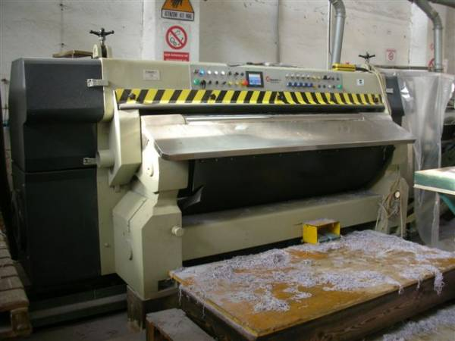
Figure 3-3 Shaving Machine
Purpose of shaving:
Shaving is required (after sammying/setting and siding to the moisture content of about 45-50%)
- To bring the leather to a uniform thickness throughout the skin area in a precise manner (and with greater accuracy than can be obtained by splitting operation) as commercial leather should be of uniform thickness.
- To remove the loosely attached tissues and fibers that reduce the aesthetic appeal of the flesh side leather and to remove flesh offal remains, if any.
- To intensify surface dyeing by exposing the inner fiber especially for suede.
Adjustments on the shaving machine:
- Adjust the distance between the feed roller and shaving cylinder by hand wheel.
- Clean the machine to get rid of shavings.
- Oil and grease all the moving parts periodically.
- Check the bushes and bearings twice in a month
- Check the tightness of the helical knife fitted on the shaving cylinder before commencing the work.
Operational parameters for shaving machine:
Shaving is the operation performed for obtaining the final hide thickness. The purpose of the shaving machine is to bring the leather to uniform thickness in a precise manner and with greater accuracy than can be obtained by splitting
- Check the proper function of all devices in the machine.
- Check that the machine is clean.
- Check the approx gap between feed roll and blade is sufficient enough.
- Check the speed of rotation of cylinder.
- Check the lubricator level for grinder-slide.
- Check the grinding devices are functioning properly.
- Check the emergency switches are functioning properly
- Ensure that all the safety devices are fixed at proper position.
- In shaving operation care should be taken to see that undue
Monitor the quality of product after shaving operation:
- Check whether the thickness is correct, free of any defect.
- Check the shaved thickness according to the required thickness.
- The shaving operation must be performed accurately enough to keep the thickness difference between the various points of the hide to within+ or – 0.05mm.
- Check the thickness should uniform throughout the leather.
Avoid area loss due to folds and creases

Buffing machine
Purpose of buffing machine
- The buffing is done on the flesh side for all types of leather to remove the loose fibers by emery papers.
- This operation is last after this the leather will go to finishing operation.
- The purpose of buffing is simply to improve the hide appearance by dressing or refurbishing the grain or the flesh side.
- It may also prepare the hide for subsequent “make up” treatment or it can already be the final beauty treatment in itself.
- The grain side of a hide can be buffed in various ways, depending on the particular product.
- Buffing is important to produce leather like suede, nubuck and corrected grain leathers
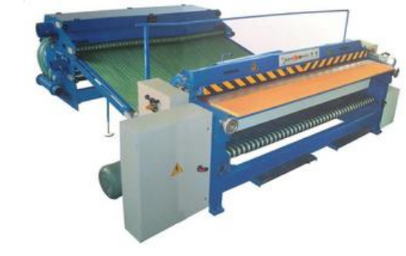
Figure 3-4 buffing machine
Working principle of Buffing machine:
- The buffing cylinder is of metal about 7"-9" diameter and may be of various widths from 10"-24".It rotates about 1000 rpm.
- The buffing cylinder is covered with buffing paper clamped tightly and uniformly in position.
- It is important to keep the paper free from accumulations of leather buffing dust. This is done by a revolving brush below the cylinder.
- Feed the leather to the cylinder manually holding it back from being pulled in to the machine.
- Below the buffing cylinder there is another brush to prevent the leather from being wrapped around the buffing cylinder
- Oscillating movement to prevent long scratch lines being formed on nap or leather surface.
- The extraction of the buffing dust generated connected to the central unit.
- The buffing roller has the following two moments.
- Rotation around its longitudinal axis
- Oscillation along this same axis
Adjustment in buffing machine:
- Control the RPM of the buffing cylinder to be 1000.
- Keep the buffing paper free from accumulations of leather buffing dust.
- Keep parallel both the feed roller and buffing cylinders to each other.
- Check for the proper functioning of the exhaust fan and brush.
- Oil or grease all the moving parts periodically.
Operational parameters for buffing machine
The buffing is done on the flesh side for all types of leather to remove the loose fibers by emery papers. The purpose of buffing is simply to improve the hide appearance by dressing or refurbishing the grain or the flesh side.
- Check the proper function of all devices in the machine.
- Check that the buffing paper is correctly fixed and the paper grip-locks are functioning properly
- Check the feed roller and buffing roller are parallel, gap between the rollers are same in all points.
- Check the grit size and quality of the buffing paper.
- Ensure the feed roller and nip roller settings are correct and the brush rollers are in right position.
- Check the emergency switches are functioning properly.
- Ensure all the belts are guarded properly.
- 24 - 120 = for coarse buffing,
- 120 - 300 = for medium buffing,
- 320 - 700 = for fine buffing,
- 800 - 1200 = for superfine buffing

Overhead dryer conveyer
Air drying involves hanging the hides on hooks so that moisture can evaporate naturally; this is the slowest process and results in shrinkage of the hide. Bad for yield, but great for giving leather a “full” or “round” hand. An air dried hide will routinely shrink by 25% (approximately 6 square feet). This also yields an article that is pliable with a bit of stretch. The advantages of air drying are
- low investment cost,
- no heat input,
- only little chance of case hardening,
- Simplicity of operation. The drawbacks of the system are its low productivity and low area yield.
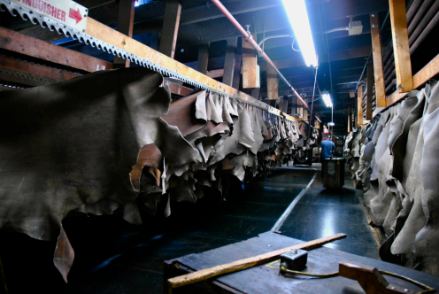
Figure 3-5 Overhead dryer conveyer
Overhead dryer adjustment
- Adjust the speed of the conveyer, it is possible to adjust 2 – 15 meter per minute .If the speed is higher the circulation will be fast so the drying time is short; the leather will have more moisture.
- The drying is more inter linked with the atmospheric temperature and humidity.
- If drying tunnel is available it is necessary to adjust the temperature accordingly.

Toggle drier machine
This is used to dry the leather in a short time by means of steam under controlled atmospheric pressure. Even-drying is obtained by means of the blower and baffles. The drying temperature can be increased to the extent of 70-80°C.
The leathers have to be loaded outside the chamber so that operator will not get affected by the hot fumes. Therefore, ample space has to be provided for loading and unloading the leathers. All the moving parts are to be suitably lubricated.
A toggling unit consists of a number of screens placed in a dryer having controlled temperature and humidity. The leather is stretched and held in place by a number of toggles that look into the screens. Advantages of toggle drying are
- Drying the large quantities of leather in a relatively small space
- Provides stretching to the leather during drying. There are some disadvantages, constant temperature and humidity conditions are difficult to maintain and control.
Adjustment
- Adjust the temperature 70 – 90o C, as the type of leather needed.
- Adjust the staying period 3 – 4 min.
- If it is automatic adjust stretching size and speed 3-4 meter per mint.

Vacuum drier machine
This is one of the modern machines and works on hydraulic, pneumatic and
mechanical principles. This is used to dry the leather and at the same time set the
grain. This is provided with hot water circulating pump to maintain constant drying
temperature; the hydraulic pump to operate the drier and pneumatic valves to
create and release the vacuum. The following system of operations has to be carried
to keep this machine working in perfect condition.
These machines utilize the principle of lowering the boiling point of water under low pressure. The skins/sides are put on Stainless steel plates hot enough up to 80 degree Celsius and a hood covers those. Now a vacuum pump extracts out the vaporised moisture from the skins and condensate water is obtained; to be drained to ETP.
As a routine maintenance one should-
- Check safety guards daily for correct functioning
- Clean the S.S. plates daily with soap water.
- Lubricate the moving tracks, pulleys and steel ropes if any.
- Service the vacuum pump once in six month.
- Check for vacuum leakages,
- Check the temperature controller.
- Check the water filter membrane once in six month.
- Clean the plate membrane/mesh once a week
- Check the moving vacuum pipes and hot water tubes for leakages, arrest if found any
- Check for compressed air leakage if any.
- Check the condenser once a year for internal leakages. Clean the dust, dirt and rust.
- Check for the solenoid valves and the plate opening & closing valves for air leakages and other defects. Remove if observed any at least once in six months.
If the plate does not heats enough, even after setting the temperature at higher level, please open the heat exchanger, surely steam leaks out into the water and it is draining out to condensate. This is important as it may lead to explosion when the steam trap is defective one, leading to pressurize the hot water chamber of the steel plate

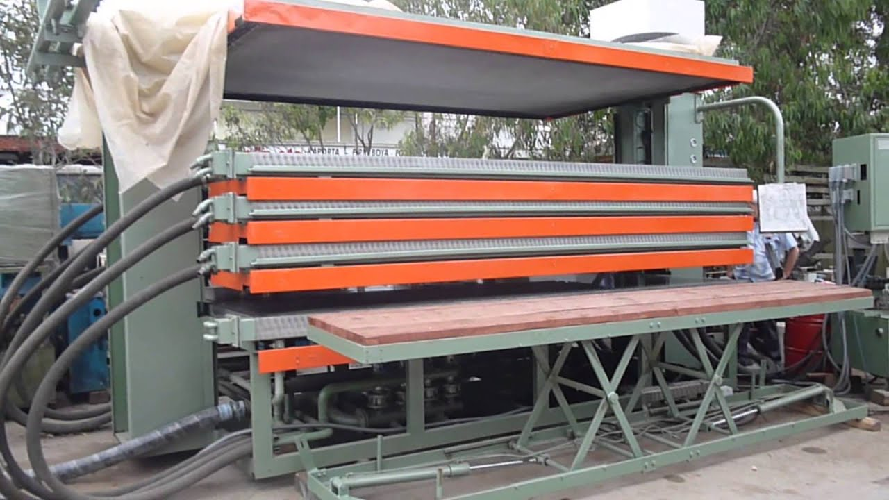
Fig. 3.6 Vacuum drier Machine
Vacuum drier process
- The first operation is the starting of the water circulation in the drier and letting out the air. Then steam is let in to increase the drier temperature with thermostat control. The temperature of the drier plates can be directly read on the control panel and maintained between 700-80°C.
- The lid of the drier is actuated automatically by the hydraulic pump through time controllers. If needed, it can be put on manual operation.
- The stainless steel plates have to be cleansed with wiper-stick. After placing the leather, slickering has to be done to remove the folds and wrinkles. Then the lid is closed by means of the hydraulic pump.
- Now the vacuum pump has to be started to create vacuum in between the
top and bottom plates to quicken the drying. The vacuum has to be
maintained at 70 cm. of Hg. The leather is kept in this condition for 60-80
seconds.
- Then vacuum is released and then the dried leather is removed.
- Under no circumstances the hot water circulating pump should be stopped.
Vacuum dryer adjustment
- Set the temperature 40 – 60o C.
- Set the time 1 - 3 min.
- Set the pressure 4 – 6 bar

Staking machine
Staking is a mechanical operation that is performed on leathers that contain 22-24%
humidity and detach the leather fibres, which makes the leather softer and more
pliable. A residual humidity of 22-24% favors the lubricating necessary for allowing
the fibres to be detached and slide between each other without breaking.
Staking can be done at different times during finishing
- Before the actual finishing, right after the leather has been completely dried. This provides softness and elasticity to the fibers that became glued together when all the waste molecules that had occupied the interfibrillary spaces and acted as cushions between the individual fibers were evaporated off.
- During the finishing phase, used in a gentler way, renews the softness that the leather may have lost because of the impregnation process, exposures to more or less high temperatures and the pressing and embossing operations
Staking machines
Leather factories have three types of staking machines: -
- Slow comb, the oldest ones,
- Rotary staking machines
- Vibration staking machine.
Slow comb machines have been discarded due to its accident proneness and rarely seen in some Asian countries.
Rotary staking machines are good for gloving leather etc, soft in nature and are very similar to fleshing machines. In addition there will be another pair of bladed fan and an auxiliary bolster to remove folds and carry away dust. Also there could be a dust extraction plant attached to the machine.
Maintenance is never a major task except changing leather bolsters and lubricating the bearings and pivots for feed carriage. Once a year changing of hydraulic oil and topping it up when required (this may not be required unless there is a minor leak) is a general practice.
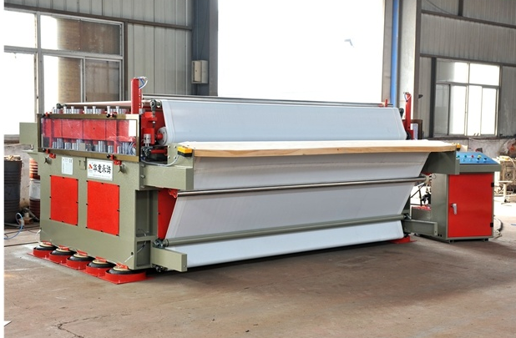
Figure 3-6 Vibration staking machine

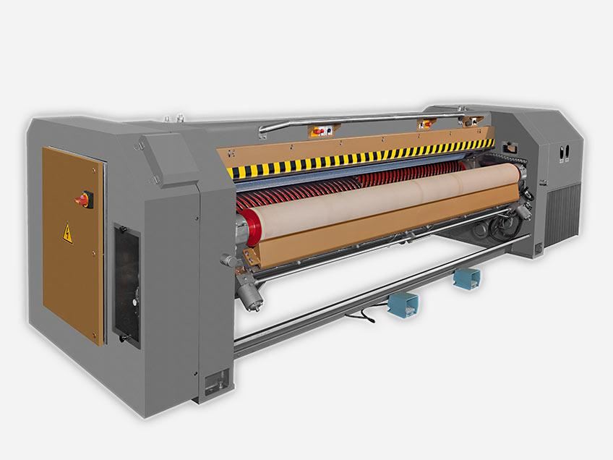
Figure 3-7 Rotary staking machines

Checking process control parameters in machine operations
Machine Operational parameters
- Visual and functional checking of the existing devices.
- Measurement of the safety distance between the fixed barriers and the danger point.
- Functional checking of the safety switches.
- Functional checking of the interlocks.
- Measurement of the noise level.
- Verification of the following exhaust points to ensure that they meet the process requirement
- Pressure
- Flow rate
- Direction

Controlling post tanning machine operations outputs

Disposal and types of solid waste
Types and sources of waste generate from crusting machine operation
- Leather industry has been categorized as one of the highly polluting industries are concerns that leather making activity
- Considerable challenge to the industry considering the harmful nature of some of the chemicals used in leather processing.
- Leather industry generates significant amounts of solid waste and industrial sewage.
- They originate from various technological steps of leather production (1mg of raw hides yields altogether about 700 kg of waste)
- The crusting process consists of many mechanical and chemical stages.
- In crusting machinery operation waste will generate as splits, tanned leather shavings (chrome or vegetable), Buffing dust and waste water produce from samming and setting operation.
- Chemical combination of useless splits, shavings, trimmings contains 3-6% of fat, 15% of mineral components, 3.5-4.5% of chromium as chromium oxide.
- The tanned leather waste can be used for secondary production.
- Nevertheless, for economic reasons waste remains mostly unutilized and goes to landfills.
- The tanned waste contains up to 4.5% of chromium, mostly as relatively non-toxic to living organism chromium (III). It can however undergo oxidation to chromium (VI) which is known as carcinogenic properties.
- Vegetable and chrome tanned shavings and splits do not easily decompose. If they are not utilized, problems of disposal are encountered.
The physical composition of tannery solid waste generated during crusting operation was found to be chrome shaving scraps after chrome tanning operation and vegetable tanning, splitting of wet blue leather, Buffing dust, and trimmings.
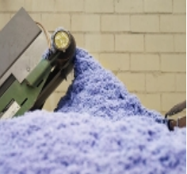
Figure 3-8 Leather shavings
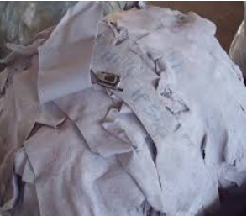
Figure 3-9 wet blue split
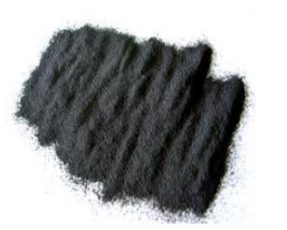
Figure 3-10 Buffing dust

Quantity of Wastes produces from shaving, buffing, splitting Processing One Ton of Raw Skins/Hides:
S.No | Nature of solid waste | Quantity(kg)/Ton
1 | Chrome splitting | 65
2 | Chrome shaving | 95
3 | Buffing dust (including shaving bovine after crust) | 65

Environmental Impacts of Tannery Solid Waste:
- Solid wastes generated from tanning industries contain different chemicals which are used during leather manufacturing process.
- These tannery solid wastes have different characteristics as different chemical and mechanical processes are applied to the raw hides/skins.
- solid waste generated during various tanning operations are not properly utilized or disposed they are likely to cause a number of problems on the environment
- Some of the bio-degradable tannery solid wastes are sources of pathogenic bacteria and volatile organic compounds emission.
- Vegetable and chrome tanned shavings and splits do not easily decompose. They are not utilized, problems of disposal are encountered.
- Excess heavy metal accumulation in soil is toxic to humans and other animals.
- Chromium metal which is the most widely used in tanning industries as chromium salt and it causes carcinogenic effect when it enters human body through food chain.

Self-check 3
Part one: chose the best Answer for the questions listed below. (each question have 1 points)
- What is the basic thing you need to monitor in samming?
A. Thickness of the wet blue
B. Moisture content of the wet blue
C. Nap effect
D. Suede effect
- What is the basic thing that you need to monitor in shaving?
A. Thickness of the wet blue
B. Moisture content of the wet blue
C. Nap effect
D. Suede effect
- What is the common complaint in shaving?
A. Over shaving
B. Folding
C. Hole
D. Shatter Mark
- What is the basic thing you need to monitor in setting out operation
A. Color uniformity
B. Removal of fat
C. The wrinkle flatness and grain smoothness
D. looseness
- Which of the following is not correct before the splitting operation is started?
A. The areas must be clean should not be slippery
B. Ensure the condition of the material is suitable for splitting.
C. No need of using personal protection during the operation.
D. The thickness that the hide will assume after it is tanned and dried
E. None of this
- Which operation is the last operation for obtaining the final hide or skin thickness?
A. Staking
B. Toggling
C. Shaving
D. Splitting
- Before shaving there is one step, which belongs to drying operation. What is that operation?
A. Overhead drying
B. Setting out
C. Vacuum drying
D. Samming
- To have good setting out the leather should be
A. Too moist
B. Should not be too moist
C. Should be trimmed
D. Should be stretched too much
- Which of the following is not factor that affect the process of drying?
A) Time
B) Speed
C) Number of leather
D) Length of the conveyer
Part two: Give short answer for the following question(each question have 2 points)
- Explain the objective of shaving.
- Explain the objective of setting out.
- Explain the objective of samming.
- Explain the objective of buffing.
- Explain the objective of different drying machine
Note: Satisfactory rating – above 60% Unsatisfactory - below 60%
You can ask you teacher for the copy of the correct answers

Operation sheet 3.1
Title: - Operating Procedures of samming Machine
Instruction: - by using operation instruction, you have to operate to operating Samming Machine after liming
Objective: - be able to develop the skill of the trainee by performing the correct Operating Procedures of Samming Machine beam house and tanning section
Tools and equipment that needed for the operations: -
- Samming machine
Precautions:-try to operate Samming for both hide and skin more than one times
Procedure
Step 1:- Switch on the machine.
Step 2:- Place the leather on the feed roller.
Step 3:- Leather passed between the two felt (Upper and lower).
Step 4:- Between two rollers high pressure acting on the leather.
Step 5:- Leather has been squeezed and the hides must be flattened sufficiently without any wrinkles
Step 6:- Moisture content is reduced from 100% to 50%.
Step 7:- Water discharge. As the water is squeezed from the leather it must drain away and not be reabsorbed by the felts
Step 8:- Clean the machine.
Step 9:- Switch off the machine.
Quality Criteria: accurately operation by given thickness

Operation sheet 3.2
Title: - Operating Procedures of wet blue splitting Machine
Instruction: - by using operation instruction, you have to operate to operating wet blue splitting Machine after liming
Objective: - be able to develop the skill of the trainee by performing the correct Operating Procedures of wet blue splitting Machine beam house and tanning section
Tools and equipment that needed for the operations: -
- Splitting machine
- Thickness gauge
Precautions:-try to operate wet blue splitting machine for both hide and skin more than one times
Procedure
Step 1:- Now the machine is ready to use.
Step 2:- Switch on the mains, start the hydraulic pump and ensure that the substance roller, cambering-decambering, table lifting and foot switches all are working properly.
Step 3:- Inspect the section (ring) rollers and rubber roller for trimming.
Step 4:- Make sure the covers and safety guards are properly fixed and emergency switches are functioning correctly
Step 5:- Start the band knife rotation, grinding wheels and ensure the bevel is correct.
Step 6:- Do the dressing of the grinding wheels with diamond dresser if necessary.
Step 7:- Check whether the pushers are excessively stressed and the electronic eye is in right position.
Step 8:- Start feeding rotation and check the correct thickness by splitting small bits. Adjust if necessary.
Step 9:- Clean the machine after finishing the work and lift away the grinders.
Step 10:- Do switch off the electric mains.
Quality Criteria: accurately operation by given thickness

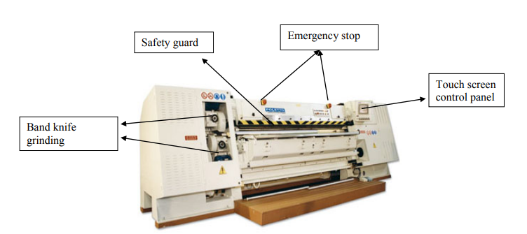
Figure 3-4 hydraulic splitting Machine

Operation sheet 3.3
Title: - Operating Procedures of setting out Machine
Instruction: - by using operation instruction, you have to operate to operating setting out Machine after liming
Objective: - be able to develop the skill of the trainee by performing the correct Operating Procedures of setting out Machine beam house and tanning section
Tools and equipment that needed for the operations: -
- setting out
Precautions:-try to operate shaving machine for both hide and skin more than one times
Procedure
Step 1:- Switch on the machine.
Step 2:- Adjust the pressure on the feed roller setting cylinder respectively.
Step 3:-Place the hides/skins on the feed roller.
Step 4:- Press the foot treadle.
Step 5:-The feed roller advances the skins alignment against the setting cylinder.
Step 6:-Setting operation takes place for the first half of the skin.
Step 7:- Depress the foot treadle so that the skin is drawn away from the setting cylinder.
Step 8:- Repeat the same procedure for the other half of the hides/skins.
Step 9:-Horse up the hides/skin to pile up.
Step 10:- Clean the machine.
Step 11:- Switch off the machine.
Step 12:- Clean the feed roller, shaving cylinder, etc.
Quality Criteria: accurately operation by given thickness

Operation sheet 3.4
Title: - Operating Procedures of Sam/setting Machine
Instruction: - by using operation instruction, you have to operate to operating Sam/setting splitting Machine after liming
Objective: - be able to develop the skill of the trainee by performing the correct Operating Procedures of Sam/setting Machine beam house and tanning section
Tools and equipment that needed for the operations: -
- Sam/setting
Precautions:-try to operate Sam/setting machine for both hide and skin more than one times
Procedure
Step 1:- Switch on the machine.
Step 2:- Place the leather on the feed roller.
Step 3:- Leather passed between the two felt (Upper and lower).
Step 4:- Between two rollers high pressure acting on the leather.
Step 5:- Leather has been squeezed and the hides must be flattened sufficiently without any wrinkles
Step 6:- Moisture content is reduced from 100% to 50%.
Step 7:- Water discharge. As the water is squeezed from the leather it must drain away and not be reabsorbed by the felts
Step 8:- Clean the machine.
Step 9:- Switch off the machine.
Quality Criteria: accurately operation by given thickness

Operation sheet 3.5
Title: - Operating Procedures of shaving Machine
Instruction: - by using operation instruction, you have to operate to operating shaving Machine after liming
Objective: - be able to develop the skill of the trainee by performing the correct Operating Procedures of shaving Machine beam house and tanning section
Tools and equipment that needed for the operations: -
- shaving
- thickness gauge
Precautions:-try to operate shaving machine for both hide and skin more than one times
Procedure
Step 1:-Switch on the machine.
Step 2:-Adjust the distance between feed rollers and shaving cylinder.
Step 3:-Sharp the shaving cylinder for sharpness and level.
Step 4:- Place the leather on the copper or brass feed roller. (First half is faced on feed roller)
Step 5:-Press the foot treadle. 6. Feed roller moves towards the shaving cylinder.
Step 7:-Then shaving is done on the leather.
Step 8:-Release the foot treadle.
Step 9:-Feed roller comes to its normal position.
Step 10:-Now repeat the same procedure for the other half of the leather.
Step 11:- Switch off the machine.
Step 12:- Clean the feed roller, shaving cylinder, etc.
Quality Criteria: accurately operation by given thickness

Operation sheet 3.6
Title: - Operating Procedures of Buffing Machine
Instruction: - by using operation instruction, you have to operate to operating Buffing Machine after liming
Objective: - be able to develop the skill of the trainee by performing the correct Operating Procedures of Buffing Machine post tanning section
Tools and equipment that needed for the operations: -
- Buffing Machine
- thickness gauge
Precautions:-try to operate Buffing Machine for both hide and skin more than one times
Procedure
Step 1:-Switch on the machine.
Step 2:-Place the leathers on the ft roller feed
Step 3:-Press the foot treadle.
Step 4:-Feed roller moves towards buffing cylinder.
Step 5:-Buffing process gets over for first half of the leather.
Step 1:-Depress the foot treadle (i.e.) feed roller come to its original position.
Step 6:-Repeat the same procedure for other half of the leather also.
Step 7:-The dust is collected in the dust-collectingbox, which should be disposed.
Step 8:-Pile the leathers.
Step 9:-Clean the machine.
Step 10:-Switch off the machine.
Quality Criteria: accurately operation by given thickness

Operation sheet 3.7
Title: - Operating Procedures of Toggling Machine
Instruction: - by using operation instruction, you have to operate to operating Toggling Machine after liming
Objective: - be able to develop the skill of the trainee by performing the correct Operating Procedures of Toggling Machine for drying operation
Tools and equipment that needed for the operations: -
- Toggling
- Clamper
Precautions:-try to operate Toggling Machine for different crust leather more than one times
Procedure
Step 1:- Stretch the leather in the mesh of the toggling table by using clips.
Step 2:- Put the mesh in the drying chamber and close the door. If it is automatic switch on the conveyer.
Step 3:- After the set time remove the leather. Step
Step 4:- Switch off the machine.
Quality Criteria: accurately operation by given temperate

Operation sheet 3.8
Title: - Operating Procedures of Vacuum dryer Machine
Instruction: - by using operation instruction, you have to operate to operating Vacuum dryer Machine after liming
Objective: - be able to develop the skill of the trainee by performing the correct Operating Procedures of Vacuum dryer Machine for drying operation
Tools and equipment that needed for the operations: -
- Vacuum dryer
Precautions:-try to operate Vacuum dryer Machine for different crust leather more than one times
Procedure
Step 1:-Lean the skin uniformly by using Teflon and stainless steel plat to flat the leather in the leather in the dryer plat.
Step 2:-Switch on the vacuum dryer with safety precision.
Step 3:-Check the leather and adjust the temperature and pressure
Quality Criteria: accurately operation by given temperate

Operation sheet 3.9
Title: - Operating Procedures of Overhead dryer conveyer
Instruction: - by using operation instruction, you have to operate to operating overhead dryer conveyer after post tanning
Objective: - be able to develop the skill of the trainee by performing the correct Operating Procedures of overhead dryer conveyer for drying operation
Tools and equipment that needed for the operations: -
- Vacuum dryer
Precautions:-try to operate overhead dryer conveyer for different crust leather more than one times
Procedure
Step 1:- Hook the leather in the conveyor hookers/place on the tube and move the loaded part.
Step 2:- Do vice versa to unload the leather
Quality Criteria: accurately operation by given temperate

Lap test 3
Instructions: Given necessary templates, tools and materials you are required to perform the following tasks. The project is expected from each student to do it.
Task-1 Given sammed wet blue leathers (from skin or hide), you are required to shave.
Task-2 Given post-tanned leathers (from skin); you are required to Sam/ set.
Task-3 Given crust leather you are required to perform splitting using splitting machine
Task -4Given crust leather you are required to perform samm using samming machine
Task -6 Given crust leather you are required to perform set out using set out machine
Task -7 Given crust leather you are required to perform buffing using buffing machine
Task -8 Given crust leather you are required to perform drying using toggling machine
Task -9 Given crust leather you are required to perform drying using vacuum drying machine
You are given three (10) hours to complete the abovementioned
Request your teacher for evaluation and feedback of your work

REFERENCE
- Covington, A. D. (2009). Tanning chemistry: the science of leather. Royal Society of Chemistry.
- Covington, A. D. (2006). The chemistry of tanning materials. In Conservation of leather and related materials (pp. 44-57). Routledge.
- Han, W., Zeng, Y., & Zhang, W. (2016). A Further Investigation on Collagen-Cr (III) Interaction at Molecular Level. Journal of the American Leather Chemists Association, 111(03), 101-106
- Leather Technicians Hand book by, J.H. Sharphouse, BSc. Revised edition 1983
- Process vessel and machine operation manual, Machine manufacturer

Participants of this Module (training material) preparation
No | Name | Qualification (Level) | Field of Study | Organization/ Institution | Mobile number | E-mail
1 | Ashenafie Mulat | BSc. | Leather engineering | Gonder poly technique collage | 0910110187 | ashenafimulat119@gmail.com
2 | Tarekeng  Jida | Msc | Chemical engineering (Leather Techenology) | LLPIDRC | 0911055370 | tarekegnb039@gmail.com
3 | Weldeyesus wendowesen | Msc | Leather engineering and Fashion Technology | TVTI | +251915854419 | abay1015@gmail.com

