Leather processing
Level-II
Based on Dec 2021, Curriculum Version 1
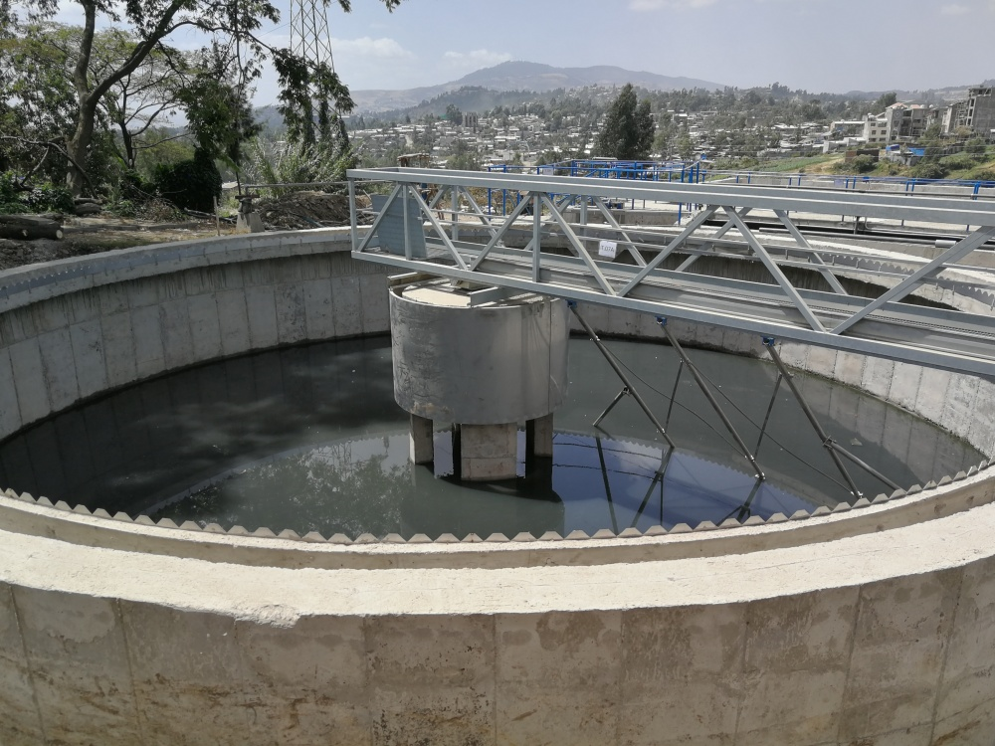

Module Title: - Operate Tannery Effluent Treatment Plant
Module code: IND LEP2 M07 1221
Nominal duration: 80 hour
Prepared by: Ministry of Labour and Skill
August, 2022
Addis Ababa, Ethiopia

Acknowledgment
Ministry of Labor and Skills wish to extend thanks and appreciation to the many representatives of TVET instructors and respective industry experts who donated their time and expertise to the development of this Teaching, Training and Learning Materials (TTLM).

Acronym
CETPs - common effluent treatment plants
DO - Dissolved oxygen
DS - Dry-solid
ETP - effluent treatment plant
MLSS - Mixed liquor suspended solids,
MBRs - membrane bioreactors
MCRT - mean cell-residence time
MGD - Million Gallons per day
TDS/tds - Total Dissolved Solids
TKN - Total Kjeldahl Nitrogen
RAS - return activated sludge
SOR - surface overflow rate
SS - suspended solids
SVI - Sludge volume index
HRT- hour per revolution time

Contents
Acknowledgment 1
Acronym 2
Introduction to the Module 5
Unit one: Perform pre-operational tasks 6
1.1 Regional/national effluent treatment standard limit 7
1.2 Work instruction and condition of effluent treatment plant machines 12
1.3 Segregating tannery liquid wastes 14
1.4 Removal of solid particulates from tannery liquid waste 15
Self-check 19
Operation sheet 1.1 19
Operation sheet 1.2 22
Lap test 23
Unit two: Perform primary treatment 24
2.1 Oxidation of lime/sulphide liquid waste 25
2.2 Treating chrome liquid waste 26
2.3 Homogenization or equalization of general tannery effluent 26
2.4 Chemical preparations and dossing during primary treatment 28
2.5 Primary sedimentation and sludge discharge 30
2.5.1 Primary sedimentation 30
2.5.2 Utilization and disposal 32
Self-check 34
Operation sheet 2.1 35
Lap test 36
Unit three: secondary treatment 37
3.1 Lifting and oxidation of primary treated effluent 38
3.2 Chemical preparations and dosing 44
3.3 Sedimentation, sludge recycling & discharging 45
Self-check 47
Operation sheet 3.1 48
Operation sheet 3.2 50
Operation sheet 3.3 51
Lap test 52
Unit four: Perform sludge dewatering 53
4.1 Sludge conditioning 54
4.2 Perform sludge dewatering 56
4.2.1 Sludge dewatering 56
4.2.2 Dewatering Technologies 56
Self-check 58
Operation sheet 4.1 59
Lap test 60
Unit five: Perform tertiary treatment 61
5.1 Nitrogen/ammonium & phosphorus removal from tannery effluent 62
5.1.1 Tertiary / advanced treatment purpose 62
5.1.2 Nutrient removal 62
5.2 Disinfecting treated tannery effluent 65
Self-check 66
Unit Six: Maintain documents and records 67
6.1 Documenting organization’s effluent treatment compliance 68
6.1.1 Records document 68
6.1.2 Importance and need for records 68
6.1.3 Types of records 69
6.2 Maintaining records for effluent treatment plant operations 72
Self-check 77
Reference 78

Introduction to the Module
In leather processing filed; the Tannery Effluent Treatment, in leather processing helps to reduce the environment impact of the west generate from leather tanning industries in leather processing operation. In leather processing, Large quantity of water is used in tanning process of which 90% of the water is discharged as effluent. A part of the leather processing, solid and gaseous wastes are also discharged into the environment
This module is designed to meet the industry requirement under the leather processing, particularly for the unit of competency: Operating Tannery Effluent Treatment Plant.
This module covers the units:
Module contents:
- Perform pre-operational tasks
- primary treatment
- secondary treatment
- sludge dewatering
- tertiary treatment
- Maintain documents and records
Learning Objective of the Module
- Perform pre-operational tasks
- Perform primary treatment
- Perform secondary treatment
- Perform sludge dewatering
- Perform tertiary treatment
- Maintain documents and records
Module Instruction
For effective use this modules trainees are expected to follow the following module instruction:
- Read the information written in each unit
- Accomplish the Self-checks at the end of each unit
- Perform Operation Sheets which were provided at the end of units
- Do the “LAP test” giver at the end of units and
- Read the identified reference book for Examples and exercise

Unit one: Perform pre-operational tasks
This unit is developed to provide you the necessary information regarding the following content coverage and topics:
  - Regional/national effluent treatment standard limit
  - Work instruction and condition of effluent treatment plant machines
  - Segregating tannery liquid wastes
  - Removal of solid particulates from tannery liquid waste
This unit will also assist you to attain the learning outcomes stated in the cover page. Specifically, upon completion of this learning guide, you will be able to:
  - standard limit of regional/national effluent treatment
  - Work instructions and OHS practices related to the tannery effluent plant treatment are identified and clarified
  - Liquid wastes are segregated based on their chemical properties or sources for treatment
  - Condition of machines and equipment for operation is checked
  - Solid particulates or suspended parts are removed manually or mechanically

Regional/national effluent treatment standard limit
Tanning industry is one of the oldest industries in the world. It is typically characterized as pollutants generated industries which produce wide varieties of high strength toxic chemicals. It is recognized as a serious environmental threat due to high chemical levels including salinity, organic load (chemical oxygen load or demand, biological oxygen demand), inorganic matter, dissolved, suspended solids, ammonia, total kjeldahl nitrogen (TKN), specific pollutants (sulfide, chromium, chloride, sodium and other salt residues) and heavy metals etc. Large quantity of water is used in tanning process of which 90% of the water is discharged as effluent. A part of the leather processing, solid and gaseous wastes are also discharged into the environment. During the chrome tanning process, 40% unused chromium salts are usually discharged in the final effluents, causing a serious threat to the environment. Exposure to chromium, pentachlorophenol and other toxic pollutants increase the risk of dermatitis, ulcer nasal septum perforation and lung cancer. Without any exceptions there is no effluents treatment plant (ETP) in leather tanning industries in the country and moreover, the owners of tannery industries are not much concerned about human health and environmental safety.
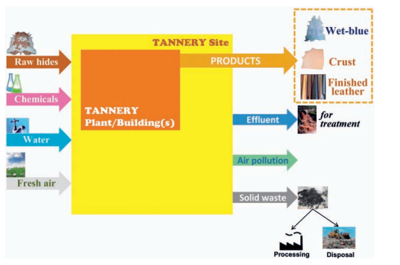
Figure 1. 1 Overview of the tanning industry

Production processes in leather tanning with inputs and outputs

Figure 1. 2 leather tanning with inputs and outputs
Table 1 Pollution Load per ton of Hides/Skins Processed
S.No | Pollution parameter | Pollution Load (Kg)
1 | Volume (m³) | 40
2 | BOD | 70
3 | COD | 180
4 | Chlorides (Cl) | 270
5 | Dissolved Solid (DS) | 600
6 | Suspended Solid (SS) | 100
7 | Sulfides | 4
8 | Chromium | 30
Note: Composite wastewater (no segregation)
Types of pollution
Tannery wastes pollute the receiving water generally in four >ways: -
- Physically,
- Chemically
- Physiologically and
- Biologically
Effluent Treatment Plant Operation
In this section, treatment process will be briefly discussed to provide an overall concept of wastewater treatment plant and detailed information on each of these operations/processes.
Before turning to treatment itself, it is important to bear in mind the following:
  - The design of an effluent treatment plant (ETP) is always tailored to the requirements of a specific site; thus, there are no two identical ETPs.
  - Pollutants contained in effluent cannot disappear; they are only converted into something which is environmentally more acceptable or easier to dispose of (sludge).
  - Somewhat paradoxically, the obvious is often overlooked: the same amount of pollutants at lower water consumption means lower hydraulic load (volume) but higher concentration – not always easy to treat.
  - It is important for a tanner to understand the relation between the leather technologies applied and wastewater treatment in order to reduce the overall cost of treatment.
Effluent treatment consists of a combination of unit processes designed to reduce wastewater contaminants to acceptable levels. A choice of which unit processes to include in the treatment takes into account a number of criteria including:
- Effectiveness in removing target pollutants
- Energy requirements
- Complexity
- Total cost (capital, operation Costs
- Robustness
- Ease of operation & maintenance
- Capability
Tannery wastewater treatment processes can be broadly classified as physical, chemical or biological. These processes, which consist of series of unit operations, are applied in different combinations and sequences depending upon the prevailing situations of influent concentration, composition and condition and specification of the effluent
Wastewater treatment is a multi-stage process to purify wastewater before it enters a body of natural water, or it is applied to the land, or it is reused. The goal is to reduce or remove organic matter, solids, nutrients, cr and other pollutants since each receiving body of water can only receive certain amounts of pollutants without suffering degradation. Therefore, each effluent treatment plant must adhere to discharge standards – limits usually promulgated by the relevant environmental authority as allowable levels of pollutants, for practical reasons expressed as bod5, cod, suspended solids (SS), Cr, total dissolved solids (TDS) and others.
The three main categories of tannery wastewater, each one having very distinctive characteristics, are:
- Effluents emanating from the beam-house – liming, deliming/bating, water from fleshing and splitting machines; they contain sulphides, their pH is high, but they are chrome-free.
- Effluents emanating from the tan yard (tanning and re-tanning, sammying) – high Cr content, acidic.
- Soaking and other general effluents, mainly from post-tanning operations (fat-liquoring, dyeing) – low Cr content
Techniques for treating effluent from tanneries include source segregation and pretreatment for removal/ recovery of chromium; grease traps, skimmers or oil water separators for separation of floatable solids; filtration for separation of filterable solids; flow and load equalization; sedimentation for suspended solids reduction using clarifiers; biological treatment, typically aerobic treatment, for reduction of BOD; biological nutrient removal for reduction in nitrogen and phosphorus; chlorination of effluent where disinfection is required; dewatering and disposal of residuals in designated hazardous waste landfills.
Air Emissions
Sources of air emissions and odor from tanning industry have been listed in the following Table 2 and Table 3
Table 2 Sources of Air Emissions
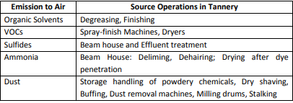
Table 3 Odor Emissions to Air
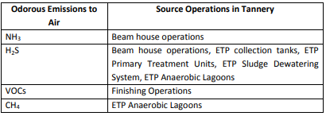
Solid Waste
Solid waste includes salt from raw skin/hide dusting; raw skin/hide trimmings; hair from the liming/dehairing process, which may contain lime and sulfides; and fleshing from raw skins/hides. Other solid waste from tannery industry includes wet-blue shavings, containing Cr₂O₃; wet-blue trimming, which is generated from finishing processes and contains Chromium oxide, syntans, and dye; and buffing dust, which also contains Chromium oxide, syntans, and dye. The reducing characteristics of tannery sludge stabilize Cr(III) with respect to Cr(VI), due to the presence of organic matter and sulfide
Strategy for Management of Solid Wastes
  - Promotion of recovery of salt and its further utilization
  - Promotion of utilization strategies for trimmings, fleshing, hair, buffing dust and chrome shavings
  - Promotion of disposal strategies based on bio-methanization for energy recovery and composting
  - Promoting recovery of value added products from fleshing ( amino acids etc)
  - Promoting the manufacture of bricks from chromium bearing sludge

Work instruction and condition of effluent treatment plant machines
Aims of Wastewater Treatment
The aim of the wastewater treatment is to enable wastewater to be disposed safely, without being a danger to public health and without polluting watercourses or causing other nuisance. In other words, the goal is to reduce or remove organic matter, solids, nutrients, chromium and other pollutants. Another important aim of the wastewater treatment is to explore the possibility of recovering energy, nutrients, water and other valuable resources from wastewater.
Machines and equipment’s
- Screening (rough bar, rotary drum, rotary brush)
- Sulphide oxidation tank
- Chrome dissolution tank
- Equalization or homogenization tank
- Sedimentation tank
- Coagulation and flocculation tank
- Aeration Sulphide, blower, vertical mixer/stirrer
- Sludge dewatering tank
- Filter press (recessed-plate, belt, decanter centrifuge)
- Pumps (dossing, submersible, screw lifting)
Treatment of Tannery waste
Screens: Required to remove fleshing, hairs, and other floating matters. Screening can be used for glue manufacture or recover hair, fleshing & fats.
Sedimentation: 4 hr HRT is effective in 90% removal of solids. It can be continuous flow or fill and draw type.
No appreciable reduction in TDS, COD, and BOD occurs in primary treatment. However, wastewater can be discharged in sewers after it.
Chemical coagulation (with or without neutralization): Coagulant like alum, ferric chloride, ferrous sulphate can be used.
- Ferrous sulphate is effective for colour, chromium, sulphide & SS removal from chrome-tan wastes.
- Alum is used with prior neutralization by CO2 or acid.
Biological treatment:
- Treatment in ASP when wastewater is mixed with sewage is feasible. About 90% removal of BOD and COD is possible.
- Chromium removal is necessary before biological treatment.
- Trickling filter can also be used.
- Anaerobic filter: 90% COD and 91 to 97% BOD removal can be obtained at HRT of 12 h.
- Low cost treatment such as oxidation pond, anaerobic lagoons followed by aerated lagoon can be used.
- Normally residual chromium concentration after removal in PST will not have adverse effect on biological treatment.
- NaCl removal is a problem from this waste.
- Spent soak liquor (10% NaCl) and pickling liquor (8% NaCl) can be segregated and treated separately by solar evaporation, when high NaCl results in the receiving streams.
- Spent liquor reuse is more attractive.
- Use of Neem oil or other preservatives than salt can also reduce the problem of NaCl.
- Segregation of spent chrome-tan liquor and recovery of chromium is often practiced.
- Chemical precipitation of Chromium in the form of Cr(OH)₃ by lime at pH 6.6. –
- Separation of Cr(OH)₃ by sedimentation or filtration.
- H2SO4 addition and recovery of chrome sulphate solution which can be reused.
- Recovery can considerably reduce pollution.

Segregating tannery liquid wastes
Categories and Segregation of Wastewater
The three main categories of wastewater, each one having very distinctive characteristics, are
- Effluents emanating from beam house Liming, deliming, water from fleshing: they contains sulphides, their pH is high, chrome free.
- Effluents emanating from the tan yard (tanning and post tanning) - high Cr content, acidic
- Soaking and other general effluents, Low Cr content
It is very important to segregate these streams and to pre-treat them separately according to their characteristics to avoid possible safety risks (formation of deadly hydrogen sulphide) and to reduce the cost of treatment and sludge disposal (to avoid contamination of sludge with Cr). The mixing of liming and tanning streams gives rise not only to the obnoxious smell typical of poorly managed tanneries; the resulting lethally poisonous gas, hydrogen sulphide (H2S), is still by far the most frequent killer in tannery accidents, which occur mainly in inadequately ventilated spaces, especially in pits and channels.
Sources of wastewater
- Wastewater originates from all the operations.
- It is either continuous from some operation or intermittent from few operations.
- Spent liquors from the soaking, liming, bating, pickling, tanning and finishing operation is discharged intermittently.
- Spent liquors are small in volume but highly polluted.
Preliminary treatment
Typically, in the case of common effluent treatment plants (CETPs) servicing tannery clusters often found in developing countries, it is essential to have pre-treatment units installed in individual tanneries. Their role is to remove large particles, sand/grit and grease, but also to significantly reduce the content of chrome and sulphides before the effluent is discharged into the collection network.

Removal of solid particulates from tannery liquid waste
Preliminary Treatment
Typically, in the case of common effluent treatment plants (CETPs) servicing tannery clusters often found in developing countries, it is essential to have pre-treatment units installed in individual tanneries. Their role is to remove large particles, sand/grit and grease, but also to significantly reduce the content of chrome and sulphides before the effluent is discharged into the collection network.
Purpose of preliminary treatment
  - The purpose of the preliminary wastewater is to remove the easily separated components i.e., coarse solids and other large materials (E.g., hair, flesh, skin/hide trimmings) often found in raw wastewater.
  - Prior to any treatment it is essential to remove the large solids and skin fragments which will otherwise block pipes, pumps and other gullies. It is also necessary to enhance the operation & maintenance of subsequent treatment units and to ensure a satisfactory quality of final effluent and final sludge product.
Sequence of preliminary treatment
The recommended sequence for preliminary treatment facilities is given in Fig. 1.3. and as follows.
  - Influent - Inlet of wastewater
  - Removable inclined bar screen - Removal of coarse solids
  - Sloping concrete slab - collection of screenings
  - Sliding gates - act as valves in channels
  - Grit channels - removal of grit
  - Drain, fitted with valve - drained out from the grit channel
  - Critical flow weir - Measure and control the flow
  - Inlet - Inlet to the next treatment process
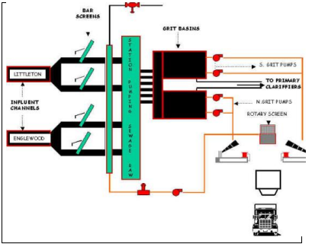
Figure 1. 3 Sequence of preliminary treatment
Screening
Screening is the process of removing large solids in tannery effluents before entering the effluent treatment.
Purpose of Screening is the first unit operation used at wastewater treatment plant. Screening removes or reduces the size of trash and large materials such as flesh, trimmed piece of skin/hide, plastics, and metals that get into treatment system. The materials that are removed from the wastewater by the screens are referred to as screenings. These solids are collected on screens and scraped off for subsequent disposal
Process description The screening chamber consists of vertical stainless steel screens at an angle (usually 30 degrees) to the horizontal. Stainless steel is used to prevent the screens from corrosion. They have uniform openings to retain large solids. The spacing of the screens determines the size of the particles removed.
- Debris is captured on screens consisting of parallel bars placed at an angle.
- Screenings collected on bars must be raked off (manually or mechanically).
- Screenings are typically disposed of in sanitary landfills.
- Debris ground-up by a comminuter typically becomes part of the waste sludge
Tannery Solid Waste Management
- Recovery and reuse of salt
- Use of lime sludge in ETP/construction application
- Animal feed from flashings
- Glue/Gelatin recovery from flashings
- Grease and protein recovery from fleshing
- Leather Board Manufacturing from chrome shavings
- Methane production from organic wastes
- Bio diesel/fuel generation
- Brick making from lime sludge
- Recovery of chromium
- Composting of waste sludge and other solid wastes
Removal of grit and floating matter
A simple, non-aerated grit-and-floating-matter removal chamber is usually placed in a horizontal gravity channel immediately after the rough screen.
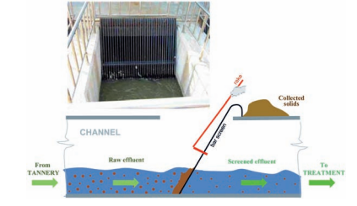
Figure 1. 4 Rough bar screen, operation principle
Fine screening should drastically reduce the amount of fine suspended solids. The figures below show rotary-drum screens with outer and inner flow.
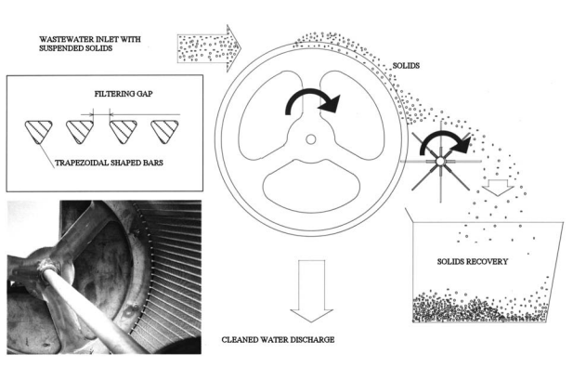
Figure 1. 4 Rotary-drum (Konica) screen, outer flow
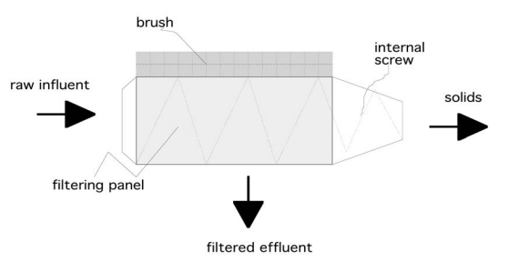
Figure 1. 5 Rotary-drum fine screen, inner flow

Self-check
Directions: Answer all the questions listed below.
Instruction;
I true or false
- Pollutants contained in effluent cannot disappear; they are only converted into something which is environmentally more acceptable or easier to dispose of (sludge).
- During the chrome tanning process, 60% unused chromium salts are usually discharged in the final effluents, causing a serious threat to the environment.
- Wastewater treatment is a multi-stage process to purify wastewater before it enters a body of natural water, or it is applied to the land, or it is reused.
II Matching
A
- Screens
- Solid waste
- Biological treatment
- Preliminary treatment

B
- Required to remove fleshing, hairs, and other floating matters
- Remove large particles, sand/grit and grease
- Includes salt from raw skin/hide dusting
- About 90% removal of BOD and COD is possible

III Short answer:
1, List and explain the three main categories of tannery wastewater.
- What is the aim of the wastewater treatment?
- Write the name of different modes of aeration in activated sludge process. (3 point)

Operation sheet 1.1
Operation title: Determination of settleable matter
Purpose: to practice and demonstrate the knowledge and skill required in determination of settleable matter.
Instruction: use the given figure below, the tools and equipment required in determination of settleable matter. For this operation you have given an hour and you are expected to provide the answer on the given table
Objective; This simple test can be made to show quickly and qualitatively if the primary and secondary processes are functioning properly. Settleables solids in tannery wastewater may be determined and reported on either a volume (ml/l) or a weight (mg/l) basis.
Apparatus:
- An Imhoff cone, made either of pyrex glass or clear plastic material
- A cone support
- A long glass stirring rod
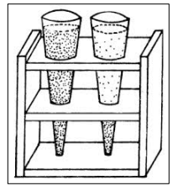
Figure 1. 6 Imhoff test
Procedure: Volumetric:
- Fill an Imhoff cone to the 1-liter mark with a well-mixed sample. Occasionally, settleables matter in a given wastewater sample may exceed the 40 ml/L graduation of Imhoff cone. In these cases, use a 500 ml volume of the sample and transfer it to an Imhoff cone. Follow the procedure, and then multiply the value of settleable matter measured by a factor of two to express the final result in milliliters per liter.
- Settle for 45 minutes and then gently stir the upper portion of the sample with the glass rod to dislodge suspended matter clinging to the tapered sides of the cone.
- Settle 15 longer, then read the volume of settleable matter in milliliters per liter and express as milliliters of solids settled per liter of original sample volume.

Operation sheet 1.2
Operation title: Procedures of brush screening of tannery west
Purpose: To practice and demonstrate the knowledge and skill required in brush screening.
Instruction: Use the given figure below, the tools and equipment required in brush screening. For this operation you have given 3 hour and you are expected to provide the answer on the table.
Procedures on each step of the treatment plant. Brush screening
- Allow the factory discharge to pass through the brush screen. Record the starting and stopping time of the machines.
- Collect the suspended matter screened by the brush screen in the tanks
- Open the gate to sulphide oxidation tank for the sulfide liquor
- Open the gate to equalization tank for general liquors
- If there is overflow immediately open the gate to the rivet just till the flow rate reaches the norm level. Records the required information
- Collect the appropriate samples of the factory discharge and carry out the necessary tests.
- If the brush screen is blocked with suspended matters ,wash the screen with plenty of water
- Open/close the gates observing the level in the tanks to avoid overflow from the tanks.

Lap test
Instructions to students:
- Given the raw materials perform the below mentioned task.
- You are given three (3) hours to complete these tasks.
- Brush screening of tannery west
- Determination of settleable matter
- Request your teacher for evaluation and feedback of your work

Unit two: Perform primary treatment
This unit is developed to provide you the necessary information regarding the following content coverage and topics:
- Oxidation of Lime/sulphide liquid waste
- Treating chrome liquid waste
- Homogenization or equalization of general tannery effluent
- Chemical preparations and dossing during primary treatment
- Primary sedimentation and sludge discharge
This unit will also assist you to attain the learning outcomes stated in the cover page. Specifically, upon completion of this learning guide, you will be able to:
- Lime/sulphide liquid waste pre-treatment is performed as per operational procedures
- Chrome liquid waste is treated as per operational procedures
- homogenization or equalization operation is performed as per operational procedures
- Chemical preparations and dossing is carried out per operational procedures
- sedimentation, clarification and sludge discharging activities are performed per operational procedures

Oxidation of lime/sulphide liquid waste
Primary treatment
Primary Treatment is a physical (non-biological) treatment process that takes place in a tank and allows substances to settle or float, and be separated from the water being treated.
Primary treatment refers to the physical-chemical separation of the major pollutants from the raw wastewater, including suspended solids, sulphide and chrome removal and the associated BOD and COD loadings. The processes usually classified as primary treatment is balancing, aeration settling or sedimentation and floatation.
Objectives
- To eliminate the coarse material normally present in the raw wastewater that could clog/block pumps, pipes and possibly sewer lines.
- To mix and balance well different tannery streams and thus produce homogenized “raw material” that can be treated in a consistent manner.
- To adjust pH and eliminate toxic substances (sulphides) and avoid shock loads that can negatively affect the rather sensitive biological treatment.
- To significantly decrease the BOD/COD load and thus simplify the biological treatment phase and reduce its cost.
To summarize, the purpose is to eliminate the coarse matter, remove almost completely Cr and sulphides, remove the major part of suspended solids, and considerably reduce the BOD and COD content.
Basic steps:
- Screening (bar, self-cleaning)
- Pumping/lifting
- Fine screening
- Equalization and sulphide oxidation
- Chemical treatment (coagulation, flocculation)
- Settling
- Sludge dewatering

Treating chrome liquid waste
Chrome effluent treatment
Originally, the tannery was carrying out only vegetable tanning and due to seasonal availability of raw material, the tannery could operate only for 3-4 months a year. Later, chrome tanning was started in 1997 to be able to operate the tannery for at least 5-7 months a year. A simple system for treatment of chrome is established as follows:
Spent liquor from chrome tanning is segregated and sent to a collection tank of 500-litre capacity. This is pumped to a reaction-cum-settling tank where mgo [supplied free of cost by a company called Chemways] is added in slurry form. There is no ph control and there is no mechanical agitation in the reaction tank. After settling, the supernatant is sent to the solar evaporation pond. Chrome sludge is taken to a collection tank from where Chemways collects it free of cost regularly, for recovery of chrome at their works.

Homogenization or equalization of general tannery effluent
The effluent from the various tanning processes varies considerably in flow and concentration of pollutants because the discharges from the leather processes are not constant. This variation affects the operation of the treatment system and could adversely affect the effluent quality from the plant.
It is very important to keep all particulate matters in suspension, i.e., to avoid settling of solids. This is achieved by using mixing-cum-aeration devices such as diffused-air systems (preferred), Venturi ejectors, and fixed or floating aerators (lately avoided due to lower efficiency and the problem of aerosols). In practice, to play it safe, the volume of the equalization tank corresponds to the total daily effluent discharge.
A typical equalization tank will have transfer pumps for equalized effluent. The capacity of the pumps is based on tank capacity, transfer time and head. One pump of cast iron with inside parts of stainless steel and one stand-by pump are sufficient unless effluent volume is very high (say 1,500 m3 /d or more). The pumping line(s) are also a good place to set an electro-magnetic flow meter
The objectives of the equalization are
  - To minimize or control fluctuations in wastewater characteristics in order to provide optimum conditions for subsequent treatment processes.
  - To homogenize the inlet wastewater in terms of quantity and quality
Equalization – homogenization – sulphide oxidation
The main aims here are:
  - homogenization of the effluent (quantity and quality); and
  - sulphide elimination, mostly by catalytic oxidation.
It is very important to keep all particulate matters in suspension, i.e., to avoid settling of solids. This is achieved by using mixing-cum-aeration devices such as diffused-air systems (preferred), Venturi ejectors, and fixed or floating aerators (lately avoided due to lower efficiency and the problem of aerosols). In practice, to play it safe, the volume of the equalization tank corresponds to the total daily effluent discharge.
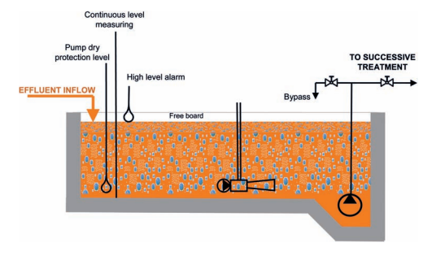
Figure 2. 1 view of equalization, homogenization tank
Approximately 1 kg of O2 is needed to oxidize 1 kg of S2- to thiosulphate, whereas the oxygen transfer efficiency is about 1.5 kg O2/kWh (simplified approximation: 1 kg S2- = 1 kg O2 = 1kWh). Again, in practice, attention is focused on the energy required to keep the solids in suspension (some 50 W/m3), which is then sufficient for sulphide oxidation; the amount of catalyst, MnSO4 · 4 H2O, industrial purity, is about 20 g per cubic meter of tank capacity. Whichever the mixing/aeration system chosen, it is necessary to be possible to remove the mixing device without stopping the treatment process. The inlet and the outlet of the equalization tank should be as far away from each other as possible to allow proper mixing (and no short-circuiting).
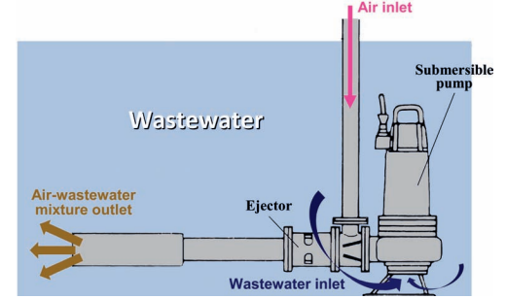
Figure 2. 2 Venturi-type ejector often installed for mixing and aeration in the homogenization tank
A typical equalization tank will have transfer pumps for equalized effluent. The capacity of the pumps is based on tank capacity, transfer time and head. One pump of cast iron with inside parts of stainless steel and one stand-by pump are sufficient unless effluent volume is very high (say 1,500 m3/d or more). The pumping line(s) are also a good place to set an electro-magnetic flow meter.

Chemical preparations and dossing during primary treatment
Typical tannery effluent treatment plant auxiliary chemicals and their dosing are given in Table 1.4.
Table 4Typical chemical chemical usages in tannery effluent treatment plant
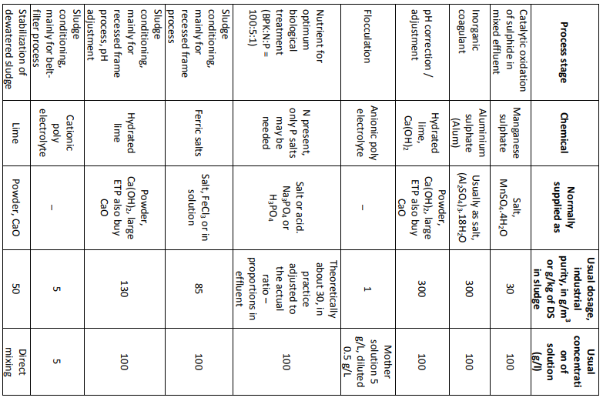Chemical treatment (coagulation, flocculation)
Chemicals are added in order to improve and accelerate the settling of suspended solids, especially of fine and colloidal matter. In wastewater treatment operations, the processes of coagulation and flocculation are employed to separate suspended solids from water. These terms are often used interchangeably, or the single term – be it “coagulation” or “flocculation” – is used to describe both; sometimes “flocculation” is understood as the second stage of “coagulation”. In fact, they are two distinct processes usually carried out in sequence as a combination of physical and chemical procedures. Finely dispersed solids (colloids) suspended in wastewater are stabilized by negative electric charges on their surfaces, causing them to repel each other. Since this prevents these charged particles from colliding to form larger masses, called flocs, they do not settle. Coagulation is the destabilization of colloids by neutralizing the forces that keep them apart. Cationic coagulants provide positive electric charges to reduce the negative charge (zeta potential) of the colloids. As a result, the particles collide to form larger particles (flocs). Rapid mixing is required to disperse the coagulant throughout the liquid. Care must be taken not to overdose the coagulants as this can cause a complete charge reversal and thus re-stabilize the colloid complex.

Flocculation is the action of polymers to form bridges between flocs and bind particles into large agglomerates or clumps. In this process it is essential that the flocculating agent be added by slow and gentle mixing to allow for contact between the small flocs and to agglomerate them into larger particles. The newly formed agglomerated particles are quite fragile and can be broken apart by shear forces during mixing. Care must also be taken not to overdose the polymer as doing so will cause settling/clarification problems. Once suspended particles are flocculated into larger particles, they can usually be removed from the liquid by sedimentation, filtration, straining or floatation. The flocculation reaction not only increases the size of floc particles in order to settle them faster, but also affects the physical nature of flocs making them less gelatinous and thereby easier to dewater. The inorganic coagulants are compounds that break colloidal suspensions and help floc forming.

Primary sedimentation and sludge discharge

Primary sedimentation
Primary sedimentation is the process by which the velocity of the water is reduced below the point at which it can transport the suspended solids matter so that much of it settles and can be removed as sludge.
The main objective at this stage is the removal of suspended solids; however, various constituents such as fats, waxes, mineral oils, floating non-fatty materials, etc. (“grease”), not already removed in the grit-andoil chamber (usually positioned between screening and equalization), are also separated here. Primary settling tanks (clarifiers) are either circular (more commonly used) or rectangular with continuous grease (scum) removal at the top and sludge removal at the bottom. The key design parameters are:
  - detention time – usually 1 to 2 hours (vertical clarifiers of the Dortmund type); \
  - surface hydraulic loading, expressed in m3/m2 of tank surface per hour or m/h, typically 1 to 2 m3/m2 per hour;
  - Surface solids rate, expressed in kg/m2 and indicating the quantity of SS crossing the surface area of the tank over a certain time span (hour, day).
The surface solids rate is most frequently used in the design of sludge thickeners but, due to the quantity (4-6 g/l) and flocculent nature of tannery effluent solids, it is useful in controlling the primary sedimentation as well. Circular tanks are generally preferred as recirculation is easier. A mechanical device (scraper) is necessary in larger settling tanks.
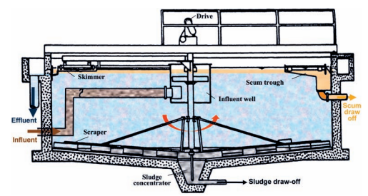
Figure 2. 3 Cross section of a typical circular sedimentation tank
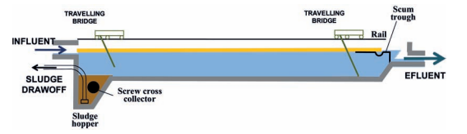
Figure 2. 4 Cross section of a rectangular sedimentation tank with travelling bridge shown in two positions
Activated sludge process
The activated sludge process is an aerobic, biological process, which uses the metabolism of microorganisms to remove substances causing oxygen demand. The qualitative biochemical reaction-taking place in the organic matter stabilization process can be summarized in the following manner:
Inert matter + Organic matter + Oxygen + Nutrients + Microorganisms ===
New micro-organisms + CO2 + H2O + additional inert matter
The activated sludge process relies on a dense microbial population being mixed in suspension with the wastewater under aerobic conditions. With a high food and oxygen supply, extremely high rates of microbial growth and respiration can be achieved, resulting in the utilization of the organic matter into oxidized end products and the biosynthesis of new microorganisms
Advantages of an activated sludge process
  - The initial cost is lower than trickling filter.
  - Compactness of design results in smaller land area requirement.
  - The effluent is a clearer sparkling liquid, which is free from odour.
  - It gives freedom from fly nuisance.
  - Result gives very, high efficiency, over 90% removal of BOD and total solids.
  - The head required for operation is small as compared to trickling filter.
Disadvantages of activated sludge process
- The operational cost is high as compared to trickling filter.
- The process is very sensitive and if goes out of order, it gives much trouble in settling it right.
- Disposal of large quantity of sludge with high moisture content becomes a problem.
- It requires a skilled attendance

Utilization and disposal
In comparison with sanitary sludges, tannery sludge has greater inorganic matter content, greater heavy metal content, especially chromium and greater sulfur compound content. However, the main stumbling block is the chromium content, with legislation and practice varying a lot from country to country.
A number of solutions for utilization and/or safe disposal of tannery sludge have been proposed, practiced, tested, and applied at pilot and industrial scale: landfill, land application, composting, anaerobic digestion, thermal treatment, verification, pyrolysis, brick making, etc., none of them proving satisfactory enough. There is certainly no universal solution for sludge utilization/application. Each ETP produces sludge of specific characteristics and different regions and countries have quite different regulations regarding sludge utilization. Therefore, prior to any ETP construction, a detailed assessment of options should be prepared and the most suitable application proposed.
In any case, handling, storage and transport of sludge and solid wastes from PTPs and ETPs should also be safe and not contaminate the surroundings; thus, for example, the collection points should be protected against bad weather (rain, for example).
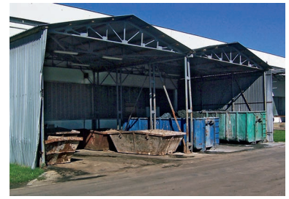
Figure 2. 5 Containers for solid waste

Self-check
Directions: Answer all the questions listed below.
Instruction
I Choice
1, Advantages of an activated sludge process
  - The initial cost is lower than trickling filter.
  - Compactness of design results in smaller land area requirement.
  - The effluent is a clearer sparkling liquid, which is free from odour.
  - It gives freedom from fly nuisance E, all
2, Purpose of Settling is
A, to remove coarse dispersed phase B, to remove coagulated and flocculated impurities.
C, To remove precipitated impurities after chemical treatment. D,all
3, Primary treatment separates suspended solids and greases from wastewater.
A, true b, false
4, The main aims of equalization – homogenization
A, homogenization of the effluent (quantity and quality); and
B, sulphide elimination, mostly by catalytic oxidation. C,all D, none
5, In comparison with sanitary sludges, tannery sludge has
a, greater inorganic matter content, b, greater heavy metal content, especially chromium c, greater sulfur compound content. d, all
II Blank space
- ……….are added in order to improve and accelerate the settling of suspended solids, especially of fine and colloidal matter.
- ………… is the action of polymers to form bridges between flocs and bind particles into large agglomerates or clumps.
- ………. is an aerobic, biological process, which uses the metabolism of microorganisms to remove substances causing oxygen demand.
- Primary treatment separates suspended …………..and ……….. from wastewater
III, Short answers
1, what is primary sedimentation?
2, Define briefly homogenization?
3, What is the objective of primary treatment?

Operation sheet 2.1
Operation title: Procedures of sulphide oxidation of tannery wastewater?
Purpose: To practice and demonstrate the knowledge and skill required in Sulphide Oxidation.
Instruction: Use the given figure below, the tools and equipment required in Sulphide Oxidation. For this operation you have given 5 hour and you are expected to provide the answer on the given table.
Procedures on each step of the treatment plant; sulphide oxidation
- Record the level difference on the tanks every morning
- Collect the concentrated sulphide liquor discharge
- charged from the factory (usually in the morning)
- Pump this liquor into equalization tank after 4 hr retention timeRecord the P^{H} settleable matter and suspended matter of the sulphide oxidation tank liquor
- Wash the tank when it is full of sludges or ever y 15 days (Record the tank of washing dates
N.B.
    - Do not by pass any liquor without the knowledge of the plant supervisor. If by passed
    - Follow all the instructions from the plant supervisor.
    - If there is inconveniency on the operation immediately inform to the plant supervisor.

Lap test
Instructions to students:
- Given the raw materials perform the below mentioned task.
- You are given three (5) hours to complete these tasks.
- sulphide oxidation
- Request your teacher for evaluation and feedback of your work

Unit three: secondary treatment
This unit is developed to provide you the necessary information regarding the following content coverage and topics:
- Lifting and oxidation of primary treated effluent
- Chemical preparations and dossing
- Sedimentation, sludge recycling & discharging
This unit will also assist you to attain the learning outcomes stated in the cover page. Specifically, upon completion of this learning guide, you will be able to:
  - Lifting and oxidation of primary treated effluent is performed.
  - Chemical preparations and dossing is carried out
  - Secondary sedimentation, sludge recycling & discharging activities are performed

Lifting and oxidation of primary treated effluent
Secondary treatment (biological treatment)
Secondary treatment is the treatment process used to remove dissolved and suspended organic materials from the water being treated. The effluent from the primary sedimentation tank contains about 60-80% of the unstable organic matter originally present in sewage. This colloidal organic matter, which passes the primary clarifiers, without settling there, has to be removed by further treatment. This further treatment of wastewater is called secondary treatment in which biological processes are used to remove most of the organic matter. The secondary treatment is directed principally towards the removal of biodegradable organics and suspended solids
Biological (secondary) treatment
- Coagulate and remove the non-settle able colloidal solids.
- Stabilize the organic matter.
- Reduce the organic matter.
- Remove the nutrients.
In short, stabilize organic matter: convert organic matter to non-biodegradable form so that it does not exert oxygen demand.
Objective and basic principles
The main objective at this stage is to further reduce the amount of organic (expressed as BOD and COD)3 and other substances still present in the effluent after the primary treatment and thereby satisfy the standards/limits for discharge into surface waters (rivers, lakes).
The biological treatment duplicates processes that take place in nature, but under controlled conditions and, especially, at a highly accelerated pace; however, the efficiency of this treatment largely depends on the biodegradability of the polluting substrate, i.e., its inherent capacity to decompose by biological processes. The remaining suspended and colloidal solids are removed by flocculation and adsorption.
While biological treatment may be aerobic, facultative or anaerobic (or some combination thereof), in practice, almost only aerobic systems are used; exceptionally, in countries with a hot climate and where a lot of land is available, facultative (preferably aerated/facultative) lagoons are also used.
Due to the inherent characteristics of tannery effluents, primarily their sulphide/sulphate content, in practice, anaerobic treatment is used only in sludge digestion.
Among many variations of the aerobic process, the most widely used method is (complete-mix) activated sludge treatment with extended aeration; despite some very interesting features, membrane bioreactors (MBRs) have not made significant inroads in the tanning sector. T
he activated sludge process is an aerobic, biological process, which uses the metabolism of microorganisms to remove substances causing oxygen demand. The qualitative biochemical reaction taking place in the organic matter stabilization process can be summarized in the following manner:
Inert matter + organic matter + oxygen + nutrients + micro-organisms =
new micro-organisms + CO2 + H2O + additional inert matter
Simply said, we stimulate micro-organisms to convert (eat and digest) harmful, oxygen-demanding organic compounds into an environmentally more acceptable form (micro-organisms) and low-energy, stable compounds like water and carbon dioxide.
The microbial community that does that job comprises various species of bacteria, fungi, protozoa, sometimes rotifers (multicellular animals only found in very stable activated sludge with long retention times), even nematodes, the composition of the population depending on a plethora of factors.
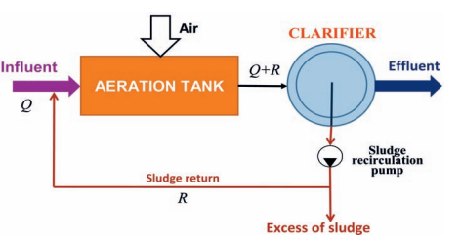
Figure 3. 1 A simplified flow diagram of the activated sludge process
Generally, the biological stage is the most complex part of the overall effluent treatment process, with highest investment and operational costs, its day-to-day running requiring considerable skills and experience.
Basic Ingredients
  - High density of microorganisms (keep organisms in system)
  - Good contact between organisms and wastes (provide mixing)
  - Provide high levels of oxygen (aeration)
  - Favorable temperature, pH, nutrients (design and operation)
  - No toxic chemicals present (control industrial inputs)
Dispersed (suspended) growth vs Fixed growth
Two approaches of secondary treatment – fixed film, and suspended film systems
Dispersed Growth (suspended organisms)
- Activated sludge
- Oxidation ditches/ponds
- Aerated lagoons, stabilization ponds
Fixed Growth (attached organisms)
- Trickling filters
- Rotating Biological Contactor
Activated Sludge
- Process in which a mixture of wastewater and microorganisms is agitated and aerated
- Leads to oxidation of dissolved organics
- After oxidation, separate sludge (mostly microbial cells, water, and other contaminants) from wastewater
- Induce microbial growth
- Need food, oxygen
- Want Mixed Liquor Suspended Solids (MLSS) of 3,000 to 6,000 mg/L
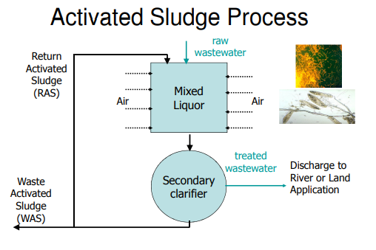
Figure 3. 2 Activated sludge process
Main operational parameters
- The main operational parameters – expressions important to understanding the process – are: Total influent volume, Q: volume of treated effluent (m3/day)
- Tank volume, V: aeration tank volume (m3)
- Organic loading, F: total BOD5 applied (kg/day)
F = (f x Q)/1,000
where f is the BOD5 of the influent (mg/l)
- Mixed liquor suspended solids, M: M = (MLSS x V)/1000
where MLSS is the concentration of SS
in mixed liquor in the aeration tank (mg/l)
- Loading factor, F/M: BOD5 kg per day per kg of mixed liquor suspended solids (MLSS) in the aeration tank (mg/l)
- Hydraulic retention time, T: T = (V/Q) x 24
where V is aeration tank volume (m3)
A uniform inlet flow over the entire day provides optimum conditions for absorbing the effect of possible peaks of organic load or toxic substances (shock loads) and enhancing the efficiency of secondary sedimentation.
The BOD here is in practice taken to represent the amount of food provided to the micro-organisms contained in the system. Due to the difficulty of obtaining reliable BOD5 values, COD is sometimes used.
Hydraulic retention time is actually the average time (in hours) the influent spends passing through the aeration tank; the extended aeration process, typical for tannery effluents, is usually longer than 24 hours.
Extended aeration plants are characterized by the introduction of wastewater directly into the reactor basin, long aeration, high sludge return ratio, low sludge wastage and high MLSS: the F/M (kg BOD/kg MLSS per day) ratio is only ≤ 0.05 – 0.1 in contrast to the conventional (0.15-0.4) or high-load type (0.4-1.0).
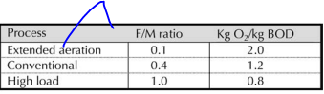
The F/M, the food to biomass (floc) ratio is a parameter crucial for operational conditions and the perromance of the biological process; regrettably, it cannot be determined quickly, on-the-spot.
Aeration devices
Water (effluent) aeration is important business that employs a wide range of equipment. In addition to cost, reliability, etc., the key criterion is the amount of air (oxygen) transfer per kW installed. Here is one – rather arbitrary – classification:
- Surface aerators
Radial flow, low speed, 20-60 rpm
Axial flow, high speed, 300-1200 rpm
Brush rotor (oxidation ditch)
- Submerged turbines
- Diffusers
Bubblers – porous and non-porous diffusers
Tubular
Jets (developed from Venturi ejectors
Aeration basins, oxidation ditch
The possibly best biological treatment of tannery effluents is the oxidation ditch (OD) and its various derivatives
- a circular aeration basin (racetrack-shaped), with rotary-brush or vertical
- rotor (carrousel) aerators that extend across the width of the ditch.
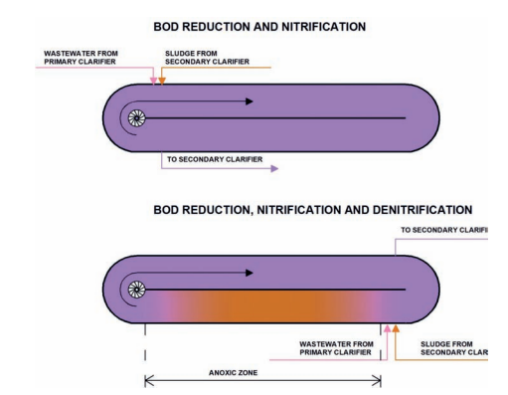
Figure 3. 3 Schematic diagram of oxidation ditches with BOD removal, nitrification and denitrification
In addition to its simple construction and easy maintenance, the main advantage of the OD is its resilience to variations in flow, pollution load, including shock loads. It is even possible to combine several ovals and maintain different aeration regimes suitable for nitrification and denitrification.

Chemical preparations and dosing
In order to plan adequately for the addition of chemicals to any treatment process, design considerations should include an estimate of the chemical dosage required. Dosage of chemicals is most necessary for a plant operator to know how to calculate the dosage of various chemicals used in tannery wastewater treatment. It is important to be accurate when calculating dosages, as too little chemical may be ineffective and too much of a chemical is a waste of money or even dangerous.
Three important factors to be considered for chemical treatment are as follows:
- Flow The flow is the rate at which water is moving through the treatment plant. Normally it is given in MGD (Million Gallons per day). One gallon is 3.7854 litres.
- Dosage The dosage is the required concentration of the chemical within the water, commonly given in mg/L. Tests of wastewater characteristics determine the required dosage of each chemical.
- Chemical feed The chemical feed is the amount of chemical to be added to the wastewater, commonly given in lbs/day. One lb is 0.4536 kg.
Chemical Dosage Calculations
In process control the exact dose of chemical must be determined through calculation for the purposes of efficient and economical operation. To apply any chemical dose correctly it is important to be able to determine the dosage calculations.
One of the most frequently used calculations in wastewater mathematics is the conversion of milligrams per liter (mg/L) concentration to pounds per day (lb/day) or pounds (lb) dosage or loading. Chemical dosages are measured in ppm or mg/L. Parts per Million (ppm) is always a comparison of weight (pounds per million pounds). One pound of chemical added to one million pounds of water would be dosage of 1 ppm.
Feed Rate Equation The following general equation is used to determine how many pounds of chemical to be fed.
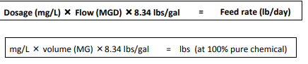
MG - Million Gallons of Water
mg/L - Chemical dosage in milligrams per liter
8.34 - Weight of 1 gallon of water
This equation is called as Feed rate Equation. If the chemical is not 100% pure, divide the pounds of chemical by the percentage (in decimal form) purity of the chemical.
Dry chemical feed rate calculations
Determining chemical feed rate of a dry chemical is simple and the following formulas can be used to calculate the required feed rate (i.e Feed Rate Equation).
Feed rate (lbs/day) = Dosage (mg/L) × Flow (MGD) × 8.34 lbs/gal
Let's consider a water treatment plant with a flow of 15 MGD. We want to add alum to the water at a dosage of 18 mg/L. What should the setting of the alum feeder be?
In order to find the answer, we make the following calculations:
Chemical feed = 15 MGD × 18 mg/L × 8.34 lbs/gal
Chemical feed = 2,252 lbs/day
And determine the alum feeder should be set to a rate of 2,252 lbs/day.
If we need to set the chemical feeder rate to pounds per hour or to pounds per minute, we merely convert units, as shown below:
2,252 lbs/day × 1 day/24 hr = 93.8 lbs/hr
  - lbs/hr × 1 hr/60 min = 1.56 lbs/mi

Sedimentation, sludge recycling & discharging
Secondary sedimentations Their design is very similar to those of primary sedimentations, but the operational conditions are different. Also, the (excess – wastage) sludge evacuated at the tank bottom is normally bulkier and more difficult to dewater.
Surface hydraulic loading – or surface overflow rate (SOR) – is the vertical velocity of the influent in the secondary sedimentation tank (m3/m2 of tank surface per hour, m/h).
SOR of approximately 0.5 m3/m2 per hour is generally used for secondary sedimentation of tannery effluents, i.e., less than for primary clarifiers.
Surface solid rate (SSR) is the quantity per hour of MLSS (kg) crossing the surface area of the secondary sedimentation tank (kg/m2 of tank surface per hour) (see primary sedimentation).
SSR values between 2.0 and 3.0 kg/m2 per hour are generally used for secondary sedimentation of tannery effluents.
The overflow from the secondary clarifiers represents the fully treated effluent usually fit for discharge into a final recipient.
In order to satisfy the legal limits for nitrogen (ammonia and TKN), very often nitrification and denitrification stages need to be introduced into the biological system. Nitrification requires extensive aeration as well as a low F: M ratio (< 0,1) to facilitate conversion of nitrogen containing organic matter into nitrate and nitrite salts. During the denitrification stage, which for operational reasons can take place either at the very beginning or at the end of the biological treatment, these salts are converted under anoxic conditions into neutral nitrogen gas (N2) and water.

Self-check
Directions: Answer all the questions listed below.
Instruction
II Choice
- Biological (secondary) treatment is
- Coagulate and remove the non-settle able colloidal solids.
- Stabilize the organic matter.
- Reduce the organic matter.
- Remove the nutrients
- Which one is not Basic Ingredients biological treatment
  - High density of microorganisms (keep organisms in system)
  - Good contact between organisms and wastes (provide mixing)
  - Reduce the organic matter
  - Favorable temperature, pH, nutrients (design and operation)
- Dispersed Growth (suspended organisms)
- Activated sludge
- Oxidation ditches/ponds
- Aerated lagoons, stabilization ponds
- Trickling filters
4, three important factors to be considered for chemical treatment as follows
A, Flow B, Dosage C, Chemical feed
II Short answers
- Define biological (secondary) treatment?
- Explain deference between dispersed (suspended) growth vs fixed growth.
- Define activated sludge?
- What is secondary sedimentations

Operation sheet 3.1
Operation title: equalization
Purpose: To practice and demonstrate the knowledge and skill required in equalization.
Instruction: Use the given figure below, the tools and equipment required in equalization. For this operation you have given 4 hour and you are expected to provide the answer on the given table.
Procedures equalization
- Collect the general liquors discharged from the factory
- While doing this regularly aerate and homogenize the liquor in this tank per the programmed set
- Record the volume of the collected liquor from the factory and the pumped one from the sulphide oxidation tank
- Record the starting and stopping time of the equipments
- When the equalization tank reaches to its maximum capacity do not add any liquor into it rather collect the factory discharge in the sulphide oxidation tank.
- Then aerate amd ,mix till the liquor in the tanks is free from sulphideion . For checking pupose use the lead acetate s/n . if it is brown is has sulphide and process the aeration-if not pump the liquor to sedimentation tank.
- Start running the compressor machine if ejectors fail seriously and their maintenanee time prolonged
- Transfer the suplhide free liquor into sedimaentation tank till the amount of liquor in the equalization tank equals allowable capacity. Record the pump time.
- Just the volume in the equalization tank reaches 300 m3 add factory discharge which has less sulphide content or pump the liquor from the sulphide oxidation tank being aerated /mixed for 4 hrs.
- As previous record the volume of the collected liquor after overnight and running time of the mixer in this tank on sheer no. 11&6, respectively.
- Wash the tank reqularly and record the date of tank washing.
- Before washing the tank check for the absence of sulphide in the liqor
- If there is no sulphide in the tank pump the liquor into sedimentation tank and when it is almost empty, wash the tank with water.
- Transfer the wash liquor into sedimentation tank.
Remark
- Do not by pass any liquor into the river.
- Do not start washing the tank when the liquor contains sulphide ion.

Operation sheet 3.2
Operation title: sedimentation
Purpose: To practice and demonstrate the knowledge and skill required in sedimentation.
Instruction: Use the given figure below, the tools and equipment required in sedimentation. For this operation you have given 5 hour and you are expected to provide the answer on the given table.
Procedures Sedimentation
- Pump the sulphide free liquor from equalization tank into the flocculation tank record the P^{H} of the liquor from equalization tank at 30 min interval in sheet no 4 stop pumping when the liquor has sulphide.
- Add the amount of aluminum sulphate and polyelectrolyte solution in the pumped liquor record the pH of the flocculated on sheet n o4 if the p^{H} is below 6 reduce the flow rate and do the reverse for pH above 9.
- Record the amount of chemicals consumed for flocculation purpose on sheet on 29
- Allow the flocculated liquor to settle in the sedimentation tank for 2 hr
- Do not add flocculated liquor in the sedimentation tank till the required retention time elapsed. This helps to get supernatant liquor having no settle able matter.
- At the moment you pump sulphide liquor operate on the mixer and record its running time.
- Start the scrubber to operate while adding flocculated liquor into the sedimentation tank use sheet no 6 to record its running time.
- Collect the required sample amount of the treated water (supernatant discharged from sedimentation tank for laboratory analysis per the programmed set.
- Wash the tank when appropriate and record the washing date on
N.B:- before dosing the recommended chemicals make sure that the chemicals are well mixed in their tank.

Operation sheet 3.3
Operation title: chrome recovery plant
Purpose: To practice and demonstrate the knowledge and skill required in chrome recovery plant.
Instruction: Use the given figure below, the tools and equipment required in chrome recovery plant. For this operation you have given 5 hour and you are expected to provide the answer on the given table.
Procedures chrome recovery plant
- Open the gate for spent chrome liquor in the chrome segregated plant and collect them in the storage tank. Use sheet to record the amount collected.
- Then pump it into the precipitation tank while filtering the suspended matter in the wedge wire screen. To record the pumping time.
- Make sure the wedge wire screen is clean enough.
- Fill the tank up to 10m³
- Add 1 kg MgO per m³ of spent chrome for basification
- Mix it thoroughly for one hour
- Allow to settle until you see a clear supernatant
- Discharge the supernatant
- Pump the 10 days collected chrome liquor in to a dissolution tank.
- Add Conc. H₂SO₄ through a gravitational tank little by little and mix it thoroughly. (for every kg of MgO add 1.18 kgs H₂SO₄)
Register the PH in every 30 minute difference until the PH falls in the range of 2.5 -3.2

Lap test
Instructions to students:
- Given the raw materials perform the below mentioned task.
- You are given five (15) hours to complete these tasks.
- equalization
- sedimentation
- chrome recovery plant
- Request your teacher for evaluation and feedback of your work

Unit four: Perform sludge dewatering
This unit is developed to provide you the necessary information regarding the following content coverage and topics:
  - Sludge conditioning
  - Sludge dewatering
This unit will also assist you to attain the learning outcomes stated in the cover page. Specifically, upon completion of this learning guide, you will be able to:
  - Sludge from respective treatment stages output (primary, secondary and tertiary) are conditioned
  - dewatering of the sludge is performed

4.1 Sludge conditioning
This is used to create a convenient condition for the de-watering process of the filter press. The conditioning of the sludge is of a paramount importance in determining the entire efficiency and performance of the de watering process. As a major input lime milk is added to the slurry so as to thickening it and to avoid bad smell.
Effects of conditioning processes
Sludge conditioning is carried out before dewatering and directly influences the processes efficiency. Conditioning may be accomplished through the utilisation of inorganic chemicals, organic chemicals or thermal treatment. The main options for conditioning and their effects on mixed sludge (primary and activated sludges) dewatering are summarised in Table 5.
Factors affecting conditioning
Conditioning aims to change the size and distribution of particles, surface charges and sludge particles interaction. The degree of hydration and the demand for chemicals and resistance to dewatering increase with the specific surface of the particles. A significant presence of colloids and thin particles with diameters normally ranging from 1µ to 10µ is very common in sewage sludges. Biomass plays a significant role in the capturing of these particles during biological treatment, diminishing sludge dewaterability and increasing the consumption of conditioning chemicals. The main purpose of sludge conditioning is to increase particle sizes, entrapping the small particles into larger flocs. This is accomplished through coagulation followed by flocculation.
Coagulation destabilises the particles, decreasing the intensity of the electrostatic repulsion forces among them. The compression of the electric double layer that surrounds each particle facilitates their mutual attraction. Flocculation allows the agglomeration of colloids and thin solids through low mixing gradients. The amount of conditioning product to be used may vary with the sludge characteristics and the dewatering equipment adopted. The water content and the level of fine solids may change depending upon the type of sludge transportation through pipes and the storage period (weekends and longer periods). These factors affect the sludge characteristics and influence the demand for conditioners prior to dewatering.
Table 5 Effects of conditioning processes
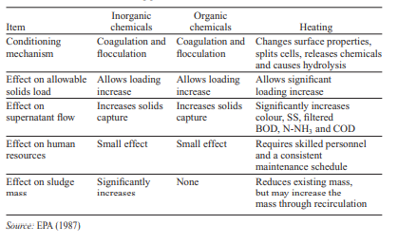
Sludge conditioning procedure
- pump the slurry form sedimentation tank into sludge conditioning tank record running time.
- when the volume of sludge reaches 6m³ start to operate the mixer record its running time
- the moment the sludge volume reaches 6m³ add the diluted lime solution till the P^{H}
- conform the existence of this P^{H} at other higher volumes till the tank becomes full of sludge
- if the P^{H} becomes lower, add diluted lime solution till you get the required PH
- Finally when the tank is full of sludge and its P^{H} reaches 10 take sample for lab
- pump the thickened slugdg for filter press operation if it fulfills all the requirements (i.e P^{H}, solid content)
N.B – Do not add powdered lime directly into the sludge conditioning tank

4.2 Perform sludge dewatering

4.2.1 Sludge dewatering
The sludge drawn from the bottom of the tank is in the form of slurry with a dry-solid (DS) content of only 2-4%. For its evacuation, special pumps – usually of the Mohno type – are used.
For further handling and disposal of sludge, it is necessary to reduce drastically the water content. This is usually achieved by:
- thickening in sludge thickeners (very much like circular clarifiers);
- mechanical dewatering in filter presses, belt-filter presses or decanters (centrifuges);
- natural drying in sludge-drying beds. In addition to power and chemical requirements, the key parameter for equipment selection is the achievable dry matter content in the dewatered sludge

Dewatering Technologies
Typically follows digestion, and is necessary prior to incineration.
Purpose is to remove water from the sludge to reduce overall volume.
Solids content increases from 1 to 4% Total Solids to 15 to 20% Total Solids.
Technologies
  - Best filter press – mechanical, low energy required
  - Centrifuge – mechanical, high energy input required
  - Sludge drying beds – non-mechanical, no energy input, depends on gravity and evaporation
Mechanical sludge dewatering
The main purpose of sludge dewatering is not only to reduce the volume and weight of material to be transported but also to attain the dry matter content required for disposal at landfills. The equipment used for this purpose – recessed-plate filters, belt presses and decanter centrifuges – was already described earlier. Here is a short comparative overview of the main characteristics and efficiencies of the various systems as well as changes in DS content throughout the treatment process.
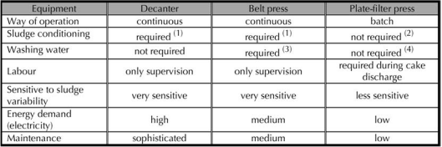
Figure 4. 1 Characteristics of sludge dewatering equipment

Self-check
Directions: Answer all the questions listed below.
I Matching

A
- Best filter press
- Centrifuge
- Sludge drying beds

B
  - mechanical, low energy required
  - mechanical, high energy input required
  - non-mechanical, no energy input, depends on gravity and evaporation

II Short answer
- Define briefly sludge dewatering?
- Explain sludge conditioning and conditioning procedure?
- Explain aims of conditioning

Operation sheet 4.1
Operation title: Sludge conditioning
Purpose: To practice and demonstrate the knowledge and skill required in sludge conditioning
Instruction: Use the given figure below, the tools and equipment required in sludge conditioning. For this operation you have given 1 hour and you are expected to provide the answer on the given table.
Procedures sedimentation; sludge conditioning
- Pump the slurry form sedimentation tank into sludge conditioning tank record running time .
- When the volume of sludge reaches 6m³ start to operate the mixer record its running time.
- the moment the sludge volume reaches 6m³ add the diluted lime solution till the P^{H}
- conform the existence of this P^{H} at other higher volumes till the tank becomes full of sludge
- if the P^{H} becomes lower, add diluted lime solution till you get the required PH
- Finally when the tank is full of sludge and its P^{H} reaches 10 take sample for lab. Analysis (record the tested characteristics)
- pump the thickened sludge for filter press operation if it fulfills all the requirements (i.e P^{H}, solid content)
N.B – Do not add powdered lime directly into the sludge conditioning tank

Lap test
Instructions to students:
- Given the raw materials perform the below mentioned task.
- You are given five (5) hours to complete these tasks.
- Sludge conditioning
- Request your teacher for evaluation and feedback of your work

Unit five: Perform tertiary treatment
This unit is developed to provide you the necessary information regarding the following content coverage and topics:
  - Nitrogen/ammonium & phosphorus removal from tannery effluent
  - Disinfecting treated tannery effluent
This unit will also assist you to attain the learning outcomes stated in the cover page. Specifically, upon completion of this learning guide, you will be able to:
  - Nitrogen/ammonium, phosphorus removal is carried out as per operational procedures
  - Disinfection of treated liquid is performed

Nitrogen/ammonium & phosphorus removal from tannery effluent

Tertiary / advanced treatment purpose
In certain cases, despite extensive physical-chemical and biological treatment in a well designed ETP, the quality of the final effluent does not meet the promulgated discharge limits. The usual culprit is the recalcitrant COD, i.e., compounds that the micro-organisms present in the floc are unable to decompose. In such cases, it is necessary to resort to additional, usually more sophisticated and rather expensive treatments such as mineralization of organic compounds by oxidation with H2O2 in the presence of ferrous sulphate (Fenton process and its derivatives). Ozonation is sometimes included not so much to kill potentially harmful micro-organisms but to destroy part of the residual COD.
Final cleaning process that improves wastewater quality before it is reused, recycled or discharged to the environment.
Mechanism: Removes remaining inorganic compounds, and substances, such as the nitrogen and phosphorus. Bacteria, viruses and parasites, which are harmful to public health, are also removed at this stage. Methods: Alum: Used to help remove additional phosphorus particles and group¬ the remaining solids together for easy removal in the filters. Chlorine contact tank disinfects the tertiary treated wastewater by¬ removing microorganisms in treated wastewater including bacteria, viruses and parasites. Remaining chlorine is removed by adding sodium bisulphate just before¬ it's discharged.

Nutrient removal
Chemicals are added for the removal of the nutrients in the wastewater prior to discharge to the receiving stream. Phosphorus is a common nutrient removed from the wastewater using chemical addition. Chemicals such as aluminum or iron salts chemically react with the phosphorus in the wastewater to form a new compound that will settle out in the final settling tanks and be removed with the waste sludge.
The following are typical chemicals used for nutrient removal.
- Aluminum Sulfate
- Ferric Chloride
- Ferric Sulfate Ferrous Sulfate
Alkalinity Supplementation
Alkalinity buffers the wastewater against changes in pH that could disrupt the wastewater treatment process. It is usually expressed as mg/L as calcium carbonate. Certain treatment processes will consume alkalinity.
- Nitrification, the treatment process that converts ammonia to nitrate, consumes alkalinity.
- Aluminum and iron added for phosphorus nutrient removal reacts with bicarbonate alkalinity in the wastewater to form aluminum and iron hydroxide.
To prevent alkalinity from being reduced so low that the pH changes, chemicals that add alkalinity must be added to the treatment process. Supplemental alkalinity might also need to be added to an anaerobic digester to maintain performance. Typical chemicals used to supplement alkalinity are listed below.
- Lime
- Sodium Bicarbonate (Baking soda)
- Sodium Carbonate (Soda ash)
- Sodium Hydroxide (Caustic soda)
- Magnesium Hydroxide
The purpose of this information sheet is to assist wastewater treatment plant operators/supervisors in the proper handling and use of commonly used chemicals in wastewater treatment processes. In 1934, around 34 U.S. wastewater plants were using chemical precipitation.
Then, chemical use declined during World War II and for some time thereafter for the three primary reasons listed below:
- Cost of chemicals
- Limited availability of chemicals
- Greater reliance on biological treatment
Now a days, Chemicals are used during wastewater treatment in an array of processes to increase effluent quality. These processes, which induce chemical reactions, are called chemical unit processes, and are used alongside biological and physical cleaning processes to achieve various wastewater discharge standards. The selection of the chemicals and the methods used for treatment depend on the characteristics of the effluent
pH and Toxic material for microorganism
Biological treatment plants must be carefully managed as they use live microorganisms to digest the pollutants. For example some of the compounds in the wastewater may be toxic to the bacteria used and pre-treatment with physical operations or chemical processes may be necessary. It is also important to monitor and control pH as adverse pH may result in death of the microorganisms and will certainly prevent them from effectively treating the waste. Ideally the pH should be maintained within pH 6-8.
Food for microorganisms
The ETP must be properly aerated and must be preferably be operated 24 hours a day, 365 days a year to ensure that the bacterial organisms are provided with sufficient “food” (i.e. wastewater) and oxygen to keep them alive. Brief breaks (for a few hours) in operation will probably do little harm but prolonged shut down will deprive the microorganisms of their food and oxygen and will damage the process so that it will not operate effectively when feeding and aeration are resumed.
Nutrient for microorganisms
Like human, microorganisms need a “balanced diet” with the right sources of carbon, nitrogen, phosphorus and sulphur. While tannery wastes have enough carbon and sulphur (sulphate) they are generally lacking in nitrogen and phosphorous containing compounds. If the microorganisms are to grow and work effectively they are likely to need addition of nutrients. Normally materials such as urea and ammonium phosphate are added.

Disinfecting treated tannery effluent
During disinfection, chemicals are added to the treated wastewater prior to discharge to the receiving stream, thereby inactivating pathogens. Such disinfection is a standard procedure adopted even for water used for domestic purposes. The following are the chemicals typically used for disinfection:
- Chlorine gas
- Sodium Hypochlorite
- Ozone
- Bromine
Odor Control
Odor masking agents and odor treatment are two methods of odor control. Odor masking agents cover offensive odors with a more pleasant smell. Odor treatment is accomplished through either neutralization or through adsorption.
- Neutralizers chemically react with odor causing compounds to change them and neutralize the odor. Common examples are chlorine, hydrogen peroxide and ozone.
- Adsorption uses activated carbon adsorption units to treat odors.
In the adsorption process, matter adheres to the surface of the adsorbent. Activated carbon has an extremely large surface area due to the presence of pores within the individual carbon particles. In fact, 1 pound of activated carbon has a surface area of 60 to 150 acres. Odor causing compounds are attracted to the activated carbon which acts like a sponge to adsorb these compounds.

Self-check
Directions: Answer all the questions listed below.
I choice
1, ------------ are typical chemicals used for nutrient removal.
a, Aluminum Sulfate b, Ferric Chloride
c, Ferric Sulfate Ferrous Sulfate d, all
2, Typical chemicals used to supplement alkalinity are --------?
a, Lime b, Sodium Bicarbonate (Baking soda)
c, Sodium Carbonate (Soda ash) d. all
3, The following are the chemicals typically used for disinfection:
a, Chlorine gas b, Sodium Hypochlorite
c, Ozone d, all
Short answers
- What is alkalinity supplementation?
- How to control odor?
- What mean disinfecting effluent

Unit Six: Maintain documents and records
This unit is developed to provide you the necessary information regarding the following content coverage and topics:
- Documenting organization’s effluent treatment compliance
- Maintaining records for effluent treatment plant operations
This unit will also assist you to attain the learning outcomes stated in the cover page. Specifically, upon completion of this learning guide, you will be able to:
  - Relevant work instructions related to effluent treatment compliance are documented and maintained
  - Records related to the tasks, where relevant are kept

Documenting organization’s effluent treatment compliance

Records document
Any business transaction or operation requires records for efficient management. This is also true for the operations of wastewater treatment facilities. The administrator, supervisors and operators of a wastewater treatment facility should know the cost and efficiency of their plant. Well-kept records will make the task of writing treatment plant cost and efficiency reports much easier.
An important factor in operating any efficient treatment system is the maintenance of accurate operational and financial records. Without a record of past operational performance, it is impossible to identify trends in any process. Records provide the operators and federal and state regulatory agencies with valuable information upon which they base their decisions concerning the system operation.
The operator should use the records as a guide in regulating, adjusting, and modifying system operation. They are also important in establishing a reliable continuing record of proof of performance and justifying decisions, expenditures, and recommendations.

Importance and need for records
Records are the backbone of all management systems. Capturing and managing records are not only regulatory requirements, but also vital to well-run operations. Records should be accurate, accessible and yet to secure to ensure that utility have the best information available.
Records are need for the following reasons:
- Plant operation: Review of operating records can indicate the efficiency of the plant and its treatment units and past problems
- Records are needed to show the type and frequency of maintenance of operating units and evaluation of effectiveness of maintenance programs.
- Records can provide data upon which to base the recommendations for modifying plant operation and facilities.
- Records of past performance and operational procedures are invaluable tools for the engineer in the evaluation of present performance and serve as a basis for the design of future treatment units.
- Records are used to support budget requests for personnel, additional facilities or equipment.
- Records for water pollution and public health aspects may be required by regulatory agencies.
- Records provide the actual data for the preparation of weekly, monthly or annual reports to administrative officials, the public, and regulatory agencies.

Types of records
The type of records to be kept will depend on the size and type of treatment plant. Records are generally separated into seven classifications:
  - Operation and performance records
  - Descriptive and inventory records of the physical plant and stock
  - Maintenance records
  - Financial or cost records
  - Personnel
  - Store room and inventory record
  - Emergency record
Operation and Performance Records
Operational records are the most extensive records kept by an operator. These records have the biggest impact on the ongoing functioning of the facility.
Physical Plant and Stock Inventory
Physical plant records do not change as quickly as other types of records because the plant is not in a constant state of change. However, these records are very useful for maintenance and repairs. Physical Plant records include design/as-built plans and specifications, building plans, and other site construction or modification documents.
As a minimum, the following records are essential for proper evaluation of plant facilities and for making future modifications or additions.
    - Contract and “as built” plans and specifications of wastewater treatment facility. This includes detailed piping and wiring plant.
    - Plans and operating instructions for plant equipment.
    - Cost of major equipment and unit items.
    - A complete record and identification card for all major equipment. The equipment card should include name of manufacturer and identifying code number.
    - List of tools, materials, chemicals, lab reagent and supplies and office supplies.
    - A record card for each industrial waste discharger containing information on type, quantity, characteristics and times of expected waste discharges.
Maintenance records
Maintenance has become more important as permit limits become stricter and utilities become more automated. A good maintenance records is a must in order to maintain successful operation of the plant. As a minimum, the following record may be required as follows:
- Mechanical maintenance record is of prime importance, as the equipment must be kept in good operating condition so as to have the plant to maintain in good performance. Manufactures provide information on the mechanical maintenance of their equipment.
- Preventive maintenance record help operating personnel to keep equipment in satisfactory operating condition and aid in detecting and correcting malfunctions before they develop into major problems.
The equipment inspection and services records provide a list of work done on the equipment as shown in table. 1.
Table 6 equipment inspection and services records
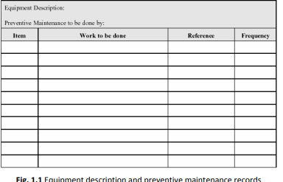
Financial or cost records
Financial records are used to track the costs of operating the facility, track current costs and develop future budgetary requirement for running the treatment facility. They include invoices, petty cash, and vouchers for smaller facilities. For larger/autonomous organizations, the records would also include payroll, accounts receivable, accounts payable, reserve funds, capital improvement funds, general ledger, bonds, and grants.
Personnel records
Personnel records are maintained on employees throughout employment. Personnel records start when someone is hired, and usually include items such as performance reviews, performance expectations, goals, and accomplishments. They may also include the person’s knowledge, skills, and abilities as well as progress toward additional certifications.
Storeroom and Inventory Management Record
As a minimum, inventory records should include the part of material description, number, quantity, record level, purchase date, cost and vendors. These records are used to monitor the materials/items used and for what purpose. It also gives the information about the inventory and schedule of re-orders.
Emergency Records
A record of major emergency conditions affecting the system will be maintained. This record should include area wide power failures, extraction pump failures, or natural disasters. It should also serve as a register of major emergencies or alarm conditions, with supplemental reports filed describing the occurrence, damage cause, emergency corrective actions taken, costs attributed to the situation, and permanent corrective actions taken, if required
Frequency of records
Records at most waste treatment facilities are kept daily and on a monthly basis.
Daily Records
Data to be recorded will depend upon the type and size of the plant. One of the most important daily records is a day-by-day dairy or log of events and operations during the day. A daily dairy or log should be maintained at every section of the plant such as lab, maintenance and administrative. The logbook may be spiral notebook or a standard daily diary made for that purpose.
Monthly Records Monthly records should reflects the total and averages of the values recorded daily or at some other frequency and in some cases should give maximum and minimum daily results

Maintaining records for effluent treatment plant operations
Components of record keeping system
A record keeping system has four components.
    - Records - Information resources, in any format, About the records has already discussed in detail in previous information sheet
    - People - the Records Liaison Officer and records contacts, who oversee a records management program; and Agency staff, who create, receive, and use records in conducting EPA business
    - Processes - procedures on how to manage records throughout their lifecycle.
    - Tools - equipment and software used to capture, organize, store, track, and retrieve the records.
Requirement of Record Keeping System
The requirement can be met by establishing a sound record keeping system that:
    - Identifies the records created or received in an organization,
    - Assigns responsibility for them, and
    - Specifies how they are maintained (e.g., classified, filed, tracked).
Benefits of Record Keeping System Good records management practices will not only help you to meet legal requirements, they will benefit you and the treatment plant in many ways such as:
    - Improving access to information
    - Reducing operating costs
    - Minimizing litigation risks
    - Safeguarding vital information
    - Supporting better management decision making
    - Preserving plant history
Characteristics of recordkeeping systems
Recordkeeping system should possess the following characteristics, in order to produce and maintain proper documentation:
- Reliability
- Routinely capture all records
- Organize records appropriately •
- Provide adequate information about the records within them
- Provide ready access to records and make records of system operation
Integrity
- Prevent un authorised access, destruction, alteration or removal of records
Compliance
- Be managed in compliance with all requirements that apply to the business documented within them
Comprehensiveness
- Manage all records resulting from the business activities that are documented or managed by the system
- Store records in ways that mean they cannot be tampered with, deleted inappropriately or altered
Accessibility
- Allow records to be shared as information resources across a workspace, business unit or organization.

Functions of recordkeeping system
Recordkeeping systems must be a capable of performing a range of standard record keeping functions.
Table 7 Functions of recordkeeping system
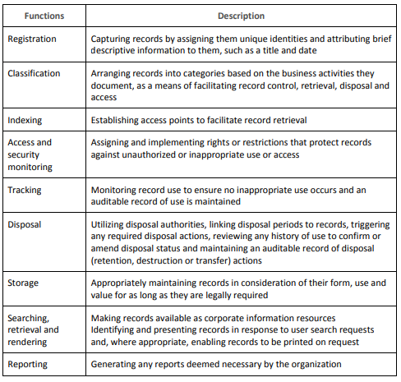
Functions of recordkeeping system
Recordkeeping systems must be a capable of performing a range of standard record keeping functions. Functions are given in Table 2.1
Table 8 Functions of recordkeeping syste
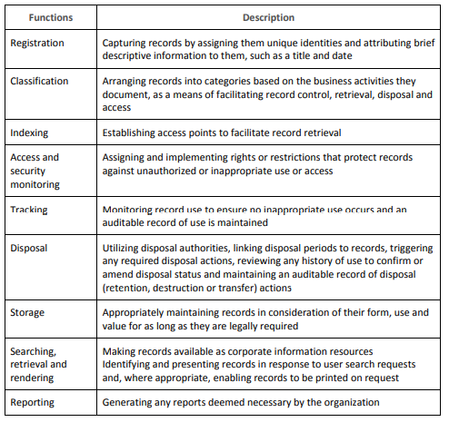
Record preservation Typically, paper correspondence and reports should be stored in folders in filing cabinets. Equipment records should be stored and kept at least as long as the equipment itself is in service. It is better to keep records too long than to dispose of them too soon.
Digital records (those) stored in computers should be backed up routinely, and copies of the backups should be maintained off-site. A critical computer system may be backed up hourly or more frequently and have a fully redundant system available in a secondary, remote location when the primary system is unavailable.
To prevent records from being destroyed in a flood, fire, or other disaster, they should be copied and distributed among multiple sites (Table 2.2).
Table 9 Distribution of records
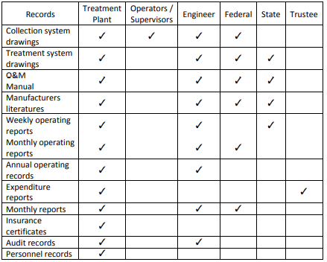

Self-check
Directions: Answer all the questions listed below.
Instruction
I matching
A
- Record Keeping System
- Operational records
- Financial records
- Physical plant records
- Frequency of records

B
- used to track the costs of operating the facility
- Improving access to information
- Useful for maintenance and repairs.
- Daily Records
- records kept by an operator
II Short answer.
1. Why is it important to keep records of plant operation?
2. Why should unusual happenings be recorded and described?
3. Write the different types of records?
4. Write short notes about on “Operation and Performance records.

Reference
- Operations of Municipal wastewater treatment plants. Vol. 1: Management and support systems, 6th edition, Water Environment Federation (WEF). WEF press, Mc graw hill publishers.
- http://www.records.nsw.gov.au
- http://www.epa.gov/records/
- Operations of Municipal wastewater treatment plants. Vol. 1: Management and support systems, 6th edition, Water Environment Federation (WEF). WEF press, Mc graw hill publishers.
- Kerri et al., “Operations of Wastewater Treatment Plants: A field study training program”, 197

Participants of this Module (training material) preparation
No | Name | Qualification (Level) | Field of Study | Organization/ Institution | Mobile number | E-mail
1 | Ashenafi Mulat | BSc | Leather engineering | Gondar poly technique collage | +251910110187 | ashenafimulat119@gmail.com
2 | Tarekeng  Jida | MSc | Chemical engineering (Leather Technology) | LLPIDRC | +251911055370 | tarekegnb039@gmail.com
3 | Weldeyesus wendowesen | MSc | Leather engineering and Fashion Technology | TVTI | +251915854419 | abay1015@gmail.com

