Leather Garments and Goods Production Level I
Based on December 2021, curriculum version I
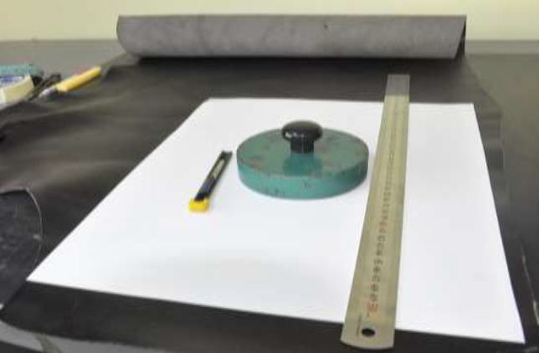
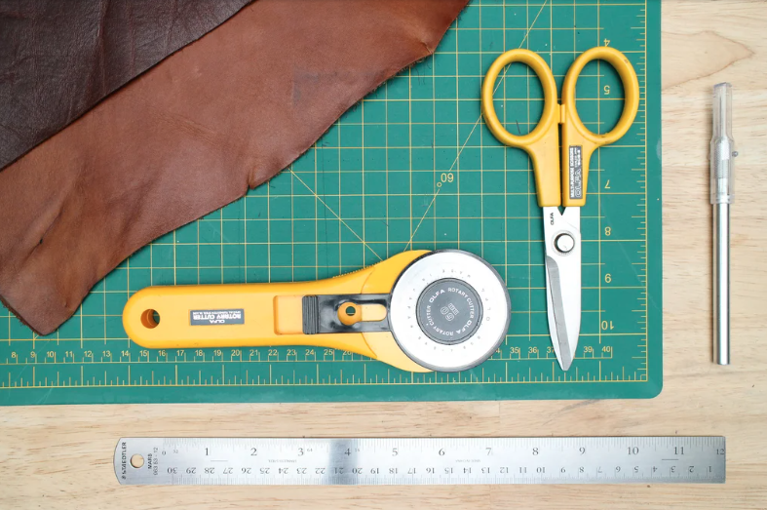
Module Title:- Performing Basic cutting
MODULE CODE:- IND LGG1 M03 1221
Nominal hour: 96hrs

Prepared by: Ministry of Labor and Skill
Aug. 2022
Addis Ababa, Ethiopia

Table of Contents
Acknowledgment 5
Acronym 6
Introduction to the Module 7
Unit One: Prepare for work 8
1.1. Setting up Workstation 9
1.2. Obtaining and interpreting cutting patterns. 10
1.3. Select cutting tools 12
1.4. Collecting and storing Cutting Materials 16
1.5. Cleaning cutting board. 17
Self check 1 20
Unit Two: cut paper and other components 22
2.1. Hand tools 23
2.2. Demonstrating Paper cutting 32
2.3. Receiving, reading, interpreting and duplicating templates 33
Start with measurements 34
2.4. Interlocking templates for cutting 36
2.5. Cutting synthetic materials 36
Self-check 2 39
Operation Sheet 2 41
Operation Sheet 2.1 perform paper cutting 41
Operation Sheet 2.2. Perform synthetic cutting 42
LAP TEST 43
Unit Three: Cut leather by hand 44
3.1. Selecting leather 45
3.2. Assessing leather defect and faults 47
3.3. Positioning temples 50
3.4. Cutting techniques 51
3.5. Problems or faults 55
3.6. OHS practice 56
Self-check 3 60
Unit four: Check cut components and finalize the work 62
4.1. Check Components 63
4.2 Identifying cutting faults and irregularity 67
4.3. Recording faults 68
4.4. Bundling, stacking and storing components 69
4.5. Completing and Maintaining Records 70
Self-check-4 72
List of Reference Materials 74

Acknowledgment

Ministry of Labor, Skills, and Ministry of Health wish to extend thanks and appreciation to the many representatives of TVET instructors and respective industry experts who donated their time and expertise to the development of this Teaching, Training and Learning Materials (TTLM).

Acronym
SOP Standard operating procedure
TTLM Teaching, Training and Learning Materials

TVET Technical and Vocational Education Training
OHS Occupational Health and Safety
PU Polyutherane
PPE Personal Protective equipment
MHOR Manual Handling Operation

Introduction to the Module
In Leather garment and goods production, the knowledge and selection of the input material plays a great role for having best quality leather products. Qualified worker must do the basic cutting needed in leather garment and goods production.
This module is designed to meet the industry requirement in leather garment and goods production occupational standard, particularly for the unit of competency:

This module is designed to meet the industry requirement in leather garment and goods production occupational standard, particularly for the unit of competency: Perform Basic cutting
This module covers the units:
- Preparing for work
- Cutting paper and other components
- Cutting leather by hand
- Checking cut components and finalizes the work

Learning Objective of the Module
- Prepare for work
- Cut paper and other components
- Cut leather by hand
- Check cut components and finalizes the work
Module Instruction
For effective use of this module trainees are expected to follow the following module instruction:
- Read the information written in each unit
- Accomplish the Self-checks at the end of each unit
- Perform Operation Sheets which were provided at the end of units
- Do the “LAP test” giver at the end of each unit and
- Read the identified reference book for Examples and exercise

Unit One: Prepare for work
This unit to provide you the necessary information regarding the following content coverage and topics:
- Setting up Workstation
- Obtaining and interpreting cutting patterns.
- Select cutting tools
- Collecting and storing Cutting Materials
- Preparing cutting board
This guide will also assist you to attain the learning outcomes stated in the cover page. Specifically, upon completion of this learning guide, you will be able to:
- Set up Workstation
- Obtain and interpret cutting patterns.
- Select cutting tools
- Collect and store Cutting Materials
Prepare cutting board

Setting up Workstation
Workstation is defined as an area, outfitted with equipment and furnishings for one or more workers. Normally leather products are operated in a workshop therefore the workstation for a leather goods/garments worker would be the workshop. It is necessary for a worker to prepare his workstation and the pieces to be done Well-arranged working area .
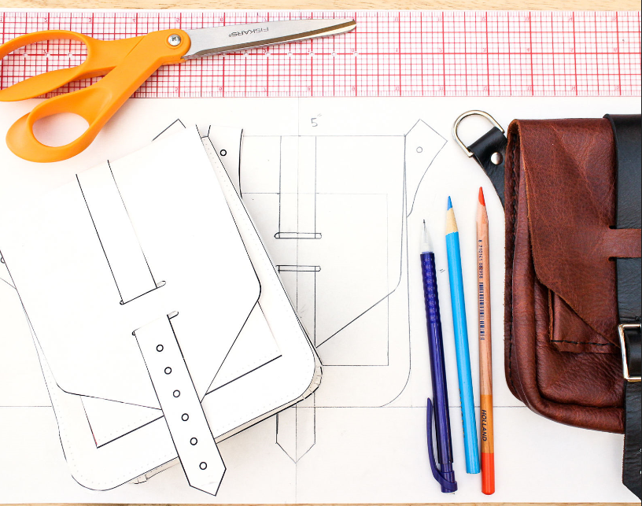
Properly sated machineries, assembling areas, good and safe placement of tools and equipment facilitates and motivates a worker to do his/her job in a good and respectable way but before doing so a worker should be well aware of the safety rules and regulations.

.

Figure1.1 Outfitted with equipment and furnishings
Having created a good working area, the subsequent effort would be put for allocation of work according to the departments/sections. The process of cutting starts after the patterns of the particular product are being completed.
Once the patterns are completed and delivered to the cutting department/section with their specification.
The next process would be selecting the specified leather and all other necessary materials to be cut (including the color and texture according to the specification given), making ready the necessary tools and equipment, assorting which is a vital process carried out by highly skilled
technicians before starting to cut. It must be done under perfect lighting system so that its quality can be assured. Leathers are assorted according to thickness needed for various parts of the product, size, color, defects, texture, and stretch/elasticity. The person should know the various defects that could exist on the skin/hide and mark them on the leather using silver marking pencil so that it would be visible enough while cutting and he/she must also know where to apply cutting i.e. matching the section of the leather with the part of the product to be cut.
Visible areas should be cut from the best section of the leather. However, before going through the process the person (cutter) should be aware of the safety procedures and ergonomic principles for a better and organized work.

Obtaining and interpreting cutting patterns.
A pattern is an arrangement of lines or shapes, especially a design in which the same shape is repeated at regular intervals over a surface.
Pattern cutting in the fashion industry is the process of taking a design and making it into leather. However, before it is made into leather product, it is made into paper (2D).
The role of a pattern cutter is to interpret your design, put it onto paper/card, or in digital form so it can then be made into fabric of your choice. In Leather sewing and fashion design, a pattern is the template from which the parts of a leather and garment are traced onto fabric before being cut out and assembled. Patterns are usually made of paper, and are sometimes made of sturdier materials like paperboard or cardboard if they need to be more robust to withstand repeated use.
The process of making or cutting patterns is sometimes condensed to the one-word Patternmaking, but it can also be written pattern(-) making or pattern cutting.
A patternmaker typically employs one of two methods to create a pattern.

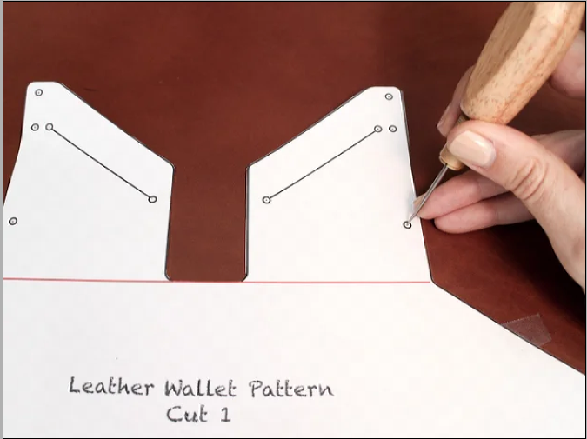
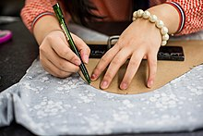
Figure1.2. Tracing pattern onto leather and fabric
The flat-pattern method is where the entire pattern is drafted on a flat surface from measurements, using rulers, curves and straightedges.
A pattern maker would also use various tools such as a notched, drill and awl to mark the pattern. Usually, flat patterning begins with the creation of a slope or block pattern, a simple, fitted garment made to the wearer's measurements.
Locating cut patterns and studying specifications once the patterns are ready:
- Cutting should start from butt to belly (i.e. from left to right side and from bottom to top).
- Make sure that the correct pattern of the article you desire to cut.
- Examine for defects, size and shape of hide/skin.
- Selective cutting must be practiced the best part of the article demands the best part of the hide/skin.
- Visible area should have good grain surface and section covered could contain grain defect.
- Good cutting begins with a sharp knife less sharpens or blunt knife cuts the leather with rugged edge.
- Over cutting and under cutting must be avoided.
- Pattern must be placed in such a way to insure quality, economy and minimum wastage.
- Straight-line cutting must be done first with steel scale/ruler curved line cutting or regular shape must be cut with templates.
- Cutting must be done on a smooth surface of soft wood, play wood, galvanized iron plate or zinc plate for accurate cutting.
- Start cutting from left top corner of the pattern and at the right bottom corner.
- Cut through the leather in one stroke.

Select cutting tools
A cutting tool is a pointed tool mounted in a machine tool and used for cutting materials.
A cutting tool or cutter is any tool that is used to remove some material from the work piece by means of shear deformation. Single-point or multipoint tools may accomplish cutting.
The tools selected for the process should be according to the specification provided by the pattern-making department. A cutter (person) should know the types of tools to be used for a particular material (leather, lining, reinforcement…).
Types of cutting tools used in leather products manufacturing
    - Cutting knife
The most important tool in leather cutting is sharp knife. Various types of knives are used for cutting.
- One -piece knife
- Scalpel
- Snap off blade knife
A. One-piece knife
This is called a hand-cutting knife with a solid non- detachable blade. The extra length of the blade makes this an excellent knife for cutting synthetic rolls in to various lengths.
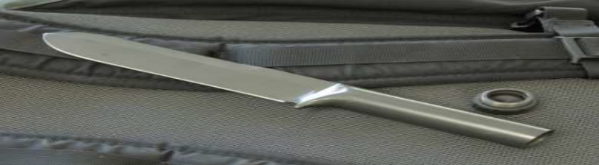

Figure 1.3. A one-piece knife

- Scalpel

Pattern cutter and European clickers use this knife extensively. The jawsare placed in to the handle.

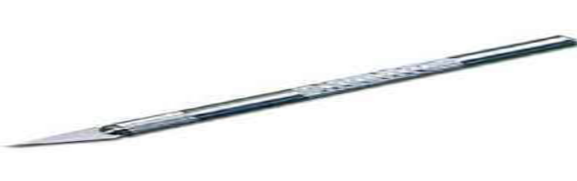

Figure1.4. Scalpel

- Snap off blade knife
The knife is held slanting 300 along the straight line and almost at a perpendicular position while cutting curves.
It is recommended for pattern cutting. The blade in this knife can be broken off on stage to give the cutter a new sharp cutting edge. The blade is held in to place by the finger adjustment.
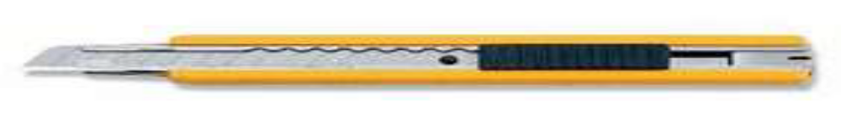

Figure1.5. Snap off blade knife
Leather cutting knifes are sharp and dangerous; therefore, students should be aware how to use these knives correctly and safely.
- When cutting with a sharp knife always cut the leather away from the body, wherever possible.
- Keep fingers away from the blade.
- Do not overstretch the arms during cutting, as this reduces the hand pressure, alters the angle of the knife and reduces the knife control at the point of cutting.
Some other Tools used during cutting operation.
- Scale/steel ruler
- weight/load
- Awl
- Silver marking pencil
- Cutting mat

    - Scale/steel ruler
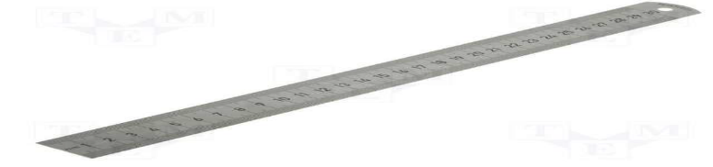
It is recommended for use when cutting straight lines with length of 500mm (mille meter) from safety point of view. Sufficient thickness of ruler is necessary minimum 2 mm.

Figure1.6. Scale/steel ruler
    - weight/load
It is a material made from steel and used to hold the material (leather) against the cutting table so that the leather will not move while the cutting process is held. It also helps to cut the component in a better quality.
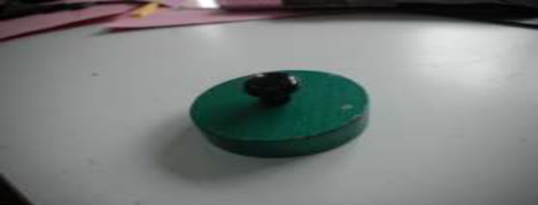
Figure 1.7.Weight/load

    - Awl
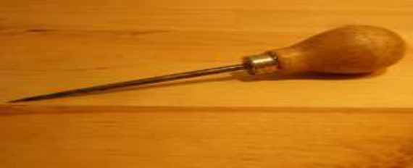
It is a sharp steel prick mostly used to mark holes in the pattern and or thin leather, pockets, buttonholes and different marks.

Figure1.8. Awl
    - Silver marking pencil
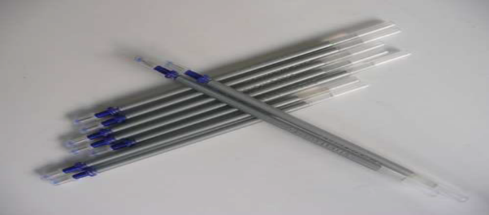
Silver marking pencil is used to mark defects on leather while assorting and to mark on patterns on leather for cutting components to achieve the maximum cutting value. It is also used to mark on the components for fixing fittings with the help of patterns.

Figure1.9. Silver marking pencil

    - Cutting mat
There are different cutting blocks plastic matt, glass matt, wood matt, zinc matt and rubber sheets matt which are used for hand cutting. The cutting matt should always be flat and convenient. Cutting mat should be kept clean of glue and other liquid avoid other materials below your cutting mat while cutting.
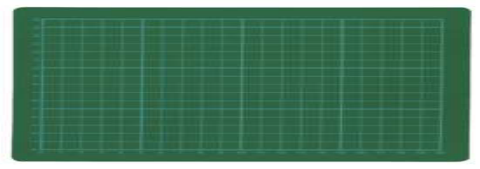

Figure1.10. Cutting mat

Collecting and storing Cutting Materials
In the cutting operation, the cutting man has to select the right quality cutting tools, because when one deals in tools. Therefore, one has to have the necessary skill to determine what kinds of the tools are most suitable for each material or tools.
Good Quality tools can be a big investment, but if you take good care of them, they will last longer and return the favor. Making sure your tools are properly stored, cleaned, and well maintained will save you time and money as well as making your projects and jobs much easier.
When it comes to storing your cutting tools, you have to work with the space that you have. Maybe you hang them on a pegboard or store them in toolboxes, bags, or chest, or maybe you keep them in drawers. Pegboards are a great storage system for tools. They let you see all your tools at one glance and they make use of wall space in an efficient way. If you do not have enough wall space for a pegboard, you can take advantage of the pegboard system by building a hinged system, a rolling pegboard, or even a portable pegboard system.
Toolboxes are also a great way to store your tools. They have the great advantage of portability. While some people do use toolboxes to store all their tools, they can also be a convenient way to transport your most commonly used tools while leaving the bulky tools stored at work place.
It is always important to be aware of the environment that you are storing your tools in as well. Rust is public enemy number one when it comes to tools. Places such as garages, basements and other enclosed areas can have humidity issues, especially if they are not air conditioned or heated. If you keep your tools in a location such as these it is definitely a good idea to invest in a dehumidifier. Placing silica gel packs in your toolboxes or drawers is also an easy and inexpensive way to help absorb moisture and keep your tools rust free.
Cleaning your tools is probably the last thing you want to do after a hard day’s work, but it is essential for keeping your tools in good shape. It is a process that only takes a few seconds and is time well spent that will prevent you from having to repair or replace tools. You can clean most hand tools with a simple wipe down using a rag. If they are Keeping all these tips in mind when storing and cleaning your cutting tools will ensure that you get the most out of your tools and they last as long as possible.
While storing your stocks and materials keep in mind that stock and materials are
- Properly piled and arranged
- Kept in storage areas. And while keeping tools they must be
- Properly arranged in place.
- Free from oil and grease.
- Inspected and maintained in good order.
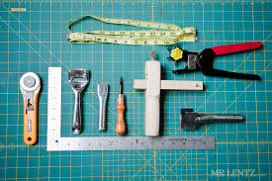
- Tool rooms and racks in clean and orderly condition.
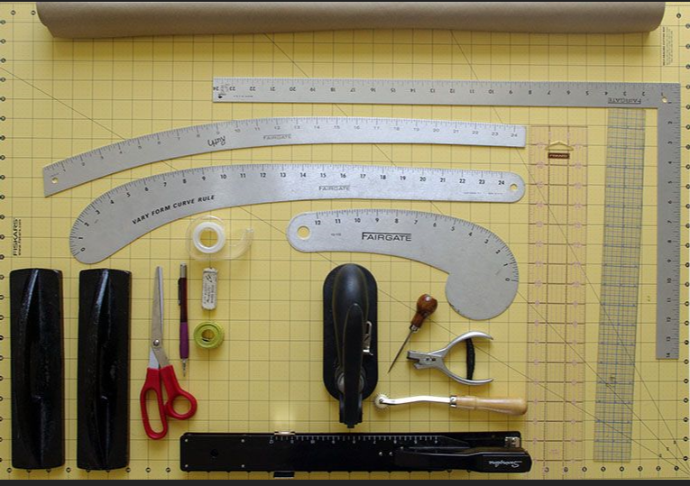

Figure 1.11. Collecting and storing Cutting Materials

Cleaning cutting board.
A cutting board is a durable board on which to place material for cutting. The kitchen cutting board is commonly used in preparing food; other types exist for cutting raw materials such as leather or plastic.
A cutting board can be made up of
- Bamboo
- Plastic
- Silicone
- Glass
- Steel

- Bamboo
Bamboo cutting boards are an alternative to plastic or glass cutting boards, partially because bamboo is commonly thought to be naturally antimicrobial .During the harvesting process, bamboo is carefully chosen for maturation, markings, and size. The stalk is then cut into specific sizes and sent through a pressing process that strips the stalks into smaller plank-like pieces. Once the bamboo is pliable, a cutting board can be produced from multiple pieces by lamination.
- Plastic
Plastic boards are usually called PE (polyethylene) cutting boards, or HDPE (high-density polyethylene plastic), the material of which these boards are made.
There are two types of HDPE boards being made. One version is made from injection-molded plastic, while the other is HDPE from an extrusion line.
There are several certifications of plastic cutting boards, one being that certifies the plastic has passed requirements to be exposed to food.
Unlike wood, plastic has no inherent antiseptic properties. waver, unlike wood, plastic boards do allow rinsing with harsher cleaning chemicals such as bleach and other disinfectants without damage to the board or retention of the chemicals to later contaminate food.
Most high-density polyethylene plastic boards are specifically designed not to dull the edge of a knife. If a score line is present, the knife is safe.
A serrated knife should not be used on a plastic cutting board. The sharper the knife, the longer the cutting board will last. Semi-disposable thin flexible cutting boards also ease transferring their contents to a cooking or storage vessel.
- Silicone
Like rubber, silicone is soft on the blade, while being just as self-healing and anti-bacterial as wood. Silicone is also heat-resistant, and lacks the rubbery smell of rubber boards.
- Glass
While glass looks like an easy surface to keep clean, glass-cutting boards can damage knives because of the high hardness of the material. Cutting on glass tends to dent, roll or even chip knife-edges in a rapid manner. Additionally,
- Steel
Steel shares with glass the advantages of the durability and ease of cleaning, as well as the tendency to damage knives. Depending on the exact steel and heat treatment used, at best a steel cutting board will wear the edge on knives quickly; at worst chip, dent, or roll it like glass

Self check 1
- Multiple Choice {8Point}

          - Which one is an area, outfitted with equipment and furnishings for one or more workers
            - Workstation
            - Pattern cutting
            - flat-pattern method
            - All
      - patternmaker is ------------------------------------
- Typically employs one of two methods to create a pattern.
- the entire pattern is drafted on a flat surface from measurements, using rulers, curves and straight edges
- draping to measure out fit
      - Which one is an arrangement of lines or shapes, especially a design in which the same shape is repeated at regular intervals over a surface.
- Pattern cutting
- pattern
- interpreting
- All
      - Which one is the types of Cutting knife
            - One -piece knife
            - Scalpel
            - Snap off blade knife
            - All
      - Silver marking pencil is----------------------------------------------
            - is used to mark defects on leather while assorting
            - It is also used to mark on the components for fixing fittings with the help of patterns.
            - to mark on patterns on leather for cutting components to achieve the maximum cutting value
            - All

II: Short Answer Question {20point}
- 1. Write are major tools that necessary for hand cutting. (5pts)
- What is the recommended length and thickness of a steel ruler? (3pts)
- What is the purpose of tracing wheel? (2pts)
- Discus about the different types of knives and their uses?(5pts)

Unit Two: cut paper and other components
This unit to provide you the necessary information regarding the following content coverage and topics:

  - using hand tools
  - demonstrating Paper cutting
  - receiving, reading, interpreting and duplicating temples
  - interlocking templates for cutting
  - cutting synthetic materials
This guide will also assist you to attain the learning outcomes stated in the cover page. Specifically, upon completion of this learning guide, you will be able to:

- Use hand tools
- Demonstrate paper cutting
- Receive ,read, interpret and duplicate templates
- Interlock templates for cutting
- cut synthetic materials

2.1. Hand tools
an instrument (as a saw, file, knife, or wrench) used or worked by hand or machine to perform a task.
Get to know the different types of leather cutting tools that make this specific task super easy. Both beginners and pros will find these tools essential for cutting straight lines, curves, and patterns in leather.
Cutting leather may seem like a daunting task but it is actually easy to do. What can be tricky, however, is making sure those cuts are done just right. Thin and soft leathers are especially known for pulling as you cut them. Small mistakes can affect the overall result of your project.
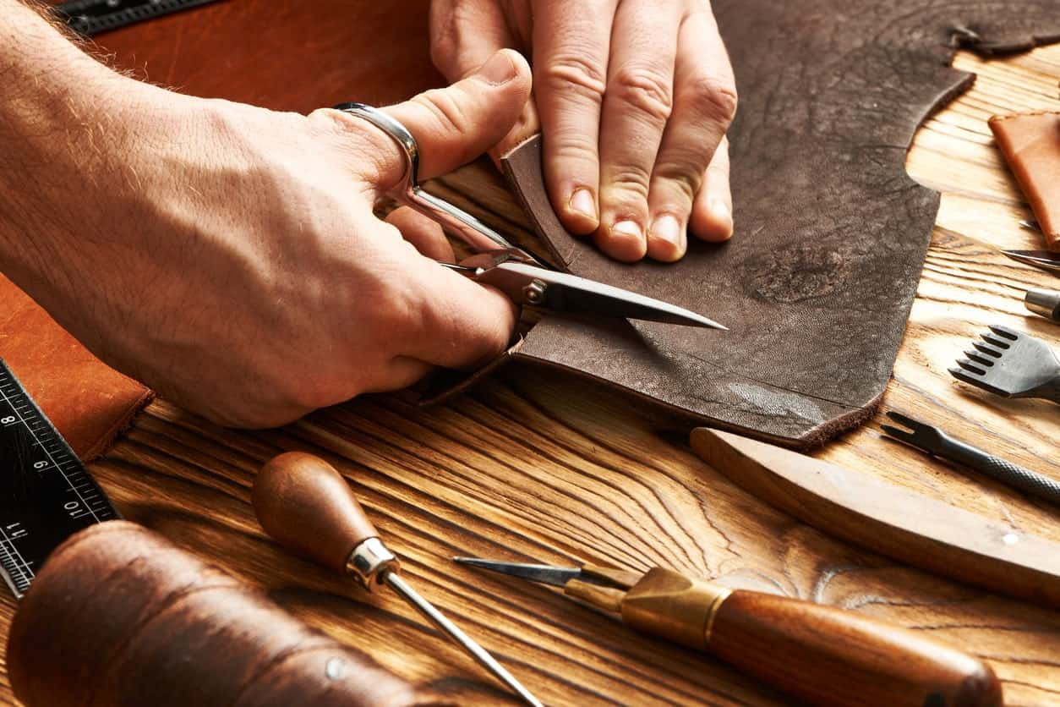

Figure 2.12.Cutting leather
One of the things to ensure you make smooth and accurate cuts for both thick and thin types of leather is to use the right leather cutting tools. There can be a lot to choose from so we narrowed down the list below to the essential ones.
Types of Leather Cutting Tools

1. Utility Knife
A utility knife is a tool that you may already own. Many people use utility knives for daily tasks and random home improvement projects. They can be useful for cutting up carpets and slicing open boxes. It is always smart to have one of these knives handy because you never know when you might need one.
When it comes to leather cutting, it is essential to have the right cutting tools. A utility knife will work great when you need to cut pieces of leather. These knives are incredibly sharp and are very thin. This is exactly the type of knife you need when you are trying to make precision cuts to a piece of leather.
This will be one of the ideal tools for cutting thin pieces of leather. You can make detailed cuts, and it will turn out nicely. The only problem you will need to consider is that this knife is not meant for cutting thicker pieces of leather. It simply is not the right blade for cutting thick slabs of leather, and you should turn to another cutting method when you have thick leather to cut.
The blades of your utility knife will need to be changed out after being used for cutting leather, as well. It will wear out the blade over time. Luckily, utility knives can be loaded with new blades rather easily. You will definitely want to pick up a high-quality utility knife if you do not own one already.

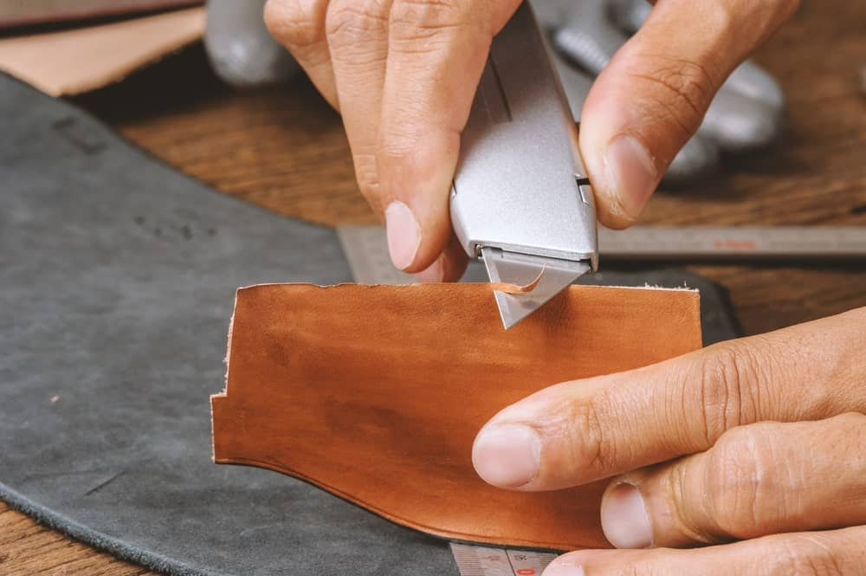
Figure2. 13.Cuttingleatherutility knife

2. Craft Knife
The craft knife is actually going to function similarly to the utility knife mentioned above.
Another very sharp blade is perfect for making precise cuts to your leather. When you need to make some detailed cuts in order to finish a leather piece, you will want to turn to this knife. It has a thin blade that is sharp enough to make the cuts precisely every time. It carries the same weakness as the utility knife, too.
This is another knife that is excellent for thinner pieces of leather. When it comes to cutting thicker pieces of leather, you are going to be better off turning to other cutting methods. It is a tool that you will want to keep around though.
A craft knife should be used to make detailed cuts. You need to know when to use the right tools for the job. You are going to be doing a lot of fine detail work when working with leather pieces. You will be getting very familiar with either your craft knife or a utility knife.
Some people really prefer the craft knife to the utility knife. The handle of the craft knife is long and thin. You will probably want to purchase this instead of a utility knife if you are going to be making leather items. It can be useful to own both though, and if you already own a utility knife, then you will be able to make do.
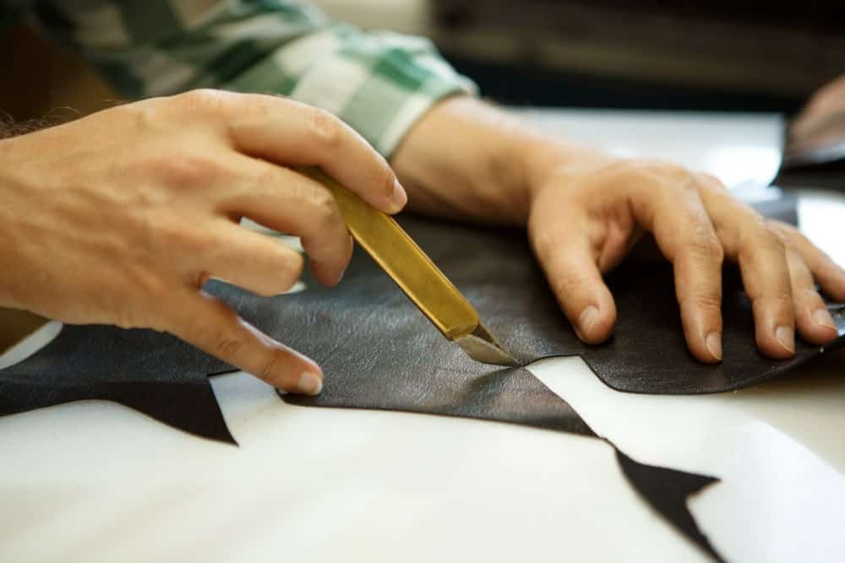
Figure 2.14.Craft Knife

3. Manual Punch
You will need to make holes in your leather in order to put rivets in it or even snaps. This is something that is common for those who make leather bracelets. You need people to be able to wear them, and you are going to have to set the snaps in the bracelet for it to be complete. The way that you make the holes for your bracelets is by using a manual punch.
This manual punch sort of looks like a pair of pliers. You will position the manual punch where you want the hole to be. You then press it into the leather and make your hole. Sometimes you will need more power in order to properly create the hole in your piece of leather, so the use of a rubber mallet may be required.
There are other styles of manual punches available, too. They are pretty versatile because they come in several sizes and will help you to punch holes even in hard to reach places. If you are going to be performing a lot of leatherwork, then you will want to own one of these. They will be an invaluable part of the process.
This manual punch is made completely out of metal. You will be able to operate it using one hand in most situations. It features a convenient spring that makes punching the holes into leather fairly simple. You might be able to cut into the thin leather with the hole punch without the use of a mallet, making it a very useful little tool.

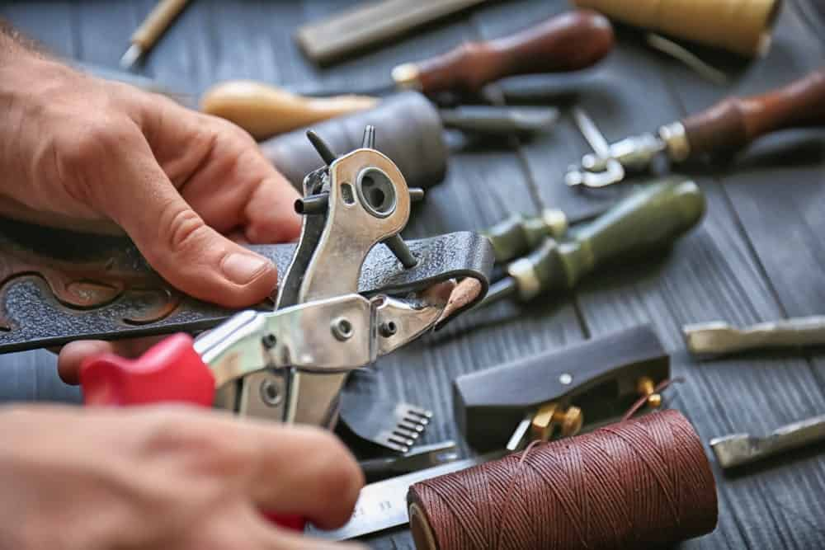

Figure 2.15.Manual Punch

4. Rubber Mallet
The rubber mallet will seem like the odd tool out on this list .It is not actually a tool that meant for cutting leather, but it is still a very important part of the process.
The hole punches that are mentioned above are going to be best used with a rubber mallet. You will be able to hammer the hole punch in order to make the holes that you’re desiring.
Mallets are used for leather reworking in a lot of other ways, as well. You will make use of a mallet to pound in rivets. Stamping pieces of leather will also require a mallet. Setting snaps in your leather will require a mallet, too, so this is important to have around if you plan to make items such as bracelets.
Some leather pieces may need to be flattening out properly, too. This will be easy to do when you have a rubber mallet to work with. You can strike the leather without damaging it and get everything prepared properly. It is not a leather-cutting tool, but it is important to the leather cutting and leather working process.
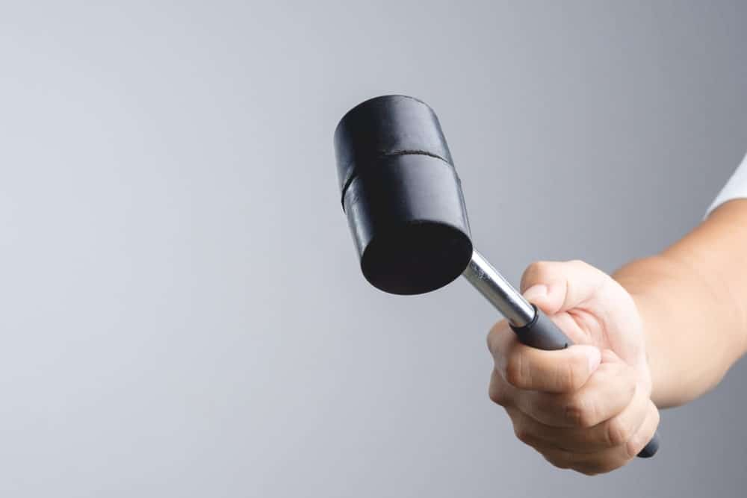
It is important to note that you should never use another type of hammer for these tasks. If you tried to accomplish the same tasks by using a claw hammer, the results would not be favorable. You could wind up damaging the leather and really messing up what you are trying to do. Avoid this, and ensure that you purchase the rubber mallet that you need today.

Figure 2.16.Rubber Mallet

5. Swivel Knives
A swivel knife is another tool that you are going to be getting familiar with. It is an important part of the leather cutting process, and you will be using it for detail work. It features a very sharp cutting head that makes cutting into a leather piece quite simple. You will be able to perform many tasks with your swivel knife.
As you might expect by the name is this knife, it has the capability of swiveling. It might be more accurate to say that it rotates, making it a type of rotary knife. You can use this to carve the leather to your liking. People who make ornate works of art on leather pieces will use swivel knives like this to do the job.
If you plan to make beautiful leather wallets with custom designs, then you will be able to use a swivel knife to do parts of the work. It will be easy to carve the leather to your liking, and you will be glad to have such a reliable tool. This knife is even adjustable, allowing you to change the length of the tool and even the rotation bearing.

This tool can be adjusted from a length of 80mm all the way up to 95mm. It is going to prove to be a very useful part of your leather cutting process. You will often find these swivel knives included in leather cutting kits, making it obvious that it is an essential tool to own. This product is a stand-alone swivel knife and will definitely be a worthwhile purchase.
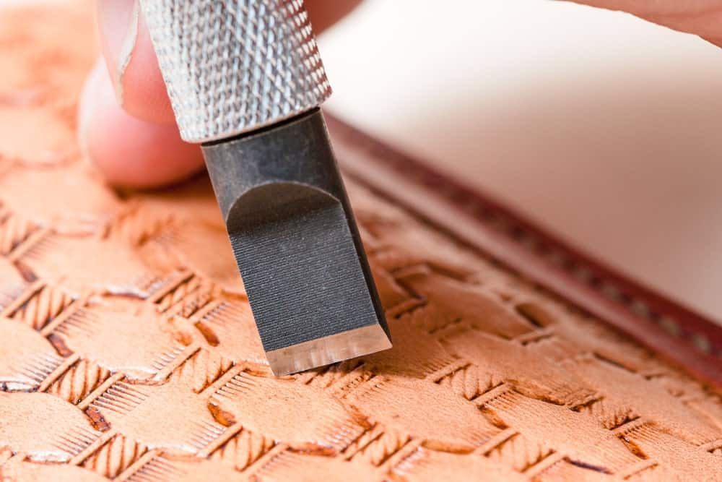
Figure 2.17.Swivel knife

6. Skiving Knives
Skiving knives are important tools to consider purchasing, as well. These knives differ from the others that have been covered on this list so far. A skiving knife is good for making general cuts because it is very sharp, but this is not the primary function of the tool. It is excellent for skiving your pieces of leather in order to shave off pieces.
When you want to be able to thin out a certain area of the leather piece that you are working on, then you will need a quality skiving blade. Skiving a piece of leather is something that you want to take slowly. You need to meticulously shave off the pieces of the leather that you are trying to alter. It may take some time, but you will be able to get great results when using this method.
This tool here is just less than seven inches in length. The wooden handle of this knife feels very good in your hands, making it easy to handle while you are trying to be precise. The blade itself is made out of stainless steel and will do the job very nicely. This tool is going to be handy for both amateur leather enthusiasts and professionals.

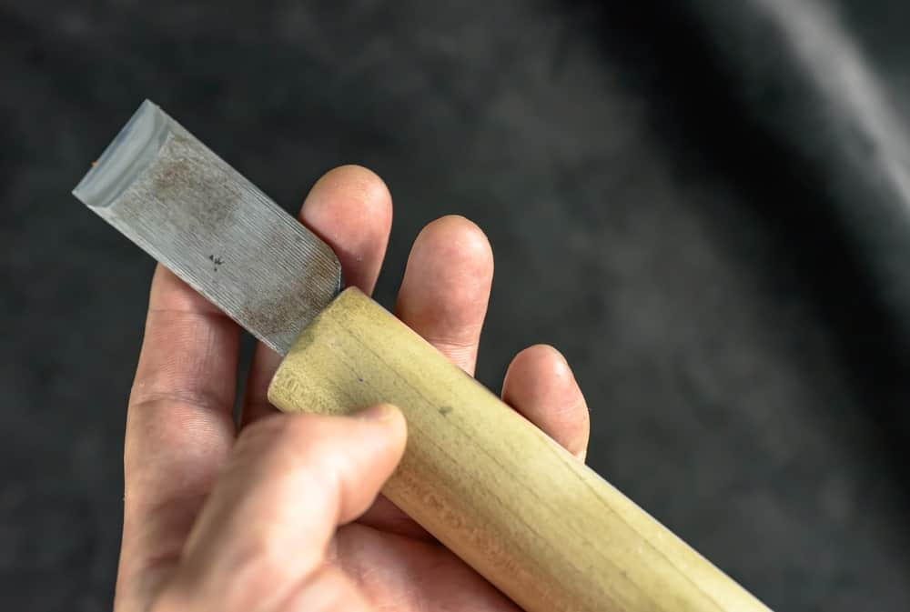
Figure 2.18.Skiving knives

7. Curved Knives
There are curved knives on the market that are perfect for certain leather cutting jobs. When you are creating complex items with your leather pieces, you may need a curved knife to make cuts in tight areas. This is the case when you are trying to construct your own leather shoes. There are going to be specific times when you will need a quality set of curved knives to be able to finish the job.
Some people even refer to this type of knife as a shoe knife because of how closely associated it is with the shoe-making process. If you have any plans of attempting to construct shoes with your leather pieces, then you will want to purchase one of these. It is going to be a helpful tool that can make your job a lot easier. It will also be useful for making repairs to shoes and other leather items.
The blade of this knife is three and a half inches long, as is the handle. The wooden handle of this knife feels very good in your hands, and you will be able to tell that this is a quality tool. The point of the blade is very sharp, as you might expect. It is important to be careful when handling the tip of this blade to avoid injuries.
This is not a blade that you will necessarily use for amateur leather cutting, but it will still be good to own. Depending on what you want to try to make, owning a curved knife is going to come in handy. As your skills grow, you will likely want to create more pieces that are complex. Having the right tools ready will allow you to attempt to broaden your capabilities.
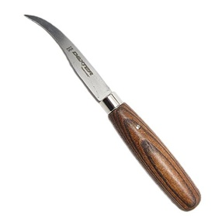

Figure 2.19. Curved knives

8. Leather Shears
Leather shears are going to be another tool that you will want to purchase. These shears will allow you to cut pieces of leather effectively so that you can make your items. You want a quality pair of shears that is going to be sharp enough to cut through leather without having problems. For this reason, it is good to go out of your way to purchase shears that are specifically meant for leather.
You can find shears that are not advertised as being leather shears that will work quite well, too. It is simply possible that the normal shears will be too dull to cut leather effectively. It will vary from tool to tool, so your best bet is to seek out leather shears. You should be able to find a quality pair of leather shears at your local arts and crafts store.
These leather shears here are capable of cutting through leather very easily. You will not have any trouble even when you are cutting through particularly thick pieces of leather. As you might expect, the tool will still have its limitations. You will want to make sure that the leather pieces are not so thick that it is impractical to cut through them with the shears.
Having access to these shears should allow you to create many fine leather items. If you are going to use other shears or scissors, simply make sure that they are sharp enough first. You do not want to make the leather that you are working on jagged in any way due to imprecise cuts. As long as you have sharp shears, this should be an easy process.
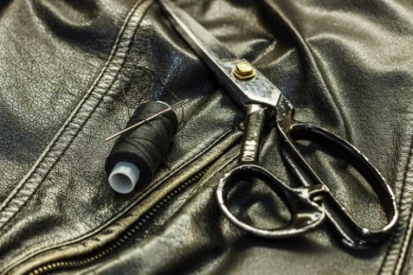

Figure 2.20.Leather shears

9. Rotary Cutters
Rotary cutters are common leather cutting tools that will be used for several purposes. When you first see a rotary cutter, you will likely think that it resembles a pizza-cutting tool. This is a very accurate comparison, as you will be using this rotary cutter in the exact same way that you do a pizza cutter. It is simple to use and will allow you to cut along patterns if you wish to do so.
These cutting tools are actually used for purposes other than leather cutting often. People purchase these rotary cutters for arts and crafts purposes regularly. They can be excellent for cutting through fabrics, felt, and even vinyl. It is a great tool for leather cutting, as well, and it is going to come in handy when you want to finish off a project properly.
When you want to use a rotary cutter to cut through leather, you will just want to ensure that it is sharp enough for the task. The leather is tough and you will need to have a blade that can handle cutting it effectively. It might be beneficial to test out the rotary cutter ahead of time to ensure that it is going to be good for leather cutting.
If it is advertised as being able to cut leather, then everything should work out just fine.
There is a sliding button on this model that is being shownhere. You can use it to extend the blade outwards while you are cutting. This useful feature might have some utility for you. The handle is very comfortable, and you will be able to make good use of this tool in your leather cutting efforts.

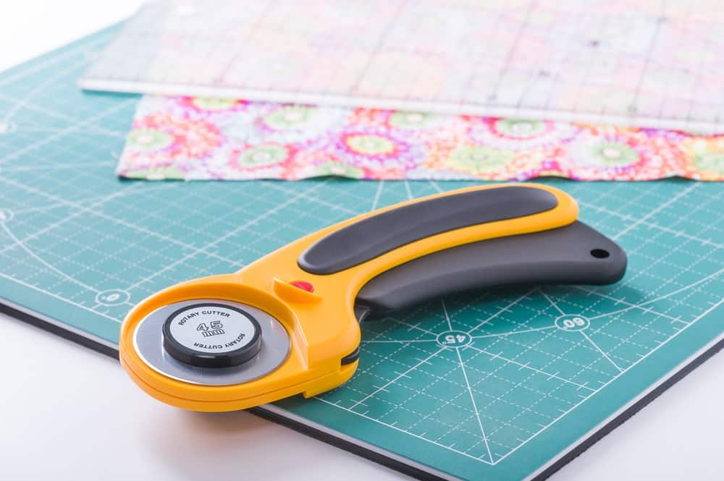

Figure 2.21.Rotary cutters

10. Cutting Mat
Of course, you are going to need a dedicated surface where you can cut your pieces of leather. It is going to be in your best interests to purchase a high-quality cutting mat. If you buy a good cutting mat, then it is going to be great for your leather cutting needs. The best mats on the market are even capable of resisting cuts and healing themselves over time.
You do not want to damage the table that you are working on. Buying a cutting mat is an affordable solution to your problems. You will have the surface that you need in order to perform the cuts properly. You will not have to feel concerned about what is underneath you while you are making the cuts, and everything is just going to go that much better.
The fact that this mat is capable of healing itself over time will allow you to use it for many years. You will not have to worry about buying a new cutting mat every few months. This cutting mat is going to stand the test of time and will definitely be a smart purchase. You will be able to get this cutting mat at a very fair price, so it is quite desirable for anyone who wants to start working with leather.
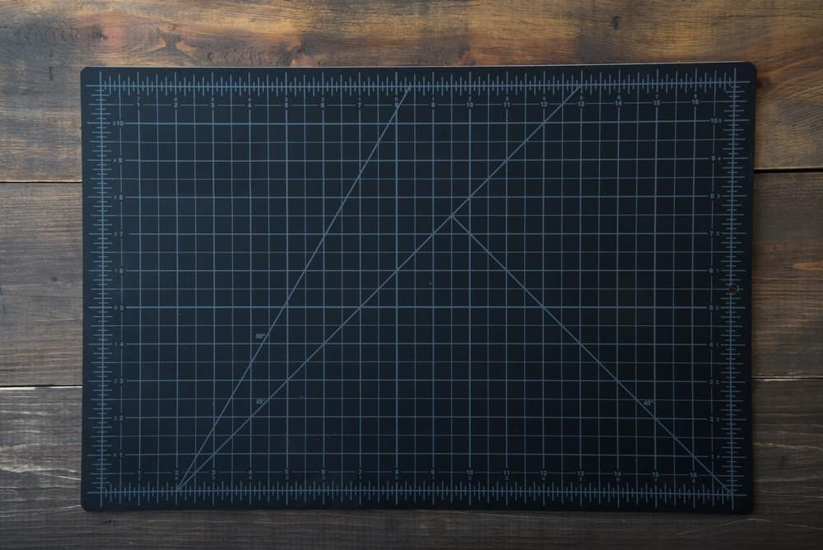
Figure 2.22.Cutting mat
- Awls - poking and scratching tools for creating small holes and marking leather.
We use them to punch sewing holes, or trace the outlines of patterns onto leather.
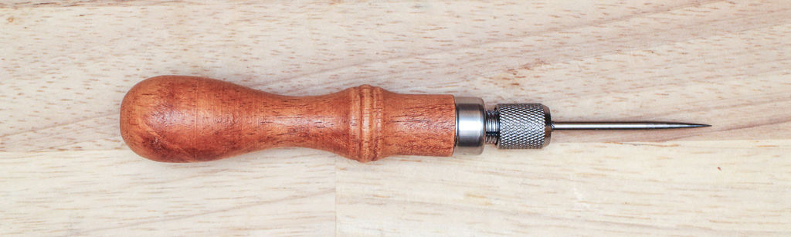
Figure2.23. Awls

- Snaps Setter - tool used to set the halves of a snap together, usually two metal parts used with a mallet.
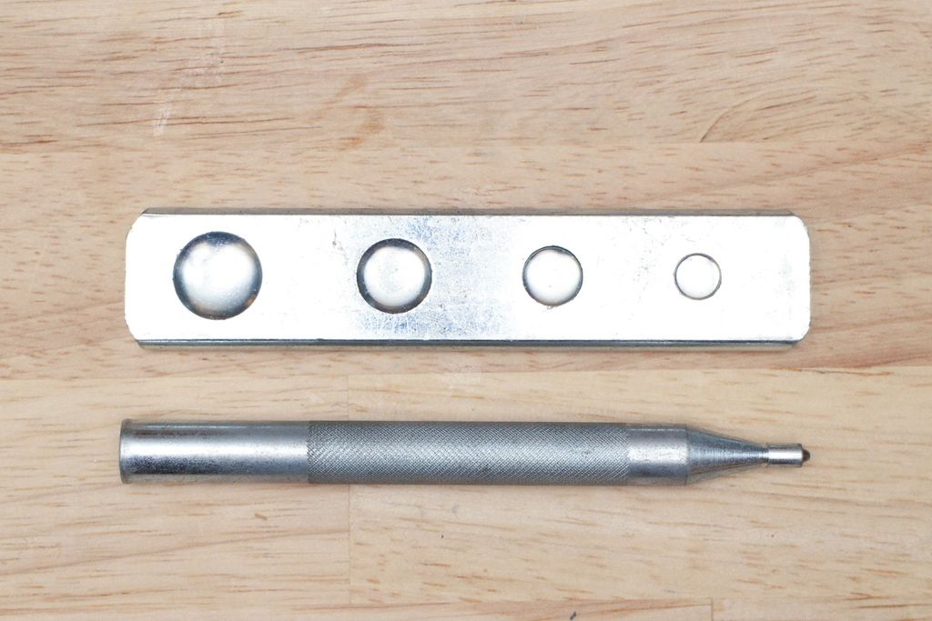
Figure 2.24. Snaps Setter

2.2. Demonstrating Paper cutting
Follow the following steps in order to properly hold your knife/cutter so that you are able to cut your paper and leather material.
Step 1:- hold the knife with thumb and middle finger
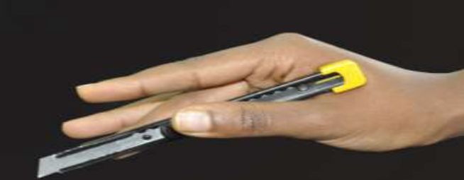Figure 2.25
Step 2:- press with index finger
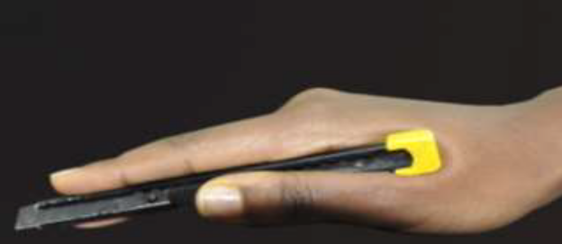Figure 2.26
Step 3:- ring finger and ladies finger are guiding the direction and should be laid in to the cutting material.
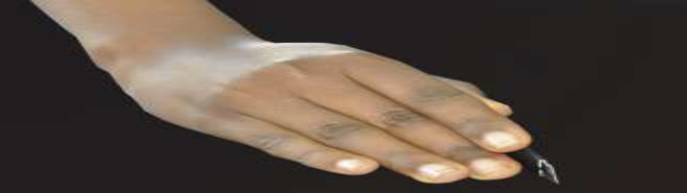Figure2.27
Step 4:- pierce the knife at the point of depart, make suitable angle (300 for straight and at list 600 to 900 for curved) and apply suitable pressure pull it towards from the top to the bottom and or from left to right according to the exercise given. Whenever you practice cutting, keep the movement of hand from elbow. Keep wrist locked, keep shoulder locked.

2.2.1 Paper exercise

The total number of exercises is 14 it is expected that student will practice one exercise 5 times but this depends on the capacity of the student i.e. if the trainer believes that the student should practice more he/she can give additional exercises. It is to practice these paper exercises with an approximate of 100 sheets of A4 size paper per student.

2.3. Receiving, reading, interpreting and duplicating templates

Making a leather template can be very intimidating. In order to make a leather template first you will want to decide what type of leather item you are going to make. Whether you are making a wallet, bag, purse or suitcase you will need to have an idea of how the item will look.

For example, let us take wallet templates receiving reading and duplicating

Wallets are much more difficult than they seem when it comes to measurements. Since wallets will have multiple pockets that need to fit in a small space it is very important to get measurements right. In addition, if you can make and understand a wallet template, it will make it much easier to understand other leather items.

Start with measurements
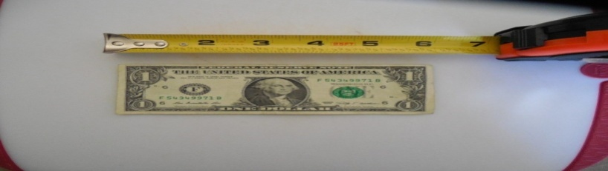
In order to make a wallet first you have to identify the type of material that a wallet can handle. Wallet materials handle money, a credit card and some other small items so you have to start the measurement of each material.

Figure 2.28.Measurement

A dollar bill is a little over 6 ^{1/8”} wide by 2 ½” tall. Therefore, we know a wallet when open must be bigger than the cash size.

An average credit card is 2 ^{1/8”} tall by 3 ^{3/8”} wide so if we want to have two sides holding cards the open wallet will need to be over 6 ¾” wide.
To start we are going to take our leather size we will be working with. For this, we will say an average size of a 4oz piece, which will equal 1/16” thick. In addition, the thickness of a credit card which is around 1/32” thick. However, for extra ease for the pockets we will use the 1/16″ thickness.

If we want to have multiple cards inside each pocket, we will add 1/16” around the whole area of our pocket. Therefore, with a credit card slot that holds one extra card you will add 1/16” around the credit card size.

You will apply this to every side of the pocket except the opening of the pocket. This will add extra room for the card slot to open allowing the cards to sit in. tend to try to keep stitching 1/8th of an inch from the edge of the pocket. Therefore, I will add an extra 1/8” around the edges that will be stitched.

A wallet card pocket holding four cards should be around 3 11/16” wide by 2 7/16”. It can get a little confusing when you have to even out the fractions, but well worth it to get an exact measurement.
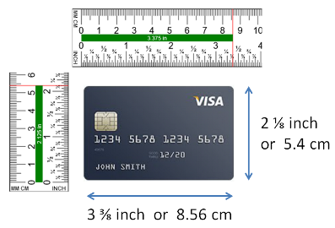
Figure 2.29.A wallet card pocket Measurement

For safety we usually round up to the nearest simple fraction so I say 3 ¾” wide by 2 ½” tall. This adds a small amount of safety and if I need to, I will put the stitching a little further than 1/8″.
When you are drawing this out constantly check the pocket, making sure the stitching lines will not be hit with the cards.
Now repeat this for any other area or just copy and paste it wherever you want the card pocket to sit.
For a foldable wallet, you will want to have a middle fold area. To close smoothly without bulging out the leather you will also want to have the back piece of leather longer than the front piece.
These are sort of personal preference depending on how wide you want the wallet to open at. A much larger back piece will have the cash pocket mouth open very wide but the wallet itself will not open as much.

2.4. Interlocking templates for cutting
Inter locking is the process of laying the patterns in the appropriate position so that waste can be minimized efficiently. It is the process of making the patterns to fit on the leather.
It is also called nesting before proceeding for nesting the person who cuts must know all the cutting principles like the lines of tightness and stretch the quality division of the components etc. In order to achieve better pattern interlocking one may consider–
- Curve to curve,
- Straight edge to straight edge interlocking
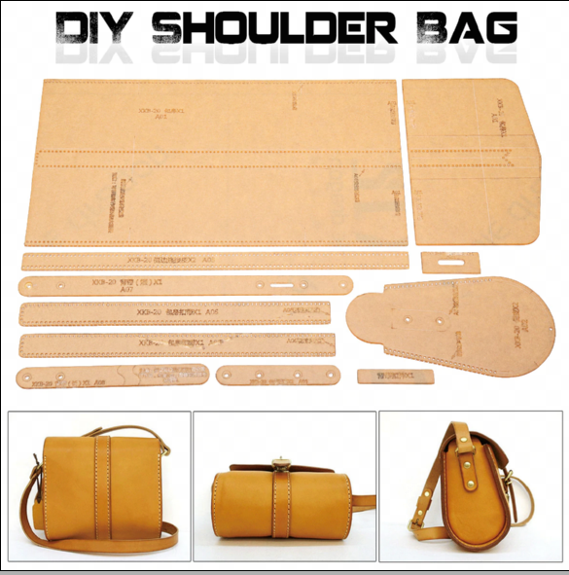
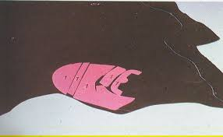
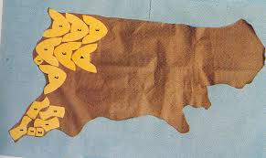
Figure 2.30. Inter locking templates for cutting (NESTING)

2.5. Cutting synthetic materials
Synthetic leather, also known as faux leather, vinyl or leatherette, is a manmade fabric made using PVC or polyurethane (PU) that is treated and dyed to resemble real leather. Synthetic leather is a cheaper, a more versatile and an ethically friendly alternative to real leather, which is made from tanned animal hides.
Synthetic leather is durable, stain resistant and cost effective. It is considered just as attractive as real leather, although the "real leather smell" and luster that many people love about real leather cannot yet be replicated.
A synthetic material has advantages of wash ability and lower price over leather lining and has advantages of leather look over fabric lining. They are also easier for cutting.
Cutting synthetic leather is super easy with the right tools. It can seem daunting if you are trying to go at it with a pair of scissors, though.
In order to cut a synthetic material you will follow the following steps
Step 1. Identify type of material that you need
Step 2.Depending on what you are cutting out, you might want to lay it out and mark it on the synthetic leather beforehand.
Step3. cut out the synthetic leather with appropriate cutter
Step 1. Identify type of material that you need
- Hobby knife with a sharp blade
- Cutter
- ruler
- synthetic leather for cutting
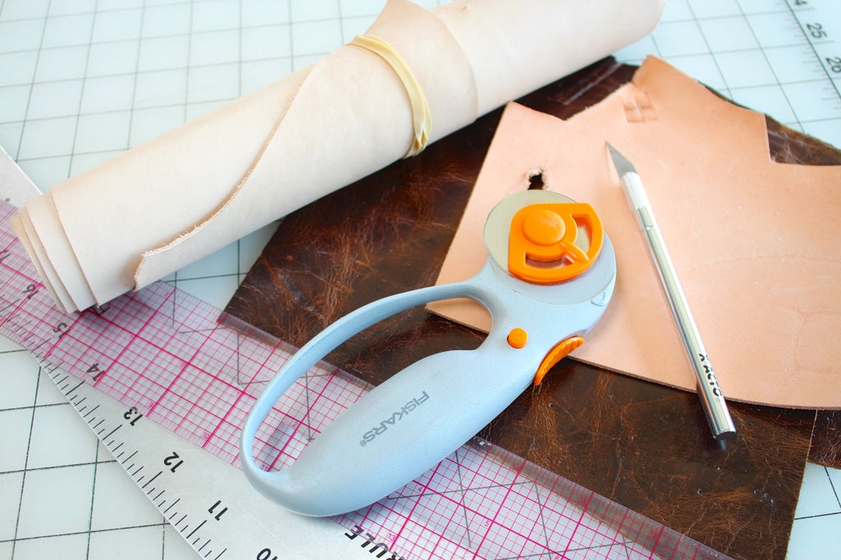
Figure 2.31.neded material
Step 2. Depending on what you are cutting out, you might want to lay it out and mark it on the synthetic leather beforehand.
- Making a stiff pattern/template is especially good if your pattern includes curves.
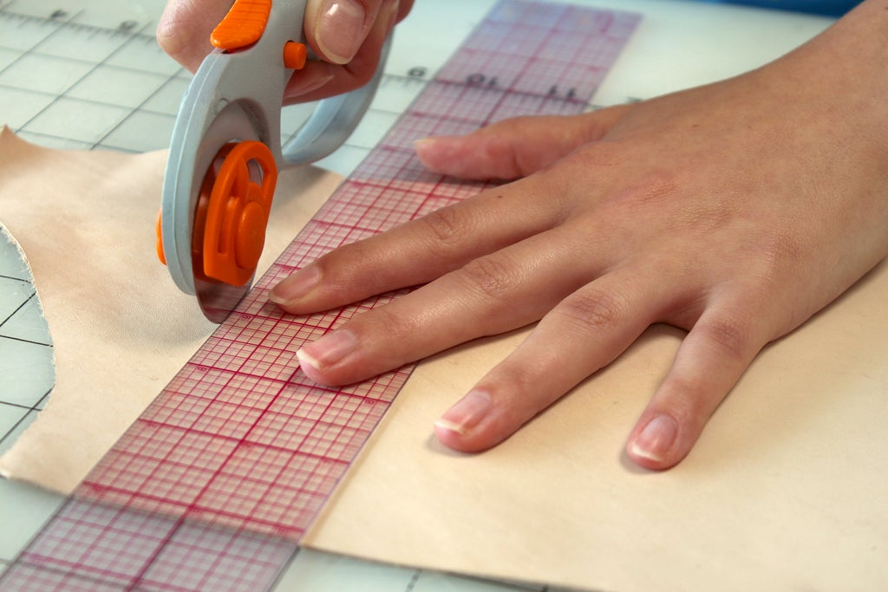
Figure 2.32. Lay out and marking
Step 3 cut out the synthetic leather with appropriate cutter
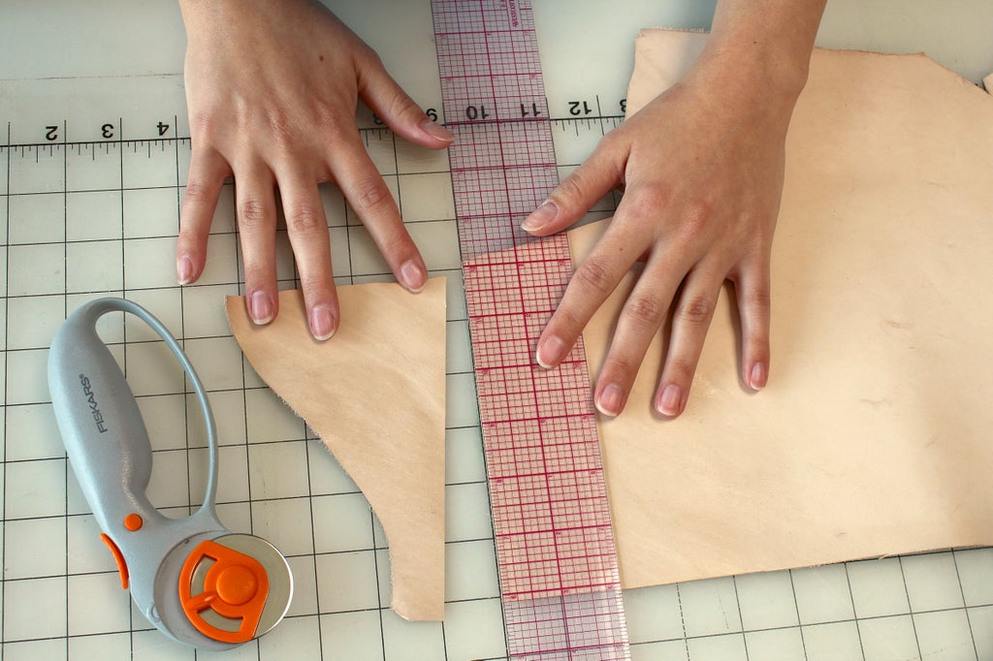
Figure 2.33. Cut out

Self-check 2
Multiple Choices {8Point}
1, Which one is to make holes in your leather in order to put rivets in it or even snaps
- Rubber Mallet
- Manual Punch
- Craft Knife
- All
2, poking and scratching tools for creating small holes and marking leather
- Awls
- Cutting Mat
- Rotary Cutters
- All
3, Which one is an arrangement of lines or shapes, especially a design in which the same shape is repeated at regular intervals over a surface.
- Pattern cutting
- pattern
- interpreting
- All
4, Which one is the types of Cutting knife
- One -piece knife
- Scalpel
- Snap off blade knife
- All
5, Silver marking pencil is----------------------------------------------
- is used to mark defects on leather while assorting
- It is also used to mark on the components for fixing fittings with the help of patterns.
- to mark on patterns on leather for cutting components to achieve the maximum cutting value
- All

Short Answer Question {20point}
            - Write are major tools that necessary for hand cutting. (5pts)
            - What is the recommended length and thickness of a steel ruler? (5pts)
            - What is the purpose of tracing wheel? (5pts)
            - Discus about the different types of knives and their uses?(5pts)

Operation Sheet 2

Operation Sheet 2.1 perform paper cutting

      - Tools and equipment
- Cutter
- Table
- Mat
      - Procedures/Steps/Techniques
Step 1 cut paper exercise 1
Step 2 cut paper exercise 2
Step 3 cut paper exercise 3
Step 4 cut paper exercise 4
Step 5 cut paper exercise 5
Step 6 cut paper exercise 6
Step 7 cut paper exercise 7
Step 8 cut paper exercise 8

Operation Sheet 2.2. Perform synthetic cutting

- Tools and equipment
- Cutter
- Table
- Mat

- Procedures/Steps/Techniques
Step 1. cut synthetic exercise 1
Step 2. cut synthetic exercise 2
Step 3. cut synthetic exercise 3
Step 4. cut synthetic exercise 4
Step 5. cut synthetic exercise 5
Step 6. cut synthetic exercise 6
Step 7. cut synthetic exercise 7
Step 8. cut synthetic exercise 8
Step 9. cut synthetic exercise 9
Step 10. cut synthetic exercise 10

LAP TEST
Name………………………………. ID…………………………….. Date…………………………………….
Time started: ________________________ Time finished: ________________

Instructions: Given necessary templates, tools and materials you are required to perform the following tasks within given hour. The project is expected from each student to do it.

Task-1 Perform paper cutting
Task-2 Perform synthetic cutting

Unit Three: Cut leather by hand
This unit to provide you the necessary information regarding the following content coverage and topics:
- selecting leather
- assessing leather defect
- positioning temples
- applying cutting techniques
- identifying Problems or faults
- carry out OHS practice

This guide will also assist you to attain the learning outcome stated in the cover page. Specifically, upon completion of this Learning Guide, you will be able to –
- select leather
- assess leather defect
- position temples
- apply cutting techniques
- identify Problems or faults
- carry out OHS practice

Selecting leather
Leather is a durable and flexible material created by tanning animal rawhide and skins. The most common raw material is cattle hide. It can be produced at manufacturing scales ranging from artisan to modern industrial scale.

The leather selection process is not an easy one but it is important to learn when designing handbags or any leather goods.
Selections are narrowed down to the most appealing skins and hides that are buttery in texture, have the right grab, weight, and slouch or structure, with hues that are richly saturated. Leathers that will age nicely are also of importance. Swatches are brought back to the design office where they are tested, matched to designs, and categorized into seasonal collections.
In most cases Leather selection is done by the Human Eye and hand, it is one of the most difficult areas to train as it relies on individual skills and concepts.
There are no exact standards or methods for grading leather since it is done by the grain characteristics sight and feel developed through experience and training.
A skin is divided into five quality regions; the best part is “Butt”. This has the tightest fiber structure. The fiber structure can vary considerably depending on the age of the animal and the living conditions. The neck and the belly have the loosest fiber structure.
Leather can be selected by different techniques such as:
- Sorting by Color
- Sorting by size or area of leather
- Sorting by texture / grain
- Sorting by thickness
- Sorting by Color – Which will help to group the same color shading from a bundle of leather and to have the same color shade in one model at the time of cutting for a product
- Sorting by size or area of leather – This type of sorting will assist the proper utilization of material to use bigger sizes for bigger patterns.
- Sorting by thickness – The thickness of the material can be split the sorting of leather by thickness will assist to use the thicker material for the required part. This is mostly important for leather garment.
- Sorting by texture / grain – Leather having similar texture will be sorted for the process needed.

Figure 3.34. Leather Sorting
Types of leather and there characteristics
- Cow Napa
- Cow Dry Milled
- Goat suede:
- Sheep Napa leathers
- Cow Napa:
Cow Napa leathers are soft and have larger area with increased cutting value and smoothness of grain. Cow Napa leathers are used for making softy types of leather goods and Garment.
- Cow Dry Milled
Cow dry-milled uppers, which are tanned with characteristic grains, developed naturally. The techniques of embossing in the hydraulic embossing press are also done to get characteristic grains. Cow dry-milled uppers are used for making heavy, medium and small leather goods.
- Goat suede:
Suede leathers are characterized by its fine velvet nap normally on the flesh side. Suede leathers are made from goat and sheep. Since suede leathers have high degree of softness, light in weight and reasonable stitch-tear and tongue-tear strength, they are used in most fashionable leather goods and leather garments. Inferior quality suede leathers are used as linings in leather goods.
Like kidskin but courses showing clear hair cell print. Size is from approx. – 40 to 90 dm2.
- Sheep Napa leathers:
Soft full grain Napa leathers made from goat and sheep are extensively used for making softy types of leather goods and leather garments. Sheepskins have a smooth grain and its strength properties are less as compared to goatskins. Sheepskins are good starting materials for making softy types of leather goods, particularly, ladies handbags, wallets, etc.

Assessing leather defect and faults
Leather defects are Imperfections in the grain surface or structure of a hide or skin resulting in unsightly appearance and/ or weakness of the resultant leather. Such defects may have arisen during the life of the animal, or may have developed in the flaying and/or preparation of the stock.
In general, leather defects are classified as
- Anti-mortem defects and
- Post mortem defects

- ANTIMORTEM DEFECTS:
Anti-mortem defects are defects that occur during the life of the animal. There are different causes of this defect this are:-
- POCK MARK
- TICK MARK
- WARBLE HOLES
- BRAND MARKS
- GOAD MARK
- SORE MARK
- THORN MARKS
- YOKE MARK
- POCK MARK: A small round depression on the grain side of the hide. Pock marks diorites the value of the hides. This depression can be controlled by mass vaccination of cattle.
- TICK MARK: A small depressions similar to pock mark caused by cattle ticks zoologically known as spider, scorpions and mites. These ticks get their nourishment by sucking blood from the cattle .This mark makes the quality of the leather inferior. One can minimize this defect by spraying tick-killing solution to the body of the cattle.
- WARBLE HOLES: These holes are caused by flying insects known as warble fly. It generally attacks on both sides of the spinal cord.

Three types of warble fly
a) HypidermaCineatum
b) HypodermicBovis
c) HypodermicErossi
- BRAND MARKS: To make branding on animal, red-hot iron is used to mark figure on the animal as per owner’s choice.
- GOAD MARK: While ploughing the field the cattle in our country often beat by their owner with a stick, which is shucked by a sharp nail on the edge. This makes permanent holes on the butt portion of the animal. This defect hampers the quality badly
- SORE MARK: Cattle are often get soared. It is not timely attended and because of that, it spreads. Ultimately, the sores heal up but the marks are left behind making the affected parts useless.
- THORN MARKS: A long and deep scratches caused by the thorny shrubs of the fences of fields or of the jungles where the cattle stray out to graze.
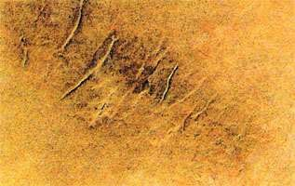
Figure 3.35. Thorn marks

- YOKE MARK: A patch of hardened skin is often found on the shoulder of the animal. This is due to the constant friction and pressure of the yoke to the shoulder.

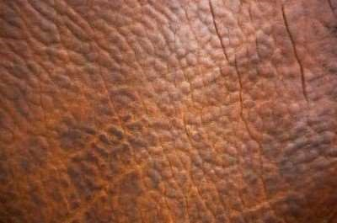
Figure 3.36. Yoke mark
In addition to the above defects, many hides are very poor in substances because of nutrition’s and old age of the animal. A large number of cattle are allowed to linger on until they die of sheer old age. The hides of such animals are loose and lack in proper substance.
- POST – MORTEM DEFECTS:
These defects occur after the animals are flayed. There are different causes of post mortem defects these are
- FLAY CUT/BUTCHER CUT
- VULTURE MARK
- BURNS
- PUTRIFICATION
- FLAY CUT/BUTCHER CUT: At the time of flaying the skin from slaughtered or dead animal the flay cut occurs due to butcher’s negligence. It diorites the quality of the skin
- VULTURE MARK: In remote village, the fallen dead cattle are often left lying on the field away from the civil area. The vultures lie on the carcass puncturing the hide with their sharp claws. In similar jackal and dogs, also damage the hides. This defect lowers the value of the hide.
- BURNS: Hides or skins of wet region are dried for preservation over wood fire. These hides often show the damage due to burning.
- PUTRIFICATION: After flaying if the hides and skins are not preserved immediately the purification may start and even can damage the whole lot of hides/skins. If the curing of the hides and skins is not sufficient, it causes local damage. Sun blister may form and the interior portion of the hide may partially putrefy during transit or store

Positioning temples
Positioning is the placement of leather patterns in lather in effective way it is a best practice in the leather goods manufacturing unit. If the cutting process is manage then the minimum wastage will be recover. In the leather, there are many defects, marks; patches but the positioning of patterns isan experience job for a cutter.
Take an example of a bag – From the butt portion the best part of a bag i.e. Front part and the Flap part will place the pattern to cut. The back part will positioned for the rest place of the butt top portion or can be neck portion. Flap inside part will cut from the neck portion. From the belly portion –Gusset, Base and Handles pattern will place it and cut the leather. The inside Zipper part, Loops and other patterns will come out from the rest pieces of the leather portion. This is the way for economical cutting the leathers into a bag-manufacturing unit or factory.
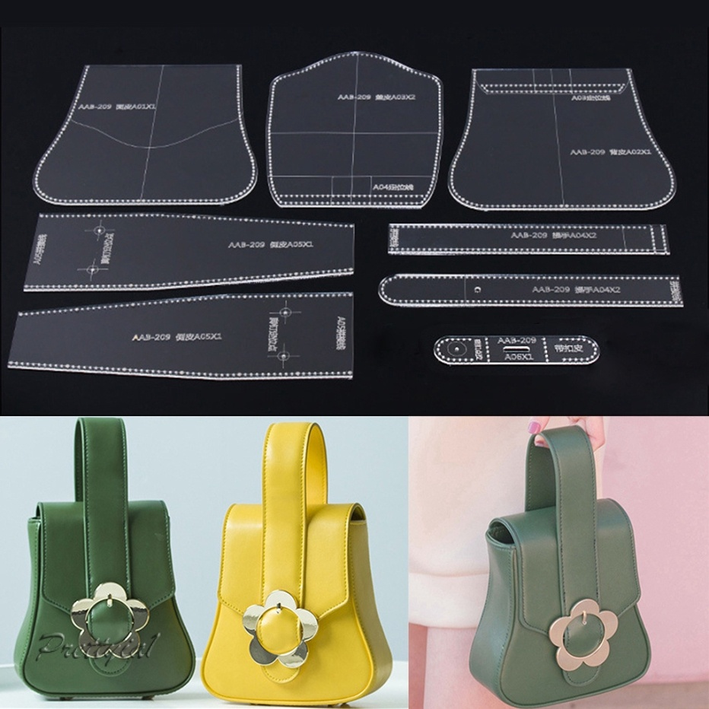
figure 3.37. Placement of leather patterns

Cutting techniques
Cutting is the process in which goods or garment material are cut and converted in to the shape of the patterns of the component of the goods or garment.
There are two types of cutting system
- Hand cutting
- Machine cutting

Hand cutting

- Hand cutting is one of the method of cutting leather or any other leather goods making material. Hand cutting is done with the use of hand knife and cutting patterns. This requires a high degree of skill.
- Hand cutting is a slow process in comparison to press cutting but it is sometimes necessary especially for low order of production or for some difficult design patterns.
- For successful cutting work, good tools and good materials are essential.

Advantages of Hand cutting
  - The cost of the patterns for hand cutting is less
  - Simple cutting tools
  - Cost of space is low
  - Storage space is greatly reduced
  - The patterns are easily handled and very little time is last in changing from one pattern to another
  - There is no power cost and low risk injury
  - No or little maintenance cost

Hand cutting is done usually in small leather goods industries using either cardboard patterns or metal templates. Hand cutting is done on an inclined wooden table fitted with a galvanized zinc sheet or Teflon sheet on its top. A sharp hacksaw blade knife made of tempered high-speed steel is used for hand cutting.
The cutting knife is used to cut the leathers and other materials like linings, foam, reinforcements, etc. used in leather goods making. Machine cutting is done in the case of bulk production. The leathers are placed one by one on the Teflon board of the hydraulic clicking press and then components are cut with the dies. Press cutting ensures speed of operation, accuracy and uniformity and least wastage.
In the process of cutting, the cutter plays a vital role because the economy of production depends upon his skill in placing patterns, maximizing the cutting value and minimizing the wastages. He must be aware of structure, sections and quality variations of the skin. The cutter is, considered the most important person after designer and pattern maker
Key points to be remembered during cutting:
- Make sure of correct patterns and markings.
- Examine for defects size and shape of the skin.
- Selective cutting must be practiced. The best part of the article demands the best part of the skin.
- Visible part must have good grain surface and section covered could contain grain defects.
- Good cutting begins with a sharp knife. Less sharpened knife or blunt knife cuts the leather with ragged edges.
- The angle between the edge of the knife and the cutting board depends of the hardness of the material being cut. A small angle for very soft materials like fabric and a greater angle for hard materials like leather and reinforcements.
- Over-cutting and under-cutting must be avoided.
- Patterns must be placed in such a way to ensure quality, economy and minimum wastage.
- Straight-line cutting must be done first with steel scale. Curved line cuttings or irregular shapes must be cut with templates.
- Cutting must be done on a smooth surface of softwood or galvanized iron plate or zinc plate for cutting accuracy.
- Place the pattern on the leather and initiate cutting from left to right.
- Start cutting from left top corner of the pattern and end at the right bottom corner.
- Use the least number of cutting strokes.
- Cut through the leather in one stroke.
- Intermittent cutting must be avoided as it may damage the components.
- Place the patterns suitably on the leathers to achieve maximum cutting with least wastage.
3.4.1Match quality region of leather
Quality regions the various areas of H/S have different quality regions. Quality is directly related to the “Tightness & the compactness” of the fiber structure. Therefore, the “best quality” of an H/S is BUTT and the worst quality “part which is almost useless from users point of view is offal. The diagram gives you a description of the quality areas of hide/skin.

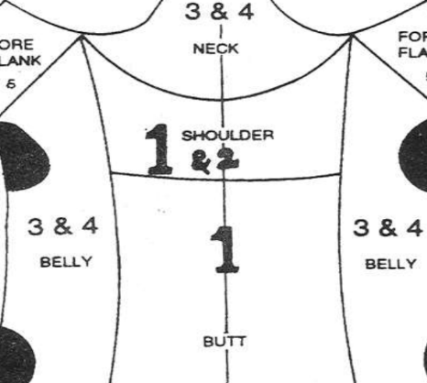

Figure3.38.Quality region of leather
Before cutting the leather to keep match quality of leather according to the cut components should be, inspect for the following defects
- Loose or fibrous material
- Brand marks operation scars and open flaws.
- Closed flaws wire marks and scratches
- Growth marks or fat wrinkles
- Veins
- Fly cuts
- Discolored areas
- Insect or parasitic damage
- Any other defect that may render an area of leather unusable
3.4.2. Match color, shape, and size leather
Color, shape and size of leather are different, because of the nature. It is get from animals. Animals grow in different areas they have different size, color, shape. Moreover, the finished leather different types of shape color and size.
Before cutting the leather to keep match quality of leather according to the cut components should be, inspect for the following defects
- Loose or fibrous material
- Brand marks operation scars and open flaws.
- Closed flaws wire marks and scratches
- Growth marks or fat wrinkles
- Veins
- Fly cuts
- Discolored areas
- Insect or parasitic damage
- Any other defect that may render an area of leather unusable

Problems or faults
The common problems or faults occur in leather products are:-
- Looseness of leather
- Signs of excessive growth
- Uneven dying
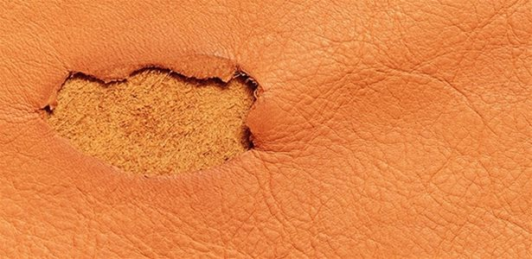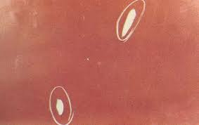
- Cracking leather
- Color variation
- Grain damage
- Poor yield
- Weak leather
- Finish failure
- Smell
- Color migration
- Breakage
- Peeling of the leather finishes Figure 3.39. Faults occur in leather products

OHS practice

OHS, or Occupational Health and Safety, is a multidisciplinary practice dealing with all aspects of health and safety in the workplace, with a strong focus on preventing workplace hazards.The goal of an occupational safety and health program is to foster a safe and healthy occupational environment. OSH also protects all the public who may be affected by the occupational environment
    - Hazard identification and control
A workplace hazard is something that can hurt you, or has the potential to hurt you. There are hazards in every type of job and every type of workplace. Everyone at the workplace: workers, managers and the employer, share in the responsibility to identify and control hazards. For workers, this first step means recognizing what a workplace hazard is (or could be) and how to report it to the employer.
For employers, the first step is to inform workers of potential hazards, to have control systems in place to decrease the risk of injury. However, what if you are not quite sure what to look for? What is a workplace hazard, anyway?
Types of workplace hazards
- Physical
- Chemical
- Biological
- Ergonomic
- Psycho-social
I. Physical
Physical hazards are things or agents that may come into contact with the body with potential for harm. Physical hazards that can exist in assembling and stitching work area can be, like slippery work surface, level and nature of noise, vibration, temperature and pressure.
II. Chemical
Chemicals are in everything around us. They can be natural or manufactured, and come in the form of liquids, gases, vapors, solids or particulates (very small pieces). Naturally occurring and manufactured chemicals both carry potential for harm for people working around them. Examples of chemical hazards that exist in assembling and stitching leather goods workbenchare - compressed gases, solvents, glues, lubrication oil for stitching machine etc.
III. Biological
Biological hazards are typically in the form of bacteria and viruses transmitted by contact with organisms or toxic substances produced by living things that can cause illnesses or diseases in humans. This happen due to not following safe work procedures currently implemented, or working in an environment that does not have safe work practices in place or doesn’t enforce them.
Iv. Ergonomic
Ergonomic hazards are caused by the way work tasks are designed and carried out. The injuries that result from ergonomic hazards always affect the muscles and the skeleton, and are the most common type of workplace injury. These injuries may happen suddenly, but are more likely to form over very long periods. Ergonomic hazards can be seen in work that involves awkward body postures (working in the same body posture for long periods), high body force (lifting or carrying heavy or awkward loads), and high task repetition (same movements over long periods).
Improper or poorly designed workstations, tools and equipment are also a part of ergonomic hazards.
v. Psycho-social
Psychosocial hazards can arise out of the many different ways that people interact with each other. This type of hazard may show up as negative workplace conditions like harrying, violence or sexual harassment. It can be due to stress outside or inside the workplace, the type of work being done or because of the attitudes and behaviors that different people bring to their jobs. Psychosocial hazards have the potential to harm our physical and mental health and safety, and the health and safety of the workplace.
    - Standard operating procedure
A standard operating procedure (SOP) is a set of step-by-step instructions compiled by an organization to help workers carry out complex routine operations. SOPs aim to achieve efficiency, quality output and uniformity of performance, while reducing miscommunication and failure to comply with regulations. Standard Operating Procedures (SOPs) help maximum safety and operational efficiency for leather goods manufacturing unit: SOPs are detailed written instructions to achieve uniformity of the performance of a specific function. A well-written SOP can be used to satisfy compliance requirements. SOPs are recommended for all procedures that pose a potential risk to the health and safety of personnel. Standard Operating Procedures (SOPs) lets you operational documents such as plans, regulation, compliance, and policies. SOPs distil requirements contained in these documents into a format that can be used by staff members in their work environment.
Standard Operating Procedures (SOPs) should be transferred without every modification to insure the expected results. Every modification or divergence of a given standard, the Procedure should being served, while an investigation and results of the investigation documented according to the internal divergence procedure.
All high-class processes and procedures should be put on in a Standard Operating Procedure. This Standard Operating Procedure should be the base for the everyday training programmed of every employee. The Standard Operating Procedure should be often updated to insure of obedience to the realization conditions and the working practice.
    - Safe materials handling
Organization safety is extremely important to staffs /workers and managers and owners. Generally leather product processing is not as dangerous as many other manufacturing plants. Occasionally accidents can happen .It is easier and cheaper to prevent accidents before rather than later.
    - Safe storage of equipment’s
This leather garment and goods unit deals with the skills and knowledge required to use hand tools for the manufacturing leather goods. It also applies to the use of hand and power tools in the maintenance. This unit is based and equivalent to the leather goods unit Use hand tools, which has been contextualized to meet the requirements of the leather exports.
This article has covered the importance of using hand tools safely and treating them with respect. Always remember, safety is essential to good job performance. Pay attention to what is going on around you, be flexible, and adapt to changing conditions. Think before you react, and keep your head in the game.
    - Reporting accidents and incidents
Members often fail to complete Accident Book entries, or report incidents, including near misses, to their managers or to local union health and safety representatives.
By doing this, they are storing up problems for other workers, making the job of keeping staff safe harder for union reps and managers and may even be breaking the law.
Employers and risk assessments Employers have a legal duty to safeguard the safety and health at work of all their employees. Part of this requires them to assess the hazards and risks that their workers are exposed to and to ensure that they have placed adequate precautions in place.
These risk assessments have to be revised at any time when evidence suggests that they are no longer valid. Reports of incidents, where there was a potential injury, even if no actual or serious injury occurred, could highlight deficiencies in the risk assessments that the employer has to remedy.
Safety representatives Safety reps do a valuable job in reducing accidents and injuries at work - independent surveys have found that the accident rate in workplaces where there are safety reps who are consulted properly by management can be as much as 50% less than workplaces with no safety reps.

Self-check 3
  - Multiple Choices {8Point}
1, Which one is is a durable and flexible material created by tanning animal rawhide and skins
- Leather
- cutting techniques
- Sorting by Color
- All
          - soft and have larger area with increased cutting value and smoothness of grain and used for making softy types of leather goods and Garment.
            - Cow Napa
            - Cow Dry Milled
            - Goat suede
            - Sheep Napa leathers

          - Which one is fine velvet nap normally on the flesh side
            - Goat suede:
            - Sheep Napa leathers
            - Cow Napa
            - Cow Dry Milled
4. Which one is the causes of Anti-mortem defects
- Tick mark
- Warble holes
- Brand marks
- Pock mark

        - Answer all the questions listed below.
1. Write are major tools that necessary for hand cutting. (5pts)
2. What is the recommended length and thickness of a steel ruler? (3pts)
3. What is the purpose of tracing wheel? (2pts)
4. Discus about the different types of knives and their uses?(5pts)
5, What is OHS ?(2 point
6. What is physical hazard? (2 point)

Unit four: Check cut components and finalize the work
This unit to provide you the necessary information regarding the following content coverage and topics:
- checking Components
- identifying cutting faults and irregularity
- recording faults
- bundling, storing, stacking of components
- maintaining records
This guide will also assist you to attain the learning outcome stated in the cover page. Specifically, upon completion of this Learning Guide, you will be able to –
- check Components
- identify cutting faults and irregularity
- record faults
- bundle, store, stacking of components
- maintain records

Check Components
In the process of pattern making, pattern maker is considered very important person next to the designer. A good pattern maker must be aware of different types of finished leathers and their suitability in making different types of leather goods. He must be well versed with the techniques of fabrication and types of constructions. He must have the essential knowledge in elementary mathematics, measurements and use of geometrical instruments for drawing geometrical shapes viz. square, rectangle, circle, etc. and other odd shapes. He must be aware of different types of fittings, linings, reinforcements and other miscellaneous items, which are used in leather goods making. The pattern maker must give in each pattern the following details, which would help the cutter in the subsequent process of cutting to cut components easily and swiftly.
    - Leather
This patterns help for the productions. The components pattern included all over allowances such as Folding allowances, Underlay allowances and Stitching allowances.
In the leather, cutting section the Labor or staffs has to maintain the quality of the leather/ material – grain, color, size, and quantity according to the requirements of the client. Before dispatch, the cutting material must check the all components. (I.e. front back, pocket, base, gusset and other necessary components)
    - Synthetic material
Materials used in bag making, due to its durability, strength, and abundance in wildlife resources. Even with the recent creation of vegan, leather made from Polyutherane (PU) synthetics and a shift in consumer consumption to non-animal based leather goods, leather made from animal skin remains a popular choice for many people.

    - Fabrics
The components pattern included all over allowances such as Underlay allowances and Stitching allowances. However, it should be shorter in size from the exact pattern. In the lining, cutting section the Labor or staffs has to maintain the quality of the lining material – upper part, color, size, quantity according to the requirements of the client. They have to maintain proper norms for cutting the lining and wastage has to be minimized. There are different types of process to accommodate lining in the bags. The lining depends according to the construction and types of the bag where it should be fitted. Linings are used as reinforcement materials in a wide variety of leather goods.
The uses of linings in leather goods are:
- to mask the rough surface of split leather components,
- to cover the defects of flesh side of the leather components,
- to add sufficient strength to the components,
- to match the color of the articles and
- To improve the elegant look of the articles. Lining is done usually with fabrics, leathers and synthetics.
    - Reinforcements
This pattern has no allowances of folding, stitching and underlay allowances. And it should be shorter than the exact patterns of the components. Normally the Eva / rubber sheet, taxon, Flexo Board, Foam, SelfFusingCloth, Bakram for using of the reinforcement cutting patterns. For bulk production, the clicking dice can be used to cut the reinforcements. Reinforcements are the materials that are introduced in the articles to add substance, strength and shape. They are introduced in the articles in between the leather and lining materials. Reinforcements play a vital role in modern leather goods without which many of the designs would not be possible and most of the articles would have to be soft and shapeless. As reinforcement materials support the shape, strength, and thickness of the articles, they have to be cut accurately in the machine wherever possible... Roll directions have to be marked on boards, as this is very important to assist bending and prevent cracking of boards.
In molded, built-up and box work constructions, reinforcement materials are generally used. Some of the reinforcement materials, which are commonly used, are cartridge/drawing papers, millboards, yellow straw boards, ply-wood/deal woods, mild steel hoop iron frames, etc.
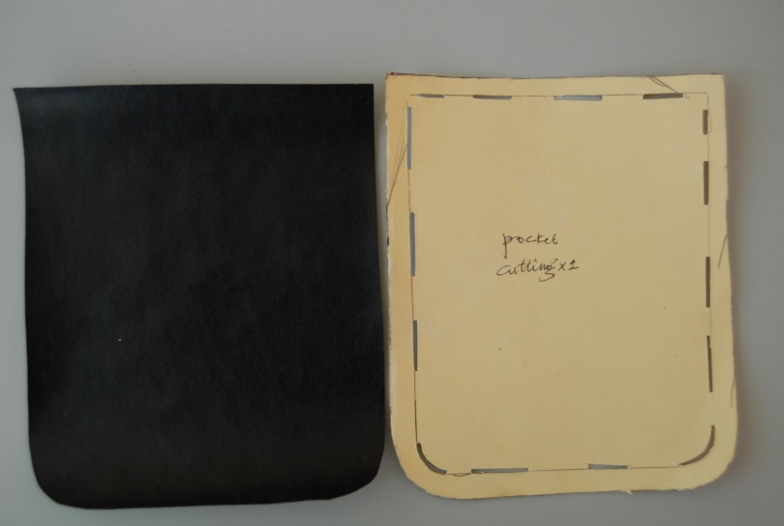
Checking Cut Components for Size and Quality of the cut edge

Figure39. The cut component
After cutting, component should be checked with the cutting pattern for exact size fitting including allowances as follows.
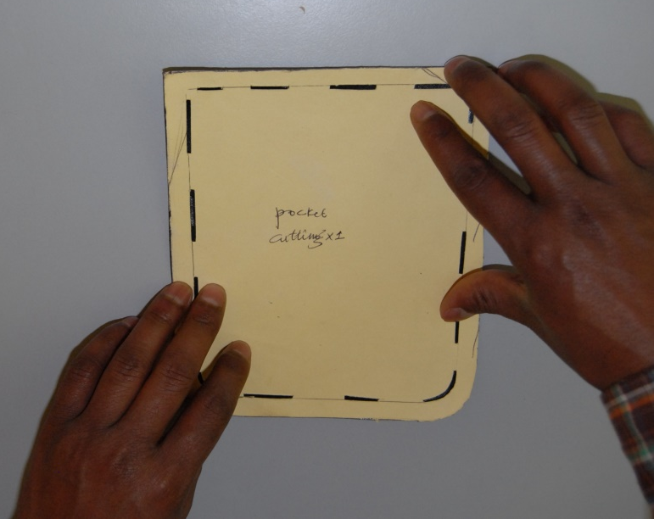
Figure40. The cut component
Then the cut component should be check with the making pattern to get the exact pocket size via the following steps:
Step 1: mark on cut leather component using the perforations on the cutting patter
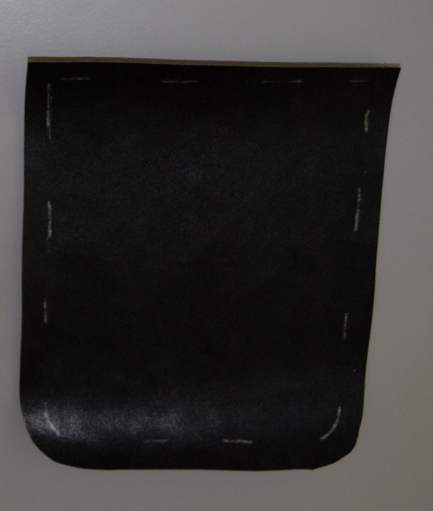
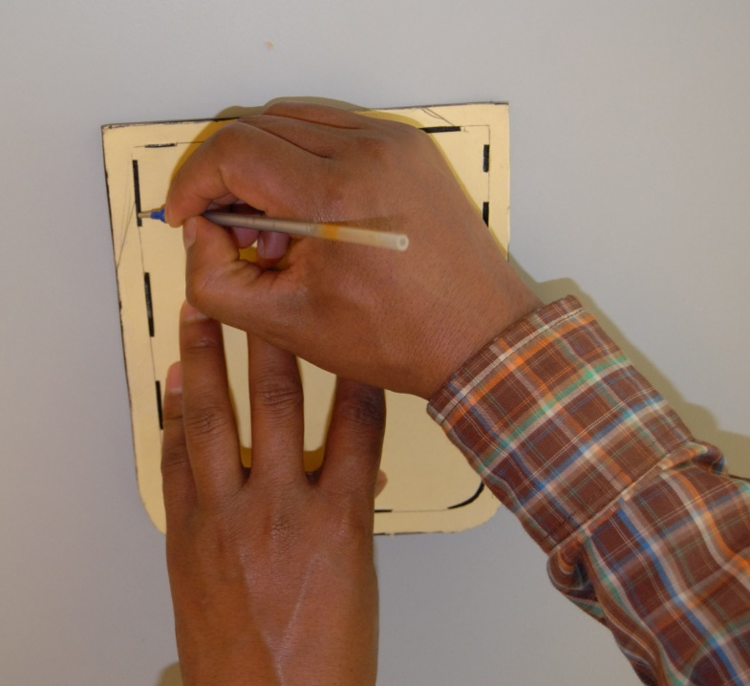

Figure 4.41.Mark on cut leather component

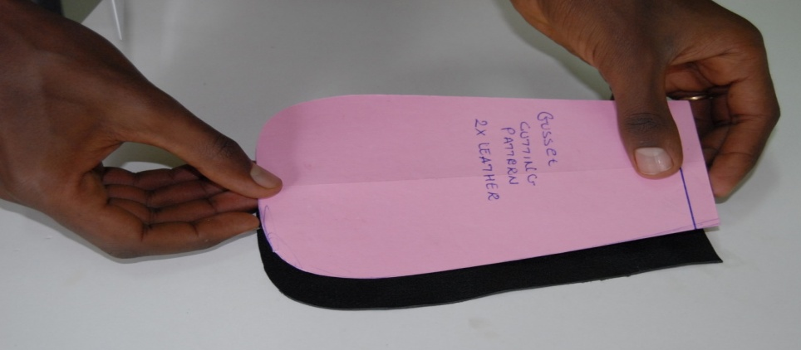
Step 2: lay the making pattern on the marked leather component to check for exact pocket size as follows

Figure42. Check for exact pocket size
In conclusion, once the model (the particular product) to be cut with all its specification has arrived to the cutting department, the cutting person should prepare all the necessary materials i.e.
- Leather, lining, reinforcements and all other materials accordingly including the color and texture.
- Check the components count the number of components that the product contains.
- Identify and prioritize them according to their size and shape
- Check how many times they should be cut their position (left/right) and so on.

4.2 Identifying cutting faults and irregularity
Since a leather skin has a non-uniform outer contour - there are defects in the leather and not all areas of the skin are of the same quality or have the same grain pattern - the art of cutting leather lies in the optimal area yield, while taking all these aspects into consideration.
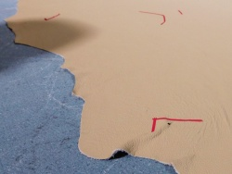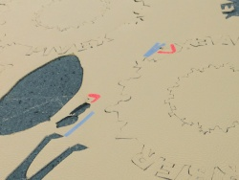
Figure 4.43.Cutting faults and irregularity
A cutter must check the skin on both sides for defects. These can be color defects or damages in the skin. Cutting lines must be chosen in such a way that the finished objects have a similar grain pattern. A cutter must select the better parts of the hide for the areas of upholstery that will get the most use, like seats and armrests. This must all be done while ensuring the smallest possible amount of cutting waste. Leather is sold by surface, and cutting waste increases costs. In the furniture and vehicle sector, the waste is generally between 30 and 45%. Smaller skins with larger blanks usually incur more wastage. Some manufacturers point to the natural characteristics of the leather and leave them visible in the blanks as long as the stability of the leather is ensured. In such cases, the waste is reduced and the consumer does not get any bad leather. The customer is only required to be sufficiently informed and does not consider such surface differences as defective.
List of cutting faults
- Miss cut
- Running shade
- Matching plies
- Number &bundling
- Notch mark
- Narrow goods
- Rugged cut
- Fabric way
- Measurement
- Tension Loose
- Alignment
- Irregular cutting

4.3. Recording faults

- Faults that must be recorded during cutting and on completed work includes-
- Bundle tickets
- Organization of work procedures and specifications
- Organizational or external personnel
- Customer/s requirements
- Work involves assembly of leather goods using table-based production processes
- Competence must be demonstrated in working to defined procedures/methods either individually or in a team environment
- Work is assessed in accordance with statutory requirements, organization insurance requirements, OH&S legislation, manual handling procedures and relevant health regulations
- Work organization procedures and practices relating to the table work operations used in the manufacture of leather components and goods
- Conditions of service, legislation and industrial agreements including workplace agreements and awards and Federal or State/Territory legislation
- Standard work practices Reporting actions include verbal and written communication in accordance with organizational policies and procedures
- Communication may be oral, written or visual and can include simple data
- Being responsible for the maintenance of own work quality and being required to contribute to the quality improvement of team or section output, where necessary
- Safety, environmental, housekeeping and quality are as specified by machine/equipment manufacturers, regulatory authorities and the enterprise

4.4. Bundling, stacking and storing components
According to OHS Bundling is the process of disassembling the stacked and cut pieces and reassembling them in production lots grouped accordingly. Manufacturers use a variety of bundling methods depending upon their needs, with four basic systems being the most common among local manufacturers.
A. Item Bundling
All pieces that comprise the product are bundled together.
B. Group
Bundling several (10-20) components are put together in a bundle and given to a single operator or team to sew.
C. Progressive Bundling
Pieces corresponding to specific sections of the product are bundled together and given to one operator. Other operators sew other parts of the garment, which are then assembled into the finished product in the final phase.
While leather stacking general safe stacking and storage rules with which employees who handle materials should be familiar, include:
- Ensure that stacks are stable and self-supporting.
- Observe height limitations when stacking materials.
- Allow sufficient clearance around stacks for safe handling and easy access.
- Make sure stacks do not block emergency exits, emergency equipment, or fire alarms.
In storing leather, we have to follow the golden rules this are
- Store leather in light proof or low light environment
- Never store leather on bare cement floors or even cement flooring with carpeting on it
- Never fold a leather
- Never wrap leather in plastic
- Keep colored leather that may bleed its color away from everything else by placing an impenetrable barrier in between
- Keep insects animals including pets and pests away from leather

4.5. Completing and Maintaining Records
- Bundle tickets
- Organization of work procedures and specifications
- Organizational or external personnel
- Customer/s requirements
- Work involves assembly of leather goods using table-based production processes
- Competence must be demonstrated in working to defined procedures/methods either individually or in a team environment
- Work is assessed in accordance with statutory requirements, organization insurance requirements, OH&S legislation, manual handling procedures and relevant health regulations
- Work organization procedures and practices relating to the table work operations used in the manufacture of leather components and goods
- Conditions of service, legislation and industrial agreements including workplace agreements and awards and Federal or State/Territory legislation
- Standard work practices
- Reporting actions include verbal and written communication in accordance with organizational policies and procedures
- Communication may be oral, written or visual and can include simple data
- Being responsible for the maintenance of own work quality and being required to contribute to the quality improvement of team or section output, where necessary
- Safety, environmental, housekeeping and quality are as specified by machine/equipment manufacturers, regulatory authorities and the enterprise Applicable regulations and legislation may include:
- Occupational health and safety legislation relevant to workplace activities
- Workers' compensation legislation

Self-check-4
I, Multiple Choices {8Point}
      - Which one is the uses of linings in leather goods
    - to mask the rough surface of split leather components,
    - to cover the defects of flesh side of the leather components,
    - to add sufficient strength to the components
    - All
      - -------is the materials that are introduced in the articles to add substance, strength and shape.
- Synthetic material
- Reinforcements
- Fabrics
- None
3. Which one is the cover defects of flesh side of the leather components
- Reinforcements
- linings
- cut edge
- All
4. Which of the following does not belong in the group?
A. Cuter
B. Synthetic
C.Leather
D. fabric/lining

- Answer all the questions listed below.
- What are the uses of lining?(2 points)
- What is the purpose of checking components?(2 points)
- What are the uses of reinforcement ?(2 point)
- What has to be checked while using fabrics? (2 point)
- What has to be checked while using leather?(2 point)
- List of cutting faults?(5point)

List of Reference Materials

1.http://www.scoutstuff.org/leather-handbook-cover.html
2. http://www.leatherati.com
3. Learning Guide for Basic Leather Garment and Goods Production Operations level 4.http://www.scoutstuff.org/leather-handbook-cover.html
5. http://www.leatherati.com
6. Learning Guide for Basic Leather Garment and Goods Production Operations level I
7. http://www.books.google.com/books/about/Leatherworking_Handbook.html?id=rc 9_JtobVG0C
8.http://www.tandyleatherfactory.com
9. Learning Guide for Basic Leather Garment and Goods Production Operations level I

